Instructions for Authors

June 2025

© 2025 Commonwealth of Australia as represented by the Department of Health, Disability and Ageing

ISSN: 2209-6051 Online

This journal is indexed by Index Medicus and Medline.

Creative Commons Licence

This publication is licensed under a Creative Commons [Attribution-NonCommercial-NoDerivatives 4.0 International Licence](https://creativecommons.org/licenses/by-nc-nd/4.0/legalcode) (Licence). You must read and understand the Licence before using any material from this publication.

Restrictions

The Licence does not cover, and there is no permission given for, use of any of the following material found in this publication (if any):

* the Commonwealth Coat of Arms (by way of information, the terms under which the Coat of Arms may be used can be found on the Department of Prime Minister and Cabinet website;
* any logos (including the interim Australian Centre for Disease Control and the Department of Health, Disability and Ageing’s logos) and trademarks;
* any photographs and images;
* any signatures; and
* any material belonging to third parties.

Disclaimer

Opinions expressed in *Communicable Diseases Intelligence* are those of the authors and not necessarily those of the Australian Government, the interim Australian Centre for Disease Control or the Department of Health, Disability and Ageing. Data may be subject to revision.

Enquiries

Enquiries regarding any other use of this publication should be addressed to the [CDI Editor](mailto:cdi.editor@health.gov.au).

About CDI

*Communicable Diseases Intelligence* (CDI) is a peer-reviewed scientific journal published by the interim Australian Centre for Disease Control within the Department of Health, Disability and Ageing.

The journal aims to disseminate information on the epidemiology, surveillance, prevention and control of communicable diseases of relevance to Australia and the near region.

**Editor**: Christina Bareja • **Deputy Editor**: Simon Petrie • **Design and Production**: Lisa Thompson

**Editorial Advisory Board**: David Durrheim, Mark Ferson, Clare Huppatz, John Kaldor, Martyn Kirk and Meru Sheel

**Submit an Article**

[Guidelines for authors](https://www.cdc.gov.au/topics/communicable-diseases/cdi/authors) and details on how to submit your publication is available on our website, or by email to the  
[CDI Editor](mailto:cdi.editor@health.gov.au).

**Contact us**

Communicable Diseases Intelligence (CDI)

interim Australian Centre for Disease Control, Department of Health, Disability and Ageing

GPO Box 9848, CANBERRA ACT 2601

Website: [cdc.gov.au/cdi](https://www.cdc.gov.au/topics/communicable-diseases/cdi)

Email: [cdi.editor@health.gov.au](mailto:cdi.editor@health.gov.au)

# Contents

CDI article submission categories and types 4

1. Unsolicited manuscript 5

2. Regular surveillance report 6

3. Invited submission/other 6

General guidelines 7

Structure for an outbreak report 7

CDI language convention and referencing guidelines 8

Author lists 9

Citations 9

References 10

Referencing examples 10

Footnotes and keyed notes 12

CDI ethics guidelines and other requirements 13

Ethics committee approvals and patients’ rights to privacy 13

Copyright 13

Privacy 13

Inclusive and respectful language 14

CDI guidelines for graphs, charts and other visuals 15

Font 15

Colours 15

Graphs and charts produced in Excel 16

Graphs and charts produced in other programs 17

Examples 18

Diagrams (editable) 19

Photographs and other non-editable formats 19

Multi-page figures and tables 19

CDI accessibility text 21

Examples 21

# CDI article submission categories and types

To ensure appropriate post-publication indexing via PubMed and Crossref, all submitted manuscripts should specify authorship and their affiliations; should specify up to 10 keywords; and should include an abstract (generally under 300 words). Except for article types within the ‘unsolicited manuscript’ category, prior agreement to submit must exist, or must be sought from the Editor.

| Article submission category | Article type | Word limita | Number of peer reviewers |
| --- | --- | --- | --- |
| 1 | Original article | 3,000 | 2 |
| 1 | Outbreak reportb | 1,000 | 1–2 |
| 1 | Case reportb | 1,000 | 1–2 |
| 1 | Surveillance summaryb | 1,000 | 1–2 |
| 1 | Letter to the Editor | 500 | 1 |
| 2 | Quarterly report | − | 0 |
| 2 | Annual report | − | 0 |
| 2 | Extended or multi-year report | − | 0 |
| 3 | Editorial | −c | −c |
| 3 | Policy and guidelines | − | 0 |
| 3 | Notice to readers | −c | −c |
| 3 | Other | −c | −c |

a Stated word limits (indicative, not prescriptive) are for main text, exclusive of abstract, tables, figures, author details, references, and all appendices and supporting information.

b Outbreak reports, case reports, and surveillance summaries are also collectively described as ‘short reports’.

c Subject to editorial discretion.

1. Unsolicited manuscript

Original article

Original articles describe original work and will most generally concern analysis and/or investigation of some phenomenon connected with the spread or control of communicable diseases.

**Requirements**

Articles should generally not include substantially more than 30 references.

### Outbreak report

Reports of communicable disease outbreaks will be considered based on their public health significance. Should include details of the investigation, including results of interventions and the significance of the outbreak for public health practice.

**Requirements**

Refer to *Structure for an outbreak report* in this section.

### Case report

Brief reports on cases of communicable disease will be considered based on their public health significance.

**Requirements**

Some discussion of the significance of the case for communicable disease control should be included.

### Surveillance summary

Brief reports on changes in the local epidemiology of a communicable disease, changes in surveillance systems, or new interventions, such as introducing vaccination in an at-risk group.

**Requirements**

Surveillance summaries should provide a brief description of the setting and a discussion of the significance of the events, changes or interventions.

### Letter to the Editor

The CDI editorial team welcomes comments on articles or current communicable disease issues in the form of letters to the editor.

**Requirements**

Letters should include no more than one figure or one chart and up to ten references.

2. Regular surveillance report

Quarterly report

These reports should include a brief analysis of one communicable disease of public health importance in Australia.

### Annual report

These reports should include a comprehensive analysis of one or more communicable diseases of public health importance in Australia.

### Extended or multi-year report

These reports should include a comprehensive analysis of one or more communicable diseases of public health importance in Australia over two or more years.

**Requirements for all of the above report types**

Reports should include discussion of incidence or prevalence, trend analyses and other data analyses relevant to informing public health measures.

## 3. Invited submission/other

Editorial

Editorials may be commissioned at the discretion of the Editor.

### Policy and guidelines

Communicable disease related policy and guidelines will be published where there is a national agreement on the content to be published. Items must be endorsed by the Communicable Diseases Network of Australia (CDNA) and of a publishable standard.

**Requirements**

Policy recommendations made by individual authors or an organisation will be considered as an Original Article.

### Notice to readers

A notice can be published to communicate information that may be of relevance to the communicable diseases community.

### Other

In exceptional circumstances, the publication of a manuscript that doesn’t fit the above categories may be published as ‘Other’.

## General guidelines

Abstracts may be structured or unstructured. Where structured, this would typically be:

* Background
* Methods
* Results
* Discussion.

For unsolicited manuscripts excluding outbreak reports and letters to the Editor, and for regular surveillance reports excluding quarterly reports, the main text should generally have a structure:

* Introduction (or Background)
* Methods
* Results
* Discussion
* Conclusions.

Methods and Results sections can have subsections as required; Discussion and Conclusions can be combined in shorter manuscripts. Figures and tables, where present, should generally only be referenced within the Methods and Results sections.

Each included figure or table must fulfil some well-defined purpose within the manuscript, and should convey pertinent information efficiently and effectively. Strive for clarity of presentation in all such items, and endeavour to limit the use of merged cells within tables.

## Structure for an outbreak report

Most outbreak reports will present only the descriptive epidemiology of the outbreak, with suspected risk factors for infection. More comprehensive reports on outbreaks should be submitted as articles. Where brevity is sought, the report’s abstract should be unstructured and similarly brief, and a maximum of 20 references is suggested.

| Section | Description and requirements |
| --- | --- |
| **Background and methods** | Including initial detection of the outbreak, case finding and interview techniques, study design and any statistical methods. |
| **Description of outbreak** | * case definition * number of cases * number laboratory confirmed, symptoms, time * place and person * epidemic curve – a maximum of two tables and/or figures is suggested. |
| **Laboratory, trace back and environmental investigations** | Details of the proportion of laboratory confirmation of cases. |
| **Public health response** | A very brief description of any actions taken to prevent further cases may be included. |
| **Discussion** | Including the significance of the outbreak for public health practice. |

# CDI language convention and referencing guidelines

Our goal is to comply with universally accepted scientific and Australian government style guidelines as much as possible. Please use the following guidelines for corresponding aspects of the manuscript.

**Scientific style and format**

[*Scientific Style and Format: the Council of Scientific Editors (CSE) Manual for Authors, Editors and Publishers*](https://www.scientificstyleandformat.org/), the latest edition, henceforth abbreviated as CSE. Latest edition at time of writing this guide is 8th.

**General style guidelines and respectful and inclusive language**

[Australian Government Style Manual](https://www.stylemanual.gov.au/).

**Spelling**

[The Macquarie Dictionary](https://www.macquariedictionary.com.au/).

**Citations**

the Vancouver system

Primary resource: CSE

Secondary resource: [*Citing Medicine*](https://www.ncbi.nlm.nih.gov/books/NBK7256/).

**References cited within the text**

Adopt the appropriate NLM title abbreviations for all journal titles.

Please pay attention to CDI’s referencing style.

**Accessibility**

See the ‘document accessibility requirements’ section within these Instructions.

CDI has a small set of guidelines for the purpose of consistency and meeting technical requirements of third-party services like indexes libraries and archives.

Author lists

**Article by-line formatting**

No titles are shown for author names on the article’s front page. Full titles for each author will be mentioned in the ‘Author details’ section, as in the below example.

**Author details (example)**

1. Prof. Jane Doe,1
2. Dr John Smith2

Anytown Regional Hospital, Anytown. General Medicine, Oldtown Memorial Hospital, Oldtown. Department of Public Health Studies, University of Capitalville

General Medicine, Capitalville University Hospital, Capitalville. Benefactor’s Medical Research Institute (BMRI), Newplace. Department of Medical Technology, University of Capitalville

**Corresponding author (example)**

Prof. Jane Doe

Address: Anytown Regional Hospital, Random Avenue, Anytown, Thatstate

Phone: + 61 1234 56789

Email: [name@sampleemail.org.au](mailto:name@sampleemail.org.au)

## Citations

Use of referencing software such as EndNote is encouraged, since this assists with consistent citation numbering (though authors are also encouraged to check carefully for duplication of reference entries, which is a problem we see in a non-negligible percentage of submitted manuscripts).

Referencing follows the Vancouver system; citations should be superscripted. Avoid using brackets or parentheses for citations.

Citation numbers should follow any adjacent punctuation marks. For example:

Competition between the two species is said to occur primarily at the juvenile stage,27,28 where *A. priori* shows significantly greater survivorship especially in resource-limited conditions;29 *A. posteriori* gets more severely affected when the number density of juvenile *A. priori*   
increases.30–32

References

* Referencing follows the Vancouver system.
* For authored items, author lists should be truncated after the sixth listed author.
* Book titles and the titles of items of Government legislation are italicised; journal names are italicised and abbreviated. The primary reference for journal title abbreviations is the NLM Catalogue (e.g., as given in PubMed).
* Cited journal articles must be specified by the appropriate publication details: year, then volume, then the article’s page range or article number, if such detail is catalogued. If the article has a digital object identifier (DOI), it should be provided after the other publication details.
* Where a page range or article number exists as an ‘identifier’ for the article (separate from a DOI), the format is [*year;volume(issue number in parentheses, if applicable):article identifier*.] For articles not bearing a page range or article number, the format is [*year;volume(issue, if applicable*).] In either instance, there should be no spaces within this specification. If a DOI exists for the article, this should then be specified as: [‘ doi: *‘ DOI URL*.] Except between the journal volume(issue) number, page range or article number and the doi URL, there should be no spaces within this specification.
* When citing journal articles, books, book chapters, or software, please do not specify month or date of publication unless this is essential for unambiguous identification of the source. Conversely, citing of websites, webpages, media releases and legislation should specify month or date of publication where this is known. Refer to the following examples for indications of the correct usage.
* When citing other work published within CDI, please ensure the correct edition of CDI is named, i.e. *Commun Dis Intell* for work published up to 2000 (vols. 1–24), *Commun Dis Intell Q Rep* for work published between 2001 and 2017 (vols. 25–41), and *Commun Dis Intell (2018)* for work published from 2018 (vol. 42) onwards.

## Referencing examples

Journal articles

Worthing KA, Lacey JA, Price DJ, McIntyre L, Steer AC, Tong SYC et al. Systematic review of group A streptococcal *emm* types associated with acute post-streptococcal glomerulonephritis. *Am J Trop Med Hyg*. 2019;100(5):1066–70. doi: <https://doi.org/10.4269/ajtmh.18-0827>.

Watchirs Smith L, Guy R, Degenhardt L, Yeung A, Rissel C, Richters J et al. Meeting sexual partners through internet sites and smartphone apps in Australia: national representative study. *J Med Internet Res*. 2018;20(12):e10683. doi: <https://doi.org/10.2196/10683>.

Day M, Pitt R, Mody N, Saunders J, Rai R, Nori A et al. Detection of 10 cases of ceftriaxone-resistant *Neisseria gonorrhoeae* in the United Kingdom, December 2021 to June 2022. *Euro Surveill*. 2022;27(46):2200803. doi: <https://doi.org/10.2807%2F1560-7917.ES.2022.27.46.2200803>.

Neldner L, Radlof S, Smith S, Littlejohn M, Hempenstall A, Hanson J. Age of hepatitis B e antigen loss in Aboriginal, Torres Strait Islander and non-Indigenous residents of tropical Australia; implications for clinical care. *Commun Dis Intell (2018)*. 2024;48. doi: <https://doi.org/10.33321/cdi.2024.48.48>.

Northern Territory Centre for Disease Control. Update on meningococcal disease in the Northern Territory (NT). *N T Dis Control Bull*. 2018;25(2):23. Available from: <https://digitallibrary.health.nt.gov.au/entities/publication/e28c05f5-7ca5-458c-b976-fd13eb50f7ee/details>.

### Books or chapers

Heymann DL, ed. *Control of Communicable Diseases Manual*. 20th ed. Fort Worth: APHA Press, 2015.

Rubin SA. 40 – Mumps vaccines. In Plotkin SA, Orenstein WA, Offit PA, Edwards KM, eds. *Plotkin’s Vaccines* (7th edition). Amsterdam: Elsevier, 2018;663–88.e11. doi: <https://doi.org/10.1016/B978-0-323-35761-6.00039-0>.

### Software

R Core Team. R: A Language and Environment for Statistical Computing. [Application.] Vienna: R Foundation for Statistical Computing; 2023. Available from: <https://www.R-project.org/>.

MapInfo. MapInfo Pro, version 15.0. [Software.] Stamford, Connecticut: Precisely; 2015. Available from: <https://www.precisely.com/product/precisely-mapinfo/mapinfo-pro>.

### Websites, webpages and downloadable resources

Australian Bureau of Statistics. Population: Census. Information on sex and age. [Webpage.] Canberra: Australian Bureau of Statistics; 28 June 2022. Available from: <https://www.abs.gov.au/statistics/people/population/population-census/2021>.

Victorian State Government Department of Health (Victoria Health). Invasive group A streptococcal disease (iGAS). [Webpage.] Melbourne: Victoria Health; 26 February 2024. Available from: <https://www.health.vic.gov.au/infectious-diseases/invasive-group-a-streptococcal-disease-igas>.

Minister for Foreign Affairs. Government delivers on expanding the Pacific workforce - six months early. [Press release.] Canberra: Australian Government Department of Foreign Affairs and Trade, Minister for Foreign Affairs; 2 February 2023. [Accessed on 28 November 2023.] Available from: <https://www.foreignminister.gov.au/minister/penny-wong/media-release/government-delivers-expanding-pacific-workforce-six-months-early>.

Australian Government Department of Health and Aged Care, Communicable Diseases Network Australia (CDNA). *Typhoid and paratyphoid: CDNA National Guidelines for Public Health Units*. [Internet.] Canberra: Australian Government Department of Health and Aged Care; 15 March 2017. [Accessed on 28 November 2023.] Available from: <https://www1.health.gov.au/internet/main/publishing.nsf/Content/cdna-song-typhoid-paratyphoid.htm>.

### Legislation

Queensland State Government Register of Legislation (Queensland Legislation). *Public Health Regulation 2018*. [Legislation.] Brisbane: Office of the Queensland Parliamentary Counsel; 2018. Available from: <https://www.legislation.qld.gov.au/view/html/inforce/current/sl-2018-0117>.

## Footnotes and keyed notes

In some circumstances, in-text reference may be required to items which don’t meet the requirements of endnoted referencing. For example, citation of a personal communication, or of an equipment supplier’s website. For such cases, footnotes should be used, marked by lowercase Roman numerals, numbered consecutively throughout the manuscript as in this example.[1],[2] As with reference citations, footnote citations should follow any adjacent punctuation.

Where keyed notes are required for a table or figure, these should be marked by lowercase alphabetic characters, starting with ‘a’ for each table and figure within the manuscript. As with reference citations, keyed note citations should follow any adjacent punctuation. Examples of keyed note use can be seen on various tables and figures throughout these Instructions.

# CDI ethics guidelines and other requirements

## Ethics committee approvals and patients’ rights to privacy

All manuscripts must include details on the ethics approval obtained for the study, including the name of the ethics committee or institutional review board, or a statement that ethics approval was not required; and an acknowledgment of all funding sources and the role of the funder (if any); and when relevant, an acknowledgement of data sources.

All investigations on human subjects must include a statement that the subjects gave their written informed consent, unless (i) data collection was covered by public health legislation or (ii) similar studies have been considered by a relevant ethics committee and a decision made that its approval was not required.

Authors should also state whether ethical approval and patient consent has been obtained for case reports, though in the interests of privacy such forms should not be shared directly with the journal. Within the article text, identifying details about patients should be omitted if they are not essential, but data should never be altered or falsified in an attempt to attain anonymity.

## Copyright

If the Article is accepted for publication in *Communicable Diseases Intelligence*, then from the date of that acceptance the author assigns to the Commonwealth all copyright throughout the world in the Article, without limitation. This means that from that date the author will no longer own any copyright in the Article, and the Commonwealth may, among other things, edit and publish the Article anywhere in any form, including electronic form and permit the use, reproduction and/or publication of the Article (or part of) by persons other than the Commonwealth, including under a Creative Commons licence.

If the Article is accepted for publication in *Communicable Diseases Intelligence*, the Commonwealth in return grants to the author(s) of the Article a permanent, irrevocable, royalty-free, non-exclusive licence to use, reproduce, adapt and exploit the Article anywhere in the world.

Where the Commonwealth already owns the copyright, the author is not required to submit the copyright form.

## Privacy

Your personal information is protected by law, including the *Privacy Act 1988* and the Australian Privacy Principles (APPs), and is being collected by the Commonwealth for the purposes of allowing us to publish your Article in *Communicable Diseases Intelligence*.

If you do not provide this information, CDI will not be able to publish your Article.

As a requirement of publication in CDI, the journal will disclose your name, the name of your Institution and your Article to Crossref, Portico and PubMed in the United States of America to facilitate the cross referencing of your Article.

## Inclusive and respectful language

CDI is committed to the use of respectful and inclusive language throughout the journal, noting nonetheless that present standards in this regard may not always be met in older archival material. For aspects of language use not covered by the [Australian Government Style Manual](https://www.stylemanual.gov.au/), please contact CDI’s editorial team for clarification.

# CDI guidelines for graphs, charts and other visuals

CDI visuals in articles are collectively referred to as figures. These visuals are made up of graphs, charts, diagrams, maps, infographics and photographs.

## Font

CDI requests all authors that provide visuals, including graphs and charts which are created in Excel or a speciality graphing or mapping software such as R or Stata, to use **Arial** as the only font within those figures.

## Colours

CDI has incorporated branding guidelines and authors are required to use our two primary colours, **navy** and **blue** first in graphs and charts (or use for the greatest data holders). After these have been used, then add other colours from the secondary colour palette.

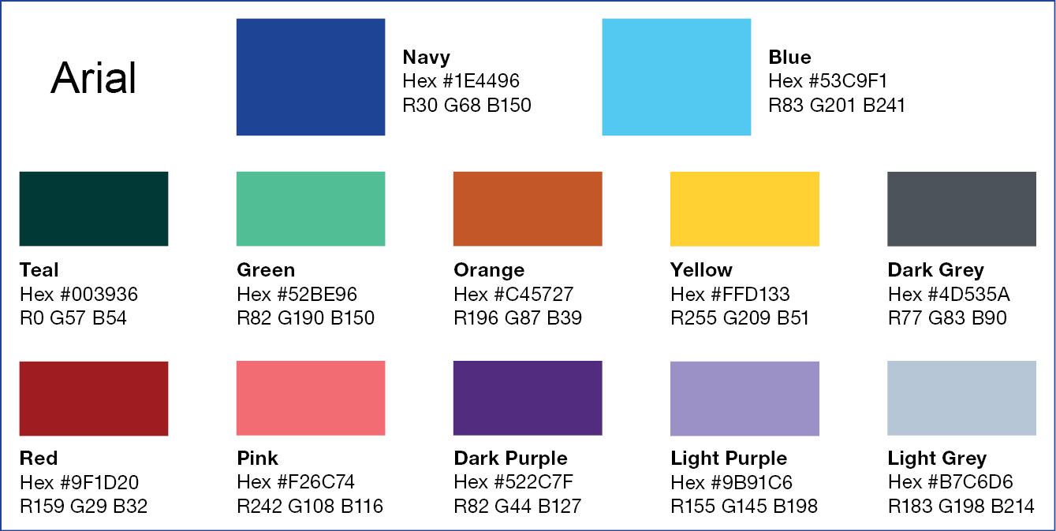

Hex codes and RGB values for this colour palette are provided in the above colour chart and in the table below. Do not use gradients, patterns or transparency in graphs and charts, and do not use the same colour for any two series.

| Colour | Hex code # | RGB value |
| --- | --- | --- |
| Navy | 1E4496 | R30 G68 B150 |
| Blue | 53C9F1 | R83 G201 B241 |
| Teal | 003936 | R0 G57 B54 |
| Green | 52BE96 | R82 G190 B150 |
| Orange | C45727 | R196 G87 B39 |
| Yellow | FFD133 | R255 G209 B51 |
| Dark Grey | 4D535A | R77 G83 B90 |
| Light Grey | B7C6D6 | R183 G198 B214 |
| Red | 9F1D20 | R159 G29 B32 |
| Pink | F26C74 | R242 G108 B116 |
| Dark Purple | 522C7F | R82 G44 B127 |
| Light Purple | 9B91C6 | R155 G145 B198 |

## Graphs and charts produced in Excel

Graphs and charts for publication in CDI need to be branded and formatted for consistency and to meet production requirements. Examples are set out on the following pages with information related to chart elements in Excel provided in the table in this section.

### Formatting

Each graph can be created as a separate chart rather than as an object in the datasheet (right-click on the sheet tab on the bottom of the page and choose Insert > New Chart).

Worksheet tabs should be appropriately titled to distinguish each graph (e.g. Figure 1, Figure 2; Figure 1 data, Figure 2 data).

The title and any footnotes for each graph should be included within the main manuscript’s Word document, with the graph inserted as a PNG or JPEG image to show placement. Do not place a title on the Excel worksheet itself.

Graphs should be formatted to the following as much as possible:

* Include only the relevant worksheets in the file.
* Do not embed Excel sheets or charts within one another.
* Ensure that all data used to generate each graph is embedded within the corresponding Excel worksheet.
* Do not link from Excel to other files or locations for the required data, or lock text (we need to edit).
* Set the Excel worksheet margins at 0.
* Do not use decimal points if all fields are a whole number.
* Do not use leading zeros, e.g. 1 Jan, not 01 Jan.
* Use sentence case and do not use abbreviations unless footnoted (except for names of states and territories).
* Alignment of text should always be horizontal where space permits, only apply vertical text if horizontal text is not possible.

It is strongly recommended that all graphs and charts within a submitted manuscript be sized and labelled consistently, to facilitate uniformity of presentation within the published article. Where possible, dimensions (width and height) of each graph should be consistent; similarly legend entries. It is recommended that authors use templates to assist in this aspect of figure generation, especially where a manuscript contains several charts for which a uniform appearance is desired.

## Graphs and charts produced in other programs

Colours and fonts listed for CDI, and specifications and requirements listed for Excel, can also be applied to graphs and charts created in other data or mapping software such as R or Stata, in order to standardise branding.

Exports **directly** from these programs should be editable (layers), allowing CDI to make edits. Vector-based formats include SVG, PDF, AI and EPS formats.

CDI requires graphs and charts in this category to be at 100% size, so type in a graph is displayed at its true size and not reduced when inserted into a document. Maximum width of the chart area is 17cm, with corresponding height (lock aspect ratio).

## Examples

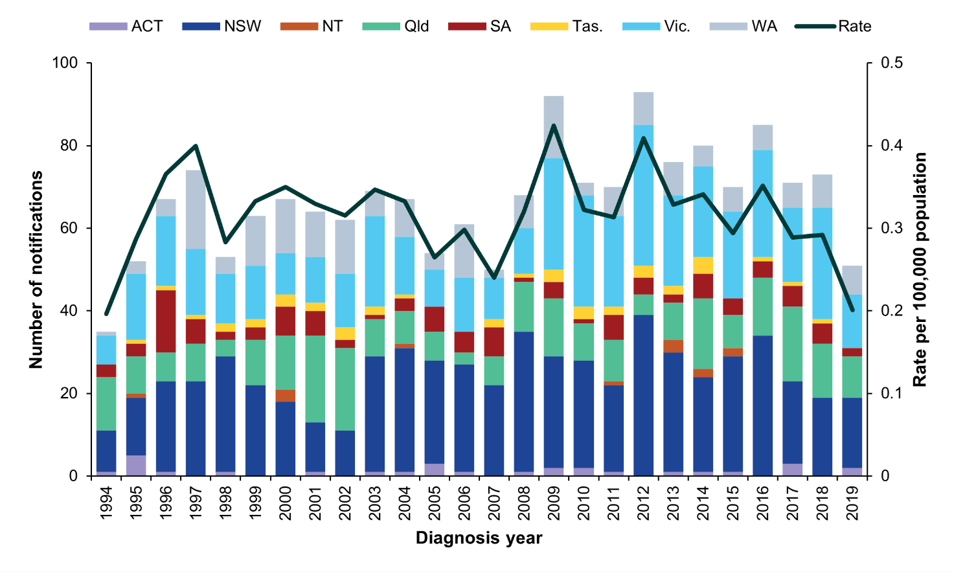

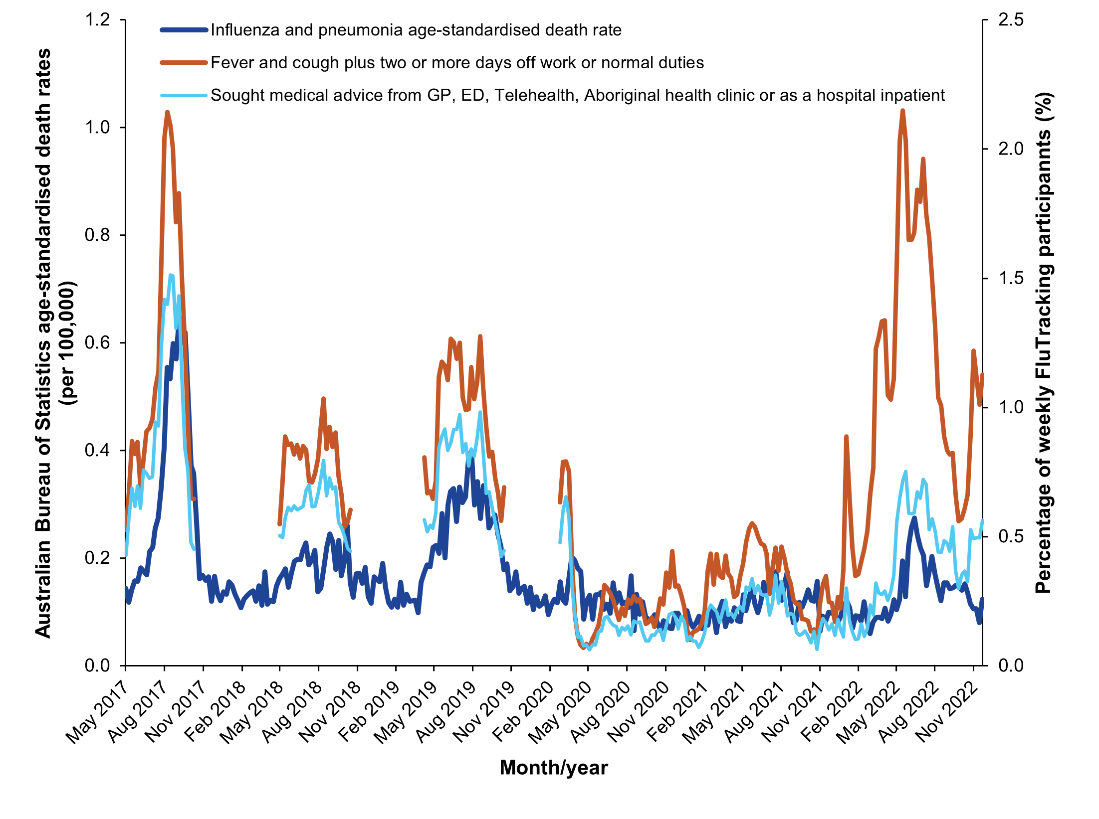

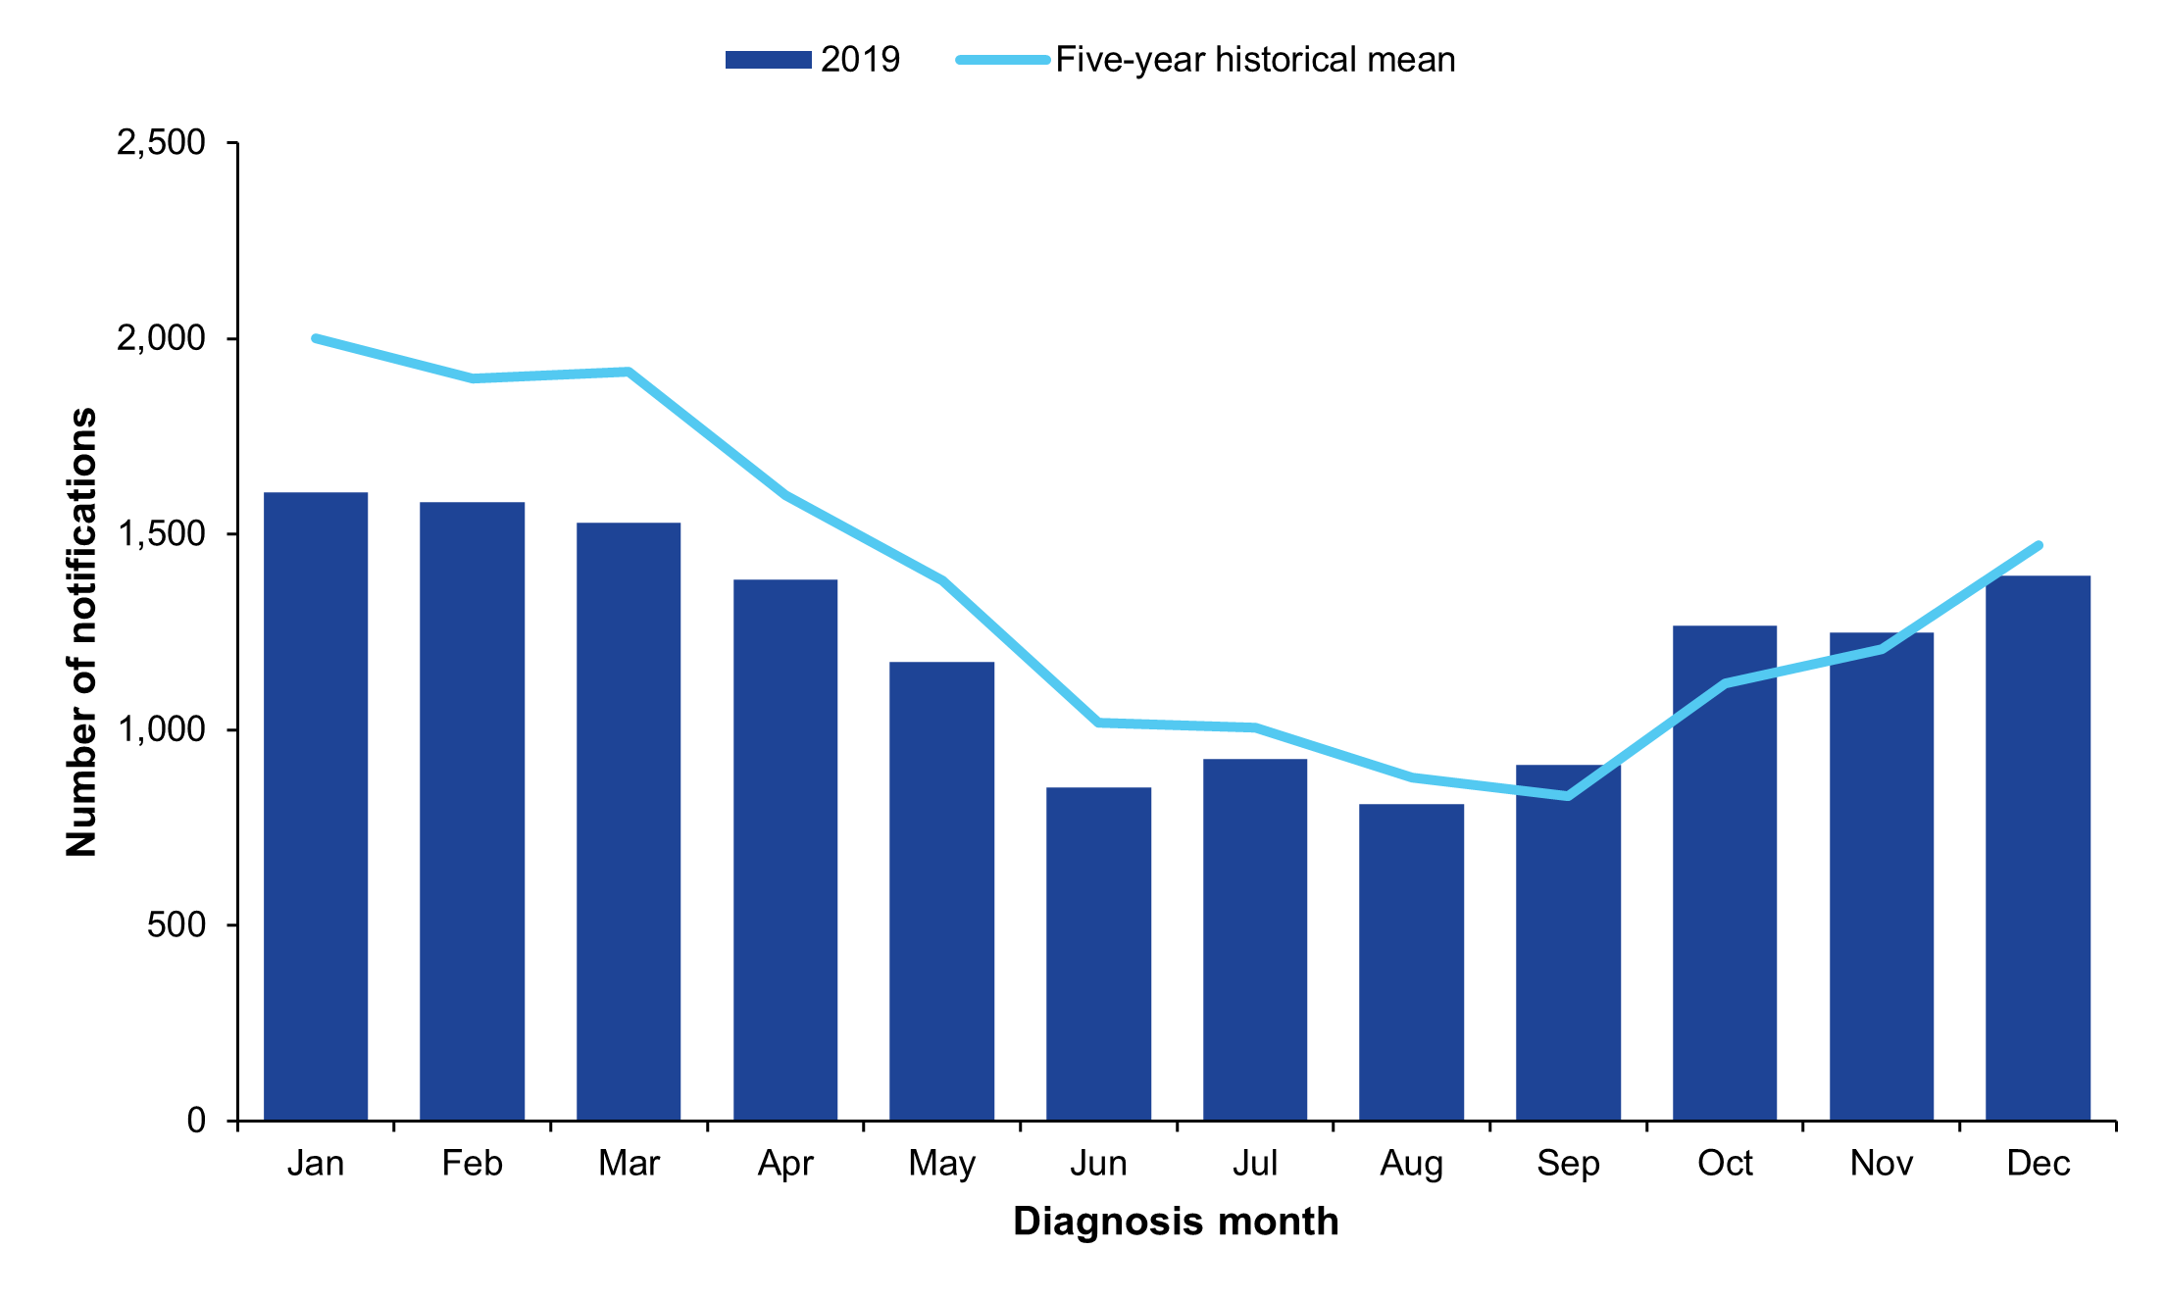

## Diagrams (editable)

Diagrams (e.g. flow charts, timelines, and **vector-based** maps and genome trees) can be included if required. Do not submit these as flattened images, but export from the program in which it was produced, in order for it to be edited by CDI. Acceptable file formats include PDF, SVG, AI, EPS.

Please use CDI colours where possible, including our red, orange and yellow for 'heat' maps. Genome trees should also use CDI colours wherever possible.

## Photographs and other non-editable formats

All photographs, **non vector-based** maps and genome trees are required to be submitted at 300 dpi at approximately A5 size (for case photographs) to A4 size (maps and genome trees), in order to be sized down to an acceptable quality. Acceptable file formats include PDF, JPEG, TIFF, PSD and PNG.

## Multi-page figures and tables

Use an appendix for tables and figures that span along several pages and interrupt the reading flow.

Excel chart elements

| Chart element | Requirements |
| --- | --- |
| Chart area | * Size: maximum width 17cm, with corresponding height (lock aspect ratio) * Background: automatic/white; no border |
| Horizontal (category) axis | * Type: Arial 8pt (not bold), colour: black * Line weight 0.75 black |
| Horizontal (category) axis title | Type: Arial 9pt bold, colour: black |
| Legend | * Type: Arial 8pt (not bold), colour: black * Background: automatic/white; no border * Position at the top or the bottom, without overlapping the chart |
| Plot area | Background: automatic/white; no border |
| Secondary vertical (value) axis | * Type: Arial 8pt (not bold), colour: black * Line weight 0.75 black |
| Secondary vertical (value) axis title | Type: Arial 9pt bold, colour: black |
| Vertical (value) axis | * Type: Arial 8pt (not bold), colour: black * Line weight 0.75 black |
| Vertical (value) axis title | Type: Arial 9pt bold, colour: black |
| Series (stacked graphs) | * Solid fill using CDI colours, no transparency and no border/outline * No shadow, glow, soft edges or 3-D format * Use an overlap of 100% and gap width of 50% |
| Series (column and bar graphs) | * Solid fill using CDI colours, no transparency and no border/outline * No shadow, glow, soft edges or 3-D format * Use an overlap of 0% and gap width of 25-50% |
| Series (line graphs) | * Outlines/lines using CDI colours; no fill, no transparency * Series can use a solid and a dashed line in the same colour in order to create difference in complex graphs. Varying weights can also be used |
| Histograms | Use a gap width of 0 |
| Axis tick mark labels | Next to axis |
| Axis tick mark type | Major: outside, minor: none |

# CDI accessibility text

This section contains some examples of descriptors that authors need to provide when submitting articles for publication. This includes document and table summaries and text descriptors for maps, figures and flow charts.

The following are examples of summaries and text descriptors required for Australian Government accessibility requirements when publishing CDI articles on a website. These examples demonstrate the level of detail and description required when completing the [article submission form](https://www.cdc.gov.au/resources/publications/cdi-article-submission-form).

When this section of the form is completed, it should specify:

* the article/report title
* a short one or two sentence summary of the article/report
* a short one sentence summary of any data tables
* a longer text description (typically one paragraph) for any figures; the description should be sufficient so that a sight-impaired person can interpret the figure.

Do not use dot points in your descriptions. The text descriptions are provided in published articles as plain-text metadata, with no provision for formatting such as dot points.

Do not repeat the headings, as this is repetitive for text readers. The advice from Vision Australia, for long descriptions, is that to provide a suitable long description, you should:

* identify the type of graph or chart
* provide a summary of the data, explaining the trends that a sighted person can see in the image.

## Examples

Each table and figure is shown here only for context. These items should **not** be included in the article submission form alongside any accessibility text.

### Article/report summary

**Title**

Yersiniosis outbreaks in Gold Coast residential aged care facilities linked to nutritionally-supplemented milkshakes, January–April 2023

**Accessibility text:**

This paper describes an outbreak of Yersinia enterocolitica in Gold Coast residential aged care facilities (RACF), linked with milkshake consumption, between January and April 2023.

### Table summary

Table 1: Likely *Leptospira* serovar of cases notified in residents of metropolitan Sydney, 2003–2022, by whether acquired in Australia or overseasa

| Serovar | Australian acquired | Overseas acquired |
| --- | --- | --- |
| Arborea | 9 | 0 |
| Australis | 2 | 6 |
| Canicola | 2 | 5 |
| Copenhageni | 0 | 5 |
| Hardjo | 3 | 4 |
| Zanoni | 0 | 3 |
| Grippotyphosa | 1 | 2 |
| Tarassovi | 0 | 1 |
| Unknown | 8 | 1 |
| Total | 25 | 27 |

a One case was diagnosed postmortem, and neither place of acquisition nor serovar was available.

**Accessibility text:**

The table describes Leptospira serovars among cases notified in metro Sydney residents from 2003 to 2022 according to whether the infection was believed to be contracted in Australia or overseas. Arborea caused 9 of 17 cases contracted in Australia and none from overseas.

### Figure summary: Example 1

Figure 1: Non-polio acute flaccid paralysis rate, Australia 1995 to 2023a

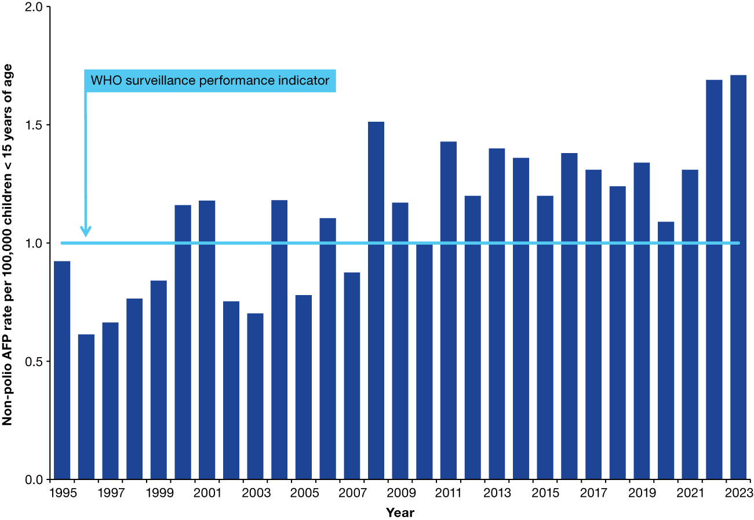

a The WHO AFP surveillance performance indicator for a polio-free country is at least one non-polio AFP case per 100,000 children < 15 years of age, which is indicated by the orange line.

**Accessibility text:**

Bar chart of Australia’s non-polio acute flaccid paralysis rate 1995 to 2023, compared to the World Health Organization surveillance performance criterion. Australia reached or exceeded the World Health Organization target of at least one non-polio acute flaccid paralysis case per 100,000 children less than 15 years of age in 2000, 2001, 2004, 2006 and 2008 to 2023.

### Figure summary: Example 2

Figure 1: Number of gonococcal disease cases reported to the National Notifiable Diseases Surveillance System,a compared with *Neisseria gonorrhoeae* isolates available for laboratory testing by the Australian Gonococcal Surveillance Programme, Australia,   
1991–2023

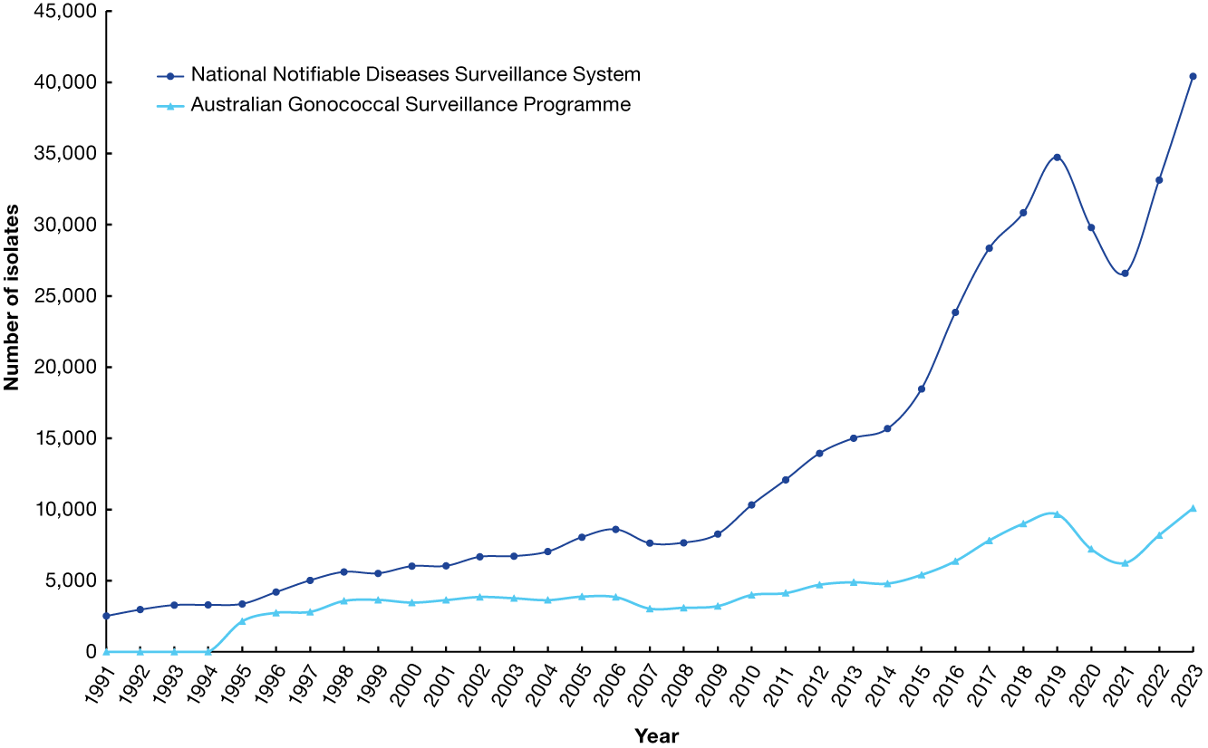

a Source: National Communicable Disease Surveillance Dashboard. Accessed 13 March 2024.9

**Accessibility text:**

The line chart shows the number of gonococcal disease cases reported to the National Notifiable Diseases Surveillance System over the years 1991 to 2023, compared with isolates available for laboratory testing by the Australian Gonococcal Surveillance Programme, Australia, over the same time period. There has been a large rise in both disease notifications and isolates available for laboratory testing over the time period, and particularly since 2010. In 2020 and 2021 there was a noticeable decline in both disease notifications and isolates, coincident with the public health strategies implemented in the COVID-19 pandemic. With the relaxation of these measures in 2022, both disease notifications and bacterial culture confirmations returned to pre-pandemic levels (2019). In 2023, there was a 16% increase in the number of notifications of N. gonorrhoeae infections in Australia (n = 40,429) compared to pre-pandemic notifications to the NNDSS in 2019 (34,743).

### Figure summary: Example 3

Figure 1: Study flow diagram, March 2022

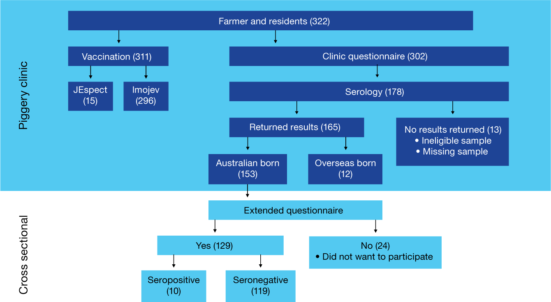

**Accessibility text:**

A flow diagram showing the flow of participants from the beginning of the study. The chart shows the total number of consenting participants in the piggery farmer serosurvey. The chart has three components: participants who completed the piggery questionnaire; questionnaire respondents who had serology collected; and participants who received the vaccination. The serology collected component flows into the seroprevalence among all workers and residents. It is also broken down into those who were Australian-born versus overseas-born; the former group includes all participants who consented to participate in the case-control study.

### Figure summary: Example 4

Figure 1: Map of the Torres Strait, Australia, showing the location of Mer, where the 2024 DENV-3 outbreak occurred

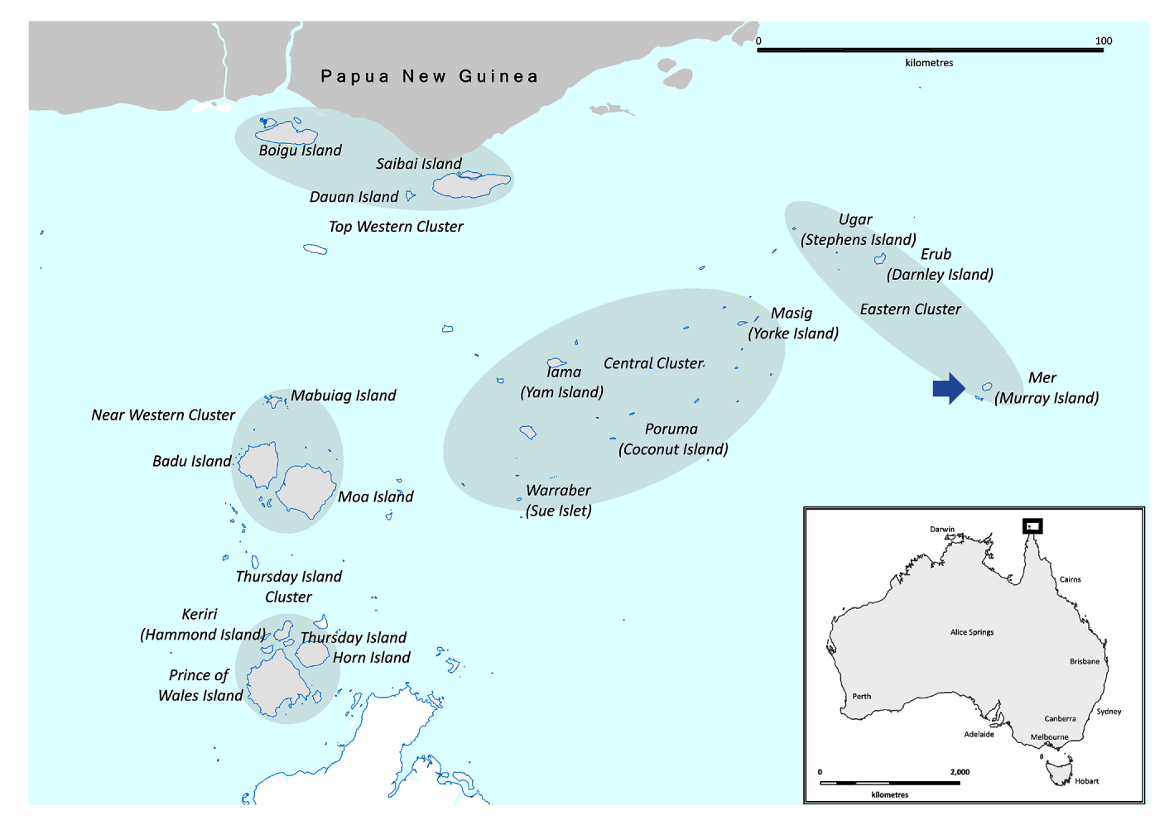

**Accessibility text:**

Figure 1 illustrates a map of the Torres Strait, Australia, showing the location of Mer, where the 2024 DENV-3 outbreak occurred.

1. Item one.
2. Item two.