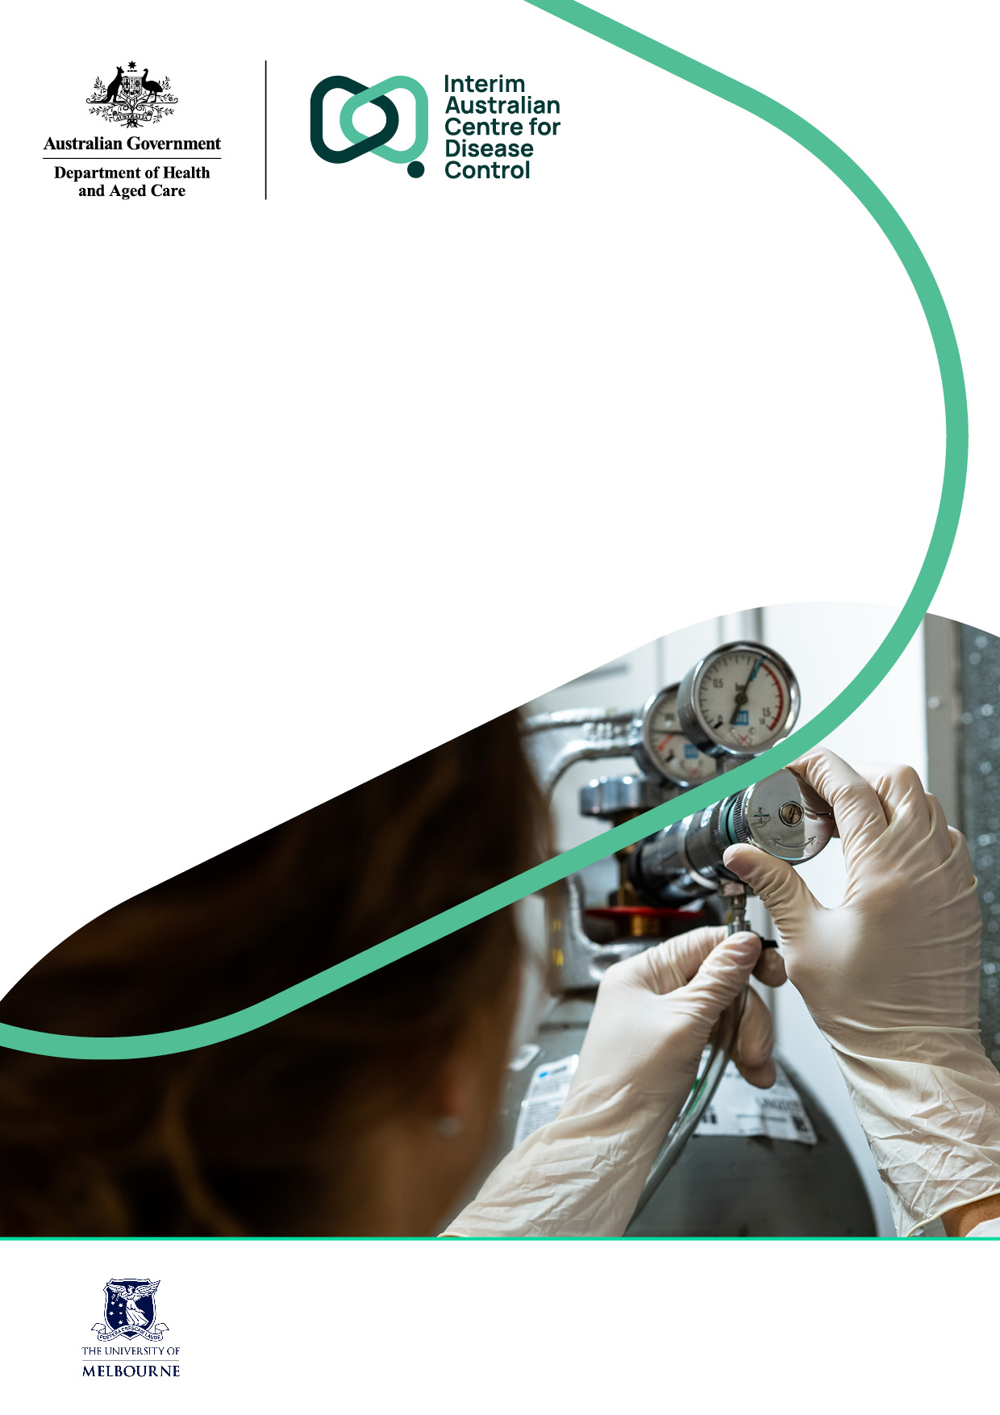
Detecting and reducing nitrous oxide leaks in healthcare facilities
  - A practical guide

© Commonwealth of Australia as represented by the Australian Centre for Disease Control
Title: Detecting and reducing nitrous oxide leaks in healthcare facilities: a practical guide.
ISBN: 978-1-74186-462-5
Acknowledgement of Country
The Australian Government acknowledges the Traditional Owners of Country throughout Australia, and their continuing connection to land, sea and community. We pay our respects to them and their cultures, and to Elders both past and present.
Citation
E Kayak, F McGain, H Burch, B Dunne, Y Gu, J Davies, R McIntyre, D Story, C Mitchell, S Gaff, E Balmaks, J Skowno, C Woinarski, J Correy, S Chanchlani, G Cooper, A Wyns, M Skellern. (2024). Detecting and reducing nitrous oxide leaks in healthcare facilities: a practical guide. Interim Australian Centre for Disease Control, Department of Health and Aged Care.
Creative Commons Licence
This publication is licensed under the Creative Commons Attribution 4.0 International Public License available from https://creativecommons.org/licenses/by/4.0/legalcode (“Licence”). You must read and understand the Licence before using any material from this publication.
Restrictions
The Licence may not give you all the permissions necessary for your intended use. For example, other rights (such as publicity, privacy and moral rights) may limit how you use the material found in this publication.
The Licence does not cover, and there is no permission given for, use of any of the following material found in this publication:
- the Commonwealth Coat of Arms. (by way of information, the terms under which the Coat of Arms may be used can be found on the Department of Prime Minister and Cabinet website)
- any logos and trademarks;
- any photographs and images;
- any signatures; and
- any material belonging to third parties. The third-party elements must be included here or have a footnote reference throughout the document showing where they are.
Attribution
Without limiting your obligations under the Licence, the Department of Health and Aged Care requests that you attribute this publication in your work. Any reasonable form of words may be used provided that you:
- include a reference to this publication and where, practicable, the relevant page numbers;
- make it clear that you have permission to use the material under the Creative Commons Attribution 4.0 International Public License;
- make it clear whether or not you have changed the material used from this publication;
- include a copyright notice in relation to the material used. In the case of no change to the material, the words “© Commonwealth of Australia (Australian Centre for Disease Control) 2024” may be used. In the case where the material has been changed or adapted, the words: “Based on Commonwealth of Australia (Australian Centre for Disease Control) material” may be used; and
- do not suggest that the Australian Centre for Disease Control endorses you or your use of the material.
Enquiries
Enquiries regarding any other use of this publication should be addressed to the Branch Manager, Communication Branch, Interim Australian Centre for Disease Control, GPO Box 9848, Canberra ACT 2601, or via e-mail to copyright@health.gov.au.

Contents

Contents 3
Figures and Tables 4
Executive Summary 5
Introduction 8
Method 1: Discrepancy Method 13
Method 2: Cylinder Weighing Method 18
Method 3: Pressure Testing Method 21
Method 4: Flow Monitoring Method 24
Recommended next steps 27
Appendices 29
References 31

Figures and Tables

List of Figures
Figure 1. Overview of methods to detect and reduce N₂O leaks 5
Figure 2. Decision pathway to assist in choice of method to detect N₂O leaks 6
Figure 3. Key stages of the Discrepancy Method 12
Figure 4. Weighing N₂O cylinders. 18
Figure 5. Overview of the Pressure Testing Method 20
Figure 6. In-line flow metre. 24

List of Tables
Table 1. Likely sites of N₂O leaks within healthcare facilities 10

Executive Summary
This report presents several methods currently used in Australia to detect and reduce leaks from nitrous oxide (N₂O) piping in healthcare facilities (Figure 1). It is intended for use by clinicians and healthcare facility managers to assist with the detection and reduction of leaks and enable informed choices about the methodology that is most suited for their context (Figure 2).
N₂O is a potent greenhouse gas with a global warming potential 265 times that of carbon dioxide (CO₂). Due to its average atmospheric lifetime of 110 years, N₂O released today will have warming effects into the next century. In addition, exposure to N₂O concentrations greater than Occupational Health and Safety standards is an occupational health risk.,
Leaks in N₂O infrastructure have been identified as a significant contributor to the emissions footprint of anaesthetic gas use in healthcare and are financially wasteful. Recent studies in Australia and in the United Kingdom have found at least half (and often more than 70%) of the N₂O supplied to many healthcare facilities leaks from infrastructure before clinical administration.,,,,,,,,
This guide is intended to assist clinicians and facility managers to:
- Identify the most appropriate method to test for N₂O leaks
- Make an informed choice about the most appropriate way to supply N₂O to a facility (i.e. piped supply versus cylinders)
- Reduce or remove N₂O supply where not clinically necessary
- Reduce waste from N₂O leaks, including through regular monitoring of N₂O supply.
This guide responds to the growing recognition among clinicians and facility managers that N₂O leaks occur frequently and lead to significant waste, financial loss, and environmental impacts.
Any detection of N₂O leaks should inform a cost-benefit analysis on steps to reduce waste from N₂O leaks, which could include regular monitoring for N₂O leaks, avoiding installing new N₂O piping, and decommissioning existing piping.

Figure 1. Overview of methods to detect and reduce N₂O leaks
Figure 1 lists the four methods to detect and reduce N₂O leaks described in this guide. The discrepancy method (method 1) compares the difference between the volume of N₂O purchased and the volume of N₂O that is clinically administered (either measured directly or estimated). It is a method that can quickly help determine whether a leak is occurring and can be used when N₂O supply cannot be interrupted. The cylinder weighing method (method 2) weighs N₂O cylinders over a certain period to detect a change over time and is a relatively precise method. The pressure testing method (method 3) measures whether there is a decrease in N₂O supply pressure over a certain period when no N₂O is being clinically administered. It provides a relatively sensitive measurement and is well-suited for testing specific sections of pipeline, thereby determining both the presence and location of any leak(s). The flow monitoring method (method 4) involves installing flow monitors to detect any flow of N₂O during a period of no clinical use, or, during periods of clinical use, to measure and compare the flow of N₂O at the source and the point of clinical administration. It requires specialised equipment but provides relatively accurate estimates and allows the location of leaks to be determined.
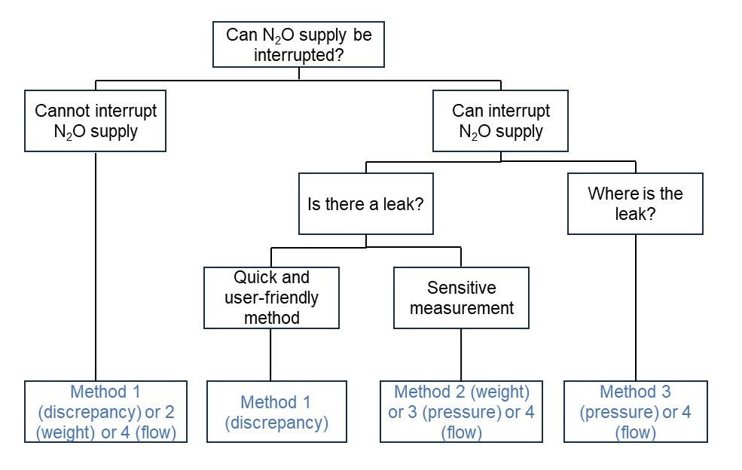Figure 2. Decision pathway to assist in choice of method to detect N₂O leaks
Figure 2 shows a decision pathway to assist with choosing the most appropriate method to detect N₂O leaks. Methods 1,2 or 4 can be used if the N₂O supply cannot be interrupted. Methods 1 or 2 can be used relatively quickly and easily to detect whether a leak is occurring. Methods 3 or 4 can be used to determine the location of leaks. Please note, Figure 2 is a guide only. The process of deciding which method to use may be influenced by other factors, including the supply infrastructure (e.g. good access to the pipeline infrastructure might favour use of the pressure method), equipment used (e.g. access to a flow meter might favour use of the flow monitoring method), and access to N₂O administration data (e.g. high-quality data might favour use of the discrepancy method). Therefore, it is recommended that you read this entire report before deciding which method(s) to use.

Introduction
Australia’s first National Health and Climate Strategy (the Strategy) sets out a whole-of-government plan for addressing the health and wellbeing impacts of climate change, whilst also addressing the contribution of the health system – encompassing public and preventive health, primary and secondary health care, and aged care – to climate change.
N₂O is a Schedule 4 medication, meaning its possession, prescription and supply is limited to certain health practitioners and authorised persons, including, in the case of N₂O, midwives and nurses. It is a significant contributor to health system emissions, accounting for around 20% of the direct (scope 1) emissions of the Australian health system. N₂O is often supplied from large cylinders in a central store (cylinder manifolds) and then delivered through a network of rigid pipelines to other areas of a facility. Pipeline supply may also be present in non-clinical areas of healthcare facilities for legacy reasons as facilities are renovated or upgraded.
Leaks in N₂O piping infrastructure have been identified as a significant contributor to the greenhouse gas emissions footprint of anaesthetic gas use in healthcare and are financially wasteful. Recent studies in Australia and in the United Kingdom have found that at least half (and often more than 70%) of the N₂O supplied to healthcare facilities leaks from infrastructure before clinical administration.^{5,6,7,8,9,10,11,12,13} Given N₂O gas is both colourless and odorless, leaks need to be actively detected.
Action 4.13 of the Strategy commits the Australian Government to working with clinicians, health care providers, states, territories, industry and suppliers, to improve patient care, protect health care staff and reduce greenhouse gas emissions from N₂O, by
- Reducing waste from N₂O leaks
- Tackling venting, the practice of releasing unused N₂O when cylinders are returned for refill
- Considering whether there are examples of unnecessary or low-value use of N₂O and, where any such examples exist, identifying and pursuing strategies for reducing this use.
For avoidance of doubt, the Australian Government recognises N₂O plays an ongoing role in healthcare provision, especially in maternity settings. The government has no intention to promote a phase out of its use.
The scope of this guide is limited to identifying and reducing waste caused by leaks from N₂O piping (i.e. the first of the above three action areas). It is only one component of the Australian Government’s wider efforts to tackle greenhouse gas emissions from anaesthetic gas use. This guide should be seen in the context of wider efforts to address the contribution of the Australian health system to climate change, as outlined in the Strategy.
This report outlines current and emerging practices used in Australia to detect and reduce leaks from N₂O piping in healthcare facilities. These practices are likely to improve and develop over time as they are further tested and new standards of best practice emerge. This guide is not intended to be prescriptive; it is the responsibility of each healthcare facility to determine which method (or methods) best suits their context and needs.
Several state and territory governments are taking action to address N₂O leaks. For example, the Queensland Government Statewide Anaesthesia and Perioperative Care Clinical Network has produced a series of recommendations on reducing N₂O emissions, which include avoiding use of N₂O where possible, avoiding installing new N₂O piping and decommissioning existing piping.⁵ Health Nitrous Oxide Reduction Working Groups have been established in several other jurisdictions, bringing together representatives from government, medical, nursing and midwifery colleges, health service staff, industry and suppliers.
International interest in addressing N₂O leaks gained momentum in 2021, when an audit of 16 hospitals in the Lothian National Health Service (NHS) revealed that waste via leaks accounted for over 95% of N₂O procured.^{7,} Further audits at 38 sites in Scotland using the discrepancy method (method 1, described below) demonstrated that 83-100% of purchased N₂O was lost via infrastructure system leaks.^{8,10} As numerous healthcare facilities in Scotland identified leaks, many have subsequently decided to decommission their piped supply of N₂O.⁸ These international trends indicate not only a growing recognition of the need to reduce waste from N₂O leaks, but also an increasing body of opinion that piped N₂O does not have a place in a sustainable high-quality health system.

Australian Standards
Currently, installation and testing of non-flammable medical gas pipeline systems is set out under the Australian Standard (AS) 2896:2021. This Standard provides instruction on the installation and maintenance of specific health equipment and systems. AS 2896:2021 informs the Australasian Health Facility Guidelines, which act as an overarching guide describing all required elements and all relevant standards that should be adhered to in healthcare facilities.
AS 2896:2021 is included in the National Construction Code and sets the minimum required level of safety, health, amenity, accessibility, and sustainability that healthcare facilities must comply with. The standard outlines a number of requirements to minimise the chance of leaks occurring. The most relevant requirements include the following:

Installation requirements for pipelines:
- 4.13.5 Any connection made to the existing system shall be tested for leaks. Final leak testing may be performed by using the ‘soapy water bubble test’ [described below] on the final connection.

Testing, commissioning, and certification:
- 5.1 Total system and zone pressure testing, flow testing and leakage test certification on commissioning, major modifications or prolonged periods of downtime.

Maintenance:
            - 6.3.2 The Manifold to be visually checked at least weekly and tested at least every year.
            - 6.5 Terminal units (wall outlet valves and seal assemblies) to be inspected and tested at least every two years.
            - 6.5(a) Seals and all O-rings in the system to be replaced every four years (or earlier if necessary).
            - 6.8 The flexible pipes and fittings in the pendent system and from outlet to anaesthetic machines to be inspected every 12 months.
Under AS 2896:2021, initial testing and ongoing maintenance of medical gas pipeline systems is limited to the use of visual checks, pressure gauge checks and the use of the ‘soapy water bubble test’ (4.13.5). The latter involves spraying detergent onto N₂O pipes and valves to search for leaks identified as bubbles, which only provides a rudimentary indication of the presence of leaks and does not allow for the size of any given leak (i.e. the volume of N₂O being leaked) to be determined. Australian healthcare facilities which have passed the AS 2896:2021 maintenance standards have subsequently been shown to have major leaks when applying the additional testing methods outlined in this document.^{9,}10^{,11} That significant leak(s) have been reported across multiple Australian healthcare facilities – despite adherence to Australian Standards for maintenance of gas pipeline systems – may reflect the fact that the Australian Standards currently do not require regular ongoing testing of the entirety of the rigid pipeline network after commissioning (except for a requirement to test after major modifications or prolonged downtime). It may also reflect the fact that the Australian Standards currently do not provide specific guidance on the use of more accurate leak testing methodologies beyond the ‘soapy water bubble test’.¹⁷ The additional methods described in this guide can significantly improve the sensitivity by which N₂O leaks are detected on an ongoing basis as part of the maintenance process.
The 2023 update to the Australasian Health Facility Guidelines suggests supplying N₂O using cylinders might be preferred over piped (reticulated) N₂O in most cases, stating that: “Except for maternity and paediatric services, reticulated nitrous oxide and associated scavenge outlets are to be considered optional. Where found to be clinically necessary, provision of nitrous oxide via piped outlets or via cylinder is to be determined at a project level.”
It is important to note that maternity and paediatric services both have higher rates of N₂O use, and consume greater quantities of N₂O per procedure, relative to other health services. Maternity services most commonly administer N₂O as pain relief during labour in birth suites and labour wards. Alternatively, N₂O can also be used for some maternity services in outpatient clinics. Due to the relatively high rate and use of N₂O in maternity services, a potential shift from administering N₂O via piped outlets to administering N₂O via cylinders could constitute a more significant change for maternity services compared to health services that use smaller quantities of N₂O; it would require a relatively large number of cylinders, additional staff time to transport cylinders, greater storage space for cylinders, and more active management of N₂O supply.
Approaches to maintenance and detection of N₂O leaks currently vary considerably between healthcare facilities. For example, a recent audit undertaken at Sir Charles Gairdner Hospital in Perth found there was no service contract in place to regularly assess N₂O infrastructure.⁹ Additionally, the hospital’s infrastructure map of the N₂O pipeline revealed the presence of active outlets in non-clinical areas, including a library, and in clinical areas where N₂O was no longer in use, such as the intensive care unit and emergency department (ED). Further examination of the system by pressure testing (method 3, described below) confirmed the presence of five leaks in pipe and theatre pendant systems (N₂O outlets fixed to medical equipment that is mounted to a ceiling or wall). The pendant leaks were likely missed when visual testing methods were used previously.

Potential sources of leaks
Leaks can occur in several places along the N₂O infrastructure of healthcare facilities (Table 1). Increasing facility age may increase the risk of leaks. Leaks may also be associated with inadequate maintenance schedules. While leaks from the manifold-pipeline system (the central pipe fitting which connects multiple gas cylinders to their points of use throughout the healthcare facility) appear to be more common, leaks can occur at other locations, including at wall outlets or at the point of clinical administration, such as an N₂O cylinder attached to an anaesthetic machine.
Table 1. Likely sites of N₂O leaks within healthcare facilities
Likely sites of N₂O leaks | Likely sources of leakage at site
Manifold pipeline system | At the connection between individual gas cylinders and the manifold pipeline system.
O-Rings | At wall outlets, in pendants (such as the Non-Interchangeable Screw Thread O-rings) or in flexible tubing (usually a blue flexible tube running from an outlet to the anaesthetic machine).
Operating theatre pendants | At the connection to the pipework or outlet, often hidden behind a ceiling or wall.
Isolating valves in the pipeline system | Leaks between pipelines and isolating valves.
Wall outlets | There may be unused wall outlets in areas originally used for patient care that have since been converted to other uses without removing the pipework supply.
Therapeutic equipment attached to gas pipelines | Leaks within the equipment.
Damaged or obsolete pipeline | In sections of the pipeline that connect to outlets, have isolating valves, or connect to a manifold.

Recommended initial steps
The following initial steps are recommended in advance of attempting to detect leaks, to obtain an overview of the existing N₂O infrastructure and history of supply:
- Engage with the healthcare facility engineering department and/or facility manager to obtain a servicing schedule for the N₂O pipeline and an up-to-date pipeline infrastructure map to help identify each outlet
- Clarify if the healthcare facility engineering department does the servicing or if they outsource this work to an external contractor. If external, confirm the contracted servicing agency adequately tests for leaks, and identify the testing method being used
- Obtain purchasing data from the healthcare facility or directly from the supply company with as much detail as possible, such as cylinder size, and weight and volume of N₂O.
While purchasing data is only necessary for the Discrepancy Method (method 1, described below), displaying purchasing data graphically by amount of N₂O purchased over a time frame (e.g. per month or year) can help identify the likelihood of leaks from changes in purchasing patterns (adjusting for any trends or cycles in clinical administration).
It is highly recommended to take a multidisciplinary approach when detecting N₂O leaks in healthcare facilities by engaging a wide range of staff members throughout the process, including representatives from engineering and infrastructure, bioengineering, pharmacy, administration, procurement, anaesthesia, midwifery and obstetrics, paediatrics, emergency services, clinical governance, sustainability, safety and quality and others.

Method 1: Discrepancy Method
The Discrepancy Method (also called the ‘N₂O Gap’) calculates the difference between purchased amounts and clinically administered (or estimated) amounts of N₂O, as outlined in Figure 3. The Discrepancy Method has been developed by the Nitrous Oxide Project in the United Kingdom.⁸

Figure 3. Key stages of the Discrepancy Method

Key benefits of Method 1:
- This is a relatively quick and user-friendly method to confirm whether a leak is present
- It provides an estimate of the total volume of a leak across an institution or health service.

Key limitations of Method 1:
- Does not identify the physical site(s) of leaks without a subsequent leak site detection process
- Residual N₂O in manifold cylinders which are returned to suppliers are included in the leak estimates
- If it is not possible to directly obtain data on clinical administration, it will have to be estimated using techniques that are likely to be imprecise.

Step 1. Determine how much N₂O the healthcare facility purchases
Seek executive support and engage with relevant staff and departments who may procure N₂O as well as external groups involved with N₂O delivery and management. This may include:
- Facilities Manager/Engineering
- Finance/Procurement team
- Pharmacy
- Sustainability Manager
- The medical gas supplier
- External engineering contractors.
It is possible that no one within the facility accurately knows how much N₂O is procured per year. If this is the case, data may need to be obtained from the external supply company.
Purchasing data can be obtained from the healthcare facility manager or directly from the supply company and should include as much detail as possible, including cylinder size, and weight and volume of N₂O. These data may be recorded monthly, every financial year, or every calendar year. If the site has multiple manifold-pipeline systems or separate administration systems, it is suggested to identify which cylinder size or cost unit applies to each system.
Aim to source N₂O procurement and cost data for at least the previous three years and then determine the average amount procured per year to reduce inaccuracy from fluctuating procurement amounts per year.

Step 2. Determine how much N₂O is administered

Option 1: Obtain clinical administration data
Where anaesthetic machines are used to administer N₂O, data on the amount of N₂O administered per year can usually be obtained from them. However, some older anaesthetic machines may not allow for N₂O data to be extracted. Where this is the case, or where N₂O is administered without anaesthetic machines, it is necessary to estimate N₂O use based on a measure of health care activity undertaken (see option 2).
Identify the specialities/areas that administer N₂O. Identify a key contact in each area who can assist in obtaining the necessary data. Ongoing engagement and collaboration with these contacts is important, including to enable any local practice changes in the use of N₂O. In non-dental facilities, the most relevant areas are usually:
- Anaesthesia / Operating theatres
- Midwifery and Obstetrics / Delivery suites
- Paediatric ED / Paediatric wards
- Adult ED
- Other areas such as wards for procedural sedation (e.g. dressing changes), cardiac catheter laboratory, radiology, or animal research laboratories.
Separate areas that have N₂O supplied by the manifold-pipeline system from those using cylinders at point of clinical administration.
Most anaesthetic machines now keep a cumulative electronic record of total N₂O administered though data may only be accurate to the nearest kilolitre. Newer machines may store gas consumption analytics in the cloud. These data may be displayed in the ‘SuperUser’ menu of each machine (the anaesthetic equipment nurse or biomedical engineering team should be able to provide the code and assistance). Appendix 1 provides further information on how to access data from anaesthetic machines.
After recording the data, it is recommended to regularly (e.g. every six months) check the recorded data. At some facilities the anaesthetic machines may never have been reset, so they will display all medical gas administered since the machines were purchased. If anaesthetic machines are sufficiently accurate, you may wish to reset each machine to enable ease of subsequent data recording.

Option 2: Estimate how much N₂O is being administered
Where N₂O is administered using older anaesthetic machines that do not allow for usage data to be extracted, or where N₂O is administered without anaesthetic machines, it is necessary to estimate N₂O use based on a measure of health care activity. It is more common for N₂O to be administered without anaesthetic machines in settings other than operating theatres, such as obstetric or paediatric procedural settings.
To estimate the amount of N₂O administered in an operating theatre, one must obtain an estimate of the number of cases that used N₂O, and an estimate of N₂O use per case.¹⁰
The number of N₂O cases can be estimated by surveying healthcare staff to determine how often they administer N₂O. Alternatively, activity data – such as the annual number of births or annual paediatric ED presentations – can be used as a proxy for N₂O use. Activity data for a specific healthcare facility can usually be obtained from a facility’s business activity centre or from facility management. The two case studies presented below are based on data from a study conducted at Sunshine Hospital, Melbourne, by Wong and coauthors.¹³
When estimating N₂O use in an obstetric setting, use the local data supplied by the healthcare facility to determine the number of labours where N₂O was administered. Alternatively, in 2021 the national Australian percentage of labours where N₂O was administered was approximately 40% (with some variation between states and territories). For labours where N₂O was administered, the average amount of N₂O used per labour was approximately 500L.
To calculate the estimated volume of N₂O administered during labour, first determine the number of labours per year at the facility, likely via medical record data. Multiply this by the best available estimate of the percentage of labours involving N₂O administration (local facility data, the state-based average, or the national average of 40%). Then multiply this by 500L to determine the amount of N₂O administered to labouring obstetric patients per year.
Case study: Estimating N2O use in an obstetric setting
Estimated N₂O use = number of labours x percentage of labours where N₂O was administered x N₂O use per labour
Consider 1,000 labours occurred per year. Using the national average (40% of labours involve N₂O administration) there were 400 labours where N₂O was administered. The average amount of N₂O administered in these cases is 500L per labour. Multiply 400 events x 500L = 200,000L of N₂O administered per year.
When estimating N₂O use in a paediatric setting, the percentage of paediatric ED cases (i.e. not all ED cases, just paediatric ones) that require administration of N₂O is estimated to be 4%. The average amount of N₂O administered per paediatric ED procedure is 60L.
To estimate the volume of N₂O administered in the paediatric ED, multiply the number of annual paediatric ED presentations by 0.04 to estimate the number of paediatric ED presentations in which N₂O was administered. Alternatively, if available, obtain the number of single-use N₂O nasal breathing circuits used by (or purchased for) paediatric ED cases. Then multiply this by 60 (the average number of litres of N₂O used per paediatric ED case that uses N₂O) to determine the amount of N₂O administered to paediatric ED patients per year.
Case study: Estimating N2O use in a paediatric ED settings
Estimated N₂O use = number of paediatric ED patients x percentage of paediatric ED patients where N₂O was administered x N₂O use per paediatric ED patient
Consider 1,000 paediatric ED patients were processed a year. Using the national average of 4%, we can estimate 40 of these patients were administered N₂O. The average amount of N₂O administered in these cases is 60L per patient. Multiplying this number by 60L = 2,400L of N₂O administered per year.

Step 3. Determine the difference between the volume of N₂O purchased and administered
Once the volume of N₂O purchased by the healthcare facility (step 1) and the volume of N₂O that is clinically administered (step 2) are determined, the difference between both numbers will indicate whether N₂O leaks are present. If you had to estimate how much N₂O is being administered (step 2, option 2) and you are not confident in the assumptions and estimates made, consider using one of the alternative methodologies described below.
Care must be taken with interpreting minor discrepancies between the amount of N₂O purchased and estimating the amount clinically administrated. We recommend considering discrepancies greater than 15% as likely to be an indicator of the existence of a leak (or multiple leaks) in the N₂O delivery infrastructure – with some adjustment for the fact that direct measurement of use will be more accurate than estimation based on activity data.
Case Study: Footscray Hospital
In 2021, Footscray Hospital in Melbourne found about 75% of total purchased hospital N₂O was lost to leaks.¹⁰ Data was obtained from the ‘Super User’ menu screen of anaesthetic machines. The emissions associated with this N₂O leakage was equivalent to over 75,000kg of carbon dioxide (CO₂e) per year. An external engineering contractor was engaged and sprayed detergent onto the N₂O pipes and all delivery systems, searching for leaks identified as bubbles. One leak was immediately identified near the main manifold and subsequently addressed.
Fixing the single N₂O leak resulted in a greater reduction in greenhouse gas emissions than many other suggested mitigation interventions, such as converting from sevoflurane to total intravenous anaesthesia, and required minimal financial investment. This experience highlights the strong value proposition for the detection of N₂O leaks in healthcare facilities.

Method 2: Cylinder Weighing Method
The Cylinder Weighing Method was developed at the Alfred Hospital, Melbourne.¹¹ It detects N₂O leaks in two possible ways. When it is possible to ensure a period during which no N₂O is administered (option 1), weigh a manifold cylinder to determine N₂O depletion from the cylinder during a period of no clinical administration. Alternatively (option 2), weigh a manifold cylinder over a set time period and calculate the discrepancy between measured (via weight) cylinder N₂O depletion and N₂O administration data.
This methodology relies on the fact that a constant pressure is maintained in the N₂O pipeline network by a regulator at the manifold, and assumes a constant temperature. Leaks of N₂O will therefore lead to a relatively constant depletion and a relatively constant reduction in cylinder weight.

Key benefits of Method 2:
- This is a method that is relatively accurate
- It is relatively easy to execute
- It provides data on the total volume released by a leak across an institution or health service
- It does not include residual N₂O contained in cylinders in the leak estimates, unlike method 1.

Key limitations of Method 2:
- This method is ideally undertaken during a period of no N₂O clinical administration (option 1), which is potentially difficult in healthcare settings where continuous access to N₂O supply is required and may require extensive consultation and involve a wide range of stakeholders
- It does not identify the physical site(s) of leaks unless subsequent leak site detection is undertaken
- Equipment and technical assistance are required in collaboration with engineering or an appropriate technician.

Option 1. Weigh the N₂O cylinder during a period of no clinical use
Measure the N₂O cylinder weight by converting the manifold to a single live cylinder (such as a “G” sized cylinder) and placing it on appropriate scales. For example, use 150kg industrial scales with a sensitivity of 10 grams (Figure 4). Smaller cylinders will be easier to handle. Appendix 2 outlines the cylinder sizes and weights used by the company BOC.
Ensure the pliable spiral copper cylinder connecting leads attaching the cylinder yoke to the manifold are manipulated into a neutral position by a trained technician. This will minimise their influence on the weight of the cylinder to no more than a 10g variation.
Record the digitally displayed gross weight of the cylinder at a set time interval (e.g. every 5 hours). Convert the cylinder mass depletion into litres of N₂O. A conversion rate of 1.85g/L N₂O can be used. The website ‘Gas encyclopedia’ offers an online tool to convert units. Appendix 3 also provides common conversions for N₂O data to assist in data communication.
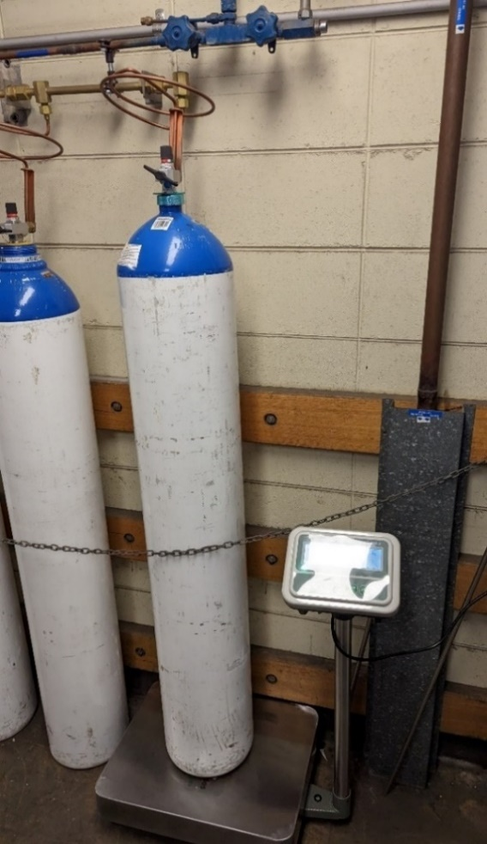
Figure 4. Weighing N₂O cylinders.
Single G-sized N₂O cylinder mounted on an industrial 150kg scale with continuous display (image provided by Dr Steven Gaff).

Sensitivity considerations:
- Take into account the sensitivity of the weighing scales used
- Ensure a regular interval of data measurement (e.g. every 5 hours)
- If a leak is present, depending on scale sensitivity a small leak could be detected over as little as a 5-hour period. For example, an annual leak of 20kg/year (a relatively small amount) would be expected to cause a weight depletion of around 11g over a 5-hour period.

Option 2. Compare N₂O cylinder depletion with N₂O administered
Calculate the discrepancy between the N₂O depletion from the cylinder (measured via weight) and the volume of N₂O clinically administered (see method 1, step 2, for an overview of how to determine the volume of N₂O administered) over the same length of time.
To be able to make this comparison, the measured change in N₂O cylinder weight must be converted to litres of N₂O. Use the conversion rate of 1.85g/L N₂O, and see Appendix 3 for common conversions.
The discrepancy between N₂O depletion from the cylinder and the volume of N₂O administered provides an indication of the presence of a leak. As with method 1, care must be taken with minor discrepancies between the N₂O amounts.
Case Study: Alfred Hospital
Using the Cylinder Weighing Method, manifold N₂O cylinder depletion was compared to clinical administration from the electronic medical record over an 18-day period of reduced clinical activity (December 2022 – January 2023).11 Cylinder weight was monitored and recorded using a video camera. The cylinder depletion was 21.88kg over the 18 days or 11,686L using the Air Liquide calculator (weight of N₂O gas at 20°C is approximately 1.85g/L).²¹
Clinical administration of N₂O during the 18-day study was estimated to be 16.5% of the N₂O cylinder depletion, hence 83.5% of the N₂O in the cylinder was leaked, equating to 197,789L per year, or 100 tonnes CO₂e per year.

Method 3: Pressure Testing Method
The Pressure Testing Method aims to detect N₂O leaks by testing the pressure decrease in a fixed volume system during a period of no clinical administration, at presumed constant temperature (Figure 5). During the test, the N₂O supply is disconnected or isolated from the gas pipeline. If N₂O must be used, it can be administered via alternative, non-piped methods (e.g. Entonox cylinders or N₂O cylinders) to ensure the piped system remains unused.
This method is based on a protocol developed in 2023 by the Green Theatres Project at the Fiona Stanley and Fremantle Hospitals. The full protocol is available on the website of the Green Theatres Project.

Figure 5. Overview of the Pressure Testing Method

Key benefits of Method 3:
- Individual departments or areas can be checked (such as one operating theatre at a time) for leaks
- The entire N₂O delivery system can also be checked as a total system.

Key limitations of Method 3:
- The test may need to be conducted out of hours, during a period of no clinical use for piped N₂O, which may be impossible in healthcare settings where continuous access to N₂O supply is required. This method may require extensive consultation and involvement of a wide range of health service staff to determine the best time to run this test with minimal disruption to care.
- Coordination is also required to ensure all areas are aware of potential N₂O alarm activation (alarms will be activated in any area that experiences a 20% reduction in N₂O supply pressure as stipulated in section 3.2 of AS 2896:2021)
- The suggested testing time is at least 4 hours for each location being examined
- As the total volume of N₂O in the system can be very large (e.g. 300L at 4atm = 1200L of N₂O) a small leak will cause a small drop in pressure and hence appropriate pressure measuring equipment is required to detect small leaks.

Step 1. Isolate the N₂O manifold
The N₂O cylinders should be disconnected or isolated from the gas pipeline by either:
- Turning off each of the N₂O cylinders in the manifold, or
- Turning off the valve between the manifold and the pipeline.
The first option is preferred as it will identify any leaks in the areas connecting the cylinders, manifold and pipeline. When testing only one zone of the healthcare facility, zone isolation valves can be used to isolate a section of pipeline from the manifold. The anaesthetic machine measuring pipeline pressure must be in the isolated section of pipeline, unless another pressure monitor has been attached. The test pipeline should be isolated for at least 4 hours.

Step 2. Measure the pressure in the isolated area
Measurements of the pipeline pressure are indicated on the anaesthetic machine and at any of the gauges that may be present. Pressure should be recorded before isolation of the manifold, and then periodically recorded once the pipeline has been isolated (e.g. every 15 minutes) at both the anaesthetic machine (i.e. digital equipment) and at any gauges in the gas room (these are usually analogue). The ambient temperature in the gas room should be recorded at the same intervals and kept constant to the extent possible.

Step 3. Determine whether a N₂O leak is present
A decrease in pressure indicates a leak, presuming constant ambient temperature. Piped N₂O is usually stored at 4atm. To provide further accuracy, a more sensitive pressure monitor could be connected to the N₂O outlet.
Example: Pressure testing the operating theatre pendant and infrastructure
There will be a valve on the N₂O pipe running into each theatre (or sometimes a group of theatres). This valve is present to enable maintenance. To do a pressure test, shut this valve and watch the pressure gauge on the anaesthetic machine. A decrease in pressure of 20% will cause the N₂O pressure monitor to sound an alarm.
The testing of pressure in individual theatres is a sensitive method to determine leaks – as the volume in the system is low. For example, 10m of N₂O piping with a diameter of 20mm has a total volume of about 3L. Therefore, even a small leak (e.g. 20ml/min) will cause the pressure to decrease by 20% within 30 minutes. The test time will vary depending on the size of the leak and the volume of the system; a leak may be detected within 10 minutes or may require several hours of testing.

Method 4: Flow Monitoring Method
This method utilises purpose-built flow metres to assist in detecting both N₂O leaks and/or the amount of N₂O that is clinically administered (in cases where anaesthetic machine records are not available). Therefore, this method can assist in detecting N₂O leaks through both direct (method 4, option 1) and indirect (method 4, option 2) means.
This method was developed by Wong and coauthors at Sunshine Hospital and subsequently adapted and implemented at Sydney Children’s Hospital Network and at the Royal Women’s Hospital, Melbourne.^{13,}

Key benefits of Method 4:
- This method has the ability to locate leaks (depending on the location of the flow meter)
- It allows for real-time, continuous measurement
- It has the potential for high-precision estimates (depending on the sensitivity of the flow meter)
- It can make use of mobile equipment, allowing multiple facilities to share the same equipment
- The permanent installation of leak detection equipment can be considered, to assist subsequent leak identification, potentially in real time.

Key limitations of Method 4:
- This method requires purpose-built flow meters and installation
- It may require access and connection to many pipe systems and outlets (affecting time and cost).

Option 1. Direct leak detection – during periods of no clinical use
This option involves installing purpose-built in-line flow meters to measure N₂O flow during periods of no clinical use. For example, flow meters compatible with Australian medical gas fittings have been developed by Western Health and University of Melbourne.¹³
Any flow of gas from the manifold in a period of no use can allow real-time identification of leaks, including estimating the size of the leak. Detection of the leak location may also be possible depending on the location of the flow meter, or the ability to isolate areas of the N₂O supply network in the healthcare facility.
Installation of a flow meter to detect leak(s) was first described by Wong and coauthors who measured N₂O flow for specific areas of Sunshine Hospital (operating theatres, birthing suites and paediatric ED).¹³ Skowno and coauthors built a mobile flow meter unit that connects between the N₂O cylinder packs and the manifold.²³ Coriolis flow meters directly measure N₂O flow rates, either for the entire facility or for isolated areas. During periods of no clinical use, low flow meters will be able to detect N₂O leakage. Leak location(s) are then identified and quantified through sequential isolation of locations and monitoring of flow.
Case study: The Children’s Hospital at Westmead, Sydney
An N₂O flow meter was installed at the Westmead Children’s Hospital in early February 2024, producing high resolution (1 minute) and high fidelity (10-100ml/min) data on N₂O use for the entire hospital over a period of several months. The average N₂O flow measured between 3am and 4am was used as a daily reference for a period of no clinical administration. Flow data is regularly cross-checked with purchasing data and data from the anaesthetic machine.
The detection of changes in flow outside of periods of high N₂O use has been successfully linked to the presence of N₂O leaks. The flow meter also measured a steady reduction in N₂O usage over time. This might have been caused by ongoing education and changes in clinical practice.
In future, this initiative might be expanded to include testing at other hospitals, and the redesign of the flowmeters to substantially reduce cost.

Option 2. Indirect leak detection – where continual access to N₂O is required
N₂O supply can be measured by installing a purpose-built flow meter at the point of the N₂O supply infrastructure (i.e. at the manifold). This may reflect supply more accurately than the use of procurement data or can be used in cases where procurement or activity data are difficult to obtain. Clinical administration of N₂O can be measured by installing a purpose-built flow meter (such as a digital portable in-line gas flow meter) at the point of N₂O clinical administration (i.e. wall outlets). The use of a threaded stainless-steel sleeve enables the leakproof attachment of the N₂O flow meter to N₂O piping.
Case Study: The Royal Women’s Hospital Melbourne
The Royal Women’s Hospital (RWH) is conducting a prospective quality assurance study in 2024, aimed at measuring the clinical administration of N₂O and checking for the presence of leaks. Purpose-built flow metres will be installed at N₂O wall outlets in two rooms – one delivery room and one labour assessment room – and will be monitored over the course of three months. As an obstetric hospital, continual access to N₂O is required. Therefore, RWH will use indirect leak detection (method 4, option 2) and will compare the estimated total administration of N₂O (obtained by flow meter measurements) with procurement data.
In consultation with the Birth Centre Director and Nurse Unit Manager, the labour room most frequently used for all labour types, along with one pre-labour assessment room, have been selected for data collection.
Western Health and the University of Melbourne have developed flow meters compatible with Australian medical gas fittings. These meters are calibrated against an anaesthetic machine flow meter (GE Aisys CS2 or equivalent) and a calibration curve (a graph showing the change in N₂O concentration over time) is obtained for each flow meter unit. After calibration, the flow meters are connected to the standard medical N₂O tubing (Figure 6) and to the N₂O administration device (e.g. a ‘Midogas’ analgesic unit). The connection points are then checked for leaks.
Total usage from the rooms included in the study will be extrapolated to the entire hospital based on the number of labours. The measured total volume of N₂O delivered will be divided by the number of labours where N₂O was administered in the two rooms where a flow meter had been installed to obtain the average volume of N₂O administered per labour. This number is then multiplied by the total number of labours in the entire facility where N₂O is administered, yielding an estimate of the total amount of N₂O administered during labour for the facility over the three-month study period. The number of people that laboured during this period, and the number that are administered N₂O during labour, is obtained from the Data and Systems team from the Department of Quality & Safety. Retrospective recordings of N₂O administered in the operating suite are also collected for the study period.
The purchased amount of N₂O is then compared with the estimated amount that was clinically administered to assess if there is a significant discrepancy (defined as more than 15%), which would indicate a leakage of N₂O.
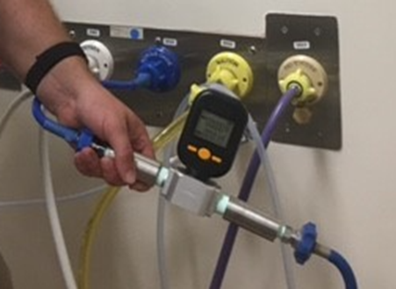
Figure 6. In-line flow metre.
Sleeved digital flow meter connected to a universal blue threaded N₂O hose (image provided by Dr Forbes McGain, 2024).

Recommended next steps
It is recommended a cost-benefit analysis be undertaken to identify the best approach to reducing waste from N₂O leaks. This could include:
- Avoiding the use of N₂O where possible
- Isolating N₂O flow for areas in a healthcare facility where N₂O is no longer in use
- Avoiding installing new N₂O piping
- Decommissioning existing piping.
As part of any cost-benefit analysis, consideration should be given to how to incorporate the environmental costs of greenhouse gas emissions into the analysis, as well as the costs of routine testing and servicing. These environmental costs should be communicated clearly to staff who procure, store and use N₂O. On the other hand, the preferences of health practitioners and user groups most likely to benefit from the continued use of N₂O - such as maternity staff and patients – should also be considered before implementing any major changes to N₂O infrastructure.
In considering next steps, it will be important to collaborate closely with engineering staff, facility management teams, anaesthetic and other departments that administer N₂O to ensure clear roles and responsibilities for regular testing and reporting. Regular testing (every 3 to 6 months) will help detect any new N₂O leaks, allow for alternative leak detection methods to be tried and compared if needed, and produce a better understanding of N₂O use over time. Consultation and collaboration with the wider health workforce will also be important, including for identifying cases of unnecessary or low-value use of N₂O and to educate the health workforce on appropriate use.
If zones in the healthcare facility are identified where no (or negligible amounts of) N₂O are administered, consider whether the isolation valve for that zone could be switched off, effectively isolating zones which are no longer in use from the rest of the N₂O infrastructure. Decommissioning N₂O infrastructure is recommended, where possible.
Healthcare facilities should also consider an organisational policy which describes the recommended uses of N₂O across their facilities. This could include appropriate indicators and a governance framework for monitoring and overseeing N₂O use. To further drive changes in N₂O administration patterns, the organisational policy would ideally encompass training of health practitioners, and through the implementation of sustainable procurement policies and reporting frameworks. Combining a whole-of-organisation approach of this kind with appropriate change communication and health workforce training would support tangible and sustained reductions in N₂O administration while maintaining the quality and safety of care delivery.
Where N₂O supply is required, healthcare facilities should consider moving away from piped N₂O and instead supplying N₂O via cylinders at the point of clinical administration. This would enable decommissioning of the entire N₂O pipeline infrastructure and would have financial and environmental benefits. Before decommissioning N₂O pipeline infrastructure, facilities should consider:
- Existing anaesthetic machines may not have a yoke for N₂O cylinders to connect to, requiring either fitting of a yoke to existing machines, an alternative method of connecting a N₂O cylinder to the machines, or the purchase of new anaesthetic machines
- Portable N₂O cylinders must have appropriate storage, access, and monitoring of use, in compliance with the applicable standards and guidelines
- Practicalities of transporting N₂O cylinders to the point of clinical administration
- Freedom of movement for patients, who may be able to move around the room more freely when administered N₂O via a cylinder
- The need to develop a new protocol for ordering portable cylinders.
Lastly, healthcare facilities are encouraged to explore avenues to minimise residual N₂O amounts in cylinders returned to suppliers, and to advocate with suppliers for solutions to avoid venting, the practice of releasing unused N₂O when cylinders are returned for refill.

Useful resources
- Australian Standard (AS) 2896:2021
- Australasian Health Facility Guidelines
- The Nitrous Oxide Project (UK) at the Centre for Sustainable Healthcare
- NHS Scotland Technical Update: Anaesthetic N₂O system loss mitigation and management
- ANZCA Environmental Sustainability Network (ESN) webinar “N₂O or Not?” Ways to mitigate the environmental impact of N₂O
- KN2OW Nitrous – Green Theatres Network
- Kn2ow Nitrous – pipeline test protocol
- Kn2ow Nitrous – anaesthetic machine reported usage guide.

Appendices

Appendix 1: How to obtain N₂O data from anaesthetic machines
Datex-Ohmeda Aisys (GE healthcare, Finland) | Obtain from ‘Super User’ menu screen
Draegers & Caresys | Requires access code. Biomed should be able to provide.
Getinge - flow i | Accessible through menu → log
GE Aysis Cs2 or a Draeger Zeus | The Green Theatres Network (Western Australia) has outlined detailed steps to access gas use data. The Children’s Hospital at Westmead has a purpose built data acquisition system for anaesthetic gas data.

Appendix 2: Cylinder size and weight
Cylinder sizes are based on sizes used by the supplier BOC Linde.
Cylinder | Tare Weight | Gross Weight | Kg of N₂O | L of N₂O | CO₂e kg
F8 | 530 | 763 | 233 | 124,400 | 61745
G | 59 | 94 | 35 | 18900 | 9275
E | 22.2 | 39 | 16.8 | 8970 | 4452
D | 10 | 16.6 | 6.6 | 3520 | 1749
C | 3.41 | 5.16 | 1.75 | 935 | 463.75

Appendix 3: Common conversions
- Converting N2O to CO2e (carbon dioxide equivalent in kgs)
1kg N₂O is equivalent to 265kg CO₂e.¹ Alternatively, N₂O from Entonox (50% N₂O, 50% O₂) can be calculated as 50% volume, or as 56.7% N₂O, 43.3% oxygen by weight. 1kg Entonox is estimated to be equivalent to 153kg CO₂e.
- Equivalent of emissions produced by Australian cars
Calculate the equivalent CO₂ emissions for the average number of Australian cars on the road annually by using the conversion factor 146.5 grams of CO₂ emissions per km. The average distance driven per year by a vehicle in Australia is 12,100km per vehicle.
- Financial
A$14 per kg of N₂O represents an approximate average cost across different cylinder types. This may be tailored to your healthcare facility based on real purchase data.

References


Please note: make sure to include Entonox (a formulation of 50% N₂O, 50% O₂) gas cylinders in your estimate. These are likely to be listed separately to N₂O cylinders on procurement ledgers.
The approach taken will depend on the case mix and N₂O delivery mechanism.
Operating theatres usually have anaesthetic machines in place which directly measure and record the amount of N₂O used in each operating theatre (including the flow rate and percentage of N₂O to O₂ of the gas being administered). Labour wards and paediatric procedural settings outside the operating theatre usually do not have anaesthetic machines present, implying N₂O use must be estimated based on activity data.
Department of Climate Change, Energy, the Environment and Water (DCCEEW), Australia’s National Greenhouse Accounts, DCCEEW webpage, 2023, accessed 15 June.
P Forster, T Storelvmo, K Armour, W Collins, JL Dufresne, D Frame, DJ Lunt, T Mauritsen, MD Palmer, M Watanabe, M Wild and H Zhang, ‘The Earth’s Energy Budget, Climate Feedbacks, and Climate Sensitivity’, in Climate Change 2021: The Physical Science Basis. Contribution of Working Group I to the Sixth Assessment Report of the Intergovernmental Panel on Climate Change, Cambridge University Press, Cambridge, United Kingdom and New York, NY, USA, 2021, pp. 923–1054, doi:10.1017/9781009157896.009.
A Pinder, L Fang, A Fieldhouse, A Goddard, R Lovett, J Khan-Perez, K Maclennan, E Mason, T MacCarrick and C Shelton, ‘Implementing nitrous oxide cracking technology in the labour ward to reduce occupational exposure and environmental emissions: a quality improvement study*’, Anaesthesia, 2022, 77(11):1228-36, doi:10.1111/anae.15838.
Safe Work Australia, Exposure standard documentation: nitrous oxide, National Occupational Health and Safety Commission webpage, Australian Government, 2024, accessed 19 January 2024.
Queensland Health, Communique – Nitrous Oxide, Statewide Anaesthesia and Perioperative Network, Queensland Government, 2022.
J Wise, ‘Creating more sustainable practice: the NHS clinical teams innovating for a greener future’, BMJ, 2021, 375:1-3, doi:10.1136/bmj.n2249.
A Chakera, I Storrar, S Roberts, G Dunn and I Sandford, Technical update: Anaesthetic nitrous oxide system loss mitigation and management, NHS Scotland Assure, 2022.
A Chakera, S Harrison, J Mitchell, C Oliver, M Ralph and C Shelton, ‘The Nitrous Oxide Project: assessment of advocacy and national directives to deliver mitigation of anaesthetic nitrous oxide’, Anaesthesia, 2024, 79:270-277, doi:10.1111/anae.16211
E Smith and C Mitchell, ‘The importance of tackling leaks in nitrous oxide pipes’, ANZCA Bulletin, 2023, 58-9, doi:10.3316/informit.981057534657403.
R Seglenieks, A Wong, F Pearson and F McGain, ‘Discrepancy between procurement and clinical use of nitrous oxide: waste not, want not’, BJA British Journal of Anaesthesia, 2021, 128(1):e32–4, doi:10.1016/j.bja.2021.10.021.
SJ Gaff, VX Chen and E Kayak, ‘A weighing method for measuring nitrous oxide leakage from hospital manifold-pipeline networks’, Anaesthesia and Intensive Care, 2024, 52(2):127-130, doi:10.1177/0310057X231198123.
T Keady, OL Nordrum, O Duffy, T Cummins, V Wall, D Ó'Cróinín and B Lyons, ‘Annual greenhouse gas emissions from inhaled anaesthetic agents in the Republic of Ireland’, British Journal of Anaesthesia, 2023, 130(1):e13-e6, doi:10.1016/j.bja.2022.09.019.
A Wong, A Gynther, C Li, M Rounds, JH Lee, D Krieser, E Posma and F McGain, ‘Quantitative nitrous oxide usage by different specialties and current patterns of use in a single hospital’, British Journal of Anaesthesia, 2022, 129(3):e59-e60, doi:10.1016/j.bja.2022.05.022.
Department of Health and Aged Care, National Health and Climate Strategy, Department of Health and Aged Care, Australian Government, 2023.
Department of Climate Change, Energy, the Environment and Water (DCCEEW), Quarterly Update of Australia’s National Greenhouse Gas Inventory: March 2023, DCCEEW, Australian Government, 2023.
A Chakera, R McQuillan, A Waite and A Marchant, ‘Establishing system waste of piped nitrous oxide: Lothian nitrous oxide mitigation project’, Anaesthesia, 2021;76:15.
Standards Australia, Medical gas systems — Installation and testing of non-flammable medical gas pipeline systems, Standards Australia, 2021.
Australasian Health Infrastructure Alliance (AHIA), Australasian Health Facility Guidelines 2018, AHIA, 2018.
Y Liu, P Lee-Archer, NM Sheridan, R Seglenieks, F McGain and VA Eley, ‘Nitrous Oxide Use in Australian Health Care: Strategies to Reduce the Climate Impact’, Anesthesia & Analgesia, 2023, 137(4):819-29, doi:10.1213/ANE.0000000000006620.
Australian Institute of Health and Welfare (AIHW), Australia’s mothers and babies, AIHW, 2023.
Gas encyclopedia, Nitrous oxide, 2022.
J Anderson, Department of Anaesthesia, Pain and Perioperative Medicine, Nitrous oxide pipeline test protocol 2023, Green Theatres Network, 2023.
J Skowno, HR Kahlaee, AJ Inglis, D McKinnon, and K Asher, ‘Hospital-level flow measurement to detect nitrous oxide leakage’, Anaesthesia, 2024, 79(8):880-881, doi:10.1111/anae.16309.
ScienceDirect, Coriolis meter - an overview 2023, Sensor Technology Handbook, 2008.
Green Theatres Network, Anaesthetic machine reported nitrous usage, 2023.
Ministry for the Environment, Measuring emissions: A Guide for Organisations, New Zealand Government, Te Kāwanatanga o Aotearoa New Zealand Government, 2023.
National Transport Commission, Carbon dioxide emissions intensity for new Australian light vehicles Canberra: National Transport Commission, National Transport Commission, Australian Government, 2021.
Australian Bureau of Statistics, Survey of Motor Vehicle Use Australia, Australian Bureau of Statistics, Australian Government, 2020.

