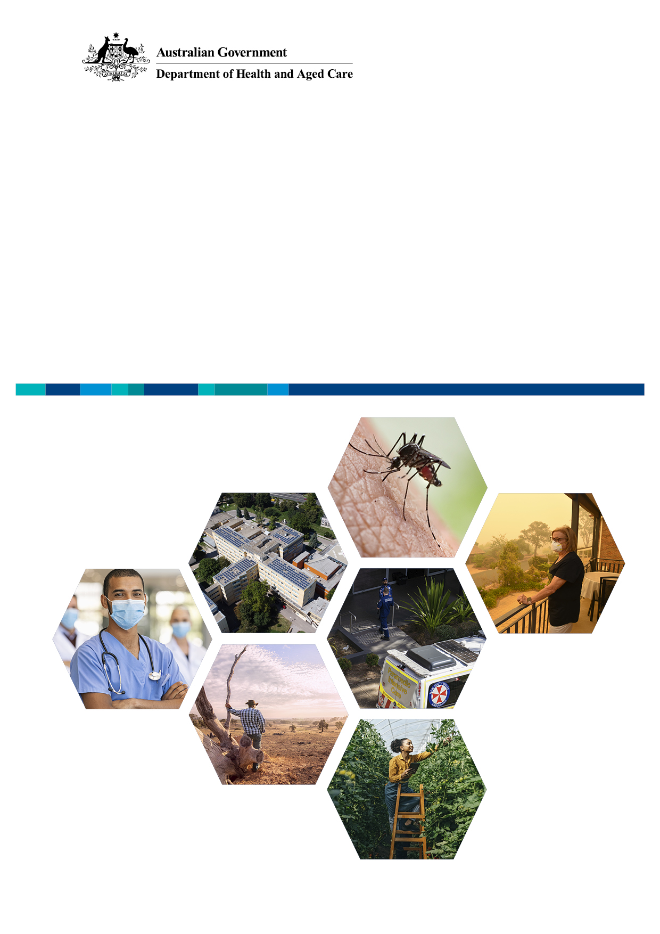
NATIONAL HEALTH AND
CLIMATE STRATEGY
  - Final thematic stakeholder engagement report
4 October 2023

Contents
Table of Contents
NATIONAL HEALTH AND CLIMATE STRATEGY 1
1 What we asked 5
1.1 Overview of stakeholder engagement process 5
1.1.1 Consultation Hub and Consultation Paper 5
1.1.2 Online submissions and survey 5
1.1.3 Workshops 6
1.1.4 Limitations 7
2 What stakeholders said 9
2.1 Strategy development and design 9
2.1.1 Approach to development of the Strategy 9
2.1.2 Scope of emissions 11
2.1.3 Objectives 12
2.1.4 Principles 15
2.1.5 Enablers 19
2.1.6 First Nations Health and climate change 26
2.2 Consultation topics 30
2.2.1 Measurement 30
2.2.2 Built environment, infrastructure, and services 35
2.2.3 Travel and transport 40
2.2.4 Prevention and optimising models of care 45
2.2.5 Medicine and gases 49
2.2.6 Waste 53
2.2.7 Supply chain 58
2.2.8 Emergency response 62
2.2.9 Health and wellbeing impacts 72
2.2.10 Health in All Policies 79
3 Where to from here? 84
3.1 Phase 2 targeted consultations 84
4 Appendices 86
4.1 Appendix A: Additional Consultation Paper questions analysis 86
4.2 Appendix B: NVIVO approach 94
4.3 Appendix C: List of all individuals that participated in workshops and/or submitted a response to the Consultation Paper 97

- What we asked
  - Overview of stakeholder engagement process
The Australian Government is developing a National Health and Climate Strategy (the Strategy). A vital input to the Strategy is the different views, ideas and experiences from stakeholders and the community. To capture these perspectives, the Department of Health and Aged Care (the Department) released a Consultation Paper and undertook a range stakeholder engagement, including national workshops, Ministerial roundtables, written submissions, and surveys. The mixed-mode stakeholder engagement process provided an opportunity for a diverse range of voices to contribute and provide feedback on the Consultation Paper, as well as the scope and focus of the Strategy. The below provides a summary of stakeholder engagement activity to date.
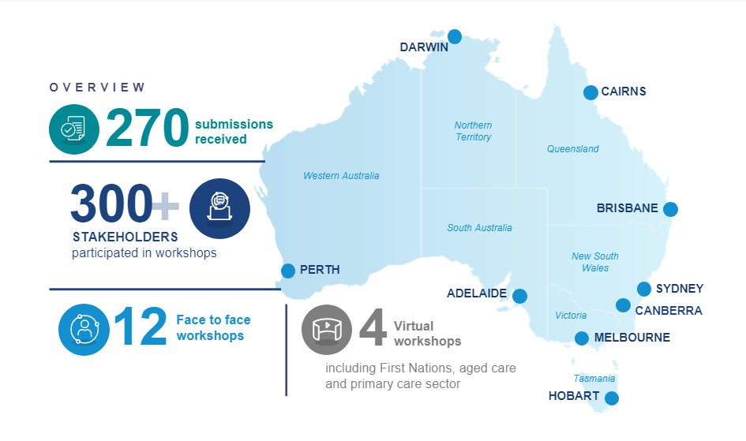
Figure 1 – Overview of stakeholder engagement
    - Consultation Hub and Consultation Paper
During engagement activities, the Department’s Consultation Hub provided stakeholders with information regarding the need for a Strategy and outlined available engagement avenues including an invitation for stakeholders to contribute via a long form submission and a shorter survey alternative. The Department drafted a Consultation Paper (available via the Consultation Hub) as a starting point for testing the proposed approach to strategy development, posing 25 questions to frame conversations, written submissions, and online surveys.
    - Online submissions and survey
The written submissions and the online survey were open to public response from 2 June 2023 to 24 July 2023. The Department received a total of 270 submissions, including written submissions (within the stipulated consultation timeframes) and 104 survey responses, from organisations and individuals across the diverse stakeholder landscape including medical professionals, primary care, advocacy organisations, academia and manufacturers, as well as medical societies and colleges.
    - Workshops
In addition to written responses, workshops (virtual and face-to-face) and roundtables were held by the Department with relevant organisations, interest groups, governments, and experts. Over 750 invitations were sent to organisations and/or individuals across the breadth of stakeholder groups (as identified by the Department in Figure 2), with over 300 stakeholders attending and contributing to workshop and Ministerial roundtable discussions.
The workshops were designed to capture stakeholders’ views on the proposed Strategy design including the scope, principles, objectives, and enablers. Workshops were also used to identify sector- and stakeholder-specific focus areas and actions to support the implementation of the Strategy. Each workshop was tailored to best capture the expertise and opinions in the room. Specific workshops targeted aged care, disability, First Nations, and primary care sectors. Phase 2 consultations will be held over August and September 2023 to continue gathering insights from other targeted stakeholder groups. At the completion of each workshop, stakeholders were reminded of the opportunity to further contribute to the discussion and Strategy development via the Consultation Hub.
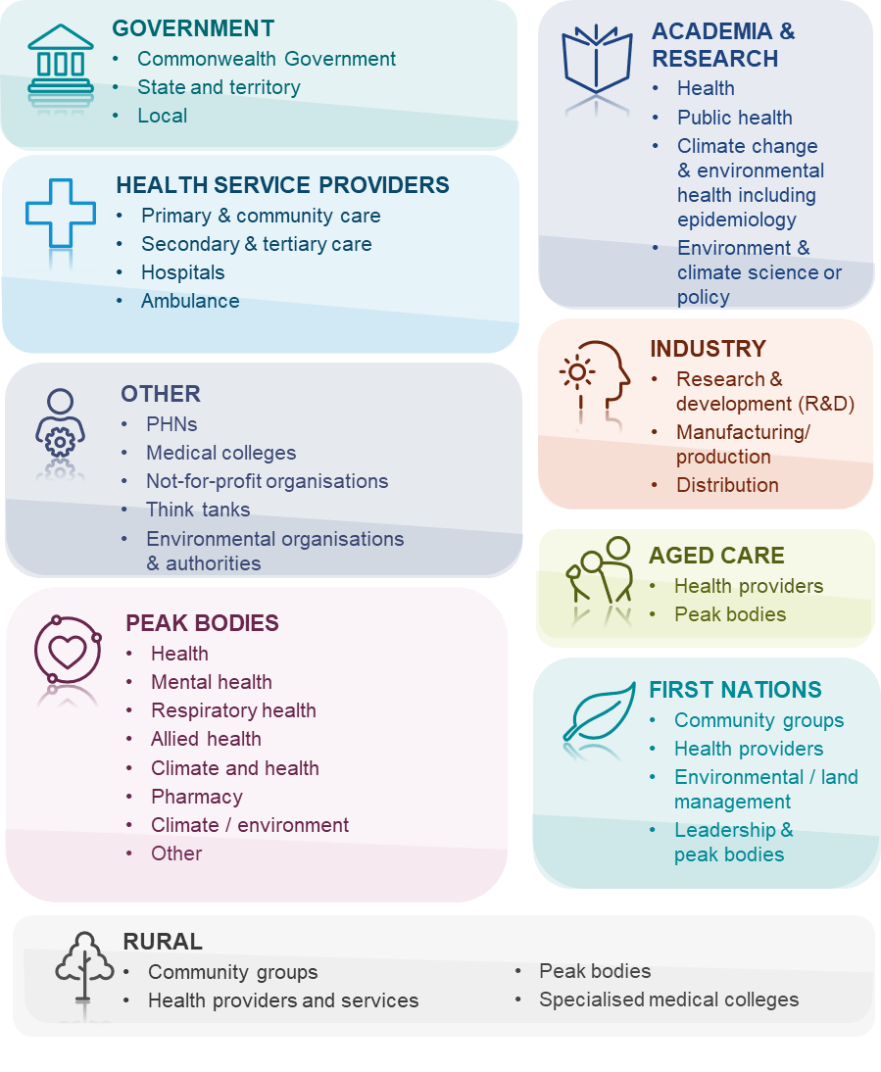
Figure 2 - Stakeholder consultation groups
    - Limitations
- Based on condensed project timeframes, this report covers high-level themes. Analysis and time allocated to thematic reporting were shortened to provide stakeholders with sufficient time to contribute. Further actions and focus areas will be analysed and prioritised by the Department during the analysis and drafting stages of the Strategy development.
- The report is thematic in nature and as such does not identify or attribute comments to individuals or organisations; rather, it refers to the relevant interested stakeholder groups. The Department will be undertaking targeted discussions with identified organisations and individuals where necessary to gather further details.
- To the extent information presented within this report was provided by stakeholders through the consultation process, it has not been reviewed for factual accuracy, and is representative of themes arising across the engagement activity. Best efforts have been made to represent stakeholders accurately; however, no further work has been undertaken to validate this information. Further research should be performed to support the Strategy developed from this consultation process.
- This report did not aim to quantify the strength or weight of stakeholder views and focuses only on thematic presentation. The views presented are limited by the sample of stakeholders that engaged with the consultation process and is not a representative sample.

- What stakeholders said
Building on the Consultation Paper and feedback from the consultation process, the themes captured in this section are organised in two categories, specifically:
- Strategy development and design – Focuses on feedback and insights gathered relating to proposed design, scope and intent as presented in the Consultation Paper i.e., principles, objectives, and enablers.
- Consultation topics – Illustrates thematic areas of focus which have emerged through the various channels of consultation. These topics identify the key areas of action across all objectives outlined in the Consultation Paper, including measurement, mitigation, adaptation, and Health in All Policies.
This report consolidates the insights and themes from across workshops, written submissions, and survey responses under these two categories and their associated themes. Reference has been made to the relevant questions in the Consultation Paper which are most aligned to the stakeholder responses.
The insights across the mixed modes of stakeholder engagement broadly align. In a small number of instances where divergent views emerged, these have been highlighted.
  - Strategy development and design
    - Approach to development of the Strategy
      - Vision, purpose, and outcome
Stakeholders consistently raised the need for a clearly defined Vision Statement to support the objectives of the Strategy.
- Most stakeholders noted that the Consultation Paper does not yet contain a Vision Statement to underpin the objectives and actions of the Strategy. The Strategy states an overarching purpose, then shifts the focus to listing the sectors that should be involved. A Vision Statement should be added as a priority so that the objectives can be reviewed in context of the Vision.
- A stakeholder representing First Nations people encouraged a holistic vision that strives to mitigate the short-, medium- and long-term impacts of climate change, and harnesses opportunities for systemic transformation.
- A peak body proposed a vision and purpose for the Strategy (this was also referenced in multiple other stakeholder submissions) specifically:
- Proposed vision – ‘A healthy, climate resilient community and net zero healthcare system’.
- Proposed purpose – ‘To reduce the impacts of climate change on the health of the population and the health system; and, to guide healthcare decarbonisation in a culturally safe and just way’.
- A peak body noted the Strategy must also be explicit in its intended outcomes, focusing on protection of population health and wellbeing. They proposed the intended outcomes to be ‘To prevent illness, injury and death associated with climate change; minimise the healthcare systems’ contribution to Australian emissions; and ensure health systems resilience’.
      - Language, terminology, and definitions
- Glossary of terminology – It was recommended that the Strategy include a glossary of definitions so that stakeholders can clearly understand the intention throughout the Strategy, in particular ‘health system’, ‘adaptation’, and ‘mitigation’. It was suggested it could leverage ‘An Australian glossary on Health and Climate Change’. The glossary provides a shared understanding of the terminology used on health and climate change and has been developed by academics and informed by end-user stakeholders.
- People in Australia – It was noted the word “Australians” excludes people living in Australia who are not citizens. This is particularly important in the health context with the challenges faced by culturally and linguistically diverse communities in navigating complex healthcare systems to access care. Where appropriate, the Strategy should refer to “people in Australia” rather than “Australians”.
- Urgency and emergency – Stakeholders consistently raised the need to emphasise this is a climate emergency and adopt action-orientated language to drive the necessary change and highlight the urgency. Stakeholders want the Strategy to acknowledge that climate change is also a health emergency and reflect the magnitude of change necessary to avert the worst health impacts.
- Physical and mental health impacts – Throughout the Strategy, reference should be made to both 'physical and mental health' impacts of climate change rather than just focusing only on physical impacts.
- Children and young people – Stakeholders noted that throughout the Consultation Paper there is little mention of infants, children, and young people as an at-risk population. This demographic of the Australian population should be acknowledged within the strategy including incorporating their perspectives in consultation, outlining their health impacts from climate change, and including them in the Strategy’s action areas.
      - Messaging of the Strategy
Stakeholders provided the following overarching comments regarding the messaging of the Strategy and what they viewed as critical to success:
- Timelines and prioritisation – Stakeholders emphasised the need for the Strategy to provide timelines, priorities, and time horizons for the delivery of the Strategy. An Implementation Plan should be developed to support and accompany the Strategy over the next three years.
- Emission targets – As discussed in 2.1.3 Objectives, stakeholders noted the need for more ambitious National emissions reduction targets across all sectors of the Australian economy, including achieving targets earlier than timelines currently set by the Commonwealth Government.
- Fossil fuels – Many stakeholders advocated for the rapid transition of Australia’s energy generation facilities away from fossil fuel and towards 100% renewable. See further detail in section 2.2.10 Health in All Policies.
- Objectives and principles – Stakeholders called for an explanation on the purpose of the objectives and principles and how they will be used in the development and implementation of the Strategy. Stakeholders also wanted further detail on how these were selected.
- Using existing frameworks – Stakeholders advocated for the Strategy to leverage existing climate change and health progress and frameworks in its development. Highlighting the option to leverage previous consultation with climate and health experts to streamline the Strategy development. The ‘Healthy, Regenerative and Just: Framework for a national strategy on climate, health and wellbeing for Australia’, was explicitly noted as representing relevant experts’ insights and providing relevant policy actions for consideration in drafting the Strategy. The importance of using existing First Nations frameworks was also underlined.
- Causes of climate change – Stakeholders reported that the Strategy should introduce the causes of climate change early in the document to establish context around the actions.
- Governance arrangements – Stakeholders suggested mapping the existing forums and governance arrangements which could help in articulating the future roles and responsibilities under the Strategy. Stakeholders noted that the establishment and transparency of governance arrangements and mechanisms, such as advisory boards and Interdepartmental committees, will be key to Strategy implementation.
    - Scope of emissions
Questions from Consultation Paper
Q3 | Which of the various types of greenhouse gas emissions discussed above [in the Consultation Paper] should be in scope of the Strategy’s emission reduction efforts?
- Scope of emissions – The majority of stakeholders called for all scope 1, 2 and 3 emissions to be included in the remit of the Strategy’s emissions reduction efforts, while a smaller number of stakeholders thought that including scope 2 and 3 emissions may be unachievable. The majority view was that clear identification of healthcare sector emissions that fall under each scope is needed. Many stakeholders also called for the scope of the Strategy to be reframed beyond carbon emission reduction of the health and aged care system to address health impacts of climate change on the population. Stakeholders suggested the following:
- The National Greenhouse and Energy Reporting Scheme (NGERS) should be expanded beyond scope 1 and 2 emissions. Stakeholders reported that scope 3 emissions embodied in the supply chain are not a regulatory requirement under the Scheme, so they are not measured or reported despite being the largest contributor to the healthcare footprint. Many stakeholders highlighted that scope 1 and 2 emissions are already commonly measured across jurisdictions.
- Scope 3 emissions comprise a large proportion of total health and aged care sector emissions (some stakeholders cited approximately 70% to 90%) and therefore warrant a large focus in the Strategy. However, some stakeholders called for treating all scope emissions with equal importance. Health and aged care industry reporting standards may assist in ensuring scope 3 emissions are carefully monitored. Measurement should be consistent across the health and aged care sector.
- While patient and visitor travel may not fall under Scope 3 emissions criteria, estimates from other comparable settings, namely England’s National Health Service (NHS), show it is possible to collect required data. At a minimum, stakeholders called for a feasibility study for measuring health-related travel emissions be conducted. Noting ideally, emissions from all health and aged care travel must be included. Stakeholders emphasised that the Department should look to emulate the approaches by the NHS, particularly around scope 3 emissions.
- The reduction of scope 3 emissions could be made more explicit within the Strategy’s Health in All Policies approach. Emissions should focus both within and outside the health and aged care systems.
- The Department could use process-based lifecycle assessment and multi-region input–output (MRIO) modelling (as used for the NHS for this purpose) should be included within the Strategy as an important contributor and support for evidence-based decision making around reducing total healthcare emissions.
- Multiple stakeholders advocated for the inclusion of all scope emissions as a crucial tool to reaching a target of 80% reduction in all emissions by 2030 and carbon-neutrality by 2040.
- It was proposed that there should be disaggregation of scope 2 figures for the hospital system. The conversion of hospital energy use to 100% renewable can then be targeted and emissions reductions measured.
- Stakeholders called for the inclusion of offshore scope 3 emissions, particularly those from pharmaceuticals and medical devices. This would change the purchasing power of health and aged care so that procurement can be moved towards lower carbon products and impact pharmaceutical and manufacturing decisions on products made overseas.
- There should be a mechanism to measure the complex interplay between different types of greenhouse gases in health and aged care. For example, comprehensive lifecycle assessments have repeatedly determined that adopting reusable over single-use health products can substantially reduce emissions, particularly when the hospital or aged care facility’s electricity source transitions to renewables. If scope 3 sources were excluded, the carbon reductions and benefits of instituting policies such as increasing reusable consumables would not be captured.
- Some stakeholders advocated for inclusion of greenhouse gas emissions from the veterinary sector. Based on stakeholder feedback, there should be synergy between climate policy, public health policy and animal health policy, given that animals contribute significantly to people's wellbeing as companions, working animals, and for farmers as a source of income.
    - Objectives
Questions from Consultation Paper
Q1 | How could these objectives be improved to better support the vision of the Strategy?
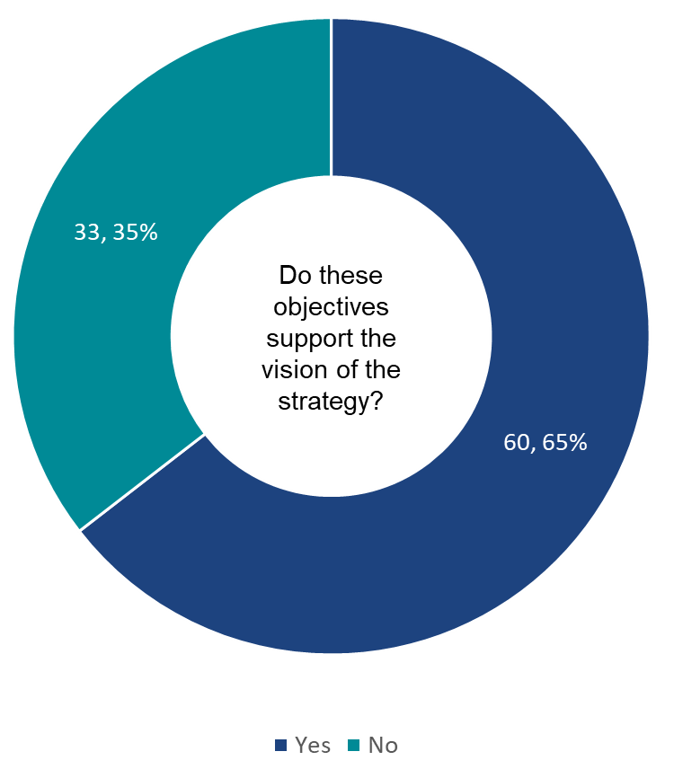
Figure 3 - Survey results to question 6
- The majority (65%, n=60) of those who answered this question noted that the four objectives outlined within the Consultation Paper support the vision of the Strategy. See Figure 3 for a breakdown of responses to this question. A total of 93 responses were received for this question.
- Noting, in some instances stakeholders appear to have selected option ‘no’ as an opportunity to provide further details or explanation rather than disagreeing with the objectives.
- Across workshops, surveys and written submissions stakeholders provided commentary to both improve the objectives and suggested additional objectives to be included within the Strategy, as detailed below.
      - Design of objectives
- Prioritisation of objectives – Several stakeholders requested re-ordering the objectives to illustrate priorities and ensure the focus is on enhancing community health, wellbeing, and resilience to climate change.
- Integration with other strategies – The Strategy should ensure it aligns with objectives and strategies in other sectors which target similar outcomes. This will ensure that policy efforts are not duplicated and are amplified by work already underway.
- Targets and detail – The current framing of the objectives could be strengthened through the inclusion of meaningful targets and key outcomes so that the progress of the objectives can be measured. Stakeholders noted the need for mitigation targets which are evidence-based and aligned to government targets across the various time horizons. Further discussed below.
- Proposed ‘reframed’ objectives – There was broad reference to and endorsement across stakeholders of the reframed objectives proposed by an Australian peak body. Specifically:
- Objective 1. Promoting and protecting health and wellbeing: This Strategy will inform and guide the development of policy and initiatives that embed health and climate considerations across all portfolios at both national, state and territory and local government level.
- Objective 2. Build a climate resilient community and health system: This Strategy will support the development of initiatives to build community, health and aged care system resilience and capacity to respond to the health impacts of climate change.
- Objective 3. Establish a net zero health and aged care system: This Strategy will guide the development of a national net zero plan for health and aged care, informed by a comprehensive assessment of the Australian health and aged care system’s carbon footprint and reflecting best scientific evidence.
      - Updates to specific objectives
In addition to the above overarching stakeholder comments the following concepts emerged relating to specific objectives. Noting further analysis regarding the proposed actions and focus of the objectives is covered in the following section 2.2 Consultation Topics.
- Measurement as an enabler – There were divergent views raised regarding whether measurement should be captured as an objective or rather an enabler to provide the foundation for action. However, a large proportion of stakeholders agreed that measurement should be considered an enabler.
- Mitigation targets and measuring progress – Commentary provided across both measurement and mitigation objectives consistently noted the need for aspirational and consistent targets:
- Stakeholders indicated that it is imperative the Strategy includes specific emissions reductions targets that are consistent with scientific evidence and current best practice.
- Stakeholders also commented that the measurement objective currently lacks a sense of urgency and to advocate for anything less would undermine the commitment to protect Australian’s health and wellbeing from climate change. Some stakeholders representing the views of medical professionals, climate action groups and other groups provided further commentary in this area and specific targets:
    - The objective should align with best practice by considering the emissions reduction targets and actions that are already being undertaken across Australia. For example, the commitment of Hunter New England Local Health Service to be carbon neutral by 2030.
    - Adopt a similar target to the NHS’s Delivering a ‘Net Zero’ National Health Service, which proposes net zero by 2040 for emissions the NHS controls directly, and net zero by 2045 for emissions the NHS can influence.
    - Some stakeholders perceived the emission reduction targets outlined in the Consultation Paper as inadequate, preferring more ambitious net zero commitments. Specifically, stakeholders provided targets between a minimum of 50% of 2005 levels by 2030 (in accordance with the Paris Agreement) to 75% below 2005 levels by 2030. Stakeholders also went on to elucidate the need for net zero emissions for all sectors, inclusive of healthcare and exports ranging from 2035 to 2045, with others calling for the sector to be net zero by 2040, with an interim reduction target of 80% by 2030.
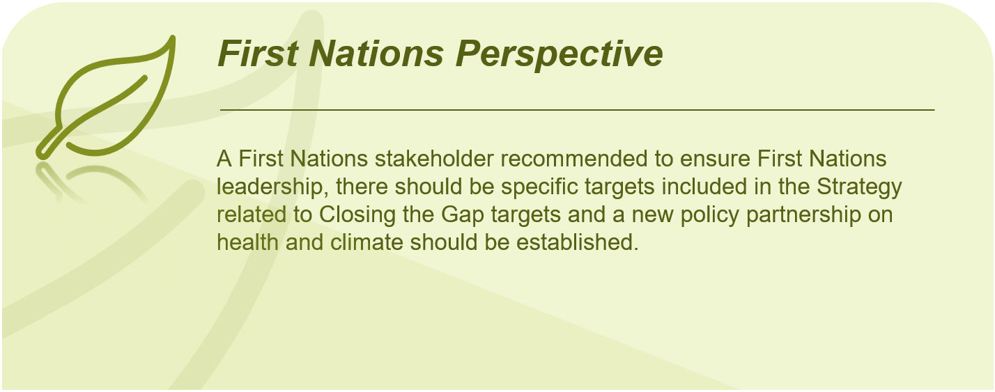Stakeholders called for the establishment of targets and measures for climate-related injury and disease prevention, health outcomes and mitigation.

- Extend adaptation beyond health system – At present, the Consultation Paper refers largely to adaptation in the health system and stakeholders noted that communities should be at the forefront, rather than health systems. Numerous stakeholders expressed that there are two components to adaptation: how the healthcare system adapts, and how the community adapts.
Some called for adaption to be split into two components – ‘Resilience of the health system’ and ‘Resilience of the community’. Whilst both require adaptation, stakeholders viewed them as two conceptually different objectives. Health system resilience could be determined by this Strategy, whilst community resilience could be addressed in broader climate change resilience strategies.
- Expand Health in All Policies – It was suggested the Health in All Policies objective be expanded to reflect the efforts across multiple policy areas. For example, ‘Maximise the synergies between good climate policy and public health policy by working across policy areas and sectors to support accelerated emissions reduction and adaptation efforts to protect and improve public health and wellbeing.’
      - Additional objectives to be considered
The following provides an overview of stakeholder suggested objectives for consideration of inclusion in the Strategy:
- Establish a net zero health and aged care system – This objective would guide the development of a national net zero plan for health and aged care, based on a comprehensive assessment of the Australian health and aged care system's carbon footprint and best scientific evidence.
- Informed and engaged communities – Focused on ensuring communities are informed of the urgency for decarbonisation and the need to move towards sustainable healthcare and are also engaged in mitigation and adaptation efforts.
- Climate in all health policies – This objective would signal to the health sector and the Australian community that reducing the impact of healthcare on the planet is everyone’s responsibility and should be embedded in all health policy and practice decisions.
- Leadership and governance – The integrated translation of policy into practice requires new ways of collaborating, redefining shared authority and facilitating effective shared decision making. It was highlighted that Governance and Leadership may sit better as an objective rather than an enabler, to drive action.
- Targeted adaptation support – Specific objective focused on supporting the adaptation needs of priority populations at greater risk of climate change health impacts.
- First Nations leadership – It was recommended that the Department include an objective that works towards Aboriginal and Torres Strait Islander leadership, rather than this being a guiding principle alone. This would support the development of tangible actions that empower First Nations leadership.
- Planetary Health Equity – A key objective should be the achievement of planetary health equity (PHE) – the equitable enjoyment of good health in a stable ecosystem. This definition of PHE recognises the impact of climate change on health and health inequities via social factors. It also recognises the importance for health equity of addressing the underlying drivers of climate change.
    - Principles
Questions from Consultation Paper
Q2 | How could these principles be improved to better inform the objectives of the Strategy?
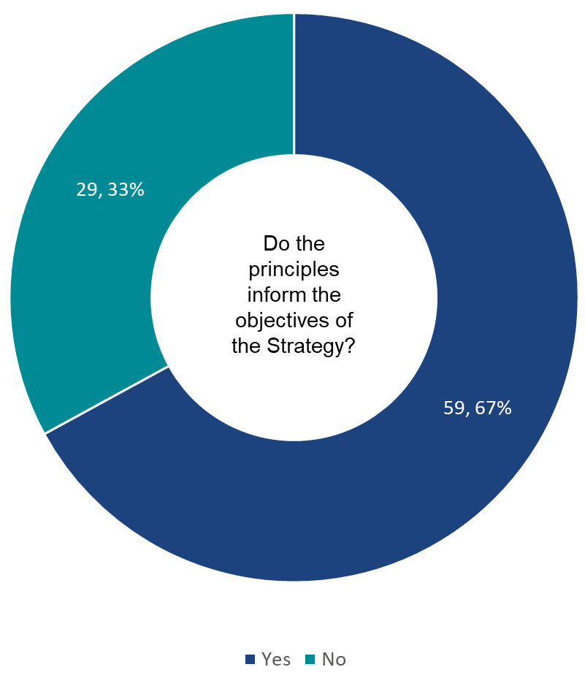
Figure 4 – Survey results to question 7
- The majority (67%, n=59) of survey respondents noted that the principles outlined within the Consultation Paper inform the objectives of the Strategy, see Figure 4 for a breakdown of responses to this question. A total of 88 responses were received for this question.
- Noting, in some instances stakeholders appear to have selected option ‘no’ as an opportunity to provide further details or explanation rather than disagreeing with the principles.
- Across workshops, surveys and written submissions stakeholders provided commentary to both improve the principles and suggested additional principles to be included within the Strategy. The below sections provide a high-level summary of these suggestions, it is not intended to be a comprehensive list, further information is contained within the stakeholder engagement analysis.
      - Additional principles suggested
In addition to the principles outlined in the Consultation Paper, stakeholders suggested the following principles:
- ‘Do no harm’ – It is essential that safety and quality is central to any actions proposed by the Strategy. Prioritising maintenance of the care outcomes at all stages.
- Human right to health – Many stakeholders cited that this Strategy should be underpinned by the principle of Health being a universal human right. Stakeholders affirmed that this right outlines “a clear set of legal obligations on states to ensure appropriate conditions for the enjoyment of health for all people without discrimination”. Some stakeholders also mentioned other human rights which intersect with health determinants, such as those related to housing and people with a disability.
- Holistic view of value-based healthcare – The Strategy must be underpinned by the established principles of a values-based healthcare system, which include maximising health outcomes, financial sustainability, patient experience, healthcare professional well-being and experience, and addressing inequities.
- Climate justice/intergenerational equity – Those who have often contributed the least to the climate crisis are impacted the most, for example, First Nations, young people, people with existing co-morbidities. It is vital that inter- and intragenerational health inequality in climate impacts is acknowledged.
- Strengths-based approaches – There should be a strength-based perspective throughout the Strategy and its associated actions. Whilst communities are vulnerable, they also have strengths and capacity to enact change and they should be supported to act. Stakeholders made specific comments regarding the Consultation Papers discussion regarding First Nations health and climate change, noting the section alternates between strength-based and deficit-based language and highlighting the need to amend this.
- Health sector advice and advocacy – Informed health professionals, and the health sector, need to be able to speak freely about the consequences of climate change on the health and wellbeing of the population. Although the impact on vulnerable groups should be highlighted, there needs to be a clear message that everyone’s health and wellbeing is going to be impacted.
- Trust and transparency – Experience with compounding natural disasters over the last five years, and the misinformation around COVID-19, has led to an erosion of trust in health and government. This will pose a significant challenge over the next 10 years. An open and transparent approach to community-level communications around climate change and health is imperative to support the successful implementation and delivery of the Strategy.
- Regeneration – The acknowledgement that sustainability will not be enough, and that the Strategy must also focus on ways to restore planetary health to create a healthy future.
Overwhelmingly, stakeholders provided consistent messaging regarding the need for place-based approaches. This has been summarised below for consideration as an additional principle in the Strategy.
- Place-based approaches – Climate change will affect different places in different ways. Most stakeholders identified the need for mitigation and adaptation strategies to be nationally led but regionally focused. Stakeholders reported the following place-based ideas:
- Government should ensure the transition to a sustainable economy is managed and planned to support those regions and sectors of the economy most affected by climate change, through the development of regionally specific transition plans that support the viability and sustainability of communities and businesses.
- Actions should be prioritised based on the specific vulnerabilities, risks and needs of the local communities. There needs to be deep collaboration between communities, local health authorities, Aboriginal Community Controlled Organisations (ACCHOs), local government, and other stakeholder groups to ensure that adaptation actions are equitable, contextually appropriate, and can effectively address immediate health system challenges posed by climate change.
- Conducting regional and local consultations with First Nations communities, both in rural and urban settings, is essential for capturing diverse perspectives and engaging with specific cultural contexts. These consultations should be inclusive, respectful, and culturally safe, allowing for open dialogue, knowledge sharing, and collaborative decision-making.
- Resilient communities can be a source of individual resilience during climate events, providing social and material support, which is protective against mental ill-health, and can be a source of shared learning and improve shared resilience to future events. With adequate resources and expert guidance, communities are uniquely placed to develop their own adaptation plans to match their local physical and social conditions.
      - Stakeholder suggested improvements to principles
First Nations leadership
There was almost unanimous support for the inclusion of First Nations leadership, knowledge, and expertise throughout all aspects of the Strategy, particularly central to decision-making.
- Define leadership and working in partnership – The distinction was made between collaboration, co-design, partnership, and leadership as terms all used in the Strategy at various points in reference to First Nations peoples. Emphasis was put on ensuring that First Nations peoples’ knowledge and experience is central to decision making however is not the same as empowering First Nations people. Respondents suggested that at worst, it could perpetuate harmful, unethical, extractive practices. To avoid this unintended consequence, the Strategy should clearly spell out what First Nations Leadership means as well as how and which objective it supports and how it will be supported.
It was recommended that Principle 1 be amended to explicitly include Aboriginal and Torres Strait Islander leadership, noting First Nations knowledge, experience and leadership must be central to decision-making on health and climate policy at all levels. It would also be useful to consider how Principle 1 and Principle 6 interact. As above, it was noted is important to be clear in terminology; if “working closely” means working in partnership, this should be explicitly stated.
- First Nations as a principle – It was noted that the discussion of First Nations peoples as a vulnerable group should occur at the principle level rather than in the later section (in the Consultation Paper) on First Nations people. With the focus of the later section to be more value-based and focus on strengths of First Nations peoples and their knowledge in climate and health.
- Governance and implementation - This principle should specify the inclusion of First Nations people in governance, design, and implementation of the Strategy. Currently the wording implies that First Nation people’s knowledge will be prioritised, but there is not a clear intent about ensuring partnership and leadership by First Nations people.
Further stakeholder feedback regarding the First Nations leadership and input is covered in the later section 2.1.6 First Nations health and climate change.
Tackling health inequities
- Vulnerable populations and health equity – The Strategy and principles should clearly define and describe which populations would be most vulnerable to climate change and acknowledge that each of these groups are impacted differently, and there is significant intersection between many of these and other demographic factors. For example, a stakeholder noted there are multiple vulnerable groups in rural and remote communities, including:
- First Nations peoples
- People with disability
- Young people and future generations
- Low socioeconomic groups
- Culturally and linguistically diverse communities
It was also noted that this understanding of specific vulnerabilities should be informed by research and established literature.
- Socio-economic determinants of health – This principle could be strengthened to specifically include more of the socio-economic determinants of health, such as housing and financial security, the barriers to accessing to health and other services, and intergenerational disadvantage.
- Improve health – Expand this principle beyond ‘prevention of disease and maintenance’ to ‘improve health’, for example, by increasing physical activity through shifting short transport trips to active travel.
Population health and prevention
- Inclusion of environmental health – It was suggested this principle focus not only on a public health perspective but also an environmental health perspective. Responses to climate change must be underpinned by an Environmental Health perspective which identifies conditions in the environment and environmental conditions that lead to public health risk.
- Primordial prevention – This principle should consider the inclusion of prevention that refers to avoiding the development of risk factors in the first place (primordial prevention). At a population level, primordial prevention includes a focus on health and environmental conditions and recognises that determinants of health are influenced by activities outside of the health system itself.
- Primary prevention – It was noted that this principle should explicitly note primary prevention (as distinct from primary care) in addition to those outlined already.
One Health
- Planetary health – Majority of stakeholders agreed with using Planetary Health instead of One Health as a principal, some suggested that the ‘Planetary Health framework’ is better suited to take a broader approach to the impacts of global environmental change on human health. Stakeholders noting that adopting a Planetary Health approach is crucial to capture the inextricable link between planetary health and human health to ensure the Strategy outcomes achieved are in the context of planetary boundaries.
Related to the above, stakeholders also provided comments regarding the scope and broader understanding of One Health including:
- Ecosystem health – One Health should include the 'ecosystem health'. To only mention animals and environment is incomplete. For context, an example of healthy indigenous ecosystems was provided – plants and fungi and microorganisms do the biggest amount of work such as decomposing, soil enrichment, plant nourishment, medicine production, oxygen production and carbon storage.
- Scope of One health – Ensure that ‘one health’ is understood in its broadest sense: Human health is not just connected to the health of animals and the environment: it depends upon it. This includes all determinants of health, not just those related to pathogens. Pollution and loss of biodiversity must be considered alongside climate change as major drivers.
Evidence-informed policymaking
- Balance of cost-effective analysis and equity – The Strategy should emphasise the need to balance the use of 'cost-effective analysis' with equity- and rights-based approaches. Stakeholders recognised cost-effectiveness is important in priority-setting however they expressed concerns with its inclusion. Decisions based on cost-effectiveness can lead to inequitable decision-making and overshadow the lived experience of people.
- Equity and justice – The Strategy should prioritise equity and justice to ensure that no communities are left behind, particularly those experiencing vulnerability, recognising the importance of responsive policymaking.
- Universalism approach – It was recommended that this principle adopt a proportionate universalism approach, whereby health interventions and policies are delivered with intensity and scale proportionately to population need and social disadvantage to address health inequities in the context of climate change.
- Expert opinion for action – It was noted there is the requirement for expert opinion for ‘action on a prudent and precautionary basis in the face of uncertainty and incomplete information’. Stakeholders highlighted the need to be informed by overseas data and consulting with academia to understand specific climate risks to health. The ARC Centre of Excellence for Climate Extremes was suggested.
Partnership-based working across all levels of government and beyond
Divergent views were collected regarding this principle, with some stakeholders calling for more targeted and focused consultation and others advocating for the expansion to other bodies and stakeholder groups, including:
- Targeted partnerships – Some stakeholders noted the ‘Partnership-based’ approach is important but specific partnerships should be targeted including with research and education bodies, not-for profits, and peak scientific bodies. The purposes of consultation need to be very clear, directed, and transparent.
- Expand partnerships principle – Stakeholders called for expansion of this principle to incorporate cross-sector working to capitalise on the skills and expertise of other industries and sectors to ensure community engagement and co-design.
- International partnerships – More explicit messaging is needed regarding international collaboration and leveraging of international practices and progress.
- Healthcare industry – This principle should specifically mention healthcare industries as partners that government agencies must work with. Government should require net-zero plans and sustainability credentials from all industry partners.
It was also noted that the language regarding ‘nationally consistent’ may not be appropriate for the varying impacts of climate change across Australia, specifically
- ‘Nationally consistent’ approach – Stakeholders highlighted that defining a ‘nationally consistent’ approach is not appropriate for this principle, noting that climate, service access and delivery as well as impacts from climate change vary significantly across rural, remote and urban areas. It was acknowledged that whilst holistic responses to climate change are appropriate, place-based responses are essential. For example, travel-related emissions may not be an appropriate target area for rural and remote communities where alternative solutions are not readily available.
    - Enablers
Questions from Consultation Paper
Q24 | How could these enablers be improved to better inform the objectives of the Strategy? Should any enablers be added or removed?
Q25 | For each of these enablers  - What is currently working well?  - What actions should the Strategy consider to support delivery?
The Consultation Paper identifies five critical enablers needed to implement the Strategy:
- Workforce, leadership, and training
- Research
- Communication and engagement
- Collaboration
- Monitoring, evaluation and reporting.
The appropriateness, completeness and importance of these enablers were tested with stakeholders through the online survey, online submission, and through a short survey accessible via QR code during the in-person and online workshops that asked ranking questions to participants.
As well as assessing appropriateness, completeness and importance, stakeholders had opportunity to suggest modifications to and provide further details for the enablers identified in the Consultation Paper and suggest replacement or additional enablers. The section below has been framed around the online survey questions relating to enablers for clarity.
      - Improvements to enablers and actions to support Strategy delivery
The short survey accessible via QR code during workshops asked respondents to rank the most important of the enablers presented in the Consultation Paper. Although stakeholders indicated in workshops and long submissions that all enablers are important, when asked to rank the enablers presented in the Consultation Paper, collaboration (40%, n = 17) and workforce, leadership, and training (29%, n = 12) were ranked the most important, while communications and engagement (21%, n = 9), monitoring and reporting (10%, n = 4) and research (n = 0) were ranking least important. Of note, the sample size (n = 42) was relatively small for these findings (see Figure 5).
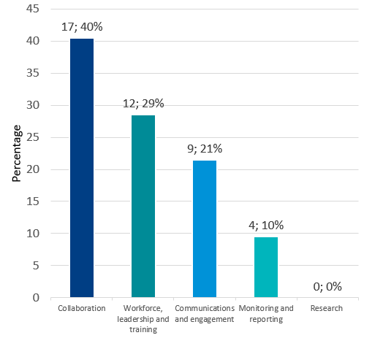
Figure 5 - Enablers from the Consultation Paper ranked most important
The short survey accessible via QR code during workshops also asked respondents to rank each of the enablers from most to least important. Figure 6 shows the number of people who ranked each enabler from one to five, with one being the most important. Collaboration was ranked as the most (40%, n = 17) or second most important (31%, n = 13) by over half of the participants. Workforce, leadership, and training was ranked most important by 29% (n = 12) of respondents and second most important by 21% (n = 9) of respondents. Monitoring and reporting and research were again ranked as having the lowest importance.
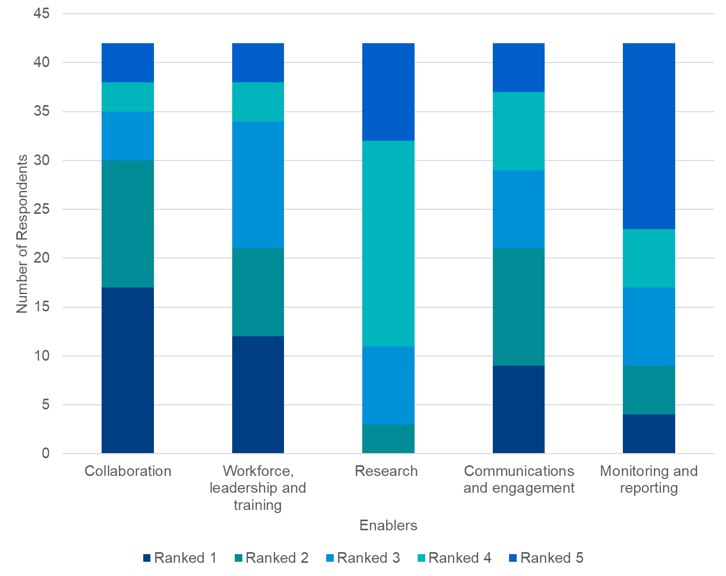
Figure 6 - Ranking of enablers from the Consultation Paper
Respondents were also asked if any additional enablers should be included in the Strategy (Figure 7). Collaboration was ranked 1 or 2 (1 being the highest) by 30 out of 42 respondents (71%). Workforce, leadership and training was ranked 1 or 2 by 20 out of 42 respondents (38%).
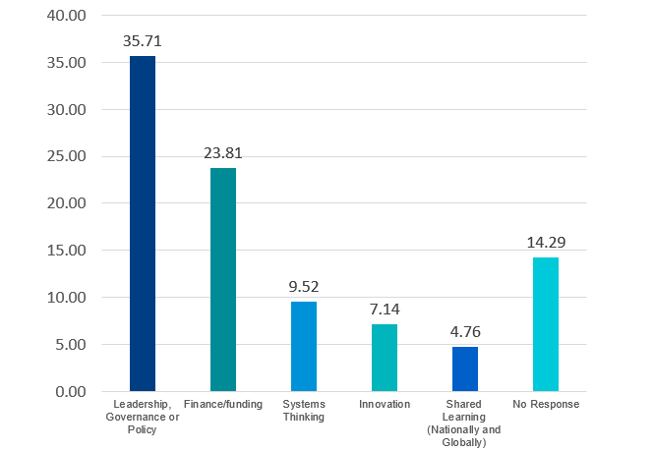
Figure 7 - Additional enablers to be considered
The appropriateness, completeness and importance of enablers were explored further during the long submissions and online survey. Respondents were able to provide further details on the presented enablers and again on potential additional enablers.
Feedback on enablers presented in the Consultation Paper
- Collaboration – In line with the high importance placed on collaboration from the QR code survey, stakeholders participating in other consultation formats stressed the importance of collaboration to achieve the objectives of the Strategy. The following further details were provided:
- There is limited government support to enable collaboration on health and climate change. The health sector has self-organised to collaborate on responding to climate change but requires government investment to scale up.
- Formal collaboration should not just be instituted between cross-jurisdictional government policy spaces but with industry, consumer organisations, and businesses.
- Collaboration requires governance including agreed shared accountabilities, clear roles and high-functioning networks, partnerships, and communities of practice to help scale the action required.
- In addition to governance structures, regular input from health and climate experts, peak professional bodies and advocacy groups is essential.
- Collaboration should be further expanded to focus on co-design and co-decision making. It should harness local knowledge.
- There should be support for regional and international collaborations to learn from best practices and leverage global expertise.
- 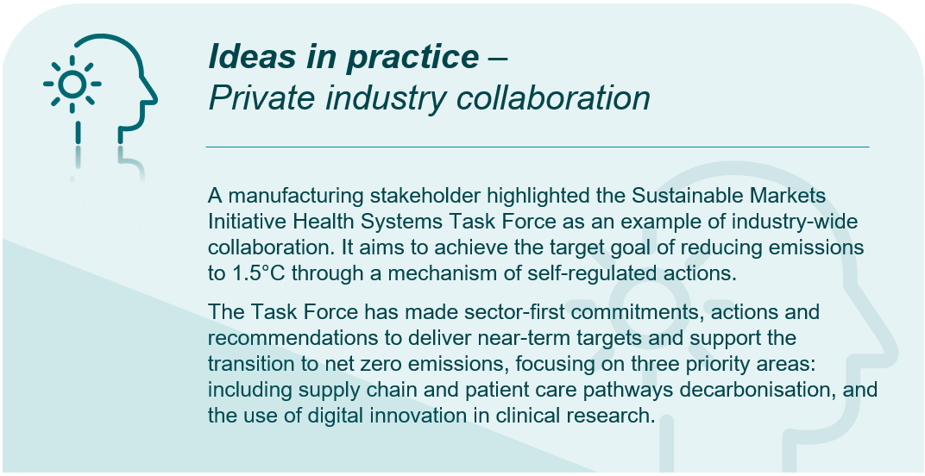Other collaboration opportunities include data sharing and research collaboration, policy coherence, capacity building, joint advocacy, climate and health alliances, and local and regional collaborations.
- Workforce, leadership, and training – Stakeholders were supportive of this enabler presented in the Consultation Paper. Stakeholders provided guidance on specific actions that could be considered to support delivery of the Strategy, including:
- Mandating education and training in climate change health impacts and mitigation practices as part of continuing professional development and other forms of training for current health and aged care workers, as well as in education of new staff.
- Education should explicitly be named within this enabler. Stakeholders highlighted the important role that education plays in galvanising the health sector workforce to support institutional efforts to reduce the impacts of climate change. Stakeholders also cautioned that there is already a high training burden placed on health and aged care workers and that the incorporation of climate education should be appropriate.
- There is a lack of support for workforce capacity building and training. There is a need for a National cross-disciplinary continuing professional development program on climate change and health for the health and aged care sector, and for people in other sectors. Training is required on the Planetary Health paradigm.
- Workforce should relate to all staff including administration, maintenance, food services in addition to clinical and medical staff. There may be a role for dedicated sustainability officers to help enact actions within the Strategy.
- This enabler should also specifically call out the First Nations workforce, leadership, and training to ensure actions are culturally safe and responsive to racism and discrimination.
- Research – Stakeholders were generally supportive of the action presented under research in the Consultation Paper. While stakeholders ranked this enabler as lower priority relative to others, they expanded on what else research as an enabler should encompass:
- There should be more readily available climate data and big data. Based on stakeholder feedback, data will drive a better understanding of the health, social and economic benefits of action on climate change. Data mapping can be performed to identify gaps.
- Targeted funding for research in the priority areas of the Strategy will help further climate and health research as an enabler.
- The Department should promote collaboration between researchers, policy staff and clinicians. This will ensure research can be developed in actions on climate change.
- The Consultation Paper should more clearly outline what will happen when additional areas of research are identified in the proposed scan of current research activities.
- There should be clear pathways and processes established to translate research into health and climate policy.
- Work is needed to encourage more researchers in the field of health and climate change. Additional work should be undertaken to encourage First Nations researchers in this field.
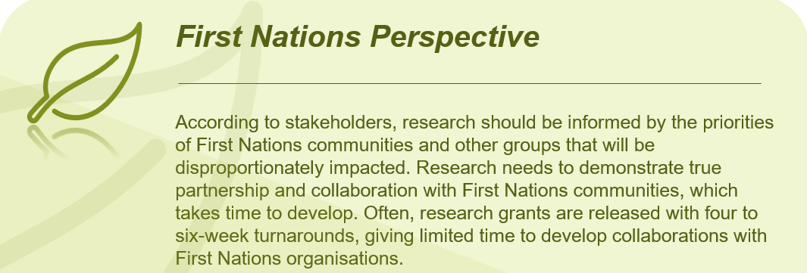
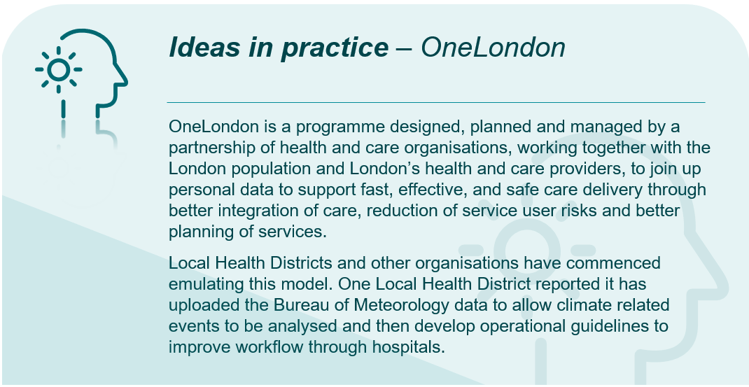
- Communication and engagement – Stakeholders stated that communication and engagement are an important component to ensuring buy-in and broad adoption of the actions laid out in the Strategy. Stakeholders provided further comments on communication and engagement enablers, and how they can be used to further the Strategy’s objectives:
- There was broad agreement that public health agencies should expand public and preventative health messaging to raise awareness of the health impacts of climate change. Improved integration of public education and awareness with the primary healthcare sector is especially important in improving outcomes for rural and remote communities that are geographically isolated.
- Stakeholders described evidence which shows that the impact of single-direction communication and engagement to elicit behaviour change is limited and can be perceived as tokenistic. Stakeholders acknowledged that transforming systems often requires changes in worldviews supported by ongoing genuine dialogue, active listening, and places where people with differing perspectives can connect in safe, respectful and inclusive spaces. Bi-directional communication was encouraged for the Strategy so that governments can hear and learn from communities and respond accordingly.
- Communication and engagement as an enabler should recognise the important role that digital infrastructure will play in the successful delivery of the Strategy.
- This enabler should identify government communications campaigns as a tool for enabling change. It was also heard that messaging and communications campaigns are not adequate during emergencies, and further support from governments is required.
- The Department should develop engagement approaches with First Nations communities, Elders and representatives that are culturally appropriate, and free from racism. It is also necessary to engage with First Nations peoples on Country. Some stakeholders suggested a First Nations advisory group could be established to facilitate this work. Other stakeholders suggested that communication and engagement should be led by ACCHOs.
- Monitoring, evaluation and reporting – Stakeholders were generally supportive of the two actions presented in the Consultation Paper. They added the following discussion points:
- The Department must commit to transparency and public reporting of progress against the Strategy. It should establish a robust monitoring and evaluation framework, including an indicator set for routine monitoring, plus a framework for evaluating implementation, effectiveness, and efficiency (including cost-benefit analysis).
- Indicators used or developed for the Strategy should align with international monitoring and reporting frameworks.
- The Department should establish a ‘Sustainable Health Unit’ to oversee monitoring of progress against the Strategy. This unit should include First Nations representation.
- Targets set in the Strategy should be science-based to enable the health and aged care sector to effectively decarbonise. It was heard that this target should be to achieve net zero by 2040, and 80% carbon emissions reduction by 2030.
- Approaches to monitoring and evaluation should be consistent to minimise reporting burden.
- Air quality was identified as a critical item for indicator development. Monitoring air quality will require significant investment in air quality monitoring infrastructure, particularly in rural and remote areas where the technology is not already available.
- Monitoring and measuring the psychological and social impacts of the ongoing threat of climate change is important, particularly among vulnerable population groups.
- Some stakeholders suggested merging this enabler with an additional measurement enabler (see below).
Additional enablers
- Measurement – Although set as an objective in the Consultation Paper, stakeholders strongly asserted that measurement should be used in the Strategy as an enabler. It was also suggested that measurement could be consolidated with monitoring, evaluation, and reporting. Based on stakeholder feedback, this enabler should define specific targets, goals, actions, and timelines, with clear accountability and responsibility frameworks. Measurement should not focus just on emissions reduction, but also to improve understanding of risk and vulnerability and how it is changing.
- Leadership and governance – Some stakeholders suggested that leadership and governance be treated as a separate enabler to workforce, leadership, and training. Stakeholders stressed that establishment of a robust governance framework is needed before actions can be performed.
- Finance, resourcing, and funding – Many stakeholders highlighted that actions arising from the Strategy must be adequately funded to put into practice. Some stakeholders thought this may sit as a component of collaboration and governance. Stakeholders also highlighted that in adding this enabler, consideration should be given to cost savings realised from undertaking actions in the Strategy.
- A stakeholder involved in the medical field advocated for funding for mitigation and adaptation of public hospitals to be included in the National Health Reform Agreement Addendum from 2025 onwards. Although it was noted that there is variation in the levels of mitigation and adaptation planning in hospitals already, it was suggested that funding is disbursed either through block funding for specific hospitals or Local Health Networks (LHNs), or as part of the National Efficient Price with relevant adjustments according to the needs of individual hospitals. This process must be equitable and not seen as punishing for those hospitals that have already progressed along the climate mitigation and adaptation path. This could also apply to residential aged care facilities.
- Systems thinking – It was heard that systems thinking should be added as an enabler to the Strategy to ensure interrelated parts, boundaries and perspectives of the health and aged care work in harmony to increase efficiency, access, and outcomes.
- Innovation – Stakeholders held that innovation should be fostered to develop effective solutions and initiatives that contribute to new technology, increase productivity, and service emerging problems. They noted this is essential to helping reducing health workforce demand and increasing access and resilience in rural and remote communities.
- National health reform arrangements – the Strategy should consider a national health reform agenda, relevant health regulation and policy as significant levers and enablers for action.
- Fairness and equity – Prioritising fairness and equity ensures the burden of transitioning to a low-carbon economy is shared fairly among all stakeholders, preventing vulnerable communities from bearing the brunt of the impacts.
- Governance and accountability – Governance establishes robust decision-making processes, defines roles and responsibilities, and can provide adequate resources and support for implementation. Governance should incorporate coordination between the National Health, Sustainability and Climate Unit (the Unit), state and territory health sustainability units, and other relevant stakeholders. Accountability structures need to be well-defined, ensuring transparency and responsibility.
- Health literacy – Empowering consumers to better understand and manage the health impacts of climate change issues facilitates more informed decisions about their own health.
    - First Nations Health and climate change
Questions from Consultation Paper
Q4 | What existing First Nations policies, initiatives, expertise, knowledge and practices should the Strategy align with or draw upon to address climate change and protect First Nations country, culture and wellbeing?
Q5 | What types of governance forums should be utilised to facilitate co-design of the Strategy with First Nations people to ensure First Nations voices, decision-making and leadership are embedded in the Strategy?
      - Alignment with First Nations policies, initiatives, expertise, knowledge, and practices
The Strategy seeks to incorporate First Nations cultures, voices, and expertise as well as respecting data sovereignty and upholding First Nations people’s right to self-determination. Throughout the engagement activities, there was strong support for this approach and stakeholders provided views and input as to how this could work in practice and suggested expertise, commentary included:
- Consultation with First Nations stakeholders – Consult with First Nations communities who are more likely to experience climate change health impacts. Example include establishing a First Nations Advisory Group, convening a national forum for First Nations leaders, conducting local consultations, and partnering with First nations organisations.
- Co-design and engagement – Commitment must be underpinned by genuine engagement and co-design principles. The process should seek to listen to and learn from First Nations Elders and communities about what the priorities are for tackling the health impacts of climate change. The Strategy should prioritise community-led adaptation planning and decision-making to further empower First Nations communities.
- Connection to traditional lands – Promote strategies that preserve and strengthen First Nations peoples’ connections to their traditional lands and environments, for example, understanding and respecting the significance of land and water in sustaining cultural practices and wellbeing.
- Proactive inclusion of First Nations knowledge – This Strategy is an opportunity to incorporate and embed First Nations thinking in a proactive manner. First Nations knowledge and experience as the oldest living culture on earth is crucial in the consideration of resilience and systemic change. For example, it was only after the bushfires of the 2019/2020 summer that First Nations management of fire was a focus. Proactive incorporation of this knowledge can reduce the ongoing direct and indirect community health impacts.
- Streamlined and meaningful engagement – Whilst the co-design of this strategy was strongly supported by stakeholders, it was noted a challenge in implementing this is often the issue of double handling and over-consulting of communities. There needs to be a streamlined process for meaningful engagement that does not over-burden First Nations people and where possible, avoids duplication of existing structures. Engagement needs to be done with key principles of respect, accountability, deep listening, and cultural safety.
- Lessons learnt and amplifying success – Ensure any engagement approaches adopt lessons learnt from the successful First Nations response to the COVID-19 pandemic and amplify those learnings within the broader strategy.
The following policies, tools and guidelines were suggested by stakeholders as relevant to draw upon or align with:
- Best Practice Principles for Clean Energy Projects (new guidelines) and a Clean Energy Negotiations Guide for First Nations (soon be released).
- Fire to Flourish – Monash Sustainable Development Institute.
- First Nations Clean Energy Network guidelines (ANU).
- Climate change and Aboriginal and Torres Strait Islander Health Discussion Paper – Lowitja Institute.
- National Aboriginal and Torres Strait Islander Health Plan 2021–2031.
- National Agreement on Closing the Gap (2020).
- National Indigenous Housing Guide
- The 5-Year Plan for Aboriginal and Torres Strait Islander Aged care (2021-2026) “Our Care, Our Way, Our Future”.
- The Ngayubah Gadan (Coming Together) Consensus Statement: Rural and Remote Multidisciplinary Health Teams.
- Uluru Statement from the Heart.
- United Nations (UN) Permanent Forum on Indigenous Issues.
- UN Declaration on the Rights of Indigenous Peoples (UNDRIP).
- Wiyi Yani U Thangani Report (2020)
The below outlines some of the initiatives and expertise suggested by stakeholders as important to addressing climate change and protecting First Nations knowledge:
- Land-based healing and connection – Many First Nations communities emphasise the importance of land-based healing and connection to health and well-being. The Strategy should recognise and support these approaches, promoting the revitalisation of cultural practices, land stewardship, and healing relationships with the environment.
- Cultural land, resources, and water management – Traditional land and water management practices, including harvesting traditional foods on Country and customary burning practices. The Strategy should incorporate and support Indigenous land and water management practices to mitigate the impacts of climate change, foster ecosystem resilience, and ensure that traditional food sources are protected.
- Holistic definition of health – Within the Strategy ensure that a First Nations definition of health is drawn upon; this is more holistic definition than a western/ biomedical definition. This definition should include physical, social, emotional, cultural and spiritual wellbeing as well as connection to Country.
- Weather and climate knowledge – Draw on First Nations knowledge and expertise regarding the land, climate, and weather. Include the Indigenous weather/seasonal/calendar/knowledge into mainstream weather reporting and decision-making regarding climate change strategies.
- Cultural heritage and language preservation – Recognising and preserving First Nations' cultural heritage and languages are essential components of climate action. Efforts to protect cultural identity can strengthen the connection to Country, leading to a greater commitment to environmental stewardship.
- Community-based climate adaptation – Many First Nations communities have developed adaptation strategies to cope with the impacts of climate change on their traditional lands and livelihoods, the Strategy should ensure consideration and acknowledgment of these strategies.
      - Suggested First Nations governance forums
Stakeholders provided input regarding how best to leverage existing governance forums and what must be established to ensure First Nations voices, decision making, and leadership are embedded in the Strategy, these comments included:
- Indigenous rights and self- governance – The Strategy should align with the principles of self-governance and self-determination of First Nations communities. This involves respecting the rights of Indigenous peoples to make decisions about their own health, lands, and resources and supporting Indigenous-led governance structures.
- Community controlled leadership – Having governance led by community-controlled organisations and the ability to bring organisations into decision-making and provide policy advice as priority topics and locations change is essential.
- Shared-decision making – Governance forums should set out how decision-making will occur under a shared decision-making framework. These forums should seek to ensure representation from a range of bodies that focus on health, environment, land, and community representatives.
The following governance forums, networks and bodies were suggested by stakeholders as mechanisms for engagement and co-design with First Nations people (noting this is not an exhaustive list):
- Australian Indigenous Doctors' Association (AIDA)
- Australian Indigenous Psychologists Association (AIPA)
- Caring for Country Partnership forum (Department of Energy Environment and Climate Action).
- Coalition of the Peaks
- Expert Reference Panel for Aboriginal and Torres Strait Islander Health (ERPATSIEH) of enHealth
- First Peoples Disability Network Australia (FPDN)
- First Peoples’ Assembly of Victoria
- Gayaa Dhuwi (Proud Spirit) Australia
- George Institute’s Guunu-maana (Heal) Aboriginal and Torres Strait Islander Health Program
- Indigenous Allied Health Australia
- Lowitja Institute
- National Aboriginal and Torres Strait Islander Health Protection (NATSIHP) Sub-committee of the Australian Health Protection Principal Committee (AHPPC).
- National Aboriginal Community Controlled Health Organisation (NACCHO)
- National Aboriginal & Torres Strait Islander Ageing and Aged Care Council (NATSIAACC).
- National Association of Aboriginal and Torres Strait Islander Health Workers and Practitioners
- National Health Leadership Forum (NHLF)
- Northern Territory Aboriginal Health Forum
- Northern Territory Executive Council on Closing The Gap / Aboriginal Affairs
- ‘Healthy Country, Healthy People’ program (NT)
- Ranger groups - land and sea management ranger groups
- Seed mob (Australia’s first Indigenous youth climate network)
- The Congress of Aboriginal and Torres Strait Islander Nurses and Midwives (CATSINaM)
- The Earth Systems and Climate Change Hub within the National Environmental Science Program at CSIRO
- The determinants of planetary health: an Indigenous consensus perspective
- The Healthy Environments and Lives Network (HEAL)
- The National Indigenous Disaster Resilience Summit
- Victorian Aboriginal Health and Wellbeing Partnership Forums (and associated Koori caucus) VACCHO Members’ Forums
- Voice to Parliament.
It should be noted that a First Nations Organisation commented that currently there is no specific forum that is Aboriginal and Torres Strait Islander-led and resourced to focus on health and climate – the stakeholder observed that this is a governance gap that needs to be filled. The stakeholder commented there is currently work under way by their organisation to engage with Aboriginal and Torres Strait Islander peoples nationally and they are assessing the feasibility of a national governance body, such as a national Aboriginal and Torres Strait Islander Coalition on Health and Climate.
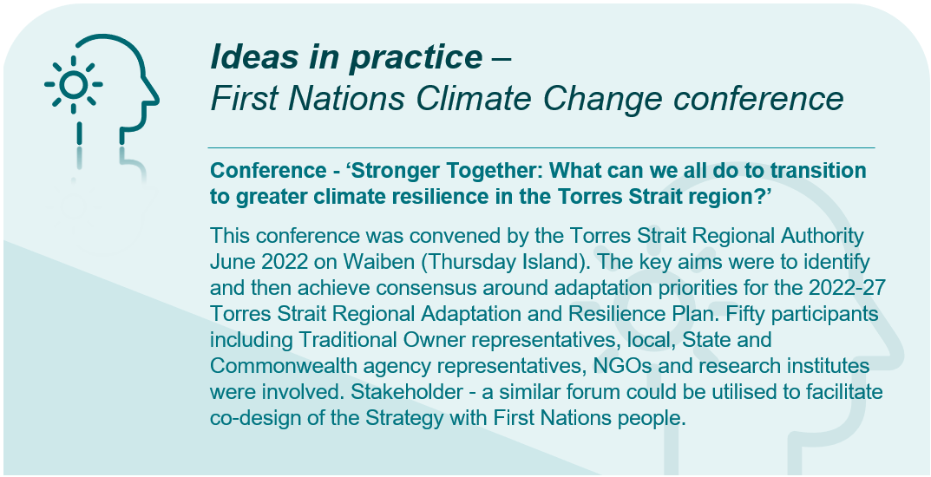
  - Consultation topics
    - Measurement
Questions from Consultation Paper
Q6 | Beyond the schemes already noted above [in the Consultation Paper], is your organisation involved in any existing or planned initiatives to measure and report on health system emissions and/or energy use in Australia?
Q7 | What additional data and information is required to support targeted emissions reduction efforts within health and aged care?

Stakeholders unanimously agreed that a coordinated and standardised measurement activity and public reporting of carbon emissions across the healthcare sector should be prioritised.
The themes that emerged focus on; measurement methodology and support, benchmarks and baselining, and the associated data and information sharing activity. These themes are outlined in more detail below.
      - Measurement methodology & reporting
- National framework and consistency – A common view amongst stakeholders was the need for a nationally coordinated and consistent framework, which outlines both the qualitative and quantitative approach to measuring and reporting emissions in the health sector. Several stakeholders provided views on approach to developing a nationally consistent framework and why this is key to success, noting:
- The importance of engaging or commissioning experts in the estimation of emissions to develop this framework, including consultation and consensus across the health sector prior to finalisation.
- The framework and methodology will be critical to providing confidence in the integrity and comparability of emissions data.
- To be effective and ensure the framework is implemented in a consistent manner, there needs to be review and assurance, to verify outputs of measurement activity and to assist with mitigating the risks of ‘greenwashing’.
- There must be transparency regarding scope of measurement and allow for accurate comparisons across entities and jurisdictions.
- Enforcement and mandatory reporting – Stakeholders emphasised that the measurement, disclosure and reporting of greenhouse gas emissions must be standardised and mandatory. The following comments were made across stakeholder engagement activities:
- Organisations will require incentives to better measure and understand their climate footprint, and current reporting schemes have minimal enforcement on health institutions.
- Relevant legislation and regulatory settings will be required to mandate reporting in a consistent and timely manner.
- Stakeholders suggested an annual reporting mechanism and monitoring must be implemented and enforced by Commonwealth Government to hold different health systems (including private and public sectors) responsible – this should include the promotion of achievements to incentivise emission reduction activities.
- Accountability and performance mechanisms must be built into measurement and reporting so that data can be captured and then accompanied by meaningful action and transformative change.
- Capacity and skillsets for measurement activity – In relation to the workforce capacity and capability required to undertake measurement and analysis activity, stakeholders expressed the view that this goes beyond the skillset of the current health sector workforce. Primary healthcare stakeholders, in particular GPs, emphasised that consideration must be given to the administrative burden for individual facilities or organisations as proposed reporting goes beyond what is currently legislated. There will be great disparity across organisational and workforce maturity in gathering and analysing emissions data, with some health facilities already collecting this data and many others who do not or currently cannot. Stakeholders identified possible supports and actions related to measurement capability, suggesting:
- The establishment of a dedicated team/National Sustainability Development Unit, as well as individual hospital or health district Sustainability Development Units, to increase capacity and support for measurement and reporting.
- Develop tools and templates to support the measurement framework. Specific to primary healthcare, which is largely made up of small business, tools need to assist businesses to measure emissions and provide a baseline. Whilst there are several generic calculators available, stakeholders noted they don’t provide information to support responsible purchasing decisions and reduced carbon emissions.
- Approach to measurement – Stakeholders consistently raised the need to leverage international progress, consistently referencing the NHS, and align Australia’s approach to measurement with validated and recognised standards. Across both workshops and written submissions stakeholders provided examples of existing tools and standards which should be considered, including but not limited to:
- Greenhouse Gas Protocol.
- Measuring what matters – wellbeing framework.
- Global Green and Healthy Hospitals (GGHH).
- Planetary Health Equity Hothouse – ANU planetary health equity impact tool.
- Climate Impact Checkup calculator.
- Green Impact.
- ANZCA Environmental Sustainability Audit tool.
- National Schemes – Some stakeholders expressed concern regarding schemes and accounts referenced within the Consultation Paper, specifically:
- Reliance solely on Australia’s National Greenhouse Accounts for estimating activity will not be sufficient, as emissions from entities that are below the NGERS reporting threshold are not captured. Workshop stakeholders also suggested the lowering of NGERS threshold and mandating reporting could support a more complete estimate.
- The National Greenhouse Gas Inventory (NGGI) is not adaptable as it estimates emissions using the UNFCCC carbon accounting framework that is designed to report emissions by source. To measure the emissions by sector, it is necessary to determine the emissions from all relevant sources that can be attributed to that sector of the economy through lifecycle assessment.
- A peak body represented at both workshops and via submissions, highlighted measurement of the health system’s carbon footprint should be informed by both top-down and bottom-up data (where available and feasible), such as lifecycle assessments.
- Carbon footprint methodologies – related to the above, several stakeholders referenced the use of Environmentally Extended (Economic) Input Output (EEIO) analysis, a process-based lifecycle assessment or a hybrid model as model options for measuring carbon footprint. Stakeholders representing medical professionals emphasised the following additional limitations of EEIO studies in guiding local decision-making and a preference for more granular outputs produced by process-based lifecycle assessment, noting specifically that:
- EEIO studies are useful for setting the scene and providing a broad overview of the healthcare sector’s greenhouse gas emissions.
- Data derived from EEIO studies are often not refined or nuanced enough to guide evidence-based product choice (including pharmaceuticals), or consideration of greenhouse gas emissions from clinical care processes and procedures.
- A limitation of EEIO studies is the assumed linear relationship between financial and environmental costs.
- Whilst stakeholders noted EEIO studies are useful for large, healthcare sector wide estimates of emissions, access to more granular carbon footprint information will be increasingly important in clinical decision-making as the healthcare sector moves towards net zero emissions.
- Whilst process-based lifecycle assessments require careful analyses of various components and inputs, they are a more reliable method when making comparisons between different clinical pathways.
- Indicators and metrics for measuring climate health – Stakeholders consistently raised the need for clear units/metrics by which greenhouse gas emissions will be measured. Suggestions were made in relation to existing metrics or indicators which could be built on or leveraged such as calculations for the NHS Carbon Footprint.
- Related to this, was the requirement for capture of standardisation metrics or normalising factors to allow appropriate comparison across different healthcare settings and jurisdictions for example:
- Gross floor area
- Number of full-time equivalent staff
- Number of patient separations
- Episodes of Care
- Occupied bed days
- Length of Stay (LOS)
- Per patient treated (PPT).
- Prioritised and proportionate action – Several stakeholders raised that measurement regulation and reporting requirements need to adopt a practicality lens and should be equitable and prioritised. Some stakeholders provided details on how they would like to see this work in practice
- Initial efforts and focus on private hospitals and hospital chains, and other large corporate providers (e.g., corporate pathology, general practice chains, aged care chains) then provide smaller-scale local providers with more time and assistance to reach compliance, particularly those operating in a rural and remote setting.
- Measuring greenhouse gas emissions must be designed to account for a realistic and practical representation of the health system's climate impacts. A stakeholder suggested this could be modelled on the UK's Delivering a 'Net Zero' National Health Service document, which breaks down the health system's carbon emissions into categories, such as supply chain and personal travel. This breakdown allows for more targeted actions, as efforts for measurement and reporting could then be prioritised on this basis.
- Measurement of co-beneficial effects and linkage to health outcomes – Many stakeholders highlighted the need for measurement activity to go beyond the greenhouse gas emissions to also capture co-benefits. Stakeholders further expanded on this, including:
- Development of an end-to-end care pathway ‘emissions calculation’ tool for specific diseases to measure and track emissions across the care journey and assess decarbonisation pathways.
- Establish better health economics capability to quantify and measure the avoided health costs of reducing emissions and the avoided emissions of improving health outcomes and models of care.
- Develop a model to estimate the beneficial effects of different types of health targets on emissions, for example reducing obesity rates by 10% and the effects this would have on hospital admissions and emissions.
- Need to measure and report on the cost of climate change in-action on Australia’s health and healthcare system, for example costs of excess deaths, disability, and healthcare (including mental health related) due to increasing extreme weather events.
- Need to develop health impact projections from climate change - reference to IPCC report - AR6 Synthesis Report: Climate Change 2023.
      - Benchmarking & Targets
- Establishment of baselines – Many stakeholders highlighted the need to develop an emissions baseline for the health system as a reference point for comparison, ongoing measurement activity and to enable the setting of realistic reduction targets. Specific points of action or consideration include:
- Engaging experts in the development of emissions baselines.
- Leverage baseline measurements to support modelling of future scenarios under a variety of conditions i.e., business as usual, committed decarbonisation, to understand impacts of actions and develop targets and like the NHS approach.
- Develop emissions profiles specific to the health and aged care sectors to both establish baselines and provide insights into the major sources of emissions, hotspots, and opportunities for reduction.
      - Data capture, information sharing and transparency
- Continuous improvement and information sharing – There was strong support for the sharing of strategies, innovations and best practice in measurement and reporting activity. Specific commentary from stakeholders included:
- Comprehensive data and information on successful emissions reduction initiatives and case studies to provide guidance and inspiration for targeted efforts. Sharing best practices and lessons learned can accelerate progress across the industry and foster a culture of continuous improvement.
- Information on technological advancements, sustainable materials, energy-efficient equipment, and successful case studies can support evidence-based decision-making and guide the implementation of sustainable practices.
- Data and information required to target emissions reduction efforts – Stakeholders commented on the need to consider the following with respect to the additional sources of data and information required to measure and support emissions reductions:
- Anaesthetic gas suppliers carbon emissions i.e., associated with Desflurane and Sevoflurane, quantities sold, and to which sectors public vs private and stratified.
- Australian database of standard CO₂ conversion factors for healthcare utilisation (e.g., ED, clinic attendance, GP appointments), medical equipment and devices and pharmaceuticals.
- Australian Disaster Resilience Index data.
- Building and facility characteristics – building age, thermal comfort, building envelope, resilience standards.
- Carbon and social accounting mechanisms to calculate the impact of different models of care (e.g., SUSQI metrics).
- Data related to unforeseen health disasters such as COVID-19 and floods.
- Demographics data - indicating key population vulnerabilities i.e., older population, respiratory conditions, mobility, disability, index of relative socioeconomic disadvantage. Noting a lot of this work has already commenced through ProfileID.
- Emergency data (historical) - climate emergency data of fire, flood, storm, drought and heatmaps including modelled risk, likelihood, and severity of impacts.
- Emerging research, innovations, and best practices in sustainable healthcare.
- Energy consumption within healthcare facilities, data on electricity, natural gas, and other energy sources used in different areas of health and aged care settings, proportion of 100% renewable electricity purchased/used across institutions.
- General practice and primary care data.
- Health workforce and patient transport emissions data and transportation patterns.
- Levels of likely fugitive emissions of 'natural' gas and Nitrous Oxide (N2O) leaks within our hospitals (gas leaks).
- Local data on the interrelationships between the determinants of climate vulnerability and social determinants of health.
- Marginal abatement cost curves to assist in identifying and prioritising work to reduce emissions.
- Natural gas levels, combustion pollutants (NO₂, Benzene, Formaldehyde etc) in the immediate and surrounding vicinity of other health facilities and modelling to extrapolate the likely health effects of exposure.
- Nitrous oxide wastage (verifiable data) i.e., via venting of returned 'empty' cylinders from hospitals.
- Perinatal data (already collected by Midwives).
- Supply chain data, including information on suppliers, manufacturers, and transportation methods.
- Volatile anaesthetic agents – a stakeholder notes this government is collected by the Australian Government however is not currently shared (despite requests).
- Waste generation rates and waste composition within healthcare facilities, the types and quantities of waste generated, including hazardous and non-hazardous waste.
- Water consumption within all social welfare, water usage patterns, identifying water-intensive processes, peak consumption.
- Data mapping and collection – related to above-mentioned data requirements, stakeholders recommended the following activities in relations to collecting and support to access the data:
- A First Nations Stakeholder recommended that the Department include Indigenous Data Sovereignty (ID-SOV) and Indigenous Data Governance (ID-GOV) in the Strategy as guiding principles and non-negotiable components related data ecosystems and processes.
- Commission a detailed data mapping project to inform health planning. This map would overlay all the locally relevant factors in a publicly accessible format, allowing for informed prioritisation of actions.
    - There is an opportunity for the Commonwealth to create national clarity and consistency around national health emissions data, this could be in the form of guidelines or standards which identify:
    - A consistent (and more fulsome) approach to data collection at the health service facility level.
    - Which data is most powerful/effective in measuring and driving change?
    - Ways which data integrity can be ensured.
    - Ways in which the data could be leveraged for optimal value.
- Information systems and management of data – stakeholders commonly referenced the need for a publicly-available national data base as a mechanism to help identify, measure and report on emissions, and as an information repository to provide guidance and best practice. Some stakeholders provided further detail regarding what capability and intersects the system should have:
- Integration with existing state and territory incentive schemes, grants research and mandatory reporting requirements (e.g. mandatory reporting for Local Governments through the NSW legislative Integrated Planning and Reporting framework) as well as interoperability of reporting systems, will be key to reducing reporting burden and ensuring access to complete data.
- Existing large data should be featured as there are multiple health systems with legacy data systems in place. Need to implement something like the ‘OneLondon’ initiative, which involves the democratisation and use of deidentified data to enable targeted research on climate and health. For example, emergency department data could be analysed for presentations with extreme events and to support preventative actions and plan.
    - Built environment, infrastructure, and services
Questions from Consultation Paper
Q9 | Which specific action areas should be considered relating to the built environment and facilities (including energy and water), over and above any existing policies or initiatives in this area?
The built environment consists of all the human-made aspects of people’s surroundings, including hospitals, facilities, roads, and other connecting transit systems. Buildings contribute to climate change through their construction, maintenance, and daily operation. This includes the materials they use; their location; and electricity, gas, and water usage.
Stakeholders commonly referenced the need for a harmonised suite of legislative, standards and codes to reduce emissions and adapt to climate change, supported by nationally consistent measurement and ratings.
The themes that emerged focus on: measurement and reporting; legislation and regulation; and implementing energy efficiency programs for current and new builds. These themes are outlined in more detail below.
      - Building standards
- Strengthening standards – Most stakeholders identified the need to strengthen building standards for existing and new healthcare facility design. Some ideas put forward across written submissions included:
- Implement national healthcare facility design and construction standards for new healthcare building design which includes guidance on integrating land/site features into design which optimising patient outcomes and minimising energy needs. New building design should be supported by a transition strategy which includes developing industry capacity and awareness to meet the construction standards.
- Develop, implement, and monitor indoor air standards for all public buildings, work and education environments, and homes.
- Establish minimum energy efficiency standards for all buildings (including public and private hospitals, schools, and social housing) to be thermally efficient, renewably powered and climate resilient.
- Building standards need to be strengthened to exclude designs that will result in increased energy needs for heating and cooling.
- Integrating resilience based on construction standards, such as the regularly amended National Construction Code (NCC 2022), would contribute towards reducing preventable health impacts.
- Policy development in urban planning, building codes and other standards relevant to the built environment will need to strike a balance between competing interest and priorities. It is important that the relevant regulatory bodies undertake their work with clear understanding of the relationship between population health and the built environment; and a recognition of the effect on population health.
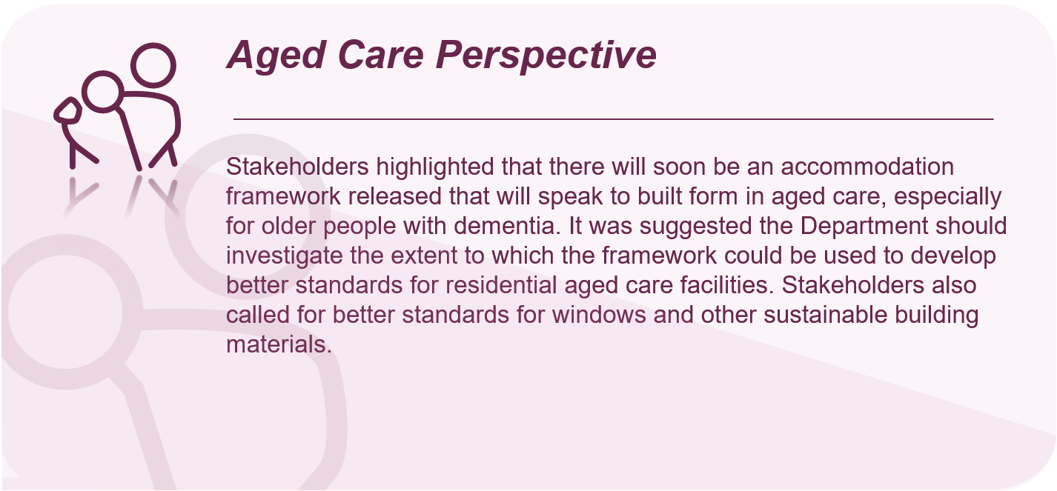
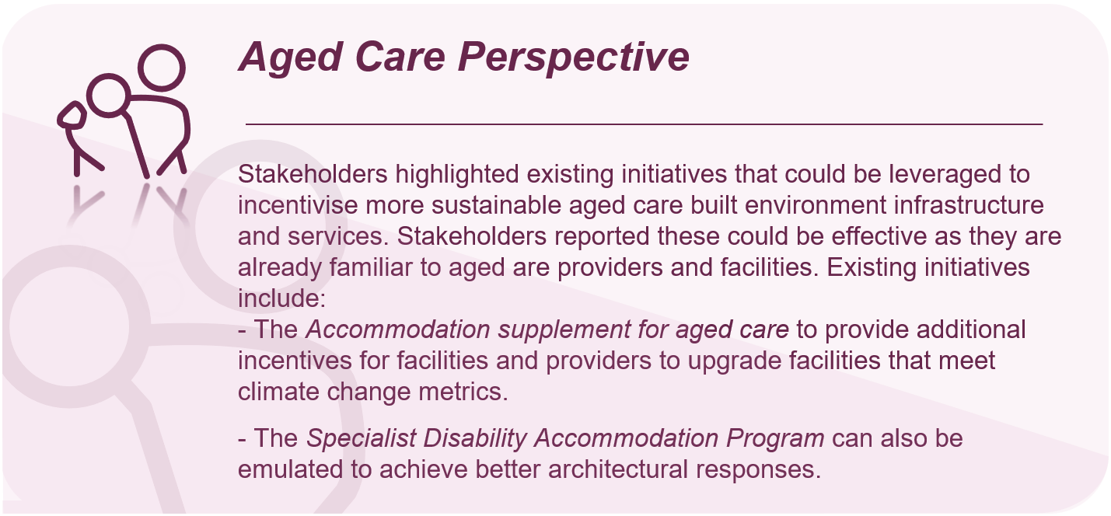
- Measurement and reporting – As previously mentioned, many stakeholders identified the need to establish key targets that healthcare facilities and other assets need to adhere to, which should inform decision-making on retrofitting existing infrastructure, and building new infrastructure. Ideas proposed by stakeholders include:
- Defining targets for transition to renewable sources of power for all healthcare facilities.
- Requirement for the measurement of the carbon footprint for any new buildings prior to Development Application approval.
- Legislation and regulation – Many stakeholders identified the need for legislative reform and regulation, in the following areas:
- Mandating government schemes such as the Green Star and NABERS rating for health and aged care facilities to ensure minimum standards of energy and water efficiency across Australia, and provide an independent, auditable verification of their achievement – for effective measurement of emissions reduction, as well as a range of other sustainability metrics.
- All new hospitals are to be all-electric (fossil fuel-free). All existing hospitals are to develop plans for removing fossil fuels as an energy source and commit to rapidly decarbonising the electricity supply for healthcare facilities.
- An immediate ban on new gas builds in all new healthcare facilities both public and private.
- Increase the biodiversity, green space, and canopy/vegetation cover, which delivers co-benefits such as reducing urban heat island effect, shade, clean air and improving mental health and wellbeing. Increasing canopy/vegetation cover and green space can also reduce building energy use and stormwater run-off to local waterways.
- Environmentally Sustainable Design (ESD) guidelines for health system capital works
- Energy efficiency – Stakeholders reported a range of initiatives to improve the energy and water efficiency of health system facilities, including:
- Implement energy efficiency measures within healthcare facilities. These include upgrading to energy-efficient lighting systems, installing motion sensors and timers to control lighting and HVAC systems, and improving insulation to reduce heating and cooling needs. Conduct energy audits to identify areas for improvement and prioritise energy-saving measures accordingly.
- Ensuring better building standards such as better insulation, design to maximise natural cooling/avoid overheating, double and triple glazing.
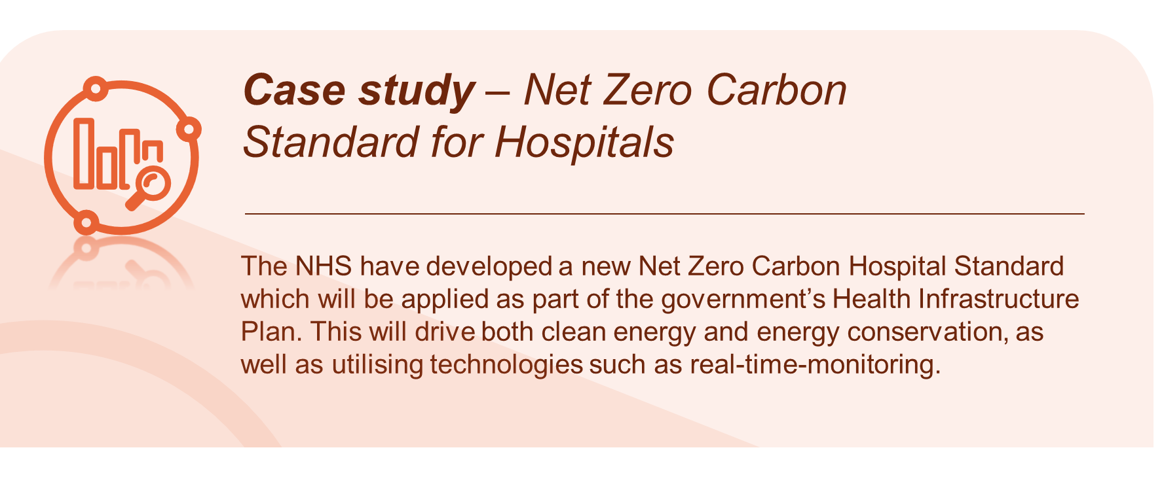
      - Asset lifecycle management
- Monitoring of performance – Monitoring the performance of existing asset operations and emissions, while continuing to identify opportunities to reduce emissions through innovation and low-carbon technologies.
- Adapt existing infrastructure and assets – An integrated assessment of the fitness for purpose and modification/upgrade/replacement requirements of healthcare infrastructure across both mitigation and adaptation is required.
- Integrity and reliability of the public health infrastructure, assets and services are also at significant risk due to evolving climate threats which were not anticipated at the time of their design or construction. Minimise resources on upgrading facilities which need to be moved or replaced due to their vulnerability to flooding, for example.
- Prioritise renewables, recycled and low-carbon materials into the built environment and integrate low-carbon operating systems into the co-design and upgrade of facilities.
- Implement energy efficiency and emission reduction programs through investments in renewable energy, energy conservation measures, and low emissions infrastructure.
- Adopt low-carbon operations through a range of energy, waste, construction, and fleet management policy practices, including offsets, to transition assets and operations towards zero net emissions.
- A distinction should be made between existing and planned infrastructure. New developments may have opportunities to design with sustainability in mind, whereas retrofitting existing buildings can be prohibitively expensive. Government should provide financial incentives and assistance to meet retrofitting targets.
      - New infrastructure
- Planning for sustainability – Stakeholders overwhelmingly identified the need for all new health infrastructure builds to consider climate change in future infrastructure delivery, serviceability and whole-of-lifecycle emissions. Stakeholders identified the following actions:
- All new and replacement infrastructure needs to be constructed to the highest, future-proofed standards for both mitigation and resilience.
- When assessing the value for money of public tenders for buildings, the tendering process should thoroughly consider whole-of-life costs, upweighting long-term savings that arise from energy efficiency measures.
- Reduce demand for large, resource-intensive healthcare facilities and ensure only necessary buildings are constructed. The demand for new infrastructure could be reduced through scaling up health promotion, telehealth and care closer to home, without compromising patient outcomes.
- New build standards – Similar to the management of existing assets, stakeholders referred to the need to implement planning and standards into the design and build of new health infrastructure. Commonly identified actions include:
- Integrating climate change and green policy into investment, planning, design, and construction standards of facilities, including the whole-of-life cycle carbon emissions.
- The building design for new buildings and retrofitted facilities should align with specific green rating systems. The Green Building Council of Australia’s Green Star initiative has an internationally recognised rating system setting the standard for healthy, resilient, positive buildings and places.
      - Infrastructure and service disruption and resilience
- Risk assessment and scenario planning – Stakeholders identified the need to implement a range of strategies focused on infrastructure and risk management. This included:
- All health services and other relevant services to conduct climate change risk assessments as a core risk management strategy.
- Assess the resilience of health infrastructure to climate-related hazards and implement necessary measures to enhance their capacity to withstand extreme weather events, such as bushfires, floods, and storms.
- Workforce support – Most stakeholders highlighted a need to implement programs that support the health workforce understand and work within an evolving risk environment. Specific actions include:
- Provide training programs for healthcare and built environment professionals to enhance their knowledge and skills in addressing climate related health risks within their remit. This includes education on recognising and managing climate-related health conditions, such as heat-related illnesses and respiratory diseases. 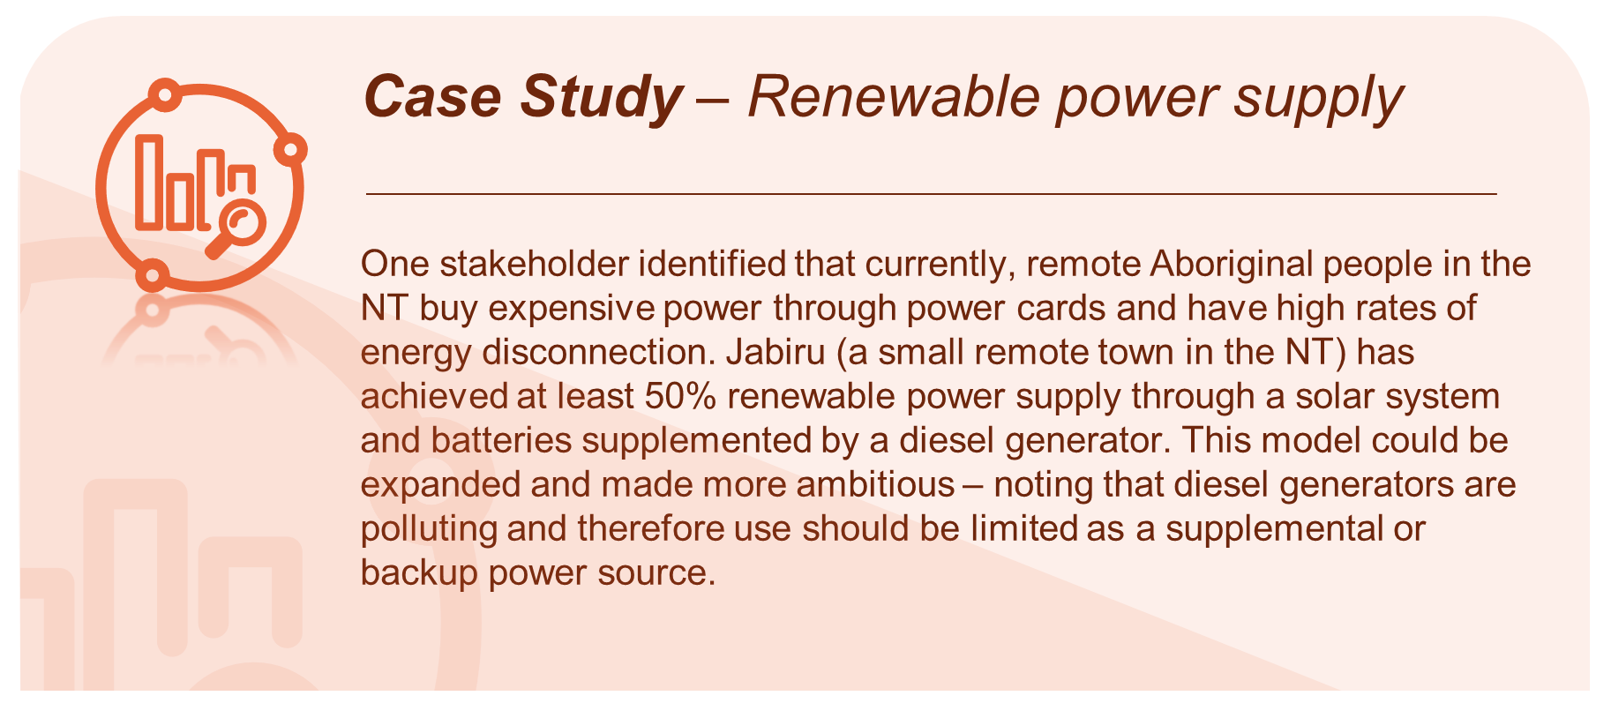
      - Building and facility operations
- Renewable energy purchasing – Several stakeholders asserted that all health and residential aged care facilities should transition to renewable energy purchasing agreements. Several energy wholesalers sell energy generated solely from renewable energy sources such as wind and solar. This was viewed as a quick approach to transitioning away from energy generated by fossil fuels until facilities have the capacity to generate renewable energy independently.
- Energy efficiency – Stakeholders overwhelmingly identified the need to implement energy efficiency across all health infrastructure assets. This includes moving away from gas to electricity, retrofitting lighting systems, and upgrading HVAC systems with energy-efficient equipment, such as high-efficiency chillers and improved insulation.
- Most stakeholders suggested ‘greening’ strategies for health campuses and buildings. Green space has a localised cooling impact, improved neighbourhood biodiversity and is also important for mental health and wellbeing.
- Some stakeholders identified a need to promote behaviour change among staff to encourage energy conservation practices, such as turning off lights and equipment when not in use.
- The establishment of a national Energy Efficiency Infrastructure Transition Fund was suggested to accelerate the transition to low emissions infrastructure upgrades, with a priority focus on urgent clinical needs.
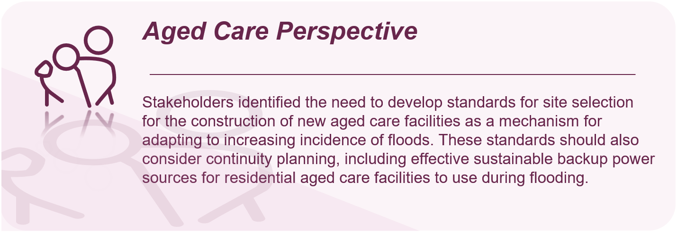
    - Travel and transport
Questions from Consultation Paper
Q10 | Which specific action areas should be considered relating to travel and transport, over and above any existing policies or initiatives in this area?
      - Reducing travel
- Conference and educational travel –Several stakeholders reflected on the need to reduce professional development travel, in particular overseas conference flights, suggesting:
- Cease remunerating senior medical and other hospital staff with business class (high carbon) flights to conferences. This process of remuneration not only contributes to high carbon travel, but it also establishes a culture of travel and messaging to junior doctors, nurses, and future medical professionals.
- Staff travel emissions should be addressed through restructuring continuous medical education (CME) funding to de-incentivise international travel for conferences, prioritise virtual attendance and permit CME allowances to be reimbursed to the clinician, used for other educational activities or environmental, social and governance projects that benefit the health system.
- Where it is deemed necessary to travel, there should be a requirement to purchase carbon offsets.
- Patient and staff travel – Stakeholders consistently raised the need for policies and programs to reduce unnecessary patient and staff, transport, and travel. Some of the examples provided by stakeholders included:
- Virtual telehealth consultations, where appropriate, should be incentivised. There was support for the extension of Medicare Benefits Scheme (MBS) items for several core consultations and counselling services. Making these items available permanently as they deliver co-benefits of increased access for rural or marginalised populations while reducing unnecessary transport emissions.
- A healthcare peak body recommended the inclusion of an action within the travel and transport focus area that highlights the importance of redesigning models of care to reduce the need for transport at all such as virtual models of care, remote monitoring, and telehealth.
- Deliver more healthcare in regional/remote areas using transportable units to reduce the distances patients need to travel.
- Implement policies and incentives to reduce travel and associated carbon emissions, such as congestion pricing and low-emission zones.
- Support for more social and affordable housing surrounding health services to allow staff to live closer to their place of employment and reduce the need for travel to and from work. Australia’s well-documented housing affordability crisis means many healthcare workers are forced to live further from their workplace and have longer commutes.
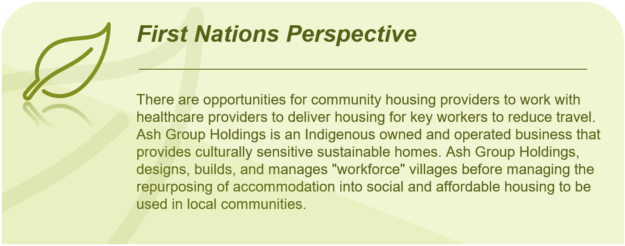
Further analysis regarding telehealth and hub-spoke models is covered in the following section 2.2.4 Prevention and optimising models of care.
- Active transport – Many stakeholders emphasised the need for additional support for active travel as a key mitigation for transport and travel emissions. With respect to active travel, stakeholders proposed a variety of actions:
- Ensure built environment design and urban planning promotes active transport, through adequate housing density, well-connected streets, mixed land uses, and proximate public transport, especially in outer suburban areas.
- Education and advocacy within the health system for active transport options, for example, instructions detailing public transport access could be provided automatically to each patient/visitor, and end of trip facilities for bicycle users to be accessible for facility staff and visitors.
- Explore options to incentivise active transport via salary packaging, for example, allow e-bike and bike purchases to be salary packaged.
- Research the barriers to staff and patients adopting active transport, and then action and regulation to address this. One stakeholder provided an example of a need for advertisement regulation surrounding larger vehicle types like SUV and 4X4 providing increased safety which decrease people’s uptake of active transport due to safety concerns.
      - Improving travel and transport efficiency
- Optimise healthcare vehicles – Stakeholders have called for the optimised use of healthcare facility fleet vehicles, as well support to transition vehicles to more sustainable models. Actions raised across the stakeholder engagement process include:
- The Strategy should consider the cost of leasing electric fleet vehicles, which is currently twice the cost of internal combustion engine (ICE) vehicles and is therefore cost-prohibitive.
- Leverage health agencies’ direct purchasing power over vehicle fleets, even if some vehicles such as ambulances are leased rather than purchased outright, electrical vehicles or high-fuel efficiency options should be preference.
- In circumstances where electric vehicle use is not practical, such as in very remote settings, a high fuel efficiency standard must be the minimum.
- Explore partnerships with vehicle manufacturers, government programs, or leasing options to support the transition.
- More research is needed into the use of hydrogen in ambulances and emergency transport; although, size and scale inhibit this in smaller jurisdictions.
- Develop a strategy or transition plan for fleet electrification, considering vehicle range requirements, charging infrastructure, and financial feasibility. Example provided by stakeholder of the Australian Capital Territory Government’s commitment to incentivise zero-emission vehicle purchases could be adopted at a national level, specifically for commercial fleet vehicles.
- A stakeholder highlighted that Australia could establish a scheme analogous to the ‘electric car pledge’ in America.
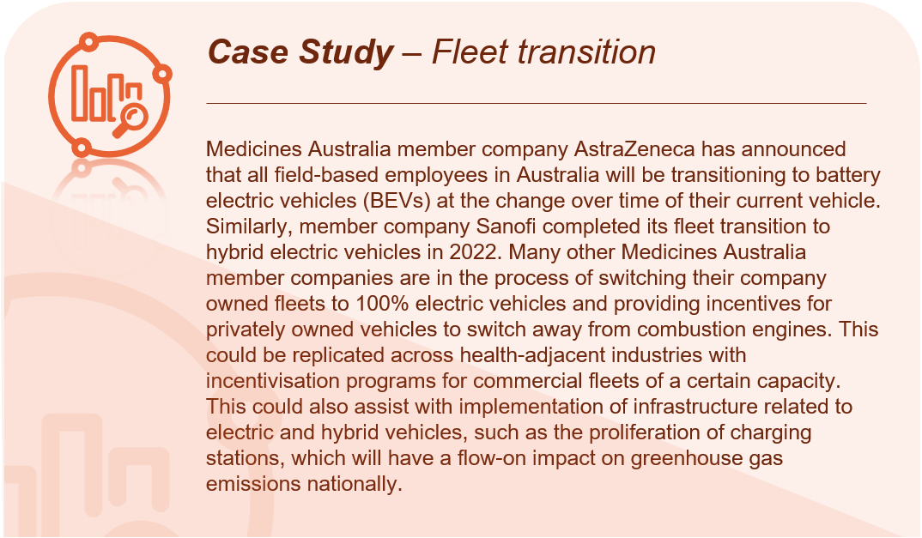
- Low-carbon fuels and fuel efficiency – Stakeholders shared limitations and considerations regarding fuel efficiency and actions to make this more accessible to the Australia health system.
- Recommending tightening of national fuel efficiency standards, phasing out internal combustion engine vehicles and committing to providing strong support for non-fossil fuel transport options even where this is relatively embryonic (for example air travel). This will require support for research and development in the field.
- Workshop stakeholders noted that options exist for lower emission fuels particularly for aircrafts, however current costs are prohibitive, there needs to be incentives or support to move to sustainable options. Sustainable fuels aren’t currently produced in Australia, and a lot of sustainable resources are sent overseas to develop sustainable fuels for other countries.
- Related to this, with the global transition from internal combustion engines and to lower carbon fuels, there is a risk that emergency services vehicles are exposed to price and supply chain challenges in the near-to mid-term.
- 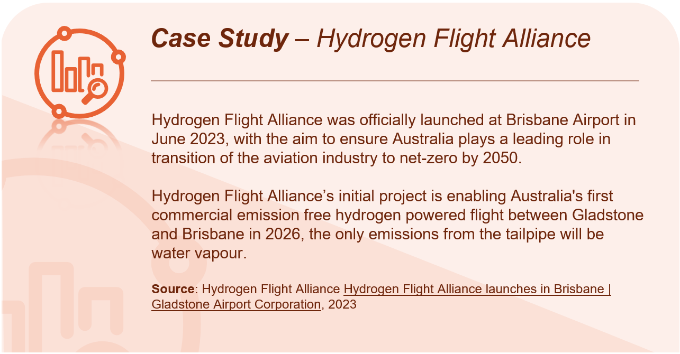Optimise asset deployment – Multiple stakeholders referenced the opportunity to improve service delivery to reduce unnecessary travel, including:
- Improved sector knowledge regarding efficient rostering practices to reduce unnecessary staff travel, suggesting national guides could be provided to support this.
- Improved triaging processes and systems to determine if emergency transport is needed. A stakeholder raised there are too many instances of ambulances being asked to respond to calls when it is not an emergency, resulting in wasted resources and travel emissions.
- Implement efficient fleet management practices such as vehicle sharing, route optimisation, and driver training to reduce fuel consumption and emissions.
- Review demand and service models to reduce ambulance kilometres.
- Public transport – Stakeholders were supportive of investment in public transport across Australia to improve efficiency and reduce the carbon impact travel and transport across the health system. Specific suggestions include:
- Promoting public transport use amongst primary health staff. A NSW Primary Health Network (PHN) stakeholder noted PHNs across Australia are strategically positioned through their connection to GPs, primary healthcare providers, and the community. As such, PHNs can assist the Government in facilitating and commissioning necessary training and development for primary health practices to reduce emissions and change behaviours amongst patients.
- Encourage state and territory governments to offer free public transport options for patients’ families and friends. Hospitals can offer shuttle transport to public transport hubs if these are not within safe walking distance.
- Provide mechanisms and easy to use collaboration channels for staff to carpool to and from work.
- The Strategy should support collaboration between state and territory government, local government, and health services to improve public transport access and incentives for patients, staff, and visitors at existing and new facilities, as well as to other essential services.
- Promotion of public transport should be done in conjunction with state and territory government Transport Departments and may include public health media campaigns and materials, with a particular focus on urban areas with greater access to both transport and doctors.
- Government must prioritise funding to run cleaner, cheaper transport across rural and remote Australia.
- In actioning any of the above, a stakeholder identified the challenges of shift work and public transportation timing. Highlighting the need for targeted work with staff, public transportation services and those who roster shift workers to facilitate public transport use, car-pooling and ride-share services.
- Support and incentives for lower carbon travel – Commentary was provided surrounding the need for support to allow stakeholders to access and adopt existing lower carbon options of travel, particularly for minority or vulnerable groups, and equally implement appropriate disincentives. Some of the examples and further details provided by stakeholders included:
- Review of current policies perceived to be working in conflict with one another, for example, Australian Tax Office tax breaks for novated lease Electric Vehicles (EVs) conflicts with NSW Health Fringe Benefit Tax sharing arrangements.
- People in the disability sector often rely on their cars for transport as public transport sometimes isn’t accessible or appropriate for them. Many can’t afford sustainable transport options such as electric vehicles, this barrier needs to be removed and people supported to invest in low-carbon travel options. Highlighting that less emissions intensive transport system also needs to be a more accessible and affordable one.
- A similar sentiment was provided regarding low-income access to EVs and prioritisation of policy actions to improve this.
- Encourage staff, patients, and visitors to switch to EVs by providing information on incentives, offering charging station access, and possibly implementing preferential parking for electric vehicles.
- Maintain Australia’s restriction of 2.5m on the width of heavy vehicles like buses. This will help stop roads and streets from being made wider which would increase the heat island effect and heat stress, increase particulate pollution from tyres and brakes, and reduce space for active travel and trees.
- Implement disincentives for people to choose personal use motor vehicles such as reducing the paved surface area for onsite carparks.
- Introduce an employee car purchasing scheme for people who work in private and public health to provide access to fleet discounts for EVs.
      - Improving infrastructure and enablers/supports for low-carbon travel
- Active transport infrastructure and services – Stakeholders emphasised the need for facilities and infrastructure to support active transport, including:
- Provide funding and rapid roll out of extensive active transport infrastructure to address health and climate policy objectives, noting that the four largest capital cities (Sydney, Melbourne, Brisbane, Perth) all have large cycling networks listed on Infrastructure Australia’s Infrastructure Priority List. This could be funded by the Australian Government in partnership with state and local governments.
- The National Obesity Strategy recognises that when access to physical activity opportunities is convenient, affordable, and safe, people are more likely to be active in their everyday lives. Active travel can be impacted by perceived amenity as well as safety concerns. Related to this, ensure adequate end of trip facilities accessible to facility staff and visitors.
- Best practice design rules will help make streets safe (and feel safe) for all users, including those using active travel – but they must be implemented consistently on new and re-built streets and roads and adapted for quickly upgrading all existing streets and roads.
- Establish a rapid formal review of state transport legislation, policies and programs that make walking and cycling less safe and convenient than driving (e.g., urban speed limits, right of way, liability, enforcement). Then tie Australian Government transport funding to immediate reform of these.
- Join the global campaign championed by the United Nations and World Health Organization (WHO) and shift the default speed limit in Australia to 30 km/h, the evidence-based maximum default safe speed, to remove barriers to people adopting active transport options.
- Electric vehicle charging infrastructure – Stakeholders emphasised that for EVs to be a viable transport option for patients, staff and facilities, further investment in supporting infrastructure is needed. Stakeholders provided the following considerations and suggested actions:
- Install EV charging stations within healthcare facility parking areas to support the adoption of electric vehicles.
- Invest in battery technology to improve resilience of fleets, assist EV charging, and use EVs as batteries.
- State and territory governments should be responsible for ensuring adequate infrastructure is provided to support low-carbon travel options into the future and supported by the Commonwealth government guidelines and funding.
- Ensure new building design and standards include adequate planning for infrastructure that supports the transition to net zero. For example, include charging stations in ambulance stations even if the fleet is not electric yet as in the future they should be and this will support reduction of travel emissions.
- Government should support relationships between medical colleges and Australian EV charging network providers to support EV uptake by clinicians
    - Prevention and optimising models of care
Questions from Consultation Paper
Q14 | Which specific action areas should be considered relating to prevention and optimising models of care, over and above any existing policies or initiatives in this area?
Q18 | What health impacts, risks and vulnerabilities should be prioritised for adaptation action through the Strategy? What process or methodology should be adopted to prioritise impacts, risks and vulnerabilities for adaptation action?
      - Incentives for models of care
- Reduce low-value care – Most stakeholders reflected on the need to reduce incentives for unnecessary medical interventions known as low-value care, and proposed a variety of actions:
- Investment in cultural change programs that target clinician behaviour towards reducing low-value, unnecessary medical procedures or testing. For example, unnecessary biopsies or specimen tests generate waste and CO₂. Some stakeholders noted that many tests are ordered out of habit or fear of consequences from senior colleagues or litigation.
- As multi-disciplinary care becomes embedded, improving clinician access to My Health Record and other digital health records to avoid unnecessary or duplicative tests.
- Explore financial incentives and financing options to support private providers in implementing emission reduction measures. This can include grants, tax incentives, or low-interest loans specifically targeted at sustainable healthcare initiatives. Partner with financial institutions to develop innovative financing models that facilitate investment in energy-efficient infrastructure and technologies.
- Either eliminate financial incentives for over-servicing, and/or provide financial incentives to avoid low-value, high-carbon healthcare.
- Incentives or support mechanisms to involve private providers in emissions reduction efforts should be made available to all health providers.
- One large private hospital provider identified the need for the Australian Government consider incentives to support the uptake of digitisation within the private healthcare system, such as tax incentives or budgetary measures to support investment.
- Non-financial incentives: Some stakeholders also referred to a need to provide resourcing to peak bodies, training colleges and other key stakeholder groups to support the transition of the primary care sector to lower carbon models of care.
      - New or changed models of care
- Prevention as mitigation – Most stakeholders referenced the role of prevention and health promotion as an important mitigation strategy.
- Optimising models of care requires a focus on value-based care approaches that prioritises outcomes that matter to people and communities against the costs of achieving those outcomes across the health treatment pathway.
- Stakeholders felt that increasing investment in preventative health, including public health campaigns, will improve health outcomes and reduce avoidable hospitalisations which are emission-intensive.
- Reduce the need for high resource use interventions (such as emergency air retrieval and/or avoidable hospitalisations) by ensuring timely access to local, preventive, and primary care and related services.
- Vulnerable cohorts – Most stakeholders raised the importance of implementing prevention strategies for vulnerable cohorts, including older people, and those living in rural and remote areas. Specific preventive actions referenced by stakeholders included:
- Developing nuanced health messaging for vulnerable cohorts that place them at higher risk during heatwaves or other climate events, such as those with specific health conditions like asthma and older Australians.
- A First Nations academic institution recommended the establishment of First Nations-led community healing centres that can support whole communities before, during and after times of crisis, such floods or fires. These centres would provide safe places for whole communities in easily accessible and safe locations. For example, the Northern Rivers Community Healing Hub played a key role in supporting the local community after the recent floods.
- Models of care – Developing and standardising models of care that are environmentally sustainable would significantly improve emissions reduction. Stakeholders provided the following ideas to contribute to emissions reduction:
- Expanding Hospital in the Home services and decentralising healthcare away from tertiary centres by adequately resourcing local health facilities to deliver appropriate care closer to home.
- Increase the focus on community care which can reduce the pressure on hospitals, increases patient choice and satisfaction, and have low-carbon advantages. Implementing these models require clinical governance, assessment, and monitoring.
- Embrace digital healthcare solutions. For example, reduce travel emissions and reduce paper waste by promoting electronic processes for patient medical records, prescriptions, data collection and communication.
- Strengthen disease surveillance systems to detect and respond to climate-sensitive diseases, such as vector-borne and waterborne diseases. This includes improving data collection, analysis, and reporting mechanisms, enhancing communication channels between health authorities, and integrating climate and environmental data into surveillance systems for early detection and response.
- Many stakeholders made positive reference to a previously funded MedicineWise initiative, Choosing Wisely, which focused on supporting prescriber decisions and reducing low-value care.
      - New healthcare technology
- Health Technology Assessments – Multiple stakeholders referenced Health Technology Assessments (HTAs) within their written submissions, both as an area which needed reform to ensure environmental impact was a measurement factor and as an avenue to mandate the emission measurement and reporting, specifically:
- Stakeholders highlighted how existing health technology assessment bodies (Therapeutic Goods Administration (TGA), Medical Services Advisory Committee (MSAC), Pharmaceutical Benefits Advisory Committee (PBAC)) could be used to mandate the measurement and reporting of emissions for new and existing healthcare technology. For example, implementing an Environmental Product Declaration.
- HTAs can also support health system sustainability. Stakeholders referenced the opportunity to incentivise the pace at which sustainability innovations are adopted into models of care, for example, through modifications to existing evaluation frameworks to include consideration of societal impact (including environmental aspects) of medical technology introduced into the health system.
- Activity level emission monitoring and product level measurement should be a focus.
- The Strategy should commit to ensuring HTAs consider carbon emissions. Currently, these assessments focus on measuring the economic cost of new pharmaceuticals, medical devices, or model of care.
- It was suggested the Strategy should consider proposing similar commitments to that of the UKs National Institute for Health and Care Excellence, to signal the measurement and capture of environmental impact of healthcare is a national priority.
- Leverage existing technology to improve access and reduce emissions – Most stakeholders identified the need to improve the use of technology to facilitate access to care, particularly those living in rural and remote areas, and reduce reliance on travel to health services, both of which contribute to emissions. Specific strategies include:
- 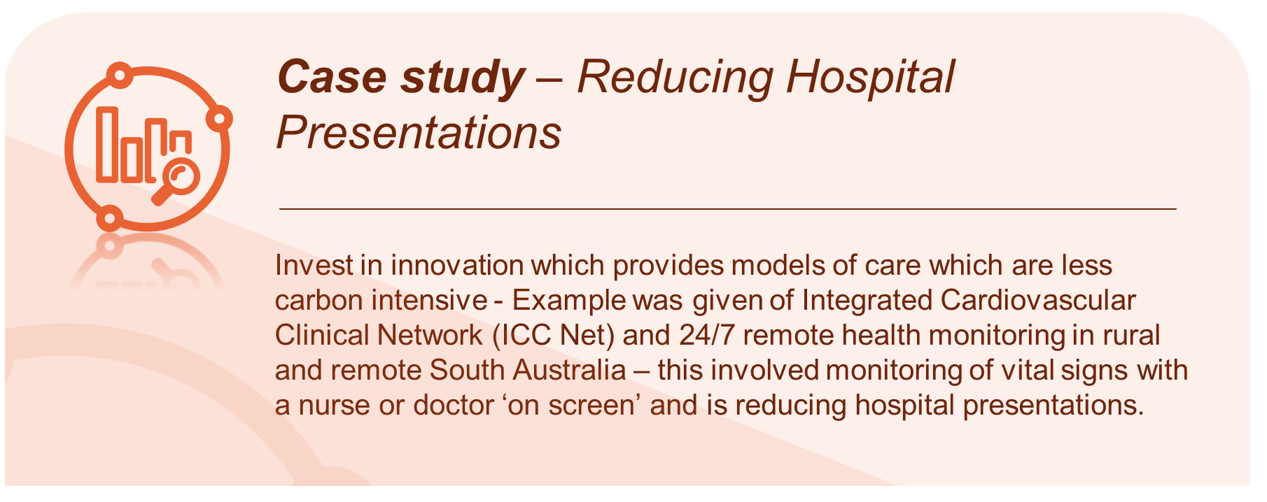Expand the availability and use of telehealth services to reduce the need for in-person visits and associated carbon emissions from patient travel as well as improve access to healthcare. Provide training and support to healthcare providers to enable efficient and effective delivery of telehealth services. Stakeholders indicated there is a need for appropriate telehealth item numbers (including for phone consultations) which should be permanently embedded in the Medicare Benefits Schedule.
- Some stakeholders recommended measuring unnecessary staff and patient travel associated activities such as testing and screening and discussion of test results which could be replaced with telehealth rather than face-to-face appointments.
- Some stakeholders cautioned that while telehealth has the potential to reduce emissions, the real-time monitoring, operations of smart devices, and data storage in power data centres, also use energy and produce emissions.
- A medical peak body indicated that public hospital communication and links with general practitioners should be improved to minimise patient travel to large hospital centres by having care through their local general practice.
- Building interoperability into the design of all healthcare software and clinical information systems will reduce administrative burden for healthcare workers. By extension this will improve healthcare worker satisfaction, create system efficiencies, and reduce low-value care. Fostering integrated team-based care supported by shared data systems can also act to reduce transport emissions though reducing the need for patients to travel to multiple appointments across diverse locations.
- Adopt artificial intelligence and new technologies – Several stakeholders described how artificial intelligence and other new technologies could be used to reduce carbon emissions from low-value care and travel. Suggestions included:
- The emergence of artificial intelligence options for autonomous analysis and reporting on tests could support carbon reduction initiatives and improve patient outcomes. It was suggested that there should be further exploration of how predictive artificial intelligence could also support a reduction in low-value care.
- Consider the role of artificial intelligence to augment the reach of virtual telehealth meetings for staff, patients and their families; for example, through automated scheduling of check-ins.
- Artificial intelligence remote monitoring, wearables and other technology should be introduced to give consumers the technology to manage their own health and reduce burden on our physical health systems. The Department and the Aged Care Quality and Safety Commission could lead this work.
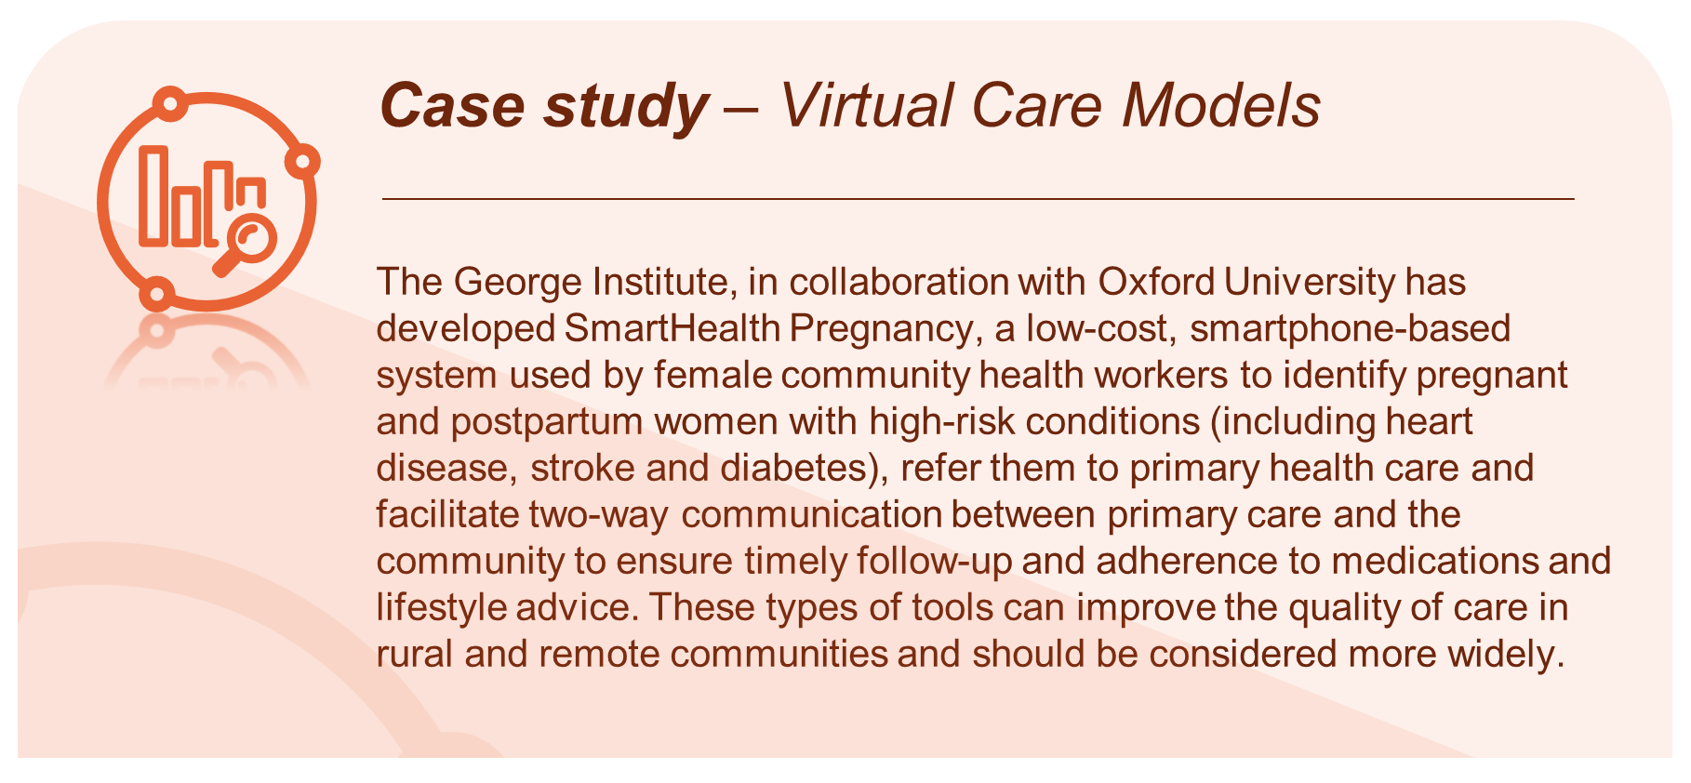
      - Local community partnerships engagement and communication
- Collaboration and engagement – Collaborate with existing Indigenous governance bodies at national, regional, and local levels. This can include partnerships with Indigenous Health Leadership Councils, Land Councils, and other representative bodies. By working closely with these entities, the Strategy can ensure that Indigenous governance structures are respected, and decision-making processes are guided by Indigenous principles and protocols.
- Awareness raising and planning – Stakeholders offered a range of actions to support awareness raising, engagement and planning for climate change and its impacts. This includes the following:
- Undertake place-based assessments of suitability of social and affordable housing relating to heat pressures, specifically for people with disability and prioritised based on their location in Australia.
- Identify and decide on whether to close or withdraw services which will no longer be viable in climate or location.
- Raise awareness among healthcare professionals, patients, and the public regarding the environmental impact of medications and the importance of sustainable medication practices. This can be through public health campaigns and education programs.
- Increase health literacy so communities and individuals can understand the complex relationship between climate change and human health.
- Establish communities of practice that engage with health professionals across the health system, including private providers to encourage climate health adaptation.
- Improve collaboration between primary care providers and acute care providers.
- Incorporate findings from previous reviews and draw on local initiatives. A key example in the NT is the ranger programs now rolling out across many communities to protect country and culture. Ranger programs draw on cultural and community knowledge as well as Western scientific expertise. Ranger programs can contribute to both mitigation of climate change (through burning to protect against uncontrolled bushfires and protecting habitat) and adaption (through environmental restoration and protection of vulnerable fauna and flora that are being impacted by climate change).
    - Medicine and gases
Questions from Consultation Paper
Q12 | Which specific action areas should be considered relating to medicines and gases, over and above any existing policies or initiatives in this area?

Stakeholders shared detailed actions and avenues to reduce usage, wastage and leakage associated with various medicines and gases, highlighting the need for reform to change behaviours and incentivise lower carbon choices.
      - Reducing gas usage, wastage, and leakage
- Reduce usage – Stakeholders acknowledged the substantial decrease in the use of gases in the last few years however they noted there is still significant progress to be made. The following comments were provided:
- Encourage midwives, obstetricians, anaesthetists, and patients to consider ways to reduce nitrous oxide use in birthing, noting that nitrous oxide is not a particularly effective labour analgesic.
- Reduce the use and or ban the use of desflurane, as both the England and Scotland NHS have done. There was overwhelming support for the phase out and ultimately prohibiting the use of desflurane due to the significant emissions impact. Numerous Australian health services identified as having successfully implemented elimination plans.
- It was noted there is ongoing uncertainty as to whether bottled nitrous oxide has fewer fugitive emissions than piped alternatives. Stakeholders called for for further evidence and analysis to support adopting a low emissions option.
- Educate clinicians, prescribers, and anaesthetists on the carbon footprint of medicines and gases and encourage use of less environmentally damaging options where possible.
- Where necessary to prescribe, provide guidance on techniques to minimise waste and optimise dosing. There is space for both government and specialty College-based educational campaigns, promoted by the Strategy.
- It was noted that the Australian Commission for Safety and Quality in Health Care has drafted a Sustainable Healthcare Module that has recently undergone public consultation. This will become mandatory in the coming years.
- Nationwide campaigns are needed to support community education and awareness regarding prescribing of inhalers and what is deemed environmentally sustainable, stakeholders viewed consumers playing an integral role in use reduction. Noting, it will be important to consider unintended consequences, such as patients feeling guilt and denying treatment if they need a therapeutic with a higher environmental impact.
- Actively support the move away from pressurised metered dose inhalers – there are effective alternatives at every level for all patients able to use one. It was suggested, to transition to low-carbon inhaler use in community and healthcare settings.
- Stakeholders representing consumers with chronic asthma and lung disease raised a concern that actions proposed in the Consultation Paper regarding reducing dispensing and prescribing of pressurised metered dose inhalers does not recognise the need to consult with people with asthma, their carers, or peak bodies. Instead, it focuses on primary care providers, suggesting a top-down approach, rather than a consumer-centred approach.
- Governance surrounding use of medicines and gases could be strengthened – this could be owned by the Australian Commission on Safety and Quality in Health Care.
Strategies and reform identified to support this are further discussed in the following section Medicine and gas regulation and policy.
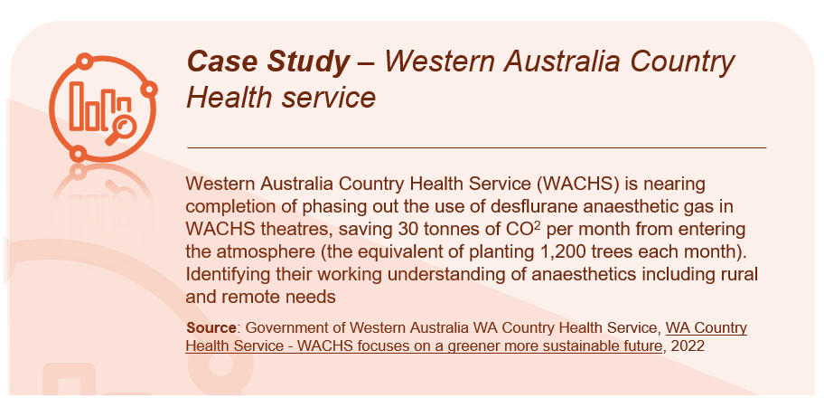
- Reducing gas leakage – Many stakeholders highlighted the significant component of emissions from healthcare usage of nitrous oxide, which is associated with gas leakage of piped systems, compared, its clinical use in obstetric pain relief, dentistry, and anaesthesia. Many called for reform and action to address this:
- Encourage all new hospitals (except for obstetric and paediatric services) to avoid the installation of piped nitrous oxide. Stakeholders raised this is being promulgated from 2023 by the Australian Health Facility Guidelines where piped nitrous oxide is not a required standard.
- Mandate nitrous oxide infrastructure management plans and national audits to ensure adequate monitoring, detection, and mitigation of leaks from the manifolds, outlets, or pipes.
- Develop targets for hospitals with existing nitrous piped systems to work towards upgrading their nitrous oxide infrastructure to reduce leakage.
- Develop a plan to progressively decommission nitrous piped systems in existing facilities and as a priority move to cylinder supply of nitrous.
- Review of nitrous oxide stock management guidelines and practices and security.
- Reducing gas wastage – Stakeholders commented that effort should be placed on reducing wastage associated with unused and discarded gas cylinders and inhalers. Suggestions include:
- Bulk nitrous oxide for hospital use is supplied in large cylinders, these are returned to suppliers with significant residual nitrous oxide as they cannot be fully emptied on the hospital manifolds due to pressure reduction in the cylinders. There is concern in the sector regarding a lack of assurance or verification from major suppliers of bulk nitrous oxide regarding the treatment of the remaining nitrous oxide. There must be changes to legislation to mandate this residual cylinder gas is captured and re-cycled and prevent major suppliers from venting residual cylinder gas to atmosphere.
- One stakeholder representing consumers who have chronic asthma suggested piloting inhaler recycling, whereby unused gases from inhalers can be captured and reused.
- Further investigation and research are needed into the lifespan of inhalers.
- Promote anaesthetic gas capture and recycling, the technology now exists to capture and recycle both sevoflurane and desflurane.
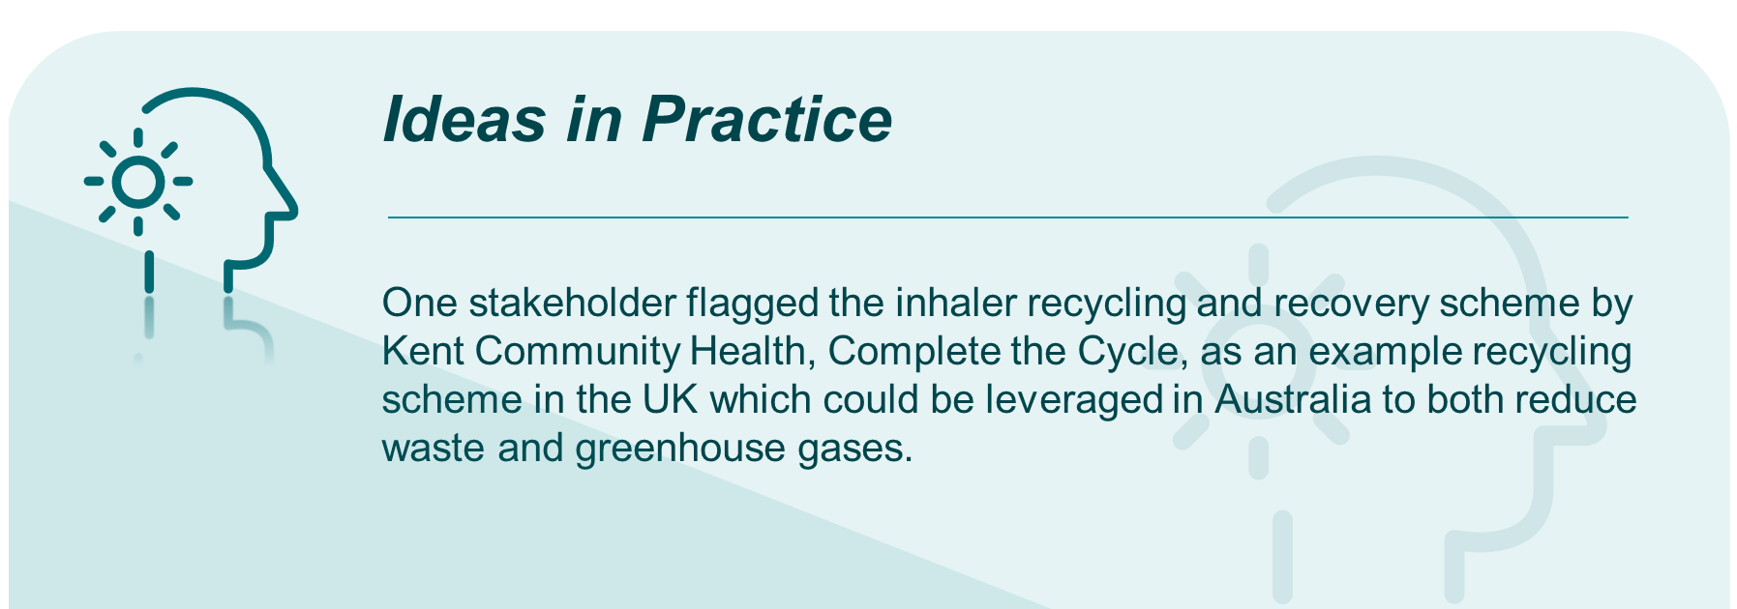
      - Medicine and gas regulation and policy
- Medicare Benefits Schedule (MBS) linkage – environmental considerations should be included in the MBS – it was proposed that the considerations of Medical Services Advisory Committee should take into consideration the environmental impact.
- Pharmaceutical Benefits Scheme (PBS) incentives – Many stakeholders highlighted the opportunity for the PBS to better align with the Strategy by providing benefits or subsidies for prescription options that are “greener” in terms of carbon footprint. Some stakeholders provided examples of how this could work in practice:
- Preferencing the use of dry powder inhalers over pressurised metered dose inhalers by changing the current PBS restrictions to only prescribing pressurised metered dose inhalers when there is a need or via authority prescriptions. This would encourage prescribers commencing patients on a new inhaler to first try the more environmentally-friendly device.
- Specifically, a stakeholder noted a need for PBS reform rulings regarding the use for terbutaline dry powder inhalers (e.g Bricanyl) which are currently a restricted item and not easily prescribed unless the clinician assesses that a patient cannot coordinate an inhaler. However, a salbutamol metered dose inhaler is more carbon intensive than terbutaline.
- Some stakeholders viewed there should be no changes for patients who are already stable on a device that they can use, and from which they derive efficacy in prevention/relief of respiratory/asthma symptoms.
- Research into which patients clearly benefit from metered dose inhalers rather than dry powder inhalers should be incentivised. In addition, research into alternative propellants or delivery systems should be prioritised.
- The Department should announce a roadmap for delisting pressurised metered dose inhalers from the PBS.
- Other mechanisms and incentives – stakeholders provided additional suggestions regarding avenues to incentivise reduction and elimination of high emission medicine and gas practices, including:
- The Australian Government should leverage health system funding agreements with state and territory governments to work towards reduction and phase out of high emissions gases.
- Explore the development of ‘green tick’ (or some other accredited indication) displaying the carbon impact of prescribing decisions for example, sustainable anaesthetics choices, the use of sustainable medications and prescriptions in primary care (an example is the use of medical gases in anaesthesia or the use of metered dose inhalers in the management of asthma).
- Include a requirement in the upcoming National Safety and Quality Health Service (NSQHS) Standards Sustainable Healthcare module for hospitals to be actively engaged in reducing their emissions associated with anaesthetic gases, inhalers, low-value prescribing and medication waste management.
- Prescribing software should have warnings added regarding environmental harms and suggest alternative options.
- The Department to work with medicines sponsors/manufacturers to address barriers that prevent the introduction of low-carbon products into the Australian market and use of low-carbon propellants in inhalers. For example, salbutamol dry powder inhalers are available in countries other than Australia.
      - Other considerations related to medicine and gases
- Some stakeholders expressed the Consultation Paper should have a broader focus on relevant medicines and gases, including:
- A focus on all therapeutics, with medicines and gases a priority.
- Expand and investigate the carbon footprint of pharmaceuticals.
- Review and where possible reduce/eliminate use of Sulphur Hexafluoride out of healthcare.
- A medical association stakeholder group called for a policy on iodinated contrast media, a substance used to delineate vessels and organs in diagnostic imaging examinations and radiotherapy planning - iodine is a carbon intensive and finite resource.
- A stakeholder also referenced the need for a specific target for phasing out natural gas from clinical settings. Besides its climate impacts, health impact assessments have identified indoor natural gas devices as posing a health risk.
- It was noted the production of oxygen has an environmental footprint, advising a more scientifically sound or optimised approach to the use of oxygen in healthcare would aid in reducing associated emissions. Highlighting that medical oxygen flow meters should be turned off when not in use to minimise waste.
    - Waste
Questions from Consultation Paper
Q13 | Which specific action areas should be considered relating to waste, over and above any existing policies or initiatives in this area?
Stakeholders shared a range of views on how waste can better mitigate the impacts of climate change. The ideas that emerged from consultations focused around reducing waste from production, and recycling and reuse of materials.
      - Reducing waste
- Single use products – Many stakeholders highlighted the high prevalence of single-use items in healthcare. Many called for reform in this area:
- Where infection control is not necessary, re-usable products should replace single-use products.
- Where single-use items are necessary, hospitals and procurement teams should require a minimum proportion of single-use product packaging be from recycled materials. It was suggested up to 50% recycled materials for single-use product packaging.
- Suppliers, manufacturers, and end users should all consider the entire product lifecycle for single-use products.
- Single-use products identified for transition to re-usable products include cups, straws, packaging materials, scissors, forceps in suture packs made of steel, surgical drapes, cold gel packs, gowns, and personal protective equipment. It was highlighted that care must be taken that the re-use process does not generate more waste than single-use products.
- The Department and state and territory health services should work with industry to move to re-usable products. The cost to implement these strategies should be considered.
- Most stakeholders recognised the increased focus on infection control since the emergence of COVID-19. It was widely reported that this focus has increased waste across health and aged care settings. Many called for action to be taken to reduce waste resulting from infection control, particularly through changes to the culture around single-use products.
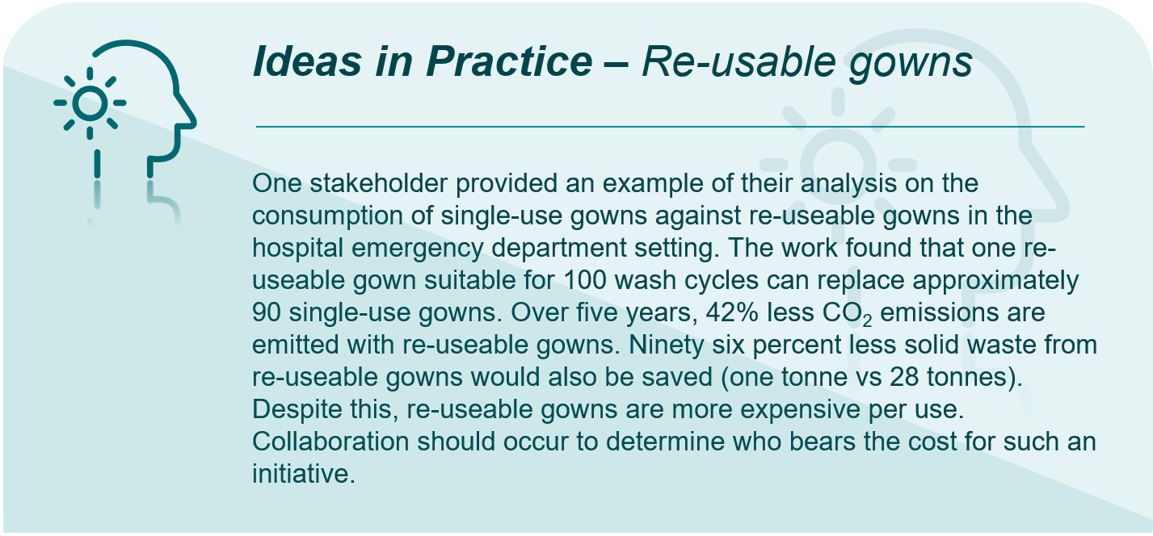
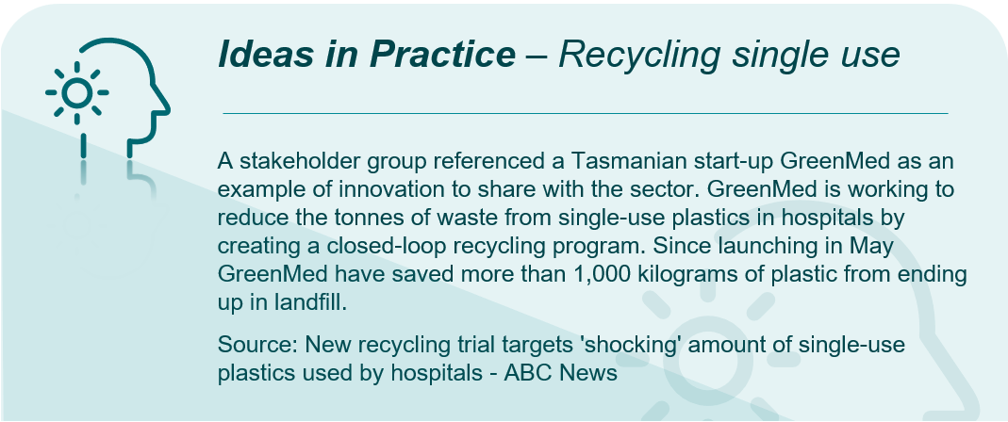
- Food waste – Many stakeholders recognised the large contribution food plays to overall wastage in healthcare – particularly in hospitals and residential aged care facilities. They stressed the need to divert food from landfill and find ways to reduce consumption of foods that create methane gas:
- Sustainable patient food choices should be promoted by health and residential aged care facilities who should source food locally.
- Health and residential aged care facilities can introduce demand-based ordering to minimise over-preparing and over-production of food and beverages.
- All health and residential aged care facilities should introduce composting programs for food and other organic waste. This may require partnerships with suitably resourced organisations. Facility staff should be educated on appropriate segregation of organic waste.
- Some suggestions were made that composting is the final step in food waste reduction. First, health and residential aged care facilities must consider reusing food scraps from preparation, donating food scraps to food recovery organisations, diverting food waste for animal feed, and using food waste for anaerobic energy production. Industry partnerships would be needed to achieve this.
- Food services in hospitals should complete regular aggregate food waste audits. These should measure food and food-related waste such as food packaging and plastic cutlery. Before mealtime (preparation waste) and after mealtime (plate waste), and waste from the plating line should be included. Where possible, auditing should occur over 14 days so that data is collected over a time series and not a single snapshot in time. This is seen by stakeholders as a key measure to reducing food waste.
- It was noted that an Australian National Food Wastage Roadmap exists that the Department can draw on for further approaches to reducing food waste.
- Stakeholders asserted that bioenzymes can be used to accelerate the decomposition of organic waste like food scraps and other biodegradable materials in health and residential aged care facilities. By breaking down waste more efficiently, bioenzymes can help reduce the production of methane.
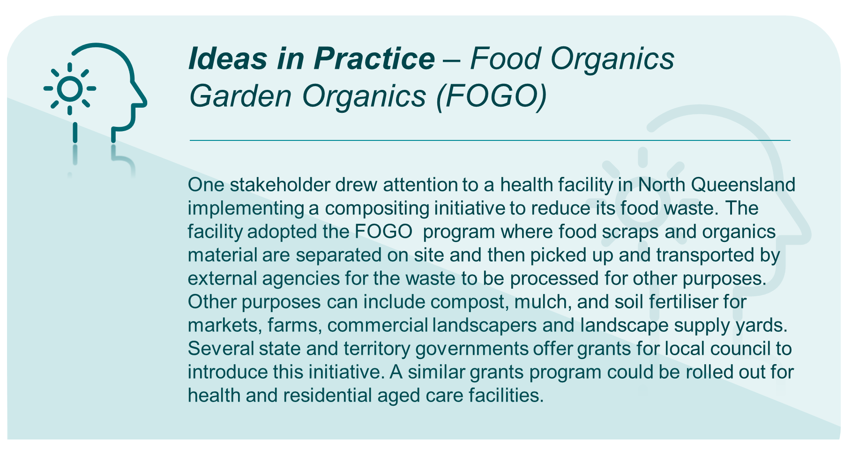
- Medicine and health product packaging – Many stakeholders supported changes to packaging of medical and health products. Specific suggestions include:
- The Department and health services should work with suppliers to explore packaging alternatives to reduce the use of plastic in medical supplies and equipment. Packaging standards also need to be developed and applied across the healthcare and residential aged care sectors. This should include reduced plastic wrap for freight.
- Many stakeholders called for the Department to work with the TGA to review packaging and information requirements for medicines to reduce packaging waste. For example, medication bottles are often partially filled. Reform could occur here to optimise bottle size and reduce packaging materials.
- Incentives could be designed to encourage consumers to return medication bottles to pharmacies for decontamination and reuse. It was suggested some of this responsibility could fall to pharmaceutical companies.
- Health and residential aged care facilities should encourage suppliers to minimise packaging, use recycled and recyclable materials through procurement processes.
- Stakeholders highlighted that the Australian Packaging Covenant Organisation has released a target of 100% recyclable packaging by 2025. While driving innovation, this target is not being achieved in health and aged care. A longer-term vision and better coordination and collaboration around essential packaging material streams are needed.
- Stakeholders repeatedly referenced the Choosing Wisely Australia® initiative that partners with Australia's health professional colleges, societies, and associations to have conversations about tests, treatments, and procedures where evidence shows they provide no benefit or, in some cases, lead to harm. An increasing number of quality improvement projects and activities are underway across the country that are building capacity for the spread and scale of Choosing Wisely. These projects are locally led and adapted to address issues that are a priority for that setting. Implementation is supported by a growing array of toolkits that are available.
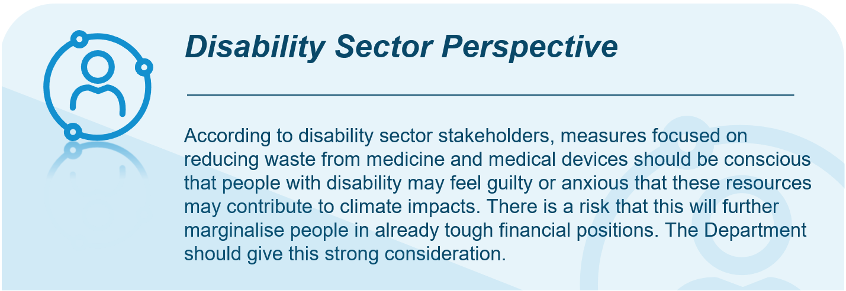
- Dispensing practices – Stakeholders generally agreed that there is a culture of over-dispensing across Australia’s health and aged care systems. Some stakeholders representing the views of professionals in the pharmaceutical industry and other groups provided further commentary in this area:
- The Department should use policy levers and collaborate with industry to reduce over-prescribing and dispensing. Surplus prescribing leads to stockpiling and expiry of unused medicine that need to be disposed of. The practice of providing medicine samples that are often not used should also be reviewed. The right levers can help change prescribing and dispensing culture.
- Data generated from technology solutions such as automated dispensing cabinets and dispensing robots can be used to reduce medication wastage at a ward or hospital-wide level. Bespoke software programs may be used to present the data in a form that is understandable to pharmacy staff and hospital stakeholders. Reports from these data can be used proactively to reduce waste.
- Nicotine vaping products accessible via medical prescription and pharmacies should be disposed of correctly to avoid environmental harms. The Department and state and territory health services should develop a wastage plan for nicotine vaping products.
- Regulatory agencies should develop national evidence-based protocols for administration of medicines that support reducing waste, such as oral use over intravenous use where clinically indicated.
      - Recycling and reusing
- Recycling literacy and capacity – Many stakeholders highlighted that awareness of correct recycling and re-use practice is needed to help reduce waste. This applies to the entire health and aged care systems, including clinicians, providers, and patients. Stakeholders reported that more policy and legislative action is needed to embed recycling and re-use at all levels. The following was raised:
- The Department, industry and state and territory health services should develop and deliver education campaigns and informative materials for staff, patients and visitors on correct recycling and re-use practice, such as correct segregation.
- Health and residential aged care facilities need support to build recycling and re-use space.
- Minimising co-mingling of waste – Stakeholders commented that effort should be placed on reducing the prevalence of waste co-mingling. Some stakeholders provided details on how they would like to see this work in practice:
- Hospitals and residential aged care facilities should be designed and modified to include more appropriate dock space and utility rooms to facilitate better processing of multiple waste streams. In particular, dock space requires more room for balers and baled product storage, or additional compactors. Facilities should develop approaches to reducing dock traffic.
- Currently, common approaches to reducing co-mingling focus on bulk science waste. A more holistic approach to reducing co-mingling should be taken.
- Mandating sector-wide requirements for recycling practices – Stakeholders generally agreed that there should be mandated recycling requirements in the health and aged care sectors. Targets can leverage existing programs and policies initiated by state and territory health services, and the Commonwealth Government. Some stakeholders further expanded on this, including:
- The Department should establish clear recycling targets, reporting pathways and requirements across the National healthcare system for everything that has recycling potential.
- While some stakeholders advocated for mandatory recycling targets, others suggested that private industry should self-regulate with government support.
- Specific approaches – Several stakeholders provided specific approaches that could be undertaken to work towards better recycling and re-use practices. Key ideas included:
- New and existing “take back” programs can be leveraged to encourage recycling and re-use. This can be further supported through the development of levers in the procurement process. One stakeholder provided an example of a private hospital provider recycling PVC IV bags and masks by handing back to a specialist recycling firm.
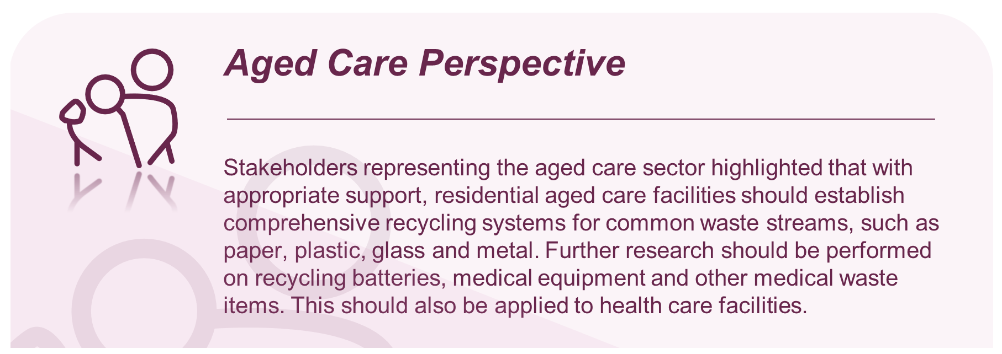
- Asset sharing should be encouraged between LHNs and charities. One LHN highlighted its work repurposing internal assets and streamlining medical donations to external charities through an online marketplace. The marketplace has created a seamless and efficient way of repurposing.
- One stakeholder representing consumers who have chronic asthma suggested piloting inhaler recycling. This is discussed further in Medicine and gases.
- There should be increased awareness on how to recycle in-home consumables such as aids for people with disability.
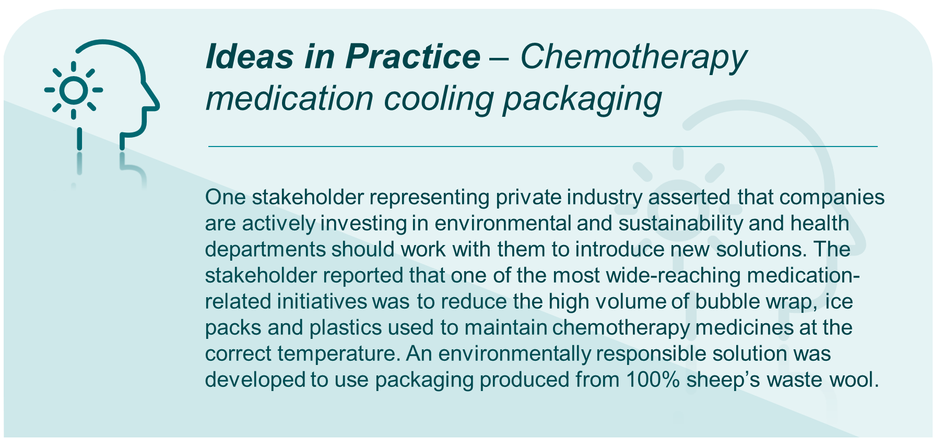
- Consideration could be given to applying antibiotic and opioid stewardship models to other medicines to reduce over-prescription and reviewing validity of use-by dates to reduce waste.
- Fund local incineration and recycling facilities to limit the transport of pharmaceutical and contaminated waste.
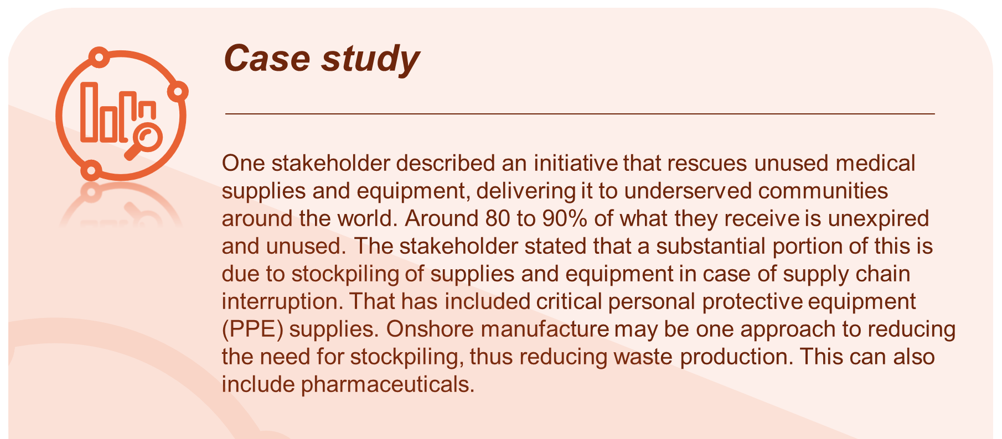
    - Supply chain
Questions from Consultation Paper
Q11 | Which specific action areas should be considered relating to supply chain, over and above any existing policies or initiatives in this area?
Q18 | What health impacts, risks and vulnerabilities should be prioritised for adaptation action through the Strategy? What process or methodology should be adopted to prioritise impacts, risks and vulnerabilities for adaptation action?
The supply chain in the health and aged care sectors involves the planning, sourcing, manufacturing, delivery and disposal of medical supplies, equipment, pharmaceuticals, and other resources needed to support care delivery. There are many opportunities to reduce the impact of these processes on climate change. Stakeholders focused suggestions around four key areas, including reducing supplier impact, supply chain governance and regulation, manufacturing and supply chain incentives, and critical resource security.
      - Reducing supplier climate impact
- Product stewardship and circular economy – Many stakeholders highlighted the need for the health and aged care sectors to adopt product stewardship and circular economy principles. Stakeholders perceived that design, production, importation, selling, use and disposal of health and aged care products is a shared responsibility of all involved. The following was raised:
- Increasing the transparency of supply chains is important. A greater understanding of the complexity, resilience and vulnerability by end users could produce better resource stewardship. Currently, the end user bears too much responsibility for sustainable processing and disposal of products. Building the cost of sustainable product lifecycle management into product stewardship will help consumers make informed choices.
- The Department should work with the broader Commonwealth Government to introduce new product stewardship legislation to embed this practice more deeply into health and aged care. A stakeholder suggested one option could be to legislate that medicines and consumables report their emissions impact and give consumers a choice to pick a lower carbon option. This will work towards changing supplier behaviour as more consumers elect for more sustainable options.
- The substantial purchasing power of health services and providers was emphasised by stakeholders. This power can be leveraged to encourage adoption of product stewardship and circular economy by requiring demonstration of these principles as a component of procurement. Additionally, greater weight should be given to suppliers that demonstrate more robust product stewardship and circular economy practices.
- It was suggested expanding the health and aged care products on the Minister’s Priority List for product stewardship. It was noted that plastics have recently been added to this list.
- Industry-wide reform should occur in collaboration with the Department to align product design with circular economy principles. This will embed sustainability into the product lifecycle.
- The Department should encourage the health and aged care systems to adopt a circular economy approach through 'buy local' procurement and promotion of reusing and redistributing resources (including furniture, information and communications technology equipment, and medical equipment).
- Baseline data collection of supplier climate impact – Many stakeholders stressed the importance of establishing an evidence-based starting point for measuring and tracking the environmental performance of suppliers. Approaches suggested by stakeholders include:
- The Department should establish the mechanisms required for collecting baseline emissions data from suppliers. These emissions can be monitored, and suppliers should regularly report progress against reduction targets. These data can also be used to identify “emission hotspots” and prioritise areas for action accordingly.
- Some stakeholders asserted that a standardised international method for assessing the quantifiable effects on the environment of a service or product from the extraction of materials up to the end-of-life. Lifecycle assessments provide a common basis for consistent, robust, and quality-assured lifecycle data, methods, and assessments. The outcomes of these eco-design programs may include new packaging options that no longer include hard-to-recycle materials, such as blister packs, a shift to recycled or more easily recyclable materials, and a reduction in overall packaging size and weight.
- Reducing need for cold chain medicines – Some stakeholders highlighted Australia’s heavy reliance on medicines requiring cold chain transportation. Better inventory management was recommended to minimise cold chain transportation and exploring shared distribution networks or centralised hubs for improved efficiency. The Department and state and territory health services should collaborate with logistics providers and suppliers to identify opportunities for efficiency improvements. It was recognised that better cold chain practices will reduce spoilage and waste.
      - Supply chain governance and regulation
- Sustainable procurement practices – Numerous stakeholders called for policies and regulation that will lead to adoption of more sustainable procurement practices. It was noted that the WHO recommends governments influence suppliers to adopt sustainable supply chain processes; however, views on the approach to achieving this is varied. While most stakeholders advocated for mandatory procurement requirements, others expressed that regulation should be minimal and sustainable practices should instead be encouraged through incentives. Discussion from stakeholders included:
- Strong support was generally noted on mandated nationally consistent procurement standards. Purchasing agents should consider factors such as energy efficiency, recycled content, and carbon footprint when making purchasing decisions. Supplier assessments for environmental sustainability should regularly be conducted and follow a standard framework. Procurement standards may also minimise anti-competition market effects.
- Mandatory measurement and reporting were recommended for private sector emissions. This stakeholder held the view that private providers will not shift behaviour without policy change.
- To support changing procurement practices, suppliers should be more transparent with information on sustainable procurement practices
- Some stakeholders asserted that regulation of procurement practices could impact the competitiveness of private industry and act as a disincentive. It was viewed that stakeholders may respond better to training and incentives that reward industry for sustainable procurement practices.
- Several stakeholders suggested that Australia looks to the NHS and to the UN’s Sustainable Procurement Plan for guidance of supply chain governance and regulation. They cited several actions from the NHS’s Net Zero Roadmap (which were also described in the Consultation Paper), including:
    - From April 2022: all NHS procurements will include a minimum 10% net zero and social value weighting.
    - From April 2023, all NHS contracts over £5 million require suppliers to publish an emissions reduction plan for scope 1, scope 2 and a subset of scope 3 emissions. From April 2024, this requirement will be extended to cover all procurements irrespective of value.
    - From April 2027, all NHS suppliers will be required to publish targets and emissions for all emissions in scope of the NHS net zero commitment – including those produced internationally.
    - From April 2028: new requirements will be introduced overseeing the provision of carbon foot printing for individual products supplied to the NHS. The NHS will work with suppliers and regulators to determine the scope and methodology.
    - From 2030: suppliers will only be able to qualify for NHS contracts if they can demonstrate their progress through published progress reports and continued carbon emissions reporting through the Evergreen sustainable supplier assessment.
      - Manufacturing and supply chain incentives
- General discussion on manufacturing and supply chain incentives – There was broad stakeholder sentiment that incentives will be important for adopting environmentally-sustainable behaviours. Stakeholders described was these incentives could be including:
- Specific incentives that may have a substantial impact on manufacturer and supplier behaviour could include those targeting solar panel manufacturing and energy agreements with 100% renewable energy wholesalers.
- Governments should consider approaches to incentivise public health and aged care providers and industry to pay a premium for products that come in multi-packs or with a lower carbon footprint, backed by lifecycle assessments tracing back to the third supplier.
- Governments should look at where cost barriers are prohibiting the uptake of climate-friendly practices and target these areas.
- Ensuring environmentally sustainable medicines are accessible and affordable for patients will be key to ensuring their use. The TGA and Pharmaceutical Benefits Advisory Committee should be consulted as Australia moves to more local pharmaceutical capabilities to ensure that environmental sustainability is a consideration when approving medicines to be registered in Australia and subsidised by the Pharmaceutical Benefits Scheme.
- Australia’s patenting system should be updated to reflect local production and supply of medications.
      - Critical resource security
- Supply chain resilience for emergency preparedness – Many stakeholders expressed concerns over supply chain vulnerabilities to emergency situations, particularly for people living in rural and remote areas. Stakeholders asserted that supply chain vulnerabilities are likely to increase as extreme weather events due to climate change increase. Critical resources likely to be affected include water, food, medicines, and vaccines. The following was discussed:
- A “food miles” concept could be introduced into supply chain practice of health institutions. A peak body representing clinicians reported that its members have seen a substantial reduction in small local farms due to land rezoning to residential. Transporting critical resources instead increases emissions from large haul transport and risk to critical resource supply during extreme weather and pandemics.
- The Department should look to state and territory governments on lessons learned on supply chain disruptions from COVID-19 to better prepare for future climate-related disruptions.
- Australia should reduce its reliance on imports for critical resources and should look to bolster local manufacturing, production and cultivation. One stakeholder from the medical field called for a comprehensive medicine supply strategy, including domestic manufacturing, to help ensure supply of critical medicines in Australia.
- Health services in local rural and remote communities should plan to transition to electric energy and local energy storage to enhance security. This will allow services to function when issues occur in another region. If energy supply is disrupted in one area, health services in nearby locations can still operate using localised storage. This point was emphasised by aged care stakeholders.
- Prioritise adaptation actions to ensure access to safe drinking water, promote sustainable water management practices, enhance food security measures, and support agricultural resilience to climate change.
- Australia should diversify away using single sources or regions to supply critical resources. By having multiple suppliers and distribution channels, health and aged care can quickly adapt and respond to changing circumstances due to extreme events.
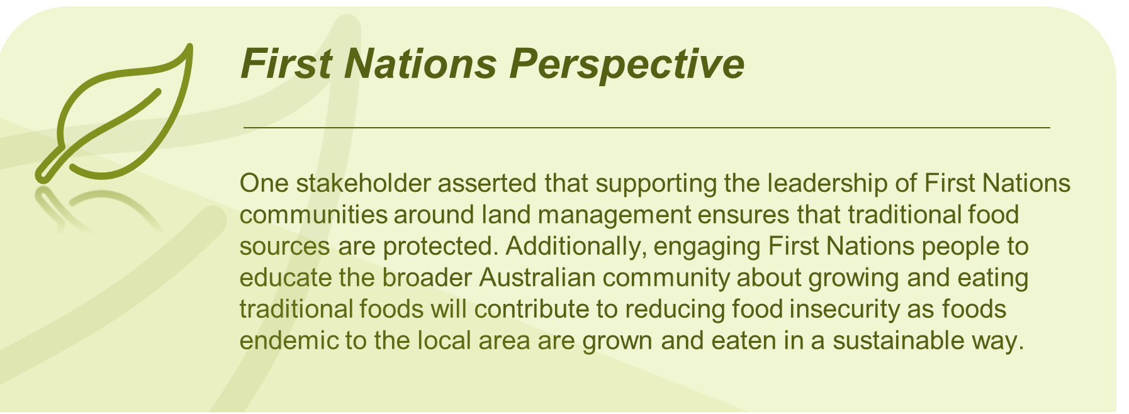
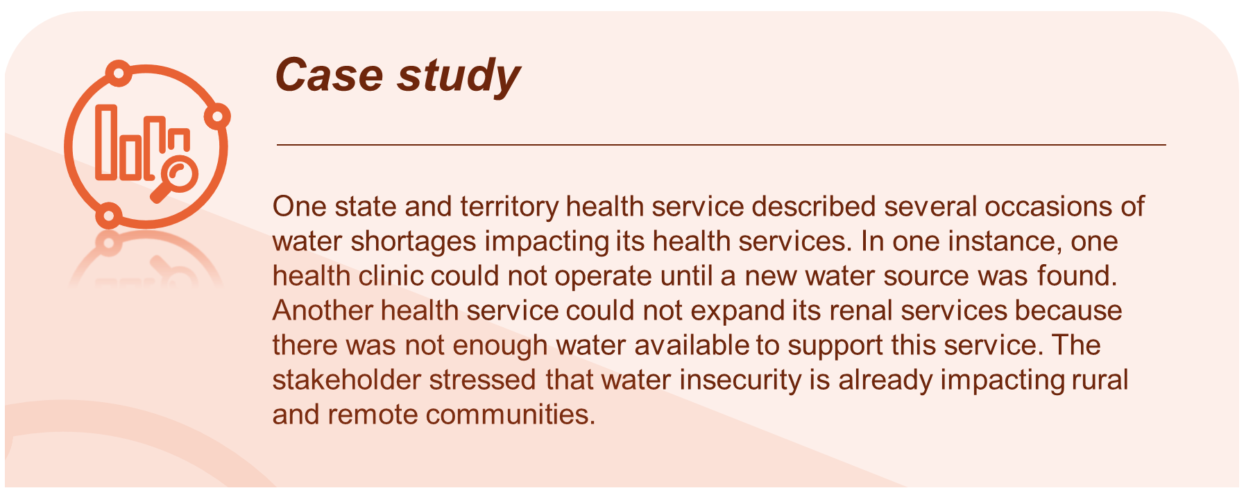
    - Emergency response
Questions from Consultation Paper
Q19 | Should the Australian government develop a National Health Vulnerability and Adaptation Assessment and National Health Adaptation Plan? If yes:  What are the key considerations in developing a methodology?  How should their development draw on work already undertaken, for example at the state and territory level, or internationally?  What are the key areas where a national approach will support local/jurisdictional vulnerability assessment and adaptation planning?
Q20 | Would there be value in the Australian government promoting a nationally consistent approach to vulnerability assessment and adaptation planning for the health system specifically, for instance by issuing guidance and associated implementation support tools for states, territories and local health systems? If yes, what topics should be covered to promote a nationally consistent approach? What examples of existing guidance (either from states/territories or internationally) should be drawn from
Q21 | What immediate high-priority health system adaptation actions are required in the next 12 to 24 months?
Discussion around emergency response considerations focused on adaptation. Within this, four key areas for action emerged from discussions, including planning, prevention and preparedness, response, and recovery and review.
      - Planning
- Vulnerability and climate risk assessments – Many stakeholders asserted that substantial work is needed to introduce robust and Nationally-consistent vulnerability and risk assessments into standard practice, and then plan responses from these accordingly. Some stakeholders commented on how this may look:
- A national health vulnerability assessment guideline would ensure consistency and comparable outcomes between jurisdictions and regions, with each jurisdiction and region delivering its own tailored vulnerability assessment.
- The ability to conduct vulnerability and risk assessments requires climate risk profiling in each jurisdiction and or region to identify climate risks.
- Ideally an Australian climate health risk assessment should build on existing work and be undertaken in parallel with risk assessments in other sectors (particularly where there are interdependencies, such as built environment, agriculture, transport, energy, and water).
- Regarding methodology, nationally consistent vulnerability and risk assessments should include several considerations, including:
    - current health status and health impacts
    - demographic and socio-economic data
    - climate projections
    - exposure assessment
    - assessment of adaptive capacity.
- The need for a comprehensive assessment of regional or community vulnerability to sub-standard air quality secondary to climate change was recommended in particular. This should involve analysing historical air quality data, climate projections, and identifying vulnerable populations and areas.
- Predictive climate modelling in vulnerability assessments should also be a mandatory inclusion to determine structural design and location of new hospitals, health centres, climate refuges and other infrastructure related investments.
- Vulnerability and risk assessments should be used to develop effective risk communication and health messaging strategies. This will ensure the dissemination of accurate and accessible information. This information can include guidance on conveying the health risks of climate change, promoting behaviour change, and addressing public concerns related to climate-related health impacts. It is noted that the Department of Climate Change, Energy, the Environment and Water recently received $28 million to develop Australia’s first climate risk assessment over two years from 2023.
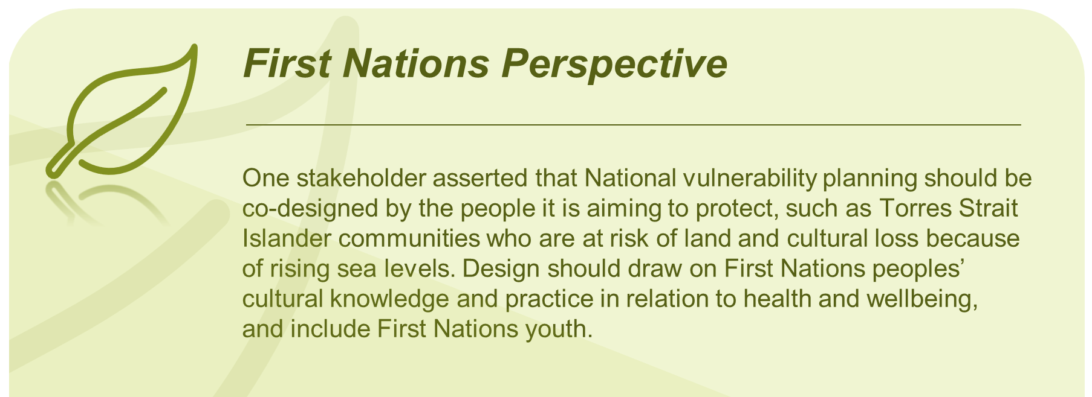
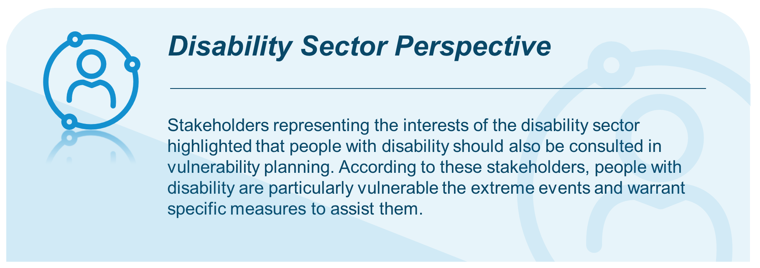
- Community engagement in planning – Many stakeholders advocated for community engagement in planning, preparedness, and prevention of climate-related emergencies. Based on stakeholder feedback, this will build both awareness and adaptive capacity.
- Mapping and awareness of vulnerable communities – As a component of vulnerability assessments, many stakeholders cited the need for vulnerable community mapping as part of emergency response planning. This would enable response agencies to adopt a data-driven approach to prioritising responses according to need and vulnerability. Vulnerable community members could include older people, people with a disability and people who are homeless. Emergency response planning for vulnerable communities should include planning for the provision of emergency supplies such as generators, fuel, water, and food. Additionally:
- Governments and health services should plan for how health and aged care will be delivered in the future as people move away from metropolitan areas.
- PHNs and LHNs should collaborate to resource adequate numbers of community nurses to monitor vulnerable community members during identified risk events.
- Funding and supporting local adaptation planning – Many stakeholders, particularly those representing the interests of rural and remote communities, advocated for support in undertaking adaptation planning. Many highlighted that health services, PHNs, LHNs and other agencies are already under-resourced in carrying out public health and healthcare functions. Many may not have capacity to plan for climate adaptation as a dedicated activity. Stakeholder feedback included:
- The Department should develop and mandate health service adaptation plans standards. These could be introduced in the Australian Council of Healthcare Standards and included as a performance measure in the National Healthcare Reform Agreement. Targets should cover both community and health service adaptation. A nationally consistent process should contribute to supporting adaptation planning; however, the Department should provide adequate funding though PHNs and LHNs.
- Stakeholders highlighted the importance of integrated and inclusive planning processes that engage primary care providers (as well as PHNs) and aged care providers. It is important that these groups are included to ensure plans are feasible and that services on the ground are aware of their roles and responsibilities.
- Multiple criteria should be considered in a standard framework, such as health impact, vulnerability, cost, feasibility, equity, and social acceptability. Decision support tools such as multi-criteria decision analysis should be used to assess trade-offs and facilitate decision-making. The Department should engage stakeholders to collectively determine priority actions based on shared values and goals.
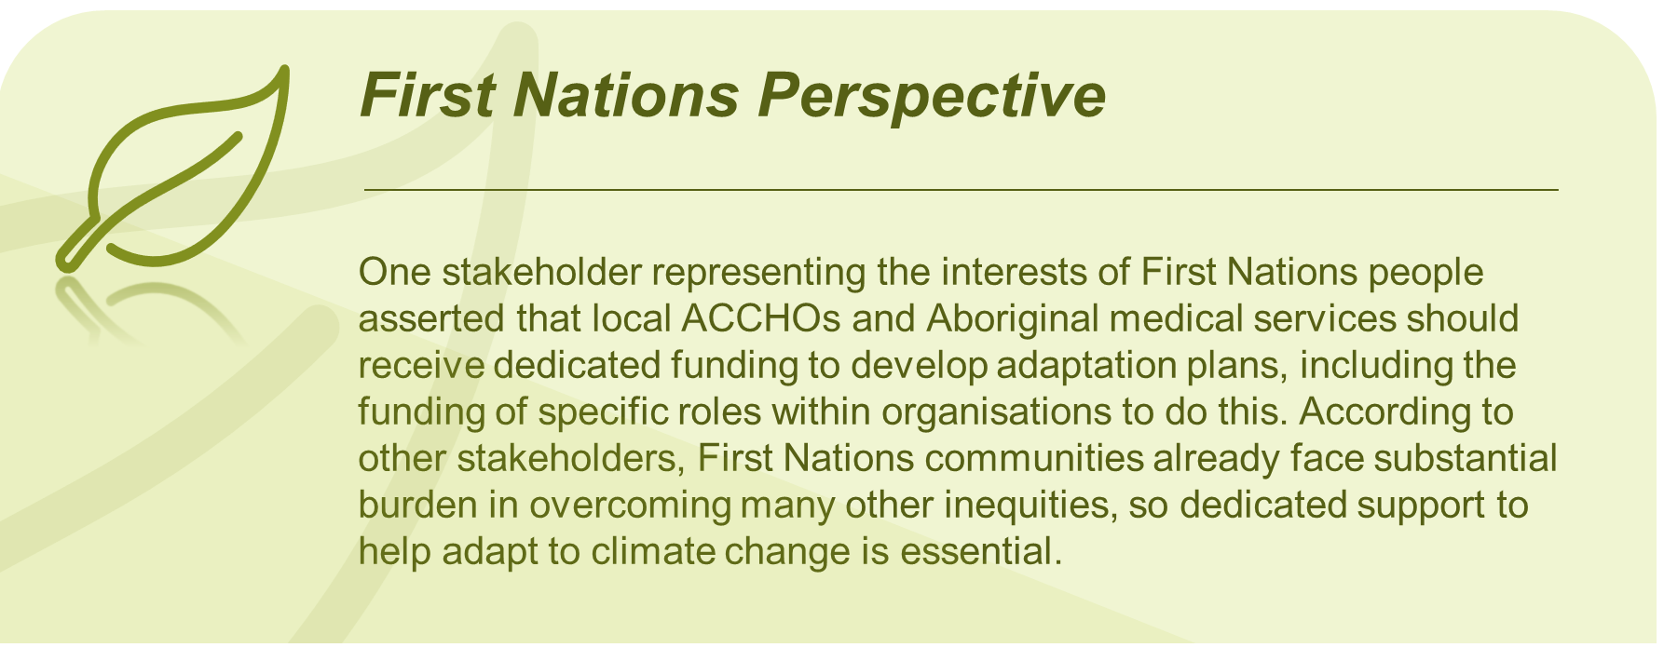
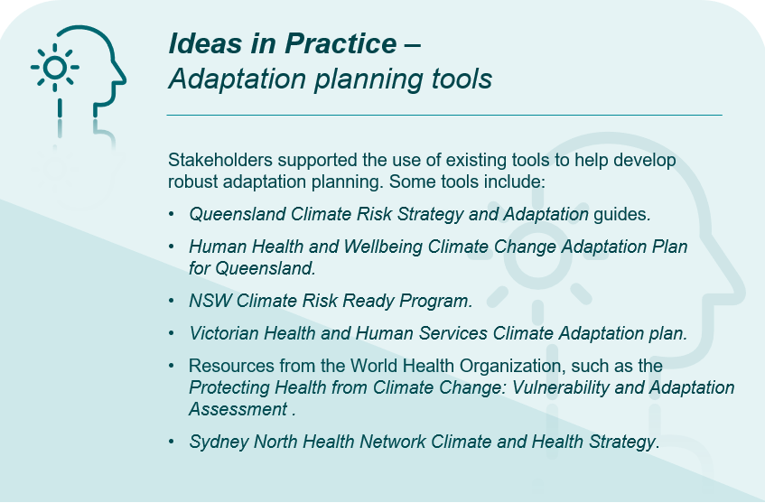
- Coordinated PHN and LHN and other agency planning – Many stakeholders stressed the importance of more coordinated planning between PHNs, LHNs, emergency agencies and NACCHO affiliate organisations. Further discussion included:
- The Department should develop KPIs around coordination and collaboration between PHNs, LHNs and NACCHO affiliate organisations. PHNs and LHNs should undertake more integrated community needs assessment and service planning but should be supported to do so.
- Substantial work and planning are needed to overcome political barriers in this area.
- The Department should draw on the successes of the Commonwealth National Strategy for Disaster Resilience.
- Increased weather and climate volatility changes the nature of planning for aeromedical service demand, such as more reliance on rotary wing aircraft over fixed wing aircraft. Stakeholders again highlighted the importance of integrated multidisciplinary planning that includes aeromedical organisations to determine the resources required for meeting changing aeromedical service demand. This should include funding.
      - Prevention & Preparedness
- Surge workforce capacity – Establishing surge capacity in health and aged care was seen by stakeholders as a crucial mechanism to prepare for extreme climate events. Stakeholders maintained that a surge workforce is essential to adapting and responding effectively to shifting demands and patient volumes and disruption of workforce supply during extreme events, ensuring continuity of care. Further discussion included:
- Other areas of focus should include hospital emergency departments, First Nations communities and recipients of disability care in the community. Agencies should work closely with PHNs, ACCHOs and LHNs to support these areas.
- State and territory governments should be responsible for funding and developing hospital surge workforces, while the Department and Commonwealth Government should focus on primary, aged and disability care.
- It was reported that experience from similar programs indicates success is dependent on support and training at the jurisdictional level. This could be applied from remote First Nations communities to multicultural metropolitan settings.
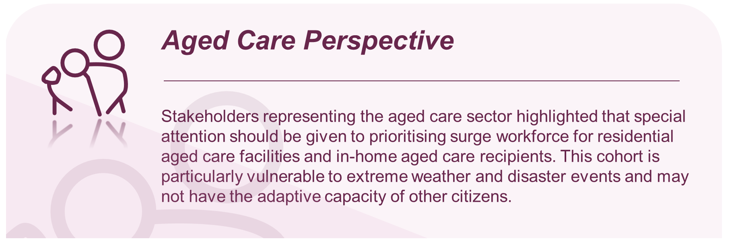
- Scenario exercises and community training – It was widely agreed that performing response exercises, community disaster training, and community awareness on disaster preparedness is another critical action in better preparing for climate change extremes. Many stakeholders provided details on what this should involve:
- Agencies should collaborate to facilitate regional, multi-district workshops including future local climate scenario planning exercises. This should involve primary care, emergency services, hospitals, First Nations leaders, the disability sector and aged care facilities – among others.
- It was suggested that the Department, in collaboration with state and territory health services, should establish a National Disaster Planning Day. This would involve exercises and training for communities to develop a household multi-hazard plan – similar to fire plans developed in consultation with rural fire services. The day would encourage individuals and families to develop a shared resource to plan for climate hazards in their area. This will encourage community activation as part of broader adaptation efforts.
- Others advocated for enhancing emergency response protocols by developing and testing emergency response plans to strengthen coordination between healthcare facilities, emergency services, and public health agencies. There should be a focus on vulnerable populations.
- Many stakeholders called for community engagement and education, including public awareness campaigns on climate-related health risks available preventive measures. This could include information on heatwave safety, promoting vector control practices, encouraging sustainable behaviours, and raising awareness about the links between climate change and health. According to stakeholders, health agencies should engage with community organisations, schools, and local leaders to foster behaviour change and build resilience at the community level.
- Health agencies should provide training and capacity building programs for healthcare professionals to enhance their knowledge and skills in addressing climate-related health risks. This includes education on recognising and managing climate-related health conditions, such as heat-related illnesses, respiratory diseases, and vector-borne diseases. Training can also cover the incorporation of climate change considerations into clinical practice and public health strategies.
- Some stakeholders representing the education sector asserted that training and education for all healthcare professionals must be included in undergraduate degrees to prepare the workforce for future climate challenges. Further learning will give healthcare professionals the skills and knowledge to set achievable targets and to make effective changes to help mitigate extreme weather events and incremental climate change.
- Stakeholders representing the interests of child and infant mental health advocated for the establishment and progression of a National Infant & Child Disaster Mental Health Advisory Committee. This committee could provide policy, operational guidance, and advice regarding the needs of infants, children, and young people in the event of disasters.

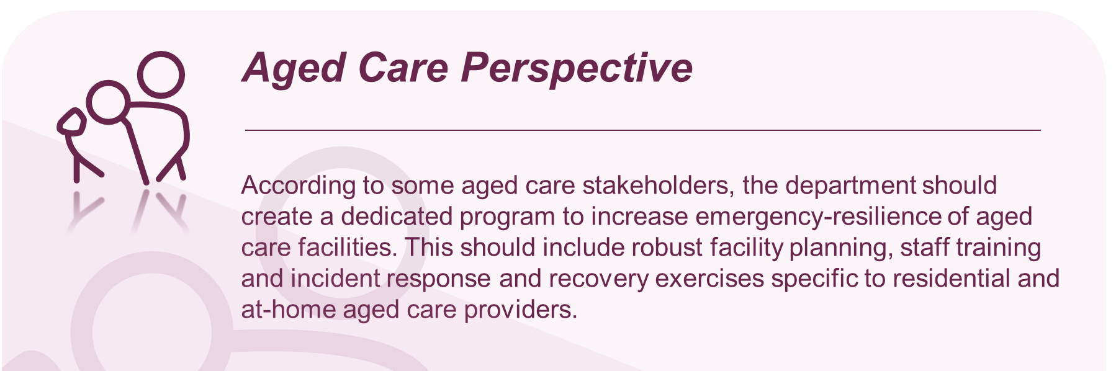

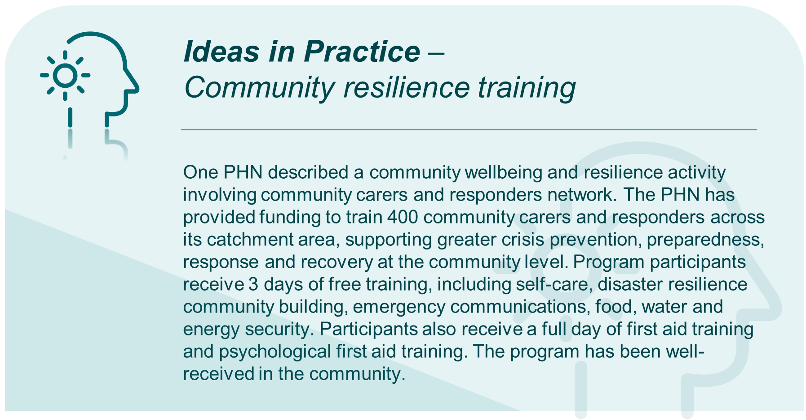
- Improved surveillance and forecasting systems – Many stakeholders also called for improved ability to detect and respond to climate-sensitive diseases like vector-borne and water borne disease, and extreme weather events. Further discussion included:
- Surveillance and forecasting systems need to include improved data collection, analysis, and reporting mechanisms, enhancing communication channels between health authorities, and integrated climate and environmental data into surveillance systems for early detection and response.
- More accurate public health messaging should also facilitate preparation and planning for health system surge capacity.
- There needs to be clear governance processes, strategic allocation of resources and flexibility in their distribution across departments and administrative boundaries.
- It was suggested that this should be a priority adaptation action for the next 12 to 24 months. This can allow health systems to plan for periods of increased patient intake and allocate staffing accordingly.
- Other prevention and preparedness discussion
- A stakeholder representing the interests of the pharmaceutical industry and several other stakeholders asserted that primary care records are often disrupted during emergencies and restoring access to primary care is a key aspect of recovery. Patient records are a key part of restoring primary care. Measures such as incentives to shift to cloud-based, more resilient formats is essential.
- It was observed that, in the recent Strengthening Australia’s Pandemic Preparedness report by the CSIRO, Australia should introduce Nationally coordinated investments in science and technology that can provide a wider range of complementary preparedness and response approaches. These could significantly reduce the economic, social, and indirect health costs associated with unplanned policy formulation.

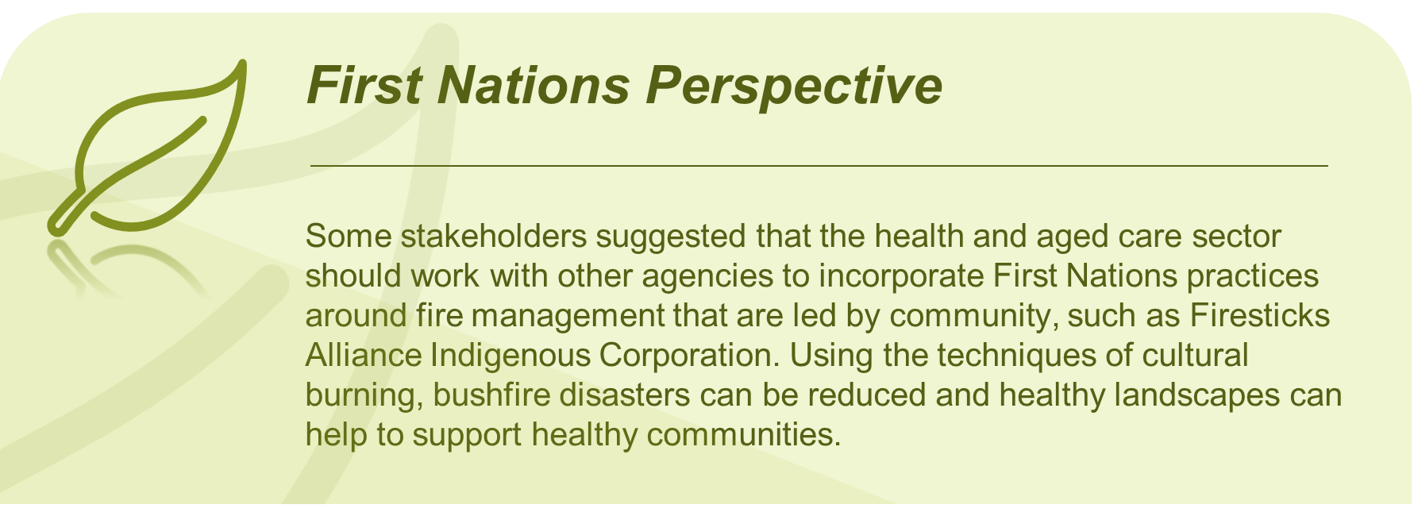
      - Response
- Availability of emergency funding – Several stakeholders stressed the importance of having prompt and transparent access to funding when needed during emergency events. This was particularly pertinent for vulnerable populations. They suggested the Department coordinates relevant agencies to reform funding procedures to create easier access to funding required during emergencies.
- Ensuring continued access to services – Many stakeholders acknowledged widespread service disruption resulting from recent extreme weather events and the COVID-19 pandemic. This is highlighted areas where emergency responses could improve in the future to ensure service continuity. Stakeholders identified the following:
- Consumers can access three-day emergency supply of some prescription medicines. This needs to be made clearer to consumers, particularly in the lead up to, or in the wake of, a natural disaster.
- Using self-nominated volunteer members of the rural doctors workforce or from rural responder support groups would ensure that there are highly skilled and experienced practitioners available to respond and assist in mitigating any delays in retrieval services.
- Services such as the CRANAplus Bush Support Line12 (which provides high-quality, free confidential 24/7 telephone support and is open to all health workers and their families in rural, remote, and isolated communities) should be promoted and supported, alongside specific training and support for in-person services to assist frontline healthcare teams working in disaster and emergency response.
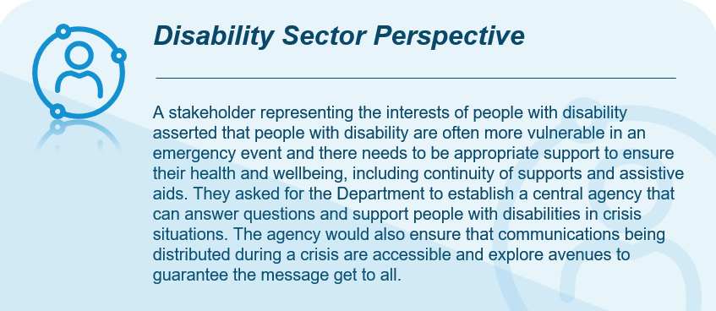
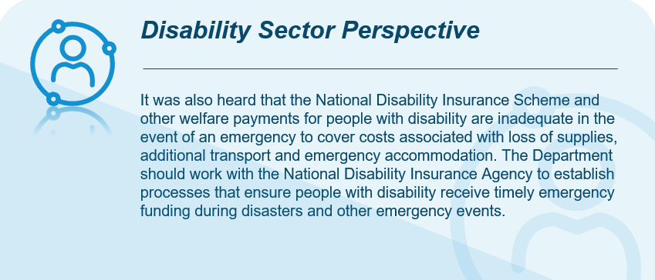
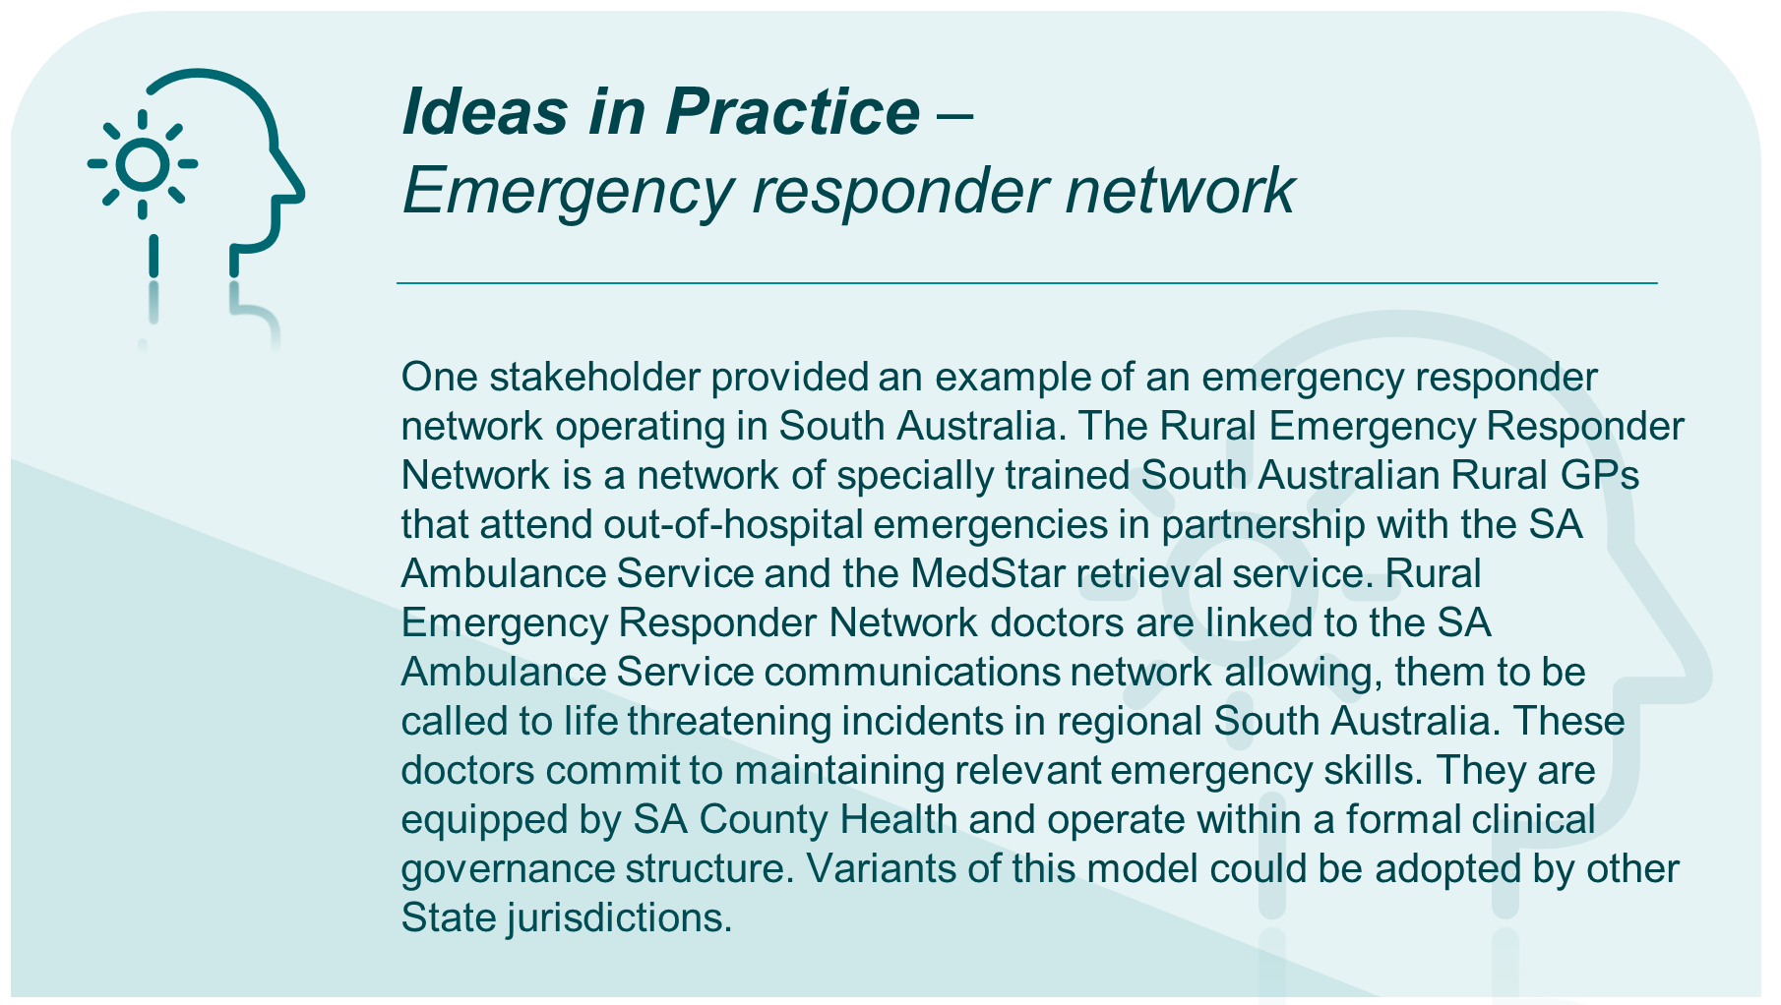
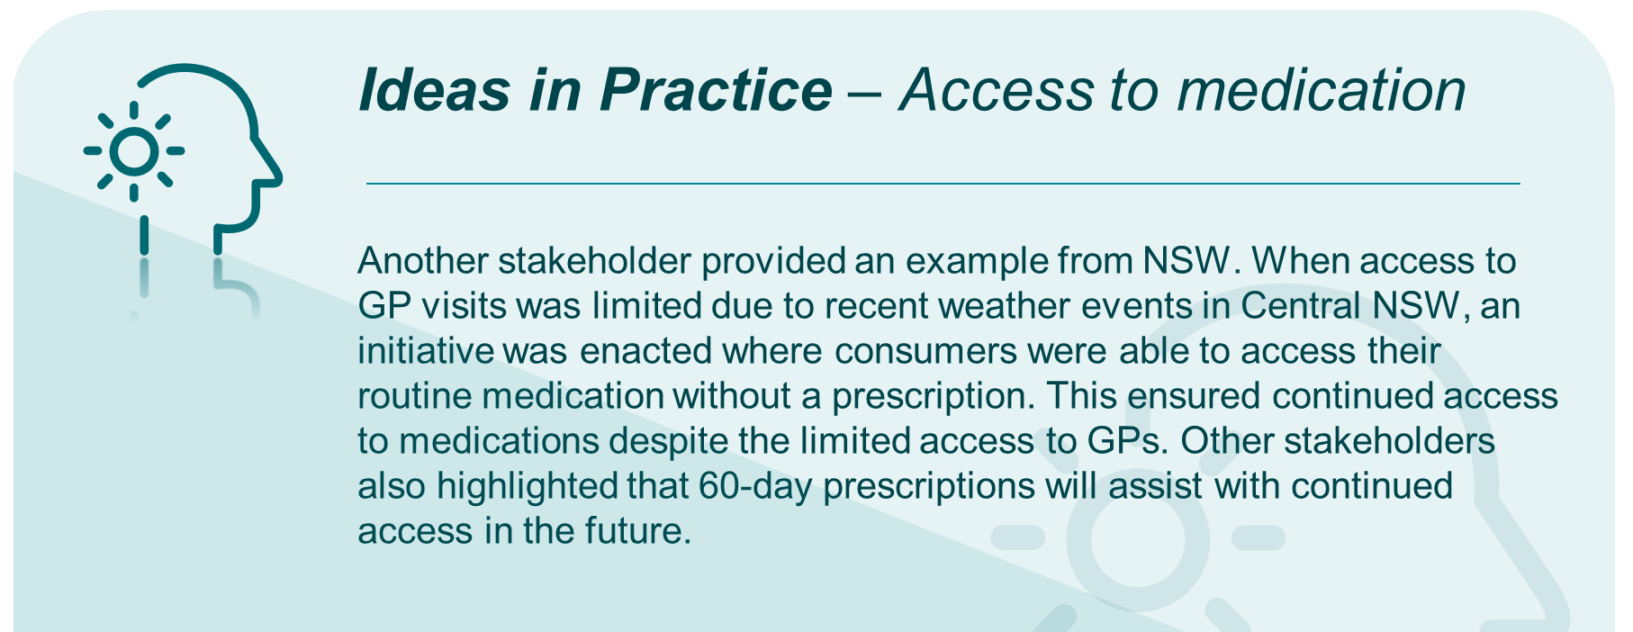
- Response coordination – It was noted that PHNs can also support healthcare providers and staff during a natural disaster by guiding emergency response protocols, resource allocation, and ensuring continuity of care. There is also capacity for PHNs to hold local information and training sessions for primary care providers likely to be involved in providing emergency/disaster-related services. Many stakeholders emphasised that a nationally consistent approach is likely to be most efficient and will aid in disaster response when a region unaffected by a disaster may be called on to assist an affected region. Further comment was made on a consistent approach to emergency responses:
- Stakeholders representing the interests of consumers living in rural and remote areas recommended that a National and regional emergency and disaster response be reviewed as one immediate health system adaptation action. This should include the involvement of rural and remote doctors.
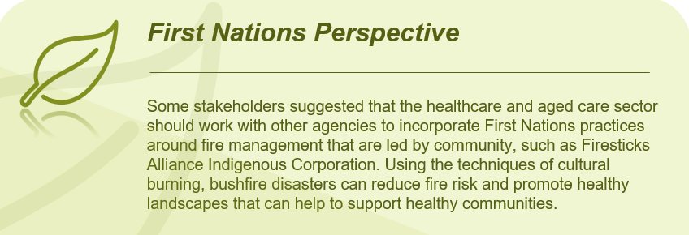
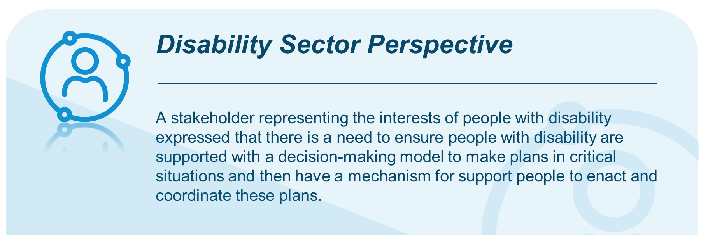
- Effective emergency communication – Many stakeholders emphasised that effective communication is critical during emergency events. It was acknowledged that often communications system fail during extreme events, so work must be performed to overcome these barriers to communication. Additional, stakeholders discussed:
- Procedures should be established to promote two-way communication during emergency events, not just one-way communication.
- There is latent capacity within communities. Emergency agencies and health departments should leverage this during emergency events.
- Health sector responses should include warnings for high pollution or poor air quality, information on masks and respiratory protection, access and egress, and dedicated places for refuge.
      - Recovery and review
- Continued access to healthcare and critical resource for displaced populations – Some stakeholders urged the Department to develop approaches to ensuring people displaced by extreme weather events have access to their routine medical care (such as chronic conditions), as well as critical resources like food, water, and shelter. It was suggested that each PHN have an action plan to provide for displaced populations.
- Regeneration of Australia’s biodiversity – Some stakeholders called for ecological knowledge of Traditional Owners and Indigenous Rangers to be combined with scientific and firefighting knowledge as part of post-fires regenerative work to preserve and re-populate species and habitat. This was seen as culturally important for First Nations peoples. It was suggested that relevant agencies should work with Traditional Owners to evaluate legal protections for landscapes identified as significant fire refuge areas for biodiversity and threatened species as part of restoration and preservation priorities.
- Mental health support – There was widespread stakeholder recognition that extreme weather events can impact the mental health of both the effected community and healthcare workers. Stakeholders broadly called for more support in protecting the mental health of citizens during and after an event. Additional discussion included:
- The Department could look to the National Disaster Mental Health and Wellbeing Framework for approaches to protecting mental health.
- Use of the Community Trauma Toolkit that supports the capacity of workforces to respond to the mental health needs of infants, children, and families in the context of disasters and community trauma. This tool has been positively received and has become a popular tool among healthcare workers.
- Review emergency response – Some stakeholders called for plans to be established to review all aspects of an emergency response. It is important to review processes before an event, and not just in hindsight after there have been opportunities for mistakes. Another stakeholder suggested that communities should design and participate in community resilience training and be supported and empowered to develop climate health recovery plans.
    - Health and wellbeing impacts
Questions from Consultation Paper
Q18 | What health impacts, risks and vulnerabilities should be prioritised for adaptation action through the Strategy? What process or methodology should be adopted to prioritise impacts, risks and vulnerabilities for adaptation action?
Stakeholders widely expressed concern about the increasing severity of the impacts of climate change on health and wellbeing. These impacts include infectious diseases, mental health, chronic disease and heat-related illnesses, as well as food and water insecurity. The effects of extreme weather events and the resilience of communities to climate and health impacts were also raised.
      - Vector-borne, water-borne and zoonotic diseases
- Disease mapping – Stakeholders asserted that more knowledge is required of diseases that may emerge or become more significant due to climate change. By performing disease mapping, health departments may obtain a better understanding of the geographical zones in Australia that are most susceptible, and plan public health adaption measures accordingly. Based on stakeholder feedback, this should be a priority of the Department. It was suggested that more funding is needed to develop a consistent National approach to mosquito surveillance.
- Priority diseases – Several stakeholders highlighted specific diseases that should be closely monitored as the impacts of climate change continue to increase. Priority diseases include:
- H5N1 influenza
- Japanese encephalitis
- Murray Valley encephalitis
- Malaria
- Aedes Albopictus
- Other diseases – While the above diseases are not exhaustive of all diseases that the Department of health should prioritise, they are a good starting point. Stakeholders suggested performing further research into existing and emerging diseases, which may form part of the remit of the Australian Centre for Disease Control (CDC).
- Child and young person susceptibility – Some stakeholders highlighted that children are more likely to experience severe symptoms from vector-borne diseases and respiratory illnesses and that the Department should plan to address these.
- Strengthened biosecurity to protect against threats – Australia remains at risk of a range of tropical diseases if new vectors are introduced. Top of the list is the mosquito Aedes Albopictus which is a vector for dengue and other viruses. Stakeholders emphasised the growing need for more stringent biosecurity protection measures.
- Biosecurity and wildlife health – Based on stakeholder feedback, without better protective measures against biosecurity and threats from wildlife, Australia is left more vulnerable to existing and new infectious diseases spreading in Australia. While the One Health principle has been discussed earlier, the following was discussed in the context of infectious disease management:
- Given the current and growing importance of wildlife in public health disease risk, there is a need for high-level incorporation of wildlife expertise and data into public health strategies. It was suggested that the Department take a strategic approach similar to WHO for predicting, detecting, and controlling these infections through an integrated and interdisciplinary approach between animal and human health.
- The Department should work with other parts of the Commonwealth Government to support and provide aid to regional neighbours to control vector-borne diseases. This will increase the overall effectiveness of disease prevention in Australia.
      - Mental health
- Mental health roadmap – Stakeholders called for the Department to create a roadmap for how mental health will be equitably embedded within all health and climate initiatives, including appropriate representation of reference groups and advisory committees. Many stakeholders highlighted the increasing emergence of eco- or climate-anxiety, which should be addressed in any planning around the worsening impacts of climate change in Australia.
- This will require increased accessibility to mental health databases that can be linked with the multiple available environmental databases.
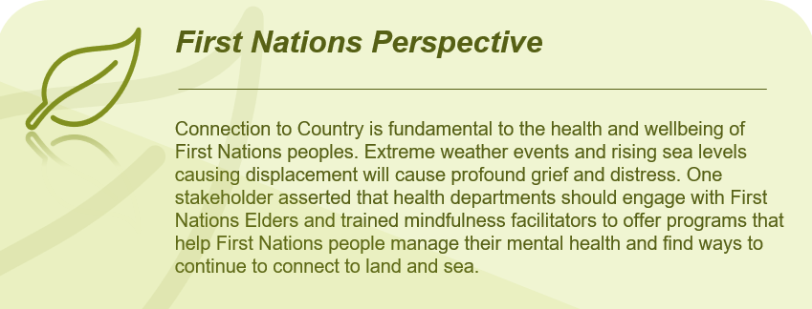
- Health professional awareness, education, and capacity building – There was widespread support from stakeholders to raise awareness among health professionals of mental ill-health related to climate change. More awareness and training will better equip health professionals to recognise, prepare for, and respond to mental health impacts of climate change. Further stakeholder feedback included:
- Climate change education should be embedded in training for mental health response, particularly acknowledging the increase in mental health presentations during and immediately following periods of heat.
- Health Departments should introduce micro-credentialing for the health workforce (including nursing and allied health professionals) to support climate change-related mental health.
- The National Disaster Mental Health and Wellbeing Framework, currently implemented by state and territory education systems should be considered.
- Access to mental health services, including for health professionals – Many stakeholders stressed the impact of extreme weather events on consumers and mental health professionals. They asserted that it is important for health Departments to take action to support health professional mental health. Discussion included:
- The Department should expand access to mental health and substance abuse services, particularly in rural and remote areas.
- Health Departments should develop and roll out health and climate impact assessments for patient care, which should include mental health and wellbeing scores. It was noted that a Climate and Health Alliance survey collecting data on mental health should inform the development of this.
- A National case study of the 2019 to 2020 bushfires found that rural and remote mental health practitioners in areas affected by bushfires reported experiencing the same traumas and challenges as their patients. Many were unable to take a break to look after their own wellbeing.
- Stakeholders called out that paramedics in particular need support to adjust to the personal and psychological impacts of climate change. Mental ill-health is highly prevalence across paramedicine. To support paramedics, access to mental health services and resources needs to be a top priority.
- Young people are particularly vulnerable to mental ill-health related to climate change and need to be prioritised as they carry a higher burden of existential risk. Many young people have experienced climate-induced trauma from climate-driven events such as floods, storms, bushfires, and drought.
- Research on mental health and climate change – Stakeholders broadly called for more research on mental health and climate change.
- Robust and routine evaluation of mental health and psychosocial support programs and policy are currently lacking and require substantial commitment and investment.
- A better understanding of the sustained and long-term mental health consequences of incremental climate change will equip decision makers with a better understanding of where and how to invest in mental health infrastructure and resources.
- There is strong value in developing a standardised set of mental health indicators to facilitate benchmarking across jurisdictions. This can build on preliminary work already completed. The establishment of a national reference group for determining these indicators would be useful.
- Greater investment in cross-disciplinary climate change and mental health research activities will further improve the evidence base to better understand mental health, wellbeing and substance use trends, identify risk factors and vulnerabilities, and support Australian communities in the face of climate events.

      - Chronic diseases
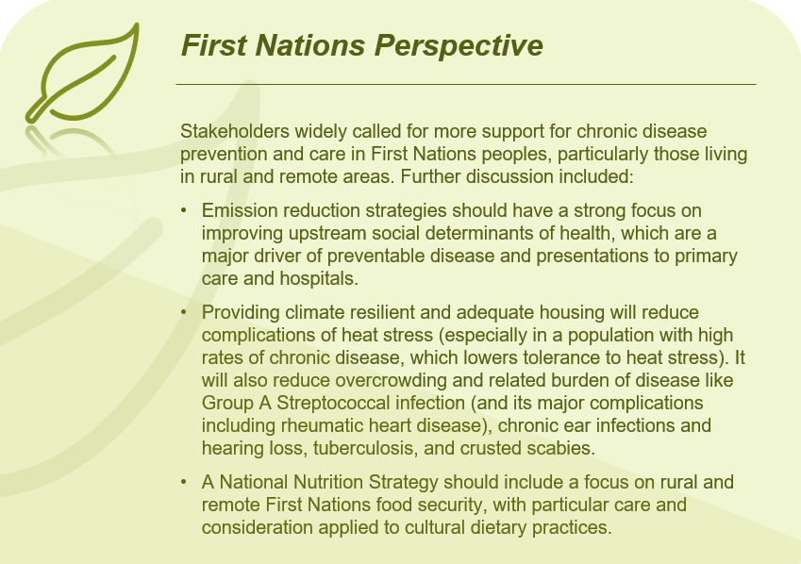
- Climate change and chronic disease management – Many stakeholders commented that increasing temperatures, air pollution and heat waves put individuals and communities at higher risk for chronic conditions including cardiovascular disease, diabetes, asthma, and kidney disease. Stakeholders provided a mix of actions related to health promotion to support chronic disease management:
- The Commonwealth Government should introduce a GP item number for a patient climate risk assessment. The care plan for this could have an element of heat wave and fire management planning. As well as providing a GP incentive, this provides an opportunity to educate patients on their vulnerability to the impacts of climate change. Two levels of climate health risk assessments were highlighted, including health risks that come directly from climate events, and health risks that come from infrastructure, transport and communities.
- The Department should develop and implement a National Nutrition Strategy addressing the entire food system to reduce emissions, increase resilience and provide sustainable, reliable sources of nutritious food. This strategy should include a focus on rural and remote First Nations food security, with particular care and consideration applied to cultural dietary practices. Good nutrition was highlighted as being important in both prevention and recovery from chronic disease.
- There is a national curriculum, but states and territories administer their own education. The Department should develop and roll out heath education related to climate change. Rural and remote communities have seen a reduction in alcohol consumption because of the national education campaigns occurring in schools, and there should be something similar for climate and health.
      - Heat and associated impacts
- 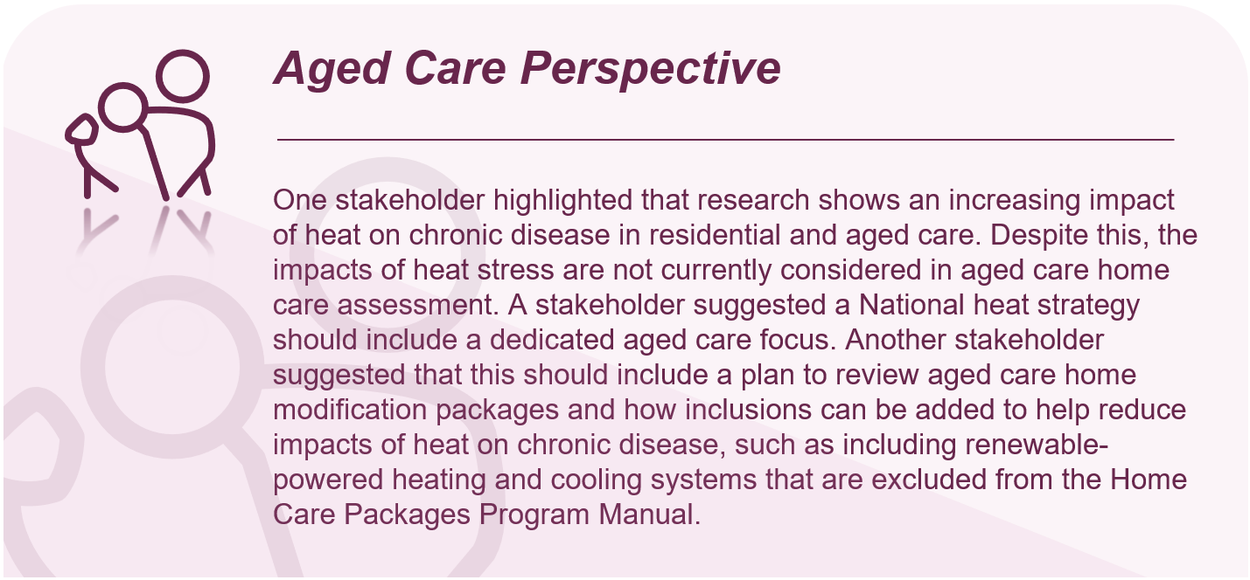National heat and health plan – Many stakeholders called for the Department to develop a coordinated heat and health plan. According to stakeholders, a heat and health strategy should consider the unique impact of heat on health on First Nations health, disability and aged care, people living in rural and remote settings, primary care and young people. Many stakeholders acknowledged that heat is one of the most substantial environmental factors that negatively impacts people with chronic disease.
- Heat mapping – Many stakeholders asserted that heat and vulnerable community mapping should be performed by health departments. According to stakeholders, this may be the responsibility of PHNs and LHNs, and coordinated by the Department as well as state and territory health services. Heat mapping could be used to develop action plans for at-risk communities.
- Heat awareness – Several stakeholders called for community education on the dangers of heat and humidity. Although some communities, particularly First Nations communities are adept in dealing with extreme climate, many people may not be aware of the risks of heat to those with chronic disease.
- Work health and safety – It was acknowledged that climate change will have serious occupational safety implications for those exposed to heat at work. This could include health and aged care workers such as paramedics, at-home aged care staff, community healthcare workers, and staff working in rural and remote areas. It could also include other occupations such as construction workers and delivery drivers. Relevant health departments should work with safe work agencies and peak bodies to develop strategies and protocols for dealing with heat and other extreme elements in the workplace. For example, stop-work measures might be put in place when a designated high temperature is reached.
- Other heat considerations – Stakeholders made other general comments on the risk of heat and health:
- Children are more vulnerable to temperature extremes and heatwaves than adults, as they are less able to regulate body temperature.
- PHNs and LHNs should help implement hot weather plans for people with existing health conditions to ensure they are aware of how to take care of their health and can cope during different events. There should be public alert systems for hot weather events, similar to fires, to allow community members to be informed and prepared. This could include reminders that it is going to be hot, to drink more, stay inside, and reschedule appointments. Workforce and technology capacity should be developed to facilitate this.
- 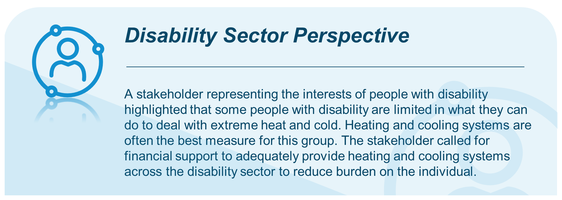The current modelling on the health effects of heat is conservative and does not consider the cost savings of prevention. Risk modelling is required and needs to consider the public health impact of more than a 2 degree increase in global temperatures.
      - Food and water security
- Food and water security strategy – Many stakeholders highlighted that food and water insecurity should be a focus of health agencies, particularly in rural and remote communities. Some stakeholders provided further commentary on how health agencies could prevent and mitigate the prevalence of food and water insecurity. Discussion included:
- A food and water security strategy must use a Health in All Policies approach by promoting food systems that meet people’s health needs and expansion of local First Nations food knowledge and production.
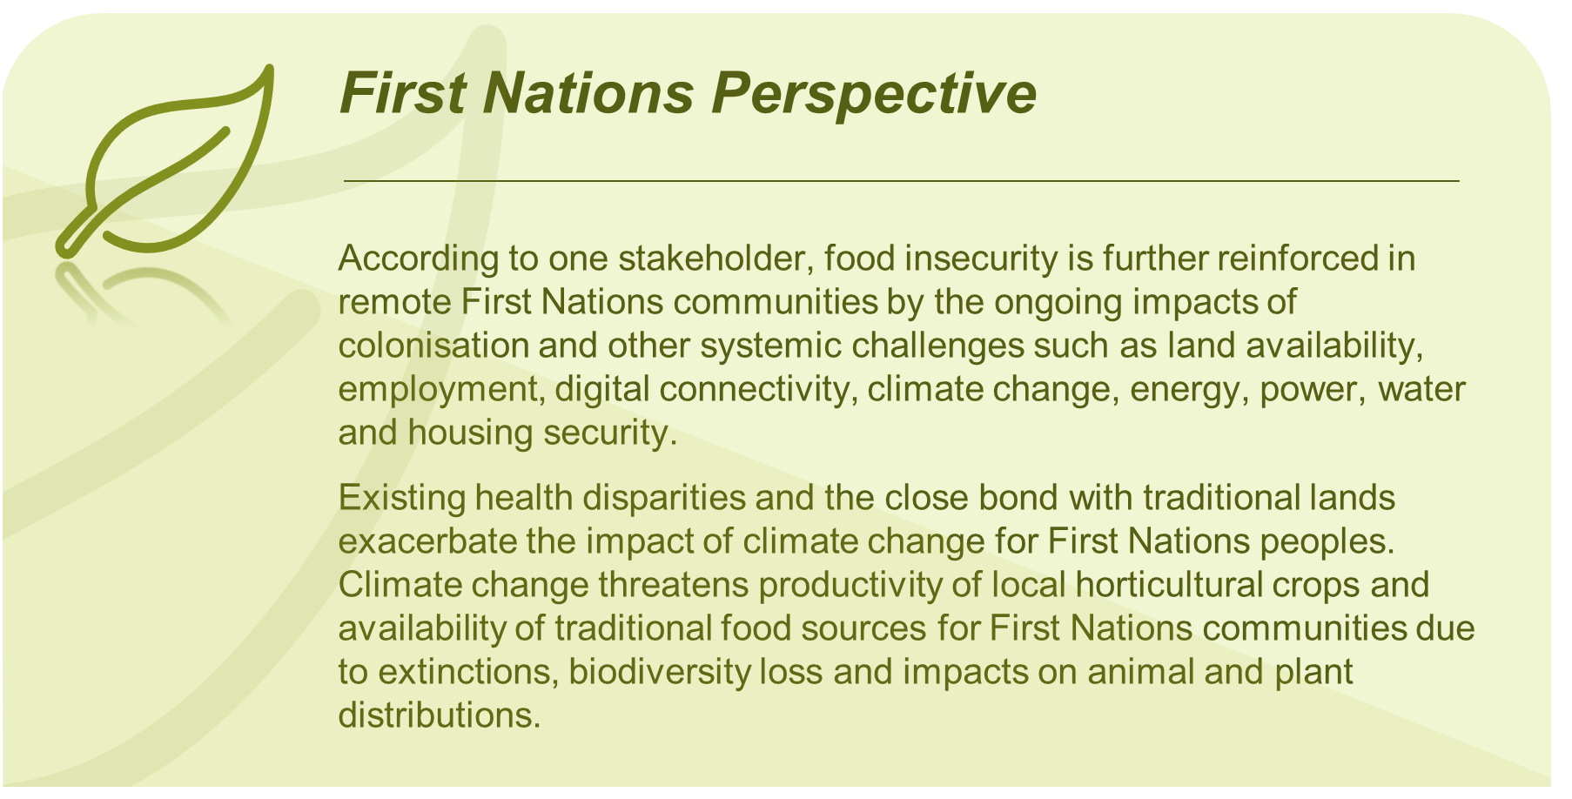
- The disparity of food and water security between regional, rural, and remote towns compared to metropolitan areas was highlighted. According to stakeholders, this disparity is driven by a range of factors such as reduced economic opportunity, extreme climates, and inadequate infrastructure.
- To help tackle water shortages, there should be strategic planning options and mapping of the worst hit communities. Available research and work in this area is currently not adequate to understand the issues in adequate detail and plan for water shortages accordingly.
- To help overcome food shortages, there should be licencing of remote stores to ensure they always stock foods. The Department should consider that high cost is a consistent issue for food supply in remote stores. There are also logistical challenges with transport. A stakeholder stated that in the NT where food and water insecurity is prevalent, there has been limited actions despite three Senate enquiries into food insecurity.
- Disruption to local food production and supply chains by heat, drought, flood, fire, or pests is under-recognised and result in several impacts: reduced agricultural production, reduced food availability, reduced quality and nutritional value, food spoilage, water poisoning, water scarcity and contamination. Approaches to dealing with these impacts in the face of climate change should be developed.
- Loss of locally sourced foods could mean changes to subsistence practices and communities becoming more reliant on store foods that can be of poor quality, unreliable and expensive in rural and remote areas due to transportation and storage costs.
- During the wet and cyclone season, remote stores look to hold larger inventories to prepare for the possibility of missed shipments. This must be balanced against the shelf life, particularly for perishable goods.
- Stores in remote communities should be considered essential services and provided with funding to ensure they can provide healthy food at reasonable prices and are resilient to weather events and power outages. Stores should have adequate storage and supplies to support communities cut off from outside supplies by extreme events. This will require government funding.
- Diversification of crops should be encouraged, along with reduced food waste and improved equity in access to food and community gardens.
- The food system should rely more on locally grown vegetable food and not mass-produced animal products on deforested land.
      - Community resilience to changing health and wellbeing impacts
- Resilient communities are important for mental health and wellbeing – Many stakeholders highlighted the importance of greater community capacity building to buffer against poor mental health and wellbeing effects from extreme weather events due to climate change. Stakeholders reported:
- Proactive investment in ‘cohesive communities’ is helpful to build resilience after climate-related disasters. The Department should take a preventative and health promotion approach to mental health and wellbeing that equips each community with networks of people with skills, such as psychological first aid and peer support. The Strategy should consider these initiatives to increase the capacities of communities to anticipate their climate risks and reduce impacts on health and wellbeing inequities in their communities.
- Stakeholders agreed that greater community emotional and psychological resilience is needed for health workers, individuals, and communities to deal with the distress due to climate change. Stakeholders supported the establishment of a dedicated research fund to identify resilience strategies.
- Stakeholders also referred to community resilience as building the capacity of priority populations (including people with disability, older people, and First Nations peoples and culturally and linguistically diverse communities) by ensuring community programs are available, accessible, affordable, and culturally safe.
- A stakeholder representing the interests of arts and culture highlighted that arts and culture plays an important role in developing community resilience to climate change and addressing the trauma caused by extreme weather events. The stakeholder referenced research that highlights how creative recovery has the capacity to mitigate disaster impacts and the disempowerment that results from the stresses and strains of natural disasters, through its unique ability to build long-lasting community resilience, wellbeing and local capacity for disaster preparedness, response and recovery. The body provided the example of the Centre for Reworlding which helps foster creative thinking in climate emergency-related disaster response.
    - Health in All Policies
Questions from Consultation Paper
Q22 | What are the key areas in which a Health in All Policies approach might assist in addressing the health and wellbeing impacts of climate change and reducing emissions?
Q23 | What are the most effective ways to facilitate collaboration and partnerships between stakeholders to maximise the synergies between climate policy and public health policy? What are some successful examples of collaboration in this area?
Stakeholders strongly encouraged the Department to implement a Health in All Policies approach to ensuring climate and health outcomes are be embedded across the whole of government response to climate change. The approach was noted as a means support initiatives that reduce emissions and improve population health. The priority policy areas and approaches to achieving Health in all Policies are discussed below.
      - Health in All Policies priority areas
- Energy policy and cessation of fossil fuel projects – Many stakeholders called for no new fossil fuel projects to be initiated in Australia and current energy production from fossil fuels to be transitioned to renewable energy sources as quickly as possible. Stakeholders cited evidence indicating substantial health implications associated with energy policy decisions. Many stakeholders asserted that continuing approval of fossil fuel projects substantially limits the impact the health and aged sector can have on mitigating and adapting to the effects of climate change. Additionally, it was suggested that the Commonwealth Government should further its work on committing to no nuclear energy in Australia. It was highlighted that some key connections of health and aged care to energy policy include:
- Gas and coal pollute the air, leading to increased incidence of asthma and other respiratory diseases.
- Climate change results in heatwaves, increasing the incidence of heat and cardiovascular illness.
- Increased incidence of natural disasters and insecure housing directly influences the social determinants of health (the social determinants of health are discussed more later).
- Finance policy – Stakeholders reported that the Commonwealth Government operates in financial and cost silos whereas an integrated approach is needed to interconnect policies and funding. Many stakeholders also called for ceasing fossil fuel subsidies and removing current requirements to demonstrate savings in specific areas, rather than in relation to overall Federal Budget costings, including health and healthcare.
- Housing policy – Many stakeholders viewed that current funding for safe, fit-for-purpose and environmentally sustainable is inadequate to achieve the goals of the Strategy indicated in the Consultation Paper. It was recommended that there should be:
- Consistent sustainable infrastructure goals.
- A requirement that essential infrastructure like public transport is within a reasonable distance of new housing developments.
- Consistent guidelines on procurement of resources for building housing.
- Regulations on the environmental impact of housing in its intended location.
- Better legislation on energy-efficient and climate-resilient housing designs.
- Transport policy – Stakeholders called for the Department to work with other sectors to help transition the transport sector’s reliance on fossil fuels. This includes policies to develop electrified public transport and active transport infrastructure such as walkable streets and bike-friendly lanes, accessible public transportation networks, and safe infrastructure for active travel. These measures have the potential to reduce air pollution, increase physical activity, and improve cardiovascular and respiratory health.
- 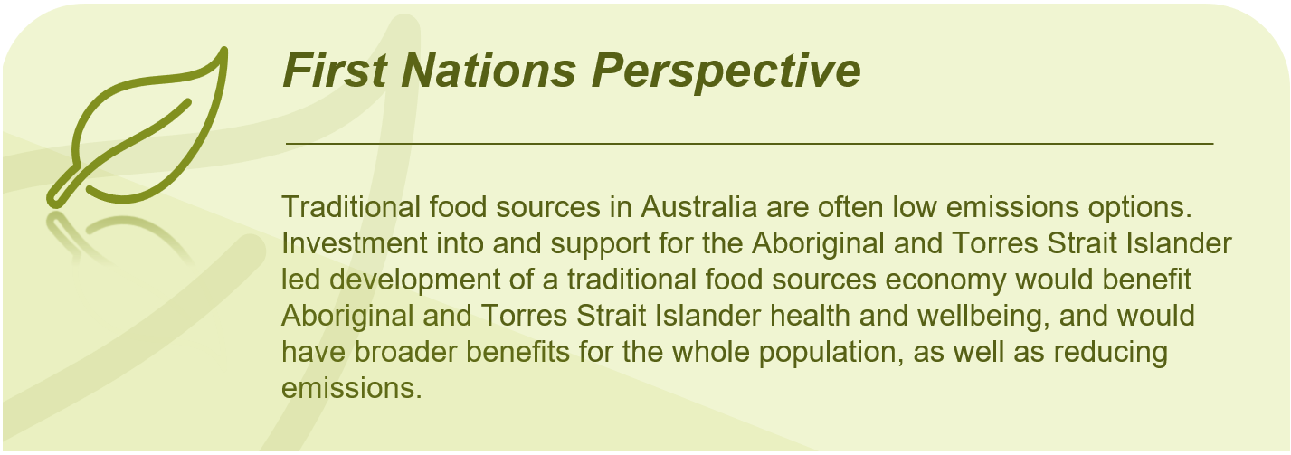Food and agriculture policy – Stakeholders highlighted that the Department should work with other Commonwealth Departments to improve agriculture production, transport and storage. It was heard that food choices, particularly the meat industry, have a significant impact on health outcomes and climate change.
- Urban planning and green infrastructure – Stakeholders cited that health considerations should be brought further into urban planning, particularly through promotion of developing green infrastructure and urban green spaces. Stakeholders recommended the Department support the development of green spaces, urban forests, and green roofs that enhance air quality, regulate temperature, and promote physical activity. These measures contribute to both climate change adaptation and improved health outcomes.
- Defence policy – It was heard that defence operations, and associated supply chains including transportation should be undertaken with a health lens. Some stakeholders were of the view that the Department should work more closely with Defence ensure it contributes to Health in All Policies.
- Education – Stakeholders elucidated how Health in All Policies could incorporate health promotion and education initiatives into school and university curricula including the medical school curriculum. The purpose of these initiatives would be to raise awareness about the health impacts of climate change, promote sustainable lifestyles and climate-friendly practices as well as build resilience. Public campaigns, formal education programs, and community activities could further raise awareness. 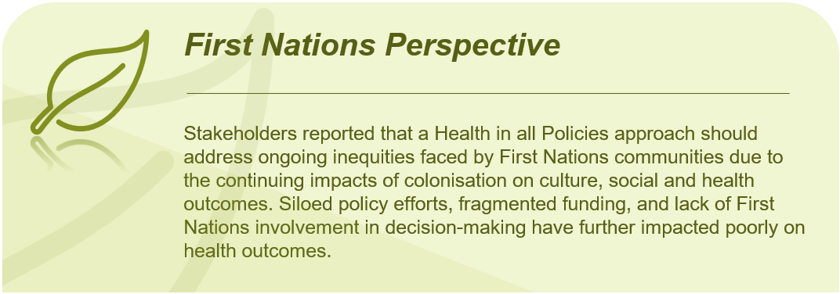
      - Social determinants of health
- Embedding the social determinants of health into Health in All Policies – Stakeholders widely called for the social determinants of health to be embedded within the Health in All Policies approach. They suggested Health in All Policies should advocate for policies that reduce health inequities, improve housing conditions, enhance access to healthcare in vulnerable communities, and support social safety nets to reduce the health impacts of climate change on disadvantaged populations.
      - Other approaches to Health in All Policies
- Remit of the Australian CDC – Stakeholders asserted that an Australian CDC would be a powerful tool in facilitating any Health in all Policies approaches. The Commonwealth Government was encouraged to build the Australian CDC with strong consideration of the Strategy, as the functions of pandemic preparedness, prevention of communicable diseases and climate change health effects require many of the same considerations and resources. Stakeholders highlighted that the Australian CDC workforce will need to have a diverse range of expertise for emergency response and regular surveillance tasks. They stated that the Australian CDC would need experts in public health, medicine, veterinary medicine, social science, engineering, immunology, etymology, ecology, environmental health, and economics, among other areas.
- Specific actions promoting Health in All Policies – Several stakeholders provided input on potential actions the Department and relevant agencies could undertake to ensure a Health in All Policies approach to climate change. These included:
- Establish a clear mandate for Health in All Policies in addition to being a strategic objective for health systems. Health in All Policies should be a formal directive mandated across all policy areas, highlighting specific policy domains where attention and collaboration with health is warranted.
- The Commonwealth Minister for Health and Aged Care should be included in the membership of the Net Zero Cabinet Committee.
- All Cabinet decisions should require a statement to be prepared outlining the expected impacts of the decision on commitments to reduce emissions and build resilience.
- A Health in All Policies approach should align with the Commonwealth Government’s Measuring What Matters framework, which aims to capture a range of factors that influence wellbeing, including the natural environment and climate change. These factors are guided but the Framework’s five key wellbeing themes, including healthy, secure, sustainable, cohesive and prosperous. Many stakeholders shared this view.
- Embed children’s climate-related health needs in all economic, and social policy design, addressing child-critical social services, social protection, built environment planning, and whole-of-government policymaking processes.

- Where to from here?
As this work enters the Strategy development phase, focus will turn to iteration and finessing of the insights gained to date, Strategy development will be informed by:
- Workshop summary reports.
- Extracts generated from thematic analysis of long-form submissions, stakeholder surveys and workshops. These extracts have been grouped separately by question in the survey and by themes identified during the analysis process.
- A register / tool of recommended actions identified during workshops that can be organised by key themes and sub-themes, responsible agency, by sector and by objective seen in the Consultation Paper.
- The summary generated in this report.
- Additional targeted stakeholder consultations.
Additional consultations held concurrently with drafting of the Strategy will form Phase 2 of this work.
  - Phase 2 targeted consultations
Phase 1 has seen stakeholder input from a broad range of backgrounds, locations, industries, and sectors with the deliberate intention of obtaining a diverse range of views on health and climate change. While some consultations during Phase 1 included sector-specific engagement, Phase 2 will focus on targeted consultations with specific industries and interest groups, for example Medical Technology providers as highlighted during Phase 1 activity.
Phase 2 consultation will involve roundtable-style/interview consultations. Consultations with targeted stakeholders will ensure that actions and nuances are appropriate for specific cohorts and considered appropriately in the Strategy. These discussions are designed to build and elaborate on ideas discovered during Phase 1.

- Appendices
  - Appendix A: Additional Consultation Paper questions analysis
For ease of reference, the below provides specific callouts and analysis against the Consultation Paper questions which are not directly linked to a report section, noting the majority of these actions and comments have been previously highlighted and covered across various sections of the report.
Questions from Consultation Paper
Q8 | What do you think of these proposed focus areas for emissions reduction? Should anything else be included?
Stakeholders suggested the following additional focus areas for emission reduction:
- Food and beverages/ food waste emissions/ food production.
- Emissions from other import countries.
- Include a focus on social determinants.
- Expand the scope of mitigation strategies beyond the health system.
- Energy should be included as a standalone focus area.
- Waste should be renamed to ‘Sustainable resource use, circular healthcare and sustainable healthcare waste management’.
- Decarbonising clinical trials.
- Low-value care.
- Consider splitting ‘prevention’ and ‘optimising models of care’ – both viewed as key and could be tagged as separate focus areas. Consider moving to the top of the list to increase focus and prioritisation.
- Other pollutants – i.e., water and soil.
It was suggested the Strategy include a high-level rationale explaining why each of the focus areas has been selected.
Q15 | What can be done to involve private providers within the health system in the Strategy’s emissions reduction efforts?
As highlighted throughout the thematic analysis, stakeholders have provided various suggestions regarding involvement of private providers within emission reduction efforts. Specific responses to this question include:
- Collaborative partnerships – Foster collaborative partnerships with private providers by establishing formal agreements or memorandums of understanding. These partnerships can outline shared goals, responsibilities, and commitments regarding emissions reduction. Encourage private providers to actively participate in developing and implementing emission reduction strategies.
- Governance arrangements – Establish a governance mechanism (such as a working group) that specifically focuses on both categories of private providers (individual health practitioners and private health organisations), to disseminate good practice from the public health system, and to set emissions reduction expectations on private providers.
- Education and capacity building – Raise awareness and provide education regarding the importance of reducing emissions into the future. Offer training and capacity-building programs to enhance their sustainable practices and help private providers develop measures to reduce emissions.
- Sharing best practices – Share successful case studies and best practices from within the health sector, highlighting examples of emissions reduction efforts undertaken by private providers. This can inspire and motivate other private providers to follow suit and adopt similar practices.
- Technical assistance and guidance – Offer technical assistance, guidance, and resources to support private providers in their emissions reduction efforts. This can include sharing toolkits, conducting energy audits, providing expertise on sustainable infrastructure upgrades, and offering training on energy-efficient practices.
- Funding and financial incentives – Fund providers to provide sustainable healthcare in their own settings, especially through reducing low-value care, and explore other opportunities for incentives to encourage private providers to invest in emissions reduction initiatives. This can involve grants, tax credits, or other financial mechanisms that reward and recognise their efforts to reduce greenhouse gas emissions.
- Medicare Benefits Schedule – Implement financial incentives within the Medicare Benefits Schedule (MBS) billing system to discourage low-value, high-carbon healthcare practices and encourage high-value, sustainable healthcare options
- Recognition and certification – Acknowledge private providers for their efforts in emissions reduction and sustainable practices and provide certifications to enhance the reputation of these private health providers. Encourage private providers to explore green building certifications and sustainable building design principles to enhance the energy and resource efficiency of their facilities
- Clear legislation, regulation, and policy – Provide the opportunity for organisations to choose the most sustainable options, and where appropriate, have supporting legislative enablers. Ensure Government policy to report emissions and provide financial incentives either punitive or provide funding to adopt more carbon conscious alternatives.
- Sustainability commitment – Private providers can make a commitment to sustainability by integrating environmental considerations into their mission, vision, and values. Establishing sustainability goals and targets, developing sustainability policies and strategies, and allocating resources for their implementation.
- National guidelines and regulations – require all health service providers to adhere to minimum standards of sustainability and emissions reductions across Australia.
- Primary Health Networks - Engage Primary Health Networks (PHNs) to provide education and training to local private GPs/allied health professionals on how they can reduce their emissions reduction efforts.
- Professional bodies - Reach private providers via professional organisations and their awareness and education avenues and communication channels.
- Energy Efficiency ratings - Mandate increased energy efficiency standards for all health service or aged care buildings to reduce emissions and increase heatwave resilience.
- Accreditation standards – Mandate involvement and adherence to a set of standards as a condition of accreditation and licencing. Private providers are significant in Australia's healthcare landscape and reducing emissions by private providers will be essential to contribute to overall reductions in the sector.
- Collaboration and engagement – Multiple private provider stakeholders expressed the desire greater engagement with government particularly in relation to issues of measurement, reporting and accountability. This would also offer opportunity to gather views and experiences could indicate current initiatives and potential opportunities in the private sector.
- Tools for baselining activity - Provide tools to assist private providers in obtaining a baseline of their emissions and information on simple strategies which can be adopted without additional cost or with minimal cost and the impact such strategies make - e.g., use of power, water, travel, purchasing decisions, using existing recycling options.
- Clear role and ownership – It is important to make clear to the industry their role in mitigation and adaptation. Highlight the contributions of the private sector to emissions and the obligations to mitigation. Some of the large private funds are good examples of what can be done and how it can be good for the private sector.
- Fiduciary responsibility – it is essential to increase awareness among health executives and boards regarding their fiduciary responsibility and the potential personal liability they may face if climate risks are not considered in their strategic and operational plans.
- Do no harm – Reminder that reducing greenhouse gas emissions aligns with all health professionals’ responsibility to do no harm – this could be a powerful approach to take when raising awareness among private providers of their responsibility to reduce greenhouse gas emissions.
Q16 | Where should the Strategy prioritise its emissions reduction efforts?  - How should the Strategy strike a balance between prioritising emissions reduction areas over which the health system has the most direct control and prioritising the areas where emissions are highest, even if it is harder to reduce emissions in these areas?  - Which of the six sources of emissions discussed above (on pages 13 to 18) are the highest priorities for action?
Stakeholders provided insights regarding their views on prioritising emissions and relevant considerations when doing so, including:
- That the prioritisation of these sources may vary based on specific circumstances, regional considerations, and the goals of the Strategy.
- Most stakeholders stated the Strategy should prioritise areas where emissions are the highest, some noting even if these are more challenging to reduce. Noting some stakeholder did disagree with prioritising and did not support action areas competing for importance.
- General support for immediate and coordinated action to reduce emissions where possible, however prioritisation of efforts should be informed by best practice.
- The Strategy should also consider co-benefits and health impacts associated with emissions reduction efforts. Prioritise actions that not only reduce emissions but also yield additional benefits.
- It was suggested the Strategy adopt a two-pronged approach to effectively address emissions reduction within the health system. Firstly, identify areas that fall under the health system's control, focusing on those that offer the most significant environmental impact per investment (the "biggest bang for buck"). Then, target areas with the highest emissions, pursuing a "revolutionary" approach to effect transformative changes. Concurrently, the second prong of the Strategy should involve identifying sectors with the highest emissions, even if they present greater challenges for reduction. In these areas, we will embrace an "evolutionary" approach, gradually implementing sustainable practices to achieve meaningful progress over time.
- To identify priorities for emissions reduction it is necessary first to build an emissions baseline that can be monitored and reported on over time.
- A research institute stakeholder further suggested development of a marginal abatement cost curve (MACC) for emissions reduction opportunities in the healthcare system. It is recommended that following the development of an emissions baseline and MACC for the healthcare system, these form part of a decarbonisation plan for the sector.
- Some stakeholders expressed there may be benefit in the national Strategy prioritising actions where the Federal government has most direct control or where it can leverage combined purchasing power of all jurisdictions to maximum effect.
- Others noted the Strategy should focus on numerous quick wins in the first 12 months to generate momentum, demonstrate positive progress and inspire broad action across the health sector.
- It was raised by numerous stakeholders that once the Strategy is developed, an implementation plan coupled with funding should be rolled out and acted upon.
Prioritisation of emission sources
Over one third of survey respondents (36%, n=30) ranked the built environment and facilities emissions sources as the highest priority for reduction efforts.
This was followed by 27% (n=22) of respondents ranking prevention and optimising models of care as the highest priority (aligning with commentary provided in written submissions regarding its prioritisation) and approximately 18% (n=15) ranking waste as the highest priority. See Figure 8 for a breakdown of stakeholder views on highest priority emissions sources, noting 83 respondents provided an answer to the highest priority emission source survey question.
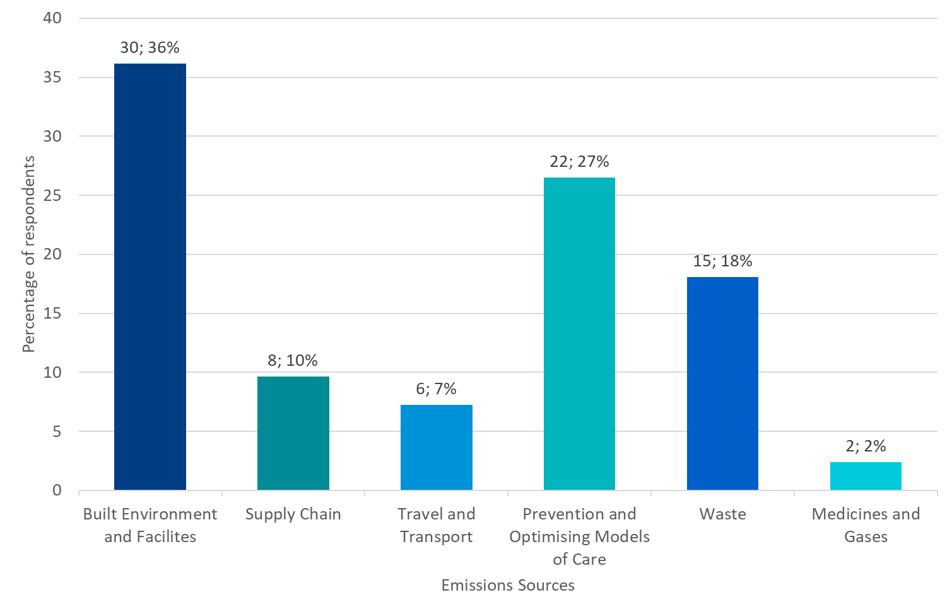
Figure 8 Highest priority for action on emission sources
The top two highest ranked priorities align with verbal feedback received during consultations, often highlighting the need to focus on preventative action, optimising alternative models of care and built environment reform and action.
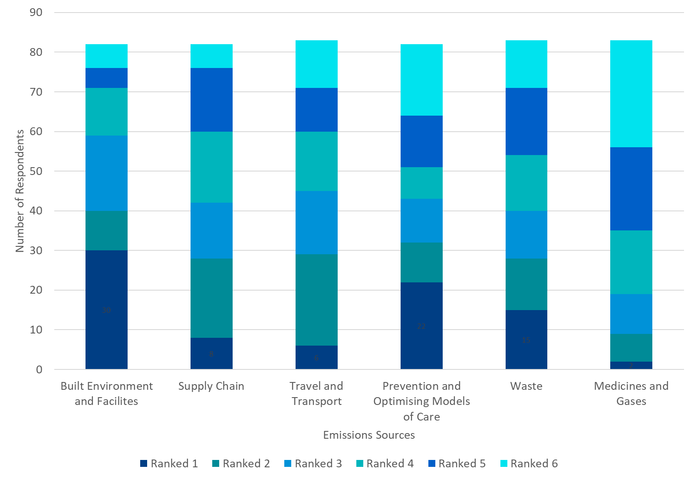
Figure 9 Ranking of priority for action on emissions sources
The below Figure 9 provides further breakdown of ranking and prioritisation of emission sources across the six focus areas. With approximately 40 respondents ranking built environment and facilities as priority one or two, and approximately 30 respondents ranking prevention and optimising models of care as priority one or two.
Q17 | What ‘quick wins’ in relation to emissions reduction should be prioritised for delivery in the twelve months following publication of the Strategy?
Stakeholders provided ‘quick wins’ to be prioritised for delivery over the short term, including but not limited to:
- Implement a Sustainability Development Unit in every hospital, health service or health district.
- Rapid phase out of fossil fuel projects, no new projects, and no expansion of existing projects; and reduction fossil fuel exports.
- Commit funding for the establishment and operation of an Aboriginal and Torres Strat Islander Coalition on Health and climate, or like body.
- Join WHO’s Alliance for Transformative Action on Climate and Health
- Embed climate and health into existing Ministerial and senior official health Australian and States and Territories governance mechanisms.
- Commission modelling on the costs of inaction, to serve as a benchmark.
- Publish an implementation plan/route map.
- Publish a monitoring and evaluation framework.
- Establish a small-scale innovation grant program for frontline clinicians.
- Expand/align environmental reporting requirements for the health system beyond scope of National Greenhouse and Energy Reporting (NGER) and National Pollutant Inventory (NPI) - refer to Financial Reporting Direction 24 (FRD24) in Victoria.
Education and awareness
- Education and awareness to healthcare workers - the immediate review and move to implement Environmentally Sustainable Healthcare teaching into all health-related learning programmes.
- Encourage peak bodies to introduce CPD points related to sustainability in healthcare.
- Launch behaviour change campaigns to raise awareness and encourage sustainable practices among healthcare staff, patients, and the broader community.
- For example, develop a campaign targeting healthcare providers and professionals, analogous to a cancer screening campaign, on the environmental impact of low-value care and the environmental co-benefits of reducing it.
Built Environment and facilities
- The Commonwealth could provide short-term and low-cost support to encourage the remaining states, which are less mature in their sustainability journey, to pilot National Australian Built Environment Rating System (NABERS) in their hospital sites and begin setting annual improvement targets.
- The Commonwealth could help facilitate an agreement for all states to commit to certify, disclose and set portfolio-improvement targets by 2025 and 2030 using NABERS.
- Advocate for no fossil-fuel use in new healthcare facilities (Canberra Hospital Expansion, Women’s and Children’s Hospital in Adelaide and proposed Melton Hospital in Victoria demonstrate possibility), with associated funding provided.
- Prioritise the replacement of fossil-fuel plant and equipment where practical.
- Legislate all new builds (residential and commercial) to be gas-free as supported by the Healthy Futures open letter to the Victorian Government.
- Installation of solar power, for primary healthcare and for remote households, to reduce power insecurity and emissions as well as indirect emissions related to health presentations.
- Electrification of hospitals and healthcare centres.
- Create national standards for sustainable health services; tangible for hospitals to utilise to guide their actions and practice moving forward.
- Identify and implement energy efficiency measures in healthcare facilities
- Conduct carbon footprint assessments within healthcare facilities to identify emissions hotspots and prioritise mitigation efforts.
- Install LED lighting, improved insulation at all health facilities.
- Introduce mandatory disclosure of building energy performance when sold and leased, by 2025.
- Mandate minimum energy efficiency performance standards for rental properties, by 2025.
- Phase out use of gas in existing homes and ban gas in new homes.
- Developing policies to support the electrification of transport fleets and healthcare facilities and the supply of 100% renewable energy.
- Phase out wood heaters from ACT suburbs through the establishment of a target date for the replacement of wood heaters with electric alternatives in all ACT suburbs (excluding rural areas), as has been done for fossil-fuel gas.
- Introduce mandatory labelling explaining the health risks associated with wood heater usage at point of sale for both wood heaters and firewood in ACT
Travel and transport
- Development of National Fuel Efficiency Standard.
- Ensure adequate end of trip facilities.
- Support and incentivise lower carbon travel options.
Supply chain
- Development of roadmap to reduce supply chain emissions in healthcare.
- Develop and implement sustainable procurement guidelines that prioritise environmentally friendly products and suppliers with low-carbon footprints.
Medicine and Gases
- Remove desflurane from public hospital formularies to discourage its use.
- Mandate public reporting of emissions from volatile anaesthetic gases and nitrous oxide from all healthcare facilities.
- Prohibit the venting of residual nitrous oxide, from ‘near empty’ cylinders, to the atmosphere.
- Invest in technological program for better pharmacy stock management.
- Implement a nitrous oxide mitigation strategy for all hospitals.
- Ceasing the supply of piped nitrous oxide in any facility which does not offer obstetric or paediatric services (converting to cylinder supply where necessary).
- Monitoring, detection, and mitigation of nitrous oxide infrastructure leaks.
- Encouraging alternative sources of analgesia where appropriate.
- Switching patients from metered dose inhalers to dry powder inhalers where clinically appropriate.
- Further development and adequate funding of the Choosing Wisely program.
- Move forward with TGA approval of anaesthetic gas capture and recycling
- Working with the TGA to review packaging and information requirements (including extension of use by dates) for medicines to reduce both waste and carbon emissions.
Waste
- Implementation of mandatory food waste audits in all Australian hospitals.
- Reduction and re-direction of hospital food waste away from landfill.
- Implement policy to preference reusable over single use products where possible.
- Reducing paper waste by increasing use of digital health solutions.
- Provide research funding to undertake a comprehensive process-based lifecycle inventory (stocktake) of commonly used reusable and single use medical equipment and emulate this process for pharmaceuticals.
Prevention and Optimising models of care
- Increased focus and funding for health prevention.
- Telehealth expansion - Accelerate the adoption and expansion of telehealth services, enabling healthcare providers to deliver care remotely and reduce the need for physical travel.
- ‘Out of Hospital Care’ model aims to support patient wellbeing to reduce the length of their hospital stay in the comfort of their own home.
- Incentivise change to behaviours and clinical practice through MBS items and subsidies.
- Develop electronic processes for patient communication.
- Review existing health services and models of care, including telehealth and ‘hospital in the home’ programs, to understand their potential to contribute to emissions reductions.
- Develop a 5-year plan to increase the investment in preventative health. Conduct a cost benefit analysis and evaluation of the impact of this approach
Q23 | What are the most effective ways to facilitate collaboration and partnerships between stakeholders to maximise the synergies between climate policy and public health policy? What are some successful examples of collaboration in this area?
 | Responses to this question are considered within each of the relevant sections under 2.2 Consultation Topics.

  - Appendix B: NVIVO approach
NVIVO is a software program designed for qualitative data analysis. It is a standard tool used in academic research and was used analyse written submissions and survey responses from the National Health and Climate Strategy Consultation Hub as well as workshop summary reports. NVIVO acts as an organising, managing, and analysing tool for text and image-based data and was developed by QSR International. It provides a robust way to synthesise large amounts of qualitative evidence.
It is important to note that NVIVO does not replace researcher analysis. Instead, it complements and aids the analysis process by allowing users or “coders” to create and apply codes to specific sections of the data, which represent concepts, themes, patterns, or ideas. These codes help in categorising and organising the data for analysis. NVIVO is not a tool that uses artificial intelligence and requires manual coding of text and image-based data.
The basic approach and methodology to NVIVO thematic analysis is summarised in the diagram below.
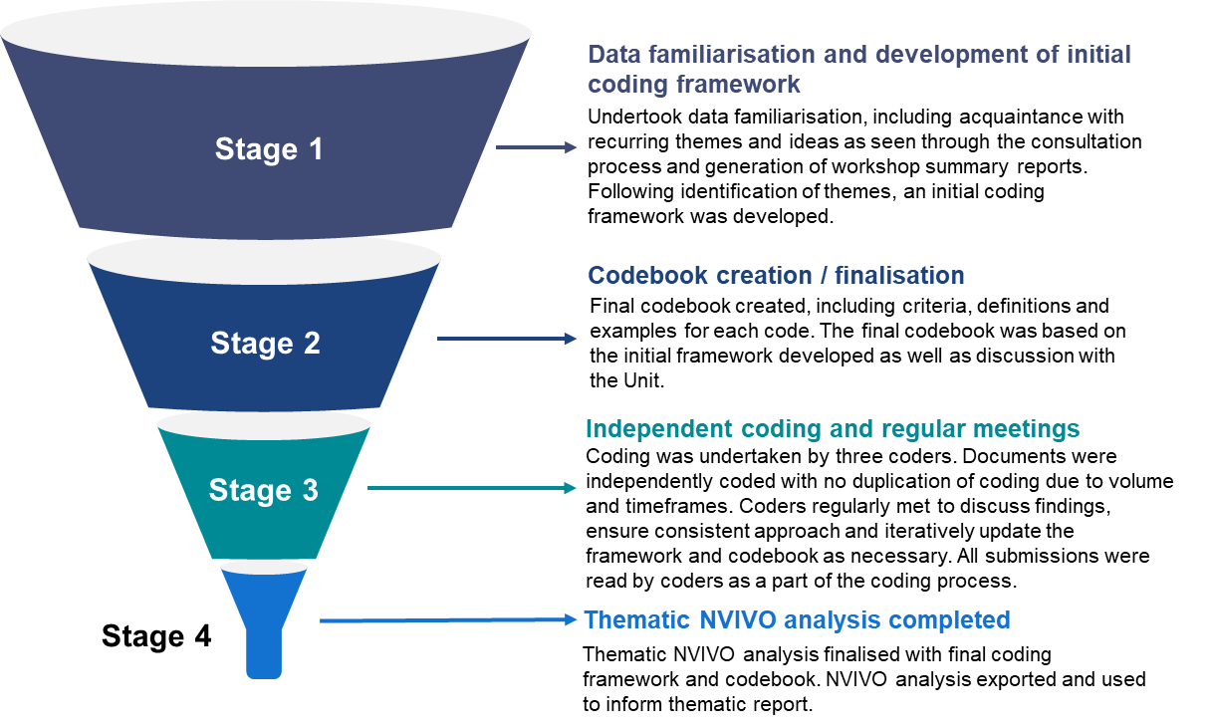
Stage 1 – data familiarisation and development of initial coding framework
Stage 1 involved familiarisation with the data and development of an initial coding framework. This included identification of recurring themes and ideas as seen through the consultation process and generation of workshop summary reports. Following identification of themes, an initial coding framework was developed.
Stage 2 – codebook creation / finalisation
Following discussion with the Unit and further assessment of the themes already identified the final coding framework was developed. The framework was inputted into NVIVO to create the codebook which would be used for all analysis. The codebook included criteria, definitions, and examples of each code to ensure coding by researchers would follow a consistent approach.
Stage 3 – independent coding and regular meetings
In Stage 3, three coders undertook coding. Prior to commencing coding, the coders familiarised themselves with the codebook and held a meeting to discuss the approach to ensure consistency of coding. Upon commencing coding, the coders met regularly to discuss findings, ensure the approach remained consistent and iteratively update the framework and codebook based on emerging themes.
A key part of the coding process included coders reading all submissions. This included written submissions and survey responses. Due to the volume of submissions and timeframes, submissions were only read and coded by one researcher.
A total of 166 written submissions were analysed during the coding process. Of these submissions, three were unable to be coded in NVIVO due to being incompatible with the software’s text-based output. Nevertheless the submissions that were incompatible for coding were read and perspectives included in the final thematic report.
Alongside the long form submissions, a total of 103 survey responses were analysed during the coding process. One additional survey was unable to be coded as the content was assessed to be inappropriate and irrelevant to the development of the National Health and Climate Strategy.
Stage 4 – thematic NVIVO analysis completed
Stage 4 saw the completion of all NVIVO thematic analysis. Upon completion, the NVIVO analysis was exported into Word format. Prior to exporting, all NVIVO coding was independently reviewed by team members who were not involved in the coding process to ensure accurate and consistent coding had occurred.
The reviewed findings from NVIVO were used to inform the final thematic report alongside the insights gathered from the workshop consultation process.
Limitations and barriers
The use of NVIVO for thematic analysis allowed for a robust and comprehensive approach, however, there were some limitations and barriers. These can be viewed below alongside the mitigation strategies that were implemented to reduce their impact.
Barrier / Limitation | Mitigation Strategy
Multiple coders were undertaking analysis independently which may have resulted in variances in how submissions were coded. |  | Coders followed a consistent framework and met regularly to reduce inconsistencies.
Storage of NVIVO files on local drives made collaboration between coders more difficult as ‘live’ updates could not be seen. |  | Coders met regularly to discuss findings and common themes emerging. Upon completion, the merging function was used to create one NVIVO file.
Documents (long form submissions and surveys) were only coded by one coder given the volume of submissions that required coding during a relatively short timeframe. |  | All NVIVO coding was independently reviewed by team members who were not involved in the coding process to ensure accurate and consistent coding had occurred. As necessary, recoding occurred in line with reviewer feedback.
NVIVO requires a licence, meaning those without a licence can only view coded documents through the Word extracts rather than directly in the software. |  | Extensive NVIVO extracts were developed to ensure those without an NVIVO licence could view analysis and coding. Original documents were centrally stored with a consistent naming convention to ensure submissions can be easily referred to as necessary.
Coding cannot be changed without access to an NVIVO licence. |  | NVIVO extracts were exported in Word format to allow text to be shifted between codes as necessary by those without an NVIVO licence.

  - Appendix C: List of all individuals that participated in workshops and/or submitted a response to the Consultation Paper
Redacted for protection of privacy.

