National Health and Climate

Strategy Implementation Plan,

2024-2028

Table of Contents
Version control 3
1. Introduction to the National Health and Climate Strategy 4
1.1 Objectives 4
1.2 Enablers 5
2. Governance and collaboration 6
2.1 Governance 6
2.2 Leadership and collaboration 7
2.2.1 Cross-portfolio collaboration 7
2.2.2 Cross-jurisdictional collaboration 8
2.2.3 Partnership with First Nations stakeholders 8
2.3 Stakeholder engagement and communication 9
3. Implementation Framework 10
3.1 Program Planning 10
3.2 Project Plans 11
3.3 Implementation Workstreams 12

Version control
This document was prepared in March 2024 by the National Health, Sustainability and Climate Unit, Environmental Health and Climate Change Branch, Health Protection Policy and Surveillance Division, interim Australian Centre for Disease Control, Australian Government Department of Health and Aged Care.
It will be reviewed and updated as needed, and changes will be reflected in the below table.
# | Revision description | Section # | Date | Approved by
1.0 | New document | All | March 2024 | Draft
1.1 | Rearranged existing material, added new risk management material |  | June 2024 | Unit Director
1.2 | Updates to existing material |  | August 2024 | Assistant Secretary

1. Introduction to the National Health and Climate Strategy
The National Health, Sustainability and Climate (NHSC) Unit, operating within the interim Australian Centre for Disease Control (CDC), has lead responsibility for implementation of the National Health and Climate Strategy (the Strategy). This Implementation Plan outlines the approach the NHSC Unit and the CDC will take to implementing the Strategy.
The Strategy sets out a whole-of-government plan for achieving healthy, climate-resilient communities, and a sustainable, resilient, high-quality, net zero health system. The Strategy commits to implementation of 49 actions over five years (from December 2023), with an update on progress in developing and delivering the Strategy to be published by 2026.
This initial Implementation Plan presents the milestones for the actions prioritised for delivery in 2024 and foreshadows the activities to deliver the remaining actions in 2025 and beyond. Further details on the Strategy’s delivery in 2025 and beyond will be included in updates to this Implementation Plan as additional resources are secured, partnerships are established, and more detailed plans are developed.

1.1 Objectives
The Strategy’s vision will be achieved through the pursuit of four objectives.
Objective 1 – Health system resilience: Build a climate-resilient health system and enhance its capacity to protect health and wellbeing from the impacts of climate change. The Strategy will inform and guide action by the health system to protect and promote population health while adapting to the impacts of climate change.
Objective 2 – Health system decarbonisation: Build a sustainable, high quality, net zero health system. The Strategy will guide the development of a plan to decarbonise the Australian health system, informed by a comprehensive assessment of the emissions footprint of the Australian health system and existing state and territory strategies and plans.
Objective 3 – International collaboration: Collaborate internationally to build sustainable, climate-resilient health systems and communities. The Strategy will identify opportunities for knowledge sharing and the development of international standards as well as highlight the ways Australia can support its neighbours to protect and promote health in their climate change responses.
Objective 4 – Health in All Policies: Support healthy, climate-resilient and sustainable communities through whole-of-government action which recognises the relationship between health and climate outcomes. The Strategy adopts a Health in All Policies approach, promoting the health co-benefits of emissions reductions across society and adaptation action beyond the health system to protect health and wellbeing from climate change.

1.2 Enablers
The Strategy also outlines actions in the following areas which will ‘enable’ delivery of its core objectives:
Enabler 1 – Workforce, leadership and training: Support and engage the health and aged care workforce to further develop the skills and capacity to raise public awareness and understanding of the health impacts of climate change and how to take action.
Enabler 2 – Research and innovation: Invest in and support coordinated climate and health research to improve the evidence base for responses to climate change, strengthen the sustainability of the health system and improve population health and wellbeing.
Enabler 3 – Communication and engagement: Effectively communicate and engage with a wide range of stakeholders and the general public to ensure actions to address the health impacts of climate change are widely understood and endorsed.
Enabler 4 – Collaboration and governance: Ensure appropriate governance structures are in place – both cross-jurisdictional and beyond government – to facilitate regular collaboration with all stakeholders

2. Governance and collaboration
The National Health and Climate Strategy (the Strategy) is a whole-of-government plan to address the health and wellbeing impacts of climate change and the contribution the health system make to climate change through the generation of greenhouse gas emissions in care delivery. The 49 actions the Australian Government has committed to under the Strategy will require a range of approaches to deliver successfully. Key to the Strategy’s implementation will be a systematic approach to managing a complex program of work, coordination and leveraging of related policy across all levels of government, a diverse range of portfolios, and the mobilisation of numerous external stakeholders including communication with consumers to increase awareness and promote behaviour change.

2.1 Governance
Implementation of the Strategy will be overseen by three new governance bodies:
- Climate & Health Expert Advisory Group. Will provide expert advice on climate and health policy, including implementation of the Strategy. Chaired by the Assistant Minister of Health and Aged Care and including academic experts, community group representatives, and representatives of health professions and sectoral groups.
- National Climate & Health Program Board. Will have overall oversight of Strategy implementation, and provide advice on the strategic direction of national climate and health policy. Chaired by the Chief Medical Officer and consisting of senior representatives from across the CDC, Department and APS.
- State and Territory Climate & Health Working Group. Will focus on supporting implementation of actions requiring collaboration between Australian Government, states and territories, and may also identify other priorities for cross-jurisdictional collaboration. Chaired by the Assistant Secretary of the Environmental Health and Climate Change Branch and consisting of the climate and health leads from each jurisdiction.
This governance structure will enhance effective collaboration on climate and health policy between various Australian Government portfolios, states and territories, and with key external stakeholders, in line with Strategy Action 7.5 (“The Australian Government will review climate and health governance structures in consultation with states and territories and consider how to enhance cross-jurisdictional collaboration, as well as collaboration across the wider climate and health stakeholder community”).
The proposed relationship between each of these groups and the NHSC Unit is outlined below.
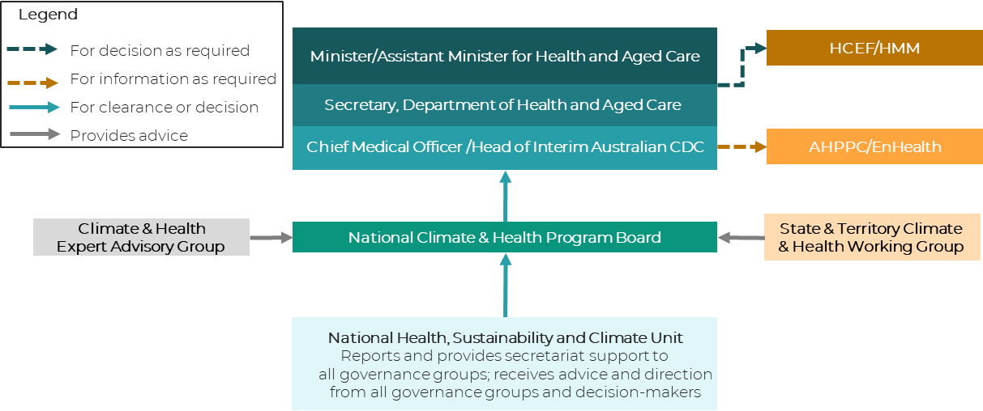

2.2 Leadership and collaboration
The impacts on health from changes to our environment and climate cut across a wide range of portfolios and sectors within the health system. Considerable resources will be dedicated to developing and maintaining working partnerships, identifying opportunities for collaboration and coordination amongst the Commonwealth, states and territories, local governments and private health organisations.
The NHSC Unit has lead responsibility for implementation of many Strategy actions. Implementation of some other actions will be the lead responsibility of other teams in the CDC or Department of Health and Aged Care. Implementation of a third set of actions will be the lead responsibility of other Australian Government agencies, or shared between these agencies and the NHSC Unit. The Department will engage with First Nations organisations to plan a shared decision making approach to implementing actions in the Strategy that impact First Nations communities.

2.2.1 Cross-portfolio collaboration
The Strategy commits to a ‘Health in All Policies’ approach, implying a cross-government commitment to consideration of health impacts in formulation of climate policy.
Delivery of many key commitments will require extensive collaboration between Australian Governments portfolios. Where other Australian Government agencies have lead responsibility for delivering Strategy commitments, the NHSC Unit will establish and maintain a close working relationship with these agencies to identify opportunities to add value and ensure climate and health issues are integrated into new policies or programs.
The National Climate & Health Program Board will be a key vehicle for facilitating cross-portfolio collaboration on climate and health policy. The CDC will also seek to represent the objectives of the Strategy through membership of APS-wide climate governance structures, such as the Powering Australia IDC, the Net Zero Plan IDC and the Risk Assessment and Adaptation Plan Working Group.

2.2.2 Cross-jurisdictional collaboration
Implementation of many Strategy actions will require extensive coordination with states and territories. The Strategy was developed with feedback and extensive input from state and territory representatives from all jurisdictions.
The states and territories have primary responsibility for large parts of the health system including the funding and management of public hospitals, regulation and licensing of private hospitals and other health premises. They also deliver community and mental health services, regulate food safety and handling, deliver services for public health and health protection. Activities to reduce greenhouse gas emissions and adapt the health system are encompassed by these responsibilities.
A number of actions in the Strategy call for cross-jurisdictional cooperation to work towards alignment of health policies, plans and activities across an agreed set of national climate and health priorities. The State & Territory Climate & Health Working Group will be a key forum for supporting cross-jurisdictional collaboration and coordination on the implementation of relevant actions in the Strategy. When required the Australian Government may seek review or endorsement of key outputs from the Strategy implementation process by cross-jurisdictional governance bodies such as the Australian Health Protection Committee (AHPC) and/or the Health Chief Executives Forum (HCEF) and/or the Health Ministers Meeting (HMM).

2.2.3 Partnership with First Nations stakeholders
The Australian Government is committed to co-designing policy in partnership with First Nations people in line with the National Agreement on Closing the Gap. This commitment to co-design is reflected in Strategy Principle 3, which recognises First Nations communities’ knowledge and experience must be central to decision-making on climate and health policy at all levels. Robust governance is needed to enable co-design of relevant measures arising from the Strategy with First Nations people. Consultation with First Nations stakeholders during development of the Strategy identified a governance gap in relation to First Nations health and climate policy.
A key challenge in implementing the First-Nations-related actions in the Strategy will be designing appropriate governance arrangements that address this gap, enabling co-design of First Nations health and climate policy between the Department and First Nations stakeholders, but do not duplicate existing structures.
To give effect to the Strategy’s commitment to First Nations leadership, we are seeking to procure the services of one or more First Nations health peak bodies to develop a proposal for governance arrangements and/or engagement mechanisms which will support First Nations people to lead the changes needed to adapt to climate change and reduce the impacts of climate change on health.

2.3 Stakeholder engagement and communication
Communication and engagement is one of four enablers of action discussed in the Strategy, as these activities will be crucial to mobilising effective collaborative action on climate and health. Development and maintenance of strategic partnerships, timely connection and communication with networks of key stakeholders and strong governance will be critical determinants of success in implementing the Strategy.
The governance structures established to oversee Strategy implementation and provide strategic direction for climate and health policy have been carefully designed to draw membership from a range of stakeholder groups identified as part of the consultation process to develop the Strategy. Representatives on the National Climate & Health Program Board, the Climate & Health Expert Advisory Group and the State & Territory Climate & Health Working Group will support engagement in their respective stakeholder segment. In addition, the development of more detailed plans for Strategy actions will be undertaken in collaboration with key delivery partners and stakeholders.
There is a particular need for engagement with communities that will be hardest hit by climate change, such as First Nations people and young people. The Strategy contains a principle acknowledging the central role of First Nations leadership in climate and health policy. The Department will work in partnership with a First-Nations-led organisation to co-design implementation of relevant actions within the Strategy.
Effective communication and engagement with the public, patients and consumers will be key to successful, equitable implementation of the Strategy. It is critical the Australian community’s understanding of the likely impacts of climate-related hazards on their own health and the health system is improved to ensure they play an active role in their own health and the resilience of the health system.
We will endeavour to support respectful and effective working relationships by:
- Communicating with and listening to our partners and stakeholders, to keep them informed about the progress of the Strategy and actively seek their input into the Strategy’s implementation.
- Developing delivery plans for Strategy actions that reflect the expectations, needs and priorities of our stakeholders and that support collaborative implementation.
- Actively seeking opportunities for collaboration through regular networking to generate and maintain momentum, and provide active support where possible.
- Modelling transparency and accountability by communicating progress in implementing the Strategy to all interested stakeholders – including communication of any roadblocks and delays.

3. Implementation Framework

3.1 Program Planning
The Strategy will be implemented using a relatively standard program management framework. The program plan (or implementation plan) outlined in this document was developed in the following stages:

- Prioritisation: Strategy actions were classified into a 2x2 matrix (see Figure 1) based on priority level (for completion or significant progression in 2024 vs not being prioritised until 2025) and responsibility level (NHSC Unit has lead responsibility for implementation vs implementation is being led by another team).

Figure 1: National Health and Climate Strategy actions split by priority and responsibility
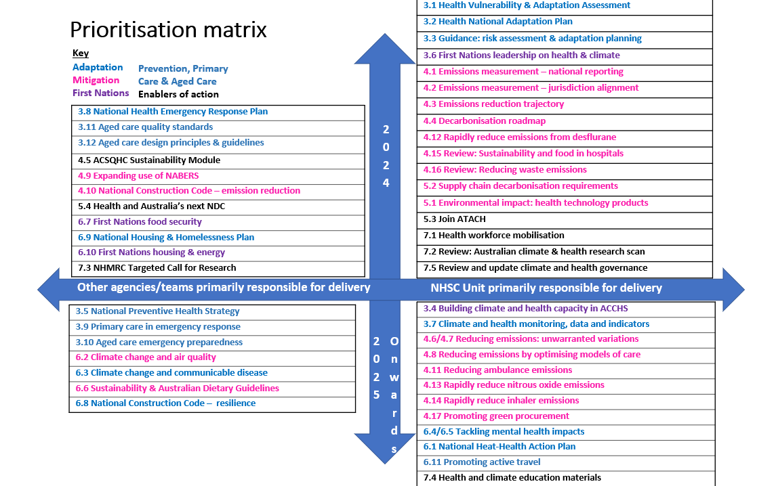

- Project planning: For all actions prioritised for 2024 implementation or progression, project plans were developed in the form of a Gantt chart. Detailed project plans were developed for actions led by NHSC Unit, while simpler project plans were developed for actions being led by others.

- Resource triangulation: A resource tracker was developed for the NHSC Unit mapping projects to staff FTE for each month in 2024..

- Risk management: A risk mapping exercise is underway to identify risks to Strategy implementation. These risks will be recorded in a risk register and scored using the Department’s Risk Assessment Matrix (see Figure 2). For risks evaluated as ‘High’, risk mitigation plans will be developed that, once fully implemented, should reduce the risk down to acceptable levels. The National Climate & Health Program Board and the Climate & Health Expert Advisory Group will receive updates on the management of these risks at their meetings.

Figure 2: Department of Health and Aged Care Risk Assessment Matrix
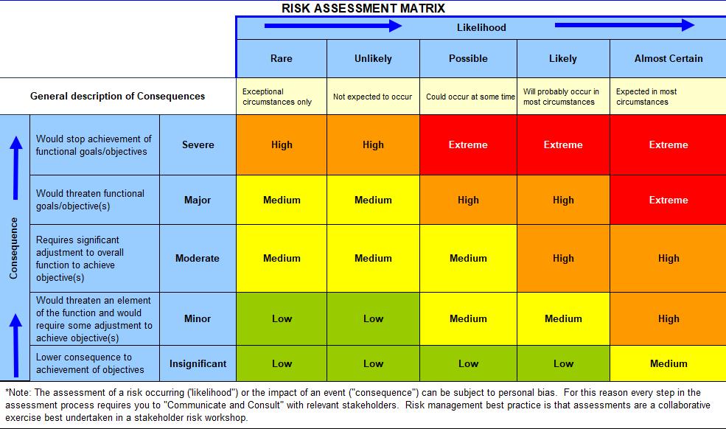

3.2 Project Plans
Project plans identify, via a Gantt chart:
- Tasks that need to be undertaken to deliver the action, with responsibility for each task assigned to a specific team or agency.
- Milestones in implementation (typically a key project deliverable linked to a specific due date).
Project plans will be reviewed regularly as part of the business-as-usual operations of the NHSC Unit. Reports on progress, including identification of projects that are at risk or behind schedule, will be provided to the National Climate & Health Program Board as part of a routine reporting cycle.

3.3 Implementation Workstreams
All Strategy actions appear either under one of the four Objectives, or under an Enabler of action. To harness synergies between different actions, the work to implement the Strategy has been organised into four ‘workstreams’ which differ slightly from the Objectives and Enablers (see Table 1 for mapping). These workstreams are:
- Adaption
- Mitigation
- Primary Care, Aged Care and Preventive Health
- First Nations
- Enablers of action
A defining feature of the third workstream on Primary Care, Aged Care and Preventive Health is that many of the actions in this workstream have both a mitigation and an adaptation component.
These workstreams will support collaboration with key stakeholder groups which represent key population groups or parts of the health system and acknowledge that work is undertaken simultaneously on mitigation and adaptation.
Table 1: Mapping of Strategy actions from Objectives Workstreams
Allocation of Strategy Actions to Delivery workstreams
Workstreams | Adaptation | Mitigation | Primary Care, Aged Care and Preventive Health | First Nations | Enablers of action
Objectives
1. Health System Resilience | 3.1, 3.2 Risk Assessment & Adaptation Plan  3.3 Guidance  3.7 Monitoring  3.8 NHERP |  | 3.5 NHPS  3.10-3.12 Aged Care | 3.6 FN leadership  3.4 ACCHS capacity
2. Health System Decarbonisation |  | All Chapter 4 actions (4.1 to 4.17)
3. International  Collaboration |  | 5.1 Footprinting  5.2 Supply chain |  |  | 5.3 ATACH  5.4 NDCs
4. Health in All Policies | 6.1 Heat  6.2 Air quality  6.3 Communicable disease  6.4, 6.5 Mental health  6.9 Housing & Homelessness Plan | 6.6 Dietary Guidelines  6.8 NCC climate resilience | 6.11 Active Travel | 6.7 FN food security  6.10 FN housing and energy
Enablers of Action |  |  |  |  | All Chapter 7 actions (7.1 to 7.5)

