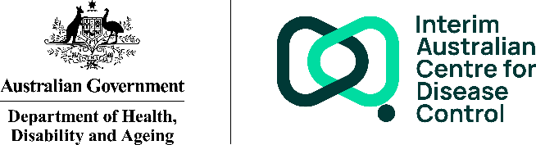
Interim Australian Centre for Disease Control
Our achievements
January to September 2025
 | Introduced legislation into Parliament to establish Australia’s CDC
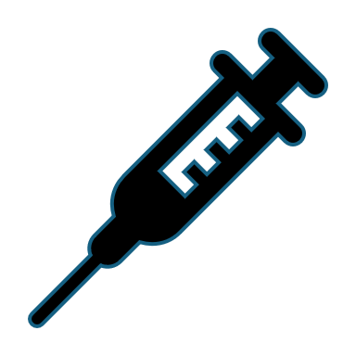 | Launched the National Immunisation Strategy 2025 to 2030, the third in Australia’s history, building on the country’s strong immunisation legacy
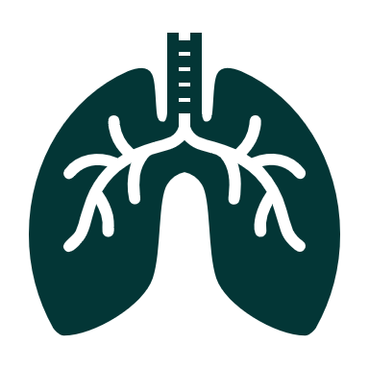 | Published the first Annual Australian Respiratory Surveillance Report covering the surveillance of COVID-19, respiratory syncytial virus, and other acute respiratory infections in Australia in 2024
   | Supported the response and recovery for Ex-Tropical Cyclone Alfred, including through the activation of the National Incident Centre
 | Delivered a national preparedness exercise for complex, compounding crises with health consequences
 | Supported the Australian Medical Assistance Team (AUSMAT) deployment in Myanmar to assist earthquake response and recovery efforts
 | Continued to support Australia’s preparedness for a possible outbreak of the H5N1 strain of avian influenza, contributing to a whole-of-government One Health approach
 | Published the first estimate of the greenhouse gas emissions of the health sector to support targeted interventions to reduce emissions
 | Delivered the National Microbial Genomics Framework for Public Health 2025 to 2027, providing a nationally strategic and consistent view for integrating microbial genomics into the Australian public health system
   | Delivered the 2025 One Health Symposium, fostering collaboration across human, animal, and environmental health sectors, with 120 attendees from 45 organisations
 | Celebrated nearly 50 years of the Communicable Diseases Intelligence journal and transitioned to the new Open Journal Systems platform
 | Sponsored and contributed to the Communicable Disease and Immunisation Conference as part of our role as a leader in public health
 | Contributed to international public health forums on public health surveillance and data systems



