National Syphilis Surveillance Quarterly Report
  - Quarter 2: 1 April – 30 June 2024

Introduction
On 23 March 2021, the Australian Health Protection Committee (AHPC) endorsed the National strategic approach for responding to rising rates of syphilis in Australia 2021 (Strategic Approach) developed to guide the national response to the continued rise in syphilis notifications in Australia. The Strategic Approach outlines three national targets which provide a specific focus for efforts towards addressing the rising rates of syphilis and adverse outcomes in Australia:

Reduce incidence of syphilis overall, with a focus on women of reproductive age
- Reduce incidence of syphilis overall, with a focus on women of reproductive age.
- Eliminate congenital syphilis.
- Control outbreaks among Aboriginal and Torres Strait Islander peoples in Queensland, the Northern Territory, Western Australia, and South Australia.
Supporting the Strategic Approach is the National syphilis surveillance and monitoring plan (Surveillance Plan) which outlines indicators that will be used to monitor progress towards achieving the three specific targets.
This report provides a quarterly account of progress against the targets and indicators in the Strategic Approach and Surveillance Plan.

Analysis
The Department of Health and Aged Care acknowledges the providers of the many sources of data used in this report and greatly appreciates their contribution.

Summary
- Syphilis notifications are being monitored across four population groups: non-Indigenous males, non-Indigenous females, Aboriginal and Torres Strait Islander males and Aboriginal and Torres Strait Islander females.
- In the previous 12 months, all population groups reported a decline in notification rates, with the exception of non-Indigenous females who observed a small increase (1%).
- Aboriginal and Torres Strait Islander people continue to be disproportionately represented in the syphilis notification data, with notification rates overall 7 times that of non-Indigenous people in the previous 12 months.
- The greatest proportion (69%) of syphilis cases were reported in non-Indigenous men, who largely resided in major cities.
- Notification rates in Aboriginal and Torres Strait Islander people in remote and very remote areas of Australia continue to be the highest, reflecting sustained transmission associated with the outbreak in Queensland, the Northern Territory, Western Australia and South Australia. Although the highest overall, notification rates have continued to trend downwards in the previous 12 months.
- Notification rates among Aboriginal and Torres Strait Islander and non-Indigenous females of reproductive age (15-44 years) residing in major cities increased in the previous 12 months.
- Increases among women of reproductive age have coincided with the highest number of congenital syphilis cases diagnosed in 2023 (n=20) since 1995 and the highest number of associated deaths ever reported in a single year (n=10).^{i}
- Seventy-nine per cent (79%) of women giving birth to an infant with congenital syphilis were diagnosed late in pregnancy.
Data presented are to 30 June 2024 unless otherwise specified.
Target 1: Reduce incidence of syphilis overall, with a focus on women of reproductive age

Indicator 1.1 - Rate of infectious syphilis
In the previous 12 months (Q3 2023 – Q2 2024), there were 5,973 cases of infectious syphilis reported to the National Notifiable Diseases Surveillance System (NNDSS). Of the 5,973 cases of infectious syphilis 5,437 cases (91%) reported Indigenous status and sex:
- The greatest proportion of cases were among non-Indigenous males (69%, n=3,773/5,437), followed by non-Indigenous females (12%, 673/5,437), Aboriginal and Torres Strait Islander females (9%, 510/5,5,437) and Aboriginal and Torres Strait Islander males (9%, 474/5,437). The remaining 7 cases (<1%, 7/5,437) were reported among non-Indigenous people who reported their sex assigned at birth as another term, other than male or female.
- Aboriginal and Torres Strait Islander males and females are disproportionately represented in the notification data, with notification rates in the previous 12 months reported as 147 and 155 per 100,000. Non-Indigenous males, despite representing the greatest proportion of total notifications, reported a notification rate substantially lower (36 per 100,000) followed by non-Indigenous females (6 per 100,000) (Figure 1).
- In the previous 12 months, non-Indigenous females were the only population group to observe an increase in notification rate (1%) compared to the preceding 12 months (Q3 2022 – Q2 2023) and five-year mean (16%).
- All other population groups observed declines compared to the preceding 12 months and five-year mean: Aboriginal and Torres Strait Islander males (9% and 4% respectively), non-Indigenous males (15% and 4% respectively) and Aboriginal and Torres Strait Islander females (5% and 1% respectively).
In the previous 12 months age-standardised notification rates of infectious syphilis by statistical area 3 (SA3) were widely distributed across Australia, (Map 1). The highest rates were reported across the north-west of Australia and in SA3’s in some major cities, including Sydney, Melbourne and Brisbane. Please refer to the methodological notes for further information on the map development.

Figure 1: Notifications (n) and notification rate (per 100,000) of infectious syphilis* reported, by Indigenous status, sex, quarter, and year, 2011 – Q2 2024
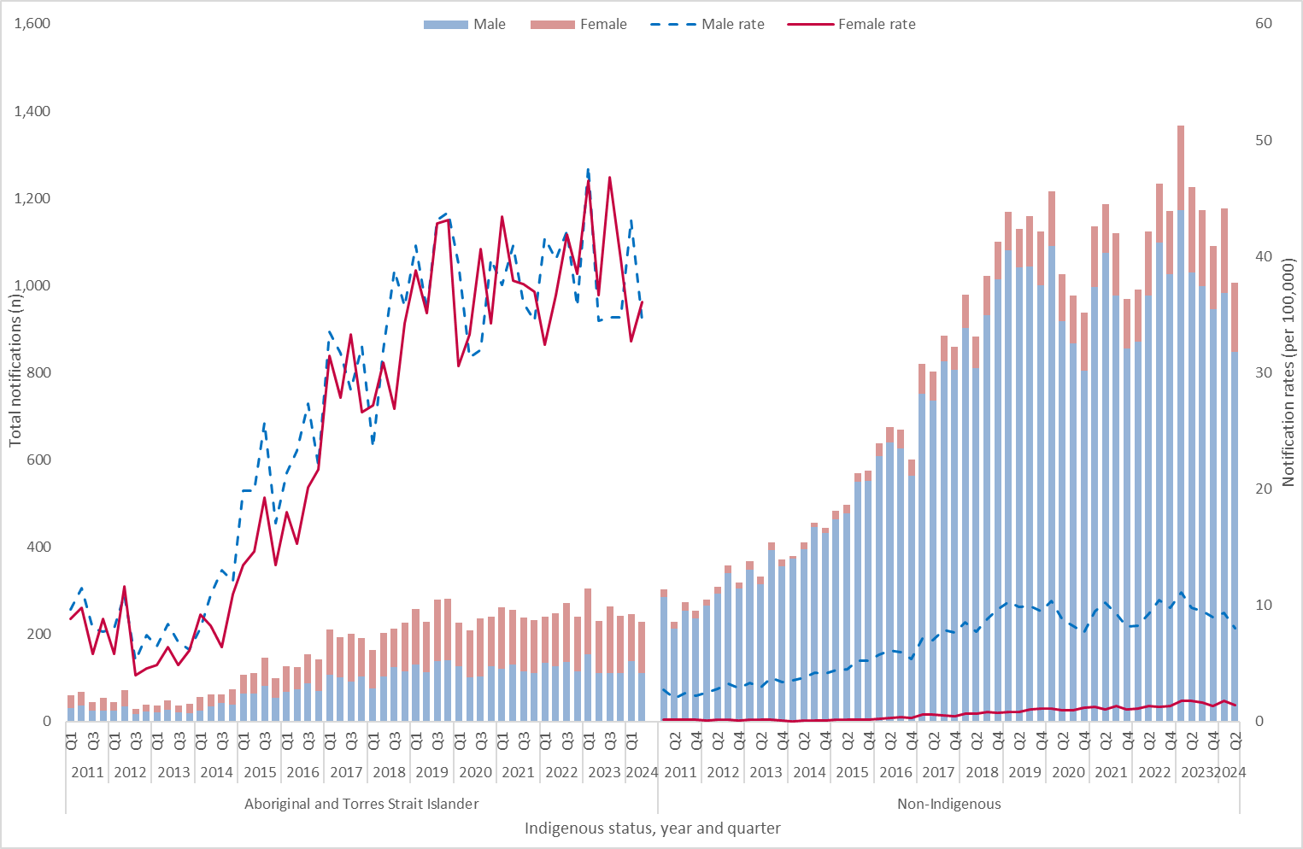
*Excludes cases for whom sex and/or Indigenous status was not reported. Due to low numbers of persons who reported their sex assigned at birth as another term, other than male or female have been excluded from the figure.
Map 1: Age-standardised notification rate (per 100,000) of infectious syphilis* by Statistical Area 3 (SA3) in the previous 12 months (Q3 2023 – Q2 2024)
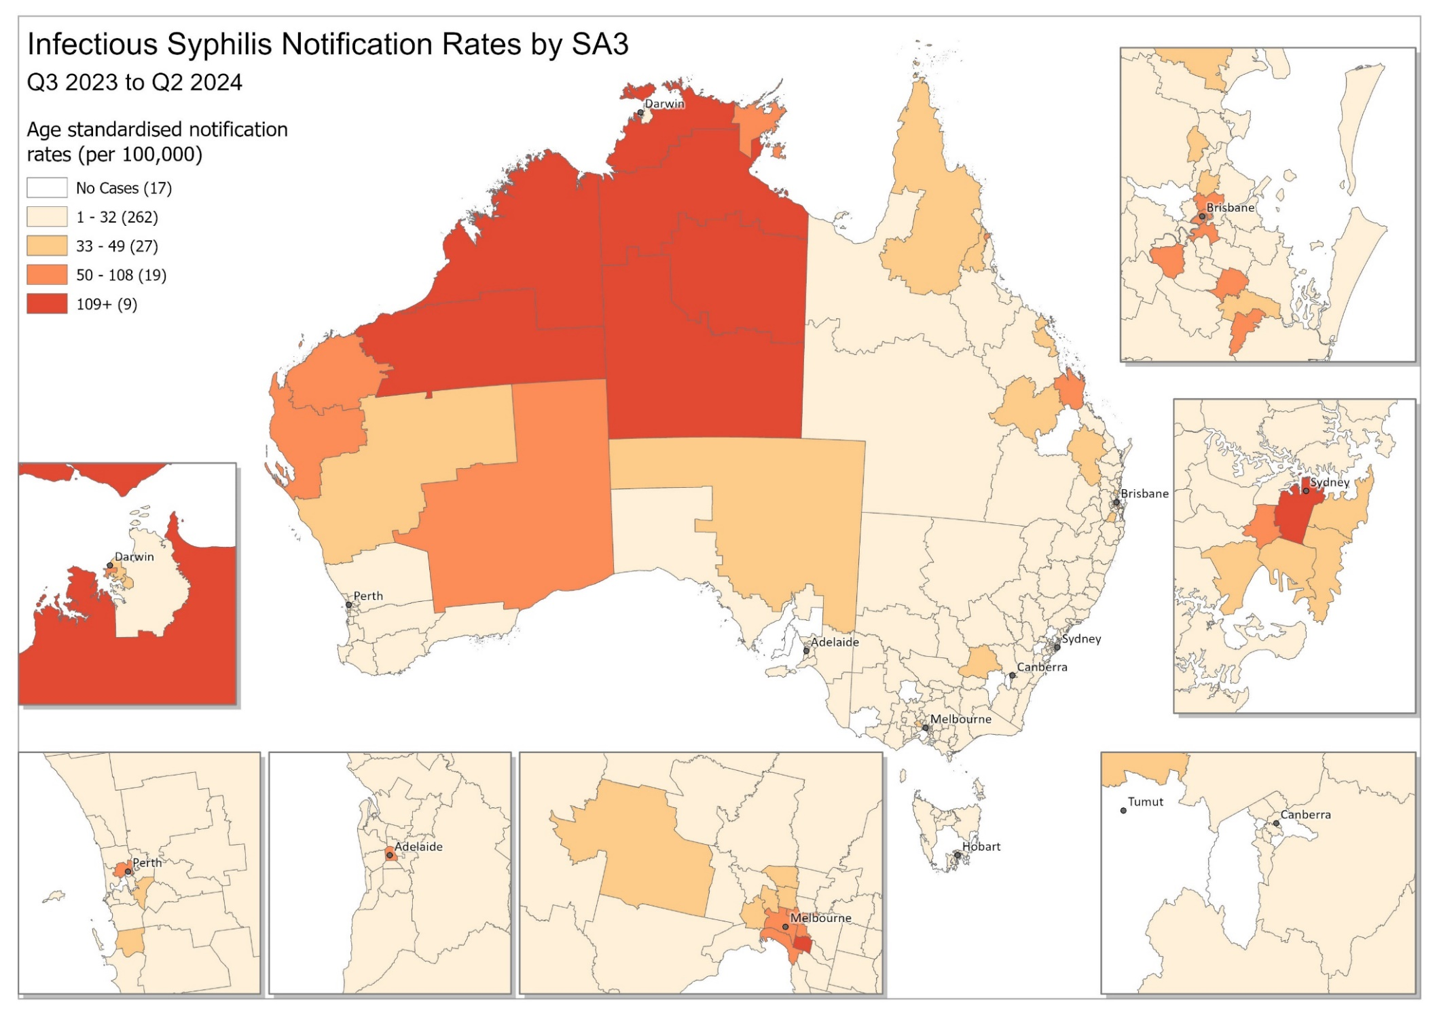
* Excludes cases where residential postcode or location were not reported.

Remoteness area
Across all remoteness areas of Australia, Aboriginal and Torres Strait Islander men and women have substantially higher notification rates compared to non-Indigenous men and women (Figures 2 a-c and 3 a-c).
In the previous 12 months (Q2 2023 – Q1 2024) the highest notification rates were reported among Aboriginal and Torres Strait Islander men and women aged 15-34 years old residing in remote and very remote areas of Australia, reflecting sustained transmission associated with the infectious syphilis outbreak in Queensland, the Northern Territory, Western Australia and South Australia (see Target 3 below for further information on the outbreak).
- Major cities
Non-Indigenous men represented the greatest proportion (79%) of syphilis notifications in major cities across Australia. Notification rates in this population group observed decreases across all age groups compared to the preceding 12 months (Q3 2022 – Q2 2023). Aboriginal and Torres Strait Islander men, representing 4% of notifications in major cities, also reported decreases across all age groups compared the preceding 12 months, with the exception of 35-44 year olds which increased by 11%.
Aboriginal and Torres Strait Islander women (4% of all notifications in major cities) reported the greatest increase overall compared to the preceding 12 months in 45+ year olds (150% noting this increase was from a lower base) followed by 35-44 year olds (28%). Non-Indigenous women (13% of all notifications in major cities) reported increases in 25-34 year olds (19%) and 35-44 year olds (3%) compared to the preceding 12 months (Figures 2a and 3a).
- Inner and outer regional areas
Non-Indigenous men represented the greatest proportion of cases reported in the past 12 months in inner and outer regional areas (54%). Increases were reported in non-Indigenous men aged 45+ year olds (28%) and 35-44 year olds (11%) in the last 12 months compared to the preceding 12 months. Aboriginal and Torres Strait Islander men (18% of all notifications in inner/outer regional areas), reported increases across all age groups except 35-44 year olds, with 15-24 year olds reporting the highest increase (45%), followed by 25-34 year olds (22%) and 45+ year olds (20%).
Aboriginal and Torres Strait Islander women (14% of all notifications in inner/outer regional areas) reported the greatest increase overall in 45+ year olds (80%) compared to the preceding 12 months, followed by 15-24 year olds (10%) but reported declines across the remaining age groups. Non-Indigenous women (14% of all notification in inner/outer regional areas) reported declines across all age groups. (Figures 2b and 3b).
- Remote and very remote areas
Aboriginal and Torres Strait Islander women and men represented 91% of cases reported over the previous 12 months in remote and very remote areas of Australia. Aboriginal and Torres Strait Islander women reported the highest proportion of cases in these areas (52%). Across all remoteness areas, notification rates were highest in Aboriginal and Torres Strait Islander men and women, particularly in the 15-24 and 25-34 year age groups. Although the highest overall, notification rates have declined in Aboriginal and Torres Strait Islander men and women in remote and very remote areas of Australia in the previous 12 months compared the preceding 12 months across all age groups, with the exception of 25-34 year old women which increased by 18% (Figures 2c and 3c).

Figure 2 a-c: Notifications (n) and notification rate (per 100,000) of infectious syphilis reported in males, by Indigenous status, remoteness area, age, quarter, and year, 2015 – Q2 2024 (a. Major cities, b. Inner and outer regional areas and c. Remote and very remote areas) *
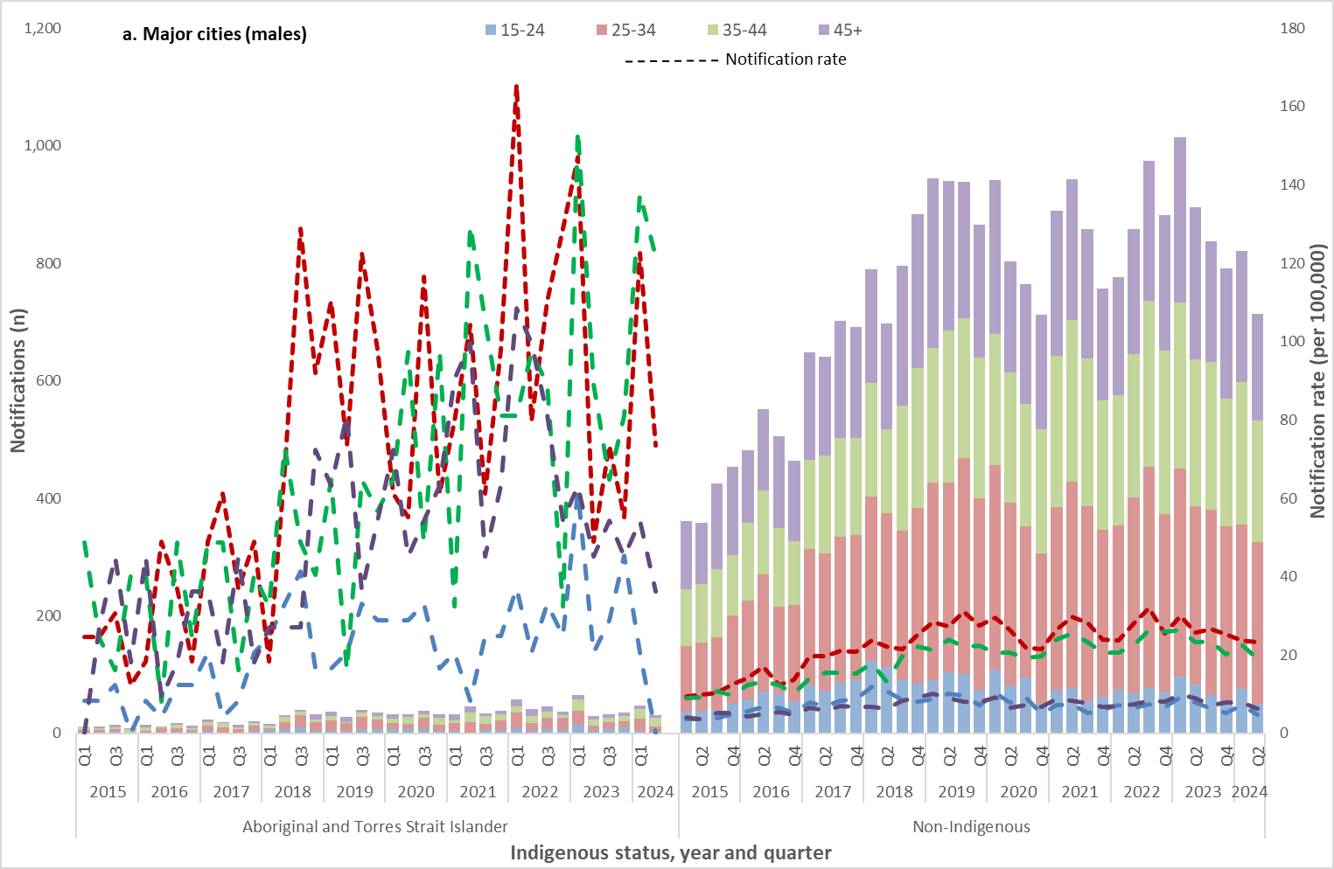
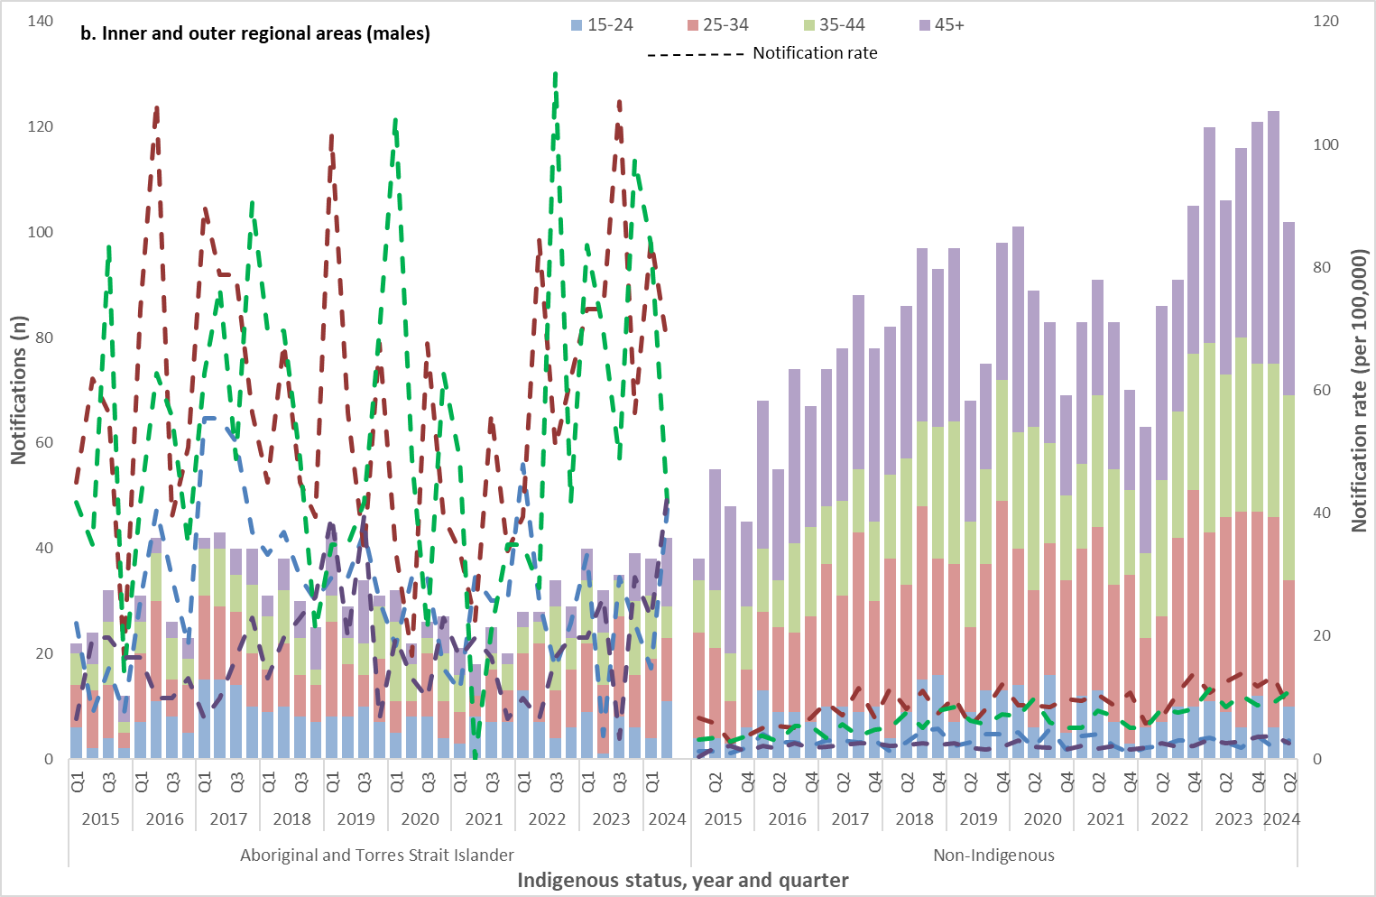
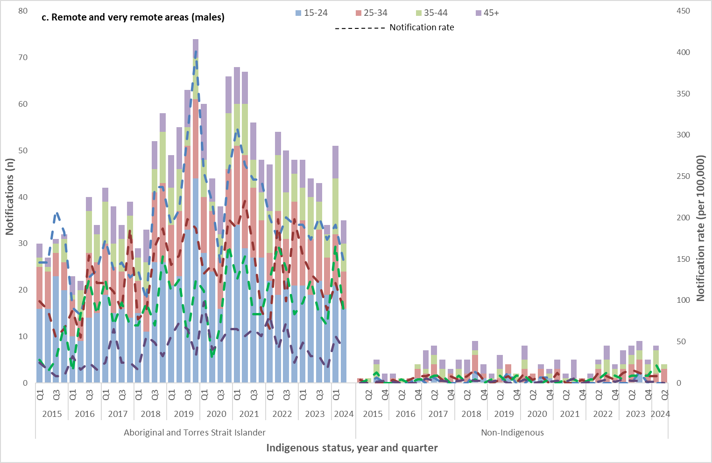
*Excludes cases for whom sex, age, Indigenous status and/or residential postcode were not reported
Figure 3 a-c: Notifications (n) and notification rate (per 100,000) of infectious syphilis reported in females, by Indigenous status, remoteness area, age, quarter, and year, 2015 – Q2 2024 (a. Major cities, b. Inner and outer regional areas and c. Remote and very remote area* 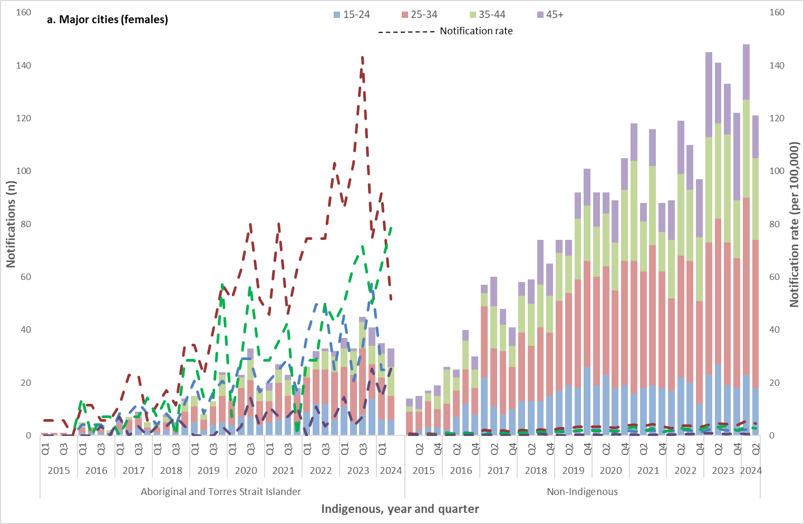
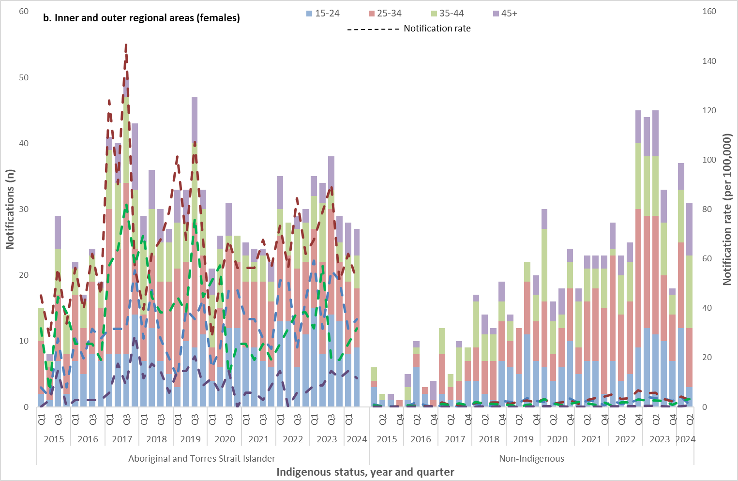
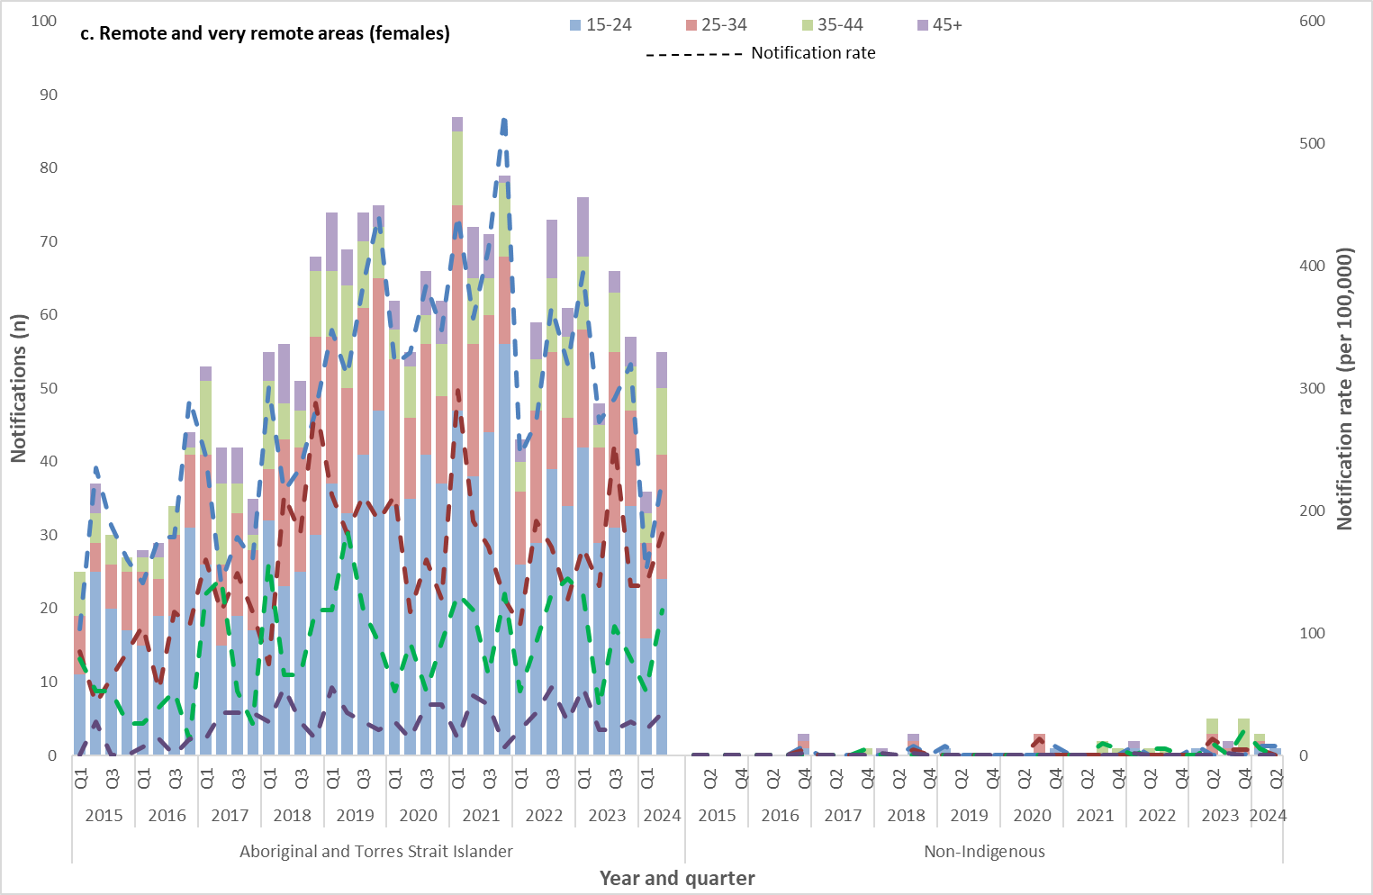
*Excludes cases for whom sex, age, Indigenous status and/or residential postcode were not reported.

Indicator 1.2 – Rate of infectious syphilis among women of reproductive age (15-44 years)
Over the previous 12 months (Q3 2023 – Q2 2024) notifications of syphilis among Aboriginal and Torres Strait Islander women aged 15-44 years were predominately in residents of remote and very remote areas of Australia, consistent with historical trends (Figure 4a). The highest notification rates, as expected, were in remote and very remote areas, however notification rates have continued to trend downwards, with a 15% decline compared to the previous 12 months (Q3 2022 – Q2 2023) and 16% compared to the 5-year mean. Aboriginal and Torres Strait Islander women residing in major cities recorded the second highest rates in the previous 12 months, increasing from the preceding 12 months by 6% and 31% compared to the 5-year mean. Inner/outer regional areas reported a rate decrease compared to the preceding 12 months and 5-year mean, 12% and 2%, respectively.
Non-Indigenous women of reproductive age diagnosed with syphilis over the previous 12 months were predominately residents of major cities of Australia, consistent with historical trends (Figure 4b). Notification rates have continued to increase in the previous 12 months for this group by 9% compared to the preceding 12 months and increased by 16% compared to the 5-year average. Notification rates in inner/outer regional areas decreased by 27% between the previous 12 months and the 12 months prior and increased by 6% compared to the 5-year average. Notification rates in remote and very remote Australia have fluctuated, noting that changes over time are from a lower base.
Figure 4a-b: Notifications (n) and notification rate (per 100,000) of infectious syphilis reported in females aged 15-44 years, by Indigenous status, remoteness area, quarter, and year, 2015 – Q2 2024 (a. Aboriginal and Torres Strait Islander and b. non-Indigenous) *
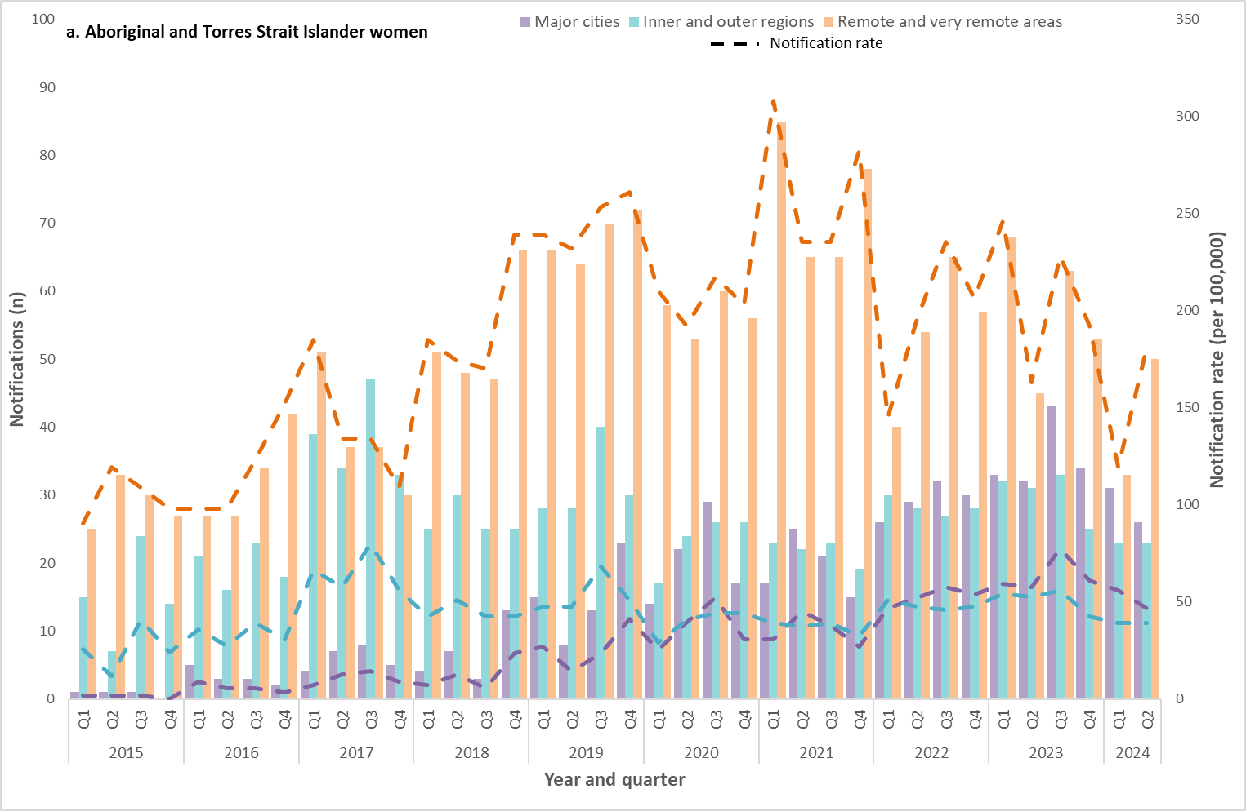
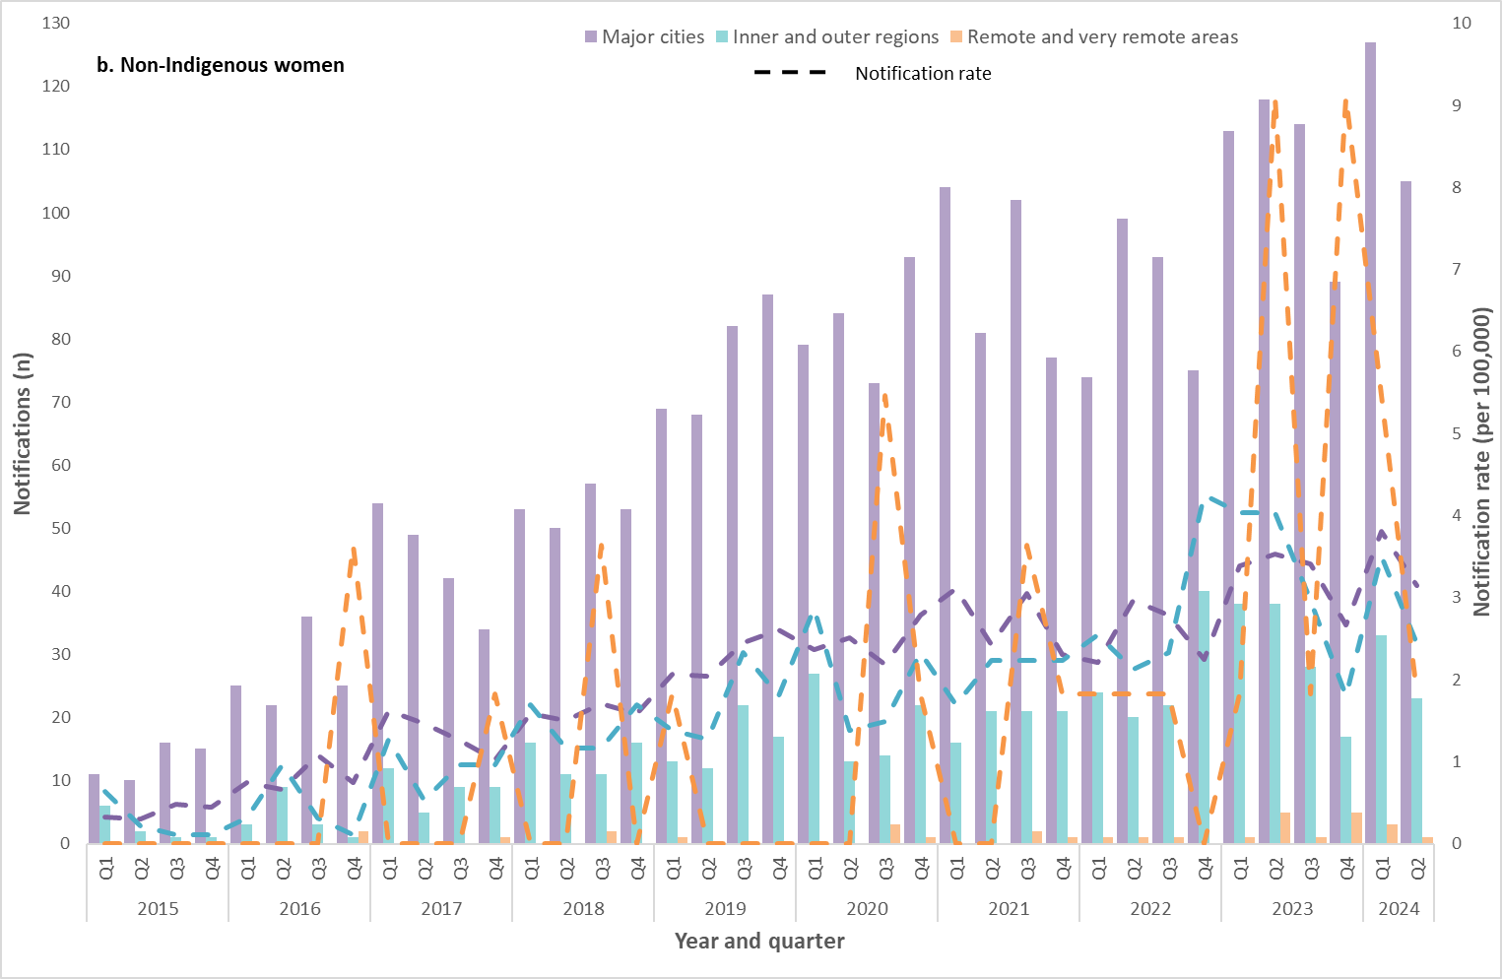
*Excludes cases for whom sex, age, Indigenous status and/or residential postcode were not reported.

Indicator 1.3 – Proportion of infectious syphilis notifications in men reporting sexual exposure with men only

Indicator 1.4 – Proportion of infectious syphilis notifications in men reporting sexual exposure with both men and women
Enhanced data (sexual exposure: same sex, opposite sex and both sexes) are used to report against indicators 1.3 and 1.4.
Completeness of enhanced sexual exposure data
Completeness of sexual exposure in males notified with infectious syphilis fluctuated between 2015 and Q2 2024, ranging from 63% to 87% (average 73%).
Same sex only was the most frequently reported sexual exposure across all categories, representing on average 55% of notifications overall, followed by opposite sex only (14%) and both sexes (4%). The proportion of cases reporting same sex only exposure fluctuated across the reporting period with the highest in 2015 (68%) and lowest in 2020 (47%) (Figure 5).
Although men reporting sexual exposure with both men and women represented the lowest proportion of all cases during the reporting period (range 3 - 6%), this proportion increased by 33% between 2015 and 2023.

Figure 5: Number of infectious syphilis notifications among men and proportion (%) of cases by sexual exposure and year 2015 – Q2 2024
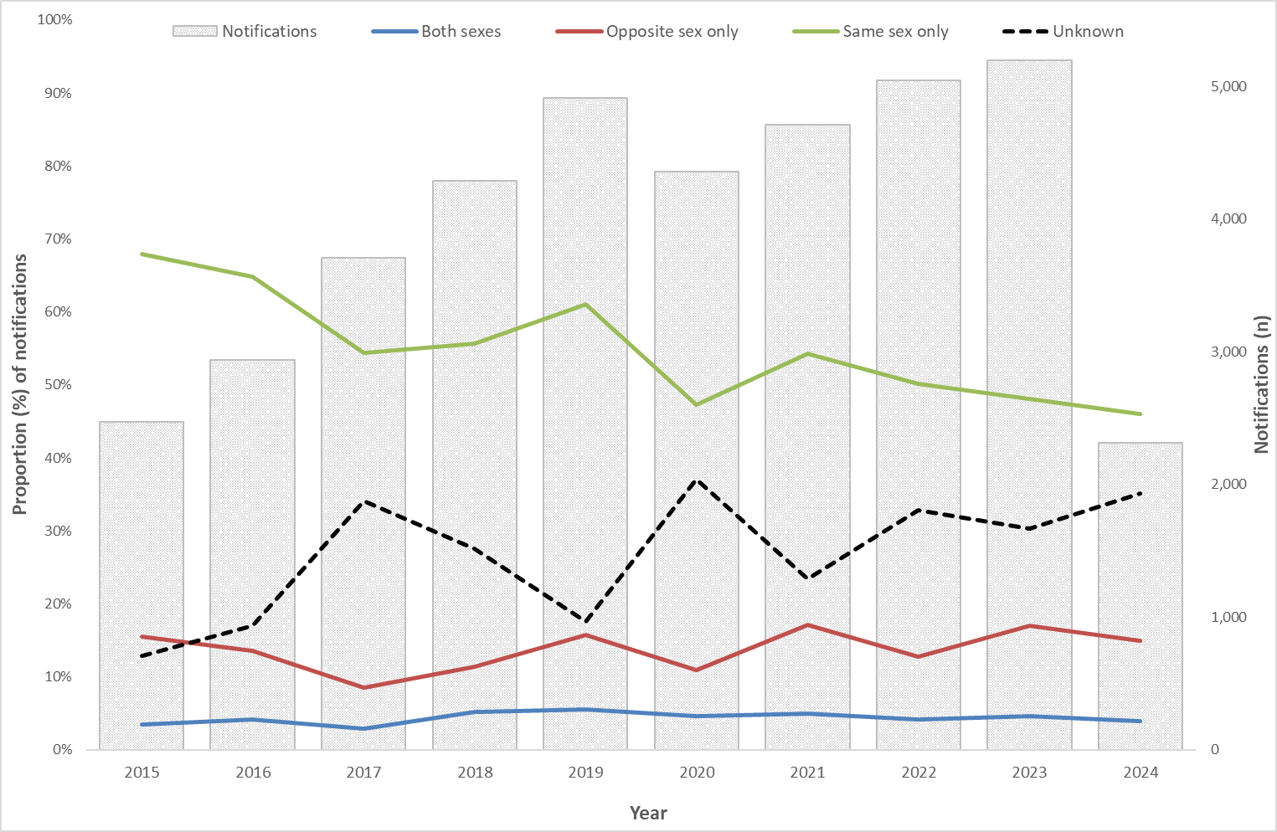
Target 2: Eliminate congenital syphilis

Indicator 2.1 – Number of congenital syphilis notifications

Indicator 2.2 – Notification rate of congenital syphilis per 100,000 live births

Indicator 2.3 – Number of congenital syphilis cases that were reported to have died from the condition
Ninety-five (95) cases of congenital syphilis were reported between 2016 and Q2 2024, 52 were reported in Aboriginal and Torres Strait Islander infants, 42 were non-Indigenous and 1 had an unknown Indigenous status (Figure 6). Among the 52 Aboriginal and Torres Strait Islander cases, 42% (22/52) were residents of major cities, 27% (14/52) from inner/outer regional areas and 31% (16/52) from remote/very remote areas. Eighty-six per cent (86%, 36/42) of non-Indigenous cases were residents of major cities, 12% (5/42) from inner/outer regional areas and 2% (1/42) had an unknown residential location. The remaining 1 case had an unknown Indigenous status and unknown residential location reported.
Aboriginal and Torres Strait Islander infants are disproportionately represented in the notification data, with rates per 100,000 live births on average 16 times that of non-Indigenous infants, noting that rates have fluctuated in both groups over time.
Thirty-one (31) congenital syphilis associated deaths were reported between 2016 and Q2 2024 (32% of all reported congenital syphilis cases reported during the period), 19 (61%, 19/31) were Aboriginal and Torres Strait Islander infants, 11 (35%, 11/31) were non-Indigenous and 1 (3%, 1/31) had an unknown Indigenous status. Of the Aboriginal and Torres Strait Islander infants who died, 10 (53%, 10/19) were reported in major cities, 4 (20%, 4/19) from inner/outer regional areas and 5 (26%, 5/19) from remote/very remote areas. Of the non-Indigenous infants, 8 (73%, 8/11) were reported in major cities, 2 (18%, 2/11) was a resident of an inner/outer regional area and the remaining case (9%, 1/11) did not have a residential area reported. The remaining case had an unknown Indigenous status and did not have a residential location reported.
Figure 6: Notifications (n) and notification rate (per 100,000 live births) of congenital syphilis, by Indigenous status, remoteness area, and year, 2016 – Q2 2024
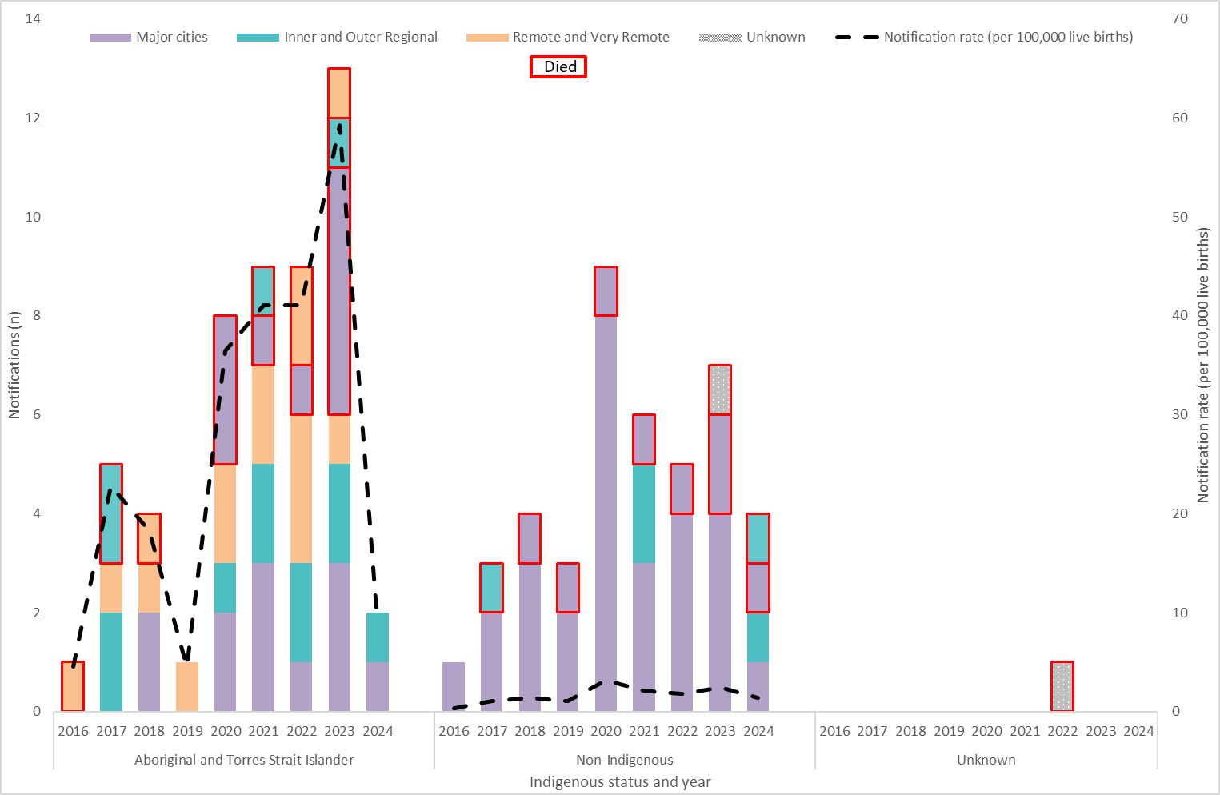

Indicator 2.4 – Proportion of syphilis notifications among women who were pregnant at time of diagnosis
Pregnancy status was available from 7 jurisdictions between 2021 and Q2 2024, 6 in 2020 and 4 between 2017 and 2019. Given the high proportion of cases with an unknown pregnancy status and retrospective changes to the data, trends overtime should be interpreted with caution.
Please note there may be differences with previous reports due to pregnancy status being reclassified in some women and the inclusion of new historical data from jurisdictions. In addition, previous reports have included data from the NT; however these data have been excluded due to information systems limitations.
In the first six months of 2024, of the syphilis notifications among Aboriginal and Torres Strait Islander women of reproductive age (15-44 years), 16% were pregnant at the time of diagnosis, 56% were not pregnant and 28% had an unknown pregnancy status (Figure 7). In previous years, the proportion of Aboriginal and Torres Strait Islander women pregnant at time of syphilis diagnosis ranged between 15% and 21%, noting that the number of jurisdictions reporting data each year varied.
Among non-Indigenous women of reproductive age in the first six months of 2024, 17% were pregnant at the time of diagnosis, 58% were not pregnant and 25% had an unknown pregnancy status (Figure 7). In previous years, the proportion of non-Indigenous women pregnant at time of syphilis diagnosis ranged between 17% and 24%, noting that the number of jurisdictions reporting data each year varied.
Figure 7: Number of syphilis notifications among women of reproductive age (15-44 years) and proportion (%) of cases pregnant at time of syphilis diagnosis, by Indigenous status and year, 2017- Q2 2024
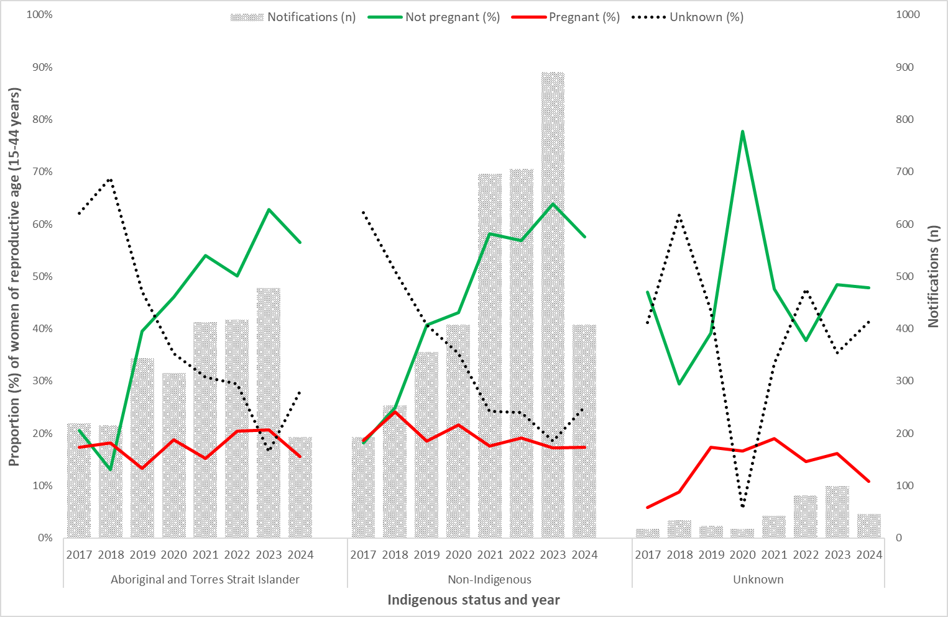

Indicator 2.5 – Number of women giving birth to an infant with congenital syphilis who were diagnosed with syphilis in pregnancy by gestation period

Indicator 2.6 – Number of women giving birth to an infant with congenital syphilis who were diagnosed with syphilis late in pregnancy
Enhanced data are used to report against indicators 2.5 and 2.6.
Completeness of enhanced congenital syphilis data
Between 2016 and Q2 2024, 100% (95/95) of congenital syphilis cases had enhanced data available, including information about the mother of the infant diagnosed with congenital syphilis.
Of the 95 congenital syphilis cases between 2016 and Q2 2024, 1 (1%, 1/95) mother giving birth to an infant with congenital syphilis was diagnosed in the 1st trimester, 10 (11%, 10/95) in the 2nd trimester, 19 (20%, 19/95) in the 3rd trimester, 26 (27%, 26/95) on the day of delivery, 34 (36%, 34/95) post-birth and 5 (5%, 5/95) had an unknown stage of pregnancy at the time of syphilis diagnosis (Table 1).
Seventy-nine per cent (79%, 75/95) of mothers giving birth to an infant with congenital syphilis were diagnosed late in pregnancy, including 15 mothers diagnosed in the 3rd trimester less than 30 days prior to delivery.

Table 1: Number of women giving birth to an infant with congenital syphilis, by gestation period mother was diagnosed with syphilis and year, 2016 – Q2 2024
Mothers gestation period at syphilis diagnosis | 2016 | 2017 | 2018 | 2019 | 2020 | 2021 | 2022 | 2023 | 2024
1st Trimester | 0 | 0 | 0 | 0 | 0 | 0 | 0 | 0 | 1
2nd Trimester | 1 | 0 | 0 | 0 | 1 | 0 | 3 | 5 | 0
3rd Trimester | 1 | 2 | 3 | 2 | 2 | 3 | 2 | 4 | 0
At birth (Day of delivery) | 0 | 2 | 2 | 0 | 6 | 5 | 4 | 5 | 2
Post-birth | 0 | 3 | 2 | 2 | 8 | 7 | 3 | 6 | 3
Unknown | 0 | 1 | 1 | 0 | 0 | 0 | 3 | 0 | 0
Total | 2 | 8 | 8 | 4 | 17 | 15 | 15 | 20 | 6
Late diagnosis | 0 | 6 | 7 | 3 | 15 | 15 | 9 | 15 | 5
Target 3: Control outbreaks among Aboriginal and Torres Strait Islander peoples in Queensland, the Northern Territory, Western Australia and South Australia
An outbreak of infectious syphilis began in northern Queensland in January 2011, extending to the Northern Territory in July 2013, the Kimberley in Western Australia in June 2014, and South Australia in November 2016.
The AHPC, in consultation with affected jurisdictions, Aboriginal Community Controlled Health Services (ACCHS) and key stakeholders, developed a National Strategic Approach and Action Plan to address the disproportionately high rates of syphilis and other bloodborne viruses and sexually transmissible infections in regional and remote Aboriginal and Torres Strait Islander communities. The Strategic Approach and Action Plan were endorsed by the Australian Health Ministers Advisory Council in December 2017.
Further information on the outbreak and response activities are available on the Department of Health and Aged Care website.

Indicator 3.1 – Number of outbreak associated infectious syphilis notifications
Since the commencement of the outbreak on 1 January 2011 to Q2 2024, a total of 6,092 infectious syphilis outbreak cases (category 1 and 2) were reported from 4 jurisdictions (Figure 8, Table 2):
- 2,158 from Queensland;
- 2,246 from the Northern Territory;
- 1,438 from Western Australia;
- 250 from South Australia.

Figure 8: Notifications of category 1 infectious syphilis outbreak cases notified in Aboriginal and Torres Strait Islander people residing in affected regions of Queensland, the Northern Territory, Western Australia, and South Australia from commencement of the outbreak in each jurisdiction to Q2 2024
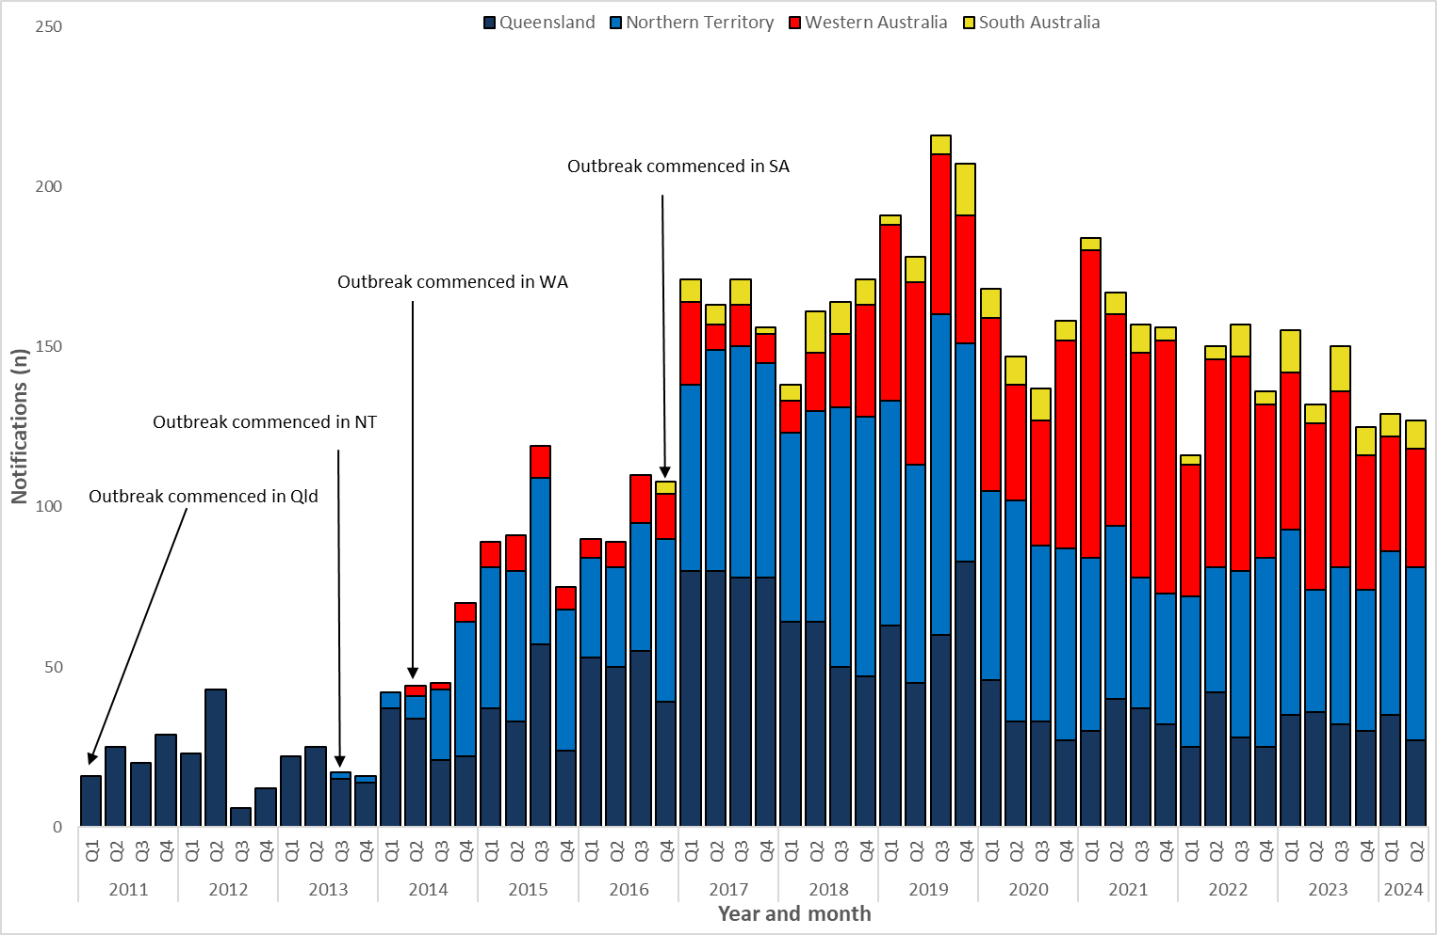
Across the 4 outbreak jurisdictions, 54% (3,217/5,964) of all category 1 cases were female and 46% (2,745/5,964) were male, with a male to female ratio of 0.9:1 suggesting predominately heterosexual transmission overall, noting the variability across specific outbreak regions and jurisdictions (Figure 9 a-d, Table 2). One (1) category 1 outbreak case had no sex reported and the remaining case reported their sex assigned at birth as another term other than male or female.
On 19 November 2020, the Multi-Jurisdictional Syphilis Working Group endorsed the expansion of the ‘target age group’ from 15-29 years to 15-34 years. This change came into effect from February 2021. Overall, 72% (4,272/5,964) of all outbreak cases were reported in 15–34-year-olds, with the proportion of cases in this age group across the outbreak period (Q1 2011 – Q2 2024) ranging between 64% and 82% (Figure 9a-d).
Table 2: Characteristics of infectious syphilis outbreak cases notified in Aboriginal and Torres Strait Islander people residing in affected regions of Queensland, the Northern Territory, Western Australia, and South Australia to Q2 2024
 | Queensland (five HHSs) | Northern Territory (seven regions) | Western Australia (three regions) | South Australia (three regions)
Category 1
Outbreak commencement month/year | January 2011 | July 2013 | June 2014 | November 2016
Total number of cases | 2,097 | 2,203 | 1,431 | 233
% Male / % Female | 47% / 53% | 46% / 54% | 43% / 57% | 53% / 47%
% 15-34 year age group | 69% | 73% | 74% | 62%
Category 2
Aboriginal and Torres Strait Islander people | 16 | 16 | 7 | 0
Non-Indigenous people | 45 | 27 | 0 | 17

Figure 9 a-d: Notifications (n) of category 1 outbreak associated syphilis cases, by age*, sex, jurisdiction, year, and quarter from commencement in each jurisdiction to Q2 2024
(a. Queensland, b. the Northern Territory, c. Western Australia and d. South Australia)
- Queensland (2011 – Q2 2024)
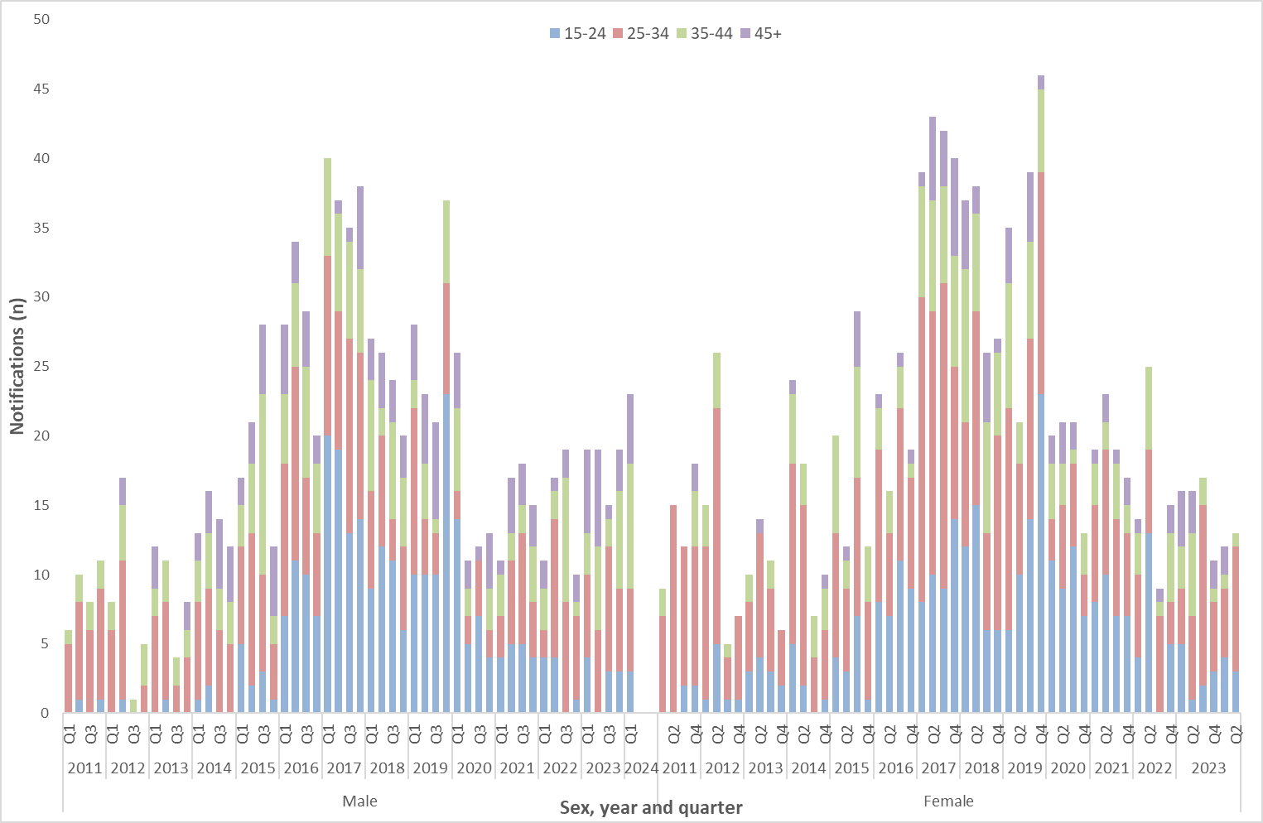

- Northern Territory (2013 – Q2 2024)
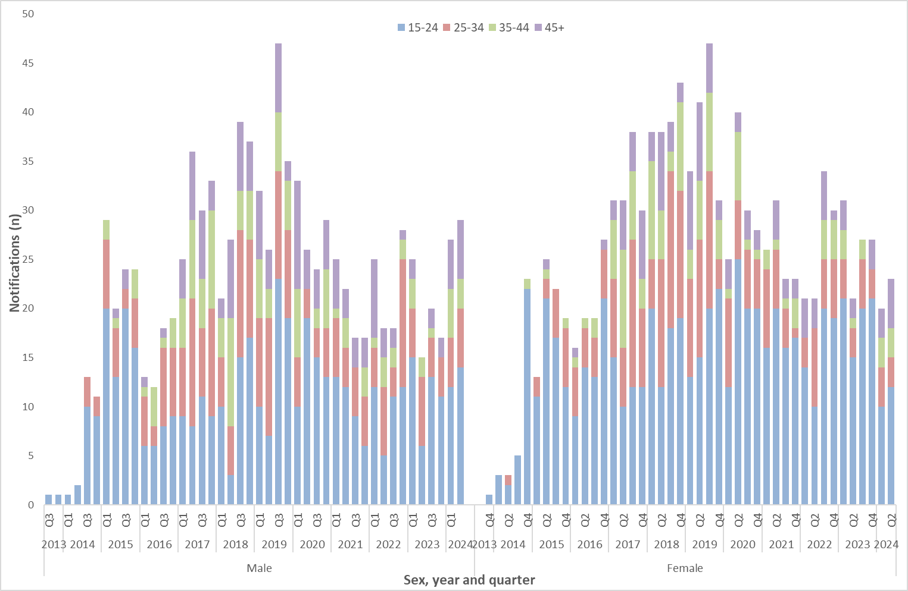
- Western Australia (2014 – Q2 2024)
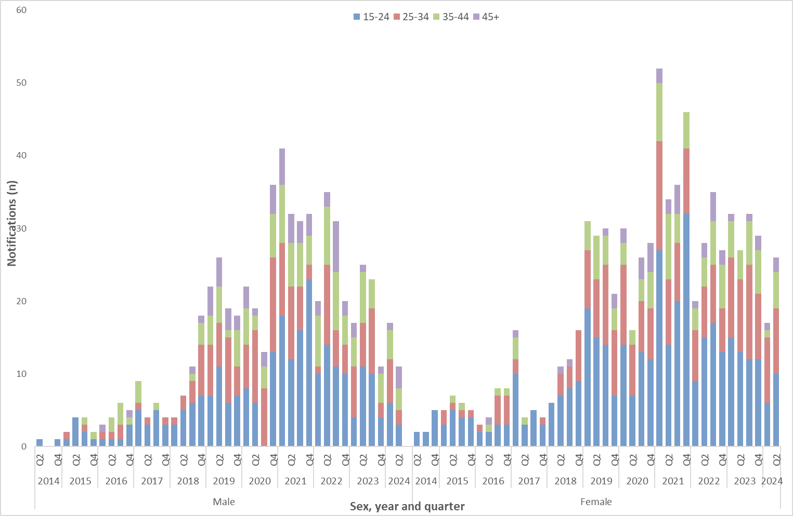

- South Australia (2016 – Q2 2024)
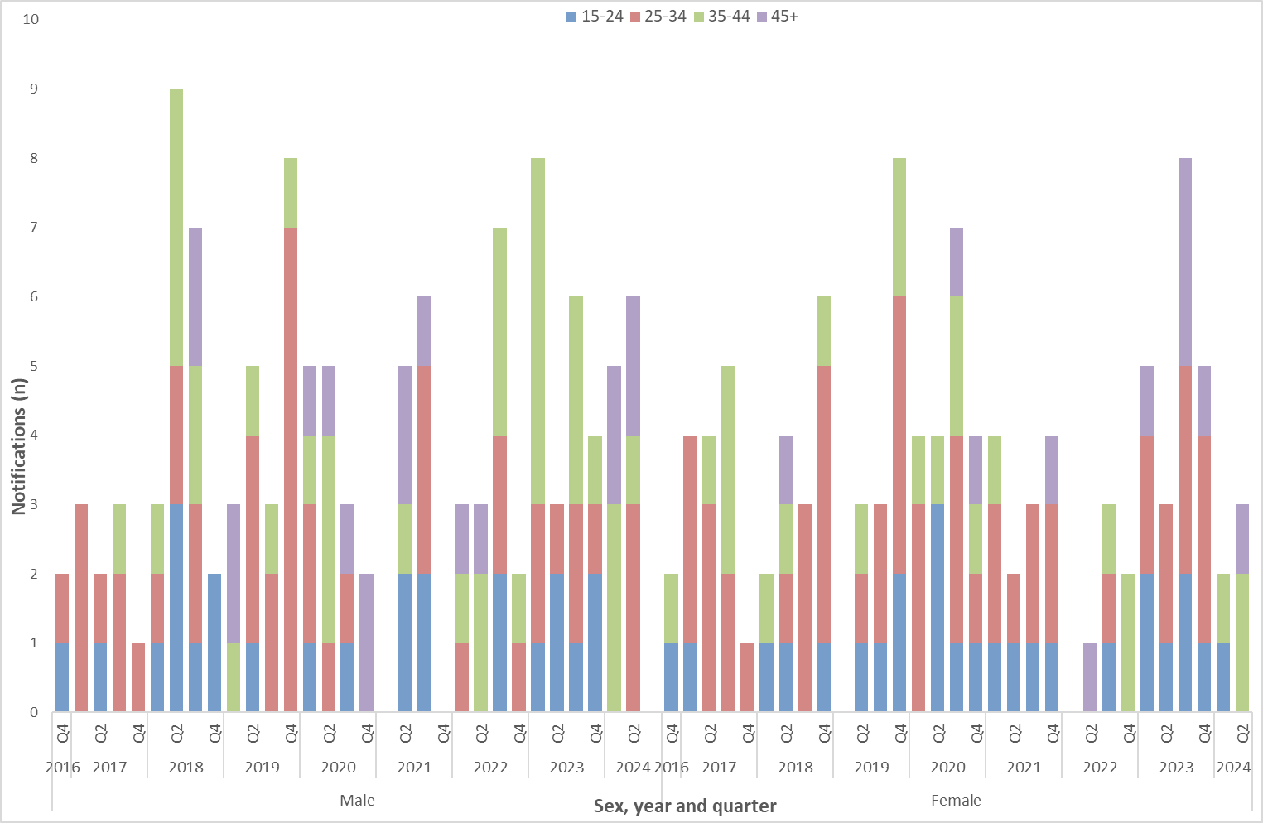
*Excludes cases aged <15 years of age.

Indicator 3.2 – Number of outbreak associated congenital syphilis notifications

Indicator 3.3 – Number of outbreak associated congenital syphilis cases that were reported to have died from the condition
Since the commencement of the outbreak in Q1 2011 to Q2 2024, there were 33 outbreak associated cases of congenital syphilis reported, 12 from Queensland, 10 from the Northern Territory, 7 from Western Australia and 4 from South Australia. Eleven (11) of these cases were reported to have died from the condition, 7 from Queensland, 1 from the Northern Territory and 3 from Western Australia (Figure 10).
Please note that two cases (1 in 2013 and 1 in 2014) previously reported as outbreak cases of congenital syphilis from the NT have been excluded from the analysis and figure 10 below as they no longer meet the outbreak case definition.

Figure 10: Notifications (n) of outbreak associated congenital syphilis cases and reported deaths, by jurisdiction, and year, 2011 – Q2 2024
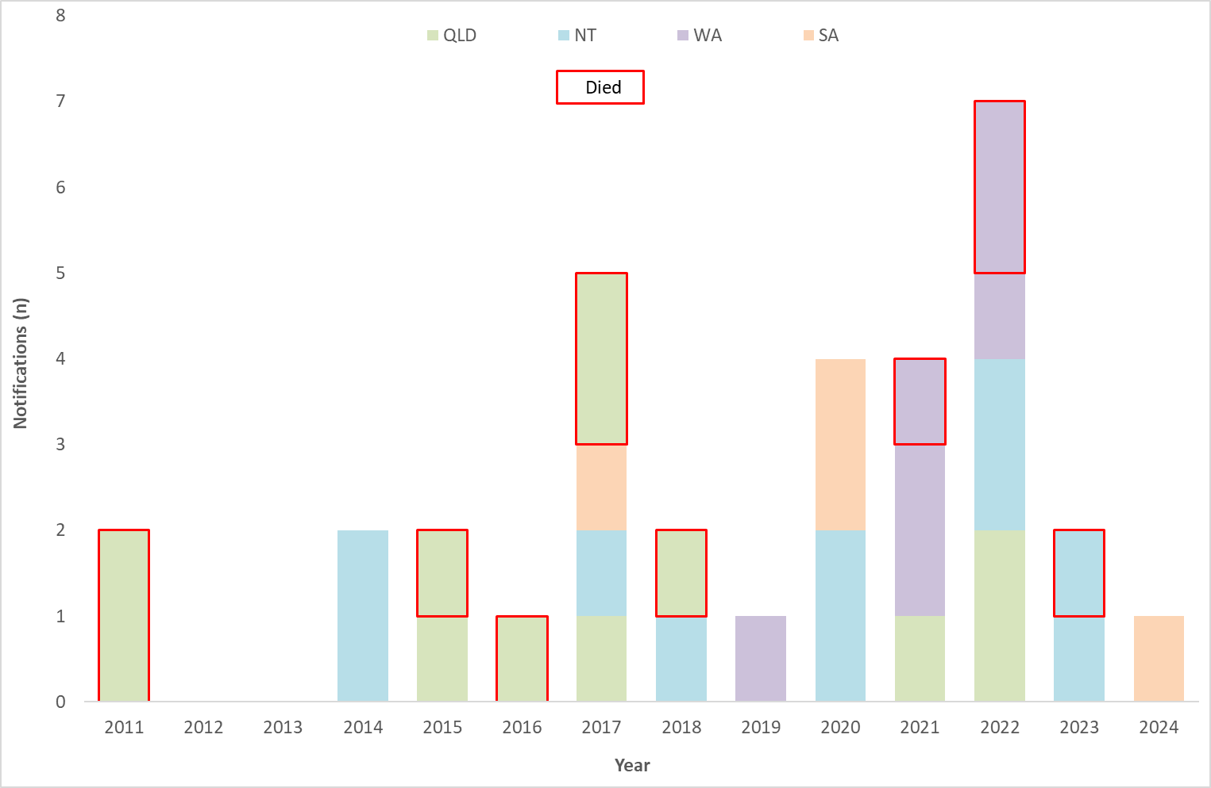

Indicator 3.4 – Proportion of outbreak associated infectious syphilis notifications among women who were pregnant at time of diagnosis
Pregnancy status was available for all 3 outbreak jurisdictions from 2020 onwards (Queensland, Western Australia, and South Australia). Between 2017 and 2019, pregnancy status was available for 2 out of 4 jurisdictions (Queensland and Western Australia). Given the high proportion of cases with an unknown pregnancy status and retrospective changes to the data, trends over time should be interpreted with caution.
Please note there may be differences with previous reports due to pregnancy status being reclassified in some women and the inclusion of new historical data from jurisdictions. In addition, previous reports have included data from the NT; however these data have been excluded due to known data issues.
In the first six months of 2024 of the outbreak associated notifications of infectious syphilis among women of reproductive age (15-44 years) reported in Queensland, Western Australia, and South Australia, 10% were pregnant, 78% were not pregnant and 12% had an unknown pregnancy status (Figure 11).

Figure 11: Proportion (%) of outbreak associated syphilis notifications among women of reproductive age (15-44 years), by pregnancy status at time of syphilis diagnosis and year, 2017 – Q2 2024
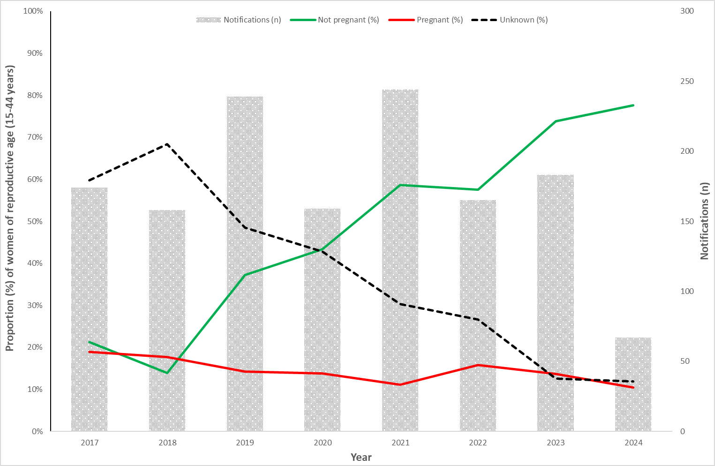

Indicator 3.5 – Cumulative number of syphilis tests delivered through participating ACCHS in outbreak affected jurisdictions

Indicator 3.6 – Proportion of people attending participating ACCHS who received a syphilis test
In August 2018, the test and treat model to curb the syphilis outbreak in Aboriginal and Torres Strait Islander communities commenced at Aboriginal Community Controlled Health Services (ACCHS) in Townsville, Cairns (Queensland), and Darwin (Northern Territory). In September 2018, the second phase commenced at ACCHS in Katherine, East Arnhem (Northern Territory), and the Kimberley (Western Australia). In May 2019, the third phase commenced at additional ACCHS in West Arnhem (Northern Territory), Pilbara, Kimberley (Western Australia), Adelaide, Port Augusta, Port Lincoln, Whyalla, Yalata, Ceduna, and Coober Pedy (South Australia). In May 2020, the fourth phase commenced at ACCHS in Mt Isa (Queensland), Tennant Creek, and Alice Springs (Northern Territory). From July 2021, the National Aboriginal Community Controlled Health Organisation (NACCHO) has been commissioned to deliver the test and treat model within the prescribed syphilis outbreak regions. Additional ACCHS were selected to commence in Innisfail, Bamaga, Rockhampton, Mareeba, Palm Island (Queensland), East Arnhem, Kintore, Utopia, Barkley Region (Northern Territory), Broome, and Kalgoorlie (Western Australia). The below data summarises syphilis testing data and coverage for participating ACCHS, noting that data are missing for some services.
Please note there may be differences with previous reports due to changes in reporting periods from monthly to quarterly; retrospective revision of data and; completeness of historical data.
As at Q2 2024, through participating ACCHS (Figures 12 and 13 a-b):
- 138,603 syphilis tests, point-of-care tests (PoCT) and serological tests, were delivered from the commencement of phase 1 of the test and treat model rollout on 1 August 2018. On average 5,788 new tests are performed each quarter (Figure 12).
- The quarterly testing coverage for clients attending participating services for all age groups was 15%, slightly higher quarterly average for the preceding 12 months (14%) (Figure 13a).
- The quarterly testing coverage for clients attending participating services within the target age group (15-34 years) was 24%, the same as the quarterly average for the preceding 12 months (Figure 13b).
- Serology only was the most common method of syphilis diagnosis during Q2 2024 (91%) consistent with historical trends (average 89%). A combination of serology and PoCT represented the second highest proportion (Q2 2024 7%; historical average 8%) followed by PoCT only (Q2 2024 2%; historical average 4%) (Figure 14).
Please note that at the time of writing data were missing for some services and therefore testing numbers reported are likely to be an underestimate of all tests delivered.
Figure 12: Cumulative number of syphilis tests (PoCT and/or serology) delivered through participating ACCHS to Aboriginal and Torres Strait Islander peoples, by quarter and year, Q3 2018* – Q2 2024
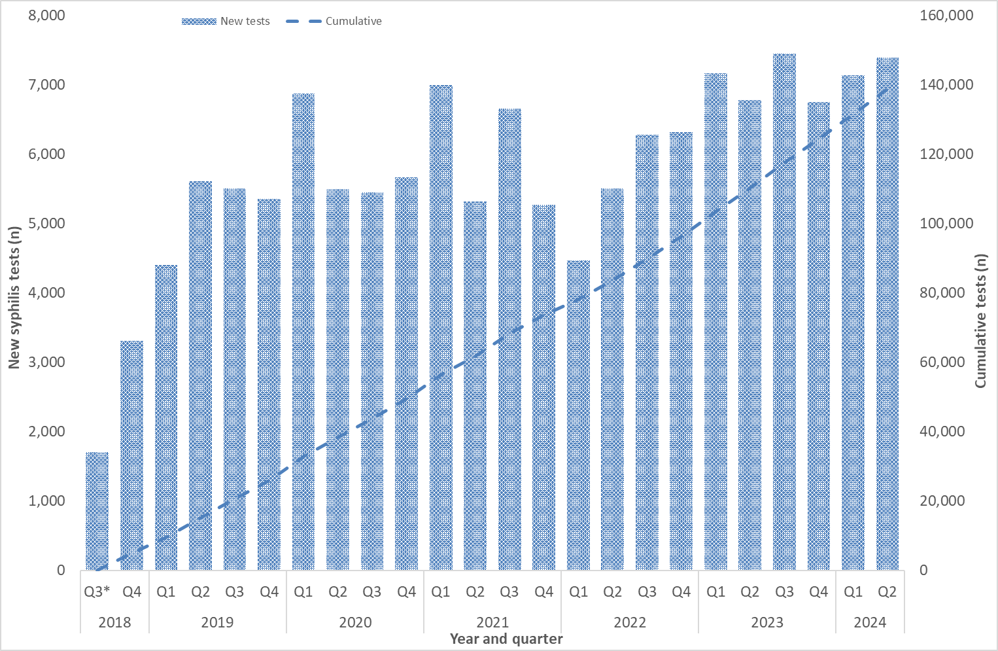
*Q3 2018 includes data for August and September only.

Figure 13 a-b: Proportion of Aboriginal and Torres Strait Islander clients attending participating ACCHS who received a syphilis test (PoCT and/or serology), quarter and year, Q3 2018* – Q2 2024 (a. all age groups b. target age group 15-34 years)
- All age groups
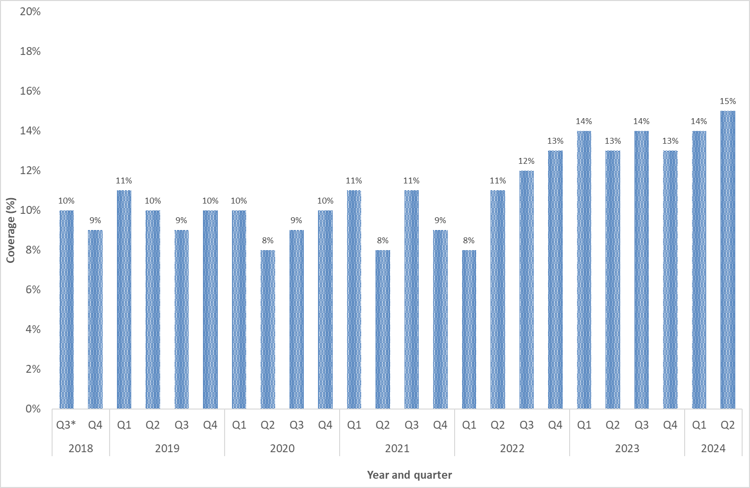
- Target age group (15-34 years)
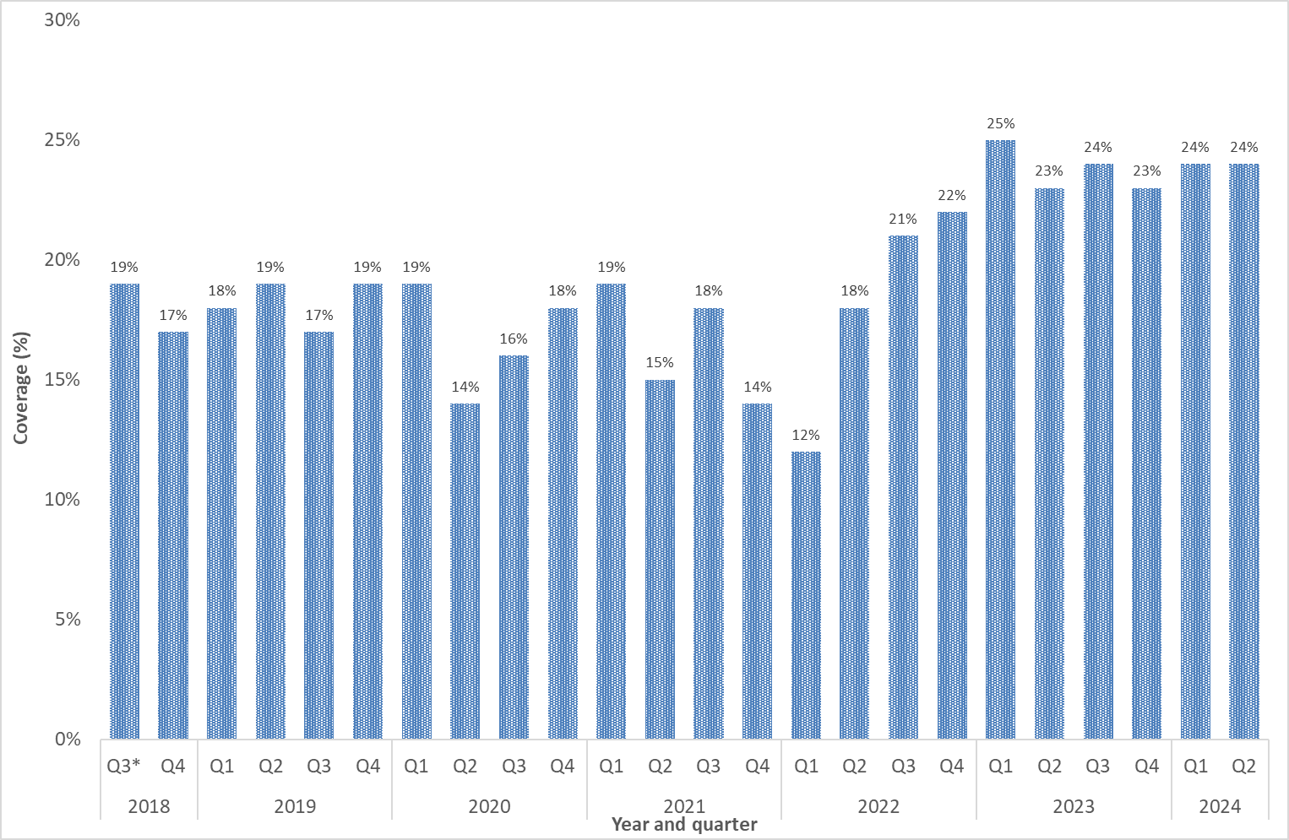
*Q3 2018 includes data for August and September only.
Figure 14: Syphilis tests delivered through participating ACCHS, by test type (PoCT only, serology only and both serology and PoCT), by quarter and year, Q3* 2018 – Q2 2024
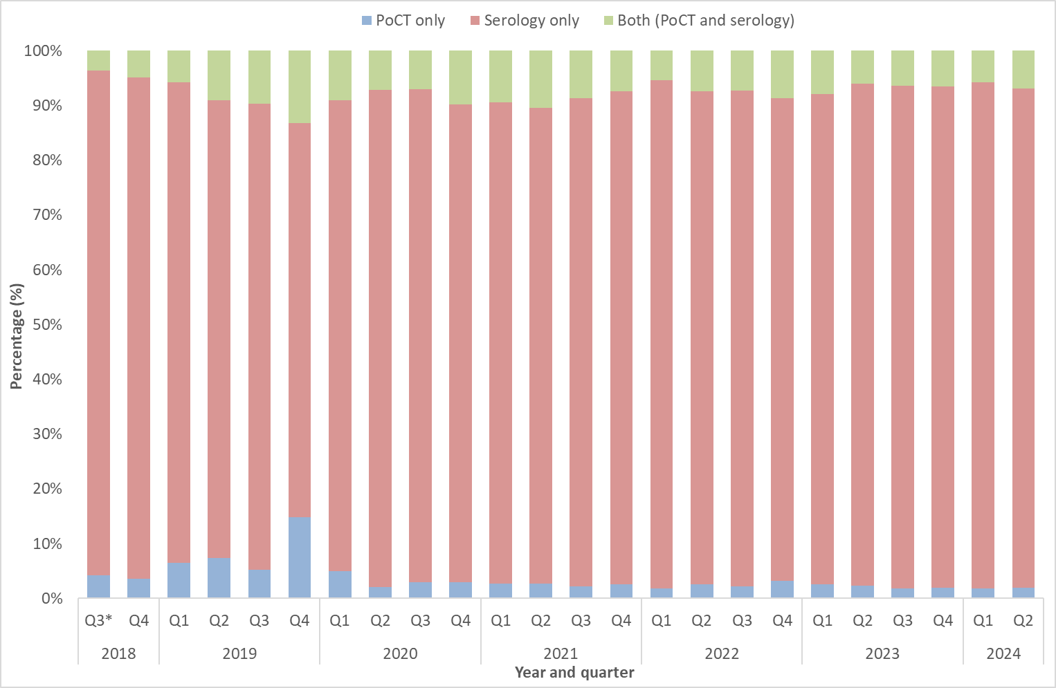
*Q3 2018 includes data for August and September only.

Methodological notes
Data were extracted from the NNDSS on 8 August 2024, by diagnosis date. Due to the dynamic nature of the NNDSS, data in this extract are subject to retrospective revision and may vary from data reported in published NNDSS reports and reports of notification data by states and territories. Data are to 30 June 2024 unless otherwise specified.
In general, notification data represent only a proportion of the total cases occurring in the community, that is, only those cases for which health care was sought, a test conducted, and a diagnosis made, followed by a notification to health authorities. The degree of under-representation of all cases is unknown and is most likely variable by disease and jurisdiction.
In interpreting these data it is important to note that changes in notifications over time may not solely reflect changes in disease prevalence or incidence. Changes in testing policies; screening programs including the preferential testing of high-risk populations; the use of less invasive and more sensitive diagnostic tests; and periodic awareness campaigns, may influence the number of notifications that occur annually.
Data elements
- ‘Diagnosis year’ was used to define the period of analysis. This date represents either the onset date or where the date of onset was not known, the earliest of the specimen collection date, the notification date, or the notification received date.
- ‘Residential postcode’ reported to the NNDSS was used to allocate notifications of infectious and congenital syphilis to remoteness areas and mapped data by Statistical Area 3 (SA3) (as defined by the Australian Bureau of Statistics). Where a postcode was not reported the notification was excluded from remoteness area and SA3 analysis.
- Tasmania and Northern Territory do not have major cities as defined by the Australian Bureau of Statistics. Tasmanian “major cities” refers to inner regional areas and in the Northern Territory refers to outer regional areas.
- ‘Residential postcode’ usually reflects the residential location of a case at the time of testing and does not necessarily represent the place where the disease was acquired.
- The ‘population denominator’ used to calculate remoteness area and SA3 rates (per 100,000 population) was extracted from the Australian Bureau of Statistics Census Table Builder (based on 2016 Census data).
- The determination of the Indigenous status is by descent, self-identification, and community acceptance. While completeness of the Indigenous status field is generally high, it should be interpreted with caution as completeness of this field varies from year to year and jurisdiction to jurisdiction.
‘Syphilis testing data’ have been provided by participating ACCHS. A participating service refers to clinics currently funded by the Australian Government Department of Health and Aged Care to deliver point of care testing in syphilis outbreak regions. Services extract data from local clinical information management systems reporting to the Australian Government Department of Health and Aged Care. Data are provided for the reporting month, and cumulatively for the previous 12 months. ‘Testing coverage’ is calculated using as the denominator ‘clients attending the service’ (a participating ACCHS) during the reporting period.
Mapped age standardised notification rates by SA3
Age-standardised notification rates were presented as geographical maps of Australia by statistical area level 3 (SA3). SA3s are geographical units defined by the ABS under the Australian Statistical Geography Standard. SA3s generally have populations between 30,000 and 130,000 persons, with some exceptions for areas with particularly low or particularly high population density.
There are 338 SA3 spatial units under the Australian Statistical Geography Standard 2016. Four spatial SA3s representing other territories (Christmas Island, Cocos (Keeling) Islands, Jervis Bay and Norfolk Island) were excluded from the analysis. Where a postcode was split into more than one SA3, the entire postcode was allocated to the SA3 containing the largest proportion of the postcode.
Crude notification rates were calculated for infectious syphilis using the 2016 ABS Census data by SA3. All crude rates were age-standardised using the ABS Standard Population Catalogue 31010DO003_201212.
Age-standardised notification rates were categorised based on the standard deviation of infectious syphilis age-standardised notification rates across SA3s and colour coded (lighter colours representing lower rates and darker colours higher rates).
Note that some rates are based on a small number of notifications, and in areas with low population density rates are based on small denominators, particularly in SA3s with population below the general ABS population threshold of 30 000 persons.
Case definitions
The CDNA national surveillance case definitions for infectious and congenital syphilis, including any historical edits, are available at: https://www.health.gov.au/casedefinitions.
The outbreak case definition classifying cases reported under ‘Target 3: Control outbreaks among Aboriginal and Torres Strait Islander peoples in Queensland, the Northern Territory, Western Australia and South Australia’ is defined:
Nationally, an infectious syphilis outbreak case is defined as: any person who is newly diagnosed with confirmed or probable infectious syphilis according to the CDNA national surveillance case definition for infectious syphilis, AND, is an Aboriginal or Torres Strait Islander person who resides in any of the following outbreak declared regions as defined and documented by that jurisdiction, at or after the dates indicated: Qld - North West Hospital and Health Service area (from 1 January 2011); Torres and Cape Hospital and Health Service area (from 1 December 2012); Cairns and Hinterland Hospital and Health Service area (from 1 August 2013); Townsville Hospital and Health Service area (from 1 January 2014); Central Queensland Hospital and Health Service area (from 1 June 2017) NT - Alice Springs Rural and Urban or Barkly district (from 1 July 2013); Katherine district (from 1 May 2014); East Arnhem district (from 1 November 2015); Darwin Rural and Urban (from 1 January 2017); WA - Kimberley region (from 1 June 2014); Pilbara region (from 1 February 2018); Goldfields region (from 1 January 2019); SA - Far North and Western and Eyre regions (from 15 November 2016); Adelaide (from 1 February 2018) (category 1 outbreak cases) OR, is a sexual contact of a confirmed outbreak case (category 2 outbreak cases).

Acknowledgements
We, the Department of Health and Aged Care, acknowledge the Traditional Owners and Custodians of Country throughout Australia. We recognise the strength and resilience of Aboriginal and Torres Strait Islander peoples and acknowledge and respect their continuing connections and relationships to country, rivers, land and sea. We acknowledge the ongoing contribution Aboriginal and Torres Strait Islander peoples make across the Health system and wider community. We also pay our respects to Elders past, present and future and extend that respect to all Traditional Custodians of this land.
The Department of Health and Aged Care acknowledges the Communicable Diseases Network Australia; the work of public health officers involved in the collection of surveillance data; state and territory public health communicable disease surveillance managers and data managers; participating Aboriginal Community Controlled Health Services, and; all public and private laboratories that support laboratory surveillance in Australia.

Contact
For any further details about information contained in this report please contact Ms Amy Bright in the Communicable Diseases Epidemiology and Surveillance Section CDESS@health.gov.au.

Syphilis has been nationally notifiable since 1991, however prior to 2004, syphilis cases were reported under the overarching category of syphilis (all), which was inclusive of all cases of syphilis regardless of the stage of infection. From 2004, the syphilis (all) category was redefined with cases of syphilis reported under 3 new categories: infectious syphilis (<2 years duration), unspecified syphilis (unspecified or >2 years duration) and congenital syphilis (https://www.health.gov.au/resources/collections/cdna-surveillance-case-definitions).
‘Late diagnosis’ is defined as a syphilis diagnosis less than 30 days prior to delivery, at birth (day of delivery) or post birth.
Totals may not add up to 100% due to rounding.
‘Late diagnosis’ is defined as a syphilis diagnosis less than 30 days prior to delivery, at birth (day of delivery) or post birth.
Outbreak cases are reported as either category 1 or category 2: category 1 cases include Aboriginal and Torres Strait Islander people residing in an outbreak declared region at the time of diagnosis, and; category 2 cases include people who are a sexual contact of a confirmed outbreak case which includes Aboriginal and Torres Strait Islander people who do not reside in an outbreak area at the time of diagnosis and non-Indigenous people regardless of where they reside. All data are provisional and subject to change due to ongoing case investigation.
Multijurisdictional Syphilis Outbreak Surveillance Report: February 2021
Qld - North West Hospital and Health Service (HHS) area (from 1 January 2011); Torres and Cape Hospital and Health Service area (from 1 December 2012); Cairns and Hinterland Hospital and Health Service area (from 1 August 2013); Townsville Hospital and Health Service area (from 1 January 2014); Central Queensland Hospital and Health Service area (from 1 June 2017) NT - Alice Springs Rural and Urban or Barkly district (from 1 July 2013); Katherine district (from 1 May 2014); East Arnhem district (from 1 November 2015); Darwin Rural and Urban (from 1 January 2017); WA - Kimberley region (from 1 June 2014); Pilbara region (from 1 February 2018); Goldfields region (from 1 January 2019); SA - Far North and Western and Eyre regions (from 15 November 2016); Adelaide (from 1 February 2018).
Category 2 cases include those that while diagnosed as per the jurisdiction in Table 2, were reported to NNDSS by the jurisdiction in which the case resides as per the NNDSS Cross Border Notification Protocol. This has been done to ensure consistency in outbreak case number reporting.
Aboriginal and Torres Strait Islander people who are sexual contacts of a confirmed outbreak case and reside outside an outbreak declared region at the time of diagnosis.
Non-Indigenous people who are sexual contacts of a confirmed outbreak case and reside in or out of an outbreak declared region at the time of diagnosis.
Qld - North West Hospital and Health Service (HHS) area (from 1 January 2011); Torres and Cape Hospital and Health Service area (from 1 December 2012); Cairns and Hinterland Hospital and Health Service area (from 1 August 2013); Townsville Hospital and Health Service area (from 1 January 2014); Central Queensland Hospital and Health Service area (from 1 June 2017) NT - Alice Springs Rural and Urban or Barkly district (from 1 July 2013); Katherine district (from 1 May 2014); East Arnhem district (from 1 November 2015); Darwin Rural and Urban (from 1 January 2017); WA - Kimberley region (from 1 June 2014); Pilbara region (from 1 February 2018); Goldfields region (from 1 January 2019); SA - Far North and Western and Eyre regions (from 15 November 2016); Adelaide (from 1 February 2018).
Excludes testing data for individuals for whom age was not reported.

