National Syphilis Surveillance Report
  - Quarter 1 2025

Introduction
On 21 November 2023, the Australian Health Protection Committee (AHPC) endorsed the National Syphilis Response Plan 2025 – 2030 (Response Plan). Four overarching national goals have been adopted to be pursued throughout the life cycle of the Response Plan (2023-2030):
- Strengthen prevention and testing strategies for syphilis in priority populations and settings, targeting high-burden areas.
- Reduce ongoing transmission and incidence of syphilis across priority populations.
- Reduce morbidity and mortality associated with syphilis.
- Eliminate congenital syphilis (defined as sustained zero congenital syphilis cases).
The Response Plan builds on the efforts of the National strategic approach for responding to rising rates of syphilis 2021.
The National Syphilis Surveillance and Monitoring Plan (the Surveillance Plan) outlines indicators that will be used to monitor progress towards achieving the above goals. Each goal covers a set of related indicators that can be disaggregated to allow finer-grained interpretation.

Reporting
This report provides a quarterly account of progress against the goals and selected indicators in the Surveillance Plan, using data available at the time of writing. A complete list of indicators and the reporting schedule are provided at Appendix A.
Completeness of NNDSS data used in this report have been calculated and are summarised at Appendix B. Where completeness is less than 50% data have been excluded from reporting.
A quarterly summary of data reported against selected indicators is provided in Tables 1 and 2.

Guidance
When considering this report we recommend you refer to the Surveillance Plan for detailed notes on the indicators and data sources.

Table 1: Quarterly summary of indicator data for the reporting period
Legend: ↑increase ↓decrease → stable
Indicators |  | Comparisons
Ref. | Summarised indicator description | Current quarter (Q1 2025)* | Previous quarter (Q4 2024) | Previous 12 months (quarterly average) (Q2 2024 – Q1 2025)
GOAL 1 - Strengthen prevention and testing strategies for syphilis in priority populations and settings, targeting high-burden areas
Indicators 1.1 and 1.4 – 1.10 reported annually
1.2 | Number of syphilis tests | 7,907 ↑↑  (cumulative 161,173) | 7,156 | 7,415
1.3 | Syphilis testing coverage – target population | 16% ↑↑ | 14% | 15%
1.3 | Syphilis testing coverage – total population | 26% ↑↑ | 24% | 24%
1.3 | Type of syphilis test – total population  Serology only  PoCT only  Both (PoCT & serology) | 92% ↑ → | 91% | 92%
1.3 |  | 1% ↓↓ | 2% | 2%
1.3 |  | 7% → ↑ | 7% | 6%
GOAL 2 - Reduce ongoing transmission and incidence of syphilis across priority populations
2.1 | Infectious syphilis rates – Aboriginal and Torres Strait Islander males | 44 (per 100,000) ↑↑ | 36 (per 100,000) | 36 (per 100,000)
2.1 | Infectious syphilis rates – Aboriginal and Torres Strait Islander females | 36 (per 100,000) ↑↑ | 28 (per 100,000) | 30 (per 100,000)
2.1 | Infectious syphilis rates – Non-Indigenous males | 9 (per 100,000) ↑↑ | 8 (per 100,000) | 8 (per 100,000)
2.1 | Infectious syphilis rates – Non-Indigenous females | 2 (per 100,000) ↑↑ | 1 (per 100,000) | 1 (per 100,000)
Mapped indicators 2.2 and 2.3
2.4 | Remoteness area and women of reproductive age: Infectious syphilis rates – Aboriginal and Torres Strait Islander women  Major cities  Inner/outer regional  Remote/very remote | 51 (per 100,000) ↓↑ | 55 (per 100,000) | 44 (per 100,000)
2.4 |  | 45 (per 100,000) ↑↑ | 23 (per 100,000) | 33 (per 100,000)
2.4 |  | 212 (per 100,000) ↑↑ | 161 (per 100,000) | 176 (per 100,000)
2.4 | Remoteness area and women of reproductive age: Infectious syphilis rates – non-Indigenous women  Major cities  Inner/outer regional  Remote/very remote | 4 (per 100,000) → ↑ | 4 (per 100,000) | 3 (per 100,000)
2.4 |  | 2 (per 100,000) → ↓ | 2 (per 100,000) | 3 (per 100,000)
2.4 |  | 4 (per 100,000) → ↑ | 4 (per 100,000) | 3 (per 100,000)
2.5 | Men, notified with infectious syphilis, reporting sexual exposure with men only (%) | 44% → ↓ | 44% | 46%
2.6 | Men, notified with infectious syphilis, reporting sexual exposure with men and women (%) | 6% ↑↑ | 5% | 5%
Indicators 2.7 – 2.10 reported annually
GOAL 3 - Reduce morbidity and mortality associated with syphilis
Data reported annually (indicators 3.1 – 3.3)
GOAL 4 - Eliminate congenital syphilis (defined as sustained zero congenital syphilis cases)
4.4 | Women of reproductive age pregnant at infectious syphilis diagnosis – Aboriginal and Torres Strait Islander women | 16% ↑ → | 15% | 16%
4.4 | Women of reproductive age pregnant at infectious syphilis diagnosis – non-Indigenous women | 16% ↑↑ | 15% | 15%
Summary for indicators 4.1 – 4.3 and 4.5 - 4.8 in table 2
*Arrows indicate increase/decrease compared to subsequent columns

Table 2: Summary of indicator data for the reporting period
Indicators |  | Comparisons
Ref. | Summarised indicator description | Current year to date (Q1 2025) | Last complete year (2024) | Previous complete year (2023)
GOAL 4 - Eliminate congenital syphilis (defined as sustained zero congenital syphilis cases)
4.1 & 4.2 | Congenital syphilis cases (deaths) Aboriginal and Torres Strait Islander infants | 1 (1) | 3 (0) | 13 (7)
4.1 & 4.2 | Congenital syphilis cases (deaths) – non-Indigenous infants | 2 (0) | 6 (3) | 7 (3)
4.1 & 4.2 | Congenital syphilis cases (deaths) – unknown Indigenous status | - | 1 (1) | -
4.3 | Congenital syphilis notification rate (per 100,000 live births) - Aboriginal and Torres Strait Islander infants | 4 (per 100,000 live births) | 12 (per 100,000 live births) | 53 (per 100,000 live births)
4.3 | Congenital syphilis notification rate (per 100,000 live births) – non-Indigenous infants | 1 (per 100,000 live births)¹ | 2 (per 100,000 live births) | 3 (per 100,000 live births)
4.5 | Women giving birth to an infant with congenital syphilis diagnosed late in pregnancy – Aboriginal and Torres Strait Islander women (% all cases) | 1 (100%) | 2 (67%) | 11 (85%)
4.5 | Women giving birth to an infant with congenital syphilis diagnosed late in pregnancy – non-Indigenous women | 2 (100%) | 6 (100%) | 4 (57%)
4.6 | Women giving birth to an infant with congenital syphilis who did not receive adequate treatment prior to delivery (% all cases) | 3 (100%) | 7 (70%) | 19 (95%)
Total numbers reported for indicators 4.7 – 4.8 (2020 – Q1 2025)
4.7 | Number of women giving birth to an infant with congenital syphilis that did not have a syphilis test/s prior to diagnosis during their pregnancy (% of all cases) | 50 (63%)
4.8 | Number of women giving birth to an infant with congenital syphilis reinfected during the current pregnancy (% of all cases) | 2 (3%)

Goal 1: Strengthen prevention and testing strategies for syphilis in priority populations and settings, targeting high-burden area
Key facts
- More than 161,000 syphilis tests were administered through participating Aboriginal Community Controlled Health Services (ACCHS).
- Quarter 1 (Q1) 2025 recorded the highest reported testing coverage for all age groups (16%) and the target age group (26%) at participating ACCHS.
- Serology was the most common method of syphilis diagnosis (92%) in participating ACCHS.
Strengthening Australia’s prevention and testing strategies for syphilis requires ongoing evaluation of current approaches, and reflection on required improvements and missed opportunities among vulnerable people and communities at a greater risk of infection. This includes people who are pregnant and have a syphilis infection, and regions and populations with disproportionately high rates of syphilis, for example Aboriginal and Torres Strait Islander people.
An important consideration when interpreting these data is that syphilis testing coverage reflects only a proportion of Aboriginal and Torres Strait Islander people attending selected ACCHS, funded by the Australian Centre for Disease Control to deliver point of care testing. These data do not include individuals accessing care outside of participating ACCHS or data from other health services and therefore may not be representative of the health service participation or testing coverage among the Aboriginal and Torres Strait Islander population more broadly. Routine collection of other suitable data sources, including data from mainstream services and ACCHS not currently funded through the national syphilis response are currently being explored and will be indicated, as appropriate, in future iterations of the Surveillance Plan.
1.2 Cumulative number of syphilis tests delivered through participating ACCHS, by target and total population
1.3 Proportion of people attending participating ACCHS receiving a syphilis test within the previous 12 months, by target and total population (syphilis testing coverage)
In August 2018 as part of the Enhanced Syphilis Response, the test and treat model commenced at selected ACCHS in Queensland, the Northern Territory and Western Australia. (1, 2) Since then the program has expanded, with a view for further expansion in the future to target high burden areas and communities impacted by syphilis.
Between August 2018 to the end of (Q1) 2025, through participating ACCHS (Figure 1) 161,173 syphilis tests, point-of-care tests (PoCT) and serological tests were delivered at over 20 services. Over this period on average 5,969 new tests were performed each quarter.
In Q1 2025 testing coverage for clients attending participating services for all age groups and the target age group (15- 34 years) was 16% and 26% respectively. This was the highest recorded percentage coverage since the program commenced (Figures 2 a-b).
In Q1 2025 diagnosis by serology only was the most common method of detecting syphilis (92%) consistent with historical trends (average 89%). A combination of serology and PoCT represented the second highest proportion (7%; historical average 7%) followed by PoCT only (1%; historical average 3%) (Figure 3).
Please note that at the time of writing data were missing for some services and therefore testing numbers reported are likely to be an underestimate of all tests delivered.
Figure 1: Cumulative number of syphilis tests (PoCT and/or serology) delivered through participating ACCHS to Aboriginal and Torres Strait Islander peoples, by quarter and year, Q3 2018 – Q1 2025
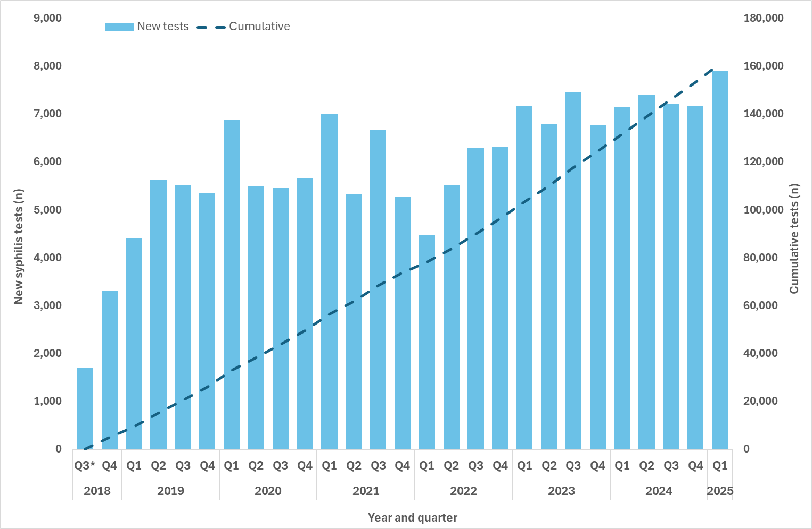
Figure 2: Proportion of Aboriginal and Torres Strait Islander clients attending participating ACCHS who received a syphilis test (PoCT and/or serology), quarter and year, Q3 20182 – Q1 2025 (a. all age groups b. target age group 15-34 years)
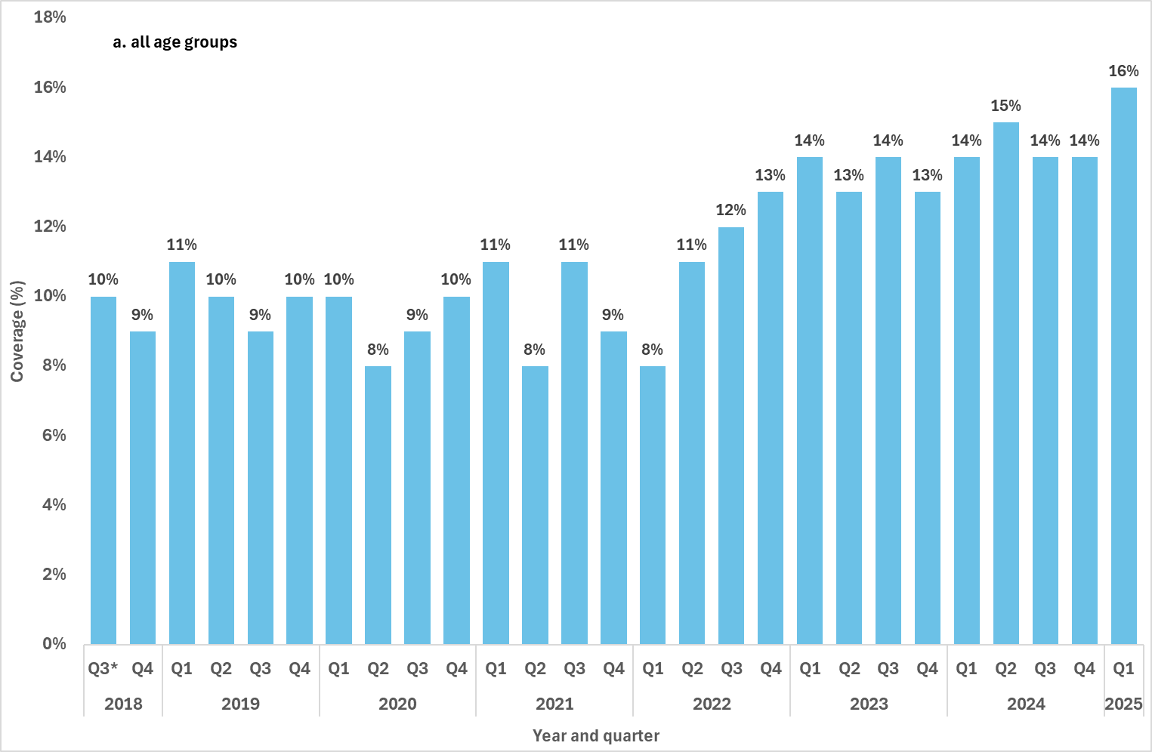
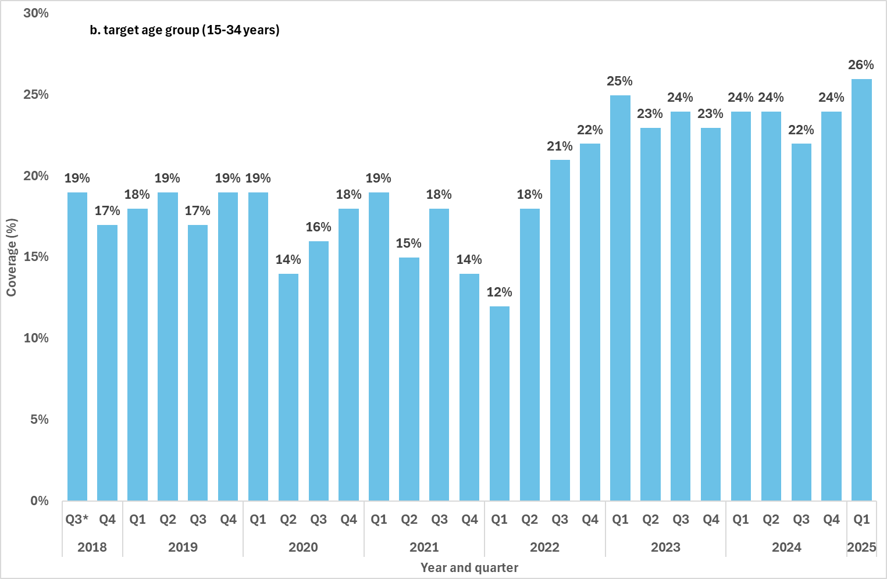
Figure 3: Proportion of syphilis tests delivered through participating ACCHS, by test type (PoCT only, serology only and both serology and PoCT), by quarter and year, Q32 2018 – Q1 2025
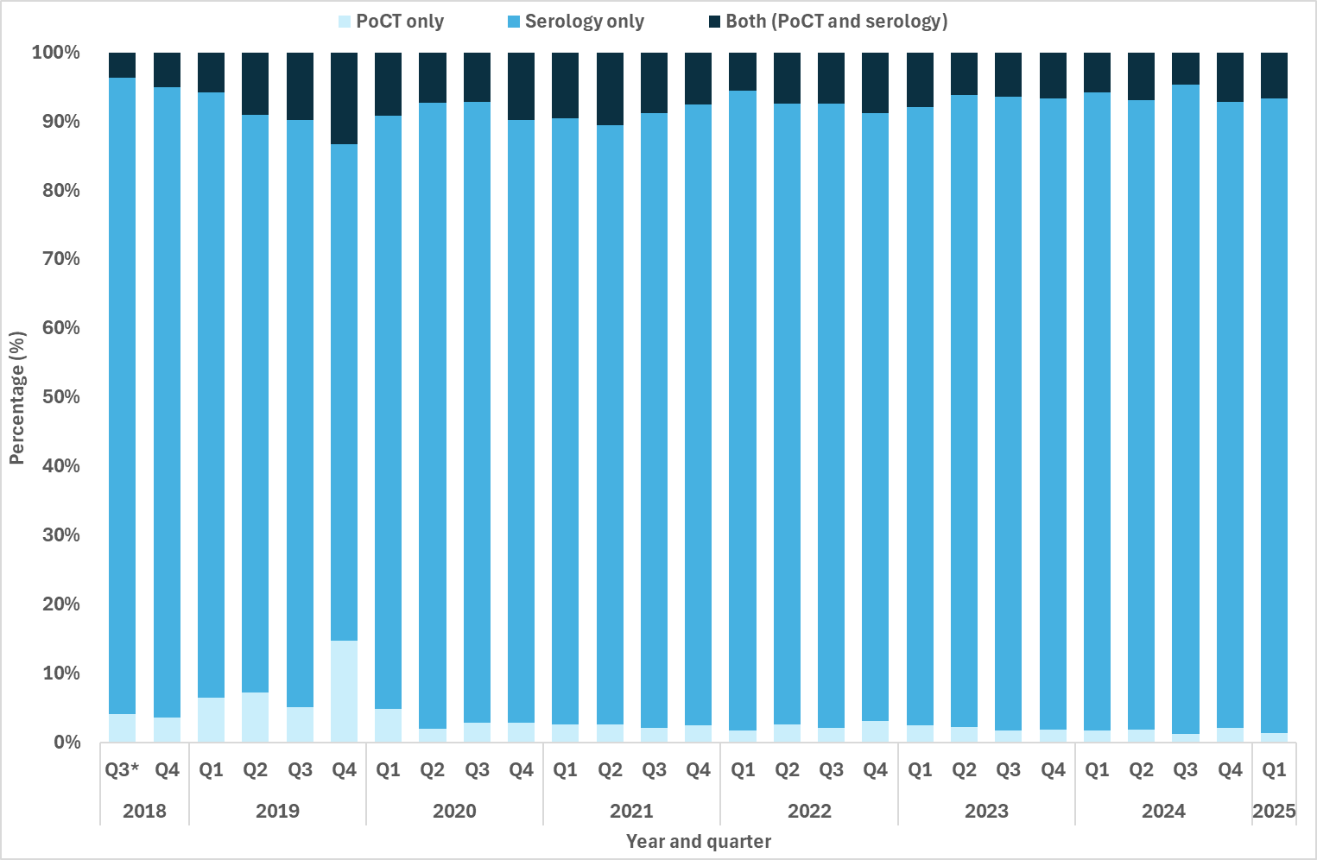

Goal 2: Reduce ongoing transmission and incidence of syphilis across priority populations
Key facts
In Q1 2025:
- 1,605 infectious syphilis cases notified, a 7% increase compared to both the 12 month quarterly mean and the 5 year quarterly mean.
- Highest rates reported in Aboriginal and Torres Strait Islander females and males aged 15-24 years in remote/very remote areas.
- Compared to the 12 month quarterly average, notification rates in:
- Aboriginal and Torres Strait Islander males increased across most remoteness areas and age groups.
- Aboriginal and Torres Strait Islander females reported increases in inner/outer and remote/very remote areas in people 25 years and over.
- Non-Indigenous males reported decreases across most age groups and remoteness areas.
- Non-Indigenous females reported small declines or remained the same.
In Q1 2025, 1,605 infectious syphilis cases were notified, a 7% increase compared to the quarterly mean over the past 12 months (1,494, Q2 2024 – Q1 2025) and 5 years (1,496, Q2 2020 – Q1 2025) (Figure 4). Consistent with historical trends, in Q1 2025 notifications were predominately reported in males (78%) and were aged 25-34 years (35%) (Table 3).
While notifications were largely reported among residents of major cities (73%), proportions in inner/outer regional areas are continuing to increase due in part to rises in notifications in urban areas in the Northern Territory (Darwin classified as an outer regional area), and areas in north Queensland (Map 2). Proportional increases in remote/very remote areas reflects consistent reporting of cases in these areas, and rises in remote/very remote areas in the Northern Territory, including previously unaffected communities (Groote Eylandt and Maningrida in East Arnhem) (Map 1 and 2) (3).
Figure 4: Notifications (n) and notification rate (per 100,000) of infectious syphilis, by Indigenous status, sex, year and quarter, 2020 – Q1 2025
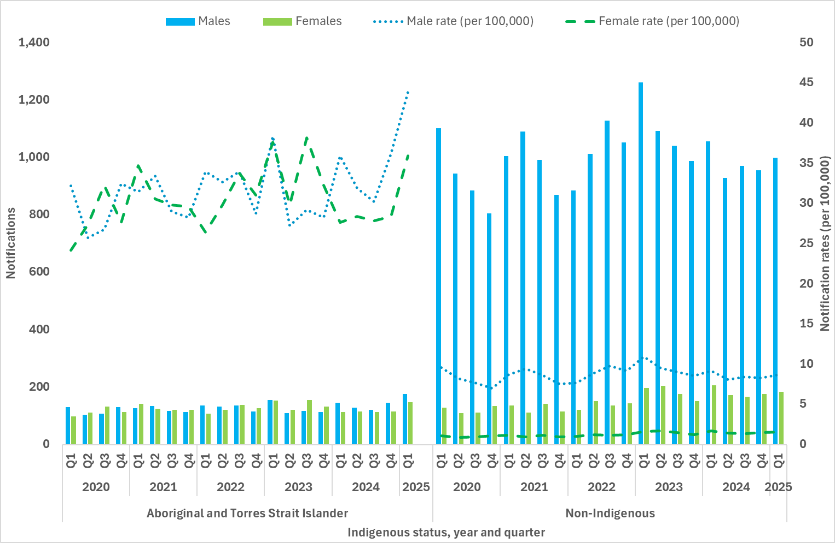

Table 3: Demographic summary of infectious syphilis notifications, 2020 – Q1 2025
Characteristics | 2020 | 2021 | 2022 | 2023 | 2024 | 2025 (Q1)
Total | 5,363 | 5,763 | 6,187 | 6,563 | 5,969 | 1,605
Sex  Female  Male  X*  Not reported | 958 | 1,037 | 1,085 | 1,334 | 1,216 | 346
Sex  Female  Male  X*  Not reported | 4,388 | 4,707 | 5,074 | 5,219 | 4,743 | 1,255
Sex  Female  Male  X*  Not reported | 4 | 6 | 8 | 5 | 1 | -
Sex  Female  Male  X*  Not reported | 13 | 13 | 20 | 5 | 9 | 4
Age group  15-24  25-34  35-44  45+ | 880 | 842 | 841 | 926 | 766 | 189
Age group  15-24  25-34  35-44  45+ | 1,911 | 2,143 | 2,281 | 2,360 | 2,102 | 559
Age group  15-24  25-34  35-44  45+ | 1,334 | 1,500 | 1,647 | 1,715 | 1,641 | 481
Age group  15-24  25-34  35-44  45+ | 1,222 | 1,263 | 1,406 | 1,546 | 1,435 | 369
Mean age at diagnosis  Female  Male  Overall | 30 | 30 | 31 | 32 | 33 | 33
Mean age at diagnosis  Female  Male  Overall | 37 | 37 | 38 | 38 | 38 | 38
Mean age at diagnosis  Female  Male  Overall | 36 | 36 | 36 | 37 | 37 | 37
Indigenous status  Aboriginal and Torres Strait Islander  Non-Indigenous  Not reported | 929 | 1,004 | 1,018 | 1,061 | 1,002 | 324
 | 4,238 | 4,479 | 4,654 | 5,119 | 4,641 | 1,184
 | 196 | 280 | 515 | 383 | 326 | 97
Remoteness  Major cities  Inner/outer regional  Remote/very remote  Not reported/Overseas resident | 4,085 | 4,412 | 4,771 | 4,987 | 4,476 | 1,174
 | 661 | 608 | 755 | 912 | 918 | 240
 | 486 | 573 | 463 | 470 | 409 | 131
 | 131 | 170 | 198 | 194 | 166 | 60
*Persons who reported their sex assigned at birth as another term, other than male or female.
2.1 Notification rate of infectious syphilis by Indigenous status, sex, age and remoteness area classification
Aboriginal and Torres Strait Islander males
In Q1 2025, notification rates among Aboriginal and Torres Strait Islander males increased across all age groups in major cities and remote and very remote areas compared to the 12 month quarterly mean. The greatest rate increase compared to the 12 month quarterly mean was reported in 25-34 year olds in major cities (50%) and 35-44 year olds in remote/very remote areas (56%) (Figure 5 a-c). Small declines were reported in inner and outer regional areas across the same comparison period among males aged <35 years, however in older age groups there were considerable increases (40%, 35-44 year olds; 33%, 45+ year olds) (Figure 5b). Overall, the highest rates for this population group were in remote and very remote areas of Australia, with the highest reported for Q1 2025 in 35-44 year olds (211 per 100,000) (Figure 5c).

Non-Indigenous males
On average non-Indigenous males represent around 81% of all infectious syphilis notifications, with the majority of these cases reported in major cities of Australia (Figure 5a). In Q1 2025, notification rates in most age groups across all remoteness areas reported a decrease compared to the 12 month and 5 year quarterly mean (Figure 5a-c).
Aboriginal and Torres Strait Islander females
In Q1 2025, Aboriginal and Torres Strait Islander females aged 15-24 years in remote/very remote areas recorded the highest notification rate among all population and geographical groups, with a rate of 252 per 100,000, noting that this was a small decline compared to the 12 month quarterly mean (261 per 100,000) (Figure 6c). Other age groups in these geographical areas reported increases in notification rates compared to the 12 month quarterly mean with the greatest increase reported in 35-44 year olds (51%) and 25-34 year olds (36%) (Figure 6c). Compared to the 12 month quarterly mean considerable increases were reported in all age groups 25 years and over in inner/outer regional areas (44%, 25-34 year olds; 67%, 35-44 year olds; 50% 45+ year olds) (Figure 6b).
Non-Indigenous females
In Q1 2025, compared to the 12 month quarterly mean, notification rates in non-Indigenous females showed small declines or remained similar across most age and geographical groups, except for 35-44 year old females in major cities of Australia where a small increasing trend was observed (Figure 6a-c). Compared to the 5 year quarterly mean however considerable increases were reported in all age groups in major cities of Australia (Figure 6a).
Figure 5 a-c: Notifications (n) and notification rate (per 100,000) of infectious syphilis reported in males, by Indigenous status, remoteness area, age, quarter, and year, 2020 – Q1 2025 (a. Major cities, b. Inner and outer regional areas and c. Remote and very remote areas)
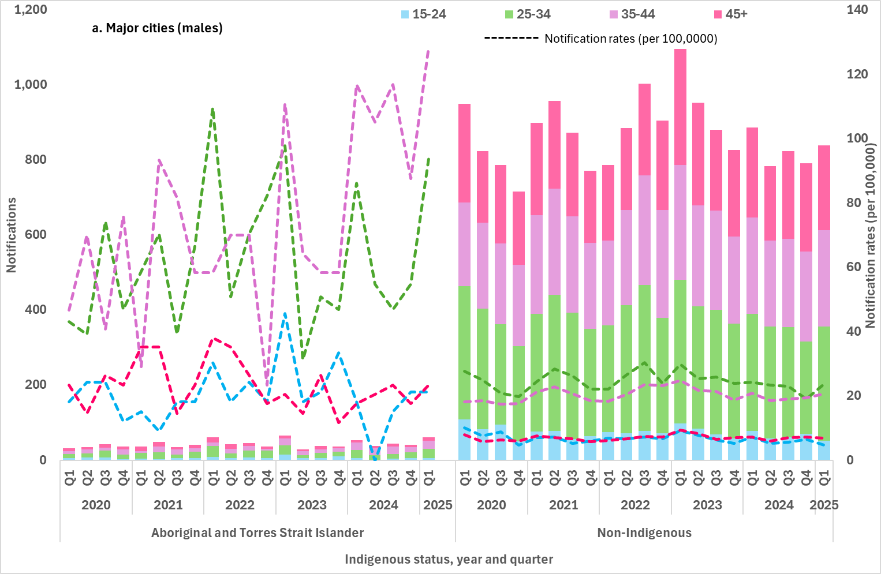
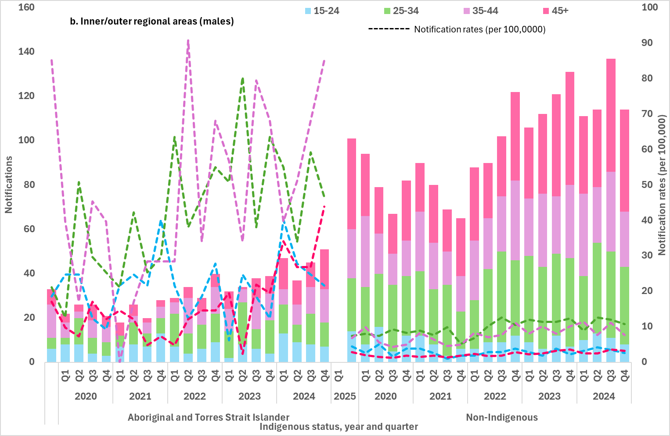
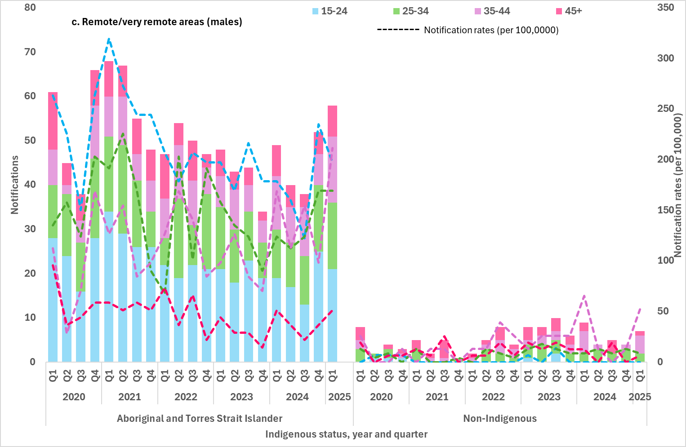

Figure 6 a-c: Notifications (n) and notification rate (per 100,000) of infectious syphilis reported in females, by Indigenous status, remoteness area, age, quarter, and year, 2020 – Q1 2025 (a. Major cities, b. Inner and outer regional areas and c. Remote and very remote area)4
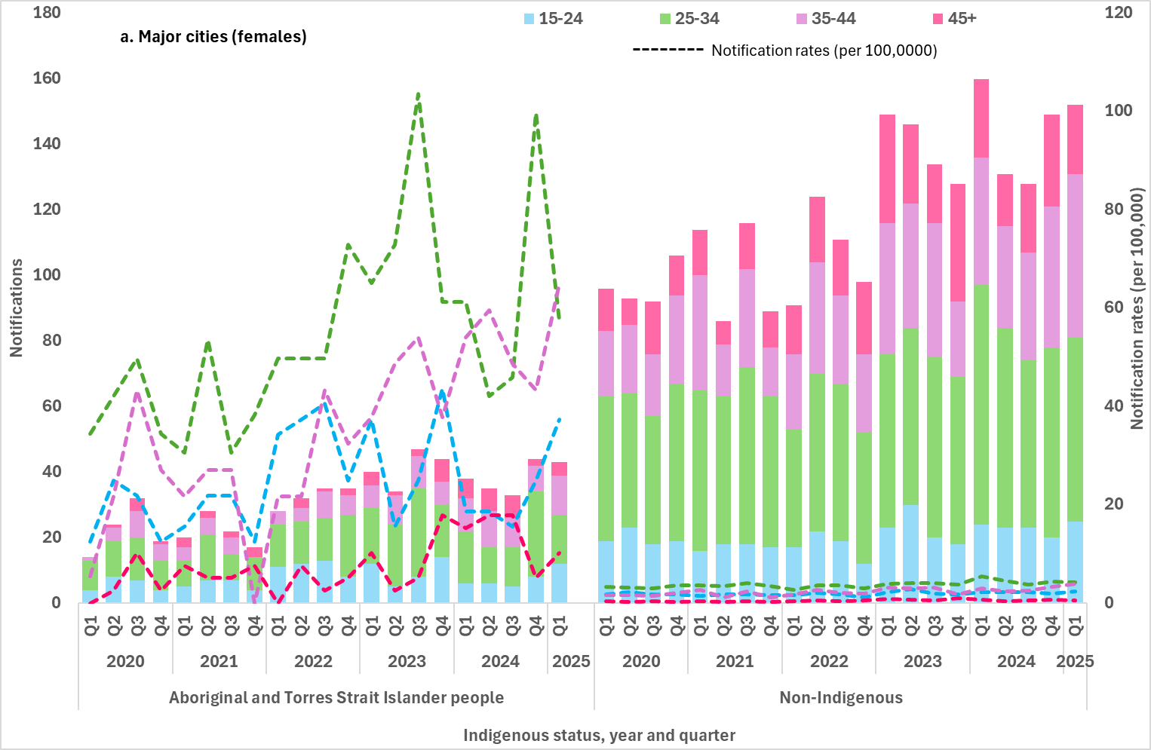
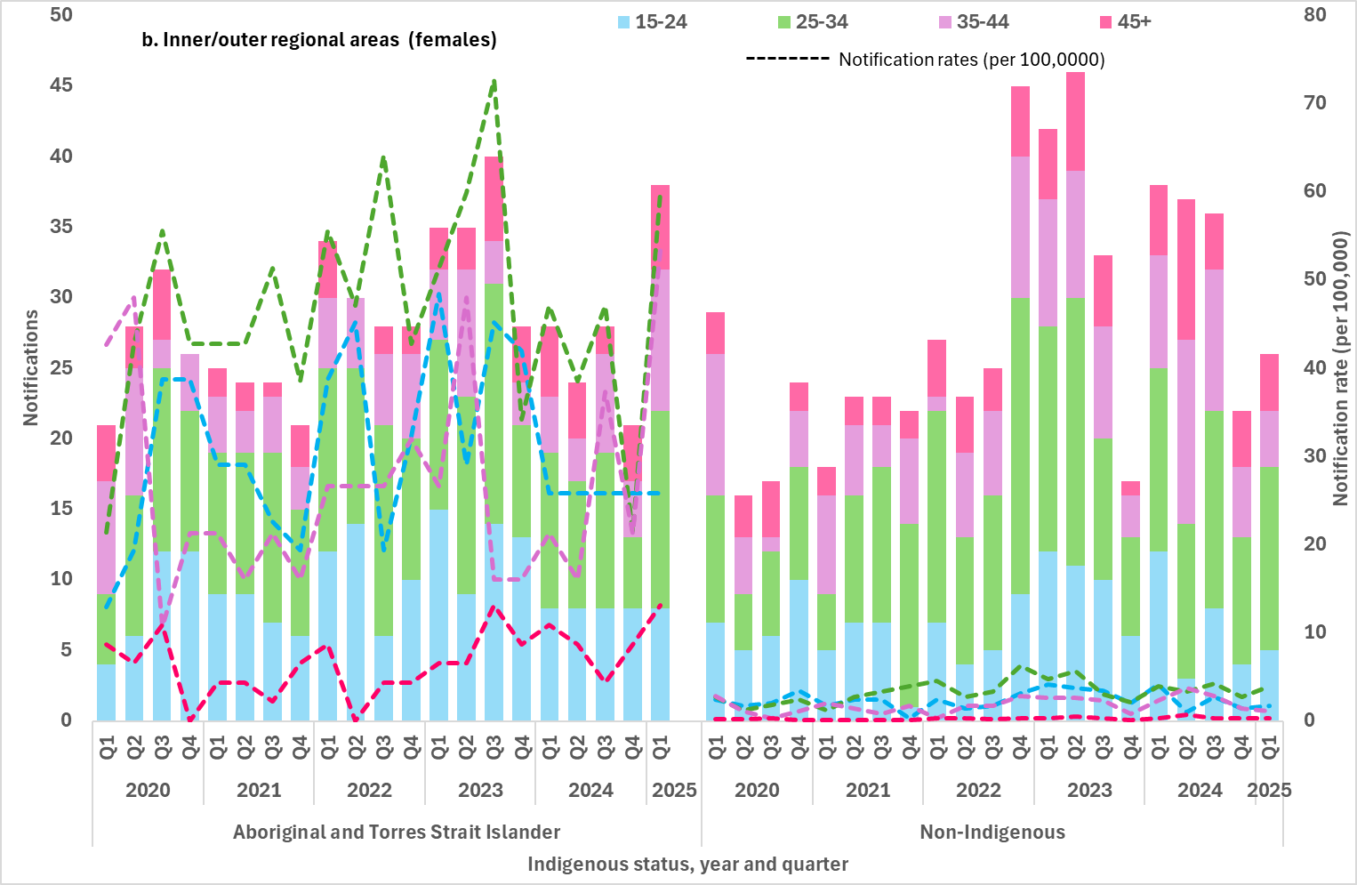
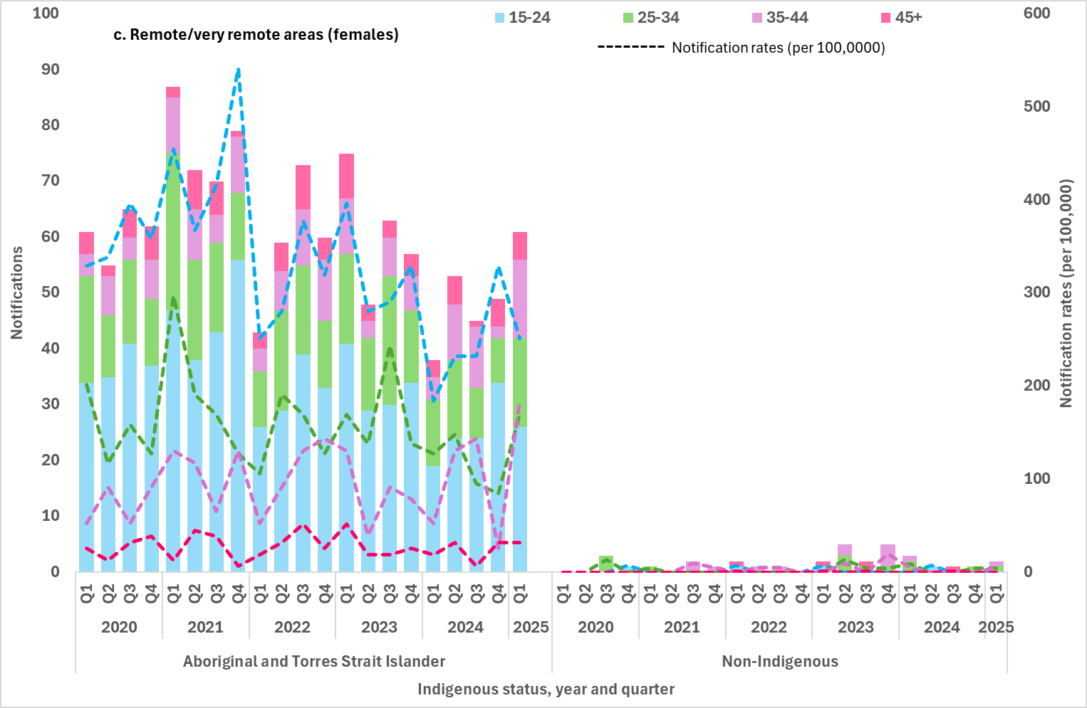
2.2 Notification rate of infectious syphilis in Aboriginal and Torres Strait Islander peoples by Indigenous Areas (IAREs)
2.3 Notification rate of infectious syphilis by Statistical Area 3 (SA3), by Indigenous status
An important consideration when interpreting mapped notification data is that the postcodes used to allocate cases to a geographical area is done so based on the residential postcode of the notified case. This may not necessarily reflect where the infection was acquired and in some instances the postcode reported may reflect the location where the case was diagnosed rather than residence and locality of acquisition. If the postcode reflects the location where an individual sought health care, the mapped notifications may reflect areas of high volume or centralised services where people are being diagnosed rather than areas with a high burden of infection or acquisition. Availability and accessibility of safe and culturally appropriate health services, particularly in remote/very remote areas and Aboriginal and Torres Strait Islander communities, along with other social factors may influence where people are tested and diagnosed, noting that this may occur outside of an individual’s place of residence (4).
Indigenous Areas
Indigenous Areas (IAREs) are geographic areas built from Indigenous Locations, which are designed to represent Aboriginal and Torres Strait Islander communities (urban and rural) that are near each other or that share language, traditional borders or Native Title (5). Age standardised infectious syphilis notification rates by IAREs for Aboriginal and Torres Strait Islander people are presented in Map 1 for the previous 12 months (Q2 2024 – Q1 2025). The highest notification rates were reported largely in very remote areas of Western Australia, South Australia and the Northern Territory, noting that in some IAREs the population was small. High notification rates in outer regional areas (Darwin and surrounds) reflect the increase in reported cases in urban areas in the Northern Territory.

Statistical Area 3 (SA3)
In the previous 12 months age-standardised notification rates of infectious syphilis by statistical area 3 (SA3) were widely distributed across Australia (Map 2). The highest rates were reported across very remote areas in the north-west of Australia and SA3’s in some major cities, including Sydney. This geographical distribution reflects the concurrent infectious syphilis outbreaks and sub-epidemics occurring across populations groups in Australia, including Aboriginal and Torres Strait Islander people in regional and remote areas, gay and bisexual men in major cities of Australia, and non-Indigenous women in major cities.
Please refer to the methodological notes for further information on the development of the maps.

Map 1: Notification rate (per 100,000) of infectious syphilis in Aboriginal and Torres Strait Islander peoples by Indigenous Areas (IAREs) in the previous 12 months (Q2 2024 – Q1 2025)4
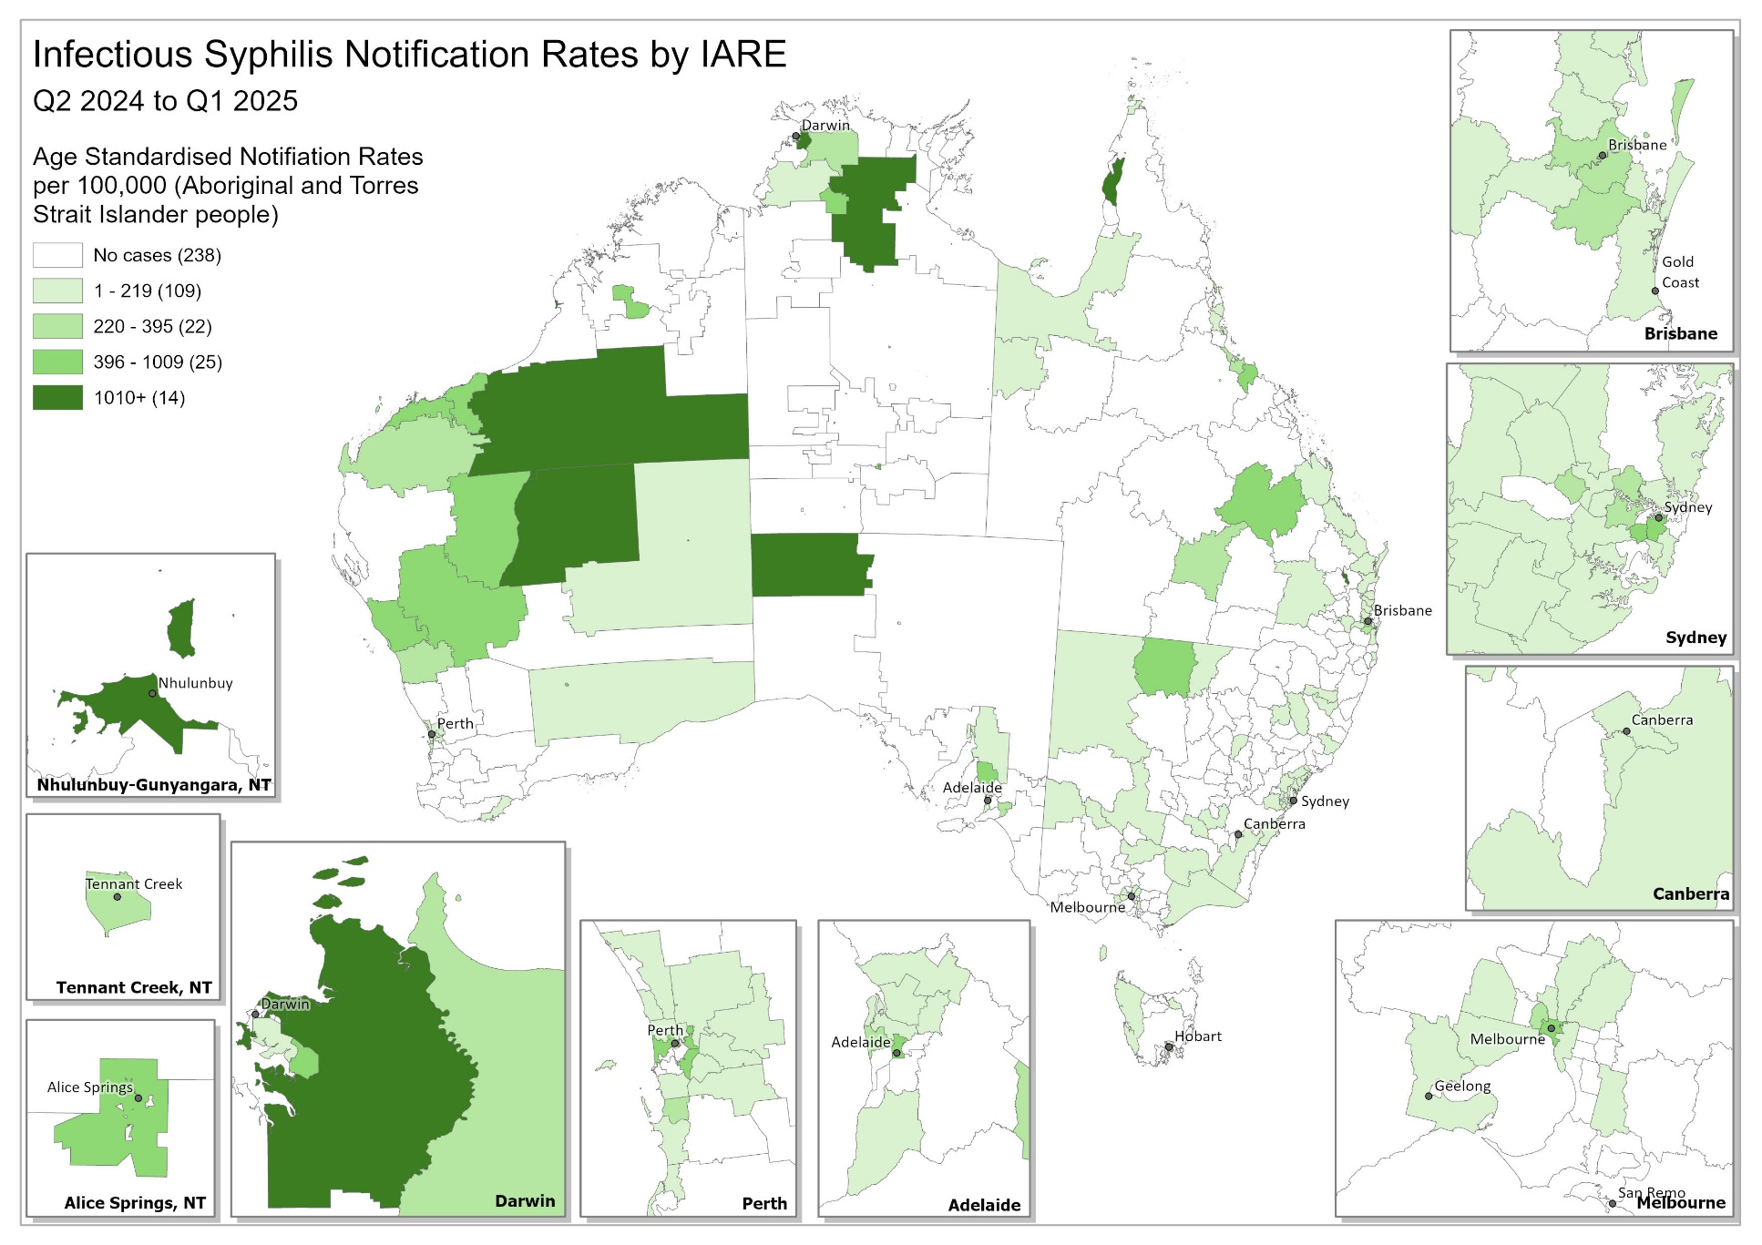
Map 2: Age-standardised notification rate (per 100,000) of infectious syphilis by Statistical Area 3 (SA3) in the previous 12 months
(Q2 2024 – Q1 2025)4
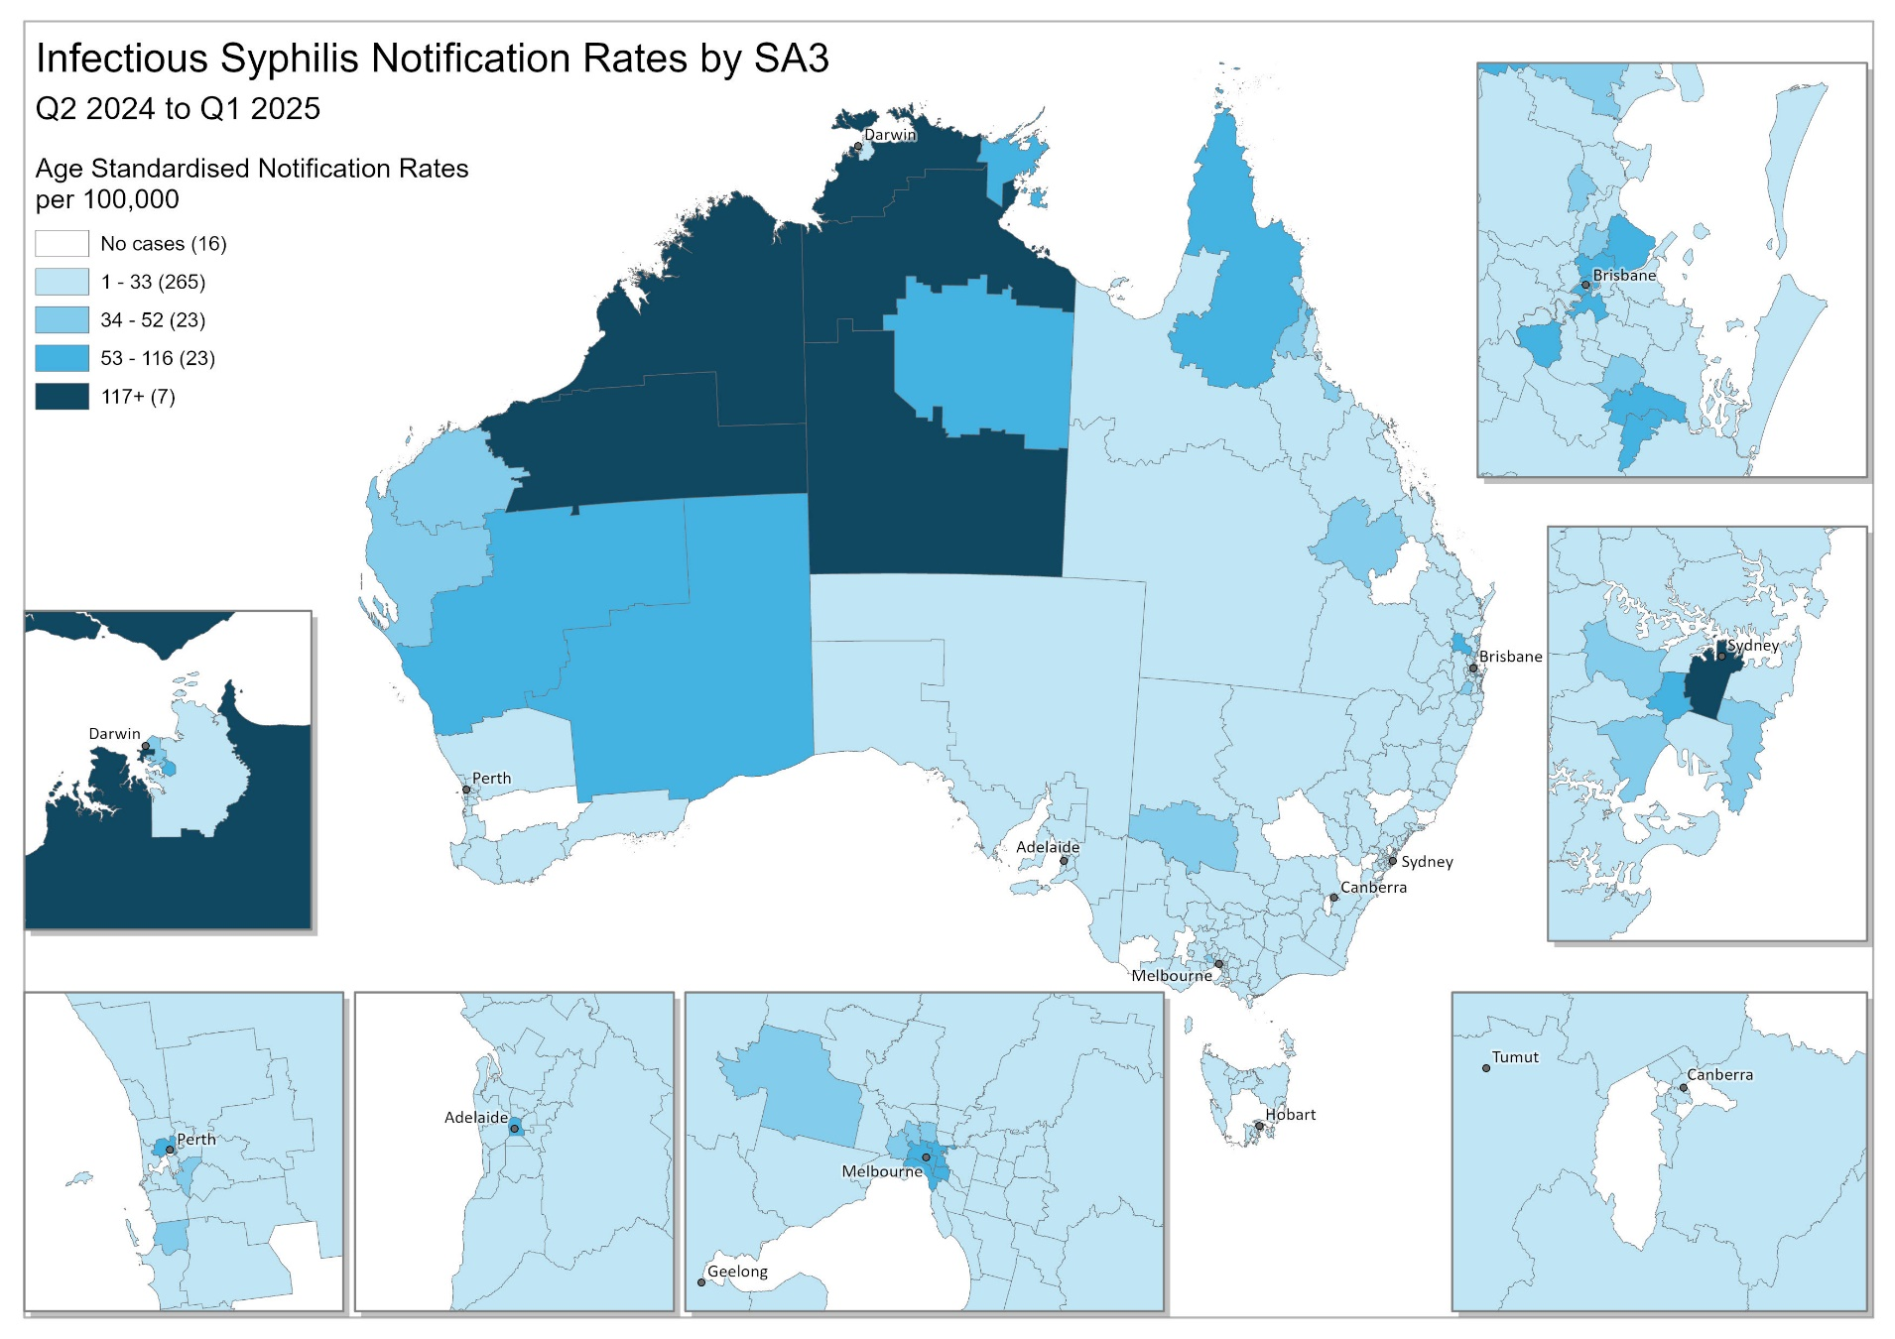

2.4 Notification rate of infectious syphilis in women of reproductive age (15-44 years) by Indigenous status and remoteness area
Between 2020 and Q1 2025, most (86%) infectious syphilis cases were reported in women are aged between 15-44 years of age, with the average proportion among Aboriginal and Torres Strait Islander women higher (89%) and non-Indigenous women lower (84%) (Figure 7a-b).
Aboriginal and Torres Strait Islander women
The highest proportion and notification rates among Aboriginal and Torres Strait Islander women of reproductive age have consistently been reported in remote/very remote areas of Australia, representing half of the cases (51%) reported between 2020 and Q1 2025 (Figure 7a). Although lower notifications and rates have been reported in major cities of Australia, the proportion of cases overall in this geographical group has been increasing since 2022 (average total 26% over the reporting period), while in inner and outer regional areas the proportion has remained relatively constant (average total 23%) (Figure 7a).
Non-Indigenous women
The majority of notifications among non-Indigenous women of reproductive age were reported in major cities of Australia, on average representing 80% of cases reported between 2020 and Q1 2025. A smaller proportion (average 19%) were reported in inner/outer regional areas, and very small proportion (average 1%) in remote and very remote Australia (Figure 7b).
Figure 7 a-b: Notifications (n) and notification rate (per 100,000) of infectious syphilis reported in women5 aged 15-44 years, by Indigenous status, remoteness area, quarter, and year, 2020 – Q1 2025 (a. Aboriginal and Torres Strait Islander and b. non-Indigenous)4
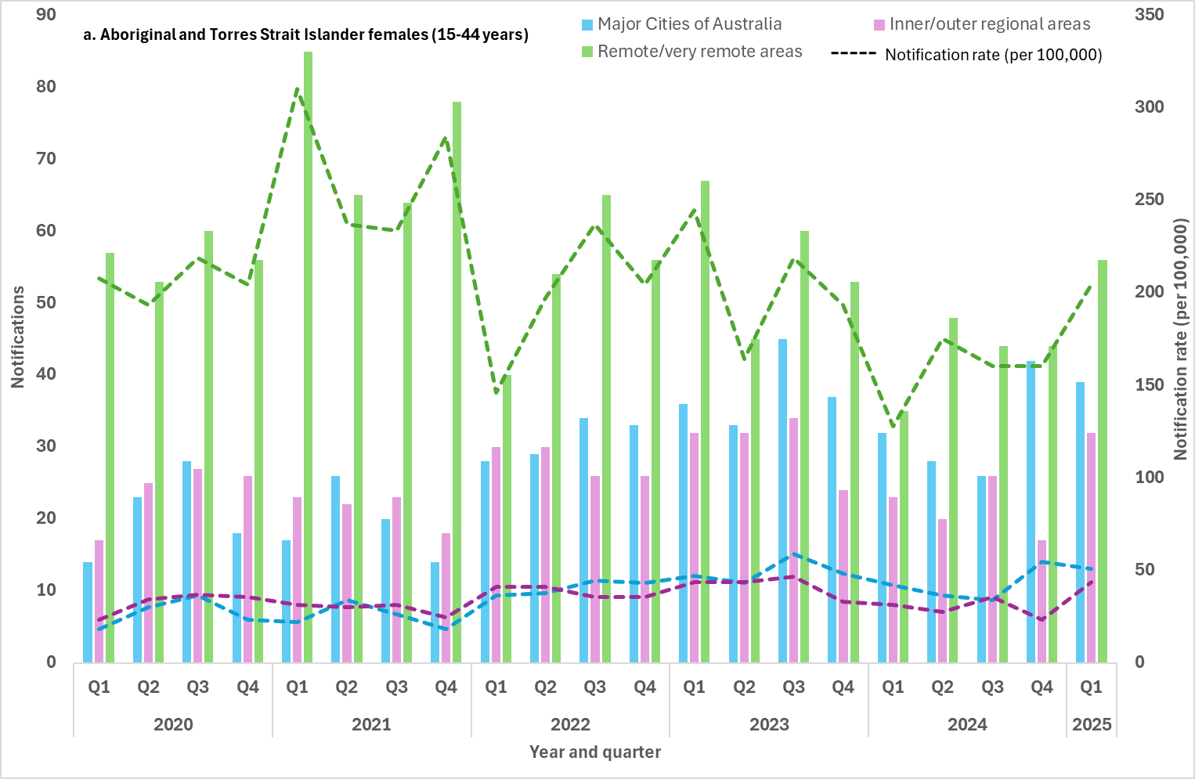
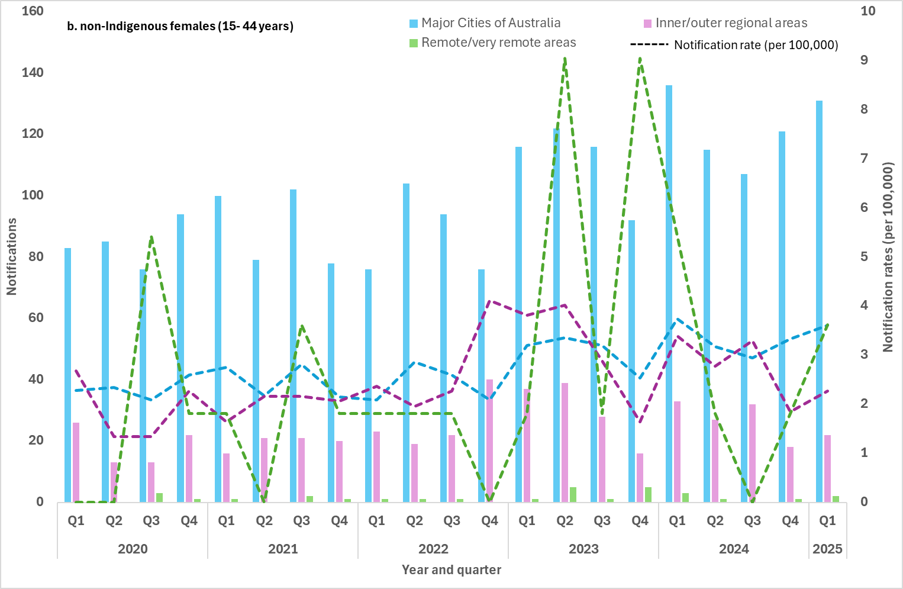
2.5 Proportion of infectious syphilis notifications in men reporting sexual exposure with men only
2.6 Proportion of infectious syphilis notifications in men reporting sexual exposure with men and women5
Enhanced data (sexual exposure: same sex, opposite sex and both sexes) are used to report against indicators 2.5 and 2.6.
Completeness of sexual exposure in males notified with infectious syphilis fluctuated between 2020 and Q1 2025, ranging from 63% to 80% (average 70%).
Males reporting sexual exposure with the same sex only represented the highest proportion of sexual exposure events (51%) in Q1 2025 consistent with historical trends. The proportion of males reporting sexual exposure with people of a different sex only was 21% in Q1 2025, with proportional increases compared with the 12 month and 5 year quarterly means, 18 and 16% respectively (Figure 8). Actual case numbers have increased in Q1 2025 by 21% compared to the 12 month quarterly mean and 40% compared to the 5 year quarterly mean (n=188). Proportionally males reporting sexual exposure with people of different and same sex was 7% in Q1 2025. While proportionally lower, actual case numbers in Q1 2025 have increased compared to the 12 month and 5 year quarterly mean, by 32 and 47% respectively (Figure 8).
Changes in sexual exposure over time suggests potential overlapping in sexual networks influencing the epidemiology of syphilis transmission across Australia, including increasing exposure to syphilis for females. This concept has also been observed in genomic analysis of Treponema pallidum (syphilis) in Australia and other sexually transmissible infections (6, 7).
Figure 8: Number of infectious syphilis notifications among males and proportion (%) of cases by sexual exposure and year 2020 – Q1 2025
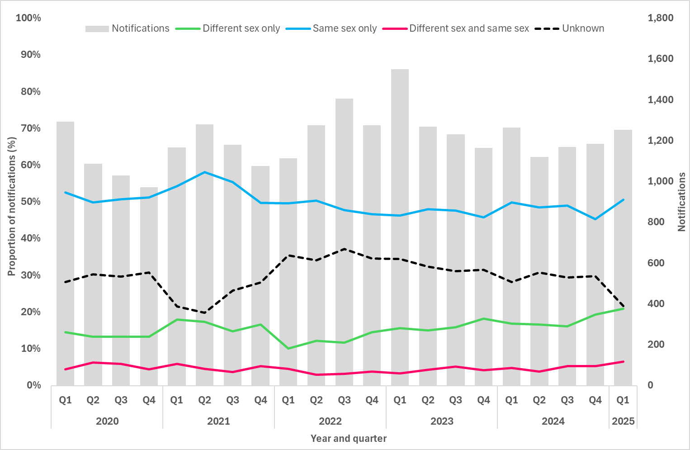

Goal 3: Reduce morbidity and mortality associated with syphilis
Death and hospitalisations data reported to the NNDSS are not used in reporting against this goal due to poor completeness and inconsistencies in reporting. More comprehensive data are available through The Australian Bureau of Statistics (ABS) and The Australian Institute of Health and Welfare (AIHW) data collections, however these data are less timely with at least a minimum one to two year delay from the reporting year.
The latest available data from the ABS and AIHW will be incorporated into annual reporting for this goal.

Goal 4: Eliminate congenital syphilis (defined as sustained zero congenital syphilis cases)
Key facts
- 3 cases of congenital syphilis were reported in Q1 2025:
– 2 non-Indigenous infants;
– 1 Aboriginal and Torres Strait Islander infant who sadly died.
- All 3 women⁴ who gave birth to these infants were diagnosed with syphilis late in pregnancy and did not receive adequate treatment prior to delivery.
- In Q1 2025, 16% of women of reproductive age were pregnant at syphilis diagnosis.
Long term trends
- Eighty cases of congenital syphilis have been reported between 2020 – Q1 2025, including 27 deaths:
– 43 Aboriginal and Torres Strait Islander infants, including 16 deaths.
– 35 non-Indigenous infants, including 9 deaths.
– 2 infants with unknown Indigenous status who died of the infection.
- Of the women giving birth to an infant with congenital syphilis between 2020 – Q1 2025:
– 83% were diagnosed late⁵ in pregnancy.
– 93% did not receive adequate⁶ treatment prior to delivery.
– 65% did not have a previous syphilis test in pregnancy.
4.1 Number of congenital syphilis cases by remoteness area and Indigenous status
4.2 Number of congenital syphilis related deaths by Indigenous status
4.3 Notification rate of congenital syphilis per 100,000 live births by remoteness area and Indigenous status
In Q1 2025, three cases of congenital syphilis were reported, two in non-Indigenous infants from major cities of Australia and one Aboriginal and Torres Strait Islander infant from remote/very remote Australia, who sadly died of the infection.
Between 2020 and Q1 2025, 80 cases of congenital syphilis cases have been notified. More than half (43/80, 54%) were reported in Aboriginal and Torres Strait Islander infants, 35 in non-Indigenous infants (35/80, 44%) and two cases with an unknown Indigenous status reported (2/80, 2%). Of the 80 cases reported 27 infants died, 16 Aboriginal and Torres Strait Islander infants, nine non-Indigenous infants, and two infants with an unknown Indigenous status (Figure 9).
Figure 9: Notifications (n) and notification rate (per 100,000 live births) of congenital syphilis, by Indigenous status, remoteness area, and year, 2020 – Q1 20251*
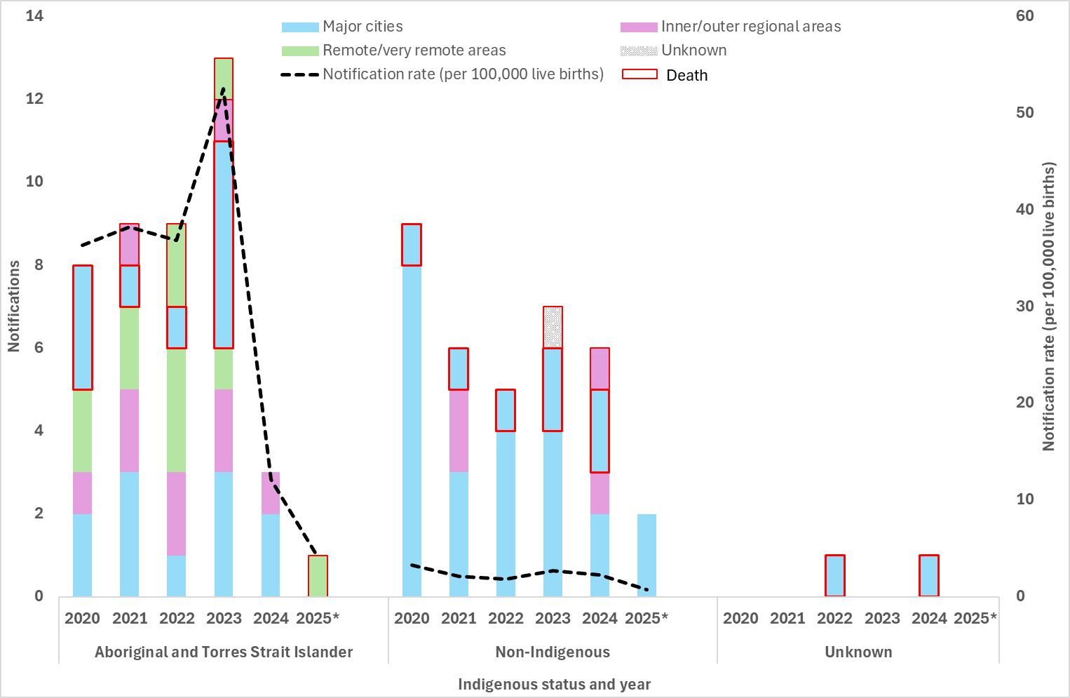
4.4 Proportion of syphilis notifications among women5 of reproductive age (15- 44 years) who were pregnant at time of diagnosis, by remoteness area and Indigenous status
Pregnancy data were available for six jurisdictions in 2020 (excluding Victoria and the Northern Territory), seven jurisdictions in 2021 to 2023 (excluding the Northern Territory), eight jurisdictions in 2024, and seven jurisdictions in Q1 2025 (excluding Victoria as data were not available at the time of writing but are expected to be presented in the Q2 2025 report).
Given the high proportion of cases with an unknown pregnancy status and retrospective changes to the data, trends overtime should be interpreted with caution. Please note there may be differences with previous reports due to pregnancy status being reclassified in some women and the inclusion of new historical data from jurisdictions.
In Q1 2025, 16% of all women of reproductive age, including those with an unknown Indigenous status, were reported to be pregnant at the time of their syphilis diagnosis, higher than the 12 month and 5 year quarterly mean (13% and 14%, respectively) (Figure 10). Aboriginal and Torres Strait Islander and non-Indigenous women of reproductive age reported the same proportion of cases pregnant at the time of syphilis diagnosis as the overall trend (Figure 10 and 11a-b).
Between 2020 and the end of 2024, Aboriginal and Torres Strait Islander women of reproductive age consistently reported higher proportions of cases pregnant at the time of syphilis diagnosis compared to non-Indigenous women, with the 5 year quarterly mean 17% and 12%, respectively.
Figure 10: Number of syphilis notifications among women5 of reproductive age (15-44 years) and proportion (%) of cases pregnant at time of syphilis diagnosis, by year, 2020 – Q1 2025
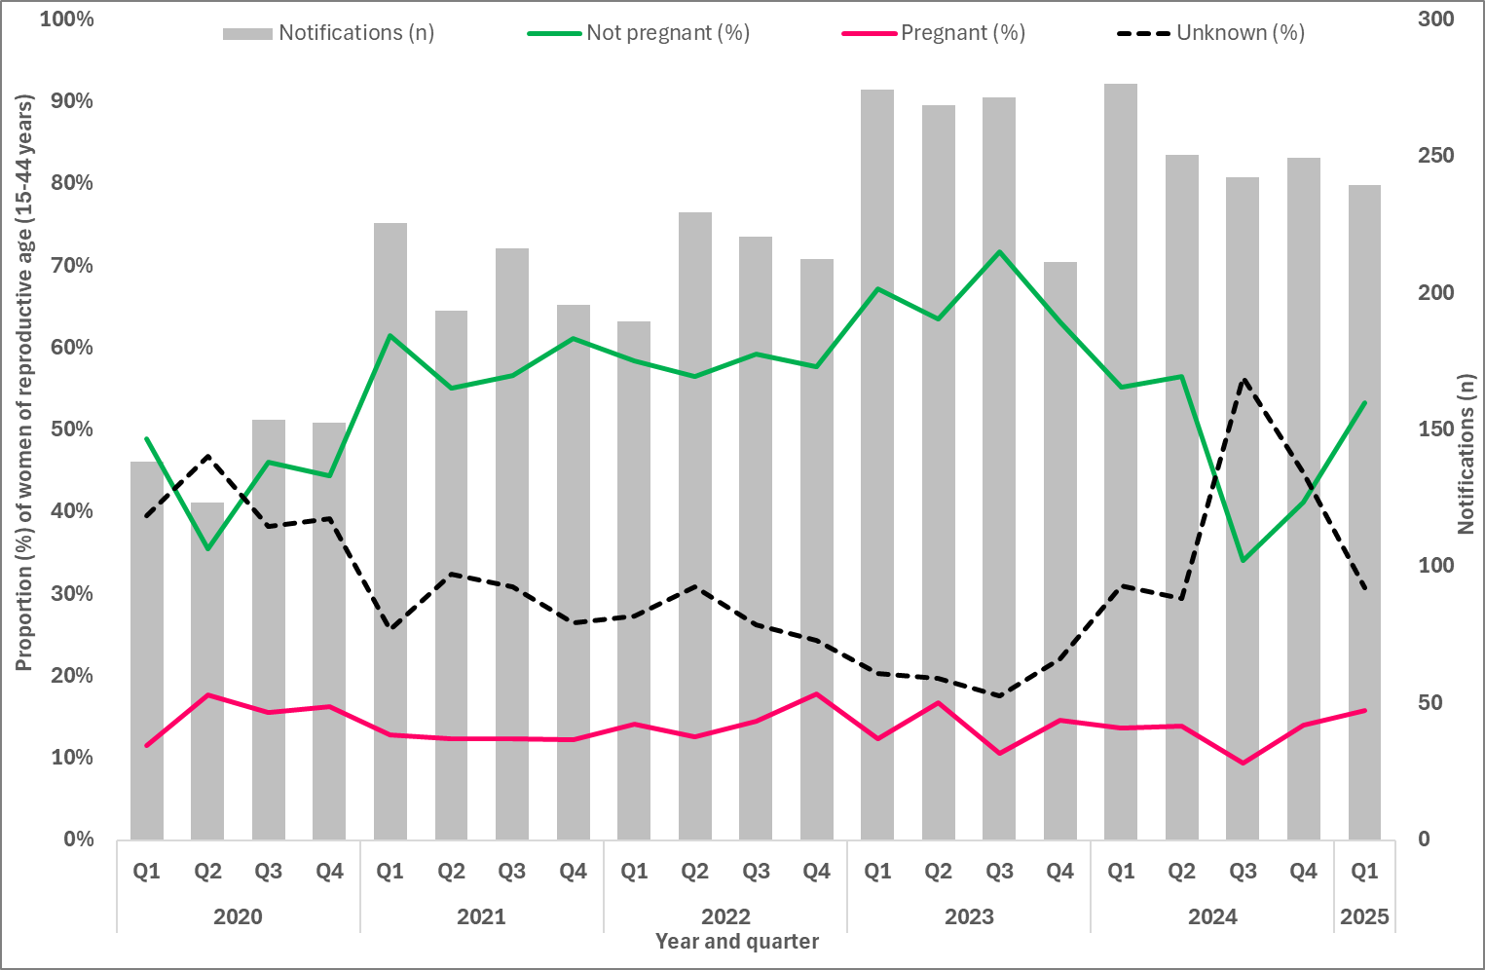
Figure 11 a-b: Number of syphilis notifications among women5 of reproductive age (15-44 years) and proportion (%) of cases pregnant at time of syphilis diagnosis, by Indigenous status and year, 2020 - Q1 2025 (a. Aboriginal and Torres Strait Islander and b. non-Indigenous)4
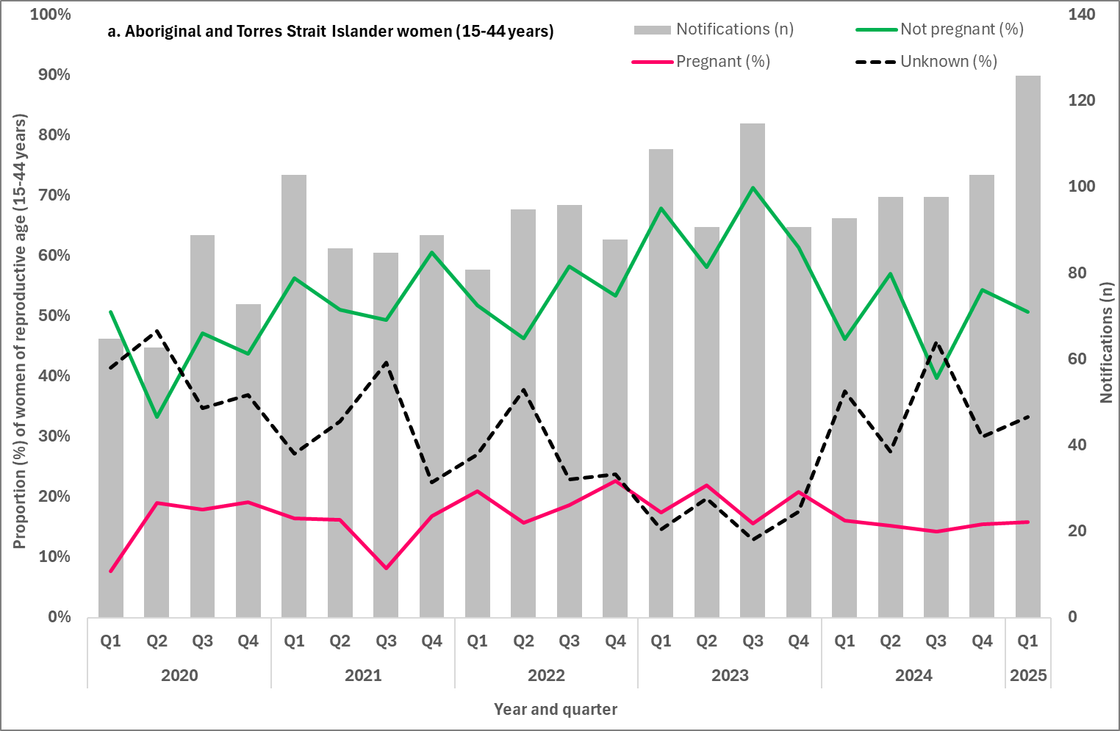
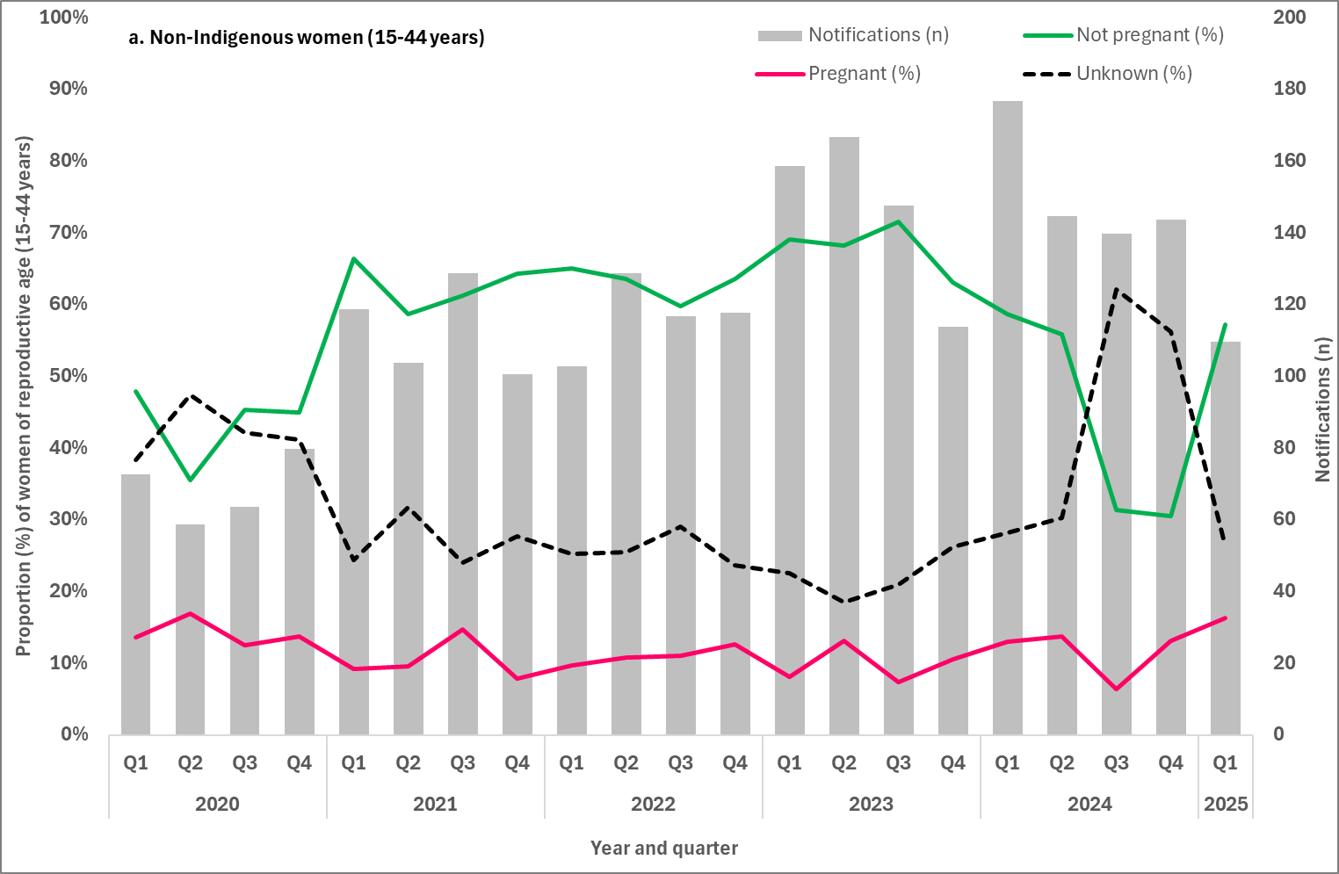
4.5 Number of women5 giving birth to an infant with congenital syphilis who were diagnosed with syphilis late in pregnancy by Indigenous status
Late diagnosis with syphilis in pregnancy refers women who did not receive treatment more than 30 days prior to delivery. Late diagnosis also includes women who were diagnosed with syphilis at-birth (day of delivery) or post-birth and therefore could not receive adequate treatment for their syphilis infection.
Most women (83%, 66/80) giving birth to an infant with congenital syphilis between 2020 and Q1 2025, were diagnosed late in pregnancy. Among non-Indigenous women this proportion was 86% (30/35), and Aboriginal and Torres Strait Islander women 79% (34/43) (Table 4).
Table 4: Number of women5 giving birth to an infant with congenital syphilis, by trimester mother was diagnosed with syphilis and year, 2020 – Q1 2025
Trimester | 2020 | 2021 | 2022 | 2023 | 2024 | 2025 (Q1)
Aboriginal and Torres Strait Islander women
1st | - | - | - | - | 1 | -
2nd | 1 | - | 2 | 2 | - | -
3rd | - | 2 | 1 | 4 | - | 1
At birth | 4 | 4 | 3 | 4 | 1 | -
Post birth | 3 | 3 | - | 3 | 1 | -
Unknown^ | - | - | 3 | - | - | -
Late diagnosis | 7 | 9 | 4 | 11 | 2 | 1
Total | 8 | 9 | 9 | 13 | 3 | 1
Non-Indigenous women
1st | - | - | - | - | - | -
2nd | - | - | 1 | 3 | - | -
3rd | 2 | 1 | 1 | - | 1 | -
At birth | 2 | 1 | 1 | 1 | 1 | 2
Post birth | 5 | 4 | 2 | 3 | 4 | -
Unknown^ | - | - | - | - | - | -
Late diagnosis | 8 | 6 | 4 | 4 | 6 | 2
Total | 9 | 6 | 5 | 7 | 6 | 2
Total women^
1st | - | - | - | - | 1 | -
2nd | 1 | - | 3 | 5 | - | -
3rd | 2 | 3 | 2 | 4 | 1 | 1
At birth | 6 | 5 | 4 | 5 | 2 | 2
Post birth | 8 | 7 | 3 | 6 | 6 | -
Unknown^ | - | - | 3 | - | - | -
Late diagnosis | 15 | 15 | 9 | 15 | 9 | 3
Total | 17 | 15 | 15 | 20 | 10 | 3
^Includes cases with an unknown stage of pregnancy at syphilis diagnosis.
4.6 Proportion of women5 giving birth to an infant with congenital syphilis receiving adequate treatment prior to delivery
Maternal treatment of syphilis was reported for 93% (74/80) of women giving birth to an infant with congenital syphilis between 2020 and Q1 2025. Of these women 97% (72/74) did not receive adequate treatment prior to delivery (Figure 12) this includes 49 women who were diagnosed at-birth (day of delivery) and post-birth and 12 women who were diagnosed in the third trimester (<30 days prior to delivery). Of the remaining cases, eight were diagnosed in the 2nd trimester and three had an unknown trimester of diagnosis.
Of the 72 women who did not receive adequate treatment prior to delivery, one-third (33%, 24/72) of these pregnancies resulted in a congenital syphilis fetal death (still-birth or following birth). Thirty-five percent of these women (35%, 25/72) gave birth to a live-born infant with a range of clinical symptoms associated with congenital syphilis including bone abnormalities, damage to spleen and/or liver, anaemia, hearing loss, jaundice and sepsis. Eight women gave birth to infants (11%, 8/72) with congenital syphilis that were diagnosed in the weeks and months following their birth. Where additional information were available, the reason for the later diagnosis were reported as the infant not being investigated at birth as they were clinically well, the mother was diagnosed with syphilis post-birth and the infant presented with symptoms post-birth. The remaining 15 women gave birth to infants (21%, 15/72) with congenital syphilis that were live-born with no congenital syphilis symptoms.
Figure 12: Adequate maternal treatment among women5 giving birth to an infant with congenital syphilis, by year, 2020 – Q1 2025*
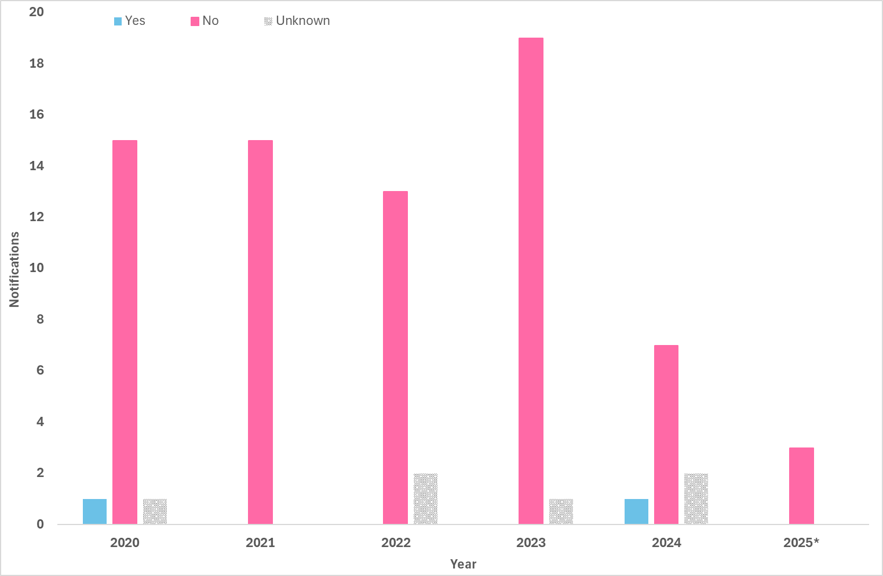
4.7 Number of women5 giving birth to an infant with congenital syphilis by number of syphilis tests received during their pregnancy
Maternal syphilis testing history was reported for 96% (77/80) of women giving birth to an infant between 2020 and Q1 2025 (Figure 13). Of those women 65% (50/77) did not report a previous syphilis test during their current pregnancy prior to being diagnosed with infectious syphilis. The remaining 27 cases (35%, 27/77) reported at least one previous syphilis test, however only women reported having 3 or more tests during their current pregnancy as recommended in national and jurisdictional guidelines (8-15) (Figure 13).
Figure 13: Maternal syphilis testing history during pregnancy among women5 giving birth to an infant with congenital syphilis, by stage of pregnancy at syphilis diagnosis, 2020 – Q1 2025
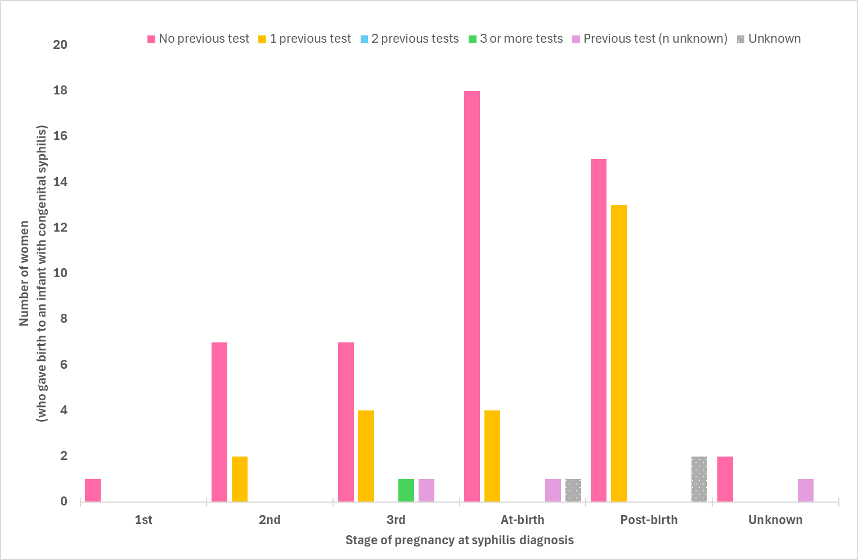
4.8 Number of women5 giving birth to an infant with congenital syphilis reinfected during their pregnancy
Maternal reinfection data, either during the current pregnancy or prior to the current pregnancy, were available for 96% (77/80) of women giving birth to an infant between 2020 and Q1 2025. Of the 77 women with data available seven (9%, 7/77) reported being diagnosed with a previous syphilis infection during the current or previous pregnancy. The remaining 70 cases (91%, 70/77) did not report a previous syphilis infection prior to the current diagnosis.

Methodological notes
Syphilis notification and enhanced data were extracted from the NNDSS on 2 October 2025, by diagnosis date. Due to the dynamic nature of the NNDSS, data in this extract are subject to retrospective revision and may vary from data reported in published NNDSS reports and reports of notification data by states and territories. Data are to 31 March 2025 unless otherwise specified.
In general, notification data represent only a proportion of the total cases occurring in the community, that is, only those cases for which health care was sought, a test conducted, and a diagnosis made, followed by a notification to health authorities. The degree of under-representation of all cases is unknown and is most likely variable by disease and jurisdiction.
In interpreting these data it is important to note that changes in notifications over time may not solely reflect changes in disease prevalence or incidence. Changes in testing policies; screening programs including the preferential testing of high-risk populations; the use of less invasive and more sensitive diagnostic tests; and periodic awareness campaigns, may influence the number of notifications that occur annually.

Data elements
- ‘Diagnosis year’ was used to define the period of analysis. This date represents either the onset date or where the date of onset was not known, the earliest of the specimen collection date, the notification date, or the notification received date.
- ‘Residential postcode’ usually reflects the residential location of a case at the time of testing and does not necessarily represent the place where the disease was acquired.
- Residential postcode’ reported to the NNDSS was used to allocate notifications of infectious and congenital syphilis to remoteness areas and mapped data by Statistical Area 3 (SA3) (as defined by the Australian Bureau of Statistics). Where a postcode was not reported the notification was excluded from remoteness area, SA3 and IARE analysis.
- The ‘population denominator’ used to calculate notification rates, including for remoteness areas, SA3 and IARE (per 100,000 population) was extracted from the Australian Bureau of Statistics Census Table Builder (based on 2021 Census data).
- The determination of the Indigenous status is by descent, self-identification, and community acceptance. While completeness of the Indigenous status field is generally high, it should be interpreted with caution as completeness of this field varies from year to year and jurisdiction to jurisdiction.
- ‘Syphilis testing data’ have been provided by participating ACCHS. A participating service refers to clinics currently funded by the Australian Government Department of Health, Disability and Ageing to deliver point of care testing in syphilis outbreak regions. Services extract data from local clinical information management systems. Data are provided for the reporting month, and cumulatively for the previous 12 months. ‘Testing coverage’ is calculated using as the denominator ‘clients attending the service’ (a participating ACCHS) during the reporting period.

Case definitions
The CDNA national surveillance case definitions for infectious and congenital syphilis, including any historical edits, are available at: https://www.health.gov.au/casedefinitions.

Acknowledgements
We, the Australian Centre for Disease Control, acknowledge the Traditional Owners and Custodians of Country throughout Australia. We recognise the strength and resilience of Aboriginal and Torres Strait Islander peoples and acknowledge and respect their continuing connections and relationships to country, rivers, land and sea. We acknowledge the ongoing contribution Aboriginal and Torres Strait Islander peoples make across the Health system and wider community. We also pay our respects to Elders past, present and future and extend that respect to all Traditional Custodians of this land.
The Australian Centre for Disease Control acknowledges the Communicable Diseases Network Australia; the work of public health officers involved in the collection of surveillance data; state and territory public health communicable disease surveillance managers and data managers; Aboriginal Community Controlled Health Services, and; all public and private laboratories that support laboratory surveillance in Australia.

Contact
For any further details about information contained in this report please contact Ms Amy Bright by emailing syphilis.surveillance@health.gov.au

Appendix A – Reporting schedule
Table 5: National syphilis goals and indicators
No. Indicator | Indicator | Reporting
GOAL 1 - Strengthen prevention and testing strategies for syphilis in priority populations and settings, targeting high-burden areas
1.1 | Reported risk factors for people giving birth to an infant with congenital syphilis | Annually
1.2 | Cumulative number of syphilis tests delivered through participating ACCHS, by target and total population | Quarterly
1.3 | Proportion of people attending participating ACCHS receiving a syphilis test within the previous 12 months, by target and total population (syphilis testing coverage) | Quarterly
1.4 | Proportion of people from priority populations tested for syphilis in the previous 12 months attending a site within the ACCESS network | Annually
1.5 | Proportion of gay and bisexual men who have sex with men who have been tested for syphilis three or more times in the previous 12 months attending a site within the ACCESS network | Annually
1.6 | Proportion of women who gave birth, by duration of pregnancy at first antenatal visit | Annually
1.7 | Proportion of women who gave birth, by duration of pregnancy at first antenatal visit, by remoteness area | Annually
1.8 | Proportion of women who gave birth, by number of antenatal visits | Annually
1.9 | Proportion of women who gave birth, by number of antenatal visits, by remoteness area | Annually
1.10 | Proportion of women who gave birth, by country of birth | Annually
GOAL 2 - Reduce ongoing transmission and incidence of syphilis across priority populations
2.1 | Notification rate of infectious syphilis by Indigenous status, sex, age and remoteness area classification | Quarterly
2.2 | Notification rate of infectious syphilis in Aboriginal and Torres Strait Islander peoples by Indigenous Areas (IAREs) | Quarterly
2.3 | Notification rate of infectious syphilis by Statistical Area 3 (SA3), by Indigenous status | Quarterly
2.4 | Notification rate of infectious syphilis in women of reproductive age (15-44 years) by Indigenous status and remoteness area | Quarterly
2.5 | Proportion of infectious syphilis notifications in men reporting sexual exposure with men only | Quarterly
2.6 | Proportion of infectious syphilis notifications in men reporting sexual exposure with men and women | Quarterly
2.7 | Proportion of infectious syphilis notifications by primary reason for testing | Annually
2.8 | Proportion of infectious syphilis notifications in gay and bisexual men who have sex with men reporting HIV PrEP use at time of syphilis diagnosis | Annually
2.9 | Proportion of infectious syphilis notifications by clinical facility where the syphilis infection was diagnosed | Annually
2.10 | Proportion of infectious syphilis notifications receiving treatment, by time to treatment | Annually
GOAL 3 - Reduce morbidity and mortality associated with syphilis
3.1 | Number of syphilis related deaths (ICD-10 coded), by stage of infection | Annually
3.2 | Number of hospitalisations with a principal diagnosis of syphilis (ICD-10 coded) | Annually
3.3 | Estimated number of Disability-adjusted life years (DALY) due to syphilis | Annually
GOAL 4 - Eliminate congenital syphilis (defined as sustained zero congenital syphilis cases)
4.1 | Number of congenital syphilis cases by remoteness area and Indigenous status | Quarterly
4.2 | Number of congenital syphilis related deaths by Indigenous status | Quarterly
4.3 | Notification rate of congenital syphilis per 100,000 live births by remoteness area and Indigenous status | Quarterly
4.4 | Proportion of syphilis notifications among women of reproductive age (15- 44 years) who were pregnant at time of diagnosis, by remoteness area classification and Indigenous status | Quarterly
4.5 | Number of women giving birth to an infant with congenital syphilis who were diagnosed with syphilis ‘late’ in pregnancy by Indigenous status | Quarterly
4.6 | Proportion of women giving birth to an infant with congenital syphilis receiving adequate treatment prior to delivery | Quarterly
4.7 | Number of women giving birth to an infant with congenital syphilis by number of syphilis tests received during their pregnancy | Quarterly
4.8 | Number of women giving birth to an infant with congenital syphilis reinfected during their pregnancy | Quarterly
4.9 | Number of women of reproductive age (15-44 years) hospitalised with a principal diagnosis of syphilis (ICD-10 coded) | Annually
4.10 | Number of women hospitalised with a principal diagnosis of syphilis in pregnancy, childbirth and puerperium (ICD-10 coded) | Annually

Appendix B – NNDSS syphilis notification and enhanced data completeness* by year, 2025
Variable | Completeness by year
Variable | 2020 | 2021 | 2022 | 2023 | 2024 | 2025 (Q1)
Indigenous status
Infectious syphilis | 96% | 95% | 92% | 94% | 94% | 94%
Congenital syphilis | 100% | 100% | 93% | 100% | 90% | 100%
Residential location (to map to reported geographies)
Remoteness Area | 98% | 97% | 97% | 97% | 98% | 97%
Statistical Area 3 |  |  |  |  | 98% (Q2 2024 – Q1 2025)
Indigenous Areas |  |  |  |  | 99% (Q2 2024 – Q1 2025; Aboriginal and Torres Strait Islander people only)
Enhanced infectious syphilis
Pregnancy status | 59% (6 jurisdictions) | 71% (7 jurisdictions) | 73% (7 jurisdictions) | 80% (7 jurisdictions) | 60% (8 jurisdictions) | 69% (7 jurisdictions)
Sexual exposure (males) | 70% | 76% | 64% | 67% | 68% | 65%
Enhanced congenital syphilis
Stage of pregnancy | 100% | 100% | 80% | 100% | 100% | 100%
Treatment prior to delivery | 94% | 100% | 87% | 95% | 80% | 100%
Testing history | 100% | 100% | 100% | 95% | 90% | 67%
Re-infection (current pregnancy) | 88% | 73% | 100% | 65% | 80% | 67%
*Where completeness is less than 50% data have been excluded from reporting.

References
1. Equity Economics. Blueprint for the Future: Evaluation of NACCHO’s Role under the Enhanced Syphilis Response. A Report prepared for the National Aboriginal Community Controlled Health Organisation (NACCHO). 2021.
2. National Syphilis Surveillance Quarterly Report (Quarter 4: 1 October - 31 December 2025). 2025.
3. Health alert: Syphilis 2025 [Available from: https://health.nt.gov.au/public-health-notifiable-diseases/syphilis.
4. Australian Institute of Health and Welfare. Aboriginal and Torres Strait Islander Health Performance Framework: summary report. AIHW: Australian Government; 2025.
5. Australian Statistical Geography Standard (ASGS) Edition 3: Indigenous Structure: Australian Bureau of Statistics; 2021 [Available from: https://www.abs.gov.au/statistics/standards/australian-statistical-geography-standard-asgs-edition-3/jul2021-jun2026/indigenous-structure.
6. Taouk M, Taiaroa G, Pasricha S, Herman S, Chow E, Azzatto F, et al. Characterisation of Treponema pallidum lineages within the contemporary syphilis outbreak in Australia: a genomic epidemiological analysis. The Lancet Microbe. 2022;3(6):e417 - e26.
7. Williamson D, Chow E, Gorrie C, Seemann T, Ingle D, Higgins N, et al. Bridging of Neisseria gonorrhoeae lineages across sexual networks in the HIV pre-exposure prophylaxis era. Nature Communications. 2019;10.
8. Syphilis – CDNA National Guidelines for Public Health Units [Available from: https://www.health.gov.au/resources/publications/syphilis-cdna-national-guidelines-for-public-health-units?language=en.
9. Queensland clinical guidelines. Translating evidence into best clinical practice - Syphilis and pregnancy (Qld Health): Queensland Health; 2025 [Available from: https://www.health.qld.gov.au/__data/assets/pdf_file/0035/736883/g-sip.pdf.
10. Statewide Maternity Shared Care Guidelines (WA Health): Government of Western Australia North Metropolitan Health Service Women and Newborn Health Service; 2021 [Available from: https://kemh.health.wa.gov.au/~/media/HSPs/NMHS/Hospitals/WNHS/Documents/Clinical-guidelines/Statewide-Maternity-Shared-Care-Guidelines.pdf.
11. South Australian Perinatal Practice Guideline. Syphilis in pregnancy and the neonate PPG015 (SA Health) 2025 [Available from: https://www.sahealth.sa.gov.au/wps/wcm/connect/4f3188804eedeac1b604b76a7ac0d6e4/Syphilis+in+pregnancy+and+the+neonate+PPG+v_5_0_.pdf?MOD=AJPERES&CACHEID=ROOTWORKSPACE-4f3188804eedeac1b604b76a7ac0d6e4-ph8fmcZ.
12. Syphilis testing during pregnancy (Safer Care Victoria) 2025 [Available from: https://www.safercare.vic.gov.au/best-practice-improvement/clinical-guidance/maternity/syphilis-testing-during-pregnancy.
13. Three syphilis tests are now recommended in every pregnancy to prevent congenital syphilis (Tas. Health) 2025 [Available from: https://www.health.tas.gov.au/news/articles/three-syphilis-tests-are-now-recommended-every-pregnancy-prevent-congenital-syphilis.
14. Congenital syphilis guidelines for the Northern Territory (NT Health) 2015 [Available from: https://digitallibrary.health.nt.gov.au/nthealthserver/api/core/bitstreams/77f72074-3e47-4697-9b80-63b3f5fd5630/content.
15. Public health clinical alert. Syphilis and mpox: Information for ACT clinicians (ACT Health) 2024 [Available from: https://www.act.gov.au/__data/assets/pdf_file/0009/2629926/Mpox-and-syphilis-clinician-alert.pdf.

The denominator (live births) is for the complete year, whereas the numerator (congenital syphilis notifications) represents cases for the reporting period. The rate calculated may be lower than rates reported for a complete (12 months) year.
Q3 2018 includes data for August and September only.
Excludes testing data for individuals for whom age was not reported.
Excludes cases for whom sex, age, Indigenous status and/or residential postcode were not reported.
The term women is used, but it is acknowledged that this may also include people with a uterus who are non-female identifying.
‘Sexual exposure’ refers to the sex of the sexual contact of the notified case and can be reported as either: person (s) of different sex only; person (s) of same sex only; person (s) of different sex AND person(s) of same sex; and sexual exposure unknown.
Late diagnosis is defined as a diagnosis of infection within 30 days prior to delivery, at birth (day of delivery), or post birth.
Treatment is considered adequate if a stage-appropriate penicillin-containing regimen is administered 30 days or more prior to delivery and all antenatal and delivery pathology were performed and results verified with no evidence of reinfection.
Reinfection is generally diagnosed on the basis of changes in RPR titre. A four-fold or two-titre rise in RPR, e.g. 1 in 2 to 1 in 8, following previous adequate treatment is considered a re-infection.
Current pregnancy refers to the pregnancy when the maternal notification was made.

