Third National Hepatitis B Strategy 2018–2022

This page is intentionally blank.
Contents
1 Introduction 1
2 Guiding principles 3
³ Snapshot of hepatitis B in Australia 5
4 About this strategy 6
5 Measuring progress 9
6 Priority populations and settings 11
7 Priority areas for action 15
8 Implementing this strategy 24
Appendix A References 26

This page is intentionally blank.

Introduction
While Australia has made significant advances in the response to hepatitis B in recent years, the disease remains a serious public health challenge.
Figure 1: Blood Borne Viruses and Sexually Transmissible Infections Standing Committee (BBVSS)
Peak organisations
Hepatitis Australia
Australian Injecting and Illicit Drug Users League (AIVL)
Australasian Society for HIV, Viral Hepatitis and Sexual Health Medicine (ASHM)
Scarlet Alliance, Australian Sex Workers Association
Australian Federation of AIDS Organisations (AFAO)
Australian Indigenous Doctors’ Association (AIDA)
National Association of People with HIV Australia (NAPWHA)
State and territory governments
ACT Health
NSW Ministry of Health
NT Department of Health
Queensland Health
SA Department for Health and Wellbeing
Tasmanian Department of Health and Human Services
Victorian Department of Health and Human Services
WA Department of Health
Australian Government Department of Health

BBVSS is a key advisory body reporting to the Australian Health Ministers’ Advisory Council through the Australian Health Protection Principal Committee on strategic policy, programs, social issues and activities related to HIV, viral hepatitis and sexually transmissible infections (STI).

The number of new diagnoses of hepatitis B in young people has declined over the last five years as a direct result of the success of the early childhood and catch-up vaccination programs. The high rates of vaccination among infants and young people, as well as vaccination of adults at risk of hepatitis B infection, will continue to have an impact on transmission of hepatitis B in Australia.
While high vaccination coverage is a critical component in eliminating hepatitis B as a public health threat, success is dependent on making sure people already living with chronic hepatitis B are diagnosed and linked to ongoing care to reduce associated morbidity, mortality and transmission.
Hepatitis B is the most common blood borne virus (BBV) in Australia and a leading cause of primary liver cancer. At the end of 2016, an estimated 237 894 people were living with chronic hepatitis B in Australia. However, only an estimated 62 per cent of people living with chronic hepatitis B were aware of their hepatitis B status, 17 per cent were accessing guideline-based care, and 7 per cent were receiving antiviral treatment.¹ These outcomes represent a major gap in Australia’s current response.
In addition, hepatitis B disproportionately impacts specific populations. Seventy-two per cent of people living with chronic hepatitis B in Australia were either born overseas (61 per cent) or are Aboriginal and Torres Strait Islander people (11 per cent) and likely acquired hepatitis B infection at birth or in early childhood.¹
Meeting international obligations and targets associated with hepatitis B is an important aim of Australia’s response. In 2016, the Australian Government endorsed the World Health Organization (WHO) Global Health Sector Strategy on Viral Hepatitis 2016–2021, which set the goal of eliminating viral hepatitis as a major public health threat by 2030. Targets for 2020 and 2030 arising from the global strategy relate to reducing incidence; increasing diagnosis and treatment of viral hepatitis; vaccination coverage; harm reduction; and reducing hepatitis-associated mortality.
Achieving these targets will require additional effort and focus. Along with comprehensive vaccination programs, the response will require increased health promotion and engagement with health professionals and priority populations, particularly culturally and linguistically diverse (CALD) and Aboriginal and Torres Strait Islander people; increased access to testing, treatment and care; improved clinical management of hepatitis B in line with global best practice; and addressing hepatitis B related stigma and discrimination, which acts as a significant barrier to testing, treatment and care.
Since the First National Hepatitis B Strategy in 2010, Australia’s response to hepatitis B has been underpinned by a partnership approach between Australian, state and territory governments, people living with and affected by viral hepatitis, community organisations, researchers and health professionals.
The Australian Government acknowledges the pivotal role, over the course of the previous strategies, of the national and state-based community and health peak organisations, and other organisations, representing the interests of CALD and Aboriginal and Torres Strait Islander communities, other priority populations, and the clinical workforce. At the national level, these organisations, particularly Hepatitis Australia and the Australasian Society for HIV, Viral Hepatitis and Sexual Health Medicine, along with the Australian Injecting and Illicit Drug Users League and Scarlet Alliance, Australian Sex Workers Association, have played a critical role in building a more comprehensive response to hepatitis B in Australia. Other key organisations which have a central role in Australia’s response to hepatitis B include the Australian Federation of AIDS Organisations; the National Association of People with HIV Australia; the Gastroenterological Society of Australia; the Australian Liver Association; the Australasian Society for Infectious Diseases; and the Australasian Hepatology Association.
This strong foundation, and the commitment and work of all partners, means that Australia remains well-placed to build on the successes under the Second National Hepatitis B Strategy 2014–2017, realise gains for all priority populations, and work towards eliminating hepatitis B as a public health threat by 2030.
Gratitude is expressed to those who participated in the stakeholder consultations and contributed to the strategy development process—in particular, the members and organisations represented on the Blood Borne Viruses and Sexually Transmissible Infections Standing Committee (see Figure 1).

Guiding principles
The Third National Hepatitis B Strategy 2018–2022 includes guiding principles to support a high-quality, evidence-based and equitable response to hepatitis B. These are included in each of the BBV and sexually transmissible infections (STI) strategies and are drawn from Australia’s efforts over time to respond to the challenges, threats and impacts of HIV, viral hepatitis, and STI. Perhaps most critical is the ongoing and meaningful participation of people living with hepatitis B and affected communities in all aspects of the response. This is central to the partnership approach and is key to the success of this strategy.
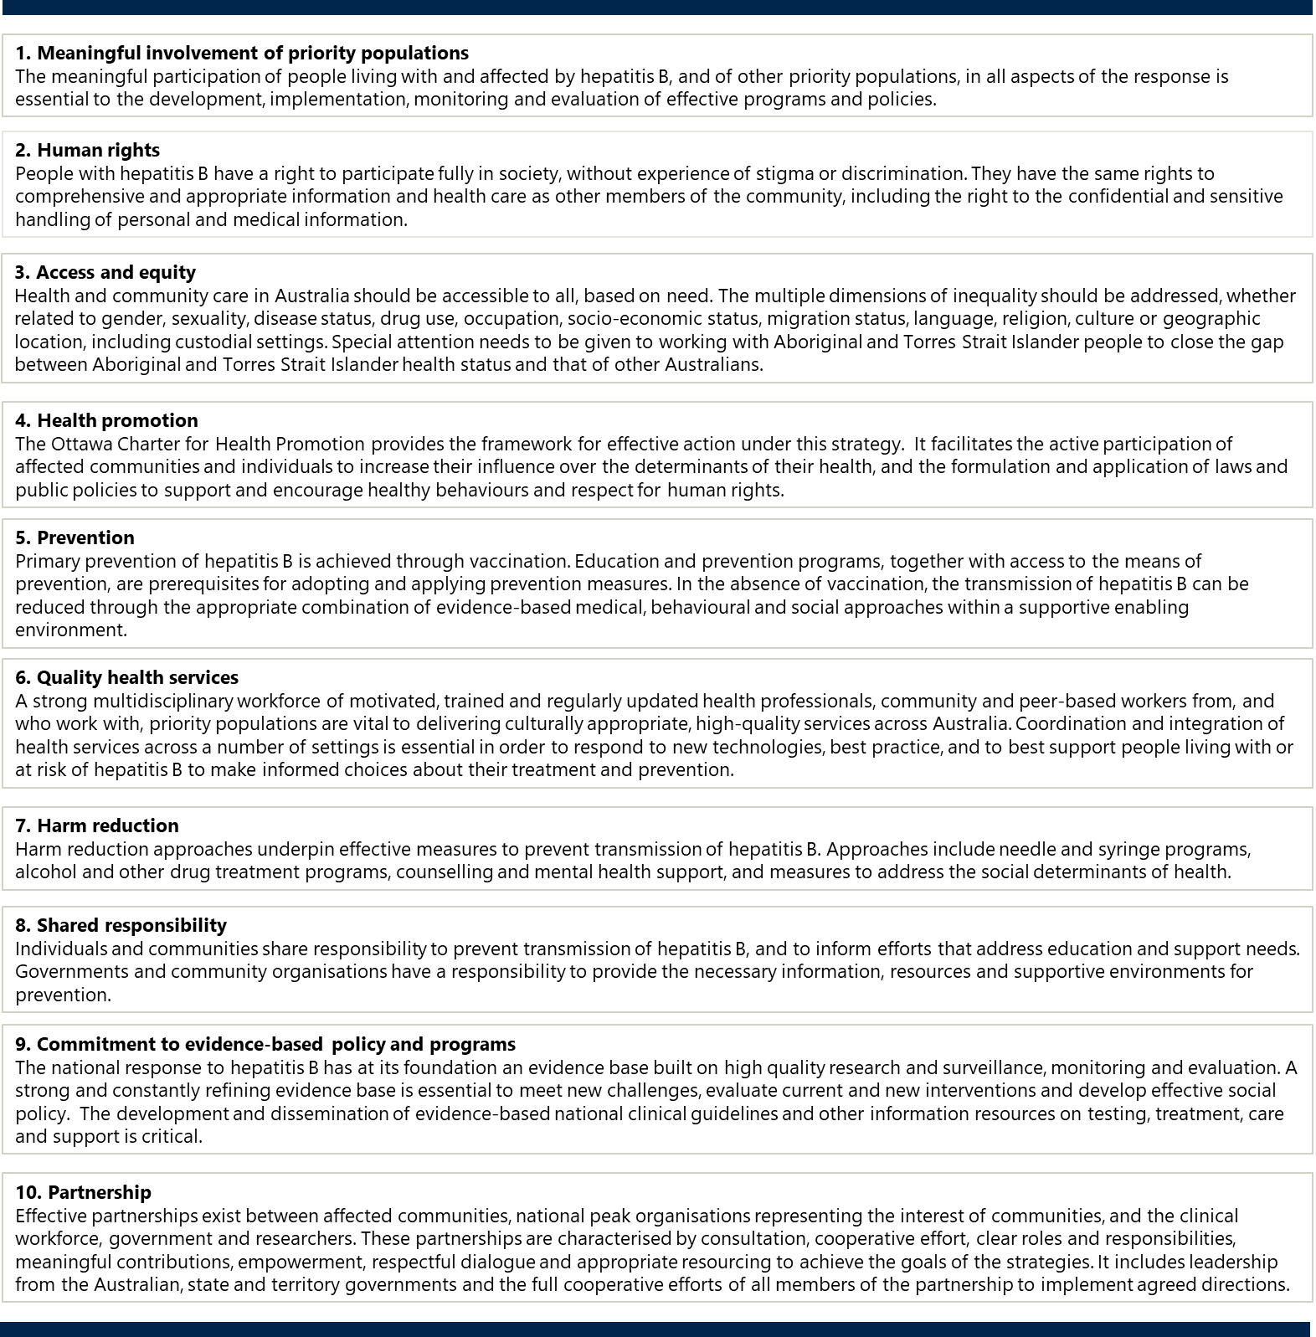

Snapshot of hepatitis B in Australia1,,,,,
Figure 2: Snapshot of hepatitis B in Australia
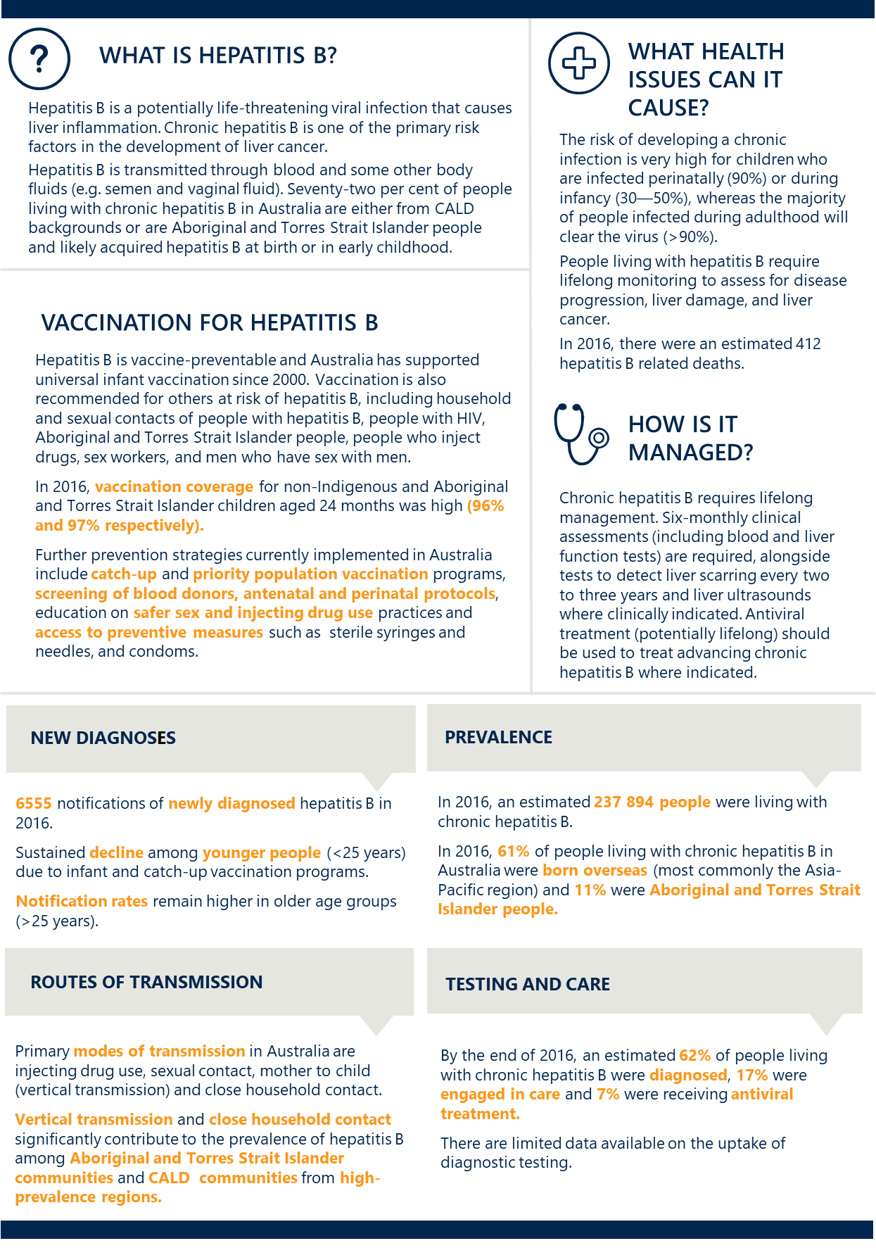

About this strategy
The Third National Hepatitis B Strategy sets the direction for Australia’s continuing response to hepatitis B for 2018 to 2022. It builds on achievements and lessons learned from previous strategies. It is one of five national strategies that, together, outline a framework for a high-quality and coordinated national response to BBV and STI in Australia. These five strategies are:
- Third National Hepatitis B Strategy 2018–2022 (this strategy)
- Fifth National Hepatitis C Strategy 2018–2022
- Eighth National HIV Strategy 2018–2022
- Fourth National Sexually Transmissible Infections Strategy 2018–2022
- Fifth National Aboriginal and Torres Strait Islander Blood Borne Viruses and Sexually Transmissible Infections Strategy 2018–2022.
Each strategy has a specific focus but shares some structural elements, including guiding principles, goals, targets, priority areas (see Section 5, ‘Measuring progress’) and defined priority populations. Also, all five national BBV and STI strategies share key priority areas for action, including education and prevention, testing, treatment and management, equitable access and coordination of care, workforce, improving data and surveillance, and stigma and discrimination.
The Third National Hepatitis B Strategy aims to provide a framework for the efforts of all partners in the response to hepatitis B, guide resourcing decisions, and monitor progress. It is informed by progress made under the Second National Hepatitis B Strategy 2014–2017; the effectiveness of current and past responses to hepatitis B in Australia and internationally; the identification of gaps and opportunities; and consultation with governments, community organisations, researchers, health professionals and other stakeholders across the country. This strategy is also informed by, and responds to, a range of surveillance data on hepatitis B in Australia and its impact on priority populations and research providing evidence for new and emerging issues in priority populations.
This strategy complements other jurisdictional, national and international policy documents that contribute to the hepatitis B response and supports the achievement of existing commitments. These include:
- state and territory viral hepatitis strategies
- National Drug Strategy 2017–2026
- National Strategic Framework for Aboriginal and Torres Strait Health Plan 2013–2023
- National Immunisation Strategies for 2013–2018 and 2019–2024
- World Health Organization (WHO) Global Health Sector Strategy on Viral Hepatitis 2016–2021
- Regional Action Plan on the Triple Elimination of Mother-to-child Transmission of HIV, Hepatitis B and Syphilis.
This strategy also supports progress towards Sustainable Development Goal 3 (‘Ensure healthy lives and promote well-being for all at all ages’) of the United Nations 2030 Agenda for Sustainable Development.
This strategy acknowledges that some states and territories have set or may set different targets to drive progress and that the goals and targets of this strategy are intended to facilitate jurisdictional efforts. Wherever possible, jurisdictions are encouraged to match or exceed the targets of this strategy.
Further detail on the implementation of this strategy, including the associated action plan, is provided under Section 8, ‘Implementing this strategy’.

PROGRESS UNDER THE SECOND NATIONAL HEPATITIS B STRATEGY 2014-17
Progress under the Second National Hepatitis B Strategy 2014–2017 provides context for the achievements in Australia to date (see Figure 3). These achievements reflect the joint efforts of governments, community organisations, affected communities, researchers and health professionals through the partnership approach.
Figure 3: Key achievements under the Second National Hepatitis B Strategy 2014–2017
 | Sustained decline of hepatitis B infection among younger people and Aboriginal and Torres Strait Islander people
 | Continued high rates of vaccination coverage in all children, including Aboriginal and Torres Strait Islander and non-Indigenous children (above 95% at 24 months of age)
 | Introduction of s. 100 prescribing for general practitioners (GPs) has allowed people living with chronic hepatitis B to have their treatment and care managed within their communities

Progress under the previous strategy has been notable in some areas. However, in others, challenges remain:
- As of March 2018, childhood vaccination coverage at 12 months was 95 per cent in the non-Indigenous population and 93 per cent in the Aboriginal and Torres Strait Islander population. At 24 months of age, coverage was 96 per cent and 97 per cent respectively. This partially met the childhood vaccination coverage target of 95 per cent (at one and two years of age) set in the previous strategy.
- Between 2012 and 2016 the overall notification rate for hepatitis B stabilised and the notification rate of hepatitis B in younger age groups declined. However, hepatitis B prevalence remains higher among people aged over 25 years. In 2016, the highest notification rate was in the 30- to 39-year age group at 61 per 100 000 population.
- As at 2016, an estimated 62 per cent of the people living with hepatitis B are aware of their status.1 This is below the target of 80 per cent of all people living with chronic hepatitis B diagnosed set in the previous strategy. In 2016, there were 6555 new hepatitis B diagnoses in Australia. Of these, 154 (2 per cent) were recorded as newly acquired,³ indicating that the vast majority of people in Australia are diagnosed after living with hepatitis B for some time.
- In 2016, an estimated 7 per cent of people living with chronic hepatitis B were receiving antiviral treatment.¹ This is well short of the target of 15 per cent set in the previous strategy.
- During the last quarter of 2016, 17.9 per cent of patients were prescribed chronic hepatitis B treatment by a general practitioner—an increase from the first quarter 2015, where 10.1 per cent received treatment from a general practitioner. This increase related to a corresponding decrease in the proportion of patients prescribed treatment by a specialist physician (67.2 per cent from 76.3 per cent).¹
The majority of people living with chronic hepatitis B are from intermediate or high-prevalence countries who now reside in Australia, with people born overseas accounting for 61 per cent of the total number of people estimated to be living with hepatitis B in 2016.¹ The notification rate for hepatitis B in Aboriginal and Torres Strait Islander people also remains higher when compared with the non-Indigenous population, and a higher prevalence of chronic hepatitis B in this population remains a significant issue.
The impact of chronic hepatitis B is difficult to measure due to the lack of comprehensive data relating to advanced disease. One indicator of the extent of disease caused by hepatitis B is the number of liver transplants due to chronic infection. Of the liver transplants in 233 people in 2016, seven (3 per cent) were attributable to chronic hepatitis B infection.¹ In addition, modelling undertaken in 2016 suggests that there were an estimated 412 deaths attributable to hepatitis B in 2016, which is similar to the previous year.¹
The limited progress against some of the targets of the previous national strategy indicates that a strengthened response to hepatitis B is needed, particularly among people from culturally and linguistically diverse (CALD) backgrounds and Aboriginal and Torres Strait Islander people, to improve rates of diagnosis and links to treatment and ongoing care. This is critical in minimising the morbidity and mortality associated with chronic hepatitis B and preventing further transmission.

Measuring progress
This strategy has overarching goals, targets and priority areas which will guide the national response to
hepatitis B for 2018–2022. Indicators and associated data sources for measuring progress towards each target are included in the Surveillance and Monitoring Plan for the five national BBV and STI strategies.
Goals
Make significant progress towards eliminating hepatitis B as a public health threat
Reduce mortality and morbidity related to hepatitis B
Eliminate the negative impact of stigma, discrimination, and legal and human rights issues on people’s health
Minimise the personal and social impact of hepatitis B
Targets
By the end of 2022:
- Achieve and maintain hepatitis B childhood vaccination coverage of 95 per cent at 12 and 24 months
- Reduce the number of newly acquired hepatitis B infections across all age groups by 50 per cent,
with a focus on priority populations
- Increase the proportion of people living with chronic hepatitis B who are diagnosed to 80 per cent
- Increase the total proportion of people living with chronic hepatitis B receiving care to 50 per cent
- For people living with chronic hepatitis B, increase the proportion receiving antiviral treatment to
20 per cent
- Reduce hepatitis B attributable mortality by 30 per cent
- Minimise the reported experience of stigma among people living with hepatitis B, and the expression of stigma, in respect to hepatitis B status
Priority areas

- Ensure a high level of knowledge, health literacy and awareness of hepatitis B in priority populations, affected families, health professionals and the general community, to create a supportive environment for increased engagement in testing, vaccination, treatment and care
- Increase awareness of the importance of hepatitis B vaccination to support uptake among priority populations
- Ensure uptake of vaccination for priority populations in line with national and state and territory based immunisation programs
- Ensure equitable access to other means of prevention, including education on safer sex practices and the provision of sterile injecting equipment through needle and syringe programs (NSPs)
- Improve targeted guideline-based testing of priority populations, including follow-up of family and contacts, and voluntary opportunistic testing
- Strengthen monitoring and appropriate care of pregnant women living with chronic hepatitis B and children born to women living with hepatitis B, including promotion of national testing, vaccination and treatment guidelines
- Support health professionals to better identify those at risk of or living with hepatitis B and provide current, innovative and effective hepatitis B testing, vaccination and care
- Support equitable access to programs and services, including vaccination and other prevention programs and resources, testing, treatment and care in all relevant settings, with a focus on innovative models of service delivery
- Continue to strengthen connections between priority populations, the healthcare workforce, specialist services and community organisations to facilitate coordination of care
- Increase workforce capability and capacity to provide and support evidence-based, innovative and effective vaccination and other prevention programs, testing, monitoring, treatment and care for people at risk of or living with hepatitis B
- Facilitate a highly skilled multidisciplinary workforce that is respectful of and responsive to the needs of people at risk of or living with hepatitis B
- Implement a range of initiatives to further investigate and address stigma and discrimination and minimise their impact on the health of people at risk of or living with hepatitis B
- Continue to work towards addressing the legal, regulatory and policy barriers which affect priority populations and influence their health-seeking behaviours
- With a focus on identified gaps, continue to build a strong evidence base for local and national responses to hepatitis B in Australia, informed by high-quality, timely data and surveillance systems

Priority populations and settings
Hepatitis B disproportionately impacts on a number of key populations. This strategy identifies priority populations and settings (see Figure 4) and acknowledges that many individuals may identify with multiple priority populations and settings. This results in a diverse variety of intersecting characteristics and risk factors unique to each individual. In accordance with the guiding principle of access and equity, the unique challenges and experiences within all priority populations need to be considered in the response. This includes, but is not limited to, all cultural and ethnic identities, gender expressions and experiences, disabilities, different geographic settings, sexual orientations and religious affiliations.
Figure 4: Priority populations and settings for the Third National Hepatitis B Strategy 2018–2022
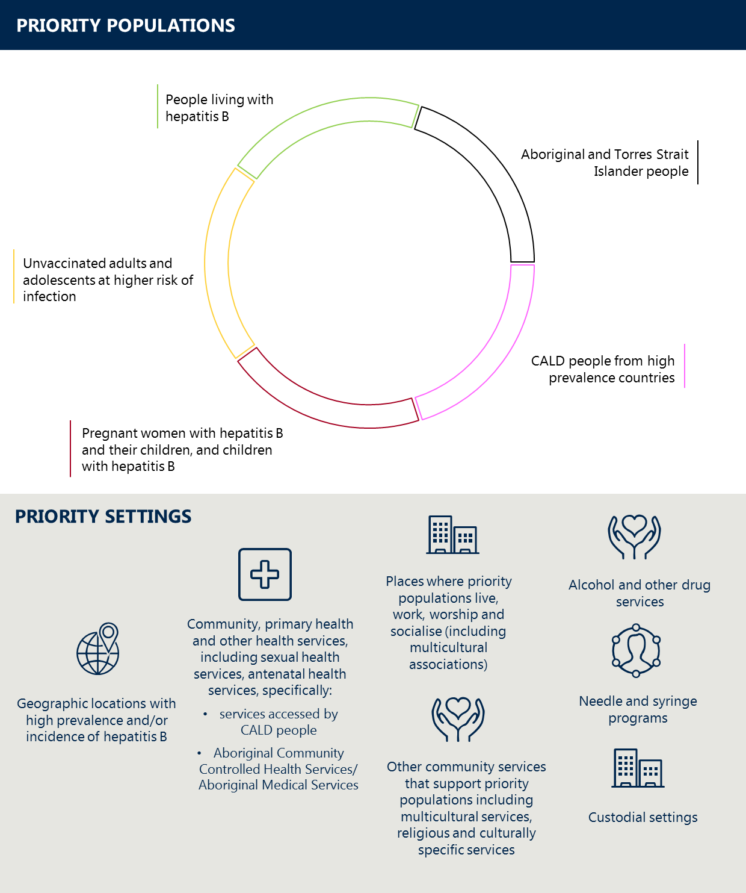
NOTE: The graphic is not intended to reflect equal priority or prevalence among populations
Increased engagement, and improved data and research, is needed to better understand how hepatitis B impacts priority populations and how inclusion in the hepatitis B response is best achieved. It is important that the unique challenges and experiences of each of the priority populations and sub-groups in relation to hepatitis B are addressed in the response.
People living with hepatitis B
The majority of people living with chronic hepatitis B are from intermediate or high-prevalence countries or are Aboriginal and Torres Strait Islander people. This includes both individuals who are diagnosed and those not yet diagnosed.
‘People living with chronic hepatitis B’ is a heterogeneous group. It includes:
  - individuals and families from countries with intermediate or high prevalence of hepatitis B, including people ineligible for subsidised health care, refugees and humanitarian entrants
  - Aboriginal and Torres Strait Islander people
  - partners and other household and intimate contacts of people who have acute or chronic hepatitis B
  - children born to mothers with chronic hepatitis B
  - people who inject drugs or with a history of injecting drug use, including those who are accessing drug treatment programs
- gay men and other men who have sex with men (MSM)
- sex workers
  - people living with hepatitis B who have a hepatitis C and/or HIV co-infection
- people living with hepatitis B who have a hepatitis D co-infection
  - people in, or previously in, custodial settings
- people with medically acquired hepatitis B
  - people who have received tattoos and body piercings in unsterile conditions
- people undergoing chemotherapy or immunosuppressive therapy.

All people with risk factors for hepatitis B (including families and close contacts) should be offered testing. If they are found to be susceptible to infection, vaccination should be offered. If they are found to be living with hepatitis B, they should be linked to care and informed of the need to closely monitor liver health with liver function and viral load tests under the direction of their treating clinician. Guideline-based care for chronic hepatitis B requires lifelong monitoring and treatment, as needed, to reduce morbidity and mortality. Given the transmission routes of hepatitis B, the infection often occurs within families, and multiple family members may be infected. Ensuring that there is effective contract tracing and support for families impacted by hepatitis B is therefore essential.
Culturally and linguistically diverse people
The majority of hepatitis B in Australia is experienced by people born overseas in hepatitis B endemic areas, with more than 95 per cent of new cases in individuals born in a country other than Australia and 61 per cent of the people living with chronic hepatitis B in Australia born overseas.¹ Key priority sub-populations include people born in North-East Asia (representing 21 per cent of people in Australia living with chronic hepatitis B), South-East Asia (17 per cent), Europe (8 per cent) and sub-Saharan Africa (4 per cent).¹
Low testing rates and treatment uptake among some CALD populations may also be caused by stigma associated with the disease; limited health-seeking behaviour; lack of availability of, access to, or familiarity with health services; privacy and confidentiality concerns; and barriers associated with language, migration status, and cultural and gender issues. Some affected populations may have low health literacy in relation to hepatitis B and its routes of transmission. Culturally appropriate and sensitive health promotion and services tailored for CALD populations are essential in helping to lessen the impact of chronic hepatitis B and reduce transmission. Effective engagement requires consultation with key priority CALD sub-populations to inform the tailoring of health promotion messaging and services to encompass a broader understanding of cultural contexts, foster inclusivity and improve testing and treatment access and uptake.
Aboriginal and Torres Strait Islander people
Hepatitis B continues to disproportionately impact Aboriginal and Torres Strait Islander people, particularly those from rural and remote communities. Lack of access to services and complex social factors mean that Aboriginal and Torres Strait Islander people may be more likely to acquire hepatitis B and have limited access to appropriate testing, monitoring, treatment and care. Along with strong vaccination programs, culturally appropriate education, prevention, testing, treatment and care programs, and antenatal care delivered through Aboriginal Community Controlled Health Services (ACCHS), Aboriginal Medical Services and mainstream services is critical.
The notification rate for hepatitis B among Aboriginal and Torres Strait Islander people declined over the period 2012 to 2016 (from 62 per 100 000 in 2012 to 31 per 100 000 in 2016). Despite this, 11 per cent of chronic hepatitis B in Australia is reported in Aboriginal and Torres Strait Islander people, and the rate of chronic hepatitis B per 100 000 population remains greater than in the non-Indigenous population. It is thought that, historically, a higher proportion of hepatitis B infection is likely to have occurred at birth or early in life for Aboriginal and Torres Strait Islander people, contributing to the higher prevalence of chronic infection due to the risk of chronicity associated with childhood infection. In 2016, the greatest rate of new hepatitis B notifications in Aboriginal and Torres Strait Islander people was in those aged 40 years and over (49 per 100 000), followed by people aged 30 to 39 years (44 per 100 000).
In the five years from 2008 to 2012 in New South Wales, Victoria, Queensland, Western Australia and the Northern Territory, the age-standardised incidence rate for liver cancer was almost three times greater among Aboriginal and Torres Strait Islander people when compared with the non-Indigenous population. This has been linked to a number of potential risk factors, including hepatitis B infection., Liver cancer was also the second highest cause of cancer-related deaths in Aboriginal and Torres Strait Islander people—over two times greater than the non-Indigenous population. Poorer health outcomes in Aboriginal and Torres Strait Islander people may be linked to reduced access to culturally appropriate health care and therefore a lesser likelihood of receiving timely diagnosis, monitoring and treatment.^{5,,,,}
There is some evidence that a unique strain of hepatitis B affects some Aboriginal and Torres Strait Islander communities in northern Australia.,, Further research is needed to understand the public health implications of this strain.
Epidemiology, policy context and priority areas for action in relation to hepatitis B in Aboriginal and Torres Strait Islander people are more specifically addressed in the Fifth National Aboriginal and Torres Strait Islander Blood Borne Viruses and Sexually Transmissible Infections Strategy 2018–2022.
Pregnant women with hepatitis B and their children, and children with hepatitis B
Pregnancy is the only time universal testing for infection with hepatitis B occurs. As a result, this is often the first time women become aware of their hepatitis B infection. Hepatitis B infection can have significant health implications for the mother and her baby, and the issues for each should be considered independently.
Children born to hepatitis B positive mothers who contract the infection at birth are at very high risk (90 per cent) of developing chronic hepatitis B.^{1,} In 2016, the notification rate in women was highest in the child-bearing age groups 30 to 39 years, followed by 25 to 29 years.
Reducing the rates of early transmission to and among children remains a priority, as does ensuring appropriate linkage to care for the mother. Increasing health literacy on the need for antenatal testing and care amongst CALD populations is integral to preventing mother-to-child transmission within this population and their family units.
Unvaccinated adults at higher risk of infection
The vast majority of people who develop chronic hepatitis B acquire the infection at birth or in childhood. Those exposed to the virus as adolescents or adults will usually clear the infection naturally. A smaller proportion will develop a chronic infection. Adults who have a higher risk of infection and who have not been vaccinated should be offered testing and, if found to be susceptible, offered vaccination for hepatitis B. Key sub-populations include:
- partners, family members, and other household and intimate contacts of people living with hepatitis B
- people who currently inject drugs
- gay men and other MSM
- sex workers
- people in custodial settings
- people living with HIV and/or hepatitis C
Specific targeted interventions to improve vaccination uptake in these sub-populations are required.
Priority settings in which priority populations may be reached
Service providers and other organisations that support priority populations are priority settings due to the contact they have with priority populations and the potential this offers for health promotion and connecting people to hepatitis B services.
The priority settings for delivery of education, vaccination and other prevention programs, testing, treatment and care services include:
- all primary healthcare services / general practice
- services working with CALD communities
- ACCHS and Aboriginal Medical Services
- migrant health services
- BBV / sexual health services
- antenatal health services
- NSPs
- alcohol and other drug services (AODs)
- custodial settings
- geographical areas of higher hepatitis B prevalence
- regional, rural and remote areas with reduced access to relevant health and community services
- other medical and non-medical services that support and represent priority populations—for example, hepatitis organisations, services working with CALD communities, Aboriginal and Torres Strait Islander organisations, organisations representing people who inject drugs, people with or at risk of HIV, and sex workers, as well as welfare services, educational institutions, youth centres, homelessness services, and mental health services (including forensic mental health facilities).

Community-based services play a vital role in support, education and health promotion across these settings.

Priority areas for action
This strategy includes a set of priority areas for action designed to support the achievement of the goals and targets. Each priority area for action relates to one or more of the targets. It is the interaction of these actions as a whole that is essential to the achievement of the strategy.
Australia’s strong enabling environment has supported the achievements made under the previous hepatitis B strategies and is vital in the implementation of the Third National Hepatitis B Strategy 2018–2022.
The priority areas for action build on the achievements and lessons learned in the response to hepatitis B. This strategy is designed to address a number of key challenges and opportunities while recognising the need for flexibility to respond to other issues as they arise.
There has been good progress to improve prevention and awareness among priority populations through infant and catch-up vaccination programs and health promotion. Barriers to effective diagnosis, management and treatment of hepatitis B continue to include lack of access to services, including education; low community awareness; and stigma and discrimination. This strategy builds on and intensifies past approaches. It recognises that more intensely focused, culturally-specific long-term strategies are needed for high-prevalence groups.
EDUCATION AND PREVENTION
- Ensure a high level of knowledge, health literacy and awareness of hepatitis B in priority populations, affected families, health professionals and the general community, to create a supportive environment for increased engagement in testing, vaccination, treatment and care
- Increase awareness of the importance of hepatitis B vaccination to support uptake among priority populations
- Ensure uptake of vaccination for priority populations in line with national and state-based immunisation programs
- Ensure equitable access to other means of prevention, including education on safer sex practices and the provision of sterile injecting equipment through NSPs
Greater awareness and understanding of hepatitis B among priority populations and the broader community is critical to achieving an improved public health response. Culturally appropriate interventions which target misconceptions and gaps in knowledge can significantly reduce stigma and discrimination, increase rates of testing and engagement in care and reduce the overall impact of infection. This is particularly important for CALD populations from intermediate and high-prevalence countries and Aboriginal and Torres Strait Islander populations. Timely, targeted interventions for migrants, refugees, overseas students and their communities would have a powerful impact on the prevalence of hepatitis B in Australia. To strengthen demand for testing and treatment, community education and resources need to contextualise hepatitis B primarily as a family health and cancer prevention issue. The adaptation of existing education, vaccination and other prevention initiatives in place for other high-risk priority populations and/or other BBV and STI should be considered in the response, in consultation with hepatitis B affected communities.
In addition to maintaining high infant vaccination coverage, targeted information campaigns and vaccination programs aimed at adolescents and adults across priority populations at risk of hepatitis B would further reduce transmission rates.,
The promotion of other evidence-based prevention measures, including sterile needles and syringes and condoms, is also essential to reduce transmission risks associated with injecting drug use and unprotected sexual activity in unvaccinated adults and adolescents. Increased awareness in priority populations regarding these additional means of prevention, and how to access them, will contribute to decreased hepatitis B transmission.
Key areas for action
- Support, develop and implement culturally appropriate and community-based hepatitis B education and health promotion programs in affected communities and their families, to:
  - improve understanding of the Australian health care system
  - increase hepatitis B related literacy, including knowledge of routes of transmission, risk factors, vaccination and other evidence-based prevention measures, the importance of testing and ongoing monitoring, and available health services and support
- Facilitate the sharing of successful approaches and initiatives to improve education and prevention within priority populations and settings
- Increase awareness and access to support the uptake of hepatitis B vaccination among eligible populations under national and state-based immunisation programs, including infants, adolescents and unvaccinated adults at higher risk of infection
- Increase access to preventative measures, including vaccination, sterile needles and syringes, and condoms, in priority settings and through community- and peer-based interventions
- Ensure implementation of antenatal and neonatal protocols to prevent vertical transmission and increase monitoring of these protocols

TESTING, TREATMENT AND MANAGEMENT
- Improve targeted guideline-based testing of priority populations, including follow-up of family and contacts, and voluntary opportunistic testing
- Strengthen monitoring and appropriate care of pregnant women living with chronic hepatitis B and children born to women living with hepatitis B, including promotion of national vaccination, testing and treatment guidelines
- Support health professionals to better identify those at risk of or living with hepatitis B and provide current, innovative and effective hepatitis B vaccination, testing and care
Regular testing for hepatitis B among priority populations and in priority settings enables not only early diagnosis but also access to treatment and ongoing care, and education to prevent transmission. Late diagnosis may lead to ongoing transmission and poor health outcomes, as opportunities to prevent progression to advanced liver disease and cancer are missed. Compassionate access programs should be considered for people requiring treatment who are not eligible for subsidised health care.
Australia has a National Hepatitis B Testing Policy that includes details on indications for testing, diagnostic strategies and quality assurance. The principles of quality testing in Australia include that informed consent is required at all times, including in custodial settings; and that testing is voluntary, accessible and non-discriminatory, confidential, and of clear benefit to the patient being tested.
Improving the diagnosis of people with hepatitis B requires increased access to testing through multiple settings, focusing on those commonly used by priority populations. These include general practices, health clinics providing care to CALD populations from countries with an intermediate to high prevalence of hepatitis B, sexual health services, antenatal health services, ACCHS, AODs and health services in custodial settings. Engagement with priority populations may be improved through the use of rapid testing and point-of-care technologies when available.
The importance of hepatitis B testing in specific groups also needs to be highlighted. This includes patients undergoing immunosuppressive therapy, including chemotherapy, and people undergoing treatment for chronic hepatitis C, as reactivation of hepatitis B can occur,and can result in liver failure and death or cause discontinuation of cancer treatment.,
There needs to be greater accessibility to testing, treatment and care services delivered at the community and primary healthcare level. Primary health care professionals are well placed to promote and increase testing and lifelong monitoring of their patients. Increased education and training, and adoption of shared care management models between primary health care and specialist services, are needed to support increased accessibility to high-quality services. Rapid patient follow-up; strong coordination of care, including referral back to primary care for non-complex patients; and active case management are critical to support diagnoses and the provision of appropriate treatment and ongoing care.
The implementation of antenatal treatment protocols and neonatal vaccination protocols alongside management and care for hepatitis B positive women is critical, particularly given the significant long-term health consequences that follow hepatitis B infection at birth (vertical transmission).3
In Australia, hepatitis B is one of the key risk factors for the development of primary liver cancer. Lifelong monitoring, including biannual blood tests supported by periodic non-invasive methods of fibrosis assessment, is the cornerstone of appropriate hepatitis B care. It supports decision-making about the long-term prescription of antiviral therapy and is critical in preventing morbidity and mortality.
Key areas for action
- Further develop and deliver evidence-based risk assessment and testing approaches for key priority populations which provide strong linkages to vaccination, ongoing monitoring and care
- Increase voluntary testing in priority populations in primary health and community settings, including through community-provided testing and mobile clinics and, where possible, case finding and follow-up for people who have previously tested hepatitis B surface antigen-positive
- Ensure health promotion and education strategies inform priority populations, and their families, of the importance of early detection, ongoing monitoring and treatment adherence, utilising an appropriate community engagement strategy
- Review and promote national training and clinical guidelines for testing, treatment, monitoring and care, including guidance on pregnancy and follow-up for babies born to hepatitis B positive mothers; and testing for hepatitis B prior to initiation of chemotherapy, immunosuppressive therapies or treatment for chronic hepatitis C
- Support active case finding and linkage to care, including through awareness raising, GP and nurse education, and networks-based approaches among people living with chronic hepatitis B and their family, household and community contacts

EQUITABLE ACCESS AND COORDINATION OF CARE
- Ensure equitable and appropriate access to programs and services, including vaccination and other prevention programs and resources, testing, treatment and care in all relevant settings, with a focus on innovative models of service delivery
- Continue to strengthen connections between priority populations, the healthcare workforce, specialist services and community organisations to facilitate coordination of care
Primary healthcare services, including general practice, clinics providing care to CALD populations from countries with intermediate or high prevalence of hepatitis B and ACCHS, are priority settings for the delivery of vaccination, prevention education, testing and treatment services for hepatitis B, in collaboration with specialist services. Public and private sexual health services also play an essential role in improving access to priority populations and in providing culturally and age appropriate services to priority populations and people that are not accessing mainstream health services.
To effectively reach priority populations, it is necessary to connect the healthcare workforce with other organisations that support and provide services to these priority populations. Service providers and other organisations that support priority populations have a role in health promotion and connecting people to hepatitis B services due to the significant contact they have with these communities. These include CALD and refugee organisations, Aboriginal and Torres Strait Islander organisations, education institutions, harm reduction services, hepatitis organisations, peer-based services, AODs, youth centres, and other services that support priority populations. Collaborations between service providers and community organisations can support awareness-raising, health literacy, and establishment and maintenance of connection to care for priority populations.
Innovative models of care tailored to local contexts need to be explored to deliver best-practice care and support and increase equity in service provision. This is of particular relevance in rural and remote areas, where recruitment and retention of staff is a challenge. Approaches need to appropriately utilise the skills of the broader clinical and community health workforce, including general practitioners, nursing professionals, pharmacists, Aboriginal and Torres Strait Islander Health Workers, community health workers and community- and peer-based workers. Opportunities to facilitate the provision of more nurse-led services, including required education, professional development and specialisation opportunities, should be a particular focus.
Vaccination and other prevention, harm reduction and treatment access campaigns must be widely advertised, and community and sector understanding of priority populations and the appropriate forms of outreach must be adapted to respond to changes in behaviour among different populations. Community- and peer-based approaches are particularly important to reach undiagnosed people and highly marginalised populations that may be missed by current services.
While most people living with hepatitis B are able to have their condition managed in primary care settings, the models of care need to include an appropriate level of engagement with specialist services. Care pathways that better support the timely referral by specialists of patients with non-complex needs for management in primary care should be explored. Embedding this into routine practice may be assisted through broader support for the effective detection and ongoing monitoring of hepatitis B in primary care settings. Models of care need to provide options for assessment of liver disease outside of specialist settings, including access to and knowledge of the non-invasive diagnostic tools for assessing liver disease severity. Access to both fibroscan and ultrasound is still an issue in most rural and remote areas and in some metropolitan areas.
Key areas for action
- Identify opportunities to improve patient management systems to better support the primary care workforce to promptly identify, and provide treatment and care for, people living with hepatitis B
- Improve the access to, and coordination of, hepatitis B services by strengthening links between service providers (including general practice; CALD and refugee services; Aboriginal and Torres Strait Islander services; sexual health services; NSPs and AODs, and other relevant health, community and peer-based services and organisations) to better engage people living with or at risk of hepatitis B with appropriate vaccination and other prevention, testing, monitoring, treatment and care.
- Encourage the provision of culturally appropriate services to priority populations, including engagement of multicultural and multilingual health professionals, peer and hepatitis educators and community liaison officers from priority populations
- Improve the availability of dedicated hepatitis B services and accredited hepatitis B prescribers, particularly in areas with high prevalence and/or large populations of CALD people from intermediate or high-prevalence countries
- Continue to explore and share experiences of innovative models of care for hepatitis B prevention and management, particularly models for rural and remote areas and areas of workforce shortage

WORKFORCE
- Increase multidisciplinary workforce capability and capacity to provide and support evidence-based, innovative and effective vaccination and other prevention, testing, monitoring, treatment and care for people at risk of or living with hepatitis B
- Facilitate a highly skilled multidisciplinary workforce that is respectful of and responsive to the needs of people with or at risk of hepatitis B
The provision of best-practice hepatitis B vaccination and other prevention, testing, monitoring, treatment and care is founded on a highly skilled workforce that is respectful of and responsive to the needs of people living with or at risk of hepatitis B. A strong multidisciplinary workforce of trained and motivated health professionals, community health workers, and community-based workers is vital to the delivery of culturally appropriate and high-quality hepatitis B services to priority populations, which include vulnerable and marginalised populations that may not readily access hepatitis B treatment services. NSPs, AODs and other relevant peer-based services also have valuable and established connections to some populations at higher risk, and opportunities to build on these need to be considered.
Identifying opportunities for workforce capacity building, knowledge sharing, upskilling and innovation is critical for improved service delivery. Issues in relation to recruitment and retention of staff need to be addressed, particularly in rural and remote areas, to ensure the required expertise, capability and capacity exists in all areas.
The continued availability of evidence-based, responsive and accessible national clinical guidelines and tools has an essential role in supporting the provision of effective hepatitis B vaccination and other prevention, treatment, monitoring and care. Guidelines must be coupled with education and training to support implementation and build workforce capacity and capability.
Specific education, professional development and specialisation opportunities need to be made available to support health professionals in the development of essential hepatitis B knowledge and skills, which enable them to appropriately identify those with hepatitis B and provide quality treatment and care. Health professionals working with CALD populations and Aboriginal and Torres Strait Islander Health Workers, jurisdictional Aboriginal Health Councils and ACCHS need to be supported to engage in hepatitis B vaccination and other prevention and care.
The ability for general practitioners who have completed specific training to prescribe treatments for hepatitis B represents a significant practice change for primary care settings. This requires ongoing education and other support for the primary care workforce, including linkages to specialist advice and care.
Key areas for action
- Implement targeted initiatives including the use of digital platforms and face-to-face learning opportunities to facilitate a highly skilled clinical and community-based workforce
- Continue to prioritise education and resources to support health professionals in the early detection, monitoring and treatment of hepatitis B and utilising available multidisciplinary referral pathways
- Support the continued provision, dissemination and maintenance of evidence-based, responsive and accessible national clinical guidelines and other information resources on vaccination, testing, monitoring, treatment, care and support for people living with hepatitis B, adapted to the needs of the workforce
- Support community organisations, the healthcare workforce and community-based workers to increase their engagement with priority populations; and consider opportunities to utilise the established networks of NSPs, AOD and peer-based services to improve hepatitis B health literacy and connection to care

ADDRESSING STIGMA AND CREATING AN ENABLING ENVIRONMENT
- Implement a range of initiatives to further investigate and address stigma and discrimination and minimise their impact on the health of people at risk of or living with hepatitis B
- Continue to work towards addressing the legal, regulatory and policy barriers which affect priority populations and influence their health-seeking behaviours
Discrimination and stigma associated with hepatitis B is a key issue to address, as it can have a significant impact on health outcomes, relationships and employment prospects and can lead to social isolation and poor mental health. Fear of stigma and discrimination and of being judged can prevent individuals and whole families from attending health services to discuss their risk of hepatitis B, requesting a hepatitis B test or taking up and continuing care. It may also limit people from seeking support from their family and friends.
Lack of engagement with services among migrant communities has also been linked to pre-existing stigma from country of origin.23, Combined with misconceptions about hepatitis B, limited health literacy or English language proficiency, and concerns about confidentiality at local primary health services, the communities most affected by hepatitis B are often unaware of their status and do not seek medical care.
The stigma and discrimination experienced by people living with hepatitis B can also be influenced by individual characteristics and the stigma and discrimination associated with those characteristics. These include cultural background, migrant or refugee status, injecting drug use, sexual orientation, gender identity, disability, or whether a person has HIV or is a sex worker. Strategies to address stigma and discrimination must acknowledge and account for intersecting stigmas.
Australia has a strong enabling environment, including legalisation of NSPs and strong anti-discrimination legislation. However, there are some key legal policy, social, cultural and economic barriers that impact on access to services. Studies have found that removing such barriers and reducing stigma and discrimination increased testing and treatment and contributed to a decrease in incidence and prevalence of various BBV and STI., Mechanisms and approaches to address barriers in Australia need to be informed by the national and international evidence base in relation to the impact on transmission and public health outcomes and need to be considered in the Australian context.
Every person who works with people at risk of, or living with, hepatitis B requires an understanding of the impact of stigma and discrimination on access to healthcare services. Education in relation to stigma in healthcare settings is considered an integral part of training programs for staff of all specialist, primary healthcare and community-based service providers.
Priority populations often face intersecting forms of disadvantage which increases their risk of infection and late diagnosis. Multiple disadvantages include poverty, racism, detention and mental health issues. Innovative, bottom-up and community-driven health promotion programs are important in ensuring programs effectively engage priority populations.
The implementation of this strategy rests within the health sector. However, many of the barriers to access and equitable treatment of affected individuals, families and communities fall outside of the responsibility of the health system. It is important that effective and meaningful dialogue is maintained across sectors and jurisdictions to support knowledge translation and to discuss the potential impacts of any wider decisions on the health of priority populations.

Key areas for action
- Incorporate messaging to counteract stigma in hepatitis B health promotion education programs and initiatives
- Monitor laws, policies, stigma and discrimination which impact on health-seeking behaviour among priority populations and their access to testing and services; and work to ameliorate legal, regulatory and policy barriers to an appropriate and evidence-based response
- Review and address institutional, regulatory and system policies which create barriers to equality of prevention (including access to vaccination), testing, treatment, care and support for priority populations, including people living with hepatitis B
- Implement initiatives aimed at minimising stigma and discrimination against people living with hepatitis B and other priority populations in the community and in healthcare settings

DATA, SURVEILLANCE, RESEARCH AND EVALUATION
- With a focus on identified gaps, continue to build a strong evidence base for local and national responses to hepatitis B in Australia, informed by high-quality, timely data and surveillance systems
Continuous improvement of data collections and systems is important to support a comprehensive understanding of the burden of BBV and STI in Australia and to monitor the impact of interventions. However, this must be appropriately targeted to ensure its effective utility; and balanced to avoid unnecessary burden for health services and frontline staff.
A number of gaps currently exist in the surveillance data. Addressing these would improve our understanding of the incidence and prevalence of hepatitis B in Australia and better inform public health responses.
There is a need to improve the timeliness and consistency of data collections across Australia to better support their completeness and comparability. Opportunities to improve the granularity of data need to be explored to better understand the true incidence and prevalence of hepatitis B and to identify trends and issues of concern in relation to specific priority and sub-populations and other demographics. Data on Aboriginal and Torres Strait Islander status and country of birth are important in informing the national response to hepatitis B for Aboriginal and Torres Strait Islander people and people from CALD backgrounds, respectively. Collection and analysis of this data on a national level remains fragmented. This is an important focus in the implementation of this strategy.
While enhanced data specifications for newly acquired hepatitis B are currently recommended, these fields are not routinely collected. Maternal transmission of hepatitis B in new notifications is not an included field in this data set. Other significant gaps include data relating to hepatitis B associated advanced disease and liver cancer. Work to define stigma and discrimination related to hepatitis B is still in its early stages.
In addition to improving disease notifications, an enhanced understanding of healthcare utilisation in those living with hepatitis B, particularly in respect to monitoring, is crucial to better inform healthcare outcomes. Additional research or modelling, to more accurately estimate the proportion of people living with chronic hepatitis B in Australia who require treatment, is vital to inform progress and targets in ensuring those with chronic hepatitis B are getting the most appropriate care. Data linkage and the monitoring of testing and treatment in those known to be hepatitis B positive is an important component of the Australian response.
It is also critical that opportunities to research current and emerging hepatitis B issues are supported. Research guides the development, implementation and evaluation of policies and programs at all levels of the national response to hepatitis B. Social, behavioural, epidemiological, clinical and basic research is important in developing a strong evidence base for managing and preventing BBV and STI in the community. Research is needed to more fully understand the impact of hepatitis B in priority populations and communities. It must be linked to the needs of affected communities, particularly CALD people and Aboriginal and Torres Strait Islander people, and be responsive to emerging risks.
Partnerships between research institutes, health professionals, and community- and peer-based organisations are valuable. Community- and peer-based organisations are often the first to identify cultural influences, social interactions, demographics of priority populations, and changes in behaviours due to their direct contact with affected communities.
Key areas for action
- Identify opportunities to improve the timeliness and consistency of data collections
- Implement initiatives to improve data completeness in clinical and pathology settings in relation to maternal hepatitis B status, Aboriginal and Torres Strait Islander status, country of birth, and likely place of hepatitis B acquisition; and for collecting data on the impact of hepatitis B on unvaccinated adults at high risk of infection
- Investigate opportunities to better measure and collect data on hepatitis B associated morbidity, mortality and experiences of stigma and discrimination
- Identify gaps in surveillance data for measuring and monitoring the implementation of this strategy and prioritise these for action
- Support research on emerging hepatitis B issues and risks and associated public health implications
- Promote a balance of social, behavioural, epidemiological and clinical research to better inform all aspects of the response
- Ensure current and future programs and activities are evaluated to ensure linkage and alignment to the priority areas of this strategy

Implementing this strategy
Leadership, partnership and connections to community
Australia’s response to hepatitis B is built on a model of partnership between government, community-based organisations, researchers, health professionals and priority populations. The partnership approach depends on clear leadership roles and accountabilities for all involved.
The Australian Government is committed to providing strong national leadership by working across portfolios and jurisdictions to achieve the goals of this strategy. The Australian Government Department of Health leads the coordination of the national response to hepatitis B under the National Hepatitis B Strategy. However, the success of the strategy is contingent on productive partnerships between Australian, state and territory governments and other partners, including peak organisations representing communities, health professionals, researchers and others. In the case of research on BBV and STI, it is imperative that this is conducted in partnership with communities and aligned with the priorities of the five national strategies.
National and state community and health peak organisations, and other organisations, representing the interests of the affected CALD and Aboriginal and Torres Strait Islander communities, other priority populations and the clinical workforce remain at the forefront of the response to hepatitis B in Australia. Organisations including Hepatitis Australia and the Australasian Society for HIV, Viral Hepatitis and Sexual Health Medicine, along with the Australian Injecting and Illicit Drug Users League; Scarlet Alliance, Australian Sex Workers Association; the Australian Federation of AIDS Organisations; the National Association for People with HIV Australia; the Gastroenterological Society of Australia; the Australian Liver Association; the Australasian Society for Infectious Diseases; and the Australasian Hepatology Association, and the relationship these organisations have with their members, have a critical role to play in the implementation of this strategy.
Action plan
The National BBV and STI Strategies action plan 2018–2022 provides the detail of specific actions for governments and partners. The action plan outlines the roles and responsibilities of governments and partners and the time frames for implementation of the actions. Indicators for measuring the progress towards achievement of the strategies’ targets will also be developed. The action plan will be reviewed as required during the lifetime of the strategies.
The five national BBV and STI strategies share a number of key actions related to areas such as workforce, improving data and surveillance, education programs, and stigma and discrimination. The action plan will focus on encouraging connections between existing programs and policies, and adapting lessons from previously successful approaches, to minimise duplication of effort. It will also look for opportunities to learn from and adapt responses used for other diseases where relevant.
Governance, reporting and evaluation
The five national BBV and STI strategies are endorsed by Australia’s Health Ministers and governed through relevant committees of the Australian Health Ministers’ Advisory Council (AHMAC). The Blood Borne Viruses and Sexually Transmissible Infections Standing Committee (BBVSS) coordinates implementation efforts across jurisdictions and reports to the Australian Health Protection Principal Committee (AHPPC) on progress in the implementation of the national strategies. BBVSS and the Communicable Diseases Network Australia (CDNA) will jointly monitor progress towards the targets of each strategy and identify emerging issues and opportunities for action.
Surveillance and monitoring plan
The National BBV and STI Surveillance and Monitoring Plan 2018–2022 supports the five national BBV and STI strategies and informs and monitors progress on achieving the targets and goal of each strategy. A subcommittee of the CDNA is responsible for overseeing the surveillance and monitoring plan and reporting on progress to the CDNA and BBVSS.
- References

From 2000, vaccination of all infants in a childhood schedule with a birth dose of monovalent paediatric hepatitis B vaccine, followed by three doses of combination vaccine, has been available under the National Immunisation Program (NIP). People under 20 years of age, refugees and other humanitarian entrants of any age can get hepatitis B vaccines for free under the NIP if they did not receive the vaccines in childhood. Some states and territories offer free vaccinations to populations at high risk.
Compared with 2016–2017.
This includes the priority populations, as described in Section 6 below. Specific targets for Aboriginal and Torres Strait Islander people are included in the Fifth National Aboriginal and Torres Strait Islander Blood Borne Viruses and Sexually Transmissible Infections Strategy.
Treatment is only beneficial in some stages of hepatitis B infection.
Baseline and percentage reduction to be determined.
Links to Section 7, ‘Priority areas for action’. Priority populations and settings are described in Section 6.
MacLachlan, J., L. Thomas, B. Cowie, and N. Allard. (2018). Hepatitis B Mapping Project. Estimates of geographic diversity in chronic hepatitis B prevalence, diagnosis, monitoring and treatment—National Report 2016. ASHM: Sydney.
Franco, E., B. Bagnato, M. G. Marino, C. Meleleo, L. Serino, and L. Zaratti. (2012). ‘Hepatitis B: epidemiology and prevention in developing countries.’ World Journal of Hepatology, 4(3):74–80.
The Kirby Institute. (2017). HIV, Viral Hepatitis and Sexually Transmissible Infections in Australia: Annual Surveillance Report 2017.University of New South Wales (UNSW) Sydney: Sydney.
Australian Government Department of Health. (2018). Childhood immunisation coverage. Accessed on 7 May 2018 at: https://beta.health.gov.au/topics/immunisation/childhood-immunisation-coverage
World Health Organization (WHO). (2017). Hepatitis B – WHO Fact Sheet. 5 July 2017. Accessed 7 May 2018 at: http://www.who.int/en/news-room/fact-sheets/detail/hepatitis-b
MacLachlan, J. J., N. Allard, V. Towell, and B. C. Cowie. (2011). ‘The burden of chronic hepatitis B virus infection in Australia, 2011.’ Australian and New Zealand Journal of Public Health, 37(5):416–422.
Australian Government Department of Health. (2018). Childhood immunisation coverage. Accessed 7 May 2018 at: https://beta.health.gov.au/topics/immunisation/childhood-immunisation-coverage
The Kirby Institute. (2017). HIV, Viral Hepatitis and Sexually Transmissible Infections in Australia: Annual Surveillance Report 2017. UNSW Sydney: Sydney.
MacLachlan, J. J., N. Allard, V. Towell, and B. C. Cowie. (2011). ‘The burden of chronic hepatitis B virus infection in Australia, 2011.’ Australian and New Zealand Journal of Public Health, 37(5):416–422.
The Kirby Institute. (2017). Bloodborne viral and sexually transmissible infections in Aboriginal and Torres Strait Islander people: Annual Surveillance Report 2017. UNSW Sydney: Sydney.
Graham, S., R. J. Guy, B. Cowie, H. C. Wand, B. Donovan, S. P. Akre, and J. S. Ward. (2013). ‘Chronic hepatitis B prevalence among Aboriginal and Torres Strait Islander Australians since universal vaccination: a systematic review and meta-analysis.’ BMC Infectious Diseases, 13:403.
Australian Institute of Health and Welfare (AIHW). (2017). Cancer in Australia 2017, Cancer Series No. 101. AIHW: Canberra.
Cunningham, J., A. R. Rumbold, X. Zhang, and J. R. Condon. (2008). ‘Incidence, aetiology, and outcomes of cancer in Indigenous people in Australia.’ Lancet Oncology, 9:585–595.
AIHW and Cancer Australia. (2013). Cancer in Aboriginal and Torres Strait Islander peoples of Australia: an overview. Cancer series No. 78. Cat. no. CAN 75. AIHW: Canberra.
Condon, J., B. Armstrong, A. Barnes, and J. Cunningham. (2003). ‘Cancer in Indigenous Australians: a review.’ Cancer Causes Control, 14:109–21.
Condon, J., X. Zhang, P. Baade, K. Griffiths, J. Cunningham, and D. Roder. (2014). ‘Cancer survival for Aboriginal and Torres Strait Islander Australians: a national study of survival rates and excess mortality.’ Population Health Metrics, 12:1.
Threlfall, T. J., and J. R. Thompson. (2009). Cancer incidence and mortality in Western Australia, 2007. Western Australian Department of Health: Perth.
AIHW. (2016). Australia’s health 2016. Australia’s health series No. 15. Cat. no. AUS 199. AIHW: Canberra.
Sugauchi, F., M. Mizokami, E. Orito et al. (2001). ‘A novel variant genotype C of hepatitis B virus identified in isolates from Australian Aborigines: complete genome sequence and phylogenetic relatedness.’ Journal of General Virology, 82(4):883–892.
Davies, J., M. Littlejohn, S. A. Locarnini et al. (2013). ‘The molecular epidemiology of hepatitis B in the Indigenous people of northern Australia.’ Journal of Gastroenterology and Hepatology, 28(7):1234–1241.
Littlejohn, M., J. Davies, L. Yuen et al. (2014). ‘Molecular virology of hepatitis B virus, sub-genotype C4 in northern Australian Indigenous populations.’ Journal of Medical Virology, 86(4):695–706.
Shepard, C. W., E. P. Simard, L. Finelli, A. E. Fiore, and B. P. Bell. (2006). ‘Hepatitis B Virus Infection: Epidemiology and Vaccination.’ Epidemiologic Reviews, 28:11–25.
Ellard, J., and J. Wallace. (2013). Stigma, Discrimination and Hepatitis B: A review of current research, Australian Research Centre in Sex, Health and Society, La Trobe University.
Cowie, B., and V. Towell. (2012). ‘Hepatitis B serology.’ Australian Family Physician, 41(4):212–214.
Wallace, J., M. Pitts, J. Ward, and S. McNally. (2013). ‘Management of chronic hepatitis B in the Torres Strait Islands: an identified need for a comprehensive public health approach to chronic hepatitis B in remote Australian Indigenous communities.’ Australian Journal of Primary Health, 20(3):73–77.
Wattiaux, A. L., J. K. Yin, F. Beard, S. Wesselingh, B. Cowie, J. Ward, and K. Macartney. (2016). ‘Hepatitis B immunization for indigenous adults, Australia,’ Bulletin of the World Health Organization, 94(11):826–834A
Australasian Society for HIV, Viral Hepatitis and Sexual Health Medicine. (2016). National HBV Testing Policy. Retrieved from Accessed 9 November 2018 at http://testingportal.ashm.org.au/hbv
Lok, A.S., J. W. Ward, R. P. Perrillo, B. J. McMahon, and T. J. Liang. (2012). ‘Reactivation of hepatitis B during immunosuppressive therapy: potentially fatal yet preventable.’ Annals of Internal Medicine, 156(10):743–745.
Therapeutic Goods Administration. (2016). Safety advisory—risk of hepatitis B virus reactivation. Australian Government Department of Health. Accessed 10 July 2018 at: https://www.tga.gov.au/alert/direct-acting-antiviral-medicines
Kusumoto S., Y. Tanaka, R. Ueda, and M. Mizokami (2011). ‘Reactivation of hepatitis B virus following rituximab-plus-steroid combination chemotherapy.’ Journal of Gastroenterology, 46(1):9–16.
Roche, B., and D. Samuel (2011). ‘The difficulties of managing severe hepatitis B virus reactivation.’ Liver International, 31(Suppl 1):104–110.
Wallace, J. (2009). ‘Engaging communities affected by hepatitis B.’ Hepatocellular Carcinoma, 33(2).
Shannon, K., S. A. Strathdee, S. M. Goldenberg et al. (2014). ‘Global epidemiology of HIV among female sex workers: influence of structural determinants.’ Lancet, 385(9962):55–71.
Ritter, A., and J. Cameron. (2005). A systematic review of harm reduction. Drug Policy Modelling Project. Monograph 06.

