

CONTENTS
Part A – Introduction 1
1. Introduction 1
Background 1
Structure of this report 1
2. Methodology 2
Number and types of submissions 5
3. Respondents 5
4. Demographics 5
Part B: Findings 6
5. Exposure pathways 6
5.1. Why PFAS exposure is of concern to respondents 6
5.2. What sources or potential exposure to PFAS concern respondents the most? 7
5.3. Other source of potential exposure causing respondents concern 9
6. Concerns about potential health impacts of PFAS Exposure 11
6.1. How concerned respondents felt about aspects of PFAS exposure on their health 11
6.2. Potential health impacts respondents were concerned about 14
7. Information and understanding 17
8. Future health impact and exposure research priorities 20
8.1. Importance of conducting further research on long-term health effects of PFAS exposure 20
8.2. Prioritising human health research areas 20
8.3. Other areas of human health research respondents want prioritised 24
9. Other comments 27
10. Key Themes 28
Appendix One – Copy of Public COnsultation Document 30

Part A – Introduction
- Introduction

Background
Per- and poly-fluoroalkyl substances (PFAS) used in fire-fighting foams on Defence bases, civilian airports and firefighting training grounds, have migrated through the groundwater into adjoining areas.
These chemicals can persist in humans, animals and the environment. In particular, they appear to accumulate in humans and are then very slowly eliminated from the body. The Environmental Health Standing Committee (enHealth) currently advises that ‘there is currently no consistent evidence that exposure to perfluorooctane sulfonate (PFOS) and perfluorooctanoic acid (PFOA) causes adverse human health effects’ (enHealth, 2016); and recent reviews conducted by regulatory bodies have concluded that there is no compelling evidence that PFAS at the concentrations found in these areas are harmful to health. However, as a precaution it is generally recommended that exposure be minimised wherever possible.
Investigation of health effects and research priorities
To further investigate the potential health effects of PFAS, the Australian Government has set aside funds to commission further research into the potential health effects of PFAS exposure.
The Expert Health Panel for PFAS (the Panel) has been established to review the current literature on potential health effects of PFAS exposure and identify priority areas for research. Allen + Clarke is an independent organisation that is assisting the Panel with this work.
The Panel has two main priorities:
- to provide advice to the Government on the health impacts of PFAS, and
- to advise the National Health and Medical Research Council on priority research areas for future research into the human health impacts of PFAS.
It is expected that the Panel will provide its advice to the Minister for Health, the Hon Greg Hunt MP, in the form of an interim report by 22 December 2017. To inform this advice, the Panel will:
- take into account the evidence available from both Australian and international scientific research into the potential human health effects of PFAS exposure; and
- consider the views of the public and other stakeholders through an invitation for public written submissions.
The public consultation process that informed this report was the mechanism for the public and other stakeholders to provide their views to the Panel on the potential health impacts of PFAS, and their views on priorities for further research.

Structure of this report
Part A of this document provides a high level introduction to the Panel and this public consultation process (section 1), a summary of the key themes from the public consultation (section 2), and the methodology (section 3). Part A also provides high level information about the respondents, including:
- Respondent numbers and type (section 4)
- Demographic information (section 5).
Part B of this document sets out the findings of the public consultation. The findings from the public consultation are presented in an order consistent with the sections of the public consultation document, specifically:
- Exposure pathways (section 6)
- Concern for potential health effects (section 7)
- Informational and understanding (section 8)
- Future research priorities (section 9)
- Other comments (section 10).
The questions used in the consultation document have been included in green boxes for context. They are accompanied by a short paragraph on the design of the question and what information each question was designed to collect.
Sections discussing the free text responses provided by respondents are broken down into sub-themes that emerged through an analysis of the text of the responses.
- Methodology
Allen + Clarke provided support to the Panel to develop a consultation document and undertake the public consultation. The purpose of the public consultation document was to allow the public to provide information to the Panel on their health concerns regarding PFAS exposure and contamination, the exposure pathways that concern them, and the extent to which they feel they have been informed on various aspects of PFAS contamination.
The consultation document also collated respondents’ views on which areas of human health research relating to PFAS they felt should be prioritised as part of the Government’s further research into the potential health effects of PFAS exposure. The consultation document is included as Appendix One.
As the Panel is required to provide an interim report to the Minister of Health by 22 December 2017, the survey predominantly contained closed-ended questions, supplemented by four open-ended questions to give respondents the opportunity to include any further comments. The reporting timeframes meant that the public consultation period could only be open for 19 days (1 November to 19 November 2017).
Respondents could complete the survey either electronically via the Survey Monkey website, by downloading a PDF version of the survey and emailing it to a dedicated email address (PFAS@allenandclarke.com), or by printing a hard copy and mailing it to a Department of Health postal address. All responses submitted were via either Survey Monkey or email; no postal submissions were received within the consultation period.
Once received by Allen + Clarke, all submissions were anonymised and given numerical identifiers. All questions were voluntary, and many respondents chose only to answer some of the questions. Submissions where respondents had not answered any questions except for the demographic information were deemed incomplete and were removed. Of the 497 submissions received through Survey Monkey, six submissions were removed due to the respondent only answering some demographic questions.
In addition, eight submissions were submitted via email, leading to a total of 499 complete submissions: 491 submissions received through Survey Monkey, and eight email submissions via email to the consultation’s dedicated email address.
Respondents were asked questions across five areas:
- General information on the respondent including demographic data (age, sex), and which sector best represented them as either an individual or a group.
- Exposure pathways including questions on why PFAS exposure is relevant to the respondent, and which exposure pathways concerned respondents the most.
- Concerns about potential health impacts of PFAS exposure, including questions on which potential health impacts from PFAS exposure concerned respondents the most.
- Information and understanding including questions on how informed respondents feel about research on PFAS and the government response to address health concerns.
- Future research priorities including questions on which topics related to human health should be prioritised for future research.
- Other comments, providing an opportunity for respondents to discuss other issues relevant to health concerns relating to PFAS exposure or future research priorities.
Multiple questions were asked in each of these sections.
Ranking questions were used to ask respondents to prioritise information where multiple options exist. Questions that used ranking questions related to exposure pathways and research priorities, as this allowed respondents to indicate the relative importance of each potential option. This data was analysed through Survey Monkey to generate weighted averages that indicate the relative priority respondents gave to each exposure pathway or research priority.
Likert scale questions were used to seek respondents’ views on the extent to which they agree or disagree with a particular statement, or the strength of their views on a particular subject. Likert scales were used to gauge the level of concern people held that PFAS had affected respondents’ health, and their understanding of research relating to PFAS.
Responses under these questions were analysed through Survey Monkey.
Open ended questions were provided to allow respondents to:
- provide their views without prompting them or providing a list that may prejudice their answers (for example, an open question was used to ask respondents about which potential health impacts on human health resulting from PFAS exposure they were concerned about), and
- provide additional or supporting information following structured, closed questions (for example, an open question was provided to allow respondents to indicate additional potential exposure sources that were not included in the closed question).
Responses to open questions were entered into an NVivo database and analysed for themes using NVivo software. Allen + Clarke set up a coding framework that grouped answers to similar questions together into themes, for example, all responses relating to potential exposure pathways were grouped together. Responses coded to these themes were further coded into sub-themes, for example, responses relating to occupational exposure to PFAS were grouped together, and responses relating to drinking water exposure pathways were grouped together. Coding responses in this way gave an indication of how many respondents gave answers under different themes to inform analysis of which issues respondents discussed the most.
Eight submissions were received through the PFAS consultation inbox, and where possible, the information in the submissions were included within the relevant sections of this analysis. A number contained a substantive amount of supplementary information that did not relate to the questions asked in the public consultation document. The supplementary information included providing research papers on PFAS, and operational policies regarding historical use of PFAS. All submissions were also provided to the Panel in full for consideration, including any supplementary information.
Where relevant, quotes from the responses have been used to provide depth to the analysis. Quotes can give emphasis to people’s experiences and concerns in a more personal and direct manner, however it is important to note that individual quotes do not necessarily represent a widely held view or even the views of a majority of submitters. Quotes have only been used where there is no identifying information that could link the quote to the respondent to ensure that respondents remain anonymous. Where quotes have been used from submissions provided on behalf of organisations, an indication of the type of organisation has been provided. Organisations have not been named as the public consultation document specified that all submissions would remain anonymous.

Using sub-groups for more detailed analysis
Demographic information gathered under the General Information and Exposure Pathways question areas was used to classify respondents into sub-groups to allow for more detailed comparisons between groups of respondents. Based on the responses received, two sub-groups were created to allow for the responses from each group to be compared and analysed independently of the other responses. The two sub-groups created based on the number of respondents were:
- Occupationally exposed: respondents who reported that they were occupationally exposed to PFAS containing chemicals at some point in their lives (n=249), and
- Living in an investigation area: respondents who reported living, or having lived, in an area being investigated for PFAS contamination (n=224).
These two sub-groups provided different perspectives regarding the health impacts and exposure pathways they were concerned about, and the research priorities they thought were most important.
Because respondents were allowed to indicate multiple reasons for why PFAS exposure was of interest to them, there is some cross over between these groups. For example, of the 249 respondents who reported being occupationally exposed to PFAS, 40 of these respondents (16%) also reported that they live, or have lived, in an area being investigated for PFAS contamination. Their answers were therefore included in the responses of both sub-groups. A small number of respondents did not fit into either of these subgroups, however their responses were considered as part of the wider analysis of responses as a whole.

Number and types of submissions
491 complete submissions were submitted through the online survey and an additional eight submissions were received through the PFAS Consultation inbox.
In total, 499 complete submissions were received from a range of individuals and organisations.
- Respondents
Are you making a submission as:
Of the total 499 completed submissions, 455 were on behalf of individual/s and 34 were on behalf of groups or organisations. Ten respondents skipped this question.
Not every respondent reported demographic information or answered every question.

- Demographics
Sex:
Respondents were asked to specify their sex. 482 respondents chose to specify their gender. Of these respondents, 332 identified as male, 144 as female, one as X (indeterminate/Intersex/unspecified), and five preferred not to say.
Overall, 332 of the 482 respondents who chose to specify their gender were male. However, when looking at subgroups, respondents who reported that they were occupationally exposed to PFAS were 96 percent male (237 respondents out of the 248 who reported that they were occupationally exposed).
There was a more even split in gender amongst those who reported that they lived, or previously lived, in an area being investigated for PFAS contamination. Of the 222 respondents who reported that they live, or previously lived, in an area being investigated for PFAS contamination – 123 identified as female (55%), 95 identified as male (43%), and four preferred not to say (2%).

Age:
Respondents were asked to indicate their age as best represented by the following range:
- aged under 25 (6 respondents);
- aged 25 to 44 (168 respondents);
- aged 45 to 64 (244 respondents);
- aged 65 to 84, or (61 respondents);
- prefer not to say (4 respondents).
483 respondents chose to answer this question.

Part B: Findings
This part presents the findings of the analysis of submissions. The findings are presented in relation to the following areas:
- Exposure pathways (section 6);
- Concern for potential health effects (section 7);
- Informational an understanding (section 8);
- Future research priorities (section 9);
- Other comments (section 10).
- Exposure pathways
Respondents were asked to indicate which PFAS exposure pathways concerned them the most, and if there were any other exposure pathways not listed in the consultation document that concerned them.
These questions were designed to inform the Panel of which aspects of PFAS contamination were of most concerned to respondents.
  - Why PFAS exposure is of concern to respondents
Question: Why is PFAS exposure of interest to you? (Check as many that apply)
Respondents were asked to use check-boxes to indicate why PFAS exposure was of interest to them from a list of pre-populated reasons. Respondents could select as many reasons for their interest in PFAS exposure as applied to their or their organisation’s circumstances.
Figure 1 displays the results under this question.
Figure 1: Why is PFAS exposure of interest to you?
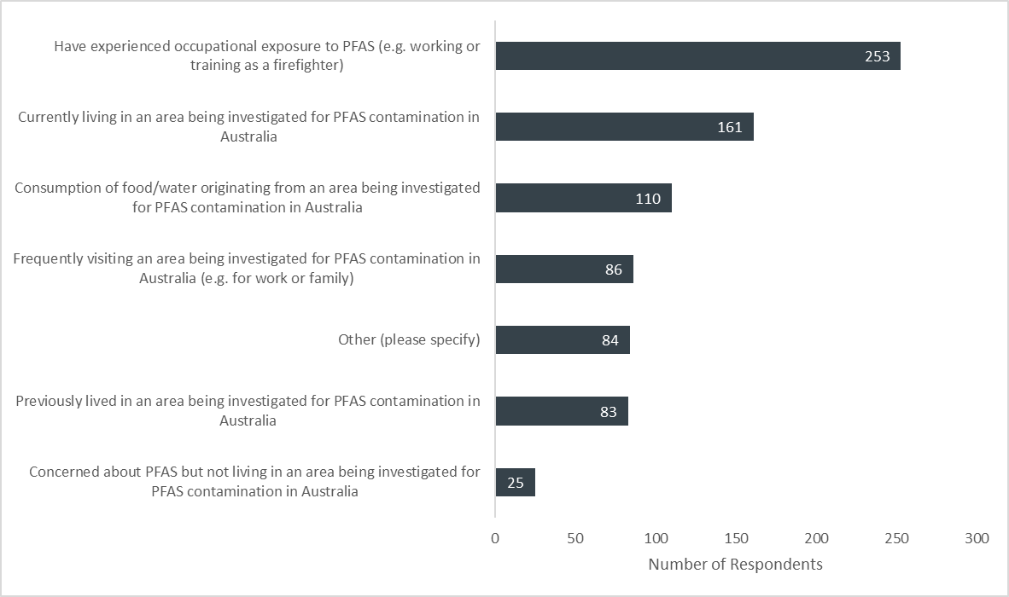

  - What sources or potential exposure to PFAS concern respondents the most?
Question: What sources of potential exposure to PFAS concern you the most? Please rank in order of what concerns you most: from 1 (most concern) to 10 (least concern).
Respondents were asked to rank the listed exposure pathways in order of what sources of exposure to PFAS they were the most concerned about. The weighted averages in the analysis below have been calculated so that a higher weighted average indicates that respondents were relatively more concerned about that particular exposure pathway compared to others.
Figure 2 displays the weighted average of these answers.
442 respondents answered this question. However, eight respondents noted in the following free text question that it was impossible to rank exposure pathways, and all should be of concern.
Figure 2: Exposure pathways ranked by level of concern
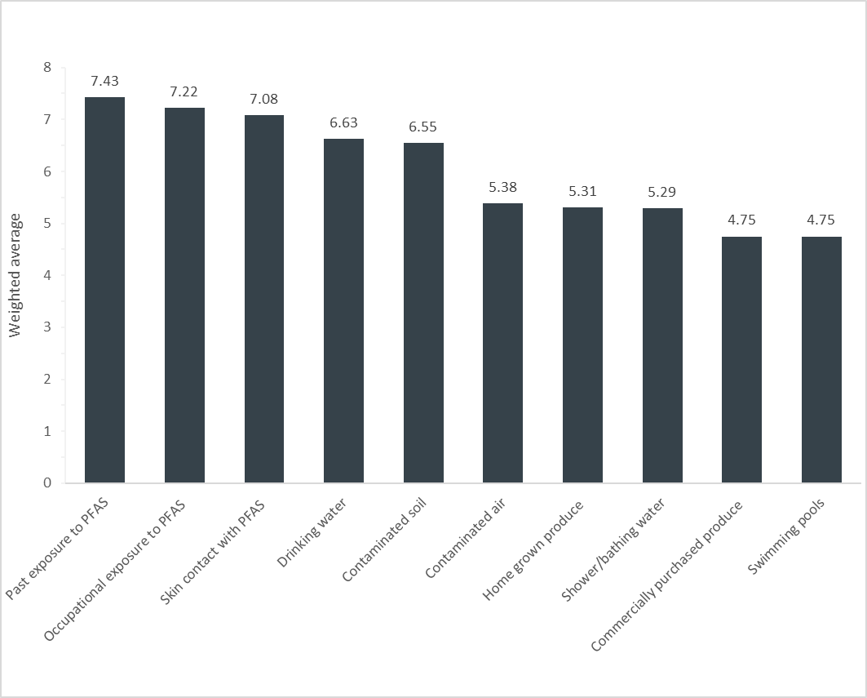

Figure 3 compares the different weighting between respondents who reported that they were occupationally exposed to PFAS, versus those who reported they lived, or have lived, in an area being investigated for PFAS contamination.
Figure 3: Exposure pathways occupationally exposed respondents vs. respondents who lived in a PFAS contaminated area were concerned about
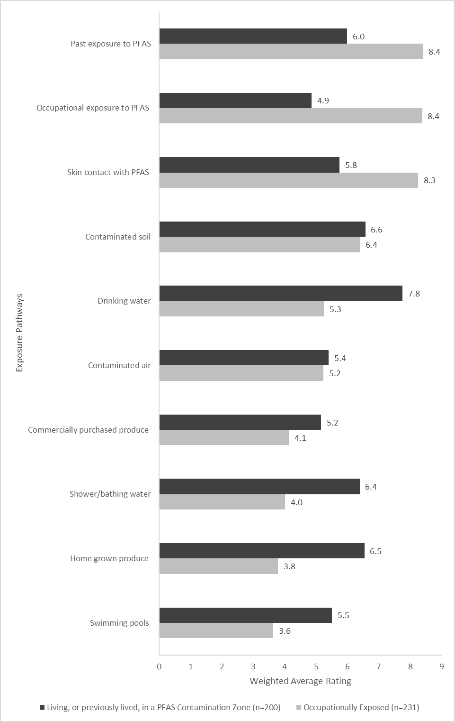

Figure 3 indicates that the exposure pathways that most concerned those who were occupationally exposed to PFAS were:
- past exposure to PFAS;
- working in an industry using PFAS chemicals; and
- skin contact with PFAS containing chemicals.
The exposure pathways that most concerned respondents who reported that they live, or have previously lived, in an area currently being investigated for PFAS exposure were:
- drinking water;
- contaminated soil; and
- home grown produce.
  - Other source of potential exposure causing respondents concern
Question: Is there a potential source of exposure to PFAS not listed in the table that you are more concerned about?
Respondents were asked if there were any other exposure pathways that were not listed in the previous question. Ninety-three respondents provided further detail on exposure pathways that they were concerned about.
While the question asked for comments on exposure pathways not listed in the previous question, 47 respondents provided additional information on occupational exposure pathways that they had selected from the list in the previous question, and 13 respondents commented on aspects of bore water contamination that concerned them. Their answers have been included in the analysis to give additional detail on why respondents were concerned about these exposure pathways.
Responses under this question provided on behalf of organisations have also been included and do not deviate significantly from those provided by individuals.

Respondents reported more detail the different kinds of occupational exposure pathways that concerned them
Forty-seven of the 93 respondents who answered this question reiterated their concerns regarding occupational exposure to PFAS, or provided more detail on the different exposure pathways they were occupationally exposed to PFAS. All of these respondents reported that this occupational exposure was in relation to training or working as a firefighter.
Some of the various occupational exposure pathways related to firefighting that respondents reported being concerned about include:
- while refilling firefighting trucks (7 respondents);
- using it as dishwashing liquid at work (6 respondents);
- accidentally ingesting foam (4 respondents);
- contaminated training grounds or dust inhalation (7 respondents).
One respondent noted:
“During training and operation duties it was not unusual to be soaked to the skins with foam also it was often in your face and was ingested”
When discussing occupational exposure, four respondents also reported concern that their families were exposed to PFAS at home when washing their work clothing or when they went home after wearing contaminated clothing.

PFAS contaminated bore and surface water
Thirteen of the 93 respondents reported that PFAS contaminated bore water or surface water was an exposure pathway that concerned them. This included concerns from respondents about coming into contact with PFAS through irrigation systems or rivers/streams that were contaminated with PFAS.
One respondent, a state Government department, noted PFAS contamination in drinking water from unreticulated water or town supply, or unlicensed ground water bores was of concern:
The exposure pathways that … is most concerned about are drinking water from sources which are not on a reticulated water or town water supply. Where there is use of surface water or groundwater used for drinking water or for irrigation of crops and livestock. There is a high potential in some areas for unlicensed groundwater bores to exist and for this bore water to be used for drinking water. Due to the chemical characteristics of PFAS, highly mobile persistent surfactant, the contamination can find its way into unlicensed bore water supplies.
Exposure to PFAS in utero or through breastmilk
Seven of the 93 respondents reported that they were concerned about babies being exposed to PFAS in utero, with three of these respondents also noting concern that babies may be exposed to PFAS through breastmilk.
Other concerns respondents noted
Respondents provided a range of other PFAS exposure pathways they were concerned about including:
- home grown product or fish (5 respondents);
- contaminated dust (4 respondents);
- other products such as Teflon (3 respondents);
- commercially purchased food (2 respondents);
- contaminated atmosphere and rain (2 respondents);
- drinking water (2 respondents);and
- playing in AFFF foam as a child at public parades (1 respondent).
- Concerns about potential health impacts of PFAS Exposure
Respondents were asked to report how concerned they felt about various aspects of PFAS exposure and any potential effects on their own health, or their family’s health. They were also asked to report any health issues they were concerned about relating to PFAS exposure.
These questions were designed to inform the Panel of what health issues potentially related to PFAS exposure were of concern to the public. This information will be used to inform the Panel’s deliberations regarding future research priorities.
  - How concerned respondents felt about aspects of PFAS exposure on their health
How concerned are you that you about the following? Please use the scale below ranging from 1 (not at all concerned) to 5 (very concerned).
Respondents were asked to report how concerned they felt that four different aspects of potential PFAS contamination was having an effect on their health, or their family’s health. The four aspects of potential PFAS contamination were the extent to which the respondent was concerned:
- that they or their family’s future health might be affected by PFAS;
- that they or their family’s health had already been affected by PFAS;
- about avoiding exposure to PFAS; and
- about indirect health impacts of living inside an investigation area.
Respondents were asked to report how concerned they felt about each aspect using the following scale:
1 | 2 | 3 | 4 | 5 | N/A
Not at all concerned | Not concerned | Neutral | Concerned | Very Concerned | N/A

Figure 4 details how respondents answered this question.

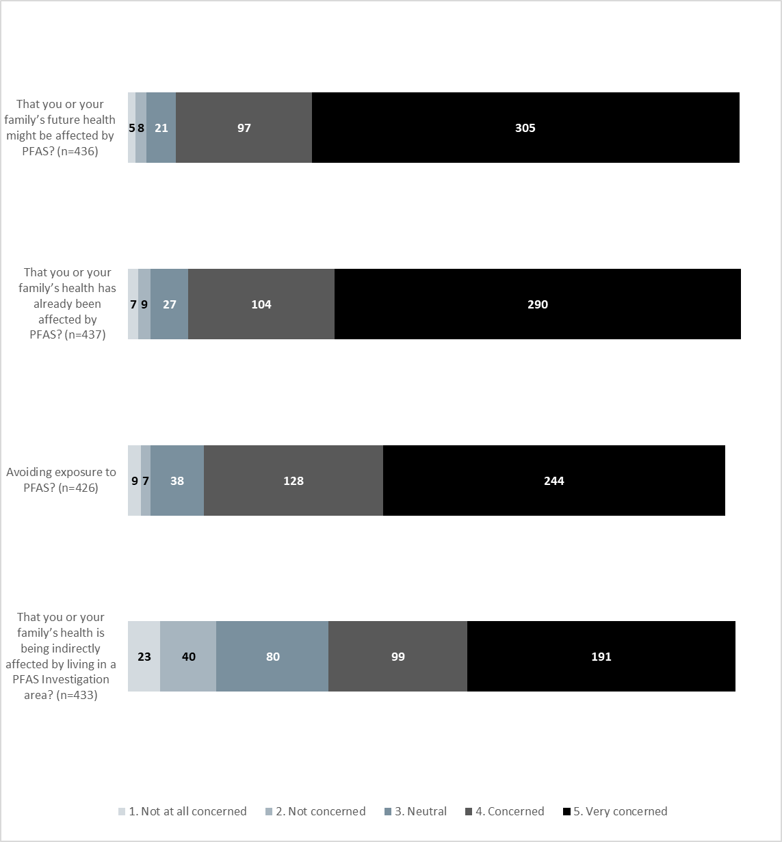
Figure 4 : How concerned are you about the following health impacts of PFAS? 1 (not at all concerned) to 5 (very concerned)
Question: How concerned are you that you or your family’s future health might be affected by PFAS?
436 respondents chose to answer this question.
Seventy percent of respondents who answered the question reported being “very concerned” that PFAS might affect their own future health or their family’s future health, and a further 22 percent reported they were “concerned.”
Question: How concerned are you that you or your family’s health has already been affected by PFAS?
437 respondents chose to answer this question.
Sixty-seven percent of respondents who answered this question reported feeling “very concerned” that their own health, or their family’s health, had already been affect by PFAS exposure, and a further 24 percent reported they were “concerned.”
Question: How concerned are you about avoiding exposure to PFAS?
426 respondents chose to answer this question.
Fifty-three percent of respondents who answered this question reported feeling “very concerned” about avoiding exposure to PFAS, a further 30 percent reported that they were “concerned.”
Question: How concerned are you that you or your family’s health is being indirectly affected by living in a PFAS Investigation area (e.g. stress and anxiety due to financial impacts, publicity or media attention?)
433 respondents chose to answer this question.
Forty-four percent of the respondents who answered this question reported feeling “very concerned” that their health, or their family’s health, was being indirectly affected by PFAS exposure, and a further 23 percent reported that they were “concerned.”
Under this question, respondents were asked whether their health was being indirectly affected by living in a PFAS investigation area. 433 respondents answered this question, however only 161 of these respondents reported that they live in a PFAS investigation area. Responses under this question have not been filtered by those who reported themselves as currently living in an investigation area. Instead, these responses could possibly be interpreted to represent wider concern that respondents were being indirectly affected by PFAS exposure more broadly, or an expression of concern for those who were living in such areas, or a mix of both.

  - Potential health impacts respondents were concerned about
Question: If you are concerned about exposure to PFAS, what potential impacts on human health from PFAS exposure are you concerned about?
Respondents were asked how concerned they were about the effect of PFAS on their health, or their family’s health. 339 respondents specifically mentioned potential health impacts on their own health, or on their families, that they were concerned about.
This question was in a free text form so that responses were unprompted.
Responses under this question provided on behalf of organisations have also been included and do not deviate significantly from those provided by individuals.

The most common response was concern that PFAS exposure may cause cancer
189 respondents reported they were concerned about a link between PFAS exposure and cancer(s).
Sixteen of the 189 respondents that expressed concern about cancer being caused by PFAS exposure noted that they, their families, or their former colleagues, had received a cancer diagnosis and they were concerned that this may be linked to PFAS exposure.
178 of the 189 respondents expressed general concern about cancer being caused by PFAS exposure without providing further detail. The remaining 11 respondents specified the types of cancers that they were concerned about in particular. These included testicular, prostate, kidney, liver, pancreatic, stomach, bladder and thyroid cancers.
One respondent, representing a community support group for residents affected by PFAS exposure, expressed concern that there is a high incidence of cancer within their community, noting that:
“39 residents within one 5km stretch of road were reported to have suffered some form of cancer in the last 15 years alone; that number has now increased to 50 upon further investigation.”

Respondents noted that they were concerned about any potential health effects that could arise from PFAS exposure
Eighty-two of the 339 respondents who answered this question noted that they were concerned about any possible health effects that could arise from PFAS exposure. These included comments noting that it was difficult to formulate a response to this question when people were not clear on the actual effects of exposure to PFAS. Examples of comments under this theme include “All ‘probable links’” and “all or any – we do not know which is the problem”.
Fifteen of the 82 respondents who noted they were concerned about any or all health impacts from PFAS, also noted that they were concerned that PFAS exposure would be linked to other health conditions in the future. One of these respondents, an individual who reported currently living in an area being investigated for PFAS contamination, noted that they were worried that PFAS exposure may cause cancers and thyroid conditions but also that these conditions:
“are just the things they have evidence for – I am most concerned about the unknown that is yet to be researched.”

Many respondents were concerned about the long-term health effects on adults, workers and children
A total of 69 respondents commented that they were concerned that PFAS exposure may cause or lead to long-term health effects. Of these 69 respondents:
- 33 respondents discussed their concern for potential long-term health effects for children who have been exposed to PFAS,
- ten respondents discussed their concerns with regard to workers who were occupationally exposed to PFAS over a long period, and
- seven respondents noted concern that their own PFAS exposure may cause epigenetic changes that may affect their children and grandchildren.
The 33 respondents who noted concern for potential long-term health effects on children’s health from PFAS exposure provided a range of comments on their concerns. Some respondents shared their experience regarding their concern for their children’s health and noted that their children had been exposed from a young age, many since they were toddlers or in utero.

Mental health impacts including stress and anxiety
Twenty-six of the 189 respondents that answered this question reported that they were concerned about the effect PFAS exposure or contamination was having on their mental health. When discussing factors that were affecting their mental health, five respondents noted that their mental health was being affected by the uncertainty over their future health and not knowing what PFAS exposure might mean for the health of their families. Four respondents noted that financial pressures from living in a contaminated area, such as not being able to access bank loans or sell their houses, was impacting their mental health.
There were a number of personal stories or anecdotes provided illustrating the impact PFAS contamination and exposure has had on people’s mental health.
One respondent who reported being occupationally exposed to PFAS suggested that the mental health aspect of PFAS exposure had not received prominence in the response when they noted that:
“there is level of mental anguish that sits at the centre of this that seems to have slipped by unnoticed.”
Another respondent who also reported being occupationally exposed to PFAS, discussed feeling like a “testing opportunity” for Australia while their mental health was significantly compromised knowing that they had limited options to move away from the contamination zone.
“Stress due to not being listened to in regards to wanting a basic test and to stop being told you don't fall into the investigation group. Please treat me as a person with worries and stress and not as a nobody”.

Respondents were concerned that PFAS exposure may cause or aggravate thyroid issues or hormonal imbalances
Thirty-two respondents commented that they were concerned about thyroid issues or a range of other hormonal imbalances including disruption to their endocrine system or other hormonal imbalance.

Concern that PFAS exposure may cause developmental effects in babies
Twenty-one respondents commented that they were concerned that PFAS exposure may adversely affect babies in utero or via exposure from breastmilk. Concerns included that PFAS may cause birth defects, developmental delays, low birth weight, neurological conditions or stillbirth.

Other health concerns that respondents wrote about
Respondents provided a range of other health issues that they were concerned may be linked to PFAS exposure including:
- Immune system response (17 respondents);
- High cholesterol and associated heart issues (15 respondents);
- Premature death (14 respondents);
- Kidney disorders (13 respondents);
- Liver issues (11 respondents);
- Fertility issues (10 respondents);
- Respiratory issues (6 respondents);
- Skin conditions (6 respondents);
- Neurological uses such as stroke or Parkinson’s (6 respondents);
- Digestive issues (4 respondents);
- Dental issues (3 respondents);
- Autism (3 respondents);
- Blood poisoning (2 respondents);
- ADHD (1 respondent); and
- Compromised vision (1 respondent).

- Information and understanding
Question: How informed do you feel on the following topics? Please use the scale below ranging from 1 (not at all informed) to 5 (very informed).
Respondents were asked how informed they felt about four different aspects of information and understanding relating to PFAS exposure and contamination:
- the Government’s response to address the health concerns of communities exposed to PFAS;
- research on the effects of PFAS exposure;
- levels of exposure to PFAS in specific communities; and
- different ways people and communities may be exposed to PFAS.
Respondents were asked to report how informed they felt about each aspect using the following scale:
1 | 2 | 3 | 4 | 5 | N/A
Not at all informed | Not informed | Neutral | Informed | Very Informed | N/A

Figure 5 details how respondents answered this question.
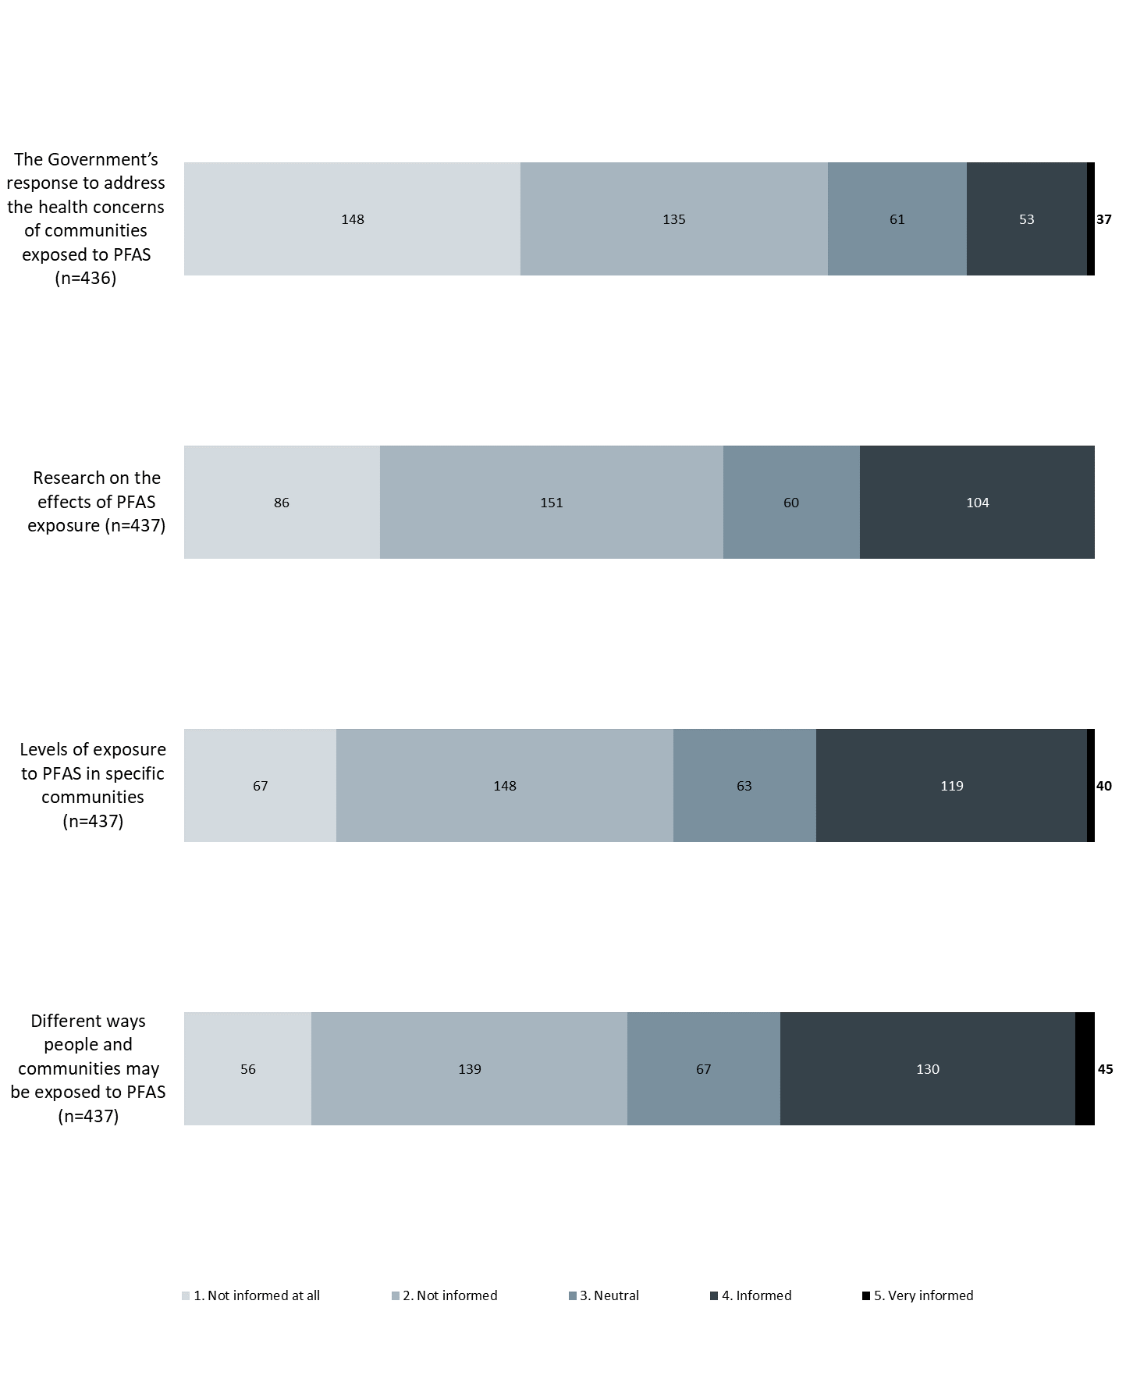
Figure 5: How informed do you feel on the following topics? Please use the scale below ranging from 1 (not at all informed) to 5 (very informed).

Question: The Government’s response to address the health concerns of communities exposed to PFAS
436 respondents answered this question.
Sixty-five percent of respondents who answered this question reported that the felt “not at all informed” or “not informed” about the Government’s response to addressing health concerns of communities exposed to PFAS.
Twenty-one percent of respondents who answered this question reported that they felt “informed” or “very informed” about the Government’s response to addressing health concerns of communities exposed to PFAS.
Question: Research on the effects of PFAS exposure
437 respondents answered this question.
Fifty-four percent of respondents who answered this question reported that they felt “not at all informed” or “not informed” about research on the effects of PFAS exposure.
Thirty-two percent of respondents who answered this question reported that they felt “informed” or “very informed” about research on the effects of PFAS exposure.
Question: Levels of exposure to PFAS in specific communities
437 respondents answered this question.
Forty-nine percent of respondents who answered this question reported that they felt “not at all informed” or “not informed” about levels of PFAS exposure in specific communities.
Thirty-six percent of respondents who answered this question reported that they felt “informed” or “very informed” about levels of PFAS exposure in specific communities.
Question: Different ways people and communities may be exposed to PFAS
437 respondents answered this question.
Forty-five percent of respondents who answered this question reported that they felt “not at all informed” or “not informed” about different ways people and communities may be exposed to PFAS.
Forty percent of respondents who answered this question reported that they felt “informed” or “very informed” about different ways people and communities may be exposed to PFAS.
- Future health impact and exposure research priorities
Respondents were asked to indicate which research areas regarding PFAS and human health they thought were most important. These questions were designed to inform the Panel’s deliberations regarding the recommended setting of future research priorities.
  - Importance of conducting further research on long-term health effects of PFAS exposure
Question: How important is it that the Australian Government undertakes more research to understand the long-term health impacts of exposure to PFAS? 1 (not important at all) to 5 (extremely important)
428 respondents chose to answer this question
Respondents were asked to use a sliding scale from one to five to indicate how important they thought it was that the Australian Government undertakes further research into the long-term health impacts of exposure to PFAS.
The average of these responses was 4.88, and the median was five.
An average close to five and a median of five indicates that respondents thought that more research into the long-term health impacts of exposure to PFAS was very important to respondents.
  - Prioritising human health research areas
Question: Do you have a preference for research on preventing further PFAS contamination, or for methods to monitor and treat already exposed communities?
433 respondents chose to answer this question.
Respondents were asked whether they had a preference for research on preventing further PFAS contamination, or monitoring and treating existing PFAS contamination.
Ninety-one percent of respondents reported that both of these research areas were important to them.
Eight percent of respondents that answered this question thought that monitoring and treating existing PFAS contamination should be given priority. One percent of respondents who answered this question thought that research into preventing further PFAS contamination was more important, and one percent of respondents who answered this question said neither was important to them.
Question: What areas of human health research do you think should be prioritised?
Respondents were asked to rank the listed research priorities in order of research topics they thought should be prioritised.
The potential areas of human health research that respondents could select from were:
- the potential health effects on workers exposed to high levels of PFAS at work (occupational exposure);
- the potential health effects on communities that have experienced high exposure to PFAS due to contamination;
- the potential health effects of PFAS exposure on vulnerable populations such as pregnant women, babies, young children and the elderly;
- the best methods to minimise exposure to PFAS in individuals and communities; and
- the potential health effects on communities that have experienced lower background exposure to PFAS chemicals.
Figure 6 displays the weighted average of these answers. A higher weighted average indicates that respondents thought that research area was more important to them relative to the other areas.
Figure 7 compares the different weighting between respondents who reported that they were occupationally exposed to PFAS, versus those who reported that they lived, or have lived, in an are being investigated for PFAS contamination.

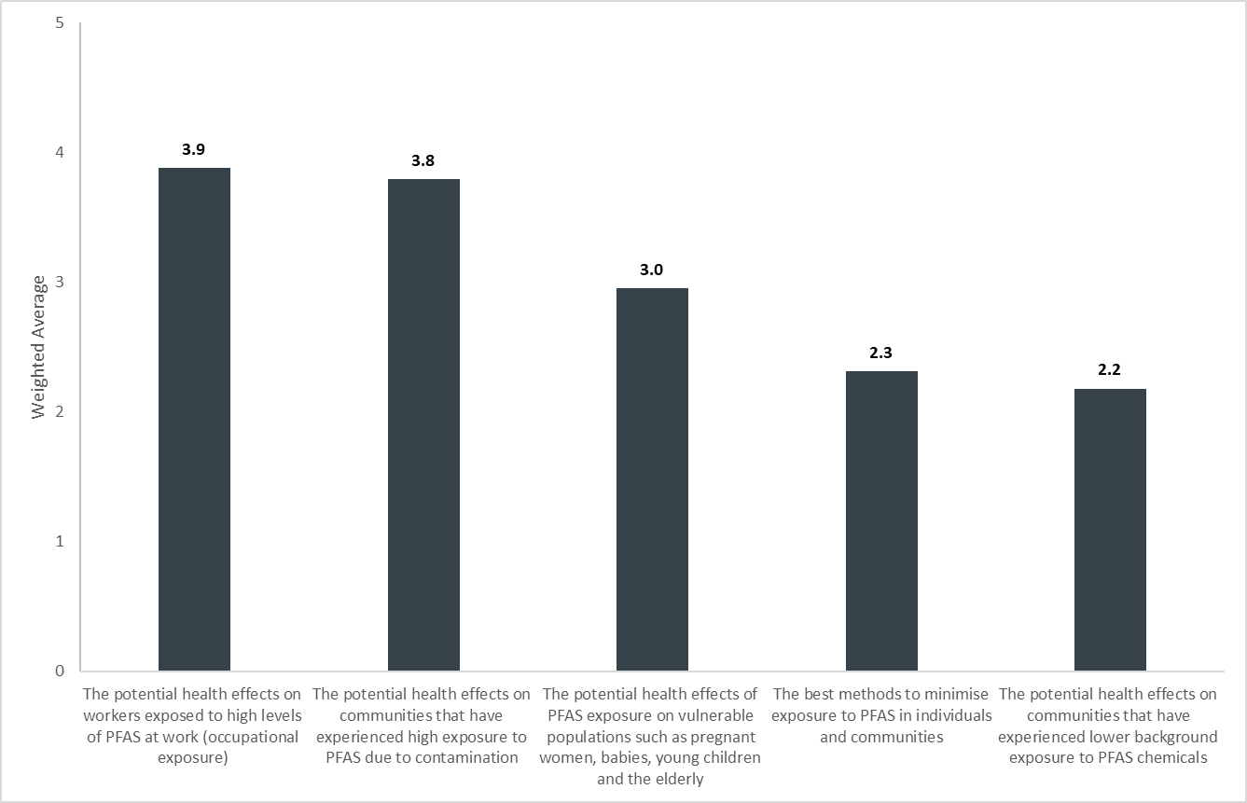
Figure 6: What areas of human health research do you think should be prioritised?

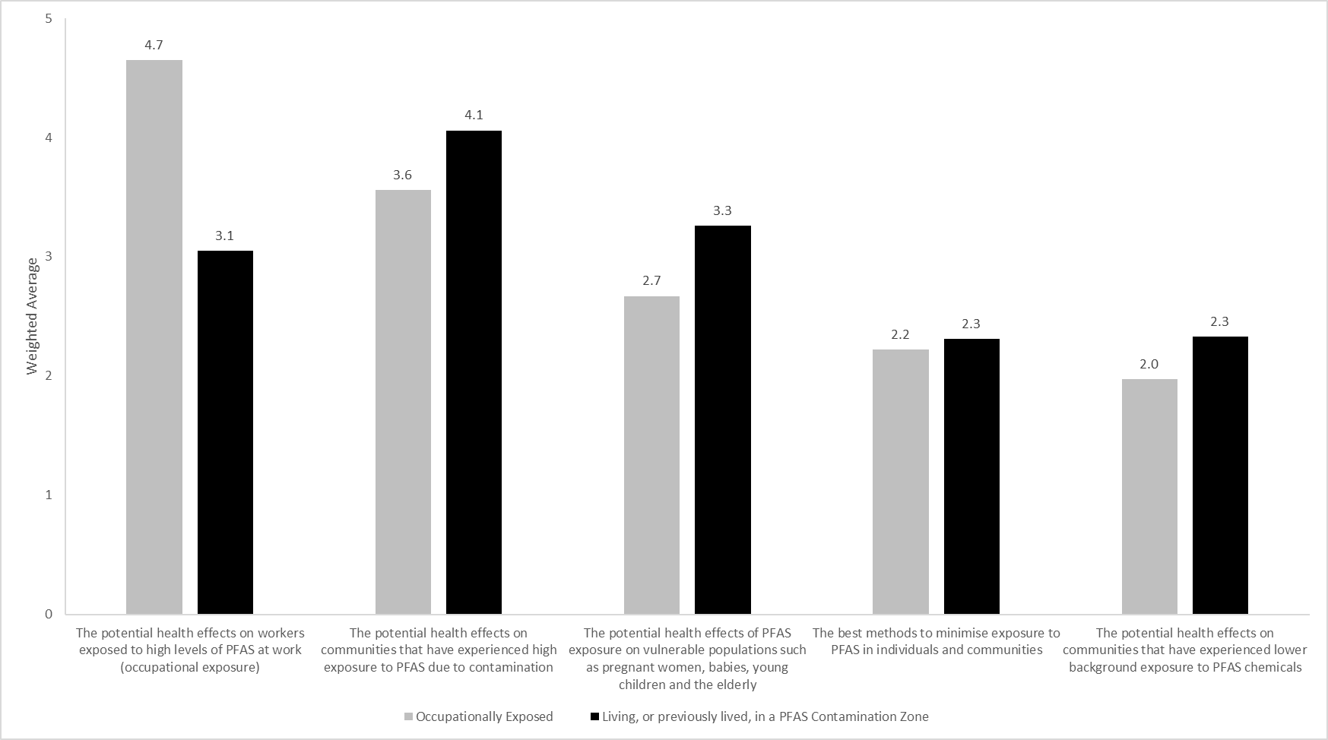
Figure 7: Research priorities areas occupationally exposed respondents vs respondents who lived, or previously lived in an area being investigated for PFAS contamination wanted prioritised

Figure 7 indicates that the occupationally exposed respondents sub-group prioritised further research into occupational exposure relative to other research. The sub-group of respondents that reported living in an investigation area prioritised further research on potential health impacts on communities that have experienced high exposure to PFAS due to contamination.
  - Other areas of human health research respondents want prioritised
Question: Is there an area of human health research not listed here that you would like to see prioritised for further research?
109 respondents answered this question specifically, and 147 respondents commented on research priorities including during their comments made in the general comments section at the end of the consultation document where there was a free text box for general comments (section 9 in this document provides a summary of these responses). This question was a free-text response question to allow respondents to write about areas that had not been specified in the previous question that asked them to rank research priorities.
Responses under this question provided on behalf of organisations have also been included and do not deviate significantly from those provided by individuals.

Blood testing for those affected by PFAS contamination
Thirty-one respondents reported that they wanted more widely available blood testing for those affected by PFAS contamination. Of these 31 respondents, eight respondents specifically wanted testing for firefighters who had been exposed to PFAS containing foam. Some respondents explained why they wanted regular blood testing, for example one respondent who reported being occupationally exposed to PFAS noted:
“I want regular testing for persons past and present who were exposed to PFAS and PFOA due to their occupation. We were exposed to these chemicals without knowing the damage they can possibly have. At the very least we can monitor our own levels and this can be documented for future research.”
In describing why blood testing services should be offered more widely, respondents mainly reported two reasons:
- six respondents wanted to check their own levels for health reasons to understand their own exposure history; and
- seven respondents thought that it should be used to inform research or epidemiological studies.
One of the respondents who reported currently living in an area being investigated for PFAS contamination and wanted extended blood testing services noted that:
“More regular repeated blood tests would prove that we are not still being contaminated while they sort all the rest of this debacle and give us great peace of mind.”
One organisation that represents firefighters recommended extending blood testing to “every Federal, State and Territory career firefighter, including appropriate support and analysis at no cost.

Further research on the health effects on firefighters of occupational exposure to PFAS
Thirty-one respondents requested research specifically on firefighters who have been exposed to PFAS containing foam and how this may affect their health. One of these respondents who reported that he was occupationally exposed to PFAS noted that:
“The aviation rescue firefighters are the canaries in the coal mine on this issue”
Two respondents discussed the fact that firefighters often have “combined multiplier effect of occupational exposure”, and they are exposed to PFAS at the fire pits which were filled with aviation fuels and AFFF that was accidentally ingested, and they also handled PFAS containing chemicals in raw and undiluted forms.
One organisation that represents firefighters requested research on the “best practice methods for measurement of exposure levels of firefighters to historical PFAS.”

Specific research on cancer
Nineteen respondents wanted research specific health conditions that they thought may be linked to PFAS exposure. Fourteen of these respondents requested that research be undertaken into whether PFAS exposure caused cancer. Other health conditions that people wanted further research on included: effects on the human immune system, links to kidney problems, and heart problems or other conditions that may be linked to PFAS.

Long term health effects of PFAS exposure
Seventeen respondents who commented on research priorities requested long term monitoring, or research into the long-term effects of PFAS exposure on health. One respondent who reported concern for PFAS exposure but did not live in an investigation area, noted that this should include intergenerational effects:
“We include in this concern for intergenerational equity - how will today's exposure impact on descendants of those exposed and future environments?”
Another respondent who reported having previously lived in an investigation area commented on the need for this research to include those who have moved out of areas currently being investigated for PFAS contamination:
“[What about] people who have moved out of the area but lived there for a substantial time i.e. 5+ years? Or does the effects happen in less years?”
One organisation that represents firefighters requested further research on:
“the evidence and understanding of potential human health effects from prolonged exposure to PFAS but also on potential methods of reducing PFAS levels.”

Health effects of PFAS exposure on vulnerable populations
Fifteen respondents who commented on research priorities requested studies on health effects on vulnerable populations including children (9 respondents), babies (5 respondents), people with autoimmune deficiencies or existing health issues (2 respondents) veterans (1 respondent), and the elderly (1 respondent).

Reducing levels of PFAS in blood
Twelve respondents requested studies on how to reduce blood levels of PFAS.

Other research priorities
Respondents provided a range of other topics for research that they though should be prioritised including:
- research into the mental health effects from PFAS exposure (8 respondents);
- effects on indigenous health (2 respondents).
Ten respondents also noted that it was difficult to prioritise research areas, as research into the health effects for different exposed communities (for example, vulnerable populations and occupationally exposed workers) are all equally important.

- Other comments
Question: Do you have any other comments or views on potential health impacts associated with PFAS exposure or priority areas for further research that you would like the Panel to consider?
Respondents were given the opportunity to provide other comments on potential health impacts associated with PFAS exposure or priority areas for further research. These comments have been included for analysis in the sections they are relevant to. A range of other comments were made by respondents under this question that are outside of the scope of work for the Panel, which is to advise the Australian Government on the potential health impacts associated with PFAS exposure and identify priority areas for further research. However, these have been summarised below.

Comments on communication by the Australian government
Forty-eight respondents commented on a perceived failure of communication regarding PFAS contamination by the Australian Government. This includes the following perceptions from respondents:
- that the Government is deliberately ignoring the concerns of those affected by PFAS contamination;
- that the Government perceives PFAS contamination as a low priority; and
- that the Government is slow in responding to PFAS contamination.

Comments regarding a need for more financial support for affected communities
Twenty-five respondents commented that there was a need for more financial assistance for communities affected by PFAS contamination. Examples of the kind of assistance requested by respondents includes:
- annual health checks;
- compensation for lost property value or other financial compensation; and
- mental health support.

Need for clarity regarding potential health effects of PFAS and exposure guidance values
Eighteen respondents commented on the need for more clarity regarding guidance on the potential health effects of PFAS exposure. One respondent who reported being occupationally exposed to PFAS noted:
“There has been a lot of testing and no one has told us anything other than it’s very contaminated. I want to know if it is going to effect my health.”
Twelve respondents commented on the need for clarity regarding safe exposure levels for PFAS.
One organisation requested further research on the need for established maximum thresholds for food and water in Australia.

- Key Themes
The public consultation process has delivered a clear statement of concern that respondents feel that PFAS exposure has already affected their health, and that it may affect their health into the future. Respondents reported that future research into the human health effects of PFAS exposure is extremely important to them.
Some of the key findings have been included below.

Exposure pathways
- Overall, respondents indicated that past exposure to PFAS, occupational exposure to PFAS, and skin contact with PFAS were the most concerning exposure pathways to them.
- When considering the views of those respondents who were occupationally exposed to PFAS, for example, from working or training as a firefighter and being regularly exposed to PFAS containing foam, these respondents ranked past exposure to PFAS, occupational exposure to PFAS and skin contact with PFAS containing products as of the most concern to them.
- When considering the views of those respondents who reported that they lived, or previously lived, in an area under investigation for PFAS contamination, these respondents ranked drinking water, contaminated soil and homegrown produce as the exposure pathways of the most concern to them.

Concerns about potential health impacts of PFAS exposure
- Over two thirds of respondents were “concerned” or “very concerned” about the following impacts of PFAS on their health:
  - that their future health, or their family’s future health might be impacted by PFAS exposure;
  - that their health, or their family’s health may have already been impacted by PFAS exposure;
  - avoiding exposure to PFAS;
  - that their health, or their family’s health, was being indirectly affected by PFAS exposure, for example, by causing stress and anxiety.
- When given the opportunity to identify which potential health impacts of PFAS exposure concerned them most, over 55 percent (189 of the 339 respondents that responded to the question) noted that they were concerned about a link between PFAS exposure and cancer(s).

Information and understanding
- Responses under information and understanding were more mixed. Over half of respondents felt “not at all informed” or “not informed” about the Government’s response to addressing health concerns of communities exposed to PFAS. Twenty-one percent of respondents reported feeling “informed” or “very informed” about the Government’s response.
- Approximately half of respondents felt “not at all informed” or “not informed” about research on the effects of PFAS exposure and levels of exposure to PFAS in specific communities. Thirty-two percent and 37 percent reported feeling “informed” or “very informed” about research on PFAS, and levels of exposure to PFAS in specific communities respectively.
- Forty-five percent of respondents reported feeling “not at all informed” or “not informed” about different ways people and communities may be exposed to PFAS. Forty percent of respondents reported feeling “informed” or “very informed” about PFAS exposure pathways.

Future health impact and exposure research priorities
- When asked about their views on what research on PFAS exposure should be prioritised, respondents reported that research on the health effects of occupational exposure to PFAS should be prioritised, along with further research into potential health impacts on communities that have experienced high exposure to PFAS due to contamination.
- Respondents who identified as occupationally exposed to PFAS prioritised future research on the health effects of occupational exposure to PFAS, and research on potential health effects on communities that have experienced high exposure to PFAS due to contamination.
- Respondents who reported that they lived, or have lived, in an area currently being investigated for PFAS contamination prioritised research on the potential health effects on communities that have experienced high exposure to PFAS, and research into the potential health effects of PFAS exposure on vulnerable populations such as pregnant women, babies, young children and the elderly.
- Thirty-one of the 109 respondents who commented on other areas of human health research they want prioritised, commented on a need for blood testing for those affected by PFAS contamination.

Appendix One – Copy of Public COnsultation Document

Expert Health Panel for PFAS – Public Consultation Process
PFAS chemicals
Per- and poly-fluoroalkyl substances (PFAS) used in fire-fighting foams on Defence bases, civilian airports and firefighting training grounds have migrated through the groundwater into adjoining areas.
These chemicals can persist in humans, animals and the environment. In particular they appear to accumulate in humans and are then very slowly eliminated from the body. The Environmental Health Standing Committee (enHealth) currently advises that ‘there is currently no consistent evidence that exposure to perfluorooctane sulfonate (PFOS) and perfluorooctanoic acid (PFOA) causes adverse human health effects’ (enHealth, 2016); and recent reviews conducted by regulatory bodies have concluded that there is no compelling evidence that PFAS at the concentrations found in these areas are harmful to health. However, as a precaution it is generally recommended that exposure be minimised wherever possible.
Investigation of health effects and research priorities
To further investigate the potential health effects of PFAS, the Australian Government has set aside funds to do further research into the potential health effects of PFAS exposure.
The Expert Health Panel for PFAS (the Panel) has been established to provide updated and independent advice to the Australian Government on the potential health impacts associated with PFAS exposure and identify priority areas for further research. Allen + Clarke is an independent organisation that is assisting the Panel with this work.
To provide its advice to Government, the Panel is reviewing the current health and other scientific evidence available in addition to seeking the views of the public who are concerned by PFAS contamination. To do this, the Panel, assisted by Allen + Clarke, is currently undertaking a public consultation process.
This document
This document poses questions to the public to help the Panel to better understand the range of public views on the potential health impacts of PFAS contamination and what the focus of future research should be. It poses the same questions as the online survey that can be found at www.allenandclarke.com/PFAS.
You don’t have to answer all of the questions if you don’t want to. The questionnaire should take you about 20 minutes and there is an opportunity to provide extra comments at the end. It may take longer than this depending on the length of written responses to questions.

How to complete the consultation questions
Web
Complete the survey online at www.allenandclarke.com/PFAS
Email
Email your completed responses to PFAS@allenandclarke.com
Post
Send your completed survey to:
Expert Health Panel for PFAS
MDP 5
Department of Health
GPO Box 9848
Canberra ACT 2601
Please ensure your responses are returned by 11:59pm on 19 November 2017.

How will your responses be managed?
Your responses will be used to collate a report that analyses the submissions to identify the key themes, areas of concern and areas of focus for future research. Allen + Clarke is collecting the consultation information into a report, which will be provided to the Panel to help inform their advice to the Australian Government. Once completed, a short summary report explaining the findings will be made available at the Department of Health website.
Your response is voluntary. Information you provide will be held by Allen + Clarke but anonymised individual responses may be made available to the Panel. Personal information will be handled in accordance with applicable privacy and information law
There will be an opportunity for you to provide additional comments or concerns that you would like the Panel to consider at the end of this questionnaire.

General
Are you making a submission as:
An individual

On behalf of a group/organisation

Other (please specify): …………………………………..

If you are making a submission on behalf of a group/organisation, please provide the name of the group/organisation and your position in that group or organisation:

Please indicate which sector best represents you:
Individual/family

Academic/research

Non-government association

Medical/public health professional

Local/State government

National government

Commercial fishery/farmer
Other (please specify): ……………………………………………………..

Sex:
Female

Male

X (Indeterminate/Intersex/Unspecified)

Prefer not to say

Age:
Under 25

25 - 44

45 - 64

65 - 84

85+

Prefer not to say

Exposure
- Why is PFAS exposure of interest to you? (Check as many that apply)
Currently living in an area being investigated for PFAS contamination in Australia

Previously lived in an area being investigated for PFAS contamination in Australia

Frequently visiting an area being investigated for PFAS contamination in Australia (e.g. for work or family)

Consumption of food/water originating from an area being investigated for PFAS contamination in Australia

Concerned about PFAS but not living in an area being investigated for PFAS contamination in Australia

Other: please specify…………………………………………………………………………………………………...

- What sources of potential exposure to PFAS concern you the most? Please rank in order of what concerns you most: from 1 (most concern) to 10 (least concern).
Exposure | Ranking (1 – 10)
Drinking water
Shower/bathing water
Swimming pools or while swimming in rivers and watering holes
Commercially purchased produce (fruit, vegetables, meat, eggs, dairy products or seafood)
Home grown produce (fruit, vegetables, meat, eggs, dairy products or seafood)
Contaminated air
Contaminated soil
Working in an industry using PFAS chemicals
Skin contact with PFAS containing products
Past exposure to PFAS

Is there a potential source of exposure to PFAS not listed in the table that you are more concerned about?

Concerns about Health impacts
- How concerned are you that you about the following? Please use the scale below ranging from 1 (not at all concerned) to 5 (very concerned).
 | 1 | 2 | 3 | 4 | 5 | N/A
 | Not at all concerned | Not concerned | Neutral | Concerned | Very concerned | N/A
That you or your family’s health has already been affected by PFAS?
That you or your family’s future health might be affected by PFAS?
About avoiding exposure to PFAS?
That you or your family’s health is being indirectly affected by living in a PFAS Investigation area (e.g. stress and anxiety due to financial impacts, publicity or media attention?)

- If you are concerned about exposure to PFAS, what potential impacts on human health from PFAS exposure are you concerned about?

Information and understanding
- How informed do you feel on the following topics? Please use the scale below ranging from 1 (not at all informed) to 5 (very informed).
 | 1 | 2 | 3 | 4 | 5 | N/A
 | Not at all informed | Not informed | Neutral | Informed | Very informed | N/A
Levels of exposure to PFAS in specific communities
Research on the effects of PFAS exposure
Different ways people and communities may be exposed to PFAS
The Government’s response to address the health concerns of communities exposed to PFAS

Future health impact and exposure research priorities
- How important is it that the Australian Government undertakes more research to understand the long-term health impacts of exposure to PFAS?
Not important at all 1 2 3 4 5 Extremely important

- Do you have a preference for research on preventing further PFAS contamination, or for methods to monitor and treat already exposed communities?
Preventing more PFAS contamination

Monitoring and treating existing PFAS contamination

Both are important to me

Neither are important to me

- What areas of human health research do you think should be prioritised?
Research area | Ranking (1 – 5)
The potential health effects on workers exposed to high levels of PFAS at work (occupational exposure)
The potential health effects on communities that have experienced high exposure to PFAS due to contamination
The potential health effects on communities that have experienced lower background exposure to PFAS chemicals
The potential health effects of PFAS exposure on vulnerable populations such as pregnant women, babies, young children and the elderly
The best methods to minimise exposure to PFAS in individuals and communities

Is there an area of human health research not listed here that you would like to see prioritised for further research?

Other COmments
- Do you have any other comments or views on potential health impacts associated with PFAS exposure or priority areas for further research that you would like the Panel to consider?

