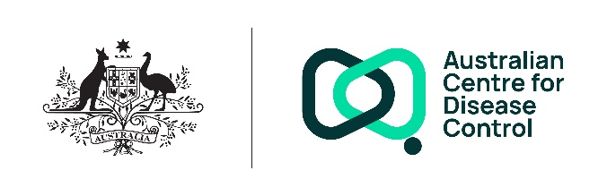
Public Interest Disclosures - APP 5 Collection Notice

Your personal information is protected by law, including the Privacy Act 1988 (Privacy Act) and the Australian Privacy Principles (APPs).
Who is collecting your personal information?
Your personal information is being collected by the Australian Centre for Disease Control (the CDC/ we).
Is the collection authorised or required by law?
The collection of this information is authorised by the Public Interest Disclosure Act 2013 (PID Act), Privacy Act and Australian Centre for Disease Control Act 2025 (CDC Act).
What information is being collected?
The CDC will collect a range of your personal information, including sensitive information, in connection with the receipt, assessment, investigation and management of a PID made under the PID Act.
Personal information may be collected directly from you when you:
- make a PID;
- participate in, or are otherwise involved in, an assessment or investigation of a PID; or
- communicate with the CDC in relation to a PID.
In some circumstances, we may collect your personal information from third parties where this is necessary and lawful, including from:
- other Commonwealth agencies;
- witnesses or persons with relevant knowledge;
- entrusted persons (as defined in s 5 of the CDC Act);
- prescribed public health entities (as defined in s 5 of the CDC Act);
- designated data service providers (as defined in s 5 of the CDC Act); or
- publicly available sources, where permitted by law.
Why does the CDC collect your personal information?
The CDC collects your personal information for the purposes of:
- receiving, assessing and investigating PIDs;
- determining whether a disclosure qualifies for protection under the PID Act;
- communicating with disclosers and other relevant individuals;
- performing the CDC’s statutory functions; and
- complying with legal obligations under the PID Act, the Privacy Act and other applicable Commonwealth laws.
Personal information collected for a specific purpose related to a PID may also be used for other purposes that are authorised or required by law, or that are directly related to that purpose.
What would happen if the CDC did not collect your personal information?
If you do not or are unable to provide your personal information, the CDC may be unable to:
- properly assess or investigate your PID;
- communicate with you about your PID or any investigation; or
- determine whether the disclosure qualifies for protection under the PID Act.
Who will the CDC disclose your personal information to?
Your personal information, including sensitive information, may be disclosed with your consent, or where required or authorised by law, including under the PID Act. This may include disclosure to:
- authorised officers of the CDC;
- entrusted persons (as defined in s 5 of the CDC Act);
- prescribed public health entities (as defined in s 5 of the CDC Act);
- designated data service providers (as defined in s 5 of the CDC Act);
- third parties engaged to assist the CDC in relation to the disclosure;
- supervisors or managers involved in handling the disclosure;
- the Commonwealth Ombudsman or other oversight bodies; or
- other Commonwealth agencies, where lawful.
Access to and correction of your personal information
The CDC’s privacy policy contains information about how you may access and seek correction of your personal information.
Privacy complaints
The CDC’s privacy policy contains information about how you may complain about a breach of the Australian Privacy Principles or the Australian Government Agencies Privacy Code and how the CDC will deal with complaints.
Overseas disclosure of your personal information
We will not disclose your personal information to any overseas recipients.
Further information
You can read the CDC’s privacy policy. You can obtain a copy of the APP privacy policy by contacting the CDC using the contact details set out at the end of this notice.
Consent
By providing your sensitive information to us, you consent to the CDC collecting the sensitive information provided about you for the purposes indicated above
By providing your personal information to any third party engaged to assist the CDC in relation to any disclosure, you consent to the CDC collecting this personal information about you from that provider.
If you are providing the CDC with personal information about another individual, unless you are authorised to consent on their behalf, you will need to inform that individual of the contents of this notice and obtain their consent to the CDC collecting their personal information.
Contact details
If you wish to contact the CDC about a privacy-related matter, including questions about this notice, please contact the CDC’s Privacy Officer by one of the following methods:
- Post
Att: Privacy Officer
GPO Box 798, Canberra ACT 2601
- Email
privacy@cdc.gov.au

