Australian Respiratory Surveillance Report

Key messages
This report presents a national epidemiological update for acute respiratory infections, including coronavirus disease 2019 (COVID-19), influenza and respiratory syncytial virus (RSV), with a focus on the current reporting period (1 December to 28 December 2025) and earlier severity reporting periods (up to 14 December 2025).
In the community: In the last month, influenza-like illness among national helpline callers increased but the rate of national helpline callers referred to seek urgent medical care remained unchanged from the previous month. Self-reported new fever and cough symptoms among community survey participants remained stable in the last month but fewer community survey participants reported taking time off work due to respiratory illness. COVID-19 cases decreased overall in the last month and remain lower than at the same time in previous years. Influenza cases continued to increase steadily—an unusual trend for this time of year—before declining sharply in the last two weeks of December. Despite this drop in notifications, influenza cases remain considerably higher than at the same time in previous seasons, likely driven by influenza A(H3N2), in particular a new subclade called subclade K. RSV cases continued to decrease in the last month, in line with trends expected at this time of year.
In general practice: In the last month, there were more general practice consultations with influenza-like illness (defined as new fever and cough symptoms) at sentinel surveillance sites than in the previous month. From June to December 2025, influenza-like illness consultation rates have generally exceeded historical trends. Like influenza case notification trends, influenza-like illness consultation rates have not yet returned to the interseasonal levels observed in previous years.
In hospitals: Sentinel hospital admissions with severe acute respiratory infections increased in the last severity reporting period, largely driven by increased influenza admissions. At sentinel hospitals, most admissions among children and adults were with influenza. The proportion of patients who were admitted directly to intensive care at a sentinel hospital site remains low. Sentinel intensive care admissions with severe acute respiratory infections have been declining overall since late June and most patients in 2025 to date have been admitted with influenza. In the last month, the average number of COVID-19 cases occupying intensive care beds was lower than the previous month; however, the average number of intensive care staff unavailable due to illness increased.
Deaths: COVID-19 has been the leading cause of acute respiratory infection mortality across 2023–2025. However, in 2025 the number of deaths involving influenza (both due to and with) has exceeded the number of deaths involving COVID-19 from August to October. All three of these acute respiratory infections are more likely to cause death in older age groups than younger age groups.
In laboratories: In the last month, test positivity for SARS-CoV-2 decreased, whilst test positivity increased for influenza and remained stable for RSV. The SARS-CoV-2 variant under monitoring, NB.1.8.1, remains the dominant SARS-CoV-2 variant in the last 28 days accounting for 45.8% of sequences in Australia. Since late September there has been consistently increasing proportion of influenza A(H3N2) samples typed, aligning with the late season increase in influenza notifications.
Vaccine coverage, effectiveness and match: Nationally, 10.6% of adults have received a COVID-19 vaccine in the last 12 months. Influenza vaccine coverage is 30.7% in 2025 to date. Since the commencement of the National RSV Mother and Infant Protection Program, 175,169 Abrysvo doses have been administered. In the last six months, nirsevimab uptake is 8% nationally. Initial Australian studies suggest that in 2025, vaccinated individuals are roughly 53% less likely to attend general practice or be hospitalised with influenza than unvaccinated people. Since October, there has been a notable increase in influenza A(H3N2) viruses that have shown reduced reactivity to the southern hemisphere 2025 vaccine strain; however, these viruses show reasonable reactivity to the 2026 proposed southern hemisphere vaccine strain. Further analysis is required to understand this change.

Australian Respiratory Surveillance Report
This report was prepared by Lauren Kutzner, Ash Donovan, Lauren Welsh, Jenna Hassall and Siobhan St George on behalf of the Australian Centre for Disease Control. We thank the staff and participants from the surveillance systems who contribute data for acute respiratory illness surveillance across Australia.
The report presents a national overview of acute respiratory infections in Australia, drawing information from several different surveillance systems. These surveillance systems help us to understand the distribution of acute respiratory illnesses in the community, the severity of infections including which populations might be at risk, and the impact of acute respiratory illnesses on the community and health system in Australia.
Surveillance indicators presented in this report are based on the Australian National Surveillance Plan for COVID-19, Influenza, and RSV. Please refer to the report Technical Supplement for information on our surveillance sources and data considerations, including the considerable impact of the COVID-19 pandemic on acute respiratory infection surveillance in Australia. A summary of data considerations for this report are provided below:
- Due to the dynamic nature of the surveillance systems used in this report, surveillance data are considered preliminary and subject to change as updates are received, with the most recent weeks considered particularly incomplete. Data in this report may vary from data reported in other national reports and reports by states and territories.
- Data in this report are presented by date of event (diagnosis, admission or death) or by the International Organization for Standardization (ISO) week date system, with weeks defined as seven-day periods which begin on a Monday and end on a Sunday. The ISO week date system is used to support trends comparisons over time more effectively. The current reporting period includes 1 December to 28 December 2025 and where comparisons to the previous month are made, this includes 3 November to 30 November 2025.
- In Australia, states and territories (the Australian Capital Territory [ACT], New South Wales [NSW], the Northern Territory [NT], Queensland [Qld], South Australia [SA], Tasmania [Tas], Victoria [Vic] and Western Australia [WA]) report notified cases to the National Notifiable Diseases Surveillance System (NNDSS) based on the Australian national surveillance case definitions. NNDSS data are analysed and reported based on diagnosis date, which is the true onset date of a case if known, otherwise it is the earliest of the specimen date, the notification date or the notification received date. The NNDSS data for this report were extracted on 7 January 2026.
- To account for the lag in collection and provision of severity data from some surveillance systems, and for the time delay between illness onset and the development of severe disease outcomes, cases with an admission date or a diagnosis date in the last two weeks are excluded from severity analyses for hospitalisations and intensive care admissions. As such, the severity reporting periods are two weeks behind the end of the current reporting period. For this report, severity reporting includes data from 17 November to 14 December 2025 unless specified otherwise. Where comparisons to the previous severity month are made this includes 20 October to 16 November 2025.
- Death registrations from the Australian Bureau of Statistics (ABS) Provisional Mortality Statistics are now used as the primary data source for measuring acute respiratory infection associated deaths. The ABS mortality data is sourced from the Registry of Births, Deaths and Marriages and is separate from the NNDSS. Registration-based mortality data needs time to be received and processed. For this reason, mortality statistics in this report may lag by at least two months.
- Analysis and reporting outputs were produced using R Statistical Software v4.3.1. While every care has been taken in preparing this report, the Australian Government Department of Health, Disability and Ageing does not accept liability for any injury or loss or damage arising from the use of, or reliance upon, the content of the report or Technical Supplement. For further information about this report refer to the Technical Supplement or contact respiratory.surveillance@cdc.gov.au.

Community surveillance
Community surveillance monitors respiratory illnesses in the community, providing information on the number of people reporting respiratory symptoms, testing practices, and the impact of respiratory illnesses. Community surveillance includes notification data obtained from laboratory tests for infections. Infections that are diagnosed and notified are only a subset of the total number of infections occurring in the community.
- In the last month (1 December to 28 December 2025), there were slightly more Healthdirect helpline callers with influenza-like illness (358 per 1,000 callers per month) than in the previous month (356 per 1,000 callers per month) (Figure 1).
- Since early November 2025, rates of influenza-like illness among helpline callers have been increasing slightly in line with trends observed at the same time in previous years. Rates declined in late December; however, this trend should be interpreted with care due to changes in healthcare and testing access, testing behaviour and population mixing over the holiday period (Figure 1).
Figure 1: Rate of influenza-like illness per 1,000 helpline callers by year and week of call*, Australia†, 22 March 2023 to 28 December 2025
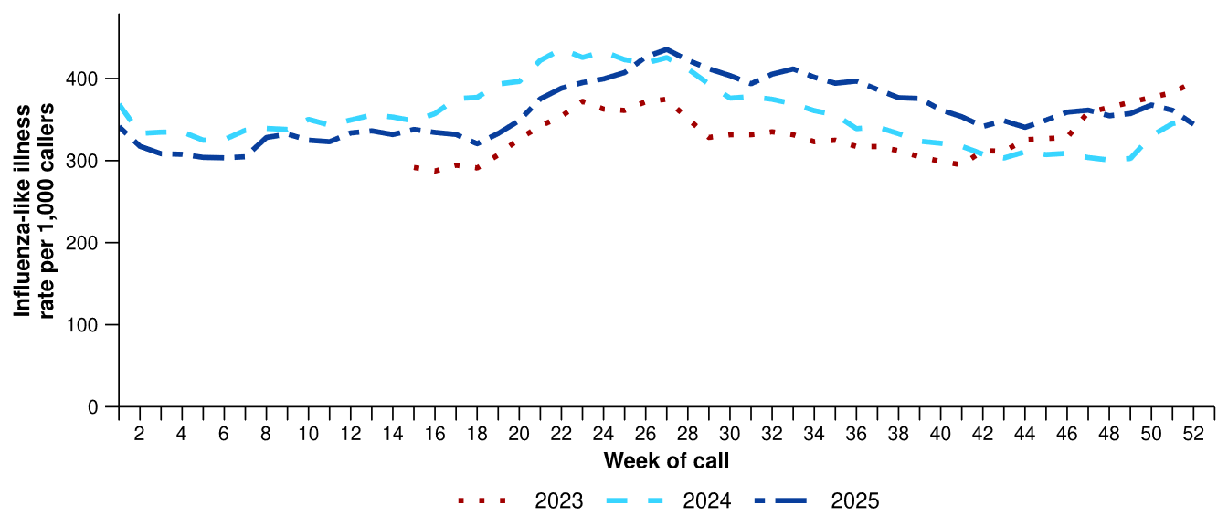
Source: Healthdirect Australia
* Healthdirect data prior to 22 March 2023 are unavailable as prior to this date a different data collection method was used.
† The Healthdirect helpline operates in all states and territories except Qld; therefore influenza-like illness trends will not be representative of Qld and may be underrepresented. See the Technical Supplement for more information.
- In the last month, the same rate of Healthdirect helpline callers with influenza-like illness were referred to seek urgent medical care (184 per 1,000 callers per month) as in the previous month (184 per 1,000 callers per month) (Figure 2).
  - Callers referred to seek urgent medical care include those referred to call triple zero, attend a hospital emergency department, contact a virtual emergency department, urgent care clinic or see a general practitioner within two hours.
- In the last month, referral pathways for influenza-like illness varied across Australia. NSW, SA and Vic had the highest proportion of callers referred to see a general practitioner (GP) or seek other urgent medical care (Figure 2). By comparison, the ACT, Tas and WA had a higher proportion of callers who were recommended to attend a hospital emergency department or call triple zero (Figure 2).
  - These differences may reflect variations in healthcare access and service models and should be interpreted with caution.

Figure 2: Proportion of referral categories* for helpline callers with influenza-like illness by jurisdiction† and call date, Australia, 1 January to 28 December 2025
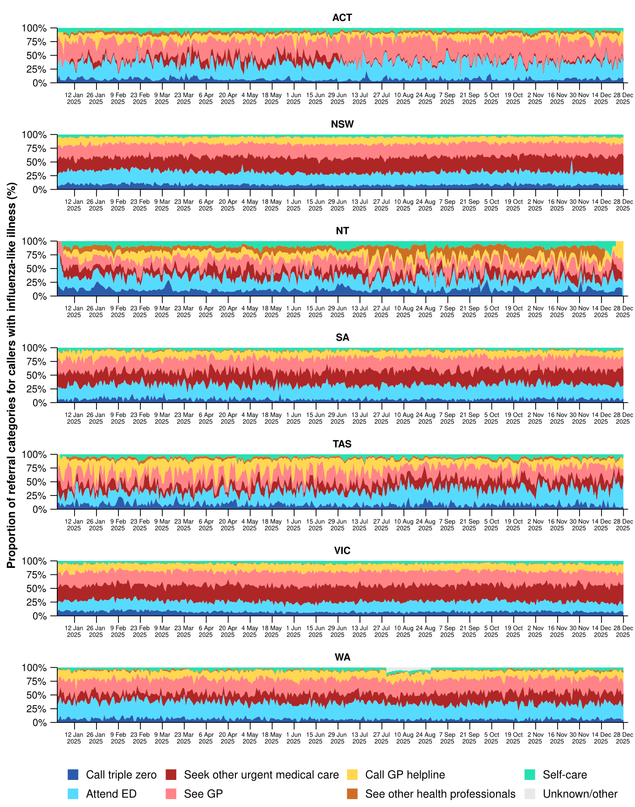
Source: Healthdirect Australia
* See other health professionals category includes pharmacist, dentist, mental health provider, primary maternity care, poison information centre or other.
† The Healthdirect helpline operates in all states and territories except Qld; therefore influenza-like illness referral trends are not provided for Qld. See the Technical Supplement for more information.

- In the last month, the same percentage of FluTracking survey participants reported new fever and cough symptoms overall (1.4%), as in the previous month (1.4%), though variable trends were observed in that time (Figure 3).
- Following an overall increasing trend in the weekly percentage of FluTracking participants reporting new fever and cough symptoms since October 2025, the weekly percentage declined in late December; however, this trend should be interpreted with care due to changes in healthcare and testing access, testing behaviour and population mixing over the holiday period. The weekly percentage remains similar to the trends observed at the same time in previous years (Figure 3).
- In the last month, more survey participants with new fever and cough symptoms used a rapid antigen test (RAT) (51.6%; 480/930) than a polymerase chain reaction (PCR) test (12.9%; 120/930) to test for severe acute respiratory syndrome coronavirus 2 (SARS-CoV-2).
- Self-reported SARS-CoV-2 RAT positivity was lower in the last month (14.4%; 69/480) than in the previous month (16.6%; 97/583). Self-reported SARS-CoV-2 PCR positivity was lower in the last month (5.0%; 6/120) than in the previous month (6.9%; 10/145).
- In the last month, 12.3% (114/930) of survey participants with new fever and cough symptoms used a PCR test to test for influenza. Self-reported influenza PCR positivity was lower this month (27.2%; 31/114), than in the previous month (33.6%; 46/137).
- In the last month, fewer survey participants reported taking three or more days off work or normal duties due to fever and cough symptoms (47.8%; 445/930), than in the previous month (51.5%; 551/1,069).
Figure 3: Age standardised percentage of survey participants reporting new fever and cough symptoms compared with the five-year average* by year and week of survey, Australia, 2022 to 28 December 2025
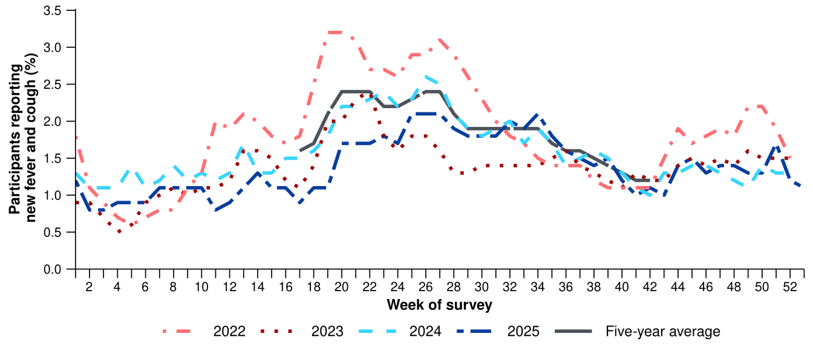
Source: FluTracking
* From 2020, FluTracking expanded their data capture period to year-round. Data before May and after October for any year before 2020 are not available for historical comparisons. The years 2020 and 2021 are excluded when comparing the current season to historical periods when influenza virus has circulated without public health restrictions. As such, the five-year average includes the years 2018 to 2019 and 2022 to 2024. Please refer to the Technical Supplement for interpretation of the five-year average.

- In the last month (1 December to 28 December 2025), there was a 5.5% decrease in COVID-19 cases, a 5.5% increase in influenza cases, and a 15.4% decrease in RSV cases.
Table 1: Notified cases and notification rate per 100,000 population by disease, five-year age group, and jurisdiction*†, Australia, 1 January to 28 December 2025
 | COVID-19 |  |  | Influenza |  |  | RSV
 | Reporting  period  (n) | Year to  date  (n) | Year to  date  (rate) | Reporting  period  (n) | Year to  date  (n) | Year to  date  (rate) | Reporting  period  (n) | Year to  date  (n) | Year to  date  (rate)
Age group (years)
0–4 | 1,076 | 18,866 | 1,250 | 4,931 | 59,455 | 3,941 | 1,691 | 78,959 | 5,233
5–9 | 482 | 5,955 | 370 | 5,598 | 72,382 | 4,493 | 222 | 13,023 | 808
10–14 | 329 | 6,056 | 362 | 3,596 | 51,421 | 3,071 | 99 | 5,847 | 349
15–19 | 369 | 6,350 | 382 | 3,576 | 33,727 | 2,028 | 112 | 4,046 | 243
20–24 | 231 | 6,324 | 353 | 2,162 | 19,613 | 1,096 | 101 | 3,216 | 180
25–29 | 278 | 7,785 | 390 | 1,930 | 18,834 | 944 | 118 | 3,746 | 188
30–34 | 351 | 9,516 | 467 | 1,645 | 23,754 | 1,165 | 122 | 4,747 | 233
35–39 | 472 | 10,964 | 552 | 1,658 | 30,046 | 1,514 | 114 | 4,744 | 239
40–44 | 371 | 10,393 | 561 | 1,494 | 30,105 | 1,626 | 115 | 4,256 | 230
45–49 | 295 | 8,862 | 544 | 1,160 | 23,281 | 1,430 | 125 | 3,996 | 245
50–54 | 303 | 8,902 | 527 | 1,141 | 21,255 | 1,258 | 157 | 5,013 | 297
55–59 | 263 | 8,610 | 562 | 1,134 | 19,420 | 1,267 | 165 | 5,438 | 355
60–64 | 299 | 9,161 | 597 | 1,167 | 19,089 | 1,244 | 163 | 6,100 | 398
65–69 | 300 | 9,462 | 696 | 1,212 | 17,605 | 1,295 | 209 | 6,384 | 470
70+ | 1,748 | 57,420 | 1,719 | 4,801 | 59,495 | 1,781 | 1,030 | 27,676 | 828
Jurisdiction
ACT | 81 | 2,976 | 628 | 633 | 8,899 | 1,877 | 30 | 2,988 | 630
NSW | 2,858 | 81,816 | 964 | 14,594 | 186,193 | 2,195 | 1,407 | 71,305 | 840
NT | 141 | 1,661 | 651 | 494 | 5,295 | 2,076 | 260 | 1,426 | 559
Qld | 1,428 | 38,028 | 681 | 7,475 | 99,287 | 1,777 | 1,544 | 34,390 | 616
SA | 481 | 11,385 | 606 | 2,874 | 35,925 | 1,913 | 231 | 12,894 | 687
Tas | 164 | 2,969 | 516 | 906 | 9,279 | 1,613 | 85 | 3,059 | 532
Vic | 1,825 | 33,885 | 485 | 8,333 | 118,444 | 1,697 | 687 | 38,341 | 549
WA | 189 | 12,037 | 406 | 1,900 | 36,483 | 1,230 | 299 | 12,802 | 432
Total | 7,167 | 184,757 | 679 | 37,209 | 499,805 | 1,837 | 4,543 | 177,205 | 651
Source: National Notifiable Diseases Surveillance System (NNDSS)
* Rate per 100,000 population for the given time period. Population data are based on the Australian Bureau of Statistics (ABS) Estimated Resident Population (ERP) for the reference period June 2024, released 12 December 2024.
† Total includes cases with missing age.

- Nationally, COVID-19 cases increased slightly across the first three weeks of December before declining in the final week (Figure 4). Although slight, this decrease should be interpreted with care due to changes in testing behaviour, healthcare and testing access, and population mixing over the holiday period.
- The number of COVID-19 cases in 2025 to date (n=184,757) is 38.1% fewer than the number of cases observed at the same time last year (n=298,700) (Figure 4).
- In the last month, COVID-19 notification rates decreased or remained relatively stable in most jurisdictions compared with the previous month (Figure 5).
- In 2025 to date, COVID-19 notification rates remain highest in people aged 70 years or over, likely due to higher case ascertainment from targeted testing strategies for populations at-risk of severe disease or who live in a high-risk setting such as a residential aged care home (Table 1).
- In 2025 to date, COVID-19 notification rates are highest in NSW and lowest in WA (Table 1).
Figure 4: Notified COVID-19 cases (laboratory-confirmed only) by year and week of diagnosis, Australia, 2022 to 28 December 2025
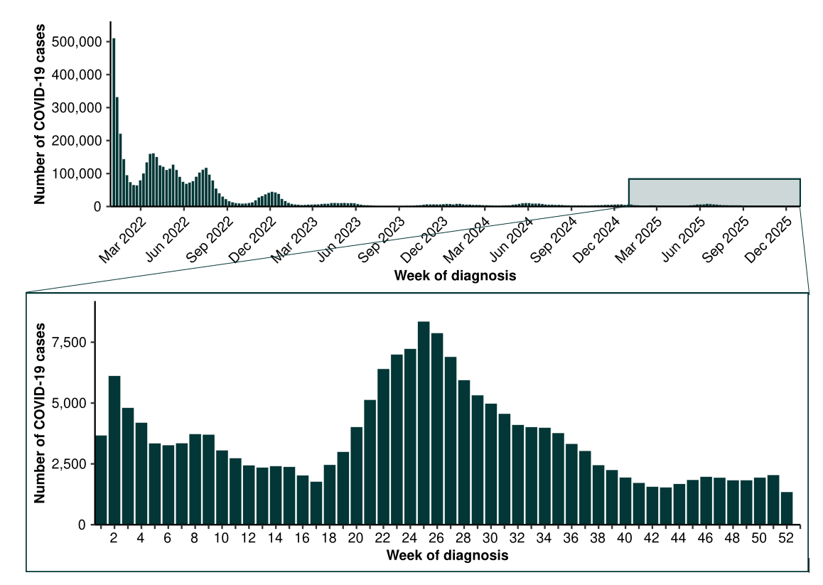
Source: National Notifiable Diseases Surveillance System (NNDSS)

Figure 5: Notification rates* per 100,000 population for COVID-19 cases by state or territory and week of diagnosis, Australia, 1 January to 28 December 2025
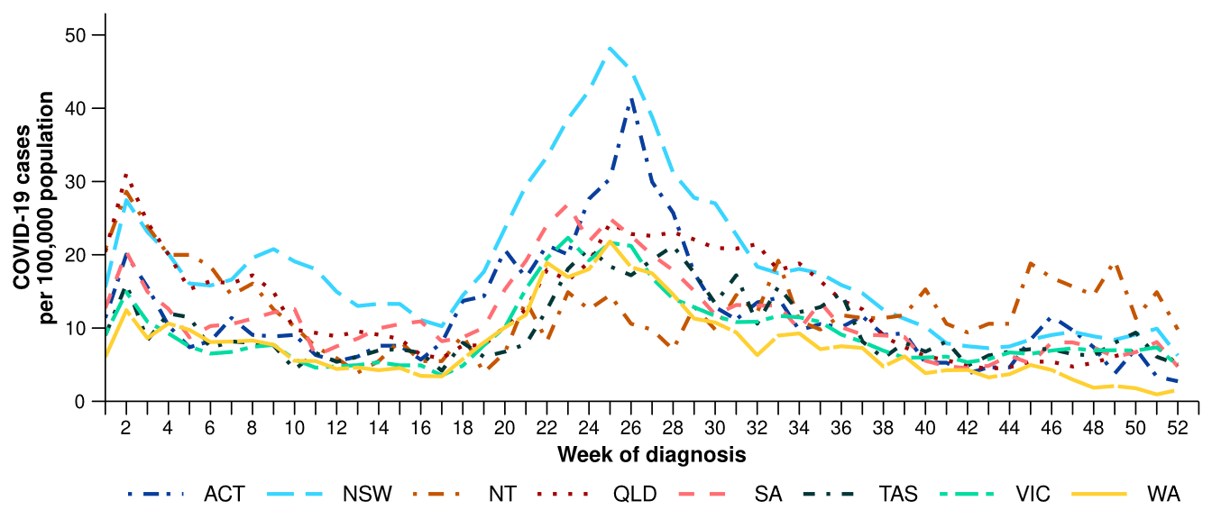
Source: National Notifiable Diseases Surveillance System (NNDSS)
* Rate per 100,000 population for the given time period. Population data are based on the Australian Bureau of Statistics (ABS) Estimated Resident Population (ERP) for the reference period June 2024, released 12 December 2024
Figure 6: Notified influenza cases and five-year average* by year and week of diagnosis, Australia, 2022 to 28 December 2025
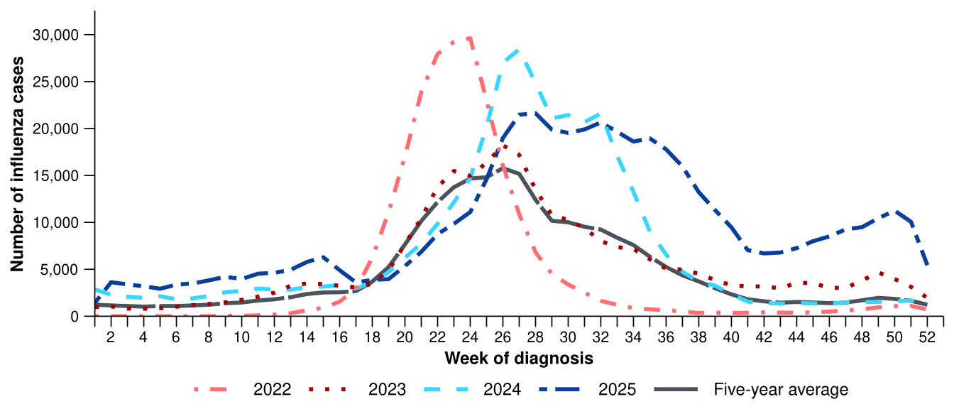
Source: National Notifiable Diseases Surveillance System (NNDSS)
* The years 2020 and 2021 are excluded when comparing the current season to historical periods when influenza virus has circulated without public health restrictions. As such, the five-year average includes the years 2018 to 2019 and 2022 to 2024. Please refer to the Technical Supplement for interpretation of the five-year average.
- Nationally, influenza cases increased steadily from late October—an unusual trend for this time of year—before declining sharply in the last two weeks of December. This decrease should be interpreted with care due to changes in testing behaviour, healthcare and testing access, and population mixing over the holiday period. Despite this drop in notifications, influenza cases remain considerably higher than at the same time in previous seasons (Figure 6).
  - Several factors may be contributing to this out-of-season increase in cases but the main driver is most likely circulation of influenza A(H3N2), in particular a new subclade called subclade K.
  - Globally, subclade K has been associated with early influenza season onset and high case numbers in many Northern Hemisphere countries.
  - Subclade K has developed seven new mutations, making it different from the 2025 southern hemisphere influenza vaccine reference strain (subclade J.2). As a result, subclade K appears to be less responsive to antibodies produced by the 2025 influenza vaccine compared to the strains circulating earlier in the season.
  - However, vaccination continues to provide important protection against severe illness from influenza. Preliminary data from the northern hemisphere indicate the 2025 vaccine still provides moderate protection against severe illness with subclade K, though real-word effectiveness data is currently limited. In addition, the subclade K viruses show reasonable match to the vaccine strain that will be included in the 2026 southern hemisphere influenza vaccine.
  - Current epidemiological data do not indicate increased severity of illness associated with subclade K; however, subclade K’s rapid spread has the potential to put increased pressure on Australian health care services over the summer and into the 2026 influenza season.
- The number of influenza cases this year to date (n=499,805) is 37.0% more than the number of cases observed at the same time last year (n=364,787). This can be attributed to a prolonged peak in cases between late June to mid-August 2025, a slower decrease in case numbers than observed in previous seasons and elevated interseasonal activity (Figure 6).
- In line with national trends, influenza notification rates across most jurisdictions increased across November and early December before declining in late December (Figure 7). As with national trends, the recent decreasing trends across jurisdictions should be interpreted with care due to changes in testing behaviour, healthcare and testing access, and population mixing over the holiday period.
- In 2025 to date, influenza notification rates remain highest in children aged 5–9 years and children aged 0–4 years (Table 1).
- In 2025 to date, influenza notification rates are highest NSW and lowest in WA (Table 1).
Figure 7: Notification rates* per 100,000 population for influenza cases by state or territory and week of diagnosis, Australia, 1 January to 28 December 2025
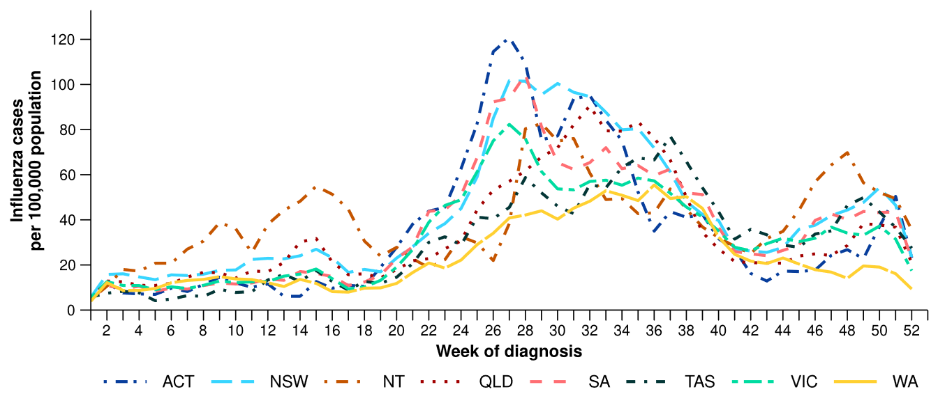
Source: National Notifiable Diseases Surveillance System (NNDSS)
* Rate per 100,000 population for the given time period. Population data are based on the Australian Bureau of Statistics (ABS) Estimated Resident Population (ERP) for the reference period June 2024, released 12 December 2024.
- In the last month, most influenza notifications were influenza A(Unsubtyped) (94.0%; 34,981/37,209), followed by influenza A(H3N2) (2.7%; 1,021/37,209), then influenza B (1.7%; 616/37,209), influenza untyped (1.4%; 535/37,209) and influenza A(H1N1) (0.1%; 52/37,209). In the last month, there were four influenza A&B co-detections (Figure 8).
- In 2025 to date, influenza A(Unsubtyped) has accounted for most cases across most age groups, followed by influenza B. The proportion of influenza B cases has been the highest in the 5–19 years age group. However, the proportion of influenza B has been decreasing across all age groups since late September (Figure 8).
- In 2025 to date, influenza A(Unsubtyped) has accounted for most influenza cases across all jurisdictions (Figure 9). All jurisdictions have experienced increased numbers of influenza B cases, though the proportion of influenza B compared with influenza A has been decreasing in all jurisdictions since late September (Figure 9).
- Since late September there has been an increase in the number of influenza A(H3N2) subtyped, particularly in the NT, Qld, Tas and WA, before an overall decline in the last month (Figure 9). However, trends in influenza subtypes should be interpreted with care as there are jurisdictional differences in the number and selection of influenza samples that undergo typing.

Figure 8: Notified influenza cases by influenza subtype, age group*, and week of diagnosis, Australia, 1 January to 28 December 2025
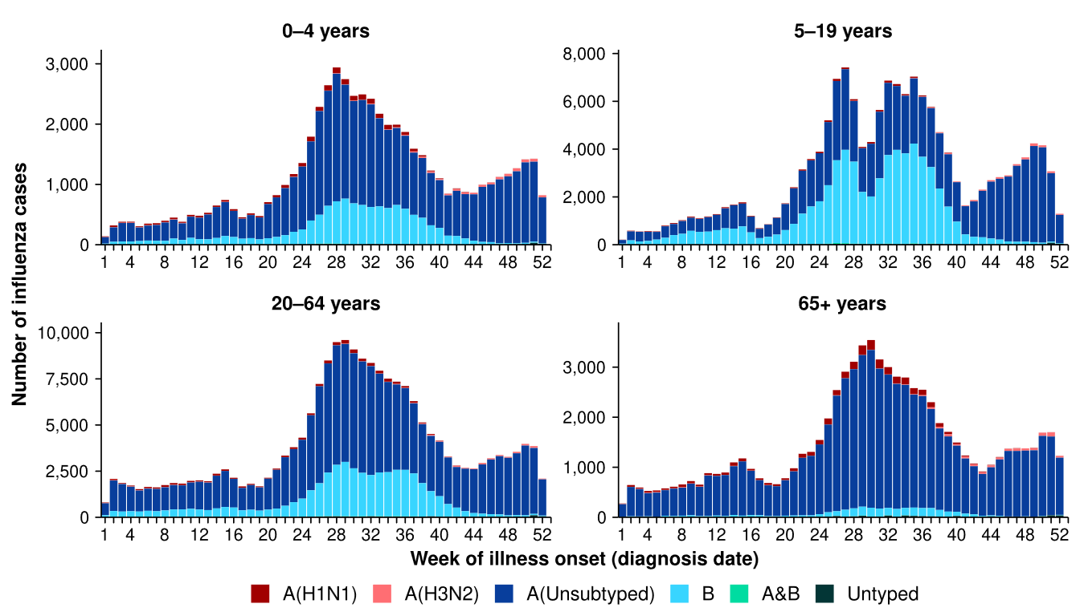
Source: National Notifiable Diseases Surveillance System (NNDSS)
* Axis varies between age groups.

Figure 9: Notified influenza cases by influenza subtype, jurisdiction*, and week of diagnosis, Australia, 1 January to 28 December 2025
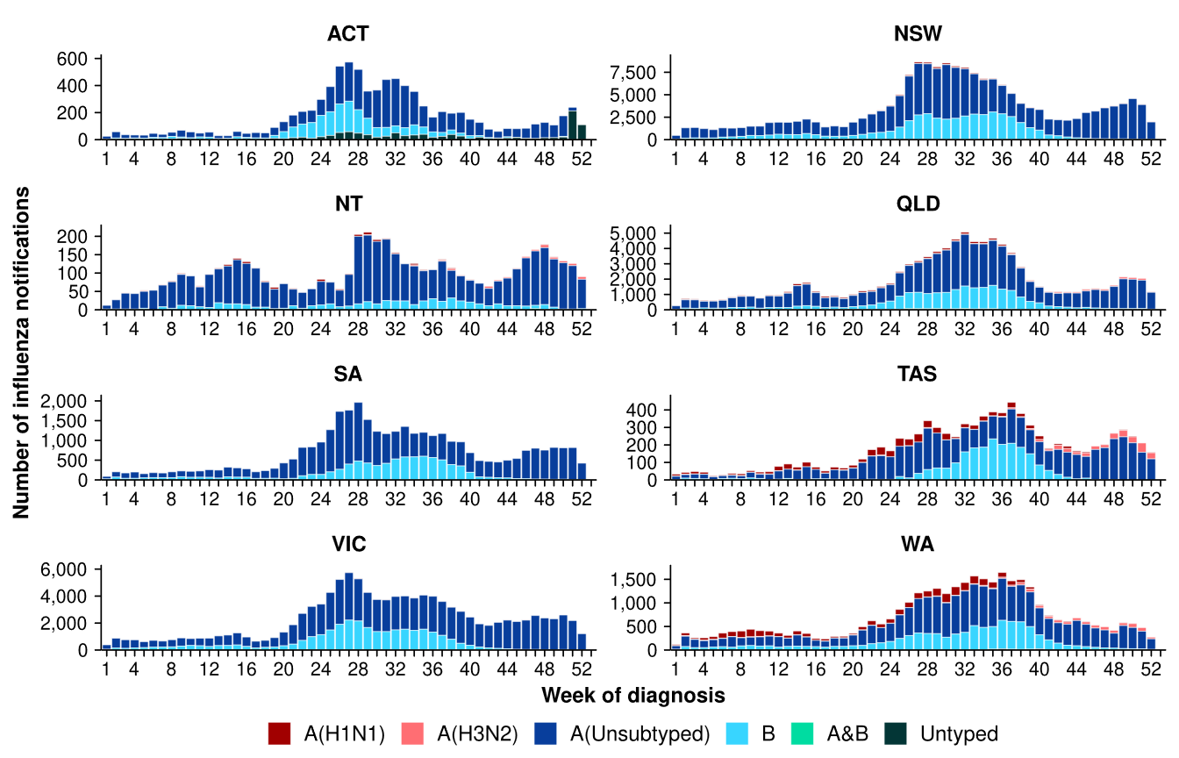
Source: National Notifiable Diseases Surveillance System (NNDSS)
* Axis varies between jurisdictions.
- Nationally, RSV cases have continued to gradually decrease following the peak in case numbers observed in July 2025 (Figure 10).
- Nationally, RSV showed an expected seasonal pattern in 2025, with case numbers increasing through March and April, and peaking mid-year, before declining towards the end of the year. The number of cases this year to date (n=177,205) is similar to the same time last year (n=175,335) (Figure 10).
- In the last month, RSV notification rates remained relatively similar or decreased across most jurisdictions compared to the previous month, except in the NT where notification rates initially increased, before a sharp decrease (Figure 11).
- In 2025 to date, RSV notification rates remain considerably higher in children aged 0–4 years than in other age groups (Table 1).
- In 2025 to date, RSV notification rates are highest in NSW and lowest in WA (Table 1).

Figure 10: Notified RSV cases by year and week of diagnosis*, Australia, 2023 to 28 December 2025
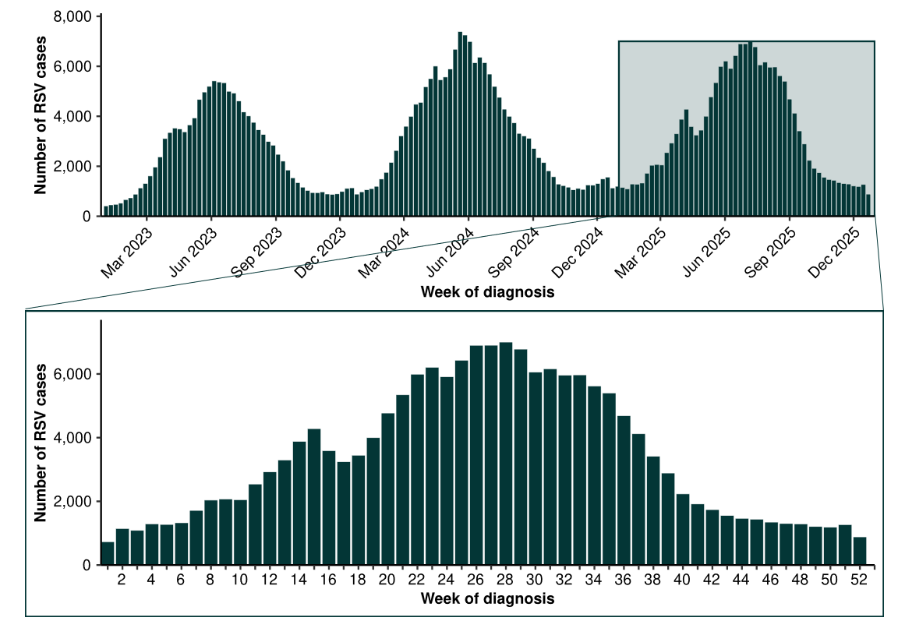
Source: National Notifiable Diseases Surveillance System (NNDSS)
* RSV became notifiable in all states and territories on 1 September 2022 and comprehensive national notification data became available after this point. For this reason, RSV notification trends are only presented from 1 January 2023.

Figure 11: Notification rates* per 100,000 population for RSV cases by state or territory and week of diagnosis, Australia, 1 January to 28 December 2025
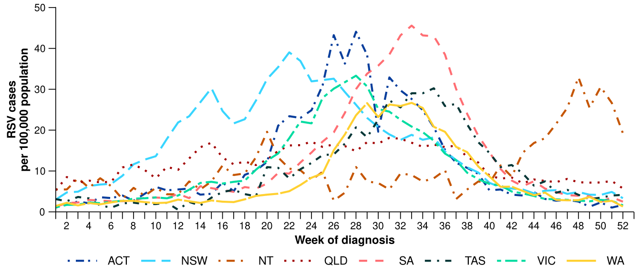
Source: National Notifiable Diseases Surveillance System (NNDSS)
* Rate per 100,000 population for the given time period. Population data are based on the Australian Bureau of Statistics (ABS) Estimated Resident Population (ERP) for the reference period June 2024, released 12 December 2024.

Primary care surveillance
Primary care surveillance monitors the number and characteristics of people who have presented to a general practice with influenza-like illness and provides insight on the different respiratory pathogens that are causing illness in the community.
- In the last month (1 December to 28 December 2025), there were slightly more general practice consultations for influenza-like illness (5.3 notifications per 1,000 consultations per month) compared to the previous month (4.9 notifications per 1,000 consultations per month) (Figure 12).
- From late June to December, influenza-like illness consultation rates have been elevated and consistently higher than in 2022, 2023 and the five-year average. During this time, influenza-like illness consultation rates have been relatively consistent with or slightly higher than those observed in 2024 (Figure 12).
- Like influenza case notification trends, influenza-like illness consultation rates have not yet returned to the interseasonal levels observed in previous years or the five-year average (Figure 6; Figure 12).
Figure 12: Rate of influenza-like illness notifications per 1,000 consultations per week in sentinel general practice sites compared with the five-year average by year and week of consultation*†, Australia, 2022 to 28 December 2025
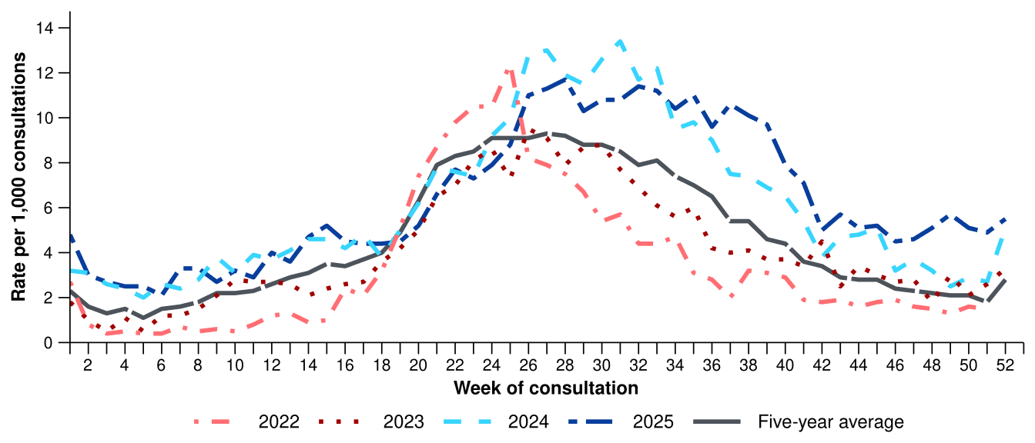
Source: Australian Sentinel Practices Research Network (ASPREN)
* The years 2020 and 2021 are excluded when comparing the current season to historical periods when influenza virus has circulated without public health restrictions. As such, the five-year average includes the years 2018 to 2019 and 2022 to 2024. Please refer to the Technical Supplement for interpretation of the five-year average.
† Please refer to the Technical Supplement for notes on impact of COVID-19 on ASPREN data.
- In the last month, 61.0% (100/164) of people attending general practice with influenza-like illness who were tested have then tested positive for a respiratory pathogen.
- In the last month, influenza (45.0%; 45/100) was the most commonly detected pathogen, followed by rhinovirus (22.0%; 22/100) and RSV (10.0%; 10/100) (Figure 13).
- In 2025 to date, 66.4% (2,116/3,186) of people attending general practice with influenza-like illness who were tested have then tested positive for a respiratory pathogen.
- In 2025 to date, rhinovirus (32.9%; 696/2,116) has been the most commonly detected pathogen, followed by influenza (31.5%; 667/2,116), RSV (9.0%; 190/2,116), SARS-CoV-2 (7.8%; 164/2,116), and human metapneumovirus (6.2%; 132/2,116) (Figure 13).

Figure 13: Number of samples tested for respiratory pathogens among people with influenza-like illness attending sentinel general practice sites by respiratory pathogen and week of specimen collection, Australia, 1 January to 28 December 2025
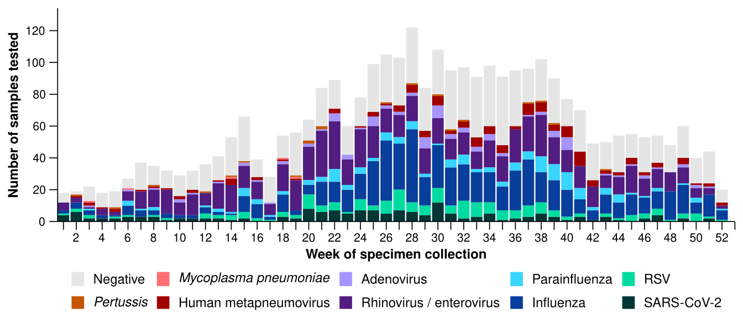
Source: Australian Sentinel Practices Research Network (ASPREN)
Note: All ASPREN swab samples are transported to the SA Pathology laboratory in Adelaide to be tested for viral and bacterial respiratory pathogens via a multiplex real-time reverse transcription polymerase chain reaction (RT-PCR) assay using in-house primers.

Hospital-based surveillance
Hospital-based surveillance monitors persons with more severe illness who have been admitted to hospital for their respiratory illness (severe acute respiratory infections). Hospital-based surveillance also measures the ability of the health system to cope with the number of severe acute respiratory infection admissions to ensure delivery of safe, timely and quality health care.
- In the last severity reporting period (17 November to 14 December 2025), more patients were admitted to a sentinel hospital with a severe acute respiratory infection (n=803), than in the previous severity reporting period (n=749).
  - In the last severity reporting period, at sentinel hospitals there were 6.2% fewer admissions with COVID-19 (from 130 to 122), 17.6% more admissions with influenza (from 476 to 560), and 15.4% fewer admissions with RSV (from 143 to 121), compared to the previous severity reporting period.
- In the year to date for severity reporting (1 January to 14 December 2025), there have been 17,020 admissions with severe acute respiratory infections at sentinel hospitals. Most patients with a severe acute respiratory infection have been admitted with influenza (n=8,418) followed by RSV (n=5,062) (Figure 14).
Figure 14: Total number of patients (children and adults) admitted with a severe acute respiratory infection to sentinel hospitals by disease and week of admission, Australia, 1 January to 14 December 2025
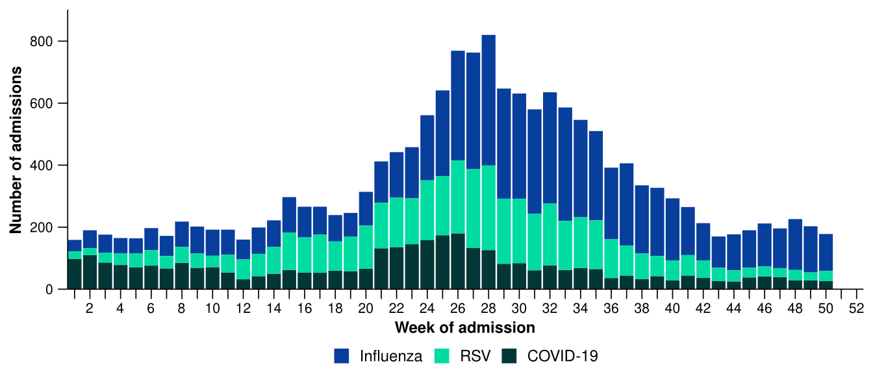
Source: Influenza Complications Alert Network (FluCAN)
- Patients admitted to sentinel hospitals with influenza have mostly been admitted with influenza A (82.3%; 6,930/8,418), while 17.4% (1,462/8,418) were admitted with influenza B.
  - Most hospital admissions with influenza A in 2025 have been with influenza A(Unsubtyped) (46.5%; 3,222/6,930), followed by influenza A(H1N1) (43.6%; 3,022/6,930) and then influenza A(H3N2) (9.9%; 686/6,930).
- In 2025 to date for severity reporting, influenza A was the most commonly detected influenza type in all age groups, except among school aged children (5–16 years) where influenza B was more commonly detected until October 2025. Influenza A(H1N1) was more common earlier in 2025 but since November both the number of admissions and the proportion of admissions with influenza A(H3N2) has increased across age groups (Figure 15).
  - Trends in influenza types/subtypes should be interpreted with care as there may be differences in the number and selection of influenza samples that undergo typing across sites.
Figure 15: Number of patients admitted with influenza to sentinel hospitals by influenza subtype, age group*, and week of admission, Australia, 1 January to 14 December 2025
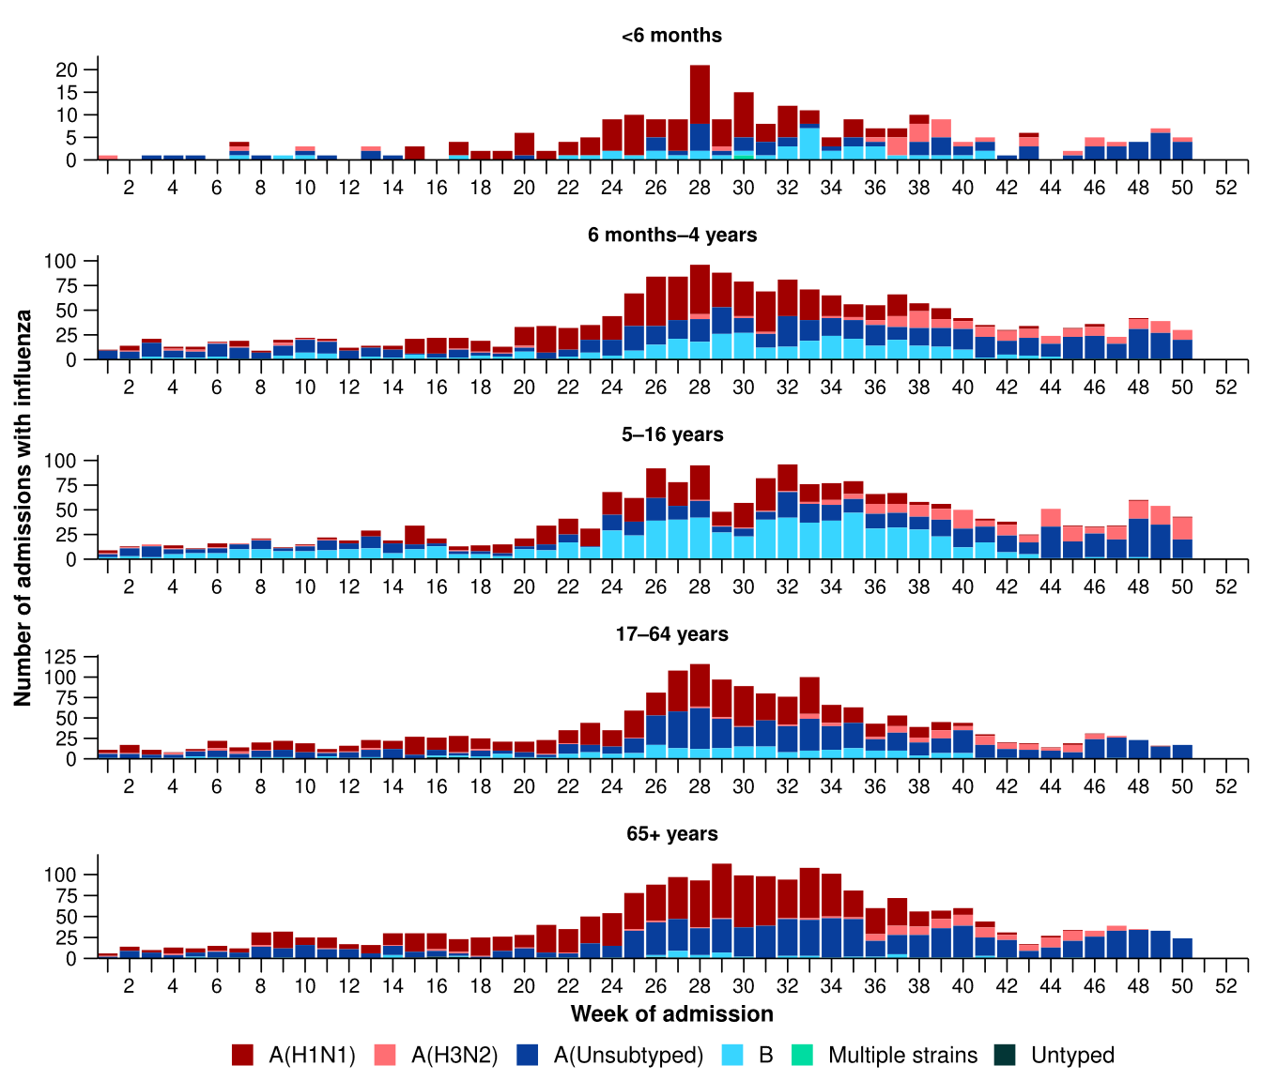
Source: Influenza Complications Alert Network (FluCAN)
* Axis varies between age groups. The age distribution of admissions with influenza may not reflect the age distribution of all patients.
- In 2025 to date for severity reporting, more children (those aged 16 years and younger) have been admitted to sentinel hospitals with influenza than with RSV or COVID-19 (Table 2a).
- Children admitted to sentinel hospitals with influenza tended to be older than children admitted with COVID-19 or RSV (Table 2a).
- Children admitted to sentinel hospitals with RSV or COVID-19 had a slightly longer length of hospital stay compared to children with influenza; however, the difference in the length of stay was minor. The proportion of children admitted directly to intensive care was slightly higher for COVID-19 than influenza and RSV (Table 2a).
- Sadly, there have been a small number of children admitted with a severe acute respiratory infections who have died in sentinel hospitals (Table 2a).
- Despite an increased number of admissions with influenza in late 2025, the proportion of children who have been admitted directly to intensive care or died has not increased considerably since July 2025 and is relatively consistent with the trends observed in 2024 (see 2024 Annual Australian Respiratory Surveillance Report).

Table 2a: Demographic characteristics and outcomes for children admitted with a severe acute respiratory infection to a sentinel hospital by disease*†‡, Australia, 1 January to 14 December 2025
 | COVID-19 | Influenza | RSV
 | Year to date for  severity reporting  (n=1,072) | Year to date for  severity reporting  (n=4,256) | Year to date for  severity reporting  (n=3,995)
Age (years)
Median [IQR] | 1 [0-4] | 4 [1-8] | 1 [0-2]
Age group (years)
< 6 months | 328 (30.6%) | 249 (5.9%) | 895 (22.4%)
6 months – 4 years | 495 (46.2%) | 1,932 (45.4%) | 2,795 (70.0%)
5–16 years | 248 (23.1%) | 2,075 (48.8%) | 305 (7.6%)
Indigenous status
Aboriginal and Torres Strait Islander | 96 (9.0%) | 297 (7.0%) | 299 (7.5%)
Length of hospital stay (days)†
Median [IQR] | 2 [1-3] | 1 [1-2] | 2 [1-3]
Patient admission location‡
Admitted to hospital ward | 995 (92.8%) | 4,035 (94.8%) | 3,791 (94.9%)
Admitted to intensive care directly | 77 (7.2%) | 221 (5.2%) | 204 (5.1%)
Discharge status†
Alive | 886 (82.6%) | 3,547 (83.3%) | 3,501 (87.6%)
Died | 1 (0.1%) | 8 (0.2%) | 2 (0.1%)
Incomplete/missing | 185 (17.3%) | 701 (16.5%) | 492 (12.3%)
Source: Influenza Complications Alert Network (FluCAN)
* Does not include patients with missing age; therefore, the sum of age-specific totals above may not equal the total number of patients.
† For patients who are still in hospital data may not be complete; therefore, these data are not included in the length of stay or discharge status. In addition, length of stay data excludes patients that acquired their infection in hospital.
‡ Admission location reflects the initial admission ward. Some patients may be initially admitted to general ward then later admitted to an intensive care and this is not reflected here. Does not include patients with missing admission location; therefore, the sum of admission location specific totals above may not equal the total number of patients.
The Paediatric Active Enhanced Disease Surveillance (PAEDS) network carries out enhanced sentinel hospital surveillance for some acute respiratory infections or conditions in children. PAEDS data for acute respiratory infections in children are presented in the Australian Respiratory Surveillance Reports in the sentinel hospital data from FluCAN. For additional information on COVID-19 in children, Paediatric Inflammatory Multisystem Syndrome (PIMS-TS) following COVID-19, influenza in children, or RSV in children please visit the PAEDS webpages and dashboards.

- In 2025 to date for severity reporting, more adults (those aged 17 years and over) have been admitted to sentinel hospitals with influenza than with COVID-19 or RSV (Table 2b).
- Adults admitted to sentinel hospitals with COVID-19 or RSV were predominately 65 years and over, whereas the proportion of admissions with influenza was only slightly higher in the 65 years and over age group compared to the 17–64 years age group (Table 2b).
- Adults admitted to sentinel hospitals with COVID-19 had a slightly longer length of hospital stay compared to adults with influenza or RSV; however, the difference in length was minor. A higher proportion of adults with influenza were admitted directly to an intensive care, compared to adults admitted with COVID-19 or RSV (Table 2b).
- Sadly, there have been a number of adults admitted with a severe acute respiratory infections who have died in sentinel hospitals (Table 2b).
- Despite an increased number of admissions with influenza in late 2025, the proportion of adults who have been admitted directly to intensive care has decreased since July 2025, and the proportion who have died has not increased considerably and is relatively consistent with the trends observed in 2024 (see 2024 Annual Australian Respiratory Surveillance Report).
Table 2b: Demographic characteristics and outcomes for adults admitted with a severe acute respiratory infection to a sentinel hospital by disease*†‡, Australia, 1 January to 14 December 2025
 | COVID-19 | Influenza | RSV
 | Year to date for  severity reporting  (n=2,468) | Year to date for  severity reporting  (n=4,161) | Year to date for  severity reporting  (n=1,067)
Age (years)
Median [IQR] | 75 [61-84] | 67 [52-78] | 73 [59-83]
Age group (years)
17–64 years | 738 (29.9%) | 1,890 (45.4%) | 349 (32.7%)
65 years and over | 1,730 (70.1%) | 2,271 (54.6%) | 718 (67.3%)
Indigenous status
Aboriginal and Torres Strait Islander | 148 (6.0%) | 375 (9.0%) | 78 (7.3%)
Length of hospital stay (days)†
Median [IQR] | 5 [2-10] | 4 [2-7] | 4 [2-8]
Patient admission location‡
Admitted to hospital ward | 2,330 (94.4%) | 3,871 (93.0%) | 997 (93.4%)
Admitted to intensive care directly | 138 (5.6%) | 290 (7.0%) | 70 (6.6%)
Discharge status†
Alive | 1,966 (79.7%) | 3,377 (81.2%) | 845 (79.2%)
Died | 87 (3.5%) | 136 (3.3%) | 49 (4.6%)
Incomplete/missing | 415 (16.8%) | 648 (15.6%) | 173 (16.2%)
Source: Influenza Complications Alert Network (FluCAN)
* Does not include patients with missing age; therefore, the sum of age-specific totals above may not equal the total number of patients.
† For patients who are still in hospital data may not be complete; therefore, these data are not included in the length of stay or discharge status. In addition, length of stay data excludes patients that acquired their infection in hospital.
‡ Admission location reflects the initial admission ward. Some patients may be initially admitted to general ward then later admitted to an intensive care and this is not reflected here. Does not include patients with missing admission location; therefore, the sum of admission location specific totals above may not equal the total number of patients.

- In the last severity reporting period, a similar number of patients have been admitted to a sentinel intensive care with a severe acute respiratory infection (n=176), as in the previous severity reporting period (n=177) (Figure 16).
- In the year to date for severity reporting, most patients were admitted to sentinel intensive care with influenza, followed by rhinovirus / enterovirus (Figure 16; Table 3).
Figure 16: Number of patients admitted with severe acute respiratory infections to a sentinel intensive care by disease and week of admission, Australia, 1 January to 14 December 2025
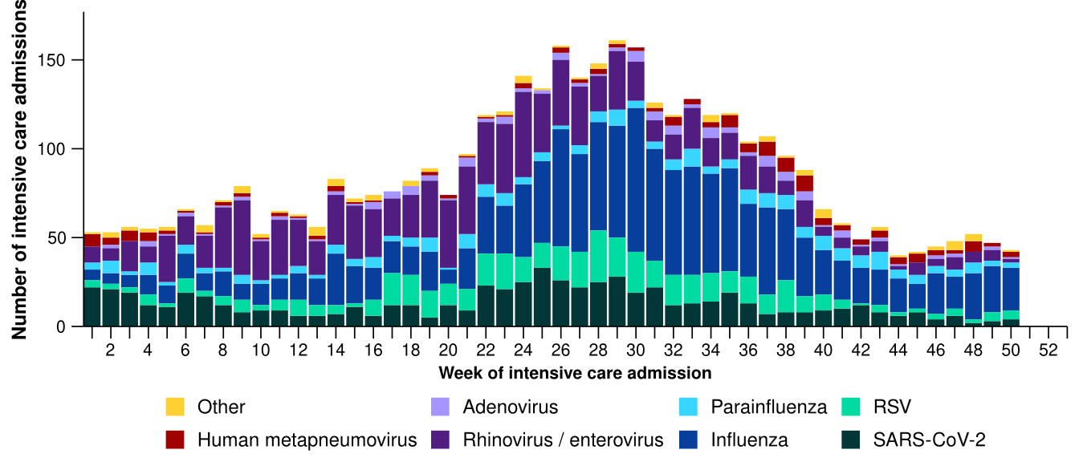
Source: Short Period Incidence Study of Severe Acute Respiratory Infection (SPRINT-SARI) Australia
Note: A range of diagnostic testing procedures are utilised across hospitals in Australia. SPRINT-SARI does not specify which diagnostic testing method should be utilised as this is the domain of the hospital and treating clinicians. Therefore, virological data from SPRINT-SARI should be interpreted with care.
Figure 17: Number of patients admitted with severe acute respiratory infections to a sentinel intensive care by disease and age group*, Australia, 1 January to 14 December 2025
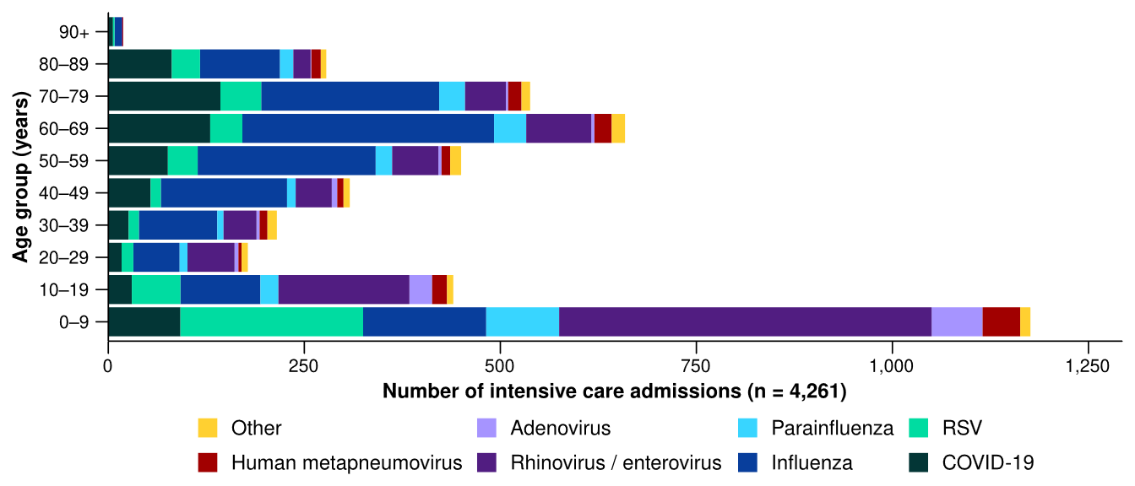
Source: Short Period Incidence Study of Severe Acute Respiratory Infection (SPRINT-SARI) Australia
Note: 5.6% (224/4,019) of patients had co-infections of respiratory pathogens; therefore, the sum of pathogen-specific totals above may not equal the total number of severe acute respiratory infection patients.
* The age distribution of severe acute respiratory infection intensive care admissions may not reflect the age distribution of all patients.
- In 2025 to date for severity reporting, admissions to a sentinel intensive care with COVID-19 or influenza have generally been among older people. In contrast, admissions with rhinovirus or RSV have been among younger people, primarily those aged 0–9 years old (Figure 17; Table 3).
- A higher proportion of admissions with influenza and parainfluenza required invasive mechanical ventilation and the length of ventilation was longest among those with influenza. The length of intensive care stay was relatively similar across diseases (Table 3).
- Most patients admitted to a sentinel intensive care with a severe acute respiratory infection have been discharged home. Sadly, a number of patients have died in hospital (Table 3). Despite an increased number of admissions with influenza in late 2025, the proportion of admissions who have died has only increased slightly since July 2025 and is relatively consistent with the trends observed in 2024 (see 2024 Annual Australian Respiratory Surveillance Report).
Table 3: Demographic characteristics and outcomes of patients admitted with a severe acute respiratory infection to a sentinel intensive care by disease*†, Australia, 1 January to 14 December 2025
 | COVID-19 | hMPV | Influenza | Parainfluenza | Rhinovirus | RSV | Other
 | Year to date for severity reporting  (n=655) | Year to date for severity reporting  (n=152) | Year to date for severity reporting  (n=1,465) | Year to date for severity reporting  (n=257) | Year to date for severity reporting  (n=1,007) | Year to date for severity reporting  (n=505) | Year to date for severity reporting  (n=220)
Age (years)
Median [IQR] | 63  [39–74] | 36  [6–67] | 57  [34–69] | 35  [6–66] | 10  [4–42] | 11  [2–60] | 18  [6–54]
Indigenous status
Aboriginal and Torres Strait Islander | 61  (9.3%) | 7  (4.6%) | 118  (8.1%) | 22  (8.6%) | 93  (9.2%) | 38  (7.5%) | 23  (10.5%)
Non-Indigenous | 594  (90.7%) | 145  (95.4%) | 1347  (91.9%) | 235  (91.4%) | 914  (90.8%) | 467  (92.5%) | 197  (89.5%)
Received invasive mechanical ventilation
Number (%) | 188  (28.7%) | 39  (25.7%) | 507  (34.6%) | 97  (37.7%) | 291  (28.9%) | 106  (21.0%) | 84  (38.2%)
Length of invasive mechanical ventilation (days)*
Median [IQR] | 3 [1–6] | 4 [1–8] | 5 [2–11] | 3 [1–6] | 3 [1–7] | 3 [1–7] | 3 [1–6]
Length of intensive care stay (days)*
Median [IQR] | 3 [2–5] | 3 [2–6] | 3 [2–7] | 3 [2–6] | 2 [1–5] | 3 [2–5] | 3 [2–6]
Length of hospital stay (days)*
Median [IQR] | 8 [4–15] | 8 [5–13] | 8 [5–16] | 7 [4–14] | 6 [3–12] | 6 [3–10] | 8 [3–17]
Patient outcome†
Ongoing care in intensive care | 7  (1.1%) | 3  (2.0%) | 36  (2.5%) | 1  (0.4%) | 8  (0.8%) | 4  (0.8%) | 2  (0.9%)
Ongoing care in hospital ward | 13  (2.0%) | 1  (0.7%) | 24  (1.6%) | 8  (3.1%) | 14  (1.4%) | 12  (2.4%) | –
Transfer to other hospital / facility | 110  (16.8%) | 15  (9.9%) | 214  (14.6%) | 33  (12.8%) | 100  (9.9%) | 59  (11.7%) | 27  (12.3%)
Discharged home | 411  (62.7%) | 118  (77.6%) | 1016  (69.4%) | 198  (77.0%) | 814  (80.8%) | 398  (78.8%) | 171  (77.7%)
Died in hospital | 108  (16.5%) | 14  (9.2%) | 167  (11.4%) | 15  (5.8%) | 66  (6.6%) | 30  (5.9%) | 19  (8.6%)
Source: Short Period Incidence Study of Severe Acute Respiratory Infection (SPRINT-SARI) Australia
Note: 5.6% (224/4,019) of patients had co-infections of respiratory pathogens; therefore, the sum of pathogen-specific totals above may not equal the total number of severe acute respiratory infection patients.
* For patients receiving ongoing care in intensive care data may not be complete; therefore, data are not included in the length of ventilation or stay.
† Patients who have been admitted with no discharge information for less than 90 days have been assumed to have ongoing care in the hospital. Patients who have no outcome entered or have been admitted for more than 90 days with no discharge information have been treated as missing.
- In the last month (1 December to 28 December 2025), there were less COVID-19 cases occupying intensive care beds across Australia than in the previous month (Figure 18).
- In the last month, there were more intensive care staff unavailable to work due to illness across Australia than in the previous month (Figure 18).
Figure 18: Average number of COVID-19 cases in intensive care and the average number of intensive care staff unavailable to work due to illness by week of report*†, Australia, 1 January to 28 December 2025
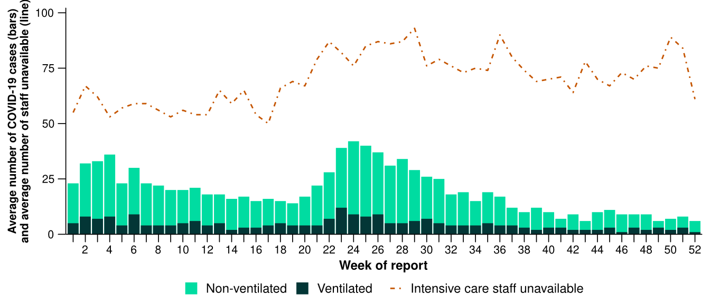
Source: Critical Health Resource Information System (CHRIS)
* Average number of ventilated and non-ventilated COVID-19 cases in intensive care includes only active COVID-19 cases (those in isolation) and does not include cleared COVID-19 cases.
† Intensive care staff include both medical and nursing staff. Staff unavailability will be underestimated in NSW as most public hospitals in NSW do not report staff unavailability.
- In the last month, the number of COVID-19 cases occupying intensive care beds decreased or remained stable in most jurisdictions except in NSW where an increase was observed compared with the previous month (Figure 19).
- In the last month, the number of intensive care staff unavailable to work due to illness increased or remained stable in most jurisdictions but decreased in the ACT, NSW, and the NT, compared with the previous month (Figure 19).

Figure 19: Average number of COVID-19 cases in intensive care and the average number of intensive care staff unavailable to work due to illness by jurisdiction and week of report*†‡, Australia, 1 January to 28 December 2025
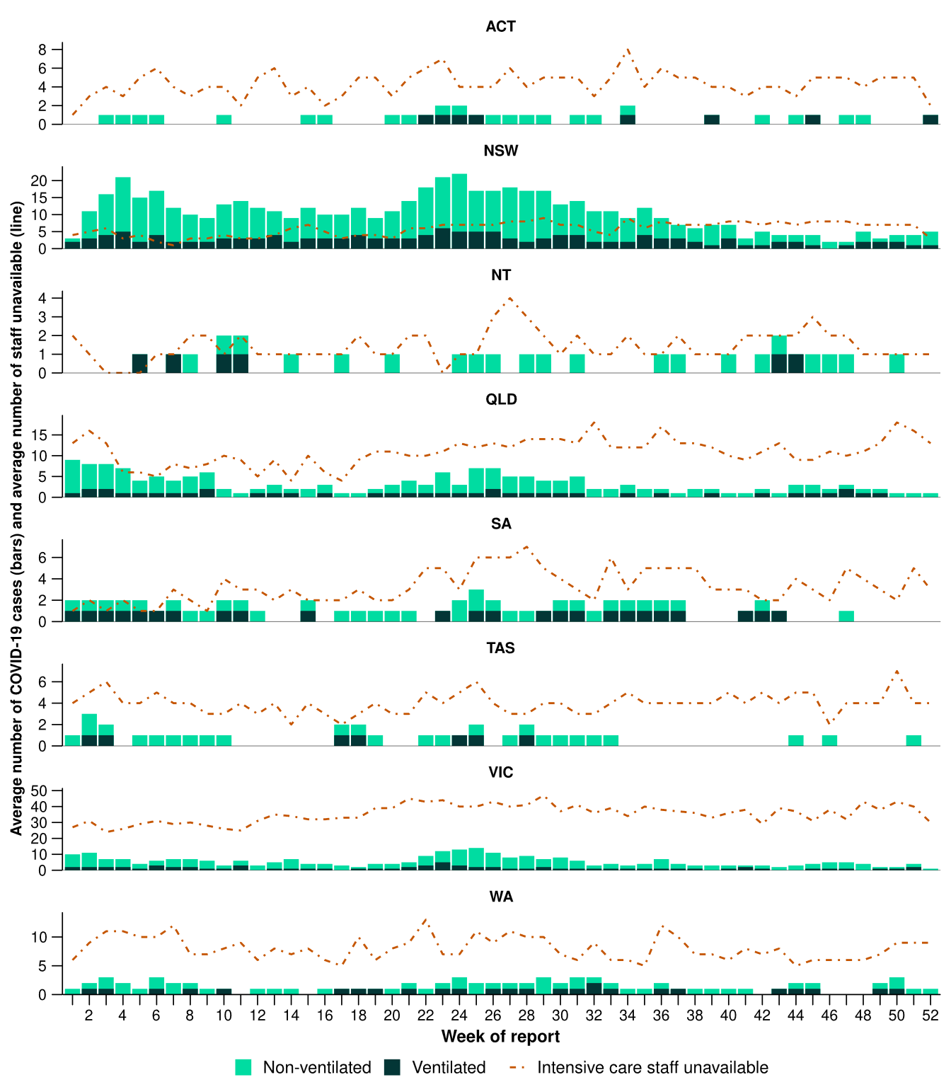
Source: Critical Health Resource Information System (CHRIS)
* Axis varies between jurisdictions.
† Average number of ventilated and non-ventilated COVID-19 cases in intensive care includes only active COVID-19 cases (those in isolation) and does not include cleared COVID-19 cases.
‡ Intensive care staff include both medical and nursing staff. Staff unavailability will be underestimated in NSW as most public hospitals in NSW do not report staff unavailability.

Mortality surveillance
Death registrations can provide information on the scale and severity of disease associated with acute respiratory infections. For more information on death registrations including completeness, timeliness, and detailed definitions of deaths due to and with acute respiratory infections, refer to the Technical Supplement.
- An acute respiratory associated death is one where the death was due to the disease (the illness has caused terminal complications such as pneumonia) or the person has died with the disease (a person has died from another cause but the illness still contributed significantly to death).
- COVID-19 has been the leading cause of acute respiratory infection mortality across 2023–2025. However, the number of deaths involving influenza (both due to and with) has exceeded the number of deaths involving COVID-19 from August to October 2025.
- In 2025 the mortality rate for deaths involving influenza (both due to and with) was higher for Aboriginal and Torres Strait Islander people than non-Indigenous people; however, the rate for deaths involving COVID-19 is lower for Aboriginal and Torres Strait Islander people than non-Indigenous people.
- Since the end of 2021, a pattern has been observed for COVID-19 where there are two peaks of mortality during the year - one occurring between November and January and the other occurring between May and August. There were more deaths in June and July 2025 than earlier in the year, but the winter peak has been much smaller than in 2023 or 2024 (Figure 20a/b).
Figure 20a: Provisional numbers of deaths due to an acute respiratory infection*† by month, year, and disease, Australia, 1 January 2023 to 30 November 2025
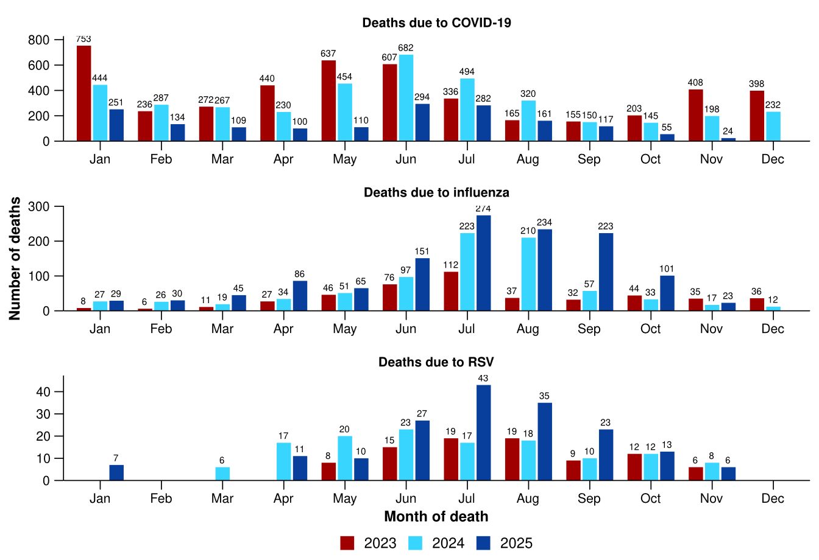
Source: Australian Bureau of Statistics, Deaths due to acute respiratory infections in Australia, released 19 December 2025.
* Axis varies between acute respiratory infections.
† Data is provisional and subject to change. It can take several weeks for death registrations to be reported, processed, coded, validated, and tabulated. Therefore, the data shown here may be incomplete. Data for some months were not published by the ABS due to small counts, and therefore not reported here. Data includes all deaths (both doctor and coroner certified) that occurred and were registered by 30 November 2025.
- Deaths due to COVID-19 fell in October 2025 to the lowest levels since July 2021. For the year to October 2025, the 1,613 deaths due to COVID-19 in 2025 were considerably less than both 2024 (3,473 deaths) and 2023 (3,804 deaths) (Figure 20a).
- Deaths due to influenza remain high for this time of year, aligning with the higher number of notifications than usual in this period. There were 1,238 deaths due to influenza in the first ten months of 2025, comparable to the first 10 months of 2017 (1,239 deaths) but higher than the first ten months of 2019 (1,046 deaths), which were both recent high mortality years for influenza (Figure 20a).
  - Although the number of deaths due to influenza in 2025 is high, this is expected when there are higher case numbers, and other surveillance systems have not indicated that illness has been more severe in 2025 compared to previous years
- Deaths due to RSV decreased in October 2025 and are comparable to the number of deaths in October 2023 and 2024 (Figure 20a).
- Deaths with COVID-19 decreased in October 2025 to the lowest levels since September 2021 (Figure 20b).
- Deaths with influenza decreased in October 2025 but remain higher than in October 2024 and 2023 (Figure 20b).
- Deaths with RSV decreased in October 2025 and are comparable to October 2024 and 2023. For the year to October, the 349 deaths with RSV are higher than in 2024 (314 deaths) and 2023 (259 deaths) (Figure 20b).
- All three of these acute respiratory infections are more likely to cause death in older age groups than younger age groups.
Figure 20b: Provisional numbers of deaths with an acute respiratory infection*† by month, year, and disease, Australia, 1 January 2023 to 30 November 2025
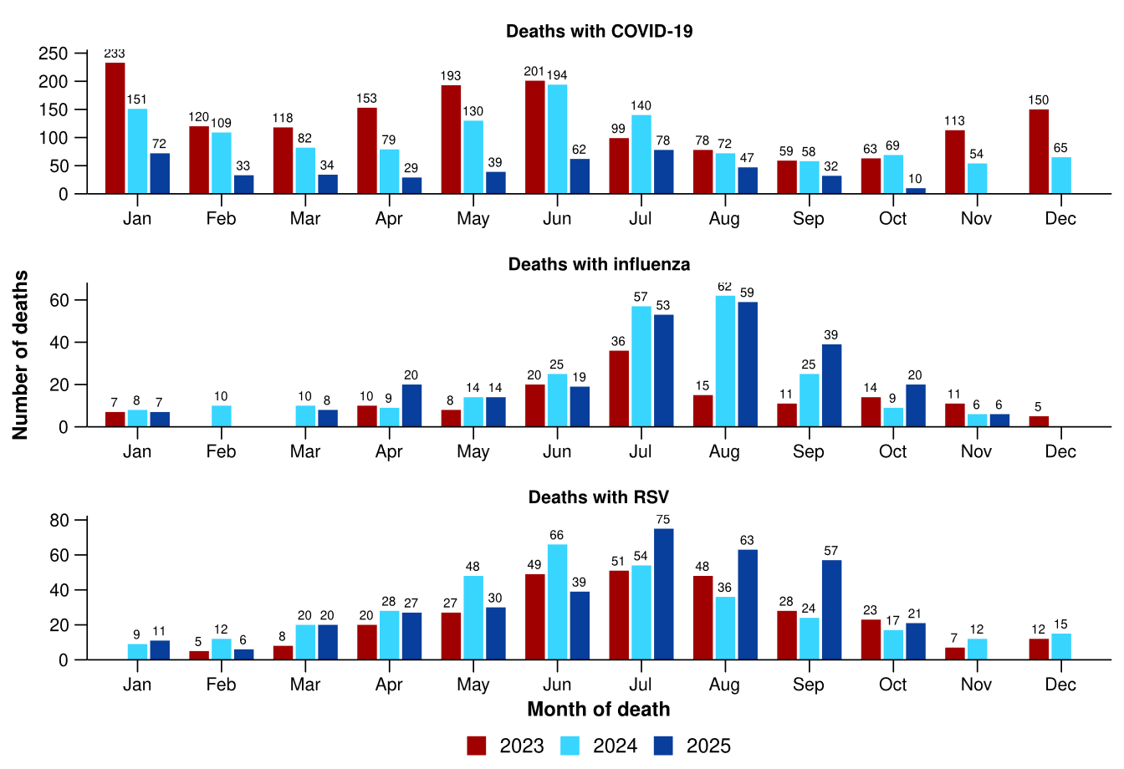
Source: Australian Bureau of Statistics, Deaths due to acute respiratory infections in Australia, released 19 December 2025.
* Axis varies between acute respiratory infections.
† Data is provisional and subject to change. It can take several weeks for death registrations to be reported, processed, coded, validated, and tabulated. Therefore, the data shown here may be incomplete. Data for some months were not published by the ABS due to small counts, and therefore not reported here. Data includes all deaths (both doctor and coroner certified) that occurred and were registered by 30 November 2025.

Laboratory surveillance
Sentinel laboratory surveillance monitors and characterises respiratory pathogens to provide information on what pathogens are circulating, potential changes in the pathogens that might affect their infectiousness, severity, ability to evade vaccine and/or infection-acquired immunity, or resistance to antivirals.
- In the last month (1 December to 28 December 2025), SARS-CoV-2 test positivity decreased to 1.6% (323/19,806), influenza test positivity increased to 9.2% (2,225/24,235), and RSV test positivity remained stable at 0.7% (148/19,806) (Figure 21).

Figure 21: Number of tests positive (bars) and test positivity (line) for SARS-CoV-2, influenza or RSV of those specimens tested by sentinel laboratories by week of report*†, Australia, 1 January to 28 December 2025
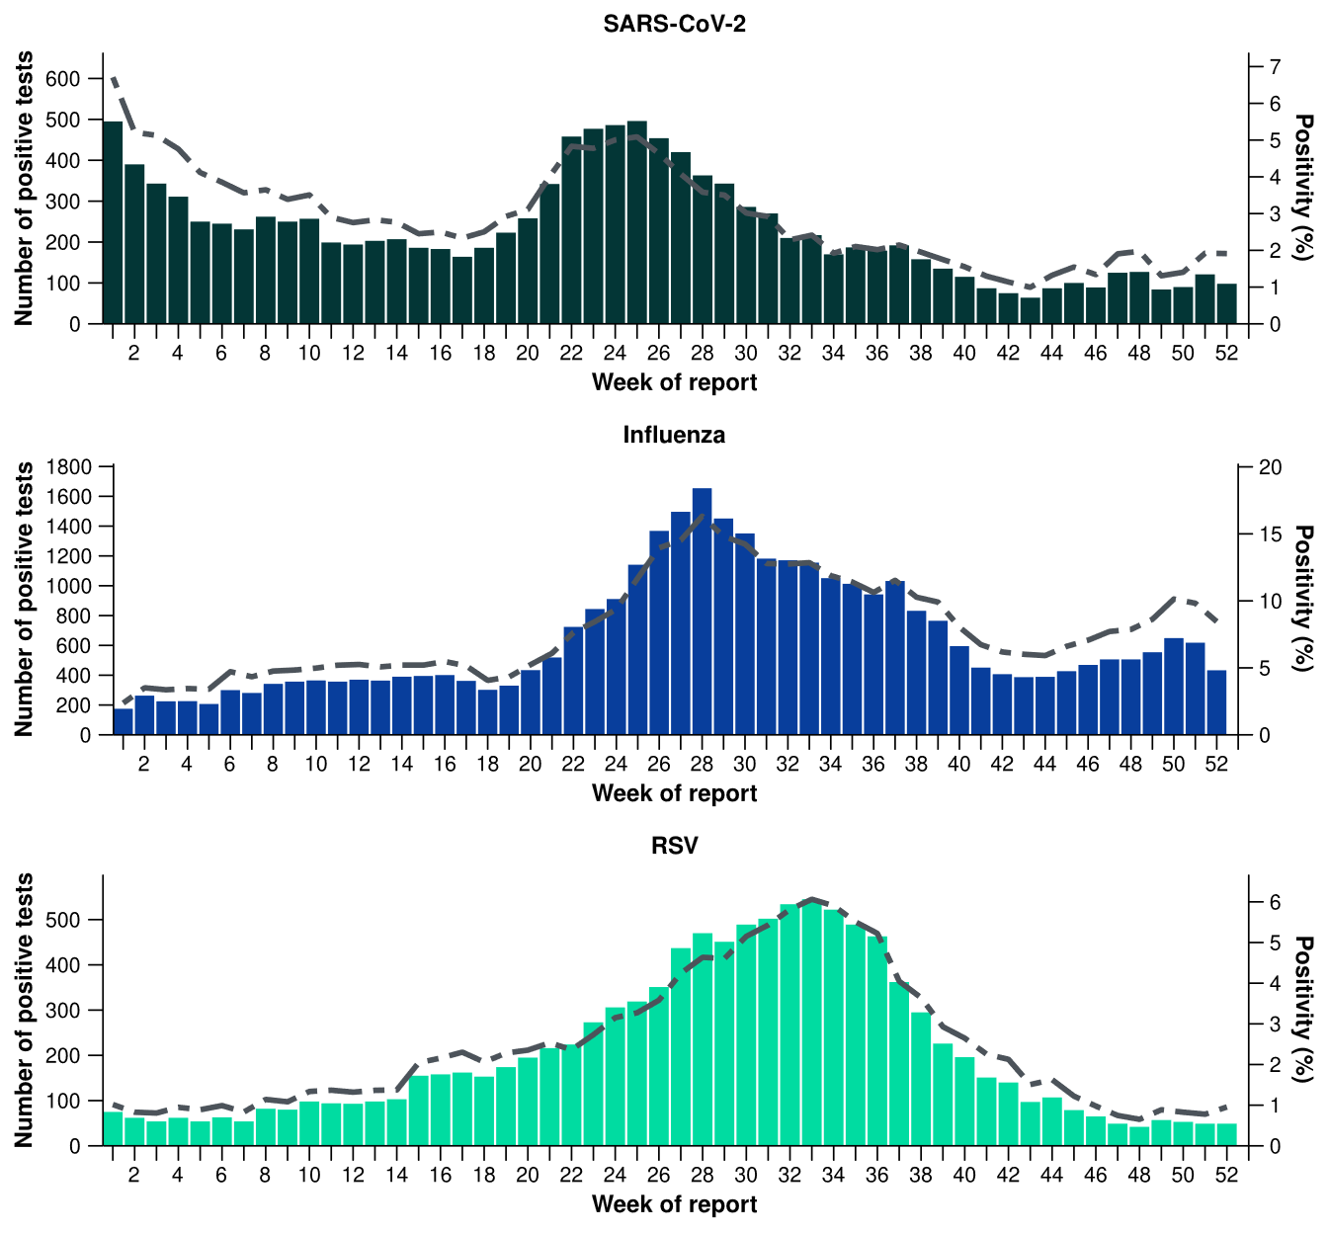
Source: Sentinel laboratories, including National Influenza Centres
* Number of specimens tested excludes data from WA as testing denominator data are different for the three pathogens in Western Australia.
† A small minority of total samples from Victoria are tested only by respiratory panel (influenza, parainfluenza, adenovirus, human metapneumovirus, seasonal coronaviruses, RSV, and some picornaviruses) but not for SARS-CoV-2. These minority samples include only forensic materials; all other samples are tested by respiratory panel and SARS-CoV-2 assay.

- There were 118 SARS-CoV-2 sequences uploaded to AusTrakka with dates of collection in the last 28 days. These sequences were from NSW, SA, Tas and Vic, with the most recent collection date 22 December 2025. The low number of sequences uploaded to AusTrakka in the last 28 days is likely due to the reduced number of cases and changes in sequencing capacity and priorities.
- Most sequences were assigned to the BA.2.86 sub-lineage within B.1.1.529 (Omicron), or recombinants consisting of one or more Omicron sub-lineages (Figure 22a/b). In the last 28 days:
  - 28.8% (34/118) of sequences were from the sub-sub-lineages JN.1 (BA.2.86.1.1), including KP.3.1.1 (32/118). No sequences were identified from KP.2
  - 63.6% (75/118) of sequences were recombinant or recombinant sub-lineages, including NB.1.8.1 and XFG
  - 7.6% (9/118) of sequences were identified as BA.3.
  - there were no BA.1, BA.4, BA.5 or other BA.2 sub-sub-lineage sequences.
- NB.1.8.1 is the dominant sub-lineage in the last 28 days, accounting for 45.8% (54/118) of sequences (Figure 22a).
- The World Health Organization (WHO) have identified certain sub-sub-lineages and recombinants as variants under monitoring (VUM) or variants of interest (VOI) because of their epidemiological, pathological, or immunological features of concern. A select number are highlighted below due to their relevance in the Australian context. There are:
  - 75 BA.3.2 (newly designated VUM) sequences in AusTrakka, with 9 collected in the last 28 days
  - 665 XFG sequences in AusTrakka, with 18 collected in the last 28 days
  - 2,651 NB.1.8.1 sequences in AusTrakka, with 54 collected in the last 28 days
  - 773 LP.8.1 sequences in AusTrakka, with 2 collected in the last 28 days
  - 3,734 KP.3.1.1 sequences in AusTrakka, with 32 sequences collected in the last 28 days.
Figure 22a: SARS-CoV-2 Omicron sub-lineage* sequences by sample collection date, showing the proportions of sequences per week†‡, Australia, 1 January to 28 December 2025
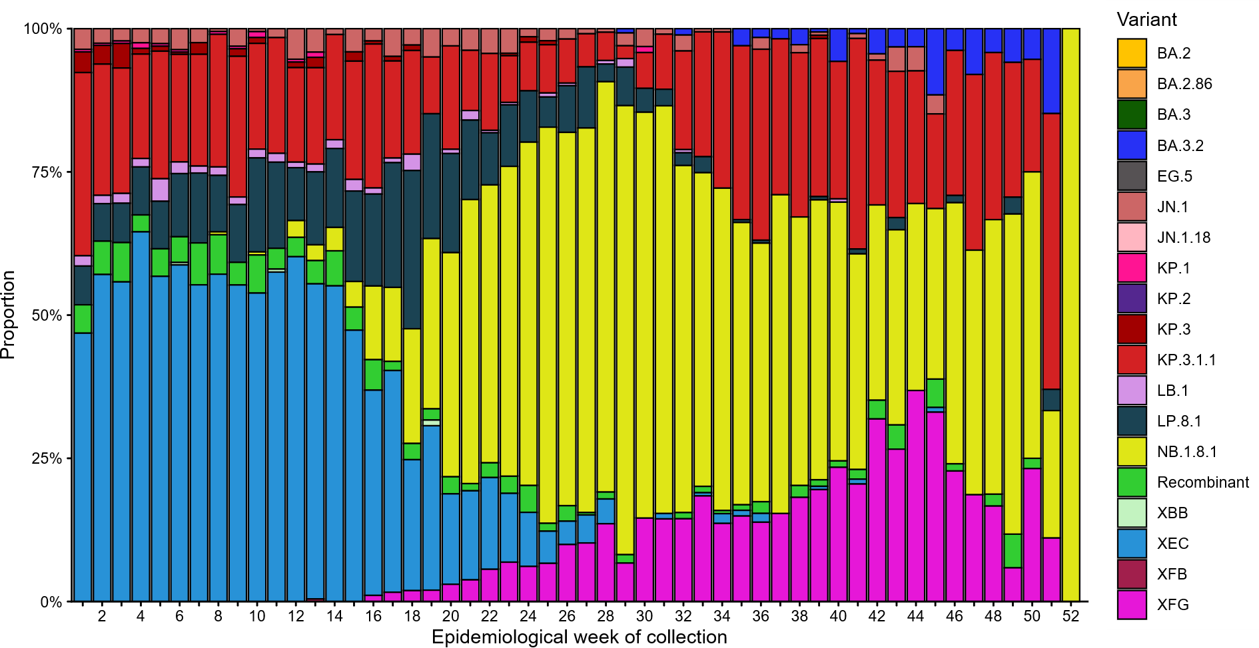Source: AusTrakka
* Some sub-sublineages are shown alongside their parent lineage, but not included in the parent lineage totals. For instance, KP.2 and KP.3 are sub-sub lineages of JN.1, so the total of JN.1 sequences will be higher than shown in the corresponding colour alone, and should include the KP.2 and KP.3 totals.
† Sequences in AusTrakka aggregated by week and reported based on date of sample collection, not date of sequencing.
‡ Proportions in Figure 22a may not be representative when sequence numbers are small; refer to Figure 22b. Data for earlier weeks may change between reporting periods as sequences with older collection dates are uploaded. These numbers are not equivalent to number of cases, as there are many cases which may not be sequenced. Non-VOI and non-VUM Omicron sub-lineages have been collapsed into parent lineages BA.1, BA.2, BA.3, BA.4 and BA.5.
Figure 22b: SARS-CoV-2 Omicron sub-lineage* sequences by sample collection date, showing the count of sequences per week†‡, Australia, 1 January to 28 December 2025
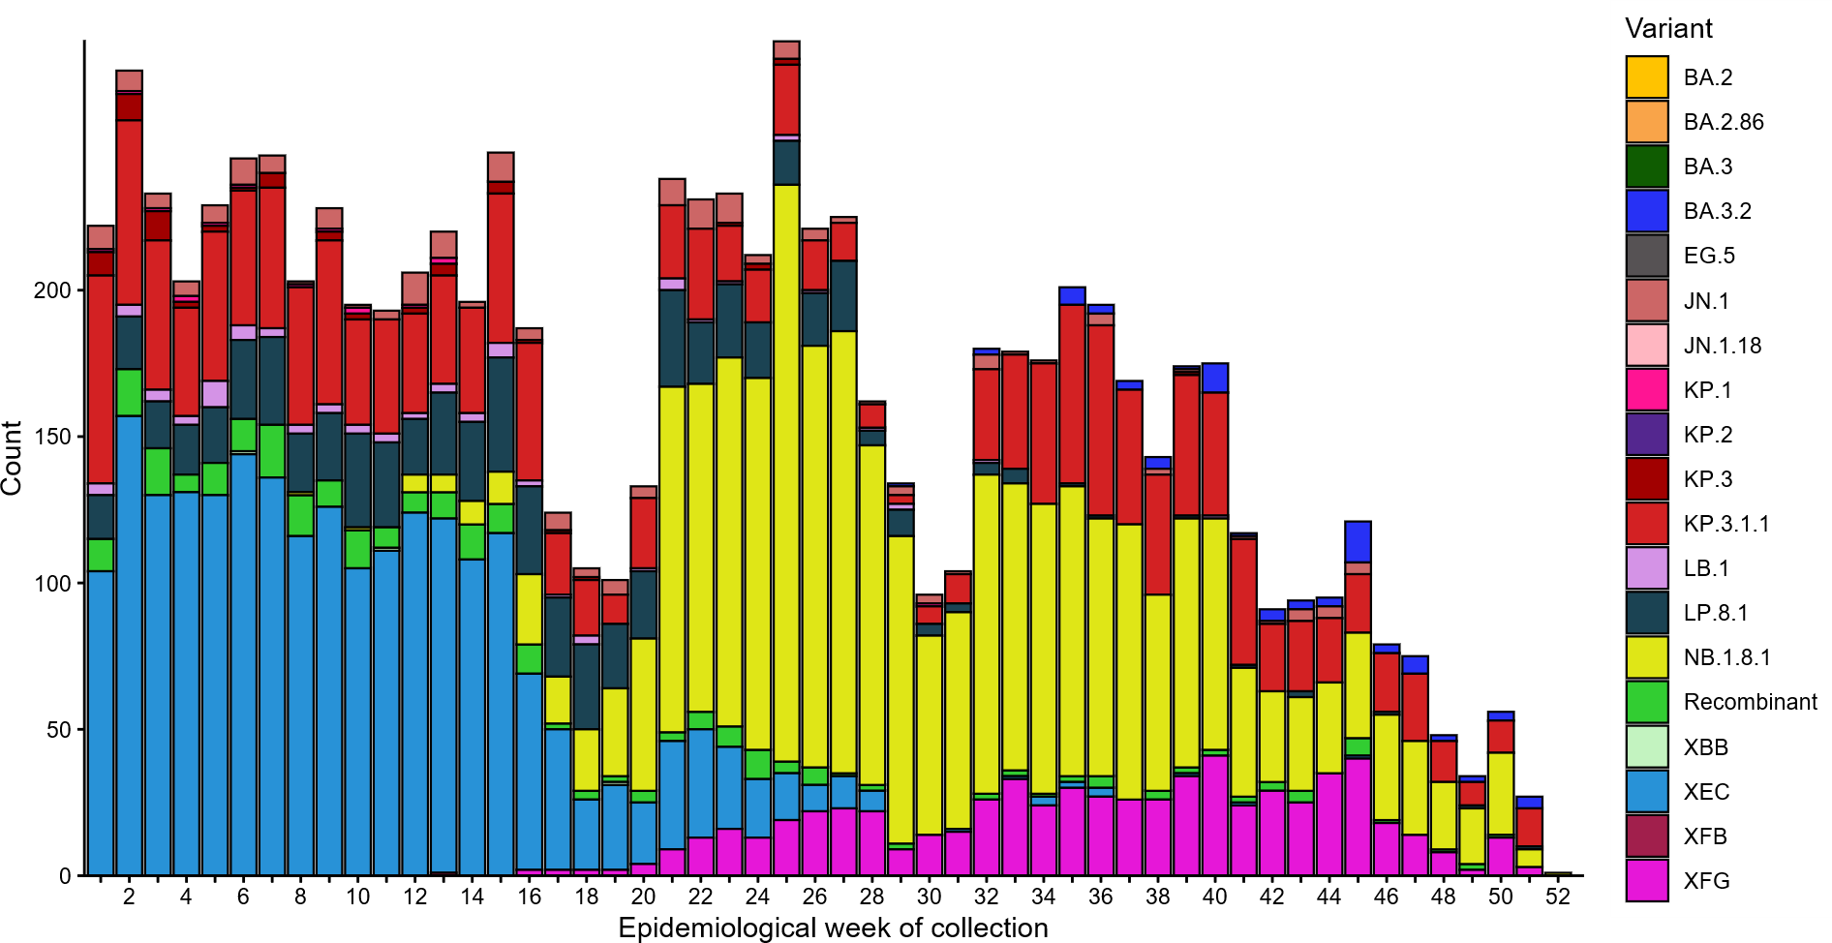
Source: AusTrakka
* Some sub-sublineages are shown alongside their parent lineage, but not included in the parent lineage totals. For instance, KP.2 and KP.3 are sub-sub lineages of JN.1, so the total of JN.1 sequences will be higher than shown in the corresponding colour alone, and should include the KP.2 and KP.3 totals.
† Sequences in AusTrakka aggregated by week and reported based on date of sample collection, not date of sequencing.
‡ Data for earlier weeks may change between reporting periods as sequences with older collection dates are uploaded. These numbers are not equivalent to number of cases, as there are many cases which may not be sequenced. Non-VOI and non-VUM Omicron sub-lineages have been collapsed into parent lineages BA.1, BA.2, BA.3, BA.4 and BA.5.
- In 2025 to date, the WHO Collaborating Centre for Reference and Research on Influenza has antigenically characterised 5,115 influenza viruses from Australia (Table 4), of which:
  - 61.6% (3,153/5,115) have been influenza A(H1N1)
  - 20.1% (1,029/5,115) have been influenza A(H3N2)
  - 18.2% (933/5,115) have been influenza B/Victoria.
- In 2025 to date, there have been no influenza B/Yamagata viruses characterised (Table 4). The last influenza B/Yamagata virus characterised in Australia was in a sample from 2020.
- The WHO Collaborating Centre for Reference and Research on Influenza and partners have published a report on the extended influenza seasons in Australia and New Zealand in 2025 due to the emergence of influenza A(H3N2) subclade K viruses. The report outlines:
  - Subclade K emerged in submitted Australian influenza samples from August onwards, spread rapidly and became predominant in October−November in Australia
  - This is the first time that such a variant has emerged so rapidly and spread so widely towards the end of the season in Australia and is unusual for A(H3N2) viruses but has been seen previously on occasions in Australia with influenza B viruses
  - Antigenic characterisation of subclade K viruses found these to be distinct from prior circulating subclade J viruses and from the A(H3N2) strain included in the 2025 southern hemisphere and 2025/26 northern hemisphere vaccines
  - a phylogeographic analysis showed that Australian subclade K viruses may have originated in or been imported from the United States (US), following detections of subclade K viruses in the US in June and July 2025
  - Importantly the Australian viruses were still susceptible to all licensed influenza antiviral drugs.
  - These analyses are limited to the small proportion of influenza samples in Australia that are subtyped and undergo further testing.
- Of the influenza A(H1N1) samples tested for neuraminidase inhibitor resistance, 2.1% (30/1,408) demonstrated highly reduced inhibition to Oseltamivir. None of the influenza A(H3N2) samples tested demonstrated highly reduced inhibition to Oseltamivir.
- None of the samples tested demonstrated highly reduced inhibition to Zanamivir.
Table 4: Australian influenza viruses typed by haemagglutination inhibition assay and jurisdiction*†, 1 January to 28 December 2025
Strain | ACT | NSW | NT | Qld | SA | Tas | Vic | WA | Total
A(H1N1) | 307 | 478 | 699 | 164 | 104 | 449 | 870 | 82 | 3,153
A(H3N2) | 44 | 202 | 331 | 55 | 24 | 79 | 254 | 40 | 1,029
B/Victoria lineage | 97 | 218 | 134 | 29 | 25 | 72 | 300 | 58 | 933
B/Yamagata lineage | 0 | 0 | 0 | 0 | 0 | 0 | 0 | 0 | 0
Total | 448 | 898 | 1,164 | 248 | 153 | 600 | 1,424 | 180 | 5,115
Source: World Health Organization (WHO) Collaborating Centre for Reference and Research on Influenza
*Viruses tested by the WHO Collaborating Centre for Reference and Research on Influenza are not necessarily a random sample of all those in the community and early-year data may be based on limited samples received. There may be up to a month delay on reporting of samples.
† Jurisdiction indicates the residential location for the individual tested, not the submitting laboratory.

Vaccine coverage, effectiveness and match
Vaccine coverage, effectiveness and match for acute respiratory infections are monitored from several data sources in Australia. Refer to the Technical Supplement for more information.

Vaccine coverage
- Nationally, 2.9% of adults (aged 18 years and over) have received a COVID-19 vaccine in the last six months (Table 5).
- Nationally, fewer adults have received a COVID-19 vaccine in the last 12 months (10.6%; Table 5), compared to the 12 months prior (11.8% from 25 December 2023 to 22 December 2024).
- In the last 12 months, vaccine coverage decreased in all age groups, with the largest decrease seen in 65–74 years age group (from 29% in the 12 months prior to 25.7% in the last 12 months).
- There has been substantial variation in COVID-19 vaccine coverage across age groups, ranging from 4.4% in adults aged 18–64 years to 40.9% in adults aged 75 years and over. Vaccine coverage increases with increasing age (Table 5).
- There has been some variation in vaccine coverage across jurisdictions, ranging from 4.1% in the NT to 18.2% in Tas (Table 5).
Table 5: COVID-19 vaccine coverage*†‡ by age group and jurisdiction, Australia, 23 December 2024 to 28 December 2025
Age group | ACT | NSW | NT | Qld | SA | Tas | Vic | WA | Total
Last 12 months (23 December 2024 to 28 December 2025)
18–64 years | 9.7 | 3.7 | 2.0 | 4.2 | 4.3 | 8.0 | 4.7 | 4.3 | 4.4
65–74 years | 46.3 | 23.8 | 15.0 | 24.8 | 26.7 | 37.9 | 26.1 | 26.0 | 25.7
≥ 75 years | 63.9 | 38.9 | 25.9 | 39.9 | 41.2 | 54.8 | 40.1 | 42.4 | 40.9
All ages (18 years and over) | 17.5 | 9.8 | 4.1 | 10.2 | 11.7 | 18.2 | 10.6 | 10.3 | 10.6
Last 6 months (23 June 2025 to 28 December 2025)
18–64 years | 2.2 | 1.0 | 0.8 | 1.2 | 1.2 | 1.9 | 1.1 | 0.9 | 1.1
65–74 years | 11.1 | 5.9 | 5.4 | 6.4 | 6.6 | 8.3 | 6.0 | 5.4 | 6.2
≥ 75 years | 21.6 | 12.4 | 10.1 | 13.1 | 13.6 | 16.6 | 12.7 | 11.7 | 13.0
All ages (18 years and over) | 4.7 | 2.8 | 1.6 | 3.0 | 3.4 | 4.7 | 2.8 | 2.5 | 2.9
Source: Australian Immunisation Register (AIR) as at 29 December 2025
* COVID-19 vaccine coverage among the general population uses the most recently available Australian Bureau of Statistics Estimated Resident Population (ERP) as denominator for population data. Age in years is calculated as at the reporting week.
† COVID-19 vaccine coverage is influenced by changes in COVID-19 vaccine recommendations and eligibility criteria. For this reason, caution should be used when comparing coverage rates in the current 12 month period to previous 12 month periods. Coverage data in these tables may differ slightly from coverage estimates in other reports due to differences in calculation methodologies and/or different data download dates.
‡ Jurisdiction is based on the state or territory in which a vaccine was administered and may differ from a person’s residential address. Population denominator data used to calculate COVID-19 vaccine coverage are based on an individual’s residential address. Total rows will include individuals where jurisdiction was missing.

- Nationally, 1.3% of Aboriginal and Torres Strait Islander adults (aged 18 years or over) have received a COVID-19 vaccine in the last six months (Table 6).
- Nationally, fewer Aboriginal and Torres Strait Islander adults have received a COVID-19 vaccine in the last 12 months (4.5%; Table 6), compared to the 12 months prior (5.6% from 25 December 2023 to 22 December 2024).
- In the last 12 months, vaccine coverage decreased in all age groups of Aboriginal and Torres Strait Islander people, with the largest decrease seen in 65–74 years age group (from 20.8% in the 12 months prior to 17.2% in the last 12 months).
- Among Aboriginal and Torres Strait Islander people there has been substantial variation in COVID-19 vaccine coverage across age groups, ranging from 2.6% in adults aged 18–64 years to 26.6% in adults aged 75 years and over. Vaccine coverage increases with increasing age (Table 6).
- Among Aboriginal and Torres Strait Islander people, there has been slight variation in vaccine coverage across jurisdictions, ranging from 2.7% in the NT to 9.2% in Tas (Table 6).
Table 6: COVID-19 vaccine coverage*†‡ among Aboriginal and Torres Strait Islander populations by age group and jurisdiction, Australia, 23 December 2024 to 28 December 2025
Age group | ACT | NSW | NT | Qld | SA | Tas | Vic | WA | Total
Last 12 months (23 December 2024 to 28 December 2025)
18–64 years | 5.9 | 2.6 | 1.9 | 2.4 | 2.6 | 5.1 | 3.6 | 2.2 | 2.6
65–74 years | 32.5 | 18.2 | 9.7 | 16.6 | 16.6 | 30.6 | 19.7 | 15.7 | 17.2
≥ 75 years | 45.4 | 28.5 | 13.6 | 24.8 | 29.2 | 42.3 | 31.9 | 26.5 | 26.6
All ages (18 years and over) | 8.8 | 4.9 | 2.7 | 4.1 | 4.7 | 9.2 | 6.3 | 3.7 | 4.5
Last 6 months (23 June 2025 to 28 December 2025)
18–64 years | 1.3 | 0.7 | 0.9 | 0.7 | 0.8 | 1.3 | 0.9 | 0.7 | 0.7
65–74 years | 7.8 | 4.9 | 4.3 | 4.5 | 3.8 | 7.7 | 4.9 | 4.6 | 4.7
≥ 75 years | 12.0 | 9.4 | 6.4 | 8.5 | 9.3 | 12.5 | 10.6 | 8.3 | 8.9
All ages (18 years and over) | 2.1 | 1.4 | 1.2 | 1.2 | 1.4 | 2.4 | 1.7 | 1.1 | 1.3
Source: Australian Immunisation Register (AIR) as at 29 December 2025
* COVID-19 vaccine coverage among Aboriginal and Torres Strait Islander populations is based on the AIR population as known at the reporting week. Age in years is calculated as at the reporting week.
† COVID-19 vaccine coverage is influenced by changes in COVID-19 vaccine recommendations and eligibility criteria. For this reason, caution should be used when comparing coverage rates in the 12 month period to previous 12 month periods. Coverage data in these tables may differ slightly from coverage estimates in other reports due to differences in calculation methodologies and/or different data download dates.
‡ Jurisdiction is based on the state or territory in which a vaccine was administered and may differ from a person’s residential address. Population denominator data used to calculate COVID-19 vaccine coverage are based on an individual’s residential address. Total rows will include individuals where jurisdiction was missing.

- From November 2025, the influenza vaccine coverage data will temporarily not be updated in line with the current reporting period, as the 2025 seasonal vaccination campaign has ended. However, historical updates may still be made to data. As a result, coverage metrics could differ between this report and previous reports.
- Nationally, influenza vaccine coverage is 30.7% for 2025 to date (Table 7).
- There has been substantial variation in influenza vaccine coverage across age groups, ranging from 14.7% in children aged 5–14 years to 61.5% in adults aged 65 years and over (Table 7). The current trend should be interpreted with care as people aged 5–64 years are generally not eligible for free seasonal influenza vaccines under the National Immunisation Program.
- There has been some variation in influenza vaccine coverage across jurisdictions, ranging from 26.1% in the NT to 40.2% in the ACT (Table 7).
- Among Aboriginal and Torres Strait Islander populations, there has been substantial variation in influenza vaccine coverage across age groups, ranging from 11.3% in children aged 5–14 years to 61.6% in adults aged 65 years and over (Table 7).
- Among Aboriginal and Torres Strait Islander populations, there has been some variation in influenza vaccine coverage across jurisdictions, ranging from 20.1% in WA to 35.6% in the NT (Table 7).

Table 7: Influenza vaccine coverage*†‡ by age group and jurisdiction, Australia, 1 March to 2 November 2025
 | ACT | NSW | NT | Qld | SA | Tas | Vic | WA | Total
Age groups
6 months to <5 years | 54.3 | 28.9 | 43.4 | 23.5 | 32.6 | 35.4 | 35.7 | 27.2 | 30.3
5–14 years | 24.0 | 13.6 | 14.5 | 13.4 | 15.6 | 15.3 | 16.1 | 15.5 | 14.7
15–49 years | 32.8 | 19.7 | 23.7 | 18.7 | 24.0 | 23.9 | 24.0 | 19.0 | 21.2
50–64 years | 44.0 | 30.3 | 26.8 | 31.9 | 36.4 | 39.6 | 34.5 | 31.1 | 32.6
≥ 65 years | 65.4 | 59.0 | 38.5 | 61.7 | 67.6 | 69.0 | 62.7 | 60.9 | 61.5
All ages (6 months and over) | 40.2 | 29.2 | 26.1 | 28.7 | 35.3 | 36.9 | 32.7 | 28.6 | 30.7
Aboriginal and Torres Strait Islander populations
6 months to <5 years | 35.2 | 19.7 | 44.4 | 16.5 | 19.8 | 25.0 | 24.8 | 20.6 | 21.0
5–14 years | 0.0 | 11.2 | 23.9 | 10.9 | 12.8 | 12.9 | 0.0 | 11.8 | 11.3
15–49 years | 26.5 | 17.3 | 33.8 | 16.4 | 20.4 | 20.1 | 19.9 | 16.3 | 18.9
50–64 years | 0.0 | 36.9 | 46.6 | 35.7 | 38.9 | 46.2 | 37.2 | 33.6 | 37.1
≥ 65 years | 70.1 | 63.5 | 49.2 | 61.5 | 64.6 | 70.8 | 64.5 | 55.3 | 61.6
All ages (6 months and over) | 21.7 | 22.3 | 35.6 | 20.5 | 24.3 | 27.0 | 22.8 | 20.1 | 22.9
Source: Australian Immunisation Register (AIR) as at 29 December 2025
* Influenza vaccine coverage uses the AIR population as the denominator. Coverage data in these tables may differ slightly from coverage estimates in other reports due to differences in calculation methodologies and/or different data download dates.
† Age is calculated based on the person’s age as at 1 July of the reporting year.
‡ From the report ending 13 July 2025, jurisdiction is based on the person’s address on the AIR rather than an individual’s residential address as recorded on Medicare. Total rows will include individuals where jurisdiction was missing. In addition, to align with departmental reporting methodologies, both the numerator (number of persons vaccinated) and denominator (AIR population) for influenza vaccine coverage only consider person records with a Personal Identification Number that was able to be matched to Medicare. Person records with a Synthetic Identification Number are now excluded from both numerator and denominator. For these reasons, influenza vaccine coverage metrics in previous Australian Respiratory Surveillance Reports and coverage metrics from the report ending 13 July 2025 moving forward should be interpreted with care.

- Since the commencement of the National RSV Mother and Infant Protection Program, 175,169 Abrysvo doses have been administered to pregnant people nationally (Table 8).
- While high maternal vaccine uptake is a positive indicator of maternal program success, it may result in lower nirsevimab uptake rates in infants. This is because maternal antibodies passed to the infant can provide protection against RSV, potentially reducing the need for infant immunisation.
Table 8: Number of doses of Abrysvo administered to pregnant people by jurisdiction*, Australia, 3 February to 28 December 2025
 | ACT | NSW | NT | Qld | SA | Tas | Vic | WA | Total
Age group
15–24 years | 246 | 4,414 | 363 | 4,094 | 959 | 479 | 2,594 | 1,672 | 14,823
25–39 years | 4,023 | 46,972 | 1,524 | 27,670 | 10,517 | 3,282 | 41,665 | 15,248 | 150,901
40–54 years | 272 | 3,113 | 72 | 1,436 | 598 | 144 | 2,914 | 896 | 9,445
Total (15–54 years) | 4,541 | 54,499 | 1,959 | 33,200 | 12,074 | 3,905 | 47,173 | 17,816 | 175,169
Source: Australian Immunisation Register (AIR) as at 29 December 2025
* Jurisdiction is based on the state or territory in which a vaccine was administered and may differ from a person’s residential address. Total rows will include individuals where jurisdiction was missing.
- In the last six months, 8% of infants (aged < 8 months) have received nirsevimab (Table 9).
- There has been slight variation in nirsevimab uptake in infants across jurisdictions, ranging from 2.9% in the ACT to 11.1% in the NT (Table 9).
- The current trend is likely due to variation in the seasonality and eligibility criteria between state and territory programs, as well as the presence of previous nirsevimab programs. Some state and territory programs are seasonal (from 1 April to 30 September), whereas others are year-round. In states with seasonal programs (SA, Tas, Vic, and parts of WA), uptake may appear disproportionately lower at this time of the year.
Table 9: Nirsevimab (Beyfortus) uptake in the last six months*†‡ by age group and jurisdiction, Australia, 23 June 2025 to 28 December 2025
 | ACT | NSW | NT | Qld | SA | Tas | Vic | WA | Total
Age group
Infants (aged < 8 months) | 2.9 | 6.0 | 11.1 | 10.2 | 7.3 | 10.5 | 7.9 | 10.0 | 8.0
Young children (aged ≥ 8 to 24 months) | 0.1 | 0.1 | 0.2 | 0.1 | 0.3 | 0.5 | 0.5 | 0.9 | 0.3
Source: Australian Immunisation Register (AIR) as at 29 December 2025
* Reporting of RSV monoclonal antibodies to the AIR is not compulsory; therefore, uptake is likely to be underestimated. Uptake data in these tables may differ slightly from estimates in other reports due to differences in calculation methodologies and/or different data download dates.
† For infants and young children vaccinated, age in months is calculate as months between the immunisation encounter and date of birth rounded down as at the reporting date. For the infant and young children population, age in months is calculated as months between the AIR data extract date and date of birth rounded down as at the reporting date.
‡ Jurisdiction is based on the state or territory in which a vaccine was administered and may differ from a person’s residential address. Total rows will include individuals where jurisdiction was missing. Population denominator data used to calculate nirsevimab uptake are based on an individual’s residential address as recorded on Medicare.

Vaccine effectiveness - interim estimates

ASPREN and FluCAN for the Global Influenza Vaccine Effectiveness (GIVE) Collaboration
- Vaccine effectiveness (VE) is the reduction in risk of influenza and its complications in those vaccinated, compared to those not vaccinated. Interim Australian studies suggest that in 2025, vaccinated people are roughly 53% less likely to attend general practice or be hospitalised with influenza than unvaccinated people. Please note, these interim estimates are based on incomplete data and the final VE estimates for 2025 may differ.
- Estimated VE against general practice attendance with influenza overall is 56% (95% Confidence Interval [CI]: 40%, 68%).
  - Estimated VE against general practice attendance with influenza A(H1N1) is 51% (95% CI: 26%, 67%). No estimates are available for VE against general practice attendance with influenza A(H3N2) at this time due to lower case numbers during the season.
  - Estimated VE against general practice attendance with influenza B is 60% (95% CI: 27%, 78%).
  - Estimated VE against general practice attendance with influenza is comparable between children (less than 18 years) (61%, 95% CI: 20%, 81%) and adults aged 65 years and over (62%, 95% CI: 41%, 75%), and lower in those aged 18–64 years (32%, 95% CI: -38%, 66%).
  - These VE estimates against general practice attendance for influenza are slightly lower than observed in 2024 (62% overall, 95% CI: 45%, 74%). VE estimates were higher in those 65 years and over in 2024 and lower in children (less than 18 years) in 2024 compared to 2025. Notably, VE estimates against general practice attendance with influenza A(H1N1), which also circulated at high levels in 2024, were substantially lower in 2025 than in 2024 (74%, 95% CI: 45%, 88%).
- Estimated VE against hospitalisation with influenza overall is 49% (95% CI: 42%, 56%).
  - Estimated VE against hospitalisation with influenza A(H1N1) is 42% (95% CI: 29%, 52%), and for influenza A(H3N2) is 60% (95% CI: 4%, 84%).
  - Estimated VE against hospitalisation with influenza B is 78% (95% CI: 68%, 85%).
  - Estimated VE against hospitalisation with influenza is much higher in children <18 years of age (67%, 95% CI: 58%, 74%), compared to adults aged 65 years and over (38%, 95% CI: 19%, 52%), and those aged 18–64 year (22%, 95% CI: -5%, 43%).
  - These VE estimates against hospitalisation with influenza are lower when compared to 2024 estimates (56% overall, 95% CI: 48%, 63%). VE in the 18–64 years and 65 years and over age groups are significantly lower compared to 2024 (60%, 95% CI: 35%, 77%, and 81%, 95% CI: 50%, 93% respectively) but remain consistent in children less than 18 years.

Vaccine match
- Refer to the Technical Supplement for information on the 2025 southern hemisphere influenza vaccines composition.
- In the year to date, 99.5% (3,136/3,153) of influenza A(H1N1) isolates, 37.4% (385/1,029) of influenza A(H3N2) isolates and 97.4% (909/933) of influenza B/Victoria lineage isolates characterised have been antigenically similar to the corresponding 2025 vaccine components.
- Since October 2025, there has been a notable increase in influenza A(H3N2) viruses received by the WHO Collaborating Centre for Reference and Research on Influenza. Antigenic testing of these viruses has shown reduced reactivity to the southern hemisphere 2025 vaccine strain; however, these viruses show reasonable reactivity to the new southern hemisphere 2026 vaccine strain. Further genetic and antigenic analysis is required to understand this change.

