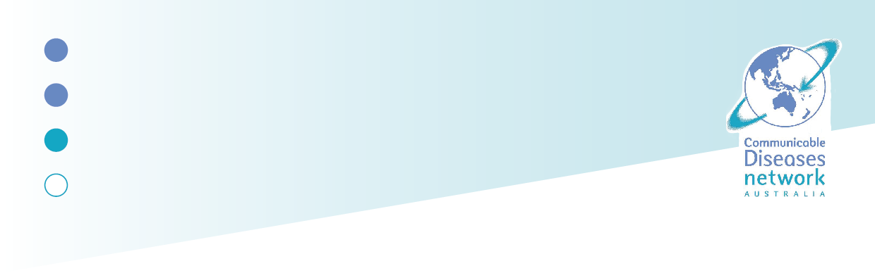
National Arbovirus and Malaria Advisory Committee (NAMAC)
CHARTER
Purpose | NAMAC is a subcommittee of the Communicable Diseases Network Australia (CDNA). Its role is to provide expert advice to CDNA on vector-borne disease (VBD) matters including arboviruses, malaria, other vectors/vector-borne pathogens and arthropods of public health concern.  NAMAC also provides advice regarding risks associated with various endemic and exotic vectors and their control. This includes advice to CDNA and governments on proposed legislative and policy changes, and on the impact of climate change on human arthropod pests and VBD through a One Health lens.  NAMAC’s objectives are to:  - Define and support the development and maintenance of high-quality surveillance to monitor transmission trends and epidemiological indicators of VBD.  - Contribute to strategic advice and policy development, with consideration given to priority populations, prevention strategies, effectiveness of treatments and future risks associated with VBD.  - Support the planning and implementation of coordinated national approaches to VBD management.  During outbreak situations, CDNA may task NAMAC with developing and contributing to advice on vector-borne diseases.
Chair | NAMAC has a Chair and Deputy Chair. The appointment of the Chair and Deputy Chair is subject to CDNA endorsement and is typically for a two-year period.  The Chair of NAMAC should, where possible, be nominated from amongst NAMAC’s jurisdictional representatives. A jurisdiction is defined as the ACT, TAS, NT, NSW, QLD, WA, SA, VIC and the Commonwealth.  To assist in succession planning, where possible, the Deputy Chair will follow as Chair in two-year cycles.
Membership | NAMAC members include:  - Jurisdictional/Government representatives from:  - ACT Health  - Department of Agriculture, Forrest and Fisheries  - Department of Health, Disability and Ageing  - Department of Health, Victoria  - New South Wales Health  - Northern Territory Department of Health  - Queensland Health  - South Australia Health  - Tasmania Department of Health  - Western Australia Health, Government of Western Australia  - Experts on a range of relevant subjects including:  - Mosquito ecology and management, clinical diagnostics, exotic mosquito risk and management, biosecurity, animal health, insecticide resistance, vector-host interactions and virus ecology, vaccines, disease prevention and management, and non-mosquito vectors.  - Cross-committee members of relevant governance committees such as CDNA, the Environmental Health Standing Committee (enHealth) and the Public Health Laboratory Network (PHLN)  All members are expected to:  - Use respectful and inclusive language to ensure a welcome and supportive environment in all facets of NAMAC business.  - Raise issues pertaining to vectors, arthropods of public health significance, VBD risk of cross-jurisdictional or national relevance that require NAMAC’s guidance on risk, mitigation or other matters warranting national action.  - Provide advice and seek advice from relevant experts on vectors or vector-borne disease, as required by the Australian Government and state/territory governments.  - Contribute to NAMAC work plans, reporting requirements and working groups, as agreed by NAMAC and CDNA.  CDNA must endorse changes to NAMAC Membership. However, changes to jurisdictional and/or government representative NAMAC members do not need to be endorsed by CDNA. CDNA will note additional experts who are engaged for a specific purpose. NAMAC can engage additional external experts as key stakeholders on specific matters as necessary.  All members and proxies must disclose any conflict of interest immediately, actual or potential, relating to their membership of the subcommittee.  Members may share committee documents with appropriate colleagues when seeking advice. Specific requests to share documents, where members are unsure, can be brought to the Secretariat for approval.  Members are responsible for providing up to date contact details to the Secretariat.
Structure | The Health Chief Executives Forum (HCEF) is the advisory and support body to the Health Ministers' Meeting. The Australian Health Protection Committee (AHPC) is a subcommittee of HCEF and supports HCEF to deliver national leadership advice on health protection.  AHPC aims to reduce the incidence and consequence of health risks posed by infectious diseases, environmental issues, and both natural and human-made disasters in Australia. The CDNA is a subcommittee of the AHPC.  NAMAC, a subcommittee of CDNA, provides advice on arbovirus and malaria surveillance and expert advice on disease management and vector control.
Meetings and Attendance | In a calendar year, NAMAC will meet 2 to 4 times a year virtually, with additional extraordinary meetings convened virtually as required. A proposed meeting schedule will be prepared by the Secretariat, endorsed annually, and provided to CDNA.  The NAMAC Jurisdictional Executive Group, comprising jurisdictional and Commonwealth members, may also meet separately on an as-needed basis.  All members are expected to attend each meeting. If a member is unable to attend, a proxy may be nominated, with notice provided to the Chair and Secretariat. All members, except invited experts, may be represented by a proxy.  Secretariat support for NAMAC is provided by the Australian Government Department of Health, Disability and Ageing.
Governance | Work plan  Upon request, NAMAC will provide CDNA with a one-year work plan for oversight of its key activities and priorities. NAMAC may develop a broader ongoing work plan, covering both business as usual and time-limited activities.  Agenda  The Chair is responsible for guiding the agenda. All members may nominate agenda items, which should focus on NAMC’s purpose and objectives, agreed priorities, CDNA tasking, and emerging vector-borne disease issues. Other matters may be included at the Chair’s discretion in consultation with members.  Matters may be progressed in formal sessions or out of session, as determined by the Chair in consultation with the Secretariat and members. Time-limited Working Groups may be established to progress specific items. Any agenda items requiring a decision should be supported by a paper, documentation or presentation unless exceptional circumstances apply.
Principles for advice and decision making | No business can be conducted without a quorum. As per the CDNA Charter, NAMAC will not normally be considered quorate unless the Chair, the Commonwealth, and more than two jurisdictions are represented by a member or their proxy.  Decisions and advice should be:  - Evidence and principles-based allowing jurisdictions flexibility in implementation.  - Consensus based, consistent with the CNDA’s Charter, noting that some decision-making and voting arrangements may be set out in legislation.  Where consensus cannot be reached within the required timeframe, alternatives may include majority vote, out of session review, dedicated jurisdictional discussion, Chair decision, or escalation to CDNA for consideration. Decisions agreed by the majority should not commit non-agreeing jurisdictions to a specific course of action without acknowledgement.  Where a vote is required, only jurisdictional members are entitled to vote, though they should consider the advice provided by non-voting members.  NAMAC advice will not be considered national policy until endorsed by CDNA and/or AHPC as appropriate  Provision of advice  The Chair’s agreement must be sought before proxies, observers or guest attend. Guest will leave once their item concludes and will not participate in committee business  Advice to external agencies and organisations must follow appropriate reporting channels, i.e. through CDNA to AHPC where applicable  If consensus cannot be reached on an item in a timely manner, the Chair will refer the matter to CDNA for consideration.
Scope of responsibility | NAMAC provides policy and public health advice to the CDNA and its relevant subcommittees on surveillance, strategic policy development and outbreak management for arboviruses, malaria, and other vector-borne diseases of national significance.  Surveillance and Reporting  Advise on surveillance and reporting systems across humans, vectors and animals including minimum state and territory data requirements.  - Coordinate surveillance activities aligned with national priorities.  - Integration of jurisdictional outcomes to inform national surveillance priorities.  - Promote One Health linkages across animal, human and environmental health.  Strategic Policy Development  Provide policy and public health advice on national strategies for managing vectors and arthropods of public health importance, including arbovirus and malaria. This advice includes:  - informing the national outbreak response in association with jurisdictional responsibilities  - identifying ongoing research requirements and outbreak investigation  - establishing lines of communications with relevant interested parties working in the arbovirus and malaria sector  - advising on other arthropod pests of humans  Expert Advice and Outbreak Management  - Provide expert technical advice on arboviruses, malaria, and other vector-borne pathogens to support detection, management, and outbreak control.  - Assess and advise on risks from endemic, exotic or invasive vector species/vector-borne pathogens.  - Coordinate outbreak response activities as required.
Review | This Charter will remain in force until otherwise agreed by CDNA. Regular review of this Charter should occur to ensure accuracy and relevance.
Record keeping and communications | Outcomes, including decisions, actions and key issues/commentary arising from the meeting, will be documented in the meeting minutes by NAMAC Secretariat. Minutes will be circulated out of session for endorsement and stored on the NAMAC SharePoint site for member access. Endorsed minutes will be stored as per official records management for the Department of Health, Disability and Ageing.
Supporting documents | NAMAC Membership List  Guidance for Intergovernmental Meetings

Document version: v1.0

