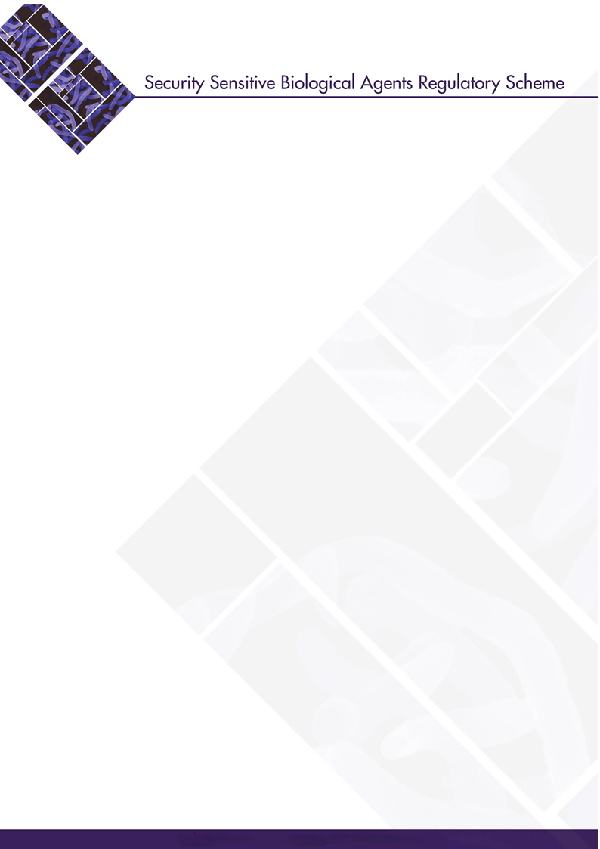

Change of Responsible Officer Details
Updated: January 2026

Introduction
Facilities must report changes to Responsible Officer(s) details to the Australian Centre for Disease Control (CDC) as soon as possible and within two business days of the change occurring.

Providing information to the Australian CDC
The information you provide to the Australian CDC is mandated by the National Health Security Act 2007 and will be included on the National Register.

It is important to answer all questions and to provide accurate information. If the information you provide is incorrect or incomplete, the Australian CDC may require you to provide additional information. This may cause delays.

Privacy
Personal information provided to the Australian CDC will comply with the requirements of the Privacy Act 1988.

Application Authorisation
Please ensure that the person completing this form holds the appropriate authority to submit this application on behalf of the entity or facility.

Instructions on completing this form
This document allows electronic entry of information into the required fields. It is recommended that, where possible, this form should be completed on a computer and a copy printed, signed
and sent to the Australian CDC.

All questions are mandatory and must be completed. If the space provided in each field is not sufficient to complete your answer, please include any additional information in an attachment with the information clearly marked as to which question it relates to.

Please ensure you retain a copy of this completed form as the Australian CDC is unable to provide copies of submitted documents.

Lodgement
To lodge this form via post you will need to use an opaque envelope and post using Australia Post’s Registered Mail service. You are considered to have submitted the report at the date and time shown on the registered post receipt.

Please do not email or fax forms to the Australian CDC as these cannot be accepted.

Please submit all postal applications to:

The Director
Laboratories and Pathogen Security Section
Australian Centre for Disease Control
MDP 140, GPO Box 9848
Canberra ACT 2601

Once the Australian CDC has received the form, you will be provided with a confirmation of receipt by email to the contact officer listed for the facility.

Further Information
Please use your facility reference number to refer to any matters relating to your facility.

If you have any queries about this form, please contact the SSBA Regulatory Scheme:
Telephone: (02) 6289 7477
Email: ssba@cdc.gov.au

PART 1: FACILITY DETAILS
Please complete the details for the entity and facility.
Facility registration number

Entity name

Facility name

PART 2: CHANGE OF RESPONSIBLE OFFICER DETAILS
Please complete the new details for the Responsible Officer or Deputy Responsible Officer.
Responsible Officer Name
Title (Dr, Mr, Ms etc)

First name

Middle name

Last name

Contact Details
Business telephone number

Mobile or emergency telephone number

Facsimile (if applicable)

Email

Responsible Officer Postal Address (if different from the facility)
Address

Suburb/City

State

Postcode

Deputy Responsible Officer Name
Title (Dr, Mr, Ms etc)

First name

Middle name

Last name

Contact Details
Business telephone number

Mobile or emergency telephone number

Facsimile (if applicable)

Email

PART 3: SIGNATURES
The information collected on this form may be used by the Australian CDC to decide whether to vary the National Register of Security Sensitive Biological Agents (National Register). If a decision is made to vary the National Register, the information contained on this form, including personal information, will be recorded on the National Register by the Australian CDC.

The information collected on this form is authorised under the National Health Security Act 2007 and National Health Security Regulations 2018. Information collected on this form may be disclosed by the Australian CDC to the Australian Security Intelligence Organisation, law enforcement agencies such as the Australian Federal Police and State and Territory police forces, other agencies responsible for responding to emergencies and other specified persons. The Australian CDC is unlikely to disclose personal information to overseas recipients.

The Australian CDC adheres to the Privacy Act 1988 (Cth) and has an Australian Privacy Principles (APP) privacy policy which you can access at https://www.cdc.gov.au/resources/publications/privacy-policy. For further information on the privacy policy, please contact the Australian CDC at privacy@cdc.gov.au. Your personal information is protected by law, and by providing your personal information to us, you acknowledge the Australian CDC collecting your details for the purpose of administering the SSBA Regulatory Scheme.

The National Register is hosted and maintained by the Department of Home Affairs.

I declare that:
- I am duly authorised to sign this declaration on behalf of the entity associated with this facility;
- The information supplied on this form and any attachment is true and correct; and
- This entity is compliant with the SSBA Standards currently in force.

Signature
Date
Full name (Please print)
Position title
Contact telephone number
Contact e-mail address

