SSBA – Guideline 9 – Non-registered facility report and requirements
  - January 2026

Introduction
This guideline provides information to non-registered entities and facilities about reporting and other requirements for handling security sensitive biological agents (SSBAs) or biological agents suspected of being SSBAs. It is a guideline only and is provided to assist in understanding the SSBA Regulatory Scheme.

Handling security sensitive biological agents
If you receive an SSBA you will need to decide if you are going to register with the Australian Centre for Disease Control (CDC), destroy the SSBA or transfer the SSBA to another facility that is willing to accept it.

Intending to handle the SSBA (including storage) for longer than 7 working days
If you intend to continue to handle the SSBA you will be required to complete an Initial Registration form. This form can be obtained from the SSBA website and must be submitted to the Australian CDC in hardcopy by Registered Post or Courier as soon as possible and within two business days of starting to handle the SSBA. You are considered to have submitted the report at the date and time shown on the registered post or courier receipt.
The information required to be submitted in your initial registration application includes the entity and facility details, the Responsible and Deputy Responsible Officer details, SSBA details, the purpose for handling, and a declaration of compliance with the SSBA Standards (Parts 2-8).
Once the required information is provided to the Australian CDC and the purpose for handling the SSBA(s) is deemed legitimate, the details provided in the Initial Registration form will be recorded on the National Register (for further information, see Guideline 2 – Registered Facility Reporting Requirements).

Handling SSBAs for a temporary period (7 working days or less)
If you only need to handle a known SSBA for seven working days or less, you may undertake a temporary handling.
Please note: These temporary handling provisions do not apply to a formerly suspected SSBA that has been subsequently confirmed through confirmatory testing procedures – these SSBAs must be handled under the suspected SSBA handling provisions as outlined below.
A facility that is temporarily handling a known SSBA that it is not registered for must report to the Australian CDC within two business days that it is handling the SSBA, using the Temporary Handling or Disposal of an SSBA report (either for a Registered or Non-Registered Facility as applicable). This report requests details about the entity and facility, the SSBA including the sample origin, what you intend to do/ what was done with the SSBA and when the SSBA was/will be disposed of.
After seven working days (or less) from initial receipt of the SSBA, the handling of the SSBA must be complete and the SSBA disposed. Confirmation of disposal will need to be reported to the Australian CDC including details of transfer or destruction methods. If the facility intends to continue handling after this seven-day period, it must register to handle the SSBA.
During the handling period, the entity must comply with Part 10 of the SSBA Standards and must report any lost or stolen samples, or unauthorised access to the samples to the SSBA Regulatory Scheme.
SSBA Standards include requirements that the entity:
- limits the access to the SSBA to only persons who have a need to handle the SSBA;
- maintains a record of who has accessed the SSBA including their identity and the date and time of access;
- stores the SSBA securely – this could include a locked freezer, locked cupboard or locked containers within these devices;
- destroys the SSBA so that no SSBA leaves the entity without being destroyed or inactivated unless being transferred;
- validates waste disposal procedures; and
- maintains records relating to the handling for 12 months for Tier 1 SSBAs and 6 months for Tier 2 SSBAs.

Transport requirements
If you are sending SSBAs to another facility then you must:
- ensure compliance with Commonwealth, State and Territory legislation governing the transport of biological agents (such as the Australian Dangerous Goods Code for Road and Rail and the Civil Aviation Safety Regulations for Air Transport);
- ensure the receiving facility is willing to accept the SSBA before shipment and maintain a record of this acceptance;
- notify the receiving facility of the shipment details at the time of the shipment;
- inform the Australian CDC if the shipment goes missing in transit as soon as you are aware of the loss; and
- inform the Australian CDC if the transfer is reported as unsuccessful.
If you are the receiving facility you must:
- confirm with the sending facility that you are willing to accept the SSBA;
- notify the sending facility when you receive the SSBA including the outcome of the transfer either successful or unsuccessful;
- verify that the transfer has been successful, this will include ensuring that the complete shipment has arrived and that there is no evidence of tampering with the shipping container; and
- notify the sending facility and transport agent if the shipment fails to arrive at the expected time.

Handling biological agents suspected of being SSBAs
If you suspect on the basis of your facility’s normal testing procedures that you are handling an SSBA, you must arrange for confirmatory testing or destroy the suspected SSBA as soon as possible and within two business days after forming your suspicion. You must also report the handling of a suspected SSBA to the Australian CDC and comply with Parts 9 and 9A of the SSBA Standards.

In-house confirmatory testing
If you, as the initial tester, are able to perform confirmatory testing you will need to report to the Australian CDC the confirmatory testing outcomes as soon as possible and within two business days after becoming aware of the results. If the testing confirms an SSBA you must comply with Part 9A of the SSBA Standards and then either register to handle the SSBA or transfer or destroy the SSBA within two business days of receiving the confirmatory test result.

External confirmatory testing
If you send the suspected SSBA to another facility for confirmatory testing you must:
- report the transfer to the Australian CDC as soon as possible and within two business days after the transfer; AND
- report the outcome of the confirmatory test to the Australian CDC as soon as possible and within two business days after becoming aware of the results. If the testing confirms an SSBA, you must comply with Part 9A of the SSBA Standards and then either register to handle, transfer or destroy the SSBA within two business days of receiving the confirmatory test result.

Destruction prior to confirmatory testing
If you choose not to carry out confirmatory testing you must destroy the sample within two business days of receipt and report the destruction of the suspected SSBA to the Australian CDC.

Reporting process
Your first report to the Australian CDC will need to use one of the paper-based reporting forms available from our website. Once you have submitted your first report, we will then provide details of how to access and use the online Data Collection System (DCS). All subsequent reports can then be provided to the Australian CDC electronically via the DCS or via the paper-based reporting forms on our website.

Reporting process flowcharts
The following flowcharts may assist entities to understand the reporting requirements and which forms to use.
- Suspected SSBAs
- Temporary handling

Flowchart 1 – Suspected SSBAs

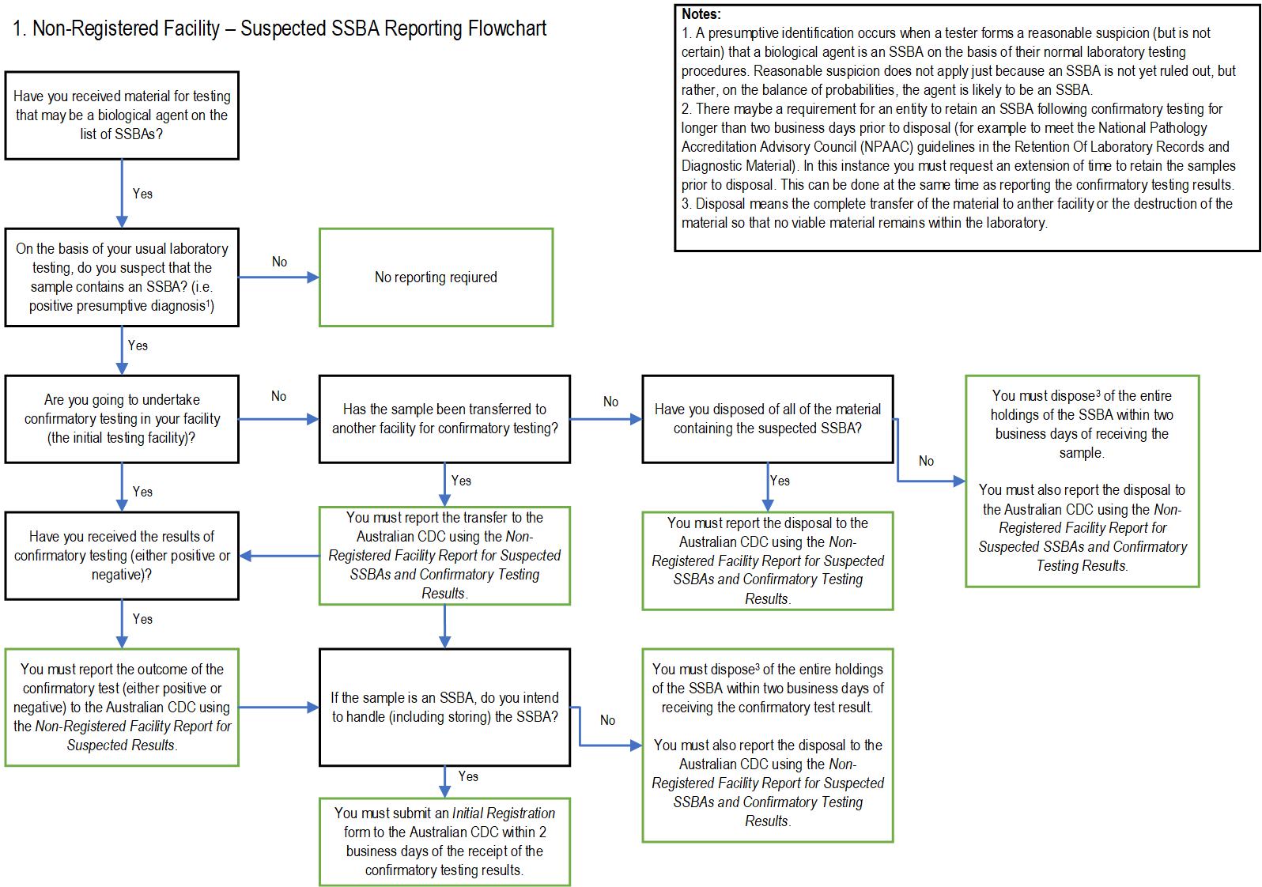

Flowchart 2 – Temporary handling

