Australian Respiratory Surveillance Report

Key messages
This report presents a national epidemiological update for acute respiratory infections, including coronavirus disease 2019 (COVID-19), influenza and respiratory syncytial virus (RSV), with a focus on the current reporting period (26 January to 22 February 2026) and earlier severity reporting periods (up to 8 February 2026).
In the community: In the last month, influenza-like illness among national helpline callers and the rate of helpline callers referred to seek urgent medical care decreased. Self-reported new fever and cough symptoms among community survey participants increased in the last month but fewer community survey participants reported taking time off work due to respiratory illness. COVID-19 cases increased in the last month but remained lower than at the same time in previous years. After a late increase in influenza cases in 2025, case numbers continued to decrease in the last month and have returned to interseasonal levels. RSV cases increased in the last month but remain comparable to trends seen at the same time in previous years.
In general practice: In the last month, there were fewer general practice consultations for influenza-like illness (defined as new fever and cough symptoms) at sentinel surveillance sites than in the previous month. While influenza-like illness consultation rates exceeded historical trends in mid to late 2025, consultation rates in 2026 have returned to interseasonal levels observed in prior years.
In hospitals: Sentinel hospital admissions with severe acute respiratory infections decreased in the last severity reporting period, largely driven by decreased influenza and COVID-19 admissions. At sentinel hospitals, most admissions among children and adults were with influenza. The proportion of patients who were admitted directly to intensive care at a sentinel hospital site remains low. Sentinel intensive care admissions with severe acute respiratory infections have been declining overall since late June 2025 and most patients have been admitted with influenza. In the last month, the average daily occupancy of intensive care patients in droplet or airborne isolation for any suspected or confirmed respiratory pathogen decreased across Australia.
Deaths: COVID-19 has been the leading cause of acute respiratory infection related mortality across the majority of 2023–2025. In 2025 the number of deaths involving COVID-19 (both due to and with) exceeded the number of deaths involving influenza. Deaths due to influenza fell in November 2025 before increasing again in December and remained high for the time of year. Although the number of deaths due to influenza in 2025 were high, this is expected when there are higher case numbers, and other surveillance systems have not indicated that illness was more severe in 2025 compared to previous years.
In laboratories: In the last month, test positivity for SARS-CoV-2 increased, test positivity for influenza decreased and test positivity for RSV was similar to the previous month. The SARS-CoV-2 variant under monitoring XFG was the most common sub-lineage in the past 28 days, accounting for 33.7% of sequences in the last 28 days. The majority of influenza samples collected by the WHO Collaborating Centre for Reference and Research on Influenza in the last month have been influenza A(H3N2).
Vaccine coverage, effectiveness and match: Nationally, 10% of adults have received a COVID-19 vaccine in the last year. Influenza vaccine coverage reached 30.7% in 2025. Influenza vaccine coverage data for 2026 are not yet available. Since the commencement of the National RSV Mother and Infant Protection Program, 205,874 Abrysvo doses have been administered. In the last six months, nirsevimab uptake is 4.6% nationally. Initial Australian studies indicate that in 2025, people who received the influenza vaccine were about 53% less likely to visit general practice or be hospitalised with influenza compared to those who were unvaccinated. Preliminary analyses also indicated the 2025 southern hemisphere vaccine was just as effective against influenza A (H3N2) subclade K in preventing general practice attendance or hospitalisation with influenza.

Australian Respiratory Surveillance Report
This report was prepared by Ash Donovan, Suzie Whitehead, Al Gomez and Siobhan St George on behalf of the Australian Centre for Disease Control (CDC). We thank the staff and participants from the surveillance systems who contribute data for acute respiratory illness surveillance across Australia.
The report presents a national overview of acute respiratory infections in Australia, drawing information from several different surveillance systems. These surveillance systems help us to understand the distribution of acute respiratory illnesses in the community, the severity of infections including which populations might be at risk, and the impact of acute respiratory illnesses on the community and health system in Australia. Surveillance indicators presented in this report are based on the Australian National Surveillance Plan for COVID-19, Influenza, and RSV. Please refer to the Technical Supplement for information on our surveillance sources and data considerations. A summary of data considerations for this report are provided below:
- Due to the dynamic nature of the surveillance systems used in this report, surveillance data are considered preliminary and subject to change as updates are received, with the most recent weeks considered particularly incomplete. Data in this report may vary from data reported in other national reports and reports by states and territories.
- Data in this report are presented by date of event (survey, diagnosis, admission or death) and by the International Organization for Standardization (ISO) week date system, with weeks defined as seven-day periods which begin on a Monday and end on a Sunday. The ISO week date system is used to support trends comparisons over time more effectively. The current reporting period includes 26 January to 22 February 2026 and where comparisons to the previous month are made, this includes 29 December 2025 to 25 January 2026.
- In Australia, states and territories (the Australian Capital Territory [ACT], New South Wales [NSW], the Northern Territory [NT], Queensland [Qld], South Australia [SA], Tasmania [Tas], Victoria [Vic] and Western Australia [WA]) report notified cases to the National Notifiable Diseases Surveillance System (NNDSS) based on the Australian national surveillance case definitions. NNDSS data are analysed and reported based on diagnosis date, which is the true onset date of a case if known, otherwise it is the earliest of the specimen date, the notification date or the notification received date. The NNDSS data for this report were extracted on 25 February 2026.
- Notification rates per 100,000 population presented in this report are for the given time period, with population data are based on the Australian Bureau of Statistics (ABS) Estimated Resident Population (ERP) for the reference period June 2024, released 12 December 2024 unless stated otherwise.
- To account for the lag in collection and provision of severity data from some surveillance systems, and for the time delay between illness onset and the development of severe disease outcomes, cases with an admission date or a diagnosis date in the last two weeks are excluded from severity analyses for hospitalisations and intensive care admissions. As such, the severity reporting periods are two weeks behind the end of the current reporting period. For this report, severity reporting includes data from 12 January to 8 February 2026 unless specified otherwise. Where comparisons to the previous severity month are made this includes 15 December 2025 to 11 January 2026.
- Death registrations from the ABS Provisional Mortality Statistics are now used as the primary data source for measuring acute respiratory infection associated deaths. The ABS mortality data is sourced from the Registry of Births, Deaths and Marriages and is separate from the NNDSS. Registration-based mortality data needs time to be received and processed, and so mortality statistics in this report may lag by at least two months.
- Analysis and reporting outputs were produced using R Statistical Software v4.3.1. While every care has been taken in preparing this report, the Australian CDC does not accept liability for any injury or loss or damage arising from the use of, or reliance upon, the content of the report. For further information about this report refer to the Technical Supplement or contact respiratory.surveillance@cdc.gov.au.

Community surveillance
Community surveillance monitors respiratory illnesses in the community, providing information on the number of people reporting respiratory symptoms, testing practices, and the impact of respiratory illnesses. Community surveillance includes notification data obtained from laboratory tests for infections. Infections that are diagnosed and notified are only a subset of the total number of infections occurring in the community.
- In the last month (26 January to 22 February 2026), there were fewer Healthdirect helpline callers with influenza-like illness (311 per 1,000 callers per month) than in the previous month (322 per 1,000 callers per month) (Figure 1).
- Similar to previous years, rates of influenza-like illness among helpline callers in January decreased and remained stable throughout February. This trend could be impacted by changes in healthcare and testing access, testing behaviour and population mixing over the holiday period (Figure 1).
Figure 1: Rate of influenza-like illness per 1,000 helpline callers by year and week of call*, Australia†, 22 March 2023 to 22 February 2026
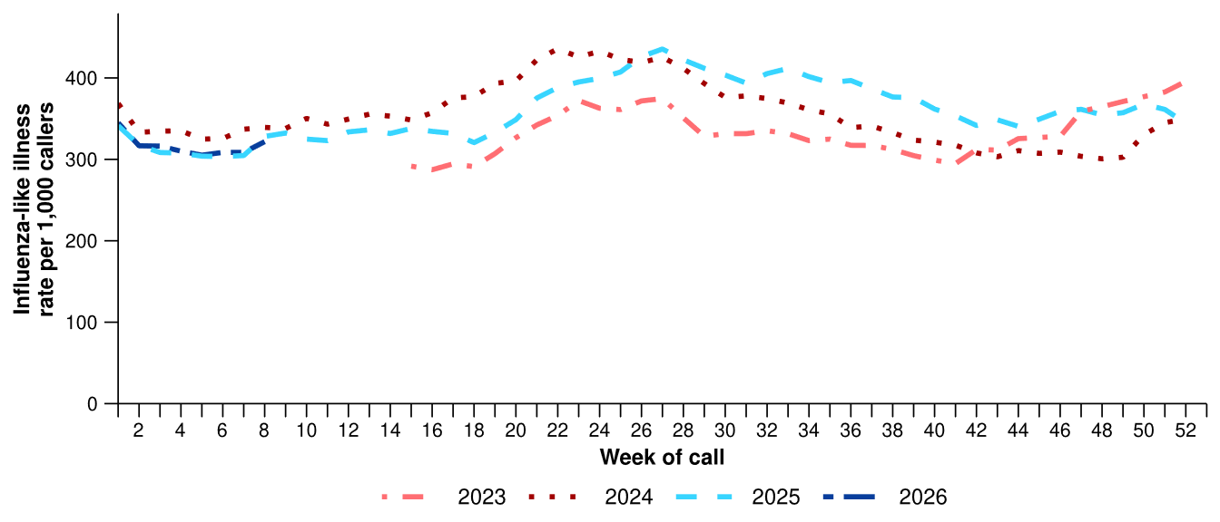
Source: Healthdirect Australia
* Healthdirect data prior to 22 March 2023 are unavailable as prior to this date a different data collection method was used.
† The Healthdirect helpline operates in all states and territories except Qld; therefore influenza-like illness trends will not be representative of Qld and may be underrepresented. See the Technical Supplement for more information.
- In the last month, there were fewer Healthdirect helpline callers with influenza-like illness referred to seek urgent medical care (161 per 1,000 callers per month) than in the previous month (168 per 1,000 callers per month) (Figure 2).
  - Callers referred to seek urgent medical care include those referred to call triple zero, attend a hospital emergency department, contact a virtual emergency department, urgent care clinic or see a general practitioner within two hours.
- In the last month, referral pathways for influenza-like illness varied across Australia. ACT, NSW, SA and Vic had the highest proportion of callers referred to see a general practitioner (GP) or seek other urgent medical care (Figure 2). By comparison, the NT, SA, Tas and WA had a higher proportion of callers who were recommended to attend a hospital emergency department or call triple zero (Figure 2).

Figure 2: Proportion of referral categories* for helpline callers with influenza-like illness by jurisdiction† and call date, Australia, 1 January to 22 February 2026
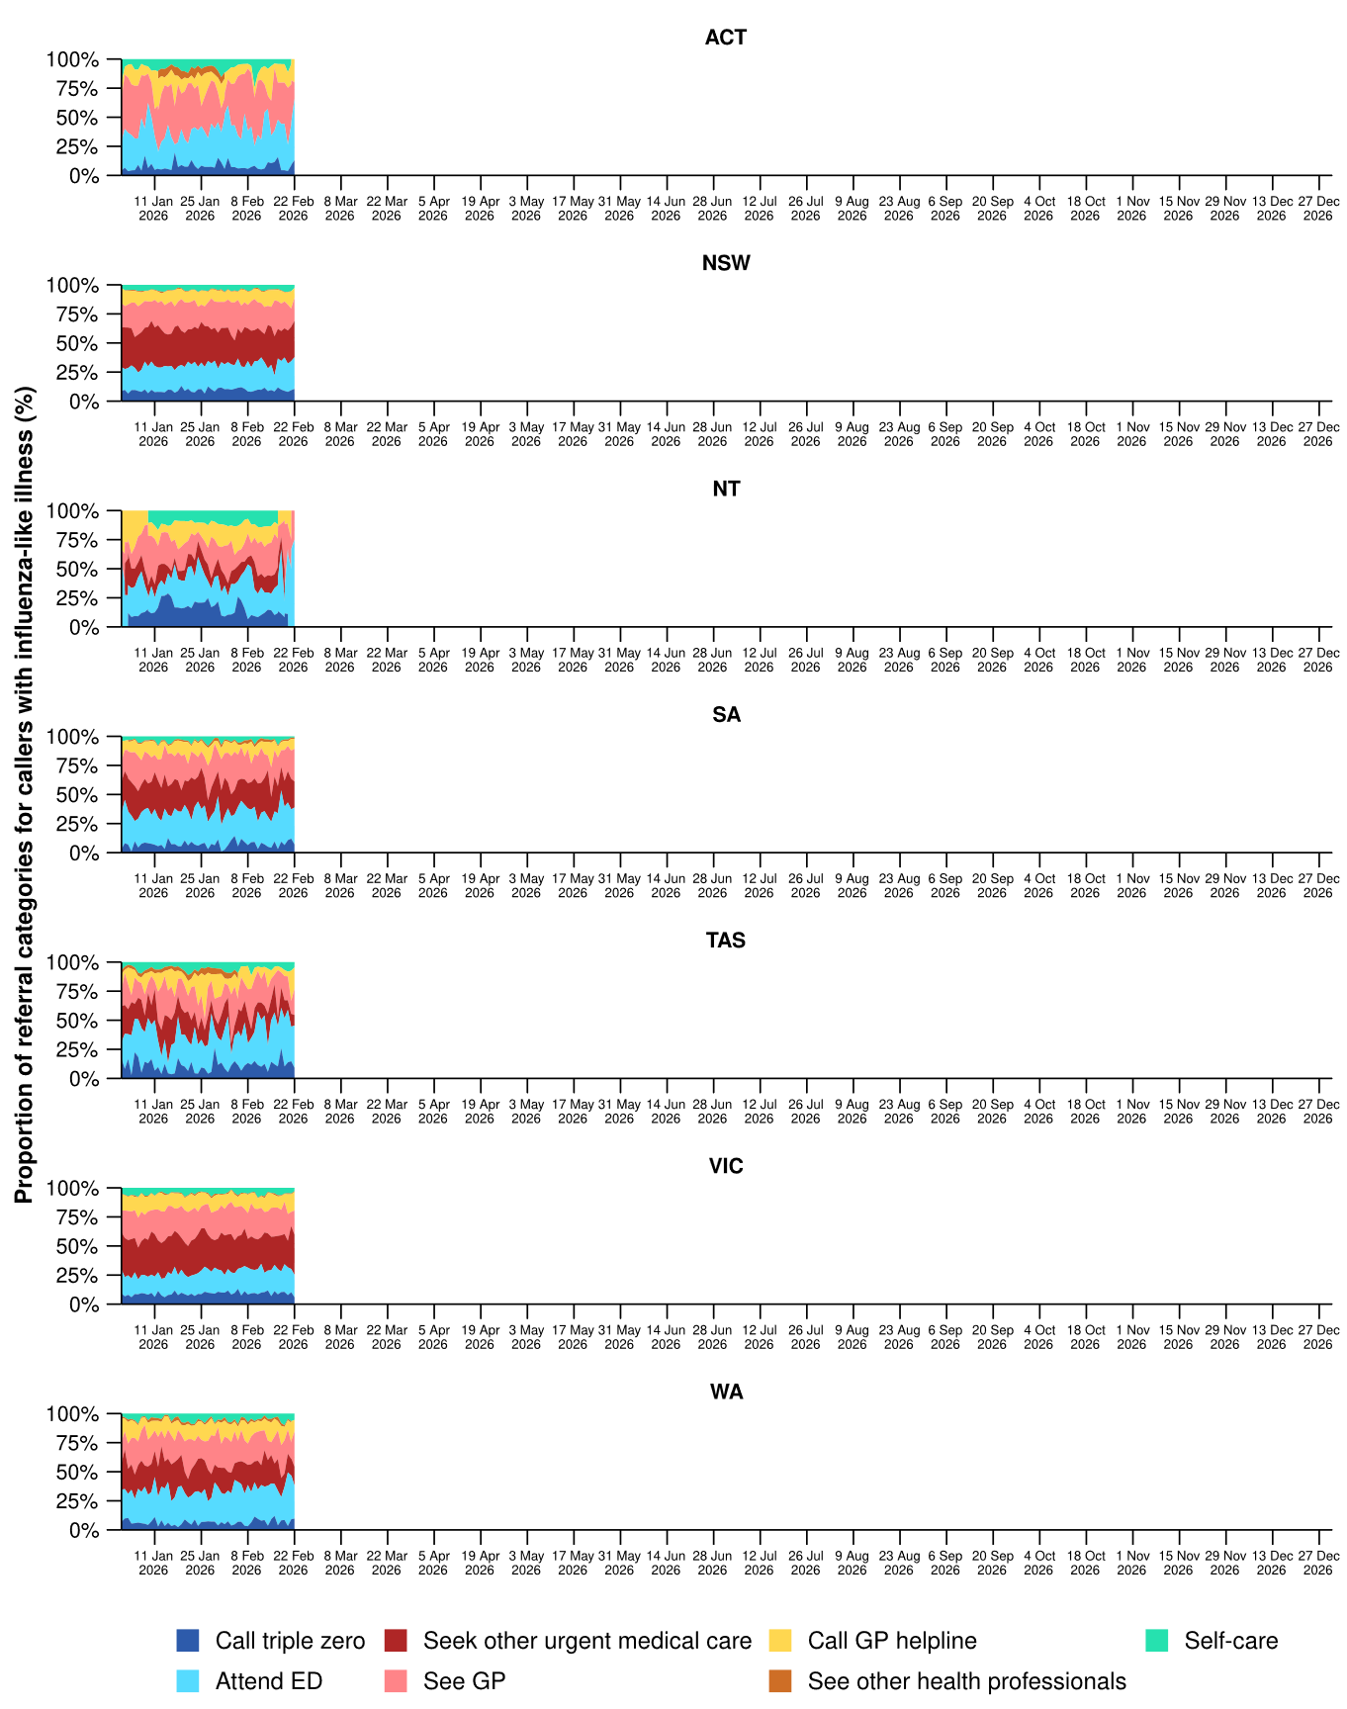
Source: Healthdirect Australia
* See other health professionals category includes pharmacist, dentist, mental health provider, primary maternity care, poison information centre or other.
† The Healthdirect helpline operates in all states and territories except Qld; therefore influenza-like illness referral trends are not provided for Qld. See the Technical Supplement for more information.

- In the last month, a slightly higher percentage of FluTracking participants reported new fever and cough symptoms (0.8%), than in the previous month (0.6%) (Figure 3).
- The weekly percentage of FluTracking participants reporting new fever and cough symptoms steadily decreased from October 2025 to January 2026; however, have increased throughout February similar to trends observed in previous years. This trend could be impacted by changes in healthcare and testing access, testing behaviour and population mixing over the holiday period (Figure 3).
- In the last month, the same percentage of First Nations FluTracking participants reported new fever and cough symptoms (0.8%) compared with the previous month (0.8%). These findings could be impacted by smaller sample sizes. For more detailed trends, please refer to figure 2 in the FluTracking reports.
Figure 3: Age standardised percentage of survey participants reporting new fever and cough symptoms compared with the five-year average* by year and week of survey, Australia, 2023 to 22 February 2026
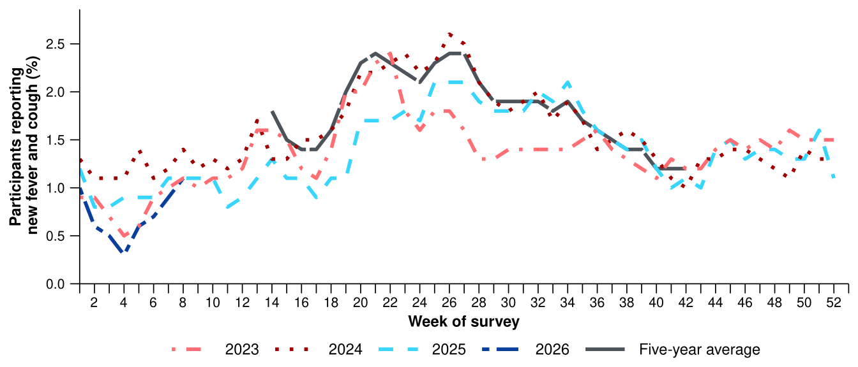
Source: FluTracking
* From 2020, FluTracking expanded their data capture period to year-round. Data before May and after October for any year before 2020 are not available for historical comparisons. The years 2020 and 2021 are excluded when comparing the current season to historical periods when influenza virus has circulated without public health restrictions. As such, the five-year average includes the years 2019 and 2022 to 2025.
- The average percentage of FluTracking participants reporting taking three or more days off work or normal duties due to fever and cough symptoms decreased in 2026 compared with the same period in 2025 and has remained lower than in 2024 and 2023 (Table 1).
- The average percentage of FluTracking participants seeking medical advice or care for fever and cough symptoms decreased in 2026 compared to the same period in 2025 and has remained lower than in 2024 and 2023 (Table 1).
Table 1: Percentage of FluTracking participants reporting new fever and cough symptoms plus three or more days off work or normal duties or seeking medical advice or care*, Australia, up to 8 February† for 2023–2026
 | 2023 | 2024 | 2025 | 2026
Reported three or more days off work or normal duties | 51.8% | 52.4% | 47.6% | 44.9%
Reported seeking medical advice or care* | 37.0% | 33.0% | 34.1% | 32.7%
Source: FluTracking
* Includes those who sought medical advice from a general practitioner, Aboriginal and Torres Strait Islander health clinic, COVID-19 clinic, emergency department, or were admitted to hospital for fever and cough.
† While FluTracking data are collected in real time, data presented here are subject to a two week reporting delay to account for the time delay between illness onset and the development of severe disease outcomes.
- In the last month, self-reported severe acute respiratory syndrome coronavirus 2 (SARS-CoV-2) polymerase chain reaction (PCR) positivity peaked in mid-February at 13%; while self-reported SARS-CoV-2 rapid antigen test (RAT) positivity increased steadily across the month to 19% (Figure 4a/b).
- In the last month, self-reported influenza PCR positivity varied, decreasing from 40% in mid-February to less than 20% by the end of the month. Self-reported influenza RAT positivity also varied over the past month with a peak of 20% (Figure 4a/b).
- In the last month, self-reported RSV PCR and RAT positivity varied. An increase in self-reported RSV PCR and RAT positivity was observed in mid-February followed by a decrease in late February with test positivity remaining below 15% throughout (Figure 4a/b).
- For more detailed testing and self-reported positivity trends, please refer to the FluTracking reports.
Figure 4a: Self-reported polymerase chain reaction (PCR) test positivity* among FluTracking participants with fever and cough symptoms by pathogen week of survey, Australia, 1 January to 22 February 2026
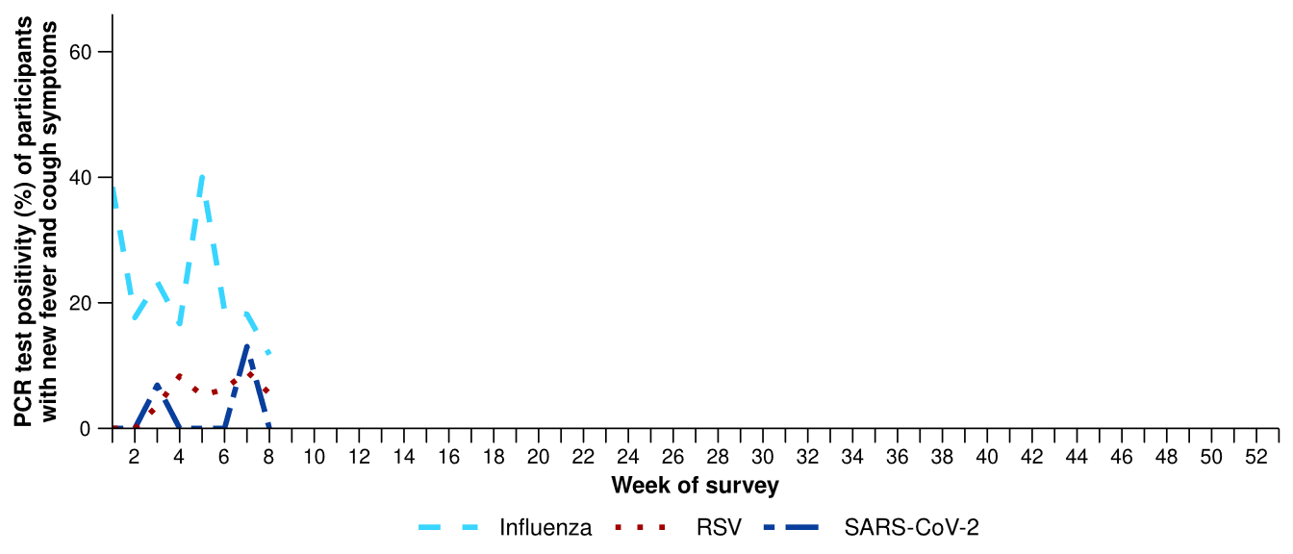
Source: FluTracking
* Denominator is based on participants who self-reported fever and cough symptoms and had a PCR test. Please refer to the Technical Supplement for more details.
Figure 4b: Self-reported rapid antigen test (RAT) positivity* among FluTracking participants with fever and cough symptoms by pathogen and week of survey, Australia, 1 January to 22 February 2026
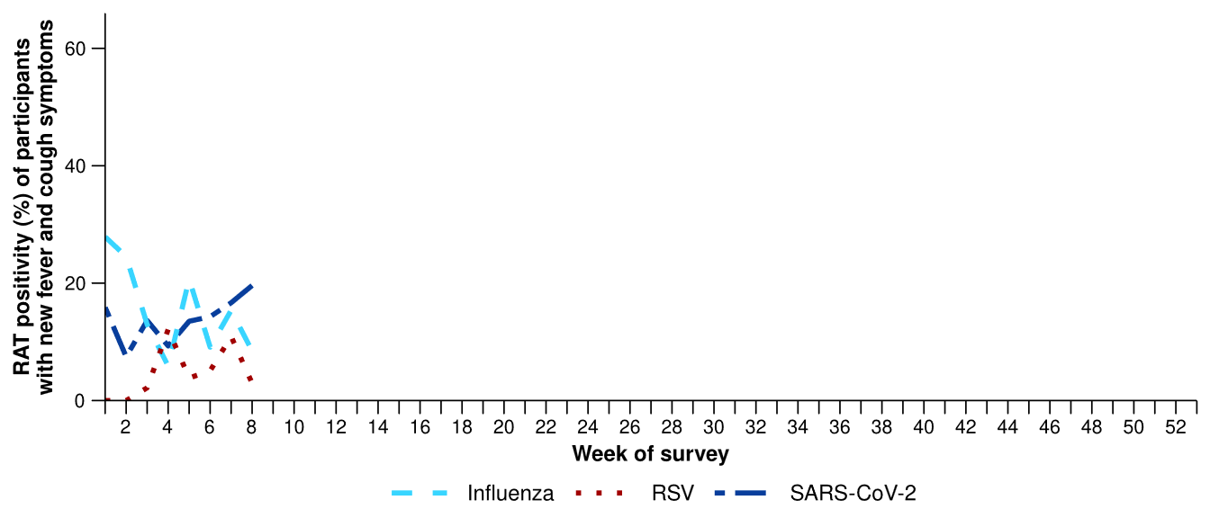
Source: FluTracking
* Denominator is based on participants who self-reported fever and cough symptoms and had a RAT. Please refer to the Technical Supplement for more details.
- In the last month (26 January to 22 February 2026), there was a 14.1% increase in COVID-19 cases, a 54.5% decrease in influenza cases, and a 23.4% increase in RSV cases.
Table 2: Notified cases and notification rate per 100,000 population by disease, five-year age group, and jurisdiction*, Australia, 1 January to 22 February 2026
 | COVID-19 |  |  | Influenza |  |  | RSV
 | Reporting  period  (n) | Year to  date  (n) | Year to  date  (rate) | Reporting  period  (n) | Year to  date  (n) | Year to  date  (rate) | Reporting  period  (n) | Year to  date  (n) | Year to  date  (rate)
Age group (years)
0–4 | 1,245 | 1,986 | 132 | 807 | 2,191 | 145 | 2,296 | 3,477 | 230
5–9 | 473 | 586 | 36 | 749 | 1,500 | 93 | 212 | 310 | 19
10–14 | 326 | 402 | 24 | 565 | 1,069 | 64 | 122 | 190 | 11
15–19 | 237 | 353 | 21 | 509 | 1,270 | 76 | 142 | 239 | 14
20–24 | 220 | 390 | 22 | 405 | 1,394 | 78 | 129 | 227 | 13
25–29 | 263 | 470 | 24 | 325 | 1,104 | 55 | 139 | 290 | 15
30–34 | 338 | 585 | 29 | 310 | 911 | 45 | 152 | 275 | 13
35–39 | 333 | 594 | 30 | 294 | 836 | 42 | 162 | 278 | 14
40–44 | 332 | 541 | 29 | 381 | 871 | 47 | 129 | 234 | 13
45–49 | 263 | 463 | 28 | 269 | 744 | 46 | 152 | 307 | 19
50–54 | 231 | 444 | 26 | 264 | 719 | 43 | 192 | 350 | 21
55–59 | 262 | 472 | 31 | 242 | 755 | 49 | 237 | 434 | 28
60–64 | 205 | 394 | 26 | 250 | 777 | 51 | 202 | 388 | 25
65–69 | 217 | 431 | 32 | 258 | 761 | 56 | 217 | 395 | 29
70–74 | 239 | 501 | 43 | 227 | 720 | 61 | 227 | 411 | 35
75+ | 1,061 | 2,230 | 103 | 596 | 2,161 | 100 | 624 | 1,287 | 59
Jurisdiction
ACT | 88 | 137 | 29 | 62 | 231 | 49 | 38 | 68 | 14
NSW | 2,748 | 4,575 | 54 | 2,391 | 5,935 | 70 | 2,262 | 3,595 | 42
NT | 29 | 82 | 32 | 130 | 423 | 166 | 157 | 366 | 143
Qld | 1,586 | 2,762 | 49 | 2,027 | 4,928 | 88 | 1,785 | 2,998 | 54
SA | 531 | 794 | 42 | 276 | 1,158 | 62 | 206 | 356 | 19
Tas | 84 | 157 | 27 | 40 | 214 | 37 | 48 | 117 | 20
Vic | 911 | 1,918 | 27 | 1,004 | 3,672 | 53 | 594 | 1,157 | 17
WA | 269 | 418 | 14 | 521 | 1,224 | 41 | 244 | 435 | 15
Total | 6,246 | 10,843 | 40 | 6,451 | 17,785 | 65 | 5,334 | 9,092 | 33
Source: National Notifiable Diseases Surveillance System (NNDSS)
* Total includes cases with missing age.
- In the last month, there were 6,246 COVID-19 cases nationally, a 14.1% increase from 5,474 cases notified in the previous month (Table 2; Figure 5).
- In the year to date, there have been 10,843 COVID-19 cases, 66.4% fewer than the 32,272 cases notified over the same period in 2025 (Table 2; Figure 5).
- In the last month, COVID-19 notification rates increased or remained relatively stable across most jurisdictions compared with the previous month, except in the NT, Tas and Vic where notification rates decreased (Figure 6).
Figure 5: Notified COVID-19 cases by year and week of diagnosis, Australia, 2023 to 22 February 2026
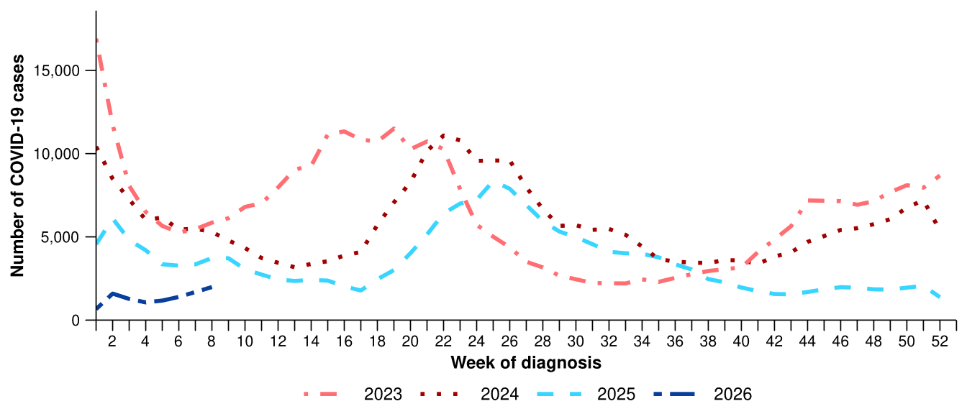
Source: National Notifiable Diseases Surveillance System (NNDSS)
Figure 6: Notification rates per 100,000 population for COVID-19 cases by state or territory and week of diagnosis, Australia, 1 January to 22 February 2026
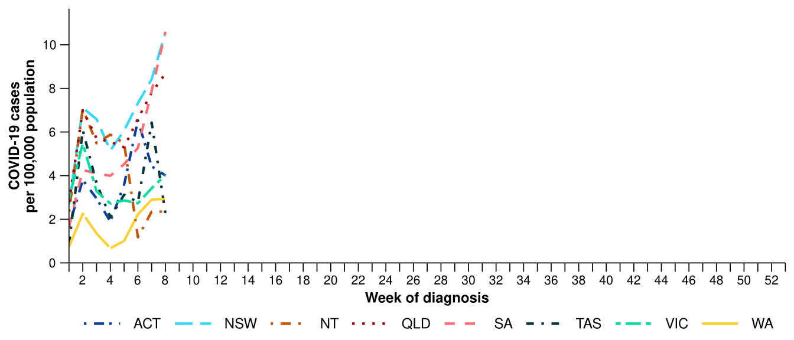
Source: National Notifiable Diseases Surveillance System (NNDSS)

- In the last month, there were 6,451 influenza cases, a 54.5% decrease from 14,190 cases notified in the previous month (Table 2; Figure 7).
- In the year to date, there have been 17,785 influenza cases, 28.8% fewer than the 24,985 cases notified over the same period in 2025 (Table 2; Figure 7).
- In the last month, influenza notification rates decreased or remained relatively stable across all jurisdictions compared with the previous month (Figure 8).
Figure 7: Notified influenza cases and five-year average* by year and week of diagnosis, Australia, 2023 to 22 February 2026
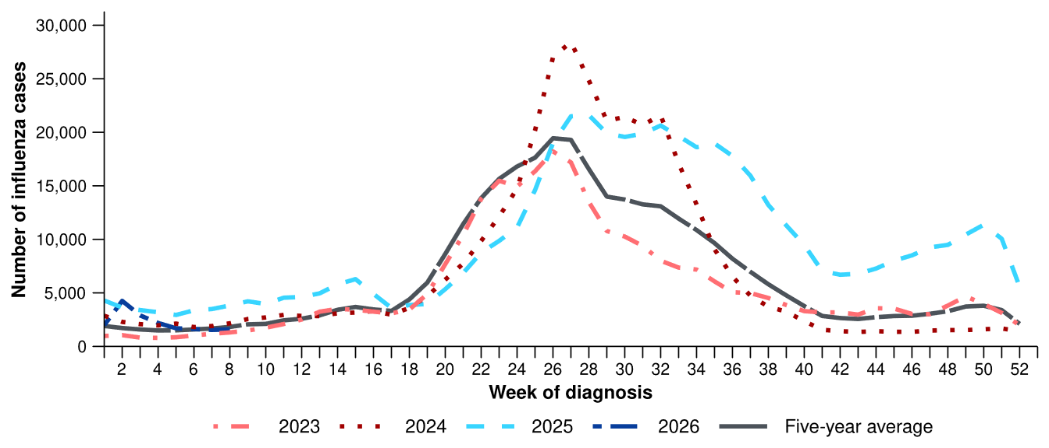
Source: National Notifiable Diseases Surveillance System (NNDSS)
* The years 2020 and 2021 are excluded when comparing the current season to historical periods when influenza virus has circulated without public health restrictions. As such, the five-year average includes the years 2019 and 2022 to 2025. Please refer to the Technical Supplement for interpretation of the five-year average.
Figure 8: Notification rates per 100,000 population for influenza cases by state or territory and week of diagnosis, Australia, 1 January to 22 February 2026
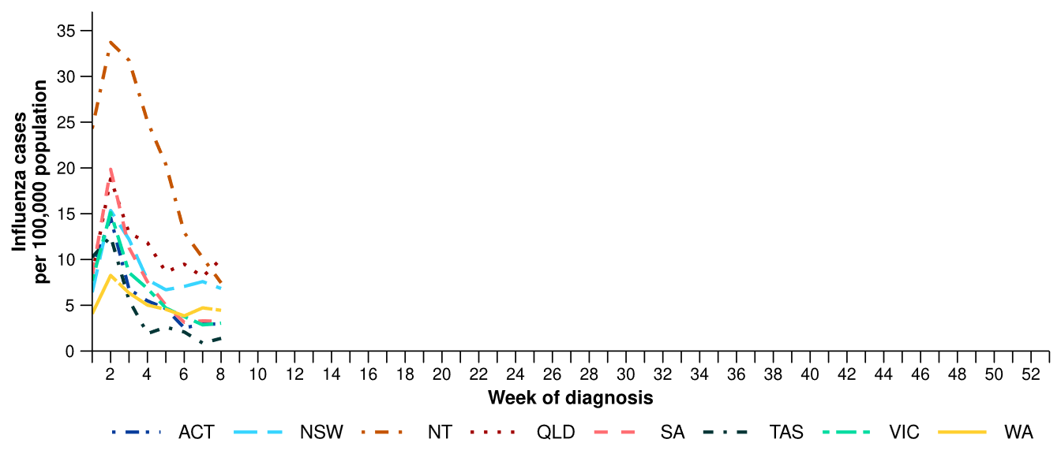
Source: National Notifiable Diseases Surveillance System (NNDSS)
- In the last month, there were 5,243 influenza A cases, a 61.1% decrease from 13,495 influenza A cases notified in the previous month, and there were 1,178 influenza B cases, a 129.6% increase from 513 influenza B cases notified in the previous month.
  - In the last month, there were 98 influenza A(H1N1) cases, a 63.3% increase from 60 cases notified in the previous month.
  - In the last month, there were 245 influenza A(H3N2) cases, a 53.5% decrease from 527 cases notified in the previous month.
- In the last month, influenza A(Unsubtyped) has accounted for most cases across most age groups, followed by influenza B. The proportion of influenza A(H3N2) cases has been the highest among children (Figure 9). Trends in influenza subtypes are influenced by differences in the number and selection of influenza samples that undergo typing across age groups and healthcare settings.
Figure 9: Notified influenza cases by influenza subtype, age group*, and week of diagnosis, Australia, 1 January to 22 February 2026
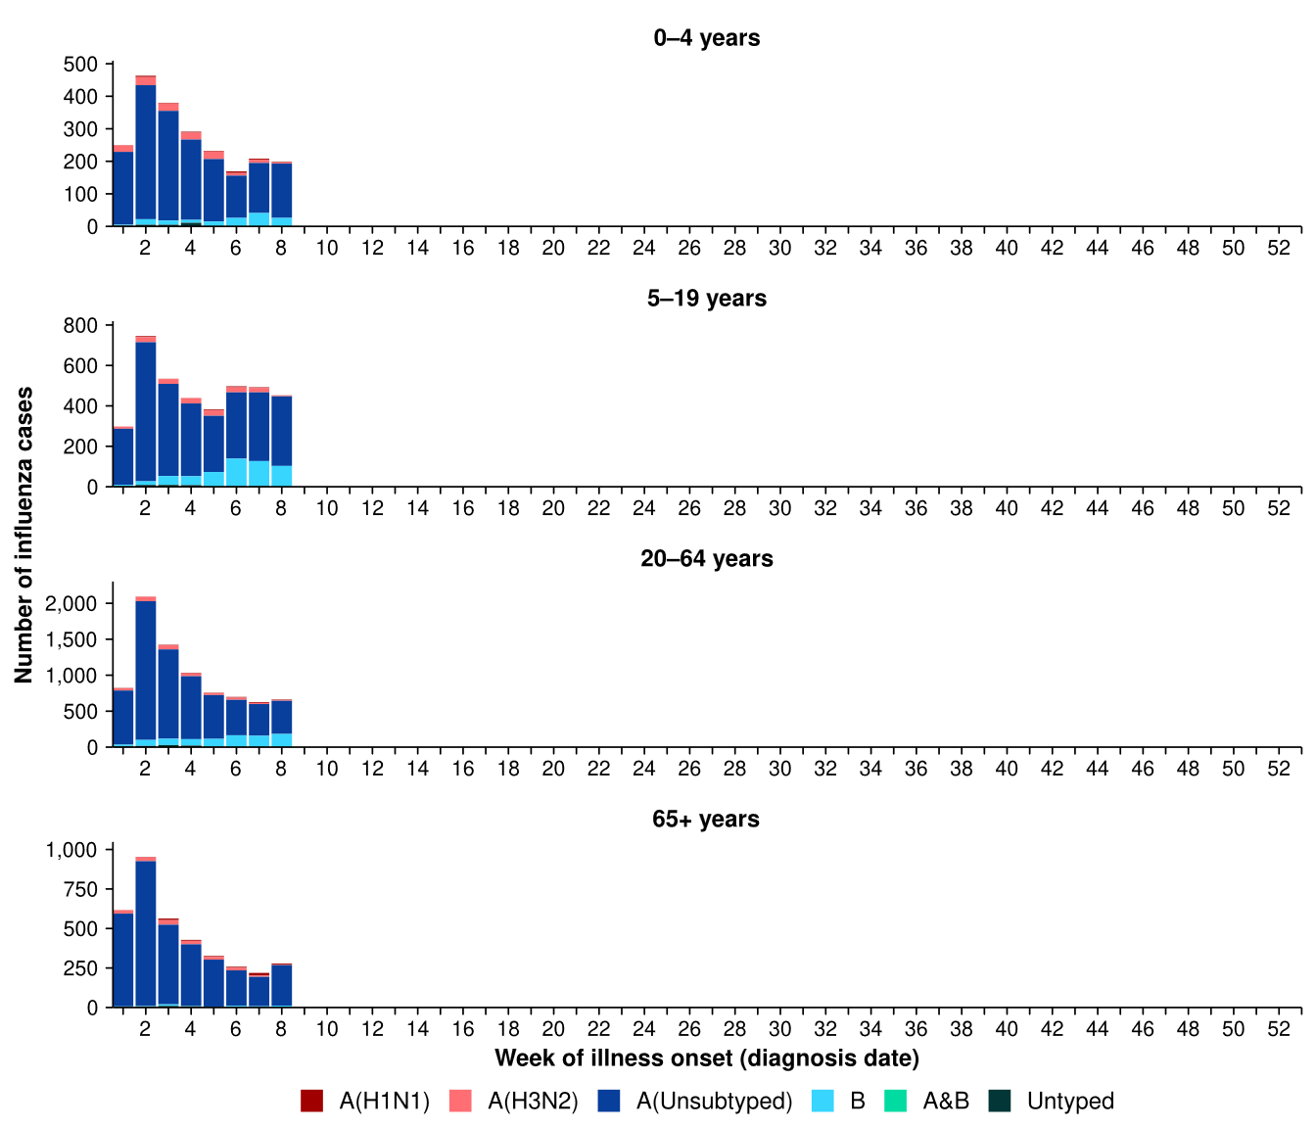
Source: National Notifiable Diseases Surveillance System (NNDSS)
* Axis varies between age groups.

- Since the start of the year, influenza A(Unsubtyped) has accounted for most influenza cases across all jurisdictions (Figure 10). Cases of influenza A(H3N2) were observed in the NT, Qld, Tas, and WA, with numbers remaining relatively stable across these jurisdictions. Influenza B was also present in low numbers across most jurisdictions, most notably in the ACT, the NT and WA (Figure 10).
- Trends in influenza subtypes are influenced by jurisdictional differences in the number and selection of influenza samples that undergo typing.
Figure 10: Notified influenza cases by influenza subtype, jurisdiction*, and week of diagnosis, Australia, 1 January to 22 February 2026
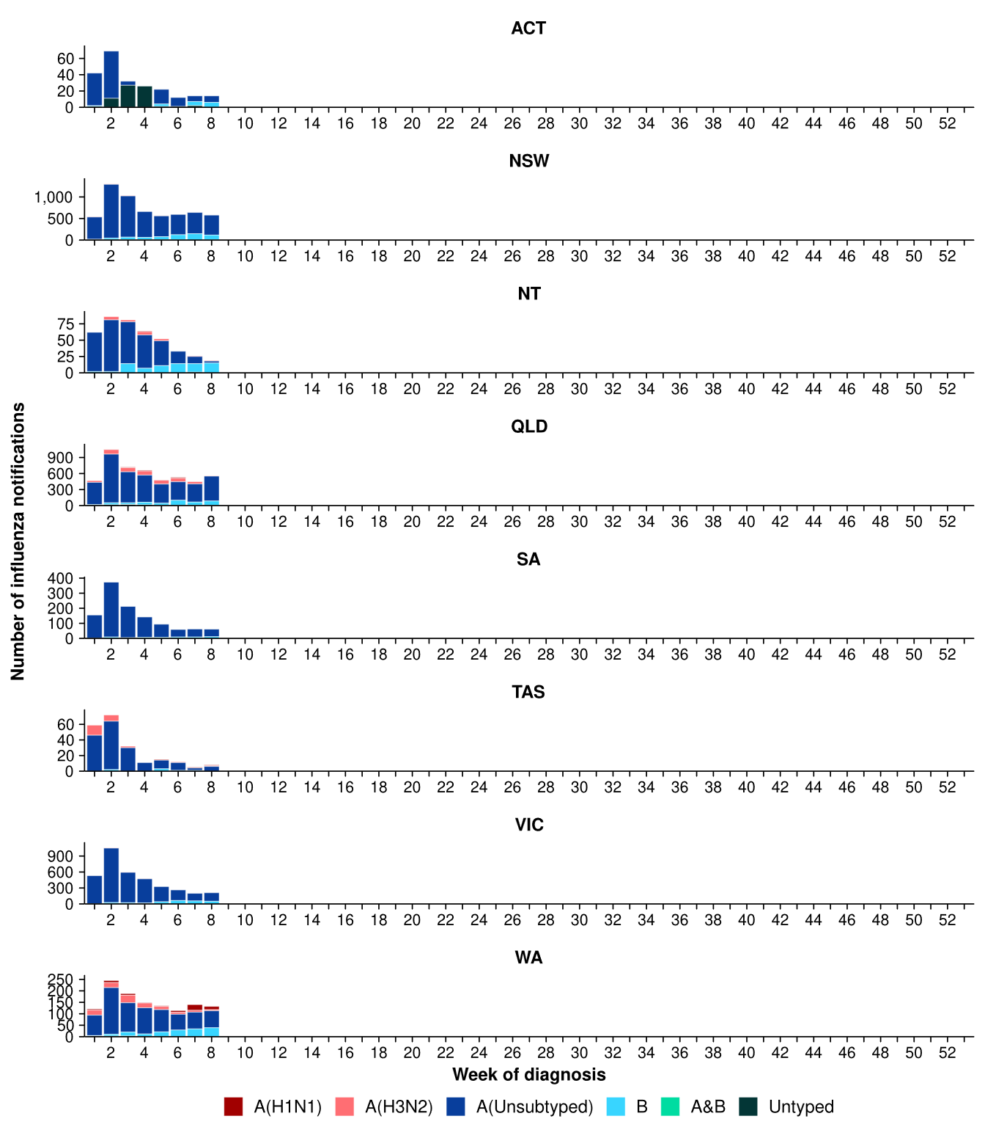
Source: National Notifiable Diseases Surveillance System (NNDSS)
* Axis varies between jurisdictions.
- In the last month, there were 5,334 RSV cases, a 23.4% increase from the 4,322 cases notified in the previous month (Table 2; Figure 11).
- In the year to date, there have been 9,092 RSV cases, 13.2% fewer than the 10,480 cases notified over the same period in 2025 (Table 2; Figure 11).
- In the last month, RSV notification rates remained relatively stable across many jurisdictions compared with the previous month but increased steadily in NSW and Qld, and decreased in the NT and Tas (Figure 12).
Figure 11: Notified RSV cases by year and week of diagnosis, Australia, 2023 to 22 February 2026
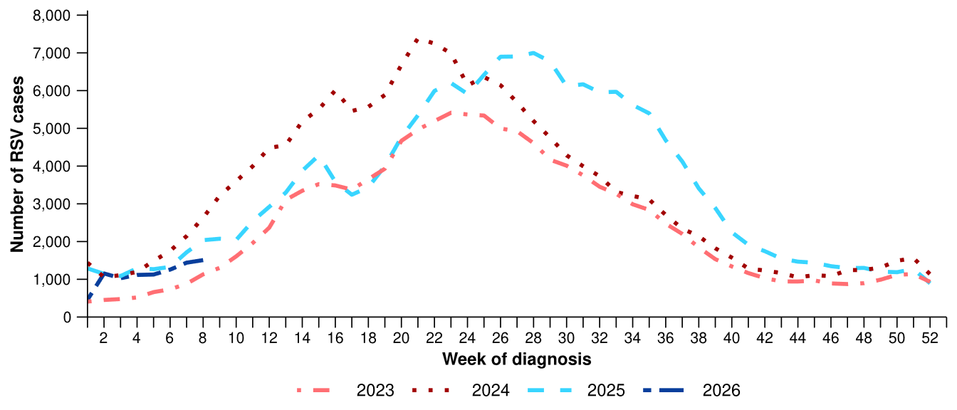
Source: National Notifiable Diseases Surveillance System (NNDSS)
Figure 12: Notification rates per 100,000 population for RSV cases by state or territory and week of diagnosis, Australia, 1 January to 22 February 2026
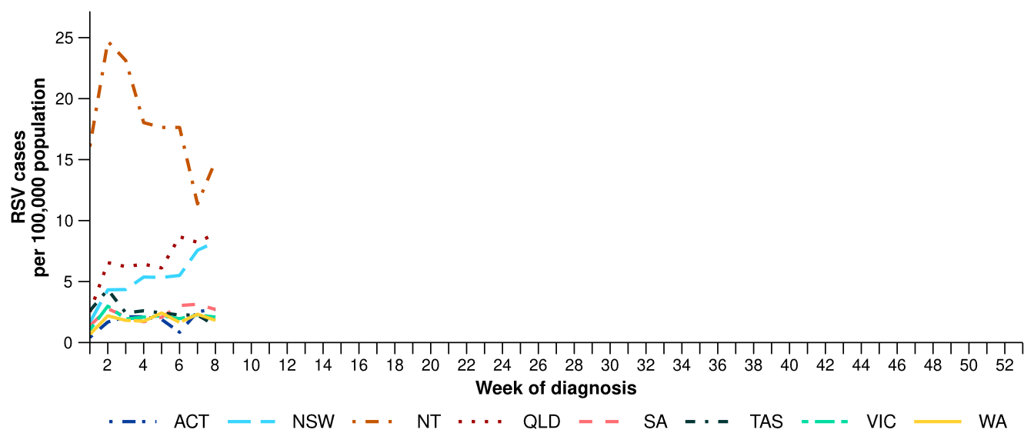
Source: National Notifiable Diseases Surveillance System (NNDSS)

Primary care surveillance
Primary care surveillance monitors the number and characteristics of people who have presented to a general practice with influenza-like illness and provides insight on the different respiratory pathogens that are causing illness in the community.
- In the last month (26 January to 22 February 2026), there were fewer general practice consultations for influenza-like illness (2.4 notifications per 1,000 consultations per month) compared to the previous month (3.7 notifications per 1,000 consultations per month) (Figure 13).
- In the last month, influenza-like illness consultation rates, while above the five-year average, have remained stable. This trend is in line with influenza-like illness consultation rates observed during the same period in 2025. This suggests that influenza-like illness consultation rates have returned to interseasonal levels, aligning with national influenza case notification trends (Figure 7; Figure 13).
Figure 13: Rate of influenza-like illness notifications per 1,000 consultations per week in sentinel general practice sites compared with the five-year average by year and week of consultation*†, Australia, 2023 to 22 February 2026
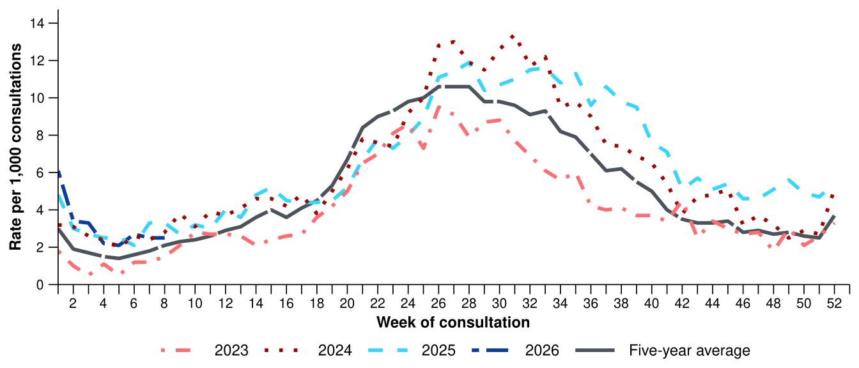
Source: Australian Sentinel Practices Research Network (ASPREN)
* The years 2020 and 2021 are excluded when comparing the current season to historical periods when influenza virus has circulated without public health restrictions. As such, the five-year average includes the years 2019 and 2022 to 2025. Please refer to the Technical Supplement for interpretation of the five-year average.
† Please refer to the Technical Supplement for notes on impact of COVID-19 on ASPREN data.

- In the last month, 61.2% (60/98) of people attending general practice with influenza-like illness who were tested have then tested positive for a respiratory pathogen.
- In the last month, rhinovirus (35.0%; 21/60) was the most commonly detected pathogen, followed by influenza (20.0%; 12/60) and adenovirus (13.3%; 8/60) (Figure 14).
- In the year to date, 50.3% (91/181) of people attending general practice with influenza-like illness who were tested have then tested positive for a respiratory pathogen.
- In the year to date, rhinovirus (39.6%; 36/91) has been the most commonly detected pathogen, followed by influenza (22.0%; 20/91), adenovirus (8.8%; 8/91), SARS-CoV-2 (7.7%; 7/91), and RSV (6.6%; 6/91) (Figure 14).

Figure 14: Number of samples tested for respiratory pathogens among people with influenza-like illness attending sentinel general practice sites by respiratory pathogen and week of specimen collection, Australia, 1 January to 22 February 2026
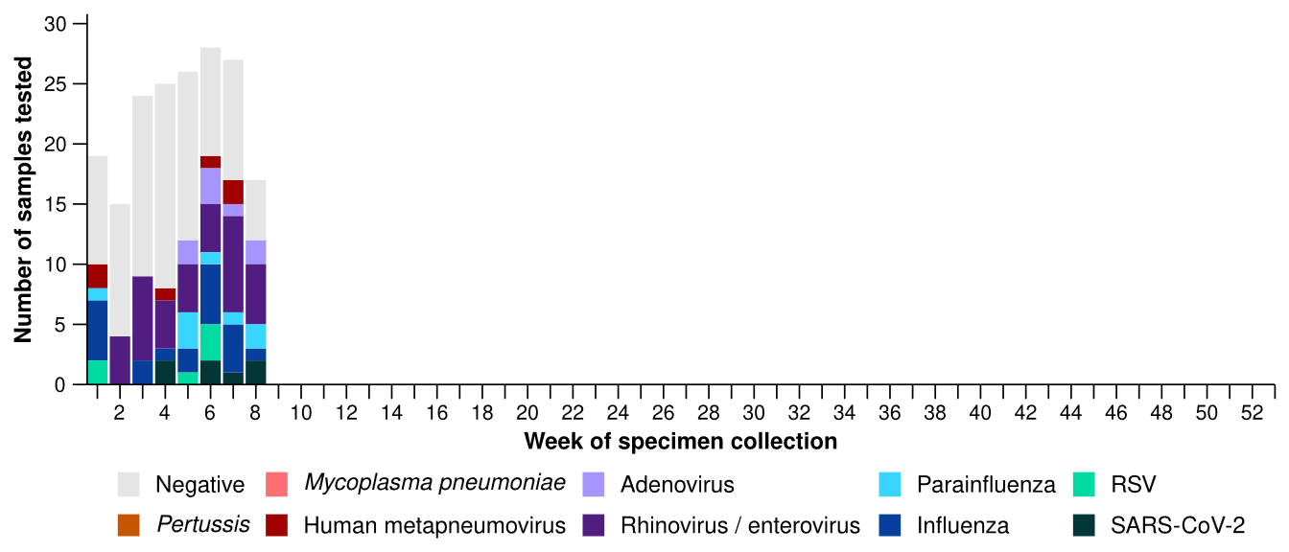
Source: Australian Sentinel Practices Research Network (ASPREN)
Note: All ASPREN swab samples are transported to the SA Pathology laboratory in Adelaide to be tested for viral and bacterial respiratory pathogens via a multiplex real-time reverse transcription polymerase chain reaction (RT-PCR) assay using in-house primers.

Hospital-based surveillance
Hospital-based surveillance monitors persons with more severe illness who have been admitted to hospital for their respiratory illness (severe acute respiratory infections). Hospital-based surveillance also measures the ability of the health system to cope with the number of severe acute respiratory infection admissions to ensure delivery of safe, timely and quality health care.
- In the last severity reporting period (12 January to 8 February 2026), fewer patients were admitted to a sentinel hospital with a severe acute respiratory infection (n=332) than in the previous severity reporting period (n=711).
  - In the last severity reporting period, at sentinel hospitals there was 27.6% fewer admissions with COVID-19 (from 116 to 84), 70.1% fewer admissions with influenza (from 495 to 148), and no changes to the numbers of admissions with RSV (from 100 to 100), compared to the previous severity reporting period.
- In the year to date for severity reporting (1 January to 8 February 2026), there have been 562 admissions with severe acute respiratory infections at sentinel hospitals. Most patients with a severe acute respiratory infection have been admitted with influenza (n=286) followed by RSV (n=146) (Figure 15).
Figure 15: Total number of patients (children and adults) admitted with a severe acute respiratory infection to sentinel hospitals by disease and week of admission, Australia, 1 January to 8 February 2026
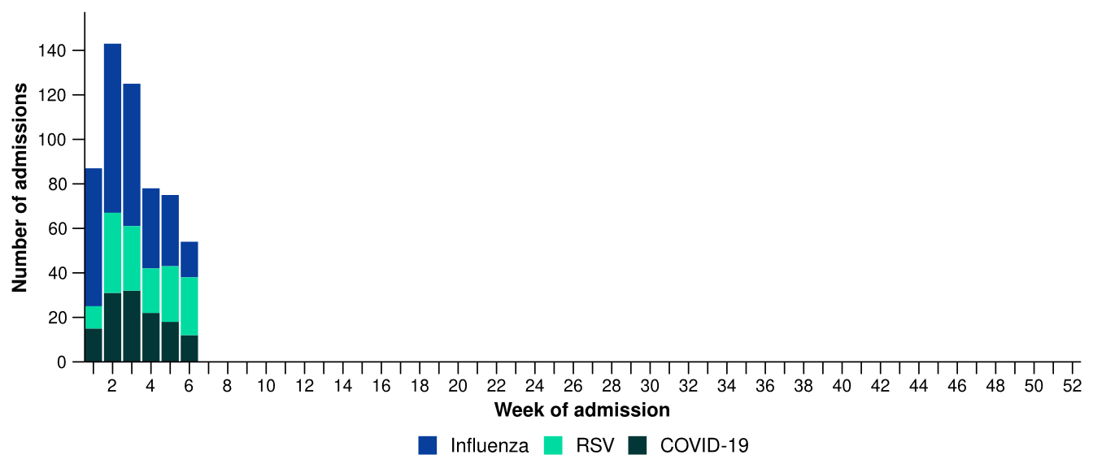
Source: Influenza Complications Alert Network (FluCAN)
- Patients admitted to sentinel hospitals with influenza have mostly been admitted with influenza A (95.1%; 272/286), while 4.9% (14/286) were admitted with influenza B.
  - Most hospital admissions with influenza A have been with influenza A(Unsubtyped) (84.2%; 229/272), followed by influenza A(H3N2) (13.6%; 37/272) and then influenza A(H1N1) (2.2%; 6/272).
- In the year to date for severity reporting, influenza A was the most commonly detected influenza type in all age groups, though influenza A(H3N2) and influenza B have also been commonly detected among children (Figure 16).
Figure 16: Number of patients admitted with influenza to sentinel hospitals by influenza subtype, age group*, and week of admission, Australia, 1 January to 8 February 2026
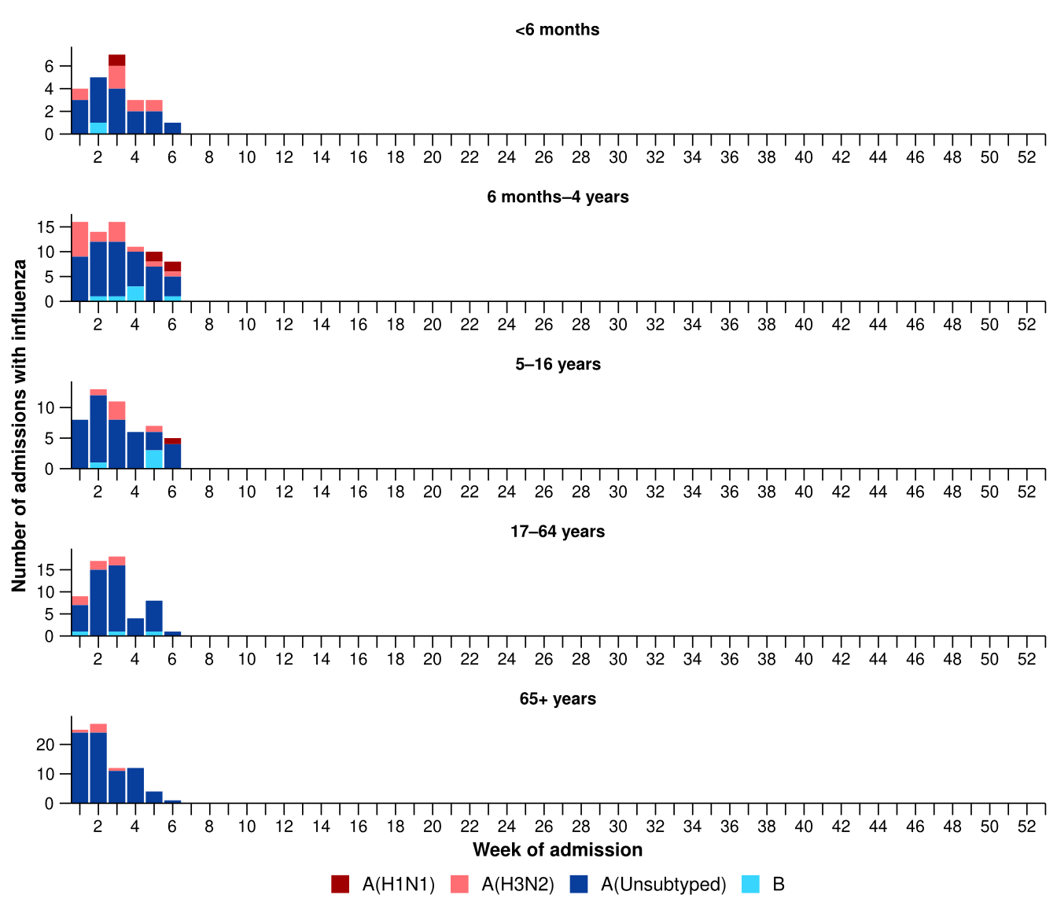
Source: Influenza Complications Alert Network (FluCAN)
* Axis varies between age groups. The age distribution of admissions with influenza may not reflect the age distribution of all patients.
- In the year to date, sentinel hospital data show more children (those aged 16 years and younger) have been admitted with influenza than with RSV or COVID-19 (Table 3a).
- Children admitted to sentinel hospitals with influenza tended to be older than children admitted with COVID-19 or RSV (Table 3a).
- Children admitted to sentinel hospitals with RSV had a slightly longer length of hospital stay compared to children with influenza or RSV; however, the difference in the length of stay was minor (Table 3a).

Table 3a: Demographic characteristics and outcomes for children admitted with a severe acute respiratory infection to a sentinel hospital by disease*†‡, Australia, 1 January to 8 February 2026
 | COVID-19 | Influenza | RSV
 | Year to date for  severity reporting  (n=58) | Year to date for  severity reporting  (n=148) | Year to date for  severity reporting  (n=122)
Age (years)
Median [IQR] | 1 [0-3] | 3 [0-6] | 1 [0-2]
Age group (years)
< 6 months | 20 (34.5%) | 23 (15.5%) | 27 (22.1%)
6 months – 4 years | 26 (44.8%) | 75 (50.7%) | 87 (71.3%)
5–16 years | 12 (20.7%) | 50 (33.8%) | 8 (6.6%)
Indigenous status
Aboriginal and Torres Strait Islander | 3 (5.2%) | 17 (11.5%) | 23 (18.9%)
Length of hospital stay (days)†
Median [IQR] | 1 [1-2] | 1 [1-2] | 1 [1-3]
Patient admission location‡
Admitted to hospital ward | 57 (98.3%) | 139 (93.9%) | 117 (95.9%)
Admitted to intensive care directly | 1 (1.7%) | 9 (6.1%) | 5 (4.1%)
Discharge status†
Alive | 41 (70.7%) | 119 (80.4%) | 96 (78.7%)
Died | - | 1 (0.7%) | -
Incomplete/missing | 17 (29.3%) | 28 (18.9%) | 26 (21.3%)
Source: Influenza Complications Alert Network (FluCAN)
* Does not include patients with missing age; therefore, the sum of age-specific totals above may not equal the total number of patients.
† For patients who are still in hospital data may not be complete; therefore, these data are not included in the length of stay or discharge status. In addition, length of stay data excludes patients that acquired their infection in hospital.
‡ Admission location reflects the initial admission ward. Some patients may be initially admitted to general ward then later admitted to an intensive care and this is not reflected here. Does not include patients with missing admission location; therefore, the sum of admission location specific totals above may not equal the total number of patients.
The Paediatric Active Enhanced Disease Surveillance (PAEDS) network carries out enhanced sentinel hospital surveillance for some acute respiratory infections or conditions in children. PAEDS data for acute respiratory infections in children are presented in the Australian Respiratory Surveillance Reports in the sentinel hospital data from FluCAN. For additional information on COVID-19 in children, Paediatric Inflammatory Multisystem Syndrome (PIMS-TS) following COVID-19, influenza in children, or RSV in children please visit the PAEDS webpages and dashboards.
- In the year to date, sentinel hospital data indicate more adults (those aged 17 years and over) have been admitted with influenza than with COVID-19 (Table 3b).
- Adults admitted to sentinel hospitals with COVID-19 and influenza have been predominately aged 65 years and over, and a greater proportion of adults aged 17–64 years have been admitted with influenza than with COVID-19 (Table 3b).
- Adults admitted to sentinel hospitals with COVID-19 had a longer length of hospital stay compared to adults admitted with influenza (Table 3b).

Table 3b: Demographic characteristics and outcomes for adults admitted with a severe acute respiratory infection to a sentinel hospital by disease*†‡, Australia, 1 January to 8 February 2026
 | COVID-19 | Influenza | RSV
 | Year to date for  severity reporting  (n=72) | Year to date for  severity reporting  (n=138) | Year to date for  severity reporting  (n=24)
Age (years)
Median [IQR] | 74 [54-83] | 70 [42-81] | 74 [66-82]
Age group (years)
17–64 years | 24 (33.3%) | 57 (41.3%) | 4 (16.7%)
65 years and over | 48 (66.7%) | 81 (58.7%) | 20 (83.3%)
Indigenous status
Aboriginal and Torres Strait Islander | 8 (11.1%) | 12 (8.7%) | 4 (16.7%)
Length of hospital stay (days)†
Median [IQR] | 4 [2-8] | 2 [1-5] | 3 [1-5]
Patient admission location‡
Admitted to hospital ward | 70 (97.2%) | 126 (91.3%) | 23 (95.8%)
Admitted to intensive care directly | 2 (2.8%) | 12 (8.7%) | 1 (4.2%)
Discharge status†
Alive | 37 (51.4%) | 97 (70.3%) | 16 (66.7%)
Died | 2 (2.8%) | 2 (1.4%) | -
Incomplete/missing | 33 (45.8%) | 39 (28.3%) | 8 (33.3%)
Source: Influenza Complications Alert Network (FluCAN)
* Does not include patients with missing age; therefore, the sum of age-specific totals above may not equal the total number of patients.
† For patients who are still in hospital data may not be complete; therefore, these data are not included in the length of stay or discharge status. In addition, length of stay data excludes patients that acquired their infection in hospital.
‡ Admission location reflects the initial admission ward. Some patients may be initially admitted to general ward then later admitted to an intensive care and this is not reflected here. Does not include patients with missing admission location; therefore, the sum of admission location specific totals above may not equal the total number of patients.

- In the last severity reporting period for sentinel intensive care (12 January to 8 February 2026), fewer patients have been admitted to a sentinel intensive care with a severe acute respiratory infection (n=110), than in the previous severity reporting period (n=199) (Figure 17).
- In the year to date for severity reporting (1 January to 8 February 2026), most patients were admitted to sentinel intensive care with influenza, followed by COVID-19 (Figure 17; Table 4).

Figure 17: Number of patients admitted with severe acute respiratory infections to a sentinel intensive care by disease and week of admission, Australia, 1 January to 8 February 2026
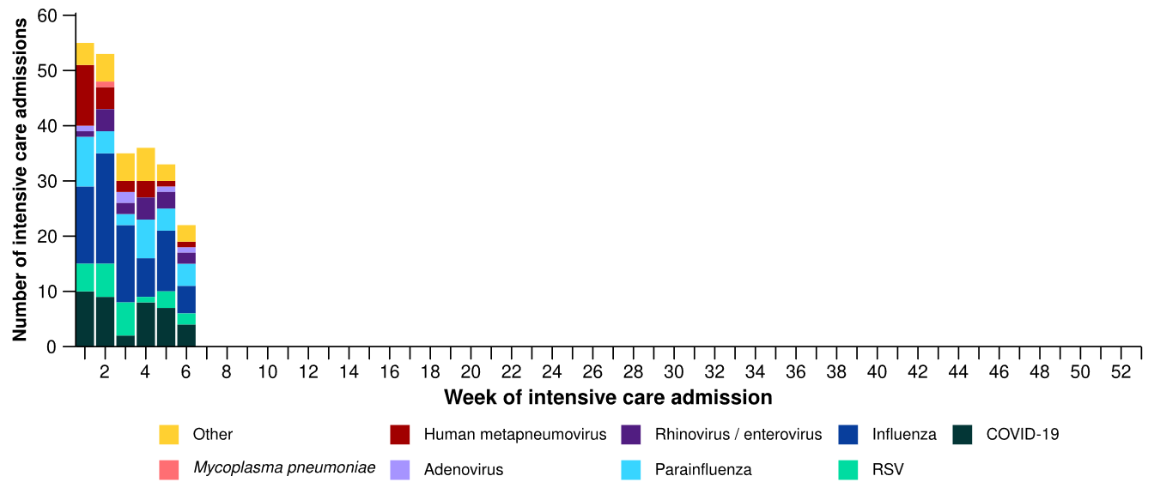
Source: Short Period Incidence Study of Severe Acute Respiratory Infection (SPRINT-SARI) Australia
Note: A range of diagnostic testing procedures are utilised across hospitals in Australia. SPRINT-SARI does not specify which diagnostic testing method should be utilised as this is the domain of the hospital and treating clinicians.
Figure 18: Number of patients admitted with severe acute respiratory infections to a sentinel intensive care by disease and age group*, Australia, 1 January to 8 February 2026
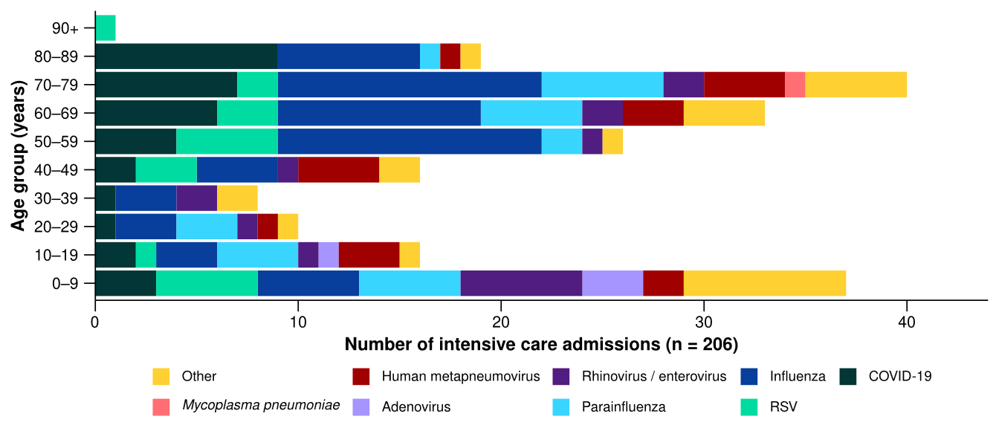
Source: Short Period Incidence Study of Severe Acute Respiratory Infection (SPRINT-SARI) Australia
Note: 11.3% (35/309) of patients had co-infections of respiratory pathogens; therefore, the sum of pathogen-specific totals above may not equal the total number of severe acute respiratory infection patients.
* The age distribution of severe acute respiratory infection intensive care admissions may not reflect the age distribution of all patients.
- In the year to date for severity reporting (1 January to 8 February 2026), there has been a higher proportion of admissions to a sentinel intensive care with COVID-19 or influenza among older people. RSV admissions have occurred in both children and adults aged over 40 years (Figure 18; Table 4).
- A higher proportion of admissions with parainfluenza, COVID-19 and hMPV required invasive mechanical ventilation and the length of ventilation was longest among those with hMPV. The length of intensive care stay was relatively similar across diseases (Table 4).
- Most patients admitted to a sentinel intensive care have been discharged home. Sadly, a number of patients have died in hospital (Table 4). Despite an increased number of admissions with influenza in late 2025, the proportion of admissions who have died has only increased slightly since July 2025 and is relatively consistent with the trends observed in 2024 (see 2024 Annual Australian Respiratory Surveillance Report).
Table 4: Demographic characteristics and outcomes of patients admitted with a severe acute respiratory infection to a sentinel intensive care by disease*†, Australia, 1 January to 8 February 2026
 | COVID-19 | hMPV | Influenza | Mycoplasma  pneumoniae | Parainfluenza | RSV
 | Year to date for severity reporting  (n=35) | Year to date for severity reporting  (n=18) | Year to date for severity reporting  (n=61) | Year to date for severity reporting  (np) | Year to date for severity reporting  (n=26) | Year to date for severity reporting  (n=20)
Age (years)
Median [IQR] | 68  [51–80] | 46  [18–70] | 59  [43–75] | np | 56  [12–71] | 53  [14–63]
Indigenous status
Aboriginal and Torres Strait Islander | 2  (5.7%) | 1  (5.6%) | 8  (13.1%) | – | 1  (3.8%) | 7  (35.0%)
Non-Indigenous | 33  (94.3%) | 17  (94.4%) | 53  (86.9%) | np | 25  (96.2%) | 13  (65.0%)
Received invasive mechanical ventilation
Number (%) | 10  (28.6%) | 5  (27.8%) | 15  (24.6%) | – | 8  (30.8%) | 4  (20.0%)
Length of invasive mechanical ventilation (days)*
Median [IQR] | 2 [1–7] | 8 [3–9] | 5 [1–12] | np | 2 [1–3] | 3 [1–93]
Length of intensive care stay (days)*
Median [IQR] | 2 [1–4] | 3 [1–6] | 2 [2–6] | np | 4 [2–5] | 3 [1–3]
Length of hospital stay (days)*
Median [IQR] | 6 [3–13] | 6 [3–9] | 7 [4–10] | np | 8 [4–11] | 9 [4–13]
Patient outcome†
Ongoing care in intensive care | 3  (8.6%) | – | 1  (1.6%) | – | 2  (7.7%) | 2  (10.0%)
Ongoing care in hospital ward | 4  (11.4%) | 1  (5.6%) | 5  (8.2%) | – | 2  (7.7%) | 1  (5.0%)
Transfer to other hospital / facility | 4  (11.4%) | 4  (22.2%) | 10  (16.4%) | – | 2  (7.7%) | 2  (10.0%)
Discharged home | 20  (57.1%) | 11  (61.1%) | 39  (63.9%) | np | 16  (61.5%) | 14  (70.0%)
Died in hospital | 4  (11.4%) | 2  (11.1%) | 6  (9.8%) | – | 4  (15.4%) | 1  (5.0%)

Source: Short Period Incidence Study of Severe Acute Respiratory Infection (SPRINT-SARI) Australia
Note: 11.3% (35/309) of patients had co-infections of respiratory pathogens; therefore, the sum of pathogen-specific totals above may not equal the total number of severe acute respiratory infection patients.
* For patients receiving ongoing care in intensive care data may not be complete; therefore, data are not included in the length of ventilation or stay.
† Patients who have been admitted with no discharge information for less than 90 days have been assumed to have ongoing care in the hospital. Patients who have no outcome entered or have been admitted for more than 90 days with no discharge information have been treated as missing. np = not published.

- In the last month (26 January to 22 February 2026), there were an average of 152 intensive care patients in droplet or airborne isolation for any suspected or confirmed respiratory pathogen each day, an 11.1% decrease from an average of 171 patients in isolation each day reported in the previous month (Figure 19).
  - Suspected or confirmed respiratory pathogens may include nationally notifiable conditions such as COVID-19, influenza, RSV or pertussis (Whooping cough) but also other non-notifiable respiratory pathogens like adenovirus, hMPV, parainfluenza, rhinovirus or bacterial infections causing atypical pneumonias.
- In the last month (26 January to 22 February 2026), there were an average of 68 intensive care staff unavailable to work due to illness each day, a 10.5% decrease from an average of 76 staff unavailable each day reported in the previous month (Figure 19).
- In the last month, the average number of intensive care patients in droplet or airborne isolation for any suspected or confirmed respiratory pathogen each day decreased or remained relatively stable across all jurisdictions compared with the previous month (Figure 20).
- In the last month, the average number of intensive care staff unavailable to work due to illness each day decreased or remained relatively stable across all jurisdictions compared with the previous month (Figure 20).
Figure 19: Weekly average daily occupancy of intensive care patients in droplet or airborne isolation for any suspected or confirmed respiratory pathogen and the weekly average daily number of intensive care staff unavailable to work due to illness by week of report*, Australia, 1 January to 22 February 2026 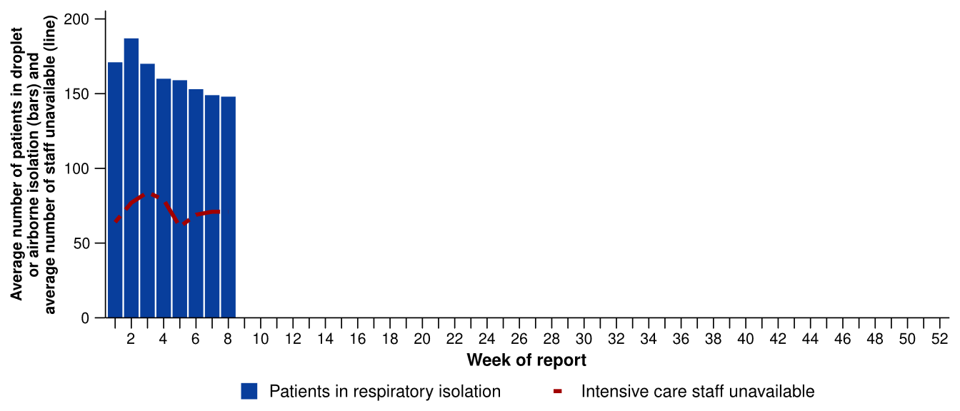
Source: Critical Health Resource Information System (CHRIS)
* Intensive care staff include both medical and nursing staff. Staff unavailability will be underestimated in NSW as most public hospitals in NSW do not report staff unavailability.

Figure 20: Weekly average daily occupancy of intensive care patients in droplet or airborne isolation for any suspected or confirmed respiratory pathogen and the weekly average daily number of intensive care staff unavailable to work due to illness by jurisdiction and week of report*†‡, Australia, 1 January to 22 February 2026
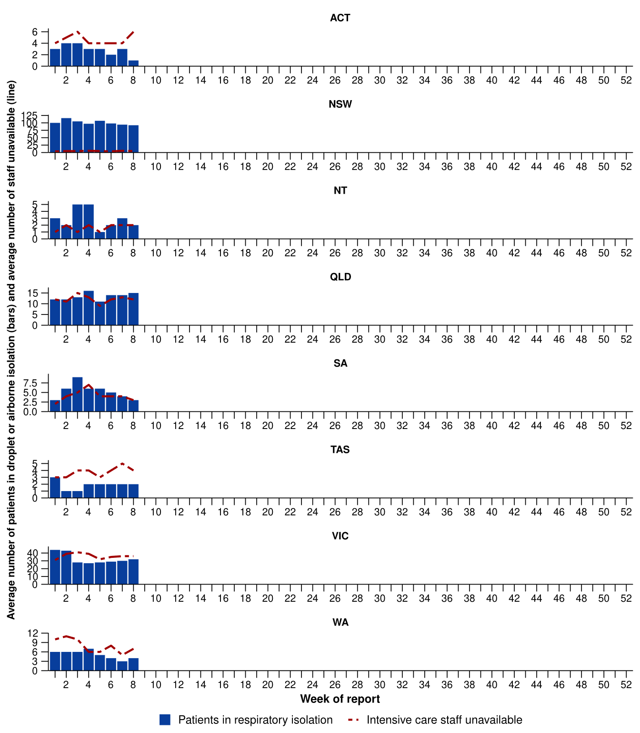
Source: Critical Health Resource Information System (CHRIS)
* Axis varies between jurisdictions.
† NSW isolation data from public hospitals includes all patients occupying intensive care beds in isolation precautions, including those in contact isolation precautions, rather than just droplet or airborne isolation precautions. For this reason, the average number of patients occupying intensive care beds in droplet or airborne isolation will be overestimated.
‡ Intensive care staff include both medical and nursing staff. Staff unavailability will be underestimated in NSW as most public hospitals in NSW do not report staff unavailability.

Mortality surveillance
Death registrations can provide information on the scale and severity of disease associated with acute respiratory infections. For more information on death registrations including completeness, timeliness, and detailed definitions of deaths due to and with acute respiratory infections, refer to the Technical Supplement.
- An acute respiratory associated death is one where the death was due to the disease (the illness has caused terminal complications such as pneumonia) or the person has died with the disease (a person has died from another cause, but the illness still contributed significantly to death).
- COVID-19 has been the leading cause of acute respiratory infection related mortality across the majority of 2023–2025. In 2025 the number of deaths involving COVID-19 (both due to and with) exceeded the number of deaths involving influenza.
- In 2025 the mortality rate for deaths involving influenza (both due to and with) was higher for Aboriginal and Torres Strait Islander people than non-Indigenous people; however, the rate for deaths involving COVID-19 is lower for Aboriginal and Torres Strait Islander people than non-Indigenous people.
- All three of these acute respiratory infections are more likely to cause death in older age groups than younger age groups.
Figure 21a: Provisional numbers of deaths due to an acute respiratory infection*† by month, year, and disease, Australia, 1 January 2024 to 31 January 2026
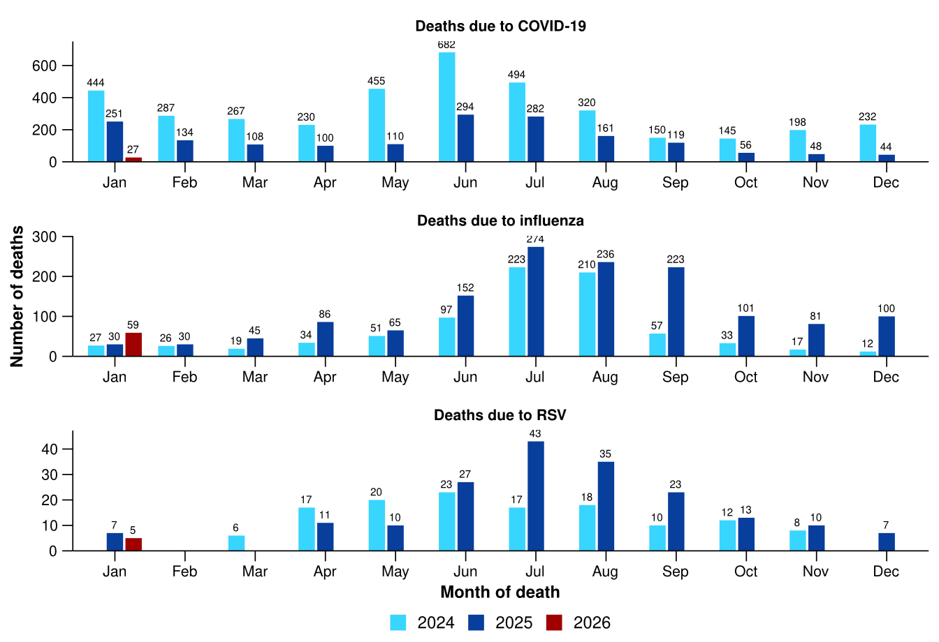
Source: Australian Bureau of Statistics, Deaths due to acute respiratory infections in Australia, released 24 February 2026.
* Axis varies between acute respiratory infections.
† Data is provisional and subject to change. It can take several weeks for death registrations to be reported, processed, coded, validated, and tabulated. Therefore, the data shown here may be incomplete. Data for some months were not published by the ABS due to small counts, and therefore not reported here. Data includes all deaths (both doctor and coroner certified) that occurred and were registered by 31 January 2026.

- Deaths due to COVID-19 fell in October 2025 to the lowest levels since July 2021. The 1,707 deaths due to COVID-19 in 2025 are well below both 2024 (3,904 deaths) and 2023 (4,610) (Figure 21a).
- Deaths due to influenza fell in November 2025 before increasing again in December and remained high for the time of year. There were 1,423 deaths due to influenza in 2025, more than the 1,276 deaths recorded in 2017 and the 1,072 deaths recorded in 2019, which were recent high mortality years for influenza (Figure 21a).
  - Although the number of deaths due to influenza in 2025 was high, this is expected when there are higher case numbers, and other surveillance systems have not indicated that illness was more severe in 2025 compared to previous years.
- Deaths due to RSV decreased in November and December 2025 and were comparable to the number of deaths in October 2023 and 2024 (Figure 21a).
- Deaths with COVID-19 fell in November 2025 and increased slightly in December, but remain at extremely low levels (Figure 21b).
- Deaths with influenza also decreased in November 2025 and increased slightly in December. Deaths with influenza were higher than deaths with COVID-19 from August 2025 and were higher than the number of deaths with influenza in the comparable month in 2024 or 2023 for several months (Figure 21b).
- Deaths with RSV decreased in November then increased in December 2025. The number of deaths was generally higher than in 2023 and 2024 from July 2025. The number of deaths with RSV overall was higher in 2025 (390 deaths) than in 2024 (341 deaths) and in 2023 (279 deaths) (Figure 21b).
Figure 21b: Provisional numbers of deaths with an acute respiratory infection*† by month, year, and disease, Australia, 1 January 2024 to 31 January 2026
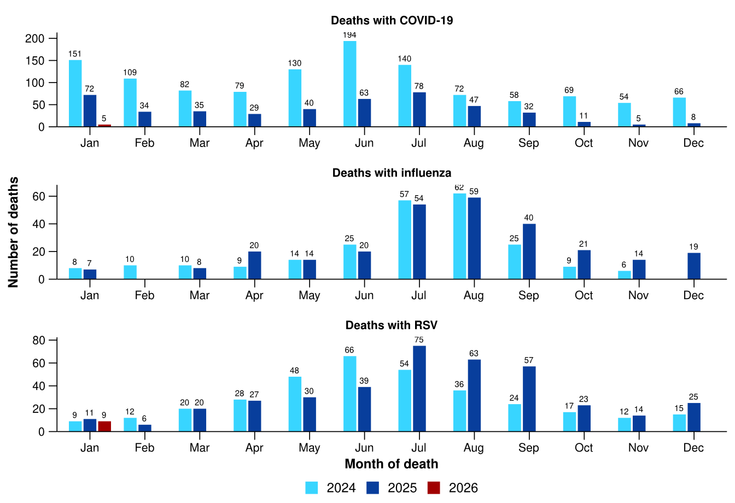
Source: Australian Bureau of Statistics, Deaths due to acute respiratory infections in Australia, released 24 February 2026.
* Axis varies between acute respiratory infections.
† Data is provisional and subject to change. It can take several weeks for death registrations to be reported, processed, coded, validated, and tabulated. Therefore, the data shown here may be incomplete. Data for some months were not published by the ABS due to small counts, and therefore not reported here. Data includes all deaths (both doctor and coroner certified) that occurred and were registered by 31 January 2026.

Laboratory surveillance
Sentinel laboratory surveillance monitors the percentage of tests with the notifiable condition detected (i.e. test positivity). It also provides information on what pathogens are circulating, potential changes in the pathogens that might affect their infectiousness, severity, ability to evade vaccine and/or infection-acquired immunity, or resistance to antivirals.
- In the last month (26 January to 22 February 2026), the percentage of SARS-CoV-2 tests that were positive increased (from 1.6% to 2.2%), the percentage of influenza tests that were positive decreased (from 2.4% to 1.6%) and the percentage of RSV tests that were positive increased slightly (from 0.7% to 0.8%) (Figure 22).

Figure 22: Number of tests positive (bars) and percentage of tests positive (line) for SARS-CoV-2, influenza or RSV of those specimens tested by sentinel laboratories by week of report*†, Australia, 1 January to 22 February 2026
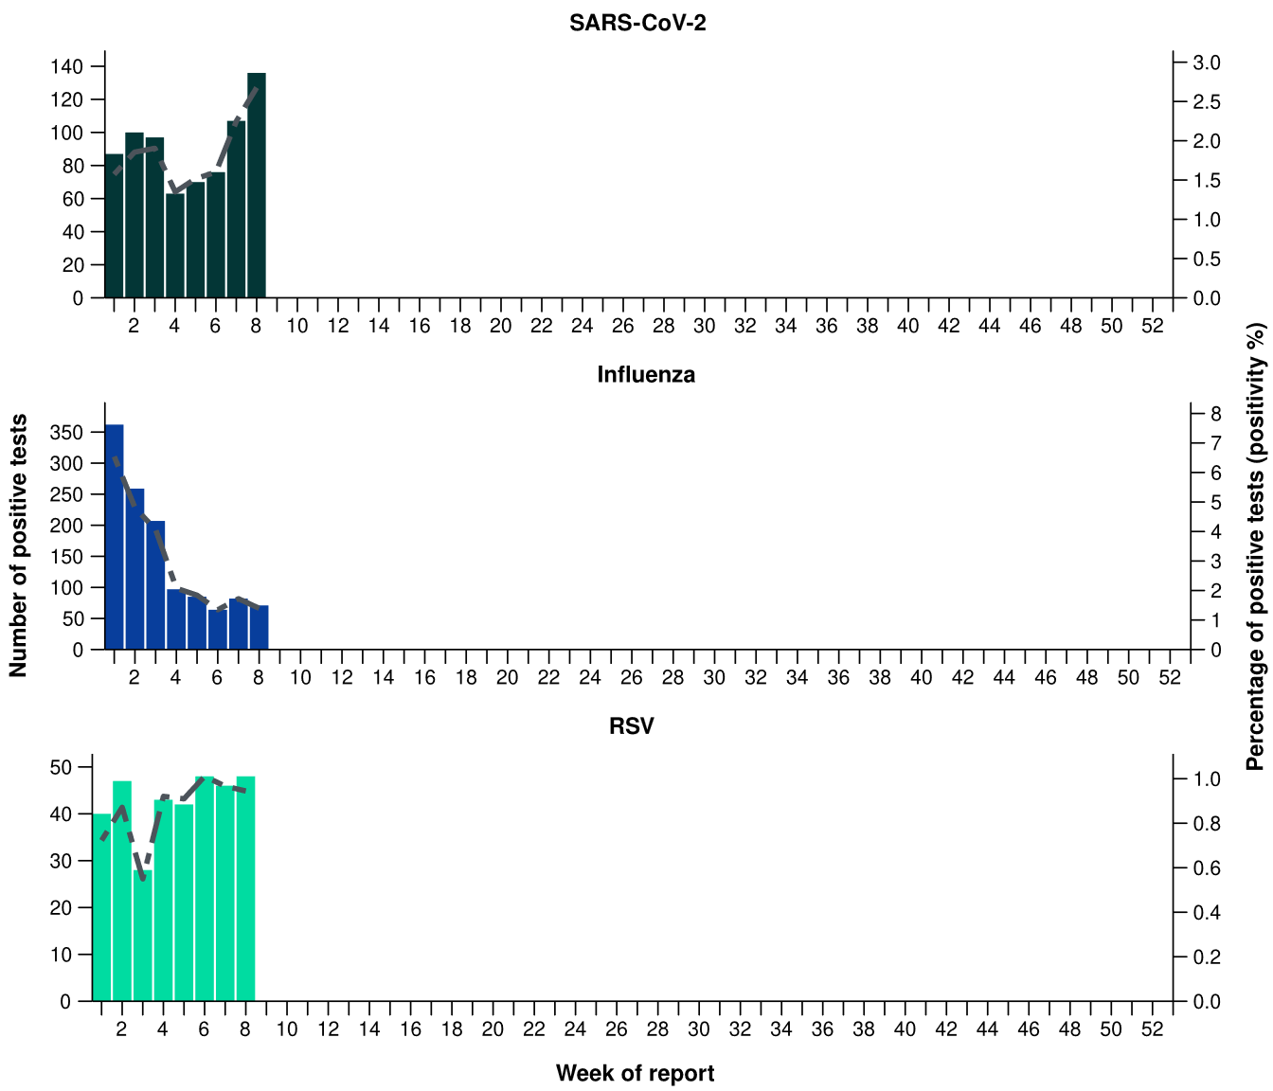
Source: Sentinel laboratories, including National Influenza Centres
* Number of specimens tested excludes data from WA as testing denominator data are different for the three pathogens in Western Australia.
† A small minority of total samples from Victoria are tested only by respiratory panel (influenza, parainfluenza, adenovirus, human metapneumovirus, seasonal coronaviruses, RSV, and some picornaviruses) but not for SARS-CoV-2. These minority samples include only forensic materials; all other samples are tested by respiratory panel and SARS-CoV-2 assay.

- There were 83 SARS-CoV-2 sequences uploaded to AusTrakka with dates of collection in the last 28 days (26 January to 22 February 2026). These sequences were from NSW, Qld and SA, with the most recent collection date 9 February 2026.
- Most sequences were assigned to the BA.2.86 sub-lineage within B.1.1.529 (Omicron) or recombinants consisting of one or more Omicron sub-lineages (Figure 23a/b). In the last 28 days:
  - 16.9% (14/83) of sequences were from the sub-sub-lineages JN.1 (BA.2.86.1.1), specifically KP.3.1.1.
  - 66.2% (55/83) of sequences were recombinant or recombinant sub-lineages, the most common including NB.1.8.1 (n=27) and XFG (n=28).
  - 15.7% (13/83) of sequences were identified as BA.3.
  - there were no BA.1, BA.4, BA.5 or other BA.2 sub-sub-lineage sequences.
- XFG was the most common sub-lineage in the past 28 days, accounting for 33.7% (28/83) of sequences (Figure 23a).
- The World Health Organization (WHO) have identified certain sub-sub-lineages and recombinants as variants under monitoring (VUM) or variants of interest (VOI) because of their epidemiological, pathological, or immunological features of concern. A select number are highlighted below due to their relevance in the Australian context. There are:
  - 212 BA.3.2 (newly designated VUM) sequences in AusTrakka, with 13 collected in the last 28 days
  - 889 XFG sequences in AusTrakka, with 28 collected in the last 28 days
  - 2,971 NB.1.8.1 sequences in AusTrakka, with 27 collected in the last 28 days
  - 777 LP.8.1 sequences in AusTrakka, with no sequences collected in the last 28 days
  - 3,929 KP.3.1.1 sequences in AusTrakka, with 5 sequences collected in the last 28 days.
Figure 23a: SARS-CoV-2 Omicron sub-lineage* sequences by sample collection date, showing (A) proportions and (B) count per week†‡, Australia, 1 January to 22 February 2026
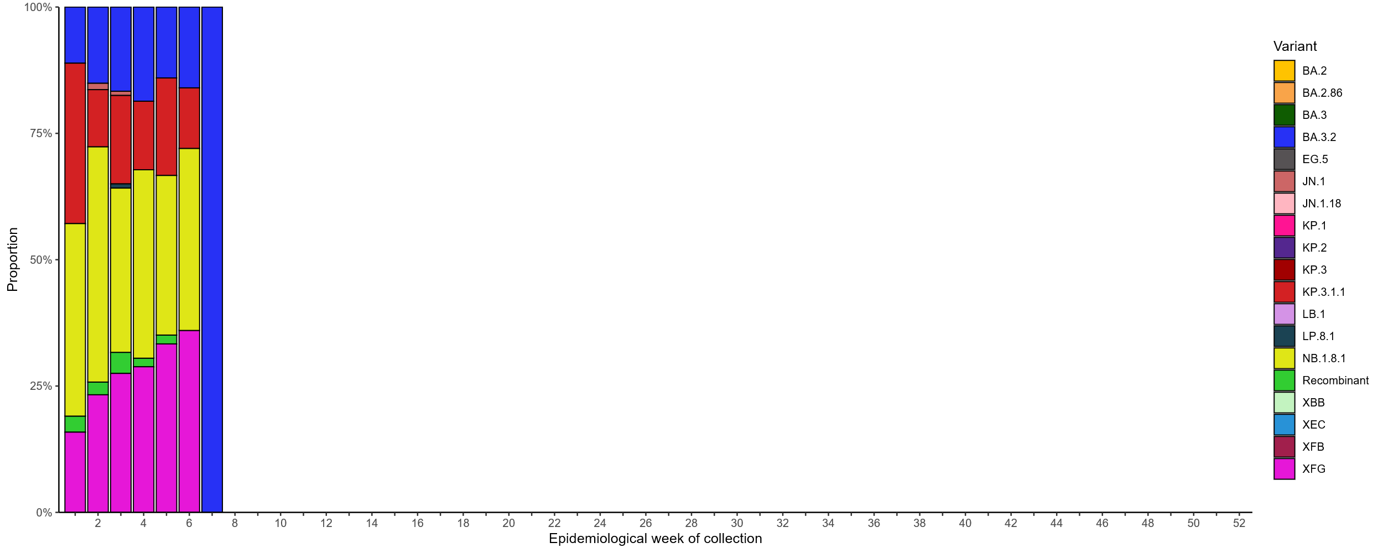

Source: AusTrakka
* Some sub-sublineages are shown alongside their parent lineage, but not included in the parent lineage totals. For instance, KP.2 and KP.3 are sub-sub lineages of JN.1, so the total of JN.1 sequences will be higher than shown in the corresponding colour alone, and should include the KP.2 and KP.3 totals.
† Sequences in AusTrakka aggregated by week and reported based on date of sample collection, not date of sequencing.
‡ Proportions in Figure 23a may not be representative when sequence numbers are small; refer to Figure 23b. Data for earlier weeks may change between reporting periods as sequences with older collection dates are uploaded. These numbers are not equivalent to number of cases, as there are many cases which may not be sequenced. Non-VOI and non-VUM Omicron sub-lineages have been collapsed into parent lineages BA.1, BA.2, BA.3, BA.4 and BA.5.

Figure 23b: SARS-CoV-2 Omicron sub-lineage* sequences by sample collection date, showing the count of sequences per week†‡, Australia, 1 January 2022 to 22 February 2026
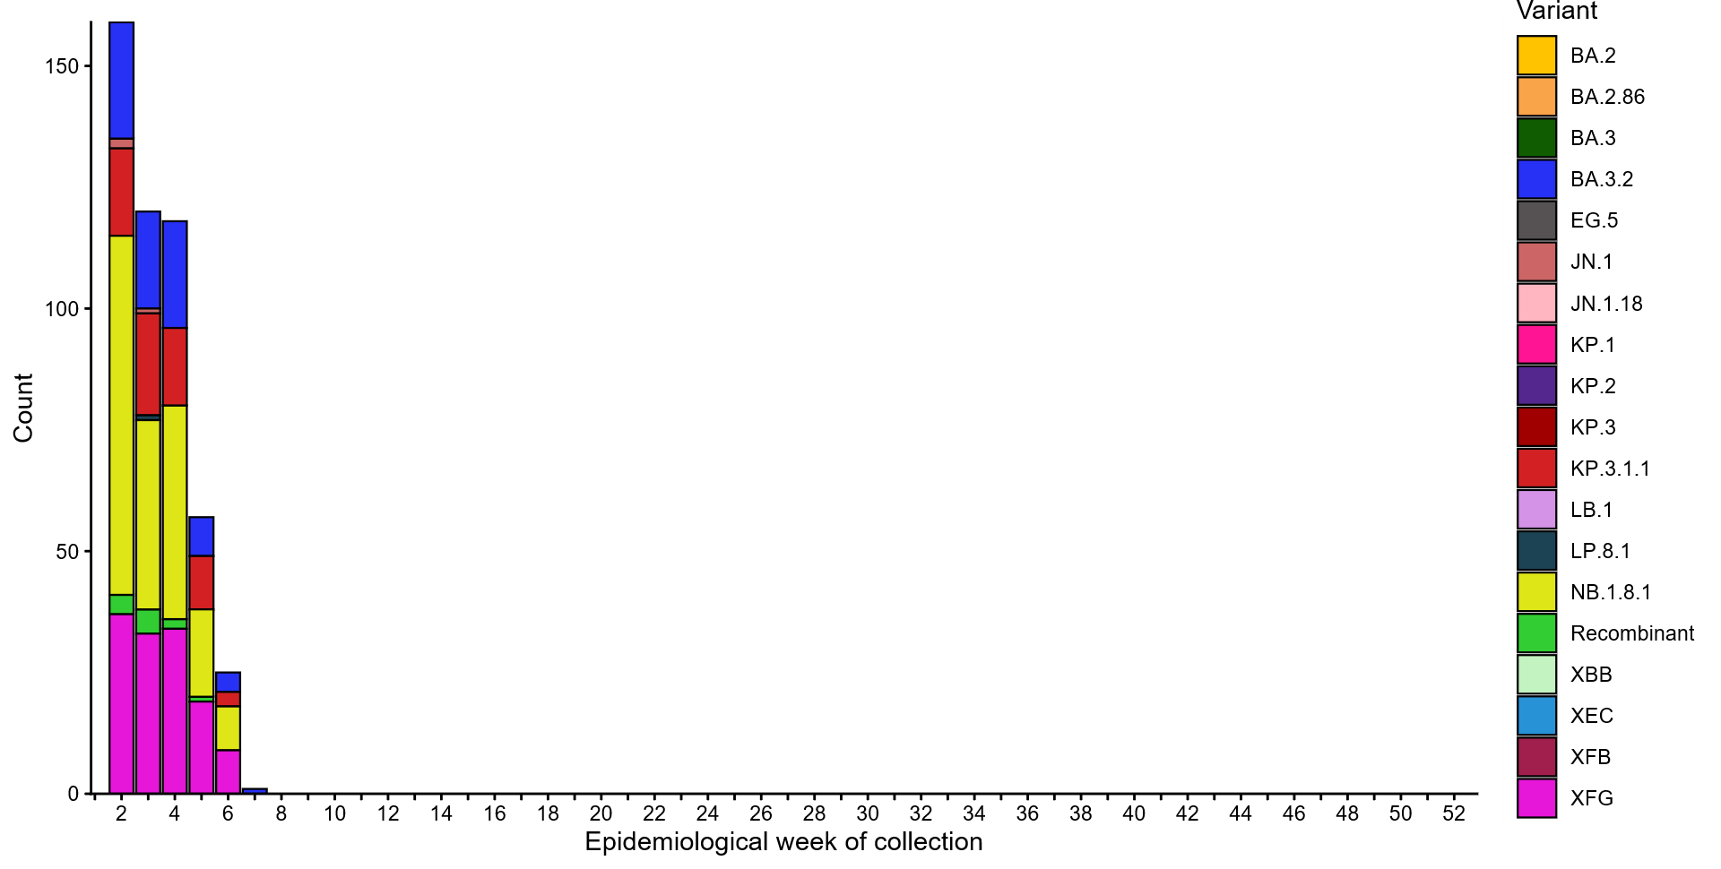
Source: AusTrakka
* Some sub-sublineages are shown alongside their parent lineage, but not included in the parent lineage totals. For instance, KP.2 and KP.3 are sub-sub lineages of JN.1, so the total of JN.1 sequences will be higher than shown in the corresponding colour alone, and should include the KP.2 and KP.3 totals.
† Sequences in AusTrakka aggregated by week and reported based on date of sample collection, not date of sequencing.
‡ Data for earlier weeks may change between reporting periods as sequences with older collection dates are uploaded. These numbers are not equivalent to number of cases, as there are many cases which may not be sequenced. Non-VOI and non-VUM Omicron sub-lineages have been collapsed into parent lineages BA.1, BA.2, BA.3, BA.4 and BA.5.
- In the year to date, the WHO Collaborating Centre for Reference and Research on Influenza has antigenically characterised 35 influenza viruses from Australia (Table 5), of which:
  - 88.6% (31/35) have been influenza A(H3N2)
  - 11.4% (4/35) have been influenza B/Victoria.
- These results represent a limited number of samples that are not nationally representative that have been received in the year to date.
- In the year to date, there have been no influenza A(H1N1) or B/Yamagata viruses characterised (Table 5). The last influenza B/Yamagata virus characterised in Australia was in a sample from 2020.
- None of the samples tested by the WHO Collaborating Centre for Reference and Research demonstrated highly reduced inhibition to zanamivir.
Table 5: Australian influenza viruses typed by haemagglutination inhibition assay and jurisdiction*†, 1 January to 22 February 2026
Strain | ACT | NSW | NT | Qld | SA | Tas | Vic | WA | Total
A(H1N1) | 0 | 0 | 0 | 0 | 0 | 0 | 0 | 0 | 0
A(H3N2) | 5 | 1 | 17 | 1 | 0 | 2 | 5 | 0 | 31
B/Victoria lineage | 0 | 0 | 4 | 0 | 0 | 0 | 0 | 0 | 4
B/Yamagata lineage | 0 | 0 | 0 | 0 | 0 | 0 | 0 | 0 | 0
Total | 5 | 1 | 21 | 1 | 0 | 2 | 5 | 0 | 35
Source: World Health Organization (WHO) Collaborating Centre for Reference and Research on Influenza
*Viruses tested by the WHO Collaborating Centre for Reference and Research on Influenza are not necessarily a random sample of all those in the community and early-year data may be based on limited samples received. There may be up to a month delay on reporting of samples.
† Jurisdiction indicates the residential location for the individual tested, not the submitting laboratory.

Vaccine coverage, effectiveness and match
Vaccine coverage, effectiveness and match for acute respiratory infections are monitored from several data sources in Australia. Refer to the Technical Supplement for more information.

Vaccine coverage
- Nationally, 2.2% of adults (aged 18 years and over) have received a COVID-19 vaccine in the last six months (Table 6).
- Nationally, the proportion of adults that have received a COVID-19 vaccine in the last 12 months (10%; Table 6) is similar to the 12 months prior (10.1% from 19 February 2024 to 16 February 2025).
- In the last 12 months, vaccine coverage varied across all age groups, with the largest variation seen in adults aged 75 years and over (from 36.2% in the 12 months prior to 38.5% in the last 12 months).
- There has been substantial variation in COVID-19 vaccine coverage across age groups, ranging from 4.1% in adults aged 18–64 years to 38.5% in adults aged 75 years and over. Vaccine coverage increases with increasing age (Table 6).
- There has been some variation in vaccine coverage across jurisdictions, ranging from 3.9% in the NT to 17.1% in Tas (Table 6).
Table 6: COVID-19 vaccine coverage*†‡ by age group and jurisdiction, Australia, 17 February 2025 to 22 February 2026
Age group | ACT | NSW | NT | Qld | SA | Tas | Vic | WA | Total
Last 12 months (17 February 2025 to 22 February 2026)
18–64 years | 9.3 | 3.5 | 1.9 | 3.9 | 4.2 | 7.5 | 4.4 | 4.1 | 4.1
65–74 years | 43.9 | 22.4 | 14.2 | 22.7 | 25.2 | 35.5 | 24.5 | 24.4 | 24.1
≥ 75 years | 61.2 | 36.8 | 24.9 | 36.9 | 39.3 | 51.5 | 37.8 | 39.7 | 38.5
All ages (18 years and over) | 16.8 | 9.3 | 3.9 | 9.5 | 11.2 | 17.1 | 10.0 | 9.7 | 10.0
Last 6 months (18 August 2025 to 22 February 2026)
18–64 years | 1.5 | 0.6 | 0.5 | 0.7 | 0.7 | 1.1 | 0.7 | 0.5 | 0.7
65–74 years | 9.6 | 4.1 | 3.6 | 4.1 | 4.9 | 5.9 | 4.3 | 3.3 | 4.2
≥ 75 years | 22.4 | 10.8 | 7.1 | 10.6 | 12.5 | 14.8 | 11.1 | 9.3 | 11.2
All ages (18 years and over) | 4.0 | 2.1 | 1.1 | 2.1 | 2.7 | 3.5 | 2.2 | 1.6 | 2.2
Source: Australian Immunisation Register (AIR) as at 23 February 2026
* COVID-19 vaccine coverage among the general population uses the most recently available Australian Bureau of Statistics Estimated Resident Population (ERP) as denominator for population data. Age in years is calculated as at the reporting week.
† COVID-19 vaccine coverage is influenced by changes in COVID-19 vaccine recommendations and eligibility criteria. Coverage data in these tables may differ slightly from coverage estimates in other reports due to differences in calculation methodologies and/or different data download dates.
‡ Jurisdiction is based on the state or territory in which a vaccine was administered and may differ from a person’s residential address. Population denominator data used to calculate COVID-19 vaccine coverage are based on an individual’s residential address. Total rows will include individuals where jurisdiction was missing.

- Nationally, 0.8% of Aboriginal and Torres Strait Islander adults (aged 18 years or over) have received a COVID-19 vaccine in the last six months (Table 7).
- Nationally, fewer Aboriginal and Torres Strait Islander adults have received a COVID-19 vaccine in the last 12 months (4.2%; Table 7), compared to the 12 months prior (4.8% from 19 February 2024 to 16 February 2025).
- In the last 12 months, vaccine coverage decreased in all age groups of Aboriginal and Torres Strait Islander people, with the largest decrease seen in 65–74 years age group (from 17.4% in the 12 months prior to 16.1% in the last 12 months).
- Among Aboriginal and Torres Strait Islander people there has been substantial variation in COVID-19 vaccine coverage across age groups, ranging from 2.4% in adults aged 18–64 years to 25.2% in adults aged 75 years and over. Vaccine coverage increases with increasing age (Table 7).
- Among Aboriginal and Torres Strait Islander people, there has been variation in vaccine coverage across jurisdictions, ranging from 2.5% in the NT to 8.7% in Tas (Table 7).
Table 7: COVID-19 vaccine coverage*†‡ among Aboriginal and Torres Strait Islander populations by age group and jurisdiction, Australia, 17 February 2025 to 22 February 2026
Age group | ACT | NSW | NT | Qld | SA | Tas | Vic | WA | Total
Last 12 months (17 February 2025 to 22 February 2026)
18–64 years | 5.6 | 2.4 | 1.8 | 2.2 | 2.5 | 4.8 | 3.4 | 2.1 | 2.4
65–74 years | 29.8 | 17.1 | 9.2 | 15.3 | 15.9 | 29.6 | 18.5 | 14.6 | 16.1
≥ 75 years | 43.5 | 26.9 | 13.9 | 23.3 | 27.2 | 38.8 | 30.1 | 25.7 | 25.2
All ages (18 years and over) | 8.3 | 4.6 | 2.5 | 3.9 | 4.5 | 8.7 | 5.9 | 3.5 | 4.2
Last 6 months (18 August 2025 to 22 February 2026)
18–64 years | 0.7 | 0.4 | 0.6 | 0.3 | 0.5 | 0.8 | 0.6 | 0.3 | 0.4
65–74 years | 6.4 | 3.1 | 3.0 | 2.4 | 2.7 | 5.1 | 3.6 | 2.6 | 2.9
≥ 75 years | 9.9 | 7.8 | 4.9 | 6.4 | 8.0 | 8.9 | 8.7 | 6.3 | 7.1
All ages (18 years and over) | 1.3 | 0.9 | 0.8 | 0.7 | 1.0 | 1.6 | 1.2 | 0.6 | 0.8
Source: Australian Immunisation Register (AIR) as at 23 February 2026
* COVID-19 vaccine coverage among Aboriginal and Torres Strait Islander populations is based on the AIR population as known at the reporting week. Age in years is calculated as at the reporting week.
† COVID-19 vaccine coverage in the most recent 12 month period may not be directly comparable to previous 12 month periods due to changes in COVID-19 vaccine eligibility criteria. Coverage data in these tables may differ slightly from coverage estimates in other reports due to differences in calculation methodologies and/or different data download dates.
‡ Jurisdiction is based on the state or territory in which a vaccine was administered and may differ from a person’s residential address. Population denominator data used to calculate COVID-19 vaccine coverage are based on an individual’s residential address. Total rows will include individuals where jurisdiction was missing.

- Influenza vaccine coverage data are not yet available for the 2026 seasonal influenza campaign in. Influenza vaccine coverage data are expected to be reported from May 2026.
- Since the commencement of the National RSV Mother and Infant Protection Program on 3 February 2025, 205,874 Abrysvo doses have been administered to pregnant people nationally (Table 8).
- While high maternal vaccine uptake is a positive indicator of maternal program success, it may result in lower nirsevimab uptake rates in infants. This is because maternal antibodies passed to the infant can provide protection against RSV, potentially reducing the need for infant immunisation.

Table 8: Number of doses of Abrysvo administered to pregnant people by jurisdiction*, Australia, 3 February 2025 to 22 February 2026
 | ACT | NSW | NT | Qld | SA | Tas | Vic | WA | Total
Age group
15–24 years | 276 | 5,143 | 453 | 4,876 | 1,132 | 560 | 3,039 | 1,947 | 17,428
25–39 years | 4,738 | 54,803 | 1,800 | 32,983 | 12,369 | 3,826 | 49,043 | 17,841 | 177,404
40–54 years | 317 | 3,620 | 88 | 1,718 | 692 | 170 | 3,393 | 1,044 | 11,042
Total (15–54 years) | 5,331 | 63,566 | 2,341 | 39,577 | 14,193 | 4,556 | 55,475 | 20,832 | 205,874
Source: Australian Immunisation Register (AIR) as at 23 February 2026
* Jurisdiction is based on the state or territory in which a vaccine was administered and may differ from a person’s residential address. Total rows will include individuals where jurisdiction was missing.
- In the last six months, 4.6% of infants (aged < 8 months) have received nirsevimab (Table 9).
- There has been variation in nirsevimab uptake in infants across jurisdictions, ranging from 1.7% in the ACT to 10.2% in the NT (Table 9).
- The current trend is likely impacted by variation in the seasonality and eligibility criteria between state and territory programs, as well as the presence of previous nirsevimab programs. Some state and territory programs are seasonal (from 1 April to 30 September), whereas others are year-round. In states with seasonal programs (SA, Tas, Vic, and parts of WA), uptake may appear disproportionately lower at this time of the year.
Table 9: Nirsevimab (Beyfortus) uptake in the last six months*†‡ by age group and jurisdiction, Australia, 18 August 2025 to 22 February 2026
 | ACT | NSW | NT | Qld | SA | Tas | Vic | WA | Total
Age group
Infants (aged < 8 months) | 1.7 | 4.6 | 10.2 | 9.1 | 1.7 | 3.8 | 2.3 | 3.3 | 4.6
Young children (aged ≥ 8 to 24 months) | 0.1 | 0.1 | 0.2 | 0.0 | 0.1 | 0.2 | 0.2 | 0.3 | 0.1
Source: Australian Immunisation Register (AIR) as at 23 February 2026
* Reporting of RSV monoclonal antibodies to the AIR is not compulsory; therefore, uptake is likely to be underestimated. Uptake data in these tables may differ slightly from estimates in other reports due to differences in calculation methodologies and/or different data download dates.
† For infants and young children vaccinated, age in months is calculate as months between the immunisation encounter and date of birth rounded down as at the reporting date. For the infant and young children population, age in months is calculated as months between the AIR data extract date and date of birth rounded down as at the reporting date.
‡ Jurisdiction is based on the state or territory in which a vaccine was administered and may differ from a person’s residential address. Total rows will include individuals where jurisdiction was missing. Population denominator data used to calculate nirsevimab uptake are based on an individual’s residential address as recorded on Medicare.

Vaccine effectiveness
- Vaccine effectiveness (VE) is the reduction in risk of disease and its complications in those vaccinated, compared to those not vaccinated.
- Interim Australian data as part of the Global Influenza Vaccine Effectiveness (GIVE) Collaboration indicate that in 2025, people who received the influenza vaccine were about 53% less likely to visit general practice or be hospitalised with influenza compared to those who were unvaccinated. Please note, these interim estimates were based on incomplete data, and the final VE estimates - expected to be released in the 2025 Annual Australian Respiratory Surveillance Report later in 2026 - may change.
- It is too early to assess VE for the 2026 influenza season.

Vaccine match
- In the year to date, 93.5% (29/31) of influenza A(H3N2) isolates and 100% (4/4) of influenza B/Victoria lineage isolates characterised have been antigenically similar to the corresponding 2026 southern hemisphere vaccine components.

2026 southern hemisphere vaccine composition
The composition of influenza vaccines for Australia in 2026 differs from the 2025 southern hemisphere and 2025/26 northern hemisphere composition. The southern hemisphere 2026 vaccine contains 2 new strains for the influenza A(H1N1)pdm09 and A(H3N2) subtype virus components.
The following influenza viruses are used for the 2026 southern hemisphere trivalent influenza vaccines in Australia:
Egg-based influenza vaccines:
- an A/Missouri/11/2025 (H1N1)pdm09-like virus
- an A/Singapore/GP20238/2024 (H3N2)-like virus
- a B/Austria/1359417/2021 (B/Victoria lineage)-like virus.
Cell-based influenza vaccines:
- an A/Missouri/11/2025 (H1N1)pdm09-like virus
- an A/Sydney/1359/2024 (H3N2)-like virus
- a B/Austria/1359417/2021 (B/Victoria lineage)-like virus.
The continued absence of confirmed detection of naturally occurring B/Yamagata lineage viruses after March 2020 is indicative of a very low risk of infection by B/Yamagata lineage viruses. Since September 2023, the WHO has recommended that the inclusion of a B/Yamagata lineage antigen in seasonal influenza vaccines is no longer warranted.

