National Syphilis Surveillance Report
  - Quarter 3 2025

© Commonwealth of Australia as represented by the Australian Centre for Disease Control
Title: National Syphilis Surveillance Report – Quarter 3 2025
Creative Commons Licence
This publication is licensed under the Creative Commons Attribution 4.0 International Public License available from https://creativecommons.org/licenses/by/4.0/legalcode (“Licence”). You must read and understand the Licence before using any material from this publication.
Restrictions
The Licence may not give you all the permissions necessary for your intended use. For example, other rights (such as publicity, privacy and moral rights) may limit how you use the material found in this publication.
The Licence does not cover, and there is no permission given for, use of any of the following material found in this publication:
- the Commonwealth Coat of Arms. (by way of information, the terms under which the Coat of Arms may be used can be found on the Department of Prime Minister and Cabinet website
- any logos and trademarks;
- any photographs and images;
- any signatures; and
- any material belonging to third parties. The third party elements must be included here or have a footnote reference throughout the document showing where they are
Attribution
Without limiting your obligations under the Licence, the Australian Centre for Disease Control requests that you attribute this publication in your work. Any reasonable form of words may be used provided that you:
- include a reference to this publication and where, practicable, the relevant page numbers;
- make it clear that you have permission to use the material under the Creative Commons Attribution 4.0 International Public License;
- make it clear whether or not you have changed the material used from this publication;
- include a copyright notice in relation to the material used. In the case of no change to the material, the words “© Commonwealth of Australia (Australian Centre for Disease Control) 2026” may be used. In the case where the material has been changed or adapted, the words: “Based on Commonwealth of Australia (Australian Centre for Disease Control) material” may be used; and
- do not suggest that the Australian Centre for Disease Control endorses you or your use of the material.
Enquiries
Enquiries regarding any other use of this publication should be addressed to the Communication and Public Information Section, Strategy and Engagement Branch, Australian Centre for Disease Control, GPO Box 798, Canberra ACT 2601, or via e-mail to CDCComms@cdc.gov.au.

Contents
List of figures 4
List of tables 5
Introduction 6
Reporting 6
Guidance 6
Terminology 6
Goal 1: Strengthen prevention and testing strategies for syphilis in priority populations and settings, targeting high-burden area 11
Indicators 1.2 and 1.3 – Syphilis tests 12
Goal 2: Reduce ongoing transmission and incidence of syphilis across priority populations 16
Indicator 2.1 – Notification rates 19
Indicators 2.2 and 2.3 – Geographical areas 24
Indicator 2.4 – Women of reproductive age 27
Indicators 2.5 and 2.6 – Males by sexual exposure 29
Goal 3: Reduce morbidity and mortality associated with syphilis 31
Goal 4: Eliminate congenital syphilis (defined as sustained zero congenital syphilis cases) 32
Indicators 4.1, 4.2 and 4.3 – Remoteness area and Indigenous status 32
Indicator 4.4 – Women who were pregnant 33
Indicator 4.5 – Late diagnosis 36
Indicator 4.6 – Adequate treatment 37
Indicator 4.7 – Testing during pregnancy 39
Indicator 4.8 – Reinfection during pregnancy 40
Notes 41
Methodological notes 41
Data elements 41
Case definitions 42
Acknowledgements 42
Contact 42
Appendix A – Goals and indicators reporting schedule 43
Appendix B – NNDSS syphilis notification and enhanced data completeness by year, 2020 to Q3 2025 46
References 48

List of figures
Figure 1. Cumulative number of syphilis tests (PoCT and or serology) delivered through participating ACCHS to Aboriginal and Torres Strait Islander peoples, by quarter and year, Q3 2018 to Q3 2025 11
Figure 2. Proportion of Aboriginal and Torres Strait Islander clients attending participating ACCHS who received a syphilis test (PoCT and or serology), quarter and year, Q3 2018 to Q3 2025 (a. all age groups; b. target age group 15 to 34 years¹) 12
Figure 3. Proportion of syphilis tests delivered through participating ACCHS, by test type (PoCT only, serology only and both serology and PoCT), by quarter and year, Q3 2018 to Q3 2025 13
Figure 4. Notifications (number) and notification rate (per 100,000)¹ of infectious syphilis, by Indigenous status, sex, year and quarter, 2020 to Q3 2025 15
Figure 5. Notifications (number) and notification rate (per 100,000) of infectious syphilis reported in males, by Indigenous status, remoteness area, age, quarter, and year, 2020 to Q3 2025¹ (a. Major cities, b. Inner and outer regional areas, c. Remote and very remote areas) 18
Figure 6. Notifications (number) and notification rate (per 100,000) of infectious syphilis reported in females, by Indigenous status, remoteness area, age, quarter, and year, 2020 to Q3 2025¹ (a. Major cities, b. Inner and outer regional areas, c. Remote and very remote areas) 20
Figure 7. Notifications (number) and notification rate (per 100,000) of infectious syphilis reported in women aged 15 to 44 years, by Indigenous status, remoteness area, quarter, and year, 2020 to Q3 2025 (a. Aboriginal and Torres Strait Islander, b. non-Indigenous) 26
Figure 8. Number of infectious syphilis notifications among males and proportion (%) of cases by sexual exposure and year 2020 to Q3 2025 28
Figure 9. Notifications (number) and notification rate (per 100,000 live births¹) of congenital syphilis, by Indigenous status, remoteness area, and year, 2020 to Q3 2025* 31
Figure 10. Number of syphilis notifications among women of reproductive age (15 to 44 years) and proportion (%) of cases pregnant at time of syphilis diagnosis, 2020 to Q3 2025¹ 32
Figure 11. Number of syphilis notifications among women of reproductive age (15 to 44 years) and proportion (%) of cases pregnant at time of syphilis diagnosis, by Indigenous status, 2020 to Q3 2025¹ (a. non-Indigenous, b. Aboriginal and Torres Strait Islander non-Indigenous) 33
Figure 12. Adequate maternal treatment among women giving birth to an infant with congenital syphilis, 2020 to Q3 2025 36
Figure 13. Maternal syphilis testing history during pregnancy among women giving birth to an infant with congenital syphilis, by stage of pregnancy at syphilis diagnosis, 2020 to Q3 2025 37

List of tables
Table 1. Quarterly summary of indicator data for the reporting period 5
Table 2. Summary of Goal 4 indicator data for the reporting period 7
Table 3. Demographic summary of infectious syphilis notifications, 2020 to Q3 2025 16
Table 4. Number of women giving birth to an infant with congenital syphilis, by trimester mother was diagnosed with syphilis, 2020 to Q3 2025 34

Introduction
On 21 November 2023, the Australian Health Protection Committee (AHPC) endorsed the National Syphilis Response Plan 2025 to 2030 (Response Plan). Four overarching national goals have been adopted to be pursued throughout the life cycle of the Response Plan (2023 to 2030):
- Strengthen prevention and testing strategies for syphilis in priority populations and settings, targeting high-burden areas.
- Reduce ongoing transmission and incidence of syphilis across priority populations.
- Reduce morbidity and mortality associated with syphilis.
- Eliminate congenital syphilis (defined as sustained zero congenital syphilis cases).
The Response Plan builds on the efforts of the National strategic approach for responding to rising notification rates of syphilis 2021.
The National Syphilis Surveillance and Monitoring Plan (the Surveillance Plan) outlines indicators that will be used to monitor progress towards achieving the above goals. Each goal covers a set of related indicators that can be disaggregated to allow finer-grained analysis.

Reporting
This report provides a quarterly account of progress against the goals and selected indicators in the Surveillance Plan, using data available at the time of writing. A complete list of indicators and the reporting schedule are provided at Appendix A.
Completeness of NNDSS data used in this report have been calculated and are summarised at Appendix B. Where completeness is less than 50% data have been excluded from reporting.
A quarterly summary of data reported against selected indicators is provided in Tables 1 and 2.

Guidance
When considering this report we recommend you refer to the Surveillance Plan for detailed notes on the indicators and data sources.

Terminology
Throughout this report, we use the term ‘women,’ but we acknowledge that this may also include people with a uterus who do not identify as being female.
- Quarterly summary of indicator data for the reporting period
↑increase ↓decrease → stable compared with subsequent columns.
Indicator | Summarised indicator description | Current quarter  (Q3 2025) | Previous quarter  (Q2 2025) | Previous 12 months (quarterly average)  (Q4 2024 to Q3 2025)
Goal 1 – Strengthen prevention and testing strategies for syphilis in priority populations and settings, targeting high-burden areas¹
1.2 | Number of syphilis tests | 8,052 ↑↑  (cumulative 176,856) | 7,631 | 7,687
1.3 | Syphilis testing coverage – target population (%) | 25% ↓→ | 26% | 25%
1.3 | Syphilis testing coverage – total population (%) | 15% ↓→ | 16% | 15%
1.3 | Type of syphilis test – total population (%)
 | Serology only | 90% ↑→ | 87% | 90%
 | PoCT only | 2% ↓→ | 3% | 2%
 | Both (PoCT and serology) | 8% ↓→ | 10% | 8%
Goal 2 – Reduce ongoing transmission and incidence of syphilis across priority populations²
2.1 | Infectious syphilis notification rates – Aboriginal and Torres Strait Islander males (per 100,000) | 37 ↑↓ | 35 | 38
2.1 | Infectious syphilis notification rates – Aboriginal and Torres Strait Islander females (per 100,000) | 34 →↑ | 34 | 33
2.1 | Infectious syphilis notification rates – Non-Indigenous males (per 100,000) | 9 →→ | 9 | 9
2.1 | Infectious syphilis notification rates – Non-Indigenous females (per 100,000) | 1 ↓→ | 2 | 1
2.4 | Remoteness area and women of reproductive age: Infectious syphilis notification rates – Aboriginal and Torres Strait Islander women (per 100,000)
 | Major cities | 55 ↑↑ | 42 | 51
 | Inner and outer regional areas | 44 ↑↑ | 37 | 37
 | Remote and very remote areas | 193 ↓↑ | 204 | 189
2.4 | Remoteness area and women of reproductive age: Infectious syphilis notification rates – non-Indigenous women (per 100,000)
 | Major cities | 3 →→ | 3 | 3
 | Inner and outer regional areas | 2 ↓→ | 3 | 2
 | Remote and very remote areas | 0 ↓↓ | 2 | 2
2.5 | Men, notified with infectious syphilis, reporting sexual exposure with men only (%) | 48% ↓↓ | 52% | 49%
2.6 | Men, notified with infectious syphilis, reporting sexual exposure with men and women (%) | 8% ↑↑ | 6% | 6%
Goal 3 – Reduce morbidity and mortality associated with syphilis³
Goal 4 – Eliminate congenital syphilis (defined as sustained zero congenital syphilis cases)⁴
4.4 | Women of reproductive age pregnant at infectious syphilis diagnosis – Aboriginal and Torres Strait Islander women (%) | 10% ↓↓ | 11% | 13%
 | Women of reproductive age pregnant at infectious syphilis diagnosis – non-Indigenous women (%) | 21% ↑↑ | 16% | 17%
Notes:
1 Indicators 1.1 and 1.4 to 1.10 are reported annually.
2 Indicators 2.2 and 2.3 are mapped; indicators 2.7 to 2.10 are reported annually.
3 Indicators 3.1 to 3.3 are reported annually.
4 Summary for indicators 4.1, 4.2, 4.3 and 4.5 to 4.8 are in Table 2.
- Summary of Goal 4 indicator data for the reporting period
Indicator | Summarised indicator description | Current year to date  (Q1 - Q3 2025) | Last complete year  (2024) | Previous complete year (2023)
Goal 4 – Eliminate congenital syphilis (defined as sustained zero congenital syphilis cases)
4.1 & 4.2 | Congenital syphilis cases (deaths) – Aboriginal and Torres Strait Islander infants | 5 (3) | 3 (0) | 13 (7)
4.1 & 4.2 | Congenital syphilis cases (deaths) – non-Indigenous infants | 6 (1) | 6 (3) | 7 (3)
4.1 & 4.2 | Congenital syphilis cases (deaths) – unknown Indigenous status | 0 (0) | 1 (1) | 0 (0)
4.3 | Congenital syphilis notification rate (per 100,000 live births¹) – Aboriginal and Torres Strait Islander infants | 20 | 12 | 53
4.3 | Congenital syphilis notification rate (per 100,000 live births¹) – non-Indigenous infants | 2 | 2 | 2
4.5 | Women giving birth to an infant with congenital syphilis diagnosed late in pregnancy – Aboriginal and Torres Strait Islander women (% all cases) | 4 (80%) | 2 (67%) | 11 (85%)
4.5 | Women giving birth to an infant with congenital syphilis diagnosed late in pregnancy – non-Indigenous women (% all cases with complete data) | 5 (83%) | 6 (100%) | 4 (67%)
4.6 | Women giving birth to an infant with congenital syphilis who did not receive adequate treatment prior to delivery (% all cases with complete data) | 10 (91%) | 7 (70%) | 19 (95%)
4.7 | Total number of women giving birth to an infant with congenital syphilis that did not have a syphilis test/s prior to diagnosis during their pregnancy (% all cases with complete data) – since 2020 – Q3 2025 | 53 (62%)
4.8 | Total number of women giving birth to an infant with congenital syphilis reinfected during the current pregnancy (% all cases with complete data) - since 2020 – Q3 2025 | 2 (2%)
Note:
1. The denominator (live births) is for the complete year, whereas the numerator (congenital syphilis notifications) represents cases for the reporting period. The rate calculated may be lower than notification rates reported for a complete (12 months) year.

Goal 1: Strengthen prevention and testing strategies for syphilis in priority populations and settings, targeting high-burden area
Key facts
More than 176,856 syphilis tests were administered through participating Aboriginal Community Controlled Health Services (ACCHS).
Quarter 3 2025 reported testing coverage consistent with historical trends for all age groups (15%) and the target age group (25%) at participating ACCHS.
Serology was the most common method of syphilis diagnosis (90%) in participating ACCHS.
Strengthening Australia’s prevention and testing strategies for syphilis requires ongoing evaluation of current approaches, and reflection on required improvements and missed opportunities among vulnerable people and communities at a greater risk of infection. This includes people who are pregnant and have a syphilis infection, and regions and populations with disproportionately high notification rates of syphilis – for example Aboriginal and Torres Strait Islander peoples.
Syphilis testing coverage data reflects only a proportion of Aboriginal and Torres Strait Islander peoples attending selected ACCHS, funded by the Australian Centre for Disease Control to deliver point of care testing.
These data do not include individuals accessing care outside of participating ACCHS or data from other health services and therefore may not be representative of the health service participation or testing coverage among the Aboriginal and Torres Strait Islander population more broadly.
Routine collection of other suitable data sources, including data from mainstream services and ACCHS not currently funded through the national syphilis response are currently being explored and will be indicated, as appropriate, in future iterations of the Surveillance Plan.

Indicators 1.2 and 1.3 – Syphilis tests
1.2 Cumulative number of syphilis tests delivered through participating ACCHS, by target and total population
1.3 Proportion of people attending participating ACCHS receiving a syphilis test within the previous 12 months, by target and total population (syphilis testing coverage)
In August 2018, as part of the Enhanced Syphilis Response, the test and treat model commenced at selected ACCHS in Queensland, the Northern Territory and Western Australia. (1, 2) Since then the program has expanded, with a view for further expansion in the future to target high burden areas and communities impacted by syphilis.
Between August 2018 and the end of Q3 2025, through participating ACCHS (Figure 1) 176,856 syphilis tests, point-of-care tests (PoCT) and serological tests were delivered at over 20 services. Over this period on average 6,098 new tests were performed each quarter.
In Q3 2025, testing coverage for clients attending participating services for all age groups and the target age group (15 to 34 years) was 15% and 25%, respectively. This was a small decline compared to Q2 2025 (Figures 2a and 2b).
In Q3 2025, diagnosis by serology only was the most common method of detecting syphilis (90%) consistent with historical trends (average 89%). A combination of serology and PoCT represented the second highest proportion (8%; historical average 8%) followed by PoCT only (2%; historical average 3%) (Figure 3).
Please note that at the time of writing data were missing for some services, and therefore testing numbers reported are likely to be an underestimate of all tests delivered.

- Cumulative number of syphilis tests (PoCT and or serology) delivered through participating ACCHS to Aboriginal and Torres Strait Islander peoples, by quarter and year, Q3 2018 to Q3 2025
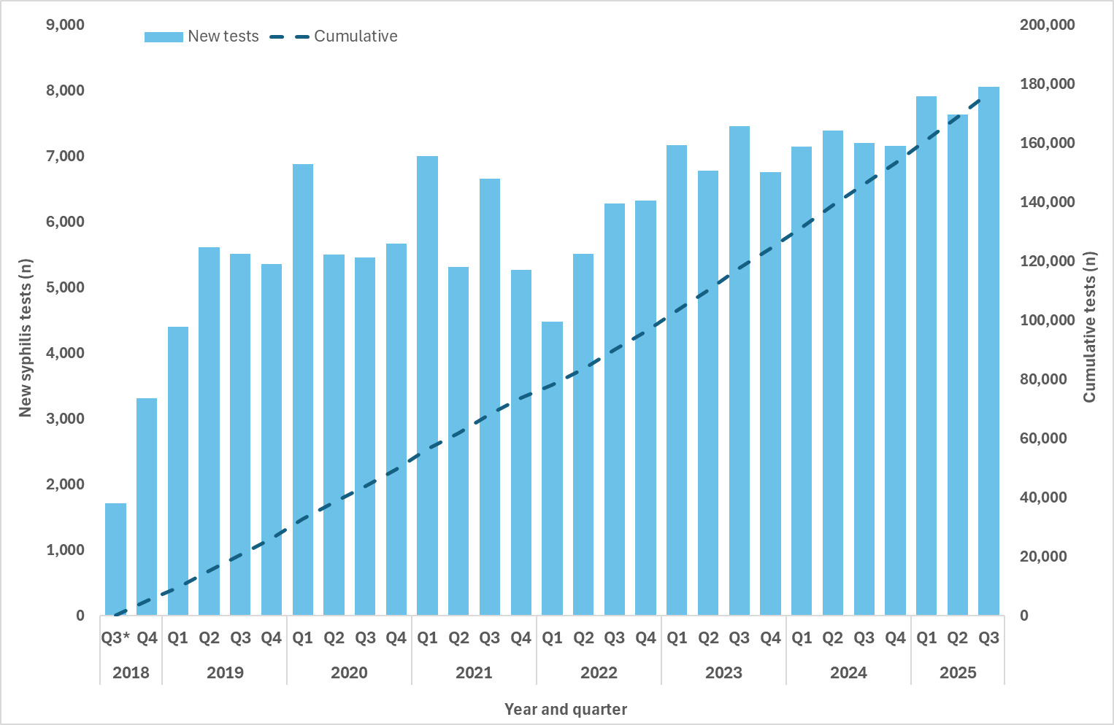
Note:
* Q3 2018 includes data for August and September only.

- Proportion of Aboriginal and Torres Strait Islander clients attending participating ACCHS who received a syphilis test (PoCT and or serology), quarter and year, Q3 2018 to Q3 2025 (a. all age groups; b. target age group 15 to 34 years¹)
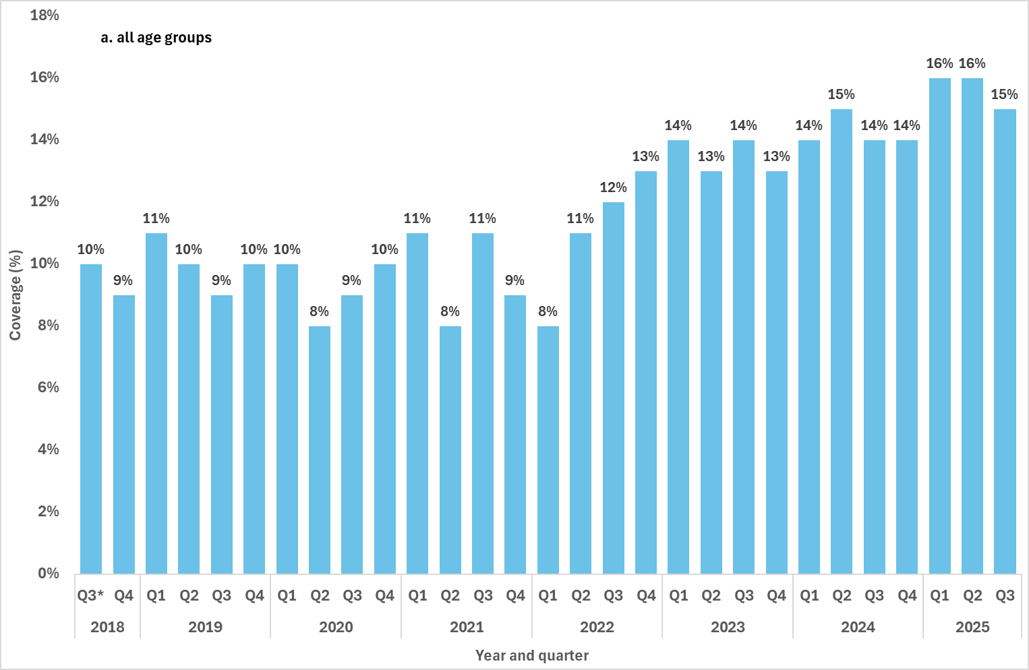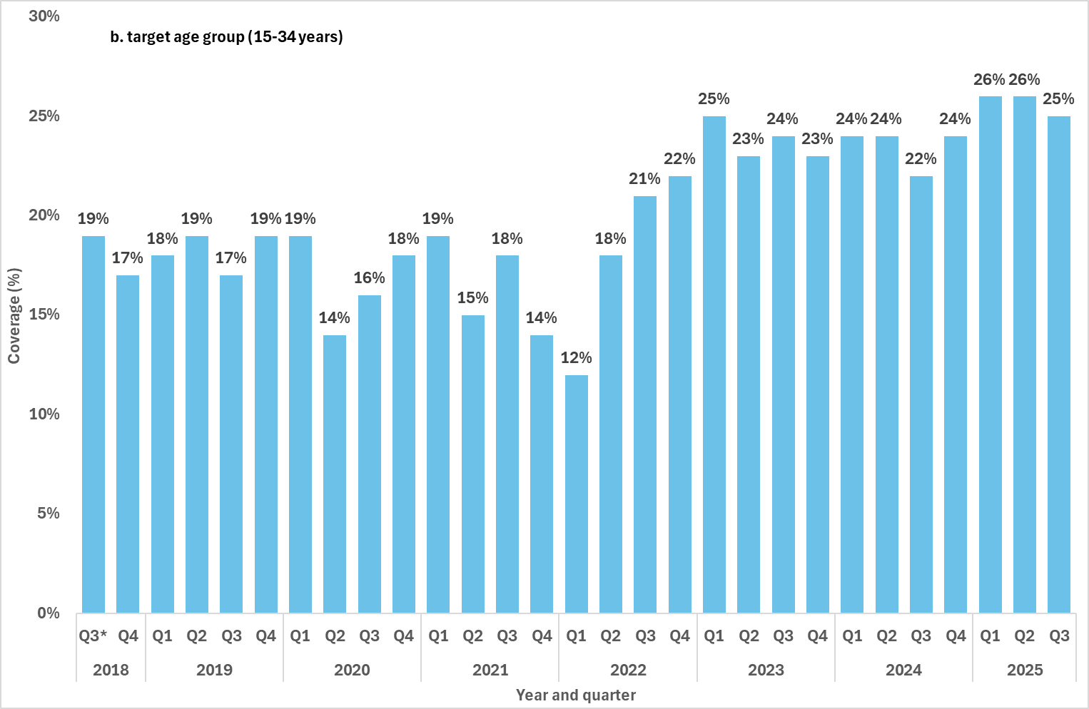
Notes:
1. Excludes testing data for individuals whose age was not reported.
* Q3 2018 includes data for August and September only.
- Proportion of syphilis tests delivered through participating ACCHS, by test type (PoCT only, serology only and both serology and PoCT), by quarter and year, Q3 2018 to Q3 2025
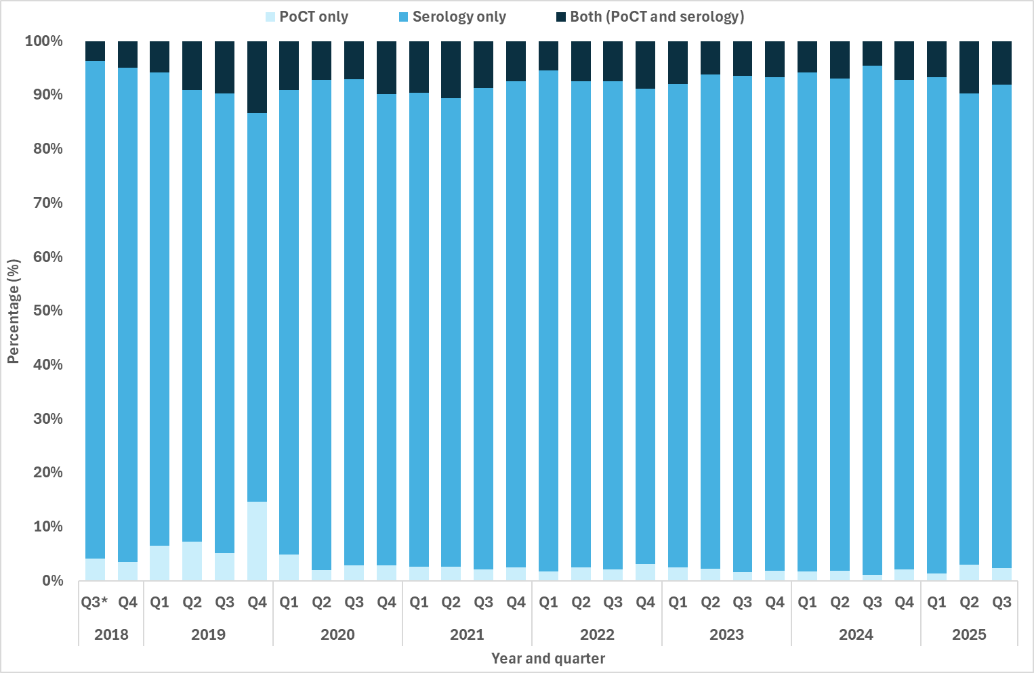
Note:
* Q3 2018 includes data for August and September only.

Goal 2: Reduce ongoing transmission and incidence of syphilis across priority populations
Key facts
Between January and September 2025, 4,699 infectious syphilis cases were reported
In Q3 2025:
1,529 infectious syphilis cases were notified, decreasing marginally compared to Q2 2025 and the 12 month quarterly mean
Highest notification rates were reported in Aboriginal and Torres Strait Islander peoples aged 15 to 24 years in remote/very remote areas
Compared with the 12-month quarterly average, notification rates in Q3 2025:
Increased in Aboriginal and Torres Strait Islander males aged 45+ years in remote/very remote areas and major cities of Australia
Increased in Aboriginal and Torres Strait Islander females aged 35-44 year olds in remote/very remote areas and inner/outer regional areas
Decreased in non-Indigenous males across most age groups and remoteness areas
Increased in non-Indigenous females aged 45+ years in major cities of Australia and inner/outer regional areas
Between January and September 2025 (Q1-Q3), 4,699 cases of infectious syphilis were notified, higher than the same reporting period in 2024 (n=4,483) and similar to the 5-year average (n=4,670).
In Q3 2025, 1,529 infectious syphilis cases were notified, a marginal decrease compared to Q2 2025 (2%, n=1,565) and the quarterly mean over the past 12 months (1%, 1,548, Q4 2024 – Q3 2025) (Figure 4). Consistent with historical trends, in Q3 2025 notifications were predominately reported in males (79%) and were aged 25-34 years (33%) (Table 3).
While notifications were largely reported among residents of major cities (74%), proportions in inner/outer regional areas are continuing to increase due in part to rises in notifications in urban areas in the Northern Territory (Darwin classified as an outer regional area), and areas in north Queensland (Map 2). Proportional increases in remote/very remote areas reflects consistent reporting of cases in these areas, and resurgence in remote/very remote areas in the Northern Territory, including Top End, Big Rivers (Katherine) and East Arnhem regions (Map 1 and 2) (3).

- Notifications (number) and notification rate (per 100,000)¹ of infectious syphilis, by Indigenous status, sex, year and quarter, 2020 to Q3 2025
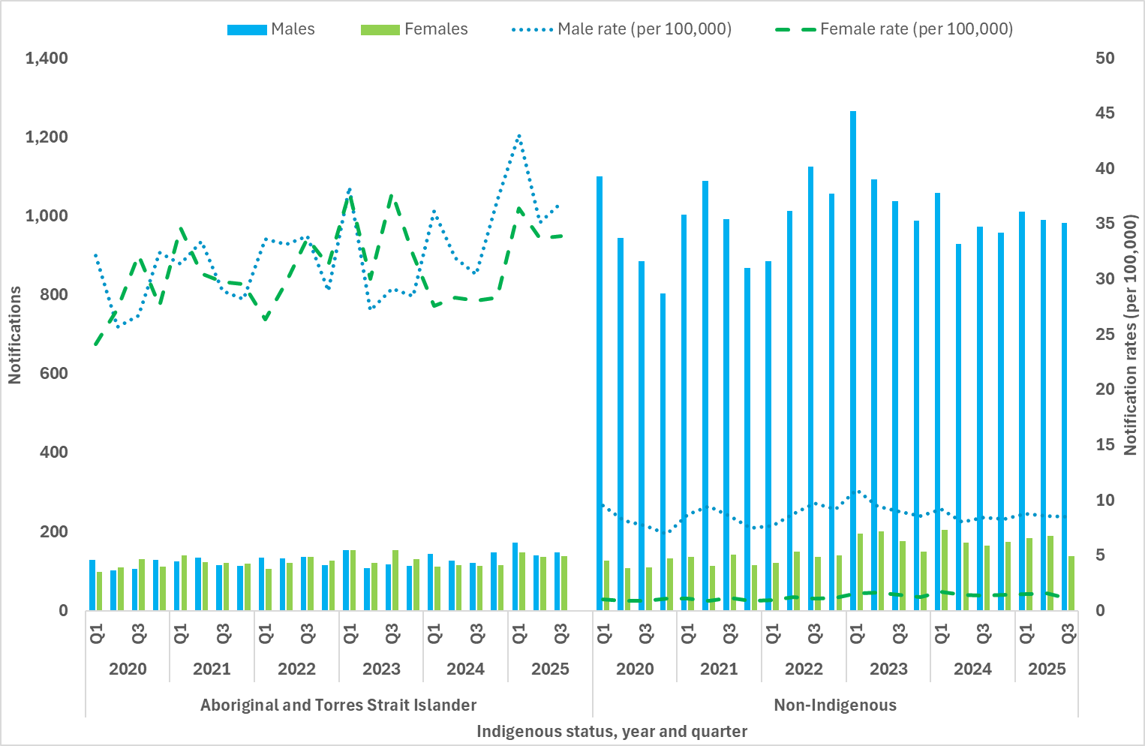
Note:
1. Excludes cases whose sex, age, Indigenous status and/or residential postcode were not reported.
- Demographic summary of infectious syphilis notifications, 2020 to Q3 2025
Characteristics | 2020 | 2021 | 2022 | 2023 | 2024 | 2025
 |  |  |  |  |  | Q1 | Q2 | Q3
Total | 5,362 | 5,765 | 6,184 | 6,566 | 5,977 | 1,605 | 1,565 | 1,529
Sex
Female | 958 | 1,040 | 1,084 | 1,334 | 1,216 | 347 | 349 | 327
Male | 4,387 | 4,706 | 5,072 | 5,221 | 4,751 | 1,254 | 1,213 | 1,201
Other¹ | 4 | 6 | 8 | 5 | 1 | 0 | 0 | 0
Not reported | 13 | 13 | 20 | 6 | 9 | 4 | 3 | 1
Age group (years)
15–24 | 881 | 843 | 843 | 926 | 768 | 185 | 165 | 197
25–34 | 1,908 | 2,145 | 2,279 | 2,360 | 2,099 | 563 | 551 | 507
35–44 | 1,335 | 1,500 | 1,645 | 1,715 | 1,645 | 479 | 455 | 447
45+ | 1,222 | 1,262 | 1,405 | 1,549 | 1,440 | 371 | 388 | 376
Mean age at diagnosis
Female | 30 | 30 | 31 | 32 | 33 | 33 | 34 | 33
Male | 37 | 37 | 38 | 38 | 38 | 39 | 39 | 39
Overall | 36 | 36 | 36 | 37 | 37 | 37 | 38 | 37
Indigenous status
Aboriginal or Torres Strait Islander | 929 | 1,004 | 1,021 | 1,063 | 1,009 | 323 | 280 | 288
Non-Indigenous | 4,238 | 4,486 | 4,660 | 5,125 | 4,653 | 1,198 | 1,183 | 1,159
Not reported | 195 | 275 | 503 | 378 | 315 | 84 | 102 | 82
Remoteness area
Major cities | 4,080 | 4,415 | 4,767 | 4,989 | 4,480 | 1,175 | 1,141 | 1,132
Inner/outer regional | 665 | 607 | 757 | 913 | 920 | 241 | 253 | 222
Remote/very remote | 486 | 573 | 463 | 470 | 411 | 128 | 121 | 129
Not reported/ overseas resident | 131 | 170 | 197 | 194 | 166 | 61 | 50 | 46
Note:
1 People who reported their sex assigned at birth as a term other than male or female.

Indicator 2.1 – Notification rates
2.1 Notification rate of infectious syphilis by Indigenous status, sex, age and remoteness area classification
Aboriginal and Torres Strait Islander males
In Q3 2025, notification rates among Aboriginal and Torres Strait Islander males decreased across most age groups in major cities and inner/outer regional areas compared to the 12-month quarterly mean. Increases were reported in remote/very remote areas in all age groups except 15-24 year olds over the same comparison period.
The greatest notification rate increase compared to the 12-month quarterly mean were reported in 45+ year olds in remote/very remote areas (60%) and major cities (75%) (Figure 5a to 5c).
Non-Indigenous males
On average non-Indigenous males represent around 80% of all infectious syphilis notifications, with most of these cases reported in major cities of Australia (Figure 5a). In Q3 2025, notification rates in most age groups across all remoteness areas reported a decrease or were similar compared to the 12 month and 5 year quarterly mean (Figure 5a to 5c).
Aboriginal and Torres Strait Islander females
In Q3 2025, Aboriginal and Torres Strait Islander females aged 15-24 years in remote/very remote areas recorded the highest notification rate among all population and geographical groups, with a notification rate of 242 per 100,000 (Figure 6c). Despite recording the highest notification rate overall, this group observed decreases in Q3 2025 compared to the 12 month and 5 year quarterly mean, 13% and 25%, respectively.
Across other geographical areas and age groups, the greatest increases in notification rates compared to the 12 month quarterly mean were reported in 35-44 year olds in remote/very remote areas (47%) and inner/outer regional areas (33%) (Figure 6a to 6c).
Non-Indigenous females
In Q3 2025, compared to the 12 month quarterly mean, notification rates in non-Indigenous females showed small declines or remained similar across most age and geographical groups, except for females aged 45+ years in major cities of Australia and inner/outer regional areas where an increasing trend was observed (Figure 6a-c). Compared to the 5 year quarterly mean however considerable increases were reported in all age groups in major cities of Australia (Figure 6a to 6c).

- Notifications (number) and notification rate (per 100,000) of infectious syphilis reported in males, by Indigenous status, remoteness area, age, quarter, and year, 2020 to Q3 2025¹ (a. Major cities, b. Inner and outer regional areas, c. Remote and very remote areas)
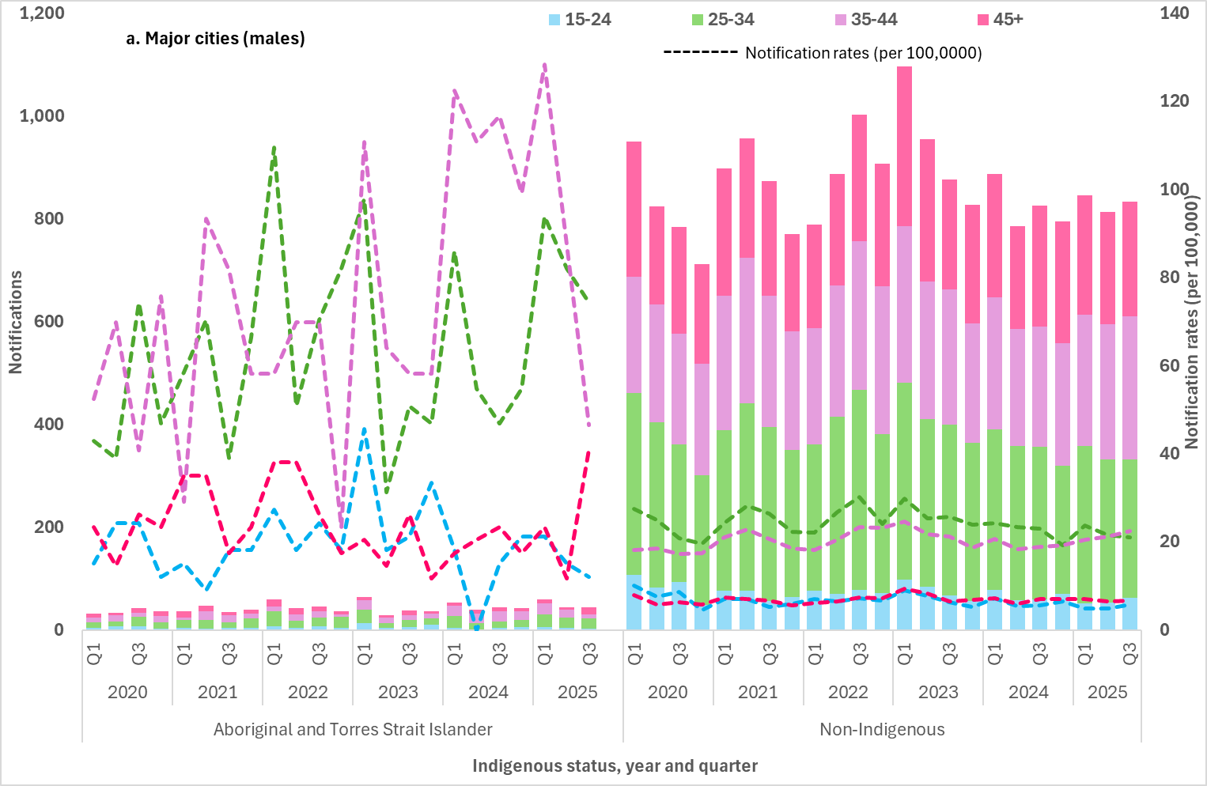
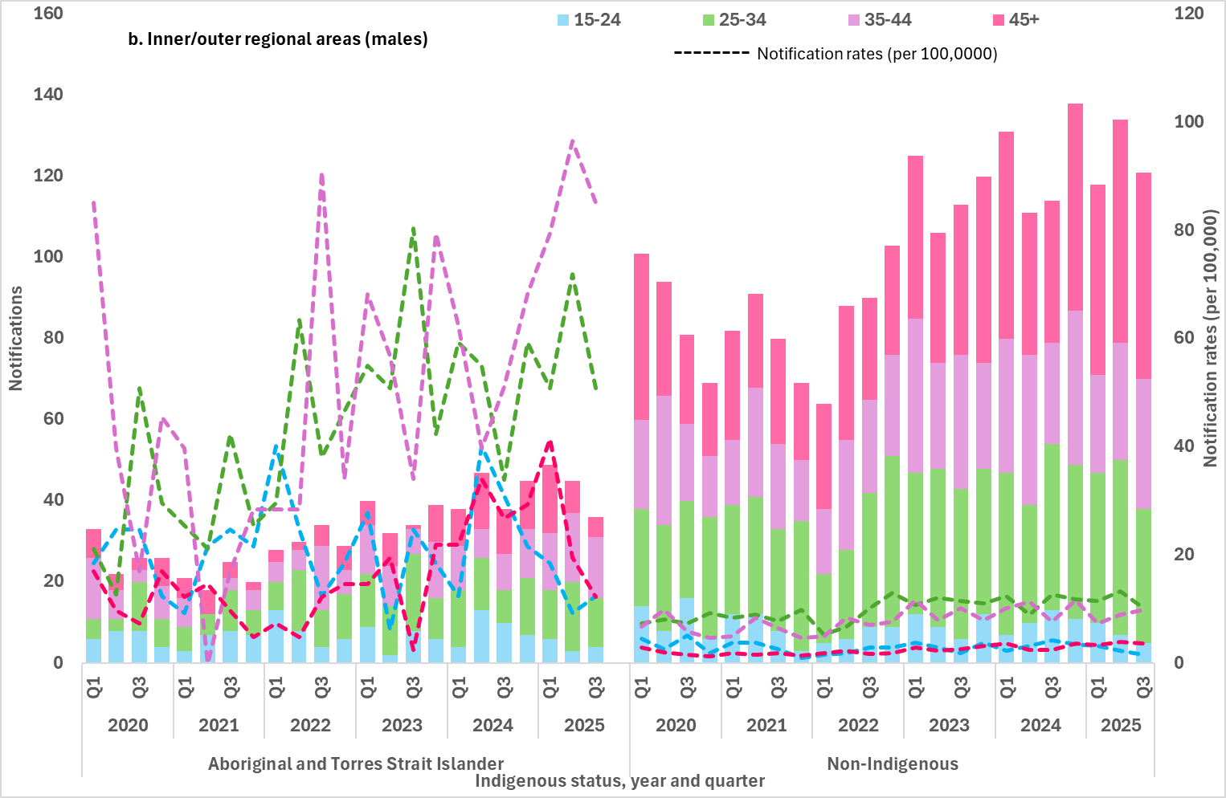
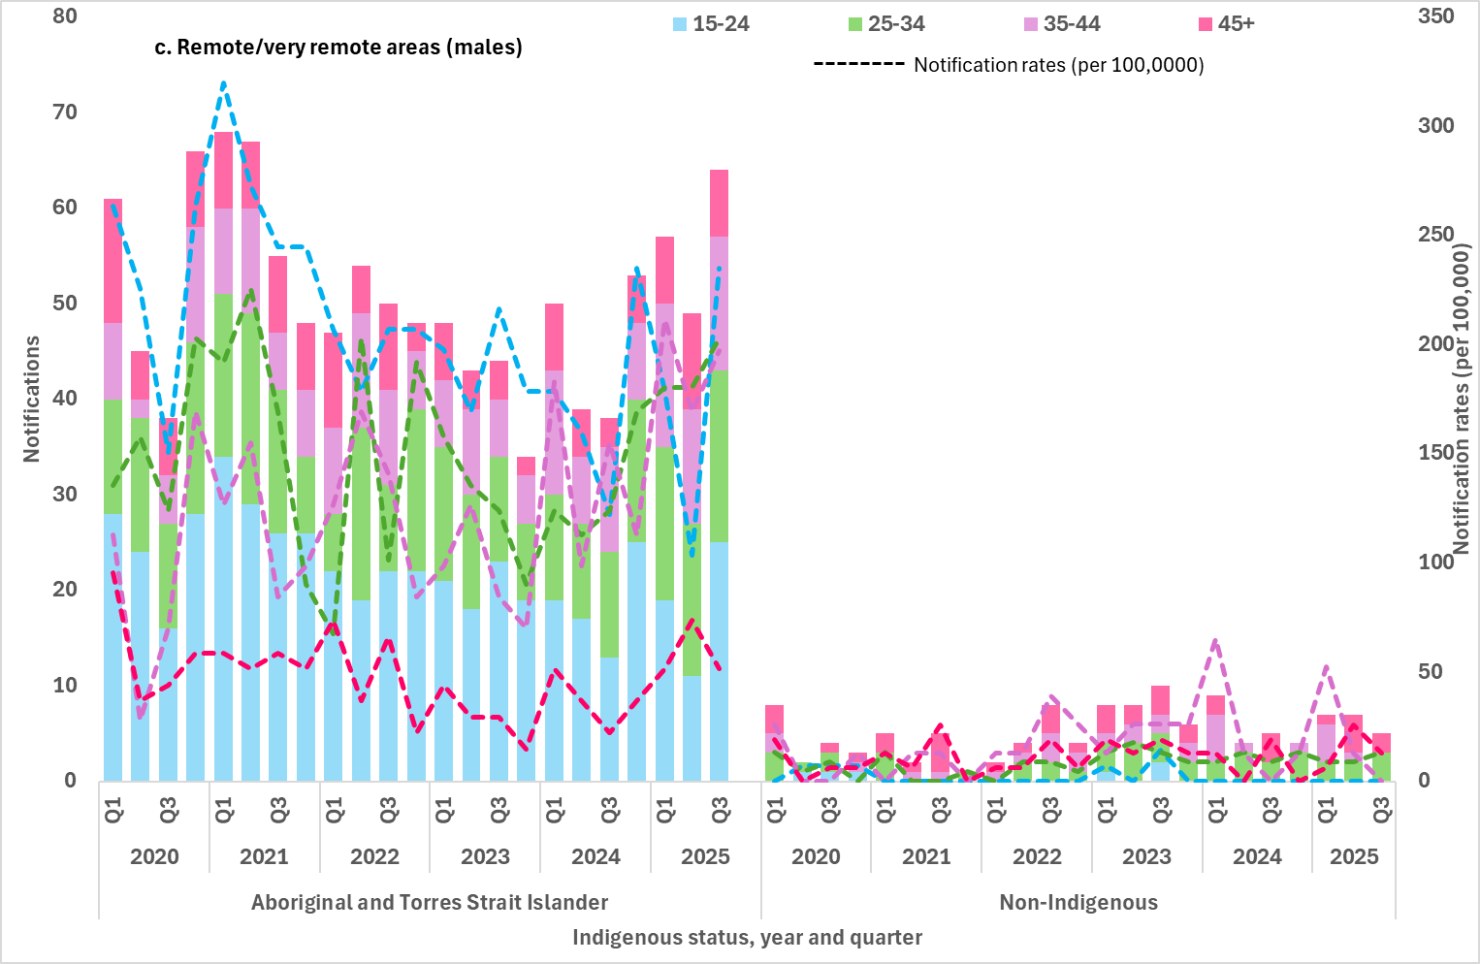
Note:
1. Excludes cases whose sex, age, Indigenous status and/or residential postcode were not reported.

- Notifications (number) and notification rate (per 100,000) of infectious syphilis reported in females, by Indigenous status, remoteness area, age, quarter, and year, 2020 to Q3 2025¹ (a. Major cities, b. Inner and outer regional areas, c. Remote and very remote areas)
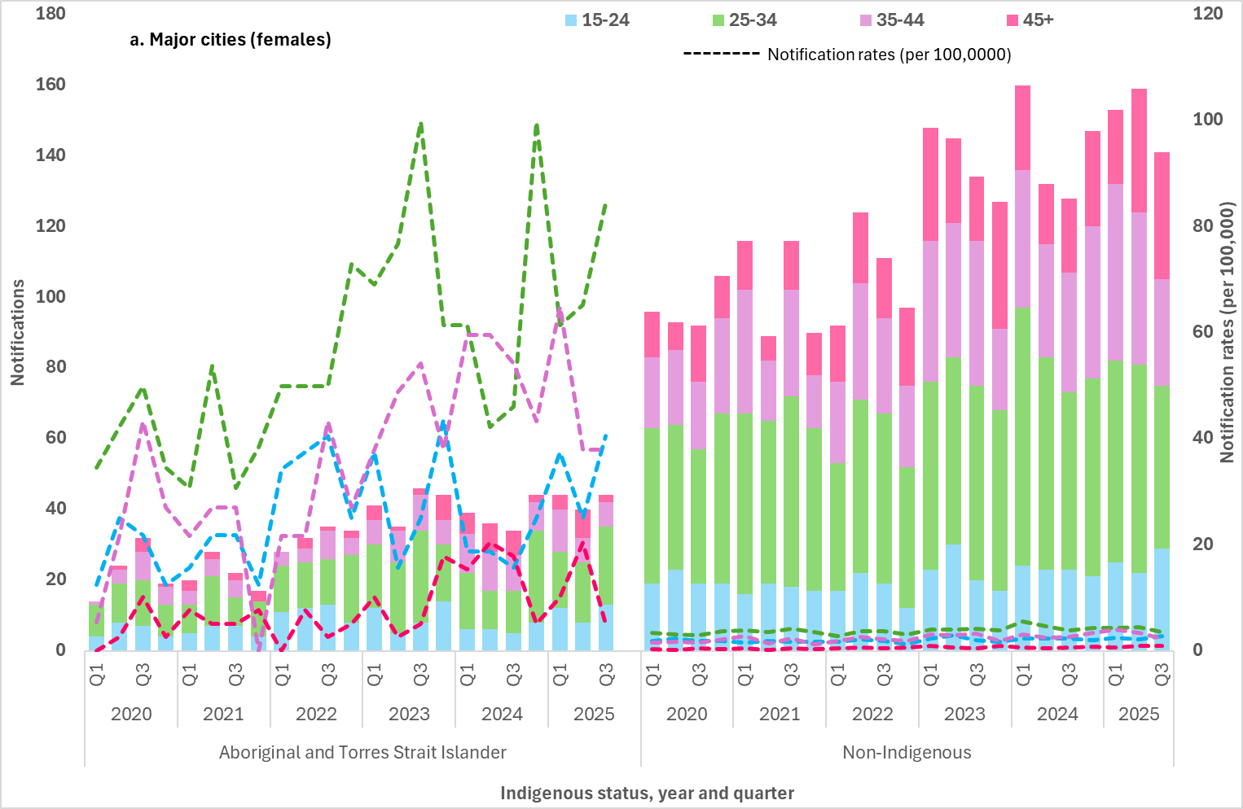
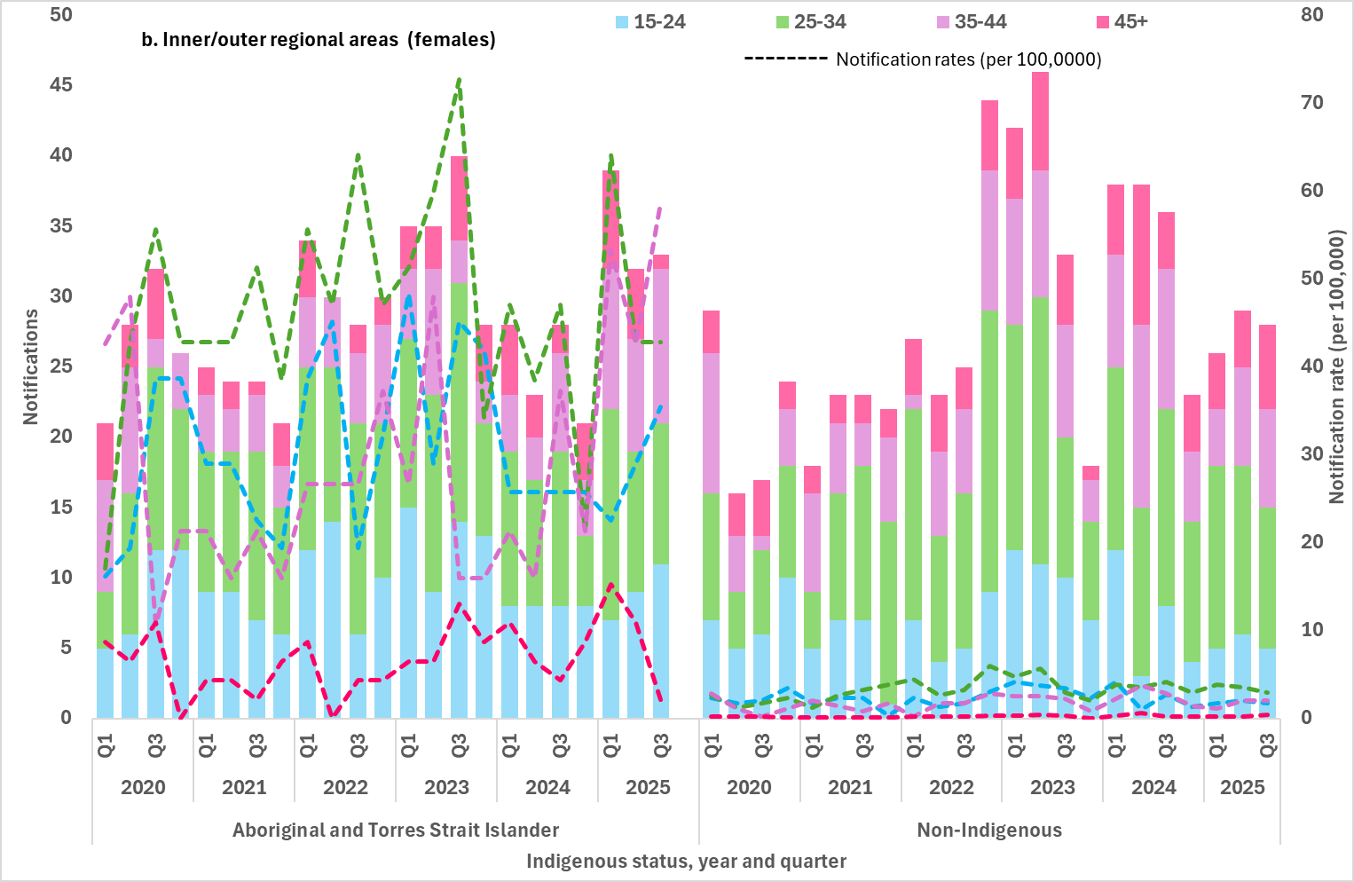
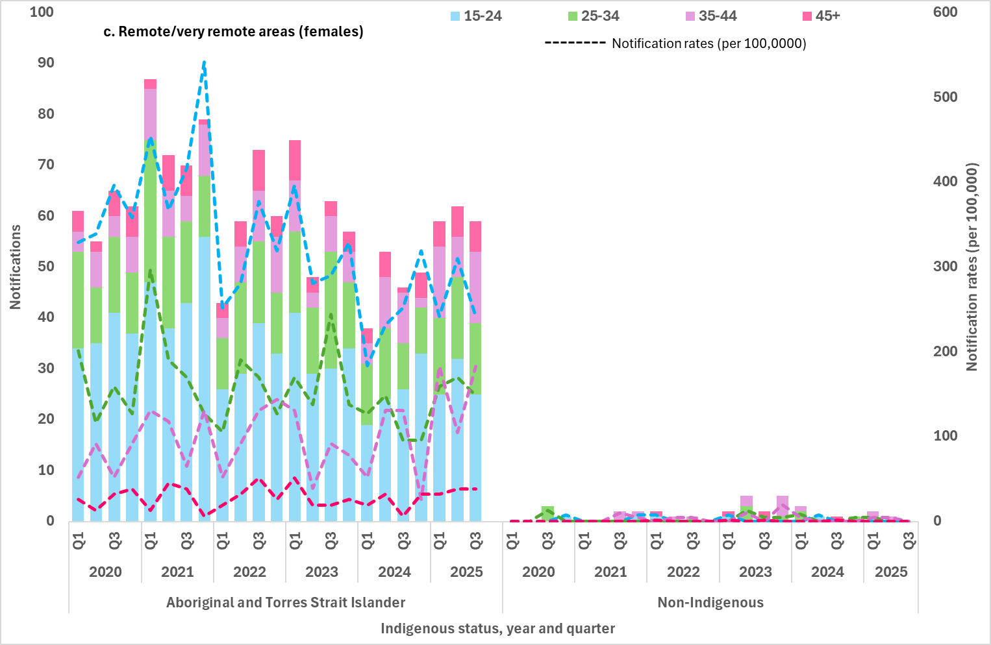
Note:
1. Excludes cases whose sex, age, Indigenous status and/or residential postcode were not reported.

Indicators 2.2 and 2.3 – Geographical areas
2.2 Notification rate of infectious syphilis in Aboriginal and Torres Strait Islander peoples by Indigenous Areas (IAREs)
2.3 Notification rate of infectious syphilis by Statistical Area 3 (SA3), by Indigenous status
Mapped notification data uses residential postcodes of notified cases to allocate cases to a geographical area. This may not necessarily reflect where the infection was acquired, and in some instances the postcode reported may reflect the location where the case was diagnosed rather than residence and locality of acquisition.
If the postcode reflects the location where an individual sought health care, the mapped notifications may reflect areas of high volume or centralised services where people are being diagnosed rather than areas with a high burden of infection or acquisition.
Availability and accessibility of safe and culturally appropriate health services, particularly in remote/very remote areas and Aboriginal and Torres Strait Islander communities, along with other social factors may influence where people are tested and diagnosed, noting that this may occur outside of an individual’s place of residence (4).
Indigenous Areas
Indigenous Areas (IAREs) are geographic areas built from Indigenous locations, which are designed to represent Aboriginal and Torres Strait Islander communities (urban and rural) that are near each other or that share language, traditional borders or Native Title (5).
Age standardised infectious syphilis notification rates by IAREs for Aboriginal and Torres Strait Islander peoples are presented in Map 1 for the previous 12 months (Q4 2024 to Q3 2025).
The highest notification rates were reported largely in very remote areas of Western Australia, South Australia and the Northern Territory, noting that in some IAREs the population was small.
High notification rates in outer regional areas (Darwin and surrounds) and communities in the Top End, Big Rivers (Katherine) and East Arnhem regions reflect the increase in reported cases in urban and remote areas in the Northern Territory (3).
Statistical Area 3 (SA3)
In the previous 12 months, age-standardised notification rates of infectious syphilis by statistical area 3 (SA3) were widely distributed across Australia (Map 2).
The highest notification rates were reported across very remote areas in the north-west of Australia and SA3s in some major cities, including Sydney.
This geographical distribution reflects the concurrent infectious syphilis outbreaks and sub-epidemics occurring across populations groups in Australia, including aboriginal and Torres Strait Islander peoples in regional and remote areas, gay and bisexual men in major cities of Australia, and non-Indigenous women in major cities.
Refer to the methodological notes for further information on the development of the maps.

Map 1: Notification rate (per 100,000) of infectious syphilis in Aboriginal and Torres Strait Islander peoples by Indigenous Areas (IAREs) in the previous 12 months (Q4 2024 to Q3 2025)
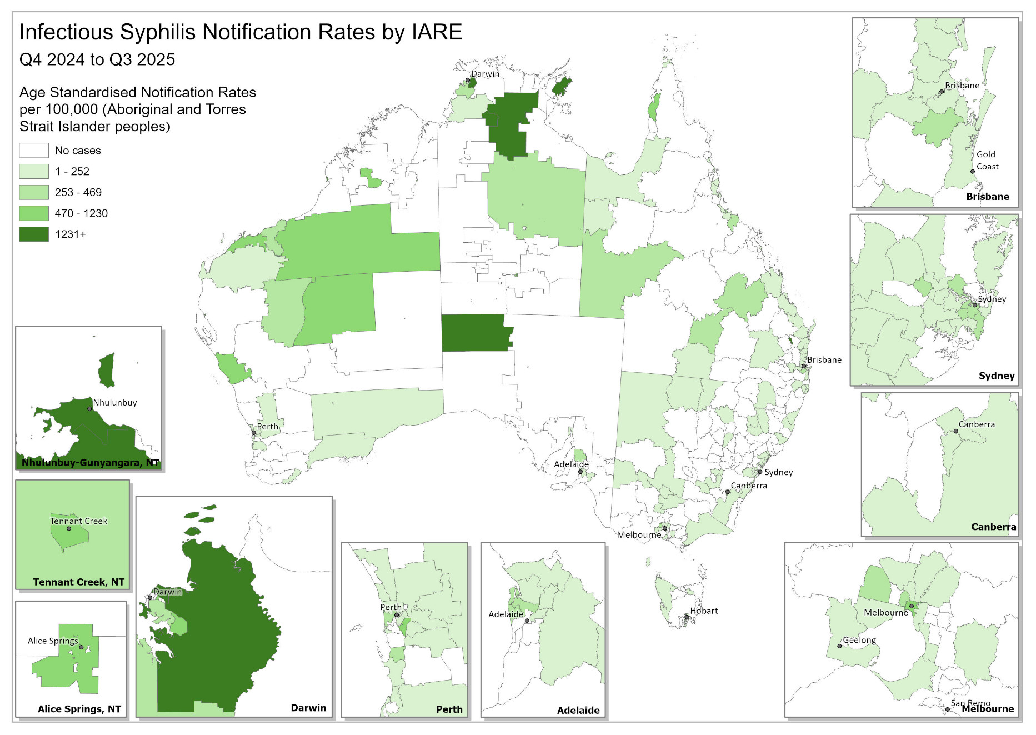
Note: Excludes cases whose Indigenous status and/or residential postcode were not reported.
Map 2: Age-standardised notification rate (per 100,000) of infectious syphilis by Statistical Area 3 (SA3) in the previous 12 months (Q4 2024 – Q3 2025)
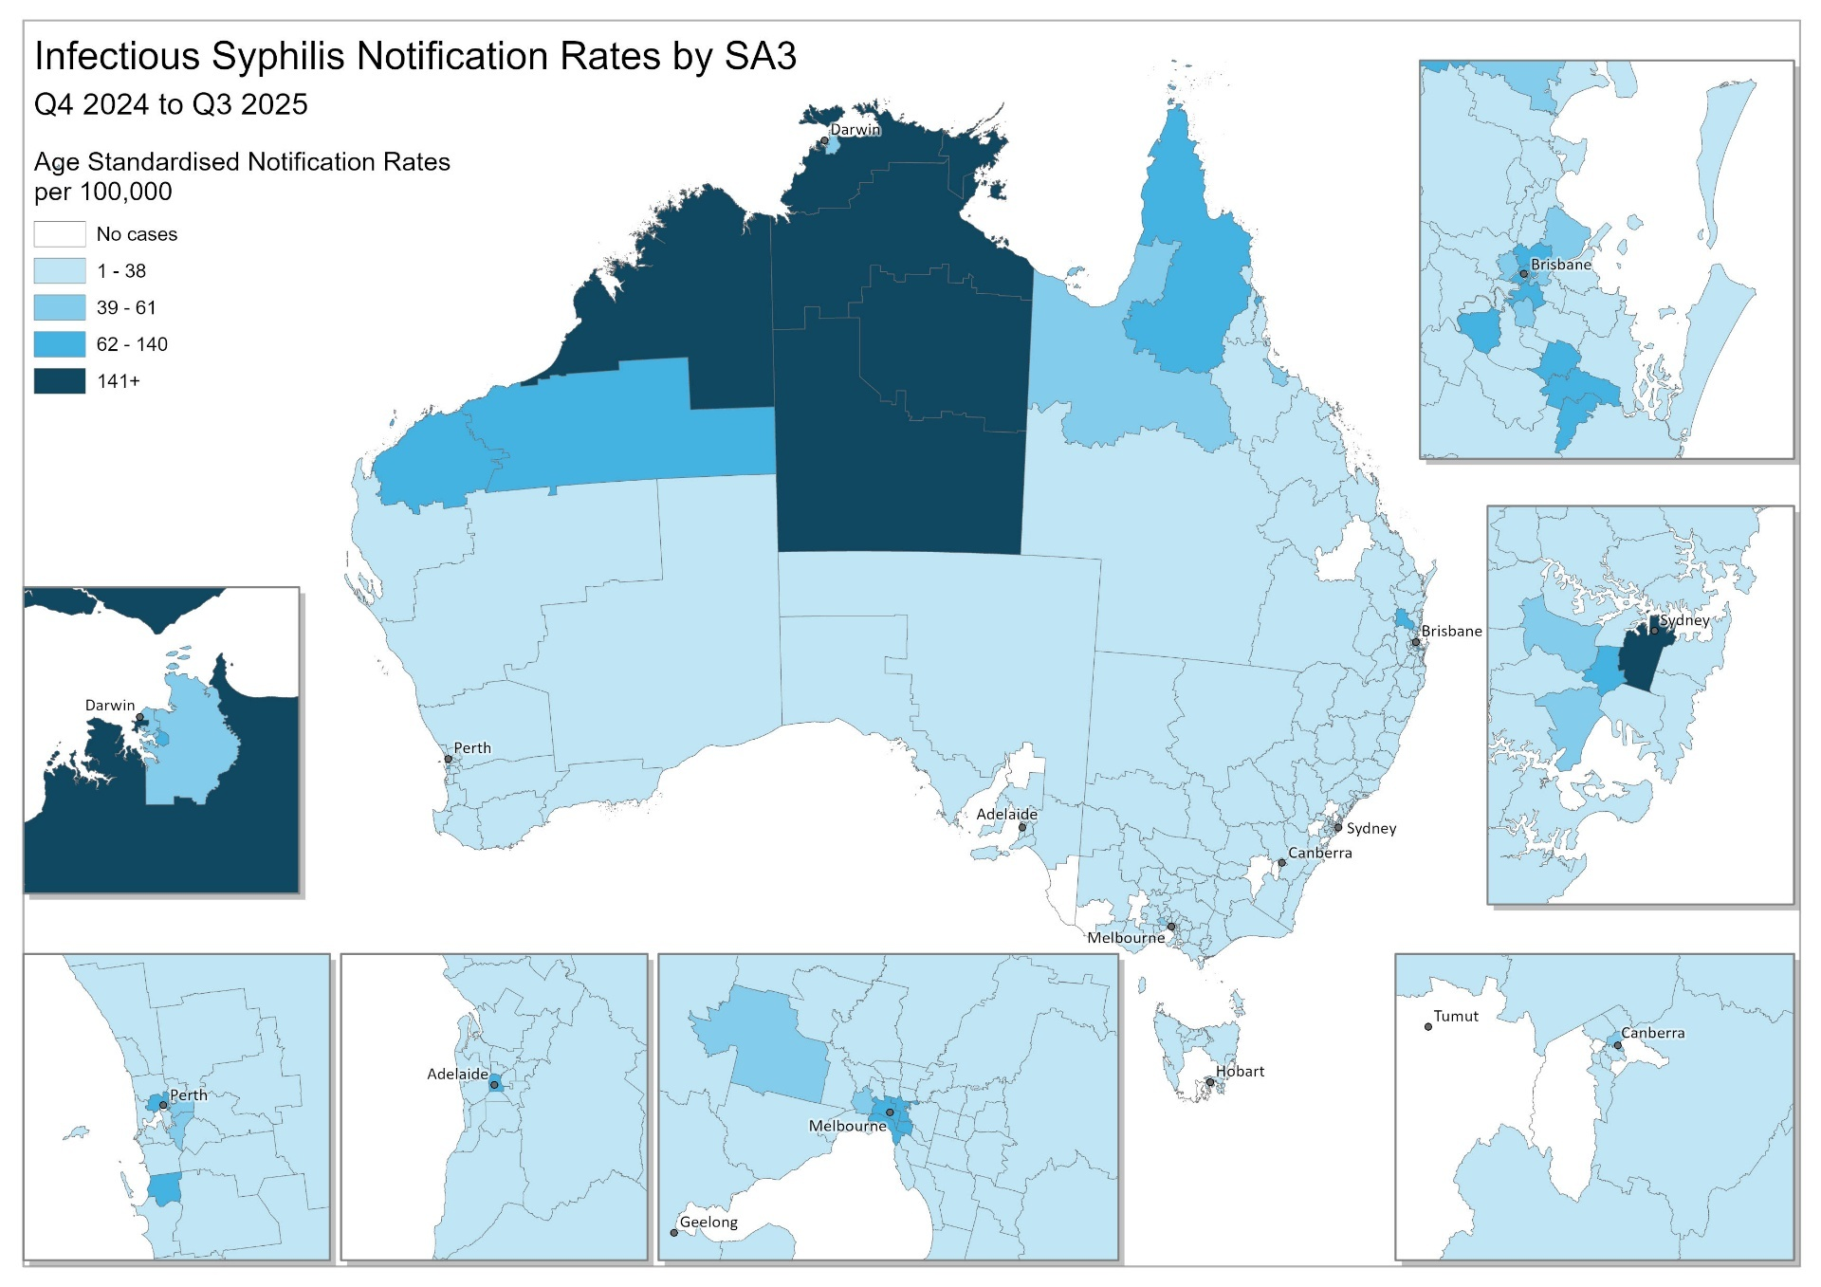
Note: Excludes cases whose residential postcode was not reported.

Indicator 2.4 – Women of reproductive age
2.4 Notification rate of infectious syphilis in women of reproductive age (15 to 44 years) by Indigenous status and remoteness area
Between 2020 and Q3 2025, of infectious syphilis cases reported among women, most (83%) were in women aged between 15 to 44 years of age, with the average proportion among Aboriginal and Torres Strait Islander women higher (92%) and non-Indigenous women lower (76%).
Aboriginal and Torres Strait Islander women
The highest proportion and notification rates among Aboriginal and Torres Strait Islander women of reproductive age have consistently been reported in remote and very remote areas of Australia, representing half of the cases (50%) reported between 2020 and Q3 2025 (Figure 7a).
Although lower notifications and rates have been reported in major cities of Australia, the proportion of cases overall has been steadily increasing, representing on average 26% of all cases in Aboriginal and Torres Strait Islander women of reproductive age. In inner and outer regional areas, the proportion has remained relatively constant, representing on average 24% (Figure 7a).
Non-Indigenous women
Most notifications among non-Indigenous women of reproductive age were reported in major cities of Australia, on average representing 80% of cases reported between 2020 and Q3 2025. A smaller proportion (average 19%) were reported in inner and outer regional areas, and small proportion (average 1%) in remote and very remote Australia (Figure 7b).

- Notifications (number) and notification rate (per 100,000) of infectious syphilis reported in women aged 15 to 44 years, by Indigenous status, remoteness area, quarter, and year, 2020 to Q3 2025 (a. Aboriginal and Torres Strait Islander, b. non-Indigenous)
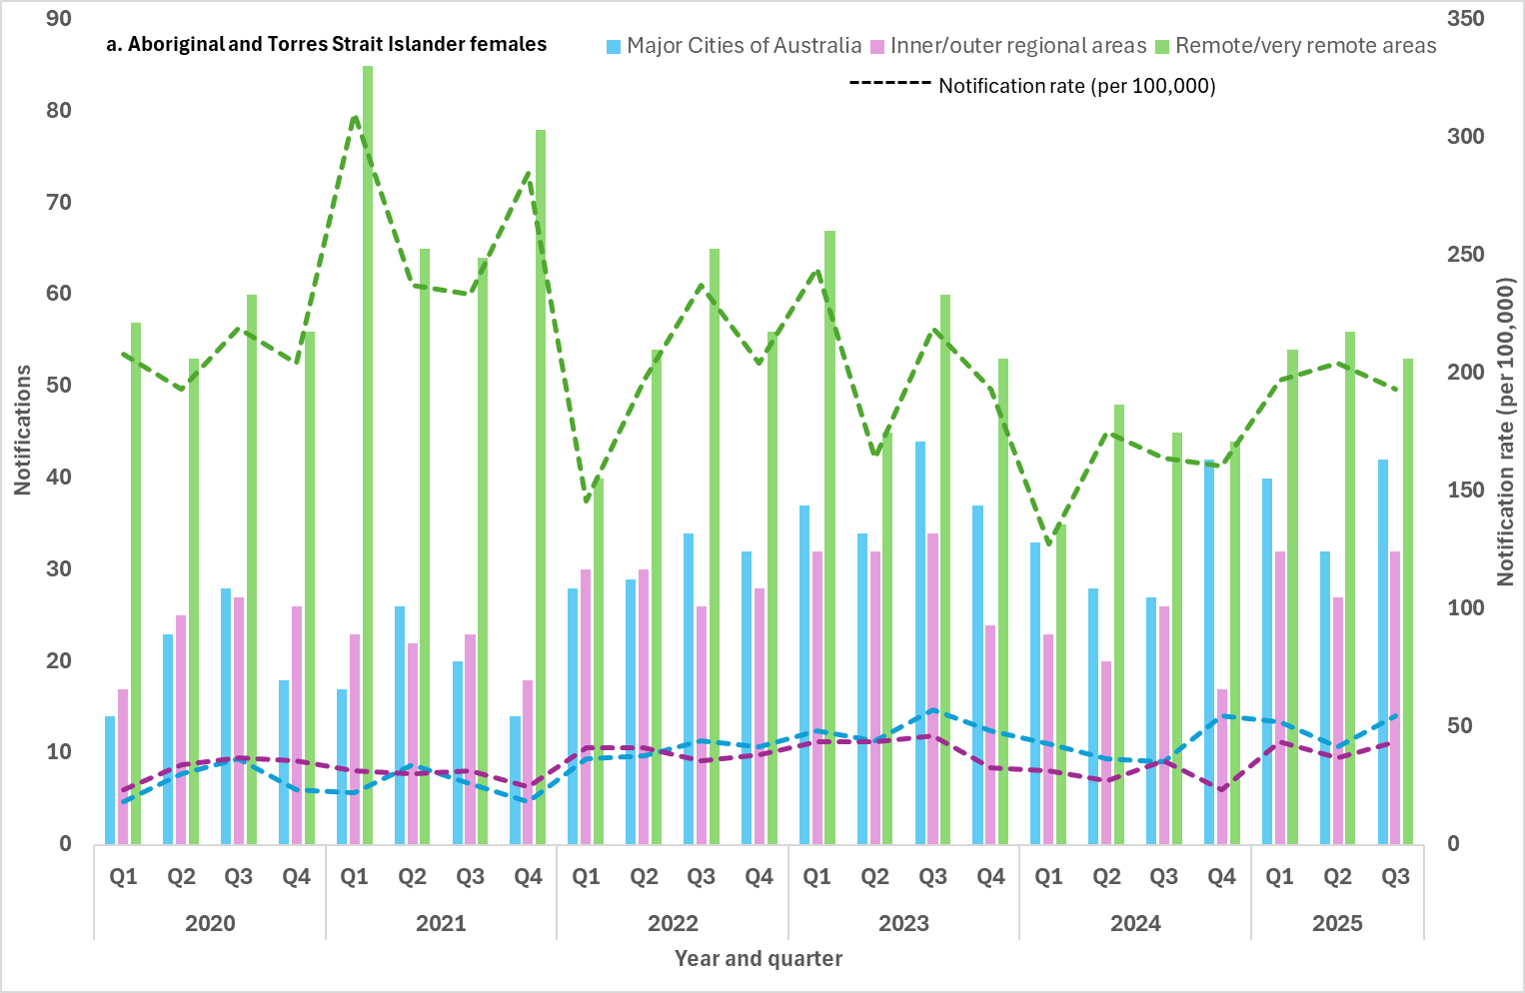
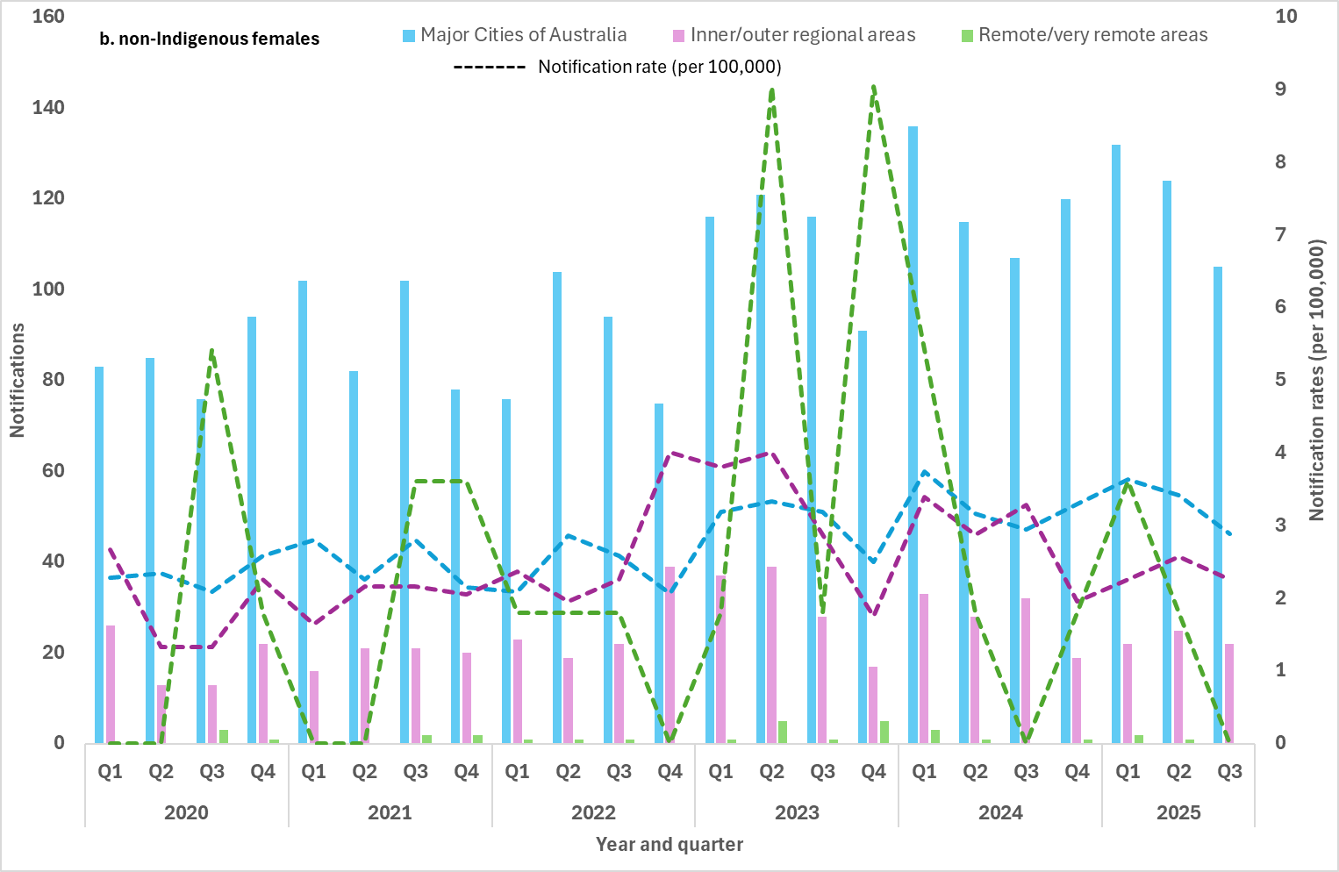
Note:
1. Excludes cases whose sex, age, Indigenous status and/or residential postcode were not reported.

Indicators 2.5 and 2.6 – Males by sexual exposure
2.5 Proportion of infectious syphilis notifications in men reporting sexual exposure with men only
2.6 Proportion of infectious syphilis notifications in men reporting sexual exposure with men and women
‘Sexual exposure’ refers to the sex of the sexual contact of the notified case and can be reported as either:
- person(s) of different sex only
- person(s) of same sex only
- person(s) of different sex AND person(s) of same sex
- sexual exposure unknown.
Enhanced data (sexual exposure: same sex, opposite sex and both sexes) are used to report against indicators 2.5 and 2.6.
Completeness of sexual exposure in males notified with infectious syphilis fluctuated between 2020 and Q3 2025, ranging from 63% to 88% (average 74%).
Males reporting sexual exposure with the same sex only, represented the highest proportion of sexual exposure events (48%) in Q3 2025 consistent with historical trends.
The proportion of males reporting sexual exposure with people of a different sex only, was 24% in Q3 2025, with proportional increases compared with the 12 month and 5-year quarterly means, 21% and 17%, respectively. Proportionally males reporting sexual exposure with people of different and same sex was 8% in Q3 2025, higher than any other quarter in the last 5 years. (Figure 8).
Changes in sexual exposure over time suggests potential overlapping in sexual networks influencing the epidemiology of syphilis transmission across Australia, including increasing exposure risk for females. This concept has also been observed in genomic analysis of Treponema pallidum (syphilis) in Australia and other sexually transmissible infections (6, 7).

- Number of infectious syphilis notifications among males and proportion (%) of cases by sexual exposure and year 2020 to Q3 2025
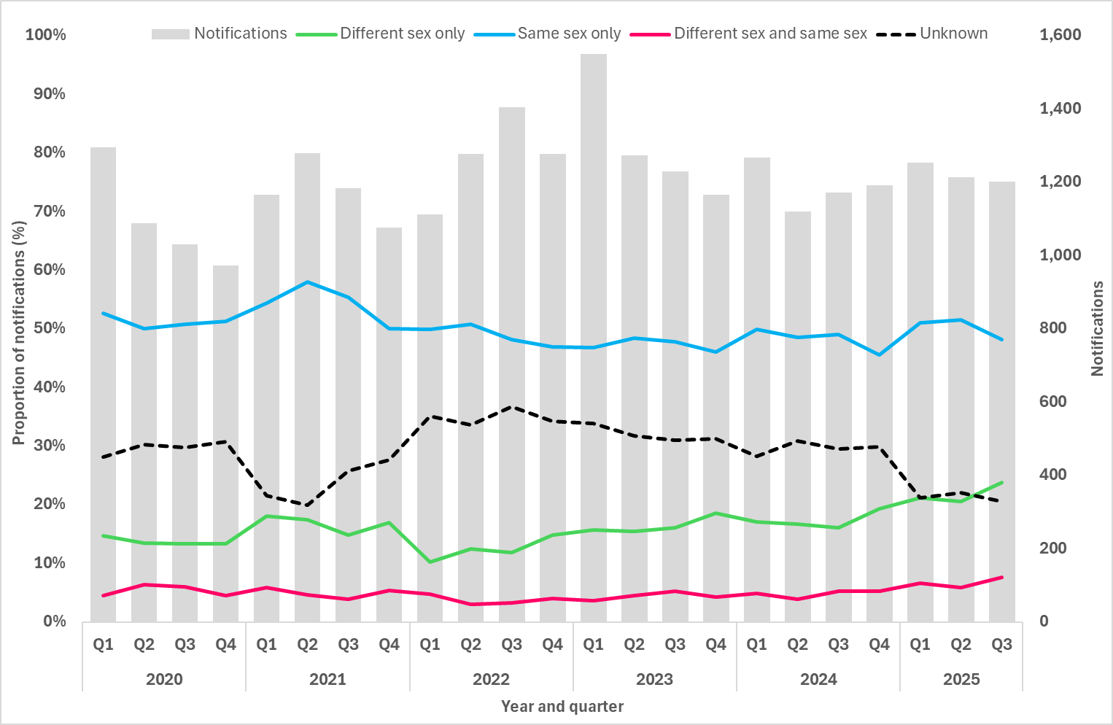

Goal 3: Reduce morbidity and mortality associated with syphilis
Death and hospitalisations data reported to the NNDSS are not used in reporting against this goal due to poor completeness and inconsistencies in reporting.
More comprehensive data are available through The Australian Bureau of Statistics (ABS) and The Australian Institute of Health and Welfare (AIHW) data collections. However, these data are less timely with at least a minimum 1 to 2-year delay from the reporting year.
The latest available data from the ABS and AIHW will be incorporated into annual reporting for this goal.

Goal 4: Eliminate congenital syphilis (defined as sustained zero congenital syphilis cases)
Key facts
Between January and September of 2025:
11 cases of congenital syphilis were reported. Of those:
- 6 were non-Indigenous infants, including 1 who sadly died
- 5 were Aboriginal and Torres Strait Islander infants, including 3 who sadly died
Nine women who gave birth to these infants were diagnosed with syphilis late in pregnancy and did not receive adequate treatment prior to delivery
17% of all women of reproductive age diagnosed with syphilis were pregnant
Long-term trends
Between 2020 and Q3 2025:
88 cases of congenital syphilis have been reported, including 30 deaths. Of those:
- 47 were Aboriginal and Torres Strait Islander infants, including 18 deaths
- 39 were non-Indigenous infants, including 10 deaths
- 2 infants with unknown Indigenous status who died of the infection.
Of the women giving birth to an infant with congenital syphilis (with data available)
- 82% were diagnosed late in pregnancy
- 96% did not receive adequate treatment prior to delivery
- 62% did not have a previous syphilis test in pregnancy

Indicators 4.1, 4.2 and 4.3 – Remoteness area and Indigenous status
4.1 Number of congenital syphilis cases by remoteness area and Indigenous status
4.2 Number of congenital syphilis related deaths by Indigenous status
4.3 Notification rate of congenital syphilis per 100,000 live births by remoteness area and Indigenous status
In the first 9 months of 2025, 11 cases of congenital syphilis were reported. Of those:
- 6 were non-Indigenous infants from major cities of Australia, including one infant who sadly died
- 5 were Aboriginal and Torres Strait Islander infants – 2 from major cities including 1 who died, 1 from inner/outer regional areas, and 2 from remote and very remote area, both who sadly died.
Between 2020 and Q3 2025, 88 cases of congenital syphilis cases have been notified.
More than half (47/88, 53%) were reported in Aboriginal and Torres Strait Islander infants, 39 in non-Indigenous infants (39/88, 44%) and 2 cases with an unknown Indigenous status reported (2/88, 2%).
Of the 88 cases reported, 30 infants tragically died, 18 Aboriginal and Torres Strait Islander infants, 10 non-Indigenous infants, and two infants with an unknown Indigenous status (Figure 9).
- Notifications (number) and notification rate (per 100,000 live births¹) of congenital syphilis, by Indigenous status, remoteness area, and year, 2020 to Q3 2025*
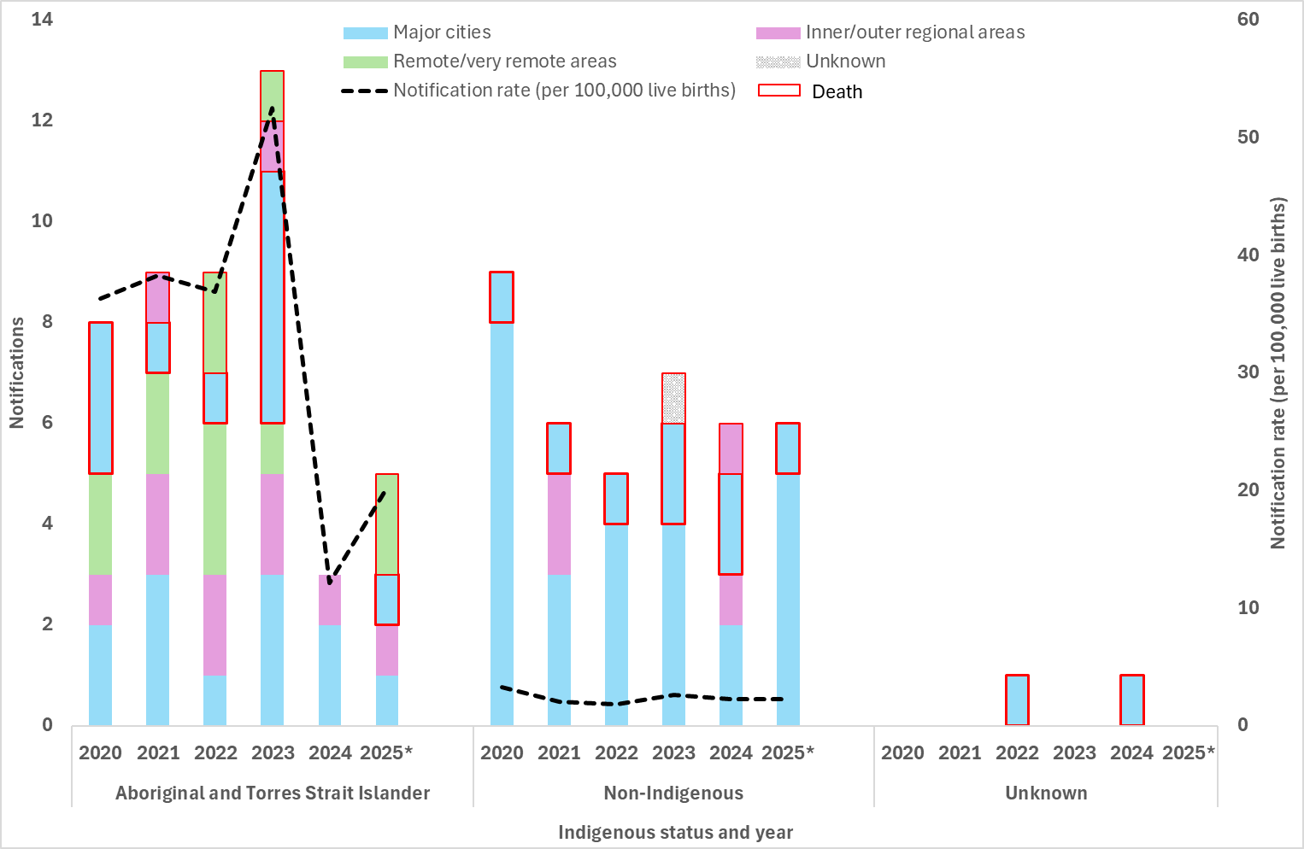
Note:
1. The denominator (live births) is for the complete year, whereas the numerator (congenital syphilis notifications) represents cases for the reporting period. The notification
rate calculated may be lower than notification rates reported for a complete (12 months) year.

Indicator 4.4 – Women who were pregnant
4.4 Proportion of syphilis notifications among women of reproductive age (15 to 44 years) who were pregnant at time of diagnosis, by remoteness area and Indigenous status
Pregnancy data were available for: 6 jurisdictions in 2020 (excluding Victoria and the Northern Territory); 7 jurisdictions in 2021 to 2023 (excluding the Northern Territory); 8 jurisdictions in 2024; 8 jurisdictions Q1-Q2 2025, and; 7 jurisdictions (excluding Victoria as data were not available at the time of writing, however it is expected that data from Victoria will be included in the Q4 2025 report).
Interpretation of these data are affected by high proportions of cases with an unknown pregnancy status and retrospective changes to the data, including differences with previous reports due to pregnancy status being reclassified and inclusion of new historical data from jurisdictions.
In Q3 2025, 17% of all women of reproductive age, including those with an unknown Indigenous status, were reported to be pregnant at the time of their syphilis diagnosis, higher than the 12-month and the same as the 5-year quarterly mean (16% and 17%, respectively) (Figure 10). In Q3 2025, the proportion of women of reproductive pregnant at syphilis diagnosis was higher among non-Indigenous women (21%) than Aboriginal and Torres Strait Islander women (10%) (Figure 10 and 11a-b). The overall 5-year proportional trend for both groups were the same (17%), noting variability across the time period likely attributed to the number of jurisdictions reporting and completeness of the data.
- Number of syphilis notifications among women of reproductive age (15 to 44 years) and proportion (%) of cases pregnant at time of syphilis diagnosis, 2020 to Q3 2025¹
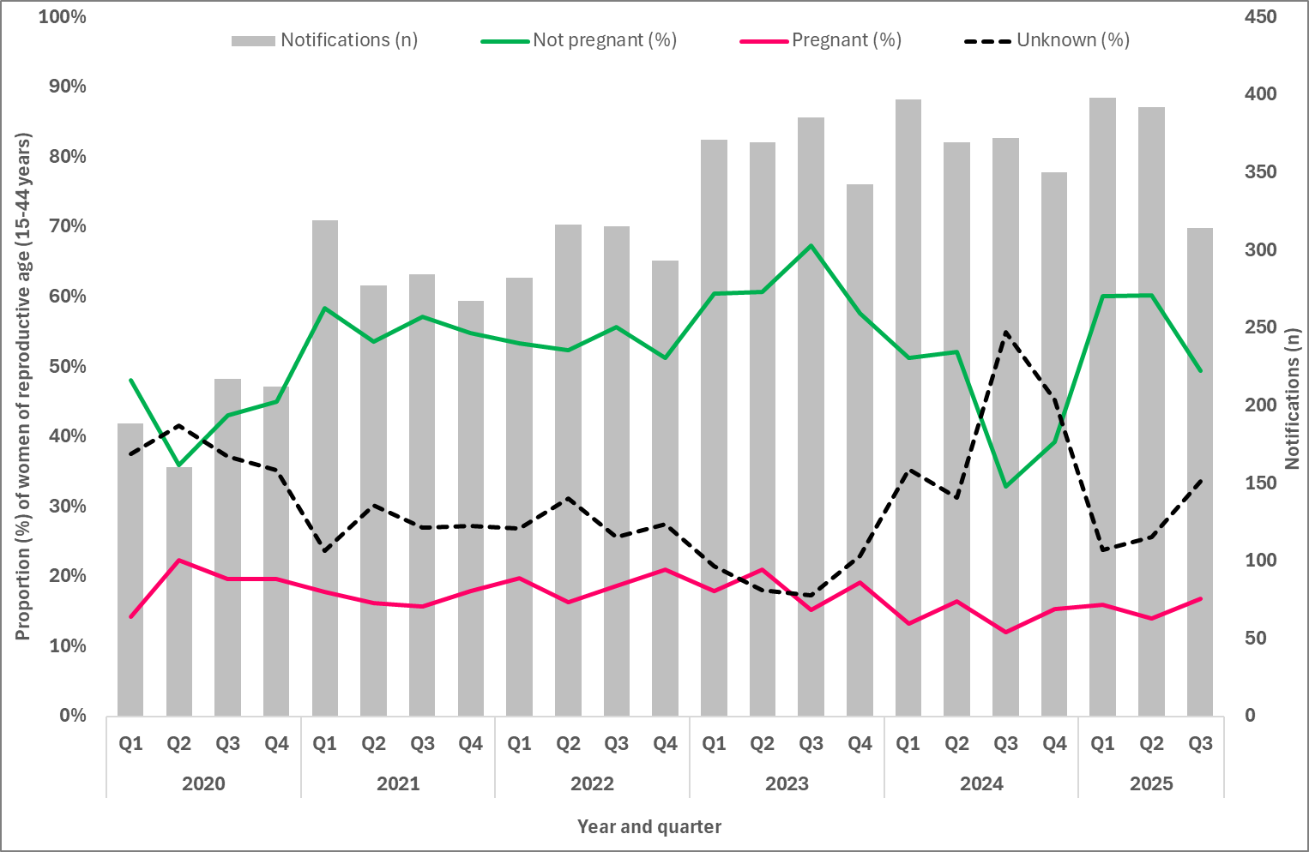
Note:
1. Excludes cases for whom sex and age were not reported.

- Number of syphilis notifications among women of reproductive age (15 to 44 years) and proportion (%) of cases pregnant at time of syphilis diagnosis, by Indigenous status, 2020 to Q3 2025¹ (a. non-Indigenous, b. Aboriginal and Torres Strait Islander non-Indigenous)
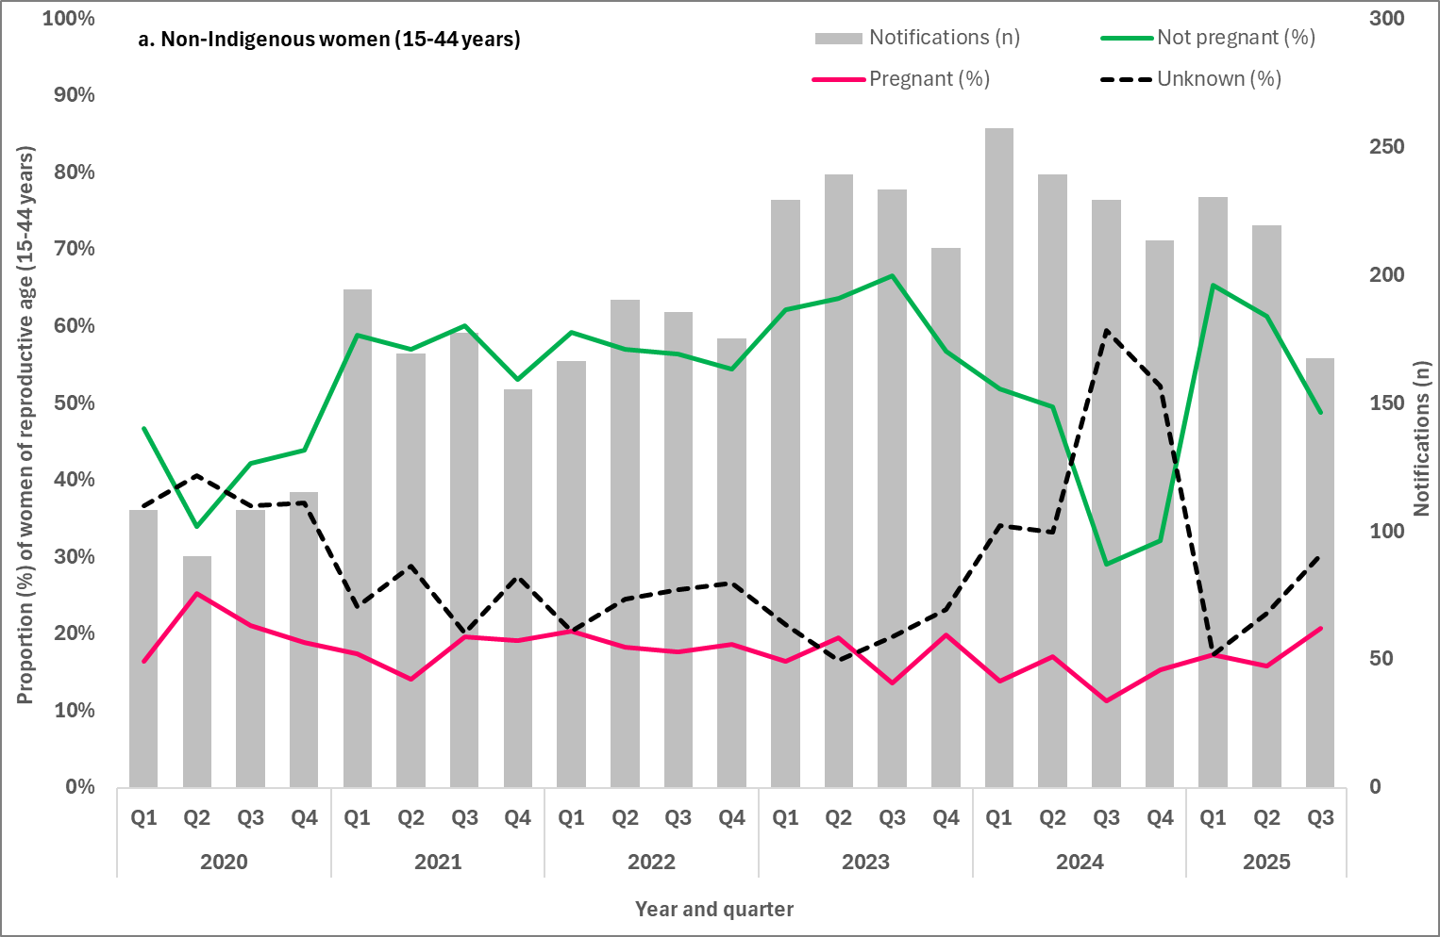
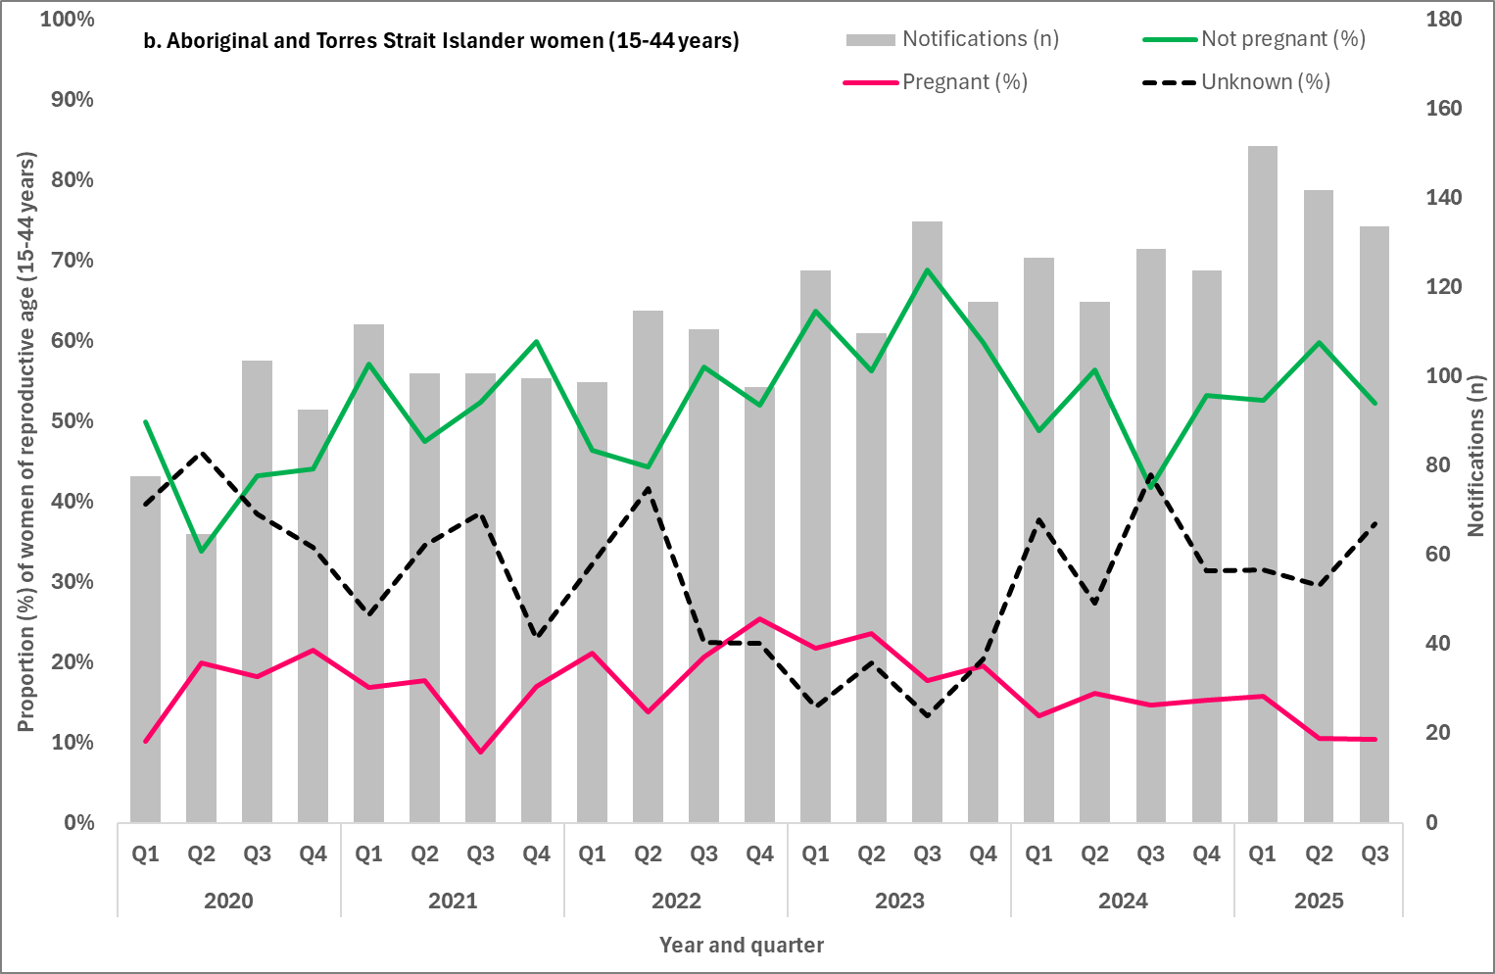
Note:
1. Excludes cases for whom sex, age and Indigenous status were not reported.

Indicator 4.5 – Late diagnosis
4.5 Number of women giving birth to an infant with congenital syphilis who were diagnosed with syphilis late in pregnancy by Indigenous status
Late diagnosis with syphilis in pregnancy refers to women who did not receive treatment more than 30 days prior to delivery. Late diagnosis also includes women who were diagnosed with syphilis at-birth (day of delivery) or post-birth and therefore could not receive adequate treatment for their syphilis infection.
Most women (82%, 72/88) giving birth to an infant with congenital syphilis between 2020 and Q3 2025, were diagnosed late in pregnancy. Among non-Indigenous women this proportion was 85% (33/39), and Aboriginal and Torres Strait Islander women 79% (37/47) (Table 4).
- Number of women giving birth to an infant with congenital syphilis, by trimester mother was diagnosed with syphilis, 2020 to Q3 2025
Stage of pregnancy | 2020 | 2021 | 2022 | 2023 | 2024 | 2025
 |  |  |  |  |  | Q1 | Q2 | Q3
Aboriginal and Torres Strait Islander women
First trimester | 0 | 0 | 0 | 0 | 1 | 0 | 0 | 0
Second trimester | 1 | 0 | 2 | 2 | 0 | 0 | 1 | 0
Third trimester | 0 | 2 | 1 | 4 | 0 | 1 | 0 | 0
At birth | 4 | 4 | 3 | 4 | 1 | 0 | 0 | 1
Post birth | 3 | 3 | 0 | 3 | 1 | 0 | 2 | 0
Unknown | 0 | 0 | 3 | 0 | 0 | 0 | 0 | 0
Late diagnosis | 7 | 9 | 4 | 11 | 2 | 1 | 2 | 1
Total | 8 | 9 | 9 | 13 | 3 | 1 | 3 | 1
Non-Indigenous women
First trimester | 0 | 0 | 0 | 0 | 0 | 0 | 0 | 0
Second trimester | 0 | 0 | 1 | 3 | 0 | 0 | 1 | 0
Third trimester | 2 | 1 | 1 | 0 | 1 | 0 | 0 | 0
At birth | 2 | 1 | 1 | 1 | 1 | 2 | 1 | 0
Post birth | 5 | 4 | 2 | 3 | 4 | 0 | 1 | 1
Unknown | 0 | 0 | 0 | 0 | 0 | 0 | 0 | 0
Late diagnosis | 8 | 6 | 4 | 4 | 6 | 2 | 2 | 1
Total | 9 | 6 | 5 | 7 | 6 | 2 | 3 | 1
Total women¹
First trimester | 0 | 0 | 0 | 0 | 1 | 0 | 0 | 0
Second trimester | 1 | 0 | 3 | 5 | 0 | 0 | 2 | 0
Third trimester | 2 | 3 | 2 | 4 | 1 | 1 | 0 | 0
At birth | 6 | 5 | 4 | 5 | 2 | 2 | 1 | 1
Post birth | 8 | 7 | 3 | 6 | 6 | 0 | 3 | 1
Unknown | 0 | 0 | 3 | 0 | 0 | 0 | 0 | 0
Late diagnosis | 15 | 15 | 9 | 15 | 9 | 3 | 4 | 2
Total | 17 | 15 | 15 | 20 | 10 | 3 | 6 | 2
Note:
1 Includes cases with unknown Indigenous status.

Indicator 4.6 – Adequate treatment
4.6 Proportion of women giving birth to an infant with congenital syphilis receiving adequate treatment prior to delivery
Treatment is considered adequate if a stage-appropriate penicillin-containing regimen is administered 30 days or more prior to delivery, and all antenatal and delivery pathology were performed and results verified with no evidence of reinfection.
Maternal treatment of syphilis was reported for 93% (82/88) of women giving birth to an infant with congenital syphilis between 2020 and Q3 2025. Of these women 96% (79/82) did not receive adequate treatment prior to delivery (Figure 12). This includes 54 women who were diagnosed at-birth (day of delivery) and post-birth and 13 women who were diagnosed in the third trimester (fewer than 30 days prior to delivery). Of the remaining cases, 9 were diagnosed in the 2nd trimester and 3 had an unknown trimester of diagnosis.
Of the 79 women who did not receive adequate treatment prior to delivery one-third (34%, 27/79) of these pregnancies resulted in a congenital syphilis fetal death (still-birth or following birth). Thirty-four per cent (34%, 27/79) gave birth to a live-born infant with a range of clinical symptoms associated with congenital syphilis including bone abnormalities, damage to spleen and/or liver, anaemia, hearing loss, jaundice and sepsis.

Eight women gave birth to infants (10%, 8/79) with congenital syphilis who were diagnosed in the weeks and months following their birth. Where additional information were available, the reason for the later diagnosis were reported as:
- the infant not being investigated at birth as they were clinically well
- the mother being diagnosed with syphilis post-birth
- the infant presenting with symptoms post-birth.
The remaining 17 women gave birth to infants (22%, 17/79) with congenital syphilis that were live-born with no congenital syphilis symptoms.
- Adequate maternal treatment among women giving birth to an infant with congenital syphilis, 2020 to Q3 2025
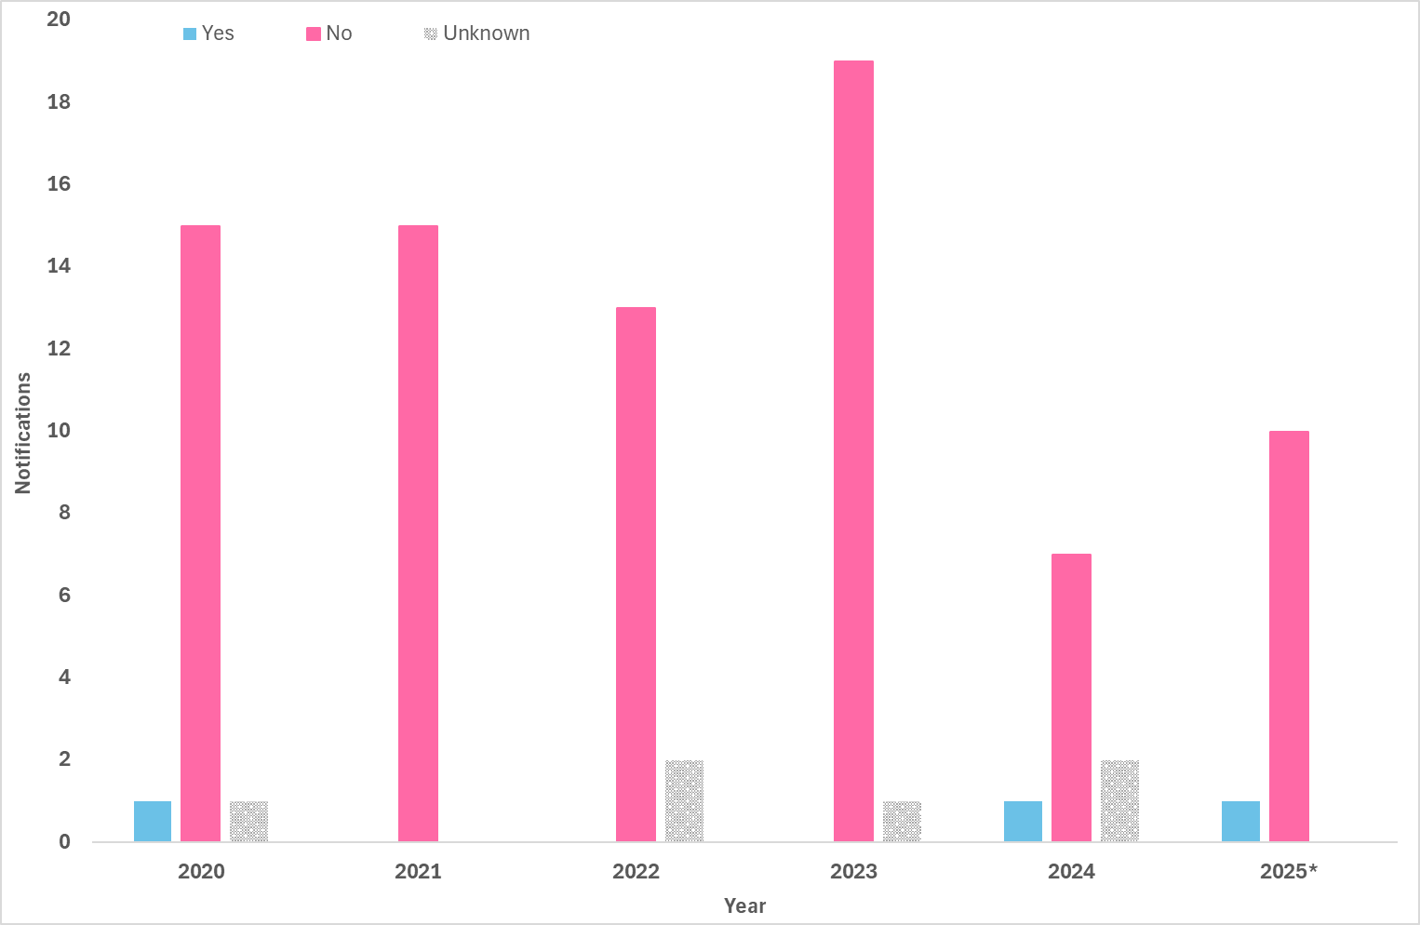

Indicator 4.7 – Testing during pregnancy
4.7 Number of women giving birth to an infant with congenital syphilis by number of syphilis tests received during their pregnancy
Maternal syphilis testing history was reported for 97% (85/88) of women giving birth to an infant with congenital syphilis between 2020 and Q2 2025 (Figure 13). Of those women, 62% (53/85) did not report a previous syphilis test during their current pregnancy prior to being diagnosed with infectious syphilis. Thirty-two per cent (32%) of cases (27/85) reported at least one previous syphilis test and one (1) case reported having two (2) tests during their current pregnancy. Only one (1) woman reported having 3 or more tests during their current pregnancy as recommended in national and jurisdictional guidelines (8-15) (Figure 13).The remaining three (3) cases reported a previous test during their current pregnancy, but the number of tests was unknown.
- Maternal syphilis testing history during pregnancy among women giving birth to an infant with congenital syphilis, by stage of pregnancy at syphilis diagnosis, 2020 to Q3 2025
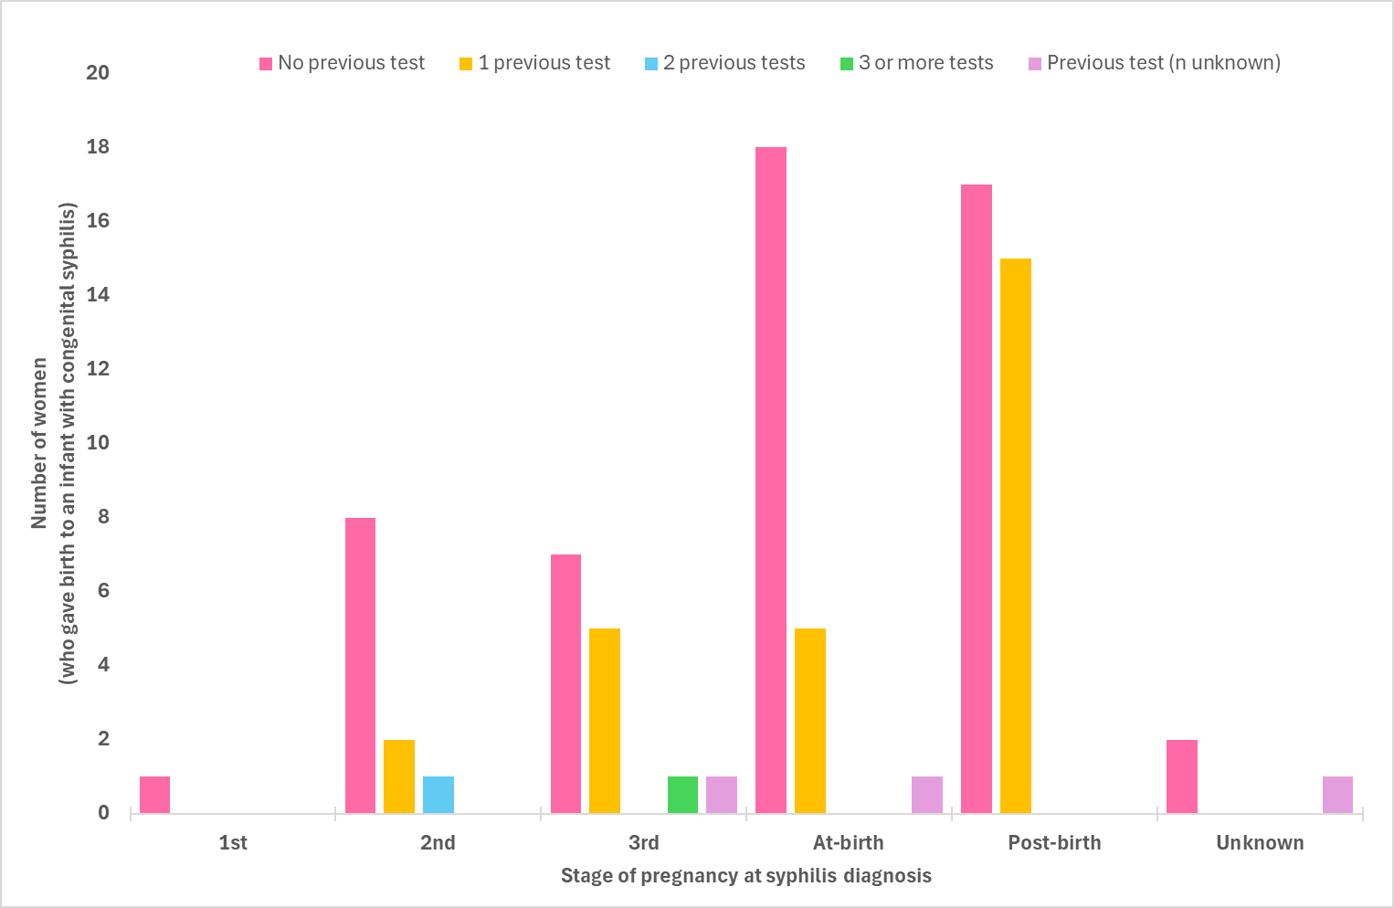

Indicator 4.8 – Reinfection during pregnancy
4.8 Number of women giving birth to an infant with congenital syphilis reinfected during their pregnancy
Reinfection is generally diagnosed on the basis of changes in RPR titre. A four-fold or two-titre rise in RPR – for example, 1 in 2 to 1 in 8 – following previous adequate treatment is considered a re-infection.
Maternal reinfection data were available for 95% (84/88) of women giving birth to an infant with congenital syphilis between 2020 and Q3 2025, either:
- during the current pregnancy (that is, the pregnancy when the maternal notification was made)
- before the current pregnancy.
Of the 84 women with data available, seven (10%, 8/84) reported being diagnosed with a previous syphilis infection during the current or previous pregnancy. The remaining 76 cases (90%, 76/84) did not report a previous syphilis infection prior to the current diagnosis.

Notes

Methodological notes
Syphilis notification and enhanced data were extracted from the NNDSS on 17 February 2026, by diagnosis date. Due to the dynamic nature of the NNDSS, data in this extract are subject to retrospective revision and may vary from data reported in published NNDSS reports and reports of notification data by states and territories. Data are to 30 September 2025 unless otherwise specified.
In general, notification data represent only a proportion of the total cases occurring in the community, that is, only those cases for which health care was sought, a test conducted, and a diagnosis made, followed by a notification to health authorities. The degree of under-representation of all cases is unknown and is most likely variable by disease and jurisdiction.
Changes in notifications over time may not solely reflect changes in disease prevalence or incidence. Changes in testing policies; screening programs including the preferential testing of high-risk populations; the use of less invasive and more sensitive diagnostic tests; and periodic awareness campaigns, may influence the number of notifications that occur annually.

Data elements
- ‘Diagnosis year’ was used to define the period of analysis. This date represents either the onset date or where the date of onset was not known, the earliest of the specimen collection date, the notification date, or the notification received date.
- ‘Residential postcode’ usually reflects the residential location of a case at the time of testing and does not necessarily represent the place where the disease was acquired.
- Residential postcode’ reported to the NNDSS was used to allocate notifications of infectious and congenital syphilis to remoteness areas and mapped data by Statistical Area 3 (SA3) (as defined by the Australian Bureau of Statistics). Where a postcode was not reported the notification was excluded from remoteness area, SA3 and IARE analysis.
- The ‘population denominator’ used to calculate notification rates, including for remoteness areas, SA3 and IARE (per 100,000 population) was extracted from the Australian Bureau of Statistics Census Table Builder (based on 2021 Census data).
- The determination of the Indigenous status is by descent, self-identification, and community acceptance. Completeness of the Indigenous status field is generally high, with variations from year to year and jurisdiction to jurisdiction.
- ‘Syphilis testing data’ have been provided by participating ACCHS. A participating service refers to clinics currently funded by the Australian Government Department of Health, Disability and Ageing to deliver point of care testing in syphilis outbreak regions. Services extract data from local clinical information management systems. Data are provided for the reporting month, and cumulatively for the previous 12 months. ‘Testing coverage’ is calculated using as the denominator ‘clients attending the service’ (a participating ACCHS) during the reporting period.

Case definitions
The CDNA national surveillance case definitions for infectious and congenital syphilis, including any historical edits, are available at: https://www.health.gov.au/casedefinitions.

Acknowledgements
We, the Australian Centre for Disease Control, acknowledge the Traditional Owners and Custodians of Country throughout Australia. We recognise the strength and resilience of Aboriginal and Torres Strait Islander peoples and acknowledge and respect their continuing connections and relationships to country, rivers, land and sea. We acknowledge the ongoing contribution Aboriginal and Torres Strait Islander peoples make across the Health system and wider community. We also pay our respects to Elders past, present and future and extend that respect to all Traditional Custodians of this land.
The Australian Centre for Disease Control acknowledges the Communicable Diseases Network Australia; the work of public health officers involved in the collection of surveillance data; state and territory public health communicable disease surveillance managers and data managers; Aboriginal Community Controlled Health Services, and; all public and private laboratories that support laboratory surveillance in Australia.

Contact
For any further details about information contained in this report please contact Ms Amy Bright by emailing syphilis.surveillance@cdc.gov.au.

Appendix A – Goals and indicators reporting schedule
Indicator number | Indicator | Reporting
Goal 1 – Strengthen prevention and testing strategies for syphilis in priority populations and settings, targeting high-burden areas
1.1 | Reported risk factors for people giving birth to an infant with congenital syphilis | Annually
1.2 | Cumulative number of syphilis tests delivered through participating ACCHS, by target and total population | Quarterly
1.3 | Proportion of people attending participating ACCHS receiving a syphilis test within the previous 12 months, by target and total population (syphilis testing coverage) | Quarterly
1.4 | Proportion of people from priority populations tested for syphilis in the previous 12 months attending a site within the ACCESS network | Annually
1.5 | Proportion of gay and bisexual men who have sex with men who have been tested for syphilis three or more times in the previous 12 months attending a site within the ACCESS network | Annually
1.6 | Proportion of women who gave birth, by duration of pregnancy at first antenatal visit | Annually
1.7 | Proportion of women who gave birth, by duration of pregnancy at first antenatal visit | Annually
1.8 | Proportion of women who gave birth, by number of antenatal visits | Annually
1.9 | Proportion of women who gave birth, by number of antenatal visits, by remoteness area | Annually
1.10 | Proportion of women who gave birth, by country of birth | Annually
Goal 2 – Reduce ongoing transmission and incidence of syphilis across priority populations
2.1 | Notification rate of infectious syphilis by Indigenous status, sex, age and remoteness area classification | Quarterly
2.2 | Notification rate of infectious syphilis in Aboriginal and Torres Strait Islander peoples by Indigenous Areas (IAREs) | Quarterly
2.3 | Notification rate of infectious syphilis by Statistical Area 3 (SA3), by Indigenous status | Quarterly
2.4 | Notification rate of infectious syphilis in women of reproductive age (15 to 44 years) by Indigenous status and remoteness area | Quarterly
2.5 | Proportion of infectious syphilis notifications in men reporting sexual exposure with men only | Quarterly
2.6 | Proportion of infectious syphilis notifications in men reporting sexual exposure with men and women | Quarterly
2.7 | Proportion of infectious syphilis notifications by primary reason for testing | Annually
2.8 | Proportion of infectious syphilis notifications in gay and bisexual men who have sex with men reporting HIV PrEP use at time of syphilis diagnosis | Annually
2.9 | Proportion of infectious syphilis notifications by clinical facility where the syphilis infection was diagnosed | Annually
2.10 | Proportion of infectious syphilis notifications receiving treatment, by time to treatment | Annually
Goal 3 – Reduce morbidity and mortality associated with syphilis
3.1 | Number of syphilis related deaths (ICD-10 coded), by stage of infection | Annually
3.2 | Number of hospitalisations with a principal diagnosis of syphilis (ICD-10 coded) | Annually
3.3 | Estimated number of disability-adjusted life years (DALY) due to syphilis | Annually
Goal 4 – Eliminate congenital syphilis (defined as sustained zero congenital syphilis cases)
4.1 | Number of congenital syphilis cases by remoteness area and Indigenous status | Quarterly
4.2 | Number of congenital syphilis related deaths by Indigenous status | Quarterly
4.3 | Notification rate of congenital syphilis per 100,000 live births by remoteness area and Indigenous status | Quarterly
4.4 | Proportion of syphilis notifications among women of reproductive age (15- 44 years) who were pregnant at time of diagnosis, by remoteness area classification and Indigenous status | Quarterly
4.5 | Number of women giving birth to an infant with congenital syphilis who were diagnosed with syphilis ‘late’ in pregnancy by Indigenous status | Quarterly
4.6 | Proportion of women giving birth to an infant with congenital syphilis receiving adequate treatment prior to delivery | Quarterly
4.7 | Number of women giving birth to an infant with congenital syphilis by number of syphilis tests received during their pregnancy | Quarterly
4.8 | Number of women giving birth to an infant with congenital syphilis reinfected during their pregnancy | Quarterly
4.9 | Number of women of reproductive age (15 to 44 years) hospitalised with a principal diagnosis of syphilis (ICD-10 coded) | Annually
4.10 | Number of women hospitalised with a principal diagnosis of syphilis in pregnancy, childbirth and puerperium (ICD-10 coded) | Annually

Appendix B – NNDSS syphilis notification and enhanced data completeness by year, 2020 to Q3 2025
Variable¹ | 2020 | 2021 | 2022 | 2023 | 2024 | 2025
 |  |  |  |  |  | Q1 | Q2 | Q3
Indigenous status
Infectious syphilis | 96% | 95% | 92% | 94% | 95% | 95% | 93% | 95%
Congenital syphilis | 100% | 100% | 93% | 100% | 90% | 100% | 100% | 100%
Residential location (to map to reported geographies)
Remoteness area | 98% | 97% | 97% | 97% | 98% | 97% | 95% | 93%
Statistical area 3 | n/a | n/a | n/a | n/a | 97%² | 97%² | 97%² | 98%²
Indigenous areas³ | n/a | n/a | n/a | n/a | 98%² | 97%² | 99%² | 98%²
Enhanced infectious syphilis
Pregnancy status | 62%⁴ | 73%⁵ | 72%⁵ | 80%⁵ | 58%⁶ | 76%⁶ | 74%⁶ | 66%⁵
Sexual exposure (males) | 70% | 76% | 65% | 68% | 70% | 79% | 78% | 79%
Enhanced congenital syphilis
Stage of pregnancy | 100% | 100% | 80% | 100% | 100% | 100% | 100% | 100%
Treatment prior to delivery | 94% | 100% | 87% | 85% | 80% | 100% | 100% | 100%
Testing history | 100% | 100% | 100% | 95% | 90% | 67% | 100% | 100%
Re-infection (current pregnancy) | 88% | 73% | 100% | 65% | 80% | 67% | 83% | 100%
Notes:
1 Where completeness is less than 50%, data has been excluded.
2 Q4 2024 to Q3 2025.
3 Aboriginal and Torres Strait Islander peoples only.
4 Includes 6 jurisdictions.
5 Includes 7 jurisdictions.
6 Includes all states and territories.

References
1. Equity Economics. Blueprint for the Future: Evaluation of NACCHO’s Role under the Enhanced Syphilis Response. A Report prepared for the National Aboriginal Community Controlled Health Organisation (NACCHO). 2021.
2. National Syphilis Surveillance Quarterly Report (Quarter 4: 1 October - 31 December 2024). 2025.
3. NT Health. Public health alert: syphilis - ongoing high transmission: NT Health Centre for Disease Control; 2026 [Available from: https://health.nt.gov.au/__data/assets/pdf_file/0009/1592199/health-alert-syphilis-update-11.02.2026.pdf.
4. Australian Institute of Health and Welfare. Aboriginal and Torres Strait Islander Health Performance Framework: summary report. AIHW: Australian Government; 2025.
5. Australian Statistical Geography Standard (ASGS) Edition 3: Indigenous Structure: Australian Bureau of Statistics; 2021 [Available from: https://www.abs.gov.au/statistics/standards/australian-statistical-geography-standard-asgs-edition-3/jul2021-jun2026/indigenous-structure.
6. Taouk M, Taiaroa G, Pasricha S, Herman S, Chow E, Azzatto F, et al. Characterisation of Treponema pallidum lineages within the contemporary syphilis outbreak in Australia: a genomic epidemiological analysis. The Lancet Microbe. 2022;3(6):e417 - e26.
7. Williamson D, Chow E, Gorrie C, Seemann T, Ingle D, Higgins N, et al. Bridging of Neisseria gonorrhoeae lineages across sexual networks in the HIV pre-exposure prophylaxis era. Nature Communications. 2019;10.
8. Syphilis – CDNA National Guidelines for Public Health Units [Available from: https://www.health.gov.au/resources/publications/syphilis-cdna-national-guidelines-for-public-health-units?language=en.
9. Queensland clinical guidelines. Translating evidence into best clinical practice - Syphilis and pregnancy (Qld Health): Queensland Health; 2025 [Available from: https://www.health.qld.gov.au/__data/assets/pdf_file/0035/736883/g-sip.pdf.
10. Statewide Maternity Shared Care Guidelines (WA Health): Government of Western Australia North Metropolitan Health Service Women and Newborn Health Service; 2021 [Available from: https://kemh.health.wa.gov.au/~/media/HSPs/NMHS/Hospitals/WNHS/Documents/Clinical-guidelines/Statewide-Maternity-Shared-Care-Guidelines.pdf.
11. South Australian Perinatal Practice Guideline. Syphilis in pregnancy and the neonate PPG015 (SA Health) 2025 [Available from: https://www.sahealth.sa.gov.au/wps/wcm/connect/4f3188804eedeac1b604b76a7ac0d6e4/Syphilis+in+pregnancy+and+the+neonate+PPG+v_5_0_.pdf?MOD=AJPERES&CACHEID=ROOTWORKSPACE-4f3188804eedeac1b604b76a7ac0d6e4-ph8fmcZ.
12. Syphilis testing during pregnancy (Safer Care Victoria) 2025 [Available from: https://www.safercare.vic.gov.au/best-practice-improvement/clinical-guidance/maternity/syphilis-testing-during-pregnancy.
13. Three syphilis tests are now recommended in every pregnancy to prevent congenital syphilis (Tas. Health) 2025 [Available from: https://www.health.tas.gov.au/news/articles/three-syphilis-tests-are-now-recommended-every-pregnancy-prevent-congenital-syphilis.
14. Congenital syphilis guidelines for the Northern Territory (NT Health) 2015 [Available from: https://digitallibrary.health.nt.gov.au/nthealthserver/api/core/bitstreams/77f72074-3e47-4697-9b80-63b3f5fd5630/content.
15. Public health clinical alert. Syphilis and mpox: Information for ACT clinicians (ACT Health) 2024 [Available from: https://www.act.gov.au/__data/assets/pdf_file/0009/2629926/Mpox-and-syphilis-clinician-alert.pdf.



