Australian Respiratory Surveillance Report

Key messages
This report presents a national update on acute respiratory infections, including coronavirus disease 2019 (COVID-19), influenza and respiratory syncytial virus (RSV). It focuses on the current reporting period (23 March to 5 April 2026) and earlier severity reporting periods (up to 22 March 2026). These key messages do not provide detailed information on age distribution, jurisdictional patterns, or comparisons with previous years. This analysis and supporting data are available in the full report.
In the community: In the last fortnight, self-reported influenza-like illness among people who contacted the national health helpline and among those who took part in community surveys remained relatively stable. In the last fortnight, COVID-19 cases decreased. Influenza cases also decreased and remain below interseasonal levels for this time of year. This decrease could be due to greater natural immunity to influenza among the population following the higher than usual influenza activity in late 2025. In the last fortnight, RSV cases increased, with this continued increasing trend indicating the 2026 RSV season has commenced.
In general practice: In the last fortnight, general practice consultations for influenza-like illness decreased slightly at sentinel surveillance sites. Consultation rates remain relatively consistent with usual interseasonal levels.
In hospitals: Sentinel hospital admissions with severe acute respiratory infections increased in the last severity reporting period, and most admissions in the last severity fortnight were with RSV. Sentinel intensive care admissions with severe acute respiratory infections declined in the previous severity reporting period, and most admissions in the previous severity period were with RSV. In the last fortnight, the average daily intensive care bed occupancy for patients in droplet or airborne isolation increased.
Deaths: COVID-19 has been the leading cause of acute respiratory infection mortality across the majority of 2020–2025; however, since August 2025 the number of deaths per month involving influenza (both due to and with) has exceeded the number of deaths involving COVID-19. The mortality burden of acute respiratory infections is highest in older adults.
In laboratories: In the last fortnight, test positivity for SARS-CoV-2 decreased, while test positivity for RSV and influenza increased. The SARS-CoV-2 variant under monitoring, NB.1.8.1 has been the most commonly sequenced SARS-CoV-2 variant.
Vaccine coverage, effectiveness and match: In the last year, 9.4% of adults have received a COVID-19 vaccine. In 2025, influenza vaccine coverage reached 30.7%; however, 2026 data are not yet available. Most influenza isolates (>87%) are a good match for the 2026 southern hemisphere vaccine components. The National RSV Mother and Infant Protection Program continues. To date, 228,644 Abrysvo doses have been administered, and nirsevimab uptake was 3.7% in the last six months.

Australian Respiratory Surveillance Report
This report was prepared by Suzie Whitehead, Lauren Welsh, Jenna Hassall and Shweta Singhal on behalf of the Australian Centre for Disease Control (CDC). We thank the staff and participants from the surveillance systems who contribute data for acute respiratory illness surveillance across Australia.
The report presents a national overview of acute respiratory infections in Australia, drawing information from several different surveillance systems. These surveillance systems help us to understand the distribution of acute respiratory illnesses in the community, the severity of infections including which populations might be at risk, and the impact of acute respiratory illnesses on the community and health system in Australia. Surveillance indicators presented in this report are based on the Australian National Surveillance Plan for COVID-19, Influenza, and RSV. A summary of data considerations for this report are provided below:
- Due to the dynamic nature of the surveillance systems used in this report, surveillance data are considered preliminary and subject to change as updates are received, with the most recent weeks considered particularly incomplete. Data in this report may vary from data reported in other national reports and reports by states and territories.
- Data in this report are presented by date of event (survey, diagnosis, admission or death) and by the International Organization for Standardization (ISO) week date system, with weeks defined as seven-day periods which begin on a Monday and end on a Sunday. The ISO week date system is used to support trends comparisons over time more effectively. The current reporting period includes 23 March to 5 April 2026 and where comparisons to the previous fortnight are made, this includes 9 March to 22 March 2026.
- In Australia, states and territories (the Australian Capital Territory [ACT], New South Wales [NSW], the Northern Territory [NT], Queensland [Qld], South Australia [SA], Tasmania [Tas], Victoria [Vic] and Western Australia [WA]) report notified cases to the National Notifiable Diseases Surveillance System (NNDSS) based on the Australian national surveillance case definitions. NNDSS data are analysed and reported based on diagnosis date, which is the true onset date of a case if known, otherwise it is the earliest of the specimen date, the notification date or the notification received date. The NNDSS data for this report were extracted on 8 April 2026.
- Notification rates per 100,000 population presented in this report are for the given time period, with population data are based on the Australian Bureau of Statistics (ABS) Estimated Resident Population (ERP) for the reference period June 2024, released 12 December 2024 unless stated otherwise.
- To account for the lag in collection and provision of severity data from some surveillance systems, and for the time delay between illness onset and the development of severe disease outcomes, cases with an admission date or a diagnosis date in the last two weeks are excluded from severity analyses for hospitalisations and intensive care admissions. As such, the severity reporting periods are two weeks behind the end of the current reporting period. For this report, severity reporting includes data from 9 March to 22 March 2026 unless specified otherwise. Where comparisons to the previous severity fortnight are made this includes 23 February to 8 March 2026.
- Death registrations from the ABS Provisional Mortality Statistics are now used as the primary data source for measuring acute respiratory infection associated deaths. The ABS mortality data is sourced from the Registry of Births, Deaths and Marriages and is separate from the NNDSS. Registration based mortality data needs time to be received and processed, and so mortality statistics in this report may lag by at least two months.
- The responsibility for the interpretation and use of the material lies with the reader. The Australian CDC does not accept liability for any injury or loss or damage arising from the use of, or reliance upon, the content of the report. Analysis and reporting outputs were produced using R Statistical Software v4.3.1.
- For further information about this report, including data sources and considerations refer to the Technical Supplement or contact respiratory.surveillance@cdc.gov.au.

Community surveillance
Community surveillance monitors respiratory illnesses in the community, providing information on the number of people reporting respiratory symptoms, testing practices, and the impact of respiratory illnesses. Community surveillance includes notification data obtained from laboratory tests for infections. Infections that are diagnosed and notified are only a subset of the total number of infections occurring in the community.
- In the last fortnight (23 March to 5 April 2026), the rate of Healthdirect helpline callers with influenza-like illness (330 per 1,000 callers per fortnight) has remained relatively steady compared to the previous fortnight (332 per 1,000 callers per fortnight) (Figure 1).
- Rates of influenza-like illness among helpline callers have remained relatively stable across March and are similar to the same time in 2025 (Figure 1).
Figure 1: Rate of influenza-like illness per 1,000 helpline callers by year and week of call*, Australia†, 22 March 2023 to 5 April 2026
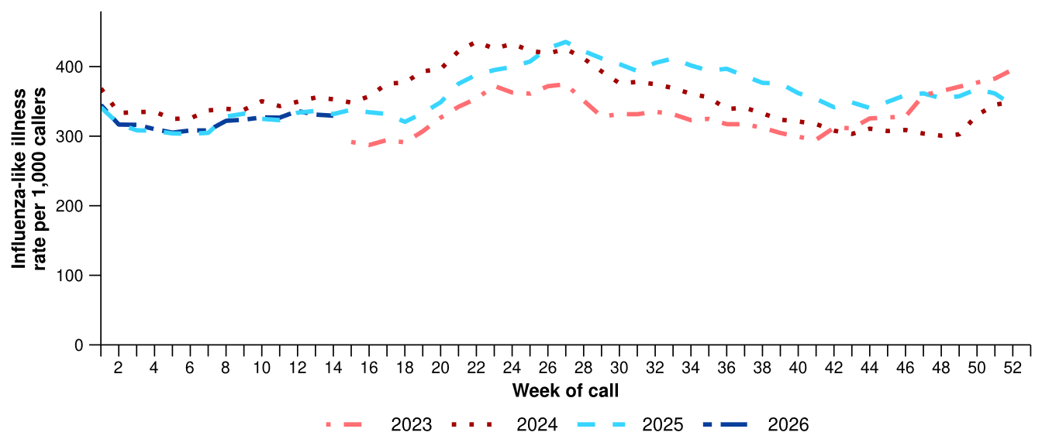
Source: Healthdirect Australia
* Healthdirect data prior to 22 March 2023 are unavailable as prior to this date a different data collection method was used.
† The Healthdirect helpline operates in all states and territories except Qld; therefore influenza-like illness trends will not be representative of Qld and may be underrepresented. See the Technical Supplement for more information.
- In the last fortnight, there were slightly more Healthdirect helpline callers with influenza-like illness referred to seek urgent medical care (176 per 1,000 callers per fortnight) than in the previous fortnight (172 per 1,000 callers per fortnight) (Figure 2).
  - Callers referred to seek urgent medical care include those referred to call triple zero, attend a hospital emergency department, contact a virtual emergency department, urgent care clinic or see a general practitioner within two hours.
- In the last fortnight, referral pathways for influenza-like illness varied across Australia. NSW and Vic had the highest proportion of callers referred to see a general practitioner (GP) or seek other urgent medical care (Figure 2). By comparison, the NT and Tas had a higher proportion of callers who were recommended to attend a hospital emergency department or call triple zero. The ACT, SA and WA had similar proportions of callers referred to see a GP or seek other urgent medical care and recommended to attend a hospital emergency department or call triple zero (Figure 2).

Figure 2: Proportion of referral categories* for helpline callers with influenza-like illness by jurisdiction† and call date, Australia, 1 January to 5 April 2026
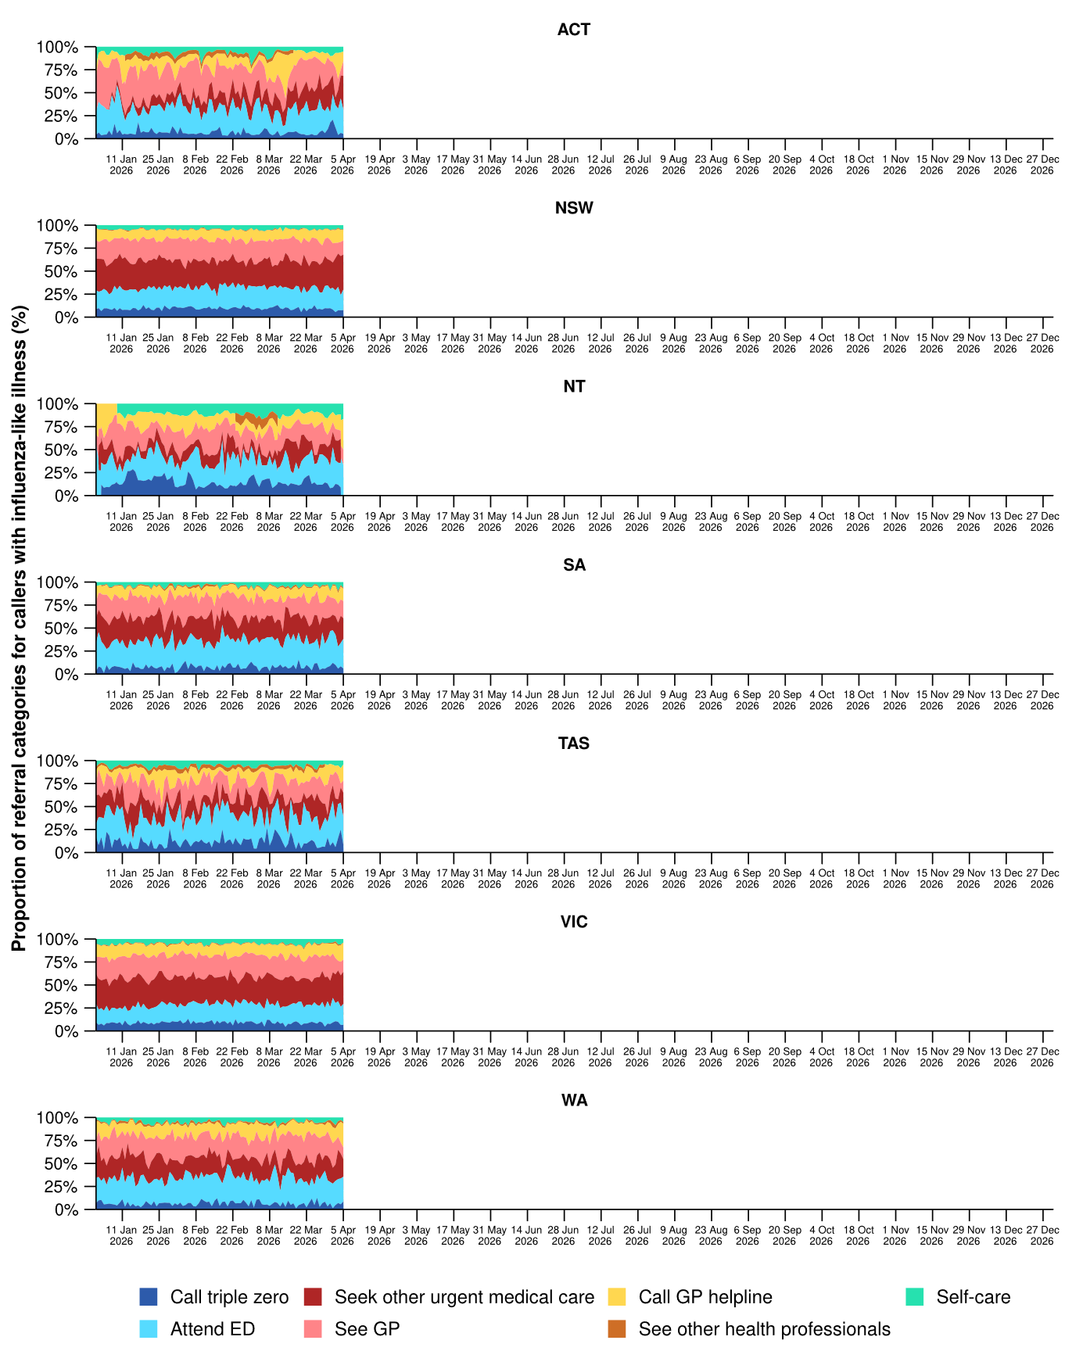
Source: Healthdirect Australia
* See other health professionals category includes pharmacist, dentist, mental health provider, primary maternity care, poison information centre or other.
† The Healthdirect helpline operates in all states and territories except Qld; therefore influenza-like illness referral trends are not provided for Qld. See the Technical Supplement for more information.

- In the last fortnight, the percentage of FluTracking participants reporting new fever and cough symptoms (1.1%) remained stable compared to the previous fortnight (1.0%) (Figure 3).
- The weekly percentage of FluTracking participants reporting new fever and cough symptoms increased from late January but remained relatively stable across March to early April, with slight week-on-week decreases observed. Since late February, the weekly percentage of FluTracking participants reporting new fever and cough symptoms was similar to the same period in 2025, but lower than the trend observed in 2023 and 2024 (Figure 3).
- In the last fortnight, a lower percentage of First Nations FluTracking participants reported new fever and cough symptoms (1.0%) compared with the previous fortnight (1.5%). These findings could be impacted by smaller sample sizes and representativeness of the data. For more detailed trends, please refer to figure 2 in the FluTracking reports.
Figure 3: Age standardised percentage of survey participants reporting new fever and cough symptoms compared with the five-year average* by year and week of survey, Australia, 2023 to 5 April 2026
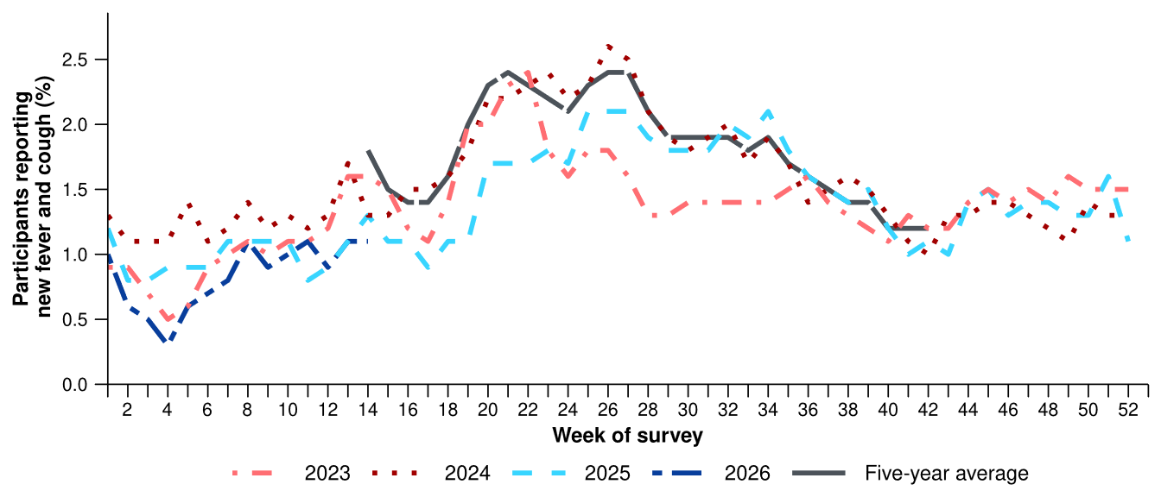
Source: FluTracking
* From 2020, FluTracking expanded their data capture period to year-round. Data before May and after October for any year before 2020 are not available for historical comparisons. The years 2020 and 2021 are excluded when comparing the current season to historical periods when influenza virus has circulated without public health restrictions. As such, the five-year average includes the years 2019 and 2022 to 2025.
- The average percentages of FluTracking participants reporting taking three or more days off work or normal duties, or seeking medical advice or care, due to fever and cough symptoms in 2026 are both lower than the same period in previous years (Table 1).
Table 1: Percentage of FluTracking participants reporting new fever and cough symptoms plus three or more days off work or normal duties or seeking medical advice or care*, Australia, up to 22 March† for 2023–2026
 | 2023 | 2024 | 2025 | 2026
Reported three or more days off work or normal duties | 50.5% | 51.2% | 48.1% | 44.1%
Reported seeking medical advice or care* | 35.9% | 32.4% | 32.3% | 30.7%
Source: FluTracking
* Includes those who sought medical advice from a general practitioner, Aboriginal and Torres Strait Islander health clinic, COVID-19 clinic, emergency department, or were admitted to hospital for fever and cough.
† While FluTracking data are collected in real time, data presented here are subject to a two week reporting delay to account for the time delay between illness onset and the development of severe disease outcomes.

- Self-reported severe acute respiratory syndrome coronavirus 2 (SARS-CoV-2) polymerase chain reaction (PCR) positivity has varied considerably, peaking in late February at 27.6% per week (Figure 4a). In contrast, self-reported SARS-CoV-2 rapid antigen test (RAT) positivity increased steadily from late January peaking at 21.1% in early March, with some weekly variations since (Figure 4b).
- Self-reported influenza PCR positivity declined from 40.0% per week in late January to 6.3% in early March, before increasing across March to 16.0% in early April (Figure 4a). Self-reported influenza RAT positivity followed a similar decline from late January to early March, though has since remained relatively low and stable at 4.2% per week in early April (Figure 4b).
- Self-reported RSV PCR positivity has fluctuated in 2026 but has not exceeded 8.7% per week (Figure 4a). There has been a gradual declining trend in self-reported RSV RAT positivity from 11.8% per week in late January to 1.6% per week in early April (Figure 4b).
- For more detailed testing and self-reported positivity trends, please refer to the FluTracking reports.
Figure 4a: Self-reported PCR test positivity* among FluTracking participants with fever and cough symptoms by pathogen week of survey, Australia, 1 January to 5 April 2026
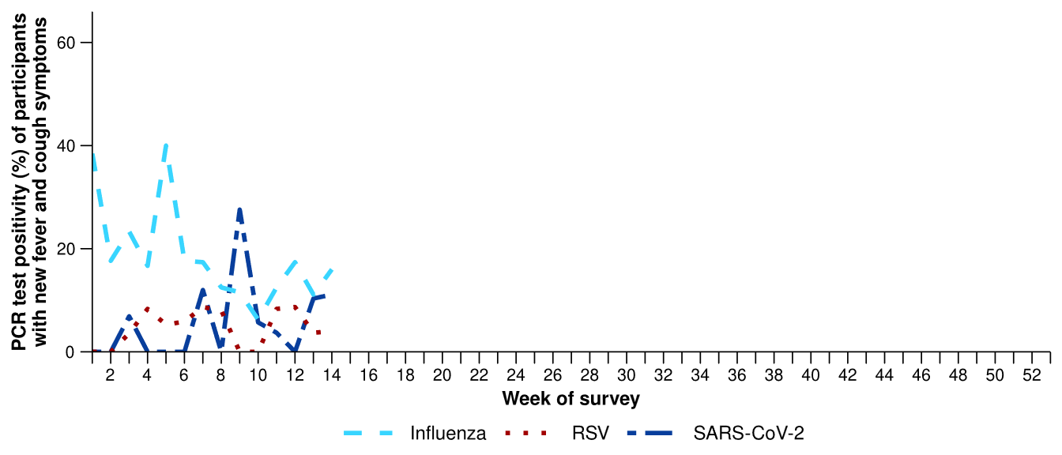
Source: FluTracking
* Denominator is based on participants who self-reported fever and cough symptoms and had a PCR test. Please refer to the Technical Supplement for more details.
Figure 4b: Self-reported RAT positivity* among FluTracking participants with fever and cough symptoms by pathogen and week of survey, Australia, 1 January to 5 April 2026
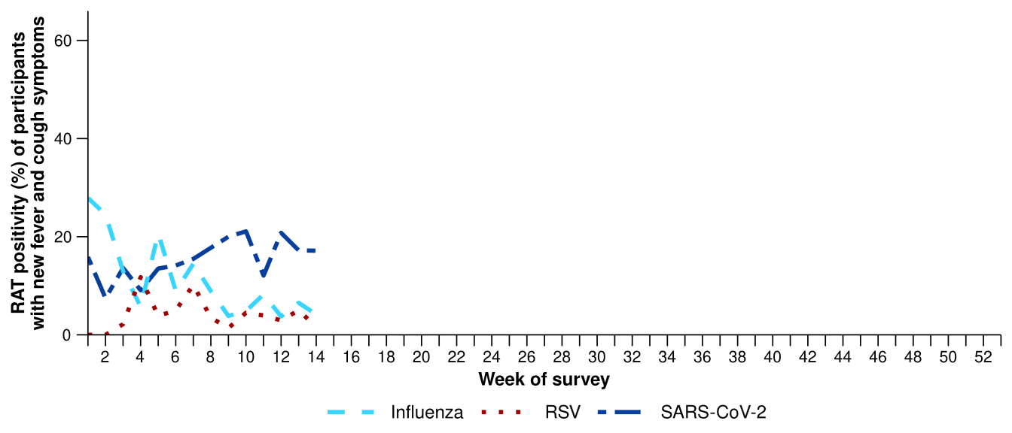
Source: FluTracking
* Denominator is based on participants who self-reported fever and cough symptoms and had a RAT. Please refer to the Technical Supplement for more details.
- In the last fortnight (23 March to 5 April 2026), there was a 6.6% decrease in COVID-19 cases, a 22.5% decrease in influenza cases, and a 13.1% increase in RSV cases.
Table 2: Notified cases and notification rate per 100,000 population by disease, five-year age group, and jurisdiction*, Australia, 1 January to 5 April 2026
 | COVID-19 |  |  | Influenza |  |  | RSV
 | Reporting  period  (n) | Year to  date  (n) | Year to  date  (rate) | Reporting  period  (n) | Year to  date  (n) | Year to  date  (rate) | Reporting  period  (n) | Year to  date  (n) | Year to  date  (rate)
Age group (years)
0–4 | 737 | 4,216 | 279 | 264 | 3,086 | 205 | 2,764 | 10,322 | 684
5–9 | 301 | 1,543 | 96 | 292 | 2,509 | 156 | 362 | 1,105 | 69
10–14 | 224 | 1,308 | 78 | 227 | 1,880 | 112 | 140 | 567 | 34
15–19 | 155 | 955 | 57 | 156 | 1,886 | 113 | 112 | 602 | 36
20–24 | 157 | 862 | 48 | 102 | 1,826 | 102 | 126 | 562 | 31
25–29 | 159 | 987 | 49 | 91 | 1,497 | 75 | 126 | 633 | 32
30–34 | 237 | 1,300 | 64 | 104 | 1,313 | 64 | 164 | 699 | 34
35–39 | 215 | 1,356 | 68 | 132 | 1,257 | 63 | 148 | 650 | 33
40–44 | 223 | 1,256 | 68 | 95 | 1,252 | 68 | 125 | 569 | 31
45–49 | 160 | 1,021 | 63 | 77 | 1,057 | 65 | 122 | 660 | 41
50–54 | 182 | 1,007 | 60 | 76 | 1,008 | 60 | 157 | 770 | 46
55–59 | 178 | 987 | 64 | 84 | 1,056 | 69 | 178 | 920 | 60
60–64 | 189 | 933 | 61 | 84 | 1,089 | 71 | 169 | 887 | 58
65–69 | 164 | 907 | 67 | 103 | 1,114 | 82 | 179 | 868 | 64
70–74 | 199 | 1,048 | 89 | 105 | 1,069 | 91 | 187 | 914 | 78
75+ | 842 | 4,595 | 212 | 254 | 3,043 | 140 | 589 | 2,860 | 132
Jurisdiction
ACT | 31 | 235 | 50 | 23 | 296 | 62 | 37 | 149 | 31
NSW | 2,056 | 10,529 | 124 | 890 | 8,955 | 106 | 3,008 | 10,968 | 129
NT | 9 | 130 | 51 | 20 | 505 | 198 | 38 | 562 | 220
Qld | 1,161 | 6,550 | 117 | 820 | 8,138 | 146 | 1,601 | 7,399 | 132
SA | 357 | 2,004 | 107 | 118 | 1,511 | 80 | 135 | 710 | 38
Tas | 31 | 273 | 47 | 17 | 291 | 51 | 44 | 248 | 43
Vic | 548 | 3,745 | 54 | 238 | 4,610 | 66 | 603 | 2,586 | 37
WA | 129 | 824 | 28 | 121 | 1,649 | 56 | 184 | 968 | 33
Total | 4,322 | 24,290 | 89 | 2,247 | 25,955 | 95 | 5,650 | 23,590 | 87
Source: National Notifiable Diseases Surveillance System (NNDSS). RSV notification data are unavailable for Tasmania from 3 April 2026.
* Total includes cases with missing age.

- In the last fortnight, there were 4,322 COVID-19 cases, a 6.6% decrease from 4,628 cases notified in the previous fortnight (Table 2; Figure 5).
- In the year to date, there have been 24,290 COVID-19 cases, 50.5% fewer than the 49,113 cases notified over the same period in 2025 (Table 2; Figure 5).
- In the last fortnight, COVID-19 notification rates decreased or remained relatively stable overall across most jurisdictions compared with the previous fortnight, except in NSW where notification rates increased (Figure 6).
Figure 5: Notified COVID-19 cases by year and week of diagnosis, Australia, 2023 to 5 April 2026
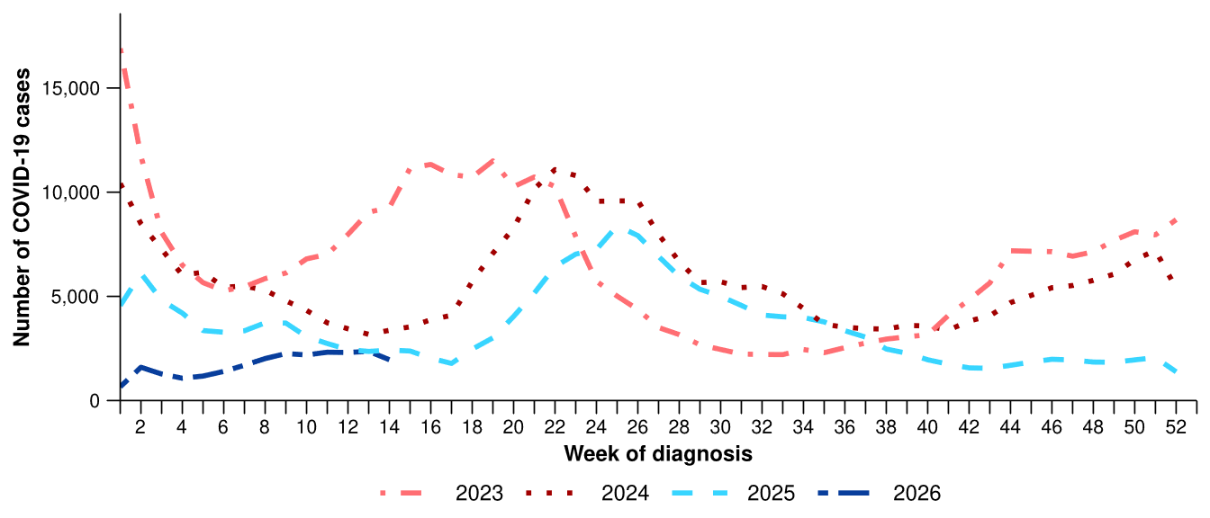
Source: National Notifiable Diseases Surveillance System (NNDSS)
Figure 6: Notification rates per 100,000 population for COVID-19 cases by state or territory and week of diagnosis, Australia, 1 January to 5 April 2026
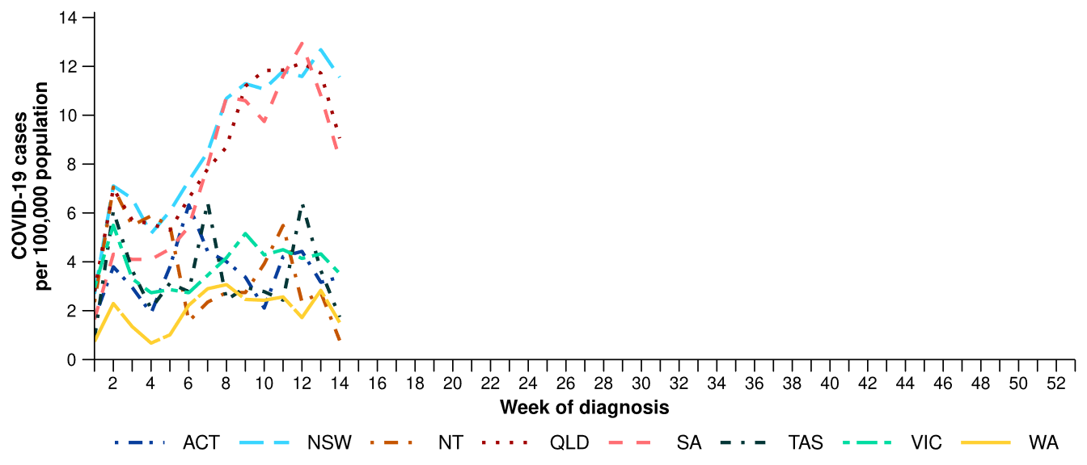
Source: National Notifiable Diseases Surveillance System (NNDSS)

- In the last fortnight, there were 2,247 influenza cases, a 22.5% decrease from 2,900 cases notified in the previous fortnight (Table 2; Figure 7).
- In the year to date, there have been 25,955 influenza cases, 51.0% fewer than the 52,931 cases notified over the same period in 2025 (Table 2; Figure 7). Influenza cases remain below interseasonal levels for this time of year (Figure 7). This decrease could be due to greater natural immunity to influenza among the population following the higher than usual influenza activity in late 2025.
- In the last fortnight, influenza notification rates decreased or remained relatively stable across most jurisdictions compared with the previous fortnight, except in the ACT and SA where notification rates increased slightly (Figure 8).
Figure 7: Notified influenza cases and five-year average* by year and week of diagnosis, Australia, 2023 to 5 April 2026
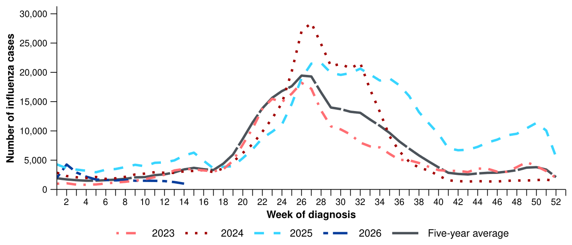
Source: National Notifiable Diseases Surveillance System (NNDSS)
* The years 2020 and 2021 are excluded when comparing the current season to historical periods when influenza virus has circulated without public health restrictions. As such, the five-year average includes the years 2019 and 2022 to 2025. Please refer to the Technical Supplement for interpretation of the five-year average.
Figure 8: Notification rates per 100,000 population for influenza cases by state or territory and week of diagnosis, Australia, 1 January to 5 April 2026
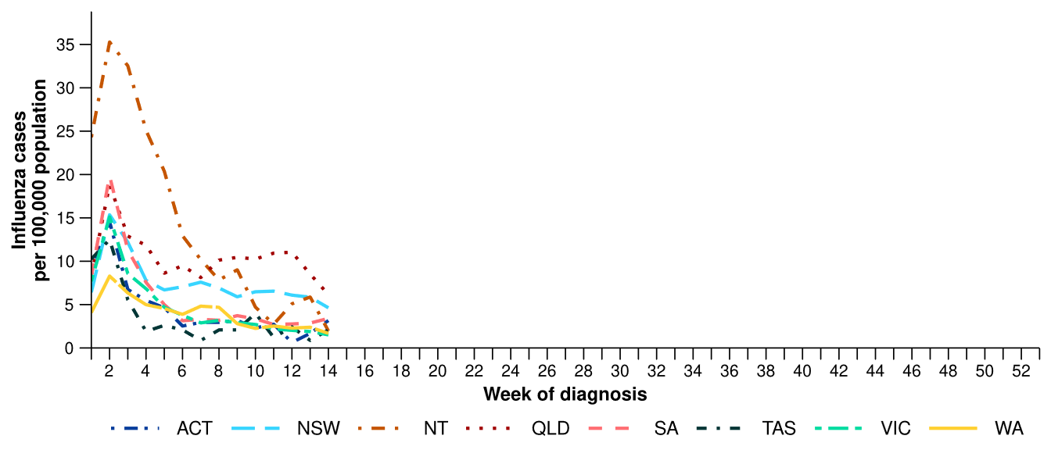
Source: National Notifiable Diseases Surveillance System (NNDSS)
- In the last fortnight, there were 1,803 influenza A cases, a 24.1% decrease from 2,374 influenza A cases notified in the previous fortnight, and there were 433 influenza B cases, a 15.6% decrease from 513 influenza B cases notified in the previous fortnight.
  - In the last fortnight, there were 9 influenza A(H1N1) cases, a 59.1% decrease from 22 cases notified in the previous fortnight.
  - In the last fortnight, there were 54 influenza A(H3N2) cases, a 12.9% decrease from 62 cases notified in the previous fortnight.
- In the year to date, influenza A(Unsubtyped) has accounted for most cases across all age groups, but since early February there has been an increasing number of influenza B notifications (Figure 9). Trends in influenza subtypes are influenced by differences in the number and selection of influenza samples that undergo typing across age groups and healthcare settings.
Figure 9: Notified influenza cases by influenza subtype, age group*, and week of diagnosis, Australia, 1 January to 5 April 2026
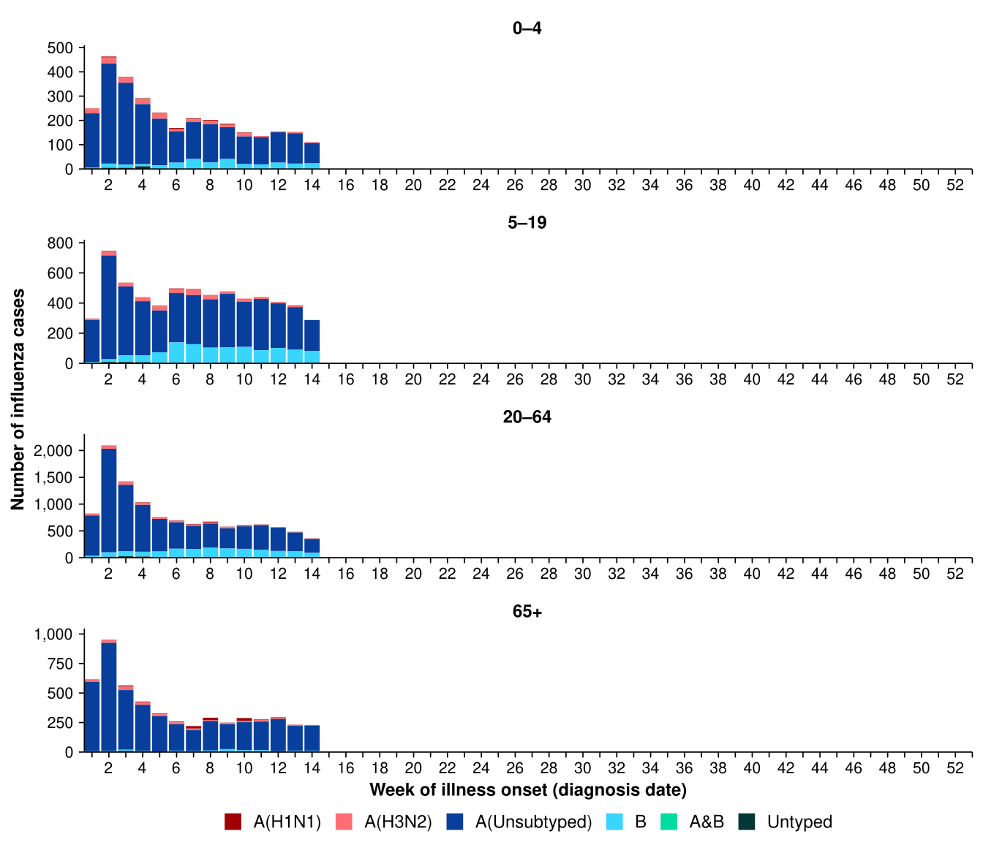
Source: National Notifiable Diseases Surveillance System (NNDSS)
* Axis varies between age groups.

- In the year to date, influenza A(Unsubtyped) has accounted for most influenza cases across all jurisdictions; however, an increasing number of influenza B notifications has been observed in most jurisdictions since early February, most notably in the NT and WA. A small number of influenza A(H3N2) notifications have been observed consistently across the year to date in Qld, Tas and WA (Figure 10).
- Trends in influenza subtypes are influenced by jurisdictional differences in the number and selection of influenza samples that undergo typing.
Figure 10: Notified influenza cases by influenza subtype, jurisdiction*, and week of diagnosis, Australia, 1 January to 5 April 2026
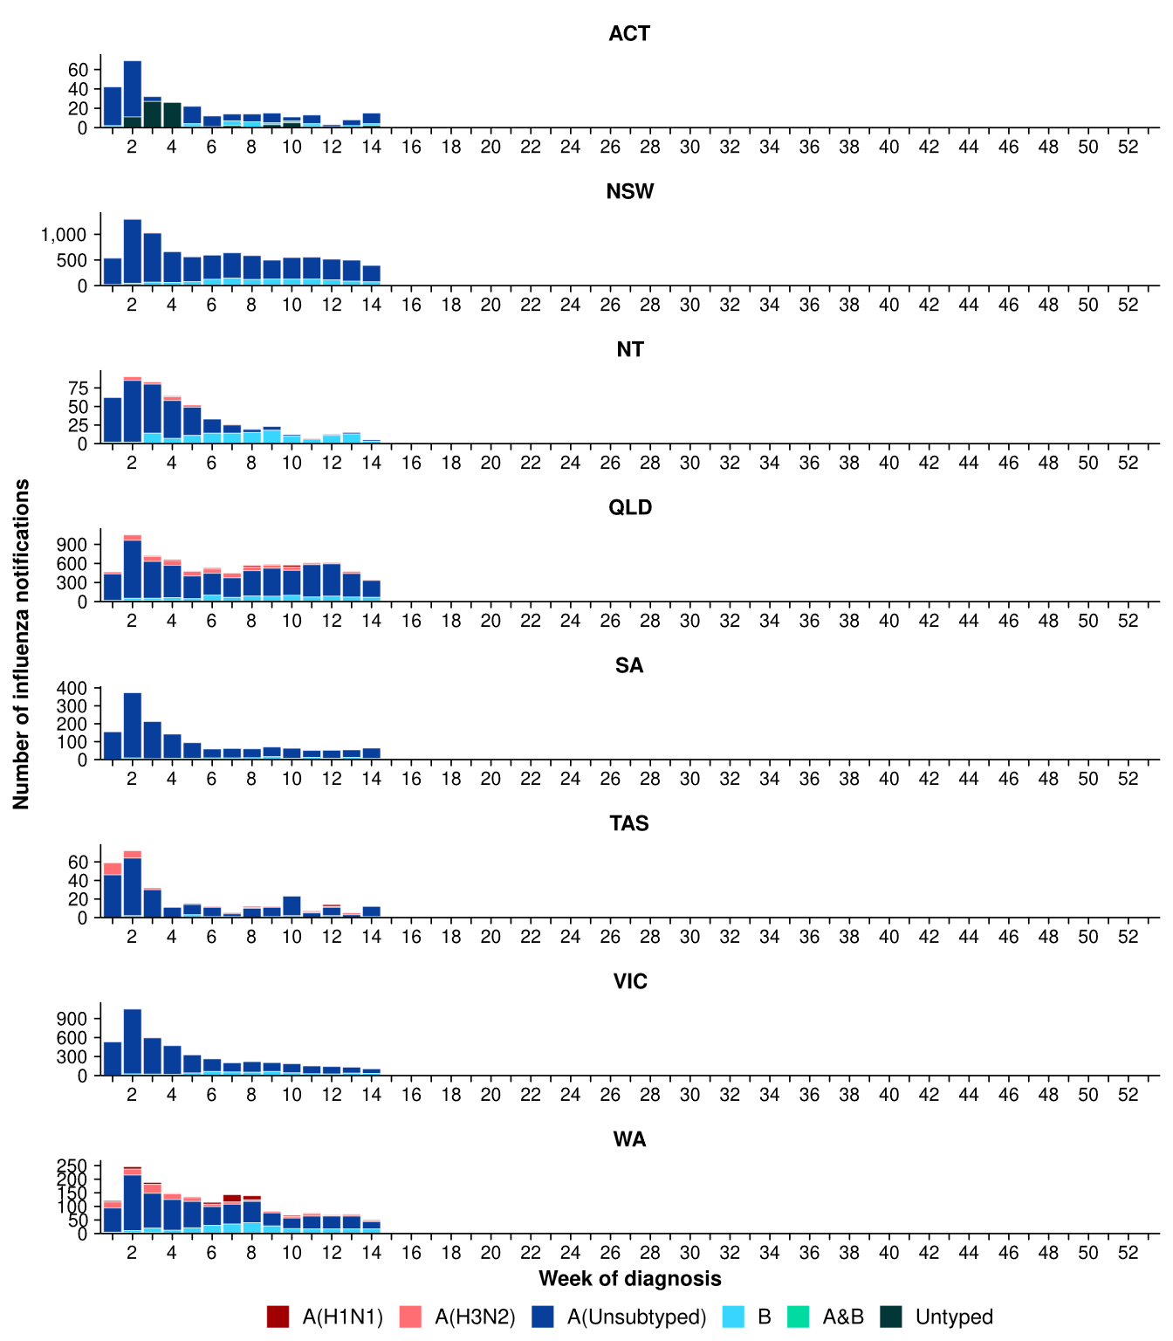
Source: National Notifiable Diseases Surveillance System (NNDSS)
* Axis varies between jurisdictions.
- In the last fortnight, there were 5,650 RSV cases, a 13.1% increase from 4,997 cases notified in the previous fortnight (Table 2; Figure 11). RSV cases have been steadily increasing since late January, indicating that the 2026 RSV season has commenced (Figure 11).
- In the year to date, there have been 23,590 RSV cases, 13.0% fewer than the 27,109 cases notified over the same period in 2025 (Table 2; Figure 11).
- In the last fortnight, RSV notification rates increased or remained relatively stable across most jurisdictions compared with the previous fortnight, except in the NT where notification rates decreased considerably (Figure 12).
Figure 11: Notified RSV cases by year and week of diagnosis, Australia, 2023 to 5 April 2026
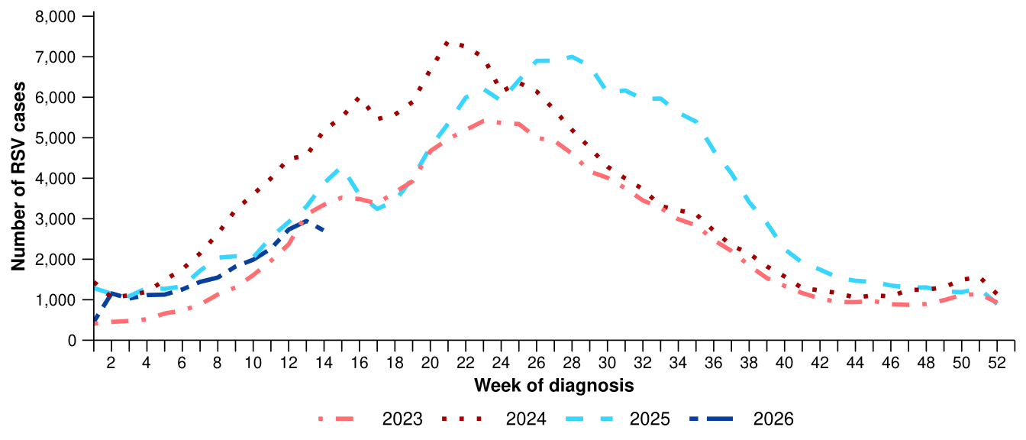
Source: National Notifiable Diseases Surveillance System (NNDSS). RSV notification data are unavailable for Tasmania from 3 April 2026.
Figure 12: Notification rates per 100,000 population for RSV cases by state or territory and week of diagnosis, Australia, 1 January to 5 April 2026
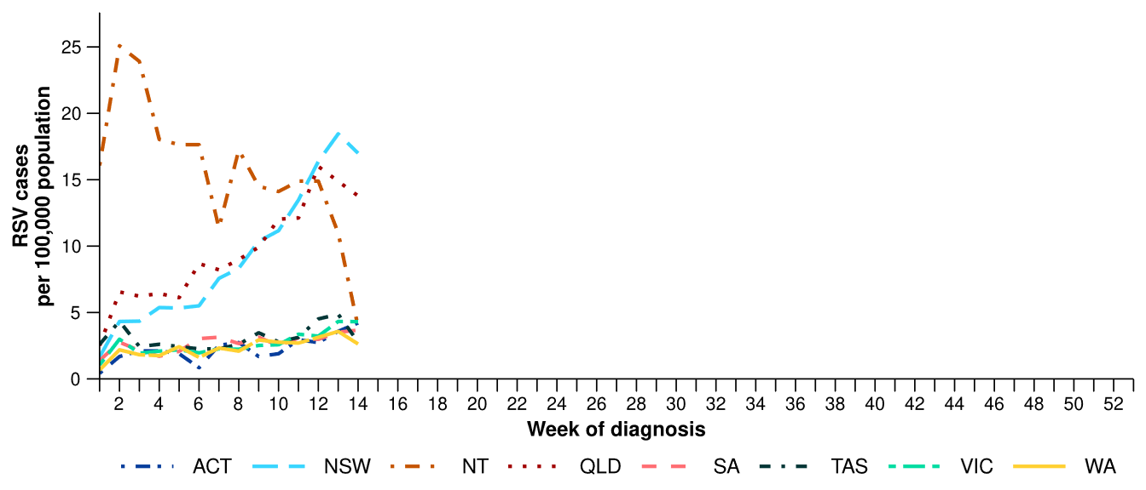
Source: National Notifiable Diseases Surveillance System (NNDSS). RSV notification data are unavailable for Tasmania from 3 April 2026.

Primary care surveillance
Primary care surveillance monitors the number and characteristics of people who have presented to a general practice with influenza-like illness and provides insight on the different respiratory pathogens that are causing illness in the community.
- In the last fortnight (23 March to 5 April 2026), there were slightly fewer general practice consultations for influenza-like illness (2.9 notifications per 1,000 consultations per fortnight) compared to the previous fortnight (3.4 notifications per 1,000 consultations per fortnight) (Figure 13).
  - The Easter holiday period may have influenced health seeking behaviours and therefore may have impacted the number of general practice consultations in the last fortnight.
- From late January, influenza-like illness consultation rates gradually increased and then since late March has been gradually declining. The slight decline in influenza-like illness consultation rates in recent weeks follows a similar trend to that in the same period in 2023 (Figure 13).
Figure 13: Rate of influenza-like illness notifications per 1,000 consultations per week in sentinel general practice sites compared with the five-year average by year and week of consultation*†, Australia, 2023 to 5 April 2026
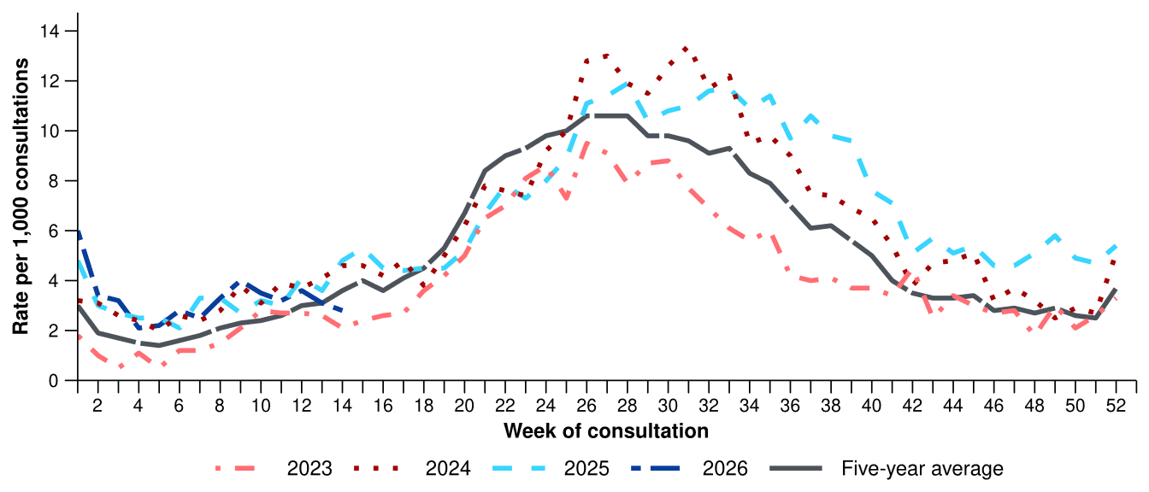
Source: Australian Sentinel Practices Research Network (ASPREN)
* The years 2020 and 2021 are excluded when comparing the current season to historical periods when influenza virus has circulated without public health restrictions. As such, the five-year average includes the years 2019 and 2022 to 2025. Please refer to the Technical Supplement for interpretation of the five-year average.
† Please refer to the Technical Supplement for notes on impact of COVID-19 on ASPREN data.
- In the last fortnight, 56.9% (37/65) of people attending general practice with influenza-like illness who were tested have then tested positive for a respiratory pathogen.
- In the last fortnight, rhinovirus (48.6%; 18/37) was the most commonly detected pathogen, followed by parainfluenza type-1 (13.5%; 5/37) and influenza (8.1%; 3/37) (Figure 14).
  - The Easter holiday period may have influenced health seeking behaviours and therefore may have impacted the number of people attending general practice and therefore the number of samples tested for respiratory pathogens in the last fortnight.
- In the year to date, 56.9% (247/434) of people attending general practice with influenza-like illness who were tested have then tested positive for a respiratory pathogen.
- In the year to date, rhinovirus (51.8%; 128/247) has been the most commonly detected pathogen, followed by influenza (13.0%; 32/247), RSV (7.7%; 19/247), SARS-CoV-2 (6.5%; 16/247), and adenovirus (6.1%; 15/247) (Figure 14).
Figure 14: Number of samples tested for respiratory pathogens among people with influenza-like illness attending sentinel general practice sites by respiratory pathogen and week of specimen collection, Australia, 1 January to 5 April 2026
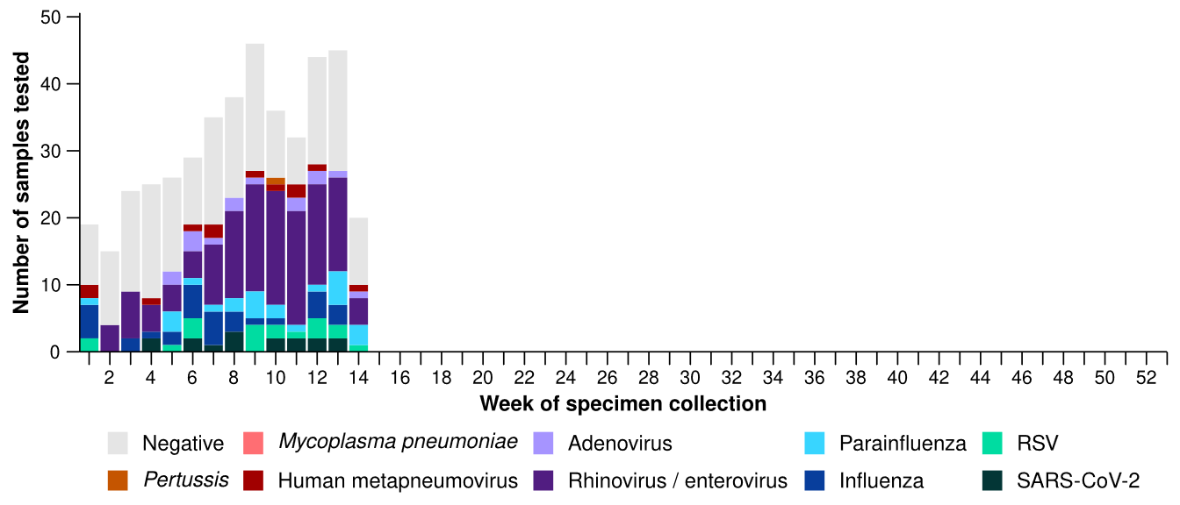
Source: Australian Sentinel Practices Research Network (ASPREN)
Note: All ASPREN swab samples are transported to the SA Pathology laboratory in Adelaide to be tested for viral and bacterial respiratory pathogens via a multiplex real-time reverse transcription polymerase chain reaction (RT-PCR) assay using in-house primers.

Hospital-based surveillance
Hospital-based surveillance monitors persons with more severe illness who have been admitted to hospital for their respiratory illness (severe acute respiratory infections). Hospital-based surveillance also measures the ability of the health system to cope with the number of severe acute respiratory infection admissions to ensure delivery of safe, timely and quality health care.
- In the last severity reporting period (9 March to 22 March 2026), more patients were admitted to a sentinel hospital with a severe acute respiratory infection (n=214), than in the previous severity reporting period (n=177).
  - In the last severity reporting period, at sentinel hospitals there was 8.5% more admissions with COVID-19 (from 59 to 64), 23.1% more admissions with influenza (from 26 to 32), and 28.3% more admissions with RSV (from 92 to 118), compared to the previous severity reporting period.
- In the year to date for severity reporting (1 January to 22 March 2026), there have been 1,157 admissions with severe acute respiratory infections at sentinel hospitals. Most patients with a severe acute respiratory infection have been admitted with RSV (n=434) followed by influenza (n=399) (Figure 15).
Figure 15: Total number of patients (children and adults) admitted with a severe acute respiratory infection to sentinel hospitals by disease and week of admission, Australia, 1 January to 22 March 2026
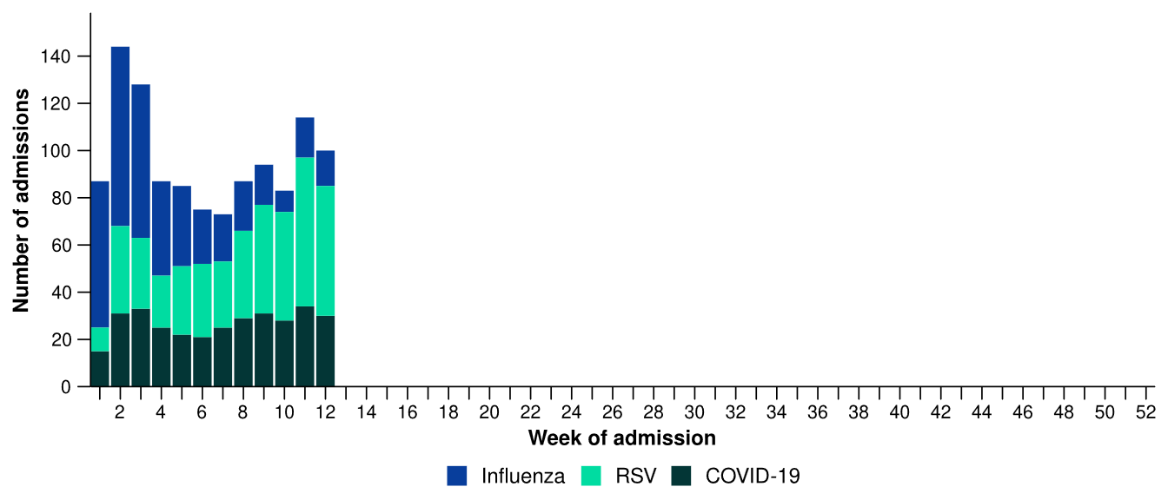
Source: Influenza Complications Alert Network (FluCAN)
- Patients admitted to sentinel hospitals with influenza have mostly been admitted with influenza A (92.2%; 368/399), while 7.8% (31/399) were admitted with influenza B.
  - Most hospital admissions with influenza A have been with influenza A(Unsubtyped) (76.6%; 282/368), followed by influenza A(H3N2) (18.5%; 68/368) and then influenza A(H1N1) (4.9%; 18/368).
- In the year to date for severity reporting, influenza A (Unsubtyped) was the most commonly detected influenza type in all age groups; however, an increasing number of children (particularly in those aged 6 months to 16 years) have been admitted to hospital with influenza A(H1N1), influenza A(H3N2) or influenza B since late January(Figure 16).

Figure 16: Number of patients admitted with influenza to sentinel hospitals by influenza subtype, age group*, and week of admission, Australia, 1 January to 22 March 2026
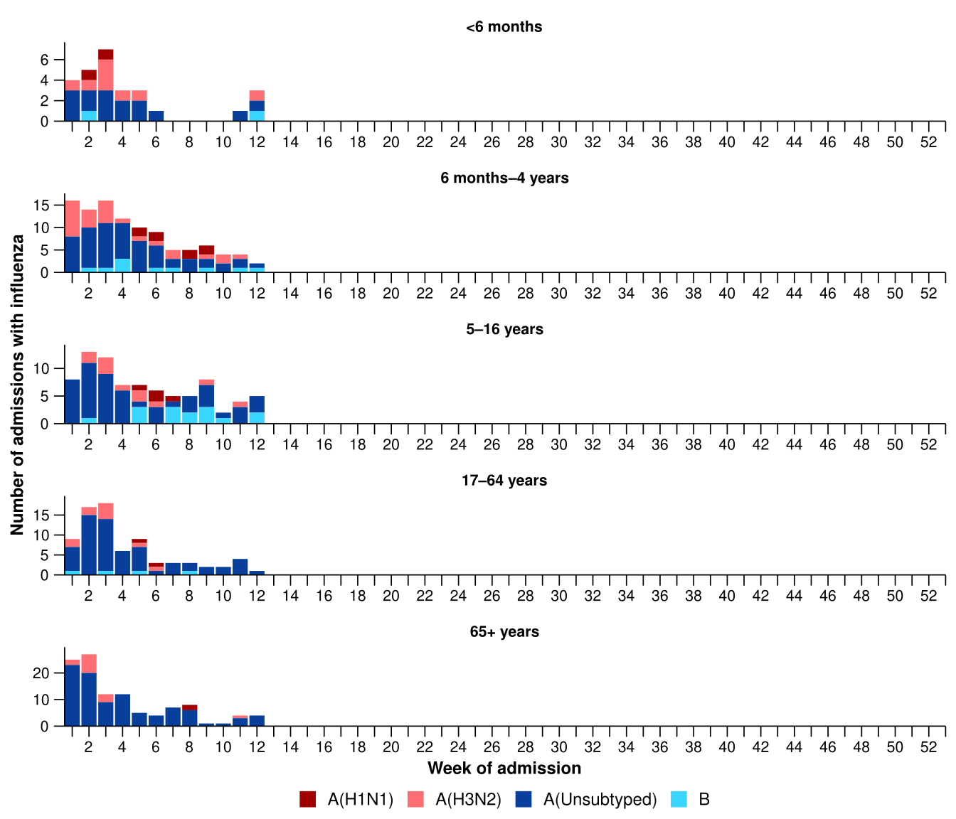
Source: Influenza Complications Alert Network (FluCAN)
* Axis varies between age groups. The age distribution of admissions with influenza may not reflect the age distribution of all patients.
- There were no children aged under 6 months admitted with influenza to sentinel hospitals from mid-February to mid-March 2026 (Figure 16).
- More children (those aged 16 years and younger) have been admitted with RSV to sentinel hospitals than with COVID-19 or influenza (Table 3a).
- Children admitted to sentinel hospitals with influenza tended to be older than children admitted with COVID-19 or RSV (Table 3a).
- Children admitted to sentinel hospitals with RSV had a slightly longer length of hospital stay compared to children with influenza or COVID-19; however, the difference in the length of stay was minor (Table 3a).
- Sadly, a small number of children admitted to sentinel hospitals with influenza or RSV have died (Table 3a).

Table 3a: Demographic characteristics and outcomes for children admitted with a severe acute respiratory infection to a sentinel hospital by disease*†‡, Australia, 1 January to 22 March 2026
 | COVID-19 | Influenza | RSV
 | Year to date for  severity reporting  (n=166) | Year to date for  severity reporting  (n=212) | Year to date for  severity reporting  (n=346)
Age (years)
Median [IQR] | 1 [0-4] | 3 [1-7] | 1 [0-2]
Age group (years)
< 6 months | 42 (25.3%) | 27 (12.7%) | 67 (19.4%)
6 months – 4 years | 84 (50.6%) | 103 (48.6%) | 253 (73.1%)
5–16 years | 40 (24.1%) | 82 (38.7%) | 26 (7.5%)
Indigenous status
Aboriginal and Torres Strait Islander | 11 (6.6%) | 25 (11.8%) | 52 (15.0%)
Length of hospital stay (days)†
Median [IQR] | 1 [1-2] | 1 [1-2] | 2 [1-3]
Patient admission location‡
Admitted to hospital ward | 164 (98.8%) | 202 (95.3%) | 332 (96.0%)
Admitted to intensive care directly | 2 (1.2%) | 10 (4.7%) | 14 (4.0%)
Discharge status†
Alive | 135 (81.3%) | 192 (90.6%) | 289 (83.5%)
Died | - | 1 (0.5%) | 1 (0.3%)
Incomplete/missing | 31 (18.7%) | 19 (9.0%) | 56 (16.2%)
Source: Influenza Complications Alert Network (FluCAN)
* Does not include patients with missing age; therefore, the sum of age-specific totals above may not equal the total number of patients.
† For patients who are still in hospital data may not be complete; therefore, these data are not included in the length of stay or discharge status. In addition, length of stay data excludes patients that acquired their infection in hospital.
‡ Admission location reflects the initial admission ward. Some patients may be initially admitted to general ward then later admitted to an intensive care and this is not reflected here. Does not include patients with missing admission location; therefore, the sum of admission location specific totals above may not equal the total number of patients.
The Paediatric Active Enhanced Disease Surveillance (PAEDS) network carries out enhanced sentinel hospital surveillance for some acute respiratory infections or conditions in children. PAEDS data for acute respiratory infections in children are presented in the Australian Respiratory Surveillance Reports in the sentinel hospital data from FluCAN. For additional information on COVID-19, influenza or RSV in children please visit the PAEDS webpages and dashboards.

- More adults (those aged 17 years and over) have been admitted with influenza to sentinel hospitals than with COVID-19 or RSV (Table 3b).
- A greater proportion of adults aged 65 years and over have been admitted to sentinel hospitals with COVID-19, influenza and RSV compared to adults aged 17–64 years (Table 3b).
- Adults admitted to sentinel hospitals with COVID-19 or RSV had slightly longer length of hospital stay compared to adults admitted with influenza (Table 3b).
- Sadly, a small number of adults admitted to sentinel hospitals with severe acute respiratory infections have died (Table 3b).
Table 3b: Demographic characteristics and outcomes for adults admitted with a severe acute respiratory infection to a sentinel hospital by disease*†‡, Australia, 1 January to 22 March 2026
 | COVID-19 | Influenza | RSV
 | Year to date for  severity reporting  (n=158) | Year to date for  severity reporting  (n=187) | Year to date for  severity reporting  (n=88)
Age (years)
Median [IQR] | 73 [60-83] | 68 [48-80] | 70 [58-80]
Age group (years)
17–64 years | 53 (33.5%) | 77 (41.2%) | 28 (31.8%)
65 years and over | 105 (66.5%) | 110 (58.8%) | 60 (68.2%)
Indigenous status
Aboriginal and Torres Strait Islander | 18 (11.4%) | 16 (8.6%) | 9 (10.2%)
Length of hospital stay (days)†
Median [IQR] | 4 [3-8] | 3 [1-6] | 4 [2-7]
Patient admission location‡
Admitted to hospital ward | 153 (96.8%) | 171 (91.4%) | 84 (95.5%)
Admitted to intensive care directly | 5 (3.2%) | 16 (8.6%) | 4 (4.5%)
Discharge status†
Alive | 104 (65.8%) | 158 (84.5%) | 67 (76.1%)
Died | 6 (3.8%) | 3 (1.6%) | 4 (4.5%)
Incomplete/missing | 48 (30.4%) | 26 (13.9%) | 17 (19.3%)
Source: Influenza Complications Alert Network (FluCAN)
* Does not include patients with missing age; therefore, the sum of age-specific totals above may not equal the total number of patients.
† For patients who are still in hospital data may not be complete; therefore, these data are not included in the length of stay or discharge status. In addition, length of stay data excludes patients that acquired their infection in hospital.
‡ Admission location reflects the initial admission ward. Some patients may be initially admitted to general ward then later admitted to an intensive care and this is not reflected here. Does not include patients with missing admission location; therefore, the sum of admission location specific totals above may not equal the total number of patients.

There has not been an update to the sentinel intensive care data this month. Sentinel intensive care surveillance data presented here have not been updated since the previous report.
- In the last severity reporting period for sentinel intensive care (9 February to 8 March 2026), fewer patients have been admitted to a sentinel intensive care with a severe acute respiratory infection (n=63), than in the previous severity reporting period (n=114) (Figure 17).
- In the year to date for severity reporting (1 January to 8 March 2026), most patients were admitted to sentinel intensive care with influenza, followed by COVID-19 (Figure 17; Table 4).
Figure 17: Number of patients admitted with severe acute respiratory infections to a sentinel intensive care by disease and week of admission, Australia, 1 January to 8 March 2026
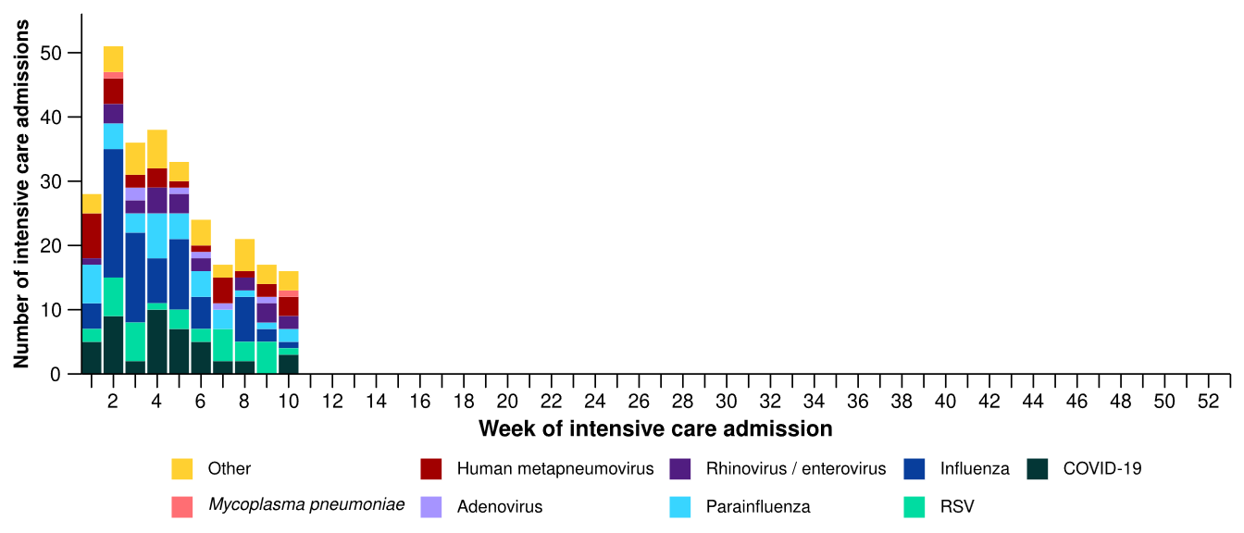
Source: Short Period Incidence Study of Severe Acute Respiratory Infection (SPRINT-SARI) Australia
Figure 18: Number of patients admitted with severe acute respiratory infections to a sentinel intensive care by disease and age group*, Australia, 1 January to 8 March 2026
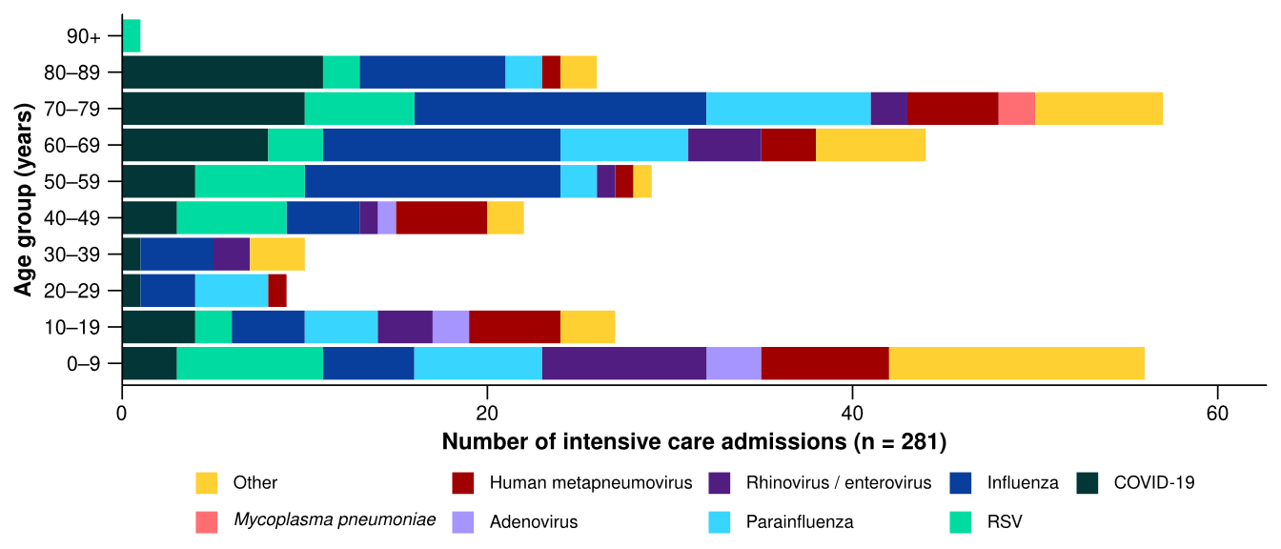
Source: Short Period Incidence Study of Severe Acute Respiratory Infection (SPRINT-SARI) Australia
Note: 14.9% (37/248) of patients had co-infections of respiratory pathogens; therefore, the sum of pathogen-specific totals above may not equal the total number of severe acute respiratory infection patients.
* The age distribution of severe acute respiratory infection intensive care admissions may not reflect the age distribution of all patients.

- In the year to date for severity reporting, most admissions have been among children aged 0–9 years or among adults aged 50 years and over (Figure 18; Table 4).
- A higher proportion of admissions with parainfluenza required invasive mechanical ventilation; however, length of invasive mechanical ventilation was longest among those with hMPV. The length of intensive care stay was longest among those with parainfluenza (Table 4).
- Sadly, a number of patients have died in hospital (Table 4).

Table 4: Demographic characteristics and outcomes of patients admitted with a severe acute respiratory infection to a sentinel intensive care by disease*†, Australia, 1 January to 8 March 2026
 | COVID-19 | hMPV | Influenza | Mycoplasma  pneumoniae | Parainfluenza | RSV
 | Year to date for severity reporting  (n=45) | Year to date for severity reporting  (n=28) | Year to date for severity reporting  (n=71) | Year to date for severity reporting  (np) | Year to date for severity reporting  (n=35) | Year to date for severity reporting  (n=34)
Age (years)
Median [IQR] | 68  [48–79] | 42  [10–64] | 60  [43–74] | np | 60  [14–74] | 53  [12–69]
Indigenous status
Aboriginal and Torres Strait Islander | 2  (4.4%) | 2  (7.1%) | 11  (15.5%) | np | 2  (5.7%) | 8  (23.5%)
Non-Indigenous | 43  (95.6%) | 26  (92.9%) | 60  (84.5%) | np | 33  (94.3%) | 26  (76.5%)
Received invasive mechanical ventilation
Number (%) | 14  (31.1%) | 6  (21.4%) | 20  (28.2%) | np | 14  (40.0%) | 8  (23.5%)
Length of invasive mechanical ventilation (days)*
Median [IQR] | 4 [1–8] | 7 [4–9] | 3 [1–11] | np | 2 [1–4] | 3 [1–4]
Length of intensive care stay (days)*
Median [IQR] | 3 [2–7] | 2 [1–5] | 2 [1–6] | np | 4 [2–7] | 3 [2–3]
Length of hospital stay (days)*
Median [IQR] | 9 [3–15] | 6 [4–9] | 7 [4–12] | np | 8 [4–13] | 8 [4–13]
Patient outcome†
Ongoing care in intensive care | 1  (2.2%) | – | 1  (1.4%) | np | 2  (5.7%) | 2  (5.9%)
Ongoing care in hospital ward | 4  (8.9%) | 1  (3.6%) | 4  (5.6%) | np | – | –
Transfer to other hospital / facility | 4  (8.9%) | 5  (17.9%) | 11  (15.5%) | np | 3  (8.6%) | 3  (8.8%)
Discharged home | 27  (60.0%) | 20  (71.4%) | 47  (66.2%) | np | 23  (65.7%) | 26  (76.5%)
Died in hospital | 9  (20.0%) | 2  (7.1%) | 7  (9.9%) | np | 7  (20.0%) | 3  (8.8%)
Source: Short Period Incidence Study of Severe Acute Respiratory Infection (SPRINT-SARI) Australia
Note: 14.9% (37/248) of patients had co-infections of respiratory pathogens; therefore, the sum of pathogen-specific totals above may not equal the total number of severe acute respiratory infection patients.
* For patients receiving ongoing care in intensive care data may not be complete; therefore, data are not included in the length of ventilation or stay.
† Patients who have been admitted with no discharge information for less than 90 days have been assumed to have ongoing care in the hospital. Patients who have no outcome entered or have been admitted for more than 90 days with no discharge information have been treated as missing.
- In the last fortnight (23 March to 5 April 2026), there were an average of 170 intensive care patients in droplet or airborne isolation for any suspected or confirmed respiratory pathogen each day, a 9.7% increase from an average of 155 patients in isolation each day reported in the previous fortnight (Figure 19).
  - Suspected or confirmed respiratory pathogens may include nationally notifiable conditions such as COVID-19, influenza, RSV or pertussis (Whooping cough) but also other non-notifiable respiratory pathogens like adenovirus, hMPV, parainfluenza, rhinovirus or bacterial infections causing atypical pneumonias.
- In the last fortnight (23 March to 5 April 2026), there were an average of 74 intensive care staff unavailable to work due to illness each day, a 13.8% increase from an average of 65 staff unavailable each day reported in the previous fortnight (Figure 19).
- In the last fortnight, the average number of intensive care patients in droplet or airborne isolation for any suspected or confirmed respiratory pathogen each day varied across jurisdictions compared with the previous fortnight, with the average number of patients in isolation each day decreasing in Tas and WA but increasing in NSW, Qld, SA and Vic (Figure 20).
- In the last fortnight, the average number of intensive care staff unavailable to work due to illness each day increased or remained relatively stable across all jurisdictions compared with the previous fortnight (Figure 20).
Figure 19: Weekly average daily occupancy of intensive care patients in droplet or airborne isolation for any suspected or confirmed respiratory pathogen and the weekly average daily number of intensive care staff unavailable to work due to illness by week of report*, Australia, 1 January to 5 April 2026 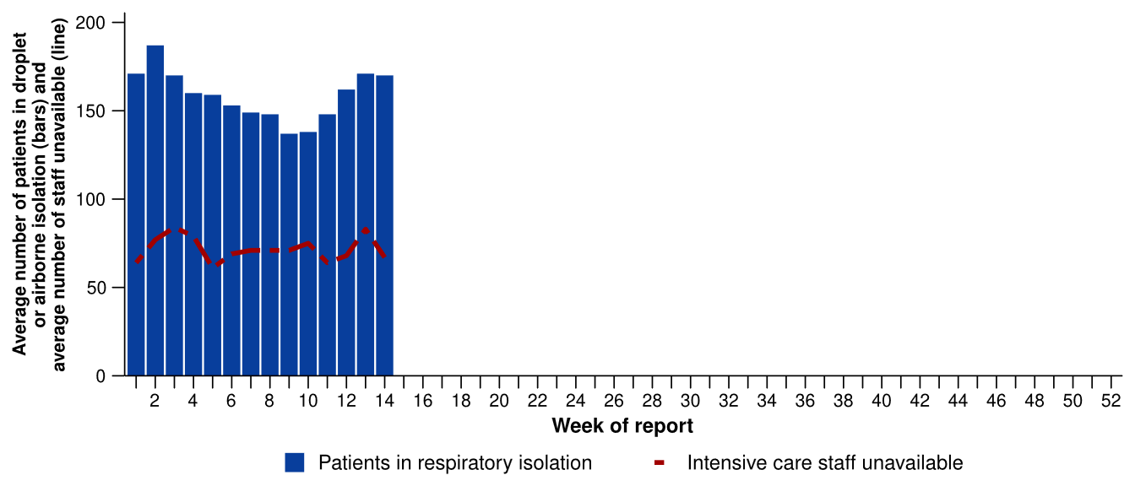
Source: Critical Health Resource Information System (CHRIS)
* Intensive care staff include both medical and nursing staff. Staff unavailability will be underestimated in NSW as most public hospitals in NSW do not report staff unavailability.

Figure 20: Weekly average daily occupancy of intensive care patients in droplet or airborne isolation for any suspected or confirmed respiratory pathogen and the weekly average daily number of intensive care staff unavailable to work due to illness by jurisdiction and week of report*†‡, Australia, 1 January to 5 April 2026
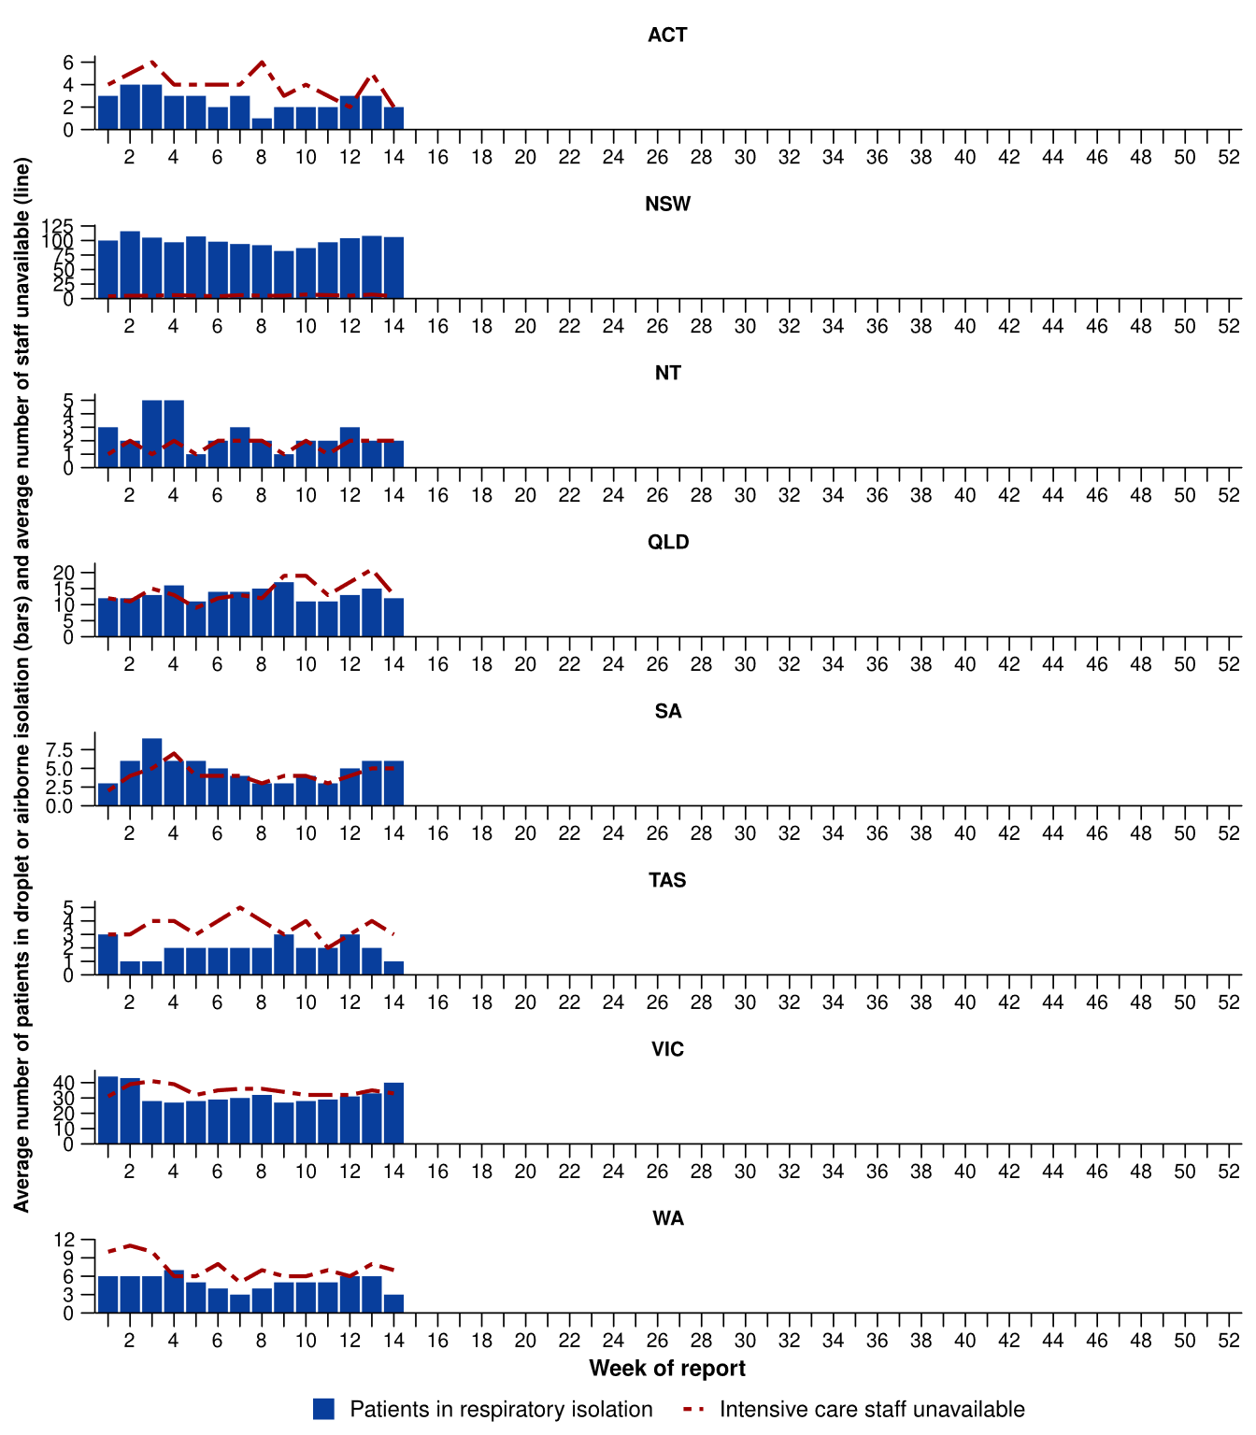
Source: Critical Health Resource Information System (CHRIS)
* Axis varies between jurisdictions.
† NSW isolation data from public hospitals includes all patients occupying intensive care beds in isolation precautions, including those in contact isolation precautions, rather than just droplet or airborne isolation precautions, which will overestimate the average number of patients occupying intensive care beds in droplet or airborne isolation in NSW. For this reason, NSW data may not be comparable to data from other jurisdictions.
‡ Intensive care staff include both medical and nursing staff. Staff unavailability will be underestimated in NSW as most public hospitals in NSW do not report staff unavailability. For this reason, NSW data may not be comparable to data from other jurisdictions.

Mortality surveillance
Death registrations can provide information on the scale and severity of disease associated with acute respiratory infections. An acute respiratory associated death is one where the death was due to the disease (the illness has caused terminal complications such as pneumonia) or the person has died with the disease (a person has died from another cause but the illness still contributed significantly to death). For more information on death registrations including completeness, timeliness, and detailed definitions of deaths due to and with acute respiratory infections, refer to the Technical Supplement.
- COVID-19 has been the leading cause of acute respiratory infection related mortality across the majority of 2020–2025; however, since August 2025 the number of deaths per month involving influenza (both due to and with) has exceeded COVID-19 deaths. Deaths involving influenza remain unseasonably high, with 133 deaths in December 2025 and 101 deaths in January 2026.
- Deaths involving COVID-19 (both due to and with) tend to peak twice a year - between November and January and then again between May and August. Preliminary data does not show a 2025–2026 summer peak, despite a small increase in deaths involving COVID-19 in January 2026.
- In 2025 influenza mortality rates were higher for both Aboriginal and Torres Strait Islander and non-Indigenous people than in 2022–2024. In contrast, in 2025 COVID-19 mortality rates among Aboriginal and Torres Strait Islander people were four times lower than in 2024.
- These acute respiratory infections are more likely to cause death in older age groups than younger age groups.
Figure 21a: Provisional numbers of deaths due to an acute respiratory infection*† by month, year, and disease, Australia, 1 January 2024 to 28 February 2026
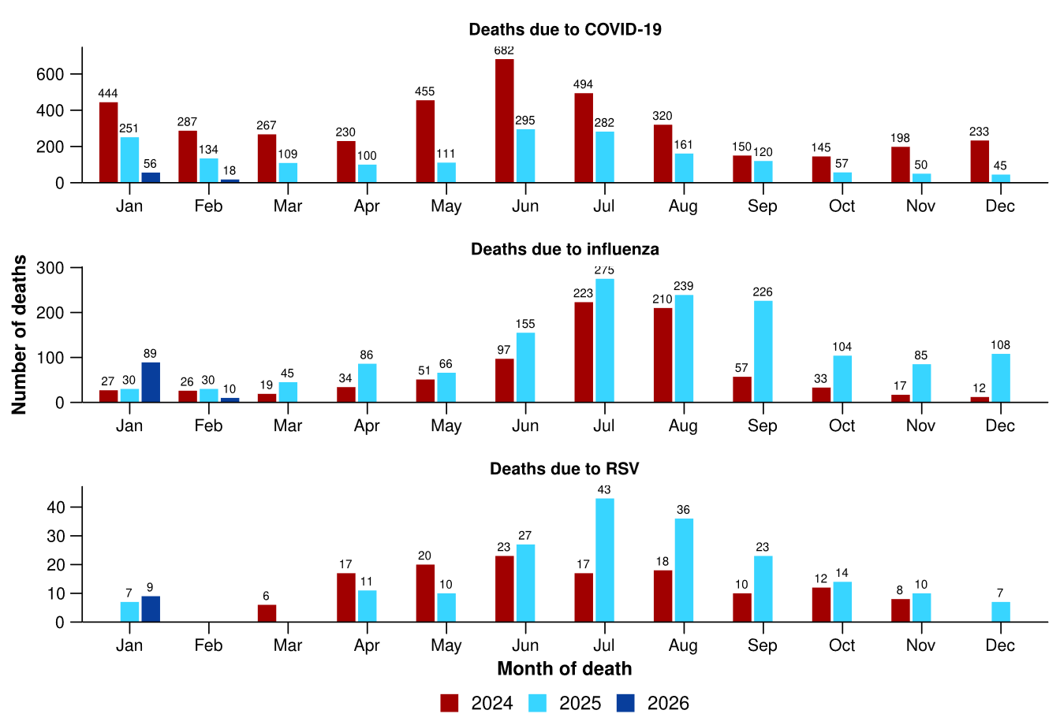
Source: Australian Bureau of Statistics (ABS), Deaths due to acute respiratory infections in Australia, released 30 March 2026.
* Axis varies between acute respiratory infections.
† Data is provisional and subject to change. It can take several weeks for death registrations to be reported, processed, coded, validated, and tabulated. Therefore, the data shown here may be incomplete. Data for some months were not published by the ABS due to small counts, and therefore not reported here. Data includes all deaths (both doctor and coroner certified) that occurred and were registered by 28 February 2026.
- Deaths due to COVID-19 increased slightly in January 2026 but remain at very low levels compared to previous years. The 1,715 deaths due to COVID-19 in 2025 are well below both 2024 (3,905 deaths) and 2023 (4,611 deaths) (Figure 21a).
- Deaths due to influenza fell in January 2026 but remain high for the time of year. There were 1,449 deaths due to influenza in 2025, above the 1,276 deaths in 2017 and the 1,072 deaths in 2019, which were recent high mortality years for influenza (Figure 21a). While influenza deaths were high in 2025, this is expected when there are higher case numbers, and other surveillance systems have not indicated that disease severity was greater than in previous years.
- Deaths due to RSV remained at low levels in January 2026, similar to the number of deaths in November and December 2025 (Figure 21a).
- Deaths with COVID-19 were slightly higher in January 2026 than December 2025, but remain at low levels compared to previous years (Figure 21b).
- Deaths with influenza or with RSV decreased in January 2026 and were similar to the number of deaths with COVID-19 (Figure 21b).
- The number of deaths with RSV was higher in 2025 (393 deaths) than in 2024 (341 deaths) and in 2023 (279 deaths) (Figure 21b).
Figure 21b: Provisional numbers of deaths with an acute respiratory infection*† by month, year, and disease, Australia, 1 January 2024 to 28 February 2026
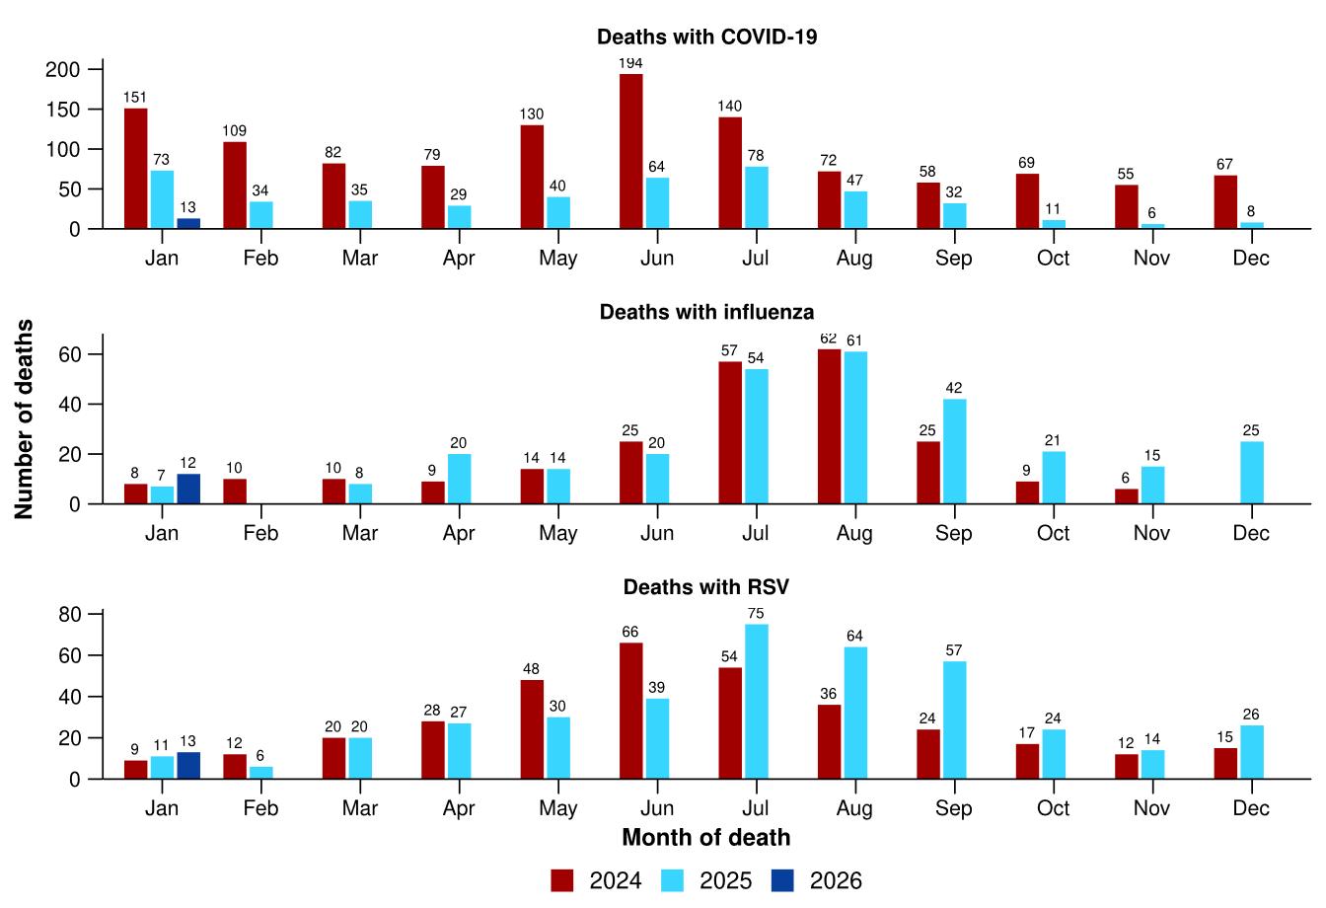
Source: Australian Bureau of Statistics (ABS), Deaths due to acute respiratory infections in Australia, released 30 March 2026.
* Axis varies between acute respiratory infections.
† Data is provisional and subject to change. It can take several weeks for death registrations to be reported, processed, coded, validated, and tabulated. Therefore, the data shown here may be incomplete. Data for some months were not published by the ABS due to small counts, and therefore not reported here. Data includes all deaths (both doctor and coroner certified) that occurred and were registered by 28 February 2026.

Laboratory surveillance
Sentinel laboratory surveillance monitors the percentage of tests with the notifiable condition detected (i.e. test positivity). It also provides information on what pathogens are circulating, potential changes in the pathogens that might affect their infectiousness, severity, ability to evade vaccine and/or infection-acquired immunity, or resistance to antivirals.
- In the last fortnight (23 March to 5 April 2026), the percentage of SARS-CoV-2 tests that were positive decreased (from 3.1% to 2.5%), the percentage of influenza tests that were positive increased (from 1.1% to 1.3%) and the percentage of RSV tests that were positive increased (from 1.0% to 1.3%) (Figure 22).
Figure 22: Number of tests positive (bars) and percentage of tests positive (line) for SARS-CoV-2, influenza or RSV of those specimens tested by sentinel laboratories by week of report*†, Australia, 1 January to 5 April 2026
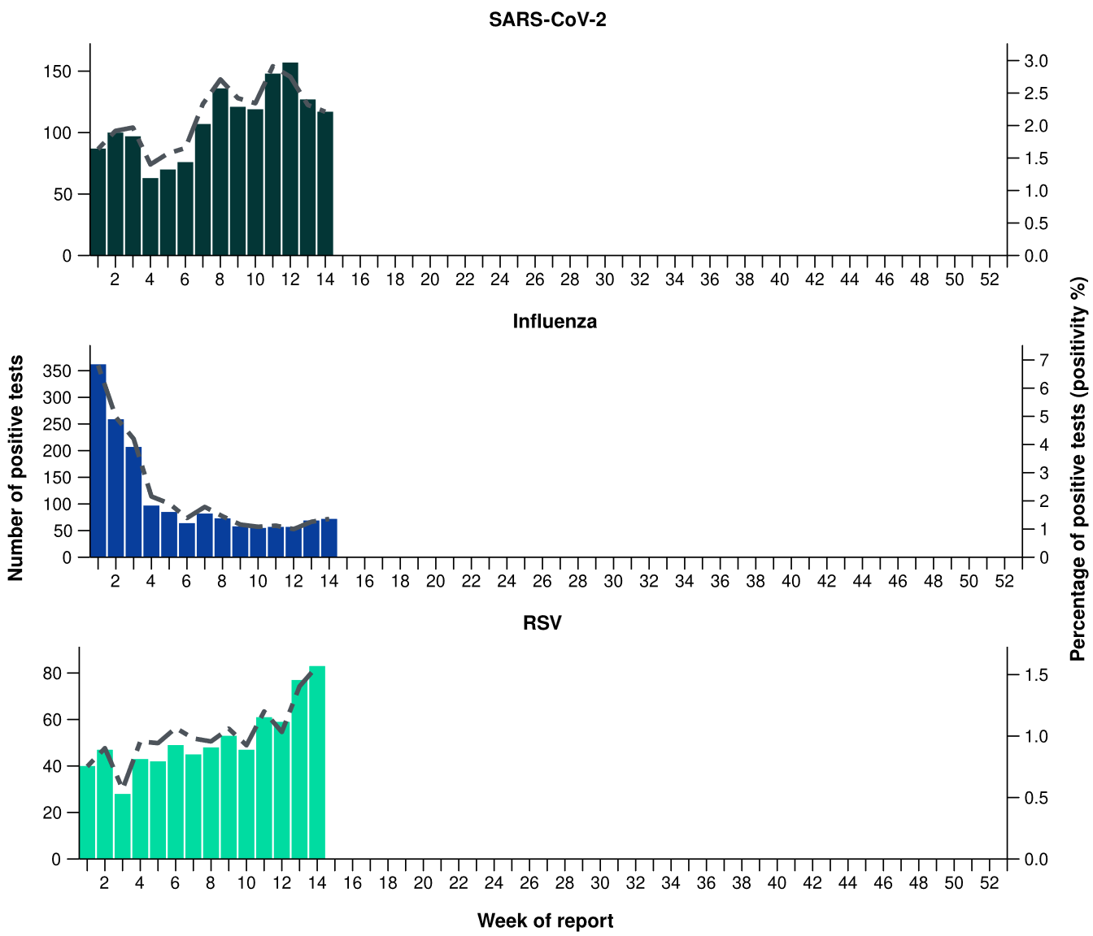
Source: Sentinel laboratories, including National Influenza Centres
* Number of specimens tested excludes data from WA as testing denominator data are different for the three pathogens in Western Australia.
† A small minority of total samples from Victoria are tested only by respiratory panel (influenza, parainfluenza, adenovirus, human metapneumovirus, seasonal coronaviruses, RSV, and some picornaviruses) but not for SARS-CoV-2. These minority samples include only forensic materials; all other samples are tested by respiratory panel and SARS-CoV-2 assay.

There has not been an update to the AusTrakka SARS-CoV-2 sequencing data. The SARS-CoV-2 sequencing data presented here have not been updated since the previous report.
- There were 78 SARS-CoV-2 sequences uploaded to AusTrakka with dates of collection in the last 28 days (23 February to 22 March 2026). These sequences were from NSW, Qld, SA and Tas with the most recent date of collection from 8 March 2026. Due to the limited number of sequences in the last 28 days the following trends may not be representative.
- Most sequences were assigned to the BA.2.86 sub-lineage within B.1.1.529 (Omicron) or recombinants consisting of one or more Omicron sub-lineages (Figure 23a/b). In the last 28 days:
  - 3.8% (3/78) of sequences were from the sub-sub-lineages JN.1 (BA.2.86.1.1), specifically KP.3.1.1.
  - 64.1% (50/78) of sequences were recombinant or recombinant sub-lineages, the most common including NB.1.8.1 (n=28) and XFG (n=19).
  - 32.1% (25/78) of sequences were identified as BA.3.
  - There were no BA.1, BA.4, BA.5 or other BA.2 sub-sub-lineage sequences.
- NB.1.8.1 was the most common sub-lineage in the past 28 days, accounting for 35.9% (28/78) of sequences (Figure 23a).
- The World Health Organization (WHO) have identified certain sub-sub-lineages and recombinants as variants under monitoring (VUM) because of their epidemiological, pathological, or immunological features of concern. A select number are highlighted below due to their relevance in the Australian context. There are:
  - 385 BA.3.2 (most recently designated VUM) sequences in AusTrakka, including 25 collected in the last 28 days
  - 1,062 XFG sequences in AusTrakka, including 19 collected in the last 28 days
  - 3,316 NB.1.8.1 sequences in AusTrakka, with 28 collected in the last 28 days
  - 4,434 KP.3.1.1 sequences in AusTrakka, with 3 sequences identified in the past 28 days.
Figure 23a: SARS-CoV-2 Omicron sub-lineage* sequences by sample collection date, showing (A) proportions and (B) count per week†‡, Australia, 1 January to 22 March 2026
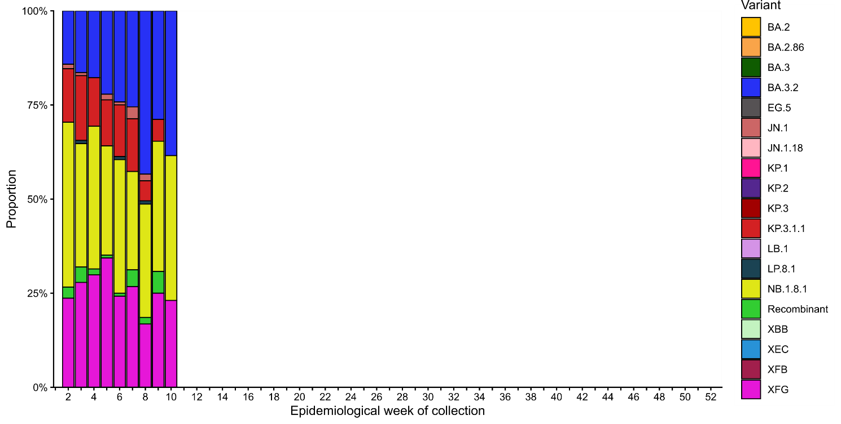
Source: AusTrakka
* Some sub-sublineages are shown alongside their parent lineage, but not included in the parent lineage totals. For instance, KP.2 and KP.3 are sub-sub lineages of JN.1, so the total of JN.1 sequences will be higher than shown in the corresponding colour alone, and should include the KP.2 and KP.3 totals.
† Sequences in AusTrakka aggregated by week and reported based on date of sample collection, not date of sequencing.
‡ Proportions in Figure 24a may not be representative when sequence numbers are small; refer to Figure 24b. Data for earlier weeks may change between reporting periods as sequences with older collection dates are uploaded. These numbers are not equivalent to number of cases, as there are many cases which may not be sequenced. Non-VOI and non-VUM Omicron sub-lineages have been collapsed into parent lineages BA.1, BA.2, BA.3, BA.4 and BA.5.
Figure 23b: SARS-CoV-2 Omicron sub-lineage* sequences by sample collection date, showing the count of sequences per week†‡, Australia, 1 January 2022 to 22 March 2026
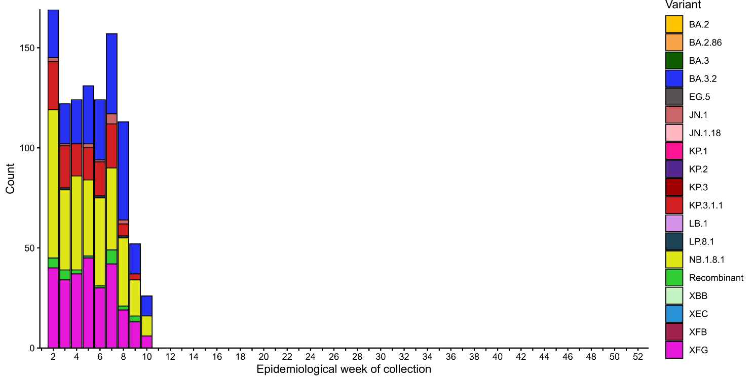
Source: AusTrakka
* Some sub-sublineages are shown alongside their parent lineage, but not included in the parent lineage totals. For instance, KP.2 and KP.3 are sub-sub lineages of JN.1, so the total of JN.1 sequences will be higher than shown in the corresponding colour alone, and should include the KP.2 and KP.3 totals.
† Sequences in AusTrakka aggregated by week and reported based on date of sample collection, not date of sequencing.
‡ Data for earlier weeks may change between reporting periods as sequences with older collection dates are uploaded. These numbers are not equivalent to number of cases, as there are many cases which may not be sequenced. Non-VOI and non-VUM Omicron sub-lineages have been collapsed into parent lineages BA.1, BA.2, BA.3, BA.4 and BA.5.

- In the year to date, the WHO Collaborating Centre for Reference and Research on Influenza has antigenically characterised 256 influenza viruses from Australia (Table 5), of which:
  - 92.6% (237/256) have been influenza A(H3N2)
  - 7.4% (19/256) have been influenza B/Victoria.
- In the year to date, there have been no influenza A(H1N1) or influenza B/Yamagata viruses characterised (Table 5). The last influenza B/Yamagata virus characterised in Australia was in a sample from 2020.
- None of the samples tested by the WHO Collaborating Centre for Reference and Research demonstrated highly reduced inhibition to oseltamivir or zanamivir.
Table 5: Australian influenza viruses typed by haemagglutination inhibition assay and jurisdiction*†, 1 January to 5 April 2026
Strain | ACT | NSW | NT | Qld | SA | Tas | Vic | WA | Total
A(H1N1) | 0 | 0 | 0 | 0 | 0 | 0 | 0 | 0 | 0
A(H3N2) | 19 | 30 | 72 | 9 | 9 | 15 | 78 | 5 | 237
B/Victoria lineage | 2 | 5 | 8 | 1 | 0 | 0 | 2 | 1 | 19
B/Yamagata lineage | 0 | 0 | 0 | 0 | 0 | 0 | 0 | 0 | 0
Total | 21 | 35 | 80 | 10 | 9 | 15 | 80 | 6 | 256
Source: World Health Organization (WHO) Collaborating Centre for Reference and Research on Influenza
*Viruses tested by the WHO Collaborating Centre for Reference and Research on Influenza are not necessarily a random sample of all those in the community and early-year data may be based on limited samples received. There may be up to a month delay on reporting of samples.
† Jurisdiction indicates the residential location for the individual tested, not the submitting laboratory.

Vaccine coverage, effectiveness and match
Vaccine coverage, effectiveness and match for acute respiratory infections are monitored from several data sources in Australia. Refer to the Technical Supplement for more information.

Vaccine coverage
- Nationally, 2.6% of adults (aged 18 years and over) have received a COVID-19 vaccine in the last six months (Table 6).
- Nationally, fewer adults have received a COVID-19 vaccine in the last 12 months (9.4%; Table 6), compared to the 12 months prior (9.7% from 1 April 2024 to 30 March 2025).
- In the last 12 months, vaccine coverage varied in all age groups, with the largest variation seen in 75 years and over age group (from 35.5% in the 12 months prior to 36.3% in the last 12 months).
- There has been substantial variation in COVID-19 vaccine coverage across age groups, ranging from 3.9% in adults aged 18–64 years to 36.3% in adults aged 75 years and over. Vaccine coverage increases with increasing age (Table 6).
- There has been some variation in vaccine coverage across jurisdictions, ranging from 3.8% in the NT to 16.3% in Tas (Table 6).
Table 6: COVID-19 vaccine coverage*†‡ by age group and jurisdiction, Australia, 31 March 2025 to 5 April 2026
Age group | ACT | NSW | NT | Qld | SA | Tas | Vic | WA | Total
Last 12 months (31 March 2025 to 5 April 2026)
18–64 years | 8.9 | 3.3 | 1.9 | 3.7 | 3.9 | 7.1 | 4.2 | 3.9 | 3.9
65–74 years | 42.0 | 21.0 | 13.6 | 21.2 | 23.3 | 33.6 | 22.9 | 22.6 | 22.5
≥ 75 years | 59.5 | 34.7 | 23.9 | 34.8 | 36.8 | 49.4 | 35.7 | 37.1 | 36.3
All ages (18 years and over) | 16.2 | 8.7 | 3.8 | 8.9 | 10.5 | 16.3 | 9.4 | 9.1 | 9.4
Last 6 months (6 October 2025 to 5 April 2026)
18–64 years | 1.8 | 0.7 | 0.6 | 0.8 | 0.9 | 1.2 | 0.8 | 0.5 | 0.8
65–74 years | 13.0 | 4.9 | 3.8 | 5.6 | 6.9 | 7.5 | 5.3 | 4.1 | 5.4
≥ 75 years | 26.8 | 12.5 | 7.5 | 13.0 | 15.7 | 17.0 | 12.9 | 10.7 | 13.2
All ages (18 years and over) | 4.9 | 2.4 | 1.1 | 2.6 | 3.4 | 4.1 | 2.5 | 1.8 | 2.6
Source: Australian Immunisation Register (AIR) as at 6 April 2026
* COVID-19 vaccine coverage among the general population uses the most recently available Australian Bureau of Statistics Estimated Resident Population (ERP) as denominator for population data. Age in years is calculated as at the reporting week.
† COVID-19 vaccine coverage is influenced by changes in COVID-19 vaccine recommendations and eligibility criteria. For this reason, coverage rates in the current 12 month period and previous 12 month periods may not be directly comparable. Coverage data in these tables may differ slightly from coverage estimates in other reports due to differences in calculation methodologies and/or different data download dates.
‡ Jurisdiction is based on the state or territory in which a vaccine was administered and may differ from a person’s residential address. Population denominator data used to calculate COVID-19 vaccine coverage are based on an individual’s residential address. Total rows will include individuals where jurisdiction was missing.

- Nationally, 1% of Aboriginal and Torres Strait Islander adults (aged 18 years or over) have received a COVID-19 vaccine in the last six months (Table 7).
- Nationally, fewer Aboriginal and Torres Strait Islander adults have received a COVID-19 vaccine in the last 12 months (4%; Table 7), compared to the 12 months prior (4.5% from 1 April 2024 to 30 March 2025).
- In the last 12 months, vaccine coverage decreased in all age groups of Aboriginal and Torres Strait Islander people, with the largest decrease seen in 65–74 years age group (from 16.3% in the 12 months prior to 14.9% in the last 12 months).
- Among Aboriginal and Torres Strait Islander people there has been substantial variation in COVID-19 vaccine coverage across age groups, ranging from 2.3% in adults aged 18–64 years to 23.9% in adults aged 75 years and over. Vaccine coverage increases with increasing age (Table 7).
- Among Aboriginal and Torres Strait Islander people, there has been slight variation in vaccine coverage across jurisdictions, ranging from 2.5% in the NT to 8.3% in Tas (Table 7).
Table 7: COVID-19 vaccine coverage*†‡ among Aboriginal and Torres Strait Islander populations by age group and jurisdiction, Australia, 31 March 2025 to 5 April 2026
Age group | ACT | NSW | NT | Qld | SA | Tas | Vic | WA | Total
Last 12 months (31 March 2025 to 5 April 2026)
18–64 years | 5.4 | 2.3 | 1.8 | 2.1 | 2.4 | 4.6 | 3.3 | 2.0 | 2.3
65–74 years | 29.5 | 15.9 | 8.6 | 14.0 | 14.8 | 27.4 | 17.2 | 13.4 | 14.9
≥ 75 years | 41.9 | 25.5 | 13.7 | 22.0 | 25.7 | 36.5 | 28.5 | 24.1 | 23.9
All ages (18 years and over) | 8.1 | 4.4 | 2.5 | 3.6 | 4.2 | 8.3 | 5.6 | 3.3 | 4.0
Last 6 months (6 October 2025 to 5 April 2026)
18–64 years | 1.0 | 0.4 | 0.6 | 0.4 | 0.5 | 0.8 | 0.7 | 0.3 | 0.4
65–74 years | 9.3 | 3.8 | 2.8 | 3.2 | 3.5 | 6.2 | 4.6 | 2.6 | 3.5
≥ 75 years | 15.2 | 9.2 | 4.9 | 7.4 | 9.2 | 10.3 | 9.5 | 6.3 | 8.1
All ages (18 years and over) | 2.0 | 1.1 | 0.9 | 0.8 | 1.1 | 1.7 | 1.4 | 0.6 | 1.0
Source: Australian Immunisation Register (AIR) as at 6 April 2026
* COVID-19 vaccine coverage among Aboriginal and Torres Strait Islander populations is based on the AIR population as known at the reporting week. Age in years is calculated as at the reporting week.
† COVID-19 vaccine coverage in the most recent 12 month period may not be directly comparable to previous 12 month periods due to changes in COVID-19 vaccine eligibility criteria. Coverage data in these tables may differ slightly from coverage estimates in other reports due to differences in calculation methodologies and/or different data download dates.
‡ Jurisdiction is based on the state or territory in which a vaccine was administered and may differ from a person’s residential address. Population denominator data used to calculate COVID-19 vaccine coverage are based on an individual’s residential address. Total rows will include individuals where jurisdiction was missing.

- Influenza vaccine coverage data are not yet available for the 2026 seasonal influenza campaign. Influenza vaccine coverage data are expected to be reported from May 2026.

- Since the commencement of the National RSV Mother and Infant Protection Program on 3 February 2025, 228,644 Abrysvo doses have been administered to pregnant people nationally (Table 8).
- While high maternal vaccine uptake is a positive indicator of maternal program success, it may result in lower nirsevimab uptake rates in infants. This is because maternal antibodies passed to the infant can provide protection against RSV, potentially reducing the need for infant immunisation.
Table 8: Number of doses of Abrysvo administered to pregnant people by jurisdiction*, Australia, 3 February to 5 April 2026
 | ACT | NSW | NT | Qld | SA | Tas | Vic | WA | Total
Age group
15–24 years | 298 | 5,732 | 511 | 5,458 | 1,250 | 618 | 3,376 | 2,176 | 19,421
25–39 years | 5,214 | 60,774 | 2,034 | 36,869 | 13,722 | 4,309 | 54,260 | 19,819 | 197,002
40–54 years | 350 | 3,997 | 99 | 1,925 | 767 | 192 | 3,740 | 1,151 | 12,221
Total (15–54 years) | 5,862 | 70,503 | 2,644 | 44,252 | 15,739 | 5,119 | 61,376 | 23,146 | 228,644
Source: Australian Immunisation Register (AIR) as at 6 April 2026
* Jurisdiction is based on the state or territory in which a vaccine was administered and may differ from a person’s residential address. Total rows will include individuals where jurisdiction was missing.
- In the last six months, 3.7% of infants (aged < 8 months) have received nirsevimab (Table 9).
- There has been some variation in nirsevimab uptake in infants across jurisdictions, ranging from 0.2% in SA to 10.6% in the NT (Table 9).
- The current trend is likely due to variation in the seasonality and eligibility criteria between state and territory programs, as well as the presence of previous nirsevimab programs. Some state and territory programs are seasonal (from 1 April to 30 September), whereas others are year-round. In states with seasonal programs (SA, Tas, Vic, and parts of WA), uptake may appear disproportionately lower at this time of the year.
Table 9: Nirsevimab (Beyfortus) uptake in the last six months*†‡ by age group and jurisdiction, Australia, 6 October 2025 to 5 April 2026
 | ACT | NSW | NT | Qld | SA | Tas | Vic | WA | Total
Age group
Infants (aged < 8 months) | 1.3 | 4.1 | 10.6 | 8.9 | 0.2 | 1.5 | 0.8 | 1.4 | 3.7
Young children (aged ≥ 8 to 24 months) | 0.1 | 0.1 | 0.1 | 0.0 | 0.0 | 0.1 | 0.1 | 0.1 | 0.1
Source: Australian Immunisation Register (AIR) as at 6 April 2026
* Reporting of RSV monoclonal antibodies to the AIR is not compulsory; therefore, uptake is likely to be underestimated. Uptake data in these tables may differ slightly from estimates in other reports due to differences in calculation methodologies and/or different data download dates.
† For infants and young children vaccinated, age in months is calculate as months between the immunisation encounter and date of birth rounded down as at the reporting date. For the infant and young children population, age in months is calculated as months between the AIR data extract date and date of birth rounded down as at the reporting date.
‡ Jurisdiction is based on the state or territory in which a vaccine was administered and may differ from a person’s residential address. Total rows will include individuals where jurisdiction was missing. Population denominator data used to calculate nirsevimab uptake are based on an individual’s residential address as recorded on Medicare.

Vaccine effectiveness
- Vaccine effectiveness (VE) is the reduction in risk of influenza and its complications in those vaccinated, compared to those not vaccinated.
- Interim Australian data as part of the Global Influenza Vaccine Effectiveness (GIVE) Collaboration indicate that in 2025, people who received the influenza vaccine were about 53% less likely to visit general practice or be hospitalised with influenza compared to those who were unvaccinated.
  - These interim estimates were based on incomplete data. Final VE estimates - expected to be released in the 2025 Annual Australian Respiratory Surveillance Report later in 2026 - may change.
- It is too early to assess VE for the 2026 influenza season.

Vaccine match
- In the year to date, 87.3% (207/237) of influenza A(H3N2) isolates and 94.7% (18/19) of influenza B/Victoria lineage isolates characterised have been antigenically similar to the corresponding 2026 southern hemisphere vaccine components.

2026 southern hemisphere vaccine composition
The composition of influenza vaccines for Australia in 2026 differs from the 2025 southern hemisphere and 2025/26 northern hemisphere composition. The southern hemisphere 2026 vaccine contains 2 new strains for the influenza A(H1N1)pdm09 and A(H3N2) subtype virus components.
The following influenza viruses are used for the 2026 southern hemisphere trivalent influenza vaccines in Australia:
Egg-based influenza vaccines:
- an A/Missouri/11/2025 (H1N1)pdm09-like virus
- an A/Singapore/GP20238/2024 (H3N2)-like virus
- a B/Austria/1359417/2021 (B/Victoria lineage)-like virus.
Cell-based influenza vaccines:
- an A/Missouri/11/2025 (H1N1)pdm09-like virus
- an A/Sydney/1359/2024 (H3N2)-like virus
- a B/Austria/1359417/2021 (B/Victoria lineage)-like virus.
The continued absence of confirmed detection of naturally occurring B/Yamagata lineage viruses after March 2020 is indicative of a very low risk of infection by B/Yamagata lineage viruses. Since September 2023, the WHO has recommended that the inclusion of a B/Yamagata lineage antigen in seasonal influenza vaccines is no longer warranted.

