Diphtheria in Australia – Epidemiological update
  - As at 8 April 2026

Data extracted from NNDSS: 9 April 2026
Latest diagnosis date: 8 April 2026
Due to the dynamic nature of the National Notifiable Diseases Surveillance System (NNDSS) and case investigations, data in this report are subject to retrospective revision and may vary from data reported in other national reports and reports by states and territories. Case definitions for the diseases included in this report are available on the Australian Centre for Disease Control website (https://www.cdc.gov.au/resources/collections/cdna-surveillance-case-definitions).

Background
- Diphtheria is an acute illness caused by toxigenic strains of Corynebacterium diphtheriae and Corynebacterium ulcerans. Infection may lead to 2 major different clinical outcomes: respiratory disease or cutaneous (skin) disease.
- Since the implementation of vaccination programs in the 1940s, the incidence of diphtheria has declined in Australia, and globally. Although diphtheria is considered rare in Australia, it remains endemic in many developing countries.
- Prior to the COVID-19 pandemic, most Australian cases were imported from overseas, with a high proportion of these cases reported as cutaneous diphtheria.
- Between 1999 and 2019, cutaneous and respiratory diphtheria occurred mostly among adults.
- During this period there were 2 deaths reported in unvaccinated adults who both acquired their infections in Australia.
- Between 2020 and 2022, there were 4 geographically dispersed diphtheria clusters in North Queensland involving a high proportion of cutaneous cases and several respiratory cases.
- The Australian Immunisation Handbook recommends diphtheria-toxoid vaccine for: routine vaccination in infants, children and adolescents; routine booster vaccination in adults, including those in special risk groups such as pregnant women, laboratory workers, and travellers to countries where health services are difficult to access. Vaccination is recommended every 10 years for travellers to countries where health services are difficult to access. Travellers to some areas where there is a higher risk of acquiring diphtheria are recommended to be vaccinated every 5 years.

Key summary points
- Notifications of diphtheria have been increasing since October 2025, with a marked increase since February 2026 and several cases of respiratory diphtheria reported in the past few weeks.
- A total of 64 cases of diphtheria have been notified in Australia in 2026, including 63 confirmed toxigenic cases and one probable case.
  - Cases so far in 2026 have already exceeded total notifications recorded in any full calendar year since the commencement of the National Notifiable Disease Surveillance System (NNDSS) in 1991. Changes in testing practices since the COVID-19 pandemic may have contributed to this increase.
    - For the same periods in 2022 to 2025, there was an average of 5.3 cases reported.
    - The last peak in annual notifications was in 2022, where a total of 31 cases were notified and associated with several clusters in northern Queensland (80.6%; 25/31).
  - Almost two-thirds (64.0%) of notified cases in 2026 have been reported in the Northern Territory (n=41), a third in Western Australia (n=21), and 2 cases in Queensland, with the majority of cases residing in areas classified as ‘remote’ or ‘regional’ (93.8%); and 2 cutaneous infections acquired overseas.
  - The majority (90.6%) of cases in 2026 have been among Aboriginal and Torres Strait Islander people.
- An AusTrakka analysis of recent diphtheria cases, based on specimens up to 10 March 2026, indicates that the recent Western Australia cases in the Kimberley region are genomically linked to cases in the Northern Territory and Queensland.
- The clinical presentation of cases since 2025 has predominantly been cutaneous diphtheria (85.6%), with 13.3% respiratory diphtheria.
  - Since December 2025, there have been 11 respiratory diphtheria infections: 10 of these cases are confirmed cases, and one is currently reported as probable^{i}. All of these respiratory diphtheria cases were locally acquired.
- So far in 2026, diphtheria cases have predominantly been among those aged 15 to 24 years and 25 to 44 years.
  - The majority of respiratory diphtheria infections have been among those aged less than 30 years.
- The vaccination status among diphtheria cases has varied by clinical presentation, with a higher proportion of cases of cutaneous diphtheria reported as having received at least three valid vaccine doses (primary course).
  - Consistent with the National Immunisation Program and broader Australian Immunisation Handbook recommendations, the number of doses received tended to increase with increasing age.
  - Vaccination provides strong protection against severe effects of diphtheria toxin, however, it does not consistently prevent carriage or transmission.

Current epidemiology of diphtheria – Australia
As of 8 April 2026, a total of 64 diphtheria infections have been notified in Australia in 2026, with one of these reported as a probable case (Figure 1).
Current case numbers are well above the historical pandemic-adjusted 5-year monthly mean (Figure 2) and pre-pandemic levels (Figure 1 and Figure 3). Notifications of diphtheria have been increasing since October 2025, with a marked increase since February 2026. The number of cases notified so far in 2026 is 12.8 times the number of cases for the equivalent period in 2025.

Figure 1: Notifications of diphtheria by confirmation status and year, Australia, 1 January 2014 to 8 April 2026
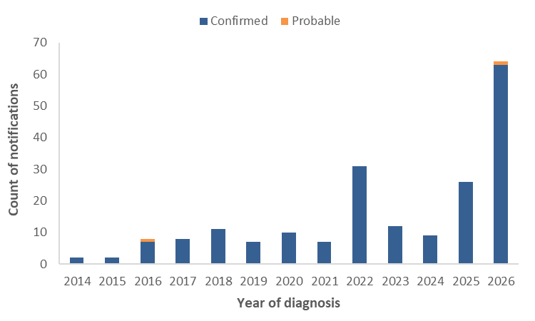
Figure 2: Notifications of diphtheria by month with 5-year* monthly rolling mean, Australia, 1 January 2025 to 8 April 2026
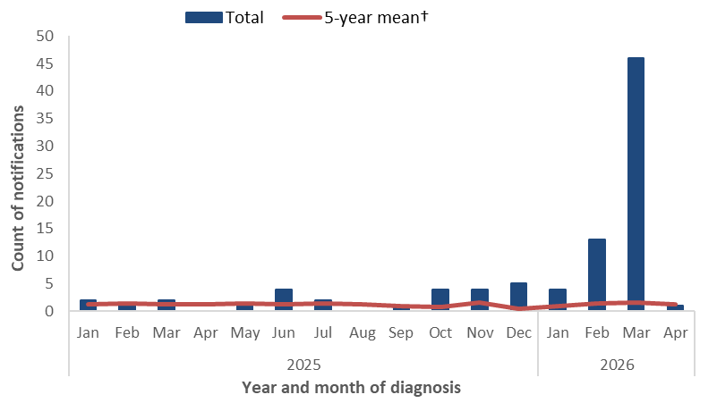
* 2025 rolling monthly mean based on the mean number of cases in the equivalent months during 2018, 2019 and 2022 to 2024. 2026 rolling monthly means are based on the mean number of cases in the equivalent months during 2019 and 2022 to 2025.
Figure 3: Notifications of diphtheria by month, Australia, 1 January 2014 to 8 April 2026
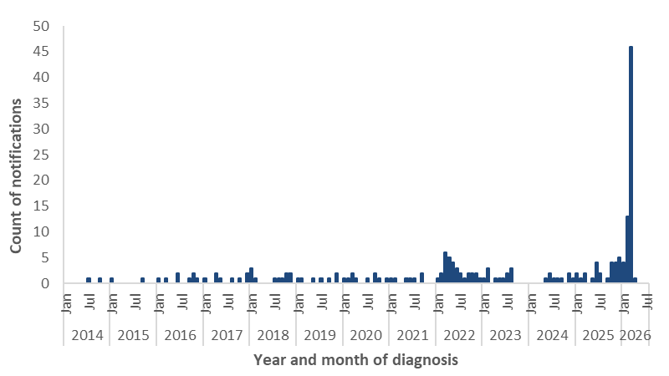

Species
Under the national case definition for diphtheria, a confirmed case requires isolation of toxigenic Corynebacterium diphtheriae or toxigenic C. ulcerans from the upper respiratory tract or skin lesion^{i}. In 2026, of the confirmed diphtheria infections for which species information was available (68.3%; 43 out of 63), all of these cases were reported as C. diphtheriae (Figure 4).
The last reported C. ulcerans infections were notified in 2024.
Figure 4: Notifications of confirmed diphtheria by species, Australia, 1 January 2014 to 8 April 2026
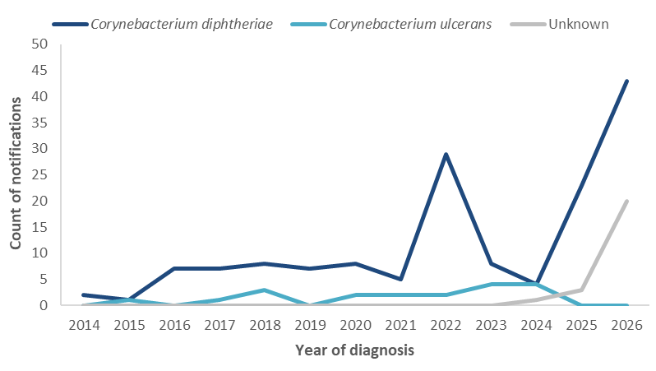

Geographic distribution
Among cases reported in 2026, two-thirds (64.0%; 41 out of 64) were reported in the Northern Territory, a third (32.8%; 21 out of 64) in Western Australia, and 2 cases were reported in Queensland (Figure 5). Most cases in 2026 (64.0%) resided in areas classified as ‘remote’, while nearly a third (29.6%) resided in ‘regional’ areas.
Figure 5: Notifications of diphtheria by year and jurisdiction, Australia, 1 January 2014 to 8 April 2026
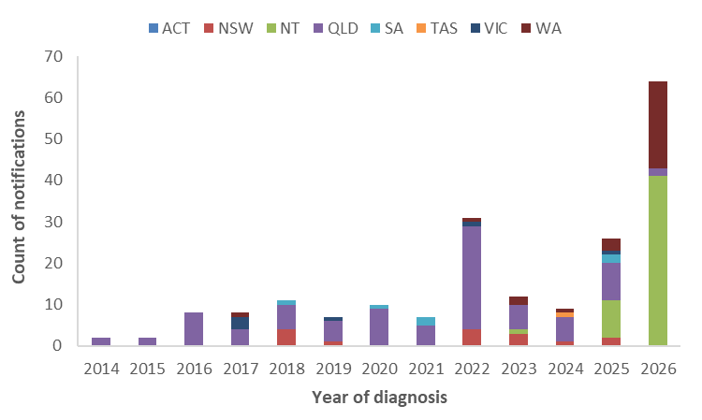

Place of acquisition
By place of acquisition, between 2014 and 2019, the majority of diphtheria cases were acquired overseas (Figure 6), predominantly in the Western Pacific and South-East Asia regions. Since 2020, the majority of diphtheria notifications have been locally acquired. So far in 2026, 2 cases (3.1%) are reported to have acquired their infection overseas.
Since 2020, there have been 9 diphtheria clusters (with 2 or more cases) reported by jurisdictions, with 4 of these clusters reported in 2026. The largest clusters occurred in North Queensland with cases involved in these clusters spanning 2020 to 2023. The more recent clusters in 2026 have been in Western Australia and the Northern Territory.
An AusTrakka analysis of recent diphtheria cases, based on specimens up to 10 March 2026, indicates that the recent Western Australia cases in the Kimberley region are genomically linked to cases in the Northern Territory and Queensland, and that the strain had been circulating for several months prior to the surge in cases in the Kimberley (Figure 7). These cases are distinct to the cases from the large clusters in North Queensland in 2020 to 2022. However, further analyses are being undertaken to assess whether the current cluster could have evolved from the 2020 to 2022 outbreak.
Figure 6: Notifications of diphtheria by place of acquisition*, Australia, 1 January 2014 to 8 April 2026
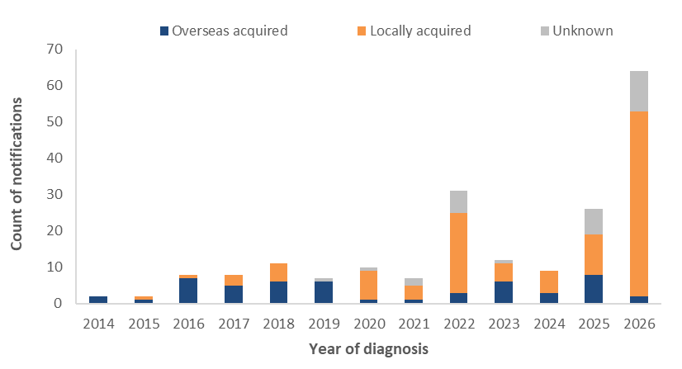
* The source of infection for 2025 and 2026 cases are provisional and subject to change.
Figure 7: AusTrakka* SNP clustering of toxigenic C. diphtheriae sequences, 12 March 2020 to 10 March 2026
* AusTrakka Genomic Analysis Report ATOI26001 – Corynebacterium diphtheriae (23 March 2026).

Clinical presentation
Nationally, since 2016, the majority of diphtheria notifications have been reported as cutaneous diphtheria. The clinical presentation of cases since 2025 has predominantly been cutaneous diphtheria (85.6%), with 13.3% respiratory diphtheria, and 1.1% unknown (Figure 8). The increase and upward trend in cutaneous diphtheria cases may be attributable to changes in testing practices, including toxigenic testing, particularly of wounds.
Figure 8: Notifications of diphtheria by clinical presentation*, Australia, 1 January 2014 to 8 April 2026
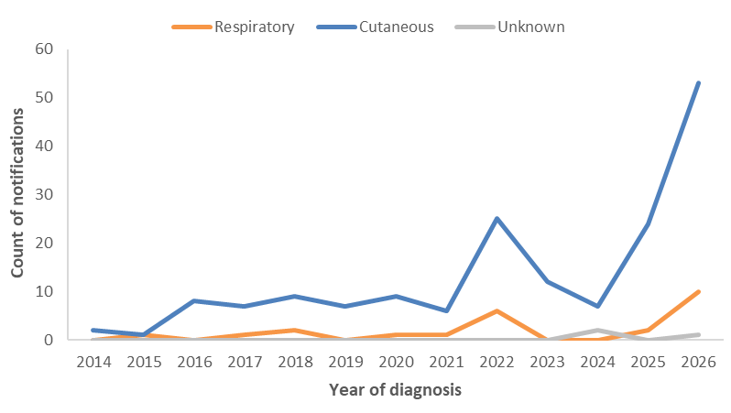
* Includes one probable respiratory diphtheria case reported in 2026.

Age and sex
Since 2014, notifications of diphtheria have predominately been reported among those aged 25 years and over, with variability in the proportion of cases reported among those in younger age groups since 2017 (Figure 9). The highest notification rates and number of cases so far in 2026 are among those in the 15 to 24 years and 25 to 44 years age groups (Figure 10). By clinical presentation, respiratory diphtheria cases so far in 2026 have been predominately among those aged less than 30 years (Figure 10).
Between 2022 and 2025, the distribution of cases by sex was relatively balanced (52.5% males), with some variability by age group. This pattern has remained broadly consistent so far in 2026, with 56.2% of cases among males.
Figure 9: Proportion of diphtheria notifications by age group, Australia, 1 January 2014 to 8 April 2026
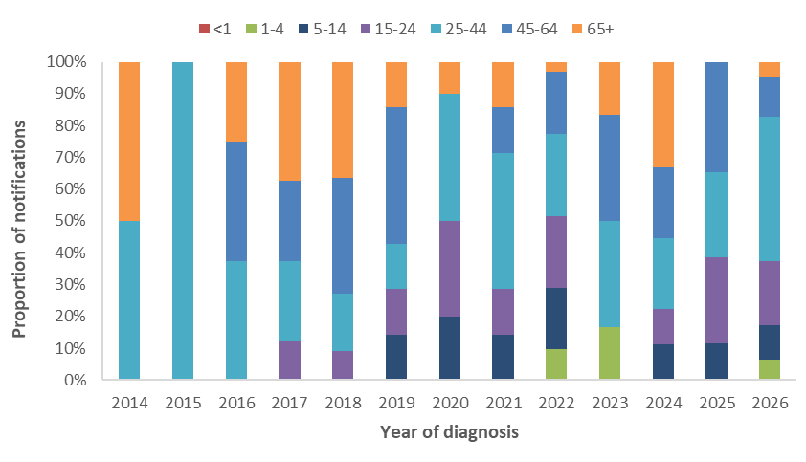
Figure 10: Notifications of diphtheria by age group and clinical presentation*, Australia, 1 January 2022 to 8 April 2026
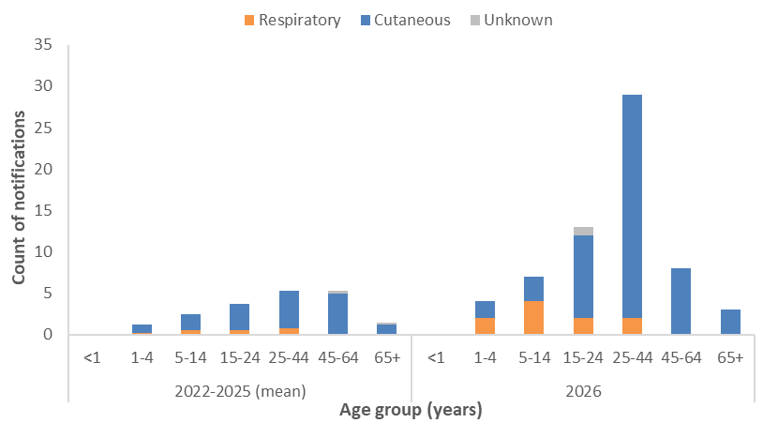
* Includes one probable respiratory diphtheria case reported in 2026.

Indigenous status
Indigenous status completeness for diphtheria has remained consistently high at over 98.3% across 2014 to 2026. Between 2014 and 2019, the proportion of diphtheria cases among Aboriginal and Torres Strait Islander people was around 10.5% of cases, noting that there were very few cases reported in 2014 and 2015 (n=4) (Figure 11). During 2020 to 2022, which included multiple diphtheria clusters in North Queensland, the proportion of cases among Aboriginal and Torres Strait Islander people increased to 64.5%. So far in 2026, 90.6% of cases have been reported among Aboriginal and Torres Strait Islander people.
Figure 11: Proportion of diphtheria notifications by Indigenous status Australia, 1 January 2014 to 8 April 2026
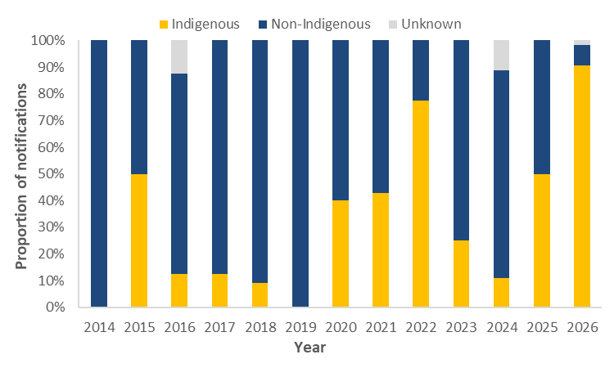

Severity
Between 2022 and 2025, just over a quarter (28.2%) of diphtheria notifications were reported as being hospitalised, with proportions of cases hospitalised higher among those with respiratory diphtheria. So far in 2026, 35.9% of diphtheria cases have been hospitalised. While the proportion of respiratory diphtheria cases in 2026 is higher than in previous years (15.6% in 2026 compared to 10.3% between 2022 and 2025), the increased proportion may also reflect a shift in the public health management of infections within a hospital setting, rather than indicating more severe disease.
The most recent diphtheria associated death was reported in 2018 and involved an unvaccinated adult who had respiratory diphtheria.

Vaccination status
The vaccination status among diphtheria cases between 2014 and 2025 has differed by clinical presentation type (Figure 12). In 2026, among cases of cutaneous diphtheria (n=53), 64.2% had received 3 or more doses, a further 18.8% had received 1 or 2 doses, and 17.0% of cases were reported as being unvaccinated or having an unknown vaccination status. Among confirmed cases of respiratory diphtheria in 2026 (n=9), 5 cases were reported to have received 3 or more doses, two cases were reported to have received 1 or 2 doses, and two cases were reported as being unvaccinated.
While vaccination provides strong protection against the severe effects of diphtheria toxin, it does not consistently prevent carriage or transmission of C. diphtheriae, regardless of whether the strain produces toxin or not.
Consistent with the National Immunisation Program and broader Australian Immunisation Handbook recommendations, the number of doses received tended to increase with increasing age (Figure 13). Since 2022, among diphtheria cases reported to have received at least 3 vaccine doses, the median number of years since last vaccine dose has typically been lower among cutaneous diphtheria cases compared to respiratory diphtheria cases (Figure 14).
More broadly, national diphtheria-tetanus-pertussis (DTP) vaccination coverage rates, based on the National Immunisation Program Schedule, among children aged 5 years as at September 2025 was 93.4% (range: 91.9% to 94.8%), and among Aboriginal and Torres Strait Islander children it was 94.7% (range: 92.9% to 96.3%). However, ‘fully immunised’ rates among the 5-year-old cohort, regardless of Indigenous status, has been gradually declining since peaking in 2020.
Figure 12: Notifications of diphtheria by vaccination status and clinical presentation type*, Australia, 1 January 2014 to 8 April 2026
(a) Cutaneous diphtheria | (b) Respiratory diphtheria*
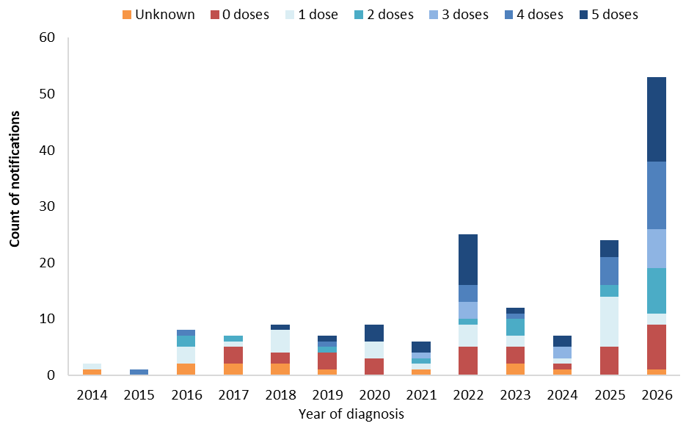 | 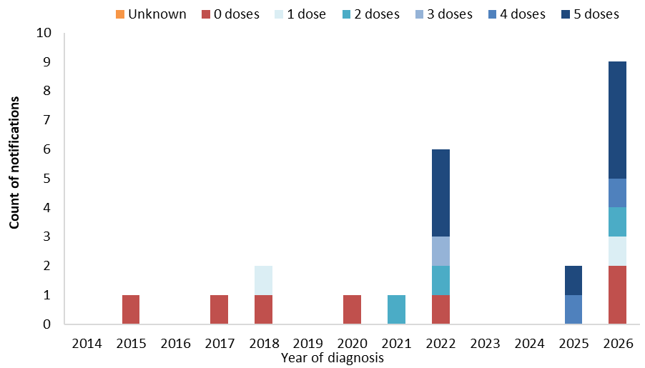
* Excludes a probable respiratory diphtheria case reported in 2026.

Figure 13: Notifications of diphtheria by vaccination status, clinical presentation type* and age group, Australia, 1 January 2022 to 8 April 2026
(a) Cutaneous diphtheria | (b) Respiratory diphtheria*
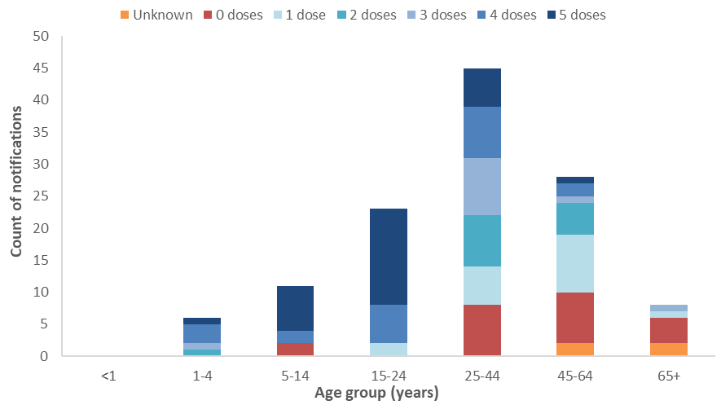 | 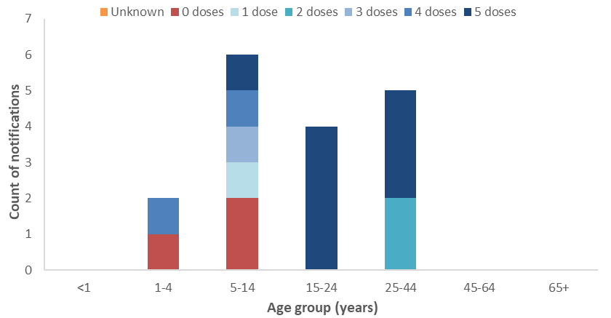
* Excludes a probable respiratory diphtheria case reported in 2026.
Figure 14: Distribution of years since last vaccine dose for notifications of diphtheria with at least 3 doses*, by clinical presentation type†, Australia, 1 January 2014 to 8 April 2026
(a) Cutaneous diphtheria | (b) Respiratory diphtheria*
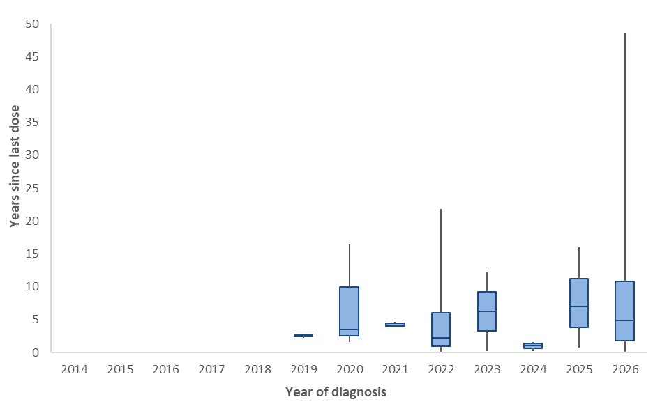 | 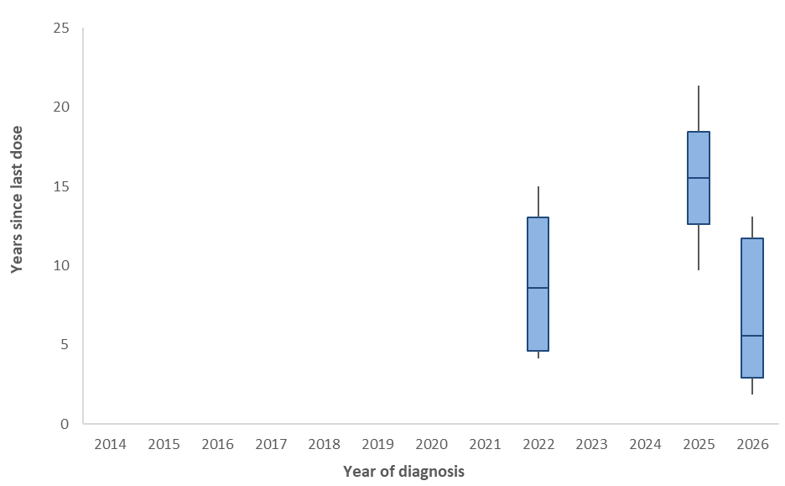
* Periods where there were less than 2 cases that had received 3 or more vaccine doses are not shown.
† Excludes a probable respiratory diphtheria case reported in 2026.

Epidemiological characteristics of diphtheria cases
Table 1: Epidemiological summary of diphtheria cases in Australia, 1 January 2025 to 8 April 2026
 | 2026  YTD* | 2025  YTD* | 2025 | 2022–2025 YTD* (mean) | 2022–2025 (mean)
Total | 64 | 5 | 26 | 5.3 | 19.5
Confirmation status
Confirmed | 63 (98%) | 5 (100%) | 26 (100%) | 5.3 (100%) | 19.5 (100%)
Probable | 1 (2%) | 0 (0%) | 0 (0%) | 0.0 (0%) | 0.0 (0%)
Species
C. diphtheriae | 44 (69%) | 4 (80%) | 23 (88%) | 4.5 (86%) | 16.0 (82%)
C. ulcerans | 0 (0%) | 0 (0%) | 0 (0%) | 0.5 (10%) | 2.5 (13%)
Unknown | 20 (31%) | 1 (20%) | 3 (12%) | 0.3 (5%) | 1.0 (5%)
State
ACT | 0 (0%) | 0 (0%) | 0 (0%) | 0.0 (0%) | 0.0 (0%)
NSW | 0 (0%) | 1 (20%) | 2 (8%) | 0.5 (10%) | 2.5 (13%)
NT | 41 (64%) | 0 (0%) | 9 (35%) | 0.0 (0%) | 2.5 (13%)
QLD | 2 (3%) | 3 (60%) | 9 (35%) | 4.3 (81%) | 11.5 (59%)
SA | 0 (0%) | 0 (0%) | 2 (8%) | 0.0 (0%) | 0.5 (3%)
TAS | 0 (0%) | 0 (0%) | 0 (0%) | 0.0 (0%) | 0.3 (1%)
VIC | 0 (0%) | 0 (0%) | 1 (4%) | 0.0 (0%) | 0.5 (3%)
WA | 21 (33%) | 1 (20%) | 3 (12%) | 0.5 (10%) | 1.8 (9%)
Remoteness area
Major cities | 1 (2%) | 1 (20%) | 6 (23%) | 1.0 (19%) | 5.3 (27%)
Regional areas | 19 (30%) | 2 (40%) | 11 (42%) | 3.3 (61%) | 9.5 (49%)
Remote areas | 41 (64%) | 2 (40%) | 9 (35%) | 1.0 (19%) | 4.5 (23%)
Unknown | 3 (5%) | 0 (0%) | 0 (0%) | 0.0 (0%) | 0.3 (1%)
Place of acquisition
Overseas acquired | 2 (3%) | 2 (40%) | 8 (31%) | 1.0 (19%) | 5.0 (26%)
Locally acquired | 51 (80%) | 2 (40%) | 11 (42%) | 3.5 (67%) | 11.0 (56%)
Unknown | 11 (17%) | 1 (20%) | 7 (27%) | 0.8 (14%) | 3.5 (18%)
Clinical manifestation
Cutaneous | 53 (83%) | 4 (80%) | 24 (92%) | 5.0 (95%) | 17.0 (87%)
Respiratory | 10 (16%) | 1 (20%) | 2 (8%) | 0.3 (5%) | 2.0 (10%)
Unknown | 1 (2%) | 0 (0%) | 0 (0%) | 0.0 (0%) | 0.5 (3%)
Age group (years)
<1 | 0 (0%) | 0 (0%) | 0 (0%) | 0.0 (0%) | 0.0 (0%)
1-4 | 4 (6%) | 0 (0%) | 0 (0%) | 0.5 (10%) | 1.3 (6%)
5-14 | 7 (11%) | 3 (60%) | 3 (12%) | 1.3 (24%) | 2.5 (13%)
15-24 | 13 (20%) | 2 (40%) | 7 (27%) | 1.3 (24%) | 3.8 (19%)
25-44 | 29 (45%) | 0 (0%) | 7 (27%) | 1.8 (33%) | 5.3 (27%)
45-64 | 8 (13%) | 0 (0%) | 9 (35%) | 0.3 (5%) | 5.3 (27%)
65+ | 3 (5%) | 0 (0%) | 0 (0%) | 0.3 (5%) | 1.5 (8%)
Sex
Male | 36 (56%) | 2 (40%) | 15 (58%) | 2.3 (43%) | 10.3 (53%)
Female | 28 (44%) | 3 (60%) | 11 (42%) | 3.0 (57%) | 9.3 (47%)
Indigenous status
Indigenous | 58 (91%) | 3 (60%) | 13 (50%) | 4.0 (76%) | 10.3 (53%)
Non-Indigenous | 5 (8%) | 2 (40%) | 13 (50%) | 1.3 (24%) | 9.0 (46%)
Unknown | 1 (2%) | 0 (0%) | 0 (0%) | 0.0 (0%) | 0.3 (1%)
Severity
Hospitalised | 23 (36%) | 1 (20%) | 10 (38%) | 1.0 (19%) | 5.5 (28%)
Died | 0 (0%) | 0 (0%) | 0 (0%) | 0.0 (0%) | 0.0 (0%)
Vaccination status
0 doses | 11 (17%) | 1 (20%) | 5 (19%) | 1.0 (19%) | 3.8 (19%)
1 dose | 3 (5%) | 0 (0%) | 9 (35%) | 0.5 (10%) | 4.5 (23%)
2 doses | 9 (14%) | 0 (0%) | 2 (8%) | 0.5 (10%) | 1.8 (9%)
3 doses | 7 (11%) | 0 (0%) | 0 (0%) | 0.8 (14%) | 1.5 (8%)
4 doses | 13 (20%) | 2 (40%) | 6 (23%) | 0.8 (14%) | 2.5 (13%)
5 doses | 20 (31%) | 2 (40%) | 4 (15%) | 1.8 (33%) | 4.8 (24%)
Unknown | 1 (2%) | 0 (0%) | 0 (0%) | 0.0 (0%) | 0.8 (4%)
* YTD represents the year to date period of 1 January to 8 April.

CDNA diphtheria case definition: https://www.cdc.gov.au/system/files/2025-09/diphtheria-surveillance-case-definition_0.pdf

