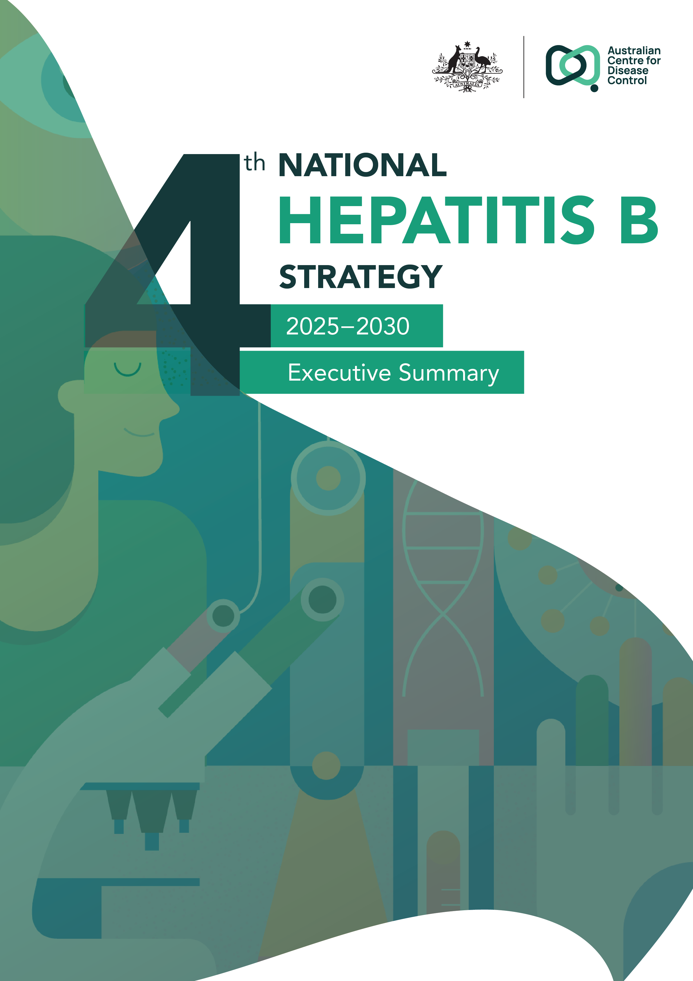
Sixth National Hepatitis B StrategyO
2025 -- 2030

Executive summary
Australia’s Fourth National Hepatitis B Strategy 2025–2030 provides a high-level roadmap to improve outcomes for people living with hepatitis B in Australia.
This strategy’s vision is to eliminate hepatitis B as a public health threat by 2030, while supporting equitable access to safe, affordable, and effective vaccines, as well as prevention, education, testing, management, treatment, and care for all.
This strategy is oriented around 4 goals and 6 priority areas for action in pursuit of this vision. The strategy has been developed in collaboration with affected communities, community peak bodies, state and territory governments, the Australian Government, researchers, and clinicians to ensure it guides the national response to achieve elimination by 2030. Ongoing partnerships between the Australian Government and state and territory governments have also played a crucial role in the development and delivery of initiatives to eliminate hepatitis B in Australia.

Hepatitis B in Australia
- Hepatitis B is a bloodborne viral infection that can be spread by blood-to-blood contact, sexual fluids, from pregnant woman to child during birth or at an early age (particularly in other countries).
- Hepatitis B is vaccine preventable.
- Hepatitis primarily affects the liver, causing liver inflammation which can lead to liver damage, cirrhosis and cancer.
- While there is no cure for hepatitis B, regular monitoring and treatment, when needed, can significantly reduce the risk of liver cirrhosis and liver cancer.
In 2023, an estimated 219,800 people were living with chronic hepatitis B in Australia, representing 0.8% of the population, disproportionately affecting priority populations including Aboriginal and Torres Strait Islander people and people from culturally, ethnically and linguistically diverse communities.
- There were an estimated 460 hepatitis B-related deaths, compared to 433 in 2016.1
- Without access to antiviral treatment over the last 2 decades, it is estimated nearly 800 people would die every year due to chronic hepatitis B.1
- An estimated 24% of people living with hepatitis B were receiving regular care for this condition, and 13% were receiving antiviral treatment.1

Goals of the Fourth National Hepatitis B Strategy 2025–2030
 | Virtually eliminate hepatitis B transmission by 2030
 | Reduce mortality and morbidity related to hepatitis B
 | Eliminate the negative impact of stigma, discrimination, and legal and human rights issues on people’s health
 | Minimise the personal and social impacts of hepatitis B

Priority populations affected by hepatitis B

People from culturally and linguistically diverse communities
People living with hepatitis B
People at risk of hepatitis B transmission
Pregnant women living with hepatitis B
Aboriginal
and Torres Strait Islander peoples living with or who are not vaccinated against
hepatitis B
Sex workers
Priority populations affected by hepatitis B

Priority areas for action
Equitable access to, and coordination of, care and support
Key actions include exploring opportunities to improve access to care and support; and expanding the provision of culturally and linguistically appropriate hepatitis B services to priority populations.
Addressing stigma and creating an enabling environment
Actions to reduce stigma include co-designing national policy with people living with hepatitis B; increasing anti-stigma (and other) training for healthcare providers; and exploring opportunities aimed at addressing systemic contributors to poor hepatitis B outcomes.
Workforce
Key actions focused on strengthening the hepatitis B workforce include increasing learning opportunities for clinical and community workforce; considering a national hepatitis B multidisciplinary workforce plan; and meaningfully involving priority populations in the development of workforce activities.
Data, surveillance, research, and evaluation
Actions include improving the timeliness and consistency of hepatitis B data collection; supporting hepatitis B curative research; and enabling more community leadership in research planning, design, and implementation.
Testing, treatment, and management
Key actions include supporting strong diagnostic approaches; and committing to exploring options for universal hepatitis B testing. Informed consent will continue to be central to all testing, treatment, and management programs.
Education and prevention
Key actions include strengthening educational materials as well as increasing awareness of, and access to, free hepatitis B vaccinations. Harm reduction strategies, such as Needle and Syringe Programs and liver health monitoring, will continue to complement vaccination in preventing progression of hepatitis B to liver disease and liver cancer.

The Kirby Institute. (2024). HIV, viral hepatitis and sexually transmissible infections in Australia Annual surveillance report 2024: Hepatitis B. www.kirby.unsw.edu.au/sites/default/files/documents/Annual_Surveillance_Report_2024_HBV.pdf

