Monitoring, evaluation and learning framework for the National Immunisation Strategy for Australia 2025–2030
  - April 2026

Acknowledgment of Country
The Australian Centre for Disease Control acknowledges and honours Aboriginal and Torres Strait Islander peoples – the Traditional Owners and Custodians of the lands and waters on which we live and work. We pay our respects to Elders past and present and extend that respect to all Aboriginal and Torres Strait Islander peoples across this country. We recognise their ongoing connection to Country, culture and community, and we commit to working in genuine partnership towards improving health outcomes for all.

Development of the framework
This framework was developed by the Australian CDC with expert advice and oversight from the National Immunisation Strategy Implementation Plan Strategic Reference Group, support from the National Centre for Immunisation Research and Surveillance and input from states and territories through the Jurisdictional Immunisation Coordinators Advisory Group. The framework is endorsed by the Australian Health Protection Committee.

Contents
Abbreviations 4
Introduction 5
Purpose and scope 5
Key evaluation questions 6
Background 7
Guiding principles 7
Governance of the framework 9
Monitoring and evaluation activities 10
Key evaluation question rationale 15
Reporting and learning 17
Monitoring and evaluation reports 17
Validation of data and results 18
Sharing of findings 18
Review of the framework and evaluation data matrix 18
References 19
Appendices 21
Appendix 1: Key terms 21
Appendix 2: NIS 2025–2030 on a page 22

Abbreviations
Abbreviation | Meaning
ACR COD URF | Australian Coordinating Registry Cause of Death Unit Record File
AHPC | Australian Health Protection Committee
AIHW | Australian Institute of Health and Welfare
AIR | Australian Immunisation Register
ATAGI | Australian Technical Advisory Group on Immunisation
CDC | Australian Centre for Disease Control
EVS | Essential Vaccines Schedule
HCEF | Health Chief Executives Forum
HMM | Health Ministers Meeting
JICAG | Jurisdictional Immunisation Coordinators Advisory Group
NCIRS | National Centre for Immunisation Research and Surveillance
NGO | Non-government organisation
NHMD | National Hospital Morbidity Database
NIAA | National Indigenous Australians Agency
NID | National Immunisation Division
NIP | National Immunisation Program
NIS | National Immunisation Strategy
NIS IP | National Immunisation Strategy Implementation Plan
NMD | National Mortality Database
NNDSS | National Notifiable Diseases Surveillance System
PBAC | Pharmaceutical Benefits Advisory Committee
PLIDA | Person Level Integrated Data Asset
SA | (Australian Bureau of Statistics) Statistical Area level
SRG | Strategic Reference Group
VPD | Vaccine-preventable disease(s)

Introduction

Purpose and scope
The purpose of this monitoring, evaluation and learning framework (hereafter, ‘the framework’) is to provide high level guidance for how the National Immunisation Strategy for Australia 2025–2030 (NIS 2025–2030)² will be monitored and evaluated and the learnings shared.
Five key evaluation questions across 2 evaluation domains – implementation and effectiveness – define the framework’s scope and associated monitoring and evaluation activities.
The framework focuses on monitoring public health outcomes and progress against the ambitious priority areas defined in the NIS 2025–2030 (Figure 1). Key evaluation questions to assess effectiveness centre around Priority Areas 1 and 2, with an emphasis on improving immunisation coverage through equitable access, building trust and confidence in immunisation, and the strategy’s overarching mission of reducing the impact of vaccine-preventable diseases (VPDs). Progress against Priority Areas 3 to 6 will be broadly assessed through the implementation domain.
The framework is intended to enable flexibility and adaptiveness through regular reviews of indicators, targets and data sources, and adopting a learning approach. Review of the evaluation domains and questions may also occur to ensure ongoing relevance of monitoring and evaluation activities and to inform development of future strategies.

Key evaluation questions
Implementation domain
- To what extent have jurisdictional action plans been developed and implemented?
Effectiveness domain
- Are immunisation coverage rates improving across all age groups and priority populations?
- Is access to vaccines more equitable for Aboriginal and Torres Strait Islander People and other priority populations?
- Has consumer trust and confidence in vaccines improved?
- Are the incidence and prevalence of VPDs declining?

Background
The NIS 2025–2030, released by the Interim Australian Centre for Disease Control in May 2025, provides a strategic pathway to increase and sustain immunisation uptake in Australia over the next 5 years.² With a vision for a healthier Australia through immunisation, the NIS 2025–2030 sets a mission to reduce the impact of VPDs in Australia through high uptake of safe, effective and equitable immunisation across the lifespan of the Australian population. The NIS 2025–2030 outlines 6 priority areas, each with strategic goals, towards which immunisation policy and program efforts will be directed (Figure 1, Appendix 2).
Figure 1. National Immunisation Strategy for Australia 2025–2030 – Vision, Mission and Priority Areas
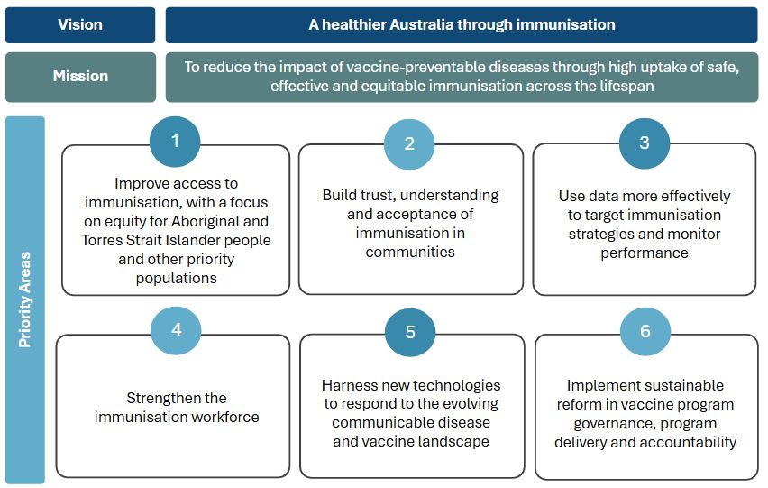

Guiding principles
Seven guiding principles underpin the development, governance and implementation of the framework (Figure 2). These principles ensure that the framework is closely aligned with the NIS 2025–2030’s strategic priorities.

Figure 2. Guiding principles for this framework
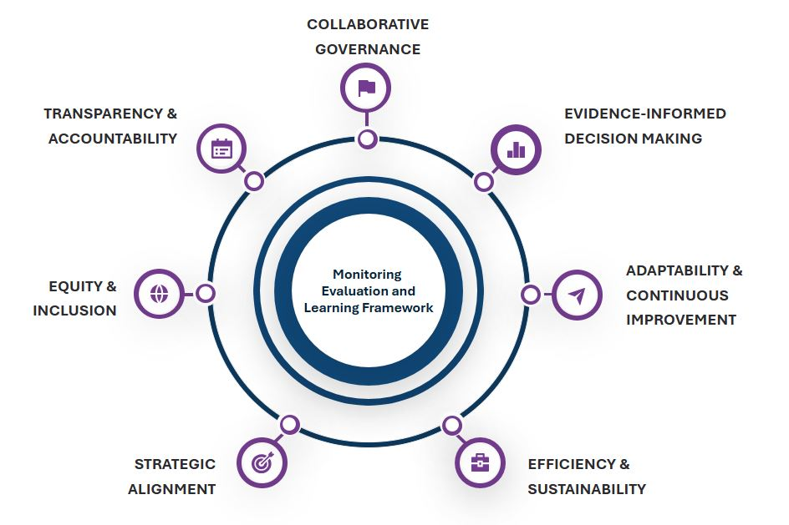
Summary of the framework’s 7 guiding principles:
- Strategic alignment: Alignment to strategic goals and indicators mapped to desired outcomes.
- Equity and inclusion: Equity embedded as a core principle.
- Transparency and accountability: Clear reporting mechanisms and open access to evaluation findings.
- Collaborative governance: Shared ownership of framework across jurisdictions and sectors.
- Evidence-informed decision making: Analysis and interpretation capacity built and integrated into policy cycles.
- Adaptability and continuous improvement: Flexibility to accommodate changing priorities, technologies and public health challenges.
- Efficiency and sustainability: Data collection processes streamlined and existing systems and partnerships leveraged.

Governance of the framework
The Australian Centre for Disease Control (CDC) holds primary responsibility for the implementation and maintenance of the framework. The CDC will ensure the collation of learnings and communication of findings generated by framework activities to inform ongoing implementation of the NIS 2025–2030 and broader immunisation policy.
Strong governance and advisory mechanisms (Figure 3) closely aligned to National Immunisation Strategy Implementation Plan (NIS IP) governance structures will bring stakeholders together to guide implementation and review of the framework, and oversight of activities and related reports.
Figure 3: Governance of the monitoring, evaluation and learning framework for the National Immunisation Strategy for Australia 2025–2030
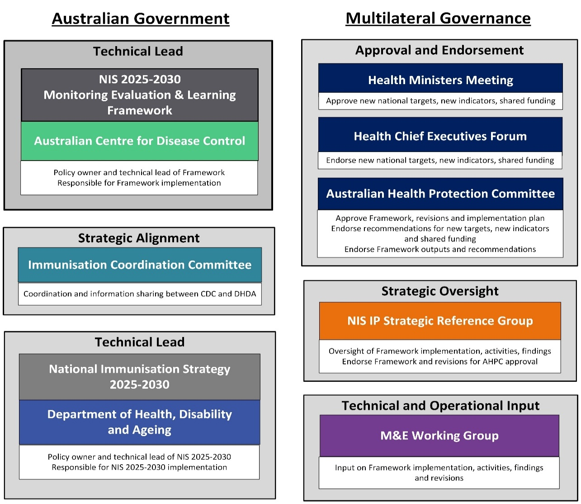
Abbreviations: AHPC - Australian Health Protection Committee; CDC – Australian Centre for Disease Control; DHDA – Department of Health, Disability and Ageing; M&E – Monitoring and Evaluation; NIS – National Immunisation Strategy; NIS IP – National Immunisation Strategy Implementation Plan.
The NIS IP Strategic Reference Group (SRG) will maintain strategic oversight of monitoring and evaluation activities. A Monitoring and Evaluation (‘M&E‘) Working Group with external representatives will provide technical and operational input, including review and monitoring and evaluation results.
Implementation of the framework will be guided by a strong commitment to ethics, equity and cultural governance throughout. Activities conducted under the framework will align with established ethical guidelines, including the National Health and Medical Research Council’s National Statement on Ethical Conduct in Human Research 2023³ and FAIR (Findable, Accessible, Interoperable, Reusable)⁴ principles for research data.
In accordance with the National Agreement on Closing the Gap Priority Reforms,⁵ implementation of the framework should support genuine partnership with Aboriginal and Torres Strait Islander communities and organisations, and shared access to locally relevant data. Data sovereignty principles should be upheld in line with the National Indigenous Australians Agency Framework for Governance of Indigenous Data,⁶ CARE (Collective Benefit, Authority to Control, Responsibility, Ethics)⁷ principles and the Maiam nayri Wingara Indigenous Data Sovereignty Principles.⁸

Monitoring and evaluation activities
This framework is underpinned by the program logic for the NIS 2025–2030 (Figure 4) and evaluation data matrix (Figure 5) - together they provide the structure for what elements of the strategy will be monitored and evaluated, and how.
The evaluation data matrix outlines the priority national indicators, aspirational targets, data sources and reporting frequencies, mapped to the framework’s key evaluation questions. Regular monitoring and reporting against the framework indicators will enable assessment of progress towards the intended outcomes of the NIS 2025–2030.
This initial evaluation data matrix (Figure 5) mostly comprises a consolidation of established indicators, targets and reporting mechanisms. It is planned to review the evaluation data matrix over time to account for framework learnings, stakeholder consultation and as new data sources emerge (refer to Review of the Framework and Evaluation Data Matrix).

Figure 4. Program logic model for implementation of the National Immunisation Strategy for Australia 2025–2030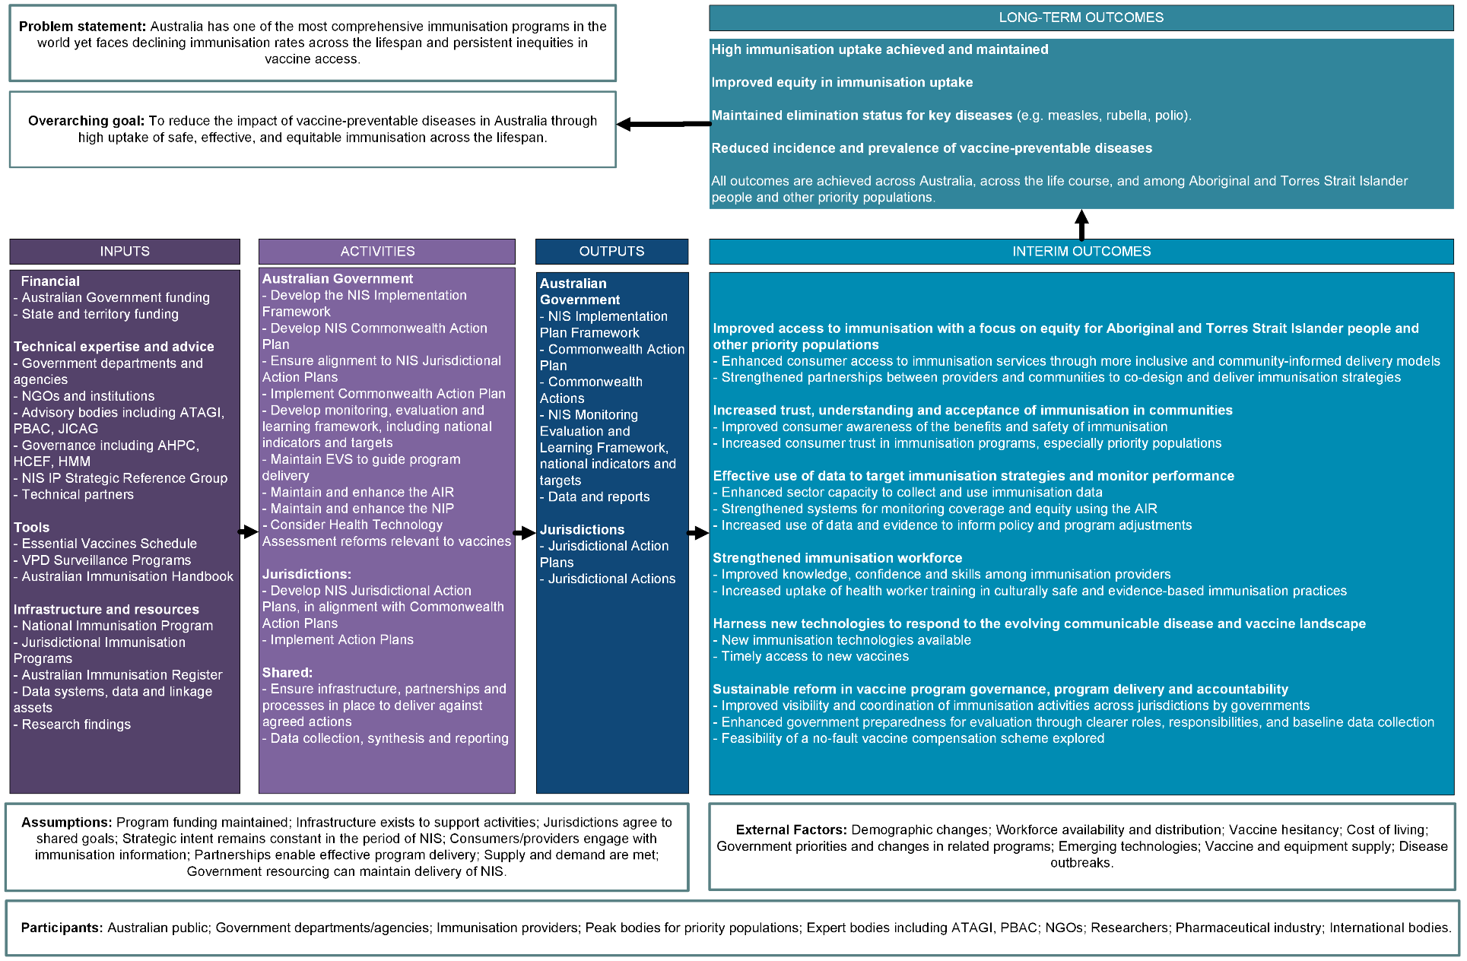
Abbreviations: AHPC – Australian Health Protection Committee; AIR – Australian Immunisation Register; ATAGI – Australian Technical Advisory Group on Immunisation; HCEF – Health Chief Executives Forum; HMM – Health Ministers Meeting; JICAG – Jurisdictional Immunisation Coordinators Advisory Group; NGO – Non-government organisation; NIP – National Immunisation Program; NIS – National Immunisation Strategy; NIS IP – National Immunisation Strategy Implementation Plan; PBAC – Pharmaceutical Benefits Advisory Committee; VPD – Vaccine-preventable diseases.
Figure 5. Evaluation data matrix for National Immunisation Strategy 2025–2030 monitoring, evaluation and learning framework
Evaluation questions | Indicators | Aspirational targets | Indicative data sources | Minimum reporting frequency | Responsible for data collation and reporting
1. To what extent have jurisdictionalª action plans been developed and implemented? | 1.1 Number (%) of jurisdictions with an action plan available with alignment to the National Immunisation Strategy (NIS) priorities | 100% jurisdictions have an annual action plan that is aligned to NIS priorities | Essential Vaccines Schedule: performance reports  Commonwealth Action Plan  Examples:  Essential vaccines: performance report 2023–24 | Annual | Centre for Disease Control (CDC) – Technical Support Partner  National Immunisation Division (NID)  Australian Institute for Health and Welfare (AIHW)
 | 1.2 Progress against activities in action plans per jurisdictionª | Quantitative and qualitative analysis of extent of completion of action plans (progress trend) |  | Annual
2. Are immunisation coverage rates improving across all age groups and priority populations? | 2.1 % of 1-, 2- and 5-year-olds assessed as fully immunised using current coverage rules (including trend) | 95% childhood immunisation coverage for children aged 1, 2, 5 years | Australian Immunisation Register (AIR)  Examples:  Immunisation data – Department of Health, Disability and Ageing  Immunisation coverage data and reports - NCIRS  Immunisation coverage data, surveys and reports - Department of Health, Disability and Ageing  Australia’s Health Performance Framework - AIHW | Annual | NID  Department of Health, Disability and Ageing – Technical Support Partner  CDC – Technical Support Partner
 | 2.2 % of 1-, 2- and 5-year-old Aboriginal and Torres Strait Islander children assessed as fully immunised using current coverage rules (including trend) | 95% childhood immunisation coverage for Aboriginal and Torres Strait Islander children aged 1, 2, 5 years |  | Annual
 | 2.3 % of adults 65 years or older who have received annual influenza vaccination in the past year (including trend) | Year-on-year increase |  | Annual
 | 2.4 % of adolescents who have received at least one dose of HPV vaccine by 15 years of age (including trend) | 90% HPV immunisation coverage by 15 years of age for all adolescents by 2030 |  | Annual
 | 2.5 % of Aboriginal and Torres Strait Islander adolescents who have received at least one dose of HPV vaccine by 15 years of age (including trend) | 90% HPV immunisation coverage by 15 years of age for all Aboriginal and Torres Strait Islander adolescents by 2030 |  | Annual
3. Is access to vaccines more equitable for Aboriginal and Torres Strait Islander people and other priority populations? | 3.1 Trends in coverage in Aboriginal and Torres Strait Islander children aged 1-, 2- and 5-years assessed as fully immunised using current coverage rules | Year-on-year increase | AIR  Examples:  Australia’s Health Performance Framework - AIHW  Aboriginal and Torres Strait Islander Health Performance Framework - NIAA, AIHW | Annual | CDC – Technical Support Partner
 | 3.2 Trends in coverage in Aboriginal and Torres Strait Islander adolescents who have received at least one dose of HPV vaccine by 15 years of age | Year-on-year increase |  | Annual | CDC – Technical Support Partner
 | 3.3 Trends in coverage in Aboriginal and Torres Strait Islander adults aged 18 years or older who have received annual influenza vaccine in the past year | Year-on-year increase |  | Annual | CDC – Technical Support Partner
 | 3.4 Trends in coverage in fully vaccinated coverage for children aged 1-, 2- and 5-years by geographical area (e.g. SA-3) | Year-on-year increase in geographical areas experiencing the lowest coverage prior to NIS implementation |  | Annual | CDC – Technical Support Partner
 | 3.5 Number (%) of surveyed group reporting vaccination access barriers, by type of access barrier | Reduced reported barriers (annual trend) | Regular surveys (e.g. National Vaccination Insights project) using validated tools | Annual | Department of Health, Disability and Ageing -Technical Support Partner
4. Has consumer trust and confidence in vaccines improved? | 4.1 Number (%) of Australian public (surveyed group) that reports increased trust and acceptance in vaccines | Increased reported trust and acceptance in vaccines (annual trend) | Regular surveys through National Vaccination Insights.  Synthesis of available literature and evidence for baseline data.  Examples:  Childhood vaccination insights  Adult vaccination insights | Annual | Department of Health, Disability and Ageing – Technical Support Partner
5. Are the incidence and prevalence of vaccine-preventable diseases declining? | 5.1 Number, rates and trends of case notifications in overall and/or specified populations (including priority populations) for selected VPDs | No target | National notifiable diseases surveillance system (NNDSS)  Example:  NNDSS - Department of Health, Disability and Ageing | Annual | CDC – Technical Support Partner
 | 5.2 Number, rates and trends of hospitalisations in overall and/or specified populations (including priority populations) for selected VPDs | No target | National Hospital Morbidity Database (NHMD)  Example:  Vaccine-preventable diseases in Australia - AIHW | Annual | CDC – Technical Support Partner
 | 5.3 Number, rates and trends of deaths in overall and/or specified populations (including priority populations) related to selected VPDs | No target | National Mortality Database (NMD) or Australian Coordinating Registry (ACR COD URF) | Annual | CDC – Technical Support Partner
 | 5.4 Achievement of endorsed elimination targets for measles, rubella and polio | Maintained elimination status for measles, rubella and polio | NNDSS + other relevant sources | Annual | CDC  AIHW
Abbreviations: ACR COD URF – Australian Coordinating Registry Cause of Death Unit Record File; AIHW – Australian Institute for Health and Welfare; AIR – Australian Immunisation Register; CDC – Centre for Disease Control; HPV – Human papillomavirus; NCIRS – National Centre for Immunisation Surveillance and Research; NHMD – National Hospital Morbidity Database; NIAA - National Indigenous Australians Agency; NIS – National Immunisation Strategy; NMD – National Mortality Database; NNDSS – National Notifiable Disease Surveillance System; SA – Statistical Area level; VPD – Vaccine-preventable diseases.

Key evaluation question rationale
The rationales for, and high-level approaches to, monitoring and evaluation for each of the 5 key evaluation questions are described below.
- To what extent have jurisdictional action plans been developed and implemented?
This question seeks to assess progress against NIS 2025–2030 implementation by monitoring progress against Commonwealth and state and territory action plans at a high level, including alignment with the NIS 2025–2030 priority areas. States and territories are key stakeholders and essential delivery partners for activities under the strategy and its priority areas. Implementation of the NIS 2025–2030 will be measured at a state and territory level by leveraging existing processes under the Essential Vaccines Schedule of the Federation Funding Agreement – Health 2025–2028 (EVS).⁹
Assessment of this question will focus on completion and progress against actions and activities described in government action plans only. This question does not seek to assess health or system level outcomes for each of the actions or activities.
- Are immunisation coverage rates improving across all age groups and priority populations?
High immunisation coverage is crucial in its mission of reducing the impact of VPDs. Using established indicators for childhood ‘fully vaccinated’ coverage and adolescent HPV vaccine coverage enable assessment of progress against pre-strategy baselines. The 95% targets for fully vaccinated coverage at 1, 2 and 5 years of age reflect longstanding national targets aimed at achieving and maintaining high levels of community protection against key VPDs. The 90% HPV vaccine coverage target by 2030 set by the National Strategy for the Elimination of Cervical Cancer in Australia,¹⁰ builds upon the World Health Organization’s Global Strategy targets.¹¹
Australian Immunisation Register (AIR) data enable timely monitoring of coverage by age group, Aboriginal and Torres Strait Islander status, geographic locations and socio-economic status. However, the AIR lacks detailed data required to assess coverage for many priority populations. Linked data assets, such as the Person Level Integrated Data Asset (PLIDA)¹² and the National Health Data Hub¹³ can be used to measure coverage in some populations, such as people with clinical risk factors for severe disease, or from culturally and linguistically diverse backgrounds. As these data systems evolve, additional indicators should be developed to strengthen monitoring and evaluation of equitable coverage.
- Is access to vaccines more equitable for Aboriginal and Torres Strait Islander People and other priority populations?
Improving equitable access to immunisation is central to the vision of the NIS 2025–2030, however measuring access at a national level is challenging. Immunisation coverage trend indicators will therefore serve as proxy measures for improved access, noting limitations in monitoring coverage among many priority populations. Aspirational equity targets focus on achieving year-on-year improvements for geographic areas with the lowest childhood immunisation coverage and for Aboriginal and Torres Strait Islander People. Additional coverage trend indicators and equity targets for other priority populations should also be considered.
Existing research, such as the National Vaccination Insights project, provide valuable information on access barriers experienced, as reported among a sample of the general population. Studies could be expanded or methods adapted to explore access barriers experienced by priority groups.
- Has consumer trust and confidence in vaccines improved?
Regular surveys and/or interviews using validated tools can provide useful insights into behavioural and social drivers for vaccination. The National Vaccination Insight project conducts nationally representative surveys to understand acceptance of vaccines within select groups, which is shaped by community trust and confidence.^{14,15} Adaptation or development of approaches to understand acceptance among priority populations is required and should be underpinned by co-design and active participation from community and organisations representing these populations.
- Are the incidence and prevalence of vaccine-preventable diseases declining?
Reducing the impact of VPDs is the core mission of the NIS 2025–2030. Measuring the impact of VPDs will occur through analyses of established national administrative data. The selected VPDs should be determined in line with CDC and Department of Health, Disability and Ageing priorities. Regular analyses and triangulation of the most recently available data across notification, hospitalisation and mortality datasets will provide a broad picture of the impact of VPDs across Australia.
No targets are proposed for disease indicators, as trends may be impacted by factors such as changes in sensitivity of diagnostics, implementation of other public health measures, and consumer health-seeking behaviour.
Where possible, monitoring and evaluation should focus on population groups relevant to the specific VPD. Further investment is required in establishing timely mechanisms (e.g. linked data) to measure the impact of VPDs among all priority populations.
While Australia has achieved elimination of measles, rubella and polio, global resurgences mean ongoing efforts are required to maintain their elimination. Monitoring and evaluation of Australia’s elimination status under the framework should align with National Verification Committee practices and relevant national plans and guidelines.^{16–18}

Reporting and learning

Monitoring and evaluation reports
Monitoring of each indicator will occur as outlined in the evaluation data matrix (Figure 5). To support timely learning and action, there will be 6-monthly checkpoints of available monitoring data, and annual monitoring reports summarising all available monitoring results will be produced.
Annual monitoring reports will be produced by October of each year to align with development of annual Commonwealth Action Plans to ensure timely learning and translation of results into action. It is also expected that annual results inform the development of state and territory action plans.
Comprehensive evaluations will be undertaken at the midpoint and in the final year of the NIS 2025–2030 (Figure 6).
Figure 6: Timeline of monitoring, evaluation and learning framework for the National Immunisation Strategy for Australia 2025–2030 activities and reports
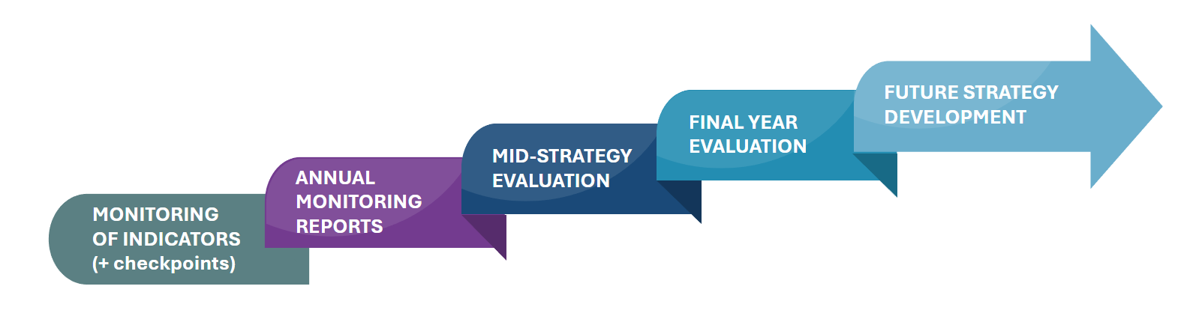

Validation of data and results
Early commencement of monitoring and timely evaluation of activities aligned with the NIS 2025–2030 are crucial for measuring progress and supporting learning throughout implementation of the strategy. The CDC will work with its technical support partners and key stakeholders, including jurisdictions and priority population representatives, through the M&E working group to ensure visibility, quality and consistency of data collection, reporting and validation. Formal governance structures (Figure 3), including cultural governance processes, will ensure appropriate scrutiny of results prior to publishing.

Sharing of findings
Annual monitoring reports will be made publicly available. Summary results from monitoring activities and evaluations will be shared with jurisdictions and other stakeholders to inform action plans and related activities. Findings and recommendations will be shared with key stakeholders and summaries will be made publicly available, where appropriate. Dissemination may include published reports, stakeholder forums and targeted briefings to support transparency, accountability and evidence-informed decision-making.

Review of the framework and evaluation data matrix
To enable flexibility and adaptiveness, regular reviews of the evaluation data matrix will occur throughout the lifespan of the framework. Updates to the matrix will be informed by insights generated through monitoring and evaluation activities, and as data systems, analytic capabilities and mechanisms for data sharing evolve. Incorporation of additional indicators and targets may also be considered in consultation with stakeholders, including jurisdictions, and subject to relevant governance and endorsement processes.
Review of the framework’s scope and approach may also occur to ensure its ongoing relevance and to inform development of future frameworks and strategies.

References
- Australian Government Department of Health, Disability and Ageing. Australian Health Protection Committee. Canberra: Australian Government; 2024 Available from: https://www.health.gov.au/committees-and-groups/australian-health-protection-committee-ahpc.
- Australian Centre for Disease Control. National Immunisation Strategy for Australia 2025–2030. Canberra: Australian Government Department of Health, Disability and Ageing; 2025. Available from: https://www.cdc.gov.au/resources/publications/national-immunisation-strategy-australia-2025-2030.
- National Health and Medical Research Council, Australian Research Council and Universities Australia (2023). National Statement on Ethical Conduct in Human Research. Canberra: National Health and Medical Research Council. Available from: https://www.nhmrc.gov.au/about-us/publications/national-statement-ethical-conduct-human-research-2025.
- GO FAIR. FAIR principles. 2018. Available from: https://www.go-fair.org/fair-principles/.
- Australian Government Department of the Prime Minister and Cabinet. Closing the gap. National Agreement on Closing the Gap: Priority Reforms, 2020. Available from: https://www.closingthegap.gov.au/national-agreement/priority-reforms.
- Commonwealth of Australia, Framework for Governance of Indigenous Data 2024. The National Indigenous Australians Agency. Available from: https://www.niaa.gov.au/resource-centre/framework-governance-indigenous-data.
- Global Indigenous Data Alliance. CARE principles for indigenous data governance. Available from: https://www.gida-global.org/care.
- Maiam nayri Wingara. (2018). Indigenous Data Sovereignty Communique Indigenous Data Sovereignty Summit 20th June 2018, Canberra, ACT. Available from: https://www.maiamnayriwingara.org/mnw-principles.
- Federal Financial Relations. Essential Vaccines Canberra: Australian Government Department of Treasury. Available from: https://federalfinancialrelations.gov.au/agreements/essential-vaccines.
- Australian Centre for the Prevention of Cervical Cancer. National Strategy for the Elimination of Cervical Cancer in Australia, 2023. Available from: https://acpcc.org.au/our-impact/elimination-strategy/.
- Global strategy to accelerate the elimination of cervical cancer as a public health problem. Geneva: World Health Organization; 2020. Licence: CC BY-NC-SA 3.0 IGO.
- Australian Bureau of Statistics. Person-level Integrated Data Asset. Canberra: ABS 2024. Available from: https://www.abs.gov.au/about/data-services/data-integration/integrated-data/person-level-integrated-data-asset-plida.
- Australian Institute of Health and Welfare. National Health Data Hub. Canberra: AIHW 2024. Available from: https://www.aihw.gov.au/reports-data/nhdh DOI: 10.25816/xdvs-6944.
- Kaufman J, Tuckerman J, Bonner C et al. Development and validation of the Vaccine Barriers Assessment Tool for identifying drivers of under-vaccination in children under five years in Australia. Human Vaccines & Immunotherapeutics 2024. doi: 10.1080/21645515.2024.2359623.
- World Health Organization (WHO). Behavioural and social drivers of vaccination: tools and practical guidance for achieving high uptake. Geneva: WHO; 2022.
- Australian Centre for Disease Control. Measles: CDNA National Guidelines for Public Health Units. Canberra: 2025. Available from: https://www.cdc.gov.au/resources/collections/cdna-series-national-guidelines-songs#p.
- Australian Centre for Disease Control. Communicable Diseases Network Australia. Rubella: CDNA National Guidelines for Public Health Units. Canberra: 2025. Available from: https://www.cdc.gov.au/resources/collections/cdna-series-national-guidelines-songs#p.
- Australian Centre for Disease Control. Polio Detection, Investigation and Response Plan for Australia. Canbera:2024. Available from; Available from: https://www.cdc.gov.au/newsroom/news-and-articles/poliovirus-detection-outbreak-response-plan-now-available.

Appendices

Appendix 1: Key terms
- Monitoring: the regular collection, analysis and use of information to enable timely and active assessment of the NIS 2025–2030 against key indicators.
- Evaluation/s: discrete, systematic assessment of changes brought about by activities under the NIS 2025–2030 and the progress towards overarching goals. May draw upon monitoring and other data sources and should include comparison with baseline data and/or against targets or anticipated outcomes and should also consider reasons why progress has or has not been achieved.
- Learning: Monitoring and evaluation findings should facilitate learnings and generate actions to improve implementation of activities under the NIS 2025–30 and inform future policies and strategies.
- Indicator: a specific, measurable variable used to track progress towards a particular outcome.
- Target: the desired value of an indicator intended to be achieved.
- Priority populations: people at greater risk of acquiring or experiencing severe outcomes related to VPDs, due to health conditions or systemic inequities (see page 12 of the NIS 2025-2030).²

Appendix 2: NIS 2025–2030 on a page

Vision | A healthier Australia through immunisation
Mission | To reduce the impact of vaccine-preventable diseases through high uptake of safe, effective and equitable immunisation across the lifespan
Priority Areas and Strategic Goals
1. Improve access to immunisation, with a focus on equity for Aboriginal and Torres Strait Islander people and other priority populations | 2. Build trust, understanding and acceptance of immunisation in communities | 3. Use data more effectively to target immunisation strategies and monitor performance | 4. Strengthen the immunisation workforce | 5. Harness new technologies to respond to the evolving communicable disease and vaccine landscape | 6. Implement sustainable reform in vaccine program governance, program delivery and accountability
Partner with communities to understand barriers to access and co-design strategies to improve vaccine access. | Engage with communities to build trust and understanding in the value of immunisation, and to combat misinformation. | Improve the completeness, timeliness and transparency of Australian Immunisation Register (AIR) data, ensuring optimal quality and utility for all stakeholders. | Embed immunisation in preventive healthcare across the lifespan. | Strengthen government immunisation program preparedness for new vaccine rollouts, including by leveraging new technologies. | Strengthen collaborative ways of working between the Australian Government and state and territory governments to deliver vaccines under the NIP and emergency programs.
Use innovative service delivery models to increase equitable access to immunisation across the lifespan. | Strengthen community partnerships for design, delivery and evaluation of tailored immunisation strategies. | Work towards creation of a whole of life, interactive, real- time dashboard of coverage data for all Australian Government-funded vaccines. | Enable immunisation providers to safely work to their full scope of practice and harmonise relevant workforce policies, training, and accreditation across all states and territories. | Systematise horizon scanning for emerging and newly vaccine-preventable diseases and the vaccine pipeline. | Support policies that improve confidence in vaccine safety and accountability, such as exploring the feasibility of a no-fault vaccine compensation scheme.
Ensure vaccine access and uptake to reach agreed national targets and maintain elimination status of measles, rubella and polio. | Track community sentiment, including for priority groups. | Expand data linkage capacity, analysis and reporting for better monitoring of vaccine program coverage, effectiveness, safety and impact. | Support Aboriginal and Torres Strait Islander health workforce development to contribute to immunisation. | Champion vaccine research and development, and support pathways to commercialisation for Australian researchers and biotechnology industries. | Standardise monitoring and evaluation of national and state and territory vaccine programs to improve outcomes.
Consider additional evidence- informed targets. | Strengthen knowledge, confidence, and skills of immunisation providers to support informed vaccination choices. | Integrate and report timely surveillance data on diseases, vaccine coverage, safety, and social and behavioural insights. | Strengthen preparedness for immunisation workforce surge capacity in future health emergencies. | Maintain onshore vaccine manufacturing capacity for increased resilience against pandemics and supply chain threats. | Strengthen Australia’s contribution to supporting regional and global immunisation efforts.
 |  | Strengthen vaccine safety surveillance, including for new vaccines, to improve detection of rare or delayed onset adverse events. | Build expertise across the immunisation and vaccine- preventable disease workforce in all areas, including data analytics, disease surveillance and communications.

Jurisdictions refers to Commonwealth and all states and territories
Jurisdictions include Commonwealth and all states and territories.
Additional measures for other priority populations will be considered for future iterations of the Evaluation Data Matrix, subject to data availability relevant to priority populations in the NIS 2025-30.
Measured using year-on-year percentage point change in coverage.
To be determined.

