Diphtheria in Australia – Epidemiological update
  - As at 11 May 2026

Data extracted from NNDSS: 12 May 2026
Latest diagnosis date: 11 May 2026
Due to the dynamic nature of the National Notifiable Diseases Surveillance System (NNDSS) and case investigations, data in this report are subject to retrospective revision and may vary from data reported in other national reports and reports by states and territories. Case definitions for the diseases included in this report are available on the Australian Centre for Disease Control website (https://www.cdc.gov.au/resources/collections/cdna-surveillance-case-definitions).

Background
- Diphtheria is an acute illness caused by toxigenic strains of Corynebacterium diphtheriae and Corynebacterium ulcerans. Infection may lead to 2 major different clinical outcomes: respiratory disease or cutaneous (skin) disease.
- Since the implementation of vaccination programs in the 1940s, the incidence of diphtheria has declined in Australia, and globally. Although diphtheria is considered rare in Australia, it remains endemic in many developing countries.
- Prior to the COVID-19 pandemic, most Australian cases were imported from overseas, with a high proportion of these cases reported as cutaneous diphtheria.
- Between 1999 and 2019, cutaneous and respiratory diphtheria occurred mostly among adults.
- During this period there were 2 deaths reported in unvaccinated adults who both acquired their infections in Australia.
- Between 2020 and 2022, there were 4 localised diphtheria clusters, each in a different geographical area of North Queensland, and involving a high proportion of cutaneous cases and several respiratory cases.
- The Australian Immunisation Handbook recommends diphtheria-toxoid vaccine for: routine vaccination in infants, children and adolescents; routine booster vaccination in adults, including those in special risk groups such as pregnant women, laboratory workers, and travellers to countries where health services are difficult to access. Vaccination is recommended every 10 years for travellers to countries where health services are difficult to access. Travellers to some areas where there is a higher risk of acquiring diphtheria are recommended to be vaccinated every 5 years.

Key summary points
- Diphtheria notifications have been increasing since October 2025, with a marked increase since February 2026.
- A total of 194 cases of diphtheria have been notified in Australia in 2026, including 192 confirmed cases and 2 probable cases
  - In the past fortnight, 64 cases have been notified, with diagnosis dates ranging from 21 March to 11 May 2026. Among these cases, 21 cases (32.8%) were respiratory diphtheria.
  - Cases so far in 2026 have exceeded total notifications in any full calendar year since the National Notifiable Diseases Surveillance System (NNDSS) began in 1991. Changes in testing practices since the COVID-19 pandemic may have contributed to this increase.
    - For the same periods in 2022 to 2025, an average of 6.5 cases were reported.
    - The last peak in annual notifications was in 2022, with 31 cases notified and associated with several clusters in northern Queensland (80.6%; 25/31).
  - Most cases in 2026 have been reported in the Northern Territory (60.3%; n=117), followed by Western Australia (36.6%; n=71), with a few cases in Queensland (n=2) and South Australia (n=4).
  - The majority of locally acquired cases are residents in areas classified as ‘outer regional’ or ‘remote and very remote’ (96.9%); with 2 cutaneous cases acquired overseas.
    - Over the past fortnight, cases have predominantly been diagnosed in areas that have recently reported other diphtheria infections.
  - Most cases (93.8%) in 2026 have been among Aboriginal and/or Torres Strait Islander people.
- AusTrakka genomic analyses indicate recent cases in Western Australia, the Northern Territory , South Australia and Queensland are genomically linked.
  - Previous analyses suggests that the current cluster shares genomic characteristics of cases from a 2020 to 2023 cluster in Queensland, noting that the findings are not considered definitive epidemiological evidence.
- Since December 2025, most cases have been cutaneous diphtheria (69.3%), with 29.6% respiratory diphtheria, and the remainder (1.1%) having an unknown clinical presentation reported.
  - All of the 59 respiratory diphtheria infections since December 2025 have been locally acquired.
  - The proportion of cases diagnosed in April 2026 that have been respiratory diphtheria infections was 37.0%.
- The median age of cases in 2026 is 26 years (IQR: 14.25-38.0), with the median age of cutaneous diphtheria cases being higher compared to respiratory diphtheria cases.
  - The majority of respiratory diphtheria infections since December 2025 (84.5%) have been among those aged less than 30 years.
- The vaccination status among diphtheria cases has varied by clinical presentation. Since 2022, a higher proportion of respiratory diphtheria cases (78.8%) had received at least three valid vaccine doses (primary course) compared with cutaneous diphtheria cases (59.9%).
  - Consistent with the National Immunisation Program and broader Australian Immunisation Handbook recommendations, the number of doses received tended to increase with increasing age.
  - Since 2022, the median period (years) since last vaccine dose was lower among cutaneous diphtheria cases (3.6 years) than among respiratory diphtheria cases (8.3 years), with the median period since last vaccine dose higher among hospitalised cases, particularly for respiratory diphtheria cases (11.1 years).
  - Vaccination provides strong protection against severe effects of diphtheria toxin, but it does not consistently prevent carriage or transmission.

Current epidemiology of diphtheria in Australia
As of 11 May 2026, a total of 194 diphtheria infections have been notified in Australia in 2026, including 2 probable cases (Figure 1). Current case numbers are well above the historical pandemic-adjusted 5-year monthly mean (Figure 2) and pre-pandemic levels (Figure 1 and
Figure 3). Notifications of diphtheria have been increasing since October 2025, with a marked increase since February 2026. The number of cases notified so far in 2026 is 29.8 times the number of cases for the equivalent periods in 2022 to 2025.
Figure 1: Notifications of diphtheria by confirmation status and year, Australia, 1 January 2014 to 11 May 2026
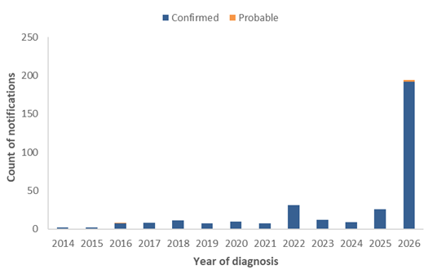
Figure 2: Notifications of diphtheria by month with 5-year* monthly rolling mean, Australia, 1 January 2025 to 11 May 2026
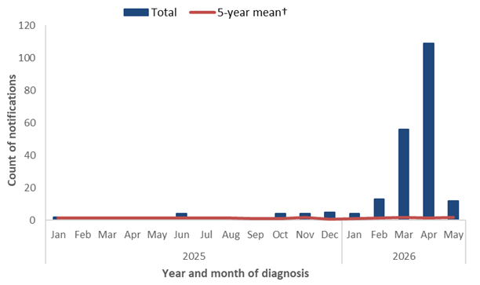
* 2025 rolling monthly mean based on the mean number of cases in the equivalent months during 2018, 2019 and 2022 to 2024. 2026 rolling monthly means are based on the mean number of cases in the equivalent months during 2019 and 2022 to 2025.
Figure 3: Notifications of diphtheria by month, Australia, 1 January 2014 to 11 May 2026
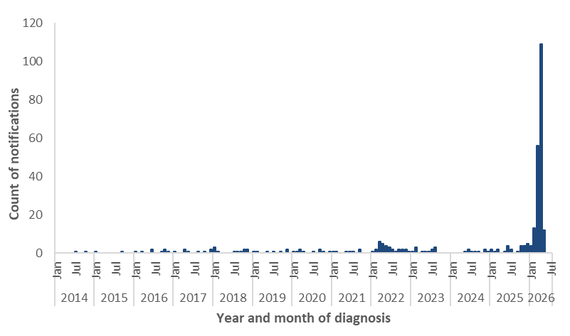

Species
Under the national case definition for diphtheria, a confirmed case requires isolation of toxigenic Corynebacterium diphtheriae or toxigenic C. ulcerans from the upper respiratory tract or skin lesion^{i}. In 2026, almost all confirmed cases were reported as C. diphtheriae (191/192), with one case of C. ulcerans diagnosed in late March this year, and no cases of unknown species reported (Figure 4).
Figure 4: Notifications of confirmed diphtheria* by species, Australia, 1 January 2014 to 11 May 2026
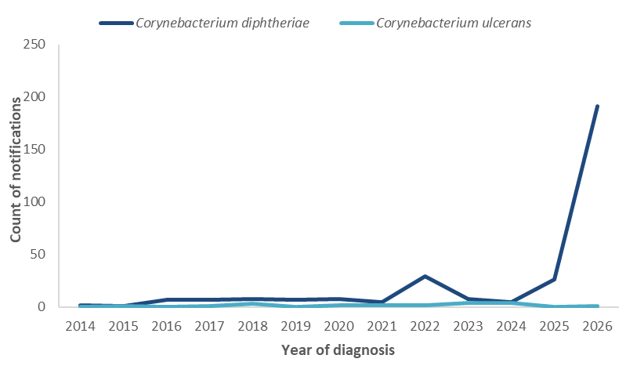
* Excludes cases with a confirmation status of ‘probable’.

Geographic distribution
Among cases reported in 2026, 60.3% (117/194) were reported in the Northern Territory, a third (36.6%; 71/194) in Western Australia, 2 cases in Queensland, and 4 cases in South Australia (Figure 5). Among locally acquired cases, there has been a notable increase in the proportion residing in ‘remote and very remote’ areas since 2021 (Figure 6). In 2026, among locally acquired cases (98.9%; 192/194), 81.8% resided in areas classified as ‘remote’ and ‘very remote’, while a further 15.1% resided in ‘outer regional’ areas. Over the past fortnight, newly notified cases have predominantly been identified in areas that have previously reported diphtheria infections.
Figure 5: Notifications of diphtheria by year and jurisdiction, Australia, 1 January 2014 to 11 May 2026
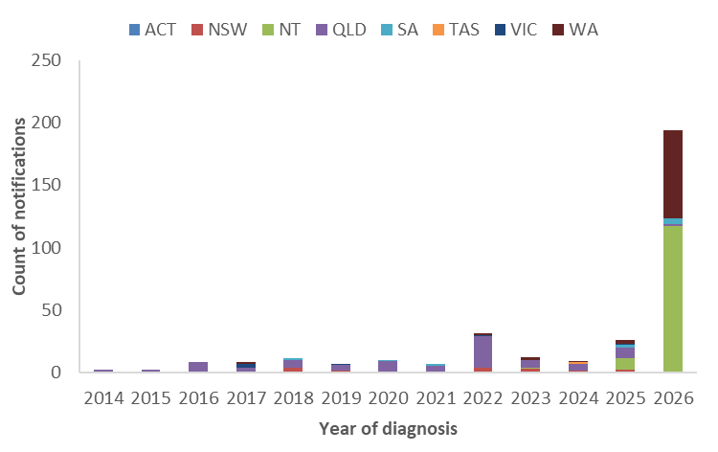
Figure 6: Notifications of locally acquired diphtheria* by year and remoteness area, 1 January 2020 to 11 May 2026
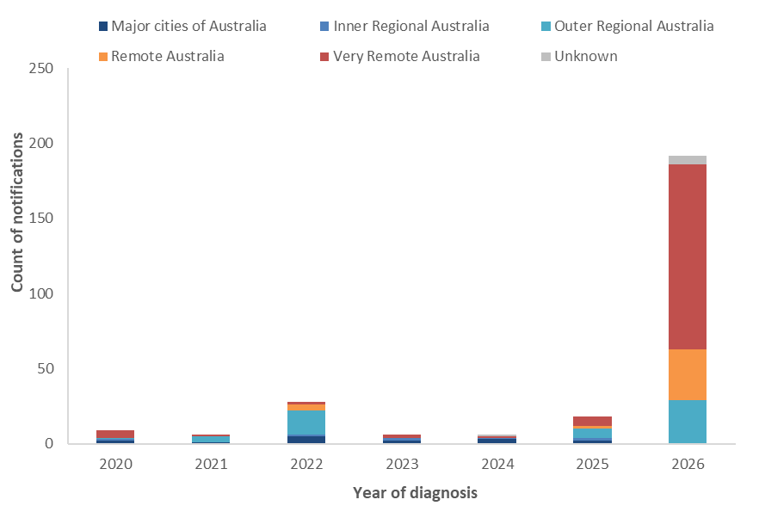
* Excludes cases acquired overseas.

Place of acquisition
By place of acquisition, between 2014 and 2019, the majority of diphtheria cases were acquired overseas (Figure 7), predominantly in the Western Pacific and South-East Asia regions. Since 2020, the majority of diphtheria notifications have been locally acquired. So far in 2026, 2 cases (1%; 2/194) are reported to have acquired their infection overseas.
Figure 7: Notifications of diphtheria by place of acquisition*, Australia, 1 January 2014 to 11 May 2026
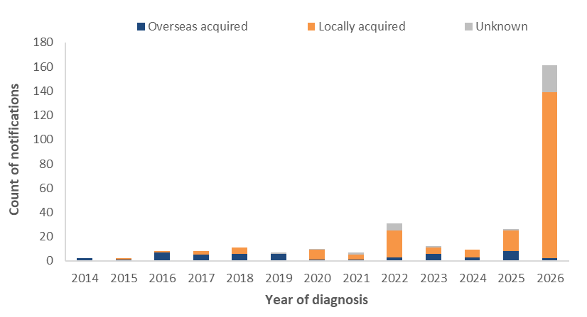
* The source of infection for 2026 cases are provisional and subject to change.
Since 2020, there have been 14 diphtheria clusters (with 2 or more cases) reported by jurisdictions, with 9 of these clusters reported in 2026. The largest epidemiologically linked clusters (10 to 16 cases) occurred in North Queensland with cases involved in these clusters spanning 2020 to 2023. The more recent clusters in 2026 have been in Western Australia, the Northern Territory and South Australia, with the size of these epidemiologically linked clusters ranging from 2 to 5 cases.
Genomic analysis of C. diphtheriae sequences uploaded to AusTrakka with date of collection from 2025 onwards, suggests that the recent Western Australia, Northern Territory and Queensland cases are genomically linked (Cluster 2:2:2) (Figure 8). Two additional clusters (Cluster 2:2:3 and 2:2:5) linked to the current outbreak at the broader genomic level (Cluster 2:2) have recently been identified, which includes a South Australian case. This genetic drift is not unexpected given the timeframe and geographic spread of cases. Previous analyses suggest that the main cluster (Cluster 2:2:2) appears to have descended from a 2020 to 2023 cluster in Queensland (Cluster 1:1:1), and the new clusters (2:2:3 and 2:2:5) have emerged from cluster 2:2:2. However, noting the small number of available intermediate sequences, the findings should be interpreted as evidence of shared genomic characteristics rather than definitive epidemiological evidence of linkage to the earlier Queensland cluster.
Figure 8: AusTrakka* SNP clustering of toxigenic C. diphtheriae sequences, 12 March 2020 to 23 April 2026
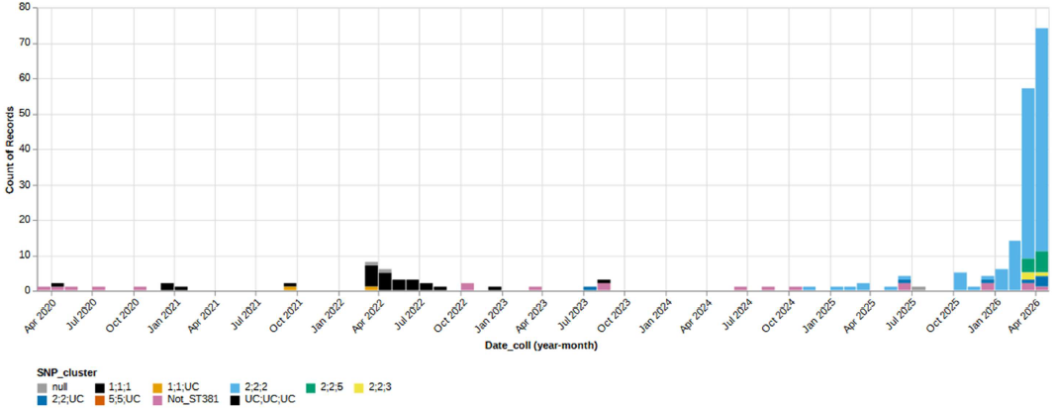
* AusTrakka Genomic Analysis Report ATOI26001 – Corynebacterium diphtheriae (12 May 2026).

Clinical presentation
Across Australia, from 2016 to 2025, most diphtheria notifications were reported as cutaneous diphtheria, with only a small number of respiratory diphtheria cases reported annually across most years during this period (Figure 9). The increase and upward trend in locally acquired cutaneous diphtheria cases during the latter part of this period may be attributable to changes in testing practices, including toxigenic testing, particularly of wounds. In 2022, respiratory diphtheria accounted for 19.4% (6/31) of cases, with all of these cases locally acquired.
In 2026, the predominant clinical presentation continues to be cutaneous diphtheria (69.1%; 134/194), with respiratory diphtheria accounting for 29.9% (58/194) of cases, and two cases reported with an unknown clinical presentation type. Over the past month, there has been an increase in the number and proportion of cases diagnosed as respiratory diphtheria (Figure 10).
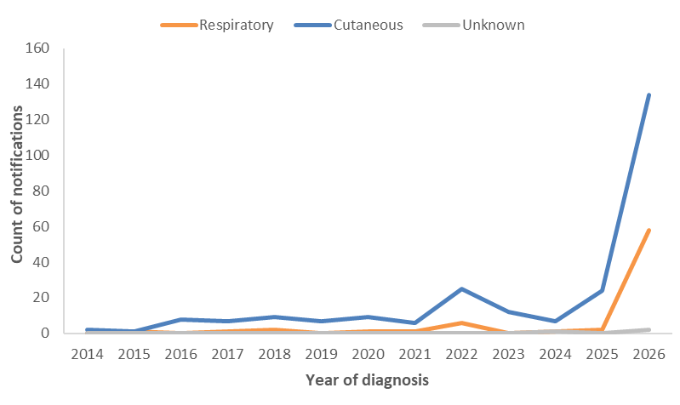
Figure 9: Notifications of diphtheria by clinical presentation, Australia, 1 January 2014 to 11 May 2026
Figure 10: Notifications of diphtheria by clinical presentation and month, Australia, 1 January 2025 to 11 May 2026
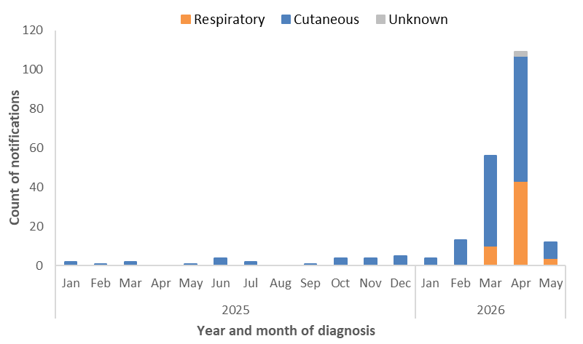

Age and sex
Since 2014, notifications of diphtheria have predominantly been reported among those aged 25 years and over, with variability in the proportion of cases reported among those in younger age groups since 2017 (Figure 11). The highest number of cases so far in 2026 are among those in the 25 to 44 years age group (Figure 12), with notification rates slightly higher among those aged 0 to 4 years and 15 to 24 years compared to those aged 25 to 44 years. So far in 2026, by clinical presentation, the median age of cutaneous diphtheria cases (31 years; IQR 18.3-42.8) has been higher compared to respiratory diphtheria cases (19 years; IQR 13.0-26.0), with this pattern consistent with previous years (Figure 12).
Between 2022 and 2025, the distribution of cases by sex was relatively balanced (52.5% males), with some variability by age group. This pattern has remained broadly consistent so far in 2026, with 43.3% (84/194) of cases among males.
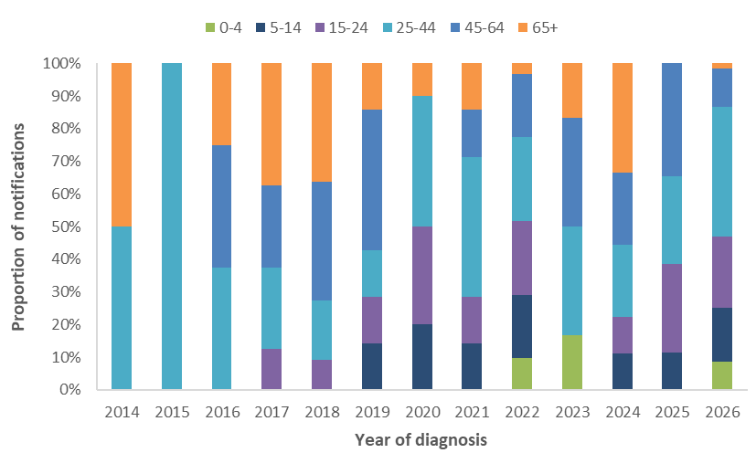
Figure 11: Proportion of diphtheria notifications by age group, Australia, 1 January 2014 to 11 May 2026

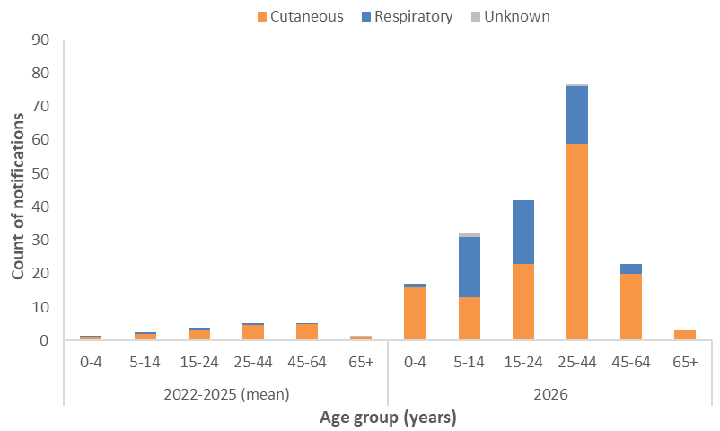
Figure 12: Notifications of diphtheria by age group and clinical presentation, Australia, 1 January 2022 to 11 May 2026

Indigenous status
Indigenous status completeness for diphtheria has remained consistently high, at over 99.0% across 2014 to 2026. Between 2014 and 2019, the proportion of diphtheria cases among Aboriginal and/or Torres Strait Islander people was around 10.5% of cases, noting that there were very few cases reported in 2014 and 2015 (n=4) (Figure 13). Between 2020 to 2022, which included multiple diphtheria clusters in North Queensland, the proportion of cases among Aboriginal and/or Torres Strait Islander people increased to 64.6%. So far in 2026, 93.8% (182/194) of cases have been reported among Aboriginal and/or Torres Strait Islander people.
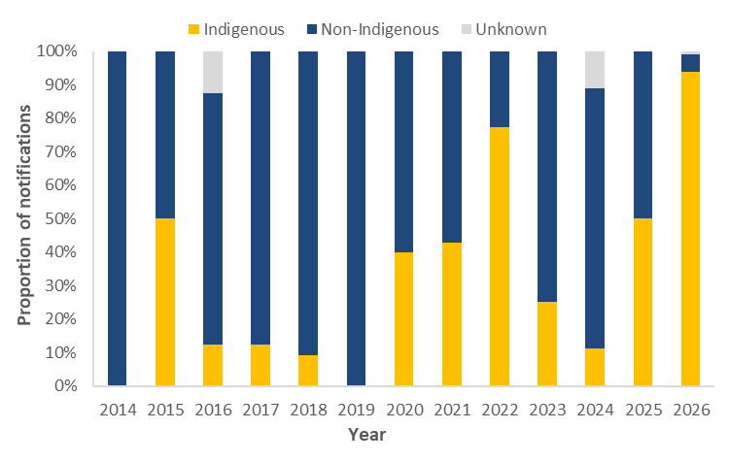
Figure 13: Proportion of diphtheria notifications by Indigenous status, Australia, 1 January 2014 to 11 May 2026

Severity
Between 2022 and 2025, just over a quarter (28.2%) of diphtheria notifications were reported as being hospitalised, with proportions of cases hospitalised higher among those with respiratory diphtheria. So far in 2026, a slightly lower proportion (24.7%; 48/194) of all diphtheria cases have been hospitalised. The proportion of respiratory diphtheria cases hospitalised (25.8%; 15/58) is similar to the proportion among cutaneous diphtheria cases (23.8%; 32/134). The proportion of cases hospitalised may vary over time and by clinical presentation type due either to true differences in disease severity or differences in the public health management of infections, including for infection control purposes.
The most recent confirmed diphtheria associated death was reported in 2018 and involved an unvaccinated adult who had respiratory diphtheria.

Vaccination status
The vaccination status among diphtheria cases has differed by clinical presentation type (Figure 14). Since 2022, a higher proportion of respiratory diphtheria cases (78.8%) had received 3 or more valid doses, compared with 59.9% of cutaneous diphtheria cases.
While vaccination provides strong protection against the severe effects of diphtheria toxin, it does not consistently prevent carriage or transmission of C. diphtheriae, regardless of whether the strain produces toxin or not.
Consistent with the National Immunisation Program and broader Australian Immunisation Handbook recommendations, the number of doses received tended to increase with increasing age (Figure 15). Since 2022, among diphtheria cases reported to have received at least 3 vaccine doses, the median number of years since last vaccine dose has typically been lower among cutaneous diphtheria cases (3.6 years) than among respiratory diphtheria cases (8.3 years) (Figure 16). For this same period, the median number of years since last vaccine dose was higher among hospitalised cases for both cutaneous diphtheria cases (5.0 years) and respiratory diphtheria cases (11.1 years).
More broadly, national diphtheria–tetanus–pertussis (DTP) vaccination coverage rates as at September 2025, based on the National Immunisation Program Schedule, was:
- 93.4% (range: 91.9% to 94.8%) among all children aged 5 years
- 94.7% (range: 92.9% to 96.3%) among Aboriginal and Torres Strait Islander children aged 5 years.
However, ‘fully immunised’ rates among the 5-year-old cohort, regardless of Indigenous status, have been gradually declining since peaking in 2020.

Figure 14: Notifications of diphtheria by vaccination status and clinical presentation type, Australia, 1 January 2014 to 11 May 2026
(a) Cutaneous diphtheria | (b) Respiratory diphtheria
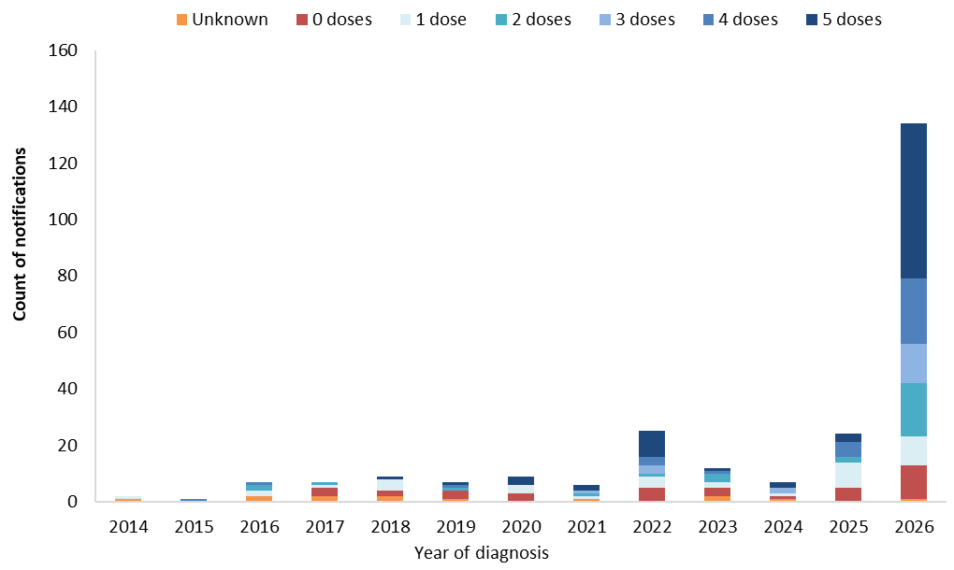 | 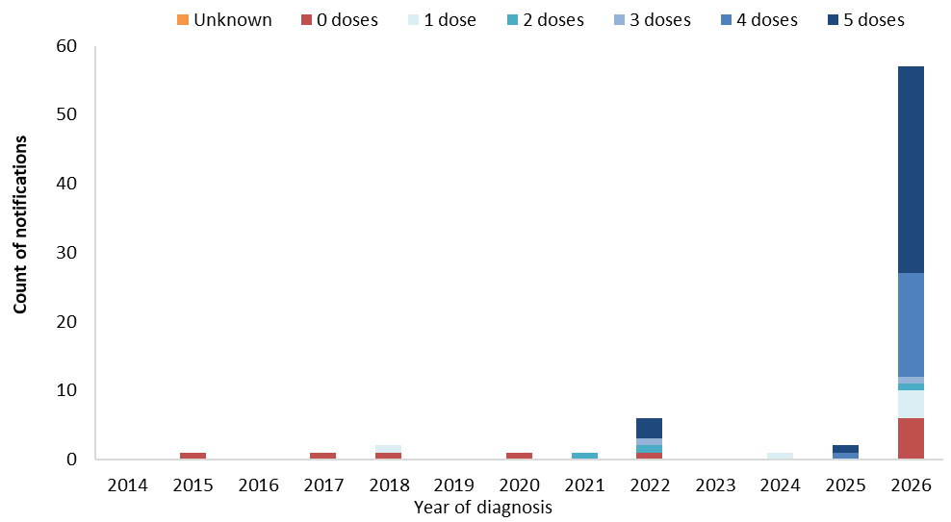
Figure 15: Notifications of diphtheria by vaccination status, clinical presentation type and age group, Australia, 1 January 2022 to 11 May 2026
(a) Cutaneous diphtheria | (b) Respiratory diphtheria*
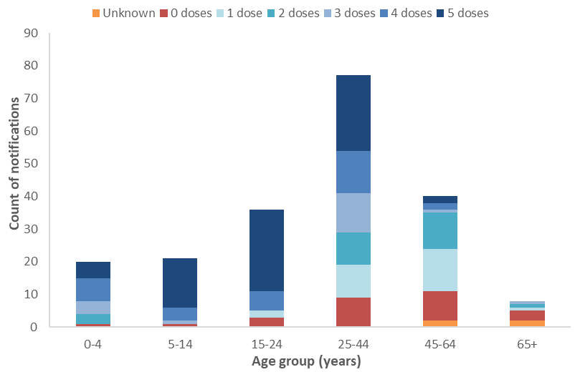 | 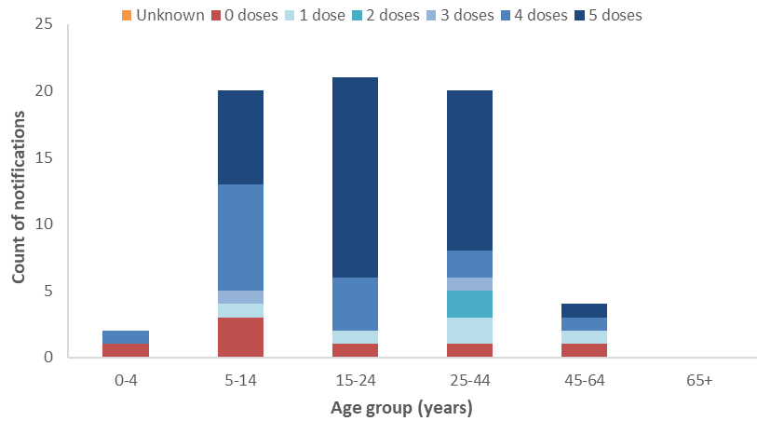
Figure 16: Distribution of years since last vaccine dose for notifications of diphtheria with at least 3 doses*, by clinical presentation type, Australia, 1 January 2014 to 11 May 2026
(a) Cutaneous diphtheria | (b) Respiratory diphtheria
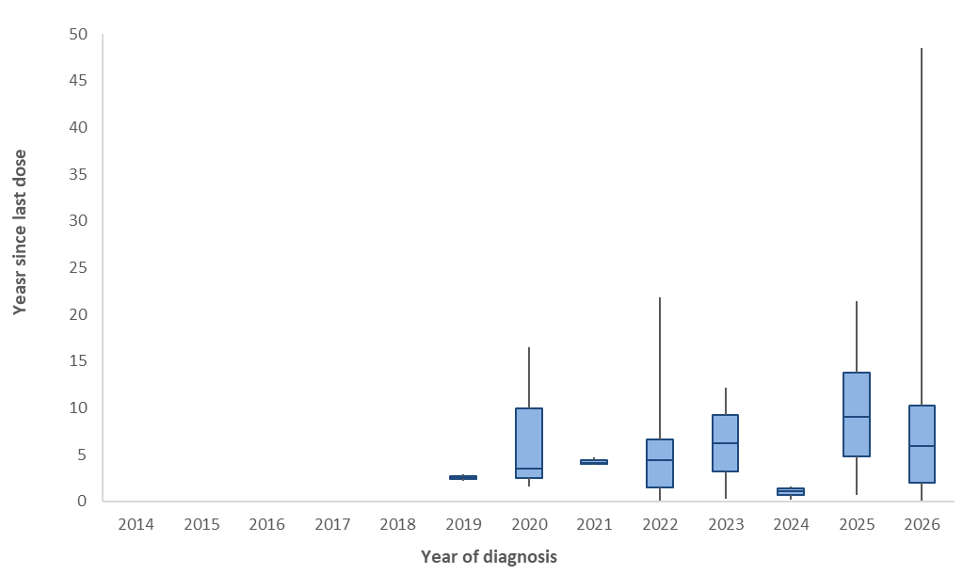 | 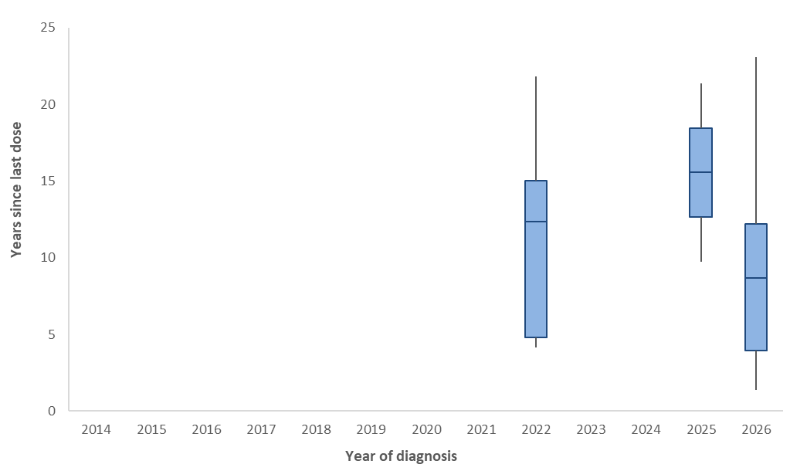
* Periods where there were less than 2 cases that had received 3 or more vaccine doses are not shown.

Epidemiological characteristics of diphtheria cases
Table 1: Epidemiological summary of diphtheria cases in Australia, 1 January 2025 to 11 May 2026
 | 2026  YTD* | 2025  YTD* | 2025 | 2022–2025 YTD* (mean) | 2022–2025 (mean)
Total | 194 | 5 | 26 | 6.5 | 19.5
Confirmation status
Confirmed | 192 (99%) | 5 (100%) | 26 (100%) | 6.5 (100%) | 19.5 (100%)
Probable | 2 (1%) | 0 (0%) | 0 (0%) | 0.0 (0%) | 0.0 (0%)
Species
C. diphtheriae | 193 (99%) | 5 (100%) | 26 (100%) | 6.0 (92%) | 17.0 (87%)
C. ulcerans | 1 (1%) | 0 (0%) | 0 (0%) | 0.5 (8%) | 2.5 (13%)
State
ACT | 0 (0%) | 0 (0%) | 0 (0%) | 0.0 (0%) | 0.0 (0%)
NSW | 0 (0%) | 1 (20%) | 2 (8%) | 0.8 (12%) | 2.5 (13%)
NT | 117 (60%) | 0 (0%) | 9 (35%) | 0.0 (0%) | 2.5 (13%)
QLD | 2 (1%) | 3 (60%) | 9 (35%) | 5.0 (77%) | 11.5 (59%)
SA | 4 (2%) | 0 (0%) | 2 (8%) | 0.0 (0%) | 0.5 (3%)
TAS | 0 (0%) | 0 (0%) | 0 (0%) | 0.0 (0%) | 0.3 (1%)
VIC | 0 (0%) | 0 (0%) | 1 (4%) | 0.0 (0%) | 0.5 (3%)
WA | 71 (37%) | 1 (20%) | 3 (12%) | 0.8 (12%) | 1.8 (9%)
Remoteness area
Major cities | 1 (1%) | 1 (20%) | 6 (23%) | 1.3 (19%) | 5.3 (27%)
Regional areas | 30 (15%) | 2 (40%) | 11 (42%) | 4.0 (62%) | 9.5 (49%)
Remote areas | 157 (81%) | 2 (40%) | 9 (35%) | 1.3 (19%) | 4.5 (23%)
Unknown | 6 (3%) | 0 (0%) | 0 (0%) | 0.0 (0%) | 0.3 (1%)
Place of acquisition
Overseas acquired | 2 (1%) | 2 (40%) | 8 (31%) | 1.3 (19%) | 5.0 (26%)
Locally acquired | 181 (93%) | 2 (40%) | 17 (65%) | 4.5 (69%) | 12.5 (64%)
Unknown | 11 (6%) | 1 (20%) | 1 (4%) | 0.8 (12%) | 2.0 (10%)
Clinical manifestation
Cutaneous | 134 (69%) | 4 (80%) | 24 (92%) | 6.0 (92%) | 17.0 (87%)
Respiratory | 58 (30%) | 1 (20%) | 2 (8%) | 0.5 (8%) | 2.3 (12%)
Unknown | 2 (1%) | 0 (0%) | 0 (0%) | 0.0 (0%) | 0.3 (1%)
Age (years)
Median (IQR) | 26.0 (14.3-38.0) | 14.0 (11.0-15.0) | 36.5 (19.8-48.5) | 23.0 (18.7-34.4) | 39.4 (22.8-52.8)
Age group (years)
0-4 | 17 (9%) | 0 (0%) | 0 (0%) | 0.5 (8%) | 1.3 (6%)
5-14 | 32 (16%) | 3 (60%) | 3 (12%) | 1.8 (27%) | 2.5 (13%)
15-24 | 42 (22%) | 2 (40%) | 7 (27%) | 1.3 (19%) | 3.8 (19%)
25-44 | 77 (40%) | 0 (0%) | 7 (27%) | 2.0 (31%) | 5.3 (27%)
45-64 | 23 (12%) | 0 (0%) | 9 (35%) | 0.8 (12%) | 5.3 (27%)
65+ | 3 (2%) | 0 (0%) | 0 (0%) | 0.3 (4%) | 1.5 (8%)
Sex
Male | 84 (43%) | 2 (40%) | 15 (58%) | 3.3 (50%) | 10.3 (53%)
Female | 110 (57%) | 3 (60%) | 11 (42%) | 3.3 (50%) | 9.3 (47%)
Indigenous status
Indigenous | 182 (94%) | 3 (60%) | 13 (50%) | 4.8 (73%) | 10.3 (53%)
Non-Indigenous | 10 (5%) | 2 (40%) | 13 (50%) | 1.8 (27%) | 9.0 (46%)
Unknown | 2 (1%) | 0 (0%) | 0 (0%) | 0.0 (0%) | 0.3 (1%)
Severity
Hospitalised | 48 (25%) | 1 (20%) | 10 (38%) | 1.5 (23%) | 5.5 (28%)
Died | 0 (0%) | 0 (0%) | 0 (0%) | 0.0 (0%) | 0.0 (0%)
Vaccination status
0 doses | 18 (9%) | 1 (20%) | 5 (19%) | 1.3 (19%) | 3.8 (19%)
1 dose | 14 (7%) | 0 (0%) | 9 (35%) | 0.8 (12%) | 4.5 (23%)
2 doses | 20 (10%) | 0 (0%) | 2 (8%) | 0.5 (8%) | 1.8 (9%)
3 doses | 15 (8%) | 0 (0%) | 0 (0%) | 0.8 (12%) | 1.5 (8%)
4 doses | 38 (20%) | 2 (40%) | 6 (23%) | 1.0 (15%) | 2.5 (13%)
5 doses | 88 (45%) | 2 (40%) | 4 (15%) | 2.3 (35%) | 4.8 (24%)
Unknown | 1 (1%) | 0 (0%) | 0 (0%) | 0.0 (0%) | 0.8 (4%)
* YTD represents the year-to-date period of 1 January to 11 May.

CDNA diphtheria case definition: https://www.cdc.gov.au/system/files/2025-09/diphtheria-surveillance-case-definition_0.pdf
1 January to 11 May

