Australian Respiratory Surveillance Report

Key messages
This report presents a national update on acute respiratory infections, including coronavirus disease 2019 (COVID-19), influenza and respiratory syncytial virus (RSV). It focuses on the current reporting period (20 April to 3 May 2026) and earlier severity reporting periods (up to 19 April 2026). These key messages do not provide detailed information on age distribution, jurisdictional patterns, or comparisons with previous years. This analysis and supporting data are available in the full report.
In the community: In the last fortnight, self-reported influenza-like illness decreased slightly among people who contacted the national health helpline but remained stable among those who took part in community surveys. In the last fortnight, COVID-19, influenza and RSV notifications all decreased. While a consistent seasonal trend for COVID-19 has not yet been established, a decrease in influenza and RSV notifications at this time of year is unusual when compared to trends observed in recent years.
In general practice: In the last fortnight, influenza-like illness consultation rates at sentinel general practice sites decreased slightly and are consistent with usual interseasonal levels. Rhinovirus / enterovirus was the most commonly detected respiratory pathogen among tested influenza-like illness patients.
In hospitals: In the last severity reporting fortnight, admissions to sentinel hospitals with severe acute respiratory infections decreased slightly and most admissions in the last severity fortnight were with RSV. Sentinel intensive care admissions with severe acute respiratory infections increased in the most recent severity reporting period, and most admissions in the last severity period were with RSV. In the last fortnight, the average daily intensive care bed occupancy for patients in droplet or airborne isolation decreased slightly.
Deaths: COVID-19 has been the leading cause of acute respiratory infection mortality across the majority of 2020–2025; however, between August 2025 and January 2026 there were more deaths involving influenza (both due to and with) each month than deaths involving COVID-19. The mortality burden of acute respiratory infections is highest in older adults.
In laboratories: In the last fortnight, test positivity for RSV increased, while test positivity for COVID-19 and influenza decreased slightly. The SARS-CoV-2 variant under monitoring, NB.1.8.1 was the most common circulating SARS-CoV-2 variant.
Vaccine coverage, effectiveness and match: In the last year, 9.2% of adults have received a COVID-19 vaccine. Nationally, influenza vaccine coverage is 14.0% for 2026 so far, noting that the 2026 seasonal influenza vaccine has only been available in Australia since April and coverage is expected to increase over the coming months. Most influenza isolates (>87%) are a good match for the 2026 southern hemisphere vaccine components. The National RSV Mother and Infant Protection Program continues. To date, 245,364 Abrysvo doses have been administered, and nirsevimab uptake over the last six months was 4.6% in infants aged up < 8 months.

Australian Respiratory Surveillance Report
This report was prepared by Emily Schembri, Suzie Whitehead, Lauren Welsh, Tracy Tsang and Siobhan St George on behalf of the Australian Centre for Disease Control (CDC). We thank the staff and participants from the surveillance systems who contribute data for acute respiratory illness surveillance across Australia.
The report presents a national overview of acute respiratory infections in Australia, drawing information from several different surveillance systems. These surveillance systems help us to understand the distribution of acute respiratory illnesses in the community, the severity of infections including which populations might be at risk, and the impact of acute respiratory illnesses on the community and health system in Australia. Surveillance indicators presented in this report are based on the Australian National Surveillance Plan for COVID-19, Influenza, and RSV. A summary of data considerations for this report are provided below:
- Due to the dynamic nature of the surveillance systems used in this report, surveillance data are considered preliminary and subject to change as updates are received, with the most recent weeks considered particularly incomplete. Data in this report may vary from data reported in other national reports and reports by states and territories.
- Data in this report are presented by date of event (survey, diagnosis, admission or death) and by the International Organization for Standardization (ISO) week date system, with weeks defined as seven-day periods which begin on a Monday and end on a Sunday. The ISO week date system is used to support trends comparisons over time more effectively. The current reporting period includes 20 April to 3 May 2026 and where comparisons to the previous fortnight are made, this includes 6 April to 19 April 2026.
- In Australia, states and territories (the Australian Capital Territory [ACT], New South Wales [NSW], the Northern Territory [NT], Queensland [Qld], South Australia [SA], Tasmania [Tas], Victoria [Vic] and Western Australia [WA]) report notified cases to the National Notifiable Diseases Surveillance System (NNDSS) based on the Australian national surveillance case definitions. NNDSS data are analysed and reported based on diagnosis date, which is the true onset date of a case if known, otherwise it is the earliest of the specimen date, the notification date or the notification received date. The NNDSS data for this report were extracted on 6 May 2026.
- Notification rates per 100,000 population presented in this report are for the given time period, with population data are based on the Australian Bureau of Statistics (ABS) Estimated Resident Population (ERP) for the reference period June 2024, released 12 December 2024 unless stated otherwise.
- To account for the lag in collection and provision of severity data from some surveillance systems, and for the time delay between illness onset and the development of severe disease outcomes, cases with an admission date or a diagnosis date in the last two weeks are excluded from severity analyses for hospitalisations and intensive care admissions. As such, the severity reporting periods are two weeks behind the end of the current reporting period. For this report, severity reporting includes data from 6 April to 19 April 2026 unless specified otherwise. Where comparisons to the previous severity fortnight are made this includes 23 March to 5 April 2026.
- Death registrations from the ABS Provisional Mortality Statistics are now used as the primary data source for measuring acute respiratory infection associated deaths. The ABS mortality data is sourced from the Registry of Births, Deaths and Marriages and is separate from the NNDSS. Registration-based mortality data needs time to be received and processed, and so mortality statistics in this report may lag by at least two months.
- The responsibility for the interpretation and use of the material lies with the reader. The Australian CDC does not accept liability for any injury or loss or damage arising from the use of, or reliance upon, the content of the report. Analysis and reporting outputs were produced using R Statistical Software v4.3.1.
- For further information about this report, including data sources and considerations refer to the Technical Supplement or contact respiratory.surveillance@cdc.gov.au.

Community surveillance
Community surveillance monitors respiratory illnesses in the community, providing information on the number of people reporting respiratory symptoms, testing practices, and the impact of respiratory illnesses. Community surveillance includes notification data obtained from laboratory tests for infections. Infections that are diagnosed and notified are only a subset of the total number of infections occurring in the community.
- In the last fortnight (20 April to 3 May 2026), the rate of Healthdirect helpline callers with influenza-like illness (326 per 1,000 callers per fortnight) decreased slightly compared to the previous fortnight (332 per 1,000 callers per fortnight) (Figure 1).
- Influenza-like illness rates in helpline callers have remained relatively stable across 2026 and are very similar to rates observed in 2025 (Figure 1).
Figure 1: Rate of influenza-like illness per 1,000 helpline callers by year and week of call*, Australia†, 22 March 2023 to 3 May 2026
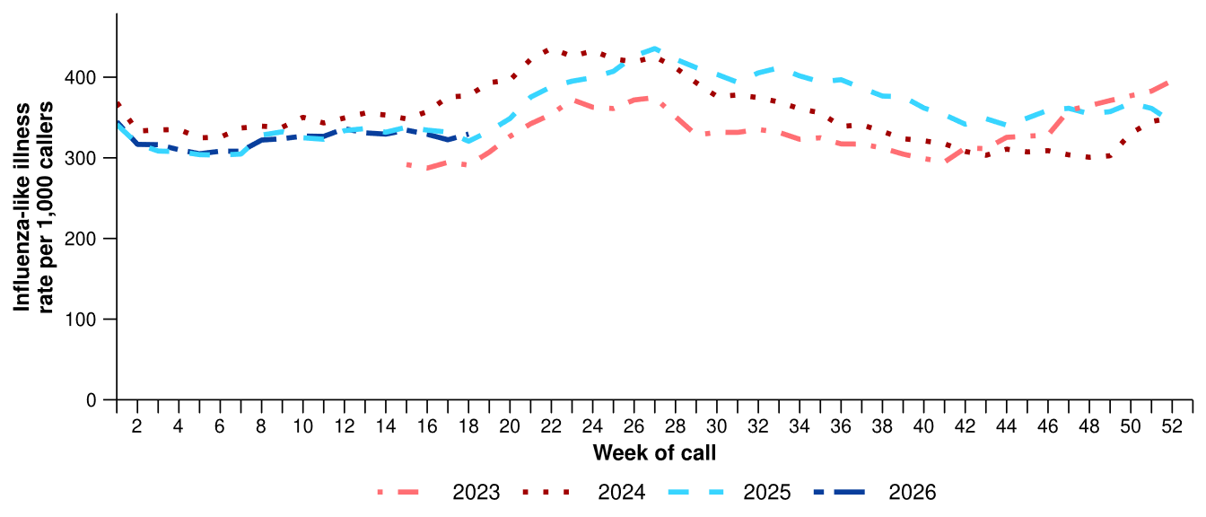
Source: Healthdirect Australia
* Healthdirect data prior to 22 March 2023 are unavailable as prior to this date a different data collection method was used.
† The Healthdirect helpline operates in all states and territories except Qld; therefore influenza-like illness trends will not be representative of Qld and may be underrepresented. See the Technical Supplement for more information.
- In the last fortnight, the rate of Healthdirect helpline callers with influenza-like illness referred to seek urgent medical care (174 per 1,000 callers per fortnight) was similar to the previous fortnight (172 per 1,000 callers per fortnight).
  - Callers referred to seek urgent medical care include those referred to call triple zero, attend a hospital emergency department, contact a virtual emergency department, urgent care clinic or see a general practitioner within two hours.
- Referral categories for callers with influenza-like illness varied across states in the last fortnight. Recommendation to attend the emergency department (ED) was the most common referral category in ACT, NT, SA, Tas and WA, while recommendation to seek other urgent medical care was most used in NSW and Vic (Figure 2).

Figure 2: Proportion of referral categories* for helpline callers with influenza-like illness by jurisdiction† and call date, Australia, 1 January to 3 May 2026
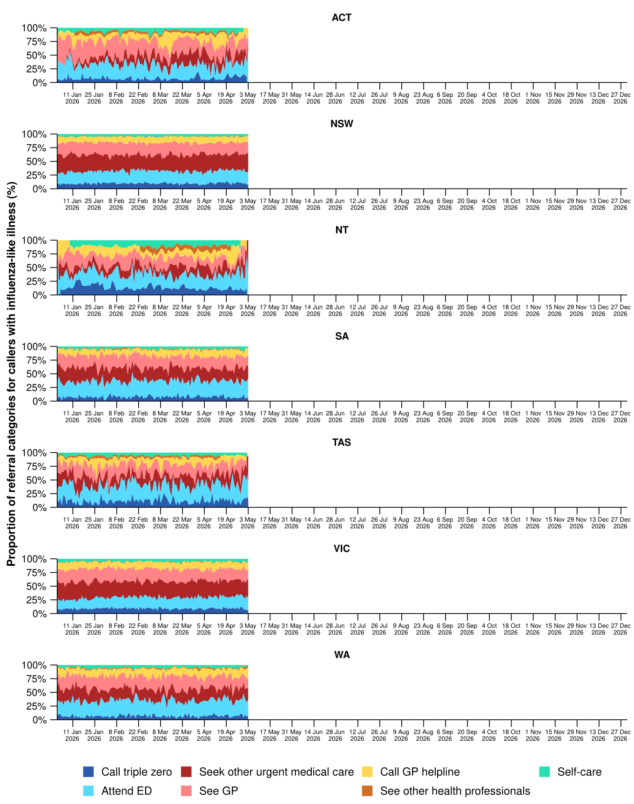
Source: Healthdirect Australia
* See other health professionals category includes pharmacist, dentist, mental health provider, primary maternity care, poison information centre or other.
† The Healthdirect helpline operates in all states and territories except Qld; therefore influenza-like illness referral trends are not provided for Qld. See the Technical Supplement for more information.

- In the last fortnight, the percentage of FluTracking participants who reported new fever and cough symptoms (0.9%) remained stable from the previous fortnight (0.9%) (Figure 3).
- The weekly percentage of FluTracking participants reporting new fever and cough symptoms has remained relatively stable with minor fluctuations across March and April. The weekly percentage of FluTracking participants reporting new fever and cough symptoms over the last fortnight was lower than the trend observed in previous years and the historical five-year average (Figure 3).
- In the last fortnight, a slightly lower percentage of First Nations FluTracking participants reported new fever and cough symptoms (0.8%) compared with the previous fortnight (0.9%). These findings could be impacted by smaller sample sizes and the representativeness of the data. For more detailed trends, please refer to figure 2 in the FluTracking reports.
Figure 3: Age standardised percentage of survey participants reporting new fever and cough symptoms compared with the five-year average* by year and week of survey, Australia, 2023 to 3 May 2026
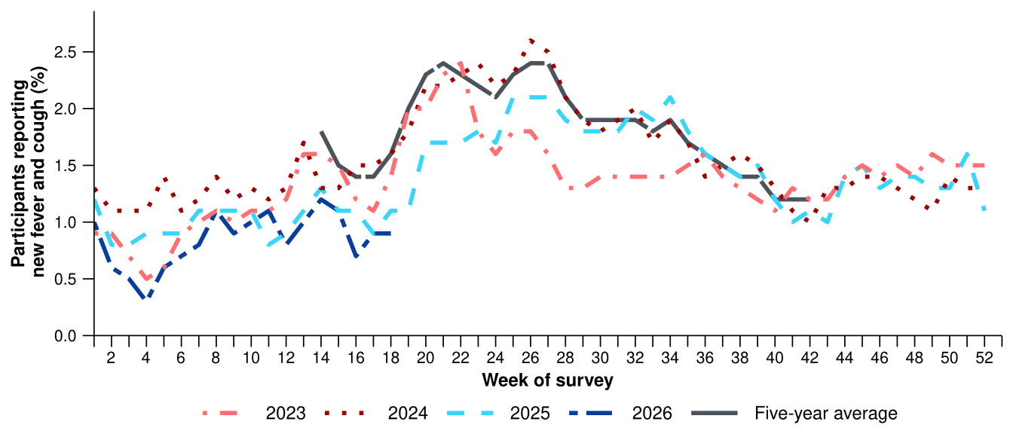
Source: FluTracking
* From 2020, FluTracking expanded their data capture period to year-round. Data before May and after October for any year before 2020 are not available for historical comparisons. The years 2020 and 2021 are excluded when comparing the current season to historical periods when influenza virus has circulated without public health restrictions. As such, the five-year average includes the years 2019 and 2022 to 2025.
- The average percentages of FluTracking participants reporting taking three or more days off work or normal duties, or seeking medical advice or care, due to fever and cough symptoms in 2026 are both lower than the same period in previous years (Table 1).
Table 1: Percentage of FluTracking participants reporting new fever and cough symptoms plus three or more days off work or normal duties or seeking medical advice or care*, Australia, up to 19 April† for 2023–2026
 | 2023 | 2024 | 2025 | 2026
Reported three or more days off work or normal duties | 50.5% | 50.6% | 47.6% | 44.3%
Reported seeking medical advice or care* | 35.3% | 31.9% | 31.6% | 30.1%
Source: FluTracking
* Includes those who sought medical advice from a general practitioner, Aboriginal and Torres Strait Islander health clinic, COVID-19 clinic, emergency department, or were admitted to hospital for fever and cough.
† While FluTracking data are collected in real time, data presented here are subject to a two week reporting delay to account for the time delay between illness onset and the development of severe disease outcomes.
- Self-reported severe acute respiratory syndrome coronavirus 2 (SARS-CoV-2) polymerase chain reaction (PCR) positivity has varied considerably this year, peaking in late February to early March at 27.6% per week (Figure 4a). While self-reported SARS-CoV-2 rapid antigen test (RAT) positivity has remained relatively low and stable since the start of the year, there was a small increase in the last fortnight compared with the previous fortnight (Figure 4b).
- Self-reported influenza PCR positivity peaked at 40.0% per week in late January. Self-reported influenza PCR positivity was the lowest at 6.2% in early-March with some week-on-week variation. In the last fortnight, self-reported influenza PCR positivity was 18.8% per week (Figure 4a). Self-reported influenza RAT positivity has followed a similar decline from January down to 3.6% per week in late March and has since remained relatively low and stable (Figure 4b).
- Self-reported RSV PCR positivity has fluctuated in 2026, peaking at 18.8% per week this fortnight (Figure 4a). Self-reported RSV RAT positivity has also fluctuated, peaking at 11.8% per week in late January with a second, smaller peak of 10.2% per week in mid-February, but has since remained relatively low and stable (Figure 4b).
- For more detailed testing and self-reported positivity trends, please refer to the FluTracking reports.
Figure 4a: Self-reported PCR test positivity* among FluTracking participants with fever and cough symptoms by pathogen week of survey, Australia, 1 January to 3 May 2026
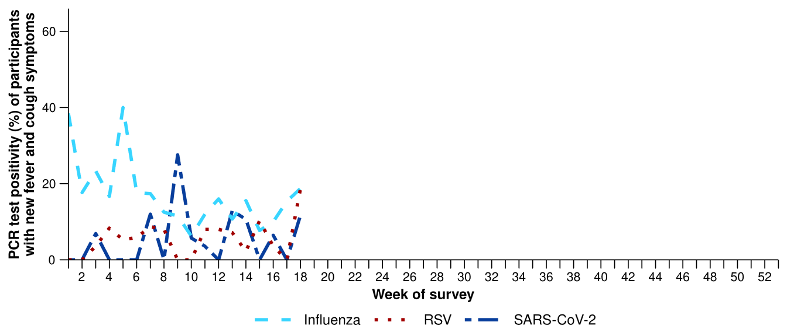
Source: FluTracking
* Denominator is based on participants who self-reported fever and cough symptoms and had a PCR test. Please refer to the Technical Supplement for more details.
Figure 4b: Self-reported RAT positivity* among FluTracking participants with fever and cough symptoms by pathogen and week of survey, Australia, 1 January to 3 May 2026
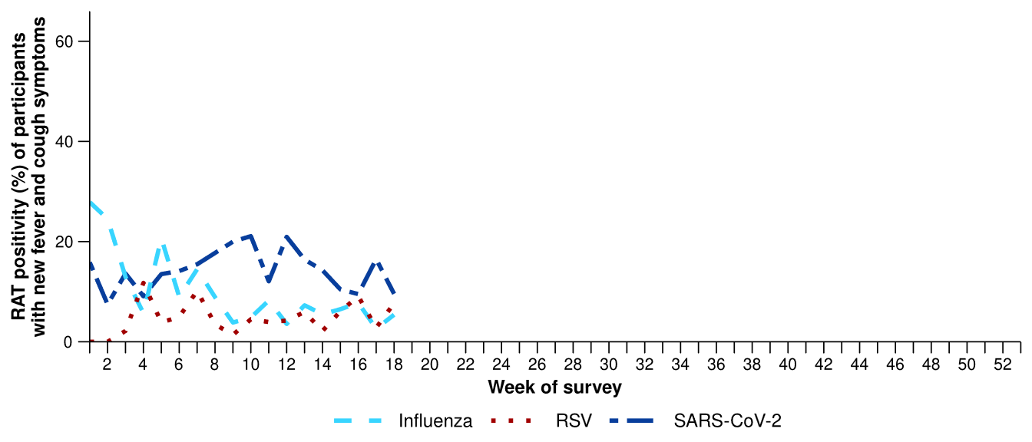
Source: FluTracking
* Denominator is based on participants who self-reported fever and cough symptoms and had a RAT. Please refer to the Technical Supplement for more details.
- In the last fortnight (20 April to 3 May 2026), there was a 5.7% decrease in COVID-19 cases, a 13.7% decrease in influenza cases, and a 11.0% decrease in RSV cases compared to the previous fortnight. While a consistent seasonal trend for COVID-19 has not yet been established, the decrease in influenza and RSV notifications at this time of year is unusual when compared to trends observed in recent years.
Table 2: Notified cases and notification rate per 100,000 population by disease, five-year age group, and jurisdiction*, Australia, 1 January to 3 May 2026
 | COVID-19 |  |  | Influenza |  |  | RSV
 | Reporting  period  (n) | Year to  date  (n) | Year to  date  (rate) | Reporting  period  (n) | Year to  date  (n) | Year to  date  (rate) | Reporting  period  (n) | Year to  date  (n) | Year to  date  (rate)
Age group (years)
0–4 | 569 | 5,472 | 363 | 269 | 3,628 | 240 | 2,593 | 15,709 | 1,041
5–9 | 98 | 1,775 | 110 | 198 | 2,888 | 179 | 186 | 1,579 | 98
10–14 | 61 | 1,427 | 85 | 121 | 2,101 | 125 | 82 | 746 | 45
15–19 | 111 | 1,160 | 70 | 82 | 2,046 | 123 | 104 | 812 | 49
20–24 | 117 | 1,108 | 62 | 59 | 1,986 | 111 | 104 | 789 | 44
25–29 | 150 | 1,297 | 65 | 70 | 1,653 | 83 | 109 | 862 | 43
30–34 | 157 | 1,671 | 82 | 82 | 1,492 | 73 | 169 | 1,049 | 51
35–39 | 201 | 1,777 | 90 | 87 | 1,445 | 73 | 137 | 957 | 48
40–44 | 183 | 1,634 | 88 | 83 | 1,434 | 77 | 127 | 837 | 45
45–49 | 140 | 1,322 | 81 | 67 | 1,219 | 75 | 118 | 917 | 56
50–54 | 134 | 1,300 | 77 | 71 | 1,164 | 69 | 133 | 1,077 | 64
55–59 | 179 | 1,312 | 86 | 64 | 1,212 | 79 | 191 | 1,307 | 85
60–64 | 150 | 1,256 | 82 | 53 | 1,223 | 80 | 190 | 1,320 | 86
65–69 | 161 | 1,222 | 90 | 57 | 1,262 | 93 | 180 | 1,294 | 95
70–74 | 196 | 1,429 | 122 | 59 | 1,211 | 103 | 211 | 1,371 | 117
75+ | 820 | 6,217 | 287 | 194 | 3,510 | 162 | 704 | 4,369 | 202
Jurisdiction
ACT | 36 | 321 | 68 | 12 | 322 | 68 | 55 | 243 | 51
NSW | 1,600 | 13,954 | 164 | 660 | 10,358 | 122 | 2,820 | 17,165 | 202
NT | 18 | 162 | 64 | 50 | 592 | 232 | 37 | 676 | 265
Qld | 671 | 7,976 | 143 | 318 | 8,994 | 161 | 1,169 | 10,006 | 179
SA | 235 | 2,554 | 136 | 107 | 1,730 | 92 | 157 | 976 | 52
Tas | 54 | 379 | 66 | 15 | 318 | 55 | 45 | 358 | 62
Vic | 623 | 4,924 | 71 | 391 | 5,370 | 77 | 830 | 4,127 | 59
WA | 191 | 1,120 | 38 | 63 | 1,803 | 61 | 226 | 1,448 | 49
Total | 3,428 | 31,390 | 115 | 1,616 | 29,487 | 108 | 5,339 | 34,999 | 129
Source: National Notifiable Diseases Surveillance System (NNDSS). RSV notification data are unavailable for Tas from 2 May 2026.
* Total includes cases with missing age.
- In the last fortnight, there were 3,428 COVID-19 cases, a 5.7% decrease from the 3,636 cases notified in the previous fortnight (Table 2; Figure 5).
- In the year to date, there have been 31,390 COVID-19 cases, 45.7% fewer than the 57,771 cases notified over the same period in 2025 (Table 2; Figure 5). There is still no consistent seasonal pattern for COVID-19.
- In the last fortnight, COVID-19 notification rates varied across jurisdictions compared with the previous fortnight, with COVID-19 notification rates decreasing in the ACT, NSW, Qld and SA but increasing in the NT, Vic and WA. COVID-19 notification rates remained stable in Tas (Figure 6).
Figure 5: Notified COVID-19 cases by year and week of diagnosis, Australia, 2023 to 3 May 2026
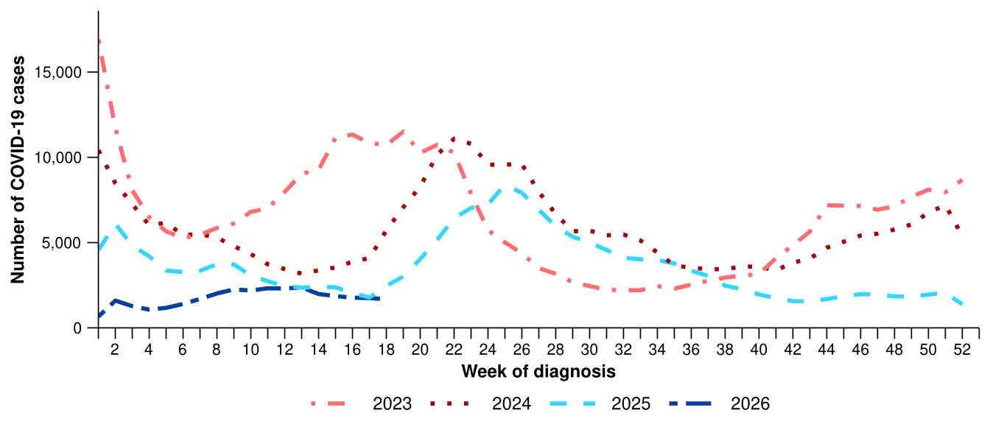
Source: National Notifiable Diseases Surveillance System (NNDSS)
Figure 6: Notification rates per 100,000 population for COVID-19 cases by state or territory and week of diagnosis, Australia, 1 January to 3 May 2026
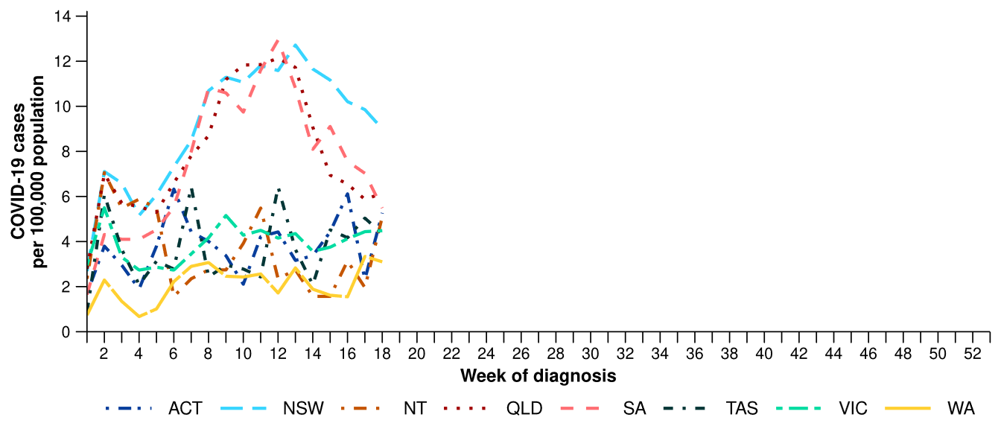
Source: National Notifiable Diseases Surveillance System (NNDSS)

- In the last fortnight, there were 1,616 influenza cases, a 13.7% decrease from 1,872 cases notified in the previous fortnight (Table 2; Figure 7). The number of influenza cases notified in the last fortnight was considerably lower than observed in recent years and the five-year average at this time.
- In the year to date, there have been 29,487 influenza cases, 58.9% fewer than the 71,755 cases notified over the same period in 2025 (Table 2; Figure 7). This decrease could potentially reflect greater population immunity following the higher than usual influenza activity in late 2025 and an ongoing impact of reduced overseas importations due to earlier influenza activity in some northern hemisphere countries in their 2025-26 influenza season.
- In the last fortnight, influenza notification rates decreased or remained relatively stable across most jurisdictions compared with the previous fortnight, except in the NT, Tas and Vic where notification rates increased (Figure 8).

Figure 7: Notified influenza cases and five-year average* by year and week of diagnosis, Australia, 2023 to 3 May 2026
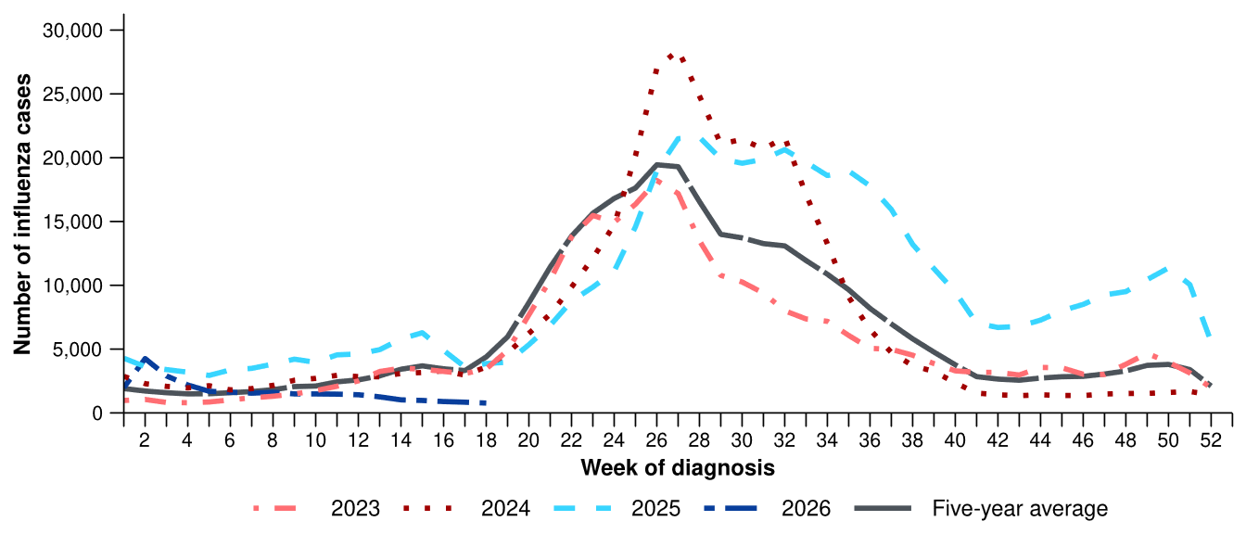
Source: National Notifiable Diseases Surveillance System (NNDSS)
* The years 2020 and 2021 are excluded when comparing the current season to historical periods when influenza virus has circulated without public health restrictions. As such, the five-year average includes the years 2019 and 2022 to 2025. Please refer to the Technical Supplement for interpretation of the five-year average.
Figure 8: Notification rates per 100,000 population for influenza cases by state or territory and week of diagnosis, Australia, 1 January to 3 May 2026
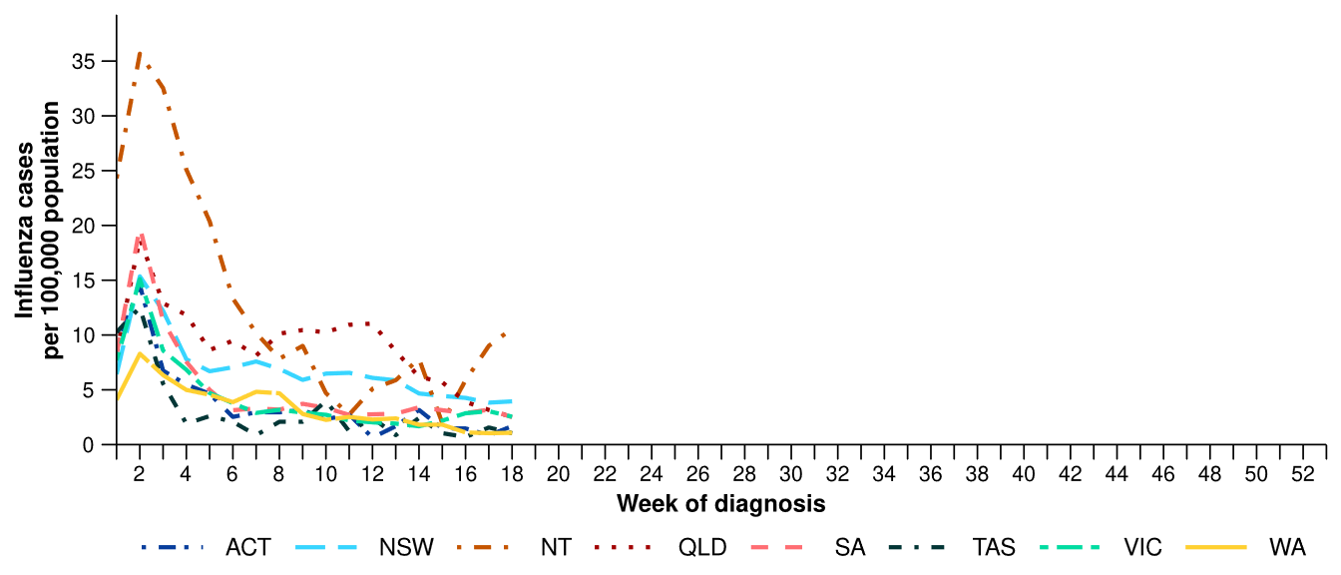
Source: National Notifiable Diseases Surveillance System (NNDSS)

- In the last fortnight, there were 1,136 influenza A cases, a 24.6% decrease from 1,506 influenza A cases notified in the previous fortnight, and there were 459 influenza B cases, a 31.1% increase from 350 influenza B cases notified in the previous fortnight.
- Among influenza A cases with subtype information available there were:
  - 11 influenza A(H1N1) cases notified in the last fortnight, a 45.0% decrease from 20 cases notified in the previous fortnight.
  - 6 influenza A(H3N2) cases notified in the last fortnight, a 94.1% decrease from 101 cases notified in the previous fortnight.
- In the year to date, influenza A(Unsubtyped) has accounted for most cases across all age groups, with the number of influenza B notifications remaining relatively consistent since early February (Figure 9). Trends in influenza subtypes are influenced by differences in the number and selection of influenza samples that undergo typing across age groups and healthcare settings.
Figure 9: Notified influenza cases by influenza subtype, age group*, and week of diagnosis, Australia, 1 January to 3 May 2026
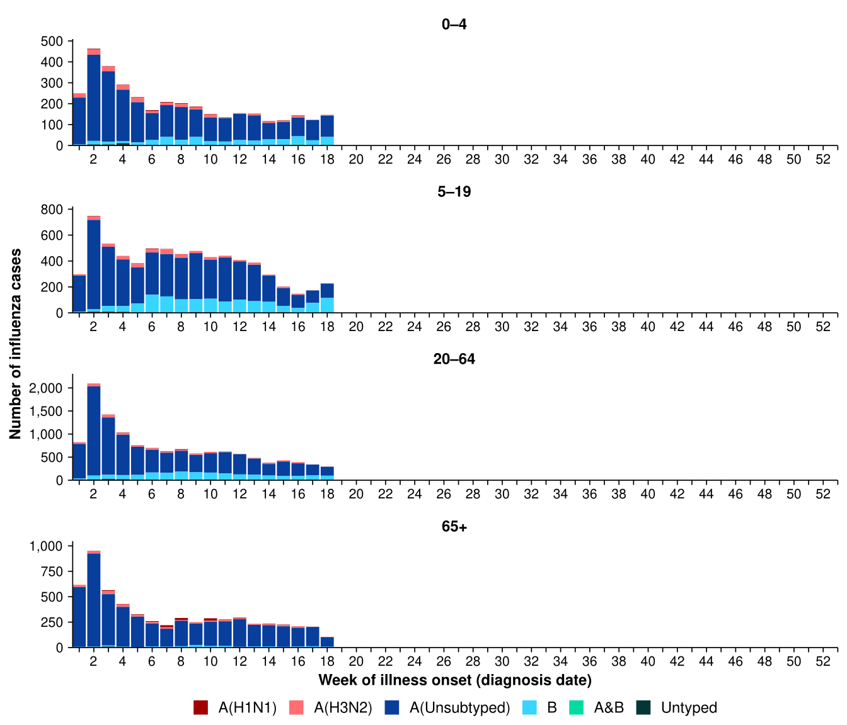
Source: National Notifiable Diseases Surveillance System (NNDSS)
* Axis varies between age groups.
- In the year to date, influenza A(Unsubtyped) has accounted for most influenza cases across all jurisdictions; however, an increasing proportion of influenza B notifications has been observed in most jurisdictions since early February, most notably in the NT (Figure 10).
- Trends in influenza subtypes are influenced by jurisdictional differences in the number and selection of influenza samples that undergo typing.

Figure 10: Notified influenza cases by influenza subtype, jurisdiction*, and week of diagnosis, Australia, 1 January to 3 May 2026
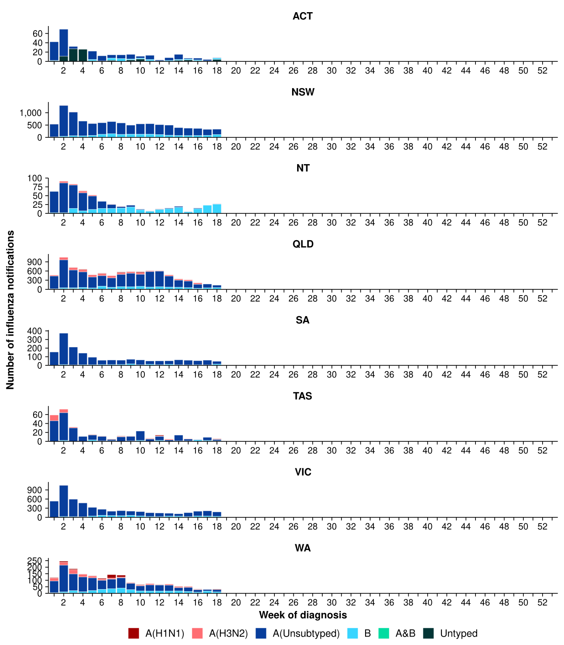
Source: National Notifiable Diseases Surveillance System (NNDSS)
* Axis varies between jurisdictions.
- In the last fortnight, there were 5,339 RSV cases, a 11.0% decrease from 5,999 cases notified in the previous fortnight (Table 2; Figure 11). The number of RSV cases notified in the last fortnight was lower than the number observed in recent years.
- In the year to date, there have been 34,999 RSV cases, 16.1% fewer than the 41,715 cases notified over the same period in 2025 (Table 2; Figure 11).
- In the last fortnight, RSV notification rates varied across jurisdictions compared with the previous fortnight, with RSV notification rates decreasing in NSW, NT, Qld and Tas but increasing in the ACT, SA and Vic. RSV notification rates remained stable in WA (Figure 12). RSV notification data are unavailable for Tas from 2 May 2026.
Figure 11: Notified RSV cases by year and week of diagnosis, Australia, 2023 to 3 May 2026
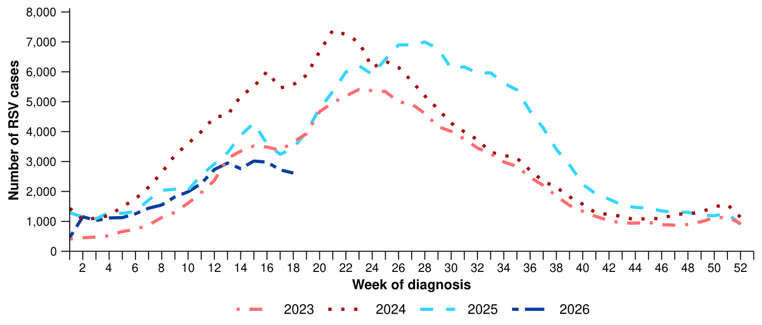
Source: National Notifiable Diseases Surveillance System (NNDSS)
Figure 12: Notification rates per 100,000 population for RSV cases by state or territory and week of diagnosis, Australia, 1 January to 3 May 2026
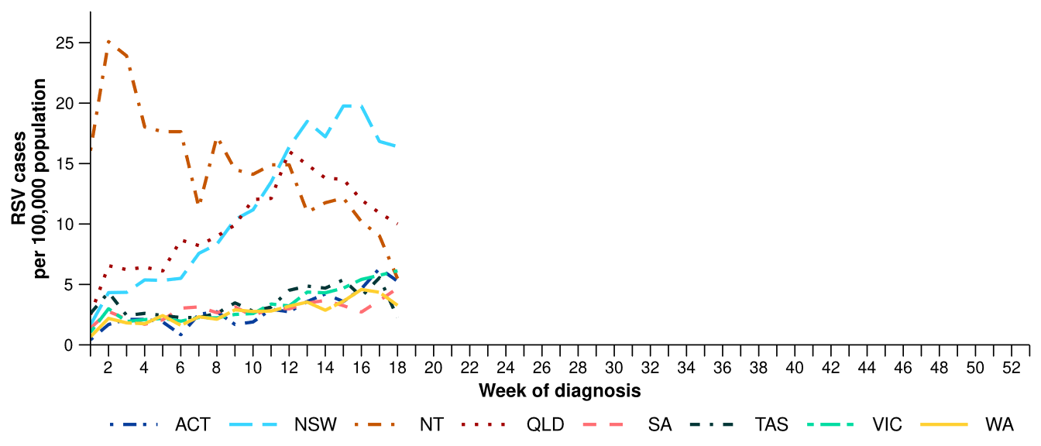
Source: National Notifiable Diseases Surveillance System (NNDSS). RSV notification data are unavailable for Tas from 2 May 2026.

Primary care surveillance
Primary care surveillance monitors the number and characteristics of people who have presented to a general practice with influenza-like illness and provides insight on the different respiratory pathogens that are causing illness in the community.
- In the last fortnight (20 April to 3 May 2026), there were slightly fewer general practice consultations for influenza-like illness (3.7 notifications per 1,000 consultations per fortnight) compared to the previous fortnight (4.0 notifications per 1,000 consultations per fortnight) (Figure 13).
- In the year to date, the rate of general practice consultations for influenza-like illness has slowly increased from late January and remained similar to the historical five-year average since late March (Figure 13).
Figure 13: Rate of influenza-like illness notifications per 1,000 consultations per week in sentinel general practice sites compared with the five-year average by year and week of consultation*†, Australia, 2023 to 3 May 2026
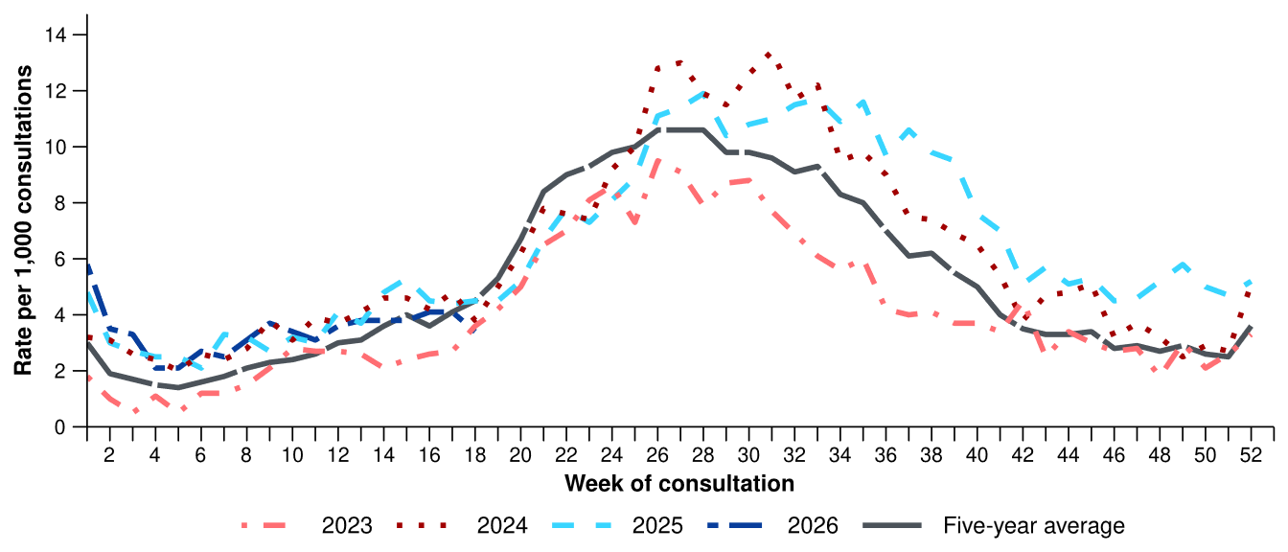
Source: Australian Sentinel Practices Research Network (ASPREN)
* The years 2020 and 2021 are excluded when comparing the current season to historical periods when influenza virus has circulated without public health restrictions. As such, the five-year average includes the years 2019 and 2022 to 2025. Please refer to the Technical Supplement for interpretation of the five-year average.
† Please refer to the Technical Supplement for notes on impact of COVID-19 on ASPREN data.
- In the last fortnight, 54.1% (46/85) of people attending general practice with influenza-like illness who were tested have then tested positive for a respiratory pathogen, similar to the previous fortnight (54.4%).
- In the last fortnight, rhinovirus / enterovirus (58.7%; 27/46) continued to be the most commonly detected pathogen, followed by parainfluenza (17.4%; 8/46) and SARS-CoV-2 (8.7%; 4/46) (Figure 14).
- In the year to date, 56.1% (365/651) of people attending general practice with influenza-like illness who were tested have then tested positive for a respiratory pathogen.
- In the year to date, rhinovirus / enterovirus (52.3%; 191/365) has been the most commonly detected pathogen, followed by parainfluenza (12.3%; 45/365), influenza (11.0%; 40/365), SARS-CoV-2 (7.4%; 27/365), and RSV (6.0%; 22/365) (Figure 14).

Figure 14: Number of samples tested for respiratory pathogens among people with influenza-like illness attending sentinel general practice sites by respiratory pathogen and week of specimen collection, Australia, 1 January to 3 May 2026
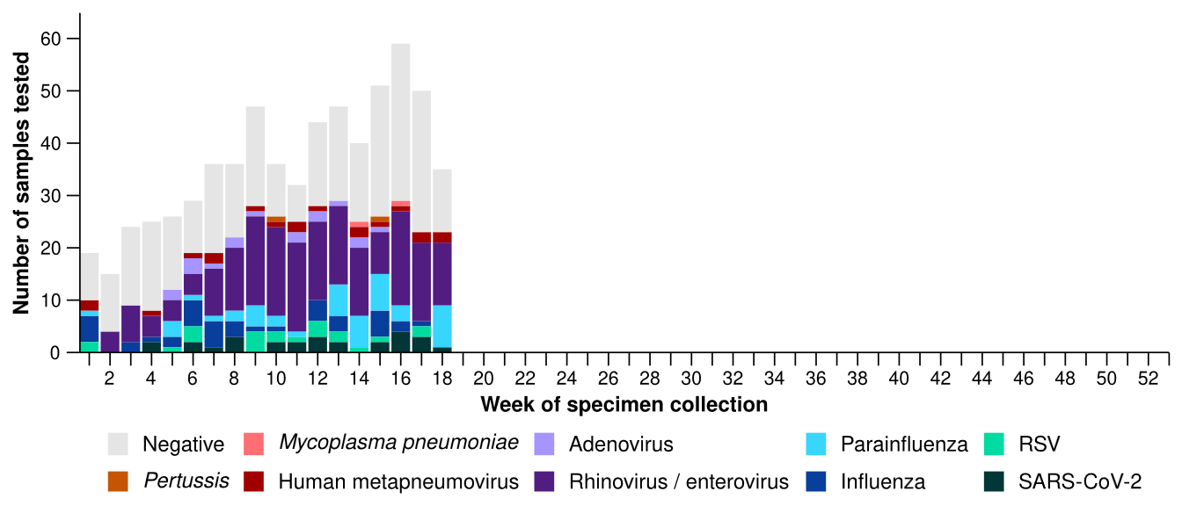
Source: Australian Sentinel Practices Research Network (ASPREN)
Note: All ASPREN swab samples are transported to the SA Pathology laboratory in Adelaide to be tested for viral and bacterial respiratory pathogens via a multiplex real-time reverse transcription polymerase chain reaction (RT-PCR) assay using in-house primers.

Hospital-based surveillance
Hospital-based surveillance monitors persons with more severe illness who have been admitted to hospital for their respiratory illness (severe acute respiratory infections). Hospital-based surveillance also measures the ability of the health system to cope with the number of severe acute respiratory infection admissions to ensure delivery of safe, timely and quality health care.
- In the last severity reporting period (6 April to 19 April 2026), slightly fewer patients were admitted to a sentinel hospital with a severe acute respiratory infection (n=235), than in the previous severity reporting period (n=243).
  - In the last severity reporting period, at sentinel hospitals there was 4.4% more admissions with COVID-19 (from 68 to 71), 14.3% more admissions with influenza (from 21 to 24), and 9.1% fewer admissions with RSV (from 154 to 140), compared to the previous severity reporting period.
- In the year to date for severity reporting (1 January to 19 April 2026), there have been 1,678 admissions with severe acute respiratory infections at sentinel hospitals. Most patients with a severe acute respiratory infection have been admitted with RSV (n=735) followed by COVID-19 (n=483) (Figure 15).
Figure 15: Total number of patients (children and adults) admitted with a severe acute respiratory infection to sentinel hospitals by disease and week of admission, Australia, 1 January to 19 April 2026
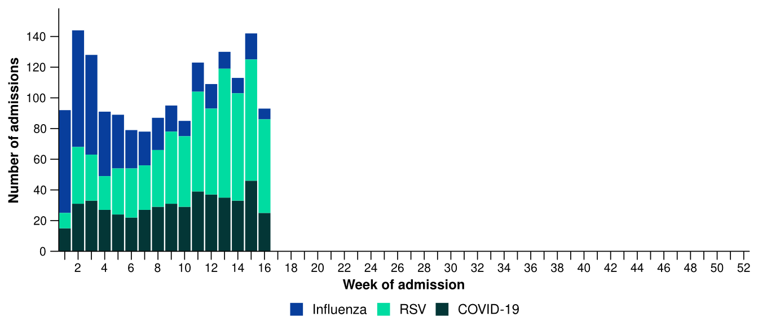
Source: Influenza Complications Alert Network (FluCAN)
- Patients admitted to sentinel hospitals with influenza have mostly been admitted with influenza A (91.5%; 421/460), while 8.0% (37/460) were admitted with influenza B.
  - Most hospital admissions with influenza A have been with influenza A(Unsubtyped) (76.5%; 322/421), followed by influenza A(H3N2) (17.6%; 74/421) and then influenza A(H1N1) (5.9%; 25/421).
- In the year to date for severity reporting, influenza A (Unsubtyped) was the most commonly detected influenza type in all age groups. Influenza B represented a smaller number of admissions overall, with a relatively higher contribution observed in younger age groups compared with adults (Figure 16).

Figure 16: Number of patients admitted with influenza to sentinel hospitals by influenza subtype, age group*, and week of admission, Australia, 1 January to 19 April 2026
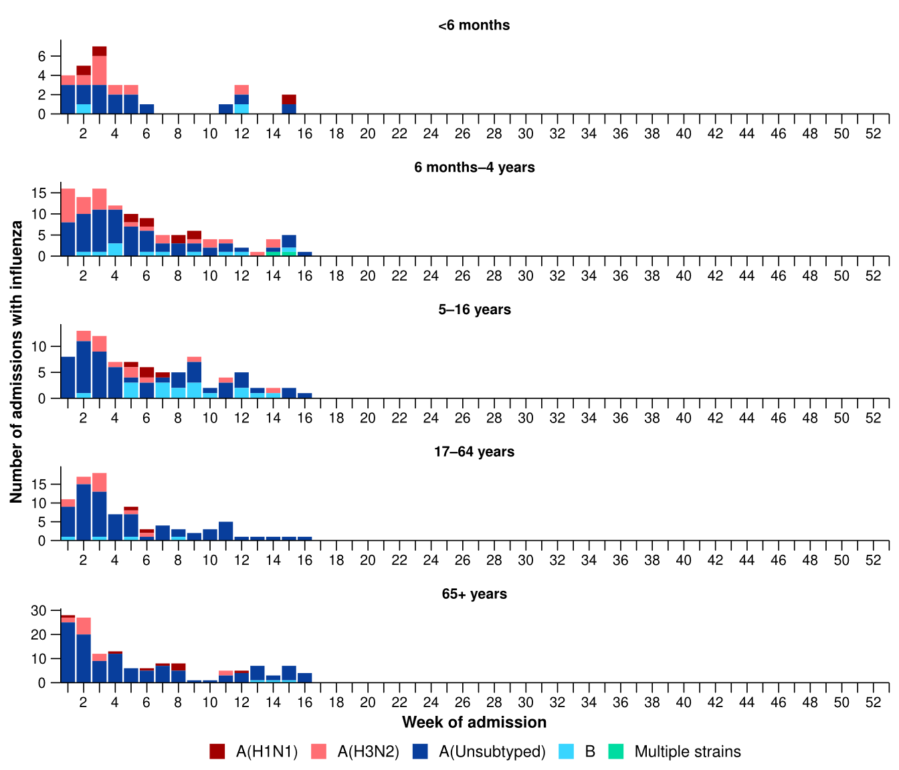
Source: Influenza Complications Alert Network (FluCAN)
* Axis varies between age groups. The age distribution of admissions with influenza may not reflect the age distribution of all patients.
- Most children (those aged 16 years and younger) have been admitted to sentinel hospitals with RSV compared to COVID-19 or influenza (Table 3a).
- Children admitted to sentinel hospitals with influenza tended to be older than children admitted with COVID-19 or RSV (Table 3a).
- Children admitted to sentinel hospitals with RSV, COVID-19 or influenza had similar lengths of hospital stays. Most were admitted to hospital wards rather than to intensive care directly (Table 3a).
- Sadly, a small number of children admitted to sentinel hospitals with influenza or RSV have died (Table 3a).
Table 3a: Demographic characteristics and outcomes for children admitted with a severe acute respiratory infection to a sentinel hospital by disease*†‡, Australia, 1 January to 19 April 2026
 | COVID-19 | Influenza | RSV
 | Year to date for  severity reporting  (n=237) | Year to date for  severity reporting  (n=232) | Year to date for  severity reporting  (n=586)
Age (years)
Median [IQR] | 1 [0-5] | 3 [1-7] | 1 [0-2]
Age group (years)
< 6 months | 56 (23.6%) | 29 (12.5%) | 113 (19.3%)
6 months – 4 years | 121 (51.1%) | 114 (49.1%) | 433 (73.9%)
5–16 years | 60 (25.3%) | 89 (38.4%) | 40 (6.8%)
Indigenous status
Aboriginal and Torres Strait Islander | 14 (5.9%) | 27 (11.6%) | 73 (12.5%)
Length of hospital stay (days)†
Median [IQR] | 2 [1-3] | 1 [1-2] | 2 [1-3]
Patient admission location‡
Admitted to hospital ward | 228 (96.2%) | 222 (95.7%) | 558 (95.2%)
Admitted to intensive care directly | 9 (3.8%) | 10 (4.3%) | 28 (4.8%)
Discharge status†
Alive | 188 (79.3%) | 218 (94.0%) | 477 (81.4%)
Died | - | 1 (0.4%) | 2 (0.3%)
Incomplete/missing | 49 (20.7%) | 13 (5.6%) | 107 (18.3%)
Source: Influenza Complications Alert Network (FluCAN)
* Does not include patients with missing age; therefore, the sum of age-specific totals above may not equal the total number of patients.
† For patients who are still in hospital data may not be complete; therefore, these data are not included in the length of stay or discharge status. In addition, length of stay data excludes patients that acquired their infection in hospital.
‡ Admission location reflects the initial admission ward. Some patients may be initially admitted to general ward then later admitted to an intensive care and this is not reflected here. Does not include patients with missing admission location; therefore, the sum of admission location specific totals above may not equal the total number of patients.
The Paediatric Active Enhanced Disease Surveillance (PAEDS) network carries out enhanced sentinel hospital surveillance for some acute respiratory infections or conditions in children. PAEDS data for acute respiratory infections in children are presented in the Australian Respiratory Surveillance Reports in the sentinel hospital data from FluCAN. For additional information on COVID-19, influenza or RSV in children please visit the PAEDS webpages and dashboards.

- More adults (those aged 17 years and over) have been admitted with COVID-19 or influenza to sentinel hospitals than with RSV (Table 3b).
- Adults that were admitted to sentinel hospitals for COVID-19, influenza and RSV were similar in age. (Table 3b).
- Adults that were admitted to sentinel hospitals for COVID-19, influenza and RSV had similar in length of stays. Most were admitted to hospital wards rather than to intensive care directly (Table 3b).
- Sadly, a small number of adults admitted to sentinel hospitals with severe acute respiratory infections have died (Table 3b).
Table 3b: Demographic characteristics and outcomes for adults admitted with a severe acute respiratory infection to a sentinel hospital by disease*†‡, Australia, 1 January to 19 April 2026
 | COVID-19 | Influenza | RSV
 | Year to date for  severity reporting  (n=246) | Year to date for  severity reporting  (n=228) | Year to date for  severity reporting  (n=149)
Age (years)
Median [IQR] | 70 [56-82] | 69 [52-79] | 70 [56-80]
Age group (years)
17–64 years | 97 (39.4%) | 87 (38.2%) | 54 (36.2%)
65 years and over | 149 (60.6%) | 141 (61.8%) | 95 (63.8%)
Indigenous status
Aboriginal and Torres Strait Islander | 24 (9.8%) | 19 (8.3%) | 15 (10.1%)
Length of hospital stay (days)†
Median [IQR] | 4 [3-8] | 3 [1-6] | 4 [2-7]
Patient admission location‡
Admitted to hospital ward | 236 (95.9%) | 211 (92.5%) | 143 (96.0%)
Admitted to intensive care directly | 10 (4.1%) | 17 (7.5%) | 6 (4.0%)
Discharge status†
Alive | 188 (76.4%) | 211 (92.5%) | 113 (75.8%)
Died | 9 (3.7%) | 7 (3.1%) | 9 (6.0%)
Incomplete/missing | 49 (19.9%) | 10 (4.4%) | 27 (18.1%)
Source: Influenza Complications Alert Network (FluCAN)
* Does not include patients with missing age; therefore, the sum of age-specific totals above may not equal the total number of patients.
† For patients who are still in hospital data may not be complete; therefore, these data are not included in the length of stay or discharge status. In addition, length of stay data excludes patients that acquired their infection in hospital.
‡ Admission location reflects the initial admission ward. Some patients may be initially admitted to general ward then later admitted to an intensive care and this is not reflected here. Does not include patients with missing admission location; therefore, the sum of admission location specific totals above may not equal the total number of patients.

There has not been an update to the sentinel intensive care data this month. Sentinel intensive care surveillance data presented here have not been updated since the previous report.
- In the last severity reporting period for sentinel intensive care (9 March to 5 April 2026), more patients have been admitted to a sentinel intensive care with a severe acute respiratory infection (n=104), than in the previous severity reporting period (n=83) (Figure 17).
- In the year to date for severity reporting (1 January to 5 April 2026), most patients were admitted to sentinel intensive care with influenza, followed by RSV (Figure 17; Table 4).
Figure 17: Number of patients admitted with severe acute respiratory infections to a sentinel intensive care by disease and week of admission, Australia, 1 January to 5 April 2026
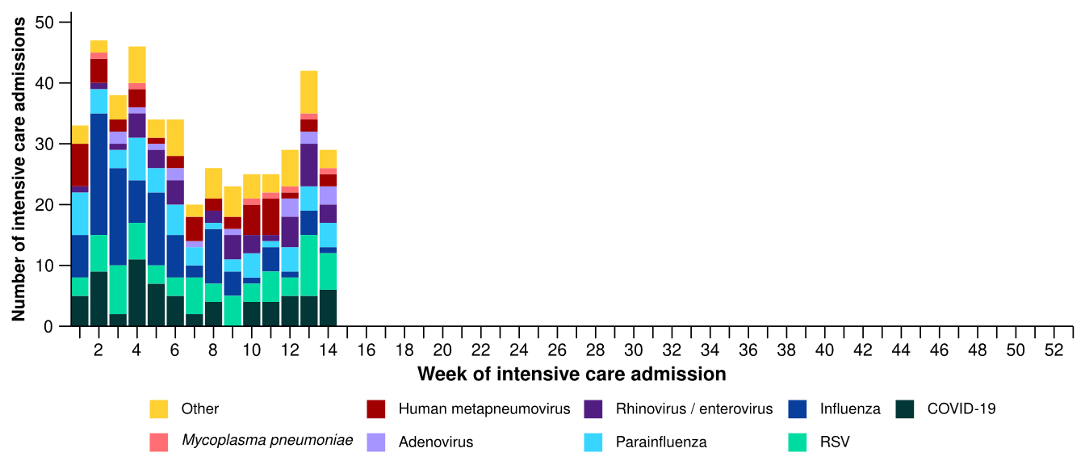
Source: Short Period Incidence Study of Severe Acute Respiratory Infection (SPRINT-SARI) Australia
Note: The sum of pathogen-specific totals above may not equal the total number of severe acute respiratory infection patients due to co-infections.
Figure 18: Number of patients admitted with severe acute respiratory infections to a sentinel intensive care by disease and age group*, Australia, 1 January to 5 April 2026
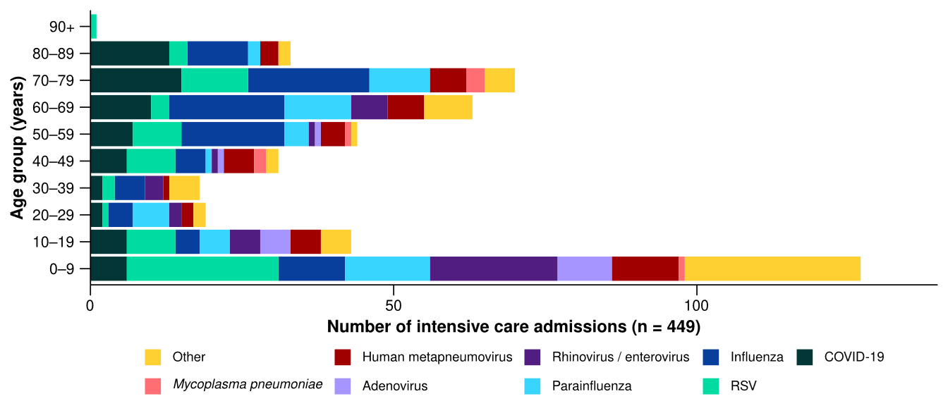
Source: Short Period Incidence Study of Severe Acute Respiratory Infection (SPRINT-SARI) Australia
Note: The sum of pathogen-specific totals above may not equal the total number of severe acute respiratory infection patients due to co-infections.
* The age distribution of severe acute respiratory infection intensive care admissions may not reflect the age distribution of all patients.
- In the year to date for severity reporting, most admissions have been among children aged 0–9 years followed by adults aged 50 years and over (Figure 18; Table 4).
- The proportion of admissions requiring invasive mechanical ventilation was higher in patients with influenza and parainfluenza; however, the length of invasive mechanical ventilation was longest in patients with Mycoplasma pneumonia (Table 4). The length of intensive care stay has been relatively similar across pathogens; however, comparisons across are limited by small numbers for some pathogens.
- Most patients with a severe acute respiratory infection have been discharged home. Sadly, a number of patients have died in hospital (Table 4).
Table 4: Demographic characteristics and outcomes of patients admitted with a severe acute respiratory infection to a sentinel intensive care by disease*†, Australia, 1 January to 5 April 2026
 | COVID-19 | hMPV | Influenza | Mycoplasma  pneumoniae | Parainfluenza | RSV
 | Year to date for severity reporting  (n=69) | Year to date for severity reporting  (n=43) | Year to date for severity reporting  (n=95) | Year to date for severity reporting  (n=7) | Year to date for severity reporting  (n=53) | Year to date for severity reporting  (n=70)
Age (years)
Median [IQR] | 65  [42–78] | 44  [9–64] | 60  [40–73] | 55  [46–76] | 54  [9–68] | 34  [5–61]
Indigenous status
Aboriginal and Torres Strait Islander | 4  (5.8%) | 5  (11.6%) | 13  (13.7%) | – | 6  (11.3%) | 13  (18.6%)
Non-Indigenous | 65  (94.2%) | 38  (88.4%) | 82  (86.3%) | 7  (100.0%) | 47  (88.7%) | 57  (81.4%)
Received invasive mechanical ventilation
Number (%) | 19  (27.5%) | 8  (18.6%) | 31  (32.6%) | 2  (28.6%) | 18  (34.0%) | 14  (20.0%)
Length of invasive mechanical ventilation (days)*
Median [IQR] | 3 [1–8] | 7 [3–8] | 3 [1–10] | 11 [7–15] | 2 [1–10] | 3 [1–5]
Length of intensive care stay (days)*
Median [IQR] | 3 [2–4] | 3 [1–5] | 3 [2–7] | 2 [1–2] | 4 [2–7] | 3 [1–4]
Length of hospital stay (days)*
Median [IQR] | 6 [3–14] | 7 [4–10] | 7 [4–13] | 4 [4–5] | 8 [4–13] | 6 [3–10]
Patient outcome†
Ongoing care in intensive care | 8  (11.6%) | – | 1  (1.1%) | 1  (14.3%) | 3  (5.7%) | 3  (4.3%)
Ongoing care in hospital ward | 4  (5.8%) | 1  (2.3%) | 2  (2.1%) | – | 2  (3.8%) | 4  (5.7%)
Transfer to other hospital / facility | 6  (8.7%) | 6  (14.0%) | 14  (14.7%) | – | 5  (9.4%) | 5  (7.1%)
Discharged home | 41  (59.4%) | 32  (74.4%) | 65  (68.4%) | 6  (85.7%) | 35  (66.0%) | 53  (75.7%)
Died in hospital | 10  (14.5%) | 4  (9.3%) | 12  (12.6%) | – | 8  (15.1%) | 5  (7.1%)
Source: Short Period Incidence Study of Severe Acute Respiratory Infection (SPRINT-SARI) Australia
Note: The sum of pathogen-specific totals above may not equal the total number of severe acute respiratory infection patients due to co-infections.
* For patients receiving ongoing care in intensive care data may not be complete; therefore, data are not included in the length of ventilation or stay.
† Patients who have been admitted with no discharge information for less than 90 days have been assumed to have ongoing care in the hospital. Patients who have no outcome entered or have been admitted for more than 90 days with no discharge information have been treated as missing.

- In the last fortnight (20 April to 3 May 2026), there were an average of 162 intensive care patients in droplet or airborne isolation for any suspected or confirmed respiratory pathogen each day, a 6.4% decrease from an average of 173 patients in isolation each day reported in the previous fortnight (Figure 19).
  - Suspected or confirmed respiratory pathogens may include nationally notifiable conditions such as COVID-19, influenza, RSV or pertussis (Whooping cough) but also other non-notifiable respiratory pathogens like adenovirus, hMPV, parainfluenza, rhinovirus or bacterial infections causing atypical pneumonias.
- In the last fortnight (20 April to 3 May 2026), there were an average of 77 intensive care staff unavailable to work due to illness each day, a 6.1% decrease from an average of 82 staff unavailable each day reported in the previous fortnight (Figure 19).
- In the last fortnight, the average number of intensive care patients in droplet or airborne isolation for any suspected or confirmed respiratory pathogen each day varied across jurisdictions compared with the previous fortnight, with the average number of patients in isolation each day decreasing in NSW, Qld and SA but increasing in the ACT, NT, Tas, Vic and WA (Figure 20).
- In the last fortnight, the average number of intensive care staff unavailable to work due to illness each day varied across jurisdictions compared with the previous fortnight, with the average number of staff unavailable each day decreasing in NSW, SA and Vic but increasing in the ACT and Qld (Figure 20).
Figure 19: Weekly average daily occupancy of intensive care patients in droplet or airborne isolation for any suspected or confirmed respiratory pathogen and the weekly average daily number of intensive care staff unavailable to work due to illness by week of report*, Australia, 1 January to 3 May 2026 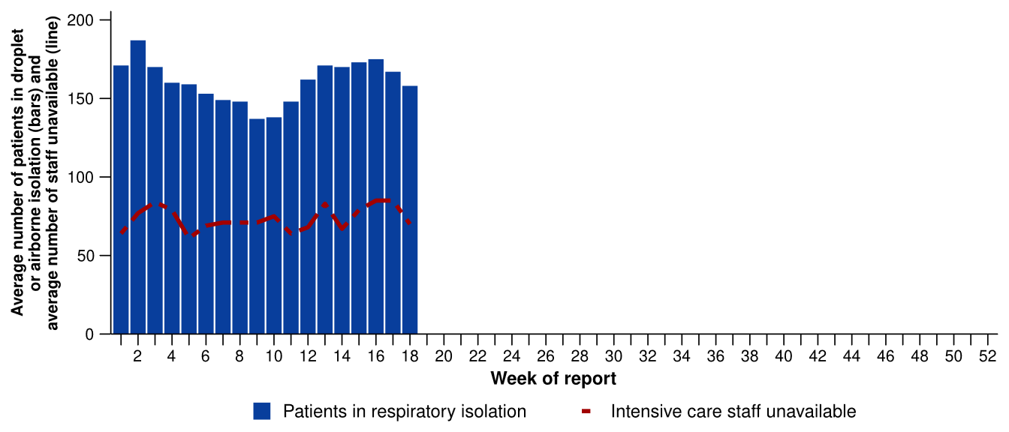
Source: Critical Health Resource Information System (CHRIS)
* Intensive care staff include both medical and nursing staff. Staff unavailability will be underestimated in NSW as most public hospitals in NSW do not report staff unavailability.

Figure 20: Weekly average daily occupancy of intensive care patients in droplet or airborne isolation for any suspected or confirmed respiratory pathogen and the weekly average daily number of intensive care staff unavailable to work due to illness by jurisdiction and week of report*†‡, Australia, 1 January to 3 May 2026
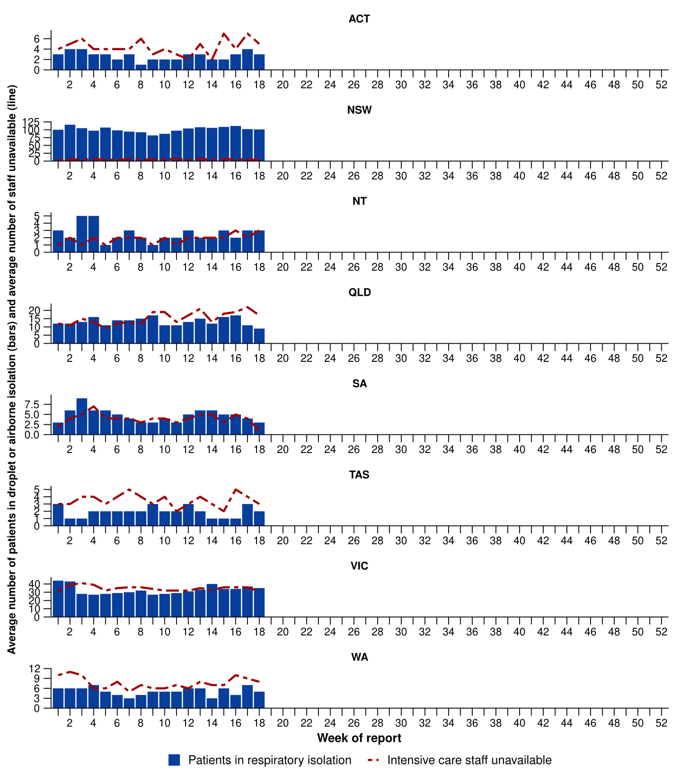
Source: Critical Health Resource Information System (CHRIS)
* Axis varies between jurisdictions.
† NSW isolation data from public hospitals includes all patients occupying intensive care beds in isolation precautions, including those in contact isolation precautions, rather than just droplet or airborne isolation precautions, which will overestimate the average number of patients occupying intensive care beds in droplet or airborne isolation in NSW. For this reason, NSW data may not be comparable to data from other jurisdictions.
‡ Intensive care staff include both medical and nursing staff. Staff unavailability will be underestimated in NSW as most public hospitals in NSW do not report staff unavailability. For this reason, NSW data may not be comparable to data from other jurisdictions.

Mortality surveillance
Death registrations can provide information on the scale and severity of disease associated with acute respiratory infections. An acute respiratory infection associated death is one where the death was due to the disease (the illness has caused terminal complications such as pneumonia) or the person has died with the disease (a person has died from another cause but the illness still contributed significantly to death). For more information refer to the Technical Supplement.
- COVID-19 has been the leading cause of acute respiratory infection related mortality across the majority of 2020–2025; however, between August 2025 and January 2026 the number of deaths per month involving influenza (both due to and with) exceeded COVID-19 deaths. Deaths involving influenza fell sharply in February 2026, with 102 deaths in January 2026 and 27 deaths in February 2026.
- Deaths involving COVID-19 (both due to and with) tend to peak twice a year - between November and January and then again between May and August. Preliminary data does not show a 2025–2026 summer peak, despite a small increase in deaths involving COVID-19 in January 2026.
- In 2025, influenza mortality rates were higher for both Aboriginal and Torres Strait Islander and non-Indigenous people than in 2022–2024. In contrast, in 2025, COVID-19 mortality rates among Aboriginal and Torres Strait Islander people were four times lower than in 2024.
- These acute respiratory infections are more likely to cause death in older age groups than younger age groups.
Figure 21a: Provisional numbers of deaths due to an acute respiratory infection*† by month, year, and disease, Australia, 1 January 2024 to 31 March 2026
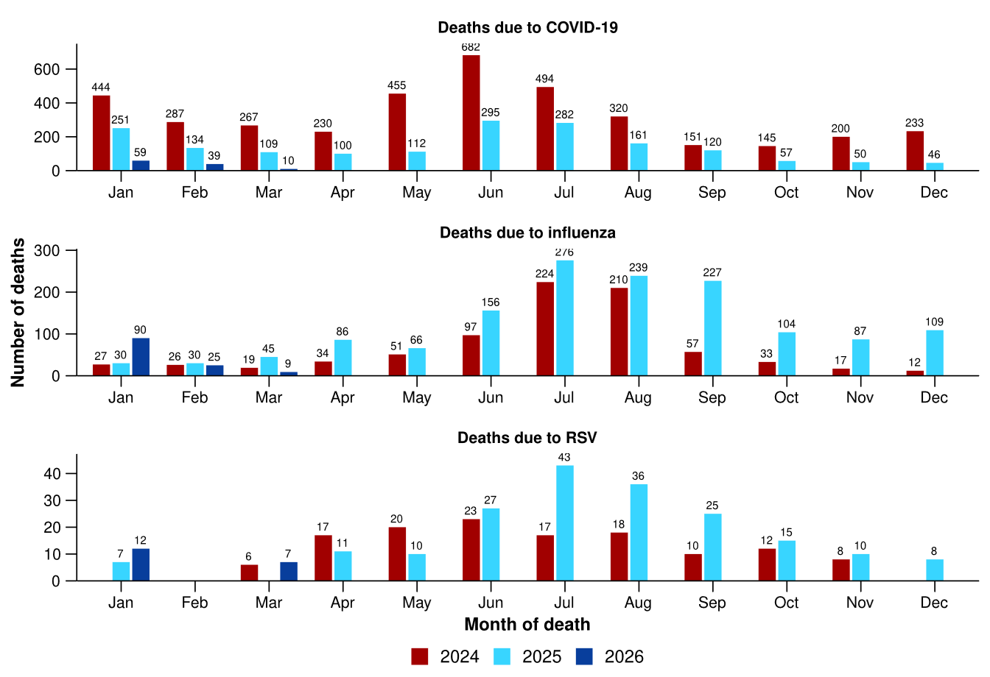
Source: Australian Bureau of Statistics (ABS), Deaths due to acute respiratory infections in Australia, released 28 April 2026.
* Axis varies between acute respiratory infections.
† Data is provisional and subject to change. It can take several weeks for death registrations to be reported, processed, coded, validated, and tabulated. Therefore, the data shown here may be incomplete. Data for some months were not published by the ABS due to small counts, and therefore not reported here. Data includes all deaths (both doctor and coroner certified) that occurred and were registered by 31 March 2026.
- Deaths due to COVID-19 fell in February 2026 and remain at a very low level compared to previous years (Figure 21a).
- Deaths due to influenza fell substantially in February 2026 to a much more typical level for the time of year (Figure 21a).
- Deaths due to RSV remained at low levels in February 2026, similar to the number of deaths in December 2025 (Figure 21a).
- Deaths with COVID-19 were slightly lower in February 2026 than January, and remain at low levels compared to previous years (Figure 21b).
- Deaths with influenza had been higher than deaths with COVID-19 since August 2025 but in January 2026 both viruses were associated with a similar number of deaths, and in February there were more deaths with COVID-19. (Figure 21b).
- Deaths with RSV have remain unchanged in February 2026 and were higher than the number of deaths with COVID-19 and with influenza.
Figure 21b: Provisional numbers of deaths with an acute respiratory infection*† by month, year, and disease, Australia, 1 January 2024 to 31 March 2026
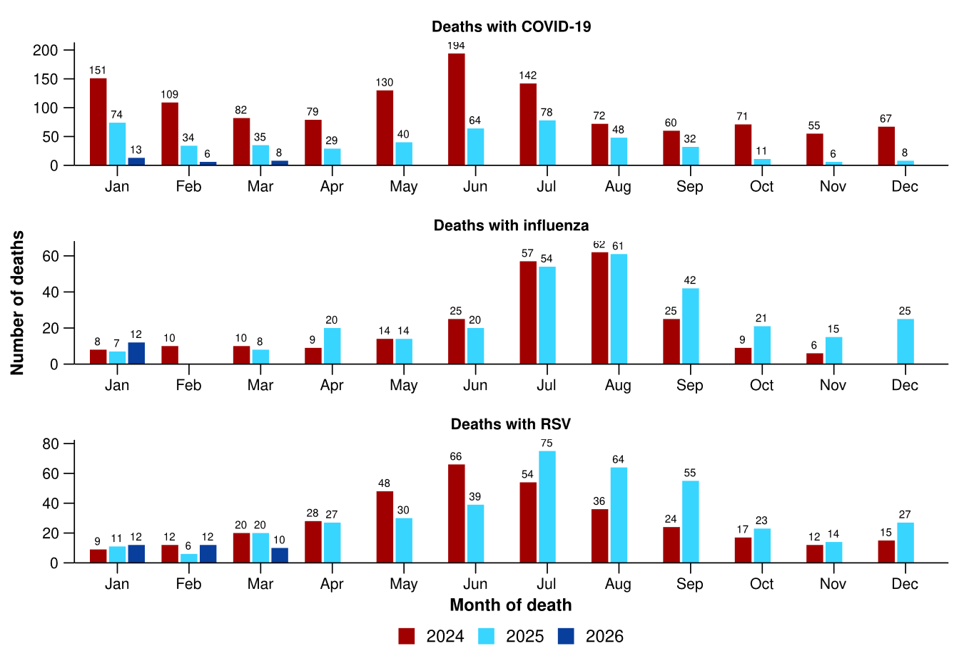
Source: Australian Bureau of Statistics (ABS), Deaths due to acute respiratory infections in Australia, released 28 April 2026.
* Axis varies between acute respiratory infections.
† Data is provisional and subject to change. It can take several weeks for death registrations to be reported, processed, coded, validated, and tabulated. Therefore, the data shown here may be incomplete. Data for some months were not published by the ABS due to small counts, and therefore not reported here. Data includes all deaths (both doctor and coroner certified) that occurred and were registered by 31 March 2026.

Laboratory surveillance
Sentinel laboratory surveillance monitors the percentage of tests with the notifiable condition detected (i.e. test positivity). It also provides information on what pathogens are circulating, potential changes in the pathogens that might affect their infectiousness, severity, ability to evade vaccine and/or infection-acquired immunity, or resistance to antivirals.
- In the last fortnight (20 April to 3 May 2026), the percentage of SARS-CoV-2 tests that were positive decreased (from 2.5% to 2.0%), the percentage of influenza tests that were positive decreased (from 1.0% to 0.8%) and the percentage of RSV tests that were positive increased (from 1.3% to 1.5%) from the previous fortnight (Figure 22).

Figure 22: Number of tests positive (bars) and percentage of tests positive (line) for SARS-CoV-2, influenza or RSV of those specimens tested by sentinel laboratories by week of report*†, Australia, 1 January to 3 May 2026
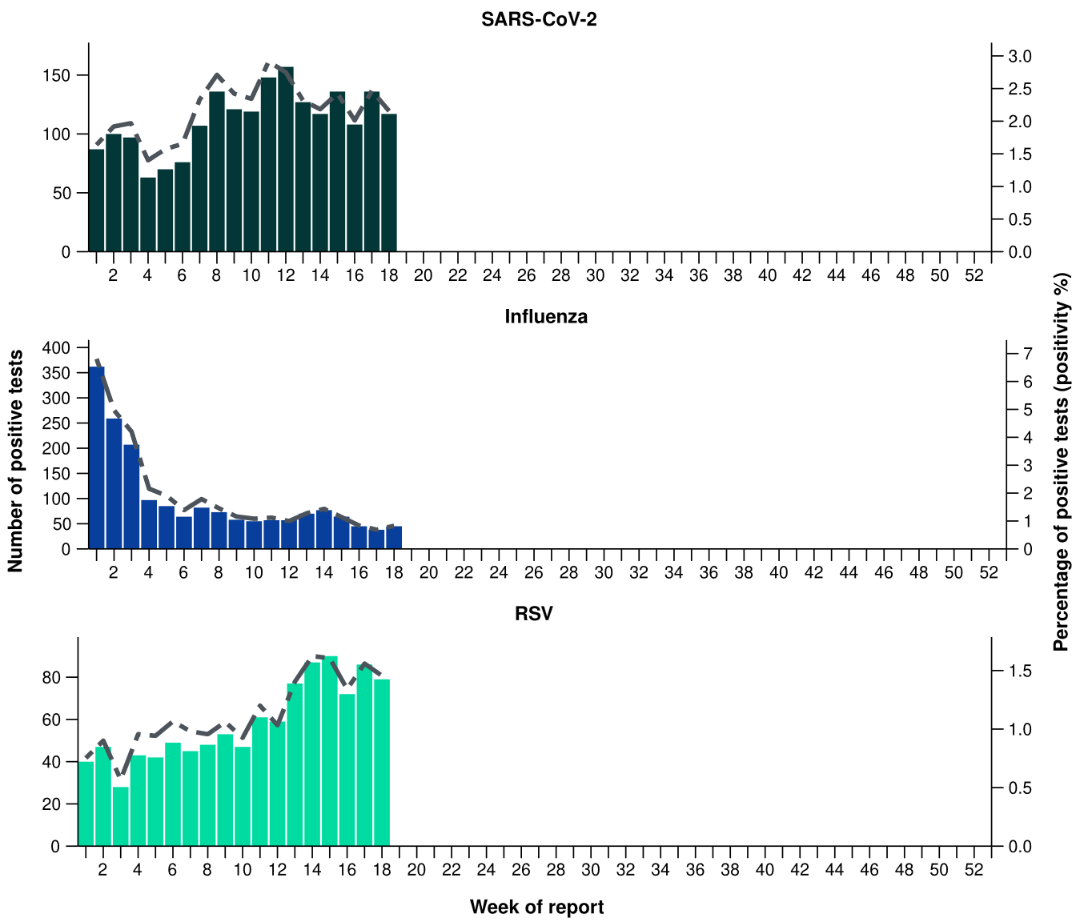
Source: Sentinel laboratories, including National Influenza Centres
* Number of specimens tested excludes data from WA as testing denominator data are different for the three pathogens in Western Australia.
† A small minority of total samples from Victoria are tested only by respiratory panel (influenza, parainfluenza, adenovirus, human metapneumovirus, seasonal coronaviruses, RSV, and some picornaviruses) but not for SARS-CoV-2. These minority samples include only forensic materials; all other samples are tested by respiratory panel and SARS-CoV-2 assay.

There has not been an update to the AusTrakka SARS-CoV-2 sequencing data. The SARS-CoV-2 sequencing data presented here have not been updated since the previous report.
- There were 86 SARS-CoV-2 sequences uploaded to AusTrakka with dates of collection in the last 28 days (23 March to 19 April 2026). These sequences were from NSW, SA and Tas with the most recent date of collection from 6 April 2026. The low number of sequences uploaded to AusTrakka in the last 28 days is likely due to the reduced number of COVID-19 cases and changes in sequencing capacity and priorities, due to issues with very limited number of sequences and representativeness of the sequences.
- Most sequences were assigned to the BA.2.86 sub-lineage within B.1.1.529 (Omicron) or recombinants consisting of one or more Omicron sub-lineages (Figure 23a/b). In the last 28 days:
  - 58.1% (50/86) of sequences were recombinant or recombinant sub-lineages, the most common including NB.1.8.1 (n=29) and XFG (n=21)
  - 31.4% (27/86) of sequences were identified as BA.3, specifically BA.3.2
  - 7.0% (6/86) of sequences were from the sub-sub-lineages JN.1 (BA.2.86.1.1), specifically KP.3.1.1
  - there were no BA.1, BA.4, BA.5 or other BA.2 sub-sub-lineage sequences.
- NB.1.8.1 was the most common sub-lineage in the last 28 days, accounting for 33.7% (29/86) of sequences (Figure 23a).
- The World Health Organization (WHO) have identified certain sub-sub-lineages and recombinants as variants under monitoring (VUM) because of their epidemiological, pathological, or immunological features of concern. A select number are highlighted below due to their relevance in the Australian context. There are:
  - 4,509 KP.3.1.1 sequences in AusTrakka, with 6 identified in the last 28 days
  - 3,449 NB.1.8.1 sequences in AusTrakka, with 29 identified in the last 28 days
  - 1,157 XFG sequences in AusTrakka, with 21 identified in the last 28 days
  - 499 BA.3.2 sequences in AusTrakka, with 27 identified in the last 28 days
Figure 23a: SARS-CoV-2 Omicron sub-lineage* sequences by sample collection date, showing proportions of sequences per week†‡, Australia, 1 January to 19 April 2026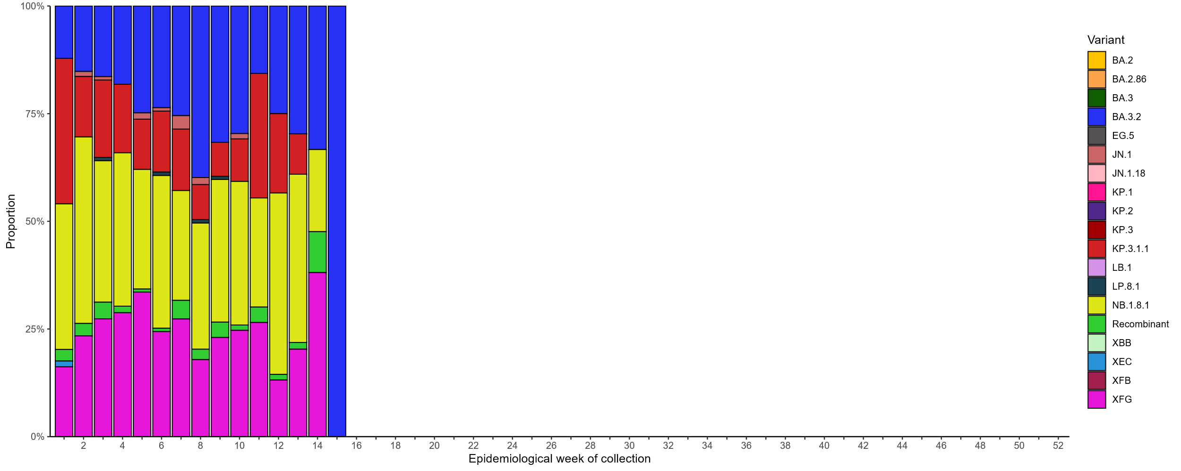
Source: AusTrakka
* Some sub-sublineages are shown alongside their parent lineage, but not included in the parent lineage totals. For instance, KP.2 and KP.3 are sub-sub lineages of JN.1, so the total of JN.1 sequences will be higher than shown in the corresponding colour alone, and should include the KP.2 and KP.3 totals.
† Sequences in AusTrakka aggregated by week and reported based on date of sample collection, not date of sequencing.
‡ Proportions in Figure 23a may not be representative when sequence numbers are small; refer to Figure 23b. Data for earlier weeks may change between reporting periods as sequences with older collection dates are uploaded. These numbers are not equivalent to number of cases, as there are many cases which may not be sequenced. Non-VOI and non-VUM Omicron sub-lineages have been collapsed into parent lineages BA.1, BA.2, BA.3, BA.4 and BA.5.
Figure 23b: SARS-CoV-2 Omicron sub-lineage* sequences by sample collection date, showing the count of sequences per week†‡, Australia, 1 January 2022 to 19 April 2026
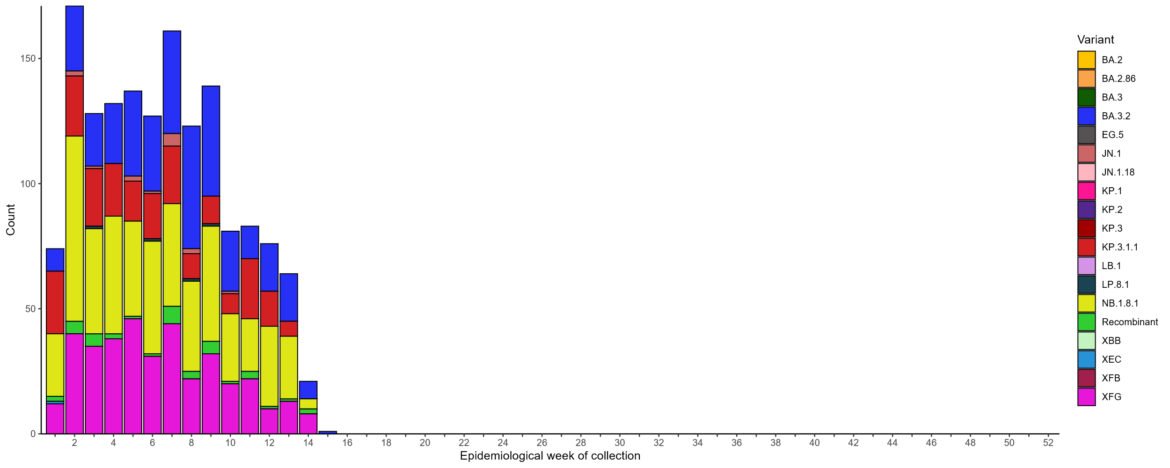
Source: AusTrakka
* Some sub-sublineages are shown alongside their parent lineage, but not included in the parent lineage totals. For instance, KP.2 and KP.3 are sub-sub lineages of JN.1, so the total of JN.1 sequences will be higher than shown in the corresponding colour alone, and should include the KP.2 and KP.3 totals.
† Sequences in AusTrakka aggregated by week and reported based on date of sample collection, not date of sequencing.
‡ Data for earlier weeks may change between reporting periods as sequences with older collection dates are uploaded. These numbers are not equivalent to number of cases, as there are many cases which may not be sequenced. Non-VOI and non-VUM Omicron sub-lineages have been collapsed into parent lineages BA.1, BA.2, BA.3, BA.4 and BA.5.
- In the year to date, the WHO Collaborating Centre for Reference and Research on Influenza has antigenically characterised 372 influenza viruses from Australia (Table 5), of which:
  - 8.6% (32/372) have been influenza A(H1N1)
  - 81.7% (304/372) have been influenza A(H3N2)
  - 9.7% (36/372) have been influenza B/Victoria.
- In the year to date, there have been no influenza B/Yamagata viruses characterised (Table 5). The last influenza B/Yamagata virus characterised in Australia was in a sample from 2020.
- In the year to date, none of the samples tested demonstrated highly reduced inhibition to oseltamivir or zanamivir.
Table 5: Australian influenza viruses typed by haemagglutination inhibition assay and jurisdiction*†, 1 January to 3 May 2026
Strain | ACT | NSW | NT | Qld | SA | Tas | Vic | WA | Total
A(H1N1) | 2 | 8 | 3 | 3 | 1 | 6 | 7 | 2 | 32
A(H3N2) | 22 | 34 | 74 | 28 | 21 | 24 | 92 | 9 | 304
B/Victoria lineage | 2 | 7 | 19 | 1 | 1 | 0 | 5 | 1 | 36
B/Yamagata lineage | 0 | 0 | 0 | 0 | 0 | 0 | 0 | 0 | 0
Total | 26 | 49 | 96 | 32 | 23 | 30 | 104 | 12 | 372
Source: World Health Organization (WHO) Collaborating Centre for Reference and Research on Influenza
*Viruses tested by the WHO Collaborating Centre for Reference and Research on Influenza are not necessarily a random sample of all those in the community and early-year data may be based on limited samples received. There may be up to a month delay on reporting of samples.
† Jurisdiction indicates the residential location for the individual tested, not the submitting laboratory.

Vaccine coverage, effectiveness and match
Vaccine coverage, effectiveness and match for acute respiratory infections are monitored from several data sources in Australia. Refer to the Technical Supplement for more information.

Vaccine coverage
- Nationally, 4.4% of adults (aged 18 years and over) have received a COVID-19 vaccine in the last six months (Table 6).
- Nationally, fewer adults have received a COVID-19 vaccine in the last 12 months (9.2%; Table 6), compared to the 12 months prior (9.8% from 29 April 2024 to 27 April 2025).
- In the last 12 months, vaccine coverage decreased in all age groups, with the largest decrease seen in 65–74 years age group (from 23.1% in the 12 months prior to 22.0% in the last 12 months).
- There has been substantial variation in COVID-19 vaccine coverage across age groups, ranging from 3.8% in adults aged 18–64 years to 35.9% in adults aged 75 years and over. Vaccine coverage increases with increasing age (Table 6).
- There has been some variation in vaccine coverage across jurisdictions, ranging from 3.7% in the NT to 16.1% in the ACT and Tas (Table 6).
Table 6: COVID-19 vaccine coverage*†‡ by age group and jurisdiction, Australia, 28 April 2025 to 3 May 2026
Age group | ACT | NSW | NT | Qld | SA | Tas | Vic | WA | Total
Last 12 months (28 April 2025 to 3 May 2026)
18–64 years | 8.8 | 3.2 | 1.9 | 3.7 | 3.9 | 7.0 | 4.1 | 3.7 | 3.8
65–74 years | 42.1 | 20.2 | 13.0 | 21.0 | 23.5 | 33.0 | 22.4 | 21.8 | 22.0
≥ 75 years | 59.8 | 33.8 | 23.1 | 34.7 | 37.4 | 49.2 | 35.4 | 36.1 | 35.9
All ages (18 years and over) | 16.1 | 8.5 | 3.7 | 8.9 | 10.5 | 16.1 | 9.2 | 8.8 | 9.2
Last 6 months (3 November 2025 to 3 May 2026)
18–64 years | 3.5 | 1.2 | 0.7 | 1.5 | 1.5 | 2.7 | 1.5 | 0.8 | 1.4
65–74 years | 24.6 | 9.5 | 5.5 | 10.4 | 13.0 | 17.4 | 11.1 | 8.5 | 10.7
≥ 75 years | 39.9 | 18.8 | 10.7 | 19.6 | 23.7 | 30.3 | 20.7 | 17.5 | 20.4
All ages (18 years and over) | 8.5 | 4.0 | 1.5 | 4.3 | 5.7 | 8.3 | 4.5 | 3.2 | 4.4
Source: Australian Immunisation Register (AIR) as at 4 May 2026
* COVID-19 vaccine coverage among the general population uses the most recently available Australian Bureau of Statistics Estimated Resident Population (ERP) as denominator for population data. Age in years is calculated as at the reporting week.
† COVID-19 vaccine coverage is influenced by changes in COVID-19 vaccine recommendations and eligibility criteria. For this reason, coverage rates in the current 12 month period and previous 12 month periods may not be directly comparable. Coverage data in these tables may differ slightly from coverage estimates in other reports due to differences in calculation methodologies and/or different data download dates.
‡ Jurisdiction is based on the state or territory in which a vaccine was administered and may differ from a person’s residential address. Population denominator data used to calculate COVID-19 vaccine coverage are based on an individual’s residential address. Total rows will include individuals where jurisdiction was missing.

- Nationally, 1.7% of Aboriginal and Torres Strait Islander adults (aged 18 years and over) have received a COVID-19 vaccine in the last six months (Table 7).
- Nationally, fewer Aboriginal and Torres Strait Islander adults have received a COVID-19 vaccine in the last 12 months (3.9%; Table 7), compared to the 12 months prior (4.4% from 29 April 2024 to 27 April 2025).
- In the last 12 months, vaccine coverage decreased in all age groups of Aboriginal and Torres Strait Islander people, with the largest decrease seen in 65–74 years age group (from 16.3% in the 12 months prior to 14.4% in the last 12 months).
- Among Aboriginal and Torres Strait Islander people, there has been substantial variation in COVID-19 vaccine coverage across age groups, ranging from 2.2% in adults aged 18–64 years to 23.2% in adults aged 75 years and over. Vaccine coverage increases with increasing age (Table 7).
- Among Aboriginal and Torres Strait Islander people, there has been slight variation in vaccine coverage across jurisdictions, ranging from 2.5% in the NT to 8.2% in Tas (Table 7).
Table 7: COVID-19 vaccine coverage*†‡ among Aboriginal and Torres Strait Islander populations by age group and jurisdiction, Australia, 28 April 2025 to 3 May 2026
Age group | ACT | NSW | NT | Qld | SA | Tas | Vic | WA | Total
Last 12 months (28 April 2025 to 3 May 2026)
18–64 years | 5.1 | 2.2 | 1.8 | 2.1 | 2.2 | 4.5 | 3.3 | 1.8 | 2.2
65–74 years | 29.8 | 15.3 | 8.0 | 13.6 | 14.5 | 27.6 | 16.9 | 12.7 | 14.4
≥ 75 years | 44.3 | 25.0 | 12.5 | 21.2 | 25.6 | 36.9 | 27.9 | 22.4 | 23.2
All ages (18 years and over) | 7.9 | 4.2 | 2.5 | 3.5 | 4.1 | 8.2 | 5.6 | 3.1 | 3.9
Last 6 months (3 November 2025 to 3 May 2026)
18–64 years | 1.8 | 0.8 | 0.6 | 0.7 | 0.9 | 1.8 | 1.3 | 0.4 | 0.8
65–74 years | 16.9 | 7.3 | 3.1 | 6.3 | 6.6 | 14.2 | 8.5 | 4.9 | 6.8
≥ 75 years | 28.6 | 13.6 | 5.7 | 11.1 | 15.3 | 20.0 | 15.5 | 9.3 | 12.4
All ages (18 years and over) | 3.6 | 1.9 | 0.9 | 1.5 | 1.8 | 3.8 | 2.5 | 1.0 | 1.7
Source: Australian Immunisation Register (AIR) as at 4 May 2026
* COVID-19 vaccine coverage among Aboriginal and Torres Strait Islander populations is based on the AIR population as known at the reporting week. Age in years is calculated as at the reporting week.
† COVID-19 vaccine coverage in the most recent 12 month period may not be directly comparable to previous 12 month periods due to changes in COVID-19 vaccine eligibility criteria. Coverage data in these tables may differ slightly from coverage estimates in other reports due to differences in calculation methodologies and/or different data download dates.
‡ Jurisdiction is based on the state or territory in which a vaccine was administered and may differ from a person’s residential address. Population denominator data used to calculate COVID-19 vaccine coverage are based on an individual’s residential address. Total rows will include individuals where jurisdiction was missing.

- Nationally, influenza vaccine coverage is 14.0% for 2026 so far, noting that the 2026 seasonal influenza vaccine has only been available in Australia since April and coverage is expected to increase over the coming months (Table 8).
- There has been substantial variation in influenza vaccine coverage across age groups, ranging from 5.7% in children aged 5–14 years to 34.6% in adults aged 65 years and over (Table 8). The current trend may be influenced by eligibility criteria as people aged 5–64 years are generally not eligible for free seasonal influenza vaccine under the National Immunisation Program.
- There has been some variation in influenza vaccine coverage across jurisdictions, ranging from 6.8% in WA to 19.7% in the ACT (Table 8).
- Among Aboriginal and Torres Strait Islander people, there has been substantial variation in influenza vaccine coverage across age groups, ranging from 4.0% in children aged 5–14 years to 32.5% in adults aged 65 years and over (Table 8).
- Among Aboriginal and Torres Strait Islander people, there has been slight variation in influenza vaccine coverage across jurisdictions, ranging from 3.1% in WA to 11.8% in Tas (Table 8).

Table 8: Influenza vaccine coverage*†‡ by age group and jurisdiction, Australia, 1 March to 3 May 2026
 | ACT | NSW | NT | Qld | SA | Tas | Vic | WA | Total
Age groups
6 months to <5 years | 18.2 | 9.7 | 10.2 | 8.4 | 9.0 | 8.8 | 9.6 | 3.3 | 8.8
5–14 years | 11.4 | 6.0 | 4.2 | 5.9 | 6.2 | 6.5 | 6.1 | 2.2 | 5.7
15–49 years | 13.9 | 8.0 | 8.9 | 8.0 | 9.6 | 9.3 | 9.5 | 2.3 | 8.0
50–64 years | 20.4 | 13.3 | 11.3 | 15.1 | 16.6 | 16.7 | 14.8 | 4.6 | 13.5
≥ 65 years | 42.1 | 33.7 | 19.7 | 37.0 | 43.6 | 38.5 | 34.8 | 24.4 | 34.6
All ages (6 months and over) | 19.7 | 14.1 | 10.4 | 14.6 | 18.0 | 17.2 | 14.9 | 6.8 | 14.0
Aboriginal and Torres Strait Islander populations
6 months to <5 years | 10.6 | 6.5 | 9.2 | 5.3 | 5.1 | 6.1 | 5.9 | 2.6 | 5.7
5–14 years | 5.0 | 4.4 | 6.3 | 4.1 | 4.2 | 5.4 | 4.2 | 1.4 | 4.0
15–49 years | 9.0 | 6.5 | 10.5 | 5.8 | 7.2 | 8.0 | 7.1 | 1.5 | 6.2
50–64 years | 19.2 | 16.5 | 17.6 | 15.1 | 16.3 | 19.7 | 16.0 | 5.0 | 14.9
≥ 65 years | 39.8 | 35.4 | 23.2 | 34.0 | 37.0 | 39.6 | 33.5 | 18.4 | 32.5
All ages (6 months and over) | 11.6 | 9.6 | 11.5 | 8.4 | 9.7 | 11.8 | 9.9 | 3.1 | 8.7
Source: Australian Immunisation Register (AIR) as at 4 May 2026
* Influenza vaccine coverage uses the AIR population as the denominator. Coverage data in these tables may differ slightly from coverage estimates in other reports due to differences in calculation methodologies and/or different data download dates.
† Age is calculated based on the person’s age as at 1 July of the reporting year.
‡ In 2026 reports, jurisdiction is based on the person’s address on the AIR rather than an individual’s residential address as recorded on Medicare. Total rows will include individuals where jurisdiction was missing. In addition, to align with departmental reporting methodologies, both the numerator (number of persons vaccinated) and denominator (AIR population) for influenza vaccine coverage only consider person records with a Personal Identification Number that was able to be matched to Medicare. Person records with a Synthetic Identification Number are now excluded from both numerator and denominator. For these reasons, influenza vaccine coverage metrics in Australian Respiratory Surveillance Reports published prior to 13 July 2025 may not be directly comparable to current coverage metrics.

- Since the commencement of the National RSV Mother and Infant Protection Program on 3 February 2025, 245,364 Abrysvo doses have been administered to pregnant people nationally (Table 9).
- While high maternal vaccine uptake is a positive indicator of maternal program success, it may result in lower nirsevimab uptake rates in infants. This is because maternal antibodies passed to the infant can provide protection against RSV, potentially reducing the need for infant immunisation.
Table 9: Number of doses of Abrysvo administered to pregnant people by jurisdiction*, Australia, 3 February 2025 to 3 May 2026
 | ACT | NSW | NT | Qld | SA | Tas | Vic | WA | Total
Age group
15–24 years | 318 | 6,126 | 556 | 5,868 | 1,353 | 655 | 3,621 | 2,373 | 20,872
25–39 years | 5,594 | 64,821 | 2,216 | 39,632 | 14,691 | 4,656 | 58,260 | 21,460 | 211,332
40–54 years | 372 | 4,276 | 106 | 2,073 | 839 | 201 | 4,039 | 1,254 | 13,160
Total (15–54 years) | 6,284 | 75,223 | 2,878 | 47,573 | 16,883 | 5,512 | 65,920 | 25,087 | 245,364
Source: Australian Immunisation Register (AIR) as at 4 May 2026
* Jurisdiction is based on the state or territory in which a vaccine was administered and may differ from a person’s residential address. Total rows will include individuals where jurisdiction was missing.
- In the last six months, 4.6% of infants (aged < 8 months) have received nirsevimab (Table 10).
- There has been some variation in nirsevimab uptake in infants across jurisdictions, ranging from 0.9% in SA to 10.9% in the NT (Table 10).
- The current trend is likely due to variation in the seasonality and eligibility criteria between state and territory programs, as well as the presence of previous nirsevimab programs. Some state and territory programs are seasonal (from 1 April to 30 September), whereas others are year-round. In states with seasonal programs (SA, Tas, Vic, and parts of WA), uptake may appear disproportionately lower at this time of the year.
Table 10: Nirsevimab (Beyfortus) uptake in the last six months*†‡ by age group and jurisdiction, Australia, 3 November 2025 to 3 May 2026
 | ACT | NSW | NT | Qld | SA | Tas | Vic | WA | Total
Age group
Infants (aged < 8 months) | 1.5 | 4.2 | 10.9 | 9.0 | 0.9 | 1.6 | 1.6 | 7.8 | 4.6
Young children (aged ≥ 8 to 24 months) | 0.2 | 0.1 | 0.1 | 0.1 | 0.1 | 0.3 | 0.1 | 0.2 | 0.1
Source: Australian Immunisation Register (AIR) as at 4 May 2026
* Reporting of RSV monoclonal antibodies to the AIR is not compulsory; therefore, uptake is likely to be underestimated. Uptake data in these tables may differ slightly from estimates in other reports due to differences in calculation methodologies and/or different data download dates.
† For infants and young children vaccinated, age in months is calculate as months between the immunisation encounter and date of birth rounded down as at the reporting date. For the infant and young children population, age in months is calculated as months between the AIR data extract date and date of birth rounded down as at the reporting date.
‡ Jurisdiction is based on the state or territory in which a vaccine was administered and may differ from a person’s residential address. Total rows will include individuals where jurisdiction was missing. Population denominator data used to calculate nirsevimab uptake are based on an individual’s residential address as recorded on Medicare.

Vaccine effectiveness
- Vaccine effectiveness (VE) is the reduction in risk of influenza and its complications in those vaccinated, compared to those not vaccinated.
- Interim Australian data as part of the Global Influenza Vaccine Effectiveness (GIVE) Collaboration indicate that in 2025, people who received the influenza vaccine were about 53% less likely to visit general practice or be hospitalised with influenza compared to those who were unvaccinated. Please note, these interim estimates were based on incomplete data, and the final VE estimates - expected to be released in the 2025 Annual Australian Respiratory Surveillance Report later in 2026 - may change.
- It is too early to assess VE for the 2026 influenza season.

Vaccine match
- In the year to date, 100% (32/32) of influenza A(H1N1) isolates, 87.5% (266/304) of influenza A(H3N2) isolates and 88.9% (32/36) of influenza B/Victoria lineage isolates characterised have been antigenically similar to the corresponding 2026 southern hemisphere vaccine components.

2026 southern hemisphere vaccine composition
The composition of influenza vaccines for Australia in 2026 differs from the 2025 southern hemisphere and 2025/26 northern hemisphere composition. The southern hemisphere 2026 vaccine contains 2 new strains for the influenza A(H1N1)pdm09 and A(H3N2) subtype virus components.
The following influenza viruses are used for the 2026 southern hemisphere trivalent influenza vaccines in Australia:
Egg-based influenza vaccines:
- an A/Missouri/11/2025 (H1N1)pdm09-like virus
- an A/Singapore/GP20238/2024 (H3N2)-like virus
- a B/Austria/1359417/2021 (B/Victoria lineage)-like virus.
Cell-based influenza vaccines:
- an A/Missouri/11/2025 (H1N1)pdm09-like virus
- an A/Sydney/1359/2024 (H3N2)-like virus
- a B/Austria/1359417/2021 (B/Victoria lineage)-like virus.
The continued absence of confirmed detection of naturally occurring B/Yamagata lineage viruses after March 2020 is indicative of a very low risk of infection by B/Yamagata lineage viruses. Since September 2023, the WHO has recommended that the inclusion of a B/Yamagata lineage antigen in seasonal influenza vaccines is no longer warranted.

