Guidance on climate risk assessment and adaptation planning for Australian health system organisations
  - Climate and Health Hazard Data for New South Wales and the Australian Capital Territory
© Commonwealth of Australia as represented by the Australian Centre for Disease Control
Title: Guidance on climate risk assessment and adaptation planning for Australian health system organisations: Climate and Health Hazard Data for New South Wales and the Australian Capital Territory.
Citation
Australian Centre for Disease Control (CDC). Guidance on climate risk assessment and adaptation planning for Australian health system organisations: Climate and Health Hazard Data for New South Wales and the Australian Capital Territory, Australian CDC, Australian Government, 2026.
Contributors
Anne Cleary, Jamie Ewert, Jake Allen, Adam Brook, Petter Nyman, Pam Wong, Anthony Kiem, Felix Edger, Richard Farr, Robert Morden, Vincent Li Creagh, Tony Weber, Dominic Blackham, Matilda Lehmann, Phoebe Spurrier, Sophia Gidis, Georgia Behrens, Madeleine Skellern.
Acknowledgments
CSIRO National Bushfire Intelligence Capability for assisting with the analysis of the Fire Hazard.
Creative Commons Licence
This publication is licensed under the Creative Commons Attribution 4.0 International Public License available from https://creativecommons.org/licenses/by/4.0/legalcode (“Licence”). You must read and understand the Licence before using any material from this publication.
Restrictions
The Licence may not give you all the permissions necessary for your intended use. For example, other rights (such as publicity, privacy and moral rights) may limit how you use the material found in this publication. The Licence does not cover, and there is no permission given for, use of any of the following material found in this publication:
- the Commonwealth Coat of Arms. (by way of information, the terms under which the Coat of Arms may be used can be found on the Department of Prime Minister and Cabinet website
- any logos and trademarks
- any photographs and images
- any signatures
- any material belonging to third parties. The third party elements must be included here or have a footnote reference throughout the document showing where they are.
Attribution
Without limiting your obligations under the Licence, the Australian Centre for Disease Control requests that you attribute this publication in your work. Any reasonable form of words may be used provided that you:
- include a reference to this publication and where practicable, the relevant page numbers
- make it clear that you have permission to use the material under the Creative Commons Attribution 4.0 International Public License
- make it clear whether or not you have changed the material used from this publication
- include a copyright notice in relation to the material used. In the case of no change to the material, the words “© Commonwealth of Australia (Australian Centre for Disease Control) 2026” may be used. In the case where the material has been changed or adapted, the words: “Based on Commonwealth of Australia (Australian Centre for Disease Control) material” may be used
- do not suggest that the Australian Centre for Disease Control endorses you or your use of the material.
Enquiries
Enquiries regarding any other use of this publication should be addressed to the Communication and Public Information Section, Strategy and Engagement Branch, Australian Centre for Disease Control, GPO Box 798, Canberra ACT 2601, or via e-mail to CDCComms@cdc.gov.au.
We welcome feedback and dialogue about this report. Please send all such correspondence to NHSC.Unit@cdc.gov.au.

Table of Contents

Table of Contents 3
Introduction 4
Australian Capital Territory health district 8
Central Coast health district 16
Eastern Sydney health district 25
Far West health district 35
Hunter New England health district 44
Illawarra Shoalhaven health district 54
Mid North Coast health district 64
Murrumbidgee health district 74
Nepean Blue Mountains health district 82
Northern NSW health district 91
Southern NSW health district 101
Western NSW health district 110
Western Sydney health district 118
References 128

Introduction
This document provides scientific climate information to help health system organisations assess, prepare for, and effectively manage climate-related risks across short-, medium-, and long-term planning horizons. A digital version of the information in this document can be found here. Further detail about the information contained in this document can be found in the accompanying methodological report.

The document presents climate hazard information summarised for health districts across New South Wales (NSW) and the Australian Capital Territory (ACT). For each health district, information is provided about six hazards – heat and humidity, fire, drought, rainfall, storms, and coastal inundation – across three different time horizons and two climate scenarios. This structure enables users to assess how climate risks may evolve over time and under different emissions pathways. The information is presented both in narrative form and through a series of detailed tables containing quantitative data. Further information on the information presented in this document is outlined below.

Health districts
This document presents climate information for 13 health districts: 12 in NSW, and 1 in the ACT (see Figure 1). 10 of the 12 NSW-based districts correspond to the local health districts (LHDs) that manage hospitals and health services across the state, while the remaining two districts merge multiple Sydney LHDs as follows:
A single Eastern Sydney health district combines the following LHDs:
  - South Eastern Sydney Local Health District
  - Sydney Local Health District
  - Northern Sydney Local Health District.
A single Western Sydney health district combines the following LHDs:
  - Western Sydney Local Health District
  - South Western Sydney Local Health District.
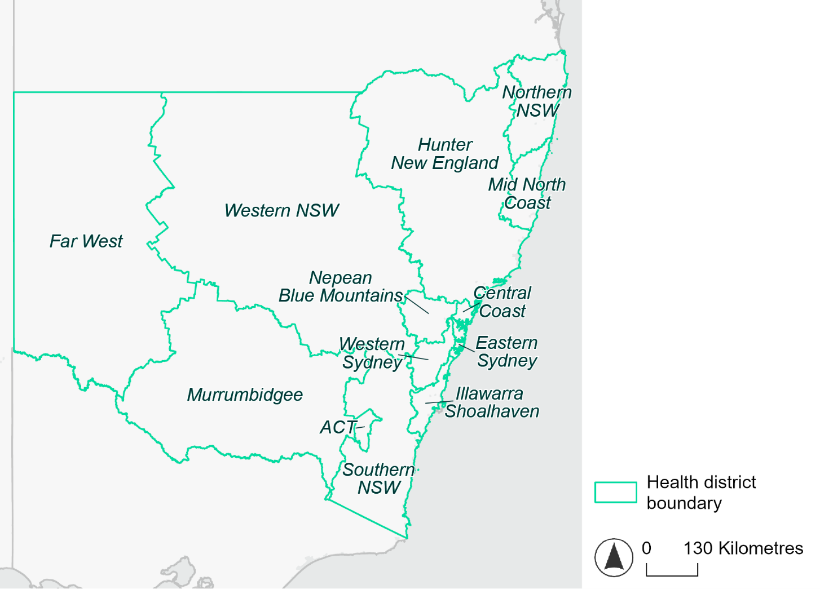
Figure 1. Map of NSW and ACT health districts used in this document.

Time horizons
This document provides climate information on each climate hazard for the following time horizons:

Time horizon | Years | Description | Use in risk assessment
Baseline | Observed data from 1985-2014 | Historical baseline position | Understand current risks and ensure they are being managed effectively
Mid-century (2050) | 2035–2064 | Medium-term climate projections | Identify and manage emerging risks to population health and health systems
Late century (2085) | 2070–2099 | Long-term climate projections | Identify long-term risks when planning infrastructure or policy with long-lasting consequences

Climate scenarios
The document provides climate information on each hazard for two different climate scenarios. A climate scenario is a plausible representation of what the future climate might look like. These scenarios are based on different assumptions about greenhouse gas emissions and other factors that influence the future climate.
This document uses Shared Socioeconomic Pathways (SSPs) as the basis for different climate scenarios. SSPs describe how socioeconomic factors (such as population, economic growth, education, urbanisation and technology development) could change over the next century and have an effect on future greenhouse gas emissions and global temperatures.

There are five main SSPs, each of which outlines a different scenario, ranging from a sustainable future with low emissions, to one with high fossil fuel uses and high emissions. The most recent iteration of SSPs incorporate information from what were previously called Representative Concentration Pathways (RCPs) which measure the expected change in radiative forcing (in W/m²) under the scenario from 1750 to 2100. SSP2-4.5 denotes what would previously have been called a scenario involving SSP2 and RCP4.5 – the reasoning for merging them being that SSP2 describes socioeconomic conditions likely to give rise to RCP4.5.

The two main scenarios used in this document are:
A ‘middle of the road’ scenario (SSP2-4.5): this scenario assumes emissions remain at current levels until the middle of the 21st century, and that net zero emissions are not reached by 2100. This scenario sees temperatures rising by about 2.7°C by the end of the century. In this document this is the lower emissions scenario across all climate hazards, except for the fire hazard (see below note).
A ‘reasonable worst-case’ scenario (SSP3-7.0): this scenario assumes both emissions and temperatures continue to rise to the end of the century due to delayed climate action. This scenario sees temperatures rise by about 3.6°C by 2100. In this document this is the higher emissions scenario across all climate hazards.

Fire hazard projections are not available for SSP2-4.5, so SSP1-2.6 is used as the lower emissions scenario for this hazard instead of SSP2-4.5. Under SSP1-2.6, global emissions are reduced but do not reach net zero until after 2050 and warming stabilises at about 1.8°C by 2100. This document refers to SSP1-2.6 as the ‘sustainability’ scenario.

Climate hazard projections
For each health district, the following information is provided for each climate hazard, across the different time horizons and climate scenarios:
- Heat and humidity: projected average, extreme and apparent temperatures; projected heatwave duration and frequency; and projected number of very hot days.
- Fire: projected area affected by different fire hazard categories for a 1-in-20-year fire event and a 1-in-100-year event.
- Drought: projected average number of months per year experiencing drought.
- Rainfall and flooding: projected number of extreme rainfall days per year, as well as projected frequency of urban and rural flood events.
- Storms: projected number of storms per year, grouped into four intensity categories based on wind speed.
- Coastal inundation: projected area of land affected by tidal inundation and storm surge and tidal inundation (coastal districts only).

The climate hazard projections in this document are based on data from nine CMIP6 Global Climate Models (ACCESS-CM2, ACCESS-ESM1-5, CESM2, CMCC-ESM2, CNRM-ESM2-1, EC-Earth3, MPI-ESM1-2-HR, NorESM2-MM, UKESM1-0-LL). These models simulate how climate hazards may change under different SSPs. Where hazard projections are based on these models, this document reports the median projected value as its primary estimate, and reports the range across all nine models in square brackets.

Australian Capital Territory health district

Health district overview
The Australian Capital Territory health district covers 2352 square kilometres with an estimated population of 456,844 residents.

..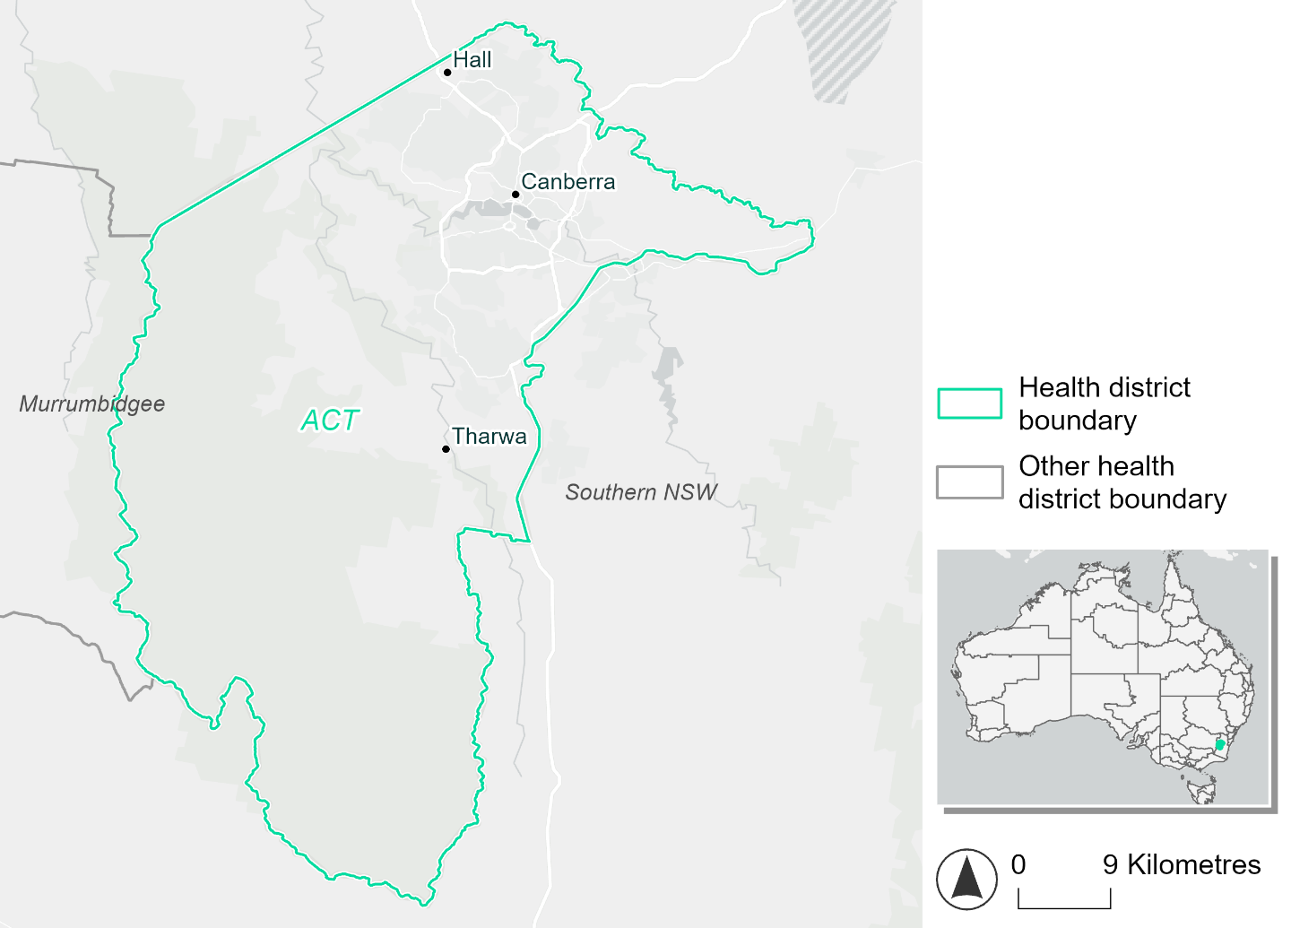
Figure 2. Map of Australian Capital Territory health district.

How will climate change affect this health district?
Heat and humidity: Higher average temperatures, hotter and more frequent hot days, warmer night-time temperatures and longer and more frequent heatwaves.
Fire: Over 50% of this health district already experiences a very high fire hazard category and this will continue in the future.
Drought: The number of months experiencing drought will increase slightly across reasonable worst-case scenarios.
Rainfall and flood: There will be more flood events in urban areas.

Australian Capital Territory health district demographic data
Demographic Data | Total
Number of households | 168,371
Persons 15 and older | 326,548
Total families | 119,775
Persons did not complete high school | 57,609
One parent families with dependents | 11,093 (9.3%)
Persons aged 65 and older | 62,121 (13.7%)
Persons aged 4 and younger | 26,618 (5.9%)
Aboriginal and Torres Strait Islander persons | 8,878 (2%)
Persons speaks language other than English | 110,964 (24.5%)
Persons working age (15-65) | 308,504 (68%)
Population Health Data | Total
Persons with core needs for assistance | 20,724 (4.6%)
Persons with arthritis | 34,957(7.7%)
Persons with asthma | 40,742 (9%)
Persons with cancer | 12,083 (2.7%)
Persons with dementia | 2,554 (0.6%)
Persons with diabetes | 17,350 (3.8%)
Persons with heart disease | 13,906 (3.1%)
Persons with kidney disease | 4,046 (0.9%)
Persons with lung condition | 5,865 (1.3%)
Persons with mental health condition | 45,197 (10%)
Persons with stroke | 3,124 (0.7%)
Persons with any other condition | 43,931 (9.7%)
Persons no health condition | 277,470 (61.2%)
Socio-economic Data | Total
Persons providing unpaid care | 54,632 (12%)
Persons homeless | 1,809 (0.4%)
Household with lone person | 43,293 (25.7%)
Households with rent and mortgage stress | 54,247 (32.2%)
Households total equivalised income below $1000 (weekly) | 41,757 (24.8%)
Households with no motor vehicle | 9,274 (5.5%)
Persons unemployed | 13,895 (3.8%)

The sections that follow outline projected climate hazards for this district. Further information on this health district, including population demographics, is provided in the online dashboard.

Heat and humidity hazard
Key projections:
More heatwaves: Heatwave events are likely to last longer and the annual number of heatwave events will increase. Under the reasonable worst-case scenario:
- By 2050, the annual number of heatwaves will more than double.
- By 2085, the annual number of heatwaves will more than triple.
Hotter days and warmer nights: The maximum temperature on hot days will increase with temperatures on hot nights also increasing.
More days above 35°C: The annual number of days greater than 35°C will increase under both middle of the road and reasonable worst-case scenarios.

 | Baseline | 2050 Scenarios |  | 2085 Scenarios
 |  | Middle of the road | Reasonable worst-case | Middle of the road | Reasonable worst-case
Average temperature (°C) | 13.4 | 14.8  [14.3, 15.4] | 15.1  [14.3, 15.8] | 15.7  [14.6, 16.7] | 16.8  [15.5, 18]
Maximum temperature on hot days (°C)^{(a)} | 30.9 | 32.7  [32.2, 34] | 33.3  [31.9, 35.1] | 33.7  [32.7, 35.6] | 34.8  [33.8, 37]
Minimum temperature on hot nights (°C)^{(b)} | 16.7 | 18.2  [17.4, 18.9] | 18.5  [17.5, 19.1] | 19.1  [17.5, 20.2] | 20.2  [18.7, 21.5]
Average apparent temperature on hot days (°C) (NOAA Heat Index)^{(c)} | 32.4 | 33.9  [33.2, 34.4] | 34.1  [33, 34.9] | 34.6  [33.7, 35.7] | 35.5  [34.4, 37]
Average heatwave duration in days^{(d)} | 5 | 6  [5, 7] | 6  [5, 7] | 6  [5, 8] | 8  [6, 11]
Number of heatwaves per year^{(d)} | 2 | 4  [4, 6] | 5  [3, 7] | 6  [4, 8] | 7  [6, 9]
Number of days per year > 35°C | 4 | 8  [6, 13] | 10  [5, 19] | 12  [7, 22] | 17  [12, 31]
Number of days per year > 40°C | 0 | 0  [0, 1] | 1  [0, 3] | 1  [0, 3] | 2  [1, 6]
Table notes: The heat and humidity hazard uses climate projections from the CMIP6 Global Climate Models [1]. Daily projections of maximum and minimum near-surface temperature and mean relative humidity are used to calculate eight heat and humidity indicators. The primary indicator value reports the median from the nine climate models, with the range reported in square brackets.
Table footnotes: (a) Based on the 95th percentile of daily maximum air temperature. (b) Based on the 95th percentile of daily minimum air temperature (i.e. the 5th percentile of daily maximum air temperature), representing the coldest part of the night on very hot nights. (c) The National Oceanic and Atmospheric Administration (NOAA) Heat Index is a measure of how hot it feels when relative humidity is factored in alongside actual air temperature. It is calculated on days with a maximum temperature of 27°C and above. Interpretation of Heat Index values: 27°C to 32°C indicates caution, 33°C to 41°C indicates extreme caution, 42°C to 54°C indicates danger and over 54°C indicates extreme danger. See methodology document for further explanation of Heat Index categories. (d) A heatwave is defined as three or more consecutive days where both daytime and overnight temperatures (daily mean temperatures) are unusually high for the location, based on the Bureau of Meteorology’s Excess Heat Factor method. For this district, an unusually high daily mean temperature is approximately 23.3°C or above.

Fire hazard
Key projections:
The majority of the health district area experiences moderate to very high fire hazard: Over half the district already experiences very high fire hazard with most of the remaining area (41%) experiencing ‘moderate to high’ fire hazard during both a 1-in-20 and 1-in-100-year fire weather event.
Hazard levels to remain high: Only slight shifts (less than 1%) in the fire hazard area are expected in the future, with less than 8% of the district area experiencing a low hazard during a 1-in-20 and 1-in-100-year fire weather event, even under a sustainability scenario.

Baseline |  | 2050 Scenarios |  | 2085 Scenarios
 |  | Sustainability | Reasonable worst-case | Sustainability | Reasonable worst-case
Hazard for a ‘1-in-20 year’ fire weather event^{(a)}
Proportion (%) of district experiencing ‘Low’ fire hazard | 8.0%  (18,788)^{(b)} | 7.9%  [7.6%, 8.0%] | 7.9%  [7.4%, 8.4%] | 7.7%  [7.0%, 8.1%] | 7.8%  [6.5%, 9.0%]
Proportion (%) of district experiencing ‘Moderate to High’ fire hazard | 41.7%  (98,375)^{(b)} | 41.9%  [41.1%, 42.8%] | 41.7%  [40.2%, 43.5%] | 42.1%  [40.3%, 44.4%] | 41.7%  [38.1%, 46.0%]
Proportion (%) of district experiencing ‘Very High’ fire hazard | 50.3%  (118,640)^{(b)} | 50.3%  [50.0%, 50.4%] | 50.4%  [49.9%, 50.8%] | 50.2%  [49.6%, 50.6%] | 50.5%  [49.3%, 51.6%]
Hazard for a ‘1-in-100 year’ fire weather event^{(a)}
Proportion (%) of district experiencing ‘Low’ fire hazard | 6.9%  (16,371)^{(b)} | 6.8%  [6.5%, 7.0%] | 7.0%  [6.5%, 7.3%] | 6.7%  [6.0%, 7.2%] | 7.0%  [5.8%, 7.9%]
Proportion (%) of district experiencing ‘Moderate to High’ fire hazard | 41.7%  (98,285)^{(b)} | 41.7%  [40.2%, 43.3%] | 41.6%  [39.4%, 44.0%] | 41.8%  [38.2%, 45.6%] | 41.5%  [36.2%, 47.3%]
Proportion (%) of district experiencing ‘Very High’ fire hazard | 51.4%  (121,147)^{(b)} | 51.5%  [51.3%, 51.7%] | 51.5%  [51.0%, 51.9%] | 51.6%  [51.1%, 52.2%] | 51.6%  [50.4%, 52.6%]
Table notes: The Fire Hazard uses the National Bushfire Intelligence Capability (NBIC) Phase 2 fire line intensity modelling based on CMIP6 climate projections. Fire Hazard is assessed using the projected Fireline Intensity (FLI) for weather events with two different return intervals (i.e. a 1-in-20 year event and a 1-in-100 year event). FLI considers slope, vegetation and weather to produce a rate of heat output per unit length (kW/m) along a bushfire’s front. Fire hazard is categorized as a low for FLI<4000 kW/m, moderate to high for 4,000 kW/m ≤FLI<12,500kW/m, and very high for FLI≥27,501kW/m. This is broadly consistent with the literature [3]. The assessment considers climate change effects based on changes in fire weather and the associated hazard that is anticipated for a meteorological event of a given return interval. This approach is different to the one adopted for the Flood Hazard, where the event magnitude is given (fixed) and the likelihood of that event varies as a result of climate change. The primary indicator value reports the median from the nine climate models, with the range reported in square brackets.
Table footnotes: (a) The area subject to different categories of fire hazard is determined for a ‘1-in-20 year’ and ‘1-in-100 year’ fire weather event, in current and future climates. Values at year 2050 are interpolated using data from baseline (2025) and 2085, assuming linear change over time. (b) Values in round brackets are the area (ha) of the health district subject to a given fire hazard.

The figures below show the proportion of the health district experiencing different fire hazard categories across different time horizons and climate scenarios during a ‘1-in-20 year’ fire weather event (Figure 3) and a ‘1-in-100 year’ fire weather event (Figure 4).
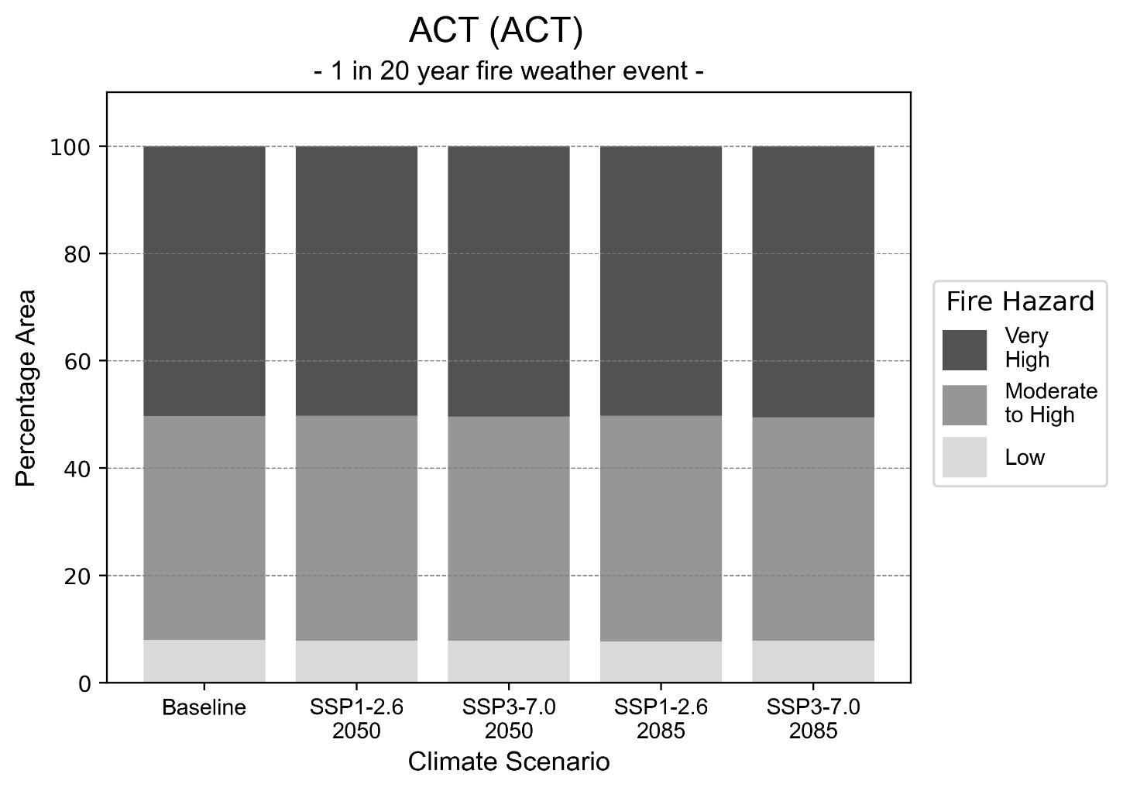
Figure 3: Stacked column chart showing the percentages of the ACT health district's total geographic area experiencing each fire hazard level during a 1-in-20-year fire weather event.
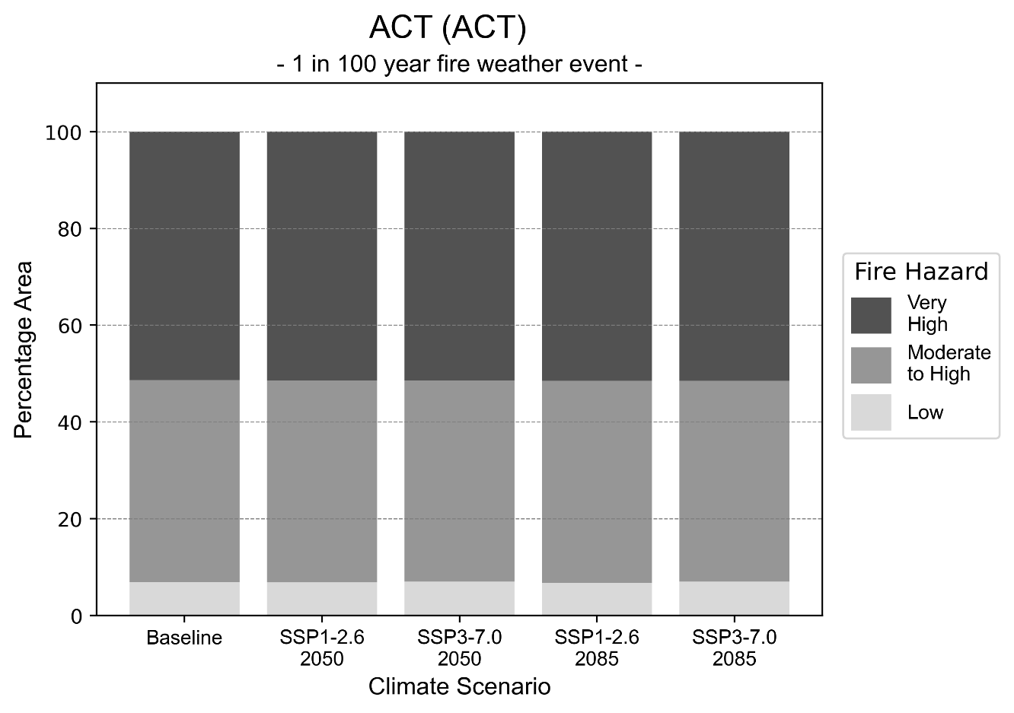
Figure 4: Stacked column chart showing the percentages of the ACT health district's total geographic area experiencing each fire hazard level during a 1-in-100-year fire weather event.

Drought hazard
Key projections:
Drought occurrence: The occurrence of drought will increase slightly across reasonable worst-case scenarios for both time horizons, with drought being experienced on average two months per year. The occurrence of drought will decrease slightly for the middle of the road scenario across both time horizons.

 | Baseline | 2050 Scenarios |  | 2085 Scenarios
 |  | Middle of the road | Reasonable worst-case | Middle of the road | Reasonable worst-case
Number of months per year in drought^{(a)} | 1.9 | 1.8  [0.4, 2.5] | 2.1  [0.6, 5.3] | 1.8  [0.5, 3.2] | 2.1  [0.2, 4.8]
Table notes: The drought hazard indicator uses climate projections from the CMIP6 Global Climate Models [1]. The primary indicator value reports the median from the nine climate models, with the range reported in square brackets.
Table footnotes: (a) The number of months per year in drought is based on the Standardised Precipitation Index (SPI). SPI is a widely used index to characterise meteorological drought on a range of timescales. This indicator uses the timescale of 12 months, reporting the average months in a year within the moderate drought range (SPI ≤ -1). SPI is calculated from accumulated rainfall over 12 months and the mean and standard deviation from historical rainfall records. For further information, see methodology document.

Storm hazard
Key projections:
More frequent high-intensity storms: The frequency of high-intensity storms will increase across both middle of the road and reasonable worst-case scenarios, with the greatest increase occurring by 2085.

Baseline |  | 2050 Scenarios |  | 2085 Scenarios
 |  | Middle of the road | Reasonable worst-case | Middle of the road | Reasonable worst-case
Number of low-intensity storms  (40-62 km/hr) per year | 73.6 | 69.2  [60.9, 76.1] | 71.1  [62.5, 78.2] | 66.6  [58.6, 73.3] | 72.6  [63.9, 79.8]
Number of medium-intensity storms (63-87 km/hr) per year | 34.8 | 31.4  [27.7, 34.6] | 29.2  [25.7, 32.1] | 29.5  [26.0, 32.5] | 27.5  [24.2, 30.3]
Number of high-intensity storms (88-117 km/hr) per year | 2.5 | 3.4  [3.0, 3.7] | 3.1  [2.8, 3.4] | 3.5  [3.1, 3.9] | 3.6  [3.2, 4.0]
Number of very-high-intensity storms (> 117 km/hr) per year | 0.0 | 0.0  [0.0, 0.0] | 0.0  [0.0, 0.0] | 0.1  [0.1, 0.1] | 0.0  [0.0, 0.0]
Table notes: The storm hazard uses climate projections from the CMIP6 Global Climate Models [1]. Daily maximum surface wind speed is used to calculate the number of annual storms across four storm intensity categories (low, medium, high and very high). The primary indicator value reports the median from the nine climate models, with the range reported in square brackets.

Rainfall and flood hazard
Key projections:
Nine extreme rainfall days per year: The number of extreme rainfall days will remain consistent across both middle of the road and reasonable worst-case scenarios, and both time horizons, with an average of approximately nine extreme rainfall days per year.
Increased flood frequency: The frequency of flood events will increase in urban environments but decrease in rural environments. The largest increase in flooding is seen in the reasonable worst-case scenario, where the frequency of a ‘1-in-100 year’ flood will more than triple by 2050 and become ten times more likely by 2085 in urban environments.

Baseline |  | 2050 Scenarios |  | 2085 Scenarios
 |  | Middle of the road | Reasonable worst-case | Middle of the road | Reasonable worst-case
Rainfall hazard
Average number of extreme rainfall days per year (> 12 mm/day)^{(a)} | 8.9 | 9.0  [8.1,11.0] | 8.8  [6.8,10.7] | 9.0  [7.7,11.1] | 8.8  [6.8,11.9]
Urban flood risk (flooding caused by a 1-hour rainfall event)^{(b)}
Frequency of a ‘1-in-1 year’ flood (rainfall depth of 17 mm)^{(c)} |  | 1.9 events in 1 year | 2.0 events in 1 year | 2.4 events in 1 year | 3.2 events in 1 year
Frequency of a ‘1-in-10 year’ flood (rainfall depth of 33 mm)^{(c)} |  | 2.6 events in 10 years | 2.7 events in 10 years | 3.6 events in 10 years | 5.6 events in 10 years
Frequency of a ‘1-in-100 year’ flood (rainfall depth of 54 mm)^{(c)} |  | 3.4 events in 100 years | 3.7 events in 100 years | 5.6 events in 100 years | 10 events in 100 years
Rural flood risk (flooding caused by a 24-hour rainfall event)^{(b)}
Frequency of a ‘1-in-1 year’ flood (rainfall depth of 52 mm)^{(c)} |  | 0.9 events in 1 year | 0.9 events in 1 year | 0.8 events in 1 year | 0.2 events in 1 year
Frequency of a ‘1-in-10 year’ flood (rainfall depth of 89 mm)^{(c)} |  | 1.0 events in 10 years | 0.9 events in 10 years | 0.4 events in 10 years | 0.2 events in 10 years
Frequency of a ‘1-in-100 year’ flood (rainfall depth of 147 mm)^{(c)} |  | 1.1 events in 100 years | 1.0 events in 100 years | 0.7 events in 100 years | 0.3 events in 100 years
Table notes: The rainfall hazard indicator uses climate projections from the CMIP6 Global Climate Models [1]. The primary indicator value reports the median from the nine climate models, with the range reported in square brackets. The flood hazard indicators use climate change considerations from the Australian Rainfall and Runoff guideline to estimate the climate projections [2].
Table footnotes: (a) Extreme rainfall is defined as rainfall above the 95th percentile of historical average daily rainfall in this health district in the period 1985-2014. The value in mm/day quoted in the indicator name is the 95th percentile of historic average daily rainfall for this health district. (b) See Methodology document for reasons for focusing on a 1-hour flood for urban areas and a 24-hour flood for rural areas. (c) The rainfall depths in mm quoted in the indicator names in this table report 1-in-1 year, 1-in-10 year and 1-in-100 year flood (rainfall) depths for this health district.

Central Coast health district

Health district overview
Surface area: 1853 square kilometres
Traditional owners: Darkinyung (Darkinjung) people
Estimated population (2019): 350,000
Estimated population (2030): 397,370
Local health services: Gosford Hospital, Long Jetty Hospital, Woy Woy Hospital, Wyong Hospital, community health services

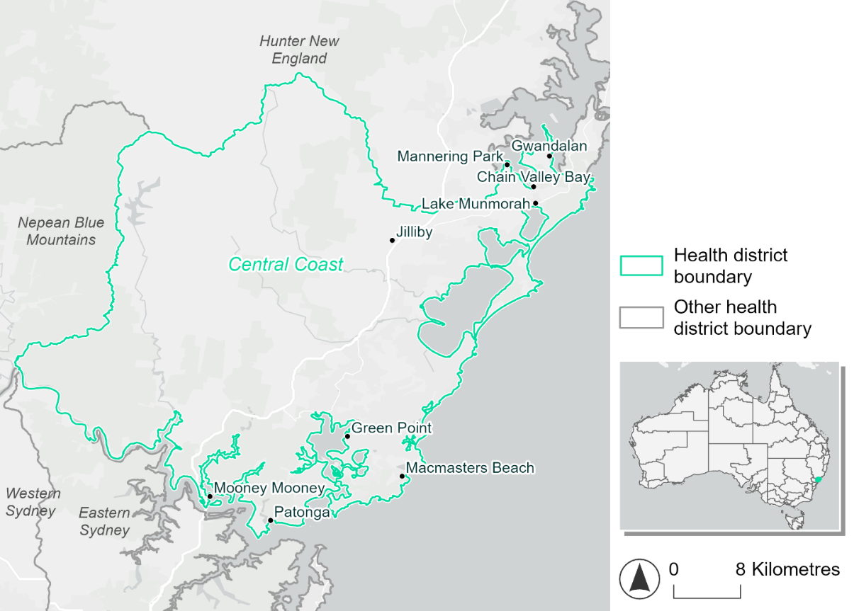
Figure 5. Map of Central Coast health district.

How will climate change affect this health district?
Heat and humidity: There will be higher average temperatures, hotter and more frequent hot days, warmer night time temperatures and longer and more frequent heat waves.
Fire: Over 70% of this health district experiences a very high fire hazard category and this will continue in the future.
Drought: The number of months experiencing drought will increase slightly.
Rainfall and flood: There will be more flood events in both urban and rural areas.
Coastal inundation: The area flooded during tidal, and storm surge and tidal inundation, will increase.

Central Coast health district demographic data
Demographic Data | Total
Number of households | 131,745
Persons 15 and older | 229,531
Total families | 94,862
Persons did not complete high school | 104,881
One parent families with dependents | 11,100 (11.7%)
Persons aged 65 and older | 77,023 (22.1%)
Persons aged 4 and younger | 20,302 (5.8%)
Aboriginal and Torres Strait Islander persons | 17,051 (4.9%)
Persons speaks language other than English | 24,648 (7.1%)
Persons working age (15-65) | 208,912 (59.8%)

Population Health Data | Total
Persons with core needs for assistance | 24,374 (7.0%)
Persons with arthritis | 40,012 (11.5%)
Persons with asthma | 33,550 (9.6%)
Persons with cancer | 13,008 (3.7%)
Persons with dementia | 3,753 (1.1%)
Persons with diabetes | 18,981 (5.4%)
Persons with heart disease | 17,497 (5.0%)
Persons with kidney disease | 4,473 (1.3%)
Persons with lung condition | 9,282 (2.7%)
Persons with mental health condition | 38,334 (11.0%)
Persons with stroke | 4,491 (1.3%)
Persons with any other condition | 31,376 (9.0%)
Persons no health condition | 189,215 (54.2%)

Socio-economic Data | Total
Persons providing unpaid care | 43,582 (12.5%)
Persons homeless | 799 (0.2%)
Household with lone person | 35,871 (27.2%)
Households with rent and mortgage stress | 73,955 (56.1%)
Households total equivalised income below $1000 (weekly) | 65,348 (49.6%)
Households with no motor vehicle | 8,443 (6.4%)
Persons unemployed | 13,661 (4.8%)

The sections that follow outline projected climate hazards for this district. Further information on this health district, including population demographics, is provided in the online dashboard.

Heat and humidity hazard
Key projections:
More heatwaves: The number of heatwaves per year will increase. By 2050, under a reasonable worst-case scenario the number of heatwaves will more than double. By 2085, under a reasonable worst-case scenario the number of heatwaves per year may quadruple.
More days above 35°C and 40°C: The number of days per year greater than 35°C and 40°C will increase under both middle of the road and reasonable worst-case scenarios.

 | Baseline | 2050 Scenarios |  | 2085 Scenarios
 |  | Middle of the road | Reasonable worst-case | Middle of the road | Reasonable worst-case
Average temperature (°C) | 16.9 | 18.3  [17.8, 19] | 18.6  [17.8, 19.5] | 19.2  [18.3, 20.4] | 20.2  [19.1, 21.5]
Maximum temperature on hot days (°C)^{(a)} | 32.6 | 34.2  [33.7, 35.2] | 34.7  [33.5, 36.2] | 35.2  [34.2, 37.1] | 36.3  [35.2, 38.3]
Minimum temperature on hot nights (°C)^{(b)} | 19.5 | 21.1  [20.3, 21.9] | 21.3  [20.3, 22.2] | 22  [20.8, 23.3] | 23  [21.7, 24.6]
Average apparent temperature on hot days (°C) (NOAA Heat Index)^{(c)} | 34.8 | 36.3  [35.4, 36.7] | 36.6  [35.6, 37.3] | 37.1  [36.1, 38.2] | 38.2  [37.1, 39.7]
Average heatwave duration in days^{(d)} | 4 | 5  [5, 5] | 5  [4, 6] | 5  [5, 7] | 6  [5, 9]
Number of heatwaves per year^{(d)} | 2 | 4  [3, 6] | 5  [3, 7] | 6  [4, 9] | 8  [6, 10]
Number of days per year  > 35°C | 9 | 16  [14, 22] | 18  [13, 27] | 22  [16, 33] | 29  [21, 44]
Number of days per year  > 40°C | 1 | 3  [2, 4] | 3  [2, 6] | 4  [2, 8] | 6  [4, 12]
Table notes: The heat and humidity hazard uses climate projections from the CMIP6 Global Climate Models [1]. Daily projections of maximum and minimum near-surface temperature and mean relative humidity are used to calculate eight heat and humidity indicators. The primary indicator value reports the median from the nine climate models, with the range reported in square brackets.
Table footnotes: (a) Based on the 95th percentile of daily maximum air temperature. (b) Based on the 95th percentile of daily minimum air temperature, representing the coldest part of the night on very hot nights. (c) The National Oceanic and Atmospheric Administration (NOAA) Heat Index is a measure of how hot it feels when relative humidity is factored in alongside actual air temperature. It is calculated on days with a maximum temperature of 27°C and above. Interpretation of Heat Index values: 27°C to 32°C indicates caution, 33°C to 41°C indicates extreme caution, 42°C to 54°C indicates danger and over 54°C indicates extreme danger. See methodology document for further explanation of Heat Index categories. (d) A heatwave is defined as three or more consecutive days where both daytime and overnight temperatures (daily mean temperatures) are unusually high for the location, based on the Bureau of Meteorology’s Excess Heat Factor method. For this district, an unusually high daily mean temperature is approximately 24.9 °C or above.

Fire hazard
Key projections:
Majority of health district area experiences very high fire hazard: Under baseline conditions, the majority (71-73%) of the health district already experiences a very high fire hazard for both 1-in-20 and 1-in-100 fire weather events. Most of the remaining health district area (20-23%) experiences low fire hazard during both 1-in-20 and 1-in-100 fire weather events.
Low fire hazard will become rarer: In both 2050 and 2085 scenarios, the majority (71-74%) of the health district will continue to experience a very high fire hazard for both 1-in-20 and 1-in-100 fire weather events. The proportion experiencing a low fire hazard will decrease (down to 8-15%) with a corresponding increase of 7-13 percentage points in the area experiencing moderate to high fire hazard.

 | Baseline |  | 2050 Scenarios |  | 2085 Scenarios
 |  |  | Sustainability | Reasonable worst-case | Sustainability | Reasonable worst-case
Hazard for a ‘1-in-20 year’ fire weather event^{(a)}
Proportion (%) of district experiencing ‘Low’ fire hazard |  | 23.1%  (38,854)^{(b)} | 19.9%  [19.4%, 20.6%] | 17.4%  [16.2%, 18.6%] | 15.4%  [14.2%, 17.2%] | 9.5%  [6.7%, 12.4%]
Proportion (%) of district experiencing ‘Moderate to High’ fire hazard |  | 5.9%  (9,953)^{(b)} | 9.1%  [7.6%, 10.3%] | 11.4%  [9.7%, 13.1%] | 13.6%  [9.9%, 16.5%] | 19.0%  [15.0%, 23.2%]
Proportion (%) of district experiencing ‘Very High’ fire hazard |  | 71.0%  (119,702)^{(b)} | 71.0%  [70.3%, 71.9%] | 71.2%  [69.9%, 72.1%] | 71.0%  [69.3%, 73.0%] | 71.4%  [68.2%, 73.7%]
Hazard for a ‘1-in-100 year’ fire weather event^{(a)}
Proportion (%) of district experiencing ‘Low’ fire hazard |  | 19.8%  (33,349)^{(b)} | 17.1%  [16.5%, 17.5%] | 14.8%  [14.3%, 15.8%] | 13.3%  [11.9%, 14.4%] | 7.8%  [6.6%, 10.2%]
Proportion (%) of district experiencing ‘Moderate to High’ fire hazard |  | 6.9%  (11,668)^{(b)} | 9.6%  [9.0%, 10.3%] | 11.8%  [10.7%, 13.4%] | 13.3%  [11.8%, 15.0%] | 18.6%  [16.1%, 22.4%]
Proportion (%) of district experiencing ‘Very High’ fire hazard |  | 73.3%  (123,493)^{(b)} | 73.3%  [73.2%, 73.4%] | 73.4%  [73.2%, 73.5%] | 73.4%  [73.0%, 73.6%] | 73.6%  [73.1%, 73.8%]
Table notes: The Fire Hazard uses the National Bushfire Intelligence Capability (NBIC) Phase 2 fire line intensity modelling based on CMIP6 climate projections. Fire Hazard is assessed using the projected Fireline Intensity (FLI) for weather events with two different return intervals (i.e. a 1-in-20 year event and a 1-in-100 year event). FLI considers slope, vegetation and weather to produce a rate of heat output per unit length (kW/m) along a bushfire’s front. Fire hazard is categorized as a low for FLI<4000 kW/m, moderate to high for 4,000 kW/m ≤FLI<12,500kW/m, and very high for FLI≥27,501kW/m. This is broadly consistent with the literature [3]. The assessment considers climate change effects based on changes in fire weather and the associated hazard that is anticipated for a meteorological event of a given return interval. This approach is different to the one adopted for the Flood Hazard, where the event magnitude is given (fixed) and the likelihood of that event varies as a result of climate change. The primary indicator value reports the median from the nine climate models, with the range reported in square brackets.
Table footnotes: (a) The area subject to different categories of fire hazard is determined for a ‘1-in-20 year’ and ‘1-in-100 year’ fire weather event, in current and future climates. Values at year 2050 are interpolated using data from baseline (2025) and 2085, assuming linear change over time. (b) Values in round brackets are the area (ha) of the health district subject to a given fire hazard.

The figures below show the proportion of the health district experiencing different fire hazard categories across different time horizons and climate scenarios during a ‘1-in-20 year’ fire weather event (Figure 6) and a ‘1-in-100 year’ fire weather event (Figure 7).
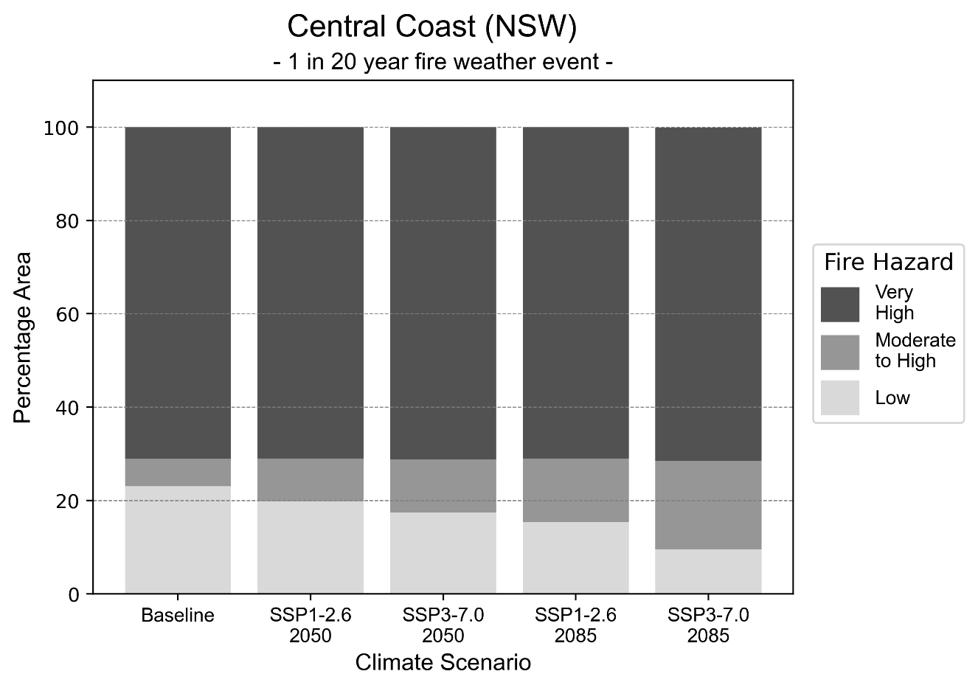
Figure 6: Stacked column chart showing the percentages of the Central Coast health district's total geographic area experiencing each fire hazard level during a 1-in-20-year fire weather event.
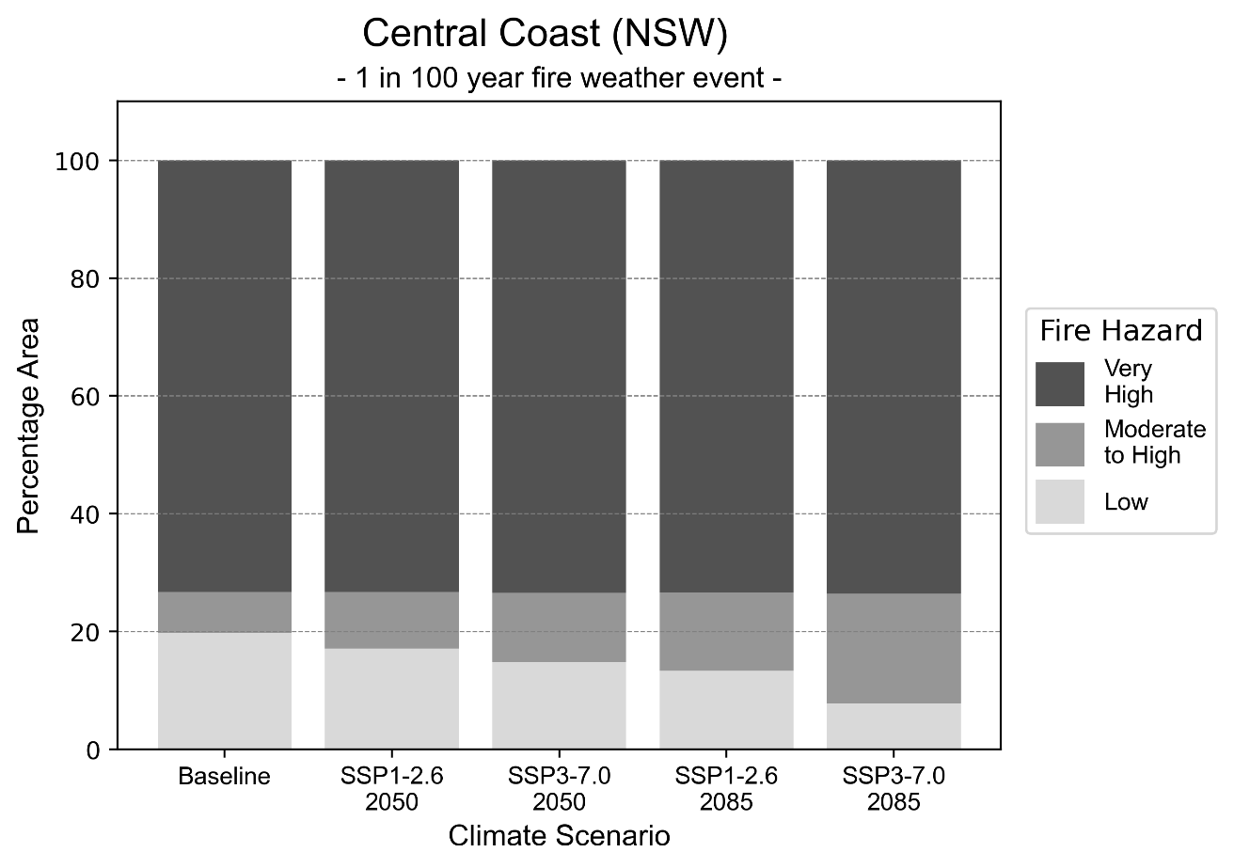
Figure 7: Stacked column chart showing the percentages of the Central Coast health district's total geographic area experiencing each fire hazard level during a 1-in-100-year fire weather event.

Drought hazard
Key projections:
Drought occurrence: The occurrence of drought will increase slightly across both middle of the road and reasonable worst-case scenarios, and both time horizons, with drought being experienced on average two months per year.

 | Baseline | 2050 Scenarios |  | 2085 Scenarios
 |  | Middle of the road | Reasonable worst-case | Middle of the road | Reasonable worst-case
Number of months per year in drought^{(a)} | 1.9 | 2.0  [1.0, 3.1] | 2.2  [0.9, 4.1] | 1.9  [0.8, 3.3] | 2.1  [0.5, 3.5]
Table notes: The drought hazard indicator uses climate projections from the CMIP6 Global Climate Models [1]. The primary indicator value reports the median from the nine climate models, with the range reported in square brackets.
Table footnotes:(a) The number of months per year in drought is based on the Standardised Precipitation Index (SPI). SPI is a widely used index to characterise meteorological drought on a range of timescales. This indicator uses the timescale of 12 months which calculates the average months in a year within the moderate drought range. A moderate drought range is classified as SPI score of ≤ -1. SPI is calculated from accumulated rainfall over 12 months and the mean and standard deviation from historical rainfall records.

Storm hazard
Key projection:
Less frequent low-intensity storms: The frequency of low-intensity storms will decrease across both middle of the road and reasonable worst-case scenarios, with the greatest decrease occurring by 2085 with no change in frequency of medium, high and very high intensity storm across both climate scenarios and time horizons.

Baseline |  | 2050 Scenarios |  | 2085 Scenarios
 |  | Middle of the road | Reasonable worst-case | Middle of the road | Reasonable worst-case
Number of low-intensity storms (40-62 km/hr) per year | 72.1 | 64.8  [57.0, 71.2] | 66.4  [58.4, 73.0] | 63.8  [56.1, 70.1] | 59.2  [52.1, 65.1]
Number of medium-intensity storms (63-87 km/hr) per year | 36.9 | 32.6  [28.7, 35.9] | 33.3  [29.3, 36.6] | 30.8  [27.1, 33.9] | 28.9  [25.4, 31.8]
Number of high-intensity storms (88-117 km/hr) per year | 8.6 | 8.3  [7.3, 9.1] | 7.9  [6.9, 8.7] | 6.5  [5.7, 7.2] | 7.0  [6.2, 7.7]
Number of very-high-intensity storms (> 117 km/hr) per year | 0.7 | 0.7  [0.6, 0.8] | 0.7  [0.6, 0.7] | 0.5  [0.5, 0.6] | 0.5  [0.4, 0.6]
Table notes: The storm hazard uses climate projections from the CMIP6 Global Climate Models [1]. Daily maximum surface wind speed is used to calculate the number of annual storms across four storm intensity categories (low, medium, high and very high). The primary indicator value reports the median from the nine climate models, with the range reported in square brackets.

Rainfall and flood hazard
Key projections:
- Ten extreme rainfall days per year: The number of extreme rainfall days will remain consistent across both middle of the road and reasonable worst-case scenarios, and both time horizons, with an average of approximately ten extreme rainfall days per year.
- Increased flood frequency: The frequency of flood events will increase, particularly in urban environments. The largest increase in flood frequency occurs in the reasonable worst-case scenario, where the frequency of a ‘1-in-100 year’ flood will triple by 2050 and become seven times more likely by 2085 in urban environments.

Baseline |  | 2050 Scenarios |  | 2085 Scenarios
 |  | Middle of the road | Reasonable worst-case | Middle of the road | Reasonable worst-case
Rainfall hazard^{(a)}
Average number of extreme rainfall days per year (> 12 mm/day)^{(a)} | 10.2 | 10.2  [8.9,11.4] | 10.1  [8.0,11.8] | 10.2  [8.8,11.9] | 10.0  [8.3,12.9]
Urban flood risk (flooding caused by a 1-hour rainfall event)^{(b)}
Frequency of a ‘1-in-1 year’ flood (rainfall depth of 26 mm)^{(c)} |  | 1.9 events in 1 year | 2.0 events in 1 year | 2.4 events in 1 year | 3.2 events in 1 year
Frequency of a ‘1-in-10 year’ flood (rainfall depth of 52 mm)^{(c)} |  | 2.3 events in 10 years | 2.5 events in 10 years | 3.2 events in 10 years | 4.9 events in 10 years
Frequency of a ‘1-in-100 year’ flood (rainfall depth of 92 mm)^{(c)} |  | 2.8 events in 100 years | 3.0 events in 100 years | 4.2 events in 100 years | 7.2 events in 100 years
Rural flood risk (flooding caused by a 24-hour rainfall event) ^{(b)}
Frequency of a ‘1-in-1 year’ flood (rainfall depth of 96 mm)^{(c)} |  | 1.1 events in 1 year | 1.1 events in 1 year | 1.1 events in 1 year | 0.8 events in 1 year
Frequency of a ‘1-in-10 year’ flood (rainfall depth of 187 mm)^{(c)} |  | 1.5 events in 10 years | 1.4 events in 10 years | 1.5 events in 10 years | 1.3 events in 10 years
Frequency of a ‘1-in-100 year’ flood (rainfall depth of 310 mm)^{(c)} |  | 1.7 events in 100 years | 1.7 events in 100 years | 1.9 events in 100 years | 1.9 events in 100 years
Table notes: The rainfall hazard indicator uses climate projections from the CMIP6 Global Climate Models [1]. The primary indicator value reports the median from the nine climate models, with the range reported in square brackets. The flood hazard indicators use climate change considerations from the Australian Rainfall and Runoff guideline to estimate the climate projections [2].
Table footnotes: (a) Extreme rainfall is defined as rainfall above the 95th percentile of historical average daily rainfall in this health district in the period 1985-2014. The value in mm/day quoted in the indicator name is the 95th percentile of historic average daily rainfall for this health district. (b) See Methodology document for reasons for focusing on a 1-hour flood for urban areas and a 24-hour flood for rural areas. (c) The rainfall depths in mm quoted in the indicator names in this table report 1 in 1, 10 and 100 year depths for this health district.

Coastal inundation hazard
Key projections:
Greater area inundated: There will be an increase in the area affected by tidal inundation (i.e. area submerged during high tide) and storm surge and tidal inundation (i.e. area submerged during a storm surge and high tide) across both middle of the road and reasonable worst-case scenarios. In the reasonable worst-case scenario, by 2085 the area inundated during a ‘1-in-1000-year’ event will nearly double.

 | Baseline | 2050 Scenarios |  | 2085 Scenarios^{(a)}
 |  | Middle of the road | Reasonable worst-case | Middle of the road | Reasonable worst-case
Tidal inundation (ha inundated)^{(b)} | 2,210.9 | 3,209.7  (+998.8) | 3,296.8  (+1,085.9) | 4,605.3  (+2,394.4) | 5,079.0  (+2,868.1)
Storm surge + tidal inundation – ‘1-in-100 year’ event (ha inundated)^{(c)} | 3,575.8 | 4,387.5  (+811.7) | 4,450.6  (+874.8) | 5,489.3  (+1,913.5) | 5,891.7  (+2,315.8)
Storm surge + tidal inundation – ‘1-in-1000 year’ event (ha inundated)^{(c)} | 3,758.7 | 4,528.9  (+770.2) | 4,590.8  (+832.0) | 5,878.5  (+2,119.7) | 6,224.6  (+2,465.8)
Table notes: The coastal inundation hazard provides an indication of flooding in coastal areas that can be attributed to sea level rise and storm inundation. The coastal inundation hazard is only reported for health districts adjoining the coastline. This table includes the projected inundation levels as well as the change from baseline conditions (in brackets).
Table footnotes: (a) For the 2085 Scenarios planning horizon, 2100 was adopted as it provides a conservative representation of the end of this period. This horizon aligns with many state planning regulations requiring consideration of sea level rise and storm tide to 2100, making the 2100 scenario particularly valuable for planning new health facilities in coastal areas. (b) The tidal inundation indicator reports the number of hectares inundated during high tide. The baseline value reports existing inundation patterns, while the 2050 and 2085 values report high tide inundation taking account of projected sea level rise due to climate change. (c) The storm surge + tidal inundation indicators report the combined effect, in hectares inundated, of high tide, sea level rise (for the 2050 and 2085 projections), and storm surge (for 1-in-100 year and 1-in-1000 year events).

Eastern Sydney health district

Health district overview
The Eastern Sydney health district contains three Local Health Districts: South Eastern Sydney Local Health District, Sydney Local Health District and Northern Sydney Local Health District.
Surface area: 1853 square kilometres
Traditional owners: Gadigal, Bediagal and Wangal peoples of the Eora Nation, Dharawal, Gweagal, Cammeraygal, Guringai, Dharug and Bidjigal peoples
Estimated population (2021): 2,687,570
Estimated population (2031): 3,026,988
Local health services: Balmain, Canterbury, Concord, Royal Prince Alfred, Hornsby, Macquarie, Mona Vale, Northern Beaches, Royal North Shore, Calvary Healthcare, Gower Wilson (Lord Howe Island), Prince of Wales, Royal Hospital for Women, St George, Sutherland, Sydney and Eye Hospital, War Memorial, Ryde
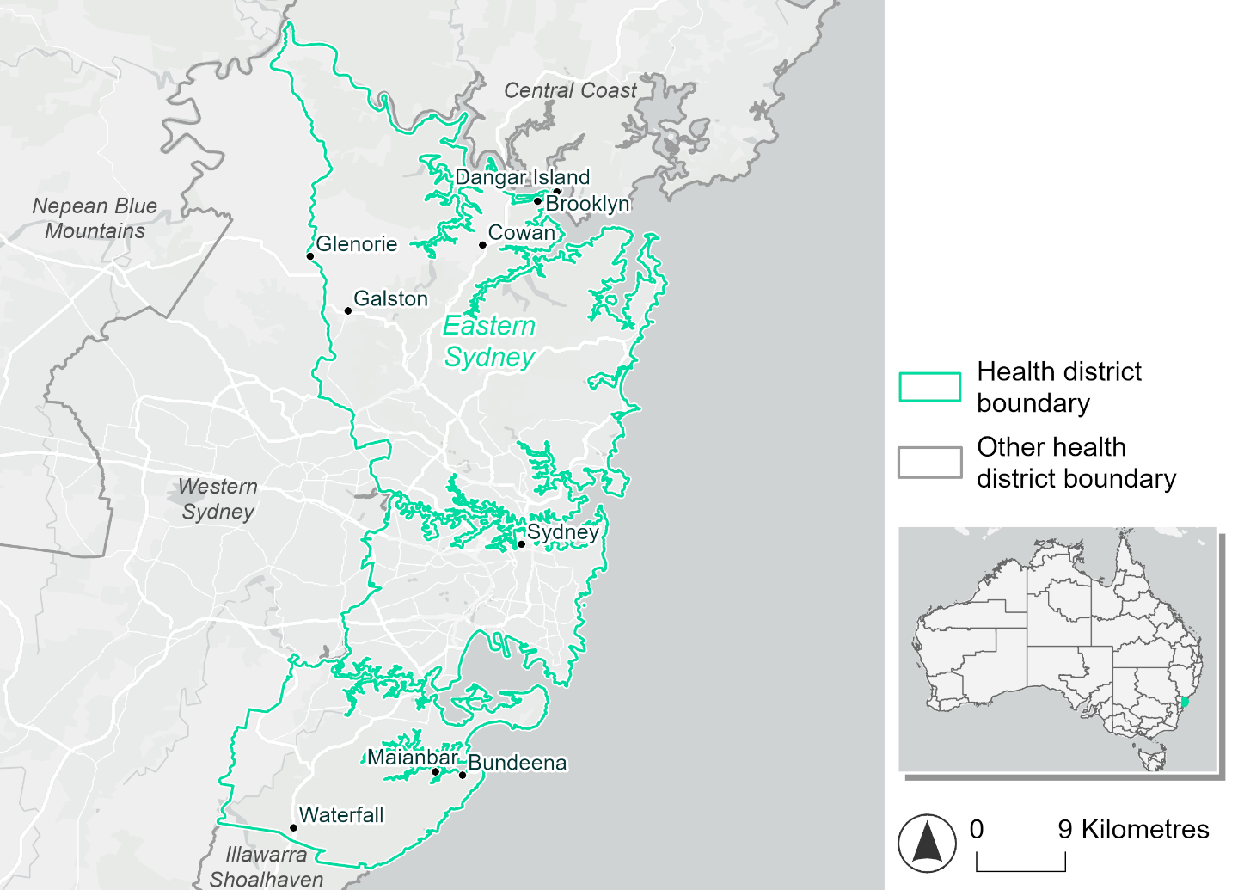
Figure 8. Map of Eastern Sydney health district.

How will climate change affect this health district?
Heat and humidity: There will be higher average temperatures, hotter and more frequent hot days, warmer night time temperatures and longer and more frequent heat waves.
Fire: Over 88% of this health district experiences very high fire hazard category and this will continue in the future.
Drought: The number of months experiencing drought will increase.
Rainfall and flood: There will be more flood events in both urban and rural areas.
Coastal inundation: The area flooded during tidal, and storm surge and tidal inundation, will increase.

Eastern Sydney health district demographic data
Demographic Data | Total
Number of households | 928,147
Persons 15 and older | 1,802,390
Total families | 650,192
Persons did not complete high school | 324,487
One parent families with dependents | 49,416 (7.6%)
Persons aged 65 and older | 393,531 (15.9%)
Persons aged 4 and younger | 126,987 (5.1%)
Aboriginal and Torres Strait Islander persons | 20,591 (0.8%)
Persons speaks language other than English | 854,593 (34.4%)
Persons working age (15-65) | 1,694,134 (68.2%)
Population Health Data | Total
Persons with core needs for assistance | 105,911 (4.3%)
Persons with arthritis | 150,733 (6.1%)
Persons with asthma | 156,891 (6.3%)
Persons with cancer | 63,840 (2.6%)
Persons with dementia | 18,355 (0.7%)
Persons with diabetes | 87,770 (3.5%)
Persons with heart disease | 79,556 (3.2%)
Persons with kidney disease | 17,040 (0.7%)
Persons with lung condition | 24,373 (1%)
Persons with mental health condition | 158,795 (6.4%)
Persons with stroke | 16,565 (0.7%)
Persons with any other condition | 177,695 (7.2%)
Persons no health condition | 1,659,812 (66.9%)
Socio-economic Data | Total
Persons providing unpaid care | 258,224 (10.4%)
Persons homeless | 13,384 (0.5%)
Household with lone person | 245,277 (26.4%)
Households with rent and mortgage stress | 508,839 (54.8%)
Households total equivalised income below $1000 (weekly) | 288,642 (31.1%)
Households with no motor vehicle | 135,326 (14.6%)
Persons unemployed | 95,085 (4.6%)

The sections that follow outline projected climate hazards for this district.

Heat and humidity hazard
Key projections:
More heatwaves: Heatwave events are likely to last longer and the number of heatwave events per year will increase. By 2050, under a reasonable worst-case scenario, the number of heatwaves will more than double. By 2085, under a reasonable worst-case scenario, the number of heatwaves per year may quadruple.
Hotter days and warmer nights: The day time and night time temperatures on hot days will increase.
More days above 35°C and 40°C: The number of days per year greater than 35°C and 40°C will increase under both middle of the road and reasonable worst-case scenarios.

 | Baseline |  | 2050 Scenarios |  | 2085 Scenarios
 |  | Middle of the road |  | Reasonable worst-case | Middle of the road | Reasonable worst-case
Average temperature (°C) | 18.5 | 19.9  [19.4, 20.6] |  | 20.2  [19.5, 21] | 20.8  [20, 21.9] | 21.7  [20.7, 23]
Maximum temperature on hot days (°C)^{(a)} | 32.4 | 33.9  [33.4, 34.9] |  | 34.3  [33.3, 35.7] | 34.8  [33.9, 36.7] | 35.9  [34.8, 37.7]
Minimum temperature on hot nights (°C)^{(b)} | 21.4 | 22.9  [22.1, 23.7] |  | 23.1  [22.3, 24] | 23.8  [22.7, 25.1] | 24.7  [23.6, 26.4]
Average apparent temperature on hot days (°C) (NOAA Heat Index)^{(c)} | 34.2 | 35.3  [34.7, 35.6] |  | 35.5  [34.9, 36] | 35.9  [35.1, 36.8] | 36.7  [35.9, 38]
Average heatwave duration in days^{(d)} | 4 | 4  [4, 5] |  | 5  [4, 6] | 5  [4, 7] | 6  [5, 9]
Number of heatwaves per year^{(d)} | 2 | 4  [3, 6] |  | 5  [3, 7] | 6  [4, 10] | 8  [6, 11]
Number of days per year  > 35°C | 8 | 14  [12, 19] |  | 15  [11, 22] | 18  [14, 28] | 24  [18, 37]
Number of days per year > 40°C | 1 | 2  [1, 3] |  | 2  [1, 4] | 3  [2, 6] | 5  [3, 9]
Table notes: The heat and humidity hazard uses climate projections from the CMIP6 Global Climate Models [1]. Daily projections of maximum and minimum near-surface temperature and mean relative humidity are used to calculate eight heat and humidity indicators. The primary indicator value reports the median from the nine climate models, with the range reported in square brackets.
Table footnotes: (a) Based on the 95th percentile of daily maximum air temperature. (b) Based on the 95th percentile of daily minimum air temperature, representing the coldest part of the night on very hot nights. (c) The National Oceanic and Atmospheric Administration (NOAA) Heat Index is a measure of how hot it feels when relative humidity is factored in alongside actual air temperature. It is calculated on days with a maximum temperature of 27°C and above. Interpretation of Heat Index values: 27°C to 32°C indicates caution, 33°C to 41°C indicates extreme caution, 42°C to 54°C indicates danger and over 54°C indicates extreme danger. See methodology document for further explanation of Heat Index categories. (d) A heatwave is defined as three or more consecutive days where both daytime and overnight temperatures (daily mean temperatures) are unusually high for the location, based on the Bureau of Meteorology’s Excess Heat Factor method. For this district, an unusually high daily mean temperature is approximately 26.4°C or above.

Fire hazard
Key projections:
- Most of the health district experiences very high fire hazard: Under baseline conditions, most of the health district area (88%) experiences very high fire hazard during a 1-in-20- or 1-in-100-year fire weather event.
- Current hazard conditions to persist: In both 2050 and 2085 scenarios, the area of the health district experiencing very high fire hazard remains high, ranging from 88.0% to 89.3%.

 | Baseline | 2050 Scenarios |  | 2085 Scenarios
 |  | Sustainability | Reasonable worst-case | Sustainability | Reasonable worst-case
Hazard for a ‘1-in-20 year’ fire weather event^{(a)}
Proportion (%) of district experiencing ‘Low’ fire hazard | 8.5%  (12,879)^{(b)} | 8.4%  [8.3%, 8.5%] | 8.1%  [7.3%, 8.3%] | 8.3%  [8.1%, 8.4%] | 7.6%  [5.6%, 8.0%]
Proportion (%) of district experiencing ‘Moderate to High’ fire hazard | 3.4%  (5,108)^{(b)} | 3.5%  [3.3%, 3.8%] | 3.4%  [2.7%, 3.8%] | 3.7%  [3.2%, 4.5%] | 3.5%  [1.8%, 4.3%]
Proportion (%) of district experiencing ‘Very High’ fire hazard | 88.1%  (133,598)^{(b)} | 88.1%  [87.7%, 88.3%] | 88.5%  [88.0%, 90.0%] | 88.0%  [87.2%, 88.5%] | 88.9%  [87.7%, 92.6%]
Hazard for a ‘1-in-100 year’ fire weather event^{(a)}
Proportion (%) of district experiencing ‘Low’ fire hazard | 8.2%  (12,504)^{(b)} | 8.1%  [8.1%, 8.2%] | 7.9%  [7.1%, 8.1%] | 8.0%  [7.8%, 8.2%] | 7.4%  [5.6%, 7.8%]
Proportion (%) of district experiencing ‘Moderate to High’ fire hazard | 3.1%  (4,679)^{(b)} | 3.2%  [3.1%, 3.3%] | 3.2%  [2.5%, 3.4%] | 3.4%  [3.2%, 3.5%] | 3.3%  [1.7%, 3.8%]
Proportion (%) of district experiencing ‘Very High’ fire hazard | 88.7%  (134,402)^{(b)} | 88.6%  [88.6%, 88.7%] | 88.9%  [88.6%, 90.3%] | 88.6%  [88.4%, 88.7%] | 89.3%  [88.6%, 92.7%]
Table notes: The Fire Hazard uses the National Bushfire Intelligence Capability (NBIC) Phase 2 fire line intensity modelling based on CMIP6 climate projections. Fire Hazard is assessed using the projected Fireline Intensity (FLI) for weather events with two different return intervals (i.e. a 1-in-20 year event and a 1-in-100 year event). FLI considers slope, vegetation and weather to produce a rate of heat output per unit length (kW/m) along a bushfire’s front. Fire hazard is categorized as a low for FLI<4000 kW/m, moderate to high for 4,000 kW/m ≤FLI<12,500kW/m, and very high for FLI≥27,501kW/m. This is broadly consistent with the literature [3]. The assessment considers climate change effects based on changes in fire weather and the associated hazard that is anticipated for a meteorological event of a given return interval. This approach is different to the one adopted for the Flood Hazard, where the event magnitude is given (fixed) and the likelihood of that event varies as a result of climate change. The primary indicator value reports the median from the nine climate models, with the range reported in square brackets.
Table footnotes: (a) The area subject to different categories of fire hazard is determined for a ‘1-in-20 year’ and ‘1-in-100 year’ fire weather event, in current and future climates. Values at year 2050 are interpolated using data from baseline (2025) and 2085, assuming linear change over time. (b) Values in round brackets are the area (ha) of the health district subject to a given fire hazard.

The figures below show the proportion of the health district experiencing different fire hazard categories across different time horizons and climate scenarios during a ‘1-in-20 year’ fire weather event (Figure 9) and a ‘1-in-100 year’ fire weather event (Figure 10).
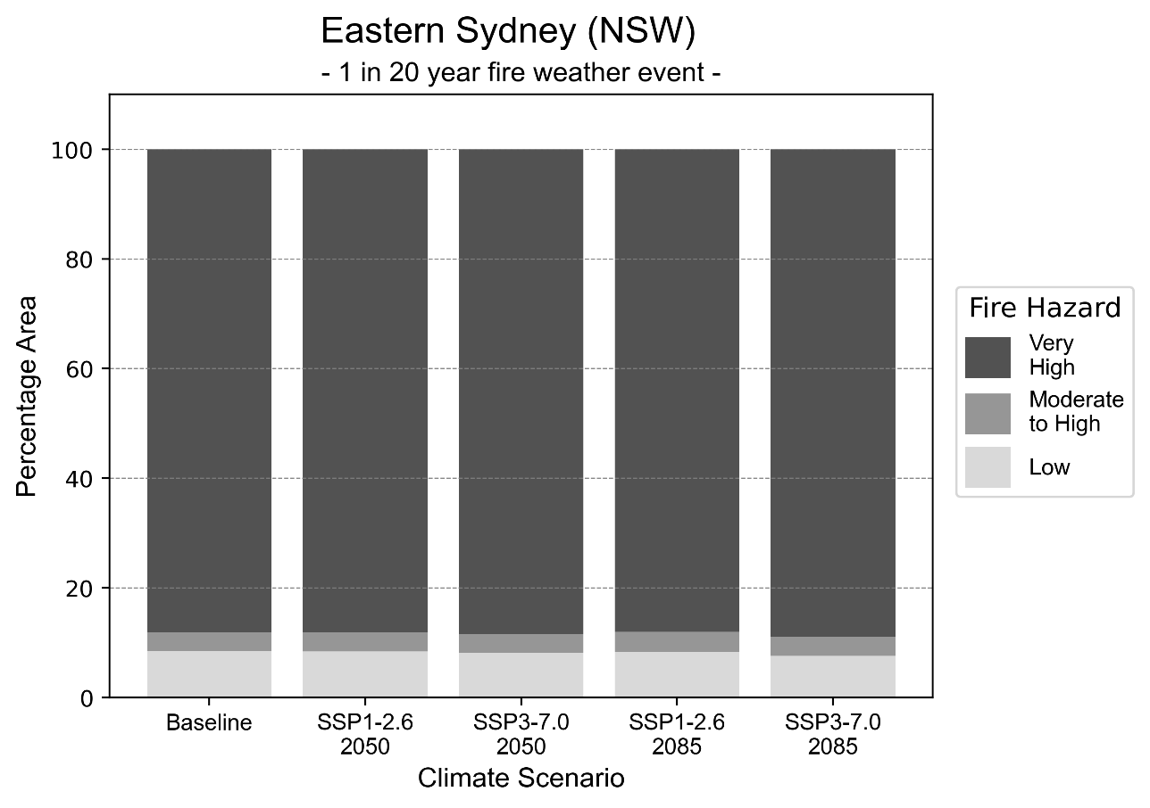
Figure 9: Stacked column chart showing the percentages of Eastern Sydney health district's total geographic area experiencing each fire hazard level during a 1-in-20-year fire weather event.
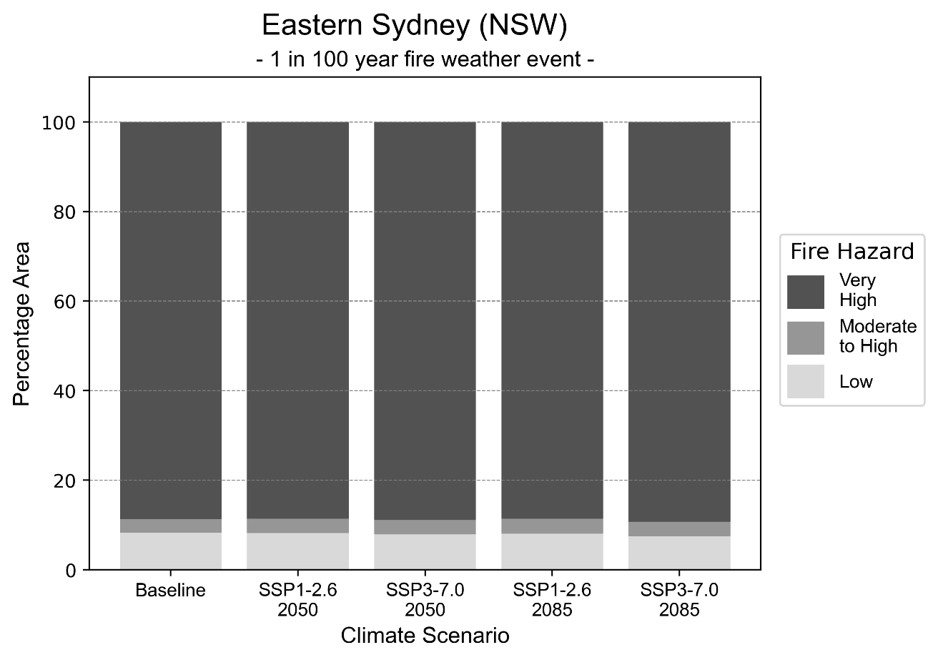
Figure 10: Stacked column chart showing the percentages of Eastern Sydney health district's total geographic area experiencing each fire hazard level during a 1-in-100-year fire weather event.

Drought hazard
Key projections:
Drought occurrence: The occurrence of drought will increase across both middle of the road and reasonable worst-case scenarios and both time horizons, with the largest increase occurring under the reasonable worst-case scenario by 2050.

 | Baseline | 2050 Scenarios |  | 2085 Scenarios
 |  | Middle of the road | Reasonable worst-case | Middle of the road | Reasonable worst-case
Number of months per year in drought^{(a)} | 1.8 | 1.9  [1.0, 3.2] | 2.3  [0.9, 4.6] | 2.0  [0.6, 3.4] | 2.1  [0.5, 3.7]
Table notes: The drought hazard indicator uses climate projections from the CMIP6 Global Climate Models [1]. The primary indicator value reports the median from the nine climate models, with the range reported in square brackets.
Table footnotes: (a) The number of months per year in drought is based on the Standardised Precipitation Index (SPI). SPI is a widely used index to characterise meteorological drought on a range of timescales. This indicator uses the timescale of 12 months which calculates the average months in a year within the moderate drought range. A moderate drought range is classified as SPI score of ≤ -1. SPI is calculated from accumulated rainfall over 12 months and the mean and standard deviation from historical rainfall records.

Storm hazard
Key projections:
Less low-intensity storms: The frequency of low-intensity storms will decrease across both middle of the road and reasonable worst-case scenarios.

Baseline |  | 2050 Scenarios |  | 2085 Scenarios
 |  | Middle of the road | Reasonable worst-case | Middle of the road | Reasonable worst-case
Number of low-intensity storms (40-62 km/hr) per year | 74.0 | 67.2  [59.2, 74.0] | 69.7  [61.4, 76.7] | 65.8  [57.9, 72.4] | 60.9  [53.6, 67.0]
Number of medium-intensity storms (63-87 km/hr) per year | 35.3 | 32.6  [28.7, 35.8] | 31.2  [27.5, 34.4] | 27.7  [24.4, 30.5] | 28.0  [24.6, 30.8]
Number of high-intensity storms (88-117 km/hr) per year | 2.0 | 2.5  [2.2, 2.8] | 1.9  [1.7, 2.1] | 2.0  [1.8, 2.2] | 2.0  [1.8, 2.2]
Number of very-high-intensity storms (> 117 km/hr) per year | 0.0 | 0.0  [0.0, 0.0] | 0.1  [0.1, 0.1] | 0.0  [0.0, 0.0] | 0.0  [0.0, 0.0]
Table notes: The storm hazard uses climate projections from the CMIP6 Global Climate Models [1]. Daily maximum surface wind speed is used to calculate the number of annual storms across four storm intensity categories (low, medium, high and very high). The primary indicator value reports the median from the nine climate models, with the range reported in square brackets.

Rainfall and flood hazard
Key projections:
- Nine extreme rainfall days per year: The number of extreme rainfall days will remain consistent across both middle of the road and reasonable worst-case scenarios, and both time horizons, with an average of approximately nine extreme rainfall days per year.
- Increased flood frequency: The frequency of flood events will increase across both middle of the road and reasonable worst-case scenarios, particularly in urban environments. The largest increase in flood frequency is seen in the reasonable worst-case scenario, where the ‘1-in-100 year’ flood will become 14 times more likely by 2085 in urban environments.

Baseline |  | 2050 Scenarios |  | 2085 Scenarios
 |  | Middle of the road | Reasonable worst-case | Middle of the road | Reasonable worst-case
Rainfall hazard^{(a)}
Average number of extreme rainfall days per year (> 11 mm/day)^{(a)} | 9.9 | 9.8  [8.6,10.9] | 9.7  [7.7,11.4] | 9.8  [8.4,11.2] | 9.7  [8.0,12.2]
Urban flood risk (flooding caused by a 1-hour rainfall event)^{(b)}
Frequency of a ‘1-in-1 year’ flood (rainfall depth of 28 mm)^{(c)} |  | 1.9 events in 1 year | 2.0 events in 1 year | 2.4 events in 1 year | 3.2 events in 1 year
Frequency of a ‘1-in-10 year’ flood (rainfall depth of 47 mm)^{(c)} |  | 3.2 events in 10 years | 3.4 events in 10 years | 5.1 events in 10 years | 7.7 events in 10 years
Frequency of a ‘1-in-100 year’ flood (rainfall depth of 71 mm)^{(c)} |  | 4.1 events in 100 years | 4.5 events in 100 years | 7.3 events in 100 years | 14 events in 100 years
Rural flood risk (flooding caused by a 24-hour rainfall event) ^{(b)}
Frequency of a ‘1-in-1 year’ flood (rainfall depth of 97 mm)^{(c)} |  | 1.2 events in 1 year | 1.2 events in 1 year | 1.2 events in 1 year | 1.1 events in 1 year
Frequency of a ‘1-in-10 year’ flood (rainfall depth of 184 mm)^{(c)} |  | 1.6 events in 10 years | 1.6 events in 10 years | 1.7 events in 10 years | 1.7 events in 10 years
Frequency of a ‘1-in-100 year’ flood (rainfall depth of 295 mm)^{(c)} |  | 1.9 events in 100 years | 1.9 events in 100 years | 2.2 events in 100 years | 2.5 events in 100 years
Table notes: The rainfall hazard indicator uses climate projections from the CMIP6 Global Climate Models [1]. The primary indicator value reports the median from the nine climate models, with the range reported in square brackets. The flood hazard indicators use climate change considerations from the Australian Rainfall and Runoff guideline to estimate the climate projections [2].
Table footnotes: (a) Extreme rainfall is defined as rainfall above the 95th percentile of historical average daily rainfall in this health district in the period 1985-2014. The value in mm/day quoted in the indicator name is the 95th percentile of historic average daily rainfall for this health district. (b) See Methodology document for reasons for focusing on a 1-hour flood for urban areas and a 24-hour flood for rural areas. (c) The rainfall depths in mm quoted in the indicator names in this table report 1 in 1-, 10- and 100-year depths for this health district.

Coastal inundation hazard
Key projections:
Greater area inundated: There will be an increase in the area affected by tidal inundation (i.e. area submerged during high tide) and storm surge and tidal inundation (i.e. the area submerged during a storm surge and high tide) across both middle of the road and reasonable worst-case scenarios. In the reasonable worst-case scenario, the area inundated during a ‘1-in-1000-year’ event will nearly double by 2085.

 | Baseline | 2050 Scenarios |  | 2085 Scenarios^{(a)}
 |  | Middle of the road | Reasonable worst-case | Middle of the road | Reasonable worst-case
Tidal inundation (ha inundated)^{(b)} | 1,752.5 | 2,182 (+429.5) | 2,221.7 (+469.2) | 2,892.0  (+1,139.4) | 3,215.8  (+1,463.3)
Storm surge + tidal inundation – ‘1-in-100 year’ event (ha inundated)^{(c)} | 2,352.6 | 2,765.0  (+412.4) | 2,804.5  (+451.9) | 3,537.4  (+1,184.8) | 3,923.4  (+1,570.8)
Storm surge + tidal inundation – ‘1-in-1000 year’ event (ha inundated)^{(c)} | 2,434.0 | 2,845.8  (+411.8) | 2,886.2  (+452.2) | 3,896.0  (+1,462.0) | 4,282.2  (+1,848.2)
Table notes: The coastal inundation hazard provides an indication of flooding in coastal areas that can be attributed to sea level rise and storm inundation. The coastal inundation hazard is only reported for health districts adjoining the coastline. This table includes the projected inundation levels as well as the change from baseline conditions (in brackets).
Table notes: The coastal inundation hazard provides an indication of flooding in coastal areas that can be attributed to sea level rise and storm inundation. The coastal inundation hazard is only reported for health districts adjoining the coastline. This table includes the projected inundation levels as well as the change from baseline conditions (in brackets).
Table footnotes: (a) For the 2085 Scenarios planning horizon, 2100 was adopted as it provides a conservative representation of the end of this period. This horizon aligns with many State planning regulations requiring consideration of sea level rise and storm tide to 2100, making the 2100 scenario particularly valuable for planning new health facilities in coastal areas. (b) The tidal inundation indicator reports the number of hectares inundated during high tide. The baseline value reports existing inundation patterns, while the 2050 and 2085 values report high tide inundation taking account of projected sea level rise due to climate change. (c) The storm surge + tidal inundation indicators report the combined effect, in hectares inundated, of high tide, sea level rise (for the 2050 and 2085 projections), and storm surge (for 1-in-100 year and 1-in-1000 year events).

Far West health district

Health district overview
Surface area: 194,949 square kilometres
Traditional Owners: Barkandji, Wilyakali, Ngiyampaa and Muthi Muthi
Estimated population (2025): 27,355
Estimated population (2035): 23,512
Local health services: Balranald Multipurpose Service, Broken Hill Base Hospital, Broken Hill Community Health Centre, Dareyone Primary Health Service, Far West Mental Health Recovery Centre, Wilcannia Multipurpose Service, Ivanhoe Health Service, Menindee Health Service, Tibooburra Health Service, Wentworth Health Service, White Cliffs Health Service, Buronga HealthOne.

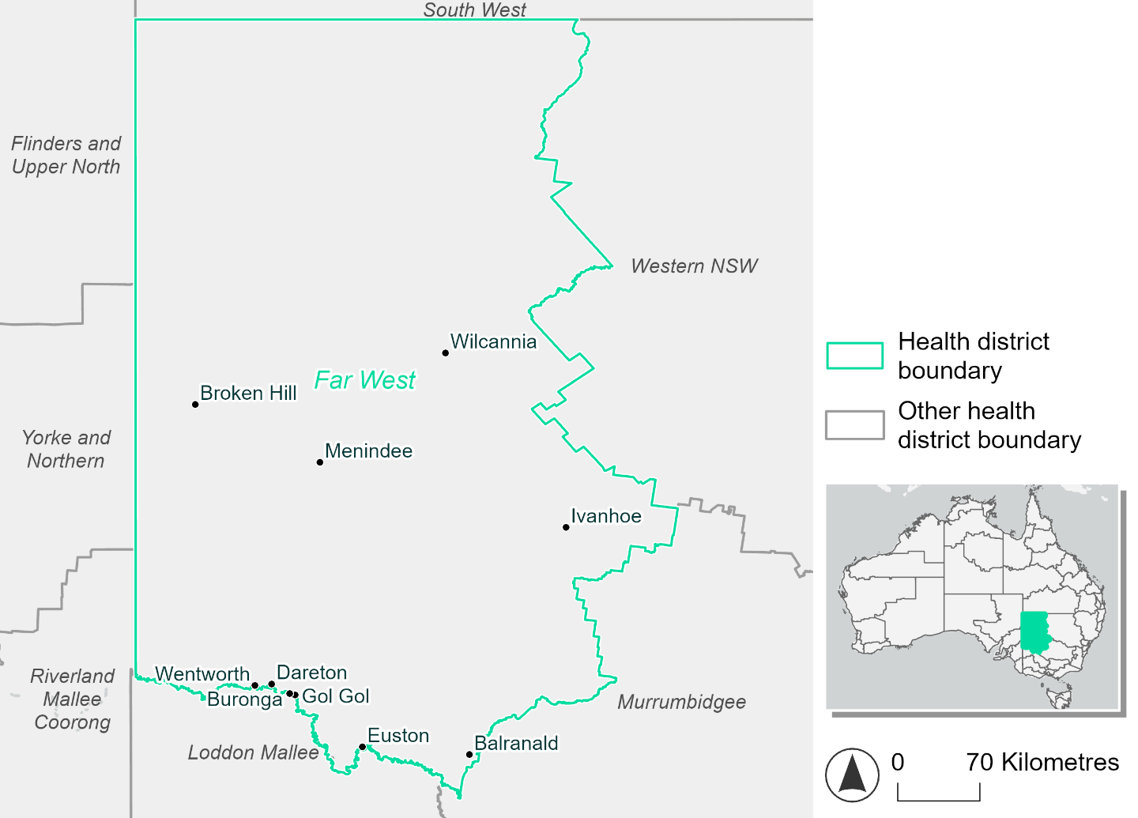
Figure 11. Map of Far West health district.

How will climate change affect this health district?
Heat and humidity: there will be higher average temperatures, hotter and more frequent hot days, warmer night time temperatures and longer and more frequent heat waves.
Fire: Approximately 20% of this health district experiences very high fire hazard category, and this will continue in the future.
Drought: The number of months experiencing drought will increase.
Rainfall and flood: Average number of extreme rainfall days per year will remain consistent. More flood events will occur in urban, with a slight reduction of flood events in rural areas.

Far West health district demographic data
Demographic Data | Total
Number of households | 115,21
Persons 15 and older | 20,015
Total families | 7,551
Persons did not complete high school | 11,299
One parent families with dependents | 965 (12.8%)
Persons aged 65 and older | 6,668 (22.1%)
Persons aged 4 and younger | 1,800 (6%)
Aboriginal and Torres Strait Islander persons | 3,191 (10.6%)
Persons speaks language other than English | 1,218 (4%)
Persons working age (15-65) | 17,959 (59.6%)
Population Health Data | Total
Persons with core needs for assistance | 2,102 (7%)
Persons with arthritis | 3,588 (11.9%)
Persons with asthma | 3,231 (10.7%)
Persons with cancer | 948 (3.1%)
Persons with dementia | 260 (0.9%)
Persons with diabetes | 2,047 (6.8%)
Persons with heart disease | 1,689 (5.6%)
Persons with kidney disease | 446 (1.5%)
Persons with lung condition | 871 (2.9)
Persons with mental health condition | 3,010 (10%)
Persons with stroke | 360 (1.2%)
Persons with any other condition | 2,226 (7.4%)
Persons no health condition | 14,948 (49.6)
Socio-economic Data | Total
Persons providing unpaid care | 3,795 (12.6%)
Persons homeless | 99 (0.3%)
Household with lone person | 3,875 (33.6%)
Households with rent and mortgage stress | 4,185 (36.3%)
Households total equivalised income below $1000 (weekly) | 6,197 (53.8%)
Households with no motor vehicle | 964 (8.4%)
Persons unemployed | 1,229 (5%)

The sections that follow outline projected climate hazards for this district.

Heat and humidity hazard
Key projections:
More heatwaves: Heatwaves are likely to last longer and become more frequent. By 2050, under a reasonable worst-case scenario, the number of heatwaves will more than double. By 2085, under a reasonable worst-case scenario, the number of heatwaves per year will be quadruple.
Hotter days and warmer nights: The maximum temperature on hot days will increase, with temperatures on hot nights also increasing.
More days above 35°C and 40°C: The number of days per year greater than 35°C and 40°C will increase under both middle of the road and reasonable worst-case scenarios.

 | Baseline | 2050 Scenarios |  | 2085 Scenarios
 |  | Middle of the road | Reasonable worst-case | Middle of the road | Reasonable worst-case
Average temperature (°C) | 17.8 | 19.3  [18.7, 19.8] | 19.5  [18.7, 20.2] | 20.2  [19.3, 21.1] | 21.3  [19.8, 22.4]
Maximum temperature on hot days (°C)^{(a)} | 36.9 | 38.8  [38.3, 39.5] | 39.1  [38.1, 40.5] | 39.8  [38.8, 41.1] | 40.9  [40, 42.6]
Minimum temperature on hot nights (°C)^{(b)} | 22.1 | 23.9  [23.1, 24.5] | 24.2  [23, 24.7] | 24.9  [23.9, 25.9] | 26.1  [24.7, 27.1]
Average apparent temperature on hot days (°C) (NOAA Heat Index)^{(c)} | 33 | 34.2  [33.6, 34.6] | 34.3  [33.5, 34.8] | 34.7  [33.7, 35.4] | 35.3  [34.4, 36.2]
Average heatwave duration in days^{(d)} | 5 | 5  [5, 6] | 6  [5, 6] | 6  [5, 6] | 6  [6, 7]
Number of heatwaves per year^{(d)} | 2 | 4  [3, 5] | 4  [3, 6] | 6  [4, 7] | 8  [5, 10]
Number of days per year  > 35°C | 33 | 50  [43, 59] | 54  [43, 68] | 63  [50, 79] | 76  [63, 97]
Number of days per year > 40°C | 5 | 12  [10, 15] | 13  [9, 21] | 17  [12, 26] | 25  [18, 39]
Table notes: The heat and humidity hazard uses climate projections from the CMIP6 Global Climate Models [1]. Daily projections of maximum and minimum near-surface temperature and mean relative humidity are used to calculate eight heat and humidity indicators. The primary indicator value reports the median from the nine climate models, with the range reported in square brackets.
Table footnotes: (a) Based on the 95th percentile of daily maximum air temperature. (b) Based on the 95th percentile of daily minimum air temperature, representing the coldest part of the night on very hot nights. (c) The National Oceanic and Atmospheric Administration (NOAA) Heat Index is a measure of how hot it feels when relative humidity is factored in alongside actual air temperature. It is calculated on days with a maximum temperature of 27°C and above. Interpretation of Heat Index values: 27°C to 32°C indicates caution, 33°C to 41°C indicates extreme caution, 42°C to 54°C indicates danger and over 54°C indicates extreme danger. See methodology document for further explanation of Heat Index categories. (d) A heatwave is defined as three or more consecutive days where both daytime and overnight temperatures (daily mean temperatures) are unusually high for the location, based on the Bureau of Meteorology’s Excess Heat Factor method. For this district, an unusually high daily mean temperature is approximately 29°C or above.

Fire hazard
Key projections:
- Majority of district area experiences low fire hazard: Under baseline conditions roughly half (48-50%) of the health district experiences a low fire hazard. Just over 20% of the district experiences very high fire hazard during the 1-in-20- and 1-in-100-year fire weather events.
- Slight increase in moderate to high fire hazard: In 2050 and 2085, the area experiencing low fire hazard will reduce by up to 3.4 percentage points, with a corresponding increase in the area experiencing moderate to high hazard.

 | Baseline | 2050 Scenarios |  | 2085 Scenarios
 |  | Sustainability | Reasonable worst-case | Sustainability | Reasonable worst-case
Hazard for a ‘1-in-20 year’ fire weather event^{(a)}
Proportion (%) of district experiencing ‘Low’ fire hazard | 50.5%  (9,828,262)^{(b)} | 50.1%  [49.6%, 50.4%] | 49.7%  [49.2%, 50.2%] | 49.6%  [48.4%, 50.4%] | 48.7%  [47.5%, 49.8%]
Proportion (%) of district experiencing ‘Moderate to High’ fire hazard | 28.9%  (5,622,106)^{(b)} | 29.1%  [28.6%, 29.5%] | 29.8%  [29.0%, 31.2%] | 29.5%  [28.3%, 30.5%] | 31.2%  [29.1%, 34.4%]
Proportion (%) of district experiencing ‘Very High’ fire hazard | 20.7%  (4,027,754)^{(b)} | 20.8%  [20.4%, 21.4%] | 20.4%  [19.2%, 20.9%] | 20.9%  [19.9%, 22.4%] | 20.1%  [17.1%, 21.2%]
Hazard for a ‘1-in-100 year’ fire weather event^{(a)}
Proportion (%) of district experiencing ‘Low’ fire hazard | 48.5%  (9,444,983)^{(b)} | 47.8%  [47.2%, 48.2%] | 47.1%  [46.5%, 47.6%] | 46.9%  [45.3%, 47.9%] | 45.1%  [43.8%, 46.3%]
Proportion (%) of district experiencing ‘Moderate to High’ fire hazard | 28.9%  (5,624,530)^{(b)} | 29.3%  [28.6%, 29.9%] | 30.6%  [29.6%, 32.3%] | 30.0%  [28.1%, 31.3%] | 32.9%  [30.6%, 37.0%]
Proportion (%) of district experiencing ‘Very High’ fire hazard | 22.6%  (4,408,609)^{(b)} | 22.8%  [22.4%, 23.6%] | 22.4%  [21.1%, 22.9%] | 23.1%  [22.0%, 25.0%] | 22.0%  [19.0%, 23.2%]
Table notes: The Fire Hazard uses the National Bushfire Intelligence Capability (NBIC) Phase 2 fire line intensity modelling based on CMIP6 climate projections. Fire Hazard is assessed using the projected Fireline Intensity (FLI) for weather events with two different return intervals (i.e. a 1-in-20 year event and a 1-in-100 year event). FLI considers slope, vegetation and weather to produce a rate of heat output per unit length (kW/m) along a bushfire’s front. Fire hazard is categorized as a low for FLI<4000 kW/m, moderate to high for 4,000 kW/m ≤FLI<12,500kW/m, and very high for FLI≥27,501kW/m. This is broadly consistent with the literature [3]. The assessment considers climate change effects based on changes in fire weather and the associated hazard that is anticipated for a meteorological event of a given return interval. This approach is different to the one adopted for the Flood Hazard, where the event magnitude is given (fixed) and the likelihood of that event varies as a result of climate change. The primary indicator value reports the median from the nine climate models, with the range reported in square brackets.
Table footnotes: (a) The area subject to different categories of fire hazard is determined for a ‘1-in-20 year’ and ‘1-in-100 year’ fire weather event, in current and future climates. Values at year 2050 are interpolated using data from baseline (2025) and 2085, assuming linear change over time. (b) Values in round brackets are the area (ha) of the health district subject to a given fire hazard.
The figures below show the proportion of the health district experiencing different fire hazard categories across different time horizons and climate scenarios during a ‘1-in-20 year’ fire weather event (Figure 12) and a ‘1-in-100 year’ fire weather event (Figure 13).
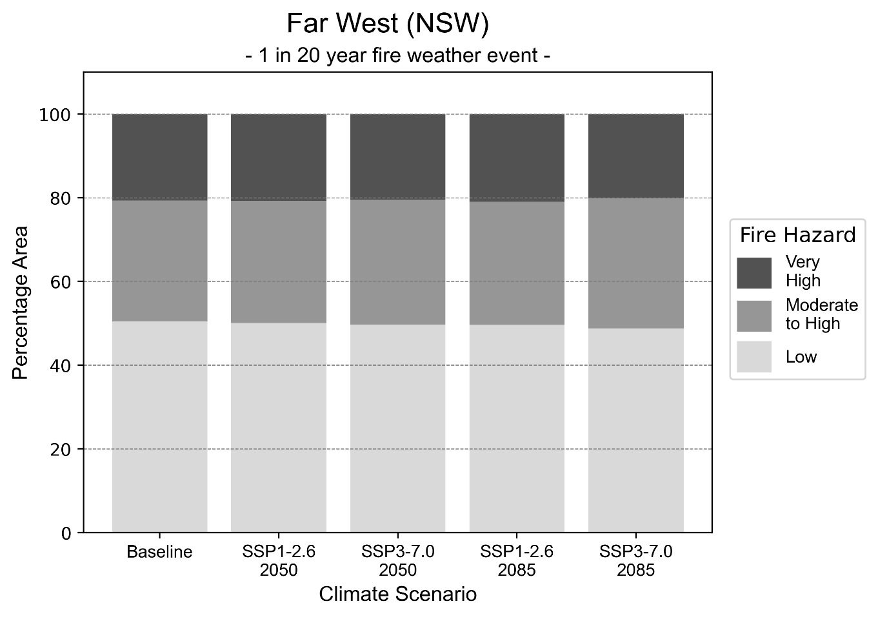
Figure 12: Stacked column chart showing the percentages of the Far West health district's total geographic area experiencing each fire hazard level during a 1-in-20-year fire weather event.
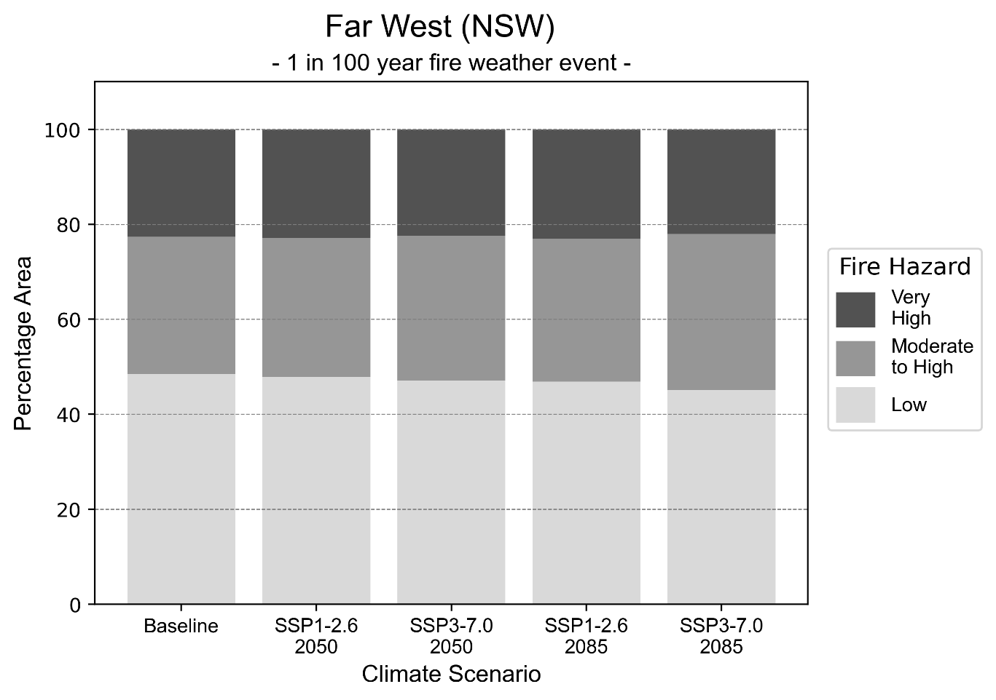
Figure 13: Stacked column chart showing the percentages of the Far West health district's total geographic area experiencing each fire hazard level during a 1-in-100-year fire weather event.

Drought hazard
Key projections:
Drought occurrence: The occurrence of drought will increase across both scenarios and time horizons, with the largest increase seen under the reasonable worst-case scenario by 2085.

 | Baseline | 2050 Scenarios |  | 2085 Scenarios
 |  | Middle of the road | Reasonable worst-case | Middle of the road | Reasonable worst-case
Number of months per year in drought^{(a)} | 1.6 | 1.8  [0.4, 3.6] | 1.8  [0.7, 4.3] | 2.0  [0.4, 3.5] | 2.3  [0.2, 5.4]
Table notes: The drought hazard indicator uses climate projections from the CMIP6 Global Climate Models [1]. The primary indicator value reports the median from the nine climate models, with the range reported in square brackets.
Table footnotes: (a) The number of months per year in drought is based on the Standardised Precipitation Index (SPI). SPI is a widely used index to characterise meteorological drought on a range of timescales. This indicator uses the timescale of 12 months which calculates the average months in a year within the moderate drought range. A moderate drought range is classified as SPI score of ≤ -1. SPI is calculated from accumulated rainfall over 12 months and the mean and standard deviation from historical rainfall records.

Storm hazard
Key projections:
More very-high-intensity storms in reasonable worst-case scenario: The frequency of very-high-intensity storms will increase across both middle of the road and reasonable worst-case scenarios by 2085.

 | Baseline | 2050 Scenarios |  | 2085 Scenarios
 |  | Middle of the road | Reasonable worst-case | Middle of the road | Reasonable worst-case
Number of low-intensity storms (40-62 km/hr) per year | 72.3 | 71.6  [63.0, 78.7] | 68.5  [60.3, 75.3] | 70.4  [62.0, 77.5] | 68.2  [60.0, 75.1]
Number of medium-intensity storms (63-87 km/hr) per year | 41.6 | 39.0  [34.3, 42.9] | 38.4  [33.8, 42.3] | 35.9  [31.6, 39.5] | 39.0  [34.3, 42.9]
Number of high-intensity storms (88-117 km/hr) per year | 30.7 | 31.1  [27.4, 34.2] | 31.5  [27.7, 34.6] | 30.6  [27.0, 33.7] | 28.3  [24.9, 31.2]
Number of very-high-intensity storms (> 117 km/hr) per year | 1.6 | 1.5  [1.3, 1.7] | 1.7  [1.5, 1.9] | 1.9  [1.6, 2.1] | 1.9  [1.7, 2.1]
Table notes: The storm hazard uses climate projections from the CMIP6 Global Climate Models [1]. Daily maximum surface wind speed is used to calculate the number of annual storms across four storm intensity categories (low, medium, high and very high). The primary indicator value reports the median from the nine climate models, with the range reported in square brackets.

Rainfall and flood hazard
Key projections:
- 13 extreme rainfall days per year: The number of extreme rainfall days will remain consistent across both scenarios and time horizons, with an average of approximately 13 extreme rainfall days per year.
- Increased flood frequency: Flooding will become more frequent across both middle of the road and reasonable worst-case scenarios in urban environments, and slightly reduce in rural environments. The largest increase in flooding is seen in the reasonable worst-case scenario where frequency of a ‘1-in-100 year’ flood will more than double by 2050 and become nearly six times more likely by 2085 in urban environments.

 | Baseline | 2050 Scenarios |  | 2085 Scenarios
 |  | Middle of the road | Reasonable worst-case | Middle of the road | Reasonable worst-case
Rainfall hazard^{(a)}
Average number of extreme rainfall days per year (> 5 mm/day)^{(a)} | 13.7 | 13.5  [11.2,17.6] | 13.6  [10.5,16.2] | 13.2  [11.2,17.0] | 12.9  [9.7,18.4]
Urban flood risk (flooding caused by a 1-hour rainfall event)^{(b)}
Frequency of a ‘1-in-1 year’ flood (rainfall depth of 12 mm)^{(c)} |  | 1.6 events in 1 year | 1.6 events in 1 year | 1.9 events in 1 year | 2.4 events in 1 year
Frequency of a ‘1-in-10 year’ flood (rainfall depth of 30 mm)^{(c)} |  | 2.1 events in 10 years | 2.1 events in 10 years | 2.6 events in 10 years | 3.6 events in 10 years
Frequency of a ‘1-in-100 year’ flood (rainfall depth of 56 mm)^{(c)} |  | 2.5 events in 100 years | 2.6 events in 100 years | 3.6 events in 100 years | 5.7 events in 100 years
Rural flood risk (flooding caused by a 24-hour rainfall event) ^{(b)}
Frequency of a ‘1-in-1 year’ flood (rainfall depth of 34 mm)^{(c)} |  | 1.0 events in 1 year | 0.9 events in 1 year | 1.0 events in 1 year | 0.5 events in 1 year
Frequency of a ‘1-in-10 year’ flood (rainfall depth of 76 mm)^{(c)} |  | 1.0 events in 10 years | 0.8 events in 10 years | 0.9 events in 10 years | 0.4 events in 10 years
Frequency of a ‘1-in-100 year’ flood (rainfall depth of 136 mm)^{(c)} |  | 1.1 events in 100 years | 1.0 events in 100 years | 0.7 events in 100 years | 0.3 events in 100 years
Table notes: The rainfall hazard indicator uses climate projections from the CMIP6 Global Climate Models [1]. The primary indicator value reports the median from the nine climate models, with the range reported in square brackets. The flood hazard indicators use climate change considerations from the Australian Rainfall and Runoff guideline to estimate the climate projections [2].
Table footnotes: (a) Extreme rainfall is defined as rainfall above the 95th percentile of historical average daily rainfall in this health district in the period 1985-2014. The value in mm/day quoted in the indicator name is the 95th percentile of historic average daily rainfall for this health district. (b) See Methodology document for reasons for focusing on a 1-hour flood for urban areas and a 24-hour flood for rural areas. (c) The rainfall depths in mm quoted in the indicator names in this table report 1 in 1-, 10- and 100-year depths for this health district.

Hunter New England health district

Health district overview
Surface area: 131,785 square kilometres
Traditional Owners: Kamilaroi, Gomilaroi, Geawegal, Bahtabah, Thungutti, Awabakal, Aniawan, Biripi, Worimi, Nganyaywana, Wonnarua, Banbai, Ngoorabul, Bundjalung, Yallaroi and Darkinung peoples
Estimated population (2025): 984,437
Estimated population (2035): 1,087,216
Local health services: The Hunter New England local health district has 27 hospitals, 11 multipurpose services and 41 community health facilities.

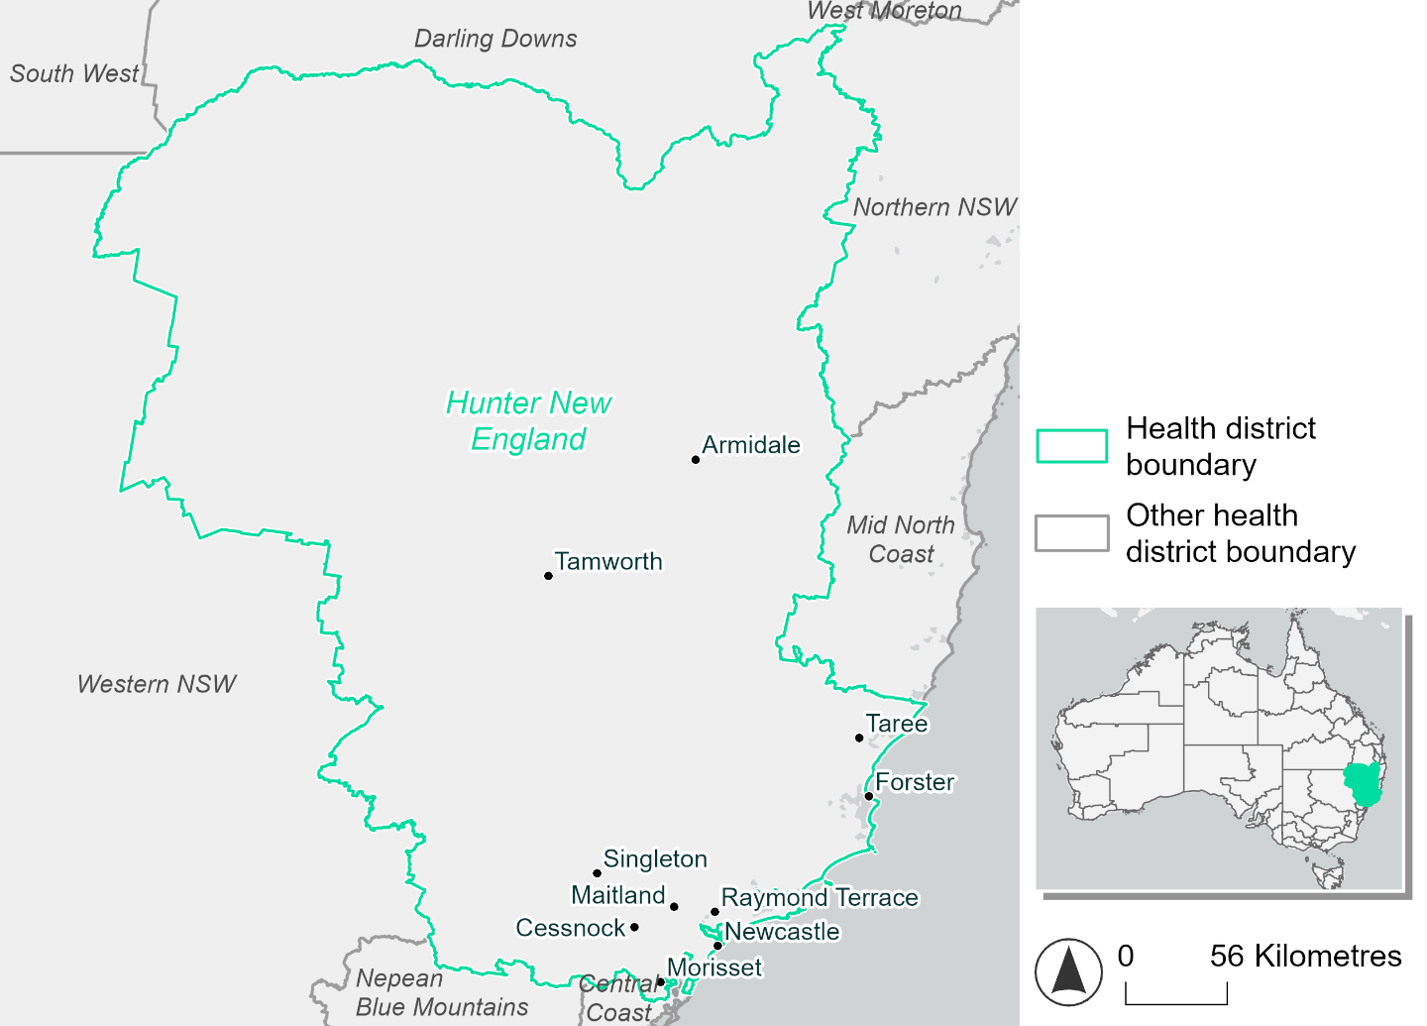
Figure 14. Map of Hunter New England health district.

How will climate change affect this health district?
Heat and humidity: There will be higher average temperatures, hotter and more frequent hot days, warmer nights and longer and more frequent heat waves.
Fire: The area of the health district experiencing moderate to high fire hazard (56-57%) and very high fire hazard (31-32%) will increase slightly under both 2050 and 2085 scenarios.
Drought: Number of months experiencing drought will increase.
Rainfall and flood: Average number of extreme rainfall days per year will remain consistent. There will be more flooding in urban and rural areas.
Coastal inundation: The area flooded during tidal and storm surge and tidal inundation will increase.

Hunter New England health district demographic data
Demographic Data | Total
Number of households | 362,808
Persons 15 and older | 651,010
Total families | 258,063
Persons did not complete high school | 314,181
One parent families with dependents | 28,921 (11.2%)
Persons aged 65 and older | 202,938 (20.8%)
Persons aged 4 and younger | 55,971 (5.7%)
Aboriginal and Torres Strait Islander persons | 71,937 (7.4%)
Persons speaks language other than English | 53,362 (5.5%)
Persons working age (15-65) | 592,920 (60.8%)
Population Health Data | Total
Persons with core needs for assistance | 66,790 (6.9%)
Persons with arthritis | 111,816 (11.5%)
Persons with asthma | 98,829 (10.1%)
Persons with cancer | 33,893 (3.5%)
Persons with dementia | 9,306 (1%)
Persons with diabetes | 53,843 (5.5%)
Persons with heart disease | 49,129 (5%)
Persons with kidney disease | 12,134 (1.2%)
Persons with lung condition | 23,797 (2.4%)
Persons with mental health condition | 112,405 (11.5%)
Persons with stroke | 11,674 (1.2%)
Persons with any other condition | 84,570 (8.7%)
Persons no health condition | 518,029 (53.1%)
Socio-economic Data | Total
Persons providing unpaid care | 127,868 (13.1%)
Persons homeless | 3,053 (0.3%)
Household with lone person | 98,527 (27.2%)
Households with rent and mortgage stress | 174,272 (48%)
Households total equivalised income below $1000 (weekly) | 178,727 (49.3%)
Households with no motor vehicle | 20,173 (5.6%)
Persons unemployed | 38,913 (5%)

The sections that follow outline projected climate hazards for this district. Further information on this health district, including population demographics, is provided in the online dashboard.

Heat and humidity hazard
Key projections:
More heatwaves: Heatwaves will last longer and become more frequent. By 2050, under a reasonable worst-case scenario, the number of heatwaves will more than double. By 2085, under a reasonable worst-case scenario, the number of heatwaves per year will quadruple.
Hotter days and warmer nights: The maximum temperature on hot days will increase, with temperatures on hot nights also increasing.
More days above 35°C and 40°C: The number of days per year greater than 35°C and 40°C will increase under both middle of the road and reasonable worst-case scenarios.

 | Baseline | 2050 Scenarios |  | 2085 Scenarios
 |  | Middle of the road | Reasonable worst-case | Middle of the road | Reasonable worst-case
Average temperature (°C) | 17.7 | 19.1  [18.6, 19.8] | 19.4  [18.7, 20.2] | 20  [19.1, 21.2] | 21  [19.9, 22.3]
Maximum temperature on hot days (°C)^{(a)} | 31.8 | 33.5  [32.9, 34.6] | 33.9  [32.7, 35.5] | 34.5  [33.5, 36.4] | 35.5  [34.3, 37.5]
Minimum temperature on hot nights (°C)^{(b)} | 20.5 | 22.1  [21.3, 22.8] | 22.2  [21.5, 23] | 22.9  [21.7, 24.2] | 23.9  [22.7, 25.4]
Average apparent temperature on hot days (°C) (NOAA Heat Index)^{(c)} | 34.5 | 35.9  [35.1, 36.4] | 36  [35.4, 36.6] | 36.5  [35.6, 37.5] | 37.6  [36.5, 39]
Average heatwave duration in days^{(d)} | 4 | 6  [5, 7] | 6  [5, 7] | 7  [6, 9] | 9  [7, 12]
Number of heatwaves per year^{(d)} | 2 | 5  [4, 6] | 5  [4, 7] | 6  [5, 9] | 8  [6, 9]
Number of days per year > 35°C | 10 | 15  [12, 20] | 17  [13, 26] | 20  [15, 32] | 27  [19, 43]
Number of days per year > 40°C | 1 | 3  [2, 4] | 3  [2, 6] | 4  [2, 9] | 6  [3, 13]
Table notes: The heat and humidity hazard uses climate projections from the CMIP6 Global Climate Models [1]. Daily projections of maximum and minimum near-surface temperature and mean relative humidity are used to calculate eight heat and humidity indicators. The primary indicator value reports the median from the nine climate models, with the range reported in square brackets.
Table footnotes: (a) Based on the 95th percentile of daily maximum air temperature. (b) Based on the 95th percentile of daily minimum air temperature, representing the coldest part of the night on very hot nights. (c) The National Oceanic and Atmospheric Administration (NOAA) Heat Index is a measure of how hot it feels when relative humidity is factored in alongside actual air temperature. It is calculated on days with a maximum temperature of 27°C and above. Interpretation of Heat Index values: 27°C to 32°C indicates caution, 33°C to 41°C indicates extreme caution, 42°C to 54°C indicates danger and over 54°C indicates extreme danger. See methodology document for further explanation of Heat Index categories. (d) A heatwave is defined as three or more consecutive days where both daytime and overnight temperatures (daily mean temperatures) are unusually high for the location, based on the Bureau of Meteorology’s Excess Heat Factor method. For this district, an unusually high daily mean temperature is approximately 25.7°C or above.

Fire hazard
Key projections:
- Majority of health district area experiences moderate to high fire hazard: Under baseline conditions just over half of the health district experiences moderate to high fire hazard for both 1-in-20- and 1-in-100-year fire weather events.
- Slight increase in overall fire hazard: In 2050 and 2085, the areas of the district that experience low fire hazard will decline slightly, decreasing by 9.9% for a 1-in-20-year fire weather event, and 8.6% for a 1-in-100-year event. There will be corresponding increases in the area experiencing moderate to high fire hazard.

 | Baseline | 2050 Scenarios |  | 2085 Scenarios
 |  | Sustainability | Reasonable worst-case | Sustainability | Reasonable worst-case
Hazard for a ‘1-in-20 year’ fire weather event^{(a)}
Proportion (%) of district experiencing ‘Low’ fire hazard | 12.4%  (1,627,615)^{(b)} | 12.0%  [11.8%, 12.4%] | 11.3%  [11.0%, 11.8%] | 11.4%  [10.9%, 12.4%] | 9.9%  [9.1%, 10.9%]
Proportion (%) of district experiencing ‘Moderate to High’ fire hazard | 56.5%  (7,434,416)^{(b)} | 56.7%  [56.2%, 57.2%] | 57.2%  [54.9%, 59.4%] | 57.1%  [55.8%, 58.1%] | 58.2%  [52.6%, 63.4%]
Proportion (%) of district experiencing ‘Very High’ fire hazard | 31.2%  (4,102,745)^{(b)} | 31.3%  [31.1%, 31.4%] | 31.5%  [31.0%, 31.9%] | 31.5%  [31.0%, 31.7%] | 31.9%  [30.8%, 33.0%]
Hazard for a ‘1-in-100 year’ fire weather event^{(a)}
Proportion (%) of district experiencing ‘Low’ fire hazard | 11.0%  (1,443,587)^{(b)} | 10.5%  [10.3%, 10.9%] | 10.0%  [9.7%, 10.3%] | 9.9%  [9.4%, 10.7%] | 8.6%  [8.0%, 9.4%]
Proportion (%) of district experiencing ‘Moderate to High’ fire hazard | 56.9%  (7,497,020)^{(b)} | 57.3%  [56.6%, 57.7%] | 57.6%  [54.8%, 60.1%] | 57.7%  [56.2%, 58.7%] | 58.5%  [51.8%, 64.5%]
Proportion (%) of district experiencing ‘Very High’ fire hazard | 32.1%  (4,224,168)^{(b)} | 32.2%  [32.2%, 32.3%] | 32.4%  [32.2%, 32.8%] | 32.4%  [32.3%, 32.6%] | 32.9%  [32.3%, 33.9%]
Table notes: The Fire Hazard uses the National Bushfire Intelligence Capability (NBIC) Phase 2 fire line intensity modelling based on CMIP6 climate projections. Fire Hazard is assessed using the projected Fireline Intensity (FLI) for weather events with two different return intervals (i.e. a 1-in-20 year event and a 1-in-100 year event). FLI considers slope, vegetation and weather to produce a rate of heat output per unit length (kW/m) along a bushfire’s front. Fire hazard is categorized as a low for FLI<4000 kW/m, moderate to high for 4,000 kW/m ≤FLI<12,500kW/m, and very high for FLI≥27,501kW/m. This is broadly consistent with the literature [3]. The assessment considers climate change effects based on changes in fire weather and the associated hazard that is anticipated for a meteorological event of a given return interval. This approach is different to the one adopted for the Flood Hazard, where the event magnitude is given (fixed) and the likelihood of that event varies as a result of climate change. The primary indicator value reports the median from the nine climate models, with the range reported in square brackets.
Table footnotes: (a) The area subject to different categories of fire hazard is determined for a ‘1-in-20 year’ and ‘1-in-100 year’ fire weather event, in current and future climates. Values at year 2050 are interpolated using data from baseline (2025) and 2085, assuming linear change over time. (b) Values in round brackets are the area (ha) of the health district subject to a given fire hazard.

The figures below show the proportion of the health district experiencing different fire hazard categories across different time horizons and climate scenarios during a ‘1-in-20 year’ fire weather event (Figure 15) and a ‘1-in-100 year’ fire weather event (Figure 16).
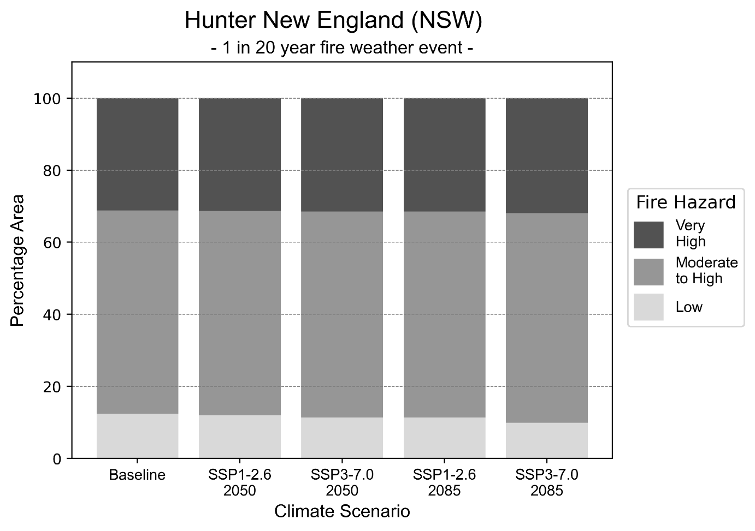
Figure 15: Stacked column chart showing the percentages of the Hunter New England health district's total geographic area experiencing each fire hazard level during a 1-in-20-year fire weather event.
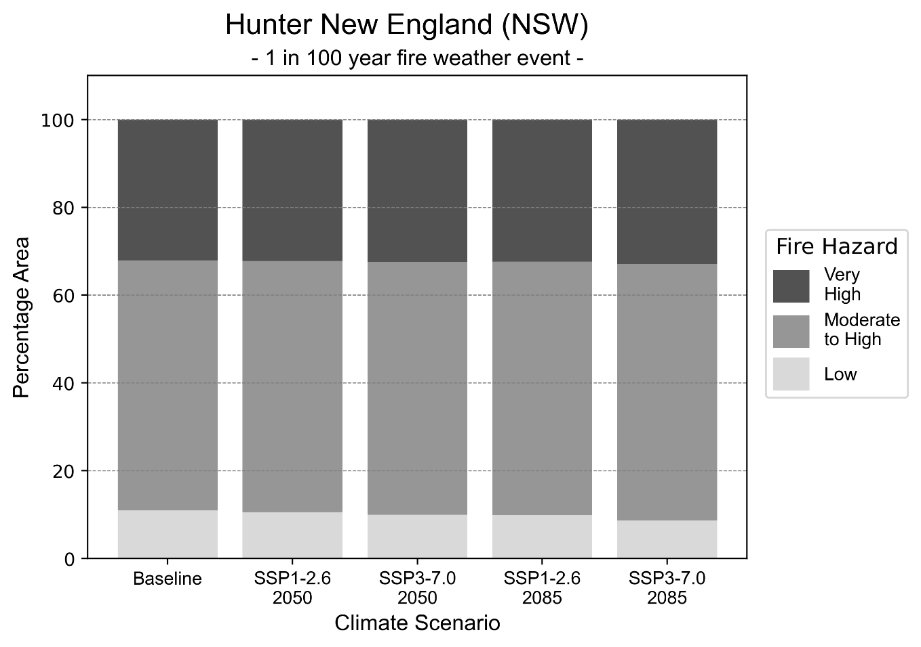
Figure 16: Stacked column chart showing the percentages of the Hunter New England health district's total geographic area experiencing each fire hazard level during a 1-in-100-year fire weather event.

Drought hazard
Key projections:
Drought occurrence: Drought will increase across both scenarios and time horizons, with the largest increase occurring under a reasonable worst-case scenario by 2050.

 | Baseline | 2050 Scenarios |  | 2085 Scenarios
 |  | Middle of the road | Reasonable worst-case | Middle of the road | Reasonable worst-case
Number of months per year in drought^{(a)} | 1.9 | 2.2  [0.3, 4.1] | 2.4  [0.5, 6.3] | 2.1  [0.4, 3.9] | 2.2  [0.1, 4.3]
Table notes: The drought hazard indicator uses climate projections from the CMIP6 Global Climate Models [1]. The primary indicator value reports the median from the nine climate models, with the range reported in square brackets.
Table footnotes: (a) The number of months per year in drought is based on the Standardised Precipitation Index (SPI). SPI is a widely used index to characterise meteorological drought on a range of timescales. This indicator uses the timescale of 12 months which calculates the average months in a year within the moderate drought range. A moderate drought range is classified as SPI score of ≤ -1. SPI is calculated from accumulated rainfall over 12 months and the mean and standard deviation from historical rainfall records.

Storm hazard
Key projections:
Fewer very-high-intensity storms: Very-high-intensity storms will be slightly less frequent in both middle of the road and reasonable worst-case scenarios, with the greatest decrease occurring by 2085.

 | Baseline | 2050 Scenarios |  | 2085 Scenarios
 |  | Middle of the road | Reasonable worst-case | Middle of the road | Reasonable worst-case
Number of low-intensity storms (40-62 km/hr) per year | 84.5 | 75.6  [66.6, 83.2] | 80.8  [71.1, 88.9] | 73.8  [64.9, 81.1] | 72.9  [64.2, 80.2]
Number of medium-intensity storms (63-87 km/hr) per year | 42.1 | 35.4  [31.1, 38.9] | 33.1  [29.2, 36.4] | 30.9  [27.2, 34.0] | 31.4  [27.6, 34.5]
Number of high-intensity storms (88-117 km/hr) per year | 29.4 | 25.7  [22.6, 28.2] | 25.1  [22.1, 27.6] | 22.8  [20.1, 25.1] | 23.8  [20.9, 26.2]
Number of very-high-intensity storms (> 117 km/hr) per year | 1.8 | 1.8  [1.6, 2.0] | 1.6  [1.4, 1.8] | 1.5  [1.3, 1.7] | 1.6  [1.4, 1.8]
Table notes: The storm hazard uses climate projections from the CMIP6 Global Climate Models [1]. Daily maximum surface wind speed is used to calculate the number of annual storms across four storm intensity categories (low, medium, high and very high). The primary indicator value reports the median from the nine climate models, with the range reported in square brackets.

Rainfall and flood hazard
Key projections:
- 11 extreme rainfall days per year: The number of extreme rainfall days will slightly reduce across both scenarios and time horizons.
- Increased flood frequency: Flooding will occur more frequently in both the middle of the road and reasonable worst-case scenarios, particularly in urban environments. The largest increase in frequency is seen in the reasonable worst-case scenario where the frequency of a ‘1-in-100 year’ flood will quadruple by 2050 and become 12 times more likely by 2085 in urban environments.

 | Baseline | 2050 Scenarios |  |  | 2085 Scenarios
 |  | Middle of the road |  | Reasonable worst-case | Middle of the road | Reasonable worst-case
Rainfall hazard^{(a)}
Average number of extreme rainfall days per year (> 12 mm/day)^{(a)} | 11.6 | 11.4  [9.5,14.2] |  | 11.3  [8.4,13.8] | 11.4  [9.6,14.0] | 11.4  [9.3,15.6]
Urban flood risk (flooding caused by a 1-hour rainfall event)^{(b)}
Frequency of a ‘1-in-1 year’ flood (rainfall depth of 21 mm)^{(c)} |  | 1.9 events in 1 year |  | 2.0 events in 1 year | 2.4 events in 1 year |  | 3.3 events in 1 year
Frequency of a ‘1-in-10 year’ flood (rainfall depth of 38 mm)^{(c)} |  | 2.9 events in 10 years |  | 3.0 events in 10 years | 4.3 events in 10 years |  | 6.6 events in 10 years
Frequency of a ‘1-in-100 year’ flood (rainfall depth of 58 mm)^{(c)} |  | 3.8 events in 100 years |  | 4.1 events in 100 years | 6.5 events in 100 years |  | 12 events in 100 years
Rural flood risk (flooding caused by a 24-hour rainfall event) ^{(b)}
Frequency of a ‘1-in-1 year’ flood (rainfall depth of 52 mm)^{(c)} |  | 1.4 events in 1 year |  | 1.5 events in 1 year | 1.6 events in 1 year |  | 1.9 events in 1 year
Frequency of a ‘1-in-10 year’ flood (rainfall depth of 92 mm)^{(c)} |  | 1.8 events in 10 years |  | 1.8 events in 10 years | 2.2 events in 10 years |  | 2.8 events in 10 years
Frequency of a ‘1-in-100 year’ flood (rainfall depth of 146 mm)^{(c)} |  | 1.9 events in 100 years |  | 2.0 events in 100 years | 2.5 events in 100 years |  | 3.4 events in 100 years
Table notes: The rainfall hazard indicator uses climate projections from the CMIP6 Global Climate Models [1]. The primary indicator value reports the median from the nine climate models, with the range reported in square brackets. The flood hazard indicators use climate change considerations from the Australian Rainfall and Runoff guideline to estimate the climate projections [2].
Table footnotes: (a) Extreme rainfall is defined as rainfall above the 95th percentile of historical average daily rainfall in this health district in the period 1985-2014. The value in mm/day quoted in the indicator name is the 95th percentile of historic average daily rainfall for this health district. (b) See Methodology document for reasons for focusing on a 1-hour flood for urban areas and a 24-hour flood for rural areas. (c) The rainfall depths in mm quoted in the indicator names in this table report 1 in 1-, 10- and 100-year depths for this health district.

Coastal inundation hazard
Key projections:
Greater area inundated: The area affected by tidal inundation (i.e. area submerged during high tide) and storm surge and tidal inundation (i.e. the area submerged during a storm surge and high tide) will both increase across both middle of the road and reasonable worst-case scenarios. In the reasonable worst-case scenario, the area inundated during a ‘1-in-1000-year’ event will increase by over 22,000 ha. by 2085.

 | Baseline | 2050 Scenarios |  | 2085 Scenarios^{(a)}
 |  | Middle of the road | Reasonable worst-case | Middle of the road | Reasonable worst-case
Tidal inundation (ha inundated)^{(b)} | 62,190.1 | 71,994.4  (+9,804.3) | 72,675.4  (+10,485.3) | 83,752.6  (+21,562.5) | 87,555.9  (+25,365.8)
Storm surge + tidal inundation – ‘1-in-100 year’ event (ha inundated)^{(c)} | 72,866.1 | 80,189.1  (+7,323.0) | 80,691.7  (+7,825.6) | 89,938.4  (+17,072.3) | 93,406.8  (+20,540.7)
Storm surge + tidal inundation – ‘1-in-1000 year’ event (ha inundated)^{(c)} | 73,935.5 | 81,024.0  (+7,088.5) | 81,516.6  (+7,581.1) | 93,044.4  (+19,108.9) | 96,146.4  (+22,210.9)
Table notes: The coastal inundation hazard provides an indication of flooding in coastal areas that can be attributed to sea level rise and storm inundation. The coastal inundation hazard is only reported for health districts adjoining the coastline. This table includes the projected inundation levels as well as the change from baseline conditions (in brackets).
Table footnotes: (a) For the 2085 Scenarios planning horizon, 2100 was adopted as it provides a conservative representation of the end of this period. This horizon aligns with State planning regulations requiring consideration of sea level rise and storm tide to 2100, making the 2100 scenario particularly valuable for planning new health facilities in coastal areas (b) The tidal inundation indicator reports the number of hectares inundated during high tide. The baseline value reports existing inundation patterns, while the 2050 and 2085 values report high tide inundation taking account of projected sea level rise due to climate change. (c) The storm surge + tidal inundation indicators report the combined effect of high tide, sea level rise (for the 2050 and 2085 projections), and storm surge (for 1-in-100 year and 1-in-1000 year events).

Illawarra Shoalhaven health district

Health district overview
Surface area: 5,687 square kilometres
Traditional Owners: Dharawal and Yuin peoples
Estimated population (2025): 448,567
Estimated population (2035): 516,926
Local health services: Bulli, Coledale, David Berry, Milton Ulladulla, Shellharbour, Shoalhaven, Wollongong

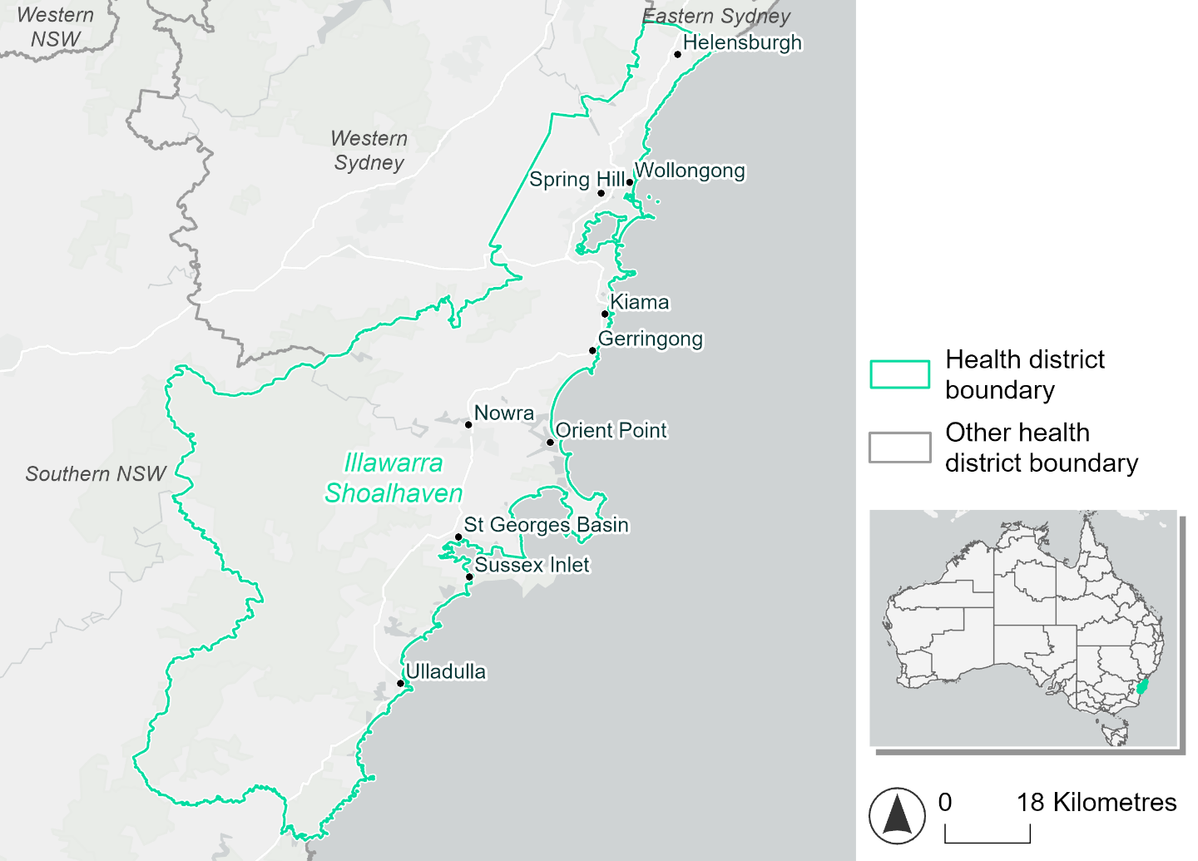
Figure 17. Map of Illawarra Shoalhaven health district.

How will climate change affect this health district?
Heat and humidity: There will be higher average temperatures, hotter and more frequent hot days, warmer night time temperatures and longer and more frequent heat waves.
Fire: Over 70% of this health district currently experiences very high fire hazard category. The area experiencing moderate to high fire hazard will increase across both 2050 and 2085 scenarios, while the area experiencing low fire hazard will reduce.
Drought: The number of months experiencing drought will increase.
Rainfall and flood: There will be more flooding in urban areas.
Coastal inundation: The area flooded during tidal, and storm surge and tidal inundation, will increase.

Illawarra Shoalhaven health district demographic data
Demographic Data | Total
Number of households | 159,597
Persons 15 and older | 287,587
Total families | 115,597
Persons did not complete high school | 128,071
One parent families with dependents | 11,480 (9.9%)
Persons aged 65 and older | 90,611 (21.2%)
Persons aged 4 and younger | 24,267 (5.7%)
Aboriginal and Torres Strait Islander persons | 18,521 (4.3%)
Persons speaks language other than English | 47,686 (11.2%)
Persons working age (15-65) | 261,965 (61.3%)
Population Health Data | Total
Persons with core needs for assistance | 29,866 (7%)
Persons with arthritis | 49,284 (11.5%)
Persons with asthma | 37,586 (8.8%)
Persons with cancer | 15,169 (3.5%)
Persons with dementia | 4,068 (1%)
Persons with diabetes | 23,337 (5.5%)
Persons with heart disease | 19,855 (4.6%)
Persons with kidney disease | 5,926 (1.4%)
Persons with lung condition | 10,256 (2.4%)
Persons with mental health condition | 44,481 (10.4%)
Persons with stroke | 5,057 (1.2%)
Persons with any other condition | 38,116 (8.9%)
Persons no health condition | 237,235 (55.5%)
Socio-economic Data | Total
Persons providing unpaid care | 56,800 (13.3%)
Persons homeless | 1,478 (0.3%)
Household with lone person | 41,350 (25.9%)
Households with rent and mortgage stress | 85,516 (53.6%)
Households total equivalised income below $1000 (weekly) | 78,225 (49%)
Households with no motor vehicle | 10,336 (6.5%)
Persons unemployed | 16,677 (4.8%)

The sections that follow outline projected climate hazards for this district. Further information on this health district, including population demographics, is provided in the online dashboard.

Heat and humidity hazard
Key projections:
More heatwaves: Heatwaves are likely to last longer and the number of heatwaves per year will increase. By 2050, under a reasonable worst-case scenario, the number of heatwaves will more than double. By 2085, under a reasonable worst-case scenario, the number of heatwaves per year will be more than quadruple.
Hotter days and warmer nights: The maximum temperature on hot days will increase with temperatures on hot nights also increasing.
More days above 35°C and 40°C: The number of days per year greater than 35°C and 40°C will increase under both middle of the road and reasonable worst-case scenarios.
 | Baseline | 2050 Scenarios |  | 2085 Scenarios
 |  | Middle of the road | Reasonable worst-case | Middle of the road | Reasonable worst-case
Average temperature (°C) | 16.5 | 17.9  [17.4, 18.5] | 18.1  [17.4, 18.9] | 18.7  [17.9, 19.8] | 19.6  [18.6, 20.9]
Maximum temperature on hot days (°C)^{(a)} | 29 | 30.5  [30, 31.4] | 30.9  [29.9, 32.2] | 31.4  [30.5, 32.9] | 32.4  [31.4, 34]
Minimum temperature on hot nights (°C)^{(b)} | 19.3 | 20.8  [20.1, 21.7] | 21  [20.1, 21.8] | 21.6  [20.7, 22.8] | 22.6  [21.5, 24]
Average apparent temperature on hot days (°C) (NOAA Heat Index)^{(c)} | 34 | 35.1  [34.3, 35.6] | 35.2  [34.7, 35.5] | 35.5  [34.8, 36.3] | 36.3  [35.5, 37.3]
Average heatwave duration in days^{(d)} | 4 | 5  [5, 6] | 6  [5, 7] | 6  [5, 8] | 8  [6, 11]
Number of heatwaves per year^{(d)} | 2 | 5  [4, 7] | 5  [3, 8] | 7  [5, 9] | 9  [7, 10]
Number of days per year  > 35°C | 4 | 6  [6, 9] | 7  [5, 9] | 8  [6, 12] | 11  [8, 16]
Number of days per year > 40°C | 0 | 1  [1, 1] | 1  [1, 2] | 1  [1, 2] | 2  [1, 4]
Table notes: The heat and humidity hazard uses climate projections from the CMIP6 Global Climate Models [1]. Daily projections of maximum and minimum near-surface temperature and mean relative humidity are used to calculate eight heat and humidity indicators. The primary indicator value reports the median from the nine climate models, with the range reported in square brackets.
Table footnotes: (a) Based on the 95th percentile of daily maximum air temperature. (b) Based on the 95th percentile of daily minimum air temperature, representing the coldest part of the night on very hot nights. (c) The National Oceanic and Atmospheric Administration (NOAA) Heat Index is a measure of how hot it feels when relative humidity is factored in alongside actual air temperature. It is calculated on days with a maximum temperature of 27°C and above. Interpretation of Heat Index values: 27°C to 32°C indicates caution, 33°C to 41°C indicates extreme caution, 42°C to 54°C indicates danger and over 54°C indicates extreme danger. See methodology document for further explanation of Heat Index categories. (d) A heatwave is defined as three or more consecutive days where both daytime and overnight temperatures (daily mean temperatures) are unusually high for the location, based on the Bureau of Meteorology’s Excess Heat Factor method. For this district, an unusually high daily mean temperature is approximately 23.6°C or above.

Fire hazard
Key projections:
- Majority of district area experiences very high fire hazard: Under baseline conditions 72- 73% of the health district already experiences very high fire hazard.
- Low fire hazard areas projected to become more hazardous: More of the district will experience moderate to high fire hazard by 2085, with areas currently rated as low fire hazard expected to shift to a higher fire hazard rating.

 | Baseline | 2050 Scenarios |  | 2085 Scenarios
 |  | Sustainability | Reasonable worst-case | Sustainability | Reasonable worst-case
Hazard for a ‘1-in-20 year’ fire weather event^{(a)}
Proportion (%) of district experiencing ‘Low’ fire hazard | 21.8%  (122,563)^{(b)} | 20.2%  [19.8%, 20.7%] | 18.8%  [18.3%, 19.6%] | 18.0%  [17.1%, 19.2%] | 14.5%  [13.5%, 16.5%]
Proportion (%) of district experiencing ‘Moderate to High’ fire hazard | 5.6%  (31,411)^{(b)} | 6.8%  [6.4%, 7.3%] | 8.3%  [7.6%, 9.5%] | 8.6%  [7.5%, 9.7%] | 12.1%  [10.3%, 15.0%]
Proportion (%) of district experiencing ‘Very High’ fire hazard | 72.6%  (408,015)^{(b)} | 72.9%  [72.9%, 73.0%] | 72.9%  [72.3%, 73.0%] | 73.4%  [73.2%, 73.5%] | 73.3%  [71.8%, 73.6%]
Hazard for a ‘1-in-100 year’ fire weather event^{(a)}
Proportion (%) of district experiencing ‘Low’ fire hazard | 19.9%  (112,003)^{(b)} | 18.1%  [17.5%, 18.7%] | 17.2%  [16.9%, 17.6%] | 15.6%  [14.0%, 17.0%] | 13.3%  [12.6%, 14.4%]
Proportion (%) of district experiencing ‘Moderate to High’ fire hazard | 6.9%  (38,677)^{(b)} | 8.5%  [7.9%, 9.2%] | 9.5%  [8.6%, 10.8%] | 10.7%  [9.4%, 12.5%] | 13.2%  [10.9%, 16.3%]
Proportion (%) of district experiencing ‘Very High’ fire hazard | 73.2%  (411,309)^{(b)} | 73.4%  [73.4%, 73.4%] | 73.3%  [72.7%, 73.4%] | 73.6%  [73.6%, 73.7%] | 73.5%  [72.0%, 73.8%]
Table notes: The Fire Hazard uses the National Bushfire Intelligence Capability (NBIC) Phase 2 fire line intensity modelling based on CMIP6 climate projections. Fire Hazard is assessed using the projected Fireline Intensity (FLI) for weather events with two different return intervals. FLI considers slope, vegetation and weather to produce a rate of heat output per unit length (kW/m) along a bushfire’s front. Fire hazard is categorized as a low (0-4,000 kW/m), moderate to high (4,001-27,499kW/m) and very high (>27,500 kW/m) fire hazard, which is broadly consistent with what is reported in the literature [3]. NOTE: The assessment considers climate change effects based on the changes in fire weather, and the associated hazard, that is anticipated for a meteorological event of a given return period (i.e. likelihood based on 1-in-20 year and 1-in-100 year). This approach is different to the one adopted for the Flood Hazard, where the event magnitude is given (fixed) and where the likelihood of that event varies as a result of climate change. The primary indicator value reports the median from the nine climate models, with the range reported in square brackets.
Table footnotes: (a) The area subject to different categories of fire hazard is determined for a ‘1-in-20 year’ and ‘1-in-100 year’ fire weather event, in current and future climates. Values at year 2050 are interpolated using data from baseline and 2090. (b) Round brackets are the area (ha) of the health district subject to a given fire hazard.

The figures below show the proportion of the health district experiencing different fire hazard categories across different time horizons and climate scenarios during a ‘1-in-20 year’ fire weather event (Figure 18) and a ‘1-in-100 year’ fire weather event (Figure 19).
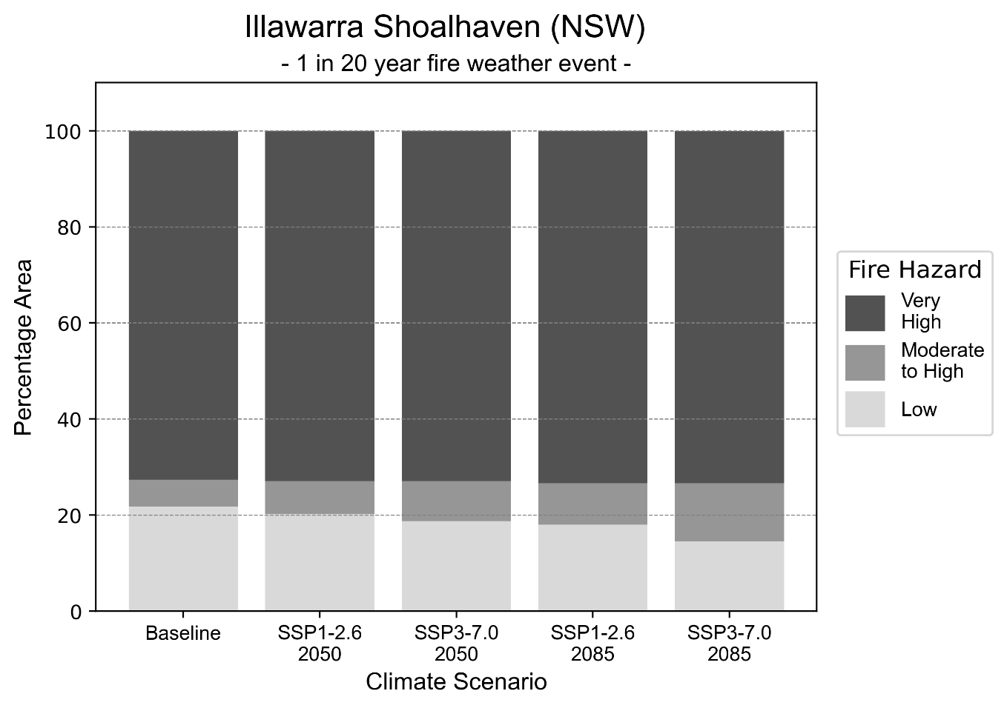
Figure 18: Stacked column chart showing the percentages of the Illawarra Shoalhaven health district's total geographic area experiencing each fire hazard level during a 1-in-20-year fire weather event.
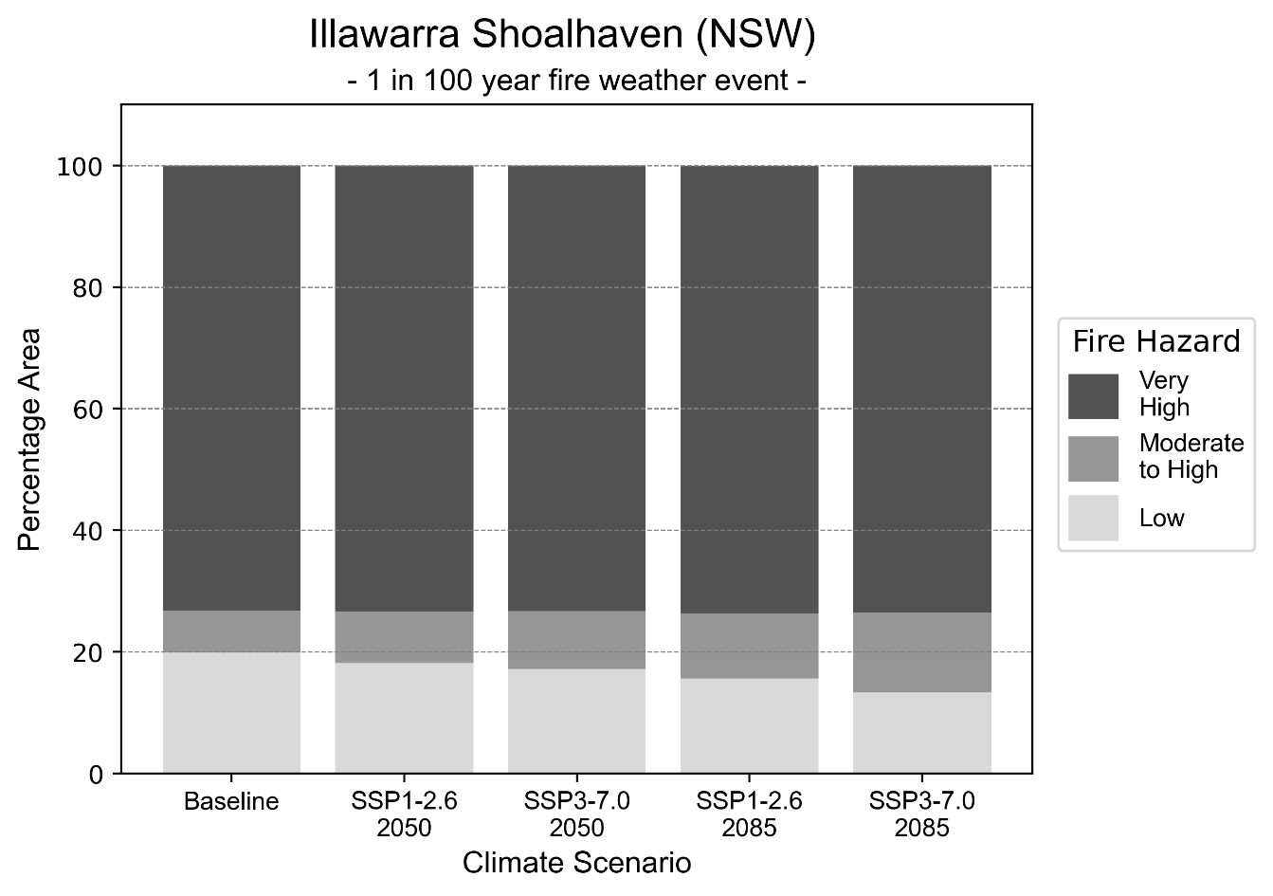
Figure 19: Stacked column chart showing the percentages of the Illawarra Shoalhaven health district's total geographic area experiencing each fire hazard level during a 1-in-100-year fire weather event.

Drought hazard
Key projections:
Drought occurrence: The occurrence of drought will increase across both scenarios and time horizons, with the largest increase occurring under a reasonable worst-case scenario by 2050.

 | Baseline | 2050 Scenarios |  | 2085 Scenarios
 |  | Middle of the road | Reasonable worst-case | Middle of the road | Reasonable worst-case
Number of months per year in drought^{(a)} | 1.7 | 1.8  [0.8, 2.7] | 2.2  [0.7, 4.7] | 1.8  [0.7, 2.9] | 2.0  [0.5, 3.7]
Table notes: The drought hazard indicator uses climate projections from the CMIP6 Global Climate Models [1]. The primary indicator value reports the median from the nine climate models, with the range reported in square brackets.
Table footnotes: (a) The number of months per year in drought is based on the Standardised Precipitation Index (SPI). SPI is a widely used index to characterise meteorological drought on a range of timescales. This indicator uses the timescale of 12 months which calculates the average months in a year within the moderate drought range. A moderate drought range is classified as SPI score of ≤ -1. SPI is calculated from accumulated rainfall over 12 months and the mean and standard deviation from historical rainfall records.

Storm hazard
Key projections:
Increase in very-high-intensity storms: The frequency of very-high-intensity storms will increase slightly across both middle of the road and reasonable worst-case scenarios with the greatest increase occurring by 2050, based on the middle of the road scenario.

 | Baseline | 2050 Scenarios |  | 2085 Scenarios
 |  | Middle of the road | Reasonable worst-case | Middle of the road | Reasonable worst-case
Number of low-intensity storms (40-62 km/hr) per year | 84.0 | 79.8  [70.2, 87.7] | 80.5  [70.8, 88.6] | 78.8  [69.3, 86.7] | 75.7  [66.6, 83.2]
Number of medium-intensity storms (63-87 km/hr) per year | 43.2 | 40.8  [35.9, 44.9] | 41.1  [36.2, 45.2] | 36.8  [32.4, 40.4] | 37.3  [32.9, 41.1]
Number of high-intensity storms (88-117 km/hr) per year | 9.5 | 10.5  [9.3, 11.6] | 9.9  [8.7, 10.9] | 9.2  [8.1, 10.2] | 9.4  [8.3, 10.3]
Number of very-high-intensity storms (> 117 km/hr) per year | 0.4 | 0.6  [0.5, 0.7] | 0.4  [0.3, 0.4] | 0.5  [0.4, 0.6] | 0.5  [0.4, 0.6]
Table notes: The storm hazard uses climate projections from the CMIP6 Global Climate Models [1]. Daily maximum surface wind speed is used to calculate the number of annual storms across four storm intensity categories (low, medium, high and very high). The primary indicator value reports the median from the nine climate models, with the range reported in square brackets.

Rainfall and flood hazard
Key projections:
- Seven extreme rainfall days per year: The number of extreme rainfall days will remain consistent across both scenarios and time horizons, with an average of approximately seven extreme rainfall days per year.
- Increased flood frequency: The frequency of flooding will increase across both middle of the road and reasonable worst-case scenarios in urban environments, and slightly decrease in rural environments. The largest increase in flooding is seen in the reasonable worst-case scenario where frequency of a ‘1-in-100 year’ flood will more than triple by 2050 and become nearly ten times more likely by 2085 in urban environments.

 | Baseline | 2050 Scenarios |  | 2085 Scenarios
 |  | Middle of the road | Reasonable worst-case | Middle of the road | Reasonable worst-case
Rainfall hazard^{(a)}
Average number of extreme rainfall days per year (> 13 mm/day)^{(a)} | 6.8 | 6.8  [6.1,8.0] | 6.7  [5.4,8.1] | 6.8  [6.2,8.2] | 6.7  [5.7,8.3]
Urban flood risk (flooding caused by a 1-hour rainfall event)^{(b)}
Frequency of a ‘1-in-1 year’ flood (rainfall depth of 24 mm)^{(c)} |  | 1.8 events in 1 year | 1.9 events in 1 year | 2.3 events in 1 year | 3.0 events in 1 year
Frequency of a ‘1-in-10 year’ flood (rainfall depth of 44 mm)^{(c)} |  | 2.7 events in 10 years | 2.9 events in 10 years | 4.0 events in 10 years | 6.2 events in 10 years
Frequency of a ‘1-in-100 year’ flood (rainfall depth of 71 mm)^{(c)} |  | 3.3 events in 100 years | 3.5 events in 100 years | 5.3 events in 100 years | 9.8 events in 100 years
Rural flood risk (flooding caused by a 24-hour rainfall event) ^{(b)}
Frequency of a ‘1-in-1 year’ flood (rainfall depth of 107 mm)^{(c)} |  | 0.6 events in 1 year | 0.6 events in 1 year | 0.5 events in 1 year | 0.1 events in 1 year
Frequency of a ‘1-in-10 year’ flood (rainfall depth of 212 mm)^{(c)} |  | 1.2 events in 10 years | 1.1 events in 10 years | 0.9 events in 10 years | 0.3 events in 10 years
Frequency of a ‘1-in-100 year’ flood (rainfall depth of 329 mm)^{(c)} |  | 1.4 events in 100 years | 1.4 events in 100 years | 1.2 events in 100 years | 0.5 events in 100 years
Table notes: The rainfall hazard indicator uses climate projections from the CMIP6 Global Climate Models [1]. The primary indicator value reports the median from the nine climate models, with the range reported in square brackets. The flood hazard indicators use climate change considerations from the Australian Rainfall and Runoff guideline to estimate the climate projections [2].
Table footnotes: (a) Extreme rainfall is defined as rainfall above the 95th percentile of historical average daily rainfall in this health district in the period 1985-2014. The value in mm/day quoted in the indicator name is the 95th percentile of historic average daily rainfall for this health district. (b) See Methodology document for reasons for focusing on a 1-hour flood for urban areas and a 24-hour flood for rural areas. (c) The rainfall depths in mm quoted in the indicator names in this table report 1 in 1-, 10- and 100-year depths for this health district.

Coastal inundation hazard
Key projections:
Greater area inundated: There will be an increase in the area affected by tidal inundation (i.e. area submerged during high tide) and storm surge and tidal inundation (i.e. the area submerged during a storm surge and high tide) across both middle of the road and reasonable worst-case scenarios. In the reasonable worst-case scenario, the area inundated during a ‘1-in-1000-year’ event will increase by over 8,000 ha. by 2085.

 | Baseline | 2050 Scenarios |  | 2085 Scenarios^{(a)}
 |  | Middle of the road | Reasonable worst-case | Middle of the road | Reasonable worst-case
Tidal inundation (ha inundated)^{(b)} | 11,931.5 | 14,418.3  (+2,486.7) | 14,621.2  (+2,689.7) | 17,898.8  (+5,967.3) | 19,536.1  (+7,604.6)
Storm surge + tidal inundation – ‘1-in-100 year’ event (ha inundated)^{(c)} | 15,755.8 | 17,777.7  (+2,021.8) | 17,957.1  (+2,201.3) | 21,866.3  (+6,110.5) | 23,616.6  (+7,860.8)
Storm surge + tidal inundation – ‘1-in-1000 year’ event (ha inundated)^{(c)} | 16,124.6 | 18,121.1  (+1,996.5) | 18,299.3  (+2,174.8) | 23,429.0  (+7,304.4) | 24,859.7  (+8,735.1)
Table notes: The coastal inundation hazard provides an indication of flooding in coastal areas that can be attributed to sea level rise and storm inundation. The coastal inundation hazard is only reported for health districts adjoining the coastline. This table includes the projected inundation levels as well as the change from baseline conditions (in brackets).
Table footnotes: (a) For the 2085 Scenarios planning horizon, 2100 was adopted as it provides a conservative representation of the end of this period. This horizon aligns with many State planning regulations requiring consideration of sea level rise and storm tide to 2100, making the 2100 scenario particularly valuable for planning new health facilities in coastal areas. (b) The tidal inundation indicator reports the number of hectares inundated during high tide. The baseline value reports existing inundation patterns, while the 2050 and 2085 values report high tide inundation taking account of projected sea level rise due to climate change. (c) The storm surge + tidal inundation indicators report the combined effect, in hectares inundated, of high tide, sea level rise (for the 2050 and 2085 projections), and storm surge (for 1-in-100 year and 1-in-1000 year events).

Mid North Coast health district

Health district overview
Surface area: 11,335 square kilometres
Traditional Owners: Gumbaynggirr, Dunghutti, Birpai and Nganyaywana peoples
Estimated population (2025): 233,133
Estimated population (2035): 248,393
Local health services: Bellingen, Coffs Harbour, Dorrigo, Kempsey, Macksville, Port Macquarie, Wauchope

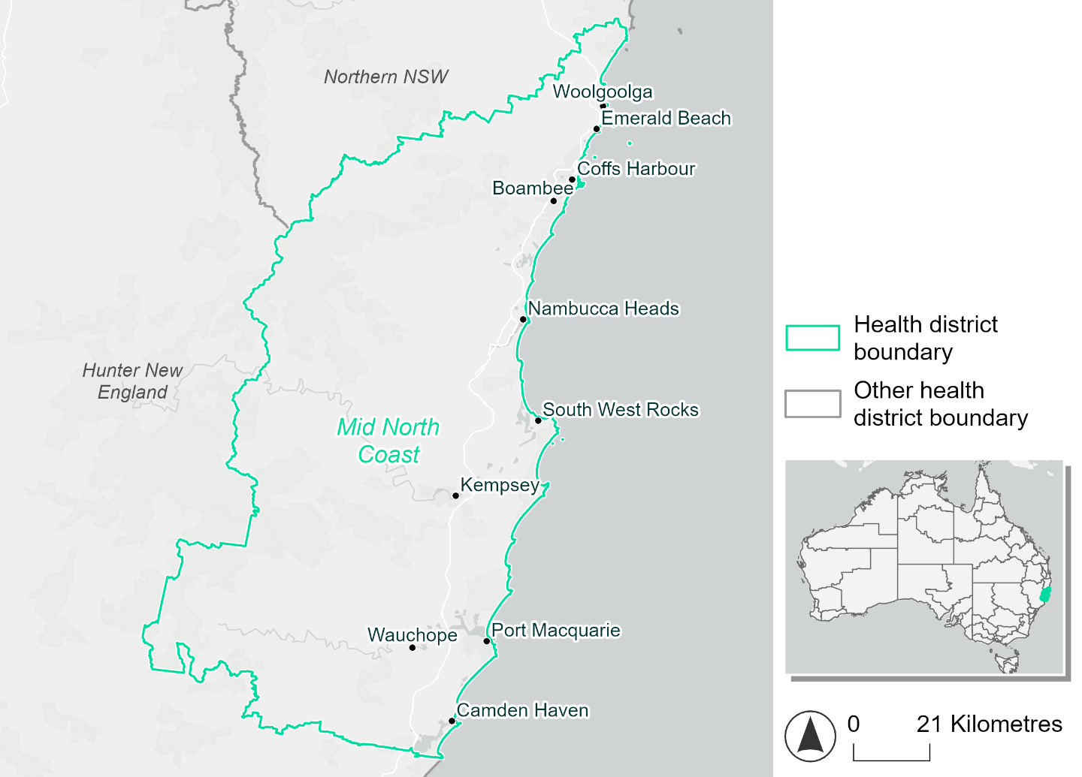
Figure 20. Map of Mid North Coast health district.

How will climate change affect this health district?
Heat and humidity: There will be higher average temperatures, hotter and more frequent hot days, warmer night time temperatures and longer and more frequent heat waves.
Fire: Over 70% of this health district experiences very high fire hazard category and this will continue in both the 2050 and 2085 scenarios. The area experiencing moderate to high fire hazard will increase across both scenarios, while the area experiencing low fire hazard will reduce.
Drought: Number of months experiencing drought will increase.
Rainfall and flood: More flooding is expected in urban and rural areas.
Coastal inundation: Increased area flooded is expected during tidal and storm surge and tidal inundation.

Mid North Coast health district demographic data
Demographic Data | Total
Number of households | 89,412
Persons 15 and older | 148,924
Total families | 62,507
Persons did not complete high school | 73,224
One parent families with dependents | 7,122 (11.4%)
Persons aged 65 and older | 61,534 (26.4%)
Persons aged 4 and younger | 11,753 (5%)
Aboriginal and Torres Strait Islander persons | 15,430 (6.6%)
Persons speaks language other than English | 12,722 (5.5%)
Persons working age (15-65) | 131,647 (56.5%)
Population Health Data | Total
Persons with core needs for assistance | 18,258 (7.8%)
Persons with arthritis | 30,937 (13.3%)
Persons with asthma | 21,231 (9.1%)
Persons with cancer | 9,933 (4.3%)
Persons with dementia | 2,815 (1.2%)
Persons with diabetes | 12,287 (5.3%)
Persons with heart disease | 13,615 (5.8%)
Persons with kidney disease | 3,187 (1.4%)
Persons with lung condition | 7,809 (3.4%)
Persons with mental health condition | 25,877 (11.1%)
Persons with stroke | 3,347 (1.4%)
Persons with any other condition | 21,401 (9.2%)
Persons no health condition | 120,366 (51.7%)
Socio-economic Data | Total
Persons providing unpaid care | 32,172 (13.8%)
Persons homeless | 961 (0.4%)
Household with lone person | 25,757 (28.8%)
Households with rent and mortgage stress | 53,494 (59.8%)
Households total equivalised income below $1000 (weekly) | 52,085 (58.3%)
Households with no motor vehicle | 4,715 (5.3%)
Persons unemployed | 10,629 (5.6%)

The sections that follow outline projected climate hazards for this district.

Heat and humidity hazard
Key projections:
More heatwaves: Heatwaves will last longer and become more frequent. Under a reasonable worst-case scenario, the number of heatwaves will double by 2050 and quadruple by 2085.
Hotter days and warmer nights: The maximum temperature on hot days will increase with temperatures on hot nights also increasing.
More days above 35°C and 40°C: The number of days per year greater than 35°C and 40°C will increase under both middle of the road and reasonable worst-case scenarios.

 | Baseline | 2050 Scenarios |  | 2085 Scenarios
 |  | Middle of the road | Reasonable worst-case | Middle of the road | Reasonable worst-case
Average temperature (°C) | 18.5 | 19.9  [19.3, 20.4] | 20.1  [19.5, 20.8] | 20.7  [19.9, 21.7] | 21.6  [20.7, 22.7]
Maximum temperature on hot days (°C)^{(a)} | 31 | 32.5  [31.9, 33.2] | 32.8  [31.9, 34.4] | 33.4  [32.5, 35] | 34.3  [33.1, 35.8]
Minimum temperature on hot nights (°C)^{(b)} | 21 | 22.4  [21.6, 23] | 22.6  [22, 23.2] | 23.2  [22.2, 24.5] | 24.2  [23.2, 25.6]
Average apparent temperature on hot days (°C) (NOAA Heat Index)^{(c)} | 35 | 36.1  [35.8, 36.6] | 36.2  [35.8, 36.9] | 36.8  [36, 37.9] | 37.9  [36.8, 39.4]
Average heatwave duration in days^{(d)} | 4 | 5  [5, 6] | 6  [5, 6] | 6  [5, 8] | 8  [6, 11]
Number of heatwaves per year^{(d)} | 2 | 5  [4, 6] | 5  [4, 7] | 7  [5, 9] | 9  [7, 10]
Number of days per year  > 35°C | 4 | 7  [6, 10] | 8  [6, 15] | 10  [7, 18] | 15  [9, 24]
Number of days per year > 40°C | 0 | 1  [1, 1] | 1  [1, 2] | 1  [1, 3] | 2  [1, 4]
Table notes: The heat and humidity hazard uses climate projections from the CMIP6 Global Climate Models [1]. Daily projections of maximum and minimum near-surface temperature and mean relative humidity are used to calculate eight heat and humidity indicators. The primary indicator value reports the median from the nine climate models, with the range reported in square brackets.
Table footnotes: (a) Based on the 95th percentile of daily maximum air temperature. (b) Based on the 95th percentile of daily minimum air temperature, representing the coldest part of the night on very hot nights. (c) The National Oceanic and Atmospheric Administration (NOAA) Heat Index is a measure of how hot it feels when relative humidity is factored in alongside actual air temperature. It is calculated on days with a maximum temperature of 27°C and above. Interpretation of Heat Index values: 27°C to 32°C indicates caution, 33°C to 41°C indicates extreme caution, 42°C to 54°C indicates danger and over 54°C indicates extreme danger. See methodology document for further explanation of Heat Index categories. (d) A heatwave is defined as three or more consecutive days where both daytime and overnight temperatures (daily mean temperatures) are unusually high for the location, based on the Bureau of Meteorology’s Excess Heat Factor method. For this district, an unusually high daily mean temperature is approximately 25.5°C or above.

Fire hazard
Key projections:
- Some changes in the extent of very high fire hazards: During a 1-in-100-year event, the percentage of the district rated as very high hazard increases to 46.6%, up from 43.5% under baseline conditions.
- Some areas will transition from low hazard to moderate and high hazard: By 2050 and 2085, the area of the district area experiencing low fire hazard will decline, by up to 19.1%. There will be a corresponding increase in the amount of the district experiencing moderate to high hazard.

 | Baseline | 2050 Scenarios |  | 2085 Scenarios
 |  | Sustainability | Reasonable worst-case | Sustainability | Reasonable worst-case
Hazard for a ‘1-in-20 year’ fire weather event^{(a)}
Proportion (%) of district experiencing ‘Low’ fire hazard | 38.3%  (433,197)^{(b)} | 35.0%  [33.8%, 37.0%] | 30.3%  [28.3%, 31.7%] | 30.5%  [27.5%, 35.2%] | 19.2%  [14.3%, 22.5%]
Proportion (%) of district experiencing ‘Moderate to High’ fire hazard | 18.2%  (206,482)^{(b)} | 21.2%  [19.1%, 22.9%] | 25.8%  [24.2%, 27.9%] | 25.3%  [20.2%, 29.4%] | 36.4%  [32.6%, 41.5%]
Proportion (%) of district experiencing ‘Very High’ fire hazard | 43.5%  (492,713)^{(b)} | 43.8%  [43.1%, 44.2%] | 43.9%  [41.7%, 45.6%] | 44.2%  [42.6%, 45.1%] | 44.4%  [39.1%, 48.5%]
Hazard for a ‘1-in-100 year’ fire weather event^{(a)}
Proportion (%) of district experiencing ‘Low’ fire hazard | 33.5%  (379,816)^{(b)} | 30.1%  [28.8%, 31.9%] | 26.3%  [25.2%, 27.4%] | 25.3%  [22.2%, 29.7%] | 16.2%  [13.5%, 18.8%]
Proportion (%) of district experiencing ‘Moderate to High’ fire hazard | 19.9%  (225,129)^{(b)} | 23.1%  [21.4%, 24.2%] | 26.7%  [23.7%, 29.0%] | 27.5%  [23.5%, 30.3%] | 36.2%  [29.0%, 41.7%]
Proportion (%) of district experiencing ‘Very High’ fire hazard | 46.6%  (527,446)^{(b)} | 46.8%  [46.4%, 47.1%] | 47.0%  [45.9%, 47.8%] | 47.2%  [46.2%, 47.8%] | 47.5%  [44.9%, 49.6%]
Table notes: The Fire Hazard uses the National Bushfire Intelligence Capability (NBIC) Phase 2 fire line intensity modelling based on CMIP6 climate projections. Fire Hazard is assessed using the projected Fireline Intensity (FLI) for weather events with two different return intervals (i.e. a 1-in-20 year event and a 1-in-100 year event). FLI considers slope, vegetation and weather to produce a rate of heat output per unit length (kW/m) along a bushfire’s front. Fire hazard is categorized as a low for FLI<4000 kW/m, moderate to high for 4,000 kW/m ≤FLI<12,500kW/m, and very high for FLI≥27,501kW/m. This is broadly consistent with the literature [3]. The assessment considers climate change effects based on changes in fire weather and the associated hazard that is anticipated for a meteorological event of a given return interval. This approach is different to the one adopted for the Flood Hazard, where the event magnitude is given (fixed) and the likelihood of that event varies as a result of climate change. The primary indicator value reports the median from the nine climate models, with the range reported in square brackets.
Table footnotes: (a) The area subject to different categories of fire hazard is determined for a ‘1-in-20 year’ and ‘1-in-100 year’ fire weather event, in current and future climates. Values at year 2050 are interpolated using data from baseline (2025) and 2085, assuming linear change over time. (b) Values in round brackets are the area (ha) of the health district subject to a given fire hazard.

The figures below show the proportion of the health district experiencing different fire hazard categories across different time horizons and climate scenarios during a ‘1-in-20 year’ fire weather event (Figure 21) and a ‘1-in-100 year’ fire weather event (Figure 22).
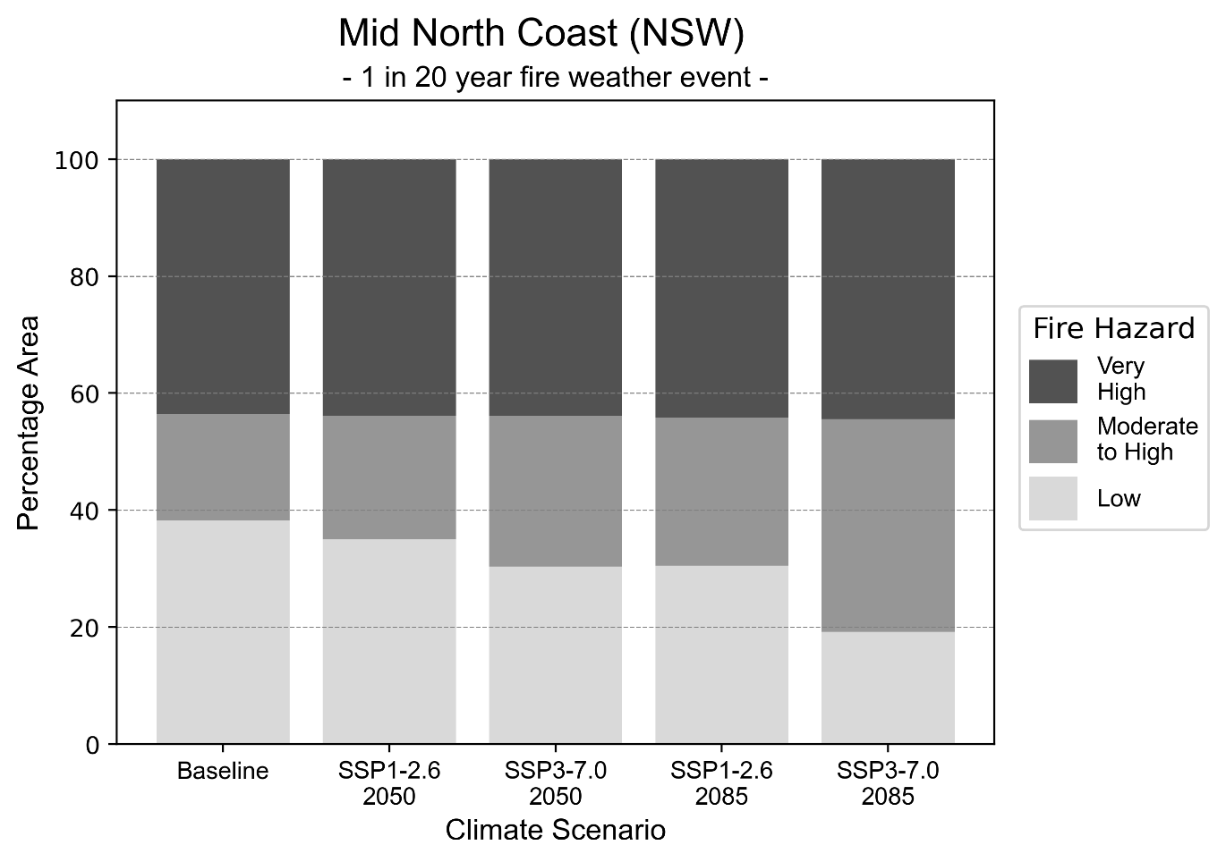
Figure 21: Stacked column chart showing the percentages of the Mid North Coast health district's total geographic area experiencing each fire hazard level during a 1-in-20-year fire weather event.
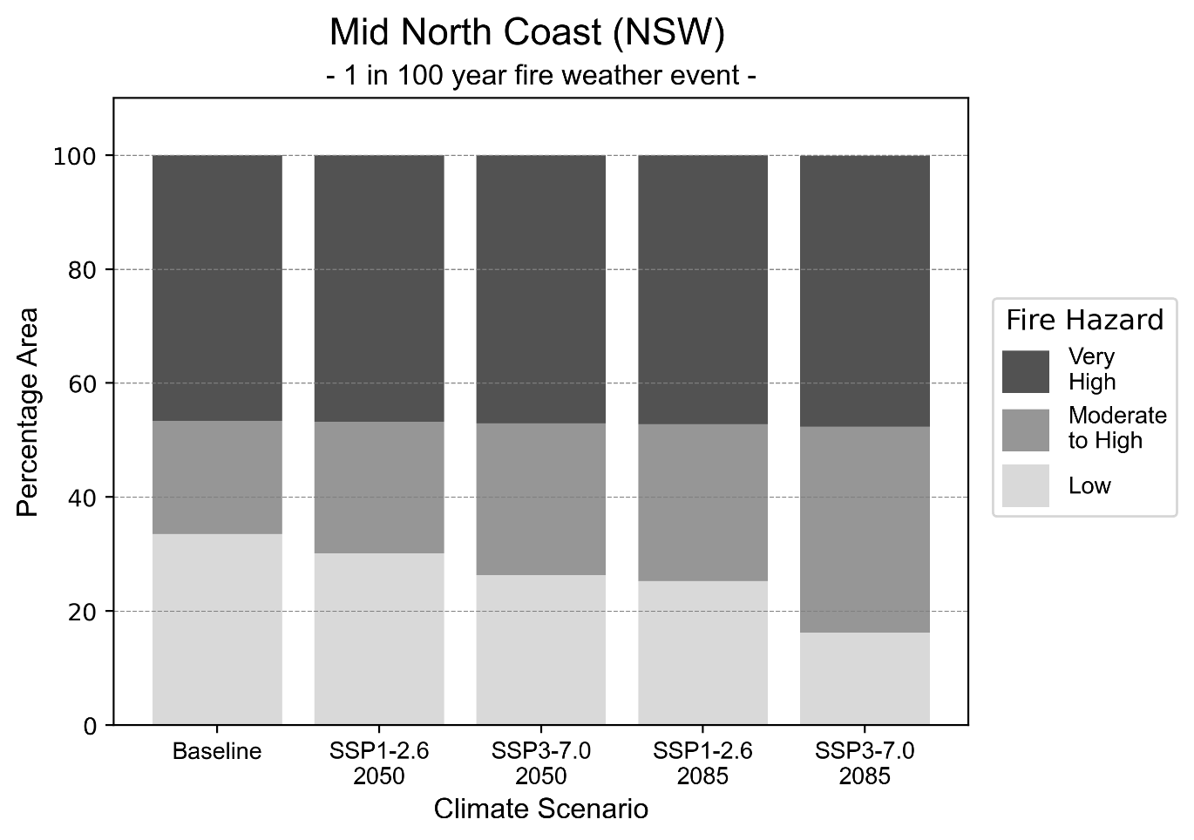
Figure 22: Stacked column chart showing the percentages of the Mid North Coast health district's total geographic area experiencing each fire hazard level during a 1-in-100-year fire weather event.

Drought hazard
Key projections:
Drought occurrence: The occurrence of drought will increase across both scenarios and time horizons, with the largest increase occurring under a reasonable worst-case scenario by 2050.

 | Baseline | 2050 Scenarios |  | 2085 Scenarios
 |  | Middle of the road | Reasonable worst-case | Middle of the road | Reasonable worst-case
Number of months per year in drought^{(a)} | 1.9 | 2.3  [0.7, 3.9] | 2.4  [0.7, 5.2] | 2.2  [0.8, 4.3] | 2.1  [0.3, 3.9]
Table notes: The drought hazard indicator uses climate projections from the CMIP6 Global Climate Models [1]. The primary indicator value reports the median from the nine climate models, with the range reported in square brackets.
Table footnotes: (a) The number of months per year in drought is based on the Standardised Precipitation Index (SPI). SPI is a widely used index to characterise meteorological drought on a range of timescales. This indicator uses the timescale of 12 months which calculates the average months in a year within the moderate drought range. A moderate drought range is classified as SPI score of ≤ -1. SPI is calculated from accumulated rainfall over 12 months and the mean and standard deviation from historical rainfall records.

Storm hazard
Key projections:
Fewer medium and high-intensity storms: The frequency of medium and high-intensity storms will decrease across both middle of the road and reasonable worst-case scenarios, with the greatest decrease occurring by 2085 based on the middle of the road scenario.

 | Baseline | 2050 Scenarios |  |  | 2085 Scenarios
 |  | Middle of the road | Reasonable worst-case |  | Middle of the road | Reasonable worst-case
Number of low-intensity storms (40-62 km/hr) per year | 73.4 | 68.7  [60.4, 75.5] |  | 71.0  [62.5, 78.1] | 66.2  [58.3, 72.8] | 61.5  [54.1, 67.7]
Number of medium-intensity storms (63-87 km/hr) per year | 33.7 | 27.4  [24.1, 30.1] | 24.2  [21.3, 26.7] |  | 21.9  [19.3, 24.1] | 25.2  [22.1, 27.7]
Number of high-intensity storms (88-117 km/hr) per year | 2.8 | 2.6  [2.3, 2.9] | 2.3  [2.0, 2.5] |  | 2.1  [1.8, 2.3] | 2.6  [2.3, 2.9]
Number of very-high-intensity storms (> 117 km/hr) per year | 0.1 | 0.1  [0.1, 0.1] | 0.0  [0.0, 0.0] |  | 0.1  [0.1, 0.1] | 0.1  [0.1, 0.1]
Table notes: The storm hazard uses climate projections from the CMIP6 Global Climate Models [1]. Daily maximum surface wind speed is used to calculate the number of annual storms across four storm intensity categories (low, medium, high and very high). The primary indicator value reports the median from the nine climate models, with the range reported in square brackets.

Rainfall and flood hazard
Key projections:
- Increased flood frequency: Flooding will become more frequent in both the middle of the road and reasonable worst-case scenarios, particularly in urban environments. The largest increase in urban flooding is seen in the reasonable worst-case scenario where frequency of a ‘1-in-100 year’ flood will quadruple by 2050 and be nearly 12 times more likely by 2085.

 | Baseline | 2050 Scenarios |  | 2085 Scenarios
 |  | Middle of the road | Reasonable worst-case | Middle of the road | Reasonable worst-case
Rainfall hazard^{(a)}
Average number of extreme rainfall days per year (> 17 mm/day)^{(a)} | 9.8 | 9.7  [8.3,11.6] | 9.6  [7.5,11.5] | 9.7  [7.8,11.4] | 9.8  [8.2,12.3]
Urban flood risk (flooding caused by a 1-hour rainfall event)^{(b)}
Frequency of a ‘1-in-1 year’ flood (rainfall depth of 29 mm)^{(c)} |  | 2.0 events in 1 year | 2.0 events in 1 year | 2.5 events in 1 year | 3.3 events in 1 year
Frequency of a ‘1-in-10 year’ flood (rainfall depth of 52 mm)^{(c)} |  | 2.9 events in 10 years | 3.1 events in 10 years | 4.4 events in 10 years | 6.8 events in 10 years
Frequency of a ‘1-in-100 year’ flood (rainfall depth of 81 mm)^{(c)} |  | 3.8 events in 100 years | 4.0 events in 100 years | 6.3 events in 100 years | 12 events in 100 years
Rural flood risk (flooding caused by a 24-hour rainfall event) ^{(b)}
Frequency of a ‘1-in-1 year’ flood (rainfall depth of 105 mm)^{(c)} |  | 1.1 events in 1 year | 1.1 events in 1 year | 1.0 events in 1 year | 0.8 events in 1 year
Frequency of a ‘1-in-10 year’ flood (rainfall depth of 213 mm)^{(c)} |  | 1.5 events in 10 years | 1.5 events in 10 years | 1.5 events in 10 years | 1.4 events in 10 years
Frequency of a ‘1-in-100 year’ flood (rainfall depth of 339 mm)^{(c)} |  | 1.8 events in 100 years | 1.8 events in 100 years | 2.1 events in 100 years | 2.1 events in 100 years
Table notes: The rainfall hazard indicator uses climate projections from the CMIP6 Global Climate Models [1]. The primary indicator value reports the median from the nine climate models, with the range reported in square brackets. The flood hazard indicators use climate change considerations from the Australian Rainfall and Runoff guideline to estimate the climate projections [2].
Table footnotes: (a) Extreme rainfall is defined as rainfall above the 95th percentile of historical average daily rainfall in this health district in the period 1985-2014. The value in mm/day quoted in the indicator name is the 95th percentile of historic average daily rainfall for this health district. (b) See Methodology document for reasons for focusing on a 1-hour flood for urban areas and a 24-hour flood for rural areas. (c) The rainfall depths in mm quoted in the indicator names in this table report 1 in 1-, 10- and 100-year depths for this health district.

Coastal inundation hazard
Key projections:
More areas inundated: There will be an increase in the area affected by tidal inundation (i.e. area submerged during high tide) and storm surge and tidal inundation (i.e. the area submerged during a storm surge and high tide) across both middle of the road and reasonable worst-case scenarios. In the reasonable worst-case scenario, the area inundated during tidal inundation will increase by over 26,000 ha. by 2085.

 | Baseline | 2050 Scenarios |  | 2085 Scenarios^{(a)}
 |  | Middle of the road | Reasonable worst-case | Middle of the road | Reasonable worst-case
Tidal inundation (ha inundated)^{(b)} | 45,189.2 | 54,715.7  (+9,526.6) | 55,260.3  (+10,071.1) | 67,475.8  (+22,286.7) | 71,328.5  (+26,139.4)
Storm surge + tidal inundation – ‘1-in-100 year’ event (ha inundated)^{(c)} | 54,310.5 | 62,556.1  (+8,245.6) | 63,031.3  (+8,720.8) | 73,289.4  (+18,978.9) | 76,505.1  (+22,194.6)
Storm surge + tidal inundation – ‘1-in-1000 year’ event (ha inundated)^{(c)} | 55,279.7 | 63,399.5  (+8,119.8) | 63,861.0  (+8,581.2) | 76,126.1  (+20,846.4) | 79,234.8  (+23,955.1)
Table notes: The coastal inundation hazard provides an indication of flooding in coastal areas that can be attributed to sea level rise and storm inundation. The coastal inundation hazard is only reported for health districts adjoining the coastline. This table includes the projected inundation levels as well as the change from baseline conditions (in brackets).
Table footnotes: (a) For the 2085 Scenarios planning horizon, 2100 was adopted as it provides a conservative representation of the end of this period. This horizon aligns with many State planning regulations requiring consideration of sea level rise and storm tide to 2100, making the 2100 scenario particularly valuable for planning new health facilities in coastal areas. (b) The tidal inundation indicator reports the number of hectares inundated during high tide. The baseline value reports existing inundation patterns, while the 2050 and 2085 values report high tide inundation taking account of projected sea level rise due to climate change. (c) The storm surge + tidal inundation indicators report the combined effect, in hectares inundated, of high tide, sea level rise (for the 2050 and 2085 projections), and storm surge (for 1-in-100 year and 1-in-1000 year events).

Murrumbidgee health district

Health district overview
Surface area: 125,243 square kilometres
Traditional Owners: Wiradjuri, Yorta Yorta, Baraba Baraba, Wemba Wemba Perrepa Perrepa, Nari Nari and Muthi Muthi peoples
Estimated population (2025): 308,080
Estimated population (2035): 331,478
Local health services: The Murrumbidgee local health district contains 41 multi-purpose service centres, community health centres and hospitals.

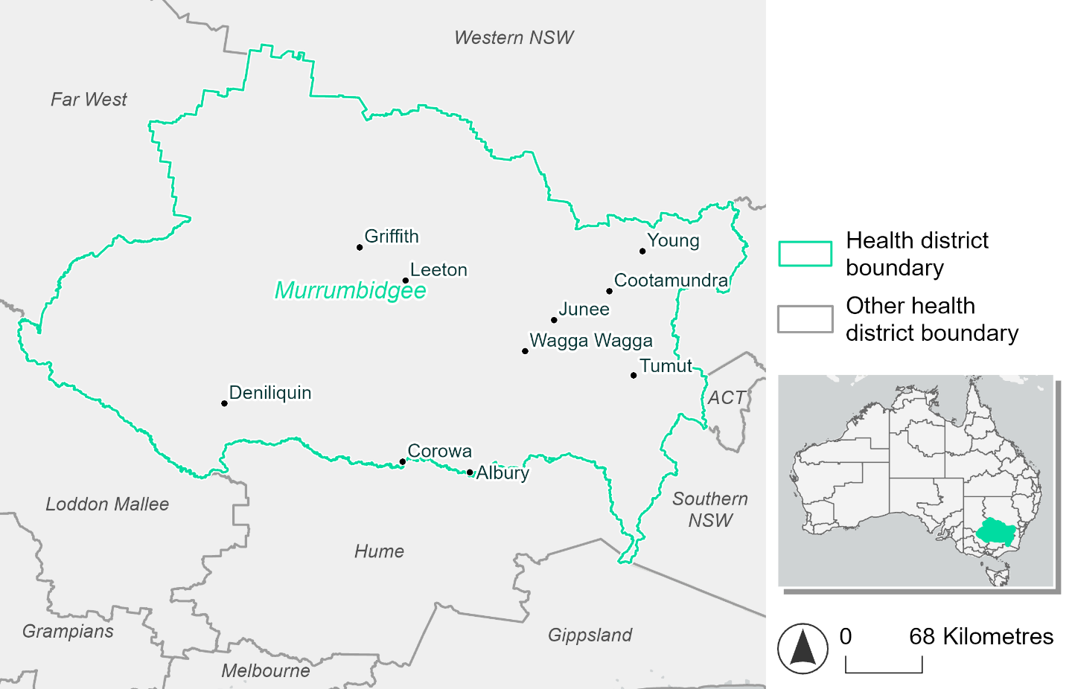
Figure 23. Map of Murrumbidgee health district.

How will climate change affect this health district?
Heat and humidity: There will be higher average temperatures, more frequent hot days, warmer night time temperatures, and longer and more frequent heat waves.
Fire: Currently over 79.0% of the district experiences moderate to high fire hazard for both 1-in-20 and 1-in-100 fire weather events. The area experiencing very high fire hazard will increase slightly (to 6.3-7.3%) for both 1-in-20 and 1-in-100 fire weather event under both 2050 and 2085 scenarios.
Drought: Number of months experiencing drought will increase.
Rainfall and flood: More flood events are expected in both urban and rural areas.

Murrumbidgee health district demographic data
Demographic Data | Total
Number of households | 114,005
Persons 15 and older | 200,805
Total families | 78,658
Persons did not complete high school | 98,068
One parent families with dependents | 8,366 (10.6%)
Persons aged 65 and older | 64,400 (21.1%)
Persons aged 4 and younger | 18,942 (6.2%)
Aboriginal and Torres Strait Islander persons | 16,708 (5.5%)
Persons speaks language other than English | 23,309 (7.6%)
Persons working age (15-65) | 182,372 (59.7%)
Population Health Data | Total
Persons with core needs for assistance | 19,407 (6.4%)
Persons with arthritis | 33,422 (10.9%)
Persons with asthma | 31,990 (10.5%)
Persons with cancer | 10,448 (3.4%)
Persons with dementia | 2,508 (0.8%)
Persons with diabetes | 15,989 (5.2%)
Persons with heart disease | 13,940 (4.6%)
Persons with kidney disease | 3,604 (1.2%)
Persons with lung condition | 7,402 (2.4%)
Persons with mental health condition | 29,401 (9.6%)
Persons with stroke | 3,484 (1.1%)
Persons with any other condition | 22,466 (7.4%)
Persons no health condition | 166,241 (54.4%)
Socio-economic Data | Total
Persons providing unpaid care | 38,979 (12.8%)
Persons homeless | 1,038 (0.3%)
Household with lone person | 33,506 (29.4%)
Households with rent and mortgage stress | 41,958 (36.8%)
Households total equivalised income below $1000 (weekly) | 58,054 (50.9%)
Households with no motor vehicle | 6,376 (5.6%)
Persons unemployed | 9,747 (4%)

The sections that follow outline projected climate hazards for this district.

Heat and humidity hazard
Key projections:
More heatwaves: Heatwaves are likely to last longer and be more frequent. Under a reasonable worst-case scenario, the number of heatwaves per year will more than double by 2050 and triple by 2085.
Hotter days and warmer nights: The maximum temperature on hot days will increase with temperatures on hot nights also increasing.
More days above 35°C and 40°C: The number of days per year greater than 35°C and 40°C will increase under both middle of the road and reasonable worst-case scenarios.

 | Baseline | 2050 Scenarios |  | 2085 Scenarios
 |  | Middle of the road | Reasonable worst-case | Middle of the road | Reasonable worst-case
Average temperature (°C) | 15.6 | 17  [16.2, 17.5] | 17.3  [16.3, 17.9] | 17.9  [16.7, 18.8] | 19  [17.5, 20.1]
Maximum temperature on hot days (°C)^{(a)} | 34.5 | 36.3  [35.8, 37.4] | 36.8  [35.4, 38.4] | 37.4  [36.2, 39.1] | 38.5  [37.3, 40.4]
Minimum temperature on hot nights (°C)^{(b)} | 19.5 | 21.1  [20.1, 21.9] | 21.4  [20, 22] | 22  [20.5, 23.1] | 23.3  [21.5, 24.4]
Average apparent temperature on hot days (°C) (NOAA Heat Index)^{(c)} | 32.5 | 34.1  [33.2, 34.7] | 34.1  [33.3, 34.8] | 34.7  [33.8, 35.8] | 35.7  [34.8, 37.1]
Average heatwave duration in days^{(d)} | 5 | 6  [5, 7] | 6  [5, 7] | 7  [6, 8] | 8  [6, 9]
Number of heatwaves per year^{(d)} | 2 | 4  [3, 5] | 5  [3, 6] | 5  [4, 7] | 7  [5, 9]
Number of days per year  > 35°C | 17 | 28  [24, 35] | 32  [22, 43] | 37  [27, 52] | 47  [35, 68]
Number of days per year > 40°C | 2 | 5  [4, 8] | 7  [4, 12] | 8  [5, 14] | 13  [8, 22]
Table notes: The heat and humidity hazard uses climate projections from the CMIP6 Global Climate Models [1]. Daily projections of maximum and minimum near-surface temperature and mean relative humidity are used to calculate eight heat and humidity indicators. The primary indicator value reports the median from the nine climate models, with the range reported in square brackets.
Table footnotes: (a) Based on the 95th percentile of daily maximum air temperature. (b) Based on the 95th percentile of daily minimum air temperature, representing the coldest part of the night on very hot nights. (c) The National Oceanic and Atmospheric Administration (NOAA) Heat Index is a measure of how hot it feels when relative humidity is factored in alongside actual air temperature. It is calculated on days with a maximum temperature of 27°C and above. Interpretation of Heat Index values: 27°C to 32°C indicates caution, 33°C to 41°C indicates extreme caution, 42°C to 54°C indicates danger and over 54°C indicates extreme danger. See methodology document for further explanation of Heat Index categories. (d) A heatwave is defined as three or more consecutive days where both daytime and overnight temperatures (daily mean temperatures) are unusually high for the location, based on the Bureau of Meteorology’s Excess Heat Factor method. For this district, an unusually high daily mean temperature is approximately 26.5°C or above.

Fire hazard
Key projection:
- Most of the health district already experiences moderate to high fire hazard: Under baseline conditions, 79-80% of the health district area experiences moderate to high fire hazard for both 1-in-20- and 1-in-100-year fire weather events. These fire hazard conditions will persist in both the 2050 and 2085 scenarios.
 | Baseline | 2050 Scenarios |  | 2085 Scenarios
 |  | Sustainability | Reasonable worst-case | Sustainability | Reasonable worst-case
Hazard for a ‘1-in-20 year’ fire weather event^{(a)}
Proportion (%) of district experiencing ‘Low’ fire hazard | 14.7%  (1,842,807)^{(b)} | 14.5%  [14.3%, 14.7%] | 14.0%  [12.1%, 14.6%] | 14.2%  [13.8%, 14.7%] | 13.0%  [8.5%, 14.6%]
Proportion (%) of district experiencing ‘Moderate to High’ fire hazard | 79.0%  (9,921,452)^{(b)} | 79.2%  [76.4%, 81.9%] | 79.5%  [73.6%, 86.1%] | 79.4%  [72.6%, 86.0%] | 80.1%  [65.9%, 95.9%]
Proportion (%) of district experiencing ‘Very High’ fire hazard | 6.3%  (789,965)^{(b)} | 6.3%  [6.3%, 6.4%] | 6.5%  [6.3%, 7.5%] | 6.4%  [6.2%, 6.5%] | 6.9%  [6.2%, 9.1%]
Hazard for a ‘1-in-100 year’ fire weather event^{(a)}
Proportion (%) of district experiencing ‘Low’ fire hazard | 13.2%  (1,657,647)^{(b)} | 13.0%  [12.9%, 13.2%] | 12.5%  [10.9%, 13.0%] | 12.8%  [12.5%, 13.1%] | 11.5%  [7.6%, 12.8%]
Proportion (%) of district experiencing ‘Moderate to High’ fire hazard | 80.1%  (10,061,57)^{(b)} | 80.3%  [76.8%, 83.6%] | 80.6%  [74.9%, 86.7%] | 80.4%  [72.2%, 88.5%] | 81.2%  [67.5%, 95.9%]
Proportion (%) of district experiencing ‘Very High’ fire hazard | 6.7%  (834,979)^{(b)} | 6.7%  [6.7%, 6.8%] | 6.9%  [6.6%, 7.8%] | 6.8%  [6.7%, 6.9%] | 7.3%  [6.6%, 9.5%]
Table notes: The Fire Hazard uses the National Bushfire Intelligence Capability (NBIC) Phase 2 fire line intensity modelling based on CMIP6 climate projections. Fire Hazard is assessed using the projected Fireline Intensity (FLI) for weather events with two different return intervals (i.e. a 1-in-20 year event and a 1-in-100 year event). FLI considers slope, vegetation and weather to produce a rate of heat output per unit length (kW/m) along a bushfire’s front. Fire hazard is categorized as a low for FLI<4000 kW/m, moderate to high for 4,000 kW/m ≤FLI<12,500kW/m, and very high for FLI≥27,501kW/m. This is broadly consistent with the literature [3]. The assessment considers climate change effects based on changes in fire weather and the associated hazard that is anticipated for a meteorological event of a given return interval. This approach is different to the one adopted for the Flood Hazard, where the event magnitude is given (fixed) and the likelihood of that event varies as a result of climate change. The primary indicator value reports the median from the nine climate models, with the range reported in square brackets.
Table footnotes: (a) The area subject to different categories of fire hazard is determined for a ‘1-in-20 year’ and ‘1-in-100 year’ fire weather event, in current and future climates. Values at year 2050 are interpolated using data from baseline (2025) and 2085, assuming linear change over time. (b) Values in round brackets are the area (ha) of the health district subject to a given fire hazard.

The figures below show the proportion of the health district experiencing different fire hazard categories across different time horizons and climate scenarios during a ‘1-in-20 year’ fire weather event (Figure 24) and a ‘1-in-100 year’ fire weather event (Figure 25).
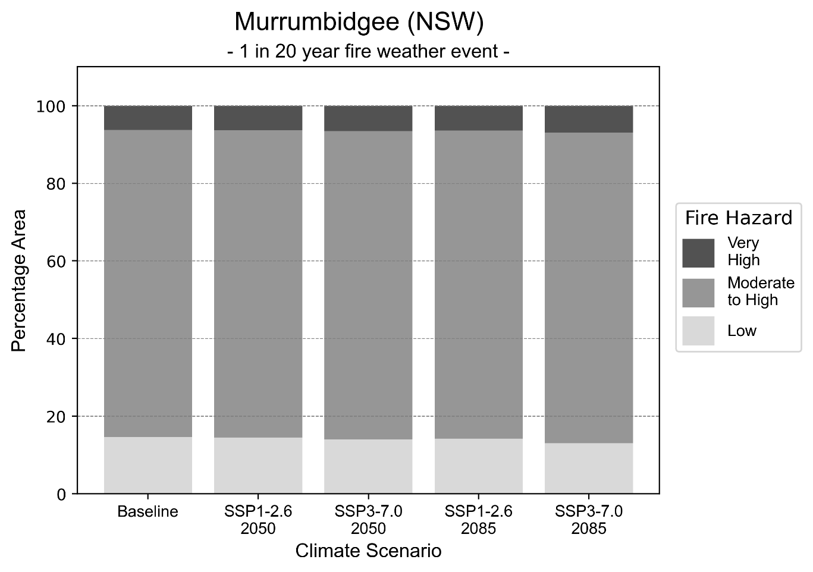
Figure 24: Stacked column chart showing the percentages of the Murrumbidgee health district's total geographic area experiencing each fire hazard level during a 1-in-20-year fire weather event.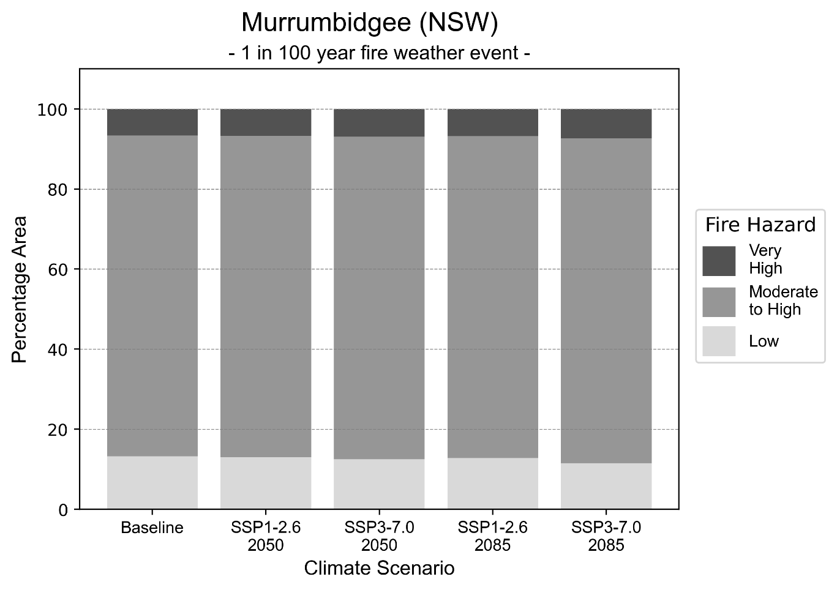Figure 25: Stacked column chart showing the percentages of the Murrumbidgee health district's total geographic area experiencing each fire hazard level during a 1-in-100-year fire weather event.

Drought hazard
Key projection:
Drought occurrence: The occurrence of drought will increase across both middle of the road and reasonable worst-case scenarios and both time horizons, with the largest increase occurring under a reasonable worst-case scenario by 2085.

 | Baseline | 2050 Scenarios |  | 2085 Scenarios
 |  | Middle of the road | Reasonable worst-case | Middle of the road | Reasonable worst-case
Number of months per year in drought^{(a)} | 1.6 | 1.8 [0.5, 3.0] | 2.0  [0.7, 5.2] | 2.0  [0.4, 3.7] | 2.5  [0.3, 6.2]
Table notes: The drought hazard indicator uses climate projections from the CMIP6 Global Climate Models [1]. The primary indicator value reports the median from the nine climate models, with the range reported in square brackets.
Table footnotes: (a) The number of months per year in drought is based on the Standardised Precipitation Index (SPI). SPI is a widely used index to characterise meteorological drought on a range of timescales. This indicator uses the timescale of 12 months which calculates the average months in a year within the moderate drought range. A moderate drought range is classified as SPI score of ≤ -1. SPI is calculated from accumulated rainfall over 12 months and the mean and standard deviation from historical rainfall records.

Storm hazard
Key projection:
More very-high-intensity storms by 2085: Very-high-intensity storms will be more frequent across both middle of the road and reasonable worst-case scenarios, with the number of very-high-intensity storms per year doubling by 2085.

 | Baseline | 2050 Scenarios |  | 2085 Scenarios
 |  | Middle of the road | Reasonable worst-case | Middle of the road | Reasonable worst-case
Number of low-intensity storms (40-62 km/hr) per year | 73.6 | 69.9  [61.5, 76.9] | 68.3  [60.1, 75.1] | 62.7  [55.2, 69.0] | 67.5  [59.4, 74.3]
Number of medium-intensity storms (63-87 km/hr) per year | 55.5 | 47.8  [42.1, 52.6] | 48.3  [42.5, 53.1] | 45.5  [40.0, 50.0] | 44.3  [39.0, 48.7]
Number of high-intensity storms (88-117 km/hr) per year | 17.6 | 17.0  [15.0, 18.7] | 16.5  [14.5, 18.2] | 17.8  [15.6, 19.5] | 17.8  [15.6, 19.5]
Number of very-high-intensity storms (> 117 km/hr) per year | 0.3 | 0.3  [0.3, 0.3] | 0.3  [0.3, 0.4] | 0.7  [0.6, 0.8] | 0.6  [0.5, 0.6]
Table notes: The storm hazard uses climate projections from the CMIP6 Global Climate Models [1]. Daily maximum surface wind speed is used to calculate the number of annual storms across four storm intensity categories (low, medium, high and very high). The primary indicator value reports the median from the nine climate models, with the range reported in square brackets.

Rainfall and flood hazard
Key projections:
- Nine extreme rainfall days per year: The number of extreme rainfall days will remain consistent across both scenarios and time horizons, with an average of approximately nine extreme rainfall days per year.
- More frequent flooding: Flooding will be more frequency in both middle of the road and reasonable worst-case scenarios, particularly in urban environments. The largest increase in frequency is seen in the reasonable worst-case scenario, where frequency of a ‘1-in-100 year’ urban flood will more than triple by 2050 and be nearly 11 times more likely by 2085.

 | Baseline | 2050 Scenarios |  | 2085 Scenarios
 |  | Middle of the road | Reasonable worst-case | Middle of the road | Reasonable worst-case
Rainfall hazard^{(a)}
Average number of extreme rainfall days per year (> 9 mm/day)^{(a)} | 9.5 | 9.8  [8.1,11.8] | 9.5  [7.0,11.3] | 9.5  [7.8,12.4] | 9.2  [6.6,13.0]
Urban flood risk (flooding caused by a 1-hour rainfall event)^{(b)}
Frequency of a ‘1-in-1 year’ flood (rainfall depth of 14 mm)^{(c)} |  | 1.8 events in 1 year | 1.9 events in 1 year | 2.3 events in 1 year | 3.0 events in 1 year
Frequency of a ‘1-in-10 year’ flood (rainfall depth of 27 mm)^{(c)} |  | 2.6 events in 10 years | 2.7 events in 10 years | 3.7 events in 10 years | 5.7 events in 10 years
Frequency of a ‘1-in-100 year’ flood (rainfall depth of 43 mm)^{(c)} |  | 3.5 events in 100 years | 3.7 events in 100 years | 5.7 events in 100 years | 11 events in 100 years
Rural flood risk (flooding caused by a 24-hour rainfall event) ^{(b)}
Frequency of a ‘1-in-1 year’ flood (rainfall depth of 39 mm)^{(c)} |  | 1.2 events in 1 year | 1.2 events in 1 year | 1.2 events in 1 year | 1.0 events in 1 year
Frequency of a ‘1-in-10 year’ flood (rainfall depth of 68 mm)^{(c)} |  | 1.6 events in 10 years | 1.6 events in 10 years | 1.8 events in 10 years | 1.7 events in 10 years
Frequency of a ‘1-in-100 year’ flood (rainfall depth of 105 mm)^{(c)} |  | 1.9 events in 100 years | 1.9 events in 100 years | 2.3 events in 100 years | 2.5 events in 100 years
Table notes: The rainfall hazard indicator uses climate projections from the CMIP6 Global Climate Models [1]. The primary indicator value reports the median from the nine climate models, with the range reported in square brackets. The flood hazard indicators use climate change considerations from the Australian Rainfall and Runoff guideline to estimate the climate projections [2].
Table footnotes: (a) Extreme rainfall is defined as rainfall above the 95th percentile of historical average daily rainfall in this health district in the period 1985-2014. The value in mm/day quoted in the indicator name is the 95th percentile of historic average daily rainfall for this health district. (b) See Methodology document for reasons for focusing on a 1-hour flood for urban areas and a 24-hour flood for rural areas. (c) The rainfall depths in mm quoted in the indicator names in this table report 1 in 1-, 10- and 100-year depths for this health district.

Nepean Blue Mountains health district

Health district overview
Surface area: 9,179 square kilometres
Traditional Owners: Dharug, Gundungurra and Wiradjuri peoples
Estimated population (2025): 389,420
Estimated population (2035): 425,061
Local health services: The Nepean Blue Mountains Local Health District contains ten community health centres, one multi-purpose service (Portland Tabulam) and five public hospitals: Blue Mountains Hospital, Hawkesbury District Hospital, Lithgow Hospital, Nepean Hospital, Springwood Hospital

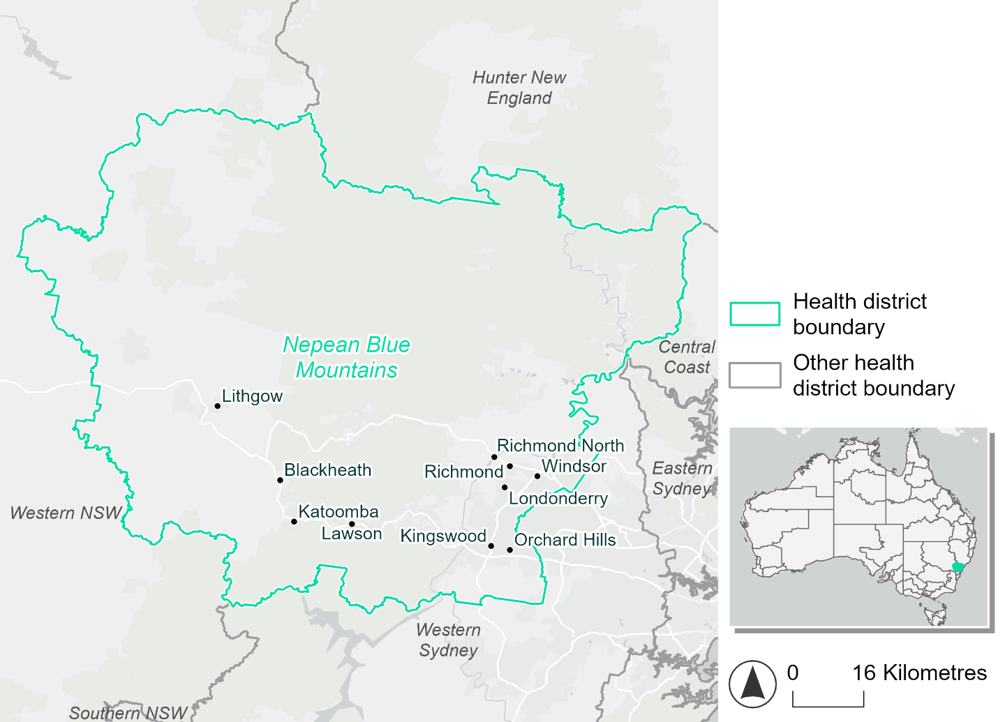
Figure 26. Map of Nepean Blue Mountains health district.

How will climate change affect this health district?
Heat and humidity: There will be higher average temperatures, more frequent hot days, warmer night time temperatures, and longer and more frequent heat waves.
Fire: Over 70% of this district currently experiences very high fire hazard, and this will increase slightly in both the 2050 and 2085 scenarios.
Drought: The number of months experiencing drought will slightly increase.
Rainfall and flood: More flood events are expected in both urban and rural areas.
Coastal inundation: While the health district is non-coastal, a small section of the Hawkesbury-Nepean river system near Richmond/ Yarrramundi is affected by tides. The area flooded during tidal, and storm surge and tidal, inundation will increase.

Nepean Blue Mountains health district demographic data
Demographic Data | Total
Number of households | 135,499
Persons 15 and older | 267,909
Total families | 103,991
Persons did not complete high school | 112,677
One parent families with dependents | 11,346 (10.9%)
Persons aged 65 and older | 62,645 (16.1%)
Persons aged 4 and younger | 25,258 (6.5%)
Aboriginal and Torres Strait Islander persons | 17,915 (4.6%)
Persons speaks language other than English | 53,527 (13.8%)
Persons working age (15-65) | 248,496 (64%)
Population Health Data | Total
Persons with core needs for assistance | 21,919 (5.6%)
Persons with arthritis | 34,754 (8.9%)
Persons with asthma | 35,100 (9%)
Persons with cancer | 10,734 (2.8%)
Persons with dementia | 2,154 (0.6%)
Persons with diabetes | 20,590 (5.3%)
Persons with heart disease | 15,685 (4%)
Persons with kidney disease | 3,670 (0.9%)
Persons with lung condition | 7,228 (1.9%)
Persons with mental health condition | 37,201 (9.6%)
Persons with stroke | 3,368 (0.9%)
Persons with any other condition | 33,211 (8.6%)
Persons no health condition | 224,961 (57.9%)
Socio-economic Data | Total
Persons providing unpaid care | 45,861 (11.8%)
Persons homeless | 1,174 (0.3%)
Household with lone person | 31,955 (23.6%)
Households with rent and mortgage stress | 71,355 (52.7%)
Households total equivalised income below $1000 (weekly) | 57,679 (42.6%)
Households with no motor vehicle | 8,133 (6%)
Persons unemployed | 13,261 (4.3%)

The sections that follow outline projected climate hazards for this district. Further information on this health district, including population demographics, is provided in the online dashboard.

Heat and humidity hazard
Key projections:
More heatwaves: There will be more heatwaves each year and these heatwaves will last longer. Under a reasonable worst-case scenario, the number of heatwaves per year will more than double by 2050, and triple by 2085.
Hotter days and warmer nights: The maximum temperature on hot days will increase, with temperatures on hot nights also increasing.
More days above 35°C and 40°C: The number of days per year greater than 35°C and 40°C will increase under both middle of the road and reasonable worst-case scenarios.

 | Baseline | 2050 Scenarios |  | 2085 Scenarios
 |  | Middle of the road | Reasonable worst-case | Middle of the road | Reasonable worst-case
Average temperature (°C) | 16.9 | 18.3  [17.8, 19] | 18.6  [17.8, 19.5] | 19.2  [18.3, 20.4] | 20.2  [19.1, 21.5]
Maximum temperature on hot days (°C)^{(a)} | 32.6 | 34.2  [33.7, 35.2] | 34.7  [33.5, 36.2] | 35.2  [34.2, 37.1] | 36.3  [35.2, 38.3]
Minimum temperature on hot nights (°C)^{(b)} | 19.5 | 21.1  [20.3, 21.9] | 21.3  [20.3, 22.2] | 22  [20.8, 23.3] | 23  [21.7, 24.6]
Average apparent temperature on hot days (°C) (NOAA Heat Index)^{(c)} | 34.8 | 36.3  [35.4, 36.7] | 36.6  [35.6, 37.3] | 37.1  [36.1, 38.2] | 38.2  [37.1, 39.7]
Average heatwave duration in days^{(d)} | 4 | 5  [5, 5] | 5  [4, 6] | 5  [5, 7] | 6  [5, 9]
Number of heatwaves per year^{(d)} | 2 | 4  [3, 6] | 5  [3, 7] | 6  [4, 9] | 8  [6, 10]
Number of days per year  > 35°C | 9 | 16  [14, 22] | 18  [13, 27] | 22  [16, 33] | 29  [21, 44]
Number of days per year > 40°C | 1 | 3  [2, 4] | 3  [2, 6] | 4  [2, 8] | 6  [4, 12]
Table notes: The heat and humidity hazard uses climate projections from the CMIP6 Global Climate Models [1]. Daily projections of maximum and minimum near-surface temperature and mean relative humidity are used to calculate eight heat and humidity indicators. The primary indicator value reports the median from the nine climate models, with the range reported in square brackets.
Table footnotes: (a) Based on the 95th percentile of daily maximum air temperature. (b) Based on the 95th percentile of daily minimum air temperature, representing the coldest part of the night on very hot nights. (c) The National Oceanic and Atmospheric Administration (NOAA) Heat Index is a measure of how hot it feels when relative humidity is factored in alongside actual air temperature. It is calculated on days with a maximum temperature of 27°C and above. Interpretation of Heat Index values: 27°C to 32°C indicates caution, 33°C to 41°C indicates extreme caution, 42°C to 54°C indicates danger and over 54°C indicates extreme danger. See methodology document for further explanation of Heat Index categories. (d) A heatwave is defined as three or more consecutive days where both daytime and overnight temperatures (daily mean temperatures) are unusually high for the location, based on the Bureau of Meteorology’s Excess Heat Factor method. For this district, an unusually high daily mean temperature is approximately 25.6°C or above.

Fire hazard
Key projections:
- Majority of district currently experiences very high fire hazard: Under baseline conditions most of the district already experiences very high fire hazard, for both the 1-in-20- and 1-in-100-year fire weather events. These hazard levels will stay roughly the same in both 2050 and 2085 scenarios, varying by no more than 1% of the district area.

 | Baseline | 2050 Scenarios |  | 2085 Scenarios
 |  | Sustainability | Reasonable worst-case | Sustainability | Reasonable worst-case
Hazard for a ‘1-in-20 year’ fire weather event^{(a)}
Proportion (%) of district experiencing ‘Low’ fire hazard | 7.8%  (71,621)^{(b)} | 7.7%  [7.6%, 8.0%] | 7.4%  [7.1%, 7.7%] | 7.6%  [7.2%, 8.2%] | 6.9%  [6.2%, 7.5%]
Proportion (%) of district experiencing ‘Moderate to High’ fire hazard | 16.1%  (147,559)  ^{(b)} | 15.9%  [15.8%, 16.1%] | 16.0%  [15.8%, 16.2%] | 15.7%  [15.3%, 16.2%] | 15.9%  [15.4%, 16.4%]
Proportion (%) of district experiencing ‘Very High’ fire hazard | 76.1%  (698,340)  ^{(b)} | 76.4%  [76.2%, 76.5%] | 76.5%  [76.4%, 76.7%] | 76.7%  [76.4%, 77.1%] | 77.1%  [76.9%, 77.6%]
Hazard for a ‘1-in-100 year’ fire weather event^{(a)}
Proportion (%) of district experiencing ‘Low’ fire hazard | 7.1%  (65,301)^{(b)} | 7.0%  [6.9%, 7.3%] | 6.8%  [6.5%, 6.9%] | 6.9%  [6.5%, 7.5%] | 6.3%  [5.6%, 6.7%]
Proportion (%) of district experiencing ‘Moderate to High’ fire hazard | 16.0%  (146,577)  ^{(b)} | 15.9%  [15.7%, 16.1%] | 16.0%  [15.9%, 16.3%] | 15.8%  [15.4%, 16.2%] | 16.1%  [15.8%, 16.7%]
Proportion (%) of district experiencing ‘Very High’ fire hazard | 76.9%  (705,641)  ^{(b)} | 77.1%  [77.0%, 77.2%] | 77.2%  [77.1%, 77.3%] | 77.3%  [77.2%, 77.5%] | 77.6%  [77.4%, 77.9%]
Table notes: The Fire Hazard uses the National Bushfire Intelligence Capability (NBIC) Phase 2 fire line intensity modelling based on CMIP6 climate projections. Fire Hazard is assessed using the projected Fireline Intensity (FLI) for weather events with two different return intervals. FLI considers slope, vegetation and weather to produce a rate of heat output per unit length (kW/m) along a bushfire’s front. Fire hazard is categorized as a low (0-4,000 kW/m), moderate to high (4,001-27,499kW/m) and very high (>27,500 kW/m) fire hazard, which is broadly consistent with what is reported in the literature [3]. NOTE: The assessment considers climate change effects based on the changes in fire weather, and the associated hazard, that is anticipated for a meteorological event of a given return period (i.e. likelihood based on 1-in-20 year and 1-in-100 year). This approach is different to the one adopted for the Flood Hazard, where the event magnitude is given (fixed) and where the likelihood of that event varies as a result of climate change. The primary indicator value reports the median from the nine climate models, with the range reported in square brackets.
Table footnotes: (a) The area subject to different categories of fire hazard is determined for a ‘1-in-20 year’ and ‘1-in-100 year’ fire weather event, in current and future climates. Values at year 2050 are interpolated using data from baseline and 2090. (b) Round brackets are the area (ha) of the health district subject to a given fire hazard.

The figures below show the proportion of the health district experiencing different fire hazard categories across different time horizons and climate scenarios during a ‘1-in-20 year’ fire weather event (Figure 27) and a ‘1-in-100 year’ fire weather event (Figure 28).
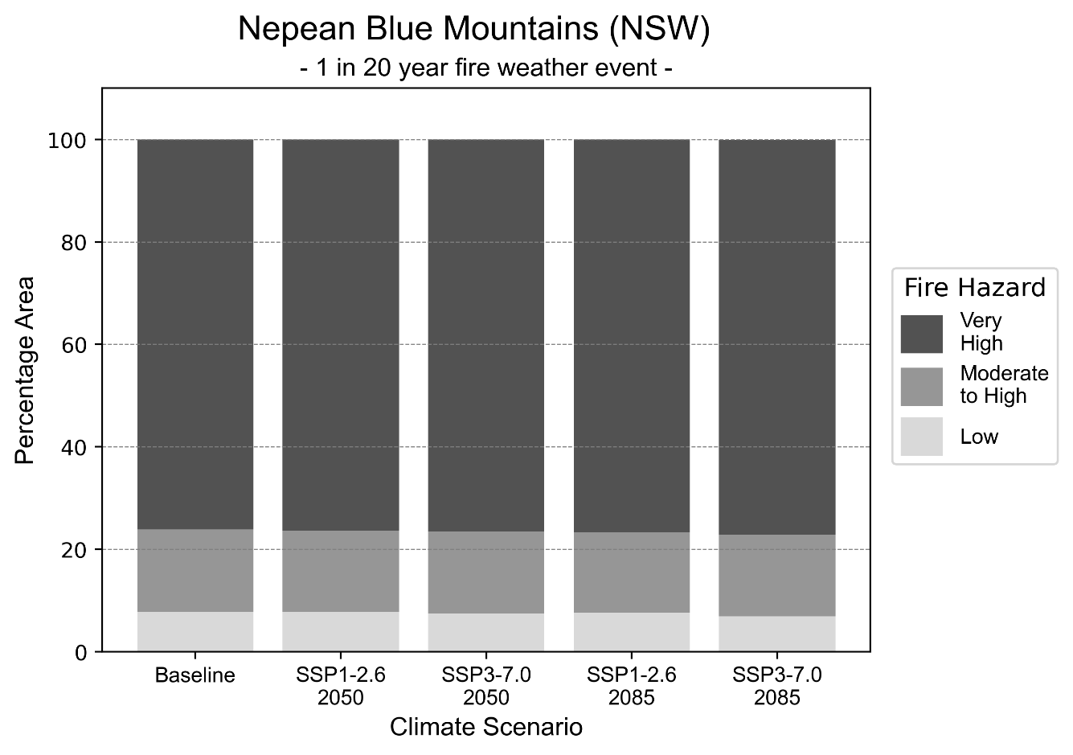
Figure 27: Stacked column chart showing the percentages of the Nepean Blue Mountains health district's total geographic area experiencing each fire hazard level during a 1-in-20-year fire weather event.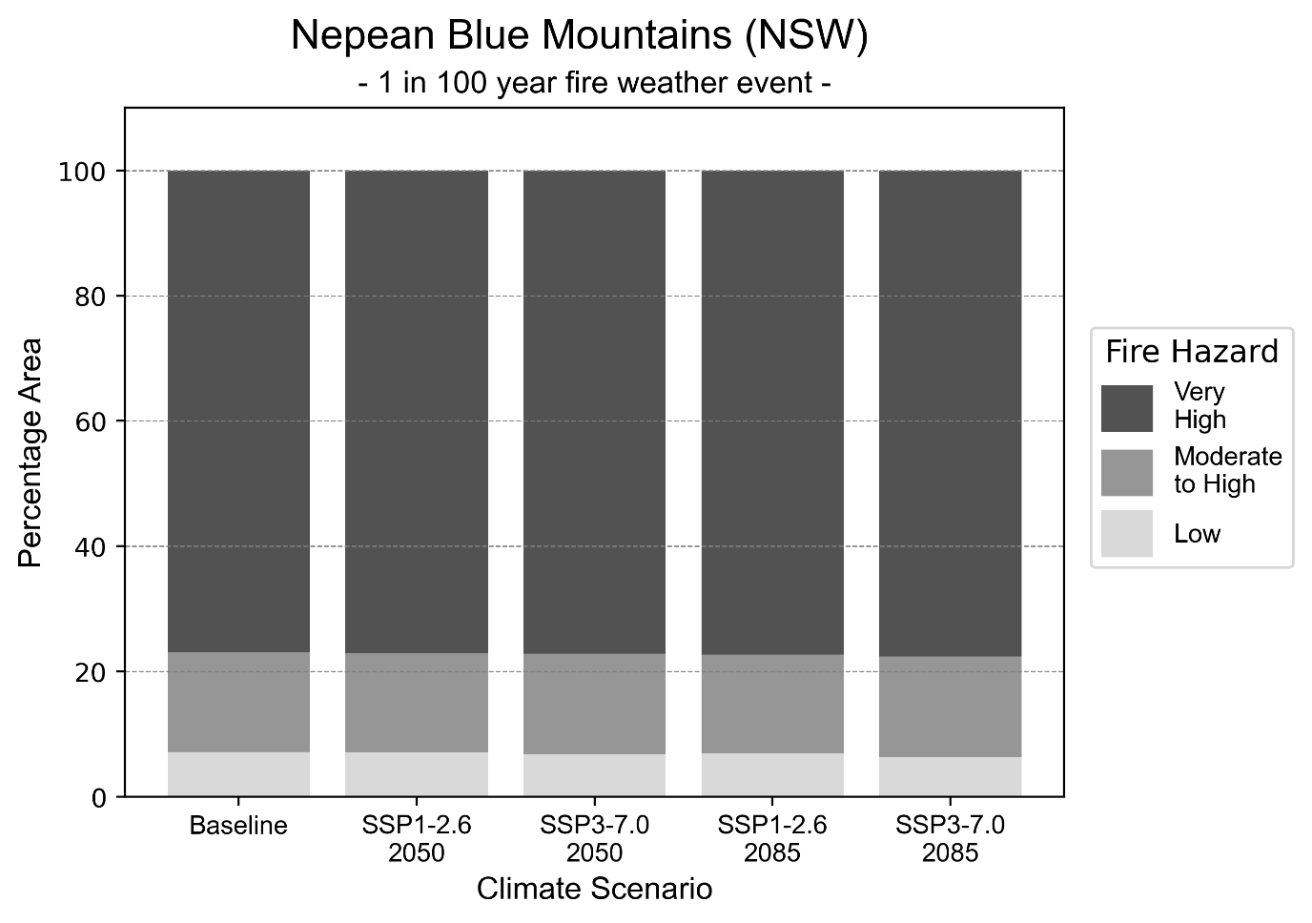Figure 28: Stacked column chart showing the percentages of the Nepean Blue Mountains health district's total geographic area experiencing each fire hazard level during a 1-in-100-year fire weather event.

Drought hazard
Key projections:
Drought occurrence: The occurrence of drought will slightly increase across both scenarios and time horizons. Drought will be experienced on average two months per year.

 | Baseline | 2050 Scenarios |  | 2085 Scenarios
 |  | Middle of the road | Reasonable worst-case | Middle of the road | Reasonable worst-case
Number of months per year in drought^{(a)} | 1.8 | 1.8  [0.5, 3.2] | 2.1  [0.4, 5.1] | 1.9  [0.4, 3.4] | 2.1  [0.2, 4.5]
Table notes: The drought hazard indicator uses climate projections from the CMIP6 Global Climate Models [1]. The primary indicator value reports the median from the nine climate models, with the range reported in square brackets.
Table footnotes:(a) The number of months per year in drought is based on the Standardised Precipitation Index (SPI). SPI is a widely used index to characterise meteorological drought on a range of timescales. This indicator uses the timescale of 12 months which calculates the average months in a year within the moderate drought range. A moderate drought range is classified as SPI score of ≤ -1. SPI is calculated from accumulated rainfall over 12 months and the mean and standard deviation from historical rainfall records.

Storm hazard
Key projections:
Less medium and low-intensity storms: Medium and low-intensity storms will become less frequent in both middle of the road and reasonable worst-case scenarios, with the greatest decrease occurring by 2085.

 | Baseline | 2050 Scenarios |  | 2085 Scenarios
 |  | Middle of the road | Reasonable worst-case | Middle of the road | Reasonable worst-case
Number of low-intensity storms (40-62 km/hr) per year | 66.1 | 62.1  [54.6, 68.3] | 63.3  [55.7, 69.7] | 58.5  [51.5, 64.4] | 59.0  [51.9, 64.9]
Number of medium-intensity storms (63-87 km/hr) per year | 36.3 | 32.6  [28.7, 35.9] | 31.3  [27.5, 34.4] | 29.1  [25.6, 32.0] | 27.1  [23.8, 29.8]
Number of high-intensity storms (88-117 km/hr) per year | 1.0 | 1.4  [1.2, 1.5] | 0.9  [0.8, 1.0] | 1.2  [1.0, 1.3] | 1.1  [1.0, 1.2]
Number of very-high-intensity storms (> 117 km/hr) per year | 0.0 | 0.0  [0.0, 0.0] | 0.0  [0.0, 0.0] | 0.0  [0.0, 0.0] | 0.0  [0.0, 0.0]
Table notes: The storm hazard uses climate projections from the CMIP6 Global Climate Models [1]. Daily maximum surface wind speed is used to calculate the number of annual storms across four storm intensity categories (low, medium, high and very high). The primary indicator value reports the median from the nine climate models, with the range reported in square brackets.

Rainfall and flood hazard
Key projections:
- 11 extreme rainfall days per year: The number of extreme rainfall days will remain consistent across both scenarios and time horizons, with an average of approximately 11 extreme rainfall days per year.
- Increased flood frequency: Flooding will become frequent in both middle of the road and reasonable worst-case scenarios, particularly in urban environments. The biggest change is seen in the reasonable worst-case scenario, where the frequency of a ‘1-in-100 year’ urban flood will more than quadruple by 2050 and become nearly 13 times more likely by 2085.

 | Baseline | 2050 Scenarios |  | 2085 Scenarios
 |  | Middle of the road | Reasonable worst-case | Middle of the road | Reasonable worst-case
Rainfall hazard^{(a)}
Average number of extreme rainfall days per year (> 12 mm/day)^{(a)} | 10.8 | 11.0  [9.3,13.1] | 10.8  [8.3,13.8] | 11.0  [9.5,13.9] | 10.8  [8.6,15.2]
Urban flood risk (flooding caused by a 1-hour rainfall event)^{(b)}
Frequency of a ‘1-in-1 year’ flood (rainfall depth of 22 mm)^{(c)} |  | 1.9 events in 1 year | 2.0 events in 1 year | 2.5 events in 1 year | 3.3 events in 1 year
Frequency of a ‘1-in-10 year’ flood (rainfall depth of 38 mm)^{(c)} |  | 3.0 events in 10 years | 3.2 events in 10 years | 4.6 events in 10 years | 7.1 events in 10 years
Frequency of a ‘1-in-100 year’ flood (rainfall depth of 59 mm)^{(c)} |  | 3.9 events in 100 years | 4.2 events in 100 years | 6.6 events in 100 years | 13 events in 100 years
Rural flood risk (flooding caused by a 24-hour rainfall event) ^{(b)}
Frequency of a ‘1-in-1 year’ flood (rainfall depth of 82 mm)^{(c)} |  | 1.7 events in 1 year | 1.6 events in 1 year | 0.8 events in 1 year | 0.9 events in 1 year
Frequency of a ‘1-in-10 year’ flood (rainfall depth of 151 mm)^{(c)} |  | 1.4 events in 10 years | 1.4 events in 10 years | 1.3 events in 10 years | 1.0 events in 10 years
Frequency of a ‘1-in-100 year’ flood (rainfall depth of 232 mm)^{(c)} |  | 1.7 events in 100 years | 1.7 events in 100 years | 1.7 events in 100 years | 1.4 events in 100 years
Table notes: The rainfall hazard indicator uses climate projections from the CMIP6 Global Climate Models [1]. The primary indicator value reports the median from the nine climate models, with the range reported in square brackets. The flood hazard indicators use climate change considerations from the Australian Rainfall and Runoff guideline to estimate the climate projections [2].
Table footnotes: (a) Extreme rainfall is defined as rainfall above the 95th percentile of historical average daily rainfall in this health district in the period 1985-2014. The value in mm/day quoted in the indicator name is the 95th percentile of historic average daily rainfall for this health district. (b) See Methodology document for reasons for focusing on a 1-hour flood for urban areas and a 24-hour flood for rural areas. (c) The rainfall depths in mm quoted in the indicator names in this table report 1 in 1-, 10- and 100-year depths for this health district.

Coastal inundation hazard
Key projections:
Greater area inundated: There will be an increase in the area affected by tidal inundation (i.e. area submerged during high tide) and storm surge and tidal inundation (i.e. the area submerged during a storm surge and high tide) across both middle of the road and reasonable worst-case scenarios. In the reasonable worst-case scenario, by 2085 the area inundated during tidal inundation will increase by over 1,000 ha.

 | Baseline | 2050 Scenarios |  | 2085 Scenarios^{(a)}
 |  | Middle of the road | Reasonable worst-case | Middle of the road | Reasonable worst-case
Tidal inundation (ha inundated)^{(b)} | 799.7 | 1,107.5  (+307.8) | 1,137.7  (+338.0) | 1,651.4  (+851.6) | 1,862.7  (+1,062.9)
Storm surge + tidal inundation – ‘1-in-100 year’ event (ha inundated)^{(c)} | 1,258.3 | 1,581.6  (+323.3) | 1,610.2  (+351.9) | 2,034.7  (+776.4) | 2,175.0  (+916.7)
Storm surge + tidal inundation – ‘1-in-1000 year’ event (ha inundated)^{(c)} | 1,334.0 | 1,654.6  (+320.7) | 1,681.5  (+347.5) | 2,176.4  (+842.4) | 2,312.0  (+978.0)
Table notes: The coastal inundation hazard provides an indication of flooding in coastal areas that can be attributed to sea level rise and storm inundation. The coastal inundation hazard is only reported for health districts adjoining the coastline. This table includes the projected inundation levels as well as the change from baseline conditions (in brackets).
Table footnotes: (a) For the 2085 Scenarios planning horizon, 2100 was adopted as it provides a conservative representation of the end of this period. This horizon aligns with many State planning regulations requiring consideration of sea level rise and storm tide to 2100, making the 2100 scenario particularly valuable for planning new health facilities in coastal areas. (b) The tidal inundation indicator reports the number of hectares inundated during high tide. The baseline value reports existing inundation patterns, while the 2050 and 2085 values report high tide inundation taking account of projected sea level rise due to climate change. (c) The storm surge + tidal inundation indicators report the combined effect, in hectares inundated, of high tide, sea level rise (for the 2050 and 2085 projections), and storm surge (for 1-in-100 year and 1-in-1000 year events).

Northern NSW health district

Health district overview
Surface area: 20,732 square kilometres
Traditional Owners:
Estimated population (2025): 314,905
Estimated population (2035): 329,888
Local health services: Ballina District Hospital, Bonalbo Multi-Purpose Service, Byron Central Hospital, Casino and District Memorial Hospital, Grafton Base Hospital, Kyogle Multi-Purpose Service, Lismore Base Hospital, Maclean District Hospital, Murwillumbah District Hospital, Nimbin Multi-Purpose Service, Tweed Valley Hospital, Urbenville Multi-Purpose Service.

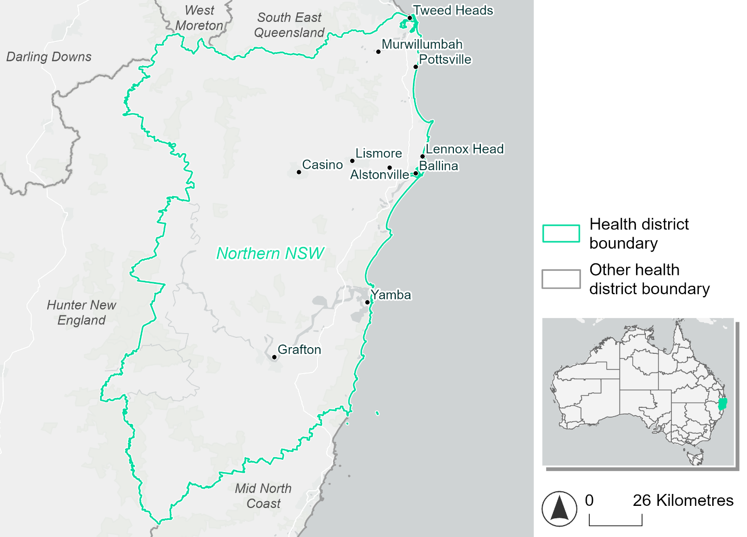
Figure 29. Map of Northern NSW health district

How will climate change affect this health district?
Heat and humidity: There will be higher average temperatures, more frequent hot days, warmer night time temperatures, and longer and more frequent heat waves.
Fire: Over 58% of this health district already experiences very high fire hazards. The area experiencing moderate to high fire hazard will increase in both the 2050 and 2085 scenarios.
Drought: The number of months experiencing drought will increase.
Rainfall and flood: There will be more floods in both urban and rural areas.
Coastal inundation: The area flooded during tidal, and storm surge and tidal inundation will increase.

Northern NSW health district demographic data
Demographic Data | Total
Number of households | 119,569
Persons 15 and older | 205,956
Total families | 82,220
Persons did not complete high school | 92,657
One parent families with dependents | 9,324 (11.3%)
Persons aged 65 and older | 77,662 (24.7%)
Persons aged 4 and younger | 15,528 (4.9%)
Aboriginal and Torres Strait Islander persons | 16,217 (5.2%)
Persons speaks language other than English | 15,212 (4.8%)
Persons working age (15-65) | 183,152 (58.4%)
Population Health Data | Total
Persons with core needs for assistance | 22,158 (7.1%)
Persons with arthritis | 35,718 (11.4%)
Persons with asthma | 26,941 (8.6%)
Persons with cancer | 12,084 (3.9%)
Persons with dementia | 3,170 (1%)
Persons with diabetes | 14,073 (4.5%)
Persons with heart disease | 16,661 (5.3%)
Persons with kidney disease | 3,998 (1.3%)
Persons with lung condition | 9,019 (2.9%)
Persons with mental health condition | 32,030 (10.2%)
Persons with stroke | 4,107 (1.3%)
Persons with any other condition | 26,614 (8.5%)
Persons no health condition | 167,558 (53.4%)
Socio-economic Data | Total
Persons providing unpaid care | 42,277 (13.5%)
Persons homeless | 1,470 (0.5%)
Household with lone person | 34,512 (28.9%)
Households with rent and mortgage stress | 71,870 (60.1%)
Households total equivalised income below $1000 (weekly) | 66,700 (55.8%)
Households with no motor vehicle | 5,990 (5%)
Persons unemployed | 13,030 (5%)

The sections that follow outline projected climate hazards for this district.

Heat and humidity hazard
Key projections:
More heatwaves: Heatwaves will be more frequent and last longer. Under a reasonable worst-case scenario, the number of heatwaves each year will double by 2050, and quadruple by 2085.
Hotter days and warmer nights: The maximum temperature on hot days will increase, with temperatures on hot nights also increasing.
More days above 35°C and 40°C: The number of days per year greater than 35°C and 40°C will increase under both middle of the road and reasonable worst-case scenarios.

 | Baseline | 2050 Scenarios |  | 2085 Scenarios
 |  | Middle of the road | Reasonable worst-case | Middle of the road | Reasonable worst-case
Average temperature (°C) | 19.5 | 20.8  [20.3, 21.4] | 21  [20.4, 21.7] | 21.6  [20.7, 22.5] | 22.5  [21.5, 23.5]
Maximum temperature on hot days (°C)^{(a)} | 31.1 | 32.5  [32, 33.2] | 32.7  [32, 34] | 33.3  [32.4, 34.6] | 34.1  [33.1, 35.5]
Minimum temperature on hot nights (°C)^{(b)} | 21.8 | 23.3  [22.5, 23.8] | 23.4  [22.8, 23.9] | 24  [23, 25] | 24.9  [23.9, 26]
Average apparent temperature on hot days (°C) (NOAA Heat Index)^{(c)} | 34.4 | 35.5  [35, 36] | 35.7  [35.1, 36.3] | 36.4  [35.4, 37.3] | 37.5  [36.4, 39]
Average heatwave duration in days^{(d)} | 5 | 6  [6, 7] | 7  [6, 8] | 8  [6, 10] | 10  [8, 14]
Number of heatwaves per year^{(d)} | 2 | 5  [4, 6] | 5  [4, 7] | 7  [5, 8] | 8  [7, 9]
Number of days per year  > 35°C | 5 | 9  [7, 11] | 10  [7, 16] | 12  [8, 18] | 17  [10, 24]
Number of days per year > 40°C | 0 | 1  [1, 1] | 1  [1, 2] | 1  [1, 3] | 2  [1, 4]
Table notes: The heat and humidity hazard uses climate projections from the CMIP6 Global Climate Models [1]. Daily projections of maximum and minimum near-surface temperature and mean relative humidity are used to calculate eight heat and humidity indicators. The primary indicator value reports the median from the nine climate models, with the range reported in square brackets.
Table footnotes: (a) Based on the 95th percentile of daily maximum air temperature. (b) Based on the 95th percentile of daily minimum air temperature, representing the coldest part of the night on very hot nights. (c) The National Oceanic and Atmospheric Administration (NOAA) Heat Index is a measure of how hot it feels when relative humidity is factored in alongside actual air temperature. It is calculated on days with a maximum temperature of 27°C and above. Interpretation of Heat Index values: 27°C to 32°C indicates caution, 33°C to 41°C indicates extreme caution, 42°C to 54°C indicates danger and over 54°C indicates extreme danger. See methodology document for further explanation of Heat Index categories. (d) A heatwave is defined as three or more consecutive days where both daytime and overnight temperatures (daily mean temperatures) are unusually high for the location, based on the Bureau of Meteorology’s Excess Heat Factor method. For this district, an unusually high daily mean temperature is approximately 26°C or above.

Fire hazard
Key projections:
- Most of the district area experiences very high fire hazard: Under baseline conditions, the majority (58-60%) of the health district experiences very high fire hazard. During a 1-in-100-year event, the area experiencing a moderate to high hazard increases to 20.5%.
- Increase in areas experiencing moderate to high hazard: In a future climate, the areas experiencing moderate to high fire hazard areas increase by up to 8.4. In the sustainability emission scenario, the area experiencing very high hazard reduces slightly (by up to 2.1 percentage points) in the reasonable worst-case for emissions. These trends are similar but less pronounced the more severe 1-in-100-year fire weather event.

 | Baseline | 2050 Scenarios |  | 2085 Scenarios
 |  | Sustainability | Reasonable worst-case | Sustainability | Reasonable worst-case
Hazard for a ‘1-in-20 year’ fire weather event^{(a)}
Proportion (%) of district experiencing ‘Low’ fire hazard | 23.6%  (506,087)^{(b)} | 22.1%  [21.6%, 23.1%] | 21.0%  [20.3%, 21.6%] | 20.0%  [18.9%, 22.4%] | 17.3%  [15.6%, 18.9%]
Proportion (%) of district experiencing ‘Moderate to High’ fire hazard | 18.4%  (395,251)^{(b)} | 19.9%  [18.8%, 20.9%] | 21.9%  [20.7%, 24.1%] | 22.0%  [19.3%, 24.3%] | 26.8%  [23.8%, 32.0%]
Proportion (%) of district experiencing ‘Very High’ fire hazard | 58.0%  (1,242,891)^{(b)} | 57.9%  [57.3%, 58.3%] | 57.1%  [55.0%, 58.3%] | 57.9%  [56.3%, 58.7%] | 55.9%  [50.8%, 58.8%]
Hazard for a ‘1-in-100 year’ fire weather event^{(a)}
Proportion (%) of district experiencing ‘Low’ fire hazard | 18.6%  (399,481)^{(b)} | 17.5%  [17.0%, 18.5%] | 16.8%  [16.4%, 17.2%] | 15.9%  [14.8%, 18.4%] | 14.3%  [13.3%, 15.1%]
Proportion (%) of district experiencing ‘Moderate to High’ fire hazard | 20.5%  (439,034)^{(b)} | 21.6%  [20.7%, 22.1%] | 22.5%  [22.0%, 23.5%] | 23.2%  [21.1%, 24.4%] | 25.3%  [24.2%, 27.7%]
Proportion (%) of district experiencing ‘Very High’ fire hazard | 60.9%  (1,305,715)^{(b)} | 60.9%  [60.7%, 61.1%] | 60.7%  [59.8%, 61.0%] | 60.9%  [60.4%, 61.3%] | 60.4%  [58.3%, 61.1%]
Table notes: The Fire Hazard uses the National Bushfire Intelligence Capability (NBIC) Phase 2 fire line intensity modelling based on CMIP6 climate projections. Fire Hazard is assessed using the projected Fireline Intensity (FLI) for weather events with two different return intervals (i.e. a 1-in-20 year event and a 1-in-100 year event). FLI considers slope, vegetation and weather to produce a rate of heat output per unit length (kW/m) along a bushfire’s front. Fire hazard is categorized as a low for FLI<4000 kW/m, moderate to high for 4,000 kW/m ≤FLI<12,500kW/m, and very high for FLI≥27,501kW/m. This is broadly consistent with the literature [3]. The assessment considers climate change effects based on changes in fire weather and the associated hazard that is anticipated for a meteorological event of a given return interval. This approach is different to the one adopted for the Flood Hazard, where the event magnitude is given (fixed) and the likelihood of that event varies as a result of climate change. The primary indicator value reports the median from the nine climate models, with the range reported in square brackets.
Table footnotes: (a) The area subject to different categories of fire hazard is determined for a ‘1-in-20 year’ and ‘1-in-100 year’ fire weather event, in current and future climates. Values at year 2050 are interpolated using data from baseline (2025) and 2085, assuming linear change over time. (b) Values in round brackets are the area (ha) of the health district subject to a given fire hazard.

The figures below show the proportion of the health district experiencing different fire hazard categories across different time horizons and climate scenarios during a ‘1-in-20 year’ fire weather event (Figure 30) and a ‘1-in-100 year’ fire weather event (Figure 31).
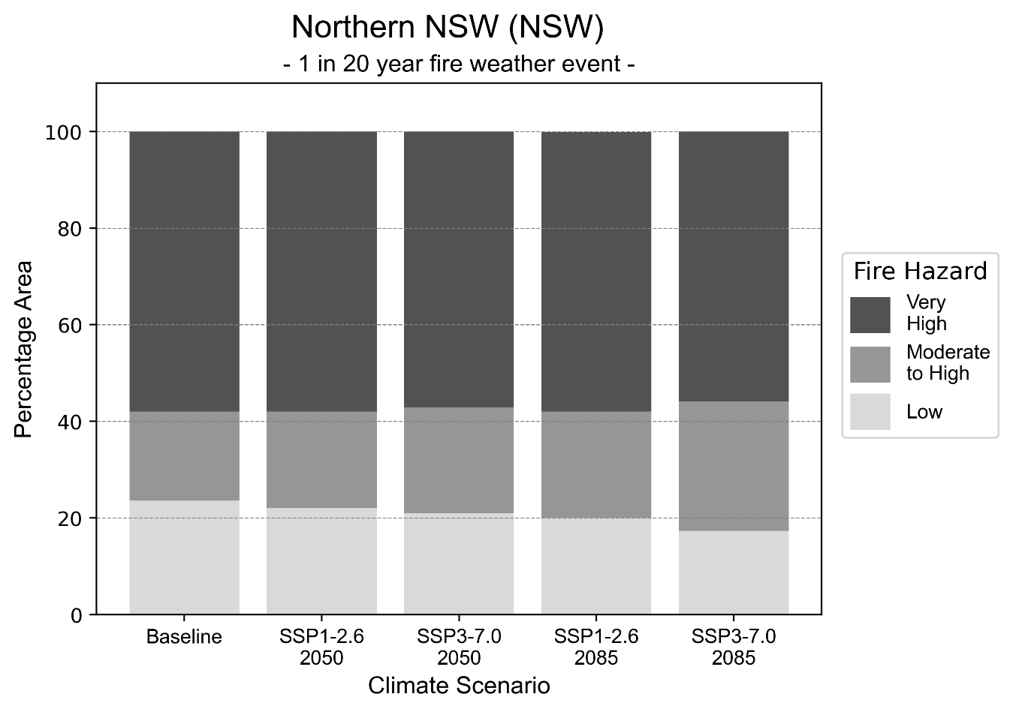
Figure 30: Stacked column chart showing the percentages of the Northern NSW health district's total geographic area experiencing each fire hazard level during a 1-in-20-year fire weather event.
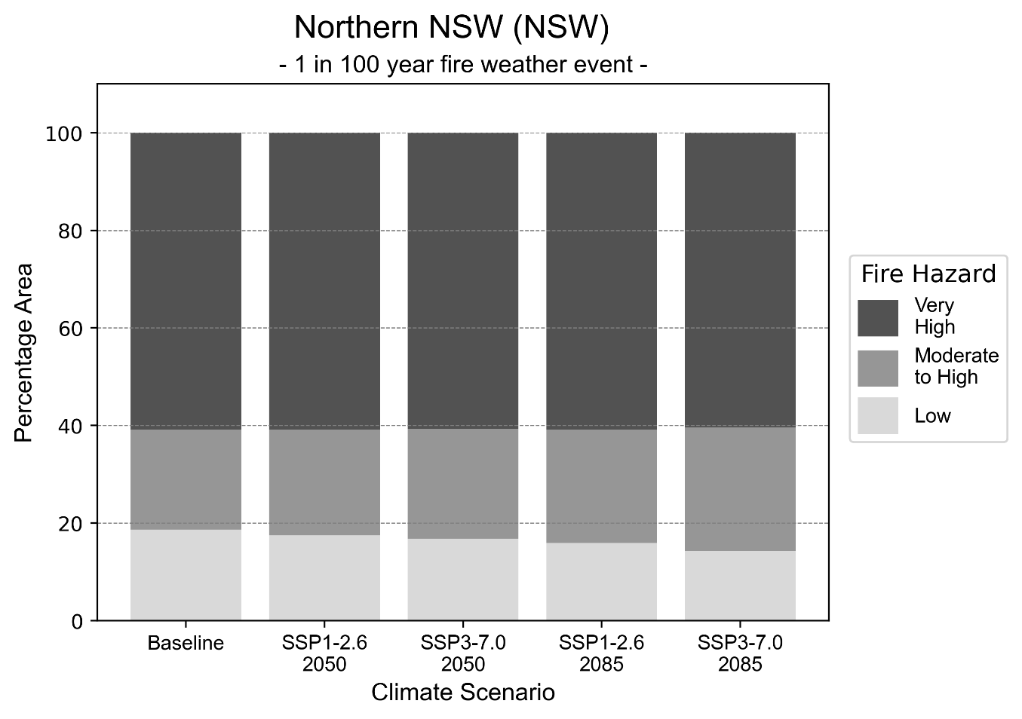
Figure 31: Stacked column chart showing the percentages of the Northern NSW health district's total geographic area experiencing each fire hazard level during a 1-in-100-year fire weather event.

Drought hazard
Key projections:
Drought occurrence: The occurrence of drought will increase across both middle of the road and reasonable worst-case scenarios and both time horizons, with the largest increase occurring under a reasonable worst-case scenario by 2050.

 | Baseline | 2050 Scenarios |  | 2085 Scenarios
 |  | Middle of the road | Reasonable worst-case | Middle of the road | Reasonable worst-case
Number of months per year in drought^{(a)} | 2.0 | 2.3  [0.6, 4.2] | 2.6  [0.6, 6.7] | 2.5  [0.7, 4.6] | 2.3  [0.3, 4.2]
Table notes: The drought hazard indicator uses climate projections from the CMIP6 Global Climate Models [1]. The primary indicator value reports the median from the nine climate models, with the range reported in square brackets.
Table footnotes: (a) The number of months per year in drought is based on the Standardised Precipitation Index (SPI). SPI is a widely used index to characterise meteorological drought on a range of timescales. This indicator uses the timescale of 12 months which calculates the average months in a year within the moderate drought range. A moderate drought range is classified as SPI score of ≤ -1. SPI is calculated from accumulated rainfall over 12 months and the mean and standard deviation from historical rainfall records.

Storm hazard
Key projections:
Less medium and high-intensity storms: Medium and high-intensity storms will become less frequent across both middle of the road and reasonable worst-case scenarios, with the greatest decrease occurring by 2085.

 | Baseline | 2050 Scenarios |  | 2085 Scenarios
 |  | Middle of the road | Reasonable worst-case | Middle of the road | Reasonable worst-case
Number of low-intensity storms (40-62 km/hr) per year | 88.2 | 83.8  [73.8, 92.2] | 82.9  [73.0, 91.2] | 78.9  [69.4, 86.8] | 76.7  [67.5, 84.4]
Number of medium-intensity storms (63-87 km/hr) per year | 49.1 | 40.7  [35.8, 44.8] | 39.7  [34.9, 43.6] | 36.0  [31.7, 39.6] | 36.4  [32.1, 40.1]
Number of high-intensity storms (88-117 km/hr) per year | 9.1 | 8.0  [7.1, 8.8] | 7.5  [6.6, 8.3] | 7.0  [6.2, 7.7] | 8.2  [7.2, 9.0]
Number of very-high-intensity storms (> 117 km/hr) per year | 0.3 | 0.4  [0.3, 0.4] | 0.3  [0.2, 0.3] | 0.3  [0.2, 0.3] | 0.4  [0.3, 0.4]
Table notes: The storm hazard uses climate projections from the CMIP6 Global Climate Models [1]. Daily maximum surface wind speed is used to calculate the number of annual storms across four storm intensity categories (low, medium, high and very high). The primary indicator value reports the median from the nine climate models, with the range reported in square brackets.

Rainfall and flood hazard
Key projections:
- 11 extreme rainfall days per year: There will be slight fewer extreme rainfall days under both scenarios and time horizons, with an average of approximately 11 extreme rainfall days per year.
- Increased flood frequency: Flooding will become more frequent across both middle of the road and reasonable worst-case scenarios, particularly in urban environments. The largest increase in urban flooding is seen in the reasonable worst-case scenario, where frequency of a ‘1-in-100 year’ flood will more than quadruple by 2050 and become nearly 14 times more likely by 2085.

 | Baseline | 2050 Scenarios |  | 2085 Scenarios
 |  | Middle of the road | Reasonable worst-case | Middle of the road | Reasonable worst-case
Rainfall hazard^{(a)}
Average number of extreme rainfall days per year (> 15 mm/day)^{(a)} | 11.0 | 10.8  [8.9,13.2] | 10.5  [7.3,13.1] | 10.5  [8.2,12.6] | 10.8  [8.6,14]
Urban flood risk (flooding caused by a 1-hour rainfall event)^{(b)}
Frequency of a ‘1-in-1 year’ flood (rainfall depth of 30 mm)^{(c)} |  | 1.9 events in 1 year | 2.0 events in 1 year | 2.4 events in 1 year | 3.2 events in 1 year
Frequency of a ‘1-in-10 year’ flood (rainfall depth of 52 mm)^{(c)} |  | 3.1 events in 10 years | 3.3 events in 10 years | 4.9 events in 10 years | 7.4 events in 10 years
Frequency of a ‘1-in-100 year’ flood (rainfall depth of 78 mm)^{(c)} |  | 4.3 events in 100 years | 4.7 events in 100 years | 7.6 events in 100 years | 14 events in 100 years
Rural flood risk (flooding caused by a 24-hour rainfall event) ^{(b)}
Frequency of a ‘1-in-1 year’ flood (rainfall depth of 85 mm)^{(c)} |  | 1.2 events in 1 year | 1.2 events in 1 year | 1.2 events in 1 year | 1.1 events in 1 year
Frequency of a ‘1-in-10 year’ flood (rainfall depth of 171 mm)^{(c)} |  | 1.5 events in 10 years | 1.5 events in 10 years | 1.6 events in 10 years | 1.7 events in 10 years
Frequency of a ‘1-in-100 year’ flood (rainfall depth of 281 mm)^{(c)} |  | 1.8 events in 100 years | 1.9 events in 100 years | 2.2 events in 100 years | 2.4 events in 100 years
Table notes: The rainfall hazard indicator uses climate projections from the CMIP6 Global Climate Models [1]. The primary indicator value reports the median from the nine climate models, with the range reported in square brackets. The flood hazard indicators use climate change considerations from the Australian Rainfall and Runoff guideline to estimate the climate projections [2].
Table footnotes: (a) Extreme rainfall is defined as rainfall above the 95th percentile of historical average daily rainfall in this health district in the period 1985-2014. The value in mm/day quoted in the indicator name is the 95th percentile of historic average daily rainfall for this health district. (b) See Methodology document for reasons for focusing on a 1-hour flood for urban areas and a 24-hour flood for rural areas. (c) The rainfall depths in mm quoted in the indicator names in this table report 1 in 1, 10 and 100 year depths for this health district.

Coastal inundation hazard
Key projections:
Greater area inundated: There will be an increase in the area affected by tidal inundation (i.e. area submerged during high tide) and storm surge and tidal inundation (i.e. the area submerged during a storm surge and high tide) across both middle of the road and reasonable worst-case scenarios. In the reasonable worst-case scenario, the area inundated during tidal inundation will increase by over 36,000 ha. by 2085.

 |  | Baseline | 2050 Scenarios |  | 2085 Scenarios^{(a)}
 |  |  | Middle of the road | Reasonable worst-case | Middle of the road | Reasonable worst-case
 | Tidal inundation (ha inundated)^{(b)} | 67,507.5 | 79,458.6  (+11,951.2) | 80,218.7  (+12,711.3) | 97,799.1  (+30,291.7) | 104,328.7  (+36,821.2)
 | Storm surge + tidal inundation – ‘1-in-100 year’ event (ha inundated)^{(c)} | 80,082.4 | 91,171.6  (+11,089.2) | 91,826.7  (+11,744.3) | 107,493.0  (+27,410.6) | 113,359.2  (+33,276.8)
 | Storm surge + tidal inundation – ‘1-in-1000 year’ event (ha inundated)^{(c)} | 81,471.6 | 92,366.7  (+10,895.1) | 93,013.6  (+11,542.0) | 112,558.6  (+31,087.0) | 118,081.0  (+36,609.4)
Table notes: The coastal inundation hazard provides an indication of flooding in coastal areas that can be attributed to sea level rise and storm inundation. The coastal inundation hazard is only reported for health districts adjoining the coastline. This table includes the projected inundation levels as well as the change from baseline conditions (in brackets).
Table footnotes: (a) For the 2085 Scenarios planning horizon, 2100 was adopted as it provides a conservative representation of the end of this period. This horizon aligns with many State planning regulations requiring consideration of sea level rise and storm tide to 2100, making the 2100 scenario particularly valuable for planning new health facilities in coastal areas. (b) The tidal inundation indicator reports the number of hectares inundated during high tide. The baseline value reports existing inundation patterns, while the 2050 and 2085 values report high tide inundation taking account of projected sea level rise due to climate change. (c) The storm surge + tidal inundation indicators report the combined effect, in hectares inundated, of high tide, sea level rise (for the 2050 and 2085 projections), and storm surge (for 1-in-100 year and 1-in-1000 year events).

Southern NSW health district

Health district overview
Surface area: 44,534 square kilometres
Traditional Owners: Gundungurra, Ngarigo, Ngunnawal and Yuin peoples
Estimated population (2025): 224,108
Estimated population (2035): 247,234
- Local health services: Crookwell District Hospital, Bega – South East Regional Hospital, Cooma Hospital and Health Service, Goulburn Base Hospital, Queanbeyan Hospital and Health Service, Yass District Hospital

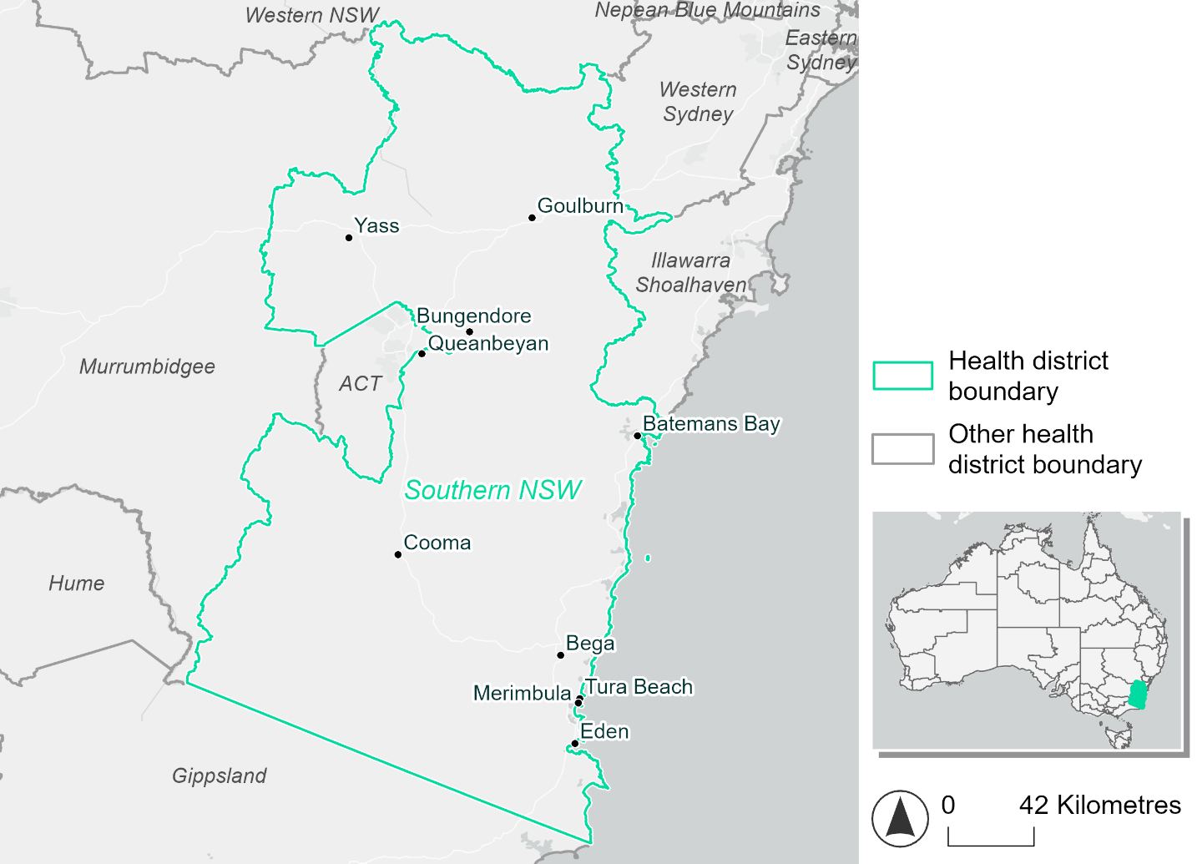
Figure 32. Map of Southern NSW health district

How will climate change affect this health district?
Heat and humidity: There will be higher average temperatures, hotter and more frequent hot days, warmer night time temperatures and longer and more frequent heat waves.
Fire: Over 40% of this district experiences very high fire hazard category, and this percentage will increase slightly across both 2050 and 2085 scenarios.
Drought: The number of months experiencing drought will slightly increase.
Rainfall and flood: There will be more flooding in both urban and rural areas.
Coastal inundation: The area flooded during tidal and storm surge and tidal inundation will increase.

Southern NSW health district demographic data
Demographic Data | Total
Number of households | 83,587
Persons 15 and older | 148,911
Total families | 59,376
Persons did not complete high school | 59,926
One parent families with dependents | 5,266 (8.9%)
Persons aged 65 and older | 48,672 (22%)
Persons aged 4 and younger | 12,082 (5.5%)
Aboriginal and Torres Strait Islander persons | 9,123 (4.1%)
Persons speaks language other than English | 15,584 (7%)
Persons working age (15-65) | 133,885 (60.6%)
Population Health Data | Total
Persons with core needs for assistance | 12,974 (5.9%)
Persons with arthritis | 26,729 (12.1%)
Persons with asthma | 20,043 (9.1%)
Persons with cancer | 8,040 (3.6%)
Persons with dementia | 1,777 (0.8%)
Persons with diabetes | 11,071 (5%)
Persons with heart disease | 10,662 (4.8%)
Persons with kidney disease | 2,900 (1.3%)
Persons with lung condition | 5,382 (2.4%)
Persons with mental health condition | 22,119 (10%)
Persons with stroke | 2,367 (1.1%)
Persons with any other condition | 19,459 (8.8%)
Persons no health condition | 119,663 (54.1%)
Socio-economic Data | Total
Persons providing unpaid care | 28,453 (12.9%)
Persons homeless | 687 (0.3%)
Household with lone person | 23,598 (28.2%)
Households with rent and mortgage stress | 36,826 (44.1%)
Households total equivalised income below $1000 (weekly) | 37,955 (45.4%)
Households with no motor vehicle | 3,343 (4%)
Persons unemployed | 6,360 (3.5%)

The sections that follow outline projected climate hazards for this district.

Heat and humidity hazard
Key projections:
More heatwaves: Heatwaves will be longer and more frequent. The number of heatwaves per year will more than double by 2050 and quadruple by 2085.
Hotter days and warmer nights: The maximum temperature on hot days will increase with temperatures on hot nights also increasing.
More days above 35°C and 40°C: The number of days per year greater than 35°C and 40°C will increase under both middle of the road and reasonable worst-case scenarios.

 | Baseline | 2050 Scenarios |  | 2085 Scenarios
 |  | Middle of the road | Reasonable worst-case | Middle of the road | Reasonable worst-case
Average temperature (°C) | 13.6 | 15  [14.4, 15.5] | 15.3  [14.4, 16] | 15.9  [14.9, 16.9] | 16.9  [15.7, 18.1]
Maximum temperature on hot days (°C)^{(a)} | 29.9 | 31.6  [31.2, 32.7] | 32.1  [30.9, 33.7] | 32.6  [31.6, 34.3] | 33.6  [32.7, 35.6]
Minimum temperature on hot nights (°C)^{(b)} | 16.6 | 18.1  [17.4, 18.9] | 18.4  [17.4, 19] | 19  [17.7, 20] | 20  [18.7, 21.3]
Average apparent temperature on hot days (°C) (NOAA Heat Index)^{(c)} | 33.1 | 34.5  [33.8, 34.9] | 34.6  [33.7, 35.2] | 35  [34.3, 36] | 35.9  [35, 37.1]
Average heatwave duration in days^{(d)} | 5 | 5  [5, 6] | 6  [5, 6] | 6  [5, 7] | 7  [6, 10]
Number of heatwaves per year^{(d)} | 2 | 5  [4, 6] | 5  [3, 7] | 6  [4, 8] | 8  [6, 9]
Number of days per year  > 35°C | 3 | 6  [5, 9] | 8  [4, 14] | 9  [5, 16] | 13  [9, 23]
Number of days per year > 40°C | 0 | 1  [0, 1] | 1  [0, 2] | 1  [0, 2] | 2  [1, 4]
Table notes: The heat and humidity hazard uses climate projections from the CMIP6 Global Climate Models [1]. Daily projections of maximum and minimum near-surface temperature and mean relative humidity are used to calculate eight heat and humidity indicators. The primary indicator value reports the median from the nine climate models, with the range reported in square brackets.
Table footnotes: (a) Based on the 95th percentile of daily maximum air temperature. (b) Based on the 95th percentile of daily minimum air temperature, representing the coldest part of the night on very hot nights. (c) The National Oceanic and Atmospheric Administration (NOAA) Heat Index is a measure of how hot it feels when relative humidity is factored in alongside actual air temperature. It is calculated on days with a maximum temperature of 27°C and above. Interpretation of Heat Index values: 27°C to 32°C indicates caution, 33°C to 41°C indicates extreme caution, 42°C to 54°C indicates danger and over 54°C indicates extreme danger. See methodology document for further explanation of Heat Index categories. (d) A heatwave is defined as three or more consecutive days where both daytime and overnight temperatures (daily mean temperatures) are unusually high for the location, based on the Bureau of Meteorology’s Excess Heat Factor method. For this district, an unusually high daily mean temperature is approximately 22.8°C or above.

Fire hazard
Key projections:
- Majority of district area experiences moderate to very high fire hazard: Under baseline conditions 50% of the health district experiences moderate to high fire hazard. Much of the remaining area (42-43%) experiences very high fire hazard.
- Current fire hazard conditions to persist: The proportions of the district experiencing each of the fire hazard level will remain fairly stable in both 2050 and 2085 scenarios.

 | Baseline | 2050 Scenarios |  | 2085 Scenarios
 |  | Sustainability | Reasonable worst-case | Sustainability | Reasonable worst-case
Hazard for a ‘1-in-20 year’ fire weather event^{(a)}
Proportion (%) of district experiencing ‘Low’ fire hazard | 7.0%  (313,275)^{(b)} | 6.9%  [6.6%, 7.0%] | 6.7%  [6.5%, 6.9%] | 6.6%  [6.1%, 6.9%] | 6.3%  [5.7%, 6.8%]
Proportion (%) of district experiencing ‘Moderate to High’ fire hazard | 50.6%  (2,252,369)^{(b)} | 50.4%  [48.6%, 52.1%] | 50.1%  [48.3%, 52.5%] | 50.1%  [45.9%, 54.2%] | 49.5%  [45.0%, 55.1%]
Proportion (%) of district experiencing ‘Very High’ fire hazard | 42.4%  (1,887,624)^{(b)} | 42.8%  [42.6%, 42.9%] | 43.1%  [42.8%, 43.9%] | 43.3%  [42.8%, 43.6%] | 44.0%  [43.3%, 46.1%]
Hazard for a ‘1-in-100 year’ fire weather event^{(a)}
Proportion (%) of district experiencing ‘Low’ fire hazard | 6.2%  (277,802)^{(b)} | 6.0%  [5.8%, 6.1%] | 6.0%  [5.7%, 6.1%] | 5.7%  [5.3%, 6.0%] | 5.6%  [5.0%, 6.0%]
Proportion (%) of district experiencing ‘Moderate to High’ fire hazard | 50.2%  (2,237,614)^{(b)} | 50.2%  [48.3%, 52.1%] | 50.0%  [48.1%, 52.3%] | 50.2%  [45.5%, 54.6%] | 49.6%  [45.0%, 55.2%]
Proportion (%) of district experiencing ‘Very High’ fire hazard | 43.5%  (1,937,852)^{(b)} | 43.8%  [43.6%, 43.9%] | 44.1%  [43.8%, 44.8%] | 44.1%  [43.8%, 44.4%] | 44.8%  [44.1%, 46.6%]
Table notes: The Fire Hazard uses the National Bushfire Intelligence Capability (NBIC) Phase 2 fire line intensity modelling based on CMIP6 climate projections. Fire Hazard is assessed using the projected Fireline Intensity (FLI) for weather events with two different return intervals (i.e. a 1-in-20 year event and a 1-in-100 year event). FLI considers slope, vegetation and weather to produce a rate of heat output per unit length (kW/m) along a bushfire’s front. Fire hazard is categorized as a low for FLI<4000 kW/m, moderate to high for 4,000 kW/m ≤FLI<12,500kW/m, and very high for FLI≥27,501kW/m. This is broadly consistent with the literature [3]. The assessment considers climate change effects based on changes in fire weather and the associated hazard that is anticipated for a meteorological event of a given return interval. This approach is different to the one adopted for the Flood Hazard, where the event magnitude is given (fixed) and the likelihood of that event varies as a result of climate change. The primary indicator value reports the median from the nine climate models, with the range reported in square brackets.
Table footnotes: (a) The area subject to different categories of fire hazard is determined for a ‘1-in-20 year’ and ‘1-in-100 year’ fire weather event, in current and future climates. Values at year 2050 are interpolated using data from baseline (2025) and 2085, assuming linear change over time. (b) Values in round brackets are the area (ha) of the health district subject to a given fire hazard.

The figures below show the proportion of the health district experiencing different fire hazard categories across different time horizons and climate scenarios during a ‘1-in-20 year’ fire weather event (Figure 33) and a ‘1-in-100 year’ fire weather event (Figure 34).

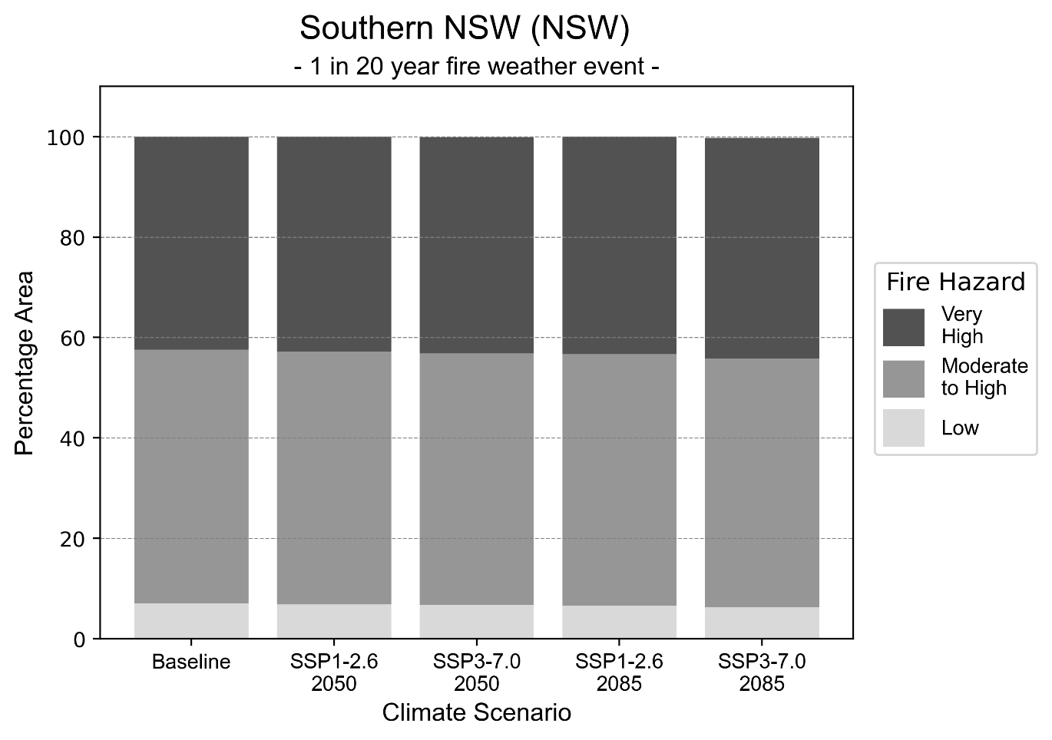
Figure 33: Stacked column chart showing the percentages of the Southern NSW health district's total geographic area experiencing each fire hazard level during a 1-in-20-year fire weather event.
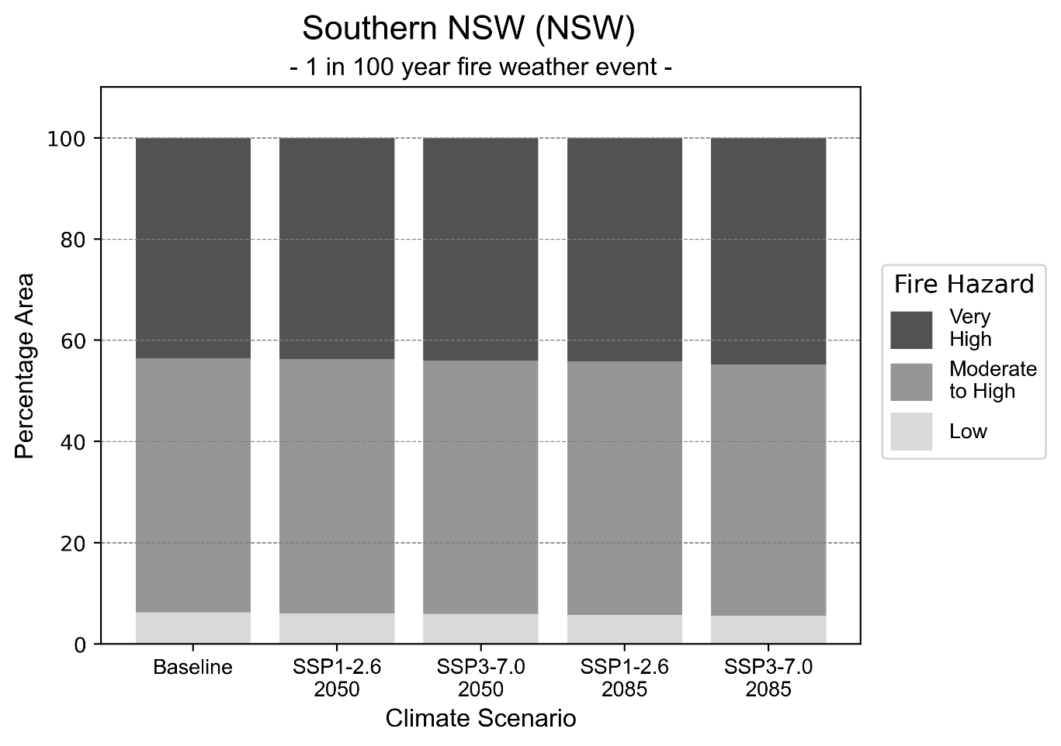
Figure 34: Stacked column chart showing the percentages of the Southern NSW health district's total geographic area experiencing each fire hazard level during a 1-in-100-year fire weather event.

Drought hazard
Key projection:
Drought occurrence: The occurrence of drought will slightly increase across both scenarios and time horizons, and be experienced on average two months per year.

 | Baseline | 2050 Scenarios |  | 2085 Scenarios
 |  | Middle of the road | Reasonable worst-case | Middle of the road | Reasonable worst-case
Number of months per year in drought^{(a)} | 1.8 | 1.7  [0.7, 2.5] | 2.2  [0.8, 5.2] | 1.8  [0.9, 3.3] | 2.2  [0.5, 5.1]
Table notes: The drought hazard indicator uses climate projections from the CMIP6 Global Climate Models [1]. The primary indicator value reports the median from the nine climate models, with the range reported in square brackets.
Table footnotes: (a) The number of months per year in drought is based on the Standardised Precipitation Index (SPI). SPI is a widely used index to characterise meteorological drought on a range of timescales. This indicator uses the timescale of 12 months which calculates the average months in a year within the moderate drought range. A moderate drought range is classified as SPI score of ≤ -1. SPI is calculated from accumulated rainfall over 12 months and the mean and standard deviation from historical rainfall records.

Storm hazard
Key projections:
More very-high-intensity storms: Very-high-intensity storms will become more frequent, with the greatest increase occurring by 2085 based on the reasonable worst-case scenario.

 | Baseline | 2050 Scenarios |  | 2085 Scenarios
 |  | Middle of the road | Reasonable worst-case | Middle of the road | Reasonable worst-case
Number of low-intensity storms (40-62 km/hr) per year | 72.9 | 67.8  [59.7, 74.6] | 70.0  [61.6, 77.0] | 64.7  [56.9, 71.2] | 66.8  [58.8, 73.5]
Number of medium-intensity storms (63-87 km/hr) per year | 38.3 | 33.5  [29.5, 36.8] | 33.5  [29.5, 36.9] | 30.3  [26.7, 33.4] | 31.3  [27.5, 34.4]
Number of high-intensity storms (88-117 km/hr) per year | 34.5 | 34.1  [30.0, 37.5] | 32.0  [28.2, 35.2] | 32.9  [28.9, 36.2] | 32.0  [28.2, 35.2]
Number of very-high-intensity storms (> 117 km/hr) per year | 1.4 | 2.0  [1.8, 2.2] | 1.5  [1.3, 1.6] | 1.7  [1.5, 1.8] | 2.6  [2.3, 2.9]
Table notes: The storm hazard uses climate projections from the CMIP6 Global Climate Models [1]. Daily maximum surface wind speed is used to calculate the number of annual storms across four storm intensity categories (low, medium, high and very high). The primary indicator value reports the median from the nine climate models, with the range reported in square brackets.

Rainfall and flood hazard
Key projections:
- 11 extreme rainfall days per year: The number of extreme rainfall days will remain consistent across both scenarios and time horizons, with an average of approximately 11 extreme rainfall days per year.
- Increased flood frequency: Flooding will become more frequent in both scenarios, particularly in urban environments. The largest increase in frequency of urban flooding is seen in the reasonable worst-case scenario where frequency of a ‘1-in-100 year’ flood will more than quadruple by 2050 and become nearly 14 times more likely by 2085.

 | Baseline | 2050 Scenarios |  | 2085 Scenarios
 |  | Middle of the road | Reasonable worst-case | Middle of the road | Reasonable worst-case
Rainfall hazard^{(a)}
Average number of extreme rainfall days per year (> 11 mm/day)^{(a)} | 11.0 | 11.1  [10.0,13.1] | 10.9  [8.4,13.0] | 11.2  [9.6,13.2] | 10.8  [8.4,13.9]
Urban flood risk (flooding caused by a 1-hour rainfall event)^{(b)}
Frequency of a ‘1-in-1 year’ flood (rainfall depth of 16 mm)^{(c)} |  | 2.0 events in 1 year | 2.1 events in 1 year | 2.6 events in 1 year | 3.5 events in 1 year
Frequency of a ‘1-in-10 year’ flood (rainfall depth of 29 mm)^{(c)} |  | 3.1 events in 10 years | 3.3 events in 10 years | 4.9 events in 10 years | 7.4 events in 10 years
Frequency of a ‘1-in-100 year’ flood (rainfall depth of 43 mm)^{(c)} |  | 4.2 events in 100 years | 4.6 events in 100 years | 7.4 events in 100 years | 14 events in 100 years
Rural flood risk (flooding caused by a 24-hour rainfall event) ^{(b)}
Frequency of a ‘1-in-1 year’ flood (rainfall depth of 54 mm)^{(c)} |  | 0.9 events in 1 year | 0.9 events in 1 year | 0.8 events in 1 year | 0.4 events in 1 year
Frequency of a ‘1-in-10 year’ flood (rainfall depth of 103 mm)^{(c)} |  | 0.9 events in 10 years | 0.9 events in 10 years | 0.4 events in 10 years | 0.2 events in 10 years
Frequency of a ‘1-in-100 year’ flood (rainfall depth of 166 mm)^{(c)} |  | 0.8 events in 100 years | 0.8 events in 100 years | 0.4 events in 100 years | 0.08 events in 100 years
Table notes: The rainfall hazard indicator uses climate projections from the CMIP6 Global Climate Models [1]. The primary indicator value reports the median from the nine climate models, with the range reported in square brackets The flood hazard indicators use climate change considerations from the Australian Rainfall and Runoff guideline to estimate the climate projections [2].
Table footnotes:(a) Extreme rainfall is defined as rainfall above the 95th percentile of historical average daily rainfall in this health district in the period 1985-2014. The value in mm/day quoted in the indicator name is the 95th percentile of historic average daily rainfall for this health district. (b) See Methodology document for reasons for focusing on a 1-hour flood for urban areas and a 24-hour flood for rural areas. (c) The rainfall depths in mm quoted in the indicator names in this table report 1 in 1, 10 and 100 year depths for this health district.

Coastal inundation hazard
Key projections:
Greater area inundated: There will be an increase in the area affected by tidal inundation (i.e. area submerged during high tide) and storm surge and tidal inundation (i.e. the area submerged during a storm surge and high tide) across both middle of the road and reasonable worst-case scenarios. In the reasonable worst-case scenario, the area inundated during a ‘1-in-1000-year’ event will increase by nearly 6,000 ha. by 2085.
 | Baseline | 2050 Scenarios |  | 2085 Scenarios^{(a)}
 |  | Middle of the road | Reasonable worst-case | Middle of the road |  | Reasonable worst-case
Tidal inundation (ha inundated)^{(b)} | 12,065.4 | 13,363.0  (+1,297.6) | 13,476.6  (+1,411.1) | 16,456.7  (+4,391.2) |  | 17,711.9  (+5,646.4)
Storm surge + tidal inundation – ‘1-in-100 year’ event (ha inundated)^{(c)} | 14,641.3 | 16,659.2  (+2,017.8) | 16,796.4  (+2,155.0) | 19,153.0  (+4,511.7) | 20,057.2  (+5,415.8)
Storm surge + tidal inundation – ‘1-in-1000 year’ event (ha inundated)^{(c)} | 14,870.9 | 16,874.4  (+2,003.5) | 17,006.0  (+2,135.1) | 19,893.3  (+5,022.4) | 20,729.7  (+5,858.8)
Table notes: The coastal inundation hazard provides an indication of flooding in coastal areas that can be attributed to sea level rise and storm inundation. The coastal inundation hazard is only reported for health districts adjoining the coastline. This table includes the projected inundation levels as well as the change from baseline conditions (in brackets).
Table footnotes: (a) For the 2085 Scenarios planning horizon, 2100 was adopted as it provides a conservative representation of the end of this period. This horizon aligns with many State planning regulations requiring consideration of sea level rise and storm tide to 2100, making the 2100 scenario particularly valuable for planning new health facilities in coastal areas. (b) The tidal inundation indicator reports the number of hectares inundated during high tide. The baseline value reports existing inundation patterns, while the 2050 and 2085 values report high tide inundation taking account of projected sea level rise due to climate change. (c) The storm surge + tidal inundation indicators report the combined effect, in hectares inundated, of high tide, sea level rise (for the 2050 and 2085 projections), and storm surge (for 1-in-100 year and 1-in-1000 year events).

Western NSW health district

Health district overview
Surface area: 247,000 square kilometres
Traditional Owners: Barindji, Barrinbinja, Barundji, Gunu, Kamilaroi, Muruwari, Wailwan, Wiradjuri and Wongaibon peoples
Estimated population (2025): 287,337
Estimated population (2035): 302,909
Local health services: Western NSW Local Health District contains 40 health service facilities.

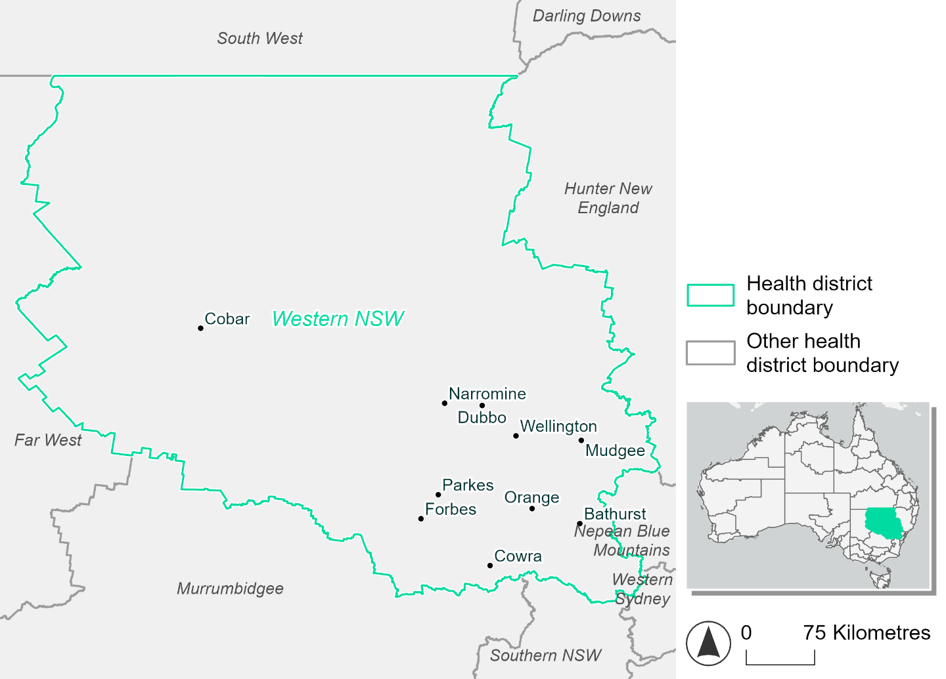
Figure 35. Map of Western NSW health district

How will climate change affect this health district?
Heat and humidity: There will be higher average temperatures, more frequent hot days, warmer night time temperatures and longer and more frequent heat waves.
Fire: Over 50% of this health district experiences moderate to high fire hazard category and this will continue in the future under both 2050 and 2085 scenarios.
Drought: The number of months experiencing drought will slightly increase.
Rainfall and flood: There will be more flooding in urban and rural areas.

Western NSW health district demographic data
Demographic Data | Total
Number of households | 102,554
Persons 15 and older | 185,383
Total families | 71,488
Persons did not complete high school | 87,504
One parent families with dependents | 8,322 (11.6%)
Persons aged 65 and older | 56,321 (19.9%)
Persons aged 4 and younger | 18,390 (6.5%)
Aboriginal and Torres Strait Islander persons | 32,026 (11.3%)
Persons speaks language other than English | 13,833 (4.9%)
Persons working age (15-65) | 169,482 (59.8%)
Population Health Data | Total
Persons with core needs for assistance | 17,399 (6.1%)
Persons with arthritis | 29,800 (10.5%)
Persons with asthma | 28,465 (10%)
Persons with cancer | 8,974 (3.2%)
Persons with dementia | 2,332 (0.8%)
Persons with diabetes | 15,224 (5.4%)
Persons with heart disease | 13,221 (4.7%)
Persons with kidney disease | 3,092 (1.1%)
Persons with lung condition | 6,936 (2.4%)
Persons with mental health condition | 27,721 (9.8%)
Persons with stroke | 2,949 (1%)
Persons with any other condition | 21,605 (7.6%)
Persons no health condition | 150,582 (53.1%)
Socio-economic Data | Total
Persons providing unpaid care | 34,575 (12.2%)
Persons homeless | 929 (0.3%)
Household with lone person | 29,729 (29%)
Households with rent and mortgage stress | 38,050 (37.1%)
Households total equivalised income below $1000 (weekly) | 50,138 (48.9%)
Households with no motor vehicle | 5,627 (5.5%)
Persons unemployed | 9,289 (4.1%)

The sections that follow outline projected climate hazards for this district.

Heat and humidity hazard
Key projections:
More heatwaves: Heatwaves will be longer and more frequent. Under a reasonable worst-case scenario, the number of heatwaves per year will double by 2050, and triple by 2085.
Hotter days and warmer nights: The maximum temperature on hot days will increase, with temperatures on hot nights also increasing.
More days above 35°C and 40°C: The number of days per year greater than 35°C and 40°C will increase under both middle of the road and reasonable worst-case scenarios.

 | Baseline | 2050 Scenarios |  | 2085 Scenarios
 |  | Middle of the road | Reasonable worst-case | Middle of the road | Reasonable worst-case
Average temperature (°C) | 15.3 | 16.7  [16.1, 17.4] | 17.1  [16.1, 17.9] | 17.7  [16.5, 19] | 18.8  [17.4, 20.2]
Maximum temperature on hot days (°C)^{(a)} | 32.9 | 34.8  [34.3, 36.2] | 35.3  [33.9, 37.3] | 35.8  [34.5, 38.1] | 37  [35.4, 39.5]
Minimum temperature on hot nights (°C)^{(b)} | 18.7 | 20.4  [19.4, 21] | 20.6  [19.4, 21.4] | 21.3  [19.7, 22.6] | 22.6  [20.8, 24]
Average apparent temperature on hot days (°C) (NOAA Heat Index)^{(c)} | 32.5 | 34.3  [33.3, 34.9] | 34.4  [33.5, 34.9] | 35.1  [33.9, 36.1] | 36.2  [34.8, 37.8]
Average heatwave duration in days^{(d)} | 5 | 6  [6, 8] | 6  [6, 8] | 7  [6, 9] | 8  [7, 12]
Number of heatwaves per year^{(d)} | 2 | 4  [3, 6] | 5  [3, 6] | 6  [4, 8] | 7  [5, 8]
Number of days per year  > 35°C | 13 | 23  [20, 33] | 26  [18, 39] | 31  [22, 50] | 40  [28, 63]
Number of days per year  > 40°C | 2 | 4  [3, 7] | 5  [3, 9] | 6  [4, 14] | 10  [5, 21]
Table notes: The heat and humidity hazard uses climate projections from the CMIP6 Global Climate Models [1]. Daily projections of maximum and minimum near-surface temperature and mean relative humidity are used to calculate eight heat and humidity indicators. The primary indicator value reports the median from the nine climate models, with the range reported in square brackets.
Table footnotes: (a) Based on the 95th percentile of daily maximum air temperature. (b) Based on the 95th percentile of daily minimum air temperature, representing the coldest part of the night on very hot nights. (c) The National Oceanic and Atmospheric Administration (NOAA) Heat Index is a measure of how hot it feels when relative humidity is factored in alongside actual air temperature. It is calculated on days with a maximum temperature of 27°C and above. Interpretation of Heat Index values: 27°C to 32°C indicates caution, 33°C to 41°C indicates extreme caution, 42°C to 54°C indicates danger and over 54°C indicates extreme danger. See methodology document for further explanation of Heat Index categories. (d) A heatwave is defined as three or more consecutive days where both daytime and overnight temperatures (daily mean temperatures) are unusually high for the location, based on the Bureau of Meteorology’s Excess Heat Factor method. For this district, an unusually high daily mean temperature is approximately 25.4°C or above.

Fire hazard
Key projections:
- Majority of district area experiences moderate to high fire hazard: Under baseline conditions, half of the health district experiences moderate to high fire hazard. About one tenth experiences very high hazard and remaining area experiences low fire hazard.
- Current fire hazard conditions to persist: The areas experiencing each hazard level remain close to their baseline proportions in the 2050 and 2085 scenarios.

 | Baseline | 2050 Scenarios |  | 2085 Scenarios
 |  | Sustainability | Reasonable worst case | Sustainability | Reasonable worst case
Hazard for a ‘1-in-20 year’ fire weather event^{(a)}
Proportion (%) of district experiencing ‘Low’ fire hazard | 33.2%  (8,188,082)^{(b)} | 33.0%  [32.6%, 33.4%] | 32.8%  [32.4%, 33.5%] | 32.7%  [31.7%, 33.7%] | 32.3%  [31.3%, 34.0%]
Proportion (%) of district experiencing ‘Moderate to High’ fire hazard | 55.2%  (13,593,044)^{(b)} | 55.3%  [54.3%, 56.2%] | 55.6%  [53.8%, 57.3%] | 55.6%  [53.1%, 57.6%] | 56.2%  [51.9%, 60.2%]
Proportion (%) of district experiencing ‘Very High’ fire hazard | 11.6%  (2,865,715)^{(b)} | 11.7%  [11.4%, 11.8%] | 11.5%  [11.3%, 11.7%] | 11.7%  [11.2%, 12.1%] | 11.4%  [10.8%, 11.8%]
Hazard for a ‘1-in-100 year’ fire weather event^{(a)}
Proportion (%) of district experiencing ‘Low’ fire hazard | 31.5%  (7,752,744)^{(b)} | 31.1%  [30.9%, 31.3%] | 30.9%  [30.4%, 31.5%] | 30.7%  [30.1%, 31.2%] | 30.1%  [28.9%, 31.6%]
Proportion (%) of district experiencing ‘Moderate to High’ fire hazard | 56.3%  (13,881,511)^{(b)} | 56.6%  [54.7%, 58.4%] | 56.9%  [53.4%, 60.3%] | 56.9%  [52.4%, 61.3%] | 57.7%  [49.2%, 65.8%]
Proportion (%) of district experiencing ‘Very High’ fire hazard | 12.2%  (3,012,585)^{(b)} | 12.3%  [12.1%, 12.5%] | 12.2%  [11.9%, 12.4%] | 12.5%  [12.0%, 12.8%] | 12.2%  [11.4%, 12.7%]
Table notes: The Fire Hazard uses the National Bushfire Intelligence Capability (NBIC) Phase 2 fire line intensity modelling based on CMIP6 climate projections. Fire Hazard is assessed using the projected Fireline Intensity (FLI) for weather events with two different return intervals (i.e. a 1-in-20 year event and a 1-in-100 year event). FLI considers slope, vegetation and weather to produce a rate of heat output per unit length (kW/m) along a bushfire’s front. Fire hazard is categorized as a low for FLI<4000 kW/m, moderate to high for 4,000 kW/m ≤FLI<12,500kW/m, and very high for FLI≥27,501kW/m. This is broadly consistent with the literature [3]. The assessment considers climate change effects based on changes in fire weather and the associated hazard that is anticipated for a meteorological event of a given return interval. This approach is different to the one adopted for the Flood Hazard, where the event magnitude is given (fixed) and the likelihood of that event varies as a result of climate change. The primary indicator value reports the median from the nine climate models, with the range reported in square brackets.
Table footnotes: (a) The area subject to different categories of fire hazard is determined for a ‘1-in-20 year’ and ‘1-in-100 year’ fire weather event, in current and future climates. Values at year 2050 are interpolated using data from baseline (2025) and 2085, assuming linear change over time. (b) Values in round brackets are the area (ha) of the health district subject to a given fire hazard.

The figures below show the proportion of the health district experiencing different fire hazard categories across different time horizons and climate scenarios during a ‘1-in-20 year’ fire weather event (Figure 36) and a ‘1-in-100 year’ fire weather event (Figure 36).
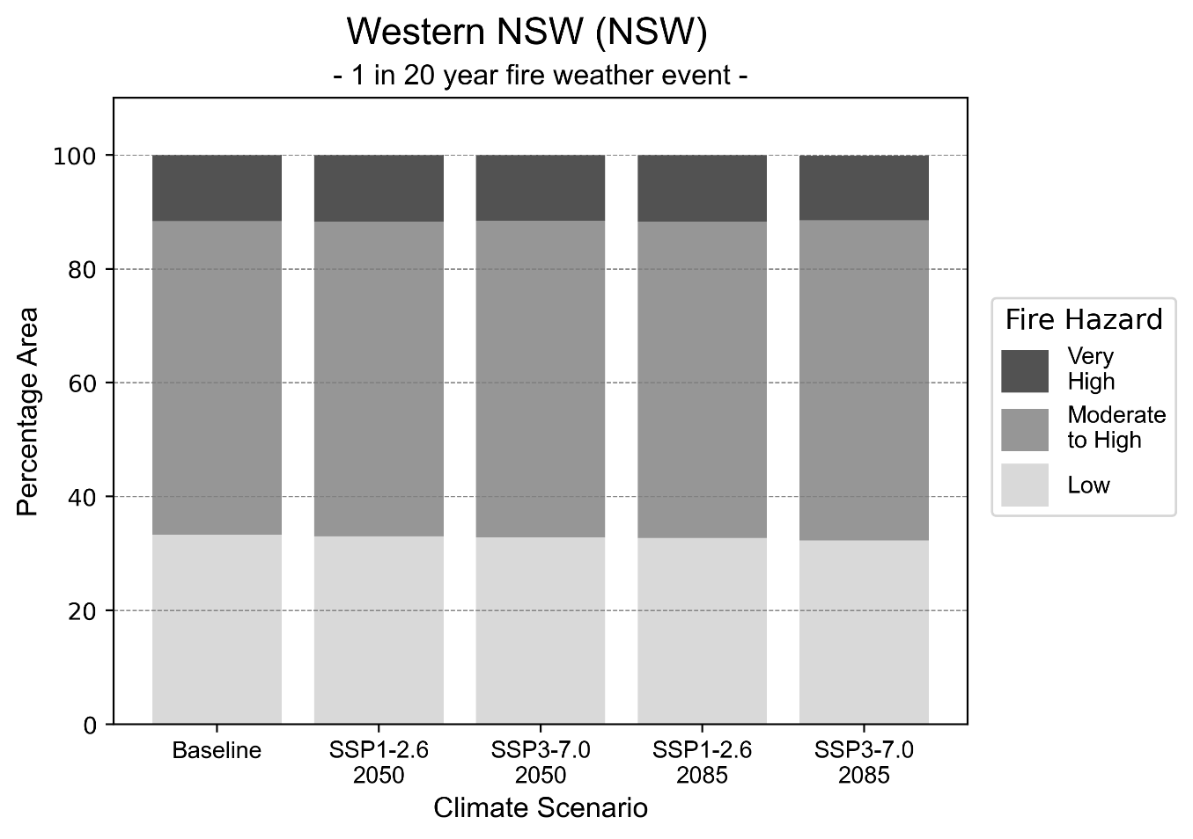
Figure 36: Stacked column chart showing the percentages of the Western NSW health district's total geographic area experiencing each fire hazard level during a 1-in-20-year fire weather event.
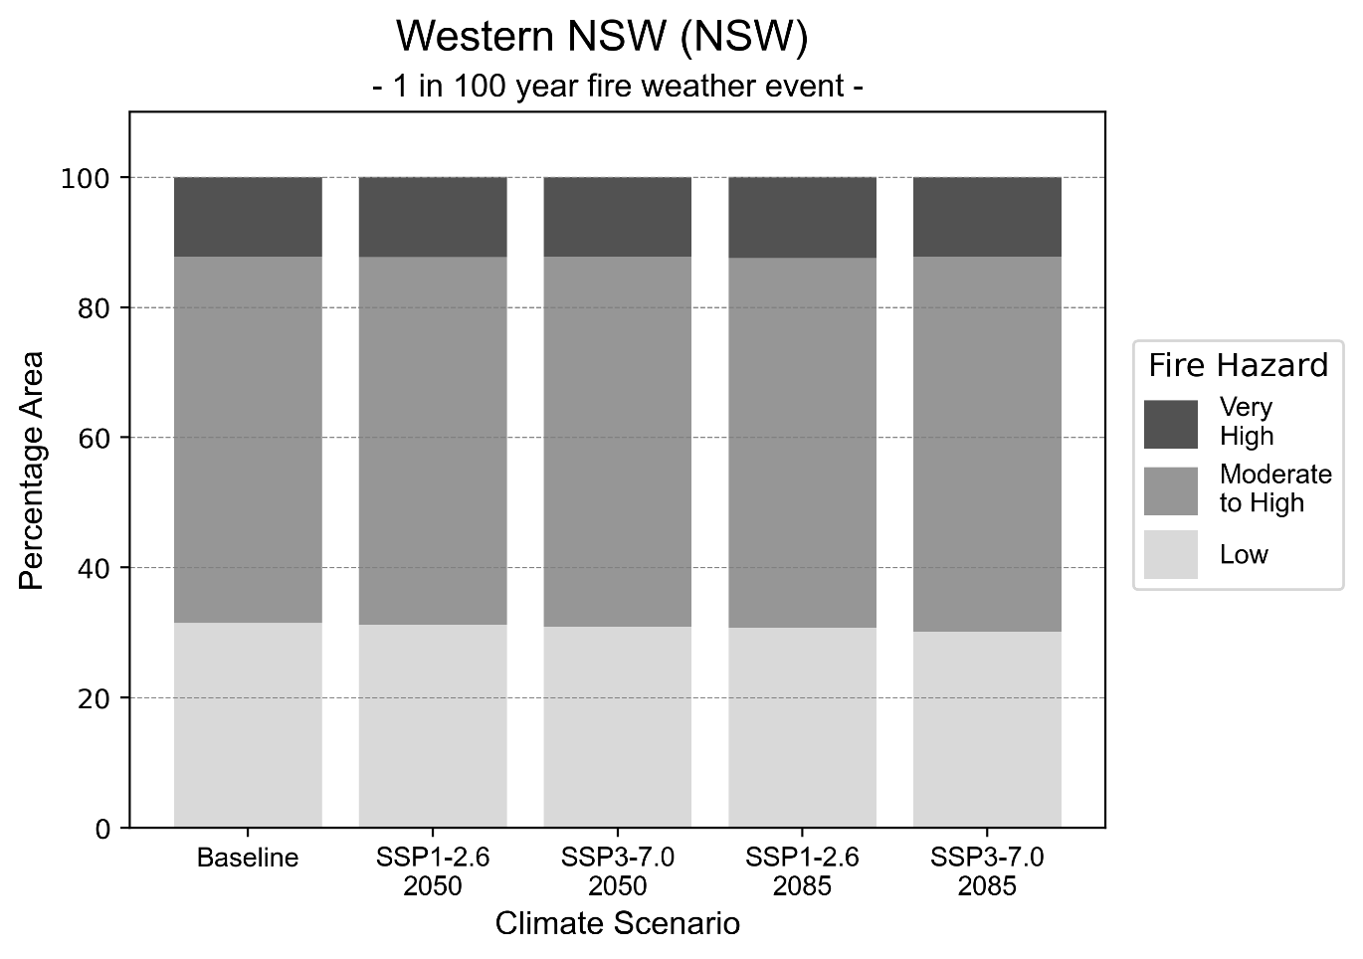
Figure 37: Stacked column chart showing the percentages of the Western NSW health district's total geographic area experiencing each fire hazard level during a 1-in-100-year fire weather event.

Drought hazard
Key projection:
Drought occurrence: The occurrence of drought will slightly increase across both scenarios and time horizons, with drought being experienced on average two months per year.

 | Baseline | 2050 Scenarios |  | 2085 Scenarios
 |  | Middle of the road | Reasonable worst-case | Middle of the road | Reasonable worst-case
Number of months per year in drought^{(a)} | 1.9 | 2.0  [0.4, 3.9] | 2.1  [0.7, 5.0] | 2.0  [0.4, 3.4] | 2.2  [0.1, 4.5]
Table notes: The drought hazard indicator uses climate projections from the CMIP6 Global Climate Models [1]. The primary indicator value reports the median from the nine climate models, with the range reported in square brackets.
Table footnotes: (a) The number of months per year in drought is based on the Standardised Precipitation Index (SPI). SPI is a widely used index to characterise meteorological drought on a range of timescales. This indicator uses the timescale of 12 months which calculates the average months in a year within the moderate drought range. A moderate drought range is classified as SPI score of ≤ -1. SPI is calculated from accumulated rainfall over 12 months and the mean and standard deviation from historical rainfall records.

Storm hazard
Key projection:
Less medium and low-intensity storms: Medium and low-intensity storms will be less frequent in both the middle of the road and reasonable worst-case scenarios, with the greatest decrease occurring by 2085, based on the middle of the road scenario.

 | Baseline | 2050 Scenarios |  | 2085 Scenarios
 |  | Middle of the road | Reasonable worst-case | Middle of the road | Reasonable worst-case
Number of low-intensity storms (40-62 km/hr) per year | 73.1 | 66.5  [58.5, 73.2] | 66.8  [58.8, 73.4] | 63.7  [56.1, 70.1] | 65.0  [57.2, 71.5]
Number of medium-intensity storms (63-87 km/hr) per year | 55.0 | 50.9  [44.8, 56.0] | 51.3  [45.2, 56.5] | 46.6  [41.0, 51.2] | 48.9  [43.1, 53.8]
Number of high-intensity storms (88-117 km/hr) per year | 17.7 | 18.0  [15.8, 19.8] | 16.3  [14.3, 17.9] | 15.8  [13.9, 17.3] | 16.7  [14.7, 18.3]
Number of very-high-intensity storms (> 117 km/hr) per year | 0.4 | 0.4  [0.4, 0.5] | 0.3  [0.2, 0.3] | 0.5  [0.4, 0.5] | 0.3  [0.2, 0.3]
Table notes: The storm hazard uses climate projections from the CMIP6 Global Climate Models [1]. Daily maximum surface wind speed is used to calculate the number of annual storms across four storm intensity categories (low, medium, high and very high). The primary indicator value reports the median from the nine climate models, with the range reported in square brackets.

Rainfall and flood hazard
Key projections:
- 13 extreme rainfall days per year: The number of extreme rainfall days will remain consistent across both scenarios and time horizons, with an average of approximately 13 extreme rainfall days per year.
- Increased flood frequency: Flooding will become more frequent across both middle of the road and reasonable worst-case scenarios, particularly in urban environments. The largest increase in urban flooding is seen in the reasonable worst-case scenario where frequency of a ‘1-in-100 year’ flood will more than triple by 2050 and become nearly ten times more likely by 2085.

 | Baseline |  | 2050 Scenarios |  |  |  |  |  | 2085 Scenarios
 |  |  | Middle of the road |  |  | Reasonable worst-case |  |  | Middle of the road |  |  | Reasonable worst-case
Rainfall hazard^{(a)}
Average number of extreme rainfall days per year (> 8 mm/day)^{(a)} | 13.0 |  | 13.0  [10.4,16.6] |  |  | 12.8  [9.3,15.5] |  |  | 12.9  [10.9,16.8] |  |  | 12.8  [9.7,18.6]
Urban flood risk (flooding caused by a 1-hour rainfall event)^{(b)}
Frequency of a ‘1-in-1 year’ flood (rainfall depth of 21 mm)^{(c)} |  | 1.7 events in 1 year |  |  | 1.8 events in 1 year |  |  | 2.1 events in 1 year |  |  | 2.8 events in 1 year
Frequency of a ‘1-in-10 year’ flood (rainfall depth of 45 mm)^{(c)} |  | 2.4 events in 10 years |  |  | 2.5 events in 10 years |  |  | 3.2 events in 10 years |  |  | 4.6 events in 10 years
Frequency of a ‘1-in-100 year’ flood (rainfall depth of 73 mm)^{(c)} |  | 3.4 events in 100 years |  |  | 3.7 events in 100 years |  |  | 5.5 events in 100 years |  |  | 9.8 events in 100 years
Rural flood risk (flooding caused by a 24-hour rainfall event) ^{(b)}
Frequency of a ‘1-in-1 year’ flood (rainfall depth of 51 mm)^{(c)} |  | 1.7 events in 1 year |  |  | 1.7 events in 1 year |  |  | 1.7 events in 1 year |  |  | 1.7 events in 1 year
Frequency of a ‘1-in-10 year’ flood (rainfall depth of 105 mm)^{(c)} |  | 1.5 events in 10 years |  |  | 1.6 events in 10 years |  |  | 1.7 events in 10 years |  |  | 1.9 events in 10 years
Frequency of a ‘1-in-100 year’ flood (rainfall depth of 181 mm)^{(c)} |  | 1.7 events in 100 years |  |  | 1.8 events in 100 years |  |  | 2.1 events in 100 years |  |  | 2.5 events in 100 years
Table notes: The rainfall hazard indicator uses climate projections from the CMIP6 Global Climate Models [1]. The primary indicator value reports the median from the nine climate models, with the range reported in square brackets. The flood hazard indicators use climate change considerations from the Australian Rainfall and Runoff guideline to estimate the climate projections [2].
Table footnotes:(a) Extreme rainfall is defined as rainfall above the 95th percentile of historical average daily rainfall in this health district in the period 1985-2014. The value in mm/day quoted in the indicator name is the 95th percentile of historic average daily rainfall for this health district. (b) See Methodology document for reasons for focusing on a 1-hour flood for urban areas and a 24-hour flood for rural areas. (c) The rainfall depths in mm quoted in the indicator names in this table report 1 in 1, 10 and 100 year depths for this health district.

Western Sydney health district

Health district overview
Western Sydney health district includes Western Sydney and South Western Sydney Local Health Districts.
Surface area: 7,023 square kilometres
Traditional Owners: Dharug, Tharawal, Dharawal and Gundungurra peoples
Estimated population (2021): 2,182,814
Estimated population (2031): 2,785,113
Local health services: Bankstown-Lidcombe, Bowral and District, Camden, Campbelltown, Fairfield, Liverpool, Auburn, Blacktown, Cumberland, Mount Druitt, Westmead

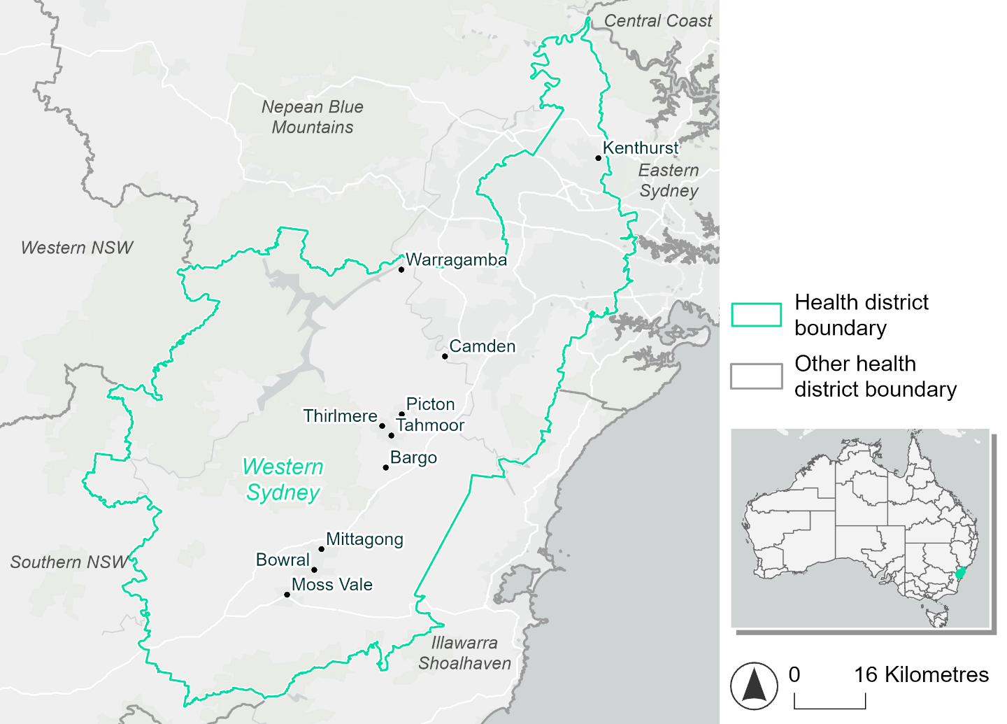
Figure 38. Map of Western Sydney health district

How will climate change affect this health district?
Heat and humidity: There will be higher average temperatures, more frequent hot days, warmer night time temperatures, and longer and more frequent heat waves.
Fire: Nearly 70% of this health district currently experiences very high fire hazard category and this will continue in the future across both 2050 and 2085 scenarios.
Drought: The number of months experiencing drought will slightly increase.
Rainfall and flood: There will be more flooding in urban and rural areas.
Coastal inundation: While the health district is non-coastal, some rivers in the district are affected by tides. The area flooded during tidal and storm surge and tidal inundation will increase.

Western Sydney health district demographic data
Demographic Data | Total
Number of households | 661,995
Persons 15 and older | 1,510,958
Total families | 551,405
Persons did not complete high school | 4,25018
One parent families with dependents | 53,574 (9.7%)
Persons aged 65 and older | 283,165 (13.1%)
Persons aged 4 and younger | 148,585 (6.9%)
Aboriginal and Torres Strait Islander persons | 38,225 (1.8%)
Persons speaks language other than English | 1,029,205 (47.7%)
Persons working age (15-65) | 1,420,646 (65.9%)
Population Health Data | Total
Persons with core needs for assistance | 123,027 (5.7%)
Persons with arthritis | 138,240 (6.4%)
Persons with asthma | 138,983 (6.4%)
Persons with cancer | 42,241 (2%)
Persons with dementia | 11,888 (0.6%)
Persons with diabetes | 117,478 (5.4%)
Persons with heart disease | 67,802 (3.1%)
Persons with kidney disease | 17,333 (0.8%)
Persons with lung condition | 24,165 (1.1%)
Persons with mental health condition | 121,589 (5.6%)
Persons with stroke | 15,423 (0.7%)
Persons with any other condition | 154,279 (7.2%)
Persons no health condition | 1,421,130 (65.9%)
Socio-economic Data | Total
Persons providing unpaid care | 227,006 (10.5%)
Persons homeless | 9,892 (0.5%)
Household with lone person | 119,667 (18.1%)
Households with rent and mortgage stress | 384,058 (58%)
Households total equivalised income below $1000 (weekly) | 295,447 (44.6%)
Households with no motor vehicle | 52,539 (7.9%)
Persons unemployed | 106,301 (6.4%)

The sections that follow outline projected climate hazards for this district. Further information on this health district, including population demographics, is provided in the online dashboard.

Heat and humidity hazard
Key projections:
More heatwaves: Heatwaves will become longer and more frequent. Under a reasonable worst-case scenario, the number of heatwaves per year will more than double by 2050, and quadruple by 2085.
Hotter days and warmer nights: The maximum temperature on hot days will increase, with temperatures on hot nights also increasing.
More days above 35°C and 40°C: The number of days per year greater than 35°C and 40°C will increase under both middle of the road and reasonable worst-case scenarios.

 | Baseline | 2050 Scenarios |  | 2085 Scenarios
 |  | Middle of the road | Reasonable worst-case | Middle of the road | Reasonable worst-case
Average temperature (°C) | 17.8 | 19.2  [18.7, 19.9] | 19.5  [18.7, 20.4] | 20.1  [19.2, 21.2] | 21  [20, 22.4]
Maximum temperature on hot days (°C)^{(a)} | 33.1 | 34.7  [34.2, 35.7] | 35.1  [34.1, 36.6] | 35.7  [34.8, 37.6] | 36.7  [35.7, 38.7]
Minimum temperature on hot nights (°C)^{(b)} | 20.5 | 22.1  [21.3, 22.9] | 22.3  [21.4, 23.2] | 22.9  [21.9, 24.3] | 23.9  [22.7, 25.5]
Average apparent temperature on hot days (°C) (NOAA Heat Index)^{(c)} | 34.9 | 36.2  [35.5, 36.7] | 36.5  [35.6, 37.2] | 37  [36.1, 38.1] | 38.1  [37, 39.5]
Average heatwave duration in days^{(d)} | 4 | 5  [4, 5] | 5  [4, 6] | 5  [4, 6] | 6  [5, 9]
Number of heatwaves per year^{(d)} | 2 | 4  [3, 6] | 5  [3, 7] | 6  [4, 10] | 8  [6, 10]
Number of days per year  > 35°C | 10 | 17  [15, 24] | 20  [15, 29] | 23  [18, 36] | 31  [23, 47]
Number of days per year > 40°C | 1 | 3  [2, 4] | 3  [2, 6] | 4  [2, 9] | 6  [4, 13]
Table notes: The heat and humidity hazard uses climate projections from the CMIP6 Global Climate Models [1]. Daily projections of maximum and minimum near-surface temperature and mean relative humidity are used to calculate eight heat and humidity indicators. The primary indicator value reports the median from the nine climate models, with the range reported in square brackets.
Table footnotes: (a) Based on the 95th percentile of daily maximum air temperature. (b) Based on the 95th percentile of daily minimum air temperature, representing the coldest part of the night on very hot nights. (c) The National Oceanic and Atmospheric Administration (NOAA) Heat Index is a measure of how hot it feels when relative humidity is factored in alongside actual air temperature. It is calculated on days with a maximum temperature of 27°C and above. Interpretation of Heat Index values: 27°C to 32°C indicates caution, 33°C to 41°C indicates extreme caution, 42°C to 54°C indicates danger and over 54°C indicates extreme danger. See methodology document for further explanation of Heat Index categories. (d) A heatwave is defined as three or more consecutive days where both daytime and overnight temperatures (daily mean temperatures) are unusually high for the location, based on the Bureau of Meteorology’s Excess Heat Factor method. For this district, an unusually high daily mean temperature is approximately 26.4°C or above.

Fire hazard
Key projections:
- Majority of district area experiences very high fire hazard: Under baseline conditions, over two-thirds of the district experiences very high fire hazard. During a 1-in-20-year fire weather event, 13.8% experiences moderate to high hazard with the remaining 17.7% experiencing low hazard. These proportions shift slightly for a 1-in-100-year event, with both low and moderate to high hazard covering about 15% of the district each.
- Current fire hazard conditions to persist: In the 2050 and 2085 scenarios, very high fire hazard continues to cover most of the district, with only slight variations from baseline levels.

 | Baseline | 2050 Scenarios |  | 2085 Scenarios
 |  | Sustainability | Reasonable worst-case | Sustainability | Reasonable worst-case
Hazard for a ‘1-in-20 year’ fire weather event^{(a)}
Proportion (%) of district experiencing ‘Low’ fire hazard | 17.7%  (124,237)^{(b)} | 17.6%  [17.0%, 18.3%] | 17.4%  [16.6%, 19.3%] | 17.4%  [15.9%, 19.2%] | 17.0%  [15.0%, 21.5%]
Proportion (%) of district experiencing ‘Moderate to High’ fire hazard | 13.8%  (96,968)^{(b)} | 13.9%  [13.1%, 14.6%] | 14.6%  [13.4%, 15.6%] | 14.0%  [12.0%, 15.6%] | 15.6%  [12.7%, 18.1%]
Proportion (%) of district experiencing ‘Very High’ fire hazard | 68.5%  (480,331)^{(b)} | 68.6%  [68.3%, 68.7%] | 68.0%  [65.1%, 68.7%] | 68.7%  [68.1%, 69.0%] | 67.4%  [60.5%, 69.0%]
Hazard for a ‘1-in-100 year’ fire weather event^{(a)}
Proportion (%) of district experiencing ‘Low’ fire hazard | 15.6%  (109,551)^{(b)} | 15.4%  [14.8%, 16.2%] | 15.2%  [14.5%, 16.6%] | 15.2%  [13.6%, 17.0%] | 14.5%  [13.0%, 18.0%]
Proportion (%) of district experiencing ‘Moderate to High’ fire hazard | 15.3%  (107,344)^{(b)} | 15.4%  [14.8%, 16.1%] | 16.3%  [15.2%, 17.8%] | 15.6%  [14.0%, 17.1%] | 17.7%  [15.0%, 21.2%]
Proportion (%) of district experiencing ‘Very High’ fire hazard | 69.1%  (484,640)^{(b)} | 69.1%  [69.0%, 69.2%] | 68.5%  [65.6%, 69.2%] | 69.2%  [69.0%, 69.4%] | 67.8%  [60.8%, 69.4%]
Table notes: The Fire Hazard uses the National Bushfire Intelligence Capability (NBIC) Phase 2 fire line intensity modelling based on CMIP6 climate projections. Fire Hazard is assessed using the projected Fireline Intensity (FLI) for weather events with two different return intervals (i.e. a 1-in-20 year event and a 1-in-100 year event). FLI considers slope, vegetation and weather to produce a rate of heat output per unit length (kW/m) along a bushfire’s front. Fire hazard is categorized as a low for FLI<4000 kW/m, moderate to high for 4,000 kW/m ≤FLI<12,500kW/m, and very high for FLI≥27,501kW/m. This is broadly consistent with the literature [3]. The assessment considers climate change effects based on changes in fire weather and the associated hazard that is anticipated for a meteorological event of a given return interval. This approach is different to the one adopted for the Flood Hazard, where the event magnitude is given (fixed) and the likelihood of that event varies as a result of climate change. The primary indicator value reports the median from the nine climate models, with the range reported in square brackets.
Table footnotes: (a) The area subject to different categories of fire hazard is determined for a ‘1-in-20 year’ and ‘1-in-100 year’ fire weather event, in current and future climates. Values at year 2050 are interpolated using data from baseline (2025) and 2085, assuming linear change over time. (b) Values in round brackets are the area (ha) of the health district subject to a given fire hazard.

The figures below show the proportion of the health district experiencing different fire hazard categories across different time horizons and climate scenarios during a ‘1-in-20 year’ fire weather event (Figure 39) and a ‘1-in-100 year’ fire weather event (Figure 40).

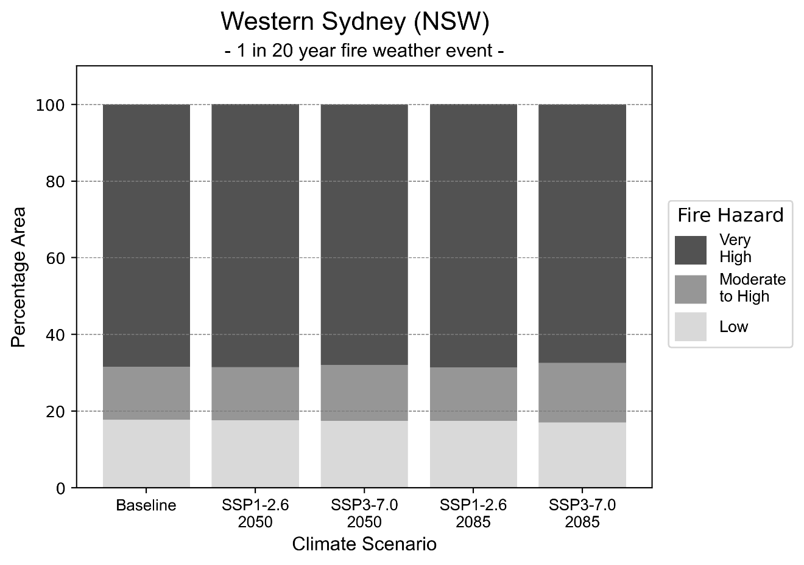
Figure 39: Stacked column chart showing the percentages of the Western Sydney health district's total geographic area experiencing each fire hazard level during a 1-in-20-year fire weather event.
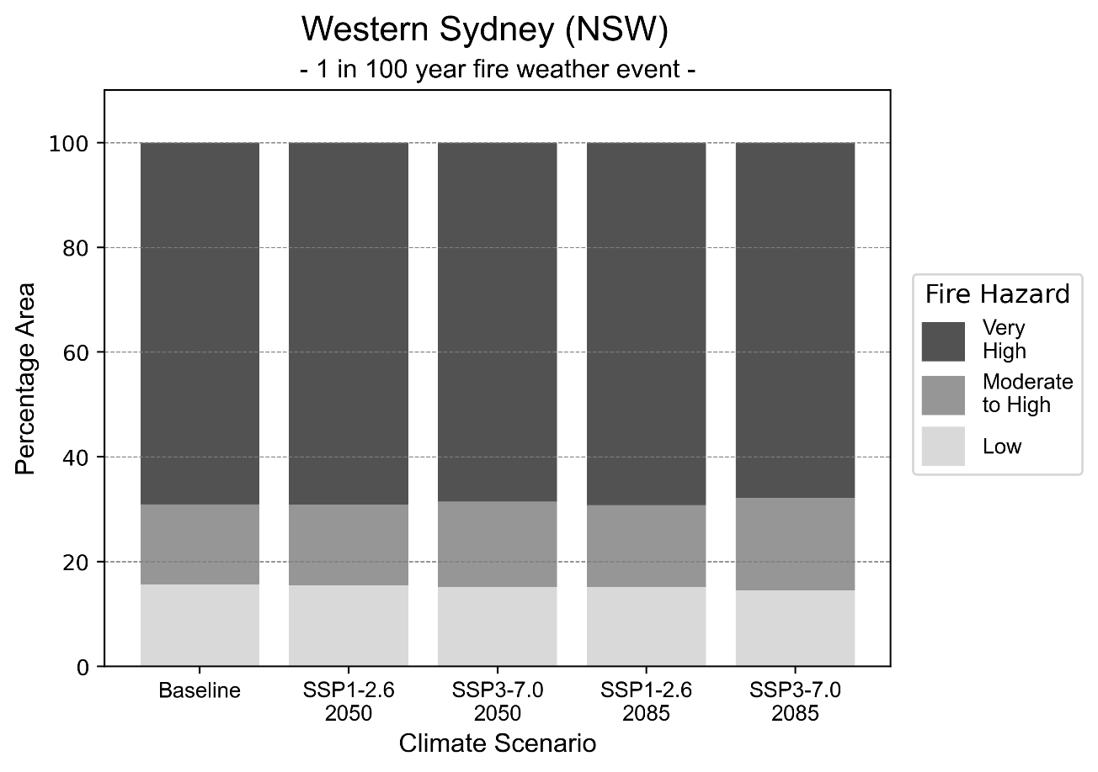
Figure 40: Stacked column chart showing the percentages of the Western Sydney health district's total geographic area experiencing each fire hazard level during a 1-in-100-year fire weather event.

Drought hazard
Key projection:
Drought occurrence: The occurrence of drought will slightly increase across both scenarios and time horizons, with drought being experienced on average two months per year.

 | Baseline | 2050 Scenarios |  | 2085 Scenarios
 |  | Middle of the road | Reasonable worst-case | Middle of the road | Reasonable worst-case
Number of months per year in drought^{(a)} | 1.8 | 1.8  [0.5, 3.0] | 2.2  [0.5, 5.0] | 1.9  [0.5, 3.2] | 2.1  [0.3, 4.3]
Table notes: The drought hazard indicator uses climate projections from the CMIP6 Global Climate Models [1]. The primary indicator value reports the median from the nine climate models, with the range reported in square brackets.
Table footnotes: (a) The number of months per year in drought is based on the Standardised Precipitation Index (SPI). SPI is a widely used index to characterise meteorological drought on a range of timescales. This indicator uses the timescale of 12 months which calculates the average months in a year within the moderate drought range. A moderate drought range is classified as SPI score of ≤ -1. SPI is calculated from accumulated rainfall over 12 months and the mean and standard deviation from historical rainfall records.

Storm hazard
Key projection:
More high-intensity storms: High-intensity storms will become more frequent across both middle of the road and reasonable worst-case scenarios, with the greatest increase occurring by 2085.

 | Baseline | 2050 Scenarios |  | 2085 Scenarios
 |  | Middle of the road | Reasonable worst-case | Middle of the road | Reasonable worst-case
Number of low-intensity storms (40-62 km/hr) per year | 72.8 | 67.6  [59.5, 74.3] | 67.8  [59.6, 74.5] | 63.1  [55.6, 69.4] | 61.4  [54.0, 67.5]
Number of medium-intensity storms (63-87 km/hr) per year | 34.8 | 32.5  [28.6, 35.7] | 31.8  [28.0, 34.9] | 28.6  [25.2, 31.5] | 28.0  [24.6, 30.8]
Number of high-intensity storms (88-117 km/hr) per year | 1.9 | 2.9  [2.5, 3.2] | 1.8  [1.6, 2.0] | 2.5  [2.2, 2.7] | 2.5  [2.2, 2.8]
Number of very-high-intensity storms (> 117 km/hr) per year | 0.0 | 0.0  [0.0, 0.0] | 0.0  [0.0, 0.0] | 0.0  [0.0, 0.0] | 0.0  [0.0, 0.0]
Table notes: The storm hazard uses climate projections from the CMIP6 Global Climate Models [1]. Daily maximum surface wind speed is used to calculate the number of annual storms across four storm intensity categories (low, medium, high and very high). The primary indicator value reports the median from the nine climate models, with the range reported in square brackets.

Rainfall and flood hazard
Key projections:
- Nine extreme rainfall days per year: The number of extreme rainfall days will remain consistent across both scenarios and time horizons, with an average of approximately nine extreme rainfall days per year.
- Increased flood frequency: Flooding will become more frequent across both middle of the road and reasonable worst-case scenarios, particularly in urban environments. In the reasonable worst-case scenario the frequency of a ‘1-in-100 year’ urban flood will more than triple by 2050, and become nearly ten times more likely by 2085.

 | Baseline | 2050 Scenarios |  | 2085 Scenarios
 |  | Middle of the road | Reasonable worst-case | Middle of the road | Reasonable worst-case
Rainfall hazard^{(a)}
Average number of extreme rainfall days per year (> 11 mm/day)^{(a)} | 8.8 | 8.8  [7.8,10.5] | 8.7  [6.8,10.9] | 8.9  [7.7,11.0] | 8.7  [7.1,11.4]
Urban flood risk (flooding caused by a 1-hour rainfall event)^{(b)}
Frequency of a ‘1-in-1 year’ flood (rainfall depth of 21 mm)^{(c)} |  | 1.9 events in 1 year | 2.0 events in 1 year | 2.4 events in 1 year | 3.2 events in 1 year
Frequency of a ‘1-in-10 year’ flood (rainfall depth of 39 mm)^{(c)} |  | 2.6 events in 10 years | 2.8 events in 10 years | 3.8 events in 10 years | 5.9 events in 10 years
Frequency of a ‘1-in-100 year’ flood (rainfall depth of 64 mm)^{(c)} |  | 3.2 events in 100 years | 3.4 events in 100 years | 5.1 events in 100 years | 9.4 events in 100 years
Rural flood risk (flooding caused by a 24-hour rainfall event) ^{(b)}
Frequency of a ‘1-in-1 year’ flood (rainfall depth of 72 mm)^{(c)} |  | 1.6 events in 1 year | 1.5 events in 1 year | 0.8 events in 1 year | 0.9 events in 1 year
Frequency of a ‘1-in-10 year’ flood (rainfall depth of 147 mm)^{(c)} |  | 1.2 events in 10 years | 1.2 events in 10 years | 1.1 events in 10 years | 0.7 events in 10 years
Frequency of a ‘1-in-100 year’ flood (rainfall depth of 234 mm)^{(c)} |  | 1.6 events in 100 years | 1.5 events in 100 years | 1.5 events in 100 years | 1.2 events in 100 years
Table notes: The rainfall hazard indicator uses climate projections from the CMIP6 Global Climate Models [1]. The primary indicator value reports the median from the nine climate models, with the range reported in square brackets. The flood hazard indicators use climate change considerations from the Australian Rainfall and Runoff guideline to estimate the climate projections [2].
Table footnotes: (a) Extreme rainfall is defined as rainfall above the 95th percentile of historical average daily rainfall in this health district in the period 1985-2014. The value in mm/day quoted in the indicator name is the 95th percentile of historic average daily rainfall for this health district. (b) See Methodology document for reasons for focusing on a 1-hour flood for urban areas and a 24-hour flood for rural areas. (c) The rainfall depths in mm quoted in the indicator names in this table report 1 in 1, 10 and 100 year depths for this health district.

Coastal inundation hazard
Key projections:
Greater area inundated: There will be an increase in the area affected by tidal inundation (i.e. area submerged during high tide) and storm surge and tidal inundation (i.e. the area submerged during a storm surge and high tide) across both middle of the road and reasonable worst-case scenarios. In the reasonable worst-case scenario, by 2085 the area inundated during tidal inundation event will increase by over 800 ha.

 | Baseline | 2050 Scenarios |  | 2085 Scenarios^{(a)}
 |  | Middle of the road | Reasonable worst-case | Middle of the road | Reasonable worst-case
Tidal inundation (ha inundated)^{(b)} | 850.4 | 1,129.2  (+278.7) | 1,153.1  (+302.7) | 1,511.0  (+660.6) | 1,672.9  (+822.5)
Storm surge + tidal inundation – ‘1-in-100 year’ event (ha inundated)^{(c)} | 1,240.1 | 1,460.2  (+220.2) | 1,480.3  (+240.3) | 1,813.6  (+573.5) | 1,950.9  (+710.8)
Storm surge + tidal inundation – ‘1-in-1000 year’ event (ha inundated)^{(c)} | 1,289.0 | 1,502.9  (+213.9) | 1,522.6  (+233.6) | 1,945.0  (+656.0) | 2,068.2  (+779.2)
Table notes: The coastal inundation hazard provides an indication of flooding in coastal areas that can be attributed to sea level rise and storm inundation. The coastal inundation hazard is only reported for health districts adjoining the coastline. This table includes the projected inundation levels as well as the change from baseline conditions (in brackets).
Table footnotes: (a) For the 2085 Scenarios planning horizon, 2100 was adopted as it provides a conservative representation of the end of this period. This horizon aligns with many State planning regulations requiring consideration of sea level rise and storm tide to 2100, making the 2100 scenario particularly valuable for planning new health facilities in coastal areas. (b) The tidal inundation indicator reports the number of hectares inundated during high tide. The baseline value reports existing inundation patterns, while the 2050 and 2085 values report high tide inundation taking account of projected sea level rise due to climate change. (c) The storm surge + tidal inundation indicators report the combined effect, in hectares inundated, of high tide, sea level rise (for the 2050 and 2085 projections), and storm surge (for 1-in-100 year and 1-in-1000 year events).

References

[1] | D. Irving, I. Macadam and M. King, “Application-ready quantile-delta-change (QDC) scaled CMIP6 climate projections for Australia (time slices, 11km grid) (v1)”, CSIRO. Data Collection, 2024.
[2] | C. Wasko, S. Westra, R. Nathan, D. Jakob, C. Nielsen, J. Evans, S. Rodgers, M. Ho, M. Babister, A. Dowdy and W. Sharples, “Australian Rainfall and Runoff (ARR) Chapter 6: 4 Climate Change Considerations”, Australian Rainfall and Runoff, 2024.
[3] | J. J. Hollis, S. Matthews, W. R. Anderson, M. G. Cruz, P. Fox-Hughes, S. Grootemaat, B. J. Kenny and S. Sauvage, “A framework for defining fire danger to support fire management operations in Australia”, International Journal of Wildland Fire, vol. 33, no.3, 2024.
[4] | Z. Hausfather and P. G. Peters, “Emissions–the ‘business as usual’ story is misleading”, Nature, 577(7792), pp.618-620., 2020.



Another scenario, SSP5-8.5, was previously considered the reasonable worst-case scenario, but it is now considered to be very unlikely to be realised due to climate action already undertaken [4].

