Guidance on climate risk assessment and adaptation planning for Australian health system organisations
  - Climate and Health Hazard Data for the Northern Territory

© Commonwealth of Australia as represented by the Australian Centre for Disease Control
Title: Guidance on climate risk assessment and adaptation planning for Australian health system organisations: Climate and Health Hazard Data for the Northern Territory.
Citation
Australian Centre for Disease Control (CDC). Guidance on climate risk assessment and adaptation planning for Australian health system organisations: Climate and Health Hazard Data for the Northern Territory, Australian CDC, Australian Government, 2026.
Contributors
Anne Cleary, Jamie Ewert, Jake Allen, Adam Brook, Petter Nyman, Pam Wong, Anthony Kiem, Felix Edger, Richard Farr, Robert Morden, Vincent Li Creagh, Tony Weber, Dominic Blackham, Matilda Lehmann, Phoebe Spurrier, Sophia Gidis, Georgia Behrens, Madeleine Skellern.
Acknowledgments
CSIRO National Bushfire Intelligence Capability for assisting with the analysis of the Fire Hazard.
Creative Commons Licence
This publication is licensed under the Creative Commons Attribution 4.0 International Public License available from https://creativecommons.org/licenses/by/4.0/legalcode (“Licence”). You must read and understand the Licence before using any material from this publication.
Restrictions
The Licence may not give you all the permissions necessary for your intended use. For example, other rights (such as publicity, privacy and moral rights) may limit how you use the material found in this publication. The Licence does not cover, and there is no permission given for, use of any of the following material found in this publication:
- the Commonwealth Coat of Arms. (by way of information, the terms under which the Coat of Arms may be used can be found on the Department of Prime Minister and Cabinet website
- any logos and trademarks
- any photographs and images
- any signatures
- any material belonging to third parties. The third party elements must be included here or have a footnote reference throughout the document showing where they are.
Attribution
Without limiting your obligations under the Licence, the Australian Centre for Disease Control requests that you attribute this publication in your work. Any reasonable form of words may be used provided that you:
- include a reference to this publication and where practicable, the relevant page numbers
- make it clear that you have permission to use the material under the Creative Commons Attribution 4.0 International Public License
- make it clear whether or not you have changed the material used from this publication
- include a copyright notice in relation to the material used. In the case of no change to the material, the words “© Commonwealth of Australia (Australian Centre for Disease Control) 2026” may be used. In the case where the material has been changed or adapted, the words: “Based on Commonwealth of Australia (Australian Centre for Disease Control) material” may be used
- do not suggest that the Australian Centre for Disease Control endorses you or your use of the material.
Enquiries
Enquiries regarding any other use of this publication should be addressed to the Communication and Public Information Section, Strategy and Engagement Branch, Australian Centre for Disease Control, GPO Box 798, Canberra ACT 2601, or via e-mail to CDCComms@cdc.gov.au.
We welcome feedback and dialogue about this report. Please send all such correspondence to NHSC.Unit@cdc.gov.au.

Table of Contents

Table of Contents 3
Introduction 4
Barkly health district 7
Big Rivers health district 16
Central Australia health district 26
East Arnhem health district 35
Top End health district 45
References 55

Introduction
This document provides scientific climate information to help health system organisations assess, prepare for and effectively manage climate-related risks across short-, medium-, and long-term planning horizons. A digital version of the information in this document can be found here. Further detail about the information contained in this document can be found in the accompanying methodological report.

The document presents climate hazard information summarised for health districts across the Northern Territory (NT). For each health district, information is provided about six hazards – heat and humidity, fire, drought, rainfall, storms, and coastal inundation – across three different time horizons and two climate scenarios. This structure enables users to assess how climate risks may evolve over time and under different emissions pathways. The information is presented both in narrative form and through a series of detailed tables containing quantitative data. Further information on the information presented in this document is outlined below.

Health districts
This document presents climate information for 5 health districts, corresponding to NT Health’s 5 service delivery regions:
Barkly
Big Rivers
Central Australia
East Arnhem
Top End.

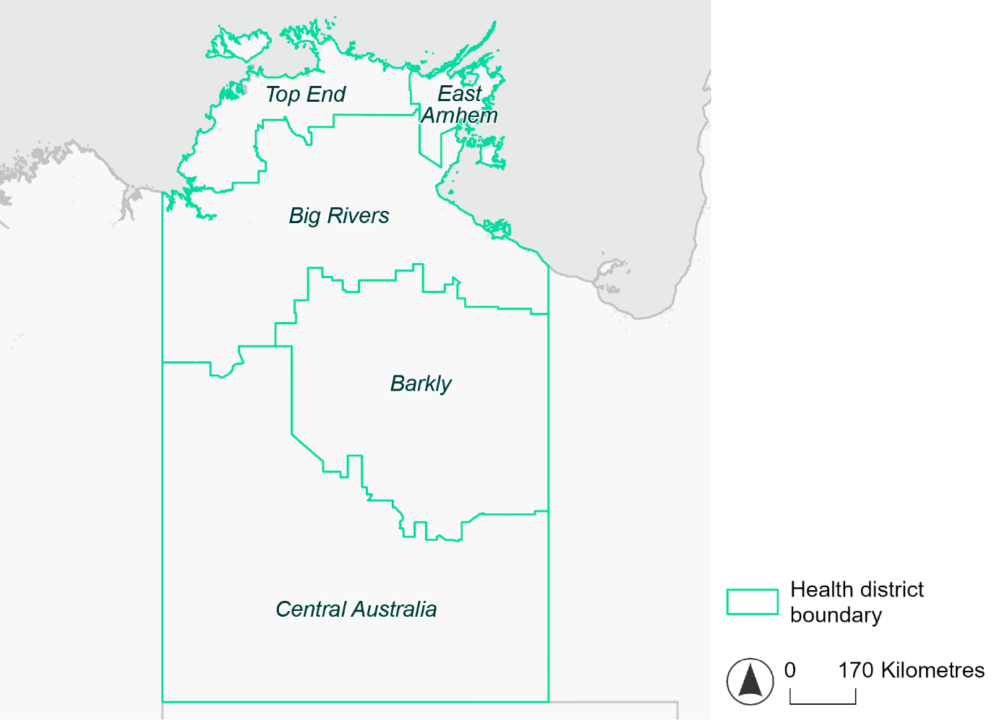
Figure 1. Map of NT health districts used in this document.

Time horizons
This document provides climate information on each climate hazard for the following time horizons:

Time horizon | Years | Description | Use in risk assessment
Baseline | Observed data from 1985-2014 | Historical baseline position | Understand current risks and ensure they are being managed effectively
Mid-century (2050) | 2035–2064 | Medium-term climate projections | Identify and manage emerging risks to population health and health systems
Late century (2085) | 2070–2099 | Long-term climate projections | Identify long-term risks when planning infrastructure or policy with long-lasting consequences

Climate scenarios
The document provides climate information on each hazard for two different climate scenarios. A climate scenario is a plausible representation of what the future climate might look like. These scenarios are based on different assumptions about greenhouse gas emissions and other factors that influence the future climate.

This document uses Shared Socioeconomic Pathways (SSPs) as the basis for different climate scenarios. SSPs describe how socioeconomic factors (such as population, economic growth, education, urbanisation and technology development) could change over the next century and have an effect on future greenhouse gas emissions and global temperatures.

There are five main SSPs, each of which outlines a different scenario, ranging from a sustainable future with low emissions, to one with high fossil fuel uses and high emissions. The most recent iteration of SSPs incorporate information from what were previously called Representative Concentration Pathways (RCPs), which measure the expected change in radiative forcing (in W/m²) under the scenario from 1750 to 2100. SSP2-4.5 denotes what would previously have been called a scenario involving SSP2 and RCP4.5 – the reasoning for merging them being that SSP2 describes socioeconomic conditions likely to give rise to RCP4.5.

The two main scenarios used in this document are:
A ‘middle of the road’ scenario (SSP2-4.5): this scenario assumes emissions remain at current levels until the middle of the 21st century, and that net zero emissions are not reached by 2100. This scenario sees temperatures rising by about 2.7°C by the end of the century. In this document this is the lower emissions scenario across all climate hazards, except for the fire hazard (see below note).
A ‘reasonable worst-case’ scenario (SSP3-7.0): this scenario assumes both emissions and temperatures continue to rise to the end of the century due to delayed climate action. This scenario sees temperatures rise by about 3.6°C by 2100. In this document this is the higher emissions scenario across all climate hazards.

Fire hazard projections are not available for SSP2-4.5, so SSP1-2.6 is used as the lower emissions scenario for this hazard instead of SSP2-4.5. Under SSP1-2.6, global emissions are reduced but do not reach net zero until after 2050 and warming stabilises at about 1.8°C by 2100. This document refers to SSP1-2.6 as the ‘sustainability’ scenario.

Climate hazard projections
For each health district, the following information is provided for each climate hazard, across the different time horizons and climate scenarios:
- Heat and humidity: projected average, extreme and apparent temperatures; projected heatwave duration and frequency; and projected number of very hot days.
- Fire: projected area affected by different fire hazard categories for a 1-in-20 year fire event and a 1-in-100 year event.
- Drought: projected average number of months per year experiencing drought.
- Rainfall and flooding: projected number of extreme rainfall days per year, as well as projected frequency of urban and rural flood events.
- Storms: projected number of storms per year, grouped into four intensity categories based on wind speed.
- Coastal inundation: projected area of land affected by tidal inundation and storm surge and tidal inundation (coastal districts only).

The climate hazard projections in this document are based on data from nine CMIP6 Global Climate Models (ACCESS-CM2, ACCESS-ESM1-5, CESM2, CMCC-ESM2, CNRM-ESM2-1, EC-Earth3, MPI-ESM1-2-HR, NorESM2-MM, UKESM1-0-LL). These models simulate how climate hazards may change under different SSPs. Where hazard projections are based on these models, this document reports the median projected value as its primary estimate, and reports the range across all nine models in square brackets.

Barkly health district

Health district overview
Surface area: 322,725 square kilometres
Estimated population: 6,091
Local health services: The region is serviced by one Aboriginal Community Controlled Health Service, Anyinginyi Health Aboriginal Corporation. Tennant Creek hospital has 20 beds, providing acute care and general practice service.

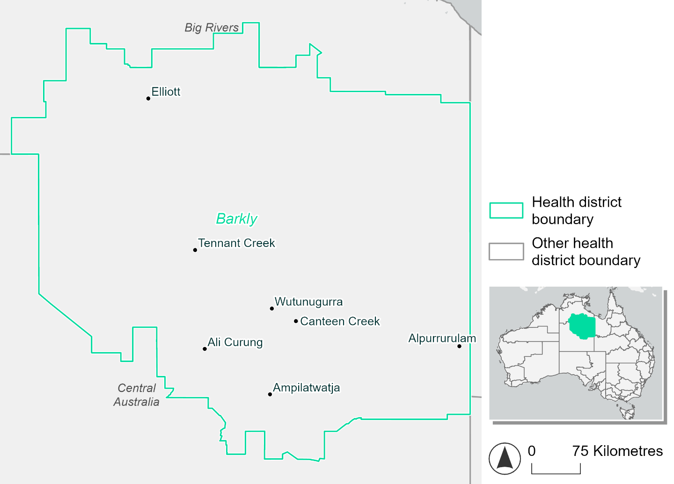Figure 2. Map of Barkly health district

How will climate change affect this health district?
Heat and humidity: Higher average temperatures, hotter and more frequent hot days, warmer night time temperatures and longer and more frequent heatwaves.
Fire: Over 60% of this health district experiences a moderate to high fire hazard category and this will slightly increase in the future.
Drought: Number of months experiencing drought will increase.
Rainfall and flood: More flood events in urban areas.

Barkly health district demographic data
Demographic Data | Total
Number of households | 1,566
Persons 15 and older | 5,018
Total families | 1,287
Persons did not complete high school | 2,828
One parent families with dependents | 259 (20.1%)
Persons aged 65 and older | 474 (6.9%)
Persons aged 4 and younger | 567 (8.2%)
Aboriginal and Torres Strait Islander persons | 3,935 (57.2%)
Persons speaks language other than English | 2,730 (39.7%)
Persons working age (15-65) | 4,779 (69.4%)
Population Health Data | Total
Persons with core needs for assistance | 188 (2.7%)
Persons with arthritis | 170 (2.5%)
Persons with asthma | 290 (4.2%)
Persons with cancer | 62 (0.9%)
Persons with dementia | 34 (0.5%)
Persons with diabetes | 494 (7.2%)
Persons with heart disease | 336 (4.9%)
Persons with kidney disease | 127 (1.8%)
Persons with lung condition | 64 (0.9%)
Persons with mental health condition | 201 (2.9%)
Persons with stroke | 34 (0.5%)
Persons with any other condition | 307 (4.5%)
Persons no health condition | 4,426 (64.3%)
Socio-economic Data | Total
Persons providing unpaid care | 655 (9.5%)
Persons homeless | 677 (9.8%)
Household with lone person | 458 (29.3%)
Households with rent and mortgage stress | 218 (13.9%)
Households total equivalised income below $1000 (weekly) | 375 (24%)
Households with no motor vehicle | 485 (31%)
Persons unemployed | 531 (11.5%)

The sections that follow outline projected climate hazards for this district. Further information on this health district, including population demographics, is provided in the online dashboard.

Heat and humidity hazard
Key projections:
More heatwaves: Heatwave events are likely to last longer and the number of heatwave events per year will increase. By 2050, under a reasonable worst-case scenario the number of heatwaves will quadruple. By 2085, under a reasonable worst-case scenario the number of heatwaves per year will more than quadruple.
Hotter days and warmer nights: The maximum temperature on hot days will increase with night time temperatures on hot nights also increasing.
More days above 35°C and 40°C: The number of days per year greater than 35°C and 40°C will increase under both middle of the road and reasonable worst-case scenarios.

 | Baseline | 2050 Scenarios |  | 2085 Scenarios
 |  | Middle of the road | Reasonable worst-case | Middle of the road | Reasonable worst-case
Average temperature (°C) | 25 | 26.8  [26.1, 27.4] | 27.1  [26.5, 28] | 27.7  [27, 28.7] | 29  [28, 30.4]
Maximum temperature on hot days (°C)^{(a)} | 40.3 | 42.1  [41.3, 42.8] | 42.3  [41.4, 43] | 43  [41.8, 43.8] | 44.2  [43, 45.2]
Minimum temperature on hot nights (°C)^{(b)} | 25.3 | 27.2  [26.5, 27.6] | 27.4  [26.7, 28] | 28.2  [27.3, 29] | 29.5  [28.5, 30.8]
Average apparent temperature on hot days (°C) (NOAA Heat Index)^{(c)} | 39.4 | 42.7  [41, 44.8] | 43  [41.9, 45] | 44.7  [43.4, 46.8] | 47.5  [45, 52.8]
Average heatwave duration in days^{(d)} | 5 | 8  [6, 10] | 8  [6, 11] | 10  [7, 14] | 14  [9, 20]
Number of heatwaves per year^{(d)} | 2 | 7  [5, 8] | 8  [6, 9] | 9  [8, 10] | 9  [9, 10]
Number of days per year  > 35°C | 139 | 178  [154, 195] | 185  [164, 207] | 199  [179, 219] | 219  [194, 248]
Number of days per year > 40°C | 23 | 60  [37, 76] | 67  [44, 91] | 84  [55, 109] | 115  [76, 152]
Table notes: The heat and humidity hazard uses climate projections from the CMIP6 Global Climate Models [1]. Daily projections of maximum and minimum near-surface temperature and mean relative humidity are used to calculate eight heat and humidity indicators. The primary indicator value reports the median from the nine climate models, with the range reported in square brackets.
Table footnotes: (a) Based on the 95th percentile of daily maximum air temperature. (b) Based on the 95th percentile of daily minimum air temperature, representing the coldest part of the night on very hot nights. (c) The National Oceanic and Atmospheric Administration (NOAA) Heat Index is a measure of how hot it feels when relative humidity is factored in alongside actual air temperature. It is calculated on days with a maximum temperature of 27°C and above. Interpretation of Heat Index values: 27°C to 32°C indicates caution, 33°C to 41°C indicates extreme caution, 42°C to 54°C indicates danger and over 54°C indicates extreme danger. See methodology document for further explanation of Heat Index categories. (d) A heatwave is defined as three or more consecutive days where both daytime and overnight temperatures (daily mean temperatures) are unusually high for the location, based on the Bureau of Meteorology’s Excess Heat Factor method. For this district, an unusually high daily mean temperature is approximately 32.3 °C or above.

Fire Hazard
Key projections:
- Majority of district area currently experiences moderate to high hazard: under baseline conditions most of the district (61-63%) experiences moderate to high fire hazard. Very high hazard covers 21-25%. The remaining low hazard area covers 14.3% of the district in a 1-in-20-year fire weather event, and 12.8% in a 1-in-100-year event.
- Low hazard area will decline slightly: in a future climate across both 2050 and 2085 scenarios the area experiencing only low hazard will decline, by up to 2.0 percentage points for a 1-in-20-year fire weather event and by 2.2 percentage points for a 1-in-100-year event.

 | Baseline | 2050 Scenarios |  |  | 2085 Scenarios
 |  | Sustainability |  | Reasonable worst-case | Sustainability | Reasonable worst-case
Hazard for a ‘1-in-20 year’ fire weather event^{(a)}
Proportion (%) of district experiencing ‘Low’ fire hazard | 14.3%  (4,599,418)^{(b)} | 14.1%  [13.1%, 14.9%] | 13.4%  [12.7%, 14.1%] |  | 13.9%  [11.4%, 15.7%] | 12.3%  [10.5%, 13.8%]
Proportion (%) of district experiencing ‘Moderate to High’ fire hazard | 63.8%  (20,589,944)  ^{(b)} | 64.1%  [60.9%, 67.6%] | 64.5%  [62.5%, 66.8%] |  | 64.4%  [56.9%, 73.0%] | 65.4%  [60.7%, 71.1%]
Proportion (%) of district experiencing ‘Very High’ fire hazard | 21.9%  (7,083,135)^{(b)} | 21.8%  [21.3%, 22.2%] | 22.1%  [21.4%, 22.8%] |  | 21.7%  [20.4%, 22.6%] | 22.3%  [20.7%, 24.1%]
Hazard for a ‘1-in-100 year’ fire weather event^{(a)}
Proportion (%) of district experiencing ‘Low’ fire hazard | 12.8%  (4,120,987)^{(b)} | 12.6%  [11.3%, 13.5%] | 11.9%  [11.3%, 12.5%] |  | 12.4%  [9.2%, 14.5%] | 10.6%  [9.2%, 12.1%]
Proportion (%) of district experiencing ‘Moderate to High’ fire hazard | 61.7%  (19,896,511)  ^{(b)} | 62.0%  [59.4%, 65.8%] | 62.3%  [60.3%, 64.4%] |  | 62.5%  [56.2%, 71.6%] | 63.3%  [58.3%, 68.3%]
Proportion (%) of district experiencing ‘Very High’ fire hazard | 25.6%  (8,254,998)^{(b)} | 25.4%  [24.7%, 25.8%] | 25.8%  [24.8%, 27.4%] |  | 25.1%  [23.5%, 26.1%] | 26.0%  [23.7%, 29.9%]
Table notes: The Fire Hazard uses the National Bushfire Intelligence Capability (NBIC) Phase 2 fire line intensity modelling based on CMIP6 climate projections. Fire Hazard is assessed using the projected Fireline Intensity (FLI) for weather events with two different return intervals (i.e. a 1-in-20-year event and a 1-in-100-year event). FLI considers slope, vegetation and weather to produce a rate of heat output per unit length (kW/m) along a bushfire’s front. Fire hazard is categorized as a low for FLI<4000 kW/m, moderate to high for 4,000 kW/m ≤FLI<12,500kW/m, and very high for FLI≥27,501kW/m. This is broadly consistent with the literature [3]. The assessment considers climate change effects based on changes in fire weather and the associated hazard that is anticipated for a meteorological event of a given return interval. This approach is different to the one adopted for the Flood Hazard, where the event magnitude is given (fixed) and the likelihood of that event varies as a result of climate change. The primary indicator value reports the median from the nine climate models, with the range reported in square brackets.
Table footnotes: (a) The area subject to different categories of fire hazard is determined for a ‘1-in-20 year’ and ‘1-in-100 year’ fire weather event, in current and future climates. Values at year 2050 are interpolated using data from baseline (2025) and 2085, assuming linear change over time. (b) Values in round brackets are the area (ha) of the health district subject to a given fire hazard.

The figures below show the proportion of the health district experiencing different fire hazard categories across different time horizons and climate scenarios during a ‘1-in-20 year’ fire weather event (Figure 3) and a ‘1-in-100 year’ fire weather event (Figure 4).
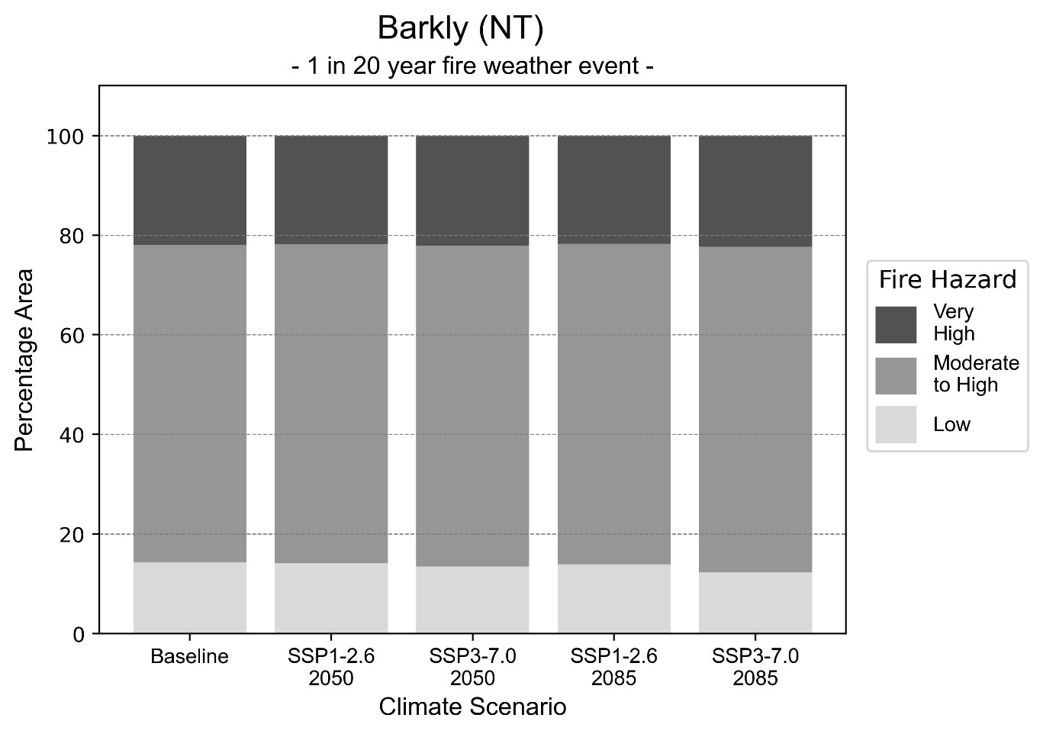
Figure 3: Stacked column chart showing the percentages of the Barkly health district's total geographic area experiencing each fire hazard level during a 1-in-20-year fire weather event.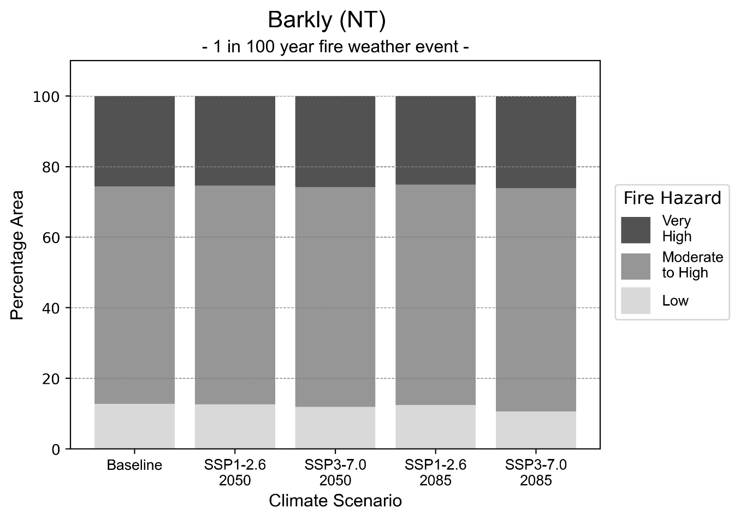
Figure 4: Stacked column chart showing the percentages of the Barkly health district's total geographic area experiencing each fire hazard level during a 1-in-100-year fire weather event.

Drought hazard
Key projections:
Drought occurrence: The occurrence of drought will increase across both middle of the road and reasonable worst-case scenarios and both time horizons, with drought being experienced on average two months per year.

 | Baseline | 2050 Scenarios |  | 2085 Scenarios
 |  | Middle of the road | Reasonable worst-case | Middle of the road | Reasonable worst-case
Number of months per year in drought^{(a)} | 1.6 | 2.7  [0.4, 4.7] | 2.0  [0.5, 3.8] | 2.1  [0.4, 4.8] | 2.3  [0.3, 5.1]
Table notes: The drought hazard indicator uses climate projections from the CMIP6 Global Climate Models [1]. The primary indicator value reports the median from the nine climate models, with the range reported in square brackets.
Table footnotes: (a) The number of months per year in drought is based on the Standardised Precipitation Index (SPI). SPI is a widely used index to characterise meteorological drought on a range of timescales. This indicator uses the timescale of 12 months which calculates the average months in a year within the moderate drought range. A moderate drought range is classified as SPI score of ≤ -1. SPI is calculated from accumulated rainfall over 12 months and the mean and standard deviation from historical rainfall records.

Storm hazard
Key projections:
More frequent high-intensity storms: The frequency of high-intensity storms will increase across both middle of the road and reasonable worst-case scenarios with the greatest increase occurring by 2085.

 | Baseline | 2050 Scenarios |  | 2085 Scenarios
 |  | Middle of the road | Reasonable worst-case | Middle of the road | Reasonable worst-case
Number of low-intensity storms (40-62 km/hr) per year | 80.7 | 79.7  [70.1, 87.7] | 83.0  [73.1, 91.3] | 79.7  [70.2, 87.7] | 81.1  [71.3, 89.2]
Number of medium-intensity storms (63-87 km/hr) per year | 66.5 | 67.5  [59.4, 74.3] | 64.7  [57.0, 71.2] | 57.3  [50.4, 63.0] | 59.4  [52.3, 65.4]
Number of high-intensity storms (88-117 km/hr) per year | 6.9 | 9.0  [7.9, 9.9] | 9.0  [7.9, 9.9] | 6.6  [5.8, 7.3] | 10.3  [9.1, 11.4]
Number of very-high-intensity storm (> 117 km/hr) per year | 0.0 | 0.0  [0.0, 0.0] | 0.1  [0.1, 0.1] | 0.0  [0.0, 0.0] | 0.1  [0.1, 0.1]
Table notes: The storm hazard uses climate projections from the CMIP6 Global Climate Models [1]. Daily maximum surface wind speed is used to calculate the number of annual storms across four storm intensity categories (low, medium, high and very high). The primary indicator value reports the median from the nine climate models, with the range reported in square brackets.

Rainfall and flood hazard
Key projections:
- Decrease in extreme rainfall days per year: The number of extreme rainfall days will decrease across both middle of the road and reasonable worst-case scenarios and both time horizons, with the largest decrease occurring under the reasonable worst-case scenario by 2085.
- Increased flood frequency: The frequency of flood events will increase in urban environments but mainly decrease in rural environments. The largest increase in flood frequency is seen in the reasonable worst-case scenario where frequency of a 1-in-100 year flood will more than quadruple by 2050 and become 14 times more likely by 2085 in urban environments. In rural environments there will be a slight increase in frequency of a 1-in-100-year flood under the middle of the road scenario by 2050, however there will slight decrease in the frequency of floods across all other 2050 and 2085 scenarios.

 | Baseline | 2050 Scenarios |  | 2085 Scenarios
 |  | Middle of the road | Reasonable worst-case | Middle of the road | Reasonable worst-case
Rainfall hazard^{(a)}
Average number of extreme rainfall days per year (> 7 mm/day)^{(a)} | 13.2 | 12.6  [8.8,16.6] | 12.5  [9.8,15.8] | 12.4  [8.5,16.9] | 12.2  [8.9,19.3]
Urban flood risk (flooding caused by a 1-hour rainfall event)^{(b)}
Frequency of a ‘1-in-1 year’ flood (rainfall depth of 27 mm)^{(c)} |  | 1.6 events in 1 year | 1.6 events in 1 year | 1.9 events in 1 year | 2.3 events in 1 year
Frequency of a ‘1-in-10 year’ flood (rainfall depth of 51 mm)^{(c)} |  | 2.8 events in 10 years | 2.9 events in 10 years | 4.0 events in 10 years | 6.0 events in 10 years
Frequency of a ‘1-in-100 year’ flood (rainfall depth of 76 mm)^{(c)} |  | 4.4 events in 100 years | 4.7 events in 100 years | 7.6 events in 100 years | 14 events in 100 years
Rural flood risk (flooding caused by a 24-hour rainfall event) ^{(b)}
Frequency of a ‘1-in-1 year’ flood (rainfall depth of 58 mm)^{(c)} |  | 0.9 events in 1 year | 0.8 events in 1 year | 0.9 events in 1 year | 0.4 events in 1 year
Frequency of a ‘1-in-10 year’ flood (rainfall depth of 129 mm)^{(c)} |  | 0.9 events in 10 years | 1.0 events in 10 years | 0.9 events in 10 years | 0.4 events in 10 years
Frequency of a ‘1-in-100 year’ flood (rainfall depth of 224 mm)^{(c)} |  | 1.1 events in 100 years | 1.0 events in 100 years | 0.7 events in 100 years | 0.3 events in 100 years
Table notes: The rainfall hazard indicator uses climate projections from the CMIP6 Global Climate Models [1]. The flood hazard indicators use climate change considerations from the Australian Rainfall and Runoff guideline to estimate the climate the climate projections [2]. The primary indicator value reports the median from the nine climate models, with the range reported in square brackets.
Table footnotes: (a) Extreme rainfall is defined as rainfall above the 95th percentile of historical average daily rainfall in this health district in the period 1985-2014. The value in mm/day quoted in the indicator name is the 95th percentile of historic average daily rainfall for this health district. (b) See Methodology document for reasons for focusing on a 1-hour flood for urban areas and a 24-hour flood for rural areas. (c) The rainfall depths in mm quoted in the indicator names in this table report 1 in 1-, 10- and 100-year depths for this health district.

Big Rivers health district

Health district overview
Surface area: 344,847 square kilometres
Estimated population: 20,869
Local health services: The Katherine township is serviced by one private general practice and Wurli-Wurlinjang Aboriginal Health Service. Sunrise Health Service Aboriginal Corporation and Katherine West Health Board service the remote regions of Roper Gulf and Victoria Daly. Katherine Hospital has 60 beds and provides emergency services, surgical and medical care, paediatrics and obstetrics.

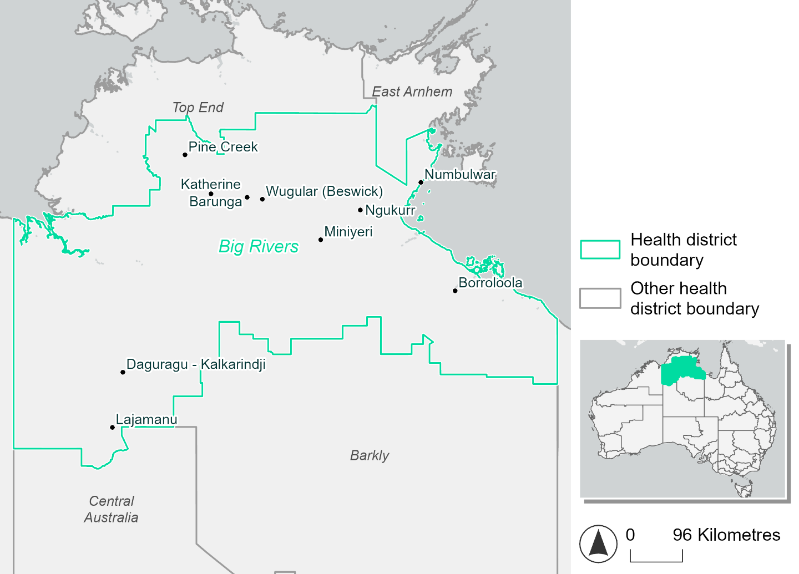
Figure 5. Map of Big Rivers health district

How will climate change affect this health district?
Heat and humidity: Higher average temperatures, hotter and more frequent hot days, warmer night time temperatures and longer and more frequent heatwaves.
Fire: 47% of this health district currently experiences a moderate to high fire hazard category and this increase under reasonable worst-case scenarios and slightly decrease under sustainability scenarios.
Drought: Number of months experiencing drought will increase.
Rainfall and flood: More flood events in urban areas.
Coastal inundation: Increased area flooded during tidal and storm surge and tidal inundation.

Big Rivers health district demographic data
Demographic Data | Total
Number of households | 4,592
Persons 15 and older | 15,789
Total families | 4,065
Persons did not complete high school | 7,686
One parent families with dependents | 666 (16.4%)
Persons aged 65 and older | 1,620 (7.4%)
Persons aged 4 and younger | 1,658 (7.6%)
Aboriginal and Torres Strait Islander persons | 9,534 (43.8%)
Persons speaks language other than English | 7,953 (36.5%)
Persons working age (15-65) | 15,119 (69.4%)
Population Health Data | Total
Persons with core needs for assistance | 600 (2.8%)
Persons with arthritis | 618 (2.8%)
Persons with asthma | 999 (4.6%)
Persons with cancer | 226 (1%)
Persons with dementia | 99 (0.5%)
Persons with diabetes | 1,215 (5.6%)
Persons with heart disease | 916 (4.2%)
Persons with kidney disease | 215 (1%)
Persons with lung condition | 210 (1%)
Persons with mental health condition | 823 (3.8%)
Persons with stroke | 106 (0.5%)
Persons with any other condition | 1079 (5%)
Persons no health condition | 13,852 (63.6%)
Socio-economic Data | Total
Persons providing unpaid care | 2,227 (10.2%)
Persons homeless | 2,405 (11%)
Household with lone person | 1,018 (22.2%)
Households with rent and mortgage stress | 793 (17.3%)
Households total equivalised income below $1000 (weekly) | 2,031 (44.2%)
Households with no motor vehicle | 880 (19.2%)
Persons unemployed | 1,429 (9.8%)

The sections that follow outline projected climate hazards for this district. Further information on this health district, including population demographics, is provided in the online dashboard.

Heat and humidity hazard
Key projections:
More heatwaves: Heatwave events are likely to last longer and the number of heatwave events per year will increase.
  - By 2050, under a reasonable worst-case scenario the number of heatwaves will more than triple.
  - By 2085, under a reasonable worst-case scenario the number of heatwaves per year will more than quadruple.
Hotter days and warmer nights: The maximum temperature on hot days will increase with night time temperatures on hot nights also increasing.
More days above 35°C and 40°C: The number of days per year greater than 35°C and 40°C will increase under both middle of the road and reasonable worst-case scenarios.

 | Baseline | 2050 Scenarios |  | 2085 Scenarios
 |  | Middle of the road | Reasonable worst-case | Middle of the road | Reasonable worst-case
Average temperature (°C) | 27.1 | 28.8  [28.1, 29.5] | 29  [28.3, 30] | 29.7  [28.7, 30.8] | 30.8  [29.6, 32.1]
Maximum temperature on hot days (°C)^{(a)} | 39.6 | 41.3  [40.6, 41.8] | 41.4  [40.8, 42] | 42.1  [41, 42.7] | 43.1  [42, 44]
Minimum temperature on hot nights (°C)^{(b)} | 25.8 | 27.5  [26.7, 28.1] | 27.7  [27.1, 28.4] | 28.3  [27.3, 29.1] | 29.6  [28.4, 30.6]
Average apparent temperature on hot days (°C) (NOAA Heat Index)^{(c)} | 44.2 | 48.7  [47, 50.4] | 49.3  [47.5, 51.4] | 51.3  [49, 53.4] | 54.5  [51.4, 57.8]
Average heatwave duration in days^{(d)} | 5 | 11  [8, 14] | 11  [8, 15] | 14  [10, 19] | 20  [14, 31]
Number of heatwaves per year^{(d)} | 2 | 7  [5, 8] | 7  [6, 9] | 8  [6, 9] | 9  [8, 10]
Number of days per year  > 35°C | 154 | 214  [180, 239] | 222  [191, 257] | 245  [207, 287] | 273  [233, 313]
Number of days per year > 40°C | 14 | 49  [30, 64] | 54  [33, 76] | 74  [40, 101] | 109  [63, 143]
Table notes: The heat and humidity hazard uses climate projections from the CMIP6 Global Climate Models [1]. Daily projections of maximum and minimum near-surface temperature and mean relative humidity are used to calculate eight heat and humidity indicators. The primary indicator value reports the median from the nine climate models, with the range reported in square brackets.
Table footnotes: (a) Based on the 95th percentile of daily maximum air temperature. (b) Based on the 95th percentile of daily minimum air temperature, representing the coldest part of the night on very hot nights. (c) The National Oceanic and Atmospheric Administration (NOAA) Heat Index is a measure of how hot it feels when relative humidity is factored in alongside actual air temperature. It is calculated on days with a maximum temperature of 27°C and above. Interpretation of Heat Index values: 27°C to 32°C indicates caution, 33°C to 41°C indicates extreme caution, 42°C to 54°C indicates danger and over 54°C indicates extreme danger. See methodology document for further explanation of Heat Index categories. (d) A heatwave is defined as three or more consecutive days where both daytime and overnight temperatures (daily mean temperatures) are unusually high for the location, based on the Bureau of Meteorology’s Excess Heat Factor method. For this district, an unusually high daily mean temperature is approximately 32.1°C or above.

Fire Hazard
Key projections:
- Most of district avoids very high hazard currently: under baseline conditions less than 5% of the district experiences very high fire hazard for both 1-in-20-year and 1-in-100-year fire weather events.
- In a 1-in-20-year event, the remainder is split roughly evenly with 46.8% of the district experiencing moderate to high hazard and 49.1% experiencing low hazard.
- For a 1-in-100-year event this shifts to 55.3% and 40.2% of the district area experiencing moderate to high and low hazard respectively.
- Low hazard area contracts under higher emissions: in a future climate, the area experiencing very high hazard remains about 4-5%.
- By 2050 the low hazard area will decrease by 2.4-3.3 percentage points in the reasonable worst-case compared to the sustainability scenario.
- By 2085 this difference increases such that 8% of the total district experiences moderate to high instead of low hazard in the reasonable worst-case emissions scenario, when compared to the sustainability pathway.

 | Baseline | 2050 Scenarios |  | 2085 Scenarios
 |  | Sustainability | Reasonable worst-case | Sustainability | Reasonable worst-case
Hazard for a ‘1-in-20 year’ fire weather event^{(a)}
Proportion (%) of district experiencing ‘Low’ fire hazard | 49.1%  (16,937,440)  ^{(b)} | 49.6%  [44.4%, 52.5%] | 46.2%  [42.7%, 48.4%] | 50.2%  [37.7%, 57.3%] | 42.2%  [33.6%, 47.3%]
Proportion (%) of district experiencing ‘Moderate to High’ fire hazard | 46.8%  (16,144,203)  ^{(b)} | 46.4%  [43.5%, 51.6%] | 49.7%  [47.6%, 53.4%] | 45.8%  [38.8%, 58.2%] | 53.8%  [48.6%, 62.5%]
Proportion (%) of district experiencing ‘Very High’ fire hazard | 4.1%  (1,403,148)^{(b)} | 4.0%  [4.0%, 4.1%] | 4.0%  [4.0%, 4.2%] | 4.0%  [3.8%, 4.2%] | 4.0%  [3.8%, 4.4%]
Hazard for a ‘1-in-100 year’ fire weather event^{(a)}
Proportion (%) of district experiencing ‘Low’ fire hazard | 40.2%  (13,877,429)  ^{(b)} | 40.9%  [34.9%, 44.6%] | 37.6%  [34.3%, 39.8%] | 41.9%  [27.5%, 50.7%] | 33.9%  [25.9%, 39.2%]
Proportion (%) of district experiencing ‘Moderate to High’ fire hazard | 55.3%  (19,080,212)  ^{(b)} | 54.6%  [51.0%, 60.5%] | 58.0%  [55.7%, 61.4%] | 53.6%  [45.0%, 67.8%] | 61.7%  [56.1%, 69.8%]
Proportion (%) of district experiencing ‘Very High’ fire hazard | 4.4%  (1,527,150)^{(b)} | 4.4%  [4.3%, 4.5%] | 4.4%  [4.3%, 4.5%] | 4.4%  [4.1%, 4.6%] | 4.4%  [4.1%, 4.7%]
Table notes: The Fire Hazard uses the National Bushfire Intelligence Capability (NBIC) Phase 2 fire line intensity modelling based on CMIP6 climate projections. Fire Hazard is assessed using the projected Fireline Intensity (FLI) for weather events with two different return intervals (i.e. a 1-in-20 year event and a 1-in-100 year event). FLI considers slope, vegetation and weather to produce a rate of heat output per unit length (kW/m) along a bushfire’s front. Fire hazard is categorized as a low for FLI<4000 kW/m, moderate to high for 4,000 kW/m ≤FLI<12,500kW/m, and very high for FLI≥27,501kW/m. This is broadly consistent with the literature [3]. The assessment considers climate change effects based on changes in fire weather and the associated hazard that is anticipated for a meteorological event of a given return interval. This approach is different to the one adopted for the Flood Hazard, where the event magnitude is given (fixed) and the likelihood of that event varies as a result of climate change. The primary indicator value reports the median from the nine climate models, with the range reported in square brackets.
Table footnotes: (a) The area subject to different categories of fire hazard is determined for a ‘1-in-20 year’ and ‘1-in-100 year’ fire weather event, in current and future climates. Values at year 2050 are interpolated using data from baseline (2025) and 2085, assuming linear change over time. (b) Values in round brackets are the area (ha) of the health district subject to a given fire hazard.

The figures below show the proportion of the health district experiencing different fire hazard categories across different time horizons and climate scenarios during a ‘1-in-20 year’ fire weather event (Figure 6) and a ‘1-in-100 year’ fire weather event (Figure 7).
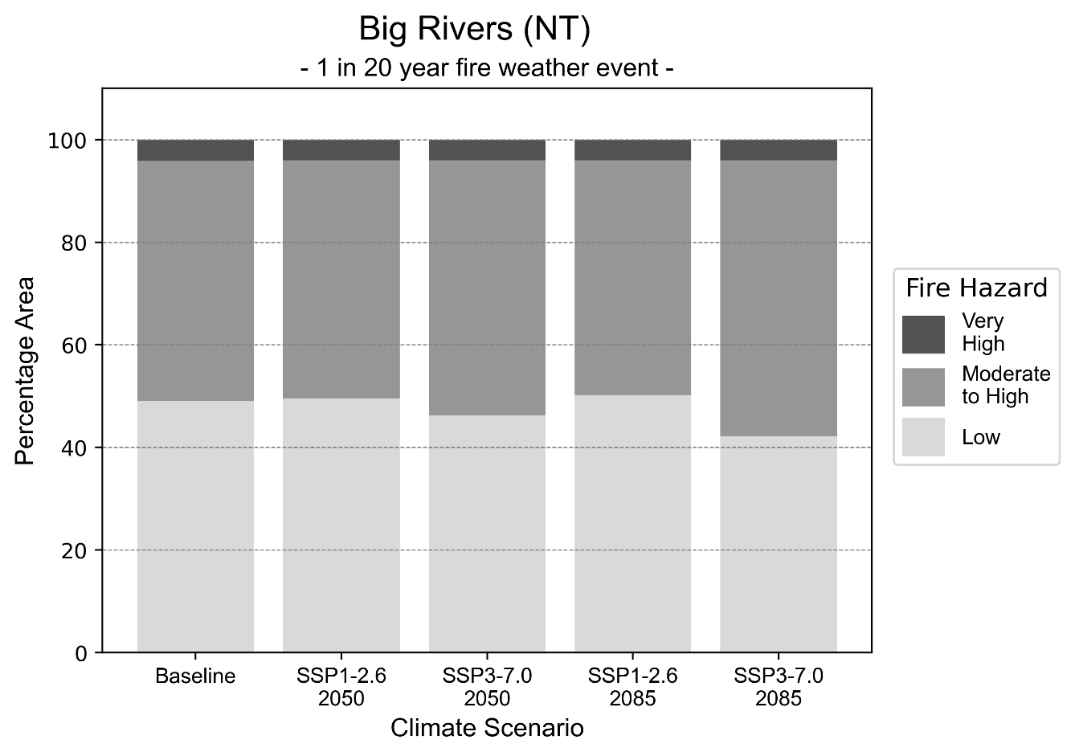
Figure 6: Stacked column chart showing the percentages of the Big Rivers health district's total geographic area experiencing each fire hazard level during a 1-in-20-year fire weather event.
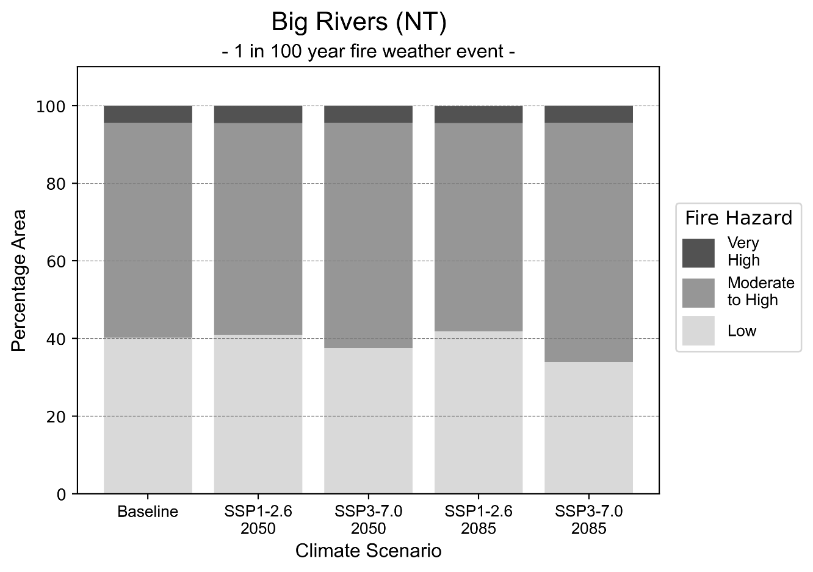
Figure 7: Stacked column chart showing the percentages of the Big Rivers health district's total geographic area experiencing each fire hazard level during a 1-in-100-year fire weather event.

Drought hazard
Key projections:
Drought occurrence: The occurrence of drought will increase across both middle of the road and reasonable worst-case scenarios and both time horizons, with drought being experienced on average two to three months per year.

 | Baseline | 2050 Scenarios |  | 2085 Scenarios
 |  | Middle of the road | Reasonable worst-case | Middle of the road | Reasonable worst-case
Number of months per year in drought^{(a)} | 1.8 | 2.5  [0.6, 4.4] | 2.3  [0.6, 4.7] | 2.7  [0.4, 5.0] | 2.7  [0.3, 5.9]
Table notes: The drought hazard indicator uses climate projections from the CMIP6 Global Climate Models [1]. The primary indicator value reports the median from the nine climate models, with the range reported in square brackets.
Table footnotes:(a) The number of months per year in drought is based on the Standardised Precipitation Index (SPI). SPI is a widely used index to characterise meteorological drought on a range of timescales. This indicator uses the timescale of 12 months which calculates the average months in a year within the moderate drought range. A moderate drought range is classified as SPI score of ≤ -1. SPI is calculated from accumulated rainfall over 12 months and the mean and standard deviation from historical rainfall records.

Storm hazard
Key projections:
More frequent very-high-intensity storms: The frequency of very-high-intensity storms will increase across both middle of the road and reasonable worst-case scenarios with the greatest increase occurring by 2085.

 | Baseline | 2050 Scenarios |  | 2085 Scenarios
 |  | Middle of the road | Reasonable worst-case | Middle of the road | Reasonable worst-case
Number of low-intensity storms (40-62 km/hr) per year | 106.4 | 101.5  [89.3, 111.6] | 102.2  [89.9, 112.4] | 99.7  [87.7, 109.7] | 98.3  [86.5, 108.1]
Number of medium-intensity storms (63-87 km/hr) per year | 44.4 | 41.5  [36.5, 45.7] | 42.9  [37.8, 47.2] | 42.5  [37.4, 46.7] | 42.3  [37.2, 46.5]
Number of high-intensity storms (88-117 km/hr) per year | 31.4 | 28.8  [25.4, 31.7] | 28.7  [25.2, 31.5] | 24.7  [21.7, 27.2] | 25.0  [22.0, 27.5]
Number of very-high-intensity storm (> 117 km/hr) per year | 1.5 | 1.9  [1.7, 2.1] | 1.5  [1.3, 1.7] | 1.8  [1.6, 2.0] | 2.2  [1.9, 2.4]
Table notes: The storm hazard uses climate projections from the CMIP6 Global Climate Models [1]. Daily maximum surface wind speed is used to calculate the number of annual storms across four storm intensity categories (low, medium, high and very high). The primary indicator value reports the median from the nine climate models, with the range reported in square brackets.

Rainfall and flood hazard
Key projections:
- Slight decrease in extreme rainfall days per year: The number of extreme rainfall days will slightly decrease across both middle of the road and reasonable worst-case scenarios and both time horizons, with the largest decrease occurring under the reasonable worst-case scenario by 2085.
- Increased flood frequency: The frequency of flood events will increase in urban environments.
- The largest increase in flood frequency is seen in the reasonable worst-case scenario where frequency of a ‘1-in-100 year’ flood will more than triple by 2050 and become 25 times more likely by 2085 in urban environments.
- In rural environments the frequency of floods will slightly increase across 2050 scenarios and slightly decrease across 2085 scenarios.

 | Baseline | 2050 Scenarios |  | 2085 Scenarios
 |  | Middle of the road | Reasonable worst-case | Middle of the road | Reasonable worst-case
Rainfall hazard^{(a)}
Average number of extreme rainfall days per year (> 12 mm/day)^{(a)} | 9.9 | 9.4  [7.0,14.3] | 9.3  [6.7,13.9] | 9.1  [6.8,13.9] | 9.0  [5.9,14.3]
Urban flood risk (flooding caused by a 1-hour rainfall event)^{(b)}
Frequency of a ‘1-in-1 year’ flood (rainfall depth of 42 mm)^{(c)} |  | 2.0 events in 1 year | 2.0 events in 1 year | 2.4 events in 1 year | 3.1 events in 1 year
Frequency of a ‘1-in-10 year’ flood (rainfall depth of 70 mm)^{(c)} |  | 3.8 events in 10 years | 4.1 events in 10 years | 5.8 events in 10 years | 8.8 events in 10 years
Frequency of a ‘1-in-100 year’ flood (rainfall depth of 95 mm)^{(c)} |  | 6.8 events in 100 years | 7.5 events in 100 years | 13 events in 100 years | 25 events in 100 years
Rural flood risk (flooding caused by a 24-hour rainfall event ^{(b)}
Frequency of a ‘1-in-1 year’ flood (rainfall depth of 81 mm)^{(c)} |  | 1.6 events in 1 year | 1.2 events in 1 year | 0.9 events in 1 year | 0.9 events in 1 year
Frequency of a ‘1-in-10 year’ flood (rainfall depth of 157 mm)^{(c)} |  | 1.4 events in 10 years | 1.2 events in 10 years | 0.8 events in 10 years | 0.4 events in 10 years
Frequency of a ‘1-in-100 year’ flood (rainfall depth of 261 mm)^{(c)} |  | 1.1 events in 100 years | 1.0 events in 100 years | 0.7 events in 100 years | 0.4 events in 100 years
Table notes: The rainfall hazard indicator uses climate projections from the CMIP6 Global Climate Models [1]. The flood hazard indicators use climate change considerations from the Australian Rainfall and Runoff guideline to estimate the climate the climate projections [2]. The primary indicator value reports the median from the nine climate models, with the range reported in square brackets.
Table footnotes: (a) Extreme rainfall is defined as rainfall above the 95th percentile of historical average daily rainfall in this health district in the period 1985-2014. The value in mm/day quoted in the indicator name is the 95th percentile of historic average daily rainfall for this health district. (b) See Methodology document for reasons for focusing on a 1-hour flood for urban areas and a 24-hour flood for rural areas. (c) The rainfall depths in mm quoted in the indicator names in this table report 1 in 1-, 10- and 100-year depths for this health district.

Coastal inundation hazard
Key projections:
Greater area inundated: There will be an increase in the area affected by tidal inundation (i.e. area submerged during high tide) and storm surge and tidal inundation (i.e. the area submerged during a storm surge and high tide) across both middle of the road and reasonable worst-case scenarios. In the reasonable worst-case scenario, by 2085 the area inundated during a ‘1-in-1000-year’ event will increase by over 88,000 ha.

 | Baseline | 2050 Scenarios |  | 2085 Scenarios^{(a)}
 |  | Middle of the road | Reasonable worst-case | Middle of the road | Reasonable worst-case
Tidal inundation (ha inundated)^{(b)} | 300,241.1 | 311,140.6  (+10,899.5) | 311,463.4  (+11,222.3) | 326,180.5  (+25,939.4) | 331,756.7  (+31,515.6)
Storm surge + tidal inundation – ‘1-in-100 year’ event (ha inundated)^{(c)} | 498,137.4 | 523,571.3  (+25,433.9) | 525,715.8  (+27,578.4) | 569,951.4  (+71,814.0) | 584,587.3  (+86,449.9)
Storm surge + tidal inundation – ‘1-in-1000 year’ event (ha inundated)^{(c)} | 674,490.3 | 696,285.1  (+21,794.8) | 697,948.9  (+23,458.6) | 750,379.7  (+75,889.4) | 763,162.0  (+88,671.7)
Table notes: The coastal inundation hazard provides an indication of flooding in coastal areas that can be attributed to sea level rise and storm inundation. The coastal inundation hazard is only reported for health districts adjoining the coastline. This table includes the projected inundation levels as well as the change from baseline conditions (in brackets).
Table footnotes: (a) For the 2085 Scenarios planning horizon, 2100 was adopted as it provides a conservative representation of the end of this period. This horizon aligns with many State planning regulations requiring consideration of sea level rise and storm tide to 2100, making the 2100 scenario particularly valuable for planning new health facilities in coastal areas. (b) The tidal inundation indicator reports the number of hectares inundated during high tide. The baseline value reports existing inundation patterns, while the 2050 and 2085 values report high tide inundation taking account of projected sea level rise due to climate change. (c) The storm surge + tidal inundation indicators report the combined effect, in hectares inundated, of high tide, sea level rise (for the 2050 and 2085 projections), and storm surge (for 1-in-100 year and 1-in-1000-year events).

Central Australia health district

Health district overview
Surface area: 543,077 square kilometres
Estimated population: 39,317
Local health services: Alice Springs has four private GP practices and one Aboriginal Community Controlled Health Service, Central Australian Aboriginal Congress which services the Aboriginal population of Alice Springs as well as a number of remote communities. Ampilatwatja, Urapuntja and Pintupi Homelands are ACCHS that service the remote Central Australia regions. Alice Springs Hospital services the region with 186 beds, providing a range of general and emergency medicine, surgical and maternity services.

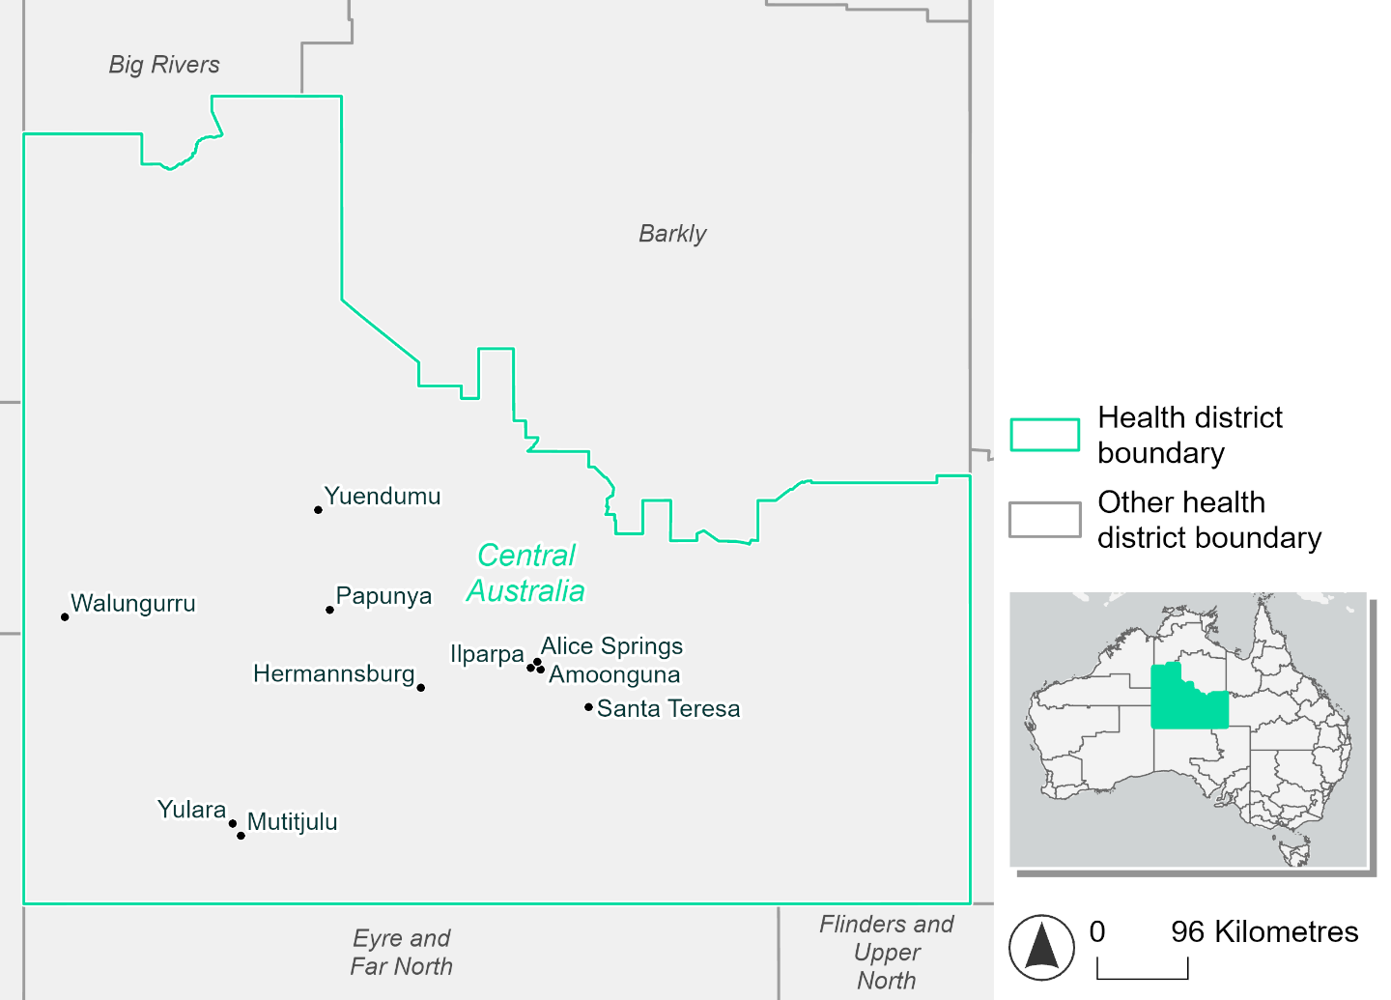
Figure 8. Map of Central Australia health district.

How will climate change affect this health district?
Heat and humidity: Higher average temperatures, hotter and more frequent hot days, warmer night time temperatures and longer and more frequent heatwaves.
Fire: 37% of this health district currently experiences a very high fire hazard category and this will slightly increase in the future.
Drought: Number of months experiencing drought will increase.
Rainfall and flood: More flood events in urban areas.
Coastal inundation: Increased area flooded during tidal and storm surge and tidal inundation.

Central Australia health district demographic data
Demographic Data | Total
Number of households | 11,078
Persons 15 and older | 29,816
Total families | 8,217
Persons did not complete high school | 12,352
One parent families with dependents | 1,211 (14.7%)
Persons aged 65 and older | 3,336 (8.3%)
Persons aged 4 and younger | 2,857 (7.1%)
Aboriginal and Torres Strait Islander persons | 12,952 (32.3%)
Persons speaks language other than English | 13,009 (32.4%)
Persons working age (15-65) | 28,353 (70.7%)
Population Health Data | Total
Persons with core needs for assistance | 1,311 (3.3%)
Persons with arthritis | 1,584 (3.9%)
Persons with asthma | 2,314 (5.8%)
Persons with cancer | 538 (1.3%)
Persons with dementia | 170 (0.4%)
Persons with diabetes | 2,353 (5.9%)
Persons with heart disease | 1,190 (3%)
Persons with kidney disease | 470 (1.2%)
Persons with lung condition | 362 (0.9%)
Persons with mental health condition | 2016 (5%)
Persons with stroke | 220 (0.5%)
Persons with any other condition | 2,358 (5.9%)
Persons no health condition | 25,895 (64.5%)
Socio-economic Data | Total
Persons providing unpaid care | 3,663 (9.1%)
Persons homeless | 2,457 (6.1%)
Household with lone person | 3,061 (27.6%)
Households with rent and mortgage stress | 2,459 (22.2%)
Households total equivalised income below $1000 (weekly) | 3,480 (31.4%)
Households with no motor vehicle | 1,580 (14.3%)
Persons unemployed | 1,805 (6.4%)

The sections that follow outline projected climate hazards for this district. Further information on this health district, including population demographics, is provided in the online dashboard.

Heat and humidity hazard
Key projections:
More heatwaves: Heatwave events are likely to last longer and the number of heatwave events per year will increase.
- By 2050, under a reasonable worst-case scenario the number of heatwaves will more than triple.
- By 2085, under a reasonable worst-case scenario the number of heatwaves per year will more than quadruple.
Hotter days and warmer nights: The maximum temperature on hot days will increase with night time temperatures on hot nights also increasing.
More days above 35°C and 40°C: The number of days per year greater than 35°C and 40°C will increase under both middle of the road and reasonable worst-case scenarios.

 | Baseline | 2050 Scenarios |  | 2085 Scenarios
 |  | Middle of the road | Reasonable worst-case | Middle of the road | Reasonable worst-case
Average temperature (°C) | 21.5 | 23.3  [22.7, 23.8] | 23.5  [22.9, 24.4] | 24.3  [23.4, 25.3] | 25.5  [24.3, 26.8]
Maximum temperature on hot days (°C)^{(a)} | 38.8 | 40.8  [40.1, 41.6] | 41  [40.3, 41.6] | 41.8  [40.7, 42.6] | 43  [41.8, 44]
Minimum temperature on hot nights (°C)^{(b)} | 24.4 | 26.4  [25.8, 27.1] | 26.6  [26.1, 27.3] | 27.5  [26.7, 28.7] | 28.8  [27.7, 30]
Average apparent temperature on hot days (°C) (NOAA Heat Index)^{(c)} | 34.9 | 36.7  [35.9, 37.1] | 37.1  [36.2, 37.7] | 38  [37.1, 38.6] | 39.5  [38, 41]
Average heatwave duration in days^{(d)} | 5 | 6  [6, 7] | 7  [6, 7] | 7  [6, 9] | 9  [7, 13]
Number of heatwaves per year^{(d)} | 2 | 6  [5, 7] | 7  [5, 8] | 9  [7, 10] | 10  [9, 10]
Number of days per year  > 35°C | 84 | 121  [97, 134] | 126  [107, 147] | 141  [121, 165] | 163  [138, 188]
Number of days per year > 40°C | 8 | 29  [20, 39] | 33  [22, 45] | 47  [29, 63] | 72  [47, 100]
Table notes: The heat and humidity hazard uses climate projections from the CMIP6 Global Climate Models [1]. Daily projections of maximum and minimum near-surface temperature and mean relative humidity are used to calculate eight heat and humidity indicators. The primary indicator value reports the median from the nine climate models, with the range reported in square brackets.
Table footnotes: (a) Based on the 95th percentile of daily maximum air temperature. (b) Based on the 95th percentile of daily minimum air temperature, representing the coldest part of the night on very hot nights. (c) The National Oceanic and Atmospheric Administration (NOAA) Heat Index is a measure of how hot it feels when relative humidity is factored in alongside actual air temperature. It is calculated on days with a maximum temperature of 27°C and above. Interpretation of Heat Index values: 27°C to 32°C indicates caution, 33°C to 41°C indicates extreme caution, 42°C to 54°C indicates danger and over 54°C indicates extreme danger. See methodology document for further explanation of Heat Index categories. (d) A heatwave is defined as three or more consecutive days where both daytime and overnight temperatures (daily mean temperatures) are unusually high for the location, based on the Bureau of Meteorology’s Excess Heat Factor method. For this district, an unusually high daily mean temperature is approximately 31.2°C or above.

Fire Hazard
Key projections:
- Very few areas currently experience low hazard: under baseline conditions, the majority of the district experiences moderate to high fire hazard (57.3% for a 1-in-20-year event and 53.3% for a 1-in-100-year event).
- Very high hazard covers 36.9% for a 1-in-20-year fire weather event and 41.1% for a 1-in-100-year event.
- Low hazard covers only 5-6% of the district during either fire weather event type.
- Current fire hazard conditions to persist: in a future climate across both 2050 and 2085 scenarios, area proportions for each of the fire hazard levels remain essentially stable, with maximum variation of 0.4 percentage points.

 | Baseline | 2050 Scenarios |  | 2085 Scenarios
 |  | Sustainability | Reasonable worst-case | Sustainability | Reasonable worst-case
Hazard for a ‘1-in-20 year’ fire weather event^{(a)}
Proportion (%) of district experiencing ‘Low’ fire hazard | 5.9%  (3,183,828)^{(b)} | 5.8%  [5.8%, 5.8%] | 5.7%  [5.3%, 5.8%] | 5.7%  [5.7%, 5.8%] | 5.5%  [4.5%, 5.8%]
Proportion (%) of district experiencing ‘Moderate to High’ fire hazard | 57.3%  (31,097,363)  ^{(b)} | 57.2%  [56.4%, 57.7%] | 57.3%  [56.7%, 57.8%] | 57.0%  [55.3%, 58.2%] | 57.3%  [55.9%, 58.6%]
Proportion (%) of district experiencing ‘Very High’ fire hazard | 36.9%  (20,026,505)  ^{(b)} | 37.1%  [36.6%, 37.4%] | 37.1%  [36.4%, 37.8%] | 37.3%  [36.2%, 38.1%] | 37.3%  [35.8%, 39.1%]
Hazard for a ‘1-in-100 year’ fire weather event^{(a)}
Proportion (%) of district experiencing ‘Low’ fire hazard | 5.6%  (3,066,302)  ^{(b)} | 5.6%  [5.6%, 5.6%] | 5.5%  [5.1%, 5.6%] | 5.5%  [5.5%, 5.6%] | 5.3%  [4.3%, 5.6%]
Proportion (%) of district experiencing ‘Moderate to High’ fire hazard | 53.3%  (28,937,973)  ^{(b)} | 53.1%  [52.1%, 53.9%] | 53.3%  [52.6%, 54.2%] | 52.9%  [50.5%, 54.8%] | 53.3%  [51.7%, 55.4%]
Proportion (%) of district experiencing ‘Very High’ fire hazard | 41.1%  (22,303,420)  ^{(b)} | 41.2%  [40.8%, 41.6%] | 41.2%  [40.4%, 42.0%] | 41.5%  [40.5%, 42.4%] | 41.4%  [39.4%, 43.3%]
Table notes: The Fire Hazard uses the National Bushfire Intelligence Capability (NBIC) Phase 2 fire line intensity modelling based on CMIP6 climate projections. Fire Hazard is assessed using the projected Fireline Intensity (FLI) for weather events with two different return intervals (i.e. a 1-in-20-year event and a 1-in-100-year event). FLI considers slope, vegetation and weather to produce a rate of heat output per unit length (kW/m) along a bushfire’s front. Fire hazard is categorized as a low for FLI<4000 kW/m, moderate to high for 4,000 kW/m ≤FLI<12,500kW/m, and very high for FLI≥27,501kW/m. This is broadly consistent with the literature [3]. The assessment considers climate change effects based on changes in fire weather and the associated hazard that is anticipated for a meteorological event of a given return interval. This approach is different to the one adopted for the Flood Hazard, where the event magnitude is given (fixed) and the likelihood of that event varies as a result of climate change. The primary indicator value reports the median from the nine climate models, with the range reported in square brackets.
Table footnotes: (a) The area subject to different categories of fire hazard is determined for a ‘1-in-20 year’ and ‘1-in-100 year’ fire weather event, in current and future climates. Values at year 2050 are interpolated using data from baseline (2025) and 2085, assuming linear change over time. (b) Values in round brackets are the area (ha) of the health district subject to a given fire hazard.

The figures below show the proportion of the health district experiencing different fire hazard categories across different time horizons and climate scenarios during a ‘1-in-20 year’ fire weather event (Figure 9) and a ‘1-in-100 year’ fire weather event (Figure 10).

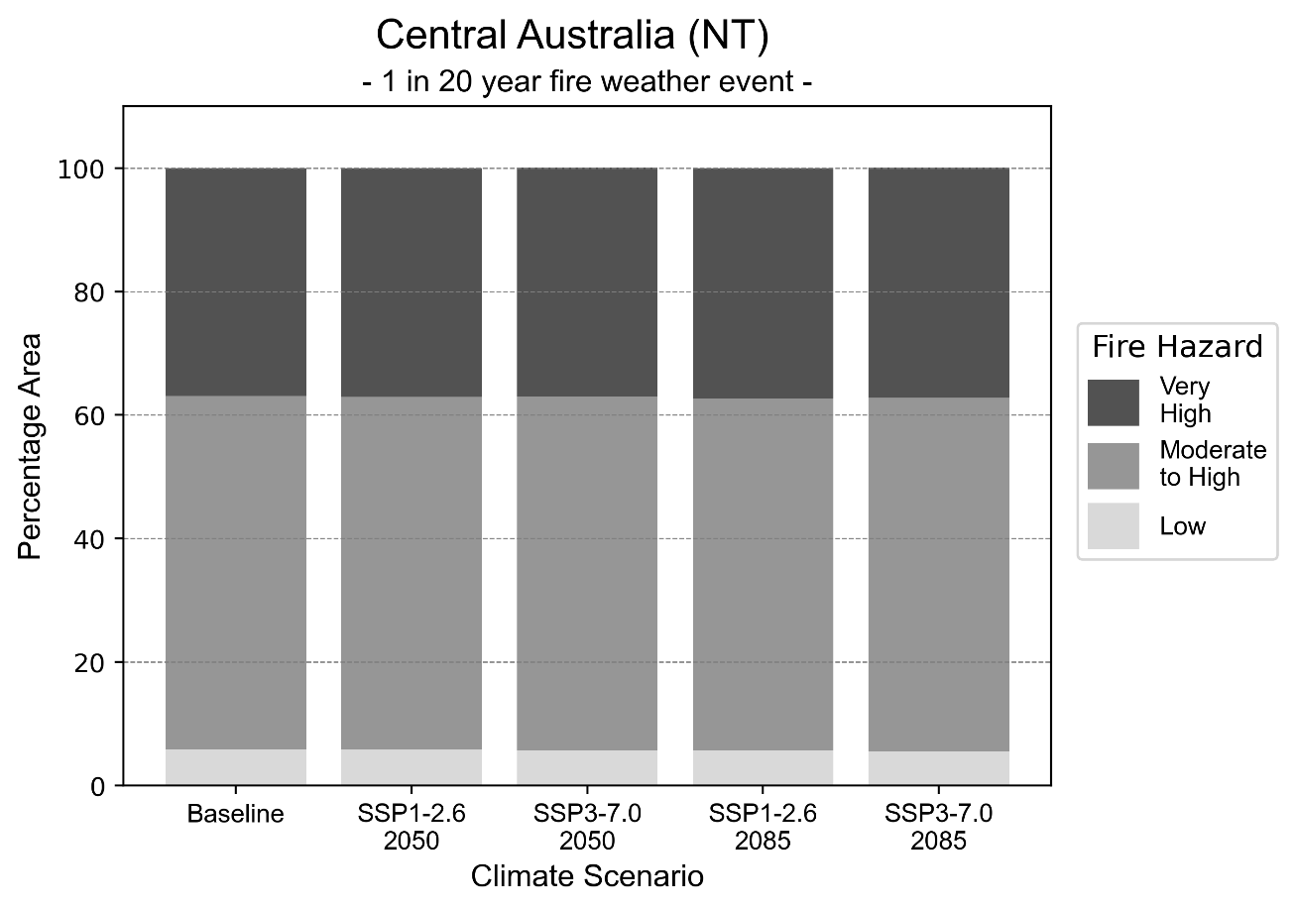
Figure 9: Stacked column chart showing the percentages of Central Australia health district's total geographic area experiencing each fire hazard level during a 1-in-20-year fire weather event.
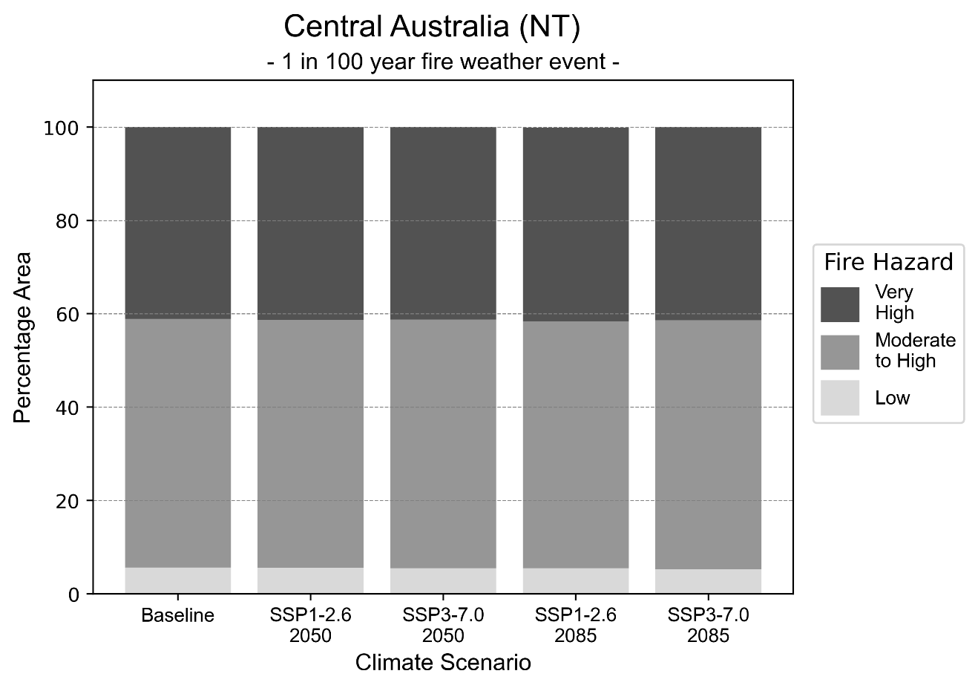
Figure 10: Stacked column chart showing the percentages of Central Australia health district's total geographic area experiencing each fire hazard level during a 1-in-100-year fire weather event.

Drought hazard
Key projections:
Drought occurrence: The occurrence of drought will increase across both middle of the road and reasonable worst-case scenarios and both time horizons, with drought being experienced on average two months per year.

 | Baseline | 2050 Scenarios |  | 2085 Scenarios
 |  | Middle of the road | Reasonable worst-case | Middle of the road | Reasonable worst-case
Number of months per year in drought^{(a)} | 1.6 | 2.3  [0.2, 4.6] | 1.9  [0.3, 4.6] | 2.3  [0.2, 4.4] | 2.5  [0.0, 6.3]
Table notes: The drought hazard indicator uses climate projections from the CMIP6 Global Climate Models [1]. The primary indicator value reports the median from the nine climate models, with the range reported in square brackets.
Table footnotes:(a) The number of months per year in drought is based on the Standardised Precipitation Index (SPI). SPI is a widely used index to characterise meteorological drought on a range of timescales. This indicator uses the timescale of 12 months which calculates the average months in a year within the moderate drought range. A moderate drought range is classified as SPI score of ≤ -1. SPI is calculated from accumulated rainfall over 12 months and the mean and standard deviation from historical rainfall records.

Storm hazard
Key projections:
More frequent high-intensity storms: The frequency of high-intensity storms will increase across both middle of the road and reasonable worst-case scenarios with the greatest increase occurring by 2050 under the middle of the road scenario.

 | Baseline | 2050 Scenarios |  | 2085 Scenarios
 |  | Middle of the road | Reasonable worst-case | Middle of the road | Reasonable worst-case
Number of low-intensity storms (40-62 km/hr) per year | 88.6 | 90.0  [79.2, 99.0] | 89.0  [78.3, 97.9] | 83.0  [73.0, 91.3] | 86.7  [76.3, 95.4]
Number of medium-intensity storms (63-87 km/hr) per year | 63.6 | 61.7  [54.3, 67.9] | 59.8  [52.6, 65.8] | 57.2  [50.4, 63.0] | 60.9  [53.6, 67.0]
Number of high-intensity storms (88-117 km/hr) per year | 30.3 | 33.6  [29.6, 37.0] | 33.3  [29.3, 36.7] | 32.7  [28.8, 36.0] | 32.9  [29.0, 36.2]
Number of very-high-intensity storm (> 117 km/hr) per year | 0.6 | 0.6  [0.6, 0.7] | 0.7  [0.6, 0.8] | 0.6  [0.5, 0.6] | 0.7  [0.6, 0.8]
Table notes: The storm hazard uses climate projections from the CMIP6 Global Climate Models [1]. Daily maximum surface wind speed is used to calculate the number of annual storms across four storm intensity categories (low, medium, high and very high). The primary indicator value reports the median from the nine climate models, with the range reported in square brackets.

Rainfall and flood hazard
Key projections:
- 12 extreme rainfall days per year: The number of extreme rainfall days will remain consistent across both middle of the road and reasonable worst-case scenarios and both time horizons, with an average of approximately 12 extreme rainfall days per year.
- Increased flood frequency: The frequency of flood events will increase in urban environments but decrease in rural environments.
- The largest increase in flood frequency is seen in the reasonable worst-case scenario where frequency of a ‘1-in-100 year’ flood will triple by 2050 and become seven times more likely by 2085 in urban environments.
- In rural environments, frequency of a ‘1-in-1 year’ flood will slightly decrease across both 2050 and 2085 scenarios, whereas the frequency of a ‘1-in-10 year’ and a ‘1-in-100 year’ flood will slightly increase under 2050 scenarios and slightly decrease across 2085 scenarios.

 | Baseline | 2050 Scenarios |  | 2085 Scenarios
 |  | Middle of the road | Reasonable worst-case | Middle of the road | Reasonable worst-case
Rainfall hazard^{(a)}
Average no. of extreme rainfall days per year (> 5 mm/day)^{(a)} | 12.6 | 12.1  [9.1,17.1] | 12.5  [9.0,17.0] | 12.1  [9.2,17.4] | 12.1  [7.8,21.9]
Urban flood risk (flooding caused by a 1-hour rainfall event)^{(b)}
Frequency of a ‘1-in-1 year’ flood (rainfall depth of 19 mm)^{(c)} |  | 1.7 events in 1 year | 1.7 events in 1 year | 2.1 events in 1 year | 2.6 events in 1 year
Frequency of a ‘1-in-10 year’ flood (rainfall depth of 44 mm)^{(c)} |  | 2.1 events in 10 years | 2.2 events in 10 years | 2.7 events in 10 years | 3.8 events in 10 years
Frequency of a ‘1-in-100 year’ flood (rainfall depth of 78 mm)^{(c)} |  | 2.8 events in 100 years | 3.0 events in 100 years | 4.2 events in 100 years | 7.0 events in 100 years
Rural flood risk (flooding caused by a 24-hour rainfall event) ^{(b)}
Frequency of a ‘1-in-1 year’ flood (rainfall depth of 46 mm)^{(c)} |  | 0.9 events in 1 year | 0.8 events in 1 year | 0.9 events in 1 year | 0.5 events in 1 year
Frequency of a ‘1-in-10 year’ flood (rainfall depth of 105 mm)^{(c)} |  | 1.1 events in 10 years | 1.0 events in 10 years | 0.7 events in 10 years | 0.3 events in 10 years
Frequency of a ‘1-in-100 year’ flood (rainfall depth of 187 mm)^{(c)} |  | 1.2 events in 100 years | 1.2 events in 100 years | 1.0 events in 100 years | 0.6 events in 100 years
Table notes: The rainfall hazard indicator uses climate projections from the CMIP6 Global Climate Models [1]. The flood hazard indicators use climate change considerations from the Australian Rainfall and Runoff guideline to estimate the climate the climate projections [2]. The primary indicator value reports the median from the nine climate models, with the range reported in square brackets.
Table footnotes: (a) Extreme rainfall is defined as rainfall above the 95th percentile of historical average daily rainfall in this health district in the period 1985-2014. The value in mm/day quoted in the indicator name is the 95th percentile of historic average daily rainfall for this health district. (b) See Methodology document for reasons for focusing on a 1-hour flood for urban areas and a 24-hour flood for rural areas. (c) The rainfall depths in mm quoted in the indicator names in this table report 1 in 1-, 10- and 100-year depths for this health district.

East Arnhem health district

Health district overview
Surface area: 33,331 square kilometres
Estimated population: 14,525
- Local health services: East Arnhem is serviced by one private general practice and three Aboriginal Community Controlled Health Services – Mitwatj Health Aboriginal Corporation, Laynhapuy Homelands Aboriginal Corporation, and Marthakal Homelands Health Service. Gove District Hospital services the region with 30 beds, providing emergency services, surgical and medical care, paediatrics and obstetrics.

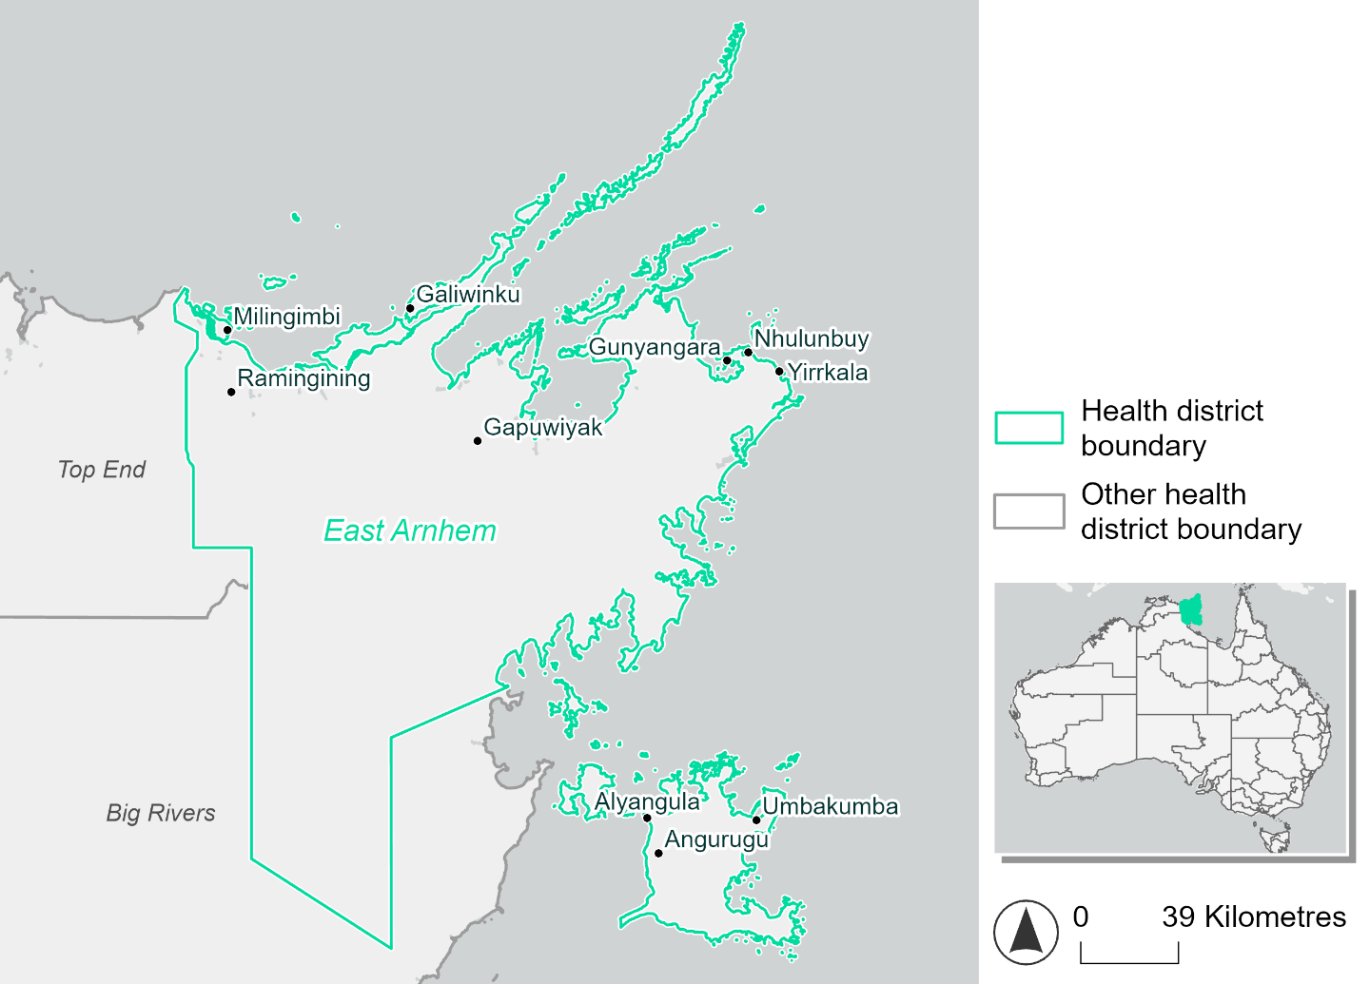
Figure 11. Map of East Arnhem health district

How will climate change affect this health district?
Heat and humidity: Higher average temperatures, hotter and more frequent hot days, warmer night time temperatures and longer and more frequent heatwaves.
Fire: Over 80% of this health district experiences a low fire hazard category and this will continue in the future.
Drought: Number of months experiencing drought will increase.
Rainfall and flood: More flood events in urban and rural environments.
Coastal inundation: Increased area flooded during tidal and storm surge and tidal inundation.

East Arnhem health district demographic data
Demographic Data | Total
Number of households | 2,507
Persons 15 and older | 10,815
Total families | 2,735
Persons did not complete high school | 5,489
One parent families with dependents | 480 (17.6%)
Persons aged 65 and older | 569 (3.9%)
Persons aged 4 and younger | 1,058 (7.2%)
Aboriginal and Torres Strait Islander persons | 8,234 (56.4%)
Persons speaks language other than English | 8,227 (56.3%)
Persons working age (15-65) | 10,501 (71.9%)
Population Health Data | Total
Persons with core needs for assistance | 424 (2.9%)
Persons with arthritis | 190 (1.3%)
Persons with asthma | 544 (3.7%)
Persons with cancer | 88 (0.6%)
Persons with dementia | 16 (0.1%)
Persons with diabetes | 491 (3.4%)
Persons with heart disease | 671 (4.6%)
Persons with kidney disease | 140 (1.0%)
Persons with lung condition | 96 (0.7%)
Persons with mental health condition | 431 (3%)
Persons with stroke | 28 (0.2%)
Persons with any other condition | 717 (4.9%)
Persons no health condition | 10,080 (69%)
Socio-economic Data | Total
Persons providing unpaid care | 2,072 (14.2%)
Persons homeless | 2,918 (20%)
Household with lone person | 389 (15.5%)
Households with rent and mortgage stress | 270 (10.8%)
Households total equivalised income below $1000 (weekly) | 104 (4.2%)
Households with no motor vehicle | 763 (30.4%)
Persons unemployed | 1,726 (17.9%)

The sections that follow outline projected climate hazards for this district. Further information on this health district, including population demographics, is provided in the online dashboard.

Heat and humidity hazard
Key projections:
More heatwaves: Heatwave events are likely to last longer and the number of heatwave events per year will increase.
- By 2050, under a reasonable worst-case scenario the number of heatwaves will more than triple.
- By 2085, under a reasonable worst-case scenario the number of heatwaves per year will more than quadruple.
Hotter days and warmer nights: The maximum temperature on hot days will increase with night time temperatures on hot nights also increasing.
More days above 35°C and 40°C: The number of days per year greater than 35°C and 40°C will increase under both middle of the road and reasonable worst-case scenarios.

 | Baseline | 2050 Scenarios |  | 2085 Scenarios
 |  | Middle of the road | Reasonable worst-case | Middle of the road | Reasonable worst-case
Average temperature (°C) | 27 | 28.3  [27.8, 28.9] | 28.5  [28.1, 29.1] | 29  [28.4, 29.7] | 29.9  [29.1, 30.6]
Maximum temperature on hot days (°C)^{(a)} | 35.8 | 37.2  [36.6, 37.6] | 37.4  [36.9, 37.8] | 37.8  [36.9, 38.3] | 38.7  [37.8, 39.4]
Minimum temperature on hot nights (°C)^{(b)} | 26.5 | 27.9  [27.2, 28.3] | 28.1  [27.5, 28.5] | 28.6  [27.8, 29.1] | 29.5  [28.7, 30.3]
Average apparent temperature on hot days (°C) (NOAA Heat Index)^{(c)} | 41.9 | 46.1  [44.4, 47.8] | 46.6  [45.1, 48.5] | 48.4  [46.2, 50.6] | 51.5  [48.6, 54.3]
Average heatwave duration in days^{(d)} | 6 | 9  [7, 10] | 9  [8, 11] | 12  [9, 15] | 18  [12, 30]
Number of heatwaves per year^{(d)} | 2 | 6  [4, 8] | 7  [5, 9] | 8  [6, 10] | 9  [8, 10]
Number of days per year  > 35°C | 45 | 93  [67, 114] | 99  [75, 124] | 123  [84, 152] | 162  [116, 202]
Number of days per year > 40°C | 1 | 4  [2, 5] | 4  [3, 7] | 6  [3, 8] | 12  [4, 18]
Table notes: The heat and humidity hazard uses climate projections from the CMIP6 Global Climate Models [1]. Daily projections of maximum and minimum near-surface temperature and mean relative humidity are used to calculate eight heat and humidity indicators. The primary indicator value reports the median from the nine climate models, with the range reported in square brackets.
Table footnotes: (a) Based on the 95th percentile of daily maximum air temperature. (b) Based on the 95th percentile of daily minimum air temperature, representing the coldest part of the night on very hot nights. (c) The National Oceanic and Atmospheric Administration (NOAA) Heat Index is a measure of how hot it feels when relative humidity is factored in alongside actual air temperature. It is calculated on days with a maximum temperature of 27°C and above. Interpretation of Heat Index values: 27°C to 32°C indicates caution, 33°C to 41°C indicates extreme caution, 42°C to 54°C indicates danger and over 54°C indicates extreme danger. See methodology document for further explanation of Heat Index categories. (d) A heatwave is defined as three or more consecutive days where both daytime and overnight temperatures (daily mean temperatures) are unusually high for the location, based on the Bureau of Meteorology’s Excess Heat Factor method. For this district, an unusually high daily mean temperature is approximately 30.6°C or above.

Fire Hazard
Key projections:
- Most of district area currently experiences low hazard: under baseline conditions, 82.8% of the district experiences low fire hazard during a 1-in-20-year fire weather event. For a 1-in-100-year fire weather event, the proportion experiencing low hazard is still high at 80.9%. Only about 3% of the district experiences ‘very high’ hazard.
- Small increase in moderate to high hazard: in a future climate across both 2050 and 2085 scenarios the area experiencing low hazard declines modestly by up to 4.2 percentage points.
- The area experiencing moderate to high hazard will increase by a similar amount, to as high as 16.9% for a 1-in-20-year fire weather event and 20.3% for a 1-in-100-year event.
- The area experiencing very high hazard is expected to remain stable at about 3%.

 | Baseline | 2050 Scenarios |  | 2085 Scenarios
 |  | Sustainability | Reasonable worst-case | Sustainability | Reasonable worst-case
Hazard for a ‘1-in-20 year’ fire weather event^{(a)}
Proportion (%) of district experiencing ‘Low’ fire hazard | 82.8%  (2,760,321)^{(b)} | 81.8%  [79.7%, 82.6%] | 81.7%  [80.5%, 82.5%] | 80.4%  [75.4%, 82.4%] | 80.1%  [77.3%, 82.0%]
Proportion (%) of district experiencing ‘Moderate to High’ fire hazard | 14.3%  (476,831)^{(b)} | 15.3%  [14.5%, 17.5%] | 15.4%  [14.7%, 16.9%] | 16.7%  [14.8%, 21.9%] | 16.9%  [15.3%, 20.5%]
Proportion (%) of district experiencing ‘Very High’ fire hazard | 2.9%  (95,973)^{(b)} | 2.9%  [2.8%,  2.9%] | 2.9%  [2.8%,  3.1%] | 2.9%  [2.8%,  3.0%] | 2.9%  [2.7%,  3.3%]
Hazard for a ‘1-in-100 year’ fire weather event^{(a)}
Proportion (%) of district experiencing ‘Low’ fire hazard | 80.9%  (2,696,177)^{(b)} | 79.3%  [75.7%, 80.6%] | 79.1%  [76.9%, 80.2%] | 77.0%  [68.4%, 80.3%] | 76.7%  [71.2%, 79.2%]
Proportion (%) of district experiencing ‘Moderate to High’ fire hazard | 16.0%  (534,922)^{(b)} | 17.7%  [16.4%, 21.3%] | 17.8%  [16.8%, 20.4%] | 20.0%  [16.8%, 28.7%] | 20.3%  [17.9%, 26.5%]
Proportion (%) of district experiencing ‘Very High’ fire hazard | 3.1%  (102,027)^{(b)} | 3.0%  [3.0%, 3.1%] | 3.1%  [3.0%, 3.2%] | 3.0%  [3.0%, 3.2%] | 3.1%  [2.9%, 3.5%]
Table notes: The Fire Hazard uses the National Bushfire Intelligence Capability (NBIC) Phase 2 fire line intensity modelling based on CMIP6 climate projections. Fire Hazard is assessed using the projected Fireline Intensity (FLI) for weather events with two different return intervals (i.e. a 1-in-20-year event and a 1-in-100-year event). FLI considers slope, vegetation and weather to produce a rate of heat output per unit length (kW/m) along a bushfire’s front. Fire hazard is categorized as a low for FLI<4000 kW/m, moderate to high for 4,000 kW/m ≤FLI<12,500kW/m, and very high for FLI≥27,501kW/m. This is broadly consistent with the literature [3]. The assessment considers climate change effects based on changes in fire weather and the associated hazard that is anticipated for a meteorological event of a given return interval. This approach is different to the one adopted for the Flood Hazard, where the event magnitude is given (fixed) and the likelihood of that event varies as a result of climate change. The primary indicator value reports the median from the nine climate models, with the range reported in square brackets.
Table footnotes: (a) The area subject to different categories of fire hazard is determined for a ‘1-in-20 year’ and ‘1-in-100 year’ fire weather event, in current and future climates. Values at year 2050 are interpolated using data from baseline (2025) and 2085, assuming linear change over time. (b) Values in round brackets are the area (ha) of the health district subject to a given fire hazard.

The figures below show the proportion of the health district experiencing different fire hazard categories across different time horizons and climate scenarios during a ‘1-in-20 year’ fire weather event (Figure 12) and a ‘1-in-100 year’ fire weather event (Figure 13).

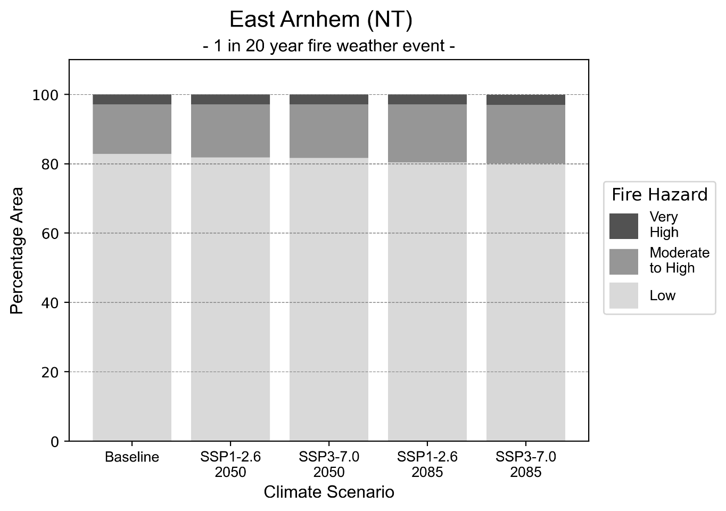
Figure 12: Stacked column chart showing the percentages of East Arnhem health district's total geographic area experiencing each fire hazard level during a 1-in-20-year fire weather event.
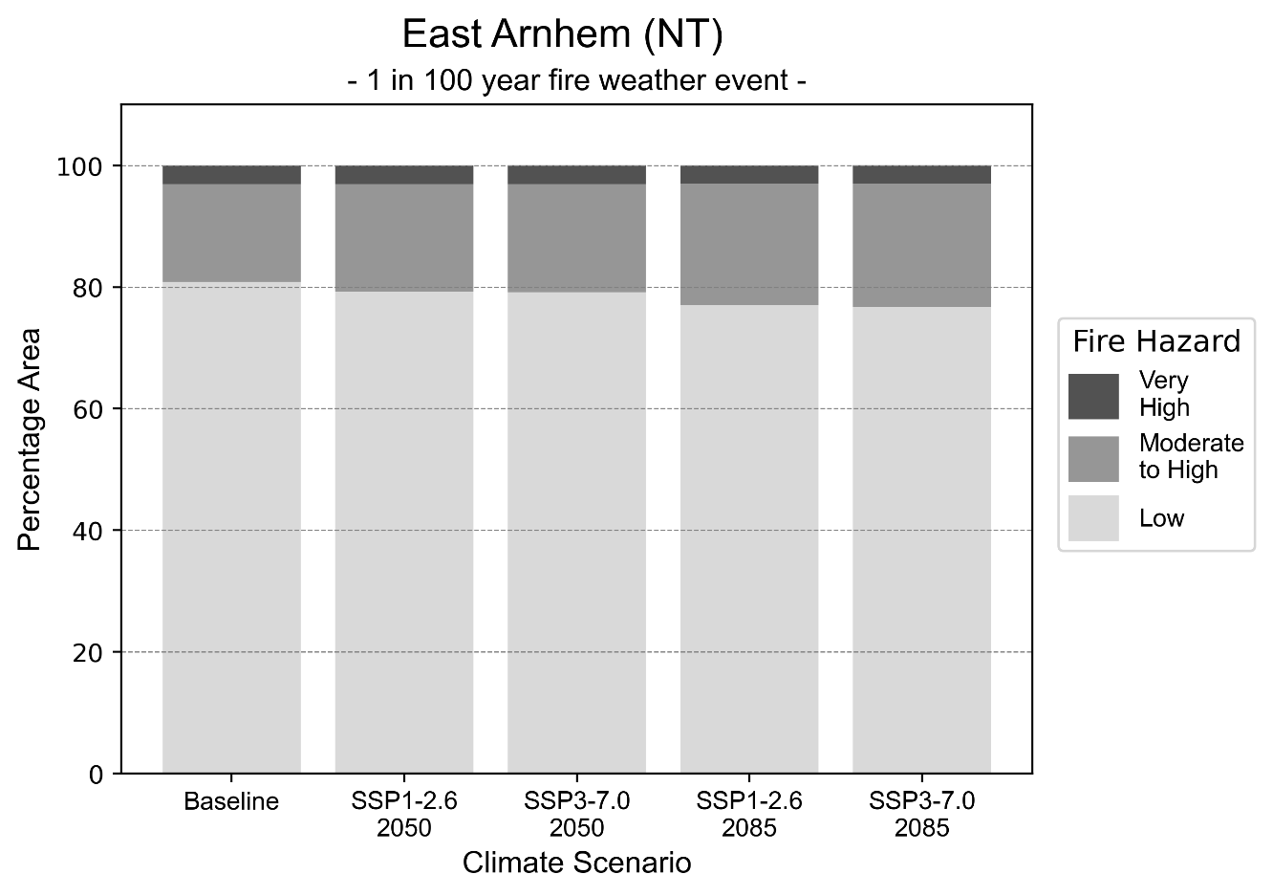
Figure 13: Stacked column chart showing the percentages of East Arnhem health district's total geographic area experiencing each fire hazard level during a 1-in-100-year fire weather event.

Drought hazard
Key projections:
Drought occurrence: The occurrence of drought will increase across both middle of the road and reasonable worst-case scenarios and both time horizons, with drought being experienced on average two to three months per year.

 | Baseline | 2050 Scenarios |  | 2085 Scenarios
 |  | Middle of the road | Reasonable worst-case | Middle of the road | Reasonable worst-case
Number of months per year in drought^{(a)} | 1.8 | 2.5  [0.3, 4.2] | 2.1  [0.5, 4.0] | 3.0  [0.5, 4.8] | 3.0  [0.3, 6.1]
Table notes: The drought hazard indicator uses climate projections from the CMIP6 Global Climate Models [1]. The primary indicator value reports the median from the nine climate models, with the range reported in square brackets.
Table footnotes: (a) The number of months per year in drought is based on the Standardised Precipitation Index (SPI). SPI is a widely used index to characterise meteorological drought on a range of timescales. This indicator uses the timescale of 12 months which calculates the average months in a year within the moderate drought range. A moderate drought range is classified as SPI score of ≤ -1. SPI is calculated from accumulated rainfall over 12 months and the mean and standard deviation from historical rainfall records.

Storm hazard
Key projections:
More frequent high and very-high-intensity storms under reasonable worst-case scenario: The frequency of high and very-high-intensity storms will remain consistent across the middle of the road scenario for both time horizons, but will increase across reasonable worst-case scenarios for both time horizons.

 | Baseline | 2050 Scenarios |  | 2085 Scenarios
 |  | Middle of the road | Reasonable worst-case | Middle of the road | Reasonable worst-case
Number of low-intensity storms (40-62 km/hr) per year | 105.5 | 106.7  [93.9, 117.4] | 105.0  [92.4, 115.5] | 106.8  [94.0, 117.5] | 108.2  [95.2, 119.0]
Number of medium-intensity storms (63-87 km/hr) per year | 52.8 | 48.8  [42.9, 53.7] | 49.3  [43.4, 54.2] | 50.5  [44.5, 55.6] | 44.5  [39.1, 48.9]
Number of high-intensity storms (88-117 km/hr) per year | 20.3 | 20.0  [17.6, 22.0] | 22.1  [19.4, 24.3] | 20.9  [18.4, 23.0] | 21.7  [19.1, 23.8]
Number of very-high-intensity storm(> 117 km/hr) per year | 0.9 | 0.8  [0.7, 0.9] | 1.3  [1.1, 1.4] | 0.9  [0.8, 1.0] | 1.4  [1.2, 1.5]
Table notes: The storm hazard uses climate projections from the CMIP6 Global Climate Models [1]. Daily maximum surface wind speed is used to calculate the number of annual storms across four storm intensity categories (low, medium, high and very high). The primary indicator value reports the median from the nine climate models, with the range reported in square brackets.

Rainfall and flood hazard
Key projections:
- Seven extreme rainfall days per year: The number of extreme rainfall days will remain consistent across both middle of the road and reasonable worst-case scenarios and both time horizons, with an average of approximately seven extreme rainfall days per year.
- Increased flood frequency: The frequency of flood events will increase in urban and rural environments. The largest increase in flood frequency is seen in the reasonable worst-case scenario where frequency of a ‘1-in-100 year’ flood will become eight times more likely by 2050 and become 29 times more likely by 2085 in urban environments.

 | Baseline | 2050 Scenarios |  | 2085 Scenarios
 |  | Middle of the road | Reasonable worst-case | Middle of the road | Reasonable worst-case
Rainfall hazard^{(a)}
Average number of extreme rainfall days per year (> 14 mm/day)^{(a)} | 7.0 | 7.0  [5.1,12.9] | 7.2  [5.6,12.2] | 6.5  [5.1,11.4] | 6.8  [4.8,12.6]
Urban flood risk (flooding caused by a 1-hour rainfall event)^{(b)}
Frequency of a ‘1-in-1 year’ flood (rainfall depth of 48 mm)^{(c)} |  | 2.1 events in 1 year | 2.2 events in 1 year | 2.7 events in 1 year | 3.5 events in 1 year
Frequency of a ‘1-in-10 year’ flood (rainfall depth of 77 mm)^{(c)} |  | 4.1 events in 10 years | 4.4 events in 10 years | 6.1 events in 10 years | 9.3 events in 10 years
Frequency of a ‘1-in-100 year’ flood (rainfall depth of 103 mm)^{(c)} |  | 7.6 events in 100 years | 8.5 events in 100 years | 14 events in 100 years | 29 events in 100 years
Rural flood risk (flooding caused by a 24-hour rainfall event) ^{(b)}
Frequency of a ‘1-in-1 year’ flood (rainfall depth of 103 mm)^{(c)} |  | 1.1 events in 1 year | 1.1 events in 1 year | 1.1 events in 1 year | 0.9 events in 1 year
Frequency of a ‘1-in-10 year’ flood (rainfall depth of 218 mm)^{(c)} |  | 1.5 events in 10 years | 1.5 events in 10 years | 1.5 events in 10 years | 1.5 events in 10 years
Frequency of a ‘1-in-100 year’ flood (rainfall depth of 375 mm)^{(c)} |  | 1.6 events in 100 years | 1.7 events in 100 years | 1.8 events in 100 years | 2.0 events in 100 years
Table notes: The rainfall hazard indicator uses climate projections from the CMIP6 Global Climate Models [1]. The flood hazard indicators use climate change considerations from the Australian Rainfall and Runoff guideline to estimate the climate the climate projections [2]. The primary indicator value reports the median from the nine climate models, with the range reported in square brackets.
Table footnotes:(a) Extreme rainfall is defined as rainfall above the 95th percentile of historical average daily rainfall in this health district in the period 1985-2014. The value in mm/day quoted in the indicator name is the 95th percentile of historic average daily rainfall for this health district. (b) See Methodology document for reasons for focusing on a 1-hour flood for urban areas and a 24-hour flood for rural areas. (c) The rainfall depths in mm quoted in the indicator names in this table report 1 in 1-, 10- and 100-year depths for this health district.

Coastal inundation hazard
Key projections:
Greater area inundated: There will be an increase in the area affected by tidal inundation (i.e. area submerged during high tide) and storm surge and tidal inundation (i.e. the area submerged during a storm surge and high tide) across both middle of the road and reasonable worst-case scenarios. In the reasonable worst-case scenario, by 2085 the area inundated during a ‘1-in-1000-year’ event will increase by nearly 50,000 ha.

 | Baseline | 2050 Scenarios |  | 2085 Scenarios^{(a)}
 |  | Middle of the road | Reasonable worst-case | Middle of the road | Reasonable worst-case
Tidal inundation (ha inundated)^{(b)} | 88,994.4 | 100,051.8  (+11,057.4) | 100,823.2  (+11,828.8) | 119,099.3  (+30,104.9) | 125,466.7  (+36,472.3)
Storm surge + tidal inundation – ‘1-in-100 year’ event (ha inundated)^{(c)} | 181,910.6 | 196,424.4  (+14,513.8) | 197,566.9  (+15,656.3) | 222,706.9  (+40,796.3) | 230,944.1  (+49,033.5)
Storm surge + tidal inundation – ‘1-in-1000 year’ event (ha inundated)^{(c)} | 259,800.0 | 272,372.5  (+12,572.6) | 273,335.3  (+13,535.3) | 301,398.9  (+41,599.0) | 309,054.8  (+49,254.8)
Table notes: The coastal inundation hazard provides an indication of flooding in coastal areas that can be attributed to sea level rise and storm inundation. The coastal inundation hazard is only reported for health districts adjoining the coastline. This table includes the projected inundation levels as well as the change from baseline conditions (in brackets).
Table footnotes: (a) For the 2085 Scenarios planning horizon, 2100 was adopted as it provides a conservative representation of the end of this period. This horizon aligns with many State planning regulations requiring consideration of sea level rise and storm tide to 2100, making the 2100 scenario particularly valuable for planning new health facilities in coastal areas. (b) The tidal inundation indicator reports the number of hectares inundated during high tide. The baseline value reports existing inundation patterns, while the 2050 and 2085 values report high tide inundation taking account of projected sea level rise due to climate change. (c) The storm surge + tidal inundation indicators report the combined effect, in hectares inundated, of high tide, sea level rise (for the 2050 and 2085 projections), and storm surge (for 1-in-100 year and 1-in-1000 year events).

Top End health district

Health district overview
Surface area: 103,987 square kilometres
Estimated population: 101,700
Local health services: Darwin is serviced by twenty-four private general practices and one Aboriginal Community Controlled Health Service, Danila Dilba Health Service, with five clinics in this region. Royal Darwin Hospital has 360 beds and provides a large range of services in all speciality areas. Co-located is Darwin Private Hospital, a 104-bed facility with specialised private services. There are two ACCHS in the region – Mala’la Health Service Aboriginal Corporation (Maningrida), and Peppimenarti Health Association. The Top End Health Service (NT Department of Health) operates a number of Aboriginal Medical Services (AMS) clinics throughout the region, including on the Tiwi Islands. There is no hospital within this region, therefore residents are required to travel to Katherine or Darwin for hospital services.

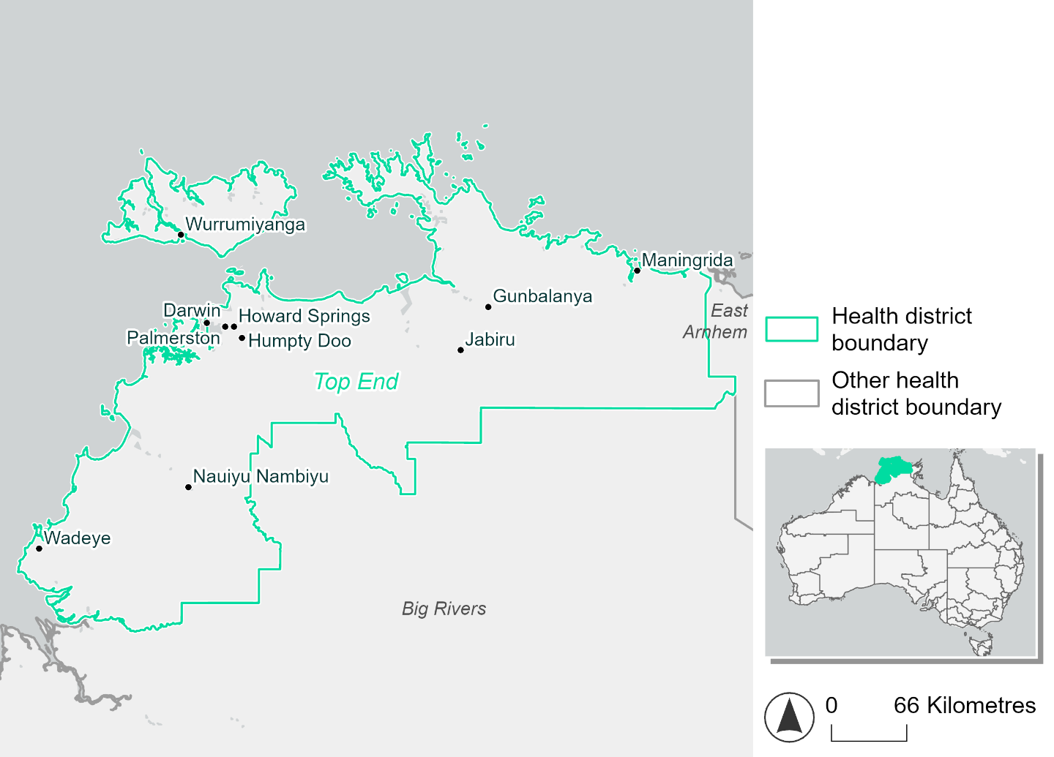
Figure 14. Map of Top End health district.

How will climate change affect this health district?
Heat and humidity: Higher average temperatures, hotter and more frequent hot days, warmer night time temperatures and longer and more frequent heatwaves.
Fire: Nearly 30% of this health district currently experiences a moderate to high fire hazard category and this will increase under a reasonable worst-case scenario.
Drought: Number of months experiencing drought will increase.
Rainfall and flood: More flood events in urban areas.
Coastal inundation: Increased area flooded during tidal and storm surge and tidal inundation.

Top End health district demographic data
Demographic Data | Total
Number of households | 50,920
Persons 15 and older | 122,609
Total families | 3,8213
Persons did not complete high school | 41,670
One parent families with dependents | 4,435 (11.6%)
Persons aged 65 and older | 16,431 (9.9%)
Persons aged 4 and younger | 11,261 (6.8%)
Aboriginal and Torres Strait Islander persons | 25,154 (15.1%)
Persons speaks language other than English | 42,864 (24.7%)
Persons working age (15-65) | 116,393 (69.8%)
Population Health Data | Total
Persons with core needs for assistance | 5,673 (3.4%)
Persons with arthritis | 8,410 (5%)
Persons with asthma | 9,859 (5.9%)
Persons with cancer | 2,907 (1.7%)
Persons with dementia | 505 (0.3%)
Persons with diabetes | 6,184 (3.7%)
Persons with heart disease | 4,483 (2.7%)
Persons with kidney disease | 1,267 (0.8%)
Persons with lung condition | 2,020 (1.2%)
Persons with mental health condition | 9,243 (5.5%)
Persons with stroke | 865 (0.5%)
Persons with any other condition | 10,706 (6.4%)
Persons no health condition | 107,765 (64.6%)
Socio-economic Data | Total
Persons providing unpaid care | 15,454 (9.3%)
Persons homeless | 4,699 (2.8%)
Household with lone person | 11,870 (23.3%)
Households with rent and mortgage stress | 15,561 (30.6%)
Households total equivalised income below $1000 (weekly) | 14,089 (27.7%)
Households with no motor vehicle | 3,942 (7.7%)
Persons unemployed | 6,936 (5.6%)

The sections that follow outline projected climate hazards for this district. Further information on this health district, including population demographics, is provided in the online dashboard.

Heat and humidity hazard
Key projections:
More heatwaves: Heatwave events are likely to last longer and the number of heatwave events per year will increase. By 2050, under a reasonable worst-case scenario the number of heatwaves will more than quadruple. By 2085, under a reasonable worst-case scenario the number of heatwaves per year will more than quadruple.
Hotter days and warmer nights: The maximum temperature on hot days will increase with night time temperatures on hot nights also increasing.
More days above 35°C and 40°C: The number of days per year greater than 35°C and 40°C will increase under both middle of the road and reasonable worst-case scenarios.

 | Baseline | 2050 Scenarios |  | 2085 Scenarios
 |  | Middle of the road | Reasonable worst-case | Middle of the road | Reasonable worst-case
Average temperature (°C) | 27.7 | 29.2  [28.6, 29.7] | 29.4  [28.8, 30.1] | 29.9  [29.1, 30.7] | 30.8  [29.9, 31.7]
Maximum temperature on hot days (°C)^{(a)} | 35.7 | 37.2  [36.5, 37.9] | 37.4  [36.7, 38.1] | 37.9  [36.8, 38.4] | 38.9  [37.6, 39.6]
Minimum temperature on hot nights (°C)^{(b)} | 27.5 | 28.9  [28.3, 29.2] | 29.1  [28.6, 29.6] | 29.6  [28.8, 30.1] | 30.5  [29.7, 31.1]
Average apparent temperature on hot days (°C) (NOAA Heat Index)^{(c)} | 42.8 | 47.3  [45.5, 48.9] | 47.8  [46.2, 50] | 49.8  [47.6, 52] | 53  [49.9, 55.7]
Average heatwave duration in days^{(d)} | 6 | 12  [9, 15] | 13  [10, 19] | 20  [11, 34] | 31  [17, 47]
Number of heatwaves per year^{(d)} | 2 | 8  [6, 10] | 9  [7, 10] | 9  [8, 10] | 9  [7, 10]
Number of days per year  > 35°C | 115 | 143  [125, 162] | 143  [117, 171] | 165  [131, 195] | 196  [155, 229]
Number of days per year > 40°C | 1 | 8  [4, 15] | 11  [5, 20] | 18  [5, 28] | 41  [14, 65]
Table notes: The heat and humidity hazard uses climate projections from the CMIP6 Global Climate Models [1]. Daily projections of maximum and minimum near-surface temperature and mean relative humidity are used to calculate eight heat and humidity indicators. The primary indicator value reports the median from the nine climate models, with the range reported in square brackets.
Table footnotes:(a) Based on the 95th percentile of daily maximum air temperature. (b) Based on the 95th percentile of daily minimum air temperature, representing the coldest part of the night on very hot nights. (c) The National Oceanic and Atmospheric Administration (NOAA) Heat Index is a measure of how hot it feels when relative humidity is factored in alongside actual air temperature. It is calculated on days with a maximum temperature of 27°C and above. Interpretation of Heat Index values: 27°C to 32°C indicates caution, 33°C to 41°C indicates extreme caution, 42°C to 54°C indicates danger and over 54°C indicates extreme danger. See methodology document for further explanation of Heat Index categories. (d) A heatwave is defined as three or more consecutive days where both daytime and overnight temperatures (daily mean temperatures) are unusually high for the location, based on the Bureau of Meteorology’s Excess Heat Factor method. For this district, an unusually high daily mean temperature is approximately 30.1°C or above.

Fire Hazard
Key projections:
- Majority of district area currently experiences low hazard: under baseline conditions 68.0% of the district experiences low fire hazard during a 1-in-20-year fire weather event, and 62% during a 1-in-100-year event. Most of the remaining area (28-34%) experiences moderate to high hazard with less than 4% affected by very high hazard during 1-in-20-year and 1-in-100-year fire weather events.
- Moderate to high hazard increases under higher emissions: in a future climate by 2050, in a sustainability scenario a small portion of the district (up to 1%) will decrease from moderate to high hazard, to low hazard. In the reasonable worst-case this trend is reversed, with the area experiencing moderate to high hazard increasing by up to 1.7 percentage points. By 2085 these pathways will diverge further, with moderate to high hazard covering 5.7% more of the district in the reasonable worst-case than in the sustainability scenario. The very high proportion remains essentially unchanged (3.6-3.9%) across all scenarios and years.

 | Baseline | 2050 Scenarios |  | 2085 Scenarios
 |  | Sustainability | Reasonable worst-case | Sustainability | Reasonable worst-case
Hazard for a ‘1-in-20 year’ fire weather event^{(a)}
Proportion (%) of district experiencing ‘Low’ fire hazard | 68.0%  (7,075,635)^{(b)} | 68.7%  [67.9%, 69.6%] | 66.3%  [65.0%, 67.5%] | 69.7%  [67.7%, 71.7%] | 63.9%  [60.8%, 66.8%]
Proportion (%) of district experiencing ‘Moderate to High’ fire hazard | 28.3%  (2,945,732)^{(b)} | 27.6%  [26.9%, 28.4%] | 30.0%  [28.9%, 31.3%] | 26.7%  [24.8%, 28.4%] | 32.4%  [29.8%, 35.5%]
Proportion (%) of district experiencing ‘Very High’ fire hazard | 3.6%  (377,379)^{(b)} | 3.6%  [3.5%, 3.7%] | 3.6%  [3.5%, 3.7%] | 3.6%  [3.4%, 3.8%] | 3.6%  [3.4%, 3.9%]
Hazard for a ‘1-in-100 year’ fire weather event^{(a)}
Proportion (%) of district experiencing ‘Low’ fire hazard | 62.0%  (6,444,077)^{(b)} | 63.0%  [62.1%, 64.1%] | 60.5%  [59.0%, 61.7%] | 64.5%  [62.4%, 67.0%] | 58.5%  [54.8%, 61.4%]
Proportion (%) of district experiencing ‘Moderate to High’ fire hazard | 34.1%  (3,550,808)^{(b)} | 33.1%  [32.1%, 33.9%] | 35.5%  [34.4%, 37.2%] | 31.7%  [29.2%, 33.5%] | 37.5%  [34.8%, 41.5%]
Proportion (%) of district experiencing ‘Very High’ fire hazard | 3.9%  (403,861)^{(b)} | 3.8%  [3.8%, 4.0%] | 3.9%  [3.8%, 4.0%] | 3.8%  [3.7%, 4.1%] | 3.9%  [3.7%, 4.1%]
Table notes: The Fire Hazard uses the National Bushfire Intelligence Capability (NBIC) Phase 2 fire line intensity modelling based on CMIP6 climate projections. Fire Hazard is assessed using the projected Fireline Intensity (FLI) for weather events with two different return intervals (i.e. a 1-in-20-year event and a 1-in-100-year event). FLI considers slope, vegetation and weather to produce a rate of heat output per unit length (kW/m) along a bushfire’s front. Fire hazard is categorized as a low for FLI<4000 kW/m, moderate to high for 4,000 kW/m ≤FLI<12,500kW/m, and very high for FLI≥27,501kW/m. This is broadly consistent with the literature [3]. The assessment considers climate change effects based on changes in fire weather and the associated hazard that is anticipated for a meteorological event of a given return interval. This approach is different to the one adopted for the Flood Hazard, where the event magnitude is given (fixed) and the likelihood of that event varies as a result of climate change. The primary indicator value reports the median from the nine climate models, with the range reported in square brackets.
Table footnotes: (a) The area subject to different categories of fire hazard is determined for a ‘1-in-20 year’ and ‘1-in-100 year’ fire weather event, in current and future climates. Values at year 2050 are interpolated using data from baseline (2025) and 2085, assuming linear change over time. (b) Values in round brackets are the area (ha) of the health district subject to a given fire hazard.

The figures below show the proportion of the health district experiencing different fire hazard categories across different time horizons and climate scenarios during a ‘1-in-20 year’ fire weather event (Figure 15) and a ‘1-in-100 year’ fire weather event (Figure 16).
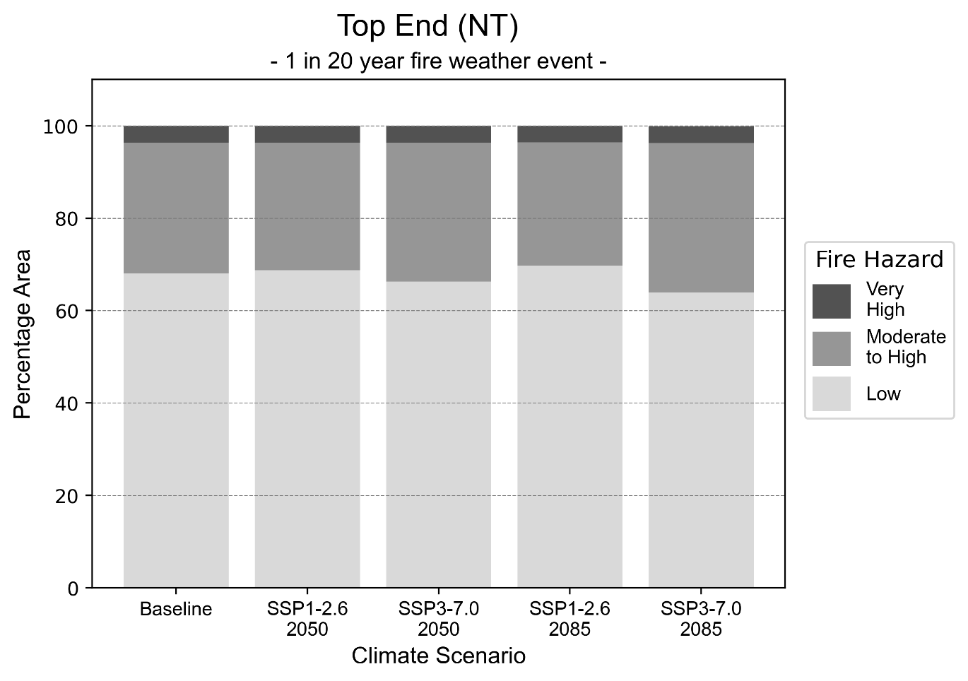
Figure 15: Stacked column chart showing the percentages of the Top End health district's total geographic area experiencing each fire hazard level during a 1-in-20-year fire weather event.
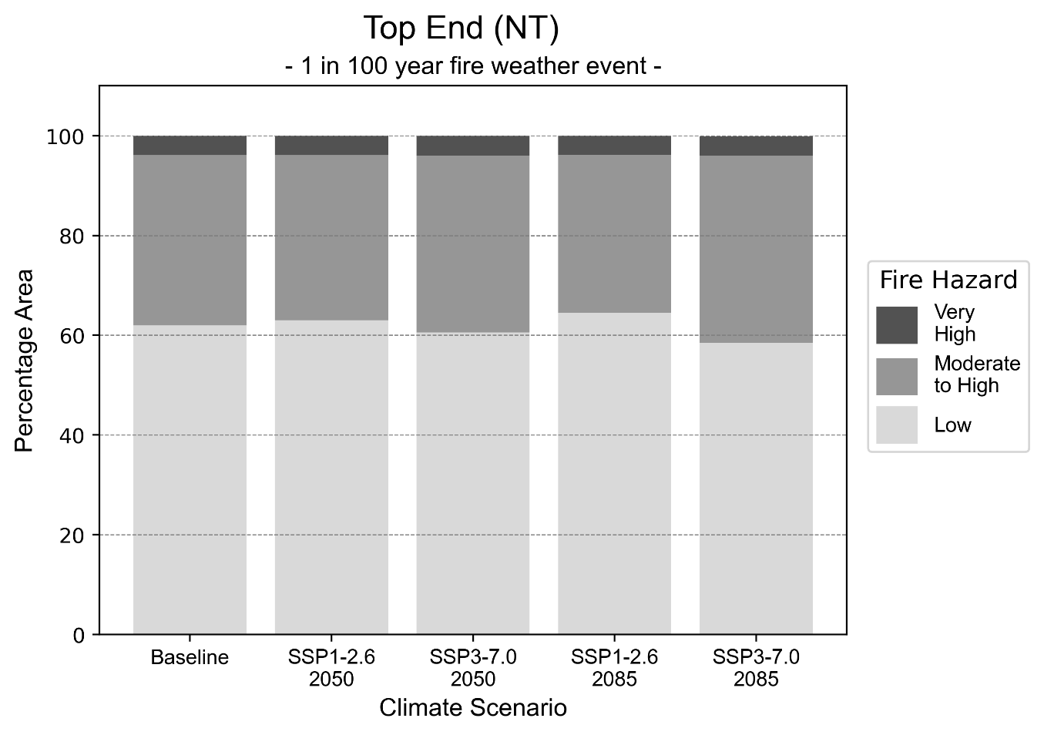
Figure 16: Stacked column chart showing the percentages of the Top End health district's total geographic area experiencing each fire hazard level during a 1-in-100-year fire weather event.

Drought hazard
Key projections:
Drought occurrence: The occurrence of drought will increase across both middle of the road and reasonable worst-case scenarios and both time horizons, with drought being experienced on average two to three months per year.

 | Baseline | 2050 Scenarios |  | 2085 Scenarios
 |  | Middle of the road | Reasonable worst-case | Middle of the road | Reasonable worst-case
Number of months per year in drought^{(a)} | 1.7 | 2.4  [0.6, 5.4] | 2.1  [0.6, 4.9] | 2.8  [0.8, 5.7] | 2.5  [0.4, 6.4]
Table notes: The drought hazard indicator uses climate projections from the CMIP6 Global Climate Models [1]. The primary indicator value reports the median from the nine climate models, with the range reported in square brackets. Table footnotes: (a) The number of months per year in drought is based on the Standardised Precipitation Index (SPI). SPI is a widely used index to characterise meteorological drought on a range of timescales. This indicator uses the timescale of 12 months which calculates the average months in a year within the moderate drought range. A moderate drought range is classified as SPI score of ≤ -1. SPI is calculated from accumulated rainfall over 12 months and the mean and standard deviation from historical rainfall records.

Storm hazard
Key projections:
More frequent very-high-intensity storms: The frequency of very-high-intensity storms will increase across both middle of the road and reasonable worst-case scenarios with the greatest increase occurring by 2085.

 | Baseline | 2050 Scenarios |  | 2085 Scenarios
 |  | Middle of the road | Reasonable worst-case | Middle of the road | Reasonable worst-case
Number of low-intensity storms (40-62 km/hr) per year | 71.7 | 65.9  [58.0, 72.5] | 66.3  [58.3, 72.9] | 68.7  [60.5, 75.6] | 67.9  [59.7, 74.7]
Number of medium-intensity storms (63-87 km/hr) per year | 65.0 | 59.5  [52.4, 65.5] | 63.1  [55.5, 69.4] | 61.9  [54.4, 68.1] | 57.8  [50.8, 63.5]
Number of high-intensity storms (88-117 km/hr) per year | 9.2 | 9.9  [8.7, 10.9] | 10.0  [8.8, 11.0] | 9.7  [8.6, 10.7] | 9.8  [8.6, 10.8]
Number of very-high-intensity storm (> 117 km/hr) per year | 0.7 | 1.4  [1.2, 1.5] | 1.1  [1.0, 1.2] | 1.4  [1.2, 1.5] | 1.5  [1.3, 1.6]
Table notes: The storm hazard uses climate projections from the CMIP6 Global Climate Models [1]. Daily maximum surface wind speed is used to calculate the number of annual storms across four storm intensity categories (low, medium, high and very high). The primary indicator value reports the median from the nine climate models, with the range reported in square brackets.

Rainfall and flood hazard
Key projections:
- Seven extreme rainfall days per year: The number of extreme rainfall days will remain consistent across both middle of the road and reasonable worst-case scenarios and both time horizons, with an average of approximately seven extreme rainfall days per year.
- Increased flood frequency: The frequency of flood events will increase in urban environments. The largest increase in flood frequency is seen in the reasonable worst-case scenario where frequency of a ‘1-in-100 year’ flood will become 11 times more likely by 2050 and become 46 times more likely by 2085 in urban environments. In rural environments the frequency of flood events will increase across 2050 and 2085 scenarios, with the exception of ‘1-in-1 year’ floods which will increase in frequency across 2050 scenarios but decrease in frequency across 2085 scenarios.

 | Baseline | 2050 Scenarios |  | 2085 Scenarios
 |  | Middle of the road | Reasonable worst-case | Middle of the road | Reasonable worst-case
Rainfall hazard^{(a)}
Average number of extreme rainfall days per year (> 16 mm/day)^{(a)} | 7.4 | 7.1  [4.8,10.6] | 7.1  [5.2,9.8] | 6.8  [5.1,9.9] | 7.2  [4.5,11.0]
Urban flood risk (flooding caused by a 1-hour rainfall event)^{(b)}
Frequency of a ‘1-in-1 year’ flood (rainfall depth of 48 mm)^{(c)} |  | 2.3 events in 1 year | 2.4 events in 1 year | 3.0 events in 1 year | 3.9 events in 1 year
Frequency of a ‘1-in-10 year’ flood (rainfall depth of 72 mm)^{(c)} |  | 5.3 events in 10 years | 5.5 events in 10 years | 7.5 events in 10 years | 12 events in 10 years
Frequency of a ‘1-in-100 year’ flood (rainfall depth of 93 mm)^{(c)} |  | 9.8 events in 100 years | 11 events in 100 years | 19 events in 100 years | 46 events in 100 years
Rural flood risk (flooding caused by a 24-hour rainfall event) ^{(b)}
Frequency of a ‘1-in-1 year’ flood (rainfall depth of 88 mm)^{(c)} |  | 1.6 events in 1 year | 1.3 events in 1 year | 0.9 events in 1 year | 0.9 events in 1 year
Frequency of a ‘1-in-10 year’ flood (rainfall depth of 168 mm)^{(c)} |  | 1.3 events in 10 years | 1.3 events in 10 years | 1.2 events in 10 years | 0.9 events in 10 years
Frequency of a ‘1-in-100 year’ flood (rainfall depth of 283 mm)^{(c)} |  | 1.5 events in 100 years | 1.5 events in 100 years | 1.5 events in 100 years | 1.4 events in 100 years
Table notes: The rainfall hazard indicator uses climate projections from the CMIP6 Global Climate Models [1]. The flood hazard indicators use climate change considerations from the Australian Rainfall and Runoff guideline to estimate the climate the climate projections [2]. The primary indicator value reports the median from the nine climate models, with the range reported in square brackets.
Table footnotes: (a) Extreme rainfall is defined as rainfall above the 95th percentile of historical average daily rainfall in this health district in the period 1985-2014. The value in mm/day quoted in the indicator name is the 95th percentile of historic average daily rainfall for this health district. (b) See Methodology document for reasons for focusing on a 1-hour flood for urban areas and a 24-hour flood for rural areas. (c) The rainfall depths in mm quoted in the indicator names in this table report 1 in 1-, 10- and 100-year depths for this health district.

Coastal inundation hazard
Key projections:
Greater area inundated: There will be an increase in the area affected by tidal inundation (i.e. area submerged during high tide) and storm surge and tidal inundation (i.e. the area submerged during a storm surge and high tide) across both middle of the road and reasonable worst-case scenarios. In the reasonable worst-case scenario, by 2085 the area inundated during a ‘1-in-1000-year’ event will increase by just over 225,000 ha.

 | Baseline | 2050 Scenarios |  | 2085^{(a)} Scenarios
 |  | Middle of the road | Reasonable worst-case | Middle of the road | Reasonable worst-case
Tidal inundation (ha inundated)^{(b)} | 404,208.1 | 438,510.1  (+34,302.0) | 441,261.2  (+37,053.1) | 528,069.9  (+123,861.8) | 568,604.1  (+164,396.1)
Storm surge + tidal inundation – ‘1-in-100 year’ event (ha inundated)^{(c)} | 658,728.3 | 717,341.2  (+58,612.9) | 721,389.4  (+62,661.0) | 819,349.2  (+160,620.8) | 851,875.9  (+193,147.5)
Storm surge + tidal inundation – ‘1-in-1000 year’ event (ha inundated)^{(c)} | 870,427.8 | 923,732.0  (+53,304.1) | 927,846.8  (+57,419.0) | 1,063,842.7  (+193,414.9) | 1,095,635.0  (+225,207.2)
Table notes: The coastal inundation hazard provides an indication of flooding in coastal areas that can be attributed to sea level rise and storm inundation. The coastal inundation hazard is only reported for health districts adjoining the coastline. This table includes the projected inundation levels as well as the change from baseline conditions (in brackets).
Table footnotes: (a) For the 2085 Scenarios planning horizon, 2100 was adopted as it provides a conservative representation of the end of this period. This horizon aligns with many State planning regulations requiring consideration of sea level rise and storm tide to 2100, making the 2100 scenario particularly valuable for planning new health facilities in coastal areas. (b) The tidal inundation indicator reports the number of hectares inundated during high tide. The baseline value reports existing inundation patterns, while the 2050 and 2085 values report high tide inundation taking account of projected sea level rise due to climate change. (c) The storm surge + tidal inundation indicators report the combined effect, in hectares inundated, of high tide, sea level rise (for the 2050 and 2085 projections), and storm surge (for 1-in-100 year and 1-in-1000-year events).

References

[1] | D. Irving, I. Macadam and M. King, “Application-ready quantile-delta-change (QDC) scaled CMIP6 climate projections for Australia (time slices, 11km grid) (v1)”, CSIRO. Data Collection, 2024.
[2] | C. Wasko, S. Westra, R. Nathan, D. Jakob, C. Nielsen, J. Evans, S. Rodgers, M. Ho, M. Babister, A. Dowdy and W. Sharples, “Australian Rainfall and Runoff (ARR) Chapter 6: 4 Climate Change Considerations”, Australian Rainfall and Runoff, 2024.
[3] | J. J. Hollis, S. Matthews, W. R. Anderson, M. G. Cruz, P. Fox-Hughes, S. Grootemaat, B. J. Kenny and S. Sauvage, “A framework for defining fire danger to support fire management operations in Australia”, International Journal of Wildland Fire, vol. 33, no.3, 2024.
[4] | Z. Hausfather and P. G. Peters, “Emissions–the ‘business as usual’story is misleading”, Nature, 577(7792), pp.618-620, 2020.



Another scenario, SSP5-8.5, was previously considered the reasonable worst-case scenario, but it is now considered to be very unlikely to be realised due to climate action already undertaken [4].

