Guidance on climate risk assessment and adaptation planning for Australian health system organisations
  - Climate and Health Hazard Data for Queensland
© Commonwealth of Australia as represented by the Australian Centre for Disease Control
Title: Guidance on climate risk assessment and adaptation planning for Australian health system organisations: Climate and Health Hazard Data for Queensland.
Citation
Australian Centre for Disease Control (CDC). Guidance on climate risk assessment and adaptation planning for Australian health system organisations: Climate and Health Hazard Data for Queensland, Australian CDC, Australian Government, 2026.
Contributors
Anne Cleary, Jamie Ewert, Jake Allen, Adam Brook, Petter Nyman, Pam Wong, Anthony Kiem, Felix Edger, Richard Farr, Robert Morden, Vincent Li Creagh, Tony Weber, Dominic Blackham, Matilda Lehmann, Phoebe Spurrier, Sophia Gidis, Georgia Behrens, Madeleine Skellern.
Acknowledgments
CSIRO National Bushfire Intelligence Capability for assisting with the analysis of the Fire Hazard.
Creative Commons Licence
This publication is licensed under the Creative Commons Attribution 4.0 International Public License available from https://creativecommons.org/licenses/by/4.0/legalcode (“Licence”). You must read and understand the Licence before using any material from this publication.
Restrictions
The Licence may not give you all the permissions necessary for your intended use. For example, other rights (such as publicity, privacy and moral rights) may limit how you use the material found in this publication. The Licence does not cover, and there is no permission given for, use of any of the following material found in this publication:
- the Commonwealth Coat of Arms. (by way of information, the terms under which the Coat of Arms may be used can be found on the Department of Prime Minister and Cabinet website
- any logos and trademarks
- any photographs and images
- any signatures
- any material belonging to third parties. The third party elements must be included here or have a footnote reference throughout the document showing where they are.
Attribution
Without limiting your obligations under the Licence, the Australian Centre for Disease Control requests that you attribute this publication in your work. Any reasonable form of words may be used provided that you:
- include a reference to this publication and where practicable, the relevant page numbers
- make it clear that you have permission to use the material under the Creativwe Commons Attribution 4.0 International Public License
- make it clear whether or not you have changed the material used from this publication
- include a copyright notice in relation to the material used. In the case of no change to the material, the words “© Commonwealth of Australia (Australian Centre for Disease Control) 2026” may be used. In the case where the material has been changed or adapted, the words: “Based on Commonwealth of Australia (Australian Centre for Disease Control) material” may be used
- do not suggest that the Australian Centre for Disease Control endorses you or your use of the material.
Enquiries
Enquiries regarding any other use of this publication should be addressed to the Communication and Public Information Section, Strategy and Engagement Branch, Australian Centre for Disease Control, GPO Box 798, Canberra ACT 2601, or via e-mail to CDCComms@cdc.gov.au.
We welcome feedback and dialogue about this report. Please send all such correspondence to NHSC.Unit@cdc.gov.au.

Table of Contents

Table of Contents 3
Introduction 4
Cairns and Hinterland health district 7
Central Queensland health district 16
Central West health district 25
Darling Downs health district 33
Mackay health district 41
North West health district 51
South East Queensland health district 61
South West health district 70
Torres and Cape health district 78
Townsville health district 87
West Moreton health district 96
Wide Bay health district 106
References 115

Introduction
This document provides scientific climate information to help health system organisations assess, prepare for and effectively manage climate-related risks across short-, medium-, and long-term planning horizons. A digital version of the information in this document can be found here. Further detail about the information contained in this document can be found in the accompanying methodological report.

The document presents climate hazard information summarised for health districts across Queensland. For each health district, information is provided about six hazards – heat and humidity, fire, drought, rainfall, storms, and coastal inundation – across three different time horizons and two climate scenarios. This structure enables users to assess how climate risks may evolve over time and under different emissions pathways. The information is presented both in narrative form and through a series of detailed tables containing quantitative data. Further information on the information presented in this document is outlined below.

Health districts
This document presents climate information for 12 health districts in Queensland. These correspond to the 15 geographically-based Hospital and Health Services (HHSs) in Queensland, with the exception that the four south east Queensland HHSs (Gold Coast, Metro North, Metro South and Sunshine Coast) are combined into a single South East health district.

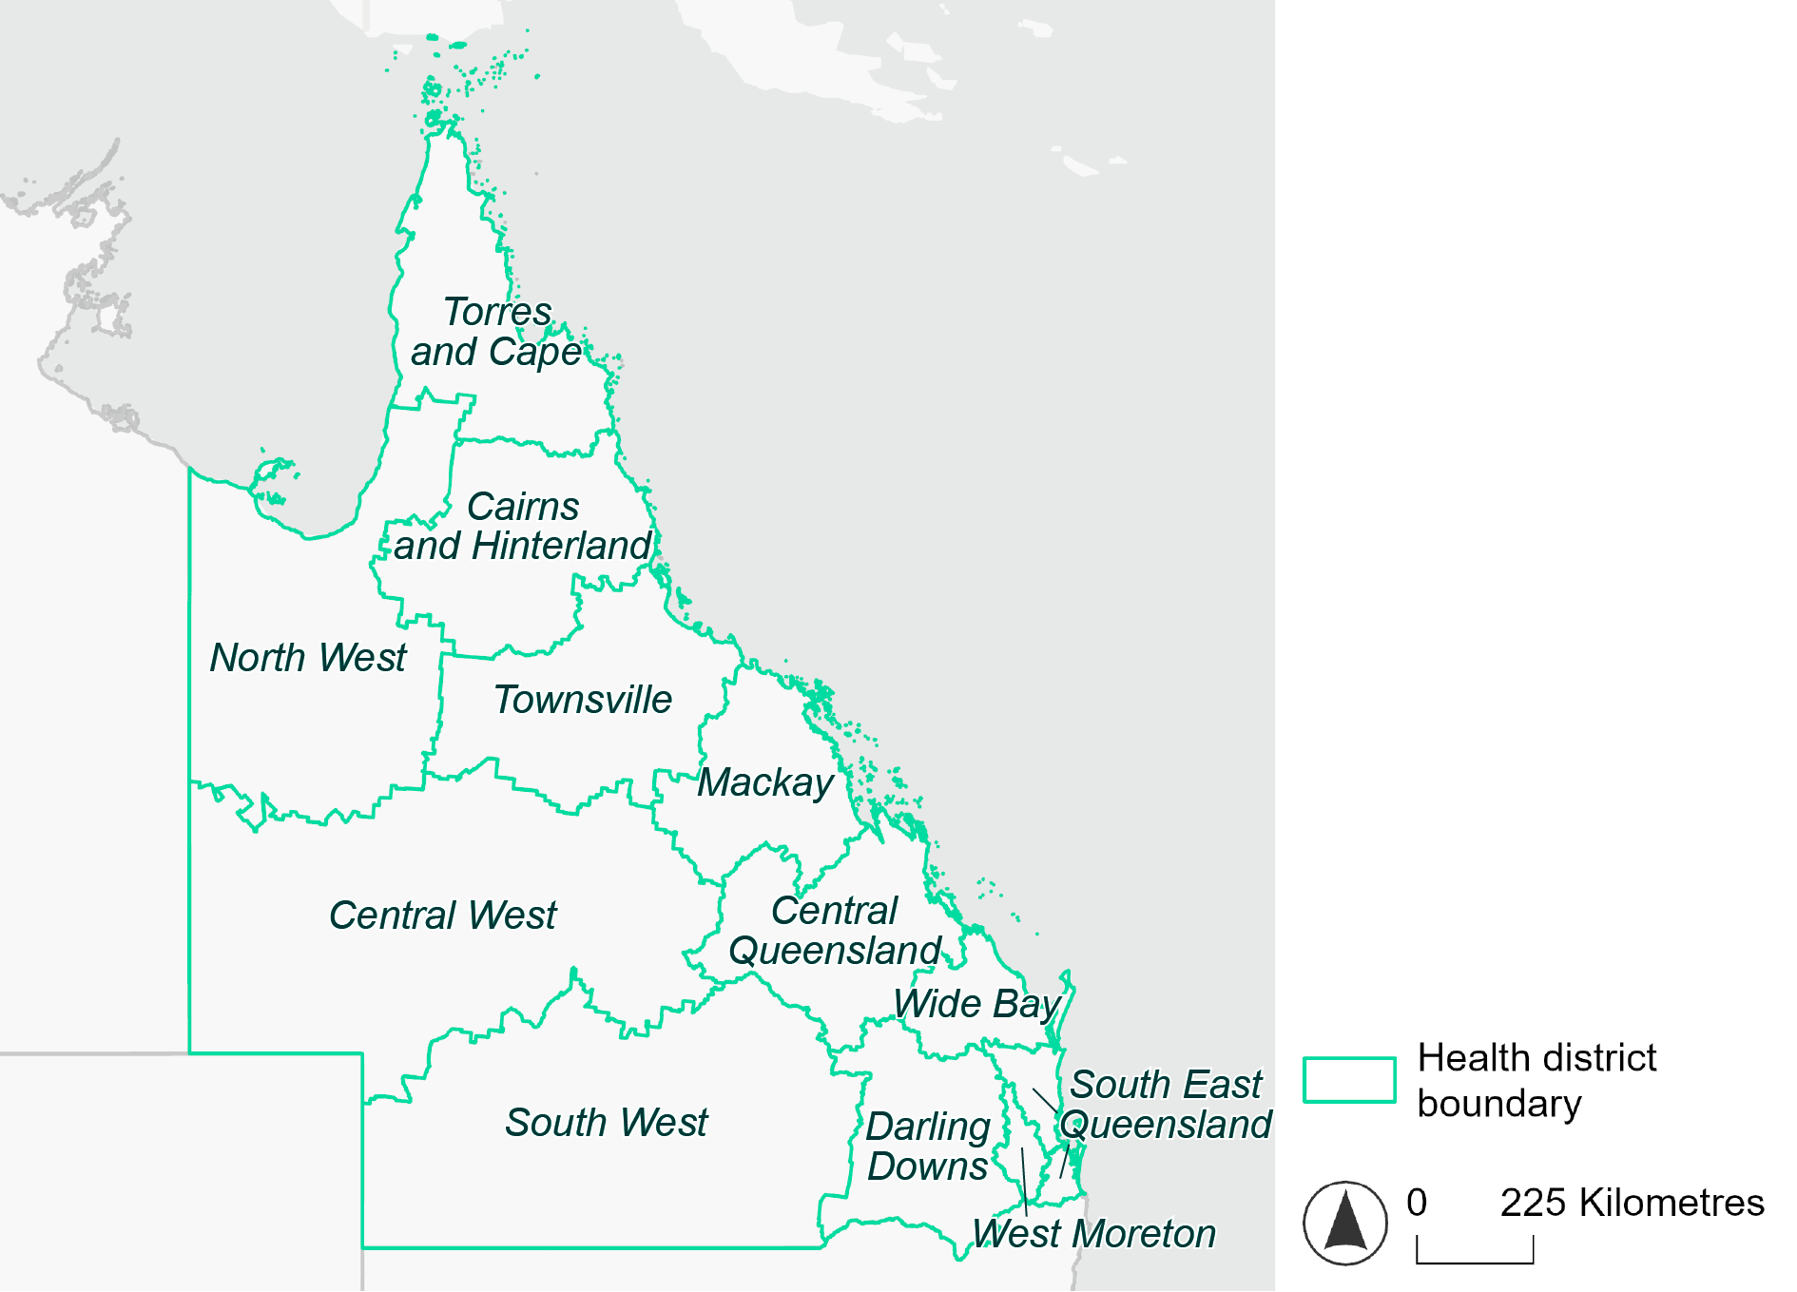
Figure 1. Map of Queensland health districts used in this document.

Time horizons
This document provides climate information on each climate hazard for the following time horizons:

Time horizon | Years | Description | Use in risk assessment
Baseline | Observed data from 1985-2014 | Historical baseline position | Understand current risks and ensure they are being managed effectively
Mid-century (2050) | 2035–2064 | Medium-term climate projections | Identify and manage emerging risks to population health and health systems
Late century (2085) | 2070–2099 | Long-term climate projections | Identify long-term risks when planning infrastructure or policy with long-lasting consequences

Climate scenarios
The document provides climate information on each hazard for two different climate scenarios. A climate scenario is a plausible representation of what the future climate might look like. These scenarios are based on different assumptions about greenhouse gas emissions and other factors that influence the future climate.

This document uses Shared Socioeconomic Pathways (SSPs) as the basis for different climate scenarios. SSPs describe how socioeconomic factors (such as population, economic growth, education, urbanisation and technology development) could change over the next century and have an effect on future greenhouse gas emissions and global temperatures.

There are five main SSPs, each of which outlines a different scenario, ranging from a sustainable future with low emissions, to one with high fossil fuel uses and high emissions. The most recent iteration of SSPs incorporate information from what were previously called Representative Concentration Pathways (RCPs), which measure the expected change in radiative forcing (in W/m2) under the scenario from 1750 to 2100. SSP2-4.5 denotes what would previously have been called a scenario involving SSP2 and RCP4.5 – the reasoning for merging them being that SSP2 describes socioeconomic conditions likely to give rise to RCP4.5.

The two main scenarios used in this document are:
A ‘middle of the road’ scenario (SSP2-4.5): this scenario assumes emissions remain at current levels until the middle of the 21st century, and that net zero emissions are not reached by 2100. This scenario sees temperatures rising by about 2.7°C by the end of the century. In this document this is the lower emissions scenario across all climate hazards, except for the fire hazard (see below note).
A ‘reasonable worst-case’ scenario (SSP3-7.0): this scenario assumes both emissions and temperatures continue to rise to the end of the century due to delayed climate action. This scenario sees temperatures rise by about 3.6°C by 2100. In this document this is the higher emissions scenario across all climate hazards.

Fire hazard projections are not available for SSP2-4.5, so SSP1-2.6 is used as the lower emissions scenario for this hazard instead of SSP2-4.5. Under SSP1-2.6, global emissions are reduced but do not reach net zero until after 2050 and warming stabilises at about 1.8°C by 2100. This document refers to SSP1-2.6 as the ‘sustainability’ scenario.

Climate hazard projections
For each health district, the following information is provided for each climate hazard, across the different time horizons and climate scenarios:
- Heat and humidity: projected average, extreme and apparent temperatures, projected heatwave duration affected by different fire hazard categories for a 1-in-20 year fire event and a 1-in-100 year event.
- Fire: projected area affected by different fire hazard categories for a 1-in-20 year fire event and a 1-in-100 year event.
- Drought: projected average number of months per year experiencing drought.
- Rainfall and flooding: projected number of extreme rainfall days per year, as well as projected frequency of urban and rural flood events.
- Storms: projected number of storms per year, grouped into four intensity categories based on wind speed.
- Coastal inundation: projected area of land affected by tidal inundation and storm surge and tidal inundation (coastal districts only).

The climate hazard projections in this document are based on data from nine CMIP6 Global Climate Models (ACCESS-CM2, ACCESS-ESM1-5, CESM2, CMCC-ESM2, CNRM-ESM2-1, EC-Earth3, MPI-ESM1-2-HR, NorESM2-MM, UKESM1-0-LL). These models simulate how climate hazards may change under different SSPs. Where hazard projections are based on these models, this document reports the median projected value as its primary estimate, and reports the range across all nine models in square brackets.

Cairns and Hinterland health district

Health district overview
Surface area: 142,900 square kilometres
Estimated population: 250,000
Local health services: The Cairns and Hinterland Hospital and Health Service includes 9 hospitals, 11 primary health sites and 9 community health centres, as well as mental health facilities and specialist services.

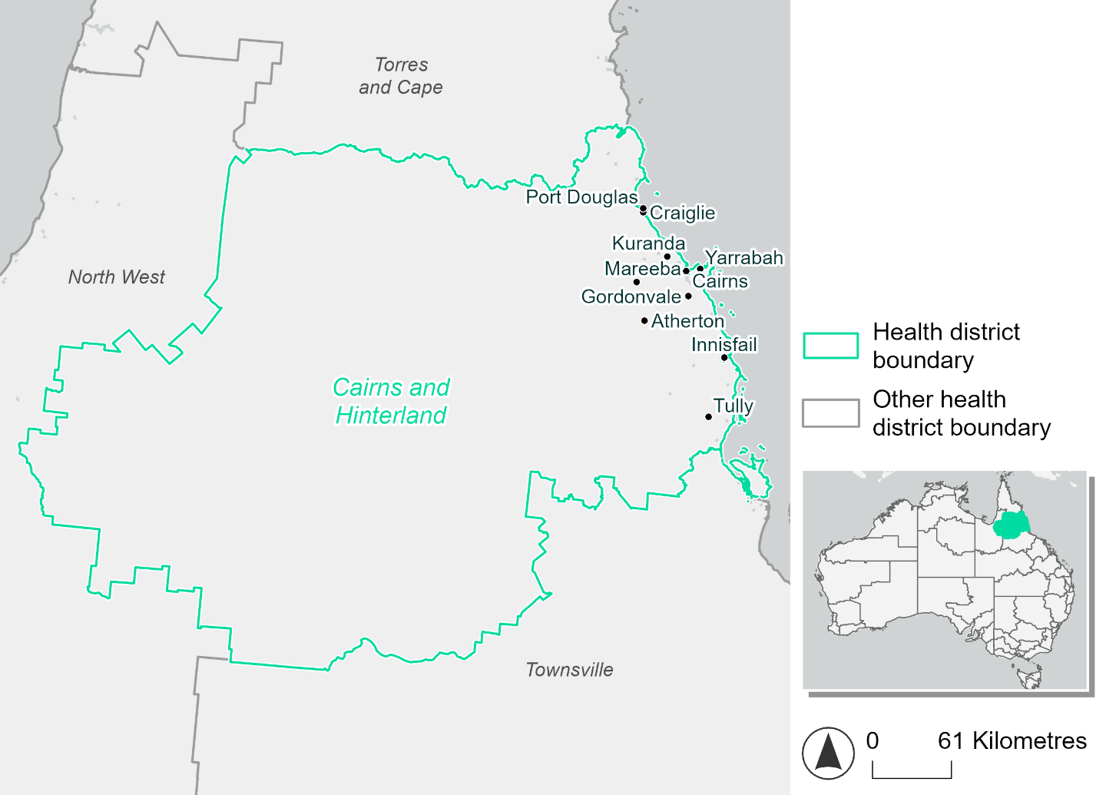
Figure 2. Map of Cairns and Hinterland health district

How will climate change affect this health district?
Heat and humidity: There will be higher average temperatures, hotter and more frequent hot days, warmer night time temperatures and longer and more frequent heat waves.
Fire: Only 2-3% of this health district experiences very high fire hazard category and this will continue in the future.
Drought: The number of months experiencing drought will increase.
Rainfall and flood: There will be more flood events in both urban and rural areas.
Coastal inundation: The area flooded during tidal, and storm surge and tidal inundation, will increase.

Cairns and Hinterland district demographic data
Demographic Data | Total
Number of households | 93,724
Persons 15 and older | 184,692
Total families | 65,841
Persons did not complete high school | 70,492
One parent families with dependents | 8,501 (12.9%)
Persons aged 65 and older | 47,988 (18.0%)
Persons aged 4 and younger | 14,274 (5.4%)
Aboriginal and Torres Strait Islander persons | 28,076 (10.6%)
Persons speaks language other than English | 33,120 (12.5%)
Persons working age (15-65) | 169,147 (63.6%)
Population Health Data | Total
Persons with core needs for assistance | 14,529 (5.5%)
Persons with arthritis | 21,051 (7.9%)
Persons with asthma | 17,045 (6.4%)
Persons with cancer | 7,859 (3%)
Persons with dementia | 1,961 (0.7%)
Persons with diabetes | 11,612 (4.4%)
Persons with heart disease | 10,566 (4%)
Persons with kidney disease | 2,313 (0.9%)
Persons with lung condition | 5,101 (1.9%)
Persons with mental health condition | 20,352 (7.7%)
Persons with stroke | 2,484 (0.9%)
Persons with any other condition | 19,794 (7.4%)
Persons no health condition | 155,730 (58.5%)
Socio-economic Data | Total
Persons providing unpaid care | 29,342 (11%)
Persons homeless | 2,270 (0.9%)
Household with lone person | 25,859 (27.6%)
Households with rent and mortgage stress | 41,424 (44.2%)
Households total equivalised income below $1000 (weekly) | 45,758 (48.8%)
Households with no motor vehicle | 5,582 (6%)
Persons unemployed | 12,568 (5.9%)

The sections that follow outline projected climate hazards for this district. Further information on this health district, including population demographics, is provided in the online dashboard.

Heat and humidity hazard
Key projections:
More heatwaves: Heatwave events are likely to last longer and the number of heatwave events per year will increase. Under the reasonable worst-case scenario:
- By 2050, the annual number of heatwaves will more than triple.
- By 2085, the annual number of heatwaves will more than quadruple.
Hotter days and warmer nights: The day time and night time temperatures on hot days will increase.
More days above 35°C: The number of days per year greater than 35°C will increase under both middle of the road and reasonable worst-case scenarios.

 | Baseline | 2050 Scenarios |  | 2085 Scenarios
 |  | Middle of the road | Reasonable worst-case | Middle of the road | Reasonable worst-case
Average temperature (°C) | 23 | 24.3  [23.8, 25] | 24.5  [24, 25.2] | 25  [24.2, 25.9] | 25.8  [25, 26.8]
Maximum temperature on hot days (°C)^{(a)} | 32.2 | 33.5  [32.8, 34.2] | 33.6  [33.1, 34.5] | 34.1  [33.2, 35.1] | 35  [34.1, 35.8]
Minimum temperature on hot nights (°C)^{(b)} | 23.4 | 24.7  [24.2, 25.2] | 24.9  [24.5, 25.4] | 25.4  [24.7, 26.1] | 26.3  [25.6, 27.1]
Average apparent temperature on hot days (°C) (NOAA Heat Index)^{(c)} | 35.6 | 37.6  [36.7, 38.3] | 37.8  [37, 38.5] | 38.8  [37.6, 39.6] | 40.4  [38.9, 41.6]
Average heatwave duration in days^{(d)} | 5 | 8  [6, 10] | 8  [7, 11] | 12  [8, 18] | 21  [12, 34]
Number of heatwaves per year^{(d)} | 3 | 7  [5, 8] | 7  [6, 9] | 8  [7, 8] | 7  [6, 8]
Number of days per year  > 35°C | 4 | 9  [5, 14] | 10  [6, 15] | 13  [6, 22] | 23  [12, 36]
Number of days per year > 40°C | 0 | 0  [0, 1] | 0  [0, 1] | 1  [0, 1] | 1  [1, 2]
Table notes: The heat and humidity hazard uses climate projections from the CMIP6 Global Climate Models [1]. Daily projections of maximum and minimum near-surface temperature and mean relative humidity are used to calculate eight heat and humidity indicators. The primary indicator value reports the median from the nine climate models, with the range reported in square brackets.
Table footnotes: (a) Based on the 95th percentile of daily maximum air temperature. (b) Based on the 95th percentile of daily minimum air temperature (i.e. the 5th percentile of daily maximum air temperature), representing the coldest part of the night on very hot nights. (c) The National Oceanic and Atmospheric Administration (NOAA) Heat Index is a measure of how hot it feels when relative humidity is factored in alongside actual air temperature. It is calculated on days with a maximum temperature of 27°C and above. Interpretation of Heat Index values: 27°C to 32°C indicates caution, 33°C to 41°C indicates extreme caution, 42°C to 54°C indicates danger and over 54°C indicates extreme danger. See methodology document for further explanation of Heat Index categories. (d) A heatwave is defined as three or more consecutive days where both daytime and overnight temperatures (daily mean temperatures) are unusually high for the location, based on the Bureau of Meteorology’s Excess Heat Factor method. For this district, an unusually high daily mean temperature is approximately 27.4°C or above.

Fire Hazard
Key projections:
- Majority of district area experiences low fire hazard: Under baseline conditions, during a 1-in-20-year fire weather event 63.4% of the district experiences low fire hazard, with 34.1% experiencing moderate to high hazard. In a 1-in-100-year event, the area experiencing moderate to high hazard increases to 42.5% of the district. Only 2.5-3.1% of the district experiences very high fire hazard.
- Current hazard conditions may persist or improve depending on emissions: In a future climate if the reasonable worst-case scenario eventuates then hazard areas will change very little; the only notable change being during a 1-in-100-year fire weather event, where the area experiencing moderate to high hazard increases by 2.3 percentage points, with a corresponding decrease in the low hazard area. If the sustainability emissions pathway is achieved, the area experiencing low hazard will increase by 4 percentage points for a 1-in-20-year fire weather event, and by 4.2 for the 1-in-100-year event. This will be accompanied by a corresponding decrease in the area experiencing moderate to high hazard, with the very high hazard area steady under all scenarios.

 | Baseline | 2050 Scenarios |  | 2085 Scenarios
 |  | Sustainability | Reasonable worst-case | Sustainability | Reasonable worst-case
Hazard for a ‘1-in-20 year’ fire weather event^{(a)}
Proportion (%) of district experiencing ‘Low’ fire hazard | 63.4%  (8,947,000)^{(b)} | 65.1%  [64.3%, 66.8%] | 63.0%  [57.4%, 64.8%] | 67.6%  [65.5%, 71.6%] | 62.5%  [49.1%, 66.9%]
Proportion (%) of district experiencing ‘Moderate to High’ fire hazard | 34.1%  (4,816,512)^{(b)} | 32.4%  [30.7%, 33.4%] | 34.5%  [32.7%, 39.9%] | 30.1%  [25.9%, 32.3%] | 35.0%  [30.7%, 48.0%]
Proportion (%) of district experiencing ‘Very High’ fire hazard | 2.5%  (353,987)^{(b)} | 2.5%  [2.4%, 2.6%] | 2.5%  [2.3%, 2.8%] | 2.4%  [2.2%, 2.7%] | 2.4%  [2.0%, 3.1%]
Hazard for a ‘1-in-100 year’ fire weather event^{(a)}
Proportion (%) of district experiencing ‘Low’ fire hazard | 54.5%  (7,689,710)^{(b)} | 56.2%  [54.1%, 58.7%] | 53.5%  [47.2%, 55.5%] | 58.7%  [53.5%, 64.6%] | 52.1%  [37.1%, 57.0%]
Proportion (%) of district experiencing ‘Moderate to High’ fire hazard | 42.5%  (5,995,401)^{(b)} | 40.7%  [38.3%, 43.0%] | 43.4%  [41.4%, 49.4%] | 38.3%  [32.4%, 43.7%] | 44.8%  [39.9%, 59.1%]
Proportion (%) of district experiencing ‘Very High’ fire hazard | 3.1%  (432,387)^{(b)} | 3.0%  [3.0%, 3.2%] | 3.0%  [2.8%, 3.3%] | 3.0%  [2.8%, 3.3%] | 3.0%  [2.5%, 3.7%]
Table notes: The Fire Hazard uses the National Bushfire Intelligence Capability (NBIC) Phase 2 fire line intensity modelling based on CMIP6 climate projections. Fire Hazard is assessed using the projected Fireline Intensity (FLI) for weather events with two different return intervals (i.e. a 1-in-20 year event and a 1-in-100 year event). FLI considers slope, vegetation and weather to produce a rate of heat output per unit length (kW/m) along a bushfire’s front. Fire hazard is categorized as a low for FLI<4000 kW/m, moderate to high for 4,000 kW/m ≤FLI<12,500kW/m, and very high for FLI≥27,501kW/m. This is broadly consistent with the literature [3]. The assessment considers climate change effects based on changes in fire weather and the associated hazard that is anticipated for a meteorological event of a given return interval. This approach is different to the one adopted for the Flood Hazard, where the event magnitude is given (fixed) and the likelihood of that event varies as a result of climate change. The primary indicator value reports the median from the nine climate models, with the range reported in square brackets.
Table footnotes: (a) The area subject to different categories of fire hazard is determined for a ‘1-in-20 year’ and ‘1-in-100 year’ fire weather event, in current and future climates. Values at year 2050 are interpolated using data from baseline (2025) and 2085, assuming linear change over time. (b) Values in round brackets are the area (ha) of the health district subject to a given fire hazard.

The figures below show the proportion of the health district experiencing different fire hazard categories across different time horizons and climate scenarios during a ‘1-in-20 year’ fire weather event (Figure 3) and a ‘1-in-100 year’ fire weather event (Figure 4).
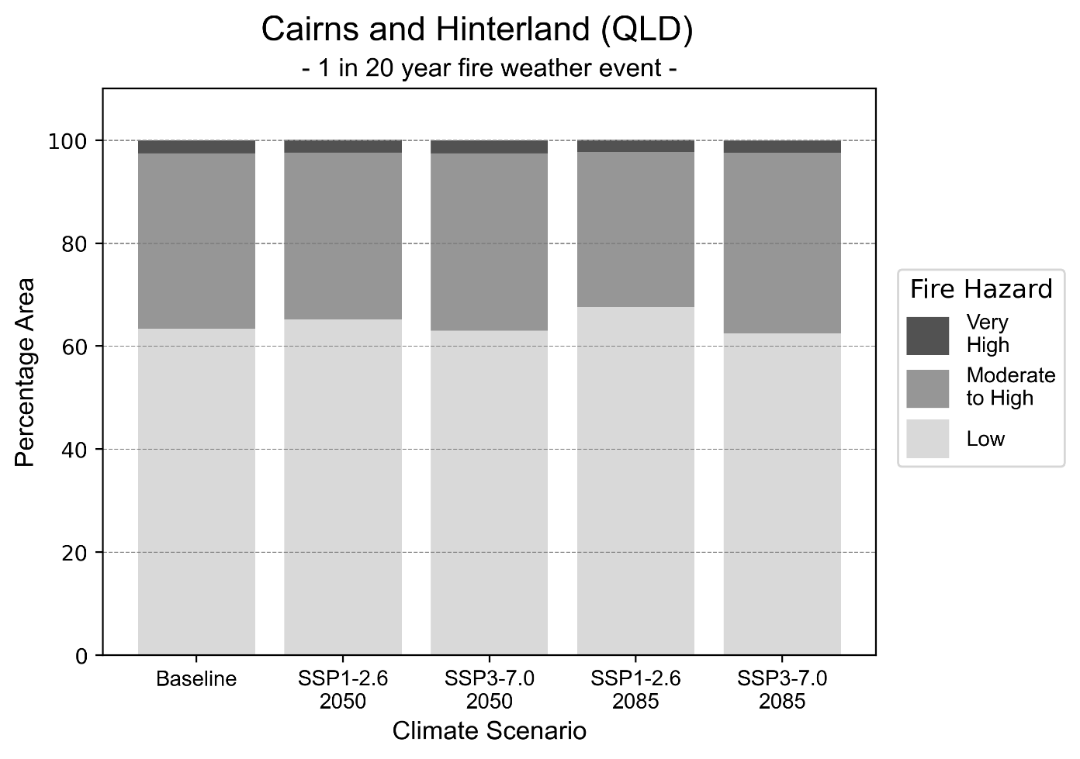
Figure 3: Stacked column chart showing the percentages of the Cairns and Hinterland health district's total geographic area experiencing each fire hazard level during a 1-in-20-year fire weather event.
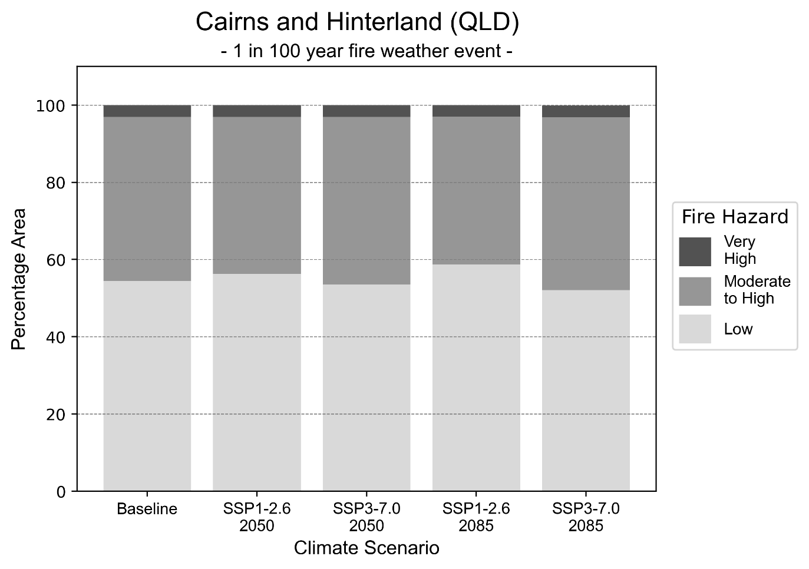
Figure 4: Stacked column chart showing the percentages of the Cairns and Hinterland health district's total geographic area experiencing each fire hazard level during a 1-in-100-year fire weather event.

Drought hazard
Key projections:
Drought occurrence: The occurrence of drought will increase across both middle of the road and reasonable worst-case scenarios for both time horizons, with the largest increase occurring under the middle of the road scenario by 2050.

 | Baseline | 2050 Scenarios |  | 2085 Scenarios
 |  | Middle of the road | Reasonable worst-case | Middle of the road | Reasonable worst-case
Number of months per year in drought^{(a)} | 1.8 | 2.7  [0.1, 5.1] | 2.5  [0.4, 5.1] | 2.7  [0.5, 5.4] | 2.6  [0.1, 6.4]
Table notes: The drought hazard indicator uses climate projections from the CMIP6 Global Climate Models [1]. The primary indicator value reports the median from the nine climate models, with the range reported in square brackets.
Table footnotes: (a) The number of months per year in drought is based on the Standardised Precipitation Index (SPI). SPI is a widely used index to characterise meteorological drought on a range of timescales. This indicator uses the timescale of 12 months which calculates the average months in a year within the moderate drought range. A moderate drought range is classified as SPI score of ≤ -1. SPI is calculated from accumulated rainfall over 12 months and the mean and standard deviation from historical rainfall records.

Storm hazard
Key projections:
More very-high-intensity storms: Very-high-intensity storms will be slightly more frequent in both middle of the road and reasonable worst-case scenarios across both time horizons.

Baseline |  | 2050 Scenarios |  | 2085 Scenarios
 |  | Middle of the road | Reasonable worst-case | Middle of the road | Reasonable worst-case
Number of low-intensity storms (40-62 km/hr) per year | 74.1 | 72.8  [64.1, 80.1] | 77.2  [68.0, 85.0] | 77.7  [68.4, 85.5] | 74.9  [65.9, 82.4]
Number of medium-intensity storms (63-87 km/hr) per year | 65.1 | 63.7  [56.1, 70.1] | 64.9  [57.1, 71.4] | 64.6  [56.9, 71.1] | 71.5  [62.9, 78.6]
Number of high-intensity storms (88-117 km/hr) per year | 8.1 | 7.7  [6.8, 8.5] | 9.7  [8.5, 10.7] | 8.1  [7.1, 8.9] | 8.9  [7.9, 9.8]
Number of very-high-intensity storms (> 117 km/hr) per year | 0.4 | 0.5  [0.4, 0.5] | 0.5  [0.4, 0.6] | 0.5  [0.5, 0.6] | 0.5  [0.4, 0.6]
Table notes: The storm hazard uses climate projections from the CMIP6 Global Climate Models [1]. Daily maximum surface wind speed is used to calculate the number of annual storms across four storm intensity categories (low, medium, high and very high). The primary indicator value reports the median from the nine climate models, with the range reported in square brackets.

Rainfall and flood hazard
Key projections:
- 11 extreme rainfall days per year: The number of extreme rainfall days will remain consistent across both middle of the road and reasonable worst-case scenarios, and both time horizons, with an average of approximately 11 extreme rainfall days per year.
- Increased flood frequency: The frequency of flood events will increase in urban and rural environments. The largest increase in flood frequency occurs in the reasonable worst-case scenario, where in urban environments the frequency of a ‘1-in-100 year’ flood will become nearly seven times more likely by 2050 and become 22 times more likely by 2085.

 | Baseline | 2050 Scenarios |  | 2085 Scenarios
 |  | Middle of the road | Reasonable worst-case | Middle of the road | Reasonable worst-case
Rainfall hazard^{(a)}
Average number of extreme rainfall days per year (> 13 mm/day)^{(a)} | 11.5 | 11.3  [8.2,19.8] | 11.3  [8.1,17.2] | 10.9  [7.5,15.1] | 11.5  [6.9,18.5]
Urban flood risk (flooding caused by a 1-hour rainfall event)^{(b)}
Frequency of a ‘1-in-1 year’ flood (rainfall depth of 42 mm)^{(c)} |  | 2.0 events in 1 year | 2.1 events in 1 year | 2.5 events in 1 year | 3.2 events in 1 year
Frequency of a ‘1-in-10 year’ flood (rainfall depth of 71 mm)^{(c)} |  | 3.6 events in 10 years | 3.8 events in 10 years | 5.5 events in 10 years | 8.2 events in 10 years
Frequency of a ‘1-in-100 year’ flood (rainfall depth of 98 mm)^{(c)} |  | 6.1 events in 100 years | 6.7 events in 100 years | 12 events in 100 years | 22 events in 100 years
Rural flood risk (flooding caused by a 24-hour rainfall event)^{(b)}
Frequency of a ‘1-in-1 year’ flood (rainfall depth of 176 mm)^{(c)} |  | 1.2 events in 1 year | 1.2 events in 1 year | 1.2 events in 1 year | 1.3 events in 1 year
Frequency of a ‘1-in-10 year’ flood (rainfall depth of 355 mm)^{(c)} |  | 1.6 events in 10 years | 1.6 events in 10 years | 1.9 events in 10 years | 2.1 events in 10 years
Frequency of a ‘1-in-100 year’ flood (rainfall depth of 572 mm)^{(c)} |  | 2.0 events in 100 years | 2.0 events in 100 years | 2.4 events in 100 years | 3.1 events in 100 years
Table notes: The rainfall hazard indicator uses climate projections from the CMIP6 Global Climate Models [1]. The primary indicator value reports the median from the nine climate models, with the range reported in square brackets. The flood hazard indicators use climate change considerations from the Australian Rainfall and Runoff guideline to estimate the climate projections [2].
Table footnotes: (a) Extreme rainfall is defined as rainfall above the 95th percentile of historical average daily rainfall in this health district in the period 1985-2014. The value in mm/day quoted in the indicator name is the 95th percentile of historic average daily rainfall for this health district. (b) See Methodology document for reasons for focusing on a 1-hour flood for urban areas and a 24-hour flood for rural areas. (c) The rainfall depths in mm quoted in the indicator names in this table report 1-in-1 year, 1-in-10 year and 1-in-100 year flood (rainfall) depths for this health district.

Coastal inundation hazard
Key projections:
Greater area inundated: There will be an increase in the area affected by tidal inundation (i.e. area submerged during high tide) and storm surge and tidal inundation (i.e. the area submerged during a storm surge and high tide) across both middle of the road and reasonable worst-case scenarios. In the reasonable worst-case scenario, by 2085 the area inundated during tidal inundation will increase by over 12,000 ha.

 | Baseline | 2050 Scenarios |  | 2085 Scenarios ^{(a)}
 |  | Middle of the road | Reasonable worst-case | Middle of the road | Reasonable worst-case
Tidal inundation (ha inundated)^{(b)} | 30,323.5 | 35,080.0  (+4,756.5) | 35,283.2  (+4,959.8) | 40,746.8  (+10,423.3) | 42,878.6  (+12,555.1)
Storm surge + tidal inundation – ‘1-in-100 year’ event (ha inundated)^{(c)} | 40,026.8 | 43,256.7  (+3,230.0) | 43,424.4  (+3,397.6) | 48,463.3  (+8,436.5) | 50,553.6  (+10,526.8)
Storm surge + tidal inundation – ‘1-in-1000 year’ event (ha inundated)^{(c)} | 45,005.7 | 48,146.5  (+3,140.8) | 48,321.0  (+3,315.2) | 55,085.5  (+10,079.8) | 57,307.9  (+12,302.1)
Table notes: The coastal inundation hazard provides an indication of flooding in coastal areas that can be attributed to sea level rise and storm inundation. The coastal inundation hazard is only reported for health districts adjoining the coastline. This table includes the projected inundation levels as well as the change from baseline conditions (in brackets).
Table footnotes: (a) For the 2085 Scenarios planning horizon, 2100 was adopted as it provides a conservative representation of the end of this period. This horizon aligns with many State planning regulations requiring consideration of sea level rise and storm tide to 2100, making the 2100 scenario particularly valuable for planning new health facilities in coastal areas. (b) The tidal inundation indicator reports the number of hectares inundated during high tide. The baseline value reports existing inundation patterns, while the 2050 and 2085 values report high tide inundation taking account of projected sea level rise due to climate change. (c) The storm surge + tidal inundation indicators report the combined effect, in hectares inundated, of high tide, sea level rise (for the 2050 and 2085 projections), and storm surge (for 1-in-100 year and 1-in-1000 year events).

Central Queensland health district

Health district overview
Surface area: 110,958 square kilometres
Estimated population: 230,000
Local health services: The region contains four hospitals and 14 health centres: Rockhampton Hospital, Gladstone Hospital, Biloela Hospital, Emerald Hospital

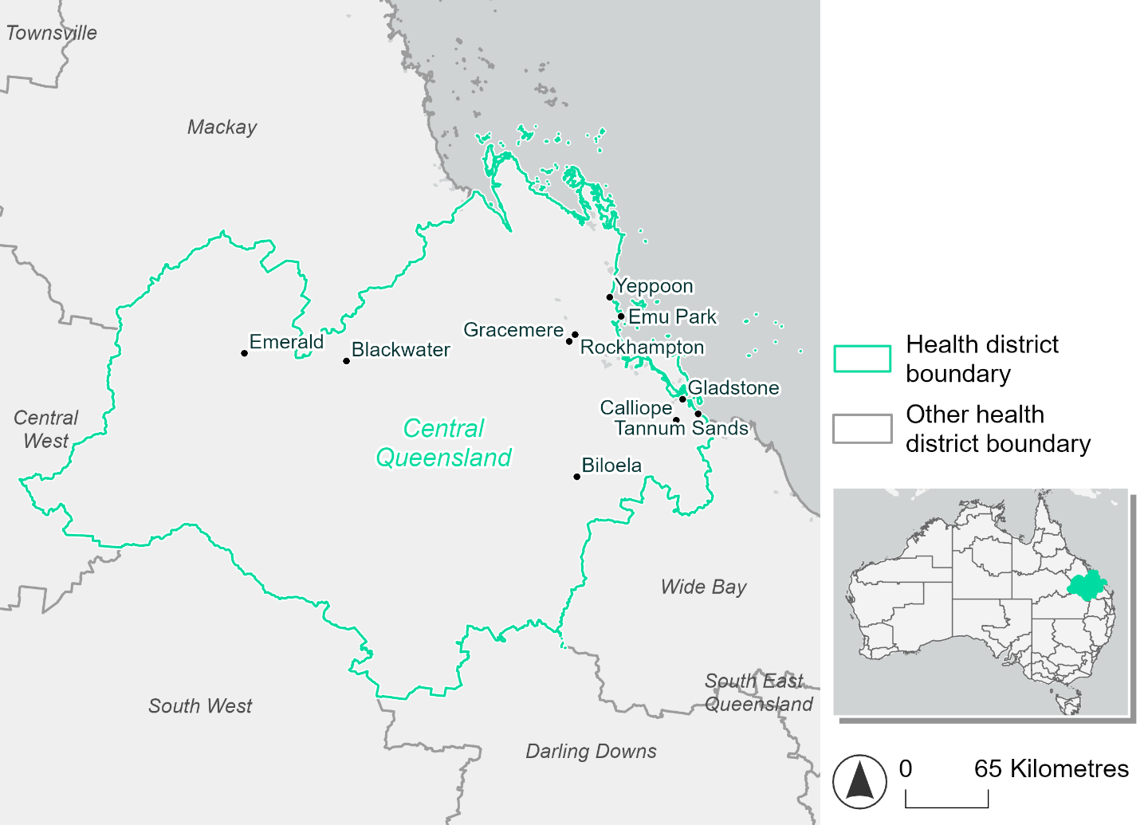
Figure 5. Map of Central Queensland health district.

How will climate change affect this health district?
Heat and humidity: There will be higher average temperatures, hotter and more frequent hot days, warmer night time temperatures and longer and more frequent heat waves.
Fire: Over 10% of this health district experiences very high fire hazard category and this will continue in the future.
Drought: The number of months experiencing drought will increase.
Rainfall and flood: There will be more flood events in both urban and rural areas.
Coastal inundation: The area flooded during tidal, and storm surge and tidal inundation, will increase.

Central Queensland health district demographic data
Demographic Data | Total
Number of households | 78,605
Persons 15 and older | 154,826
Total families | 57,080
Persons did not complete high school | 67,549
One parent families with dependents | 6,867 (12%)
Persons aged 65 and older | 34,783 (15.4%)
Persons aged 4 and younger | 14,502 (6.4%)
Aboriginal and Torres Strait Islander persons | 16,173 (7.1%)
Persons speaks language other than English | 12,094 (5.3%)
Persons working age (15-65) | 143,600 (63.5%)
Population Health Data | Total
Persons with core needs for assistance | 131,54 (5.8%)
Persons with arthritis | 20,263 (9%)
Persons with asthma | 19,658 (8.7%)
Persons with cancer | 6,356 (2.8%)
Persons with dementia | 1,360 (0.6%)
Persons with diabetes | 11,067 (4.9%)
Persons with heart disease | 9,635 (4.3%)
Persons with kidney disease | 2,146 (0.9%)
Persons with lung condition | 5,286 (2.3%)
Persons with mental health condition | 21,169 (9.4%)
Persons with stroke | 2,133 (0.9%)
Persons with any other condition | 16,915 (7.5%)
Persons no health condition | 127,782 (56.5%)
Socio-economic Data | Total
Persons providing unpaid care | 25,386 (11.2%)
Persons homeless | 1,020 (0.5%)
Household with lone person | 20,402 (26%)
Households with rent and mortgage stress | 25,772 (32.8%)
Households total equivalised income below $1000 (weekly) | 34,161 (43.5%)
Households with no motor vehicle | 3,987 (5.1%)
Persons unemployed | 9,573 (5.5%)

The sections that follow outline projected climate hazards for this district. Further information on this health district, including population demographics, is provided in the online dashboard.

Heat and humidity hazard
Key projections:
More heatwaves: Heatwave events are likely to last longer and the number of heatwave events per year will increase. By 2050, under a reasonable worst-case scenario, the number of heatwaves will triple. By 2085, under a reasonable worst-case scenario, the number of heatwaves per year will more than triple.
Hotter days and warmer nights: The day time and night time temperatures on hot days will increase.
More days above 35°C and 40°C: The number of days per year greater than 35°C and 40°C will increase under both middle of the road and reasonable worst-case scenarios.

 | Baseline | 2050 Scenarios |  | 2085 Scenarios
 |  | Middle of the road | Reasonable worst-case | Middle of the road | Reasonable worst-case
Average temperature (°C) | 22.2 | 23.6  [23.1, 24.3] | 23.8  [23.3, 24.5] | 24.4  [23.6, 25.2] | 25.3  [24.5, 26.4]
Maximum temperature on hot days (°C)^{(a)} | 34 | 35.5  [34.8, 36.3] | 35.7  [34.9, 36.6] | 36.2  [35.4, 37.3] | 37.1  [36.2, 38.4]
Minimum temperature on hot nights (°C)^{(b)} | 23.5 | 24.9  [24.3, 25.3] | 25  [24.5, 25.6] | 25.6  [24.9, 26.2] | 26.5  [25.7, 27.3]
Average apparent temperature on hot days (°C) (NOAA Heat Index)^{(c)} | 36.1 | 38.3  [37.6, 39.2] | 38.5  [37.5, 39.5] | 39.6  [38.6, 40.8] | 41  [39.9, 42.7]
Average heatwave duration in days^{(d)} | 5 | 8  [7, 10] | 8  [7, 10] | 11  [8, 15] | 15  [11, 23]
Number of heatwaves per year^{(d)} | 2 | 6  [4, 7] | 6  [5, 8] | 7  [6, 8] | 7  [7, 8]
Number of days per year  > 35°C | 15 | 30  [21, 42] | 33  [23, 47] | 42  [29, 63] | 59  [37, 90]
Number of days per year > 40°C | 1 | 2  [1, 3] | 2  [1, 4] | 3  [1, 6] | 6  [2, 12]
Table notes: The heat and humidity hazard uses climate projections from the CMIP6 Global Climate Models [1]. Daily projections of maximum and minimum near-surface temperature and mean relative humidity are used to calculate eight heat and humidity indicators. The primary indicator value reports the median from the nine climate models, with the range reported in square brackets.
Table footnotes: (a) Based on the 95th percentile of daily maximum air temperature. (b) Based on the 95th percentile of daily minimum air temperature, representing the coldest part of the night on very hot nights. (c) The National Oceanic and Atmospheric Administration (NOAA) Heat Index is a measure of how hot it feels when relative humidity is factored in alongside actual air temperature. It is calculated on days with a maximum temperature of 27°C and above. Interpretation of Heat Index values: 27°C to 32°C indicates caution, 33°C to 41°C indicates extreme caution, 42°C to 54°C indicates danger and over 54°C indicates extreme danger. See methodology document for further explanation of Heat Index categories. (d) A heatwave is defined as three or more consecutive days where both daytime and overnight temperatures (daily mean temperatures) are unusually high for the location, based on the Bureau of Meteorology’s Excess Heat Factor method. For this district, an unusually high daily mean temperature is approximately 28.2°C or above.

Fire Hazard
Key projections:
- Majority of district area experiences moderate to high hazard: Under baseline conditions, 73-74% of the district experiences moderate to high fire hazard. For a 1-in-20-year fire weather event, 15.0% experiences low fire hazard and 11.3% experiences very high hazard. During a 1-in-100-year fire weather event, the area experiencing low hazard reduces to 12.0% while 14.8% of the district experiences very high fire hazard.
- Current fire hazard conditions to persist: In a future climate across both 2050 and 2085 scenarios, the areas exposed to each hazard level remain similar to baseline for both 1-in-20-year and 1-in-100-year fire weather events, with no area changing by more than 1 percentage point.

 | Baseline | 2050 Scenarios |  | 2085 Scenarios
 |  | Sustainability | Reasonable worst-case | Sustainability | Reasonable worst-case
Hazard for a ‘1-in-20 year’ fire weather event^{(a)}
Proportion (%) of district experiencing ‘Low’ fire hazard | 15.0%  (1,661,933)^{(b)} | 15.1%  [14.7%, 15.3%] | 14.8%  [14.0%, 15.4%] | 15.2%  [14.4%, 15.8%] | 14.5%  [12.7%, 15.9%]
Proportion (%) of district experiencing ‘Moderate to High’ fire hazard | 73.7%  (8,181,764)^{(b)} | 73.6%  [73.2%, 74.1%] | 74.0%  [72.7%, 75.3%] | 73.5%  [72.4%, 74.6%] | 74.4%  [71.3%, 77.4%]
Proportion (%) of district experiencing ‘Very High’ fire hazard | 11.3%  (1,252,180)^{(b)} | 11.3%  [10.9%, 11.5%] | 11.2%  [10.6%, 11.9%] | 11.3%  [10.4%, 11.9%] | 11.1%  [9.6%, 12.8%]
Hazard for a ‘1-in-100 year’ fire weather event^{(a)}
Proportion (%) of district experiencing ‘Low’ fire hazard | 12.0%  (1,334,795)^{(b)} | 12.1%  [11.9%, 12.4%] | 11.9%  [11.2%, 12.4%] | 12.3%  [11.7%, 12.8%] | 11.7%  [10.1%, 13.0%]
Proportion (%) of district experiencing ‘Moderate to High’ fire hazard | 73.1%  (8,114,128)^{(b)} | 73.1%  [71.7%, 74.2%] | 73.5%  [69.9%, 77.4%] | 73.1%  [69.7%, 75.8%] | 74.1%  [65.5%, 83.3%]
Proportion (%) of district experiencing ‘Very High’ fire hazard | 14.8%  (1,646,955)^{(b)} | 14.7%  [14.2%, 15.2%] | 14.6%  [14.0%, 15.1%] | 14.6%  [13.3%, 15.6%] | 14.2%  [12.7%, 15.4%]
Table notes: The Fire Hazard uses the National Bushfire Intelligence Capability (NBIC) Phase 2 fire line intensity modelling based on CMIP6 climate projections. Fire Hazard is assessed using the projected Fireline Intensity (FLI) for weather events with two different return intervals (i.e. a 1-in-20 year event and a 1-in-100 year event). FLI considers slope, vegetation and weather to produce a rate of heat output per unit length (kW/m) along a bushfire’s front. Fire hazard is categorized as a low for FLI<4000 kW/m, moderate to high for 4,000 kW/m ≤FLI<12,500kW/m, and very high for FLI≥27,501kW/m. This is broadly consistent with the literature [3]. The assessment considers climate change effects based on changes in fire weather and the associated hazard that is anticipated for a meteorological event of a given return interval. This approach is different to the one adopted for the Flood Hazard, where the event magnitude is given (fixed) and the likelihood of that event varies as a result of climate change. The primary indicator value reports the median from the nine climate models, with the range reported in square brackets.
Table footnotes: (a) The area subject to different categories of fire hazard is determined for a ‘1-in-20 year’ and ‘1-in-100 year’ fire weather event, in current and future climates. Values at year 2050 are interpolated using data from baseline (2025) and 2085, assuming linear change over time. (b) Values in round brackets are the area (ha) of the health district subject to a given fire hazard.

The figures below show the proportion of the health district experiencing different fire hazard categories across different time horizons and climate scenarios during a ‘1-in-20 year’ fire weather event (Figure 6) and a ‘1-in-100 year’ fire weather event (Figure 7).
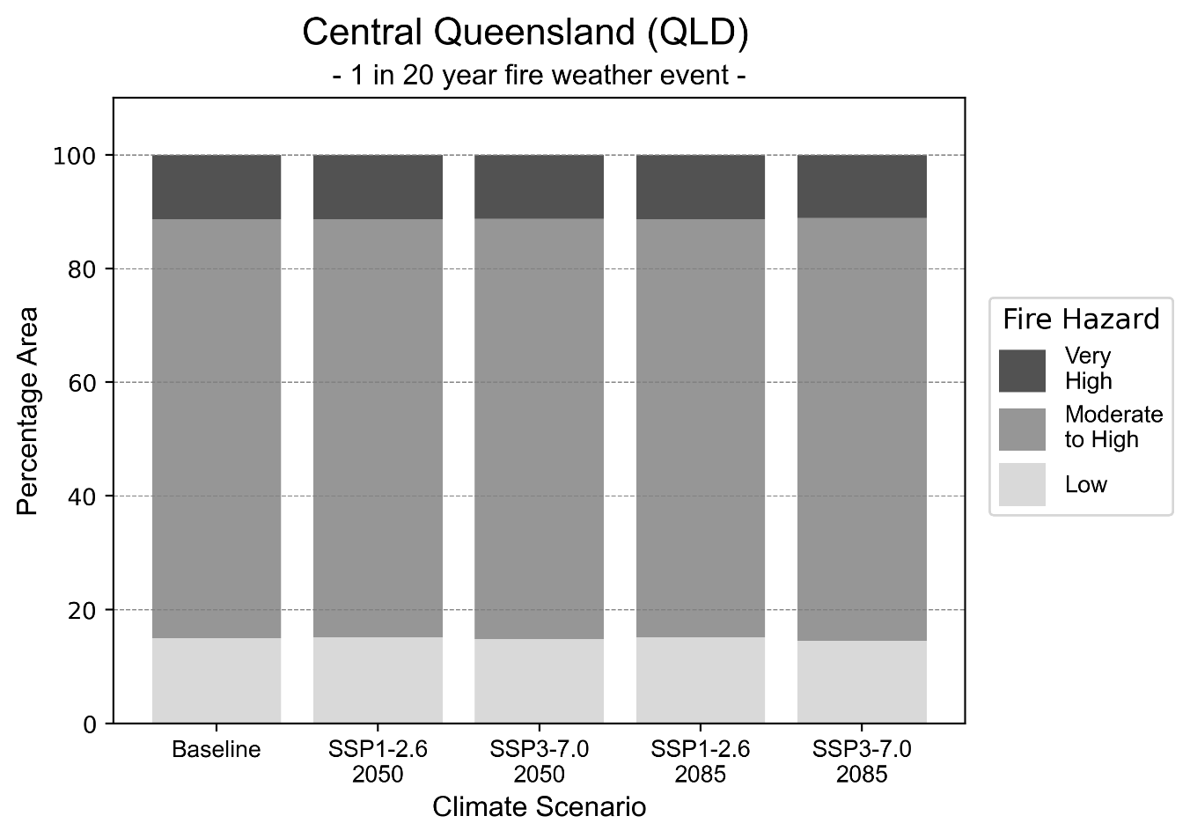
Figure 6: Stacked column chart showing the percentages of the Central Queensland health district's total geographic area experiencing each fire hazard level during a 1-in-20-year fire weather event.
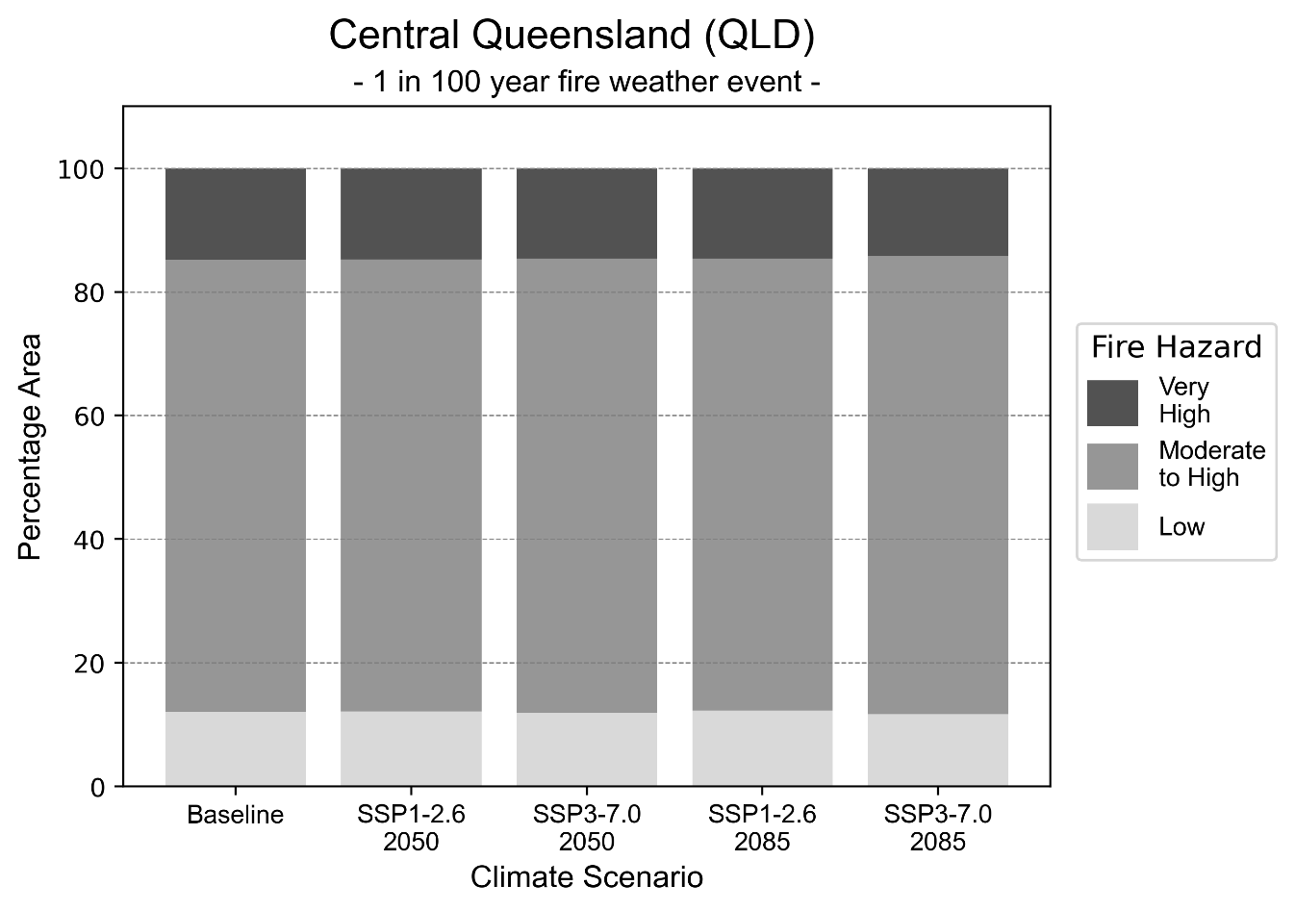
Figure 7: Stacked column chart showing the percentages of the Central Queensland health district's total geographic area experiencing each fire hazard level during a 1-in-100-year fire weather event.

Drought hazard
Key projections:
Drought occurrence: The occurrence of drought will increase across both middle of the road and reasonable worst-case scenarios for both time horizons, with the largest increase occurring under the reasonable worst-case scenario by 2050.

 | Baseline | 2050 Scenarios |  | 2085 Scenarios
 |  | Middle of the road | Reasonable worst-case | Middle of the road | Reasonable worst-case
Number of months per year in drought^{(a)} | 1.6 | 2.3  [0.2, 4.9] | 2.7  [0.1, 7.0] | 2.5  [0.3, 5.1] | 2.5  [0.0, 6.3]
Table notes: The drought hazard indicator uses climate projections from the CMIP6 Global Climate Models [1]. The primary indicator value reports the median from the nine climate models, with the range reported in square brackets.
Table footnotes: (a) The number of months per year in drought is based on the Standardised Precipitation Index (SPI). SPI is a widely used index to characterise meteorological drought on a range of timescales. This indicator uses the timescale of 12 months which calculates the average months in a year within the moderate drought range. A moderate drought range is classified as SPI score of ≤ -1. SPI is calculated from accumulated rainfall over 12 months and the mean and standard deviation from historical rainfall records.

Storm hazard
Key projections:
Fewer very-high-intensity storms: Very-high-intensity storms will be less frequent in both middle of the road and reasonable worst-case scenarios across both time horizons.

Baseline |  | 2050 Scenarios |  | 2085 Scenarios
 |  | Middle of the road | Reasonable worst-case | Middle of the road | Reasonable worst-case
Number of low-intensity storms (40-62 km/hr) per year | 76.6 | 77.9  [68.6, 85.7] | 79.1  [69.6, 87.0] | 79.5  [70.0, 87.5] | 79.0  [69.5, 86.9]
Number of medium-intensity storms (63-87 km/hr) per year | 47.4 | 44.4  [39.1, 48.9] | 49.2  [43.3, 54.1] | 43.8  [38.5, 48.2] | 46.3  [40.8, 51.0]
Number of high-intensity storms (88-117 km/hr) per year | 35.3 | 30.1  [26.5, 33.1] | 28.0  [24.6, 30.8] | 28.0  [24.7, 30.8] | 26.4  [23.2, 29.0]
Number of very-high-intensity storm (> 117 km/hr) per year | 1.5 | 1.0  [0.9, 1.1] | 1.1  [1.0, 1.2] | 1.3  [1.1, 1.4] | 1.0  [0.9, 1.1]
Table notes: The storm hazard uses climate projections from the CMIP6 Global Climate Models [1]. Daily maximum surface wind speed is used to calculate the number of annual storms across four storm intensity categories (low, medium, high and very high). The primary indicator value reports the median from the nine climate models, with the range reported in square brackets.

Rainfall and flood hazard
Key projections:
- Nine extreme rainfall days per year: The number of extreme rainfall days will remain consistent across both middle of the road and reasonable worst-case scenarios, and both time horizons, with an average of approximately nine extreme rainfall days per year.
- Increased flood frequency: The frequency of flood events will increase in both urban and rural environments. The largest increase in flood frequency occurs in the reasonable worst-case scenario, where the frequency of a ‘1-in-100 year’ flood will quadruple by 2050 and become 13 times more likely by 2085 in urban environments.

 | Baseline | 2050 Scenarios |  | 2085 Scenarios
 |  | Middle of the road | Reasonable worst-case | Middle of the road | Reasonable worst-case
Rainfall hazard^{(a)}
Average number of extreme rainfall days per year (> 11 mm/day)^{(a)} | 9.3 | 8.8  [7.1,11.2] | 8.7  [6.1,11.5] | 8.5  [6.2,10.6] | 8.7  [6.3,12.7]
Urban flood risk (flooding caused by a 1-hour rainfall event)^{(b)}
Frequency of a ‘1-in-1 year’ flood (rainfall depth of 37 mm)^{(c)} |  | 1.9 events in 1 year | 1.9 events in 1 year | 2.3 events in 1 year | 3.0 events in 1 year
Frequency of a ‘1-in-10 year’ flood (rainfall depth of 65 mm)^{(c)} |  | 3.0 events in 10 years | 3.2 events in 10 years | 4.6 events in 10 years | 7.1 events in 10 years
Frequency of a ‘1-in-100 year’ flood (rainfall depth of 100 mm)^{(c)} |  | 3.9 events in 100 years | 4.2 events in 100 years | 6.7 events in 100 years | 13 events in 100 years
Rural flood risk (flooding caused by a 24-hour rainfall event)^{(b)}
Frequency of a ‘1-in-1 year’ flood (rainfall depth of 96 mm)^{(c)} |  | 1.2 events in 1 year | 1.2 events in 1 year | 1.2 events in 1 year | 1.1 events in 1 year
Frequency of a ‘1-in-10 year’ flood (rainfall depth of 219 mm)^{(c)} |  | 1.5 events in 10 years | 1.5 events in 10 years | 1.6 events in 10 years | 1.6 events in 10 years
Frequency of a ‘1-in-100 year’ flood (rainfall depth of 408 mm)^{(c)} |  | 1.6 events in 100 years | 1.7 events in 100 years | 1.9 events in 100 years | 2.2 events in 100 years
Table notes: The rainfall hazard indicator uses climate projections from the CMIP6 Global Climate Models [1]. The primary indicator value reports the median from the nine climate models, with the range reported in square brackets. The flood hazard indicators use climate change considerations from the Australian Rainfall and Runoff guideline to estimate the climate projections [2].
Table footnotes: (a) Extreme rainfall is defined as rainfall above the 95th percentile of historical average daily rainfall in this health district in the period 1985-2014. The value in mm/day quoted in the indicator name is the 95th percentile of historic average daily rainfall for this health district. (b) See Methodology document for reasons for focusing on a 1-hour flood for urban areas and a 24-hour flood for rural areas. (c) The rainfall depths in mm quoted in the indicator names in this table report 1 in 1, 10 and 100 year depths for this health district.

Coastal inundation hazard
Key projections:
Greater area inundated: There will be an increase in the area affected by tidal inundation (i.e. area submerged during high tide) and storm surge and tidal inundation (i.e. the area submerged during a storm surge and high tide) across both middle of the road and reasonable worst-case scenarios. In the reasonable worst-case scenario, by 2085 the area inundated during tidal inundation will increase by over 41,000 ha.

 | Baseline | 2050 Scenarios |  | 2085 Scenarios^{(a)}
 |  | Middle of the road | Reasonable worst-case | Middle of the road | Reasonable worst-case
Tidal inundation (ha inundated)^{(b)} | 143,467.1 | 155,949.4  (+12,482.2) | 156,724.4  (+13,257.2) | 177,516.4  (+34,049.2) | 184,583.9  (+41,116.7)
Storm surge + tidal inundation – ‘1-in-100 year’ event (ha inundated)^{(c)} | 164,642.1 | 177,209.6  (+12,567.5) | 177,949.2  (+13,307.1) | 195,655.2  (+31,013.1) | 201,805.2  (+37,163.1)
Storm surge + tidal inundation – ‘1-in-1000 year’ event (ha inundated)^{(c)} | 175,864.5 | 188,394.0  (+12,529.5) | 189,135.0  (+13,270.4) | 209,662.7  (+33,798.1) | 214,825.7  (+38,961.1)
Table notes: The coastal inundation hazard provides an indication of flooding in coastal areas that can be attributed to sea level rise and storm inundation. The coastal inundation hazard is only reported for health districts adjoining the coastline. This table includes the projected inundation levels as well as the change from baseline conditions (in brackets).
Table footnotes: (a) For the 2085 Scenarios planning horizon, 2100 was adopted as it provides a conservative representation of the end of this period. This horizon aligns with many State planning regulations requiring consideration of sea level rise and storm tide to 2100, making the 2100 scenario particularly valuable for planning new health facilities in coastal areas. (b) The tidal inundation indicator reports the number of hectares inundated during high tide. The baseline value reports existing inundation patterns, while the 2050 and 2085 values report high tide inundation taking account of projected sea level rise due to climate change. (c) The storm surge + tidal inundation indicators report the combined effect, in hectares inundated, of high tide, sea level rise (for the 2050 and 2085 projections), and storm surge (for 1-in-100 year and 1-in-1000 year events).

Central West health district

Health district overview
Surface area: 381,907 square kilometres
Local health services: The Central West Hospital and Health Service region has 21 hospitals and health centres, including five hospitals: Longreach Hospital, Blackall Hospital, Alpha Multipurpose Health Service, Barcaldine Multipurpose Health Service, Winton Multipurpose Health Service

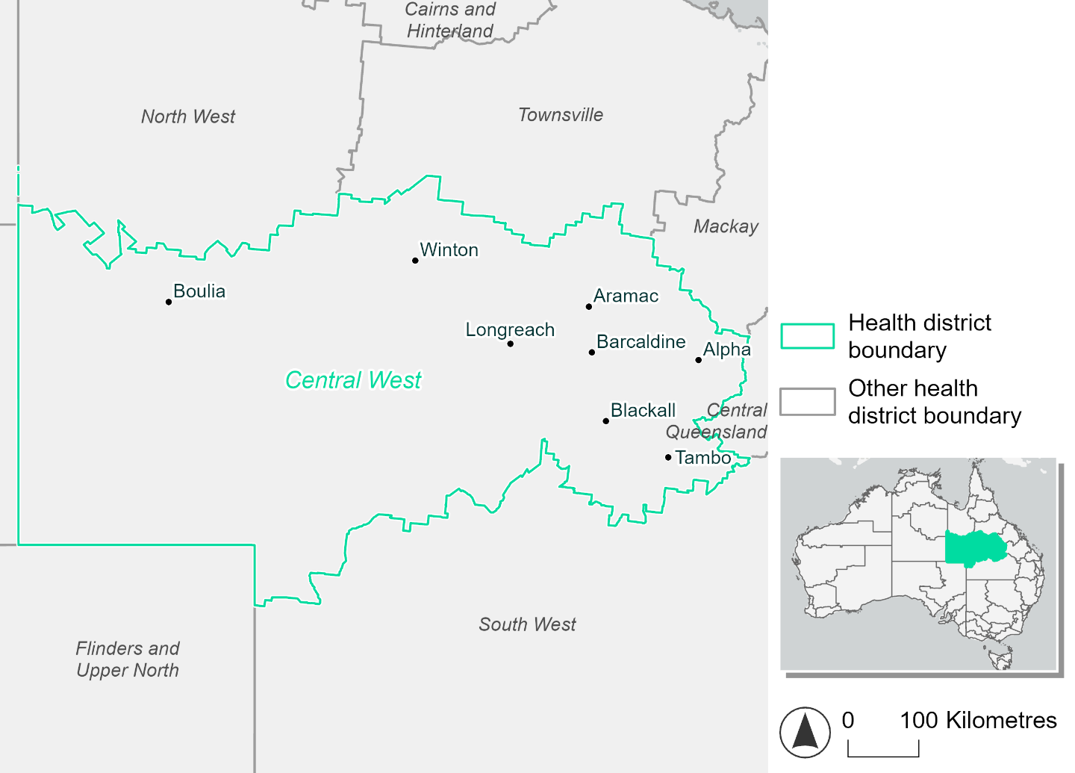
Figure 8. Map of Central West health district

How will climate change affect this health district?
Heat and humidity: There will be higher average temperatures, hotter and more frequent hot days, warmer night time temperatures and longer and more frequent heat waves.
Fire: Only 3-4% of this health district experiences very high fire hazard category and this will continue in the future.
Drought: The number of months experiencing drought will increase.
Rainfall and flood: There will be more flood events in urban areas.

Central West health district demographic data
Demographic Data | Total
Number of households | 3,900
Persons 15 and older | 7,203
Total families | 2,526
Persons did not complete high school | 3,173
One parent families with dependents | 237 (9.4%)
Persons aged 65 and older | 2,079 (19.6%)
Persons aged 4 and younger | 651 (6.1%)
Aboriginal and Torres Strait Islander persons | 834 (7.9%)
Persons speaks language other than English | 260 (2.5%)
Persons working age (15-65) | 6,534 (61.5%)
Population Health Data | Total
Persons with core needs for assistance | 491 (4.6%)
Persons with arthritis | 819 (7.7%)
Persons with asthma | 900 (8.5%)
Persons with cancer | 290 (2.7%)
Persons with dementia | 91 (0.9%)
Persons with diabetes | 567 (5.3%)
Persons with heart disease | 479 (4.5%)
Persons with kidney disease | 115 (1.1%)
Persons with lung condition | 208 (2%)
Persons with mental health condition | 716 (6.7%)
Persons with stroke | 105 (1%)
Persons with any other condition | 631 (5.9%)
Persons no health condition | 5,943 (56%)
Socio-economic Data | Total
Persons providing unpaid care | 1,038 (9.8%)
Persons homeless | 65 (0.6%)
Household with lone person | 1,304 (33.4%)
Households with rent and mortgage stress | 788 (20.2%)
Households total equivalised income below $1000 (weekly) | 1,685 (43.2%)
Households with no motor vehicle | 233 (6%)
Persons unemployed | 184 (2.1%)

The sections that follow outline projected climate hazards for this district. Further information on this health district, including population demographics, is provided in the online dashboard.

Heat and humidity hazard
Key projections:
More heatwaves: Heatwave events are likely to last longer and the number of heatwave events per year will increase. By 2050, under a reasonable worst-case scenario, the number of heatwaves will triple. By 2085, under a reasonable worst-case scenario, the number of heatwaves per year will quadruple.
Hotter days and warmer nights: The day time and night time temperatures on hot days will increase.
More days above 35°C and 40°C: The number of days per year greater than 35°C and 40°C will increase under both middle of the road and reasonable worst-case scenarios.

 | Baseline | 2050 Scenarios |  | 2085 Scenarios
 |  | Middle of the road | Reasonable worst-case | Middle of the road | Reasonable worst-case
Average temperature (°C) | 23.4 | 25.2  [24.6, 25.9] | 25.5  [24.7, 26.3] | 26.1  [25.3, 27.2] | 27.3  [26.1, 28.6]
Maximum temperature on hot days (°C)^{(a)} | 38.7 | 40.6  [39.8, 41.3] | 40.7  [39.8, 41.5] | 41.4  [40.3, 42.5] | 42.6  [41.5, 43.7]
Minimum temperature on hot nights (°C)^{(b)} | 25.1 | 27  [26.3, 27.4] | 27.2  [26.4, 27.8] | 27.9  [27.1, 28.9] | 29.1  [28, 30.2]
Average apparent temperature on hot days (°C) (NOAA Heat Index)^{(c)} | 36.2 | 38.2  [37.3, 38.9] | 38.5  [37.9, 39.4] | 39.6  [38.7, 41.1] | 41.2  [39.9, 42.5]
Average heatwave duration in days^{(d)} | 5 | 8  [6, 10] | 8  [6, 10] | 10  [7, 13] | 13  [9, 20]
Number of heatwaves per year^{(d)} | 2 | 6  [5, 7] | 6  [5, 8] | 7  [6, 9] | 8  [8, 9]
Number of days per year  > 35°C | 88 | 130  [103, 151] | 136  [113, 166] | 151  [124, 179] | 171  [135, 202]
Number of days per year > 40°C | 10 | 30  [20, 42] | 32  [19, 47] | 44  [26, 67] | 66  [41, 101]
Table notes: The heat and humidity hazard uses climate projections from the CMIP6 Global Climate Models [1]. Daily projections of maximum and minimum near-surface temperature and mean relative humidity are used to calculate eight heat and humidity indicators. The primary indicator value reports the median from the nine climate models, with the range reported in square brackets.
Table footnotes: (a) Based on the 95th percentile of daily maximum air temperature. (b) Based on the 95th percentile of daily minimum air temperature, representing the coldest part of the night on very hot nights. (c) The National Oceanic and Atmospheric Administration (NOAA) Heat Index is a measure of how hot it feels when relative humidity is factored in alongside actual air temperature. It is calculated on days with a maximum temperature of 27°C and above. Interpretation of Heat Index values: 27°C to 32°C indicates caution, 33°C to 41°C indicates extreme caution, 42°C to 54°C indicates danger and over 54°C indicates extreme danger. See methodology document for further explanation of Heat Index categories. (d) A heatwave is defined as three or more consecutive days where both daytime and overnight temperatures (daily mean temperatures) are unusually high for the location, based on the Bureau of Meteorology’s Excess Heat Factor method. For this district, an unusually high daily mean temperature is approximately 31.5 °C or above.

Fire Hazard
Key projections:
- Evenly spread fire hazard currently: Under baseline conditions less than 5% of the district experiences very high fire hazard. Roughly half of the remaining area (47-49%) experiences moderate to high fire hazard with a similar proportion (47-49%) experiencing low fire hazard.
- Slight increase in moderate to high hazard depending on emissions: In a future climate under a sustainability emissions scenario, the maximum change in area by 2050 or by 2085 is 1.2 percentage points for both the 1-in-20- and 1-in-100-year fire weather events, indicating little overall change in this scenario. Under the reasonable worst-case emissions scenario, the area experiencing moderate to high hazard increases by up to 3.1 percentage points for a 1-in-20-year fire weather event, and 3.7 for the 1-in-100-year event. The small area experiencing very high hazard stays stable, varying by at most 0.2 percentage points for each fire weather event type.

 | Baseline | 2050 Scenarios |  | 2085 Scenarios
 |  | Sustainability | Reasonable worst-case | Sustainability | Reasonable worst-case
Hazard for a ‘1-in-20 year’ fire weather event^{(a)}
Proportion (%) of district experiencing ‘Low’ fire hazard | 48.9%  (18,684,262)  ^{(b)} | 48.6%  [48.1%, 48.9%] | 47.5%  [45.8%, 48.5%] | 48.1%  [47.0%, 48.9%] | 45.6%  [41.4%, 48.0%]
Proportion (%) of district experiencing ‘Moderate to High’ fire hazard | 47.4%  (18,100,717)  ^{(b)} | 47.8%  [47.1%, 48.5%] | 48.9%  [47.5%, 50.6%] | 48.4%  [46.7%, 50.0%] | 50.9%  [47.7%, 55.0%]
Proportion (%) of district experiencing ‘Very High’ fire hazard | 3.7%  (1,405,724)^{(b)} | 3.6%  [3.5%, 3.8%] | 3.6%  [3.5%, 3.8%] | 3.5%  [3.2%, 3.9%] | 3.5%  [3.2%, 3.9%]
Hazard for a ‘1-in-100 year’ fire weather event^{(a)}
Proportion (%) of district experiencing ‘Low’ fire hazard | 46.0%  (17,572,528)  ^{(b)} | 45.6%  [45.0%, 46.1%] | 44.3%  [42.3%, 45.4%] | 45.0%  [43.5%, 46.2%] | 41.9%  [37.1%, 44.6%]
Proportion (%) of district experiencing ‘Moderate to High’ fire hazard | 49.7%  (18,963,859)  ^{(b)} | 50.2%  [49.4%, 51.0%] | 51.4%  [50.0%, 53.3%] | 50.9%  [49.1%, 52.8%] | 53.9%  [50.6%, 58.5%]
Proportion (%) of district experiencing ‘Very High’ fire hazard | 4.3%  (1,654,315)^{(b)} | 4.3%  [4.2%, 4.4%] | 4.3%  [4.2%, 4.4%] | 4.2%  [4.0%, 4.5%] | 4.2%  [3.9%, 4.6%]
Table notes: The Fire Hazard uses the National Bushfire Intelligence Capability (NBIC) Phase 2 fire line intensity modelling based on CMIP6 climate projections. Fire Hazard is assessed using the projected Fireline Intensity (FLI) for weather events with two different return intervals (i.e. a 1-in-20 year event and a 1-in-100 year event). FLI considers slope, vegetation and weather to produce a rate of heat output per unit length (kW/m) along a bushfire’s front. Fire hazard is categorized as a low for FLI<4000 kW/m, moderate to high for 4,000 kW/m ≤FLI<12,500kW/m, and very high for FLI≥27,501kW/m. This is broadly consistent with the literature [3]. The assessment considers climate change effects based on changes in fire weather and the associated hazard that is anticipated for a meteorological event of a given return interval. This approach is different to the one adopted for the Flood Hazard, where the event magnitude is given (fixed) and the likelihood of that event varies as a result of climate change. The primary indicator value reports the median from the nine climate models, with the range reported in square brackets.
Table footnotes: (a) The area subject to different categories of fire hazard is determined for a ‘1-in-20 year’ and ‘1-in-100 year’ fire weather event, in current and future climates. Values at year 2050 are interpolated using data from baseline (2025) and 2085, assuming linear change over time. (b) Values in round brackets are the area (ha) of the health district subject to a given fire hazard.

The figures below show the proportion of the health district experiencing different fire hazard categories across different time horizons and climate scenarios during a ‘1-in-20 year’ fire weather event (Figure 9) and a ‘1-in-100 year’ fire weather event (Figure 10).
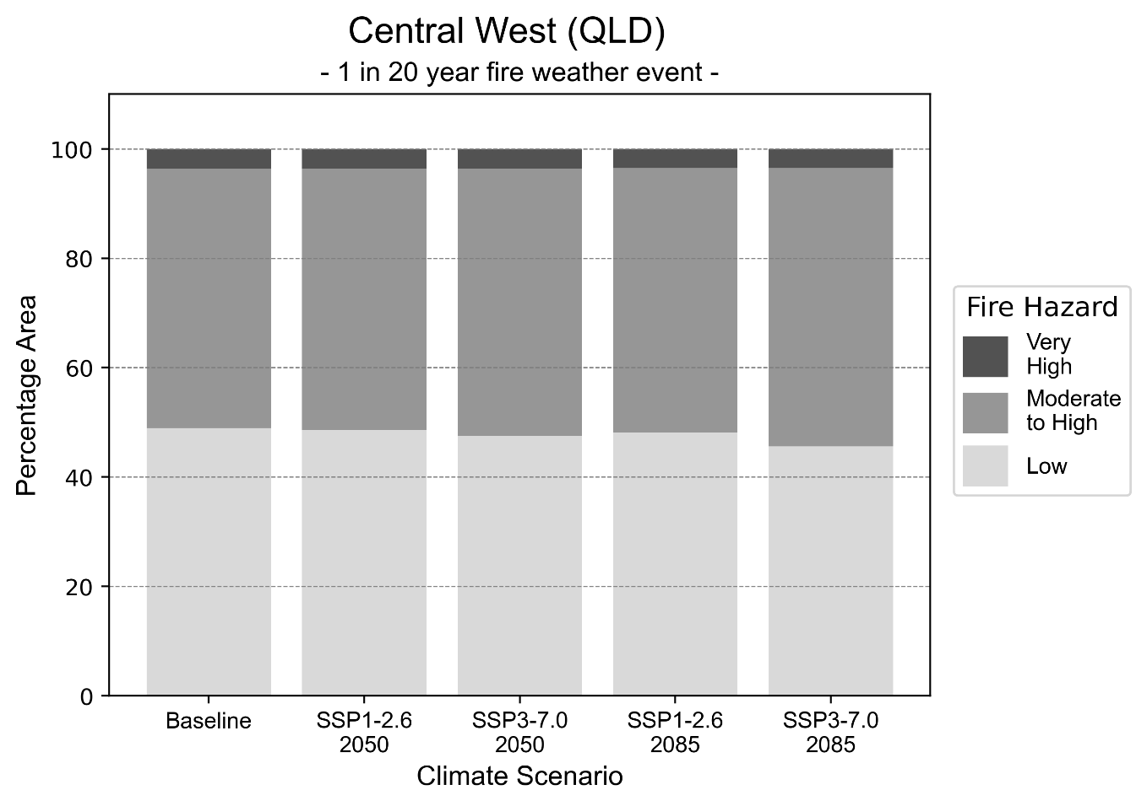
Figure 9: Stacked column chart showing the percentages of the Central West health district's total geographic area experiencing each fire hazard level during a 1-in-20-year fire weather event.
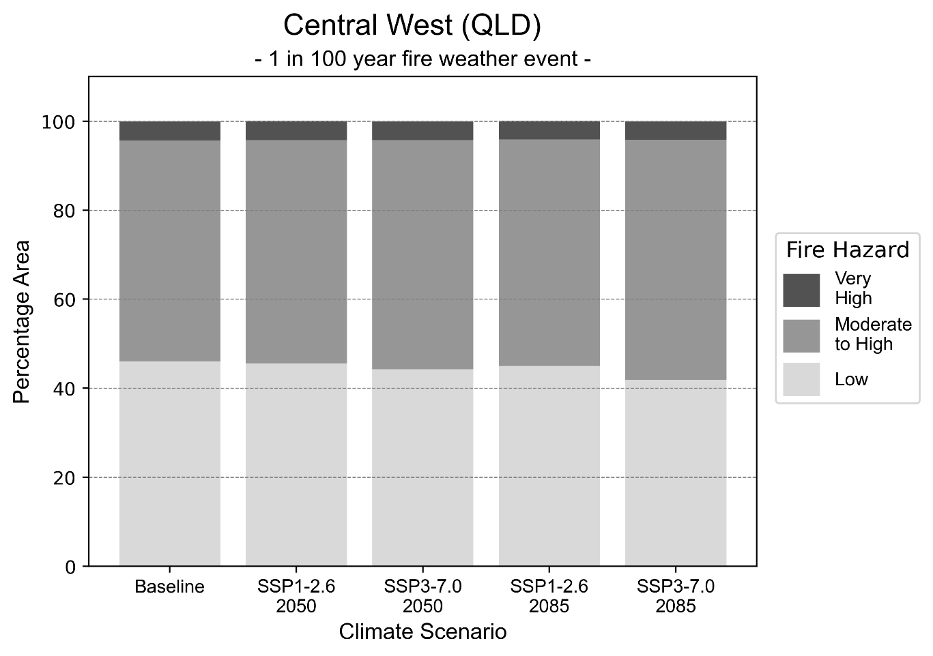
Figure 10: Stacked column chart showing the percentages of the Central West health district's total geographic area experiencing each fire hazard level during a 1-in-100-year fire weather event.

Drought hazard
Key projections:
Drought occurrence: The occurrence of drought will increase across both middle of the road and reasonable worst-case scenarios for both time horizons, with the largest increase occurring under the middle of the road scenario by 2085.

 | Baseline | 2050 Scenarios |  | 2085 Scenarios
 |  | Middle of the road | Reasonable worst-case | Middle of the road | Reasonable worst-case
Number of months per year in drought^{(a)} | 1.6 | 2.5  [0.1, 5.6] | 2.3  [0.3, 5.5] | 2.6  [0.2, 5.3] | 2.5  [0.1, 5.6]
Table notes: The drought hazard indicator uses climate projections from the CMIP6 Global Climate Models [1]. The primary indicator value reports the median from the nine climate models, with the range reported in square brackets.
Table footnotes: (a) The number of months per year in drought is based on the Standardised Precipitation Index (SPI). SPI is a widely used index to characterise meteorological drought on a range of timescales. This indicator uses the timescale of 12 months which calculates the average months in a year within the moderate drought range. A moderate drought range is classified as SPI score of ≤ -1. SPI is calculated from accumulated rainfall over 12 months and the mean and standard deviation from historical rainfall records.

Storm hazard
Key projections:
More very-high-intensity storms under reasonable worst-case scenario: For both time horizons, very-high-intensity storms will be more frequent under the reasonable worst-case scenario but will remain consistent under the middle of the road scenario.

Baseline |  | 2050 Scenarios |  | 2085 Scenarios
 |  | Middle of the road | Reasonable worst-case | Middle of the road | Reasonable worst-case
Number of low-intensity storms (40-62 km/hr) per year | 75.1 | 74.4  [65.5, 81.8] | 73.9  [65.1, 81.3] | 69.5  [61.2, 76.5] | 71.4  [62.9, 78.6]
Number of medium-intensity storms (63-87 km/hr) per year | 60.3 | 57.7  [50.8, 63.5] | 60.1  [52.9, 66.1] | 54.6  [48.1, 60.1] | 57.1  [50.2, 62.8]
Number of high-intensity storms (88-117 km/hr) per year | 12.7 | 13.7  [12.1, 15.1] | 14.2  [12.5, 15.6] | 13.0  [11.4, 14.3] | 14.2  [12.5, 15.7]
Number of very-high-intensity storm (>117 km/hr) per year | 0.3 | 0.3  [0.3, 0.4] | 0.4  [0.4, 0.5] | 0.3  [0.2, 0.3] | 0.4  [0.4, 0.5]
Table notes: The storm hazard uses climate projections from the CMIP6 Global Climate Models [1]. Daily maximum surface wind speed is used to calculate the number of annual storms across four storm intensity categories (low, medium, high and very high). The average number of storms per year is reported, with the maximum and minimum values across climate models reported in square brackets.

Rainfall and flood hazard
Key projections:
- Fewer extreme rainfall days per year: The number of extreme rainfall days will decrease slightly across both middle of the road and reasonable worst-case scenarios, and both time horizons, with an average of approximately 11 to 12 extreme rainfall days per year.
- Increased flood frequency: The frequency of flood events will increase in urban environments. The largest increase in flood frequency occurs in the reasonable worst-case scenario, where the frequency of a ‘1-in-100 year’ flood will nearly triple by 2050 and become nearly seven times more likely by 2085 in urban environments. In rural environments, by 2085 the frequency of all types of floods events will decrease, with the exception of the ‘1-in-100 year’ flood event which will increase in frequency under the middle of the road scenario by 2085.

 | Baseline | 2050 Scenarios |  | 2085 Scenarios
 |  | Middle of the road | Reasonable worst-case | Middle of the road | Reasonable worst-case
Rainfall hazard^{(a)}
Average number of extreme rainfall days per year (> 6 mm/day)^{(a)} | 12.1 | 11.7  [8.3,17.2] | 11.6  [8.5,14.8] | 11.3  [8.7,17.0] | 11.7  [8.2,20.1]
Urban flood risk (flooding caused by a 1-hour rainfall event)^{(b)}
Frequency of a ‘1-in-1 year’ flood (rainfall depth of 22 mm)^{(c)} |  | 1.6 events in 1 year | 1.6 events in 1 year | 1.9 events in 1 year | 2.3 events in 1 year
Frequency of a ‘1-in-10 year’ flood (rainfall depth of 54 mm)^{(c)} |  | 2.1 events in 10 years | 2.1 events in 10 years | 2.6 events in 10 years | 3.5 events in 10 years
Frequency of a ‘1-in-100 year’ flood (rainfall depth of 98 mm)^{(c)} |  | 2.8 events in 100 years | 2.9 events in 100 years | 4.1 events in 100 years | 6.7 events in 100 years
Rural flood risk (flooding caused by a 24-hour rainfall event)^{(b)}
Frequency of a ‘1-in-1 year’ flood (rainfall depth of 59 mm)^{(c)} |  | 0.9 events in 1 year | 0.8 events in 1 year | 0.9 events in 1 year | 0.5 events in 1 year
Frequency of a ‘1-in-10 year’ flood (rainfall depth of 133 mm)^{(c)} |  | 1.1 events in 10 years | 1.1 events in 10 years | 0.8 events in 10 years | 0.4 events in 10 years
Frequency of a ‘1-in-100 year’ flood (rainfall depth of 228 mm)^{(c)} |  | 1.3 events in 100 years | 1.3 events in 100 years | 1.1 events in 100 years | 0.6 events in 100 years
Table notes: The rainfall hazard indicator uses climate projections from the CMIP6 Global Climate Models [1]. The primary indicator value reports the median from the nine climate models, with the range reported in square brackets. The flood hazard indicators use climate change considerations from the Australian Rainfall and Runoff guideline to estimate the climate projections [2].
Table footnotes:(a) Extreme rainfall is defined as rainfall above the 95th percentile of historical average daily rainfall in this health district in the period 1985-2014. The value in mm/day quoted in the indicator name is the 95th percentile of historic average daily rainfall for this health district. (b) See Methodology document for reasons for focusing on a 1-hour flood for urban areas and a 24-hour flood for rural areas. (c) The rainfall depths in mm quoted in the indicator names in this table report 1 in 1, 10 and 100 year depths for this health district.

Darling Downs health district

Health district Overview
Surface area: 88,498 square kilometres
Estimated population: 300,000
Local health services: Darling Downs Hospital and Health Service region has 24 hospitals and health centres including: Toowoomba Hospital, Ballie Henderson Hospital, Warwick Hospital, Kingaroy Hospital, Dalby Hospital, Stanthorpe Hospital, Goondiwindi Hospital

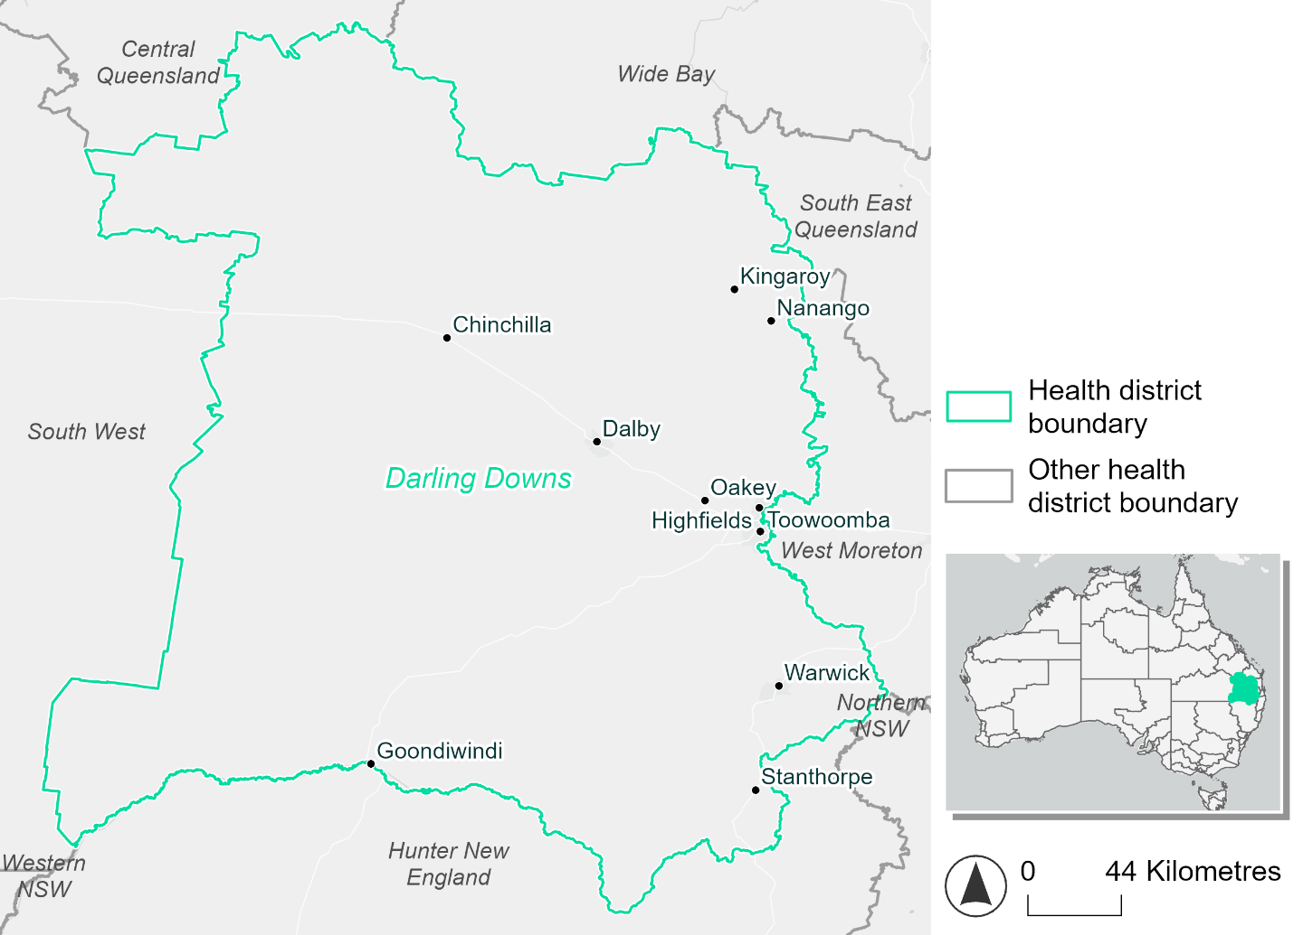
Figure 11. Map of Darling Downs health district.

How will climate change affect this health district?
Heat and humidity: There will be higher average temperatures, hotter and more frequent hot days, warmer night time temperatures and longer and more frequent heat waves.
Fire: 12-15% of this health district experiences very high fire hazard category and this will continue in the future.
Drought: The number of months experiencing drought will increase.
Rainfall and flood: There will be more flood events in both urban and rural areas.

Darling Downs health district demographic data
Demographic Data | Total
Number of households | 107,597
Persons 15 and older | 194,666
Total families | 75,813
Persons did not complete high school | 85,888
One parent families with dependents | 8,573 (11.3%)
Persons aged 65 and older | 61,585 (20.8%)
Persons aged 4 and younger | 17,515 (5.9%)
Aboriginal and Torres Strait Islander persons | 17,260 (5.8%)
Persons speaks language other than English | 19,946 (6.7%)
Persons working age (15-65) | 177,056 (59.8%)
Population Health Data | Total
Persons with core needs for assistance | 21,167 (7.1%)
Persons with arthritis | 32,830 (11.1%)
Persons with asthma | 29,215 (9.9%)
Persons with cancer | 10,176 (3.4%)
Persons with dementia | 2,522 (0.9%)
Persons with diabetes | 16,294 (5.5%)
Persons with heart disease | 14,955 (5%)
Persons with kidney disease | 3,372 (1.1%)
Persons with lung condition | 6,924 (2.3%)
Persons with mental health condition | 31,547 (10.7%)
Persons with stroke | 3,560 (1.2%)
Persons with any other condition | 25,757 (8.7%)
Persons no health condition | 160,370 (54.1%)
Socio-economic Data | Total
Persons providing unpaid care | 37,858 (12.8%)
Persons homeless | 1,288 (0.4%)
Household with lone person | 30,111 (28%)
Households with rent and mortgage stress | 41,724 (38.8%)
Households total equivalised income below $1000 (weekly) | 57,089 (53.1%)
Households with no motor vehicle | 5,568 (5.2%)
Persons unemployed | 11,809 (5.1%)

The sections that follow outline projected climate hazards for this district. Further information on this health district, including population demographics, is provided in the online dashboard.

Heat and humidity hazard
Key projections:
More heatwaves: Heatwave events are likely to last longer and the number of heatwave events per year will increase. By 2050, under a reasonable worst-case scenario, the number of heatwaves will triple. By 2085, under a reasonable worst-case scenario, the number of heatwaves per year will quadruple.
Hotter days and warmer nights: The day time and night time temperatures on hot days will increase.
More days above 35°C and 40°C: The number of days per year greater than 35°C and 40°C will increase under both middle of the road and reasonable worst-case scenarios.

 | Baseline | 2050 Scenarios |  | 2085 Scenarios
 |  | Middle of the road | Reasonable worst-case | Middle of the road | Reasonable worst-case
Average temperature (°C) | 18.2 | 19.7  [19.1, 20.2] | 20  [19.2, 20.9] | 20.6  [19.5, 21.5] | 21.6  [20.4, 22.7]
Maximum temperature on hot days (°C)^{(a)} | 32.3 | 34  [33.3, 35] | 34.3  [33.1, 36.7] | 35  [33.9, 36.6] | 36  [34.6, 37.9]
Minimum temperature on hot nights (°C)^{(b)} | 20 | 21.5  [20.7, 22.1] | 21.7  [21, 22.3] | 22.3  [21.1, 23.2] | 23.3  [22.1, 24.3]
Average apparent temperature on hot days (°C) (NOAA Heat Index)^{(c)} | 33.5 | 35.3  [34.7, 36] | 35.5  [34.8, 36.6] | 36.4  [35.3, 37.5] | 37.9  [36.5, 39.5]
Average heatwave duration in days^{(d)} | 5 | 6  [6, 7] | 6  [5, 9] | 8  [6, 10] | 10  [7, 15]
Number of heatwaves per year^{(d)} | 2 | 5  [4, 7] | 6  [5, 8] | 7  [5, 9] | 8  [7, 9]
Number of days per year  > 35°C | 6 | 15  [11, 22] | 18  [10, 40] | 22  [13, 37] | 34  [19, 57]
Number of days per year > 40°C | 0 | 1  [0, 2] | 1  [0, 4] | 2  [0, 4] | 4  [1, 8]
Table notes: The heat and humidity hazard uses climate projections from the CMIP6 Global Climate Models [1]. Daily projections of maximum and minimum near-surface temperature and mean relative humidity are used to calculate eight heat and humidity indicators. The primary indicator value reports the median from the nine climate models, with the range reported in square brackets.
Table footnotes:(a) Based on the 95th percentile of daily maximum air temperature. (b) Based on the 95th percentile of daily minimum air temperature, representing the coldest part of the night on very hot nights. (c) The National Oceanic and Atmospheric Administration (NOAA) Heat Index is a measure of how hot it feels when relative humidity is factored in alongside actual air temperature. It is calculated on days with a maximum temperature of 27°C and above. Interpretation of Heat Index values: 27°C to 32°C indicates caution, 33°C to 41°C indicates extreme caution, 42°C to 54°C indicates danger and over 54°C indicates extreme danger. See methodology document for further explanation of Heat Index categories. (d) A heatwave is defined as three or more consecutive days where both daytime and overnight temperatures (daily mean temperatures) are unusually high for the location, based on the Bureau of Meteorology’s Excess Heat Factor method. For this district, an unusually high daily mean temperature is approximately 25.7°C or above.

Fire Hazard
Key projections:
- Majority of district area experiences moderate to high hazard: Under baseline conditions about three-quarters of the district (74-75%) experiences moderate to high fire hazard. During a 1-in-20-year fire weather event the remainder is split evenly (about 12% each) between low and very high hazard. In a 1-in-100-year fire weather event, 10% of the district experiences low hazard and 15% experiences very high hazard.
- Current fire hazard conditions to persist: In a future climate across both 2050 and 2085 scenarios the area experiencing moderate to high hazard increases very slightly, to as high as 76.8% in a 1-in-20-year fire weather event and 75.7% during a 1-in-100-year event. The areas experiencing low or very high hazard both decline slightly by less than 1 percentage point.

 | Baseline | 2050 Scenarios |  | 2085 Scenarios
 |  | Sustainability | Reasonable worst-case | Sustainability | Reasonable worst-case
Hazard for a ‘1-in-20 year’ fire weather event^{(a)}
Proportion (%) of district experiencing ‘Low’ fire hazard | 12.1%  (1,075,223)^{(b)} | 12.0%  [11.8%, 12.2%] | 11.8%  [11.2%, 12.1%] | 11.7%  [11.4%, 12.3%] | 11.4%  [9.8%, 12.1%]
Proportion (%) of district experiencing ‘Moderate to High’ fire hazard | 75.5%  (6,679,096)^{(b)} | 75.6%  [74.4%, 77.0%] | 76.0%  [75.0%, 77.1%] | 75.7%  [72.9%, 79.1%] | 76.8%  [74.4%, 79.4%]
Proportion (%) of district experiencing ‘Very High’ fire hazard | 12.4%  (1,095,452)^{(b)} | 12.4%  [11.8%, 12.8%] | 12.2%  [11.4%, 13.3%] | 12.5%  [10.9%, 13.3%] | 11.9%  [10.1%, 14.7%]
Hazard for a ‘1-in-100 year’ fire weather event^{(a)}
Proportion (%) of district experiencing ‘Low’ fire hazard | 10.5%  (932,069)^{(b)} | 10.4%  [10.1%, 10.6%] | 10.2%  [9.6%, 10.4%] | 10.1%  [9.6%, 10.6%] | 9.7%  [8.3%, 10.3%]
Proportion (%) of district experiencing ‘Moderate to High’ fire hazard | 74.2%  (6,570,424)^{(b)} | 74.4%  [72.6%, 76.2%] | 74.9%  [73.2%, 76.2%] | 74.6%  [70.4%, 78.9%] | 75.7%  [71.8%, 78.9%]
Proportion (%) of district experiencing ‘Very High’ fire hazard | 15.2%  (1,347,279)^{(b)} | 15.2%  [14.7%, 15.5%] | 14.9%  [14.5%, 15.5%] | 15.2%  [13.9%, 16.0%] | 14.5%  [13.4%, 16.0%]
Table notes: The Fire Hazard uses the National Bushfire Intelligence Capability (NBIC) Phase 2 fire line intensity modelling based on CMIP6 climate projections. Fire Hazard is assessed using the projected Fireline Intensity (FLI) for weather events with two different return intervals (i.e. a 1-in-20 year event and a 1-in-100 year event). FLI considers slope, vegetation and weather to produce a rate of heat output per unit length (kW/m) along a bushfire’s front. Fire hazard is categorized as a low for FLI<4000 kW/m, moderate to high for 4,000 kW/m ≤FLI<12,500kW/m, and very high for FLI≥27,501kW/m. This is broadly consistent with the literature [3]. The assessment considers climate change effects based on changes in fire weather and the associated hazard that is anticipated for a meteorological event of a given return interval. This approach is different to the one adopted for the Flood Hazard, where the event magnitude is given (fixed) and the likelihood of that event varies as a result of climate change. The primary indicator value reports the median from the nine climate models, with the range reported in square brackets.
Table footnotes: (a) The area subject to different categories of fire hazard is determined for a ‘1-in-20 year’ and ‘1-in-100 year’ fire weather event, in current and future climates. Values at year 2050 are interpolated using data from baseline (2025) and 2085, assuming linear change over time. (b) Values in round brackets are the area (ha) of the health district subject to a given fire hazard.

The figures below show the proportion of the health district experiencing different fire hazard categories across different time horizons and climate scenarios during a ‘1-in-20 year’ fire weather event (Figure 12) and a ‘1-in-100 year’ fire weather event (Figure 13).
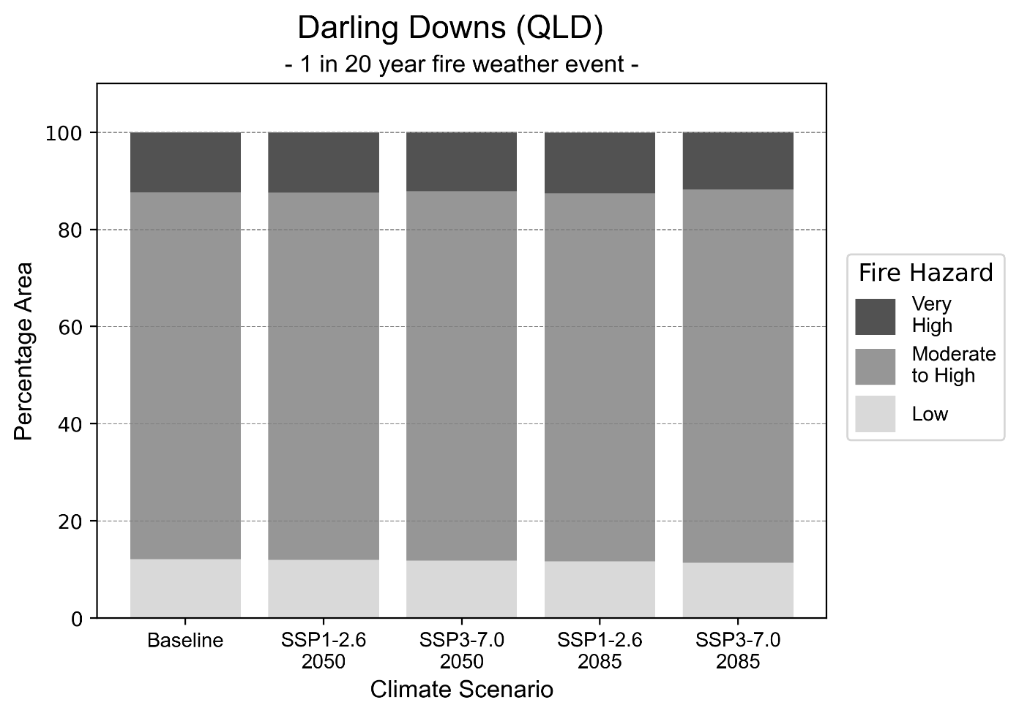
Figure 12: Stacked column chart showing the percentages of the Darling Downs health district's total geographic area experiencing each fire hazard level during a 1-in-20-year fire weather event.
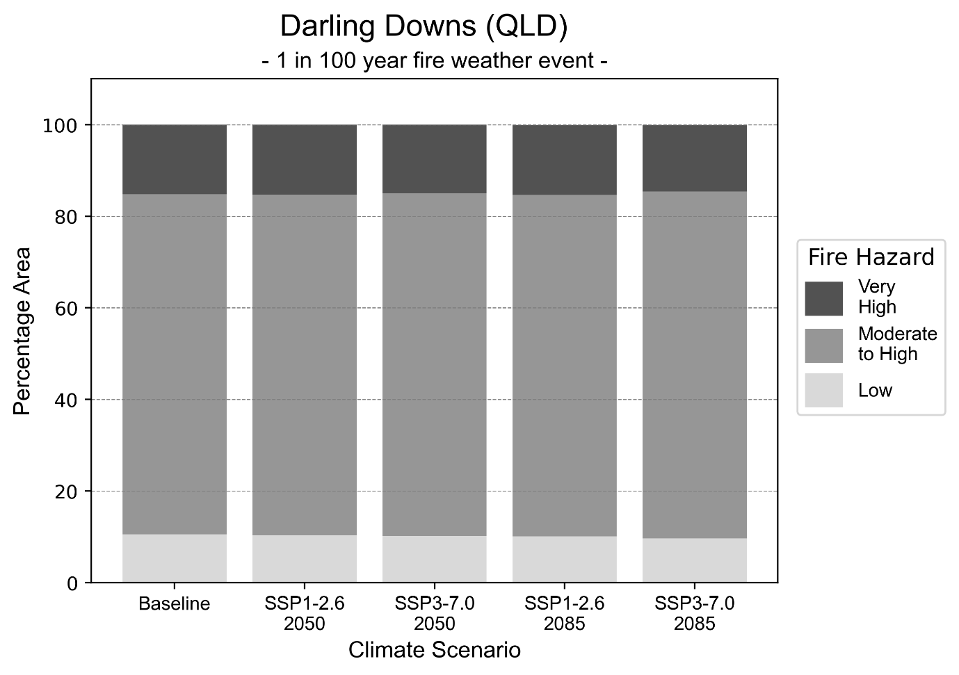
Figure 13: Stacked column chart showing the percentages of the Darling Downs health district's total geographic area experiencing each fire hazard level during a 1-in-100-year fire weather event.

Drought hazard
Key projections:
Drought occurrence: The occurrence of drought will increase across both middle of the road and reasonable worst-case scenarios for both time horizons, with the largest increase occurring under the reasonable worst-case scenario by 2050.

 | Baseline | 2050 Scenarios |  | 2085 Scenarios
 |  | Middle of the road | Reasonable worst-case | Middle of the road | Reasonable worst-case
Number of months per year in drought^{(a)} | 1.8 | 2.5  [0.3, 5.1] | 2.8  [0.5, 8.2] | 2.6  [0.5, 4.6] | 2.6  [0.1, 6.2]
Table notes: The drought hazard indicator uses climate projections from the CMIP6 Global Climate Models [1]. The primary indicator value reports the median from the nine climate models, with the range reported in square brackets.
Table footnotes:(a) The number of months per year in drought is based on the Standardised Precipitation Index (SPI). SPI is a widely used index to characterise meteorological drought on a range of timescales. This indicator uses the timescale of 12 months which calculates the average months in a year within the moderate drought range. A moderate drought range is classified as SPI score of ≤ -1. SPI is calculated from accumulated rainfall over 12 months and the mean and standard deviation from historical rainfall records.

Storm hazard
Key projections:
Fewer high-intensity storms: High-intensity storms will be less frequent in both middle of the road and reasonable worst-case scenarios, with the greatest decrease occurring by 2050.

 | Baseline | 2050 Scenarios |  | 2085 Scenarios
 |  | Middle of the road | Reasonable worst-case | Middle of the road | Reasonable worst-case
Number of low-intensity storms (40-62 km/hr) per year | 107.3 | 98.2  [86.4, 108.0] | 97.7  [85.9, 107.4] | 91.0  [80.1, 100.1] | 96.1  [84.6, 105.7]
Number of medium-intensity storms (63-87 km/hr) per year | 36.6 | 31.9  [28.1, 35.1] | 30.4  [26.8, 33.4] | 27.5  [24.2, 30.2] | 32.1  [28.2, 35.3]
Number of high-intensity storms (88-117 km/hr) per year | 4.3 | 3.3  [2.9, 3.6] | 3.3  [2.9, 3.6] | 3.9  [3.4, 4.3] | 3.5  [3.1, 3.9]
Number of very-high-intensity storm (> 117 km/hr) per year | 0.0 | 0.0  [0.0, 0.0] | 0.0  [0.0, 0.0] | 0.0  [0.0, 0.0] | 0.0  [0.0, 0.0]
Table notes: The storm hazard uses climate projections from the CMIP6 Global Climate Models [1]. Daily maximum surface wind speed is used to calculate the number of annual storms across four storm intensity categories (low, medium, high and very high). The primary indicator value reports the median from the nine climate models, with the range reported in square brackets.

Rainfall and flood hazard
Key projections:
- Fewer extreme rainfall days per year: The number of extreme rainfall days will slightly decrease across both middle of the road and reasonable worst-case scenarios, and both time horizons, with the largest decrease occurring by 2085 under the middle of the road scenario.
- Increased flood frequency: The frequency of flood events will increase both in urban and rural environments. The largest increase in flood frequency occurs in the reasonable worst-case scenario, where the frequency of a ‘1-in-100 year’ flood will nearly quadruple by 2050 and become 11 times more likely by 2085 in urban environments.

 | Baseline | 2050 Scenarios |  | 2085 Scenarios
 |  | Middle of the road | Reasonable worst-case | Middle of the road | Reasonable worst-case
Rainfall hazard^{(a)}
Average number of extreme rainfall days per year (> 10 mm/day)^{(a)} | 11.3 | 10.8  [8.8,13.5] | 10.5  [7.2,12.7] | 10.4  [8.7,12.9] | 10.7  [8.0,14.4]
Urban flood risk (flooding caused by a 1-hour rainfall event)^{(b)}
Frequency of a ‘1-in-1 year’ flood (rainfall depth of 29 mm)^{(c)} |  | 1.8 events in 1 year | 1.9 events in 1 year | 2.3 events in 1 year | 2.9 events in 1 year
Frequency of a ‘1-in-10 year’ flood (rainfall depth of 56 mm)^{(c)} |  | 2.6 times in 10 years | 2.7 times in 10 years | 3.6 times in 10 years | 5.5 times in 10 years
Frequency of a ‘1-in-100 year’ flood (rainfall depth of 89 mm)^{(c)} |  | 3.6 times in 100 years | 3.8 times in 100 years | 5.8 times in 100 years | 11 times in 100 years
Rural flood risk (flooding caused by a 24-hour rainfall event)^{(b)}
Frequency of a ‘1-in-1 year’ flood (rainfall depth of 65 mm)^{(c)} |  | 1.3 events in 1 year | 1.3 events in 1 year | 1.5 events in 1 year | 1.6 events in 1 year
Frequency of a ‘1-in-10 year’ flood (rainfall depth of 124 mm)^{(c)} |  | 1.7 events in 10 years | 1.7 events in 10 years | 2.0 events in 10 years | 2.3 events in 10 years
Frequency of a ‘1-in-100 year’ flood (rainfall depth of 197 mm)^{(c)} |  | 2.0 events in 100 years | 2.1 events in 100 years | 2.5 events in 100 years | 3.3 events in 100 years
Table notes: The rainfall hazard indicator uses climate projections from the CMIP6 Global Climate Models [1]. The primary indicator value reports the median from the nine climate models, with the range reported in square brackets. The flood hazard indicators use climate change considerations from the Australian Rainfall and Runoff guideline to estimate the climate projections [2].
Table footnotes: (a) Extreme rainfall is defined as rainfall above the 95th percentile of historical average daily rainfall in this health district in the period 1985-2014. The value in mm/day quoted in the indicator name is the 95th percentile of historic average daily rainfall for this health district. (b) See Methodology document for reasons for focusing on a 1-hour flood for urban areas and a 24-hour flood for rural areas. (c) The rainfall depths in mm quoted in the indicator names in this table report 1 in 1, 10 and 100 year depths for this health district.

Mackay health district

Health district overview
Surface area: 90,124 square kilometres
Local health services: The Mackay Hospital and Health Service region contains six hospitals, two Multipurpose Health Services, four community health centres and one Mental Health and Alcohol and Other Drugs Service:
Mackay Base Hospital  Proserpine Hospital  Bowen Hospital  Sarina Hospital  Dysart Hospital  Moranbah Hospital  Greater Whitsunday Mental Health and Alcohol and Other Drugs Service | Clermont Multipurpose Health Service  Collinsville Multipurpose Health Service  Carlyle Community Health Centre  Mackay Community Health Centre  Middlemount Community Health Centre  Whitsunday Community Health Centre.

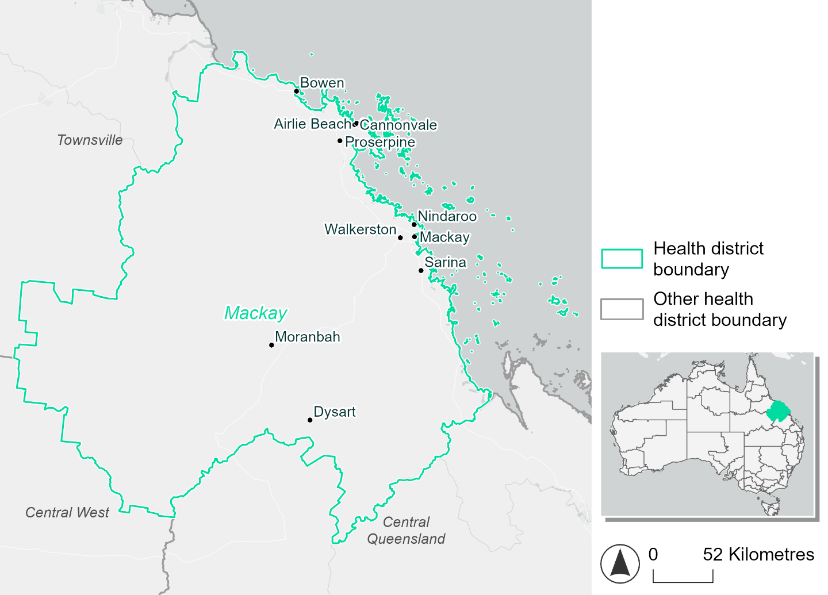
Figure 14. Map of Mackay health district.

How will climate change affect this health district?
Heat and humidity: There will be higher average temperatures, hotter and more frequent hot days, warmer night time temperatures and longer and more frequent heat waves.
Fire: Only 7-8% of this health district experiences very high fire hazard category and this will continue in the future.
Drought: The number of months experiencing drought will increase.
Rainfall and flood: There will be more flood events in both urban and rural areas.
Coastal inundation: The area flooded during tidal, and storm surge and tidal inundation, will increase.

Mackay health district demographic data
Demographic Data | Total
Number of households | 61,884
Persons 15 and older | 131,584
Total families | 45,446
Persons did not complete high school | 55,009
One parent families with dependents | 4,694 (10.3%)
Persons aged 65 and older | 27,203 (14.6%)
Persons aged 4 and younger | 11,531 (6.2%)
Aboriginal and Torres Strait Islander persons | 10,807 (5.8%)
Persons speaks language other than English | 10,803 (5.8%)
Persons working age (15-65) | 122,339 (65.7%)
Population Health Data | Total
Persons with core needs for assistance | 8,427 (4.5%)
Persons with arthritis | 14,029 (7.5%)
Persons with asthma | 13,902 (7.5%)
Persons with cancer | 4,843 (2.6%)
Persons with dementia | 1,094 (0.6%)
Persons with diabetes | 7,969 (4.3%)
Persons with heart disease | 7,118 (3.8%)
Persons with kidney disease | 1,595 (0.9%)
Persons with lung condition | 3,409 (1.8%)
Persons with mental health condition | 14,112 (7.6%)
Persons with stroke | 1,501 (0.8%)
Persons with any other condition | 11,739 (6.3%)
Persons no health condition | 107,423 (57.7%)
Socio-economic Data | Total
Persons providing unpaid care | 17,834 (9.6%)
Persons homeless | 721 (0.4%)
Household with lone person | 15,368 (24.8%)
Households with rent and mortgage stress | 20,801 (33.6%)
Households total equivalised income below $1000 (weekly) | 23,854 (38.5%)
Households with no motor vehicle | 2,593 (4.2%)
Persons unemployed | 5,671 (3.9%)

The sections that follow outline projected climate hazards for this district. Further information on this health district, including population demographics, is provided in the online dashboard.

Heat and humidity hazard
Key projections:
More heatwaves: Heatwave events are likely to last longer and the number of heatwave events per year will increase. By 2050, under a reasonable worst-case scenario, the number of heatwaves will triple. By 2085, under a reasonable worst-case scenario, the number of heatwaves per year will more than triple quadruple.
Hotter days and warmer nights: The day time and night time temperatures on hot days will increase.
More days above 35°C and 40°C: The number of days per year greater than 35°C and 40°C will increase under both middle of the road and reasonable worst-case scenarios.

 | Baseline | 2050 Scenarios |  | 2085 Scenarios
 |  | Middle of the road | Reasonable worst-case | Middle of the road | Reasonable worst-case
Average temperature (°C) | 22.9 | 24.3  [23.7, 25] | 24.5  [23.9, 25.2] | 25  [24.2, 25.8] | 25.8  [25, 26.9]
Maximum temperature on hot days (°C)^{(a)} | 32.8 | 34.2  [33.5, 34.8] | 34.3  [33.8, 34.9] | 34.8  [34.1, 35.5] | 35.7  [35, 36.5]
Minimum temperature on hot nights (°C)^{(b)} | 24.6 | 25.9  [25.3, 26.3] | 26  [25.6, 26.5] | 26.6  [25.9, 27.2] | 27.5  [26.7, 28.2]
Average apparent temperature on hot days (°C) (NOAA Heat Index)^{(c)} | 35.5 | 37.6  [36.7, 38.5] | 37.8  [36.9, 38.7] | 38.9  [37.9, 39.9] | 40.4  [39.2, 41.8]
Average heatwave duration in days^{(d)} | 5 | 9  [7, 11] | 9  [7, 12] | 13  [10, 17] | 19  [14, 27]
Number of heatwaves per year^{(d)} | 2 | 6  [5, 7] | 6  [5, 7] | 7  [6, 7] | 7  [6, 8]
Number of days per year  > 35°C | 9 | 18  [12, 25] | 20  [14, 27] | 25  [16, 35] | 37  [24, 56]
Number of days per year > 40°C | 0 | 1  [0, 2] | 1  [1, 2] | 2  [1, 3] | 3  [1, 5]
Table notes: The heat and humidity hazard uses climate projections from the CMIP6 Global Climate Models [1]. Daily projections of maximum and minimum near-surface temperature and mean relative humidity are used to calculate eight heat and humidity indicators. The primary indicator value reports the median from the nine climate models, with the range reported in square brackets.
Table footnotes: (a) Based on the 95th percentile of daily maximum air temperature. (b) Based on the 95th percentile of daily minimum air temperature, representing the coldest part of the night on very hot nights. (c) The National Oceanic and Atmospheric Administration (NOAA) Heat Index is a measure of how hot it feels when relative humidity is factored in alongside actual air temperature. It is calculated on days with a maximum temperature of 27°C and above. Interpretation of Heat Index values: 27°C to 32°C indicates caution, 33°C to 41°C indicates extreme caution, 42°C to 54°C indicates danger and over 54°C indicates extreme danger. See methodology document for further explanation of Heat Index categories. (d) A heatwave is defined as three or more consecutive days where both daytime and overnight temperatures (daily mean temperatures) are unusually high for the location, based on the Bureau of Meteorology’s Excess Heat Factor method. For this district, an unusually high daily mean temperature is approximately 28.3°C or above.

Fire Hazard
Key projections:
- Majority of district area experiences moderate to high hazard: Under baseline conditions over half of the district experiences moderate to high fire hazard; 57.3% during a 1-in-20-year fire weather event and 62.5% during a 1-in-100-year event. 29-35% of the district is affected by low fire hazard, and 7-8% by very high fire hazard.
- Current hazard conditions to persist without sustainable emissions: In a future climate, the proportion of the district experiencing very high fire hazard is expected to decline slightly, by up to 1 percentage point for a 1-in-20-year fire weather event and 0.9 percentage points for a 1-in-100-year event. Under the sustainability scenario, the area experiencing low fire hazard increases slightly by 1.0-1.5 percentage points by 2050 and an additional 0.8-1.3 percentage points by 2085. In the reasonable worst-case scenario, both the low and moderate to high hazard areas stay very close to their baseline levels.

 | Baseline | 2050 Scenarios |  | 2085 Scenarios
 |  | Sustainability | Reasonable worst-case | Sustainability | Reasonable worst-case
Hazard for a ‘1-in-20 year’ fire weather event^{(a)}
Proportion (%) of district experiencing ‘Low’ fire hazard | 35.3%  (3,185,560)^{(b)} | 36.0%  [35.3%, 36.7%] | 35.5%  [34.5%, 36.4%] | 36.8%  [35.2%, 38.6%] | 35.6%  [33.4%, 37.9%]
Proportion (%) of district experiencing ‘Moderate to High’ fire hazard | 57.3%  (5,163,538)^{(b)} | 56.7%  [56.0%, 57.5%] | 57.5%  [56.2%, 59.5%] | 55.9%  [54.1%, 57.9%] | 57.9%  [54.6%, 62.6%]
Proportion (%) of district experiencing ‘Very High’ fire hazard | 7.4%  (663,331)^{(b)} | 7.3%  [7.2%, 7.6%] | 7.0%  [6.0%, 7.6%] | 7.3%  [6.9%, 7.9%] | 6.4%  [4.0%, 7.9%]
Hazard for a ‘1-in-100 year’ fire weather event^{(a)}
Proportion (%) of district experiencing ‘Low’ fire hazard | 29.0%  (2,614,328)^{(b)} | 30.0%  [29.2%, 30.8%] | 29.2%  [27.8%, 30.8%] | 31.3%  [29.4%, 33.4%] | 29.5%  [26.0%, 33.3%]
Proportion (%) of district experiencing ‘Moderate to High’ fire hazard | 62.5%  (5,630,399)^{(b)} | 61.6%  [60.7%, 62.9%] | 62.7%  [60.7%, 65.4%] | 60.3%  [58.2%, 63.4%] | 62.9%  [58.3%, 69.4%]
Proportion (%) of district experiencing ‘Very High’ fire hazard | 8.5%  (767,702)^{(b)} | 8.5%  [8.3%, 8.7%] | 8.1%  [6.9%, 8.6%] | 8.5%  [8.1%, 9.0%] | 7.6%  [4.7%, 8.8%]
Table notes: The Fire Hazard uses the National Bushfire Intelligence Capability (NBIC) Phase 2 fire line intensity modelling based on CMIP6 climate projections. Fire Hazard is assessed using the projected Fireline Intensity (FLI) for weather events with two different return intervals (i.e. a 1-in-20 year event and a 1-in-100 year event). FLI considers slope, vegetation and weather to produce a rate of heat output per unit length (kW/m) along a bushfire’s front. Fire hazard is categorized as a low for FLI<4000 kW/m, moderate to high for 4,000 kW/m ≤FLI<12,500kW/m, and very high for FLI≥27,501kW/m. This is broadly consistent with the literature [3]. The assessment considers climate change effects based on changes in fire weather and the associated hazard that is anticipated for a meteorological event of a given return interval. This approach is different to the one adopted for the Flood Hazard, where the event magnitude is given (fixed) and the likelihood of that event varies as a result of climate change. The primary indicator value reports the median from the nine climate models, with the range reported in square brackets.
Table footnotes: (a) The area subject to different categories of fire hazard is determined for a ‘1-in-20 year’ and ‘1-in-100 year’ fire weather event, in current and future climates. Values at year 2050 are interpolated using data from baseline (2025) and 2085, assuming linear change over time. (b) Values in round brackets are the area (ha) of the health district subject to a given fire hazard.

The figures below show the proportion of the health district experiencing different fire hazard categories across different time horizons and climate scenarios during a ‘1-in-20 year’ fire weather event (Figure 15) and a ‘1-in-100 year’ fire weather event (Figure 16).
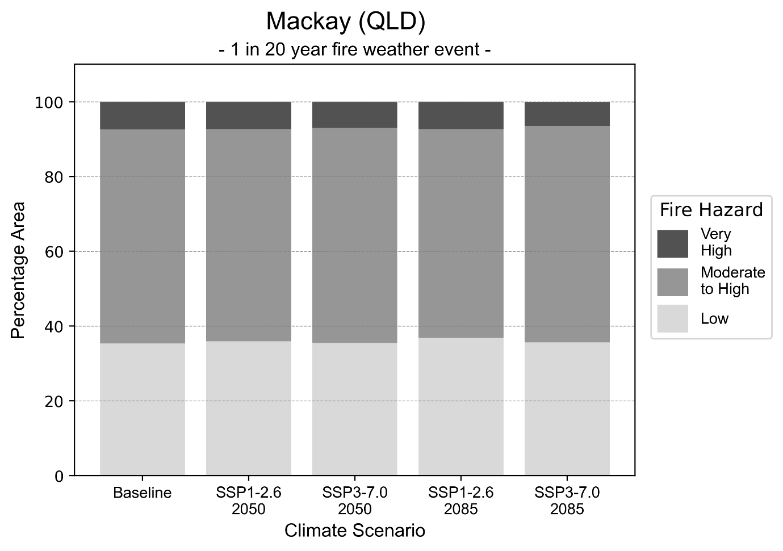
Figure 15: Stacked column chart showing the percentages of the Mackay health district's total geographic area experiencing each fire hazard level during a 1-in-20-year fire weather event.
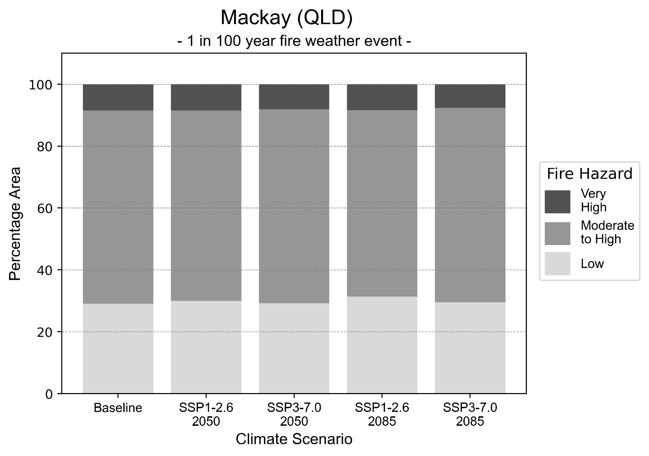
Figure 16: Stacked column chart showing the percentages of the Mackay health district's total geographic area experiencing each fire hazard level during a 1-in-100-year fire weather event.

Drought hazard
Key projections:
Drought occurrence: The occurrence of drought will increase across both middle of the road and reasonable worst-case scenarios for both time horizons, with the largest increase occurring under the middle of the road scenario by 2085.

 | Baseline | 2050 Scenarios |  | 2085 Scenarios
 |  | Middle of the road | Reasonable worst-case | Middle of the road | Reasonable worst-case
Number of months per year in drought^{(a)} | 1.6 | 2.3  [0.4, 4.7] | 2.5  [0.3, 6.0] | 2.6  [0.3, 4.6] | 2.3  [0.0, 5.4]
Table notes: The drought hazard indicator uses climate projections from the CMIP6 Global Climate Models [1]. The primary indicator value reports the median from the nine climate models, with the range reported in square brackets.
Table footnotes: (a) The number of months per year in drought is based on the Standardised Precipitation Index (SPI). SPI is a widely used index to characterise meteorological drought on a range of timescales. This indicator uses the timescale of 12 months which calculates the average months in a year within the moderate drought range. A moderate drought range is classified as SPI score of ≤ -1. SPI is calculated from accumulated rainfall over 12 months and the mean and standard deviation from historical rainfall records.

Storm hazard
Key projections:
Very-high-intensity storms will remain consistent or increase under the middle of the road scenario: Under the middle of the road scenario, the frequency of very-high-intensity storms will remain consistent by 2050 but increase by 2085. Under the reasonable worst-case scenario, the frequency of very-high-intensity storms but will decrease across both time horizons.

Baseline |  | 2050 Scenarios |  | 2085 Scenarios
 |  | Middle of the road | Reasonable worst-case | Middle of the road | Reasonable worst-case
Number of low-intensity storms (40-62 km/hr) per year | 72.9 | 71.3  [62.7, 78.4] | 73.7  [64.9, 81.1] | 74.5  [65.5, 81.9] | 77.3  [68.0, 85.0]
Number of medium-intensity storms (63-87 km/hr) per year | 61.0 | 54.6  [48.1, 60.1] | 60.0  [52.8, 66.0] | 57.5  [50.6, 63.2] | 57.1  [50.3, 62.8]
Number of high-intensity storms (88-117 km/hr) per year | 12.3 | 12.4  [10.9, 13.7] | 11.8  [10.4, 13.0] | 11.8  [10.4, 12.9] | 10.4  [9.2, 11.5]
Number of very-high-intensity storms (> 117 km/hr) per year | 0.6 | 0.6  [0.6, 0.7] | 0.5  [0.4, 0.6] | 0.7  [0.6, 0.7] | 0.5  [0.4, 0.6]
Table notes: The storm hazard uses climate projections from the CMIP6 Global Climate Models [1]. Daily maximum surface wind speed is used to calculate the number of annual storms across four storm intensity categories (low, medium, high and very high). The primary indicator value reports the median from the nine climate models, with the range reported in square brackets.

Rainfall and flood hazard
Key projections:
- Ten extreme rainfall days per year: The number of extreme rainfall days will remain consistent across both middle of the road and reasonable worst-case scenarios, and both time horizons, with an average of approximately ten extreme rainfall days per year.
- Increased flood frequency: The frequency of flood events will increase in urban and rural environments. The largest increase in flood frequency occurs in the reasonable worst-case scenario, where the frequency of a ‘1-in-100 year’ flood become five time more likely by 2050 and become 17 times more likely by 2085 in urban environments.

 | Baseline | 2050 Scenarios |  | 2085 Scenarios
 |  | Middle of the road | Reasonable worst-case | Middle of the road | Reasonable worst-case
Rainfall hazard^{(a)}
Average number of extreme rainfall days per year (> 10 mm/day)^{(a)} | 10.3 | 9.7  [7.8,12.7] | 9.7  [6.7,13.2] | 9.3  [6.6,12.3] | 9.9  [6.9,14.9]
Urban flood risk (flooding caused by a 1-hour rainfall event)^{(b)}
Frequency of a ‘1-in-1 year’ flood (rainfall depth of 45 mm)^{(c)} |  | 1.9 events in 1 year | 2.0 events in 1 year | 2.3 events in 1 year | 3.0 events in 1 year
Frequency of a ‘1-in-10 year’ flood (rainfall depth of 80 mm)^{(c)} |  | 3.1 events in 10 years | 3.3 events in 10 years | 4.8 events in 10 years | 7.2 events in 10 years
Frequency of a ‘1-in-100 year’ flood (rainfall depth of 115 mm)^{(c)} |  | 5.0 events in 100 years | 5.4 events in 100 years | 9.1 events in 100 years | 17 events in 100 years
Rural flood risk (flooding caused by a 24-hour rainfall event)^{(b)}
Frequency of a ‘1-in-1 year’ flood (rainfall depth of 157 mm)^{(c)} |  | 1.1 events in 1 year | 1.1 events in 1 year | 1.2 events in 1 year | 1.2 events in 1 year
Frequency of a ‘1-in-10 year’ flood (rainfall depth of 356 mm)^{(c)} |  | 1.5 events in 10 years | 1.6 events in 10 years | 1.7 events in 10 years | 1.9 events in 10 years
Frequency of a ‘1-in-100 year’ flood (rainfall depth of 624 mm)^{(c)} |  | 1.8 events in 100 years | 1.8 events in 100 years | 2.1 events in 100 years | 2.6 events in 100 years
Table notes: The rainfall hazard indicator uses climate projections from the CMIP6 Global Climate Models [1]. The primary indicator value reports the median from the nine climate models, with the range reported in square brackets. The flood hazard indicators use climate change considerations from the Australian Rainfall and Runoff guideline to estimate the climate projections [2].
Table footnotes: (a) Extreme rainfall is defined as rainfall above the 95th percentile of historical average daily rainfall in this health district in the period 1985-2014. The value in mm/day quoted in the indicator name is the 95th percentile of historic average daily rainfall for this health district. (b) See Methodology document for reasons for focusing on a 1-hour flood for urban areas and a 24-hour flood for rural areas. (c) The rainfall depths in mm quoted in the indicator names in this table report 1 in 1, 10 and 100 year depths for this health district.

Coastal inundation hazard
Key projections:
Greater area inundated: There will be an increase in the area affected by tidal inundation (i.e. area submerged during high tide) and storm surge and tidal inundation (i.e. the area submerged during a storm surge and high tide) across both middle of the road and reasonable worst-case scenarios. In the reasonable worst-case scenario, by 2085 the area inundated during tidal inundation will increase by over 28,000 ha.

 | Baseline | 2050 Scenarios |  | 2085 Scenarios^{(a)}
 |  | Middle of the road | Reasonable worst-case | Middle of the road | Reasonable worst-case
Tidal inundation (ha inundated)^{(b)} | 100,373.2 | 109,888.7  (+9,515.6) | 110,421.2  (+10,048.0) | 124,369.6  (+23,996.4) | 128,428.3  (+28,055.1)
Storm surge + tidal inundation – ‘1-in-100 year’ event (ha inundated)^{(c)} | 123,172.5 | 129,659.5  (+6,487.0) | 129,999.6  (+6,827.1) | 138,303.7  (+15,131.2) | 141,276.8  (+18,104.3)
Storm surge + tidal inundation – ‘1-in-1000 year’ event (ha inundated)^{(c)} | 134,905.6 | 140,084.9  (+5,179.3) | 140,358.4  (+5,452.8) | 149,166.5  (+14,260.9) | 151,669.2  (+16,763.6)
Table notes: The coastal inundation hazard provides an indication of flooding in coastal areas that can be attributed to sea level rise and storm inundation. The coastal inundation hazard is only reported for health districts adjoining the coastline. This table includes the projected inundation levels as well as the change from baseline conditions (in brackets).
Table footnotes: (a) For the 2085 Scenarios planning horizon, 2100 was adopted as it provides a conservative representation of the end of this period. This horizon aligns with many State planning regulations requiring consideration of sea level rise and storm tide to 2100, making the 2100 scenario particularly valuable for planning new health facilities in coastal areas. (b) The tidal inundation indicator reports the number of hectares inundated during high tide. The baseline value reports existing inundation patterns, while the 2050 and 2085 values report high tide inundation taking account of projected sea level rise due to climate change. (c) The storm surge + tidal inundation indicators report the combined effect, in hectares inundated, of high tide, sea level rise (for the 2050 and 2085 projections), and storm surge (for 1-in-100 year and 1-in-1000 year events).

North West health district

Health district overview
Surface area: 252,988 square kilometres
Local health services: The North West Hospital and Health Service region contains 11 health facilities:
- Mornington Island Hospital and Aboriginal Community Health Centre
- Mount Isa Hospital
- Burketown Primary Health Clinic
- Cloncurry Multipurpose Health Service
- Camooweal Primary Health Clinic
- Normanton Hospital
- Dajarra Primary Health Clinic
- Karumba Primary Health Care Clinic
- Julia Creek Multipurpose Health Service
- Yellagundgimarra Hospital Doomadgee and Community Health Centre
- McKinlay Primary Health Clinic.

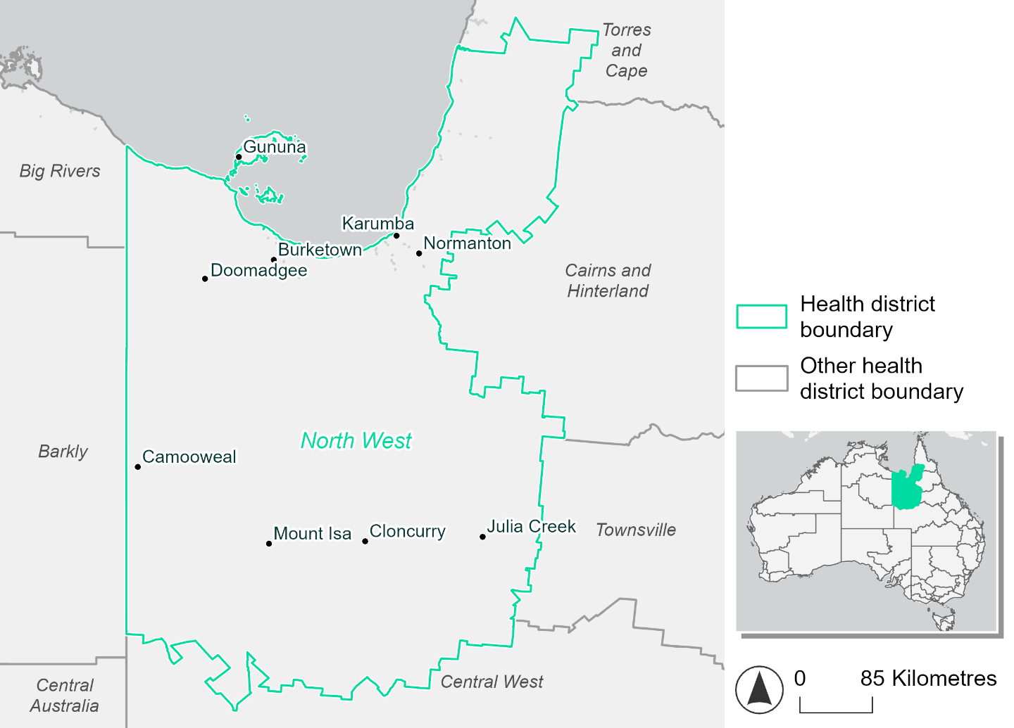
Figure 17. Map of North West health district

How will climate change affect this health district?
Heat and humidity: There will be higher average temperatures, hotter and more frequent hot days, warmer night time temperatures and longer and more frequent heat waves.
Fire: Only 6-7% of this health district experiences very high fire hazard category and this will continue in the future.
Drought: The number of months experiencing drought will increase.
Rainfall and flood: There will be more flood events in urban areas.
Coastal inundation: The area flooded during tidal, and storm surge and tidal inundation, will increase.

North West health district demographic data
Demographic Data | Total
Number of households | 9,030
Persons 15 and older | 20,499
Total families | 6,395
Persons did not complete high school | 8,524
One parent families with dependents | 945 (14.8%)
Persons aged 65 and older | 2,481 (8.7%)
Persons aged 4 and younger | 2,346 (8.2%)
Aboriginal and Torres Strait Islander persons | 8,012 (28%)
Persons speaks language other than English | 2,491 (8.7%)
Persons working age (15-65) | 19,588 (68.3%)
Population Health Data | Total
Persons with core needs for assistance | 871 (3%)
Persons with arthritis | 1,236 (4.3%)
Persons with asthma | 1,893 (6.6%)
Persons with cancer | 422 (1.5%)
Persons with dementia | 126 (0.4%)
Persons with diabetes | 1,431 (5%)
Persons with heart disease | 923 (3.2%)
Persons with kidney disease | 288 (1%)
Persons with lung condition | 325 (1.1%)
Persons with mental health condition | 1,417 (4.9%)
Persons with stroke | 154 (0.5%)
Persons with any other condition | 1,437 (5%)
Persons no health condition | 18,253 (63.7%)
Socio-economic Data | Total
Persons providing unpaid care | 2,045 (7.1%)
Persons homeless | 956 (3.3%)
Household with lone person | 2,567 (28.4%)
Households with rent and mortgage stress | 1,890 (20.9%)
Households total equivalised income below $1000 (weekly) | 2,958 (32.8%)
Households with no motor vehicle | 883 (9.8%)
Persons unemployed | 1,031 (4.8%)

The sections that follow outline projected climate hazards for this district. Further information on this health district, including population demographics, is provided in the online dashboard.

Heat and humidity hazard
Key projections:
More heatwaves: Heatwave events are likely to last longer and the number of heatwave events per year will increase. By 2050, under a reasonable worst-case scenario, the number of heatwaves will more than triple. By 2085, under a reasonable worst-case scenario, the number of heatwaves per year will more than quadruple.
Hotter days and warmer nights: The day time and night time temperatures on hot days will increase.
More days above 35°C and 40°C: The number of days per year greater than 35°C and 40°C will increase under both middle of the road and reasonable worst-case scenarios.

 | Baseline | 2050 Scenarios |  | 2085 Scenarios
 |  | Middle of the road | Reasonable worst-case | Middle of the road | Reasonable worst-case
Average temperature (°C) | 24.9 | 26.6  [25.9, 27.4] | 26.9  [26.1, 27.7] | 27.6  [26.7, 28.6] | 28.8  [27.6, 30]
Maximum temperature on hot days (°C)^{(a)} | 39 | 40.8  [40, 41.5] | 41  [40.1, 41.7] | 41.6  [40.5, 42.4] | 42.8  [41.6, 43.7]
Minimum temperature on hot nights (°C)^{(b)} | 25.1 | 27  [26.2, 27.5] | 27.2  [26.3, 27.8] | 27.9  [26.9, 29] | 29.2  [28.1, 30.3]
Average apparent temperature on hot days (°C) (NOAA Heat Index)^{(c)} | 39.3 | 42.4  [41.1, 44.2] | 42.9  [41.6, 45] | 44.4  [43, 46.7] | 47.3  [45, 51.7]
Average heatwave duration in days^{(d)} | 5 | 8  [6, 10] | 8  [7, 10] | 11  [7, 15] | 16  [10, 24]
Number of heatwaves per year^{(d)} | 2 | 7  [5, 8] | 7  [5, 9] | 8  [7, 9] | 9  [8, 10]
Number of days per year > 35°C | 112 | 159  [124, 180] | 165  [137, 191] | 182  [153, 210] | 206  [174, 236]
Number of days per year > 40°C | 10 | 36  [21, 49] | 39  [21, 57] | 54  [28, 77] | 82  [47, 113]
Table notes: The heat and humidity hazard uses climate projections from the CMIP6 Global Climate Models [1]. Daily projections of maximum and minimum near-surface temperature and mean relative humidity are used to calculate eight heat and humidity indicators. The primary indicator value reports the median from the nine climate models, with the range reported in square brackets.
Table footnotes: (a) Based on the 95th percentile of daily maximum air temperature. (b) Based on the 95th percentile of daily minimum air temperature, representing the coldest part of the night on very hot nights. (c) The National Oceanic and Atmospheric Administration (NOAA) Heat Index is a measure of how hot it feels when relative humidity is factored in alongside actual air temperature. It is calculated on days with a maximum temperature of 27°C and above. Interpretation of Heat Index values: 27°C to 32°C indicates caution, 33°C to 41°C indicates extreme caution, 42°C to 54°C indicates danger and over 54°C indicates extreme danger. See methodology document for further explanation of Heat Index categories. (d) A heatwave is defined as three or more consecutive days where both daytime and overnight temperatures (daily mean temperatures) are unusually high for the location, based on the Bureau of Meteorology’s Excess Heat Factor method. For this district, an unusually high daily mean temperature is approximately 31.6°C or above.

Fire Hazard
Key projections:
- Majority of district area experiences moderate to high hazard: Under baseline conditions, over half the district (53-56%) experiences moderate to high fire hazard. 36-40% experiences low hazard, and about 6% experiences very high fire hazard.
- Small increase to overall hazard: In a future climate across both 2050 and 2085 scenarios, the proportion of the district experiencing very high fire hazard stays roughly the same as baseline, varying by at most 0.2 percentage points. The area experiencing moderate to high hazard increases modestly but steadily across time and with increasing emissions, by up to 3.9 percentage points for a 1-in-20-year fire weather event, and 4.8 for a 1-in-100-year event. The area experiencing low hazard decreases proportionately.

 | Baseline | 2050 Scenarios |  | 2085 Scenarios
 |  | Sustainability | Reasonable worst-case | Sustainability | Reasonable worst-case
Hazard for a ‘1-in-20 year’ fire weather event^{(a)}
Proportion (%) of district experiencing ‘Low’ fire hazard | 40.5%  (10,236,117)  ^{(b)} | 39.9%  [39.4%, 40.9%] | 38.9%  [37.0%, 40.0%] | 39.1%  [37.8%, 41.6%] | 36.8%  [32.2%, 39.3%]
Proportion (%) of district experiencing ‘Moderate to High’ fire hazard | 53.4%  (13,515,040)  ^{(b)} | 54.1%  [52.7%, 56.3%] | 55.0%  [52.9%, 56.7%] | 55.1%  [51.6%, 60.4%] | 57.3%  [52.1%, 61.4%]
Proportion (%) of district experiencing ‘Very High’ fire hazard | 6.1%  (1,547,651)^{(b)} | 6.0%  [6.0%, 6.1%] | 6.1%  [6.0%, 6.2%] | 5.9%  [5.8%, 6.0%] | 6.0%  [5.8%, 6.3%]
Hazard for a ‘1-in-100 year’ fire weather event^{(a)}
Proportion (%) of district experiencing ‘Low’ fire hazard | 36.6%  (9,266,772)^{(b)} | 35.9%  [34.7%, 37.4%] | 34.7%  [32.8%, 35.9%] | 34.9%  [32.0%, 38.4%] | 32.0%  [27.4%, 34.9%]
Proportion (%) of district experiencing ‘Moderate to High’ fire hazard | 56.7%  (14,355,160)  ^{(b)} | 57.6%  [55.9%, 60.4%] | 58.7%  [56.8%, 60.5%] | 58.7%  [54.8%, 65.6%] | 61.5%  [57.0%, 65.8%]
Proportion (%) of district experiencing ‘Very High’ fire hazard | 6.6%  (1,676,876)^{(b)} | 6.5%  [6.4%, 6.6%] | 6.6%  [6.4%, 6.9%] | 6.4%  [6.2%, 6.6%] | 6.5%  [6.2%, 7.4%]
Table notes: The Fire Hazard uses the National Bushfire Intelligence Capability (NBIC) Phase 2 fire line intensity modelling based on CMIP6 climate projections. Fire Hazard is assessed using the projected Fireline Intensity (FLI) for weather events with two different return intervals (i.e. a 1-in-20 year event and a 1-in-100 year event). FLI considers slope, vegetation and weather to produce a rate of heat output per unit length (kW/m) along a bushfire’s front. Fire hazard is categorized as a low for FLI<4000 kW/m, moderate to high for 4,000 kW/m ≤FLI<12,500kW/m, and very high for FLI≥27,501kW/m. This is broadly consistent with the literature [3]. The assessment considers climate change effects based on changes in fire weather and the associated hazard that is anticipated for a meteorological event of a given return interval. This approach is different to the one adopted for the Flood Hazard, where the event magnitude is given (fixed) and the likelihood of that event varies as a result of climate change. The primary indicator value reports the median from the nine climate models, with the range reported in square brackets.
Table footnotes: (a) The area subject to different categories of fire hazard is determined for a ‘1-in-20 year’ and ‘1-in-100 year’ fire weather event, in current and future climates. Values at year 2050 are interpolated using data from baseline (2025) and 2085, assuming linear change over time. (b) Values in round brackets are the area (ha) of the health district subject to a given fire hazard.

The figures below show the proportion of the health district experiencing different fire hazard categories across different time horizons and climate scenarios during a ‘1-in-20 year’ fire weather event (Figure 18) and a ‘1-in-100 year’ fire weather event (Figure 19).
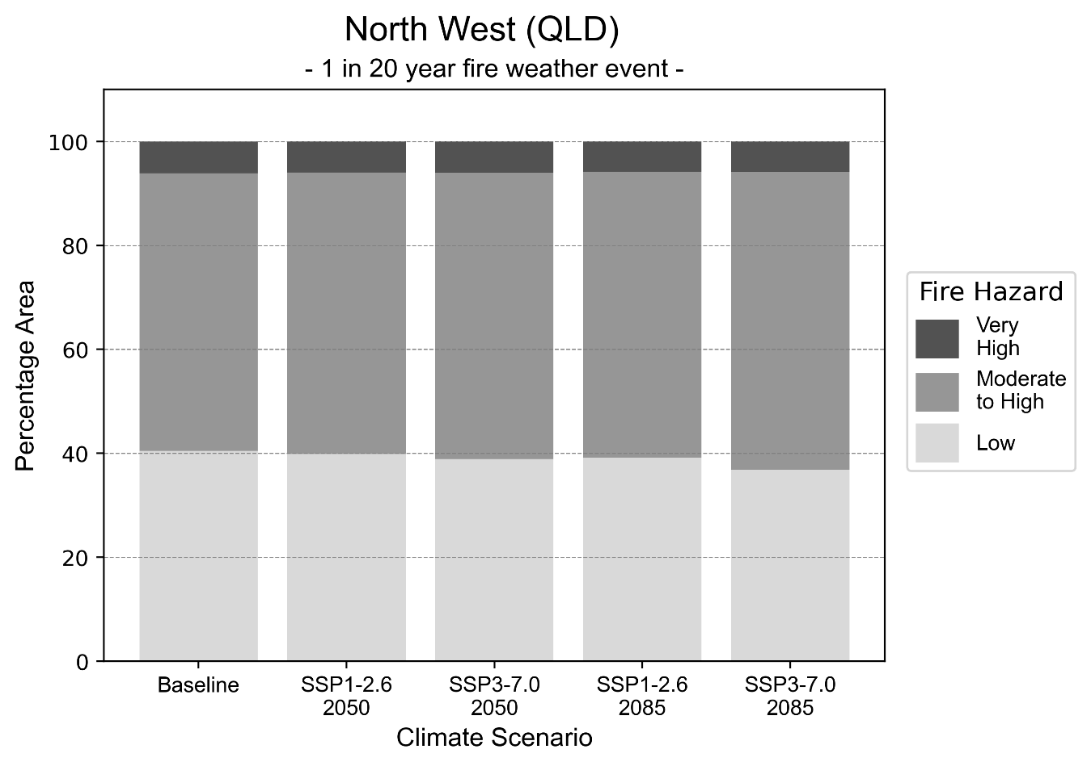
Figure 18: Stacked column chart showing the percentages of the North West health district's total geographic area experiencing each fire hazard level during a 1-in-20-year fire weather event.

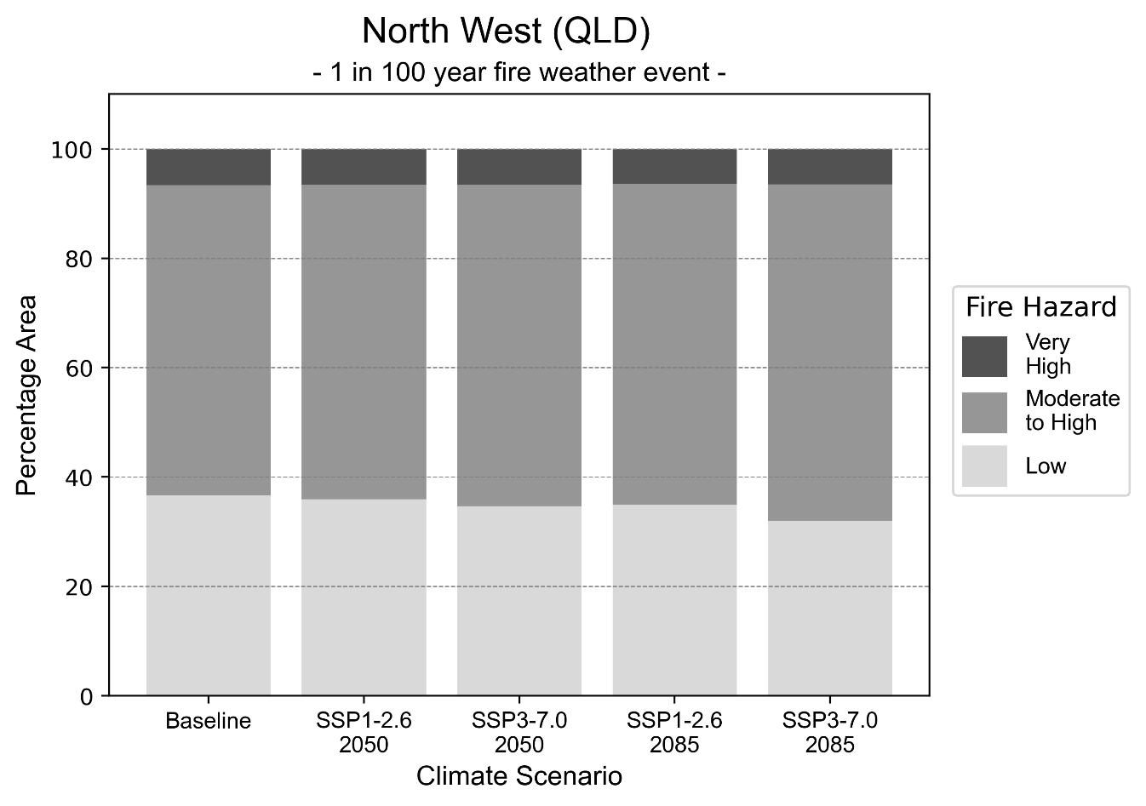
Figure 19: Stacked column chart showing the percentages of the North West health district's total geographic area experiencing each fire hazard level during a 1-in-100-year fire weather event.

Drought hazard
Key projections:
Drought occurrence: The occurrence of drought will increase across both middle of the road and reasonable worst-case scenarios for both time horizons, with the largest increase occurring under the middle of the road scenario by 2050.

 | Baseline | 2050 Scenarios |  | 2085 Scenarios
 |  | Middle of the road | Reasonable worst-case | Middle of the road | Reasonable worst-case
Number of months per year in drought^{(a)} | 1.6 | 2.7  [0.4, 6.0] | 2.5  [0.2, 5.7] | 2.7  [0.3, 5.6] | 2.7  [0.0, 6.7]
Table notes: The drought hazard indicator uses climate projections from the CMIP6 Global Climate Models [1]. The primary indicator value reports the median from the nine climate models, with the range reported in square brackets.
Table footnotes: (a) The number of months per year in drought is based on the Standardised Precipitation Index (SPI). SPI is a widely used index to characterise meteorological drought on a range of timescales. This indicator uses the timescale of 12 months which calculates the average months in a year within the moderate drought range. A moderate drought range is classified as SPI score of ≤ -1. SPI is calculated from accumulated rainfall over 12 months and the mean and standard deviation from historical rainfall records.

Storm hazard
Key projections:
More very-high-intensity storms under the reasonable worst-case scenario: Under the reasonable worst-case scenario, very-high-intensity storms will be more frequent across both time horizons, with the greatest increase occurring by 2085. Under the middle of the road scenario, the frequency of very-high-intensity storms will decrease by 2050, but remain the same frequency as baseline by 2085.

Baseline |  | 2050 Scenarios |  | 2085 Scenarios
 |  | Middle of the road | Reasonable worst-case | Middle of the road | Reasonable worst-case
Number of low-intensity storms (40-62 km/hr) per year | 106.9 | 103.3  [90.9, 113.7] | 107.2  [94.3, 117.9] | 100.4  [88.4, 110.5] | 102.1  [89.8, 112.3]
Number of medium-intensity storms (63-87 km/hr) per year | 48.7 | 41.4  [36.5, 45.6] | 42.9  [37.8, 47.2] | 40.2  [35.3, 44.2] | 36.8  [32.4, 40.5]
Number of high-intensity storms (88-117 km/hr) per year | 23.7 | 19.6  [17.2, 21.6] | 20.3  [17.9, 22.3] | 15.5  [13.7, 17.1] | 15.6  [13.7, 17.2]
Number of very-high-intensity storm (> 117 km/hr) per year | 0.7 | 0.6  [0.5, 0.7] | 0.9  [0.8, 1.0] | 0.7  [0.6, 0.8] | 1.2  [1.0, 1.3]
Table notes: The storm hazard uses climate projections from the CMIP6 Global Climate Models [1]. Daily maximum surface wind speed is used to calculate the number of annual storms across four storm intensity categories (low, medium, high and very high). The primary indicator value reports the median from the nine climate models, with the range reported in square brackets.

Rainfall and flood hazard
Key projections:
- 11 extreme rainfall days per year: The number of extreme rainfall days will remain consistent across both middle of the road and reasonable worst-case scenarios, and both time horizons, with an average of approximately 11 extreme rainfall days per year.
- Increased flood frequency: The frequency of flood events will increase in urban environments. The largest increase in flood frequency occurs in the reasonable worst-case scenario, where the frequency of a ‘1-in-100 year’ flood will become nearly six times more likely by 2050 and become 17 times more likely by 2085 in urban environments. In rural environments, for both middle of the road and reasonable worst-case scenarios, the frequency of all flood types will increase by 2050, but decrease by 2085.

 | Baseline | 2050 Scenarios |  | 2085 Scenarios
 |  | Middle of the road | Reasonable worst-case | Middle of the road | Reasonable worst-case
Rainfall hazard^{(a)}
Average number of extreme rainfall days per year (> 10 mm/day)^{(a)} | 11.3 | 10.6  [7.5,16.1] | 10.7  [7.0,16.9] | 10.6  [7.1,15.5] | 10.6  [5.5,17.4]
Urban flood risk (flooding caused by a 1-hour rainfall event)^{(b)}
Frequency of a ‘1-in-1 year’ flood (rainfall depth of 37 mm)^{(c)} |  | 1.7 events in 1 year | 1.7 events in 1 year | 2.1 events in 1 year | 2.5 events in 1 year
Frequency of a ‘1-in-10 year’ flood (rainfall depth of 69 mm)^{(c)} |  | 2.8 events in 10 years | 3.0 events in 10 years | 4.1 events in 10 years | 6.2 events in 10 years
Frequency of a ‘1-in-100 year’ flood (rainfall depth of 99 mm)^{(c)} |  | 5.2 events in 100 years | 5.7 events in 100 years | 9.4 events in 100 years | 17 events in 100 years
Rural flood risk (flooding caused by a 24-hour rainfall event)^{(b)}
Frequency of a ‘1-in-1 year’ flood (rainfall depth of 76 mm)^{(c)} |  | 1.3 events in 1 year | 1.1 events in 1 year | 0.8 events in 1 year | 0.8 events in 1 year
Frequency of a ‘1-in-10 year’ flood (rainfall depth of 167 mm)^{(c)} |  | 1.5 events in 10 years | 1.2 events in 10 years | 0.9 events in 10 years | 0.3 events in 10 years
Frequency of a ‘1-in-100 year’ flood (rainfall depth of 286 mm)^{(c)} |  | 1.2 events in 100 years | 1.1 events in 100 years | 0.9 events in 100 years | 0.6 events in 100 years
Table notes: The rainfall hazard indicator uses climate projections from the CMIP6 Global Climate Models [1]. The primary indicator value reports the median from the nine climate models, with the range reported in square brackets. The flood hazard indicators use climate change considerations from the Australian Rainfall and Runoff guideline to estimate the climate projections [2].
Table footnotes: (a) Extreme rainfall is defined as rainfall above the 95th percentile of historical average daily rainfall in this health district in the period 1985-2014. The value in mm/day quoted in the indicator name is the 95th percentile of historic average daily rainfall for this health district. (b) See Methodology document for reasons for focusing on a 1-hour flood for urban areas and a 24-hour flood for rural areas. (c) The rainfall depths in mm quoted in the indicator names in this table report 1 in 1, 10 and 100 year depths for this health district.

Coastal inundation hazard
Key projections:
Greater area inundated: There will be an increase in the area affected by tidal inundation (i.e. area submerged during high tide) and storm surge and tidal inundation (i.e. the area submerged during a storm surge and high tide) across both middle of the road and reasonable worst-case scenarios. In the reasonable worst-case scenario, by 2085 the area inundated during tidal inundation will increase by over 132,000 ha.

 | Baseline | 2050 Scenarios |  | 2085 Scenarios^{(a)}
 |  | Middle of the road | Reasonable worst-case | Middle of the road | Reasonable worst-case
Tidal inundation (ha inundated)^{(b)} | 372,183.7 | 405,187.6  (+33,003.9) | 407,853.4  (+35,669.7) | 477,322.3  (+105,138.6) | 504,734.7  (+132,551.0)
Storm surge + tidal inundation – ‘1-in-100 year’ event (ha inundated)^{(c)} | 874,825.8 | 915,106.6  (+40,280.8) | 917,766.1  (+42,940.3) | 983,702.7  (+108,876.9) | 1,006,924.9  (+132,099.2)
Storm surge + tidal inundation – ‘1-in-1000 year’ event (ha inundated)^{(c)} | 1,160,283.6 | 1,194,679.7  (+34,396.1) | 1,196,707.3  (+36,423.6) | 1,267,802.2  (+107,518.6) | 1,286,467.5  (+126,183.9)
Table notes: The coastal inundation hazard provides an indication of flooding in coastal areas that can be attributed to sea level rise and storm inundation. The coastal inundation hazard is only reported for health districts adjoining the coastline. This table includes the projected inundation levels as well as the change from baseline conditions (in brackets).
Table footnotes: (a) For the 2085 Scenarios planning horizon, 2100 was adopted as it provides a conservative representation of the end of this period. This horizon aligns with many State planning regulations requiring consideration of sea level rise and storm tide to 2100, making the 2100 scenario particularly valuable for planning new health facilities in coastal areas. (b) The tidal inundation indicator reports the number of hectares inundated during high tide. The baseline value reports existing inundation patterns, while the 2050 and 2085 values report high tide inundation taking account of projected sea level rise due to climate change. (c) The storm surge + tidal inundation indicators report the combined effect, in hectares inundated, of high tide, sea level rise (for the 2050 and 2085 projections), and storm surge (for 1-in-100 year and 1-in-1000 year events).

South East Queensland health district

Health district overview
The South East Queensland health district region contains Gold Coast, Metro North, Metro South and Sunshine Coast Hospital and Health Service areas.
Surface area: 19,661 square kilometres
Local health services: 24 hospitals and 40 health centres.

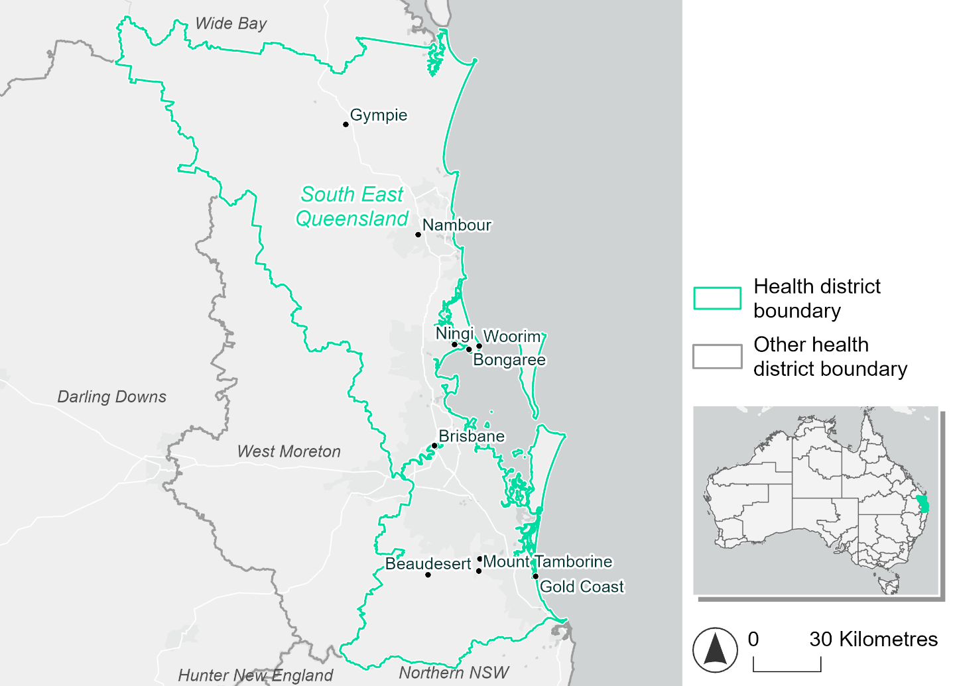
Figure 20. Map of South East Queensland health district.

How will climate change affect this health district?
Heat and humidity: There will be higher average temperatures, hotter and more frequent hot days, warmer night time temperatures and longer and more frequent heat waves.
Fire: Over 40% of this health district experiences very high fire hazard category and this will continue in the future.
Drought: The number of months experiencing drought will increase.
Rainfall and flood: There will be more flood events in both urban and rural areas.
Coastal inundation: The area flooded during tidal, and storm surge and tidal inundation, will increase.

South East Queensland health district demographic data
Demographic Data | Total
Number of households | 1,217,089
Persons 15 and older | 2,417,996
Total families | 895,654
Persons did not complete high school | 732,856
One parent families with dependents | 95,571 (10.7%)
Persons aged 65 and older | 566,612 (16.4%)
Persons aged 4 and younger | 194,832 (5.6%)
Aboriginal and Torres Strait Islander persons | 87,178 (2.5%)
Persons speaks language other than English | 525,268 (15.2%)
Persons working age (15-65) | 2,253,138 (65.3%)
Population Health Data | Total
Persons with core needs for assistance | 189,914 (5.5%)
Persons with arthritis | 287,220 (8.3%)
Persons with asthma | 289,689 (8.4%)
Persons with cancer | 106,331 (3.1%)
Persons with dementia | 24,869 (0.7%)
Persons with diabetes | 142,420 (4.1%)
Persons with heart disease | 137,349 (4%)
Persons with kidney disease | 29,473 (0.9%)
Persons with lung condition | 65,426 (1.9%)
Persons with mental health condition | 330,128 (9.6%)
Persons with stroke | 31,251 (0.9%)
Persons with any other condition | 296,924 (8.6%)
Persons no health condition | 2,062,698 (59.8%)
Socio-economic Data | Total
Persons providing unpaid care | 392,328 (11.4%)
Persons homeless | 11,452 (0.3%)
Household with lone person | 289,750 (23.8%)
Households with rent and mortgage stress | 580,003 (47.7%)
Households total equivalised income below $1000 (weekly) | 517,025 (42.5%)
Households with no motor vehicle | 70,926 (5.8%)
Persons unemployed | 147,038 (5.4%)

The sections that follow outline projected climate hazards for this district. Further information on this health district, including population demographics, is provided in the online dashboard.

Heat and humidity hazard
Key projections:
More heatwaves: Heatwave events are likely to last longer and the number of heatwave events per year will increase. By 2050, under a reasonable worst-case scenario, the number of heatwaves will triple. By 2085, under a reasonable worst-case scenario, the number of heatwaves per year will quadruple.
Hotter days and warmer nights: The day time and night time temperatures on hot days will increase.
More days above 35°C and 40°C: The number of days per year greater than 35°C and 40°C will increase under both middle of the road and reasonable worst-case scenarios.

 | Baseline | 2050 Scenarios |  | 2085 Scenarios
 |  | Middle of the road | Reasonable worst-case | Middle of the road | Reasonable worst-case
Average temperature (°C) | 20.3 | 21.7  [21.2, 22.3] | 21.9  [21.3, 22.6] | 22.5  [21.6, 23.4] | 23.4  [22.4, 24.4]
Maximum temperature on hot days (°C)^{(a)} | 32.3 | 33.7  [33.2, 34.5] | 33.9  [33, 35] | 34.5  [33.6, 35.7] | 35.4  [34.3, 36.8]
Minimum temperature on hot nights (°C)^{(b)} | 22.3 | 23.7  [22.9, 24.2] | 23.8  [23.3, 24.4] | 24.4  [23.4, 25.2] | 25.3  [24.3, 26.3]
Average apparent temperature on hot days (°C) (NOAA Heat Index)^{(c)} | 34.4 | 36  [35.4, 36.6] | 36.1  [35.4, 36.7] | 37  [36, 38] | 38.3  [37.2, 39.8]
Average heatwave duration in days^{(d)} | 5 | 6  [6, 8] | 7  [6, 8] | 8  [6, 11] | 11  [8, 16]
Number of heatwaves per year^{(d)} | 2 | 5  [4, 6] | 6  [5, 7] | 7  [5, 8] | 8  [7, 9]
Number of days per year  > 35°C | 6 | 11  [9, 16] | 12  [8, 20] | 16  [10, 25] | 24  [14, 37]
Number of days per year > 40°C | 0 | 1  [1, 1] | 1  [1, 2] | 1  [1, 3] | 2  [1, 5]
Table notes: The heat and humidity hazard uses climate projections from the CMIP6 Global Climate Models [1]. Daily projections of maximum and minimum near-surface temperature and mean relative humidity are used to calculate eight heat and humidity indicators. The primary indicator value reports the median from the nine climate models, with the range reported in square brackets.
Table footnotes: (a) Based on the 95th percentile of daily maximum air temperature. (b) Based on the 95th percentile of daily minimum air temperature, representing the coldest part of the night on very hot nights. (c) The National Oceanic and Atmospheric Administration (NOAA) Heat Index is a measure of how hot it feels when relative humidity is factored in alongside actual air temperature. It is calculated on days with a maximum temperature of 27°C and above. Interpretation of Heat Index values: 27°C to 32°C indicates caution, 33°C to 41°C indicates extreme caution, 42°C to 54°C indicates danger and over 54°C indicates extreme danger. See methodology document for further explanation of Heat Index categories. (d) A heatwave is defined as three or more consecutive days where both daytime and overnight temperatures (daily mean temperatures) are unusually high for the location, based on the Bureau of Meteorology’s Excess Heat Factor method. For this district, an unusually high daily mean temperature is approximately 26.8°C or above.

Fire Hazard
Key projections:
- Evenly spread fire hazard currently: Under baseline conditions during a 1-in-20-year fire weather event, 22.1% of the district experiences low fire hazard. 35.5% experiences moderate to high fire hazard, and the remaining 42.5% experiences very high fire hazard. In a 1-in-100-year fire weather event, 19.2% experiences low hazard, 33.3% experiences moderate to high hazard, and 47.5% of the district experiences very high hazard.
- Slight increase in moderate to high fire hazard: In a future climate across both 2050 and 2085 scenarios, the area experiencing low hazard reduces by up to 3.3 percentage points for the 1-in-20-year fire weather event, and up to 2.8 percentage points for the 1-in-100-year event. Very high hazard area is also expected to decrease slightly, by up to 1.5 percentage points. The area experiencing moderate to high fire hazard will increase to as high as 40.0% of the district for a 1-in-20-year fire weather event, and 37.7% for a 1-in-100-year event.

 | Baseline | 2050 Scenarios |  | 2085 Scenarios
 |  | Sustainability | Reasonable worst-case | Sustainability | Reasonable worst-case
Hazard for a ‘1-in-20 year’ fire weather event^{(a)}
Proportion (%) of district experiencing ‘Low’ fire hazard | 22.1%  (433,523)^{(b)} | 21.2%  [20.6%, 21.8%] | 20.7%  [20.1%, 21.2%] | 19.9%  [18.5%, 21.5%] | 18.8%  [17.3%, 20.1%]
Proportion (%) of district experiencing ‘Moderate to High’ fire hazard | 35.5%  (696,984)^{(b)} | 36.1%  [35.3%, 36.7%] | 37.3%  [34.6%, 39.8%] | 37.0%  [35.0%, 38.4%] | 40.0%  [33.4%, 45.9%]
Proportion (%) of district experiencing ‘Very High’ fire hazard | 42.5%  (835,570)^{(b)} | 42.7%  [42.2%, 43.6%] | 41.9%  [39.5%, 45.3%] | 43.1%  [41.9%, 45.2%] | 41.1%  [35.4%, 49.2%]
Hazard for a ‘1-in-100 year’ fire weather event^{(a)}
Proportion (%) of district experiencing ‘Low’ fire hazard | 19.2%  (376,707)^{(b)} | 18.3%  [17.6%, 19.1%] | 18.0%  [17.7%, 18.5%] | 17.0%  [15.3%, 19.0%] | 16.4%  [15.6%, 17.5%]
Proportion (%) of district experiencing ‘Moderate to High’ fire hazard | 33.3%  (655,587)^{(b)} | 34.2%  [33.5%, 35.1%] | 35.2%  [33.1%, 36.8%] | 35.4%  [33.7%, 37.5%] | 37.7%  [32.7%, 41.7%]
Proportion (%) of district experiencing ‘Very High’ fire hazard | 47.5%  (933,784)^{(b)} | 47.5%  [46.9%, 48.4%] | 46.9%  [45.3%, 49.2%] | 47.5%  [46.1%, 49.6%] | 46.0%  [42.2%, 51.5%]
Table notes: The Fire Hazard uses the National Bushfire Intelligence Capability (NBIC) Phase 2 fire line intensity modelling based on CMIP6 climate projections. Fire Hazard is assessed using the projected Fireline Intensity (FLI) for weather events with two different return intervals (i.e. a 1-in-20 year event and a 1-in-100 year event). FLI considers slope, vegetation and weather to produce a rate of heat output per unit length (kW/m) along a bushfire’s front. Fire hazard is categorized as a low for FLI<4000 kW/m, moderate to high for 4,000 kW/m ≤FLI<12,500kW/m, and very high for FLI≥27,501kW/m. This is broadly consistent with the literature [3]. The assessment considers climate change effects based on changes in fire weather and the associated hazard that is anticipated for a meteorological event of a given return interval. This approach is different to the one adopted for the Flood Hazard, where the event magnitude is given (fixed) and the likelihood of that event varies as a result of climate change. The primary indicator value reports the median from the nine climate models, with the range reported in square brackets.
Table footnotes: (a) The area subject to different categories of fire hazard is determined for a ‘1-in-20 year’ and ‘1-in-100 year’ fire weather event, in current and future climates. Values at year 2050 are interpolated using data from baseline (2025) and 2085, assuming linear change over time. (b) Values in round brackets are the area (ha) of the health district subject to a given fire hazard.

The figures below show the proportion of the health district experiencing different fire hazard categories across different time horizons and climate scenarios during a ‘1-in-20 year’ fire weather event (Figure 21) and a ‘1-in-100 year’ fire weather event (Figure 22).
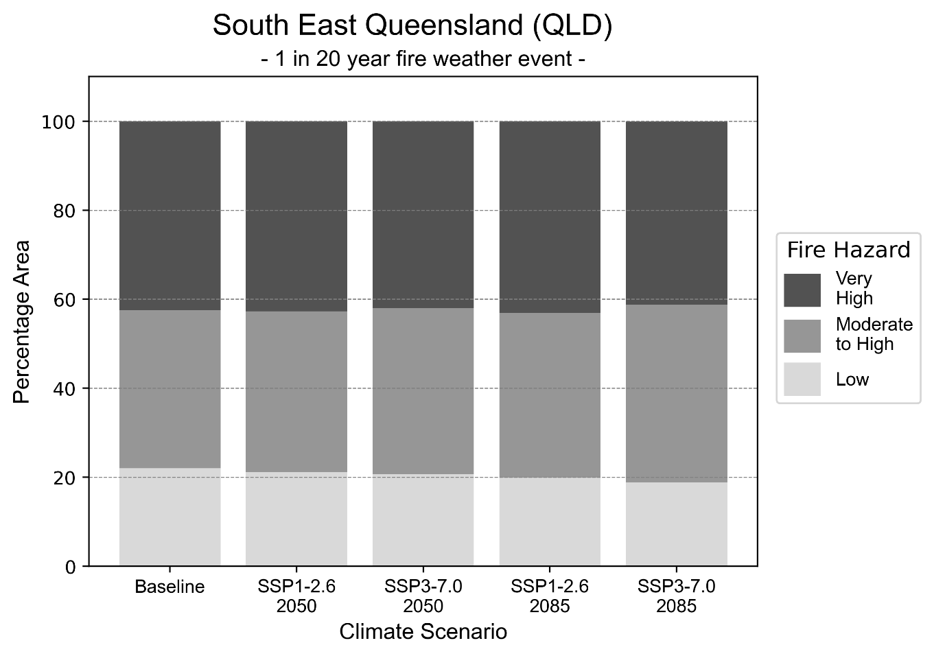
Figure 21: Stacked column chart showing the percentages of the South East Queensland health district's total geographic area experiencing each fire hazard level during a 1-in-20-year fire weather event.

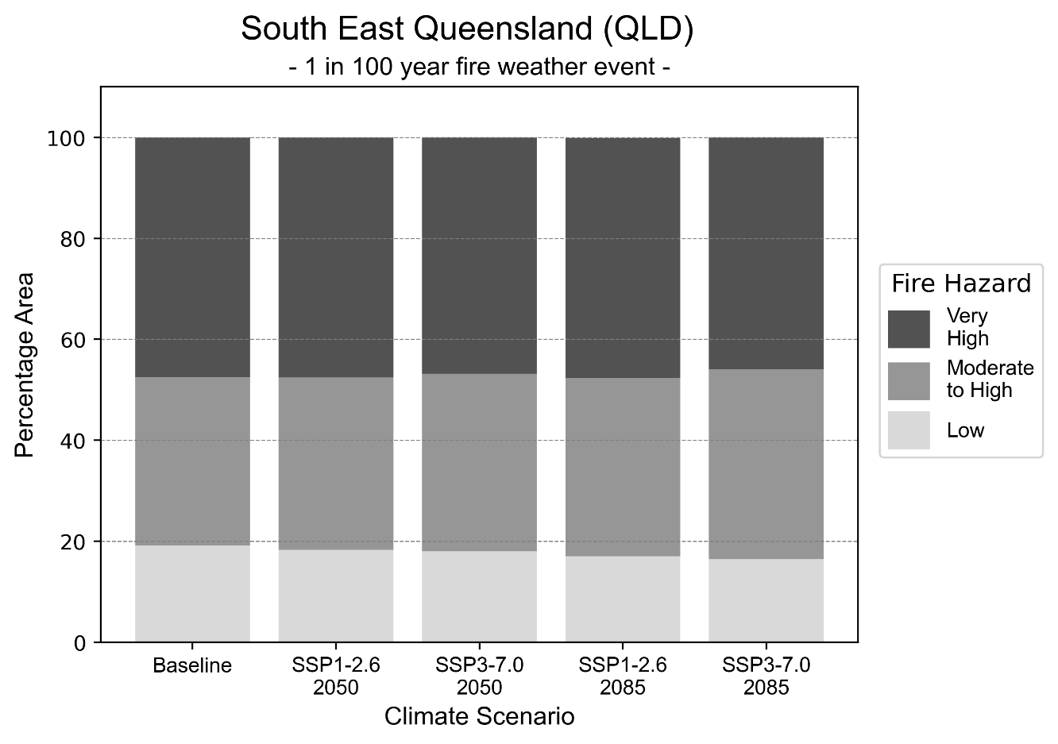
Figure 22: Stacked column chart showing the percentages of the South East Queensland health district's total geographic area experiencing each fire hazard level during a 1-in-100-year fire weather event.

Drought hazard
Key projections:
Drought occurrence: The occurrence of drought will increase across both middle of the road and reasonable worst-case scenarios for both time horizons, with the largest increase occurring under the reasonable worst-case scenario by 2050.

 | Baseline | 2050 Scenarios |  | 2085 Scenarios
 |  | Middle of the road | Reasonable worst-case | Middle of the road | Reasonable worst-case
Number of months per year in drought^{(a)} | 1.7 | 2.4  [0.6, 5.1] | 2.9  [0.4, 8.0] | 2.8  [0.5, 5.6] | 2.7  [0.3, 6.5]
Table notes: The drought hazard indicator uses climate projections from the CMIP6 Global Climate Models [1]. The primary indicator value reports the median from the nine climate models, with the range reported in square brackets.
Table footnotes: (a) The number of months per year in drought is based on the Standardised Precipitation Index (SPI). SPI is a widely used index to characterise meteorological drought on a range of timescales. This indicator uses the timescale of 12 months which calculates the average months in a year within the moderate drought range. A moderate drought range is classified as SPI score of ≤ -1. SPI is calculated from accumulated rainfall over 12 months and the mean and standard deviation from historical rainfall records.

Storm hazard
Key projections:
More very-high-intensity storms by 2085: Under both middle of the road and reasonable worst-case scenarios, the frequency of very-high-intensity storms will be remain consistent by 2050, but increase by 2085.

 | Baseline | 2050 Scenarios |  | 2085 Scenarios
 |  | Middle of the road | Reasonable worst-case | Middle of the road | Reasonable worst-case
Number of low-intensity storms (40-62 km/hr) per year | 73.6 | 70.9  [62.4, 78.0] | 70.6  [62.1, 77.7] | 67.7  [59.6, 74.5] | 69.1  [60.8, 76.0]
Number of medium-intensity storms (63-87 km/hr) per year | 54.4 | 46.9  [41.2, 51.6] | 45.7  [40.2, 50.3] | 44.0  [38.7, 48.4] | 43.1  [37.9, 47.4]
Number of high-intensity storms (88-117 km/hr) per year | 18.5 | 15.3  [13.5, 16.9] | 14.4  [12.7, 15.9] | 12.6  [11.1, 13.9] | 13.9  [12.2, 15.3]
Number of very-high-intensity storm (> 117 km/hr) per year | 0.5 | 0.5  [0.4, 0.6] | 0.5  [0.5, 0.6] | 0.7  [0.6, 0.7] | 0.7  [0.6, 0.7]
Table notes: The storm hazard uses climate projections from the CMIP6 Global Climate Models [1]. Daily maximum surface wind speed is used to calculate the number of annual storms across four storm intensity categories (low, medium, high and very high). The primary indicator value reports the median from the nine climate models, with the range reported in square brackets.

Rainfall and flood hazard
Key projections:
- Seven extreme rainfall days per year: The number of extreme rainfall days will remain consistent across both middle of the road and reasonable worst-case scenarios, and both time horizons, with an average of approximately seven extreme rainfall days per year.
- Increased flood frequency: The frequency of flood events will increase in urban and rural environments. The largest increase in flood frequency occurs in the reasonable worst-case scenario, where the frequency of a ‘1-in-100 year’ flood more than quadruple by 2050 and become 13 times more likely by 2085 in urban environments.

 | Baseline | 2050 Scenarios |  | 2085 Scenarios
 |  | Middle of the road | Reasonable worst-case | Middle of the road | Reasonable worst-case
Rainfall hazard^{(a)}
Average number of extreme rainfall days per year (> 13 mm/day)^{(a)} | 7.2 | 7  [5.9,8.2] | 6.8  [4.8,8.5] | 6.8  [5.4,8.1] | 6.7  [5.0,8.3]
Urban flood risk (flooding caused by a 1-hour rainfall event)^{(b)}
Frequency of a ‘1-in-1 year’ flood (rainfall depth of 35 mm)^{(c)} |  | 1.9 events in 1 year | 2.0 events in 1 year | 2.4 events in 1 year | 3.2 events in 1 year
Frequency of a ‘1-in-10 year’ flood (rainfall depth of 65 mm)^{(c)} |  | 2.9 events in 10 years | 3.0 events in 10 years | 4.2 events in 10 years | 6.5 events in 10 years
Frequency of a ‘1-in-100 year’ flood (rainfall depth of 98 mm)^{(c)} |  | 4.1 events in 100 years | 4.4 events in 100 years | 7.0 events in 100 years | 13 events in 100 years
Rural flood risk (flooding caused by a 24-hour rainfall event)^{(b)}
Frequency of a ‘1-in-1 year’ flood (rainfall depth of 99 mm)^{(c)} |  | 1.2 events in 1 year | 1.1 events in 1 year | 1.1 events in 1 year | 1.0 events in 1 year
Frequency of a ‘1-in-10 year’ flood (rainfall depth of 203 mm)^{(c)} |  | 1.5 events in 10 years | 1.5 events in 10 years | 1.6 events in 10 years | 1.7 events in 10 years
Frequency of a ‘1-in-100 year’ flood (rainfall depth of 341 mm)^{(c)} |  | 1.8 events in 100 years | 1.8 events in 100 years | 2.1 events in 100 years | 2.3 events in 100 years
Table notes: The rainfall hazard indicator uses climate projections from the CMIP6 Global Climate Models [1]. The primary indicator value reports the median from the nine climate models, with the range reported in square brackets. The flood hazard indicators use climate change considerations from the Australian Rainfall and Runoff guideline to estimate the climate projections [2].
Table footnotes: (a) Extreme rainfall is defined as rainfall above the 95th percentile of historical average daily rainfall in this health district in the period 1985-2014. The value in mm/day quoted in the indicator name is the 95th percentile of historic average daily rainfall for this health district. (b) See Methodology document for reasons for focusing on a 1-hour flood for urban areas and a 24-hour flood for rural areas. (c) The rainfall depths in mm quoted in the indicator names in this table report 1 in 1, 10 and 100 year depths for this health district.

Coastal inundation hazard
Key projections:
Greater area inundated: There will be an increase in the area affected by tidal inundation (i.e. area submerged during high tide) and storm surge and tidal inundation (i.e. the area submerged during a storm surge and high tide) across both middle of the road and reasonable worst-case scenarios. In the reasonable worst-case scenario, by 2085 the area inundated during a ‘1-in-1000-year’ event will increase by nearly 28,000 ha.

 | Baseline | 2050 Scenarios |  | 2085 Scenarios^{(a)}
 |  | Middle of the road | Reasonable worst-case | Middle of the road | Reasonable worst-case
Tidal inundation (ha inundated)^{(b)} | 52,757.8 | 60,547.8  (+7,790.0) | 61,063.0  (+8,305.2) | 73,879.7  (+21,121.9) | 79,058.1  (+26,300.2)
Storm surge + tidal inundation – ‘1-in-100 year’ event (ha inundated)^{(c)} | 61,457.8 | 69,043.7  (+7,585.8) | 69,529.9  (+8,072.0) | 81,428.7  (+19,970.9) | 86,256.5  (+24,798.7)
Storm surge + tidal inundation – ‘1-in-1000 year’ event (ha inundated)^{(c)} | 63,243.3 | 70,796.1  (+7,552.8) | 71,283.7  (+8,040.4) | 86,297.6  (+23,054.3) | 91,197.6  (+27,954.3)
Table notes: The coastal inundation hazard provides an indication of flooding in coastal areas that can be attributed to sea level rise and storm inundation. The coastal inundation hazard is only reported for health districts adjoining the coastline. This table includes the projected inundation levels as well as the change from baseline conditions (in brackets).
Table footnotes: (a) For the 2085 Scenarios planning horizon, 2100 was adopted as it provides a conservative representation of the end of this period. This horizon aligns with many State planning regulations requiring consideration of sea level rise and storm tide to 2100, making the 2100 scenario particularly valuable for planning new health facilities in coastal areas. (b) The tidal inundation indicator reports the number of hectares inundated during high tide. The baseline value reports existing inundation patterns, while the 2050 and 2085 values report high tide inundation taking account of projected sea level rise due to climate change. (c) The storm surge + tidal inundation indicators report the combined effect, in hectares inundated, of high tide, sea level rise (for the 2050 and 2085 projections), and storm surge (for 1-in-100 year and 1-in-1000 year events).

South West health district

Health district overview
Surface area: 319,274 square kilometres
Local health services: The South West Hospital and Health Service region includes 12 health centres and three hospitals: Roma Hospital, Charleville Hospital, St George Hospital.

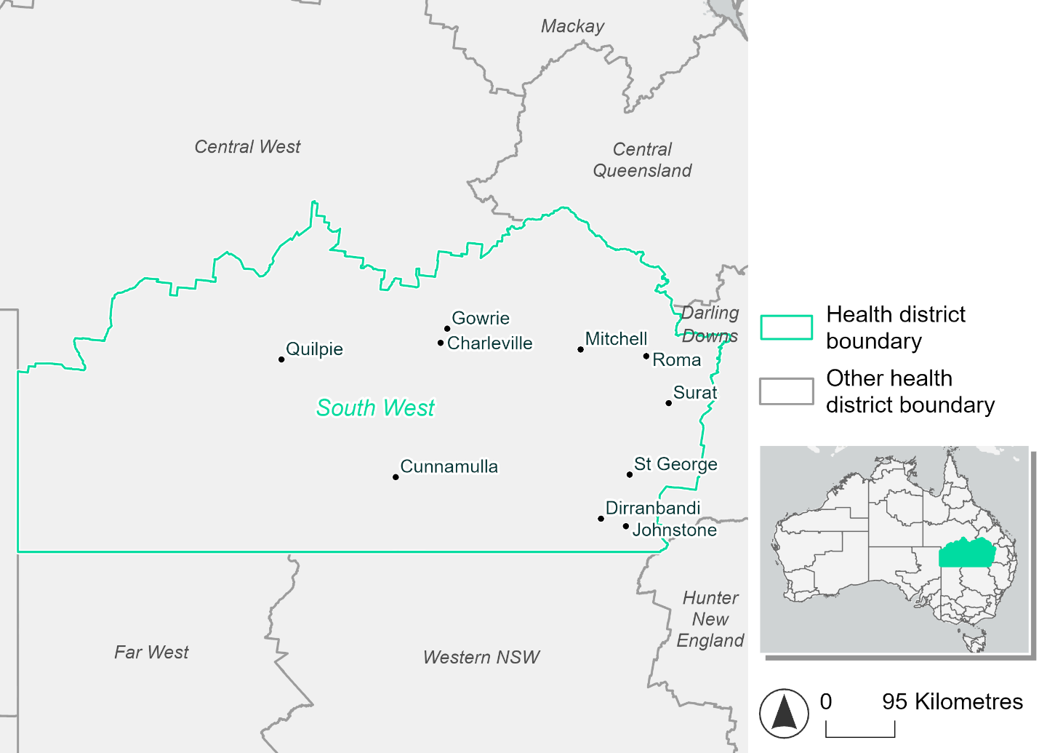
Figure 23. Map of South West health district.

How will climate change affect this health district?
Heat and humidity: There will be higher average temperatures, hotter and more frequent hot days, warmer night time temperatures and longer and more frequent heat waves.
Fire: Over 88% of this health district experiences very high fire hazard category and this will continue in the future.
Drought: The number of months experiencing drought will increase.
Rainfall and flood: There will be more flood events in both urban and rural areas.

South West health district demographic data
Demographic Data | Total
Number of households | 8,789
Persons 15 and older | 16,383
Total families | 5,906
Persons did not complete high school | 7,377
One parent families with dependents | 616 (10.4%)
Persons aged 65 and older | 4,134 (17.1%)
Persons aged 4 and younger | 1,733 (7.2%)
Aboriginal and Torres Strait Islander persons | 3,318 (13.7%)
Persons speaks language other than English | 951 (3.9%)
Persons working age (15-65) | 15,048 (62.3%)
Population Health Data | Total
Persons with core needs for assistance | 1,079 (4.5%)
Persons with arthritis | 2,215 (9.2%)
Persons with asthma | 2,432 (10.1%)
Persons with cancer | 669 (2.8%)
Persons with dementia | 125 (0.5%)
Persons with diabetes | 1,259 (5.2%)
Persons with heart disease | 1,052 (4.4%)
Persons with kidney disease | 233 (1%)
Persons with lung condition | 526 (2.2%)
Persons with mental health condition | 1,732 (7.2%)
Persons with stroke | 200 (0.8%)
Persons with any other condition | 1,361 (5.6%)
Persons no health condition | 13,463 (55.7%)
Socio-economic Data | Total
Persons providing unpaid care | 2,390 (9.9%)
Persons homeless | 138 (0.6%)
Household with lone person | 2,750 (31.3%)
Households with rent and mortgage stress | 2,138 (24.3%)
Households total equivalised income below $1000 (weekly) | 4,067 (46.3%)
Households with no motor vehicle | 485 (5.5%)
Persons unemployed | 586 (3.1%)

The sections that follow outline projected climate hazards for this district. Further information on this health district, including population demographics, is provided in the online dashboard.

Heat and humidity hazard
Key projections:
More heatwaves: Heatwave events are likely to last longer and the number of heatwave events per year will increase. By 2050, under a reasonable worst-case scenario, the number of heatwaves will triple. By 2085, under a reasonable worst-case scenario, the number of heatwaves per year will quadruple.
Hotter days and warmer nights: The day time and night time temperatures on hot days will increase.
More days above 35°C and 40°C: The number of days per year greater than 35°C and 40°C will increase under both middle of the road and reasonable worst-case scenarios.

 | Baseline | 2050 Scenarios |  | 2085 Scenarios
 |  | Middle of the road | Reasonable worst-case | Middle of the road | Reasonable worst-case
Average temperature (°C) | 20.6 | 22.2  [21.7, 22.8] | 22.5  [21.8, 23.3] | 23.2  [22.3, 24.3] | 24.4  [23.1, 25.7]
Maximum temperature on hot days (°C)^{(a)} | 36.8 | 38.7  [38, 39.8] | 39  [37.9, 40.2] | 39.6  [38.5, 41.3] | 40.8  [39.6, 42.7]
Minimum temperature on hot nights (°C)^{(b)} | 23.2 | 25  [24.3, 25.6] | 25.2  [24.3, 26] | 25.9  [25, 26.9] | 27.2  [25.9, 28.3]
Average apparent temperature on hot days (°C) (NOAA Heat Index)^{(c)} | 34.4 | 36.6  [35.5, 37.2] | 36.8  [36.1, 37.6] | 37.9  [36.8, 39.1] | 39.2  [38, 40.3]
Average heatwave duration in days^{(d)} | 5 | 7  [6, 9] | 7  [6, 9] | 9  [7, 12] | 11  [8, 17]
Number of heatwaves per year^{(d)} | 2 | 5  [5, 6] | 6  [5, 7] | 7  [6, 8] | 8  [7, 9]
Number of days per year  > 35°C | 41 | 72  [56, 93] | 79  [59, 106] | 92  [74, 125] | 113  [87, 152]
Number of days per year > 40°C | 3 | 11  [7, 18] | 13  [7, 22] | 18  [9, 36] | 31  [17, 58]
Table notes: The heat and humidity hazard uses climate projections from the CMIP6 Global Climate Models [1]. Daily projections of maximum and minimum near-surface temperature and mean relative humidity are used to calculate eight heat and humidity indicators. The primary indicator value reports the median from the nine climate models, with the range reported in square brackets.
Table footnotes: (a) Based on the 95th percentile of daily maximum air temperature. (b) Based on the 95th percentile of daily minimum air temperature, representing the coldest part of the night on very hot nights. (c) The National Oceanic and Atmospheric Administration (NOAA) Heat Index is a measure of how hot it feels when relative humidity is factored in alongside actual air temperature. It is calculated on days with a maximum temperature of 27°C and above. Interpretation of Heat Index values: 27°C to 32°C indicates caution, 33°C to 41°C indicates extreme caution, 42°C to 54°C indicates danger and over 54°C indicates extreme danger. See methodology document for further explanation of Heat Index categories. (d) A heatwave is defined as three or more consecutive days where both daytime and overnight temperatures (daily mean temperatures) are unusually high for the location, based on the Bureau of Meteorology’s Excess Heat Factor method. For this district, an unusually high daily mean temperature is approximately 29.6°C or above.

Fire Hazard
Key projections:
- Evenly spread fire hazard currently: Under baseline conditions during a 1-in-20-year fire weather event, 46.6% of the district experiences low fire hazard while 46.1% experiences moderate to high hazard. The remaining 7.3% experiences very high hazard. During a more severe 1-in-100-year fire weather event, these values shift slightly towards higher hazard but the relative proportions remain roughly the same.
- Slight reduction in low hazard area: In a future climate across both 2050 and 2085 scenarios, the area experiencing very high hazard remains within 0.3 percentage points of baseline levels. There is a slight decrease in the area experiencing low hazard and a corresponding increase in the area experiencing moderate to high hazard. The magnitude of this shift is 2-3 percentage points for a 1-in-20-year fire weather event, and 3-4 percentage points for a 1-in-100-year event.

 | Baseline | 2050 Scenarios |  | 2085 Scenarios
 |  | Sustainability | Reasonable worst-case | Sustainability | Reasonable worst-case
Hazard for a ‘1-in-20 year’ fire weather event^{(a)}
Proportion (%) of district experiencing ‘Low’ fire hazard | 46.6%  (14,886,960)  ^{(b)} | 46.2%  [45.4%, 46.7%] | 45.7%  [45.1%, 46.1%] | 45.5%  [43.7%, 46.9%] | 44.3%  [42.9%, 45.4%]
Proportion (%) of district experiencing ‘Moderate to High’ fire hazard | 46.1%  (14,717,557)  ^{(b)} | 46.6%  [45.7%, 47.3%] | 47.2%  [45.3%, 48.5%] | 47.3%  [45.1%, 48.9%] | 48.7%  [44.3%, 51.9%]
Proportion (%) of district experiencing ‘Very High’ fire hazard | 7.3%  (2,322,846)^{(b)} | 7.2%  [6.8%, 7.6%] | 7.2%  [7.0%, 7.5%] | 7.1%  [6.1%, 8.0%] | 7.1%  [6.5%, 7.9%]
Hazard for a ‘1-in-100 year’ fire weather event^{(a)}
Proportion (%) of district experiencing ‘Low’ fire hazard | 43.8%  (13,984,869)  ^{(b)} | 43.1%  [42.0%, 43.9%] | 42.4%  [41.7%, 43.1%] | 42.1%  [39.4%, 44.1%] | 40.4%  [38.7%, 42.0%]
Proportion (%) of district experiencing ‘Moderate to High’ fire hazard | 47.4%  (15,144,072)  ^{(b)} | 48.2%  [46.8%, 49.5%] | 49.0%  [47.4%, 50.1%] | 49.2%  [46.0%, 52.4%] | 51.1%  [47.4%, 53.8%]
Proportion (%) of district experiencing ‘Very High’ fire hazard | 8.8%  (2,798,421)^{(b)} | 8.7%  [8.3%, 9.2%] | 8.7%  [8.5%, 9.0%] | 8.7%  [7.7%, 9.7%] | 8.5%  [8.1%, 9.3%]
Table notes: The Fire Hazard uses the National Bushfire Intelligence Capability (NBIC) Phase 2 fire line intensity modelling based on CMIP6 climate projections. Fire Hazard is assessed using the projected Fireline Intensity (FLI) for weather events with two different return intervals (i.e. a 1-in-20 year event and a 1-in-100 year event). FLI considers slope, vegetation and weather to produce a rate of heat output per unit length (kW/m) along a bushfire’s front. Fire hazard is categorized as a low for FLI<4000 kW/m, moderate to high for 4,000 kW/m ≤FLI<12,500kW/m, and very high for FLI≥27,501kW/m. This is broadly consistent with the literature [3]. The assessment considers climate change effects based on changes in fire weather and the associated hazard that is anticipated for a meteorological event of a given return interval. This approach is different to the one adopted for the Flood Hazard, where the event magnitude is given (fixed) and the likelihood of that event varies as a result of climate change. The primary indicator value reports the median from the nine climate models, with the range reported in square brackets.
Table footnotes: (a) The area subject to different categories of fire hazard is determined for a ‘1-in-20 year’ and ‘1-in-100 year’ fire weather event, in current and future climates. Values at year 2050 are interpolated using data from baseline (2025) and 2085, assuming linear change over time. (b) Values in round brackets are the area (ha) of the health district subject to a given fire hazard.

The figures below show the proportion of the health district experiencing different fire hazard categories across different time horizons and climate scenarios during a ‘1-in-20 year’ fire weather event (Figure 24) and a ‘1-in-100 year’ fire weather event (Figure 25).
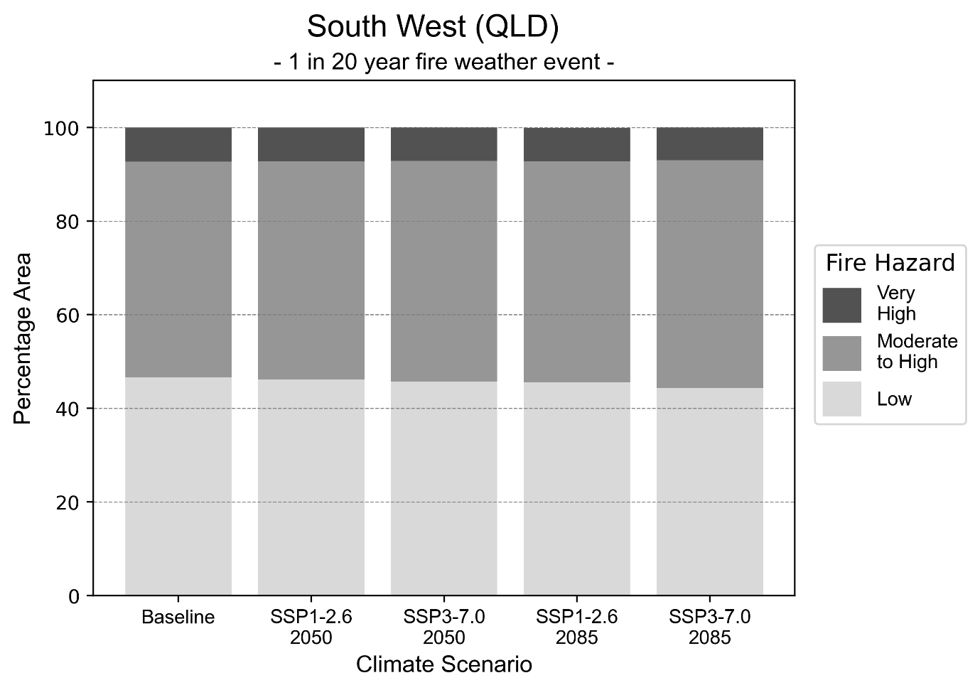
Figure 24: Stacked column chart showing the percentages of the South West health district's total geographic area experiencing each fire hazard level during a 1-in-20-year fire weather event.
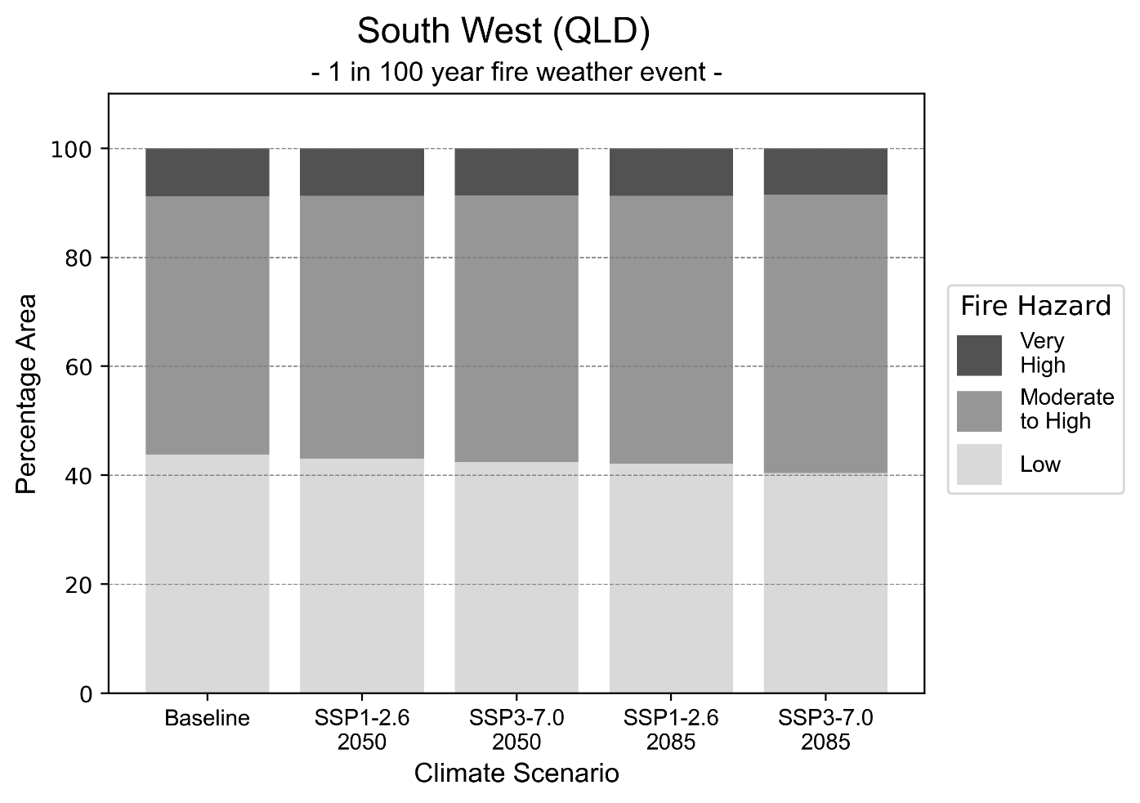Figure 25: Stacked column chart showing the percentages of the South West health district's total geographic area experiencing each fire hazard level during a 1-in-100-year fire weather event.

Drought hazard
Key projections:
Drought occurrence: The occurrence of drought will increase across both middle of the road and reasonable worst-case scenarios for both time horizons, with the largest increase occurring under the middle of the road scenario by 2085.

 | Baseline | 2050 Scenarios |  | 2085 Scenarios
 |  | Middle of the road | Reasonable worst-case | Middle of the road | Reasonable worst-case
Number of months per year in drought^{(a)} | 1.7 | 2.3  [0.2, 5.2] | 2.2  [0.7, 5.5] | 2.4  [0.4, 4.8] | 2.2  [0.1, 4.8]
Table notes: The drought hazard indicator uses climate projections from the CMIP6 Global Climate Models [1]. The primary indicator value reports the median from the nine climate models, with the range reported in square brackets.
Table footnotes: (a) The number of months per year in drought is based on the Standardised Precipitation Index (SPI). SPI is a widely used index to characterise meteorological drought on a range of timescales. This indicator uses the timescale of 12 months which calculates the average months in a year within the moderate drought range. A moderate drought range is classified as SPI score of ≤ -1. SPI is calculated from accumulated rainfall over 12 months and the mean and standard deviation from historical rainfall records.

Storm hazard
Key projections:
Fewer very-high-intensity storms by 2085: Under the middle of the road scenario the frequency of very-high-intensity storms will increase slightly by 2050 but decrease by 2085. Under the reasonable worst-case scenario the frequency of very-high-intensity storms will decrease across both time horizons.

Baseline |  | 2050 Scenarios |  | 2085 Scenarios
 |  | Middle of the road | Reasonable worst-case | Middle of the road | Reasonable worst-case
Number of low-intensity storms (40-62 km/hr) per year | 73.8 | 70.5  [62.0, 77.5] | 69.4  [61.0, 76.3] | 68.5  [60.3, 75.4] | 69.4  [61.1, 76.3]
Number of medium-intensity storms (63-87 km/hr) per year | 54.8 | 55.7  [49.0, 61.3] | 54.4  [47.9, 59.8] | 51.8  [45.6, 57.0] | 52.9  [46.6, 58.2]
Number of high-intensity storms (88-117 km/hr) per year | 17.7 | 17.7  [15.6, 19.5] | 17.5  [15.4, 19.3] | 16.1  [14.2, 17.7] | 18.1  [15.9, 19.9]
Number of very-high-intensity storm (> 117 km/hr) per year | 0.7 | 0.8  [0.7, 0.8] | 0.6  [0.5, 0.6] | 0.5  [0.5, 0.6] | 0.5  [0.5, 0.6]
Table notes: The storm hazard uses climate projections from the CMIP6 Global Climate Models [1]. Daily maximum surface wind speed is used to calculate the number of annual storms across four storm intensity categories (low, medium, high and very high). The primary indicator value reports the median from the nine climate models, with the range reported in square brackets.

Rainfall and flood hazard
Key projections:
- Fewer extreme rainfall days per year: The number of extreme rainfall days will slightly decrease across both middle of the road and reasonable worst-case scenarios, and both time horizons, with an average of approximately 13-14 extreme rainfall days per year.
- Increased flood frequency: The frequency of flood events will increase in urban environments. The largest increase in flood frequency occurs in the reasonable worst-case scenario, where the frequency of a ‘1-in-100 year’ flood will nearly quadruple by 2050 and become ten times more likely by 2085 in urban environments. In rural environments, for both middle of the road and reasonable worst-case scenarios, the frequency of all flood types will mainly increase by 2050, but decrease by 2085.

 | Baseline | 2050 Scenarios |  | 2085 Scenarios
 |  | Middle of the road | Reasonable worst-case | Middle of the road | Reasonable worst-case
Rainfall hazard^{(a)}
Average number of extreme rainfall days per year (> 7 mm/day)^{(a)} | 14.2 | 13.8  [10.3,18.4] | 13.6  [9.8,15.8] | 13.4  [10.8,18.3] | 13.9  [10.5,22.5]
Urban flood risk (flooding caused by a 1-hour rainfall event)^{(b)}
Frequency of a ‘1-in-1 year’ flood (rainfall depth of 20 mm)^{(c)} |  | 1.6 events in 1 year | 1.7 events in 1 year | 2.0 events in 1 year | 2.4 events in 1 year
Frequency of a ‘1-in-10 year’ flood (rainfall depth of 40 mm)^{(c)} |  | 2.4 events in 10 years | 2.6 events in 10 years | 3.4 events in 10 years | 5.1 events in 10 years
Frequency of a ‘1-in-100 year’ flood (rainfall depth of 65 mm)^{(c)} |  | 3.4 events in 100 years | 3.7 events in 100 years | 5.5 events in 100 years | 10 events in 100 years
Rural flood risk (flooding caused by a 24-hour rainfall event)^{(b)}
Frequency of a ‘1-in-1 year’ flood (rainfall depth of 50 mm)^{(c)} |  | 1.1 events in 1 year | 1.0 events in 1 year | 0.7 events in 1 year | 0.4 events in 1 year
Frequency of a ‘1-in-10 year’ flood (rainfall depth of 99 mm)^{(c)} |  | 1.1 events in 10 years | 1.1 events in 10 years | 0.7 events in 10 years | 0.3 events in 10 years
Frequency of a ‘1-in-100 year’ flood (rainfall depth of 161 mm)^{(c)} |  | 1.2 events in 100 years | 1.2 events in 100 years | 0.9 events in 100 years | 0.4 events in 100 years
Table notes: The rainfall hazard indicator uses climate projections from the CMIP6 Global Climate Models [1]. The primary indicator value reports the median from the nine climate models, with the range reported in square brackets. The flood hazard indicators use climate change considerations from the Australian Rainfall and Runoff guideline to estimate the climate projections [2]. (
Table footnotes: a) Extreme rainfall is defined as rainfall above the 95th percentile of historical average daily rainfall in this health district in the period 1985-2014. The value in mm/day quoted in the indicator name is the 95th percentile of historic average daily rainfall for this health district. (b) See Methodology document for reasons for focusing on a 1-hour flood for urban areas and a 24-hour flood for rural areas. (c) The rainfall depths in mm quoted in the indicator names in this table report 1 in 1, 10 and 100 year depths for this health district.

Torres and Cape health district

Health district overview
Surface area: 129,770 square kilometres
Local health services: 31 community health centres and four major hospitals and health centres: Weipa Integrated Health Service, Thursday Island Hospital, Bamaga Hospital, Cooktown Multipurpose Health Service

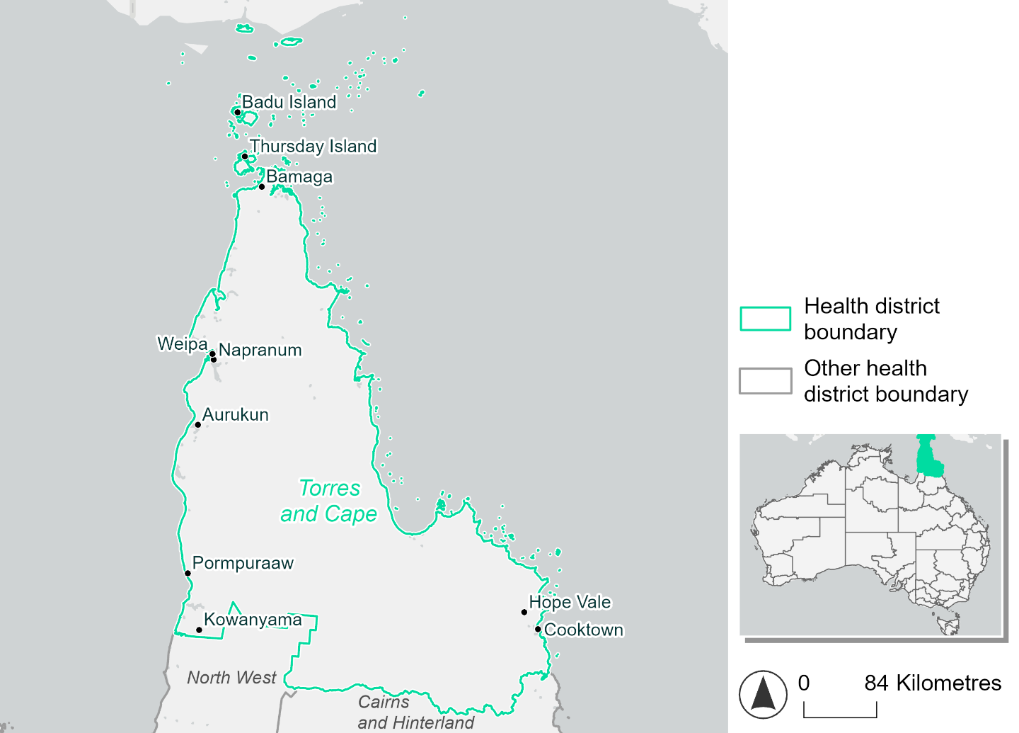
Figure 26. Map of Torres and Cape health district

How will climate change affect this health district?
Heat and humidity: There will be higher average temperatures, hotter and more frequent hot days, warmer night time temperatures and longer and more frequent heat waves.
Fire: Only 2% of this health district experiences very high fire hazard category and this will continue in the future.
Drought: The number of months experiencing drought will increase.
Rainfall and flood: There will be more flood events in urban areas.
Coastal inundation: The area flooded during tidal, and storm surge and tidal inundation, will increase.

Torres and Cape health district demographic data
Demographic Data | Total
Number of households | 6,850
Persons 15 and older | 17,773
Total families | 5,612
Persons did not complete high school | 7,662
One parent families with dependents | 1,154 (20.6%)
Persons aged 65 and older | 2,088 (8.1%)
Persons aged 4 and younger | 2,250 (8.7%)
Aboriginal and Torres Strait Islander persons | 15,258 (59%)
Persons speaks language other than English | 10,776 (41.6%)
Persons working age (15-65) | 16,883 (65.2%)
Population Health Data | Total
Persons with core needs for assistance | 749 (2.9%)
Persons with arthritis | 720 (2.8%)
Persons with asthma | 981 (3.8%)
Persons with cancer | 253 (1%)
Persons with dementia | 77 (0.3%)
Persons with diabetes | 1542 (6%)
Persons with heart disease | 739 (2.9%)
Persons with kidney disease | 207 (0.8%)
Persons with lung condition | 190 (0.7%)
Persons with mental health condition | 698 (2.7%)
Persons with stroke | 98 (0.4%)
Persons with any other condition | 1,022 (3.9%)
Persons no health condition | 17,009 (65.7%)
Socio-economic Data | Total
Persons providing unpaid care | 2,305 (8.9%)
Persons homeless | 728 (2.8%)
Household with lone person | 1,659 (24.2%)
Households with rent and mortgage stress | 1,134 (16.6%)
Households total equivalised income below $1000 (weekly) | 2,979 (43.5%)
Households with no motor vehicle | 1,672 (24.4%)
Persons unemployed | 2,137 (11.6%)

The sections that follow outline projected climate hazards for this district. Further information on this health district, including population demographics, is provided in the online dashboard.

Heat and humidity hazard
Key projections:
More heatwaves: Heatwave events are likely to last longer and the number of heatwave events per year will increase. By 2050, under a reasonable worst-case scenario, the number of heatwaves will quadruple. By 2085, under a reasonable worst-case scenario, the number of heatwaves per year will more than quadruple.
Hotter days and warmer nights: The day time and night time temperatures on hot days will increase.
More days above 35°C and 40°C: The number of days per year greater than 35°C and 40°C will increase under both middle of the road and reasonable worst-case scenarios.

 | Baseline | 2050 Scenarios |  | 2085 Scenarios
 |  | Middle of the road | Reasonable worst-case | Middle of the road | Reasonable worst-case
Average temperature (°C) | 26.5 | 27.8  [27.3, 28.2] | 27.9  [27.5, 28.4] | 28.4  [27.8, 29] | 29.2  [28.5, 29.9]
Maximum temperature on hot days (°C)^{(a)} | 34 | 35.3  [34.8, 35.7] | 35.5  [35, 36] | 35.9  [35.1, 36.4] | 36.8  [36, 37.4]
Minimum temperature on hot nights (°C)^{(b)} | 26.1 | 27.4  [26.8, 27.8] | 27.6  [27.1, 28] | 28.1  [27.3, 28.6] | 29  [28.2, 29.7]
Average apparent temperature on hot days (°C) (NOAA Heat Index)^{(c)} | 38.5 | 41.8  [40.5, 43] | 42.2  [41, 43.6] | 43.7  [41.9, 45.2] | 46.2  [43.8, 48.5]
Average heatwave duration in days^{(d)} | 5 | 12  [9, 16] | 13  [10, 18] | 20  [12, 27] | 30  [20, 46]
Number of heatwaves per year^{(d)} | 2 | 8  [6, 9] | 8  [7, 9] | 9  [8, 9] | 8  [6, 9]
Number of days per year  > 35°C | 36 | 53  [40, 63] | 56  [44, 71] | 69  [49, 86] | 96  [66, 122]
Number of days per year > 40°C | 0 | 3  [1, 5] | 4  [2, 6] | 6  [2, 8] | 11  [6, 15]
Table notes: The heat and humidity hazard uses climate projections from the CMIP6 Global Climate Models [1]. Daily projections of maximum and minimum near-surface temperature and mean relative humidity are used to calculate eight heat and humidity indicators. The primary indicator value reports the median from the nine climate models, with the range reported in square brackets.
Table notes: (a) Based on the 95th percentile of daily maximum air temperature. (b) Based on the 95th percentile of daily minimum air temperature, representing the coldest part of the night on very hot nights. (c) The National Oceanic and Atmospheric Administration (NOAA) Heat Index is a measure of how hot it feels when relative humidity is factored in alongside actual air temperature. It is calculated on days with a maximum temperature of 27°C and above. Interpretation of Heat Index values: 27°C to 32°C indicates caution, 33°C to 41°C indicates extreme caution, 42°C to 54°C indicates danger and over 54°C indicates extreme danger. See methodology document for further explanation of Heat Index categories. (d) A heatwave is defined as three or more consecutive days where both daytime and overnight temperatures (daily mean temperatures) are unusually high for the location, based on the Bureau of Meteorology’s Excess Heat Factor method. For this district, an unusually high daily mean temperature is approximately 29.3°C or above.

Fire Hazard
Key projections:
- Most of district area currently experiences low fire hazard: Under baseline conditions, 84-86% of the district experiences low fire hazard. Less than 2% experiences very high hazard, with the remaining 11-13% experiencing moderate to high fire hazard.
- Current fire hazard conditions to persist: In a future climate across both 2050 and 2085 scenarios, the areas experiencing moderate to high or very high fire hazard stay fairly stable compared to their baseline levels. The sustainability scenario shows a slight improvement from baseline, with the area experiencing moderate to high hazard reducing by up to 1.2 percentage points for a 1-in-20-year fire weather event, and by up to 2.3 percentage points for a 1-in-100-year event. This lower-emissions scenario sees up to 88% of the district exposed to only low hazard by 2085.

 |  | Baseline | 2050 Scenarios |  | 2085 Scenarios
 |  |  | Sustainability | Reasonable worst-case | Sustainability | Reasonable worst-case
Hazard for a ‘1-in-20 year’ fire weather event^{(a)}
Proportion (%) of district experiencing ‘Low’ fire hazard |  | 86.8%  (11,262,908)  ^{(b)} | 87.3%  [87.2%, 87.6%] | 86.8%  [85.3%, 87.3%] | 88.1%  [87.7%, 88.7%] | 86.7%  [83.3%, 88.0%]
Proportion (%) of district experiencing ‘Moderate to High’ fire hazard |  | 11.5%  (1,486,586)^{(b)} | 11.0%  [10.7%, 11.1%] | 11.6%  [11.0%, 13.0%] | 10.3%  [9.7%, 10.6%] | 11.7%  [10.4%, 15.2%]
Proportion (%) of district experiencing ‘Very High’ fire hazard |  | 1.8%  (227,588)^{(b)} | 1.7%  [1.7%, 1.7%] | 1.7%  [1.6%, 1.8%] | 1.7%  [1.6%, 1.7%] | 1.7%  [1.5%, 1.8%]
Hazard for a ‘1-in-100 year’ fire weather event^{(a)}
Proportion (%) of district experiencing ‘Low’ fire hazard |  | 84.6%  (10,982,381)  ^{(b)} | 85.6%  [85.4%, 86.0%] | 84.5%  [82.5%, 85.4%] | 86.9%  [86.5%, 87.9%] | 84.4%  [79.5%, 86.5%]
Proportion (%) of district experiencing ‘Moderate to High’ fire hazard |  | 13.5%  (1,748,117)^{(b)} | 12.5%  [12.1%, 12.7%] | 13.6%  [12.7%, 15.7%] | 11.2%  [10.3%, 11.6%] | 13.8%  [11.7%, 18.8%]
Proportion (%) of district experiencing ‘Very High’ fire hazard |  | 1.9%  (246,584)^{(b)} | 1.9%  [1.9%, 1.9%] | 1.9%  [1.8%, 1.9%] | 1.8%  [1.8%, 1.9%] | 1.9%  [1.6%, 2.0%]
Table notes: The Fire Hazard uses the National Bushfire Intelligence Capability (NBIC) Phase 2 fire line intensity modelling based on CMIP6 climate projections. Fire Hazard is assessed using the projected Fireline Intensity (FLI) for weather events with two different return intervals (i.e. a 1-in-20 year event and a 1-in-100 year event). FLI considers slope, vegetation and weather to produce a rate of heat output per unit length (kW/m) along a bushfire’s front. Fire hazard is categorized as a low for FLI<4000 kW/m, moderate to high for 4,000 kW/m ≤FLI<12,500kW/m, and very high for FLI≥27,501kW/m. This is broadly consistent with the literature [3]. The assessment considers climate change effects based on changes in fire weather and the associated hazard that is anticipated for a meteorological event of a given return interval. This approach is different to the one adopted for the Flood Hazard, where the event magnitude is given (fixed) and the likelihood of that event varies as a result of climate change. The primary indicator value reports the median from the nine climate models, with the range reported in square brackets.
Table footnotes: (a) The area subject to different categories of fire hazard is determined for a ‘1-in-20 year’ and ‘1-in-100 year’ fire weather event, in current and future climates. Values at year 2050 are interpolated using data from baseline (2025) and 2085, assuming linear change over time. (b) Values in round brackets are the area (ha) of the health district subject to a given fire hazard.

The figures below show the proportion of the health district experiencing different fire hazard categories across different time horizons and climate scenarios during a ‘1-in-20 year’ fire weather event (Figure 27) and a ‘1-in-100 year’ fire weather event (Figure 28).
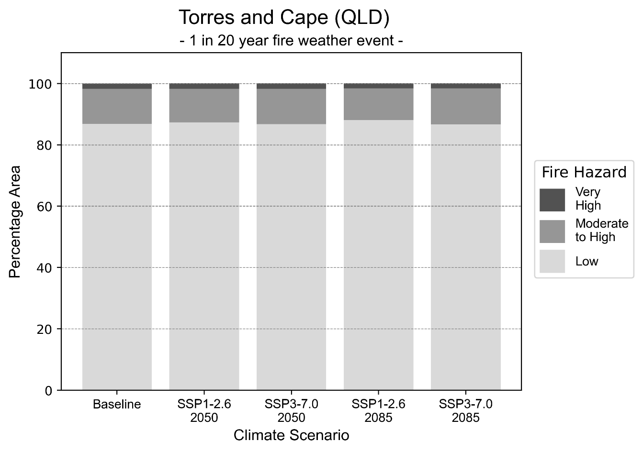
Figure 27: Stacked column chart showing the percentages of the Torres and Cape health district's total geographic area experiencing each fire hazard level during a 1-in-20-year fire weather event.
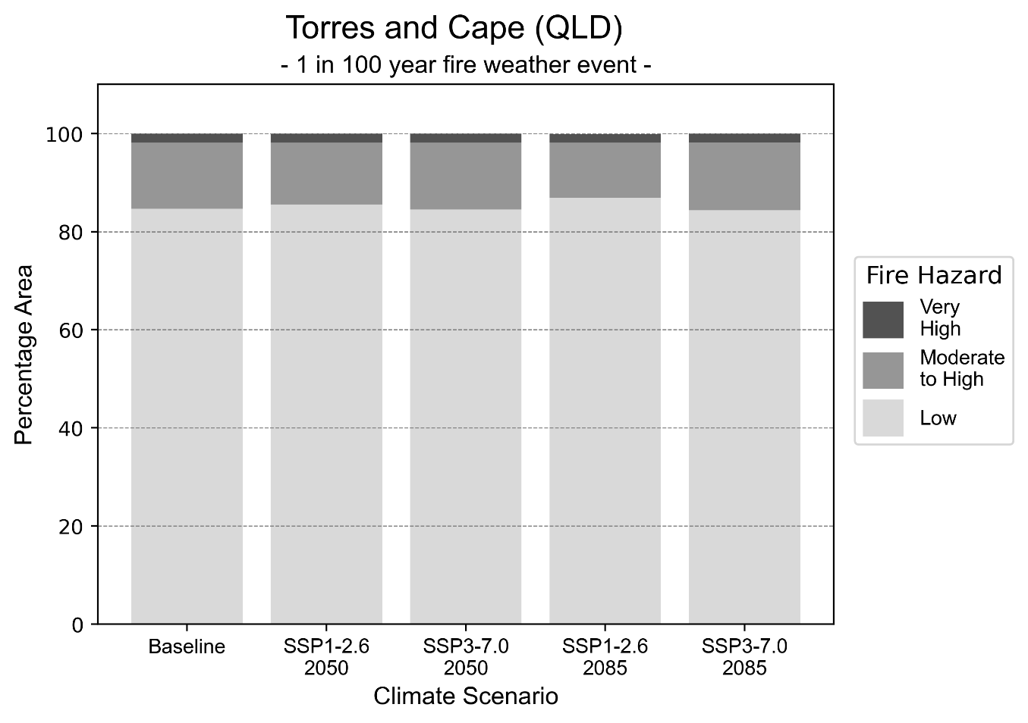
Figure 28: Stacked column chart showing the percentages of the Torres and Cape health district's total geographic area experiencing each fire hazard level during a 1-in-100-year fire weather event.

Drought hazard
Key projections:
Drought occurrence: The occurrence of drought will increase across both middle of the road and reasonable worst-case scenarios for both time horizons, with the largest increase occurring under the middle of the road scenario by 2085.

 | Baseline | 2050 Scenarios |  | 2085 Scenarios
 |  | Middle of the road | Reasonable worst-case | Middle of the road | Reasonable worst-case
Number of months per year in drought^{(a)} | 2.0 | 2.9  [0.3, 5.3] | 2.7  [0.5, 5.1] | 3.0  [0.8, 6.6] | 2.8  [0.3, 6.2]
Table notes: The drought hazard indicator uses climate projections from the CMIP6 Global Climate Models [1]. The primary indicator value reports the median from the nine climate models, with the range reported in square brackets.
Table footnotes: (a) The number of months per year in drought is based on the Standardised Precipitation Index (SPI). SPI is a widely used index to characterise meteorological drought on a range of timescales. This indicator uses the timescale of 12 months which calculates the average months in a year within the moderate drought range. A moderate drought range is classified as SPI score of ≤ -1. SPI is calculated from accumulated rainfall over 12 months and the mean and standard deviation from historical rainfall records.

Storm hazard
Key projections:
More very-high-intensity storms under the reasonable worst-case scenario: Under the reasonable worst-case scenario the frequency of very-high-intensity storms will increase across both time horizons. Under the middle of the road scenario the frequency of very-high-intensity storms will remain consistent across both horizons.

Baseline |  | 2050 Scenarios |  |  | 2085 Scenarios
 |  | Middle of the road | Reasonable worst-case | Middle of the road |  | Reasonable worst-case
Number of low-intensity storms (40-62 km/hr) per year | 74.1 | 70.5  [62.0, 77.6] | 69.8  [61.4, 76.8] | 71.8  [63.2, 79.0] |  | 72.8  [64.1, 80.1]
Number of medium-intensity storms (63-87 km/hr) per year | 74.9 | 73.7  [64.9, 81.1] | 71.5  [62.9, 78.6] | 72.3  [63.6, 79.5] |  | 75.4  [66.4, 83.0]
Number of high-intensity storms (88-117 km/hr) per year | 35.6 | 32.8  [28.9, 36.1] | 36.8  [32.4, 40.4] | 38.7  [34.1, 42.6] |  | 36.7  [32.3, 40.3]
Number of very-high-intensity storm (> 117 km/hr) per year | 0.8 | 0.8  [0.7, 0.8] | 0.9  [0.8, 1.0] | 0.8  [0.7, 0.8] |  | 1.0  [0.9, 1.1]
Table notes: The storm hazard uses climate projections from the CMIP6 Global Climate Models [1]. Daily maximum surface wind speed is used to calculate the number of annual storms across four storm intensity categories (low, medium, high and very high). The primary indicator value reports the median from the nine climate models, with the range reported in square brackets.

Rainfall and flood hazard
Key projections:
- Seven extreme rainfall days per year: The number of extreme rainfall days will remain consistent across both middle of the road and reasonable worst-case scenarios, and both time horizons, with an average of approximately seven extreme rainfall days per year.
- Increased flood frequency: The frequency of flood events will increase in urban environments. The largest increase in flood frequency occurs in the reasonable worst-case scenario, where the frequency of a ‘1-in-100 year’ flood will become nearly eight times more likely by 2050 and become 29 times more likely by 2085 in urban environments. In rural environments, the frequency for a ‘1-in-10 year’ and a ‘1-in-100 year’ flood will increase for both middle of the road and reasonable worst-case scenarios across both time horizons.

 | Baseline | 2050 Scenarios |  | 2085 Scenarios
 |  | Middle of the road | Reasonable worst-case | Middle of the road | Reasonable worst-case
Rainfall hazard^{(a)}
Average number of extreme rainfall days per year (> 16 mm/day)^{(a)} | 7.1 | 6.9  [4.7,12.4] | 6.9  [5.2,10.8] | 6.7  [4.5,10.2] | 6.9  [4.6,11.3]
Urban flood risk (flooding caused by a 1-hour rainfall event)^{(b)}
Frequency of a ‘1-in-1 year’ flood (rainfall depth of 48 mm)^{(c)} |  | 2.0 events in 1 year | 2.1 events in 1 year | 2.5 events in 1 year | 3.2 events in 1 year
Frequency of a ‘1-in-10 year’ flood (rainfall depth of 77 mm)^{(c)} |  | 4.4 events in 10 years | 4.8 events in 10 years | 6.5 events in 10 years | 10 events in 10 years
Frequency of a ‘1-in-100 year’ flood (rainfall depth of 103 mm)^{(c)} |  | 7.1 events in 100 years | 7.9 events in 100 years | 14 events in 100 years | 29 events in 100 years
Rural flood risk (flooding caused by a 24-hour rainfall event ^{(b)}
Frequency of a ‘1-in-1 year’ flood (rainfall depth of 103 mm)^{(c)} |  | 1.1 events in 1 year | 1.0 events in 1 year | 1.0 events in 1 year | 0.7 events in 1 year
Frequency of a ‘1-in-10 year’ flood (rainfall depth of 201 mm)^{(c)} |  | 1.5 events in 10 years | 1.4 events in 10 years | 1.4 events in 10 years | 1.3 events in 10 years
Frequency of a ‘1-in-100 year’ flood (rainfall depth of 338 mm)^{(c)} |  | 1.6 events in 100 years | 1.6 events in 100 years | 1.8 events in 100 years | 1.8 events in 100 years
Table notes: The rainfall hazard indicator uses climate projections from the CMIP6 Global Climate Models [1]. The primary indicator value reports the median from the nine climate models, with the range reported in square brackets. The flood hazard indicators use climate change considerations from the Australian Rainfall and Runoff guideline to estimate the climate projections [2].
Table footnotes: (a) Extreme rainfall is defined as rainfall above the 95th percentile of historical average daily rainfall in this health district in the period 1985-2014. The value in mm/day quoted in the indicator name is the 95th percentile of historic average daily rainfall for this health district. (b) See Methodology document for reasons for focusing on a 1-hour flood for urban areas and a 24-hour flood for rural areas. (c) The rainfall depths in mm quoted in the indicator names in this table report 1 in 1, 10 and 100 year depths for this health district.

Coastal inundation hazard
Key projections:
Greater area inundated: There will be an increase in the area affected by tidal inundation (i.e. area submerged during high tide) and storm surge and tidal inundation (i.e. the area submerged during a storm surge and high tide) across both middle of the road and reasonable worst-case scenarios. In the reasonable worst-case scenario, by 2085 the area inundated during a ‘1-in-1000-year’ event will increase by nearly 60,000 ha.

 | Baseline | 2050 Scenarios |  | 2085 Scenarios^{(a)}
 |  | Middle of the road | Reasonable worst-case | Middle of the road | Reasonable worst-case
Tidal inundation (ha inundated)^{(b)} | 48,609.5 | 50,342.2  (+1,732.7) | 50,506.4  (+1,896.9) | 54,016.3  (+5,406.8) | 58,246.8  (+9,637.3)
Storm surge + tidal inundation – ‘1-in-100 year’ event (ha inundated)^{(c)} | 71,701.5 | 76,954.4  (+5,252.9) | 77,503.4  (+5,801.9) | 89,669.2  (+17,967.7) | 94,047.7  (+22,346.2)
Storm surge + tidal inundation – ‘1-in-1000 year’ event (ha inundated)^{(c)} | 102,253.6 | 113,854.2  (+11,600.6) | 114,857.7  (+12,604.1) | 147,747.1  (+45,493.5) | 161,365.0  (+59,111.4)
Table notes: The coastal inundation hazard provides an indication of flooding in coastal areas that can be attributed to sea level rise and storm inundation. The coastal inundation hazard is only reported for health districts adjoining the coastline. This table includes the projected inundation levels as well as the change from baseline conditions (in brackets).
Table footnotes: (a) For the 2085 Scenarios planning horizon, 2100 was adopted as it provides a conservative representation of the end of this period. This horizon aligns with many State planning regulations requiring consideration of sea level rise and storm tide to 2100, making the 2100 scenario particularly valuable for planning new health facilities in coastal areas. (b) The tidal inundation indicator reports the number of hectares inundated during high tide. The baseline value reports existing inundation patterns, while the 2050 and 2085 values report high tide inundation taking account of projected sea level rise due to climate change. (c) The storm surge + tidal inundation indicators report the combined effect, in hectares inundated, of high tide, sea level rise (for the 2050 and 2085 projections), and storm surge (for 1-in-100 year and 1-in-1000 year events).

Townsville health district

Health district overview
Surface area: 149,054 square kilometres
Estimated population: 250,000
Local health services: The Townsville Hospital and Health Service region includes 21 facilities across its catchment; 19 hospitals and community health campuses and two residential aged care facilities.

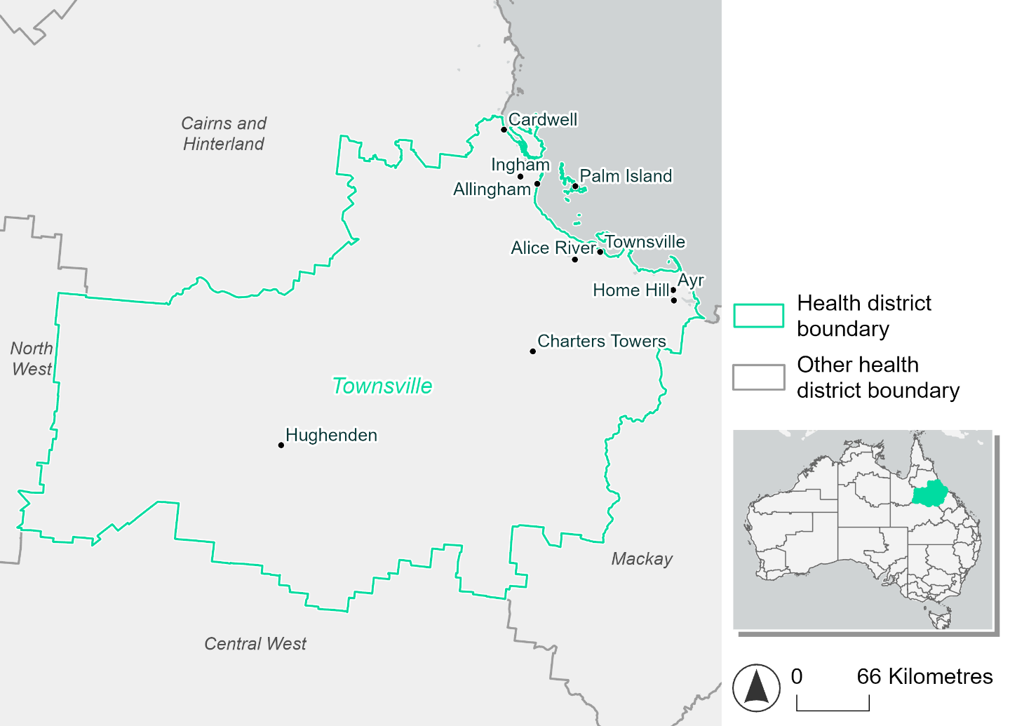
Figure 29. Map of Townsville health district.

How will climate change affect this health district?
Heat and humidity: There will be higher average temperatures, hotter and more frequent hot days, warmer night time temperatures and longer and more frequent heat waves.
Fire: Only 3-4% of this health district experiences very high fire hazard category and this will continue in the future.
Drought: The number of months experiencing drought will increase.
Rainfall and flood: There will be more flood events in both urban and rural areas.
Coastal inundation: The area flooded during tidal, and storm surge and tidal inundation, will increase.

Townsville health district demographic data
Demographic Data | Total
Number of households | 86,828
Persons 15 and older | 171,505
Total families | 61,452
Persons did not complete high school | 66,709
One parent families with dependents | 7,769 (12.6%)
Persons aged 65 and older | 39,050 (16%)
Persons aged 4 and younger | 14,201 (5.8%)
Aboriginal and Torres Strait Islander persons | 21,534 (8.8%)
Persons speaks language other than English | 18,238 (7.5%)
Persons working age (15-65) | 159,165 (65%)
Population Health Data | Total
Persons with core needs for assistance | 14,390 (5.9%)
Persons with arthritis | 22,197 (9.1%)
Persons with asthma | 19,477 (8%)
Persons with cancer | 7,457 (3%)
Persons with dementia | 1,945 (0.8%)
Persons with diabetes | 11,974 (4.9%)
Persons with heart disease | 10,629 (4.3%)
Persons with kidney disease | 2,461 (1%)
Persons with lung condition | 5,080 (2.1%)
Persons with mental health condition | 23,945 (9.8%)
Persons with stroke | 2,190 (0.9%)
Persons with any other condition | 19,512 (8%)
Persons no health condition | 137,759 (56.3%)
Socio-economic Data | Total
Persons providing unpaid care | 27,681 (11.3%)
Persons homeless | 1,219 (0.5%)
Household with lone person | 23,336 (26.9%)
Households with rent and mortgage stress | 29,341 (33.8%)
Households total equivalised income below $1000 (weekly) | 37,889 (43.6%)
Households with no motor vehicle | 4,772 (5.5%)
Persons unemployed | 9,803 (5.1%)

The sections that follow outline projected climate hazards for this district. Further information on this health district, including population demographics, is provided in the online dashboard.

Heat and humidity hazard
Key projections:
More heatwaves: Heatwave events are likely to last longer and the number of heatwave events per year will increase. By 2050, under a reasonable worst-case scenario, the number of heatwaves will more than triple. By 2085, under a reasonable worst-case scenario, the number of heatwaves per year will more than triple.
Hotter days and warmer nights: The day time and night time temperatures on hot days will increase.
More days above 35°C and 40°C: The number of days per year greater than 35°C and 40°C will increase under both middle of the road and reasonable worst-case scenarios.

 | Baseline | 2050 Scenarios |  | 2085 Scenarios
 |  | Middle of the road | Reasonable worst-case | Middle of the road | Reasonable worst-case
Average temperature (°C) | 23.9 | 25.3  [24.8, 25.9] | 25.5  [25, 26.1] | 26  [25.3, 26.8] | 26.9  [26.1, 27.7]
Maximum temperature on hot days (°C)^{(a)} | 33.7 | 35.1  [34.3, 35.8] | 35.3  [34.5, 35.9] | 35.8  [34.8, 36.5] | 36.7  [35.7, 37.5]
Minimum temperature on hot nights (°C)^{(b)} | 25.1 | 26.5  [26, 26.9] | 26.6  [26.2, 27.1] | 27.2  [26.5, 27.7] | 28.1  [27.3, 28.9]
Average apparent temperature on hot days (°C) (NOAA Heat Index)^{(c)} | 36.8 | 39.2  [38.3, 40.1] | 39.5  [38.5, 40.5] | 40.6  [39.4, 42] | 42.8  [40.9, 44.8]
Average heatwave duration in days^{(d)} | 6 | 8  [7, 10] | 9  [7, 11] | 12  [8, 16] | 19  [12, 27]
Number of heatwaves per year^{(d)} | 2 | 7  [5, 8] | 7  [5, 8] | 7  [7, 8] | 7  [6, 8]
Number of days per year  > 35°C | 10 | 23  [14, 34] | 27  [16, 37] | 37  [19, 56] | 63  [33, 90]
Number of days per year > 40°C | 0 | 1  [1, 2] | 2  [1, 2] | 2  [1, 3] | 4  [2, 5]
Table notes: The heat and humidity hazard uses climate projections from the CMIP6 Global Climate Models [1]. Daily projections of maximum and minimum near-surface temperature and mean relative humidity are used to calculate eight heat and humidity indicators. The primary indicator value reports the median from the nine climate models, with the range reported in square brackets.
Table footnotes: (a) Based on the 95th percentile of daily maximum air temperature. (b) Based on the 95th percentile of daily minimum air temperature, representing the coldest part of the night on very hot nights. (c) The National Oceanic and Atmospheric Administration (NOAA) Heat Index is a measure of how hot it feels when relative humidity is factored in alongside actual air temperature. It is calculated on days with a maximum temperature of 27°C and above. Interpretation of Heat Index values: 27°C to 32°C indicates caution, 33°C to 41°C indicates extreme caution, 42°C to 54°C indicates danger and over 54°C indicates extreme danger. See methodology document for further explanation of Heat Index categories. (d) A heatwave is defined as three or more consecutive days where both daytime and overnight temperatures (daily mean temperatures) are unusually high for the location, based on the Bureau of Meteorology’s Excess Heat Factor method. For this district, an unusually high daily mean temperature is approximately 29 °C or above.

Fire Hazard
Key projections:
- Most of district escapes very high hazard currently: Under baseline conditions, only 3.4% of the district experiences very high hazard during a 1-in-20-year fire weather event, or 4.3% during a 1-in-100-year event. A 1-in-20-year fire weather event sees 46.9% of the district exposed to moderate to high hazard, while the remaining 48.7% experiences low hazard. For a 1-in-100-year event, the area experiencing moderate to high hazard is notably higher at 57.3%, with 38.4% experiencing low fire hazard.
- Future fire hazard may reduce slightly depending on emissions: In a future climate by 2050, under the reasonable worst-case scenario the areas experiencing low and moderate to high fire hazard remain essentially the same. In the sustainability scenario, the low hazard area increases by 1.5-2.8 percentage points and the moderate to high hazard area reduces by 1.4-2.8 percentage points. By 2085, a 1-in-20-year fire weather event produces similar fire hazard conditions to baseline in the reasonable worst-case, but under the sustainability scenario the low hazard area will increase by an additional 2.2 percentage points from 2050 levels, and the moderate to high hazard area will decrease by a similar amount. The conditions for a 1-in-100-year fire weather event in 2085 are also notably (about 4%) better in a sustainability scenario in terms of low and moderate to high fire hazard. However, unlike the 1-in-20-year fire the reasonable worst-case for a 1-in-100-year fire is expected to be slightly better than under today’s conditions.

Baseline |  | 2050 Scenarios |  | 2085 Scenarios
 |  | Sustainability | Reasonable worst-case | Sustainability | Reasonable worst-case
Hazard for a ‘1-in-20 year’ fire weather event^{(a)}
Proportion (%) of district experiencing ‘Low’ fire hazard | 49.7%  (7,407,581)^{(b)} | 51.2%  [50.7%, 52.1%] | 49.7%  [45.2%, 51.5%] | 53.3%  [52.0%, 55.5%] | 49.6%  [39.0%, 54.0%]
Proportion (%) of district experiencing ‘Moderate to High’ fire hazard | 46.9%  (6,992,195)^{(b)} | 45.5%  [44.4%, 46.7%] | 47.1%  [45.4%, 51.4%] | 43.6%  [41.0%, 46.4%] | 47.3%  [43.3%, 57.7%]
Proportion (%) of district experiencing ‘Very High’ fire hazard | 3.4%  (505,637)^{(b)} | 3.3%  [3.1%, 3.4%] | 3.3%  [3.1%, 3.4%] | 3.1%  [2.8%, 3.5%] | 3.1%  [2.8%, 3.5%]
Hazard for a ‘1-in-100 year’ fire weather event^{(a)}
Proportion (%) of district experiencing ‘Low’ fire hazard | 38.4%  (5,727,659)^{(b)} | 41.2%  [40.3%, 42.7%] | 39.5%  [34.3%, 41.9%] | 45.1%  [43.0%, 48.7%] | 40.9%  [28.6%, 46.8%]
Proportion (%) of district experiencing ‘Moderate to High’ fire hazard | 57.3%  (8,535,849)^{(b)} | 54.6%  [52.7%, 56.2%] | 56.3%  [54.0%, 61.4%] | 50.9%  [46.2%, 54.8%] | 54.9%  [49.5%, 67.3%]
Proportion (%) of district experiencing ‘Very High’ fire hazard | 4.3%  (641,905)^{(b)} | 4.2%  [4.0%, 4.3%] | 4.3%  [4.0%, 4.6%] | 4.0%  [3.6%, 4.4%] | 4.2%  [3.6%, 5.0%]
Table notes: The Fire Hazard uses the National Bushfire Intelligence Capability (NBIC) Phase 2 fire line intensity modelling based on CMIP6 climate projections. Fire Hazard is assessed using the projected Fireline Intensity (FLI) for weather events with two different return intervals (i.e. a 1-in-20 year event and a 1-in-100 year event). FLI considers slope, vegetation and weather to produce a rate of heat output per unit length (kW/m) along a bushfire’s front. Fire hazard is categorized as a low for FLI<4000 kW/m, moderate to high for 4,000 kW/m ≤FLI<12,500kW/m, and very high for FLI≥27,501kW/m. This is broadly consistent with the literature [3]. The assessment considers climate change effects based on changes in fire weather and the associated hazard that is anticipated for a meteorological event of a given return interval. This approach is different to the one adopted for the Flood Hazard, where the event magnitude is given (fixed) and the likelihood of that event varies as a result of climate change. The primary indicator value reports the median from the nine climate models, with the range reported in square brackets.
Table footnotes: (a) The area subject to different categories of fire hazard is determined for a ‘1-in-20 year’ and ‘1-in-100 year’ fire weather event, in current and future climates. Values at year 2050 are interpolated using data from baseline (2025) and 2085, assuming linear change over time. (b) Values in round brackets are the area (ha) of the health district subject to a given fire hazard.

The figures below show the proportion of the health district experiencing different fire hazard categories across different time horizons and climate scenarios during a ‘1-in-20 year’ fire weather event (Figure 30) and a ‘1-in-100 year’ fire weather event (Figure 31).
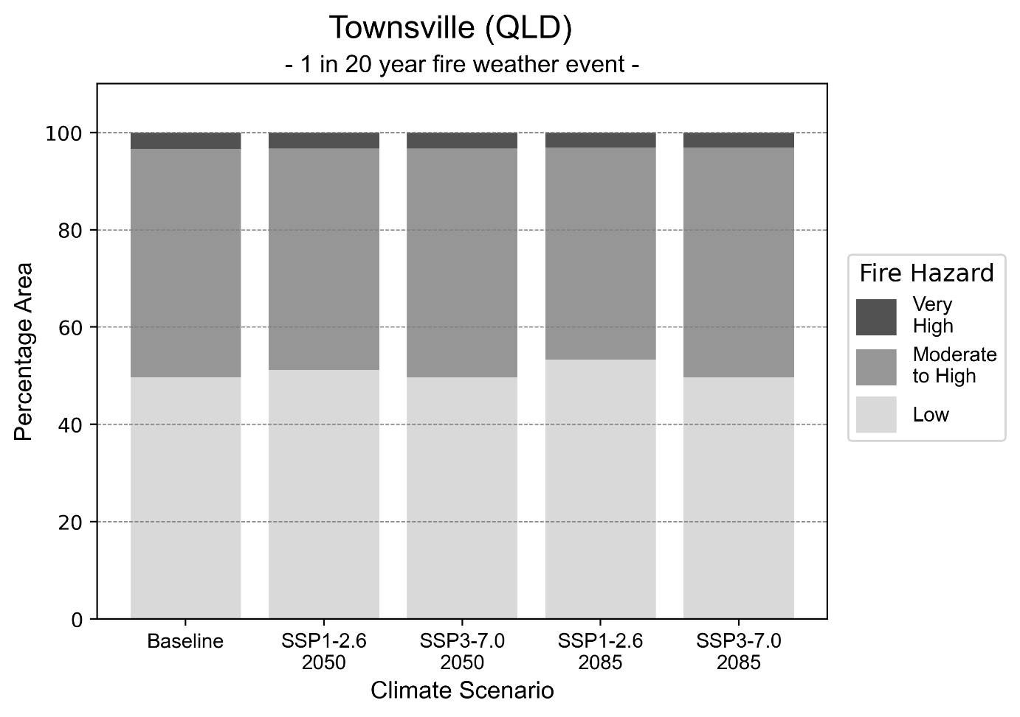
Figure 30: Stacked column chart showing the percentages of the Townsville health district's total geographic area experiencing each fire hazard level during a 1-in-20-year fire weather event.
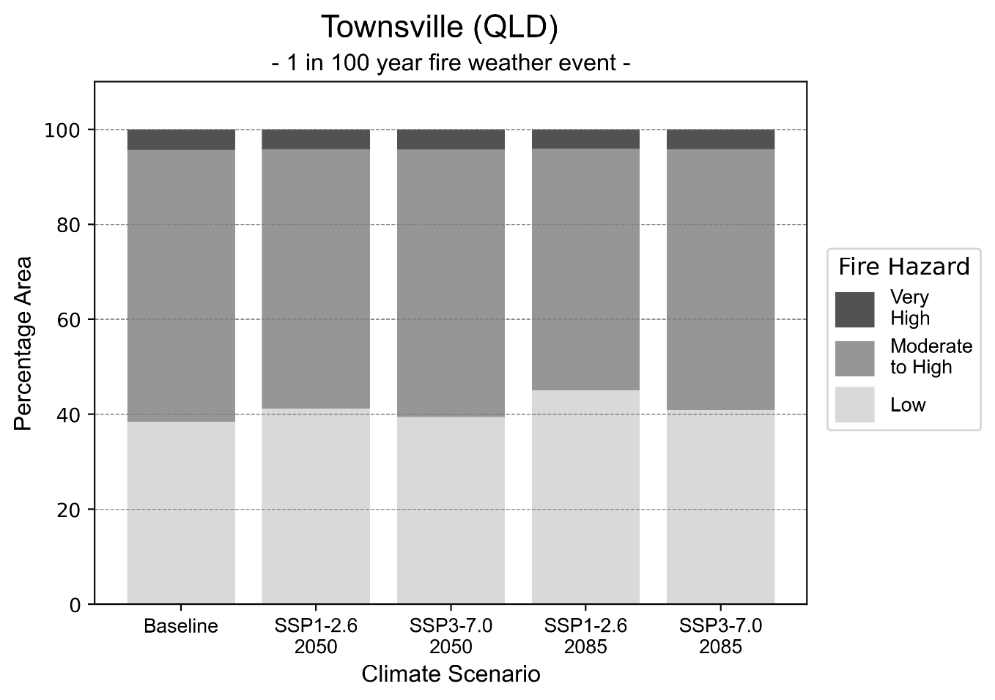
Figure 31: Stacked column chart showing the percentages of the Townsville health district's total geographic area experiencing each fire hazard level during a 1-in-100-year fire weather event.

Drought hazard
Key projections:
Drought occurrence: The occurrence of drought will increase across both middle of the road and reasonable worst-case scenarios for both time horizons, with the largest increase occurring under the middle of the road scenario by 2085.

 | Baseline | 2050 Scenarios |  | 2085 Scenarios
 |  | Middle of the road | Reasonable worst-case | Middle of the road | Reasonable worst-case
Number of months per year in drought^{(a)} | 1.7 | 2.5  [0.3, 5.3] | 2.5  [0.2. 5.6] | 2.7  [0.2, 5.4] | 2.5  [0.0. 5.5]
Table notes: The drought hazard indicator uses climate projections from the CMIP6 Global Climate Models [1]. The primary indicator value reports the median from the nine climate models, with the range reported in square brackets.
Table footnotes: (a) The number of months per year in drought is based on the Standardised Precipitation Index (SPI). SPI is a widely used index to characterise meteorological drought on a range of timescales. This indicator uses the timescale of 12 months which calculates the average months in a year within the moderate drought range. A moderate drought range is classified as SPI score of ≤ -1. SPI is calculated from accumulated rainfall over 12 months and the mean and standard deviation from historical rainfall records.

Storm hazard
Key projections:
More high and very-high-intensity storms: High and very-high-intensity storms will be more frequent in both middle of the road and reasonable worst-case scenarios across both time horizons, with the exception of the reasonable worst-case scenario where the frequency of very-high-intensity storms will be the same as baseline conditions by 2085.

Baseline |  | 2050 Scenarios |  | 2085 Scenarios
 |  | Middle of the road | Reasonable worst-case | Middle of the road | Reasonable worst-case
Number of low-intensity storms (40-62 km/hr) per year | 77.4 | 76.3  [67.1, 83.9] | 76.3  [67.1, 83.9] | 75.6  [66.5, 83.1] | 79.2  [69.7, 87.1]
Number of medium-intensity storms (63-87 km/hr) per year | 66.9 | 62.3  [54.8, 68.5] | 66.2  [58.3, 72.8] | 62.4  [54.9, 68.6] | 65.0  [57.2, 71.5]
Number of high-intensity storms (88-117 km/hr) per year | 4.4 | 4.8  [4.3, 5.3] | 4.9  [4.3, 5.4] | 4.8  [4.3, 5.3] | 5.1  [4.5, 5.6]
Number of very-high-intensity storm (> 117 km/hr) per year | 0.4 | 0.5  [0.4, 0.5] | 0.5  [0.4, 0.5] | 0.5  [0.4, 0.5] | 0.4  [0.4, 0.4]
Table notes: The storm hazard uses climate projections from the CMIP6 Global Climate Models [1]. Daily maximum surface wind speed is used to calculate the number of annual storms across four storm intensity categories (low, medium, high and very high). The primary indicator value reports the median from the nine climate models, with the range reported in square brackets.

Rainfall and flood hazard
Key projections:
- Ten extreme rainfall days per year: The number of extreme rainfall days will remain consistent across both middle of the road and reasonable worst-case scenarios, and both time horizons, with an average of approximately ten extreme rainfall days per year.
- Increased flood frequency: The frequency of flood events will increase in urban and rural environments. The largest increase in flood frequency occurs in the reasonable worst-case scenario, where the frequency of a ‘1-in-100 year’ flood will become five times more likely by 2050 and become 15 times more likely by 2085 in urban environments.

 | Baseline | 2050 Scenarios |  | 2085 Scenarios
 |  | Middle of the road | Reasonable worst-case | Middle of the road | Reasonable worst-case
Rainfall hazard^{(a)}
Average number of extreme rainfall days per year (> 10 mm/day)^{(a)} | 10.8 | 10.4  [7.9,14.6] | 10.4  [7.3,14.4] | 9.9  [7.5,13.6] | 10.5  [7.0,16.2]
Urban flood risk (flooding caused by a 1-hour rainfall event)^{(b)}
Frequency of a ‘1-in-1 year’ flood (rainfall depth of 40 mm)^{(c)} |  | 1.7 events in 1 year | 1.8 events in 1 year | 2.1 events in 1 year | 2.6 events in 1 year
Frequency of a ‘1-in-10 year’ flood (rainfall depth of 74 mm)^{(c)} |  | 2.8 events in 10 years | 3.0 events in 10 years | 4.1 events in 10 years | 6.2 events in 10 years
Frequency of a ‘1-in-100 year’ flood (rainfall depth of 109 mm)^{(c)} |  | 4.5 events in 100 years | 4.9 events in 100 years | 8.0 events in 100 years | 15 events in 100 years
Rural flood risk (flooding caused by a 24-hour rainfall event)^{(b)}
Frequency of a ‘1-in-1 year’ flood (rainfall depth of 123 mm)^{(c)} |  | 1.1 events in 1 year | 1.1 events in 1 year | 1.2 events in 1 year | 1.2 events in 1 year
Frequency of a ‘1-in-10 year’ flood (rainfall depth of 274 mm)^{(c)} |  | 1.6 events in 10 years | 1.6 events in 10 years | 1.7 events in 10 years | 2.0 events in 10 years
Frequency of a ‘1-in-100 year’ flood (rainfall depth of 449 mm)^{(c)} |  | 2.0 events in 100 years | 2.0 events in 100 years | 2.4 events in 100 years | 3.0 events in 100 years
Table notes: The rainfall hazard indicator uses climate projections from the CMIP6 Global Climate Models [1]. The primary indicator value reports the median from the nine climate models, with the range reported in square brackets. The flood hazard indicators use climate change considerations from the Australian Rainfall and Runoff guideline to estimate the climate projections [2].
Table footnotes: (a) Extreme rainfall is defined as rainfall above the 95th percentile of historical average daily rainfall in this health district in the period 1985-2014. The value in mm/day quoted in the indicator name is the 95th percentile of historic average daily rainfall for this health district. (b) See Methodology document for reasons for focusing on a 1-hour flood for urban areas and a 24-hour flood for rural areas. (c) The rainfall depths in mm quoted in the indicator names in this table report 1 in 1, 10 and 100 year depths for this health district.

Coastal inundation hazard
Key projections:
Greater area inundated: There will be an increase in the area affected by tidal inundation (i.e. area submerged during high tide) and storm surge and tidal inundation (i.e. the area submerged during a storm surge and high tide) across both middle of the road and reasonable worst-case scenarios. In the reasonable worst-case scenario, by 2085 the area inundated during a tidal inundation event will increase by over 30,000 ha.

 | Baseline | 2050 Scenarios |  | 2085 Scenarios^{(a)}
 |  | Middle of the road | Reasonable worst-case | Middle of the road | Reasonable worst-case
Tidal inundation (ha inundated)^{(b)} | 101,970.1 | 113,674.4  (+11,704.4) | 114,206.6  (+12,236.5) | 127,814.1  (+25,844.1) | 132,408.2  (+30,438.1)
Storm surge + tidal inundation – ‘1-in-100 year’ event (ha inundated)^{(c)} | 128,853.7 | 135,843.1  (+6,989.4) | 136,198.7  (+7,345.0) | 146,777.9  (+17,924.3) | 150,913.6  (+22,059.9)
Storm surge + tidal inundation – ‘1-in-1000 year’ event (ha inundated)^{(c)} | 146,359.2 | 152,698.2  (+6,339.0) | 153,017.8  (+6,658.6) | 165,507.2  (+19,148.0) | 169,322.0  (+22,962.7)
Table notes: The coastal inundation hazard provides an indication of flooding in coastal areas that can be attributed to sea level rise and storm inundation. The coastal inundation hazard is only reported for health districts adjoining the coastline. This table includes the projected inundation levels as well as the change from baseline conditions (in brackets).
Table footnotes: (a) For the 2085 Scenarios planning horizon, 2100 was adopted as it provides a conservative representation of the end of this period. This horizon aligns with many State planning regulations requiring consideration of sea level rise and storm tide to 2100, making the 2100 scenario particularly valuable for planning new health facilities in coastal areas. (b) The tidal inundation indicator reports the number of hectares inundated during high tide. The baseline value reports existing inundation patterns, while the 2050 and 2085 values report high tide inundation taking account of projected sea level rise due to climate change. (c) The storm surge + tidal inundation indicators report the combined effect, in hectares inundated, of high tide, sea level rise (for the 2050 and 2085 projections), and storm surge (for 1-in-100 year and 1-in-1000 year events).

West Moreton health district

Health district overview
Surface area: 9,506 square kilometres
Local health services: The West Moreton Hospital and Health Service region contain six hospitals and five health centres:
- Ipswich Hospital  - Boonah Hospital  - Esk Hospital  - Gatton Hospital  - Laidley Hospital  - Ripley Satellite Hospital | Gailes community care unit  Ipswich Health Plaza  Goodna Community Centre  Ipswich Community Dental Clinic  The Park – centre for mental health.

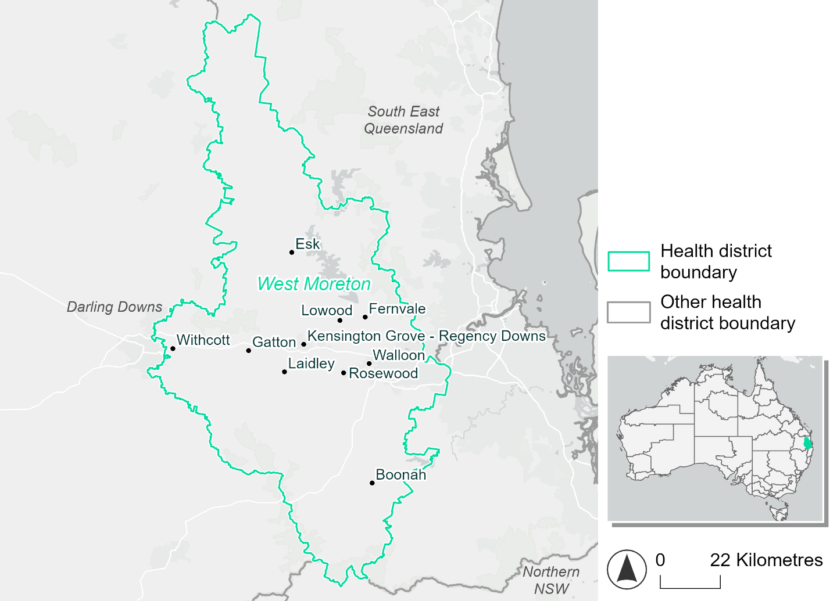
Figure 32. Map of West Moreton health district

How will climate change affect this health district?
Heat and humidity: There will be higher average temperatures, hotter and more frequent hot days, warmer night time temperatures and longer and more frequent heat waves.
Fire: Nearly 40% of this health district experiences very high fire hazard category and this will continue in the future.
Drought: The number of months experiencing drought will increase.
Rainfall and flood: There will be more flood events in both urban and rural areas.
Coastal inundation: While this district is not immediately coastal, some rivers are affected by tides. The area flooded during tidal, and storm surge and tidal inundation, will increase.

West Moreton health district demographic data
Demographic Data | Total
Number of households | 106,276
Persons 15 and older | 223,571
Total families | 82,311
Persons did not complete high school | 88,668
One parent families with dependents | 11,319 (13.8%)
Persons aged 65 and older | 43,233 (13.3%)
Persons aged 4 and younger | 23,034 (7.1%)
Aboriginal and Torres Strait Islander persons | 16,070 (4.9%)
Persons speaks language other than English | 36,576 (11.2%)
Persons working age (15-65) | 209,914 (64.5%)
Population Health Data | Total
Persons with core needs for assistance | 21,012 (6.5%)
Persons with arthritis | 30,423 (9.3%)
Persons with asthma | 34,171 (10.5%)
Persons with cancer | 8,939 (2.7%)
Persons with dementia | 1,509 (0.5%)
Persons with diabetes | 16,929 (5.2%)
Persons with heart disease | 12,521 (3.8%)
Persons with kidney disease | 2,991 (0.9%)
Persons with lung condition | 7,242 (2.2%)
Persons with mental health condition | 38,032 (11.7%)
Persons with stroke | 2,990 (0.9%)
Persons with any other condition | 29,680 (9.1%)
Persons no health condition | 182,150 (56%)
Socio-economic Data | Total
Persons providing unpaid care | 40,272 (12.4%)
Persons homeless | 1,234 (0.4%)
Household with lone person | 23,142 (21.8%)
Households with rent and mortgage stress | 44,631 (42%)
Households total equivalised income below $1000 (weekly) | 51,575 (48.5%)
Households with no motor vehicle | 4,593 (4.3%)
Persons unemployed | 15,354 (6.4%)

The sections that follow outline projected climate hazards for this district. Further information on this health district, including population demographics, is provided in the online dashboard.

Heat and humidity hazard
Key projections:
More heatwaves: Heatwave events are likely to last longer and the number of heatwave events per year will increase. By 2050, under a reasonable worst-case scenario, the number of heatwaves will more than double. By 2085, under a reasonable worst-case scenario, the number of heatwaves per year will quadruple.
Hotter days and warmer nights: The day time and night time temperatures on hot days will increase.
More days above 35°C and 40°C: The number of days per year greater than 35°C and 40°C will increase under both middle of the road and reasonable worst-case scenarios.

 | Baseline | 2050 Scenarios |  | 2085 Scenarios
 |  | Middle of the road | Reasonable worst-case | Middle of the road | Reasonable worst-case
Average temperature (°C) | 20.1 | 21.6  [21.1, 22.1] | 21.8  [21.2, 22.4] | 22.4  [21.5, 23.3] | 23.3  [22.4, 24.4]
Maximum temperature on hot days (°C)^{(a)} | 34 | 35.5  [34.8, 36.4] | 35.7  [34.5, 37.3] | 36.3  [35.3, 37.7] | 37.3  [36, 38.8]
Minimum temperature on hot nights (°C)^{(b)} | 21.8 | 23.2  [22.4, 23.8] | 23.4  [22.8, 23.9] | 24  [22.9, 24.8] | 24.9  [23.9, 25.9]
Average apparent temperature on hot days (°C) (NOAA Heat Index)^{(c)} | 35.5 | 37.4  [36.9, 38.1] | 37.6  [36.9, 38.5] | 38.7  [37.6, 39.8] | 40.1  [39, 41.8]
Average heatwave duration in days^{(d)} | 5 | 6  [6, 7] | 6  [5, 8] | 7  [6, 9] | 9  [7, 13]
Number of heatwaves per year^{(d)} | 2 | 5  [4, 6] | 5  [4, 7] | 7  [5, 9] | 8  [7, 9]
Number of days per year  > 35°C | 12 | 23  [17, 31] | 26  [15, 48] | 33  [21, 49] | 47  [28, 68]
Number of days per year > 40°C | 1 | 2  [1, 4] | 3  [1, 6] | 4  [2, 7] | 6  [2, 11]
Table notes: The heat and humidity hazard uses climate projections from the CMIP6 Global Climate Models [1]. Daily projections of maximum and minimum near-surface temperature and mean relative humidity are used to calculate eight heat and humidity indicators. The primary indicator value reports the median from the nine climate models, with the range reported in square brackets.
Table footnotes: (a) Based on the 95th percentile of daily maximum air temperature. (b) Based on the 95th percentile of daily minimum air temperature, representing the coldest part of the night on very hot nights. (c) The National Oceanic and Atmospheric Administration (NOAA) Heat Index is a measure of how hot it feels when relative humidity is factored in alongside actual air temperature. It is calculated on days with a maximum temperature of 27°C and above. Interpretation of Heat Index values: 27°C to 32°C indicates caution, 33°C to 41°C indicates extreme caution, 42°C to 54°C indicates danger and over 54°C indicates extreme danger. See methodology document for further explanation of Heat Index categories. (d) A heatwave is defined as three or more consecutive days where both daytime and overnight temperatures (daily mean temperatures) are unusually high for the location, based on the Bureau of Meteorology’s Excess Heat Factor method. For this district, an unusually high daily mean temperature is approximately 27.4°C or above.

Fire Hazard
Key projections:
- Very little area experiences low fire hazard: Under baseline conditions 52-54% of the district area experiences moderate to high fire hazard, 38% experiences very high fire hazard, and just 6-8% experiences low fire hazard.
- Current fire hazard conditions to persist: In a future climate across both 2050 and 2085 scenarios, the percentages of the district area experiencing the different hazard levels remain within 1.5 percentage points of their baseline levels.

 | Baseline | 2050 Scenarios |  | 2085 Scenarios
 |  | Sustainability | Reasonable worst-case | Sustainability | Reasonable worst-case
Hazard for a ‘1-in-20 year’ fire weather event^{(a)}
Proportion (%) of district experiencing ‘Low’ fire hazard | 8.8%  (83,230)^{(b)} | 8.3%  [8.0%, 8.8%] | 8.1%  [7.5%, 8.5%] | 7.7%  [6.9%, 8.8%] | 7.3%  [5.7%, 8.1%]
Proportion (%) of district experiencing ‘Moderate to High’ fire hazard | 52.8%  (501,708)^{(b)} | 53.2%  [52.7%, 53.7%] | 53.4%  [52.2%, 55.0%] | 53.8%  [52.6%, 55.0%] | 54.3%  [51.3%, 58.0%]
Proportion (%) of district experiencing ‘Very High’ fire hazard | 38.5%  (365,669)^{(b)} | 38.4%  [38.4%, 38.5%] | 38.4%  [38.3%, 38.6%] | 38.4%  [38.3%, 38.6%] | 38.3%  [38.0%, 38.8%]
Hazard for a ‘1-in-100 year’ fire weather event^{(a)}
Proportion (%) of district experiencing ‘Low’ fire hazard | 6.8%  (64,460)^{(b)} | 6.5%  [6.0%, 6.9%] | 6.4%  [5.7%, 6.7%] | 6.0%  [4.9%, 7.0%] | 5.8%  [4.3%, 6.5%]
Proportion (%) of district experiencing ‘Moderate to High’ fire hazard | 54.4%  (516,713)^{(b)} | 54.7%  [52.2%, 57.2%] | 54.8%  [51.6%, 58.2%] | 55.1%  [49.2%, 61.2%] | 55.4%  [47.8%, 63.6%]
Proportion (%) of district experiencing ‘Very High’ fire hazard | 38.9%  (369,434)^{(b)} | 38.9%  [38.8%, 38.9%] | 38.8%  [38.8%, 39.0%] | 38.9%  [38.7%, 39.0%] | 38.8%  [38.7%, 39.3%]
Table notes: The Fire Hazard uses the National Bushfire Intelligence Capability (NBIC) Phase 2 fire line intensity modelling based on CMIP6 climate projections. Fire Hazard is assessed using the projected Fireline Intensity (FLI) for weather events with two different return intervals (i.e. a 1-in-20 year event and a 1-in-100 year event). FLI considers slope, vegetation and weather to produce a rate of heat output per unit length (kW/m) along a bushfire’s front. Fire hazard is categorized as a low for FLI<4000 kW/m, moderate to high for 4,000 kW/m ≤FLI<12,500kW/m, and very high for FLI≥27,501kW/m. This is broadly consistent with the literature [3]. The assessment considers climate change effects based on changes in fire weather and the associated hazard that is anticipated for a meteorological event of a given return interval. This approach is different to the one adopted for the Flood Hazard, where the event magnitude is given (fixed) and the likelihood of that event varies as a result of climate change. The primary indicator value reports the median from the nine climate models, with the range reported in square brackets.
Table footnotes: (a) The area subject to different categories of fire hazard is determined for a ‘1-in-20 year’ and ‘1-in-100 year’ fire weather event, in current and future climates. Values at year 2050 are interpolated using data from baseline (2025) and 2085, assuming linear change over time. (b) Values in round brackets are the area (ha) of the health district subject to a given fire hazard.

The figures below show the proportion of the health district experiencing different fire hazard categories across different time horizons and climate scenarios during a ‘1-in-20 year’ fire weather event (Figure 33) and a ‘1-in-100 year’ fire weather event (Figure 34).
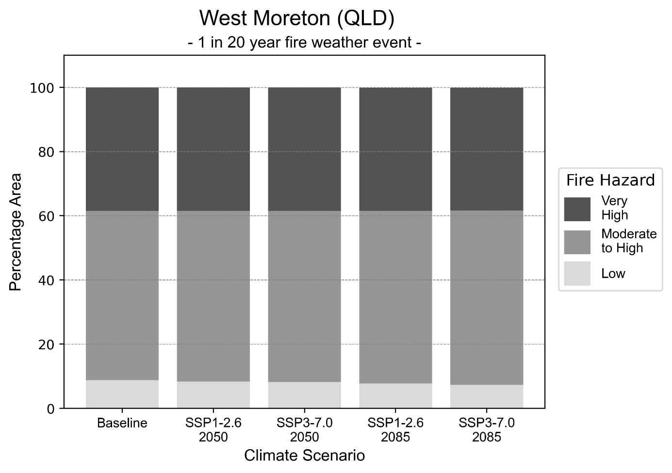
Figure 33: Stacked column chart showing the percentages of the West Moreton health district's total geographic area experiencing each fire hazard level during a 1-in-20-year fire weather event.
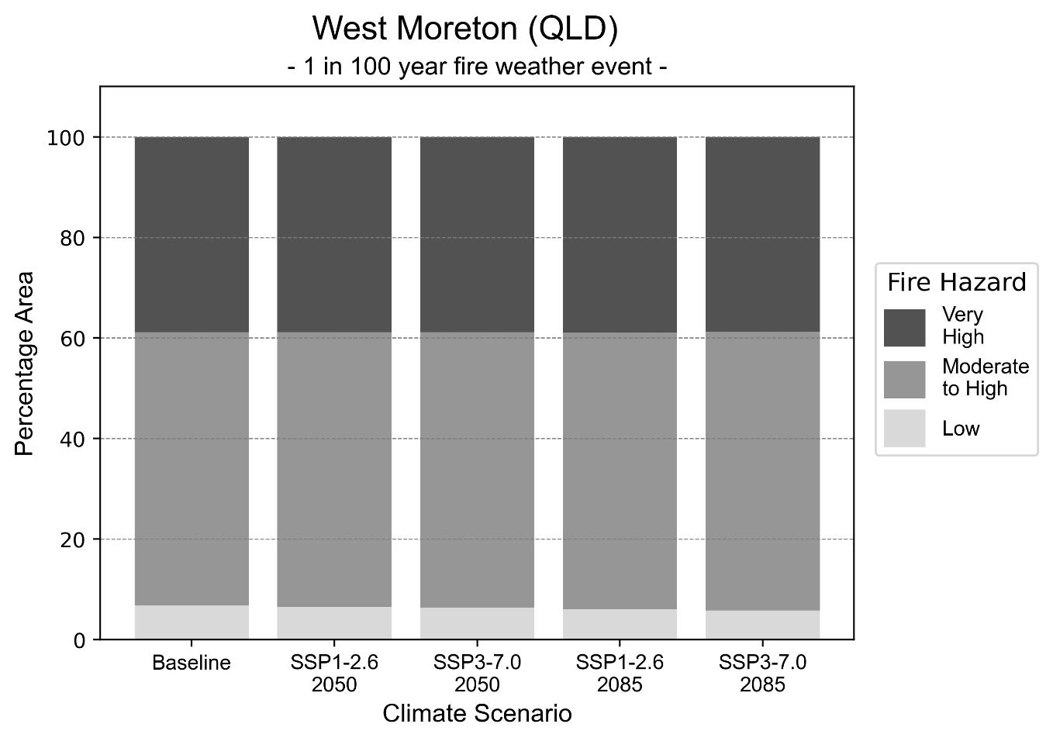
Figure 34: Stacked column chart showing the percentages of the West Moreton health district's total geographic area experiencing each fire hazard level during a 1-in-100-year fire weather event.

Drought hazard
Key projections:
Drought occurrence: The occurrence of drought will increase across both middle of the road and reasonable worst-case scenarios for both time horizons, with the largest increase occurring under the reasonable worst-case scenario by 2050.

 | Baseline | 2050 Scenarios |  | 2085 Scenarios
 |  | Middle of the road | Reasonable worst-case | Middle of the road | Reasonable worst-case
Number of months per year in drought^{(a)} | 1.8 | 2.4  [0.6, 4.8] | 2.9  [0.5, 8.2] | 2.7  [0.7, 5.2] | 2.6  [0.3, 6.1]
Table notes: The drought hazard indicator uses climate projections from the CMIP6 Global Climate Models [1]. The primary indicator value reports the median from the nine climate models, with the range reported in square brackets.
Table footnotes: (a) The number of months per year in drought is based on the Standardised Precipitation Index (SPI). SPI is a widely used index to characterise meteorological drought on a range of timescales. This indicator uses the timescale of 12 months which calculates the average months in a year within the moderate drought range. A moderate drought range is classified as SPI score of ≤ -1. SPI is calculated from accumulated rainfall over 12 months and the mean and standard deviation from historical rainfall records.

Storm hazard
Key projections:
Fewer high-intensity storms: High high-intensity storms will be less frequent in both middle of the road and reasonable worst-case scenarios across both time horizons, with the exception of the reasonable worst-case scenario where the frequency of high-intensity storms will be the same as baseline conditions by 2085.

Baseline |  | 2050 Scenarios |  | 2085 Scenarios
 |  | Middle of the road | Reasonable worst-case | Middle of the road | Reasonable worst-case
Number of low-intensity storms (40-62 km/hr) per year | 82.5 | 74.5  [65.6, 82.0] | 71.8  [63.2, 79.0] | 64.7  [56.9, 71.1] | 70.0  [61.6, 77.0]
Number of medium-intensity storms (63-87 km/hr) per year | 23.0 | 19.0  [16.7, 20.9] | 18.1  [15.9, 19.9] | 17.0  [15.0, 18.7] | 18.3  [16.1, 20.1]
Number of high-intensity storms (88-117 km/hr) per year | 0.9 | 0.7  [0.6, 0.7] | 0.5  [0.5, 0.6] | 0.7  [0.6, 0.8] | 0.9  [0.8, 1.0]
Number of very-high-intensity storms (> 117 km/hr) per year | 0.0 | 0.0  [0.0, 0.0] | 0.0  [0.0, 0.0] | 0.0  [0.0, 0.0] | 0.0  [0.0, 0.0]
Table notes: The storm hazard uses climate projections from the CMIP6 Global Climate Models [1]. Daily maximum surface wind speed is used to calculate the number of annual storms across four storm intensity categories (low, medium, high and very high). The primary indicator value reports the median from the nine climate models, with the range reported in square brackets.

Rainfall and flood hazard
Key projections:
- Fewer extreme rainfall days per year: The number of extreme rainfall days will slightly decrease across both middle of the road and reasonable worst-case scenarios, and both time horizons, with an average of approximately nine extreme rainfall days per year.
- Increased flood frequency: The frequency of flood events will increase in urban and rural environments. The largest increase in flood frequency occurs in the reasonable worst-case scenario, where the frequency of a ‘1-in-100 year’ flood will quadruple by 2050 and become 11 times more likely by 2085 in urban environments.

 | Baseline | 2050 Scenarios |  | 2085 Scenarios
 |  | Middle of the road | Reasonable worst-case | Middle of the road | Reasonable worst-case
Rainfall hazard^{(a)}
Average number of extreme rainfall days per year (> 13 mm/day)^{(a)} | 9.7 | 9.4  [7.9,11.4] | 9  [6.2,11.3] | 9.1  [7.2,10.9] | 9.1  [6.9,11.8]
Urban flood risk (flooding caused by a 1-hour rainfall event)^{(b)}
Frequency of a ‘1-in-1 year’ flood (rainfall depth of 28 mm)^{(c)} |  | 1.8 events in 1 year | 1.9 events in 1 year | 2.2 events in 1 year | 2.9 events in 1 year
Frequency of a ‘1-in-10 year’ flood (rainfall depth of 53 mm)^{(c)} |  | 2.6 events in 10 years | 2.7 events in 10 years | 3.7 events in 10 years | 5.7 events in 10 years
Frequency of a ‘1-in-100 year’ flood (rainfall depth of 84 mm)^{(c)} |  | 3.7 events in 100 years | 4.0 events in 100 years | 6.1 events in 100 years | 11 events in 100 years
Rural flood risk (flooding caused by a 24-hour rainfall event)^{(b)}
Frequency of a ‘1-in-1 year’ flood (rainfall depth of 71 mm)^{(c)} |  | 1.3 events in 1 year | 1.3 events in 1 year | 1.3 events in 1 year | 1.3 events in 1 year
Frequency of a ‘1-in-10 year’ flood (rainfall depth of 133 mm)^{(c)} |  | 1.7 events in 10 years | 1.7 events in 10 years | 1.9 events in 10 years | 2.1 events in 10 years
Frequency of a ‘1-in-100 year’ flood (rainfall depth of 214 mm)^{(c)} |  | 1.9 events in 100 years | 1.9 events in 100 years | 2.2 events in 100 years | 2.7 events in 100 years
Table notes: The rainfall hazard indicator uses climate projections from the CMIP6 Global Climate Models [1]. The primary indicator value reports the median from the nine climate models, with the range reported in square brackets. The flood hazard indicators use climate change considerations from the Australian Rainfall and Runoff guideline to estimate the climate projections [2].
Table footnotes: (a) Extreme rainfall is defined as rainfall above the 95th percentile of historical average daily rainfall in this health district in the period 1985-2014. The value in mm/day quoted in the indicator name is the 95th percentile of historic average daily rainfall for this health district. (b) See Methodology document for reasons for focusing on a 1-hour flood for urban areas and a 24-hour flood for rural areas. (c) The rainfall depths in mm quoted in the indicator names in this table report 1 in 1, 10 and 100 year depths for this health district.

Coastal inundation hazard
While the West Moreton health district does not have any coastline, the lower Bremer River and upper Brisbane River near Ipswich are affected by the tide which means that the coastal inundation hazard will need to be considered for this health district.

Key projections:
Greater area inundated: There will be an increase in the area affected by tidal inundation (i.e. area submerged during high tide) and storm surge and tidal inundation (i.e. the area submerged during a storm surge and high tide) across both middle of the road and reasonable worst-case scenarios. In the reasonable worst-case scenario, by 2085 the area inundated during a 1-in-1000 year storm surge and tidal inundation event will increase by 47 ha.

 | Baseline | 2050 Scenarios |  | 2085 Scenarios^{(a)}
 |  | Middle of the road | Reasonable worst-case | Middle of the road | Reasonable worst-case
Tidal inundation (ha inundated)^{(b)} | 367.4 | 381.1  (+13.7) | 381.9  (+14.5) | 402.5  (+35.0) | 411.5  (+44.1)
Storm surge + tidal inundation – ‘1-in-100 year’ event (ha inundated)^{(c)} | 384.1 | 396.3  (+12.2) | 397.1  (+13.0) | 417.6  (+33.4) | 426.5  (+42.3)
Storm surge + tidal inundation – ‘1-in-1000 year’ event (ha inundated)^{(c)} | 389.2 | 396.3  (+12.2) | 402.0  (+12.8) | 428.4  (+39.2) | 436.6  (+47.4)
Table notes: The coastal inundation hazard provides an indication of flooding in coastal areas that can be attributed to sea level rise and storm inundation. The coastal inundation hazard is only reported for health districts adjoining the coastline. This table includes the projected inundation levels as well as the change from baseline conditions (in brackets).
Table footnotes: (a) For the 2085 Scenarios planning horizon, 2100 was adopted as it provides a conservative representation of the end of this period. This horizon aligns with many State planning regulations requiring consideration of sea level rise and storm tide to 2100, making the 2100 scenario particularly valuable for planning new health facilities in coastal areas. (b) The tidal inundation indicator reports the number of hectares inundated during high tide. The baseline value reports existing inundation patterns, while the 2050 and 2085 values report high tide inundation taking account of projected sea level rise due to climate change. (c) The storm surge + tidal inundation indicators report the combined effect, in hectares inundated, of high tide, sea level rise (for the 2050 and 2085 projections), and storm surge (for 1-in-100 year and 1-in-1000 year events).

Wide Bay health district

Health district Overview
Surface area: 36,973 square kilometres
Estimated population: 225,000
Local health services: The Wide Bay Hospital and Health Service region contains Bundaberg Hospital, Hervey Bay Hospital, Maryborough Hospital, Gayndah Hospital, Gin Gin Hospital, Monto Hospital, Childers Multipurpose Health Service, Biggenden Multipurpose Health Service, Eidsvold Multipurpose Health Service, Mundubbera Multipurpose Health Service and Mt Perry Health Centre.

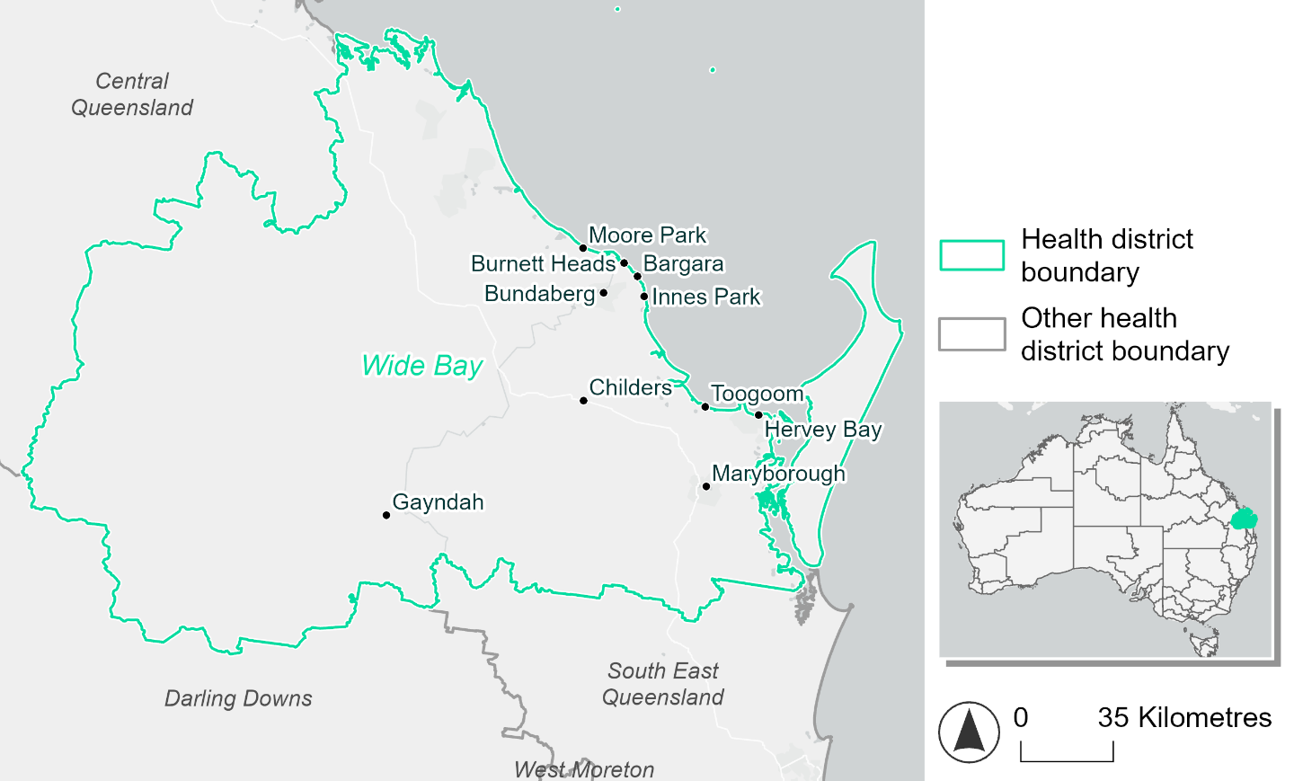
Figure 35. Map of Wide Bay health district.

How will climate change affect this health district?
Heat and humidity: There will be higher average temperatures, hotter and more frequent hot days, warmer night time temperatures and longer and more frequent heat waves.
Fire: 18-28% of this health district experiences very high fire hazard category and this will continue in the future.
Drought: The number of months experiencing drought will increase.
Rainfall and flood: There will be more flood events in both urban and rural areas.
Coastal inundation: The area flooded during tidal, and storm surge and tidal inundation, will increase.

Wide Bay health district demographic data
Demographic Data | Total
Number of households | 88,923
Persons 15 and older | 151,091
Total families | 62,632
Persons did not complete high school | 79,987
One parent families with dependents | 6,878 (11%)
Persons aged 65 and older | 65,580 (28%)
Persons aged 4 and younger | 10,321 (4.4%)
Aboriginal and Torres Strait Islander persons | 11,588 (4.9%)
Persons speaks language other than English | 10,183 (4.3%)
Persons working age (15-65) | 132,119 (56.3%)
Population Health Data | Total
Persons with core needs for assistance | 22,773 (9.7%)
Persons with arthritis | 36,217 (15.4%)
Persons with asthma | 23,130 (9.9%)
Persons with cancer | 10,682 (4.6%)
Persons with dementia | 2,568 (1.1%)
Persons with diabetes | 15,835 (6.7%)
Persons with heart disease | 15,992 (6.8%)
Persons with kidney disease | 3,450 (1.5%)
Persons with lung condition | 10,079 (4.3%)
Persons with mental health condition | 28,145 (12%)
Persons with stroke | 3,895 (1.7%)
Persons with any other condition | 23,852 (10.2%)
Persons no health condition | 112,683 (48%)
Socio-economic Data | Total
Persons providing unpaid care | 32,952 (14%)
Persons homeless | 1,366 (0.6%)
Household with lone person | 24,740 (27.8%)
Households with rent and mortgage stress | 43,129 (48.5%)
Households total equivalised income below $1000 (weekly) | 55,238 (62.1%)
Households with no motor vehicle | 4,937 (5.6%)
Persons unemployed | 14,719 (7.7%)

The sections that follow outline projected climate hazards for this district. Further information on this health district, including population demographics, is provided in the online dashboard.

Heat and humidity hazard
Key projections:
More heatwaves: Heatwave events are likely to last longer and the number of heatwave events per year will increase. By 2050, under a reasonable worst-case scenario, the number of heatwaves will triple. By 2085, under a reasonable worst-case scenario, the number of heatwaves per year will more than triple.
Hotter days and warmer nights: The day time and night time temperatures on hot days will increase.
More days above 35°C and 40°C: The number of days per year greater than 35°C and 40°C will increase under both middle of the road and reasonable worst-case scenarios.

 | Baseline | 2050 Scenarios |  | 2085 Scenarios
 |  | Middle of the road | Reasonable worst-case | Middle of the road | Reasonable worst-case
Average temperature (°C) | 21.5 | 22.8  [22.3, 23.3] | 23  [22.4, 23.7] | 23.5  [22.7, 24.4] | 24.4  [23.5, 25.4]
Maximum temperature on hot days (°C)^{(a)} | 32.3 | 33.7  [33.1, 34.5] | 33.9  [33.2, 34.7] | 34.5  [33.7, 35.6] | 35.3  [34.5, 36.7]
Minimum temperature on hot nights (°C)^{(b)} | 23.3 | 24.6  [23.9, 25] | 24.8  [24.3, 25.3] | 25.3  [24.4, 26] | 26.2  [25.3, 27]
Average apparent temperature on hot days (°C) (NOAA Heat Index)^{(c)} | 34.7 | 36.6  [35.7, 37.5] | 36.8  [36, 37.7] | 37.9  [36.7, 39.1] | 39.2  [38.1, 40.7]
Average heatwave duration in days^{(d)} | 6 | 8  [7, 10] | 8  [7, 10] | 11  [8, 15] | 15  [11, 22]
Number of heatwaves per year^{(d)} | 2 | 5  [4, 6] | 6  [5, 7] | 7  [6, 7] | 7  [7, 8]
Number of days per year  > 35°C | 4 | 10  [6, 15] | 11  [6, 17] | 15  [10, 27] | 26  [15, 46]
Number of days per year > 40°C | 0 | 1  [0, 1] | 1  [0, 1] | 1  [0, 2] | 1  [0, 3]
Table notes: The heat and humidity hazard uses climate projections from the CMIP6 Global Climate Models [1]. Daily projections of maximum and minimum near-surface temperature and mean relative humidity are used to calculate eight heat and humidity indicators. The primary indicator value reports the median from the nine climate models, with the range reported in square brackets.
Table footnotes: (a) Based on the 95th percentile of daily maximum air temperature. (b) Based on the 95th percentile of daily minimum air temperature, representing the coldest part of the night on very hot nights. (c) The National Oceanic and Atmospheric Administration (NOAA) Heat Index is a measure of how hot it feels when relative humidity is factored in alongside actual air temperature. It is calculated on days with a maximum temperature of 27°C and above. Interpretation of Heat Index values: 27°C to 32°C indicates caution, 33°C to 41°C indicates extreme caution, 42°C to 54°C indicates danger and over 54°C indicates extreme danger. See methodology document for further explanation of Heat Index categories. (d) A heatwave is defined as three or more consecutive days where both daytime and overnight temperatures (daily mean temperatures) are unusually high for the location, based on the Bureau of Meteorology’s Excess Heat Factor method. For this district, an unusually high daily mean temperature is approximately 27.4°C as above.

Fire Hazard
Key projections:
- Majority of district area experiences moderate to high hazard: Under baseline conditions, 63.7% of the area experiences moderate to high hazard in a 1-in-20-year fire weather event, and 56.3% in a 1-in-100-year event. In the 1-in-20-year event the remainder is roughly evenly split between low (17.6%) and very high (18.7%) fire hazard. This changes to 15.3% and 28.4% of the area in low and very high hazard respectively for the 1-in-100-year fire weather event.
- Current hazard conditions to persist depending on emissions: In a future climate across both 2050 and 2085 scenarios the proportion of the district experiencing low fire hazard stays fairly stable, varying by less than 1 percentage point across emissions scenarios for each weather event type. For a 1-in-20-year fire weather event, the area experiencing very high fire hazard reduces by 0.6 percentage points in 2050 and 1.6 percentage points by 2085, compared to the sustainability pathway where the area experiencing very high hazard stays very close to its baseline level. This trend is similar but slightly more pronounced for the 1-in-100-year event, where the very high area for the reasonable worst-case is 1.4 percentage points lower than the sustainability scenario by 2050, and 3.2 percentage points lower by 2085.

 | Baseline | 2050 Scenarios |  | 2085 Scenarios
 |  | Sustainability | Reasonable worst-case | Sustainability | Reasonable worst-case
Hazard for a ‘1-in-20 year’ fire weather event^{(a)}
Proportion (%) of district experiencing ‘Low’ fire hazard | 17.6%  (648,933)^{(b)} | 17.4%  [16.9%, 17.6%] | 17.2%  [16.1%, 18.0%] | 17.2%  [16.1%, 17.7%] | 16.8%  [14.1%, 18.6%]
Proportion (%) of district experiencing ‘Moderate to High’ fire hazard | 63.7%  (2,356,634)^{(b)} | 63.8%  [62.8%, 64.8%] | 64.6%  [61.5%, 66.3%] | 63.9%  [61.5%, 66.2%] | 65.9%  [58.3%, 69.8%]
Proportion (%) of district experiencing ‘Very High’ fire hazard | 18.7%  (691,809)^{(b)} | 18.7%  [17.9%, 19.3%] | 18.1%  [16.6%, 20.5%] | 18.8%  [16.8%, 20.2%] | 17.2%  [13.7%, 23.0%]
Hazard for a ‘1-in-100 year’ fire weather event^{(a)}
Proportion (%) of district experiencing ‘Low’ fire hazard | 15.3%  (566,729)^{(b)} | 15.1%  [14.8%, 15.4%] | 14.9%  [13.8%, 15.6%] | 14.9%  [14.0%, 15.4%] | 14.4%  [11.7%, 16.1%]
Proportion (%) of district experiencing ‘Moderate to High’ fire hazard | 56.3%  (2,080,436)^{(b)} | 56.6%  [54.4%, 58.3%] | 58.2%  [54.5%, 60.0%] | 57.0%  [51.9%, 61.2%] | 60.8%  [52.0%, 65.3%]
Proportion (%) of district experiencing ‘Very High’ fire hazard | 28.4%  (1,050,212)^{(b)} | 28.3%  [26.5%, 30.2%] | 26.9%  [25.6%, 29.1%] | 28.1%  [23.9%, 32.8%] | 24.9%  [21.6%, 30.0%]
Table notes: The Fire Hazard uses the National Bushfire Intelligence Capability (NBIC) Phase 2 fire line intensity modelling based on CMIP6 climate projections. Fire Hazard is assessed using the projected Fireline Intensity (FLI) for weather events with two different return intervals (i.e. a 1-in-20 year event and a 1-in-100 year event). FLI considers slope, vegetation and weather to produce a rate of heat output per unit length (kW/m) along a bushfire’s front. Fire hazard is categorized as a low for FLI<4000 kW/m, moderate to high for 4,000 kW/m ≤FLI<12,500kW/m, and very high for FLI≥27,501kW/m. This is broadly consistent with the literature [3]. The assessment considers climate change effects based on changes in fire weather and the associated hazard that is anticipated for a meteorological event of a given return interval. This approach is different to the one adopted for the Flood Hazard, where the event magnitude is given (fixed) and the likelihood of that event varies as a result of climate change. The primary indicator value reports the median from the nine climate models, with the range reported in square brackets.
Table footnotes: (a) The area subject to different categories of fire hazard is determined for a ‘1-in-20 year’ and ‘1-in-100 year’ fire weather event, in current and future climates. Values at year 2050 are interpolated using data from baseline (2025) and 2085, assuming linear change over time. (b) Values in round brackets are the area (ha) of the health district subject to a given fire hazard.

The figures below show the proportion of the health district experiencing different fire hazard categories across different time horizons and climate scenarios during a ‘1-in-20 year’ fire weather event (Figure 36) and a ‘1-in-100 year’ fire weather event (Figure 37).
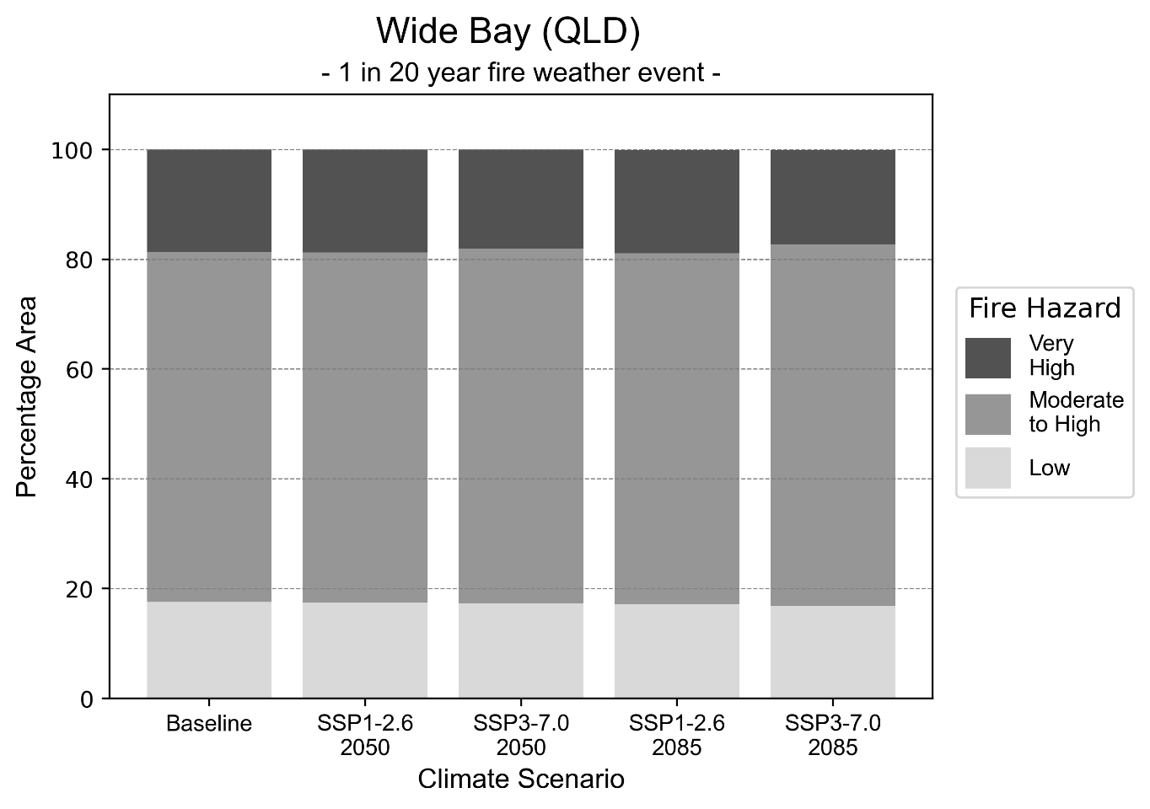
Figure 36: Stacked column chart showing the percentages of the Wide Bay health district's total geographic area experiencing each fire hazard level during a 1-in-20-year fire weather event.
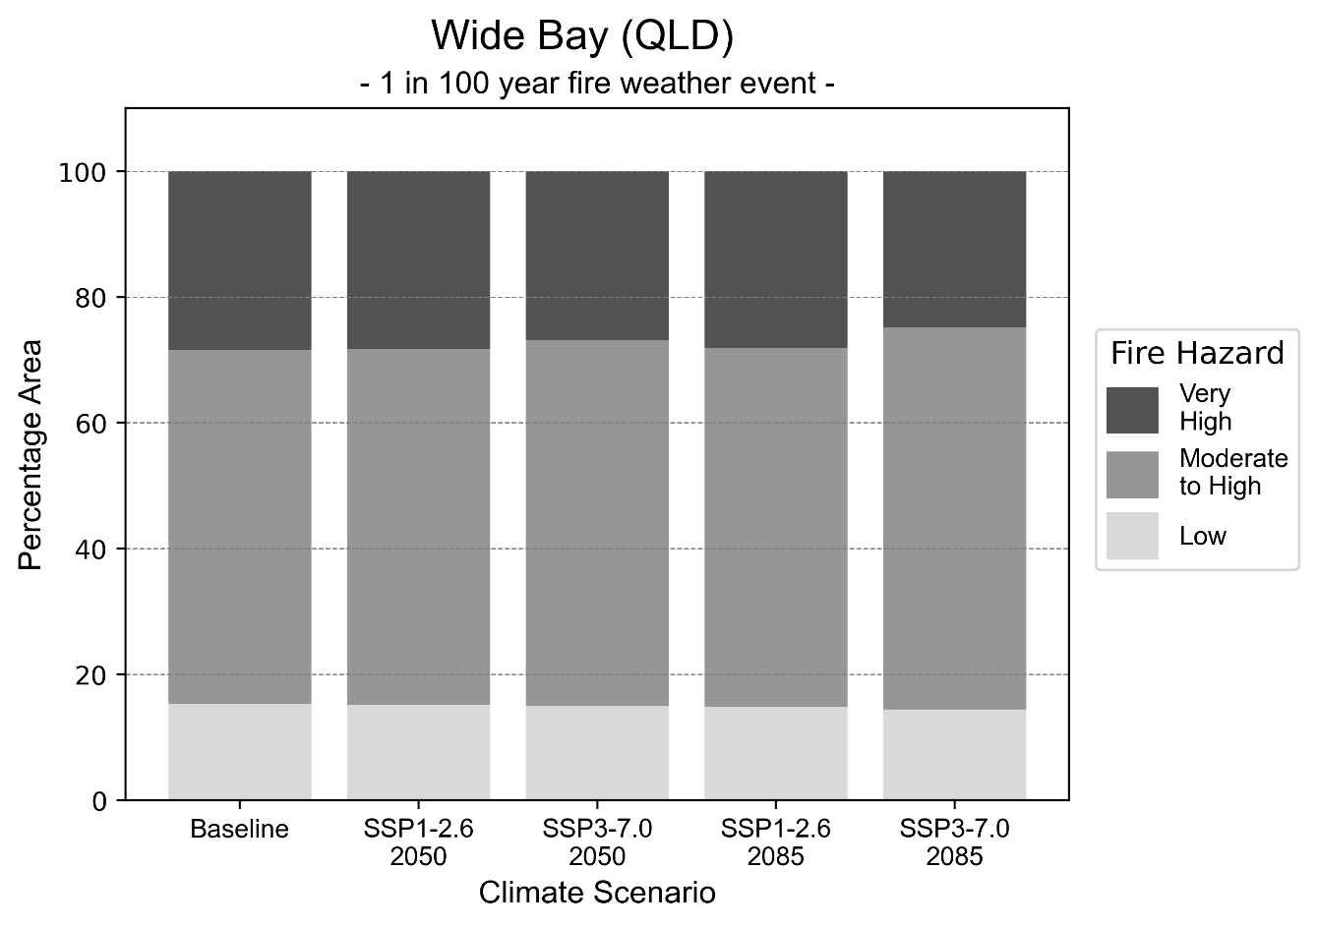
Figure 37: Stacked column chart showing the percentages of the Wide Bay health district's total geographic area experiencing each fire hazard level during a 1-in-100-year fire weather event.

Drought hazard
Key projections:
Drought occurrence: The occurrence of drought will increase across both middle of the road and reasonable worst-case scenarios for both time horizons, with the largest increase occurring under the reasonable worst-case scenario by 2050.

 | Baseline | 2050 Scenarios |  | 2085 Scenarios
 |  | Middle of the road | Reasonable worst-case | Middle of the road | Reasonable worst-case
Number of months per year in drought^{(a)} | 1.8 | 2.4  [0.5, 4.7] | 2.8  [0.4, 7.9] | 2.8  [0.5, 5.2] | 2.8  [0.2, 7.0]
Table notes: The drought hazard indicator uses climate projections from the CMIP6 Global Climate Models [1]. The primary indicator value reports the median from the nine climate models, with the range reported in square brackets.
Table footnotes: (a) The number of months per year in drought is based on the Standardised Precipitation Index (SPI). SPI is a widely used index to characterise meteorological drought on a range of timescales. This indicator uses the timescale of 12 months which calculates the average months in a year within the moderate drought range. A moderate drought range is classified as SPI score of ≤ -1. SPI is calculated from accumulated rainfall over 12 months and the mean and standard deviation from historical rainfall records.

Storm hazard
Key projections:
Fewer high-intensity storms: High-intensity storms will be less frequent in both middle of the road and reasonable worst-case scenarios across both time horizons.

 | Baseline | 2050 Scenarios |  | 2085 Scenarios
 |  | Middle of the road | Reasonable worst-case | Middle of the road | Reasonable worst-case
Number of low-intensity storms (40-62 km/hr) per year | 80.5 | 76.6  [67.4, 84.3] | 79.0  [69.5, 86.9] | 74.0  [65.1, 81.4] | 76.8  [67.6, 84.5]
Number of medium-intensity storms (63-87 km/hr) per year | 58.8 | 53.2  [46.8, 58.5] | 51.9  [45.6, 57.1] | 50.2  [44.2, 55.3] | 49.7  [43.7, 54.6]
Number of high-intensity storms (88-117 km/hr) per year | 6.9 | 5.3  [4.7, 5.9] | 5.1  [4.5, 5.6] | 5.7  [5.0, 6.2] | 5.3  [4.7, 5.8]
Number of very-high-intensity storm (> 117 km/hr) per year | 0.2 | 0.2  [0.1, 0.2] | 0.2  [0.1, 0.2] | 0.2  [0.2, 0.2] | 0.2  [0.1, 0.2]
Table notes: The storm hazard uses climate projections from the CMIP6 Global Climate Models [1]. Daily maximum surface wind speed is used to calculate the number of annual storms across four storm intensity categories (low, medium, high and very high). The primary indicator value reports the median from the nine climate models, with the range reported in square brackets.

Rainfall and flood hazard
Key projections:
- Nine extreme rainfall days per year: The number of extreme rainfall days will remain consistent across both middle of the road and reasonable worst-case scenarios, and both time horizons, with an average of approximately nine extreme rainfall days per year.
- Increased flood frequency: The frequency of flood events will increase in urban and rural environments. The largest increase in flood frequency occurs in the reasonable worst-case scenario, where the frequency of a ‘1-in-100 year’ flood will more than quadruple by 2050 and become 13 times more likely by 2085 in urban environments.

 | Baseline | 2050 Scenarios |  | 2085 Scenarios
 |  | Middle of the road | Reasonable worst-case | Middle of the road | Reasonable worst-case
Rainfall hazard^{(a)}
Average number of extreme rainfall days per year (> 12 mm/day)^{(a)} | 9.3 | 8.9  [7.3,11.0] | 8.6  [6.0,10.8] | 8.5  [6.6,10.4] | 8.5  [6.3,10.8]
Urban flood risk (flooding caused by a 1-hour rainfall event)^{(b)}
Frequency of a ‘1-in-1 year’ flood (rainfall depth of 32 mm)^{(c)} |  | 1.9 events in 1 year | 2.0 events in 1 year | 2.4 events in 1 year | 3.1 events in 1 year
Frequency of a ‘1-in-10 year’ flood (rainfall depth of 58 mm)^{(c)} |  | 2.8 events in 10 years | 3.0 events in 10 years | 4.1 events in 10 years | 6.3 events in 10 years
Frequency of a ‘1-in-100 year’ flood (rainfall depth of 89 mm)^{(c)} |  | 4.1 events in 100 years | 4.4 events in 100 years | 7.0 events in 100 years | 13 events in 100 years
Rural flood risk (flooding caused by a 24-hour rainfall event)^{(b)}
Frequency of a ‘1-in-1 year’ flood (rainfall depth of 77 mm)^{(c)} |  | 1.2 events in 1 year | 1.2 events in 1 year | 1.2 events in 1 year | 1.1 events in 1 year
Frequency of a ‘1-in-10 year’ flood (rainfall depth of 156 mm)^{(c)} |  | 1.5 events in 10 years | 1.5 events in 10 years | 1.7 events in 10 years | 1.7 events in 10 years
Frequency of a ‘1-in-100 year’ flood (rainfall depth of 258 mm)^{(c)} |  | 1.8 events in 100 years | 1.8 events in 100 years | 2.1 events in 100 years | 2.5 events in 100 years
Table notes: The rainfall hazard indicator uses climate projections from the CMIP6 Global Climate Models [1]. The primary indicator value reports the median from the nine climate models, with the range reported in square brackets. The flood hazard indicators use climate change considerations from the Australian Rainfall and Runoff guideline to estimate the climate projections [2].
Table footnotes: (a) Extreme rainfall is defined as rainfall above the 95th percentile of historical average daily rainfall in this health district in the period 1985-2014. The value in mm/day quoted in the indicator name is the 95th percentile of historic average daily rainfall for this health district. (b) See Methodology document for reasons for focusing on a 1-hour flood for urban areas and a 24-hour flood for rural areas. (c) The rainfall depths in mm quoted in the indicator names in this table report 1 in 1, 10 and 100 year depths for this health district.

Coastal inundation hazard
Key projections:
Greater area inundated: There will be an increase in the area affected by tidal inundation (i.e. area submerged during high tide) and storm surge and tidal inundation (i.e. the area submerged during a storm surge and high tide) across both middle of the road and reasonable worst-case scenarios. In the reasonable worst-case scenario, by 2085 the area inundated during tidal inundation event will increase by over 20,000 ha.

 | Baseline | 2050 Scenarios |  | 2085 Scenarios^{(a)}
 |  | Middle of the road | Reasonable worst-case | Middle of the road | Reasonable worst-case
Tidal inundation (ha inundated)^{(b)} | 43,344.1 | 49,805.1  (+6,461.0) | 50,202.5  (+6,858.4) | 60,283.7  (+16,939.5) | 64,013.1  (+20,668.9)
Storm surge + tidal inundation – ‘1-in-100 year’ event (ha inundated)^{(c)} | 55,525.7 | 61,256.3  (+5,730.6) | 61,591.6  (+6,065.9) | 69,765.3  (+14,239.6) | 72,955.1  (+17,429.4)
Storm surge + tidal inundation – ‘1-in-1000 year’ event (ha inundated)^{(c)} | 60,372.9 | 65,532.1  (+5,159.2) | 65,844.1  (+5,471.2) | 76,223.5  (+15,850.6) | 79,321.0  (+18,948.1)
Table notes: The coastal inundation hazard provides an indication of flooding in coastal areas that can be attributed to sea level rise and storm inundation. The coastal inundation hazard is only reported for health districts adjoining the coastline. This table includes the projected inundation levels as well as the change from baseline conditions (in brackets).
Table footnotes: (a) For the 2085 Scenarios planning horizon, 2100 was adopted as it provides a conservative representation of the end of this period. This horizon aligns with many State planning regulations requiring consideration of sea level rise and storm tide to 2100, making the 2100 scenario particularly valuable for planning new health facilities in coastal areas. (b) The tidal inundation indicator reports the number of hectares inundated during high tide. The baseline value reports existing inundation patterns, while the 2050 and 2085 values report high tide inundation taking account of projected sea level rise due to climate change. (c) The storm surge + tidal inundation indicators report the combined effect, in hectares inundated, of high tide, sea level rise (for the 2050 and 2085 projections), and storm surge (for 1-in-100 year and 1-in-1000 year events).

References

[1] | D. Irving, I. Macadam and M. King, “Application-ready quantile-delta-change (QDC) scaled CMIP6 climate projections for Australia (time slices, 11km grid) (v1)”, CSIRO. Data Collection, 2024.
[2] | C. Wasko, S. Westra, R. Nathan, D. Jakob, C. Nielsen, J. Evans, S. Rodgers, M. Ho, M. Babister, A. Dowdy and W. Sharples, “Australian Rainfall and Runoff (ARR) Chapter 6: 4 Climate Change Considerations”, Australian Rainfall and Runoff, 2024.
[3] | J. J. Hollis, S. Matthews, W. R. Anderson, M. G. Cruz, P. Fox-Hughes, S. Grootemaat, B. J. Kenny and S. Sauvage, “A framework for defining fire danger to support fire management operations in Australia”, International Journal of Wildland Fire, vol.33, no.3, 2024.
[4] | Z. Hausfather and P. G. Peters, “Emissions–the ‘business as usual’story is misleading”, Nature, 577(7792), pp.618-620, 2020.



Another scenario, SSP5-8.5, was previously considered the reasonable worst-case scenario, but it is now considered to be very unlikely to be realised due to climate action already undertaken [4].

