Guidance on climate risk assessment and adaptation planning for Australian health system organisations
  - Climate and Health Hazard Data for South Australia

© Commonwealth of Australia as represented by the Australian Centre for Disease Control
Title: Guidance on climate risk assessment and adaptation planning for Australian health system organisations: Climate and Health Hazard Data for South Australia.
Citation
Australian Centre for Disease Control (CDC). Guidance on climate risk assessment and adaptation planning for Australian health system organisations: Climate and Health Hazard Data for South Australia, Australian CDC, Australian Government, 2026.
Contributors
Anne Cleary, Jamie Ewert, Jake Allen, Adam Brook, Petter Nyman, Pam Wong, Anthony Kiem, Felix Edger, Richard Farr, Robert Morden, Vincent Li Creagh, Tony Weber, Dominic Blackham, Matilda Lehmann, Phoebe Spurrier, Sophia Gidis, Georgia Behrens, Madeleine Skellern.
Acknowledgments
CSIRO National Bushfire Intelligence Capability for assisting with the analysis of the Fire Hazard.
Creative Commons Licence
This publication is licensed under the Creative Commons Attribution 4.0 International Public License available from https://creativecommons.org/licenses/by/4.0/legalcode (“Licence”). You must read and understand the Licence before using any material from this publication.
Restrictions
The Licence may not give you all the permissions necessary for your intended use. For example, other rights (such as publicity, privacy and moral rights) may limit how you use the material found in this publication. The Licence does not cover, and there is no permission given for, use of any of the following material found in this publication:
- the Commonwealth Coat of Arms. (by way of information, the terms under which the Coat of Arms may be used can be found on the Department of Prime Minister and Cabinet website
- any logos and trademarks
- any photographs and images
- any signatures
- any material belonging to third parties. The third party elements must be included here or have a footnote reference throughout the document showing where they are.
Attribution
Without limiting your obligations under the Licence, the Australian Centre for Disease Control requests that you attribute this publication in your work. Any reasonable form of words may be used provided that you:
- include a reference to this publication and where practicable, the relevant page numbers
- make it clear that you have permission to use the material under the Creative Commons Attribution 4.0 International Public License
- make it clear whether or not you have changed the material used from this publication
- include a copyright notice in relation to the material used. In the case of no change to the material, the words “© Commonwealth of Australia (Australian Centre for Disease Control) 2026” may be used. In the case where the material has been changed or adapted, the words: “Based on Commonwealth of Australia (Australian Centre for Disease Control) material” may be used
- do not suggest that the Australian Centre for Disease Control endorses you or your use of the material.
Enquiries
Enquiries regarding any other use of this publication should be addressed to the Communication and Public Information Section, Strategy and Engagement Branch, Australian Centre for Disease Control, GPO Box 798, Canberra ACT 2601, or via e-mail to CDCComms@cdc.gov.au.
We welcome feedback and dialogue about this report. Please send all such correspondence to NHSC.Unit@cdc.gov.au.

Table of Contents

Table of Contents 3
Introduction 4
Adelaide health district 7
Barossa Hills Fleurieu health district 17
Eyre and Far North health district 26
Flinders and Upper North health district 36
Limestone Coast health district 46
Riverland Mallee Coorong health district 56
Yorke and Northern health district 66
References 76

Introduction

This document provides scientific climate information to help health system organisations assess, prepare for and effectively manage climate-related risks across short-, medium-, and long-term planning horizons. A digital version of the information in this document can be found here. Further detail about the information contained in this document can be found in the accompanying methodological report.

The document presents climate hazard information summarised for health districts across South Australia. For each health district, information is provided about six hazards – heat and humidity, fire, drought, rainfall, storms, and coastal inundation – across three different time horizons and two climate scenarios. This structure enables users to assess how climate risks may evolve over time and under different emissions pathways. The information is presented both in narrative form and through a series of detailed tables containing quantitative data. Further information on the information presented in this document is outlined below.

Health districts
This document presents climate information for 7 health districts, corresponding to the 9 geographically based SA Health Local Health Networks, with the three Adelaide Local Health Networks (Central Adelaide, Northern Adelaide and Southern Adelaide) combined into a single Adelaide health district.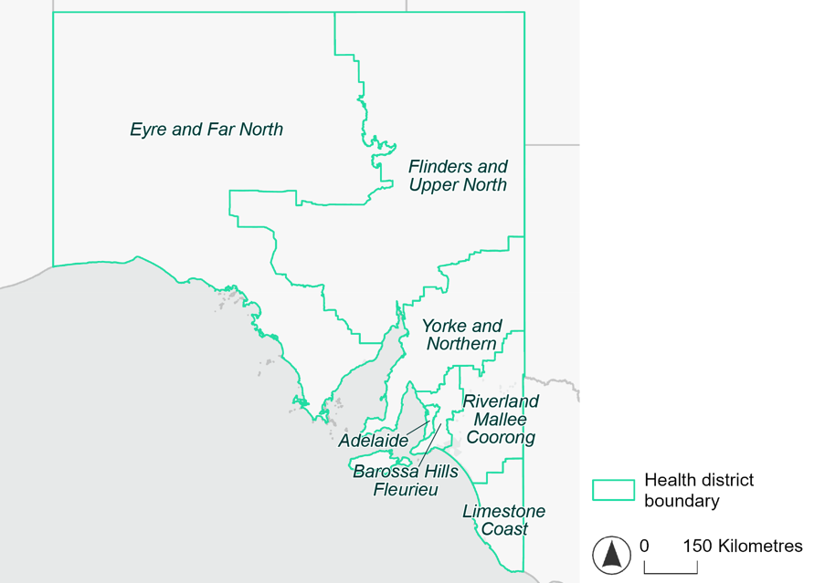
Figure 1. Map of South Australian health districts used in this document.

Time horizons
This document provides climate information on each climate hazard for the following time horizons:

Time horizon | Years | Description | Use in risk assessment
Baseline | Observed data from 1985-2014 | Historical baseline position | Understand current risks and ensure they are being managed effectively
Mid-century (2050) | 2035–2064 | Medium-term climate projections | Identify and manage emerging risks to population health and health systems
Late century (2085) | 2070–2099 | Long-term climate projections | Identify long-term risks when planning infrastructure or policy with long-lasting consequences

Climate scenarios
The document provides climate information on each hazard for two different climate scenarios. A climate scenario is a plausible representation of what the future climate might look like. These scenarios are based on different assumptions about greenhouse gas emissions and other factors that influence the future climate.

This document uses Shared Socioeconomic Pathways (SSPs) as the basis for different climate scenarios. SSPs describe how socioeconomic factors (such as population, economic growth, education, urbanisation and technology development) could change over the next century and have an effect on future greenhouse gas emissions and global temperatures.

There are five main SSPs, each of which outlines a different scenario, ranging from a sustainable future with low emissions, to one with high fossil fuel uses and high emissions. The most recent iteration of SSPs incorporate information from what were previously called Representative Concentration Pathways (RCPs), which measure the expected change in radiative forcing (in W/m2) under the scenario from 1750 to 2100. SSP2-4.5 denotes what would previously have been called a scenario involving SSP2 and RCP4.5 – the reasoning for merging them being that SSP2 describes socioeconomic conditions likely to give rise to RCP4.5.

The two main scenarios used in this document are:
A ‘middle of the road’ scenario (SSP2-4.5): this scenario assumes emissions remain at current levels until the middle of the 21st century, and that net zero emissions are not reached by 2100. This scenario sees temperatures rising by about 2.7°C by the end of the century. In this document this is the lower emissions scenario across all climate hazards, except for the fire hazard (see below note).
A ‘reasonable worst-case’ scenario (SSP3-7.0): this scenario assumes both emissions and temperatures continue to rise to the end of the century due to delayed climate action. This scenario sees temperatures rise by about 3.6°C by 2100. In this document this is the higher emissions scenario across all climate hazards.

Fire hazard projections are not available for SSP2-4.5, so SSP1-2.6 is used as the lower emissions scenario for this hazard instead of SSP2-4.5. Under SSP1-2.6, global emissions are reduced but do not reach net zero until after 2050 and warming stabilises at about 1.8°C by 2100. This document refers to SSP1-2.6 as the ‘sustainability’ scenario.

Climate hazard projections
For each health district, the following information is provided for each climate hazard, across the different time horizons and climate scenarios:
- Heat and humidity: projected average, extreme and apparent temperatures; projected heatwave duration and frequency; and projected number of very hot days.
- Fire: projected area affected by different fire hazard categories for a 1-in-20 year fire event and a 1-in-100 year event.
- Drought: projected average number of months per year experiencing drought.
- Rainfall and flooding: projected number of extreme rainfall days per year, as well as projected frequency of urban and rural flood events.
- Storms: projected number of storms per year, grouped into four intensity categories based on wind speed.
- Coastal inundation: projected area of land affected by tidal inundation and storm surge and tidal inundation (coastal districts only).

The climate hazard projections in this document are based on data from nine CMIP6 Global Climate Models (ACCESS-CM2, ACCESS-ESM1-5, CESM2, CMCC-ESM2, CNRM-ESM2-1, EC-Earth3, MPI-ESM1-2-HR, NorESM2-MM, UKESM1-0-LL). These models simulate how climate hazards may change under different SSPs. Where hazard projections are based on these models, this document reports the median projected value as its primary estimate, and reports the range across all nine models in square brackets.

Adelaide health district

Health district overview
The Adelaide health district includes Northern Adelaide Local Health Network, Central Adelaide Local Health Network and Southern Adelaide Local Health Network. The Adelaide health district covers 1,563 square kilometres and contains eight hospitals:
Royal Adelaide Hospital
The Queen Elizabeth Hospital
Hampstead Rehabilitation Hospital
Royal Adelaide Hospital
The Queen Elizabeth Hospital
Hampstead Rehabilitation Hospital
Flinders Medical Centre
Noarlunga Hospital

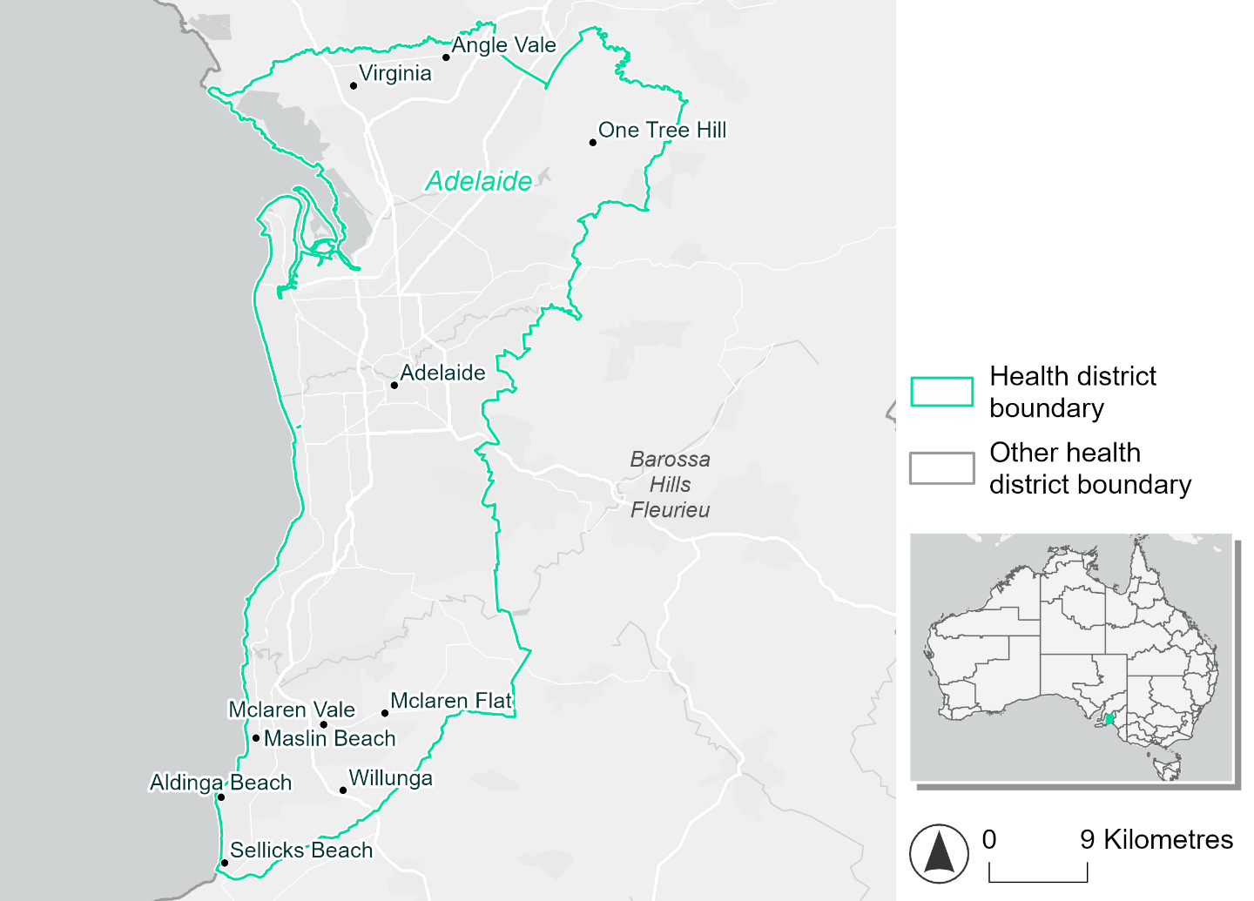
Figure 2. Map of Adelaide health district

How will climate change affect this health district?
Heat and humidity: Higher average temperatures, hotter and more frequent hot days, warmer night time temperatures and more frequent heatwaves.
Fire: 20% of this health district currently experiences very high fire hazard category and this will increase slightly in the future.
Drought: Number of months experiencing drought will increase.
Rainfall and flood: More flood events in urban areas.
Coastal inundation: Increased area flooded during tidal and storm surge and tidal inundation.

Adelaide health district demographic data
Demographic Data | Total
Number of households | 492,868
Persons 15 and older | 902,829
Total families | 341,884
Persons did not complete high school | 312,534
One parent families with dependents | 36,406 (10.6%)
Persons aged 65 and older | 239,166 (18.4%)
Persons aged 4 and younger | 70,561 (5.4%)
Aboriginal and Torres Strait Islander persons | 22,071 (1.7%)
Persons speaks language other than English | 290,199 (22.4%)
Persons working age (15-65) | 836,301 (64.5%)
Population Health Data | Total
Persons with core needs for assistance | 84,421 (6.5%)
Persons with arthritis | 122,478 (9.4%)
Persons with asthma | 112,232 (8.7%)
Persons with cancer | 39,547 (3.1%)
Persons with dementia | 12,542 (1%)
Persons with diabetes | 71,097 (5.5%)
Persons with heart disease | 56,714 (4.4%)
Persons with kidney disease | 11,330 (0.9%)
Persons with lung condition | 23,730 (1.8%)
Persons with mental health condition | 126,535 (9.8%)
Persons with stroke | 13,051 (1%)
Persons with any other condition | 115,646 (8.9%)
Persons no health condition | 771,443 (59.5%)
Socio-economic Data | Total
Persons providing unpaid care | 168,642 (13%)
Persons homeless | 5,331 (0.4%)
Household with lone person | 139,006 (28.2%)
Households with rent and mortgage stress | 215,979 (43.8%)
Households total equivalised income below $1000 (weekly) | 236,904 (48.1%)
Households with no motor vehicle | 39,093 (7.9%)
Persons unemployed | 60,898 (5.8%)

The sections that follow outline projected climate hazards for this district. Further information on this health district, including population demographics, is provide in the online dashboard.

Heat and humidity hazard
Key projections:
More heatwaves: Heatwave events are likely to last longer and the number of heatwave events per year will increase. By 2050, under a reasonable worst-case scenario the number of heatwaves will increase from two events per year to three. By 2085, under a reasonable worst-case scenario the number of heatwaves per year will more than double.
Hotter days and warmer nights: The maximum temperature on hot days will increase with night time temperatures on hot nights also increasing.
More days above 35°C and 40°C: The number of days per year greater than 35°C and 40°C will increase under both middle of the road and reasonable worst-case scenarios across both time horizons.

 | Baseline | 2050 Scenarios |  | 2085 Scenarios
 |  | Middle of the road | Reasonable worst-case | Middle of the road | Reasonable worst-case
Average temperature (°C) | 16.6 | 17.7  [17.1, 18] | 17.9  [17.2, 18.4] | 18.5  [17.6, 19.1] | 19.2  [18, 20.2]
Maximum temperature on hot days (°C)^{(a)} | 34.7 | 36  [35.5, 36.4] | 36.3  [35.3, 37.1] | 36.8  [35.9, 37.6] | 37.7  [36.7, 38.5]
Minimum temperature on hot nights (°C)^{(b)} | 21.1 | 22.3  [21.3, 22.9] | 22.5  [21.6, 23] | 23.1  [21.8, 23.7] | 23.9  [22.8, 24.7]
Average apparent temperature on hot days (°C) (NOAA Heat Index)^{(c)} | 33.5 | 34.2  [34, 34.4] | 34.3  [33.9, 34.8] | 34.5  [34.1, 35] | 35.1  [34.6, 35.6]
Average heatwave duration in days^{(d)} | 4 | 5  [4, 5] | 5  [5, 5] | 5  [4, 5] | 5  [5, 5]
Number of heatwaves per year^{(d)} | 2 | 3  [2, 3] | 3  [2, 4] | 4  [3, 5] | 5  [3, 6]
Number of days per year  > 35°C | 17 | 24  [21, 26] | 25  [20, 30] | 28  [23, 33] | 34  [28, 40]
Number of days per year > 40°C | 3 | 5  [4, 6] | 6  [3, 8] | 7  [5, 10] | 10  [6, 13]
Table notes: The heat and humidity hazard uses climate projections from the CMIP6 Global Climate Models [1]. Daily projections of maximum and minimum near-surface temperature and mean relative humidity are used to calculate eight heat and humidity indicators. The primary indicator value reports the median from the nine climate models, with the range reported in square brackets.
Table footnotes: (a) Based on the 95th percentile of daily maximum air temperature. (b) Based on the 95th percentile of daily minimum air temperature, representing the coldest part of the night on very hot nights. (c) The National Oceanic and Atmospheric Administration (NOAA) Heat Index is a measure of how hot it feels when relative humidity is factored in alongside actual air temperature. It is calculated on days with a maximum temperature of 27°C and above. Interpretation of Heat Index values: 27°C to 32°C indicates caution, 33°C to 41°C indicates extreme caution, 42°C to 54°C indicates danger and over 54°C indicates extreme danger. See methodology document for further explanation of Heat Index categories. (d) A heatwave is defined as three or more consecutive days where both daytime and overnight temperatures (daily mean temperatures) are unusually high for the location, based on the Bureau of Meteorology’s Excess Heat Factor method. For this district, an unusually high daily mean temperature is approximately 27.4°C or above.

Fire hazard
Key projections:
Majority of district area experiences moderate to high hazard: Under baseline conditions, the majority (61-62%) of the district experiences moderate to high fire hazard. Very high and low fire hazard cover roughly equal portions of the remaining area during a 1-in-20-year fire weather event. During a 1-in-100-year event, the very high hazard area covers a little more of the district than low hazard.
Slight increase in overall fire hazard: In a future climate, hazard levels are projected to increase slightly over time and in higher-emissions scenarios. For a 1-in-20-year fire weather event, these increases could see the proportions of the district experiencing moderate to high hazard increase by up to 2.2 percentage points, and very high hazard by up to 1.4. In a 1-in-100-year fire weather event more of this increase is seen in the very high fire hazard area, which could increase by up to 2.1 percentage points in this more severe event.

 | Baseline | 2050 Scenarios |  | 2085 Scenarios
 |  | Sustainability | Reasonable worst-case | Sustainability | Reasonable worst-case
Hazard for a ‘1-in-20 year’ fire weather event^{(a)}
Proportion (%) of district experiencing ‘Low’ fire hazard | 19.7%  (30,726)^{(b)} | 19.1%  [18.2%, 20.3%] | 18.2%  [14.8%, 19.9%] | 18.2%  [16.2%, 21.3%] | 16.2%  [7.9%, 20.2%]
Proportion (%) of district experiencing ‘Moderate to High’ fire hazard | 61.3%  (95,830)^{(b)} | 61.6%  [60.0%, 63.0%] | 62.2%  [59.4%, 67.0%] | 61.9%  [58.2%, 65.3%] | 63.5%  [56.6%, 74.9%]
Proportion (%) of district experiencing ‘Very High’ fire hazard | 19.0%  (29,725)^{(b)} | 19.4%  [18.7%, 19.6%] | 19.6%  [18.9%, 20.5%] | 19.9%  [18.3%, 20.3%] | 20.4%  [18.8%, 22.5%]
Hazard for a ‘1-in-100 year’ fire weather event^{(a)}
Proportion (%) of district experiencing ‘Low’ fire hazard | 17.3%  (27,109)^{(b)} | 16.7%  [15.7%, 17.9%] | 16.0%  [12.6%, 17.6%] | 15.8%  [13.3%, 18.6%] | 14.0%  [5.9%, 18.0%]
Proportion (%) of district experiencing ‘Moderate to High’ fire hazard | 62.0%  (96,877)^{(b)} | 62.2%  [60.7%, 64.0%] | 62.5%  [59.8%, 67.0%] | 62.6%  [58.9%, 66.7%] | 63.1%  [56.8%, 73.9%]
Proportion (%) of district experiencing ‘Very High’ fire hazard | 20.7%  (32,294)^{(b)} | 21.1%  [20.2%, 21.5%] | 21.6%  [20.6%, 22.7%] | 21.7%  [19.5%, 22.7%] | 22.8%  [20.5%, 25.5%]
Table notes: The Fire Hazard uses the National Bushfire Intelligence Capability (NBIC) Phase 2 fire line intensity modelling based on CMIP6 climate projections. Fire Hazard is assessed using the projected Fireline Intensity (FLI) for weather events with two different return intervals (i.e. a 1-in-20 year event and a 1-in-100 year event). FLI considers slope, vegetation and weather to produce a rate of heat output per unit length (kW/m) along a bushfire’s front. Fire hazard is categorized as a low for FLI<4000 kW/m, moderate to high for 4,000 kW/m ≤FLI<12,500kW/m, and very high for FLI≥27,501kW/m. This is broadly consistent with the literature [3]. The assessment considers climate change effects based on changes in fire weather and the associated hazard that is anticipated for a meteorological event of a given return interval. This approach is different to the one adopted for the Flood Hazard, where the event magnitude is given (fixed) and the likelihood of that event varies as a result of climate change. The primary indicator value reports the median from the nine climate models, with the range reported in square brackets.
Table footnotes: (a) The area subject to different categories of fire hazard is determined for a ‘1-in-20 year’ and ‘1-in-100 year’ fire weather event, in current and future climates. Values at year 2050 are interpolated using data from baseline (2025) and 2085, assuming linear change over time. (b) Values in round brackets are the area (ha) of the health district subject to a given fire hazard.

The figures below show the proportion of the health district experiencing different fire hazard categories across different time horizons and climate scenarios during a ‘1-in-20 year’ fire weather event (Figure 3) and a ‘1-in-100 year’ fire weather event (Figure 4).
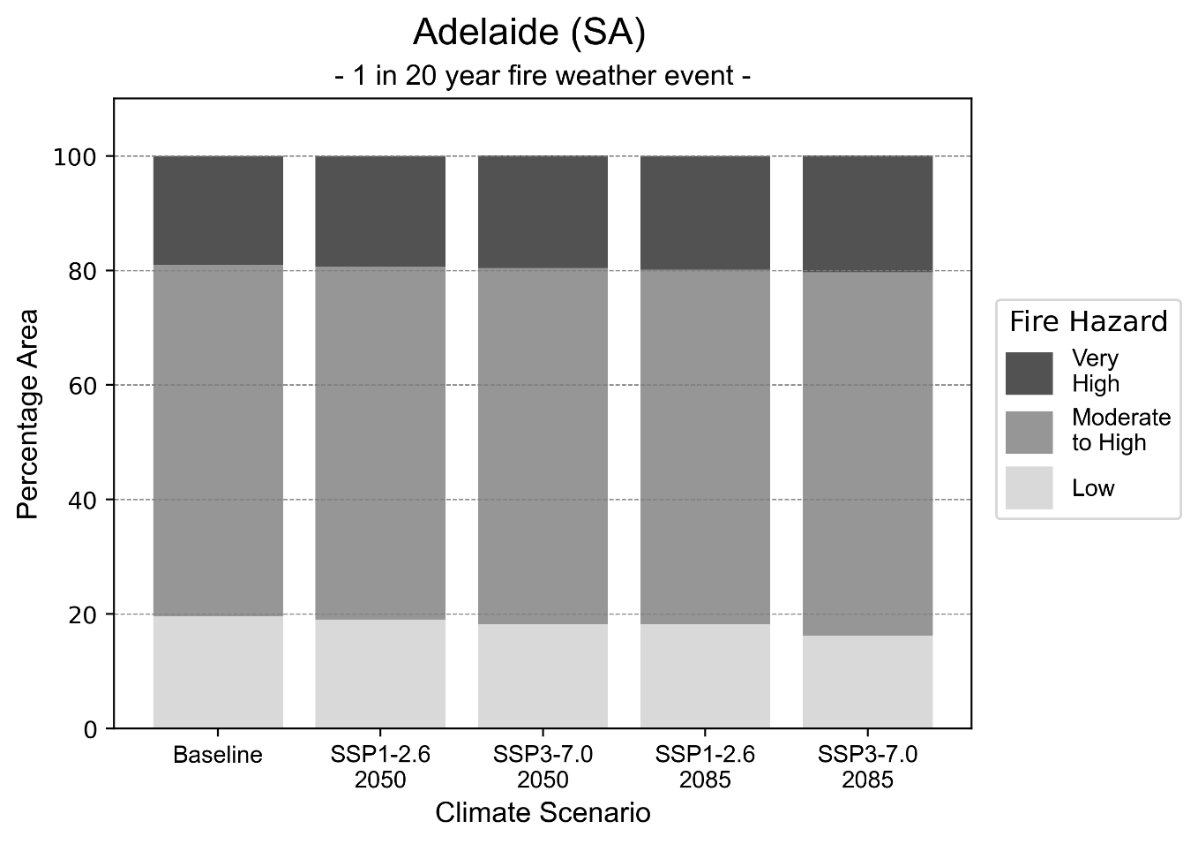
Figure 3: Stacked column chart showing the percentages of the Adelaide health district's total geographic area experiencing each fire hazard level during a 1-in-20-year fire weather event.
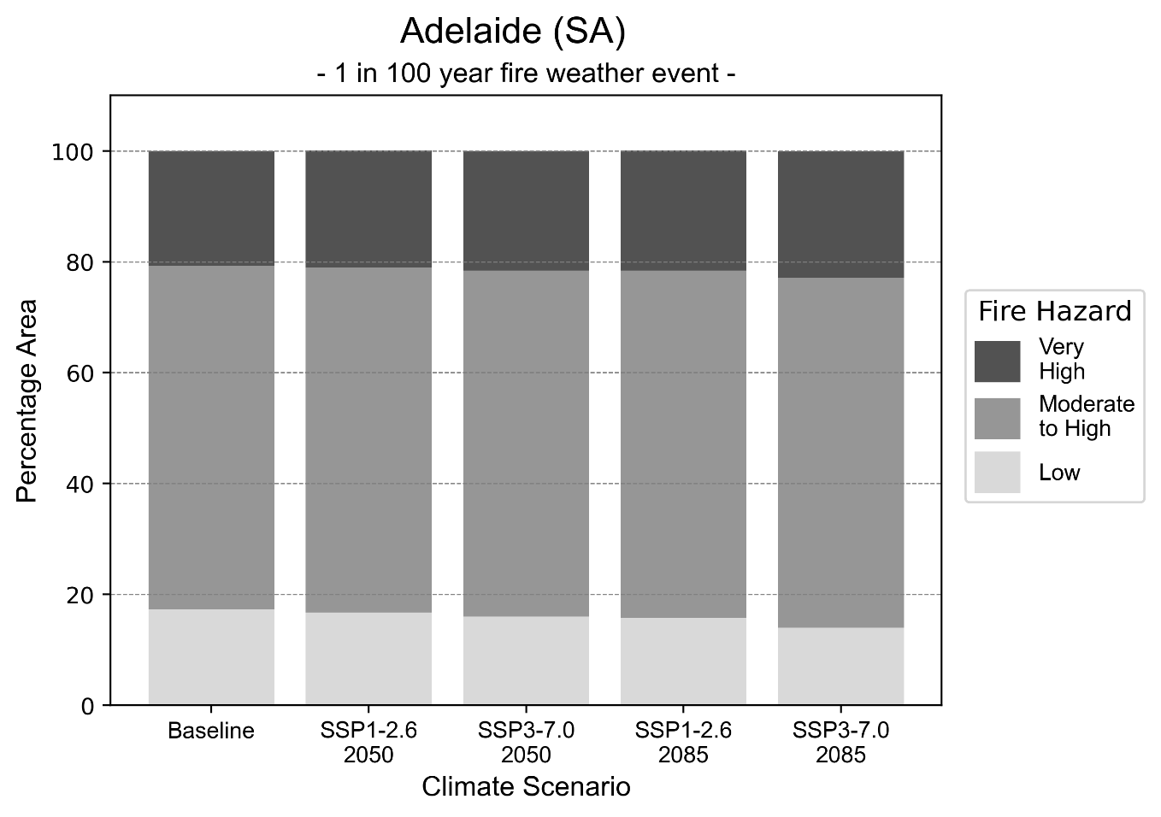
Figure 4: Stacked column chart showing the percentages of the Adelaide health district's total geographic area experiencing each fire hazard level during a 1-in-100-year fire weather event.

Drought hazard
Key projections:
Drought occurrence: The occurrence of drought will increase across both middle of the road and reasonable worst-case scenarios and both time horizons, with the largest increase occurring under the reasonable worst-case scenario by 2085.

 | Baseline | 2050 Scenarios |  | 2085 Scenarios
 |  | Middle of the road | Reasonable worst-case | Middle of the road | Reasonable worst-case
Number of months per year in drought^{(a)} | 1.7 | 3.3  [0.9, 5.9] | 3.3  [1.3, 7.8] | 4.1  [1.7, 8.0] | 4.7  [1.0, 10.5]
Table notes: The drought hazard indicator uses climate projections from the CMIP6 Global Climate Models [1]. The primary indicator value reports the median from the nine climate models, with the range reported in square brackets.
Table footnotes: (a) The number of months per year in drought is based on the Standardised Precipitation Index (SPI). SPI is a widely used index to characterise meteorological drought on a range of timescales. This indicator uses the timescale of 12 months which calculates the average months in a year within the moderate drought range. A moderate drought range is classified as SPI score of ≤ -1. SPI is calculated from accumulated rainfall over 12 months and the mean and standard deviation from historical rainfall records.

Storm hazard
Key projections:
Less frequent high-intensity storms: The frequency of high-intensity storms will decrease across both middle of the road and reasonable worst-case scenarios with the greatest decrease occurring by 2085.

 | Baseline |  | 2050 Scenarios |  |  | 2085 Scenarios
 |  | Middle of the road |  | Reasonable worst-case | Middle of the road |  | Reasonable worst-case
Number of low-intensity storms (40-62 km/hr) per year | 78.4 | 72.3  [63.6, 79.5] |  | 72.5  [63.8, 79.7] | 69.5  [61.2, 76.5] |  | 69.3  [61.0, 76.2]
Number of medium-intensity storms (63-87 km/hr) per year | 54.4 | 53.4  [47.0, 58.8] |  | 50.2  [44.2, 55.2] | 48.1  [42.3, 52.9] |  | 45.2  [39.8, 49.8]
Number of high-intensity storms (88-117 km/hr) per year | 13.4 | 12.8  [11.2, 14.0] |  | 10.7  [9.4, 11.8] | 11.1  [9.8, 12.2] |  | 10.2  [9.0, 11.2]
Number of very-high-intensity storm (> 117 km/hr) per year | 0.2 | 0.2  [0.2, 0.2] |  | 0.1  [0.1, 0.1] | 0.2  [0.1, 0.2] |  | 0.1  [0.1, 0.1]
Table notes: The storm hazard uses climate projections from the CMIP6 Global Climate Models [1]. Daily maximum surface wind speed is used to calculate the number of annual storms across four storm intensity categories (low, medium, high and very high). The primary indicator value reports the median from the nine climate models, with the range reported in square brackets.

Rainfall and flood hazard
Key projections:
- Decrease in number of extreme rainfall days per year: The number of extreme rainfall days will remain decrease across both middle of the road and reasonable worst-case scenarios and both time horizons, with the largest decrease seen in the reasonable worst-case scenario where the number of number of extreme rainfall days will reduce from 12 to ten by 2085.
- Increased flood frequency: The frequency of flood events will increase in urban environments but decrease in rural environments. The largest increase in flood frequency is seen in the reasonable worst-case scenario where frequency of a ‘1-in-100 year’ flood will triple by 2050 and become seven times more likely by 2085 in urban environments.

 | Baseline | 2050 Scenarios |  | 2085 Scenarios
 |  | Middle of the road | Reasonable worst-case | Middle of the road | Reasonable worst-case
Rainfall hazard^{(a)}
Average number of extreme rainfall days per year (> 10 mm/day)^{(a)} | 12.2 | 11.1  [9.4,13.9] | 11.0  [8.2,13.2] | 10.6  [8.6,12.2] | 10.5  [6.8,13.5]
Urban flood risk (flooding caused by a 1-hour rainfall event)^{(b)}
Frequency of a ‘1-in-1 year’ flood (rainfall depth of 13 mm)^{(c)} |  | 2.0 events in 1 year | 2.1 events in 1 year | 2.6 events in 1 year | 3.6 events in 1 year
Frequency of a ‘1-in-10 year’ flood (rainfall depth of 25 mm)^{(c)} |  | 2.4 events in 10 years | 2.5 events in 10 years | 3.4 events in 10 years | 5.2 events in 10 years
Frequency of a ‘1-in-100 year’ flood (rainfall depth of 44 mm)^{(c)} |  | 2.8 events in 100 years | 3.0 events in 100 years | 4.2 events in 100 years | 7.3 events in 100 years
Rural flood risk (flooding caused by a 24-hour rainfall event)^{(b)}
Frequency of a ‘1-in-1 year’ flood (rainfall depth of 36 mm)^{(c)} |  | 0.9 events in 1 year | 0.8 events in 1 year | 0.9 events in 1 year | 0.4 events in 1 year
Frequency of a ‘1-in-10 year’ flood (rainfall depth of 64 mm)^{(c)} |  | 0.9 events in 10 years | 1.0 events in 10 years | 0.9 events in 10 years | 0.2 events in 10 years
Frequency of a ‘1-in-100 year’ flood (rainfall depth of 100 mm)^{(c)} |  | 0.8 events in 100 years | 0.8 events in 100 years | 0.4 events in 100 years | 0.08 events in 100 years
Table notes: The rainfall hazard indicator uses climate projections from the CMIP6 Global Climate Models [1]. The primary indicator value reports the median from the nine climate models, with the range reported in square brackets. The flood hazard indicators use climate change considerations from the Australian Rainfall and Runoff guideline to estimate the climate the climate projections [2].
Table footnotes: (a) Extreme rainfall is defined as rainfall above the 95th percentile of historical average daily rainfall in this health district in the period 1985-2014. The value in mm/day quoted in the indicator name is the 95th percentile of historic average daily rainfall for this health district. (b) See Methodology document for reasons for focusing on a 1-hour flood for urban areas and a 24-hour flood for rural areas. (c) The rainfall depths in mm quoted in the indicator names in this table report 1 in 1-, 10- and 100-year depths for this health district.

Coastal inundation hazard
Key projections:
Greater area inundated: There will be an increase in the area affected by tidal inundation (i.e. area submerged during high tide) and storm surge and tidal inundation (i.e. the area submerged during a storm surge and high tide) across both middle of the road and reasonable worst-case scenarios. In the reasonable worst-case scenario, by 2085 the area inundated during a ‘1-in-1000-year’ event will increase by nearly 4,000 ha.

 | Baseline | 2050 Scenarios |  | 2085 Scenarios^{(a)}
 |  | Middle of the road | Reasonable worst-case | Middle of the road | Reasonable worst-case
Tidal inundation (ha inundated)^{(b)} | 3,631.8 | 4,072.4  (+440.6) | 4,097.3  (+465.5) | 4,948.5  (+1,316.7) | 5,226.3  (+1,594.5)
Storm surge + tidal inundation – ‘1-in-100 year’ event (ha inundated)^{(c)} | 8,794.1 | 9,767.4  (+973.2) | 9,815.3  (+1,021.2) | 11,376.2  (+2,582.0) | 11,993.9  (+3,199.8)
Storm surge + tidal inundation – ‘1-in-1000 year’ event (ha inundated)^{(c)} | 9,892.5 | 10,742.2  (+849.7) | 10,792.3  (+899.8) | 13,151.1  (+3,258.6) | 13,691.2  (+3,798.7)
Table notes: The coastal inundation hazard provides an indication of flooding in coastal areas that can be attributed to sea level rise and storm inundation. The coastal inundation hazard is only reported for health districts adjoining the coastline. This table includes the projected inundation levels as well as the change from baseline conditions (in brackets).
Table footnotes: (a) For the 2085 Scenarios planning horizon, 2100 was adopted as it provides a conservative representation of the end of this period. This horizon aligns with many State planning regulations requiring consideration of sea level rise and storm tide to 2100, making the 2100 scenario particularly valuable for planning new health facilities in coastal areas. (b) The tidal inundation indicator reports the number of hectares inundated during high tide. The baseline value reports existing inundation patterns, while the 2050 and 2085 values report high tide inundation taking account of projected sea level rise due to climate change. (c) The storm surge + tidal inundation indicators report the combined effect, in hectares inundated, of high tide, sea level rise (for the 2050 and 2085 projections), and storm surge (for 1-in-100 year and 1-in-1000 year events).

Barossa Hills Fleurieu health district

Health district overview
The Barossa Hills Fleurieu Local Health Network covers 15,353 square kilometres. The Barossa Hills Fleurieu Local Health Network contains 12 hospitals and health services:
Angaston District Hospital  Eudunda Hospital  Gawler Health Service  Kangaroo Island Health Service  Kapunda Hospital  Country Health Connect | Mount Barker District Soldiers’ Memorial Hospital  Mount Pleasant District Hospital  Tanunda War Memorial Hospital  Southern Fleurieu Health Service  Strathalbyn and District Health Service  Gumeracha District Soldiers’ Memorial Hospital.

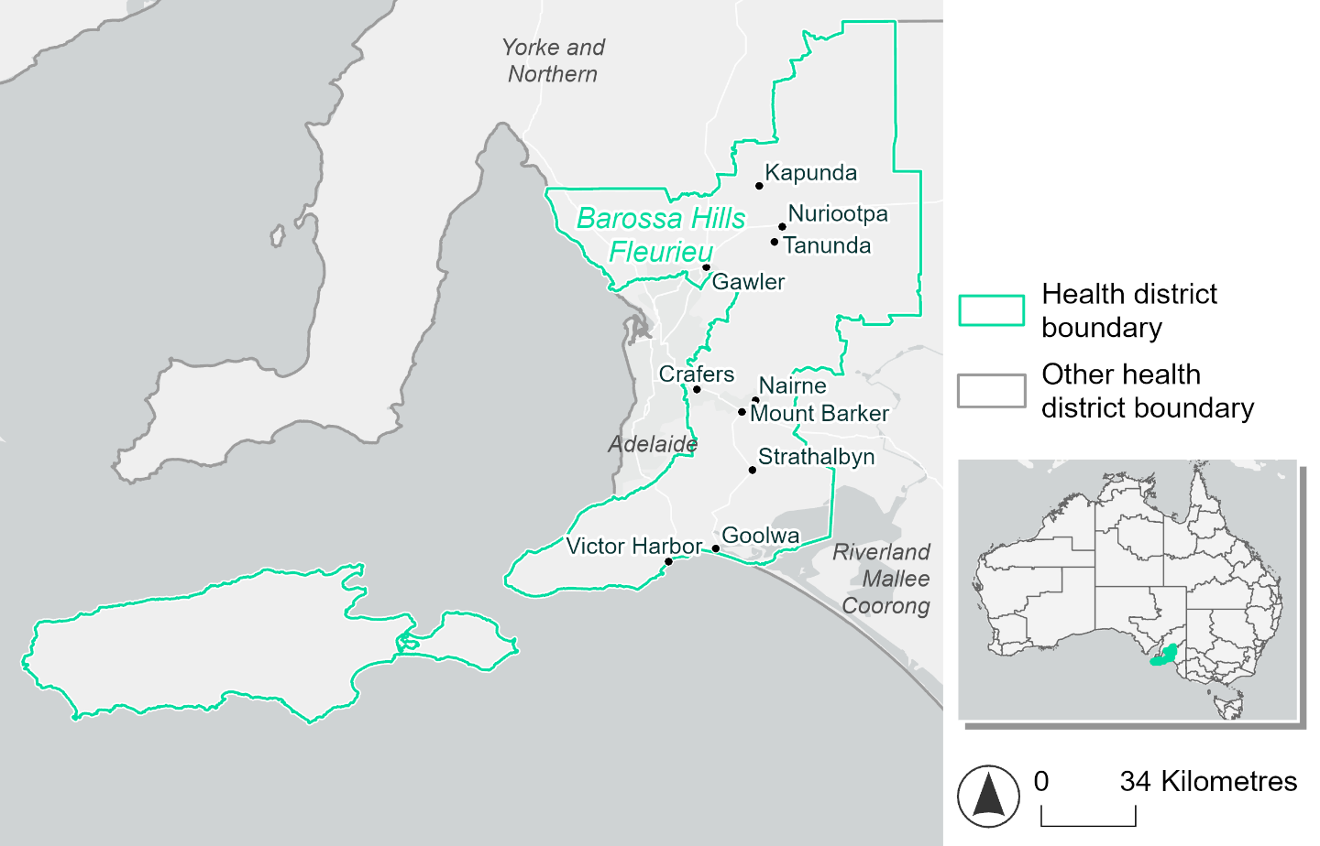
Figure 5. Map of Barossa Hills Fleurieu health district.

How will climate change affect this health district?
Heat and humidity: Higher average temperatures, hotter and more frequent hot days, warmer night time temperatures and more frequent heatwaves.
Fire: Over 20% of this health district experiences very high fire hazard category and this will continue in the future.
Drought: Number of months experiencing drought will increase.
Rainfall and flood: More flood events in urban areas.
Coastal inundation: Increased area flooded during tidal and storm surge and tidal inundation.

Barossa Hill Fleurieu health district demographic data
Demographic Data | Total
Number of households | 82,512
Persons 15 and older | 146,866
Total families | 60,952
Persons did not complete high school | 63,445
One parent families with dependents | 5,318 (8.7%)
Persons aged 65 and older | 52,376 (23.5%)
Persons aged 4 and younger | 11,288 (5.1%)
Aboriginal and Torres Strait Islander persons | 3,239 (1.5%)
Persons speaks language other than English | 8,705 (3.9%)
Persons working age (15-65) | 131,529 (59.1%)
Population Health Data | Total
Persons with core needs for assistance | 13,430 (6%)
Persons with arthritis | 25,683 (11.5%)
Persons with asthma | 21,356 (9.6%)
Persons with cancer | 8,383 (3.8%)
Persons with dementia | 2,056 (0.9%)
Persons with diabetes | 12,168 (5.5%)
Persons with heart disease | 11,399 (5.1%)
Persons with kidney disease | 1,905 (0.9%)
Persons with lung condition | 4,837 (2.2%)
Persons with mental health condition | 23,364 (10.5%)
Persons with stroke | 2,446 (1.1%)
Persons with any other condition | 20,426 (9.2%)
Persons no health condition | 123,011 (55.3%)
Socio-economic Data | Total
Persons providing unpaid care | 31,367 (14.1%)
Persons homeless | 368 (0.2%)
Household with lone person | 20,930 (25.4%)
Households with rent and mortgage stress | 38,106 (46.2%)
Households total equivalised income below $1000 (weekly) | 41,856 (50.7%)
Households with no motor vehicle | 2,857 (3.5%)
Persons unemployed | 7,395 (4.2%)

The sections that follow outline projected climate hazards for this district. Further information on this health district, including population demographics, is provided in the online dashboard.

Heat and humidity hazard
Key projections:
More heatwaves: Heatwave events are likely to last longer and the number of heatwave events per year will increase. By 2050, under a reasonable worst-case scenario the number of heatwaves will increase from two events per year to three. By 2085, under a reasonable worst-case scenario the number of heatwaves per year will more than double.
Hotter days and warmer nights: The maximum temperature on hot days will increase with night time temperatures on hot nights also increasing.
More days above 35°C and 40°C: The number of days per year greater than 35°C and 40°C will increase under both middle of the road and reasonable worst-case scenarios.

 | Baseline | 2050 Scenarios |  | 2085 Scenarios
 |  | Middle of the road | Reasonable worst-case | Middle of the road | Reasonable worst-case
Average temperature (°C) | 14.9 | 16  [15.3, 16.3] | 16.2  [15.5, 16.7] | 16.8  [15.9, 17.4] | 17.5  [16.3, 18.5]
Maximum temperature on hot days (°C)^{(a)} | 33.5 | 34.8  [34.3, 35.3] | 35.1  [34.1, 36] | 35.6  [34.8, 36.4] | 36.5  [35.5, 37.4]
Minimum temperature on hot nights (°C)^{(b)} | 18.3 | 19.6  [18.6, 20.1] | 19.8  [18.8, 20.3] | 20.3  [19, 21] | 21.2  [20.1, 22]
Average apparent temperature on hot days (°C) (NOAA Heat Index)^{(c)} | 34.4 | 35.3  [35, 35.6] | 35.4  [34.9, 36] | 35.7  [35.3, 36.3] | 36.4  [35.7, 36.9]
Average heatwave duration in days^{(d)} | 4 | 5  [4, 5] | 5  [4, 5] | 5  [4, 5] | 5  [5, 5]
Number of heatwaves per year^{(d)} | 2 | 3  [2, 3] | 3  [2, 4] | 4  [2, 5] | 5  [3, 6]
Number of days per year  > 35°C | 13 | 19  [17, 21] | 20  [16, 24] | 23  [18, 27] | 28  [22, 33]
Number of days per year > 40°C | 2 | 4  [3, 5] | 4  [3, 6] | 5  [4, 7] | 8  [5, 10]
Table notes: The heat and humidity hazard uses climate projections from the CMIP6 Global Climate Models [1]. Daily projections of maximum and minimum near-surface temperature and mean relative humidity are used to calculate eight heat and humidity indicators. The primary indicator value reports the median from the nine climate models, with the range reported in square brackets.
Table footnotes: (a) Based on the 95th percentile of daily maximum air temperature. (b) Based on the 95th percentile of daily minimum air temperature, representing the coldest part of the night on very hot nights. (c) The National Oceanic and Atmospheric Administration (NOAA) Heat Index is a measure of how hot it feels when relative humidity is factored in alongside actual air temperature. It is calculated on days with a maximum temperature of 27°C and above. Interpretation of Heat Index values: 27°C to 32°C indicates caution, 33°C to 41°C indicates extreme caution, 42°C to 54°C indicates danger and over 54°C indicates extreme danger. See methodology document for further explanation of Heat Index categories. (d) A heatwave is defined as three or more consecutive days where both daytime and overnight temperatures (daily mean temperatures) are unusually high for the location, based on the Bureau of Meteorology’s Excess Heat Factor method. For this district, an unusually high daily mean temperature is approximately 25.5°C or above.

Fire hazard
Key projections:
Majority of district area experiences moderate to high fire hazard: Under baseline conditions, for a 1-in-20-year fire weather event 73.8% of the district experiences moderate to high fire hazard. 19.4% experiences very high hazard, with only 6.8% experiencing low fire hazard. For a 1-in-100-year event, the area experiencing very high hazard increases by 2 percentage points to 21.4%
Very high hazard area to increase: In a future climate across both 2050 and 2085 scenarios the area experiencing very high fire hazard will increase. This change is relatively small for a 1-in-20-year fire weather event, with an increase of up to 2.4 percentage points from baseline levels. The areas experiencing both low and moderate to high hazard decrease slightly as a result. The change is slightly larger for a 1-in-100-year fire, where by 2085 in the reasonable worst-case scenario an extra 4% of the district area could be experiencing very high fire hazard compared to baseline.

 | Baseline | 2050 Scenarios |  | 2085 Scenarios
 |  | Sustainability | Reasonable worst-case | Sustainability | Reasonable worst-case
Hazard for a ‘1-in-20 year’ fire weather event^{(a)}
Proportion (%) of district experiencing ‘Low’ fire hazard | 6.8%  (104,401)^{(b)} | 6.7%  [6.3%, 7.3%] | 6.4%  [6.1%, 6.8%] | 6.5%  [5.7%, 7.9%] | 5.9%  [5.1%, 6.9%]
Proportion (%) of district experiencing ‘Moderate to High’ fire hazard | 73.8%  (1,132,490)^{(b)} | 73.6%  [70.0%, 77.1%] | 73.2%  [69.8%, 76.0%] | 73.3%  [64.7%, 81.7%] | 72.3%  [64.2%, 79.1%]
Proportion (%) of district experiencing ‘Very High’ fire hazard | 19.4%  (298,449)^{(b)} | 19.8%  [19.2%, 20.2%] | 20.4%  [19.9%, 21.5%] | 20.3%  [18.9%, 21.2%] | 21.8%  [20.5%, 24.5%]
Hazard for a ‘1-in-100 year’ fire weather event^{(a)}
Proportion (%) of district experiencing ‘Low’ fire hazard | 6.0%  (92,283)^{(b)} | 5.8%  [5.6%, 6.5%] | 5.6%  [5.3%, 6.0%] | 5.6%  [5.0%, 7.1%] | 5.1%  [4.4%, 6.1%]
Proportion (%) of district experiencing ‘Moderate to High’ fire hazard | 72.6%  (1,114,153)^{(b)} | 72.0%  [69.7%, 74.7%] | 70.9%  [68.4%, 73.2%] | 71.1%  [65.8%, 77.7%] | 68.6%  [62.6%, 74.1%]
Proportion (%) of district experiencing ‘Very High’ fire hazard | 21.4%  (328,905)^{(b)} | 22.2%  [20.9%, 22.9%] | 23.5%  [22.1%, 25.6%] | 23.3%  [20.1%, 25.0%] | 26.4%  [23.1%, 31.5%]
Table notes: The Fire Hazard uses the National Bushfire Intelligence Capability (NBIC) Phase 2 fire line intensity modelling based on CMIP6 climate projections. Fire Hazard is assessed using the projected Fireline Intensity (FLI) for weather events with two different return intervals (i.e. a 1-in-20 year event and a 1-in-100 year event). FLI considers slope, vegetation and weather to produce a rate of heat output per unit length (kW/m) along a bushfire’s front. Fire hazard is categorized as a low for FLI<4000 kW/m, moderate to high for 4,000 kW/m ≤FLI<12,500kW/m, and very high for FLI≥27,501kW/m. This is broadly consistent with the literature [3]. The assessment considers climate change effects based on changes in fire weather and the associated hazard that is anticipated for a meteorological event of a given return interval. This approach is different to the one adopted for the Flood Hazard, where the event magnitude is given (fixed) and the likelihood of that event varies as a result of climate change. The primary indicator value reports the median from the nine climate models, with the range reported in square brackets.
Table footnotes: (a) The area subject to different categories of fire hazard is determined for a ‘1-in-20 year’ and ‘1-in-100 year’ fire weather event, in current and future climates. Values at year 2050 are interpolated using data from baseline (2025) and 2085, assuming linear change over time. (b) Values in round brackets are the area (ha) of the health district subject to a given fire hazard.

The figures below show the proportion of the health district experiencing different fire hazard categories across different time horizons and climate scenarios during a ‘1-in-20 year’ fire weather event (Figure 6) and a ‘1-in-100 year’ fire weather event (Figure 7).
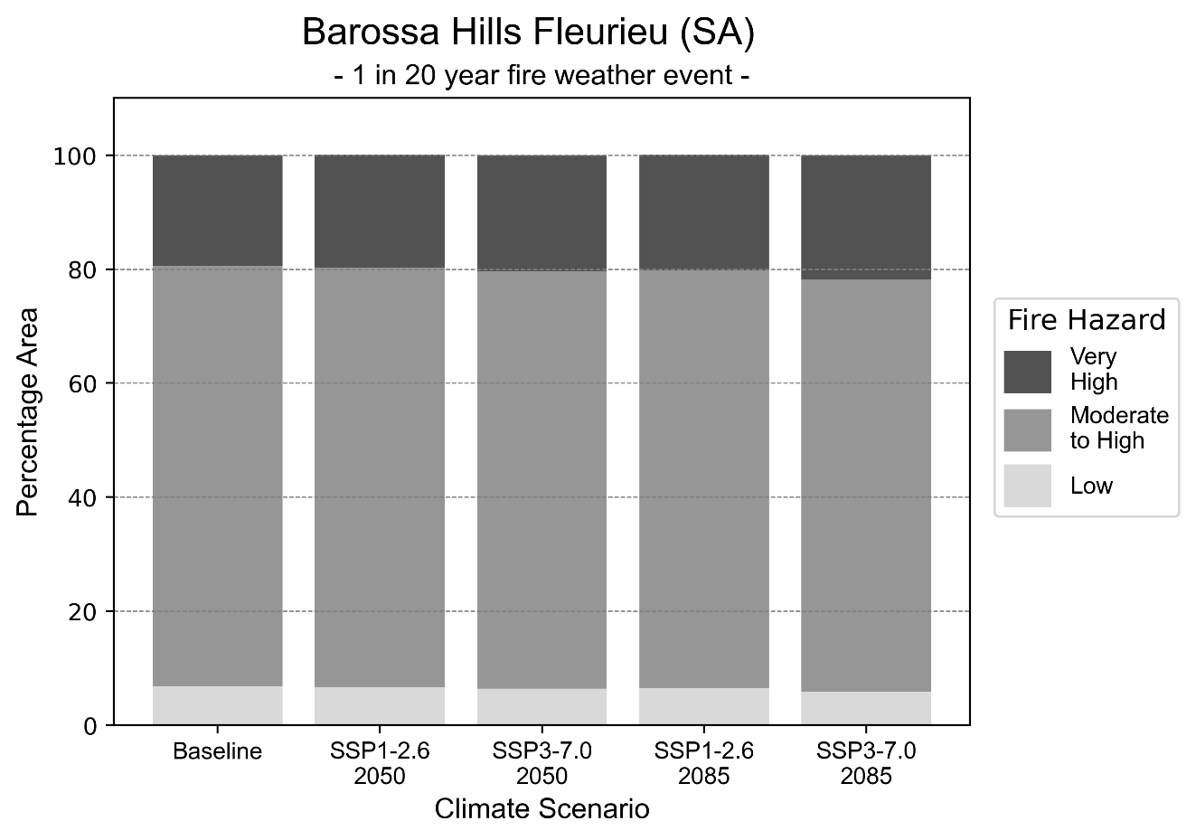
Figure 6: Stacked column chart showing the percentages of Barossa Hills Fleurieu health district's total geographic area experiencing each fire hazard level during a 1-in-20-year fire weather event.
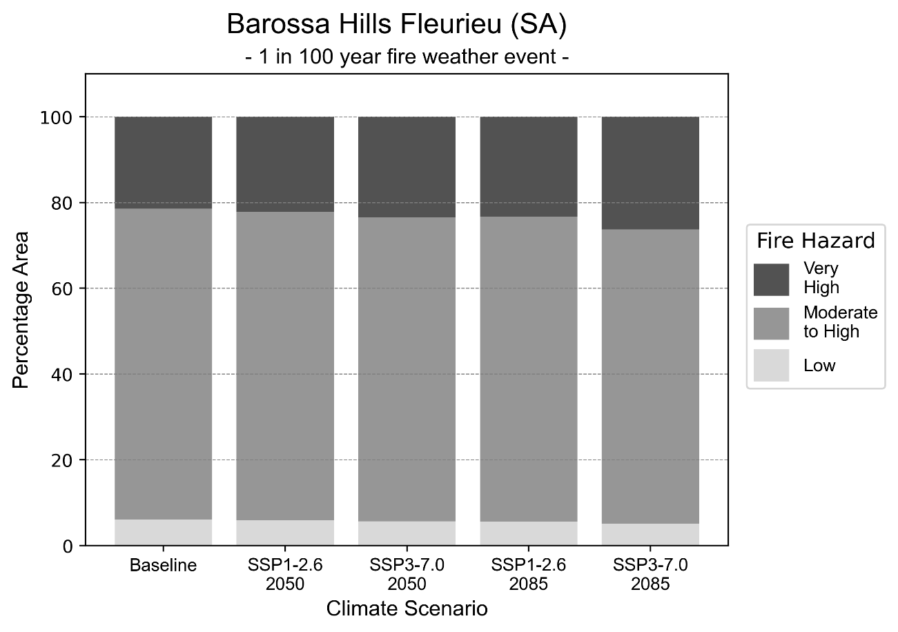
Figure 7: Stacked column chart showing the percentages of Barossa Hills Fleurieu health district's total geographic area experiencing each fire hazard level during a 1-in-100-year fire weather event.

Drought hazard
Key projections:
Drought occurrence: The occurrence of drought will increase across both middle of the road and reasonable worst-case scenarios and both time horizons, with the largest increase occurring under the reasonable worst-case scenario by 2085.

 | Baseline | 2050 Scenarios |  | 2085 Scenarios
 |  | Middle of the road | Reasonable worst-case | Middle of the road | Reasonable worst-case
No. months per year in drought⁽¹⁾ | 1.7 | 3.1  [1.7, 4.3] | 3.3  [1.5, 6.2] | 4.0  [1.7, 6.3] | 4.9  [1.6, 9.1]
Table notes: The drought hazard indicator uses climate projections from the CMIP6 Global Climate Models [1]. The primary indicator value reports the median from the nine climate models, with the range reported in square brackets.
Table footnotes:(a) The number of months per year in drought is based on the Standardised Precipitation Index (SPI). SPI is a widely used index to characterise meteorological drought on a range of timescales. This indicator uses the timescale of 12 months which calculates the average months in a year within the moderate drought range. A moderate drought range is classified as SPI score of ≤ -1. SPI is calculated from accumulated rainfall over 12 months and the mean and standard deviation from historical rainfall records.

Storm hazard
Key projections:
Less frequent high and very-high-intensity storms: The frequency of high and very-high-intensity storms will decrease across both middle of the road and reasonable worst-case scenarios with the greatest decrease occurring by 2085.

 | Baseline | 2050 Scenarios |  | 2085 Scenarios
 |  | Middle of the road | Reasonable worst-case | Middle of the road | Reasonable worst-case
Number of low-intensity storms (40-62 km/hr) per year | 72.9 | 69.5  [61.1, 76.4] | 68.8  [60.5, 75.6] | 67.7  [59.6, 74.5] | 67.6  [59.5, 74.3]
Number of medium-intensity storms (63-87 km/hr) per year | 69.5 | 66.6  [58.6, 73.3] | 64.1  [56.4, 70.5] | 61.0  [53.7, 67.1] | 59.4  [52.3, 65.3]
Number of high-intensity storms (88-117 km/hr) per year | 32.8 | 30.9  [27.2, 34.0] | 28.4  [25.0, 31.2] | 26.8  [23.6, 29.5] | 24.5  [21.6, 27.0]
Number of very-high-intensity storm (> 117 km/hr) per year | 7.9 | 7.4  [6.5, 8.2] | 5.4  [4.8, 5.9] | 7.3  [6.4, 8.0] | 5.9  [5.2, 6.5]
Table notes: The storm hazard uses climate projections from the CMIP6 Global Climate Models [1]. Daily maximum surface wind speed is used to calculate the number of annual storms across four storm intensity categories (low, medium, high and very high). The primary indicator value reports the median from the nine climate models, with the range reported in square brackets.

Rainfall and flood hazard
Key projections:
- Four extreme rainfall days per year: The number of extreme rainfall days will decrease slightly across both middle of the road and reasonable worst-case scenarios and both time horizons, with an average of approximately nine extreme rainfall days per year.
- Increased flood frequency: The frequency of flood events will increase in urban environments but decrease in rural environments. The largest increase in flood frequency is seen in the reasonable worst-case scenario where frequency of a ‘1-in-100 year’ flood will more than triple by 2050 and become ten times more likely by 2085 in urban environments.

 | Baseline | 2050 Scenarios |  | 2085 Scenarios
 |  | Middle of the road | Reasonable worst-case | Middle of the road | Reasonable worst-case
Rainfall hazard^{(a)}
Average number of extreme rainfall days per year (> 7 mm/day)^{(a)} | 4.2 | 3.9  [3.4,4.8] | 3.9  [3.1,4.5] | 3.7  [3.2,4.4] | 3.7  [2.6,4.8]
Urban flood risk (flooding caused by a 1-hour rainfall event)^{(b)}
Frequency of a ‘1-in-1 year’ flood (rainfall depth of 14 mm)^{(c)} |  | 2.3 events in 1 year | 2.4 events in 1 year | 3.2 events in 1 year | 4.5 events in 1 year
Frequency of a ‘1-in-10 year’ flood (rainfall depth of 24 mm)^{(c)} |  | 3.0 events in 10 years | 3.2 events in 10 years | 4.8 events in 10 years | 7.4 events in 10 years
Frequency of a ‘1-in-100 year’ flood (rainfall depth of 39 mm)^{(c)} |  | 3.3 events in 100 years | 3.5 events in 100 years | 5.3 events in 100 years | 10 events in 100 years
Rural flood risk (flooding caused by a 24-hour rainfall event)^{(b)}
Frequency of a ‘1-in-1 year’ flood (rainfall depth of 50 mm)^{(c)} |  | 0.9 events in 1 year | 0.9 events in 1 year | 0.8 events in 1 year | 0.2 events in 1 year
Frequency of a ‘1-in-10 year’ flood (rainfall depth of 85 mm)^{(c)} |  | 1.1 events in 10 years | 1.1 events in 10 years | 0.5 events in 10 years | 0.2 events in 10 years
Frequency of a ‘1-in-100 year’ flood (rainfall depth of 135 mm)^{(c)} |  | 1.0 events in 100 years | 0.8 events in 100 years | 0.6 events in 100 years | 0.2 events in 100 years
Table notes: The rainfall hazard indicator uses climate projections from the CMIP6 Global Climate Models [1]. The primary indicator value reports the median from the nine climate models, with the range reported in square brackets. The flood hazard indicators use climate change considerations from the Australian Rainfall and Runoff guideline to estimate the climate the climate projections [2].
Table footnotes: (a) Extreme rainfall is defined as rainfall above the 95th percentile of historical average daily rainfall in this health district in the period 1985-2014. The value in mm/day quoted in the indicator name is the 95th percentile of historic average daily rainfall for this health district. (b) See Methodology document for reasons for focusing on a 1-hour flood for urban areas and a 24-hour flood for rural areas. (c) The rainfall depths in mm quoted in the indicator names in this table report 1 in 1-, 10- and 100-year depths for this health district.

Coastal inundation hazard
Key projections:
Greater area inundated: There will be an increase in the area affected by tidal inundation (i.e. area submerged during high tide) and storm surge and tidal inundation (i.e. the area submerged during a storm surge and high tide) across both middle of the road and reasonable worst-case scenarios. In the reasonable worst-case scenario, by 2085 the area inundated during a ‘1-in-1000-year’ event will increase by over 3,000 ha.

 | Baseline | 2050 Scenarios |  | 2085 Scenarios^{(a)}
 |  | Middle of the road | Reasonable worst-case | Middle of the road | Reasonable worst-case
Tidal inundation (ha inundated)^{(b)} | 27,681.3 | 29,935.6  (+2,254.3) | 30,039.0  (+2,357.7) | 32,569.7  (+4,888.4) | 33,234.4  (+5,553.1)
Storm surge + tidal inundation – ‘1-in-100 year’ event (ha inundated)^{(c)} | 35,633.0 | 36,592.5  (+959.5) | 36,639.4  (+1,006.5) | 38,312.2  (+2,679.2) | 38,668.7  (+3,035.7)
Storm surge + tidal inundation – ‘1-in-1000 year’ event (ha inundated)^{(c)} | 36,479.0 | 37,438.6  (+959.6) | 37,477.8  (+998.8) | 39,405.9  (+2,926.9) | 39,771.5  (+3,292.5)
Table notes: The coastal inundation hazard provides an indication of flooding in coastal areas that can be attributed to sea level rise and storm inundation. The coastal inundation hazard is only reported for health districts adjoining the coastline. This table includes the projected inundation levels as well as the change from baseline conditions (in brackets).
Table footnotes: (a) For the 2085 Scenarios planning horizon, 2100 was adopted as it provides a conservative representation of the end of this period. This horizon aligns with many State planning regulations requiring consideration of sea level rise and storm tide to 2100, making the 2100 scenario particularly valuable for planning new health facilities in coastal areas. (b) The tidal inundation indicator reports the number of hectares inundated during high tide. The baseline value reports existing inundation patterns, while the 2050 and 2085 values report high tide inundation taking account of projected sea level rise due to climate change. (c) The storm surge + tidal inundation indicators report the combined effect, in hectares inundated, of high tide, sea level rise (for the 2050 and 2085 projections), and storm surge (for 1-in-100 year and 1-in-1000 year events).

Eyre and Far North health district

Health district overview
The Eyre and Far North health district consists of the Eyre Peninsula and the Far North of South Australia and covers 337,626 square kilometres, making it one of the largest health districts in Australia (Figure 8). It takes in the Eyre Peninsula, the western part of South Australia, and north to Coober Pedy.

The Eyre and Far North health district services a resident population of just over 40,000 including hospital, community, in-home and residential aged care, early childhood and disability support, and community-based mental health services. The health district includes 11 public hospitals:
Ceduna  Cleve  Cowell | Coober Pedy  Cummins  Elliston | Kimba  Port Lincoln  Streaky Bay | Tumby Bay  Wudinna.

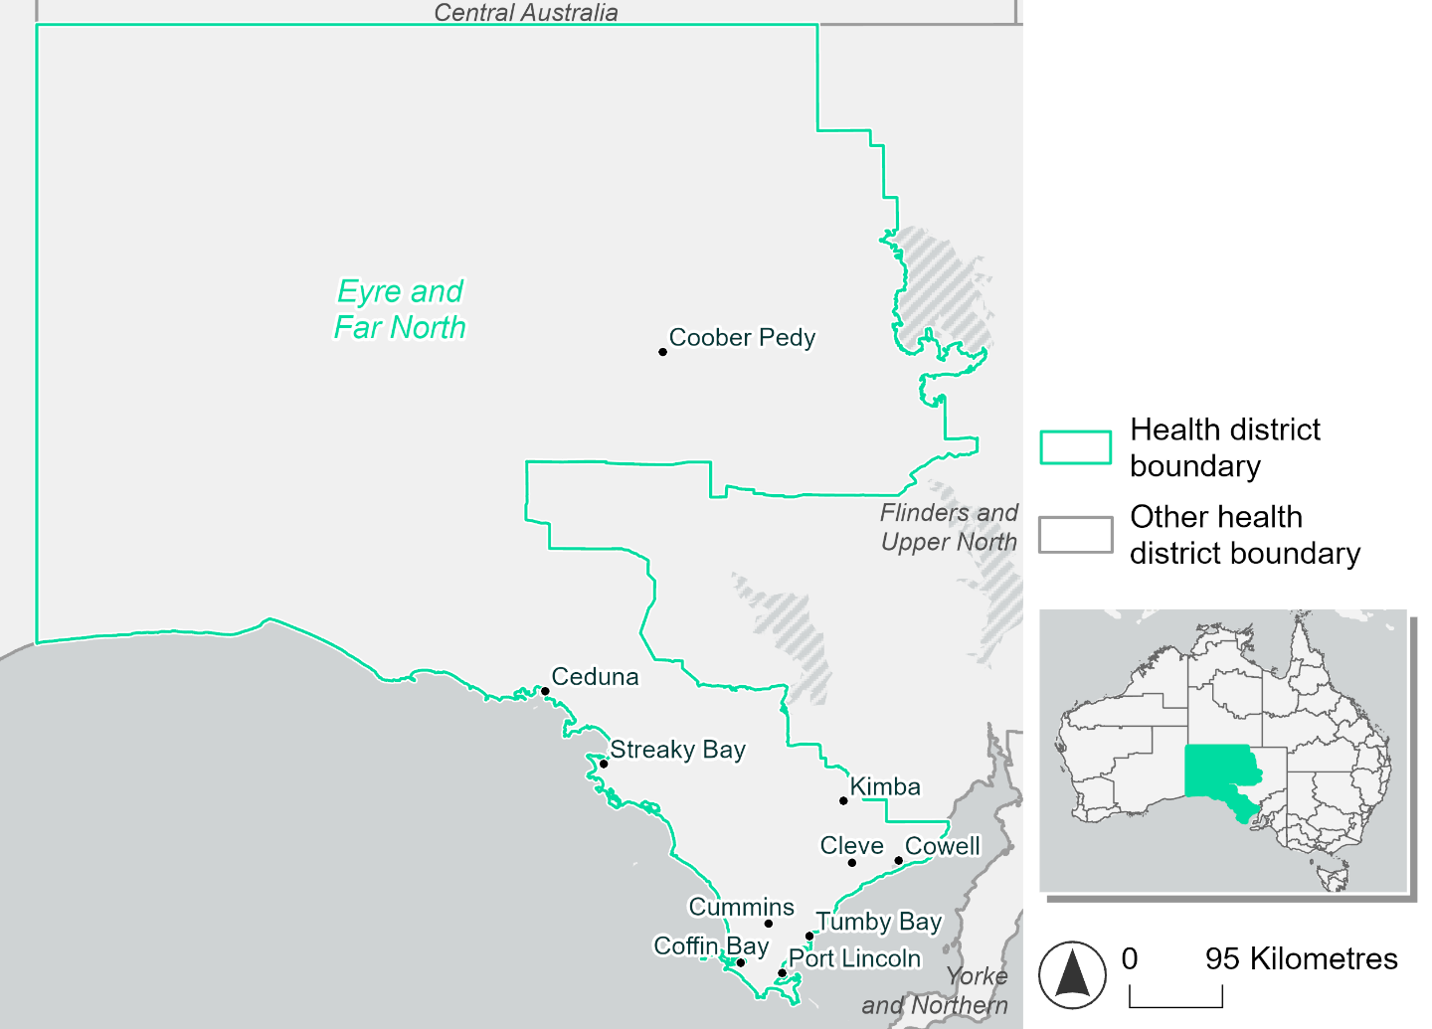
Figure 8. Map of Eyre and Far North health district.

How will climate change affect this health district?
Heat and humidity: Higher average temperatures, hotter and more frequent hot days, warmer night time temperatures and more frequent heatwaves.
Fire: Over 20% of this health district experiences very high fire hazard category and this will increase slightly in the future.
Drought: Number of months experiencing drought will increase.
Rainfall and flood: More flood events in urban areas.
Coastal inundation: Increased area flooded during tidal and storm surge and tidal inundation.

Eyre and Far North health district demographic data
Demographic Data | Total
Number of households | 15,067
Persons 15 and older | 27,947
Total families | 10,290
Persons did not complete high school | 14,364
One parent families with dependents | 1,043 (10.1%)
Persons aged 65 and older | 8,693 (20.9%)
Persons aged 4 and younger | 2,394 (5.7%)
Aboriginal and Torres Strait Islander persons | 5,013 (12%)
Persons speaks language other than English | 3,945 (9.5%)
Persons working age (15-65) | 25,175 (60.4%)
Population Health Data | Total
Persons with core needs for assistance | 2,109 (5.1%)
Persons with arthritis | 3,550 (8.5%)
Persons with asthma | 3,386 (8.1%)
Persons with cancer | 1,210 (2.9%)
Persons with dementia | 337 (0.8%)
Persons with diabetes | 2,405 (5.8%)
Persons with heart disease | 1,814 (4.4%)
Persons with kidney disease | 311 (0.7%)
Persons with lung condition | 829 (2%)
Persons with mental health condition | 2,903 (7%)
Persons with stroke | 345 (0.8%)
Persons with any other condition | 2,603 (6.2%)
Persons no health condition | 24,319 (58.3%)
Socio-economic Data | Total
Persons providing unpaid care | 5,144 (12.3%)
Persons homeless | 554 (1.3%)
Household with lone person | 4,672 (31%)
Households with rent and mortgage stress | 4,620 (30.7%)
Households total equivalised income below $1000 (weekly) | 7,812 (51.8%)
Households with no motor vehicle | 1,026 (6.8%)
Persons unemployed | 1,795 (5.5%)

The sections that follow outline projected climate hazards for this district. Further information on this health district, including population demographics, is provide in the online dashboard.

Heat and humidity hazard
Key projections:
More heatwaves: The number of heatwave events per year will increase. By 2050, under a reasonable worst-case scenario the number of heatwaves will increase from two events per year to three. By 2085, under a reasonable worst-case scenario the number of heatwaves per year will more than double.
Hotter days and warmer nights: The maximum temperature on hot days will increase with night time temperatures on hot nights also increasing.
More days above 35°C and 40°C: The number of days per year greater than 35°C and 40°C will increase under both middle of the road and reasonable worst-case scenarios for both time horizons.

 | Baseline | 2050 Scenarios |  | 2085 Scenarios
 |  | Middle of the road | Reasonable worst-case | Middle of the road | Reasonable worst-case
Average temperature (°C) | 17.6 | 18.7  [18.2, 19.1] | 18.9  [18.2, 19.6] | 19.5  [18.6, 20.2] | 20.3  [19, 21.3]
Maximum temperature on hot days (°C)^{(a)} | 36.6 | 38  [37.6, 38.5] | 38.2  [37.4, 39.2] | 38.8  [38.1, 39.7] | 39.7  [38.7, 40.7]
Minimum temperature on hot nights (°C)^{(b)} | 19.9 | 21.2  [20.3, 21.6] | 21.4  [20.6, 22] | 21.9  [20.7, 22.6] | 22.8  [21.5, 23.7]
Average apparent temperature on hot days (°C) (NOAA Heat Index)^{(c)} | 36 | 37  [36.6, 37.6] | 37.2  [36.6, 37.7] | 37.5  [37, 38.2] | 38.2  [37.4, 38.9]
Average heatwave duration in days^{(d)} | 5 | 5  [5, 5] | 5  [5, 5] | 5  [5, 5] | 5  [5, 6]
Number of heatwaves per year^{(d)} | 2 | 3  [2, 4] | 3  [2, 4] | 4  [3, 5] | 5  [4, 7]
Number of days per year  > 35°C | 32 | 43  [40, 46] | 45  [40, 52] | 50  [44, 57] | 57  [49, 66]
Number of days per year > 40°C | 7 | 13  [12, 16] | 14  [11, 19] | 18  [14, 23] | 23  [18, 30]
Table notes: The heat and humidity hazard uses climate projections from the CMIP6 Global Climate Models [1]. Daily projections of maximum and minimum near-surface temperature and mean relative humidity are used to calculate eight heat and humidity indicators. The primary indicator value reports the median from the nine climate models, with the range reported in square brackets.
Table footnotes: (a) Based on the 95th percentile of daily maximum air temperature. (b) Based on the 95th percentile of daily minimum air temperature, representing the coldest part of the night on very hot nights. (c) The National Oceanic and Atmospheric Administration (NOAA) Heat Index is a measure of how hot it feels when relative humidity is factored in alongside actual air temperature. It is calculated on days with a maximum temperature of 27°C and above. Interpretation of Heat Index values: 27°C to 32°C indicates caution, 33°C to 41°C indicates extreme caution, 42°C to 54°C indicates danger and over 54°C indicates extreme danger. See methodology document for further explanation of Heat Index categories. (d) A heatwave is defined as three or more consecutive days where both daytime and overnight temperatures (daily mean temperatures) are unusually high for the location, based on the Bureau of Meteorology’s Excess Heat Factor method. For this district, an unusually high daily mean temperature is approximately 27.9°C or above.

Fire hazard
Key projections:
Fire hazard evenly spread currently: Under baseline conditions for a 1-in-20-year fire weather event, 32.3% of the district area experiences low fire hazard, 46.1% experiences moderate to high hazard, while the remaining 21.6% experiences very high fire hazard. During a 1-in-100-year event, the area experiencing low hazard reduces to 31.2% of the district and there is an increase of 2.2 percentage points to 23.8% of the district experiencing very high fire hazard during this more severe event.
Current fire hazard conditions to persist: In a future climate across both 2050 and 2085 scenarios overall hazard levels remain fairly similar to baseline, with changes of no more than 1.6 percentage points in hazard level areas across both the 1-in-20-year and 1-in-100-year fire weather events.

 | Baseline | 2050 Scenarios |  | 2085 Scenarios
 |  | Sustainability | Reasonable worst-case | Sustainability | Reasonable worst-case
Hazard for a ‘1-in-20 year’ fire weather event^{(a)}
Proportion (%) of district experiencing ‘Low’ fire hazard | 32.3%  (16,052,90)^{(b)} | 32.1%  [31.8%, 32.4%] | 31.8%  [31.6%, 32.0%] | 31.7%  [31.2%, 32.5%] | 31.0%  [30.5%, 31.5%]
Proportion (%) of district experiencing ‘Moderate to High’ fire hazard | 46.1%  (22,911,34)^{(b)} | 46.3%  [45.9%, 46.8%] | 46.7%  [45.9%, 47.8%] | 46.6%  [45.7%, 47.7%] | 47.4%  [45.7%, 50.1%]
Proportion (%) of district experiencing ‘Very High’ fire hazard | 21.6%  (10,715,05)^{(b)} | 21.6%  [21.2%, 22.0%] | 21.6%  [21.3%, 21.8%] | 21.7%  [20.6%, 22.7%] | 21.6%  [20.9%, 22.1%]
Hazard for a ‘1-in-100 year’ fire weather event^{(a)}
Proportion (%) of district experiencing ‘Low’ fire hazard | 31.2%  (15,501,95)^{(b)} | 30.9%  [30.6%, 31.3%] | 30.5%  [30.3%, 30.8%] | 30.5%  [29.7%, 31.4%] | 29.6%  [29.0%, 30.2%]
Proportion (%) of district experiencing ‘Moderate to High’ fire hazard | 45.0%  (22,332,01)^{(b)} | 45.1%  [44.5%, 45.5%] | 45.5%  [44.8%, 46.7%] | 45.2%  [43.9%, 46.3%] | 46.3%  [44.7%, 49.1%]
Proportion (%) of district experiencing ‘Very High’ fire hazard | 23.8%  (11,845,33)^{(b)} | 24.0%  [23.3%, 24.9%] | 24.0%  [23.5%, 24.5%] | 24.3%  [22.6%, 26.4%] | 24.1%  [22.9%, 25.3%]
Table notes: The Fire Hazard uses the National Bushfire Intelligence Capability (NBIC) Phase 2 fire line intensity modelling based on CMIP6 climate projections. Fire Hazard is assessed using the projected Fireline Intensity (FLI) for weather events with two different return intervals (i.e. a 1-in-20 year event and a 1-in-100 year event). FLI considers slope, vegetation and weather to produce a rate of heat output per unit length (kW/m) along a bushfire’s front. Fire hazard is categorized as a low for FLI<4000 kW/m, moderate to high for 4,000 kW/m ≤FLI<12,500kW/m, and very high for FLI≥27,501kW/m. This is broadly consistent with the literature [3]. The assessment considers climate change effects based on changes in fire weather and the associated hazard that is anticipated for a meteorological event of a given return interval. This approach is different to the one adopted for the Flood Hazard, where the event magnitude is given (fixed) and the likelihood of that event varies as a result of climate change. The primary indicator value reports the median from the nine climate models, with the range reported in square brackets.
Table footnotes: (a) The area subject to different categories of fire hazard is determined for a ‘1-in-20 year’ and ‘1-in-100 year’ fire weather event, in current and future climates. Values at year 2050 are interpolated using data from baseline (2025) and 2085, assuming linear change over time. (b) Values in round brackets are the area (ha) of the health district subject to a given fire hazard.

The figures below show the proportion of the health district experiencing different fire hazard categories across different time horizons and climate scenarios during a ‘1-in-20 year’ fire weather event (Figure 9) and a ‘1-in-100 year’ fire weather event (Figure 10).
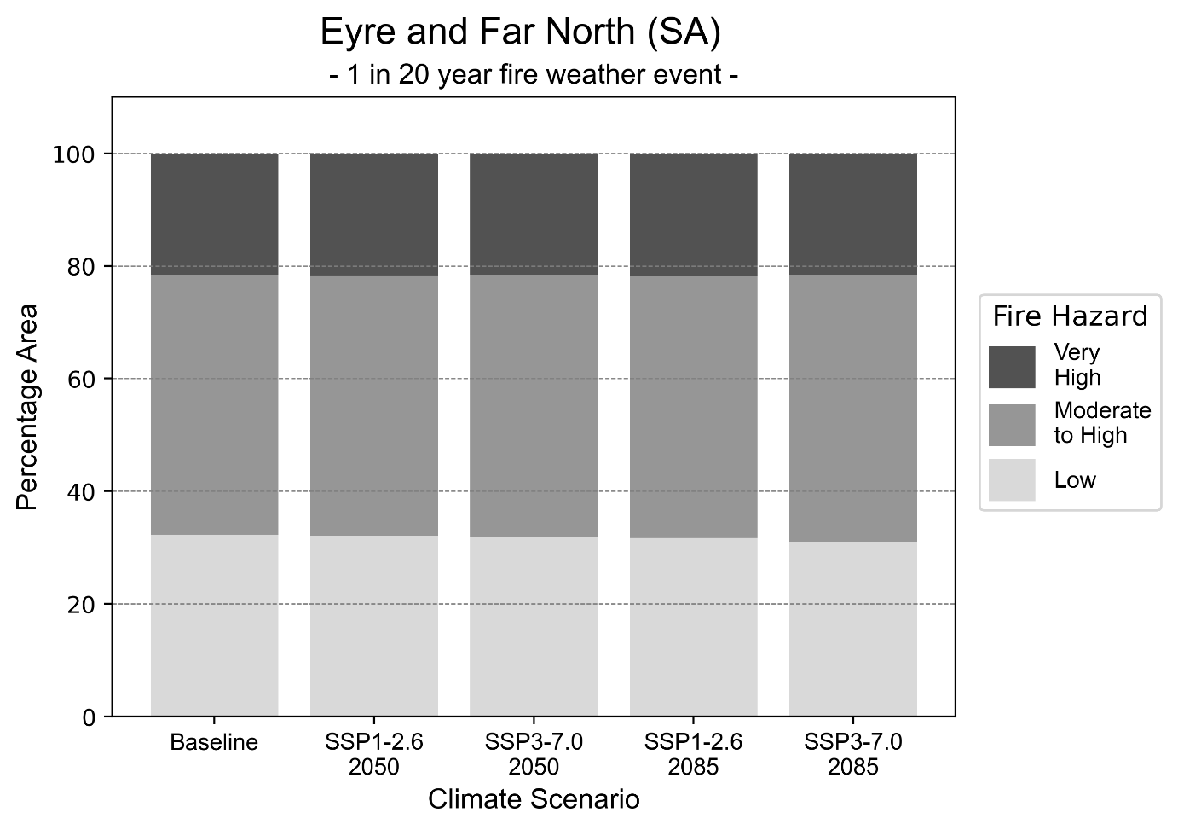
Figure 9: Stacked column chart showing percentages of Eyre and Far North health district's total geographic area experiencing each fire hazard level during a 1-in-20-year fire weather event.
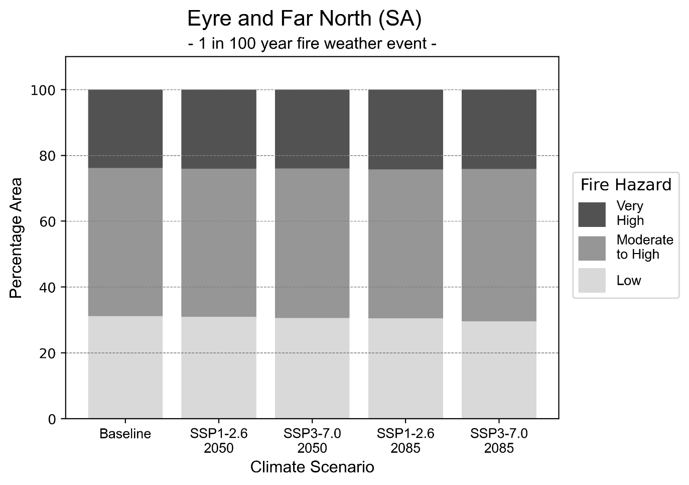
Figure 10: Stacked column chart showing percentages of Eyre and Far North health district's total geographic area experiencing each fire hazard level during a 1-in-100-year fire weather event.

Drought hazard
Key projections:
Drought occurrence: The occurrence of drought will increase across both middle of the road and reasonable worst-case scenarios and both time horizons, with the largest increase occurring under the reasonable worst-case scenario by 2085.

 | Baseline | 2050 Scenarios |  | 2085 Scenarios
 |  | Middle of the road | Reasonable worst-case | Middle of the road | Reasonable worst-case
Number of months per year in drought^{(a)} | 1.6 | 2.5  [0.9, 4.6] | 2.2  [0.5, 5.0] | 2.7  [0.5, 5.1] | 3.1  [0.2, 7.4]
Table notes: The drought hazard indicator uses climate projections from the CMIP6 Global Climate Models [1]. The primary indicator value reports the median from the nine climate models, with the range reported in square brackets.
Table footnotes: (a) The number of months per year in drought is based on the Standardised Precipitation Index (SPI). SPI is a widely used index to characterise meteorological drought on a range of timescales. This indicator uses the timescale of 12 months which calculates the average months in a year within the moderate drought range. A moderate drought range is classified as SPI score of ≤ -1. SPI is calculated from accumulated rainfall over 12 months and the mean and standard deviation from historical rainfall records.

Storm hazard
Key projections:
Less frequent low-intensity storms: The frequency of low-intensity storms will decrease across both middle of the road and reasonable worst-case scenarios and both time horizons. High and very-high-intensity storms will increase under the middle of the road scenario by 2050, but decrease across all other scenarios and horizons.

 | Baseline | 2050 Scenarios |  | 2085 Scenarios
 |  | Middle of the road | Reasonable worst-case | Middle of the road | Reasonable worst-case
Number of low-intensity storms (40-62 km/hr) per year | 73.0 | 70.8  [62.3, 77.8] | 72.6  [63.9, 79.9] | 69.3  [61.0, 76.2] | 70.4  [61.9, 77.4]
Number of medium-intensity storms (63-87 km/hr) per year | 46.2 | 46.4  [40.8, 51.0] | 45.2  [39.8, 49.7] | 41.1  [36.2, 45.2] | 42.6  [37.5, 46.9]
Number of high-intensity storms (88-17 km/hr) per year | 48.9 | 50.4  [44.4, 55.4] | 46.6  [41.0, 51.3] | 46.7  [41.1, 51.4] | 43.5  [38.3, 47.9]
Number of very-high-intensity storm> 117 km/hr) per year | 15.4 | 17.0  [15.0, 18.7] | 13.7  [12.1, 15.1] | 13.9  [12.2, 15.3] | 12.5  [11.0, 13.8]
Table notes: The storm hazard uses climate projections from the CMIP6 Global Climate Models [1]. Daily maximum surface wind speed is used to calculate the number of annual storms across four storm intensity categories (low, medium, high and very high). The primary indicator value reports the median from the nine climate models, with the range reported in square brackets.

Rainfall and flood hazard
Key projections:
- Ten extreme rainfall days per year: The number of extreme rainfall days will decline slightly across both middle of the road and reasonable worst-case scenarios and both time horizons, with an average of approximately ten extreme rainfall days per year.
- Increased flood frequency: The frequency of flood events will increase in urban environments. The largest increase in flood frequency is seen in the reasonable worst-case scenario where frequency of a ‘1-in-100 year’ flood will more than double by 2050 and become nearly six times more likely by 2085 in urban environments. Flood events in rural areas will remain consistent across 2050 scenarios but will reduce across 2085 scenarios, particularly the reasonable worst-case scenario.

 | Baseline | 2050 Scenarios |  | 2085 Scenarios
 |  | Middle of the road | Reasonable worst-case | Middle of the road | Reasonable worst-case
Rainfall hazard^{(a)}
Average number of extreme rainfall days per year (> 4 mm/day)^{(a)} | 10.7 | 10.3  [7.6,12.9] | 10.6  [7.8,14.1] | 10.0  [7.7,13.3] | 10.1  [6.5,16.6]
Urban flood risk (flooding caused by a 1-hour rainfall event)^{(b)}
Frequency of a ‘1-in-1 year’ flood (rainfall depth of 10 mm)^{(c)} |  | 1.6 events in 1 year | 1.7 events in 1 year | 2.0 events in 1 year | 2.5 events in 1 year
Frequency of a ‘1-in-10 year’ flood (rainfall depth of 25 mm)^{(c)} |  | 2.1 events in 10 years | 2.1 events in 10 years | 2.6 events in 10 years | 3.6 events in 10 years
Frequency of a ‘1-in-100 year’ flood (rainfall depth of 48 mm)^{(c)} |  | 2.6 events in 100 years | 2.7 events in 100 years | 3.7 events in 100 years | 5.9 events in 100 years
Rural flood risk (flooding caused by a 24-hour rainfall event) ^{(b)}
Frequency of a ‘1-in-1 year’ flood (rainfall depth of 25 mm)^{(c)} |  | 1.0 events in 1 year | 0.9 events in 1 year | 1.0 events in 1 year | 0.4 events in 1 year
Frequency of a ‘1-in-10 year’ flood (rainfall depth of 63 mm)^{(c)} |  | 1.0 events in 10 years | 0.8 events in 10 years | 0.9 events in 10 years | 0.4 events in 10 years
Frequency of a ‘1-in-100 year’ flood (rainfall depth of 125 mm)^{(c)} |  | 1.0 events in 100 years | 1.0 events in 100 years | 0.7 events in 100 years | 0.3 events in 100 years
Table notes: The rainfall hazard indicator uses climate projections from the CMIP6 Global Climate Models [1]. The primary indicator value reports the median from the nine climate models, with the range reported in square brackets. The flood hazard indicators use climate change considerations from the Australian Rainfall and Runoff guideline to estimate the climate the climate projections [2].
Table footnotes: (a) Extreme rainfall is defined as rainfall above the 95th percentile of historical average daily rainfall in this health district in the period 1985-2014. The value in mm/day quoted in the indicator name is the 95th percentile of historic average daily rainfall for this health district. (b) See Methodology document for reasons for focusing on a 1-hour flood for urban areas and a 24-hour flood for rural areas. (c) The rainfall depths in mm quoted in the indicator names in this table report 1 in 1-, 10- and 100-year depths for this health district.

Coastal inundation hazard
Key projections:
Greater area inundated: There will be an increase in the area affected by tidal inundation (i.e. area submerged during high tide) and storm surge and tidal inundation (i.e. the area submerged during a storm surge and high tide) across both middle of the road and reasonable worst-case scenarios. In the reasonable worst-case scenario, by 2085 the area inundated during a ‘1-in-1000-year’ event will increase by over 13,000 ha.

 | Baseline | 2050 Scenarios |  | 2085 Scenarios^{(a)}
 |  | Middle of the road | Reasonable worst-case | Middle of the road | Reasonable worst-case
Tidal inundation (ha inundated)^{(b)} | 28,733.5 | 31,735.3  (+3,001.8) | 31,967.7  (+3,234.2) | 38,103.0  (+9,369.5) | 40,393.7  (+11,660.2)
Storm surge + tidal inundation – ‘1-in-100 year’ event (ha inundated)^{(c)} | 46,826.0 | 50,442.5  (+3,616.5) | 50,674.0  (+3,848.0) | 56,446.6  (+9,620.6) | 58,546.7  (+11,720.8)
Storm surge + tidal inundation – ‘1-in-1000 year’ event (ha inundated)^{(c)} | 49,323.2 | 52,554.8  (+3,231.5) | 52,791.8  (+3,468.6) | 60,522.7  (+11,199.4) | 62,756.5  (+13,433.2)
Table notes: The coastal inundation hazard provides an indication of flooding in coastal areas that can be attributed to sea level rise and storm inundation. The coastal inundation hazard is only reported for health districts adjoining the coastline. This table includes the projected inundation levels as well as the change from baseline conditions (in brackets).
Table footnotes: (a) For the 2085 Scenarios planning horizon, 2100 was adopted as it provides a conservative representation of the end of this period. This horizon aligns with many State planning regulations requiring consideration of sea level rise and storm tide to 2100, making the 2100 scenario particularly valuable for planning new health facilities in coastal areas. (b) The tidal inundation indicator reports the number of hectares inundated during high tide. The baseline value reports existing inundation patterns, while the 2050 and 2085 values report high tide inundation taking account of projected sea level rise due to climate change. (c) The storm surge + tidal inundation indicators report the combined effect, in hectares inundated, of high tide, sea level rise (for the 2050 and 2085 projections), and storm surge (for 1-in-100 year and 1-in-1000 year events).

Flinders and Upper North health district

Health district overview
The Flinders and Upper North Local Health Network covers 330,425 square kilometres and contains eight hospitals and health services:
Hawker Memorial Hospital
Leigh Creek Health Service
Port Augusta Hospital and Regional Health Service
Community Health Service of Flinders and Upper North Local Health Network
Quorn Health Service
Roxby Downs Hospital
Whyalla Hospital and Health Service.

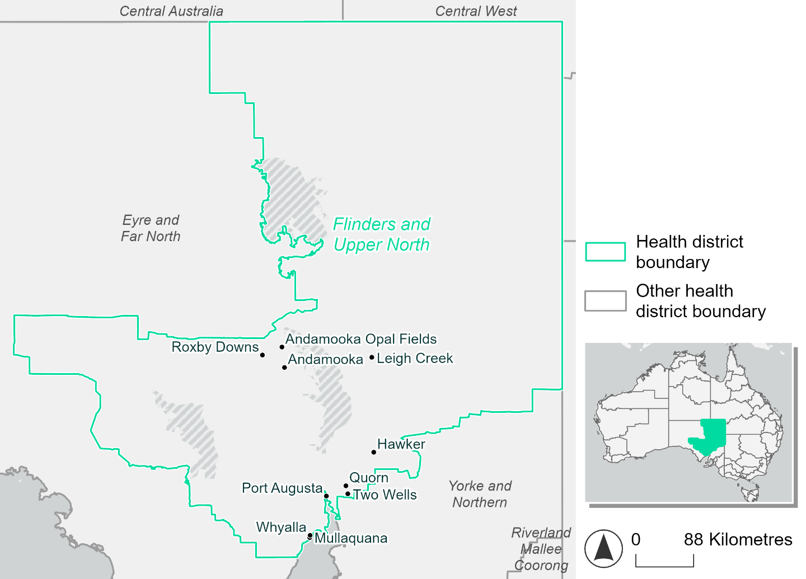
Figure 11. Map of Flinders and Upper North health district

How will climate change affect this health district?
Heat and humidity: Higher average temperatures, hotter and more frequent hot days, warmer night time temperatures and more frequent heatwaves.
Fire: Over 15% of this health district experiences very high fire hazard category and this will continue in the future.
Drought: Number of months experiencing drought will increase.
Rainfall and flood: More flood events in urban areas.
Coastal inundation: Increased area flooded during tidal and storm surge and tidal inundation.

Flinders and Upper North health district demographic data
Demographic Data | Total
Number of households | 16,532
Persons 15 and older | 30,301
Total families | 10,457
Persons did not complete high school | 15,705
One parent families with dependents | 1,437 (13.7%)
Persons aged 65 and older | 7,426 (17%)
Persons aged 4 and younger | 2,531 (5.8%)
Aboriginal and Torres Strait Islander persons | 4,630 (10.6%)
Persons speaks language other than English | 2,874 (6.6%)
Persons working age (15-65) | 28,095 (64.4%)
Population Health Data | Total
Persons with core needs for assistance | 2,753 (6.3%)
Persons with arthritis | 4,594 (10.5%)
Persons with asthma | 4,548 (10.4%)
Persons with cancer | 1,299 (3%)
Persons with dementia | 384 (0.9%)
Persons with diabetes | 3,161 (7.2%)
Persons with heart disease | 1,985 (4.5%)
Persons with kidney disease | 522 (1.2%)
Persons with lung condition | 1,130 (2.6%)
Persons with mental health condition | 4,043 (9.3%)
Persons with stroke | 452 (1%)
Persons with any other condition | 3,403 (7.8%)
Persons no health condition | 23,258 (53.3%)
Socio-economic Data | Total
Persons providing unpaid care | 5,105 (11.7%)
Persons homeless | 306 (0.7%)
Household with lone person | 5,760 (34.8%)
Households with rent and mortgage stress | 4,626 (28%)
Households total equivalised income below $1000 (weekly) | 8,221 (49.7%)
Households with no motor vehicle | 1,692 (10.2%)
Persons unemployed | 2,215 (6.4%)

The sections that follow outline projected climate hazards for this district. Further information on this health district, including population demographics, is provide in the online dashboard.

Heat and humidity hazard
Key projections:
More heatwaves: The number of heatwave events per year will increase. By 2050, under a reasonable worst-case scenario the number of heatwaves will more than double. By 2085, under a reasonable worst-case scenario the number of heatwaves per year will more than triple.
Hotter days and warmer nights: The maximum temperature on hot days will increase with night time temperatures on hot nights also increasing.
More days above 35°C and 40°C: The number of days per year greater than 35°C and 40°C will increase under both middle of the road and reasonable worst-case scenarios.

 | Baseline | 2050 Scenarios |  | 2085 Scenarios
 |  | Middle of the road | Reasonable worst-case | Middle of the road | Reasonable worst-case
Average temperature (°C) | 18.2 | 19.5  [19, 19.9] | 19.7  [19, 20.4] | 20.4  [19.5, 21.1] | 21.3  [20, 22.5]
Maximum temperature on hot days (°C)^{(a)} | 38 | 39.7  [39.1, 40.4] | 40  [39, 41.3] | 40.7  [39.9, 42] | 41.8  [40.9, 43.3]
Minimum temperature on hot nights (°C)^{(b)} | 20.8 | 22.4  [21.5, 22.9] | 22.6  [21.5, 23] | 23.3  [22.2, 24.2] | 24.3  [22.9, 25.4]
Average apparent temperature on hot days (°C) (NOAA Heat Index)^{(c)} | 35.5 | 36.6  [35.9, 37.4] | 36.7  [36.2, 37.3] | 37.1  [36.2, 38.1] | 37.8  [36.5, 39]
Average heatwave duration in days^{(d)} | 5 | 5  [5, 5] | 5  [5, 6] | 5  [5, 6] | 6  [5, 6]
Number of heatwaves per year^{(d)} | 2 | 3  [3, 4] | 4  [2, 5] | 5  [3, 7] | 7  [4, 9]
Number of days per year  > 35°C | 39 | 53  [47, 59] | 56  [49, 67] | 63  [55, 74] | 74  [63, 90]
Number of days per year > 40°C | 10 | 18  [15, 21] | 20  [14, 27] | 24  [18, 32] | 31  [25, 42]
Table notes: The heat and humidity hazard uses climate projections from the CMIP6 Global Climate Models [1]. Daily projections of maximum and minimum near-surface temperature and mean relative humidity are used to calculate eight heat and humidity indicators. The primary indicator value reports the median from the nine climate models, with the range reported in square brackets.
Table footnotes: (a) Based on the 95th percentile of daily maximum air temperature. (b) Based on the 95th percentile of daily minimum air temperature, representing the coldest part of the night on very hot nights. (c) The National Oceanic and Atmospheric Administration (NOAA) Heat Index is a measure of how hot it feels when relative humidity is factored in alongside actual air temperature. It is calculated on days with a maximum temperature of 27°C and above. Interpretation of Heat Index values: 27°C to 32°C indicates caution, 33°C to 41°C indicates extreme caution, 42°C to 54°C indicates danger and over 54°C indicates extreme danger. See methodology document for further explanation of Heat Index categories. (d) A heatwave is defined as three or more consecutive days where both daytime and overnight temperatures (daily mean temperatures) are unusually high for the location, based on the Bureau of Meteorology’s Excess Heat Factor method. For this district, an unusually high daily mean temperature is approximately 28.9°C or above.

Fire hazard
Key projections:
Fire hazard evenly spread currently: Under baseline conditions, about half (50-51%) of the district experiences low fire hazard in both the 1-in-20-year and 1-in-100-year fire weather events. 15.2% of the district experiences very high fire hazard during a 1-in-20-year event, increasing to 16.8% during the more severe 1-in-100-year event. About a third (32-33%) experiences moderate to high hazard under both event types.
Current fire hazard conditions to persist: In a future climate across both 2050 and 2085 scenarios, fire hazard levels are expected to remain similar to their baseline levels. For both the 1-in-20-year and 1-in-100-year fire weather events, the proportions of the district experiencing each hazard level change by no more than 0.8 percentage points.

 | Baseline | 2050 Scenarios |  | 2085 Scenarios
 |  | Sustainability | Reasonable worst-case | Sustainability | Reasonable worst-case
Hazard for a ‘1-in-20 year’ fire weather event^{(a)}
Proportion (%) of district experiencing ‘Low’ fire hazard | 51.2%  (16,924,19)^{(b)} | 51.1%  [51.0%, 51.3%] | 51.0%  [50.9%, 51.4%] | 50.9%  [50.6%, 51.3%] | 50.8%  [50.4%, 51.6%]
Proportion (%) of district experiencing ‘Moderate to High’ fire hazard | 33.6%  (11,095,88)^{(b)} | 33.7%  [32.8%, 34.5%] | 33.8%  [33.0%, 34.5%] | 33.8%  [31.8%, 35.8%] | 34.2%  [32.2%, 35.7%]
Proportion (%) of district experiencing ‘Very High’ fire hazard | 15.2%  (5,022,530)^{(b)} | 15.2%  [15.0%, 15.4%] | 15.2%  [15.0%, 15.2%] | 15.2%  [14.8%, 15.7%] | 15.1%  [14.7%, 15.2%]
Hazard for a ‘1-in-100 year’ fire weather event^{(a)}
Proportion (%) of district experiencing ‘Low’ fire hazard | 50.5%  (16,698,20)^{(b)} | 50.4%  [50.1%, 50.6%] | 50.3%  [50.1%, 50.6%] | 50.1%  [49.4%, 50.7%] | 49.9%  [49.5%, 50.6%]
Proportion (%) of district experiencing ‘Moderate to High’ fire hazard | 32.7%  (10,806,15)^{(b)} | 32.7%  [31.3%, 34.2%] | 33.0%  [32.0%, 34.4%] | 32.8%  [29.4%, 36.3%] | 33.5%  [31.0%, 36.7%]
Proportion (%) of district experiencing ‘Very High’ fire hazard | 16.8%  (5,538,162)^{(b)} | 16.9%  [16.4%, 17.5%] | 16.7%  [16.3%, 16.8%] | 17.1%  [16.0%, 18.5%] | 16.6%  [15.7%, 16.9%]
Table notes: The Fire Hazard uses the National Bushfire Intelligence Capability (NBIC) Phase 2 fire line intensity modelling based on CMIP6 climate projections. Fire Hazard is assessed using the projected Fireline Intensity (FLI) for weather events with two different return intervals (i.e. a 1-in-20 year event and a 1-in-100 year event). FLI considers slope, vegetation and weather to produce a rate of heat output per unit length (kW/m) along a bushfire’s front. Fire hazard is categorized as a low for FLI<4000 kW/m, moderate to high for 4,000 kW/m ≤FLI<12,500kW/m, and very high for FLI≥27,501kW/m. This is broadly consistent with the literature [3]. The assessment considers climate change effects based on changes in fire weather and the associated hazard that is anticipated for a meteorological event of a given return interval. This approach is different to the one adopted for the Flood Hazard, where the event magnitude is given (fixed) and the likelihood of that event varies as a result of climate change. The primary indicator value reports the median from the nine climate models, with the range reported in square brackets.
Table footnotes: (a) The area subject to different categories of fire hazard is determined for a ‘1-in-20 year’ and ‘1-in-100 year’ fire weather event, in current and future climates. Values at year 2050 are interpolated using data from baseline (2025) and 2085, assuming linear change over time. (b) Values in round brackets are the area (ha) of the health district subject to a given fire hazard.

The figures below show the proportion of the health district experiencing different fire hazard categories across different time horizons and climate scenarios during a ‘1-in-20 year’ fire weather event (Figure 12) and a ‘1-in-100 year’ fire weather event (Figure 13).
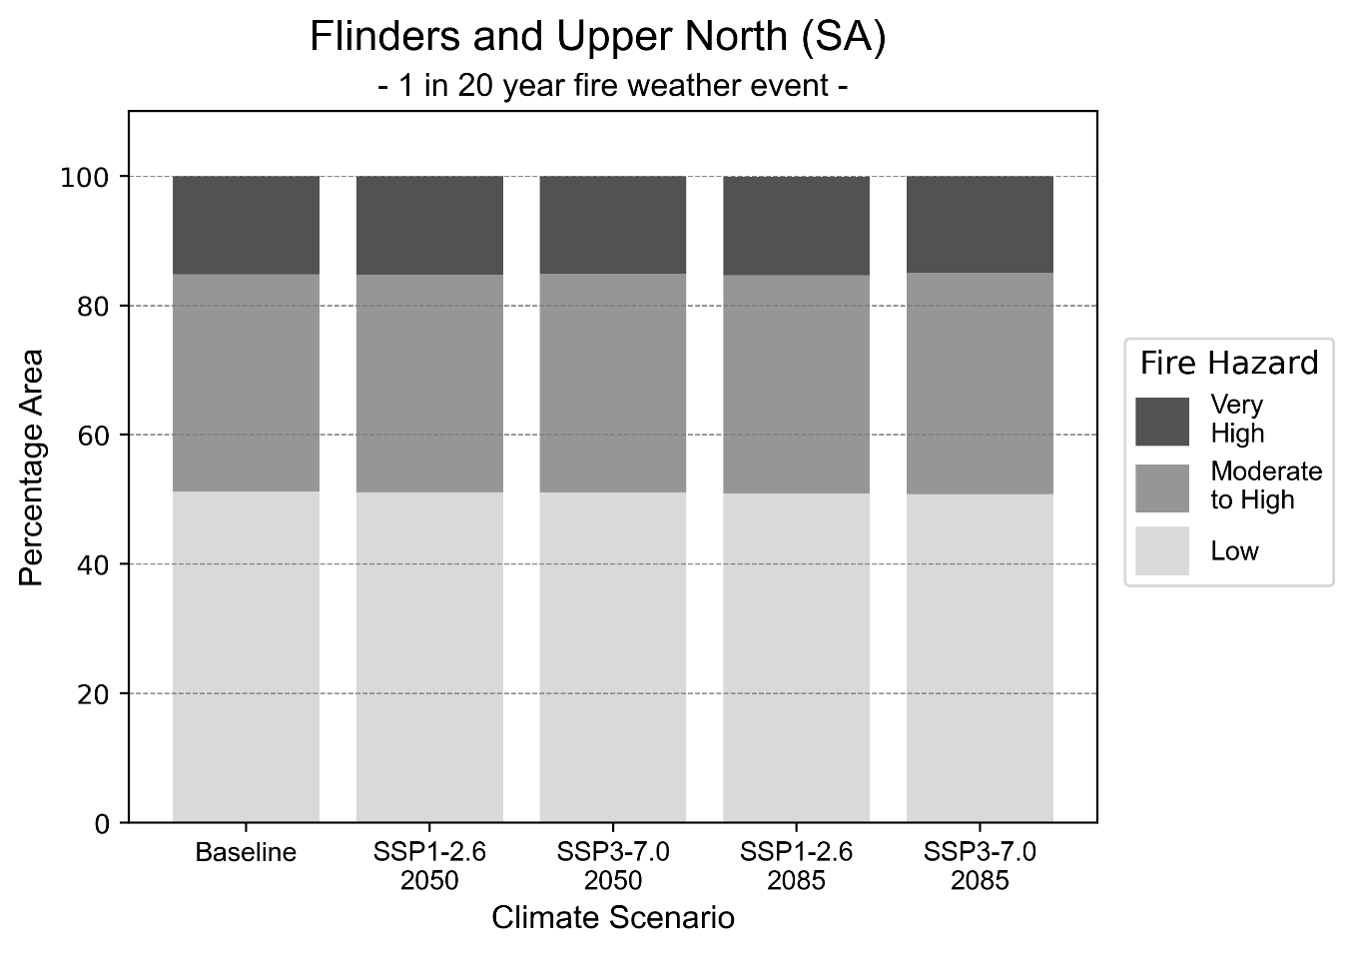
Figure 12: Stacked column chart showing percentages of Flinders and Upper North health district's total geographic area experiencing each fire hazard level during a 1-in-20-year fire weather event.
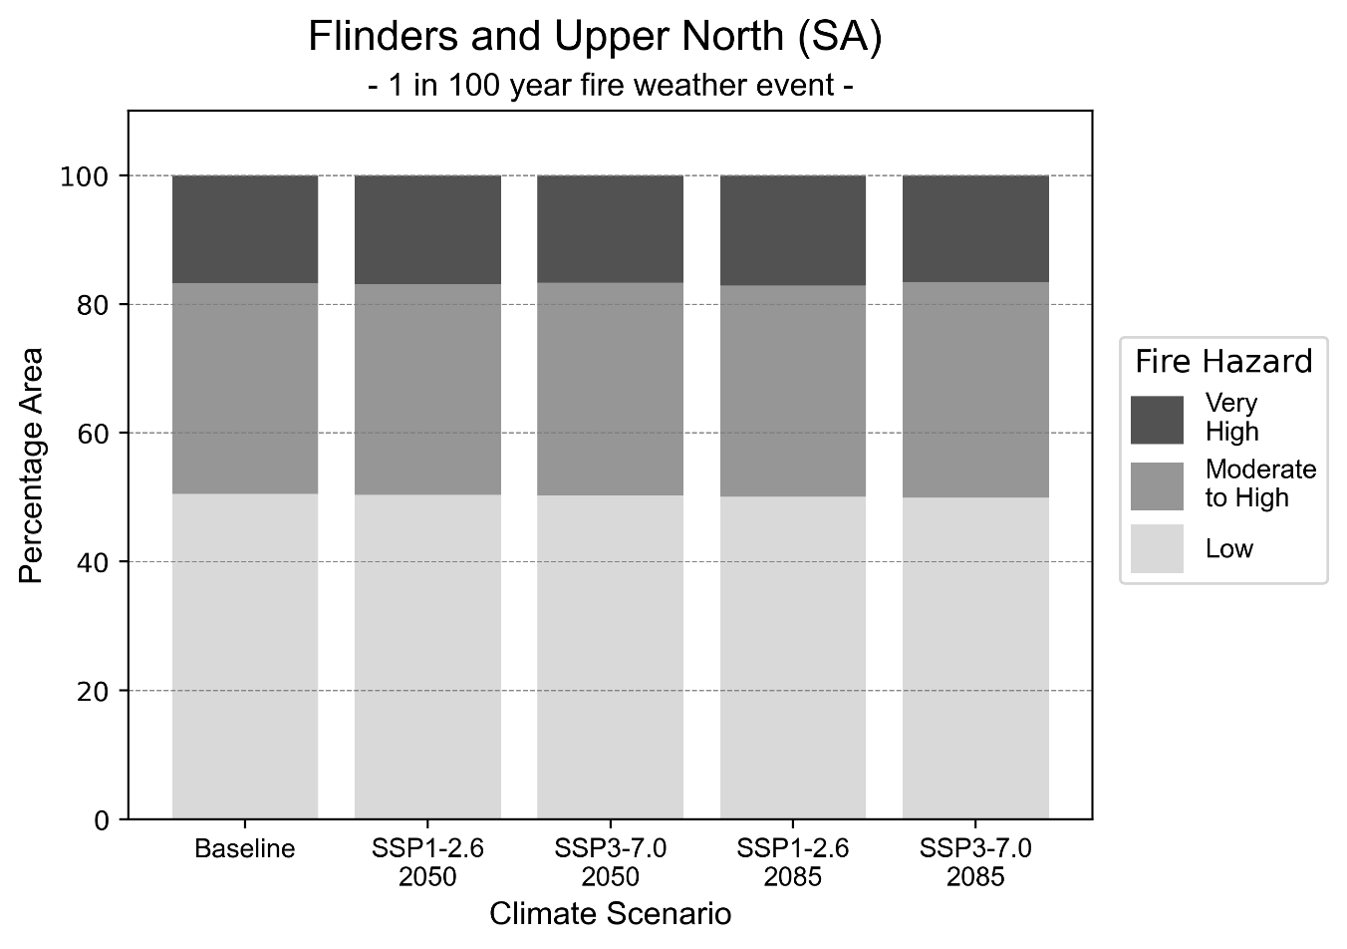
Figure 13: Stacked column chart showing the percentages of Flinders and Upper North health district's total geographic area experiencing each fire hazard level during a 1-in-100-year fire weather event.

Drought hazard
Key projections:
Drought occurrence: The occurrence of drought will increase across both middle of the road and reasonable worst-case scenarios and both time horizons, with the largest increase occurring under the reasonable worst-case scenario by 2085.

 | Baseline | 2050 Scenarios |  | 2085 Scenarios
 |  | Middle of the road | Reasonable worst-case | Middle of the road | Reasonable worst-case
Number of months per year in drought^{(a)} | 1.6 | 2.4  [0.8, 4.6] | 2.1  [0.9, 4.6] | 2.5  [0.5, 4.8] | 2.8  [0.1, 7.0]
Table notes: The drought hazard indicator uses climate projections from the CMIP6 Global Climate Models [1]. The primary indicator value reports the median from the nine climate models, with the range reported in square brackets.
Table footnotes: (a) The number of months per year in drought is based on the Standardised Precipitation Index (SPI). SPI is a widely used index to characterise meteorological drought on a range of timescales. This indicator uses the timescale of 12 months which calculates the average months in a year within the moderate drought range. A moderate drought range is classified as SPI score of ≤ -1. SPI is calculated from accumulated rainfall over 12 months and the mean and standard deviation from historical rainfall records.

Storm hazard
Key projections:
More frequent very-high-intensity storms: The frequency of very-high-intensity storms will increase across both middle of the road and reasonable worst-case scenarios with the greatest increase occurring for the middle of the road scenario by 2050.

 | Baseline | 2050 Scenarios |  | 2085 Scenarios
 |  | Middle of the road | Reasonable worst-case | Middle of the road | Reasonable worst-case
Number of low-intensity storms (40-62 km/hr) per year | 73.0 | 70.1  [61.7, 77.1] | 69.8  [61.5, 76.8] | 69.3  [61.0, 76.3] | 68.1  [59.9, 74.9]
Number of medium-intensity storms (63-87 km/hr) per year | 70.4 | 67.3  [59.2, 74.0] | 63.7  [56.1, 70.1] | 64.8  [57.1, 71.3] | 63.8  [56.2, 70.2]
Number of high-intensity storms (88-117 km/hr) per year | 33.3 | 35.5  [31.2, 39.0] | 34.1  [30.0, 37.5] | 32.7  [28.8, 36.0] | 32.8  [28.8, 36.0]
Number of very-high-intensity storm (> 117 km/hr) per year | 6.9 | 8.5  [7.5, 9.4] | 8.2  [7.2, 9.0] | 7.6  [6.7, 8.4] | 7.0  [6.2, 7.7]
Table notes: The storm hazard uses climate projections from the CMIP6 Global Climate Models [1]. Daily maximum surface wind speed is used to calculate the number of annual storms across four storm intensity categories (low, medium, high and very high). The primary indicator value reports the median from the nine climate models, with the range reported in square brackets.

Rainfall and flood hazard
Key projections:
- Ten extreme rainfall days per year: The number of extreme rainfall days will remain consistent across both middle of the road and reasonable worst-case scenarios and both time horizons, with an average of approximately ten extreme rainfall days per year.
- Increased flood frequency: The frequency of flood events will increase in urban environments. The largest increase in flood frequency is seen in the reasonable worst-case scenario where frequency of a ‘1-in-100 year’ flood will more than double by 2050 and become nearly six times more likely by 2085 in urban environments. Flood events in rural areas will remain consistent across 2050 scenarios but will reduce across 2085 scenarios, particularly the reasonable worst-case scenario.

 | Baseline | 2050 Scenarios |  | 2085 Scenarios
 |  | Middle of the road | Reasonable worst-case | Middle of the road | Reasonable worst-case
Rainfall hazard^{(a)}
Average no. of extreme rainfall days per year (> 3 mm/day)^{(a)} | 10.3 | 9.8  [7.6,12.4] | 9.8  [7.6,11.5] | 9.5  [7.8,12.3] | 9.6  [6.5,15.3]
Urban flood risk (flooding caused by a 1-hour rainfall event)^{(b)}
Frequency of a ‘1-in-1 year’ flood (rainfall depth of 12 mm)^{(c)} |  | 1.5 events in 1 year | 1.5 events in 1 year | 1.7 events in 1 year | 2.1 events in 1 year
Frequency of a ‘1-in-10 year’ flood (rainfall depth of 29 mm)^{(c)} |  | 2.0 events in 10 years | 2.1 events in 10 years | 2.6 events in 10 years | 3.5 events in 10 years
Frequency of a ‘1-in-100 year’ flood (rainfall depth of 56 mm)^{(c)} |  | 2.5 events in 100 years | 2.6 events in 100 years | 3.6 events in 100 years | 5.7 events in 100 years
Rural flood risk (flooding caused by a 24-hour rainfall event) ^{(b)}
Frequency of a ‘1-in-1 year’ flood (rainfall depth of 30 mm)^{(c)} |  | 1.0 events in 1 year | 0.9 events in 1 year | 0.9 events in 1 year | 0.5 events in 1 year
Frequency of a ‘1-in-10 year’ flood (rainfall depth of 76 mm)^{(c)} |  | 1.0 events in 10 years | 1.0 events in 10 years | 1.0 events in 10 years | 0.5 events in 10 years
Frequency of a ‘1-in-100 year’ flood (rainfall depth of 148 mm)^{(c)} |  | 1.1 events in 100 years | 1.1 events in 100 years | 0.8 events in 100 years | 0.5 events in 100 years
Table notes: The rainfall hazard indicator uses climate projections from the CMIP6 Global Climate Models [1]. The primary indicator value reports the median from the nine climate models, with the range reported in square brackets. The flood hazard indicators use climate change considerations from the Australian Rainfall and Runoff guideline to estimate the climate the climate projections [2].
Table footnotes: (a) Extreme rainfall is defined as rainfall above the 95th percentile of historical average daily rainfall in this health district in the period 1985-2014. The value in mm/day quoted in the indicator name is the 95th percentile of historic average daily rainfall for this health district. (b) See Methodology document for reasons for focusing on a 1-hour flood for urban areas and a 24-hour flood for rural areas. (c) The rainfall depths in mm quoted in the indicator names in this table report 1 in 1-, 10- and 100-year depths for this health district.

Coastal inundation hazard
Key projections:
Greater area inundated: There will be an increase in the area affected by tidal inundation (i.e. area submerged during high tide) and storm surge and tidal inundation (i.e. the area submerged during a storm surge and high tide) across both middle of the road and reasonable worst-case scenarios. In the reasonable worst-case scenario, by 2085 the area inundated during a ‘1-in-1000-year’ event will nearly double.

 | Baseline | 2050 Scenarios |  | 2085 Scenarios^{(a)}
 |  | Middle of the road | Reasonable worst-case | Middle of the road | Reasonable worst-case
Tidal inundation (ha inundated)^{(b)} | 511.8 | 574.1  (+62.3) | 579.0  (+67.2) | 736.2  (+224.4) | 821.9  (+310.1)
Storm surge + tidal inundation – ‘1-in-100 year’ event (ha inundated)^{(c)} | 2,798.7 | 3,717.1  (+918.5) | 3,872.7  (+1,074.1) | 5,794.5  (+2,995.9) | 6,400.1  (+3,601.4)
Storm surge + tidal inundation – ‘1-in-1000 year’ event (ha inundated)^{(c)} | 4,752.4 | 5,597.1  (+844.7) | 5,658.9  (+906.5) | 8,264.8  (+3,512.5) | 9,063.3  (+4,310.9)
Table notes: The coastal inundation hazard provides an indication of flooding in coastal areas that can be attributed to sea level rise and storm inundation. The coastal inundation hazard is only reported for health districts adjoining the coastline. This table includes the projected inundation levels as well as the change from baseline conditions (in brackets).
Table footnotes: (a) For the 2085 Scenarios planning horizon, 2100 was adopted as it provides a conservative representation of the end of this period. This horizon aligns with many State planning regulations requiring consideration of sea level rise and storm tide to 2100, making the 2100 scenario particularly valuable for planning new health facilities in coastal areas. (b) The tidal inundation indicator reports the number of hectares inundated during high tide. The baseline value reports existing inundation patterns, while the 2050 and 2085 values report high tide inundation taking account of projected sea level rise due to climate change. (c) The storm surge + tidal inundation indicators report the combined effect, in hectares inundated, of high tide, sea level rise (for the 2050 and 2085 projections), and storm surge (for 1-in-100 year and 1-in-1000 year events).

Limestone Coast health district

Health district overview
The Limestone Coast Local Health Network covers 21,337 square kilometres. The Limestone Coast Local Health Network contains 16 hospitals and health service facilities:
Bordertown Memorial Hospital  Keith and District Healthcare  Kingston Multi-Purpose Service  Millicent and Districts Hospital and Health Service  Mount Gambier and Districts Health Service  Naracoorte Health Service  Penola Multi-Purpose Service | Country Health Connect (Penola)  Country Health Connect (Naracoorte)  Country Health Connect (Wehl St, Mount Gambier)  Country Health Connect (James St, Mount Gambier)  Country Health Connect (Millicent)  Country Health Connect (Kingston)  Country Health Connect (Lucindale)  Country Health Connect (Keith)  Country Health Connect (Tatiara)

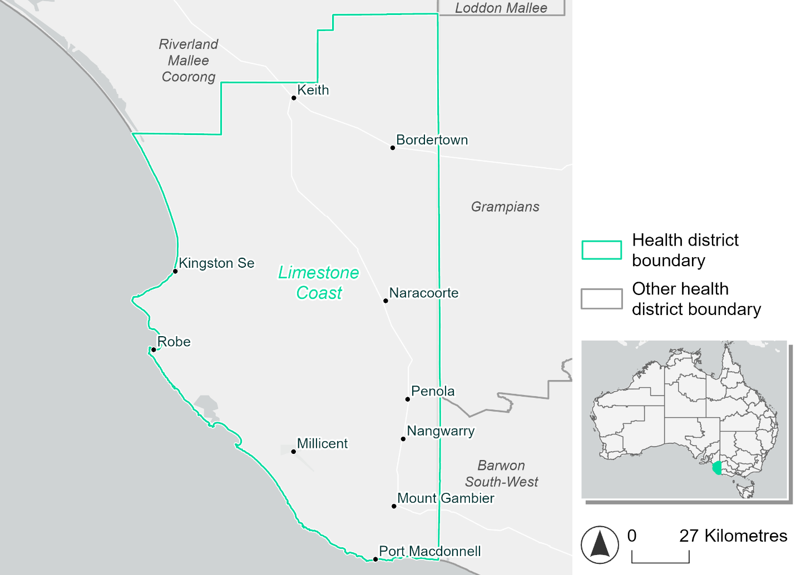
Figure 14. Map of Limestone Coast health district

How will climate change affect this health district?
Heat and humidity: Higher average temperatures, hotter and more frequent hot days, warmer night time temperatures and more frequent heatwaves.
Fire: Over 12% of this health district experiences very high fire hazard category and this will increase in the future.
Drought: Number of months experiencing drought will increase.
Rainfall and flood: More flood events in urban areas.
Coastal inundation: Increased area flooded during tidal and storm surge and tidal inundation.

Limestone Coast health district demographic data
Demographic Data | Total
Number of households | 25,902
Persons 15 and older | 46,290
Total families | 17,624
Persons did not complete high school | 23,949
One parent families with dependents | 1,734 (9.8%)
Persons aged 65 and older | 14,971 (21.8%)
Persons aged 4 and younger | 3,645 (5.3%)
Aboriginal and Torres Strait Islander persons | 1,593 (2.3%)
Persons speaks language other than English | 3,931 (5.7%)
Persons working age (15-65) | 41,809 (60.8%)
Population Health Data | Total
Persons with core needs for assistance | 4,088 (5.9%)
Persons with arthritis | 7,038 (10.2%)
Persons with asthma | 6,349 (9.2%)
Persons with cancer | 2,105 (3.1%)
Persons with dementia | 605 (0.9%)
Persons with diabetes | 3,966 (5.8%)
Persons with heart disease | 3,389 (4.9%)
Persons with kidney disease | 649 (0.9%)
Persons with lung condition | 1,571 (2.3%)
Persons with mental health condition | 6,261 (9.1%)
Persons with stroke | 742 (1.1%)
Persons with any other condition | 5,124 (7.5%)
Persons no health condition | 38,207 (55.6%)
Socio-economic Data | Total
Persons providing unpaid care | 8,468 (12.3%)
Persons homeless | 238 (0.3%)
Household with lone person | 7,887 (30.4%)
Households with rent and mortgage stress | 8,258 (31.9%)
Households total equivalised income below $1000 (weekly) | 13,961 (53.9%)
Households with no motor vehicle | 1,305 (5%)
Persons unemployed | 2,057 (3.7%)

The sections that follow outline projected climate hazards for this district. Further information on this health district, including population demographics, is provided in the online dashboard.

Heat and humidity hazard
Key projections:
More heatwaves: The number of heatwave events per year will increase. By 2050, under a reasonable worst-case scenario the number of heatwaves will increase from two events per year to three. By 2085, under a reasonable worst-case scenario the number of heatwaves per year will more than double.
Hotter days and warmer nights: The maximum temperature on hot days will increase with night time temperatures on hot nights also increasing.
More days above 35°C and 40°C: The number of days per year greater than 35°C and 40°C will increase under both middle of the road and reasonable worst-case scenarios.

 | Baseline | 2050 Scenarios |  | 2085 Scenarios
 |  | Middle of the road | Reasonable worst-case | Middle of the road | Reasonable worst-case
Average temperature (°C) | 14.5 | 15.5  [14.8, 15.9] | 15.7  [15, 16.2] | 16.3  [15.3, 16.9] | 17  [15.7, 17.9]
Maximum temperature on hot days (°C)^{(a)} | 32.2 | 33.3  [32.6, 34] | 33.6  [32.8, 34.5] | 34.1  [33.2, 35.1] | 34.9  [33.8, 36.1]
Minimum temperature on hot nights (°C)^{(b)} | 16.5 | 17.6  [16.6, 18] | 17.8  [17, 18.3] | 18.3  [17.1, 18.9] | 19.2  [17.8, 20.3]
Average apparent temperature on hot days (°C) (NOAA Heat Index)^{(c)} | 35.9 | 36.7  [36.2, 37.4] | 36.8  [36.1, 37.6] | 37.2  [36.5, 38.1] | 37.7  [37.1, 38.4]
Average heatwave duration in days^{(d)} | 4 | 4  [4, 4] | 4  [4, 4] | 4  [4, 4] | 4  [4, 5]
Number of heatwaves per year^{(d)} | 2 | 3  [2, 3] | 3  [2, 4] | 3  [2, 4] | 5  [3, 6]
Number of days per year  > 35°C | 10 | 13  [11, 16] | 14  [11, 18] | 16  [13, 20] | 19  [15, 24]
Number of days per year > 40°C | 2 | 3  [2, 4] | 3  [2, 5] | 4  [3, 6] | 5  [4, 8]
Table notes: The heat and humidity hazard uses climate projections from the CMIP6 Global Climate Models [1]. Daily projections of maximum and minimum near-surface temperature and mean relative humidity are used to calculate eight heat and humidity indicators. The primary indicator value reports the median from the nine climate models, with the range reported in square brackets.
Table footnotes: (a) Based on the 95th percentile of daily maximum air temperature. (b) Based on the 95th percentile of daily minimum air temperature, representing the coldest part of the night on very hot nights. (c) The National Oceanic and Atmospheric Administration (NOAA) Heat Index is a measure of how hot it feels when relative humidity is factored in alongside actual air temperature. It is calculated on days with a maximum temperature of 27°C and above. Interpretation of Heat Index values: 27°C to 32°C indicates caution, 33°C to 41°C indicates extreme caution, 42°C to 54°C indicates danger and over 54°C indicates extreme danger. See methodology document for further explanation of Heat Index categories. (d) A heatwave is defined as three or more consecutive days where both daytime and overnight temperatures (daily mean temperatures) are unusually high for the location, based on the Bureau of Meteorology’s Excess Heat Factor method. For this district, an unusually high daily mean temperature is approximately 24.1 °C or above.

Fire hazard
Key projections:
Most of district area experiences moderate to high fire hazard: Under baseline conditions, for a 1-in-20-year fire weather event 81.8% of the district experiences moderate to high fire hazard, with 12.8% experiencing very high hazard. For a 1-in-100-year event, 80.3% experiences moderate to high hazard while 15.3% experiences very high fire hazard.
Current conditions to persist depending on emissions: In a future climate, fire hazard levels during a 1-in-20-year fire weather event remain about the same as baseline. For a 1-in-100-year fire weather event, the proportion of the district experiencing very high hazard will increase, but this increase will be smaller under the higher-emissions reasonable worst-case scenario. This scenario sees increases of 0.9 percentage points by 2050 and an additional 1.2 by 2085, while the lower-emissions sustainability scenario sees the very high hazard area increase by 2.1 percentage points by 2050 and an additional 3 percentage points by 2085.

 | Baseline | 2050 Scenarios |  | 2085 Scenarios
 |  | Sustainability | Reasonable worst-case | Sustainability | Reasonable worst-case
Hazard for a ‘1-in-20 year’ fire weather event^{(a)}
Proportion (%) of district experiencing ‘Low’ fire hazard | 5.3%  (114,131)^{(b)} | 5.2%  [5.0%, 5.7%] | 5.2%  [4.9%, 5.7%] | 5.0%  [4.5%, 6.3%] | 5.1%  [4.3%, 6.2%]
Proportion (%) of district experiencing ‘Moderate to High’ fire hazard | 81.8%  (1,745,515)^{(b)} | 81.5%  [75.0%, 87.8%] | 81.5%  [76.4%, 85.9%] | 81.0%  [65.4%, 96.1%] | 81.0%  [68.8%, 91.7%]
Proportion (%) of district experiencing ‘Very High’ fire hazard | 12.8%  (274,036)^{(b)} | 13.3%  [12.7%, 13.8%] | 13.3%  [12.9%, 13.9%] | 14.0%  [12.4%, 15.2%] | 13.9%  [12.9%, 15.3%]
Hazard for a ‘1-in-100 year’ fire weather event^{(a)}
Proportion (%) of district experiencing ‘Low’ fire hazard | 4.4%  (93,967)^{(b)} | 4.2%  [4.1%, 4.7%] | 4.3%  [4.1%, 4.7%] | 4.0%  [3.7%, 5.2%] | 4.2%  [3.6%, 5.2%]
Proportion (%) of district experiencing ‘Moderate to High’ fire hazard | 80.3%  (1,713,369)^{(b)} | 78.3%  [75.4%, 83.8%] | 79.5%  [76.6%, 82.4%] | 75.6%  [68.6%, 88.8%] | 78.4%  [71.4%, 85.3%]
Proportion (%) of district experiencing ‘Very High’ fire hazard | 15.3%  (326,347)^{(b)} | 17.4%  [14.3%, 20.4%] | 16.2%  [15.1%, 17.9%] | 20.4%  [12.9%, 27.5%] | 17.4%  [14.8%, 21.6%]
Table notes: The Fire Hazard uses the National Bushfire Intelligence Capability (NBIC) Phase 2 fire line intensity modelling based on CMIP6 climate projections. Fire Hazard is assessed using the projected Fireline Intensity (FLI) for weather events with two different return intervals (i.e. a 1-in-20 year event and a 1-in-100 year event). FLI considers slope, vegetation and weather to produce a rate of heat output per unit length (kW/m) along a bushfire’s front. Fire hazard is categorized as a low for FLI<4000 kW/m, moderate to high for 4,000 kW/m ≤FLI<12,500kW/m, and very high for FLI≥27,501kW/m. This is broadly consistent with the literature [3]. The assessment considers climate change effects based on changes in fire weather and the associated hazard that is anticipated for a meteorological event of a given return interval. This approach is different to the one adopted for the Flood Hazard, where the event magnitude is given (fixed) and the likelihood of that event varies as a result of climate change. The primary indicator value reports the median from the nine climate models, with the range reported in square brackets.
Table footnotes: (a) The area subject to different categories of fire hazard is determined for a ‘1-in-20 year’ and ‘1-in-100 year’ fire weather event, in current and future climates. Values at year 2050 are interpolated using data from baseline (2025) and 2085, assuming linear change over time. (b) Values in round brackets are the area (ha) of the health district subject to a given fire hazard.

The figures below show the proportion of the health district experiencing different fire hazard categories across different time horizons and climate scenarios during a ‘1-in-20 year’ fire weather event (Figure 15) and a ‘1-in-100 year’ fire weather event (Figure 16).
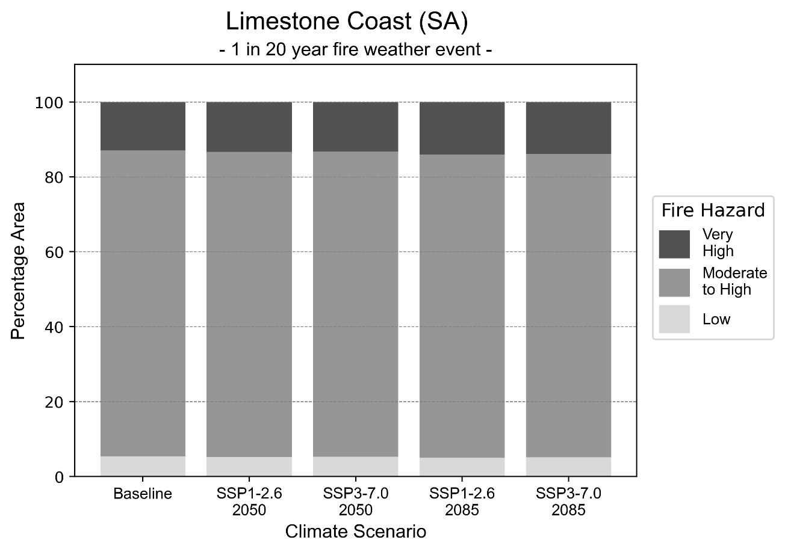
Figure 15: Stacked column chart showing the percentages of Limestone Coast health district's total geographic area experiencing each fire hazard level during a 1-in-20-year fire weather event.
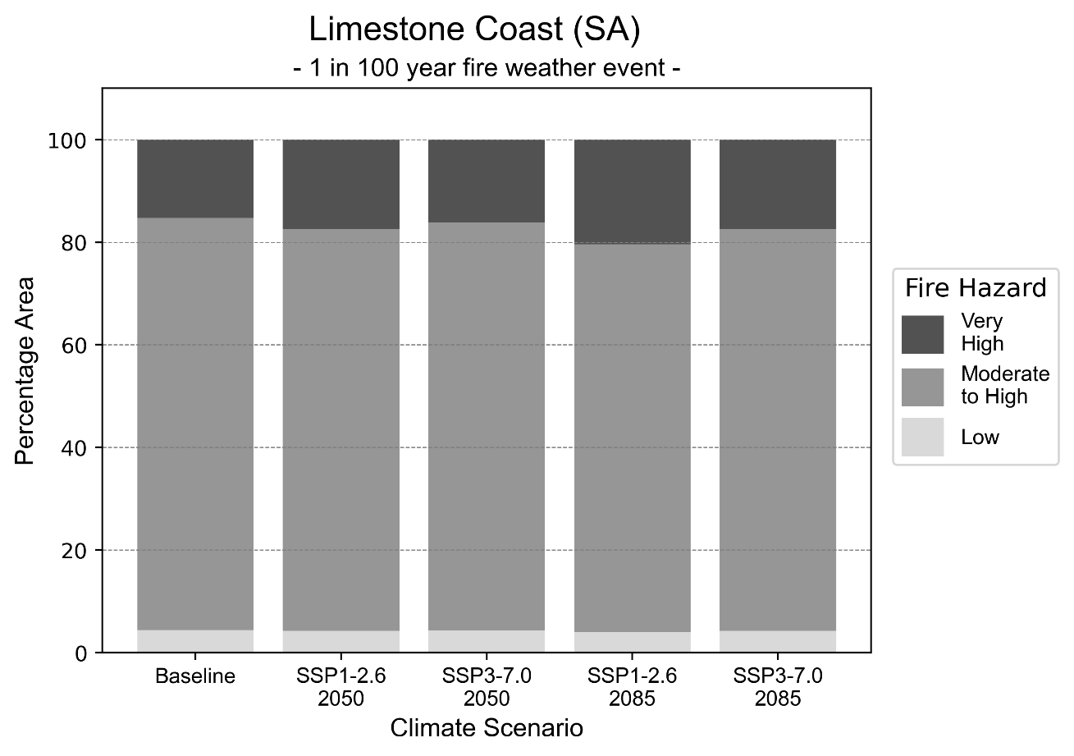
Figure 16: Stacked column chart showing the percentages of Limestone Coast health district's total geographic area experiencing each fire hazard level during a 1-in-100-year fire weather event.

Drought hazard
Key projections:
Drought occurrence: The occurrence of drought will increase across both middle of the road and reasonable worst-case scenarios and both time horizons, with the largest increase occurring under the reasonable worst-case scenario by 2085.

 | Baseline | 2050 Scenarios |  | 2085 Scenarios
 |  | Middle of the road | Reasonable worst-case | Middle of the road | Reasonable worst-case
Number of months per year in drought^{(a)} | 1.7 | 3.2  [1.0, 5.7] | 3.5  [1.4, 7.0] | 4.2  [1.9, 6.4] | 5.1  [1.2, 9.3]
Table notes: The drought hazard indicator uses climate projections from the CMIP6 Global Climate Models [1]. The primary indicator value reports the median from the nine climate models, with the range reported in square brackets.
Table footnotes: (a) The number of months per year in drought is based on the Standardised Precipitation Index (SPI). SPI is a widely used index to characterise meteorological drought on a range of timescales. This indicator uses the timescale of 12 months which calculates the average months in a year within the moderate drought range. A moderate drought range is classified as SPI score of ≤ -1. SPI is calculated from accumulated rainfall over 12 months and the mean and standard deviation from historical rainfall records.

Storm hazard
Key projections:
Less frequent high and very-high-intensity storms: The frequency of high and very-high-intensity storms will decrease across both middle of the road and reasonable worst-case scenarios for both time horizon.

 | Baseline | 2050 Scenarios |  | 2085 Scenarios
 |  | Middle of the road | Reasonable worst-case | Middle of the road | Reasonable worst-case
Number of low-intensity storms (40-62 km/hr) per year | 86.8 | 83.3  [73.3, 91.6] | 84.1  [74.0, 92.5] | 81.9  [72.1, 90.1] | 82.6  [72.7, 90.9]
Number of medium-intensity storms (63-87 km/hr) per year | 60.2 | 58.4  [51.4, 64.2] | 55.0  [48.4, 60.5] | 52.2  [45.9, 57.4] | 49.4  [43.5, 54.3]
Number of high-intensity storms (88-117 km/hr) per year | 33.1 | 30.7  [27.0, 33.7] | 29.1  [25.6, 32.0] | 29.2  [25.7, 32.2] | 27.1  [23.9, 29.8]
Number of very-high-intensity storm (> 117 km/hr) per year | 4.0 | 3.4  [3.0, 3.7] | 2.7  [2.3, 2.9] | 3.6  [3.2, 4.0] | 3.4  [3.0, 3.7]
Table notes: The storm hazard uses climate projections from the CMIP6 Global Climate Models [1]. Daily maximum surface wind speed is used to calculate the number of annual storms across four storm intensity categories (low, medium, high and very high). The primary indicator value reports the median from the nine climate models, with the range reported in square brackets.

Rainfall and flood hazard
Key projections:
- Decrease in number of extreme rainfall days per year: The number of extreme rainfall days will decrease across both middle of the road and reasonable worst-case scenarios and both time horizons, with the largest decrease seen in the reasonable worst-case scenario where the number of extreme rainfall days will reduce from 13 to 12 by 2085.
- Increased flood frequency: The frequency of flood events will increase in urban environments, but decrease in rural environments. The largest increase in flood frequency is seen in the reasonable worst-case scenario where frequency of a ‘1-in-100 year’ flood will more than triple by 2050 and become eight times more likely by 2085 in urban environments.

 | Baseline | 2050 Scenarios |  | 2085 Scenarios
 |  | Middle of the road | Reasonable worst-case | Middle of the road | Reasonable worst-case
Rainfall hazard^{(a)}
Average number of extreme rainfall days per year (> 8 mm/day)^{(a)} | 13.5 | 12.5  [11.0,14.9] | 12.3  [9.9,14.7] | 12.1  [10.6,14.4] | 11.9  [9.0,15.5]
Urban flood risk (flooding caused by a 1-hour rainfall event)^{(b)}
Frequency of a ‘1-in-1 year’ flood (rainfall depth of 12 mm)^{(c)} |  | 2.0 events in 1 year | 2.1 events in 1 year | 2.6 events in 1 year | 3.7 events in 1 year
Frequency of a ‘1-in-10 year’ flood (rainfall depth of 22 mm)^{(c)} |  | 2.6 events in 10 years | 2.7 events in 10 years | 3.8 events in 10 years | 5.9 events in 10 years
Frequency of a ‘1-in-100 year’ flood (rainfall depth of 38 mm)^{(c)} |  | 3.0 events in 100 years | 3.2 events in 100 years | 4.7 events in 100 years | 8.4 events in 100 years
Rural flood risk (flooding caused by a 24-hour rainfall event) ^{(b)}
Frequency of a ‘1-in-1 year’ flood (rainfall depth of 34 mm)^{(c)} |  | 0.7 events in 1 year | 0.9 events in 1 year | 0.8 events in 1 year | 0.2 events in 1 year
Frequency of a ‘1-in-10 year’ flood (rainfall depth of 62 mm)^{(c)} |  | 0.9 events in 10 years | 0.9 events in 10 years | 0.3 events in 10 years | 0.2 events in 10 years
Frequency of a ‘1-in-100 year’ flood (rainfall depth of 101 mm)^{(c)} |  | 0.9 events in 100 years | 0.9 events in 100 years | 0.4 events in 100 years | 0.09 events in 100 years
Table notes: The rainfall hazard indicator uses climate projections from the CMIP6 Global Climate Models [1]. The primary indicator value reports the median from the nine climate models, with the range reported in square brackets. The flood hazard indicators use climate change considerations from the Australian Rainfall and Runoff guideline to estimate the climate the climate projections [2].
Table footnotes: (a) Extreme rainfall is defined as rainfall above the 95th percentile of historical average daily rainfall in this health district in the period 1985-2014. The value in mm/day quoted in the indicator name is the 95th percentile of historic average daily rainfall for this health district. (b) See Methodology document for reasons for focusing on a 1-hour flood for urban areas and a 24-hour flood for rural areas. (c) The rainfall depths in mm quoted in the indicator names in this table report 1 in 1-, 10- and 100-year depths for this health district.

Coastal inundation hazard
Key projections:
Greater area inundated: There will be an increase in the area affected by tidal inundation (i.e. area submerged during high tide) and storm surge and tidal inundation (i.e. the area submerged during a storm surge and high tide) across both middle of the road and reasonable worst-case scenarios. In the reasonable worst-case scenario, by 2085 the area inundated during a ‘1-in-1000-year’ event will increase by over 14,000 ha.

 | Baseline | 2050 Scenarios |  | 2085 Scenarios^{(a)}
 |  | Middle of the road | Reasonable worst-case | Middle of the road | Reasonable worst-case
Tidal inundation (ha inundated)^{(b)} | 27,033.0 | 28,943.6  (+1,910.5) | 29,083.8  (+2,050.8) | 33,599.5  (+6,566.4) | 35,218.9  (+8,185.8)
Storm surge + tidal inundation – ‘1-in-100 year’ event (ha inundated)^{(c)} | 37,276.3 | 40,699.1  (+3,422.8) | 40,884.5  (+3,608.3) | 47,648.0  (+10,371.8) | 49,496.1  (+12,219.8)
Storm surge + tidal inundation – ‘1-in-1000 year’ event (ha inundated)^{(c)} | 38,890.1 | 42,602.3  (+3,712.3) | 42,799.1  (+3,909.0) | 51,187.5  (+12,297.4) | 53,125.6  (+14,235.6)
Table notes: The coastal inundation hazard provides an indication of flooding in coastal areas that can be attributed to sea level rise and storm inundation. The coastal inundation hazard is only reported for health districts adjoining the coastline. This table includes the projected inundation levels as well as the change from baseline conditions (in brackets).
Table footnotes: (a) For the 2085 Scenarios planning horizon, 2100 was adopted as it provides a conservative representation of the end of this period. This horizon aligns with many State planning regulations requiring consideration of sea level rise and storm tide to 2100, making the 2100 scenario particularly valuable for planning new health facilities in coastal areas. (b) The tidal inundation indicator reports the number of hectares inundated during high tide. The baseline value reports existing inundation patterns, while the 2050 and 2085 values report high tide inundation taking account of projected sea level rise due to climate change. (c) The storm surge + tidal inundation indicators report the combined effect, in hectares inundated, of high tide, sea level rise (for the 2050 and 2085 projections), and storm surge (for 1-in-100 year and 1-in-1000 year events).

Riverland Mallee Coorong health district

Health district overview
The Riverland Mallee Coorong Local Health Network covers 42,773 square kilometres and contains 19 hospitals and health services:
Barmera Hospital  Loxton Hospital Complex  Riverland General Hospital  Tailem Bend District Hospital  Mallee Medical Practice Karoonda  Lameroo District Health Service  Mallee Medical Practice, Lameroo  Mallee Medical Practice, Pinnaroo  Mannum District Hospital  Waikerie Health Service  Pinnaroo Soldiers' Memorial Hospital  Renmark Paringa District Hospital | Country Health Connect (Meningie Community Health Centre)  Country Health Connect (Murray Mallee Community Health Service)  Country Health Connect (Riverland Community Health Service)  Country Health Connect (Coonalpyn and Tintinara Clinics)  Karoonda and District Soldiers' Memorial Hospital  Meningie and Districts Memorial Hospital and Health Services  Murray Bridge Soldiers' Memorial Hospital

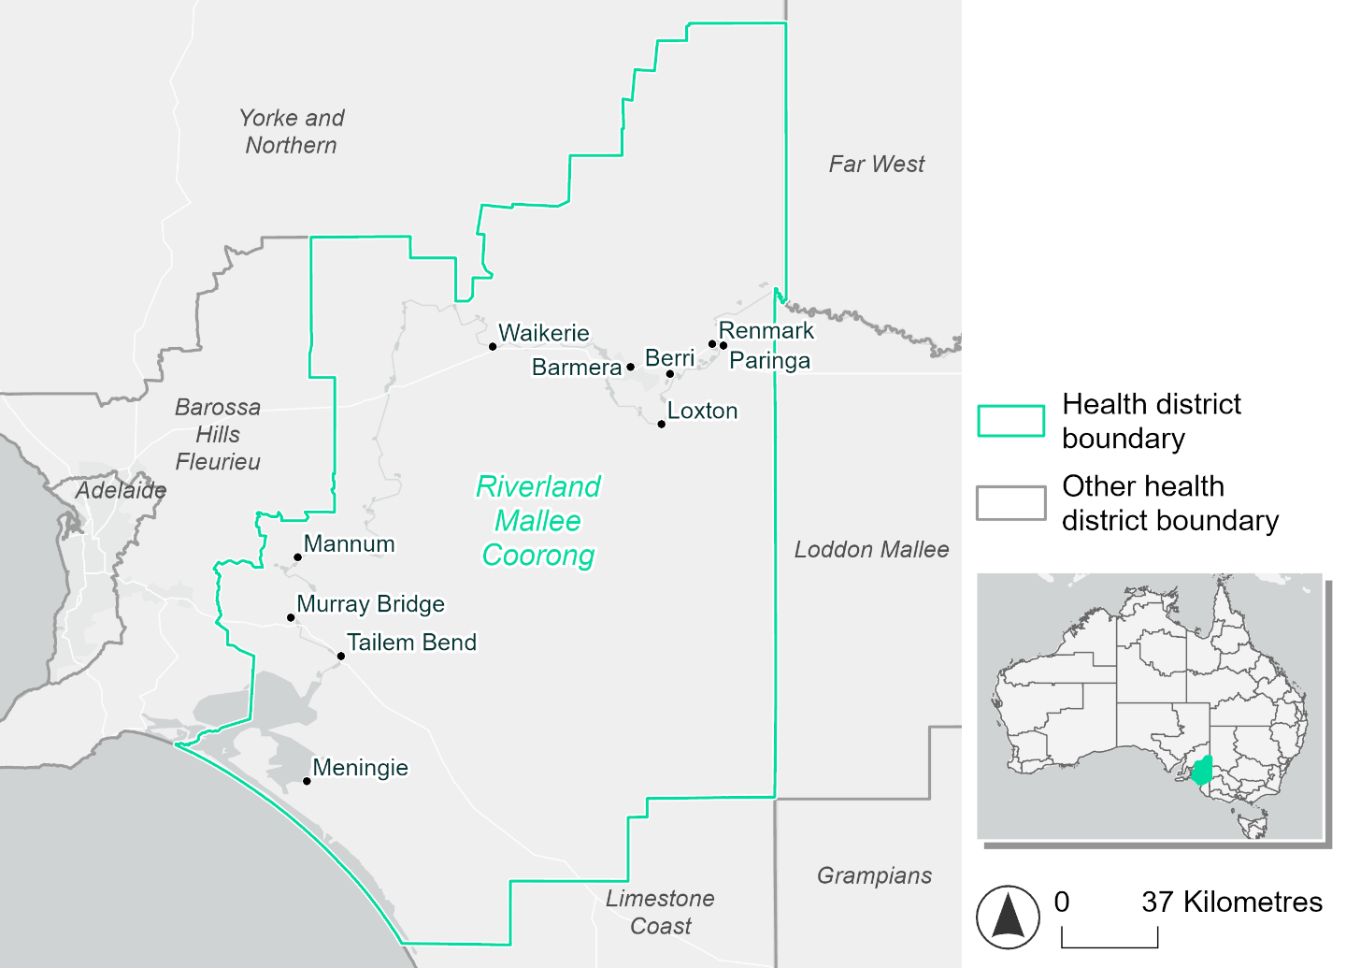
Figure 17. Map of Riverland Mallee Coorong health district

How will climate change affect this health district?
Heat and humidity: Higher average temperatures, hotter and more frequent hot days, warmer night time temperatures and more frequent heatwaves.
Fire: Over 11% of this health district experiences very high fire hazard category and this will continue in the future.
Drought: Number of months experiencing drought will increase.
Rainfall and flood: More flood events in urban areas.
Coastal inundation: Increased area flooded during tidal and storm surge and tidal inundation.

Riverland Mallee Coorong health district demographic data
Demographic Data | Total
Number of households | 27,527
Persons 15 and older | 47,181
Total families | 18,387
Persons did not complete high school | 25,777
One parent families with dependents | 1,860 (10.1%)
Persons aged 65 and older | 17,428 (24.5%)
Persons aged 4 and younger | 3,585 (5%)
Aboriginal and Torres Strait Islander persons | 2,976 (4.2%)
Persons speaks language other than English | 5,230 (7.3%)
Persons working age (15-65) | 42,097 (59.2%)
Population Health Data | Total
Persons with core needs for assistance | 5,418 (7.6%)
Persons with arthritis | 8,936 (12.6%)
Persons with asthma | 6,910 (9.7%)
Persons with cancer | 2,553 (3.6%)
Persons with dementia | 750 (1.1%)
Persons with diabetes | 4,904 (6.9%)
Persons with heart disease | 3,841 (5.4%)
Persons with kidney disease | 692 (1%)
Persons with lung condition | 2,008 (2.8%)
Persons with mental health condition | 7,326 (10.3%)
Persons with stroke | 865 (1.2%)
Persons with any other condition | 6,040 (8.5%)
Persons no health condition | 37,224 (52.3%)
Socio-economic Data | Total
Persons providing unpaid care | 9,384 (13.2%)
Persons homeless | 349 (0.5%)
Household with lone person | 8,728 (31.7%)
Households with rent and mortgage stress | 10,480 (38.1%)
Households total equivalised income below $1000 (weekly) | 16,877 (61.3%)
Households with no motor vehicle | 1,544 (5.6%)
Persons unemployed | 3,034 (5.2%)

The sections that follow outline projected climate hazards for this district. Further information on this health district, including population demographics, is provided in the online dashboard.

Heat and humidity hazard
Key projections:
More heatwaves: The number of heatwave events per year will increase. By 2050, under a reasonable worst-case scenario the number of heatwaves will double. By 2085, under a reasonable worst-case scenario the number of heatwaves per year will triple.
Hotter days and warmer nights: The maximum temperature on hot days will increase with night time temperatures on hot nights also increasing.
More days above 35°C and 40°C: The number of days per year greater than 35°C and 40°C will increase under both middle of the road and reasonable worst-case scenarios across both time horizons.

 | Baseline | 2050 Scenarios |  | 2085 Scenarios
 |  | Middle of the road | Reasonable worst-case | Middle of the road | Reasonable worst-case
Average temperature (°C) | 16.7 | 17.9  [17.2, 18.4] | 18.1  [17.3, 18.7] | 18.8  [17.8, 19.5] | 19.6  [18.3, 20.7]
Maximum temperature on hot days (°C)^{(a)} | 36.3 | 37.9  [37.3, 38.6] | 38.2  [37.2, 39.4] | 38.8  [37.8, 39.9] | 39.9  [38.8, 41.2]
Minimum temperature on hot nights (°C)^{(b)} | 18.8 | 20.3  [19.3, 20.9] | 20.6  [19.4, 21.1] | 21.2  [19.9, 22] | 22.2  [20.8, 23.3]
Average apparent temperature on hot days (°C) (NOAA Heat Index)^{(c)} | 35.2 | 36.1  [35.6, 36.6] | 36.2  [35.8, 37] | 36.5  [35.8, 37.2] | 37.2  [36.3, 38.1]
Average heatwave duration in days^{(d)} | 5 | 5  [5, 5] | 5  [4, 5] | 5  [5, 5] | 5  [5, 5]
Number of heatwaves per year^{(d)} | 2 | 3  [2, 4] | 4  [2, 5] | 4  [3, 6] | 6  [4, 8]
Number of days per year  > 35°C | 26 | 37  [32, 42] | 40  [32, 48] | 45  [37, 53] | 54  [46, 66]
Number of days per year > 40°C | 6 | 11  [9, 13] | 12  [8, 17] | 14  [10, 20] | 19  [14, 26]
Table notes: The heat and humidity hazard uses climate projections from the CMIP6 Global Climate Models [1]. Daily projections of maximum and minimum near-surface temperature and mean relative humidity are used to calculate eight heat and humidity indicators. The average of each indicator is reported along with the maximum and minimum values across climate models reported in brackets.
Table footnotes: (a) Based on the 95th percentile of daily maximum air temperature. (b) Based on the 95th percentile of daily minimum air temperature, representing the coldest part of the night on very hot nights. (c) The National Oceanic and Atmospheric Administration (NOAA) Heat Index is a measure of how hot it feels when relative humidity is factored in alongside actual air temperature. It is calculated on days with a maximum temperature of 27°C and above. Interpretation of Heat Index values: 27°C to 32°C indicates caution, 33°C to 41°C indicates extreme caution, 42°C to 54°C indicates danger and over 54°C indicates extreme danger. See methodology document for further explanation of Heat Index categories. (d) A heatwave is defined as three or more consecutive days where both daytime and overnight temperatures (daily mean temperatures) are unusually high for the location, based on the Bureau of Meteorology’s Excess Heat Factor method. For this district, an unusually high daily mean temperature is approximately 27.2 °C or above.

Fire hazard
Key projections:
Majority of district area experiences moderate to high hazard: Under baseline conditions for a 1-in-20-year fire weather event, two-thirds of the district (67.8%) experiences moderate to high fire hazard. 20.6% experiences low fire hazard, with the remaining 11.6% experiencing very high fire hazard. In a more severe 1-in-100-year fire weather event, the proportion experiencing low fire hazard decreases by 2.5 percentage points with a corresponding increase in moderate to high fire hazard.
Some low hazard areas will see moderate to high fire hazard: In a future climate across both 2050 and 2085 scenarios, the area experiencing very high fire hazard stays fairly steady for the two types of fire weather event. For a 1-in-20-year event, the area experiencing low hazard reduces by up to 1.5 percentage points, with up to an additional 2% of the district experiencing moderate to high fire hazard. During a 1-in-100-year fire weather event these changes will be slightly more pronounced, with a 2.1 percentage point reduction in low fire hazard area and an increase of 2.3 percentage points in moderate to high fire hazard.

 | Baseline | 2050 Scenarios |  | 2085 Scenarios
 |  | Sustainability | Reasonable worst-case | Sustainability | Reasonable worst-case
Hazard for a ‘1-in-20 year’ fire weather event^{(a)}
Proportion (%) of district experiencing ‘Low’ fire hazard | 20.6%  (883,072)^{(b)} | 20.3%  [19.5%, 21.3%] | 20.0%  [19.0%, 20.9%] | 19.9%  [17.9%, 22.2%] | 19.1%  [16.7%, 21.2%]
Proportion (%) of district experiencing ‘Moderate to High’ fire hazard | 67.8%  (2,899,871)^{(b)} | 68.0%  [64.6%, 71.0%] | 68.6%  [66.2%, 71.1%] | 68.4%  [60.1%, 75.4%] | 69.8%  [64.0%, 75.7%]
Proportion (%) of district experiencing ‘Very High’ fire hazard | 11.6%  (494,350)^{(b)} | 11.6%  [11.4%, 11.8%] | 11.4%  [10.7%, 11.7%] | 11.7%  [11.1%, 12.1%] | 11.2%  [9.5%, 11.8%]
Hazard for a ‘1-in-100 year’ fire weather event^{(a)}
Proportion (%) of district experiencing ‘Low’ fire hazard | 18.1%  (772,615)^{(b)} | 17.5%  [16.7%, 18.6%] | 17.2%  [16.3%, 18.2%] | 16.8%  [14.9%, 19.4%] | 16.0%  [13.8%, 18.5%]
Proportion (%) of district experiencing ‘Moderate to High’ fire hazard | 69.9%  (2,989,926)^{(b)} | 70.3%  [66.2%, 74.0%] | 70.9%  [67.7%, 74.5%] | 70.8%  [60.9%, 79.8%] | 72.2%  [64.6%, 80.9%]
Proportion (%) of district experiencing ‘Very High’ fire hazard | 12.0%  (514,753)^{(b)} | 12.1%  [11.9%, 12.3%] | 11.9%  [11.2%, 12.2%] | 12.3%  [11.7%, 12.7%] | 11.8%  [10.1%, 12.5%]
Table notes: The Fire Hazard uses the National Bushfire Intelligence Capability (NBIC) Phase 2 fire line intensity modelling based on CMIP6 climate projections. Fire Hazard is assessed using the projected Fireline Intensity (FLI) for weather events with two different return intervals (i.e. a 1-in-20 year event and a 1-in-100 year event). FLI considers slope, vegetation and weather to produce a rate of heat output per unit length (kW/m) along a bushfire’s front. Fire hazard is categorized as a low for FLI<4000 kW/m, moderate to high for 4,000 kW/m ≤FLI<12,500kW/m, and very high for FLI≥27,501kW/m. This is broadly consistent with the literature [3]. The assessment considers climate change effects based on changes in fire weather and the associated hazard that is anticipated for a meteorological event of a given return interval. This approach is different to the one adopted for the Flood Hazard, where the event magnitude is given (fixed) and the likelihood of that event varies as a result of climate change. The primary indicator value reports the median from the nine climate models, with the range reported in square brackets.
Table footnotes: (a) The area subject to different categories of fire hazard is determined for a ‘1-in-20 year’ and ‘1-in-100 year’ fire weather event, in current and future climates. Values at year 2050 are interpolated using data from baseline (2025) and 2085, assuming linear change over time. (b) Values in round brackets are the area (ha) of the health district subject to a given fire hazard.

The figures below show the proportion of the health district experiencing different fire hazard categories across different time horizons and climate scenarios during a ‘1-in-20 year’ fire weather event (Figure 18) and a ‘1-in-100 year’ fire weather event (Figure 19).
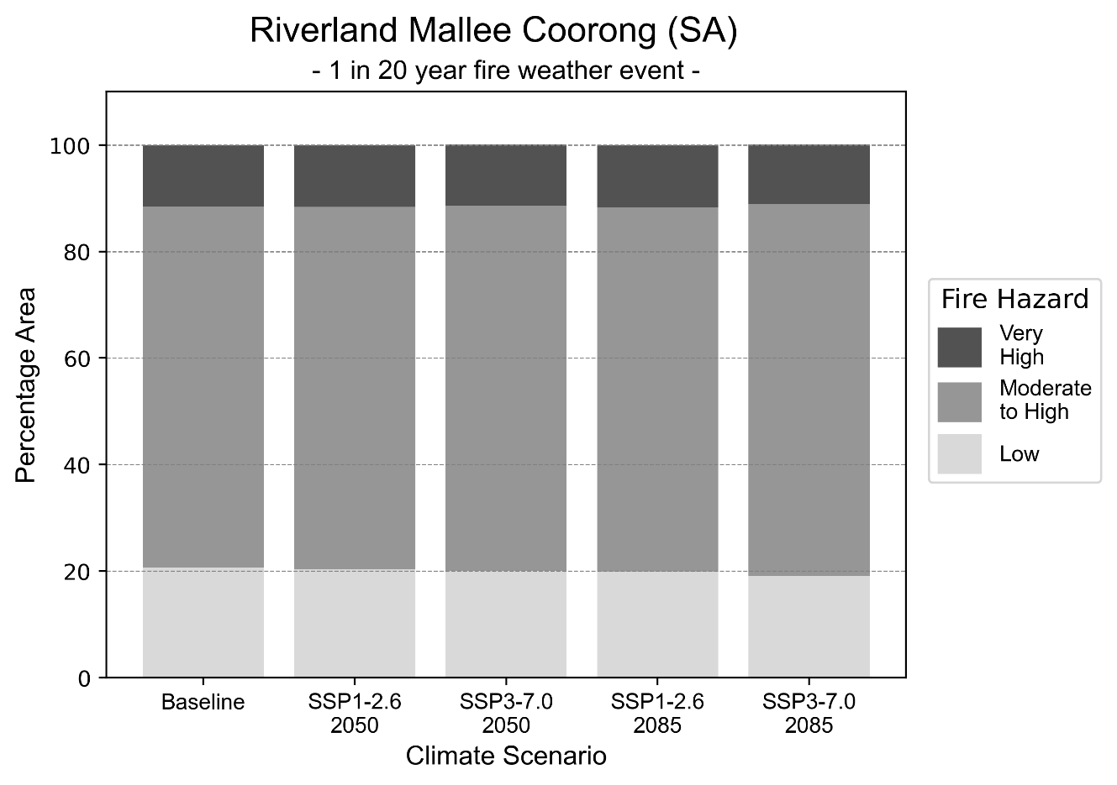
Figure 18: Stacked column chart showing the percentages of Riverland Mallee Coorong health district's total geographic area experiencing each fire hazard level during a 1-in-20-year fire weather event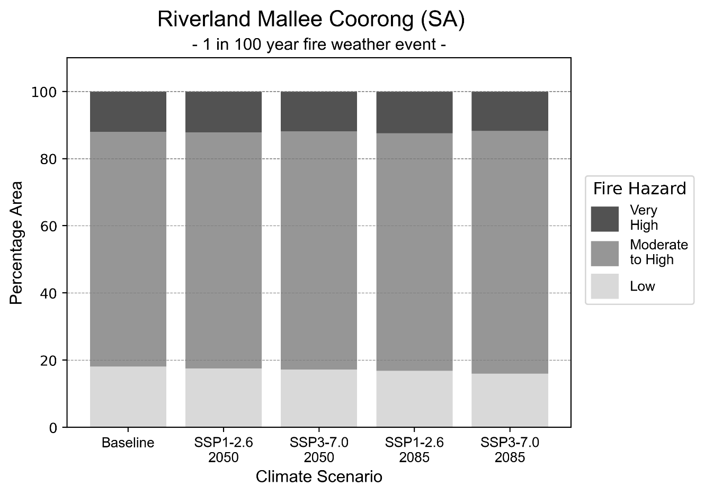
Figure 19: Stacked column chart showing the percentages of Riverland Mallee Coorong health district's total geographic area experiencing each fire hazard level during a 1-in-100-year fire weather event.

Drought hazard
Key projections:
Drought occurrence: The occurrence of drought will increase across both middle of the road and reasonable worst-case scenarios and both time horizons, with the largest increase occurring under the reasonable worst-case scenario by 2085.

 | Baseline | 2050 Scenarios |  | 2085 Scenarios
 |  | Middle of the road | Reasonable worst-case | Middle of the road | Reasonable worst-case
Number of months per year in drought^{(a)} | 1.5 | 2.7  [0.4, 4.6] | 2.6  [0.9, 5.4] | 3.2  [0.9, 5.9] | 3.6  [0.4, 8.2]
Table notes: The drought hazard indicator uses climate projections from the CMIP6 Global Climate Models [1]. The primary indicator value reports the median from the nine climate models, with the range reported in square brackets.
Table footnotes: (a) The number of months per year in drought is based on the Standardised Precipitation Index (SPI). SPI is a widely used index to characterise meteorological drought on a range of timescales. This indicator uses the timescale of 12 months which calculates the average months in a year within the moderate drought range. A moderate drought range is classified as SPI score of ≤ -1. SPI is calculated from accumulated rainfall over 12 months and the mean and standard deviation from historical rainfall records.

Storm hazard
Key projections:
Less frequent high-intensity storms: The frequency of high-intensity storms will decrease across both middle of the road and reasonable worst-case scenarios with the greatest decrease occurring by 2085. The number of very-high-intensity storms per year will remain consistent across both time horizons for the middle of the road scenario, but decrease across both horizons for the reasonable worst-case scenario.

Baseline |  | 2085 Scenarios |  | 2085 Scenarios
 |  | Middle of the road | Reasonable worst-case | Middle of the road | Reasonable worst-case
Number of low-intensity storms (40-62 km/hr) per year | 80.5 | 78.8  [69.3, 86.7] | 77.4  [68.1, 85.2] | 74.7  [65.7, 82.2] | 73.8  [64.9, 81.2]
Number of medium-intensity storms (63-87 km/hr) per year | 50.3 | 49.0  [43.1, 53.9] | 46.0  [40.5, 50.6] | 45.1  [39.7, 49.6] | 42.8  [37.6, 47.0]
Number of high-intensity storms (88-117 km/hr) per year | 32.5 | 30.4  [26.8, 33.5] | 29.4  [25.8, 32.3] | 27.7  [24.4, 30.5] | 26.6  [23.4, 29.3]
Number of very-high-intensity storms (> 117 km/hr) per year | 3.9 | 3.9  [3.4, 4.3] | 3.2  [2.8, 3.5] | 3.9  [3.5, 4.3] | 3.6  [3.2, 4.0]
Table notes: The storm hazard uses climate projections from the CMIP6 Global Climate Models [1]. Daily maximum surface wind speed is used to calculate the number of annual storms across four storm intensity categories (low, medium, high and very high). The primary indicator value reports the median from the nine climate models, with the range reported in square brackets.

Rainfall and flood hazard
Key projections:
- Over eleven extreme rainfall days per year: The number of extreme rainfall days will reduce across both middle of the road and reasonable worst-case scenarios and both time horizons, with an average of approximately eleven extreme rainfall days per year.
- Increased flood frequency: The frequency of flood events will increase in urban environments, but reduce in rural environments. The largest increase in flood frequency is seen in the reasonable worst-case scenario where frequency of a ‘1-in-100 year’ flood will nearly triple by 2050 and become over six times more likely by 2085 in urban environments.

 | Baseline | 2050 Scenarios |  | 2085 Scenarios
 |  | Middle of the road | Reasonable worst-case | Middle of the road | Reasonable worst-case
Rainfall hazard^{(a)}
Average number of extreme rainfall days per year (> 5 mm/day)^{(a)} | 11.6 | 11.2  [9.6,14.9] | 11.1  [8.9,13.4] | 10.7  [9.2,13.2] | 10.7  [7.7,15.1]
Urban flood risk (flooding caused by a 1-hour rainfall event)^{(b)}
Frequency of a ‘1-in-1 year’ flood (rainfall depth of 11 mm)^{(c)} |  | 1.8 events in 1 year | 1.9 events in 1 year | 2.3 events in 1 year | 3.0 events in 1 year
Frequency of a ‘1-in-10 year’ flood (rainfall depth of 26 mm)^{(c)} |  | 2.1 events in 10 years | 2.2 events in 10 years | 2.8 events in 10 years | 3.9 events in 10 years
Frequency of a ‘1-in-100 year’ flood (rainfall depth of 46 mm)^{(c)} |  | 2.7 events in 100 years | 2.9 events in 100 years | 4.0 events in 100 years | 6.6 events in 100 years
Rural flood risk (flooding caused by a 24-hour rainfall event) ^{(b)}
Frequency of a ‘1-in-1 year’ flood (rainfall depth of 28 mm)^{(c)} |  | 0.9 events in 1 year | 0.7 events in 1 year | 0.8 events in 1 year | 0.4 events in 1 year
Frequency of a ‘1-in-10 year’ flood (rainfall depth of 58 mm)^{(c)} |  | 0.7 events in 10 years | 0.9 events in 10 years | 0.8 events in 10 years | 0.2 events in 10 years
Frequency of a ‘1-in-100 year’ flood (rainfall depth of 104 mm)^{(c)} |  | 0.8 events in 100 years | 0.7 events in 100 years | 0.5 events in 100 years | 0.1 events in 100 years
Table notes: The rainfall hazard indicator uses climate projections from the CMIP6 Global Climate Models [1]. The primary indicator value reports the median from the nine climate models, with the range reported in square brackets. The flood hazard indicators use climate change considerations from the Australian Rainfall and Runoff guideline to estimate the climate the climate projections [2].
Table footnotes: (a) Extreme rainfall is defined as rainfall above the 95th percentile of historical average daily rainfall in this health district in the period 1985-2014. The value in mm/day quoted in the indicator name is the 95th percentile of historic average daily rainfall for this health district. (b) See Methodology document for reasons for focusing on a 1-hour flood for urban areas and a 24-hour flood for rural areas. (c) The rainfall depths in mm quoted in the indicator names in this table report 1 in 1-, 10- and 100-year depths for this health district.

Coastal inundation hazard
Key projections:
Greater area inundated: There will be an increase in the area affected by tidal inundation (i.e. area submerged during high tide) and storm surge and tidal inundation (i.e. the area submerged during a storm surge and high tide) across both middle of the road and reasonable worst-case scenarios. In the reasonable worst-case scenario, by 2085 the area inundated during a ‘1-in-1000-year’ event will increase by over 8,000 ha.

 | Baseline | 2050 Scenarios |  | 2085 Scenarios^{(a)}
 |  | Middle of the road | Reasonable worst-case | Middle of the road | Reasonable worst-case
Tidal inundation (ha inundated)^{(b)} | 94,176.4 | 98,148.3  (+3,971.9) | 98,355.1  (+4,178.7) | 104,255.7  (+10,079.3) | 105,604.8  (+11,428.4)
Storm surge + tidal inundation – ‘1-in-100 year’ event (ha inundated)^{(c)} | 107,138.1 | 109,645.8  (+2,507.7) | 109,764.5  (+2,626.4) | 113,459.1  (+6,321.0) | 114,583.6  (+7,445.5)
Storm surge + tidal inundation – ‘1-in-1000 year’ event (ha inundated)^{(c)} | 108,139.5 | 110,583.9  (+2,444.4) | 110,696.5  (+2,556.9) | 115,495.1  (+7,355.5) | 116,718.4  (+8,578.9)
Table notes: The coastal inundation hazard provides an indication of flooding in coastal areas that can be attributed to sea level rise and storm inundation. The coastal inundation hazard is only reported for health districts adjoining the coastline. This table includes the projected inundation levels as well as the change from baseline conditions (in brackets).
Table footnotes: (a) For the 2085 Scenarios planning horizon, 2100 was adopted as it provides a conservative representation of the end of this period. This horizon aligns with many State planning regulations requiring consideration of sea level rise and storm tide to 2100, making the 2100 scenario particularly valuable for planning new health facilities in coastal areas. (b) The tidal inundation indicator reports the number of hectares inundated during high tide. The baseline value reports existing inundation patterns, while the 2050 and 2085 values report high tide inundation taking account of projected sea level rise due to climate change. (c) The storm surge + tidal inundation indicators report the combined effect, in hectares inundated, of high tide, sea level rise (for the 2050 and 2085 projections), and storm surge (for 1-in-100 year and 1-in-1000 year events).

Yorke and Northern health district

Health district overview
The Yorke and Northern Local Health Network covers 75,764 square kilometres and contains 23 hospitals and health services:
Balaklava Soldiers’ Memorial District Hospital  Booleroo Hospital  Booleroo Medical Centre  Burra Hospital  Maitland Hospital  Clare Hospital  Crystal Hospital  Gladstone Health Centre  Jamestown Hospital  Yorketown Hospital | Laura and District Hospital  Minlaton Health Centre  Orroroo and District Health Service  Orroroo Health Centre  Peterborough Hospital  Port Broughton District Hospital  Port Pirie Hospital  Riverton District Hospital  Snowtown Hospital  Wallaroo Hospital  Country Health Connect (York Peninsula, Lower North and Mid North)

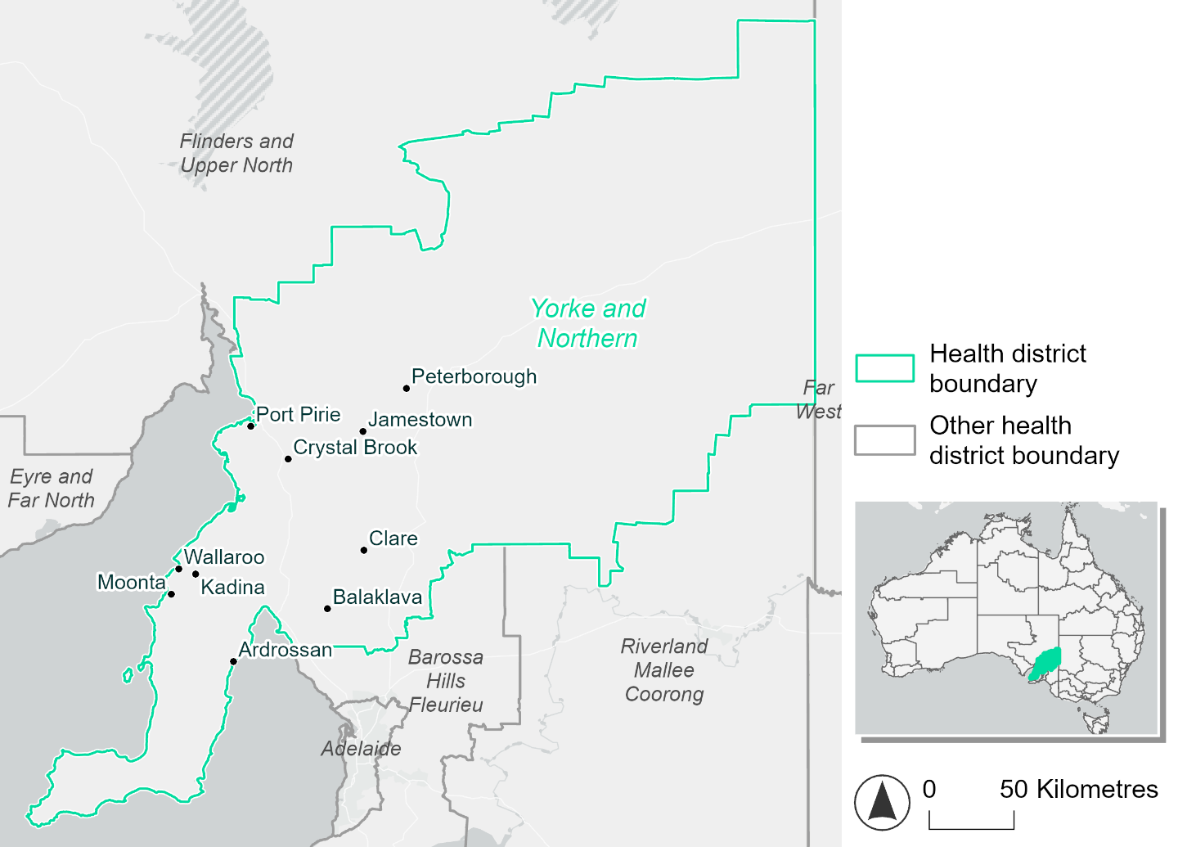
Figure 20. Map of Yorke and Northern health district.

How will climate change affect this health district?
Heat and humidity: Higher average temperatures, hotter and more frequent hot days, warmer night time temperatures and more frequent heatwaves.
Fire: Over 9% of this health district experiences very high fire hazard category and this will increase in the future.
Drought: Number of months experiencing drought will remain the same.
Rainfall and flood: More flood events in urban areas.
Coastal inundation: Increased area flooded during tidal and storm surge and tidal inundation.

Yorke and Northern health district demographic data
Demographic Data | Total
Number of households | 30,935
Persons 15 and older | 48,976
Total families | 20,225
Persons did not complete high school | 27,448
One parent families with dependents | 1,889 (9.3%)
Persons aged 65 and older | 21,823 (28.4%)
Persons aged 4 and younger | 3,743 (4.9%)
Aboriginal and Torres Strait Islander persons | 2,665 (3.5%)
Persons speaks language other than English | 2,113 (2.8%)
Persons working age (15-65) | 42,557 (55.5%)
Population Health Data | Total
Persons with core needs for assistance | 6,166 (8%)
Persons with arthritis | 11,286 (14.7%)
Persons with asthma | 8,065 (10.5%)
Persons with cancer | 3,053 (4%)
Persons with dementia | 896 (1.2%)
Persons with diabetes | 6,181 (8.1%)
Persons with heart disease | 4,822 (6.3%)
Persons with kidney disease | 988 (1.3%)
Persons with lung condition | 2,517 (3.3%)
Persons with mental health condition | 8,540 (11.1%)
Persons with stroke | 1,064 (1.4%)
Persons with any other condition | 6,910 (9%)
Persons no health condition | 38,253 (49.9%)
Socio-economic Data | Total
Persons providing unpaid care | 10,506 (13.7%)
Persons homeless | 246 (0.3%)
Household with lone person | 10,264 (33.2%)
Households with rent and mortgage stress | 12,206 (39.5%)
Households total equivalised income below $1000 (weekly) | 18,856 (61%)
Households with no motor vehicle | 1,681 (5.4%)
Persons unemployed | 3,609 (5.7%)

The sections that follow outline projected climate hazards for this district. Further information on this health district, including population demographics, is provided in the online dashboard.

Heat and humidity hazard
Key projections:
More heatwaves: The number of heatwave events per year will increase. By 2050, under a reasonable worst-case scenario the number of heatwaves will double. By 2085, under a reasonable worst-case scenario the number of heatwaves per year will triple.
Hotter days and warmer nights: The maximum temperature on hot days will increase with night time temperatures on hot nights also increasing.
More days above 35°C and 40°C: The number of days per year greater than 35°C and 40°C will increase under both middle of the road and reasonable worst-case scenarios across both time horizons.

 | Baseline | 2050 Scenarios |  | 2085 Scenarios
 |  | Middle of the road | Reasonable worst-case | Middle of the road | Reasonable worst-case
Average temperature (°C) | 16.7 | 17.9  [17.3, 18.3] | 18.1  [17.4, 18.8] | 18.8  [17.8, 19.4] | 19.6  [18.3, 20.6]
Maximum temperature on hot days (°C)^{(a)} | 36 | 37.5  [37, 38.1] | 37.8  [36.8, 38.9] | 38.4  [37.5, 39.4] | 39.3  [38.3, 40.5]
Minimum temperature on hot nights (°C)^{(b)} | 19.9 | 21.3  [20.4, 21.9] | 21.6  [20.5, 22] | 22.2  [21, 22.9] | 23.1  [21.9, 24]
Average apparent temperature on hot days (°C) (NOAA Heat Index)^{(c)} | 34.6 | 35.6  [35.2, 36.1] | 35.7  [35.2, 36.5] | 36  [35.4, 36.9] | 36.7  [35.9, 37.6]
Average heatwave duration in days^{(d)} | 5 | 5  [5, 5] | 5  [5, 5] | 5  [5, 5] | 5  [5, 5]
Number of heatwaves per year^{(d)} | 2 | 3  [2, 4] | 4  [2, 5] | 4  [3, 5] | 6  [4, 7]
Number of days per year  > 35°C | 24 | 35  [30, 39] | 37  [30, 45] | 42  [35, 50] | 50  [41, 61]
Number of days per year > 40°C | 5 | 9  [7, 11] | 10  [6, 14] | 12  [9, 17] | 16  [12, 22]
Table notes: The heat and humidity hazard uses climate projections from the CMIP6 Global Climate Models [1]. Daily projections of maximum and minimum near-surface temperature and mean relative humidity are used to calculate eight heat and humidity indicators. The primary indicator value reports the median from the nine climate models, with the range reported in square brackets.
Table footnotes: (a) Based on the 95th percentile of daily maximum air temperature. (b) Based on the 95th percentile of daily minimum air temperature, representing the coldest part of the night on very hot nights. (c) The National Oceanic and Atmospheric Administration (NOAA) Heat Index is a measure of how hot it feels when relative humidity is factored in alongside actual air temperature. It is calculated on days with a maximum temperature of 27°C and above. Interpretation of Heat Index values: 27°C to 32°C indicates caution, 33°C to 41°C indicates extreme caution, 42°C to 54°C indicates danger and over 54°C indicates extreme danger. See methodology document for further explanation of Heat Index categories. (d) A heatwave is defined as three or more consecutive days where both daytime and overnight temperatures (daily mean temperatures) are unusually high for the location, based on the Bureau of Meteorology’s Excess Heat Factor method. For this district, an unusually high daily mean temperature is approximately 27.6°C or above.

Fire hazard
Key projections:
Fire hazard evenly spread currently: Under baseline conditions 42-44% of the district experiences low fire hazard while 45-46% experiences moderate to high hazard. 9.2% of the district experiences very high fire hazard during a 1-in-20-year fire weather event, increasing to 11.5% for a 1-in-100-year event.
Very high hazard area to increase slightly: In a future climate across both 2050 and 2085 scenarios, the proportion of the district experiencing very high fire hazard will increase slightly, by up to 2.2 percentage points for a 1-in-20-year fire weather event and up to 2.8 for a 1-in-100-year event. The low and moderate to high fire hazard areas both decline slightly, by up to 1.6 percentage point
 | Baseline | 2050 Scenarios |  | 2085 Scenarios
 |  | Sustainability | Reasonable worst-case | Sustainability | Reasonable worst-case
Hazard for a ‘1-in-20 year’ fire weather event^{(a)}
Proportion (%) of district experiencing ‘Low’ fire hazard | 44.0%  (3,331,925)^{(b)} | 43.9% [43.5%, 44.4%] | 43.6% [43.3%, 43.9%] | 43.7% [42.9%, 44.9%] | 43.0% [42.4%, 43.7%]
Proportion (%) of district experiencing ‘Moderate to High’ fire hazard | 46.8%  (3,547,138)^{(b)} | 46.5% [45.2%, 47.9%] | 46.3% [45.1%, 47.6%] | 46.0% [43.0%, 49.5%] | 45.6% [42.8%, 48.8%]
Proportion (%) of district experiencing ‘Very High’ fire hazard | 9.2%  (697,328)^{(b)} | 9.7% [8.9%, 10.3%] | 10.1% [9.1%, 11.2%] | 10.3% [8.5%, 11.8%] | 11.4% [9.0%, 14.0%]
Hazard for a ‘1-in-100 year’ fire weather event^{(a)}
Proportion (%) of district experiencing ‘Low’ fire hazard | 42.9%  (3,249,501)^{(b)} | 42.8% [42.2%, 43.3%] | 42.4% [42.0%, 42.8%] | 42.6% [41.3%, 43.9%] | 41.7% [40.8%, 42.6%]
Proportion (%) of district experiencing ‘Moderate to High’ fire hazard | 45.6%  (3,457,582)^{(b)} | 45.2% [44.3%, 46.7%] | 45.0% [43.5%, 46.5%] | 44.5% [42.4%, 48.2%] | 44.0% [40.6%, 47.7%]
Proportion (%) of district experiencing ‘Very High’ fire hazard | 11.5%  (869,309)^{(b)} | 12.1% [11.0%, 13.2%] | 12.7% [11.5%, 13.9%] | 12.9% [10.3%, 15.6%] | 14.3% [11.5%, 17.3%]
Table notes: The Fire Hazard uses the National Bushfire Intelligence Capability (NBIC) Phase 2 fire line intensity modelling based on CMIP6 climate projections. Fire Hazard is assessed using the projected Fireline Intensity (FLI) for weather events with two different return intervals (i.e. a 1-in-20 year event and a 1-in-100 year event). FLI considers slope, vegetation and weather to produce a rate of heat output per unit length (kW/m) along a bushfire’s front. Fire hazard is categorized as a low for FLI<4000 kW/m, moderate to high for 4,000 kW/m ≤FLI<12,500kW/m, and very high for FLI≥27,501kW/m. This is broadly consistent with the literature [3]. The assessment considers climate change effects based on changes in fire weather and the associated hazard that is anticipated for a meteorological event of a given return interval. This approach is different to the one adopted for the Flood Hazard, where the event magnitude is given (fixed) and the likelihood of that event varies as a result of climate change. The primary indicator value reports the median from the nine climate models, with the range reported in square brackets.
Table footnotes: (a) The area subject to different categories of fire hazard is determined for a ‘1-in-20 year’ and ‘1-in-100 year’ fire weather event, in current and future climates. Values at year 2050 are interpolated using data from baseline (2025) and 2085, assuming linear change over time. (b) Values in round brackets are the area (ha) of the health district subject to a given fire hazard.

The figures below show the proportion of the health district experiencing different fire hazard categories across different time horizons and climate scenarios during a ‘1-in-20 year’ fire weather event (Figure 21) and a ‘1-in-100 year’ fire weather event (Figure 22).
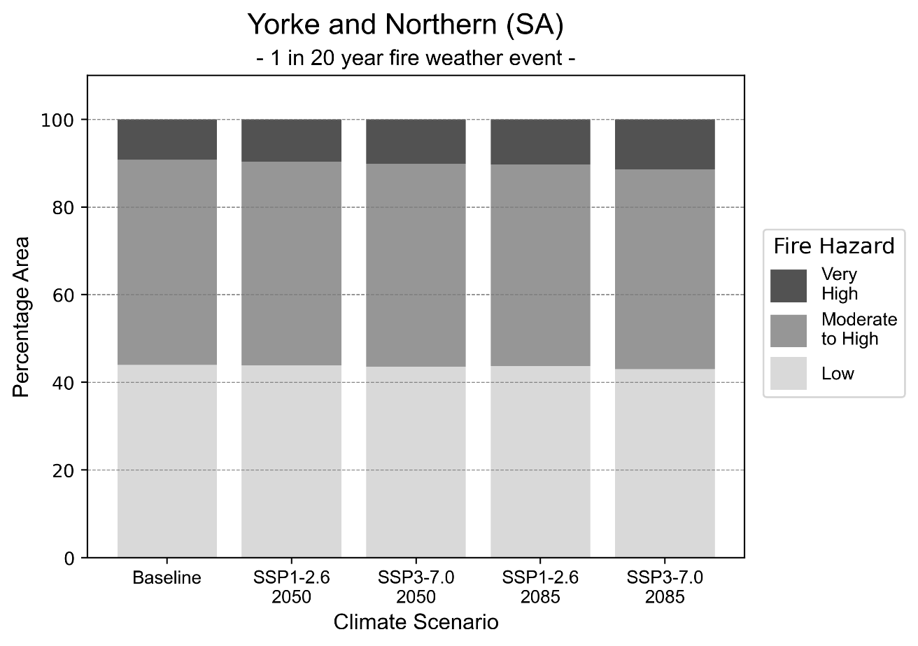
Figure 21: Stacked column chart showing the percentages of Yorke and Northern health district's total geographic area experiencing each fire hazard level during a 1-in-20-year fire weather event.
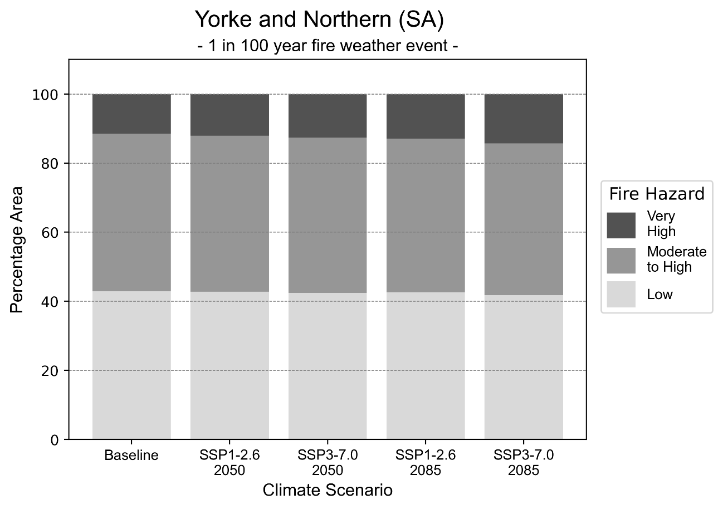
Figure 22: Stacked column chart showing the percentages of Yorke and Northern health district's total geographic area experiencing each fire hazard level during a 1-in-100-year fire weather event.

Drought hazard
Key projections:
Drought occurrence: The occurrence of drought will increase across both middle of the road and reasonable worst-case scenarios and both time horizons, with the largest increase occurring under the reasonable worst-case scenario by 2085.

 | Baseline | 2050 Scenarios |  | 2085 Scenarios
 |  | Middle of the road | Reasonable worst-case | Middle of the road | Reasonable worst-case
Number of months per year in drought^{(a)} | 1.6 | 2.6  [0.7, 4.7] | 2.6  [0.9, 5.5] | 3.1  [0.8, 6.1] | 3.6  [0.5, 8.6]
Table notes: The drought hazard indicator uses climate projections from the CMIP6 Global Climate Models [1]. The primary indicator value reports the median from the nine climate models, with the range reported in square brackets.
Table footnotes: (a) The number of months per year in drought is based on the Standardised Precipitation Index (SPI). SPI is a widely used index to characterise meteorological drought on a range of timescales. This indicator uses the timescale of 12 months which calculates the average months in a year within the moderate drought range. A moderate drought range is classified as SPI score of ≤ -1. SPI is calculated from accumulated rainfall over 12 months and the mean and standard deviation from historical rainfall records.

Storm hazard
Key projections:
Less frequent high-intensity storms: The frequency of high-intensity storms will decrease across both middle of the road and reasonable worst-case scenarios with the greatest decrease occurring by 2085. The number of very-high-intensity storms per year will remain consistent across both time horizons for the middle of the road scenario, but decrease across both horizons for the reasonable worst-case scenario.

Baseline |  | 2050 Scenarios |  | 2085 Scenarios
 |  | Middle of the road | Reasonable worst-case | Middle of the road | Reasonable worst-case
Number of low-intensity storms (40-62 km/hr) per year | 74.5 | 69.1  [60.8, 76.0] | 70.5  [62.1, 77.6] | 70.6  [62.1, 77.6] | 69.1  [60.8, 76.0]
Number of medium-intensity storms (63-87 km/hr) per year | 73.1 | 71.9  [63.3, 79.1] | 67.0  [59.0, 73.7] | 64.5  [56.8, 71.0] | 63.0  [55.5, 69.3]
Number of high-intensity storms (88-117 km/hr) per year | 30.5 | 29.5  [25.9, 32.4] | 28.5  [25.1, 31.4] | 27.1  [23.8, 29.8] | 26.0  [22.9, 28.6]
Number of very-high-intensity storm (> 117 km/hr) per year | 5.7 | 6.0  [5.3, 6.6] | 4.7  [4.2, 5.2] | 5.7  [5.0, 6.2] | 4.6  [4.0, 5.1]
Table notes: The storm hazard uses climate projections from the CMIP6 Global Climate Models [1]. Daily maximum surface wind speed is used to calculate the number of annual storms across four storm intensity categories (low, medium, high and very high). The primary indicator value reports the median from the nine climate models, with the range reported in square brackets.

Rainfall and flood hazard
Key projections:
- Seven extreme rainfall days per year: The number of extreme rainfall days will decrease slightly across both middle of the road and reasonable worst-case scenarios and both time horizons, with an average of approximately seven extreme rainfall days per year.
- Increased flood frequency: The frequency of flood events will increase in urban environments. The largest increase in flood frequency is seen in the reasonable worst-case scenario where frequency of a ‘1-in-100 year’ flood will nearly triple by 2050 and become six times more likely by 2085 in urban environments. Flood events in rural areas will remain consistent across 2050 scenarios but will reduce across 2085 scenarios, particularly the reasonable worst-case scenario.

 | Baseline | 2050 Scenarios |  | 2085 Scenarios
 |  | Middle of the road | Reasonable worst-case | Middle of the road | Reasonable worst-case
Rainfall hazard^{(a)}
Average number of extreme rainfall days per year (> 5 mm/day)^{(a)} | 7.7 | 7.3  [6.0,9.3] | 7.3  [5.9,8.7] | 7.0  [5.9,8.9] | 6.9  [4.8,10.0]
Urban flood risk (flooding caused by a 1-hour rainfall event)^{(b)}
Frequency of a ‘1-in-1 year’ flood (rainfall depth of 12 mm)^{(c)} |  | 1.7 events in 1 year | 1.8 events in 1 year | 2.2 events in 1 year | 2.9 events in 1 year
Frequency of a ‘1-in-10 year’ flood (rainfall depth of 28 mm)^{(c)} |  | 2.1 events in 10 years | 2.2 events in 10 years | 2.8 events in 10 years | 3.9 events in 10 years
Frequency of a ‘1-in-100 year’ flood (rainfall depth of 52 mm)^{(c)} |  | 2.6 events in 100 years | 2.8 events in 100 years | 3.9 events in 100 years | 6.3 events in 100 years
Rural flood risk (flooding caused by a 24-hour rainfall event)^{(b)}
Frequency of a ‘1-in-1 year’ flood (rainfall depth of 34 mm)^{(c)} |  | 1.0 events in 1 year | 0.9 events in 1 year | 0.8 events in 1 year | 0.4 events in 1 year
Frequency of a ‘1-in-10 year’ flood (rainfall depth of 74 mm)^{(c)} |  | 0.9 events in 10 years | 1.0 events in 10 years | 1.0 events in 10 years | 0.5 events in 10 years
Frequency of a ‘1-in-100 year’ flood (rainfall depth of 129 mm)^{(c)} |  | 1.1 events in 100 years | 1.1 events in 100 years | 0.8 events in 100 years | 0.3 events in 100 years
Table notes: The rainfall hazard indicator uses climate projections from the CMIP6 Global Climate Models [1]. The primary indicator value reports the median from the nine climate models, with the range reported in square brackets. The flood hazard indicators use climate change considerations from the Australian Rainfall and Runoff guideline to estimate the climate the climate projections [2].
Table footnotes: (a) Extreme rainfall is defined as rainfall above the 95th percentile of historical average daily rainfall in this health district in the period 1985-2014. The value in mm/day quoted in the indicator name is the 95th percentile of historic average daily rainfall for this health district. (b) See Methodology document for reasons for focusing on a 1-hour flood for urban areas and a 24-hour flood for rural areas. (c) The rainfall depths in mm quoted in the indicator names in this table report 1 in 1-, 10- and 100-year depths for this health district.

Coastal inundation hazard
Key projections:
Greater area inundated: There will be an increase in the area affected by tidal inundation (i.e. area submerged during high tide) and storm surge and tidal inundation (i.e. the area submerged during a storm surge and high tide) across both middle of the road and reasonable worst-case scenarios. In the reasonable worst-case scenario, by 2085 the area inundated during a ‘1-in-1000-year’ event will increase by just over 5,000 ha.

 | Baseline | 2050 Scenarios |  | 2085 Scenarios^{(a)}
 |  | Middle of the road | Reasonable worst-case | Middle of the road | Reasonable worst-case
Tidal inundation (ha inundated)^{(b)} | 3,227.4 | 3,677.3  (+449.9) | 3,862.8  (+635.4) | 4,811.9  (+1,584.5) | 5,125.1  (+1,897.8)
Storm surge + tidal inundation – ‘1-in-100 year’ event (ha inundated)^{(c)} | 6,660.7 | 7,559.0  (+898.3) | 7,615.3  (+954.6) | 9,432.2  (+2,771.5) | 10,134.6  (+3,473.9)
Storm surge + tidal inundation – ‘1-in-1000 year’ event (ha inundated)^{(c)} | 7,452.1 | 8,494.5  (+1,042.4) | 8,564.8  (+1,112.8) | 11,496.5  (+4,044.4) | 12,485.8  (+5,033.7)
Table notes: The coastal inundation hazard provides an indication of flooding in coastal areas that can be attributed to sea level rise and storm inundation. The coastal inundation hazard is only reported for health districts adjoining the coastline. This table includes the projected inundation levels as well as the change from baseline conditions (in brackets).
Table footnotes: (a) For the 2085 Scenarios planning horizon, 2100 was adopted as it provides a conservative representation of the end of this period. This horizon aligns with many State planning regulations requiring consideration of sea level rise and storm tide to 2100, making the 2100 scenario particularly valuable for planning new health facilities in coastal areas. (b) The tidal inundation indicator reports the number of hectares inundated during high tide. The baseline value reports existing inundation patterns, while the 2050 and 2085 values report high tide inundation taking account of projected sea level rise due to climate change. (c) The storm surge + tidal inundation indicators report the combined effect, in hectares inundated, of high tide, sea level rise (for the 2050 and 2085 projections), and storm surge (for 1-in-100 year and 1-in-1000 year events).

References

[1] | D. Irving, I. Macadam and M. King, “Application-ready quantile-delta-change (QDC) scaled CMIP6 climate projections for Australia (time slices, 11km grid) (v1)”, CSIRO. Data Collection, 2024.
[2] | C. Wasko, S. Westra, R. Nathan, D. Jakob, C. Nielsen, J. Evans, S. Rodgers, M. Ho, M. Babister, A. Dowdy and W. Sharples, “Australian Rainfall and Runoff (ARR) Chapter 6: 4 Climate Change Considerations”, Australian Rainfall and Runoff, 2024.
[3] | J. J. Hollis, S. Matthews, W. R. Anderson, M. G. Cruz, P. Fox-Hughes, S. Grootemaat, B. J. Kenny and S. Sauvage, “A framework for defining fire danger to support fire management operations in Australia”, International Journal of Wildland Fire, vol. 33, no.3, 2024.
[4] | Z. Hausfather and P. G. Peters, “Emissions–the ‘business as usual’story is misleading”, Nature, 577(7792), pp. 618-620., 2020.



Another scenario, SSP5-8.5, was previously considered the reasonable worst-case scenario, but it is now considered to be very unlikely to be realised due to climate action already undertaken [4].

