Guidance on climate risk assessment and adaptation planning for Australian health system organisations

Climate and Health Hazard Data for Tasmania
© Commonwealth of Australia as represented by the Australian Centre for Disease Control
Title: Guidance on climate risk assessment and adaptation planning for Australian health system organisations: Climate and Health Hazard Data for Tasmania.
Citation
Australian Centre for Disease Control (CDC). Guidance on climate risk assessment and adaptation planning for Australian health system organisations: Climate and Health Hazard Data for Tasmania, Australian CDC, Australian Government, 2026.
Contributors
Anne Cleary, Jamie Ewert, Jake Allen, Adam Brook, Petter Nyman, Pam Wong, Anthony Kiem, Felix Edger, Richard Farr, Robert Morden, Vincent Li Creagh, Tony Weber, Dominic Blackham, Matilda Lehmann, Phoebe Spurrier, Sophia Gidis, Georgia Behrens, Madeleine Skellern.
Acknowledgments
CSIRO National Bushfire Intelligence Capability for assisting with the analysis of the Fire Hazard.
Creative Commons Licence
This publication is licensed under the Creative Commons Attribution 4.0 International Public License available from https://creativecommons.org/licenses/by/4.0/legalcode (“Licence”). You must read and understand the Licence before using any material from this publication.
Restrictions
The Licence may not give you all the permissions necessary for your intended use. For example, other rights (such as publicity, privacy and moral rights) may limit how you use the material found in this publication. The Licence does not cover, and there is no permission given for, use of any of the following material found in this publication:
- the Commonwealth Coat of Arms. (by way of information, the terms under which the Coat of Arms may be used can be found on the Department of Prime Minister and Cabinet website
- any logos and trademarks
- any photographs and images
- any signatures
- any material belonging to third parties. The third party elements must be included here or have a footnote reference throughout the document showing where they are.
Attribution
Without limiting your obligations under the Licence, the Australian Centre for Disease Control requests that you attribute this publication in your work. Any reasonable form of words may be used provided that you:
- include a reference to this publication and where practicable, the relevant page numbers
- make it clear that you have permission to use the material under the Creative Commons Attribution 4.0 International Public License
- make it clear whether or not you have changed the material used from this publication
- include a copyright notice in relation to the material used. In the case of no change to the material, the words “© Commonwealth of Australia (Australian Centre for Disease Control) 2026” may be used. In the case where the material has been changed or adapted, the words: “Based on Commonwealth of Australia (Australian Centre for Disease Control) material” may be used
- do not suggest that the Australian Centre for Disease Control endorses you or your use of the material.
Enquiries
Enquiries regarding any other use of this publication should be addressed to the Communication and Public Information Section, Strategy and Engagement Branch, Australian Centre for Disease Control, GPO Box 798, Canberra ACT 2601, or via e-mail to CDCComms@cdc.gov.au.
We welcome feedback and dialogue about this report. Please send all such correspondence to NHSC.Unit@cdc.gov.au.

Table of Contents

Table of Contents 3
Introduction 4
North-East health district 7
North-West health district 16
South health district 25
References 34

Introduction
This document provides scientific climate information to help health system organisations assess, prepare for and effectively manage climate-related risks across short-, medium-, and long-term planning horizons. A digital version of the information in this document can be found here. Further detail about the information contained in this document can be found in the accompanying methodological report.

The document presents climate hazard information summarised for health districts across Tasmania. For each health district, information is provided about six hazards – heat and humidity, fire, drought, rainfall, storms, and coastal inundation – across three different time horizons and two climate scenarios. This structure enables users to assess how climate risks may evolve over time and under different emissions pathways. The information is presented both in narrative form and through a series of detailed tables containing quantitative data. Further information on the information presented in this document is outlined below.

Health districts
This document presents climate information for 3 health districts in, which are constructed using the 4 Tasmanian Statistical Divisions (SDs) used by the Australian Bureau of Statistics (see Figure 1). The health districts are as follows:
- The West & North SD is the North-West heath district.
- The Launceston & North East SD is the North-East health district.
- The South East SD and Hobart SD are merged to form the South health district.

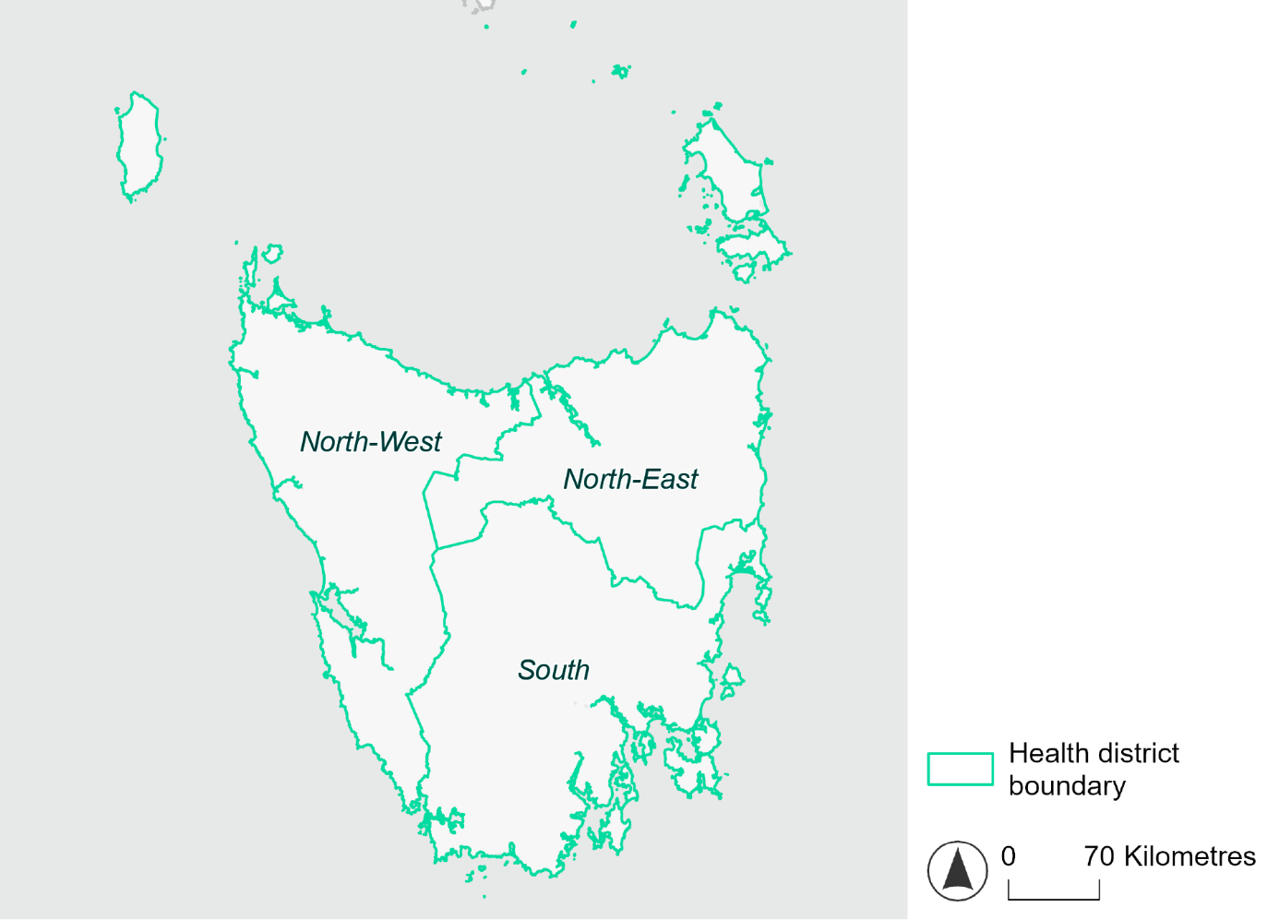
Figure 1. Map of Tasmanian health districts used in this document.

Time horizons
This document provides climate information on each climate hazard for the following time horizons:

Time horizon | Years | Description | Use in risk assessment
Baseline | Observed data from 1985-2014 | Historical baseline position | Understand current risks and ensure they are being managed effectively
Mid-century (2050) | 2035–2064 | Medium-term climate projections | Identify and manage emerging risks to population health and health systems
Late century (2085) | 2070–2099 | Long-term climate projections | Identify long-term risks when planning infrastructure or policy with long-lasting consequences

Climate scenarios
The document provides climate information on each hazard for two different climate scenarios. A climate scenario is a plausible representation of what the future climate might look like. These scenarios are based on different assumptions about greenhouse gas emissions and other factors that influence the future climate.

This document uses Shared Socioeconomic Pathways (SSPs) as the basis for different climate scenarios. SSPs describe how socioeconomic factors (such as population, economic growth, education, urbanisation and technology development) could change over the next century and have an effect on future greenhouse gas emissions and global temperatures.

There are five main SSPs, each of which outlines a different scenario, ranging from a sustainable future with low emissions, to one with high fossil fuel uses and high emissions. The most recent iteration of SSPs incorporate information from what were previously called Representative Concentration Pathways (RCPs), which measure the expected change in radiative forcing (in W/m²) under the scenario from 1750 to 2100. SSP2-4.5 denotes what would previously have been called a scenario involving SSP2 and RCP4.5 – the reasoning for merging them being that SSP2 describes socioeconomic conditions likely to give rise to RCP4.5.

The two main scenarios used in this document are:
A ‘middle of the road’ scenario (SSP2-4.5): this scenario assumes emissions remain at current levels until the middle of the 21st century, and that net zero emissions are not reached by 2100. This scenario sees temperatures rising by about 2.7°C by the end of the century. In this document this is the lower emissions scenario across all climate hazards, except for the fire hazard (see below note).
A ‘reasonable worst-case’ scenario (SSP3-7.0): this scenario assumes both emissions and temperatures continue to rise to the end of the century due to delayed climate action. This scenario sees temperatures rise by about 3.6°C by 2100. In this document this is the higher emissions scenario across all climate hazards.

Fire hazard projections are not available for SSP2-4.5, so SSP1-2.6 is used as the lower emissions scenario for this hazard instead of SSP2-4.5. Under SSP1-2.6, global emissions are reduced but do not reach net zero until after 2050 and warming stabilises at about 1.8°C by 2100. This document refers to SSP1-2.6 as the ‘sustainability’ scenario.

Climate hazard projections
For each health district, the following information is provided for each climate hazard, across the different time horizons and climate scenarios:
- Heat and humidity: projected average, extreme and apparent temperatures; projected heatwave duration and frequency; and projected number of very hot days.
- Fire: projected area affected by different fire hazard categories for a 1-in-20 year fire event and a 1-in-100 year event.
- Drought: projected average number of months per year experiencing drought.
- Rainfall and flooding: projected number of extreme rainfall days per year, as well as projected frequency of urban and rural flood events.
- Storms: projected number of storms per year, grouped into four intensity categories based on wind speed.
- Coastal inundation: projected area of land affected by tidal inundation and storm surge and tidal inundation (coastal districts only).

The climate hazard projections in this document are based on data from nine CMIP6 Global Climate Models (ACCESS-CM2, ACCESS-ESM1-5, CESM2, CMCC-ESM2, CNRM-ESM2-1, EC-Earth3, MPI-ESM1-2-HR, NorESM2-MM, UKESM1-0-LL). These models simulate how climate hazards may change under different SSPs. Where hazard projections are based on these models, this document reports the median projected value as its primary estimate, and reports the range across all nine models in square brackets.

North-East health district

Health district overview
The North-East health district covers 19,975 square kilometres and contains the Launceston General Hospital.

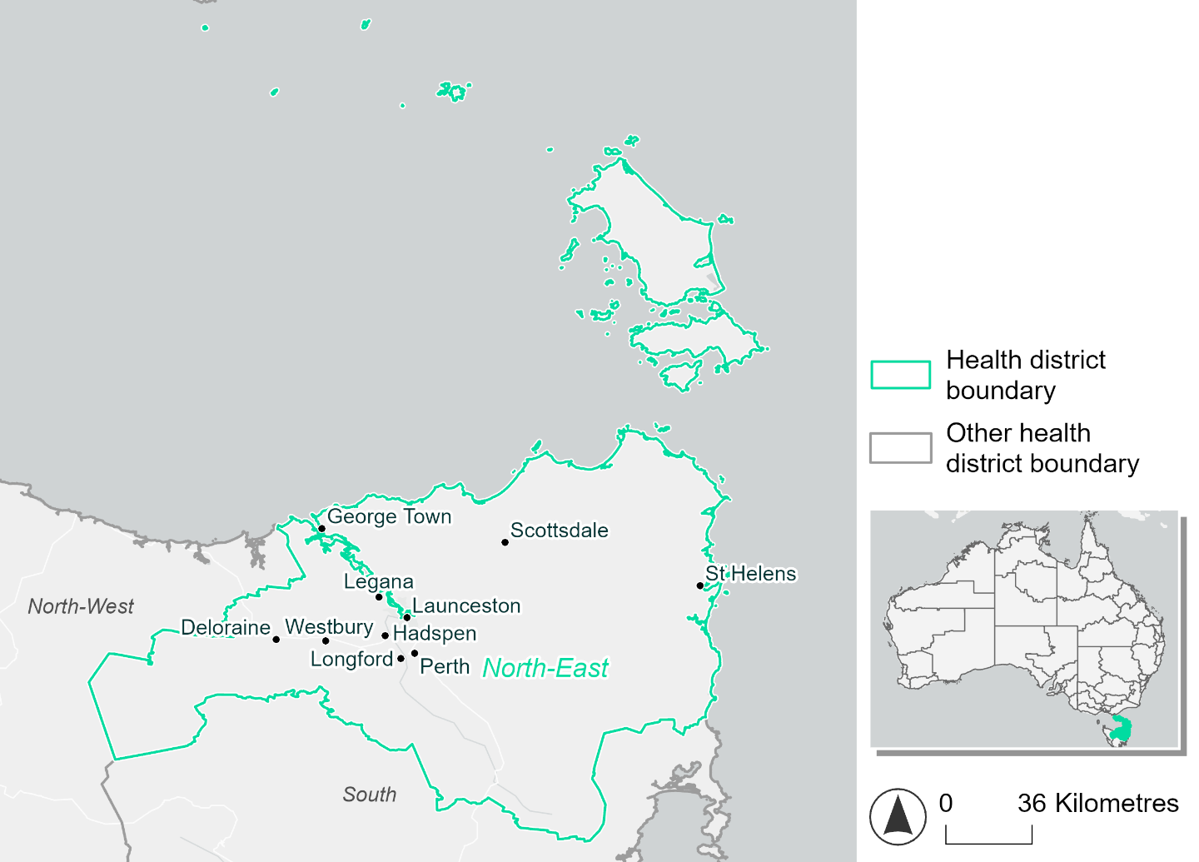
Figure 2. Map of North-East health district.

How will climate change affect this health district?
Heat and humidity: Higher average temperatures, hotter and more frequent hot days, warmer night time temperatures and longer and more frequent heat waves.
Fire: Over 40% of this health district experiences very high fire hazard category and this will increase in the future.
Drought: Number of months experiencing drought will increase.
Rainfall and flood: Average number of extreme rainfall days per year will stay the same. More flood events in urban areas and less floods in rural areas.
Coastal inundation: Increased area flooded during tidal and storm surge and tidal inundation.

North-East health district demographic data
Demographic Data | Total
Number of households | 60,359
Persons 15 and older | 105,708
Total families | 41,012
Persons did not complete high school | 52,317
One parent families with dependents | 4,574 (11.2%)
Persons aged 65 and older | 34,095 (21.9%)
Persons aged 4 and younger | 7,880 (5.1%)
Aboriginal and Torres Strait Islander persons | 5,846 (3.8%)
Persons speaks language other than English | 10,763 (6.9%)
Persons working age (15-65) | 95,607 (61.5%)
Population Health Data | Total
Persons with core needs for assistance | 10,721 (6.9%)
Persons with arthritis | 19,874 (12.8%)
Persons with asthma | 15,274 (9.8%)
Persons with cancer | 5,374 (3.5%)
Persons with dementia | 1,128 (0.7%)
Persons with diabetes | 8,281 (5.3%)
Persons with heart disease | 7,251 (4.7%)
Persons with kidney disease | 1,834 (1.2%)
Persons with lung condition | 4,438 (2.9%)
Persons with mental health condition | 17,513 (11.3%)
Persons with stroke | 2,040 (1.3%)
Persons with any other condition | 13,909 (8.9%)
Persons no health condition | 83,767 (53.9%)
Socio-economic Data | Total
Persons providing unpaid care | 19,765 (12.7%)
Persons homeless | 619 (0.4%)
Household with lone person | 18,165 (30.1%)
Households with rent and mortgage stress | 25,715 (42.6%)
Households total equivalised income below $1000 (weekly) | 33,914 (56.2%)
Households with no motor vehicle | 3,382 (5.6%)
Persons unemployed | 7,522 (6%)

The sections that follow outline projected climate hazards for this district. Further information on this health district, including population demographics, is provided in the online dashboard.

Heat and humidity hazard
Key projections:
More heatwaves: The number of heatwaves per year will increase. By 2050, under a reasonable worst-case scenario the number of heatwaves will more than double. By 2085, under a reasonable worst-case scenario the number of heatwaves per year may quadruple.
Hotter days and warmer nights: The maximum temperature on hot days will increase with night time temperatures on hot nights also increasing.
More days above 35°C: The number of days per year greater than 35°C will slightly increase under both middle of the road and reasonable worst-case scenarios.

 | Baseline | 2050 Scenarios |  | 2085 Scenarios
 |  | Middle of the road | Reasonable worst-case | Middle of the road | Reasonable worst-case
Average temperature (°C) | 11.8 | 13.1  [12.3, 13.6] | 13.2  [12.5, 13.7] | 13.8  [12.8, 14.7] | 14.7  [13.4, 16]
Maximum temperature on hot days (°C)^{(a)} | 25.6 | 27.2  [26.5, 28.2] | 27.4  [26.5, 28.2] | 28  [27.1, 29.4] | 29.2  [28, 31]
Minimum temperature on hot nights (°C)^{(b)} | 13.7 | 15.2  [14.3, 15.7] | 15.3  [14.4, 15.9] | 15.9  [14.7, 16.9] | 17  [15.5, 18.3]
Average apparent temperature on hot days (°C) (NOAA Heat Index)^{(c)} | 31.3 | 31.8  [31.4, 32.3] | 31.9  [30.9, 32.3] | 32.2  [31.5, 32.8] | 32.7  [32, 33.5]
Average heatwave duration in days^{(d)} | 4 | 5  [4, 6] | 5  [4, 6] | 6  [5, 8] | 8  [6, 11]
Number of heatwaves per year^{(d)} | 2 | 5  [3, 6] | 5  [3, 6] | 6  [4, 8] | 8  [6, 10]
Number of days per year  > 35°C | 0 | 1  [0, 1] | 1  [0, 1] | 1  [0, 2] | 2  [1, 4]
Number of days per year > 40°C | 0 | 0  [0, 0] | 0  [0, 0] | 0  [0, 0] | 0  [0, 0]
Table notes: The heat and humidity hazard uses climate projections from the CMIP6 Global Climate Models [1]. Daily projections of maximum and minimum near-surface temperature and mean relative humidity are used to calculate eight heat and humidity indicators. The primary indicator value reports the median from the nine climate models, with the range reported in square brackets.
Table footnotes: (a) Based on the 95th percentile of daily maximum air temperature. (b) Based on the 95th percentile of daily minimum air temperature, representing the coldest part of the night on very hot nights. (c) The National Oceanic and Atmospheric Administration (NOAA) Heat Index is a measure of how hot it feels when relative humidity is factored in alongside actual air temperature. It is calculated on days with a maximum temperature of 27°C and above. Interpretation of Heat Index values: 27°C to 32°C indicates caution, 33°C to 41°C indicates extreme caution, 42°C to 54°C indicates danger and over 54°C indicates extreme danger. See methodology document for further explanation of Heat Index categories. (d) A heatwave is defined as three or more consecutive days where both daytime and overnight temperatures (daily mean temperatures) are unusually high for the location, based on the Bureau of Meteorology’s Excess Heat Factor method. For this district, an unusually high daily mean temperature is approximately 19.2°C or above.

Fire hazard
Key projections:
Significant portion of district experiences very high fire hazard: under baseline conditions, 40.2% of the district experiences very high hazard during a 1-in-20-year fire weather event. During the same event, 31.8% experiences moderate to high hazard, with the remaining 28.1% experiencing low fire hazard. For a 1-in-100-year fire weather event, the area experiencing very high hazard increases to 42.9% of the district, with corresponding decreases in the other categories.
Very high fire hazard to increase: in a future climate across both 2050 and 2085 scenarios, an additional 6.4% of the district will experience very high fire hazard during a 1-in-20-year fire weather event, and an additional 5.5% of the district during a 1-in-100-year event. In the reasonable worst-case emissions scenario, nearly half (48.4%) of this district will experience very high fire hazard during a 1-in-100-year fire weather event.

 | Baseline | 2050 Scenarios |  | 2085 Scenarios
 |  | Sustainability | Reasonable worst-case | Sustainability | Reasonable worst-case
Hazard for a ‘1-in-20 year’ fire weather event^{(a)}
Proportion (%) of district experiencing ‘Low’ fire hazard | 28.1%  (560,366)^{(b)} | 27.5%  [26.7%, 28.8%] | 27.1%  [26.2%, 28.3%] | 26.8%  [24.7%, 29.8%] | 25.8%  [23.7%, 28.7%]
Proportion (%) of district experiencing ‘Moderate to High’ fire hazard | 31.8%  (635,141)^{(b)} | 30.8%  [29.9%, 32.0%] | 30.0%  [29.0%, 31.3%] | 29.5%  [27.2%, 32.3%] | 27.6%  [25.1%, 30.7%]
Proportion (%) of district experiencing ‘Very High’ fire hazard | 40.2%  (802,027)^{(b)} | 41.7%  [39.9%, 42.8%] | 42.8%  [41.2%, 43.7%] | 43.8%  [39.5%, 46.6%] | 46.6%  [42.7%, 48.6%]
Hazard for a ‘1-in-100 year’ fire weather event^{(a)}
Proportion (%) of district experiencing ‘Low’ fire hazard | 26.3%  (525,483)^{(b)} | 25.7%  [24.8%, 27.1%] | 25.2%  [24.5%, 26.4%] | 24.9%  [22.8%, 28.1%] | 23.7%  [22.0%, 26.5%]
Proportion (%) of district experiencing ‘Moderate to High’ fire hazard | 30.8%  (615,197)^{(b)} | 30.2%  [29.4%, 31.2%] | 29.6%  [28.9%, 30.2%] | 29.3%  [27.5%, 31.7%] | 27.9%  [26.2%, 29.4%]
Proportion (%) of district experiencing ‘Very High’ fire hazard | 42.9%  (856,854)^{(b)} | 44.1%  [42.5%, 45.0%] | 45.2%  [44.1%, 45.7%] | 45.8%  [41.9%, 47.9%] | 48.4%  [45.7%, 49.6%]
Table notes: The Fire Hazard uses the National Bushfire Intelligence Capability (NBIC) Phase 2 fire line intensity modelling based on CMIP6 climate projections. Fire Hazard is assessed using the projected Fireline Intensity (FLI) for weather events with two different return intervals (i.e. a 1-in-20 year event and a 1-in-100 year event). FLI considers slope, vegetation and weather to produce a rate of heat output per unit length (kW/m) along a bushfire’s front. Fire hazard is categorized as a low for FLI<4000 kW/m, moderate to high for 4,000 kW/m ≤FLI<12,500kW/m, and very high for FLI≥27,501kW/m. This is broadly consistent with the literature [3]. The assessment considers climate change effects based on changes in fire weather and the associated hazard that is anticipated for a meteorological event of a given return interval. This approach is different to the one adopted for the Flood Hazard, where the event magnitude is given (fixed) and the likelihood of that event varies as a result of climate change. The primary indicator value reports the median from the nine climate models, with the range reported in square brackets.
Table footnotes: (a) The area subject to different categories of fire hazard is determined for a ‘1-in-20 year’ and ‘1-in-100 year’ fire weather event, in current and future climates. Values at year 2050 are interpolated using data from baseline (2025) and 2085, assuming linear change over time. (b) Values in round brackets are the area (ha) of the health district subject to a given fire hazard.

The figures below show the proportion of the health district experiencing different fire hazard categories across different time horizons and climate scenarios during a ‘1-in-20 year’ fire weather event (Figure 3) and a ‘1-in-100 year’ fire weather event (Figure 4).

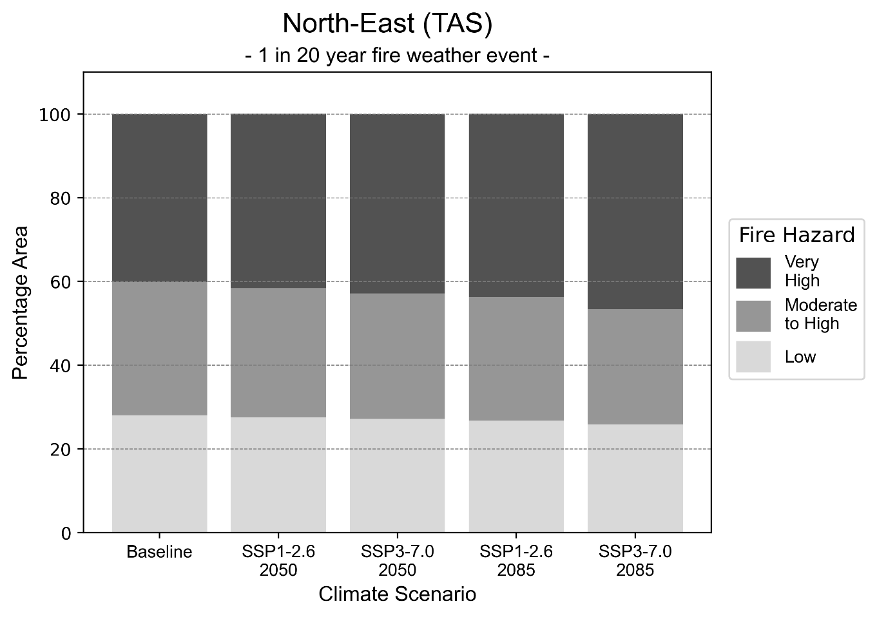
Figure 3: Stacked column chart showing the percentages of the North-East health district's total geographic area experiencing each fire hazard level during a 1-in-20-year fire weather event.
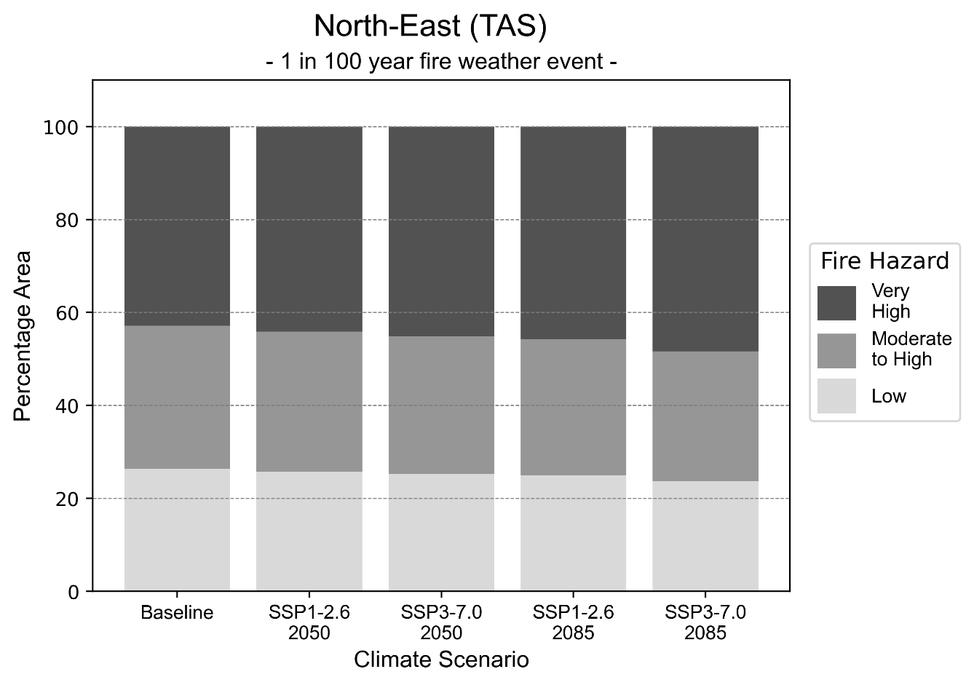
Figure 4: Stacked column chart showing the percentages of the North-East health district's total geographic area experiencing each fire hazard level during a 1-in-100-year fire weather event.

Drought hazard
Key projections:
Drought occurrence: The occurrence of drought will increase across both middle of the road and reasonable worst-case scenarios and both time horizons, with the greatest increase occurring under the reasonable worst-case scenario by 2085.

 | Baseline | 2050 Scenarios |  | 2085 Scenarios
 |  | Middle of the road | Reasonable worst-case | Middle of the road | Reasonable worst-case
Number of months per year in drought^{(a)} | 1.8 | 2.3  [0.7, 4.5] | 2.5  [1.5, 4.3] | 2.8  [1.2, 4.4] | 3.7  [1.3, 6.8]
Table notes: The drought hazard indicator uses climate projections from the CMIP6 Global Climate Models [1]. The primary indicator value reports the median from the nine climate models, with the range reported in square brackets.
Table footnotes: (a) The number of months per year in drought is based on the Standardised Precipitation Index (SPI). SPI is a widely used index to characterise meteorological drought on a range of timescales. This indicator uses the timescale of 12 months which calculates the average months in a year within the moderate drought range. A moderate drought range is classified as SPI score of ≤ -1. SPI is calculated from accumulated rainfall over 12 months and the mean and standard deviation from historical rainfall records.

Storm hazard
Key projections:
Less frequent high-intensity storms: The frequency of high-intensity storms will decrease across both middle of the road and reasonable worst-case scenarios with the greatest decrease occurring by 2085.

 | Baseline | 2050 Scenarios |  | 2085 Scenarios
 |  | Middle of the road | Reasonable worst-case | Middle of the road | Reasonable worst-case
Number of low-intensity storms (40-62 km/hr) per year | 52.0 | 52.1  [45.8, 57.3] | 52.9  [46.6, 58.2] | 53.0  [46.6, 58.3] | 51.4  [45.3, 56.6]
Number of medium-intensity storms (63-87 km/hr) per year | 64.1 | 62.0  [54.6, 68.2] | 62.9  [55.4, 69.2] | 58.4  [51.4, 64.2] | 57.3  [50.4, 63.0]
Number of high-intensity storms (88-117 km/hr) per year | 36.4 | 33.5  [29.5, 36.9] | 32.9  [29.0, 36.2] | 30.9  [27.2, 34.0] | 30.7  [27.0, 33.8]
Number of very-high-intensity storm (> 117 km/hr) per year | 36.9 | 37.7  [33.1, 41.4] | 37.5  [33.0, 41.3] | 36.0  [31.7, 39.6] | 33.0  [29.0, 36.3]
Table notes: The storm hazard uses climate projections from the CMIP6 Global Climate Models [1]. Daily maximum surface wind speed is used to calculate the number of annual storms across four storm intensity categories (low, medium, high and very high). The primary indicator value reports the median from the nine climate models, with the range reported in square brackets.

Rainfall and flood hazard
Key projections:
- Five extreme rainfall days per year: The number of extreme rainfall days will reduce slightly across both middle of the road and reasonable worst-case scenarios and both time horizons, with an average of approximately five extreme rainfall days per year.
- Increased flood frequency: The frequency of flood events will increase in urban environments but decrease in rural environments. The largest increase in flood frequency is seen in the reasonable worst-case scenario where frequency of a ‘1-in-100 year’ flood will more than triple by 2050 and become 13 times more likely by 2085 in urban environments.

 | Baseline | 2050 Scenarios |  | 2085 Scenarios
 |  | Middle of the road | Reasonable worst-case | Middle of the road | Reasonable worst-case
Rainfall hazard^{(a)}
Average number of extreme rainfall days per year (> 14 mm/day)^{(a)} | 5.5 | 5.5  [4.9,6.1] | 5.4  [5.0,6.0] | 5.4  [4.9,6.1] | 5.2  [4.4,6.1]
Urban flood risk (flooding caused by a 1-hour rainfall event)^{(b)}
Frequency of a ‘1-in-1 year’ flood (rainfall depth of 14 mm)^{(c)} |  | 2.2 events in 1 year | 2.3 events in 1 year | 3.1 events in 1 year | 4.4 events in 1 year
Frequency of a ‘1-in-10 year’ flood (rainfall depth of 23 mm)^{(c)} |  | 3.1 events in 10 years | 3.3 events in 10 years | 4.8 events in 10 years | 7.4 events in 10 years
Frequency of a ‘1-in-100 year’ flood (rainfall depth of 36 mm)^{(c)} |  | 3.9 events in 100 years | 4.2 events in 100 years | 6.6 events in 100 years | 13 events in 100 years
Rural flood risk (flooding caused by a 24-hour rainfall event) ^{(b)}
Frequency of a ‘1-in-1 year’ flood (rainfall depth of 48 mm)^{(c)} |  | 0.8 events in 1 year | 0.8 events in 1 year | 0.4 events in 1 year | 0.04 events in 1 year
Frequency of a ‘1-in-10 year’ flood (rainfall depth of 78 mm)^{(c)} |  | 0.8 events in 10 years | 0.4 events in 10 years | 0.3 events in 10 years | 0.04 events in 10 years
Frequency of a ‘1-in-100 year’ flood (rainfall depth of 115 mm)^{(c)} |  | 0.8 events in 100 years | 0.8 events in 100 years | 0.4 events in 100 years | 0.05 events in 100 years
Table notes: The rainfall hazard indicator uses climate projections from the CMIP6 Global Climate Models [1]. The primary indicator value reports the median from the nine climate models, with the range reported in square brackets. The flood hazard indicators use climate change considerations from the Australian Rainfall and Runoff guideline to estimate the climate the climate projections [2].
Table footnotes:(a) Extreme rainfall is defined as rainfall above the 95th percentile of historical average daily rainfall in this health district in the period 1985-2014. The value in mm/day quoted in the indicator name is the 95th percentile of historic average daily rainfall for this health district. (b) See Methodology document for reasons for focusing on a 1-hour flood for urban areas and a 24-hour flood for rural areas. (c) The rainfall depths in mm quoted in the indicator names in this table report 1 in 1-, 10- and 100-year depths for this health district.

Coastal inundation hazard
Key projections:
Greater area inundated: There will be an increase in the area affected by tidal inundation (i.e. area submerged during high tide) and storm surge and tidal inundation (i.e. the area submerged during a storm surge and high tide) across both middle of the road and reasonable worst-case scenarios. In the reasonable worst-case scenario, by 2085 the area inundated during a ‘1-in-1000-year’ event will increase by nearly 6,000 ha.

 | Baseline | 2050 Scenarios |  | 2085 Scenarios^{(a)}
 |  | Middle of the road | Reasonable worst-case | Middle of the road | Reasonable worst-case
Tidal inundation (ha inundated)^{(b)} | 9,607.6 | 10,958.3  (+1,350.7) | 11,068.2  (+1,460.7) | 13,272.6  (+3,665.1) | 14,390.1  (+4,782.5)
Storm surge + tidal inundation – ‘1-in-100 year’ event (ha inundated)^{(c)} | 13,590.6 | 15,021.7  (+1,431.1) | 15,135.0  (+1,544.4) | 17,539.3  (+3,948.7) | 18,701.7  (+5,111.1)
Storm surge + tidal inundation – ‘1-in-1000 year’ event (ha inundated)^{(c)} | 14,124.2 | 15,569.9  (+1,445.7) | 15,686.1  (+1,561.9) | 18,860.2  (+4,736.0) | 20,013.9  (+5,889.8)
Table notes: The coastal inundation hazard provides an indication of flooding in coastal areas that can be attributed to sea level rise and storm inundation. The coastal inundation hazard is only reported for health districts adjoining the coastline. This table includes the projected inundation levels as well as the change from baseline conditions (in brackets).
Table footnotes: (a) For the 2085 Scenarios planning horizon, 2100 was adopted as it provides a conservative representation of the end of this period. This horizon aligns with many State planning regulations requiring consideration of sea level rise and storm tide to 2100, making the 2100 scenario particularly valuable for planning new health facilities in coastal areas. (b) The tidal inundation indicator reports the number of hectares inundated during high tide. The baseline value reports existing inundation patterns, while the 2050 and 2085 values report high tide inundation taking account of projected sea level rise due to climate change. (c) The storm surge + tidal inundation indicators report the combined effect, in hectares inundated, of high tide, sea level rise (for the 2050 and 2085 projections), and storm surge (for 1-in-100 year and 1-in-1000 year events).

North-West health district

Health district overview
The North-West health district covers 22,524 square kilometres and contains the North-West Regional Hospital and Mersey Community Hospital.

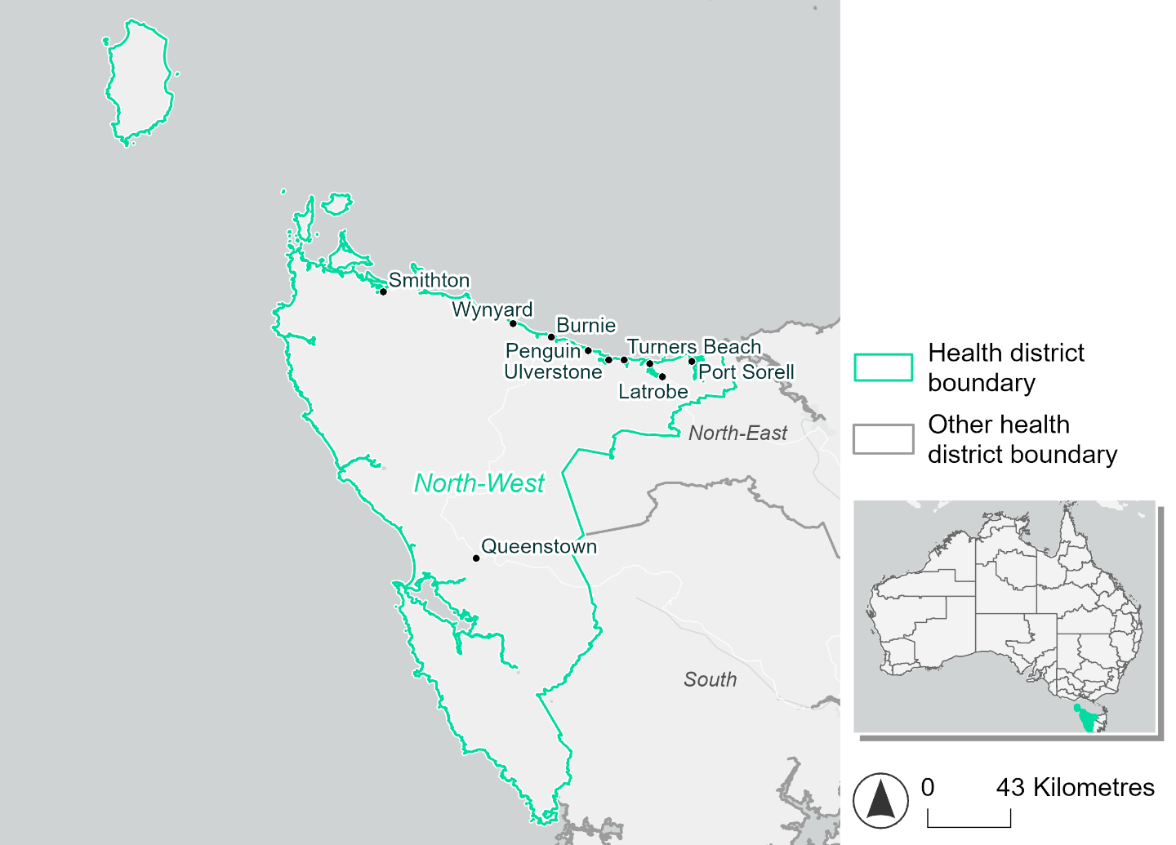
Figure 5. Map of North-West health district

How will climate change affect this health district?
Heat and humidity: Higher average temperatures, hotter and more frequent hot days, warmer night time temperatures and longer and more frequent heat waves.
Fire: Nearly 30% of this health district experiences very high fire hazard category and this will increase in the future.
Drought: Number of months experiencing drought will increase.
Rainfall and flood: Average number of extreme rainfall days per year will stay the same. More flood events in urban areas and less flood events and rural areas.
Coastal inundation: Increased area flooded during tidal and storm surge and tidal inundation.

North-West health district demographic data
Demographic Data | Total
Number of households | 46,864
Persons 15 and older | 80,046
Total families | 31,809
Persons did not complete high school | 46,316
One parent families with dependents | 3,615 (11.4%)
Persons aged 65 and older | 27,504 (23%)
Persons aged 4 and younger | 6,166 (5.2%)
Aboriginal and Torres Strait Islander persons | 9,766 (8.2%)
Persons speaks language other than English | 4,594 (3.8%)
Persons working age (15-65) | 71,918 (60.2%)
Population Health Data | Total
Persons with core needs for assistance | 9,022 (7.5%)
Persons with arthritis | 15,819 (13.2%)
Persons with asthma | 12,365 (10.3%)
Persons with cancer | 4,246 (3.6%)
Persons with dementia | 833 (0.7%)
Persons with diabetes | 7,038 (5.9%)
Persons with heart disease | 6,063 (5.1%)
Persons with kidney disease | 1,696 (1.4%)
Persons with lung condition | 3,726 (3.1%)
Persons with mental health condition | 13,415 (11.2%)
Persons with stroke | 1,622 (1.4%)
Persons with any other condition | 10,616 (8.9%)
Persons no health condition | 62,726 (52.5%)
Socio-economic Data | Total
Persons providing unpaid care | 16,069 (13.4%)
Persons homeless | 516 (0.4%)
Household with lone person | 14,417 (30.8%)
Households with rent and mortgage stress | 19,286 (41.2%)
Households total equivalised income below $1000 (weekly) | 26,971 (57.6%)
Households with no motor vehicle | 2,675 (5.7%)
Persons unemployed | 5,343 (5.5%)
The sections that follow outline projected climate hazards for this district. Further information on this health district, including population demographics, is provided in the online dashboard.

Heat and humidity hazard
Key projections:
More heatwaves: The number of heatwaves per year will increase. By 2050, under a reasonable worst-case scenario the number of heatwaves will more than double. By 2085, under a reasonable worst-case scenario the number of heatwaves per year may quadruple.
Hotter days and warmer nights: The maximum temperature on hot days will increase with night time temperatures on hot nights also increasing.

 | Baseline | 2050 Scenarios |  | 2085 Scenarios
 |  | Middle of the road | Reasonable worst-case | Middle of the road | Reasonable worst-case
Average temperature (°C) | 11.6 | 12.8  [12, 13.3] | 12.9  [12.2, 13.4] | 13.5  [12.5, 14.5] | 14.4  [13, 15.6]
Maximum temperature on hot days (°C)^{(a)} | 23.3 | 24.7  [23.9, 25.4] | 24.9  [24, 25.5] | 25.6  [24.6, 26.7] | 26.7  [25.5, 28.1]
Minimum temperature on hot nights (°C)^{(b)} | 14 | 15.4  [14.4, 16] | 15.6  [14.6, 16.1] | 16.2  [14.8, 17.3] | 17.2  [15.6, 18.6]
Average apparent temperature on hot days (°C) (NOAA Heat Index)^{(c)} | 31 | 31.2  [30.5, 31.8] | 31.3  [30.8, 31.7] | 31.6  [31, 32.1] | 31.9  [31.3, 32.5]
Average heatwave duration in days^{(d)} | 5 | 6  [5, 6] | 6  [5, 6] | 6  [5, 8] | 8  [6, 11]
Number of heatwaves per year^{(d)} | 2 | 5  [3, 6] | 5  [3, 6] | 6  [4, 8] | 8  [5, 10]
Number of days per year  > 35°C | 0 | 0  [0, 0] | 0  [0, 0] | 0  [0, 0] | 0  [0, 1]
Number of days per year > 40°C | 0 | 0  [0, 0] | 0  [0, 0] | 0  [0, 0] | 0  [0, 0]
Table notes: The heat and humidity hazard uses climate projections from the CMIP6 Global Climate Models [1]. Daily projections of maximum and minimum near-surface temperature and mean relative humidity are used to calculate eight heat and humidity indicators. The primary indicator value reports the median from the nine climate models, with the range reported in square brackets.
Table footnotes: (a) Based on the 95th percentile of daily maximum air temperature. (b) Based on the 95th percentile of daily minimum air temperature, representing the coldest part of the night on very hot nights. (c) The National Oceanic and Atmospheric Administration (NOAA) Heat Index is a measure of how hot it feels when relative humidity is factored in alongside actual air temperature. It is calculated on days with a maximum temperature of 27°C and above. Interpretation of Heat Index values: 27°C to 32°C indicates caution, 33°C to 41°C indicates extreme caution, 42°C to 54°C indicates danger and over 54°C indicates extreme danger. See methodology document for further explanation of Heat Index categories. (d) A heatwave is defined as three or more consecutive days where both daytime and overnight temperatures (daily mean temperatures) are unusually high for the location, based on the Bureau of Meteorology’s Excess Heat Factor method. For this district, an unusually high daily mean temperature is approximately 18.2°C or above.

Fire hazard
Key projections:
Fire hazard evenly spread currently: under baseline conditions 41-43% of the district experiences low fire hazard, 26-27% experiences moderate to high hazard, and 28-31% experiences very high fire hazard.
Overall fire hazard to increase: in a future climate across both 2050 and 2085 scenarios, the proportion of the district experiencing low fire hazard decreases significantly. In a 1-in-20-year fire weather event, the area experiencing low fire hazard could decrease down to 32.9% of the district by 2085 in the reasonable worst-case, a reduction of 10.4% of the total district area. For a 1-in-100 year event, this change increases so that up to 10.9% of the district will no longer experience low fire hazard. Very high fire hazard area will increase by up to 5.5 percentage points for a 1-in-20-year fire weather event, and up to 6.1 for a 1-in-100-year event.

 | Baseline | 2050 Scenarios |  | 2085 Scenarios
 |  | Sustainability | Reasonable worst-case | Sustainability | Reasonable worst-case
Hazard for a ‘1-in-20 year’ fire weather event^{(a)}
Proportion (%) of district experiencing ‘Low’ fire hazard | 43.3%  (975,851)^{(b)} | 41.5%  [39.5%, 44.4%] | 39.0%  [37.7%, 40.7%] | 38.9%  [34.2%, 45.9%] | 32.9%  [29.8%, 37.1%]
Proportion (%) of district experiencing ‘Moderate to High’ fire hazard | 27.9%  (627,531)^{(b)} | 28.7%  [27.4%, 29.8%] | 29.9%  [28.4%, 31.3%] | 29.9%  [26.8%, 32.6%] | 32.7%  [29.2%, 36.2%]
Proportion (%) of district experiencing ‘Very High’ fire hazard | 28.8%  (649,096)^{(b)} | 29.9%  [28.5%, 31.3%] | 31.1%  [29.4%, 32.2%] | 31.3%  [28.0%, 34.7%] | 34.3%  [30.2%, 36.9%]
Hazard for a ‘1-in-100 year’ fire weather event^{(a)}
Proportion (%) of district experiencing ‘Low’ fire hazard | 41.6%  (936,534)^{(b)} | 39.7%  [37.9%, 43.0%] | 37.0%  [35.6%, 39.1%] | 37.0%  [32.7%, 45.1%] | 30.7%  [27.2%, 35.6%]
Proportion (%) of district experiencing ‘Moderate to High’ fire hazard | 26.6%  (599,249)^{(b)} | 27.6%  [26.1%, 28.8%] | 28.6%  [27.4%, 29.6%] | 28.9%  [25.5%, 31.8%] | 31.4%  [28.6%, 33.8%]
Proportion (%) of district experiencing ‘Very High’ fire hazard | 31.8%  (716,697)^{(b)} | 32.8%  [31.4%, 34.3%] | 34.4%  [32.4%, 35.4%] | 34.1%  [30.7%, 37.8%] | 37.9%  [33.1%, 40.4%]
Table notes: The Fire Hazard uses the National Bushfire Intelligence Capability (NBIC) Phase 2 fire line intensity modelling based on CMIP6 climate projections. Fire Hazard is assessed using the projected Fireline Intensity (FLI) for weather events with two different return intervals (i.e. a 1-in-20 year event and a 1-in-100 year event). FLI considers slope, vegetation and weather to produce a rate of heat output per unit length (kW/m) along a bushfire’s front. Fire hazard is categorized as a low for FLI<4000 kW/m, moderate to high for 4,000 kW/m ≤FLI<12,500kW/m, and very high for FLI≥27,501kW/m. This is broadly consistent with the literature [3]. The assessment considers climate change effects based on changes in fire weather and the associated hazard that is anticipated for a meteorological event of a given return interval. This approach is different to the one adopted for the Flood Hazard, where the event magnitude is given (fixed) and the likelihood of that event varies as a result of climate change. The primary indicator value reports the median from the nine climate models, with the range reported in square brackets.
Table footnotes: (a) The area subject to different categories of fire hazard is determined for a ‘1-in-20 year’ and ‘1-in-100 year’ fire weather event, in current and future climates. Values at year 2050 are interpolated using data from baseline (2025) and 2085, assuming linear change over time. (b) Values in round brackets are the area (ha) of the health district subject to a given fire hazard.

The figures below show the proportion of the health district experiencing different fire hazard categories across different time horizons and climate scenarios during a ‘1-in-20 year’ fire weather event (Figure 6) and a ‘1-in-100 year’ fire weather event (Figure 7).

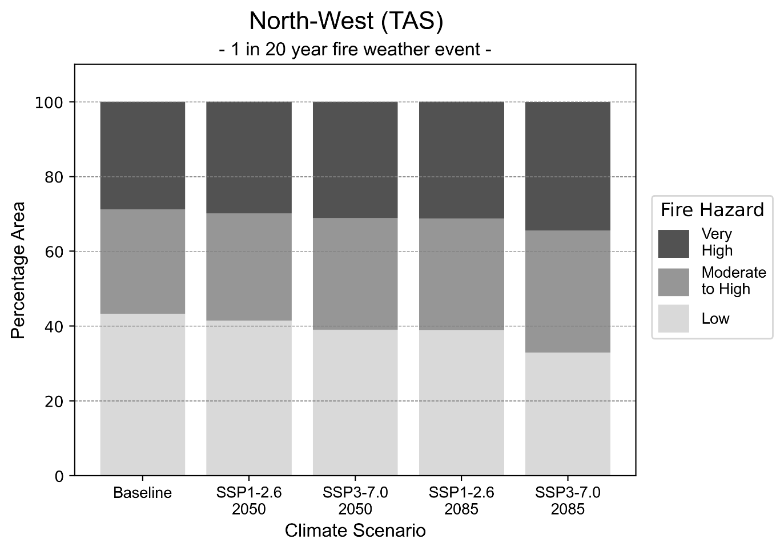
Figure 6: Stacked column chart showing the percentages of the North-West health district's total geographic area experiencing each fire hazard level during a 1-in-20-year fire weather event.
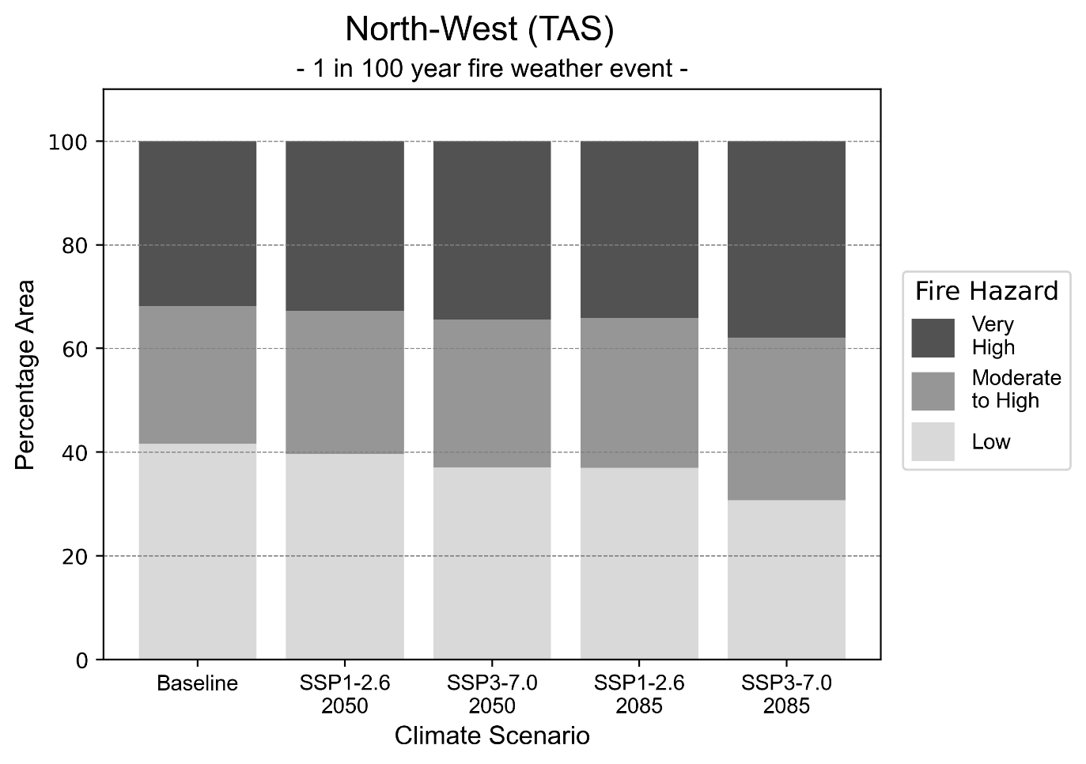
Figure 7: Stacked column chart showing the percentages of the North-West health district's total geographic area experiencing each fire hazard level during a 1-in-100-year fire weather event.

Drought hazard
Key projections:
Drought occurrence: The occurrence of drought increase across both middle of the road and reasonable worst-case scenarios and both time horizons, with the greatest increase occurring under the reasonable worst-case scenario by 2085.

 | Baseline | 2050 Scenarios |  | 2085 Scenarios
 |  | Middle of the road | Reasonable worst-case | Middle of the road | Reasonable worst-case
Number of months per year in drought^{(a)} | 1.8 | 2.4  [0.7, 4.1] | 2.5  [1.2, 4.2] | 2.9  [1.7, 5.1] | 3.9  [1.2, 6.8]
Table notes: The drought hazard indicator uses climate projections from the CMIP6 Global Climate Models [1]. The primary indicator value reports the median from the nine climate models, with the range reported in square brackets.
Table footnotes: (a) The number of months per year in drought is based on the Standardised Precipitation Index (SPI). SPI is a widely used index to characterise meteorological drought on a range of timescales. This indicator uses the timescale of 12 months which calculates the average months in a year within the moderate drought range. A moderate drought range is classified as SPI score of ≤ -1. SPI is calculated from accumulated rainfall over 12 months and the mean and standard deviation from historical rainfall records.

Storm hazard
Key projections:
Less frequent high-intensity and very-high-intensity storms: The frequency of high-intensity and very-high-intensity storms will decrease across both middle of the road and reasonable worst-case scenarios with the greatest decrease occurring by 2085.

 | Baseline | 2050 Scenarios |  | 2085 Scenarios
 |  | Middle of the road | Reasonable worst-case | Middle of the road | Reasonable worst-case
Number of low-intensity storms (40-62 km/hr) per year | 81.8 | 82.0  [72.2, 90.2] | 83.1  [73.2, 91.4] | 80.7  [71.0, 88.7] | 80.0  [70.4, 88.0]
Number of medium-intensity storms (63-87 km/hr) per year | 73.1 | 65.3  [57.5, 71.8] | 67.0  [58.9, 73.7] | 62.3  [54.9, 68.6] | 61.4  [54.0, 67.5]
Number of high-intensity storms (88-117 km/hr) per year | 37.3 | 34.7  [30.6, 38.2] | 35.7  [31.4, 39.3] | 32.9  [28.9, 36.2] | 30.4  [26.8, 33.5]
Number of very-high-intensity storm (> 117 km/hr) per year | 36.6 | 35.8  [31.5, 39.4] | 35.1  [30.9, 38.6] | 35.4  [31.2, 38.9] | 33.4  [29.4, 36.8]
Table notes: The storm hazard uses climate projections from the CMIP6 Global Climate Models [1]. Daily maximum surface wind speed is used to calculate the number of annual storms across four storm intensity categories (low, medium, high and very high). The primary indicator value reports the median from the nine climate models, with the range reported in square brackets.

Rainfall and flood hazard
Key projections:
- Four extreme rainfall days per year: The number of extreme rainfall days will remain consistent across both middle of the road and reasonable worst-case scenarios and both time horizons, with an average of approximately four extreme rainfall days per year.
- Increased flood frequency: The frequency of flood events will increase in urban environments but decrease in rural environments. The largest increase in flood frequency is seen in the reasonable worst-case scenario where frequency of a ‘1-in-100 year’ flood will more than triple by 2050 and become 11 times more likely by 2085 in urban environments.

 | Baseline | 2050 Scenarios |  | 2085 Scenarios
 |  | Middle of the road | Reasonable worst-case | Middle of the road | Reasonable worst-case
Rainfall hazard^{(a)}
Average number of extreme rainfall days per year (> 20 mm/day)^{(a)} | 4.2 | 4.3  [3.9,4.9] | 4.3  [3.8,4.7] | 4.3  [3.9,4.7] | 4.2  [3.4,4.9]
Urban flood risk (flooding caused by a 1-hour rainfall event)^{(b)}
Frequency of a ‘1-in-1 year’ flood (rainfall depth of 16 mm)^{(c)} |  | 2.3 events in 1 year | 2.5 events in 1 year | 3.2 events in 1 year | 4.7 events in 1 year
Frequency of a ‘1-in-10 year’ flood (rainfall depth of 29 mm)^{(c)} |  | 2.7 events in 10 years | 2.9 events in 10 years | 4.0 events in 10 years | 6.2 events in 10 years
Frequency of a ‘1-in-100 year’ flood (rainfall depth of 46 mm)^{(c)} |  | 3.5 events in 100 years | 3.8 events in 100 years | 5.8 events in 100 years | 11 events in 100 years
Rural flood risk (flooding caused by a 24-hour rainfall event) ^{(b)}
Frequency of a ‘1-in-1 year’ flood (rainfall depth of 60 mm)^{(c)} |  | 0.8 events in 1 year | 0.8 events in 1 year | 0.4 events in 1 year | 0.09 events in 1 year
Frequency of a ‘1-in-10 year’ flood (rainfall depth of 101 mm)^{(c)} |  | 1.0 events in 10 years | 1.0 events in 10 years | 0.3 events in 10 years | 0.05 events in 10 years
Frequency of a ‘1-in-100 year’ flood (rainfall depth of 158 mm)^{(c)} |  | 0.9 events in 100 years | 0.8 events in 100 years | 0.6 events in 100 years | 0.1 events in 100 years
Table notes: The rainfall hazard indicator uses climate projections from the CMIP6 Global Climate Models [1]. The primary indicator value reports the median from the nine climate models, with the range reported in square brackets. The flood hazard indicators use climate change considerations from the Australian Rainfall and Runoff guideline to estimate the climate the climate projections [2].
Table footnotes: (a) Extreme rainfall is defined as rainfall above the 95th percentile of historical average daily rainfall in this health district in the period 1985-2014. The value in mm/day quoted in the indicator name is the 95th percentile of historic average daily rainfall for this health district. (b) See Methodology document for reasons for focusing on a 1-hour flood for urban areas and a 24-hour flood for rural areas. (c) The rainfall depths in mm quoted in the indicator names in this table report 1 in 1-, 10- and 100-year depths for this health district.

Coastal inundation hazard
Key projections:
Greater area inundated: There will be an increase in the area affected by tidal inundation (i.e. area submerged during high tide) and storm surge and tidal inundation (i.e. the area submerged during a storm surge and high tide) across both middle of the road and reasonable worst-case scenarios. In the reasonable worst-case scenario, by 2085 the area inundated during a ‘1-in-1000-year’ event will increase by nearly 4,000 ha.

 | Baseline | 2050 Scenarios |  | 2085 Scenarios^{(a)}
 |  | Middle of the road | Reasonable worst-case | Middle of the road | Reasonable worst-case
Tidal inundation (ha inundated)^{(b)} | 3,082.2 | 3,498.7  (+416.4) | 3,525.0  (+442.7) | 4,546.1  (+1,463.9) | 5,025.6  (+1,943.4)
Storm surge + tidal inundation – ‘1-in-100 year’ event (ha inundated)^{(c)} | 5,631.3 | 6,538.3  (+907.0) | 6,595.2  (+963.9) | 8,256.7  (+2,625.3) | 8,918.5  (+3,287.1)
Storm surge + tidal inundation – ‘1-in-1000 year’ event (ha inundated)^{(c)} | 6,311.7 | 7,218.9  (+907.1) | 7,274.8  (+963.1) | 9,501.6  (+3,189.9) | 10,109.5  (+3,797.7)
Table notes: The coastal inundation hazard provides an indication of flooding in coastal areas that can be attributed to sea level rise and storm inundation. The coastal inundation hazard is only reported for health districts adjoining the coastline. This table includes the projected inundation levels as well as the change from baseline conditions (in brackets).
Table footnotes: (a) For the 2085 Scenarios planning horizon, 2100 was adopted as it provides a conservative representation of the end of this period. This horizon aligns with many State planning regulations requiring consideration of sea level rise and storm tide to 2100, making the 2100 scenario particularly valuable for planning new health facilities in coastal areas. (b) The tidal inundation indicator reports the number of hectares inundated during high tide. The baseline value reports existing inundation patterns, while the 2050 and 2085 values report high tide inundation taking account of projected sea level rise due to climate change. (c) The storm surge + tidal inundation indicators report the combined effect, in hectares inundated, of high tide, sea level rise (for the 2050 and 2085 projections), and storm surge (for 1-in-100 year and 1-in-1000 year events).

South health district

Health district overview
The South health district covers 25,517 square kilometres and contains the Royal Hobart Hospital.

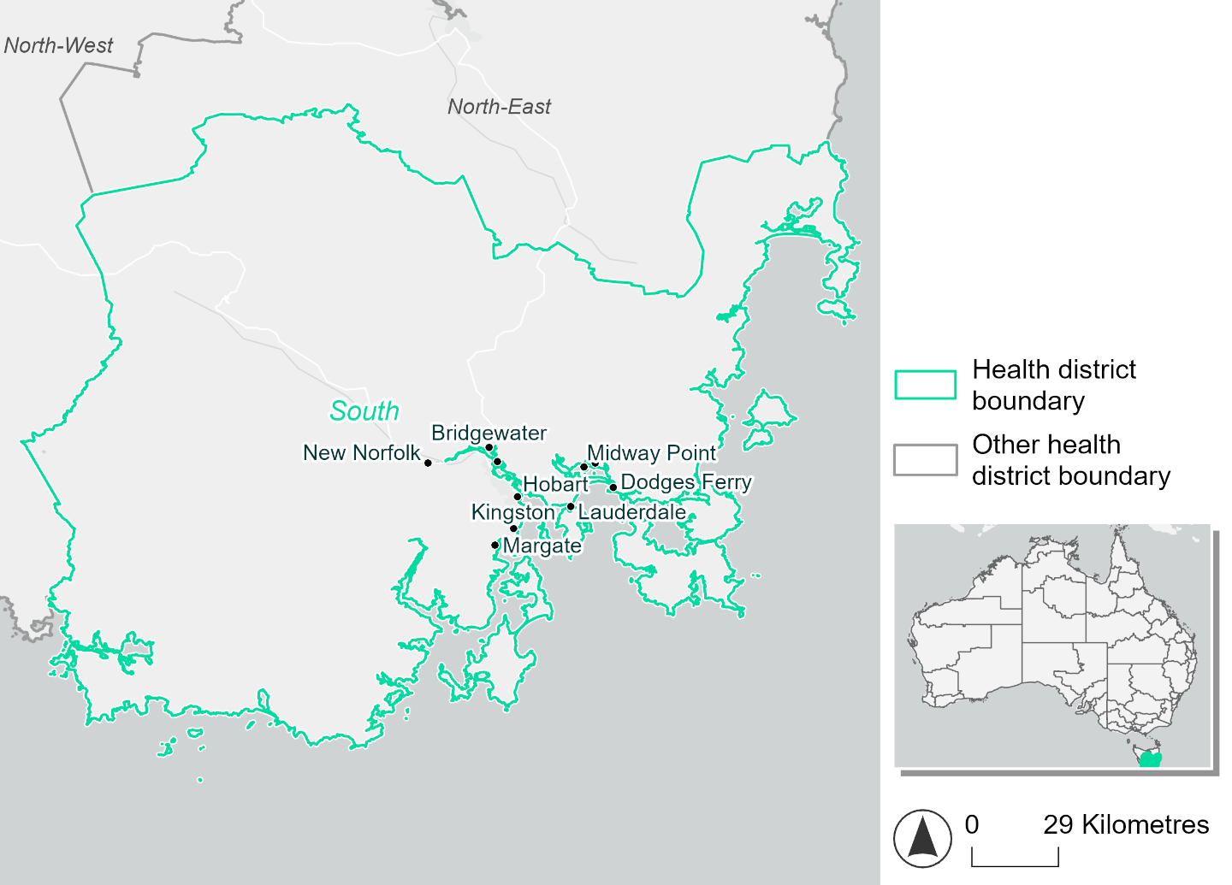
Figure 8. Map of South health district.

How will climate change affect this health district?
Heat and humidity: Higher average temperatures, hotter and more frequent hot days, warmer night time temperatures and longer and more frequent heat waves.
Fire: Nearly 50% of this health district experiences very high fire hazard category and this will increase in the future.
Drought: Number of months experiencing drought will increase.
Rainfall and flood: Average number of extreme rainfall days per year will stay the same. More flood events in urban areas and less floods in rural areas.
Coastal inundation: Increased area flooded during tidal and storm surge and tidal inundation.

South health district demographic data
Demographic Data | Total
Number of households | 111,173
Persons 15 and older | 206,172
Total families | 77,758
Persons did not complete high school | 80,656
One parent families with dependents | 8,861 (11.4%)
Persons aged 65 and older | 57,750 (19.5%)
Persons aged 4 and younger | 15,360 (5.2%)
Aboriginal and Torres Strait Islander persons | 14,425 (4.9%)
Persons speaks language other than English | 33,249 (11.2%)
Persons working age (15-65) | 188,972 (63.9%)
Population Health Data | Total
Persons with core needs for assistance | 18,220 (6.2%)
Persons with arthritis | 34,208 (11.6%)
Persons with asthma | 25,873 (8.7%)
Persons with cancer | 9,915 (3.4%)
Persons with dementia | 2,389 (0.8%)
Persons with diabetes | 13,734 (4.6%)
Persons with heart disease | 12,415 (4.2%)
Persons with kidney disease | 2,805 (0.9%)
Persons with lung condition | 6,102 (2.1%)
Persons with mental health condition | 34,379 (11.6%)
Persons with stroke | 3,263 (1.1%)
Persons with any other condition | 26,087 (8.8%)
Persons no health condition | 166,109 (56.1%)
Socio-economic Data | Total
Persons providing unpaid care | 37,793 (12.8%)
Persons homeless | 1,206 (0.4%)
Household with lone person | 30,791 (27.7%)
Households with rent and mortgage stress | 51,026 (45.9%)
Households total equivalised income below $1000 (weekly) | 54,618 (49.1%)
Households with no motor vehicle | 6,954 (6.3%)
Persons unemployed | 14,839 (6.2%)

The sections that follow outline projected climate hazards for this district. Further information on this health district, including population demographics, is provided in the online dashboard.

Heat and humidity hazard
Key projections:
More heatwaves: The number of heatwaves per year will increase. By 2050, under a reasonable worst-case scenario the number of heatwaves will more than double. By 2085, under a reasonable worst-case scenario the number of heatwaves per year may quadruple.
Hotter days and warmer nights: The maximum temperature on hot days will increase with night time temperatures on hot nights also increasing.
More days above 35°C: The number of days per year greater than 35°C will increase under both middle of the road and reasonable worst-case scenarios.

 | Baseline | 2050 Scenarios |  | 2085 Scenarios
 |  | Middle of the road | Reasonable worst-case | Middle of the road | Reasonable worst-case
Average temperature (°C) | 11.3 | 12.6  [11.8, 13.1] | 12.7  [12, 13.2] | 13.4  [12.4, 14.3] | 14.3  [12.9, 15.6]
Maximum temperature on hot days (°C)^{(a)} | 25.7 | 27.3  [26.4, 28.3] | 27.4  [26.6, 28.1] | 28.2  [27.3, 29.5] | 29.3  [28, 31.1]
Minimum temperature on hot nights (°C)^{(b)} | 13.2 | 14.7  [13.7, 15.3] | 14.9  [14, 15.3] | 15.5  [14.3, 16.4] | 16.5  [15, 18]
Average apparent temperature on hot days (°C) (NOAA Heat Index)^{(c)} | 32.3 | 32.9  [32.4, 33.5] | 32.9  [32, 33.5] | 33.2  [32.5, 34] | 33.6  [32.8, 34.5]
Average heatwave duration in days^{(d)} | 4 | 4  [4, 4] | 4  [4, 4] | 4  [4, 5] | 5  [4, 7]
Number of heatwaves per year^{(d)} | 2 | 4  [2, 5] | 4  [3, 6] | 6  [3, 8] | 8  [5, 12]
Number of days per year  > 35°C | 1 | 2  [1, 3] | 2  [1, 3] | 3  [2, 5] | 4  [2, 7]
Number of days per year > 40°C | 0 | 0  [0, 0] | 0  [0, 0] | 0  [0, 1] | 0  [0, 1]
Table notes: The heat and humidity hazard uses climate projections from the CMIP6 Global Climate Models [1]. Daily projections of maximum and minimum near-surface temperature and mean relative humidity are used to calculate eight heat and humidity indicators. The primary indicator value reports the median from the nine climate models, with the range reported in square brackets.
Table footnotes: (a) Based on the 95th percentile of daily maximum air temperature. (b) Based on the 95th percentile of daily minimum air temperature, representing the coldest part of the night on very hot nights. (c) The National Oceanic and Atmospheric Administration (NOAA) Heat Index is a measure of how hot it feels when relative humidity is factored in alongside actual air temperature. It is calculated on days with a maximum temperature of 27°C and above. Interpretation of Heat Index values: 27°C to 32°C indicates caution, 33°C to 41°C indicates extreme caution, 42°C to 54°C indicates danger and over 54°C indicates extreme danger. See methodology document for further explanation of Heat Index categories. (d) A heatwave is defined as three or more consecutive days where both daytime and overnight temperatures (daily mean temperatures) are unusually high for the location, based on the Bureau of Meteorology’s Excess Heat Factor method. For this district, an unusually high daily mean temperature is approximately 19.1°C or above.

Fire hazard
Key projections:
Majority of district experiences moderate to very high fire hazard: under baseline conditions, almost half (45-47%) of the district experiences very high fire hazard, with 30-31% experiencing moderate to high hazard. 22-23% experiences low fire hazard.
Very high fire hazard to increase: in a future climate across both 2050 and 2085 scenarios, the proportion of the district experiencing very high fire hazard increases, while the percentage experiencing low hazard decreases proportionally. For a 1-in-20-year fire event, the area experiencing very high hazard will increase by up to 4.4 percentage points to 50.0% of the district. For a 1-in-100-year event, the area will increase by a similar amount to cover up to 51.7% of the health district. The moderate to high hazard area remains roughly the same, increasing by up 0.8-1.5 percentage points. Up to 5.1% of the district area that experiences low hazard currently during a 1-in-20-year fire weather event may experience moderate to very high hazard during the same type of weather event by 2085; this shift increases to 5.6% of the district for the 1-in-100-year event.

 | Baseline | 2050 Scenarios |  | 2085 Scenarios
 |  | Sustainability | Reasonable worst-case | Sustainability | Reasonable worst-case
Hazard for a ‘1-in-20 year’ fire weather event^{(a)}
Proportion (%) of district experiencing ‘Low’ fire hazard | 23.2%  (591,913)^{(b)} | 22.2%  [21.4%, 23.1%] | 21.1%  [20.2%, 22.5%] | 20.8%  [19.0%, 23.0%] | 18.1%  [16.1%, 21.6%]
Proportion (%) of district experiencing ‘Moderate to High’ fire hazard | 31.2%  (797,060)^{(b)} | 31.3%  [30.3%, 32.1%] | 31.6%  [30.4%, 32.3%] | 31.3%  [29.1%, 33.4%] | 32.0%  [29.2%, 33.9%]
Proportion (%) of district experiencing ‘Very High’ fire hazard | 45.6%  (1,162,769)^{(b)} | 46.5%  [45.8%, 47.2%] | 47.4%  [46.2%, 48.0%] | 47.9%  [46.2%, 49.6%] | 50.0%  [47.0%, 51.4%]
Hazard for a ‘1-in-100 year’ fire weather event^{(a)}
Proportion (%) of district experiencing ‘Low’ fire hazard | 22.0%  (562,615)^{(b)} | 20.9%  [20.2%, 21.9%] | 19.7%  [19.0%, 21.1%] | 19.4%  [17.6%, 21.6%] | 16.4%  [14.7%, 19.8%]
Proportion (%) of district experiencing ‘Moderate to High’ fire hazard | 30.3%  (773,871)^{(b)} | 30.6%  [29.9%, 31.4%] | 30.9%  [29.8%, 31.8%] | 31.0%  [29.2%, 33.0%] | 31.8%  [29.1%, 33.9%]
Proportion (%) of district experiencing ‘Very High’ fire hazard | 47.6%  (1,215,256)^{(b)} | 48.4%  [47.8%, 49.1%] | 49.3%  [48.2%, 49.9%] | 49.6%  [48.0%, 51.2%] | 51.7%  [49.0%, 53.1%]
Table notes: The Fire Hazard uses the National Bushfire Intelligence Capability (NBIC) Phase 2 fire line intensity modelling based on CMIP6 climate projections. Fire Hazard is assessed using the projected Fireline Intensity (FLI) for weather events with two different return intervals (i.e. a 1-in-20 year event and a 1-in-100 year event). FLI considers slope, vegetation and weather to produce a rate of heat output per unit length (kW/m) along a bushfire’s front. Fire hazard is categorized as a low for FLI<4000 kW/m, moderate to high for 4,000 kW/m ≤FLI<12,500kW/m, and very high for FLI≥27,501kW/m. This is broadly consistent with the literature [3]. The assessment considers climate change effects based on changes in fire weather and the associated hazard that is anticipated for a meteorological event of a given return interval. This approach is different to the one adopted for the Flood Hazard, where the event magnitude is given (fixed) and the likelihood of that event varies as a result of climate change. The primary indicator value reports the median from the nine climate models, with the range reported in square brackets.
Table footnotes: (a) The area subject to different categories of fire hazard is determined for a ‘1-in-20 year’ and ‘1-in-100 year’ fire weather event, in current and future climates. Values at year 2050 are interpolated using data from baseline (2025) and 2085, assuming linear change over time. (b) Values in round brackets are the area (ha) of the health district subject to a given fire hazard.

The figures below show the proportion of the health district experiencing different fire hazard categories across different time horizons and climate scenarios during a ‘1-in-20 year’ fire weather event (Figure 9) and a ‘1-in-100 year’ fire weather event (Figure 10).
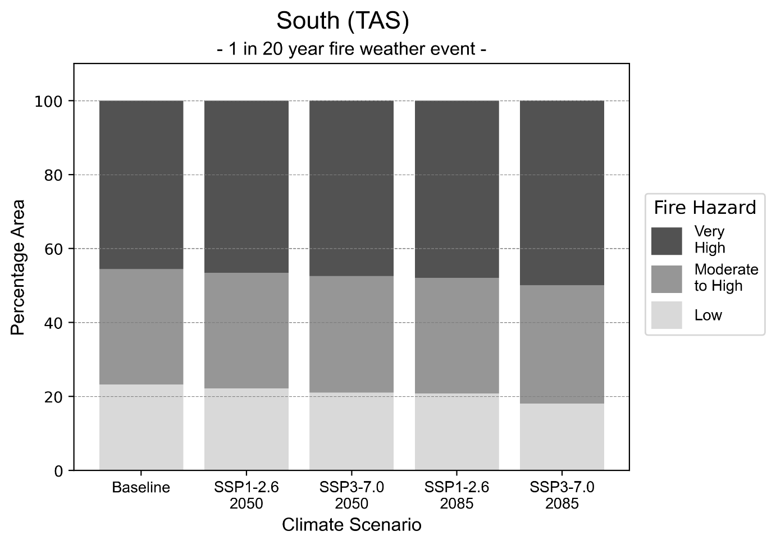
Figure 9: Stacked column chart showing the percentages of the South health district's total geographic area experiencing each fire hazard level during a 1-in-20-year fire weather event.
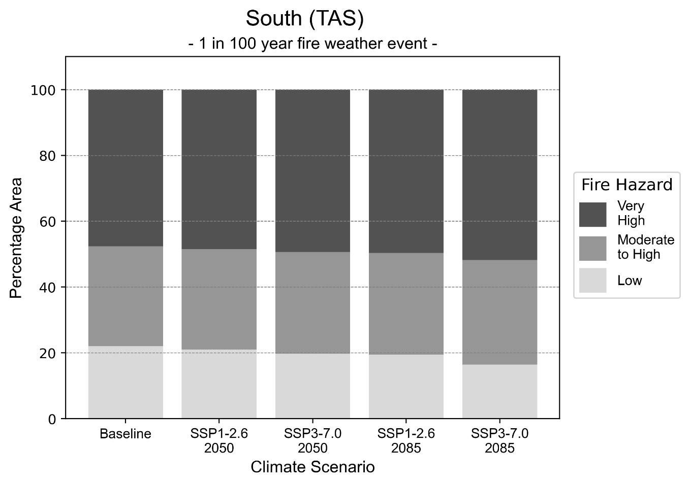
Figure 10: Stacked column chart showing the percentages of the South health district's total geographic area experiencing each fire hazard level during a 1-in-100-year fire weather event.

Drought hazard
Key projections:
Drought occurrence: The occurrence of drought will increase across both middle of the road and reasonable worst-case scenarios and both time horizons, with the greatest increase occurring under the reasonable worst-case scenario by 2085.

 | Baseline | 2050 Scenarios |  | 2085 Scenarios
 |  | Middle of the road | Reasonable worst-case | Middle of the road | Reasonable worst-case
Number of months per year in drought^{(a)} | 1.8 | 1.9  [0.9, 3.2] | 2.0  [1.3, 3.1] | 2.2  [1.2, 3.6] | 2.7  [0.8, 5.2]
Table notes: The drought hazard indicator uses climate projections from the CMIP6 Global Climate Models [1]. The primary indicator value reports the median from the nine climate models, with the range reported in square brackets.
Table footnotes: (a) The number of months per year in drought is based on the Standardised Precipitation Index (SPI). SPI is a widely used index to characterise meteorological drought on a range of timescales. This indicator uses the timescale of 12 months which calculates the average months in a year within the moderate drought range. A moderate drought range is classified as SPI score of ≤ -1. SPI is calculated from accumulated rainfall over 12 months and the mean and standard deviation from historical rainfall records.

Storm hazard
Key projections:
More frequent very-high-intensity storms: The frequency of very-high-intensity storms will increase across both middle of the road and reasonable worst-case scenarios and both time horizons.

 | Baseline | 2050 Scenarios |  | 2085 Scenarios
 |  | Middle of the road | Reasonable worst-case | Middle of the road | Reasonable worst-case
Number of low-intensity storms (40-62 km/hr) per year | 59.3 | 58.3  [51.3, 64.1] | 58.5  [51.5, 64.4] | 59.3  [52.2, 65.2] | 58.7  [51.7, 64.6]
Number of medium-intensity storms (63-87 km/hr) per year | 62.0 | 60.4  [53.1, 66.4] | 61.0  [53.7, 67.1] | 58.8  [51.7, 64.7] | 59.2  [52.1, 65.2]
Number of high-intensity storms (88-117 km/hr) per year | 52.2 | 51.9  [45.6, 57.1] | 52.2  [45.9, 57.4] | 48.5  [42.7, 53.4] | 48.2  [42.4, 53.0]
Number of very-high-intensity storm (> 117 km/hr) per year | 20.7 | 23.4  [20.6, 25.8] | 23.5  [20.7, 25.8] | 23.4  [20.6, 25.7] | 23.5  [20.7, 25.9]
Table notes: The storm hazard uses climate projections from the CMIP6 Global Climate Models [1]. Daily maximum surface wind speed is used to calculate the number of annual storms across four storm intensity categories (low, medium, high and very high). The primary indicator value reports the median from the nine climate models, with the range reported in square brackets.

Rainfall and flood hazard
Key projections:
- Slight increase in number of extreme rainfall days per year: The number of extreme rainfall days will increase slightly across both middle of the road and reasonable worst-case scenarios and both time horizons, with an average of number of extreme rainfall days per year increasing from ten to 11 days.
- Increased flood frequency: The frequency of flood events will increase in urban environments but decrease in rural environments. The largest increase in flood frequency is seen in the reasonable worst-case scenario where frequency of a ‘1-in-100 year’ flood will more than triple by 2050 and become 11 times more likely by 2085 in urban environments.

 | Baseline | 2050 Scenarios |  | 2085 Scenarios
 |  | Middle of the road | Reasonable worst-case | Middle of the road | Reasonable worst-case
Rainfall hazard^{(a)}
Average number of extreme rainfall days per year (> 14 mm/day)^{(a)} | 10.4 | 11.0  [10.0,12.2] | 10.9  [10.1,11.6] | 10.9  [9.8,11.6] | 10.9  [9.0,12.5]
Urban flood risk (flooding caused by a 1-hour rainfall event)^{(b)}
Frequency of a ‘1-in-1 year’ flood (rainfall depth of 11 mm)^{(c)} |  | 2.1 events in 1 year | 2.2 events in 1 year | 2.8 events in 1 year | 3.9 events in 1 year
Frequency of a ‘1-in-10 year’ flood (rainfall depth of 21 mm)^{(c)} |  | 2.6 events in 10 years | 2.8 events in 10 years | 3.8 events in 10 years | 5.8 events in 10 years
Frequency of a ‘1-in-100 year’ flood (rainfall depth of 33 mm)^{(c)} |  | 3.6 events in 100 years | 3.8 events in 100 years | 5.9 events in 100 years | 11 events in 100 years
Rural flood risk (flooding caused by a 24-hour rainfall event)^{(b)}
Frequency of a ‘1-in-1 year’ flood (rainfall depth of 50 mm)^{(c)} |  | 1.0 events in 1 year | 1.0 events in 1 year | 0.4 events in 1 year | 0.2 events in 1 year
Frequency of a ‘1-in-10 year’ flood (rainfall depth of 101 mm)^{(c)} |  | 0.6 events in 10 years | 0.6 events in 10 years | 0.3 events in 10 years | 0.06 events in 10 years
Frequency of a ‘1-in-100 year’ flood (rainfall depth of 162 mm)^{(c)} |  | 0.9 events in 100 years | 0.9 events in 100 years | 0.6 events in 100 years | 0.1 events in 100 years
Table notes: The rainfall hazard indicator uses climate projections from the CMIP6 Global Climate Models [1]. The primary indicator value reports the median from the nine climate models, with the range reported in square brackets. The flood hazard indicators use climate change considerations from the Australian Rainfall and Runoff guideline to estimate the climate the climate projections [2].
Table footnotes (a) Extreme rainfall is defined as rainfall above the 95th percentile of historical average daily rainfall in this health district in the period 1985-2014. The value in mm/day quoted in the indicator name is the 95th percentile of historic average daily rainfall for this health district. (b) See Methodology document for reasons for focusing on a 1-hour flood for urban areas and a 24-hour flood for rural areas. (c) The rainfall depths in mm quoted in the indicator names in this table report 1 in 1-, 10- and 100-year depths for this health district.

Coastal inundation hazard
Key projections:
Greater area inundated: There will be an increase in the area affected by tidal inundation (i.e. area submerged during high tide) and storm surge and tidal inundation (i.e. the area submerged during a storm surge and high tide) across both middle of the road and reasonable worst-case scenarios. In the reasonable worst-case scenario, by 2085 the area inundated during a ‘1-in-1000-year’ event will increase by nearly 4,000 ha.

 | Baseline | 2050 Scenarios |  | 2085 Scenarios^{(a)}
 |  | Middle of the road | Reasonable worst-case | Middle of the road | Reasonable worst-case
Tidal inundation (ha inundated)^{(b)} | 4,590.0 | 6,096.7  (+1,506.7) | 6,193.9  (+1,603.9) | 7,878.9  (+3,288.9) | 8,550.3  (+3,960.3)
Storm surge + tidal inundation – ‘1-in-100 year’ event (ha inundated)^{(c)} | 7,766.5 | 8,680.5  (+914.0) | 8,752.0  (+985.5) | 10,225.8  (+2,459.3) | 10,946.4  (+3,179.9)
Storm surge + tidal inundation – ‘1-in-1000 year’ event (ha inundated)^{(c)} | 8,191.6 | 9,099.0  (+907.4) | 9,172.7  (+981.1) | 11,118.3  (+2,926.7) | 11,859.8  (+3,668.1)
Table notes: The coastal inundation hazard provides an indication of flooding in coastal areas that can be attributed to sea level rise and storm inundation. The coastal inundation hazard is only reported for health districts adjoining the coastline. This table includes the projected inundation levels as well as the change from baseline conditions (in brackets).
Table footnotes: (a) For the 2085 Scenarios planning horizon, 2100 was adopted as it provides a conservative representation of the end of this period. This horizon aligns with many State planning regulations requiring consideration of sea level rise and storm tide to 2100, making the 2100 scenario particularly valuable for planning new health facilities in coastal areas. (b) The tidal inundation indicator reports the number of hectares inundated during high tide. The baseline value reports existing inundation patterns, while the 2050 and 2085 values report high tide inundation taking account of projected sea level rise due to climate change. (c) The storm surge + tidal inundation indicators report the combined effect, in hectares inundated, of high tide, sea level rise (for the 2050 and 2085 projections), and storm surge (for 1-in-100 year and 1-in-1000 year events).

References

[1] | D. Irving, I. Macadam and M. King, “Application-ready quantile-delta-change (QDC) scaled CMIP6 climate projections for Australia (time slices, 11km grid) (v1)”, CSIRO. Data Collection, 2024.
[2] | C. Wasko, S. Westra, R. Nathan, D. Jakob, C. Nielsen, J. Evans, S. Rodgers, M. Ho, M. Babister, A. Dowdy and W. Sharples, “Australian Rainfall and Runoff (ARR) Chapter 6: 4 Climate Change Considerations”, Australian Rainfall and Runoff, 2024.
[3] | J. J. Hollis, S. Matthews, W. R. Anderson, M. G. Cruz, P. Fox-Hughes, S. Grootemaat, B. J. Kenny and S. Sauvage, “A framework for defining fire danger to support fire management operations in Australia”, International Journal of Wildland Fire, vol. 33, no.3, 2024.
[4] | Z. Hausfather and P. G. Peters, “Emissions–the ‘business as usual’story is misleading”, Nature, 577(7792), pp.618-620., 2020.



Another scenario, SSP5-8.5, was previously considered the reasonable worst-case scenario, but it is now considered to be very unlikely to be realised due to climate action already undertaken [4].

