Guidance on climate risk assessment and adaptation planning for Australian health system organisations

Climate and Health Hazard Data for Victoria
© Commonwealth of Australia as represented by the Australian Centre for Disease Control
Title: Guidance on climate risk assessment and adaptation planning for Australian health system organisations: Climate and Health Hazard Data for Victoria.
Citation
Australian Centre for Disease Control (CDC). Guidance on climate risk assessment and adaptation planning for Australian health system organisations: Climate and Health Hazard Data for Victoria, Australian CDC, Australian Government, 2026.
Contributors
Anne Cleary, Jamie Ewert, Jake Allen, Adam Brook, Petter Nyman, Pam Wong, Anthony Kiem, Felix Edger, Richard Farr, Robert Morden, Vincent Li Creagh, Tony Weber, Dominic Blackham, Matilda Lehmann, Phoebe Spurrier, Sophia Gidis, Georgia Behrens, Madeleine Skellern.
Acknowledgments
CSIRO National Bushfire Intelligence Capability for assisting with the analysis of the Fire Hazard.
Creative Commons Licence
This publication is licensed under the Creative Commons Attribution 4.0 International Public License available from https://creativecommons.org/licenses/by/4.0/legalcode (“Licence”). You must read and understand the Licence before using any material from this publication.
Restrictions
The Licence may not give you all the permissions necessary for your intended use. For example, other rights (such as publicity, privacy and moral rights) may limit how you use the material found in this publication. The Licence does not cover, and there is no permission given for, use of any of the following material found in this publication:
- the Commonwealth Coat of Arms. (by way of information, the terms under which the Coat of Arms may be used can be found on the Department of Prime Minister and Cabinet website
- any logos and trademarks
- any photographs and images
- any signatures
- any material belonging to third parties. The third party elements must be included here or have a footnote reference throughout the document showing where they are.
Attribution
Without limiting your obligations under the Licence, the Australian Centre for Disease Control requests that you attribute this publication in your work. Any reasonable form of words may be used provided that you:
- include a reference to this publication and where practicable, the relevant page numbers
- make it clear that you have permission to use the material under the Creative Commons Attribution 4.0 International Public License
- make it clear whether or not you have changed the material used from this publication
- include a copyright notice in relation to the material used. In the case of no change to the material, the words “© Commonwealth of Australia (Australian Centre for Disease Control) 2026” may be used. In the case where the material has been changed or adapted, the words: “Based on Commonwealth of Australia (Australian Centre for Disease Control) material” may be used
- do not suggest that the Australian Centre for Disease Control endorses you or your use of the material.
Enquiries
Enquiries regarding any other use of this publication should be addressed to the Communication and Public Information Section, Strategy and Engagement Branch, Australian Centre for Disease Control, GPO Box 798, Canberra ACT 2601, or via e-mail to CDCComms@cdc.gov.au.
We welcome feedback and dialogue about this report. Please send all such correspondence to NHSC.Unit@cdc.gov.au.

Table of Contents

Table of Contents 3
Introduction 4
Barwon South-West health district 8
Gippsland health district 17
Grampians health district 26
Hume health district 34
Loddon Mallee health district 42
Melbourne health district 50
References 59

Introduction

This document provides scientific climate information to help health system organisations assess, prepare for and effectively manage climate-related risks across short-, medium-, and long-term planning horizons. A digital version of the information in this document can be found here. Further detail about the information contained in this document can be found in the accompanying methodological report.

The document presents climate hazard information summarised for health districts across Victoria. For each health district, information is provided about six hazards – heat and humidity, fire, drought, rainfall, storms, and coastal inundation – across three different time horizons and two climate scenarios. This structure enables users to assess how climate risks may evolve over time and under different emissions pathways. The information is presented both in narrative form and through a series of detailed tables containing quantitative data. Further information on the information presented in this document is outlined below.

Health districts
Victoria established 12 Local Health Service Networks (LHSNs) on 1 July 2025. As preparation of this Climate and Health Hazard Data commenced before the LHSNs were established, a different approach to constructing health districts was adopted. 5 health districts correspond to the Victorian Department of Health’s former rural health regions (Barwon South Western, Gippsland, Grampians, Hume and Loddon Mallee), while a sixth health district was constructed by merging the Department’s former regions covering Melbourne (Northern Metropolitan, Southern Metropolitan, Eastern Metropolitan and Western Metropolitan).w

These 6 health districts used in the Climate and Health Hazard Data correspond to the LHSNs as follows:
The Gippsland, Grampians, Hume and Loddon Mallee health districts broadly align with their respective LHSNs.
Barwon South-West health district encompasses areas now principally covered by the Barwon and South West LHSNs.
Melbourne health district combines the metropolitan Melbourne LHSNs.
Some LHSNs also cross the metropolitan-rural interface (North Metro and Mitchell LHSN, East Metro and Murrindindi LHSN).

Future updates to the Climate and Health Hazard Data will seek to align the health districts used for Victoria to current LHSN boundaries.
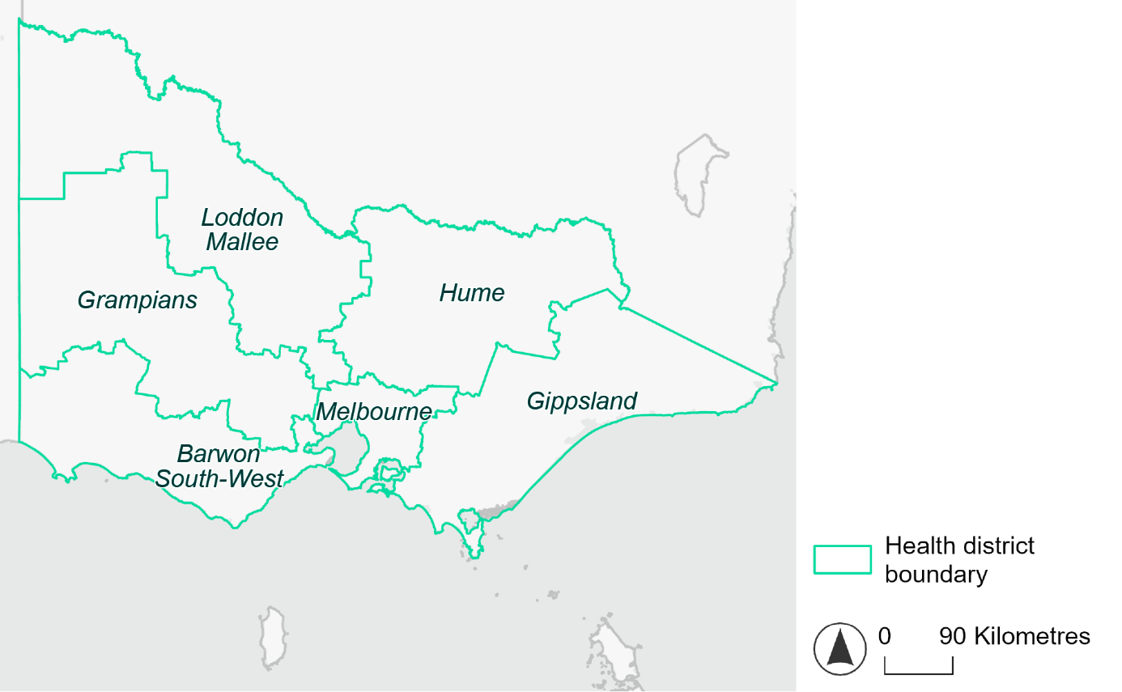
Figure 1. Map of Victorian health districts used in this document.

Time horizons
This document provides climate information on each climate hazard for the following time horizons:

Time horizon | Years | Description | Use in risk assessment
Baseline | Observed data from 1985-2014 | Historical baseline position | Understand current risks and ensure they are being managed effectively
Mid-century (2050) | 2035–2064 | Medium-term climate projections | Identify and manage emerging risks to population health and health systems
Late century (2085) | 2070–2099 | Long-term climate projections | Identify long-term risks when planning infrastructure or policy with long-lasting consequences

Climate scenarios
The document provides climate information on each hazard for two different climate scenarios. A climate scenario is a plausible representation of what the future climate might look like. These scenarios are based on different assumptions about greenhouse gas emissions and other factors that influence the future climate.

This document uses Shared Socioeconomic Pathways (SSPs) as the basis for different climate scenarios. SSPs describe how socioeconomic factors (such as population, economic growth, education, urbanisation and technology development) could change over the next century and influence future greenhouse gas emissions and global temperatures.

There are five main SSPs, each of which outlines a different scenario, ranging from a sustainable future with low emissions, to one with high fossil fuel uses and high emissions. The most recent iteration of SSPs incorporate information from what were previously called Representative Concentration Pathways (RCPs), which measure the expected change in radiative forcing (in W/m2) under the scenario from 1750 to 2100. SSP2-4.5 denotes what would previously have been called a scenario involving SSP2 and RCP4.5 – the reasoning for merging them being that SSP2 describes socioeconomic conditions likely to give rise to RCP4.5.

The two main scenarios used in this document are:
A ‘middle of the road’ scenario (SSP2-4.5): this scenario assumes emissions remain at current levels until the middle of the 21st century, and that net zero emissions are not reached by 2100. This scenario sees temperatures rising by about 2.7°C by the end of the century. In this document this is the lower emissions scenario across all climate hazards, except for the fire hazard (see below note).
A ‘reasonable worst-case’ scenario (SSP3-7.0): this scenario assumes both emissions and temperatures continue to rise to the end of the century due to delayed climate action. This scenario sees temperatures rise by about 3.6°C by 2100. In this document this is the higher emissions scenario across all climate hazards.

Fire hazard projections are not available for SSP2-4.5, so SSP1-2.6 is used as the lower emissions scenario for this hazard instead of SSP2-4.5. Under SSP1-2.6, global emissions are reduced but do not reach net zero until after 2050 and warming stabilises at about 1.8°C by 2100. This document refers to SSP1-2.6 as the ‘sustainability’ scenario.

Climate hazard projections
For each health district, the following information is provided for each climate hazard, across the different time horizons and climate scenarios:
- Heat and humidity: projected average, extreme and apparent temperatures; projected heatwave duration and frequency; and projected number of very hot days.
- Fire: projected area affected by different fire hazard categories for a 1-in-20 year fire event and a 1-in-100 year event.
- Drought: projected average number of months per year experiencing drought.
- Rainfall and flooding: projected number of extreme rainfall days per year, as well as projected frequency of urban and rural flood events.
- Storms: projected number of storms per year, grouped into four intensity categories based on wind speed.
- Coastal inundation: projected area of land affected by tidal inundation and storm surge and tidal inundation (coastal districts only).

The climate hazard projections in this document are based on data from nine CMIP6 Global Climate Models (ACCESS-CM2, ACCESS-ESM1-5, CESM2, CMCC-ESM2, CNRM-ESM2-1, EC-Earth3, MPI-ESM1-2-HR, NorESM2-MM, UKESM1-0-LL). These models simulate how climate hazards may change under different SSPs. Where hazard projections are based on these models, this document reports the median projected value as its primary estimate, and reports the range across all nine models in square brackets.

Barwon South-West health district

Health district overview
The Barwon South-West health district covers 29,165 square kilometres.

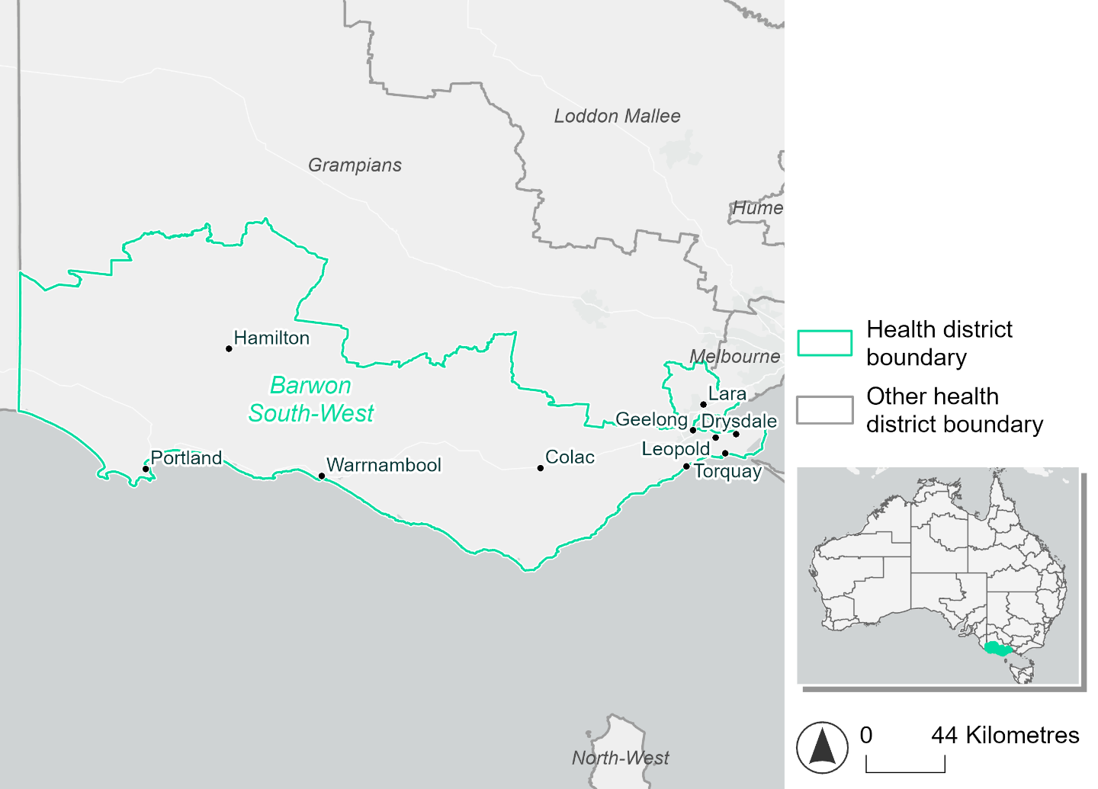
Figure 2. Map of Barwon South-West health district

How will climate change affect this health district?
Heat and humidity: Higher average temperatures, hotter and more frequent hot days, warmer night time temperatures and more frequent heat waves.
Fire: Over 25% of this health district currently experiences very high fire hazard category and this will increase slightly across both 2050 and 2085 scenarios, particularly for a 1-in-100 year fire weather event.
Drought: Number of months experiencing drought will increase.
Rainfall and flood: More flood events in urban areas.
Coastal inundation: Increased area flooded during tidal and storm surge and tidal inundation.

Barwon South-West health district demographic data
Demographic Data | Total
Number of households | 168,872
Persons 15 and older | 301,462
Total families | 117,409
Persons did not complete high school | 120,367
One parent families with dependents | 11,291 (9.6%)
Persons aged 65 and older | 93,038 (20.9%)
Persons aged 4 and younger | 25,063 (5.6%)
Aboriginal and Torres Strait Islander persons | 6,297 (1.4%)
Persons speaks language other than English | 38,575 (8.6%)
Persons working age (15-65) | 274,145 (61.5%)
Population Health Data | Total
Persons with core needs for assistance | 27,858 (6.2%)
Persons with arthritis | 43,033 (9.6%)
Persons with asthma | 42,240 (9.5%)
Persons with cancer | 14,820 (3.3%)
Persons with dementia | 3,841 (0.9%)
Persons with diabetes | 21,272 (4.8%)
Persons with heart disease | 19,929 (4.5%)
Persons with kidney disease | 4,355 (1%)
Persons with lung condition | 8,666 (1.9%)
Persons with mental health condition | 46,294 (10.4%)
Persons with stroke | 5,058 (1.1%)
Persons with any other condition | 37,410 (8.4%)
Persons no health condition | 252,159 (56.5%)
Socio-economic Data | Total
Persons providing unpaid care | 61,129 (13.7%)
Persons homeless | 2,056 (0.5%)
Household with lone person | 47,562 (28.2%)
Households with rent and mortgage stress | 71,013 (42.1%)
Households total equivalised income below $1000 (weekly) | 80,403 (47.6%)
Households with no motor vehicle | 8,042 (4.8%)
Persons unemployed | 14,320 (3.9%)

The sections that follow outline projected climate hazards for this district. Further information on this health district, including population demographics, is provided in the online dashboard.

Heat and humidity hazard
Key projections:
More heatwaves: The number of heatwave events per year will increase. By 2050, under a reasonable worst-case scenario the number of heatwaves will increase from two heatwaves per year to three per year. By 2085, under a reasonable worst-case scenario the number of heatwaves per year will triple.
Hotter days and warmer nights: The maximum temperature on hot days will increase with night time temperatures on hot nights also increasing.
More days above 35°C and 40°C: The number of days per year greater than 35°C and 40°C will increase under both middle of the road and reasonable worst-case scenarios.

 | Baseline | 2050 Scenarios |  | 2085 Scenarios
 |  | Middle of the road | Reasonable worst-case | Middle of the road | Reasonable worst-case
Average temperature (°C) | 14.5 | 15.6  [14.9, 16] | 15.8  [15.1, 16.2] | 16.3  [15.5, 17.2] | 17.2  [15.9, 18.2]
Maximum temperature on hot days (°C)^{(a)} | 30.3 | 31.7  [31.1, 32.4] | 32  [31.1, 32.9] | 32.6  [31.7, 33.7] | 33.6  [32.5, 35.1]
Minimum temperature on hot nights (°C)^{(b)} | 16.9 | 18.2  [17.5, 18.8] | 18.4  [17.5, 18.9] | 18.9  [17.9, 19.9] | 20  [18.6, 21]
Average apparent temperature on hot days (°C) (NOAA Heat Index)^{(c)} | 35.2 | 36.1  [35.6, 36.8] | 36.2  [35.3, 37.1] | 36.8  [36.1, 37.9] | 37.4  [36.7, 38.4]
Average heatwave duration in days^{(d)} | 4 | 4  [4, 4] | 4  [4, 4] | 4  [4, 5] | 5  [4, 5]
Number of heatwaves per year^{(d)} | 2 | 3  [2, 4] | 3  [2, 4] | 4  [3, 6] | 6  [4, 9]
Number of days per year  > 35°C | 7 | 10  [8, 11] | 10  [7, 13] | 12  [10, 16] | 15  [12, 20]
Number of days per year > 40°C | 1 | 2  [1, 3] | 2  [1, 3] | 3  [2, 5] | 4  [2, 6]
Table notes: The heat and humidity hazard uses climate projections from the CMIP6 Global Climate Models [1]. Daily projections of maximum and minimum near-surface temperature and mean relative humidity are used to calculate eight heat and humidity indicators. The primary indicator value reports the median from the nine climate models, with the range reported in square brackets.
Table footnotes: (a) Based on the 95th percentile of daily maximum air temperature. (b) Based on the 95th percentile of daily minimum air temperature, representing the coldest part of the night on very hot nights. (c) The National Oceanic and Atmospheric Administration (NOAA) Heat Index is a measure of how hot it feels when relative humidity is factored in alongside actual air temperature. It is calculated on days with a maximum temperature of 27°C and above. Interpretation of Heat Index values: 27°C to 32°C indicates caution, 33°C to 41°C indicates extreme caution, 42°C to 54°C indicates danger and over 54°C indicates extreme danger. See methodology document for further explanation of Heat Index categories. (d) A heatwave is defined as three or more consecutive days where both daytime and overnight temperatures (daily mean temperatures) are unusually high for the location, based on the Bureau of Meteorology’s Excess Heat Factor method. For this district, an unusually high daily mean temperature is approximately 23.2 °C or above.

Fire hazard
Key projections:
Majority of district area experiences moderate to high fire hazard: under baseline conditions, two-thirds (68-69%) of the district area experiences moderate to high fire hazard. 25-26% experiences very high hazard, and just 4-5% experiences very low fire hazard.
Very high fire hazard to increase slightly: in a future climate across both 2050 and 2085 scenarios, the proportion of the district area experiencing very high fire hazard will increase. For a 1-in-20-year fire weather event, this increase will be up to 1 percentage point regardless of emissions pathway. For a 1-in-100-year event the increase in very high hazard could be up to 3.7% of the district by 2085, with a difference of less than 1 percentage point between the emissions pathways for 2050 and 2085.

 | Baseline | 2050 Scenarios |  | 2085 Scenarios
 |  | Sustainability | Reasonable worst-case | Sustainability | Reasonable worst-case
Hazard for a ‘1-in-20 year’ fire weather event^{(a)}
Proportion (%) of district experiencing ‘Low’ fire hazard | 5.6%  (163,382)^{(b)} | 5.4%  [5.0%, 6.1%] | 5.1%  [4.6%, 5.9%] | 5.0%  [4.2%, 6.7%] | 4.3%  [3.2%, 6.4%]
Proportion (%) of district experiencing ‘Moderate to High’ fire hazard | 69.0%  (2,012,895)^{(b)} | 68.8%  [64.6%, 73.2%] | 69.1%  [63.0%, 74.8%] | 68.6%  [58.5%, 79.1%] | 69.3%  [54.6%, 82.8%]
Proportion (%) of district experiencing ‘Very High’ fire hazard | 25.4%  (740,230)^{(b)} | 25.8%  [25.3%, 26.1%] | 25.8%  [25.3%, 26.4%] | 26.4%  [25.3%, 27.0%] | 26.4%  [25.1%, 27.8%]
Hazard for a ‘1-in-100 year’ fire weather event^{(a)}
Proportion (%) of district experiencing ‘Low’ fire hazard | 4.9%  (142,632)^{(b)} | 4.6%  [4.4%, 5.1%] | 4.3%  [3.9%, 5.0%] | 4.2%  [3.7%, 5.4%] | 3.4%  [2.5%, 5.1%]
Proportion (%) of district experiencing ‘Moderate to High’ fire hazard | 68.4%  (1,994,471)^{(b)} | 67.1%  [64.6%, 70.9%] | 67.8%  [64.3%, 70.8%] | 65.4%  [59.3%, 74.5%] | 67.1%  [58.6%, 74.3%]
Proportion (%) of district experiencing ‘Very High’ fire hazard | 26.7%  (779,405)^{(b)} | 28.3%  [26.8%, 28.8%] | 27.9%  [26.7%, 29.9%] | 30.4%  [27.0%, 31.8%] | 29.5%  [26.6%, 34.3%]
Table notes: The Fire Hazard uses the National Bushfire Intelligence Capability (NBIC) Phase 2 fire line intensity modelling based on CMIP6 climate projections. Fire Hazard is assessed using the projected Fireline Intensity (FLI) for weather events with two different return intervals (i.e. a 1-in-20-year event and a 1-in-100-year event). FLI considers slope, vegetation and weather to produce a rate of heat output per unit length (kW/m) along a bushfire’s front. Fire hazard is categorized as a low for FLI<4000 kW/m, moderate to high for 4,000 kW/m ≤FLI<12,500kW/m, and very high for FLI≥27,501kW/m. This is broadly consistent with the literature [3]. The assessment considers climate change effects based on changes in fire weather and the associated hazard that is anticipated for a meteorological event of a given return interval. This approach is different to the one adopted for the Flood Hazard, where the event magnitude is given (fixed) and the likelihood of that event varies as a result of climate change. The primary indicator value reports the median from the nine climate models, with the range reported in square brackets.
Table footnotes: (a) The area subject to different categories of fire hazard is determined for a ‘1-in-20 year’ and ‘1-in-100 year’ fire weather event, in current and future climates. Values at year 2050 are interpolated using data from baseline (2025) and 2085, assuming linear change over time. (b) Values in round brackets are the area (ha) of the health district subject to a given fire hazard.

The figures below show the proportion of the health district experiencing different fire hazard categories across different time horizons and climate scenarios during a ‘1-in-20 year’ fire weather event (Figure 3) and a ‘1-in-100 year’ fire weather event (Figure 4).

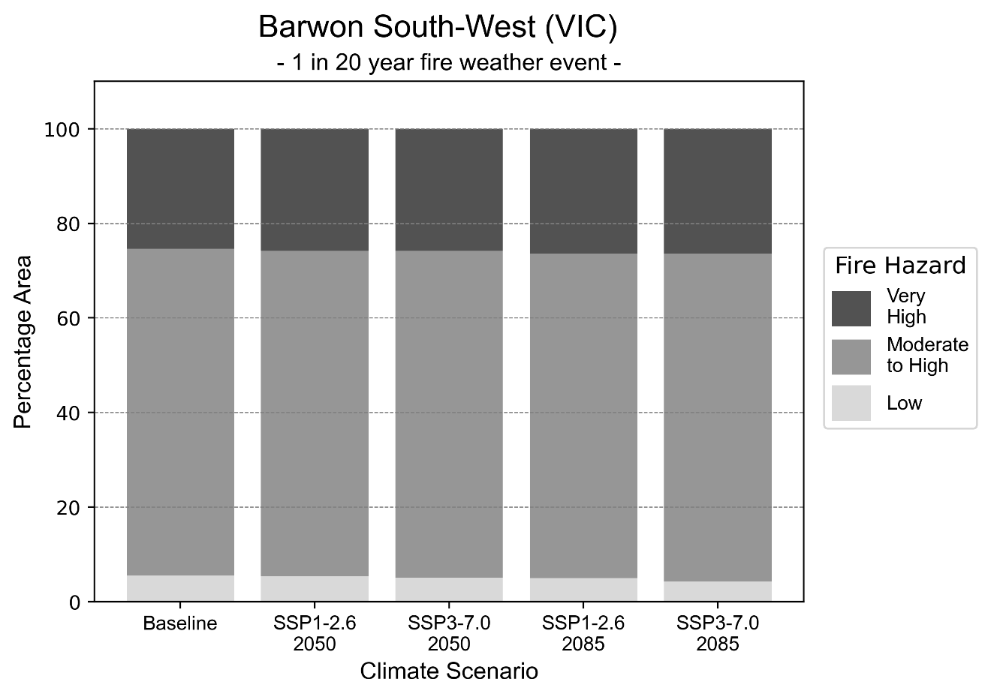
Figure 3: Stacked column chart showing the percentages of Barwon South-West health district's total geographic area experiencing each fire hazard level during a 1-in-20-year fire weather event.
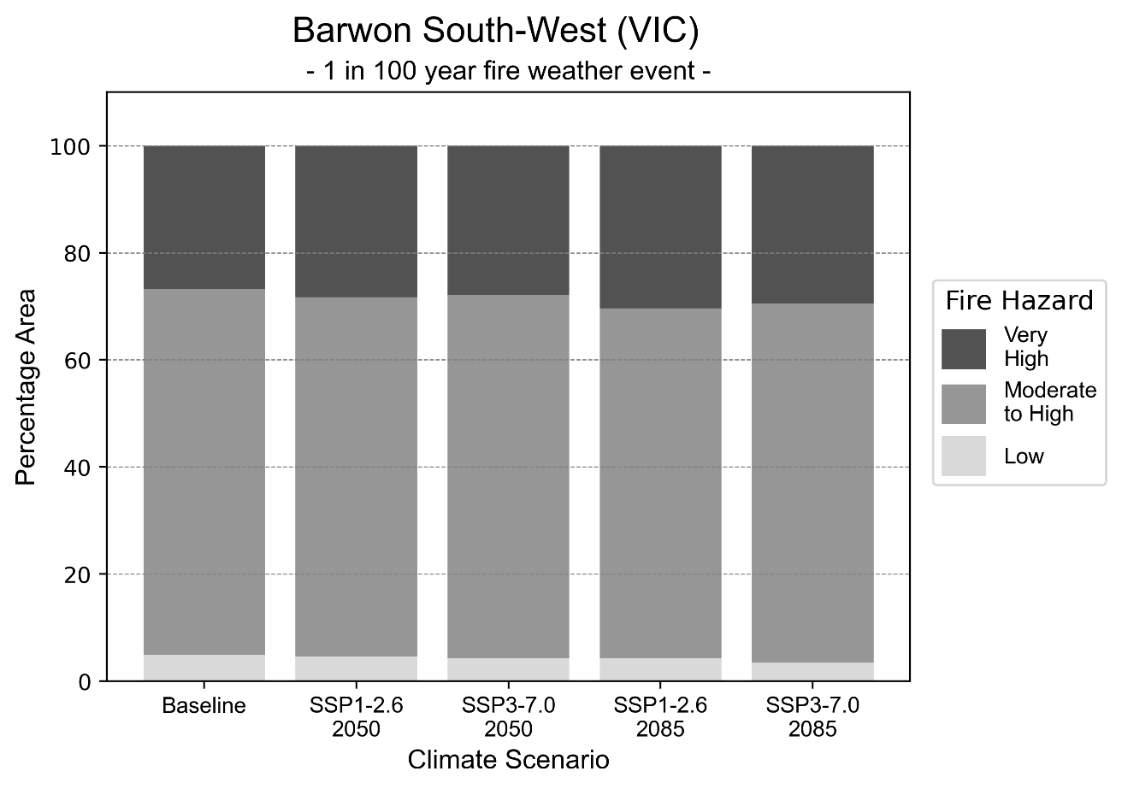
Figure 4: Stacked column chart showing the percentages of Barwon South-West health district's total geographic area experiencing each fire hazard level during a 1-in-100-year fire weather event.

Drought hazard
Key projections:
Drought occurrence: The occurrence of drought will increase across both middle of the road and reasonable worst-case scenarios and both time horizons, with the largest increase occurring under the reasonable worst-case scenario by 2085.

 | Baseline | 2050 Scenarios |  | 2085 Scenarios
 |  | Middle of the road | Reasonable worst-case | Middle of the road | Reasonable worst-case
Number of months per year in drought^{(a)} | 1.8 | 3.1  [1.0, 5.3] | 3.3  [1.8, 5.3] | 3.9  [2.7, 5.4] | 4.6  [1.5, 7.8]
Table notes: The drought hazard indicator uses climate projections from the CMIP6 Global Climate Models [1]. The primary indicator value reports the median from the nine climate models, with the range reported in square brackets.
Table footnotes: (a) The number of months per year in drought is based on the Standardised Precipitation Index (SPI). SPI is a widely used index to characterise meteorological drought on a range of timescales. This indicator uses the timescale of 12 months which calculates the average months in a year within the moderate drought range. A moderate drought range is classified as SPI score of ≤ -1. SPI is calculated from accumulated rainfall over 12 months and the mean and standard deviation from historical rainfall records.

Storm hazard
Key projections:
Fewer high-intensity storms: The frequency of high-intensity storms will decrease across both middle of the road and reasonable worst-case scenarios with the greatest decrease occurring by 2085.

 | Baseline | 2050 Scenarios |  | 2085 Scenarios
 |  | Middle of the road | Reasonable worst-case | Middle of the road | Reasonable worst-case
Number of low-intensity storms (40-62 km/hr) per year | 74.1 | 68.7  [60.5, 75.6] | 70.2  [61.7, 77.2] | 67.3  [59.3, 74.1] | 66.4  [58.4, 73.0]
Number of medium-intensity storms (63-87 km/hr) per year | 59.1 | 55.2  [48.6, 60.7] | 53.4  [47.0, 58.8] | 49.2  [43.3, 54.2] | 49.2  [43.3, 54.1]
Number of high-intensity storms (88-117 km/hr) per year | 38.8 | 36.0  [31.7, 39.6] | 35.0  [30.8, 38.5] | 34.7  [30.5, 38.2] | 30.7  [27.0, 33.8]
Number of very-high-intensity storms (> 117 km/hr) per year | 11.6 | 11.3  [10.0, 12.5] | 10.0  [8.8, 11.0] | 11.0  [9.7, 12.1] | 10.6  [9.3, 11.6]
Table notes: The storm hazard uses climate projections from the CMIP6 Global Climate Models [1]. Daily maximum surface wind speed is used to calculate the number of annual storms across four storm intensity categories (low, medium, high and very high). The average number of storms per year is reported, with the maximum and minimum values across climate models reported in brackets. The primary indicator value reports the median from the nine climate models, with the range reported in square brackets.

Rainfall and flood hazard
Key projections:
- Decline in extreme rainfall days per year: The number of extreme rainfall days will decline across both middle of the road and reasonable worst-case scenarios and both time horizons, with the largest decline seen by 2085 where nine extreme rainfall days per year will reduce to eight days.
- Increased flood frequency: The frequency of flood events will increase in urban environments but decrease in rural environments. The largest increase in flood frequency is seen in the reasonable worst-case scenario where frequency of a ‘1-in-100 year’ flood will more than triple by 2050 and become seven times more likely by 2085 in urban environments.

 | Baseline | 2050 Scenarios |  | 2085 Scenarios
 |  | Middle of the road | Reasonable worst-case | Middle of the road | Reasonable worst-case
Rainfall hazard^{(a)}
Average number of extreme rainfall days per year (> 9 mm/day)^{(a)} | 8.9 | 8.3  [7.2,9.7] | 8.3  [6.8,9.4] | 8.0  [7.3,8.7] | 8.0  [6.2,10.2]
Urban flood risk (flooding caused by a 1-hour rainfall event)^{(b)}
Frequency of a ‘1-in-1 year’ flood (rainfall depth of 12 mm)^{(c)} |  | 2.0 events in 1 year | 2.1 events in 1 year | 2.6 events in 1 year | 3.6 events in 1 year
Frequency of a ‘1-in-10 year’ flood (rainfall depth of 27 mm)^{(c)} |  | 2.2 events in 10 years | 2.3 events in 10 years | 2.9 events in 10 years | 4.2 events in 10 years
Frequency of a ‘1-in-100 year’ flood (rainfall depth of 48 mm)^{(c)} |  | 2.9 events in 100 years | 3.1 events in 100 years | 4.3 events in 100 years | 7.3 events in 100 years
Rural flood risk (flooding caused by a 24-hour rainfall event)^{(b)}
Frequency of a ‘1-in-1 year’ flood (rainfall depth of 36 mm)^{(c)} |  | 0.9 events in 1 year | 0.8 events in 1 year | 0.4 events in 1 year | 0.2 events in 1 year
Frequency of a ‘1-in-10 year’ flood (rainfall depth of 69 mm)^{(c)} |  | 0.9 events in 10 years | 0.9 events in 10 years | 0.4 events in 10 years | 0.09 events in 10 years
Frequency of a ‘1-in-100 year’ flood (rainfall depth of 117 mm)^{(c)} |  | 0.7 events in 100 years | 0.6 events in 100 years | 0.3 events in 100 years | 0.07 events in 100 years
Table notes: The rainfall hazard indicator uses climate projections from the CMIP6 Global Climate Models [1]. The primary indicator value reports the median from the nine climate models, with the range reported in square brackets. The flood hazard indicators use climate change considerations from the Australian Rainfall and Runoff guideline to estimate the climate the climate projections [2].
Table footnotes: (a) Extreme rainfall is defined as rainfall above the 95th percentile of historical average daily rainfall in this health district in the period 1985-2014. The value in mm/day quoted in the indicator name is the 95th percentile of historic average daily rainfall for this health district. (b) See Methodology document for reasons for focusing on a 1-hour flood for urban areas and a 24-hour flood for rural areas. (c) The rainfall depths in mm quoted in the indicator names in this table report 1 in 1-, 10- and 100-year depths for this health district.

Coastal inundation hazard
Key projections:
Greater area inundated: There will be an increase in the area affected by tidal inundation (i.e. area submerged during high tide) and storm surge and tidal inundation (i.e. the area submerged during a storm surge and high tide) across both middle of the road and reasonable worst-case scenarios. In the reasonable worst-case scenario, by 2085 the area inundated during tidal inundation event will increase by nearly 6000 ha.

 | Baseline | 2050 Scenarios |  | 2085 Scenarios^{(a)}
 |  | Middle of the road | Reasonable worst-case | Middle of the road | Reasonable worst-case
Tidal inundation (ha inundated)^{(b)} | 9,770.1 | 11,517.6  (+1,747.4) | 11,618.7  (+1,848.6) | 14,609.8  (+4,839.7) | 15,511.3  (+5,741.1)
Storm surge + tidal inundation – ‘1-in-100 year’ event (ha inundated)^{(c)} | 15,523.1 | 17,175.3  (+1,652.2) | 17,262.0  (+1,738.9) | 19,625.6  (+4,102.5) | 20,275.9  (+4,752.8)
Storm surge + tidal inundation – ‘1-in-1000 year’ event (ha inundated)^{(c)} | 16,323.0 | 17,851.1  (+1,528.1) | 17,940.5  (+1,617.5) | 20,881.9  (+4,558.9) | 21,604.8  (+5,281.8)
Table notes: The coastal inundation hazard provides an indication of flooding in coastal areas that can be attributed to sea level rise and storm inundation. The coastal inundation hazard is only reported for health districts adjoining the coastline. This table includes the projected inundation levels as well as the change from baseline conditions (in brackets).
Table footnotes: (a) For the 2085 Scenarios planning horizon, 2100 was adopted as it provides a conservative representation of the end of this period. This horizon aligns with many State planning regulations requiring consideration of sea level rise and storm tide to 2100, making the 2100 scenario particularly valuable for planning new health facilities in coastal areas. (b) The tidal inundation indicator reports the number of hectares inundated during high tide. The baseline value reports existing inundation patterns, while the 2050 and 2085 values report high tide inundation taking account of projected sea level rise due to climate change. (c) The storm surge + tidal inundation indicators report the combined effect, in hectares inundated, of high tide, sea level rise (for the 2050 and 2085 projections), and storm surge (for 1-in-100 year and 1-in-1000-year events).

Gippsland health district

Health district overview
The Gippsland health district covers 41,753 square kilometres.

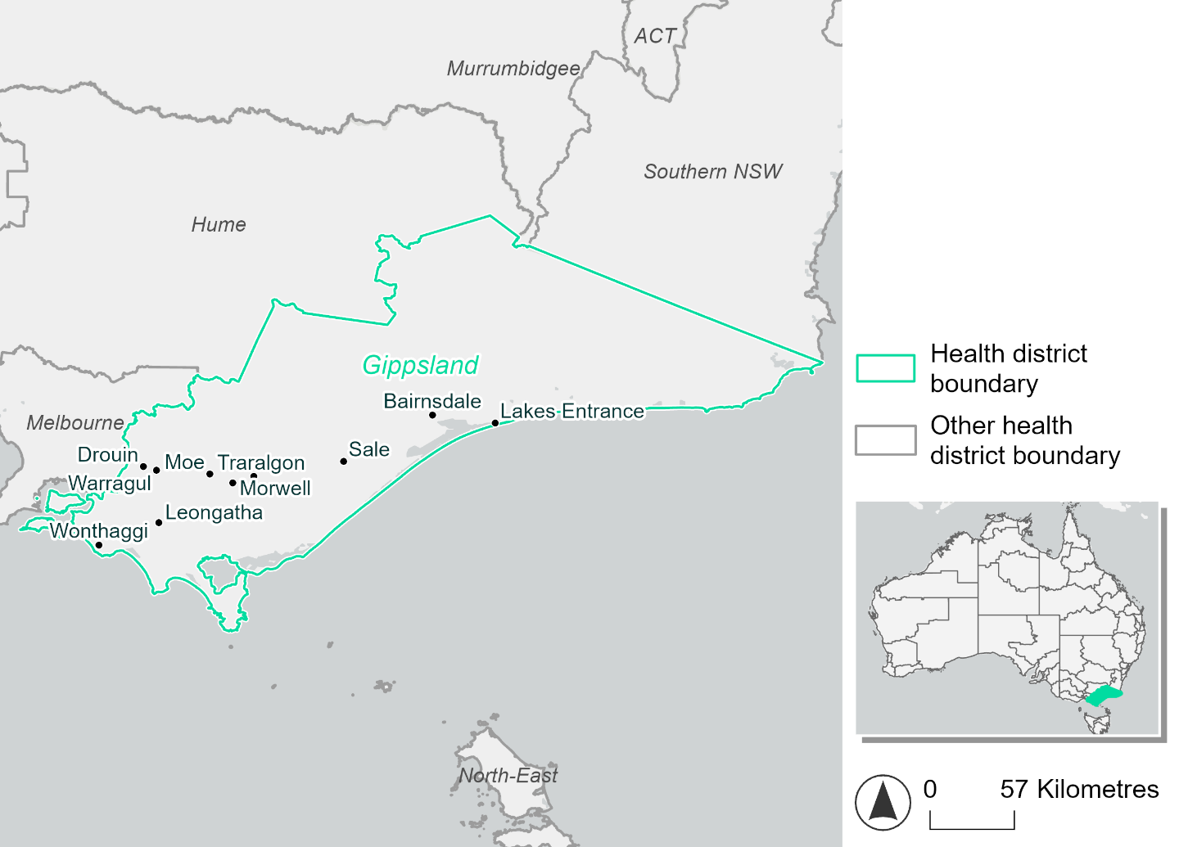
Figure 5. Map of Gippsland health district

How will climate change affect this health district?
Heat and humidity: Higher average temperatures, hotter and more frequent hot days, warmer night time temperatures and longer and more frequent heat waves.
Fire: Over 50% of this health district currently experiences very high fire hazard category and this will increase across both 2050 and 2085 scenarios.
Drought: Number of months experiencing drought will increase.
Rainfall and flood: More flood events in urban areas.
Coastal inundation: Increased area flooded during tidal and storm surge and tidal inundation.

Gippsland health district demographic data
Demographic Data | Total
Number of households | 118,079
Persons 15 and older | 199,447
Total families | 80,816
Persons did not complete high school | 98,463
One parent families with dependents | 8,121 (10%)
Persons aged 65 and older | 75,313 (24.8%)
Persons aged 4 and younger | 16,069 (5.3%)
Aboriginal and Torres Strait Islander persons | 5,811 (1.9%)
Persons speaks language other than English | 14,979 (4.9%)
Persons working age (15-65) | 176,893 (58.1%)
Population Health Data | Total
Persons with core needs for assistance | 22,101 (7.3%)
Persons with arthritis | 37,500 (12.3%)
Persons with asthma | 29,746 (9.8%)
Persons with cancer | 11,594 (3.8%)
Persons with dementia | 2,258 (0.7%)
Persons with diabetes | 17,544 (5.8%)
Persons with heart disease | 17,188 (5.6%)
Persons with kidney disease | 3,514 (1.2%)
Persons with lung condition | 8,902 (2.9%)
Persons with mental health condition | 33,362 (11%)
Persons with stroke | 4,192 (1.4%)
Persons with any other condition | 27,408 (9%)
Persons no health condition | 157,303 (51.7%)
Socio-economic Data | Total
Persons providing unpaid care | 43,676 (14.4%)
Persons homeless | 1,007 (0.3%)
Household with lone person | 35,816 (30.3%)
Households with rent and mortgage stress | 53,367 (45.2%)
Households total equivalised income below $1000 (weekly) | 65,824 (55.7%)
Households with no motor vehicle | 5,489 (4.6%)
Persons unemployed | 11,898 (4.8%)

The sections that follow outline projected climate hazards for this district. Further information on this health district, including population demographics, is provided in the online dashboard.

Heat and humidity hazard
Key projections:
More heatwaves: Heatwave events are likely to last longer and the number of heatwave events per year will increase. By 2050, under a reasonable worst-case scenario the number of heatwaves will double. By 2085, under a reasonable worst-case scenario the number of heatwaves per year will more than triple.
Hotter days and warmer nights: The maximum temperature on hot days will increase with night time temperatures on hot nights also increasing.
More days above 35°C and 40°C: The number of days per year greater than 35°C and 40°C will increase under both middle of the road and reasonable worst-case scenarios.

 | Baseline | 2050 Scenarios |  | 2085 Scenarios
 |  | Middle of the road | Reasonable worst-case | Middle of the road | Reasonable worst-case
Average temperature (°C) | 14.1 | 15.3  [14.7, 15.8] | 15.5  [14.8, 16.1] | 16.1  [15.2, 16.9] | 17.1  [15.8, 18.2]
Maximum temperature on hot days (°C)^{(a)} | 30.1 | 31.6  [31, 32.5] | 32  [30.9, 33] | 32.6  [31.7, 33.9] | 33.6  [32.5, 35.4]
Minimum temperature on hot nights (°C)^{(b)} | 16.5 | 18  [17.4, 18.7] | 18.2  [17.3, 18.8] | 18.8  [17.9, 19.8] | 19.8  [18.7, 21.1]
Average apparent temperature on hot days (°C) (NOAA Heat Index)^{(c)} | 34.8 | 35.9  [35.4, 36.5] | 36.1  [35.1, 36.8] | 36.5  [35.7, 37.5] | 37.3  [36.5, 38.3]
Average heatwave duration in days^{(d)} | 4 | 4  [4, 5] | 5  [4, 5] | 5  [4, 5] | 5  [5, 6]
Number of heatwaves per year^{(d)} | 2 | 4  [3, 5] | 4  [2, 5] | 5  [3, 7] | 7  [5, 10]
Number of days per year  > 35°C | 5 | 8  [6, 10] | 9  [6, 11] | 10  [8, 15] | 14  [10, 21]
Number of days per year > 40°C | 0 | 1  [1, 1] | 1  [1, 2] | 2  [1, 3] | 3  [1, 5]
Table notes: The heat and humidity hazard uses climate projections from the CMIP6 Global Climate Models [1]. Daily projections of maximum and minimum near-surface temperature and mean relative humidity are used to calculate eight heat and humidity indicators. The primary indicator value reports the median from the nine climate models, with the range reported in square brackets.
Table footnotes: (a) Based on the 95th percentile of daily maximum air temperature. (b) Based on the 95th percentile of daily minimum air temperature, representing the coldest part of the night on very hot nights. (c) The National Oceanic and Atmospheric Administration (NOAA) Heat Index is a measure of how hot it feels when relative humidity is factored in alongside actual air temperature. It is calculated on days with a maximum temperature of 27°C and above. Interpretation of Heat Index values: 27°C to 32°C indicates caution, 33°C to 41°C indicates extreme caution, 42°C to 54°C indicates danger and over 54°C indicates extreme danger. See methodology document for further explanation of Heat Index categories. (d) A heatwave is defined as three or more consecutive days where both daytime and overnight temperatures (daily mean temperatures) are unusually high for the location, based on the Bureau of Meteorology’s Excess Heat Factor method. For this district, an unusually high daily mean temperature is approximately 22.9°C or above.

Fire hazard
Key projections:
Majority of district area experiences very high fire hazard: under baseline conditions during a 1-in-20-year fire weather event, over half of the district (54.8%) experiences very high fire hazard. 30.3% experiences moderate to high hazard, with 14.9% experiencing low fire hazard. For a 1-in-100-year fire weather event, these proportions shift a little with low fire hazard decreasing to cover 13.2% of the area, moderate to high decreasing to 28%, and very high fire hazard increasing to cover 58.8% of the health district area.
Very high fire hazard to increase: in a future climate across both 2050 and 2085 scenarios, more of the district will experience very high hazard instead of moderate to high or low hazard. For a 1-in-20-year fire weather event, up to an additional 5.8% of the district will experience very high hazard, with moderate to high hazard and low hazard reducing by up to 1.3 and 4.4 percentage points respectively. During a 1-in-100-year fire weather event the very high fire hazard area will increase by up to 4.6 percentage points. The area experiencing low and moderate to high fire hazards will decrease by up to 1.8 and 2.8 percentage points respectively for this more severe event type.

 | Baseline | 2050 Scenarios |  | 2085 Scenarios
 |  | Sustainability | Reasonable worst-case | Sustainability | Reasonable worst-case
Hazard for a ‘1-in-20 year’ fire weather event^{(a)}
Proportion (%) of district experiencing ‘Low’ fire hazard | 14.9%  (621,962)^{(b)} | 14.4%  [13.7%, 15.0%] | 14.4%  [13.4%, 15.4%] | 13.8%  [12.1%, 15.2%] | 13.6%  [11.4%, 16.0%]
Proportion (%) of district experiencing ‘Moderate to High’ fire hazard | 30.3%  (1,264,295)^{(b)} | 29.4%  [28.4%, 31.0%] | 28.5%  [27.0%, 30.2%] | 28.2%  [25.8%, 32.1%] | 25.9%  [22.3%, 30.2%]
Proportion (%) of district experiencing ‘Very High’ fire hazard | 54.8%  (2,289,140)^{(b)} | 56.2%  [54.6%, 57.2%] | 57.2%  [55.6%, 58.4%] | 58.1%  [54.2%, 60.6%] | 60.6%  [56.7%, 63.4%]
Hazard for a ‘1-in-100 year’ fire weather event^{(a)}
Proportion (%) of district experiencing ‘Low’ fire hazard | 13.2%  (551,083)^{(b)} | 12.7%  [12.1%, 13.2%] | 12.4%  [11.6%, 13.4%] | 11.9%  [10.5%, 13.2%] | 11.4%  [9.4%, 13.7%]
Proportion (%) of district experiencing ‘Moderate to High’ fire hazard | 28.0%  (1,168,686)^{(b)} | 27.5%  [26.6%, 29.1%] | 26.8%  [26.0%, 27.6%] | 26.9%  [24.7%, 30.7%] | 25.2%  [23.2%, 27.0%]
Proportion (%) of district experiencing ‘Very High’ fire hazard | 58.8%  (2,455,628)^{(b)} | 59.8%  [58.3%, 60.6%] | 60.7%  [59.8%, 61.4%] | 61.2%  [57.5%, 63.2%] | 63.4%  [61.2%, 65.0%]
Table notes: The Fire Hazard uses the National Bushfire Intelligence Capability (NBIC) Phase 2 fire line intensity modelling based on CMIP6 climate projections. Fire Hazard is assessed using the projected Fireline Intensity (FLI) for weather events with two different return intervals (i.e. a 1-in-20-year event and a 1-in-100-year event). FLI considers slope, vegetation and weather to produce a rate of heat output per unit length (kW/m) along a bushfire’s front. Fire hazard is categorized as a low for FLI<4000 kW/m, moderate to high for 4,000 kW/m ≤FLI<12,500kW/m, and very high for FLI≥27,501kW/m. This is broadly consistent with the literature [3]. The assessment considers climate change effects based on changes in fire weather and the associated hazard that is anticipated for a meteorological event of a given return interval. This approach is different to the one adopted for the Flood Hazard, where the event magnitude is given (fixed) and the likelihood of that event varies as a result of climate change. The primary indicator value reports the median from the nine climate models, with the range reported in square brackets.
Table footnotes: (a) The area subject to different categories of fire hazard is determined for a ‘1-in-20 year’ and ‘1-in-100 year’ fire weather event, in current and future climates. Values at year 2050 are interpolated using data from baseline (2025) and 2085, assuming linear change over time. (b) Values in round brackets are the area (ha) of the health district subject to a given fire hazard.

The figures below show the proportion of the health district experiencing different fire hazard categories across different time horizons and climate scenarios during a ‘1-in-20 year’ fire weather event (Figure 6) and a ‘1-in-100 year’ fire weather event (Figure 7).
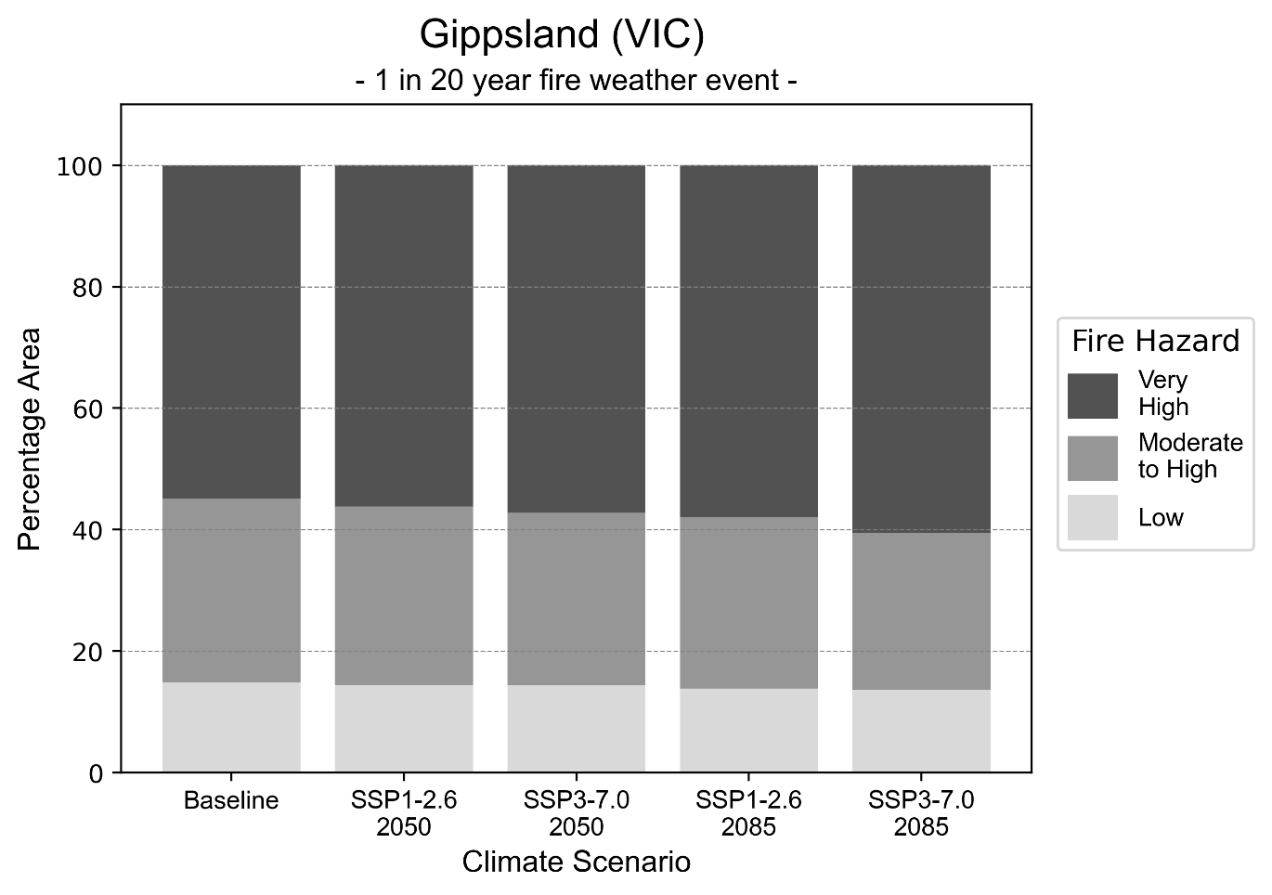
Figure 6: Stacked column chart showing the percentages of the Gippsland health district's total geographic area experiencing each fire hazard level during a 1-in-20-year fire weather event.
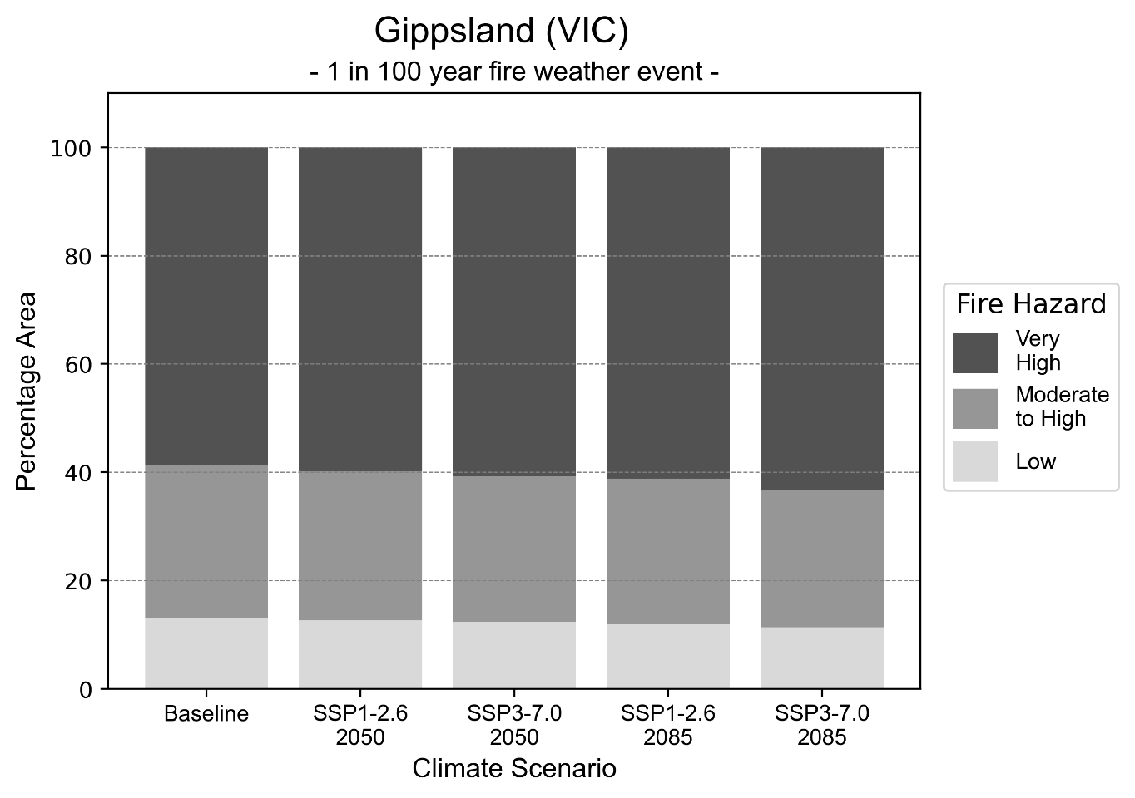
Figure 7: Stacked column chart showing the percentages of the Gippsland health district's total geographic area experiencing each fire hazard level during a 1-in-100-year fire weather event.

Drought hazard
Key projections:
Drought occurrence: The occurrence of drought will increase across both middle of the road and reasonable worst-case scenarios and both time horizons, with the largest increase occurring under the reasonable worst-case scenario by 2085.

 | Baseline | 2050 Scenarios |  | 2085 Scenarios
 |  | Middle of the road | Reasonable worst-case | Middle of the road | Reasonable worst-case
Number of months per year in drought^{(a)} | 1.8 | 2.1  [1.1, 3.4] | 2.5  [1.3, 4.7] | 2.5  [1.6, 3.7] | 3.1  [1.1, 6.3]
Table notes: The drought hazard indicator uses climate projections from the CMIP6 Global Climate Models [1]. The primary indicator value reports the median from the nine climate models, with the range reported in square brackets.
Table footnotes: (a) The number of months per year in drought is based on the Standardised Precipitation Index (SPI). SPI is a widely used index to characterise meteorological drought on a range of timescales. This indicator uses the timescale of 12 months which calculates the average months in a year within the moderate drought range. A moderate drought range is classified as SPI score of ≤ -1. SPI is calculated from accumulated rainfall over 12 months and the mean and standard deviation from historical rainfall records.

Storm hazard
Key projections:
Fewer high-intensity storms: The frequency of high-intensity storms will decrease across both middle of the road and reasonable worst-case scenarios with the greatest decrease occurring by 2085.

 | Baseline | 2050 Scenarios |  | 2085 Scenarios
 |  | Middle of the road | Reasonable worst-case | Middle of the road | Reasonable worst-case
Number of low-intensity storms (40-62 km/hr) per year | 74.1 | 68.7  [60.5, 75.6] | 70.2  [61.7, 77.2] | 67.3  [59.3, 74.1] | 66.4  [58.4, 73.0]
Number of medium-intensity storms (63-87 km/hr) per year | 59.1 | 55.2  [48.6, 60.7] | 53.4  [47.0, 58.8] | 49.2  [43.3, 54.2] | 49.2  [43.3, 54.1]
Number of high-intensity storms (88-117 km/hr) per year | 38.8 | 36.0  [31.7, 39.6] | 35.0  [30.8, 38.5] | 34.7  [30.5, 38.2] | 30.7  [27.0, 33.8]
Number of very-high-intensity storms (> 117 km/hr) per year | 11.6 | 11.3  [10.0, 12.5] | 10.0  [8.8, 11.0] | 11.0  [9.7, 12.1] | 10.6  [9.3, 11.6]
Table notes: The storm hazard uses climate projections from the CMIP6 Global Climate Models [1]. Daily maximum surface wind speed is used to calculate the number of annual storms across four storm intensity categories (low, medium, high and very high). The primary indicator value reports the median from the nine climate models, with the range reported in square brackets.

Rainfall and flood hazard
Key projections:
- Seven extreme rainfall days per year: The number of extreme rainfall days will remain consistent across both middle of the road and reasonable worst-case scenarios and both time horizons, with an average of approximately seven extreme rainfall days per year.
- Increased flood frequency: The frequency of flood events will increase in urban environments and decrease in rural environments. The largest increase in flood frequency is seen in the reasonable worst-case scenario where frequency of a ‘1-in-100 year’ flood will triple by 2050 and become seven times more likely by 2085 in urban environments.

 | Baseline | 2050 Scenarios |  | 2085 Scenarios
 |  | Middle of the road | Reasonable worst-case | Middle of the road | Reasonable worst-case
Rainfall hazard^{(a)}
Average number of extreme rainfall days per year (> 12 mm/day)^{(a)} | 6.8 | 6.8  [5.9,7.6] | 6.6  [5.3,7.6] | 6.7  [6.0,7.4] | 6.5  [4.9,7.8]
Urban flood risk (flooding caused by a 1-hour rainfall event)^{(b)}
Frequency of a ‘1-in-1 year’ flood (rainfall depth of 14 mm)^{(c)} |  | 1.8 events in 1 year | 1.9 events in 1 year | 2.4 events in 1 year | 3.2 events in 1 year
Frequency of a ‘1-in-10 year’ flood (rainfall depth of 30 mm)^{(c)} |  | 2.3 events in 10 years | 2.4 events in 10 years | 3.1 events in 10 years | 4.6 events in 10 years
Frequency of a ‘1-in-100 year’ flood (rainfall depth of 53 mm)^{(c)} |  | 2.8 events in 100 years | 3.0 events in 100 years | 4.2 events in 100 years | 7.2 events in 100 years
Rural flood risk (flooding caused by a 24-hour rainfall event) ^{(b)}
Frequency of a ‘1-in-1 year’ flood (rainfall depth of 49 mm)^{(c)} |  | 0.9 events in 1 year | 0.9 events in 1 year | 0.5 events in 1 year | 0.2 events in 1 year
Frequency of a ‘1-in-10 year’ flood (rainfall depth of 92 mm)^{(c)} |  | 0.9 events in 10 years | 0.9 events in 10 years | 0.5 events in 10 years | 0.1 events in 10 years
Frequency of a ‘1-in-100 year’ flood (rainfall depth of 145 mm)^{(c)} |  | 1.1 events in 100 years | 1.1 events in 100 years | 0.8 events in 100 years | 0.2 events in 100 years
Table notes: The rainfall hazard indicator uses climate projections from the CMIP6 Global Climate Models [1]. The primary indicator value reports the median from the nine climate models, with the range reported in square brackets. The flood hazard indicators use climate change considerations from the Australian Rainfall and Runoff guideline to estimate the climate the climate projections [2].
Table footnotes: (a) Extreme rainfall is defined as rainfall above the 95th percentile of historical average daily rainfall in this health district in the period 1985-2014. The value in mm/day quoted in the indicator name is the 95th percentile of historic average daily rainfall for this health district. (b) See Methodology document for reasons for focusing on a 1-hour flood for urban areas and a 24-hour flood for rural areas. (c) The rainfall depths in mm quoted in the indicator names in this table report 1 in 1-, 10- and 100-year depths for this health district.

Coastal inundation hazard
Key projections:
Greater area inundated: There will be an increase in the area affected by tidal inundation (i.e. area submerged during high tide) and storm surge and tidal inundation (i.e. the area submerged during a storm surge and high tide) across both middle of the road and reasonable worst-case scenarios. In the reasonable worst-case scenario, by 2085 the area inundated during tidal inundation event will increase by over 30,000 ha.
 | Baseline | 2050 Scenarios |  | 2085 Scenarios^{(a)}
 |  | Middle of the road | Reasonable worst-case | Middle of the road | Reasonable worst-case
Tidal inundation (ha inundated)^{(b)} | 109,210.3 | 117,993.0  (+8,782.8) | 118,644.1  (+9,433.8) | 132,962.1  (+23,751.8) | 139,396.1  (+30,185.9)
Storm surge + tidal inundation – ‘1-in-100 year’ event (ha inundated)^{(c)} | 138,405.3 | 147,288.6  (+8,883.3) | 147,873.2  (+9,467.9) | 158,866.7  (+20,461.4) | 162,603.8  (+24,198.5)
Storm surge + tidal inundation – ‘1-in-1000 year’ event (ha inundated)^{(c)} | 142,349.9 | 150,864.2  (+8,514.3) | 151,388.9  (+9,039.1) | 164,081.2  (+21,731.3) | 167,352.8  (+25,002.9)

Table notes: The coastal inundation hazard provides an indication of flooding in coastal areas that can be attributed to sea level rise and storm inundation. The coastal inundation hazard is only reported for health districts adjoining the coastline. This table includes the projected inundation levels as well as the change from baseline conditions (in brackets).
Table footnotes: (a) For the 2085 Scenarios planning horizon, 2100 was adopted as it provides a conservative representation of the end of this period. This horizon aligns with many State planning regulations requiring consideration of sea level rise and storm tide to 2100, making the 2100 scenario particularly valuable for planning new health facilities in coastal areas. (b) The tidal inundation indicator reports the number of hectares inundated during high tide. The baseline value reports existing inundation patterns, while the 2050 and 2085 values report high tide inundation taking account of projected sea level rise due to climate change. (c) The storm surge + tidal inundation indicators report the combined effect, in hectares inundated, of high tide, sea level rise (for the 2050 and 2085 projections), and storm surge (for 1-in-100 year and 1-in-1000 year events).

Grampians health district

Health district overview
The Melbourne health district covers 48,627 square kilometres.

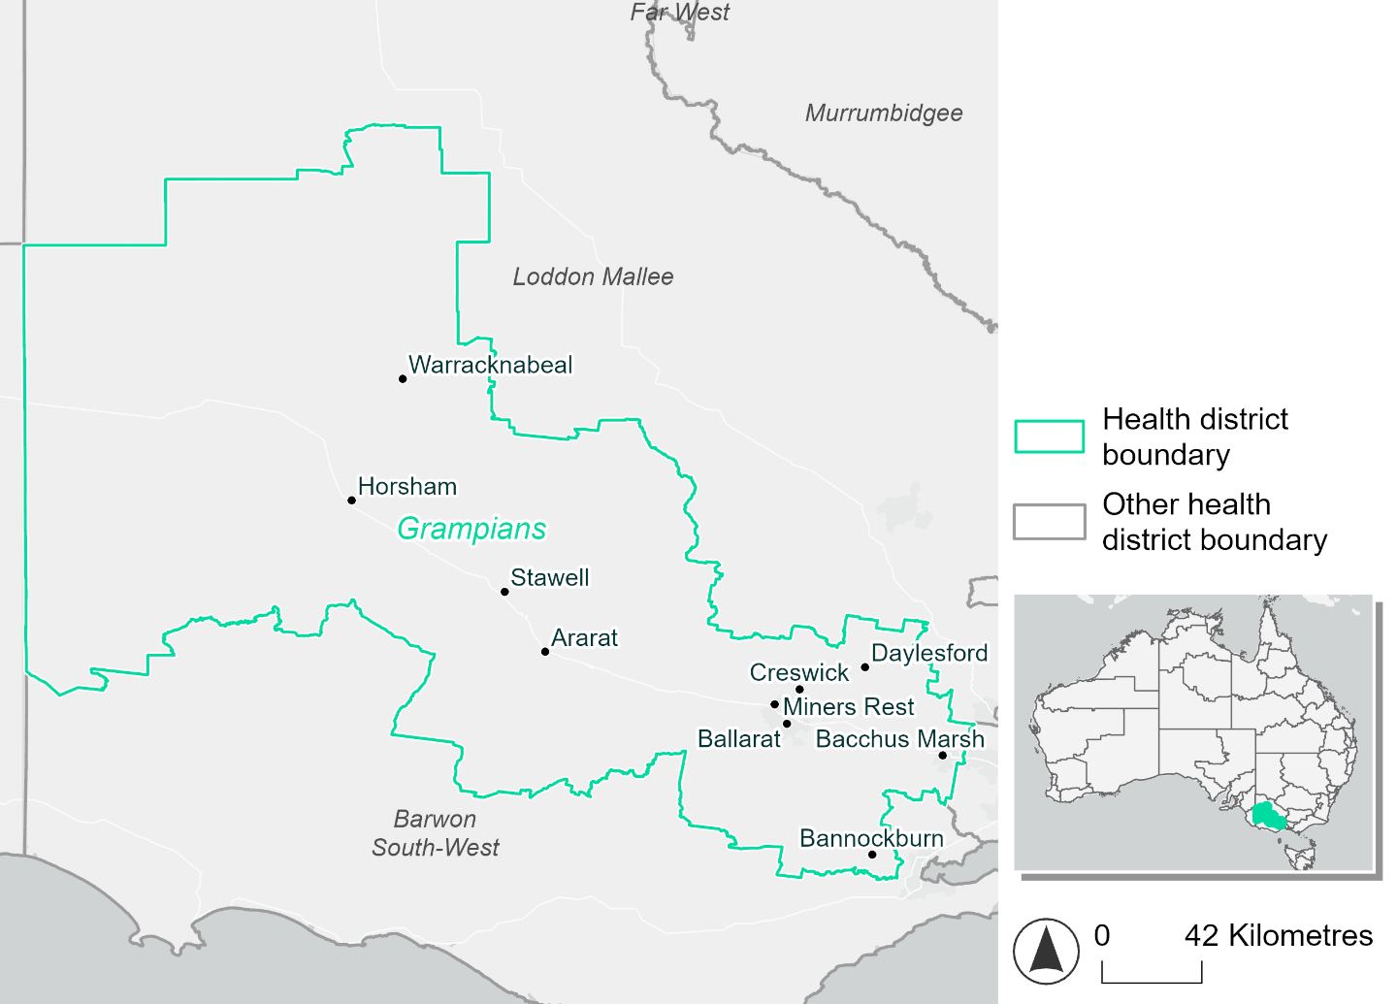
Figure 8. Map of Grampians health district.

How will climate change affect this health district?
Heat and humidity: Higher average temperatures, hotter and more frequent hot days, warmer night time temperatures and more frequent heat waves.
Fire: Over 10% of this health district currently experiences very high fire hazard category and this will increase across both 2050 and 2085 scenarios.
Drought: Number of months experiencing drought will increase.
Rainfall and flood: More flood events in both urban and rural areas.
Coastal inundation: While this health district is not coastal, some rivers within the district are affected by tides in their downstream sections. Increased area flooded during tidal and storm surge and tidal inundation.

Grampians health district demographic data
Demographic Data | Total
Number of households | 100,694
Persons 15 and older | 177,959
Total families | 69,478
Persons did not complete high school | 78,627
One parent families with dependents | 7,254 (10.4%)
Persons aged 65 and older | 53,594 (20.3%)
Persons aged 4 and younger | 14,828 (5.6%)
Aboriginal and Torres Strait Islander persons | 4,415 (1.7%)
Persons speaks language other than English | 15,499 (5.6%)
Persons working age (15-65) | 161,849 (61.3%)
Population Health Data | Total
Persons with core needs for assistance | 18,157 (6.9%)
Persons with arthritis | 29,023 (11%)
Persons with asthma | 27,868 (10.6%)
Persons with cancer | 9,274 (3.5%)
Persons with dementia | 1,957 (0.7%)
Persons with diabetes | 13,828 (5.2%)
Persons with heart disease | 12,617 (4.8%)
Persons with kidney disease | 2,410 (0.9%)
Persons with lung condition | 6,552 (2.5%)
Persons with mental health condition | 30,602 (11.6%)
Persons with stroke | 3,121 (1.2%)
Persons with any other condition | 23,818 (9%)
Persons no health condition | 141,116 (53.5%)
Socio-economic Data | Total
Persons providing unpaid care | 37,598 (14.2%)
Persons homeless | 1,038 (0.4%)
Household with lone person | 29,293 (29.1%)
Households with rent and mortgage stress | 40,532 (40.3%)
Households total equivalised income below $1000 (weekly) | 51,245 (50.9%)
Households with no motor vehicle | 4,816 (4.8%)
Persons unemployed | 8,691 (4.1%)

The sections that follow outline projected climate hazards for this district. Further information on this health district, including population demographics, is provided in the online dashboard.

Heat and humidity hazard
Key projections:
More heatwaves: The number of heatwave events per year will increase. By 2050, under a reasonable worst-case scenario the number of heatwaves will double. By 2085, under a reasonable worst-case scenario the number of heatwaves per year will triple.
Hotter days and warmer nights: The maximum temperature on hot days will increase with night time temperatures on hot nights also increasing.
More days above 35°C and 40°C: The number of days per year greater than 35°C and 40°C will increase under both middle of the road and reasonable worst-case scenarios.

 | Baseline | 2050 Scenarios |  | 2085 Scenarios
 |  | Middle of the road | Reasonable worst-case | Middle of the road | Reasonable worst-case
Average temperature (°C) | 13.2 | 14.4  [13.8, 14.9] | 14.6  [13.9, 15.2] | 15.2  [14.3, 16] | 16.1  [14.8, 17.2]
Maximum temperature on hot days (°C)^{(a)} | 30.8 | 32.3  [31.7, 33] | 32.8  [31.6, 33.8] | 33.4  [32.4, 34.5] | 34.4  [33.2, 35.8]
Minimum temperature on hot nights (°C)^{(b)} | 16.6 | 18.1  [17.5, 18.8] | 18.3  [17.3, 18.8] | 18.9  [18, 20] | 20.1  [18.7, 21.1]
Average apparent temperature on hot days (°C) (NOAA Heat Index)^{(c)} | 33.3 | 34.2  [33.6, 34.7] | 34.3  [33.3, 35] | 34.7  [33.9, 35.6] | 35.4  [34.5, 36.3]
Average heatwave duration in days^{(d)} | 4 | 4  [4, 4] | 4  [4, 5] | 5  [4, 5] | 5  [4, 5]
Number of heatwaves per year^{(d)} | 2 | 3  [3, 4] | 4  [2, 5] | 5  [3, 6] | 6  [4, 9]
Number of days per year  > 35°C | 6 | 10  [8, 12] | 11  [7, 15] | 13  [10, 17] | 17  [12, 24]
Number of days per year > 40°C | 1 | 1  [1, 2] | 2  [1, 3] | 2  [1, 4] | 4  [2, 6]
Table notes: The heat and humidity hazard uses climate projections from the CMIP6 Global Climate Models [1]. Daily projections of maximum and minimum near-surface temperature and mean relative humidity are used to calculate eight heat and humidity indicators. The average of each indicator is reported along with the maximum and minimum values across climate models reported in brackets.
Table footnotes: (a) Based on the 95th percentile of daily maximum air temperature. (b) Based on the 95th percentile of daily minimum air temperature, representing the coldest part of the night on very hot nights. (c) The National Oceanic and Atmospheric Administration (NOAA) Heat Index is a measure of how hot it feels when relative humidity is factored in alongside actual air temperature. It is calculated on days with a maximum temperature of 27°C and above. Interpretation of Heat Index values: 27°C to 32°C indicates caution, 33°C to 41°C indicates extreme caution, 42°C to 54°C indicates danger and over 54°C indicates extreme danger. See methodology document for further explanation of Heat Index categories. (d) A heatwave is defined as three or more consecutive days where both daytime and overnight temperatures (daily mean temperatures) are unusually high for the location, based on the Bureau of Meteorology’s Excess Heat Factor method. For this district, an unusually high daily mean temperature is approximately 23.3°C or above.

Fire hazard
Key projections:
Most of district area experiences moderate to high fire hazard: under baseline conditions, 79-80% of the district experiences moderate to high fire hazard. 7-8% experiences low fire hazard, while the remaining 11-13% experiences very high hazard.
Very high hazard area to increase for more severe events: in a future climate across 2050 and 2085 scenarios, the relative proportions of each of the hazard levels stay roughly the same, varying by at most 1.1 percentage points, for a 1-in-20-year fire weather event. For a more severe 1-in-100-year event, the area experiencing very high fire hazard increases by up to 4.4 percentage points compared to baseline, with a corresponding decrease in moderate to high hazard.

 | Baseline | 2050 Scenarios |  | 2085 Scenarios
 |  | Sustainability | Reasonable worst-case | Sustainability | Reasonable worst-case
Hazard for a ‘1-in-20 year’ fire weather event^{(a)}
Proportion (%) of district experiencing ‘Low’ fire hazard | 8.8%  (428,964)^{(b)} | 8.7%  [8.5%, 9.1%] | 8.7%  [8.2%, 9.2%] | 8.6%  [8.0%, 9.6%] | 8.6%  [7.4%, 9.8%]
Proportion (%) of district experiencing ‘Moderate to High’ fire hazard | 80.1%  (3,892,706)^{(b)} | 79.9%  [76.6%, 83.1%] | 79.7%  [75.9%, 82.7%] | 79.6%  [71.8%, 87.3%] | 79.2%  [70.2%, 86.5%]
Proportion (%) of district experiencing ‘Very High’ fire hazard | 11.1%  (541,049)^{(b)} | 11.4%  [11.1%, 11.6%] | 11.6%  [11.1%, 12.0%] | 11.8%  [11.0%, 12.3%] | 12.2%  [11.0%, 13.2%]
Hazard for a ‘1-in-100 year’ fire weather event^{(a)}
Proportion (%) of district experiencing ‘Low’ fire hazard | 7.5%  (363,269)^{(b)} | 7.4%  [7.1%, 7.8%] | 7.4%  [6.9%, 7.9%] | 7.2%  [6.6%, 8.2%] | 7.2%  [6.0%, 8.5%]
Proportion (%) of district experiencing ‘Moderate to High’ fire hazard | 79.0%  (3,839,786)^{(b)} | 77.7%  [76.4%, 79.5%] | 77.3%  [75.3%, 79.6%] | 75.9%  [72.7%, 80.2%] | 74.9%  [70.2%, 80.6%]
Proportion (%) of district experiencing ‘Very High’ fire hazard | 13.6%  (659,665)^{(b)} | 15.0%  [13.2%, 16.0%] | 15.4%  [13.8%, 17.6%] | 16.9%  [12.6%, 19.3%] | 18.0%  [14.1%, 23.2%]
Table notes: The Fire Hazard uses the National Bushfire Intelligence Capability (NBIC) Phase 2 fire line intensity modelling based on CMIP6 climate projections. Fire Hazard is assessed using the projected Fireline Intensity (FLI) for weather events with two different return intervals (i.e. a 1-in-20 year event and a 1-in-100 year event). FLI considers slope, vegetation and weather to produce a rate of heat output per unit length (kW/m) along a bushfire’s front. Fire hazard is categorized as a low for FLI<4000 kW/m, moderate to high for 4,000 kW/m ≤FLI<12,500kW/m, and very high for FLI≥27,501kW/m. This is broadly consistent with the literature [3]. The assessment considers climate change effects based on changes in fire weather and the associated hazard that is anticipated for a meteorological event of a given return interval. This approach is different to the one adopted for the Flood Hazard, where the event magnitude is given (fixed) and the likelihood of that event varies as a result of climate change. The primary indicator value reports the median from the nine climate models, with the range reported in square brackets.
Table footnotes: (a) The area subject to different categories of fire hazard is determined for a ‘1-in-20 year’ and ‘1-in-100 year’ fire weather event, in current and future climates. Values at year 2050 are interpolated using data from baseline (2025) and 2085, assuming linear change over time. (b) Values in round brackets are the area (ha) of the health district subject to a given fire hazard.

The figures below show the proportion of the health district experiencing different fire hazard categories across different time horizons and climate scenarios during a ‘1-in-20 year’ fire weather event (Figure 9) and a ‘1-in-100 year’ fire weather event (Figure 10).
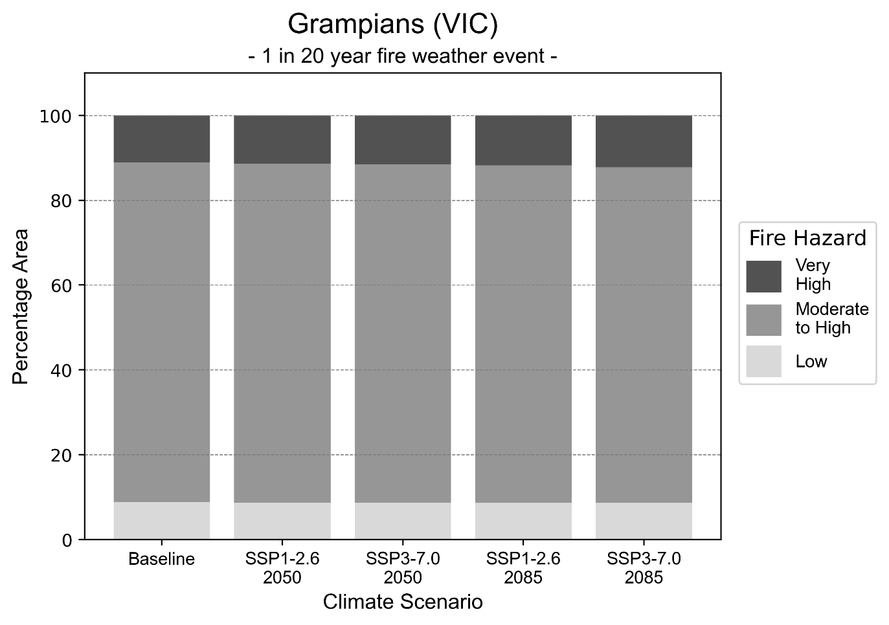
Figure 9: Stacked column chart showing the percentages of the Grampians health district's total geographic area experiencing each fire hazard level during a 1-in-20-year fire weather event.
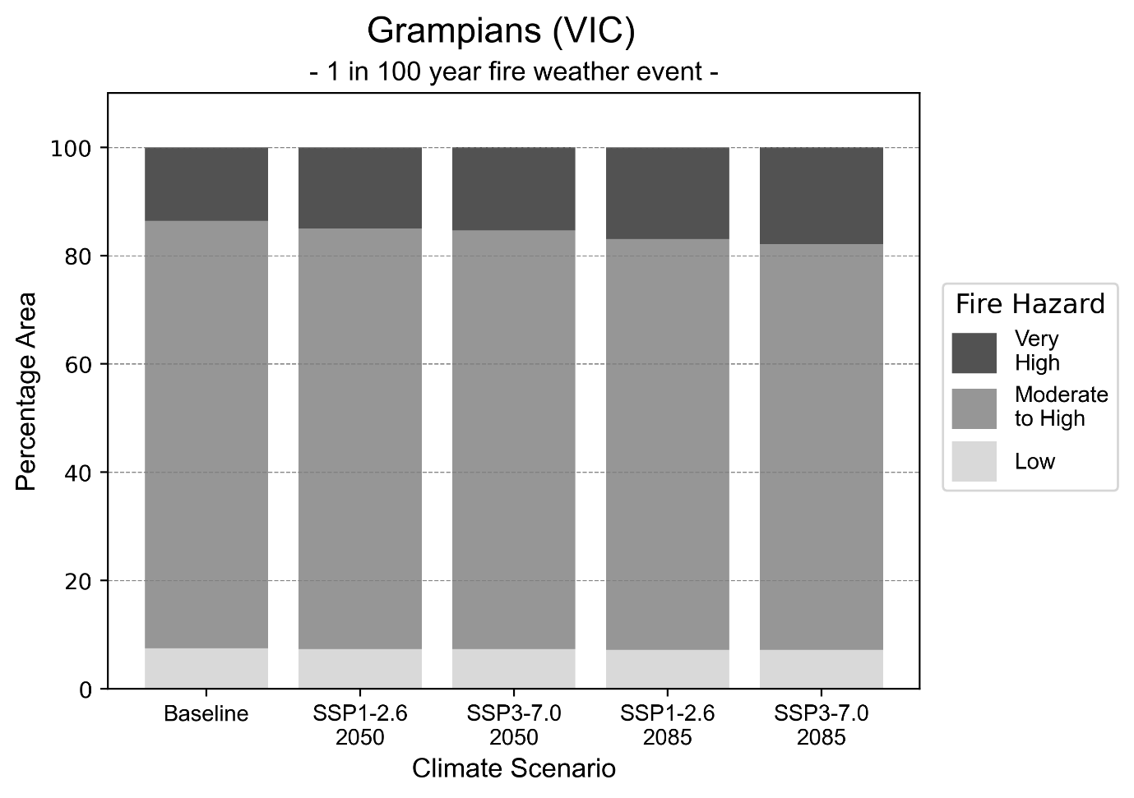
Figure 10: Stacked column chart showing the percentages of the Grampians health district's total geographic area experiencing each fire hazard level during a 1-in-100-year fire weather event.

Drought hazard
Key projections:
Drought occurrence: The occurrence of drought will remain consistent across both middle of the road and reasonable worst-case scenarios and both time horizons, with the largest increase occurring under the reasonable worst-case scenario by 2085.

 | Baseline | 2050 Scenarios |  | 2085 Scenarios
 |  | Middle of the road | Reasonable worst-case | Middle of the road | Reasonable worst-case
Number of months per year in drought^{(a)} | 1.7 | 2.8  [0.4, 4.8] | 2.8  [1.1, 5.5] | 3.3  [1.6, 5.0] | 4.0  [0.7, 8.3]
Table notes: The drought hazard indicator uses climate projections from the CMIP6 Global Climate Models [1]. The primary indicator value reports the median from the nine climate models, with the range reported in square brackets.
Table footnotes: (a) The number of months per year in drought is based on the Standardised Precipitation Index (SPI). SPI is a widely used index to characterise meteorological drought on a range of timescales. This indicator uses the timescale of 12 months which calculates the average months in a year within the moderate drought range. A moderate drought range is classified as SPI score of ≤ -1. SPI is calculated from accumulated rainfall over 12 months and the mean and standard deviation from historical rainfall records.

Storm hazard
Key projections:
Fewer high-intensity storms: The frequency of high-intensity storms will decrease across both middle of the road and reasonable worst-case scenarios with the greatest decrease occurring by 2085.

 | Baseline | 2050 Scenarios |  | 2085 Scenarios
 |  | Middle of the road | Reasonable worst-case | Middle of the road | Reasonable worst-case
Number of low-intensity storms (40-62 km/hr) per year | 78.1 | 75.5  [66.5, 83.1] | 75.1  [66.1, 82.6] | 70.4  [62.0, 77.4] | 71.3  [62.7, 78.4]
Number of medium-intensity storms (63-87 km/hr) per year | 40.4 | 40.4  [35.6, 44.4] | 38.7  [34.1, 42.6] | 36.8  [32.4, 40.5] | 36.7  [32.3, 40.4]
Number of high-intensity storms (88-117 km/hr) per year | 35.7 | 33.6  [29.5, 36.9] | 32.0  [28.2, 35.2] | 32.1  [28.2, 35.3] | 31.4  [27.6, 34.5]
Number of very-high-intensity storms (> 117 km/hr) per year | 1.0 | 0.9  [0.8, 1.0] | 0.6  [0.6, 0.7] | 0.8  [0.7, 0.9] | 1.2  [1.1, 1.3]
Table notes: The storm hazard uses climate projections from the CMIP6 Global Climate Models [1]. Daily maximum surface wind speed is used to calculate the number of annual storms across four storm intensity categories (low, medium, high and very high). The primary indicator value reports the median from the nine climate models, with the range reported in square brackets.

Rainfall and flood hazard
Key projections:
- Decline in number of extreme rainfall days per year: The number of extreme rainfall days will slightly decline across both middle of the road and reasonable worst-case scenarios and both time horizons, with the largest decline occurring under the reasonable worst-case scenario by 2085.
- Increased flood frequency: The frequency of flood events will increase in urban environments. The largest increase in flood frequency is seen in the reasonable worst-case scenario where frequency of a ‘1-in-100 year’ flood will triple by 2050 and become seven times more likely by 2085 in urban environments.

 | Baseline | 2050 Scenarios |  | 2085 Scenarios
 |  | Middle of the road | Reasonable worst-case | Middle of the road | Reasonable worst-case
Rainfall hazard^{(a)}
Average no. of extreme rainfall days per year (> 8 mm/day)^{(a)} | 9.0 | 8.5  [7.1,10.8] | 8.5  [6.5,10.2] | 8.2  [7.0,9.6] | 8.1  [5.8,11.0]
Urban flood risk (flooding caused by a 1-hour rainfall event)^{(b)}
Frequency of a ‘1-in-1 year’ flood (rainfall depth of 13 mm)^{(c)} |  | 1.9 events in 1 year | 2.0 events in 1 year | 2.4 events in 1 year | 3.3 events in 1 year
Frequency of a ‘1-in-10 year’ flood (rainfall depth of 27 mm)^{(c)} |  | 2.3 events in 10 years | 2.4 events in 10 years | 3.2 events in 10 years | 4.8 events in 10 years
Frequency of a ‘1-in-100 year’ flood (rainfall depth of 46 mm)^{(c)} |  | 2.8 events in 100 years | 3.0 events in 100 years | 4.3 events in 100 years | 7.3 events in 100 years
Rural flood risk (flooding caused by a 24-hour rainfall event)^{(b)}
Frequency of a ‘1-in-1 year’ flood (rainfall depth of 36 mm)^{(c)} |  | 0.8 events in 1 year | 0.9 events in 1 year | 0.9 events in 1 year | 0.4 events in 1 year
Frequency of a ‘1-in-10 year’ flood (rainfall depth of 69 mm)^{(c)} |  | 1.1 events in 10 years | 1.1 events in 10 years | 0.5 events in 10 years | 0.2 events in 10 years
Frequency of a ‘1-in-100 year’ flood (rainfall depth of 113 mm)^{(c)} |  | 1.1 events in 100 years | 1.0 events in 100 years | 0.7 events in 100 years | 0.3 events in 100 years
Table notes: The rainfall hazard indicator uses climate projections from the CMIP6 Global Climate Models [1]. The primary indicator value reports the median from the nine climate models, with the range reported in square brackets. The flood hazard indicators use climate change considerations from the Australian Rainfall and Runoff guideline to estimate the climate the climate projections [2].
Table footnotes: (a) Extreme rainfall is defined as rainfall above the 95th percentile of historical average daily rainfall in this health district in the period 1985-2014. The value in mm/day quoted in the indicator name is the 95th percentile of historic average daily rainfall for this health district. (b) See Methodology document for reasons for focusing on a 1-hour flood for urban areas and a 24-hour flood for rural areas. (c) The rainfall depths in mm quoted in the indicator names in this table report 1 in 1-, 10- and 100-year depths for this health district.

Hume health district

Health district overview
The Hume health district covers 40,396 square kilometres.

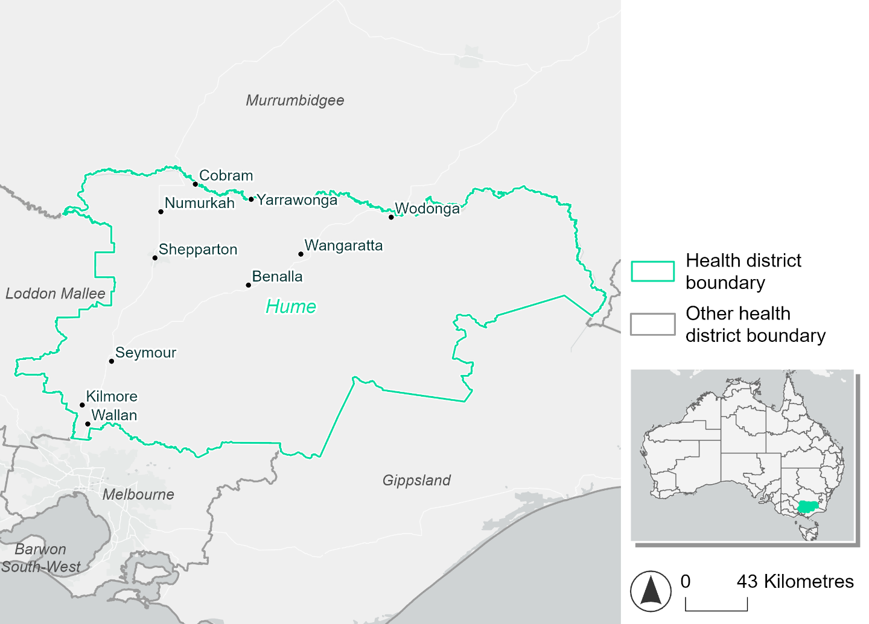
Figure 11. Map of Hume health district.

How will climate change affect this health district?
Heat and humidity: Higher average temperatures, hotter and more frequent hot days, warmer night time temperatures and more frequent heat waves.
Fire: Nearly 40% of this health district currently experiences very high fire hazard category and this will increase slightly across both 2050 and 2085 scenarios.
Drought: Number of months experiencing drought will increase.
Rainfall and flood: More flood events in urban areas.

Hume health district demographic data
Demographic Data | Total
Number of households | 117,030
Persons 15 and older | 208,842
Total families | 82,725
Persons did not complete high school | 97,314
One parent families with dependents | 8,379 (10.1%)
Persons aged 65 and older | 68,068 (21.7%)
Persons aged 4 and younger | 17,782 (5.7%)
Aboriginal and Torres Strait Islander persons | 7,840 (2.5%)
Persons speaks language other than English | 27,366 (8.7%)
Persons working age (15-65) | 188,637 (60.1%)
Population Health Data | Total
Persons with core needs for assistance | 21,154 (6.7%)
Persons with arthritis | 35,444 (11.3%)
Persons with asthma | 30,973 (9.9%)
Persons with cancer | 11,199 (3.6%)
Persons with dementia | 2,418 (0.8%)
Persons with diabetes | 16,725 (5.3%)
Persons with heart disease | 15,681 (5%)
Persons with kidney disease | 3,629 (1.2%)
Persons with lung condition | 7,603 (2.4%)
Persons with mental health condition | 32,692 (10.4%)
Persons with stroke | 3,676 (1.2%)
Persons with any other condition | 26,755 (8.5%)
Persons no health condition | 169,368 (53.9%)
Socio-economic Data | Total
Persons providing unpaid care | 43,418 (13.8%)
Persons homeless | 1,116 (0.4%)
Household with lone person | 33,041 (28.2%)
Households with rent and mortgage stress | 47,889 (40.9%)
Households total equivalised income below $1000 (weekly) | 60,697 (51.9%)
Households with no motor vehicle | 4,810 (4.1%)
Persons unemployed | 9,638 (3.8%)

The sections that follow outline projected climate hazards for this district. Further information on this health district, including population demographics, is provide in the online dashboard.

Heat and humidity hazard
Key projections:
More heatwaves: The number of heatwave events per year will increase. By 2050, under a reasonable worst-case scenario the number of heatwaves will double. By 2085, under a reasonable worst-case scenario the number of heatwaves per year will more than triple.
Hotter days and warmer nights: The maximum temperature on hot days will increase with night time temperatures on hot nights also increasing.
More days above 35°C and 40°C: The number of days per year greater than 35°C and 40°C will increase under both middle of the road and reasonable worst-case scenarios.

 | Baseline | 2050 Scenarios |  | 2085 Scenarios
 |  | Middle of the road | Reasonable worst-case | Middle of the road | Reasonable worst-case
Average temperature (°C) | 14.3 | 15.6  [14.9, 16.2] | 15.9  [14.9, 16.5] | 16.5  [15.4, 17.4] | 17.6  [16, 18.7]
Maximum temperature on hot days (°C)^{(a)} | 32.6 | 34.3  [33.5, 35.2] | 34.8  [33.3, 36.1] | 35.4  [34.2, 36.9] | 36.5  [35.2, 38.2]
Minimum temperature on hot nights (°C)^{(b)} | 18 | 19.5  [18.5, 20.5] | 19.8  [18.3, 20.4] | 20.4  [19, 21.6] | 21.6  [19.8, 22.9]
Average apparent temperature on hot days (°C) (NOAA Heat Index)^{(c)} | 32.8 | 34  [33.4, 34.6] | 34.2  [33.4, 34.8] | 34.7  [33.8, 35.6] | 35.5  [34.7, 36.6]
Average heatwave duration in days^{(d)} | 5 | 5  [5, 6] | 5  [5, 6] | 6  [5, 7] | 7  [6, 8]
Number of heatwaves per year^{(d)} | 2 | 4  [3, 5] | 4  [3, 5] | 5  [4, 7] | 7  [5, 9]
Number of days per year  > 35°C | 11 | 17  [14, 22] | 20  [13, 27] | 24  [17, 33] | 31  [22, 45]
Number of days per year > 40°C | 1 | 3  [2, 5] | 4  [2, 7] | 5  [3, 9] | 7  [4, 13]
Table notes: The heat and humidity hazard uses climate projections from the CMIP6 Global Climate Models [1]. Daily projections of maximum and minimum near-surface temperature and mean relative humidity are used to calculate eight heat and humidity indicators. The primary indicator value reports the median from the nine climate models, with the range reported in square brackets.
Table footnotes: (a) Based on the 95th percentile of daily maximum air temperature. (b) Based on the 95th percentile of daily minimum air temperature, representing the coldest part of the night on very hot nights. (c) The National Oceanic and Atmospheric Administration (NOAA) Heat Index is a measure of how hot it feels when relative humidity is factored in alongside actual air temperature. It is calculated on days with a maximum temperature of 27°C and above. Interpretation of Heat Index values: 27°C to 32°C indicates caution, 33°C to 41°C indicates extreme caution, 42°C to 54°C indicates danger and over 54°C indicates extreme danger. See methodology document for further explanation of Heat Index categories. (d) A heatwave is defined as three or more consecutive days where both daytime and overnight temperatures (daily mean temperatures) are unusually high for the location, based on the Bureau of Meteorology’s Excess Heat Factor method. For this district, an unusually high daily mean temperature is approximately 24.8°C or above.

Fire hazard
Key projections:
Most of district experiences moderate to very high hazard: under baseline conditions, just 6-7% of the district experiences low fire hazard. Over half (53-55%) of the district experiences moderate to high fire hazard, and 37-40% experiences very high hazard.
Current fire hazard conditions to persist: in a future climate across both 2050 and 2085 scenarios, the current hazardous conditions will persist. For a 1-in-20-year fire weather event, up to an additional 1% of the district will experience very high fire hazard, with very slight decreases in low and moderate-to-high hazard. The trend is similar for a 1-in-100-year fire event, with very high hazard increasing from 40.2% of the district at baseline, to up to 41.0% in 2085 for the reasonable worst-case scenario.

 | Baseline | 2050 Scenarios |  | 2085 Scenarios
 |  | Sustainability | Reasonable worst-case | Sustainability | Reasonable worst-case
Hazard for a ‘1-in-20 year’ fire weather event^{(a)}
Proportion (%) of district experiencing ‘Low’ fire hazard | 7.3%  (292,977)^{(b)} | 7.1%  [7.0%, 7.2%] | 7.1%  [6.8%, 7.7%] | 6.9%  [6.6%, 7.2%] | 6.9%  [6.1%, 8.4%]
Proportion (%) of district experiencing ‘Moderate to High’ fire hazard | 55.0%  (2,220,556)^{(b)} | 54.8%  [53.4%, 56.0%] | 54.6%  [50.1%, 59.2%] | 54.5%  [51.1%, 57.5%] | 54.2%  [43.4%, 65.1%]
Proportion (%) of district experiencing ‘Very High’ fire hazard | 37.8%  (1,526,104)^{(b)} | 38.1%  [37.6%, 38.5%] | 38.2%  [37.3%, 38.9%] | 38.6%  [37.4%, 39.5%] | 38.8%  [36.6%, 40.4%]
Hazard for a ‘1-in-100 year’ fire weather event^{(a)}
Proportion (%) of district experiencing ‘Low’ fire hazard | 6.2%  (249,859)^{(b)} | 6.0%  [5.9%, 6.1%] | 6.1%  [5.7%, 6.6%] | 5.8%  [5.6%, 6.0%] | 5.9%  [5.1%, 7.2%]
Proportion (%) of district experiencing ‘Moderate to High’ fire hazard | 53.6%  (2,166,200)^{(b)} | 53.5%  [52.5%, 54.3%] | 53.4%  [49.7%, 57.1%] | 53.3%  [50.9%, 55.3%] | 53.1%  [44.2%, 61.9%]
Proportion (%) of district experiencing ‘Very High’ fire hazard | 40.2%  (1,623,578)^{(b)} | 40.5%  [40.1%, 40.8%] | 40.5%  [39.7%, 41.2%] | 40.9%  [39.9%, 41.7%] | 41.0%  [38.9%, 42.6%]
Table notes: The Fire Hazard uses the National Bushfire Intelligence Capability (NBIC) Phase 2 fire line intensity modelling based on CMIP6 climate projections. Fire Hazard is assessed using the projected Fireline Intensity (FLI) for weather events with two different return intervals (i.e. a 1-in-20 year event and a 1-in-100 year event). FLI considers slope, vegetation and weather to produce a rate of heat output per unit length (kW/m) along a bushfire’s front. Fire hazard is categorized as a low for FLI<4000 kW/m, moderate to high for 4,000 kW/m ≤FLI<12,500kW/m, and very high for FLI≥27,501kW/m. This is broadly consistent with the literature [3]. The assessment considers climate change effects based on changes in fire weather and the associated hazard that is anticipated for a meteorological event of a given return interval. This approach is different to the one adopted for the Flood Hazard, where the event magnitude is given (fixed) and the likelihood of that event varies as a result of climate change. The primary indicator value reports the median from the nine climate models, with the range reported in square brackets.
Table footnotes: (a) The area subject to different categories of fire hazard is determined for a ‘1-in-20 year’ and ‘1-in-100 year’ fire weather event, in current and future climates. Values at year 2050 are interpolated using data from baseline (2025) and 2085, assuming linear change over time. (b) Values in round brackets are the area (ha) of the health district subject to a given fire hazard.

The figures below show the proportion of the health district experiencing different fire hazard categories across different time horizons and climate scenarios during a ‘1-in-20 year’ fire weather event (Figure 12) and a ‘1-in-100 year’ fire weather event (Figure 13).
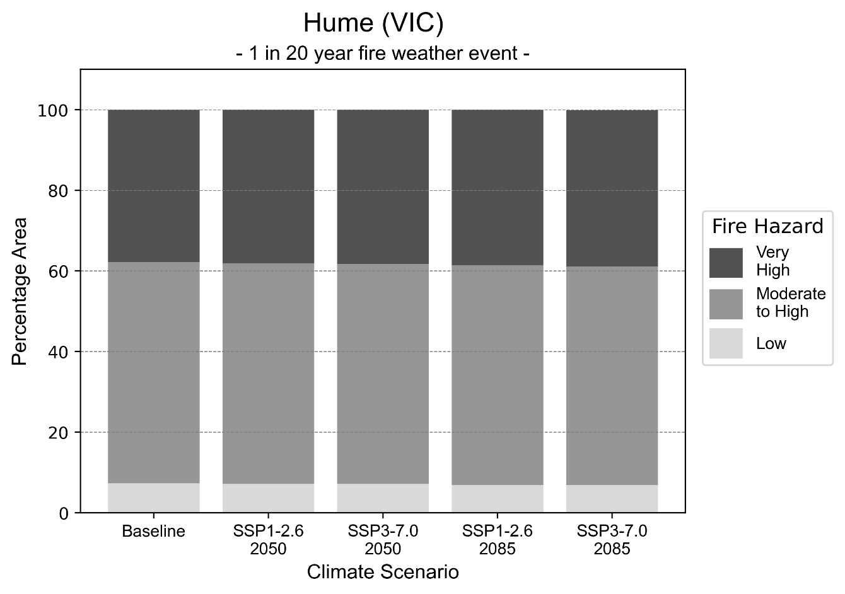
Figure 12: Stacked column chart showing the percentages of the Hume health district's total geographic area experiencing each fire hazard level during a 1-in-20-year fire weather event.
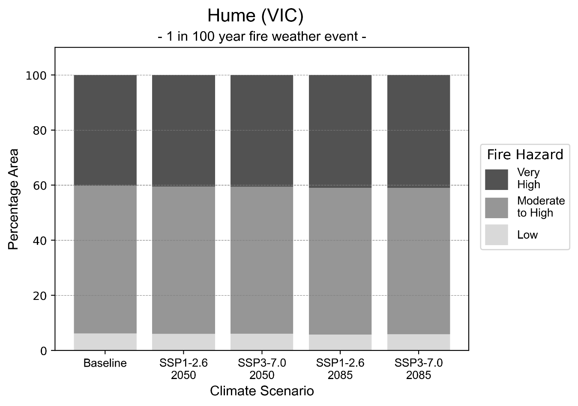
Figure 13: Stacked column chart showing the percentages of the Hume health district's total geographic area experiencing each fire hazard level during a 1-in-100-year fire weather event.

Drought hazard
Key projections:
Drought occurrence: The occurrence of drought will remain consistent across both middle of the road and reasonable worst-case scenarios and both time horizons, with the largest increase occurring under the reasonable worst-case scenario by 2085.

 | Baseline | 2050 Scenarios |  | 2085 Scenarios
 |  | Middle of the road | Reasonable worst-case | Middle of the road | Reasonable worst-case
Number of months per year in drought^{(a)} | 1.8 | 2.0  [0.8, 3.2] | 2.3  [1.3, 4.8] | 2.3  [1.0, 3.7] | 3.0  [0.7, 6.4]
Table notes: The drought hazard indicator uses climate projections from the CMIP6 Global Climate Models [1]. The primary indicator value reports the median from the nine climate models, with the range reported in square brackets.
Table footnotes: (a) The number of months per year in drought is based on the Standardised Precipitation Index (SPI). SPI is a widely used index to characterise meteorological drought on a range of timescales. This indicator uses the timescale of 12 months which calculates the average months in a year within the moderate drought range. A moderate drought range is classified as SPI score of ≤ -1. SPI is calculated from accumulated rainfall over 12 months and the mean and standard deviation from historical rainfall records.

Storm hazard
Key projections:
Fewer medium-intensity storms: The frequency of medium-intensity storms will decrease across both middle of the road and reasonable worst-case scenarios with the greatest decrease occurring by 2085.

Baseline |  | 2050 Scenarios |  | 2050 Scenarios
 |  | Middle of the road | Reasonable worst-case | Middle of the road | Reasonable worst-case
Number of low-intensity storms (40-62 km/hr) per year | 73.6 | 69.3  [61.0, 76.2] | 70.5  [62.1, 77.6] | 68.3  [60.1, 75.2] | 69.2  [60.9, 76.2]
Number of medium-intensity storms (63-87 km/hr) per year | 61.0 | 59.6  [52.5, 65.6] | 56.5  [49.7, 62.1] | 54.5  [48.0, 60.0] | 53.8  [47.3, 59.1]
Number of high-intensity storms (88-117 km/hr) per year | 13.2 | 12.8  [11.2, 14.0] | 11.7  [10.3, 12.9] | 12.4  [10.9, 13.6] | 13.9  [12.2, 15.3]
Number of very-high-intensity storms (> 117 km/hr) per year | 0.2 | 0.2  [0.1, 0.2] | 0.1  [0.1, 0.1] | 0.2  [0.1, 0.2] | 0.1  [0.1, 0.1]
Table notes: The storm hazard uses climate projections from the CMIP6 Global Climate Models [1]. Daily maximum surface wind speed is used to calculate the number of annual storms across four storm intensity categories (low, medium, high and very high). The primary indicator value reports the median from the nine climate models, with the range reported in square brackets.

Rainfall and flood hazard
Key projections:
- Ten extreme rainfall days per year: The number of extreme rainfall days will remain consistent across both middle of the road and reasonable worst-case scenarios and both time horizons, with an average of approximately ten extreme rainfall days per year.
- Increased flood frequency: The frequency of flood events will increase in urban environments, but decrease in rural environments. The largest increase in flood frequency is seen in the reasonable worst-case scenario where frequency of a ‘1-in-100 year’ flood will more than quadruple by 2050 and become 12 times more likely by 2085 in urban environments.

 | Baseline | 2050 Scenarios |  | 2085 Scenarios
 |  | Middle of the road | Reasonable worst-case | Middle of the road | Reasonable worst-case
Rainfall hazard^{(a)}
Average number of extreme rainfall days per year (> 15 mm/day)^{(a)} | 10.6 | 10.7  [9.1,13.0] | 10.4  [7.9,12.0] | 10.3  [8.8,12.4] | 10.1  [7.1,13.6]
Urban flood risk (flooding caused by a 1-hour rainfall event)^{(b)}
Frequency of a ‘1-in-1 year’ flood (rainfall depth of 17 mm)^{(c)} |  | 1.9 events in 1 year | 2.0 events in 1 year | 2.4 events in 1 year | 3.2 events in 1 year
Frequency of a ‘1-in-10 year’ flood (rainfall depth of 32 mm)^{(c)} |  | 2.6 events in 10 years | 2.7 events in 10 years | 3.7 events in 10 years | 5.5 events in 10 years
Frequency of a ‘1-in-100 year’ flood (rainfall depth of 50 mm)^{(c)} |  | 3.9 events in 100 years | 4.2 events in 100 years | 6.5 events in 100 years | 12 events in 100 years
Rural flood risk (flooding caused by a 24-hour rainfall event) ^{(b)}
Frequency of a ‘1-in-1 year’ flood (rainfall depth of 44 mm)^{(c)} |  | 0.9 events in 1 year | 0.9 events in 1 year | 0.9 events in 1 year | 0.2 events in 1 year
Frequency of a ‘1-in-10 year’ flood (rainfall depth of 79 mm)^{(c)} |  | 0.9 events in 10 years | 0.9 events in 10 years | 0.4 events in 10 years | 0.2 events in 10 years
Frequency of a ‘1-in-100 year’ flood (rainfall depth of 126 mm)^{(c)} |  | 0.9 events in 100 years | 0.8 events in 100 years | 0.5 events in 100 years | 0.1 events in 100 years
Table notes: The rainfall hazard indicator uses climate projections from the CMIP6 Global Climate Models [1]. The average number of extreme rainfall days per year is reported along with the maximum and minimum values across climate models reported in brackets. The flood hazard indicators use climate change considerations from the Australian Rainfall and Runoff guideline to estimate the climate the climate projections [2].
Table footnotes: (a) Extreme rainfall is defined as rainfall above the 95th percentile of historical average daily rainfall in this health district in the period 1985-2014. The value in mm/day quoted in the indicator name is the 95th percentile of historic average daily rainfall for this health district. (b) See Methodology document for reasons for focusing on a 1-hour flood for urban areas and a 24-hour flood for rural areas. (c) The rainfall depths in mm quoted in the indicator names in this table report 1 in 1, 10 and 100 year depths for this health district.

Loddon Mallee health district

Health district overview
The Loddon Mallee health district covers 58,957 square kilometres.

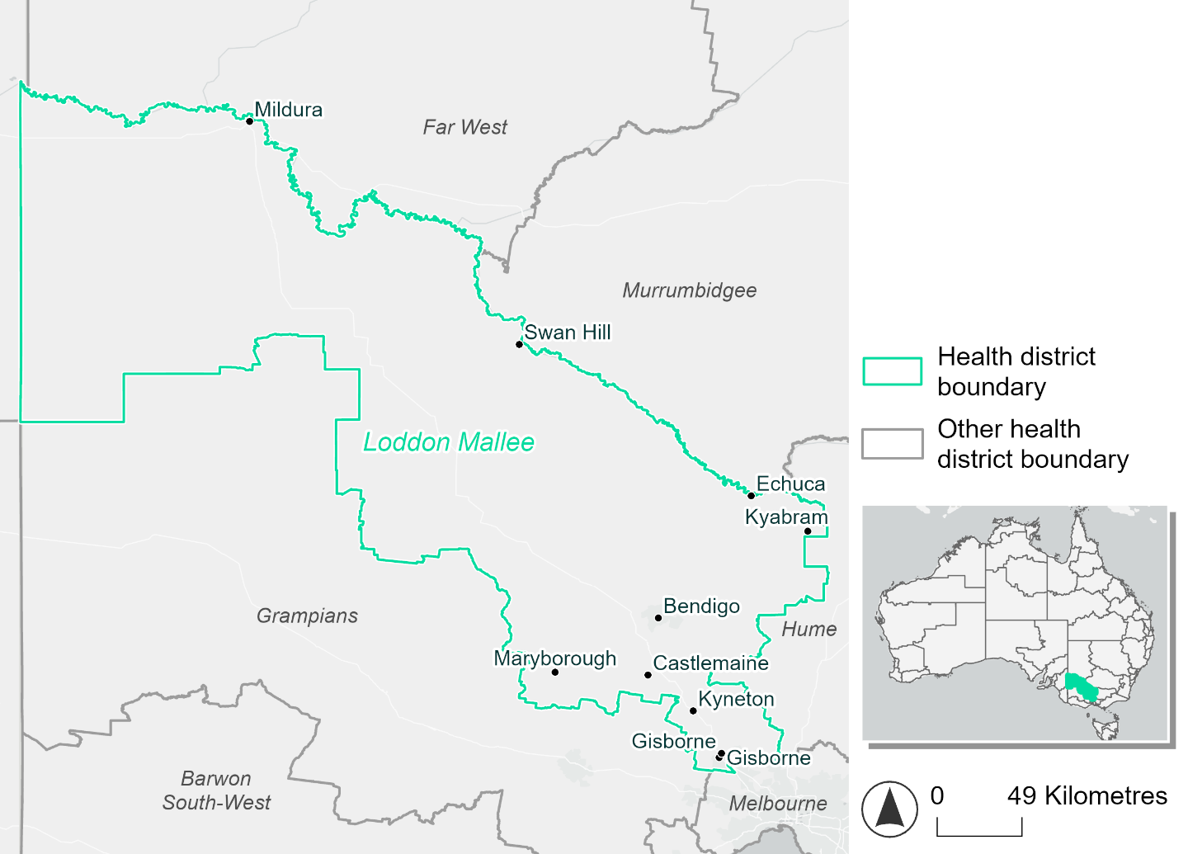
Figure 14. Map of Loddon Mallee health district.

How will climate change affect this health district?
Heat and humidity: Higher average temperatures, hotter and more frequent hot days, warmer night time temperatures and longer and more frequent heat waves.
Fire: 80% of this health district experiences moderate to high fire hazard category and this will continue across both 2050 and 2085 scenarios.
Drought: Number of months experiencing drought will increase.
Rainfall and flood: More flood events in urban areas.

Loddon Mallee health district demographic data
Demographic Data | Total
Number of households | 132,882
Persons 15 and older | 232,476
Total families | 92,622
Persons did not complete high school | 105,880
One parent families with dependents | 9,675 (10.4%)
Persons aged 65 and older | 76,265 (21.8%)
Persons aged 4 and younger | 19,311 (5.5%)
Aboriginal and Torres Strait Islander persons | 9,095 (2.6%)
Persons speaks language other than English | 24,022 (6.9%)
Persons working age (15-65) | 210,324 (60.1%)
Population Health Data | Total
Persons with core needs for assistance | 24,039 (6.9%)
Persons with arthritis | 39,804 (11.4%)
Persons with asthma | 34,847 (10%)
Persons with cancer | 12,500 (3.6%)
Persons with dementia | 2,841 (0.8%)
Persons with diabetes | 18,227 (5.2%)
Persons with heart disease | 16,970 (4.8%)
Persons with kidney disease | 3,965 (1.1%)
Persons with lung condition | 7,994 (2.3%)
Persons with mental health condition | 37,961 (10.8%)
Persons with stroke | 4,067 (1.2%)
Persons with any other condition | 29,725 (8.5%)
Persons no health condition | 187,280 (53.5%)
Socio-economic Data | Total
Persons providing unpaid care | 49,534 (14.1%)
Persons homeless | 1,452 (0.4%)
Household with lone person | 38,041 (28.6%)
Households with rent and mortgage stress | 52,914 (39.8%)
Households total equivalised income below $1000 (weekly) | 69,138 (52%)
Households with no motor vehicle | 6,215 (4.7%)
Persons unemployed | 11,798 (4.1%)

The sections that follow outline projected climate hazards for this district. Further information on this health district, including population demographics, is provided in the online dashboard.

Heat and humidity hazard
Key projections:
More heatwaves: Heatwave events are likely to last longer and the number of heatwave events per year will increase. By 2050, under a reasonable worst-case scenario the number of heatwaves will double. By 2085, under a reasonable worst-case scenario the number of heatwaves per year will more than triple.
Hotter days and warmer nights: The maximum temperature on hot days will increase with night time temperatures on hot nights also increasing.
More days above 35°C and 40°C: The number of days per year greater than 35°C and 40°C will increase under both middle of the road and reasonable worst-case scenarios.
 | Baseline | 2050 Scenarios |  | 2085 Scenarios
 |  | Middle of the road | Reasonable worst-case | Middle of the road | Reasonable worst-case
Average temperature (°C) | 14.9 | 16.2  [15.5, 16.8] | 16.5  [15.6, 17.1] | 17.1  [16.1, 18] | 18.1  [16.6, 19.2]
Maximum temperature on hot days (°C)^{(a)} | 33.6 | 35.3  [34.6, 36.1] | 35.7  [34.5, 37] | 36.4  [35.3, 37.7] | 37.4  [36.3, 39]
Minimum temperature on hot nights (°C)^{(b)} | 18.3 | 19.9  [19.1, 20.8] | 20.2  [18.9, 20.7] | 20.8  [19.6, 21.9] | 22  [20.4, 23.2]
Average apparent temperature on hot days (°C) (NOAA Heat Index)^{(c)} | 32.9 | 34  [33.4, 34.5] | 34.1  [33.4, 34.7] | 34.5  [33.8, 35.3] | 35.2  [34.3, 36.2]
Average heatwave duration in days^{(d)} | 4 | 5  [5, 5] | 5  [4, 5] | 5  [5, 6] | 6  [5, 7]
Number of heatwaves per year^{(d)} | 2 | 4  [3, 5] | 4  [3, 5] | 5  [4, 7] | 7  [5, 9]
Number of days per year > 35°C | 15 | 23  [19, 28] | 26  [19, 34] | 30  [23, 39] | 38  [30, 51]
Number of days per year > 40°C | 2 | 5  [4, 7] | 6  [4, 9] | 7  [5, 12] | 11  [7, 17]
Table notes: The heat and humidity hazard uses climate projections from the CMIP6 Global Climate Models [1]. Daily projections of maximum and minimum near-surface temperature and mean relative humidity are used to calculate eight heat and humidity indicators. The average of each indicator is reported along with the maximum and minimum values across climate models reported in brackets.
Table footnotes: (a) Based on the 95th percentile of daily maximum air temperature. (b) Based on the 95th percentile of daily minimum air temperature, representing the coldest part of the night on very hot nights. (c) The National Oceanic and Atmospheric Administration (NOAA) Heat Index is a measure of how hot it feels when relative humidity is factored in alongside actual air temperature. It is calculated on days with a maximum temperature of 27°C and above. Interpretation of Heat Index values: 27°C to 32°C indicates caution, 33°C to 41°C indicates extreme caution, 42°C to 54°C indicates danger and over 54°C indicates extreme danger. See methodology document for further explanation of Heat Index categories. (d) A heatwave is defined as three or more consecutive days where both daytime and overnight temperatures (daily mean temperatures) are unusually high for the location, based on the Bureau of Meteorology’s Excess Heat Factor method. For this district, an unusually high daily mean temperature is approximately 25.5°C or above.

Fire hazard
Key projections:
Most of district area currently experiences moderate to high hazard: under baseline conditions, 79.2% of the district experiences moderate to high fire hazard during a 1-in-20-year fire weather event, and 81.1% during a 1-in-100-year event. Low hazard is experienced by 14-17% of the district, and very high hazard by 3-4%.
Current fire hazard conditions to persist: in a future climate across both 2050 and 2085 scenarios, the areas affected by the different hazard levels remain roughly the same, with a maximum variation of 0.7 percentage points for both the 1-in-20-year and 1-in-100-year fire weather events.

 | Baseline | 2050 Scenarios |  | 2085 Scenarios
 |  | Sustainability | Reasonable worst-case | Sustainability | Reasonable worst-case
Hazard for a ‘1-in-20 year’ fire weather event^{(a)}
Proportion (%) of district experiencing ‘Low’ fire hazard | 17.0%  (1,001,394)^{(b)} | 17.0%  [16.4%, 17.6%] | 16.8%  [16.0%, 17.5%] | 17.0%  [15.7%, 18.5%] | 16.6%  [14.7%, 18.3%]
Proportion (%) of district experiencing ‘Moderate to High’ fire hazard | 79.2%  (4,672,048)^{(b)} | 79.2%  [74.3%, 83.9%] | 79.4%  [74.9%, 83.8%] | 79.2%  [67.3%, 90.4%] | 79.5%  [68.9%, 90.1%]
Proportion (%) of district experiencing ‘Very High’ fire hazard | 3.8%  (222,253)^{(b)} | 3.8%  [3.7%, 3.8%] | 3.8%  [3.7%, 3.9%] | 3.8%  [3.7%, 3.9%] | 3.8%  [3.6%, 4.0%]
Hazard for a ‘1-in-100 year’ fire weather event^{(a)}
Proportion (%) of district experiencing ‘Low’ fire hazard | 14.6%  (860,180)^{(b)} | 14.5%  [14.0%, 15.0%] | 14.3%  [13.7%, 15.0%] | 14.3%  [13.2%, 15.6%] | 13.9%  [12.4%, 15.5%]
Proportion (%) of district experiencing ‘Moderate to High’ fire hazard | 81.1%  (4,782,627)^{(b)} | 81.1%  [78.3%, 83.6%] | 81.1%  [77.7%, 84.8%] | 81.0%  [74.4%, 87.1%] | 81.1%  [72.8%, 89.9%]
Proportion (%) of district experiencing ‘Very High’ fire hazard | 4.3%  (252,887)^{(b)} | 4.5%  [4.2%, 4.8%] | 4.6%  [4.3%, 5.0%] | 4.7%  [4.1%, 5.4%] | 5.0%  [4.2%, 6.1%]
Table notes: The Fire Hazard uses the National Bushfire Intelligence Capability (NBIC) Phase 2 fire line intensity modelling based on CMIP6 climate projections. Fire Hazard is assessed using the projected Fireline Intensity (FLI) for weather events with two different return intervals (i.e. a 1-in-20 year event and a 1-in-100 year event). FLI considers slope, vegetation and weather to produce a rate of heat output per unit length (kW/m) along a bushfire’s front. Fire hazard is categorized as a low for FLI<4000 kW/m, moderate to high for 4,000 kW/m ≤FLI<12,500kW/m, and very high for FLI≥27,501kW/m. This is broadly consistent with the literature [3]. The assessment considers climate change effects based on changes in fire weather and the associated hazard that is anticipated for a meteorological event of a given return interval. This approach is different to the one adopted for the Flood Hazard, where the event magnitude is given (fixed) and the likelihood of that event varies as a result of climate change. The primary indicator value reports the median from the nine climate models, with the range reported in square brackets.
Table footnotes: (a) The area subject to different categories of fire hazard is determined for a ‘1-in-20 year’ and ‘1-in-100 year’ fire weather event, in current and future climates. Values at year 2050 are interpolated using data from baseline (2025) and 2085, assuming linear change over time. (b) Values in round brackets are the area (ha) of the health district subject to a given fire hazard.

The figures below show the proportion of the health district experiencing different fire hazard categories across different time horizons and climate scenarios during a ‘1-in-20 year’ fire weather event (Figure 15) and a ‘1-in-100 year’ fire weather event (Figure 16).

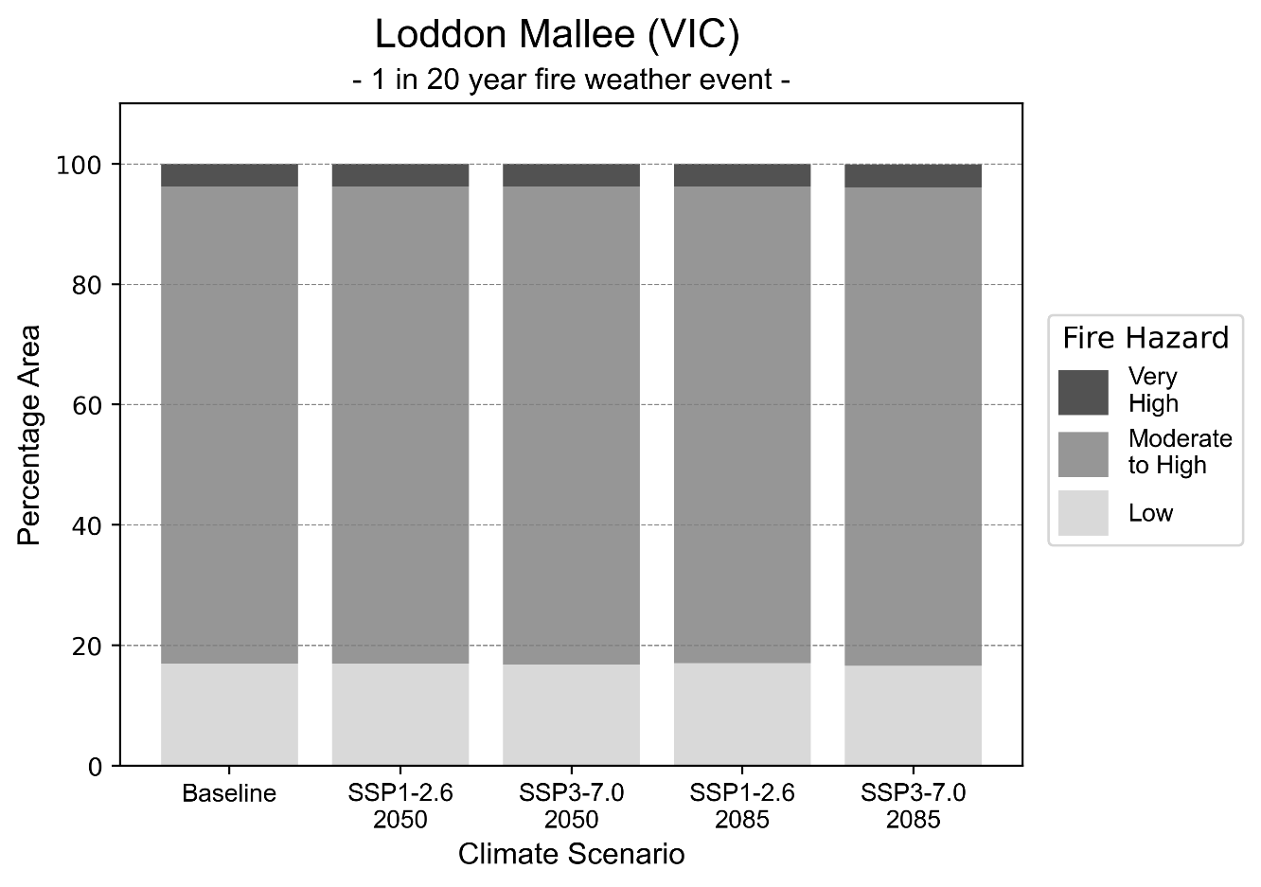
Figure 15: Stacked column chart showing the percentages of Loddon Mallee health district's total geographic area experiencing each fire hazard level during a 1-in-20-year fire weather event.
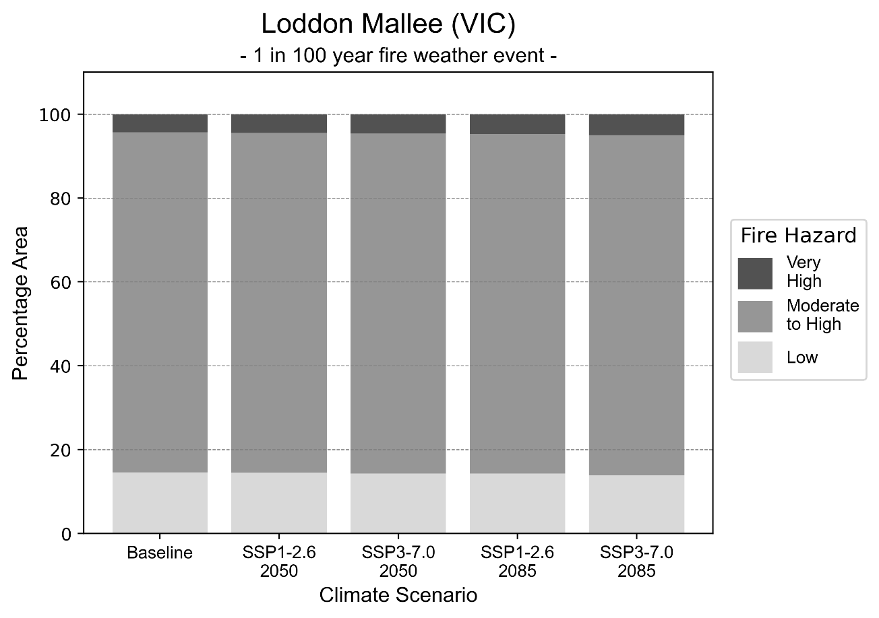
Figure 16: Stacked column chart showing the percentages of Loddon Mallee health district's total geographic area experiencing each fire hazard level during a 1-in-100-year fire weather event.

Drought hazard
Key projections:
Drought occurrence: The occurrence of drought will remain consistent across both middle of the road and reasonable worst-case scenarios and both time horizons, with the largest increase occurring under the reasonable worst-case scenario by 2085.

 | Baseline | 2050 Scenarios |  | 2085 Scenarios
 |  | Middle of the road | Reasonable worst-case | Middle of the road | Reasonable worst-case
Number of months per year in drought^{(a)} | 1.6 | 2.1  [0.3, 3.6] | 2.1  [0.8, 4.3] | 2.5  [0.7, 4.0] | 2.9  [0.3, 6.6]
Table notes: The drought hazard indicator uses climate projections from the CMIP6 Global Climate Models [1]. The primary indicator value reports the median from the nine climate models, with the range reported in square brackets.
Table footnotes: (a) The number of months per year in drought is based on the Standardised Precipitation Index (SPI). SPI is a widely used index to characterise meteorological drought on a range of timescales. This indicator uses the timescale of 12 months which calculates the average months in a year within the moderate drought range. A moderate drought range is classified as SPI score of ≤ -1. SPI is calculated from accumulated rainfall over 12 months and the mean and standard deviation from historical rainfall records.

Storm hazard
Key projections:
Fewer high-intensity storms: The frequency of high-intensity storms will decrease across both middle of the road and reasonable worst-case scenarios with the greatest decrease occurring by 2085.

Baseline |  | 2050 Scenarios |  | 2085 Scenarios
 |  | Middle of the road | Reasonable worst-case | Middle of the road | Reasonable worst-case
Number of low-intensity storms (40-62 km/hr) per year | 73.8 | 70.9  [62.4, 78.0] | 70.7  [62.2, 77.7] | 67.8  [59.7, 74.6] | 67.8  [59.7, 74.6]
Number of medium-intensity storms (63-87 km/hr) per year | 48.6 | 48.4  [42.6, 53.2] | 45.4  [40.0, 50.0] | 43.4  [38.2, 47.8] | 44.1  [38.8, 48.5]
Number of high-intensity storms (88-117 km/hr) per year | 24.8 | 23.5  [20.7, 25.8] | 22.9  [20.1, 25.2] | 22.9  [20.2, 25.2] | 22.7  [20.0, 25.0]
Number of very-high-intensity storms (> 117 km/hr) per year | 0.4 | 0.3  [0.3, 0.3] | 0.3  [0.3, 0.4] | 0.4  [0.4, 0.5] | 0.5  [0.5, 0.6]
Table notes: The storm hazard uses climate projections from the CMIP6 Global Climate Models [1]. Daily maximum surface wind speed is used to calculate the number of annual storms across four storm intensity categories (low, medium, high and very high). The primary indicator value reports the median from the nine climate models, with the range reported in square brackets.

Rainfall and flood hazard
Key projections:
- Seven extreme rainfall days per year: The number of extreme rainfall days will remain consistent across both middle of the road and reasonable worst-case scenarios and both time horizons, with an average of approximately seven extreme rainfall days per year.
- Increased flood frequency: The frequency of flood events will increase in urban environments but decrease in rural environments. The largest increase in flood frequency is seen in the reasonable worst-case scenario where frequency of a ‘1-in-100 year’ flood will nearly triple by 2050 and become nearly six times more likely by 2085 in urban environments.

 | Baseline | 2050 Scenarios |  | 2085 Scenarios
 |  | Middle of the road | Reasonable worst-case | Middle of the road | Reasonable worst-case
Rainfall hazard^{(a)}
Average number of extreme rainfall days per year (> 7 mm/day)^{(a)} | 7.0 | 7.0  [5.8,9.4] | 6.9  [5.3,8.5] | 6.7  [5.8,8.2] | 6.7  [4.7,9.4]
Urban flood risk (flooding caused by a 1-hour rainfall event)^{(b)}
Frequency of a ‘1-in-1 year’ flood (rainfall depth of 13 mm)^{(c)} |  | 1.7 events in 1 year | 1.8 events in 1 year | 2.2 events in 1 year | 2.9 events in 1 year
Frequency of a ‘1-in-10 year’ flood (rainfall depth of 31 mm)^{(c)} |  | 2.1 events in 10 years | 2.2 events in 10 years | 2.7 events in 10 years | 3.7 events in 10 years
Frequency of a ‘1-in-100 year’ flood (rainfall depth of 59 mm)^{(c)} |  | 2.5 events in 100 years | 2.7 events in 100 years | 3.7 events in 100 years | 5.8 events in 100 years
Rural flood risk (flooding caused by a 24-hour rainfall event)^{(b)}
Frequency of a ‘1-in-1 year’ flood (rainfall depth of 34 mm)^{(c)} |  | 0.8 events in 1 year | 0.9 events in 1 year | 0.9 events in 1 year | 0.4 events in 1 year
Frequency of a ‘1-in-10 year’ flood (rainfall depth of 69 mm)^{(c)} |  | 1.1 events in 10 years | 1.1 events in 10 years | 0.5 events in 10 years | 0.2 events in 10 years
Frequency of a ‘1-in-100 year’ flood (rainfall depth of 110 mm)^{(c)} |  | 0.9 events in 100 years | 0.7 events in 100 years | 0.4 events in 100 years | 0.08 events in 100 years
Table notes: The rainfall hazard indicator uses climate projections from the CMIP6 Global Climate Models [1]. The primary indicator value reports the median from the nine climate models, with the range reported in square brackets. The flood hazard indicators use climate change considerations from the Australian Rainfall and Runoff guideline to estimate the climate the climate projections [2].
Table footnotes: (a) Extreme rainfall is defined as rainfall above the 95th percentile of historical average daily rainfall in this health district in the period 1985-2014. The value in mm/day quoted in the indicator name is the 95th percentile of historic average daily rainfall for this health district. (b) See Methodology document for reasons for focusing on a 1-hour flood for urban areas and a 24-hour flood for rural areas. (c) The rainfall depths in mm quoted in the indicator names in this table report 1 in 1, 10 and 100 year depths for this health district.

Melbourne health district

Health district overview
The Melbourne health district include northern metropolitan, southern metropolitan, eastern metropolitan and western metropolitan health regions. The Melbourne health district covers 8,826 square kilometres.

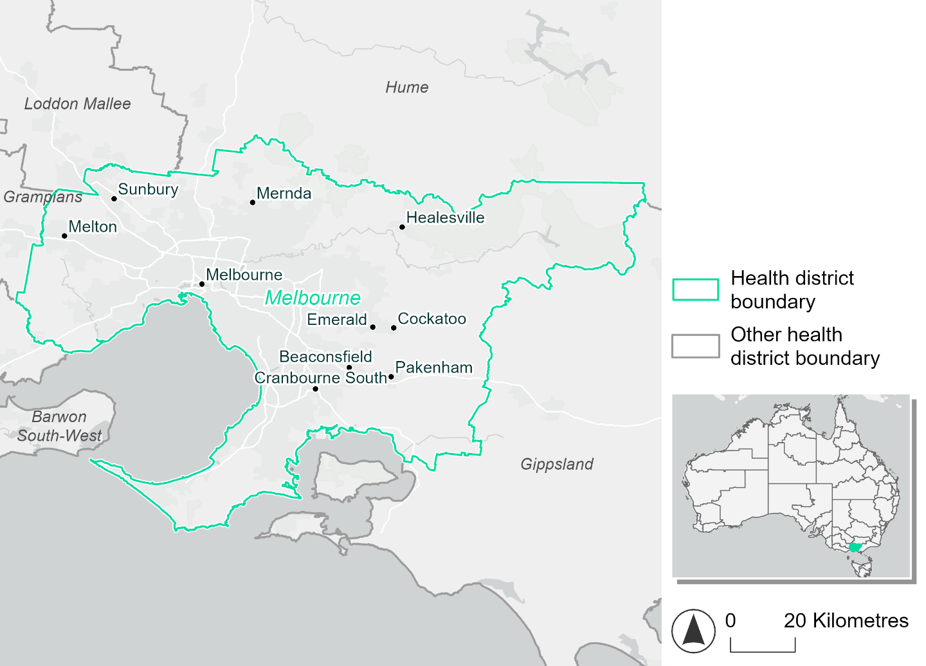
Figure 17. Map of Melbourne health district.

How will climate change affect this health district?
Heat and humidity: Higher average temperatures, hotter and more frequent hot days, warmer night time temperatures and more frequent heat waves.
Fire: Over 30% of this health district currently experiences very high fire hazard category and this will increase across both 2050 and 2085 scenarios.
Drought: Number of months experiencing drought will increase.
Rainfall and flood: More flood events in urban areas.
Coastal inundation: Increased area flooded during tidal and storm surge and tidal inundation.

Melbourne health district demographic data
Demographic Data | Total
Number of households | 1,752,713
Persons 15 and older | 3,534,165
Total families | 1,275,783
Persons did not complete high school | 897,813
One parent families with dependents | 116,418 (9.1%)
Persons aged 65 and older | 732,661 (14.8%)
Persons aged 4 and younger | 289,674 (5.9%)
Aboriginal and Torres Strait Islander persons | 31,802 (0.6%)
Persons speaks language other than English | 1,670,359 (33.8%)
Persons working age (15-65) | 3,322,795 (67.2%)
Population Health Data | Total
Persons with core needs for assistance | 268,265 (5.4%)
Persons with arthritis | 339,855 (6.9%)
Persons with asthma | 386,291 (7.8%)
Persons with cancer | 121,892 (2.5%)
Persons with dementia | 32,714 (0.7%)
Persons with diabetes | 219,838 (4.4%)
Persons with heart disease | 163,179 (3.3%)
Persons with kidney disease | 39,784 (0.8%)
Persons with lung condition | 57,853 (1.2%)
Persons with mental health condition | 398,366 (8.1%)
Persons with stroke | 40,072 (0.8%)
Persons with any other condition | 381,593 (7.7%)
Persons no health condition | 3,147,289 (63.6%)
Socio-economic Data | Total
Persons providing unpaid care | 618,542 (12.5%)
Persons homeless | 23,938 (0.5%)
Household with lone person | 435,804 (24.9%)
Households with rent and mortgage stress | 842,524 (48.1%)
Households total equivalised income below $1000 (weekly) | 711,648 (40.6%)
Households with no motor vehicle | 149,959 (8.6%)
Persons unemployed | 214,695 (5.4%)

The sections that follow outline projected climate hazards for this district. Further information on this health district, including population demographics, is provided in the online dashboard.

Heat and humidity hazard
Key projections:
More heatwaves: The number of heatwave events per year will increase. By 2050, under a reasonable worst-case scenario the number of heatwaves will increase from two to three heatwaves per year. By 2085, under a reasonable worst-case scenario the number of heatwaves per year will more than triple.
Hotter days and warmer nights: The maximum temperature on hot days will increase with night time temperatures on hot nights also increasing.
More days above 35°C and 40°C: The number of days per year greater than 35°C and 40°C will increase under both middle of the road and reasonable worst-case scenarios.

 | Baseline | 2050 Scenarios |  | 2085 Scenarios
 |  | Middle of the road | Reasonable worst-case | Middle of the road | Reasonable worst-case
Average temperature (°C) | 15.3 | 16.5  [15.9, 16.9] | 16.7  [16, 17.2] | 17.3  [16.4, 18.1] | 18.2  [16.9, 19.3]
Maximum temperature on hot days (°C)^{(a)} | 32 | 33.5  [32.7, 34.3] | 33.9  [32.8, 34.9] | 34.5  [33.6, 35.7] | 35.6  [34.4, 37.2]
Minimum temperature on hot nights (°C)^{(b)} | 18.5 | 20  [19.4, 20.6] | 20.2  [19.2, 20.6] | 20.8  [19.8, 21.8] | 21.9  [20.5, 22.9]
Average apparent temperature on hot days (°C) (NOAA Heat Index)^{(c)} | 34.1 | 35  [34.6, 35.6] | 35.2  [34.3, 35.9] | 35.6  [34.8, 36.5] | 36.4  [35.5, 37.2]
Average heatwave duration in days^{(d)} | 4 | 4  [4, 4] | 4  [4, 4] | 4  [4, 5] | 5  [4, 5]
Number of heatwaves per year^{(d)} | 2 | 3  [2, 4] | 3  [2, 4] | 4  [3, 6] | 7  [4, 9]
Number of days per year > 35°C | 8 | 13  [11, 16] | 14  [10, 18] | 17  [13, 22] | 22  [16, 30]
Number of days per year > 40°C | 1 | 2  [2, 3] | 3  [1, 4] | 4  [2, 6] | 5  [3, 9]
Table notes: The heat and humidity hazard uses climate projections from the CMIP6 Global Climate Models [1]. Daily projections of maximum and minimum near-surface temperature and mean relative humidity are used to calculate eight heat and humidity indicators. The primary indicator value reports the median from the nine climate models, with the range reported in square brackets.
Table footnotes: (a) Based on the 95th percentile of daily maximum air temperature. (b) Based on the 95th percentile of daily minimum air temperature, representing the coldest part of the night on very hot nights. (c) The National Oceanic and Atmospheric Administration (NOAA) Heat Index is a measure of how hot it feels when relative humidity is factored in alongside actual air temperature. It is calculated on days with a maximum temperature of 27°C and above. Interpretation of Heat Index values: 27°C to 32°C indicates caution, 33°C to 41°C indicates extreme caution, 42°C to 54°C indicates danger and over 54°C indicates extreme danger. See methodology document for further explanation of Heat Index categories. (d) A heatwave is defined as three or more consecutive days where both daytime and overnight temperatures (daily mean temperatures) are unusually high for the location, based on the Bureau of Meteorology’s Excess Heat Factor method. For this district, an unusually high daily mean temperature is approximately 25 °C or above.

Fire hazard
Key projections:
Most of district area experiences moderate to very high fire hazard: under baseline conditions about half (50%) of the district area experiences moderate to high fire hazard, and about a third (33-36%) experiences very high hazard. The remaining 12-15% of the district area experiences low fire hazard.
Very high hazard to increase slightly: in a future climate across both 2050 and 2085 scenarios, about half of the district area (49-50%) will continue to experience moderate to high fire hazard. The area experiencing very high fire hazard will increase by up to 3.2 percentage points for a 1-in-20-year fire weather event and by 2.8 for a 1-in-100-year event, with corresponding decreases in the area experiencing low fire hazard.

 | Baseline | 2050 Scenarios |  | 2085 Scenarios
 |  | Sustainability | Reasonable worst-case | Sustainability | Reasonable worst-case
Hazard for a ‘1-in-20 year’ fire weather event^{(a)}
Proportion (%) of district experiencing ‘Low’ fire hazard | 15.5%  (137,192)^{(b)} | 14.8%  [14.0%, 15.6%] | 14.8%  [13.7%, 16.6%] | 13.8%  [11.9%, 15.7%] | 13.7%  [11.2%, 18.1%]
Proportion (%) of district experiencing ‘Moderate to High’ fire hazard | 50.9%  (449,099)^{(b)} | 50.8%  [49.8%, 52.1%] | 50.3%  [48.6%, 51.8%] | 50.8%  [48.4%, 53.8%] | 49.5%  [45.5%, 53.2%]
Proportion (%) of district experiencing ‘Very High’ fire hazard | 33.6%  (296,349)^{(b)} | 34.3%  [33.7%, 35.1%] | 34.9%  [32.6%, 35.9%] | 35.4%  [33.8%, 37.2%] | 36.8%  [31.2%, 39.1%]
Hazard for a ‘1-in-100 year’ fire weather event^{(a)}
Proportion (%) of district experiencing ‘Low’ fire hazard | 12.8%  (112,839)^{(b)} | 12.1%  [11.5%, 12.7%] | 12.0%  [11.1%, 13.5%] | 11.1%  [9.8%, 12.5%] | 10.9%  [8.8%, 14.4%]
Proportion (%) of district experiencing ‘Moderate to High’ fire hazard | 50.4%  (444,578)^{(b)} | 50.3%  [48.2%, 52.8%] | 50.0%  [47.7%, 53.0%] | 50.3%  [45.2%, 56.3%] | 49.6%  [44.0%, 56.6%]
Proportion (%) of district experiencing ‘Very High’ fire hazard | 36.8%  (325,223)^{(b)} | 37.5%  [36.7%, 38.3%] | 38.0%  [36.1%, 38.7%] | 38.5%  [36.6%, 40.3%] | 39.6%  [35.1%, 41.2%]
Table notes: The Fire Hazard uses the National Bushfire Intelligence Capability (NBIC) Phase 2 fire line intensity modelling based on CMIP6 climate projections. Fire Hazard is assessed using the projected Fireline Intensity (FLI) for weather events with two different return intervals (i.e. a 1-in-20-year event and a 1-in-100-year event). FLI considers slope, vegetation and weather to produce a rate of heat output per unit length (kW/m) along a bushfire’s front. Fire hazard is categorized as a low for FLI<4000 kW/m, moderate to high for 4,000 kW/m ≤FLI<12,500kW/m, and very high for FLI≥27,501kW/m. This is broadly consistent with the literature [3]. The assessment considers climate change effects based on changes in fire weather and the associated hazard that is anticipated for a meteorological event of a given return interval. This approach is different to the one adopted for the Flood Hazard, where the event magnitude is given (fixed) and the likelihood of that event varies as a result of climate change. The primary indicator value reports the median from the nine climate models, with the range reported in square brackets.
Table footnotes: (a) The area subject to different categories of fire hazard is determined for a ‘1-in-20 year’ and ‘1-in-100 year’ fire weather event, in current and future climates. Values at year 2050 are interpolated using data from baseline (2025) and 2085, assuming linear change over time. (b) Values in round brackets are the area (ha) of the health district subject to a given fire hazard.

The figures below show the proportion of the health district experiencing different fire hazard categories across different time horizons and climate scenarios during a ‘1-in-20 year’ fire weather event (Figure 18) and a ‘1-in-100 year’ fire weather event (Figure 19).
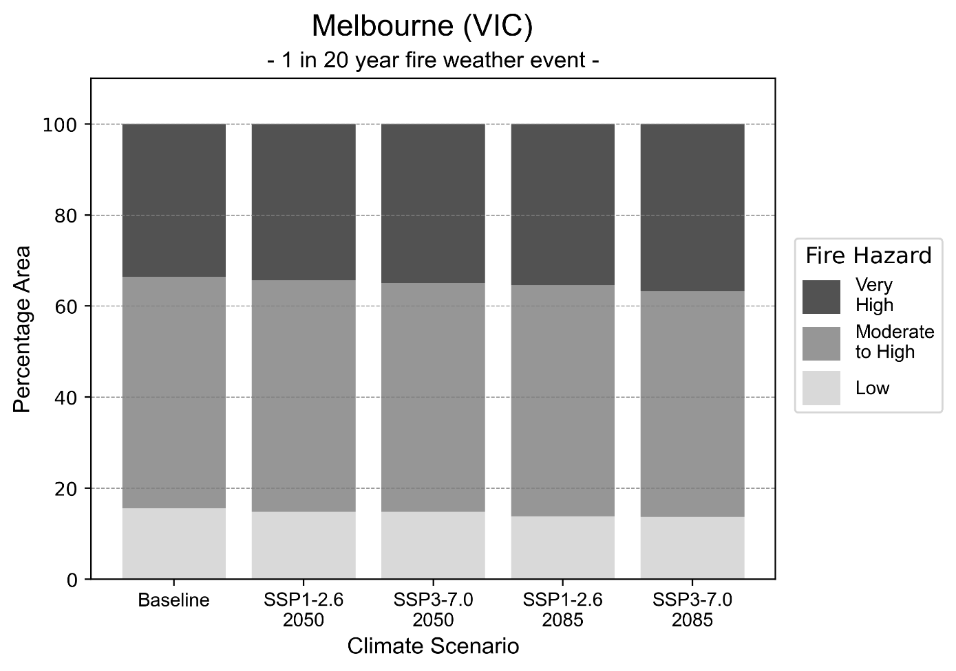
Figure 18: Stacked column chart showing the percentages of the Melbourne health district's total geographic area experiencing each fire hazard level during a 1-in-20-year fire weather event.
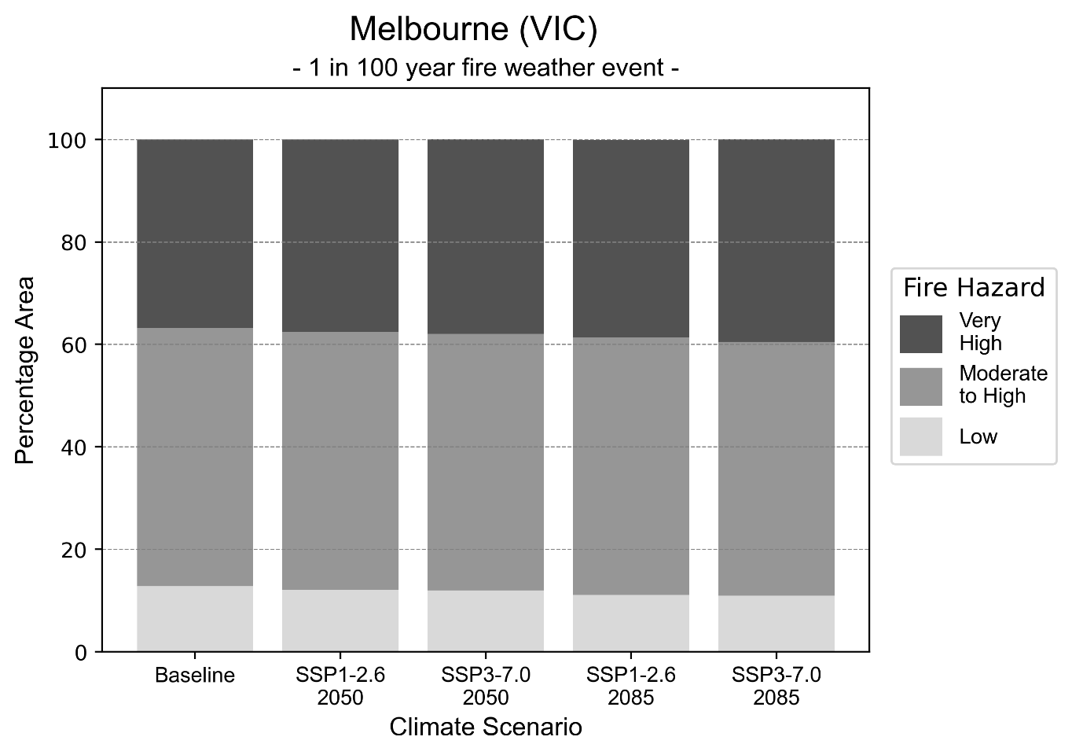
Figure 19: Stacked column chart showing the percentages of the Melbourne health district's total geographic area experiencing each fire hazard level during a 1-in-100-year fire weather event.

Drought hazard
Key projections:
Drought occurrence: The occurrence of drought will remain consistent across both middle of the road and reasonable worst-case scenarios and both time horizons, with the largest increase occurring under the reasonable worst-case scenario by 2085.

 | Baseline | 2050 Scenarios |  | 2085 Scenarios
 |  | Middle of the road | Reasonable worst-case | Middle of the road | Reasonable worst-case
Number of months per year in drought^{(a} | 2.0 | 2.6  [0.9, 4.0] | 2.9  [1.6, 4.7] | 3.3  [1.6, 4.3] | 3.9  [1.2, 6.9]
Table notes: The drought hazard indicator uses climate projections from the CMIP6 Global Climate Models [1]. The primary indicator value reports the median from the nine climate models, with the range reported in square brackets.
Table footnotes: (a) The number of months per year in drought is based on the Standardised Precipitation Index (SPI). SPI is a widely used index to characterise meteorological drought on a range of timescales. This indicator uses the timescale of 12 months which calculates the average months in a year within the moderate drought range. A moderate drought range is classified as SPI score of ≤ -1. SPI is calculated from accumulated rainfall over 12 months and the mean and standard deviation from historical rainfall records.

Storm hazard
Key projections:
Fewer high and very-high-intensity storms: The frequency of high and very-high-intensity storms will decrease across both middle of the road and reasonable worst-case scenarios with the greatest decrease occurring by 2085.

 | Baseline | 2050 Scenarios |  | 2085 Scenarios
 |  | Middle of the road | Reasonable worst-case | Middle of the road | Reasonable worst-case
Number of low-intensity storms (40-62 km/hr) per year | 72.7 | 72.3  [63.6, 79.5] | 73.0  [64.2, 80.3] | 71.7  [63.1, 78.8] | 72.1  [63.4, 79.3]
Number of medium-intensity storms (63-87 km/hr) per year | 70.6 | 64.1  [56.4, 70.5] | 63.2  [55.6, 69.6] | 59.6  [52.5, 65.6] | 57.1  [50.3, 62.8]
Number of high-intensity storms (88-117 km/hr) per year | 32.5 | 31.0  [27.3, 34.1] | 30.7  [27.0, 33.8] | 28.2  [24.8, 31.1] | 27.1  [23.8, 29.8]
Number of very-high-intensity storms (> 117 km/hr) per year | 7.2 | 6.9  [6.0, 7.6] | 5.7  [5.0, 6.3] | 6.8  [6.0, 7.5] | 6.8  [6.0, 7.5]
Table notes: The storm hazard uses climate projections from the CMIP6 Global Climate Models [1]. Daily maximum surface wind speed is used to calculate the number of annual storms across four storm intensity categories (low, medium, high and very high). The primary indicator value reports the median from the nine climate models, with the range reported in square brackets.

Rainfall and flood hazard
Key projections:
- Nine extreme rainfall days per year: The number of extreme rainfall days will remain consistent across both middle of the road and reasonable worst-case scenarios and both time horizons, with an average of approximately nine extreme rainfall days per year.
- Increased flood frequency: The frequency of flood events will increase in urban environments. The largest increase in flood frequency is seen in the reasonable worst-case scenario where frequency of a ‘1-in-100 year’ flood will more than triple by 2050 and become eight times more likely by 2085 in urban environments.

 | Baseline | 2050 Scenarios |  | 2085 Scenarios
 |  | Middle of the road | Reasonable worst-case | Middle of the road | Reasonable worst-case
Rainfall hazard^{(a)}
Average number of extreme rainfall days per year (> 13 mm/day)^{(a)} | 9.8 | 9.6  [8.4,11.8] | 9.4  [7.5,11.0] | 9.2  [8.2,10.7] | 9.1  [6.6,11.4]
Urban flood risk (flooding caused by a 1-hour rainfall event)^{(b)}
Frequency of a ‘1-in-1 year’ flood (rainfall depth of 16 mm)^{(c)} |  | 1.9 events in 1 year | 2.0 events in 1 year | 2.5 events in 1 year | 3.3 events in 1 year
Frequency of a ‘1-in-10 year’ flood (rainfall depth of 29 mm)^{(c)} |  | 2.7 events in 10 years | 2.9 events in 10 years | 4.1 events in 10 years | 6.5 events in 10 years
Frequency of a ‘1-in-100 year’ flood (rainfall depth of 49 mm)^{(c)} |  | 2.9 events in 100 years | 3.1 events in 100 years | 4.5 events in 100 years | 8.1 events in 100 years
Rural flood risk (flooding caused by a 24-hour rainfall event)^{(b)}
Frequency of a ‘1-in-1 year’ flood (rainfall depth of 45 mm)^{(c)} |  | 1.0 events in 1 year | 1.0 events in 1 year | 0.5 events in 1 year | 0.1 events in 1 year
Frequency of a ‘1-in-10 year’ flood (rainfall depth of 82 mm)^{(c)} |  | 1.0 events in 10 years | 1.0 events in 10 years | 0.6 events in 10 years | 0.2 events in 10 years
Frequency of a ‘1-in-100 year’ flood (rainfall depth of 128 mm)^{(c)} |  | 1.2 events in 100 years | 1.2 events in 100 years | 1.0 events in 100 years | 0.5 events in 100 years
Table notes: The rainfall hazard indicator uses climate projections from the CMIP6 Global Climate Models [1]. The primary indicator value reports the median from the nine climate models, with the range reported in square brackets. The flood hazard indicators use climate change considerations from the Australian Rainfall and Runoff guideline to estimate the climate the climate projections [2].
Table footnotes: (a) Extreme rainfall is defined as rainfall above the 95th percentile of historical average daily rainfall in this health district in the period 1985-2014. The value in mm/day quoted in the indicator name is the 95th percentile of historic average daily rainfall for this health district. (b) See Methodology document for reasons for focusing on a 1-hour flood for urban areas and a 24-hour flood for rural areas. (c) The rainfall depths in mm quoted in the indicator names in this table report 1 in 1-, 10- and 100-year depths for this health district.

Coastal inundation hazard
Key projections:
Greater area inundated: There will be an increase in the area affected by tidal inundation (i.e. area submerged during high tide) and storm surge and tidal inundation (i.e. the area submerged during a storm surge and high tide) across both middle of the road and reasonable worst-case scenarios. In the reasonable worst-case scenario, by 2085 the area inundated during a storm surge and tidal inundation event will increase by over 7,000 ha.

 | Baseline | 2050 Scenarios |  | 2085 Scenarios^{(a)}
 |  | Middle of the road | Reasonable worst-case | Middle of the road | Reasonable worst-case
Tidal inundation (ha inundated)^{(b)} | 2,227.5 | 2,966.1  (+738.6) | 3,017.8  (+790.2) | 4,901.5  (+2,674.0) | 5,700.9  (+3,473.4)
Storm surge + tidal inundation – ‘1-in-100 year’ event (ha inundated)^{(c)} | 6,713.8 | 8,339.9  (+1,626.1) | 8,457.0  (+1,743.2) | 11,499.9  (+4,786.1) | 12,553.5  (+5,839.8)
Storm surge + tidal inundation – ‘1-in-1000 year’ event (ha inundated)^{(c)} | 8,118.8 | 9,899.2  (+1,780.4) | 10,010.3  (+1,891.5) | 14,082.2  (+5,963.4) | 15,258.2  (+7,139.4)
Table notes: The coastal inundation hazard provides an indication of flooding in coastal areas that can be attributed to sea level rise and storm inundation. The coastal inundation hazard is only reported for health districts adjoining the coastline. This table includes the projected inundation levels as well as the change from baseline conditions (in brackets).
Table footnotes: (a) For the 2085 Scenarios planning horizon, 2100 was adopted as it provides a conservative representation of the end of this period. This horizon aligns with many State planning regulations requiring consideration of sea level rise and storm tide to 2100, making the 2100 scenario particularly valuable for planning new health facilities in coastal areas. (b) The tidal inundation indicator reports the number of hectares inundated during high tide. The baseline value reports existing inundation patterns, while the 2050 and 2085 values report high tide inundation taking account of projected sea level rise due to climate change. (c) The storm surge + tidal inundation indicators report the combined effect, in hectares inundated, of high tide, sea level rise (for the 2050 and 2085 projections), and storm surge (for 1-in-100 year and 1-in-1000-year events).

References

[1] | D. Irving, I. Macadam and M. King, “Application-ready quantile-delta-change (QDC) scaled CMIP6 climate projections for Australia (time slices, 11km grid) (v1)”, CSIRO. Data Collection, 2024.
[2] | C. Wasko, S. Westra, R. Nathan, D. Jakob, C. Nielsen, J. Evans, S. Rodgers, M. Ho, M. Babister, A. Dowdy and W. Sharples, “Australian Rainfall and Runoff (ARR) Chapter 6: 4 Climate Change Considerations”, Australian Rainfall and Runoff, 2024.
[3] | J. J. Hollis, S. Matthews, W. R. Anderson, M. G. Cruz, P. Fox-Hughes, S. Grootemaat, B. J. Kenny and S. Sauvage, “A framework for defining fire danger to support fire management operations in Australia”, International Journal of Wildland Fire, vol. 33, no.3, 2024.
[4] | Z. Hausfather and P. G. Peters, “Emissions–the ‘business as usual’story is misleading”, Nature, 577(7792), pp.618-620., 2020.



Another scenario, SSP5-8.5, was previously considered the reasonable worst-case scenario, but it is now considered to be very unlikely to be realised due to climate action already undertaken [4].

