Guidance on climate risk assessment and adaptation planning for Australian health system organisations

Climate and Health Hazard Data for Western Australia
© Commonwealth of Australia as represented by the Australian Centre for Disease Control
Title: Guidance on climate risk assessment and adaptation planning for Australian health system organisations: Climate and Health Hazard Data for Western Australia.
Citation
Australian Centre for Disease Control (CDC). Guidance on climate risk assessment and adaptation planning for Australian health system organisations: Climate and Health Hazard Data for Western Australia, Australian CDC, Australian Government, 2026.
Contributors
Anne Cleary, Jamie Ewert, Jake Allen, Adam Brook, Petter Nyman, Pam Wong, Anthony Kiem, Felix Edger, Richard Farr, Robert Morden, Vincent Li Creagh, Tony Weber, Dominic Blackham, Matilda Lehmann, Phoebe Spurrier, Sophia Gidis, Georgia Behrens, Madeleine Skellern.
Acknowledgments
CSIRO National Bushfire Intelligence Capability for assisting with the analysis of the Fire Hazard.
Creative Commons Licence
This publication is licensed under the Creative Commons Attribution 4.0 International Public License available from https://creativecommons.org/licenses/by/4.0/legalcode (“Licence”). You must read and understand the Licence before using any material from this publication.
Restrictions
The Licence may not give you all the permissions necessary for your intended use. For example, other rights (such as publicity, privacy and moral rights) may limit how you use the material found in this publication. The Licence does not cover, and there is no permission given for, use of any of the following material found in this publication:
- the Commonwealth Coat of Arms. (by way of information, the terms under which the Coat of Arms may be used can be found on the Department of Prime Minister and Cabinet website
- any logos and trademarks
- any photographs and images
- any signatures
- any material belonging to third parties. The third party elements must be included here or have a footnote reference throughout the document showing where they are.
Attribution
Without limiting your obligations under the Licence, the Australian Centre for Disease Control requests that you attribute this publication in your work. Any reasonable form of words may be used provided that you:
- include a reference to this publication and where practicable, the relevant page numbers
- make it clear that you have permission to use the material under the Creative Commons Attribution 4.0 International Public License
- make it clear whether or not you have changed the material used from this publication
- include a copyright notice in relation to the material used. In the case of no change to the material, the words “© Commonwealth of Australia (Australian Centre for Disease Control) 2026” may be used. In the case where the material has been changed or adapted, the words: “Based on Commonwealth of Australia (Australian Centre for Disease Control) material” may be used
- do not suggest that the Australian Centre for Disease Control endorses you or your use of the material.
Enquiries
Enquiries regarding any other use of this publication should be addressed to the Communication and Public Information Section, Strategy and Engagement Branch, Australian Centre for Disease Control, GPO Box 798, Canberra ACT 2601, or via e-mail to CDCComms@cdc.gov.au.
We welcome feedback and dialogue about this report. Please send all such correspondence to NHSC.Unit@cdc.gov.au.

Table of Contents

Table of Contents 3
Introduction 4
Goldfields health district 8
Great Southern health district 17
Kimberley health district 26
Mid West health district 35
Perth health district 44
Pilbara health district 54
South West health district 63
Wheatbelt health district 73
References 82

Introduction

This document provides scientific climate information to help health system organisations assess, prepare for and effectively manage climate-related risks across short-, medium-, and long-term planning horizons. A digital version of the information in this document can be found here. Further detail about the information contained in this document can be found in the accompanying methodological report.

The document presents climate hazard information summarised for health districts across Western Australia (WA). For each health district, information is provided about six hazards – heat and humidity, fire, drought, rainfall, storms, and coastal inundation – across three different time horizons and two climate scenarios. This structure enables users to assess how climate risks may evolve over time and under different emissions pathways. The information is presented both in narrative form and through a series of detailed tables containing quantitative data. Further information on the information presented in this document is outlined below.

Health districts
This document presents climate information for 8 health districts derived from WA Health Services.
- The 7 regions of the WA Country Health Service each become their own health district:
- Goldfields health district
- Great Southern health district
- Kimberly health district
- Mid West health district
- Pilbara health district
- South West health district
- Wheatbelt health district.
A single Perth health district is constructed from the following health services:
- East Metropolitan Health Service
- North Metropolitan Health Service
- South Metropolitan Health Service.
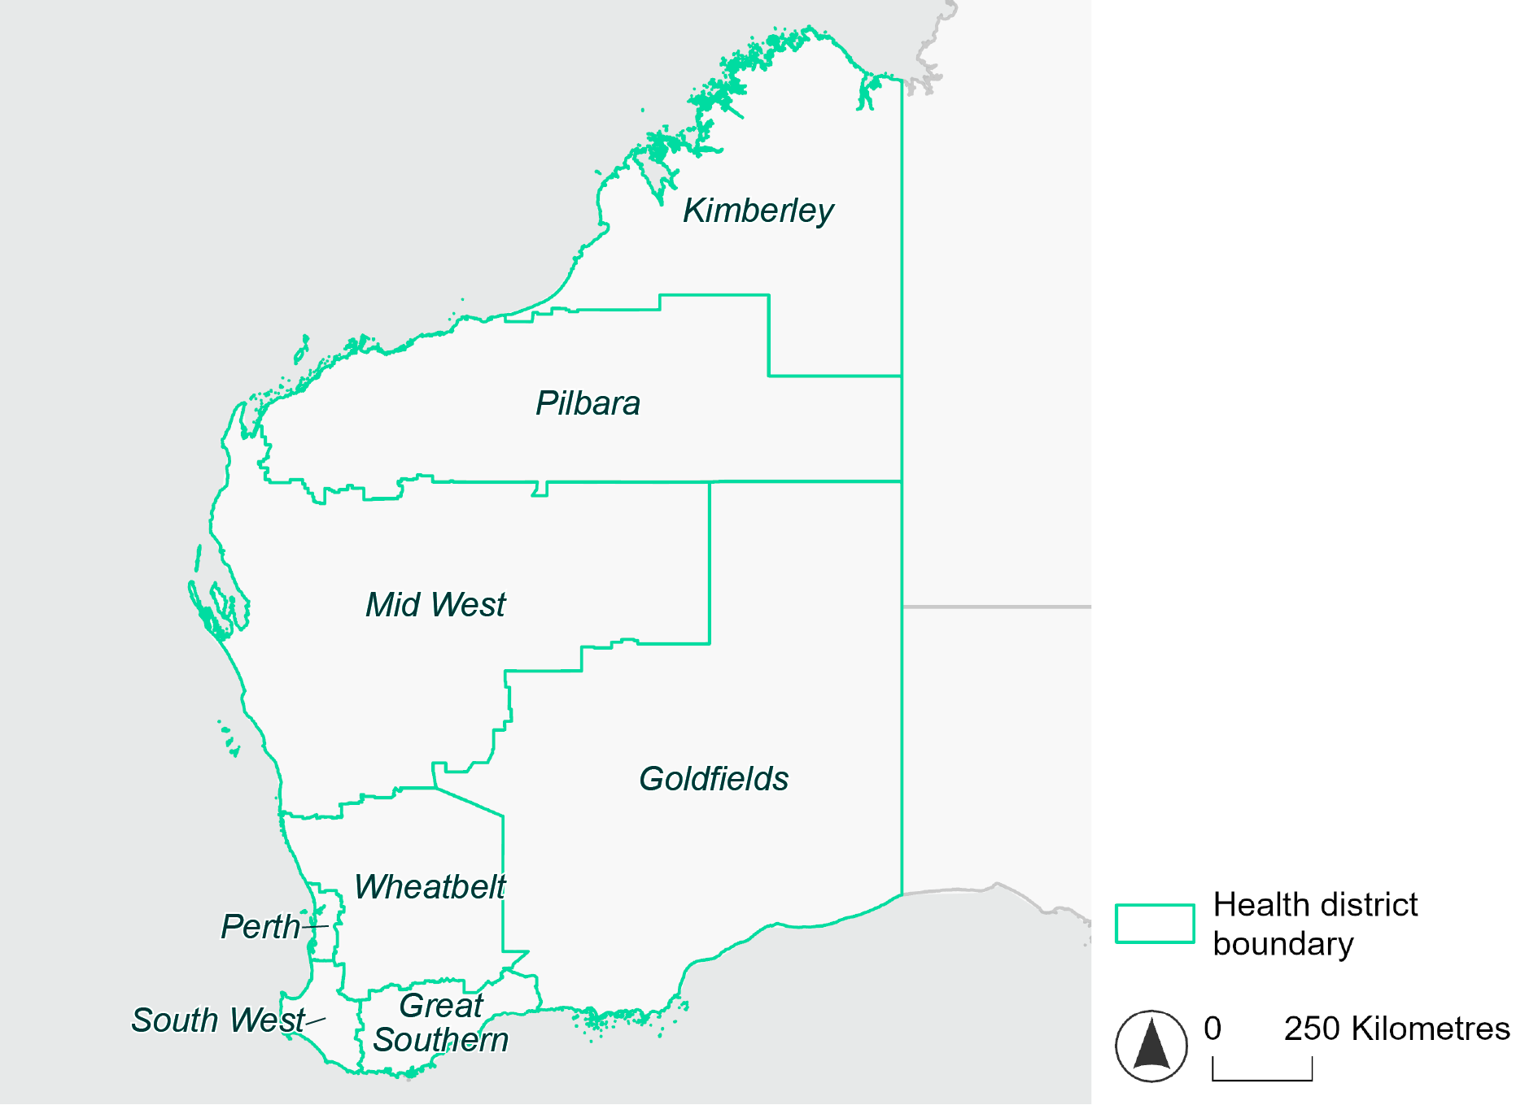
Figure 1 Map of WA health districts used in this document.

Time horizons
This document provides climate information on each climate hazard for the following time horizons:

Time horizon | Years | Description | Use in risk assessment
Baseline | Observed data from 1985-2014 | Historical baseline position | Understand current risks and ensure they are being managed effectively
Mid-century (2050) | 2035–2064 | Medium-term climate projections | Identify and manage emerging risks to population health and health systems
Late century (2085) | 2070–2099 | Long-term climate projections | Identify long-term risks when planning infrastructure or policy with long-lasting consequences

Climate scenarios
The document provides climate information on each hazard for two different climate scenarios. A climate scenario is a plausible representation of what the future climate might look like. These scenarios are based on different assumptions about greenhouse gas emissions and other factors that influence the future climate.

This document uses Shared Socioeconomic Pathways (SSPs) as the basis for different climate scenarios. SSPs describe how socioeconomic factors (such as population, economic growth, education, urbanisation and technology development) could change over the next century and have an effect on future greenhouse gas emissions and global temperatures.

There are five main SSPs, each of which outlines a different scenario, ranging from a sustainable future with low emissions, to one with high fossil fuel uses and high emissions. The most recent iteration of SSPs incorporate information from what were previously called Representative Concentration Pathways (RCPs), which measure the expected change in radiative forcing (in W/m2) under the scenario from 1750 to 2100. SSP2-4.5 denotes what would previously have been called a scenario involving SSP2 and RCP4.5 – the reasoning for merging them being that SSP2 describes socioeconomic conditions likely to give rise to RCP4.5.

The two main scenarios used in this document are:
A ‘middle of the road’ scenario (SSP2-4.5): this scenario assumes emissions remain at current levels until the middle of the 21st century, and that net zero emissions are not reached by 2100. This scenario sees temperatures rising by about 2.7°C by the end of the century. In this document this is the lower emissions scenario across all climate hazards, except for the fire hazard (see below note).
A ‘reasonable worst-case’ scenario (SSP3-7.0): this scenario assumes both emissions and temperatures continue to rise to the end of the century due to delayed climate action. This scenario sees temperatures rise by about 3.6°C by 2100. In this document this is the higher emissions scenario across all climate hazards.

Fire hazard projections are not available for SSP2-4.5, so SSP1-2.6 is used as the lower emissions scenario for this hazard instead of SSP2-4.5. Under SSP1-2.6, global emissions are reduced but do not reach net zero until after 2050 and warming stabilises at about 1.8°C by 2100. This document refers to SSP1-2.6 as the ‘sustainability’ scenario.

Climate hazard projections
For each health district, the following information is provided for each climate hazard, across the different time horizons and climate scenarios:
- Heat and humidity: projected average, extreme and apparent temperatures; projected heatwave duration and frequency; and projected number of very hot days.
- Fire: projected area affected by different fire hazard categories for a 1-in-20 year fire event and a 1-in-100 year event.
- Drought: projected average number of months per year experiencing drought.
- Rainfall and flooding: projected number of extreme rainfall days per year, as well as projected frequency of urban and rural flood events.
- Storms: projected number of storms per year, grouped into four intensity categories based on wind speed.
- Coastal inundation: projected area of land affected by tidal inundation and storm surge and tidal inundation (coastal districts only).

The climate hazard projections in this document are based on data from nine CMIP6 Global Climate Models (ACCESS-CM2, ACCESS-ESM1-5, CESM2, CMCC-ESM2, CNRM-ESM2-1, EC-Earth3, MPI-ESM1-2-HR, NorESM2-MM, UKESM1-0-LL). These models simulate how climate hazards may change under different SSPs. Where hazard projections are based on these models, this document reports the median projected value as its primary estimate, and reports the range across all nine models in square brackets.

Goldfields health district

Health district overview
Surface area: 770,488 square kilometres (including offshore islands).
Estimated population (2020): 52,348
Local health services: The Goldfields health region contains one Regional Hospital in Kalgoorlie and one District Hospital in Esperance, three Small Hospitals in Laverton, Leonora and Norseman and three Nursing Posts/Health Centres. Mental Health services and Population Health Services are also provided across the region; Coolgardie Health Centre, Kalgoorlie Hospital, Kambalda Health Centre, Laverton Hospital, Leonora Hospital, Menzies Health Centre, Esperance Hospital, Norseman Hospital.

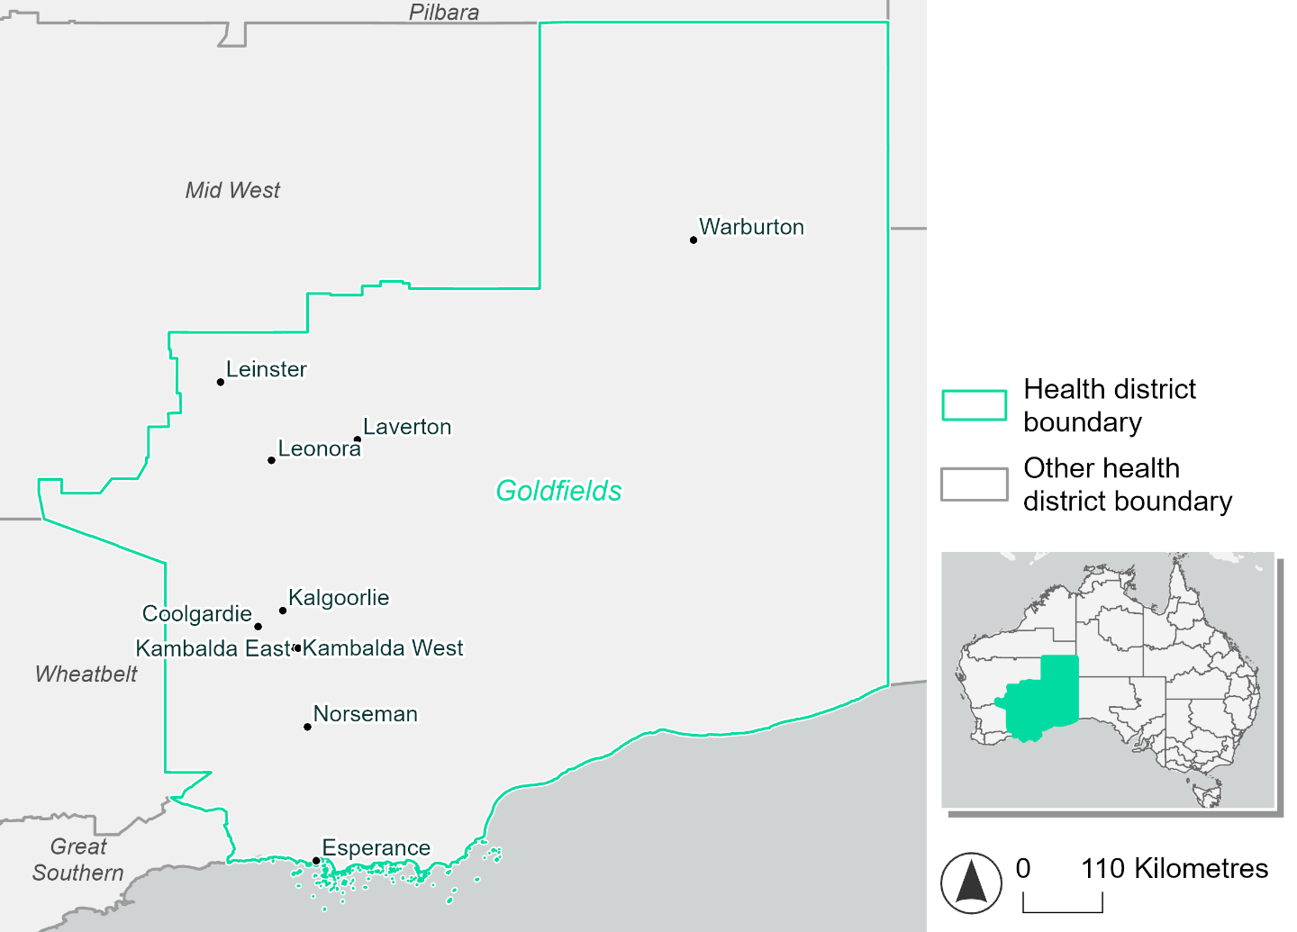
Figure 2 Map of Goldfields health district.

How will climate change affect this health district?
Heat and humidity: Higher average temperatures, hotter and more frequent hot days, warmer night time temperatures and longer and more frequent heatwaves.
Fire: Over 37% of this health district experiences a very high fire hazard category and this will continue in the future.
Drought: The number of months experiencing drought will increase.
Rainfall and flood: There will be more flood events in urban areas.
Coastal inundation: The area flooded during tidal, and storm surge and tidal inundation, will increase.

Goldfields health district demographic data
Demographic Data | Total
Number of households | 17,494
Persons 15 and older | 39,696
Total families | 12,175
Persons did not complete high school | 17,368
One parent families with dependents | 1,277 (10.5%)
Persons aged 65 and older | 6,680 (12.1%)
Persons aged 4 and younger | 3,702 (6.7%)
Aboriginal and Torres Strait Islander persons | 5,026 (9.1%)
Persons speaks language other than English | 6,247 (11.3%)
Persons working age (15-65) | 37,360 (67.6%)
Population Health Data | Total
Persons with core needs for assistance | 1,841 (3.3%)
Persons with arthritis | 3,454 (6.2%)
Persons with asthma | 3,829 (6.9%)
Persons with cancer | 1,135 (2.1%)
Persons with dementia | 239 (0.4%)
Persons with diabetes | 2,560 (4.6%)
Persons with heart disease | 1,660 (3%)
Persons with kidney disease | 462 (0.8%)
Persons with lung condition | 857 (1.6%)
Persons with mental health condition | 3,672 (6.6%)
Persons with stroke | 359 (0.6%)
Persons with any other condition | 3,067 (5.5%)
Persons no health condition | 32,489 (58.8%)
Socio-economic Data | Total
Persons providing unpaid care | 4,365 (7.9%)
Persons homeless | 534 (1%)
Household with lone person | 5,052 (28.9%)
Households with rent and mortgage stress | 4,251 (24.3%)
Households total equivalised income below $1000 (weekly) | 5,768 (33%)
Households with no motor vehicle | 1,072 (6.1%)
Persons unemployed | 1,617 (3.9%)

The sections that follow outline projected climate hazards for this district. Further information on this health district, including population demographics, is provided in the online dashboard.

Heat and humidity hazard
Key projections:
More heatwaves: Heatwave events are likely to last longer and the number of heatwave events per year will increase. By 2050, under a reasonable worst-case scenario, the number of heatwaves will double. By 2085, under a reasonable worst-case scenario, the number of heatwaves per year will more than triple.
Hotter days and warmer nights: The maximum temperature on hot days will increase with night time temperatures on hot nights also increasing.
More days above 35°C and 40°C: The number of days per year greater than 35°C and 40°C will increase under both middle of the road and reasonable worst-case scenarios.

 | Baseline | 2050 Scenarios |  | 2085 Scenarios
 |  | Middle of the road | Reasonable worst-case | Middle of the road | Reasonable worst-case
Average temperature (°C) | 18.6 | 20  [19.5, 20.4] | 20.2  [19.7, 20.9] | 20.9  [20.2, 21.6] | 21.9  [20.8, 22.9]
Maximum temperature on hot days (°C)^{(a)} | 37.6 | 39.2  [38.6, 40.1] | 39.6  [38.7, 41.1] | 40.3  [39.1, 41.5] | 41.4  [40.5, 43.1]
Minimum temperature on hot nights (°C)^{(b)} | 20.5 | 21.9  [21.5, 22.5] | 22.2  [21.7, 23] | 22.9  [22.1, 23.6] | 24  [23.2, 25.1]
Average apparent temperature on hot days (°C) (NOAA Heat Index)^{(c)} | 34.2 | 35.4  [35.1, 35.9] | 35.6  [35.2, 36.1] | 36.2  [35.4, 36.9] | 37  [36, 38.2]
Average heatwave duration in days^{(d)} | 4 | 5  [5, 6] | 5  [5, 6] | 6  [5, 6] | 6  [6, 8]
Number of heatwaves per year^{(d)} | 2 | 4  [3, 5] | 4  [4, 6] | 6  [4, 7] | 7  [6, 9]
Number of days per year  > 35°C | 42 | 60  [50, 66] | 63  [54, 77] | 72  [60, 84] | 86  [74, 103]
Number of days per year > 40°C | 8 | 17  [14, 22] | 19  [15, 28] | 24  [17, 32] | 33  [25, 47]
Table notes: The heat and humidity hazard uses climate projections from the CMIP6 Global Climate Models [1]. Daily projections of maximum and minimum near-surface temperature and mean relative humidity are used to calculate eight heat and humidity indicators. The primary indicator value reports the median from the nine climate models, with the range reported in square brackets.
Table footnotes: (a) Based on the 95th percentile of daily maximum air temperature. (b) Based on the 95th percentile of daily minimum air temperature, representing the coldest part of the night on very hot nights. (c) The National Oceanic and Atmospheric Administration (NOAA) Heat Index is a measure of how hot it feels when relative humidity is factored in alongside actual air temperature. It is calculated on days with a maximum temperature of 27°C and above. Interpretation of Heat Index values: 27°C to 32°C indicates caution, 33°C to 41°C indicates extreme caution, 42°C to 54°C indicates danger and over 54°C indicates extreme danger. See methodology document for further explanation of Heat Index categories. (d) A heatwave is defined as three or more consecutive days where both daytime and overnight temperatures (daily mean temperatures) are unusually high for the location, based on the Bureau of Meteorology’s Excess Heat Factor method. For this district, an unusually high daily mean temperature is approximately 28.6°C or above.

Fire hazard
Key projections:
Fire hazard evenly spread currently: Under baseline conditions, 22-23% of the district area experiences low fire hazard, 36-39% experiences moderate to high fire hazard, and 37-41% experiences very high hazard.
Current hazard levels to persist: In a future climate across both 2050 and 2085 scenarios, hazard levels cover roughly the same areas as they do at baseline, with variation of no more than 1.6 percentage points.

 | Baseline | 2050 Scenarios |  | 2085 Scenarios
 |  | Sustainability | Reasonable worst-case | Sustainability | Reasonable worst-case
Hazard for a ‘1-in-20 year’ fire weather event^{(a)}
Proportion (%) of district experiencing ‘Low’ fire hazard | 23.7%  (18,001,659)  ^{(b)} | 23.7%  [23.2%, 24.4%] | 23.3%  [23.0%, 23.8%] | 23.6%  [22.5%, 25.4%] | 22.8%  [22.0%, 24.0%]
Proportion (%) of district experiencing ‘Moderate to High’ fire hazard | 39.0%  (29,643,530)  ^{(b)} | 39.0%  [38.4%, 39.8%] | 39.5%  [38.8%, 40.3%] | 39.1%  [37.6%, 40.9%] | 40.3%  [38.4%, 42.2%]
Proportion (%) of district experiencing ‘Very High’ fire hazard | 37.3%  (28,342,013)  ^{(b)} | 37.3%  [36.6%, 37.5%] | 37.1%  [36.7%, 38.2%] | 37.3%  [35.7%, 37.9%] | 36.9%  [35.9%, 39.4%]
Hazard for a ‘1-in-100 year’ fire weather event^{(a)}
Proportion (%) of district experiencing ‘Low’ fire hazard | 22.0%  (16,720,397)  ^{(b)} | 21.8%  [21.5%, 22.5%] | 21.5%  [21.3%, 22.1%] | 21.6%  [20.7%, 23.1%] | 20.9%  [20.2%, 22.2%]
Proportion (%) of district experiencing ‘Moderate to High’ fire hazard | 36.9%  (28,015,812)  ^{(b)} | 37.0%  [36.5%, 37.9%] | 37.5%  [36.7%, 38.0%] | 37.3%  [35.9%, 39.3%] | 38.5%  [36.5%, 39.7%]
Proportion (%) of district experiencing ‘Very High’ fire hazard | 41.1%  (31,250,993)  ^{(b)} | 41.1%  [40.3%, 41.3%] | 40.9%  [40.4%, 42.0%] | 41.0%  [39.1%, 41.6%] | 40.5%  [39.4%, 43.2%]
Table notes: The Fire Hazard uses the National Bushfire Intelligence Capability (NBIC) Phase 2 fire line intensity modelling based on CMIP6 climate projections. Fire Hazard is assessed using the projected Fireline Intensity (FLI) for weather events with two different return intervals (i.e. a 1-in-20 year event and a 1-in-100 year event). FLI considers slope, vegetation and weather to produce a rate of heat output per unit length (kW/m) along a bushfire’s front. Fire hazard is categorized as a low for FLI<4000 kW/m, moderate to high for 4,000 kW/m ≤FLI<12,500kW/m, and very high for FLI≥27,501kW/m. This is broadly consistent with the literature [3]. The assessment considers climate change effects based on changes in fire weather and the associated hazard that is anticipated for a meteorological event of a given return interval. This approach is different to the one adopted for the Flood Hazard, where the event magnitude is given (fixed) and the likelihood of that event varies as a result of climate change. The primary indicator value reports the median from the nine climate models, with the range reported in square brackets.
Table footnotes: (a) The area subject to different categories of fire hazard is determined for a ‘1-in-20 year’ and ‘1-in-100 year’ fire weather event, in current and future climates. Values at year 2050 are interpolated using data from baseline (2025) and 2085, assuming linear change over time. (b) Values in round brackets are the area (ha) of the health district subject to a given fire hazard.

The figures below show the proportion of the health district experiencing different fire hazard categories across different time horizons and climate scenarios during a ‘1-in-20 year’ fire weather event (Figure 3) and a ‘1-in-100 year’ fire weather event (Figure 4).
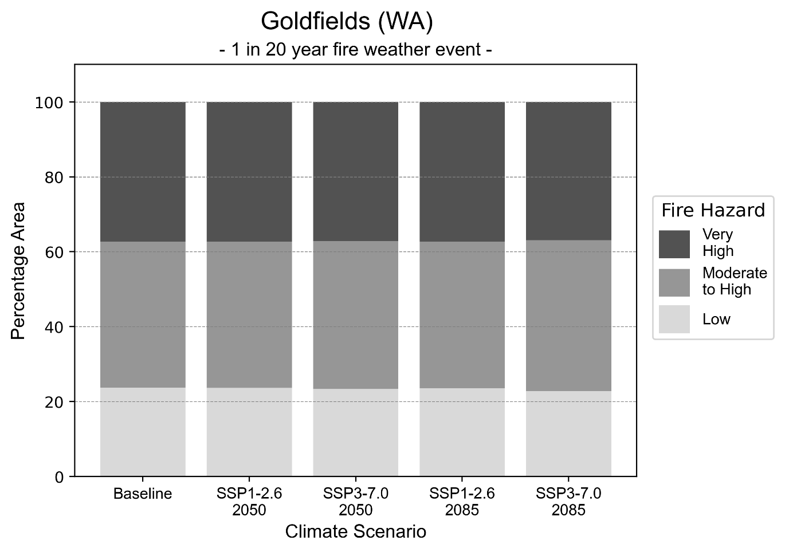
Figure 3 Stacked column chart showing the percentages of the Goldfields health district's total geographic area experiencing each fire hazard level during a 1-in-20-year fire weather event.
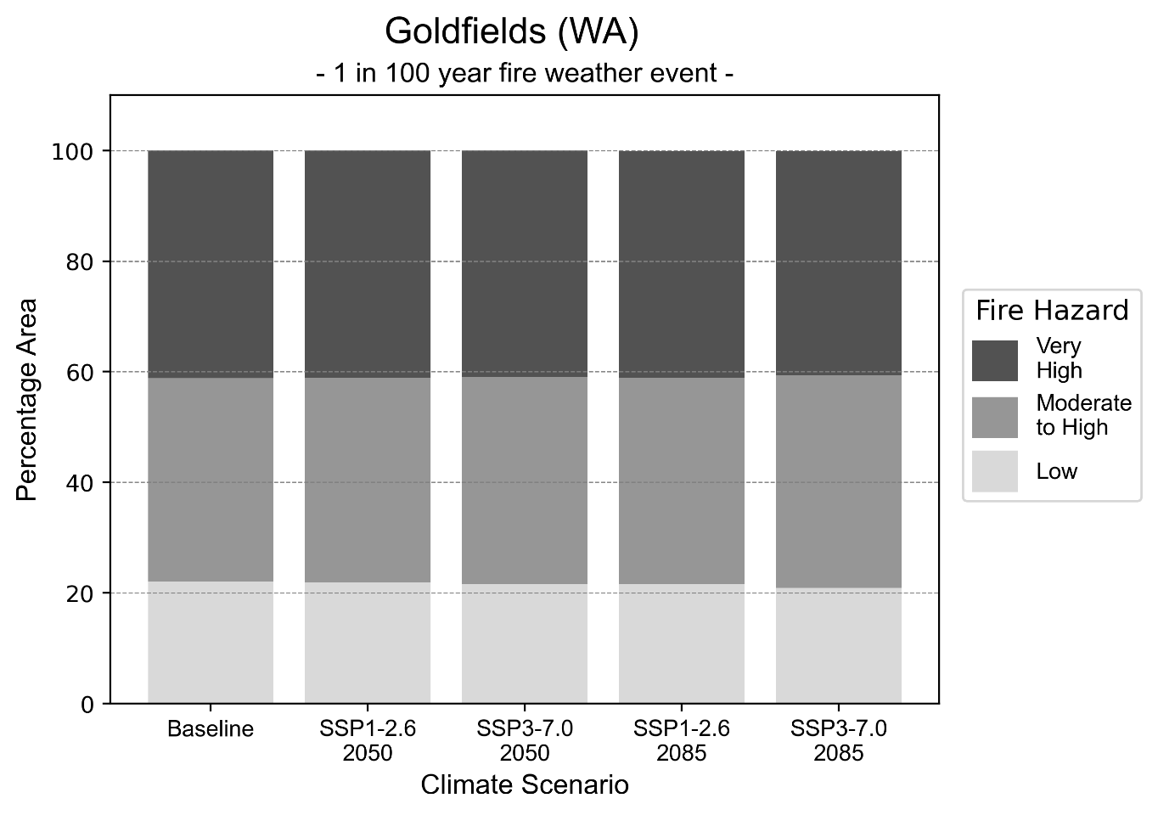
Figure 4 Stacked column chart showing the percentages of the Goldfields health district's total geographic area experiencing each fire hazard level during a 1-in-100-year fire weather event.

Drought hazard
Key projections:
Drought occurrence: The occurrence of drought will increase across both middle of the road and reasonable worst-case scenarios for both time horizons, with the largest increase occurring under the reasonable worst-case scenario by 2085.

 | Baseline | 2050 Scenarios |  | 2085 Scenarios
 |  | Middle of the road | Reasonable worst-case | Middle of the road | Reasonable worst-case
Number of months per year in drought^{(a)} | 1.7 | 2.4  [0.3, 4.3] | 2.2  [0.4, 5.9] | 2.7  [0.4, 6.0] | 3.1  [0.1, 7.2]
Table notes: The drought hazard indicator uses climate projections from the CMIP6 Global Climate Models [1]. The primary indicator value reports the median from the nine climate models, with the range reported in square brackets.
Table footnotes: (a) The number of months per year in drought is based on the Standardised Precipitation Index (SPI). SPI is a widely used index to characterise meteorological drought on a range of timescales. This indicator uses the timescale of 12 months which calculates the average months in a year within the moderate drought range. A moderate drought range is classified as SPI score of ≤ -1. SPI is calculated from accumulated rainfall over 12 months and the mean and standard deviation from historical rainfall records.

Storm hazard
Key projections:
More frequent high and very-high-intensity storms under the middle of the road scenario by 2050: The frequency of high and very-high-intensity storms will increase under the middle of the road scenario by 2050 but decrease across all other scenarios and time horizons.

Baseline |  | 2050 Scenarios |  | 2085 Scenarios
 |  | Middle of the road | Reasonable worst-case | Middle of the road | Reasonable worst-case
Number of low-intensity storms (40-62 km/hr) per year | 82.4 | 80.2  [70.6, 88.2] | 81.8  [72.0, 90.0] | 79.3  [69.8, 87.3] | 83.0  [73.0, 91.3]
Number of medium-intensity storms (63-87 km/hr) per year | 50.8 | 48.9  [43.0, 53.8] | 48.8  [43.0, 53.7] | 47.0  [41.4, 51.7] | 45.9  [40.4, 50.5]
Number of high-intensity storms (88-117 km/hr) per year | 47.6 | 49.2  [43.3, 54.1] | 45.2  [39.8, 49.8] | 43.1  [37.9, 47.4] | 41.3  [36.3, 45.4]
Number of very-high-intensity storm (> 117 km/hr) per year | 12.6 | 14.5  [12.7, 15.9] | 12.0  [10.6, 13.2] | 11.5  [10.1, 12.6] | 10.2  [9.0, 11.2]
Table notes: The storm hazard uses climate projections from the CMIP6 Global Climate Models [1]. Daily maximum surface wind speed is used to calculate the number of annual storms across four storm intensity categories (low, medium, high and very high). The primary indicator value reports the median from the nine climate models, with the range reported in square brackets.

Rainfall and flood hazard
Key projections:
- 11 extreme rainfall days per year: The number of extreme rainfall days will decrease slightly across both middle of the road and reasonable worst-case scenarios, and both time horizons, with an average of approximately 11 extreme rainfall days per year.
- Increased flood frequency: The frequency of flood events will increase in urban environments but decrease in rural environments. The largest increase in flooding is seen in the reasonable worst-case scenario, where the frequency of a ‘1-in-100 year’ flood will nearly triple by 2050 and become nearly six times more likely by 2085 in urban environments.

 | Baseline | 2050 Scenarios |  | 2085 Scenarios
 |  | Middle of the road | Reasonable worst-case | Middle of the road | Reasonable worst-case
Rainfall hazard^{(a)}
Average number of extreme rainfall days per year (> 5 mm/day)^{(a)} | 11.5 | 11.3  [9.1,16.1] | 11.5  [8.2,14.9] | 10.9  [8.1,15.1] | 10.9  [7.2,18.6]
Urban flood risk (flooding caused by a 1-hour rainfall event)^{(b)}
Frequency of a ‘1-in-1 year’ flood (rainfall depth of 11 mm)^{(c)} |  | 1.7 events in 1 year | 1.7 events in 1 year | 2.1 events in 1 year | 2.6 events in 1 year
Frequency of a ‘1-in-10 year’ flood (rainfall depth of 27 mm)^{(c)} |  | 2.0 events in 10 years | 2.1 events in 10 years | 2.6 events in 10 years | 3.5 events in 10 years
Frequency of a ‘1-in-100 year’ flood (rainfall depth of 51 mm)^{(c)} |  | 2.5 events in 100 years | 2.6 events in 100 years | 3.6 events in 100 years | 5.7 events in 100 years
Rural flood risk (flooding caused by a 24-hour rainfall event)^{(b)}
Frequency of a ‘1-in-1 year’ flood (rainfall depth of 31 mm)^{(c)} |  | 1.0 events in 1 year | 0.9 events in 1 year | 0.9 events in 1 year | 0.4 events in 1 year
Frequency of a ‘1-in-10 year’ flood (rainfall depth of 72 mm)^{(c)} |  | 1.0 events in 10 years | 0.7 events in 10 years | 1.0 events in 10 years | 0.5 events in 10 years
Frequency of a ‘1-in-100 year’ flood (rainfall depth of 133 mm)^{(c)} |  | 1.1 events in 100 years | 1.0 events in 100 years | 0.8 events in 100 years | 0.3 events in 100 years
Table notes: The rainfall hazard indicator uses climate projections from the CMIP6 Global Climate Models [1]. The average number of extreme rainfall days per year is reported along with the maximum and minimum values across climate models reported in brackets. The flood hazard indicators use climate change considerations from the Australian Rainfall and Runoff guideline to estimate the climate projections [2].
Table footnotes: (a) Extreme rainfall is defined as rainfall above the 95th percentile of historical average daily rainfall in this health district in the period 1985-2014. The value in mm/day quoted in the indicator name is the 95th percentile of historic average daily rainfall for this health district. (b) See Methodology document for reasons for focusing on a 1-hour flood for urban areas and a 24-hour flood for rural areas. (c) The rainfall depths in mm quoted in the indicator names in this table report 1 in 1-, 10- and 100-year depths for this health district.

Coastal inundation hazard
Key projections:
Greater area inundated: There will be an increase in the area affected by tidal inundation (i.e. area submerged during high tide) and storm surge and tidal inundation (i.e. the area submerged during a storm surge and high tide) across both middle of the road and reasonable worst-case scenarios. In the reasonable worst-case scenario, by 2085 the area inundated during a ‘1-in-1000-year’ event will increase by over 5,500 ha.

 | Baseline | 2050 Scenarios |  | 2085 Scenarios^{(a)}
 |  | Middle of the road | Reasonable worst-case | Middle of the road | Reasonable worst-case
Tidal inundation (ha inundated) ^{(b)} | 7,577.4 | 7,744.4  (+167.0) | 7,759.2  (+181.9) | 9,683.8  (+2,106.4) | 9,905.9  (+2,328.5)
Storm surge + tidal inundation – ‘1-in-100 year’ event (ha inundated)^{(c)} | 9,645.8 | 9,926.1  (+280.2) | 9,945.6  (+299.8) | 10,452.5  (+806.7) | 10,603.6  (+957.8)
Storm surge + tidal inundation – ‘1-in-1000 year’ event (ha inundated)^{(c)} | 9,727.7 | 10,016.6  (+288.9) | 10,034.4  (+306.7) | 10,689.2  (+961.5) | 15,409.6  (+5,681.9)
Table notes: The coastal inundation hazard provides an indication of flooding in coastal areas that can be attributed to sea level rise and storm inundation. The coastal inundation hazard is only reported for health districts adjoining the coastline. This table includes the projected inundation levels as well as the change from baseline conditions (in brackets).
Table footnotes: (a) For the 2085 Scenarios planning horizon, 2100 was adopted as it provides a conservative representation of the end of this period. This horizon aligns with many State planning regulations requiring consideration of sea level rise and storm tide to 2100, making the 2100 scenario particularly valuable for planning new health facilities in coastal areas. (b) The tidal inundation indicator reports the number of hectares inundated during high tide. The baseline value reports existing inundation patterns, while the 2050 and 2085 values report high tide inundation taking account of projected sea level rise due to climate change. (c) The storm surge + tidal inundation indicators report the combined effect, in hectares inundated, of high tide, sea level rise (for the 2050 and 2085 projections), and storm surge (for 1-in-100 year and 1-in-1000 year events).

Great Southern health district

Health district overview
Surface area: 39,007 square kilometres
Estimated population (2020): 62,917
Local health services: The Great Southern region includes one District Hospital (Katanning Hospital), two small hospitals (Gnowangerup and Kojonup Hospitals), one regional hospital (Albany Hospital), three small hospitals (Denmark, Plantagenet and Ravensthorpe Hospitals) and three Nursing Posts/Health Centres (Tambellup, Bremer Bay and Jerramungup Health Centres):

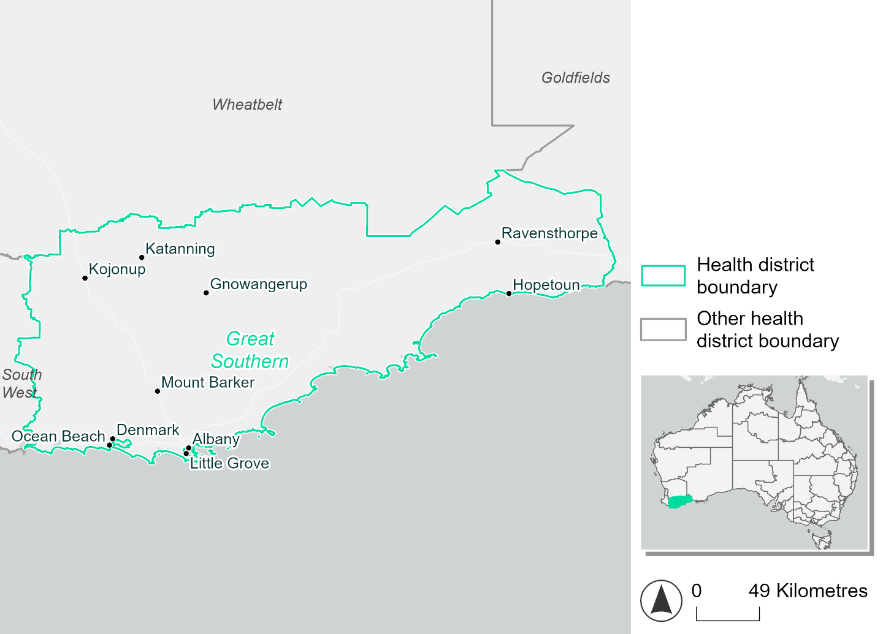
Figure 5 Map of Great Southern health district.

How will climate change affect this health district?
Heat and humidity: Higher average temperatures, hotter and more frequent hot days, warmer night time temperatures and more frequent heatwaves.
Fire: Over 14% of this health district experiences a very high fire hazard category and this will increase in the future.
Drought: The number of months experiencing drought will increase.
Rainfall and flood: There will be more flood events in urban and rural areas.
Coastal inundation: The area flooded during tidal, and storm surge and tidal inundation, will increase.

Great Southern health district demographic data
Demographic Data | Total
Number of households | 23,817
Persons 15 and older | 43,643
Total families | 16,548
Persons did not complete high school | 19,539
One parent families with dependents | 1,543 (9.3%)
Persons aged 65 and older | 14,970 (22.7%)
Persons aged 4 and younger | 3,561 (5.4%)
Aboriginal and Torres Strait Islander persons | 2,552 (3.9%)
Persons speaks language other than English | 4,189 (6.3%)
Persons working age (15-65) | 39,121 (59.2%)
Population Health Data | Total
Persons with core needs for assistance | 3,712 (5.6%)
Persons with arthritis | 7,247 (11%)
Persons with asthma | 5,493 (8.3%)
Persons with cancer | 2,368 (3.6%)
Persons with dementia | 583 (0.9%)
Persons with diabetes | 3,430 (5.2%)
Persons with heart disease | 2,998 (4.5%)
Persons with kidney disease | 531 (0.8%)
Persons with lung condition | 1,369 (2.1%)
Persons with mental health condition | 6,494 (9.8%)
Persons with stroke | 712 (1.1%)
Persons with any other condition | 5,297 (8%)
Persons no health condition | 35,984 (54.5%)
Socio-economic Data | Total
Persons providing unpaid care | 8,234 (12.5%)
Persons homeless | 327 (0.5%)
Household with lone person | 6,979 (29.3%)
Households with rent and mortgage stress | 10,211 (42.9%)
Households total equivalised income below $1000 (weekly) | 12,377 (52%)
Households with no motor vehicle | 951 (4%)
Persons unemployed | 1,973 (3.8%)

The sections that follow outline projected climate hazards for this district. Further information on this health district, including population demographics, is provided in the online dashboard.

Heat and humidity hazard
Key projections:
More heatwaves: The number of heatwave events per year will increase. By 2050, under a reasonable worst-case scenario, the number of heatwaves will more than double. By 2085, under a reasonable worst-case scenario, the number of heatwaves per year will more than triple.
Hotter days and warmer nights: The maximum temperature on hot days will increase with night time temperatures on hot nights also increasing.
More days above 35°C: The number of days per year greater than 35°C will increase under both middle of the road and reasonable worst-case scenarios.

 | Baseline | 2050 Scenarios |  | 2085 Scenarios
 |  | Middle of the road | Reasonable worst-case | Middle of the road | Reasonable worst-case
Average temperature (°C) | 15.5 | 16.6  [16, 17] | 16.7  [16.3, 17.3] | 17.3  [16.7, 17.9] | 18  [17.1, 19]
Maximum temperature on hot days (°C)^{(a)} | 29.6 | 30.6  [30.2, 31.5] | 30.9  [30.4, 32.1] | 31.5  [30.8, 32.6] | 32.3  [31.4, 33.6]
Minimum temperature on hot nights (°C)^{(b)} | 16.9 | 18  [17.2, 18.6] | 18.2  [17.5, 18.8] | 18.8  [18, 19.5] | 19.5  [18.4, 20.7]
Average apparent temperature on hot days (°C) (NOAA Heat Index)^{(c)} | 35.8 | 36.6  [36.3, 37] | 36.8  [36.6, 37.6] | 37.1  [36.8, 37.6] | 37.6  [37.1, 38.3]
Average heatwave duration in days^{(d)} | 4 | 4  [4, 4] | 4  [4, 5] | 5  [4, 5] | 5  [4, 6]
Number of heatwaves per year^{(d)} | 2 | 4  [2, 5] | 4  [3, 6] | 6  [4, 8] | 7  [5, 10]
Number of days per year  > 35°C | 6 | 8  [7, 11] | 9  [8, 13] | 11  [9, 14] | 13  [11, 18]
Number of days per year > 40°C | 1 | 1  [1, 1] | 1  [1, 3] | 2  [1, 3] | 3  [2, 5]
Table notes: The heat and humidity hazard uses climate projections from the CMIP6 Global Climate Models [1]. Daily projections of maximum and minimum near-surface temperature and mean relative humidity are used to calculate eight heat and humidity indicators. The primary indicator value reports the median from the nine climate models, with the range reported in square brackets.
Table footnotes: (a) Based on the 95th percentile of daily maximum air temperature. (b) Based on the 95th percentile of daily minimum air temperature, representing the coldest part of the night on very hot nights. (c) The National Oceanic and Atmospheric Administration (NOAA) Heat Index is a measure of how hot it feels when relative humidity is factored in alongside actual air temperature. It is calculated on days with a maximum temperature of 27°C and above. Interpretation of Heat Index values: 27°C to 32°C indicates caution, 33°C to 41°C indicates extreme caution, 42°C to 54°C indicates danger and over 54°C indicates extreme danger. See methodology document for further explanation of Heat Index categories. (d) A heatwave is defined as three or more consecutive days where both daytime and overnight temperatures (daily mean temperatures) are unusually high for the location, based on the Bureau of Meteorology’s Excess Heat Factor method. For this district, an unusually high daily mean temperature is approximately 22.8°C or above.

Fire hazard
Key projections:
Majority of district area experiences moderate to high fire hazard: Under baseline conditions, 78% of the district experiences moderate to high fire hazard. 14-16% experiences very high hazard, with only 5-6% experiencing low fire hazard.
Current fire hazard conditions to persist: In a future climate across both 2050 and 2085 scenarios, the maximum variation in hazard level area compared to baseline is 1.4% of the district area.

 | Baseline | 2050 Scenarios |  | 2085 Scenarios
 |  | Sustainability | Reasonable worst-case | Sustainability | Reasonable worst-case
Hazard for a ‘1-in-20 year’ fire weather event^{(a)}
Proportion (%) of district experiencing ‘Low’ fire hazard | 6.5%  (315,891)^{(b)} | 6.8%  [6.2%, 7.5%] | 6.5%  [6.2%, 7.1%] | 7.2%  [5.9%, 9.0%] | 6.6%  [5.8%, 7.9%]
Proportion (%) of district experiencing ‘Moderate to High’ fire hazard | 78.8%  (3,840,037)^{(b)} | 78.3%  [70.5%, 86.0%] | 78.4%  [74.7%, 81.5%] | 77.7%  [58.8%, 96.2%] | 77.8%  [69.1%, 85.2%]
Proportion (%) of district experiencing ‘Very High’ fire hazard | 14.7%  (718,379)^{(b)} | 14.9%  [14.4%, 15.3%] | 15.1%  [14.3%, 16.1%] | 15.1%  [13.9%, 16.0%] | 15.7%  [13.7%, 17.9%]
Hazard for a ‘1-in-100 year’ fire weather event^{(a)}
Proportion (%) of district experiencing ‘Low’ fire hazard | 5.0%  (245,276)^{(b)} | 5.3%  [4.9%, 5.9%] | 5.1%  [4.9%, 5.5%] | 5.6%  [4.6%, 7.1%] | 5.1%  [4.7%, 6.1%]
Proportion (%) of district experiencing ‘Moderate to High’ fire hazard | 78.4%  (3,823,575)^{(b)} | 77.9%  [72.2%, 84.0%] | 77.8%  [74.2%, 80.9%] | 77.1%  [63.4%, 91.7%] | 77.0%  [68.3%, 84.3%]
Proportion (%) of district experiencing ‘Very High’ fire hazard | 16.5%  (805,456)^{(b)} | 16.9%  [16.3%, 17.7%] | 17.1%  [15.8%, 19.1%] | 17.4%  [15.9%, 19.3%] | 17.9%  [14.9%, 22.8%]
Table notes: The Fire Hazard uses the National Bushfire Intelligence Capability (NBIC) Phase 2 fire line intensity modelling based on CMIP6 climate projections. Fire Hazard is assessed using the projected Fireline Intensity (FLI) for weather events with two different return intervals (i.e. a 1-in-20-year event and a 1-in-100-year event). FLI considers slope, vegetation and weather to produce a rate of heat output per unit length (kW/m) along a bushfire’s front. Fire hazard is categorized as a low for FLI<4000 kW/m, moderate to high for 4,000 kW/m ≤FLI<12,500kW/m, and very high for FLI≥27,501kW/m. This is broadly consistent with the literature [3]. The assessment considers climate change effects based on changes in fire weather and the associated hazard that is anticipated for a meteorological event of a given return interval. This approach is different to the one adopted for the Flood Hazard, where the event magnitude is given (fixed) and the likelihood of that event varies as a result of climate change. The primary indicator value reports the median from the nine climate models, with the range reported in square brackets.
Table footnotes: (a) The area subject to different categories of fire hazard is determined for a ‘1-in-20 year’ and ‘1-in-100 year’ fire weather event, in current and future climates. Values at year 2050 are interpolated using data from baseline (2025) and 2085, assuming linear change over time. (b) Values in round brackets are the area (ha) of the health district subject to a given fire hazard.

The figures below show the proportion of the health district experiencing different fire hazard categories across different time horizons and climate scenarios during a ‘1-in-20 year’ fire weather event (Figure 6) and a ‘1-in-100 year’ fire weather event (Figure 7).
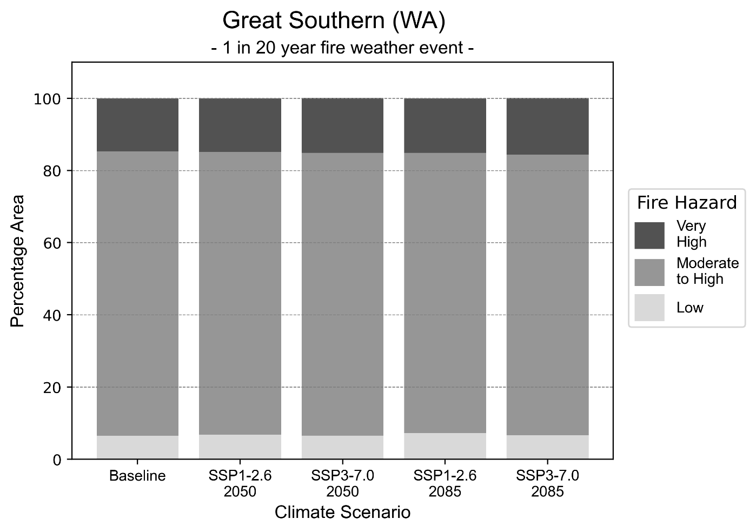
Figure 6 Stacked column chart showing the percentages of the Great Southern health district's total geographic area experiencing each fire hazard level during a 1-in-20-year fire weather event.
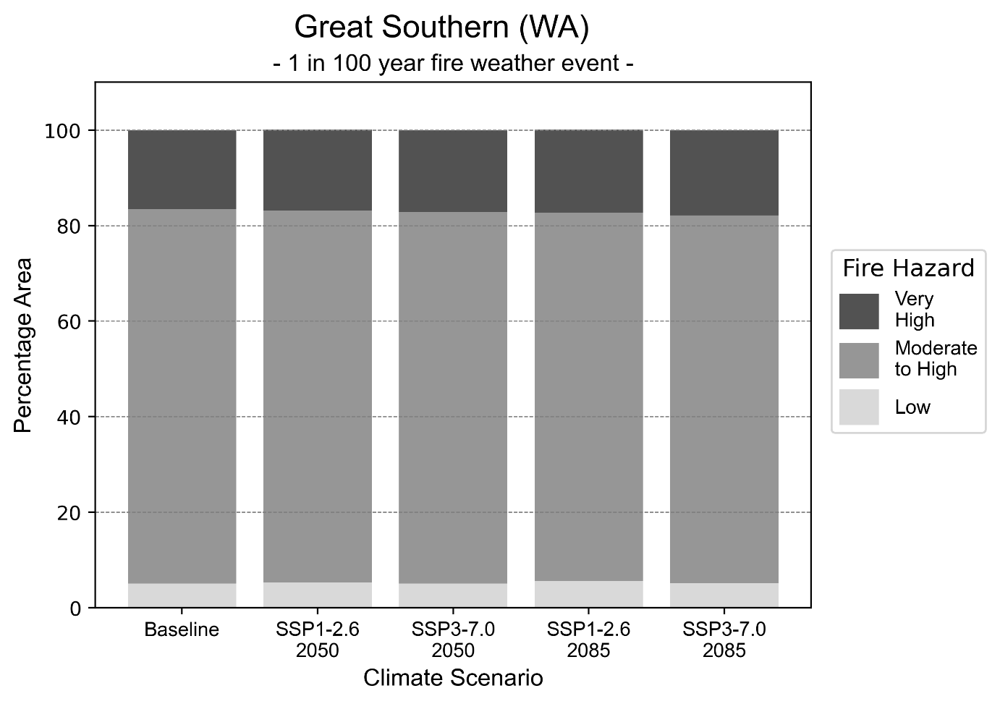
Figure 7 Stacked column chart showing the percentages of the Great Southern health district's total geographic area experiencing each fire hazard level during a 1-in-100-year fire weather event.

Drought hazard
Key projections:
Drought occurrence: The occurrence of drought will increase across both middle of the road and reasonable worst-case scenarios for both time horizons, with the largest increase occurring under the reasonable worst-case scenario by 2085.

 | Baseline | 2050 Scenarios |  | 2085 Scenarios
 |  | Middle of the road | Reasonable worst-case | Middle of the road | Reasonable worst-case
Number of months per year in drought^{(a)} | 2.0 | 4.2  [1.4, 6.6] | 4.6  [2.9, 7.0] | 4.8  [2.0, 7.7] | 6.3  [1.7, 8.9]
Table notes: The drought hazard indicator uses climate projections from the CMIP6 Global Climate Models [1]. The primary indicator value reports the median from the nine climate models, with the range reported in square brackets.
Table footnotes: (a) The number of months per year in drought is based on the Standardised Precipitation Index (SPI). SPI is a widely used index to characterise meteorological drought on a range of timescales. This indicator uses the timescale of 12 months which calculates the average months in a year within the moderate drought range. A moderate drought range is classified as SPI score of ≤ -1. SPI is calculated from accumulated rainfall over 12 months and the mean and standard deviation from historical rainfall records.

Storm hazard
Key projections:
Less frequent high and very-high-intensity storms: The frequency of high and very-high-intensity storms will decrease across both middle of the road and reasonable worst-case scenarios, with the greatest increase occurring by 2085.

Baseline |  | 2050 Scenarios |  | 2085 Scenarios
 |  | Middle of the road | Reasonable worst-case | Middle of the road | Reasonable worst-case
Number of low-intensity storms (40-62 km/hr) per year | 72.9 | 71.3  [62.8, 78.5] | 70.4  [61.9, 77.4] | 70.2  [61.8, 77.2] | 70.6  [62.1, 77.7]
Number of medium-intensity storms (63-87 km/hr) per year | 73.6 | 68.3  [60.1, 75.1] | 71.5  [62.9, 78.7] | 65.2  [57.3, 71.7] | 68.8  [60.5, 75.7]
Number of high-intensity storms (88-117 km/hr) per year | 27.9 | 26.3  [23.1, 28.9] | 22.3  [19.6, 24.5] | 23.0  [20.2, 25.3] | 19.9  [17.5, 21.9]
Number of very-high-intensity storm (> 117 km/hr) per year | 8.7 | 8.0  [7.0, 8.8] | 6.5  [5.7, 7.1] | 7.1  [6.2, 7.8] | 5.2  [4.6, 5.8]
Table notes: The storm hazard uses climate projections from the CMIP6 Global Climate Models [1]. Daily maximum surface wind speed is used to calculate the number of annual storms across four storm intensity categories (low, medium, high and very high). The primary indicator value reports the median from the nine climate models, with the range reported in square brackets.

Rainfall and flood hazard
Key projections:
- Fewer extreme rainfall days per year: The number of extreme rainfall days will decrease across both middle of the road and reasonable worst-case scenarios, and both time horizons, with the largest decrease occurring under the reasonable worst-case scenario by 2085.
- Increased flood frequency: The frequency of flood events will increase in urban and rural environments. The largest increase in flooding is seen in the reasonable worst-case scenario, where the frequency of a ‘1-in-100 year’ flood will triple by 2050 and become seven times more likely by 2085 in urban environments.

 | Baseline | 2050 Scenarios |  | 2085 Scenarios
 |  | Middle of the road | Reasonable worst-case | Middle of the road | Reasonable worst-case
Rainfall hazard^{(a)}
Average number of extreme rainfall days per year (> 7 mm/day)⁽¹⁾ | 10.4 | 8.8  [7.2,11.1] | 8.5  [7.0,9.5] | 8.4  [5.8,10.8] | 7.6  [5.8,10.8]
Urban flood risk (flooding caused by a 1-hour rainfall event)^{(b)}
Frequency of a ‘1-in-1 year’ flood (rainfall depth of 12 mm)⁽²⁾ |  | 1.9 events in 1 year | 2.0 events in 1 year | 2.4 events in 1 year | 3.2 events in 1 year
Frequency of a ‘1-in-10 year’ flood (rainfall depth of 24 mm)⁽²⁾ |  | 2.2 events in 10 years | 2.3 events in 10 years | 3.0 events in 10 years | 4.4 events in 10 years
Frequency of a ‘1-in-100 year’ flood (rainfall depth of 43 mm)⁽²⁾ |  | 2.8 events in 100 years | 3.0 events in 100 years | 4.3 events in 100 years | 7.2 events in 100 years
Rural flood risk (flooding caused by a 24-hour rainfall event)^{(b)}
Frequency of a ‘1-in-1 year’ flood (rainfall depth of 31 mm)⁽²⁾ |  | 1.3 events in 1 year | 1.3 events in 1 year | 0.9 events in 1 year | 0.9 events in 1 year
Frequency of a ‘1-in-10 year’ flood (rainfall depth of 67 mm)⁽²⁾ |  | 1.3 events in 10 years | 1.3 events in 10 years | 1.3 events in 10 years | 1.1 events in 10 years
Frequency of a ‘1-in-100 year’ flood (rainfall depth of 127 mm)⁽²⁾ |  | 1.5 events in 100 years | 1.5 events in 100 years | 1.6 events in 100 years | 1.5 events in 100 years
Table notes: The rainfall hazard indicator uses climate projections from the CMIP6 Global Climate Models [1]. The primary indicator value reports the median from the nine climate models, with the range reported in square brackets. The flood hazard indicators use climate change considerations from the Australian Rainfall and Runoff guideline to estimate the climate projections [2].
Table footnotes: (a) Extreme rainfall is defined as rainfall above the 95th percentile of historical average daily rainfall in this health district in the period 1985-2014. The value in mm/day quoted in the indicator name is the 95th percentile of historic average daily rainfall for this health district. (b) See Methodology document for reasons for focusing on a 1-hour flood for urban areas and a 24-hour flood for rural areas. (c) The rainfall depths in mm quoted in the indicator names in this table report 1 in 1-, 10- and 100-year depths for this health district.

Coastal inundation hazard
Key projections:
Greater area inundated: There will be an increase in the area affected by tidal inundation (i.e. area submerged during high tide) and storm surge and tidal inundation (i.e. the area submerged during a storm surge and high tide) across both middle of the road and reasonable worst-case scenarios. In the reasonable worst-case scenario, by 2085 the area inundated during a tidal inundation will increase by over 3,500 ha.

 | Baseline | 2050 Scenarios |  | 2085^{(a)} Scenarios
 |  | Middle of the road | Reasonable worst-case | Middle of the road | Reasonable worst-case
Tidal inundation (ha inundated)^{(b)} | 9,824.1 | 10,294.9  (+470.8) | 10,325.3  (+501.2) | 13,115.1  (+3,291.0) | 13,440.8  (+3,616.7)
Storm surge + tidal inundation – ‘1-in-100 year’ event (ha inundated)^{(c)} | 12,710.5 | 13,232.3  (+521.8) | 13,266.7  (+556.2) | 14,250.8  (+1,540.3) | 14,607.4  (+1,896.9)
Storm surge + tidal inundation – ‘1-in-1000 year’ event (ha inundated)^{(c)} | 12,766.1 | 13,284.0  (+517.9) | 13,317.7  (+551.6) | 14,607.8  (+1,841.7) | 14,978.9  (+2,212.8)
Table notes: The coastal inundation hazard provides an indication of flooding in coastal areas that can be attributed to sea level rise and storm inundation. The coastal inundation hazard is only reported for health districts adjoining the coastline. This table includes the projected inundation levels as well as the change from baseline conditions (in brackets).
Table footnotes: (a) For the 2085 Scenarios planning horizon, 2100 was adopted as it provides a conservative representation of the end of this period. This horizon aligns with many State planning regulations requiring consideration of sea level rise and storm tide to 2100, making the 2100 scenario particularly valuable for planning new health facilities in coastal areas. (b) The tidal inundation indicator reports the number of hectares inundated during high tide. The baseline value reports existing inundation patterns, while the 2050 and 2085 values report high tide inundation taking account of projected sea level rise due to climate change. (c) The storm surge + tidal inundation indicators report the combined effect, in hectares inundated, of high tide, sea level rise (for the 2050 and 2085 projections), and storm surge (for 1-in-100 year and 1-in-1000-year events).

Kimberley health district

Health district overview
Surface area: 424,517 square kilometres
Estimated population (2020): 36,054
Local health services: The Kimberley health region contains six hospitals and health services; Broome Health Campus, Derby Health Service, Fitzroy Valley Health Service, Halls Creek Health Service, Kununurra District Hospital, Wyndham Health Service.

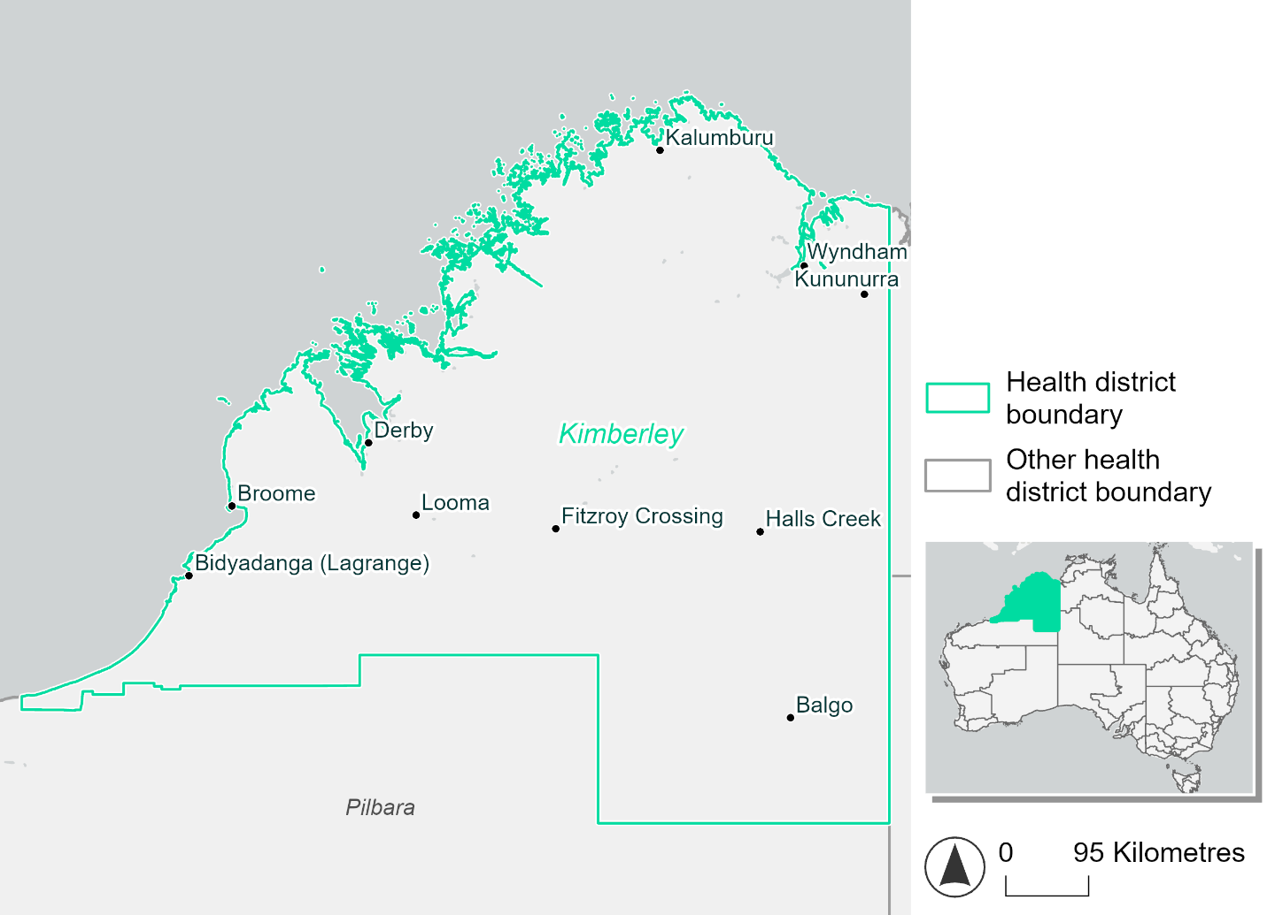
Figure 8 Map of Kimberley health district

How will climate change affect this health district?
Heat and humidity: Higher average temperatures, hotter and more frequent hot days, warmer night time temperatures and longer and more frequent heatwaves.
Fire: Over 20% of this health district experiences a very high fire hazard category and this will increase in the future.
Drought: The number of months experiencing drought will increase.
Rainfall and flood: There will be more flood events in urban areas.
Coastal inundation: The area flooded during tidal, and storm surge and tidal inundation, will increase.

Kimberly health district demographic data
Demographic Data | Total
Number of households | 10,039
Persons 15 and older | 28,162
Total families | 7,597
Persons did not complete high school | 11,569
One parent families with dependents | 1,343 (17.7%)
Persons aged 65 and older | 2,998 (7.7%)
Persons aged 4 and younger | 2,941 (7.6%)
Aboriginal and Torres Strait Islander persons | 14,405 (37%)
Persons speaks language other than English | 7,102 (18.2%)
Persons working age (15-65) | 26,780 (68.8%)
Population Health Data | Total
Persons with core needs for assistance | 1,022 (2.6%)
Persons with arthritis | 1,258 (3.2%)
Persons with asthma | 1,775 (4.6%)
Persons with cancer | 512 (1.3%)
Persons with dementia | 131 (0.3%)
Persons with diabetes | 1,616 (4.2%)
Persons with heart disease | 889 (2.3%)
Persons with kidney disease | 364 (0.9%)
Persons with lung condition | 368 (0.9%)
Persons with mental health condition | 1,567 (4%)
Persons with stroke | 170 (0.4%)
Persons with any other condition | 1,680 (4.3%)
Persons no health condition | 24,159 (62.1%)
Socio-economic Data | Total
Persons providing unpaid care | 3,360 (8.6%)
Persons homeless | 1,032 (2.7%)
Household with lone person | 2,608 (26%)
Households with rent and mortgage stress | 2,609 (26%)
Households total equivalised income below $1000 (weekly) | 3,774 (37.6%)
Households with no motor vehicle | 1,764 (17.6%)
Persons unemployed | 1,854 (6.9%)

The sections that follow outline projected climate hazards for this district. Further information on this health district, including population demographics, is provided in the online dashboard.

Heat and humidity hazard
Key projections:
More heatwaves: Heatwave events are likely to last longer and the number of heatwave events per year will increase. By 2050, under a reasonable worst-case scenario, the number of heatwaves will quadruple. By 2085, under a reasonable worst-case scenario, the number of heatwaves per year will more than quadruple.
Hotter days and warmer nights: The maximum temperature on hot days will increase with night time temperatures on hot nights also increasing.
More days above 35°C and 40°C: The number of days per year greater than 35°C and 40°C will increase under both middle of the road and reasonable worst-case scenarios.

 | Baseline | 2050 Scenarios |  | 2085 Scenarios
 |  | Middle of the road | Reasonable worst-case | Middle of the road | Reasonable worst-case
Average temperature (°C) | 27.3 | 29  [28.5, 29.6] | 29.2  [28.7, 30.1] | 29.9  [29.1, 30.9] | 30.9  [29.9, 32.2]
Maximum temperature on hot days (°C)^{(a)} | 39.8 | 41.4  [40.6, 41.8] | 41.6  [40.8, 42.3] | 42.2  [41.1, 42.9] | 43.2  [41.9, 44.3]
Minimum temperature on hot nights (°C)^{(b)} | 27.1 | 28.6  [28, 29] | 28.9  [28.3, 29.5] | 29.5  [28.6, 30.2] | 30.5  [29.5, 31.5]
Average apparent temperature on hot days (°C) (NOAA Heat Index)^{(c)} | 45.6 | 50.4  [48.6, 52] | 51.2  [49.5, 53.6] | 53.3  [51.3, 56.4] | 57  [54.1, 61]
Average heatwave duration in days^{(d)} | 5 | 9  [7, 11] | 10  [7, 14] | 13  [8, 18] | 18  [12, 27]
Number of heatwaves per year^{(d)} | 2 | 7  [6, 8] | 8  [6, 9] | 8  [7, 9] | 9  [8, 9]
Number of days per year  > 35°C | 146 | 203  [176, 230] | 211  [187, 245] | 233  [205, 267] | 262  [227, 309]
Number of days per year > 40°C | 23 | 53  [36, 69] | 58  [39, 78] | 74  [46, 95] | 101  [64, 143]
Table notes: The heat and humidity hazard uses climate projections from the CMIP6 Global Climate Models [1]. Daily projections of maximum and minimum near-surface temperature and mean relative humidity are used to calculate eight heat and humidity indicators. The primary indicator value reports the median from the nine climate models, with the range reported in square brackets.
Table footnotes: (a) Based on the 95th percentile of daily maximum air temperature. (b) Based on the 95th percentile of daily minimum air temperature, representing the coldest part of the night on very hot nights. (c) The National Oceanic and Atmospheric Administration (NOAA) Heat Index is a measure of how hot it feels when relative humidity is factored in alongside actual air temperature. It is calculated on days with a maximum temperature of 27°C and above. Interpretation of Heat Index values: 27°C to 32°C indicates caution, 33°C to 41°C indicates extreme caution, 42°C to 54°C indicates danger and over 54°C indicates extreme danger. See methodology document for further explanation of Heat Index categories. (d) A heatwave is defined as three or more consecutive days where both daytime and overnight temperatures (daily mean temperatures) are unusually high for the location, based on the Bureau of Meteorology’s Excess Heat Factor method. For this district, an unusually high daily mean temperature is approximately 32.5°C or above.

Fire hazard
Key projections:
Fire hazard evenly spread currently: Under baseline conditions, during a 1-in-20-year fire weather event half (49.4%) of the district area experiences moderate to high fire hazard. 23.5% experiences very high fire hazard, and the remaining 27.2% experiences low hazard. During a more severe 1-in-100-year event, the area experiencing low hazard decreases by 4.9 percentage points and the areas experiencing moderate to high and very high hazard increase by 2.4 and 2.6 percentage points respectively, when compared to the 1-in-20-year event.
Moderate to high hazard to increase slightly: In a future climate across both 2050 and 2085 scenarios, the area experiencing moderate to high fire hazard increases by up to 3.6 percentage points for a 1-in-20-year fire weather event and by up to 3.4 for a 1-in-100-year event, with corresponding decreases in the area experiencing low fire hazard.

 | Baseline | 2050 Scenarios |  | 2085 Scenarios
 |  | Sustainability | Reasonable worst-case | Sustainability | Reasonable worst-case
Hazard for a ‘1-in-20 year’ fire weather event^{(a)}
Proportion (%) of district experiencing ‘Low’ fire hazard | 27.2%  (11,402,376)  ^{(b)} | 26.6%  [25.0%, 28.0%] | 25.7%  [24.6%, 26.5%] | 25.7%  [22.0%, 29.2%] | 23.7%  [21.0%, 25.6%]
Proportion (%) of district experiencing ‘Moderate to High’ fire hazard | 49.4%  (20,705,399)  ^{(b)} | 49.6%  [47.8%, 51.0%] | 50.9%  [50.0%, 52.0%] | 49.9%  [45.7%, 53.2%] | 53.0%  [50.8%, 55.6%]
Proportion (%) of district experiencing ‘Very High’ fire hazard | 23.5%  (9,848,024)^{(b)} | 23.9%  [23.3%, 24.9%] | 23.4%  [22.9%, 23.7%] | 24.4%  [23.0%, 26.9%] | 23.2%  [22.1%, 24.1%]
Hazard for a ‘1-in-100 year’ fire weather event^{(a)}
Proportion (%) of district experiencing ‘Low’ fire hazard | 22.3%  (9,344,694)^{(b)} | 21.7%  [20.3%, 23.1%] | 21.0%  [20.0%, 21.7%] | 20.9%  [17.6%, 24.3%] | 19.1%  [16.9%, 20.8%]
Proportion (%) of district experiencing ‘Moderate to High’ fire hazard | 51.8%  (21,745,405)  ^{(b)} | 52.0%  [50.6%, 53.2%] | 53.2%  [52.4%, 54.4%] | 52.3%  [48.8%, 55.0%] | 55.2%  [53.1%, 58.1%]
Proportion (%) of district experiencing ‘Very High’ fire hazard | 25.9%  (10,865,699)  ^{(b)} | 26.3%  [25.6%, 27.2%] | 25.8%  [25.3%, 26.1%] | 26.8%  [25.3%, 29.0%] | 25.7%  [24.5%, 26.5%]
Table notes: The Fire Hazard uses the National Bushfire Intelligence Capability (NBIC) Phase 2 fire line intensity modelling based on CMIP6 climate projections. Fire Hazard is assessed using the projected Fireline Intensity (FLI) for weather events with two different return intervals (i.e. a 1-in-20-year event and a 1-in-100-year event). FLI considers slope, vegetation and weather to produce a rate of heat output per unit length (kW/m) along a bushfire’s front. Fire hazard is categorized as a low for FLI<4000 kW/m, moderate to high for 4,000 kW/m ≤FLI<12,500kW/m, and very high for FLI≥27,501kW/m. This is broadly consistent with the literature [3]. The assessment considers climate change effects based on changes in fire weather and the associated hazard that is anticipated for a meteorological event of a given return interval. This approach is different to the one adopted for the Flood Hazard, where the event magnitude is given (fixed) and the likelihood of that event varies as a result of climate change. The primary indicator value reports the median from the nine climate models, with the range reported in square brackets.
Table footnotes: (a) The area subject to different categories of fire hazard is determined for a ‘1-in-20 year’ and ‘1-in-100 year’ fire weather event, in current and future climates. Values at year 2050 are interpolated using data from baseline (2025) and 2085, assuming linear change over time. (b) Values in round brackets are the area (ha) of the health district subject to a given fire hazard.

The figures below show the proportion of the health district experiencing different fire hazard categories across different time horizons and climate scenarios during a ‘1-in-20 year’ fire weather event (Figure 9) and a ‘1-in-100 year’ fire weather event (Figure 10).
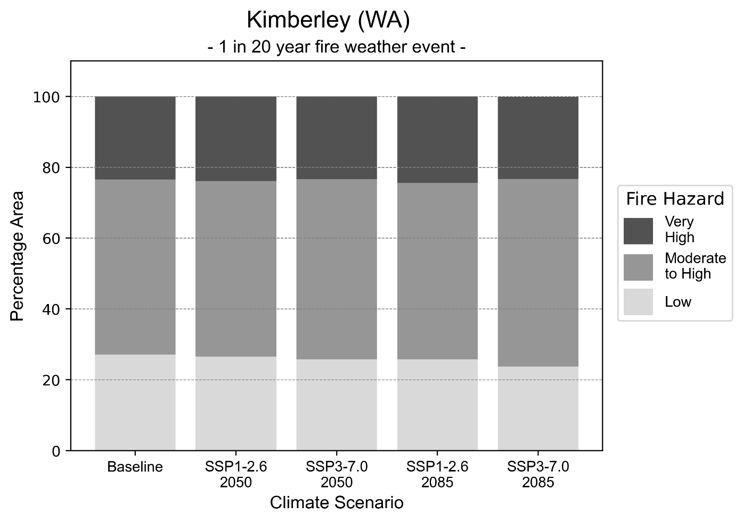
Figure 9: Stacked column chart showing the percentages of the Kimberley health district's total geographic area experiencing each fire hazard level during a 1-in-20-year fire weather event.
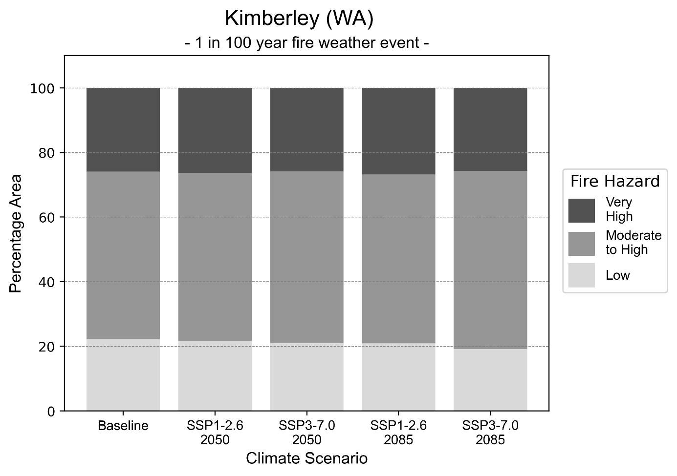
Figure 10: Stacked column chart showing the percentages of the Kimberley health district's total geographic area experiencing each fire hazard level during a 1-in-100-year fire weather event.

Drought hazard
Key projections:
Drought occurrence: The occurrence of drought will increase across both middle of the road and reasonable worst-case scenarios for both time horizons, with the largest increase occurring under the reasonable worst-case scenario by 2085.

 | Baseline | 2050 Scenarios |  | 2085 Scenarios
 |  | Middle of the road | Reasonable worst-case | Middle of the road | Reasonable worst-case
Number of months per year in drought^{(a)} | 1.6 | 2.8  [0.6, 6.7] | 2.5  [0.7, 6.6] | 2.8  [0.6, 7.2] | 3.1  [0.4, 8.0]
Table notes: The drought hazard indicator uses climate projections from the CMIP6 Global Climate Models [1]. The primary indicator value reports the median from the nine climate models, with the range reported in square brackets.
Table footnotes: (a) The number of months per year in drought is based on the Standardised Precipitation Index (SPI). SPI is a widely used index to characterise meteorological drought on a range of timescales. This indicator uses the timescale of 12 months which calculates the average months in a year within the moderate drought range. A moderate drought range is classified as SPI score of ≤ -1. SPI is calculated from accumulated rainfall over 12 months and the mean and standard deviation from historical rainfall records.

Storm hazard
Key projections:
More frequent very-high-intensity storms: The frequency of very-high-intensity storms will increase under the middle of the road scenario across both time horizons but will decrease under the reasonable worst-case scenario across both time horizons.

Baseline |  | 2050 Scenarios |  | 2085 Scenarios
 |  | Middle of the road | Reasonable worst-case | Middle of the road | Reasonable worst-case
Number of low-intensity storms (40-62 km/hr) per year | 78.9 | 72.3  [63.6, 79.5] | 71.8  [63.2, 79.0] | 71.6  [63.0, 78.8] | 73.7  [64.9, 81.1]
Number of medium-intensity storms (63-87 km/hr) per year | 66.9 | 62.4  [54.9, 68.6] | 61.0  [53.7, 67.1] | 57.8  [50.9, 63.6] | 55.6  [49.0, 61.2]
Number of high-intensity storms (88-117 km/hr) per year | 33.5 | 33.1  [29.1, 36.4] | 33.4  [29.4, 36.7] | 31.0  [27.3, 34.1] | 28.4  [25.0, 31.2]
Number of very-high-intensity storm (> 117 km/hr) per year | 3.5 | 4.0  [3.5, 4.4] | 2.9  [2.5, 3.2] | 3.8  [3.3, 4.1] | 3.2  [2.8, 3.5]
Table notes: The storm hazard uses climate projections from the CMIP6 Global Climate Models [1]. Daily maximum surface wind speed is used to calculate the number of annual storms across four storm intensity categories (low, medium, high and very high). The primary indicator value reports the median from the nine climate models, with the range reported in square brackets.

Rainfall and flood hazard
Key projections:
- Fewer extreme rainfall days per year: The number of extreme rainfall days will decrease slightly across both middle of the road and reasonable worst-case scenarios, and both time horizons, with an average of approximately nine extreme rainfall days per year.
- Increased flood frequency: The frequency of flood events will increase in urban environments. The largest increase in flooding is seen in the reasonable worst-case scenario, where the frequency of a ‘1-in-100 year’ flood will become seven times more likely by 2050 and become 22 times more likely by 2085 in urban environments. In rural environments frequency of flood events will increase across 2050 scenarios, but decrease across 2085 scenarios.

 | Baseline | 2050 Scenarios |  | 2085 Scenarios
 |  | Middle of the road | Reasonable worst-case | Middle of the road | Reasonable worst-case
Rainfall hazard^{(a)}
Average number of extreme rainfall days per year (> 10 mm/day)^{(a)} | 9.9 | 8.9  [5.5,12.4] | 9.2  [5.9,11.2] | 9.0  [5.6,11.5] | 8.8  [4.8,12.1]
Urban flood risk (flooding caused by a 1-hour rainfall event)^{(b)}
Frequency of a ‘1-in-1 year’ flood (rainfall depth of 40 mm)^{(c)} |  | 1.9 events in 1 year | 2.0 events in 1 year | 2.4 events in 1 year | 3.0 events in 1 year
Frequency of a ‘1-in-10 year’ flood (rainfall depth of 69 mm)^{(c)} |  | 3.3 events in 10 years | 3.5 events in 10 years | 5.1 events in 10 years | 7.5 events in 10 years
Frequency of a ‘1-in-100 year’ flood (rainfall depth of 94 mm)^{(c)} |  | 6.4 events in 100 years | 7.1 events in 100 years | 12 events in 100 years | 22 events in 100 years
Rural flood risk (flooding caused by a 24-hour rainfall event) ^{(b)}
Frequency of a ‘1-in-1 year’ flood (rainfall depth of 74 mm)^{(c)} |  | 1.5 events in 1 year | 1.2 events in 1 year | 0.9 events in 1 year | 0.8 events in 1 year
Frequency of a ‘1-in-10 year’ flood (rainfall depth of 149 mm)^{(c)} |  | 1.5 events in 10 years | 1.2 events in 10 years | 0.9 events in 10 years | 0.4 events in 10 years
Frequency of a ‘1-in-100 year’ flood (rainfall depth of 246 mm)^{(c)} |  | 1.2 events in 100 years | 1.1 events in 100 years | 0.7 events in 100 years | 0.3 events in 100 years
Table notes: The rainfall hazard indicator uses climate projections from the CMIP6 Global Climate Models [1]. The primary indicator value reports the median from the nine climate models, with the range reported in square brackets. The flood hazard indicators use climate change considerations from the Australian Rainfall and Runoff guideline to estimate the climate projections [2].
Table footnotes: (a) Extreme rainfall is defined as rainfall above the 95th percentile of historical average daily rainfall in this health district in the period 1985-2014. The value in mm/day quoted in the indicator name is the 95th percentile of historic average daily rainfall for this health district. (b) See Methodology document for reasons for focusing on a 1-hour flood for urban areas and a 24-hour flood for rural areas. (c) The rainfall depths in mm quoted in the indicator names in this table report 1 in 1-, 10- and 100-year depths for this health district.

Coastal inundation hazard
Key projections:
Greater area inundated: There will be an increase in the area affected by tidal inundation (i.e. area submerged during high tide) and storm surge and tidal inundation (i.e. the area submerged during a storm surge and high tide) across both middle of the road and reasonable worst-case scenarios. In the reasonable worst-case scenario, by 2085 the area inundated during a ‘1-in-1000-year’ event will increase by over 155,000 ha.

 | Baseline | 2050 Scenarios |  | 2085 Scenarios^{(a)}
 |  | Middle of the road | Reasonable worst-case | Middle of the road | Reasonable worst-case
Tidal inundation (ha inundated)^{(b)} | 329,110.4 | 343,694.2  (+14,583.7) | 344,908.4  (+15,798.0) | 382,247.9  (+53,137.4) | 397,003.6  (+67,893.2)
Storm surge + tidal inundation – ‘1-in-100 year’ event (ha inundated)^{(c)} | 373,083.2 | 393,923.4  (+20,840.2) | 395,506.5  (+22,423.3) | 440,500.5  (+67,417.2) | 455,491.0  (+82,407.8)
Storm surge + tidal inundation – ‘1-in-1000 year’ event (ha inundated)^{(c)} | 466,427.7 | 494,246.5  (+27,818.8) | 496,263.4  (+29,835.7) | 563,363.1  (+96,935.3) | 581,501.9  (+115,074.2)
Table notes: The coastal inundation hazard provides an indication of flooding in coastal areas that can be attributed to sea level rise and storm inundation. The coastal inundation hazard is only reported for health districts adjoining the coastline. This table includes the projected inundation levels as well as the change from baseline conditions (in brackets)
Table footnotes: (a) For the 2085 Scenarios planning horizon, 2100 was adopted as it provides a conservative representation of the end of this period. This horizon aligns with many State planning regulations requiring consideration of sea level rise and storm tide to 2100, making the 2100 scenario particularly valuable for planning new health facilities in coastal areas. (b) The tidal inundation indicator reports the number of hectares inundated during high tide. The baseline value reports existing inundation patterns, while the 2050 and 2085 values report high tide inundation taking account of projected sea level rise due to climate change. (c) The storm surge + tidal inundation indicators report the combined effect, in hectares inundated, of high tide, sea level rise (for the 2050 and 2085 projections), and storm surge (for 1-in-100 year and 1-in-1000-year events).

Mid West health district

Health district overview
Surface area: over 600,000 square kilometres
Estimated population (2020): 61,031
Local health services: The Midwest health region contains a Regional Hospital in Geraldton and a District Hospital in Carnarvon, two Small Hospitals in Exmouth and Meekatharra and 11 Remote Area Nursing Posts/Health Centres.

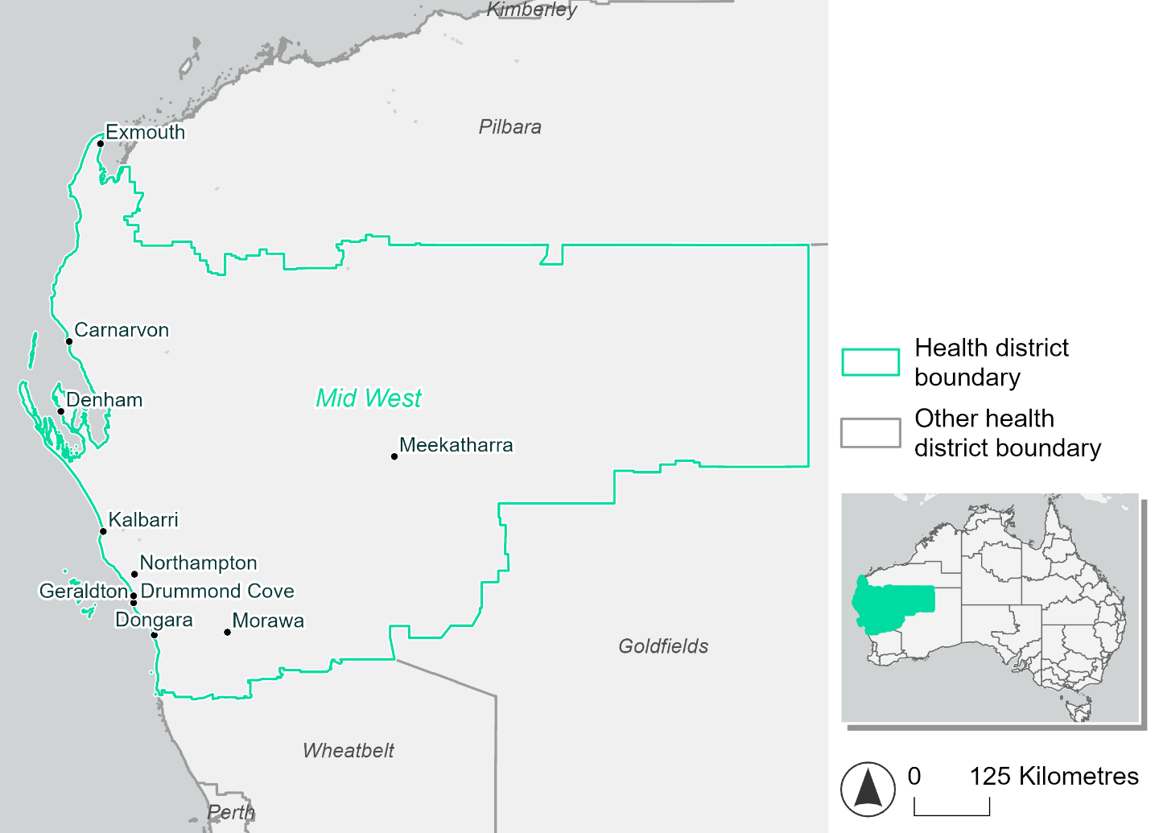
Figure 11. Map of Mid West health district

How will climate change affect this health district?
Heat and humidity: Higher average temperatures, hotter and more frequent hot days, warmer night time temperatures and longer and more frequent heatwaves.
Fire: Over 38% of this health district experiences a very high fire hazard category and this will continue in the future.
Drought: The number of months experiencing drought will increase.
Rainfall and flood: There will be more flood events in urban areas.
Coastal inundation: The area flooded during tidal, and storm surge and tidal inundation, will increase.

Mid West health district demographic data
Demographic Data | Total
Number of households | 22,799
Persons 15 and older | 46,449
Total families | 15,844
Persons did not complete high school | 21,596
One parent families with dependents | 1,755 (11.1%)
Persons aged 65 and older | 12,617 (18.6%)
Persons aged 4 and younger | 3,913 (5.8%)
Aboriginal and Torres Strait Islander persons | 6,348 (9.4%)
Persons speaks language other than English | 4,644 (6.9%)
Persons working age (15-65) | 42,339 (62.5%)
Population Health Data | Total
Persons with core needs for assistance | 3,135 (4.6%)
Persons with arthritis | 5,715 (8.4%)
Persons with asthma | 5,240 (7.7%)
Persons with cancer | 2,042 (3%)
Persons with dementia | 508 (0.8%)
Persons with diabetes | 3,704 (5.5%)
Persons with heart disease | 2,783 (4.1%)
Persons with kidney disease | 789 (1.2%)
Persons with lung condition | 1,373 (2%)
Persons with mental health condition | 5,332 (7.9%)
Persons with stroke | 600 (0.9%)
Persons with any other condition | 4,488 (6.6%)
Persons no health condition | 36,782 (54.3%)
Socio-economic Data | Total
Persons providing unpaid care | 6,867 (10.1%)
Persons homeless | 557 (0.8%)
Household with lone person | 6,656 (29.2%)
Households with rent and mortgage stress | 8,089 (35.5%)
Households total equivalised income below $1000 (weekly) | 10,406 (45.6%)
Households with no motor vehicle | 1,083 (4.8%)
Persons unemployed | 2,539 (4.8%)

The sections that follow outline projected climate hazards for this district. Further information on this health district, including population demographics, is provided in the online dashboard.

Heat and humidity hazard
Key projections:
More heatwaves: Heatwave events are likely to last longer and the number of heatwave events per year will increase. By 2050, under a reasonable worst-case scenario, the number of heatwaves will double. By 2085, under a reasonable worst-case scenario, the number of heatwaves per year will more than triple.
Hotter days and warmer nights: The maximum temperature on hot days will increase with night time temperatures on hot nights also increasing.
More days above 35°C and 40°C: The number of days per year greater than 35°C and 40°C will increase under both middle of the road and reasonable worst-case scenarios.

 | Baseline | 2050 Scenarios |  | 2085 Scenarios
 |  | Middle of the road | Reasonable worst-case | Middle of the road | Reasonable worst-case
Average temperature (°C) | 20.6 | 21.8  [21.4, 22.4] | 22.1  [21.7, 22.7] | 22.7  [22.1, 23.4] | 23.6  [22.8, 24.6]
Maximum temperature on hot days (°C)^{(a)} | 38.4 | 39.7  [39.3, 40.4] | 40  [39.6, 40.9] | 40.6  [40, 41.6] | 41.6  [41, 42.8]
Minimum temperature on hot nights (°C)^{(b)} | 22.5 | 23.8  [23.3, 24.5] | 24  [23.7, 24.6] | 24.7  [24, 25.5] | 25.6  [25, 26.7]
Average apparent temperature on hot days (°C) (NOAA Heat Index)^{(c)} | 37.6 | 38.7  [38.5, 39] | 38.8  [38.4, 39.3] | 39.6  [38.7, 40.6] | 40.3  [39.6, 42]
Average heatwave duration in days^{(d)} | 4 | 5  [5, 6] | 5  [5, 6] | 6  [5, 6] | 6  [6, 7]
Number of heatwaves per year^{(d)} | 2 | 4  [3, 5] | 4  [3, 5] | 5  [4, 6] | 7  [6, 8]
Number of days per year  > 35°C | 50 | 63  [58, 69] | 65  [61, 73] | 72  [66, 82] | 82  [75, 95]
Number of days per year > 40°C | 11 | 19  [16, 24] | 21  [18, 27] | 25  [21, 34] | 33  [28, 44]
Table notes: The heat and humidity hazard uses climate projections from the CMIP6 Global Climate Models [1]. Daily projections of maximum and minimum near-surface temperature and mean relative humidity are used to calculate eight heat and humidity indicators. The primary indicator value reports the median from the nine climate models, with the range reported in square brackets.
Table footnotes: (a) Based on the 95th percentile of daily maximum air temperature. (b) Based on the 95th percentile of daily minimum air temperature, representing the coldest part of the night on very hot nights. (c) The National Oceanic and Atmospheric Administration (NOAA) Heat Index is a measure of how hot it feels when relative humidity is factored in alongside actual air temperature. It is calculated on days with a maximum temperature of 27°C and above. Interpretation of Heat Index values: 27°C to 32°C indicates caution, 33°C to 41°C indicates extreme caution, 42°C to 54°C indicates danger and over 54°C indicates extreme danger. See methodology document for further explanation of Heat Index categories. (d) A heatwave is defined as three or more consecutive days where both daytime and overnight temperatures (daily mean temperatures) are unusually high for the location, based on the Bureau of Meteorology’s Excess Heat Factor method. For this district, an unusually high daily mean temperature is approximately 30.1 °C or above.

Fire hazard
Key projections:
Fire hazard evenly spread currently: Under baseline conditions, 31-32% of the district experiences low fire hazard, 27-29% experiences moderate to high hazard, and 38-41% experiences very high fire hazard.
Current fire hazard conditions to persist: In a future climate across both 2050 and 2085 scenarios, the overall hazard levels remain roughly the same as at baseline, with variation of at most 1.4 percentage points from baseline levels by 2085.

 | Baseline | 2050 Scenarios |  | 2085 Scenarios
 |  | Sustainability | Reasonable worst-case | Sustainability | Reasonable worst-case
Hazard for a ‘1-in-20 year’ fire weather event^{(a)}
Proportion (%) of district experiencing ‘Low’ fire hazard | 32.2%  (19,352,644)^{(b)} | 32.0%  [31.9%, 32.1%] | 31.8%  [31.3%, 32.0%] | 31.9%  [31.6%, 32.1%] | 31.2%  [30.0%, 31.9%]
Proportion (%) of district experiencing ‘Moderate to High’ fire hazard | 29.3%  (17,619,122)^{(b)} | 29.4%  [29.0%, 29.8%] | 29.7%  [29.5%, 30.4%] | 29.5%  [28.6%, 30.6%] | 30.4%  [29.7%, 32.0%]
Proportion (%) of district experiencing ‘Very High’ fire hazard | 38.6%  (23,217,637)^{(b)} | 38.6%  [38.5%, 38.9%] | 38.5%  [38.3%, 38.6%] | 38.7%  [38.3%, 39.3%] | 38.3%  [37.9%, 38.7%]
Hazard for a ‘1-in-100 year’ fire weather event^{(a)}
Proportion (%) of district experiencing ‘Low’ fire hazard | 31.3%  (18,827,995)^{(b)} | 31.1%  [31.0%, 31.2%] | 30.7%  [30.1%, 31.0%] | 30.9%  [30.6%, 31.2%] | 30.0%  [28.5%, 30.7%]
Proportion (%) of district experiencing ‘Moderate to High’ fire hazard | 27.3%  (16,451,383)^{(b)} | 27.4%  [27.0%, 27.8%] | 27.9%  [27.4%, 28.8%] | 27.5%  [26.6%, 28.5%] | 28.7%  [27.4%, 30.9%]
Proportion (%) of district experiencing ‘Very High’ fire hazard | 41.4%  (24,910,025)^{(b)} | 41.5%  [41.3%, 41.7%] | 41.4%  [41.1%, 41.7%] | 41.6%  [41.1%, 42.2%] | 41.3%  [40.7%, 42.1%]
Table notes: The Fire Hazard uses the National Bushfire Intelligence Capability (NBIC) Phase 2 fire line intensity modelling based on CMIP6 climate projections. Fire Hazard is assessed using the projected Fireline Intensity (FLI) for weather events with two different return intervals (i.e. a 1-in-20-year event and a 1-in-100-year event). FLI considers slope, vegetation and weather to produce a rate of heat output per unit length (kW/m) along a bushfire’s front. Fire hazard is categorized as a low for FLI<4000 kW/m, moderate to high for 4,000 kW/m ≤FLI<12,500kW/m, and very high for FLI≥27,501kW/m. This is broadly consistent with the literature [3]. The assessment considers climate change effects based on changes in fire weather and the associated hazard that is anticipated for a meteorological event of a given return interval. This approach is different to the one adopted for the Flood Hazard, where the event magnitude is given (fixed) and the likelihood of that event varies as a result of climate change. The primary indicator value reports the median from the nine climate models, with the range reported in square brackets.
Table footnotes: (a) The area subject to different categories of fire hazard is determined for a ‘1-in-20 year’ and ‘1-in-100 year’ fire weather event, in current and future climates. Values at year 2050 are interpolated using data from baseline (2025) and 2085, assuming linear change over time. (b) Values in round brackets are the area (ha) of the health district subject to a given fire hazard.

The figures below show the proportion of the health district experiencing different fire hazard categories across different time horizons and climate scenarios during a ‘1-in-20 year’ fire weather event (Figure 12) and a ‘1-in-100 year’ fire weather event (Figure 13).

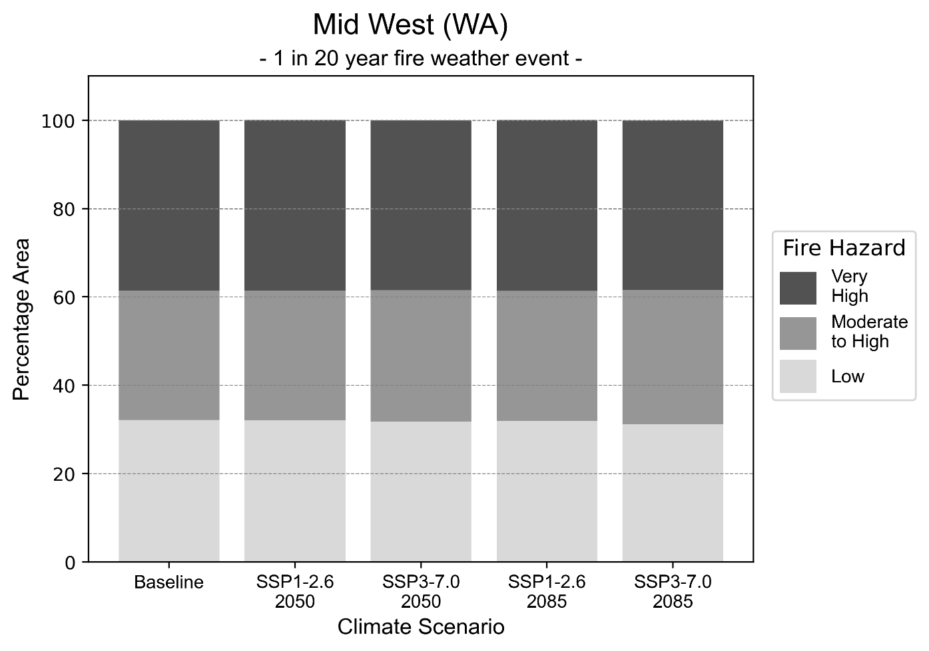
Figure 12: Stacked column chart showing the percentages of the Mid West health district's total geographic area experiencing each fire hazard level during a 1-in-20-year fire weather event.
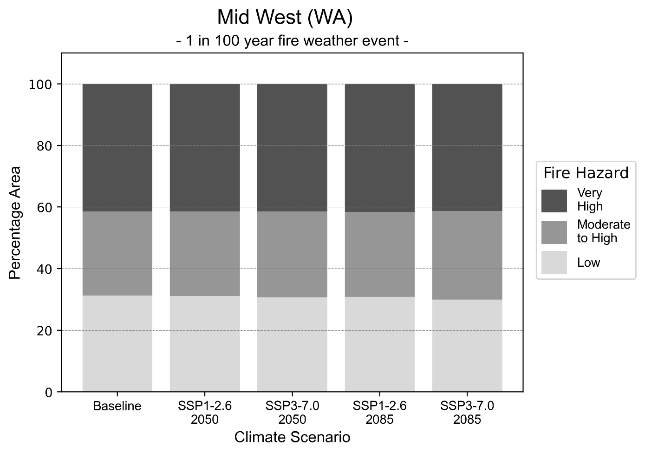
Figure 13: Stacked column chart showing the percentages of the Mid West health district's total geographic area experiencing each fire hazard level during a 1-in-100-year fire weather event.

Drought hazard
Key projections:
Drought occurrence: The occurrence of drought will increase across both middle of the road and reasonable worst-case scenarios for both time horizons, with the largest increase occurring under the reasonable worst-case scenario by 2085.

 | Baseline | 2050 Scenarios |  | 2085 Scenarios
 |  | Middle of the road | Reasonable worst-case | Middle of the road | Reasonable worst-case
Number of months per year in drought^{(a)} | 1.8 | 2.8  [0.3, 4.8] | 2.5  [0.6, 6.5] | 2.9  [0.6, 5.8] | 3.5  [0.2, 7.3]
Table notes: The drought hazard indicator uses climate projections from the CMIP6 Global Climate Models [1]. The primary indicator value reports the median from the nine climate models, with the range reported in square brackets.
Table footnotes: (a) The number of months per year in drought is based on the Standardised Precipitation Index (SPI). SPI is a widely used index to characterise meteorological drought on a range of timescales. This indicator uses the timescale of 12 months which calculates the average months in a year within the moderate drought range. A moderate drought range is classified as SPI score of ≤ -1. SPI is calculated from accumulated rainfall over 12 months and the mean and standard deviation from historical rainfall records.

Storm hazard
Key projections:
Less frequent high and very-high-intensity storms: The frequency of high and very-high-intensity storms will decrease across both middle of the road and reasonable worst-case scenarios, with the greatest decreases occurring by 2085.

 | Baseline | 2050 Scenarios |  | 2085 Scenarios
 |  | Middle of the road | Reasonable worst-case | Middle of the road | Reasonable worst-case
Number of low-intensity storms (40-62 km/hr) per year | 100.1 | 104.2  [91.7, 114.6] | 104.5  [91.9, 114.9] | 105.9  [93.2, 116.5] | 111.5  [98.1, 122.7]
Number of medium-intensity storms (63-87 km/hr) per year | 75.0 | 76.8  [67.6, 84.5] | 75.0  [66.0, 82.5] | 69.7  [61.4, 76.7] | 73.9  [65.0, 81.3]
Number of high-intensity storms (88-117 km/hr) per year | 65.1 | 62.7  [55.1, 68.9] | 63.0  [55.4, 69.3] | 58.6  [51.5, 64.4] | 51.8  [45.6, 57.0]
Number of very-high-intensity storm (> 117 km/hr) per year | 7.9 | 7.8  [6.9, 8.6] | 6.8  [6.0, 7.4] | 7.1  [6.2, 7.8] | 5.8  [5.1, 6.3]
Table notes: The storm hazard uses climate projections from the CMIP6 Global Climate Models [1]. Daily maximum surface wind speed is used to calculate the number of annual storms across four storm intensity categories (low, medium, high and very high). The primary indicator value reports the median from the nine climate models, with the range reported in square brackets.

Rainfall and flood hazard
Key projections:
- Fewer extreme rainfall days per year: The number of extreme rainfall days will slightly decrease across both middle of the road and reasonable worst-case scenarios, and both time horizons, with an average of approximately nine extreme rainfall days per year.
- Increased flood frequency: The frequency of flood events will increase in urban environments but decrease in rural environments. The largest increase in flooding is seen in the reasonable worst-case scenario, where the frequency of a ‘1-in-100 year’ flood will nearly triple by 2050 and become over five times more likely by 2085 in urban environments.

 | Baseline | 2050 Scenarios |  | 2085 Scenarios
 |  | Middle of the road | Reasonable worst-case | Middle of the road | Reasonable worst-case
Rainfall hazard^{(a)}
Average number of extreme rainfall days per year (> 5 mm/day)^{(a)} | 10.1 | 9.6  [7.6,14.8] | 9.7  [6.6,12.6] | 9.4  [6.9,12.7] | 9.0  [6.2,15.6]
Urban flood risk (flooding caused by a 1-hour rainfall event)^{(b)}
Frequency of a ‘1-in-1 year’ flood (rainfall depth of 14 mm)^{(c)} |  | 1.5 events in 1 year | 1.6 events in 1 year | 1.9 events in 1 year | 2.3 events in 1 year
Frequency of a ‘1-in-10 year’ flood (rainfall depth of 34 mm)^{(c)} |  | 2.0 events in 10 years | 2.1 events in 10 years | 2.6 events in 10 years | 3.5 events in 10 years
Frequency of a ‘1-in-100 year’ flood (rainfall depth of 66 mm)^{(c)} |  | 2.5 events in 100 years | 2.6 events in 100 years | 3.5 events in 100 years | 5.5 events in 100 years
Rural flood risk (flooding caused by a 24-hour rainfall event) ^{(b)}
Frequency of a ‘1-in-1 year’ flood (rainfall depth of 36 mm)^{(c)} |  | 1.0 events in 1 year | 0.9 events in 1 year | 0.9 events in 1 year | 0.5 events in 1 year
Frequency of a ‘1-in-10 year’ flood (rainfall depth of 87 mm)^{(c)} |  | 0.9 events in 10 years | 1.0 events in 10 years | 1.0 events in 10 years | 0.4 events in 10 years
Frequency of a ‘1-in-100 year’ flood (rainfall depth of 146 mm)^{(c)} |  | 1.1 events in 100 years | 1.1 events in 100 years | 0.8 events in 100 years | 0.2 events in 100 years
Table notes: The rainfall hazard indicator uses climate projections from the CMIP6 Global Climate Models [1]. The primary indicator value reports the median from the nine climate models, with the range reported in square brackets. The flood hazard indicators use climate change considerations from the Australian Rainfall and Runoff guideline to estimate the climate projections [2].
Table footnotes: (a) Extreme rainfall is defined as rainfall above the 95th percentile of historical average daily rainfall in this health district in the period 1985-2014. The value in mm/day quoted in the indicator name is the 95th percentile of historic average daily rainfall for this health district. (b) See Methodology document for reasons for focusing on a 1-hour flood for urban areas and a 24-hour flood for rural areas. (c) The rainfall depths in mm quoted in the indicator names in this table report 1 in 1-, 10- and 100-year depths for this health district.

Coastal inundation hazard
Key projections:
Greater area inundated: There will be an increase in the area affected by tidal inundation (i.e. area submerged during high tide) and storm surge and tidal inundation (i.e. the area submerged during a storm surge and high tide) across both middle of the road and reasonable worst-case scenarios. In the reasonable worst-case scenario, by 2085 the area inundated during a ‘1-in-1000-year’ event will increase by over 34,000 ha.

 | Baseline | 2050 Scenarios |  | 2085 Scenarios^{(a)}
 |  | Middle of the road | Reasonable worst-case | Middle of the road | Reasonable worst-case
Tidal inundation (ha inundated)^{(b)} | 196,536.3 | 202,797.0  (+6,260.6) | 203,278.0  (+6,741.6) | 216,565.4  (+20,029.1) | 220,554.3  (+24,018.0)
Storm surge + tidal inundation – ‘1-in-100 year’ event (ha inundated)^{(c)} | 240,498.2 | 252,711.8  (+12,213.5) | 253,474.9  (+12,976.7) | 272,951.7  (+32,453.5) | 278,121.0  (+37,622.8)
Storm surge + tidal inundation – ‘1-in-1000 year’ event (ha inundated)^{(c)} | 299,798.1 | 307,811.5  (+8,013.4) | 308,401.7  (+8,603.6) | 327,184.9  (+27,386.8) | 334,196.1  (+34,398.0)
Table notes: The coastal inundation hazard provides an indication of flooding in coastal areas that can be attributed to sea level rise and storm inundation. The coastal inundation hazard is only reported for health districts adjoining the coastline. This table includes the projected inundation levels as well as the change from baseline conditions (in brackets).
Table footnotes: (a) For the 2085 Scenarios planning horizon, 2100 was adopted as it provides a conservative representation of the end of this period. This horizon aligns with many State planning regulations requiring consideration of sea level rise and storm tide to 2100, making the 2100 scenario particularly valuable for planning new health facilities in coastal areas. (b) The tidal inundation indicator reports the number of hectares inundated during high tide. The baseline value reports existing inundation patterns, while the 2050 and 2085 values report high tide inundation taking account of projected sea level rise due to climate change. (c) The storm surge + tidal inundation indicators report the combined effect, in hectares inundated, of high tide, sea level rise (for the 2050 and 2085 projections), and storm surge (for 1-in-100 year and 1-in-1000-year events).

Perth health district

Health district overview
The Perth health district includes the North Metropolitan, South Metropolitan and East Metropolitan Health Services.
Surface area: 10,949 square kilometres
Local health services: The Perth health region contains 14 hospitals, health services and health groups:
Armadale Health Service  Bentley Health Service  Byford Health Hub  Kalamunda Hospital  Royal Perth Hospital  St John of Gold Midland Public Hospital  Sir Charles Gairdner Hospital | Osborne Park Hospital  King Edward Memorial Hospital  Graylands Hospital  Joondalup Health Campus  Fiona Stanley Fremantle Hospitals Group  Peel Health Campus  Rockingham Peel Group

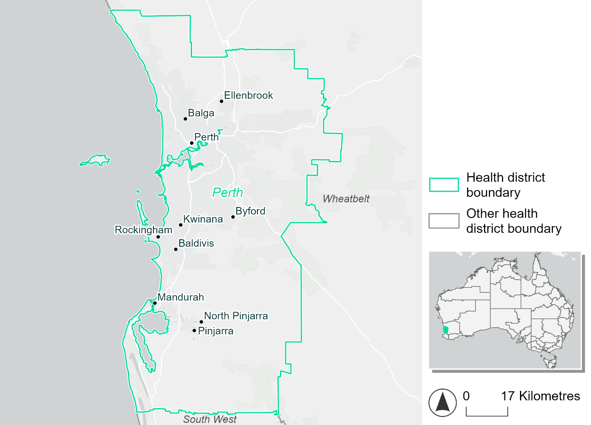
Figure 14. Map of Perth health district.

How will climate change affect this health district?
Heat and humidity: Higher average temperatures, hotter and more frequent hot days, warmer night time temperatures and longer and more frequent heatwaves.
Fire: Over 40% of this health district experiences a very high fire hazard category and this will continue in the future.
Drought: The number of months experiencing drought will increase.
Rainfall and flood: There will be more flood events in urban areas.
Coastal inundation: The area flooded during tidal, and storm surge and tidal inundation, will increase.

Perth health district demographic data
Demographic Data | Total
Number of households | 780,445
Persons 15 and older | 1,562,158
Total families | 571,403
Persons did not complete high school | 490,282
One parent families with dependents | 56,111 (9.8%)
Persons aged 65 and older | 350,774 (15.7%)
Persons aged 4 and younger | 135,615 (6.1%)
Aboriginal and Torres Strait Islander persons | 42,240 (1.9%)
Persons speaks language other than English | 442,461 (19.8%)
Persons working age (15-65) | 1,457,647 (65.3%)
Population Health Data | Total
Persons with core needs for assistance | 97,982 (4.4%)
Persons with arthritis | 165,177 (7.4%)
Persons with asthma | 163,458 (7.3%)
Persons with cancer | 60,472 (2.7%)
Persons with dementia | 14,727 (0.7%)
Persons with diabetes | 96,527 (4.3%)
Persons with heart disease | 78,272 (3.5%)
Persons with kidney disease | 16,602 (0.7%)
Persons with lung condition | 34,110 (1.5%)
Persons with mental health condition | 186,639 (8.4%)
Persons with stroke | 17,521 (0.8%)
Persons with any other condition | 168,834 (7.6%)
Persons no health condition | 1,393,295 (62.5%)
Socio-economic Data | Total
Persons providing unpaid care | 241,698 (10.8%)
Persons homeless | 5,768 (0.3%)
Household with lone person | 194,653 (24.9%)
Households with rent and mortgage stress | 338,221 (43.3%)
Households total equivalised income below $1000 (weekly) | 306,058 (39.2%)
Households with no motor vehicle | 38,191 (4.9%)
Persons unemployed | 92,129 (5.4%)

The sections that follow outline projected climate hazards for this district. Further information on this health district, including population demographics, is provided in the online dashboard.

Heat and humidity hazard
Key projections:
More heatwaves: Heatwave events are likely to last longer and the number of heatwave events per year will increase. By 2050, under a reasonable worst-case scenario, the number of heatwaves will double. By 2085, under a reasonable worst-case scenario, the number of heatwaves per year will more than triple.
Hotter days and warmer nights: The maximum temperature on hot days will increase with night time temperatures on hot nights also increasing.
More days above 35°C and 40°C: The number of days per year greater than 35°C and 40°C will increase under both middle of the road and reasonable worst-case scenarios.

 | Baseline | 2050 Scenarios |  | 2085 Scenarios
 |  | Middle of the road | Reasonable worst-case | Middle of the road | Reasonable worst-case
Average temperature (°C) | 18.6 | 19.8  [19.3, 20.2] | 20  [19.6, 20.5] | 20.6  [20, 21.2] | 21.5  [20.6, 22.3]
Maximum temperature on hot days (°C)^{(a)} | 36.3 | 37.5  [37, 38.3] | 37.8  [37.4, 38.7] | 38.4  [37.9, 39.4] | 39.4  [38.9, 40.6]
Minimum temperature on hot nights (°C)^{(b)} | 20.8 | 22  [21.3, 22.6] | 22.3  [21.7, 22.8] | 23  [22.2, 23.5] | 23.9  [23, 24.8]
Average apparent temperature on hot days (°C) (NOAA Heat Index)^{(c)} | 34.7 | 35.6  [35.5, 36.3] | 35.9  [35.6, 36.6] | 36.5  [35.9, 37.3] | 37.2  [36.6, 38.6]
Average heatwave duration in days^{(d)} | 4 | 5  [5, 5] | 5  [5, 5] | 5  [5, 5] | 6  [5, 7]
Number of heatwaves per year^{(d)} | 2 | 4  [3, 5] | 4  [3, 5] | 5  [4, 7] | 7  [6, 8]
Number of days per year  > 35°C | 28 | 38  [34, 45] | 41  [37, 49] | 47  [42, 56] | 57  [51, 69]
Number of days per year > 40°C | 3 | 7  [5, 9] | 8  [6, 11] | 10  [8, 15] | 15  [12, 23]
Table notes: The heat and humidity hazard uses climate projections from the CMIP6 Global Climate Models [1]. Daily projections of maximum and minimum near-surface temperature and mean relative humidity are used to calculate eight heat and humidity indicators. The primary indicator value reports the median from the nine climate models, with the range reported in square brackets.
Table footnotes: (a) Based on the 95th percentile of daily maximum air temperature. (b) Based on the 95th percentile of daily minimum air temperature, representing the coldest part of the night on very hot nights. (c) The National Oceanic and Atmospheric Administration (NOAA) Heat Index is a measure of how hot it feels when relative humidity is factored in alongside actual air temperature. It is calculated on days with a maximum temperature of 27°C and above. Interpretation of Heat Index values: 27°C to 32°C indicates caution, 33°C to 41°C indicates extreme caution, 42°C to 54°C indicates danger and over 54°C indicates extreme danger. See methodology document for further explanation of Heat Index categories. (d) A heatwave is defined as three or more consecutive days where both daytime and overnight temperatures (daily mean temperatures) are unusually high for the location, based on the Bureau of Meteorology’s Excess Heat Factor method. For this district, an unusually high daily mean temperature is approximately 28.3°C or above.

Fire hazard
Key projections:
Majority of district area experiences moderate to very high hazard: Under baseline conditions, 14.3% of the district experiences low hazard during a 1-in-20-year fire weather event. During this event type, 44.7% of the district experiences moderate to high hazard and 41.0% experiences very high fire hazard. During a 1-in-100-year fire weather event, the low fire hazard area decreases to 13.3% of the district and the moderate to high hazard area reduces to 39.0% of the district. 47.8% of the district experiences very high fire hazard during this more severe event type.
Current hazard levels to persist depending on emissions: In a future climate the distribution of hazard levels changes very little under the sustainability scenario, with maximum variation of 1 percentage point in the area of each hazard level for each fire weather event type. In the reasonable worst-case emissions scenario, the very high hazard area is slightly smaller than it is in the sustainability scenario. By 2085, for a 1-in-20-year fire weather event the area experiencing very high fire hazard is 1.2 percentage points less than in the sustainability scenario. For a 1-in-100-year fire weather event, this difference increases to 3.5 percentage points.

 | Baseline | 2050 Scenarios |  | 2085 Scenarios
 |  | Sustainability | Reasonable worst-case | Sustainability | Reasonable worst-case
Hazard for a ‘1-in-20 year’ fire weather event^{(a)}
Proportion (%) of district experiencing ‘Low’ fire hazard | 14.3%  (115,895)^{(b)} | 14.0%  [13.6%, 14.6%] | 14.2%  [13.2%, 17.7%] | 13.5%  [12.6%, 14.9%] | 14.1%  [11.7%, 22.5%]
Proportion (%) of district experiencing ‘Moderate to High’ fire hazard | 44.7%  (362,058)^{(b)} | 44.6%  [42.8%, 46.7%] | 44.9%  [43.0%, 51.5%] | 44.4%  [40.2%, 49.5%] | 45.2%  [40.5%, 60.9%]
Proportion (%) of district experiencing ‘Very High’ fire hazard | 41.0%  (331,895)^{(b)} | 41.4%  [38.7%, 43.5%] | 40.9%  [30.8%, 43.5%] | 42.0%  [35.6%, 47.0%] | 40.8%  [16.5%, 47.1%]
Hazard for a ‘1-in-100 year’ fire weather event^{(a)}
Proportion (%) of district experiencing ‘Low’ fire hazard | 13.3%  (107,601)^{(b)} | 12.9%  [12.5%, 13.5%] | 13.1%  [12.2%, 16.3%] | 12.4%  [11.4%, 13.9%] | 12.9%  [10.6%, 20.6%]
Proportion (%) of district experiencing ‘Moderate to High’ fire hazard | 39.0%  (315,523)^{(b)} | 39.1%  [37.2%, 40.7%] | 40.4%  [37.9%, 48.0%] | 39.4%  [34.8%, 43.1%] | 42.5%  [36.3%, 60.7%]
Proportion (%) of district experiencing ‘Very High’ fire hazard | 47.8%  (386,724)^{(b)} | 47.9%  [46.0%, 48.6%] | 46.4%  [35.6%, 48.7%] | 48.1%  [43.5%, 49.8%] | 44.6%  [18.7%, 50.1%]
Table notes: The Fire Hazard uses the National Bushfire Intelligence Capability (NBIC) Phase 2 fire line intensity modelling based on CMIP6 climate projections. Fire Hazard is assessed using the projected Fireline Intensity (FLI) for weather events with two different return intervals (i.e. a 1-in-20-year event and a 1-in-100-year event). FLI considers slope, vegetation and weather to produce a rate of heat output per unit length (kW/m) along a bushfire’s front. Fire hazard is categorized as a low for FLI<4000 kW/m, moderate to high for 4,000 kW/m ≤FLI<12,500kW/m, and very high for FLI≥27,501kW/m. This is broadly consistent with the literature [3]. The assessment considers climate change effects based on changes in fire weather and the associated hazard that is anticipated for a meteorological event of a given return interval. This approach is different to the one adopted for the Flood Hazard, where the event magnitude is given (fixed) and the likelihood of that event varies as a result of climate change. The primary indicator value reports the median from the nine climate models, with the range reported in square brackets.
Table footnotes: (a) The area subject to different categories of fire hazard is determined for a ‘1-in-20 year’ and ‘1-in-100 year’ fire weather event, in current and future climates. Values at year 2050 are interpolated using data from baseline (2025) and 2085, assuming linear change over time. (b) Values in round brackets are the area (ha) of the health district subject to a given fire hazard.

The figures below show the proportion of the health district experiencing different fire hazard categories across different time horizons and climate scenarios during a ‘1-in-20 year’ fire weather event (Figure 15) and a ‘1-in-100 year’ fire weather event (Figure 16).
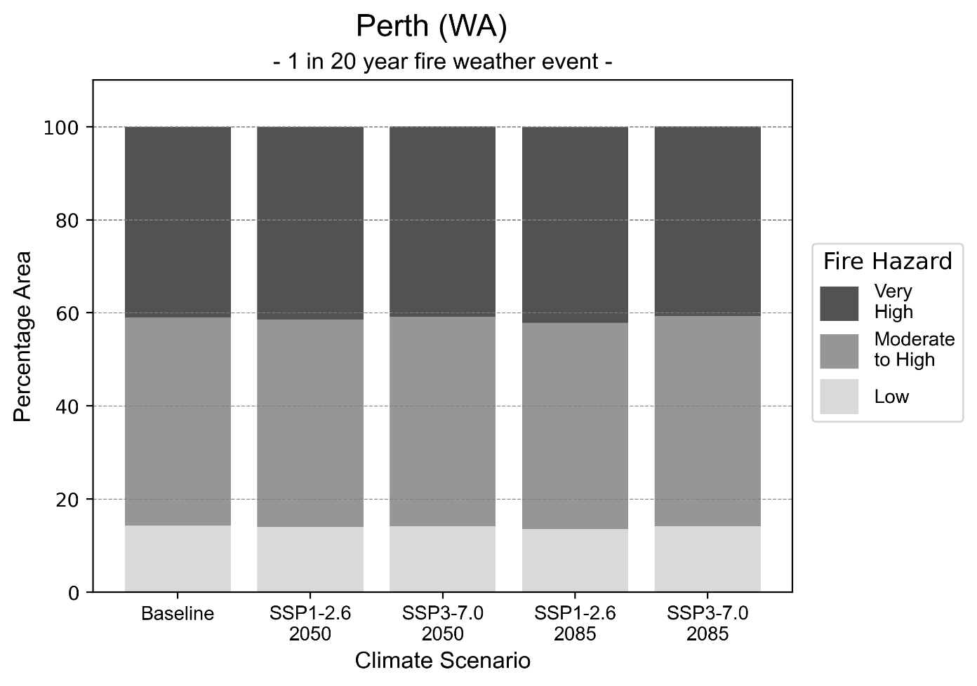
Figure 15: Stacked column chart showing the percentages of the Perth health district's total geographic area experiencing each fire hazard level during a 1-in-20-year fire weather event.
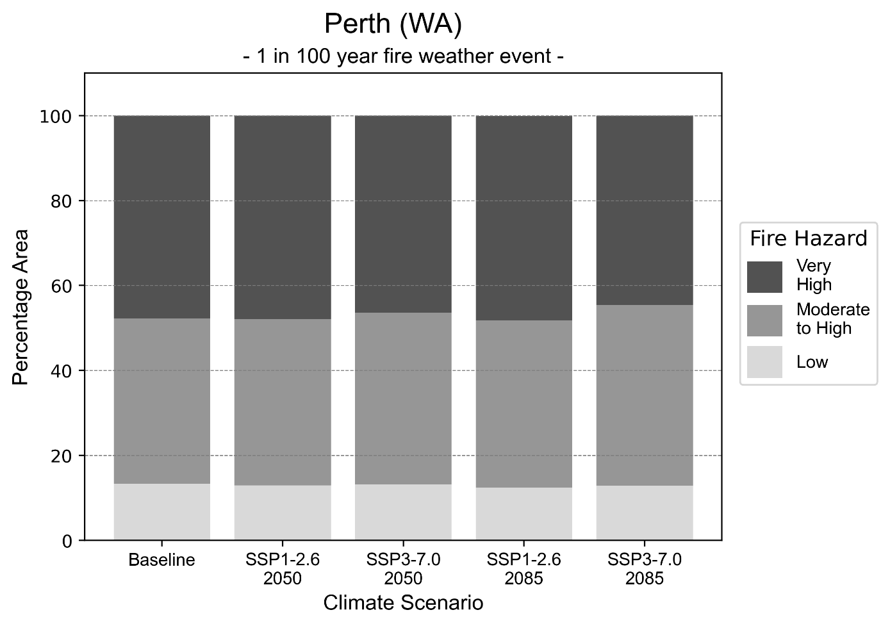
Figure 16: Stacked column chart showing the percentages of the Perth health district's total geographic area experiencing each fire hazard level during a 1-in-100-year fire weather event.

Drought hazard
Key projections:
Drought occurrence: The occurrence of drought will increase across both middle of the road and reasonable worst-case scenarios for both time horizons, with the largest increase occurring under the reasonable worst-case scenario by 2085.

 | Baseline | 2050 Scenarios |  | 2085 Scenarios
 |  | Middle of the road | Reasonable worst-case | Middle of the road | Reasonable worst-case
Number of months per year in drought^{(a)} | 1.7 | 4.9  [2.0, 7.0] | 5.0  [2.4, 7.1] | 5.6  [3.1, 8.3] | 7.5  [4.6, 10.4]
Table notes: The drought hazard indicator uses climate projections from the CMIP6 Global Climate Models [1]. The primary indicator value reports the median from the nine climate models, with the range reported in square brackets.
Table footnotes: (a) The number of months per year in drought is based on the Standardised Precipitation Index (SPI). SPI is a widely used index to characterise meteorological drought on a range of timescales. This indicator uses the timescale of 12 months which calculates the average months in a year within the moderate drought range. A moderate drought range is classified as SPI score of ≤ -1. SPI is calculated from accumulated rainfall over 12 months and the mean and standard deviation from historical rainfall records.

Storm hazard
Key projections:
Less frequent high and very-high-intensity storms: The frequency of high and very-high-intensity storms will decrease across both middle of the road and reasonable worst-case scenarios, with the greatest decreases occurring by 2085.

 | Baseline | 2050 Scenarios |  | 2085 Scenarios
 |  | Middle of the road | Reasonable worst-case | Middle of the road | Reasonable worst-case
Number of low-intensity storms (40-62 km/hr) per year | 74.6 | 73.2  [64.4, 80.5] | 75.5  [66.4, 83.0] | 71.5  [62.9, 78.7] | 72.5  [63.8, 79.8]
Number of medium-intensity storms (63-87 km/hr) per year | 67.3 | 69.6  [61.2, 76.5] | 70.5  [62.1, 77.6] | 67.1  [59.0, 73.8] | 72.8  [64.0, 80.0]
Number of high-intensity storms (88-117 km/hr) per year | 30.9 | 29.8  [26.3, 32.8] | 29.1  [25.6, 32.0] | 26.5  [23.3, 29.1] | 28.7  [25.3, 31.6]
Number of very-high-intensity storm (> 117 km/hr) per year | 11.4 | 10.7  [9.4, 11.8] | 9.1  [8.0, 10.0] | 9.1  [8.0, 10.0] | 7.3  [6.4, 8.0]
Table notes: The storm hazard uses climate projections from the CMIP6 Global Climate Models [1]. Daily maximum surface wind speed is used to calculate the number of annual storms across four storm intensity categories (low, medium, high and very high). The primary indicator value reports the median from the nine climate models, with the range reported in square brackets.

Rainfall and flood hazard
Key projections:
- Less extreme rainfall days per year: The number of extreme rainfall days will decrease across both middle of the road and reasonable worst-case scenarios, and both time horizons, with the greatest decrease occurring under the reasonable worst-case scenario by 2085.
- Increased flood frequency: The frequency of flood events will increase in urban environments but decrease in rural environments. The largest increase in flooding is seen in the reasonable worst-case scenario, where the frequency of a ‘1-in-100 year’ flood will more than quadruple by 2050 and become 13 times more likely by 2085 in urban environments.

 | Baseline | 2050 Scenarios |  | 2085 Scenarios
 |  | Middle of the road | Reasonable worst-case | Middle of the road | Reasonable worst-case
Rainfall hazard^{(a)}
Average number of extreme rainfall days per year (> 10 mm/day)⁽¹⁾ | 10.9 | 8.5  [7.3,10.7] | 8.4  [7.2,9.9] | 8.1  [6.8,9.8] | 7.1  [5.7,8.8]
Urban flood risk (flooding caused by a 1-hour rainfall event)^{(b)}
Frequency of a ‘1-in-1 year’ flood (rainfall depth of 18 mm)^{(c)} |  | 2.2 events in 1 year | 2.3 events in 1 year | 3.0 events in 1 year | 4.2 events in 1 year
Frequency of a ‘1-in-10 year’ flood (rainfall depth of 30 mm)^{(c)} |  | 3.4 events in 10 years | 3.7 events in 10 years | 5.5 events in 10 years | 8.5 events in 10 years
Frequency of a ‘1-in-100 year’ flood (rainfall depth of 45 mm)^{(c)} |  | 3.9 events in 100 years | 4.2 events in 100 years | 6.7 events in 100 years | 13 events in 100 years
Rural flood risk (flooding caused by a 24-hour rainfall event)^{(b)}
Frequency of a ‘1-in-1 year’ flood (rainfall depth of 54 mm)^{(c)} |  | 0.9 events in 1 year | 0.8 events in 1 year | 0.8 events in 1 year | 0.3 events in 1 year
Frequency of a ‘1-in-10 year’ flood (rainfall depth of 90 mm)^{(c)} |  | 0.8 events in 10 years | 1.0 events in 10 years | 0.8 events in 10 years | 0.2 events in 10 years
Frequency of a ‘1-in-100 year’ flood (rainfall depth of 143 mm)^{(c)} |  | 0.9 events in 100 years | 0.9 events in 100 years | 0.8 events in 100 years | 0.2 events in 100 years
Table notes: The rainfall hazard indicator uses climate projections from the CMIP6 Global Climate Models [1]. The primary indicator value reports the median from the nine climate models, with the range reported in square brackets. The flood hazard indicators use climate change considerations from the Australian Rainfall and Runoff guideline to estimate the climate projections [2].
Table footnotes: (a) Extreme rainfall is defined as rainfall above the 95th percentile of historical average daily rainfall in this health district in the period 1985-2014. The value in mm/day quoted in the indicator name is the 95th percentile of historic average daily rainfall for this health district. (b) See Methodology document for reasons for focusing on a 1-hour flood for urban areas and a 24-hour flood for rural areas. (c) The rainfall depths in mm quoted in the indicator names in this table report 1 in 1-, 10- and 100-year depths for this health district.

Coastal inundation hazard
Key projections:
Greater area inundated: There will be an increase in the area affected by tidal inundation (i.e. area submerged during high tide) and storm surge and tidal inundation (i.e. the area submerged during a storm surge and high tide) across both middle of the road and reasonable worst-case scenarios. In the reasonable worst-case scenario, by 2085 the area inundated during a ‘1-in-1000-year’ event will increase by over 6,000 ha.

 | Baseline | 2050 Scenarios |  | 2085^{(a)} Scenarios
 |  | Middle of the road | Reasonable worst-case | Middle of the road | Reasonable worst-case
Tidal inundation (ha inundated)^{(b)} | 6,543.5 | 7,868.1  (+1,324.5) | 7,957.1  (+1,413.6) | 10,550.7  (+4,007.1) | 11,470.0  (+4,926.4)
Storm surge + tidal inundation – ‘1-in-100 year’ event (ha inundated)^{(c)} | 10,016.6 | 11,655.4  (+1,638.8) | 11,760.8  (+1,744.2) | 14,410.1  (+4,393.5) | 15,231.5  (+5,214.9)
Storm surge + tidal inundation – ‘1-in-1000 year’ event (ha inundated)^{(c)} | 10,325.5 | 11,937.1  (+1,611.5) | 12,038.5  (+1,713.0) | 15,448.2  (+5,122.6) | 16,360.8  (+6,035.3)
Table notes: The coastal inundation hazard provides an indication of flooding in coastal areas that can be attributed to sea level rise and storm inundation. The coastal inundation hazard is only reported for health districts adjoining the coastline. This table includes the projected inundation levels as well as the change from baseline conditions (in brackets).
Table footnotes: (a) For the 2085 Scenarios planning horizon, 2100 was adopted as it provides a conservative representation of the end of this period. This horizon aligns with many State planning regulations requiring consideration of sea level rise and storm tide to 2100, making the 2100 scenario particularly valuable for planning new health facilities in coastal areas. (b) The tidal inundation indicator reports the number of hectares inundated during high tide. The baseline value reports existing inundation patterns, while the 2050 and 2085 values report high tide inundation taking account of projected sea level rise due to climate change. (c) The storm surge + tidal inundation indicators report the combined effect, in hectares inundated, of high tide, sea level rise (for the 2050 and 2085 projections), and storm surge (for 1-in-100 year and 1-in-1000-year events).

Pilbara health district

Health district overview
Surface area: 507,896 square kilometres
Estimated population (2020): 62,841
Local health services: The Pilbara health region contains nine hospitals and health services: Karratha Health Campus, Roebourne Hospital, Onslow Health Service, Paraburdoo Hospital, Tom Price Hospital, Newman Health Service, Marble Bar Nursing Post, Nullagine Nursing Post, Hedland Health Campus.

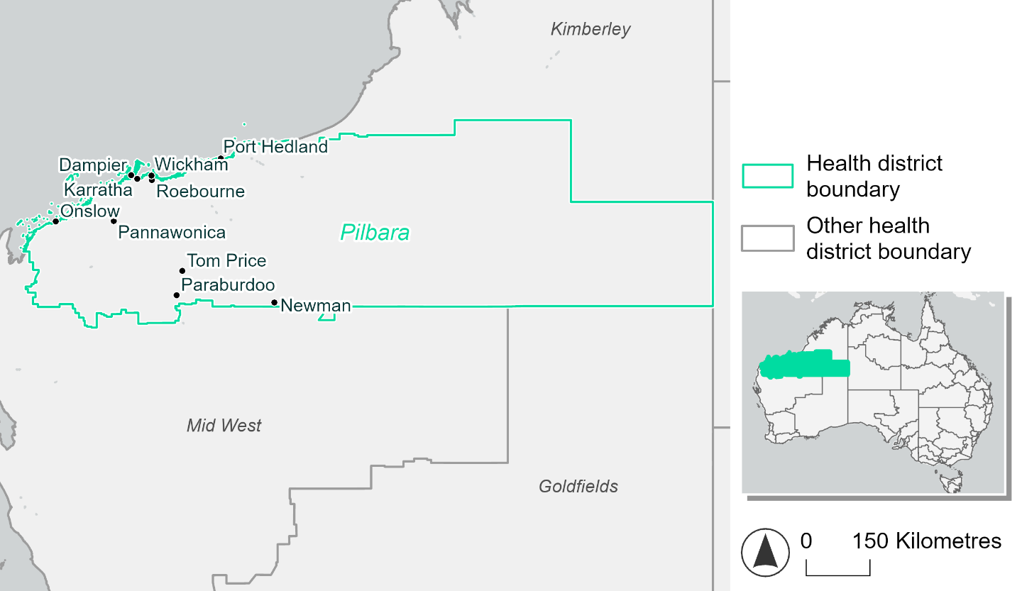
Figure 17. Map of Pilbara health district

How will climate change affect this health district?
Heat and humidity: Higher average temperatures, hotter and more frequent hot days, warmer night time temperatures and longer and more frequent heatwaves.
Fire: Over 40% of this health district experiences a very high fire hazard category and this will continue in the future.
Drought: The number of months experiencing drought will increase.
Rainfall and flood: There will be more flood events in urban areas.
Coastal inundation: The area flooded during tidal, and storm surge and tidal inundation, will increase.

Pilbara health district demographic data
Demographic Data | Total
Number of households | 14,395
Persons 15 and older | 44,302
Total families | 10,785
Persons did not complete high school | 15,133
One parent families with dependents | 969 (9%)
Persons aged 65 and older | 2,026 (3.4%)
Persons aged 4 and younger | 4,811 (8.2%)
Aboriginal and Torres Strait Islander persons | 8,034 (13.6%)
Persons speaks language other than English | 7,911 (13.4%)
Persons working age (15-65) | 43,191 (73.3%)
Population Health Data | Total
Persons with core needs for assistance | 877 (1.5%)
Persons with arthritis | 1,602 (2.7%)
Persons with asthma | 3,282 (5.6%)
Persons with cancer | 580 (1%)
Persons with dementia | 72 (0.1%)
Persons with diabetes | 1,672 (2.8%)
Persons with heart disease | 800 (1.4%)
Persons with kidney disease | 206 (0.3%)
Persons with lung condition | 311 (0.5%)
Persons with mental health condition | 2,716 (4.6%)
Persons with stroke | 142 (0.2%)
Persons with any other condition | 2,295 (3.9%)
Persons no health condition | 36,635 (62.2%)
Socio-economic Data | Total
Persons providing unpaid care | 3,407 (5.8%)
Persons homeless | 586 (1%)
Household with lone person | 3,437 (23.9%)
Households with rent and mortgage stress | 2,508 (17.4%)
Households total equivalised income below $1000 (weekly) | 2,259 (15.7%)
Households with no motor vehicle | 690 (4.8%)
Persons unemployed | 1,358 (3.2%)

The sections that follow outline projected climate hazards for this district. Further information on this health district, including population demographics, is provided in the online dashboard.

Heat and humidity hazard
Key projections:
More heatwaves: Heatwave events are likely to last longer and the number of heatwave events per year will increase. By 2050, under a reasonable worst-case scenario, the number of heatwaves will more than triple. By 2085, under a reasonable worst-case scenario, the number of heatwaves per year will more than quadruple.
Hotter days and warmer nights: The maximum temperature on hot days will increase with night time temperatures on hot nights also increasing.
More days above 35°C and 40°C: The number of days per year greater than 35°C and 40°C will increase under both middle of the road and reasonable worst-case scenarios.

 | Baseline | 2050 Scenarios |  | 2085 Scenarios
 |  | Middle of the road | Reasonable worst-case | Middle of the road | Reasonable worst-case
Average temperature (°C) | 25.9 | 27.5  [26.9, 28] | 27.7  [27.2, 28.5] | 28.4  [27.7, 29.3] | 29.5  [28.7, 30.7]
Maximum temperature on hot days (°C)^{(a)} | 41.4 | 42.9  [42.2, 43.4] | 43.2  [42.6, 44] | 43.8  [43.1, 44.6] | 45  [43.9, 46]
Minimum temperature on hot nights (°C)^{(b)} | 26.5 | 28  [27.5, 28.4] | 28.3  [27.8, 28.8] | 28.9  [28.2, 29.6] | 30  [29.1, 30.9]
Average apparent temperature on hot days (°C) (NOAA Heat Index)^{(c)} | 42 | 45.1  [44, 45.9] | 45.6  [44.6, 47] | 47.1  [45.9, 49.2] | 49.7  [48, 52.7]
Average heatwave duration in days^{(d)} | 4 | 6  [5, 7] | 7  [6, 9] | 8  [7, 11] | 11  [8, 16]
Number of heatwaves per year^{(d)} | 2 | 6  [5, 7] | 7  [5, 8] | 8  [7, 9] | 9  [9, 10]
Number of days per year > 35°C | 147 | 182  [160, 199] | 188  [170, 206] | 202  [183, 223] | 225  [197, 256]
Number of days per year > 40°C | 39 | 68  [52, 79] | 74  [57, 92] | 89  [70, 110] | 114  [85, 148]
Table notes: The heat and humidity hazard uses climate projections from the CMIP6 Global Climate Models [1]. Daily projections of maximum and minimum near-surface temperature and mean relative humidity are used to calculate eight heat and humidity indicators. The primary indicator value reports the median from the nine climate models, with the range reported in square brackets.
Table footnotes: (a) Based on the 95th percentile of daily maximum air temperature. (b) Based on the 95th percentile of daily minimum air temperature, representing the coldest part of the night on very hot nights. (c) The National Oceanic and Atmospheric Administration (NOAA) Heat Index is a measure of how hot it feels when relative humidity is factored in alongside actual air temperature. It is calculated on days with a maximum temperature of 27°C and above. Interpretation of Heat Index values: 27°C to 32°C indicates caution, 33°C to 41°C indicates extreme caution, 42°C to 54°C indicates danger and over 54°C indicates extreme danger. See methodology document for further explanation of Heat Index categories. (d) A heatwave is defined as three or more consecutive days where both daytime and overnight temperatures (daily mean temperatures) are unusually high for the location, based on the Bureau of Meteorology’s Excess Heat Factor method. For this district, an unusually high daily mean temperature is approximately 33.3°C or above.

Fire hazard
Key projections:
Majority of district experiences moderate to very high fire hazard: Under baseline conditions, 12% of the district area experiences low fire hazard. 43-46% experiences moderate to high hazard, and the remaining 41-45% experiences very high fire hazard.
Current fire hazard conditions to persist: In a future climate across both 2050 and 2085 scenarios, the areas experiencing each of the fire hazard levels remain within 1.1 percentage points of their baseline levels for both the 1-in-20-year and the 1-in-100-year fire weather events.
 | Baseline | 2050 Scenarios |  | 2085 Scenarios
 |  | Sustainability | Reasonable worst-case | Sustainability | Reasonable worst-case
Hazard for a ‘1-in-20 year’ fire weather event^{(a)}
Proportion (%) of district experiencing ‘Low’ fire hazard | 12.3%  (6,247,257)^{(b)} | 12.2%  [12.0%, 12.3%] | 12.1%  [12.0%, 12.3%] | 11.9%  [11.4%, 12.2%] | 11.8%  [11.5%, 12.2%]
Proportion (%) of district experiencing ‘Moderate to High’ fire hazard | 46.6%  (23,560,374)^{(b)} | 46.3%  [45.7%, 46.9%] | 46.6%  [45.9%, 47.5%] | 46.0%  [44.4%, 47.4%] | 46.7%  [44.9%, 48.7%]
Proportion (%) of district experiencing ‘Very High’ fire hazard | 41.1%  (20,780,351)^{(b)} | 41.5%  [41.0%, 42.2%] | 41.2%  [40.8%, 41.9%] | 42.1%  [40.9%, 43.8%] | 41.4%  [40.3%, 43.1%]
Hazard for a ‘1-in-100 year’ fire weather event^{(a)}
Proportion (%) of district experiencing ‘Low’ fire hazard | 11.9%  (6,000,938)^{(b)} | 11.7%  [11.4%, 11.8%] | 11.6%  [11.5%, 11.8%] | 11.4%  [10.8%, 11.7%] | 11.3%  [10.9%, 11.7%]
Proportion (%) of district experiencing ‘Moderate to High’ fire hazard | 43.0%  (21,766,919)^{(b)} | 42.7%  [42.0%, 43.4%] | 43.1%  [42.3%, 43.9%] | 42.3%  [40.6%, 43.9%] | 43.1%  [41.4%, 45.1%]
Proportion (%) of district experiencing ‘Very High’ fire hazard | 45.1%  (22,820,125)^{(b)} | 45.6%  [45.1%, 46.4%] | 45.3%  [44.7%, 45.9%] | 46.2%  [45.2%, 48.1%] | 45.6%  [44.2%, 47.1%]
Table notes: The Fire Hazard uses the National Bushfire Intelligence Capability (NBIC) Phase 2 fire line intensity modelling based on CMIP6 climate projections. Fire Hazard is assessed using the projected Fireline Intensity (FLI) for weather events with two different return intervals (i.e. a 1-in-20 year event and a 1-in-100 year event). FLI considers slope, vegetation and weather to produce a rate of heat output per unit length (kW/m) along a bushfire’s front. Fire hazard is categorized as a low for FLI<4000 kW/m, moderate to high for 4,000 kW/m ≤FLI<12,500kW/m, and very high for FLI≥27,501kW/m. This is broadly consistent with the literature [3]. The assessment considers climate change effects based on changes in fire weather and the associated hazard that is anticipated for a meteorological event of a given return interval. This approach is different to the one adopted for the Flood Hazard, where the event magnitude is given (fixed) and the likelihood of that event varies as a result of climate change. The primary indicator value reports the median from the nine climate models, with the range reported in square brackets.
Table footnotes: (a) The area subject to different categories of fire hazard is determined for a ‘1-in-20 year’ and ‘1-in-100 year’ fire weather event, in current and future climates. Values at year 2050 are interpolated using data from baseline (2025) and 2085, assuming linear change over time. (b) Values in round brackets are the area (ha) of the health district subject to a given fire hazard.

The figures below show the proportion of the health district experiencing different fire hazard categories across different time horizons and climate scenarios during a ‘1-in-20 year’ fire weather event (Figure 18) and a ‘1-in-100 year’ fire weather event (Figure 19).
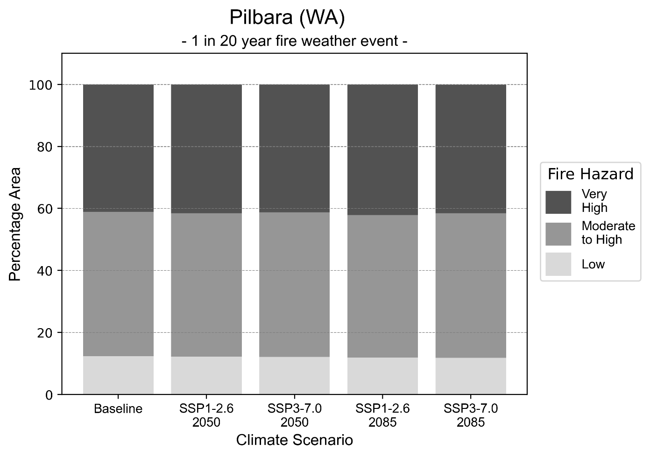
Figure 18: Stacked column chart showing the percentages of the Pilbara health district's total geographic area experiencing each fire hazard level during a 1-in-20-year fire weather event.
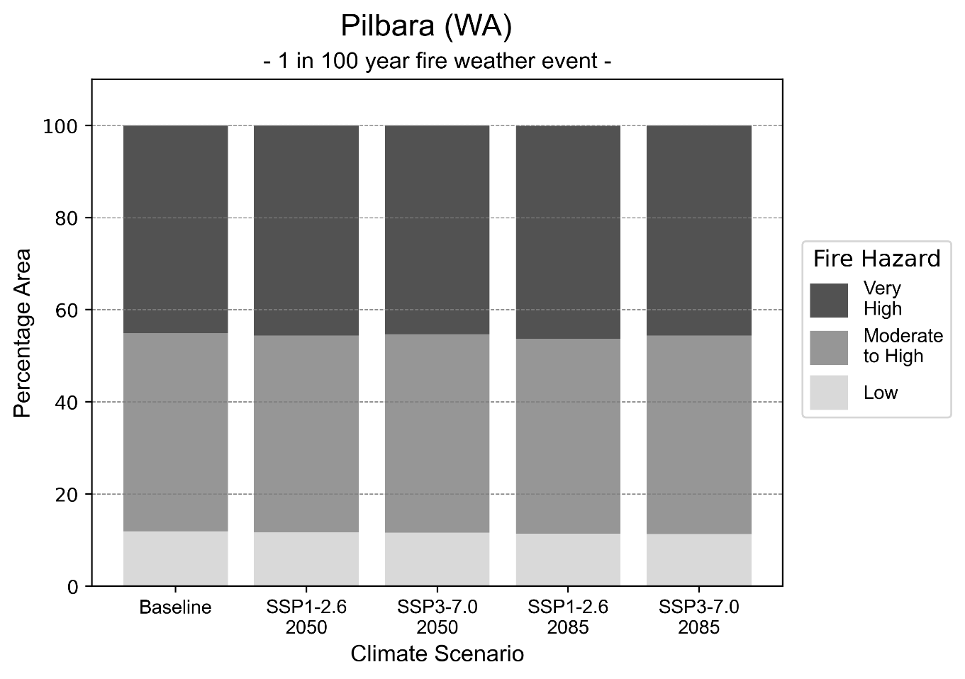
Figure 19: Stacked column chart showing the percentages of the Pilbara health district's total geographic area experiencing each fire hazard level during a 1-in-100-year fire weather event.

Drought hazard
Key projections:
Drought occurrence: The occurrence of drought will increase across both middle of the road and reasonable worst-case scenarios for both time horizons, with the largest increase occurring under the reasonable worst-case scenario by 2085.

 | Baseline | 2050 Scenarios |  | 2085 Scenarios
 |  | Middle of the road | Reasonable worst-case | Middle of the road | Reasonable worst-case
Number of months per year in drought^{(a)} | 1.6 | 2.5  [0.2, 5.3] | 2.3  [0.3, 6.3] | 2.6  [0.3, 6.0] | 3.0  [0.1, 7.2]
Table notes: The drought hazard indicator uses climate projections from the CMIP6 Global Climate Models [1]. The primary indicator value reports the median from the nine climate models, with the range reported in square brackets.
Table footnotes: (a) The number of months per year in drought is based on the Standardised Precipitation Index (SPI). SPI is a widely used index to characterise meteorological drought on a range of timescales. This indicator uses the timescale of 12 months which calculates the average months in a year within the moderate drought range. A moderate drought range is classified as SPI score of ≤ -1. SPI is calculated from accumulated rainfall over 12 months and the mean and standard deviation from historical rainfall records.

Storm hazard
Key projections:
Less frequent high and very-high-intensity storms: The frequency of high and very-high-intensity storms will decrease across both middle of the road and reasonable worst-case scenarios, with the greatest decreases occurring by 2085.

 | Baseline | 2050 Scenarios |  | 2085 Scenarios
 |  | Middle of the road | Reasonable worst-case | Middle of the road | Reasonable worst-case
Number of low-intensity storms (40-62 km/hr) per year | 75.3 | 73.1  [64.3, 80.4] | 70.5  [62.1, 77.6] | 70.3  [61.9, 77.4] | 69.6  [61.3, 76.6]
Number of medium-intensity storms (63-87 km/hr) per year | 72.4 | 66.4  [58.4, 73.0] | 64.9  [57.1, 71.4] | 65.5  [57.7, 72.1] | 61.5  [54.1, 67.7]
Number of high-intensity storms (88-117 km/hr) per year | 33.6 | 31.9  [28.1, 35.1] | 33.8  [29.7, 37.1] | 29.5  [26.0, 32.5] | 25.1  [22.1, 27.6]
Number of very-high-intensity storm (> 117 km/hr) per year | 3.9 | 3.8  [3.3, 4.1] | 3.8  [3.3, 4.1] | 3.9  [3.4, 4.3] | 3.2  [2.8, 3.5]
Table notes: The storm hazard uses climate projections from the CMIP6 Global Climate Models [1]. Daily maximum surface wind speed is used to calculate the number of annual storms across four storm intensity categories (low, medium, high and very high). The primary indicator value reports the median from the nine climate models, with the range reported in square brackets.

Rainfall and flood hazard
Key projections:
- Less extreme rainfall days per year: The number of extreme rainfall days will decrease across both middle of the road and reasonable worst-case scenarios, and both time horizons, with an average of approximately 12 extreme rainfall days per year.
- Increased flood frequency: The frequency of flood events will increase in urban environments. The largest increase in flooding is seen in the reasonable worst-case scenario, where the frequency of a ‘1-in-100 year’ flood will nearly quadruple by 2050 and become 11 times more likely by 2085 in urban environments. In rural environments, the frequency of a 1-in-100-year flood event will increase slightly across all scenarios with the exception of the reasonable worst-case scenario where a decrease will occur by 2085.

 | Baseline | 2050 Scenarios |  | 2085 Scenarios
 |  | Middle of the road | Reasonable worst-case | Middle of the road | Reasonable worst-case
Rainfall hazard^{(a)}
Average number of extreme rainfall days per year (> 5 mm/day)^{(a)} | 13.1 | 12.3  [8.4,17.8] | 12.7  [7.9,18.4] | 12.0  [7.9,17.0] | 12.1  [6.7,20.8]
Urban flood risk (flooding caused by a 1-hour rainfall event)^{(b)}
Frequency of a ‘1-in-1 year’ flood (rainfall depth of 22 mm)^{(c)} |  | 1.7 events in 1 year | 1.7 events in 1 year | 2.0 events in 1 year | 2.5 events in 1 year
Frequency of a ‘1-in-10 year’ flood (rainfall depth of 45 mm)^{(c)} |  | 2.5 events in 10 years | 2.6 events in 10 years | 3.5 events in 10 years | 5.2 events in 10 years
Frequency of a ‘1-in-100 year’ flood (rainfall depth of 71 mm)^{(c)} |  | 3.6 events in 100 years | 3.9 events in 100 years | 5.9 events in 100 years | 11 events in 100 years
Rural flood risk (flooding caused by a 24-hour rainfall event)^{(b)}
Frequency of a ‘1-in-1 year’ flood (rainfall depth of 52 mm)^{(c)} |  | 0.9 events in 1 year | 0.8 events in 1 year | 1.0 events in 1 year | 0.5 events in 1 year
Frequency of a ‘1-in-10 year’ flood (rainfall depth of 126 mm)^{(c)} |  | 1.1 events in 10 years | 1.1 events in 10 years | 0.8 events in 10 years | 0.4 events in 10 years
Frequency of a ‘1-in-100 year’ flood (rainfall depth of 225 mm)^{(c)} |  | 1.3 events in 100 years | 1.3 events in 100 years | 1.1 events in 100 years | 0.7 events in 100 years
Table notes: The rainfall hazard indicator uses climate projections from the CMIP6 Global Climate Models [1]. The primary indicator value reports the median from the nine climate models, with the range reported in square brackets. The flood hazard indicators use climate change considerations from the Australian Rainfall and Runoff guideline to estimate the climate projections [2].
Table footnotes: (a) Extreme rainfall is defined as rainfall above the 95th percentile of historical average daily rainfall in this health district in the period 1985-2014. The value in mm/day quoted in the indicator name is the 95th percentile of historic average daily rainfall for this health district. (b) See Methodology document for reasons for focusing on a 1-hour flood for urban areas and a 24-hour flood for rural areas. (c) The rainfall depths in mm quoted in the indicator names in this table report 1 in 1-, 10- and 100-year depths for this health district.

Coastal inundation hazard
Key projections:
Greater area inundated: There will be an increase in the area affected by tidal inundation (i.e. area submerged during high tide) and storm surge and tidal inundation (i.e. the area submerged during a storm surge and high tide) across both middle of the road and reasonable worst-case scenarios. In the reasonable worst-case scenario, by 2085 the area inundated during a ‘1-in-1000-year’ event will increase by over 79,000 ha.

 | Baseline | 2050 Scenarios |  | 2085 Scenarios^{(a)}
 |  | Middle of the road | Reasonable worst-case | Middle of the road | Reasonable worst-case
Tidal inundation (ha inundated)^{(b)} | 40,187.4 | 45,711.5  (+5,524.1) | 45,960.5  (+5,773.0) | 57,362.5  (+17,175.0) | 62,486.5  (+22,299.1)
Storm surge + tidal inundation – ‘1-in-100 year’ event (ha inundated)^{(c)} | 125,663.7 | 137,530.8  (+11,867.1) | 138,401.2  (+12,737.5) | 163,893.6  (+38,229.9) | 171,497.9  (+45,834.2)
Storm surge + tidal inundation – ‘1-in-1000 year’ event (ha inundated)^{(c)} | 238,152.5 | 256,489.5  (+18,337.0) | 257,796.2  (+19,643.7) | 305,254.3  (+67,101.8) | 317,432.1  (+79,279.7)
Table notes: The coastal inundation hazard provides an indication of flooding in coastal areas that can be attributed to sea level rise and storm inundation. The coastal inundation hazard is only reported for health districts adjoining the coastline. This table includes the projected inundation levels as well as the change from baseline conditions (in brackets).
Table footnotes: (a) For the 2085 Scenarios planning horizon, 2100 was adopted as it provides a conservative representation of the end of this period. This horizon aligns with many State planning regulations requiring consideration of sea level rise and storm tide to 2100, making the 2100 scenario particularly valuable for planning new health facilities in coastal areas. (b) The tidal inundation indicator reports the number of hectares inundated during high tide. The baseline value reports existing inundation patterns, while the 2050 and 2085 values report high tide inundation taking account of projected sea level rise due to climate change. (c) The storm surge + tidal inundation indicators report the combined effect, in hectares inundated, of high tide, sea level rise (for the 2050 and 2085 projections), and storm surge (for 1-in-100 year and 1-in-1000 year events).

South West health district

Health district overview
Surface area: 23,998 square kilometres
Estimated population (2020): 181,801
Local health services: South West health region contains 12 hospitals:
Bunbury Hospital  Harvey Hospital  Busselton Hospital  Augusta Hospital  Margaret River Hospital  Boyup Brook Soldiers Memorial Hospital | Bridgetown Hospital  Nannup Hospital  Pemberton Hospital  Warren Hospital  Donnybrook Hospital  Collie Hospital.

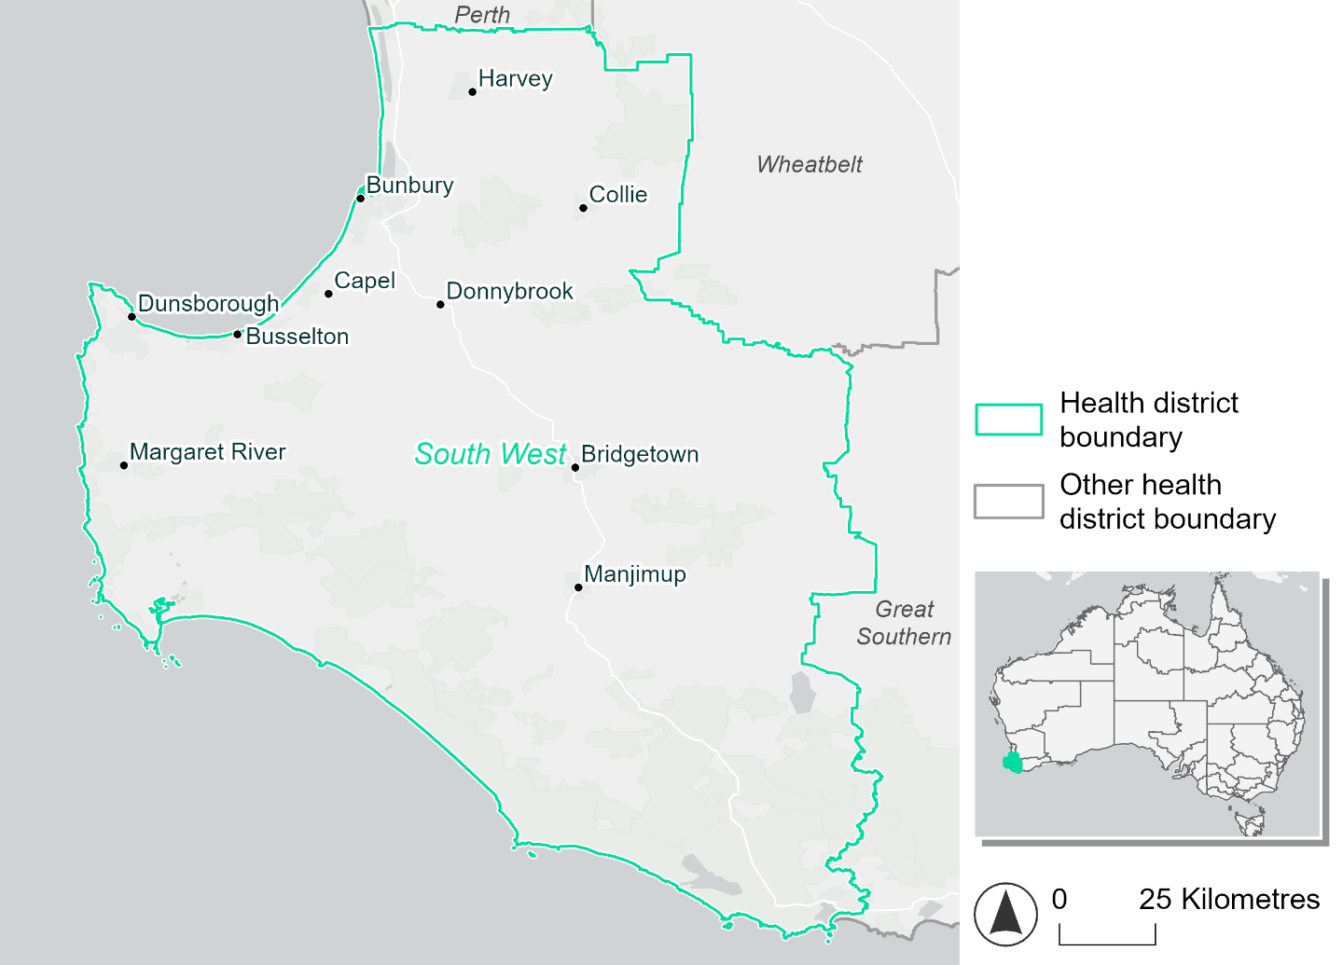
Figure 20. Map of South West health district.

How will climate change affect this health district?
Heat and humidity: Higher average temperatures, hotter and more frequent hot days, warmer night time temperatures and longer and more frequent heatwaves.
Fire: Over 50% of this health district experiences a very high fire hazard category and this will continue in the future.
Drought: The number of months experiencing drought will increase.
Rainfall and flood: There will be more flood events in urban areas.
Coastal inundation: The area flooded during tidal, and storm surge and tidal inundation, will increase.

South West health district demographic data
Demographic Data | Total
Number of households | 6,8373
Persons 15 and older | 129,647
Total families | 49,715
Persons did not complete high school | 5,9240
One parent families with dependents | 5,087 (10.2%)
Persons aged 65 and older | 39,464 (20.4%)
Persons aged 4 and younger | 10,679 (5.5%)
Aboriginal and Torres Strait Islander persons | 5,167 (2.7%)
Persons speaks language other than English | 12,334 (6.4%)
Persons working age (15-65) | 117,457 (60.6%)
Population Health Data | Total
Persons with core needs for assistance | 9,647 (5%)
Persons with arthritis | 19,630 (10.1%)
Persons with asthma | 15,509 (8%)
Persons with cancer | 6,392 (3.3%)
Persons with dementia | 1,476 (0.8%)
Persons with diabetes | 9,091 (4.7%)
Persons with heart disease | 7,734 (4%)
Persons with kidney disease | 1,522 (0.8%)
Persons with lung condition | 3,743 (1.9%)
Persons with mental health condition | 18,232 (9.4%)
Persons with stroke | 1,891 (1%)
Persons with any other condition | 14,644 (7.6%)
Persons no health condition | 110,994 (57.3%)
Socio-economic Data | Total
Persons providing unpaid care | 22,536 (11.6%)
Persons homeless | 673 (0.3%)
Household with lone person | 17,723 (25.9%)
Households with rent and mortgage stress | 30,073 (44%)
Households total equivalised income below $1000 (weekly) | 32,057 (46.9%)
Households with no motor vehicle | 2,427 (3.5%)
Persons unemployed | 6,322 (4.2%)

The sections that follow outline projected climate hazards for this district. Further information on this health district, including population demographics, is provided in the online dashboard.

Heat and humidity hazard
Key projections:
More heatwaves: Heatwave events are likely to last longer and the number of heatwave events per year will increase. By 2050, under a reasonable worst-case scenario, the number of heatwaves will double. By 2085, under a reasonable worst-case scenario, the number of heatwaves per year will triple.
Hotter days and warmer nights: The maximum temperature on hot days will increase with night time temperatures on hot nights also increasing.
More days above 35°C and 40°C: The number of days per year greater than 35°C and 40°C will increase under both middle of the road and reasonable worst-case scenarios.

 | Baseline | 2050 Scenarios |  | 2085 Scenarios
 |  | Middle of the road | Reasonable worst-case | Middle of the road | Reasonable worst-case
Average temperature (°C) | 16.7 | 17.7  [17.3, 18.1] | 17.9  [17.6, 18.4] | 18.5  [18, 19] | 19.3  [18.5, 20.1]
Maximum temperature on hot days (°C)^{(a)} | 33.8 | 34.8  [34.5, 35.5] | 35.1  [34.8, 35.9] | 35.7  [35.3, 36.6] | 36.6  [36.1, 37.7]
Minimum temperature on hot nights (°C)^{(b)} | 18.1 | 19.2  [18.5, 19.7] | 19.4  [18.8, 19.8] | 20  [19.3, 20.5] | 20.8  [19.8, 21.7]
Average apparent temperature on hot days (°C) (NOAA Heat Index)^{(c)} | 34.4 | 35.3  [35, 36] | 35.5  [35.2, 36.3] | 36.2  [35.6, 37] | 37  [36.4, 38.3]
Average heatwave duration in days^{(d)} | 4 | 5  [5, 5] | 5  [5, 5] | 5  [5, 5] | 5  [5, 6]
Number of heatwaves per year^{(d)} | 2 | 4  [3, 4] | 4  [3, 5] | 5  [4, 6] | 6  [5, 8]
Number of days per year > 35°C | 13 | 18  [17, 23] | 20  [18, 25] | 24  [21, 30] | 31  [27, 39]
Number of days per year > 40°C | 1 | 2  [1, 2] | 2  [1, 3] | 3  [1, 5] | 5  [3, 8]
Table notes: The heat and humidity hazard uses climate projections from the CMIP6 Global Climate Models [1]. Daily projections of maximum and minimum near-surface temperature and mean relative humidity are used to calculate eight heat and humidity indicators. The primary indicator value reports the median from the nine climate models, with the range reported in square brackets.
Table footnotes: (a) Based on the 95th percentile of daily maximum air temperature. (b) Based on the 95th percentile of daily minimum air temperature, representing the coldest part of the night on very hot nights. (c) The National Oceanic and Atmospheric Administration (NOAA) Heat Index is a measure of how hot it feels when relative humidity is factored in alongside actual air temperature. It is calculated on days with a maximum temperature of 27°C and above. Interpretation of Heat Index values: 27°C to 32°C indicates caution, 33°C to 41°C indicates extreme caution, 42°C to 54°C indicates danger and over 54°C indicates extreme danger. See methodology document for further explanation of Heat Index categories. (d) A heatwave is defined as three or more consecutive days where both daytime and overnight temperatures (daily mean temperatures) are unusually high for the location, based on the Bureau of Meteorology’s Excess Heat Factor method. For this district, an unusually high daily mean temperature is approximately 25.6°C or above.

Fire hazard
Key projections:
Majority of district experiences very high fire hazard: Under baseline conditions for a 1-in-20-year fire weather event, 61.8% of the district experiences very high fire hazard levels, with only 4.7% of the district area experiencing low hazard. The remaining third of the district (33.5%) experiences moderate to high hazard. During a more severe 1-in-100-year event, 70.4% of the district experiences very high hazard and the area experiencing moderate to high hazard drops to one quarter (25.7%), while low hazard areas only cover 3.9% of the district.
Very high hazard to increase for more common fires: In a future climate for a 1-in-100-year fire weather event, the area experiencing very high hazard is already 70.4% of the district and only increases up to 71.5% by 2085 under the reasonable worst-case scenario. For a less-rare 1-in-20-year fire weather event, very high fire hazard is experienced by more of the district across both 2050 and 2085 scenarios when compared to baseline, increasing by up to 6.7% of the total district area.

 | Baseline | 2050 Scenarios |  | 2085 Scenarios
 |  | Sustainability | Reasonable worst-case | Sustainability | Reasonable worst-case
Hazard for a ‘1-in-20 year’ fire weather event^{(a)}
Proportion (%) of district experiencing ‘Low’ fire hazard | 4.7%  (112,420)^{(b)} | 4.5%  [4.3%, 4.8%] | 4.3%  [4.2%, 4.4%] | 4.2%  [3.7%, 4.9%] | 3.7%  [3.5%, 4.0%]
Proportion (%) of district experiencing ‘Moderate to High’ fire hazard | 33.5%  (802,950)^{(b)} | 32.8%  [31.1%, 36.5%] | 31.1%  [30.2%, 33.4%] | 31.7%  [27.7%, 40.6%] | 27.7%  [25.5%, 33.3%]
Proportion (%) of district experiencing ‘Very High’ fire hazard | 61.8%  (1,481,491)^{(b)} | 62.7%  [58.7%, 64.3%] | 64.6%  [62.4%, 65.5%] | 64.0%  [54.4%, 67.9%] | 68.5%  [63.2%, 70.6%]
Hazard for a ‘1-in-100 year’ fire weather event^{(a)}
Proportion (%) of district experiencing ‘Low’ fire hazard | 3.9%  (92,737)^{(b)} | 3.7%  [3.5%, 3.9%] | 3.5%  [3.4%, 3.7%] | 3.4%  [2.9%, 4.0%] | 3.1%  [2.8%, 3.4%]
Proportion (%) of district experiencing ‘Moderate to High’ fire hazard | 25.7%  (616,343)^{(b)} | 25.8%  [24.7%, 26.5%] | 25.6%  [25.0%, 26.2%] | 25.8%  [23.3%, 27.7%] | 25.4%  [24.0%, 26.8%]
Proportion (%) of district experiencing ‘Very High’ fire hazard | 70.4%  (1,687,781)^{(b)} | 70.5%  [69.7%, 71.1%] | 70.9%  [70.6%, 71.2%] | 70.7%  [68.8%, 72.1%] | 71.5%  [70.9%, 72.4%]
Table notes: The Fire Hazard uses the National Bushfire Intelligence Capability (NBIC) Phase 2 fire line intensity modelling based on CMIP6 climate projections. Fire Hazard is assessed using the projected Fireline Intensity (FLI) for weather events with two different return intervals (i.e. a 1-in-20 year event and a 1-in-100 year event). FLI considers slope, vegetation and weather to produce a rate of heat output per unit length (kW/m) along a bushfire’s front. Fire hazard is categorized as a low for FLI<4000 kW/m, moderate to high for 4,000 kW/m ≤FLI<12,500kW/m, and very high for FLI≥27,501kW/m. This is broadly consistent with the literature [3]. The assessment considers climate change effects based on changes in fire weather and the associated hazard that is anticipated for a meteorological event of a given return interval. This approach is different to the one adopted for the Flood Hazard, where the event magnitude is given (fixed) and the likelihood of that event varies as a result of climate change. The primary indicator value reports the median from the nine climate models, with the range reported in square brackets.
Table footnotes: (a) The area subject to different categories of fire hazard is determined for a ‘1-in-20 year’ and ‘1-in-100 year’ fire weather event, in current and future climates. Values at year 2050 are interpolated using data from baseline (2025) and 2085, assuming linear change over time. (b) Values in round brackets are the area (ha) of the health district subject to a given fire hazard.

The figures below show the proportion of the health district experiencing different fire hazard categories across different time horizons and climate scenarios during a ‘1-in-20 year’ fire weather event (Figure 21) and a ‘1-in-100 year’ fire weather event (Figure 22).

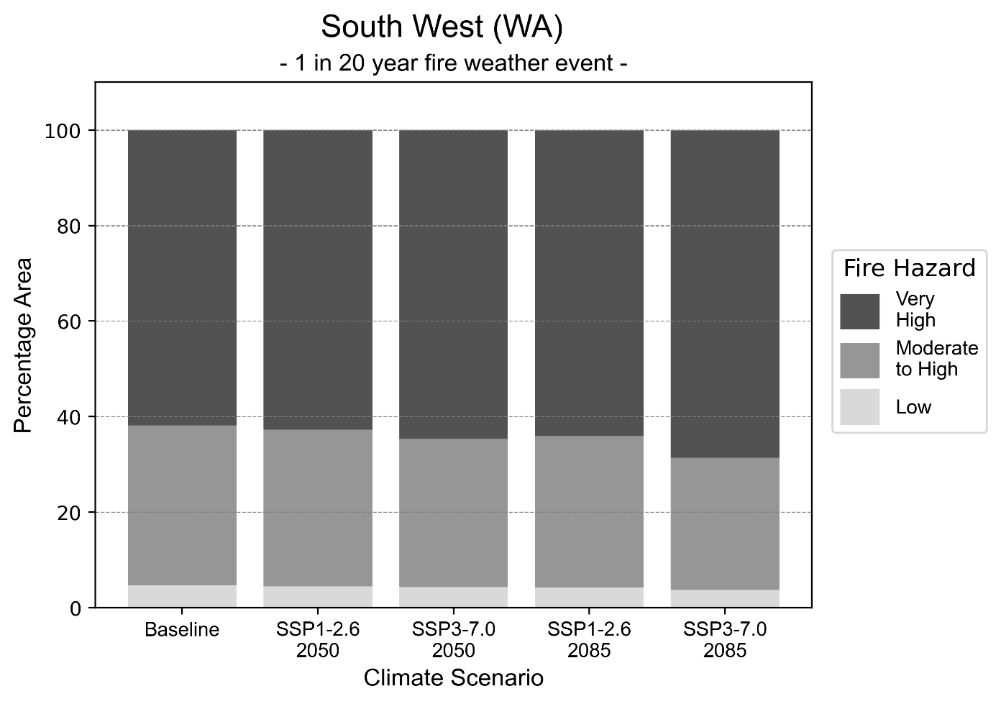
Figure 21: Stacked column chart showing the percentages of the South West health district's total geographic area experiencing each fire hazard level during a 1-in-20-year fire weather event.
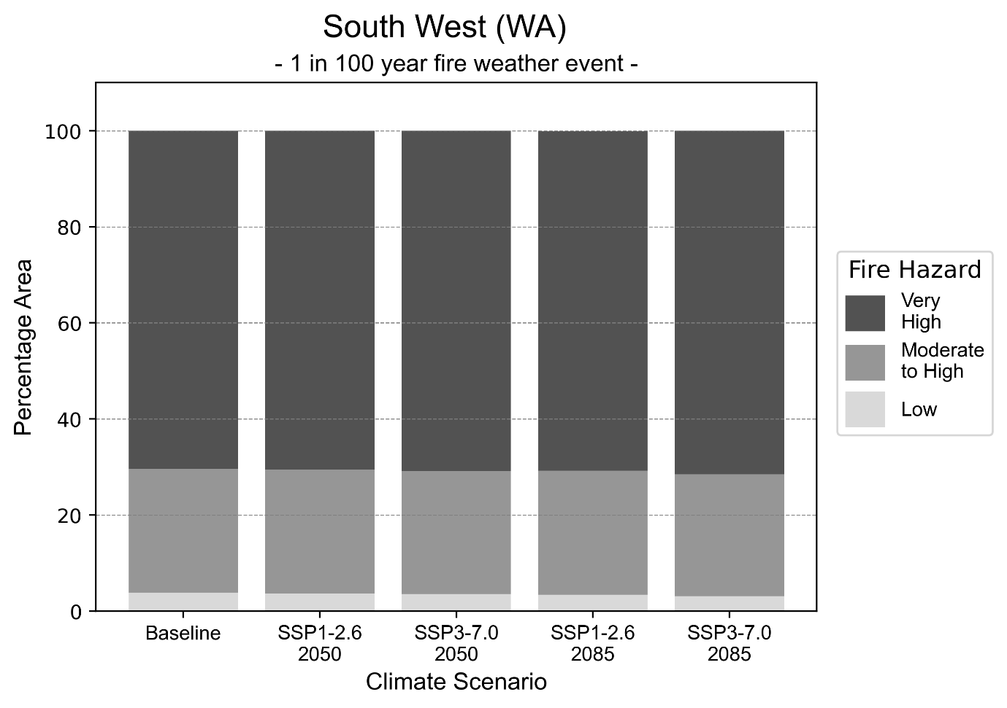
Figure 22: Stacked column chart showing the percentages of the South West health district's total geographic area experiencing each fire hazard level during a 1-in-100-year fire weather event.

Drought hazard
Key projections:
Drought occurrence: The occurrence of drought will increase across both middle of the road and reasonable worst-case scenarios for both time horizons, with the largest increase occurring under the reasonable worst-case scenario by 2085.

 | Baseline | 2050 Scenarios |  | 2085 Scenarios
 |  | Middle of the road | Reasonable worst-case | Middle of the road | Reasonable worst-case
Number of months per year in drought^{(a)} | 1.7 | 5.2  [2.4, 7.6] | 5.7  [3.1, 7.5] | 6.3  [4.2, 9.4] | 8.3  [5.5, 10.5]
Table notes: The drought hazard indicator uses climate projections from the CMIP6 Global Climate Models [1]. The primary indicator value reports the median from the nine climate models, with the range reported in square brackets.
Table footnotes: (a) The number of months per year in drought is based on the Standardised Precipitation Index (SPI). SPI is a widely used index to characterise meteorological drought on a range of timescales. This indicator uses the timescale of 12 months which calculates the average months in a year within the moderate drought range. A moderate drought range is classified as SPI score of ≤ -1. SPI is calculated from accumulated rainfall over 12 months and the mean and standard deviation from historical rainfall records.

Storm hazard
Key projections:
Less frequent high and very-high-intensity storms: The frequency of high and very-high-intensity storms will decrease across both middle of the road and reasonable worst-case scenarios, with the greatest decreases occurring by 2085.

 | Baseline | 2050 Scenarios |  | 2085 Scenarios
 |  | Middle of the road | Reasonable worst-case | Middle of the road | Reasonable worst-case
Number of low-intensity storms (40-62 km/hr) per year | 89.8 | 92.2  [81.1, 101.4] | 90.5  [79.6, 99.6] | 91.2  [80.3, 100.4] | 92.4  [81.3, 101.7]
Number of medium-intensity storms (63-87 km/hr) per year | 58.1 | 57.7  [50.7, 63.4] | 59.0  [51.9, 64.9] | 54.9  [48.3, 60.4] | 59.8  [52.7, 65.8]
Number of high-intensity storms (88-117 km/hr) per year | 31.7 | 30.1  [26.5, 33.1] | 28.6  [25.2, 31.5] | 27.6  [24.3, 30.4] | 27.6  [24.3, 30.4]
Number of very-high-intensity storm (> 117 km/hr) per year | 4.8 | 4.2  [3.7, 4.6] | 3.7  [3.2, 4.0] | 3.7  [3.3, 4.1] | 2.8  [2.5, 3.1]
Table notes: The storm hazard uses climate projections from the CMIP6 Global Climate Models [1]. Daily maximum surface wind speed is used to calculate the number of annual storms across four storm intensity categories (low, medium, high and very high). The primary indicator value reports the median from the nine climate models, with the range reported in square brackets.

Rainfall and flood hazard
Key projections:
- Less extreme rainfall days per year: The number of extreme rainfall days will decrease across both middle of the road and reasonable worst-case scenarios, and both time horizons, with the largest decrease occurring under the reasonable worst-case scenario by 2085.
- Increased flood frequency: The frequency of flood events will increase in urban environments but decrease in rural environments. The largest increase in flooding is seen in the reasonable worst-case scenario, where the frequency of a ‘1-in-100 year’ flood will more than triple by 2050 and become 11 times more likely by 2085 in urban environments.

 | Baseline | 2050 Scenarios |  | 2050 Scenarios
 |  | Middle of the road | Reasonable worst-case | Middle of the road | Reasonable worst-case
Rainfall hazard^{(a)}
Average number of extreme rainfall days per year (> 9 mm/day)^{(a)} | 10.7 | 8.6  [7.6,10.4] | 8.3  [7.4,10.0] | 8.1  [6.5,9.4] | 7.1  [5.8,8.6]
Urban flood risk (flooding caused by a 1-hour rainfall event)^{(b)}
Frequency of a ‘1-in-1 year’ flood (rainfall depth of 15 mm)^{(c)} |  | 2.3 events in 1 year | 2.4 events in 1 year | 3.2 events in 1 year | 4.6 events in 1 year
Frequency of a ‘1-in-10 year’ flood (rainfall depth of 25 mm)^{(c)} |  | 3.2 events in 10 years | 3.5 events in 10 years | 5.2 events in 10 years | 8.2 events in 10 years
Frequency of a ‘1-in-100 year’ flood (rainfall depth of 40 mm)^{(c)} |  | 3.4 events in 100 years | 3.6 events in 100 years | 5.5 events in 100 years | 11 events in 100 years
Rural flood risk (flooding caused by a 24-hour rainfall event) ^{(b)}
Frequency of a ‘1-in-1 year’ flood (rainfall depth of 48 mm)^{(c)} |  | 0.9 events in 1 year | 0.7 events in 1 year | 0.9 events in 1 year | 0.4 events in 1 year
Frequency of a ‘1-in-10 year’ (rainfall depth of 78 mm)^{(c)} |  | 0.9 events in 10 years | 1.0 events in 10 years | 0.8 events in 10 years | 0.2 events in 10 years
Frequency of a ‘1-in-100 year’ flood (rainfall depth of 118 mm)^{(c)} |  | 1.1 events in 100 years | 1.0 events in 100 years | 0.6 events in 100 years | 0.2 events in 100 years
Table notes: The rainfall hazard indicator uses climate projections from the CMIP6 Global Climate Models [1]. The primary indicator value reports the median from the nine climate models, with the range reported in square brackets. The flood hazard indicators use climate change considerations from the Australian Rainfall and Runoff guideline to estimate the climate projections [2].
Table footnotes: (a) Extreme rainfall is defined as rainfall above the 95th percentile of historical average daily rainfall in this health district in the period 1985-2014. The value in mm/day quoted in the indicator name is the 95th percentile of historic average daily rainfall for this health district. (b) See Methodology document for reasons for focusing on a 1-hour flood for urban areas and a 24-hour flood for rural areas. (c) The rainfall depths in mm quoted in the indicator names in this table report 1 in 1-, 10- and 100-year depths for this health district.

Coastal inundation hazard
Key projections:
Greater area inundated: There will be an increase in the area affected by tidal inundation (i.e. area submerged during high tide) and storm surge and tidal inundation (i.e. the area submerged during a storm surge and high tide) across both middle of the road and reasonable worst-case scenarios. In the reasonable worst-case scenario, by 2085 the area inundated during a ‘1-in-1000-year’ event will increase by nearly 5,000 ha.

 | Baseline | 2050 Scenarios |  | 2085 Scenarios^{(a)}
 |  | Middle of the road | Reasonable worst-case | Middle of the road | Reasonable worst-case
Tidal inundation (ha inundated)^{(b)} | 10,788.9 | 12,091.1  (+1,302.2) | 12,175.3  (+1,386.3) | 14,542.4  (+3,753.5) | 15,210.9  (+4,422.0)
Storm surge + tidal inundation – ‘1-in-100 year’ event (ha inundated)^{(c)} | 14,985.8 | 16,159.8  (+1,174.0) | 16,234.5  (+1,248.7) | 18,432.9  (+3,447.0) | 19,149.9  (+4,164.1)
Storm surge + tidal inundation – ‘1-in-1000 year’ event (ha inundated)^{(c)} | 15,529.9 | 16,697.2  (+1,167.3) | 16,773.7  (+1,243.8) | 19,636.0  (+4,106.1) | 20,436.6  (+4,906.7)
Table notes: The coastal inundation hazard provides an indication of flooding in coastal areas that can be attributed to sea level rise and storm inundation. The coastal inundation hazard is only reported for health districts adjoining the coastline. This table includes the projected inundation levels as well as the change from baseline conditions (in brackets).
Table footnotes: (a) For the 2085 Scenarios planning horizon, 2100 was adopted as it provides a conservative representation of the end of this period. This horizon aligns with many State planning regulations requiring consideration of sea level rise and storm tide to 2100, making the 2100 scenario particularly valuable for planning new health facilities in coastal areas. (b) The tidal inundation indicator reports the number of hectares inundated during high tide. The baseline value reports existing inundation patterns, while the 2050 and 2085 values report high tide inundation taking account of projected sea level rise due to climate change. (c) The storm surge + tidal inundation indicators report the combined effect, in hectares inundated, of high tide, sea level rise (for the 2050 and 2085 projections), and storm surge (for 1-in-100 year and 1-in-1000-year events).

Wheatbelt health district

Health district overview
Surface area: 155,256 square kilometres (including islands)
Estimated population (2020): 75,455
Local health services: The Wheatbelt health region contains 4 District Hospitals, 18 Small Hospitals and 9 Nursing Posts/Health Centres, as well as 5 Silver Chain health centres.

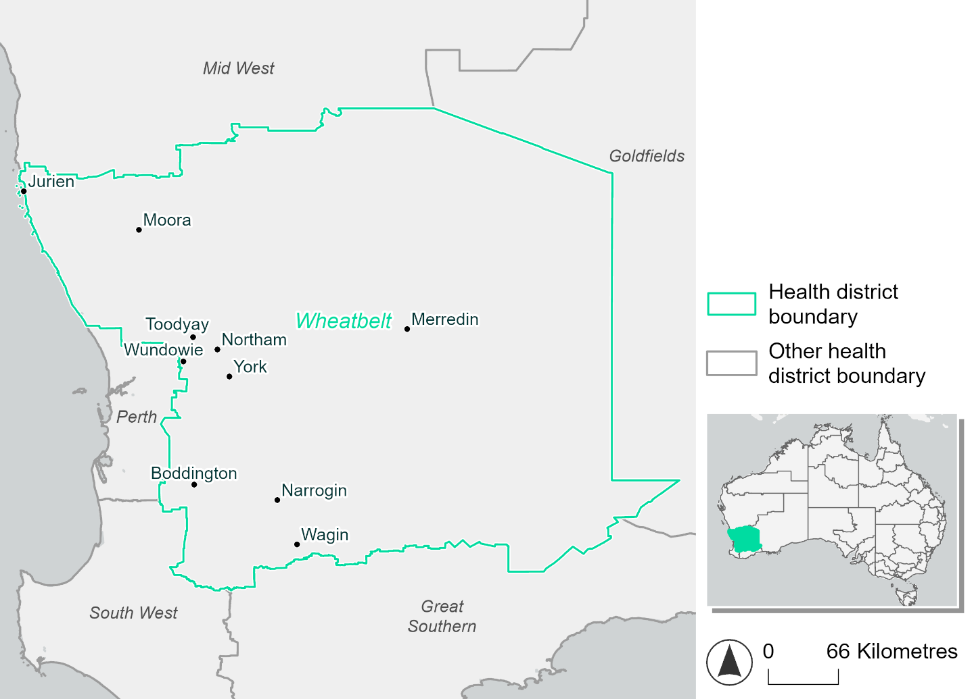
Figure 23. Map of Wheatbelt health district.

How will climate change affect this health district?
Heat and humidity: Higher average temperatures, hotter and more frequent hot days, warmer night time temperatures and longer and more frequent heatwaves.
Fire: Over 50% of this health district experiences a very high fire hazard category and this will continue in the future.
Drought: The number of months experiencing drought will increase.
Rainfall and flood: There will be more flood events in urban areas.
Coastal inundation: The area flooded during tidal, and storm surge and tidal inundation, will increase.

Wheatbelt health district demographic data
Demographic Data | Total
Number of households | 27,347
Persons 15 and older | 51,787
Total families | 19,029
Persons did not complete high school | 24,085
One parent families with dependents | 1,466 (7.7%)
Persons aged 65 and older | 17,950 (23.1%)
Persons aged 4 and younger | 4,077 (5.3%)
Aboriginal and Torres Strait Islander persons | 3,398 (4.4%)
Persons speaks language other than English | 3,584 (4.6%)
Persons working age (15-65) | 46,072 (59.4%)
Population Health Data | Total
Persons with core needs for assistance | 3,919 (5.1%)
Persons with arthritis | 8,287 (10.7%)
Persons with asthma | 6,320 (8.1%)
Persons with cancer | 2,734 (3.5%)
Persons with dementia | 515 (0.7%)
Persons with diabetes | 4,338 (5.6%)
Persons with heart disease | 3,783 (4.9%)
Persons with kidney disease | 772 (1%)
Persons with lung condition | 1,849 (2.4%)
Persons with mental health condition | 6,508 (8.4%)
Persons with stroke | 857 (1.1%)
Persons with any other condition | 5,494 (7.1%)
Persons no health condition | 41,040 (52.9%)
Socio-economic Data | Total
Persons providing unpaid care | 8,629 (11.1%)
Persons homeless | 227 (0.3%)
Household with lone person | 8,064 (29.5%)
Households with rent and mortgage stress | 9,312 (34.1%)
Households total equivalised income below $1000 (weekly) | 13,296 (48.6%)
Households with no motor vehicle | 909 (3.3%)
Persons unemployed | 2,719 (4.4%)

The sections that follow outline projected climate hazards for this district. Further information on this health district, including population demographics, is provided in the online dashboard.

Heat and humidity hazard
Key projections:
More heatwaves: Heatwave events are likely to last longer and the number of heatwave events per year will increase. By 2050, under a reasonable worst-case scenario, the number of heatwaves will more than double. By 2085, under a reasonable worst-case scenario, the number of heatwaves per year will quadruple.
Hotter days and warmer nights: The maximum temperature on hot days will increase with night time temperatures on hot nights also increasing.
More days above 35°C and 40°C: The number of days per year greater than 35°C and 40°C will increase under both middle of the road and reasonable worst-case scenarios.

 | Baseline | 2050 Scenarios |  | 2085 Scenarios
 |  | Middle of the road | Reasonable worst-case | Middle of the road | Reasonable worst-case
Average temperature (°C) | 17.5 | 18.8  [18.3, 19.3] | 19.1  [18.5, 19.7] | 19.7  [19, 20.4] | 20.7  [19.7, 21.6]
Maximum temperature on hot days (°C)^{(a)} | 36.6 | 38  [37.6, 38.9] | 38.3  [37.8, 39.6] | 39  [38.4, 40.2] | 40.2  [39.5, 41.7]
Minimum temperature on hot nights (°C)^{(b)} | 19.3 | 20.7  [20, 21.4] | 21  [20.3, 21.7] | 21.7  [20.9, 22.5] | 22.8  [21.9, 23.9]
Average apparent temperature on hot days (°C) (NOAA Heat Index)^{(c)} | 35.2 | 36.4  [36, 37] | 36.7  [36.4, 37.5] | 37.5  [36.7, 38.4] | 38.4  [37.6, 40.1]
Average heatwave duration in days^{(d)} | 4 | 5  [5, 6] | 5  [5, 6] | 6  [5, 6] | 6  [6, 8]
Number of heatwaves per year^{(d)} | 2 | 4  [3, 6] | 5  [4, 7] | 6  [5, 8] | 8  [7, 9]
Number of days per year  > 35°C | 32 | 46  [41, 55] | 50  [45, 62] | 58  [51, 71] | 70  [63, 85]
Number of days per year > 40°C | 4 | 9  [7, 12] | 10  [8, 17] | 14  [10, 21] | 21  [16, 33]
Table notes: The heat and humidity hazard uses climate projections from the CMIP6 Global Climate Models [1]. Daily projections of maximum and minimum near-surface temperature and mean relative humidity are used to calculate eight heat and humidity indicators. The primary indicator value reports the median from the nine climate models, with the range reported in square brackets.
Table footnotes: (a) Based on the 95th percentile of daily maximum air temperature. (b) Based on the 95th percentile of daily minimum air temperature, representing the coldest part of the night on very hot nights. (c) The National Oceanic and Atmospheric Administration (NOAA) Heat Index is a measure of how hot it feels when relative humidity is factored in alongside actual air temperature. It is calculated on days with a maximum temperature of 27°C and above. Interpretation of Heat Index values: 27°C to 32°C indicates caution, 33°C to 41°C indicates extreme caution, 42°C to 54°C indicates danger and over 54°C indicates extreme danger. See methodology document for further explanation of Heat Index categories. (d) A heatwave is defined as three or more consecutive days where both daytime and overnight temperatures (daily mean temperatures) are unusually high for the location, based on the Bureau of Meteorology’s Excess Heat Factor method. For this district, an unusually high daily mean temperature is approximately 27.5°C or above.

Fire hazard
Key projections:
Majority of district area experiences moderate to high fire hazard: Under baseline conditions, 73-74% of the district experiences moderate to high fire hazard. 17-19% experiences low fire hazard with the remaining 7-8% experiencing very high fire hazard.
Current fire hazard conditions to persist: In a future climate across both 2050 and 2085 scenarios, the proportions of the district experiencing each hazard level remain close to their baseline levels, varying by no more than 1.1% of the total district area.

 | Baseline | 2050 Scenarios |  | 2085 Scenarios
 |  | Sustainability | Reasonable worst-case | Sustainability | Reasonable worst-case
Hazard for a ‘1-in-20 year’ fire weather event^{(a)}
Proportion (%) of district experiencing ‘Low’ fire hazard | 19.1%  (3,024,246)^{(b)} | 19.1%  [18.8%, 19.8%] | 18.8%  [18.5%, 19.3%] | 19.1%  [18.4%, 20.7%] | 18.5%  [17.6%, 19.5%]
Proportion (%) of district experiencing ‘Moderate to High’ fire hazard | 73.3%  (11,620,391)  ^{(b)} | 73.3%  [67.8%, 78.6%] | 73.4%  [70.7%, 76.0%] | 73.2%  [60.0%, 86.1%] | 73.5%  [67.0%, 79.7%]
Proportion (%) of district experiencing ‘Very High’ fire hazard | 7.6%  (1,211,379)^{(b)} | 7.6%  [7.4%, 7.8%] | 7.8%  [7.5%, 8.2%] | 7.6%  [7.1%, 8.0%] | 8.0%  [7.4%, 9.0%]
Hazard for a ‘1-in-100 year’ fire weather event^{(a)}
Proportion (%) of district experiencing ‘Low’ fire hazard | 17.4%  (2,760,064)^{(b)} | 17.3%  [17.0%, 18.1%] | 16.9%  [16.6%, 17.4%] | 17.2%  [16.4%, 19.0%] | 16.3%  [15.5%, 17.5%]
Proportion (%) of district experiencing ‘Moderate to High’ fire hazard | 74.3%  (11,779,313)  ^{(b)} | 74.3%  [69.3%, 79.0%] | 74.4%  [71.4%, 76.9%] | 74.4%  [62.4%, 85.7%] | 74.5%  [67.4%, 80.6%]
Proportion (%) of district experiencing ‘Very High’ fire hazard | 8.3%  (1,316,639)^{(b)} | 8.3%  [8.1%, 8.5%] | 8.6%  [8.3%, 9.6%] | 8.4%  [7.9%, 8.7%] | 9.1%  [8.3%, 11.4%]
Table notes: The Fire Hazard uses the National Bushfire Intelligence Capability (NBIC) Phase 2 fire line intensity modelling based on CMIP6 climate projections. Fire Hazard is assessed using the projected Fireline Intensity (FLI) for weather events with two different return intervals (i.e. a 1-in-20 year event and a 1-in-100 year event). FLI considers slope, vegetation and weather to produce a rate of heat output per unit length (kW/m) along a bushfire’s front. Fire hazard is categorized as a low for FLI<4000 kW/m, moderate to high for 4,000 kW/m ≤FLI<12,500kW/m, and very high for FLI≥27,501kW/m. This is broadly consistent with the literature [3]. The assessment considers climate change effects based on changes in fire weather and the associated hazard that is anticipated for a meteorological event of a given return interval. This approach is different to the one adopted for the Flood Hazard, where the event magnitude is given (fixed) and the likelihood of that event varies as a result of climate change. The primary indicator value reports the median from the nine climate models, with the range reported in square brackets.
Table footnotes: (a) The area subject to different categories of fire hazard is determined for a ‘1-in-20 year’ and ‘1-in-100 year’ fire weather event, in current and future climates. Values at year 2050 are interpolated using data from baseline (2025) and 2085, assuming linear change over time. (b) Values in round brackets are the area (ha) of the health district subject to a given fire hazard.

The figures below show the proportion of the health district experiencing different fire hazard categories across different time horizons and climate scenarios during a ‘1-in-20 year’ fire weather event (Figure 24) and a ‘1-in-100 year’ fire weather event (Figure 25).
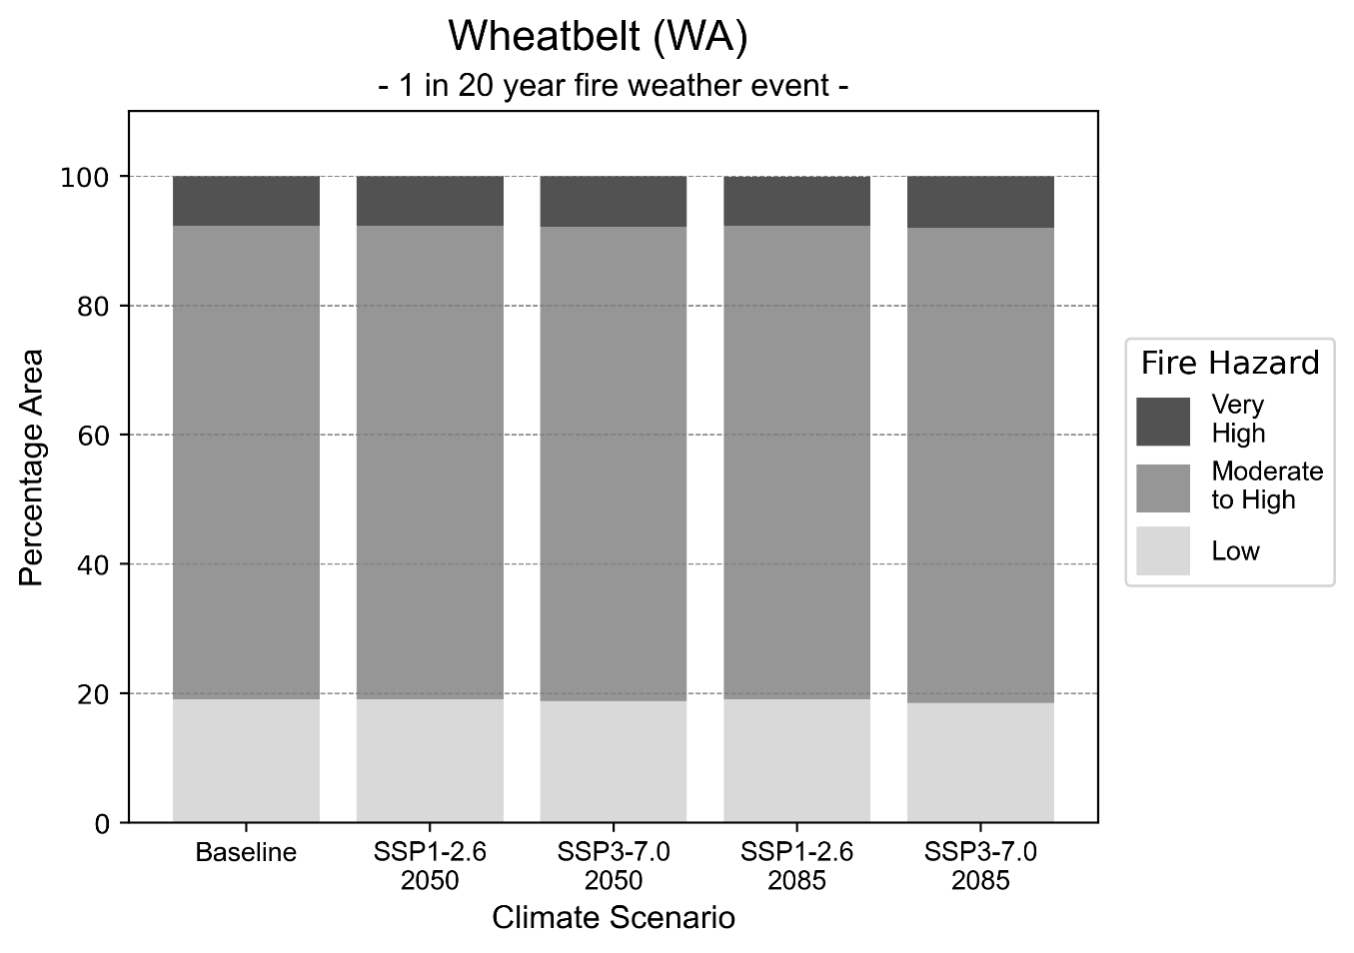
Figure 24: Stacked column chart showing the percentages of the Wheatbelt health district's total geographic area experiencing each fire hazard level during a 1-in-20-year fire weather event.
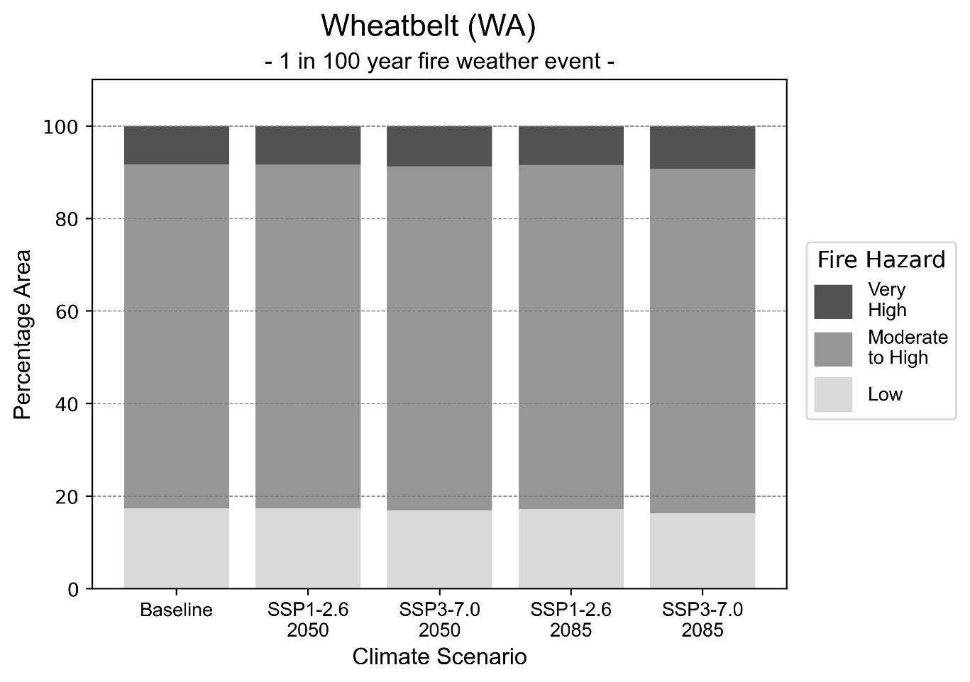
Figure 25: Stacked column chart showing the percentages of the Wheatbelt health district's total geographic area experiencing each fire hazard level during a 1-in-100-year fire weather event.

Drought hazard
Key projections:
Drought occurrence: The occurrence of drought will increase across both middle of the road and reasonable worst-case scenarios for both time horizons, with the largest increase occurring under the reasonable worst-case scenario by 2085.

 | Baseline | 2050 Scenarios |  | 2085 Scenarios
 |  | Middle of the road | Reasonable worst-case | Middle of the road | Reasonable worst-case
Number of months per year in drought^{(a)} | 1.8 | 4.2  [0.8, 6.1] | 4.3  [2.1, 7.7] | 4.6  [1.5, 6.2] | 5.7  [1.3, 8.9]
Table notes: The drought hazard indicator uses climate projections from the CMIP6 Global Climate Models [1]. The primary indicator value reports the median from the nine climate models, with the range reported in square brackets.
Table footnotes: (a) The number of months per year in drought is based on the Standardised Precipitation Index (SPI). SPI is a widely used index to characterise meteorological drought on a range of timescales. This indicator uses the timescale of 12 months which calculates the average months in a year within the moderate drought range. A moderate drought range is classified as SPI score of ≤ -1. SPI is calculated from accumulated rainfall over 12 months and the mean and standard deviation from historical rainfall records.

Storm hazard
Key projections:
Less frequent high and very-high-intensity storms: The frequency of high and very-high-intensity storms will decrease across both middle of the road and reasonable worst-case scenarios, with the greatest decreases occurring by 2085.

 | Baseline | 2050 Scenarios |  | 2085 Scenarios
 |  | Middle of the road | Reasonable worst-case | Middle of the road | Reasonable worst-case
Number of low-intensity storms (40-62 km/hr) per year | 92.8 | 92.1  [81.0, 101.3] | 91.7  [80.7, 100.9] | 91.1  [80.1, 100.2] | 92.1  [81.0, 101.3]
Number of medium-intensity storms (63-87 km/hr) per year | 57.9 | 58.2  [51.2, 64.0] | 59.1  [52.0, 65.0] | 52.8  [46.5, 58.1] | 58.8  [51.7, 64.6]
Number of high-intensity storms (88-117 km/hr) per year | 31.7 | 31.0  [27.3, 34.1] | 28.6  [25.2, 31.5] | 29.4  [25.8, 32.3] | 26.2  [23.1, 28.9]
Number of very-high-intensity storm (> 117 km/hr) per year | 1.2 | 1.3  [1.2, 1.5] | 1.1  [0.9, 1.2] | 1.3  [1.1, 1.4] | 0.8  [0.7, 0.9]
Table notes: The storm hazard uses climate projections from the CMIP6 Global Climate Models [1]. Daily maximum surface wind speed is used to calculate the number of annual storms across four storm intensity categories (low, medium, high and very high). The primary indicator value reports the median from the nine climate models, with the range reported in square brackets.

Rainfall and flood hazard
Key projections:
- Fewer extreme rainfall days per year: The number of extreme rainfall days will remain consistent across both middle of the road and reasonable worst-case scenarios, with the largest decrease occurring under the reasonable worst-case scenario by 2085.
- Increased flood frequency: The frequency of flood events will increase in urban environments but decrease in rural environments. The largest increase in flooding is seen in the reasonable worst-case scenario, where the frequency of a ‘1-in-100 year’ flood will triple by 2050 and become seven times more likely by 2085 in urban environments.

 | Baseline | 2050 Scenarios |  | 2085 Scenarios
 |  | Middle of the road | Reasonable worst-case | Middle of the road | Reasonable worst-case
Rainfall hazard^{(a)}
Average number of extreme rainfall days per year (> 6 mm/day)^{(a)} | 12.3 | 10.3  [8.2,15.1] | 10.1  [7.6,11.9] | 9.9  [8.5,13.3] | 9.2  [6.6,14.1]
Urban flood risk (flooding caused by a 1-hour rainfall event)^{(b)}
Frequency of a ‘1-in-1 year’ flood (rainfall depth of 12 mm)^{(c)} |  | 1.8 events in 1 year | 1.9 events in 1 year | 2.3 events in 1 year | 3.0 events in 1 year
Frequency of a ‘1-in-10 year’ flood (rainfall depth of 26 mm)^{(c)} |  | 2.3 events in 10 years | 2.4 events in 10 years | 3.1 events in 10 years | 4.6 events in 10 years
Frequency of a ‘1-in-100 year’ flood (rainfall depth of 45 mm)^{(c)} |  | 2.8 events in 100 years | 3.0 events in 100 years | 4.2 events in 100 years | 7.3 events in 100 years
Rural flood risk (flooding caused by a 24-hour rainfall event) ^{(b)}
Frequency of a ‘1-in-1 year’ flood (rainfall depth of 33 mm)^{(c)} |  | 1.0 events in 1 year | 0.9 events in 1 year | 1.0 events in 1 year | 0.5 events in 1 year
Frequency of a ‘1-in-10 year’ flood (rainfall depth of 66 mm)^{(c)} |  | 1.0 events in 10 years | 0.6 events in 10 years | 1.1 events in 10 years | 0.5 events in 10 years
Frequency of a ‘1-in-100 year’ flood (rainfall depth of 119 mm)^{(c)} |  | 1.0 events in 100 years | 1.0 events in 100 years | 0.7 events in 100 years | 0.3 events in 100 years
Table notes: The rainfall hazard indicator uses climate projections from the CMIP6 Global Climate Models [1]. The primary indicator value reports the median from the nine climate models, with the range reported in square brackets. The flood hazard indicators use climate change considerations from the Australian Rainfall and Runoff guideline to estimate the climate projections [2].
Table footnotes: (a) Extreme rainfall is defined as rainfall above the 95th percentile of historical average daily rainfall in this health district in the period 1985-2014. The value in mm/day quoted in the indicator name is the 95th percentile of historic average daily rainfall for this health district. (b) See Methodology document for reasons for focusing on a 1-hour flood for urban areas and a 24-hour flood for rural areas. (c) The rainfall depths in mm quoted in the indicator names in this table report 1 in 1-, 10- and 100-year depths for this health district.

Coastal inundation hazard
Key projections:
Greater area inundated: There will be an increase in the area affected by tidal inundation (i.e. area submerged during high tide) and storm surge and tidal inundation (i.e. the area submerged during a storm surge and high tide) across both middle of the road and reasonable worst-case scenarios. In the reasonable worst-case scenario, by 2085 the area inundated during a ‘1-in-1000-year’ event will increase by over 800 ha.

 | Baseline | 2050 Scenarios |  | 2085 Scenarios^{(a)}
 |  | Middle of the road | Reasonable worst-case | Middle of the road | Reasonable worst-case
Tidal inundation (ha inundated)^{(b)} | 794.1 | 856.4  (+62.3) | 861.7  (+67.6) | 1,060.5  (+266.4) | 1,140.5  (+346.3)
Storm surge + tidal inundation – ‘1-in-100 year’ event (ha inundated)^{(c)} | 975.5 | 1,103.1  (+127.6) | 1,112.8  (+137.3) | 1,501.2  (+525.8) | 1,652.5  (+677.1)
Storm surge + tidal inundation – ‘1-in-1000 year’ event (ha inundated)^{(c)} | 987.1 | 1,117.6  (+130.5) | 1,127.6  (+140.6) | 1,671.7  (+684.7) | 1,815.8  (+828.7)
Table notes: The coastal inundation hazard provides an indication of flooding in coastal areas that can be attributed to sea level rise and storm inundation. The coastal inundation hazard is only reported for health districts adjoining the coastline. This table includes the projected inundation levels as well as the change from baseline conditions (in brackets).
Table footnotes: (a) For the 2085 Scenarios planning horizon, 2100 was adopted as it provides a conservative representation of the end of this period. This horizon aligns with many State planning regulations requiring consideration of sea level rise and storm tide to 2100, making the 2100 scenario particularly valuable for planning new health facilities in coastal areas. (b) The tidal inundation indicator reports the number of hectares inundated during high tide. The baseline value reports existing inundation patterns, while the 2050 and 2085 values report high tide inundation taking account of projected sea level rise due to climate change. (c) The storm surge + tidal inundation indicators report the combined effect, in hectares inundated, of high tide, sea level rise (for the 2050 and 2085 projections), and storm surge (for 1-in-100 year and 1-in-1000-year events).

References

[1] | D. Irving, I. Macadam and M. King, “Application-ready quantile-delta-change (QDC) scaled CMIP6 climate projections for Australia (time slices, 11km grid) (v1)”, CSIRO. Data Collection, 2024.
[2] | C. Wasko, S. Westra, R. Nathan, D. Jakob, C. Nielsen, J. Evans, S. Rodgers, M. Ho, M. Babister, A. Dowdy and W. Sharples, “Australian Rainfall and Runoff (ARR) Chapter 6: 4 Climate Change Considerations”, Australian Rainfall and Runoff, 2024.
[3] | J. J. Hollis, S. Matthews, W. R. Anderson, M. G. Cruz, P. Fox-Hughes, S. Grootemaat, B. J. Kenny and S. Sauvage, “A framework for defining fire danger to support fire management operations in Australia”, International Journal of Wildland Fire, vol. 33, no.3, 2024.
[4] | Z. Hausfather and P. G. Peters, “Emissions–the ‘business as usual’story is misleading”, Nature, 577(7792), pp. 618-620., 2020.



Another scenario, SSP5-8.5, was previously considered the reasonable worst-case scenario, but it is now considered to be very unlikely to be realised due to climate action already undertaken [4].

