Guidance on climate risk assessment and adaptation planning for Australian health system organisations
  - Overview

Director-General’s foreword
Australia’s health system is facing profound challenges.
From more extreme weather and stronger heatwaves to shifting disease patterns, climate change is already having direct impacts on our health and wellbeing.
Disruption to critical infrastructure – like electricity, water supply, and roads – and increased demand on health services compound to further stretch our services, workforce and resources.
The risks for health system organisations from climate change are complex and many, demanding urgent attention, strategic planning, and decisive action.
As custodians of public health, we are entrusted not only with responding to these challenges, but also with leading the way in adaptation and resilience.
It is our duty to ensure future generations inherit health services that are prepared for and resilient to climate risks.
Our detailed guidance seeks to help health system organisations identify, assess and manage climate-related risks, and to develop robust adaptation plans tailored to the unique needs of their communities and regions.
The practical manual, templates and district-level data are designed to empower health leaders, practitioners and planners.
I urge all health system stakeholders to make full use of this guidance.
With proactive planning, open dialogue and a commitment to continuous improvement, we can strengthen our collective resilience to minimise disruption, and continue to deliver quality care in a changing climate.
Let this guidance be a cornerstone for our shared journey towards a healthier, more sustainable future for all Australians in the face of climate risk.

Professor Zoe Wainer
Director-General
Australian Centre for Disease Control

Acknowledgement of Country
The Australian Centre for Disease Control acknowledges the Traditional Custodians of Country throughout Australia and their connections to land, sea, and community. We pay our respects to their Elders past and present and extend that respect to all Aboriginal and Torres Strait Islander people.

Executive Summary
This guidance package has been designed to support Australian health system organisations to identify, assess and manage risks posed by climate change to service delivery, infrastructure and population health. It consists of the following:
- Overview: an introduction for decision-makers to the purpose and scope of climate risk assessment and adaptation planning and the structure of the guidance package.
Manual: step-by-step instructions on how to conduct a climate risk assessment, develop an adaptation plan, and conduct associated monitoring and reporting activities. Additional supporting materials are included in appendices.
Templates: a set of templates that can be used to complete your risk assessment and adaptation plan. These are designed to be flexible, allowing users to tailor them to suit their organisation’s needs, preferences, and context. Users are encouraged to modify the templates as required, and to use them alongside any relevant risk management frameworks, templates, or resources already in use within their organisation.
Climate and Health Hazard Data: a compendium of climate hazard and demographic information for 53 health districts across the country to support development of climate risk assessments.
The first part of the manual provides step-by-step instructions on conducting a risk assessment, in two stages. A first-pass assessment identifies relevant climate hazards for your organisation, as well as associated risks to population health, service delivery and infrastructure. Organisations can choose to stop after conducting a first-pass assessment, or alternatively, the first-pass assessment can inform a second-pass assessment involving risk analysis, which culminates in assessing the likelihood and consequence of these risks and prioritising them for adaptation action.
The second part of the manual provides step-by-step instructions for developing an adaptation plan (including an associated business case) and then implementing the plan (including monitoring and evaluation of progress).
As well as providing a practical how-to guide and accompanying resources and templates, this guidance aims to support Australian health system organisations to embed consideration of climate risks into organisation-wide governance, risk management, planning and procedures – for instance into an organisational enterprise risk management framework.
The guidance may be used by a wide range of staff across all types of organisations that make up the Australian health system. The guidance is not intended to supersede existing climate risk or disaster management arrangements, and is intended to build on and complement existing Australian Government climate risk and adaptation initiatives, including Australia’s first National Climate Risk Assessment and National Adaptation Plan, the Climate Risk and Opportunity Management Program (CROMP) for the for the public sector, and amendments to the Corporations Act 2001 introducing climate-related financial disclosure requirements for selected entities.,,,
Access to the full suite of products developed as part of the guidance is available on the Australian Centre for Disease Control website: Guidance on climate risk assessment and adaptation planning.

Purpose
Climate change is affecting health and wellbeing in Australia. In the last decade, catastrophic floods, devastating fires, and intensifying heat have taken a physical and mental toll on people across the country. In the years ahead, even with a rapid acceleration of global mitigation efforts, climate change will increase pressures on the natural and social systems that support population health and wellbeing.
To support Australian health system organisations to address climate-related risks to health and health systems, the Australian Centre for Disease Control (CDC) has prepared this Guidance on climate risk assessment and adaptation planning package to support Australian health system organisations to identify, assess and manage risks posed by climate change to service delivery, infrastructure and population health. The guidance package consists of this overview, a manual (or step-by-step guide), templates, and a Climate and Health Hazard Data resource providing demographic and climate hazard data for 53 health districts across the country. Publication of the guidance fulfils Action 3.3 of the National Health and Climate Strategy.
This guidance aims to support Australian health system organisations to embed consideration of climate risks into organisation-wide governance, risk management, planning and procedures – for instance into an organisational enterprise risk management framework.
The guidance can be used by all types of organisations that make up the Australian health system. The guidance does not supersede existing climate risk or disaster management planning arrangements, but can help to enable organisations to embed climate risk assessment and adaptation planning into operational decision-making, risk management, and planning and strategy development processes. Users of the guidance should consider existing obligations to report on and consider climate risk.

Scope
This Australian CDC’s guidance supports Australian health system organisations to identify climate risks, and to develop and implement climate adaptation plans. It helps organisations embed assessment and management of climate risks into their governance, risk management, planning and procedures. This integration is critical to ensuring climate risks are assessed and managed effectively.
Users of this guidance may include:
- hospitals
- aged care providers
- local health networks
- Primary Health Networks
- Aboriginal Community Controlled Health Services
- other primary and secondary care services
- state and territory health departments.
A wide range of staff within these organisations can use this guidance: no particular professional background or skillset is assumed, in recognition that responsibility for climate risk assessment and adaptation planning can vary significantly between organisations.
The guidance focuses primarily on the assessment and management of physical climate risks – risks that arise directly from the physical impacts of climate change, such as damage to infrastructure from extreme weather, increased illness during heatwaves, or disruptions to services caused by flooding. The Key concepts section below discusses other types of climate risk, including transition risks and liability risks. This focus on physical risk helps keep the climate risk assessment process practical and achievable for health system organisations still developing their climate risk capacity and capability. Health system organisations seeking to comprehensively assess transition and liability risks should supplement this guidance with other available resources, outlined in the manual. For example, Treasury’s forthcoming voluntary guidance on Climate-related Transition Planning which covers an organisation’s internal transition planning to address both transition and physical risks and opportunities by developing and working towards achieving mitigation and adaptation objectives.
In addition to this guidance package, users should review any context-specific requirements (legislative and/or regulatory) in relation to climate risk assessment and disclosure to ensure compliance
Importantly, the guidance does not prescribe how reporting entities should meet climate scenario requirements under the Corporations Act or AASB S2. The Australian Accounting Standards Board (AASB) issued AASB S2 Climate-related Disclosures to mandate climate-related financial disclosures for certain entities via the Corporations Act 2001. AASB S2 sets out the requirements for an entity to disclose information about its climate-related risks and opportunities, including climate-related scenario analysis requirements. This guidance for health system organisations is not part of the AASB S2 and does not add or change the requirements in AASB S2 or the Corporations Act. The Australian Securities and Investments Commission (ASIC), as the regulator responsible for administering the sustainability reporting requirements, provides general guidance on these requirements and their intent in ASIC Regulatory Guide RG 280: Sustainability reporting (RG 280), particularly sections RG 280.98 to RG 280.101. ASIC may issue further guidance as needed.
Commonwealth Climate Disclosure is the Australian Government’s policy for Commonwealth entities and Commonwealth companies to publicly report on their exposure to climate risks and opportunities, as well as their actions to manage them. To view the full Requirements, visit the Commonwealth Climate Disclosure Requirements web page. This guidance does not add or change the requirements for Commonwealth entities and Commonwealth companies meet requirements under the Commonwealth Climate Disclosure policy.

Policy context
This guidance package complements and builds on a series of recent landmark Australian Government initiatives on climate risk assessment and adaptation planning. These include:
- Australia’s first National Climate Risk Assessment and National Adaptation Plan, which provide a comprehensive understanding of Australia’s climate risks and adaptation actions.^{1,2}
- The Climate Risk and Opportunity Management Program (CROMP), which provides guidance, support and a digital tool for entities from all levels of government to identify and manage climate risks and opportunities.³
- Amendments to the Corporations Act 2001, which introduced climate-related financial disclosure requirements for selected entities.⁴
The Australian Government is also working to reduce emissions to help limit the worst impacts of climate change, with a target to reduce emissions to 62-70% below 2005 levels by 2035 and achieve net zero by 2050. These targets were set out in Australia’s latest Nationally Determined Contribution, which was submitted to the United Nations Framework Convention on Climate Change in September 2025. The Net Zero Plan sets out how Australia will achieve these targets, and is supported by six sector emissions reduction plans.,
The guidance also complements and builds on existing guidance by jurisdictional health departments, such as Queensland Health’s Climate Change Adaptation Planning Guidance and the Victorian Department of Health’s climate risk toolkit for Victorian health services.,
This guidance delivers a key commitment from the National Health and Climate Strategy (the strategy), released by the Australian Government in December 2023.⁵ The strategy sets out a whole-of-government plan for achieving a climate-resilient health system that protects and promotes the health and wellbeing of people in Australia in a changing climate.
Consultations undertaken to inform development of the strategy identified a need for practical guidance to support health system organisations across Australia to assess and manage climate-related risks. Stakeholders emphasised that this guidance should be usable by a wide range of health system organisations, support place-based identification of local risks, facilitate integration of climate risks into existing enterprise risk management systems, and address both risks to service delivery and risks to population health.
To address this identified need, Action 3.3 of the strategy committed to developing nationally relevant guidance on climate risk assessment and adaptation planning for health system organisations. This commitment recognises that undertaking climate risk assessments and developing adaptation plans is a critical first step in developing evidence-based, strategic responses to climate impacts on population health and health systems. The commitment is also in line with expanding regulatory expectations across jurisdictions and globally for organisations to identify, disclose, and manage climate-related risks.,,,

Why is it important to assess climate risks and adapt?
Health system organisations can achieve many organisational objectives by undertaking climate risk assessment and adaptation planning. These include:
- Protecting population health: Identifying and proactively managing climate-related risks will help to maintain population health and reduce preventable illness.
- Building long-term system resilience and ensuring business continuity: Identifying and managing climate risks to service delivery supports long-term resilience, business continuity and efficiency during extreme weather events and climate-related disruptions, helping to ensure health system organisations can continue to deliver critical services.
- Managing financial impacts: Climate change can increase costs through damage to infrastructure and utilities, and increased demand for medications and care. Adaptation planning helps organisations prepare for and manage these financial pressures.
- Meeting disclosure requirements: Organisations are increasingly expected to report how they are identifying and managing climate-related risks in financial disclosures, in line with emerging international standards. In using this guidance package, practitioners should also review any specific requirements (legislative, regulatory, or policy-based) that may apply to their organisation to ensure compliance with context-specific obligations.
- Supporting environmental sustainability: Adaptation actions to improve resilience, like installing solar panels or improving water and energy efficiency, can reduce emissions and improve service reliability and sustainability. To avoid maladaptation, it is important that adaptation actions support environmental sustainability to the greatest extent possible.
- Enhancing reputation: Taking meaningful action to manage climate risks can strengthen an organisation’s reputation, helping attract and retain staff, meeting patient and community expectations, and demonstrating leadership in environmental stewardship.

Structure
The guidance provides a detailed guide to conducting a climate risk assessment and developing an adaptation plan. It has four parts, summarised in Figure 1.
- Structure of guidance package
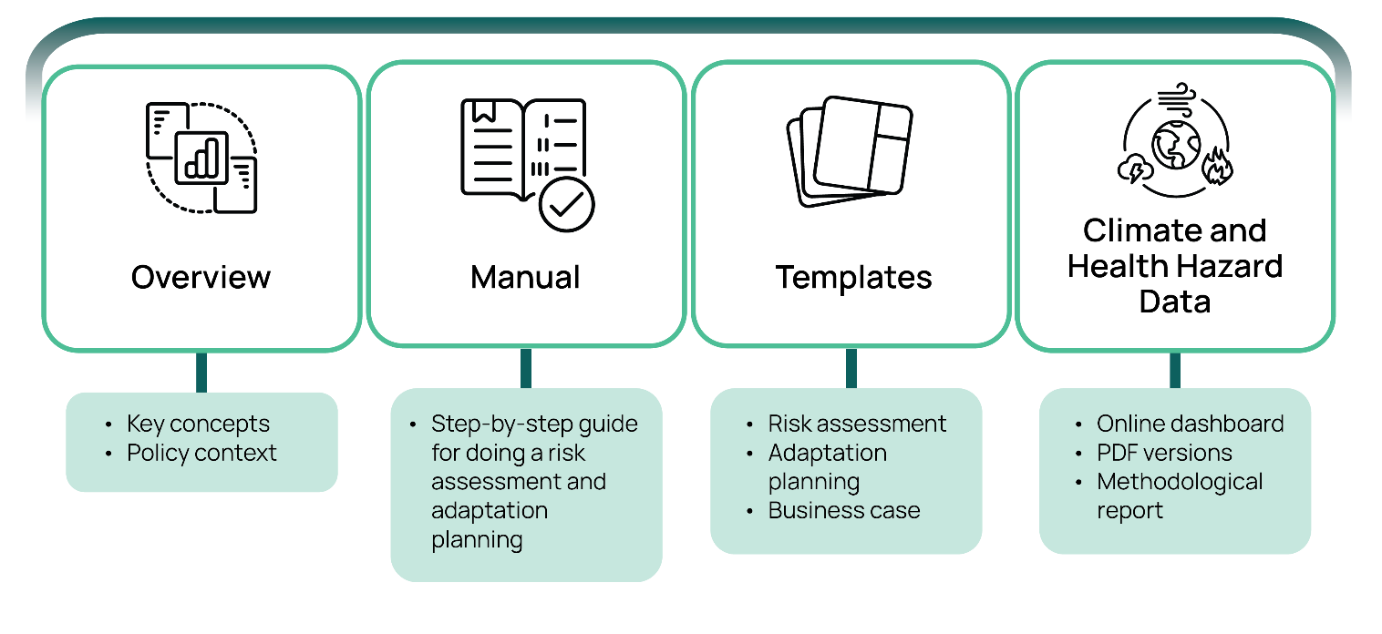
Overview: an introduction for decision-makers to the purpose and scope of climate risk assessment and adaptation planning and the structure of the guidance package.
Manual: step-by-step instructions on how to conduct a climate risk assessment, develop an adaptation plan, and conduct associated monitoring and reporting activities. Additional supporting materials are included in appendices.
Templates: a set of templates that can be used to complete your risk assessment and adaptation plan. These are designed to be flexible, allowing users to tailor them to suit their organisation’s needs, preferences, and context. Users are encouraged to modify the templates as required, and to use them alongside any relevant risk management frameworks, templates, or resources already in use within their organisation.
Climate and Health Hazard Data: a compendium of climate hazard and demographic information for 53 health districts across the country to support you in delivering in your risk assessment and adaptation plan. This resource is available in two different formats:
  - Downloadable document (PDF): provides information on a district-by-district basis. There is one document per state or territory containing information for each health district in that jurisdiction (except for the ACT and NSW, which are provided in a single document).
  - Online dashboard: provides district-by-district information and allows for more detailed and in-depth exploration of hazard and demographic data within each health district.
A detailed Methodological Report accompanies the Climate and Health Hazard Data, which provides detailed descriptions of the concepts, datasets, and analytical methods used to estimate reported exposure to climate-related hazards.
Users of the guidance are encouraged to work sequentially through the steps outlined in the manual (summarised in Figure 2 below), informed by information in the Climate and Health Hazard Data, appendices, and any relevant external resources as needed. As users progress through each step, findings and decisions can be recorded using the templates and adapted to suit an organisation’s specific needs and context.
Throughout the risk assessment and adaptation planning process, organisations are encouraged to draw on information beyond what is included in the guidance, such as:
- desktop research and document reviews
- individual interviews with staff, stakeholders, or subject matter experts
- questionnaires or surveys to gather input from a broader group
- workshops or group brainstorming sessions to facilitate structured discussion and consensus-building.

Risk assessment process
The first part of the manual provides step-by-step instructions on conducting a risk assessment. The risk assessment process is divided into 2 stages. The first-pass assessment identifies relevant climate hazards for an organisation, as well as associated risks to population health, service delivery and infrastructure.
Organisations can choose to stop after conducting a first-pass assessment, or alternatively, the first-pass assessment can inform a second-pass assessment involving risk analysis, which culminates in assessing the likelihood and consequence of these risks and prioritising them for adaptation action.

Adaptation planning process
The remaining sections of the manual provide step-by-step instructions for developing an adaptation plan (including an associated business case) and then implementing the plan (including monitoring and evaluation of progress). Appendices provide a review of evidence on climate risks to population health and additional resources on running consultation workshops and identifying climate risks and adaptation options.
- Overview of the climate risk assessment and adaptation planning process
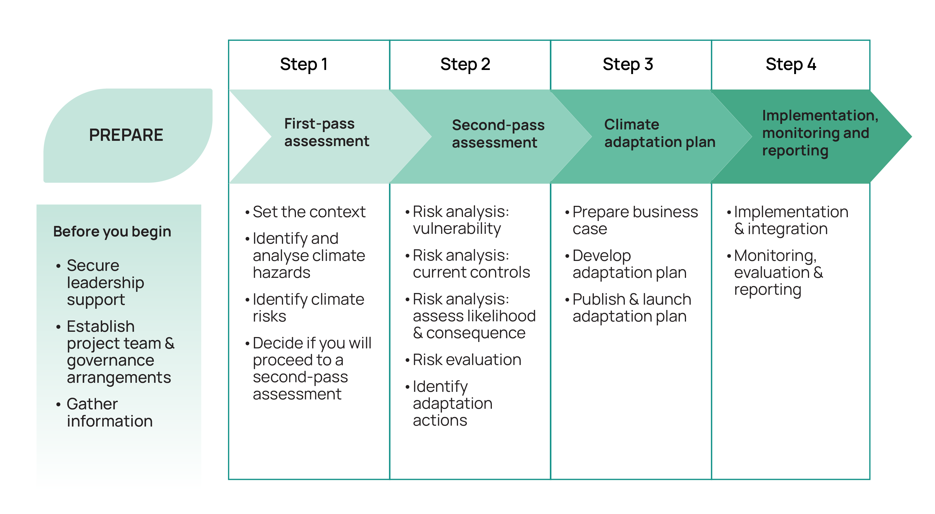

Key concepts

What is climate risk?
Climate risk refers to the potential for harm or disruption caused by climate change and/or efforts to limit it.³ Climate risks can be grouped in the following categories:
- Physical risks: these risks arise directly from the physical impacts of climate change, such as damage to infrastructure from extreme weather, increased illness during heatwaves, or disruptions to services caused by flooding. Physical climate risks arise when people, natural systems, services, infrastructure, resources, or other assets are exposed to climate-related hazards (such as heatwaves, bushfires, floods, or storms).
- Transition risks: these risks are associated with the shift to a low-emissions economy. Transition risks are typically thought of in the following categories:
Policy, legal & regulatory: risks from laws, regulations, or policies aimed at reducing emissions or improving sustainability.
Reputational: risks of negative public perceptions and/or reactions if an organisation is perceived to have failed to take appropriate climate action.
Technology: risks associated with shifts to new, lower-emissions technologies.
Market: risks from shifts in market conditions, such as changes in demand, supply chains, or costs due to the transition to a low-carbon economy.
- Liability risks: these risks are associated with people or businesses seeking compensation for losses they may have suffered due to climate change, including losses relating to physical and transition risks.
This guidance focuses on physical climate risks to minimise complexity for health system organisations still developing capacity and capability in climate risk assessment. Physical climate risks to health, wellbeing and health systems eventuate when climate hazards (both extreme weather events and gradual environmental changes) interact with exposed and vulnerable people, natural systems, services, infrastructure, resources, or other assets. These risks can be thought of in two interconnected domains: risks to population health and risks to the health system, as seen in Figure 3. However, it is generally considered best practice for climate risk assessment to encompass consideration of transition and liability risks where possible.
- Climate risks to health, wellbeing and health systems
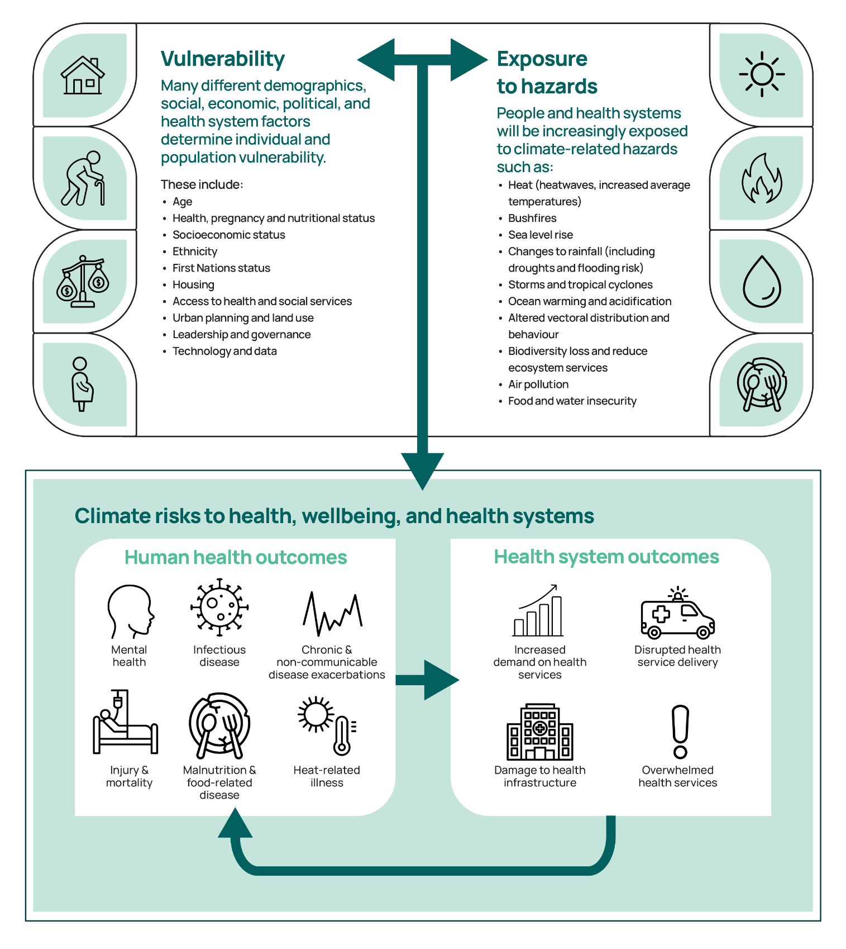

What is a climate risk assessment?
A climate risk assessment is the process of identifying and evaluating how climate change could affect people, natural systems, services, infrastructure, resources, or other assets. The goal is to support decisions and actions that reduce harm and improve preparedness for a changing climate. Importantly, climate risk assessments should be treated as an ongoing and dynamic process, which should be revisited and updated as climate and other conditions change over time.
As well as considering current risks, climate risk assessments typically consider two or more ‘climate scenarios’ (often using Shared Socioeconomic Pathways or SSPs) outlining how climate conditions might change under different levels of global greenhouse gas emissions and resulting atmospheric concentrations. Uncertainty about current and future risks is managed by clearly stating assumptions, using scenarios to explore different futures, and designing actions that can be adjusted over time. The manual provides further information on these topics.

What about climate-related opportunities?
The impacts of climate change for health, wellbeing and health systems are overwhelmingly negative. As such, this guidance focuses on supporting health system organisations to prevent and/or manage the potential adverse consequences of climate change. However, climate change mitigation and adaptation measures present significant opportunities to improve health outcomes, enhance resilience, and achieve operational efficiencies. For example, improving building insulation can help maintain safe indoor temperatures during extreme heat, reducing risks to patients and staff while lowering demand on cooling systems. This increases operational resilience as well as reducing energy use, emissions, and costs.
Many recent climate risk assessment frameworks, including the CROMP, prompt the identification of climate-related opportunities alongside risks.^{8,} Although not the focus of this guidance, routinely considering and pursuing the opportunities and co-benefits of climate mitigation and adaptation measures is extremely worthwhile. Users should review any specific requirements (legislative, regulatory, or policy-based) that may apply to their organisation in relation to the assessment of climate-related opportunities to ensure compliance with context-specific obligations.

What is climate adaptation?
Climate adaptation is a process of preparing for and/or adjusting to the impacts of climate change. It involves taking practical steps to reduce harm and protect people, natural systems, services, infrastructure, resources, or other assets. It is a complex and ongoing process, consisting of an ongoing cycle of four activities, outlined in Figure 4: understand and assess; prioritise and plan; adapt and respond; and monitor change. For health system organisations, climate adaptation could, for instance, involve planning to ensure facilities remain operational during extreme weather, or providing advice and support to priority populations to help them prevent and/or manage the health impacts of bushfire smoke. Effective adaptation can build climate resilience – the capacity to prepare for, respond to, and recover from climate impacts.
- The cycle for adapting to climate change (adapted from the National Adaptation Plan)
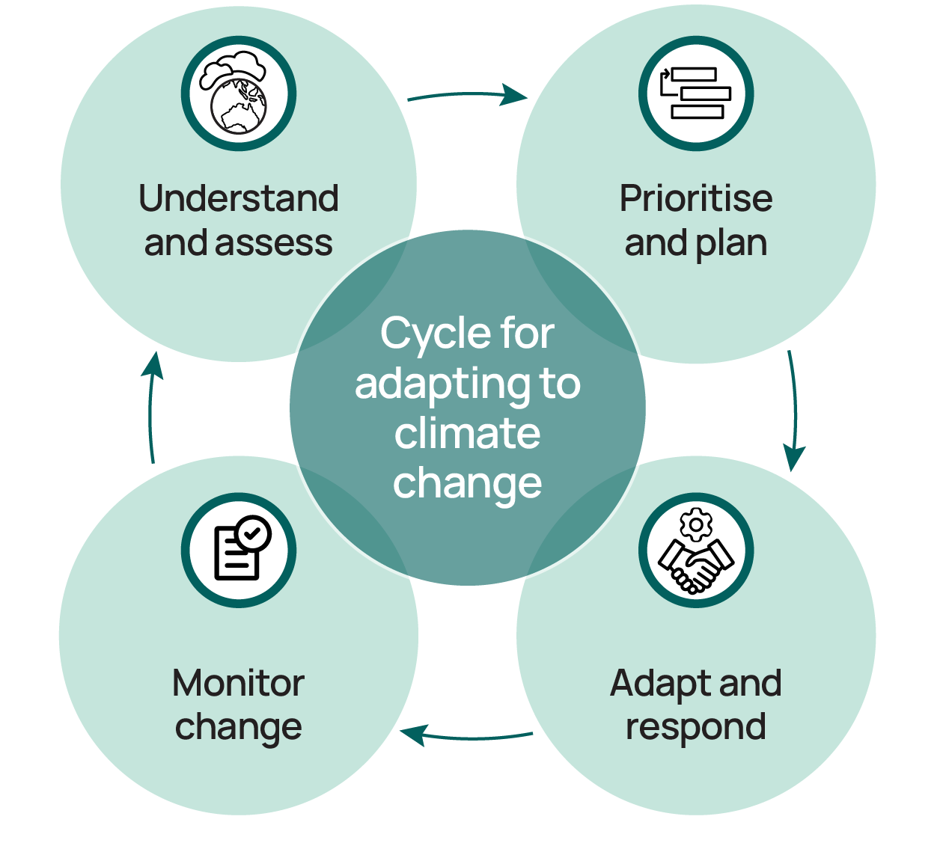
Adaptation is different to, but closely connected to, mitigation, which focuses on reducing the greenhouse gas emissions that cause climate change. While emissions mitigation aims to slow or prevent future climate change, adaptation aims to reduce the likelihood of climate impacts eventuating and/or the severity of impacts when they do occur. Both adaptation and mitigation are essential, and both can have significant benefits for health and wellbeing; indeed, effective adaptation requires credible mitigation strategies to address the root causes of climate risks and impacts.

What is an adaptation plan?
A climate adaptation plan outlines the actions an organisation will take to prevent, prepare for, and respond to the impacts of climate change. It is based on an understanding of climate risks (typically obtained via a preceding risk assessment), and focuses on reducing vulnerability (and, where possible, exposure) to climate-related hazards to minimise the likelihood or consequence of a climate risk being realised. Its aim is to prevent or minimise harm, protect people, assets and services, and strengthen resilience. For health system organisations, this includes planning for events like heatwaves, bushfires, floods, and climate-sensitive disease outbreaks, and ensuring infrastructure, workforce, and communities are ready to respond to changing conditions.

References



Australian Climate Service, National Climate Risk Assessment, Australian Government, 2025, accessed 18 May 2026.
Australian Department of Climate Change, Energy, the Environment and Water, National Adaptation Plan, Australian Government, 2025, accessed 18 May 2026.
Australian Department of Climate Change, Energy, the Environment and Water, Climate Risk and Opportunity Management Program Technical Guidance, Australian Government, 2025, accessed 18 May 2026.
Australian Department of Treasury, Climate related financial reporting and guidance, Australian Government, 2025, accessed 18 May 2026.
Australian Department of Health and Aged Care, National Health and Climate Strategy, Australian Government, 2023, accessed 18 May 2026.
Australian Department of the Treasury, Climate-related transition planning: Voluntary Guidance, Australian Government, accessed 22 September 2026.
Australian Accounting Standards Board (AASB), Australian Sustainability Reporting Standard AASB S2, Australian Government, 2024, accessed 27 May 2026.
Australian Securities & Investments Commission (ASIC), REP 809 Response to submissions on CP 380 Sustainability reporting, ASIC, 2025, accessed 21 May 2026.
Australian Department of Climate Change, Energy, the Environment and Water, Australia’s 2035 Nationally Determined Contribution, Australian Government, 2025, accessed 27 May 2025.
Department of Climate Change, Energy, the Environment and Water, Australia’s Net Zero Plan, Australian Government, 2025, accessed 27 May 2026.
Department of Climate Change, Energy, the Environment and Water, Annual Climate Change Statement 2025, Australian Government, 2025, accessed 27 May 2026.
Queensland Health, Climate Change Adaptation Planning Guidance Guidelines, Queensland Government, 2019, accessed 18 May 2026.
Victoria Department of Health, Climate change risk toolkit for Victorian health services (internal policy document), Victoria State Government, 2025.
Australian Department of Health and Aged Care, National Health and Climate Strategy Final thematic stakeholder engagement report, Australian Government, 2023, accessed 18 May 2026.
Australian Department of Climate Change, Energy, the Environment and Water, Climate Risk Management: The Australian Government’s Approach to Climate Risk and Opportunity Management in the Public Sector 2024-2026, Australian Government, 2024.
Australian Department of the Treasury, Policy Impact Analysis: Climate-related financial disclosures, Australian Government, 2022, accessed 18 May 2026.
Australian Accounting Standards Board, Climate-Related Disclosures, Australian Government, 2024, accessed 18 May 2026.
NHS England, NHS Climate Change Risk Assessment (CCRA) tool, NHS England, 2025, accessed 18 May 2026.
Intergovernmental Panel on Climate Change Working Group II, Fact Sheet – Health: Climate Change Impacts and Risks, World Meteorological Organisation and United Nations Environment Programme, 2023, accessed 18 May 2026.
Adapt New South Wales, Climate Risk Ready NSW Guide, New South Wales Government, 2021, accessed 18 May 2026.
S Mehryar, What is the difference between climate change adaptation and resilience?, Grantham Research Institute on Climate Change and the Environment, 2022, accessed 18 May 2026.

