Diphtheria in Australia – Epidemiological update
  - As at 29 June 2026

Data extracted from NNDSS: 30 June 2026
Latest diagnosis date: 29 June 2026
Due to the dynamic nature of the National Notifiable Diseases Surveillance System (NNDSS) and case investigations, data in this report are subject to retrospective revision and may vary from data reported in other national reports and reports by states and territories. Case definitions for the diseases included in this report are available on the Australian Centre for Disease Control website (https://www.cdc.gov.au/resources/collections/cdna-surveillance-case-definitions).

Background
- Diphtheria is an acute illness caused by toxin producing strains of Corynebacterium diphtheriae and Corynebacterium ulcerans. Infection may lead to two different clinical outcomes: respiratory disease or cutaneous (skin) disease.
- In the early 1900s, diphtheria caused more deaths in Australia than any other infectious disease. Since the implementation of vaccination programs in the 1940s, the incidence of diphtheria has declined in Australia, and globally. Although diphtheria is considered rare in Australia, it remains endemic in many developing countries.
- Prior to the COVID-19 pandemic, most Australian cases were imported from overseas, with a high proportion of these cases reported as cutaneous diphtheria.
- Between 1999 and 2019, cutaneous and respiratory diphtheria occurred mostly among adults. During this period there were 2 deaths reported in unvaccinated adults who both acquired their infections in Australia.
- Between 2020 and 2022, there were 4 localised diphtheria clusters, each in a different geographical area of North Queensland, and involving a high proportion of cutaneous cases and several respiratory cases.
- The Australian Immunisation Handbook recommends diphtheria-toxoid vaccine for: routine vaccination in infants, children and adolescents; routine booster vaccination in adults, including those in special risk groups such as pregnant women, laboratory workers, and travellers to countries where health services are difficult to access. Vaccination is recommended every 10 years for travellers to countries where health services are difficult to access. Travellers to some areas where there is a higher risk of acquiring diphtheria are recommended to be vaccinated every 5 years.
- For further information please refer to the Australian CDC Diphtheria page.

Key summary points
- A total of 413 cases of diphtheria have been notified in Australia in 2026, including 410 confirmed cases and three probable cases.
- In recent weeks, the number of cases diagnosed nationally appears to have plateaued from mid-April to early June. Noting recent diagnosis date trends are likely incomplete, at the sub-national level, cases in the NT appears to have plateaued from mid-April to late May, with indications of a gradual decline since. In WA, while there had been a steady increase in cases since April, in the past fortnight there has been a slowing in the number of cases diagnosed.
- In the past fortnight, there were 38 cases notified compared to 66 cases in the previous fortnight. Among cases notified this fortnight (n=38):
  - Most notified cases (55.3%) were from WA and 44.7% were from the NT.
  - Diagnosis dates among cases ranged from 2 June to 28 June 2026, with 15 cases (39.5%) classified as respiratory diphtheria.
  - Newly notified cases have predominately acquired their infections in areas with recently reported diphtheria infections.
- In 2026, most cases have been reported in the Northern Territory (54.7%; n=226) and Western Australia (42.4%; n=175), with a few cases in South Australia (n=8) and Queensland (n=4).
  - Three cases were acquired overseas: two cutaneous diphtheria cases, and one case with clinical presentation information pending.
  - Among locally acquired cases (n=410), almost all are residents in areas classified as ‘outer regional’, ‘remote’ or ‘very remote’ (99.5%).
  - Most cases (94.9%) have been among Aboriginal and/or Torres Strait Islander people.
  - Around two-thirds of cases (65.1%) have been cutaneous diphtheria, with 32.7% classified as respiratory diphtheria, and clinical presentation information pending for 9 cases. All of the 135 respiratory diphtheria infections in 2026 have been locally acquired.
  - The median age of cases is 24 years (IQR: 12.0-36.0), with the median age of cutaneous diphtheria cases being higher (28 years) compared to respiratory diphtheria cases (17 years).
  - Overall, around 18% of diphtheria cases have been hospitalised, with the proportion hospitalised being similar by clinical presentation type and noting that cases may be hospitalised for public health management reasons.
    - The cause of death for a diphtheria case notified in April 2026 indicates that diphtheria was the probable cause.
- AusTrakka genomic analyses indicate recent cases in Western Australia, the Northern Territory, South Australia and Queensland are genomically linked.
  - Previous analyses suggests that the current cluster shares genomic characteristics of cases from a 2020 to 2023 cluster in Queensland, noting that the findings are not considered definitive epidemiological evidence.
- Vaccination provides strong protection against the severe effects of diphtheria toxin, but it does not consistently prevent carriage or transmission.
  - A high proportion of respiratory diphtheria cases (85.7%) and cutaneous diphtheria cases (75.7%) in 2026 had received at least three valid vaccine doses (primary course).
    - Among cases who had received at least three valid vaccine doses, the median period since last vaccination was lower for cutaneous diphtheria cases (3.1 years) than for respiratory diphtheria cases (7.2 years), and was highest among hospitalised respiratory diphtheria cases (8.7 years).
  - Consistent with the National Immunisation Program and broader Australian Immunisation Handbook recommendations, the number of doses received tended to increase with age.
    - National vaccination coverage rates for children aged 5 years as at September 2025 was 93.4%, with coverage rates higher among Aboriginal and Torres Strait Islander children at 94.7%.

Current epidemiology of diphtheria in Australia
As of 29 June 2026, a total of 413 diphtheria cases have been notified in Australia in 2026, including three probable cases^{i}, representing a substantial increase compared with historical levels. For the equivalent periods in 2022 to 2025, an average of 10.3 cases were reported (Table 1). The previous peak in annual notifications occurred in 2022, with 31 cases, the majority of which were associated with several clusters in northern Queensland (80.6%; 25/31).
Notifications of diphtheria began increasing in October 2025, with a marked increase from February 2026. While the number of cases diagnosed nationally appears to have plateaued between mid-April and early June, there has been variability at the sub-national level (see Geographic distribution). In the past fortnight, 38 cases were notified, compared with 66 cases in the previous fortnight, with diagnosis dates ranging between 2 June and 28 June 2026. Figure 1 provides an epidemic curve of cases by diagnosis month, noting recent diagnosis date trends are likely incomplete and should be interpreted with caution.
Figure 1: Notifications of diphtheria by month of diagnosis*, Australia, 1 January 2025 to 29 June 2026
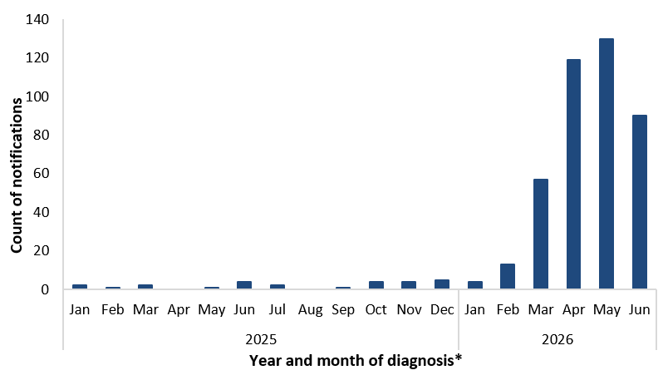
* Reporting delays between diagnosis date and notification to the NNDSS, particularly in recent weeks, and the incomplete current month
affect data completeness. Trends for recent periods should be interpreted with caution.

Species
Under the national case definition for diphtheria, a confirmed case requires isolation of toxigenic Corynebacterium diphtheriae or toxigenic C. ulcerans from the upper respiratory tract or skin lesion^{i}. In 2026, almost all confirmed cases were reported as C. diphtheriae (410/413), with three locally acquired cases of C. ulcerans diagnosed in late March and two cases in June this year, and no cases of unknown species reported.

Geographic distribution
Among cases reported in 2026, 54.7% (226/413) were reported in the Northern Territory, 42.4% (175/413) in Western Australia, 8 cases in South Australia and 4 cases in Queensland. Among the 38 cases notified this fortnight, just over half (55.3%; 21/38) were notified from WA, with diagnosis dates among cases this fortnight being between early to late June 2026. By diagnosis date, notifications in the NT appear to have plateaued from mid-April to late May, with indications of a gradual decline since. In WA, while there had been a steady increase in notifications since April, in recent weeks there has been an apparent slowing of notifications (Figure 2).
Among locally acquired cases, there was a notable increase in the proportion of cases residing in ‘remote’ and ‘very remote’ areas since 2021. In 2026, among locally acquired cases (99.3%; 410/413), 88.0% resided in areas classified as ‘remote’ and ‘very remote’, while a further 11.5% resided in ‘outer regional’ areas (Figure 3).
Over the past fortnight, newly notified cases of C. diphtheriae have predominantly been acquired in areas with previously reported diphtheria infections.
Figure 2: Notifications of diphtheria by jurisdiction and month of diagnosis, Australia, 1 January 2025 to 29 June 2026
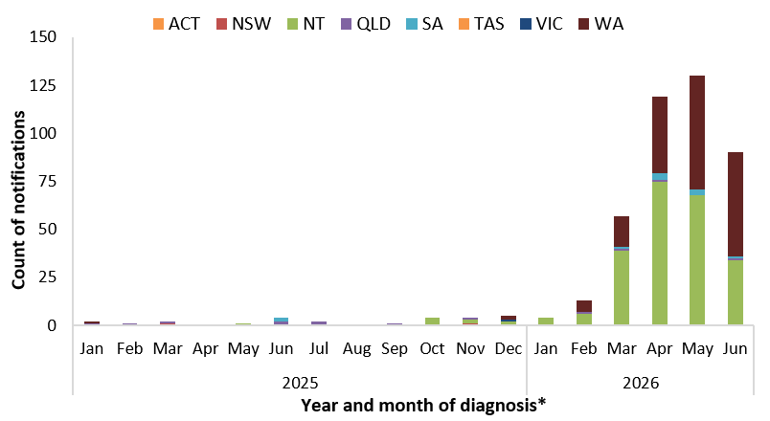
* Reporting delays between diagnosis and notification to the NNDSS, particularly in recent weeks, and the incomplete current month affect data completeness. Trends for recent periods should be interpreted with caution.
Figure 3: Proportion of locally acquired* diphtheria by remoteness area of residence† and year of diagnosis, 1 January 2025 to 29 June 2026
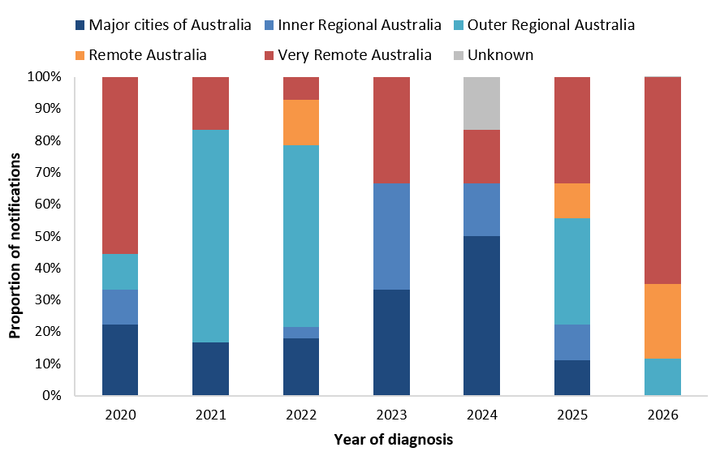
* Excludes cases acquired overseas. † Remoteness area of residence is based on the ABS Australian Statistical Geography Standard Remoteness Structure Postal Areas Correspondence.

Place of acquisition
By place of acquisition, between 2014 and 2019, the majority of diphtheria cases were acquired overseas, predominantly in the Western Pacific and South-East Asia regions. Since 2020, the majority of diphtheria notifications have been locally acquired. So far in 2026, 3 cases (0.8%; 3/357) are reported to have acquired their infection overseas.
Since 2020, there have been 16 diphtheria clusters (with 2 or more cases) reported by jurisdictions, with 11 of these clusters reported in 2026. The largest epidemiologically linked clusters (10 to 16 cases) occurred in North Queensland with cases involved in these clusters spanning 2020 to 2023. The more recent clusters in 2026 have been in Western Australia, the Northern Territory and South Australia, with the size of these epidemiologically linked clusters ranging from 2 to 8 cases.
Genomic analysis of C. diphtheriae sequences uploaded to AusTrakka with dates of collection from 2025 up to 27 May 2026, suggests that the Western Australia, Northern Territory, Queensland and South Australian cases since 2025 are genomically linked (Cluster 2:2:2) (Figure 4). All sequences have been confirmed as tox gene positive. Two additional clusters (Cluster 2:2:3 and 2:2:5) linked to the current outbreak at the broader genomic level (Cluster 2:2) were identified in March 2026, which includes cases from the Northern Territory and South Australia. This genetic drift is expected given the timeframe and geographic spread of cases. Previous analyses suggest that the main cluster (Cluster 2:2:2) appears to have descended from a 2020 to 2023 cluster in Queensland (Cluster 1:1:1), and the new clusters (2:2:3 and 2:2:5) have emerged from cluster 2:2:2. However, noting the small number of available intermediate sequences, the findings should be interpreted as evidence of shared genomic characteristics rather than definitive epidemiological evidence of linkage to the earlier Queensland cluster.
Figure 4: AusTrakka* SNP clustering of toxigenic C. diphtheriae sequences, 12 March 2020 to 27 May 2026
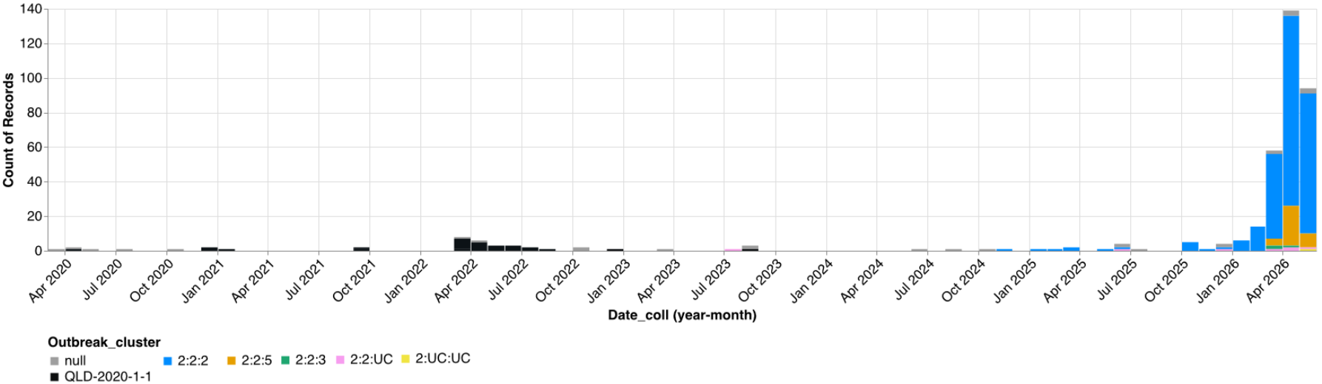
* AusTrakka Genomic Analysis Report ATOI26001 – Corynebacterium diphtheriae (10 June 2026).

Clinical presentation
Across Australia, from 2016 to 2025, most diphtheria notifications were reported as cutaneous diphtheria, with only a small number of respiratory diphtheria cases reported annually across most years during this period. The increase and upward trend in locally acquired cutaneous diphtheria cases during the latter part of this period may be attributable to changes in testing practices, including toxigenic testing, particularly of wounds, as well as the inclusion of cutaneous diphtheria in the national case definition from 2017^{i}. In 2022, respiratory diphtheria accounted for 19.4% (6/31) of cases, with all of these cases locally acquired.
In 2026, the predominant clinical presentation continues to be cutaneous diphtheria (65.1%; 269/413), with respiratory diphtheria accounting for 32.7% (135/413) of cases, and clinical presentation information pending for 9 cases (Figure 5).
Figure 5: Notifications of diphtheria by clinical presentation and month of diagnosis*, Australia, 1 January 2025 to 29 June 2026
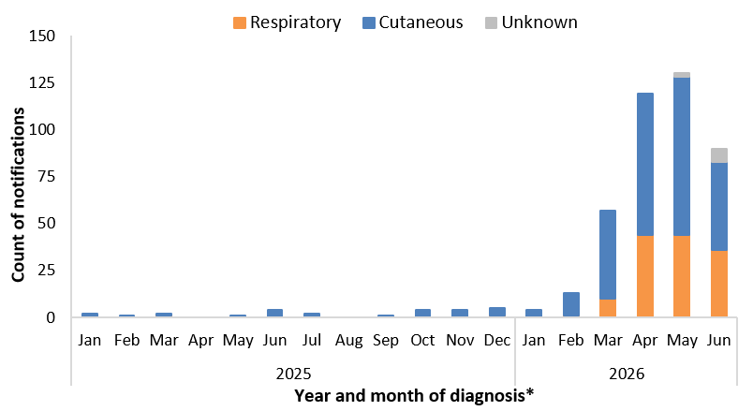
* Reporting delays between diagnosis and notification to the NNDSS, particularly in recent weeks, and the incomplete current month affect data completeness. Trends for recent periods should be interpreted with caution.

Age and sex
Since 2014, notifications of diphtheria have predominantly been reported among those aged 25 years and over, with variability in the proportion of cases reported among those in younger age groups since 2017 (Figure 6). The highest number of cases so far in 2026 are among those in the 25 to 44 years age group (Figure 7), with notification rates highest among the 0 to 4, 5 to 14 and 15 to 24 years age groups. So far in 2026, by clinical presentation, the median age of cutaneous diphtheria cases (28 years; IQR 11.0-41.0) has been higher compared to respiratory diphtheria cases (17 years; IQR 12.0-27.0), with this pattern consistent with previous years (Figure 7).
Between 2022 and 2025, the distribution of cases by sex was relatively balanced (48.1% females), with some variability by age group. In 2026, a higher proportion of cases overall are among females (55.4%), with variability also observed by age group.
Figure 6: Proportion of diphtheria notifications by age group, Australia, 1 January 2014 to 29 June 2026
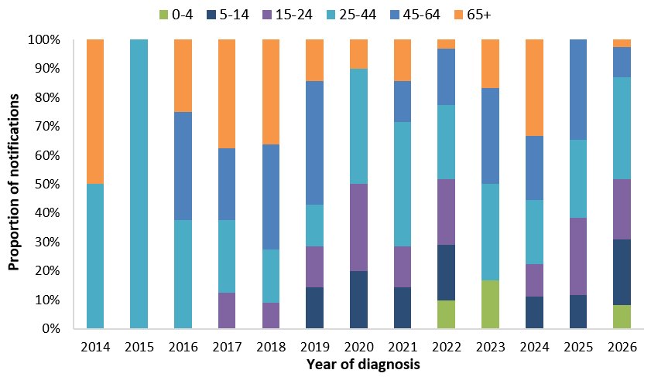
Figure 7: Notifications of diphtheria by age group and clinical presentation, Australia, 1 January 2022 to 29 June 2026
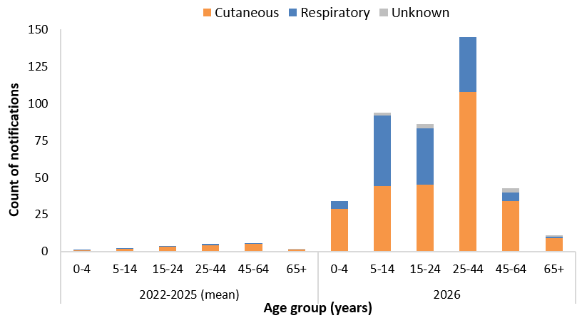

Indigenous status
Indigenous status completeness for diphtheria has remained consistently high, at over 99.0% across 2014 to 2026. Between 2014 and 2019, the proportion of diphtheria cases among Aboriginal and/or Torres Strait Islander people was around 10.5% of cases, noting that there were very few cases reported in 2014 and 2015 (n=4) (Figure 8). Between 2020 to 2022, which included multiple diphtheria clusters in North Queensland, the proportion of cases among Aboriginal and/or Torres Strait Islander people increased to 64.6%. So far in 2026, 94.9% (392/413) of cases have been reported among Aboriginal and/or Torres Strait Islander people.
Figure 8: Proportion of diphtheria notifications by Indigenous status, Australia, 1 January 2014 to 29 June 2026
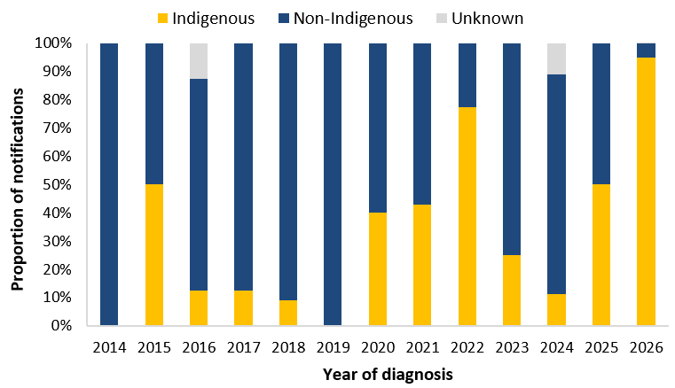

Severity
Between 2022 and 2025, just over a quarter (28.2%) of diphtheria notifications were reported as being hospitalised, with proportions of cases hospitalised higher among those with respiratory diphtheria. So far in 2026, a lower proportion (17.9%; 74/413) of all diphtheria cases have been hospitalised. The proportion of respiratory diphtheria cases hospitalised (17.8%; 24/135) is similar to the proportion among cutaneous diphtheria cases (17.5%; 47/269). The proportion of cases hospitalised may vary over time and by clinical presentation type due either to true differences in disease severity or differences in the public health management of cases, including for infection control purposes.
In 2026, one death has been reported in a diphtheria case notified in April, with diphtheria indicated as the probable cause. Prior to 2026, the most recent diphtheria associated death was reported in 2018.

Vaccination status
The vaccination status among diphtheria cases has differed by clinical presentation type. In 2026, a higher proportion of respiratory diphtheria cases (85.7%) had received 3 or more valid doses, compared with 75.7% of cutaneous diphtheria cases.
While vaccination provides strong protection against the severe effects of diphtheria toxin, it does not consistently prevent carriage or transmission of C. diphtheriae, regardless of whether the strain produces toxin or not.
Consistent with the National Immunisation Program and broader Australian Immunisation Handbook recommendations, the number of doses received tended to increase with increasing age (Figure 9). In 2026, among diphtheria cases reported to have received at least 3 vaccine doses, the median number of years since last vaccine dose has typically been lower among cutaneous diphtheria cases (3.1 years) than among respiratory diphtheria cases (7.2 years) (Figure 10). For this same period, the median number of years since last vaccine dose was highest among hospitalised cases with respiratory diphtheria (8.7 years).
More broadly, national diphtheria–tetanus–pertussis (DTP) vaccination coverage rates as at September 2025, based on the National Immunisation Program Schedule, was:
- 93.4% (range: 91.9% to 94.8%) among all children aged 5 years
- 94.7% (range: 92.9% to 96.3%) among Aboriginal and Torres Strait Islander children aged 5 years.
However, ‘fully immunised’ rates among the 5-year-old cohort, regardless of Indigenous status, have been gradually declining since peaking in 2020.
Figure 9: Notifications of diphtheria by vaccination status, clinical presentation type and age group, Australia, 1 January to 29 June 2026
(a) Cutaneous diphtheria | (b) Respiratory diphtheria
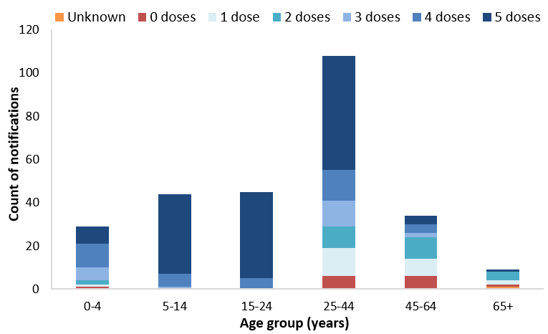 | 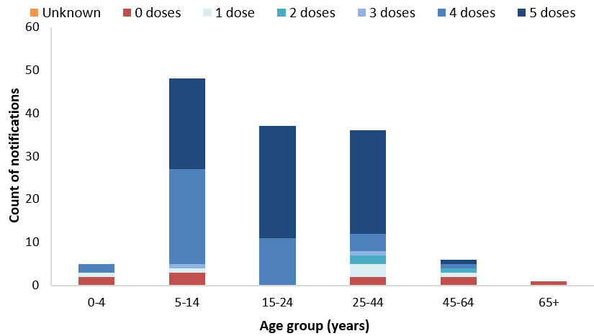
Figure 10: Distribution of years since last vaccine dose for notifications of diphtheria with at least 3 doses*, by clinical presentation type, Australia, 1 January 2014 to 29 June 2026
(a) Cutaneous diphtheria | (b) Respiratory diphtheria
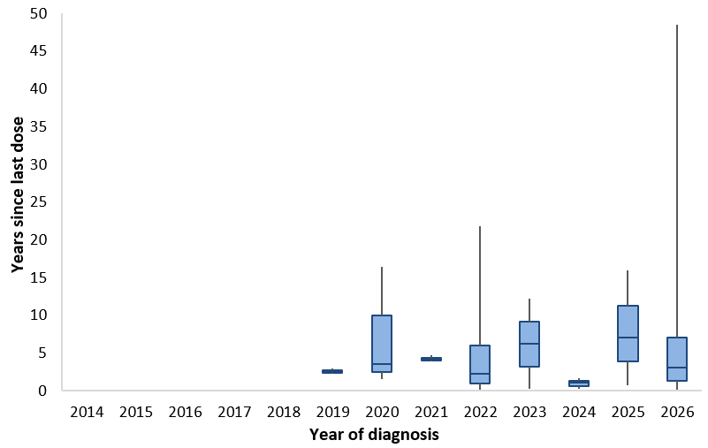 | 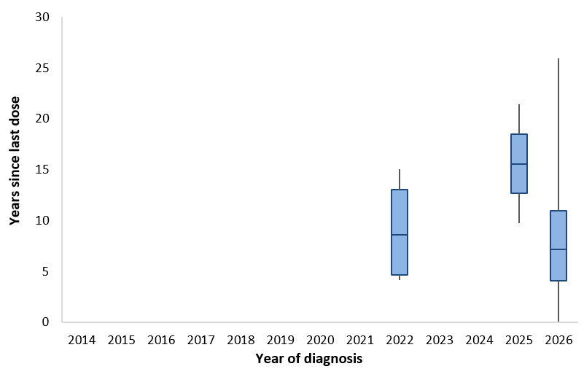
* Periods where there were less than 2 cases that had received 3 or more vaccine doses are not shown.

Epidemiological characteristics of diphtheria cases
Table 1: Epidemiological summary of diphtheria cases* in Australia, 1 January 2022 to 29 June 2026
 | Past 4-weeks (2 June to 29 June 2026)* | 2026  YTD† | 2025 | 2022–2025 YTD† (mean) | 2022–2025 (mean)
Total | 84 | 413 | 26 | 10.3 | 19.5
Confirmation status
Confirmed | 82 (98%) | 410 (99%) | 26 (100%) | 10.3 (100%) | 19.5 (100%)
Probable | 2 (2%) | 3 (1%) | 0 (0%) | 0.0 (0%) | 0.0 (0%)
Species
C. diphtheriae | 82 (98%) | 410 (99%) | 26 (100%) | 8.8 (85%) | 17.0 (87%)
C. ulcerans | 2 (2%) | 3 (1%) | 0 (0%) | 1.5 (15%) | 2.5 (13%)
State
ACT | 0 (0%) | 0 (0%) | 0 (0%) | 0.0 (0%) | 0.0 (0%)
NSW | 0 (0%) | 0 (0%) | 2 (8%) | 1.5 (15%) | 2.5 (13%)
NT | 30 (36%) | 226 (55%) | 9 (35%) | 0.3 (2%) | 2.5 (13%)
QLD | 1 (1%) | 4 (1%) | 9 (35%) | 7.3 (71%) | 11.5 (59%)
SA | 1 (1%) | 8 (2%) | 2 (8%) | 0.5 (5%) | 0.5 (3%)
TAS | 0 (0%) | 0 (0%) | 0 (0%) | 0.0 (0%) | 0.3 (1%)
VIC | 0 (0%) | 0 (0%) | 1 (4%) | 0.0 (0%) | 0.5 (3%)
WA | 52 (62%) | 175 (42%) | 3 (12%) | 0.8 (7%) | 1.8 (9%)
Remoteness area of residence‡
Major cities | 2 (2%) | 3 (1%) | 6 (23%) | 2.3 (22%) | 5.3 (27%)
Regional areas‡ | 3 (4%) | 48 (12%) | 11 (42%) | 6.0 (59%) | 9.5 (49%)
Remote areas‡ | 79 (94%) | 361 (87%) | 9 (35%) | 2.0 (20%) | 4.5 (23%)
Unknown | 0 (0%) | 1 (0%) | 0 (0%) | 0.0 (0%) | 0.3 (1%)
Place of acquisition
Overseas acquired | 1 (1%) | 3 (1%) | 8 (31%) | 2.0 (20%) | 5.0 (26%)
Locally acquired | 78 (93%) | 392 (95%) | 17 (65%) | 7.3 (71%) | 12.5 (64%)
Unknown | 5 (6%) | 18 (4%) | 1 (4%) | 1.0 (10%) | 2.0 (10%)
Clinical manifestation
Cutaneous | 42 (50%) | 269 (65%) | 24 (92%) | 9.0 (88%) | 17.0 (87%)
Respiratory | 35 (42%) | 135 (33%) | 2 (8%) | 1.3 (12%) | 2.3 (12%)
Unknown | 7 (8%) | 9 (2%) | 0 (0%) | 0.0 (0%) | 0.3 (1%)
Age (years)
Median (IQR) | 21.0 (12.0-31.0) | 24.0 (12.0-36.0) | 36.5 (19.8-48.5) | 37.0 (25.9-46.1) | 39.4 (22.8-52.8)
Age group (years)
0-4 | 5 (6%) | 34 (8%) | 0 (0%) | 0.8 (7%) | 1.3 (6%)
5-14 | 23 (27%) | 94 (23%) | 3 (12%) | 2.0 (20%) | 2.5 (13%)
15-24 | 22 (26%) | 86 (21%) | 7 (27%) | 2.3 (22%) | 3.8 (19%)
25-44 | 22 (26%) | 145 (35%) | 7 (27%) | 3.0 (29%) | 5.3 (27%)
45-64 | 8 (10%) | 43 (10%) | 9 (35%) | 1.5 (15%) | 5.3 (27%)
65+ | 4 (5%) | 11 (3%) | 0 (0%) | 0.8 (7%) | 1.5 (8%)
Sex
Male | 40 (48%) | 184 (45%) | 15 (58%) | 5.0 (49%) | 10.3 (53%)
Female | 44 (52%) | 229 (55%) | 11 (42%) | 5.3 (51%) | 9.3 (47%)
Indigenous status
Indigenous | 80 (95%) | 392 (95%) | 13 (50%) | 6.5 (63%) | 10.3 (53%)
Non-Indigenous | 4 (5%) | 20 (5%) | 13 (50%) | 3.5 (34%) | 9.0 (46%)
Unknown | 0 (0%) | 1 (0%) | 0 (0%) | 0.3 (2%) | 0.3 (1%)
Severity
Hospitalised | 6 (7%) | 74 (18%) | 10 (38%) | 2.0 (20%) | 5.5 (28%)
Died | 0 (0%) | 1§ (0%) | 0 (0%) | 0.0 (0%) | 0.0 (0%)
Vaccination status
0 doses | 6 (7%) | 26 (6%) | 5 (19%) | 2.0 (20%) | 3.8 (19%)
1 dose | 6 (7%) | 32 (8%) | 9 (35%) | 1.5 (15%) | 4.5 (23%)
2 doses | 3 (4%) | 30 (7%) | 2 (8%) | 0.8 (7%) | 1.8 (9%)
3 doses | 2 (2%) | 23 (6%) | 0 (0%) | 1.0 (10%) | 1.5 (8%)
4 doses | 17 (20%) | 81 (20%) | 6 (23%) | 1.5 (15%) | 2.5 (13%)
5 doses | 50 (60%) | 220 (53%) | 4 (15%) | 3.3 (32%) | 4.8 (24%)
Unknown | 0 (0%) | 1 (0%) | 0 (0%) | 0.3 (2%) | 0.8 (4%)
* By diagnosis date, noting that data toward the end of the analysis period is likely incomplete.
†YTD represents the year-to-date diagnosis period of 1 January to 29 June.
‡ Remoteness area of residence includes both locally acquired and overseas acquired cases, and is based on the ABS Australian Statistical Geography Standard Remoteness Structure Postal Areas Correspondence. The categories of ‘Inner Regional’ and ‘Outer Regional’ have been combined to ‘Regional’. The categories of ‘Remote’ and ‘Very Remote’ have been combined to ‘Remote’.
§ The cause of death indicates that diphtheria was the probable cause.

CDNA diphtheria case definition: https://www.cdc.gov.au/system/files/2025-09/diphtheria-surveillance-case-definition_0.pdf
Diagnosis date is the preferred public health indicator of disease transmission activity. However, delays between diagnosis and notification to the NNDSS result in incomplete data for more recent weeks. Analyses by notification date can be used as a proxy for more current trends, with an underlying assumption of a stable distribution of reporting lags.
1 January to 29 June
Diagnosis date is the preferred public health indicator of disease transmission activity. However, delays between diagnosis and notification to the NNDSS result in incomplete data for more recent weeks. Notification date can be used as a proxy for more current trends, with an underlying assumption of a stable distribution of reporting lags.
C. ulcerans is considered a zoonotic infection and is not related to the current outbreak which is caused by C. diphtheriae. Historically, C. ulcerans has been associated with consumption of raw or unpasteurised milk products or direct contact with infected domestic or farm animals.

