Australian Respiratory Surveillance Report

Key messages
This report presents a national update on acute respiratory infections, including coronavirus disease 2019 (COVID-19), influenza and respiratory syncytial virus (RSV). It focuses on the current reporting period (10 August to 23 August 2026) and earlier severity reporting periods (up to 9 August 2026). These key messages do not routinely provide detailed information on age distribution, jurisdictional patterns, or comparisons with previous years. This analysis and supporting data are available in the full report.
In the community: In the last fortnight, self-reported influenza-like illness increased among people who contacted the national health helpline and those who took part in community surveys. COVID-19 cases increased in the last fortnight and in contrast to previous years, national data in 2026 to date do not yet show a clear winter peak. Influenza cases continued to increase substantially in the last fortnight, and current surveillance data suggest that the national influenza peak in 2026 is yet to occur, and trends will continue to be monitored. RSV cases continued to decrease in the last fortnight.
In general practice: In the last fortnight, influenza-like illness consultation rates at sentinel general practice sites increased. The consultation rates are higher than observed at the same time in 2023 and remain lower than observed at the same time in 2024–2025, and similar to the historical five-year average.
In hospitals: In the last severity reporting fortnight, admissions to sentinel hospitals with severe acute respiratory infections decreased. Sentinel intensive care admissions with severe acute respiratory infections increased in the severity reporting period (29 June to 26 July 2026). In the last fortnight, the average daily intensive care bed occupancy for patients in droplet or airborne isolation increased.
Deaths: From August 2025 to January 2026, there were more deaths involving influenza (both due to and with) each month than deaths involving COVID-19. Since February 2026, the number of deaths involving COVID-19 have again been higher than those involving influenza. The mortality burden of acute respiratory infections is highest in older adults.
In laboratories: In the last fortnight, test positivity increased for SARS-CoV-2 and influenza, and decreased for RSV. The SARS-CoV-2 variant under monitoring, NB.1.8.1 was the most common circulating SARS-CoV-2 variant.
Vaccine coverage, effectiveness and match: In the last year, 8.0% of adults have received a COVID-19 vaccine. In 2026 to date, influenza vaccine coverage is 30.0%. Most influenza isolates (>69%) are a good match for the 2026 southern hemisphere vaccine components. The National RSV Mother and Infant Protection Program continues. To date, 311,692 Abrysvo doses have been administered, and nirsevimab uptake over the last six months was 7.8% in infants aged up to < 8 months.

Australian Respiratory Surveillance Report
This report was prepared by Lilli Morales, Lauren Kutzner, Nga Nguyen, Tracy Tsang and Shweta Singhal on behalf of the Australian Centre for Disease Control (CDC). We thank the staff and participants from the surveillance systems who contribute data for acute respiratory illness surveillance across Australia.
The report presents a national overview of acute respiratory infections in Australia, drawing information from several different surveillance systems. These surveillance systems help us to understand the distribution of acute respiratory illnesses in the community, the severity of infections including which populations might be at risk, and the impact of acute respiratory illnesses on the community and health system in Australia. Surveillance indicators presented in this report are based on the Australian National Surveillance Plan for COVID-19, Influenza, and RSV. A summary of data considerations for this report are provided below.
- Due to the dynamic nature of the surveillance systems used in this report, surveillance data are considered preliminary and subject to change as updates are received, with the most recent weeks considered particularly incomplete. Data in this report may vary from data reported in other national reports and reports by states and territories.
- Data in this report are presented by date of event (survey, diagnosis, admission or death) and by the International Organization for Standardization (ISO) week date system, with weeks defined as seven-day periods which begin on a Monday and end on a Sunday. The ISO week date system is used to support trends comparisons over time more effectively. The current reporting period includes 10 August to 23 August 2026 and where comparisons to the previous fortnight are made, this includes 27 July to 9 August 2026.
- In Australia, states and territories (the Australian Capital Territory [ACT], New South Wales [NSW], the Northern Territory [NT], Queensland [Qld], South Australia [SA], Tasmania [Tas], Victoria [Vic] and Western Australia [WA]) report notified cases to the National Notifiable Diseases Surveillance System (NNDSS) based on the Australian national surveillance case definitions. NNDSS data are analysed and reported based on diagnosis date, which is the true onset date of a case if known, otherwise it is the earliest of the specimen date, the notification date or the notification received date. The NNDSS data for this report were extracted on 26 August 2026.
- Notification rates per 100,000 population presented in this report are for the given time period, with population data are based on the Australian Bureau of Statistics (ABS) Estimated Resident Population (ERP) for the reference period June 2025, released 18 December 2025 unless stated otherwise.
- To account for the lag in collection and provision of severity data from some surveillance systems, and for the time delay between illness onset and the development of severe disease outcomes, cases with an admission date or a diagnosis date in the last two weeks are excluded from severity analyses for hospitalisations and intensive care admissions. As such, the severity reporting periods are two weeks behind the end of the current reporting period. For this report, severity reporting includes data from 27 July to 9 August 2026 unless specified otherwise. Where comparisons to the previous severity fortnight are made this includes 13 July to 26 July 2026.
- Death registrations from the ABS Provisional Mortality Statistics are now used as the primary data source for measuring acute respiratory infection associated deaths. The ABS mortality data is sourced from the Registry of Births, Deaths and Marriages and is separate from the NNDSS. Registration-based mortality data needs time to be received and processed, and so mortality statistics in this report may lag by at least two months.
- The responsibility for the interpretation and use of the material lies with the reader. The Australian CDC does not accept liability for any injury or loss or damage arising from the use of, or reliance upon, the content of the report. Analysis and reporting outputs were produced using R Statistical Software v4.3.1.
- For further information about this report, including data sources and considerations refer to the Technical Supplement or contact respiratory.surveillance@cdc.gov.au.

Community surveillance
Community surveillance monitors respiratory illnesses in the community, providing information on the number of people reporting respiratory symptoms, testing practices, and the impact of respiratory illnesses. Community surveillance includes notification data obtained from laboratory tests for infections. Infections that are diagnosed and notified are only a subset of the total number of infections occurring in the community.
- In the last fortnight (10 August to 23 August 2026), the rate of Healthdirect helpline callers with influenza-like illness (398 per 1,000 callers per fortnight) increased compared to the previous fortnight (379 per 1,000 callers per fortnight) (Figure 1).
- Influenza-like illness rates in helpline callers have increased steadily from late-April and reached their highest level of 2026 to date in the last fortnight. Current influenza-like illness rates are higher than those observed at the same time in 2023 and 2024, and slightly lower than those recorded in 2025 (Figure 1).
Figure 1: Rate of influenza-like illness per 1,000 helpline callers by year and week of call*, Australia†, 22 March 2023 to 23 August 2026
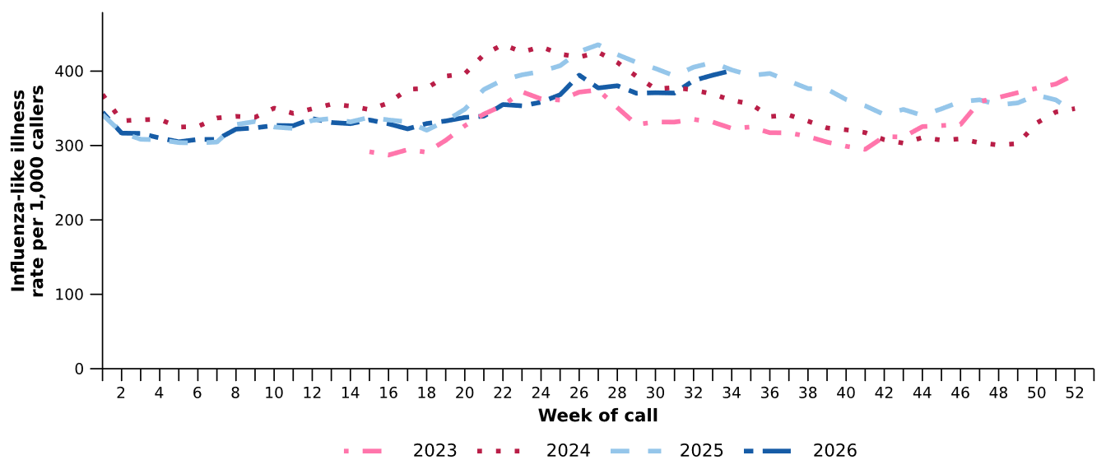
Source: Healthdirect Australia
* Healthdirect data prior to 22 March 2023 are unavailable as prior to this date a different data collection method was used.
† The Healthdirect helpline operates in all states and territories except Qld; therefore influenza-like illness trends will not be representative of Qld and may be underrepresented. See the Technical Supplement for more information.
- In the last fortnight, the rate of Healthdirect helpline callers with influenza-like illness referred to seek urgent medical care (206 per 1,000 callers per fortnight) increased compared to the previous fortnight (198 per 1,000 callers per fortnight).
- In the last fortnight, referral categories for helpline callers with influenza-like illness varied across jurisdictions. Referral to ‘Attend ED’ was most used in the ACT, the NT, SA, Tas and WA. Meanwhile, ‘Seek other urgent medical care’ was most used in NSW and Vic (Figure 2).

Figure 2: Proportion of referral categories* for helpline callers with influenza-like illness by jurisdiction† and call date, Australia, 1 January to 23 August 2026
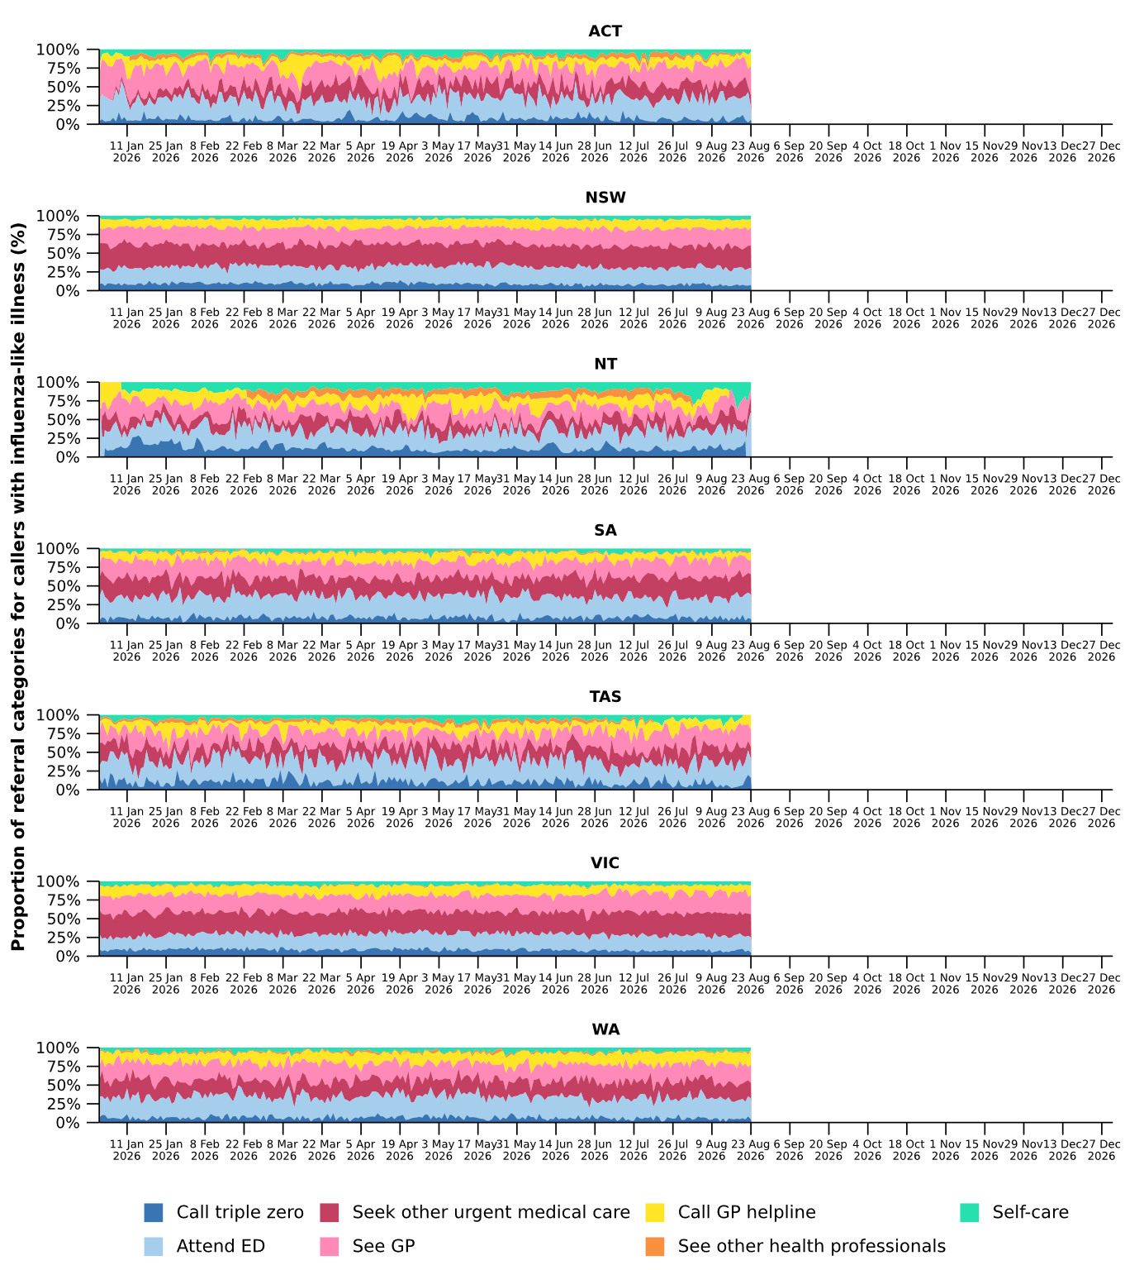
Source: Healthdirect Australia
* See other health professionals category includes pharmacist, dentist, mental health provider, primary maternity care, poison information centre or other.
† The Healthdirect helpline operates in all states and territories except Qld; therefore influenza-like illness referral trends are not provided for Qld. See the Technical Supplement for more information.

- In the last fortnight, a slightly higher percentage of FluTracking participants reported new fever and cough symptoms (2.0%), than in the previous fortnight (1.6%) (Figure 3).
- The percentage of FluTracking participants that reported new fever and cough symptoms has overall increased since late January 2026, with some week-on-week variations. In the last fortnight, the percentage continued to increase, to its highest level of 2026 to date, and was comparable to levels observed at the same time in 2025, and slightly above the percentage reported in 2024 (Figure 3).
- In the last fortnight, a slightly higher percentage of First Nations FluTracking participants reported new fever and cough symptoms (1.9%) compared with the previous fortnight (1.1%). These findings could be impacted by smaller sample sizes and the representativeness of the data. For more detailed trends, please refer to figure 2 in the FluTracking reports.
Figure 3: Age standardised percentage of survey participants reporting new fever and cough symptoms compared with the five-year average* by year and week of survey, Australia, 2023 to 23 August 2026
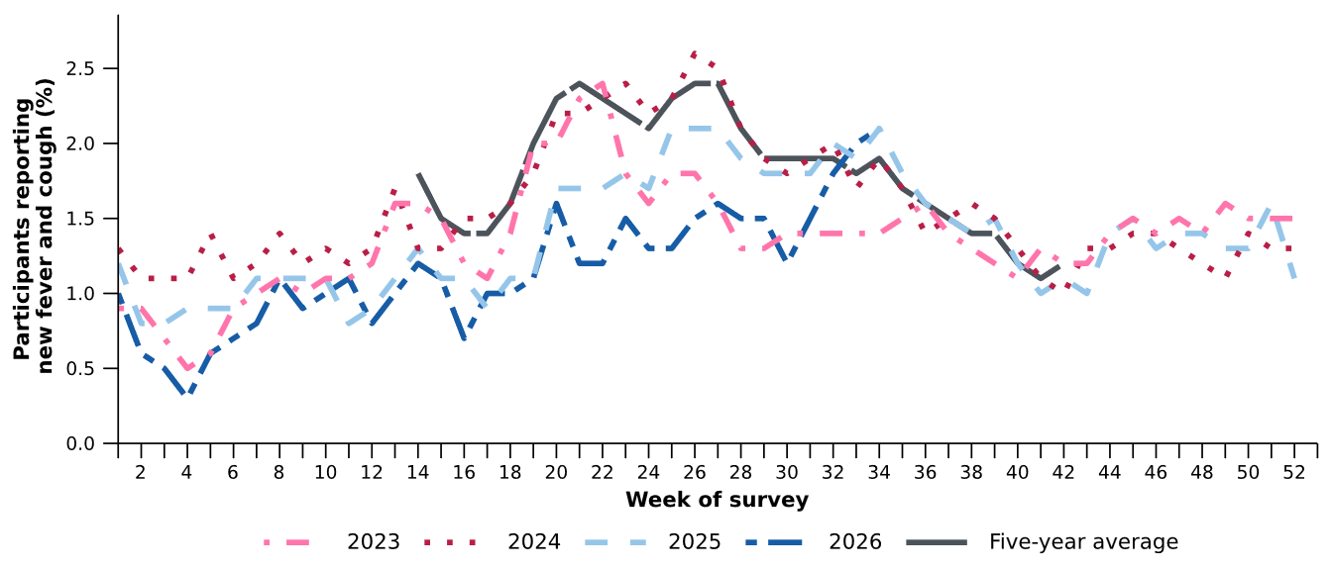
Source: FluTracking
* From 2020, FluTracking expanded their data capture period to year-round. Data before May and after October for any year before 2020 are not available for historical comparisons. The years 2020 and 2021 are excluded when comparing the current season to historical periods when influenza virus has circulated without public health restrictions. As such, the five-year average includes the years 2019 and 2022 to 2025.

- The average percentages of FluTracking participants reporting taking three or more days off work or normal duties and seeking medical advice or care due to fever and cough symptoms were lower in 2026 than at the same time in previous years (Table 1).
Table 1: Percentage of FluTracking participants reporting new fever and cough symptoms plus three or more days off work or normal duties or seeking medical advice or care*, Australia, up to 9 August† for 2023–2026
 | 2023 | 2024 | 2025 | 2026
Reported three or more days off work or normal duties | 51.2% | 52.0% | 48.7% | 45.0%
Reported seeking medical advice or care* | 33.8% | 32.2% | 30.9% | 29.1%
Source: FluTracking
* Includes those who sought medical advice from a general practitioner, Aboriginal and Torres Strait Islander health clinic, COVID-19 clinic, emergency department, or were admitted to hospital for fever and cough.
† While FluTracking data are collected in real time, data presented here are subject to a two week reporting delay to account for the time delay between illness onset and the development of severe disease outcomes.

- Self-reported severe acute respiratory syndrome coronavirus 2 (SARS-CoV-2) polymerase chain reaction (PCR) test positivity and rapid antigen test (RAT) positivity have fluctuated throughout 2026. In the last fortnight, SARS-CoV-2 PCR positivity increased while RAT positivity remained relatively stable compared to the previous fortnight (Figure 4a; Figure 4b).
- Self-reported influenza PCR and RAT positivity have fluctuated throughout 2026. An overall increasing trend in PCR and RAT positivity was observed from mid-May. In the last fortnight, influenza PCR and RAT positivity both increased to their highest levels observed since the commencement of the 2026 winter season (Figure 4a; Figure 4b).
- Self-reported RSV PCR and RAT positivity have fluctuated throughout 2026. Compared to the previous fortnight, RSV PCR positivity increased slightly, and RAT positivity remained relatively stable (Figure 4a; Figure 4b).
Figure 4a: Self-reported PCR test positivity*† among FluTracking participants with fever and cough symptoms by pathogen week of survey, Australia, 1 January to 23 August 2026
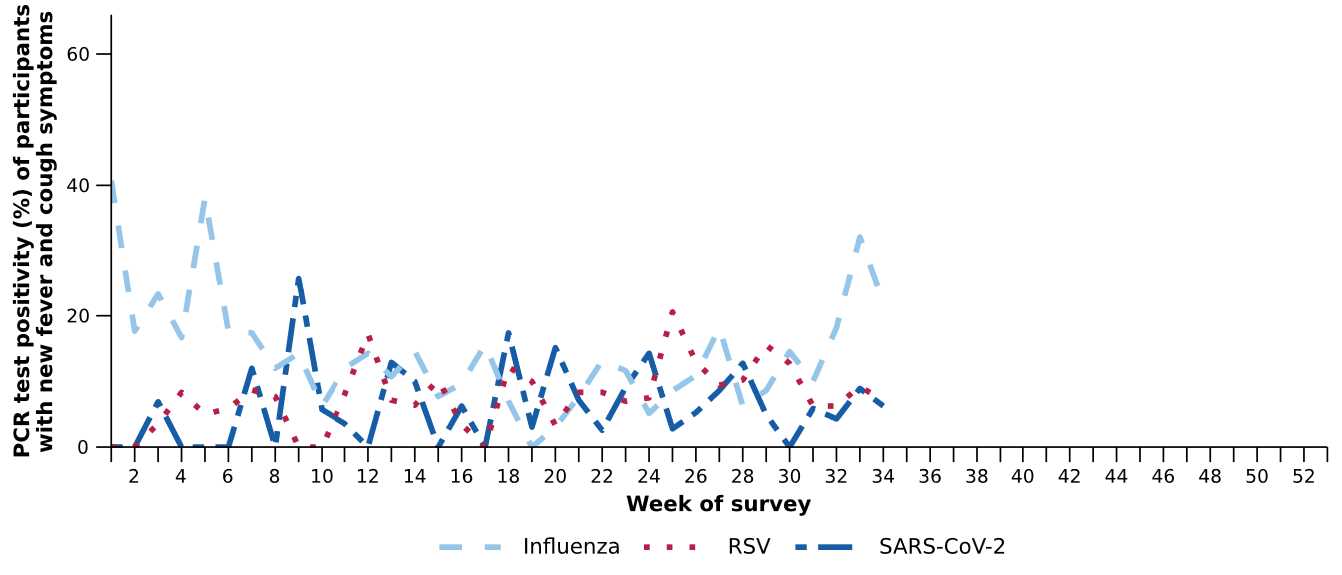
Source: FluTracking
* Denominator is based on participants who self-reported fever and cough symptoms and had a PCR test.
† Historical FluTracking testing and test positivity estimates have been recalculated to incorporate amendments made to survey test results after initial submission. Values may therefore differ from those reported previously.
Figure 4b: Self-reported RAT positivity*† among FluTracking participants with fever and cough symptoms by pathogen and week of survey, Australia, 1 January to 23 August 2026
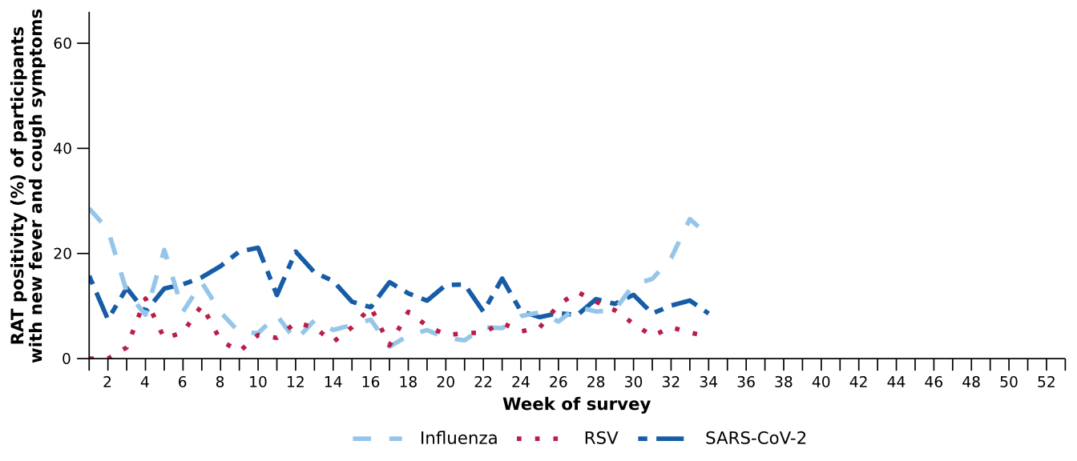
Source: FluTracking
* Denominator is based on participants who self-reported fever and cough symptoms and had a RAT.
† Historical FluTracking testing and test positivity estimates have been recalculated to incorporate amendments made to survey test results after initial submission. Values may therefore differ from those reported previously.

- In the last fortnight (10 August to 23 August 2026), there was a 13.3% increase in COVID-19 cases, a 77.4% increase in influenza cases, and a 17.0% decrease in RSV cases compared to the previous fortnight.
Table 2: Notified cases and notification rate per 100,000 population by disease, five-year age group, and jurisdiction*, Australia, 1 January to 23 August 2026
 | COVID-19 |  |  | Influenza |  |  | RSV
 | Reporting  period  (n) | Year to  date  (n) | Year to  date  (rate) | Reporting  period  (n) | Year to  date  (n) | Year to  date  (rate) | Reporting  period  (n) | Year to  date  (n) | Year to  date  (rate)
Age group (years)
0–4 | 513 | 10,067 | 663 | 3,186 | 13,364 | 881 | 3,112 | 52,832 | 3,482
5–9 | 141 | 3,092 | 193 | 3,766 | 13,673 | 853 | 667 | 7,470 | 466
10–14 | 157 | 2,526 | 150 | 3,134 | 10,882 | 647 | 394 | 3,343 | 199
15–19 | 221 | 2,375 | 139 | 2,304 | 8,517 | 500 | 277 | 2,730 | 160
20–24 | 162 | 2,158 | 119 | 1,203 | 5,474 | 302 | 192 | 2,352 | 130
25–29 | 213 | 2,691 | 133 | 1,083 | 4,748 | 234 | 224 | 2,740 | 135
30–34 | 242 | 3,345 | 162 | 1,110 | 4,684 | 227 | 247 | 3,296 | 160
35–39 | 290 | 3,724 | 184 | 1,253 | 4,784 | 237 | 258 | 3,337 | 165
40–44 | 268 | 3,441 | 180 | 1,163 | 4,763 | 249 | 243 | 3,015 | 158
45–49 | 211 | 2,793 | 169 | 949 | 3,738 | 226 | 248 | 2,911 | 176
50–54 | 244 | 2,817 | 167 | 829 | 3,320 | 197 | 326 | 3,439 | 204
55–59 | 245 | 2,813 | 181 | 769 | 3,207 | 206 | 322 | 3,926 | 253
60–64 | 198 | 2,686 | 175 | 788 | 3,208 | 209 | 349 | 4,247 | 276
65–69 | 204 | 2,734 | 197 | 744 | 3,170 | 228 | 367 | 4,274 | 308
70–74 | 229 | 3,049 | 256 | 654 | 2,878 | 241 | 366 | 4,375 | 367
75+ | 1,159 | 14,011 | 620 | 1,699 | 7,973 | 353 | 993 | 13,115 | 581
Jurisdiction
ACT | 133 | 1,047 | 216 | 683 | 1,526 | 315 | 312 | 1,811 | 374
NSW | 2,047 | 30,187 | 351 | 13,566 | 51,286 | 597 | 2,760 | 50,856 | 592
NT | 9 | 293 | 111 | 46 | 792 | 300 | 30 | 940 | 356
Qld | 631 | 12,153 | 214 | 3,829 | 17,941 | 316 | 1,123 | 21,372 | 377
SA | 167 | 4,085 | 215 | 984 | 4,015 | 211 | 1,275 | 7,781 | 409
Tas | 101 | 1,046 | 182 | 193 | 730 | 127 | 206 | 2,118 | 368
Vic | 1,253 | 11,684 | 165 | 4,017 | 14,551 | 206 | 1,965 | 24,044 | 340
WA | 361 | 3,862 | 127 | 1,319 | 7,590 | 249 | 916 | 8,499 | 279
Total | 4,702 | 64,357 | 233 | 24,637 | 98,431 | 356 | 8,587 | 117,421 | 425
Source: National Notifiable Diseases Surveillance System (NNDSS). RSV notification data are unavailable for Tas from 21 August 2026.
* Total includes cases with missing age.

- In the last fortnight, there were 4,702 COVID-19 cases, a 13.3% increase from 4,149 cases notified in the previous fortnight (Table 2; Figure 5).
- In the year to date, there have been 64,357 COVID-19 cases, 56.0% fewer than the 146,232 cases notified over the same period in 2025 (Table 2; Figure 5). In contrast to previous years, national data in 2026 to date do not yet show a clear winter peak. The Australian CDC will continue to monitor this trend as additional cases are notified.
- In the last fortnight, COVID-19 notification rates increased or remained relatively stable across most jurisdictions compared with the previous fortnight, except in the NT where notification rates decreased (Figure 6).
Figure 5: Notified COVID-19 cases by year and week of diagnosis, Australia, 2023 to 23 August 2026
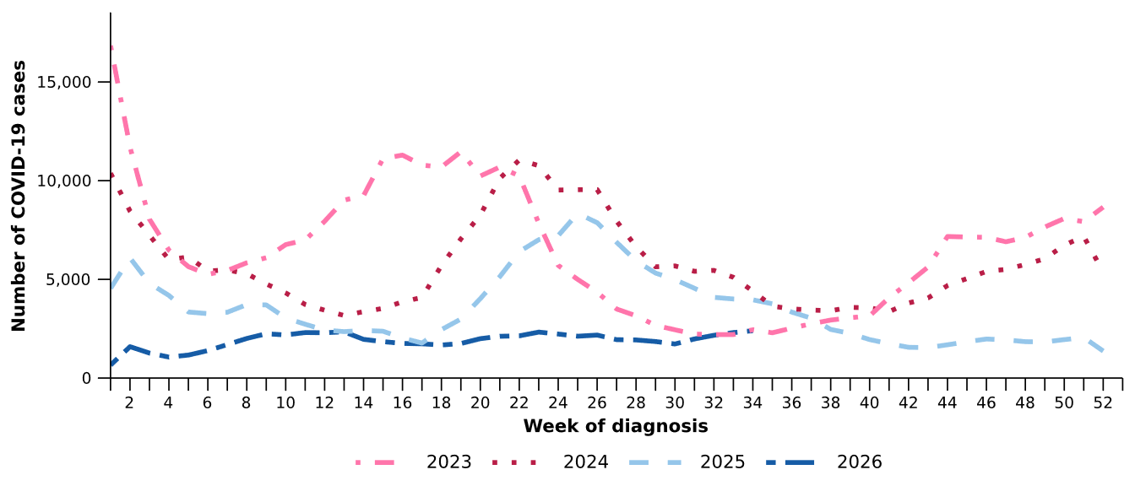
Source: National Notifiable Diseases Surveillance System (NNDSS)

Figure 6: Notification rates per 100,000 population for COVID-19 cases by state or territory and week of diagnosis, Australia, 1 January to 23 August 2026
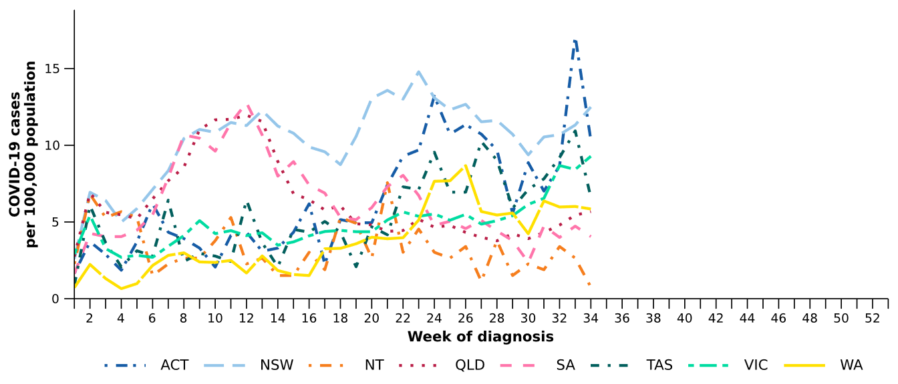
Source: National Notifiable Diseases Surveillance System (NNDSS)

- In the last fortnight, there were 24,637 influenza cases, a 77.4% increase from 13,890 cases notified in the previous fortnight (Table 2; Figure 7). The timing of this continued substantial increase is broadly consistent with earlier, pre-pandemic influenza seasonal patterns (e.g., 2015–2018). These seasons were characterised by an increase in influenza cases from June and peaking later in winter, typically around late-August to early September. Current surveillance data suggest that national influenza peak is yet to occur, and trends will continue to be monitored.
- In the year to date, there have been 98,431 influenza cases, 68.4% fewer than the 311,701 cases notified over the same period in 2025 (Table 2; Figure 7).
- In the last fortnight, influenza notification rates increased or remained relatively stable across most jurisdictions compared with the previous fortnight, except in the NT where notification rates decreased (Figure 8).
Figure 7: Notified influenza cases and five-year average* by year and week of diagnosis, Australia, 2023 to 23 August 2026
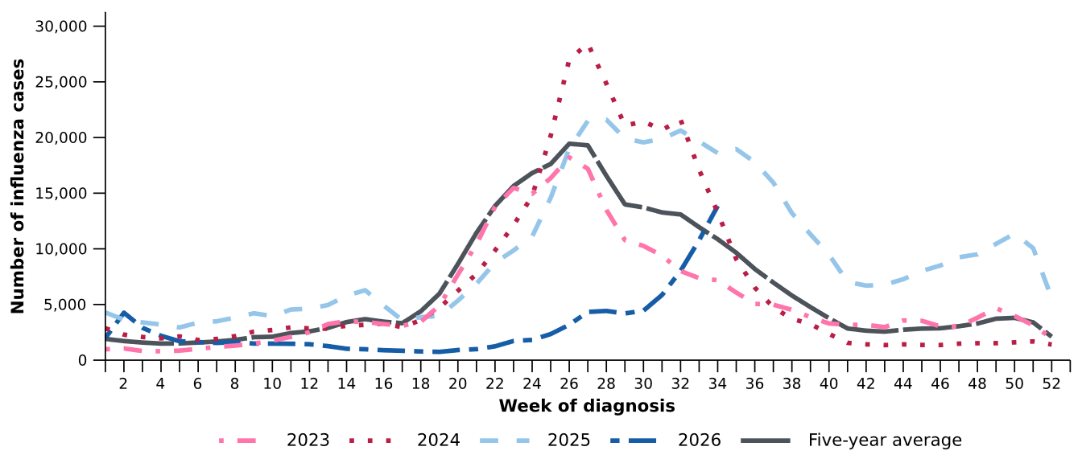
Source: National Notifiable Diseases Surveillance System (NNDSS)
* The years 2020 and 2021 are excluded when comparing the current season to historical periods when influenza virus has circulated without public health restrictions. As such, the five-year average includes the years 2019 and 2022 to 2025.

Figure 8: Notification rates per 100,000 population for influenza cases by state or territory and week of diagnosis, Australia, 1 January to 23 August 2026
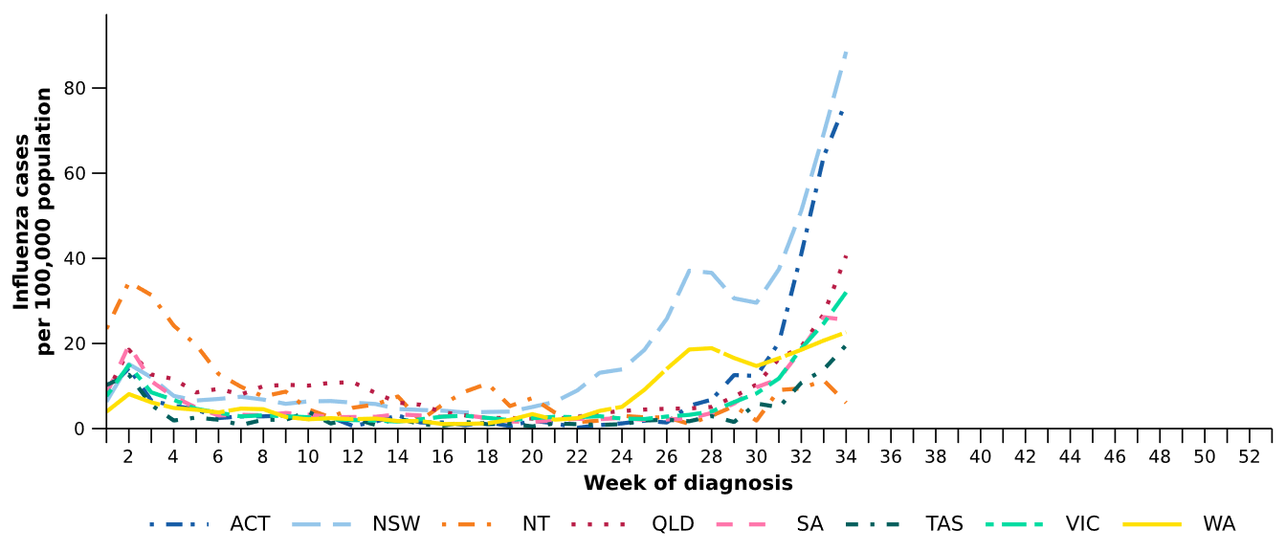
Source: National Notifiable Diseases Surveillance System (NNDSS)
- In the last fortnight, there were 23,186 influenza A cases, a 79.1% increase from 12,949 influenza A cases notified in the previous fortnight, and there were 1,288 influenza B cases, a 48.7% increase from 866 influenza B cases notified in the previous fortnight.
- In the last fortnight, among influenza A cases with subtype information available there were:
  - 129 influenza A(H1N1) cases, a 43.3% increase from 90 cases notified in the previous fortnight.
  - 467 influenza A(H3N2) cases, a 0.6% decrease from 470 cases notified in the previous fortnight.
- Throughout 2026, influenza A(unsubtyped) has been the dominant reported influenza subtype across all age groups. Influenza A(H3N2) notifications have been reported across all age groups, though most notably in children aged 0–4 years and adults aged 65 years and over. A small increase in influenza B notifications has been observed among the 5–19 and 20–64 years age groups in recent weeks (Figure 9).
- In the last fortnight, influenza activity continued to increase across all age groups (Figure 9).
- Trends in influenza subtypes are influenced by differences in the number and selection of influenza samples that undergo typing across age groups and healthcare settings.

Figure 9: Notified influenza cases by influenza subtype, age group*, and week of diagnosis, Australia, 1 January to 23 August 2026
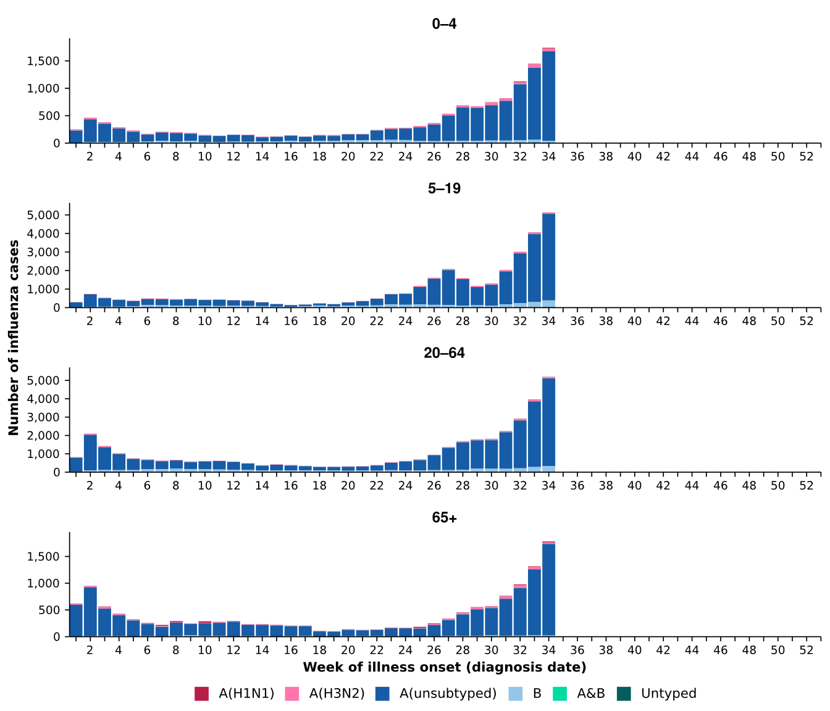
Source: National Notifiable Diseases Surveillance System (NNDSS)
* Axis varies between age groups.

- In the year to date, influenza A(unsubtyped) accounts for the highest number of notifications across most jurisdictions. In recent weeks, notifications of influenza A(H3N2) have increased in Tas and WA. Influenza B notifications have fluctuated in the NT and increased slightly in Vic (Figure 10).
Figure 10: Notified influenza cases by influenza subtype, jurisdiction*, and week of diagnosis, Australia, 1 January to 23 August 2026
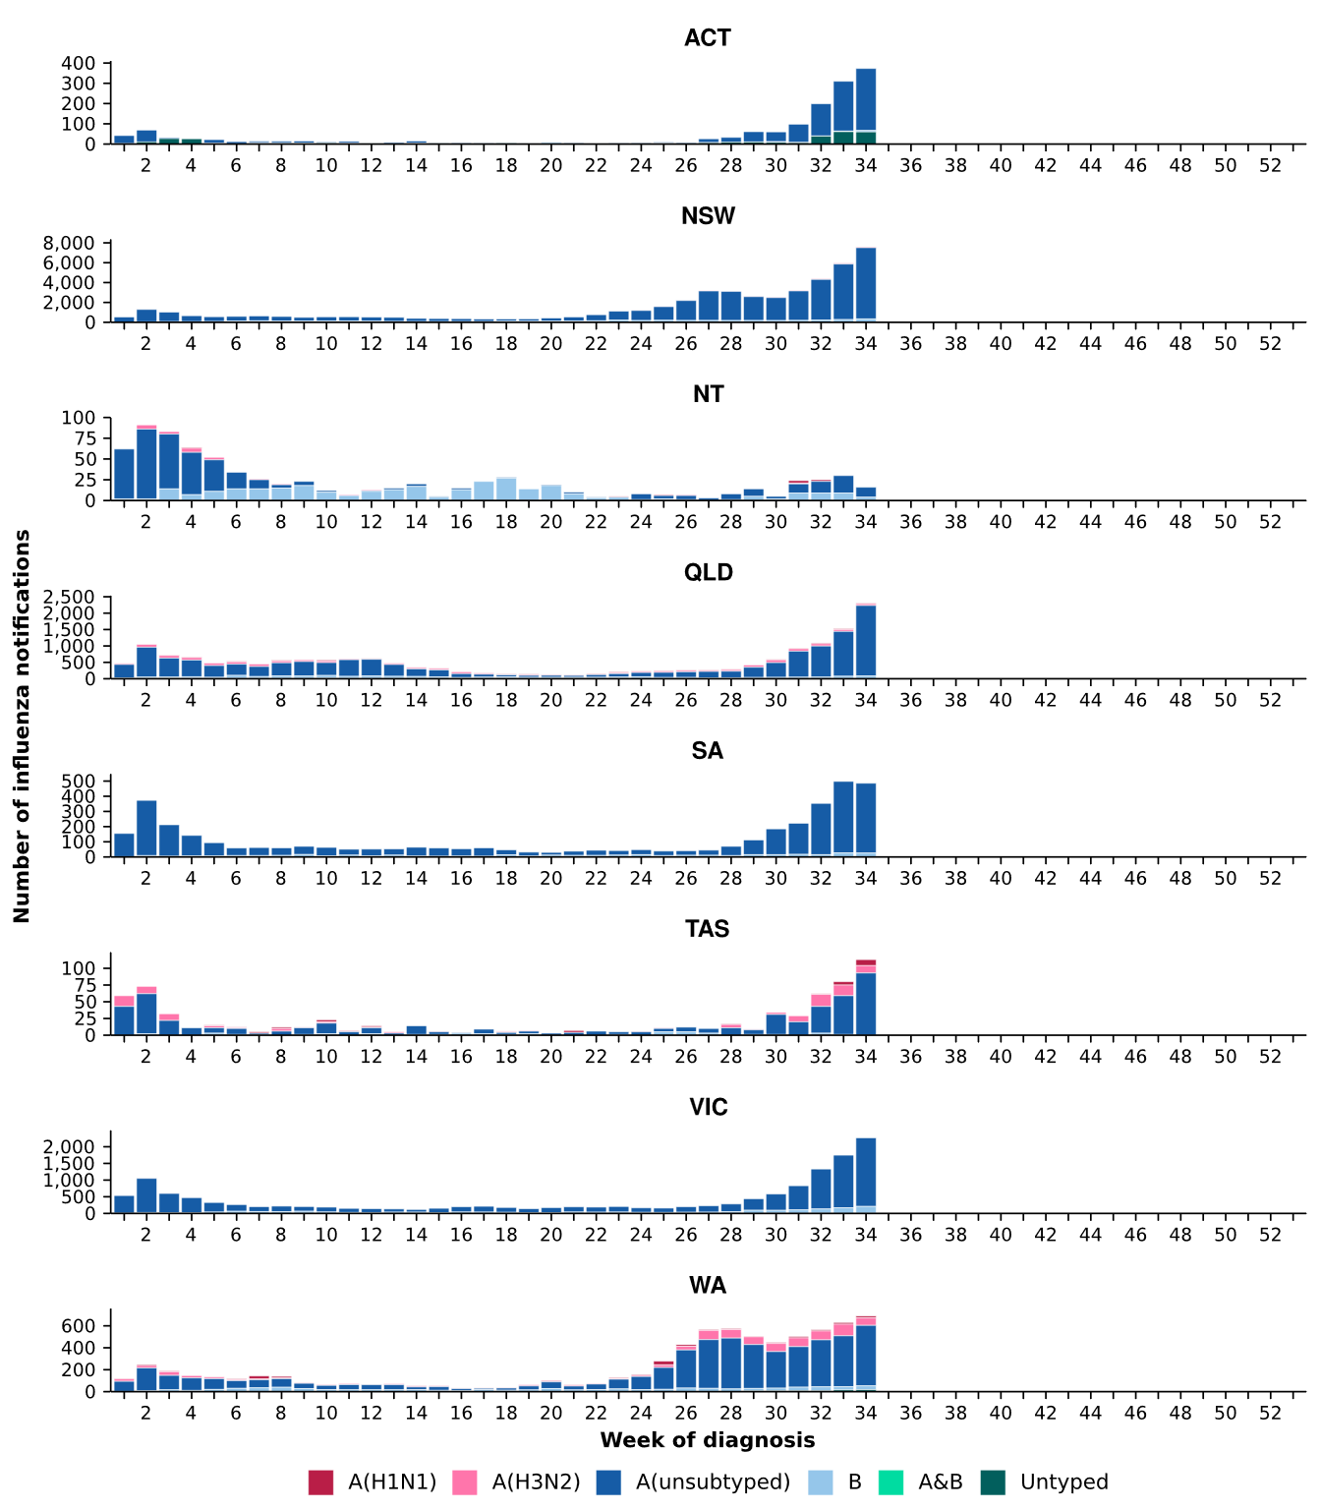
Source: National Notifiable Diseases Surveillance System (NNDSS)
* Axis varies between jurisdictions.

- In the last fortnight, there were 8,587 RSV cases, a 17.0% decrease from 10,343 cases notified in the previous fortnight (Table 2; Figure 11).
- In the year to date, there have been 117,421 RSV cases, 14.7% fewer than the 137,697 cases notified over the same period in 2025. Since its winter peak in late-June, RSV notifications have continued to decrease (Table 2; Figure 11).
- In the last fortnight, RSV notification rates decreased or remained relatively stable across most jurisdictions compared with the previous fortnight, except in the ACT where notification rates increased (Figure 12).
Figure 11: Notified RSV cases by year and week of diagnosis, Australia, 2023 to 23 August 2026
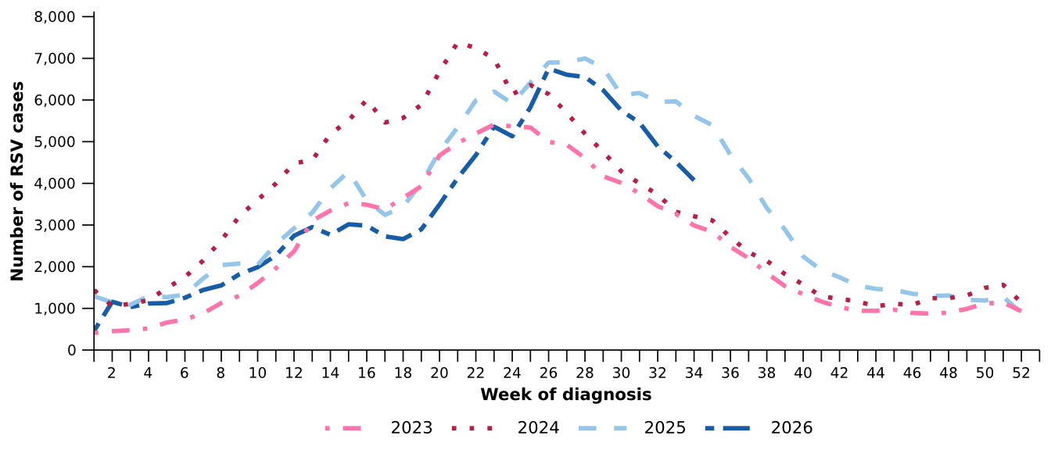
Source: National Notifiable Diseases Surveillance System (NNDSS)

Figure 12: Notification rates per 100,000 population for RSV cases by state or territory and week of diagnosis, Australia, 1 January to 23 August 2026
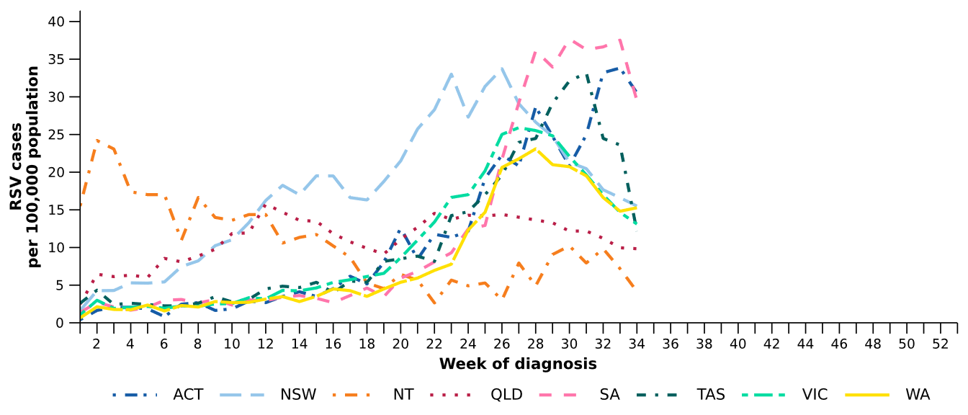
Source: National Notifiable Diseases Surveillance System (NNDSS). RSV notification data are unavailable for Tas from 21 August 2026.

Primary care surveillance
Primary care surveillance monitors the number and characteristics of people who have presented to a general practice with influenza-like illness and provides insight on the different respiratory pathogens that are causing illness in the community.
- In the last fortnight (10 August to 23 August 2026), there were more general practice consultations for influenza-like illness (8.7 notifications per 1,000 consultations per fortnight) compared to previous fortnight (6.9 notifications per 1,000 consultations per fortnight) (Figure 13).
- Influenza-like illness notification rates per 1,000 consultations reached their highest level of 2026 to date in the last fortnight. The consultation rates are higher than observed at the same time in 2023 and remained lower than observed at the same time in 2024–2025, and similar to the historical five-year average (Figure 13).
Figure 13: Rate of influenza-like illness notifications per 1,000 consultations per week in sentinel general practice sites compared with the five-year average by year and week of consultation*†, Australia, 2023 to 23 August 2026
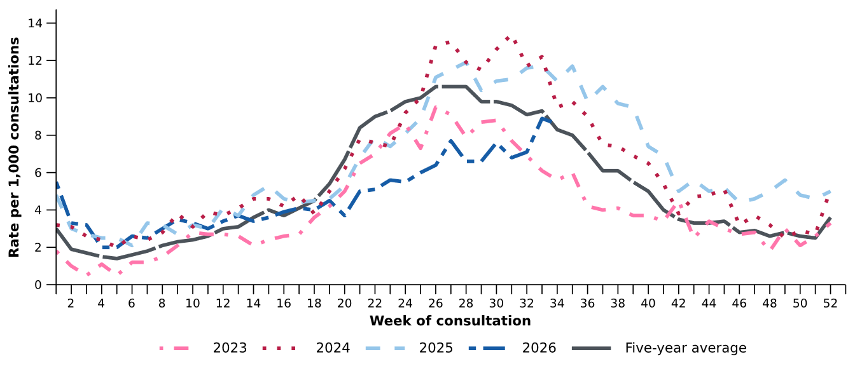
Source: Australian Sentinel Practices Research Network (ASPREN)
* The years 2020 and 2021 are excluded when comparing the current season to historical periods when influenza virus has circulated without public health restrictions. As such, the five-year average includes the years 2019 and 2022 to 2025.
† Please refer to the Technical Supplement for notes on impact of COVID-19 on ASPREN data.

- In the last fortnight, 61.5% (91/148) of people attending general practice with influenza-like illness who were tested have then tested positive for a respiratory pathogen (Figure 14).
- In the last fortnight, rhinovirus / enterovirus (31.9%; 29/91) was the most commonly detected pathogen, followed by influenza (30.8%; 28/91) and human metapneumovirus (12.1%; 11/91) (Figure 14).
- In the year to date, 59.0% (1,125/1,908) of people attending general practice with influenza-like illness who were tested have then tested positive for a respiratory pathogen.
- In the year to date, rhinovirus / enterovirus (46.0%; 518/1,125) has been the most commonly detected pathogen, followed by influenza (12.7%; 143/1,125), RSV (12.1%; 136/1,125), parainfluenza (10.3%; 116/1,125), and human metapneumovirus (7.3%; 82/1,125) (Figure 14).
Figure 14: Number of samples tested for respiratory pathogens among people with influenza-like illness attending sentinel general practice sites by respiratory pathogen and week of specimen collection, Australia, 1 January to 23 August 2026
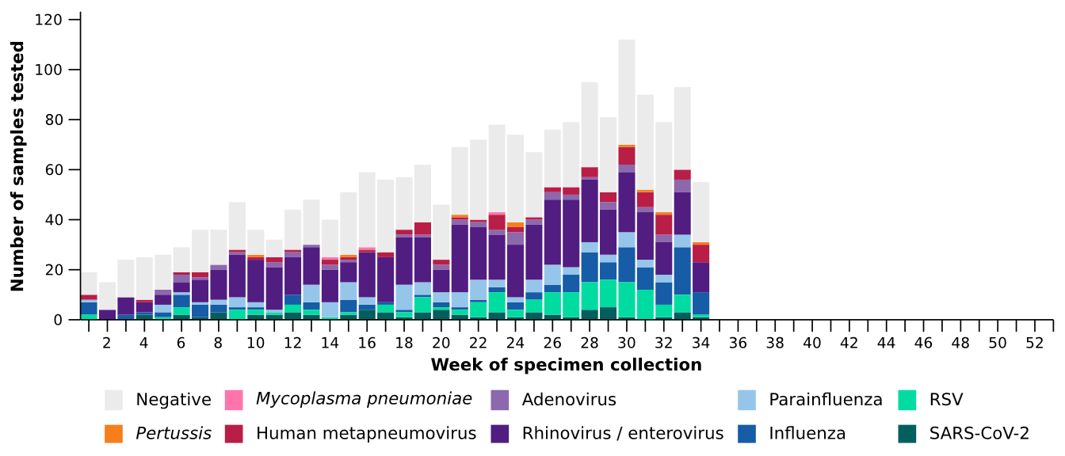
Source: Australian Sentinel Practices Research Network (ASPREN)
Note: All ASPREN swab samples are transported to the SA Pathology laboratory in Adelaide to be tested for viral and bacterial respiratory pathogens via a multiplex real-time reverse transcription polymerase chain reaction (RT-PCR) assay using in-house primers.

Hospital-based surveillance
Hospital-based surveillance monitors people with more severe illness who have been admitted to hospital for their respiratory illness (severe acute respiratory infections). Hospital-based surveillance also measures the ability of the health system to cope with the number of severe acute respiratory infection admissions to ensure delivery of safe, timely and quality health care.
- In the last severity reporting period (27 July to 9 August 2026), fewer patients were admitted to a sentinel hospital with a severe acute respiratory infection (n=445), than in the previous severity reporting period (n=473).
  - In the last severity reporting period, at sentinel hospitals there was 15.3% fewer admissions with COVID-19 (from 59 to 50), 64.6% more admissions with influenza (from 96 to 158), and 25.5% fewer admissions with RSV (from 318 to 237), compared to the previous severity reporting period.
- In the year to date for severity reporting (1 January to 9 August 2026), there have been 5,038 admissions with severe acute respiratory infections at sentinel hospitals. Most patients with a severe acute respiratory infection have been admitted with RSV (n=2,907) followed by influenza (n=1,077) (Figure 15).
Figure 15: Total number of patients (children and adults) admitted with a severe acute respiratory infection to sentinel hospitals by disease and week of admission, Australia, 1 January to 9 August 2026
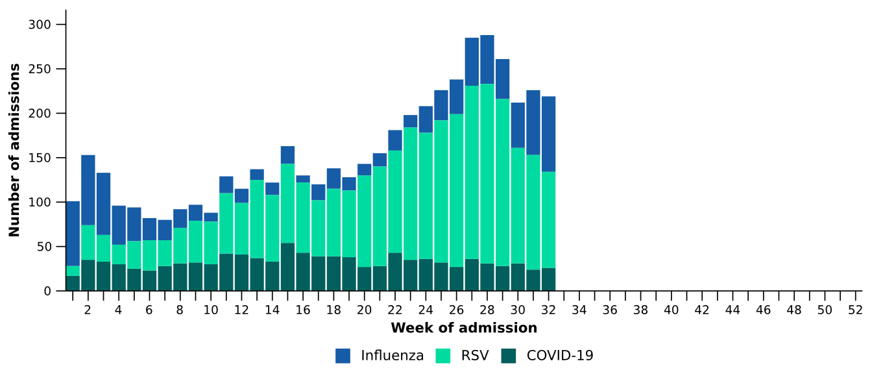
Source: Influenza Complications Alert Network (FluCAN)
- Patients admitted to sentinel hospitals with influenza have mostly been admitted with influenza A (90.7%; 977/1,077), while 8.6% (93/1,077) were admitted with influenza B (Figure 16).
  - Most hospital admissions with influenza A have been with influenza A(unsubtyped) (62.4%; 610/977), followed by influenza A(H3N2) (28.1%; 275/977) and then influenza A(H1N1) (9.4%; 92/977).
- In recent severity reporting periods, influenza A(H3N2) admissions have increased across most age groups, particularly among the 6 months–4 years and 5–16 years age groups (Figure 16).
Figure 16: Number of patients admitted with influenza to sentinel hospitals by influenza subtype, age group*, and week of admission, Australia, 1 January to 9 August 2026
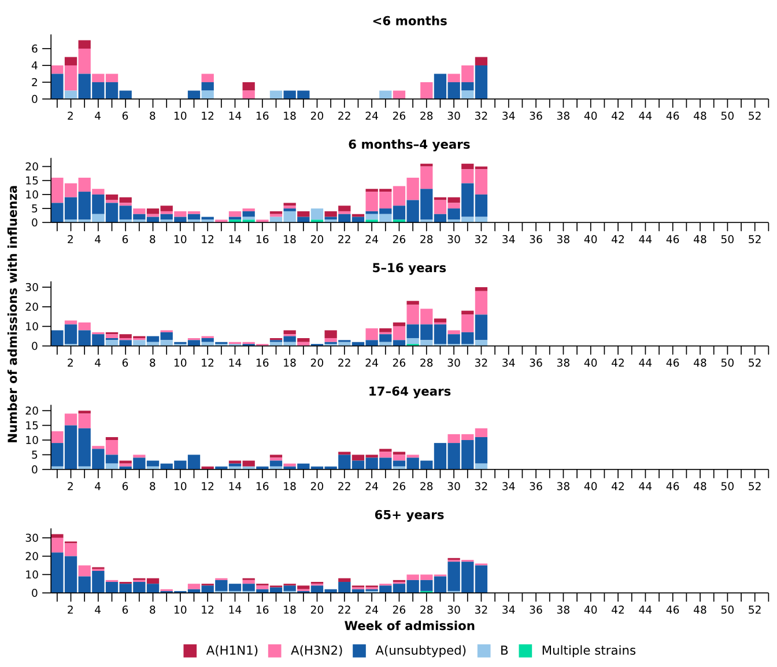
Source: Influenza Complications Alert Network (FluCAN)
* Axis varies between age groups. The age distribution of admissions with influenza may not reflect the age distribution of all patients.
- In the year to date for severity reporting, RSV accounted for the highest number of admissions among children aged 16 years and younger (Table 3a).
- Children admitted with influenza were slightly older than those admitted with COVID-19 or RSV (Table 3a).
- The median length of stay reported for children admitted to sentinel hospitals was similar and most children were admitted to the general hospital ward rather than to intensive care directly (Table 3a).
- Sadly, a small number of children admitted to sentinel hospitals with severe acute respiratory infections have died (Table 3a).

Table 3a: Demographic characteristics and outcomes for children admitted with a severe acute respiratory infection to a sentinel hospital by disease*†‡, Australia, 1 January to 9 August 2026
 | COVID-19 | Influenza | RSV
 | Year to date for  severity reporting  (n=469) | Year to date for  severity reporting  (n=592) | Year to date for  severity reporting  (n=2,292)
Age (years)
Median [IQR] | 1 [0-4] | 4 [1-8] | 1 [0-2]
Age group (years)
< 6 months | 116 (24.7%) | 51 (8.6%) | 466 (20.3%)
6 months – 4 years | 249 (53.1%) | 280 (47.3%) | 1,626 (70.9%)
5–16 years | 104 (22.2%) | 261 (44.1%) | 200 (8.7%)
Indigenous status
Aboriginal and Torres Strait Islander | 30 (6.4%) | 37 (6.2%) | 185 (8.1%)
Length of hospital stay (days)†
Median [IQR] | 2 [1-3] | 1 [1-2] | 2 [1-3]
Patient admission location‡
Admitted to hospital ward | 447 (95.3%) | 568 (95.9%) | 2,172 (94.8%)
Admitted to intensive care directly | 22 (4.7%) | 24 (4.1%) | 120 (5.2%)
Discharge status†
Alive | 402 (85.7%) | 467 (78.9%) | 1,699 (74.1%)
Died | - | 1 (0.2%) | 2 (0.1%)
Incomplete/missing | 67 (14.3%) | 124 (20.9%) | 591 (25.8%)
Source: Influenza Complications Alert Network (FluCAN)
* Does not include patients with missing age; therefore, the sum of age-specific totals above may not equal the total number of patients.
† For patients who are still in hospital data may not be complete; therefore, these data are not included in the length of stay or discharge status. In addition, length of stay data excludes patients that acquired their infection in hospital.
‡ Admission location reflects the initial admission ward. Some patients may be initially admitted to general ward then later admitted to an intensive care and this is not reflected here. Does not include patients with missing admission location; therefore, the sum of admission location specific totals above may not equal the total number of patients.
The Paediatric Active Enhanced Disease Surveillance (PAEDS) network conducts enhanced sentinel hospital surveillance for select acute respiratory infections or conditions in children. PAEDS data are presented within the sentinel hospital data from FluCAN in this report. For additional information on select acute respiratory conditions in children please visit the PAEDS webpages.

- In the year to date for severity reporting, RSV accounted for the highest number of admissions among adults (aged 17 years and over) (Table 3b).
- Adults admitted to sentinel hospitals with COVID-19, influenza or RSV were similar in age, with most aged 65 years and over (Table 3b).
- The median length of stay reported for adults admitted to sentinel hospitals was similar, and most adults were admitted to the general hospital ward rather than to intensive care directly (Table 3b).
- Sadly, a number of adults admitted to sentinel hospitals with severe acute respiratory infections have died (Table 3b).
Table 3b: Demographic characteristics and outcomes for adults admitted with a severe acute respiratory infection to a sentinel hospital by disease*†‡, Australia, 1 January to 9 August 2026
 | COVID-19 | Influenza | RSV
 | Year to date for  severity reporting  (n=585) | Year to date for  severity reporting  (n=485) | Year to date for  severity reporting  (n=615)
Age (years)
Median [IQR] | 71 [56-83] | 69 [54-80] | 71 [58-81]
Age group (years)
17–64 years | 216 (36.9%) | 196 (40.4%) | 220 (35.8%)
65 years and over | 369 (63.1%) | 289 (59.6%) | 395 (64.2%)
Indigenous status
Aboriginal and Torres Strait Islander | 42 (7.2%) | 32 (6.6%) | 51 (8.3%)
Length of hospital stay (days)†
Median [IQR] | 4 [3-8] | 3 [2-6] | 4 [2-7]
Patient admission location‡
Admitted to hospital ward | 559 (95.6%) | 448 (92.4%) | 584 (95.0%)
Admitted to intensive care directly | 26 (4.4%) | 37 (7.6%) | 31 (5.0%)
Discharge status†
Alive | 424 (72.5%) | 387 (79.8%) | 429 (69.8%)
Died | 23 (3.9%) | 11 (2.3%) | 22 (3.6%)
Incomplete/missing | 138 (23.6%) | 87 (17.9%) | 164 (26.7%)
Source: Influenza Complications Alert Network (FluCAN)
* Does not include patients with missing age; therefore, the sum of age-specific totals above may not equal the total number of patients.
† For patients who are still in hospital data may not be complete; therefore, these data are not included in the length of stay or discharge status. In addition, length of stay data excludes patients that acquired their infection in hospital.
‡ Admission location reflects the initial admission ward. Some patients may be initially admitted to general ward then later admitted to an intensive care and this is not reflected here. Does not include patients with missing admission location; therefore, the sum of admission location specific totals above may not equal the total number of patients.

The sentinel intensive care data have not been updated since the previous report (severity period 1 January to 26 July 2026), so data here remain unchanged.
- In the last severity reporting period for sentinel intensive care (29 June to 26 July 2026), more patients have been admitted to a sentinel intensive care with a severe acute respiratory infection (n=225), than in the previous severity reporting period (n=174) (Figure 17).
- In the year to date for severity reporting (1 January to 26 July 2026), most patients were admitted to sentinel intensive care with RSV, followed by COVID-19 (Figure 17; Table 4).
Figure 17: Number of patients admitted with severe acute respiratory infections to a sentinel intensive care by disease and week of admission, Australia, 1 January to 26 July 2026
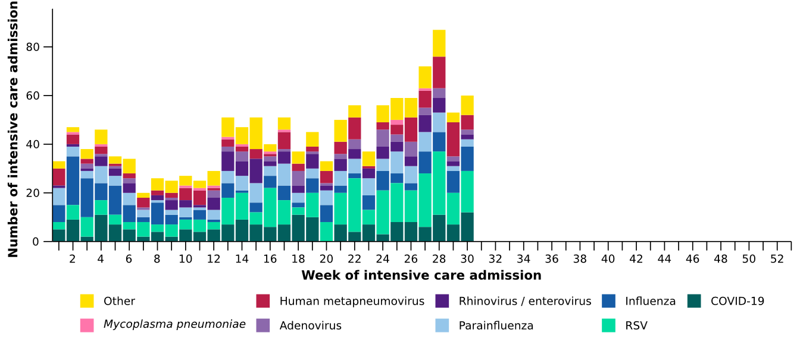
Source: Short Period Incidence Study of Severe Acute Respiratory Infection (SPRINT-SARI) Australia
Note: The sum of pathogen-specific totals above may not equal the total number of severe acute respiratory infection patients due to co-infections.
Figure 18: Number of patients admitted with severe acute respiratory infections to a sentinel intensive care by disease and age group*, Australia, 1 January to 26 July 2026
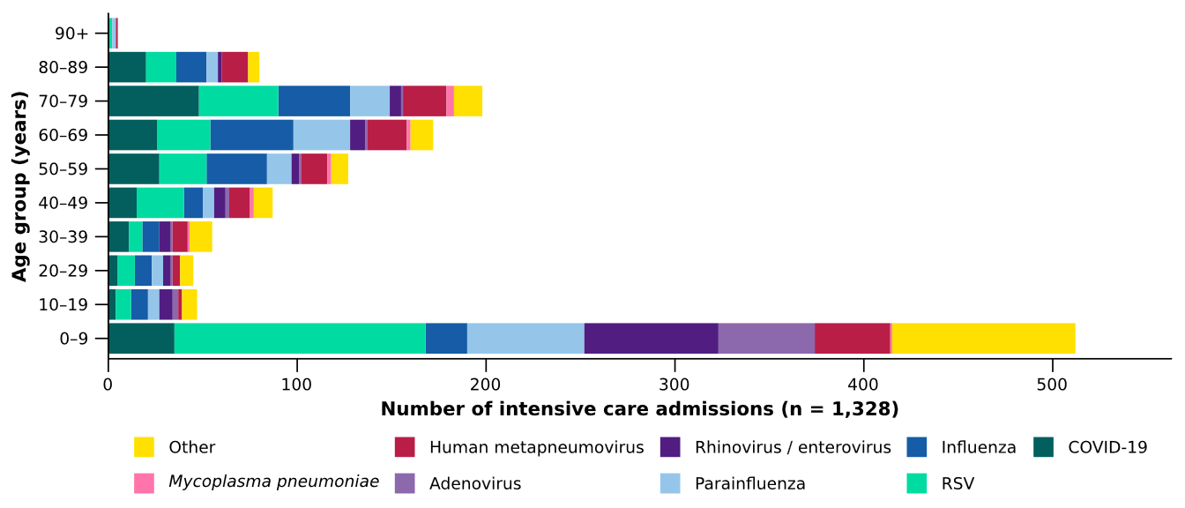
Source: Short Period Incidence Study of Severe Acute Respiratory Infection (SPRINT-SARI) Australia
Note: The sum of pathogen-specific totals above may not equal the total number of severe acute respiratory infection patients due to co-infections.
* The age distribution of severe acute respiratory infection intensive care admissions may not reflect the age distribution of all patients.
- In the year to date for severity reporting, children aged 0–9 years accounted for the highest number of sentinel intensive care admissions (Figure 18). The median age of patients admitted to sentinel intensive care was lowest in patients admitted for RSV (Table 4).
- The proportion of admissions requiring invasive mechanical ventilation was highest in patients with parainfluenza, followed by mycoplasma pneumoniae. The length of invasive mechanical ventilation was longest in patients with hMPV (Table 4).
- The length of intensive care stay has been relatively similar across pathogens (Table 4).
- Most patients admitted with a severe acute respiratory infection to a sentinel intensive care were discharged home. Sadly, a number of patients have died in hospital (Table 4).
Table 4: Demographic characteristics and outcomes of patients admitted with a severe acute respiratory infection to a sentinel intensive care by disease*†, Australia, 1 January to 26 July 2026
 | COVID-19 | hMPV | Influenza | 𝘔𝘺𝘤𝘰𝘱𝘭𝘢𝘴𝘮𝘢  𝘱𝘯𝘦𝘶𝘮𝘰𝘯𝘪𝘢𝘦 | Parainfluenza | RSV
 | Year to date for severity reporting  (n=191) | Year to date for severity reporting  (n=138) | Year to date for severity reporting  (n=189) | Year to date for severity reporting  (n=12) | Year to date for severity reporting  (n=152) | Year to date for severity reporting  (n=296)
Age (years)
Median [IQR] | 59  [35–73] | 52  [6–70] | 60  [35–72] | 60  [46–74] | 44  [2–67] | 26  [1–64]
Indigenous status
Aboriginal and Torres Strait Islander | 16  (8.4%) | 14  (10.1%) | 18  (9.5%) | – | 14  (9.2%) | 30  (10.1%)
Non-Indigenous | 175  (91.6%) | 124  (89.9%) | 171  (90.5%) | 12  (100.0%) | 138  (90.8%) | 266  (89.9%)
Received invasive mechanical ventilation
Number (%) | 58  (30.4%) | 33  (23.9%) | 62  (32.8%) | 4  (33.3%) | 54  (35.5%) | 70  (23.6%)
Length of invasive mechanical ventilation (days)*
Median [IQR] | 2 [1–7] | 5 [1–7] | 4 [1–10] | 2 [1–7] | 3 [1–8] | 3 [2–7]
Length of intensive care stay (days)*
Median [IQR] | 3 [2–6] | 3 [2–6] | 3 [2–7] | 3 [2–6] | 4 [2–7] | 3 [2–5]
Length of hospital stay (days)*
Median [IQR] | 8 [4–14] | 8 [5–12] | 8 [5–12] | 8 [4–20] | 7 [3–15] | 7 [4–11]
Patient outcome†
Ongoing care in intensive care | 4  (2.1%) | 1  (0.7%) | 6  (3.2%) | – | 6  (3.9%) | 5  (1.7%)
Ongoing care in hospital ward | 11  (5.8%) | 8  (5.8%) | 3  (1.6%) | – | 4  (2.6%) | 12  (4.1%)
Transfer to other hospital / facility | 23  (12.0%) | 20  (14.5%) | 29  (15.3%) | 3  (25.0%) | 14  (9.2%) | 39  (13.2%)
Discharged home | 123  (64.4%) | 97  (70.3%) | 129  (68.3%) | 8  (66.7%) | 112  (73.7%) | 222  (75.0%)
Died in hospital | 30  (15.7%) | 11  (8.0%) | 20  (10.6%) | 1  (8.3%) | 15  (9.9%) | 18  (6.1%)
Source: Short Period Incidence Study of Severe Acute Respiratory Infection (SPRINT-SARI) Australia
Note: The sum of pathogen-specific totals above may not equal the total number of severe acute respiratory infection patients due to co-infections.
* For patients receiving ongoing care in intensive care data may not be complete; therefore, data are not included in the length of ventilation or stay.
† Patients who have been admitted with no discharge information for less than 90 days have been assumed to have ongoing care in the hospital. Patients who have no outcome entered or have been admitted for more than 90 days with no discharge information have been treated as missing.
- In the last fortnight (10 August to 23 August 2026), there were an average of 218 intensive care patients in droplet or airborne isolation for any suspected or confirmed respiratory pathogen each day, a 6.1% increase from an average of 206 patients in isolation each day reported in the previous fortnight (Figure 19).
- In the last fortnight (10 August to 23 August 2026), there were an average of 101 intensive care staff unavailable to work due to illness each day, a 13.9% increase from an average of 89 staff unavailable each day reported in the previous fortnight (Figure 19).
- In the last fortnight, the average number of intensive care patients in droplet or airborne isolation for any suspected or confirmed respiratory pathogen increased or remained relatively stable across most jurisdictions compared with the previous fortnight, except in WA where the average number of patients in isolation each day decreased (Figure 20).
- In the last fortnight, the average number of intensive care staff unavailable to work due to illness each day increased or remained relatively stable across most jurisdictions compared with the previous fortnight, except in Qld and Tas where the average number of staff unavailable each day decreased (Figure 20).
Figure 19: Weekly average daily occupancy of intensive care patients in droplet or airborne isolation for any suspected or confirmed respiratory pathogen and the weekly average daily number of intensive care staff unavailable to work due to illness by week of report*, Australia, 1 January to 23 August 2026
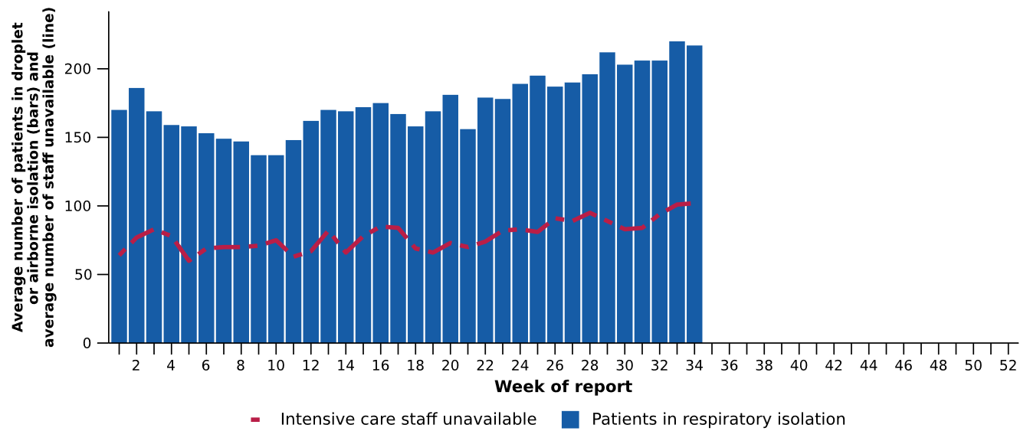
Source: Critical Health Resource Information System (CHRIS)
* Intensive care staff include both medical and nursing staff. Staff unavailability will be underestimated in NSW as most public hospitals in NSW do not report staff unavailability.

Figure 20: Weekly average daily occupancy of intensive care patients in droplet or airborne isolation for any suspected or confirmed respiratory pathogen and the weekly average daily number of intensive care staff unavailable to work due to illness by jurisdiction and week of report*†‡, Australia, 1 January to 23 August 2026
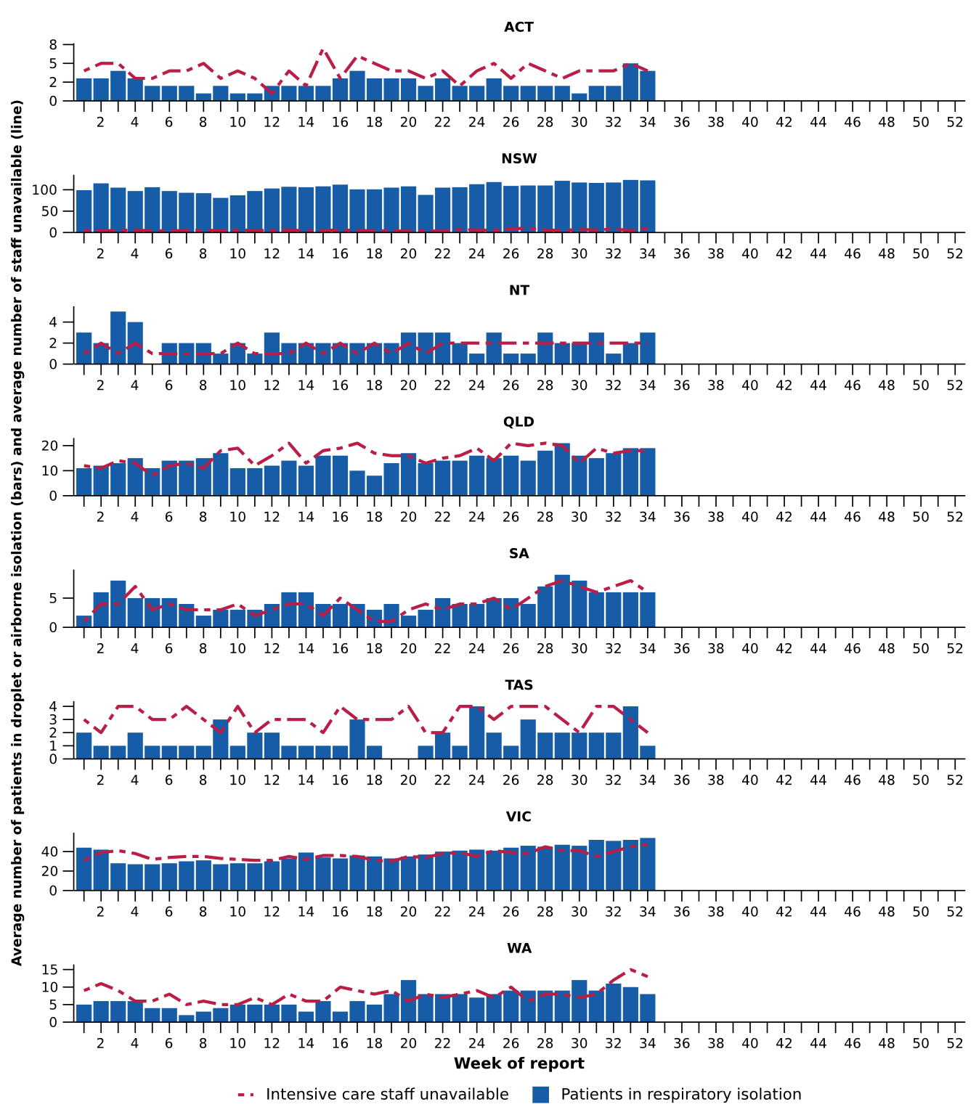
Source: Critical Health Resource Information System (CHRIS)
* Axis varies between jurisdictions.
† NSW isolation data from public hospitals includes all patients occupying intensive care beds in isolation precautions, including those in contact isolation precautions, rather than just droplet or airborne isolation precautions, which will overestimate the average number of patients occupying intensive care beds in droplet or airborne isolation in NSW. For this reason, NSW data may not be comparable to data from other jurisdictions.
‡ Intensive care staff include both medical and nursing staff. Staff unavailability will be underestimated in NSW as most public hospitals in NSW do not report staff unavailability. For this reason, NSW data may not be comparable to data from other jurisdictions.

Mortality surveillance
Death registrations can provide information on the scale and severity of disease associated with acute respiratory infections. An acute respiratory infection associated death is one where the death was due to the disease (the illness has caused terminal complications such as pneumonia) or the person has died with the disease (a person has died from another cause but the illness still contributed significantly to death).
The Provisional Mortality Statistics have not been updated since the previous report, so data here remain unchanged.
- COVID-19 has been the leading cause of acute respiratory infection related mortality across the majority of 2020–2025; however, between August 2025 and January 2026 the number of deaths per month involving influenza (both due to and with) were well above usual levels, exceeding COVID-19 deaths. Since February 2026, deaths involving COVID-19 have again been higher than those involving influenza.
- In Aboriginal and Torres Strait Islander people, there were more deaths involving COVID-19 in 2022–2024; however, in 2025 there were more deaths involving influenza. So far in 2026 there have been the same number of deaths involving COVID-19 as involving influenza.
- Deaths involving acute respiratory infections were more common in older age groups.
Figure 21a: Provisional numbers of deaths due to an acute respiratory infection*† by month, year, and disease, Australia, 1 January 2024 to 30 June 2026
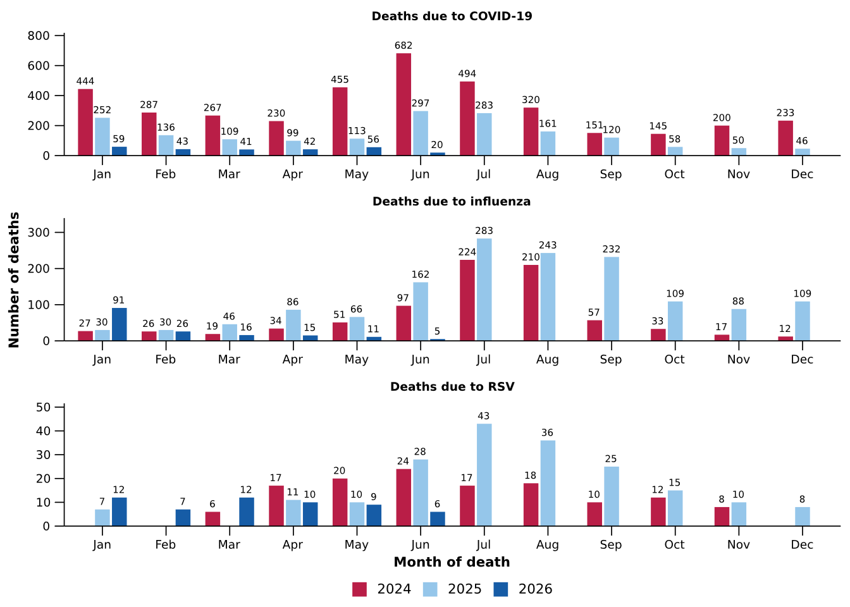
Source: Australian Bureau of Statistics (ABS), Deaths due to acute respiratory infections in Australia, released 30 July 2026.
* Axis varies between acute respiratory infections.
† Data is provisional and subject to change. It can take several weeks for death registrations to be reported, processed, coded, validated, and tabulated. Therefore, the data shown here may be incomplete. Data for some months were not published by the ABS due to small counts, and therefore not reported here. Data includes all deaths (both doctor and coroner certified) that occurred and were registered by 30 June 2026.
- Deaths due to COVID-19 increased slightly in May 2026 but are much lower compared to previous years. The 1,724 deaths due to COVID-19 in 2025 are well below both 2024 (3,908 deaths) and 2023 (4,614) (Figure 21a).
- Deaths due to influenza were relatively stable in March and April 2026 before declining slightly in May 2026. Deaths due to influenza in May 2026 are substantially lower than each May since 2022, however, are not unusually low for May compared to pre-pandemic years and align with low influenza case numbers (Figure 21a).
- Deaths due to RSV remained at low levels in May 2026 (Figure 21a).
- Deaths with COVID-19 fell in May 2026 following a slight increase in the number of deaths with COVID-19 reported in March and April. Deaths with COVID-19 in 2026 remain low compared to previous years (Figure 21b).
- There have been very few deaths with influenza since January 2026 (Figure 21b).
- Deaths with RSV rose in May 2026 in line with increasing RSV case numbers. The number of deaths with RSV was higher in 2025 (405 deaths) than in 2024 (341 deaths) and in 2023 (280 deaths) (Figure 21b).
Figure 21b: Provisional numbers of deaths with an acute respiratory infection*† by month, year, and disease, Australia, 1 January 2024 to 30 June 2026
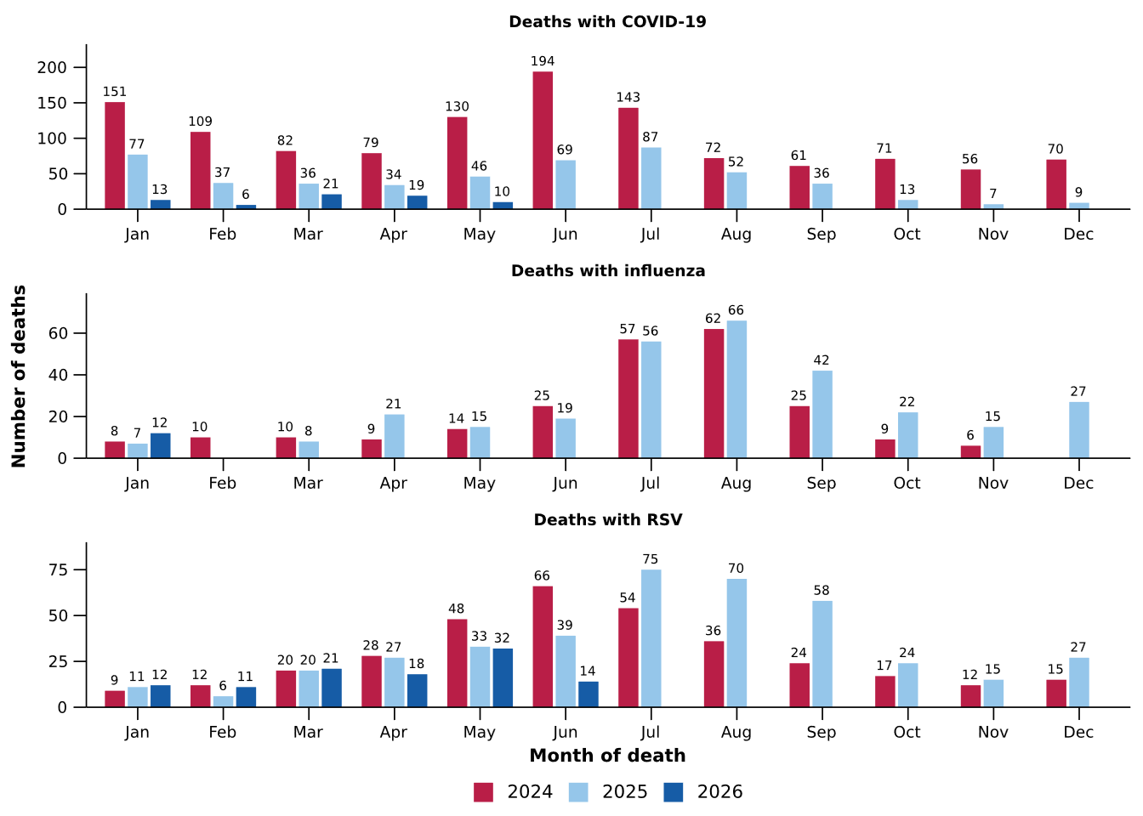
Source: Australian Bureau of Statistics (ABS), Deaths due to acute respiratory infections in Australia, released 30 July 2026.
* Axis varies between acute respiratory infections.
† Data is provisional and subject to change. It can take several weeks for death registrations to be reported, processed, coded, validated, and tabulated. Therefore, the data shown here may be incomplete. Data for some months were not published by the ABS due to small counts, and therefore not reported here. Data includes all deaths (both doctor and coroner certified) that occurred and were registered by 30 June 2026.

Laboratory surveillance
Sentinel laboratory surveillance monitors the percentage of tests with the notifiable condition detected (i.e. test positivity). It also provides information on what pathogens are circulating, potential changes in the pathogens that might affect their infectiousness, severity, ability to evade vaccine and/or infection-acquired immunity, or resistance to antivirals.
- In the last fortnight (10 August to 23 August 2026), the percentage of SARS-CoV-2 tests that were positive increased (from 1.2% to 1.6%), the percentage of influenza tests that were positive increased (from 5.0% to 7.3%) and the percentage of RSV tests that were positive decreased (from 6.5% to 5.5%) (Figure 22).
Figure 22: Number of tests positive (bars) and percentage of tests positive (line) for SARS-CoV-2, influenza or RSV of those specimens tested by sentinel laboratories by week of report*†, Australia, 1 January to 23 August 2026
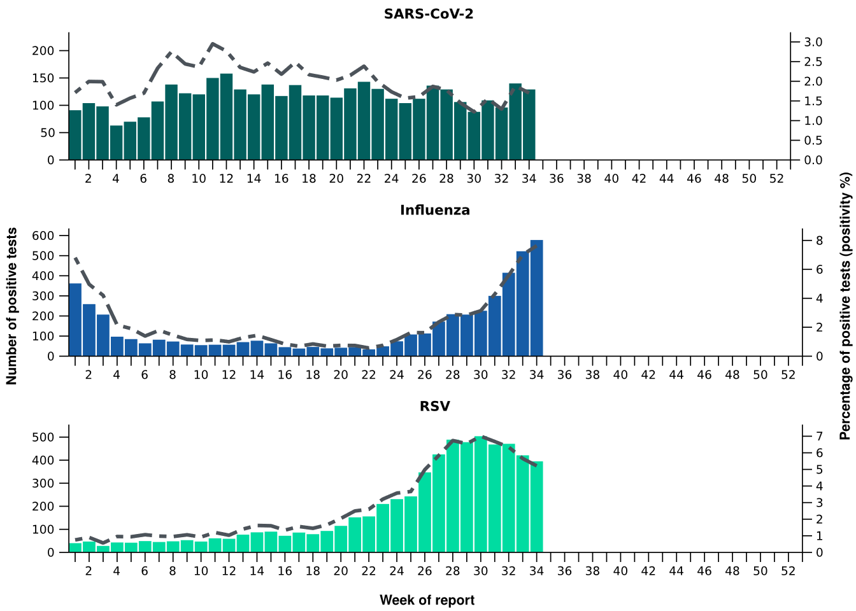
Source: Sentinel laboratories, including National Influenza Centres
* Number of specimens tested excludes data from WA as testing denominator data are different for the three pathogens in Western Australia.
† A small minority of total samples from Victoria are tested only by respiratory panel (influenza, parainfluenza, adenovirus, human metapneumovirus, seasonal coronaviruses, RSV, and some picornaviruses) but not for SARS-CoV-2. These minority samples include only forensic materials; all other samples are tested by respiratory panel and SARS-CoV-2 assay.

The SARS-CoV-2 sequencing data have not been updated since the previous report (1 January to 9 August 2026), so data here remain unchanged.
- There were 88 SARS-CoV-2 sequences uploaded to AusTrakka with dates of collection in the last 28 days (13 July to 9 August 2026). These sequences were from NSW, SA and WA with the most recent date of collection from 27 July 2026. The low number of sequences uploaded to AusTrakka in the last 28 days is likely due to the reduced number of COVID-19 cases and changes in sequencing capacity and priorities. The limited number of sequences and potential lack of representativeness may limit interpretation.
- Most sequences were recombinants consisting of one or more Omicron sub-lineages (Figure 23a/b). In the last 28 days:
  - 62.5% (55/88) of sequences were recombinant or recombinant sub-lineages, the most common including NB.1.8.1 (n=52) and XFG (n=3).
  - 22.7% (20/88) of sequences were identified as BA.3, specifically BA.3.2.
  - 14.8% (13/88) of sequences were from the sub-sub-lineages JN.1 (BA.2.86.1.1), specifically from the RF lineage.
  - There were no BA.1, BA.4, BA.5 or other BA.2 sub-sub-lineage sequences.
- NB.1.8.1 was the most common sub-lineage in the last 28 days, accounting for 59.1% (52/88) of sequences (Figure 23a).
- The World Health Organization (WHO) have identified certain sub-sub-lineages and recombinants as variants under monitoring (VUM) because of their epidemiological, pathological, or immunological features of concern. A select number are highlighted below due to their relevance in the Australian context. There are:
  - 4,535 KP.3.1.1 sequences in AusTrakka, with none identified in the last 28 days.
  - 4,387 NB.1.8.1 sequences in AusTrakka, with 52 collected in the last 28 days.
  - 1,550 XFG sequences in AusTrakka, with 3 collected in the last 28 days.
  - 1,074 BA.3.2 sequences in AusTrakka, with 20 collected in the last 28 days.

Figure 23a: SARS-CoV-2 Omicron sub-lineage* sequences by sample collection date, showing proportions of sequences per week†‡, Australia, 1 January to 9 August 2026
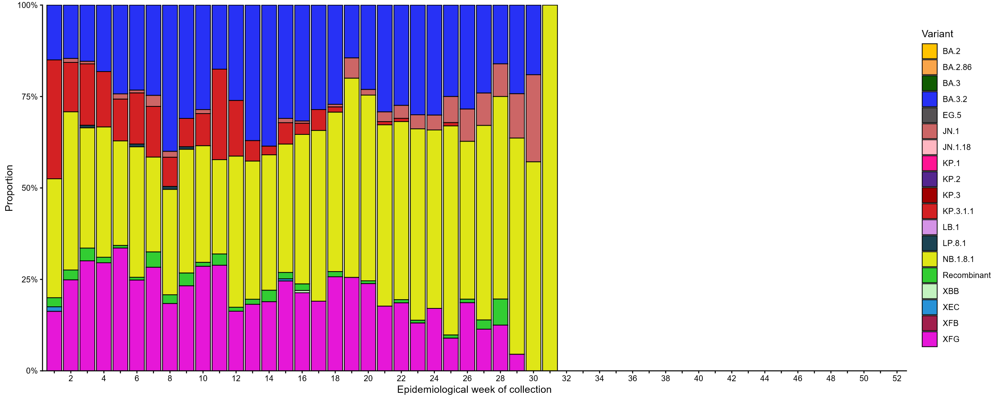
Source: AusTrakka
* Some sub-sublineages are shown alongside their parent lineage, but not included in the parent lineage totals. For instance, KP.2 and KP.3 are sub-sub lineages of JN.1, so the total of JN.1 sequences will be higher than shown in the corresponding colour alone, and should include the KP.2 and KP.3 totals.
† Sequences in AusTrakka aggregated by week and reported based on date of sample collection, not date of sequencing.
‡ Proportions in Figure 23a may not be representative when sequence numbers are small; refer to Figure 23b. Data for earlier weeks may change between reporting periods as sequences with older collection dates are uploaded. These numbers are not equivalent to number of cases, as there are many cases which may not be sequenced. Non-VOI and non-VUM Omicron sub-lineages have been collapsed into parent lineages BA.1, BA.2, BA.3, BA.4 and BA.5.

Figure 23b: SARS-CoV-2 Omicron sub-lineage* sequences by sample collection date, showing the count of sequences per week†‡, Australia, 1 January to 9 August 2026
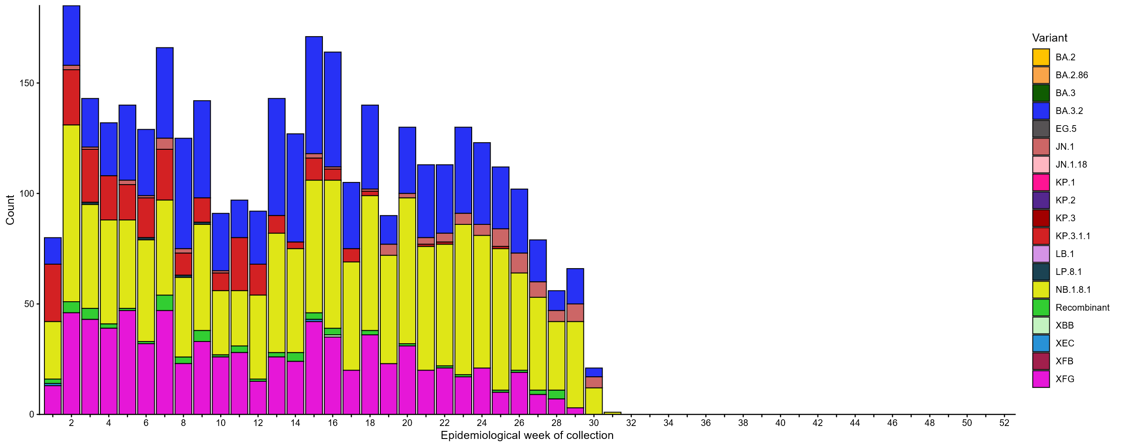
Source: AusTrakka
* Some sub-sublineages are shown alongside their parent lineage, but not included in the parent lineage totals. For instance, KP.2 and KP.3 are sub-sub lineages of JN.1, so the total of JN.1 sequences will be higher than shown in the corresponding colour alone, and should include the KP.2 and KP.3 totals.
† Sequences in AusTrakka aggregated by week and reported based on date of sample collection, not date of sequencing.
‡ Data for earlier weeks may change between reporting periods as sequences with older collection dates are uploaded. These numbers are not equivalent to number of cases, as there are many cases which may not be sequenced. Non-VOI and non-VUM Omicron sub-lineages have been collapsed into parent lineages BA.1, BA.2, BA.3, BA.4 and BA.5.

- In the year to date, the WHO Collaborating Centre for Reference and Research on Influenza has antigenically characterised 818 influenza viruses from Australia (Table 5), of which:
  - 16.0% (131/818) have been influenza A(H1N1)
  - 71.1% (582/818) have been influenza A(H3N2)
  - 12.8% (105/818) have been influenza B/Victoria.
- In the year to date, 1.6% (1/61) of influenza A(H1N1) samples tested for neuraminidase inhibitor resistance demonstrated highly reduced inhibition to oseltamivir. None of the influenza A(H3N2) or influenza B samples tested demonstrated highly reduced inhibition to oseltamivir.
- In the year to date, none of the samples tested demonstrated highly reduced inhibition to zanamivir.
Table 5: Australian influenza viruses typed by haemagglutination inhibition assay and jurisdiction*†, 1 January to 23 August 2026
Strain | ACT | NSW | NT | Qld | SA | Tas | Vic | WA | Total
A(H1N1) | 4 | 27 | 7 | 9 | 18 | 14 | 45 | 7 | 131
A(H3N2) | 37 | 164 | 80 | 41 | 27 | 49 | 150 | 34 | 582
B/Victoria lineage | 4 | 15 | 56 | 1 | 1 | 4 | 21 | 3 | 105
Total | 45 | 206 | 143 | 51 | 46 | 67 | 216 | 44 | 818
Source: World Health Organization (WHO) Collaborating Centre for Reference and Research on Influenza
*Viruses tested by the WHO Collaborating Centre for Reference and Research on Influenza are not necessarily a random sample of all those in the community and early-year data may be based on limited samples received. There may be up to a month delay on reporting of samples.
† Jurisdiction indicates the residential location for the individual tested, not the submitting laboratory.

Vaccine coverage, effectiveness and match
Vaccine coverage, effectiveness and match for acute respiratory infections are monitored from several data sources in Australia. Refer to the Technical Supplement for more information.

Vaccine coverage
- In the last 12 months, fewer adults have received a COVID-19 vaccine (8.0%; Table 6), compared to the 12 months prior (10.3% from 19 August 2024 to 17 August 2025).
- In the last 12 months, vaccine coverage decreased in all age groups, with the largest decrease seen in the 75 years and over age group (from 35.8% in the 12 months prior to 29.8% in the last 12 months).
- There has been substantial variation in COVID-19 vaccine coverage across age groups, ranging from 3.0% in adults aged 18–64 years to 29.8% in adults aged 75 years and over (Table 6).
- There has been some variation in vaccine coverage across jurisdictions, ranging from 3.0% in the NT to 15.6% in Tas (Table 6).
Table 6: COVID-19 vaccine coverage*†‡ by age group and jurisdiction, Australia, 18 August 2025 to 23 August 2026
Age group | ACT | NSW | NT | Qld | SA | Tas | Vic | WA | AUS
Last 12 months (18 August 2025 to 23 August 2026)
18–64 years | 7.7 | 2.5 | 1.4 | 2.9 | 3.1 | 6.1 | 3.3 | 2.9 | 3.0
65–74 years | 36.7 | 17.0 | 8.8 | 17.3 | 21.6 | 32.6 | 19.8 | 18.3 | 18.4
≥ 75 years | 51.0 | 28.7 | 13.0 | 28.3 | 33.9 | 47.2 | 31.2 | 30.8 | 29.8
All ages (18 years and over) | 15.3 | 7.6 | 3.0 | 7.5 | 9.7 | 15.6 | 8.5 | 7.7 | 8.0
Last 6 months (23 February 2026 to 23 August 2026)
18–64 years | 6.3 | 2.0 | 0.9 | 2.3 | 2.5 | 5.2 | 2.7 | 2.5 | 2.4
65–74 years | 31.8 | 14.6 | 6.6 | 14.7 | 18.6 | 29.2 | 17.3 | 16.4 | 15.9
≥ 75 years | 43.3 | 24.1 | 10.3 | 23.2 | 27.9 | 41.3 | 26.4 | 26.9 | 25.1
All ages (18 years and over) | 12.9 | 6.3 | 2.2 | 6.2 | 8.1 | 13.6 | 7.1 | 6.7 | 6.7
Source: Australian Immunisation Register (AIR) as at 24 August 2026
* COVID-19 vaccine coverage uses the AIR population as the denominator (from 6 July 2026 onwards). Coverage data in these tables may differ slightly from coverage estimates in other reports due to differences in calculation methodologies and/or different data download dates.
† COVID-19 vaccine coverage is influenced by changes in COVID-19 vaccine recommendations and eligibility criteria. For this reason, coverage rates in the current 12 month period and previous 12 month periods may not be directly comparable.
‡ Total rows will include individuals where jurisdiction was missing.

- In the last 12 months, fewer Aboriginal and Torres Strait Islander adults have received a COVID-19 vaccine (3.5%; Table 7), compared to the 12 months prior (4.8% from 19 August 2024 to 17 August 2025).
- In the last 12 months, vaccine coverage decreased in all age groups of Aboriginal and Torres Strait Islander people, with the largest decrease seen in the 75 years and over age group (from 27.6% in the 12 months prior to 22.8% in the last 12 months).
- Among Aboriginal and Torres Strait Islander people there has been substantial variation in COVID-19 vaccine coverage across age groups, ranging from 1.8% in adults aged 18–64 years to 22.8% in adults aged 75 years and over (Table 7).
- Among Aboriginal and Torres Strait Islander people, there has been slight variation in vaccine coverage across jurisdictions, ranging from 2.1% in the NT to 8.0% in Tas (Table 7).
Table 7: COVID-19 vaccine coverage*†‡ among Aboriginal and Torres Strait Islander populations by age group and jurisdiction, Australia, 18 August 2025 to 23 August 2026
Age group | ACT | NSW | NT | Qld | SA | Tas | Vic | WA | AUS
Last 12 months (18 August 2025 to 23 August 2026)
18–64 years | 4.7 | 1.9 | 1.4 | 1.6 | 1.8 | 4.1 | 2.6 | 1.5 | 1.8
65–74 years | 31.5 | 14.8 | 7.2 | 11.9 | 12.4 | 28.8 | 16.5 | 11.6 | 13.5
≥ 75 years | 46.9 | 25.1 | 12.6 | 19.8 | 25.0 | 36.8 | 28.2 | 20.7 | 22.8
All ages (18 years and over) | 7.9 | 3.9 | 2.1 | 3.0 | 3.5 | 8.0 | 5.0 | 2.7 | 3.5
Last 6 months (23 February 2026 to 23 August 2026)
18–64 years | 4.0 | 1.5 | 0.8 | 1.3 | 1.4 | 3.4 | 2.1 | 1.3 | 1.5
65–74 years | 28.9 | 12.8 | 4.7 | 10.3 | 10.4 | 25.4 | 14.2 | 9.8 | 11.6
≥ 75 years | 41.8 | 20.9 | 8.8 | 16.2 | 21.1 | 32.4 | 23.7 | 17.1 | 18.9
All ages (18 years and over) | 6.9 | 3.3 | 1.3 | 2.5 | 2.8 | 6.9 | 4.1 | 2.3 | 2.9
Source: Australian Immunisation Register (AIR) as at 24 August 2026
* COVID-19 vaccine coverage uses the AIR population as the denominator (from 6 July 2026 onwards). Coverage data in these tables may differ slightly from coverage estimates in other reports due to differences in calculation methodologies and/or different data download dates.
† COVID-19 vaccine coverage in the most recent 12 month period may not be directly comparable to previous 12 month periods due to changes in COVID-19 vaccine eligibility criteria.
‡ Total rows will include individuals where jurisdiction was missing.

- Influenza vaccine coverage is 30.0% for 2026 so far (Table 8).
- There has been substantial variation in influenza vaccine coverage across age groups, ranging from 16.3% in children aged 5–14 years to 60.1% in adults aged 65 years and over (Table 8). The current trend is influenced by eligibility criteria as people aged 5–64 years are generally not eligible for free seasonal influenza vaccine under the National Immunisation Program.
- There has been some variation in influenza vaccine coverage across jurisdictions, ranging from 26.0% in the NT to 39.0% in the ACT (Table 8).
- Among Aboriginal and Torres Strait Islander populations, there has been substantial variation in influenza vaccine coverage across age groups, ranging from 16.3% in children aged 5–14 years to 59.9% in adults aged 65 years and over (Table 8).
- Among Aboriginal and Torres Strait Islander populations, there has been some variation in influenza vaccine coverage across jurisdictions, ranging from 21.1% in Qld to 38.5% in the NT (Table 8).
Table 8: Influenza vaccine coverage*†‡ by age group and jurisdiction, Australia, 1 March to 23 August 2026
 | ACT | NSW | NT | Qld | SA | Tas | Vic | WA | AUS
Age groups
6 months to <5 years | 56.0 | 35.8 | 43.1 | 30.2 | 35.6 | 39.6 | 38.3 | 33.5 | 35.5
5–14 years | 25.8 | 16.2 | 16.5 | 14.6 | 15.5 | 16.7 | 16.4 | 18.7 | 16.3
15–49 years | 30.9 | 19.0 | 23.8 | 17.2 | 22.1 | 22.5 | 22.7 | 18.2 | 20.0
50–64 years | 41.3 | 28.5 | 25.9 | 28.7 | 33.8 | 36.4 | 32.1 | 29.1 | 30.2
≥ 65 years | 64.8 | 58.2 | 36.4 | 59.4 | 66.2 | 67.7 | 61.3 | 59.6 | 60.1
All ages (6 months and over) | 39.0 | 29.2 | 26.0 | 27.6 | 33.9 | 35.9 | 31.7 | 28.5 | 30.0
Aboriginal and Torres Strait Islander populations
6 months to <5 years | 38.6 | 26.6 | 44.2 | 23.1 | 23.7 | 27.9 | 26.9 | 27.2 | 26.7
5–14 years | 19.8 | 15.5 | 28.8 | 14.5 | 15.9 | 15.5 | 15.7 | 16.7 | 16.3
15–49 years | 24.3 | 17.2 | 36.9 | 15.7 | 20.3 | 19.6 | 19.1 | 17.5 | 19.0
50–64 years | 44.1 | 35.4 | 48.4 | 32.9 | 37.4 | 42.0 | 36.0 | 33.1 | 36.1
≥ 65 years | 66.6 | 62.4 | 49.3 | 58.7 | 62.5 | 69.7 | 62.6 | 54.2 | 59.9
All ages (6 months and over) | 29.8 | 23.6 | 38.5 | 21.1 | 25.0 | 27.1 | 25.2 | 22.4 | 24.3
Source: Australian Immunisation Register (AIR) as at 24 August 2026
* Influenza vaccine coverage uses the AIR population as the denominator. Coverage data in these tables may differ slightly from coverage estimates in other reports due to differences in calculation methodologies and/or different data download dates.
† Total rows will include individuals where jurisdiction was missing.

- Since the commencement of the National RSV Mother and Infant Protection Program on 3 February 2025, 311,692 Abrysvo doses have been administered to pregnant people nationally (Table 9).
- While high maternal vaccine uptake is a positive indicator of maternal program success, it may result in lower nirsevimab uptake rates in infants. This is because maternal antibodies passed to the infant can provide protection against RSV, potentially reducing the need for infant immunisation.
Table 9: Number of doses of Abrysvo administered to pregnant people by jurisdiction*, Australia, 3 February 2025 to 23 August 2026
 | ACT | NSW | NT | Qld | SA | Tas | Vic | WA | AUS
Age group
15–24 years | 409 | 7,779 | 720 | 7,550 | 1,740 | 838 | 4,562 | 3,045 | 26,643
25–39 years | 6,932 | 82,204 | 2,857 | 50,475 | 18,594 | 5,847 | 73,574 | 27,849 | 268,332
40–54 years | 459 | 5,400 | 144 | 2,635 | 1,086 | 259 | 5,116 | 1,618 | 16,717
Total (15–54 years) | 7,800 | 95,383 | 3,721 | 60,660 | 21,420 | 6,944 | 83,252 | 32,512 | 311,692
Source: Australian Immunisation Register (AIR) as at 24 August 2026
* Administered doses in this table may differ slightly from estimates in other reports due to differences in calculation methodologies and/or different data download dates.
† Total rows will include individuals where jurisdiction was missing.
- In the last six months, 7.8% of infants (aged < 8 months) have received nirsevimab (Table 10).
- There has been substantial variation in nirsevimab uptake in infants across jurisdictions, ranging from 1.4% in the ACT to 29.1% in WA (Table 10).
- The current trend likely reflects differences in the timing and eligibility criteria between state and territory programs. Some state and territory programs are seasonal (from 1 April to 30 September), whereas others are year-round.
Table 10: Nirsevimab (Beyfortus) uptake in the last six months*†‡ by age group and jurisdiction, Australia, 23 February 2026 to 23 August 2026
 | ACT | NSW | NT | Qld | SA | Tas | Vic | WA | AUS
Age group
Infants (aged < 8 months) | 1.4 | 4.2 | 9.0 | 8.0 | 3.4 | 4.5 | 4.5 | 29.1 | 7.8
Young children (aged ≥ 8 to 24 months) | 0.4 | 0.2 | 0.4 | 0.1 | 0.4 | 0.6 | 0.4 | 1.3 | 0.4
Source: Australian Immunisation Register (AIR) as at 24 August 2026
* Reporting of RSV monoclonal antibodies to the AIR is not compulsory; therefore, uptake is likely to be underestimated. Uptake data in these tables may differ slightly from estimates in other reports due to differences in calculation methodologies and/or different data download dates.
† For infants and young children vaccinated, age in months is calculate as months between the immunisation encounter and date of birth rounded down as at the reporting date. For the infant and young children population, age in months is calculated as months between the AIR data extract date and date of birth rounded down as at the reporting date.
‡ Total rows will include individuals where jurisdiction was missing.

Vaccine effectiveness
- Australian data, as part of the Global Influenza Vaccine Effectiveness (GIVE) Collaboration, indicate that in 2025, people who received the influenza vaccine were about 49% less likely to visit general practice and 43% less likely to be hospitalised with influenza compared to those who were unvaccinated.
- It is too early to assess VE for the 2026 influenza season.

Vaccine match
- In the year to date, 100% (131/131) of influenza A(H1N1) isolates, 69.2% (403/582) of influenza A(H3N2) isolates and 90.5% (95/105) of influenza B/Victoria lineage isolates characterised have been antigenically similar to the corresponding 2026 southern hemisphere vaccine components.

2026 southern hemisphere vaccine composition
The composition of influenza vaccines for Australia in 2026 differs from the 2025 southern hemisphere and 2025/26 northern hemisphere composition. The southern hemisphere 2026 vaccine contains 2 new strains for the influenza A(H1N1)pdm09 and A(H3N2) subtype virus components.
The following influenza viruses are used for the 2026 southern hemisphere trivalent influenza vaccines in Australia:
Egg-based influenza vaccines:
- an A/Missouri/11/2025 (H1N1)pdm09-like virus
- an A/Singapore/GP20238/2024 (H3N2)-like virus
- a B/Austria/1359417/2021 (B/Victoria lineage)-like virus.
Cell-based influenza vaccines:
- an A/Missouri/11/2025 (H1N1)pdm09-like virus
- an A/Sydney/1359/2024 (H3N2)-like virus
- a B/Austria/1359417/2021 (B/Victoria lineage)-like virus.
The continued absence of confirmed detection of naturally occurring B/Yamagata lineage viruses after March 2020 is indicative of a very low risk of infection by B/Yamagata lineage viruses. Since September 2023, the WHO has recommended that the inclusion of a B/Yamagata lineage antigen in seasonal influenza vaccines is no longer warranted.

