Australian Respiratory Surveillance Report

Key messages
This report presents a national update on acute respiratory infections, including coronavirus disease 2019 (COVID-19), influenza and respiratory syncytial virus (RSV). It focuses on the current reporting period (24 August to 6 September 2026) and earlier severity reporting periods (up to 23 August 2026). These key messages do not routinely provide detailed information on age distribution, jurisdictional patterns, or comparisons with previous years. This analysis and supporting data are available in the full report.
In the community: In the last fortnight, self-reported influenza-like illness increased among people who contacted the national health helpline but decreased slightly among those who took part in community surveys. COVID-19 cases decreased by 12.2% in the last fortnight. Influenza cases continued to rise nationally over the last fortnight (+27.2%), but growth has slowed. While activity may not yet have peaked, overall influenza activity in 2026 remains substantially lower than in 2025, the timing and pattern of activity is more consistent with pre-pandemic seasonal influenza seasons. RSV cases decreased by 19.5% in the last fortnight, consistent with seasonal patterns.
In general practice: In the last fortnight, influenza-like illness consultation rates at sentinel general practice sites decreased. Consultation rates remain elevated compared to earlier in 2026 but are relatively consistent with usual interseasonal levels.
In hospitals: In the last severity reporting fortnight, admissions to sentinel hospitals with severe acute respiratory infections decreased and most admissions in the last severity fortnight were with influenza. In the last severity reporting period for sentinel intensive care admissions with severe acute respiratory infections, the number of admissions also declined and most admissions were with influenza. In the last fortnight, the average daily intensive care bed occupancy for patients in droplet or airborne isolation increased.
Deaths: COVID-19 has been the leading cause of acute respiratory infection mortality across the majority of 2020-2025; however, between August 2025 and January 2026 there were more deaths involving influenza (both due to and with) each month than deaths involving COVID-19. The mortality burden of acute respiratory infections is highest in older adults.
In laboratories: In the last fortnight, test positivity for SARS-CoV-2 and RSV decreased, but test positivity for influenza increased. The SARS-CoV-2 variant under monitoring, NB.1.8.1 remains the most common circulating SARS-CoV-2 variant.
Vaccine coverage, effectiveness and match: In the last year, 8.0% of adults have received a COVID-19 vaccine. In 2026 to date, influenza vaccine coverage is 30.2%, which is slightly higher than the same time in 2024 and 2025. Most influenza isolates (>87%) are a good match for the 2026 southern hemisphere vaccine components. The National RSV Mother and Infant Protection Program continues, with 320,049 Abrysvo doses administered to date, and nirsevimab uptake at 7.8% in infants aged up <8 months over the last six months.

Australian Respiratory Surveillance Report
This report was prepared by Lauren Kutzner, Nga Nguyen, and Jenna Hassall on behalf of the Australian Centre for Disease Control (CDC). We thank the staff and participants from the states, territories and the surveillance systems who contribute data for acute respiratory illness surveillance across Australia.
The report presents a national overview of acute respiratory infections in Australia, drawing information from several different surveillance systems. These surveillance systems help us to understand the distribution of acute respiratory illnesses in the community, the severity of infections including which populations might be at risk, and the impact of acute respiratory illnesses on the community and health system in Australia. Surveillance indicators presented in this report are based on the Australian National Surveillance Plan for COVID-19, Influenza, and RSV. A summary of data considerations for this report are provided below.
- Due to the dynamic nature of the surveillance systems used in this report, surveillance data are considered preliminary and subject to change as updates are received, with the most recent weeks considered particularly incomplete. Data in this report may vary from data reported in other national reports and reports by states and territories.
- Data in this report are presented by date of event (survey, diagnosis, admission or death) and by the International Organization for Standardization (ISO) week date system, with weeks defined as seven-day periods which begin on a Monday and end on a Sunday. The ISO week date system is used to support trends comparisons over time more effectively. The current reporting period includes 24 August to 6 September 2026 and where comparisons to the previous fortnight are made, this includes 10 August to 23 August 2026.
- In Australia, states and territories (the Australian Capital Territory [ACT], New South Wales [NSW], the Northern Territory [NT], Queensland [Qld], South Australia [SA], Tasmania [Tas], Victoria [Vic] and Western Australia [WA]) report notified cases to the National Notifiable Diseases Surveillance System (NNDSS) based on the Australian national surveillance case definitions. NNDSS data are analysed and reported based on diagnosis date, which is the true onset date of a case if known, otherwise it is the earliest of the specimen date, the notification date or the notification received date. The NNDSS data for this report were extracted on 9 September 2026.
- Notification rates per 100,000 population presented in this report are for the given time period, with population data are based on the Australian Bureau of Statistics (ABS) Estimated Resident Population (ERP) for the reference period June 2025, released 18 December 2025 unless stated otherwise.
- To account for the lag in collection and provision of severity data from some surveillance systems, and for the time delay between illness onset and the development of severe disease outcomes, cases with an admission date or a diagnosis date in the last two weeks are excluded from severity analyses for hospitalisations and intensive care admissions. As such, the severity reporting periods are two weeks behind the end of the current reporting period. For this report, severity reporting includes data from 10 August to 23 August 2026 unless specified otherwise. Where comparisons to the previous severity fortnight are made this includes 27 July to 9 August 2026.
- Death registrations from the ABS Provisional Mortality Statistics are now used as the primary data source for measuring acute respiratory infection associated deaths. The ABS mortality data is sourced from the Registry of Births, Deaths and Marriages and is separate from the NNDSS. Registration-based mortality data needs time to be received and processed, and so mortality statistics in this report may lag by at least two months.
- The responsibility for the interpretation and use of the material lies with the reader. The Australian CDC does not accept liability for any injury or loss or damage arising from the use of, or reliance upon, the content of the report. Analysis and reporting outputs were produced using R Statistical Software v4.3.1.
- For further information about this report, including data sources and considerations refer to the Technical Supplement or contact respiratory.surveillance@cdc.gov.au.

Community surveillance
Community surveillance monitors respiratory illnesses in the community, providing information on the number of people reporting respiratory symptoms, testing practices, and the impact of respiratory illnesses. Community surveillance includes notification data obtained from laboratory tests for infections. Infections that are diagnosed and notified are only a subset of the total number of infections occurring in the community.
- In the last fortnight (24 August to 6 September 2026), the rate of Healthdirect helpline callers with influenza-like illness (404 per 1,000 callers per fortnight) increased compared to the previous fortnight (398 per 1,000 callers per fortnight) (Figure 1).
- Influenza-like illness rates in helpline callers have been increasing gradually from late April 2026 and in the last fortnight surpassed influenza-like illness rates seen at the same time in previous years (Figure 1).
Figure 1: Rate of influenza-like illness per 1,000 helpline callers by year and week of call*, Australia†, 22 March 2023 to 6 September 2026
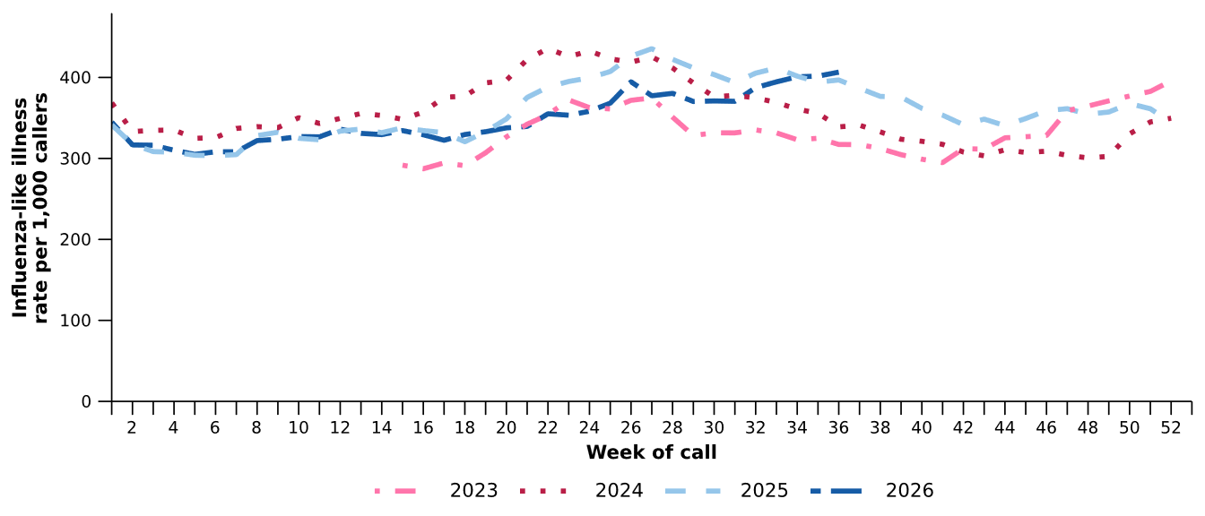
Source: Healthdirect Australia
* Healthdirect data prior to 22 March 2023 are unavailable as prior to this date a different data collection method was used.
† The Healthdirect helpline operates in all states and territories except Qld; therefore influenza-like illness trends will not be representative of Qld and may be underrepresented. See the Technical Supplement for more information.
- In the last fortnight, the rate of Healthdirect helpline callers with influenza-like illness referred to seek urgent medical care (210 per 1,000 callers per fortnight) increased slightly compared to the previous fortnight (206 per 1,000 callers per fortnight).
- In the last fortnight, referral categories for helpline callers with influenza-like illness varied across jurisdictions. Referral to ‘Attend ED’ or ‘Seek other urgent medical care’ was most used in NSW, the NT, SA, Tas, Vic and WA. Meanwhile, ‘See GP’ was most used in the ACT (Figure 2).

Figure 2: Proportion of referral categories* for helpline callers with influenza-like illness by jurisdiction† and call date, Australia, 1 January to 6 September 2026
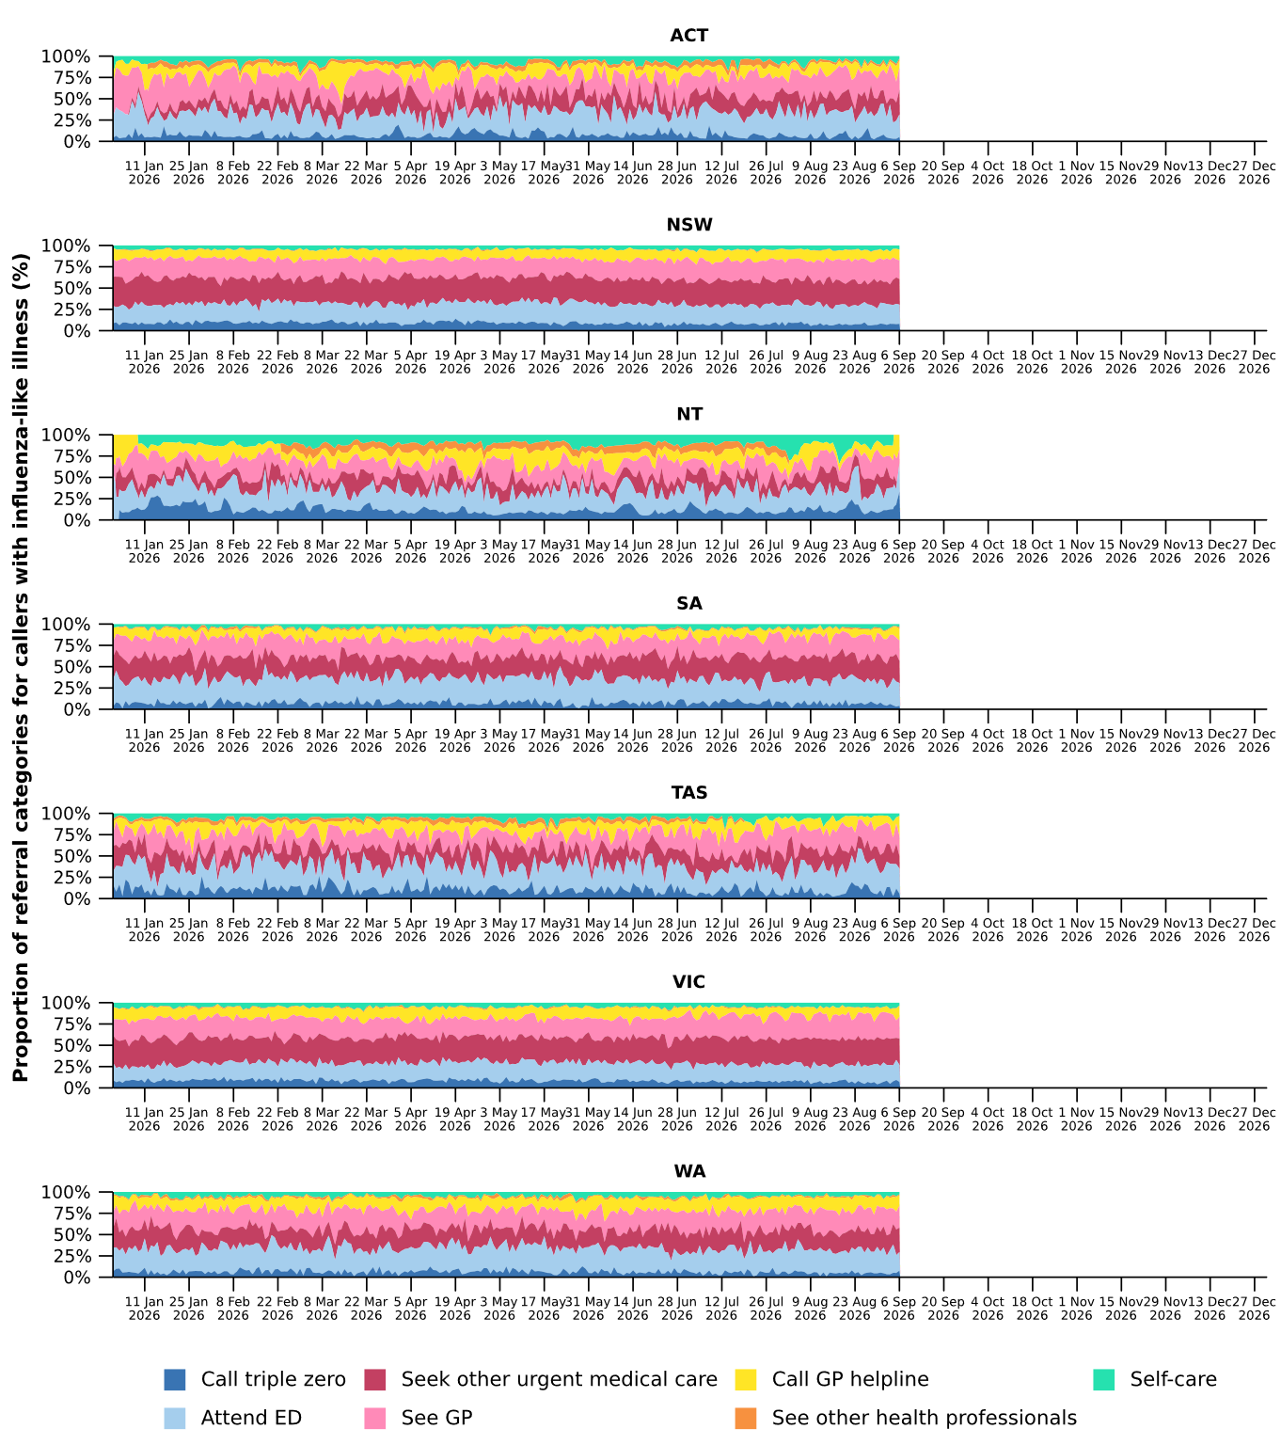
Source: Healthdirect Australia
* See other health professionals category includes pharmacist, dentist, mental health provider, primary maternity care, poison information centre or other.
† The Healthdirect helpline operates in all states and territories except Qld; therefore influenza-like illness referral trends are not provided for Qld. See the Technical Supplement for more information.

- In the last fortnight, a slightly lower percentage of FluTracking participants reported new fever and cough symptoms (1.8%), than in the previous fortnight (2.0%) (Figure 3).
- Following a steadily increasing trend since late July and an apparent peak of 2.1% of FluTracking participants reporting new fever and cough symptoms in late August 2025, the percentage of participants that reported new fever and cough symptoms decreased overall in recent weeks (Figure 3).
- In the last fortnight, a slightly higher percentage of First Nations FluTracking participants reported new fever and cough symptoms (2.0%) compared with the previous fortnight (1.8%). These findings could be impacted by smaller sample sizes and the representativeness of the data. For more detailed trends, please refer to figure 2 in the FluTracking reports.
Figure 3: Age standardised percentage of survey participants reporting new fever and cough symptoms compared with the five-year average*† by year and week of survey, Australia, 2023 to 6 September 2026
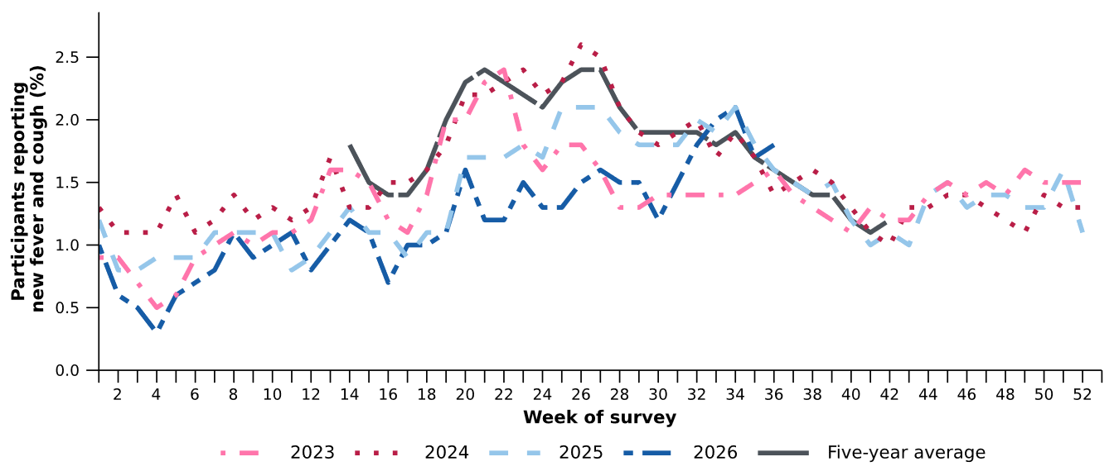
Source: FluTracking
* From 2020, FluTracking expanded their data capture period to year-round. Data before May and after October for any year before 2020 are not available for historical comparisons. The years 2020 and 2021 are excluded when comparing the current season to historical periods when influenza virus has circulated without public health restrictions. As such, the five-year average includes the years 2019 and 2022 to 2025..
† Historical FluTracking testing and test positivity estimates have been recalculated to incorporate amendments made to survey test results after initial submission. Values may therefore differ from those reported previously.
- The average percentages of FluTracking participants reporting taking three or more days off work or normal duties and seeking medical advice or care due to fever and cough symptoms were lower in 2026 than at the same time in previous years (Table 1).
Table 1: Percentage of FluTracking participants reporting new fever and cough symptoms plus three or more days off work or normal duties or seeking medical advice or care*, Australia, up to 23 August† for 2023–2026
 | 2023 | 2024 | 2025 | 2026
Reported three or more days off work or normal duties | 51.0% | 51.9% | 48.9% | 45.2%
Reported seeking medical advice or care* | 33.7% | 32.4% | 30.9% | 29.3%
Source: FluTracking
* Includes those who sought medical advice from a general practitioner, Aboriginal and Torres Strait Islander health clinic, COVID-19 clinic, emergency department, or were admitted to hospital for fever and cough.
† While FluTracking data are collected in real time, data presented here are subject to a two week reporting delay to account for the time delay between illness onset and the development of severe disease outcomes.

- Self-reported severe acute respiratory syndrome coronavirus 2 (SARS-CoV-2) polymerase chain reaction (PCR) test positivity and rapid antigen test (RAT) positivity have fluctuated throughout 2026, though both remain low and stable below 8.3% test positivity in the last fortnight (Figure 4a; Figure 4b).
- Self-reported influenza PCR positivity has been consistently increasing since early August, reaching 34.4% test positivity in the week ending 6 September 2026 (Figure 4a). Self-reported influenza RAT positivity has been gradually increasing since late April, with the rate of increase increasing in the since mid-July, reaching 28.0% test positivity per week across the last fortnight (Figure 4b).
- Self-reported RSV PCR test positivity has fluctuated across 2026 but there has been an overall decreasing since RSV PCR test positivity reached a peak of 20.6% test positivity per week in late June 2026 (Figure 4a). Self-reported RSV RAT positivity has also followed an overall decreasing trend since RSV RAT positivity reached a peak of 12.7% test positivity in early July 2026 (Figure 4b).
Figure 4a: Self-reported PCR test positivity* among FluTracking participants with fever and cough symptoms by pathogen week of survey, Australia, 1 January to 6 September 2026
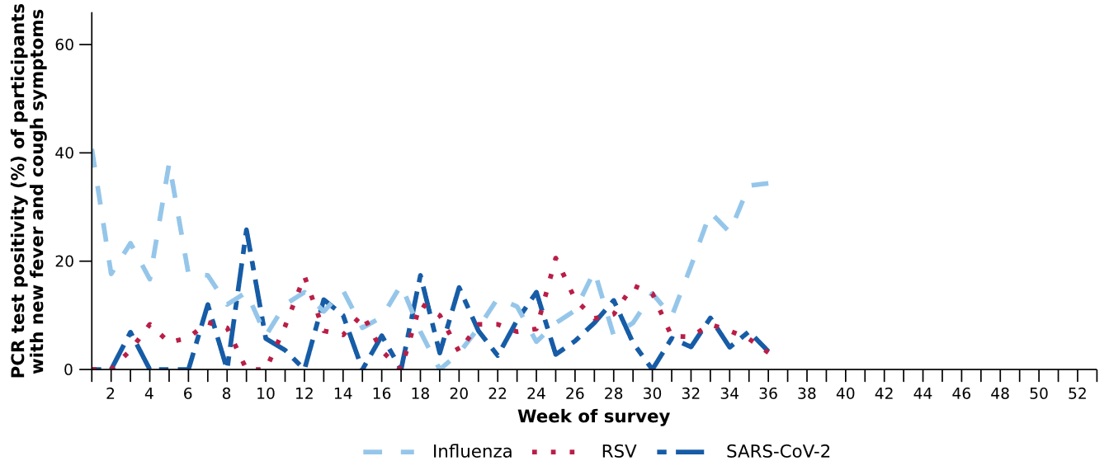
Source: FluTracking
* Denominator is based on participants who self-reported fever and cough symptoms and had a PCR test.
Figure 4b: Self-reported RAT positivity* among FluTracking participants with fever and cough symptoms by pathogen and week of survey, Australia, 1 January to 6 September 2026
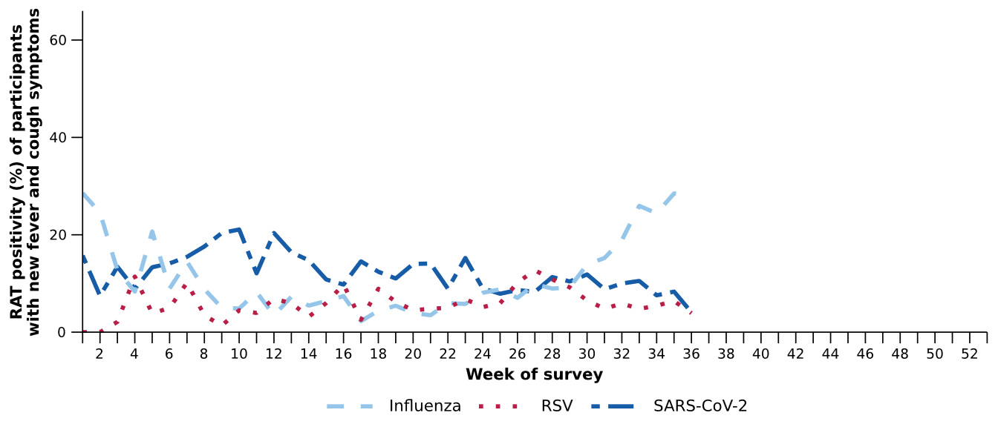
Source: FluTracking
* Denominator is based on participants who self-reported fever and cough symptoms and had a RAT.
- In the last fortnight (24 August to 6 September 2026), there was a 12.2% decrease in COVID-19 cases, a 27.2% increase in influenza cases, and a 19.5% decrease in RSV cases compared to the previous fortnight.
Table 2: Notified cases and notification rate per 100,000 population by disease, five-year age group, and jurisdiction*, Australia, 1 January to 6 September 2026
 | COVID-19 |  |  | Influenza |  |  | RSV
 | Reporting  period  (n) | Year to  date  (n) | Year to  date  (rate) | Reporting  period  (n) | Year to  date  (n) | Year to  date  (rate) | Reporting  period  (n) | Year to  date  (n) | Year to  date  (rate)
Age group (years)
0–4 | 474 | 10,517 | 693 | 3,985 | 17,382 | 1,145 | 2,522 | 55,456 | 3,655
5–9 | 105 | 3,187 | 199 | 4,802 | 18,508 | 1,154 | 596 | 8,083 | 504
10–14 | 125 | 2,648 | 157 | 3,530 | 14,438 | 858 | 326 | 3,683 | 219
15–19 | 179 | 2,554 | 150 | 2,560 | 11,091 | 651 | 299 | 3,041 | 178
20–24 | 159 | 2,318 | 128 | 1,503 | 6,990 | 385 | 172 | 2,532 | 140
25–29 | 183 | 2,874 | 142 | 1,303 | 6,065 | 299 | 175 | 2,926 | 144
30–34 | 212 | 3,562 | 173 | 1,473 | 6,183 | 299 | 220 | 3,523 | 171
35–39 | 242 | 3,971 | 197 | 1,625 | 6,421 | 318 | 227 | 3,572 | 177
40–44 | 245 | 3,688 | 193 | 1,629 | 6,404 | 335 | 216 | 3,243 | 169
45–49 | 200 | 2,998 | 182 | 1,258 | 5,007 | 303 | 209 | 3,133 | 190
50–54 | 221 | 3,041 | 180 | 1,212 | 4,543 | 269 | 250 | 3,701 | 219
55–59 | 201 | 3,016 | 194 | 1,143 | 4,360 | 281 | 269 | 4,215 | 271
60–64 | 173 | 2,858 | 186 | 1,044 | 4,262 | 277 | 290 | 4,558 | 297
65–69 | 216 | 2,953 | 213 | 1,052 | 4,228 | 305 | 289 | 4,581 | 330
70–74 | 223 | 3,274 | 275 | 955 | 3,844 | 322 | 318 | 4,711 | 395
75+ | 1,020 | 15,039 | 666 | 2,574 | 10,579 | 468 | 696 | 13,856 | 613
Jurisdiction
ACT | 69 | 1,117 | 230 | 604 | 2,131 | 440 | 195 | 2,006 | 414
NSW | 1,596 | 31,752 | 369 | 14,256 | 65,615 | 764 | 2,259 | 53,126 | 618
NT | 10 | 305 | 115 | 92 | 902 | 341 | 46 | 1,003 | 379
Qld | 586 | 12,739 | 225 | 6,625 | 24,574 | 433 | 1,062 | 22,440 | 396
SA | 189 | 4,276 | 225 | 1,378 | 5,390 | 283 | 1,009 | 8,790 | 462
Tas | 64 | 1,111 | 193 | 285 | 1,020 | 177 | 138 | 2,307 | 401
Vic | 1,218 | 12,909 | 182 | 7,039 | 21,723 | 307 | 1,594 | 25,861 | 366
WA | 446 | 4,324 | 142 | 1,371 | 9,000 | 296 | 772 | 9,301 | 306
Total | 4,178 | 68,533 | 248 | 31,650 | 130,355 | 472 | 7,075 | 124,834 | 452
Source: National Notifiable Diseases Surveillance System (NNDSS)
* Total includes cases with missing age.

- In the last fortnight, there were 4,178 COVID-19 cases, a 12.2% decrease from 4,757 cases notified in the previous fortnight (Table 2; Figure 5).
- In the year to date, there have been 68,533 COVID-19 cases, 55.3% fewer than the 153,183 cases notified over the same period in 2025 (Table 2; Figure 5). There was a minor increase in cases notified nationally in late August, driven by increasing case numbers across the ACT, NSW, Qld, Tas and Vic at the same point in time; however, unlike previous years there has been no clear national winter peak in 2026.
- In the last fortnight, COVID-19 notification rates decreased or remained relatively stable across most jurisdictions compared with the previous fortnight, except in SA and WA where notification rates increased (Figure 6).
Figure 5: Notified COVID-19 cases by year and week of diagnosis, Australia, 2023 to 6 September 2026
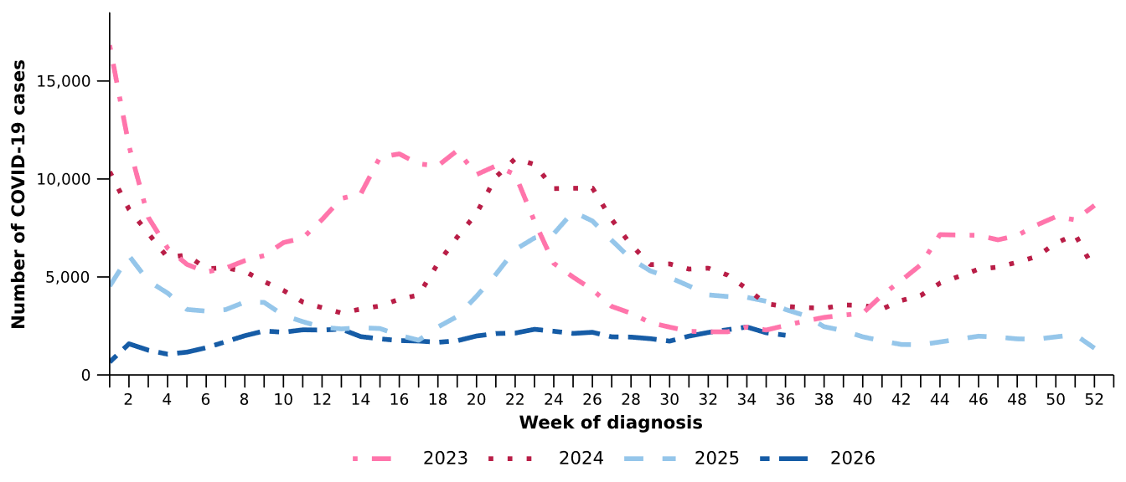
Source: National Notifiable Diseases Surveillance System (NNDSS)

Figure 6: Notification rates per 100,000 population for COVID-19 cases by state or territory and week of diagnosis, Australia, 1 January to 6 September 2026
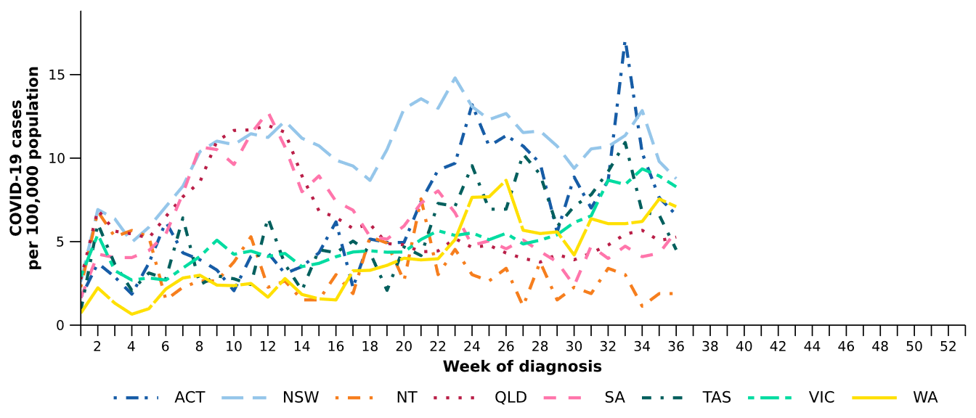
Source: National Notifiable Diseases Surveillance System (NNDSS)

- In the last fortnight, there were 31,650 influenza cases, a 27.2% increase from 24,883 cases notified in the previous fortnight (Table 2; Figure 7). The timing of this continued increase is broadly consistent with pre-pandemic influenza seasonal patterns (e.g., 2015–2018), which were characterised by increasing case numbers from June and typically peaked in late August to early September. While influenza cases continue to increase, suggesting a national peak has not yet been reached, the rate of increase slowed in the last fortnight (Figure 7).
- In the year to date, there have been 130,355 influenza cases, 62.6% fewer than the 348,570 cases notified over the same period in 2025 (Table 2; Figure 7). Lower than expected influenza cases during January to June 2026 may have been influenced by greater population immunity following the higher-than-usual influenza activity in late 2025, together with the impact of seasonal influenza vaccination programs. While the later onset of sustained increases in influenza activity observed from late July 2026 may reflect a combination of factors that supported increased spread, including:
  - waning natural immunity following lower-than-usual case numbers earlier in 2026
  - a combination of initial waning of vaccine-derived immunity following slowing of seasonal influenza vaccine uptake after May and lower preliminary influenza vaccine effectiveness estimates than in previous years
  - increased population mixing following the return to school after the mid-year holidays in July
  - timing of climatic conditions, noting that although the 2026 Australian winter was among the warmest on record across many parts of the country, and colder weather predominately occurred from mid-July onwards which may have supported increased transmission as people spent more time in close contact indoors
  - a return to pre-pandemic seasonal influenza patterns described above.
- In the last fortnight, influenza notification rates increased or remained relatively stable across most jurisdictions compared with the previous fortnight, except in the ACT where notification rates decreased (Figure 8).
Figure 7: Notified influenza cases and five-year average* by year and week of diagnosis, Australia, 2023 to 6 September 2026
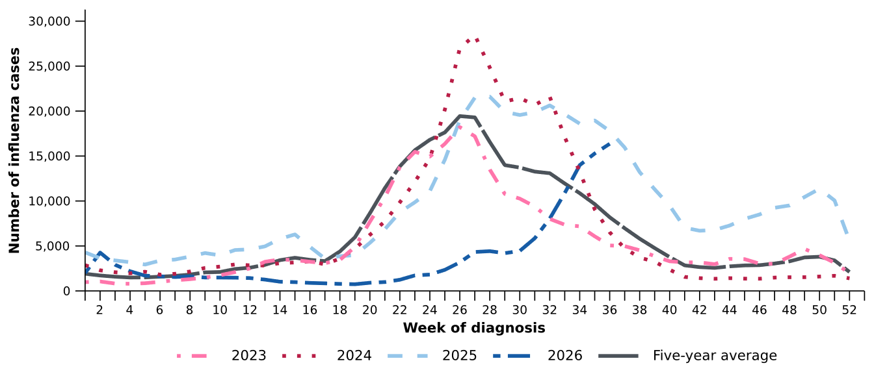
Source: National Notifiable Diseases Surveillance System (NNDSS)
* The years 2020 and 2021 are excluded when comparing the current season to historical periods when influenza virus has circulated without public health restrictions. As such, the five-year average includes the years 2019 and 2022 to 2025.
Figure 8: Notification rates per 100,000 population for influenza cases by state or territory and week of diagnosis, Australia, 1 January to 6 September 2026
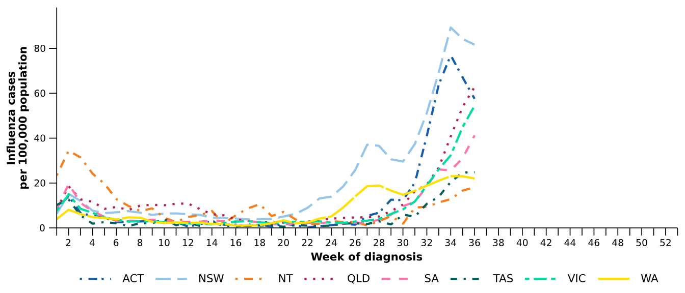
Source: National Notifiable Diseases Surveillance System (NNDSS)
- In the last fortnight, there were 30,074 influenza A cases, a 28.4% increase from 23,421 influenza A cases notified in the previous fortnight, and there were 1,443 influenza B cases, a 11.1% increase from 1,299 influenza B cases notified in the previous fortnight.
- In the last fortnight, among influenza A cases with subtype information available there were:
  - 226 influenza A(H1N1) cases, a 22.2% increase from 185 cases notified in the previous fortnight.
  - 491 influenza A(H3N2) cases, a 15.8% decrease from 583 cases notified in the previous fortnight.
- Throughout 2026, influenza A(unsubtyped) has been the dominant reported influenza subtype across all age groups. Influenza A(H3N2) notifications have been reported across all age groups, though most notably in children aged 0–4 years and adults aged 65 years and over. In recent weeks there has been a small increase in the number of influenza B notifications across all age groups (Figure 9).
- Trends in influenza subtypes are influenced by differences in the number and selection of influenza samples that undergo typing across age groups and healthcare settings.

Figure 9: Notified influenza cases by influenza subtype, age group*, and week of diagnosis, Australia, 1 January to 6 September 2026
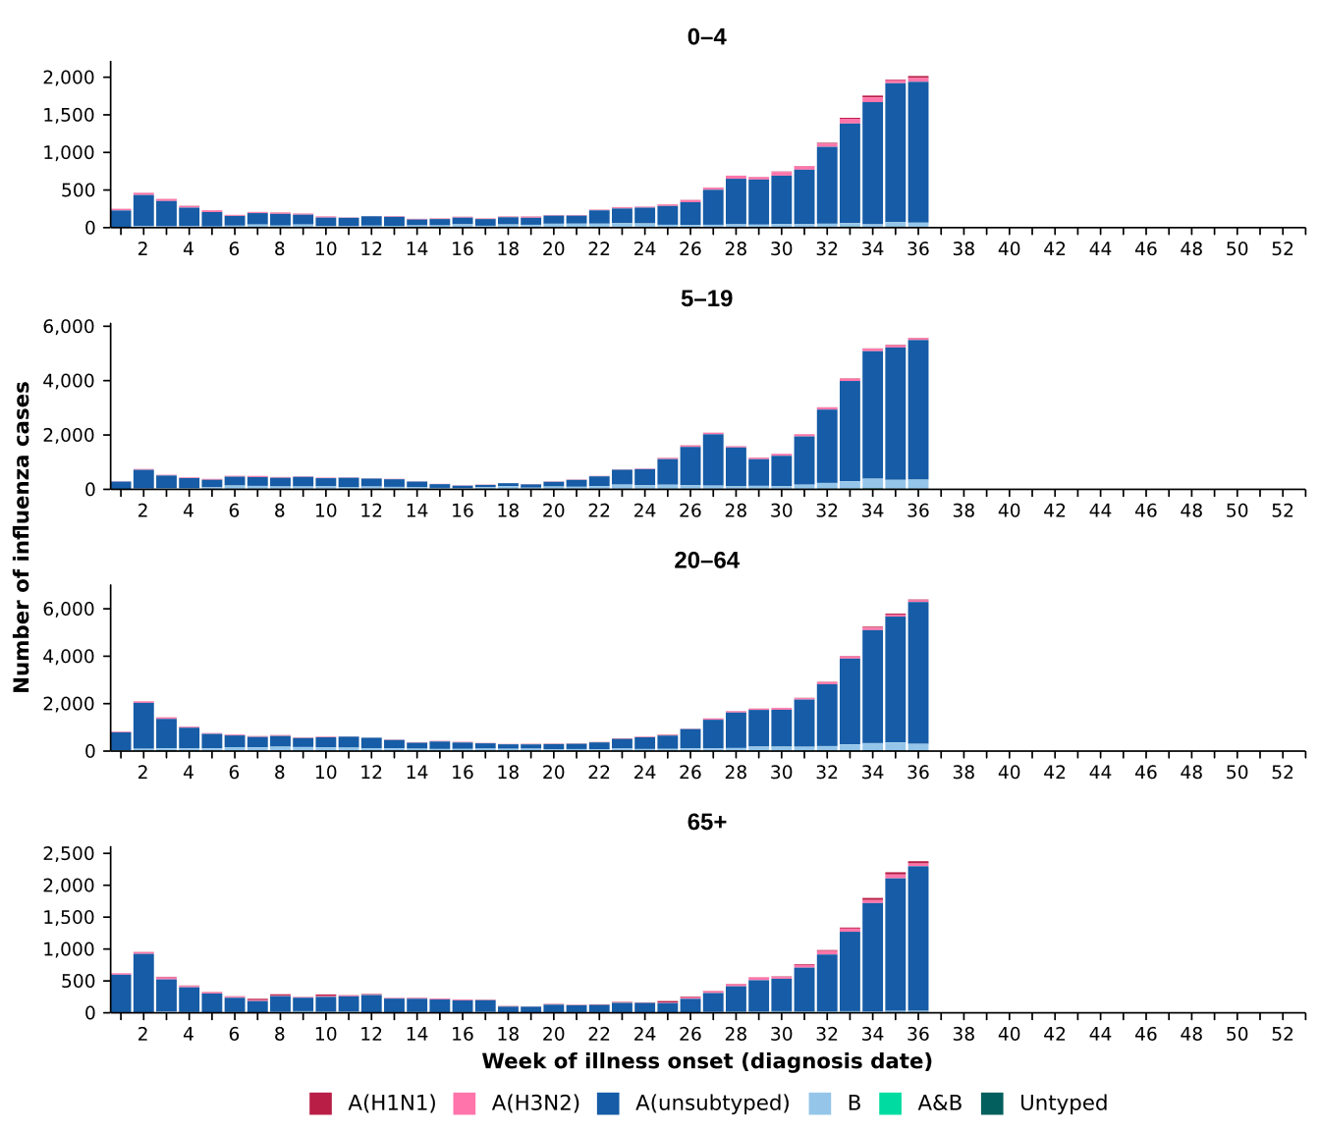
Source: National Notifiable Diseases Surveillance System (NNDSS)
* Axis varies between age groups.

- In the year to date, influenza A(unsubtyped) accounts for the highest number of notifications across most jurisdictions. In recent months, influenza A(H3N2) notifications have increased in Tas and WA. Influenza B notifications been consistently reported in the NT throughout 2026, and the number of influenza B notifications has been increasing in NSW, Vic and WA in recent weeks (Figure 10).
Figure 10: Notified influenza cases by influenza subtype, jurisdiction*, and week of diagnosis, Australia, 1 January to 6 September 2026
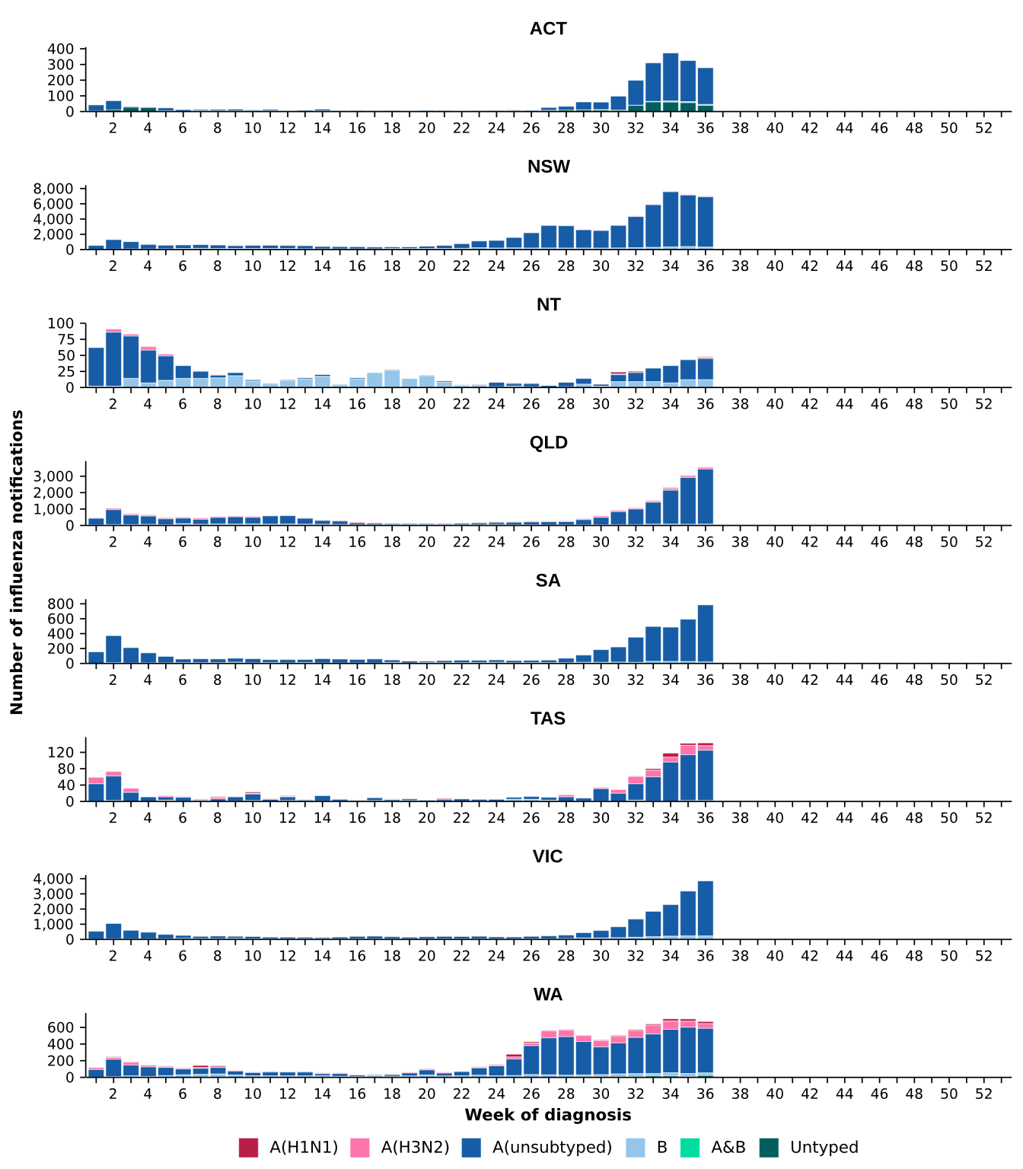
Source: National Notifiable Diseases Surveillance System (NNDSS)
* Axis varies between jurisdictions.

- In the last fortnight, there were 7,075 RSV cases, a 19.5% decrease from 8,787 cases notified in the previous fortnight (Table 2; Figure 11).
- In the year to date, there have been 124,834 RSV cases, 15.6% fewer than the 147,828 cases notified over the same period in 2025. Since the late June peak, RSV notifications have continued to decrease (Table 2; Figure 11).
- In the last fortnight, RSV notification rates decreased or remained relatively stable across all jurisdictions compared with the previous fortnight (Figure 12).
Figure 11: Notified RSV cases by year and week of diagnosis, Australia, 2023 to 6 September 2026
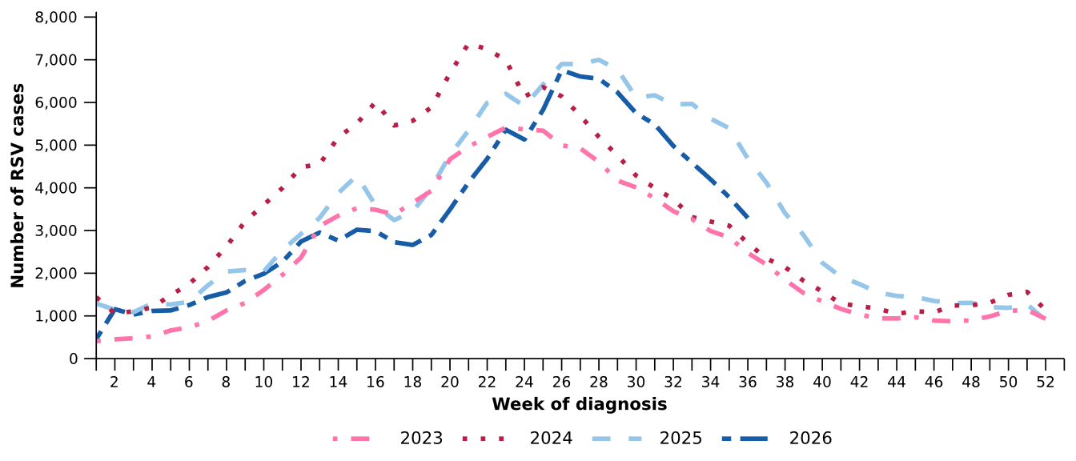
Source: National Notifiable Diseases Surveillance System (NNDSS)

Figure 12: Notification rates per 100,000 population for RSV cases by state or territory and week of diagnosis, Australia, 1 January to 6 September 2026
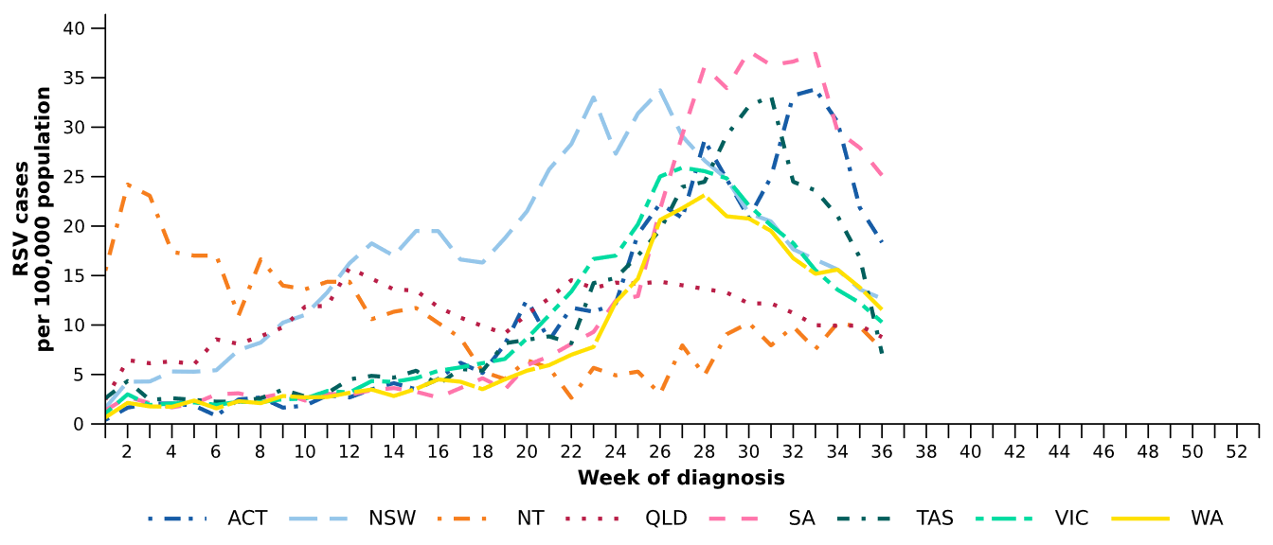
Source: National Notifiable Diseases Surveillance System (NNDSS)

Primary care surveillance
Primary care surveillance monitors the number and characteristics of people who have presented to a general practice with influenza-like illness and provides insight on the different respiratory pathogens that are causing illness in the community.
- In the last fortnight (24 August to 6 September 2026), there were fewer general practice consultations for influenza-like illness (7.9 notifications per 1,000 consultations per fortnight) compared to previous fortnight (8.9 notifications per 1,000 consultations per fortnight) (Figure 13).
- Despite an apparent decrease in the last fortnight, influenza-like illness notification rates per 1,000 consultations remained elevated compared to earlier in the year but are still lower than at the same time in 2024–2025, and similar to the historical five-year average (Figure 13).
Figure 13: Rate of influenza-like illness notifications per 1,000 consultations per week in sentinel general practice sites compared with the five-year average by year and week of consultation*†, Australia, 2023 to 6 September 2026
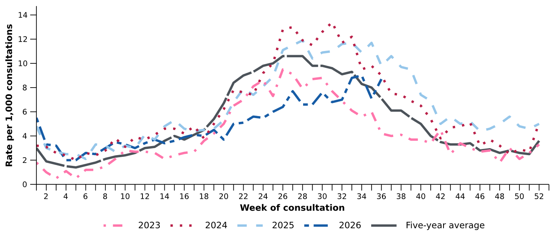
Source: Australian Sentinel Practices Research Network (ASPREN)
* The years 2020 and 2021 are excluded when comparing the current season to historical periods when influenza virus has circulated without public health restrictions. As such, the five-year average includes the years 2019 and 2022 to 2025.
† Please refer to the Technical Supplement for notes on impact of COVID-19 on ASPREN data.

- In the last fortnight, 57.3% (59/103) of people attending general practice with influenza-like illness who were tested have then tested positive for a respiratory pathogen.
- In the last fortnight, rhinovirus / enterovirus (33.9%; 20/59) was the most commonly detected pathogen, followed by influenza (25.4%; 15/59) and human metapneumovirus (18.6%; 11/59) (Figure 14).
- In the year to date, 59.0% (1,219/2,066) of people attending general practice with influenza-like illness who were tested have then tested positive for a respiratory pathogen.
- In the year to date, rhinovirus / enterovirus (45.0%; 548/1,219) has been the most commonly detected pathogen, followed by influenza (13.9%; 169/1,219), RSV (11.9%; 145/1,219), parainfluenza (9.7%; 118/1,219), and human metapneumovirus (8.1%; 99/1,219) (Figure 14).
Figure 14: Number of samples tested for respiratory pathogens among people with influenza-like illness attending sentinel general practice sites by respiratory pathogen and week of specimen collection, Australia, 1 January to 6 September 2026
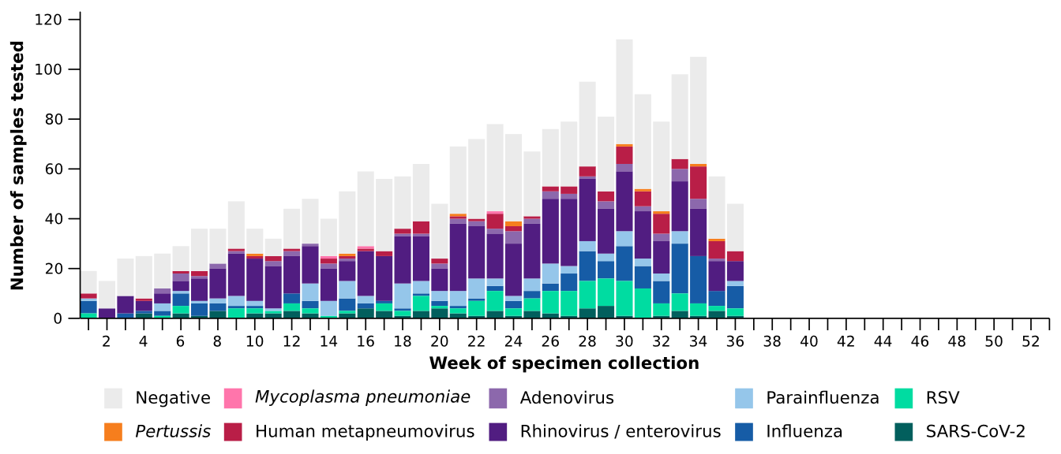
Source: Australian Sentinel Practices Research Network (ASPREN)
Note: All ASPREN swab samples are transported to the SA Pathology laboratory in Adelaide to be tested for viral and bacterial respiratory pathogens via a multiplex real-time reverse transcription polymerase chain reaction (RT-PCR) assay using in-house primers.

Hospital-based surveillance
Hospital-based surveillance monitors people with more severe illness who have been admitted to hospital for their respiratory illness (severe acute respiratory infections). Hospital-based surveillance also measures the ability of the health system to cope with the number of severe acute respiratory infection admissions to ensure delivery of safe, timely and quality health care.
- In the last severity reporting period (10 August to 23 August 2026), fewer patients were admitted to a sentinel hospital with a severe acute respiratory infection (n=472), than in the previous severity reporting period (n=546).
  - In the last severity reporting period, at sentinel hospitals there was 10.3% fewer admissions with COVID-19 (from 58 to 52), 35.0% more admissions with influenza (from 183 to 247), and 43.3% fewer admissions with RSV (from 305 to 173), compared to the previous severity reporting period.
- In the year to date for severity reporting (1 January to 23 August 2026), there have been 5,678 admissions with severe acute respiratory infections at sentinel hospitals. Most patients with a severe acute respiratory infection have been admitted with RSV (n=3,192) followed by influenza (n=1,368) (Figure 15).
Figure 15: Total number of patients (children and adults) admitted with a severe acute respiratory infection to sentinel hospitals by disease and week of admission, Australia, 1 January to 23 August 2026
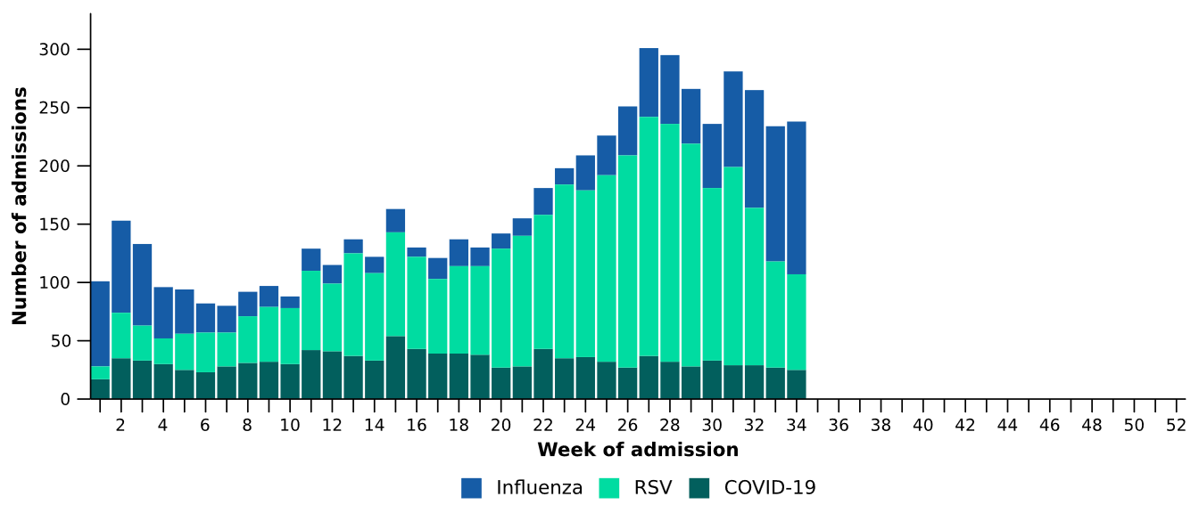
Source: Influenza Complications Alert Network (FluCAN)
- Patients admitted to sentinel hospitals with influenza have mostly been admitted with influenza A (91.5%; 1,252/1,368), while 8.0% (109/1,368) were admitted with influenza B.
  - Most hospital admissions with influenza A have been with influenza A(unsubtyped) (58.9%; 737/1,252), followed by influenza A(H3N2) (31.1%; 389/1,252) and then influenza A(H1N1) (10.1%; 126/1,252).
- In recent severity reporting periods, influenza A(H3N2) admissions have increased across most age groups, particularly among the 6 months–4 years and 5–16 years age groups. To a lesser extent there have been some increases in influenza A(H1N1) and influenza/B admissions among younger age groups in recent severity reporting periods (Figure 16).

Figure 16: Number of patients admitted with influenza to sentinel hospitals by influenza subtype, age group*, and week of admission, Australia, 1 January to 23 August 2026
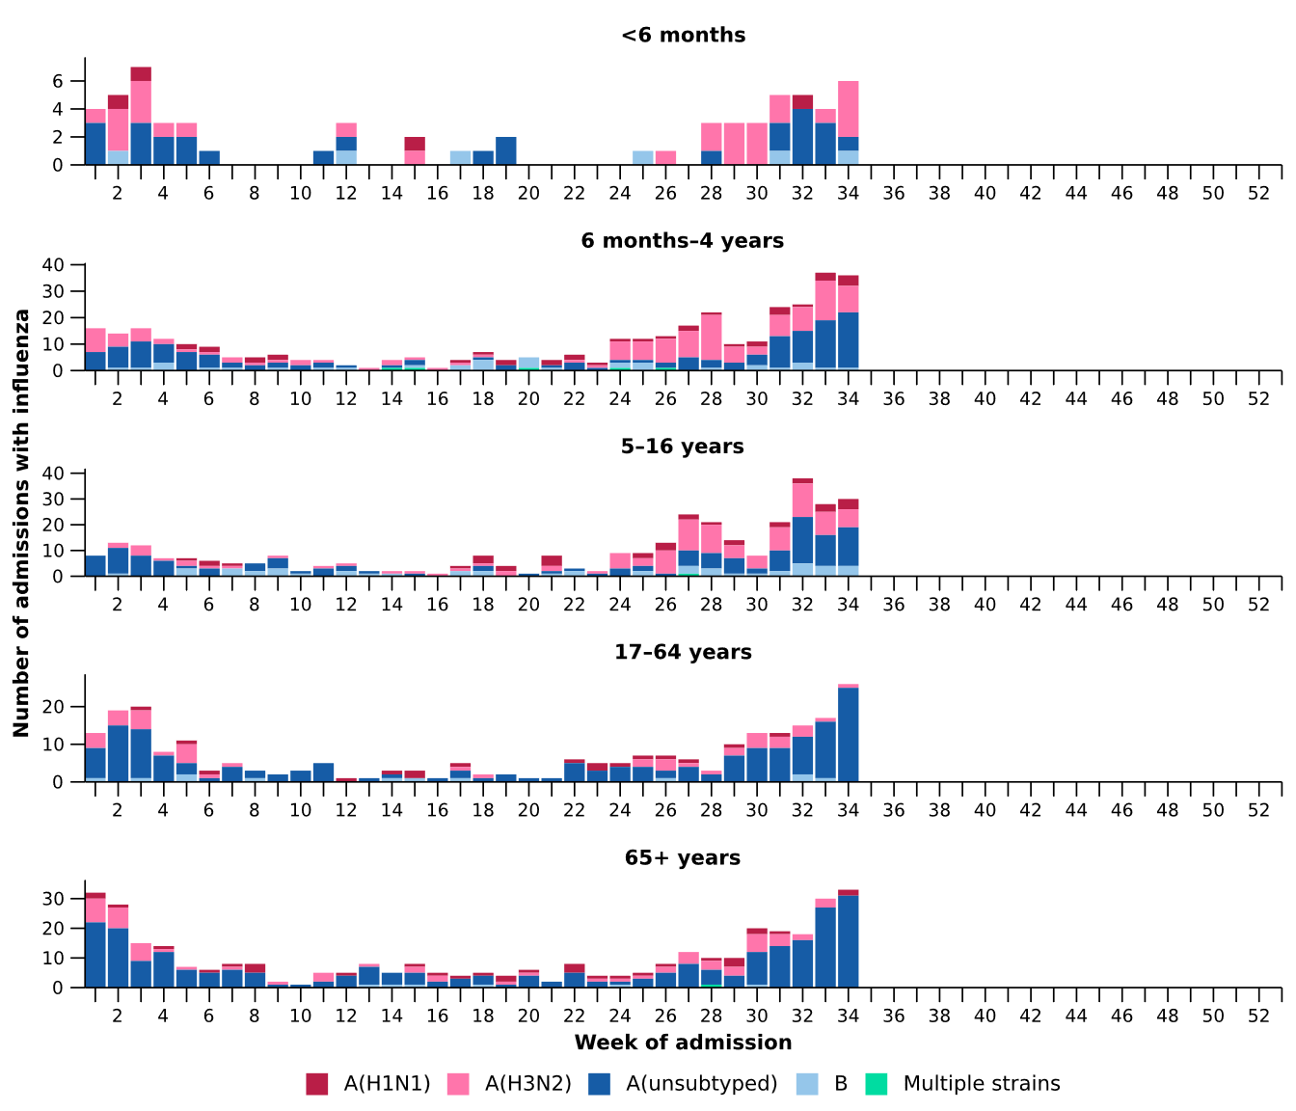
Source: Influenza Complications Alert Network (FluCAN)
* Axis varies between age groups. The age distribution of admissions with influenza may not reflect the age distribution of all patients.
- In the year to date for severity reporting, there have been substantially more admissions with RSV among children aged 16 years and younger, compared to the number of admissions with either COVID-19 or influenza (Table 3a).
- Children admitted with influenza were slightly older than those admitted with COVID-19 or RSV (Table 3a).
- The median length of stay reported for children admitted to sentinel hospitals was similar and most children were admitted to the general hospital ward rather than to intensive care directly (Table 3a).
- Sadly, a small number of children admitted to sentinel hospitals with severe acute respiratory infections have died (Table 3a).

Table 3a: Demographic characteristics and outcomes for children admitted with a severe acute respiratory infection to a sentinel hospital by disease*†‡, Australia, 1 January to 23 August 2026
 | COVID-19 | Influenza | RSV
 | Year to date for  severity reporting  (n=498) | Year to date for  severity reporting  (n=764) | Year to date for  severity reporting  (n=2,505)
Age (years)
Median [IQR] | 1 [0-4] | 4 [1-7] | 1 [0-2]
Age group (years)
< 6 months | 125 (25.1%) | 64 (8.4%) | 509 (20.3%)
6 months – 4 years | 265 (53.2%) | 366 (47.9%) | 1,775 (70.9%)
5–16 years | 108 (21.7%) | 334 (43.7%) | 221 (8.8%)
Indigenous status
Aboriginal and Torres Strait Islander | 30 (6.0%) | 46 (6.0%) | 207 (8.3%)
Length of hospital stay (days)†
Median [IQR] | 2 [1-3] | 1 [1-2] | 2 [1-3]
Patient admission location‡
Admitted to hospital ward | 475 (95.4%) | 735 (96.2%) | 2,375 (94.8%)
Admitted to intensive care directly | 23 (4.6%) | 29 (3.8%) | 130 (5.2%)
Discharge status†
Alive | 428 (85.9%) | 588 (77.0%) | 1,950 (77.8%)
Died | - | 2 (0.3%) | 2 (0.1%)
Incomplete/missing | 70 (14.1%) | 174 (22.8%) | 553 (22.1%)
Source: Influenza Complications Alert Network (FluCAN)
* Does not include patients with missing age; therefore, the sum of age-specific totals above may not equal the total number of patients.
† For patients who are still in hospital data may not be complete; therefore, these data are not included in the length of stay or discharge status. In addition, length of stay data excludes patients that acquired their infection in hospital.
‡ Admission location reflects the initial admission ward. Some patients may be initially admitted to general ward then later admitted to an intensive care and this is not reflected here. Does not include patients with missing admission location; therefore, the sum of admission location specific totals above may not equal the total number of patients.
The Paediatric Active Enhanced Disease Surveillance (PAEDS) network conducts enhanced sentinel hospital surveillance for select acute respiratory infections or conditions in children. PAEDS data are presented within the sentinel hospital data from FluCAN in this report. For additional information on select acute respiratory conditions in children please visit the PAEDS webpages.

- In the year to date for severity reporting, admissions among adults (aged 17 years and over) have been approximately equally distributed among COVID-19, influenza and RSV (Table 3b).
- A higher proportion of admissions occurred among those aged 65 years and over (Table 3b).
- The median length of stay reported for adults admitted to sentinel hospitals was similar, and most adults were admitted to the general hospital ward rather than to intensive care directly (Table 3b).
- Sadly, a number of adults admitted to sentinel hospitals with severe acute respiratory infections have died (Table 3b).
Table 3b: Demographic characteristics and outcomes for adults admitted with a severe acute respiratory infection to a sentinel hospital by disease*†‡, Australia, 1 January to 23 August 2026
 | COVID-19 | Influenza | RSV
 | Year to date for  severity reporting  (n=620) | Year to date for  severity reporting  (n=604) | Year to date for  severity reporting  (n=687)
Age (years)
Median [IQR] | 72 [56-83] | 69 [54-80] | 71 [59-82]
Age group (years)
17–64 years | 228 (36.8%) | 245 (40.6%) | 240 (34.9%)
65 years and over | 392 (63.2%) | 359 (59.4%) | 447 (65.1%)
Indigenous status
Aboriginal and Torres Strait Islander | 44 (7.1%) | 37 (6.1%) | 54 (7.9%)
Length of hospital stay (days)†
Median [IQR] | 4 [3-8] | 3 [2-6] | 4 [2-7]
Patient admission location‡
Admitted to hospital ward | 594 (95.8%) | 559 (92.5%) | 653 (95.1%)
Admitted to intensive care directly | 26 (4.2%) | 45 (7.5%) | 34 (4.9%)
Discharge status†
Alive | 443 (71.5%) | 459 (76.0%) | 494 (71.9%)
Died | 27 (4.4%) | 12 (2.0%) | 26 (3.8%)
Incomplete/missing | 150 (24.2%) | 133 (22.0%) | 167 (24.3%)
Source: Influenza Complications Alert Network (FluCAN)
* Does not include patients with missing age; therefore, the sum of age-specific totals above may not equal the total number of patients.
† For patients who are still in hospital data may not be complete; therefore, these data are not included in the length of stay or discharge status. In addition, length of stay data excludes patients that acquired their infection in hospital.
‡ Admission location reflects the initial admission ward. Some patients may be initially admitted to general ward then later admitted to an intensive care and this is not reflected here. Does not include patients with missing admission location; therefore, the sum of admission location specific totals above may not equal the total number of patients
- In the last severity reporting period for sentinel intensive care (27 July to 23 August 2026), fewer patients have been admitted to a sentinel intensive care with a severe acute respiratory infection (n=212), than in the previous severity reporting period (n=248) (Figure 17).
- In the year to date for severity reporting (1 January to 23 August 2026), most patients were admitted to sentinel intensive care with RSV, followed by influenza (Figure 17; Table 4).
Figure 17: Number of patients admitted with severe acute respiratory infections to a sentinel intensive care by disease and week of admission, Australia, 1 January to 23 August 2026
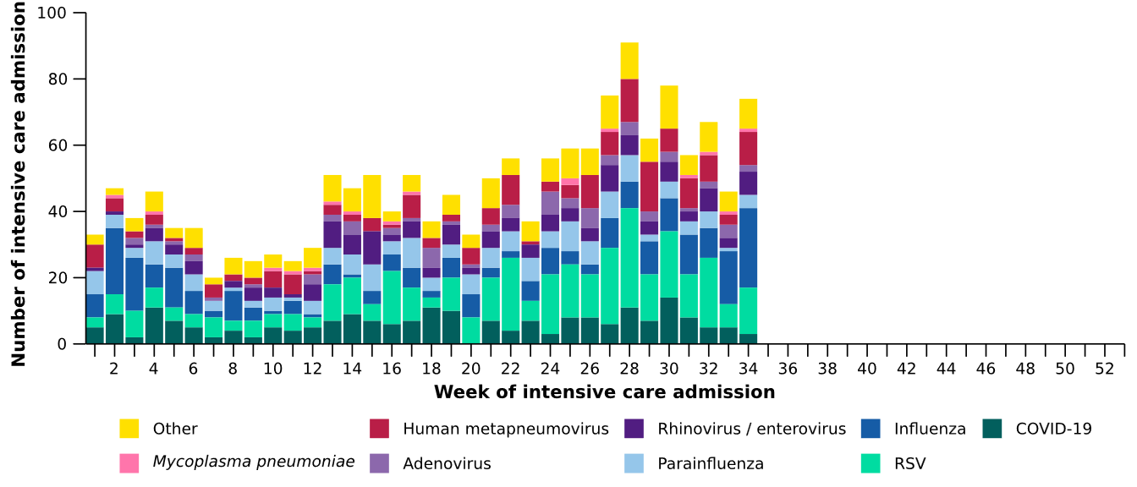
Source: Short Period Incidence Study of Severe Acute Respiratory Infection (SPRINT-SARI) Australia
Note: The sum of pathogen-specific totals above may not equal the total number of severe acute respiratory infection patients due to co-infections.
Figure 18: Number of patients admitted with severe acute respiratory infections to a sentinel intensive care by disease and age group*, Australia, 1 January to 23 August 2026
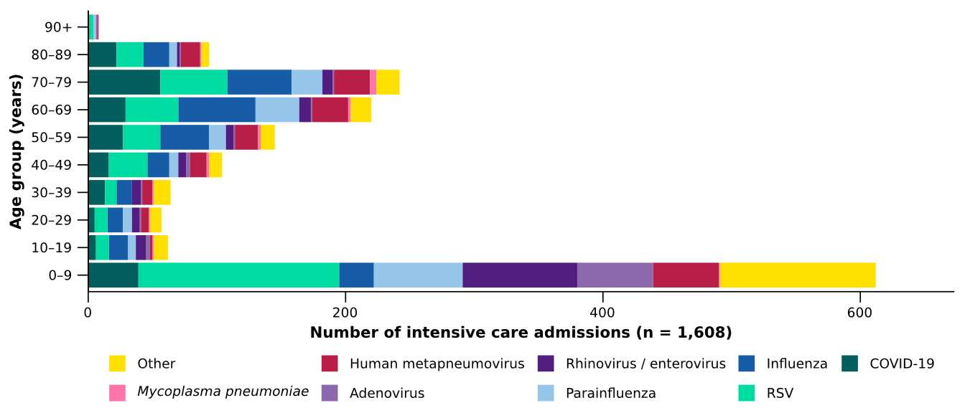
Source: Short Period Incidence Study of Severe Acute Respiratory Infection (SPRINT-SARI) Australia
Note: The sum of pathogen-specific totals above may not equal the total number of severe acute respiratory infection patients due to co-infections.
* The age distribution of severe acute respiratory infection intensive care admissions may not reflect the age distribution of all patients.
- In the year to date for severity reporting, children aged 0–9 years accounted for the highest number of sentinel intensive care admissions, and the median age at admission was lowest among patients admitted with RSV (Figure 18; Table 4).
- The proportion of admissions requiring invasive mechanical ventilation was highest in patients with Mycoplasma pneumoniae, followed by parainfluenza, while the length of invasive mechanical ventilation was longest in patients with hMPV and influenza (Table 4).
- The length of intensive care stay has been relatively similar across diseases (Table 4).
- Most patients admitted with a severe acute respiratory infection to a sentinel intensive care were discharged home. Sadly, a number of patients have died in hospital (Table 4).
Table 4: Demographic characteristics and outcomes of patients admitted with a severe acute respiratory infection to a sentinel intensive care by disease*†, Australia, 1 January to 23 August 2026
 | COVID-19 | hMPV | Influenza | 𝘔𝘺𝘤𝘰𝘱𝘭𝘢𝘴𝘮𝘢  𝘱𝘯𝘦𝘶𝘮𝘰𝘯𝘪𝘢𝘦 | Parainfluenza | RSV
 | Year to date for severity reporting  (n=214) | Year to date for severity reporting  (n=170) | Year to date for severity reporting  (n=251) | Year to date for severity reporting  (n=16) | Year to date for severity reporting  (n=168) | Year to date for severity reporting  (n=361)
Age (years)
Median [IQR] | 60  [33–73] | 52  [5–70] | 60  [33–71] | 60  [42–74] | 44  [2–66] | 35  [1–65]
Indigenous status
Aboriginal and Torres Strait Islander | 19  (8.9%) | 16  (9.4%) | 26  (10.4%) | – | 15  (8.9%) | 37  (10.2%)
Non-Indigenous | 195  (91.1%) | 154  (90.6%) | 225  (89.6%) | 16  (100.0%) | 153  (91.1%) | 324  (89.8%)
Received invasive mechanical ventilation
Number (%) | 69  (32.2%) | 44  (25.9%) | 77  (30.7%) | 6  (37.5%) | 58  (34.5%) | 83  (23.0%)
Length of invasive mechanical ventilation (days)*
Median [IQR] | 2 [1–6] | 4 [2–7] | 4 [1–10] | 2 [0–15] | 3 [1–8] | 3 [2–7]
Length of intensive care stay (days)*
Median [IQR] | 3 [2–7] | 3 [2–6] | 3 [2–6] | 3 [2–7] | 3 [2–7] | 3 [2–5]
Length of hospital stay (days)*
Median [IQR] | 8 [4–14] | 8 [5–12] | 8 [5–12] | 8 [4–14] | 7 [3–15] | 7 [4–12]
Patient outcome†
Ongoing care in intensive care | 6  (2.8%) | 2  (1.2%) | 8  (3.2%) | – | 6  (3.6%) | 6  (1.7%)
Ongoing care in hospital ward | 9  (4.2%) | 10  (5.9%) | 13  (5.2%) | – | 5  (3.0%) | 10  (2.8%)
Transfer to other hospital / facility | 25  (11.7%) | 23  (13.5%) | 35  (13.9%) | 4  (25.0%) | 16  (9.5%) | 50  (13.9%)
Discharged home | 140  (65.4%) | 121  (71.2%) | 169  (67.3%) | 10  (62.5%) | 123  (73.2%) | 269  (74.5%)
Died in hospital | 34  (15.9%) | 13  (7.6%) | 24  (9.6%) | 2  (12.5%) | 16  (9.5%) | 26  (7.2%)
Source: Short Period Incidence Study of Severe Acute Respiratory Infection (SPRINT-SARI) Australia
Note: The sum of pathogen-specific totals above may not equal the total number of severe acute respiratory infection patients due to co-infections.
* For patients receiving ongoing care in intensive care data may not be complete; therefore, data are not included in the length of ventilation or stay.
† Patients who have been admitted with no discharge information for less than 90 days have been assumed to have ongoing care in the hospital. Patients who have no outcome entered or have been admitted for more than 90 days with no discharge information have been treated as missing.
- In the last fortnight (24 August to 6 September 2026), there were an average of 231 intensive care patients in droplet or airborne isolation for any suspected or confirmed respiratory pathogen each day, a 5.9% increase from an average of 218 patients in isolation each day reported in the previous fortnight. (Figure 19).
- In the last fortnight (24 August to 6 September 2026), there were an average of 102 intensive care staff unavailable to work due to illness each day, a 1.1% increase from an average of 101 staff unavailable each day reported in the previous fortnight. (Figure 19).
- In the last fortnight, the average number of intensive care patients in droplet or airborne isolation for any suspected or confirmed respiratory pathogen increased or remained relatively stable across most jurisdictions compared with the previous fortnight, except in the ACT where the average number of patients in isolation each day decreased (Figure 20).
- In the last fortnight, the average number of intensive care staff unavailable to work due to illness increased or remained relatively stable across most jurisdictions compared with the previous fortnight, except in the NT, Qld and WA where the average number of staff unavailable each day decreased (Figure 20).
Figure 19: Weekly average daily occupancy of intensive care patients in droplet or airborne isolation for any suspected or confirmed respiratory pathogen and the weekly average daily number of intensive care staff unavailable to work due to illness by week of report*, Australia, 1 January to 6 September 2026
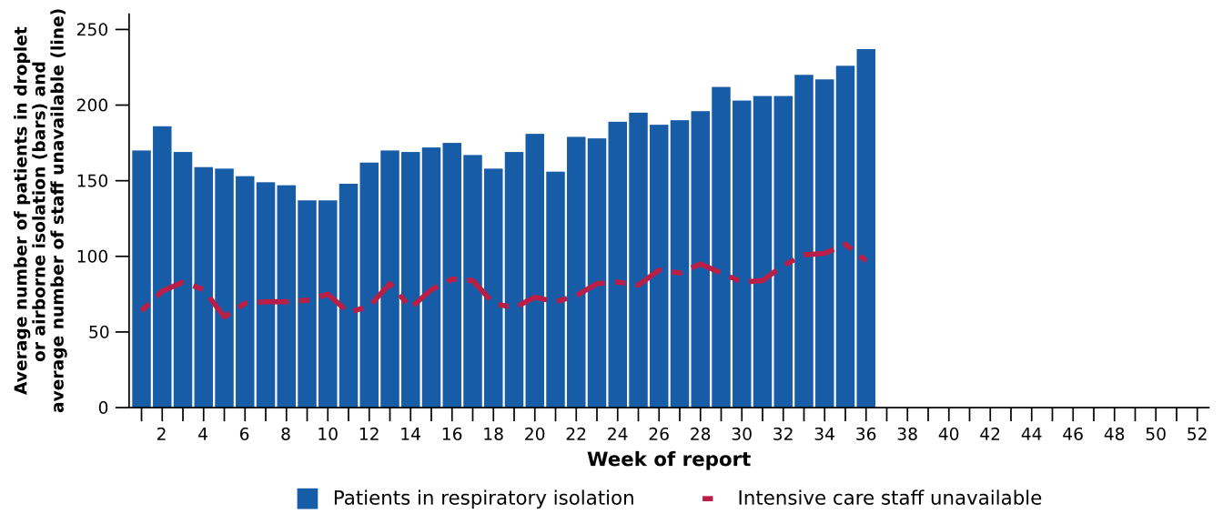
Source: Critical Health Resource Information System (CHRIS)
* Intensive care staff include both medical and nursing staff. Staff unavailability will be underestimated in NSW as most public hospitals in NSW do not report staff unavailability.

Figure 20: Weekly average daily occupancy of intensive care patients in droplet or airborne isolation for any suspected or confirmed respiratory pathogen and the weekly average daily number of intensive care staff unavailable to work due to illness by jurisdiction and week of report*†‡, Australia, 1 January to 6 September 2026
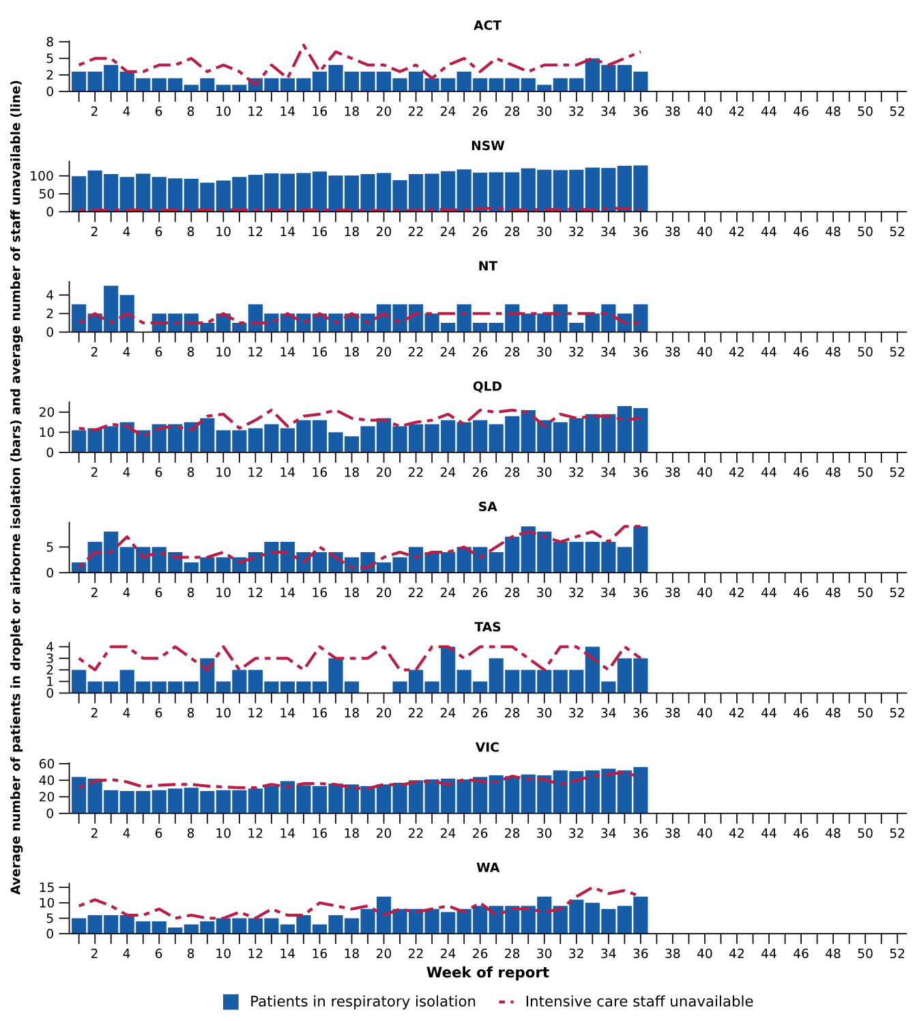
Source: Critical Health Resource Information System (CHRIS)
* Axis varies between jurisdictions.
† NSW isolation data from public hospitals includes all patients occupying intensive care beds in isolation precautions, including those in contact isolation precautions, rather than just droplet or airborne isolation precautions, which will overestimate the average number of patients occupying intensive care beds in droplet or airborne isolation in NSW. For this reason, NSW data may not be comparable to data from other jurisdictions.
‡ Intensive care staff include both medical and nursing staff. Staff unavailability will be underestimated in NSW as most public hospitals in NSW do not report staff unavailability. For this reason, NSW data may not be comparable to data from other jurisdictions.

Mortality surveillance
Death registrations can provide information on the scale and severity of disease associated with acute respiratory infections. An acute respiratory infection associated death is one where the death was due to the disease (the illness has caused terminal complications such as pneumonia) or the person has died with the disease (a person has died from another cause but the illness still contributed significantly to death).
- COVID-19 has been the leading cause of acute respiratory infection related mortality across the majority of 2020–2025; however, between August 2025 and January 2026 the number of deaths per month involving influenza (both due to and with) were well above usual levels, exceeding COVID-19 deaths. Since February 2026, deaths involving COVID-19 have again been higher than those involving influenza.
- In Aboriginal and Torres Strait Islander people, there were more deaths involving COVID-19 in 2022–2024; however, in 2025 there were more deaths involving influenza. So far in 2026 there have been slightly more deaths involving COVID-19 than involving influenza.
- Deaths involving acute respiratory infections were more common in older age groups.
Figure 21a: Provisional numbers of deaths due to an acute respiratory infection*† by month, year, and disease, Australia, 1 January 2024 to 31 July 2026
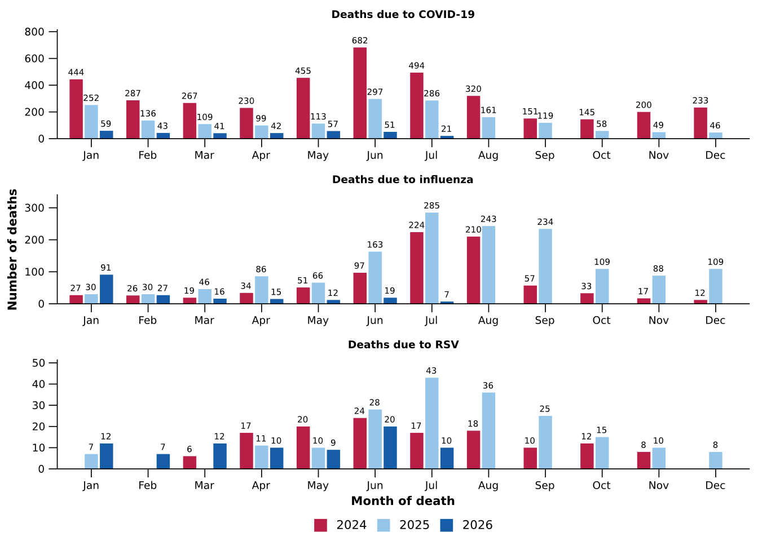
Source: Australian Bureau of Statistics (ABS), Deaths due to acute respiratory infections in Australia, released 28 August 2026.
* Axis varies between acute respiratory infections.
† Data is provisional and subject to change. It can take several weeks for death registrations to be reported, processed, coded, validated, and tabulated. Therefore, the data shown here may be incomplete. Data for some months were not published by the ABS due to small counts, and therefore not reported here. Data includes all deaths (both doctor and coroner certified) that occurred and were registered by 31 July 2026.
- Deaths due to COVID-19 fell slightly in June 2026 and were much lower compared to previous years. The 1,725 deaths due to COVID-19 in 2025 were well below both 2024 (3,908 deaths) and 2023 (4,614) (Figure 21a).
- Deaths due to influenza increased slightly in June 2026 but remained substantially lower than in June of each year since 2022, consistent with low influenza case numbers during June (Figure 21a; Figure 7). There were 1,489 deaths due to influenza in 2025, above the 1,276 deaths recorded in 2017 and the 1,072 deaths recorded in 2019, which are considered to be high mortality years (Figure 21a).
- Deaths due to RSV rose to 20 in June 2026 but remained lower than in June 2024 and 2025 (Figure 21a).
- Deaths with COVID-19 rose slightly in June 2026 but remained much lower compared to previous years (Figure 21b).
- There have been very few deaths with influenza since January 2026 (Figure 21b).
- Deaths with RSV remained elevated in June 2026, and were higher than the number of deaths with influenza or with COVID-19. The number of deaths with RSV in June 2026 remained lower than in June 2024 and 2025. The number of deaths with RSV was higher in 2025 (407 deaths) than in 2024 (341 deaths) and 2023 (280 deaths) (Figure 21b).
Figure 21b: Provisional numbers of deaths with an acute respiratory infection*† by month, year, and disease, Australia, 1 January 2024 to 31 July 2026
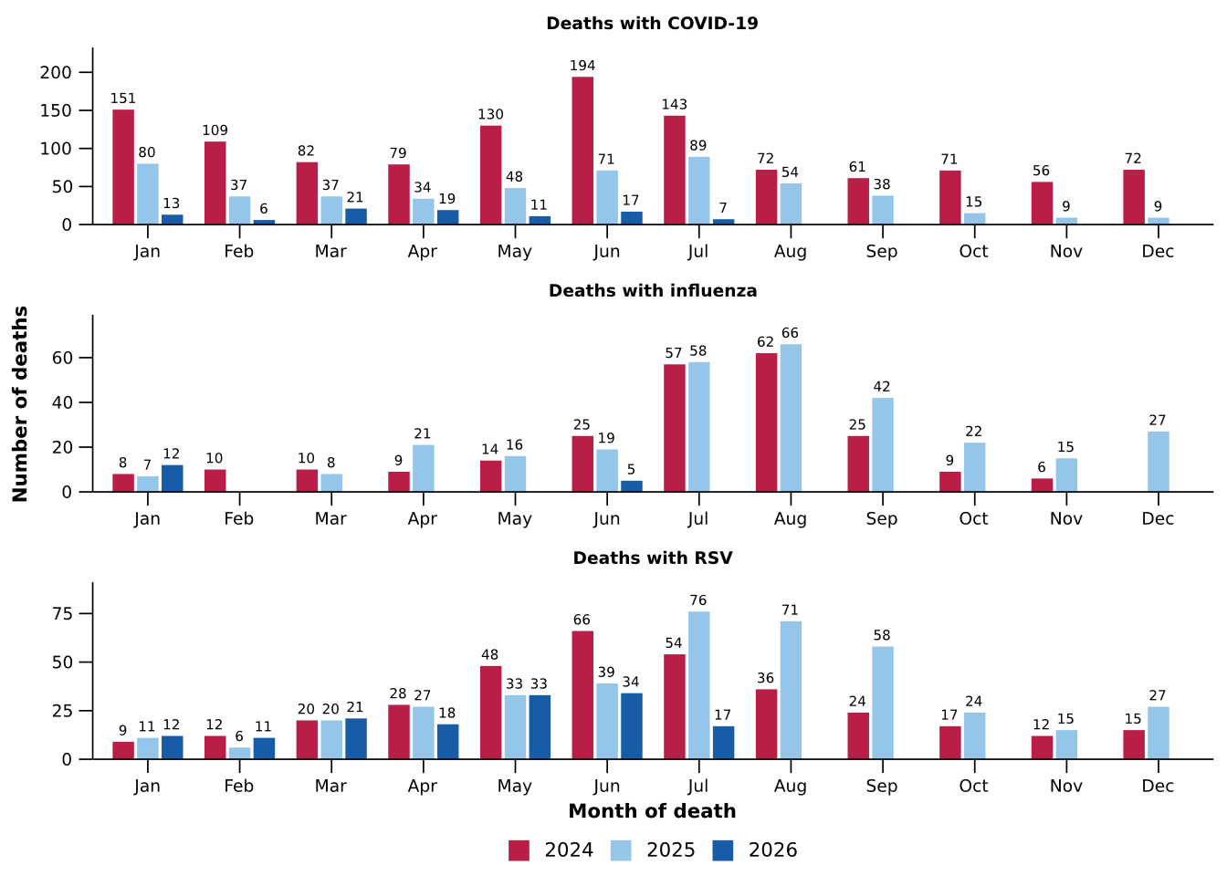
Source: Australian Bureau of Statistics (ABS), Deaths due to acute respiratory infections in Australia, released 28 August 2026.
* Axis varies between acute respiratory infections.
† Data is provisional and subject to change. It can take several weeks for death registrations to be reported, processed, coded, validated, and tabulated. Therefore, the data shown here may be incomplete. Data for some months were not published by the ABS due to small counts, and therefore not reported here. Data includes all deaths (both doctor and coroner certified) that occurred and were registered by 31 July 2026.

Laboratory surveillance
Sentinel laboratory surveillance monitors the percentage of tests with the notifiable condition detected (i.e. test positivity). It also provides information on what pathogens are circulating, potential changes in the pathogens that might affect their infectiousness, severity, ability to evade vaccine and/or infection-acquired immunity, or resistance to antivirals.
- In the last fortnight (24 August to 6 September 2026), the percentage of SARS-CoV-2 tests that were positive decreased (from 1.6% to 1.3%), the percentage of influenza tests that were positive increased (from 7.4% to 8.4%) and the percentage of RSV tests that were positive decreased (from 5.5% to 4.3%) (Figure 22).
Figure 22: Number of tests positive (bars) and percentage of tests positive (line) for SARS-CoV-2, influenza or RSV of those specimens tested by sentinel laboratories by week of report*†, Australia, 1 January to 6 September 2026
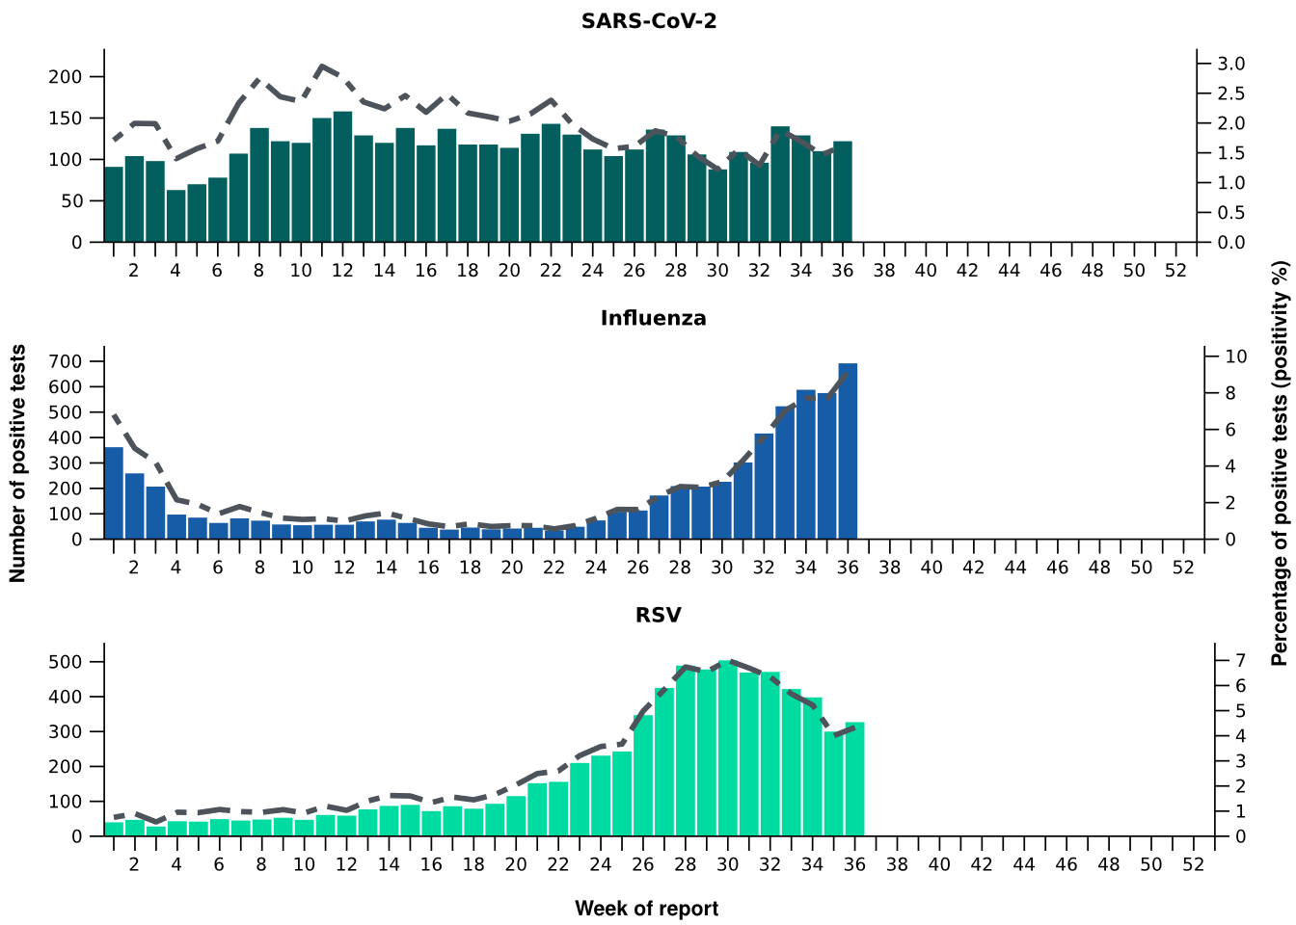
Source: Sentinel laboratories, including National Influenza Centres
* Number of specimens tested excludes data from WA as testing denominator data are different for the three pathogens in Western Australia.
† A small minority of total samples from Victoria are tested only by respiratory panel (influenza, parainfluenza, adenovirus, human metapneumovirus, seasonal coronaviruses, RSV, and some picornaviruses) but not for SARS-CoV-2. These minority samples include only forensic materials; all other samples are tested by respiratory panel and SARS-CoV-2 assay.

- There were 126 SARS-CoV-2 sequences uploaded to AusTrakka with dates of collection in the last 28 days (10 August to 6 September 2026). These sequences were from NSW, SA, Tas and WA with the most recent date of collection from 23 August 2026. The low number of sequences uploaded to AusTrakka in the last 28 days is likely due to the reduced number of COVID-19 cases and changes in sequencing capacity and priorities. The limited number of sequences and potential lack of representativeness may limit interpretation.
- Most sequences were recombinants consisting of one or more Omicron sub-lineages (Figure 23a/b). In the last 28 days:
  - 79.4% (100/126) of sequences were recombinant or recombinant sub-lineages, the most common including NB.1.8.1 (n=62), PQ.16.1.1 (n=24) and XFG (n=10)
  - 15.9% (20/126) of sequences were identified as BA.3, specifically BA.3.2
  - 4.8% (6/126) of sequences were from the sub-sub-lineages JN.1 (BA.2.86.1.1), specifically from the RF lineage
  - There were no BA.1, BA.4, BA.5 or other BA.2 sub-sub-lineage sequences.
- NB.1.8.1 was the most common sub-lineage in the last 28 days, accounting for 49.2% (62/126) of sequences (Figure 23a).
- The World Health Organization (WHO) have identified certain sub-sub-lineages and recombinants as variants under monitoring (VUM) because of their epidemiological, pathological, or immunological features of concern. A select number are highlighted below due to their relevance in the Australian context. There are:
  - 4,535 KP.3.1.1 sequences in AusTrakka, with none identified in the last 28 days.
  - 4,508 NB.1.8.1 sequences in AusTrakka, with 62 collected in the last 28 days.
  - 159 PQ.16.1.1 sequences in AusTrakka, with 24 collected in the last 28 days.
  - 1,601 XFG sequences in AusTrakka, with 10 collected in the last 28 days.
  - 1,144 BA.3.2 sequences in AusTrakka, with 20 collected in the last 28 days.

Figure 23a: SARS-CoV-2 Omicron sub-lineage* sequences by sample collection date, showing proportions of sequences per week†‡, Australia, 1 January to 6 September 2026
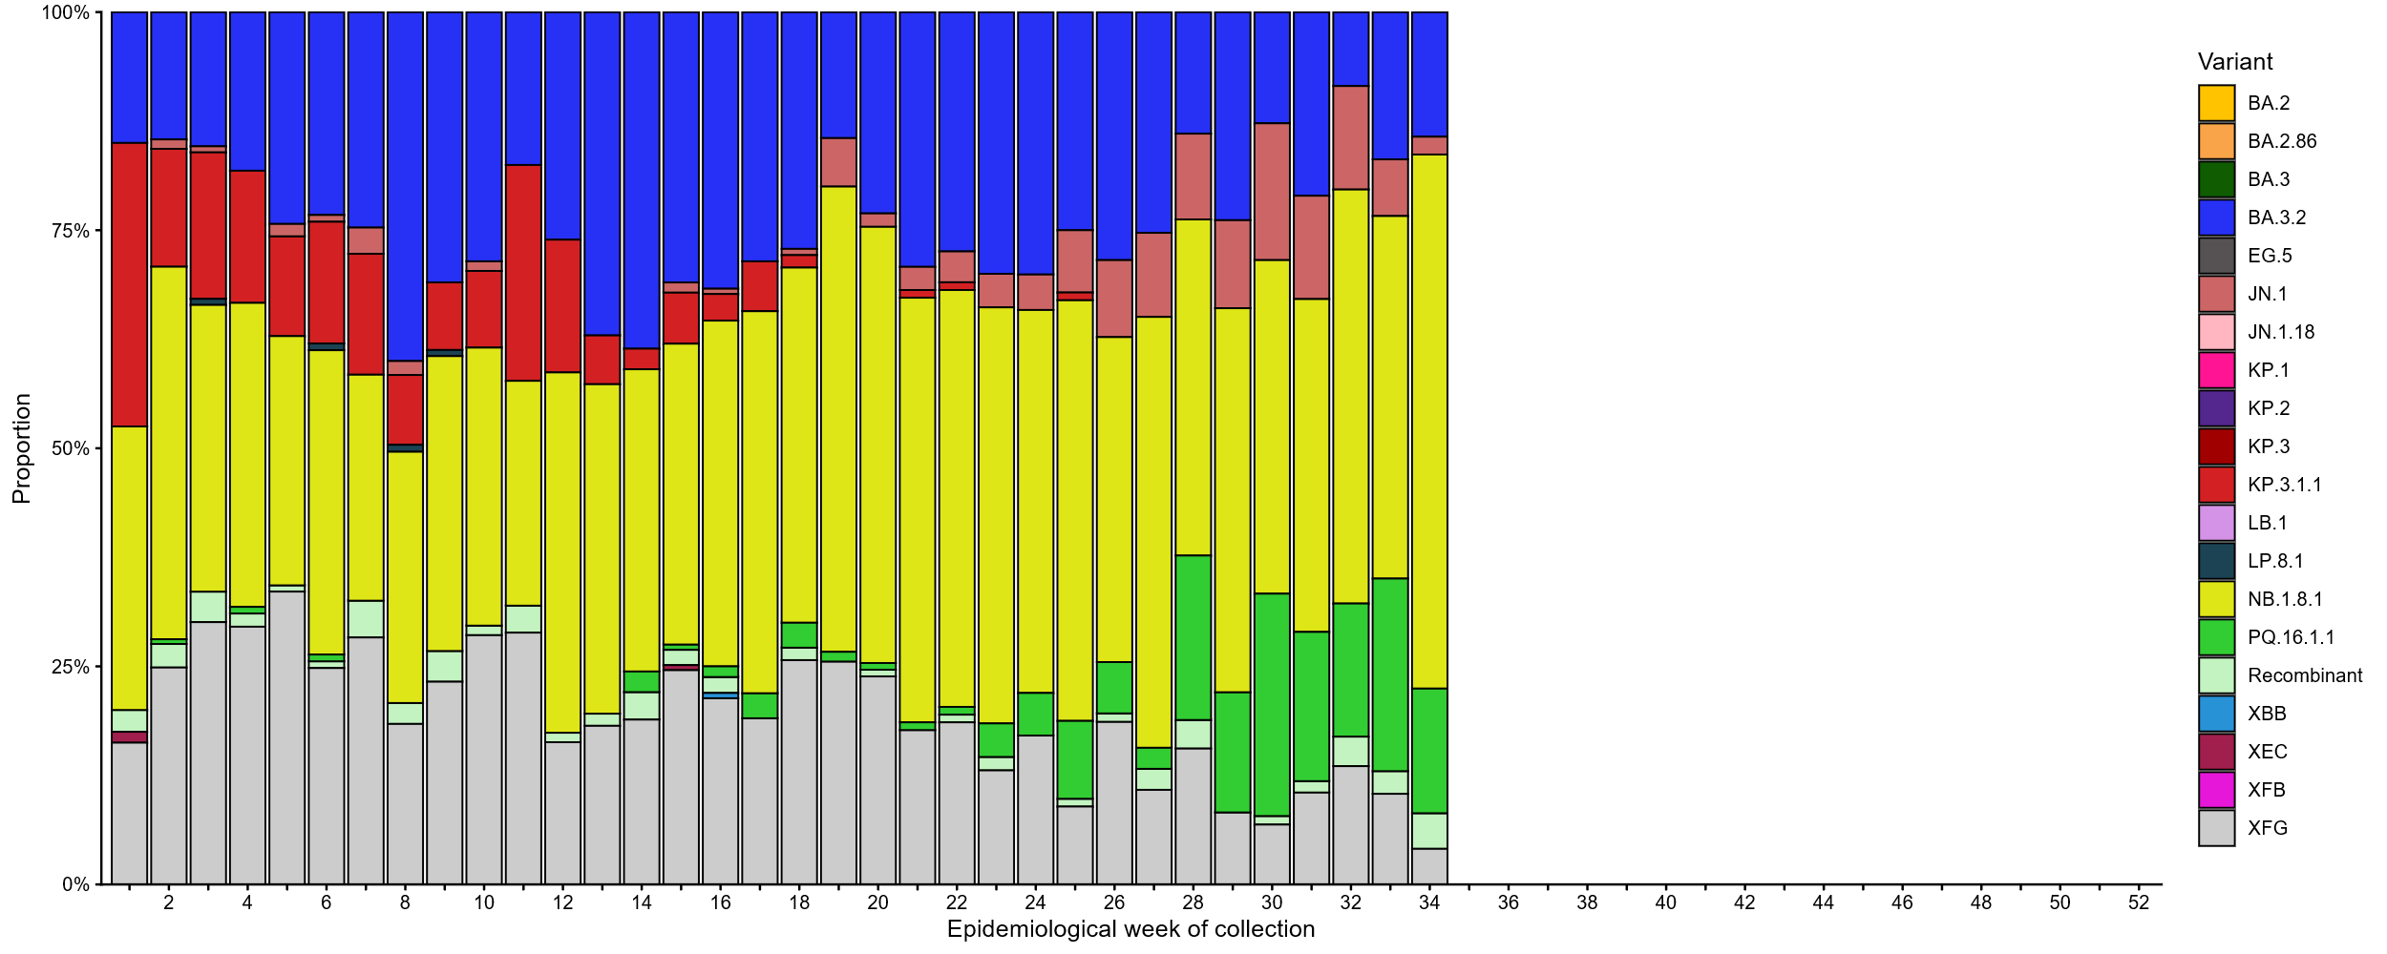Source: AusTrakka
* Some sub-sublineages are shown alongside their parent lineage, but not included in the parent lineage totals. For instance, KP.2 and KP.3 are sub-sub lineages of JN.1, so the total of JN.1 sequences will be higher than shown in the corresponding colour alone, and should include the KP.2 and KP.3 totals.
† Sequences in AusTrakka aggregated by week and reported based on date of sample collection, not date of sequencing.
‡ Proportions in Figure 23a may not be representative when sequence numbers are small; refer to Figure 23b. Data for earlier weeks may change between reporting periods as sequences with older collection dates are uploaded. These numbers are not equivalent to number of cases, as there are many cases which may not be sequenced. Non-VOI and non-VUM Omicron sub-lineages have been collapsed into parent lineages BA.1, BA.2, BA.3, BA.4 and BA.5.

Figure 23b: SARS-CoV-2 Omicron sub-lineage* sequences by sample collection date, showing the count of sequences per week†‡, Australia, 1 January to 6 September 2026
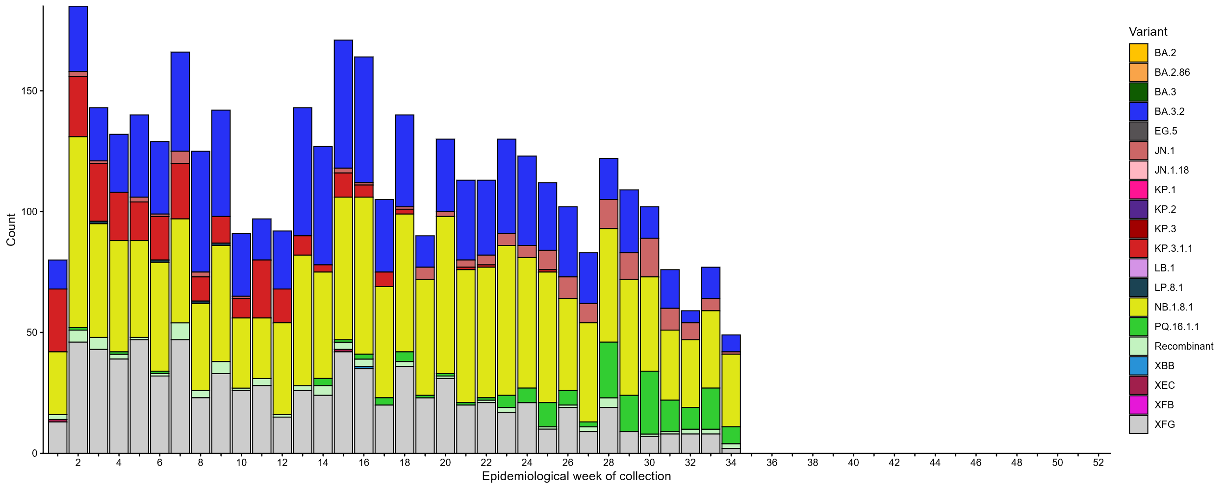Source: AusTrakka
* Some sub-sublineages are shown alongside their parent lineage, but not included in the parent lineage totals. For instance, KP.2 and KP.3 are sub-sub lineages of JN.1, so the total of JN.1 sequences will be higher than shown in the corresponding colour alone, and should include the KP.2 and KP.3 totals.
† Sequences in AusTrakka aggregated by week and reported based on date of sample collection, not date of sequencing.
‡ Data for earlier weeks may change between reporting periods as sequences with older collection dates are uploaded. These numbers are not equivalent to number of cases, as there are many cases which may not be sequenced. Non-VOI and non-VUM Omicron sub-lineages have been collapsed into parent lineages BA.1, BA.2, BA.3, BA.4 and BA.5.

- In the year to date, the WHO Collaborating Centre for Reference and Research on Influenza has antigenically characterised 924 influenza viruses from Australia (Table 5), of which:
  - 17.5% (162/924) have been influenza A(H1N1)
  - 71.1% (657/924) have been influenza A(H3N2)
  - 11.4% (105/924) have been influenza B/Victoria.
- In the year to date, 1.5% (1/68) samples tested for neuraminidase inhibitor resistance demonstrated highly reduced inhibition to oseltamivir.
- None of the influenza A(H3N2) samples tested demonstrated highly reduced inhibition to oseltamivir.
- None of the samples tested demonstrated highly reduced inhibition to zanamivir.
Table 5: Australian influenza viruses typed by haemagglutination inhibition assay and jurisdiction*†, 1 January to 6 September 2026
Strain | ACT | NSW | NT | Qld | SA | Tas | Vic | WA | Total
A(H1N1) | 4 | 42 | 11 | 9 | 18 | 14 | 52 | 12 | 162
A(H3N2) | 55 | 199 | 83 | 44 | 28 | 57 | 153 | 38 | 657
B/Victoria lineage | 4 | 15 | 56 | 1 | 1 | 4 | 21 | 3 | 105
Total | 63 | 256 | 150 | 54 | 47 | 75 | 226 | 53 | 924
Source: World Health Organization (WHO) Collaborating Centre for Reference and Research on Influenza
*Viruses tested by the WHO Collaborating Centre for Reference and Research on Influenza are not necessarily a random sample of all those in the community and early-year data may be based on limited samples received. There may be up to a month delay on reporting of samples.
† Jurisdiction indicates the residential location for the individual tested, not the submitting laboratory.

Vaccine coverage, effectiveness and match
Vaccine coverage, effectiveness and match for acute respiratory infections are monitored from several data sources in Australia. Refer to the Technical Supplement for more information.

Vaccine coverage
- In the last 12 months, fewer adults have received a COVID-19 vaccine (8.0%; Table 6), compared to the 12 months prior (10.3% from 2 September 2024 to 31 August 2025).
- In the last 12 months, vaccine coverage decreased in all age groups, with the largest decrease seen in the 75 years and over age group (from 35.9% in the 12 months prior to 29.9% in the last 12 months).
- There has been substantial variation in COVID-19 vaccine coverage across age groups, ranging from 2.9% in adults aged 18–64 years to 29.9% in adults aged 75 years and over (Table 6).
- There has been some variation in vaccine coverage across jurisdictions, ranging from 2.9% in the NT to 15.6% in Tas (Table 6).
Table 6: COVID-19 vaccine coverage*†‡ by age group and jurisdiction, Australia, 1 September 2025 to 6 September 2026
Age group | ACT | NSW | NT | Qld | SA | Tas | Vic | WA | AUS
Last 12 months (1 September 2025 to 6 September 2026)
18–64 years | 7.7 | 2.5 | 1.4 | 2.8 | 3.1 | 6.1 | 3.3 | 2.8 | 2.9
65–74 years | 36.7 | 17.0 | 8.6 | 17.3 | 21.6 | 32.6 | 19.8 | 18.3 | 18.4
≥ 75 years | 51.1 | 28.8 | 12.9 | 28.3 | 33.9 | 47.3 | 31.3 | 30.8 | 29.9
All ages (18 years and over) | 15.2 | 7.6 | 2.9 | 7.4 | 9.7 | 15.6 | 8.5 | 7.6 | 8.0
Last 6 months (2 March 2026 to 6 September 2026)
18–64 years | 6.4 | 2.0 | 1.0 | 2.3 | 2.5 | 5.3 | 2.7 | 2.5 | 2.4
65–74 years | 31.5 | 14.6 | 6.6 | 14.6 | 18.4 | 29.0 | 17.2 | 16.3 | 15.8
≥ 75 years | 42.8 | 23.9 | 10.4 | 23.0 | 27.7 | 40.9 | 26.2 | 26.7 | 24.8
All ages (18 years and over) | 12.8 | 6.3 | 2.2 | 6.1 | 8.0 | 13.6 | 7.1 | 6.7 | 6.7
Source: Australian Immunisation Register (AIR) as at 6 September 2026
* COVID-19 vaccine coverage uses the AIR population as the denominator (from 6 July 2026 onwards). Coverage data in these tables may differ slightly from coverage estimates in other reports due to differences in calculation methodologies and/or different data download dates.
† COVID-19 vaccine coverage is influenced by changes in COVID-19 vaccine recommendations and eligibility criteria. For this reason, coverage rates in the current 12 month period and previous 12 month periods may not be directly comparable.
‡ Total rows will include individuals where jurisdiction was missing.

- In the last 12 months, fewer Aboriginal and Torres Strait Islander adults have received a COVID-19 vaccine (3.5%; Table 7), compared to the 12 months prior (4.7% from 2 September 2024 to 31 August 2025).
- In the last 12 months, vaccine coverage decreased in all age groups of Aboriginal and Torres Strait Islander people, with the largest decrease seen in the 75 years and over age group (from 27.6% in the 12 months prior to 22.7% in the last 12 months).
- Among Aboriginal and Torres Strait Islander people there has been substantial variation in COVID-19 vaccine coverage across age groups, ranging from 1.8% in adults aged 18–64 years to 22.7% in adults aged 75 years and over (Table 7).
- Among Aboriginal and Torres Strait Islander people, there has been slight variation in vaccine coverage across jurisdictions, ranging from 2.0% in the NT to 8.0% in the ACT (Table 7).
Table 7: COVID-19 vaccine coverage*†‡ among Aboriginal and Torres Strait Islander populations by age group and jurisdiction, Australia, 1 September 2025 to 6 September 2026
Age group | ACT | NSW | NT | Qld | SA | Tas | Vic | WA | AUS
Last 12 months (1 September 2025 to 6 September 2026)
18–64 years | 4.9 | 1.9 | 1.4 | 1.6 | 1.8 | 4.1 | 2.6 | 1.5 | 1.8
65–74 years | 31.5 | 14.7 | 6.8 | 11.9 | 12.6 | 28.7 | 16.4 | 11.6 | 13.5
≥ 75 years | 47.4 | 25.0 | 12.7 | 19.8 | 24.9 | 37.2 | 28.3 | 20.5 | 22.7
All ages (18 years and over) | 8.0 | 3.9 | 2.0 | 3.0 | 3.6 | 8.0 | 5.0 | 2.8 | 3.5
Last 6 months (2 March 2026 to 6 September 2026)
18–64 years | 4.2 | 1.5 | 0.8 | 1.3 | 1.4 | 3.4 | 2.1 | 1.3 | 1.5
65–74 years | 28.0 | 12.8 | 4.7 | 10.2 | 10.6 | 25.3 | 14.1 | 9.8 | 11.6
≥ 75 years | 41.8 | 20.7 | 9.3 | 16.2 | 20.8 | 32.1 | 23.8 | 17.0 | 18.8
All ages (18 years and over) | 6.9 | 3.3 | 1.3 | 2.5 | 2.9 | 6.8 | 4.1 | 2.3 | 2.9
Source: Australian Immunisation Register (AIR) as at 6 September 2026
* COVID-19 vaccine coverage uses the AIR population as the denominator (from 6 July 2026 onwards). Coverage data in these tables may differ slightly from coverage estimates in other reports due to differences in calculation methodologies and/or different data download dates.
† COVID-19 vaccine coverage in the most recent 12 month period may not be directly comparable to previous 12 month periods due to changes in COVID-19 vaccine eligibility criteria.
‡ Total rows will include individuals where jurisdiction was missing.

- Influenza vaccine coverage is 30.2% for 2026 so far (Table 8). This is slightly higher than at the same time in 2025 (30.0%) and 2024 (29.5%) but lower than in 2023 (31.6%) and 2022 (37.9%).
- There has been substantial variation in influenza vaccine coverage across age groups, ranging from 16.4% in children aged 5–14 years to 60.4% in adults aged 65 years and over (Table 8). The current trend is influenced by eligibility criteria as people aged 5–64 years are generally not eligible for free seasonal influenza vaccine under the National Immunisation Program.
- There has been some variation in influenza vaccine coverage across jurisdictions, ranging from 26.7% in the NT to 39.2% in the ACT (Table 8).
- Among Aboriginal and Torres Strait Islander populations, there has been substantial variation in influenza vaccine coverage across age groups, ranging from 16.7% in children aged 5–14 years to 60.4% in adults aged 65 years and over (Table 8).
- Among Aboriginal and Torres Strait Islander populations, there has been some variation in influenza vaccine coverage across jurisdictions, ranging from 21.6% in Qld to 40.0% in the NT (Table 8).

Table 8: Influenza vaccine coverage*†‡ by age group and jurisdiction, Australia, 1 March to 6 September 2026
 | ACT | NSW | NT | Qld | SA | Tas | Vic | WA | AUS
Age groups
6 months to <5 years | 57.2 | 36.4 | 45.4 | 30.9 | 36.6 | 40.8 | 39.4 | 34.1 | 36.4
5–14 years | 25.9 | 16.3 | 17.2 | 14.7 | 15.6 | 16.8 | 16.5 | 18.8 | 16.4
15–49 years | 31.0 | 19.2 | 24.5 | 17.3 | 22.3 | 22.7 | 22.9 | 18.3 | 20.2
50–64 years | 41.5 | 28.6 | 26.4 | 28.9 | 34.0 | 36.7 | 32.2 | 29.2 | 30.4
≥ 65 years | 65.0 | 58.5 | 36.9 | 59.7 | 66.5 | 68.0 | 61.5 | 59.8 | 60.4
All ages (6 months and over) | 39.2 | 29.4 | 26.7 | 27.8 | 34.1 | 36.1 | 31.9 | 28.6 | 30.2
Aboriginal and Torres Strait Islander populations
6 months to <5 years | 40.1 | 27.2 | 46.7 | 23.8 | 24.9 | 28.9 | 27.9 | 28.1 | 27.6
5–14 years | 20.0 | 15.7 | 30.2 | 14.9 | 16.3 | 15.9 | 16.0 | 17.1 | 16.7
15–49 years | 24.8 | 17.5 | 38.4 | 16.0 | 20.8 | 19.9 | 19.5 | 17.9 | 19.4
50–64 years | 44.5 | 35.7 | 49.7 | 33.4 | 38.0 | 42.3 | 36.3 | 33.8 | 36.6
≥ 65 years | 67.2 | 62.6 | 50.4 | 59.2 | 62.9 | 70.1 | 62.8 | 54.8 | 60.4
All ages (6 months and over) | 30.4 | 23.9 | 40.0 | 21.6 | 25.5 | 27.4 | 25.6 | 22.9 | 24.8
Source: Australian Immunisation Register (AIR) as at 7 September 2026
* Influenza vaccine coverage uses the AIR population as the denominator. Coverage data in these tables may differ slightly from coverage estimates in other reports due to differences in calculation methodologies and/or different data download dates.
† Total rows will include individuals where jurisdiction was missing.

- Since the commencement of the National RSV Mother and Infant Protection Program on 3 February 2025, 320,049 Abrysvo doses have been administered to pregnant people nationally (Table 9).
- While high maternal vaccine uptake is a positive indicator of maternal program success, it may result in lower nirsevimab uptake rates in infants. This is because maternal antibodies passed to the infant can provide protection against RSV, potentially reducing the need for infant immunisation.
Table 9: Number of doses of Abrysvo administered to pregnant people by jurisdiction*, Australia, 3 February 2025 to 6 September 2026
 | ACT | NSW | NT | Qld | SA | Tas | Vic | WA | AUS
Age group
15–24 years | 414 | 7,993 | 735 | 7,755 | 1,792 | 863 | 4,682 | 3,131 | 27,365
25–39 years | 7,089 | 84,287 | 2,944 | 51,819 | 19,069 | 5,958 | 75,686 | 28,664 | 275,516
40–54 years | 468 | 5,546 | 149 | 2,712 | 1,110 | 265 | 5,256 | 1,662 | 17,168
Total (15–54 years) | 7,971 | 97,826 | 3,828 | 62,286 | 21,971 | 7,086 | 85,624 | 33,457 | 320,049
Source: Australian Immunisation Register (AIR) as at 6 September 2026
* Administered doses in this table may differ slightly from estimates in other reports due to differences in calculation methodologies and/or different data download dates.
† Total rows will include individuals where jurisdiction was missing.
- In the last six months, 7.8% of infants (aged < 8 months) have received nirsevimab (Table 10).
- There has been substantial variation in nirsevimab uptake in infants across jurisdictions, ranging from 1.4% in the ACT to 29.3% in WA (Table 10).
- The current trend likely reflects differences in the timing and eligibility criteria between state and territory programs. Some state and territory programs are seasonal (from 1 April to 30 September), whereas others are year-round. In states with seasonal programs (SA, Tas, Vic, and parts of WA), uptake may appear disproportionately higher at this time of the year.
Table 10: Nirsevimab (Beyfortus) uptake in the last six months*†‡ by age group and jurisdiction, Australia, 2 March 2026 to 6 September 2026
 | ACT | NSW | NT | Qld | SA | Tas | Vic | WA | AUS
Age group
Infants (aged < 8 months) | 1.4 | 4.2 | 9.1 | 7.8 | 3.5 | 4.7 | 4.8 | 29.3 | 7.8
Young children (aged ≥ 8 to 24 months) | 0.3 | 0.2 | 0.4 | 0.1 | 0.5 | 0.6 | 0.4 | 1.4 | 0.4
Source: Australian Immunisation Register (AIR) as at 6 September 2026
* Reporting of RSV monoclonal antibodies to the AIR is not compulsory; therefore, uptake is likely to be underestimated. Uptake data in these tables may differ slightly from estimates in other reports due to differences in calculation methodologies and/or different data download dates.
† For infants and young children vaccinated, age in months is calculate as months between the immunisation encounter and date of birth rounded down as at the reporting date. For the infant and young children population, age in months is calculated as months between the AIR data extract date and date of birth rounded down as at the reporting date.
‡ Total rows will include individuals where jurisdiction was missing.

Vaccine effectiveness (interim estimates)
- Preliminary Australian estimates of influenza vaccine effectiveness suggest influenza vaccination reduced the risk of being hospitalised with influenza by 35.0% in 2026 (95% CI: 17.8%, 48.6%) compared with people who were not vaccinated. This is slightly lower than the final vaccine effectiveness estimate of 43% in 2025.
  - Influenza vaccination reduced the risk of being hospitalised influenza B by 68.5% (95% CI: 28.4%, 86.1%), compared with 32.5% (95% CI: 13.8%, 47.2%) for influenza A. Similar patterns were observed in 2025, with higher vaccine effectiveness against influenza B than influenza A.
  - The reduction in the risk of being hospitalised with influenza was highest among adults aged 65 years and over (49.0%; 95% CI: 19.6%, 67.7%), and lower among children aged under 16 years (17.6%; 95% CI: -23.0%, 44.8%). This differs from 2025, when the highest vaccine effectiveness was observed in children. However, these age-specific estimates were imprecise, reflecting uncertainty in the subgroup analyses.
- These estimates are based on incomplete data and the final season estimates may differ.
- Preliminary estimates of influenza vaccine effectiveness against general practice visits for influenza are not yet available for 2026 and will be reported in a future update.

Vaccine match
- In the year to date, 100% (162/162) of influenza A(H1N1) isolates, 72.5% (476/657) of influenza A(H3N2) isolates and 90.5% (95/105) of influenza B/Victoria lineage isolates characterised have been antigenically similar to the corresponding 2026 southern hemisphere vaccine components.

2026 southern hemisphere vaccine composition
The composition of influenza vaccines for Australia in 2026 differs from the 2025 southern hemisphere and 2025/26 northern hemisphere composition. The southern hemisphere 2026 vaccine contains 2 new strains for the influenza A(H1N1)pdm09 and A(H3N2) subtype virus components.
The following influenza viruses are used for the 2026 southern hemisphere trivalent influenza vaccines in Australia:
Egg-based influenza vaccines:
- an A/Missouri/11/2025 (H1N1)pdm09-like virus
- an A/Singapore/GP20238/2024 (H3N2)-like virus
- a B/Austria/1359417/2021 (B/Victoria lineage)-like virus.
Cell-based influenza vaccines:
- an A/Missouri/11/2025 (H1N1)pdm09-like virus
- an A/Sydney/1359/2024 (H3N2)-like virus
- a B/Austria/1359417/2021 (B/Victoria lineage)-like virus.
The continued absence of confirmed detection of naturally occurring B/Yamagata lineage viruses after March 2020 is indicative of a very low risk of infection by B/Yamagata lineage viruses. Since September 2023, the WHO has recommended that the inclusion of a B/Yamagata lineage antigen in seasonal influenza vaccines is no longer warranted.

Bureau of Meteorology. Monthly Summary for Australia; Australia in July 2026 [Web page]. Melbourne: Bureau of Meteorology; 2026 [cited 2026 Sep 10]. Available from: https://www.bom.gov.au/clim_data/IDCKGC1AR0/202607.summary.shtml

