National Syphilis Surveillance Report
  - Annual Report 2025

© Commonwealth of Australia as represented by the Australian Centre for Disease Control
Title: National Syphilis Surveillance Report – Annual Report 2025
Creative Commons Licence
This publication is licensed under the Creative Commons Attribution 4.0 International Public License available from https://creativecommons.org/licenses/by/4.0/legalcode (“Licence”). You must read and understand the Licence before using any material from this publication.
Restrictions
The Licence may not give you all the permissions necessary for your intended use. For example, other rights (such as publicity, privacy and moral rights) may limit how you use the material found in this publication.
The Licence does not cover, and there is no permission given for, use of any of the following material found in this publication:
- the Commonwealth Coat of Arms (by way of information, the terms under which the Coat of Arms may be used can be found on the Department of Prime Minister and Cabinet website)
- any logos and trademarks
- any photographs and images
- any signatures
- any material belonging to third parties. The third-party elements must be included here or have a footnote reference throughout the document showing where they are.
Attribution
Without limiting your obligations under the Licence, the Australian Centre for Disease Control requests that you attribute this publication in your work. Any reasonable form of words may be used provided that you:
- include a reference to this publication and, where practicable, the relevant page numbers
- make it clear that you have permission to use the material under the Creative Commons Attribution 4.0 International Public License
- make it clear whether or not you have changed the material used from this publication
- include a copyright notice in relation to the material used. In the case of no change to the material, the words “© Commonwealth of Australia (Australian Centre for Disease Control) 2026” may be used. In the case where the material has been changed or adapted, the words: “Based on Commonwealth of Australia (Australian Centre for Disease Control) material” may be used
- do not suggest that the Australian Centre for Disease Control endorses you or your use of the material.
Enquiries
Enquiries regarding any other use of this publication should be addressed to the Communications and Public Information Section, Strategy and Engagement Branch, Australian Centre for Disease Control, GPO Box 795, Canberra ACT 2601, or via e-mail to comms@cdc.gov.au.

Contents
Introduction 3
Reporting 3
Guidance 3
Terminology 4
Goal 1: Strengthen prevention and testing strategies for syphilis in priority populations and settings, targeting high-burden area 10
Indicator 1.1 – Risk factors 10
Indicators 1.2 and 1.3 – Syphilis tests (Aboriginal and Torres Strait Islander people) 11
Indicators 1.4 and 1.5 – Syphilis tests (priority populations) 15
Indicators 1.6 – 1.10 – Antenatal care 18
First antenatal visit 18
Goal 2: Reduce ongoing transmission and incidence of syphilis across priority populations 23
Indicator 2.1 – Notification rates 26
Indicators 2.2 and 2.3 – Geographical areas 30
Indicator 2.4 – Women of reproductive age 34
Aboriginal and Torres Strait Islander women 34
Non-Indigenous women 34
Indicators 2.5 and 2.6 – Males by sexual exposure 36
Indicators 2.7 – Reason for testing 37
Indicators 2.8 – HIV PrEP 39
Indicators 2.9 – Place of diagnosis 40
Indicators 2.10 – Time to treatment 42
Goal 3: Reduce morbidity and mortality associated with syphilis 44
Indicator 3.1 – Deaths 44
Indicators 3.2 – Hospitalisations (all) 45
Indicators 3.3 – Disability-adjusted life years 45
Goal 4: Eliminate congenital syphilis (defined as sustained zero congenital syphilis cases) 46
Indicators 4.1, 4.2 and 4.3 – Remoteness area and Indigenous status 46
Indicator 4.4 – Women who were pregnant 47
Indicator 4.5 – Late diagnosis 50
Indicator 4.6 – Adequate treatment 51
Indicator 4.7 – Testing during pregnancy 52
Indicator 4.8 – Reinfection during pregnancy 53
Indicator 4.9 – Hospitalised (women of reproductive age) 54
Indicator 4.10 – Hospitalisation during pregnancy 54
Notes 55
Methodological notes 55
Data elements 55
Case definitions 56
Acknowledgements 57
Contact 57
Appendix A – Goals and indicators reporting schedule 58
Appendix B – NNDSS syphilis notification and enhanced data completeness by year, 2020 to 2025 61
References 63

Introduction
On 21 November 2023, the Australian Health Protection Committee (AHPC) endorsed the National Syphilis Response Plan 2025 to 2030 (Response Plan). Four overarching national goals have been adopted to be pursued throughout the life cycle of the Response Plan (2023 to 2030):
- Strengthen prevention and testing strategies for syphilis in priority populations and settings, targeting high-burden areas.
- Reduce ongoing transmission and incidence of syphilis across priority populations.
- Reduce morbidity and mortality associated with syphilis.
- Eliminate congenital syphilis (defined as sustained zero congenital syphilis cases).
The Response Plan builds on the efforts of the National strategic approach for responding to rising notification rates of syphilis 2021.
The National Syphilis Surveillance and Monitoring Plan (the Surveillance Plan) outlines indicators that will be used to monitor progress towards achieving the above goals. Each goal covers a set of related indicators that can be disaggregated to allow finer-grained analysis.

Reporting
This report provides an annual account of progress against the goals and indicators in the Surveillance Plan, using data available at the time of writing. A complete list of indicators and the reporting schedule are provided at Appendix A.
Completeness of National Notifiable Diseases Surveillance System (NNDSS) data used in this report have been calculated and are summarised at Appendix B. Where completeness is less than 50% data have been excluded from reporting.
A summary of data reported against selected indicators are provided in Table 1 and Table 2.

Guidance
When considering this report, we recommend you refer to the Surveillance Plan for detailed notes on the indicators and data sources.

Terminology
Sex at birth is used throughout this report to categorise cases as either male/men or female/women. We acknowledge that this categorisation may not represent a person’s gender identity at syphilis diagnosis. For example, we use the term ‘women’ when describing reproductive risk for congenital syphilis, but acknowledge that people with a uterus who do not identify as being female may also be included.
We are committed to improving our collection of the ‘gender at diagnosis’ field to better inform our analysis and represent gender diversity. It is our intention to report on these data as completeness of the field improves.

Data are reported for the specified year and may not be comparable to quarterly reports where data are presented for the quarter.
- Summary of indicator data for the reporting period (2021–2025)
↑increase ↓decrease → stable compared with subsequent columns.
Indicator | Summarised indicator description | Current year  (2025) | Previous year  (2024) | Previous 5 year average  (2021–2025)
Goal 1 – Strengthen prevention and testing strategies for syphilis in priority populations and settings, targeting high-burden areas1
1.2 | Number of syphilis tests | 31,396 ↑↑  (cumulative 184,752) | 28,895 | 27,072
1.3 | Syphilis testing coverage – target population (%) | 25% ↑↑ | 24% | 22%
1.3 | Syphilis testing coverage – total population (%) | 15% ↑↑ | 14% | 13%
1.3 | Type of syphilis test – total population (%)
1.3 | Serology only | 90% ↓→ | 92% | 90%
1.3 | PoCT only | 2% →→ | 2% | 2%
1.3 | Both (PoCT and serology) | 8% ↑↑ | 6% | 7%
1.4 | Syphilis testing coverage – priority populations (all sites) (%)
1.4 | Gay, bisexual and other men who have sex with men | 78% →↑ | 78% | 77%
1.4 | Culturally and Linguistically Diverse people | 64% →↑ | 64% | 60%
1.4 | Aboriginal and Torres Strait Islander people | 32% ↓↑ | 34% | 30%
1.4 | Trans and gender diverse people | 56% ↓↑ | 57% | 55%
1.4 | People born overseas | 23% →↓ | 23% | 19%
1.4 | Young adults (16–29 years) | 56% ↓↑ | 57% | 55%
1.5 | Three or more times syphilis tests – gay, bisexual and MSM (all sites) (%) | 26% ↓→ | 27% | 26%
Goal 2 – Reduce ongoing transmission and incidence of syphilis across priority populations2,3
2.1 | Infectious syphilis notification rates – Aboriginal and Torres Strait Islander males (per 100,000) | 148 ↑↑ | 136 | 132
2.1 | Infectious syphilis notification rates – Aboriginal and Torres Strait Islander females(per 100,000) | 133 ↑↑ | 113 | 126
2.1 | Infectious syphilis notification rates – Non-Indigenous males (per 100,000) | 34 →↓ | 34 | 35
2.1 | Infectious syphilis notification rates – Non-Indigenous females (per 100,000) | 6 →↑ | 6 | 5.4
2.4 | Remoteness area and women of reproductive age: Infectious syphilis notification rates – Aboriginal and Torres Strait Islander women (per 100,000)
2.4 | Major cities | 174 ↑↑ | 170 | 160
2.4 | Inner and outer regional areas | 179 ↑↑ | 116 | 146
2.4 | Remote and very remote areas | 770 ↑↓ | 628 | 816
2.4 | Remoteness area and women of reproductive age: Infectious syphilis notification rates – non-Indigenous women (per 100,000)
2.4 | Major cities | 12 ↓↑ | 13 | 11
2.4 | Inner and outer regional areas | 9 ↑↑ | 11 | 10
2.4 | Remote and very remote areas | 11 ↑→ | 9 | 11
2.5 | Men, notified with infectious syphilis, reporting sexual exposure with men only (%) | 50% ↓↓ | 52% | 52%
2.6 | Men, notified with infectious syphilis, reporting sexual exposure with men and women (%) | 7% ↑↑ | 5% | 5%
2.8 | HIV PrEP use – gay, bisexual and MSM (%) | 31% ↓ | 32% | n/a
2.10 | Treatment received (%) | 69% ↑↑ | 64% | 64%
Goal 3 – Reduce morbidity and mortality associated with syphilis4,5
Goal 4 – Eliminate congenital syphilis (defined as sustained zero congenital syphilis cases)5
4.1 & 4.2 | Congenital syphilis cases (deaths) – Aboriginal and Torres Strait Islander infants | 6 (4) | 3 (0) | 8 (3)
4.1 & 4.2 | Congenital syphilis cases (deaths) – non-Indigenous infants | 8 (3) | 6 (3) | 6 (2)
4.1 & 4.2 | Congenital syphilis cases (deaths) – unknown Indigenous status | 0 (0) | 1 (1) | n/a
4.3 | Congenital syphilis notification rate (per 100,000 live births1) – Aboriginal and Torres Strait Islander infants | 24 | 12 | 33
4.3 | Congenital syphilis notification rate (per 100,000 live births1) – non-Indigenous infants | 3 | 2 | 2
4.4 | Women of reproductive age pregnant at infectious syphilis diagnosis – Aboriginal and Torres Strait Islander women (%) | 12% | 15% | 14%
4.4 | Women of reproductive age pregnant at infectious syphilis diagnosis – non-Indigenous women (%) | 18% | 14% | 17%
4.5 | Women giving birth to an infant with congenital syphilis diagnosed late in pregnancy – Aboriginal and Torres Strait Islander women (% all cases with complete data) | 4 (67%) | 2 (67%) | 6 (75%)
4.5 | Women giving birth to an infant with congenital syphilis diagnosed late in pregnancy – non-Indigenous women (% all cases with complete data) | 7 (88%) | 6 (100%) | 5 (83%)
4.6 | Women giving birth to an infant with congenital syphilis who did not  receive adequate treatment prior to delivery (% all cases with complete data) | 13 (93%) | 7 (88%) | 13 (93%)
4.7 | Total number of women giving birth to an infant with congenital syphilis  that did not have a syphilis test/s prior to diagnosis during their  pregnancy (% all cases with complete data) – since 2020 to 2025 | 57 (65%)
4.8 | Total number of women giving birth to an infant with congenital syphilis  reinfected during the current pregnancy (% all cases with complete data) - since 2020 to 2025 | 2 (2%)
Notes:
- Indicators 1.1,1.6, 1.7, 1.8, 1.9 and 1.10 excluded. Described under goal 1.
- Indicators 2.2 and 2.3 are mapped.
- Indicators 2.7 and 2.9 excluded. Described under goal 2.
- Indicator 3.3 excluded. Described under goal 3.
- Summary for indicators 3.1, 3.2, 4.9 and 4.10 are in Table 2.

- Summary of indicator data for the reporting period
Indicator | Summarised indicator description | Current year | Previous year
Goal 1 – Strengthen prevention and testing strategies for syphilis in priority populations and settings, targeting high-burden areas1
Goal 3 – Reduce morbidity and mortality associated with syphilis2
3.1 | Number of syphilis related deaths (ICD-10 coded A51, A52 & A53) | 0  (2024) | 2  (2023)
3.2 | Number of hospitalisations with a principal diagnosis of syphilis (ICD-10 coded A51, A52 & A53) | 320  (2023/24) | 320  (2022/23)
Goal 4 – Eliminate congenital syphilis (defined as sustained zero congenital syphilis cases)
4.9 | Number of women of reproductive age (15-44 years) hospitalised with a principal diagnosis of syphilis (ICD-10 coded A51, A52 & A53) | 57  (2023/24) | 35  (2022/23)
4.10 | Number of women hospitalised with a principal diagnosis of syphilis in pregnancy, childbirth and puerperium (ICD-10 coded A51, A52 & A53) | 30  (2023/24) | 36  (2022/23)
Notes:
- Indicators 1.1,1.6, 1.7, 1.8, 1.9 and 1.10 excluded. Described under goal 1.
- Indicator 3.3 excluded. Described under goal 3.

Goal 1: Strengthen prevention and testing strategies for syphilis in priority populations and settings, targeting high-burden area
Key facts
- More than 184,752 syphilis tests were administered through participating Aboriginal Community Controlled Health Services (ACCHS).
In 2025 reported testing coverage was consistent with historical trends for all age groups (15%) and the target age group (25%) at participating ACCHS.
- Serology was the most common method of syphilis diagnosis (90%) in participating ACCHS.
Priority populations
In 2025 the overall proportion of selected priority populations tested for syphilis was:
- 78% for GBMSM
- 60% for trans and gender diverse people
- 58% for culturally and linguistically diverse people
60% young adults (aged 16–29 years).
Antenatal care
In 2023:
- 69% of Aboriginal and Torres Strait Islander people giving birth, and 77% of non-Indigenous people, had their first antenatal visit within the first 14 weeks of pregnancy.
- Most people who gave birth had five or more antenatal visits (94% for non-Indigenous people and 88% for Aboriginal and Torres Strait Islander people).

Indicator 1.1 – Risk factors
1.1 Reported risk factors for people giving birth to an infant with congenital syphilis
The NNDSS enhanced congenital syphilis data set includes a free text field that provides the opportunity for reporting jurisdictions to highlight additional information about the person giving birth to the notified congenital syphilis case. Completion of these fields is variable by jurisdiction and is reliant on public health follow-up.
Analysis of the free text highlighted common themes, including harmful substance use, housing instability, mental illness, complex social determinants of health and missed opportunities for syphilis testing and treatment.
These themes are consistent with findings from studies in Australia and comparative countries internationally, with issues such as housing instability, mental health concerns, socioeconomic disparities, family violence, language barriers, and other life stressors associated with low prenatal care attendance and poor maternal-child outcomes (1-5).

Indicators 1.2 and 1.3 – Syphilis tests (Aboriginal and Torres Strait Islander people)
1.2 Cumulative number of syphilis tests delivered through participating ACCHS, by target and total population
1.3 Proportion of people attending participating ACCHS receiving a syphilis test within the previous 12 months, by target and total population (syphilis testing coverage)
In August 2018, as part of the Enhanced Syphilis Response, the test and treat model commenced at selected ACCHS in Queensland, the Northern Territory and Western Australia. (6, 7). Since then, the program has expanded, with a view for further expansion in the future to target high burden areas and communities impacted by syphilis.
Syphilis testing coverage data reflects only a proportion of Aboriginal and Torres Strait Islander people attending selected ACCHS, funded by the Australian Centre for Disease Control to deliver point of care testing.
These data do not include individuals accessing care outside of participating ACCHS or data from other health services and therefore may not be representative of the health service participation or testing coverage among the Aboriginal and Torres Strait Islander population more broadly.
Between August 2018 and the end of 2025, through participating ACCHS (Figure 1) 184,752 syphilis tests, point-of-care tests (PoCT) and serological tests were delivered at over 20 services. Over this period on average 25,676 new tests were performed each year.
In 2025, testing coverage for clients attending participating services for all age groups and the target age group (15 to 34 years) was 15% and 25%, respectively. This was a small increase compared to 2024 (Figure 2).
In 2025, diagnosis by serology only was the most common method of detecting syphilis (90%) consistent with historical trends (average 89%). A combination of serology and PoCT represented the second highest proportion (8%; historical average 8%) followed by PoCT only (2%; historical average 3%) (Figure 3).
Please note that at the time of writing, data were missing for some services, and therefore testing numbers reported are likely to be an underestimate of all tests delivered.
- Cumulative number of syphilis tests (PoCT and or serology) delivered through participating ACCHS to Aboriginal and Torres Strait Islander people, by quarter and year, Q3 2018 to Q4 2025
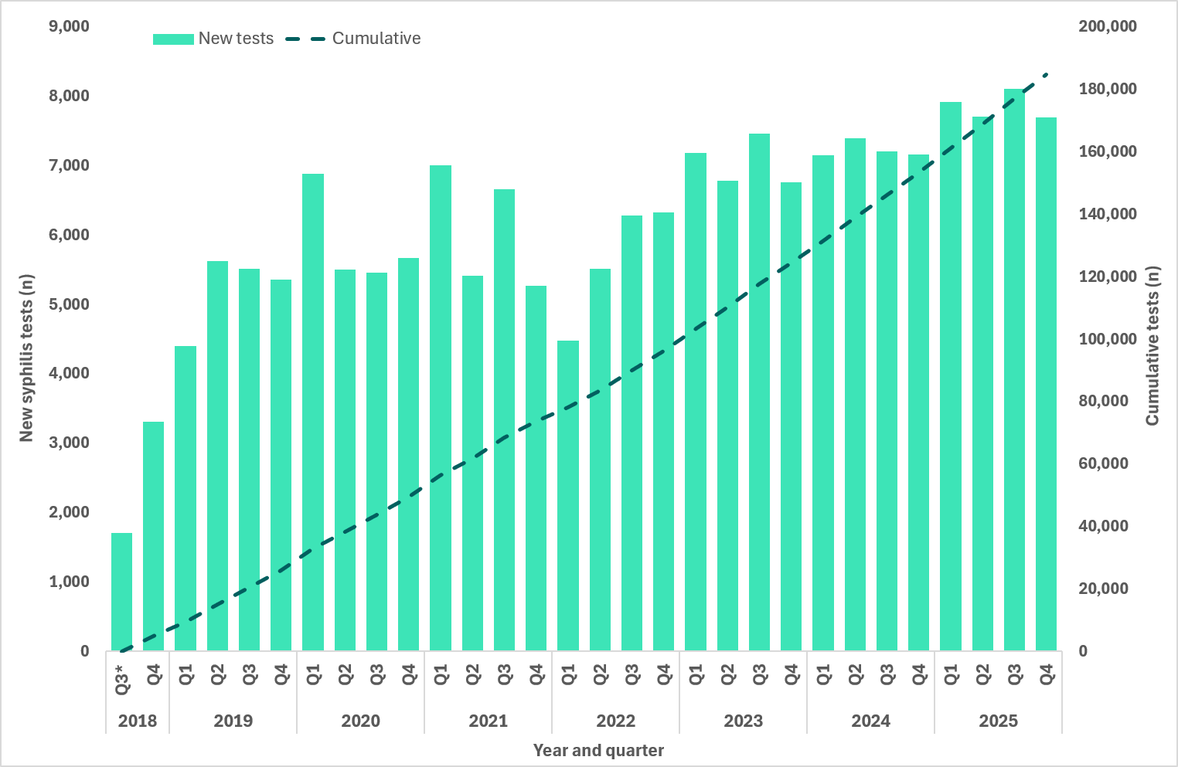
Note: * Q3 2018 includes data for August and September only.
- Proportion of Aboriginal and Torres Strait Islander clients attending participating ACCHS who received a syphilis test (PoCT and or serology), quarter and year, Q3 2018 to Q4 2025 (a. All age groups; b. Target age group 15 to 34 years1)
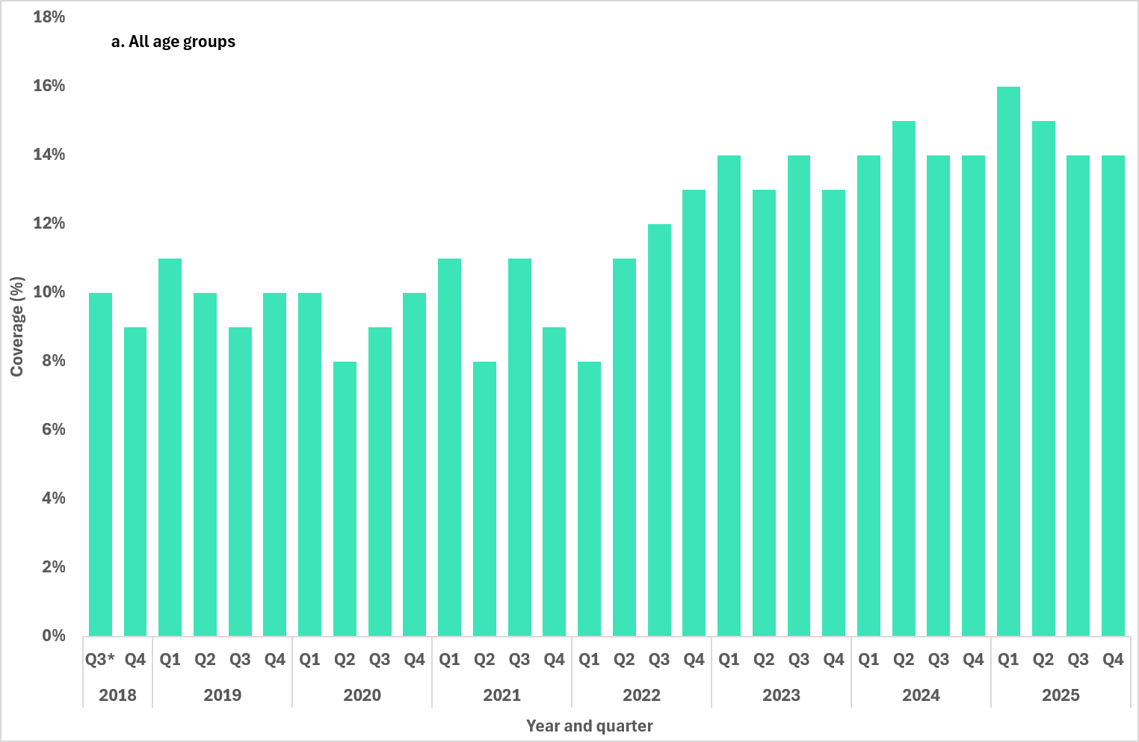
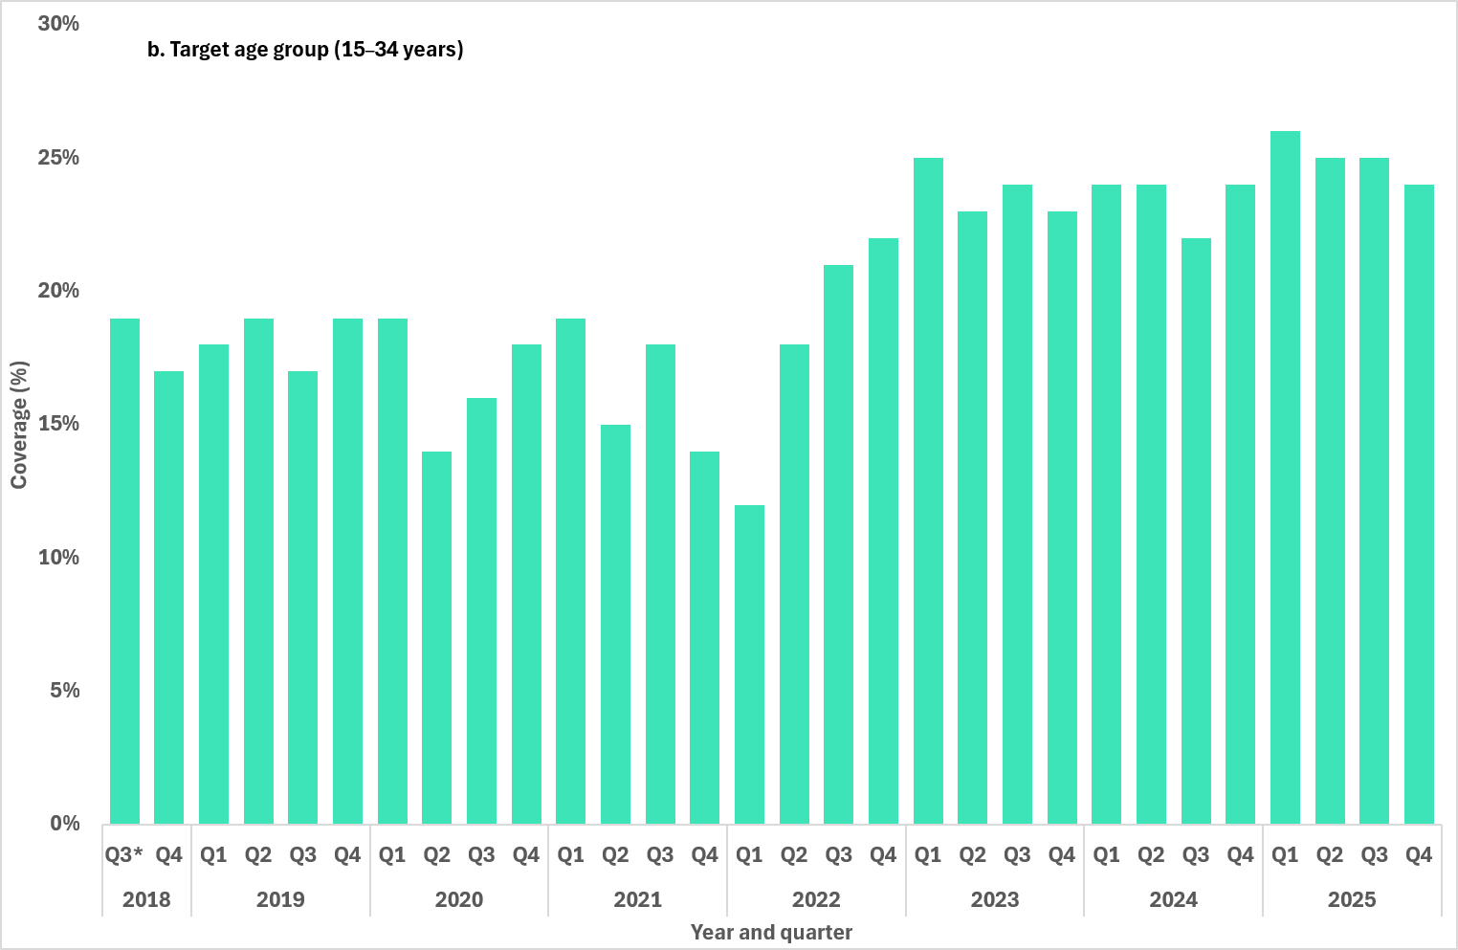
Notes: 1. Excludes testing data for individuals whose age was not reported. * Q3 2018 includes data for August and September only.
- Proportion of syphilis tests delivered through participating ACCHS, by test type (PoCT only, serology only and both serology and PoCT), by quarter and year, Q3 2018 to Q4 2025
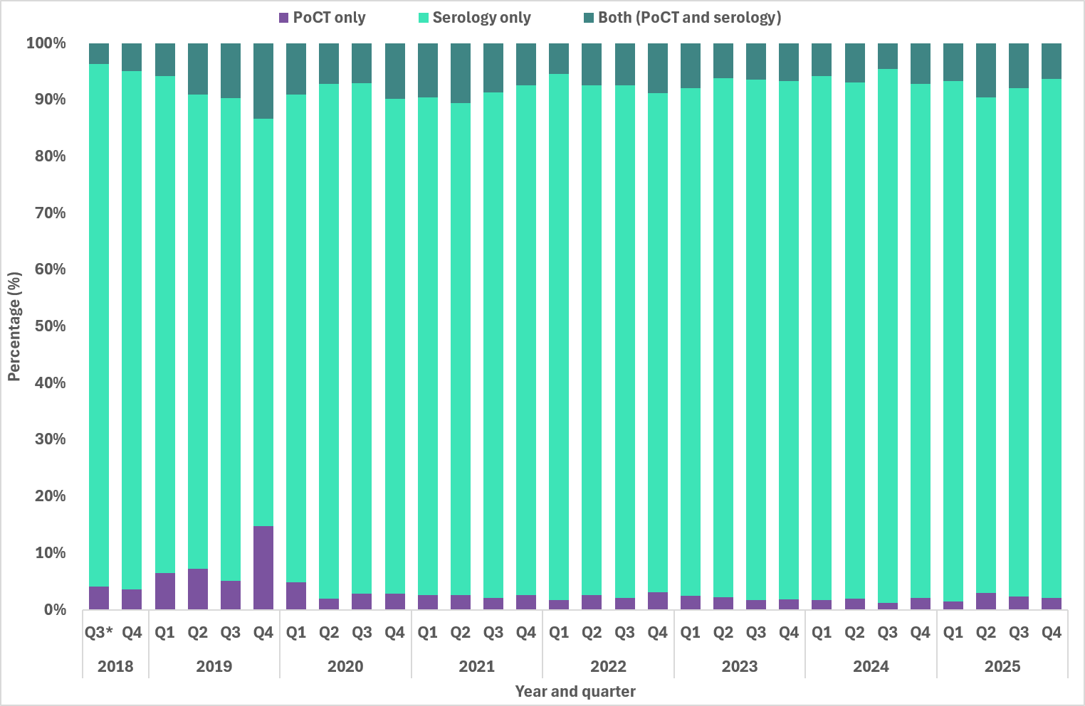
Note: * Q3 2018 includes data for August and September only.

Indicators 1.4 and 1.5 – Syphilis tests (priority populations)
1.4 Proportion of people from priority populations tested for syphilis in the previous 12 months attending a site within the ACCESS network
1.5 Proportion of gay, bisexual, and other men who have sex with men who have been tested for syphilis three or more times in the previous 12 months attending a site within the ACCESS network
The Australian Collaboration for Coordinated Enhanced Sentinel Surveillance of Sexually Transmissible Infections and Blood Borne Virusus (ACCESS) is a national sentinel surveillance network that collates de̶–identified clinical data from more than 100 sexual health clinics, general practices, hospitals, community health services and pathology laboratories across Australia.
Over the past 10 years (2016–2025), the overall proportion of people tested for syphilis attending any ACCESS site has remained relatively stable across all priority populations, apart from small declines seen from 2020 to 2022, coinciding with the COVID-19 pandemic. Since then, proportions of people tested has increased and remained stable over the past three years (2023–2025). Gay, bisexual, and other men who have sex with men (GBMSM) reported the largest proportion of people tested for syphilis in the reporting period (78% 2025), with an average of 78% over the past 10 years (Figure 4a). In 2025, the proportion of culturally and linguisitcally diverse (CALD) people having a syphilis test was 64% (10 year average 58%), followed by trans and gender diverse people (56%;10 year average 60%) and young adults (56%;10 year average 60%).
Across sexual health clinics and high case load general practices, people engaging in sex work reported the highest proportions tested for syphilis representing 89% in 2025 (10 year average 89%), followed by GBMSM (80% 2025; 81% 10 year average), CALD people (78% 2025; 74% 10 year average) and people who inject drugs (78% 2025; 78% 10 year average) (Figure 4b).

- Proportion of people from priority populations tested for syphilis in the previous 12 months attending a site within the ACCESS network (a. All sites; b. Sexual health clinics and high case load general practices)
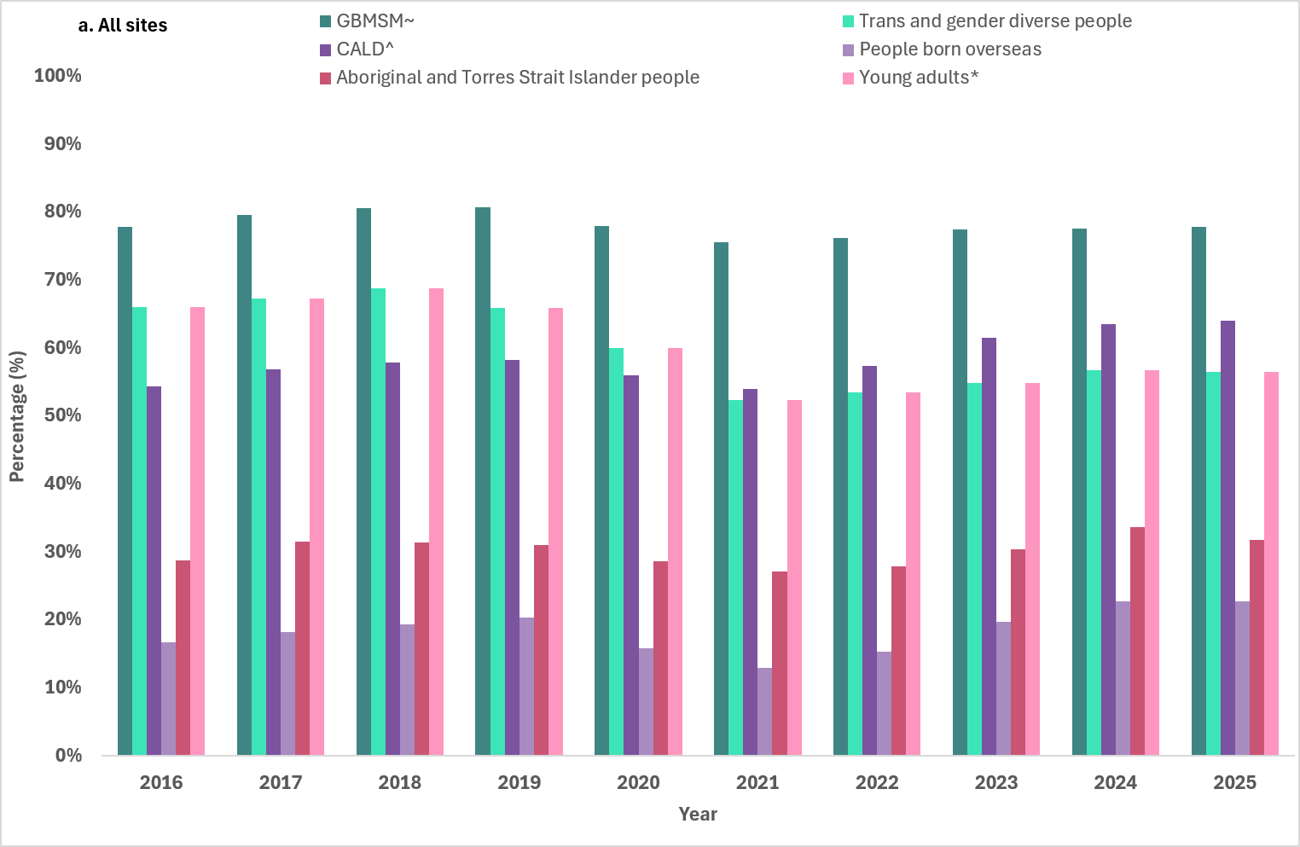
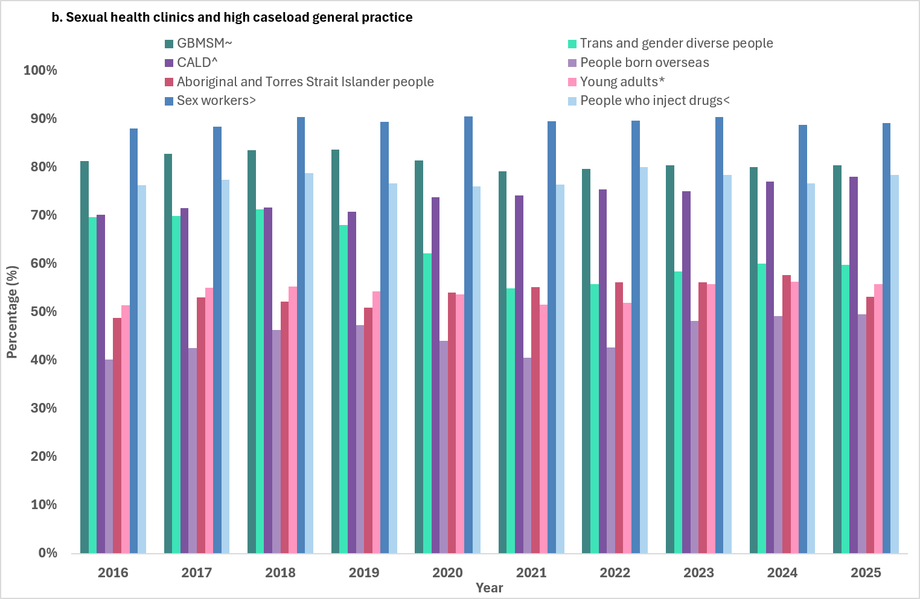Notes: ~ Gay, bisexual and other men who have sex with men. ^Born overseas or speaking a language other than English at home. *16–29 years of age. >Reported sex work in the last 12 months. <Reported injecting drug use in the last 12 months.
Over the past 10 years (2016–2025) the proportion of gay, bisexual and other men who have sex with men who have been tested for syphilis three or more times in the previous 12 months attending a site within the ACCESS network has increased from 25% in 2016 to a peak of 33% in 2018. A decline was then seen reaching a low of 25% in 2022. Since then, the proportion has remained stable and was 26% in 2025. While repeat syphilis testing was highest in the years leading up to 2018, these high levels were not sustained, with testing frequency remaining below peak levels in recent years (Figure 5).
- Proportion of gay, bisexual, and other men who have sex with men who have been tested for syphilis three or more times in the previous 12 months attending a site within the ACCESS network
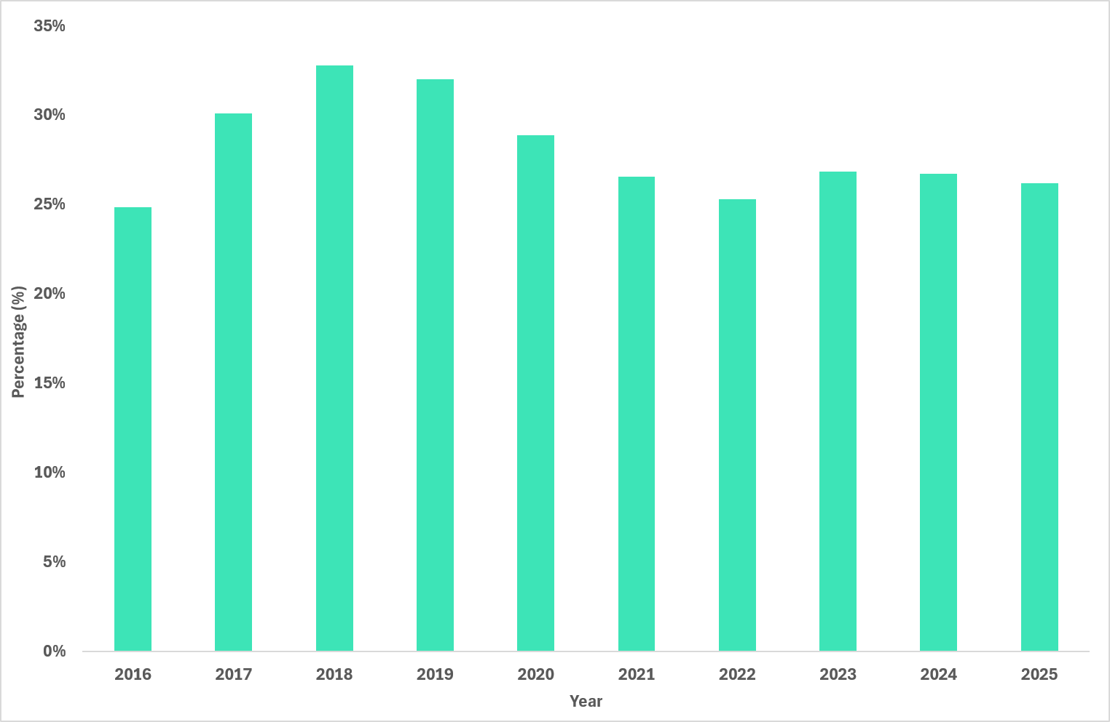

Indicators 1.6 – 1.10 – Antenatal care
1.6 Proportion of women who gave birth, by duration of pregnancy at first antenatal visit
1.7 Proportion of women who gave birth, by duration of pregnancy at first antenatal visit, by remoteness area
1.8 Proportion of women who gave birth, by number of antenatal visits
1.9 Proportion of women who gave birth, by number of antenatal visits, by remoteness area
1.10 Proportion of women who gave birth, by country of birth
The National Perinatal Data Collection (NDPC), as reported in the Australian Institute of Health and Welfare (AIHW) Australia’s mothers and babies report have been used to report against these indicators. Methodology and notes related to the NPDC are available on the AIHW website.
The NPDC does not currently include specific data related to syphilis testing, so assumptions have been made when reporting against these indicators. It is assumed that each antenatal visit provides an opportunity for a syphilis test. For example, indicator 1.6 ‘Proportion of people who gave birth, by duration of pregnancy at first antenatal visit’, assumes that a syphilis test was requested at the first antenatal visit, and that based on duration of pregnancy at the first visit indicates the stage of pregnancy when the person was first tested for syphilis.
These data will be used as a proxy as work continues to develop more robust mechanisms of reporting syphilis testing coverage and antenatal care among pregnant people.

First antenatal visit
The Australian Pregnancy Care Guidelines recommend that all pregnant people are universally offered syphilis testing at the first antenatal contact regardless of assessed risk. Guidelines suggest that the first antenatal visit occurs before 10 weeks of pregnancy (8).
Between 2013 and 2023, the proportions of pregnant people having their first antenatal visit before 14 weeks' gestation increased (Figure 6 a–b), this was consistent across all remoteness categories. Aboriginal and Torres Strait Islander people giving birth having their first visit before 14 weeks was lower (69% in 2023; 68% 5 year average) compared to non-Indigenous people (77% in 2023 and 5 year average). The proportion attending their first antenatal visit at 14–19 weeks and at 20 weeks or more has declined over time for both population groups, as expected given increases in earlier attendance.
Early first antenatal visit attendance (<14 weeks' gestation) was most common among people residing in major cities. Proportions of later presentation for first antenatal visit has remained higher among people residing in remote and very remote areas compared to those living in major cities.
For more detailed analysis of these data please see the AIHW's mothers and babies report (9).
- Proportion of women who gave birth, by duration of pregnancy at first antenatal visit, by Indigenous status and year, 2013 to 2023 (a. Non-Indigenous females; b. Aboriginal and Torres Strait Islander females)
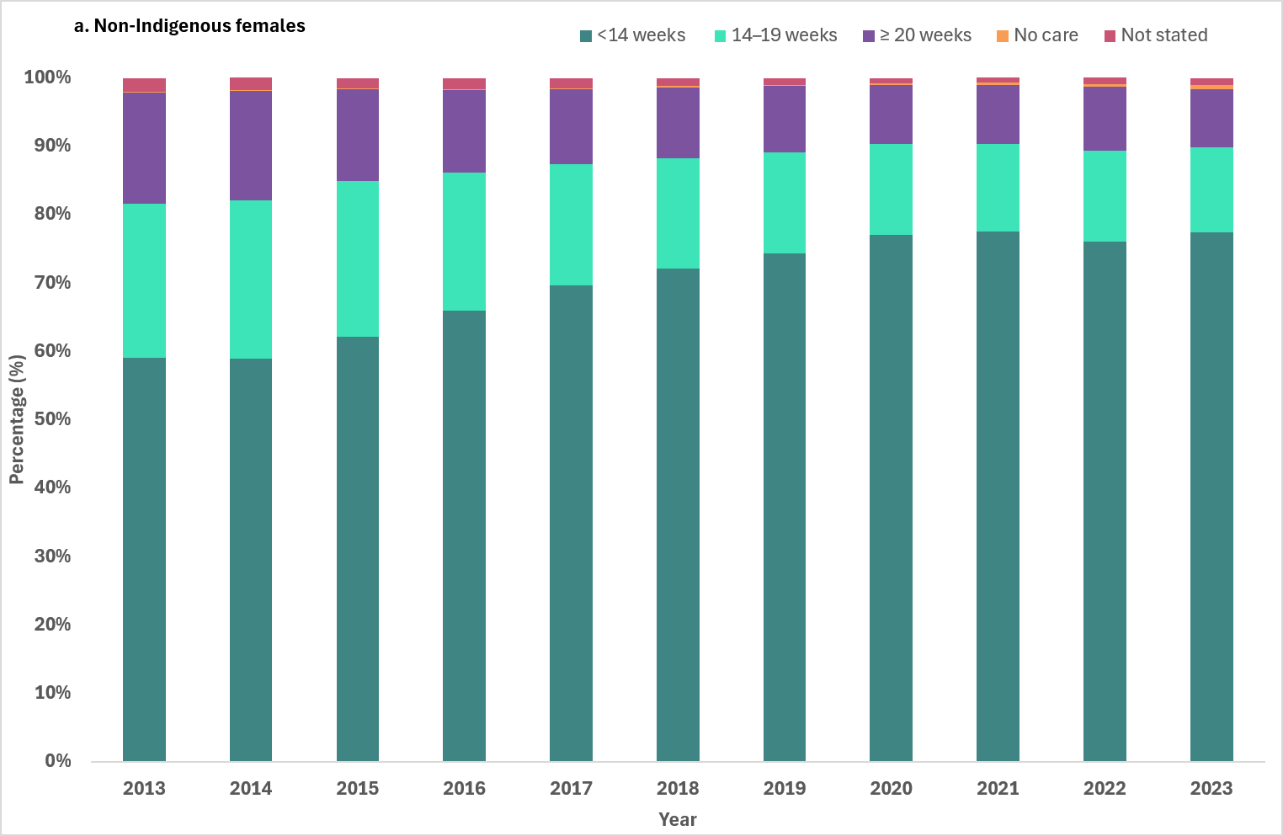
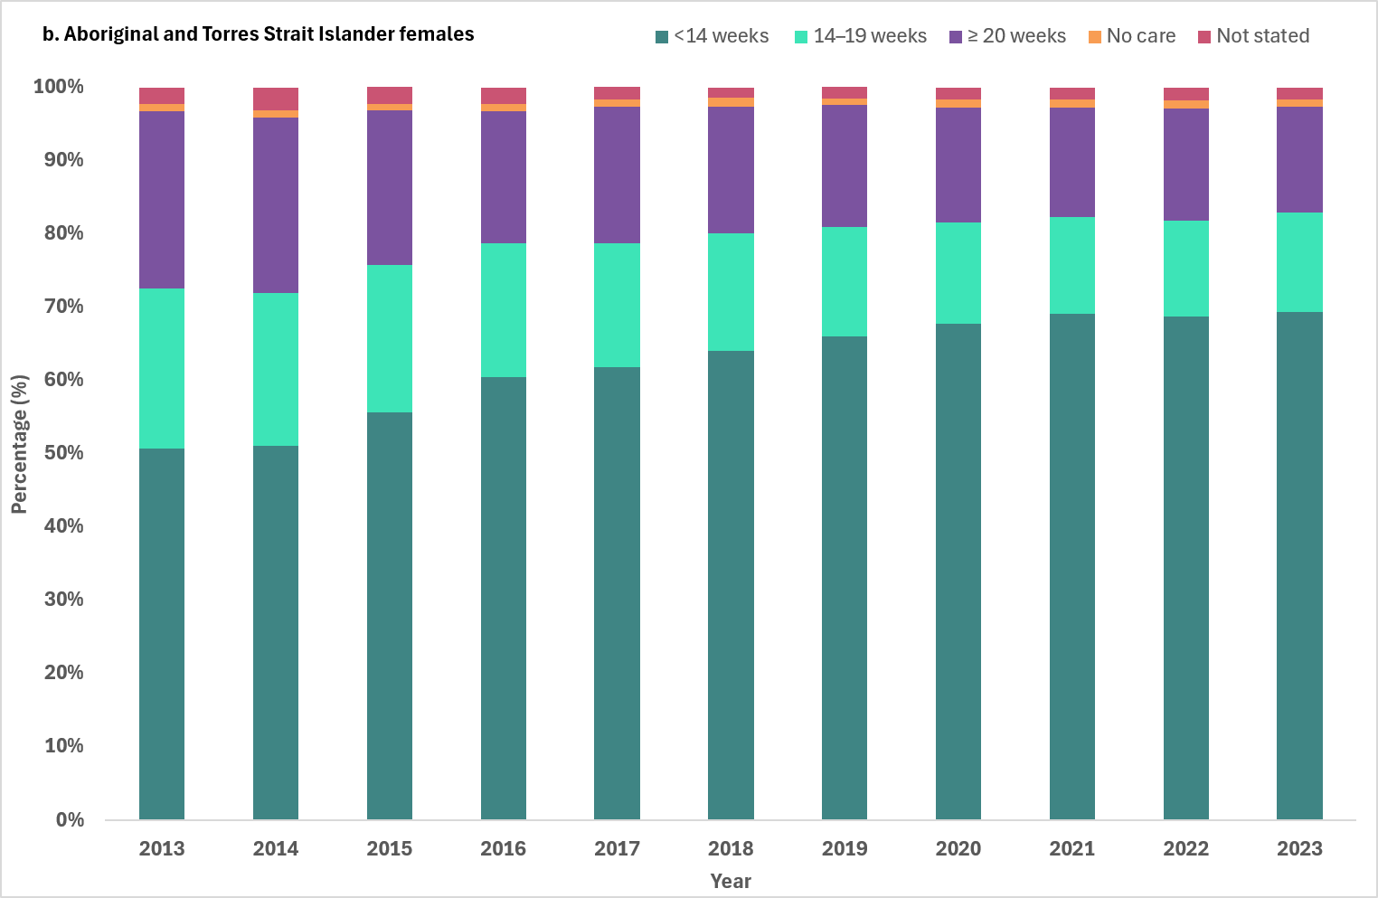

Number of antenatal visits
Between 2018 and 2023, most people who gave birth attended five or more antenatal visits, with disparities between non-Indigenous people (range 93%–94%) compared to Aboriginal and Torres Strait Islander people (range 86%–88%) over the reporting period. The proportion attending five or more visits increased slightly for both groups over this reporting period (Figure 7).
From 2018 to 2023, most people who gave birth had five or more antenatal visits, with proportions averaging above 90% for all remoteness areas. Lower proportions of five or more antenatal visits and higher proportions of two to four visits were reported among people residing in remote and very remote areas. The proportion of people with no antenatal visits or only one visit remained very low across all remoteness areas, although generally higher in very remote areas. Overall, while antenatal care attendance is high, geographic disparities remain, particularly for those living in remote and very remote areas (Figure 8).
For more detailed analysis of these data please see the AIHW's mothers and babies report (9).
- Proportion of women who gave birth, by number of antenatal visits, by Indigenous status and year, 2018 to 2023
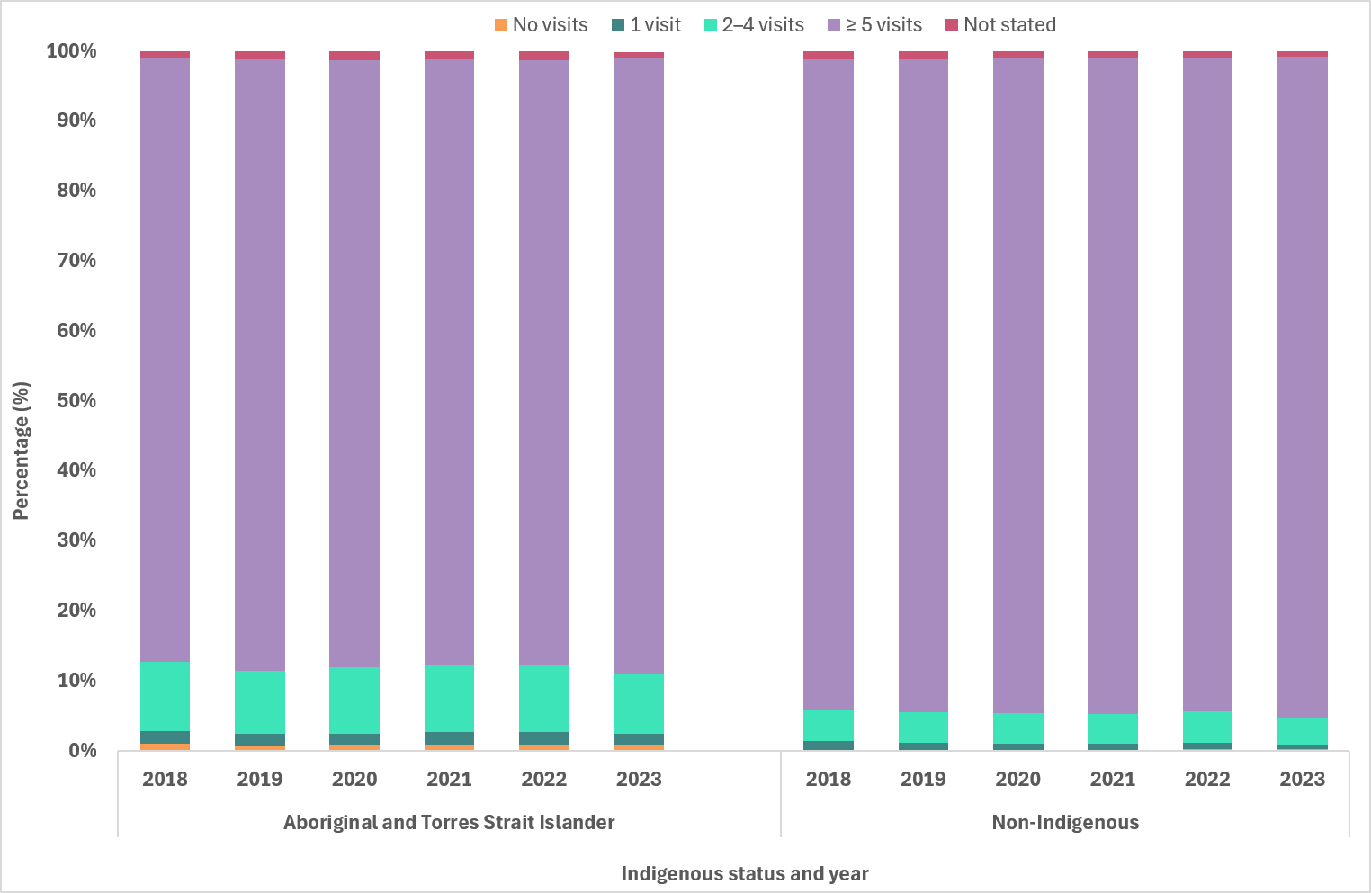

- Proportion of women who gave birth, by number of antenatal visits, by remoteness area and year, 2018 to 2023
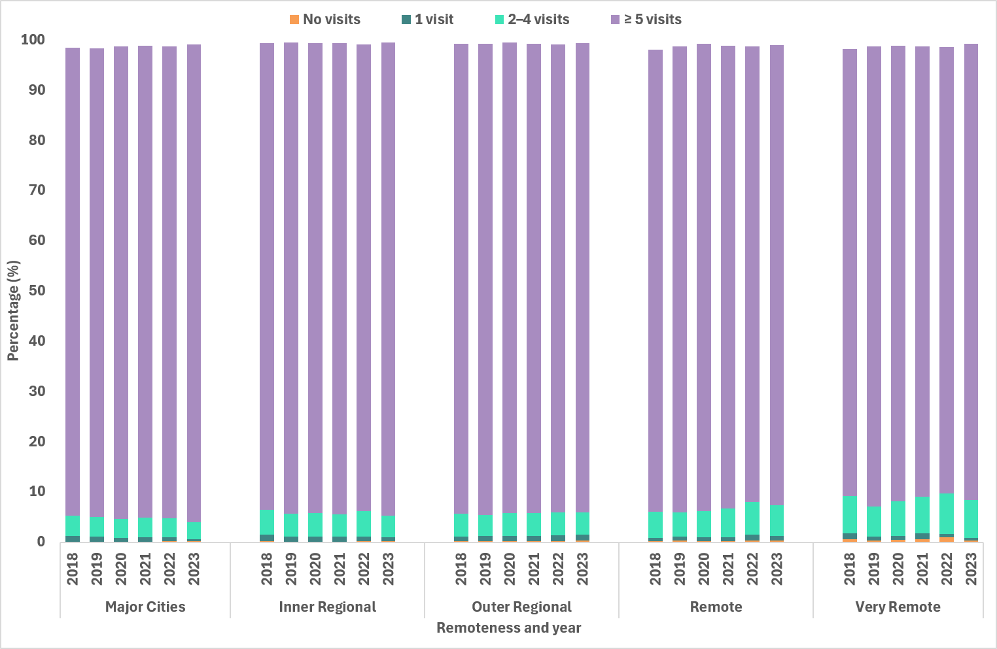
Country of birth
In 2023, around two-thirds (65.1%) of people who gave birth were born in Australia. India was the leading overseas country of birth, representing 5.9%, followed by New Zealand (2.4%), China (2.3%) and the United Kingdom (2.2%). People born in the Philippines, Nepal, Pakistan and Vietnam contributed between 1.1% and 1.7% of births.
For more detailed analysis of these data please see the AIHW's mothers and babies report (10).

Goal 2: Reduce ongoing transmission and incidence of syphilis across priority populations
Key facts
In 2025:
6,069 infectious syphilis cases were reported, marginally higher than 2024 and lower than the 5 year mean.
The highest notification rates were reported in Aboriginal and Torres Strait Islander people aged 15 to 24 years in remote/very remote areas.
HIV PrEP use at syphilis diagnosis was reported for 31% of gay bisexual and men who have sex with men.
69% of notifications received treatment for the syphilis infection (3% did not receive treatment and 28% had an unknown treatment status).
The median time to treatment was 7 days.
Presentation with clinical symptoms (36%) was the most frequently reported reason for syphilis testing.
General practice (34%) was the most frequently reported setting for diagnosis of infectious syphilis notifications.
In 2025, 6,069 cases of infectious syphilis were notified, higher compared to 2024 (n=5,979) and lower than the 5-year average (n=6,111) (Figure 9, Table 3). Consistent with historical trends, in 2025 notifications were predominately reported in males (78%) and were aged 25–34 years (34%) (Table 3).
While notifications were largely reported among residents of major cities (73%), proportions in inner/outer regional areas are continuing to increase due in part to rises in notifications in urban areas in the Northern Territory (Darwin classified as an outer regional area), and areas in north Queensland. Proportional increases in remote/very remote areas reflects consistent reporting of cases in these areas, and resurgence in remote/very remote areas in the Northern Territory, including Top End, Big Rivers (Katherine) and East Arnhem regions (Map 1 and 2) (11).

- Notifications (number) and notification rate (per 100,000)1 of infectious syphilis, by Indigenous status, sex, year and quarter, 2020 to Q4 2025
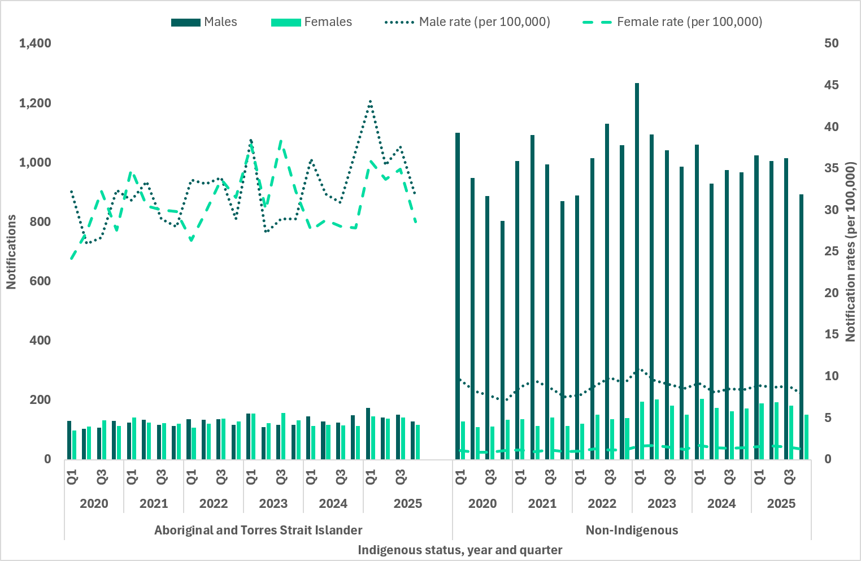
Note: 1. Excludes cases whose sex, age, Indigenous status and/or residential postcode were not reported.
- Demographic summary of infectious syphilis notifications, 2020 to 2025
Characteristics | 2020 | 2021 | 2022 | 2023 | 2024 | 2025
Total | 5,363 | 5,761 | 6,182 | 6,564 | 5,979 | 6,069
Sex
Female | 957 | 1,038 | 1,084 | 1,336 | 1,215 | 1,299
Male | 4,389 | 4,706 | 5,072 | 5,217 | 4,754 | 4,758
Other1 | 2 | 6 | 8 | 4 | 1 | 0
Not reported | 15 | 11 | 18 | 7 | 9 | 12
Age group (years)
15–24 | 883 | 841 | 843 | 925 | 768 | 713
25–34 | 1,907 | 2,143 | 2,278 | 2,359 | 2,102 | 2,067
35–44 | 1,335 | 1,500 | 1,645 | 1,716 | 1,647 | 1,793
45+ | 1,222 | 1,262 | 1,404 | 1,550 | 1,437 | 1474
Mean age at diagnosis
Female | 30 | 30 | 31 | 32 | 33 | 33
Male | 37 | 37 | 38 | 38 | 38 | 39
Overall | 36 | 36 | 36 | 37 | 37 | 38
Indigenous status
Aboriginal or Torres Strait Islander | 931 | 1,004 | 1,022 | 1,066 | 1,011 | 1,140
Non-Indigenous | 4,241 | 4,485 | 4,664 | 5,132 | 4,660 | 4,603
Not reported | 191 | 272 | 496 | 366 | 308 | 326
Remoteness area
Major cities | 4,087 | 4,417 | 4,767 | 4,992 | 4,488 | 4,453
Inner/outer regional | 658 | 604 | 759 | 915 | 918 | 955
Remote/very remote | 486 | 576 | 465 | 470 | 413 | 484
Not reported/ overseas resident | 132 | 164 | 191 | 187 | 160 | 177
Note: 1 People who reported their sex assigned at birth as a term other than male or female.

Indicator 2.1 – Notification rates
2.1 Notification rates of infectious syphilis by Indigenous status, sex, age and remoteness area classification
Aboriginal and Torres Strait Islander males
In 2025, notification rates among Aboriginal and Torres Strait Islander males increased across most age groups in major cities, inner/outer regional areas and remote/very remote areas compared to 2024 (Figure 10 a-c).
The greatest notification rate increase compared to 2024 was reported in 35–44 year olds in inner/outer regional areas (54%) and 45+ year olds in residing in major cities (36%) (Figure 10 a-c).
Non-Indigenous males
On average, non-Indigenous males represent around 80% of all infectious syphilis notifications, with most of these cases reported in major cities of Australia (Figure 10 a). In 2025, notification rates in most age groups across all remoteness areas reported a decrease or were similar compared to 2024 and 5 year quarterly mean (Figure 10 a-c).
Aboriginal and Torres Strait Islander females
In 2025, Aboriginal and Torres Strait Islander females aged 15–24 years in remote/very remote areas recorded the highest notification rates among all population and geographical groups, with a notification rate of 1,026 per 100,000 (Figure 11 c). Despite recording the highest notification rate overall, this group observed decreases in 2025 compared to the 5 year mean (19%), but an increase compared to 2024 (5%).
Across other geographical areas and age groups, the greatest increases in notification rates compared to 2024 were reported in 35–44 year olds in inner/outer regional areas (128%) and remote/very remote areas (73%) (Figure 11 a-c).
Non-Indigenous females
In 2025, compared to 2024, notification rates in non-Indigenous females showed small declines or remained similar across most age and geographical groups, except for females aged 15–24 years residing in major cities of Australia where an increasing trend was observed (Figure 11a). Compared to the 5 year mean, considerable increases were reported in all age groups in major cities of Australia (Figure 11 a-c).

- Notifications (number) and notification rate (per 100,000) of infectious syphilis reported in males, by Indigenous status, remoteness area, age, quarter, and year, 2020 to Q4 20251 (a. Major cities, b. Inner and outer regional areas, c. Remote and very remote areas)
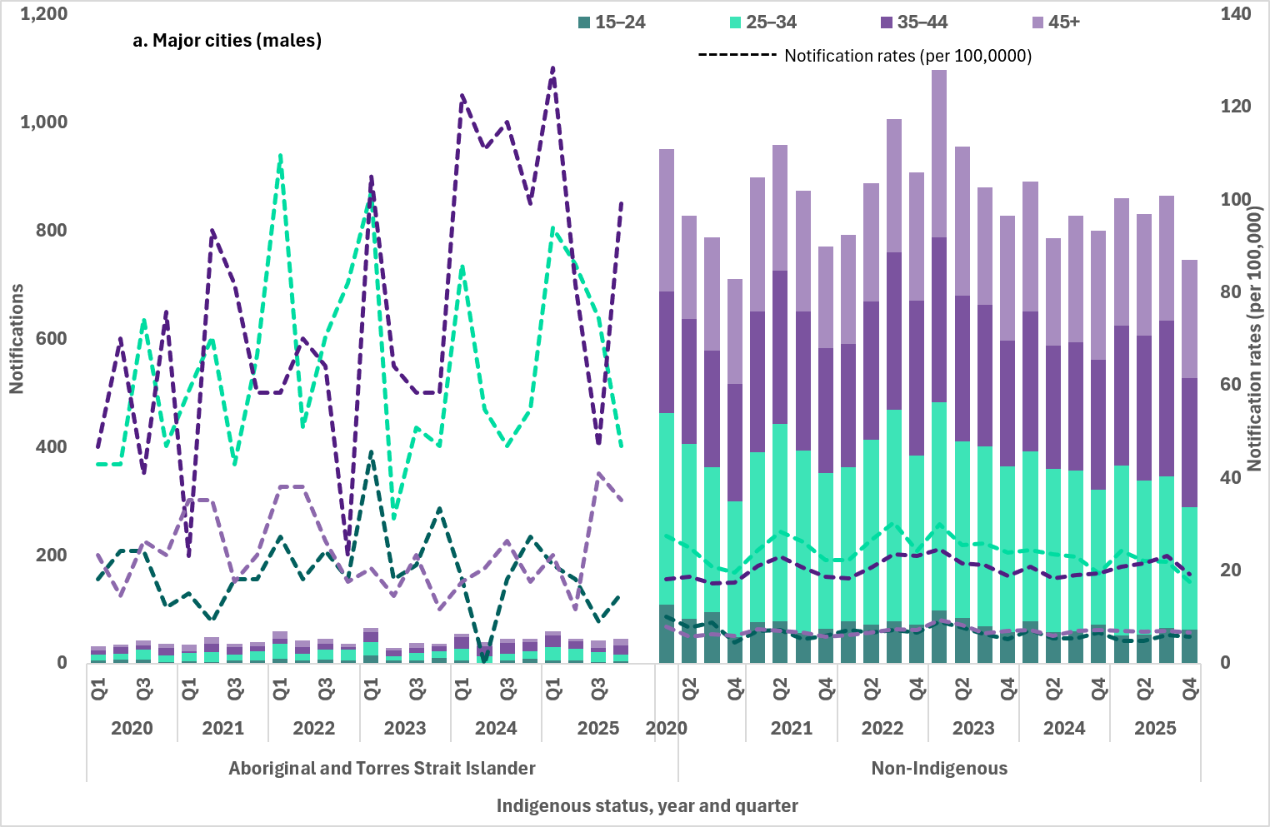
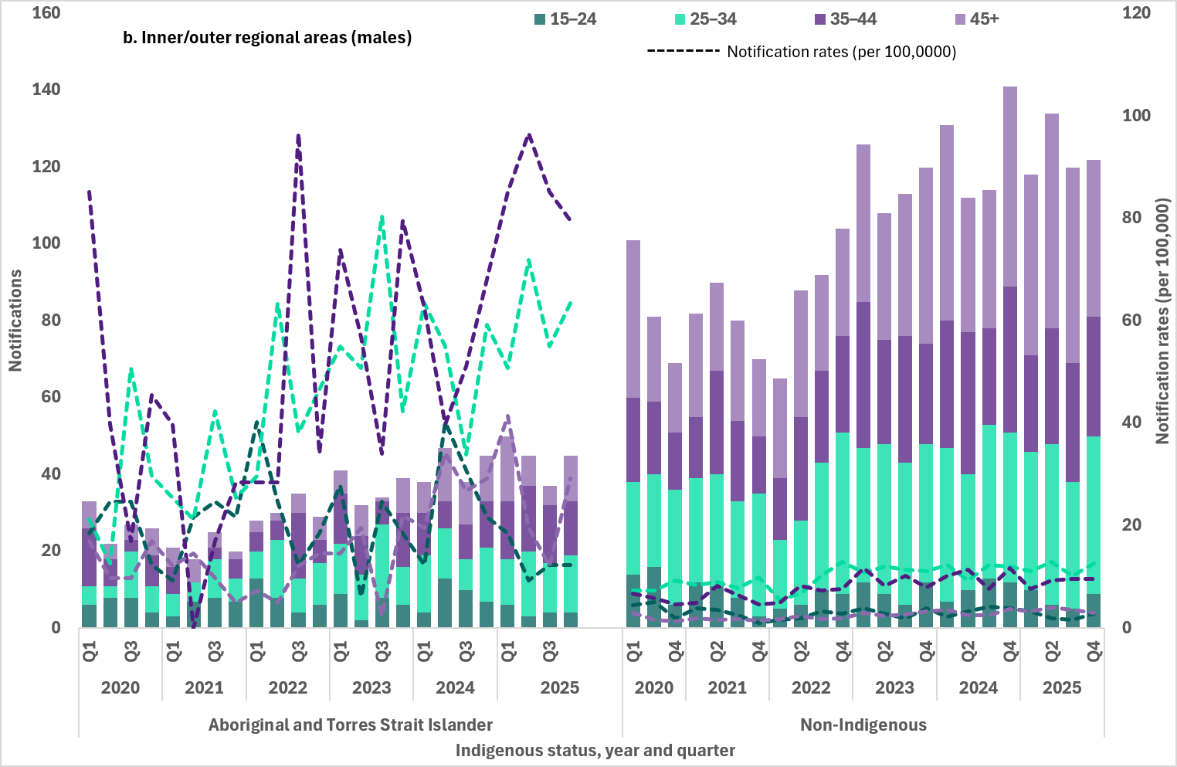
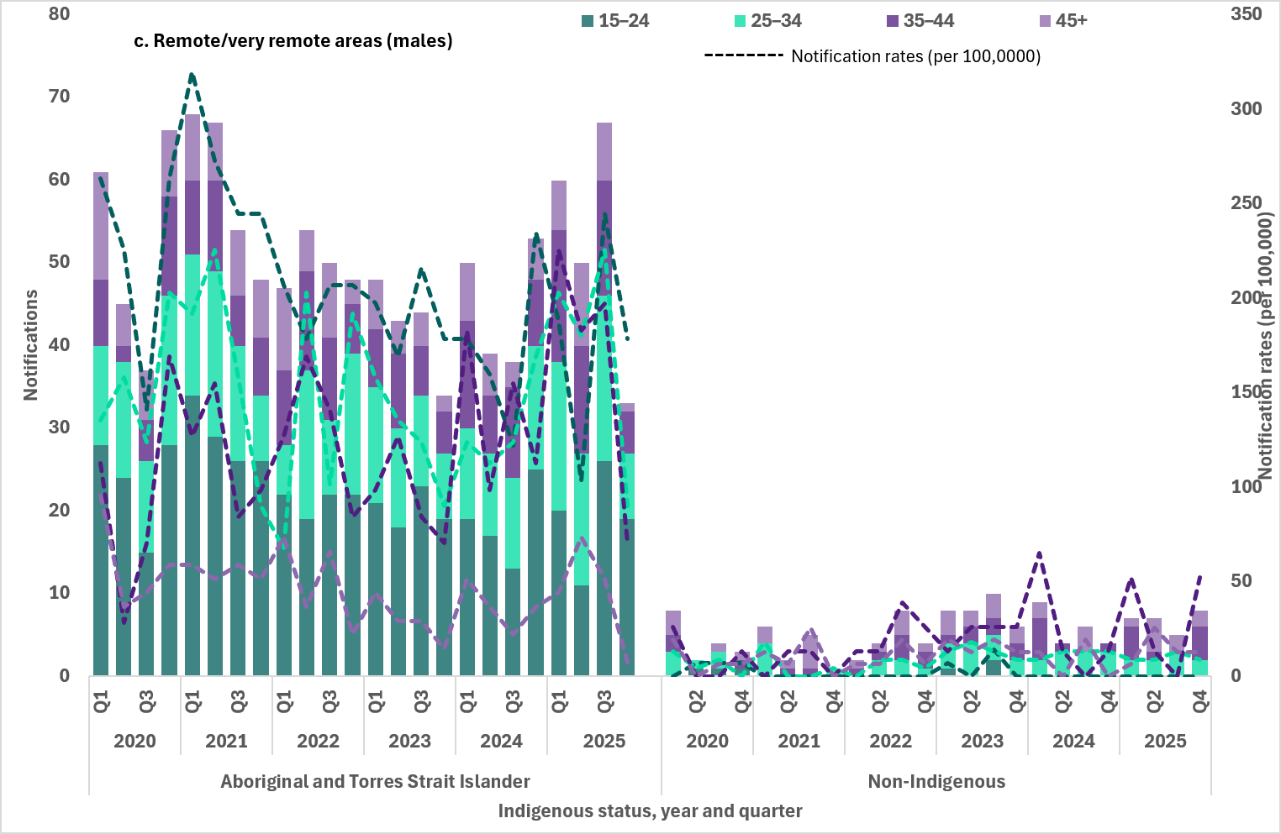
Note: 1. Excludes cases whose sex, age, Indigenous status and/or residential postcode were not reported.

- Notifications (number) and notification rate (per 100,000) of infectious syphilis reported in females, by Indigenous status, remoteness area, age, quarter, and year, 2020 to Q4 20251 (a. Major cities, b. Inner and outer regional areas, c. Remote and very remote areas)
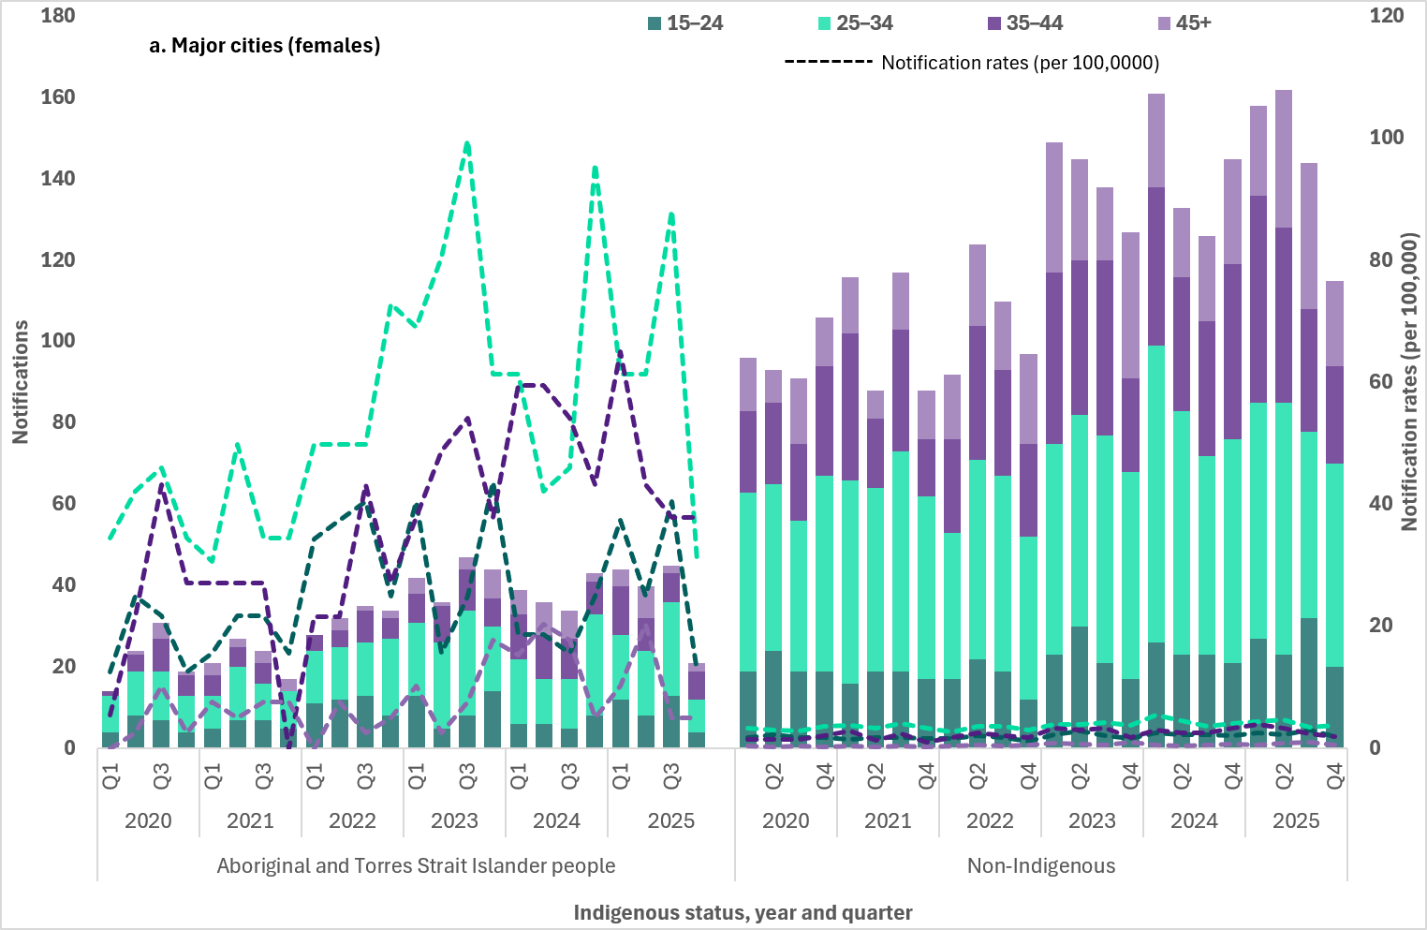
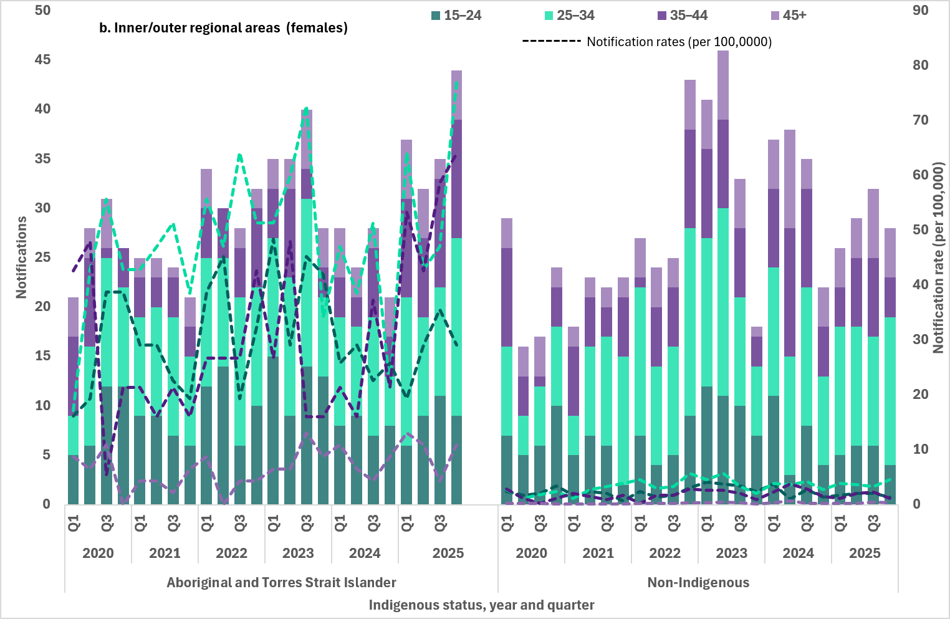
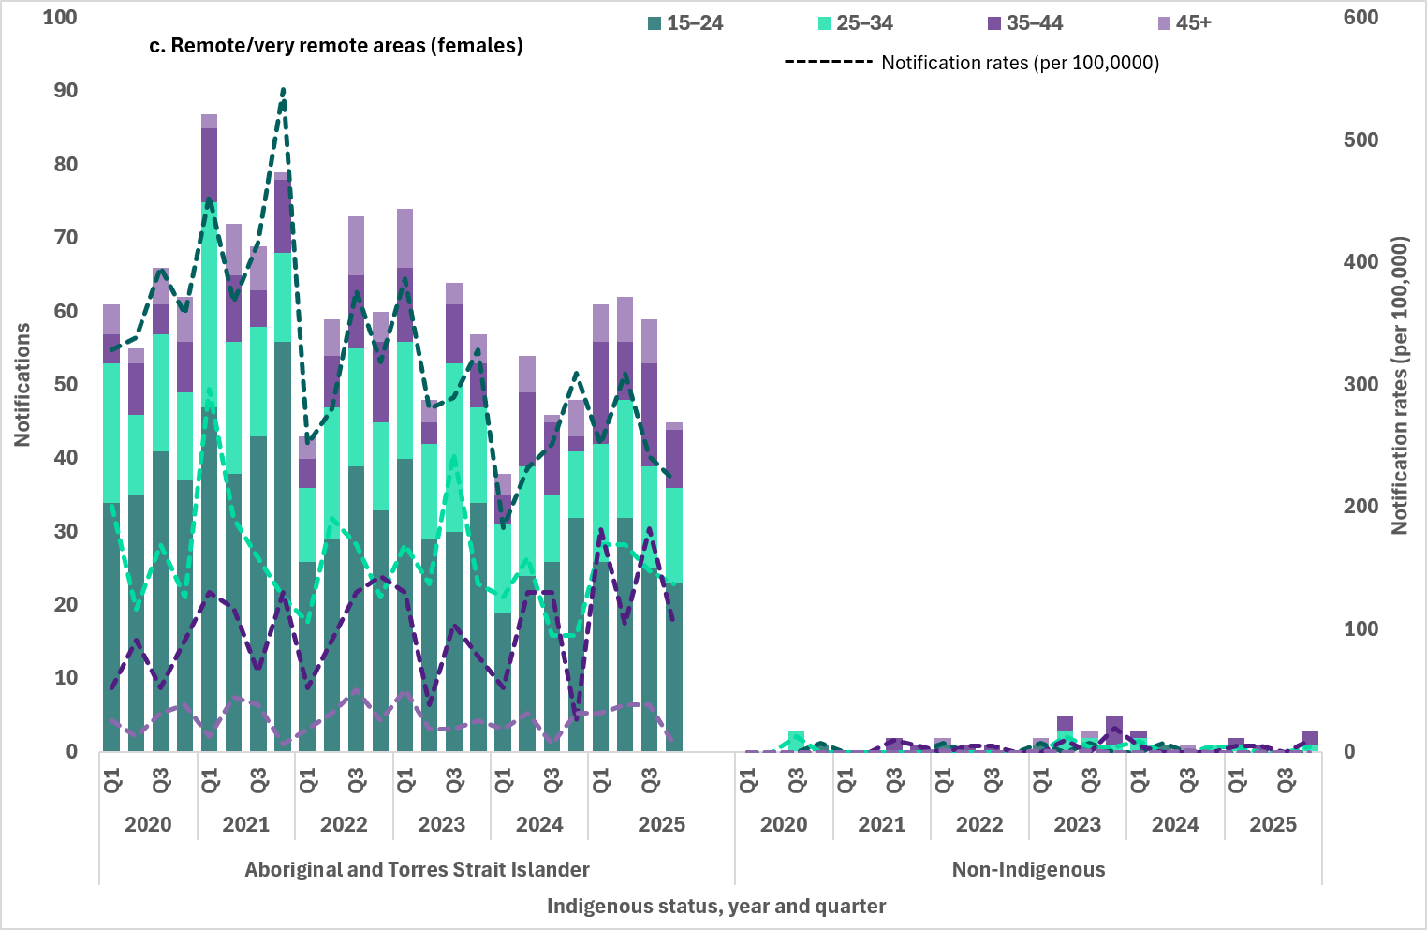
Note: 1. Excludes cases whose sex, age, Indigenous status and/or residential postcode were not reported.

Indicators 2.2 and 2.3 – Geographical areas
2.2 Notification rate of infectious syphilis in Aboriginal and Torres Strait Islander people by Indigenous Areas (IAREs)
2.3 Notification rate of infectious syphilis by Statistical Area 3 (SA3), by Indigenous status
Mapped notification data uses residential postcodes of notified cases to allocate cases to a geographical area. This may not necessarily reflect where the infection was acquired, and in some instances the postcode reported may reflect the location where the case was diagnosed rather than residence and locality of acquisition.
If the postcode reflects the location where an individual sought health care, the mapped notifications may reflect areas of high volume or centralised services where people are being diagnosed rather than areas with a high burden of infection or acquisition.
Availability and accessibility of safe and culturally appropriate health services, particularly in remote/very remote areas and Aboriginal and Torres Strait Islander communities, along with other social factors may influence where people are tested and diagnosed, noting that this may occur outside of an individual’s place of residence (12).
Indigenous Areas
Indigenous Areas (IAREs) are geographic areas built from Indigenous locations, which are designed to represent Aboriginal and Torres Strait Islander communities (urban and rural) that are near each other or that share language, traditional borders or Native Title (13).
Age standardised infectious syphilis notification rates by IAREs for Aboriginal and Torres Strait Islander people are presented in Map 1 for 2025.
The highest notification rates were reported largely in very remote areas of Western Australia, South Australia and the Northern Territory, noting that in some IAREs the population was small.
High notification rates in outer regional areas (Darwin and surrounds) and communities in the Top End, Big Rivers (Katherine) and East Arnhem regions reflect the increase in reported cases in urban and remote areas in the Northern Territory (11).
Statistical Area 3 (SA3)
In 2025, age-standardised notification rates of infectious syphilis by statistical area 3 (SA3) were widely distributed across Australia (Map 2).
The highest notification rates were reported across very remote areas in the north-west of Australia and SA3s in some major cities, including Sydney.
This geographical distribution reflects the concurrent infectious syphilis outbreaks and sub-epidemics occurring across populations groups in Australia, including Aboriginal and Torres Strait Islander people in regional and remote areas, gay and bisexual men in major cities of Australia, and non-Indigenous women in major cities.
Refer to the methodological notes for further information on the development of the maps.

Map 1: Notification rate (per 100,000) of infectious syphilis in Aboriginal and Torres Strait Islander people by Indigenous Areas (IAREs) in 2025
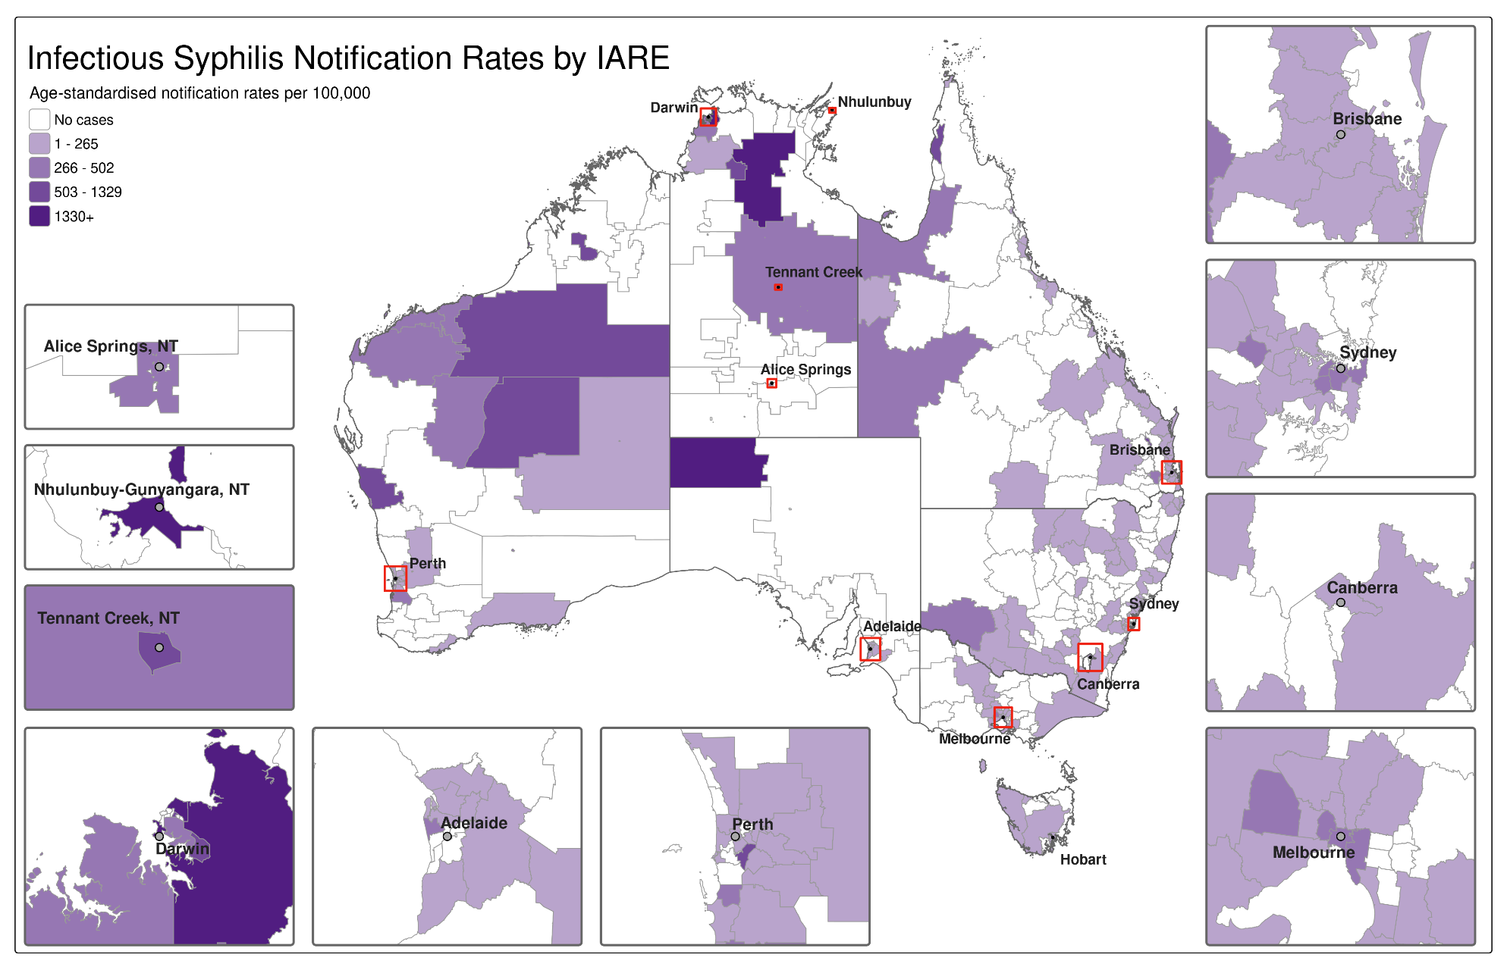
Note: Excludes cases whose Indigenous status and/or residential postcode were not reported.
Map 2: Age-standardised notification rate (per 100,000) of infectious syphilis by Statistical Area 3 (SA3) in 2025
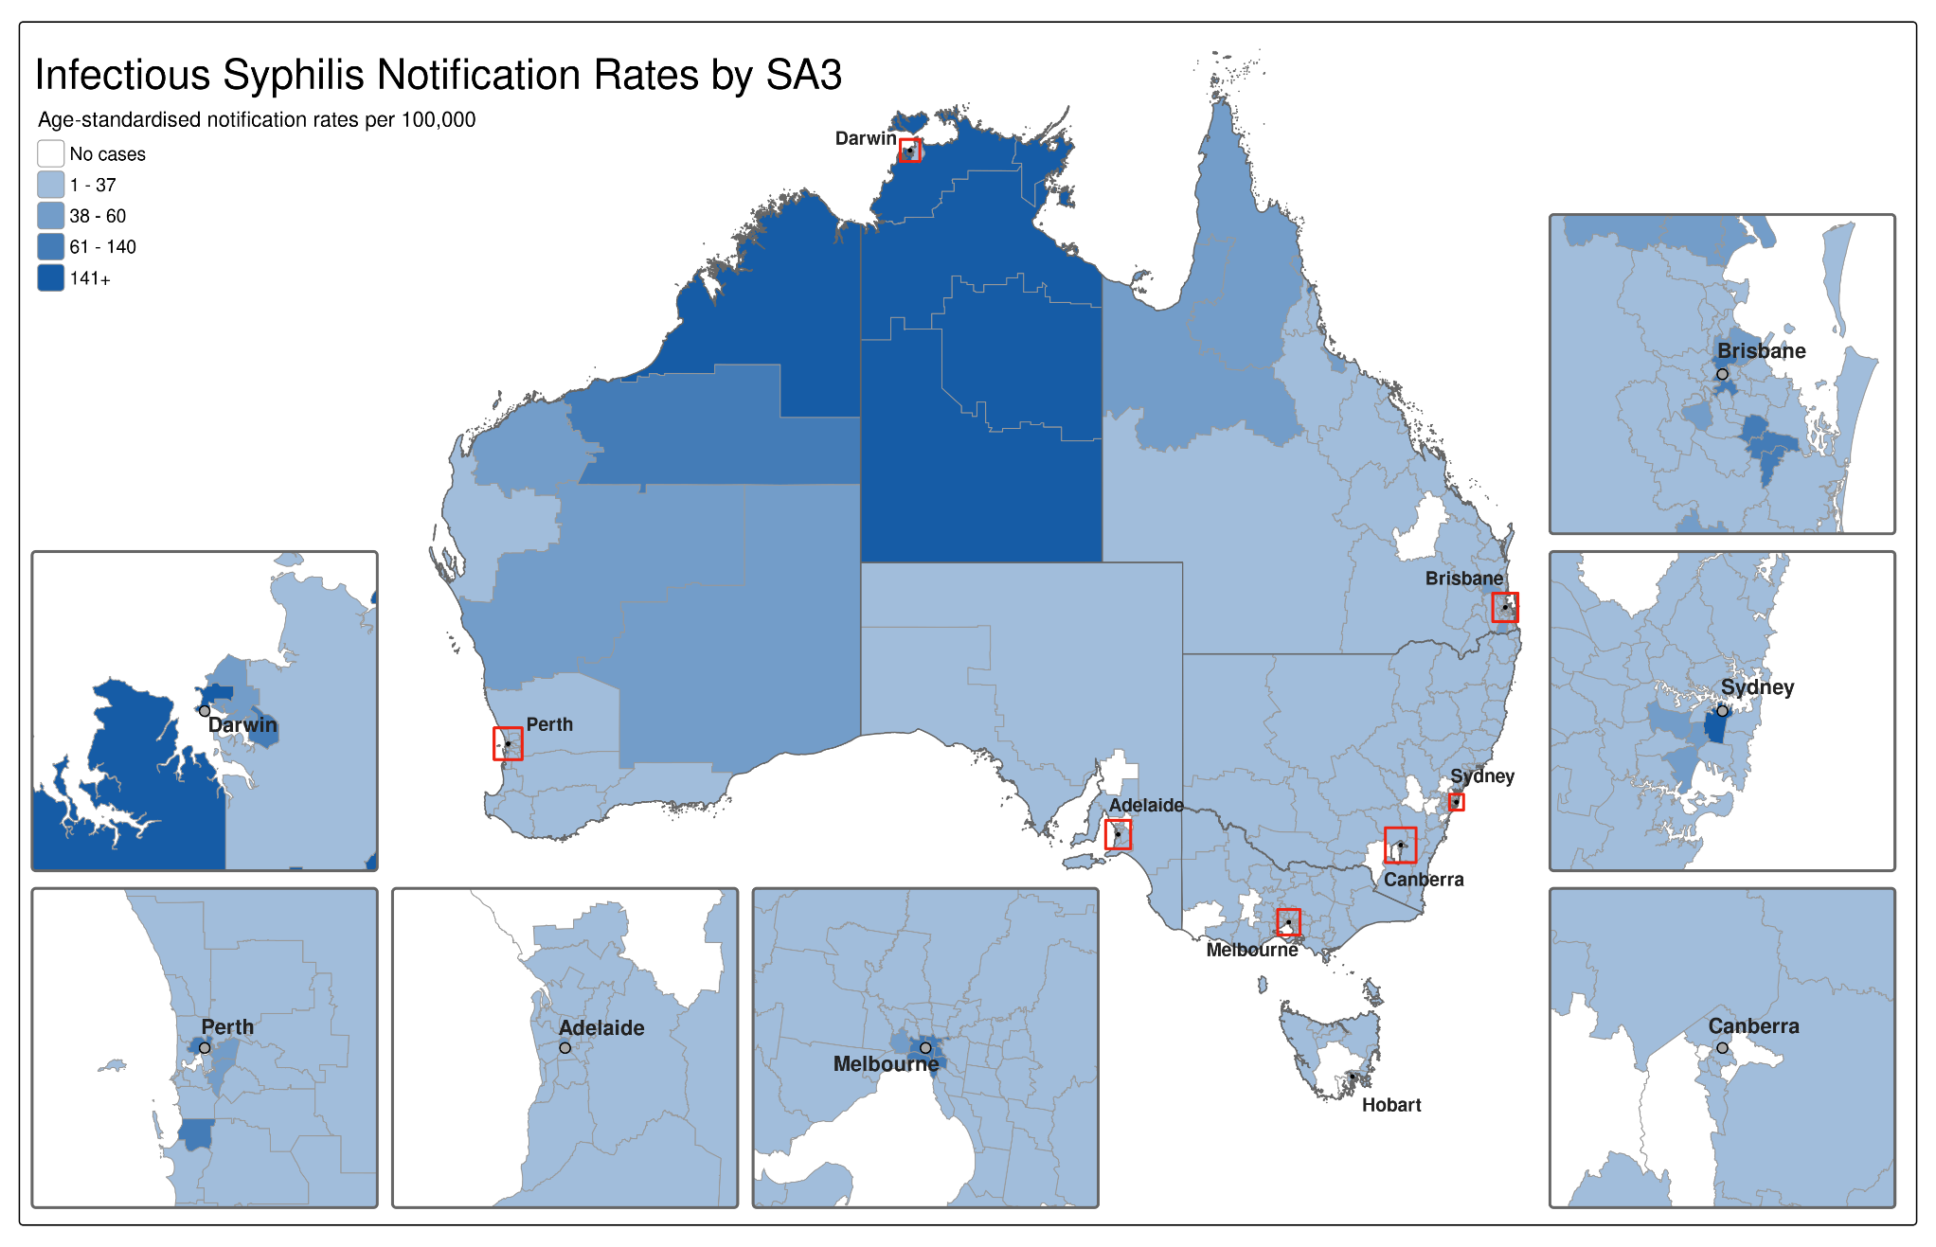
Note: Excludes cases whose residential postcode was not reported.

Indicator 2.4 – Women of reproductive age
2.4 Notification rates of infectious syphilis in women of reproductive age (15 to 44 years) by Indigenous status and remoteness area
Between 2020 and 2025, of infectious syphilis cases reported among women, most (86%) were in women aged between 15 to 44 years of age, with the average proportion among Aboriginal and Torres Strait Islander women higher (89%) and non-Indigenous women lower (84%).

Aboriginal and Torres Strait Islander women
The highest proportion and notification rates among Aboriginal and Torres Strait Islander women of reproductive age have consistently been reported in remote and very remote areas of Australia, representing half of the cases (50%) reported between 2020 and 2025 (Figure 12 a).
Although lower notifications and rates have been reported in major cities of Australia, the proportion of cases overall has been steadily increasing, representing on average 26% of all cases in Aboriginal and Torres Strait Islander women of reproductive age. In inner and outer regional areas, the proportion has remained relatively constant, representing on average 24% (Figure 12 a).

Non-Indigenous women
Most notifications among non-Indigenous women of reproductive age were reported in major cities of Australia, on average representing 80% of cases reported between 2020 and 2025. A smaller proportion (average 19%) were reported in inner and outer regional areas, and small proportion (average 1%) in remote and very remote Australia (Figure 12 b).

- Notifications (number) and notification rate (per 100,000) of infectious syphilis reported in women aged 15 to 44 years, by Indigenous status, remoteness area, quarter, and year, 2020 to Q4 2025 (a. Aboriginal and Torres Strait Islander, b. Non-Indigenous)
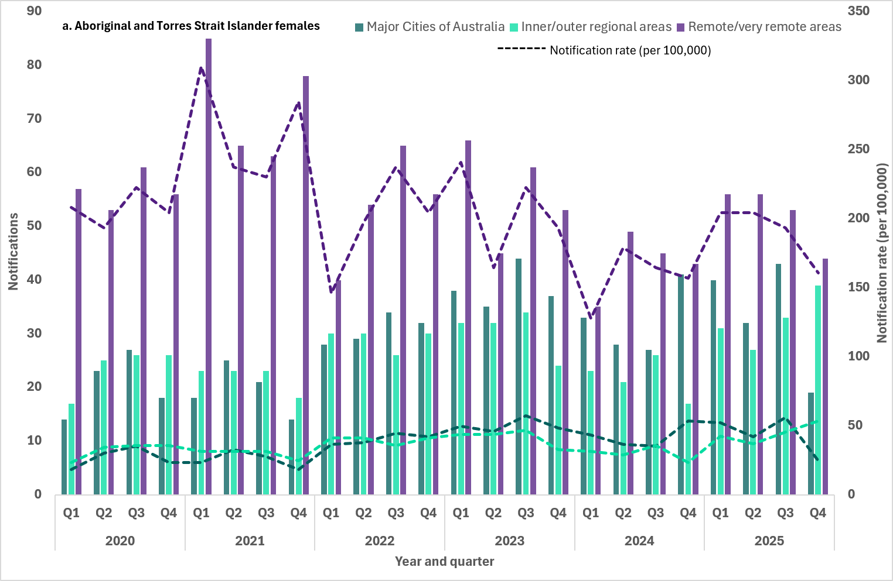
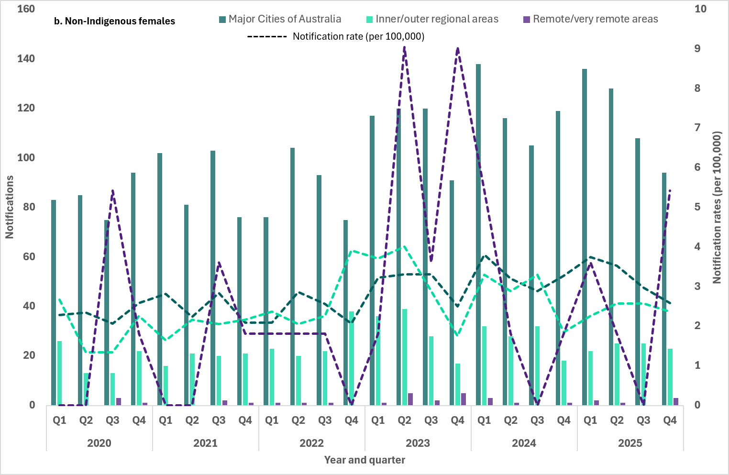Note: 1. Excludes cases whose sex, age, Indigenous status and/or residential postcode were not reported.

Indicators 2.5 and 2.6 – Males by sexual exposure
2.5 Proportion of infectious syphilis notifications in men reporting sexual exposure with men only
2.6 Proportion of infectious syphilis notifications in men reporting sexual exposure with men and women
‘Sexual exposure’ refers to the sex of the sexual contact of the notified case and can be reported as either:
- person(s) of different sex only
- person(s) of same sex only
- person(s) of different sex AND person(s) of same sex
- sexual exposure unknown.
Enhanced data (sexual exposure: same sex, different sex and, different and same sex) are used to report against indicators 2.5 and 2.6.
Completeness of sexual exposure in males notified with infectious syphilis fluctuated between 2020 and 2025, ranging from 74% to 81% (average 77%).
Males reporting sexual exposure with the same sex only represented the highest proportion of reported sexual exposure events in 2025 (50%), consistent with historical trends.
The proportion of males reporting sexual exposure with people of a different sex only was 23% in 2025, with proportional increases compared to 2024 and 5-year mean, 20% and 19% respectively. Proportionally, males reporting sexual exposure with people of different and same sex was 7% in 2025, higher than 2024 (5%) and the 5 year mean (5%) (Figure 13).
Changes in sexual exposure over time suggests potential overlapping in sexual networks influencing the epidemiology of syphilis transmission across Australia, including increasing exposure risk for females. This concept has also been observed in genomic analysis of Treponema pallidum (syphilis) in Australia and other sexually transmissible infections (14, 15).

- Number of infectious syphilis notifications among males and proportion (%) of cases by sexual exposure and year 2020 to Q4 2025
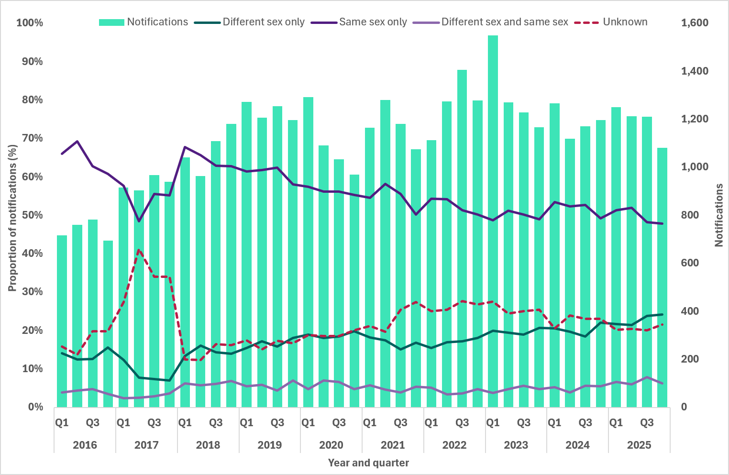

Indicators 2.7 – Reason for testing
2.7 Proportion of infectious syphilis notifications by reason for testing
Enhanced data field ‘reason for testing’ refers to the primary reason the notified case was tested for syphilis. It is acknowledged there can be more than one reason to test for syphilis, however the data captured reflects the principal reason and can be reported as either:
- clinical symptoms
- sexual contact of a person(s) with an STI (including contact tracing)
- screening associated with pregnancy.
- correctional service/justice health screening
- STI screening (including HIV PrEP STI screening and excluding contact tracing)
- confirmation of a reactive point of care test (PoCT)
- other reason.
Reason for testing data were available for: 4 jurisdictions in 2020 (excluding Queensland, Western Australia, Tasmania and the Northern Territory); 5 jurisdictions in 2021 to 2022 (excluding Western Australia, Tasmania and the Northern Territory); 6 jurisdictions in 2023 to 2024 (excluding Western Australia and the Northern Territory), and; 7 jurisdictions in 2025 (excluding the Northern Territory). Completeness for this enhanced data field fluctuated between 2020 and 2025, ranging from 65% to 82% (average 75%), noting the variations in jurisdictional reporting across the period.
In 2025, the most frequently reported primary reason for testing was presentation with clinical symptoms (36%) prompting a syphilis diagnostic test, higher compared to the 5 year mean (32%) and previous year (27%). STI screening (including HIV PrEP STI screening) was the second most frequently reported reason representing 32% of notifications in 2025, higher than the 5 year mean (31%) and previous year (27%) (Figure 14).
In 2025, among Aboriginal and Torres Strait Islander people, STI screening was the most frequently reported reason for testing (32%) similar to non-Indigenous people (33%). Across the other categories there were considerable variations when comparing Aboriginal and Torres Strait Islander people and non-Indigenous people, including testing in correctional/justice health screening (5% and <1% respectively), and presentation with clinical symptoms (28% and 37% respectively). Further analysis is underway to better understand these data and will be presented in future publications.
- Number of infectious syphilis notifications and proportion (%) of cases by primary reason for testing and year 2020 to 2025
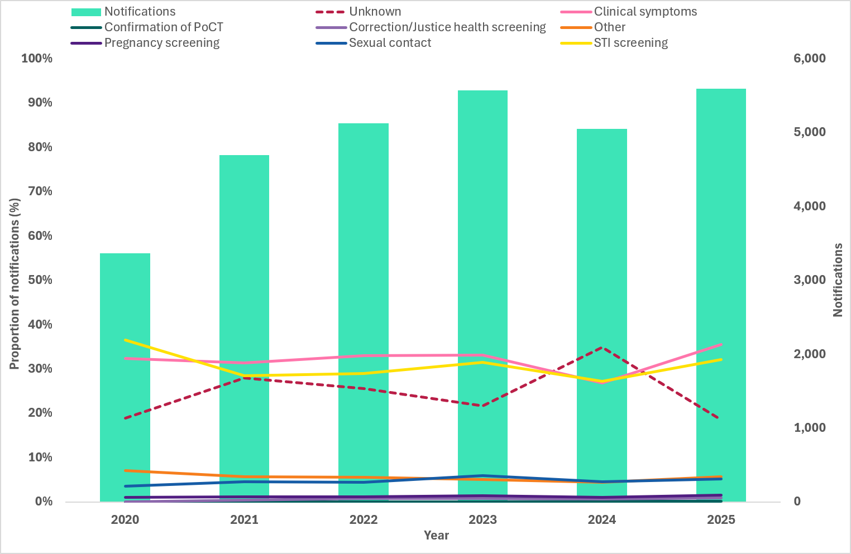

Indicators 2.8 – HIV PrEP
2.8 Proportion of infectious syphilis notifications in gay, bisexual, and other men who have sex with men reporting HIV PrEP use at time of syphilis diagnosis
HIV PrEP is a highly effective prevention strategy for people who may be at risk of HIV infection, including GBMSM (16). It is recommended that persons who are prescribed PrEP are followed up at least every 3 months, which includes testing for syphilis and other STIs (17).
Enhanced data fields ‘sexual exposure’ (see indicators 2.5 and 2.6) and ‘HIV PrEP use’ at time of syphilis diagnosis were used to report against this indicator. Sexual exposure in males reported as either person(s) of same sex only or person(s) of different sex AND person(s) of same sex were used as a proxy for GBMSM. These two categories of sexual exposure represented on average 60% of all syphilis notifications in males across the reporting period.
‘HIV PrEP use’ data were available for: 5 jurisdictions in 2022 (excluding Western Australia, Tasmania and the Northern Territory); 6 jurisdictions in 2023 to 2024 (excluding the Northern Territory and Western Australia), and; 7 jurisdictions in 2025 (excluding the Northern Territory). Completeness for this enhanced data field fluctuated between 2022 and 2025, ranging from 62% to 86% (average 76%), noting the variations in jurisdictional reporting across the period.
In 2025, 31% of GBMSM reported using HIV PrEP at the time of their syphilis diagnosis, declining marginally from 2024 (32%) and 2023 (33%) (Figure 15).

- Number of infectious syphilis notifications in males reporting sexual exposure with the same sex only or with different and same sex, and proportion (%) of cases by HIV PrEP use at diagnosis and year 2022 to 2025
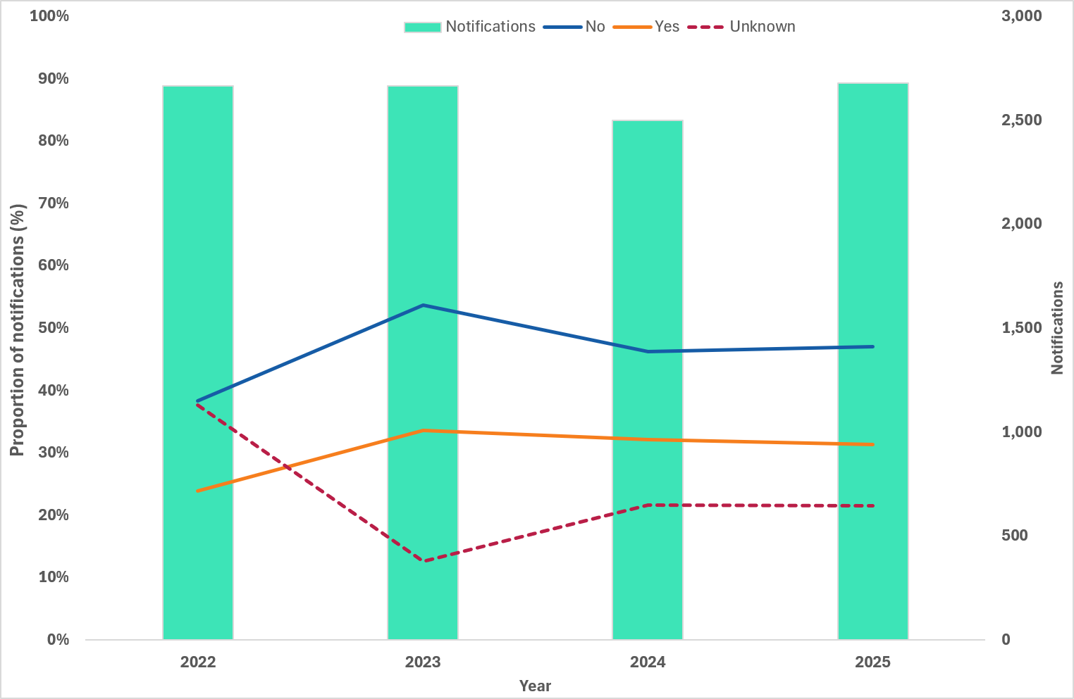

Indicators 2.9 – Place of diagnosis
2.9 Proportion of infectious syphilis notifications by clinical facility where the syphilis infection was diagnosed
‘Clinical facility type’ refers to the facility where the syphilis infection was diagnosed. These data have been collected since 2005, with new categories included from January 2024, with some jurisdictions providing data retrospectively. Data represented for the new categories pre-2024 (as noted in the list below) may under-represent notifications diagnosed in the specified facility.
Not all facilities listed are ‘clinical facilities’. The naming convention has been retained for this field to minimise confusion when reviewing this field retrospectively.

Clinical facility type of a notified case can be reported as either:
- Public hospital
- Private hospital
- Sexual health clinic
- Family planning clinic
- General practice
- Correctional service/Justice health (from 2024)
- Aboriginal health service (from 2024 – includes Aboriginal Community Controlled Health Services and other Aboriginal Health Services)
- Migration services (from 2024)
- Drug and alcohol services (from 2024)
- Online services (from 2024 – includes virtual health services that exclusively provide services online)
- Other
- Unknown
Data were available for all jurisdictions, with the exception of the Northern Territory, and with varying completeness across jurisdictions and reporting years. Completeness of the field between 2020 and 2025 ranged between 77% and 92% (average 85%).
In 2025, overall general practice was the most frequently reported setting for diagnosis of notified infectious syphilis cases (34%), lower than preceding years but consistent with historical trends (range 37% and 44%, average 40%) (Figure 16). This finding is consistent with known testing and treatment trends in Australia, with primary care settings the most common place for STI diagnosis (18). Sexual health clinics were the second most frequently reported setting overall in 2025 (28%), lower than 2024 and average (both 30%).
There is considerable variation in the setting where notified infectious syphilis cases were diagnosed, particularly when disaggregating the data by geographical area (for example, remoteness area) and Indigenous status. For example, in remote/very remote areas of Australia diagnosis in sexual health clinics represents only 5%, which is expected given the locality of such services are usually in town centres. Further analysis is underway to better understand these data and will be presented in future publications.

- Proportion (%) of infectious syphilis cases by clinical facility where infection was diagnosed and year 2020 to 2025
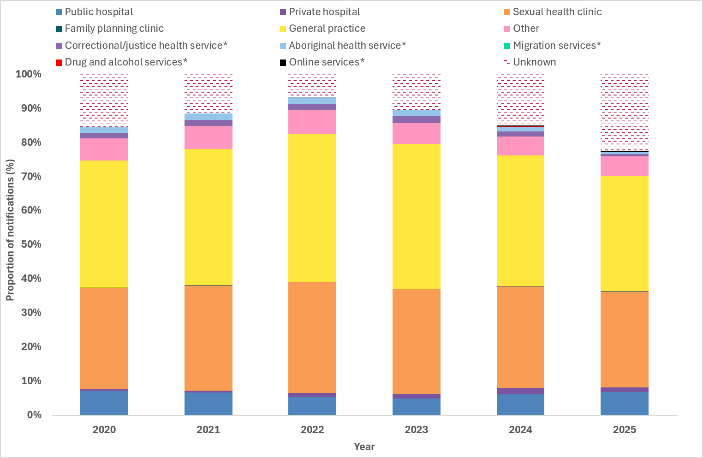

Indicators 2.10 – Time to treatment
2.10 Proportion of infectious syphilis notifications receiving treatment, by time to treatment
Time to treatment is calculated among a subset of infectious syphilis notifications where ‘treatment’ was recorded as ‘yes’ and a ‘date treatment commenced’ was reported. The time to treatment reflects the days/months difference between diagnosis date and the date treatment commenced. It is recommended that treatment for syphilis should be provided as soon as possible after diagnosis, particularly for infectious syphilis, and ideally within 2 days after diagnosis (19).
Treatment data were available for: 4 jurisdictions in 2020 (excluding Western Australia, Queensland, Tasmania and the Northern Territory); 5 jurisdictions in 2021 to 2022 (excluding Tasmania, Western Australia and the Northern Territory), 6 jurisdictions in 2023 to 2024 (excluding the Northern Territory and Western Australia), and; 7 jurisdictions in 2025 (excluding the Northern Territory). Completeness for the enhanced data field ‘treatment’ fluctuated between 2020 and 2025, ranging from 64% to 81% (average 70%), noting variations in jurisdictional reporting across the period.
In 2025, 69% of notified infectious syphilis cases reported receiving treatment for their infection, while 3% did not receive treatment and 28% has an unknown treatment status (Figure 17). Disaggregation by Indigenous status is not currently available for this indicator due to completeness for Aboriginal and Torres Strait Islander people being less than 50%.
Date treatment commenced, to calculate time to treatment, was available for 2025 only given poor completeness for previous years. Treatment date was available for 84% of cases reporting ‘yes’ to receiving treatment for a diagnosed syphilis infection in 2025. Of these cases, 9% received treatment on the day of diagnosis, 16% received treatment within 2 days, 55% within a week, 75% within 2 weeks and 90% within a month and 96% within 2 months (noting the proportions were cumulative). A small proportion (4%) were treated more than two months after the date of diagnosis. Overall, the median time to treatment was 7 days.
- Number of infectious syphilis notifications and proportion (%) of cases by treatment status and year 2020 to 2025
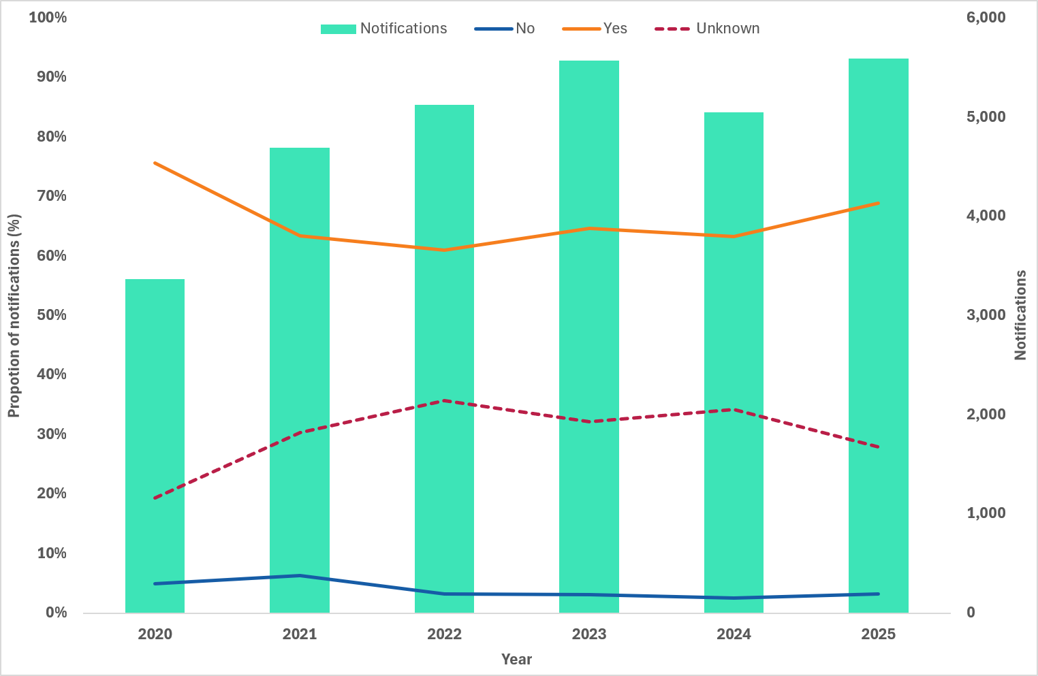

Goal 3: Reduce morbidity and mortality associated with syphilis
Key facts
Between 2020-24:
No deaths were reported due to early syphilis (A51)
11 deaths due to late syphilis (A52)
2 deaths due to unspecified syphilis (A53)
Late syphilis accounted for the most syphilis related hospital separations
Syphilis-related DALY were highest among males.
Death and hospitalisations data reported to the NNDSS are not used in reporting against this goal due to poor completeness and inconsistencies in reporting.
More comprehensive data are available through the Australian Bureau of Statistics (ABS) and the AIHW data collections. However, these data are less timely with at least a minimum 1 to 2-year delay from the reporting year.
Syphilis related deaths and hospitalisations are reported to the ABS and AIHW classified by the International Classification of Diseases (ICD), these codes are used globally to track and classify all health conditions, diseases, and causes of death (20). Syphilis is categorised across four ICD-10 codes: Congenital syphilis (A50), Early syphilis (A51), Late syphilis (A52) and Other and unspecified syphilis (A53).
The latest available data from the ABS and AIHW have been incorporated into this annual report.

Indicator 3.1 – Deaths
3.1 Number of syphilis related deaths (ICD-10 coded), by stage of infection
Over the past 5 years (2020-2024) no deaths were attributed to early syphilis (A51). Deaths due to late syphilis (A52) increased from 1 death in 2020 to 5 deaths in both 2021 and 2022 before declining to zero in 2023 and 2024. Two deaths were recorded as other and unspecified syphilis (A53) in 2023, with no deaths reported in all other years.
Data on congenital syphilis deaths are reported under Goal 4: Eliminate congenital syphilis.

Indicators 3.2 – Hospitalisations (all)
3.2 Number of hospitalisations with a principal diagnosis of syphilis (ICD-10 coded)
The National Hospitals data collection includes the major national hospitals databases held by the AIHW. Syphilis related hospitalisations are included in this collection under the Admitted Patient Care National Minimum Data Set (APC NMDS), this collection contains information about care provided to admitted patients in Australian hospitals. The number of hospitalisations are referred to as separations. A separation in these data represent the end of an episode of care of admitted patient care, where an episode of care can range from same-day to multiple days (21, 22). Data for this indicator are based on hospital separations; not unique individuals hospitalised. As a person may be admitted to hospital more than once during the reporting period, separation counts may exceed the number of people hospitalised.
Syphilis related hospital separations (A51, A52 and A53) increased from 273 in 2021–22 to 320 in 2022–23, and remained at this level in 2023–24. Late syphilis (A52) consistently accounted for most separations, while early syphilis (A51) showed a notable increase between 2019–20 to 2023–24 (35 and 62 respectively). Separations for other and unspecified syphilis (A53) remained relatively stable and represented a small proportion of all syphilis related hospitalisations. More detailed data can be found in the AIHW's Hospitals data downloads (23).

Indicators 3.3 – Disability-adjusted life years
3.3 Estimated number of Disability-adjusted life years (DALY) due to syphilis
The AIHW Australian Burden of Disease Study provides estimates for over 200 diseases and injuries in Australia. The summary measure ‘disability-adjusted life years’ (or DALY) measures the years of healthy life lost from death and illness. Syphilis is included in this study under the 'infectious diseases' disease group.
In 2024, syphilis-related DALY were highest among males, who accounted for 93% of the total syphilis-related burden. By age, the highest DALY were observed among men aged 60–69 years (26%), with a smaller secondary concentration among those aged 80–84 years (7%). Across all infectious diseases in the collection, syphilis accounted for 0.07% of total infectious diseases related DALY and ranked 16th highest (out of 36 diseases).
More detailed data on syphilis-related burden of disease can be found in the Australian Burden of Disease Study (24).

Goal 4: Eliminate congenital syphilis (defined as sustained zero congenital syphilis cases)
Key facts
In 2025:
14 cases of congenital syphilis were reported. Of those:
8 were non-Indigenous infants, including 3 who sadly died
6 were Aboriginal and Torres Strait Islander infants, including 4 who sadly died
11 women who gave birth to these infants were diagnosed with syphilis late in pregnancy and did not receive adequate treatment prior to delivery
17% of all women of reproductive age diagnosed with syphilis were pregnant.
Hospitalisations
Between 2019 and 2024:
Syphilis-related hospital separations increased among women of reproductive age
Hospital separations with a principal diagnosis of syphilis during pregnancy, childbirth and the puerperium fluctuated.

Indicators 4.1, 4.2 and 4.3 – Remoteness area and Indigenous status
4.1 Number of congenital syphilis cases by remoteness area and Indigenous status
4.2 Number of congenital syphilis related deaths by Indigenous status
4.3 Notification rate of congenital syphilis per 100,000 live births by remoteness area and Indigenous status
In 2025, 14 cases of congenital syphilis were reported. Of those:
- 8 were non-Indigenous infants – 7 from major cities of Australia, including 2 infants who died, and 1 from an inner/outer regional area who died.
- 6 were Aboriginal and Torres Strait Islander infants – 2 from major cities including 1 who died, 1 from an inner/outer regional area, and 3 from remote and very remote areas who all sadly died.
Between 2020 and 2025, 91 cases of congenital syphilis cases were notified. More than half (48/91, 53%) were reported in Aboriginal and Torres Strait Islander infants, 41 in non-Indigenous infants (41/91, 45%) and 2 cases with an unknown Indigenous status reported (2/91, 2%). Of the 91 cases reported, 33 infants died: 19 Aboriginal and Torres Strait Islander infants, 12 non-Indigenous infants, and 2 infants with an unknown Indigenous status (Figure 18).
- Notifications (number) and notification rate (per 100,000 live births) of congenital syphilis, by Indigenous status, remoteness area, and year, 2020 to 2025
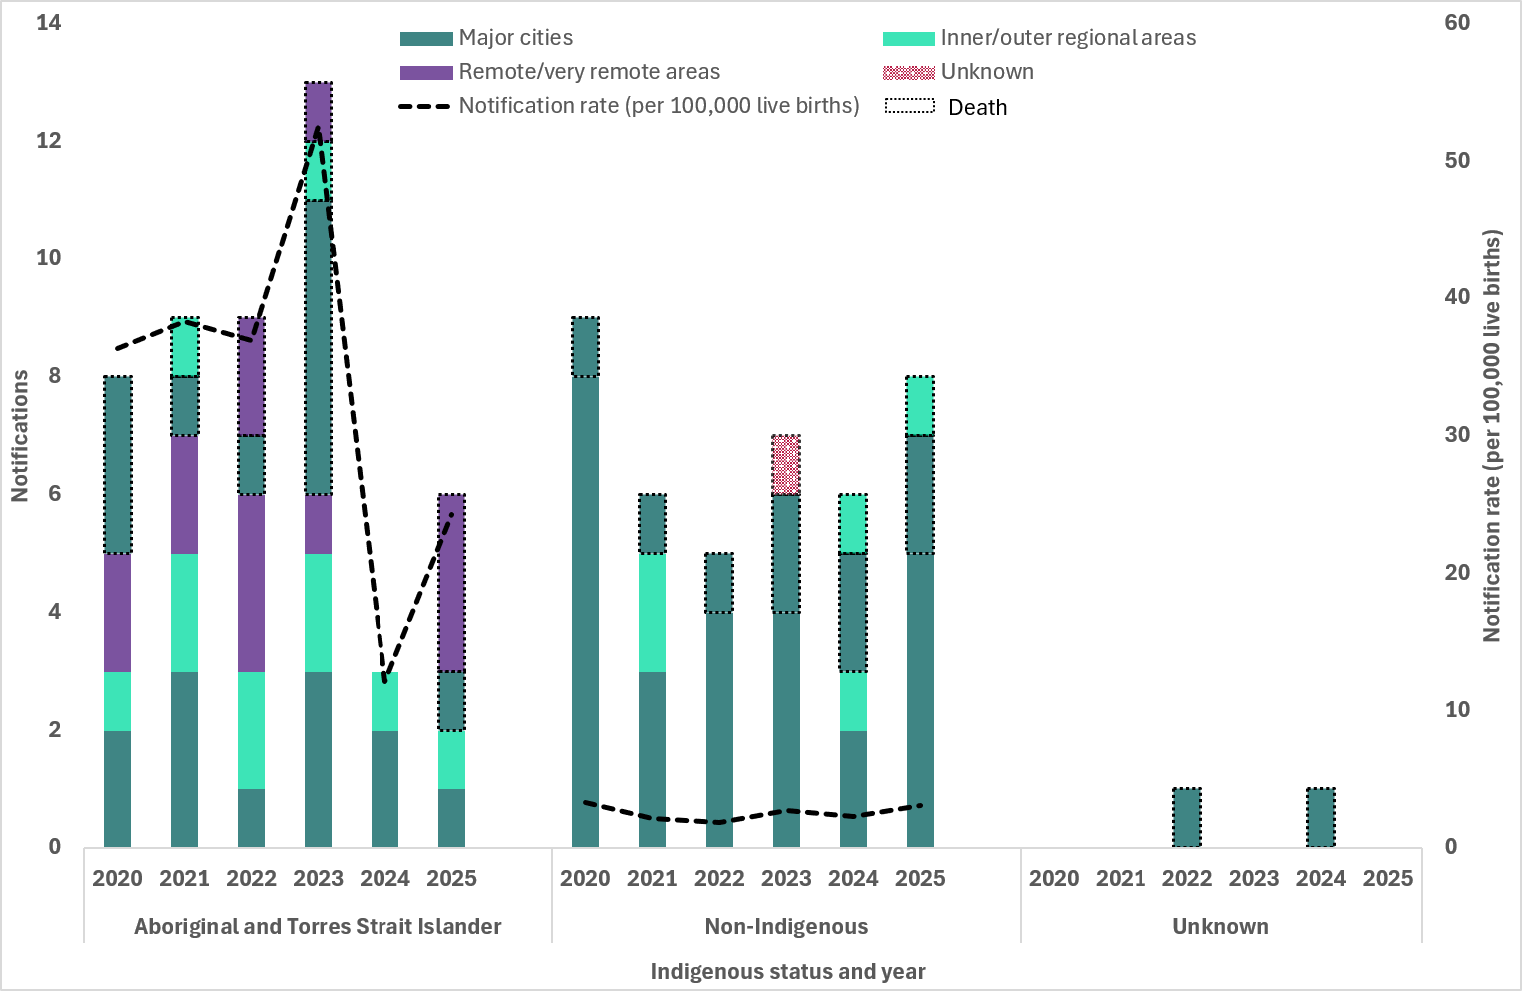

Indicator 4.4 – Women who were pregnant
4.4 Proportion of syphilis notifications among women of reproductive age (15 to 44 years) who were pregnant at time of diagnosis, by remoteness area and Indigenous status
Pregnancy data were available for: 6 jurisdictions in 2020 (excluding Victoria and the Northern Territory); 7 jurisdictions in 2021 to 2023 (excluding the Northern Territory); and 8 jurisdictions in 2024 and 2025.
Interpretation of these data are affected by high proportions of cases with an unknown pregnancy status and retrospective changes to the data, including differences with previous reports due to pregnancy status being reclassified and inclusion of new historical data from jurisdictions.
In 2025, 16% of all women of reproductive age, including those with an unknown Indigenous status, were reported to be pregnant at the time of their syphilis diagnosis, higher than 2024 and lower than the 5-year mean (14% and 17%, respectively) (Figure 19). In 2025, the proportion of women of reproductive age pregnant at syphilis diagnosis was higher among non-Indigenous women (18%) than Aboriginal and Torres Strait Islander women (12%) (Figure 20 a-b).
- Number of syphilis notifications among women of reproductive age (15 to 44 years) and proportion (%) of cases pregnant at time of syphilis diagnosis, 2020 to Q4 2025¹
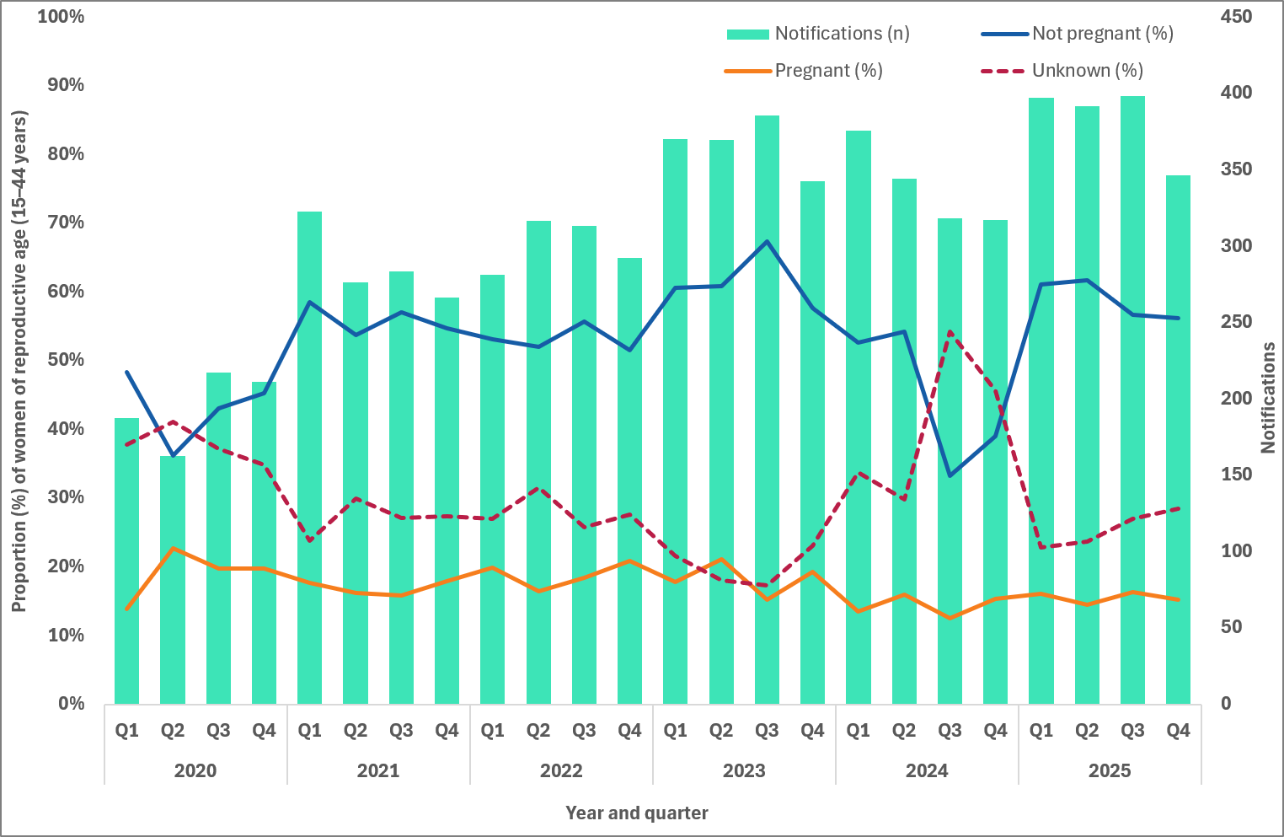
Note: 1. Excludes cases for whom sex and age were not reported.

- Number of syphilis notifications among women of reproductive age (15 to 44 years) and proportion (%) of cases pregnant at time of syphilis diagnosis, by Indigenous status, 2020 to Q4 20251 (a. non-Indigenous, b. Aboriginal and Torres Strait Islander)
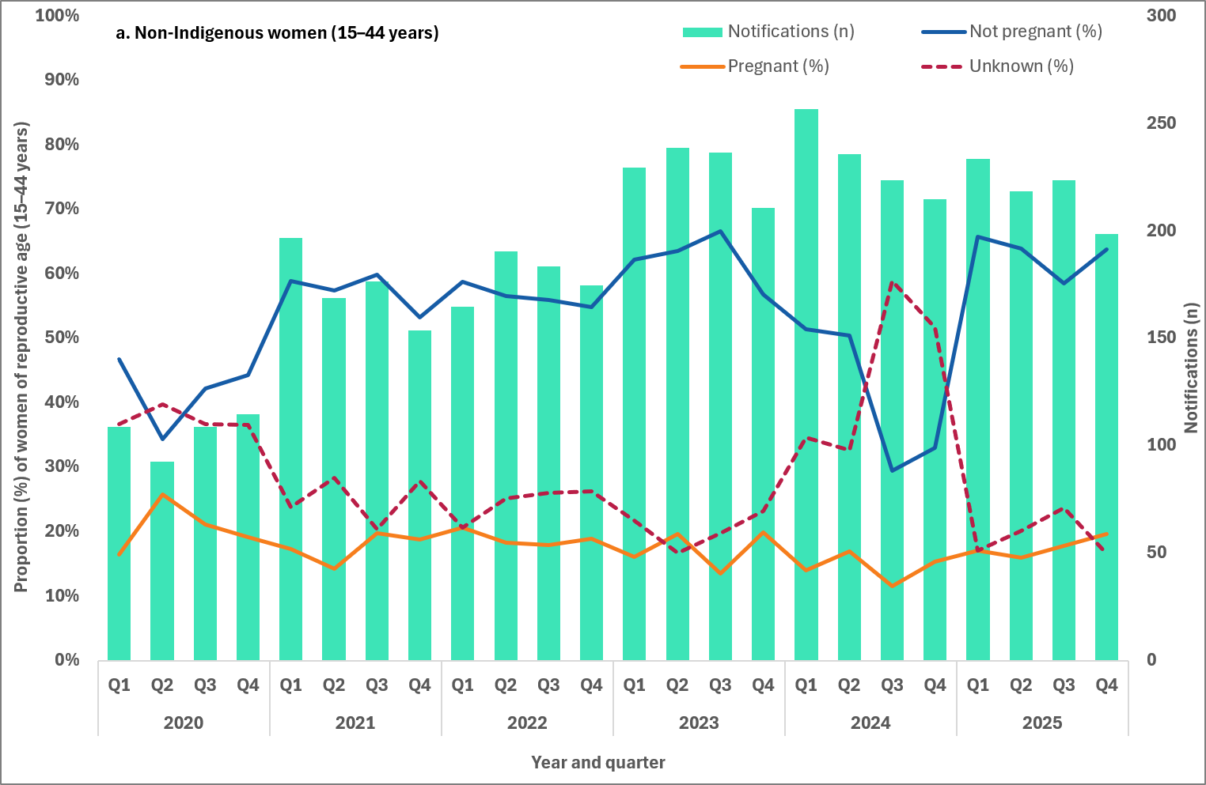
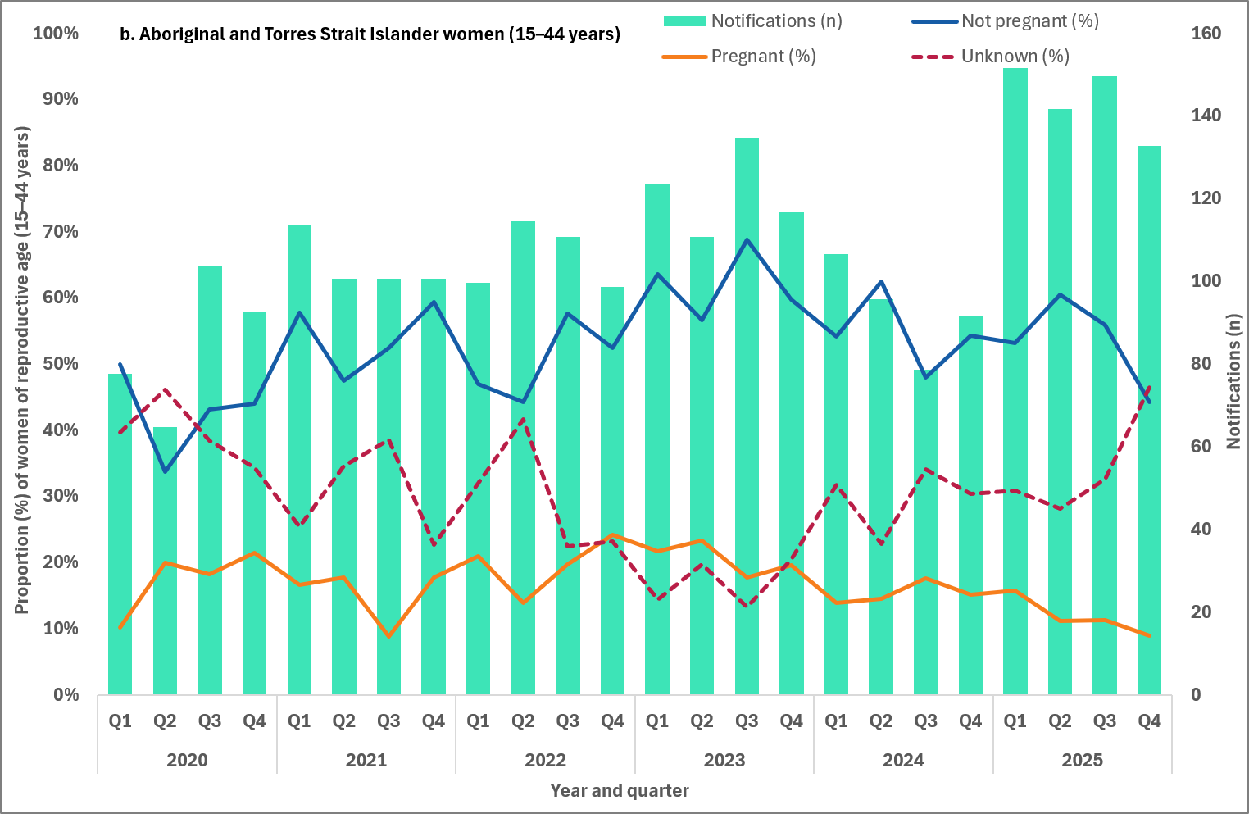
Note: 1. Excludes cases for whom sex, age and Indigenous status were not reported.

Indicator 4.5 – Late diagnosis
4.5 Number of women giving birth to an infant with congenital syphilis who were diagnosed with syphilis late in pregnancy by Indigenous status
Late diagnosis of syphilis in pregnancy refers to women who did not receive treatment more than 30 days prior to delivery. Late diagnosis also includes women who were diagnosed with syphilis at-birth (day of delivery) or post-birth and therefore could not receive adequate treatment for their syphilis infection.
Most women (81%, 74/91) giving birth to an infant with congenital syphilis between 2020 and 2025 were diagnosed late in pregnancy. Among non-Indigenous women this proportion was 85% (35/41), and Aboriginal and Torres Strait Islander women 77% (37/48) (Table 4).
- Table Number of women giving birth to an infant with congenital syphilis, by trimester mother was diagnosed with syphilis, 2020 to 2025
Stage of pregnancy | 2020 | 2021 | 2022 | 2023 | 2024 | 2025
Aboriginal and Torres Strait Islander women
First trimester | 0 | 0 | 0 | 0 | 1 | 0
Second trimester | 1 | 0 | 2 | 2 | 0 | 2
Third trimester | 0 | 2 | 1 | 4 | 0 | 2
At birth | 4 | 4 | 3 | 4 | 1 | 0
Post birth | 3 | 3 | 0 | 3 | 1 | 2
Unknown | 0 | 0 | 3 | 0 | 0 | 0
Late diagnosis | 7 | 9 | 4 | 11 | 2 | 4
Total | 8 | 9 | 9 | 13 | 3 | 6
Non-Indigenous women
First trimester | 0 | 0 | 0 | 0 | 0 | 0
Second trimester | 0 | 0 | 1 | 3 | 0 | 1
Third trimester | 2 | 1 | 1 | 0 | 1 | 0
At birth | 2 | 1 | 1 | 1 | 1 | 3
Post birth | 5 | 4 | 2 | 3 | 4 | 4
Unknown | 0 | 0 | 0 | 0 | 0 | 0
Late diagnosis | 8 | 6 | 4 | 4 | 6 | 7
Total | 9 | 6 | 5 | 7 | 6 | 8
Total women1
First trimester | 0 | 0 | 0 | 0 | 1 | 0
Second trimester | 1 | 0 | 3 | 5 | 0 | 3
Third trimester | 2 | 3 | 2 | 4 | 1 | 2
At birth | 6 | 5 | 4 | 5 | 2 | 3
Post birth | 8 | 7 | 3 | 6 | 6 | 6
Unknown | 0 | 0 | 3 | 0 | 0 | 0
Late diagnosis | 14 | 12 | 7 | 11 | 8 | 9
Total | 17 | 15 | 15 | 20 | 10 | 14
Note: 1 Includes cases with unknown Indigenous status.

Indicator 4.6 – Adequate treatment
4.6 Proportion of women giving birth to an infant with congenital syphilis receiving adequate treatment prior to delivery
Treatment is considered adequate if a stage-appropriate penicillin-containing regimen is administered 30 days or more prior to delivery, and all antenatal and delivery pathology were performed and results verified with no evidence of reinfection.
Maternal treatment of syphilis was reported for 93% (85/91) of women giving birth to an infant with congenital syphilis between 2020 and 2025. Of these women, 96% (82/85) did not receive adequate treatment prior to delivery (Figure 21). This includes 56 women who were diagnosed at-birth (day of delivery) and post-birth, and 13 women who were diagnosed in the third trimester (fewer than 30 days prior to delivery). Of the remaining cases, 10 were diagnosed in the 2nd trimester and 3 had an unknown trimester of diagnosis.
Of the 82 women who did not receive adequate treatment prior to delivery one-third (37%, 30/82) of these pregnancies resulted in a congenital syphilis foetal death (still-birth or following birth). Thirty-three per cent (33%, 27/82) gave birth to a live-born infant with a range of clinical symptoms associated with congenital syphilis including bone abnormalities, damage to spleen and/or liver, anaemia, hearing loss, jaundice and sepsis.
Eight women gave birth to infants (10%, 8/82) with congenital syphilis who were diagnosed in the weeks and months following their birth. Where additional information were available, the reason for the later diagnosis were reported as:
- the infant not being investigated at birth as they were clinically well
- the mother being diagnosed with syphilis post-birth
- the infant presenting with symptoms post-birth.
The remaining 17 women gave birth to infants (21%, 17/82) with congenital syphilis who were live-born with no congenital syphilis symptoms.
- Adequate maternal treatment among women giving birth to an infant with congenital syphilis, 2020 to 2025
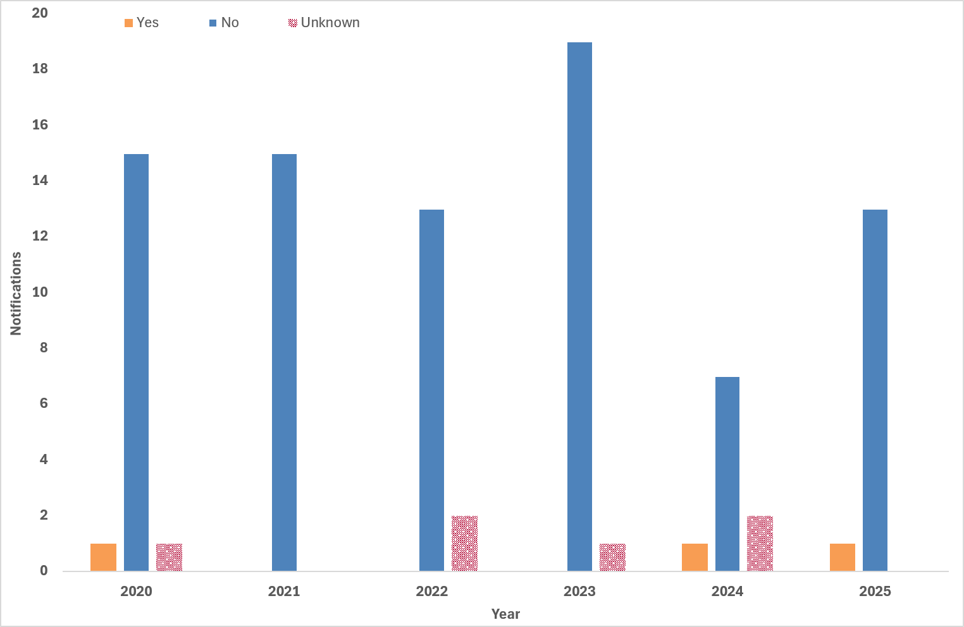

Indicator 4.7 – Testing during pregnancy
4.7 Number of women giving birth to an infant with congenital syphilis by number of syphilis tests received during their pregnancy
Maternal syphilis testing history was reported for 97% (88/91) of women giving birth to an infant with congenital syphilis between 2020 and 2025 (Figure 22). Of those women, 65% (57/88) did not report a previous syphilis test during their current pregnancy prior to being diagnosed with infectious syphilis. Thirty per cent (30%) of cases (26/88) reported at least one previous syphilis test and 1 case reported having 2 tests during their current pregnancy. Only 1 woman reported having 3 or more tests during their current pregnancy as recommended in national and jurisdictional guidelines (25-32).The remaining 3 cases reported a previous test during their current pregnancy, but the number of tests was unknown.

- Maternal syphilis testing history during pregnancy among women giving birth to an infant with congenital syphilis, by stage of pregnancy at syphilis diagnosis, 2020 to 2025
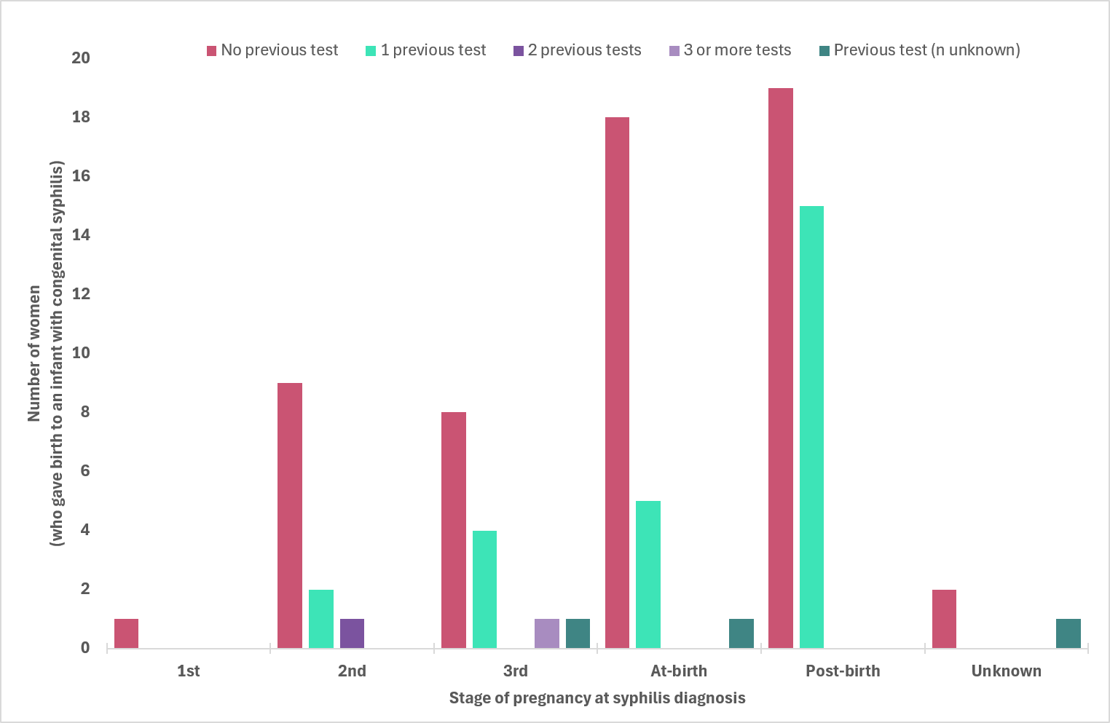

Indicator 4.8 – Reinfection during pregnancy
4.8 Number of women giving birth to an infant with congenital syphilis reinfected during their pregnancy
Reinfection is generally diagnosed on the basis of changes in Rapid Plasma Reagin (RPR) titre. A four-fold or two-titre rise in RPR – for example, 1 in 2 to 1 in 8 – following previous adequate treatment is considered a re-infection.
Maternal reinfection data were available for 96% (87/91) of women giving birth to an infant with congenital syphilis between 2020 and 2025, either:
- during the current pregnancy (that is, the pregnancy when the maternal notification was made)
- before the current pregnancy.
Of the 87 women with data available, 4 (5%, 4/87) reported being diagnosed with a previous syphilis infection during the current or a previous pregnancy. Historical infection with syphilis was reported for 5 women (6%, 5/87), 4 were not pregnant at diagnosis and 1 for whom it was unknown if they were pregnant at diagnosis. The remaining 78 cases (90%, 78/87) did not report a previous syphilis infection prior to the current diagnosis.

Indicator 4.9 – Hospitalised (women of reproductive age)
4.9 Number of women of reproductive age (15–44 years) hospitalised with a principal diagnosis of syphilis (ICD-10 coded)
Refer to Goal 3: Reduce morbidity and mortality associated with syphilis for details on categorisation of syphilis-related hospital separations.
Syphilis related hospital separations (A51, A52 and A53) among women of reproductive age (15-44 years), increased from 29 episodes in 2019–20 to 35 and 36 in 2021–22 and 2022–23 respectively before increasing again to 57 in 2023–24. The increase across this entire time period was reported in separations for both early syphilis (A51), which increased from 6 to 15 between 2019–20 and 2023–24, and late syphilis (A52), which increased from 8 to 32 over the same period. Late syphilis (A52) accounted for the largest proportion of separations in 2023–24 (56%), while hospitalisations for early (A51) and other and unspecified syphilis (A53) remained comparatively low, 15 and 10 episodes, respectively. More detailed data can be found in the AIHW's Hospitals data downloads (23).

Indicator 4.10 – Hospitalisation during pregnancy
4.10 Number of people hospitalised with a principal diagnosis of syphilis in pregnancy, childbirth and puerperium (ICD-10 coded)
Refer to Goal 3: Reduce morbidity and mortality associated with syphilis for details on hospital separations.
The number of hospital separations with a principal diagnosis of syphilis during pregnancy, childbirth and the puerperium (O98.1) fluctuated between 2019–20 and 2023–24, declining from 25 separations in 2019–20 to 15 in 2020–21 before increasing to 36 in 2022–23. Separations decreased slightly to 30 in 2023–24 yet remained higher than levels observed at the start of this period. More detailed data can be found in the AIHW's Hospitals data downloads(23).

Notes

Methodological notes
Syphilis notification and enhanced data were extracted from the NNDSS on 15 July 2026, by diagnosis date. Due to the dynamic nature of the NNDSS, data in this extract are subject to retrospective revision and may vary from data reported in published NNDSS reports and reports of notification data by states and territories. Data are to 31 December 2025 unless otherwise specified.
In general, notification data represent only a proportion of the total cases occurring in the community, that is, only those cases for which health care was sought, a test conducted, and a diagnosis made, followed by a notification to health authorities. The degree of under-representation of all cases is unknown and is most likely variable by disease and jurisdiction.
Changes in notifications over time may not solely reflect changes in disease prevalence or incidence. Changes in testing policies; screening programs including the preferential testing of high-risk populations; the use of less invasive and more sensitive diagnostic tests; and periodic awareness campaigns, may influence the number of notifications that occur annually.

Data elements
- ‘Diagnosis year’ was used to define the period of analysis. This date represents either the onset date or where the date of onset was not known, the earliest of the specimen collection date, the notification date, or the notification received date.
- ‘Residential postcode’ usually reflects the residential location of a case at the time of testing and does not necessarily represent the place where the disease was acquired.
- ‘Residential postcode’ reported to the NNDSS was used to allocate notifications of infectious and congenital syphilis to remoteness areas and mapped data by Statistical Area 3 (SA3) (as defined by the ABS). Where a postcode was not reported the notification was excluded from remoteness area, SA3 and IARE analysis.
- The ‘population denominator’ used to calculate notification rates, including for remoteness areas, SA3 and IARE (per 100,000 population) was extracted from the ABS Census Table Builder (based on 2021 Census data).
- The determination of the Indigenous status is by descent, self-identification, and community acceptance. Completeness of the Indigenous status field is generally high, with variations from year to year and jurisdiction to jurisdiction.
- ‘Syphilis testing data’ have been provided by participating ACCHS. A participating service refers to clinics currently funded by the Australian Centre for Disease Control to deliver point of care testing in syphilis outbreak regions. Services extract data from local clinical information management systems. Data are provided for the reporting quarter, and cumulatively for the previous 12 months. ‘Testing coverage’ is calculated using as the denominator ‘clients attending the service’ (a participating ACCHS) during the reporting period.
- The NPDC collates data on pregnancy and childbirth. The data are based on births reported to the perinatal data collection in each state and territory in Australia. Midwives and other birth attendants, using information obtained from mothers and from hospital or other records, complete notification forms for each birth. A standard de-identified extract is provided to the AIHW on an annual basis to form the NPDC.
- The APC NMDS collects information about care provided to admitted patients in Australian hospitals. The scope of the APC NMDS is episodes of care for admitted patients in all public and private acute and psychiatric hospitals, free standing day hospital facilities and alcohol and drug treatment centres in Australia. Hospitals operated by the Australian Defence Force, corrections authorities and in Australia's off-shore territories may also be included.
- General methods for estimation of burden of disease can be found in the Australian Burden of Disease Study: Methods and supplementary material 2018, About - Australian Institute of Health and Welfare. This includes descriptions for DALYs.
- ABS Cause of Death data include all deaths that occurred and were registered in Australia, including deaths of persons whose usual residence was overseas. Deaths of Australian residents that occurred outside Australia may be registered by individual registries but are not included in ABS deaths or causes of death statistics.

Case definitions
The CDNA national surveillance case definitions for infectious and congenital syphilis, including any historical edits, are available at: https://www.cdc.gov.au/resources/collections/cdna-surveillance-case-definitions

Acknowledgements
We, the Australian Centre for Disease Control, acknowledge the Traditional Owners and Custodians of Country throughout Australia. We recognise the strength and resilience of Aboriginal and Torres Strait Islander people and acknowledge and respect their continuing connections and relationships to country, rivers, land and sea. We acknowledge the ongoing contribution Aboriginal and Torres Strait Islander people make across the Health system and wider community. We also pay our respects to Elders past, present and future and extend that respect to all Traditional Custodians of this land.
The Australian Centre for Disease Control acknowledges the Communicable Diseases Network Australia; the work of public health officers involved in the collection of surveillance data; state and territory public health communicable disease surveillance managers and data managers; Aboriginal Community Controlled Health Services, and; all public and private laboratories that support laboratory surveillance in Australia.

Contact
For any further details about information contained in this report please contact
Ms Amy Bright by emailing syphilis.surveillance@cdc.gov.au.

Appendix A – Goals and indicators reporting schedule
Indicator number | Indicator | Reporting
Goal 1 – Strengthen prevention and testing strategies for syphilis in priority populations and settings, targeting high-burden areas
1.1 | Reported risk factors for people giving birth to an infant with congenital syphilis | Annually
1.2 | Cumulative number of syphilis tests delivered through participating ACCHS, by target and total population | Quarterly
1.3 | Proportion of people attending participating ACCHS receiving a syphilis test within the previous 12 months, by target and total population (syphilis testing coverage) | Quarterly
1.4 | Proportion of people from priority populations tested for syphilis in the previous 12 months attending a site within the ACCESS network | Annually
1.5 | Proportion of gay and bisexual men who have sex with men who have been tested for syphilis three or more times in the previous 12 months attending a site within the ACCESS network | Annually
1.6 | Proportion of women who gave birth, by duration of pregnancy at first antenatal visit | Annually
1.7 | Proportion of women who gave birth, by duration of pregnancy at first antenatal visit, by remoteness area | Annually
1.8 | Proportion of women who gave birth, by number of antenatal visits | Annually
1.9 | Proportion of women who gave birth, by number of antenatal visits, by remoteness area | Annually
1.10 | Proportion of women who gave birth, by country of birth | Annually
Goal 2 – Reduce ongoing transmission and incidence of syphilis across priority populations
2.1 | Notification rate of infectious syphilis by Indigenous status, sex, age and remoteness area classification | Quarterly
2.2 | Notification rate of infectious syphilis in Aboriginal and Torres Strait Islander people by Indigenous Areas (IAREs) | Quarterly
2.3 | Notification rate of infectious syphilis by Statistical Area 3 (SA3), by Indigenous status | Quarterly
2.4 | Notification rate of infectious syphilis in women of reproductive age (15 to 44 years) by Indigenous status and remoteness area | Quarterly
2.5 | Proportion of infectious syphilis notifications in men reporting sexual exposure with men only | Quarterly
2.6 | Proportion of infectious syphilis notifications in men reporting sexual exposure with men and women | Quarterly
2.7 | Proportion of infectious syphilis notifications by primary reason for testing | Annually
2.8 | Proportion of infectious syphilis notifications in gay and bisexual men who have sex with men reporting HIV PrEP use at time of syphilis diagnosis | Annually
2.9 | Proportion of infectious syphilis notifications by clinical facility where the syphilis infection was diagnosed | Annually
2.10 | Proportion of infectious syphilis notifications receiving treatment, by time to treatment | Annually
Goal 3 – Reduce morbidity and mortality associated with syphilis
3.1 | Number of syphilis related deaths (ICD-10 coded), by stage of infection | Annually
3.2 | Number of hospitalisations with a principal diagnosis of syphilis (ICD-10 coded) | Annually
3.3 | Estimated number of disability-adjusted life years (DALY) due to syphilis | Annually
Goal 4 – Eliminate congenital syphilis (defined as sustained zero congenital syphilis cases)
4.1 | Number of congenital syphilis cases by remoteness area and Indigenous status | Quarterly
4.2 | Number of congenital syphilis related deaths by Indigenous status | Quarterly
4.3 | Notification rate of congenital syphilis per 100,000 live births by remoteness area and Indigenous status | Quarterly
4.4 | Proportion of syphilis notifications among women of reproductive age (15 to 44 years) who were pregnant at time of diagnosis, by remoteness area classification and Indigenous status | Quarterly
4.5 | Number of women giving birth to an infant with congenital syphilis who were diagnosed with syphilis ‘late’ in pregnancy by Indigenous status | Quarterly
4.6 | Proportion of women giving birth to an infant with congenital syphilis receiving adequate treatment prior to delivery | Quarterly
4.7 | Number of women giving birth to an infant with congenital syphilis by number of syphilis tests received during their pregnancy | Quarterly
4.8 | Number of women giving birth to an infant with congenital syphilis reinfected during their pregnancy | Quarterly
4.9 | Number of women of reproductive age (15 to 44 years) hospitalised with a principal diagnosis of syphilis (ICD-10 coded) | Annually
4.10 | Number of women hospitalised with a principal diagnosis of syphilis in pregnancy, childbirth and puerperium (ICD-10 coded) | Annually

Appendix B – NNDSS syphilis notification and enhanced data completeness by year, 2020 to 2025
Variable1 | 2020 | 2021 | 2022 | 2023 | 2024 | 2025
Indigenous status
Infectious syphilis | 96% | 95% | 92% | 94% | 95% | 95%
Congenital syphilis | 100% | 100% | 93% | 100% | 90% | 100%
Residential location (to map to reported geographies)
Remoteness area | 98% | 97% | 97% | 97% | 97% | 97%
Statistical area 3 | n/a | n/a | n/a | n/a | n/a | 97%
Indigenous areas2 | n/a | n/a | n/a | n/a | n/a | 98%
Enhanced infectious syphilis
Pregnancy status | 62%3 | 73%4 | 72%4 | 80%4 | 60%4 | 74%5
Sexual exposure (males) | 81% | 77% | 74% | 77% | 79% | 77%
Primary reason for testing | 81%6 | 72%7 | 74%7 | 78%3 | 65%3 | 82%4
HIV PrEP use (males, sexual exposure) | n/a | n/a | 62%7 | 87%3 | 78%3 | 78%4
Clinical facility type | 84%4 | 87%4 | 92%4 | 89%4 | 84%4 | 77%4
Treatment (time to treatment) | 81%6 (n/a) | 70%7 (n/a) | 64%7 (n/a) | 68%3 (n/a) | 66%3 (n/a) | 72%4 (84%)
Enhanced congenital syphilis
Stage of pregnancy | 100% | 100% | 80% | 100% | 100% | 100%
Treatment prior to delivery | 94% | 100% | 87% | 95% | 80% | 100%
Testing history | 100% | 100% | 100% | 95% | 90% | 93%
Re-infection (current pregnancy) | 88% | 73% | 100% | 65% | 80% | 86%
Notes:
- Where completeness is less than 50%, data has been excluded.
- Aboriginal and Torres Strait Islander people only.
- Includes 6 jurisdictions.
- Includes 7 jurisdictions.
- Includes all states and territories.
- Includes 4 jurisdictions.
- Includes 5 jurisdictions.

References
1. Penman SV, Beatson RM, Walker EH, Goldfeld S, Molloy CS. Barriers to accessing and receiving antenatal care: Findings from interviews with Australian women experiencing disadvantage. Journal of Advanced Nursing. 2023;79(12):4672-86.
2. Vasilevski V, Graham K, McKay F, Dunn M, Wright M, Radelaar E, et al. Barriers and enablers to antenatal care attendance for women referred to social work services in a Victorian regional hospital: A qualitative descriptive study. Women and Birth. 2024;37(2):443-50.
3. Neely E, Dixon L, Bartle C, Raven B, Aspin C. Providing maternity care for disadvantaged women in Aotearoa New Zealand: The impact on midwives. Women Birth. 2022;35(2):144-51.
4. Cunnington S, Mims C, Barbeau R, Booker S, Abiado MA, Robinson G, et al. Lessons learned from a sustained mobile prenatal care delivery program: results from a mixed-methods evaluation to understand appointment attendance and patient satisfaction. BMC Pregnancy and Childbirth. 2026;26(1):610.
5. Doherty EA, Griffin S, Cartmell KB, Heo M, Chen L, Britt JL, et al. Patient Characteristics Associated With Group Prenatal Care Attendance in a Randomized Controlled Trial. Women's Health Issues. 2026;36(2):151-62.
6. Equity Economics. Blueprint for the Future: Evaluation of NACCHO’s Role under the Enhanced Syphilis Response. A Report prepared for the National Aboriginal Community Controlled Health Organisation (NACCHO). 2021.
7. National Syphilis Surveillance Quarterly Report (Quarter 4: 1 October - 31 December 2024). 2025.
8. Australian Living Evidence Collaboration. Australian Pregnancy Care Guidelines (version 10.1) 2026 [Available from: https://app.magicapp.org/?language=ms#/guideline/jm83RE.
9. Australian Institute of Health and Welfare. Australia's mothers and babies 2026 [Available from: https://www.aihw.gov.au/reports/mothers-babies/australias-mothers-babies/contents/antenatal-period/antenatal-visits.
10. Australian Institute of Health and Welfare. Australia's mothers and babies: maternal country of birth 2026 [Available from: https://www.aihw.gov.au/reports/mothers-babies/australias-mothers-babies/contents/overview-and-demographics/maternal-country-of-birth.
11. NT Health. Public health alert: syphilis - ongoing high transmission: NT Health Centre for Disease Control; 2026 [Available from: https://health.nt.gov.au/__data/assets/pdf_file/0009/1592199/health-alert-syphilis-update-11.02.2026.pdf.
12. Australian Institute of Health and Welfare. Aboriginal and Torres Strait Islander Health Performance Framework: summary report. AIHW: Australian Government; 2025.
13. Australian Statistical Geography Standard (ASGS) Edition 3: Indigenous Structure: Australian Bureau of Statistics; 2021 [Available from: https://www.abs.gov.au/statistics/standards/australian-statistical-geography-standard-asgs-edition-3/jul2021-jun2026/indigenous-structure.
14. Taouk M, Taiaroa G, Pasricha S, Herman S, Chow E, Azzatto F, et al. Characterisation of Treponema pallidum lineages within the contemporary syphilis outbreak in Australia: a genomic epidemiological analysis. The Lancet Microbe. 2022;3(6):e417 - e26.
15. Williamson D, Chow E, Gorrie C, Seemann T, Ingle D, Higgins N, et al. Bridging of Neisseria gonorrhoeae lineages across sexual networks in the HIV pre-exposure prophylaxis era. Nature Communications. 2019;10.
16. World Health Organization. HIV and AIDS (fact sheet) 2026 [Available from: https://www.who.int/news-room/fact-sheets/detail/hiv-aids.
17. ASHM Health National PrEP Guidelines Update. Prevent HIV by prescribing PrEP 2025 [Available from: https://hiv.guidelines.org.au/wp-content/uploads/2026/01/ASHM-PrEP-guidelines-2025_FINAL.pdf.
18. Ong J, Bourne C, Dean J, Ryder N, Cornelisse V, Murray S, et al. Australian sexually transmitted infection (STI) management guidelines for use in primary care 2022 update. Sexual Health. 2023;20(1).
19. Australian STI management guidelines for use in primary care: syphilis [Available from: https://sti.guidelines.org.au/sexually-transmissible-infections/syphilis/.
20. World Health Organization. International Classification of Diseases 11th Revision 2024 [Available from: https://www.who.int/standards/classifications/classification-of-diseases.
21. Australian Institute of Health and Welfare. METEOR (metadata online registry): separation [Available from: https://meteor.aihw.gov.au/content/327268.
22. Australian Institute of Health and Welfare. National Hospitals data collection [Available from: https://www.aihw.gov.au/about-our-data/our-data-collections/national-hospitals-data-collection.
23. Australian Institute of Health and Welfare. Hospitals: data downloads [Available from: https://www.aihw.gov.au/hospitals/latest-updates-and-downloads/data.
24. Australian Institute of Health and Welfare. Australian Burden of Disease Study 2024 2024 [Available from: https://www.aihw.gov.au/reports/burden-of-disease/australian-burden-of-disease-study-2024/data.
25. Syphilis – CDNA National Guidelines for Public Health Units [Available from: https://www.health.gov.au/resources/publications/syphilis-cdna-national-guidelines-for-public-health-units?language=en.
26. Queensland clinical guidelines. Translating evidence into best clinical practice - Syphilis and pregnancy (Qld Health): Queensland Health; 2025 [Available from: https://www.health.qld.gov.au/__data/assets/pdf_file/0035/736883/g-sip.pdf.
27. Statewide Maternity Shared Care Guidelines (WA Health): Government of Western Australia North Metropolitan Health Service Women and Newborn Health Service; 2021 [Available from: https://kemh.health.wa.gov.au/~/media/HSPs/NMHS/Hospitals/WNHS/Documents/Clinical-guidelines/Statewide-Maternity-Shared-Care-Guidelines.pdf.
28. South Australian Perinatal Practice Guideline. Syphilis in pregnancy and the neonate PPG015 (SA Health) 2025 [Available from: https://www.sahealth.sa.gov.au/wps/wcm/connect/4f3188804eedeac1b604b76a7ac0d6e4/Syphilis+in+pregnancy+and+the+neonate+PPG+v_5_0_.pdf?MOD=AJPERES&CACHEID=ROOTWORKSPACE-4f3188804eedeac1b604b76a7ac0d6e4-ph8fmcZ.
29. Syphilis testing during pregnancy (Safer Care Victoria) 2025 [Available from: https://www.safercare.vic.gov.au/best-practice-improvement/clinical-guidance/maternity/syphilis-testing-during-pregnancy.
30. Three syphilis tests are now recommended in every pregnancy to prevent congenital syphilis (Tas. Health) 2025 [Available from: https://www.health.tas.gov.au/news/articles/three-syphilis-tests-are-now-recommended-every-pregnancy-prevent-congenital-syphilis.
31. Congenital syphilis guidelines for the Northern Territory (NT Health) 2015 [Available from: https://digitallibrary.health.nt.gov.au/nthealthserver/api/core/bitstreams/77f72074-3e47-4697-9b80-63b3f5fd5630/content.
32. Public health clinical alert. Syphilis and mpox: Information for ACT clinicians (ACT Health) 2024 [Available from: https://www.act.gov.au/__data/assets/pdf_file/0009/2629926/Mpox-and-syphilis-clinician-alert.pdf.



Does not add up to 100% due to rounding.

