Diphtheria in Australia – Epidemiological update
  - As at 5 October 2026

Data extracted from NNDSS: 6 October 2026
Latest diagnosis date: 5 October 2026
Due to the dynamic nature of the National Notifiable Diseases Surveillance System (NNDSS) and case investigations, data in this report are subject to retrospective revision and may vary from data reported in other national reports and reports by states and territories. Case definitions for the diseases included in this report are available on the Australian Centre for Disease Control website (https://www.cdc.gov.au/resources/collections/cdna-surveillance-case-definitions).

Background
- Diphtheria is an acute illness caused by toxin producing strains of Corynebacterium diphtheriae and Corynebacterium ulcerans. Infection may lead to two different clinical outcomes: respiratory disease or cutaneous (skin) disease.
- In the early 1900s, diphtheria caused more deaths in Australia than any other infectious disease. Since the implementation of vaccination programs in the 1940s, the incidence of diphtheria has declined in Australia, and globally. Although diphtheria is considered rare in Australia, it remains endemic in many developing countries.
- Prior to the COVID-19 pandemic, most Australian cases were imported from overseas, with a high proportion of these cases reported as cutaneous diphtheria. Between 1999 and 2019, cutaneous and respiratory diphtheria occurred mostly among adults. During this period there were 2 deaths reported in unvaccinated adults who both acquired their infections in Australia.
- Between 2020 and 2022, there were 4 localised diphtheria clusters, each in a different geographical area of North Queensland, and involving a high proportion of cutaneous cases and several respiratory cases.
- The Australian Immunisation Handbook recommends diphtheria-toxoid vaccine for: routine vaccination in infants, children and adolescents; routine booster vaccination in adults, including those in special risk groups such as pregnant women, laboratory workers, and travellers to countries where health services are difficult to access. Vaccination is recommended every 10 years for travellers to countries where health services are difficult to access. Travellers to some areas where there is a higher risk of acquiring diphtheria are recommended to be vaccinated every 5 years.
For further information please refer to the Australian CDC Diphtheria page.

Key summary points
- A total of 612 cases of diphtheria have been notified in Australia in 2026, including one probable case.
- Nationally, while cases remain below the peak observed between late May and early June, notifications have fluctuated in recent weeks and trends continue to vary across affected jurisdictions. Cases in the Northern Territory have generally declined following a peak in May. In Western Australia, while case numbers remain below the peak observed in June, notifications were elevated in mid-September. In South Australia, case numbers have remained low, with sporadic notifications reported since March, predominantly in the northern areas of the state.
- In the past fortnight, 5 cases were notified, compared with 35 cases in the previous fortnight. Among cases notified this fortnight (n=5):
  - Three cases were notified in the Northern Territory and two cases in Western Australia.
  - Diagnosis dates were from mid to late September 2026, with 2 cases classified as respiratory diphtheria.
  - Newly notified cases predominantly acquired their infections in areas with recently reported diphtheria activity.
- In 2026, most cases have been reported in the Northern Territory (52.0%; n=318) and Western Australia (43.6%; n=267), with a smaller number of cases reported in South Australia (3.6%; n=22) and Queensland (0.8%; n=5).
  - The majority of cases are reported as Corynebacterium diphtheriae (99.3%), with four cases (0.7%) reported as C. ulcerans.
  - Three cutaneous diphtheria cases were acquired overseas.
  - Among locally acquired cases (n=609), almost all (98.5%) resided in areas classified as ‘outer regional’, ‘remote’ or ‘very remote’.
  - Most cases (95.1%) have been among Aboriginal and/or Torres Strait Islander people.
  - Around two-thirds of cases (66.3%) have been cutaneous diphtheria, while 31.9% have been classified as respiratory diphtheria. Clinical presentation information is pending for 11 cases. All 195 respiratory diphtheria cases in 2026 have been locally acquired.
  - The median age of cases is 22 years (IQR: 11.0-35.0), with the median age of cutaneous diphtheria cases being higher (25 years) compared to respiratory diphtheria cases (16 years).
  - Overall, around 18% of diphtheria cases have been hospitalised. The proportion hospitalised was similar by clinical presentation type, noting that cases may be hospitalised for reasons other than diphtheria severity.
    - Diphtheria remains a potentially severe disease and can result in serious outcomes.
    - The cause of death for a diphtheria case notified in April 2026 indicates that diphtheria was the probable cause.
- AusTrakka genomic analyses indicate that recent locally acquired cases of C. diphtheriae in Western Australia, the Northern Territory, South Australia and Queensland are genomically closely related and form part of the same outbreak group.
  - Previous analyses suggest that this outbreak group is distinct from, but likely descended from, the same ancestral lineage as cases from a 2020 to 2023 cluster in Queensland, noting that the findings are not considered definitive epidemiological evidence.
- Vaccination provides strong protection against the severe effects of diphtheria toxin, but it does not consistently prevent carriage or transmission.
  - While a high proportion of respiratory diphtheria cases (87.7%) and cutaneous diphtheria cases (78.6%) in 2026 had received at least three valid vaccine doses (primary course), the proportion of cases hospitalised was lower among those who had received at least three vaccine doses than among those who had received two or fewer doses, regardless of clinical presentation type.
  - Consistent with the National Immunisation Program and broader Australian Immunisation Handbook recommendations, the number of doses received among cases tended to increase with age.
    - The proportion of adults who have received at least one dose of a diphtheria-containing vaccine within the past 5 years continues to increase in outbreak-affected areas.

Current epidemiology of diphtheria in Australia
As of 5 October 2026, a total of 612 diphtheria cases have been notified in Australia in 2026, including one probable case^{i}, representing a substantial increase compared with historical levels. For the equivalent periods in 2022 to 2025, an average of 14.5 cases were reported (Table 1). The previous peak in annual notifications occurred in 2022, with 31 cases, the majority of which were associated with several clusters in northern Queensland (80.6%; 25/31).
Notifications of diphtheria began increasing in October 2025, with a marked increase from February 2026. Nationally, the number of diphtheria cases diagnosed each week was elevated between mid-April and early June, with a peak occurring in late May and early June. Since then, case numbers have generally declined, although trends have varied across affected jurisdictions (see Geographic distribution). In the past fortnight, 5 cases were notified, compared with 35 cases in the previous fortnight, with diagnosis dates from 11 to 23 September 2026. Figure 1 provides an epidemic curve of cases by diagnosis month, noting recent diagnosis date trends are likely incomplete and should be interpreted with caution.
Figure 1: Notifications of diphtheria by month of diagnosis*, Australia, 1 January 2025 to 5 October 2026
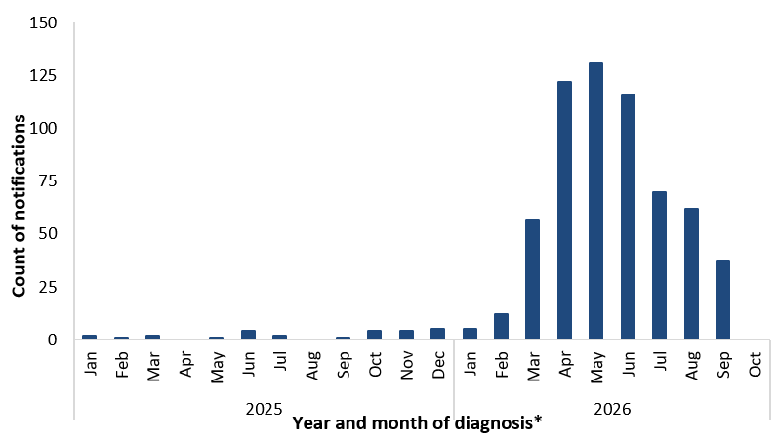
* Reporting delays between diagnosis date and notification to the NNDSS particularly in recent weeks, and the incomplete current month affect data completeness. Trends for recent periods should be interpreted with caution.

Species
Under the national case definition for diphtheria, a confirmed case requires isolation of toxigenic C. diphtheriae or toxigenic C. ulcerans from the upper respiratory tract or skin lesion^{i}. Among confirmed cases in 2026 (n=611), almost all were C. diphtheriae (99.3%; 607/611), with four C. ulcerans cases (0.7%; 4/611). All C. ulcerans cases were locally acquired, with their diagnoses occurring in March (n=1), April (n=1) and June (n=2).

Geographic distribution
Among cases reported in 2026, 52.0% (318/612) were reported in the Northern Territory, 43.6% (267/612) in Western Australia, 3.6% (22/612) in South Australia and 0.8% (5/612) in Queensland. Among the 5 cases notified this fortnight, three were from the Northern Territory and two were reported from Western Australia. Diagnosis dates among cases this fortnight ranged from mid to late September 2026. Over the past fortnight, newly notified cases of C. diphtheriae were predominantly acquired in areas with previously reported diphtheria infections.
By diagnosis date, cases in the Northern Territory have generally declined following a peak in May (Figure 2). In Western Australia, while case numbers remain below the peak observed in June, notifications were elevated in mid-September. In South Australia, case numbers have remained low and sporadic since late March, with most weeks reporting one or no cases.
Among locally acquired cases, there was a notable increase in the proportion of cases residing in ‘remote’ and ‘very remote’ areas since 2021. In 2026, among locally acquired cases (99.5%; 609/612), 88.5% resided in areas classified as ‘remote’ and ‘very remote’, while a further 10.0% resided in ‘outer regional’ areas (Figure 3).
Figure 2: Notifications of diphtheria by jurisdiction and month of diagnosis, Australia, 1 January 2025 to 5 October 2026
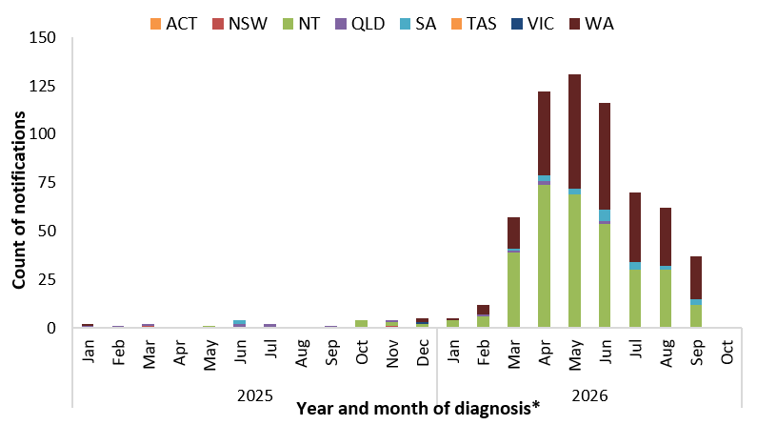
* Reporting delays between diagnosis and notification to the NNDSS, particularly in recent weeks, and the incomplete current month affect data completeness. Trends for recent periods should be interpreted with caution.
Figure 3: Proportion of locally acquired* diphtheria by remoteness area of residence† and year of diagnosis‡, 1 January 2020 to 5 October 2026
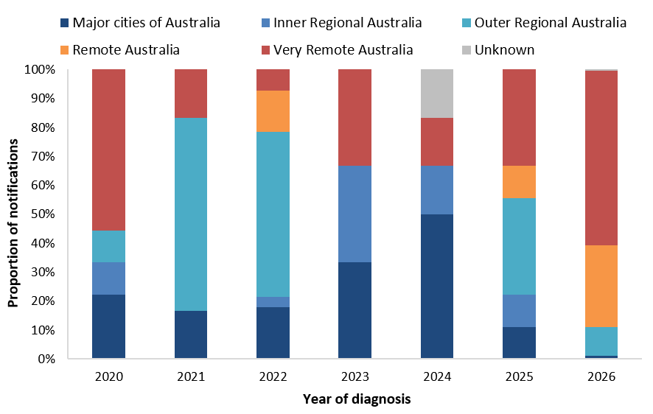
* Excludes cases acquired overseas. † Remoteness area of residence is based on the ABS Australian Statistical Geography Standard Remoteness Structure Postal Areas Correspondence.

Place of acquisition
By place of acquisition, between 2014 and 2019, the majority of diphtheria cases were acquired overseas, predominantly in the Western Pacific and South-East Asia regions. Since 2020, the majority of diphtheria notifications have been locally acquired. So far in 2026, 3 cases (0.5%; 3/612) are reported to have acquired their infection overseas.
Since 2020, there have been 20 diphtheria clusters (with 2 or more cases) reported by jurisdictions, with 15 of these clusters reported in 2026. Prior to 2026, the largest epidemiologically linked clusters (10 to 16 cases) occurred in North Queensland with cases involved in these clusters spanning 2020 to 2023. The more recent clusters in 2026 have been in Western Australia, the Northern Territory and South Australia, with the size of these epidemiologically linked clusters ranging from 2 to 20 cases.
Genomic analysis of C. diphtheriae sequences uploaded to AusTrakka, with collection dates from 2025 up to 4 September 2026, suggests that locally acquired C. diphtheriae cases in Western Australia, the Northern Territory, South Australia and Queensland are all closely related and form part of the same outbreak group known as AUS-2026.
Genomic analyses suggest that AU-2026 is distinct from but likely descended from the same ancestral lineage as the Queensland cluster of cases identified between 2020 and 2023 (QLD-2020). This is also consistent with previous findings that the AUS-2026 and QLD-2020 are genetically very similar. However, because not all infections are sampled, and some samples may not have been genome sequenced, definitive epidemiological links cannot be determined from these genomic analyses alone.

Clinical presentation
Across Australia, from 2016 to 2025, most diphtheria notifications were reported as cutaneous diphtheria, with only a small number of respiratory diphtheria cases reported annually across most years during this period. The increase and upward trend in locally acquired cutaneous diphtheria cases during the latter part of this period may be attributable to changes in testing practices, including toxigenic testing, particularly of wounds, as well as the inclusion of cutaneous diphtheria in the national case definition from 2017^{i}. In 2022, which coincided with the diphtheria clusters in North Queensland, respiratory diphtheria accounted for 19.4% (6/31) of cases, all of which were locally acquired.
In 2026, the predominant clinical presentation continues to be cutaneous diphtheria (66.3%; 406/612), with respiratory diphtheria accounting for 31.9% (195/612) of cases, and clinical presentation information pending for 11 cases (Figure 4).
Figure 4: Notifications of diphtheria by clinical presentation and month of diagnosis*, Australia, 1 January 2025 to 5 October 2026
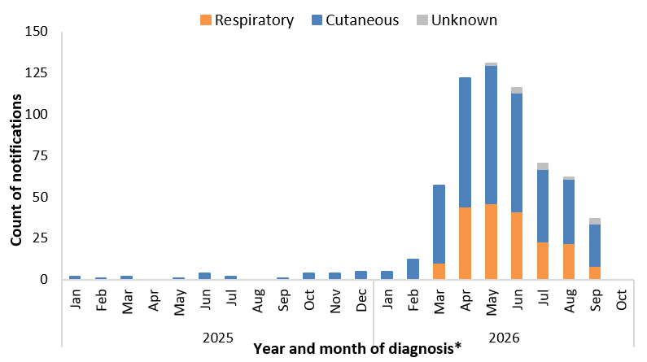
* Reporting delays between diagnosis and notification to the NNDSS, particularly in recent weeks, and the incomplete current month affect data completeness. Trends for recent periods should be interpreted with caution.

Age and sex
Since 2014, notifications of diphtheria have predominantly been reported among those aged 25 years and over, with variability in the proportion of cases reported among those in younger age groups since 2017 (Figure 5). While the largest number of cases notified in 2026 have been among those in the 25 to 44 years age group (Figure 6), notification rates have been highest among the 5 to 14 and 15 to 24 years age groups. So far in 2026, by clinical presentation, the median age of cutaneous diphtheria cases (25 years; IQR 11.0-38.0) has been higher compared to respiratory diphtheria cases (16 years; IQR 11.5-26.5), with this pattern consistent with previous years (Figure 6).
Between 2022 and 2025, the distribution of cases by sex was relatively balanced (47.4% females), with some variability by age group. In 2026, a higher proportion of cases overall are among females (53.9%), with variability also observed by age group.
Figure 5: Proportion of diphtheria notifications by age group*, Australia, 1 January 2014 to 5 October 2026
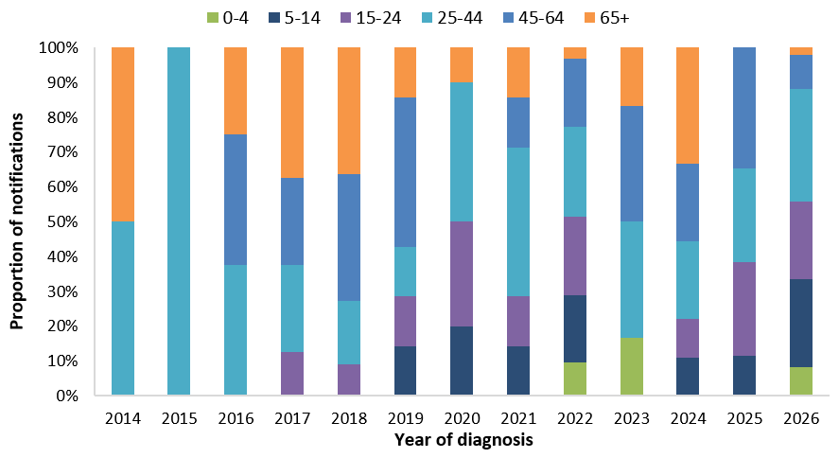
* Age groups are of unequal range, therefore the proportion of notifications in each age group should be interpreted with caution.
Figure 6: Notifications of diphtheria by age group and clinical presentation, Australia, 1 January to 5 October 2026
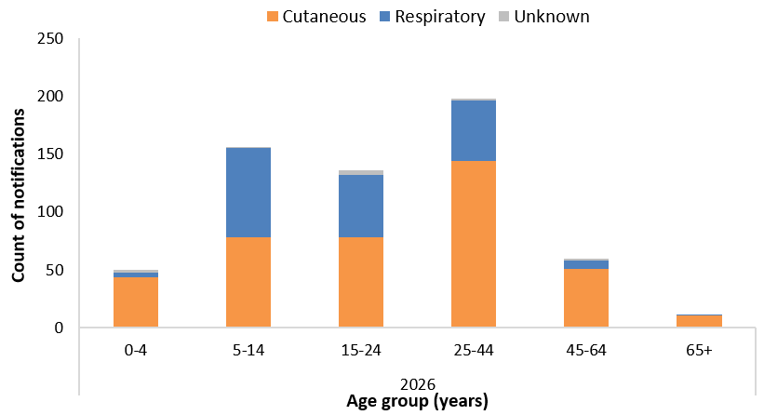

Indigenous status
Indigenous status completeness for diphtheria has remained consistently high, at over 99.0% across 2014 to 2026. Between 2014 and 2019, the proportion of diphtheria cases among Aboriginal and/or Torres Strait Islander people was around 10.5% of cases, noting that there were very few cases reported in 2014 and 2015 (n=4) (Figure 7). Between 2020 to 2022, which included multiple diphtheria clusters in North Queensland, the proportion of cases among Aboriginal and/or Torres Strait Islander people increased to 64.6%. So far in 2026, 95.1% (582/612) of cases have been reported among Aboriginal and/or Torres Strait Islander people.
Figure 7: Proportion of diphtheria notifications by Indigenous status, Australia, 1 January 2014 to 5 October 2026
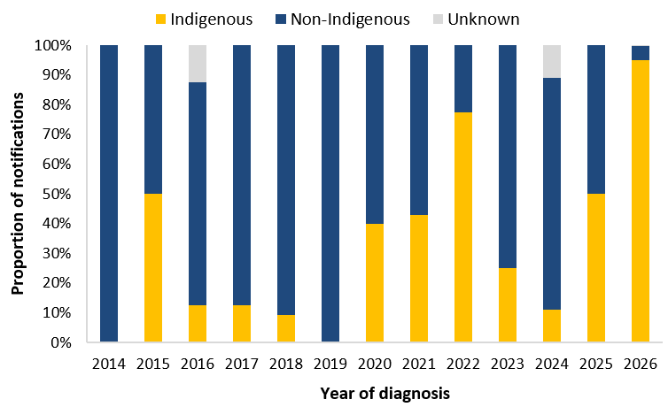

Severity
Between 2022 and 2025, just over a quarter (28.2%) of diphtheria notifications were reported as being hospitalised, with proportions of cases hospitalised higher among those with respiratory diphtheria. So far in 2026, a lower proportion (18.3%; 112/612) of all diphtheria cases have been hospitalised. The proportion of respiratory diphtheria cases hospitalised (18.5%; 36/195) is similar to the proportion among cutaneous diphtheria cases (18.0%; 73/406). While the proportion of cases hospitalised may vary over time and by clinical presentation type, due either to true differences in disease severity or differences in the public health management of cases, diphtheria remains a potentially severe disease and can result in serious outcomes, including hospitalisation and death.
In 2026, one death has been reported in a diphtheria case notified in April, with diphtheria indicated as the probable cause. Prior to 2026, the most recent diphtheria associated death was reported in 2018.

Vaccination status
The vaccination status among diphtheria cases has differed by clinical presentation type. In 2026, a higher proportion of respiratory diphtheria cases (87.7%) had received 3 or more valid doses (primary course), compared with 78.6% of cutaneous diphtheria cases.
Vaccination provides strong protection against the severe effects of diphtheria toxin, however, it does not consistently prevent carriage or transmission of C. diphtheriae, regardless of whether the strain produces toxin or not. While the high proportion of vaccinated cases likely reflects historically high vaccination coverage in Australia, consistent with the protective effect of vaccination against severe disease, hospitalisation was more common among respiratory diphtheria cases with two or fewer recorded vaccine doses (45.8%; 11/24) than among cases who had received three or more doses (14.0%; 24/171). Similarly, among cutaneous cases, the corresponding proportions were 25.6% (22/86) and 13.8% (44/319), respectively.
Consistent with the National Immunisation Program and broader Australian Immunisation Handbook recommendations, the number of doses received among cases tended to increase with increasing age (Figure 8). In 2026, among diphtheria cases reported to have received at least 3 vaccine doses, the median period since last vaccine dose was lower among cutaneous diphtheria cases (4.3 years) than among respiratory diphtheria cases (7.1 years) (Figure 9). Among respiratory diphtheria cases, the median period since last vaccine dose was very similar among hospitalised cases and non-hospitalised cases.
Analyses of the Australian Immunisation Register indicate that coverage with at least one dose of a diphtheria-containing vaccine within the past 5 years among adults aged 20 years and over is increasing in outbreak-affected areas. This trend reflects targeted vaccination activities in response to the current outbreak.
More broadly, national diphtheria–tetanus–pertussis (DTP) vaccination coverage among children aged 5 years, assessed as at September 2025 and based on the National Immunisation Program Schedule, was:
- 93.4% (range: 91.9% to 94.8%) among all children.
- 94.7% (range: 92.9% to 96.3%) among Aboriginal and Torres Strait Islander children.
However, coverage rates among the 5-year-old cohort, regardless of Indigenous status, have gradually declined since peaking in 2020. For further information on vaccination coverage, including by geographic area, please refer to the Department of Health, Disability and Ageing Immunisation dashboards.
Figure 8: Notifications of diphtheria by vaccination status, clinical presentation type and age group, Australia, 1 January to 5 October 2026
(a) Cutaneous diphtheria | (b) Respiratory diphtheria
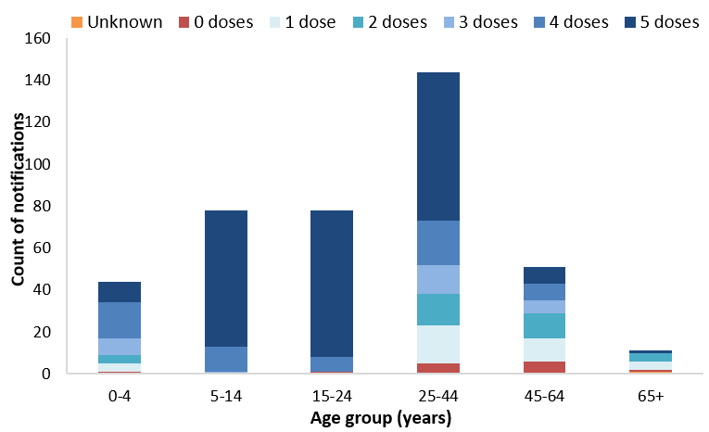 | 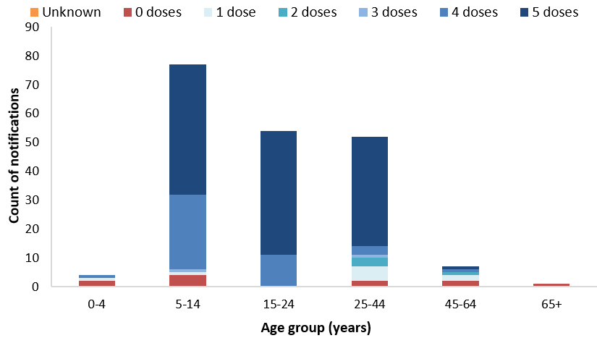
Figure 9: Distribution of years since last vaccine dose for notifications of diphtheria with at least 3 doses*, by clinical presentation type, Australia, 1 January 2014 to 5 October 2026
(a) Cutaneous diphtheria | (b) Respiratory diphtheria
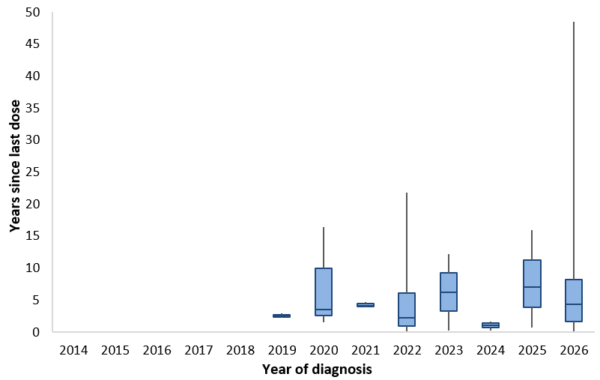 | 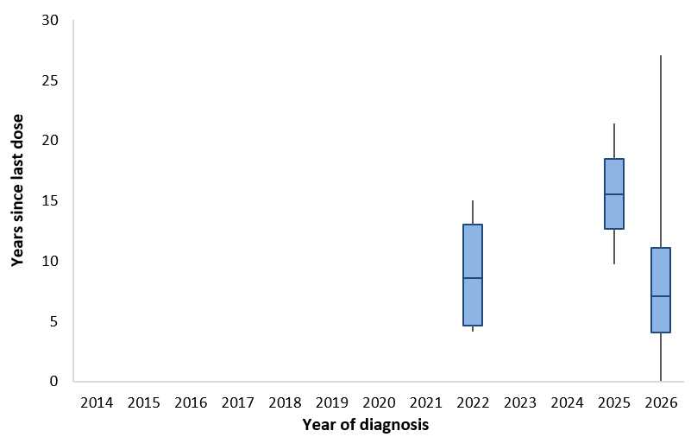
* Periods where there were less than 2 cases that had received 3 or more vaccine doses are not shown

Epidemiological characteristics of diphtheria cases
Table 1: Epidemiological summary of diphtheria cases* in Australia, 1 January 2022 to 5 October 2026
 | Past 4-weeks  (8 September to 5 October 2026)* | 2026  YTD† | 2025 | 2022–2025 YTD† (mean) | 2022–2025 (mean)
Total | 22 | 612 | 26 | 14.5 | 19.5
Confirmation status
Confirmed | 22 (100%) | 611 (100%) | 26 (100%) | 14.5 (100%) | 19.5 (100%)
Probable | 0 (0%) | 1 (0%) | 0 (0%) | 0.0 (0%) | 0.0 (0%)
Species
C. diphtheriae | 22 (100%) | 608 (99%) | 23 (88%) | 11.8 (81%) | 16.3 (83%)
C. ulcerans | 0 (0%) | 4 (1%) | 3 (12%) | 2.8 (19%) | 3.3 (17%)
State
ACT | 0 (0%) | 0 (0%) | 0 (0%) | 0.0 (0%) | 0.0 (0%)
NSW | 0 (0%) | 0 (0%) | 2 (8%) | 2.0 (14%) | 2.5 (13%)
NT | 8 (36%) | 318 (52%) | 9 (35%) | 0.8 (5%) | 2.5 (13%)
QLD | 0 (0%) | 5 (1%) | 9 (35%) | 10.0 (69%) | 11.5 (59%)
SA | 1 (5%) | 22 (4%) | 2 (8%) | 0.5 (3%) | 0.5 (3%)
TAS | 0 (0%) | 0 (0%) | 0 (0%) | 0.3 (2%) | 0.3 (1%)
VIC | 0 (0%) | 0 (0%) | 1 (4%) | 0.0 (0%) | 0.5 (3%)
WA | 13 (59%) | 267 (44%) | 3 (12%) | 1.0 (7%) | 1.8 (9%)
Remoteness area of residence‡
Major cities | 0 (0%) | 9 (1%) | 6 (23%) | 3.8 (26%) | 5.3 (27%)
Regional areas‡ | 1 (5%) | 62 (10%) | 11 (42%) | 7.8 (53%) | 9.5 (49%)
Remote areas‡ | 21 (95%) | 539 (88%) | 9 (35%) | 3.0 (21%) | 4.5 (23%)
Unknown | 0 (0%) | 2 (0%) | 0 (0%) | 0.0 (0%) | 0.3 (1%)
Place of acquisition
Overseas acquired | 0 (0%) | 3 (0%) | 8 (31%) | 3.5 (24%) | 5.0 (26%)
Locally acquired | 22 (100%) | 589 (96%) | 17 (65%) | 9.3 (64%) | 12.5 (64%)
Unknown | 0 (0%) | 20 (3%) | 1 (4%) | 1.8 (12%) | 2.0 (10%)
Clinical manifestation
Cutaneous | 15 (68%) | 406 (66%) | 24 (92%) | 12.3 (84%) | 17.0 (87%)
Respiratory | 5 (23%) | 195 (32%) | 2 (8%) | 2.0 (14%) | 2.3 (12%)
Unknown | 2 (9%) | 11 (2%) | 0 (0%) | 0.3 (2%) | 0.3 (1%)
Age (years)
Median (IQR) | 17.0 (10.5-26.8) | 22.0 (11.0-35.0) | 36.5 (19.8-48.5) | 37.3 (23.1-48.4) | 39.4 (22.8-52.8)
Age group (years)
0-4 | 3 (14%) | 50 (8%) | 0 (0%) | 1.3 (9%) | 1.3 (6%)
5-14 | 3 (14%) | 156 (25%) | 3 (12%) | 2.3 (16%) | 2.5 (13%)
15-24 | 9 (41%) | 136 (22%) | 7 (27%) | 2.8 (19%) | 3.8 (19%)
25-44 | 5 (23%) | 198 (32%) | 7 (27%) | 4.0 (28%) | 5.3 (27%)
45-64 | 1 (5%) | 60 (10%) | 9 (35%) | 3.0 (21%) | 5.3 (27%)
65+ | 1 (5%) | 12 (2%) | 0 (0%) | 1.3 (9%) | 1.5 (8%)
Sex
Male | 14 (64%) | 282 (46%) | 15 (58%) | 7.5 (52%) | 10.3 (53%)
Female | 8 (36%) | 330 (54%) | 11 (42%) | 7.0 (48%) | 9.3 (47%)
Indigenous status
Indigenous | 20 (91%) | 582 (95%) | 13 (50%) | 8.0 (55%) | 10.3 (53%)
Non-Indigenous | 2 (9%) | 28 (5%) | 13 (50%) | 6.3 (43%) | 9.0 (46%)
Unknown | 0 (0%) | 2 (0%) | 0 (0%) | 0.3 (2%) | 0.3 (1%)
Severity
Hospitalised | 4 (18%) | 112 (18%) | 10 (38%) | 3.0 (21%) | 5.5 (28%)
Died | 0 (0%) | 1§ (0%) | 0 (0%) | 0.0 (0%) | 0.0 (0%)
Vaccination status
0 doses | 1 (5%) | 26 (4%) | 5 (19%) | 2.5 (17%) | 3.8 (19%)
1 dose | 2 (9%) | 49 (8%) | 9 (35%) | 2.8 (19%) | 4.5 (23%)
2 doses | 0 (0%) | 39 (6%) | 2 (8%) | 1.3 (9%) | 1.8 (9%)
3 doses | 0 (0%) | 33 (5%) | 0 (0%) | 1.5 (10%) | 1.5 (8%)
4 doses | 6 (27%) | 110 (18%) | 6 (23%) | 2.0 (14%) | 2.5 (13%)
5 doses | 13 (59%) | 354 (58%) | 4 (15%) | 4.0 (28%) | 4.8 (24%)
Unknown | 0 (0%) | 1 (0%) | 0 (0%) | 0.5 (3%) | 0.8 (4%)
* By diagnosis date, noting that data toward the end of the analysis period is likely incomplete.
†YTD represents the year-to-date diagnosis period of 1 January to 5 October.
‡ Remoteness area of residence includes both locally acquired and overseas acquired cases, and is based on the ABS Australian Statistical Geography Standard Remoteness Structure Postal Areas Correspondence. The categories of ‘Inner Regional’ and ‘Outer Regional’ have been combined to ‘Regional’. The categories of ‘Remote’ and ‘Very Remote’ have been combined to ‘Remote’.
§ The cause of death indicates that diphtheria was the probable cause.

CDNA diphtheria case definition: https://www.cdc.gov.au/system/files/2025-09/diphtheria-surveillance-case-definition_0.pdf
Diagnosis date is the preferred public health indicator of disease transmission activity. However, delays between diagnosis and notification to the NNDSS result in incomplete data for more recent weeks. Analyses by notification date can be used as a proxy for more current trends, with an underlying assumption of a stable distribution of reporting lags.
C. ulcerans is considered a zoonotic infection and is not related to the current outbreak which is caused by C. diphtheriae. Historically, C. ulcerans has been associated with consumption of raw or unpasteurised milk products or direct contact with infected domestic or farm animals.
Australian Immunisation Register Diphtheria immunisation dashboard
1 January to 5 October
Diagnosis date is the preferred public health indicator of disease transmission activity. However, delays between diagnosis and notification to the NNDSS result in incomplete data for more recent weeks. Notification date can be used as a proxy for more current trends, with an underlying assumption of a stable distribution of reporting lags.
C. ulcerans is considered a zoonotic infection and is not related to the current outbreak which is caused by C. diphtheriae. Historically, C. ulcerans has been associated with consumption of raw or unpasteurised milk products or direct contact with infected domestic or farm animals.
Please note: To account for increasing genomic diversity, AusTrakka has revised its approach to grouping related cases. Rather than relying only on SNP-based clustering, outbreak groups are now determined using a broader assessment of genomic relatedness. The AU-2026 outbreak group includes all samples previously classified as clusters 2:2:2, 2:2:5 and 2:2:3. This is consistent with previous analyses that these cases are genomically linked.
Diphtheria | Australian Centre for Disease Control
Current coverage data tables for all children | Australian Government Department of Health, Disability and Ageing
Current coverage data tables for Aboriginal and Torres Strait Islander children | Australian Government Department of Health, Disability and Ageing

