
Annual Report
  - 2025–2026

Publication information

Acknowledgement of Country
The Australian Centre for Disease Control acknowledges and honours Aboriginal and Torres Strait Islander peoples – the Traditional Owners and Custodians of the lands and waters on which we live and work. We pay our respects to Elders past and present and extend that respect to all Aboriginal and Torres Strait Islander peoples across this country. We recognise their ongoing connection to Country, culture and community, and we commit to working in genuine partnership towards improving health outcomes for all.

Cover artwork
Health and Connection
Artist: Jason Douglas (Dalmarri)
This artwork was created through a collaborative session between Australian Centre for Disease Control staff and Aboriginal artist Jason Douglas from Dalmarri.
It represents the journey of communities, staff and knowledge working together to protect health. The work reflects shared responsibility, the pathways through which diseases move, and the ways preparedness, care and collective action interrupt those pathways to keep communities safe.
At its centre are 4 concentric circles representing layers of protection, knowledge and preparedness. Surrounding pathways, lines and symbols reflect disease, control, research and the movement of people and information across teams and communities. The inner circles represent CDC staff, connected with partners and communities across the country.
Throughout the artwork, symbols of gathering, pathways, waterholes, shields, campsites and bush medicine reflect the enduring knowledge and practices of First Nations peoples in understanding, preventing and responding to disease.
Grounded in connection to people and place, the artwork reflects a future where strong systems, clear pathways and collective action support the health and wellbeing of all communities.

Publication details
© 2026 Commonwealth of Australia as represented by the Australian Centre for Disease Control.
This work is copyright. Apart from any use as permitted under the Copyright Act 1968, no part may be reproduced by any process without prior written permission from the Australian Centre for Disease Control.
Produced by the Australian Centre for Disease Control, Canberra, ACT.

Contact
Requests and enquiries concerning the contents of the report should be addressed to:
Australian Centre for Disease Control
PO Box 795
Canberra ACT 2601, Australia
Email: governance@cdc.gov.au
The report is also available on our website (https://www.cdc.gov.au/)

Letter of transmittal
Dear Minister
I, as the accountable authority for the Australian Centre for Disease Control (CDC), am pleased to present the annual report for the financial year 2025–26.
This report has been prepared for the purposes of section 46 of the Public Governance, Performance and Accountability Act 2013 (PGPA Act), which requires that an annual report be given to the entity’s responsible Minister for presentation to the Parliament.
This report also includes additional requirements that are specified in the enabling legislation, the Australian Centre for Disease Control Act 2025 (CDC Act).
This report includes the entities audited annual financial statements as required by subsection 43(4) of the PGPA Act. It also includes the entities annual performance statements as required under section 39 of the PGPA Act.
In accordance with section 10, and as required by subsection 17AG(2), of the Public Governance, Performance and Accountability Rule 2014 (PGPA Rule), I certify that:
- the agency prepared fraud and corruption risk assessments and fraud and corruption control plans
- the agency had appropriate mechanisms to prevent, detect, investigate, record and confidentially report suspected fraud and corruption
- We took all reasonable measures to appropriately deal with fraud relating to the agency.
Yours sincerely
Professor Zoe Wainer
Director-General
Australian Centre for Disease Control
Date: 14/10/26

Contents
Publication information 2
Acknowledgement of Country 2
Cover artwork 2
Publication details 3
Contact 3
Letter of transmittal 4
1. Director-General's review 7
2. Overview of the Australian Centre for Disease Control 9
3. How the CDC Adds Value 10
3.1. Transparency on public health advice 13
3.2. Pandemic preparedness and coordination 15
a. Australia’s pandemic preparedness 15
b. The impact of climate change on health of Australians 17
4. Performance report 24
4.1. Annual performance statements 24
4.1.1. Statements of preparation 24
4.1.2. Overview 25
4.1.3. Analysis of performance 27
4.2. Report on financial performance 28
4.2.1. Financial performance 28
5. Management and accountability 30
5.1. Corporate governance 30
5.1.1. Fraud and corruption control and prevention 31
5.2. Audit and risk committee 32
5.3. External scrutiny 33
5.4. Management of human resources 33
5.4.1. Managing and developing employees 33
5.4.2. Workplace agreements 34
5.4.3. Employee statistics 36
5.4.4. APS employee statistics 38
5.4.5. Performance pay 42
5.5. Executive remuneration 43
5.6. Purchasing 44
5.7. Consultancy and non-consultancy contract expenditure 44
5.7.1. Reportable consultancy contracts 44
5.7.2. Reportable non-consultancy contracts 46
5.8. Strategic commissioning framework 46
5.9. Australian National Audit Office (ANAO) access clauses 46
5.10. Exempt contracts 47
5.11. Small business 47
6. Other mandatory information 48
6.1. Grants 48
6.2. Disability reporting 48
6.3. Freedom of information 49
6.4. Legal Services and expenditure 49
7. Appendices 50
7.1. Financial Statements (including independent audit report) 50
7.2. Other legislative requirements 82
7.2.1. Environment Protection and Biodiversity Conservation Act 1999 82
7.2.2. Work, Health and Safety Act 2011 83
8. Aids to access 85
8.1. Abbreviations and acronyms 85
8.2. Glossary 87
8.3. List of requirements 91
8.4. Index 100

- Director-General's review
Welcome to the 2025–26 Annual Report for the CDC. This period covers the commencement of the CDC on 1 January 2026 as a new national public health institution with a clear purpose: to help Australia see risks earlier so that we can act earlier, and more effectively.
Since commencement, the CDC has focused on building the foundations of a modern national public health agency while supporting governments, health professionals and communities to understand and respond to emerging public health risks.
Over our first six months, we worked every day to bring together evidence, expertise and intelligence from across Australia and around the world. We monitored emerging health threats, assessed risks, provided advice to governments and strengthened the partnerships that enable coordinated public health action. This included supporting Australia's response to outbreaks and emerging infectious disease threats, sharing trusted public health information, and helping decision-makers act with confidence when uncertainty was high.
During our first six months, the CDC strengthened national surveillance, epidemiological analysis and public health coordination in response to the largest national diphtheria outbreak reported in Australia, where notifications increased sharply from February 2026. We brought together information from jurisdictions, laboratories, genomic surveillance and immunisation systems to support evidence-based decision-making and nationally consistent public health action.
We also supported Australia's response to the emergence of Andes virus hantavirus among passengers from the MV Hondius, working with international counterparts and Australian jurisdictions to assess risks, provide advice to governments and support the safe repatriation and quarantine of affected travellers.
At the same time, we monitored and assessed the outbreak of Ebola disease caused by Bundibugyo virus in the Democratic Republic of the Congo, providing regular situation updates, nationally consistent advice and risk assessments to support preparedness and informed decision-making.
Following the detection of high pathogenicity avian influenza A(H5N1) clade 2.3.4.4b in migratory birds in southern Australia, the CDC supported the national response through human health risk assessment, preparedness activities, laboratory coordination, public communications and collaboration across governments and sectors.
Much of this work happened quietly and often before issues reached public attention. Through surveillance, epidemiology, risk assessment, scientific analysis and collaboration with states and territories, researchers, clinicians and international partners, we worked to identify potential risks early, understand their implications and support proportionate responses. These activities reflect a core principle of public health: the earlier we understand a risk, the greater our opportunity to prevent harm.
The success of a public health agency is often measured by what does not happen: the outbreak contained before it spreads, the risk identified before it grows, the health threat anticipated before it becomes a crisis. While we are still in our earliest stages, our first six months have reinforced the importance of trusted advice, strong partnerships, transparent communication and a relentless focus on preparedness.
Strong partnerships have underpinned the CDC’s leadership in supporting Australia’s response to blood-borne viruses and sexually transmissible infections through policy, funding and research initiatives in our first six months. From stewarding the national response to rising rates of syphilis and congenital syphilis, to supporting implementation of expanded access to HIV prevention and treatment for populations who are unable to access Medicare-funded services, the CDC is partnering to deliver surveillance, programs, and research.
As we continue to build Australia's national public health capability, we remain focused on helping Australia prevent what we can and prepare for what we cannot, whilst providing the trusted public health advice that enables governments, communities and individuals to act earlier and with confidence. Australia is stronger and safer when someone is always looking ahead.
I acknowledge all agency staff whose work and dedication have contributed to the success of the CDC’s first six months.
Professor Zoe Wainer
Director-General
Australian Centre for Disease Control
14/10/26

- Overview of the Australian Centre for Disease Control
The CDC is Australia’s national public health institute.
Established under the Australian Centre for Disease Control Act 2025 (CDC Act), the purpose of the CDC is to strengthen Australia’s national capability to prevent, detect and respond to disease and other public health challenges.
The CDC Act sets out the functions and powers of the Director-General and supporting role of CDC staff in the performance of the Director-General’s functions.
The CDC brings together experts in epidemiology, surveillance, data science and public health practice to support evidence-informed decision-making across the health system. Through analysis of relevant public health data (both national and international), the CDC will identify emerging risks and provide expert advice. The CDC helps support governments, health services and communities to better protect the health of Australians. The CDC's advice function helps translate complex public health evidence into practical guidance for decision-makers. This includes synthesising information from surveillance systems, laboratories, jurisdictions, international partners and scientific literature to support timely and proportionate responses to emerging threats. Through its advice, the CDC contributes to nationally consistent approaches while respecting the responsibilities of states and territories within Australia's federated health system.
The CDC’s role is to support and strengthen this system through national data, analysis, intelligence and collaboration across jurisdictions and the broader public health community. The CDC also supports the development and delivery of nationally coordinated public health policies and programs, working with jurisdictions and the Commonwealth to translate evidence into practical action to address priority health risks. The CDC operates within Australia’s federated health system where states and territories retain primary responsibility for public health delivery and emergency management.

- How the CDC Adds Value
The CDC strengthens Australia’s ability to identify health threats early, understand their likely impact, and support coordinated action before risks escalate. By bringing together surveillance data, epidemiological expertise, public health intelligence and scientific advice from across jurisdictions, the CDC helps governments make informed decisions, improves national consistency in public health responses and provides trusted information to health professionals and the public.
The value of this work is often unseen. Effective public health action means outbreaks are contained more quickly, risks are identified earlier, and communities are better protected from avoidable harm.
During its first six months of operation, the CDC supported national responses to Australia's largest recorded diphtheria outbreak, provided risk assessments and advice relating to the emergence of Andes virus hantavirus infection among international travellers, monitored international Ebola outbreaks to support preparedness, and contributed to national planning and response activities following the detection of highly pathogenic avian influenza A (H5N1) in Australia. These activities demonstrate how the CDC translates public health intelligence and expertise into practical support for governments, health services and communities.
During this period the CDC also continued the Australian Government’s efforts to strengthen Australia’s response to blood-borne viruses and sexually transmissible infections through major policy, funding and implementation achievements. The CDC supported the launch of the Fourth National Hepatitis B Strategy 2025–2030 and the Sixth National Hepatitis C Strategy 2025–2030, establishing a renewed national framework to drive progress towards the elimination of viral hepatitis as a public health challenge by 2030.
In addition, the CDC continued to support and coordinate the national response to syphilis, including implementation of new Australian Government budget measures to urgently address rising rates of congenital syphilis through targeted investment in culturally safe antenatal care, testing and treatment initiatives. The CDC also contributed to addressing emerging environmental health threats through the publication of evidence reviews, including on microplastics, participation in parliamentary inquiries, and continued implementation of the National Climate and Health Strategy.
Together, these activities demonstrate the CDC's role in translating evidence into coordinated action that protects and improves the health of Australians and strengthens the nation's preparedness for both communicable and non-communicable public health risks.

Organisational structure on 1 January 2026.
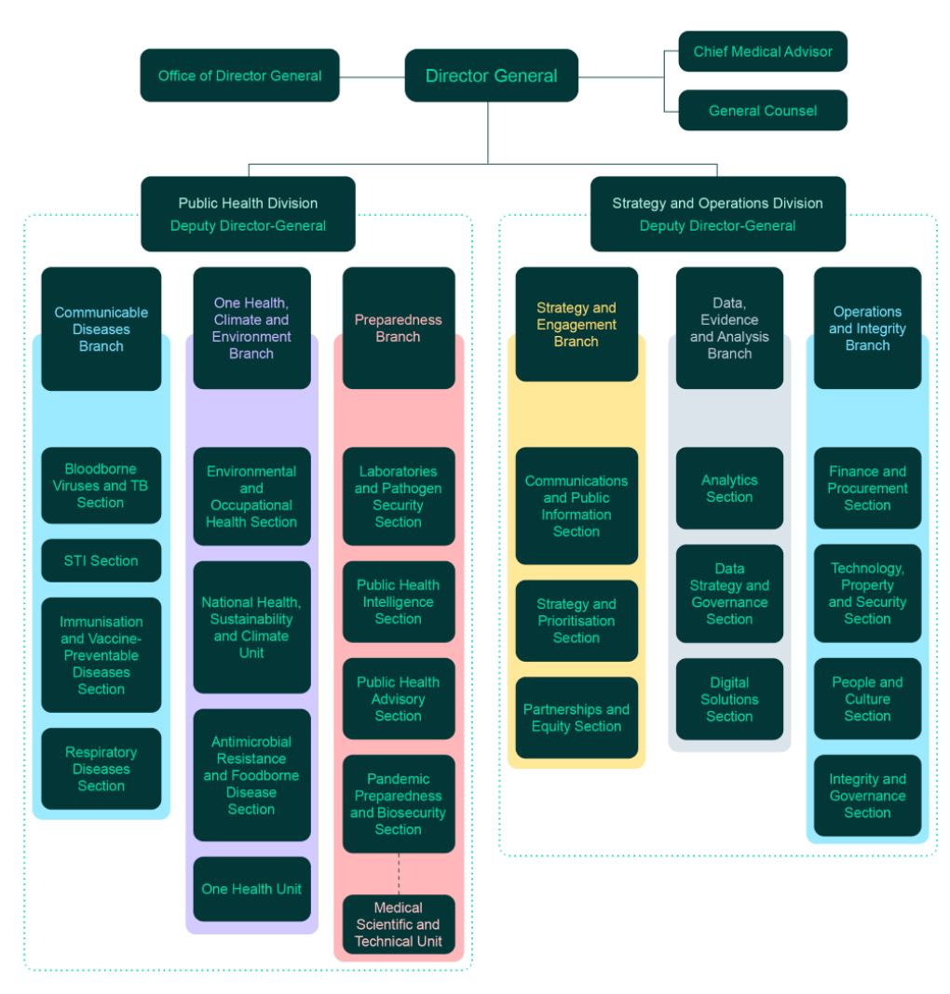

  - Transparency on public health advice
Transparency is central to the CDC's role as a trusted public health institution. Public confidence in health advice is strengthened when evidence, reasoning and recommendations are made available. Transparency enables governments, health professionals, researchers and communities to understand emerging risks, supports consistent decision-making across jurisdictions, and helps maintain trust during periods of uncertainty.
The CDC's publication framework is intended to ensure that public health advice can be considered and understood while balancing requirements relating to privacy, national security and other protected information.
During its first six months, the CDC routinely provided advice to government, published surveillance reports, risk assessments, guidance and health information products, and supported transparent communication about emerging health risks. Although no final and settled public health advice was required to be published under sections 20 to 22 of the CDC Act by 30 June 2026, this is because the CDC has continued to proactively publish public health information, advice and evidence-based resources in support of its commitment to transparency. These efforts to make public health information more accessible have negated the need to publish separately under ss20 to 22 of the CDC Act.
During the reporting period, six pieces of public health advice were exempted from publication. These exemptions were applied in accordance with the legislative framework. Consistent with its statutory obligations, the CDC continues to make public health information and advice publicly available wherever appropriate.

Exemptions under sections 20–22 of the Australian Centre for Disease Control Act 2025
Advice reference | Reason(s)
Advice no.1 of the reporting period (not published) | - subpara (a)(vi) of the definition of exempt material (section 45 of the Freedom of Information Act 1982)  - subpara (b)(i) of the definition of exempt material (Australian Centre for Disease Control Act 2025)  - subpara (a)(viii) of the definition of exempt material (section 47 of the Freedom of Information Act 1982)
Advice no.2 of the reporting period (not published) | - subpara (a)(vi) of the definition of exempt material (section 45 of the Freedom of Information Act 1982)  - subpara (b)(i) of the definition of exempt material (Australian Centre for Disease Control Act 2025)  - subpara (a)(viii) of the definition of exempt material (section 47 of the Freedom of Information Act 1982)
Advice no.3 of the reporting period (not published) | - subpara (a)(vi) of the definition of exempt material (section 45 of the Freedom of Information Act 1982)  - subpara (a)(viii) of the definition of exempt material (section 47 of the Freedom of Information Act 1982)  - subpara (b)(i) of the definition of exempt material (Australian Centre for Disease Control Act 2025)
Advice no.4 of the reporting period (not published) | - subpara (a)(i) of the definition of exempt material (section 33 of the Freedom of Information Act 1982)
Advice no.5 of the reporting period (not published) | - subpara (a)(vi) of the definition of exempt material (section 45 of the Freedom of Information Act 1982)  - subpara (a)(i) of the definition of exempt material (section 33 of the Freedom of Information Act 1982)
Advice no.6 of the reporting period (not published) | - subpara (a)(vi) of the definition of exempt material (section 45 of the Freedom of Information Act 1982)  - subpara (a)(i) of the definition of exempt material (section 33 of the Freedom of Information Act 1982)  - subpara (a)(iii) of the definition of exempt material (section 37 of the Freedom of Information Act 1982)  - subpara (b)(i) of the definition of exempt material (Australian Centre for Disease Control Act 2025)

Extensions under sections 20–22 of the Australian Centre for Disease Control Act 2025
Advice reference | Reason(s)
N/A | N/A

  - Pandemic preparedness and coordination
- Australia’s pandemic preparedness

Context
Pandemics remain a significant risk to human health, economic stability and social wellbeing. COVID-19 demonstrated that preparedness must be sustained before a crisis and is a shared responsibility across governments, health systems, communities, researchers and industry.
As Australia’s national public health institute, the CDC has a strategic and enabling role in helping the nation understand, monitor and strengthen preparedness over time. It is one part of a broader system involving the Department of Health, Disability and Ageing (DHDA), the National Emergency Management Agency and other Australian Government agencies, state and territory governments and public health authorities, health-care providers, research institutions, industry and communities. The DHDA leads Australian Government health response operations, supported by established arrangements including the National Health Emergency Response Arrangements and the Australian Government Crisis Management Framework. Within this system, the CDC assesses capability, identifies risks and gaps, supports evidence-informed planning and advises on national readiness.
Under section 77A(a) of the CDC Act, the CDC is required to include an assessment of Australia’s pandemic preparedness in its annual report. This first assessment outlines work undertaken during the reporting period to better understand, monitor and support preparedness across Australia, providing an initial baseline for future reporting and continuous improvement.

Overall assessment
Australia maintains strong foundational pandemic preparedness capabilities, including established surveillance, laboratory, public health, emergency management and health-system arrangements. Preparedness maturity is, however, uneven across capabilities and sectors. Further work is needed to strengthen national assessment and monitoring, clarify shared responsibilities, embed equity and community perspectives, and translate lessons and plans into sustained implementation.
Key risks include capability degradation between emergencies, workforce and supply-chain constraints, fragmented data and governance arrangements, variable readiness across jurisdictions and sectors, and gaps in interoperability and surge capacity. This first assessment under section 77A(a) of the CDC Act establishes an initial qualitative baseline. Future annual reports will assess increases or decreases in capability against this baseline as the evidence base and assessment approach mature.

Work undertaken in 2025-26
During the reporting period, the CDC advanced an ‘always on’ approach to preparedness, recognising that investment before a crisis helps reduce the health, social and economic impacts of emergencies. A major focus was development of a draft Pandemic Preparedness Strategic Framework to provide a consistent national structure for identifying capabilities, responsible stakeholders, gaps and priorities for improvement and investment. The framework is intended to complement, not replace, operational response arrangements maintained by the DHDA and partners.
The CDC reviewed Australian and international frameworks, synthesised lessons from the Commonwealth COVID-19 Response Inquiry and other emergencies, mapped proposed capabilities and accountabilities, and tested the approach with internal subject-matter experts across the CDC and DHDA. The mapped capabilities span surveillance and early warning, laboratories, infection prevention and control, data and intelligence, risk communication and community engagement, emergency management and coordination, workforce, medical countermeasures, border health and governance.

What the work indicates
Initial mapping indicates substantial capability and established arrangements in many areas, but evidence is not yet sufficiently consistent to support a comprehensive national maturity rating. Priorities for further assessment include system interoperability, sustainable workforce and surge capacity, equitable preparedness for priority populations, cross-sector implementation and clearer measures of readiness and improvement. Organisation-wide workshops and targeted consultations helped refine the draft approach and identify operational considerations, emerging risks and existing strengths. The work also reinforced that future pandemics would affect communities differently and that effective preparedness requires trust, accessible risk communication and meaningful engagement with communities likely to be disproportionately affected.

Monitoring and future assessment
Preliminary work commenced on a proportionate approach to monitoring preparedness over time. This will build on and avoid duplicating existing arrangements, particularly Australia’s annual reporting under the International Health Regulations (2005) through the State Party Self-Assessment Annual Report (SPAR), coordinated by the DHDA as Australia’s National IHR Authority. SPAR provides an established baseline across many core capacities. The CDC will consider how SPAR results, relevant domestic assessments and targeted evidence on capabilities not fully covered by SPAR can support future reporting, identify priorities and demonstrate change over time.
The CDC will seek to test and refine the strategic framework with the DHDA, other Australian Government agencies, states and territories, technical and research partners, industry and communities throughout 2026-27. It will also clarify how the framework complements existing plans and accountability mechanisms and develop an initial monitoring and reporting approach. These steps will strengthen the evidence available for future assessments under section 77A(a), but do not yet constitute a comprehensive national maturity assessment.

Conclusion
Australia maintains strong foundational preparedness capabilities, but continued work is needed to mature national assessment and monitoring, strengthen equity considerations, clarify shared accountability and support consistent cross-sector implementation. Future CDC annual reports will build on this initial baseline and provide progressively more detailed assessments of strengths, gaps, risks and priorities for improvement.
- The impact of climate change on health of Australians
Section 77A(b) of the CDC Act establishes a requirement for the CDC’s annual report to include an assessment of the impacts of climate change on health for Australians, including as compared to any previous such periods. This report constitutes the first annual assessment of climate impacts on Australians’ health from the CDC.
The CDC is – with input from the Australian Institute of Health and Welfare (AIHW) – developing a bespoke reporting framework to enable robust annual assessments of the health impacts of climate change in Australia in future years. It is anticipated that the first assessment using this new reporting framework will be included in the CDC’s annual report for 2026–27.
In this first reporting period, the CDC presents key findings and assessments associated with health and wellbeing from Australia’s first National Climate Risk Assessment which was published in September 2025 (ACS 2025). The findings provide a baseline of data and findings for health impacts associated with climate change over recent years and do not provide an assessment of impacts recorded or extrapolated for the preceding year.

Key impacts of climate change on health for Australians as sourced from the national assessment
Australia’s climate has already warmed by an average of over 1.5°C since records began in 1910, resulting in increased frequency and intensity of extreme weather events across Australia (Bureau of Meteorology 2024). Climate hazards such as extreme heat, bushfires, storms and flooding are already having adverse impacts on both physical and mental health and wellbeing in Australia. These impacts are unevenly distributed, with many marginalised groups disproportionally affected (Cissé et al. 2022).
The available evidence indicated that
- Extreme heat currently represents the clearest quantified climate-related health burden in Australia, with heatwaves associated with an estimated 1,418 excess deaths, almost 68,000 excess emergency department presentations and more than 130,000 excess General Practitioner (GP) attendances over 11 years from 2007–2017.
- Flooding is identified as the second highest cause of deaths from exposure to climate-related hazards after heatwaves, while floods, cyclones and bushfires also contribute substantial longer-term morbidity through respiratory and cardiovascular disease, mental ill health, disruption to chronic disease management and pressure on health services.
- Bushfire smoke is another major source of mortality and disease burden: compared with a low bushfire year, the 2019 bushfire scenario was associated with around 900 attributable deaths and the loss of an additional 18,600 disability-adjusted life years.
- Climate-sensitive communicable diseases are an additional emerging concern, with Australian data showing relationships between climatic conditions, disease incidence and pathogen genetic variation.

Sources for reporting
Content used for the CDC Annual Report has been sourced from two reports:
- The Health and Wellbeing Technical Report (HWTR) prepared by the Australian Climate Service for the National Climate Risk Assessment.
- The Air Quality and Communicable Diseases Technical Report (AQCDTR) prepared by the CSIRO for the Australian Climate Service as part of the National Climate Risk Assessment.
Findings are drawn only from the reports and retain the reported estimates, confidence intervals and caveats. Where the reports do not provide a confidence interval or effect estimate, none has been added. The technical reports combine new National Climate Risk Assessment analysis with findings from cited Australian studies.

Heat-related impacts
- During the 2007–2017 study period, there were 739,639 deaths nationally during the warm season (October to March). Mortality increased by 2% during heatwaves (RR 1.02; 95% CI 1.01–1.03), with 1,418 excess deaths (95% CI 723–2,113). The HWTR notes that heat-attributable deaths may be understated because deaths in which heat played a role can often be attributed to underlying health conditions. [HWTR, p.38–39] (Varghese et al. 2020; Longden et al. 2020; Coates et al. 2022)
- Emergency department (ED) presentations increased by 2.9% (95% CI 1.5–4.2%) during low-intensity heatwaves and by 3.4% (95% CI 1.2–5.5%) during severe/extreme heatwaves. This corresponded to 67,974 excess ED presentations during 2007–2017; 82% occurred during low-intensity heatwaves, which are more frequent than severe/extreme heatwaves. Heatwaves place considerable strain on emergency services. [HWTR, p.39] (Beaty et al. 2021)
- GP attendances increased by 4% (95% CI 3–4%) during severe/extreme heatwaves, with an estimated 130,915 excess GP attendances during the study period. There was no significant increase in GP attendance risk during low-severity heatwaves. [HWTR, p.39] (PEAN 2021)
- Heat-health outcomes varied by remoteness. The increase in mortality risk during heatwaves was greatest in very remote areas (7.5% increase), followed by outer regional areas (3.4%) and major cities (2.3%). GP attendance during severe/extreme heatwaves was highest in inner regional areas (4.6%) and major cities (4.4%) – perhaps more a reflection of higher availability in these areas than higher need. [HWTR, p.39]
- In the report's Australian event examples, the 2009 Adelaide heatwave was associated with a 140% increase in direct heat-related admissions and a 37% increase in total mortality among people aged 15–64 years. During the January 2014 Victorian heatwave, metropolitan ambulance caseload increased 25%, all cause public hospital ED presentations increased 7%, and ED presentations among people aged 75 years and older increased 23%. [HWTR, p.37] (Nitschke et al. 2011a; AIHW 2024; Department of Health 2014)
- For Adelaide, ambulance callouts increased by 5% (95% CI 3–6%) during low-intensity heatwaves and by 8% (95% CI 6–11%) during severe/extreme heatwaves. National ambulance callout data were not available for the study. [HWTR, p.39] (Varghese et al. 2021)

Flooding
- The National Climate Risk Assessment highlights floods as the second highest cause of deaths from climate-related hazards in Australia, after heatwaves.
- Severe and immediate health effects identified from floods include drowning, physical trauma, electrocution from downed power lines, waterborne diseases and hypothermia from prolonged exposure to cold floodwaters. [HWTR, pp.99; 110–112, 114]
- Snakes and spiders which have been displaced by floodwater also pose an immediate threat to human life. [HWTR, pp110] (Du et al. 2010).
- Floodwater can also have a delayed impact on health whereby exposure can lead to skin infections, gastroenteritis, and/or water- and vector-borne disease (Hunter 2003), and respiratory problems associated with mould in water damaged homes. Flooding can also disrupt healthcare access and strain health services. [HWTR, pp.110–112, 114]

Bushfires and air quality
- Bushfires can cause burns, smoke inhalation, physical injury and heat-related illness. Bushfire smoke is associated with respiratory and cardiovascular problems, including asthma, bronchitis, heart attacks and strokes, and can increase asthma medication use, ED attendances and hospital admissions for respiratory illness. Some health effects from prolonged smoke exposure may persist for years. [HWTR, p.59]
- Bushfires are a key contributor to air pollution in Australia, producing airborne particles with a diameter of 2.5 micrometres or less (PM2.5) that are small enough to enter the lungs and bloodstream. The National Assessment reviewed impacts observed in high bushfire activity years of 2009, 2019 and 2020 in comparison to a low bushfire activity year in 2015.
- As compared with 2015, the population-weighted annual average for PM2.5 exposure was 31% higher in 2019 (8.6 µg/m³) and 15% higher in 2020 (7.6 µg/m³). [HWTR, p.68]
- The estimated burden of disease attributable to bushfire smoke (measured in disability adjusted life years or DALYs) was 22% higher in the 2019 scenario (around 18,600 additional DALYs, or 0.4% of total burden of disease), 11% higher in the 2020 scenario (around 9,200 additional DALYs, or 0.2% of total burden), and 5.9% higher in the 2009 scenario (around 4,900 additional DALYs, or 0.1% of total burden). [HWTR, p.69]
- Deaths attributable to bushfire smoke (estimated as deaths attributable to air pollution relative to 2015) were around 900 in the 2019 scenario (0.6% of total deaths in Australia), 450 in the 2020 scenario (0.3%), and 240 in the 2009 scenario (0.2%). [HWTR, p.69–70]
- In the 2019 scenario, the proportion of disease burden attributable to air pollution was 10.3% for coronary heart disease, 9.0% for chronic obstructive pulmonary disease (COPD), 11.1% for lung cancer, 10.4% for stroke, 18.2% for type 2 diabetes and 6.6% for lower respiratory infections. Each was higher than in the 2015 comparison scenario. [HWTR, p.71]
- Most of the total disease burden attributable to bushfires occurred in Australians aged 65 years and older. In this age group, coronary heart disease contributed the greatest attributable burden, followed by type 2 diabetes, COPD and lung cancer. [HWTR, p.70]

Communicable disease
Climate change is expected to affect the emergence and transmission of numerous communicable diseases in Australia and worldwide. Climate sensitive communicable diseases include:
- vector-borne diseases
- water-borne diseases
- zoonotic diseases
- food-borne diseases
- soil-borne diseases. [NCRA pp.136-137]
Routinely collected pathogens of concern: there is a clear temperature influence to incidence for many communicable diseases. Notifiable disease data for influenza (2008-2019) found a strong association between annual influenza incidence and the annual population density-weighted maximum surface air temperature nationally, excluding ACT (r=0.785; p<0.002) and a strong association between methicillin-resistant Staphylococcus aureus (MRSA) incidence and the annual population density-weighted maximum surface air temperature over north Australia (r=0.638; p<0.005).
Zoonotic spillover (an infectious pathogen moving from animals into humans) has occurred across a wide range of Australian animal hosts. Viruses were identified with previous spillover across 11 animal orders – eight mammalian and three avian – with spillover risk linked to the environmental conditions, including climate conditions, that shape where animal hosts, pathogens and people overlap. [AQCDTR, pp.81–83].
Pathogenic mutation – analysis of influenza genomes from 2000-2020 identified 674 variants associated with maximum temperature and 663 associated with minimum temperature. Analysis of Japanese encephalitis genomes from 2000-2022 identified 612 genetic features associated with El Niño or La Niña conditions. These analyses provide emerging evidence of associations between climatic conditions, communicable disease patterns and pathogen genetic variation, highlighting the need for improved genomic, temporal and geographic data to better understand these relationships. [AQCDTR, pp.96–100].

Tropical cyclones
- The National Assessment identifies that tropical cyclones can cause physical injuries, deaths caused by strong winds, debris, storm surges, and flooding. These events can also lead to water and vector borne disease. [HWTR, pp.84]
- Health risks are compounded by damage to critical infrastructure, the built environment, and the vulnerability of populations. Tropical cyclones can damage hospitals and clinics, interrupt routine medical care and medicines, and increase demand for primary care after an event because of infectious diseases, chronic condition management and mental health needs. [HWTR, pp.94–96; 110]
- Tropical cyclones can significantly affect mental health, particularly for individuals with pre-existing mental health conditions (Woodlands et al. 2023). Survivors may experience trauma from the event itself and the loss of loved ones, homes and possessions (Mitchell, Maheen and Bowen 2024). The stress and uncertainty following a cyclone can lead to depression and anxiety, especially if individuals face prolonged displacement or financial hardship. [HWTR, pp.94–95]

Mental health
- The National Assessment identifies mental health impacts driven by climate change across multiple hazards. Extreme heat can aggravate psychiatric conditions and has been linked to higher rates of suicide and mental-health-related hospital admissions. Bushfires are associated with Post Traumatic Stress Disorder (PTSD), anxiety and depression, while floods and cyclones can cause acute and longer-term anxiety, depression, PTSD and psychosocial stress, particularly following loss, displacement and prolonged recovery. [HWTR, pp.37, 59, 95, 111, 114]

Chronic and non-communicable disease
- Heatwaves can worsen pre-existing heart disease, diabetes and respiratory illness. Cyclones and floods can interrupt ongoing management of chronic conditions by damaging health infrastructure, disrupting access to medicines and services, and increasing demand for primary care. [HWTR, pp.37, 94–95, 111]
- The National Assessment identifies that climate change will result in disproportionate impacts and vulnerability. Health impacts are shaped by exposure, vulnerability and capacity to respond. The report identifies greater risks for groups including older people, children, people with disabilities or pre-existing illness, people with insecure or poor-quality housing, lower income and marginalised communities, First Nations peoples, and culturally and linguistically diverse communities. [HWTR, pp.4, 95–96, 110–114]

Other impacts
It is known that climate change is affecting, or will affect, the health of people in Australia via a variety of channels not considered here. Climate change will affect health through a range of impacts on air quality beyond bushfire smoke – for example, through increased ozone pollution or changed pollination patterns. Climate change will also affect health through impacts on food and water security, as well as food safety. As part of work to meet its statutory responsibility to undertake annual reporting on the impacts of climate change on the health of Australians, the CDC will continuously monitor the full range of impacts of climate change on Australians’ health, with a focus on quantifying impacts of greatest concern.

References
Australian Climate Service. (2025). Health and Wellbeing Technical Report: A technical report for the National Climate Risk Assessment. Australian Climate Service, Australia.
Boyle J, Diouf I, Emmerson K, Golchin M, Hickson R, Kargarfard N, Sexton J, Shausan A, Wilson L, Wozniak T, Yoon J, Seabrook S, and Jayasena R. (2025). Air Quality and Communicable Diseases Technical Report. A technical report prepared for the Australian Climate Service as part of the National Climate Risk Assessment. CSIRO, Australia. https://doi.org/10.25919%2F9nac-a029

- Performance report
  - Annual performance statements

Statements of preparation
As the accountable authority of Australian Centre for Disease Control, I present the 2025–26 Annual Performance Statements, as required under paragraph 39(1)(a) of the PGPA Act and CDC Act. In my opinion, the annual performance statements:
- accurately present the entity’s performance in the reporting period, and
- comply with subsection 39(2) of the PGPA Act.
Professor Zoe Wainer
Director-General
Date: 14/10/26

Overview
CDC has one outcome:
Outcome 1 – Protect and promote the health of all Australians through nationally coordinated public health data and delivery of evidence-informed expert advice; and strategic program development and implementation; to detect, prepare for, prevent, and enable responses to public health threats and disease.
And one program:
Program 1.1 – Analyse, understand and advise to support health protection planning and preparedness.
Support timely and consistent national public health planning and action including through the collection, analysis, and sharing of public health information and data. Strengthen national prevention and preparedness for, and protection from, public health threats and disease; including through strategic partnerships, engagement and by providing transparent, expert advice to inform decision-making and community awareness.
- Performance measures 2025–26
Performance measures | Target results | Actual result year end | Variance/ Executive commentary
Transparent and accountable public health advice /  Legislative compliance | 100% of final and settled public health advice provided under Section 20 of the CDC Act is published within the timeframe specified in Section 21 of the CDC Act, subject to any exemptions under Section 22 of the CDC Act. | 100% effective in fulfilling public health advisory role | While no final and settled public health advice met the statutory publication requirements under sections 20-22 of the CDC Act during the reporting period, the CDC actively fulfilled its broader public health advisory role. Throughout its first six months of operation, the CDC provided advice to governments, supported public health decision-making, published surveillance reports, guidance materials, risk assessments and public information products, and maintained transparency through regular publication of evidence-based information. The result therefore reflects the specific legislative publication provisions rather than the volume of advice provided or the extent of CDC's public communications activity.  Achieved.
Establish accountability and governance frameworks. | Executive Committee established by 28 February 2026.  Audit and Risk Committee established by 30 April 2026.  Risk Management Framework established by 30 June 2026. | Executive Committee established 20 Jan 2026  Audit and Risk Committee established 21 April 2026.  Enterprise Risk Framework endorsed 29 June 2026. | Achieved

Analysis of performance
In the first six months of CDC operation, both 2025–26 Performance Measures have achieved planned performance. This provided the foundations for transparent decision-making, risk management and organisational accountability, supporting the CDC’s ability to operate as a trusted national public health institution.
The CDC has a legislated obligation under the CDC Act to have regard to the need for transparency in the performance of all its functions (Section 12(1)(c)).
While the measure relating to transparent and accountable public health advice reports no final and settled public health advice required to be published under sections 20 to 22 CDC Act, the CDC publishes a volume of public health advice and information outside of the requirements of s20.
Six pieces of public health advice given to government agencies have been exempted from publication in accordance with section 22 in the legislative framework.
This result does not indicate an absence of public health advice or public communication activity. Since commencement of the CDC Act, the CDC has published a broad range of trusted public health information and advice through its public-facing website, including situation and surveillance reports, disease prevention advice, guidance for health professionals, guidelines and case definitions, national strategies and frameworks, evidence reviews and peer-reviewed research. In addition to other information and advice, the CDC publishes interactive and supporting products, including applications and tools such as the National Occupational Respiratory Disease Registry monthly data and the National Notifiable Disease Surveillance System (NNDDS) data visualisation tool. All of this material supports ministers, government agencies, health professionals and the public in responding to public health risks.

  - Report on financial performance

Financial performance
The CDC’s departmental appropriation for 2025–26 was $35.105 million, with a further $10.969 million of funding provided for capital purchases. Total departmental expenditure for 2025–26 was $25.815 million, predominately covering employee benefits, and shared services and property costs.
In addition, the CDC oversaw $67.031 million of administered expenditure.
Further information on the CDC’s financial performance is available in the tables below and in the audited financial statements and accompanying notes at Appendix 7.1.
- Resource statement 2025–26
 | Actual available appropriation for 2025–26  $’000 | Payments made in  2025–26  $’000 | Balance remaining in 2025–26  $’000
Departmental
Annual appropriation – ordinary annual services | 35,607 | 21,827 | 13,780
Prior year appropriations – ordinary annual services | 7,521 | 0 | 7,521
Other services – equity injections | 10,969 | 0 | 10,969
Administered
Annual appropriation – ordinary annual services | 95,899 | 50,875 | 45,024
Total resourcing and payments | 149,996 | 72,702 | 77,294

- Expenses per Outcome 2025–26
 | Budget  2025–26  $’000 | Actual expense  2025–26  $’000 | Variance  2025–26  $’000
Outcome 1: Protect and promote the health of all Australians through nationally coordinated public health data and delivery of evidence-informed expert advice; and strategic program development and implementation; to detect, prepare for, prevent, and enable responses to public health threats and disease.
Program 1.1
Departmental expenses | 26,343 | 25,815 | 528
Net expenses not requiring appropriation in the budget year | (43) | (47) | 4
Administered expenses | 80,100 | 67,031 | 13,069
Total for Outcome 1 | 106,400 | 92,799 | 13,601
Average staff levels (number) | 126 | 113 | 13

- Management and accountability
  - Corporate governance
During the reporting period, Mr Paul McCormack served as Acting Director-General and Accountable Authority from 1 January 2026 to 28 February 2026. On 1 March 2026, Professor Zoe Wainer commenced as Director-General and assumed the role of Accountable Authority under the PGPA Act. Overall accountability for the CDC rests with the Director-General, who is responsible for the agency's governance, performance, and proper use and management of public resources.
The CDC published its 2025–26 Corporate Plan on 12 June 2026. It outlined the CDC’s vision and mission, objectives, key activities and performance criteria for the next 4 years.
The corporate plan is available on the website www.cdc.gov.au
Strong corporate governance underpins the CDC’s role as a trusted national public health authority. To support the Director-General as accountable authority, the CDC has established senior governance committees that provide advice, assurance and oversight on strategy, risk, performance and the delivery of high-priority initiatives. These arrangements will be reviewed and refined as the agency matures.
The key governance committees and their roles are outlined below.
- Key governance committees and roles
Senior governance and assurance committees | Advice and recommendations
Executive Committee | The senior management committee of the entity, comprising the Director-General and Deputy Directors-General. It operated in an advisory capacity to support the Director-General, as the Accountable Authority, to discharge their functions under the Act and other public administration legislation. The Committee provided strategic leadership, coordination and management oversight, and supported whole-of-agency alignment on priorities, performance and risks, including oversight of matters related to the Corporate Plan and Portfolio Budget Statements.
Audit and Risk Committee (ARC) | An independent committee that provided advice and assurance to the Director-General on the appropriateness of the CDC’s financial reporting, systems of internal control, performance reporting, and risk oversight and management arrangements, in accordance with the PGPA Act and related policy requirements.
Data Governance Committee or Data, Analytics and Digital Subcommittee | The Data, Analytics and Digital Subcommittee provided the oversight and assurance for CDC data practices, including governance of CDC-owned and managed data assets and oversight of CDC use of external data. It operates within the authorising environment set by the CDC Act and supports ethical, lawful and transparent data use.

Fraud and corruption control and prevention
The CDC is committed to maintaining robust fraud and corruption control arrangements. We have implemented all reasonable measures to prevent, detect and respond to fraud and corruption, consistent with section 10 of the PGPA Rule.
The CDC’s Fraud and Corruption Control Plan outlined our approach to preventing, detecting, reporting and investigating fraud and corruption. It also sets out actions to address harm caused by fraudulent activity, recover any proceeds, support external scrutiny and accountability, and ensure staff complete annual mandatory fraud awareness training. The plan aligns with the Commonwealth Fraud and Corruption Control Framework 2024, Resource Management Guide 201, the CDC’s Risk Management Framework and the Accountable Authority Instructions.
The CDC recognises the Australian community’s expectation that Commonwealth entities and officials manage public resources responsibly. We remain committed to protecting public resources and maintaining high standards of integrity. During 2025–26, no suspected or actual instances of fraud or corruption were detected.
Certification of Fraud and Corruption Control Arrangements
I, Zoe Wainer, certify that I am satisfied that for 2025-26, the CDC has:
- Prepared a fraud and corruption control plan and associated risk assessment
- appropriate prevention, detection, investigation and reporting mechanisms that meet the CDC’s needs
- taken all reasonable measures to appropriately deal with fraud and corruption relating to the CDC.
Professor Zoe Wainer
Director-General
Australian Centre for Disease Control
Date: 14/10/26
  - Audit and risk committee
The CDC ARC Charter is available on the CDC website at: https://www.cdc.gov.au/resources/publications/audit-and-risk-committee-charter
- Membership of the ARC 2025–26
Member name, qualifications, knowledge, skills or experience | Number of meetings attended | Total number of meetings held | Total  annual remuneration (GST inc.) | Additional information (including role on committee)
Chair, Mr Bruce Hunter  Mr Hunter has extensive experience in the Public and Private Sectors, having been a former Deputy Secretary in the Australian Public Service and partner of 2 global consulting firms (McKinsey & Company and EY). Mr Hunter has advised the highest levels of Government on strategic reform, operating models, governance and financial management, both locally and internationally. Mr Hunter is Fellow Certified Practicing Accountant, a Certified Advisory Board Chair, and completed the Advanced Management Programme at INSEAD, France. | 1 | 1 | $6,875 | Nil
Dr Wendy Southern PSM  Dr Southern previously held the roles of Deputy Director-General of the Australian Security Intelligence Organisation and Deputy Secretary at both the Department of Health and the Department of Immigration and Border Protection. Her responsibilities spanned across strategic policy, program management, organisational governance, transformation, and corporate management. She currently serves on the ARC of the National Archives of Australia, Department of Home Affairs, Department of Finance, the Australian Federal Police, and the Parliamentary Budget Office. She is also a member of the National Archives of Australia Advisory Council and the National Suicide Prevention Office Advisory Board. | 1 | 1 | $2,750 | Nil
Ms Erin Cockram  Erin Cockram is an experienced finance and assurance professional with more than 20 years of expertise across audit, accounting, financial management, risk, governance, and internal controls in both public and private sector environments. Erin has experience as a CFO within government and in her current role within the Department of Employment and Workplace Relations (DEWR) AS Finance Branch, she provides strategic financial leadership and oversight, bringing strong analytical, compliance, and assurance capabilities. | 1 | 1 | Nil | Nil
  - External scrutiny
The CDC and its activities are subject to external scrutiny. During the reporting period:
- There were no judicial decisions or decisions of administrative tribunals during the year that had, or may have, a significant impact on operations.
- There were no reports on CDC during the reporting period by the Commonwealth Ombudsman or the Office of the Australian Information Commissioner.
  - Management of human resources

Managing and developing employees
The CDC recognises that its people are central to achieving its strategic objectives and delivering on its public health mission. During the reporting period, the agency continued to build a capable, diverse and engaged workforce through strategic workforce planning, targeted recruitment, onboarding and employee development initiatives.
The CDC invested in learning and development to strengthen workforce capability and support organisational growth. Employees were provided with access to mandatory training, technical and professional development opportunities, leadership programs and on-the-job learning, supported through regular performance and development conversations as well as partnerships with external organisations.
The agency is committed to maintaining a safe, healthy and inclusive workplace. Work health, safety and wellbeing remained a priority, with employees supported through wellbeing initiatives, flexible working arrangements, workplace consultation and access to employee support services.

Workplace agreements
The CDC's employment arrangements are governed by the DHDA Enterprise Agreement, which applies to CDC employees. Where appropriate, the agency also utilises Individual Flexibility Arrangements (IFAs) and determinations made under section 24(1) of the Public Service Act 1999 to meet specific business and employee needs. The agency did not utilise Australian Workplace Agreements or common law contracts for APS employees during the reporting period.
These arrangements support the CDC's ability to attract, retain and reward a highly skilled workforce while providing flexibility to address individual circumstances and operational requirements.
The CDC provides a range of non-salary benefits to support employee wellbeing, engagement and productivity, including:
- flexible working arrangements, including hybrid and remote working options
- access to paid leave entitlements in accordance with the Enterprise Agreement and legislation
- study assistance and learning and development opportunities
- access to the Employee Assistance Program (EAP) and wellbeing initiatives;
- workplace adjustments and support for employees with disability
- cultural, diversity and inclusion initiatives
- access to salary packaging arrangements and superannuation benefits in accordance with Australian Government employment conditions.
These benefits supported the agency's commitment to fostering a safe, inclusive and high-performing workplace.
- Public Service Act 1999 Employment arrangements 2025–26
Employment arrangements |  | SES | Non-SES | Total
Enterprise Agreement | 0 |  | 268 | 268
Australian Workplace Agreement | 0 |  | 0 | 0
Common Law Contracts | 0 |  | 0 | 0
Determinations under subsection 24(1) of the Public Service Act 1999 | 8 |  | 1 | 9
Total | 8 |  | 269 | 277

Employee statistics
- All ongoing employees
Location | Man or Male | Man or Male | Man or Male | Woman or Female | Woman or Female | Woman or Female | Non-binary | Non-binary | Non-binary | Prefers not to answer | Prefers not to answer | Prefers not to answer | Uses a different term | Uses a different term | Uses a different term | Total
 | Full-time | Part-time | Total | Full-time | Part-time | Total | Full-time | Part-time | Total | Full-time | Part-time | Total | Full-time | Part-time | Total
NSW | 8 | 0 | 8 | 18 | 2 | 20 | 1 | 0 | 1 | 0 | 0 | 0 | 0 | 0 | 0 | 29
QLD | 4 | 0 | 4 | 13 | 2 | 15 | 0 | 0 | 0 | 0 | 0 | 0 | 0 | 0 | 0 | 19
SA | 4 | 1 | 5 | 10 | 5 | 15 | 0 | 0 | 0 | 0 | 0 | 0 | 0 | 0 | 0 | 20
TAS | 2 | 0 | 2 | 1 | 1 | 2 | 0 | 0 | 0 | 0 | 0 | 0 | 0 | 0 | 0 | 4
VIC | 7 | 0 | 7 | 27 | 3 | 30 | 0 | 0 | 0 | 0 | 0 | 0 | 0 | 0 | 0 | 37
WA | 2 | 0 | 2 | 2 | 0 | 2 | 0 | 0 | 0 | 0 | 0 | 0 | 0 | 0 | 0 | 4
ACT | 38 | 2 | 40 | 86 | 20 | 106 | 0 | 0 | 0 | 0 | 0 | 0 | 0 | 0 | 0 | 146
NT | 0 | 0 | 0 | 1 | 0 | 1 | 0 | 0 | 0 | 0 | 0 | 0 | 0 | 0 | 0 | 1
External Territories | 0 | 0 | 0 | 0 | 0 | 0 | 0 | 0 | 0 | 0 | 0 | 0 | 0 | 0 | 0 | 0
Overseas | 1 | 0 | 1 | 0 | 1 | 1 | 0 | 0 | 0 | 0 | 0 | 0 | 0 | 0 | 0 | 2
Total | 66 | 3 | 69 | 158 | 34 | 192 | 1 | 0 | 1 | 0 | 0 | 0 | 0 | 0 | 0 | 262

- All non-ongoing employees
Location | Man or Male | Man or Male | Man or Male | Woman or Female | Woman or Female | Woman or Female | Non-binary | Non-binary | Non-binary | Prefers not to answer | Prefers not to answer | Prefers not to answer | Uses a different term | Uses a different term | Uses a different term | Total
 | Full-time | Part-time | Total | Full-time | Part-time | Total | Full-time | Part-time | Total | Full-time | Part-time | Total | Full-time | Part-time | Total
NSW | 0 | 0 | 0 | 1 | 0 | 1 | 0 | 0 | 0 | 0 | 0 | 0 | 0 | 0 | 0 | 1
QLD | 0 | 0 | 0 | 1 | 0 | 1 | 0 | 0 | 0 | 0 | 0 | 0 | 0 | 0 | 0 | 1
SA | 0 | 0 | 0 | 0 | 0 | 0 | 0 | 0 | 0 | 0 | 0 | 0 | 0 | 0 | 0 | 0
TAS | 0 | 0 | 0 | 0 | 0 | 0 | 0 | 0 | 0 | 0 | 0 | 0 | 0 | 0 | 0 | 0
VIC | 1 | 0 | 1 | 3 | 1 | 4 | 0 | 0 | 0 | 0 | 0 | 0 | 0 | 0 | 0 | 5
WA | 0 | 0 | 0 | 0 | 0 | 0 | 0 | 0 | 0 | 0 | 0 | 0 | 0 | 0 | 0 | 0
ACT | 1 | 1 | 2 | 6 | 0 | 6 | 0 | 0 | 0 | 0 | 0 | 0 | 0 | 0 | 0 | 8
NT | 0 | 0 | 0 | 0 | 0 | 0 | 0 | 0 | 0 | 0 | 0 | 0 | 0 | 0 | 0 | 0
External Territories | 0 | 0 | 0 | 0 | 0 | 0 | 0 | 0 | 0 | 0 | 0 | 0 | 0 | 0 | 0 | 0
Overseas | 0 | 0 | 0 | 0 | 0 | 1 | 0 | 0 | 0 | 0 | 0 | 0 | 0 | 0 | 0 | 0
Total | 2 | 1 | 3 | 11 | 1 | 12 | 0 | 0 | 0 | 0 | 0 | 0 | 0 | 0 | 0 | 15

APS employee statistics
- Public Service Act 1999 Ongoing employees
Classification | Man or  Male | Man or Male | Man or Male | Woman/ Female | Woman/ Female | Woman/ Female | Non-binary | Non-binary | Non-binary | Prefers not to answer | Prefers not to answer | Prefers not to answer | Uses a different term | Uses a different term | Uses a different term | Total
 | Full-time | Part-time | Total | Full-time | Part-time | Total | Full-time | Part-time | Total | Full-time | Part-time | Total | Full-time | Part-time | Total
SES 3 | 0 | 0 | 0 | 0 | 0 | 0 | 0 | 0 | 0 | 0 | 0 | 0 | 0 | 0 | 0 | 0
SES 2 | 1 | 0 | 1 | 1 | 0 | 1 | 0 | 0 | 0 | 0 | 0 | 0 | 0 | 0 | 0 | 2
SES 1 | 3 | 0 | 3 | 3 | 0 | 3 | 0 | 0 | 0 | 0 | 0 | 0 | 0 | 0 | 0 | 6
EL 2 | 12 | 0 | 12 | 12 | 0 | 12 | 0 | 0 | 0 | 0 | 0 | 0 | 0 | 0 | 0 | 24
EL 1 | 16 | 2 | 18 | 51 | 9 | 60 | 0 | 0 | 0 | 0 | 0 | 0 | 0 | 0 | 0 | 78
APS 6 | 17 | 1 | 18 | 63 | 19 | 82 | 0 | 0 | 0 | 0 | 0 | 0 | 0 | 0 | 0 | 100
APS 5 | 10 | 0 | 10 | 20 | 5 | 25 | 1 | 0 | 1 | 0 | 0 | 0 | 0 | 0 | 0 | 36
APS 4 | 2 | 0 | 2 | 5 | 0 | 5 | 0 | 0 | 0 | 0 | 0 | 0 | 0 | 0 | 0 | 7
APS 3 | 1 | 0 | 1 | 0 | 0 | 0 | 0 | 0 | 0 | 0 | 0 | 0 | 0 | 0 | 0 | 1
APS 2 | 1 | 0 | 1 | 0 | 0 | 0 | 0 | 0 | 0 | 0 | 0 | 0 | 0 | 0 | 0 | 1
APS 1 | 0 | 0 | 0 | 0 | 0 | 0 | 0 | 0 | 0 | 0 | 0 | 0 | 0 | 0 | 0 | 0
Other | 3 | 0 | 3 | 3 | 1 | 4 | 0 | 0 | 0 | 0 | 0 | 0 | 0 | 0 | 0 | 7
Total | 66 | 3 | 69 | 158 | 34 | 192 | 1 | 0 | 1 | 0 | 0 | 0 | 0 | 0 | 0 | 262

- Public Service Act 1999 Non-ongoing employees
Classification | Man or Male | Man or Male | Man or Male | Woman or Female | Woman or Female | Woman or Female | Non-binary | Non-binary | Non-binary | Prefers not to answer | Prefers not to answer | Prefers not to answer | Uses a different term | Uses a different term | Uses a different term | Total
 | Full-time | Part-time | Total | Full-time | Part-time | Total | Full-time | Part-time | Total | Full-time | Part-time | Total | Full-time | Part-time | Total
SES 3 | 0 | 0 | 0 | 0 | 0 | 0 | 0 | 0 | 0 | 0 | 0 | 0 | 0 | 0 | 0 | 0
SES 2 | 0 | 0 | 0 | 0 | 0 | 0 | 0 | 0 | 0 | 0 | 0 | 0 | 0 | 0 | 0 | 0
SES 1 | 0 | 0 | 0 | 0 | 0 | 0 | 0 | 0 | 0 | 0 | 0 | 0 | 0 | 0 | 0 | 0
EL 2 | 0 | 0 | 0 | 0 | 0 | 0 | 0 | 0 | 0 | 0 | 0 | 0 | 0 | 0 | 0 | 0
EL 1 | 2 | 0 | 2 | 2 | 1 | 3 | 0 | 0 | 0 | 0 | 0 | 0 | 0 | 0 | 0 | 5
APS 6 | 0 | 0 | 0 | 6 | 0 | 6 | 0 | 0 | 0 | 0 | 0 | 0 | 0 | 0 | 0 | 6
APS 5 | 0 | 0 | 0 | 0 | 0 | 0 | 0 | 0 | 0 | 0 | 0 | 0 | 0 | 0 | 0 | 0
APS 4 | 0 | 1 | 1 | 2 | 0 | 2 | 0 | 0 | 0 | 0 | 0 | 0 | 0 | 0 | 0 | 3
APS 3 | 0 | 0 | 0 | 0 | 0 | 0 | 0 | 0 | 0 | 0 | 0 | 0 | 0 | 0 | 0 | 0
APS 2 | 0 | 0 | 0 | 0 | 0 | 0 | 0 | 0 | 0 | 0 | 0 | 0 | 0 | 0 | 0 | 0
APS 1 | 0 | 0 | 0 | 0 | 0 | 0 | 0 | 0 | 0 | 0 | 0 | 0 | 0 | 0 | 0 | 0
Other | 0 | 0 | 0 | 1 | 0 | 1 | 0 | 0 | 0 | 0 | 0 | 0 | 0 | 0 | 0 | 1
Total | 2 | 1 | 3 | 11 | 1 | 12 | 0 | 0 | 0 | 0 | 0 | 0 | 0 | 0 | 0 | 15

- Public Service Act 1999 Employees by full-time and part-time status
Classification | Ongoing | Ongoing | Ongoing | Non-ongoing | Non-ongoing | Non-ongoing | Total
 | Full-time | Part-time | Total Ongoing | Full-time | Part-time | Total non-ongoing
SES 3 | 0 | 0 | 0 | 0 | 0 | 0 | 0
SES 2 | 2 | 0 | 2 | 0 | 0 | 0 | 2
SES 1 | 6 | 0 | 6 | 0 | 0 | 0 | 6
EL 2 | 24 | 0 | 24 | 0 | 0 | 0 | 24
EL 1 | 67 | 11 | 78 | 4 | 1 | 5 | 83
APS 6 | 80 | 20 | 100 | 6 | 0 | 6 | 106
APS 5 | 31 | 5 | 36 | 0 | 0 | 0 | 36
APS 4 | 7 | 0 | 7 | 2 | 1 | 3 | 10
APS 3 | 1 | 0 | 1 | 0 | 0 | 0 | 1
APS 2 | 1 | 0 | 1 | 0 | 0 | 0 | 1
APS 1 | 0 | 0 | 0 | 0 | 0 | 0 | 0
Other | 6 | 1 | 7 | 1 | 0 | 1 | 8
Total | 225 | 37 | 262 | 13 | 2 | 15 | 277

- Public Service Act 1999 Employment type by location
Location | Ongoing | Non-ongoing | Total
NSW | 29 | 1 | 30
QLD | 19 | 1 | 20
SA | 20 | 0 | 20
TAS | 4 | 0 | 4
VIC | 37 | 5 | 42
WA | 4 | 0 | 4
ACT | 146 | 8 | 154
NT | 1 | 0 | 1
External Territories | 0 | 0 | 0
Overseas | 2 | 0 | 2
Total | 262 | 16 | 277
- Public Service Act 1999 Indigenous employment
Employment basis | Total
Ongoing | 4
Non-ongoing | 0
Total | 4

- Public Service Act 1999 Employment salary ranges by classification level (minimum/maximum)
Classification | Minimum salary | Maximum salary
SES 3 | 0 | 0
SES 2 | 295,921 | 359,203
SES 1 | 232,938 | 281,034
MO 4 | 192,612 | 212,009
MO 3 | 176,624 | 184,927
SPA 2 | 176,426 | 183,562
Legal 2 EL 2 | 169,100 | 182,680
MO 2 | 157,964 | 166,437
EL 2 | 149,077 | 176,499
Legal 1 EL1 | 130,387 | 154,622
EL 1 | 124,951 | 142,509
MO 1 | 112,161 | 144,353
Legal 1 APS 6 | 101,679 | 112,198
APS 6 | 101,679 | 114,709
Legal 1 APS 5 | 0 | 94,111
APS 5 | 90,830 | 98,228
Legal 1 APS 4 | 0 | 88,229
APS 4 | 84,740 | 89,538
APS 3 | 74,795 | 82,905
APS 2 | 64,723 | 70,629
APS 1 | 57,497 | 62,195

Performance pay

Public Service Act 1999 Employment Performance Pay by Classification Level
The CDC did not have arrangements for performance pay during 2025/26.

  - Executive remuneration
- Information about remuneration for key management personnel
 |  | Short-term benefits | Short-term benefits | Short-term benefits | Post‑employment benefits | Other long-term benefits | Other long-term benefits | Termination benefits | Total remuneration
Name | Position Title | Base salary | Bonuses | Other benefits and allowances | Superannuation contributions | Long service leave | Other long-term benefits | Termination benefits | Total remuneration
Zoe Wainer | Director-General | 164,314 | 0 | 1,381 | 10,006 | 1,067 | 0 | 0 | 176,768
Paul McCormack | Deputy Director-General | 192,299 | 0 | 2,047 | 33,189 | 4,777 | 0 | 0 | 232,312
Emily Harper | Deputy Director-General | 127,248 | 0 | 1,460 | 19,054 | (35) | 0 | 0 | 147,727
- Information about remuneration for senior executives
 |  | Short-term benefits | Short-term benefits | Short-term benefits | Post‑employment benefits | Other long-term benefits | Other long-term benefits | Termination benefits | Total remuneration
Total remuneration bands | Number of senior executives | Average base salary | Average bonuses | Average other benefits and allowances | Average superannuation contributions | Average long service leave | Average other long-term benefits | Average termination benefits | Average total remuneration
$0 - $220,000 | 7 | 111,081 | 0 | 0 | 18,790 | 4,098 | 0 | 0 | 133,970
$220,001 - $245,000 | 1 | 190,793 | 0 | 0 | 27,585 | 3,522 | 0 | 0 | 221,901

  - Purchasing
The CDC has reviewed its internal procurement policies and confirm that its procurement activities comply with the Commonwealth Procurement Rules. No instances of non-compliance were identified
Further information on the CDC’s procurement activities is available on Austender: [https://www.tenders.gov.au/senateorder/list].
  - Consultancy and non-consultancy contract expenditure

Reportable consultancy contracts
The CDC engages consultants to provide specialist expertise and undertake independent research or assessments in relation to carrying out defined reviews or evaluations; or providing independent advice, information, or creative solutions to assist the agency in decision making.
The CDC considers the skills and resources required for the task, the skills available internally, and the cost-effectiveness of engaging external expertise. Decisions to engage consultants are made in accordance with the PGPA Act and related regulations, including the Commonwealth Procurement Rules and internal policies.
From 1 January 2026 to 30 June 2026, 6 new reportable consultancy contracts were entered into involving total actual expenditure of $0.135 million. In addition, 8 ongoing reportable consultancy contracts were active during the period that transition to the CDC through the machinery of governance process, involving total actual expenditure of $0.816 million.
Annual reports contain information about actual expenditure on reportable consultancy contracts. Information on the value of reportable consultancy contracts is available on the AusTender website.
- Expenditure on reportable consultancy contracts
Reportable consultancy contracts | Number | Expenditure $’000 (GST inc.)
New contracts entered into during the reporting period | 6 | $135
Ongoing contracts entered into during a previous reporting period | 10 | $816
Total | 18 | $951
- Organisations receiving a share of reportable consultancy contract expenditure
Name of organisation | Organisation ABN | Expenditure $’000 (GST inc.)
Indigenous Professional Services | 32 608 918 252 | $394
Commonwealth Scientific and Industrial Research Organisation | 41 687 119 230 | $258
Grosvenor Performance Group Pty Ltd | 47 105 237 590 | $120
Maddocks | 63 478 951 337 | $82
SLR Consulting Australia Pty Ltd | 29 001 584 612 | $52

Reportable non-consultancy contracts
Annual reports contain information about actual expenditure on reportable non-consultancy contracts. Information on the value of reportable non-consultancy contracts is available on the AusTender website.
- Expenditure on reportable non-consultancy contracts
Reportable Non-Consultancy Contract | Number | Expenditure $’000 (GST inc.)
New contracts entered into during the reporting period | 52 | $3,356
Ongoing contracts entered into during a previous reporting period | 76 | $31,962
Total | 125 | $35,318
- Organisations receiving a share of reportable non-consultancy contract expenditure
Name of organisation | Organisation ABN | Expenditure $’000 (GST inc.)
National Aboriginal Community Controlled Health Organisation | 89 078 949 710 | $11,325
University of New South Wales | 57 195 873 179 | $6,259
Monash University | 12 377 614 012 | $2,940
Promoting Health4all Pty Ltd | 63 684 721 426 | $2,850
St Vincent's Institute of Medical Research | 52 004 705 640 | $2,550
  - Strategic commissioning framework
The CDC workforce leads the delivery of its core activities. Consistent with the APS Strategic Commissioning Framework, contractors and consultants are used sparingly, and only where specialist skills or advice are required, or where services cannot be sourced within the APS. In 2025–26, this included support for building corporate systems and information and communications technology capability.
  - Australian National Audit Office (ANAO) access clauses
The CDC did not enter into any contracts that the precluded access by the Auditor-General in 2025–26.
  - Exempt contracts
The CDC did not enter into any contracts that were exempt from publication on the AusTender website in 2025–26.
  - Small business
The CDC supports small business participation in the Commonwealth Government procurement market. Small and Medium Enterprises (SME) and Small Enterprise participation statistics are available on the Department of Finance's website.
The CDC supports small and medium sized enterprises through its procurement practices by complying with the Commonwealth Procurement Framework, implementing the Indigenous Procurement Policy noting that many Indigenous businesses are also small and medium enterprises, using standardised contracts for low-risk procurements, using credit cards for procurements valued below $10,000, and complying with the Government’s Supplier Pay On-Time or Pay Interest Policy.
- Other mandatory information
  - Grants
Funding is provided through grant programs across the clinical and community sectors. Funding provided through grants in 2025–26 supported:
- the operation of the National High Security Quarantine Laboratory and World Health Organization Collaborating Centre for Reference and Research on Influenza at the Peter Doherty Institute for Infection and Immunity,
- the delivery of the Royal College of Pathologists of Australasia Quality Assurance Program for high-risk biological agents,
- peak bodies representing communities impacted by blood borne viruses (BBV) and sexually transmissible infections (STI) for implementation of the Australian Governments National BBV and STI Strategies, through targeted, accessible and culturally safe programs with the aim of reducing the incidence of BBVs and STIs and improving health outcomes for priority populations,
- technical and research organisations including universities for the development of new research in the BBV and STI field, to ensure that the CDC continues to deliver evidence-based policies and programs, and
- surveillance grants, supporting the CDC’s mission to detect and prevent public health threats.
Information on grants awarded by the CDC during the period is available at www.cdc.gov.au/resources/publications/agency-contracts-2025-26-financial-year and on the Australian Government’s grant information system, GrantConnect, at www.grants.gov.au.
  - Disability reporting
Australia’s Disability Strategy 2021-2031 (the Strategy) is the overarching framework for inclusive policies, programs and infrastructure that will support people with disability to participate in all areas of Australian life. The Strategy sets out where practical changes will be made to improve the lives of people with disability in Australia. It acts to ensure the principles underpinning the United Nations Convention on the Rights of Persons with Disabilities are incorporated into Australia’s policies and programs that affect people with disability, their families and carers. All levels of government have committed to deliver more comprehensive and visible reporting under the Strategy. A range of reports on progress of the Strategy’s actions and outcome areas will be published and available at https://www.disabilitygateway.gov.au/ads.
Disability reporting is included the Australian Public Service Commission’s State of the Service reports and the APS Statistical Bulletin. These reports are available at http://www.apsc.gov.au.
  - Freedom of information
The CDC’s Information Publication Scheme statement, pursuant to Part II of the Freedom of Information Act 1982, is available at Information Publication Scheme (IPS) | Australian Centre for Disease Control
  - Legal Services and expenditure
The table below outlines the agency’s legal services expenditure for 2025-26, in compliance with paragraph 11.1(ba) of the Legal Services Directions 2017.
- Legal services expenditure for 2025-26
Description | 2025-26 cost $’000 (excluding GST)
Total external legal services expenditure | 290.365
Total internal legal services expenditure | 287.947

- Appendices
Information required by other Acts or instruments to be included in the annual report must be included in one or more appendices to the report.
Appendices may also be used to provide supplementary information or to present tables required in the annual report. This is at the discretion of the accountable authority.
  - Financial Statements (including independent audit report)
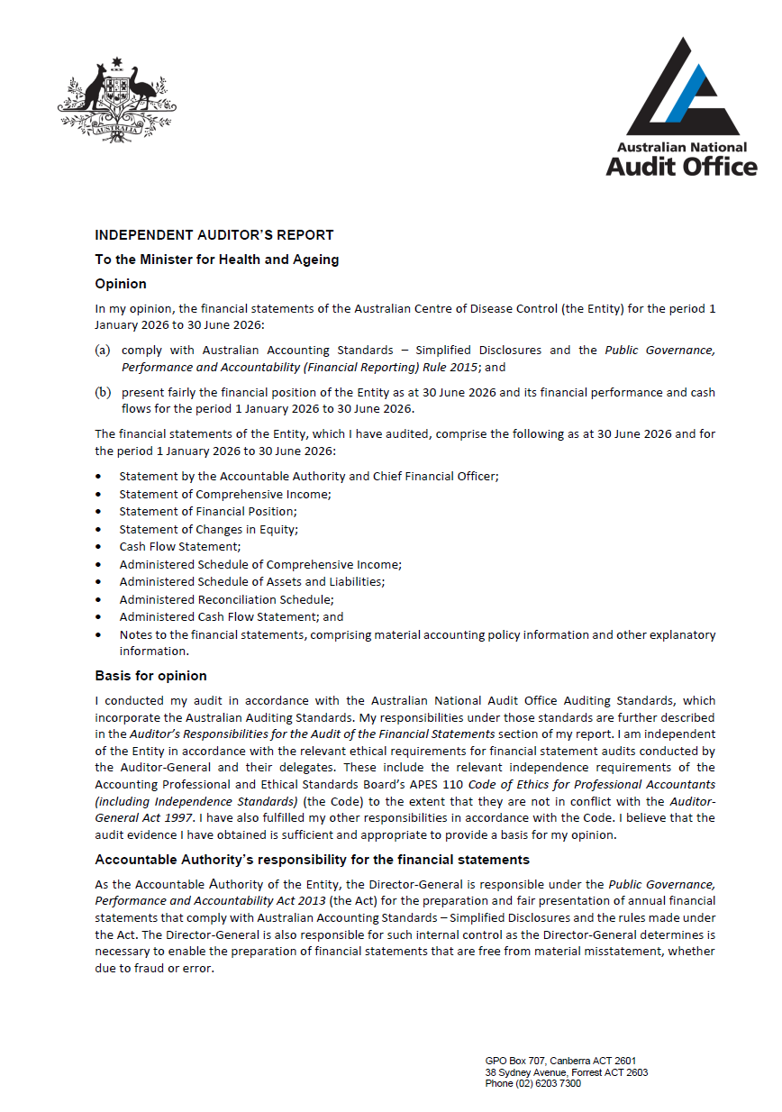
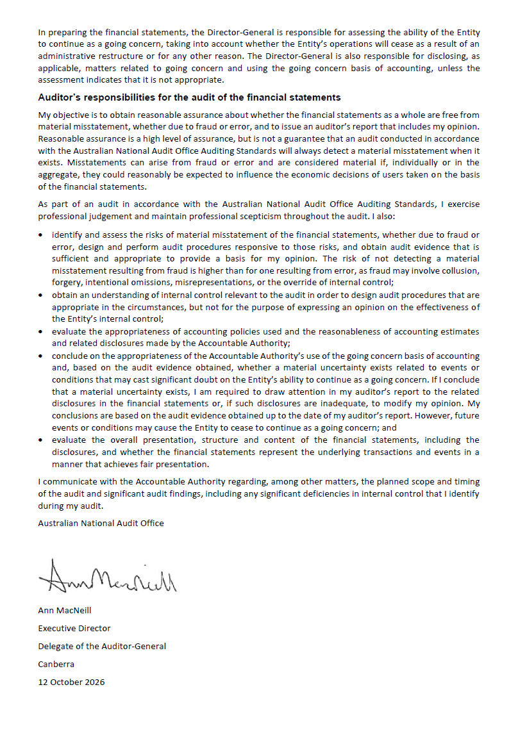
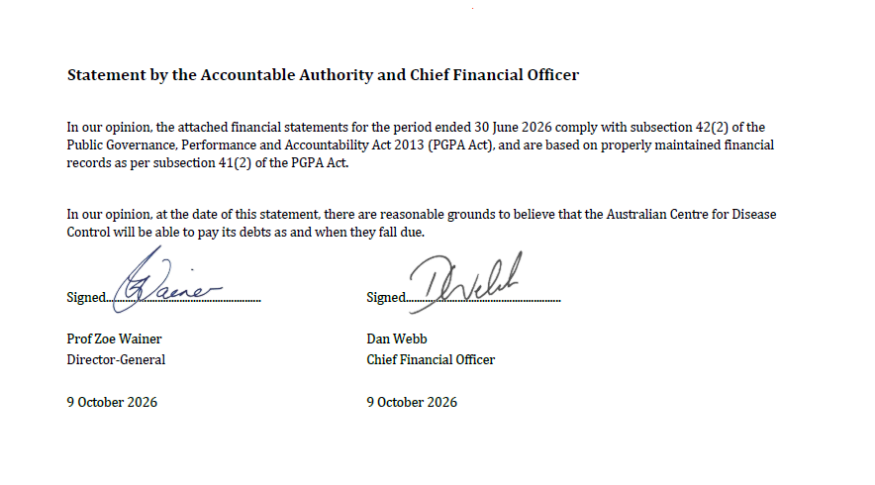
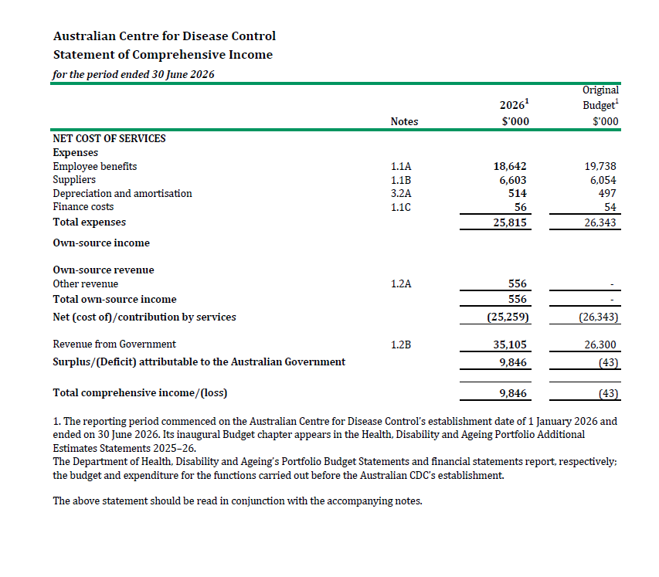
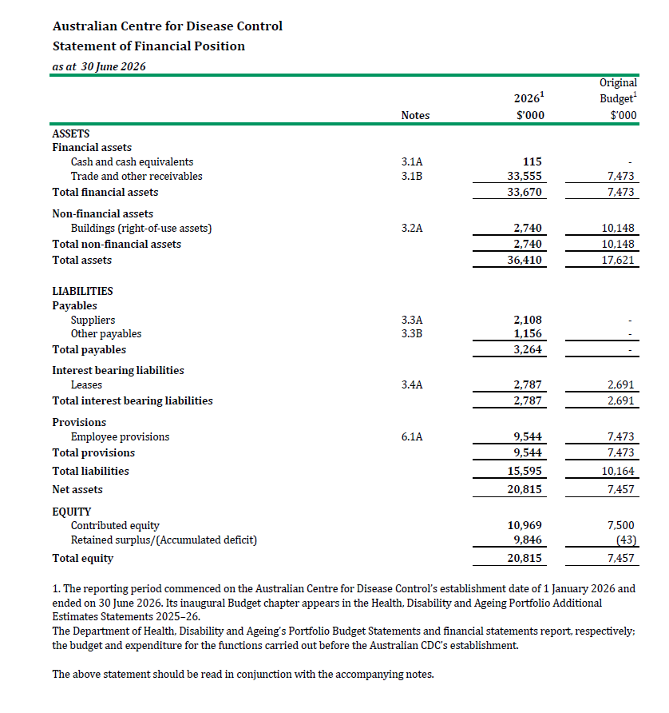
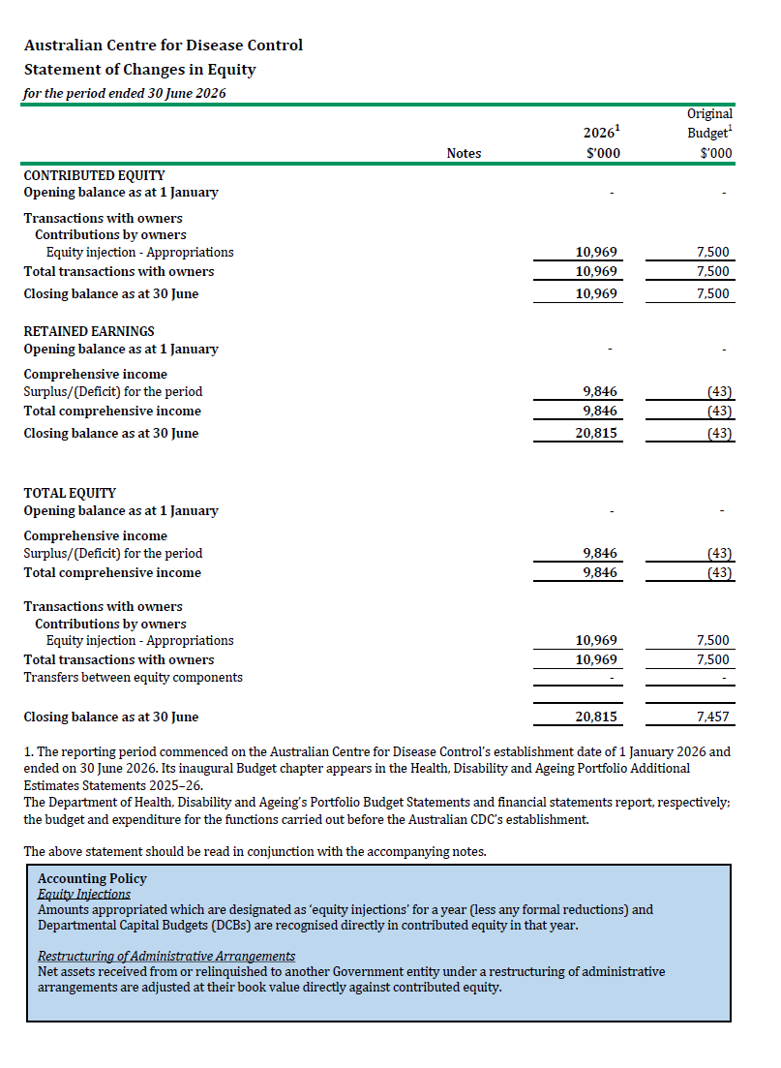
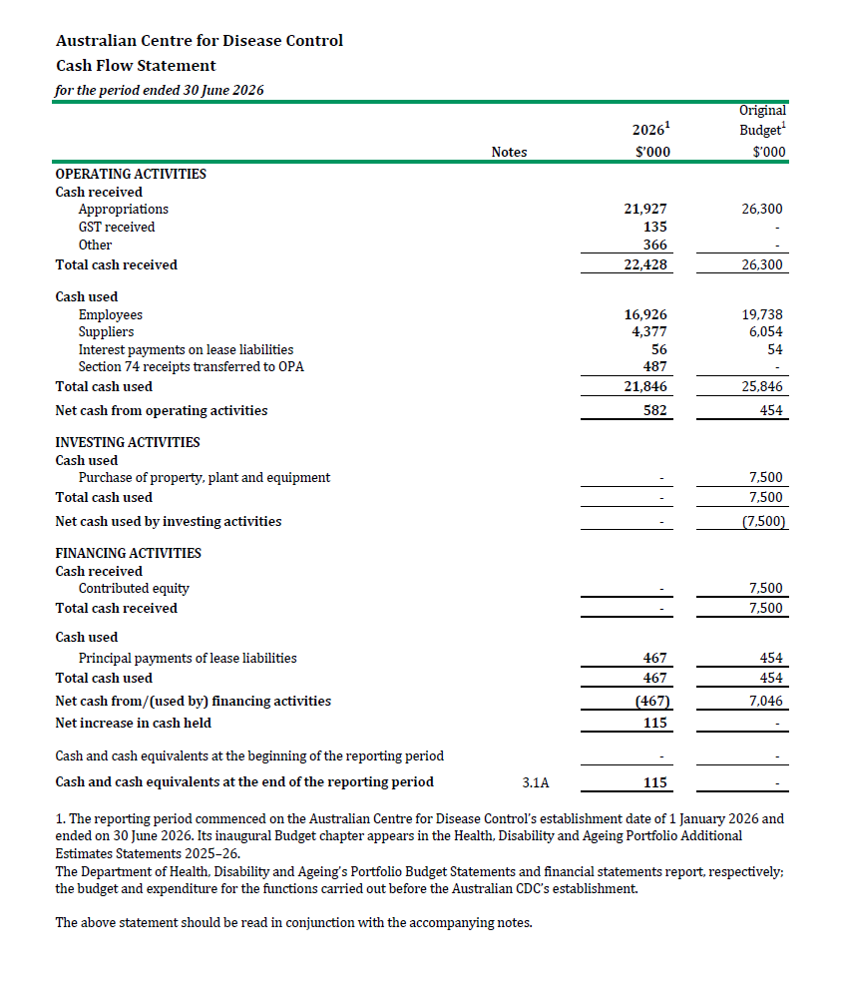
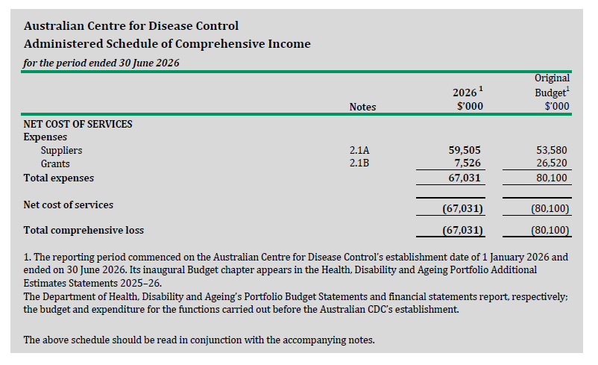
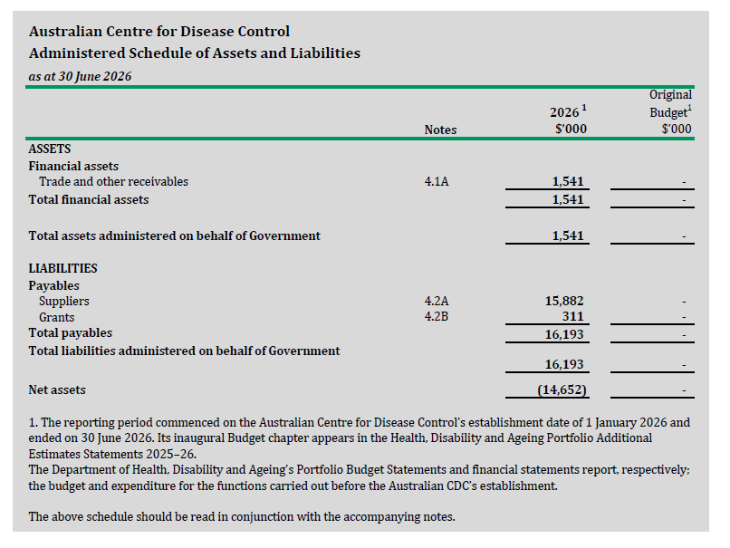
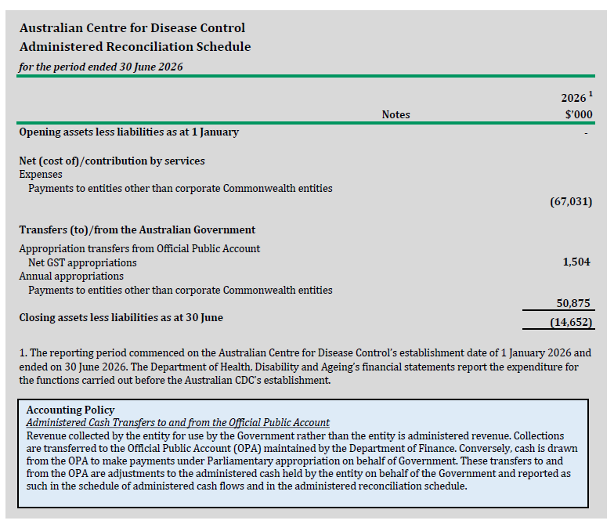
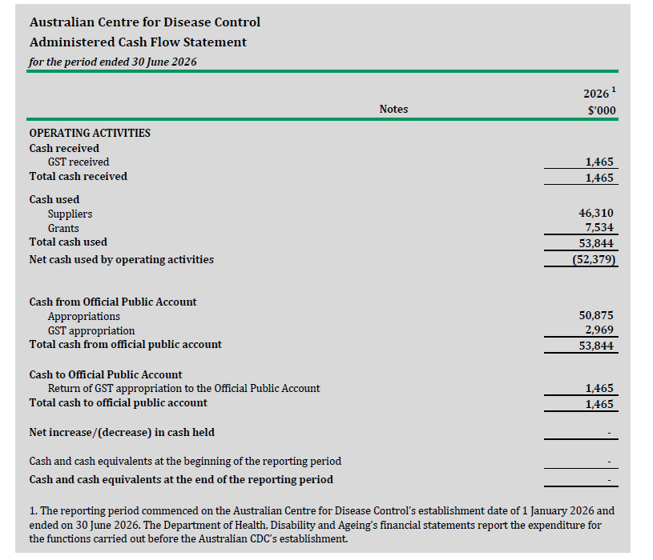
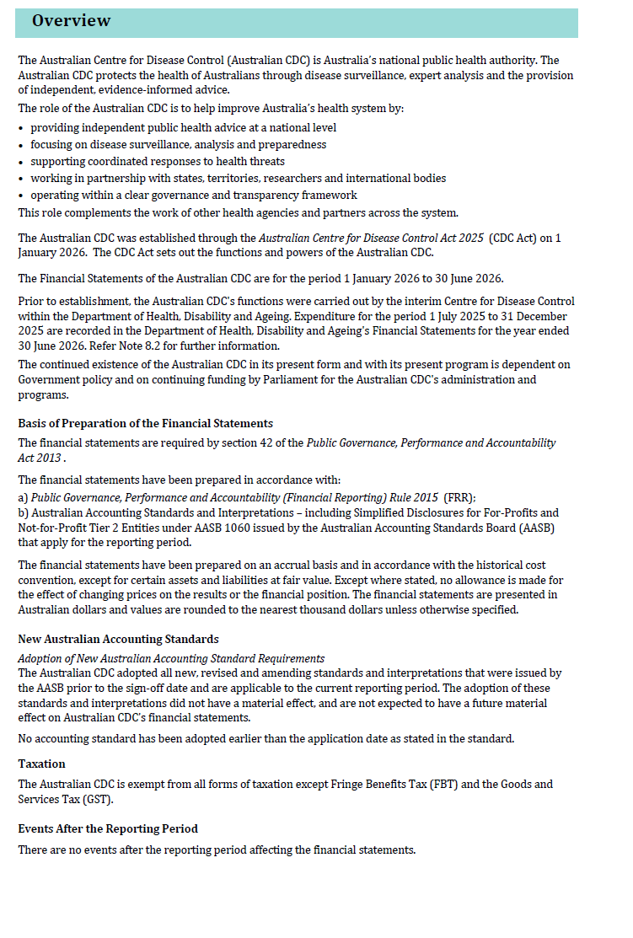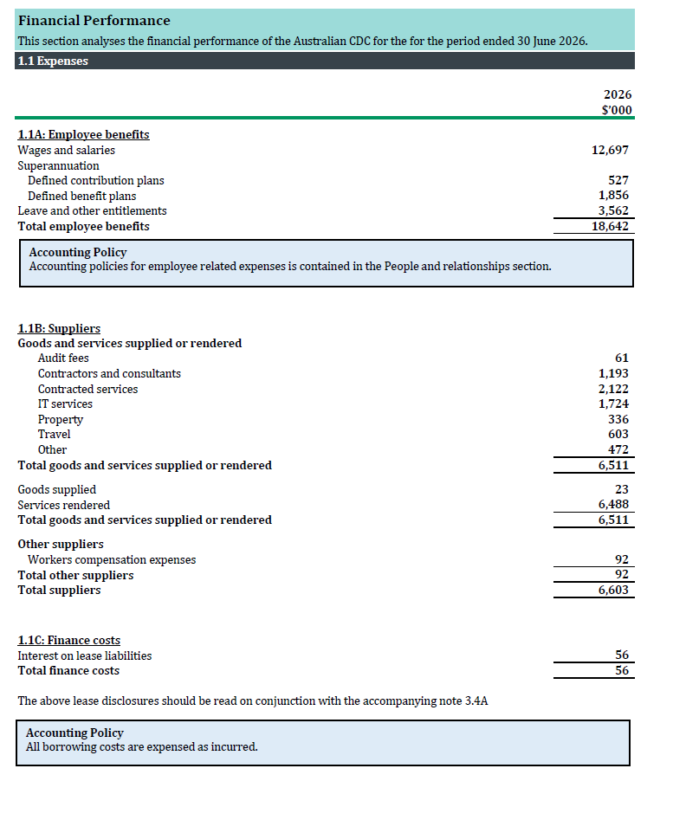
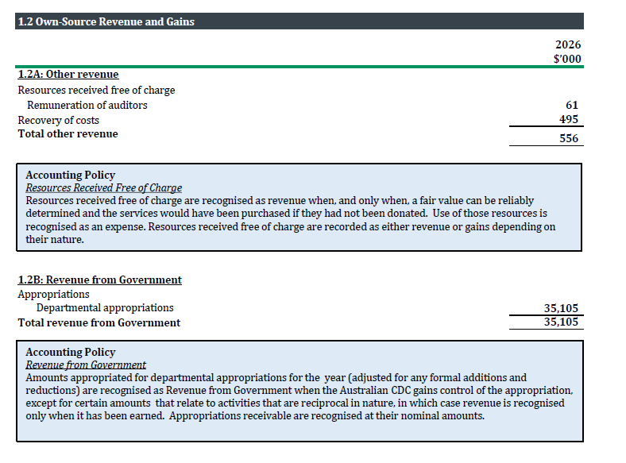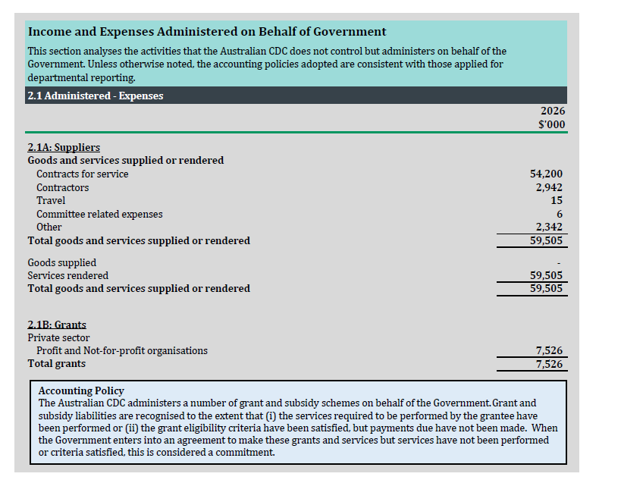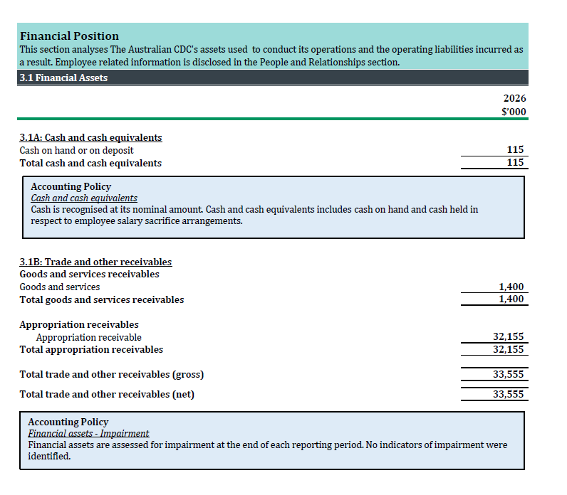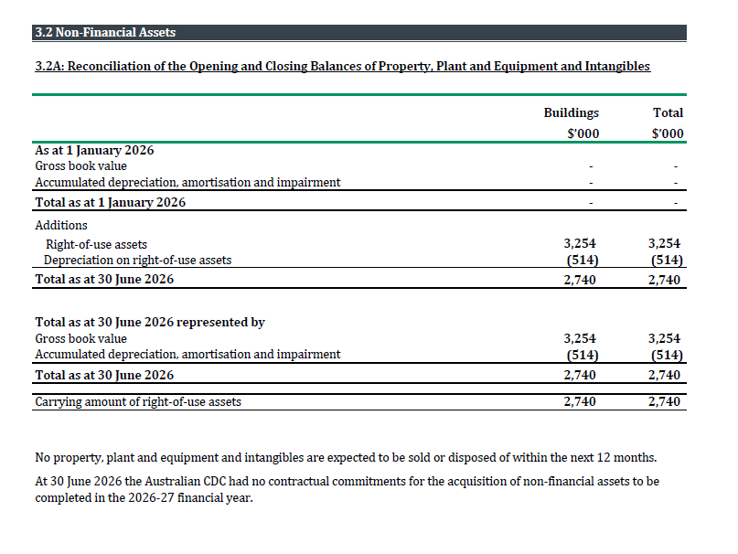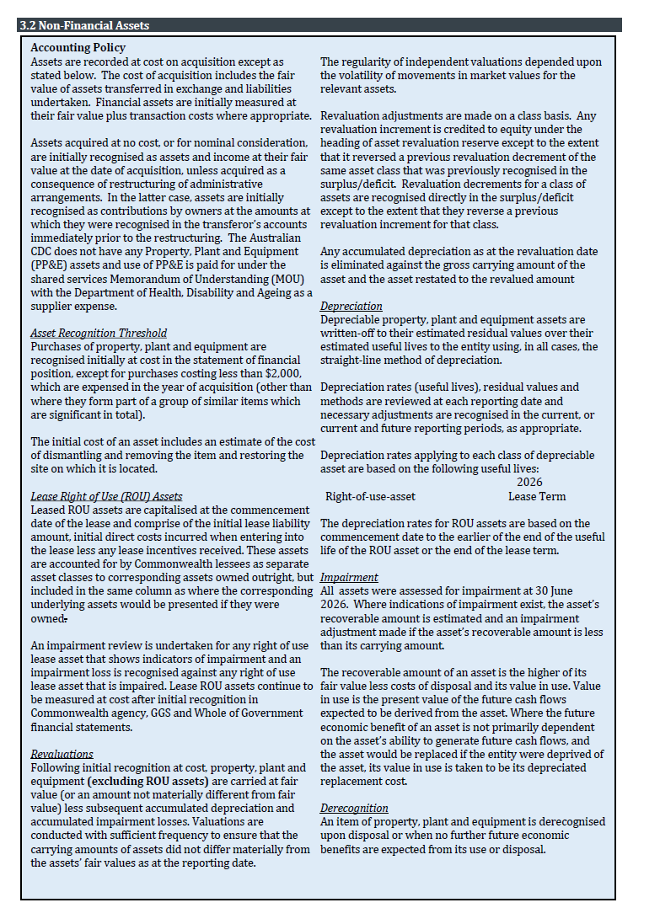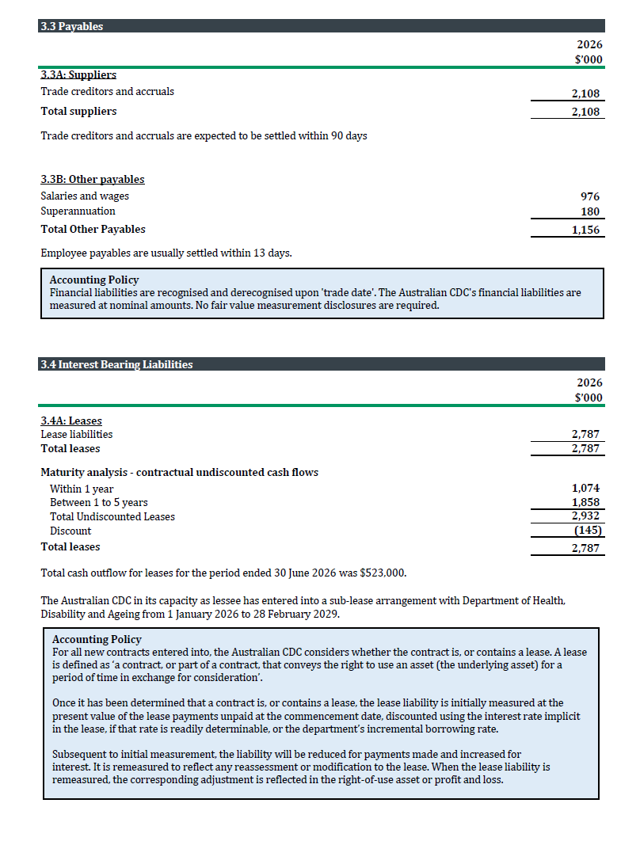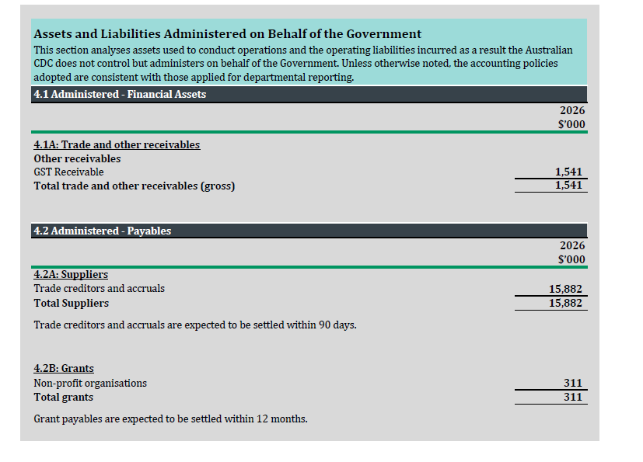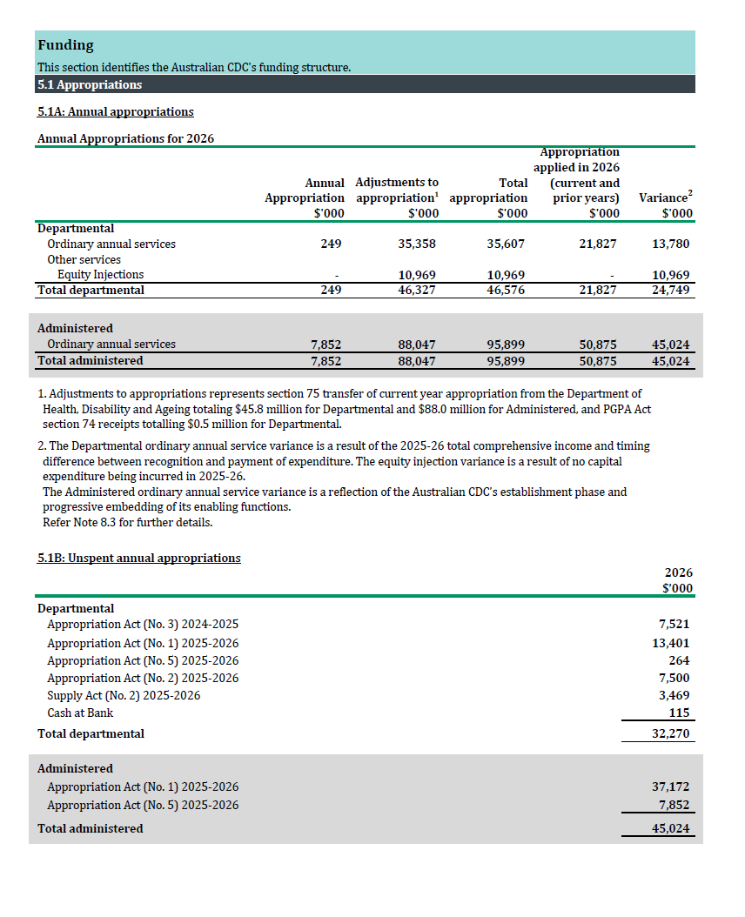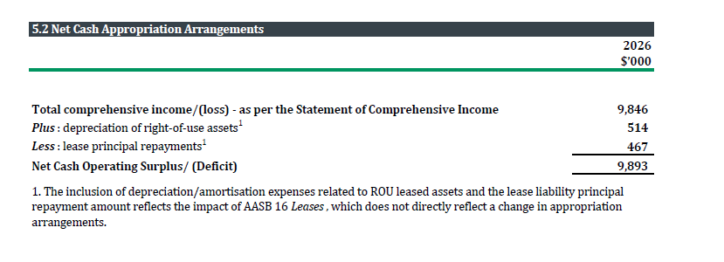
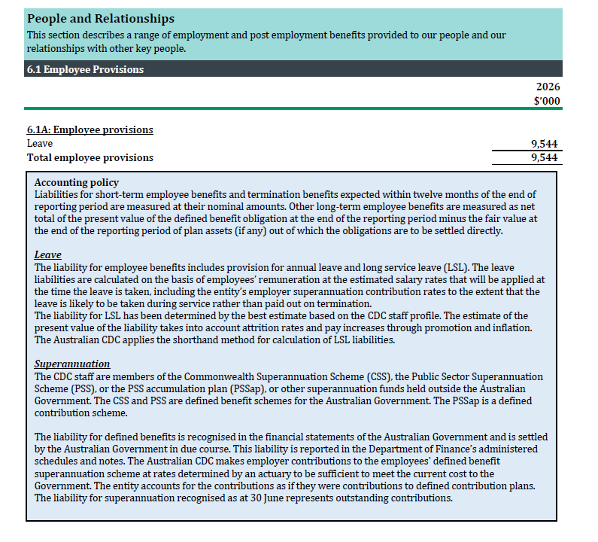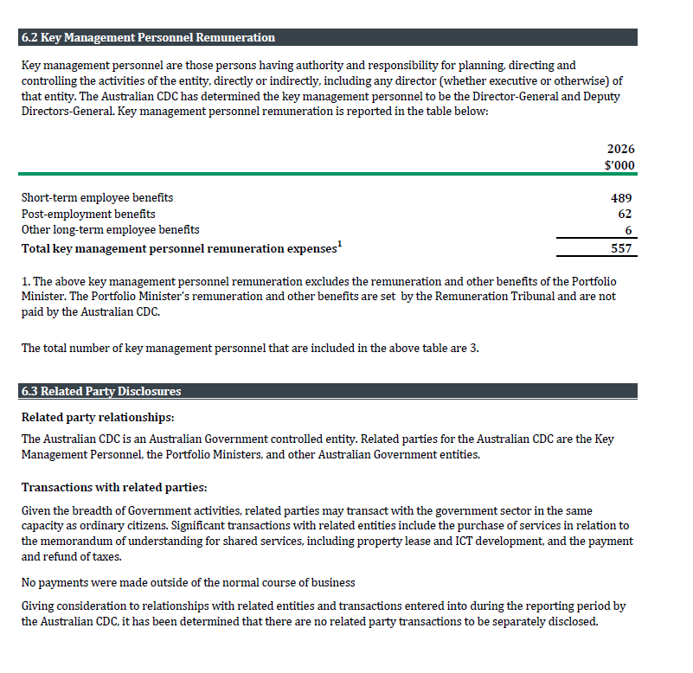
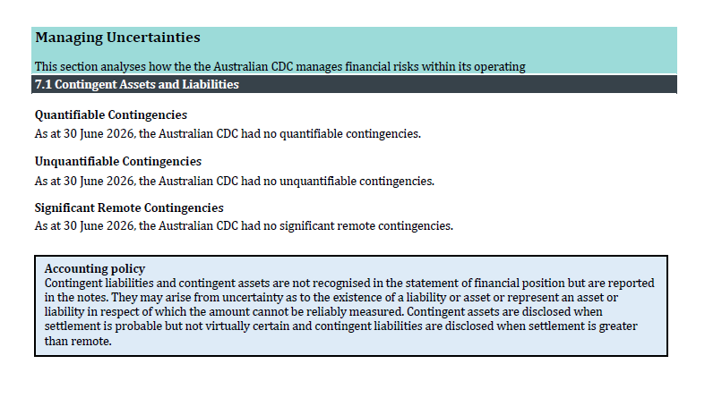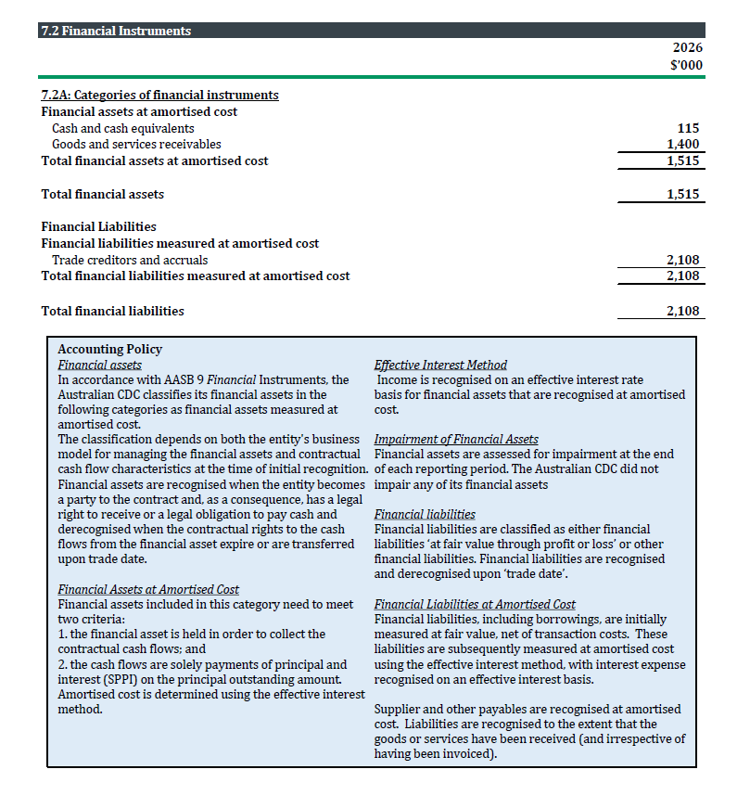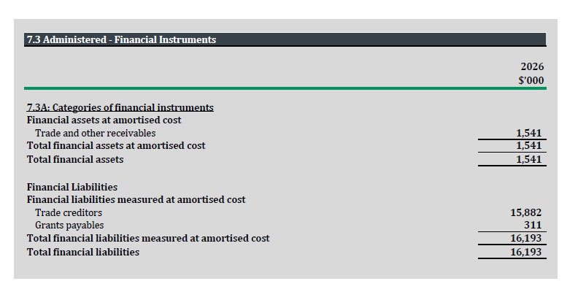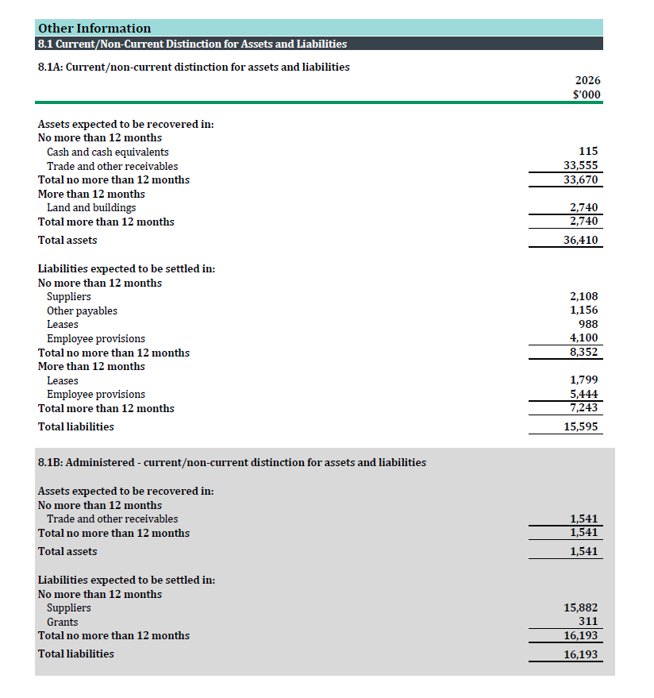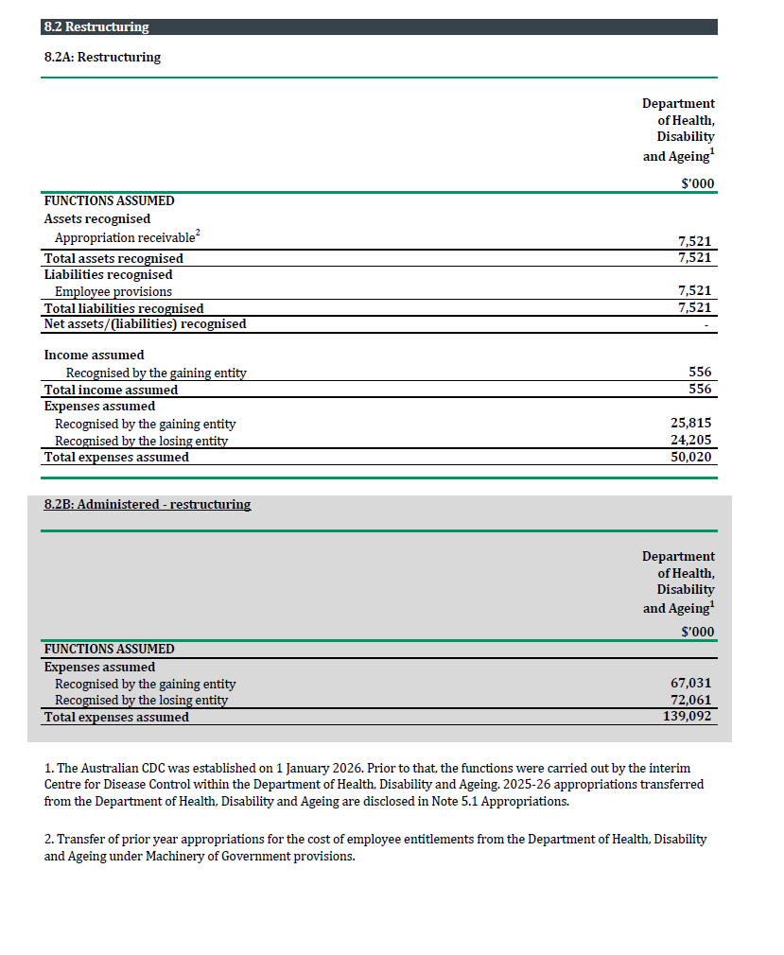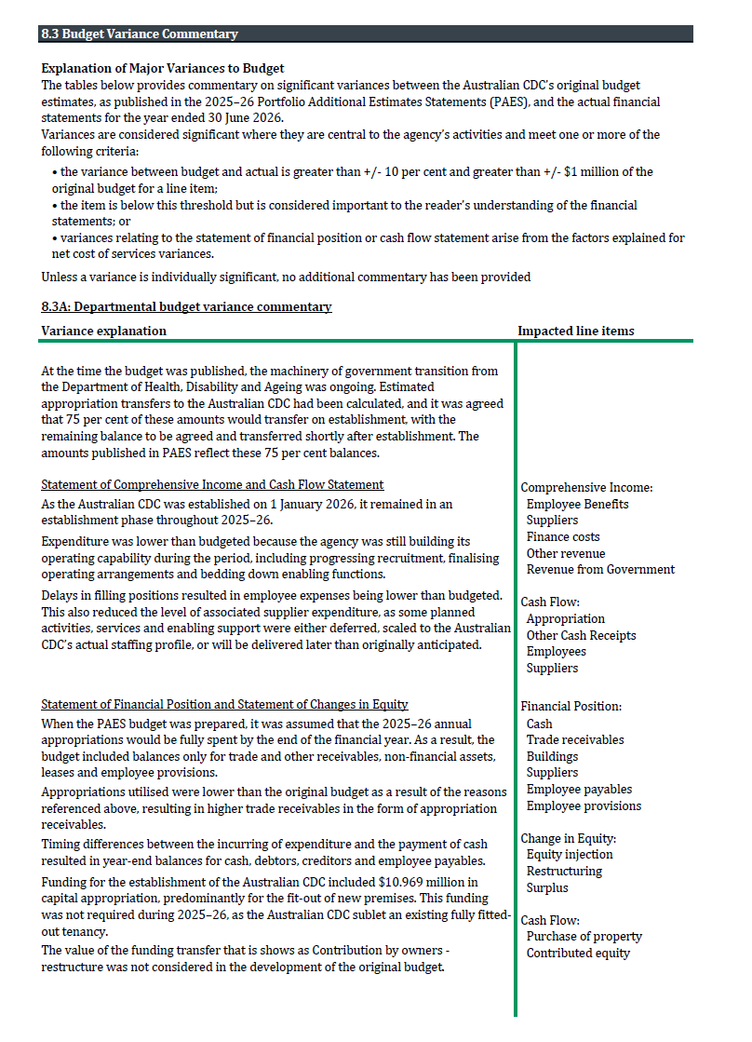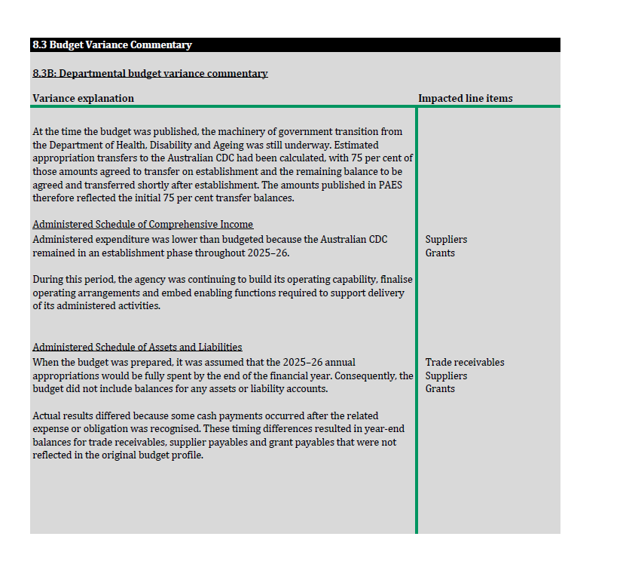
#
  - Other legislative requirements

Environment Protection and Biodiversity Conservation Act 1999
The principles of ecologically sustainable development (ESD), outlined in section 3A of the Environment Protection and Biodiversity Conservation Act 1999, are that:
- decision making processes should effectively integrate both long term and short term economic, environmental, social and equity considerations
- if there are threats of serious or irreversible environmental damage, lack of full scientific certainty should not be used as a reason for postponing measures to prevent environmental degradation
- the present generation should ensure the health, diversity and productivity of the environment is maintained or enhanced for the benefit of future generations
- the conservation of biological diversity and ecological integrity should be a fundamental consideration in decision making
- improved valuation, pricing and incentive mechanisms should be promoted.
The CDC contributes to the principles of ecologically sustainable development by incorporating environmental considerations into its operations and decision-making processes. During the reporting period, the CDC sought to minimise the environmental impacts of its activities through sustainable workplace practices, including the use of digital systems to reduce paper consumption, waste reduction and recycling initiatives, energy-efficient office practices, and the use of virtual collaboration technologies to reduce travel where appropriate. The CDC continues to review opportunities to improve its environmental performance and support the Australian Government’s broader sustainability objectives.
The CDC applies the principles of the EPBC Act where possible and appropriate. This includes encouraging ecologically sustainable practices, such as:
- use of videoconferencing to reduce official travel;
- paper-light and electronic records management practices;
- recycling and waste minimisation initiatives in office locations;
- energy-efficient workplace arrangements; and
- alignment with Australian Government sustainability and emissions reduction initiatives.

Work, Health and Safety Act 2011
The CDC is committed to protecting the health, safety and welfare of its workers, contractors and visitors. We recognise that providing a safe and healthy workplace supports employee wellbeing, strengthens organisational culture and contributes to effective performance. Through mandatory work health and safety training, risk management processes, workplace consultation and wellbeing initiatives, we foster a culture of safety and continuous improvement. These measures assist us to meet our legislative obligations while maintaining a workplace that is safe, inclusive and health-conscious.
- The CDC undertook a number of health and safety initiatives in 2025-26, including the following:
- 4 staff of staff attended first aid training and 6 have been appointed to the role of First Aid Officers.
- All staff were required to undertake workstation assessments of their remote workplace set-up.
- All staff had access to an influenza vaccination program with access to COVID-19 booster vaccinations. Staff were able to access vouchers for free vaccination at participating pharmacies.
- Employees had access to a range of health, safety and wellbeing initiatives, including work health and safety resources, first aid services, rehabilitation support, wellbeing programs and confidential counselling through the Employee Assistance Program (EAP), which was also available to immediate family members. The CDC has 3 Harassment Contact Officers.
- CDC Staff are required to complete mandatory Safety Essentials every 12 months. Staff can access advice and guidance in relation to work health and safety injury and illness matters from the CDC intranet site, or through the shared services arrangement with the DHDA. No investigations were conducted, and no notices were issued under the WHS Act 2011 during 2025–26.

Employee Census
CDC Staff participated in the 2026 Australian Public Service Census, achieving a 93% response rate. The census provides valuable insights into employee experiences across areas such as engagement, leadership, communication, wellbeing and organisational culture, and will inform initiatives to strengthen workforce capability and support the CDC’s continued development as Australia’s national Centre for Disease Control.
The results reflected a workforce that is highly committed to the CDC’s purpose and demonstrates strong levels of engagement, collaboration and psychological safety. The census also identified opportunities to further strengthen learning and development, workforce capability, organisational change management and cross-CDC collaboration as the agency continues to mature.

- Aids to access
  - Abbreviations and acronyms
AASB | Australian Accounting Standards Board. The national body responsible for developing and maintaining accounting standards in Australia.
ACS | Australian Climate Service
ACT | Australian Capital Territory
AIHW | Australian Institute of Health and Welfare
ANAO | Australian National Audit Office
APSC | Australian Public Service Commission
APS | Australian Public Service
AQCDTR | Air Quality and Communicable Diseases Technical Report
ARC | Audit and Risk Committee
BBV | Blood-borne Virus
CDC | Australian Centre for Disease Control
CCD | Commonwealth Climate Disclosure
CI | Confidence Interval
COPD | Chronic Obstructive Pulmonary Disease
CPRs | Commonwealth Procurement Rules
CSIRO | Commonwealth Scientific and Industrial Research Organisation
DALY | Disability-Adjusted Life Year
DEWR | Department of Employment and Workplace Relations
DHDA | Department of Health, Disability and Ageing
EAP | Employee Assistance Program
ED | Emergency Department
EL | Executive Level
EPBC Act | Environment Protection and Biodiversity Conservation Act 1999
EY | Ernst & Young
FBT | Fringe Benefit Tax
FOI | Freedom of Information
FRR | Financial Reporting Requirements
GP | General Practitioner
GST | Goods and Services Tax
HIV | Human Immunodeficiency Virus
HWTR | Health and Wellbeing Technical Report
IFA | Individual Flexibility Arrangement
IHR | International Health Regulations
IPS | Information Publication Scheme
MRSA | Methicillin-resistant Staphylococcus aureus
NACCHO | National Aboriginal Community Controlled Health Organisation
NEMA | National Emergency Management Agency
NNDSS | National Notifiable Diseases Surveillance System
NSW | New South Wales
NT | Northern Territory
PGPA Act | Public Governance, Performance and Accountability Act 2013
PGPA Rule | Public Governance, Performance and Accountability Rule 2014
PM2.5 | Particulate Matter 2.5 micrometres or less
PSM | Public Service Medal
PTSD | Post-Traumatic Stress Disorder
QLD | Queensland
RR | Relative Risk
SA | South Australia
SES | Senior Executive Service
SME | Small and Medium Enterprise
SPAR | State Party Self-Assessment Annual Report
SPA | Senior Professional Appointment
STI | Sexually Transmissible Infection
TAS | Tasmania
VIC | Victoria
WA | Western Australia
WHO | World Health Organization
  - Glossary
AASB | Australian Accounting Standards Board. The national body responsible for developing and maintaining accounting standards in Australia.
Administered Activities | Activities that the CDC manages on behalf of the Australian Government but does not control.
Administered Expenses | Expenses incurred on behalf of the Australian Government and reported separately from departmental expenses.
Amortisation | The systematic allocation of the cost of an intangible asset over its useful life.
Appropriation | Authority provided by Parliament to spend public money for specific purposes.
Appropriation Receivable | Funding approved by Parliament that is due to be received by an entity.
Asset | A resource controlled by an entity from which future economic benefits are expected to flow.
Audit Opinion | The Auditor-General's conclusion on whether the financial statements fairly present the entity's financial position and performance.
Avian Influenza | Avian Influenza is a viral disease of birds found worldwide. Avian influenza strains are described as low pathogenicity (LPAI) or high pathogenicity (HPAI). Most LPAI strains of avian influenza virus cause minimal disease in wild birds and poultry. However, some LPAI strains can evolve into HPAI strains when they spread among poultry and can result in widescale death of poultry and wild birds.
Blood-borne Viruses (BBV) | Viruses that are transmitted through blood and other bodily fluids, including hepatitis B, hepatitis C and HIV.
Cach and Cash Equivalents | Cash on hand and short-term, highly liquid investments readily convertible to known amounts of cash.
Chronic Disease | The term applied to a diverse group of diseases, such as heart disease, cancer and arthritis, that tend to be long-lasting and persistent in their symptoms or development. Although these features also apply to some communicable diseases (infections), chronic disease is usually confined to non-communicable diseases.
Climate-sensitive Diseases | Diseases whose occurrence, transmission or spread is influenced by climatic and environmental conditions.
Communicable Disease | An infectious disease transmissible (as from person to person) by direct contact with an infected individual or the individual’s discharges or by indirect means.
Contingent Liability | A potential obligation arising from past events whose existence depends on future events outside the entity's control.
Contributed Equity | Funding provided by the Australian Government that is recognised directly in equity rather than as revenue.
COVID-19 | Coronavirus disease 2019. An illness caused by the SARS-CoV-2 virus that was first identified in December 2019. Formerly known as 2019-nCoV.
Data Governance | The framework of policies, processes and oversight arrangements that ensure data is used responsibly, securely and effectively.
Depreciation | The systematic allocation of the cost of a tangible asset over its useful life.
Disease Surveillance | The systematic collection, analysis and interpretation of health data to detect and monitor diseases and public health threats.
Employee Provisions | Amounts recognised for employee entitlements such as annual leave and long service leave.
Epidemiology | The study of the distribution, causes and control of diseases and health conditions within populations.
Equity Injection | Capital funding provided by the Australian Government to invest in an entity's assets or capability.
Evidence-informed Decision-making | The use of the best available evidence, data and expertise to support policy, program and operational decisions.
FBT | Fringe Benefits Tax. A tax paid on certain benefits provided to employees or associates.
Federated Health System | Australia's system of government in which responsibility for health is shared between the Commonwealth, state and territory governments.
Financial Instrument | A contract that gives rise to a financial asset of one entity and a financial liability or equity instrument of another entity.
Financial Year | The 12-month period from 1 July to 30 June.
FRR | Public Governance, Performance and Accountability (Financial Reporting) Rule 2015. The financial reporting requirements for Commonwealth entities.
General Practitioner | A medical practitioner who provides primary care to patients and their families within the community.
Genomic Surveillance | The monitoring of pathogens through genetic sequencing to identify variants, transmission patterns and emerging risks.
Health Protection | Activities aimed at preventing or reducing risks to public health from infectious diseases, environmental hazards and other threats.
Influenza (flu) | Caused by the influenza virus, which is easily spread from person to person and is not the same as the common cold. The flu is a serious disease as it can lead to bronchitis, croup, pneumonia, ear infections, heart and other organ damage, brain inflammation and brain damage, and death.
Japanese Encephalitis | Japanese encephalitis is caused by the Japanese encephalitis virus (JEV). It is spread through bites from mosquitos, which become infected through biting infected pigs and waterbirds.
Medicare | A national, government-funded scheme that subsidises the cost of personal medical services for all Australians and aims to help them afford medical care.
National Preparedness | The capability of governments, health systems and communities to prevent, respond to and recover from public health emergencies.
One Health | An approach recognising the interconnectedness of human, animal and environmental health.
Pandemic | A pandemic is a worldwide spread of a new disease, such as a new influenza virus, or the coronavirus that causes COVID-19.
Pandemic Preparedness | Activities undertaken before a pandemic occurs to strengthen the capacity to prevent, detect, respond to and recover from large-scale infectious disease outbreaks.
Primary Care | Provides the patient with a broad spectrum of care, both preventive and curative, over a period of time and coordinates all of the care the person receives.
Public Health Advice | Evidence-based information, recommendations and assessments provided to support decision-making on public health matters.
Public Health Intelligence | Information derived from surveillance, monitoring, analysis and risk assessment used to identify and understand public health threats.
Public Health Risk Assessment | A systematic process used to evaluate the likelihood and consequences of a public health threat.
Public Health Threat | Any biological, environmental or other hazard that could adversely affect the health of a population.
Risk Assessment | The process of identifying, analysing and evaluating risks to support informed decision-making.
Surge Capacity | The ability of a health system or organisation to rapidly increase resources and services during emergencies.
Sexually transmitted Infection (STI) | Infections primarily spread through sexual contact.
Syphilis | Syphilis is a serious infection caused by the Treponema pallidum bacterium. It has a complex disease progression, and early symptoms are often unnoticed. Left untreated, it can have significant health effects in several organ systems. In pregnant women it can lead to birth complications, congenital syphilis, and miscarriages. Syphilis is treatable with long-acting penicillin injections.
Transparency | The practice of making information, decisions and evidence publicly available to promote accountability and trust.
World Health Organisation (WHO) | The WHO is a specialised agency of the United Nations (UN). Its primary role is to direct and coordinate international health within the UN system. The WHO has 194 member states, including Australia.
Zoonotic Disease | A disease that can be transmitted between animals and humans.

  - List of requirements
This table is required by section 17AJ(d) of the PGPA Rule and is set out in Schedule 2 of the PGPA Rule.
The following table must be included within the annual report as an aid to access. The ‘Part of report’ column should be completed with section references to assist the reader.
PGPA Rule reference | Part of report | Description | Requirement | Section
17AD(g) | - | Letter of transmittal | -
17AI | Letter of transmittal | A copy of the letter of transmittal signed and dated by accountable authority on date final text approved, with statement that the report has been prepared in accordance with section 46 of the Act and any enabling legislation that specifies additional requirements in relation to the annual report. | Mandatory | (ii)
17AD(h) | - | Aids to access | -
17AJ(a) | Table of contents | Table of contents (print only) | Mandatory | (iii)
17AJ(b) | Index | Alphabetical index (print only) | Mandatory | Section 8.4
17AJ(c) | Glossary | Glossary of abbreviations and acronyms | Mandatory | Section 8.2
17AJ(d) | List of requirements | List of requirements | Mandatory | Section 8.3
17AJ(e) | Publication information | Details of contact officer | Mandatory | (i)
17AJ(f) | Publication information | Entity’s website address | Mandatory | (i)
17AJ(g) | Publication information | Electronic address of report | Mandatory | (i)
17AD(a) | - | Review by accountable authority | -
17AD(a) | Director-General’s review | A review by the accountable authority of the entity | Mandatory | Section 1
17AD(b) | - | Overview of the entity | -
17AE(1)(a)(i) | Overview of the Australian Centre for Disease Control | A description of the role and functions of the entity | Mandatory | Section 2
17AE(1)(a)(ii) | How the CDC adds value | A description of the organisational structure of the entity | Mandatory | Section 3
17AE(1)(a)(iii) | Transparency on public health advice | A description of the outcomes and programmes administered by the entity | Mandatory | Section 3.1
17AE(1)(a)(iv) | Corporate governance | A description of the purposes of the entity as included in corporate plan | Mandatory | Section 5.1
17AE(1)(aa)(i) | Corporate governance | Name of the accountable authority or each member of the accountable authority | Mandatory | Section 5.1
17AE(1)(aa)(ii) | Corporate governance | Position title of the accountable authority or each member of the accountable authority | Mandatory | Section 5.1
17AE(1)(aa)(iii) | Corporate governance | Period as the accountable authority or member of the accountable authority within the reporting period | Mandatory | Section 5.1
17AE(1)(b) | How the CDC adds value | An outline of the structure of the portfolio of the entity | Portfolio departments - mandatory | Section 3
17AE(2) | - | Where the outcomes and programs administered by the entity differ from any Portfolio Budget Statement, Portfolio Additional Estimates Statement or other portfolio estimates statement that was prepared for the entity for the period, include details of variation and reasons for change | Not Applicable | -
17AD(c) | - | Report on the Performance of the entity | -
- | - | Annual performance statements | -
17AD(c)(i); 16F | Annual performance statement | Annual performance statements in accordance with paragraph 39(1)(b) of the Act and section 16F of the Rule | Mandatory | Section 4.1
17AD(c)(ii) | - | Report on Financial Performance | -
17AF(1)(a) | Report on financial performance | A discussion and analysis of the entity’s financial performance | Mandatory | Section 4.2
17AF(1)(b) | Financial performance | A table summarising the total resources and total payments of the entity | Mandatory | Section 4.2.1
17AF(2) | - | If there may be significant changes in the financial results during or after the previous or current reporting period, information on those changes, including: the cause of any operating loss of the entity; how the entity has responded to the loss and the actions that have been taken in relation to the loss; and any matter or circumstances that it can reasonably be anticipated will have a significant impact on the entity’s future operation or financial results | Not Applicable | -
17AD(d) | - | Management and Accountability | -
- | - | Corporate Governance | -
17AG(2)(a) | Fraud and corruption control and prevention | Information on compliance with section 10 (fraud and corruption systems) | Mandatory | Section 5.1.1
17AG(2)(b)(i) | Fraud and corruption control and prevention | A certification by accountable authority that fraud and corruption risk assessments have been conducted and fraud and corruption control plans have been prepared | Mandatory | Section 5.1.1
17AG(2)(b)(ii) | Fraud and corruption control and prevention | A certification by accountable authority that appropriate mechanisms for preventing, detecting incidents of, investigating or otherwise dealing with, and recording or reporting fraud and corruption that meet the specific needs of the entity are in place | Mandatory | Section 5.1.1
17AG(2)(b)(iii) | Fraud and corruption control and prevention | A certification by accountable authority that all reasonable measures have been taken to deal appropriately with fraud and corruption relating to the entity | Mandatory | Section 5.1.1
17AG(2)(c) | Corporate governance | An outline of structures and processes in place for the entity to implement principles and objectives of corporate governance | Mandatory | Section 5.1
17AG(2)(d) – (e) | - | A statement of significant issues reported to Minister under paragraph 19(1)(e) of the Act that relates to non-compliance with Finance law and action taken to remedy non-compliance | Not Applicable | -
 | - | Audit Committee | -
17AG(2A)(a) | Audit and risk committee | A direct electronic address of the charter determining the functions of the entity’s audit committee | Mandatory | Section 5.2
17AG(2A)(b) | Audit and risk committee | The name of each member of the entity’s audit committee | Mandatory | Section 5.2
17AG(2A)(c) | Audit and risk committee | The qualifications, knowledge, skills or experience of each member of the entity’s audit committee | Mandatory | Section 5.2
17AG(2A)(d) | Audit and risk committee | Information about the attendance of each member of the entity’s audit committee at committee meeting | Mandatory | Section 5.2
17AG(2A)(e) | Audit and risk committee | The remuneration of each member of the entity’s audit committee. | Mandatory | Section 5.2
 | - | External Scrutiny | -
17AG(3) | External scrutiny | Information on the most significant developments in external scrutiny and the entity’s response to the scrutiny | Mandatory | Section 5.3
17AG(3)(a) | - | Information on judicial decisions and decisions of administrative tribunals and by the Australian Information Commissioner that may have a significant effect on the operations of the entity | Not applicable | -
17AG(3)(b) | - | Information on any reports on operations of the entity by the Auditor-General (other than report under section 43 of the Act), a Parliamentary Committee, or the Commonwealth Ombudsman | Not applicable | -
17AG(3)(c) | - | Information on any capability reviews on the entity that were released during the period | Not applicable | -
 | - | Management of Human Resources | -
17AG(4)(a) | Managing and developing employees | An assessment of the entity’s effectiveness in managing and developing employees to achieve entity objectives | Mandatory | Section 5.4.1
17AG(4)(aa) | Employee statistics | Statistics on the entity’s employees on an ongoing and non-ongoing basis, including the following:  (a) statistics on full-time employees  (b) statistics on part-time employees  (c) statistics on gender  (d) statistics on staff location | Mandatory | Section 5.4.3
17AG(4)(b) | APS employee statistics | Statistics on the entity’s APS employees on an ongoing and non-ongoing basis; including the following:  Statistics on staffing classification level  Statistics on full-time employees  Statistics on part-time employees  Statistics on gender  Statistics on staff location  Statistics on employees who identify as Indigenous | Mandatory | Section 5.4.4
17AG(4)(c) | Workplace agreements | Information on any enterprise agreements, individual flexibility arrangements, Australian workplace agreements, common law contracts and determinations under subsection 24(1) of the Public Service Act 1999 | Mandatory | Section 5.4.2
17AG(4)(c)(i) | APS employee statistics | Information on the number of SES and non-SES employees covered by agreements etc identified in paragraph 17AG(4)(c) | Mandatory | Section 5.4.4
17AG(4)(c)(ii) | APS employee statistics | The salary ranges available for APS employees by classification level | Mandatory | Section 5.4.4
17AG(4)(c)(iii) | Workplace agreements | A description of non-salary benefits provided to employees | Mandatory | Section 5.4.2
17AG(4)(d)(i) | Performance pay | Information on the number of employees at each classification level who received performance pay | If applicable, Mandatory | Section 5.4.5
17AG(4)(d)(ii) | - | Information on aggregate amounts of performance pay at each classification level | Not applicable | -
17AG(4)(d)(iii) | - | Information on the average amount of performance payment, and range of such payments, at each classification level | Not applicable | -
17AG(4)(d)(iv) | - | Information on aggregate amount of performance payments | Not applicable | -
 | - | Assets Management | -
17AG(5) | - | An assessment of effectiveness of assets management where asset management is a significant part of the entity’s activities | Not applicable | -
 | - | Purchasing | -
17AG(6) | Purchasing | An assessment of entity performance against the Commonwealth Procurement Rules. | Mandatory | Section 5.6
 | - | Reportable consultancy contracts | -
17AG(7)(a) | Reportable consultancy contracts | A summary statement detailing the number of new reportable consultancy contracts entered into during the period; the total actual expenditure on all such contracts (inclusive of GST); the number of ongoing reportable consultancy contracts that were entered into during a previous reporting period; and the total actual expenditure in the reporting period on those ongoing contracts (inclusive of GST) | Mandatory | Section 5.7.1
17AG(7)(b) | Reportable consultancy contracts | A statement that “During [reporting period], [specified number] new reportable consultancy contracts were entered into involving total actual expenditure of $[specified million]. In addition, [specified number] ongoing reportable consultancy contracts were active during the period, involving total actual expenditure of $[specified million]” | Mandatory | Section 5.7.1
17AG(7)(c) | Reportable consultancy contracts | A summary of the policies and procedures for selecting and engaging consultants and the main categories of purposes for which consultants were selected and engaged | Mandatory | Section 5.7.1
17AG(7)(d) | Reportable consultancy contracts | A statement that Annual reports contain information about actual expenditure on reportable consultancy contracts. Information on the value of reportable consultancy contracts is available on the AusTender website.” | Mandatory | Section 5.7.1
 | - | Reportable non-consultancy contracts | -
17AG(7A)(a) | Reportable non-consultancy contracts | A summary statement detailing the number of new reportable non-consultancy contracts entered into during the period; the total actual expenditure on such contracts (inclusive of GST); the number of ongoing reportable non-consultancy contracts that were entered into during a previous reporting period; and the total actual expenditure in the reporting period on those ongoing contracts (inclusive of GST) | Mandatory | Section 5.7.2
17AG(7A)(b) | Reportable non-consultancy contracts | A statement that “Annual reports contain information about actual expenditure on reportable non-consultancy contracts. Information on the value of reportable non-consultancy contracts is available on the AusTender website.” | Mandatory | Section 5.7.2
17AD(daa) | Consultancy and non-consultancy contract expenditure | Additional information about organisations receiving amounts under reportable consultancy contracts or reportable non-consultancy contracts | Mandatory | Section 5.7
17AGA | Consultancy and non-consultancy contract expenditure | Additional information, in accordance with section 17AGA, about organisations receiving amounts under reportable consultancy contracts or reportable non-consultancy contracts | Mandatory | Section 5.7
 | - | Australian National Audit Office Access Clauses | -
17AG(8) | - | If an entity entered into a contract with a value of more than $100,000 (inclusive of GST) and the contract did not provide the Auditor-General with access to the contractor’s premises, the report must include the name of the contractor, purpose and value of the contract, and the reason why a clause allowing access was not included in the contract. | Not applicable | -
 | - | Exempt contracts | -
17AG(9) | - | If an entity entered into a contract or there is a standing offer with a value greater than $10,000 (inclusive of GST) which has been exempted from being published in AusTender because it would disclose exempt matters under the FOI Act, the annual report must include a statement that the contract or standing offer has been exempted, and the value of the contract or standing offer, to the extent that doing so does not disclose the exempt matters | Not applicable | -
 | - | Small business | -
17AG(10)(a) | Small business | A statement that “[Name of entity] supports small business participation in the Commonwealth Government procurement market. Small and Medium Enterprises (SME) and Small Enterprise participation statistics are available on the Department of Finance’s website.” | Mandatory | Section 5.11
17AG(10)(b) | Small business | An outline of the ways in which the procurement practices of the entity support small and medium enterprises. | Mandatory | Section 5.11
17AG(10)(c) | - | If the entity is considered by the Department administered by the Finance Minister as material in nature—a statement that “[Name of entity] recognises the importance of ensuring that small businesses are paid on time. The results of the Survey of Australian Government Payments to Small Business are available on the Treasury’s website.” | Not applicable | -
 | - | Financial Statements | -
17AD(e) | Financial Statements | Inclusion of the annual financial statements in accordance with subsection 43(4) of the Act. | Mandatory | Section 7.1
 | - | Executive Remuneration | -
17AD(da) | Executive remuneration | Information about executive remuneration in accordance with Subdivision C of Division 3A of Part 2-3 of the Rule. | Mandatory | Section 5.5
17AD(f) | - | Other Mandatory Information | -
17AH(1)(a)(i) | - | If the entity conducted advertising campaigns, a statement that “During [reporting period], the [name of entity] conducted the following advertising campaigns: [name of advertising campaigns undertaken]. Further information on those advertising campaigns is available at [address of entity’s website] and in the reports on Australian Government advertising prepared by the Department of Finance. Those reports are available on the Department of Finance’s website.” | Not applicable | -
17AH(1)(a)(ii) | - | If the entity did not conduct advertising campaigns, a statement to that effect. | Not applicable | -
17AH(1)(b) | Grants | A statement that “Information on grants awarded by [name of entity] during [reporting period] is available at [address of entity’s website].” | If applicable, Mandatory | Section 6.1
17AH(1)(c) | Disability reporting | Outline of mechanisms of disability reporting, including reference to website for further information. | Mandatory | Section 6.2
17AH(1)(d) | Freedom of information | Website reference to where the entity’s Information Publication Scheme statement pursuant to Part II of FOI Act can be found. | Mandatory | Section 6.3
17AH(1)(e) | - | Correction of material errors in previous annual report | Not applicable | -
17AH(2) | Other legislative requirements | Information required by other legislation | Mandatory | Section 7.2
  - Index
A
- Abbreviations and acronyms, 85–86
- Aboriginal and Torres Strait Islander peoples, 2
- Accountability, 25, 29–30
- Acknowledgement of Country, 2
- Andes virus hantavirus, 7, 10
- Annual Performance Statements, 24
- Audit and Risk Committee (ARC), 25, 29, 31
- Australian Centre for Disease Control Act 2025, 4, 9, 14
- Australian Climate Service (ACS), 17
- Australian National Audit Office (ANAO), 46, 85
B
- Blood-borne viruses (BBV), 8, 48, 85, 87
- Bushfire smoke, 18,
C
- Climate change, 21
- Climate-sensitive diseases, 87
- Communicable diseases, 21
- Community engagement, 16
- Congenital syphilis, 8, 10
- Consultancy contracts, 44–45
- Contact details, 3
- Corporate governance, 29
- Corporate Plan 2025–26, 29
- COVID-19, 15–16, 83
D
- Data science, 9
- Department of Health, Disability and Ageing (DHDA), 15, 19, 85
- Diphtheria, 7, 10
- Disability reporting, 48–49
- Director-General, 4, 7–9, 24, 29–30
E
- Ebola disease, 7, 10
- Employee Census, 83
- Employee statistics, 35–42
- Environmental health, 10, 89
- Epidemiology, 8–9, 88
- Executive Committee, 25, 29
- Executive remuneration, 43
F
- Federated health system, 9, 88
- Financial performance, 27
- Financial statements, 4, 27, 50–80
- Flooding, 18, 20, 22
- Fraud and corruption control, 4, 30
- Freedom of Information (FOI), 14, 49, 85
G
- Genomic surveillance, 7, 88
- Glossary, 86-90
- Governance committees, 29
- Grants, 48
H
- H5N1 avian influenza, 7, 10
- Health protection, 24, 88
- HIV, 8, 85
- Human resources, 32
I
- Indigenous employment, 40
- Information Publication Scheme (IPS), 49
- Influenza, 21, 48
- Infectious diseases, 22, 88
- International Health Regulations (IHR), 16
J
- Japanese encephalitis, 21, 88
L
- Laboratories, 7, 9, 16
- Legal services expenditure, 49
- Letter of transmittal, 4
M
- Management and accountability, 29–47
- Mental health, 18, 22
- MV Hondius, 7
N
- National Climate and Health Strategy, 10
- National Climate Risk Assessment, 17–20
- National Emergency Management Agency (NEMA), 23
- National Notifiable Diseases Surveillance System (NNDSS), 86
- National preparedness, 89
- Non-consultancy contracts, 46
O
- One Health, 89
- Organisational structure, 12
- Outbreak response, 7-11
P
- Pandemic preparedness, 15–17,
- Pandemic Preparedness Strategic Framework, 16
- Performance measures, 25–26
- Performance report, 24–28
- Procurement, 44, 47
- Public health advice, 13–14, 24–25, 58
- Public health intelligence, 10, 89
- Public health risk assessment, 89
- Public health surveillance, 7–10
Q
- Quarantine, 7, 48
R
- Respiratory disease, 26
- Risk assessment, 7–10, 15–17, 59
- Risk management framework, 25, 31
S
- Sexually transmissible infections (STI), 8, 10–12, 48
- Small business procurement, 48
- SPAR (State Party Self-Assessment Annual Report), 17, 86
- Strategic commissioning framework, 46
- Surveillance, 7–10, 15, 25
- Syphilis, 8, 11, 89
T
- Transparency, 13–14, 25, 89
- Tropical cyclones, 22
V
- Viral hepatitis, 10
W
- Workforce capability, 16, 33, 83
- Work Health and Safety (WHS), 83
- Workplace agreements, 33
- World Health Organization (WHO), 48, 86
Z
- Zoe Wainer, 4, 8, 24, 29, 43
- Zoonotic diseases, 21–22,



The reporting period commenced on the CDC’s establishment date of January 1 2026 and ended 30 June 2026. Its inaugural Budget chapter appears in the Health, Disability and Ageing Portfolio Estimates Statements 2025-26.
The reported ASL numbers are the average staff levels for the period of 1 July 2025 to 30 June 2026. The ASL for the period of the CDC’s establishment approximately doubled these values.

