Australian Respiratory Surveillance Report

Key messages
This report presents a national update on acute respiratory infections, including coronavirus disease 2019 (COVID-19), influenza and respiratory syncytial virus (RSV). It focuses on the current reporting period (19 October to 1 November 2026) and earlier severity reporting periods (up to 18 October 2026). These key messages do not routinely provide detailed information on age distribution, jurisdictional patterns, or comparisons with previous years. This analysis and supporting data are available in the full report.
In the community: In the last fortnight, self-reported influenza-like illness decreased slightly among people who contacted the national health helpline while the percentage of self-reported influenza-like illness reported via community surveys remained consistent with the previous fortnight. COVID-19 cases increased in the last fortnight (+12.6%), though case numbers remain relatively low and stable. No clear national COVID-19 winter peak was observed in 2026. Following a late start to the 2026 influenza season, national influenza notifications have continued to decline since late September, with a 6.6% decrease reported in the last fortnight. The continued downward trend in influenza activity suggests that the national peak may have passed. RSV cases declined by 12.7% in the last fortnight, consistent with seasonal trends, and are now at interseasonal levels.
In general practice: In the last fortnight, influenza-like illness consultation rates at sentinel general practice sites decreased but remain elevated relative to the same period in previous years and the five-year historical average.
In hospitals: In the last severity reporting fortnight, admissions to sentinel hospitals with severe acute respiratory infections decreased; influenza admissions continue to account for greatest number of admissions. In the last fortnight, the average daily intensive care bed occupancy for patients in droplet or airborne isolation decreased compared to the previous fortnight.
Deaths: There were more deaths involving (both due to and with) influenza in August 2026 than deaths involving COVID-19 or RSV. However, the number of deaths involving all three respiratory diseases in August 2026 are lower than in the same period in 2025. The mortality burden of acute respiratory infections is highest in older adults.
In laboratories: In the last fortnight, test positivity for SARS-CoV-2 increased slightly, while test positivity for influenza and RSV decreased. The SARS-CoV-2 variant under monitoring, NB.1.8.1 remains the most common circulating SARS-CoV-2 variant.
Vaccine coverage, effectiveness and match: In the last year, 8.0% of adults have received a COVID-19 vaccine. In 2026 to date, influenza vaccine coverage is 30.7%. Preliminary Australian estimates suggest influenza vaccination provided moderate protection in 2026, reducing the risk of general practice attendance with influenza by 58% and hospitalisation with influenza by 35%. Most influenza isolates (>84%) have been a good match for the 2026 southern hemisphere vaccine components. The National RSV Mother and Infant Protection Program continues. To date, 351,511 Abrysvo doses have been administered, and nirsevimab uptake over the last six months was 6.8% in infants aged under 8 months.

Australian Respiratory Surveillance Report
This report was prepared by Nga Nguyen, Suzie Whitehead and Tracy Tsang on behalf of the Australian Centre for Disease Control (CDC). We thank the staff and participants from the surveillance systems who contribute data for acute respiratory illness surveillance across Australia.
The report presents a national overview of acute respiratory infections in Australia, drawing information from several different surveillance systems. These surveillance systems help us to understand the distribution of acute respiratory illnesses in the community, the severity of infections including which populations might be at risk, and the impact of acute respiratory illnesses on the community and health system in Australia. Surveillance indicators presented in this report are based on the Australian National Surveillance Plan for COVID-19, Influenza, and RSV. A summary of data considerations for this report are provided below.
- Due to the dynamic nature of the surveillance systems used in this report, surveillance data are considered preliminary and subject to change as updates are received, with the most recent weeks considered particularly incomplete. Data in this report may vary from data reported in other national reports and reports by states and territories.
- Data in this report are presented by date of event (survey, diagnosis, admission or death) and by the International Organization for Standardization (ISO) week date system, with weeks defined as seven-day periods which begin on a Monday and end on a Sunday. The ISO week date system is used to support trends comparisons over time more effectively. The current reporting period includes 19 October to 1 November 2026 and where comparisons to the previous fortnight are made, this includes 5 October to 18 October 2026.
- In Australia, states and territories (the Australian Capital Territory [ACT], New South Wales [NSW], the Northern Territory [NT], Queensland [Qld], South Australia [SA], Tasmania [Tas], Victoria [Vic] and Western Australia [WA]) report notified cases to the National Notifiable Diseases Surveillance System (NNDSS) based on the Australian national surveillance case definitions. NNDSS data are analysed and reported based on diagnosis date, which is the true onset date of a case if known, otherwise it is the earliest of the specimen date, the notification date or the notification received date. The NNDSS data for this report were extracted on 4 November 2026.
- Notification rates per 100,000 population presented in this report are for the given time period, with population data are based on the Australian Bureau of Statistics (ABS) Estimated Resident Population (ERP) for the reference period June 2025, released 18 December 2025 unless stated otherwise.
- To account for the lag in collection and provision of severity data from some surveillance systems, and for the time delay between illness onset and the development of severe disease outcomes, cases with an admission date or a diagnosis date in the last two weeks are excluded from severity analyses for hospitalisations and intensive care admissions. As such, the severity reporting periods are two weeks behind the end of the current reporting period. For this report, severity reporting includes data from 5 October to 18 October 2026 unless specified otherwise. Where comparisons to the previous severity fortnight are made this includes 21 September to 4 October 2026.
- Death registrations from the ABS Provisional Mortality Statistics are now used as the primary data source for measuring acute respiratory infection associated deaths. The ABS mortality data is sourced from the Registry of Births, Deaths and Marriages and is separate from the NNDSS. Registration-based mortality data needs time to be received and processed, and so mortality statistics in this report may lag by at least two months.
- The responsibility for the interpretation and use of the material lies with the reader. The Australian CDC does not accept liability for any injury or loss or damage arising from the use of, or reliance upon, the content of the report. Analysis and reporting outputs were produced using R Statistical Software v4.3.1.
- For further information about this report, including data sources and considerations refer to the Technical Supplement or contact respiratory.surveillance@cdc.gov.au.

Community surveillance
Community surveillance monitors respiratory illnesses in the community, providing information on the number of people reporting respiratory symptoms, testing practices, and the impact of respiratory illnesses. Community surveillance includes notification data obtained from laboratory tests for infections. Infections that are diagnosed and notified are only a subset of the total number of infections occurring in the community.
- In the last fortnight (19 October to 1 November 2026), the rate of Healthdirect helpline callers with influenza-like illness (344 per 1,000 callers per fortnight) decreased slightly compared to the previous fortnight (356 per 1,000 callers per fortnight) (Figure 1).
- Influenza-like illness rates in helpline callers increased gradually from late April to early September 2026, before declining gradually from mid-September. For most of 2026, influenza-like illness rates in helpline callers have remained comparable to trends observed in 2025 (Figure 1).
Figure 1: Rate of influenza-like illness per 1,000 helpline callers by year and week of call*, Australia†, 22 March 2023 to 1 November 2026
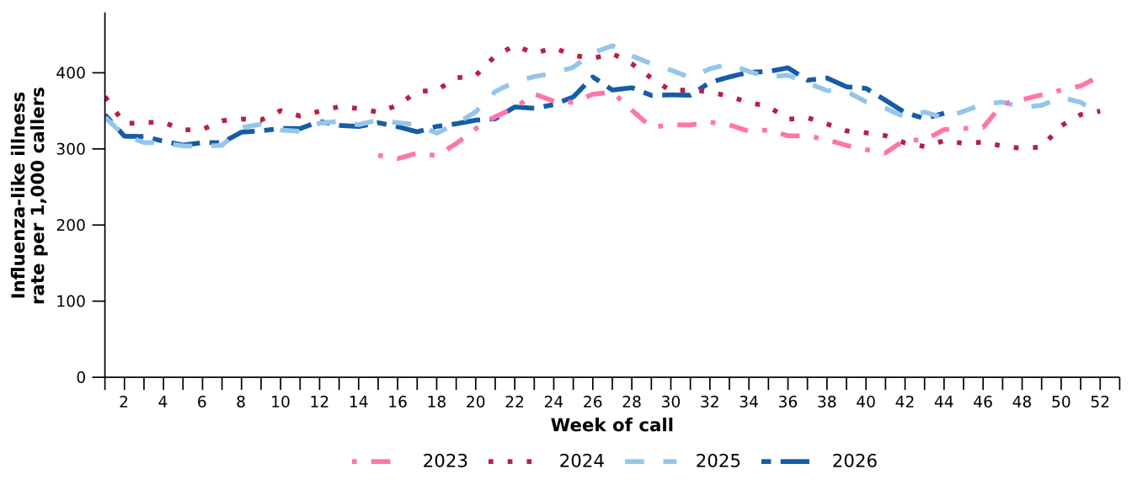
Source: Healthdirect Australia
* Healthdirect data prior to 22 March 2023 are unavailable as prior to this date a different data collection method was used.
† The Healthdirect helpline operates in all states and territories except Qld; therefore influenza-like illness trends will not be representative of Qld and may be underrepresented. See the Technical Supplement for more information.
- In the last fortnight, the rate of Healthdirect helpline callers with influenza-like illness referred to seek urgent medical care (176 per 1,000 callers per fortnight) was similar to the previous fortnight (178 per 1,000 callers per fortnight).
- In the last fortnight, referral categories for helpline callers with influenza-like illness varied across jurisdictions. Referral to ‘Attend Emergency Department’ or ‘See General Practitioner’ were the most common referral categories in all jurisdictions (Figure 2).

Figure 2: Proportion of referral categories* for helpline callers with influenza-like illness by jurisdiction† and call date, Australia, 1 January to 1 November 2026
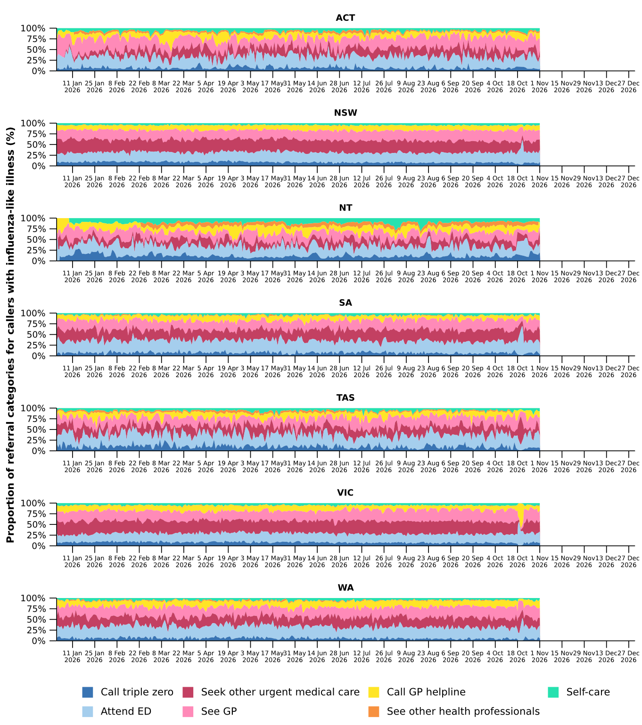
Source: Healthdirect Australia
* See other health professionals category includes pharmacist, dentist, mental health provider, primary maternity care, poison information centre or other.
† The Healthdirect helpline operates in all states and territories except Qld; therefore influenza-like illness referral trends are not provided for Qld. See the Technical Supplement for more information.

- In the last fortnight, the percentage of FluTracking participants reporting new fever and cough symptoms was consistent with the previous fortnight remaining at 1.2% (Figure 3).
- Following an overall increase since late July and an apparent peak of 2.1% in late August 2026, the proportion of FluTracking participants reporting new fever and cough symptoms has subsequently declined and is now similar to trends observed at the same time in previous years (Figure 3).
- In the last fortnight, a lower percentage of First Nations FluTracking participants reported new fever and cough symptoms (0.6%) compared with the previous fortnight (1.3%). These findings could be impacted by smaller sample sizes and the representativeness of the data. For more detailed trends, please refer to figure 2 in the FluTracking reports.
Figure 3: Age standardised percentage of survey participants reporting new fever and cough symptoms compared with the five-year average* by year and week of survey, Australia, 2023 to 1 November 2026
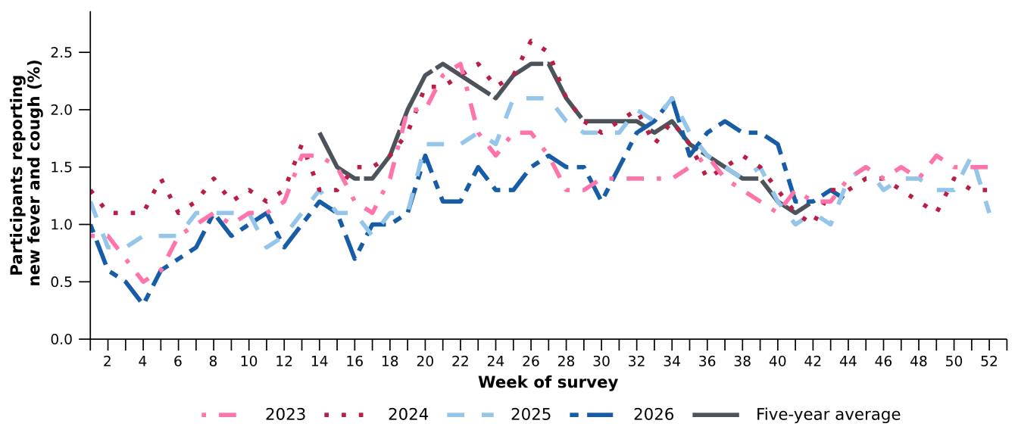
Source: FluTracking
* From 2020, FluTracking expanded their data capture period to year-round. Data before May and after October for any year before 2020 are not available for historical comparisons. The years 2020 and 2021 are excluded when comparing the current season to historical periods when influenza virus has circulated without public health restrictions. As such, the five-year average includes the years 2019 and 2022 to 2025.

- The average proportions of FluTracking participants reporting taking three or more days off work or normal duties and seeking medical advice or care due to fever and cough symptoms, were lower in 2026 than at the same time in previous years (Table 1).
Table 1: Percentage of FluTracking participants reporting new fever and cough symptoms plus three or more days off work or normal duties or seeking medical advice or care*, Australia, up to 18 October† for 2023–2026
 | 2023 | 2024 | 2025 | 2026
Reported three or more days off work or normal duties | 50.5% | 51.2% | 48.7% | 46.4%
Reported seeking medical advice or care* | 33.7% | 32.6% | 31.4% | 30.0%
Source: FluTracking
* Includes those who sought medical advice from a general practitioner, Aboriginal and Torres Strait Islander health clinic, COVID-19 clinic, emergency department, or were admitted to hospital for fever and cough.
† While FluTracking data are collected in real time, data presented here are subject to a two week reporting delay to account for the time delay between illness onset and the development of severe disease outcomes.

- Self-reported severe acute respiratory syndrome coronavirus 2 (SARS-CoV-2) polymerase chain reaction (PCR) test positivity and rapid antigen test (RAT) positivity fluctuated across January to July 2026, followed by an overall gradual declining trend from August. In the last fortnight, both self-reported PCR and RAT positivity were higher compared to the previous fortnight, though remained below 12.1% per week (Figure 4a; Figure 4b).
- Self-reported influenza PCR positivity increased sharply from early August 2026 to 41.4% per week in late September, before decreasing and then sharply increasing again in the last fortnight to 58.3% per week (Figure 4a). Self-reported influenza RAT positivity increased gradually from late April, reaching an apparent peak of 42.9% per week in early October. Since then, self-reported influenza RAT positivity has overall declined, decreasing to 28.5% per week in the last fortnight (Figure 4a; Figure 4b).
- Self-reported RSV PCR test positivity and RAT positivity have gradually decreased since peaking at 20.6% in mid-June 2026 and 12.7% in early July 2026, respectively, with positivity remaining relatively low and below 2.8% per week in the last fortnight (Figure 4a; Figure 4b).
Figure 4a: Self-reported PCR test positivity*† among FluTracking participants with fever and cough symptoms by pathogen week of survey, Australia, 1 January to 1 November 2026
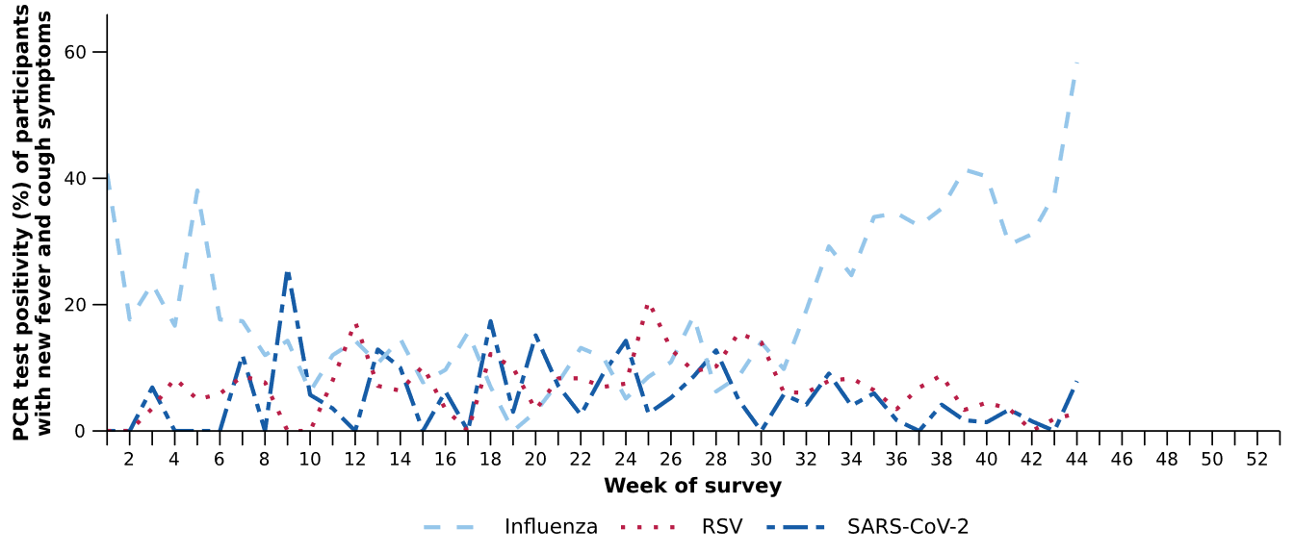
Source: FluTracking
* Denominator is based on participants who self-reported fever and cough symptoms and had a PCR test.
† Historical FluTracking testing and test positivity estimates have been recalculated to incorporate amendments made to survey test results after initial submission. Values may therefore differ from those reported previously.
Figure 4b: Self-reported RAT positivity*† among FluTracking participants with fever and cough symptoms by pathogen and week of survey, Australia, 1 January to 1 November 2026
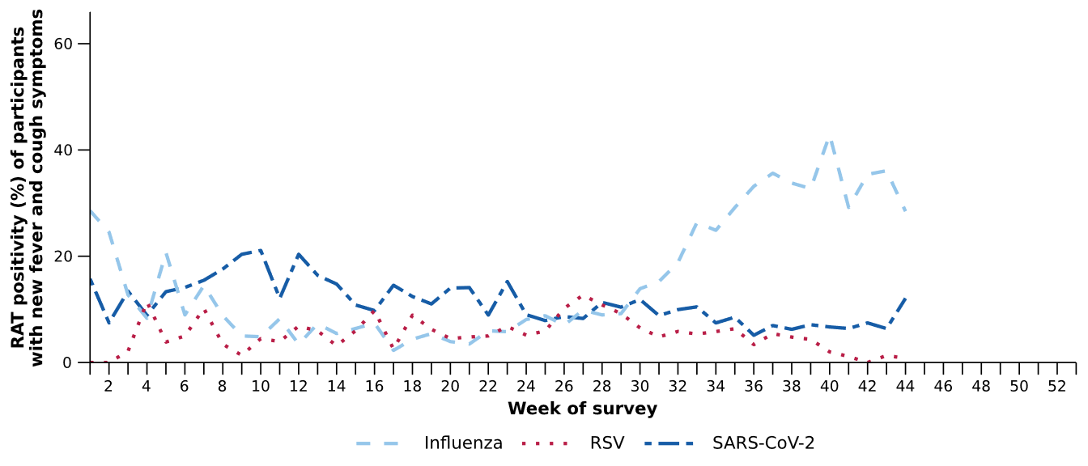
Source: FluTracking
* Denominator is based on participants who self-reported fever and cough symptoms and had a RAT.
† Historical FluTracking testing and test positivity estimates have been recalculated to incorporate amendments made to survey test results after initial submission. Values may therefore differ from those reported previously.
- In the last fortnight (19 October to 1 November 2026), there was a 12.6% increase in COVID-19 cases, a 6.6% decrease in influenza cases, and a 12.7% decrease in RSV cases compared to the previous fortnight.
Table 2: Notified cases and notification rate per 100,000 population by disease, five-year age group, and jurisdiction*, Australia, 1 January to 1 November 2026
 | COVID-19 |  |  | Influenza |  |  | RSV
 | Reporting  period  (n) | Year to  date  (n) | Year to  date  (rate) | Reporting  period  (n) | Year to  date  (n) | Year to  date  (rate) | Reporting  period  (n) | Year to  date  (n) | Year to  date  (rate)
Age group (years)
0–4 | 277 | 11,620 | 766 | 2,467 | 30,081 | 1,982 | 987 | 60,855 | 4,010
5–9 | 57 | 3,373 | 210 | 2,082 | 29,666 | 1,850 | 122 | 9,019 | 562
10–14 | 66 | 2,861 | 170 | 1,330 | 21,642 | 1,286 | 72 | 4,266 | 254
15–19 | 144 | 3,011 | 177 | 1,233 | 17,405 | 1,021 | 87 | 3,562 | 209
20–24 | 136 | 2,839 | 156 | 853 | 12,056 | 664 | 53 | 2,897 | 160
25–29 | 155 | 3,433 | 169 | 846 | 10,679 | 527 | 67 | 3,329 | 164
30–34 | 162 | 4,243 | 205 | 1,111 | 11,442 | 554 | 80 | 3,978 | 193
35–39 | 176 | 4,646 | 230 | 1,331 | 12,736 | 631 | 71 | 3,997 | 198
40–44 | 169 | 4,376 | 229 | 1,384 | 12,707 | 664 | 75 | 3,717 | 194
45–49 | 135 | 3,583 | 217 | 1,223 | 10,457 | 633 | 79 | 3,613 | 219
50–54 | 170 | 3,682 | 218 | 1,244 | 10,300 | 610 | 74 | 4,253 | 252
55–59 | 178 | 3,669 | 236 | 1,337 | 10,372 | 667 | 113 | 4,847 | 312
60–64 | 153 | 3,517 | 229 | 1,412 | 10,221 | 665 | 98 | 5,192 | 338
65–69 | 191 | 3,643 | 262 | 1,335 | 10,081 | 726 | 97 | 5,252 | 378
70–74 | 163 | 3,986 | 334 | 1,272 | 9,302 | 780 | 98 | 5,388 | 452
75+ | 851 | 18,315 | 811 | 3,509 | 26,198 | 1,160 | 212 | 15,392 | 682
Jurisdiction
ACT | 48 | 1,307 | 270 | 305 | 3,847 | 794 | 33 | 2,307 | 476
NSW | 1,019 | 36,017 | 419 | 6,669 | 101,379 | 1,180 | 892 | 58,197 | 677
NT | 7 | 352 | 133 | 135 | 1,607 | 608 | 27 | 1,155 | 437
Qld | 766 | 15,128 | 267 | 6,775 | 50,062 | 883 | 703 | 25,257 | 445
SA | 207 | 4,990 | 262 | 1,737 | 13,940 | 733 | 118 | 10,187 | 536
Tas | 42 | 1,274 | 221 | 487 | 3,963 | 688 | 38 | 2,709 | 470
Vic | 792 | 16,221 | 229 | 5,992 | 55,072 | 778 | 406 | 29,045 | 411
WA | 303 | 5,543 | 182 | 1,871 | 15,534 | 510 | 168 | 10,721 | 352
Total | 3,184 | 80,832 | 293 | 23,971 | 245,404 | 889 | 2,385 | 139,578 | 505
Source: National Notifiable Diseases Surveillance System (NNDSS). COVID-19 notification data are unavailable for NT from 29 October 2026.
* Total includes cases with missing age.

- In the last fortnight, there were 3,184 COVID-19 cases, a 12.6% increase from 2,827 cases notified in the previous fortnight (Table 2; Figure 5).
- In the year to date, there have been 80,832 COVID-19 cases, 52.1% fewer than the 168,785 cases notified over the same period in 2025 (Table 2; Figure 5). COVID-19 case numbers have remained relatively low and stable throughout 2026 compared with the same period in recent years. There was a slight increase in cases observed nationally in late August 2026, driven by increases in the ACT, NSW, Qld, Tas and Vic; however, unlike previous years there was no clear national winter peak of COVID-19 cases in 2026.
- In the last fortnight, COVID-19 notification rates increased or remained relatively stable across most jurisdictions compared with the previous fortnight, except in the NT where notification rates decreased (Figure 6).
Figure 5: Notified COVID-19 cases by year and week of diagnosis, Australia, 2023 to 1 November 2026
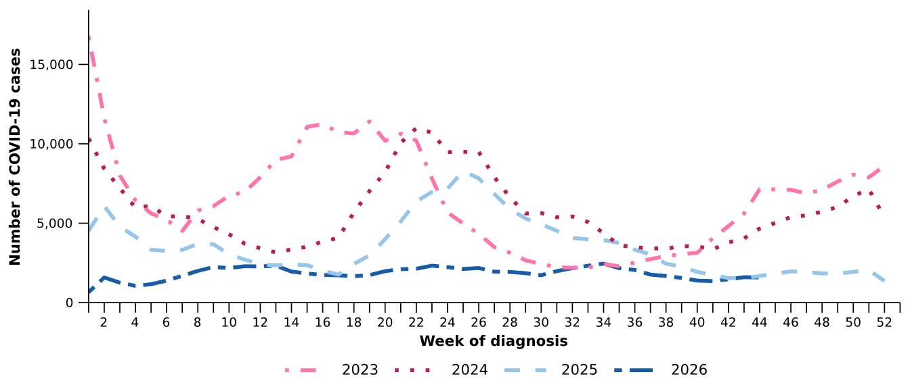
Source: National Notifiable Diseases Surveillance System (NNDSS)

Figure 6: Notification rates per 100,000 population for COVID-19 cases by state or territory and week of diagnosis, Australia, 1 January to 1 November 2026
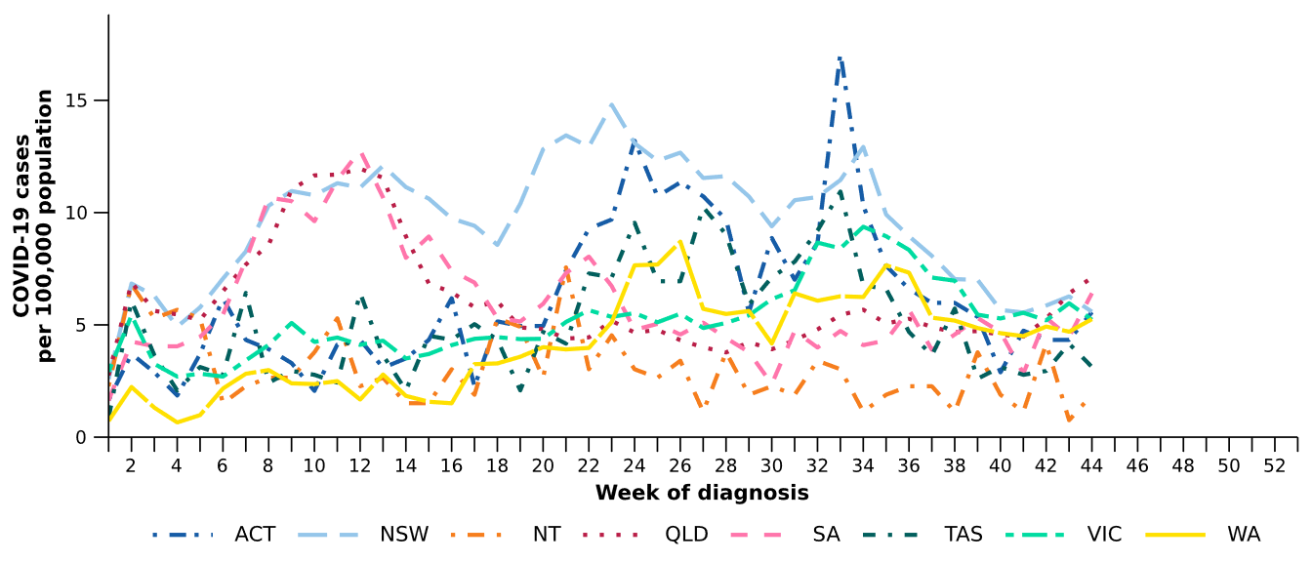
Source: National Notifiable Diseases Surveillance System (NNDSS). COVID-19 notification data are unavailable for NT from 29 October 2026.

- In the last fortnight, there were 23,971 influenza cases, a 6.6% decrease from 25,659 cases notified in the previous fortnight (Table 2; Figure 7). Influenza notifications have continued to decline in influenza notifications since late September, suggesting that influenza activity may have passed its national peak in 2026. While notifications are declining across most jurisdictions, notifications are continuing to increase in WA and have been gradually increasing again in Qld since early October. Year-to-date activity remains broadly comparable in magnitude to the 2023 season and the historical five-year average.
- In the year to date, there have been 245,404 influenza cases, 42.5% fewer than the 426,877 cases notified over the same period in 2025 (Table 2; Figure 7). While national influenza activity in 2026 occurred later than in recent years, the timing has been broadly consistent with pre-pandemic seasonal patterns (e.g. 2015–2018), characterised by increases in notifications from June with peak activity in late August to early September.
- Lower than expected influenza cases during January to June 2026 may reflect greater population immunity following the higher-than-usual influenza activity in late 2025 and the impact of seasonal influenza vaccination. The later onset of sustained increases in influenza activity from late July to early September 2026 may reflect a combination of factors that supported transmission, including:
  - waning natural immunity following lower-than-usual case numbers earlier in 2026
  - initial waning of vaccine-derived immunity following slowing of seasonal influenza vaccine uptake after May together with lower preliminary influenza vaccine effectiveness estimates than in previous years
  - increased population mixing following the return to school after the mid-year holidays in July
  - the timing of climatic conditions, noting that although the 2026 Australian winter was among the warmest on record across many parts of the country, colder weather predominately occurred from mid-July onwards which may have supported increased transmission as people spent more time in close contact indoors
  - a return to pre-pandemic seasonal influenza patterns described above.
Figure 7: Notified influenza cases and five-year average* by year and week of diagnosis, Australia, 2023 to 1 November 2026
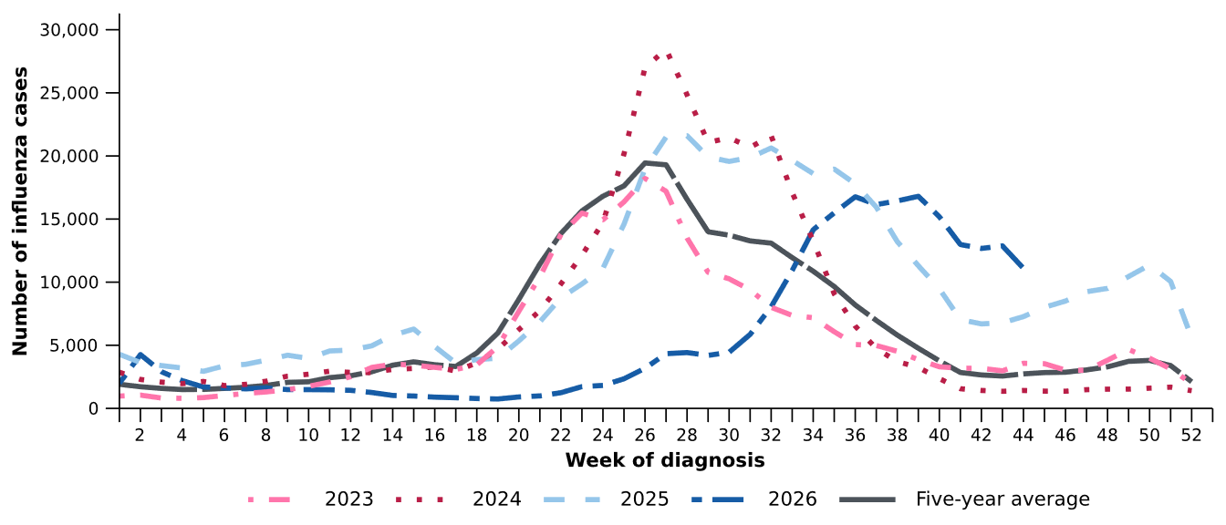
Source: National Notifiable Diseases Surveillance System (NNDSS)
* The years 2020 and 2021 are excluded when comparing the current season to historical periods when influenza virus has circulated without public health restrictions. As such, the five-year average includes the years 2019 and 2022 to 2025.
- In the last fortnight, influenza notification rates decreased or remained relatively stable across most jurisdictions compared with the previous fortnight, except in Qld and WA where notification rates increased (Figure 8).
Figure 8: Notification rates per 100,000 population for influenza cases by state or territory and week of diagnosis, Australia, 1 January to 1 November 2026
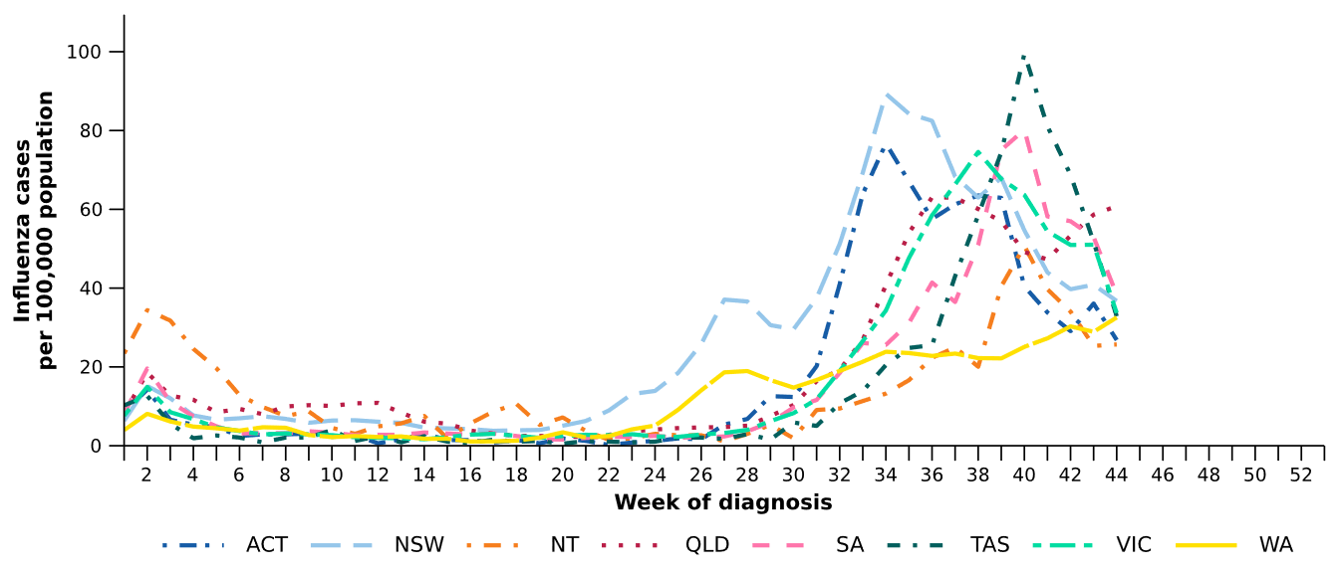
Source: National Notifiable Diseases Surveillance System (NNDSS).
- In the last fortnight, there were 22,909 influenza A cases, a 6.9% decrease from 24,611 influenza A cases notified in the previous fortnight, and there were 966 influenza B cases, a 1.2% increase from 955 influenza B cases notified in the previous fortnight.
- In the last fortnight, among influenza A cases with subtype information available there were:
  - 545 influenza A(H1N1) cases, a 24.8% decrease from 725 cases notified in the previous fortnight.
  - 43 influenza A(H3N2) cases, a 70.5% decrease from 146 cases notified in the previous fortnight.
- Throughout 2026, influenza A(unsubtyped) has been the dominant reported influenza subtype across all age groups. In recent weeks, the number of influenza A(H3N2) notifications have declined, while influenza A(H1N1) notifications have increased, primarily among adults aged 65 years and over. Influenza B notifications have also been reported across all age groups in 2026 but accounted for an increasing number of typed notifications among people aged under 65 years from August onwards (Figure 9).
- Trends in influenza subtypes are influenced by differences in the number and selection of influenza samples that undergo typing across age groups and healthcare settings.

Figure 9: Notified influenza cases by influenza subtype, age group*, and week of diagnosis, Australia, 1 January to 1 November 2026
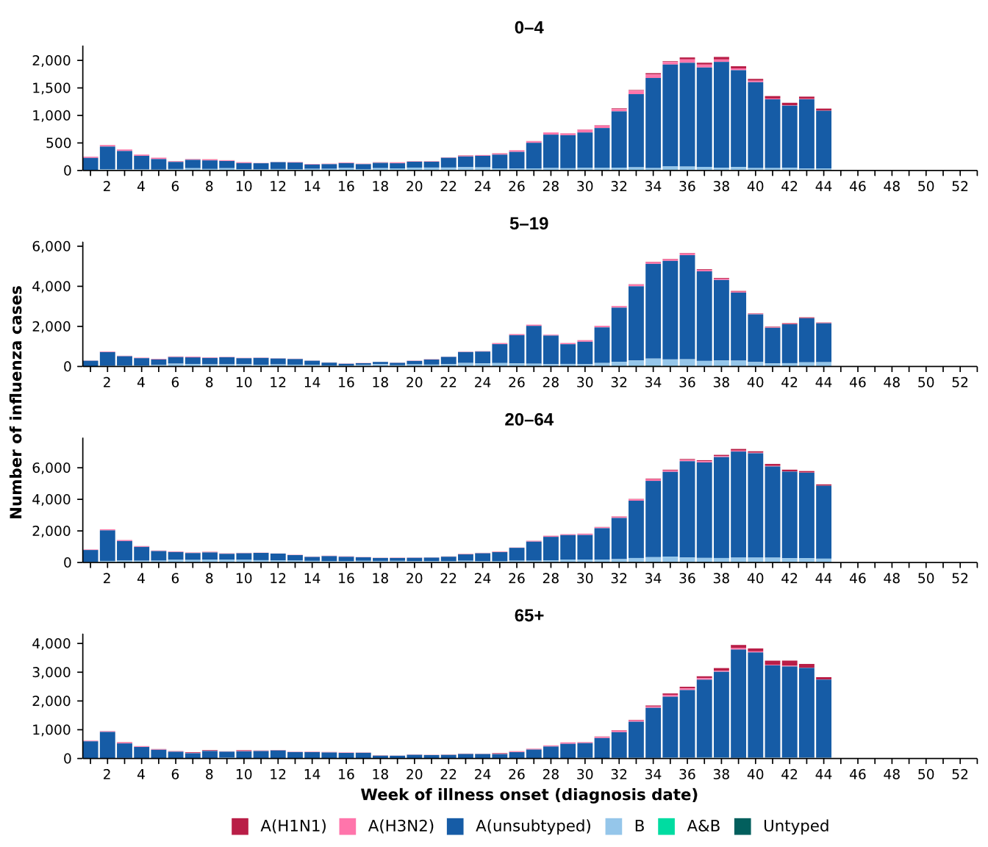
Source: National Notifiable Diseases Surveillance System (NNDSS)
* Axis varies between age groups.

- In the year to date, influenza A(unsubtyped) has accounted for the highest number of notifications across most jurisdictions, except in the NT where a high number of influenza B notifications were consistently reported until early September. From July, increasing numbers of influenza A(H3N2) notifications were reported in the NT, Qld, Tas and WA followed by a decline across October. The number of influenza A(H1N1) notifications have increased in recent weeks, most notably in Tas and WA (Figure 10).
Figure 10: Notified influenza cases by influenza subtype, jurisdiction*, and week of diagnosis, Australia, 1 January to 1 November 2026
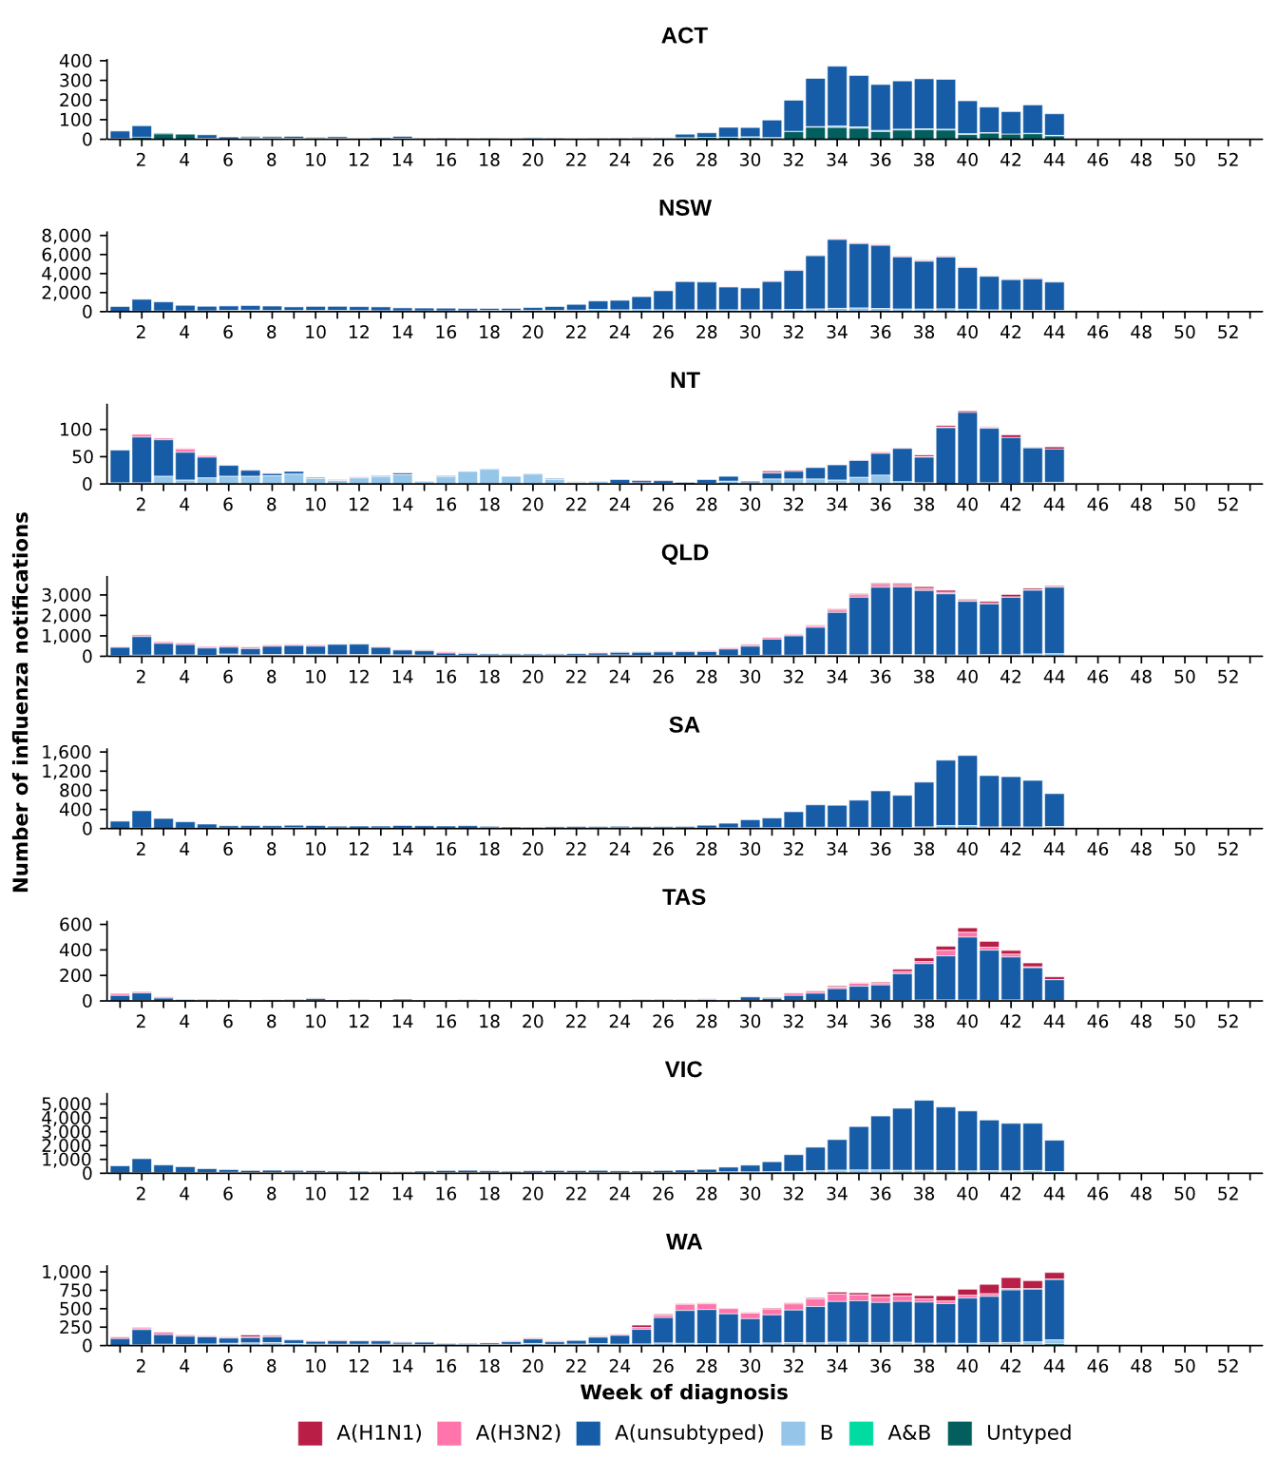
Source: National Notifiable Diseases Surveillance System (NNDSS).
* Axis varies between jurisdictions.

- In the last fortnight, there were 2,385 RSV cases, a 12.7% decrease from 2,733 cases notified in the previous fortnight. Since the national peak in late June, RSV notifications have consistently decreased with cases currently at interseasonal levels (Table 2; Figure 11).
- In the year to date, there have been 139,578 RSV cases, 16.6% fewer than the 167,334 cases notified over the same period in 2025 (Table 2; Figure 11).
- In the last fortnight, RSV notification rates decreased or remained relatively stable across most jurisdictions compared with the previous fortnight, except in Qld where notification rates increased (Figure 12).
Figure 11: Notified RSV cases by year and week of diagnosis, Australia, 2023 to 1 November 2026
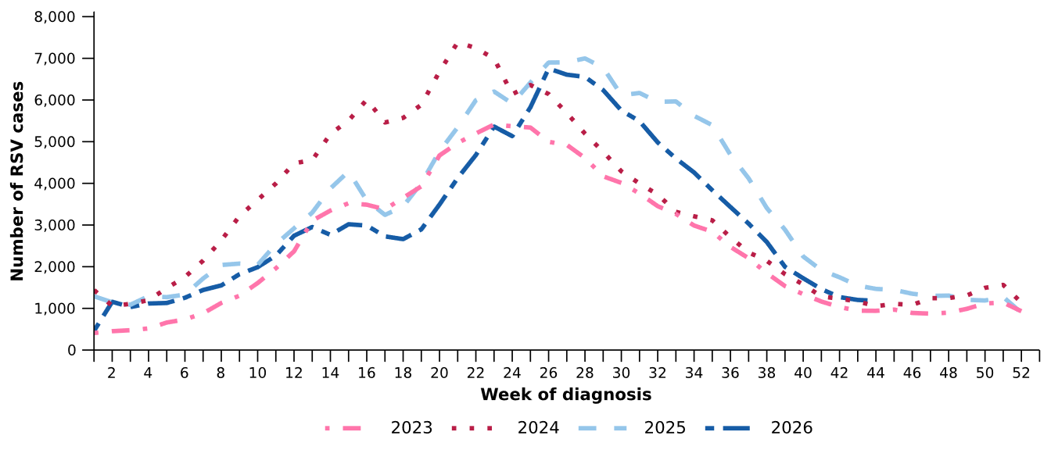
Source: National Notifiable Diseases Surveillance System (NNDSS)

Figure 12: Notification rates per 100,000 population for RSV cases by state or territory and week of diagnosis, Australia, 1 January to 1 November 2026
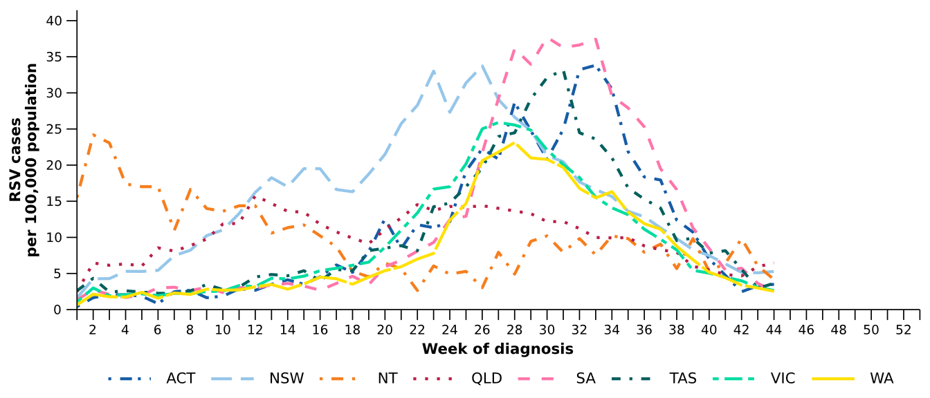
Source: National Notifiable Diseases Surveillance System (NNDSS)

Primary care surveillance
Primary care surveillance monitors the number and characteristics of people who have presented to a general practice with influenza-like illness and provides insight on the different respiratory pathogens that are causing illness in the community.
- In the last fortnight (19 October to 1 November 2026), there were fewer general practice consultations for influenza-like illness (6.7 notifications per 1,000 consultations per fortnight) compared to previous fortnight (7.7 notifications per 1,000 consultations per fortnight) (Figure 13).
- Influenza-like illness notifications per 1,000 consultations increased gradually to a peak of 9.8 notifications per week in late September. Influenza-like illness activity has since decreased but remains elevated relative to the same period in previous years and the five-year historical average (Figure 13). This pattern is consistent with the later onset and subsequent decline in influenza activity observed in other surveillance systems during the 2026 influenza season.
Figure 13: Rate of influenza-like illness notifications per 1,000 consultations per week in sentinel general practice sites compared with the five-year average by year and week of consultation*†, Australia, 2023 to 1 November 2026
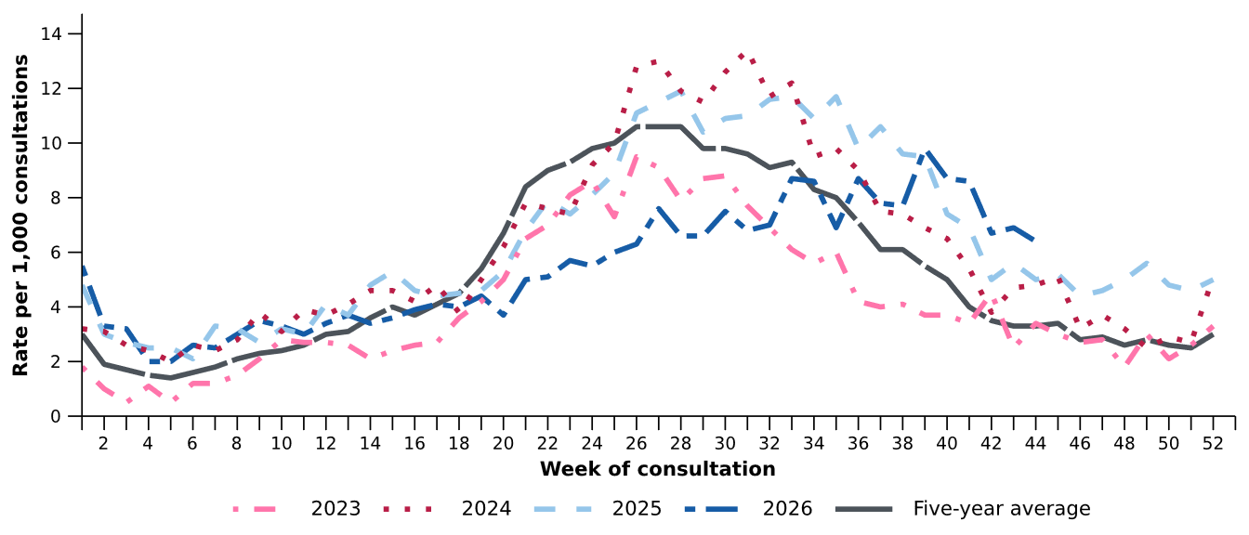
Source: Australian Sentinel Practices Research Network (ASPREN)
* The years 2020 and 2021 are excluded when comparing the current season to historical periods when influenza virus has circulated without public health restrictions. As such, the five-year average includes the years 2019 and 2022 to 2025.
† Please refer to the Technical Supplement for notes on impact of COVID-19 on ASPREN data.

- In the last fortnight, 67.4% (60/89) of people attending general practice with influenza-like illness who were tested have then tested positive for a respiratory pathogen.
- In the last fortnight, rhinovirus / enterovirus (33.3%; 20/60) was the most commonly detected pathogen, followed by influenza (30.0%; 18/60) and SARS-CoV-2 (8.3%; 5/60) (Figure 14).
- In the year to date, 60.5% (1,602/2,650) of people attending general practice with influenza-like illness who were tested have then tested positive for a respiratory pathogen.
- In the year to date, rhinovirus / enterovirus (41.1%; 658/1,602) has been the most commonly detected pathogen, followed by influenza (20.3%; 325/1,602), RSV (9.9%; 158/1,602), parainfluenza (9.1%; 146/1,602), and human metapneumovirus (8.7%; 140/1,602) (Figure 14).
Figure 14: Number of samples tested for respiratory pathogens among people with influenza-like illness attending sentinel general practice sites by respiratory pathogen and week of specimen collection, Australia, 1 January to 1 November 2026
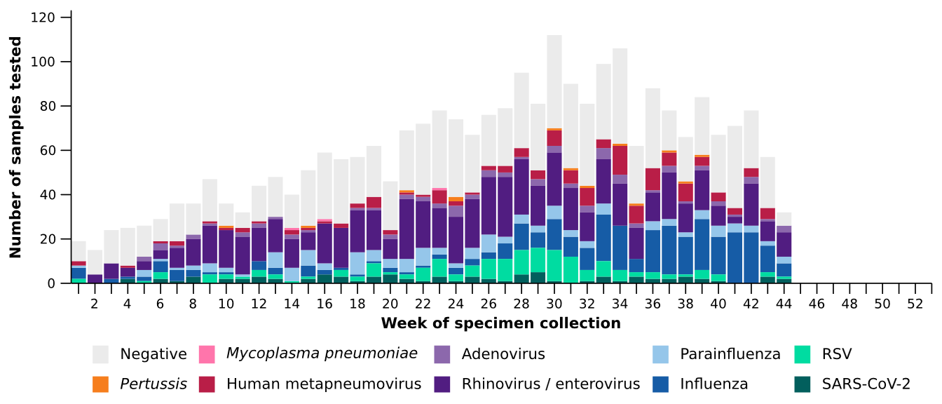
Source: Australian Sentinel Practices Research Network (ASPREN)
Note: All ASPREN swab samples are transported to the SA Pathology laboratory in Adelaide to be tested for viral and bacterial respiratory pathogens via a multiplex real-time reverse transcription polymerase chain reaction (RT-PCR) assay using in-house primers.

Hospital-based surveillance
Hospital-based surveillance monitors people with more severe illness who have been admitted to hospital for their respiratory illness (severe acute respiratory infections). Hospital-based surveillance also measures the ability of the health system to cope with the number of severe acute respiratory infection admissions to ensure delivery of safe, timely and quality health care.
- In the last severity reporting period (5 October to 18 October 2026), fewer patients were admitted to a sentinel hospital with a severe acute respiratory infection (n=300), than in the previous severity reporting period (n=551).
  - In the last severity reporting period, at sentinel hospitals there was 18.8% fewer admissions with COVID-19 (from 32 to 26), 50.2% fewer admissions with influenza (from 452 to 225), and 26.9% fewer admissions with RSV (from 67 to 49), compared to the previous severity reporting period.
- In the year to date for severity reporting (1 January to 18 October 2026), there have been 8,344 admissions with severe acute respiratory infections at sentinel hospitals. Most patients with a severe acute respiratory infection have been admitted with RSV (n=3,791) followed by influenza (n=3,202) (Figure 15).
Figure 15: Total number of patients (children and adults) admitted with a severe acute respiratory infection to sentinel hospitals by disease and week of admission, Australia, 1 January to 18 October 2026
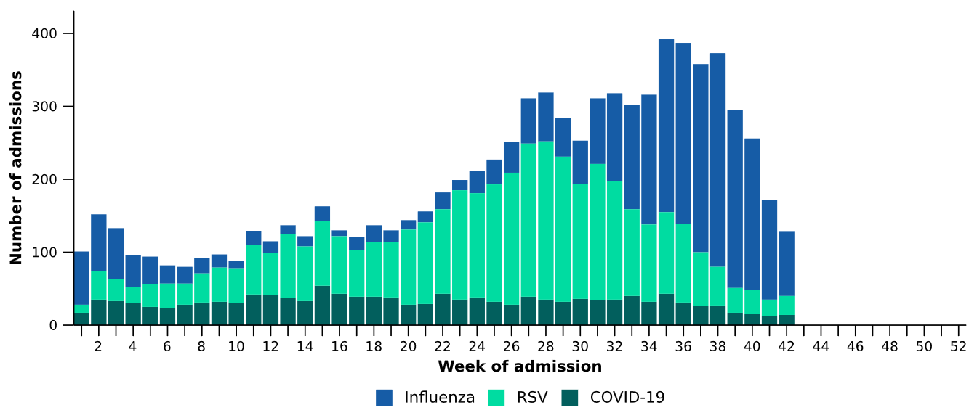
Source: Influenza Complications Alert Network (FluCAN)
- Patients admitted to sentinel hospitals with influenza have mostly been admitted with influenza A (94.9%; 3,039/3,202), while 4.8% (153/3,202) were admitted with influenza B.
  - Most hospital admissions with influenza A have been with influenza A(unsubtyped) (70.4%; 2,139/3,039), followed by influenza A(H3N2) (18.8%; 571/3,039) and then influenza A(H1N1) (10.8%; 329/3,039).
- In recent weeks for severity reporting, the number of hospital admissions with influenza A(H1N1) has increased, while the number of admissions with influenza A(H3N2) has declined. This change in influenza subtype distribution was observed across all age groups, reflecting the changes in trends reported in the community (Figure 9; Figure 10) (Figure 16).

Figure 16: Number of patients admitted with influenza to sentinel hospitals by influenza subtype, age group*, and week of admission, Australia, 1 January to 18 October 2026
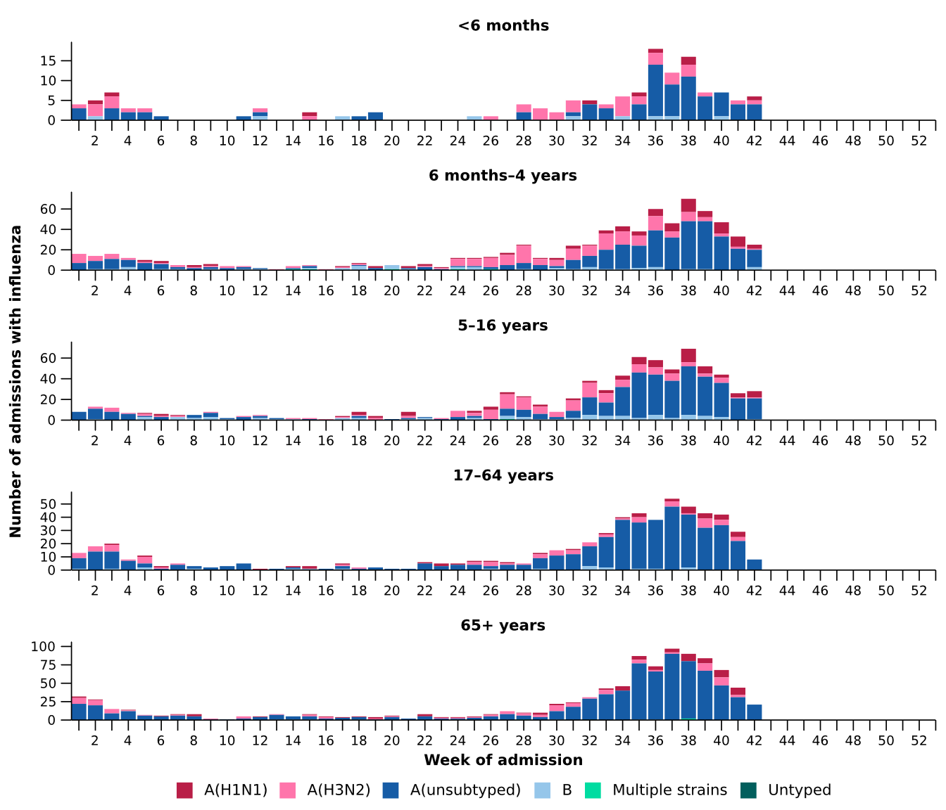
Source: Influenza Complications Alert Network (FluCAN)
* Axis varies between age groups. The age distribution of admissions with influenza may not reflect the age distribution of all patients.
- RSV accounted for the highest number of admissions among children aged 16 years and under, with 2,878 admissions compared with 1,641 influenza admissions and 563 COVID-19 admissions (Table 3a).
- Most children aged 4 years and under were admitted with RSV or COVID-19 whilst older children, those aged 5 to 16 years, were mostly admitted to hospital with influenza (Table 3a).
- Hospital stays were generally short and direct intensive care admissions were uncommon across all three diseases. The median length of stay was 1–3 days, and 3.8–5.3% of children were admitted directly to intensive care (Table 3a).

Table 3a: Demographic characteristics and outcomes for children admitted with a severe acute respiratory infection to a sentinel hospital by disease*†‡, Australia, 1 January to 18 October 2026
 | COVID-19 | Influenza | RSV
 | Year to date for  severity reporting  (n=563) | Year to date for  severity reporting  (n=1,641) | Year to date for  severity reporting  (n=2,878)
Age (years)
Median [IQR] | 1 [0-3] | 4 [1-8] | 1 [0-2]
Age group (years)
< 6 months | 153 (27.2%) | 142 (8.7%) | 603 (21.0%)
6 months – 4 years | 292 (51.9%) | 758 (46.2%) | 2,023 (70.3%)
5–16 years | 118 (21.0%) | 741 (45.2%) | 252 (8.8%)
Indigenous status
Aboriginal and Torres Strait Islander | 32 (5.7%) | 109 (6.6%) | 261 (9.1%)
Length of hospital stay (days)†
Median [IQR] | 2 [1-3] | 1 [1-2] | 2 [1-3]
Patient admission location‡
Admitted to hospital ward | 538 (95.6%) | 1,579 (96.2%) | 2,725 (94.7%)
Admitted to intensive care directly | 25 (4.4%) | 62 (3.8%) | 153 (5.3%)
Discharge status†
Alive | 504 (89.5%) | 1,188 (72.4%) | 2,528 (87.8%)
Died | - | 5 (0.3%) | 2 (0.1%)
Incomplete/missing | 59 (10.5%) | 448 (27.3%) | 348 (12.1%)
Source: Influenza Complications Alert Network (FluCAN)
* Does not include patients with missing age; therefore, the sum of age-specific totals above may not equal the total number of patients.
† For patients who are still in hospital data may not be complete; therefore, these data are not included in the length of stay or discharge status. In addition, length of stay data excludes patients that acquired their infection in hospital.
‡ Admission location reflects the initial admission ward. Some patients may be initially admitted to general ward then later admitted to an intensive care and this is not reflected here. Does not include patients with missing admission location; therefore, the sum of admission location specific totals above may not equal the total number of patients.
The Paediatric Active Enhanced Disease Surveillance (PAEDS) network conducts enhanced sentinel hospital surveillance for select acute respiratory infections or conditions in children. PAEDS data are presented within the sentinel hospital data from FluCAN in this report. For additional information on select acute respiratory conditions in children please visit the PAEDS webpages.

- Influenza accounted for the highest number of admissions among adults aged 17 years and over, with 1,559 admissions compared with 913 RSV admissions and 787 COVID-19 admissions (Table 3b).
- Most adults admitted with COVID-19, influenza or RSV were aged 65 years and over, accounting for around 62.2–64.2% of admissions for each disease (Table 3b).
- Hospital stays were generally short, with a median length of stay of 3 days for influenza and 4 days for COVID-19 and RSV. Direct admission to intensive care was more common among patients with influenza, occurring in 6.9% of admissions, compared with 5.0% for RSV and 3.8% for COVID-19 (Table 3b).
- The proportion of adults admitted to sentinel hospitals who died was higher among those admitted with RSV (3.9%) and COVID-19 (3.8%) compared with influenza (2.3%; Table 3b).

Table 3b: Demographic characteristics and outcomes for adults admitted with a severe acute respiratory infection to a sentinel hospital by disease*†‡, Australia, 1 January to 18 October 2026
 | COVID-19 | Influenza | RSV
 | Year to date for  severity reporting  (n=787) | Year to date for  severity reporting  (n=1,559) | Year to date for  severity reporting  (n=913)
Age (years)
Median [IQR] | 72 [56-83] | 70 [55-80] | 70 [58-81]
Age group (years)
17–64 years | 286 (36.3%) | 590 (37.8%) | 327 (35.8%)
65 years and over | 501 (63.7%) | 969 (62.2%) | 586 (64.2%)
Indigenous status
Aboriginal and Torres Strait Islander | 50 (6.4%) | 111 (7.1%) | 90 (9.9%)
Length of hospital stay (days)†
Median [IQR] | 4 [3-9] | 3 [2-7] | 4 [2-7]
Patient admission location‡
Admitted to hospital ward | 757 (96.2%) | 1,452 (93.1%) | 867 (95.0%)
Admitted to intensive care directly | 30 (3.8%) | 107 (6.9%) | 46 (5.0%)
Discharge status†
Alive | 513 (65.2%) | 1,019 (65.4%) | 634 (69.4%)
Died | 30 (3.8%) | 36 (2.3%) | 36 (3.9%)
Incomplete/missing | 244 (31.0%) | 504 (32.3%) | 243 (26.6%)
Source: Influenza Complications Alert Network (FluCAN)
* Does not include patients with missing age; therefore, the sum of age-specific totals above may not equal the total number of patients.
† For patients who are still in hospital data may not be complete; therefore, these data are not included in the length of stay or discharge status. In addition, length of stay data excludes patients that acquired their infection in hospital.
‡ Admission location reflects the initial admission ward. Some patients may be initially admitted to general ward then later admitted to an intensive care and this is not reflected here. Does not include patients with missing admission location; therefore, the sum of admission location specific totals above may not equal the total number of patients.

Due to database upgrades, updated sentinel intensive care data were not available for this report. Sentinel intensive care data remains unchanged from the last report with the reporting period inclusive of 1 January to 20 September 2026.
- In the last severity reporting period for sentinel intensive care (24 August to 20 September 2026), more patients have been admitted to a sentinel intensive care with a severe acute respiratory infection (n=312), than in the previous severity reporting period (n=234) (Figure 17).
- In the year to date for severity reporting (1 January to 20 September 2026), most patients were admitted to sentinel intensive care with influenza, followed by RSV (Figure 17; Table 4).
Figure 17: Number of patients admitted with severe acute respiratory infections to a sentinel intensive care by disease and week of admission, Australia, 1 January to 20 September 2026
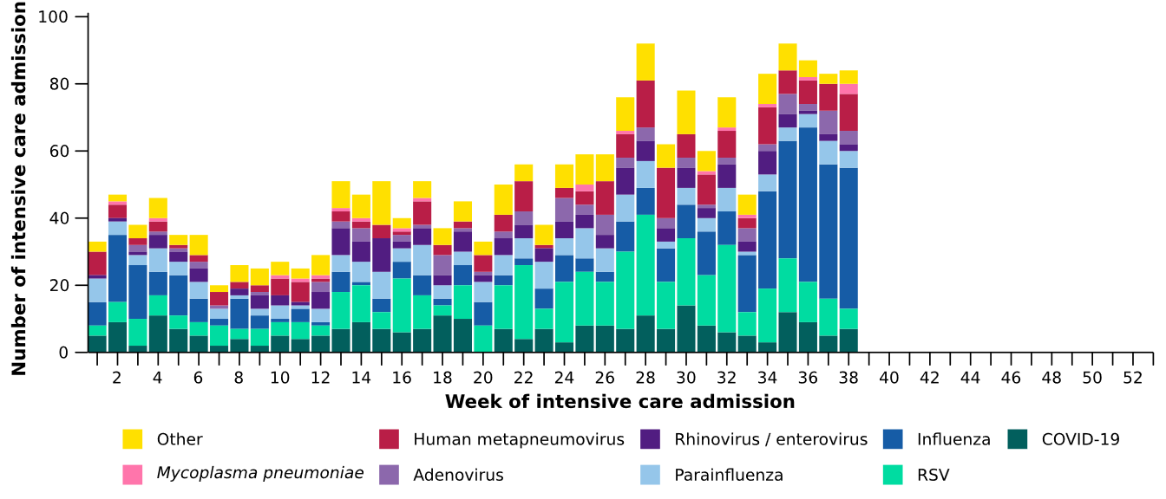
Source: Short Period Incidence Study of Severe Acute Respiratory Infection (SPRINT-SARI) Australia
Note: The sum of pathogen-specific totals above may not equal the total number of severe acute respiratory infection patients due to co-infections.
Figure 18: Number of patients admitted with severe acute respiratory infections to a sentinel intensive care by disease and age group*, Australia, 1 January to 20 September 2026
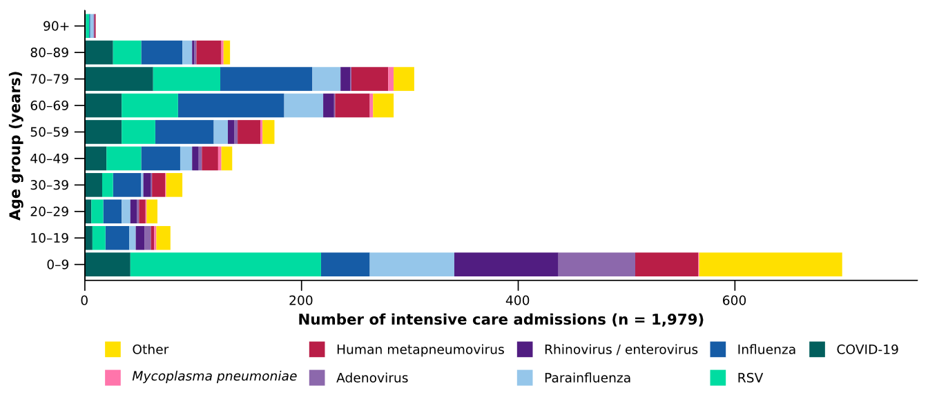
Source: Short Period Incidence Study of Severe Acute Respiratory Infection (SPRINT-SARI) Australia
Note: The sum of pathogen-specific totals above may not equal the total number of severe acute respiratory infection patients due to co-infections.
* The age distribution of severe acute respiratory infection intensive care admissions may not reflect the age distribution of all patients.

- Children aged 0–9 years accounted for the highest number of sentinel intensive care admissions, and the median age at admission was lowest among patients admitted with RSV (Figure 18; Table 4).
- The proportion of admissions requiring invasive mechanical ventilation was highest among patients with Mycoplasma pneumoniae, followed by COVID-19, while the median duration of invasive mechanical ventilation was longest among patients with hMPV and parainfluenza (Table 4).
Table 4: Demographic characteristics and outcomes of patients admitted with a severe acute respiratory infection to a sentinel intensive care by disease*†, Australia, 1 January to 20 September 2026
 | COVID-19 | hMPV | Influenza | 𝘔𝘺𝘤𝘰𝘱𝘭𝘢𝘴𝘮𝘢  𝘱𝘯𝘦𝘶𝘮𝘰𝘯𝘪𝘢𝘦 | Parainfluenza | RSV
 | Year to date for severity reporting  (n=249) | Year to date for severity reporting  (n=205) | Year to date for severity reporting  (n=422) | Year to date for severity reporting  (n=20) | Year to date for severity reporting  (n=192) | Year to date for severity reporting  (n=415)
Age (years)
Median [IQR] | 59  [35–73] | 53  [6–70] | 61  [37–71] | 60  [40–74] | 44  [2–66] | 38  [1–67]
Indigenous status
Aboriginal and Torres Strait Islander | 23  (9.2%) | 19  (9.3%) | 36  (8.5%) | – | 17  (8.9%) | 37  (8.9%)
Non-Indigenous | 226  (90.8%) | 186  (90.7%) | 386  (91.5%) | 20  (100.0%) | 175  (91.1%) | 378  (91.1%)
Received invasive mechanical ventilation
Number (%) | 85  (34.1%) | 52  (25.4%) | 118  (28.0%) | 9  (45.0%) | 65  (33.9%) | 101  (24.3%)
Length of invasive mechanical ventilation (days)*
Median [IQR] | 2 [1–5] | 4 [2–7] | 3 [1–8] | 3 [1–6] | 4 [1–9] | 3 [2–7]
Length of intensive care stay (days)*
Median [IQR] | 3 [2–7] | 3 [2–6] | 3 [2–6] | 4 [2–8] | 4 [2–7] | 3 [2–5]
Length of hospital stay (days)*
Median [IQR] | 8 [4–14] | 8 [5–13] | 7 [4–11] | 9 [4–13] | 7 [3–15] | 7 [4–13]
Patient outcome†
Ongoing care in intensive care | 7  (2.8%) | 2  (1.0%) | 18  (4.3%) | – | 3  (1.6%) | 5  (1.2%)
Ongoing care in hospital ward | 10  (4.0%) | 9  (4.4%) | 23  (5.5%) | – | 8  (4.2%) | 8  (1.9%)
Transfer to other hospital / facility | 31  (12.4%) | 30  (14.6%) | 55  (13.0%) | 5  (25.0%) | 23  (12.0%) | 58  (14.0%)
Discharged home | 159  (63.9%) | 147  (71.7%) | 280  (66.4%) | 12  (60.0%) | 137  (71.4%) | 312  (75.2%)
Died in hospital | 42  (16.9%) | 16  (7.8%) | 43  (10.2%) | 3  (15.0%) | 18  (9.4%) | 31  (7.5%)
Source: Short Period Incidence Study of Severe Acute Respiratory Infection (SPRINT-SARI) Australia
Note: The sum of pathogen-specific totals above may not equal the total number of severe acute respiratory infection patients due to co-infections.
* For patients receiving ongoing care in intensive care data may not be complete; therefore, data are not included in the length of ventilation or stay.
† Patients who have been admitted with no discharge information for less than 90 days have been assumed to have ongoing care in the hospital. Patients who have no outcome entered or have been admitted for more than 90 days with no discharge information have been treated as missing.

- In the last fortnight (19 October to 1 November 2026), there were an average of 228 intensive care patients in droplet or airborne isolation for any suspected or confirmed respiratory pathogen each day, a 5.2% decrease from an average of 240 patients in isolation each day reported in the previous fortnight (Figure 19).
- In the last fortnight (19 October to 1 November 2026), there were an average of 92 intensive care staff unavailable to work due to illness each day, a 5.0% decrease from an average of 97 staff unavailable each day reported in the previous fortnight (Figure 19).
- In the last fortnight, the average number of intensive care patients in droplet or airborne isolation for any suspected or confirmed respiratory pathogen decreased or remained relatively stable across most jurisdictions compared with the previous fortnight, except in the NT and Qld where the average number of patients in isolation each day increased (Figure 20).
- In the last fortnight, the average number of intensive care staff unavailable to work due to illness increased or remained relatively stable across most jurisdictions compared with the previous fortnight, except in Qld, Vic and WA where the average number of staff unavailable each day decreased (Figure 20).
Figure 19: Weekly average daily occupancy of intensive care patients in droplet or airborne isolation for any suspected or confirmed respiratory pathogen and the weekly average daily number of intensive care staff unavailable to work due to illness by week of report*, Australia, 1 January to 1 November 2026
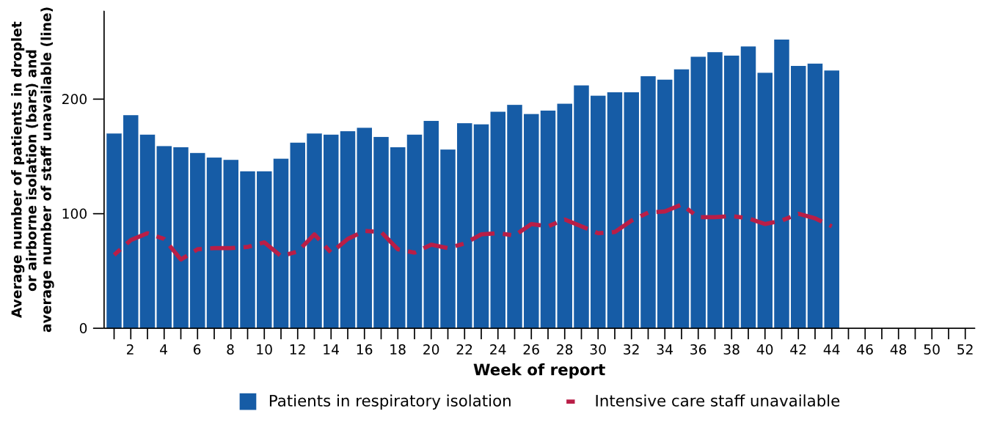
Source: Critical Health Resource Information System (CHRIS)
* Intensive care staff include both medical and nursing staff. Staff unavailability will be underestimated in NSW as most public hospitals in NSW do not report staff unavailability.

Figure 20: Weekly average daily occupancy of intensive care patients in droplet or airborne isolation for any suspected or confirmed respiratory pathogen and the weekly average daily number of intensive care staff unavailable to work due to illness by jurisdiction and week of report*†‡, Australia, 1 January to 1 November 2026
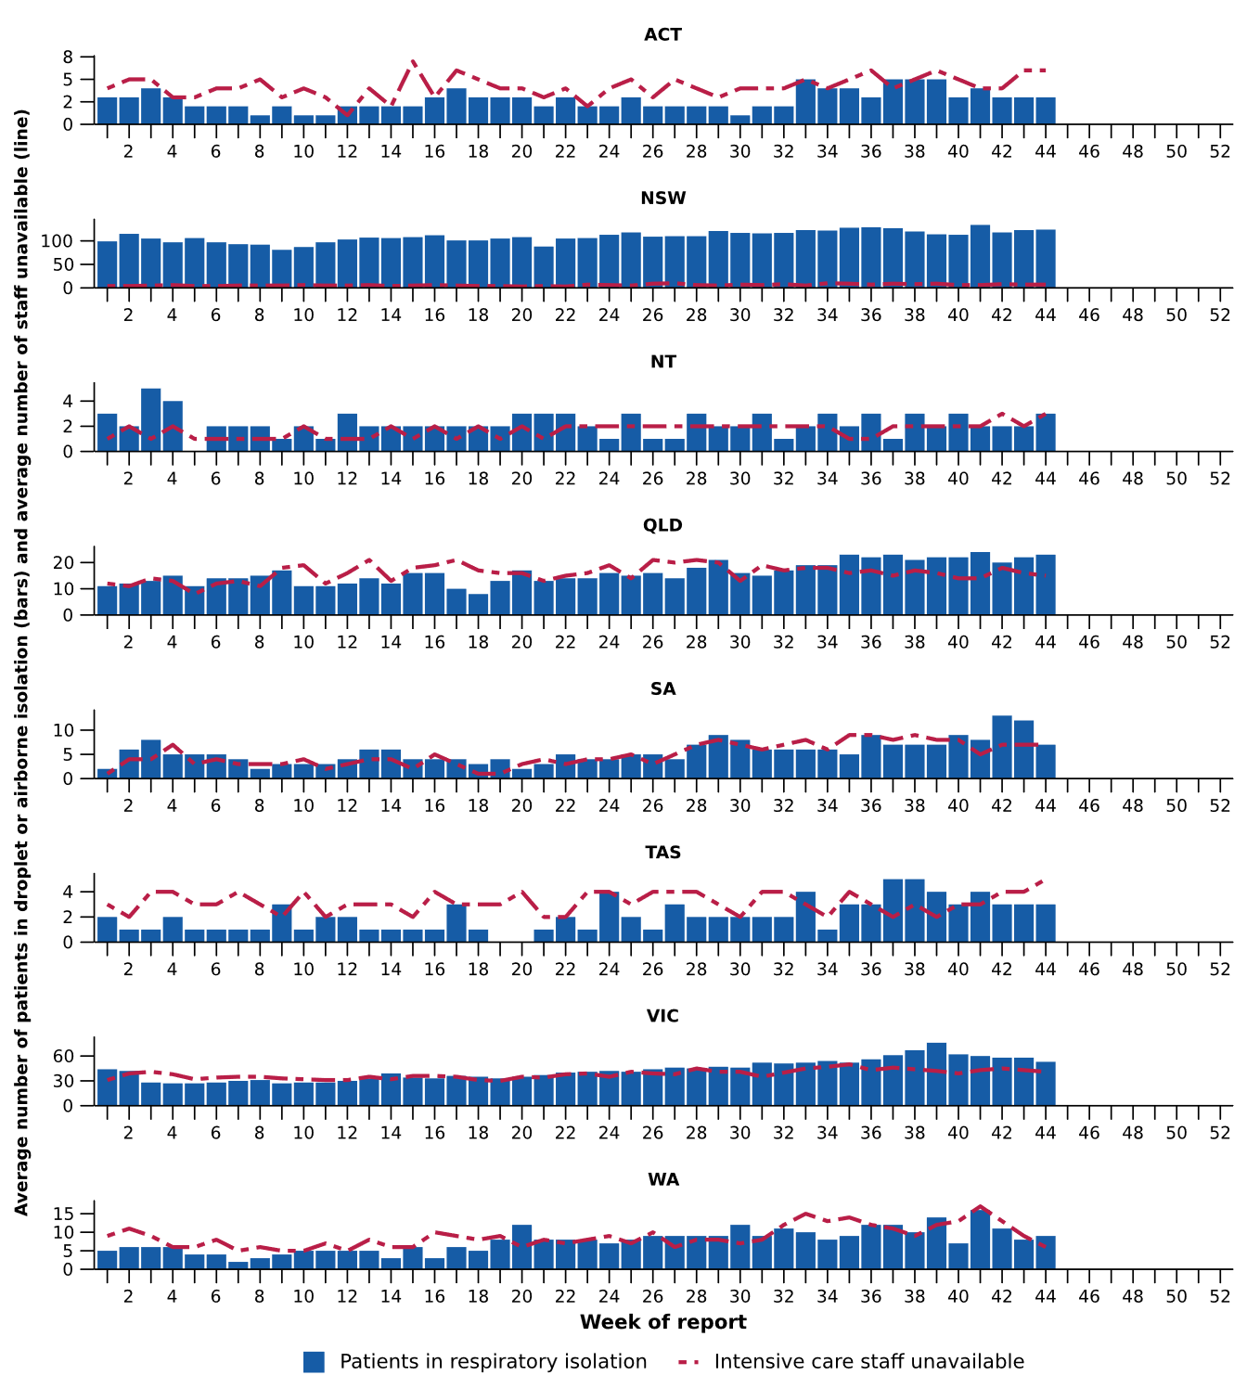
Source: Critical Health Resource Information System (CHRIS)
* Axis varies between jurisdictions.
† NSW isolation data from public hospitals includes all patients occupying intensive care beds in isolation precautions, including those in contact isolation precautions, rather than just droplet or airborne isolation precautions, which will overestimate the average number of patients occupying intensive care beds in droplet or airborne isolation in NSW. For this reason, NSW data may not be comparable to data from other jurisdictions.
‡ Intensive care staff include both medical and nursing staff. Staff unavailability will be underestimated in NSW as most public hospitals in NSW do not report staff unavailability. For this reason, NSW data may not be comparable to data from other jurisdictions.

Mortality surveillance
Death registrations can provide information on the scale and severity of disease associated with acute respiratory infections. An acute respiratory infection associated death is one where the death was due to the disease (the illness has caused terminal complications such as pneumonia) or the person has died with the disease (a person has died from another cause but the illness still contributed significantly to death).
- For most of 2020 to 2026, COVID-19 was the leading cause of acute respiratory infection-related mortality. However, monthly deaths involving (both due to and with) COVID-19 have remained relatively stable since October 2025. The fewer than 100 deaths recorded each month aligns with the relatively low and stable COVID-19 notifications observed across the same period (October 2025–August 2026; Figure 5). Annual deaths involving COVID-19 have also declined each year since 2023.
- There were more deaths involving influenza in August 2026 than deaths involving COVID-19 or RSV. However, the number of deaths involving all three respiratory diseases in August 2026 are lower than in the same period in 2025, reflective of the variation in seasonal patterns observed in 2026 compared to 2025, particularly for COVID-19 and influenza (Figure 5; Figure 7).
- Deaths involving acute respiratory infections were more common in older age groups.
Figure 21a: Provisional numbers of deaths due to an acute respiratory infection*† by month, year, and disease, Australia, 1 January 2024 to 30 September 2026
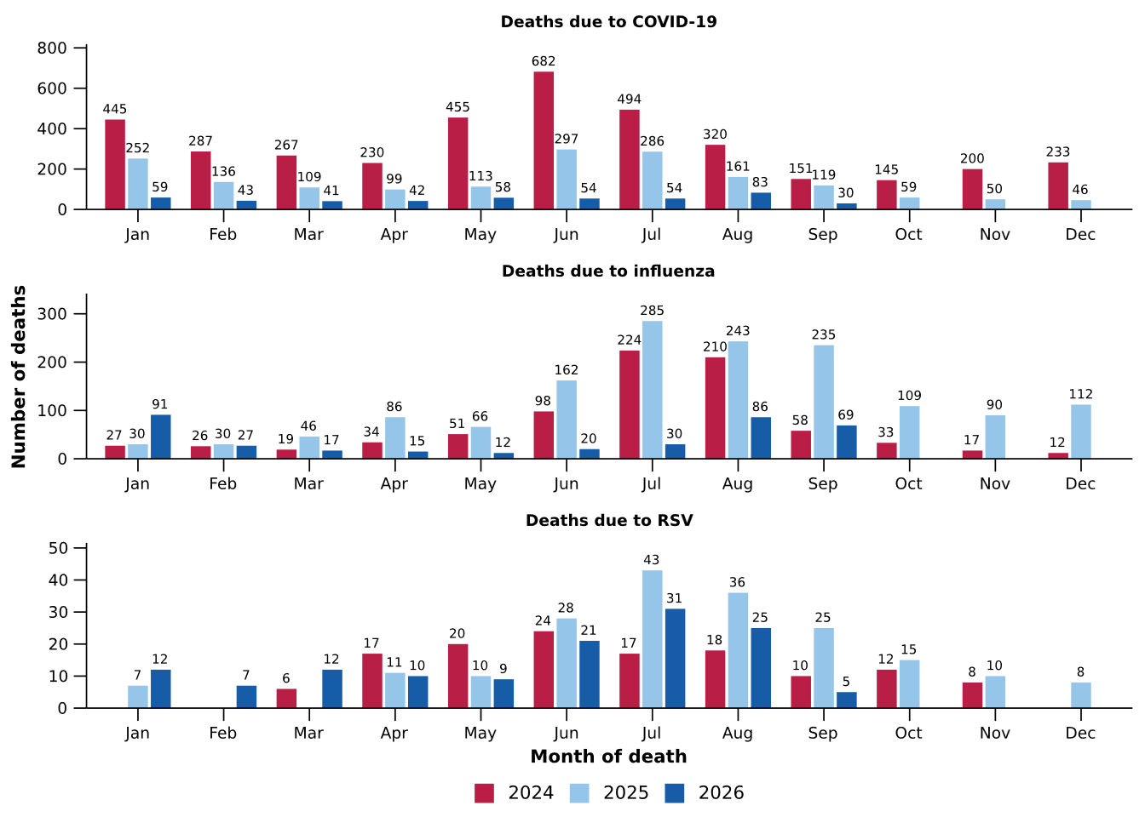
Source: Australian Bureau of Statistics (ABS), Deaths due to acute respiratory infections in Australia, released 29 October 2026.
* Axis varies between acute respiratory infections.
† Data is provisional and subject to change. It can take several weeks for death registrations to be reported, processed, coded, validated, and tabulated. Therefore, the data shown here may be incomplete. Data for some months were not published by the ABS due to small counts, and therefore not reported here. Data includes all deaths (both doctor and coroner certified) that occurred and were registered by 30 September 2026.
- Deaths due to COVID-19 increased in August 2026 but remained much lower compared to previous years (Figure 21a).
- Deaths due to influenza increased in August 2026 but remained substantially lower than in August 2024 and 2025, aligning with increasing influenza notifications during August and delayed influenza season in 2026 compared to 2024 and 2025 (Figure 21a; Figure 7).
- Deaths due to RSV fell to 25 in August 2026, which is higher than in August 2024 but lower than in August 2025 (Figure 21a).
- Deaths with COVID-19 fell slightly in August 2026 and are much lower compared to previous years (Figure 21b).
- Deaths with influenza increased in August 2026, consistent with increasing influenza notifications in August 2026, though remain much lower than previous years (Figure 21b; Figure 7).
- Deaths with RSV increased slightly in August 2026, though are lower than in August 2025 but higher than in 2024 (Figure 21b).
Figure 21b: Provisional numbers of deaths with an acute respiratory infection*† by month, year, and disease, Australia, 1 January 2024 to 30 September 2026
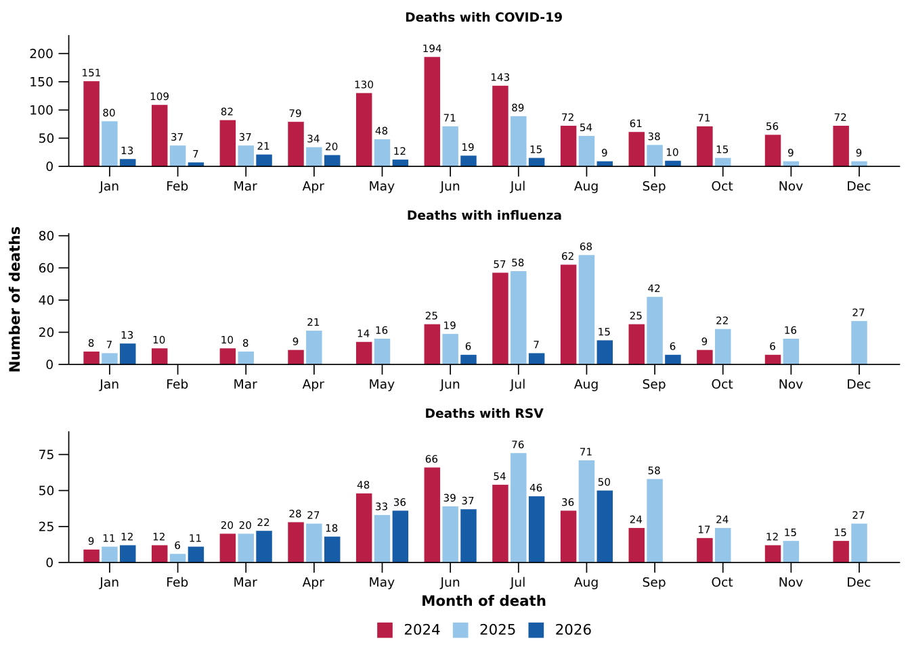
Source: Australian Bureau of Statistics (ABS), Deaths due to acute respiratory infections in Australia, released 29 October 2026.
* Axis varies between acute respiratory infections.
† Data is provisional and subject to change. It can take several weeks for death registrations to be reported, processed, coded, validated, and tabulated. Therefore, the data shown here may be incomplete. Data for some months were not published by the ABS due to small counts, and therefore not reported here. Data includes all deaths (both doctor and coroner certified) that occurred and were registered by 30 September 2026.

Laboratory surveillance
Sentinel laboratory surveillance monitors the percentage of tests with the notifiable condition detected (i.e. test positivity). It also provides information on what pathogens are circulating, potential changes in the pathogens that might affect their infectiousness, severity, ability to evade vaccine and/or infection-acquired immunity, or resistance to antivirals.
- In the last fortnight (19 October to 1 November 2026), the percentage of SARS-CoV-2 tests that were positive increased slightly (from 1.3% to 1.4%), the percentage of influenza tests that were positive decreased (from 14.6% to 11.9%) and the percentage of RSV tests that were positive decreased (from 1.4% to 0.9%), aligning with notification trends for all three pathogens in the last fortnight (Table 2; Figure 22).
Figure 22: Number of tests positive (bars) and percentage of tests positive (line) for SARS-CoV-2, influenza or RSV of those specimens tested by sentinel laboratories by week of report*†, Australia, 1 January to 1 November 2026
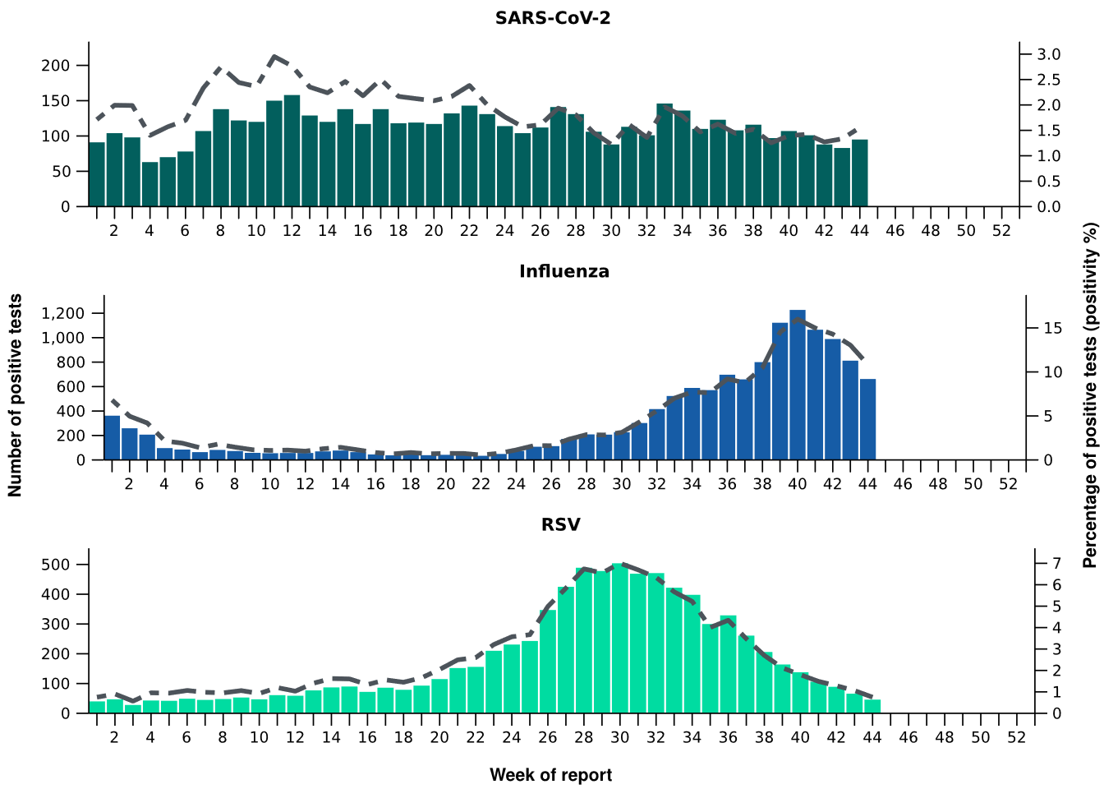
Source: Sentinel laboratories, including National Influenza Centres
* Number of specimens tested excludes data from WA as testing denominator data are different for the three pathogens in Western Australia.
† A small minority of total samples from Victoria are tested only by respiratory panel (influenza, parainfluenza, adenovirus, human metapneumovirus, seasonal coronaviruses, RSV, and some picornaviruses) but not for SARS-CoV-2. These minority samples include only forensic materials; all other samples are tested by respiratory panel and SARS-CoV-2 assay.

- There were 69 SARS-CoV-2 sequences uploaded to AusTrakka with dates of collection in the last 28 days (5 October to 1 November 2026). These sequences were from NSW, SA and WA with the most recent date of collection from 19 October 2026. The low number of sequences uploaded to AusTrakka in the last 28 days due to the reduced number of COVID-19 cases. The limited number of sequences and lack of representativeness may limit interpretation.
- Most sequences were recombinants consisting of one or more Omicron sub-lineages (Figure 23a/b). In the last 28 days:
  - 73.9% (51/69) of sequences were recombinant or recombinant sub-lineages, the most common including NB.1.8.1 (n=26), PQ.16.1.1 (n=16) and XFG (n=6).
  - 11.6% (8/69) of sequences were identified as BA.3, specifically BA.3.2.
  - 14.5% (10/69) of sequences were from the sub-sub-lineages JN.1 (BA.2.86.1.1), including KP.3.1.1.
  - There were no BA.1, BA.4, BA.5 or other BA.2 sub-sub-lineage sequences.
- NB.1.8.1 was the most common sub-lineage in the last 28 days, accounting for 37.7% (26/69) of sequences (Figure 23a).
- The World Health Organization (WHO) have identified certain sub-sub-lineages and recombinants as variants under monitoring (VUM) because of their epidemiological, pathological, or immunological features of concern. A select number are highlighted below due to their relevance in the Australian context. There are:
  - 4,806 NB.1.8.1 sequences in AusTrakka, with 26 collected in the last 28 days.
  - 338 PQ.16.1.1 sequences in AusTrakka, with 16 collected in the last 28 days.
  - 1,259 BA.3.2 sequences in AusTrakka, with eight collected in the last 28 days.
  - 1,677 XFG sequences in AusTrakka, with six collected in the last 28 days.

Figure 23a: SARS-CoV-2 Omicron sub-lineage* sequences by sample collection date, showing proportions of sequences per week†‡, Australia, 1 January to 1 November 2026
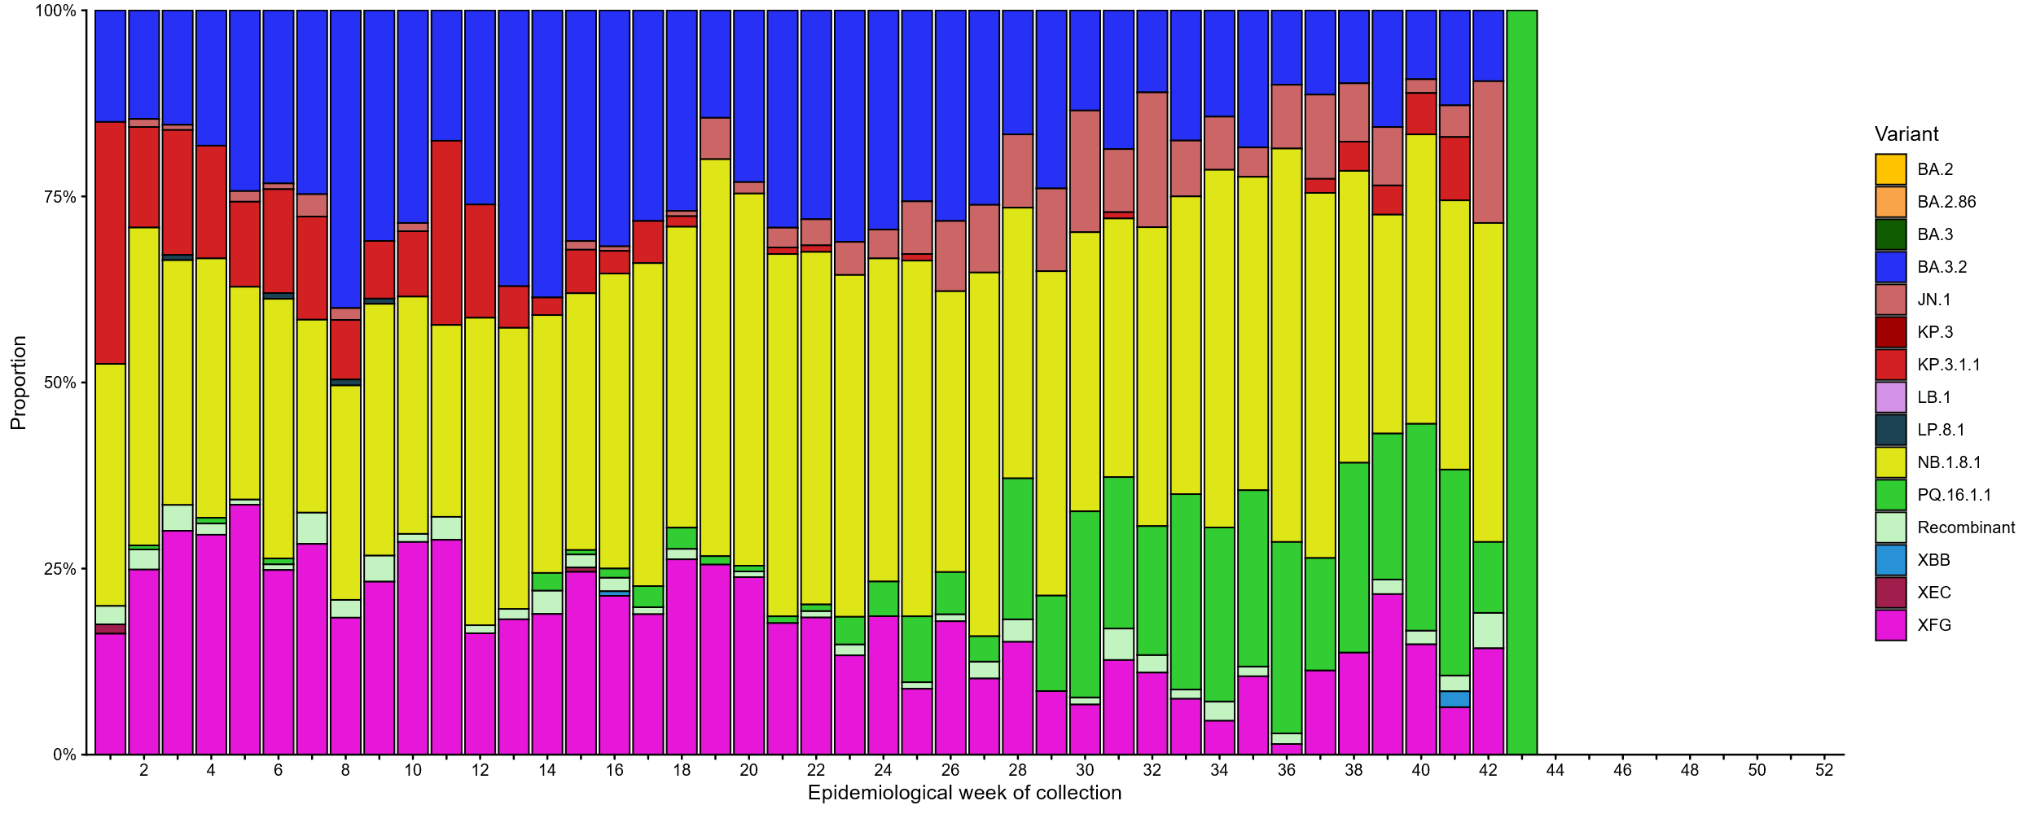
Source: AusTrakka
* Some sub-sublineages are shown alongside their parent lineage, but not included in the parent lineage totals. For instance, KP.2 and KP.3 are sub-sub lineages of JN.1, so the total of JN.1 sequences will be higher than shown in the corresponding colour alone, and should include the KP.2 and KP.3 totals.
† Sequences in AusTrakka aggregated by week and reported based on date of sample collection, not date of sequencing.
‡ Proportions in Figure 23a may not be representative when sequence numbers are small; refer to Figure 23b. Data for earlier weeks may change between reporting periods as sequences with older collection dates are uploaded. These numbers are not equivalent to number of cases, as there are many cases which may not be sequenced. Non-VOI and non-VUM Omicron sub-lineages have been collapsed into parent lineages BA.1, BA.2, BA.3, BA.4 and BA.5.

Figure 23b: SARS-CoV-2 Omicron sub-lineage* sequences by sample collection date, showing the count of sequences per week†‡, Australia, 1 January to 1 November 2026
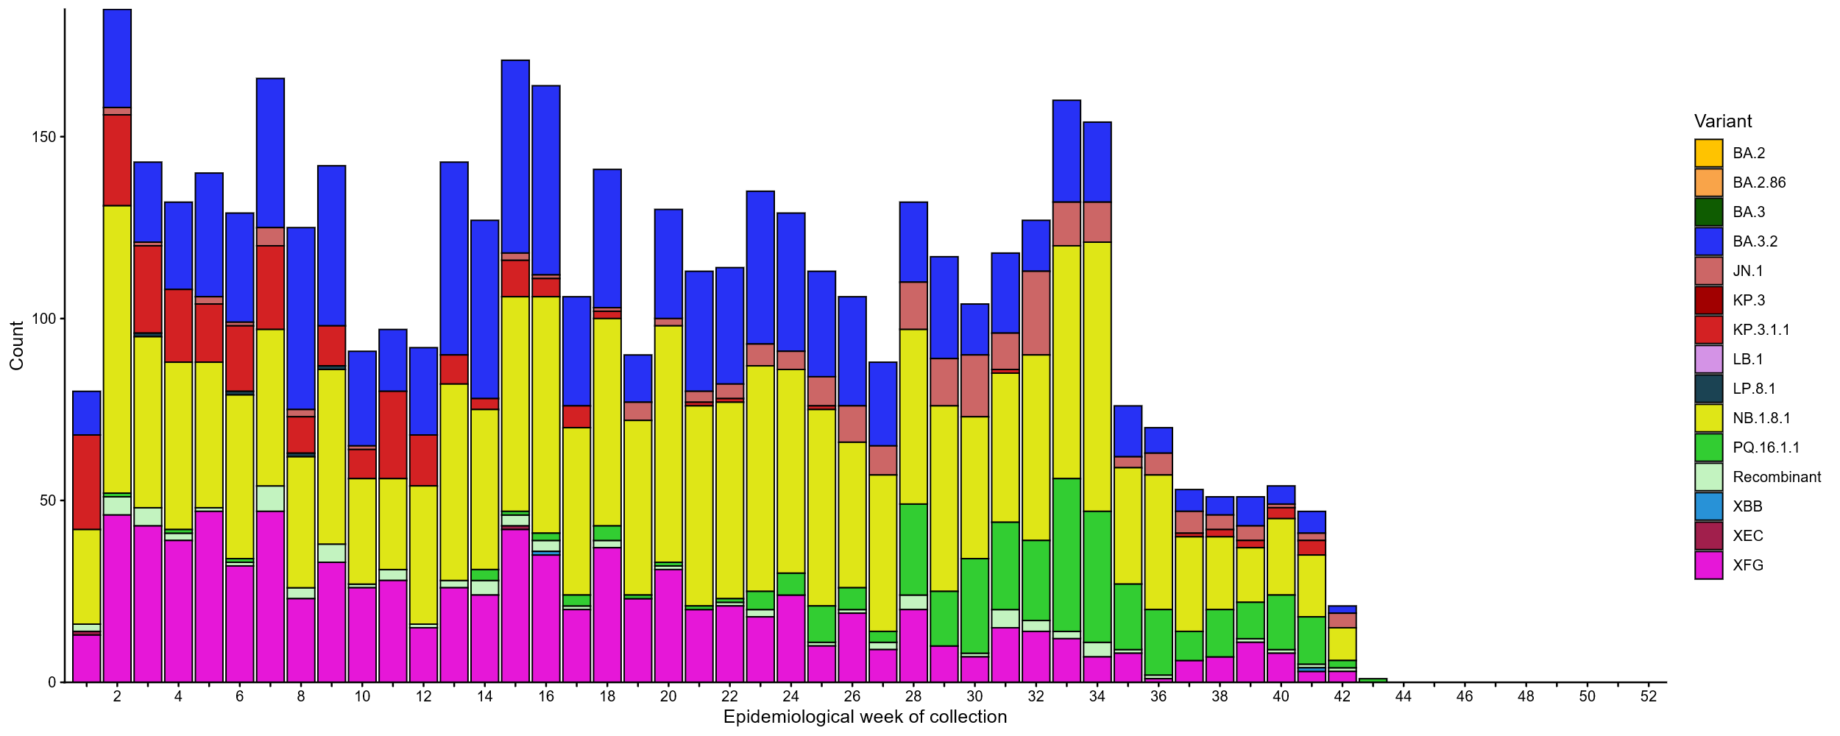Source: AusTrakka
* Some sub-sublineages are shown alongside their parent lineage, but not included in the parent lineage totals. For instance, KP.2 and KP.3 are sub-sub lineages of JN.1, so the total of JN.1 sequences will be higher than shown in the corresponding colour alone, and should include the KP.2 and KP.3 totals.
† Sequences in AusTrakka aggregated by week and reported based on date of sample collection, not date of sequencing.
‡ Data for earlier weeks may change between reporting periods as sequences with older collection dates are uploaded. These numbers are not equivalent to number of cases, as there are many cases which may not be sequenced. Non-VOI and non-VUM Omicron sub-lineages have been collapsed into parent lineages BA.1, BA.2, BA.3, BA.4 and BA.5.

- In the year to date, the WHO Collaborating Centre for Reference and Research on Influenza has antigenically characterised 2,141 influenza viruses from Australia (Table 5), of which:
  - 30.2% (646/2,141) have been influenza A(H1N1)
  - 62.2% (1,332/2,141) have been influenza A(H3N2)
  - 7.6% (163/2,141) have been influenza B/Victoria.
- In the year to date, 1.3% (1/78) of influenza A(H1N1) samples tested for neuraminidase inhibitor resistance demonstrated highly reduced inhibition to oseltamivir. None of the influenza A(H3N2) samples tested demonstrated highly reduced inhibition to oseltamivir, and none of the samples tested demonstrated highly reduced inhibition to zanamivir.
Table 5: Australian influenza viruses typed by haemagglutination inhibition assay and jurisdiction*†, 1 January to 1 November 2026
Strain | ACT | NSW | NT | Qld | SA | Tas | Vic | WA | Total
A(H1N1) | 63 | 143 | 82 | 58 | 20 | 78 | 170 | 32 | 646
A(H3N2) | 141 | 329 | 140 | 119 | 51 | 161 | 303 | 88 | 1,332
B/Victoria lineage | 5 | 23 | 67 | 1 | 4 | 6 | 46 | 11 | 163
Total | 209 | 495 | 289 | 178 | 75 | 245 | 519 | 131 | 2,141
Source: World Health Organization (WHO) Collaborating Centre for Reference and Research on Influenza
*Viruses tested by the WHO Collaborating Centre for Reference and Research on Influenza are not necessarily a random sample of all those in the community and early-year data may be based on limited samples received. There may be up to a month delay on reporting of samples.
† Jurisdiction indicates the residential location for the individual tested, not the submitting laboratory.

Vaccine coverage, effectiveness and match
Vaccine coverage, effectiveness and match for acute respiratory infections are monitored from several data sources in Australia. Refer to the Technical Supplement for more information.

Vaccine coverage
- In the last 12 months, fewer adults have received a COVID-19 vaccine (8.0%; Table 6), compared to the 12 months prior (10.2% from 28 October 2024 to 26 October 2025).
- In the last 12 months, vaccine coverage decreased in all age groups, with the largest decrease seen in the 75 years and over age group (from 35.7% in the 12 months prior to 29.9% in the last 12 months).
- There has been substantial variation in COVID-19 vaccine coverage across age groups, ranging from 2.9% in adults aged 18–64 years to 29.9% in adults aged 75 years and over (Table 6). Coverage trends are influenced by vaccine recommendations and eligibility criteria, as people aged under 65 years are generally not recommended to receive an annual COVID-19 vaccine, and are not eligible for free COVID-19 vaccines under the National Immunisation Program.
- There has been some variation in vaccine coverage across jurisdictions, ranging from 2.8% in the NT to 15.7% in Tas (Table 6).
Table 6: COVID-19 vaccine coverage*†‡ by age group and jurisdiction, Australia, 27 October 2025 to 1 November 2026
Age group | ACT | NSW | NT | Qld | SA | Tas | Vic | WA | AUS
Last 12 months (27 October 2025 to 1 November 2026)
18–64 years | 7.7 | 2.5 | 1.3 | 2.8 | 3.0 | 6.2 | 3.3 | 2.8 | 2.9
65–74 years | 36.6 | 16.9 | 8.4 | 17.1 | 21.4 | 32.6 | 19.7 | 18.1 | 18.2
≥ 75 years | 51.2 | 28.8 | 12.8 | 28.2 | 34.0 | 47.5 | 31.4 | 30.9 | 29.9
All ages (18 years and over) | 15.3 | 7.5 | 2.8 | 7.4 | 9.6 | 15.7 | 8.4 | 7.6 | 8.0
Last 6 months (27 April 2026 to 1 November 2026)
18–64 years | 4.4 | 1.5 | 0.7 | 1.5 | 1.6 | 3.7 | 1.9 | 2.1 | 1.7
65–74 years | 18.6 | 9.6 | 4.5 | 8.6 | 10.5 | 17.9 | 11.0 | 11.5 | 10.1
≥ 75 years | 28.0 | 16.8 | 7.3 | 14.8 | 17.6 | 26.6 | 18.0 | 19.3 | 16.9
All ages (18 years and over) | 8.3 | 4.4 | 1.5 | 3.8 | 5.0 | 8.9 | 4.8 | 5.0 | 4.5
Source: Australian Immunisation Register (AIR) as at 1 November 2026
* COVID-19 vaccine coverage uses the AIR population as the denominator (from 6 July 2026 onwards). Coverage data in these tables may differ slightly from coverage estimates in other reports due to differences in calculation methodologies and/or different data download dates.
† COVID-19 vaccine coverage is influenced by changes in COVID-19 vaccine recommendations and eligibility criteria. For this reason, coverage rates in the current 12 month period and previous 12 month periods may not be directly comparable.
‡ Total rows will include individuals where jurisdiction was missing.

- In the last 12 months, fewer Aboriginal and Torres Strait Islander adults have received a COVID-19 vaccine (3.4%; Table 7), compared to the 12 months prior (4.6% from 28 October 2024 to 26 October 2025).
- In the last 12 months, vaccine coverage decreased in all age groups of Aboriginal and Torres Strait Islander people, with the largest decrease seen in adults aged 75 years and over (from 27.6% in the 12 months prior to 22.5% in the last 12 months).
- Among Aboriginal and Torres Strait Islander people there has been substantial variation in COVID-19 vaccine coverage across age groups, ranging from 1.8% in adults aged 18–64 years to 22.5% in adults aged 75 years and over (Table 7). Coverage trends are influenced by vaccine recommendations and eligibility criteria, with Aboriginal and Torres Strait Islander people under 50 years not eligible for free COVID-19 vaccines under the National Immunisation Program.
- Among Aboriginal and Torres Strait Islander people, there has been slight variation in vaccine coverage across jurisdictions, ranging from 1.8% in the NT to 8.1% in the ACT (Table 7).
Table 7: COVID-19 vaccine coverage*†‡ among Aboriginal and Torres Strait Islander populations by age group and jurisdiction, Australia, 27 October 2025 to 1 November 2026
Age group | ACT | NSW | NT | Qld | SA | Tas | Vic | WA | AUS
Last 12 months (27 October 2025 to 1 November 2026)
18–64 years | 5.0 | 1.8 | 1.2 | 1.6 | 1.8 | 4.0 | 2.6 | 1.5 | 1.8
65–74 years | 32.0 | 14.7 | 6.7 | 11.8 | 12.5 | 28.9 | 16.7 | 11.1 | 13.4
≥ 75 years | 47.8 | 24.8 | 12.9 | 19.4 | 24.7 | 36.9 | 28.2 | 20.6 | 22.5
All ages (18 years and over) | 8.1 | 3.8 | 1.8 | 2.9 | 3.4 | 7.8 | 5.0 | 2.6 | 3.4
Last 6 months (27 April 2026 to 1 November 2026)
18–64 years | 3.3 | 1.1 | 0.5 | 0.9 | 1.0 | 2.3 | 1.5 | 1.1 | 1.0
65–74 years | 17.8 | 8.1 | 3.6 | 6.2 | 6.5 | 16.2 | 9.3 | 6.8 | 7.4
≥ 75 years | 22.9 | 14.2 | 7.8 | 10.6 | 12.8 | 19.2 | 16.6 | 13.1 | 12.7
All ages (18 years and over) | 4.9 | 2.2 | 0.9 | 1.6 | 1.8 | 4.4 | 2.8 | 1.8 | 1.9
Source: Australian Immunisation Register (AIR) as at 1 November 2026
* COVID-19 vaccine coverage uses the AIR population as the denominator (from 6 July 2026 onwards). Coverage data in these tables may differ slightly from coverage estimates in other reports due to differences in calculation methodologies and/or different data download dates.
† COVID-19 vaccine coverage in the most recent 12 month period may not be directly comparable to previous 12 month periods due to changes in COVID-19 vaccine eligibility criteria.
‡ Total rows will include individuals where jurisdiction was missing.

- Influenza vaccine coverage is 30.7% for 2026 so far (Table 8).
- There has been substantial variation in influenza vaccine coverage across age groups, ranging from 16.6% in children aged 5–14 years to 61.0% in adults aged 65 years and over (Table 8). The current trend is influenced by eligibility criteria as people aged 5–64 years are generally not eligible for free seasonal influenza vaccine under the National Immunisation Program.
- There has been some variation in influenza vaccine coverage across jurisdictions, ranging from 28.3% in Qld to 39.8% in the ACT (Table 8).
- Among Aboriginal and Torres Strait Islander populations, there has been substantial variation in influenza vaccine coverage across age groups, ranging from 17.5% in children aged 5–14 years to 61.4% in adults aged 65 years and over (Table 8).
- Among Aboriginal and Torres Strait Islander populations, there has been substantial variation in influenza vaccine coverage across jurisdictions, ranging from 22.4% in Qld to 44.1% in the NT (Table 8).
Table 8: Influenza vaccine coverage*†‡ by age group and jurisdiction, Australia, 1 March to 1 November 2026
 | ACT | NSW | NT | Qld | SA | Tas | Vic | WA | AUS
Age groups
6 months to <5 years | 59.6 | 37.4 | 50.1 | 32.1 | 38.2 | 43.3 | 41.5 | 35.2 | 37.8
5–14 years | 26.2 | 16.4 | 19.0 | 14.9 | 15.8 | 17.2 | 16.8 | 19.0 | 16.6
15–49 years | 31.5 | 19.5 | 26.5 | 17.8 | 22.8 | 23.3 | 23.4 | 18.7 | 20.6
50–64 years | 41.9 | 28.9 | 27.6 | 29.4 | 34.5 | 37.3 | 32.6 | 29.5 | 30.8
≥ 65 years | 65.5 | 59.0 | 38.1 | 60.4 | 67.2 | 68.8 | 62.2 | 60.2 | 61.0
All ages (6 months and over) | 39.8 | 29.7 | 28.6 | 28.3 | 34.7 | 36.8 | 32.5 | 29.0 | 30.7
Aboriginal and Torres Strait Islander populations
6 months to <5 years | 43.4 | 28.5 | 53.3 | 25.3 | 26.6 | 30.6 | 30.8 | 30.4 | 29.6
5–14 years | 20.7 | 16.1 | 33.9 | 15.5 | 17.1 | 16.6 | 16.6 | 18.1 | 17.5
15–49 years | 25.8 | 18.1 | 42.6 | 17.0 | 22.1 | 20.7 | 20.3 | 19.3 | 20.6
50–64 years | 45.0 | 36.4 | 53.5 | 34.6 | 39.7 | 43.3 | 37.1 | 35.7 | 37.9
≥ 65 years | 68.3 | 63.3 | 52.6 | 60.3 | 64.2 | 71.1 | 63.8 | 56.1 | 61.4
All ages (6 months and over) | 31.4 | 24.5 | 44.1 | 22.4 | 26.7 | 28.2 | 26.4 | 24.3 | 25.9
Source: Australian Immunisation Register (AIR) as at 2 November 2026
* Influenza vaccine coverage uses the AIR population as the denominator. Coverage data in these tables may differ slightly from coverage estimates in other reports due to differences in calculation methodologies and/or different data download dates.
† Total rows will include individuals where jurisdiction was missing.

- Since the commencement of the National RSV Mother and Infant Protection Program on 3 February 2025, 351,511 Abrysvo doses have been administered to pregnant people nationally (Table 9).
- While high maternal vaccine uptake is a positive indicator of maternal program success, it may result in lower nirsevimab uptake rates in infants. This is because maternal antibodies passed to the infant can provide protection against RSV, potentially reducing the need for infant immunisation.
Table 9: Number of doses of Abrysvo administered to pregnant people by jurisdiction*, Australia, 3 February 2025 to 1 November 2026
 | ACT | NSW | NT | Qld | SA | Tas | Vic | WA | AUS
Age group
15–24 years | 462 | 8,801 | 802 | 8,528 | 1,963 | 948 | 5,127 | 3,445 | 30,076
25–39 years | 7,775 | 92,623 | 3,239 | 56,868 | 20,942 | 6,542 | 83,021 | 31,626 | 302,636
40–54 years | 515 | 6,091 | 170 | 2,946 | 1,202 | 291 | 5,768 | 1,816 | 18,799
Total (15–54 years) | 8,752 | 107,515 | 4,211 | 68,342 | 24,107 | 7,781 | 93,916 | 36,887 | 351,511
Source: Australian Immunisation Register (AIR) as at 1 November 2026
* Administered doses in this table may differ slightly from estimates in other reports due to differences in calculation methodologies and/or different data download dates.
† Total rows will include individuals where jurisdiction was missing.
- In the last six months, 6.8% of infants (aged under 8 months) have received nirsevimab (Table 10).
- There has been substantial variation in nirsevimab uptake in infants across jurisdictions, ranging from 1.3% in the ACT to 23.5% in WA (Table 10).
- The current trend may reflect differences in the timing and eligibility criteria between state and territory programs. Some state and territory programs are seasonal (from 1 April to 30 September), whereas others are year-round. In states with seasonal programs (SA, Tas, Vic, and parts of WA), uptake may appear disproportionately higher during and shortly after cessation of the program.
Table 10: Nirsevimab (Beyfortus) uptake in the last six months*†‡ by age group and jurisdiction, Australia, 27 April 2026 to 1 November 2026
 | ACT | NSW | NT | Qld | SA | Tas | Vic | WA | AUS
Age group
Infants (aged < 8 months) | 1.3 | 3.8 | 8.8 | 7.3 | 2.9 | 4.4 | 4.3 | 23.5 | 6.8
Young children (aged ≥ 8 to 24 months) | 0.2 | 0.1 | 0.6 | 0.1 | 0.3 | 0.4 | 0.3 | 1.5 | 0.4
Source: Australian Immunisation Register (AIR) as at 1 November 2026
* Reporting of RSV monoclonal antibodies to the AIR is not compulsory; therefore, uptake is likely to be underestimated. Uptake data in these tables may differ slightly from estimates in other reports due to differences in calculation methodologies and/or different data download dates.
† For infants and young children vaccinated, age in months is calculate as months between the immunisation encounter and date of birth rounded down as at the reporting date. For the infant and young children population, age in months is calculated as months between the AIR data extract date and date of birth rounded down as at the reporting date.
‡ Total rows will include individuals where jurisdiction was missing.

Vaccine effectiveness (interim estimates)
- Preliminary Australian estimates of influenza vaccine effectiveness suggest influenza vaccination reduced the risk of attending a general practice with influenza by 58% in 2026 (95% CI: 23%, 77%) compared with people who were not vaccinated. This is comparable to the final VE estimate of 51% (95% CI: 38%, 61%) in 2025.
  - Age and subtype-specific VE estimates are not yet available, as the number of cases available to date was insufficient to produce reliable estimates.
- Preliminary Australian estimates of influenza vaccine effectiveness suggest influenza vaccination reduced the risk of being hospitalised with influenza by 35% in 2026 (95% CI: 18%, 49%) compared with people who were not vaccinated. This is comparable to the final VE estimate of 43% (95% CI: 39%, 48%) in 2025.
  - Influenza vaccination reduced the risk of being hospitalised influenza B by 69% (95% CI: 28%, 86%), compared with 33% (95% CI: 14%, 47%) for influenza A. Similar patterns were observed in 2025, with higher VE against influenza B than influenza A.
  - The reduction in the risk of being hospitalised with influenza was highest among adults aged 65 years and over (49%; 95% CI: 20%, 68%), and lower among children aged under 16 years (18%; 95% CI: -23%, 45%). This differs from 2025, when the highest VE was observed in children. However, these age-specific estimates were imprecise.
- These estimates are based on incomplete data and the final season estimates may differ.

Vaccine match
- In the year to date, 89.5% (578/646) of influenza A(H1N1) isolates, 84.9% (1,131/1,332) of influenza A(H3N2) isolates and 91.4% (149/163) of influenza B/Victoria lineage isolates characterised have been antigenically similar to the corresponding 2026 southern hemisphere vaccine components.

2026 southern hemisphere vaccine composition
The composition of influenza vaccines for Australia in 2026 differs from the 2025 southern hemisphere and 2025/26 northern hemisphere composition. The southern hemisphere 2026 vaccine contains 2 new strains for the influenza A(H1N1)pdm09 and A(H3N2) subtype virus components. The following influenza viruses are used for the 2026 southern hemisphere trivalent influenza vaccines in Australia:
Egg-based influenza vaccines:
- an A/Missouri/11/2025 (H1N1)pdm09-like virus
- an A/Singapore/GP20238/2024 (H3N2)-like virus
- a B/Austria/1359417/2021 (B/Victoria lineage)-like virus.
Cell-based influenza vaccines:
- an A/Missouri/11/2025 (H1N1)pdm09-like virus
- an A/Sydney/1359/2024 (H3N2)-like virus
- a B/Austria/1359417/2021 (B/Victoria lineage)-like virus.
The continued absence of confirmed detection of naturally occurring B/Yamagata lineage viruses after March 2020 indicates a very low risk of infection by B/Yamagata viruses. Since September 2023, the WHO has recommended that the inclusion of a B/Yamagata lineage antigen in seasonal influenza vaccines is no longer warranted.

Bureau of Meteorology. Monthly Summary for Australia; Australia in July 2026 [Web page]. Melbourne: Bureau of Meteorology; 2026 [cited 2026 Sep 10]. Available from: https://www.bom.gov.au/clim_data/IDCKGC1AR0/202607.summary.shtml

