Australian Respiratory Surveillance Report

Key messages
This report presents a national epidemiological update for acute respiratory infections, including coronavirus disease 2019 (COVID-19), influenza and respiratory syncytial virus (RSV), with a focus on the current reporting period (24 February to 23 March 2025) and earlier severity reporting periods (up to 9 March 2025).
To better monitor the increases in acute respiratory infections over the traditional respiratory virus season (April through to October) the Australian Respiratory Surveillance Report will now be published fortnightly, with the next report expected to be published on Friday 11 April 2025.
In the community: Respiratory illness activity (self-reported new fever and cough symptoms) is currently lower than observed at the same time in previous years. Fewer people reported taking time off work due to respiratory illness (self-reported new fever and cough symptoms) this month. The number of COVID-19 cases remains low this month. The number of influenza cases this month is slightly higher than the five-year average and the number of cases seen in the same period in previous years; however, influenza case numbers remain at low interseasonal levels. The number of RSV cases this month, particularly in the last two weeks, is higher than in the previous month and increasingly steadily. This may signal the start of the RSV season nationally, however this steadily increasing trend has not been observed in all jurisdictions.
In general practice: As in the same period in 2024, influenza-like-illness consultation rates this month remain slightly higher than observed at the same time in previous years and the five-year average.
In hospitals: Sentinel hospital-based surveillance shows the number of patients admitted with severe acute respiratory infections has remained low and stable this severity reporting period. Most of these patients were admitted with COVID-19. The length of hospital stay continues to vary only slightly between illnesses and the proportion of those patients who were admitted directly to an intensive care has remained low. More children (those aged 16 years and younger) were admitted with RSV and influenza than with COVID-19 at sentinel hospitals, while more adults were admitted with COVID-19 compared to influenza or RSV. Sentinel intensive care surveillance shows the overall number of patients with severe acute respiratory infections has decreased in this severity reporting period. The duration of intensive care stay varies slightly between illnesses. The average number of COVID-19 cases in intensive care has decreased this month. Likewise, the average number of intensive care staff unavailable due to COVID-19 illness or exposure has decreased.
Deaths: COVID-19 has been the leading cause of acute respiratory infection mortality across 2023-2025. All three acute respiratory infections (COVID-19, influenza and RSV) under surveillance are more likely to cause death in older age groups than younger age groups. Please note, the Australian Bureau of Statistics acute respiratory infection mortality reporting provides data up to 31 January 2025 only.
In laboratories: Test positivity for SARS-CoV-2, influenza and RSV remained low and stable this month, though a slight increase in influenza and RSV test positivity was observed. The recombinant lineage XEC is now the dominant SARS-CoV-2 variant in Australia; however the proportion of JN.1 and associated sub-lineages has increased recently due to a decrease in the proportion of recombinant lineages. On 24 January 2025, the World Health Organization designated LP.8.1 as a variant under monitoring. The proportion of LP.8.1 sequences is growing rapidly compared to co-circulating variants; however, there is no significant increase in case numbers associated with LP.8.1 infections, and there are no reports to suggest that the associated disease severity is higher compared to other circulating variants. Small numbers of LP.8.1 sub-lineage sequences have been observed in Australia.
Vaccine coverage, effectiveness and match: It is too early to assess or report vaccination data for 2025. Of isolates characterised in 2025 thus far, over 98% have been antigenically similar, or a good match, to the corresponding 2025 vaccine components.

Australian Respiratory Surveillance Report
This report was prepared by Ash Donovan, Lauren Welsh, Jenna Hassall, and Siobhan St George on behalf of the interim Australian Centre for Disease Control. We thank the staff and participants from the surveillance systems who contribute data for acute respiratory illness surveillance across Australia.
The report presents a national overview of acute respiratory infections in Australia, drawing information from several different surveillance systems. These surveillance systems help us to understand the distribution of acute respiratory illnesses in the community, the severity of infections including which populations might be at risk, and the impact of acute respiratory illnesses on the community and health system in Australia.
Surveillance indicators presented in this report are based on the Australian National Surveillance Plan for COVID-19, Influenza, and RSV. Please refer to the Technical Supplement – Australian Respiratory Surveillance Report for information on our surveillance sources and data considerations, including the considerable impact of the COVID-19 pandemic on acute respiratory infection surveillance in Australia. A summary of data considerations for this report are provided below:
- Due to the dynamic nature of the surveillance systems used in this report, surveillance data are considered preliminary and subject to change as updates are received, with the most recent weeks considered particularly incomplete. Data in this report may vary from data reported in other national reports and reports by states and territories.
- Data in this report are presented by date of event (diagnosis, admission or death) or by the International Organization for Standardization (ISO) week date system, with weeks defined as seven-day periods which begin on a Monday and end on a Sunday. The ISO week date system is used to support trends comparisons over time more effectively. The current reporting period this month includes 24 February to 23 March 2025 and where comparisons to the previous month are made this includes 27 January to 23 February 2025.
- In Australia, states and territories report notified cases to the National Notifiable Diseases Surveillance System (NNDSS) based on the Australian national surveillance case definitions. NNDSS data are analysed and reported based on diagnosis date, which is the true onset date of a case if known, otherwise it is the earliest of the specimen date, the notification date, or the notification received date. The NNDSS data for this report were extracted on 26 March 2025.
- To account for the lag in collection and provision of severity data from some surveillance systems, and for the time delay between illness onset and the development of severe disease outcomes, cases with an admission date or a diagnosis date in the last two weeks are excluded from severity analyses for hospitalisations and intensive care admissions. As such, the severity reporting periods are two weeks behind the end of the current reporting period. For this report, severity reporting includes data from 10 February to 9 March 2025 and where comparisons to the previous severity month are made this includes 13 January to 9 February 2025.
- Death registrations from the Australian Bureau of Statistics (ABS) Provisional Mortality Statistics are now used as the primary data source for measuring acute respiratory infection associated deaths. The ABS mortality data is sourced from the Registry of Births, Deaths and Marriages and is separate from the NNDSS. Registration-based mortality data needs time to be received and processed. For this reason, mortality statistics in this report may lag by at least two months.
- Analysis and reporting outputs were produced using R Statistical Software v4.3.1. While every care has been taken in preparing this report, the Australian Government Department of Health and Aged Care does not accept liability for any injury or loss or damage arising from the use of, or reliance upon, the content of the report or Technical Supplement. For further information about this report refer to the Technical Supplement – Australian Respiratory Surveillance Report or contact respiratory.surveillance@health.gov.au.

Community surveillance
Community surveillance monitors respiratory illnesses in the community, providing information on the number of people reporting respiratory symptoms, testing practices, and the impact of respiratory illnesses. Community surveillance includes notification data obtained from laboratory tests for infections. Infections that are diagnosed and notified are only a subset of the total number of infections occurring in the community.
- Community surveys via FluTracking indicate respiratory illness symptoms and test positivity remain low and stable this month, consistent with interseasonal levels in previous years.
- This month (24 February to 23 March 2025), a similar proportion of survey participants reported new fever and cough symptoms as the previous month (1.0% in both); however, a decreasing trend has been observed in the past two weeks (Figure 1).
- This month, more survey participants with new fever and cough symptoms used a rapid antigen test (RAT) (58.2%; 619/1,063) than a polymerase chain reaction (PCR) test (9.5%; 101/1,063) to test for severe acute respiratory syndrome coronavirus 2 (SARS-CoV-2).
  - Self-reported SARS-CoV-2 RAT positivity was lower this month (23.3%; 144/619) than in the previous month (32.0%; 230/718). Self-reported SARS-CoV-2 PCR positivity was also lower this month (9.9%; 10/101) than in the previous month (20.4%; 30/147).
- This month, 8.2% (87/1,063) of survey participants with new fever and cough symptoms used a PCR test to test for influenza. Self-reported influenza PCR positivity was higher this month (33.3%; 29/87), than in the previous month (16.9%; 22/130).
- This month fewer survey participants reported taking three or more days off work or normal duties due to fever and cough symptoms (45.3%; 482/1,063), than in the previous month (49.4%; 573/1,160).
In the year to date, the weekly proportion of survey participants with new fever and cough symptoms has been relatively consistent with the proportions observed at the same time in 2022–2023; however, has been lower than observed at the same time in 2024 (Figure 1).
Figure 1: Age standardised proportion of survey participants reporting new fever and cough symptoms compared with the five-year average* by year and week of report, Australia, 2022 to 23 March 2025
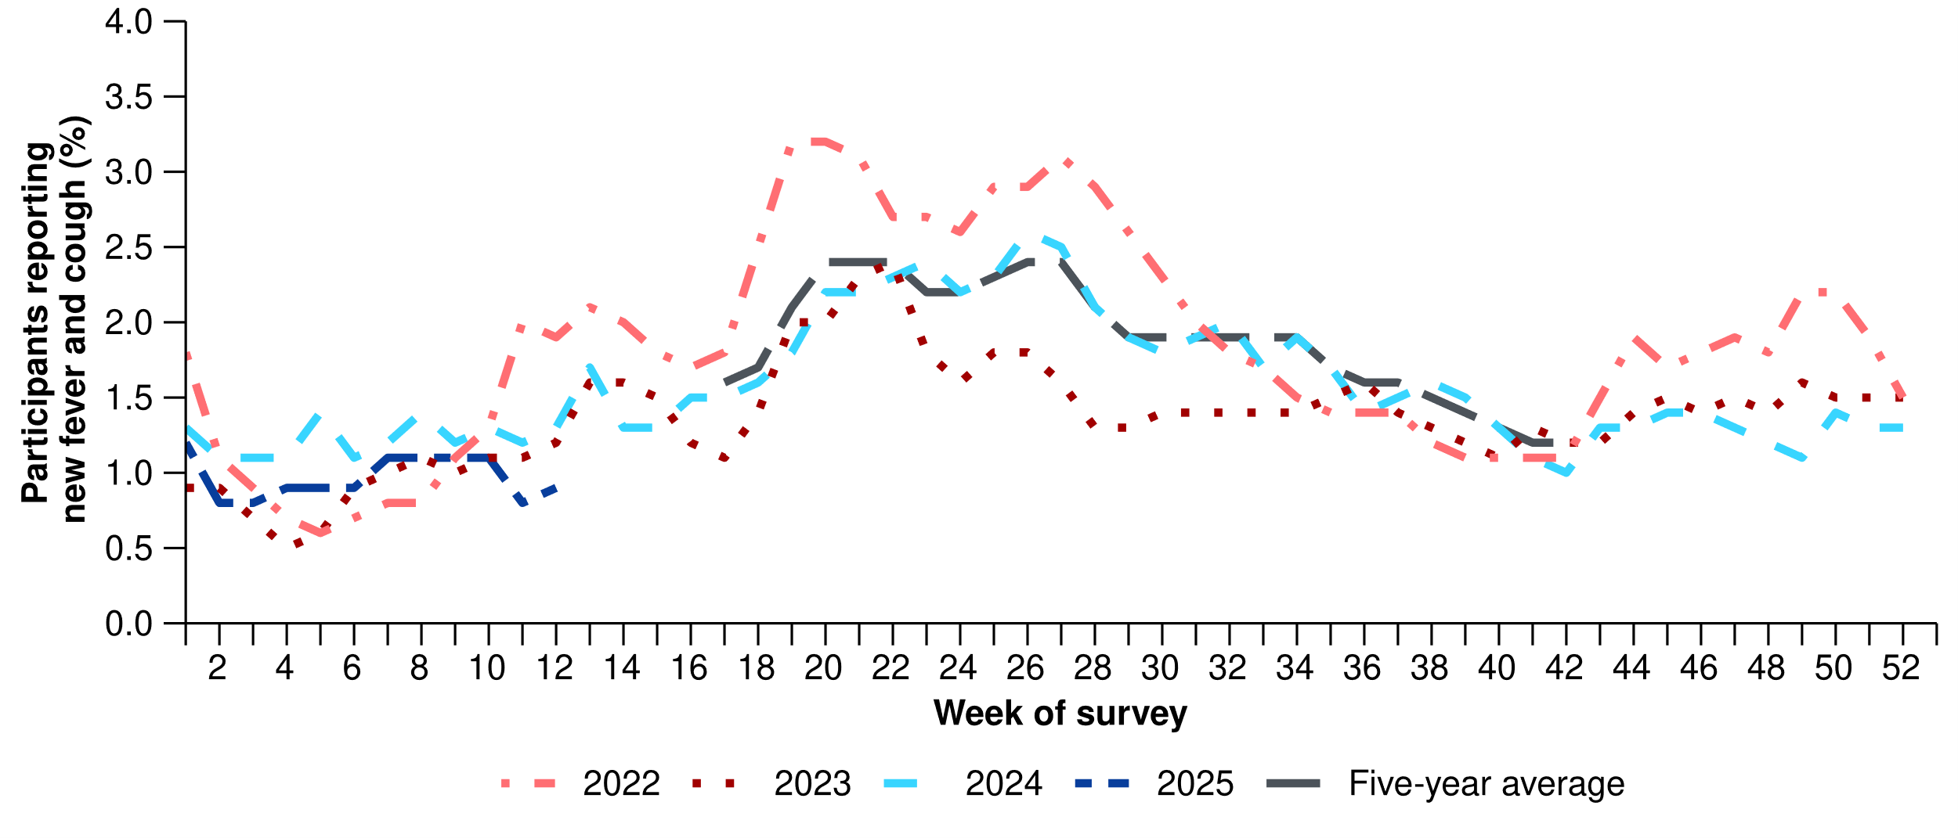
Source: FluTracking
* From 2020, FluTracking expanded their data capture period to year-round. Data before May and after October for any year before 2020 are not available for historical comparisons. The years 2020 and 2021 are excluded when comparing the current season to historical periods when influenza virus has circulated without public health restrictions. As such, the five-year average includes the years 2018 to 2019 and 2022 to 2024. Please refer to the Technical Supplement for interpretation of the five-year average.
- This month (24 February to 23 March 2025), there was a 12.8% decrease in COVID-19 notifications, a 26.3% increase in influenza notifications, and a 50.2% increase in RSV notifications.
Table 1: Notified cases and notification rate per 100,000 population by disease, five-year age group, and jurisdiction*†, Australia, 1 January to 23 March 2025
 | COVID-19 |  |  | Influenza |  |  | RSV
 | Reporting  period  (n) | Year to  date  (n) | Year to  date  (rate) | Reporting  period  (n) | Year to  date  (n) | Year to  date  (rate) | Reporting  period  (n) | Year to  date  (n) | Year to  date  (rate)
Age group (years)
0–4 | 1,092 | 4,540 | 301 | 1,782 | 4,409 | 292 | 5,001 | 10,014 | 664
5–9 | 360 | 1,134 | 70 | 2,176 | 4,537 | 282 | 625 | 1,063 | 66
10–14 | 513 | 1,236 | 74 | 1,480 | 3,063 | 183 | 302 | 548 | 33
15–19 | 578 | 1,531 | 92 | 1,057 | 2,321 | 140 | 199 | 428 | 26
20–24 | 456 | 1,592 | 89 | 672 | 1,787 | 100 | 154 | 379 | 21
25–29 | 492 | 1,876 | 94 | 661 | 1,749 | 88 | 193 | 462 | 23
30–34 | 616 | 2,233 | 110 | 806 | 2,226 | 109 | 262 | 534 | 26
35–39 | 686 | 2,553 | 129 | 1,009 | 2,804 | 141 | 212 | 480 | 24
40–44 | 736 | 2,439 | 132 | 992 | 2,809 | 152 | 187 | 436 | 24
45–49 | 644 | 2,210 | 136 | 851 | 2,434 | 149 | 190 | 453 | 28
50–54 | 604 | 2,208 | 131 | 884 | 2,432 | 144 | 232 | 563 | 33
55–59 | 589 | 2,114 | 138 | 805 | 2,138 | 139 | 268 | 644 | 42
60–64 | 606 | 2,322 | 151 | 908 | 2,195 | 143 | 261 | 650 | 42
65–69 | 601 | 2,412 | 177 | 789 | 1,908 | 140 | 293 | 686 | 50
70+ | 3,494 | 14,414 | 431 | 2,323 | 5,626 | 168 | 1,153 | 2,780 | 83
Jurisdiction
ACT | 143 | 583 | 123 | 225 | 550 | 116 | 101 | 202 | 43
NSW | 6,154 | 19,209 | 226 | 6,826 | 16,375 | 193 | 5,592 | 10,093 | 119
NT | 92 | 506 | 198 | 354 | 737 | 289 | 47 | 170 | 67
Qld | 2,395 | 11,383 | 204 | 3,623 | 8,967 | 161 | 2,219 | 5,889 | 105
SA | 721 | 2,627 | 140 | 922 | 2,308 | 123 | 277 | 642 | 34
Tas. | 140 | 595 | 103 | 221 | 510 | 89 | 36 | 149 | 26
Vic. | 1,758 | 7,148 | 102 | 3,488 | 9,039 | 129 | 987 | 2,200 | 32
WA | 668 | 2,777 | 94 | 1,537 | 3,954 | 133 | 274 | 776 | 26
Total | 12,071 | 44,828 | 165 | 17,196 | 42,440 | 156 | 9,533 | 20,121 | 74
Source: National Notifiable Diseases Surveillance System (NNDSS)
* Rate per 100,000 population for the given time period. Population data are based on the Australian Bureau of Statistics (ABS) Estimated Resident Population (ERP) for the reference period June 2024, released 12 December 2024.
† Total includes cases with missing age.

- This month, the number of COVID-19 cases remains low. Following an increase in COVID-19 cases in late 2024 and early January 2025; an overall decreasing trend was observed in the past two months. Despite a small, unsustained increase in early February, the number of COVID-19 cases this month remain lower than the number of cases at the same time last year and less than half the number of cases reported in the June 2024 peak (Figure 2).
- In the year to date, COVID-19 notification rates remain highest in people aged 70 years or over, likely due to higher case ascertainment from targeted testing strategies for populations at-risk of severe disease or who live in a high-risk setting such as a residential aged care home (Table 1).
- This month, COVID-19 notification rates showed a small increase in most jurisdictions in late February, before steadily decreasing across all jurisdictions in March (Figure 3).
- In the year to date, COVID-19 notification rates are highest in New South Wales, Queensland, and the Northern Territory and lowest in Western Australia (Table 1).
Figure 2: Notified COVID-19 cases (laboratory-confirmed only) by year and week of diagnosis, Australia, 2022 to 23 March 2025
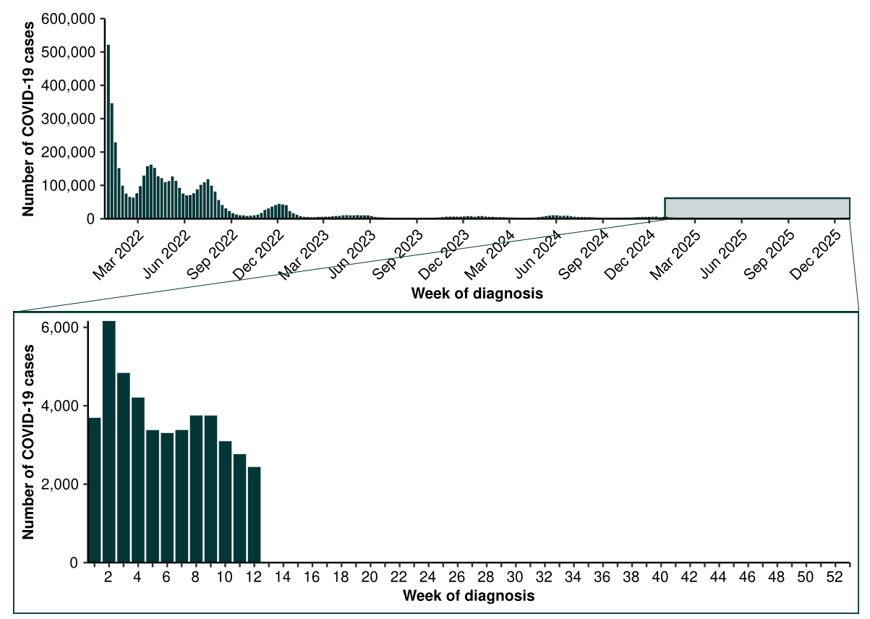
Source: National Notifiable Diseases Surveillance System (NNDSS)

Figure 3: Notification rates* per 100,000 population for COVID-19 cases by state or territory and week of diagnosis, Australia, 1 January to 23 March 2025
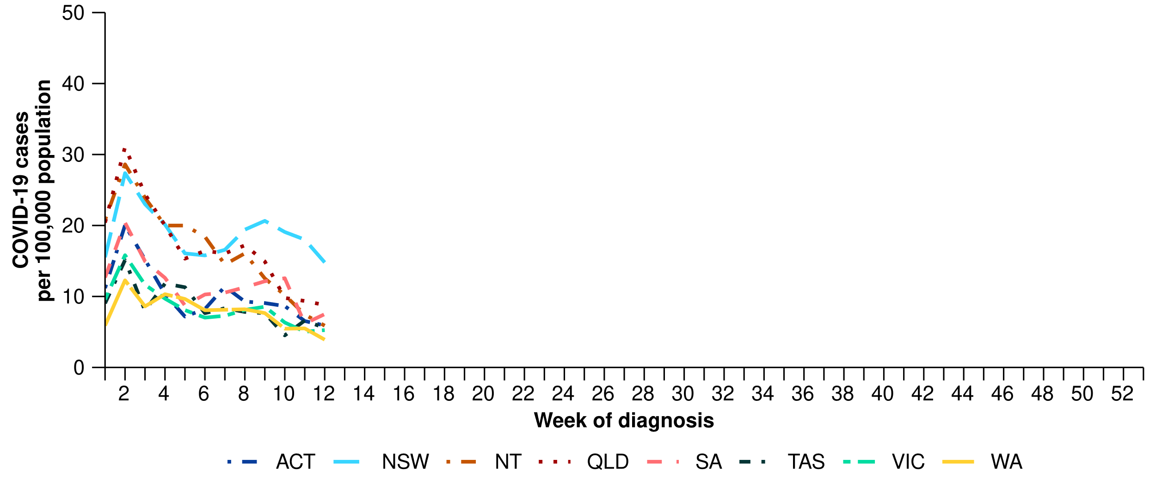Source: National Notifiable Diseases Surveillance System (NNDSS)
* Rate per 100,000 population for the given time period. Population data are based on the Australian Bureau of Statistics (ABS) Estimated Resident Population (ERP) for the reference period June 2024, released 12 December 2024
Figure 4a: Notified influenza cases and five-year average* by influenza subtype, year, week of diagnosis, Australia, 2022 to 23 March 2025
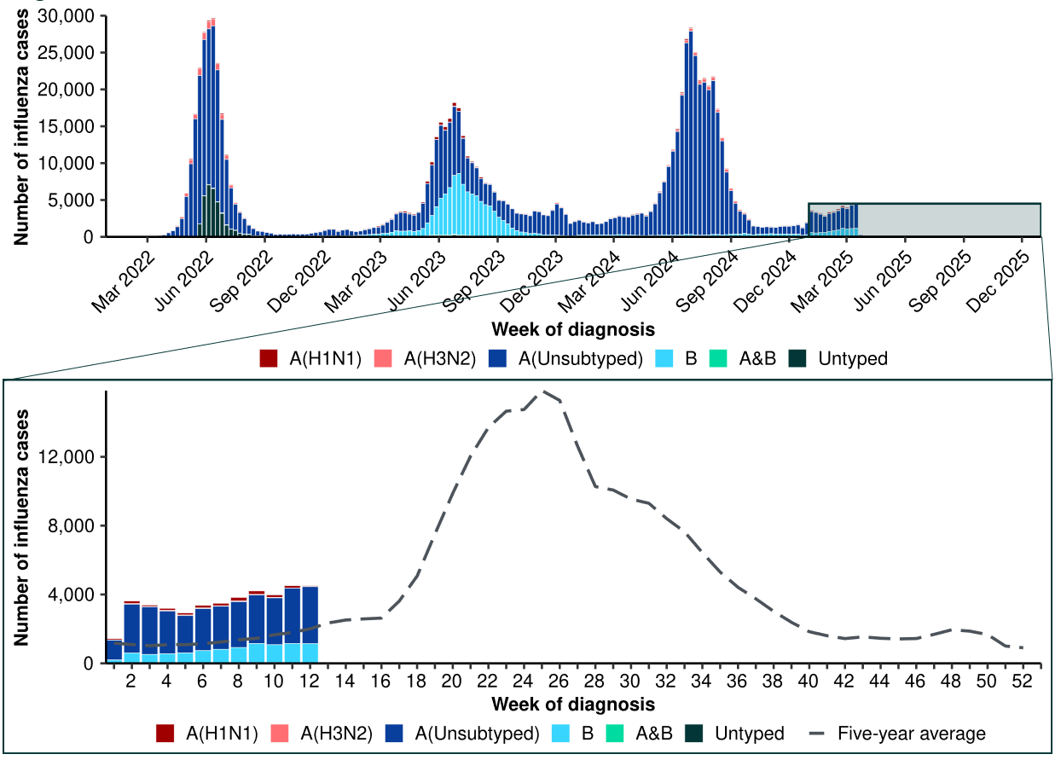
Source: National Notifiable Diseases Surveillance System (NNDSS)
* The years 2020 and 2021 are excluded when comparing the current season to historical periods when influenza virus has circulated without public health restrictions. As such, the five-year average includes the years 2018 to 2019 and 2022 to 2024. Please refer to the Technical Supplement for interpretation of the five-year average.
Figure 4b: Notified influenza cases to the NNDSS by year and week of diagnosis, Australia, 2022 to 23 March 2025
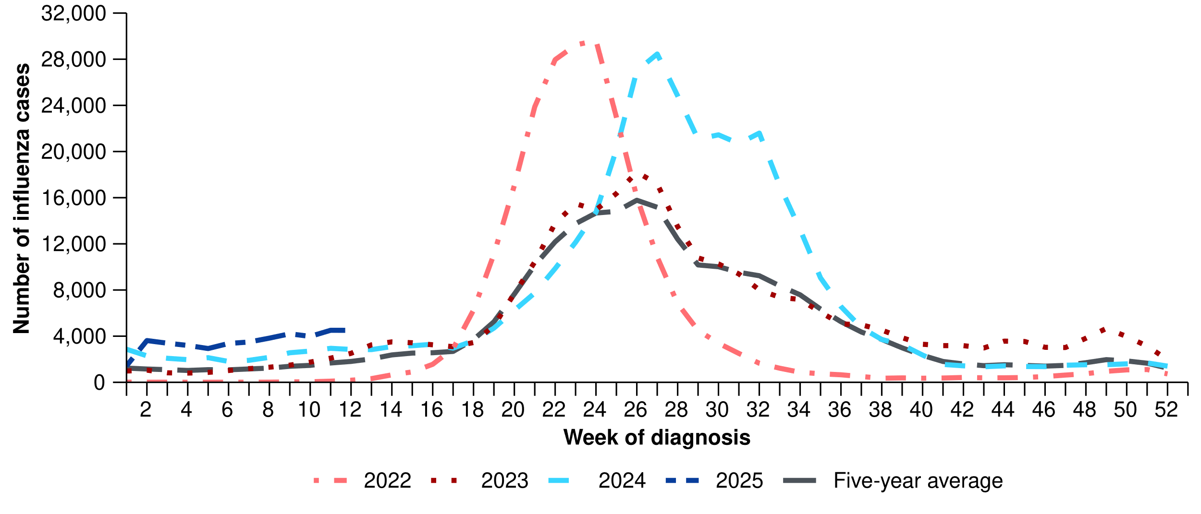
Source: National Notifiable Diseases Surveillance System (NNDSS)
* The years 2020 and 2021 are excluded when comparing the current season to historical periods when influenza virus has circulated without public health restrictions. As such, the five-year average includes the years 2018 to 2019 and 2022 to 2024. Please refer to the Technical Supplement for interpretation of the five-year average.
- This month, the number of influenza cases remains relatively low. The number of influenza cases this month is slightly higher than last month, the five-year average, and the number of cases seen in the same period in previous years; however, case numbers remain at interseasonal levels (Figure 4a; Figure 4b).
  - Though the number of influenza cases is higher than in the past, the increase in the number of cases this month is consistent with increases observed in previous summer periods (Figure 4a; Figure 4b).
  - This increase could be due to increased influenza circulating in the community, perhaps driven in part by travellers to the northern hemisphere returning with influenza infections. However, it could also be influenced by changes in health-seeking behaviour (increased testing) associated with increases in respiratory virus circulation (especially COVID-19) in the summer period.
- In the year to date, influenza notification rates have been highest in children aged 0–4 years and 5–9 years (Table 1).
- This month, influenza notification rates increased across most jurisdictions compared to the previous month, except in Western Australia where a decrease was observed. Notification rates in the Northern Territory increased considerably from late January to early March; however, there has been considerable fluctuation in notification rates across March (Figure 5).
- In the year to date, influenza notification rates are highest in the Northern Territory and New South Wales and lowest in Tasmania (Table 1).
- This month, most influenza notifications were influenza A(Unsubtyped) (70.3%; 12,094/17,196), followed by influenza B (25.7%; 4,413/17,196), then influenza A(H1N1) (3.1%; 531/17,196) and influenza A(H3N2) (0.5%; 78/17,196). There were eight influenza A&B co-detections (Figure 6).
- In the year to date, there has been a higher proportion of influenza B notifications observed than at the same time in 2024 (Figure 4a). Although too early to tell, this may indicate there could be a comparatively higher proportion of influenza B cases this season.
- In the year to date, influenza A has accounted for the majority of influenza notifications across all jurisdictions; however, most jurisdictions have been experiencing increasing proportions of influenza B notifications (Figure 6).
Figure 5: Notification rates* per 100,000 population for influenza cases by state or territory and week of diagnosis, Australia, 1 January to 23 March 2025
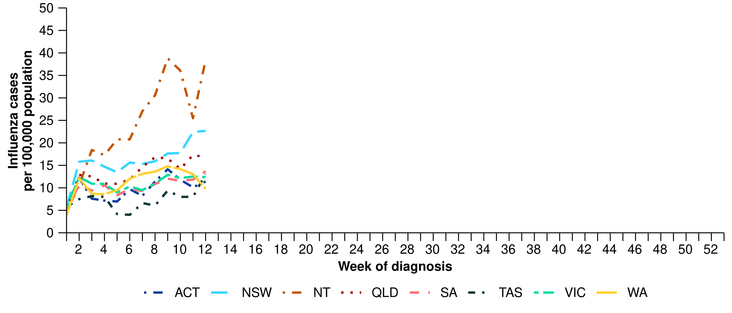Source: National Notifiable Diseases Surveillance System (NNDSS)
* Rate per 100,000 population for the given time period. Population data are based on the Australian Bureau of Statistics (ABS) Estimated Resident Population (ERP) for the reference period June 2024, released 12 December 2024.
Figure 6: Notified influenza cases by influenza subtype, jurisdiction*, and week of diagnosis, Australia, 1 January to 23 March 2025
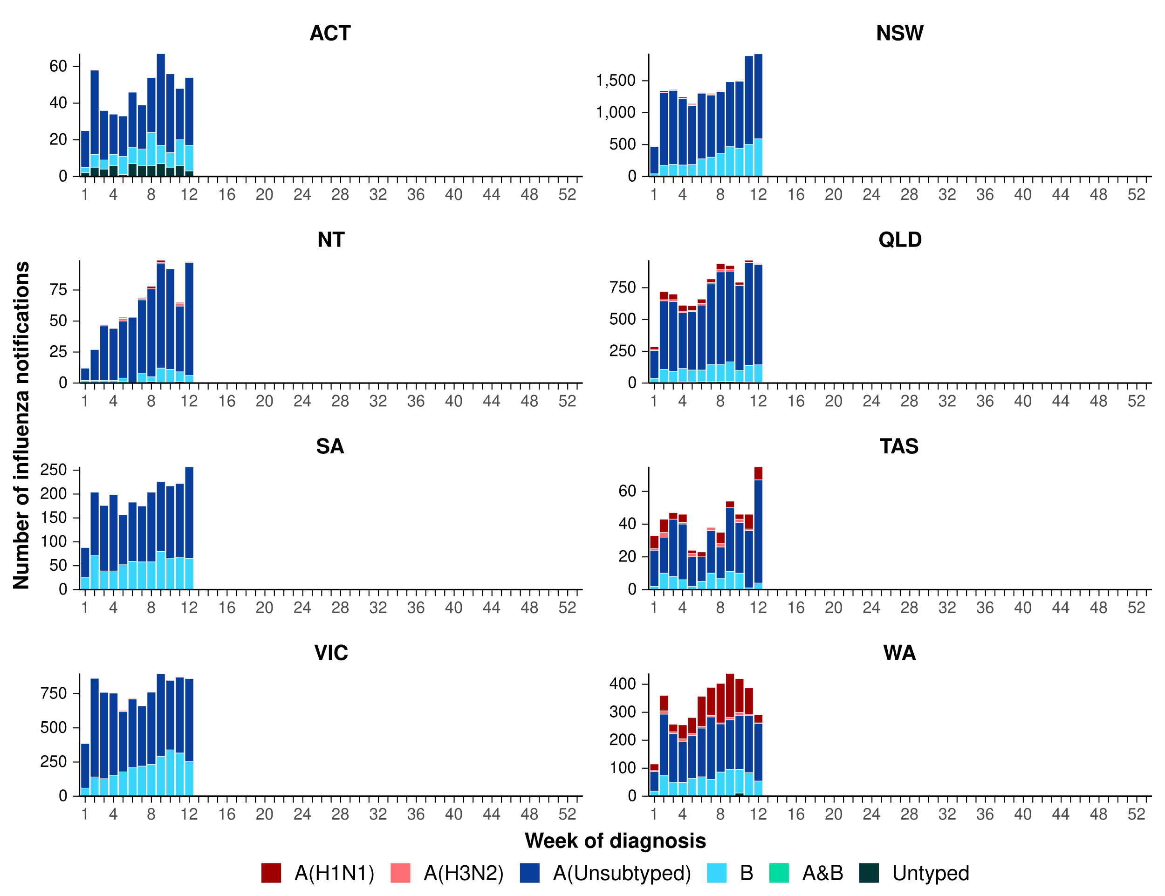
Source: National Notifiable Diseases Surveillance System (NNDSS)
* Axis varies between jurisdictions.
- This month, the number of RSV cases have increased to moderate levels. The number of RSV cases this month, particularly in the last two weeks, is higher than in the previous month. This trend, largely driven by increased notifications in New South Wales and Queensland, may signal the start of the RSV season nationally; however this steadily increasing trend has not been observed in all jurisdictions (Figure 7; Figure 8).
  - Similar to influenza notification trends, the recent increase in RSV cases could be due to increased RSV circulating in the community; however, could also be influenced by the changes in health-seeking behaviour (increased testing) described above.
- In the year to date, RSV notification rates remain considerably higher in children aged 0–4 years than in other age groups (Table 1).
- This month, RSV notification rates increased considerably in New South Wales. Notification rates also increased this month in Queensland and the Australia Capital Territory, but remained relatively low and stable in other jurisdictions (Figure 8).
- In the year to date, RSV notification rates are highest in New South Wales and Queensland, and lowest Western Australia (Table 1).
Figure 7: RSV cases notified to the NNDSS by year and week of diagnosis*, Australia, 2023 to 23 March 2025
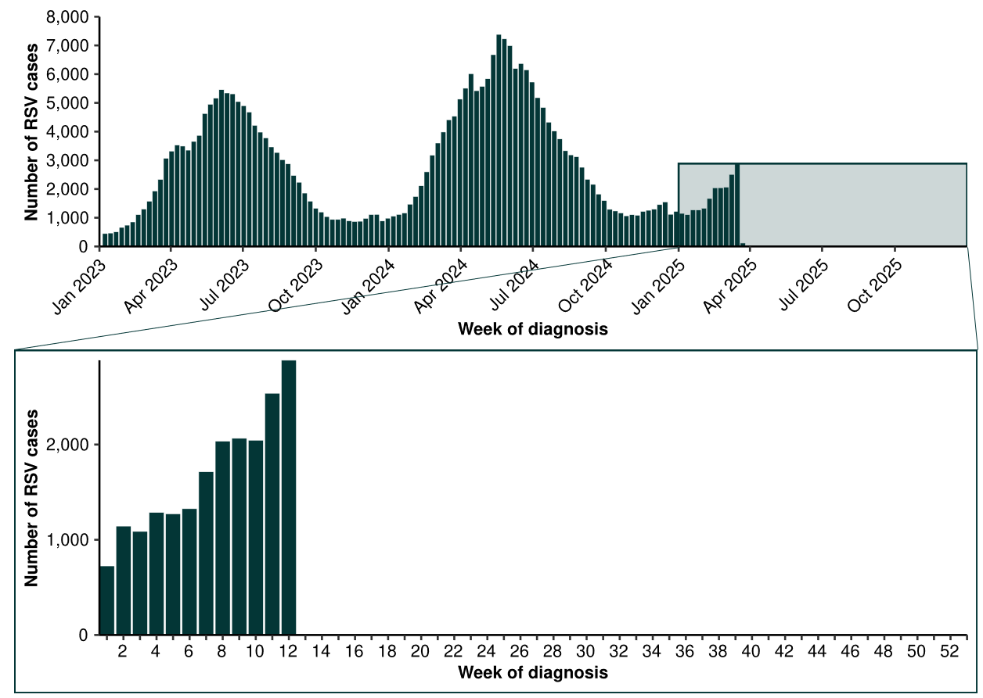
Source: National Notifiable Diseases Surveillance System (NNDSS). Please note, RSV became notifiable in all states and territories on 1 September 2022 and comprehensive national notification data became available after this point. For this reason, RSV notification trends are only presented from 1 January 2023.
Figure 8: Notification rates* per 100,000 population for RSV cases by state or territory and week of diagnosis, Australia, 1 January to 23 March 2025
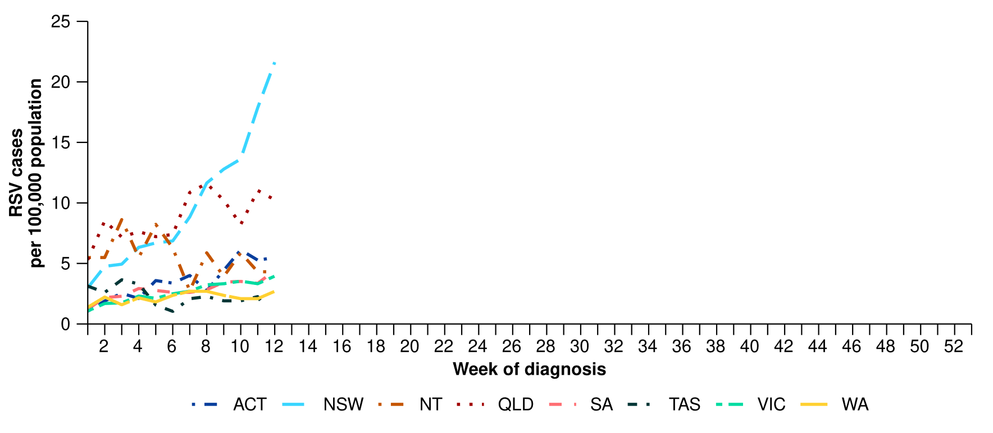
Source: National Notifiable Diseases Surveillance System (NNDSS). RSV notification data are unavailable for Tasmania from 19 March 2025.
* Rate per 100,000 population for the given time period. Population data are based on the Australian Bureau of Statistics (ABS) Estimated Resident Population (ERP) for the reference period June 2024, released 12 December 2024.

Primary care surveillance
Primary care surveillance monitors the number and characteristics of people who have presented to their general practitioner with influenza-like-illness and provides insight on the different respiratory pathogens that are causing illness in the community.
- Sentinel general practice surveillance indicates medical attendance for respiratory illness has increased this month, though a variety of respiratory pathogens continue to circulate in the community, with rhinovirus and influenza being the most common.
- Due to a technical issue the rate of influenza-like-illness notifications per 1,000 consultations are unavailable for the week ending Sunday 23 March 2025. Therefore, the rate of influenza-like-illness notifications for the whole of this month are not compared to last month.
- Between 24 February to 16 March 2025, there were slightly less general practice consultations for influenza-like illness per week (2.6 per 1,000 consultations per week) than in the previous three week period from 3 February to 23 February 2025 (2.9 per 1,000 consultations per week) (Figure 9).
- Like the same period in 2024, influenza-like-illness rates this month remain slightly higher than observed in at the same time in previous years and the five-year average (Figure 9).
Figure 9: Rate of influenza-like-illness per 1,000 consultations per week with sentinel general practice sites compared with the five-year average by year and week of consultation*†, Australia, 2022 to 16 March 2025
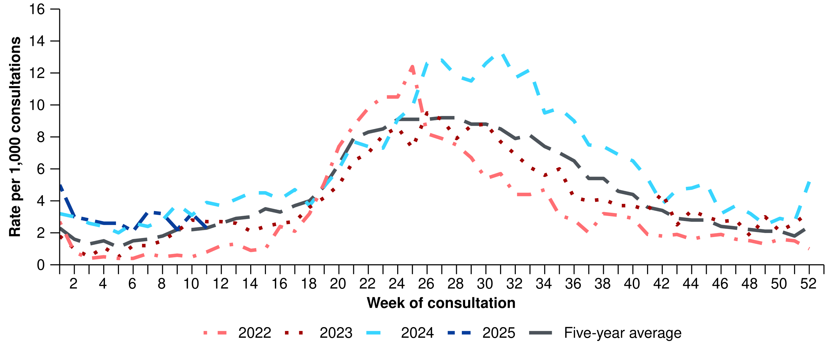Source: Australian Sentinel Practice Research Network (ASPREN). Due to a technical issue the rate of influenza-like-illness notifications per 1,000 consultations are unavailable for the week ending Sunday 23 March 2025.
* The years 2020 and 2021 are excluded when comparing the current season to historical periods when influenza virus has circulated without public health restrictions. As such, the five-year average includes the years 2018 to 2019 and 2022 to 2024. Please refer to the Technical Supplement for interpretation of the five-year average.
† Please refer to the Technical Supplement for notes on impact of COVID-19 on ASPREN data.

- In the year to date, 62.0% (194/313) of people attending general practice with influenza-like-illness who were tested have then tested positive for a respiratory pathogen.
- Rhinovirus (42.8%; 83/194) was the most commonly detected, followed by influenza (18.0%; 35/194), SARS-CoV-2 (16.5%; 32/194), human metapneumovirus (6.7%; 13/194), and RSV (6.2%; 12/194) (Figure 10).
Figure 10: Number of samples tested for respiratory pathogens among people with influenza-like-illness attending sentinel general practice sites by respiratory pathogen and week of specimen collection, Australia, 1 January to 23 March 2025
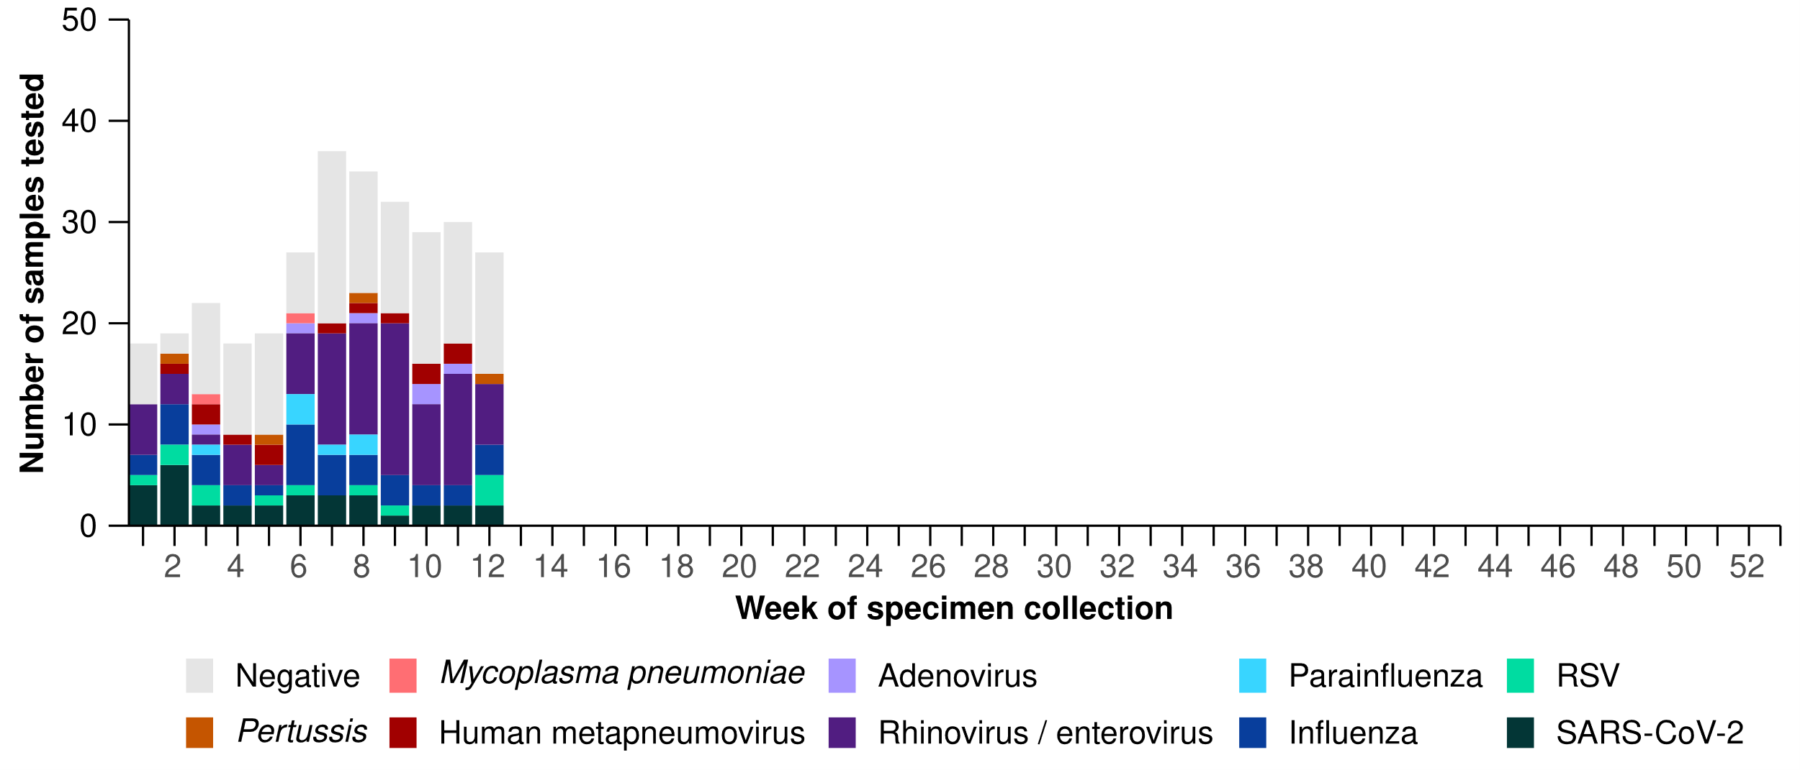
Source: Australian Sentinel Practice Research Network (ASPREN)
Note: All ASPREN swab samples are transported to the SA Pathology laboratory in Adelaide to be tested for viral and bacterial respiratory pathogens via a multiplex real-time reverse transcription polymerase chain reaction (RT-PCR) assay using in-house primers.

Hospital-based surveillance
Hospital-based surveillance monitors persons with more severe illness who have been admitted to hospital for their respiratory illness (severe acute respiratory infections). Hospital-based surveillance also measures the ability of the health system to cope with the number of severe acute respiratory infection admissions to ensure delivery of safe, timely and quality health care.
- Sentinel hospital-based surveillance shows the number of patients admitted with severe acute respiratory infections has remained low and stable overall this severity reporting period. The length of hospital stay continues to vary only slightly between illnesses and the proportion of patients with a severe acute respiratory infection who were admitted directly to an intensive care has remained low.
- In this severity reporting period (10 February to 9 March 2025), more patients were admitted to a sentinel hospital with a severe acute respiratory infection (n = 573), than in the previous severity reporting period (n = 549).
- In the year to date for severity reporting (1 January to 9 March 2025), most patients with a severe acute respiratory infection were admitted with COVID-19 (Figure 11).
- Patients admitted to sentinel hospitals with influenza have mostly been admitted with influenza A 80.6% (395/490), while 19.2% (94/490) were admitted with influenza B.
  - Most hospital admissions with influenza A have been with influenza A(Unsubtyped) (89.4%; 353/395), followed by influenza A(H1N1) (8.4%; 33/395), and then influenza A(H3N2)
(2.3%; 9/395).
Figure 11: Total number of patients (children and adults) admitted with a severe acute respiratory infection to sentinel hospitals by disease and week of admission*†‡, Australia, 1 January to 9 March 2025
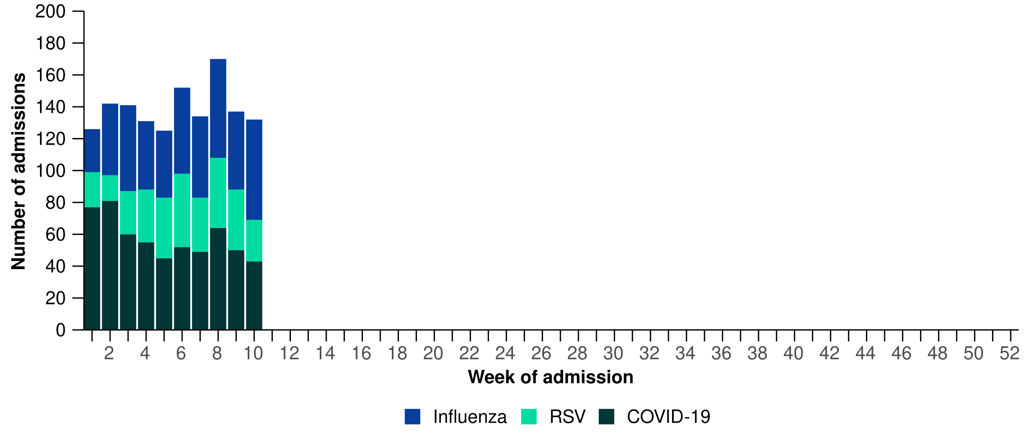
Source: Influenza Complications Alert Network (FluCAN)

- In the year to date for severity reporting, slightly more children (those aged 16 years and younger) were admitted with influenza and RSV than with COVID-19 at sentinel hospitals (Table 2a).
- Children admitted to sentinel hospitals with influenza tended to be older than children admitted with COVID-19 or RSV (Table 2a).
- There were only minor differences in the length of stay between children admitted with COVID-19, influenza and RSV; however, a higher proportion of children admitted with COVID-19 were admitted directly to intensive care, compared to children admitted with influenza or RSV (Table 2a).
Table 2a: Demographic characteristics and outcomes for children admitted with a severe acute respiratory infection to a sentinel hospital by disease, Australia, 1 January to 9 March 2025
 | COVID-19 | Influenza | RSV
 | Year to date for  severity reporting  (n=233) | Year to date for  severity reporting  (n=289) | Year to date for  severity reporting  (n=265)
Age (years)
Median [IQR] | 1 [0–3] | 4 [1–8] | 1 [0–2]
Age group (years)
< 6 months | 79 (33.9%) | 13 (4.5%) | 60 (22.6%)
6 months – 4 years | 107 (45.9%) | 144 (49.8%) | 183 (69.1%)
5–16 years | 47 (20.2%) | 132 (45.7%) | 22 (8.3%)
Indigenous status
Aboriginal and Torres Strait Islander | 25 (10.7%) | 21 (7.3%) | 19 (7.2%)
Length of hospital stay (days)†
Median [IQR] | 1 [1–2] | 1 [1–2] | 2 [1–3]
Patient admission location‡
Admitted to hospital ward | 219 (94.0%) | 280 (96.9%) | 252 (95.1%)
Admitted to intensive care directly | 14 (6.0%) | 9 (3.1%) | 13 (4.9%)
Discharge status†
Alive | 181 (77.7%) | 241 (83.4%) | 207 (78.1%)
Died | – | – | –
Incomplete/missing | 52 (22.3%) | 48 (16.6%) | 58 (21.9%)
Source: Influenza Complications Alert Network (FluCAN)
* Does not include patients with missing age; therefore, the sum of age-specific totals above may not equal the total number of patients.
† For patients who are still in hospital data may not be complete; therefore, these data are not included in the length of stay or discharge status. In addition, length of stay data excludes patients that acquired their infection in hospital.
‡ Admission location reflects the initial admission ward. Some patients may be initially admitted to general ward then later admitted to an intensive care and this is not reflected here. Does not include patients with missing admission location; therefore, the sum of admission location specific totals above may not equal the total number of patients.
The Paediatric Active Enhanced Disease Surveillance (PAEDS) network carries out enhanced sentinel hospital surveillance for some acute respiratory infections or conditions in children. PAEDS data for acute respiratory infections in children are presented in the Australian Respiratory Surveillance Reports in the Influenza Complications Alert Network (FluCAN) data. For additional information on COVID-19 in children, Paediatric Inflammatory Multisystem Syndrome (PIMS-TS) following COVID-19, influenza in children, or RSV in children please visit the PAEDS webpages and dashboards.

- In the year to date for severity reporting, the number of adults (those aged 17 years and over) admitted with COVID-19 to sentinel hospitals was much higher than for either influenza or RSV (Table 2b).
- Adults admitted to sentinel hospitals with COVID-19 or RSV were predominantly 65 years and over, while the proportion of admissions with influenza were similar across both the 17–64 years and 65 years and over age groups (Table 2b).
- There were only minor differences in the length of stay between adults admitted with COVID-19, influenza and RSV. A higher proportion of adults admitted with influenza or RSV were admitted directly to intensive care, compared to adults admitted with COVID-19 (Table 2b).
- Sadly, a small number of adults admitted with a severe acute respiratory infection have died in hospital (Table 2b).
Table 2b: Demographic characteristics and outcomes for adults admitted with a severe acute respiratory infection to a sentinel hospital by disease, Australia, 1 January to 9 March 2025
 | COVID-19 | Influenza | RSV
 | Year to date for  severity reporting  (n=343) | Year to date for  severity reporting  (n=201) | Year to date for  severity reporting  (n=59)
Age (years)
Median [IQR] | 75 [60–83] | 64 [49–77] | 72 [58–80]
Age group (years)
17–64 years | 105 (30.6%) | 103 (51.2%) | 21 (35.6%)
65 years and over | 238 (69.4%) | 98 (48.8%) | 38 (64.4%)
Indigenous status
Aboriginal and Torres Strait Islander | 29 (8.5%) | 12 (6.0%) | 5 (8.5%)
Length of hospital stay (days)†
Median [IQR] | 4 [2–7] | 3 [2–5] | 4 [2–8]
Patient admission location‡
Admitted to hospital ward | 319 (93.0%) | 179 (89.1%) | 52 (88.1%)
Admitted to intensive care directly | 24 (7.0%) | 22 (10.9%) | 7 (11.9%)
Discharge status†
Alive | 259 (75.5%) | 150 (74.6%) | 38 (64.4%)
Died | 9 (2.6%) | 2 (1.0%) | 3 (5.1%)
Incomplete/missing | 75 (21.9%) | 49 (24.4%) | 18 (30.5%)
Source: Influenza Complications Alert Network (FluCAN)
* Does not include patients with missing age; therefore, the sum of age-specific totals above may not equal the total number of patients.
† For patients who are still in hospital data may not be complete; therefore, these data are not included in the length of stay or discharge status. In addition, length of stay data excludes patients that acquired their infection in hospital.
‡ Admission location reflects the initial admission ward. Some patients may be initially admitted to general ward then later admitted to an intensive care and this is not reflected here. Does not include patients with missing admission location; therefore, the sum of admission location specific totals above may not equal the total number of patients.
- Sentinel intensive care surveillance shows the number of patients admitted to intensive care with severe acute respiratory infections has remained low and stable this month.
- In this severity reporting period (10 February to 9 March 2025), fewer patients have been admitted to a sentinel intensive care with a severe acute respiratory infection (n=155), than in the previous severity reporting period (n=170) (Figure 12).
- In the year to date for severity reporting (1 January to 9 March 2025), most patients were admitted to a sentinel intensive care with COVID-19, closely followed by rhinovirus (Figure 12; Table 3).
- In the year to date for severity reporting, admissions to a sentinel intensive care with COVID-19, human metapneumovirus (hMPV) or influenza were generally among older age groups. In contrast, admissions with rhinovirus or RSV were among younger people (Table 3).
- There were only minor differences in the length of intensive care stay for people admitted to a sentinel intensive care across pathogens (Table 3).
- Most patients admitted to a sentinel intensive care with a severe acute respiratory infection have been discharged home. Sadly, a small number of patients have died in hospital (Table 3).
Figure 12: Number of patients admitted with severe acute respiratory infections to a sentinel intensive care by pathogen and week of admission, Australia, 1 January to 9 March 2025
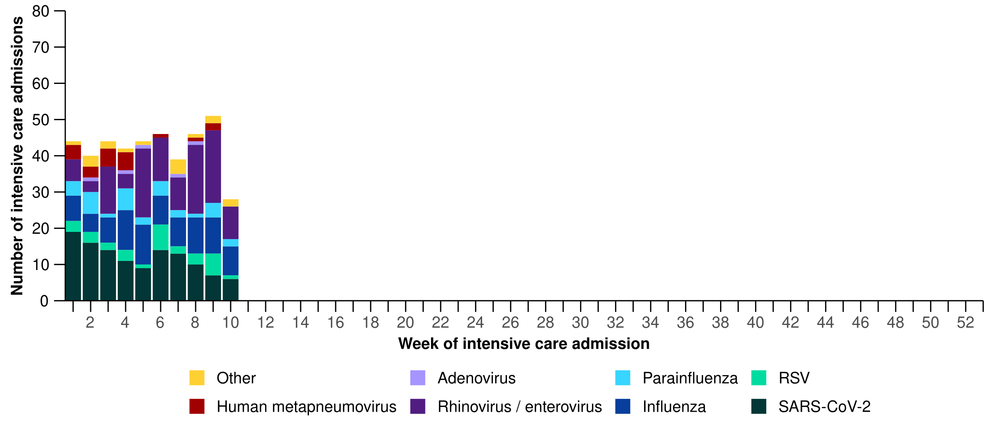
Source: Short Period Incidence Study of Severe Acute Respiratory Infection (SPRINT-SARI) Australia
Note: There are a range of diagnostic testing procedures utilised across public and private hospitals within Australia. Diagnostic testing can be by nucleic acid amplification tests (NAATs), including PCR tests, or immunoassays (rapid antigen tests). Each sentinel hospital site will use these diagnostic methods variably and there are multiple manufacturers. SPRINT-SARI does not specify which diagnostic testing method should be utilised as this is the domain for the participating hospital site and treating clinicians. For this reason, virological data from SPRINT-SARI should be interpreted with caution.

Table 3: Demographic characteristics and outcomes of patients admitted with a severe acute respiratory infection to a sentinel intensive care by disease*†‡, Australia, 1 January to 9 March 2025
 | COVID-19 | hMPV | Influenza | Parainfluenza | Rhinovirus | RSV | Other
 | Year to date for severity reporting  (n=119) | Year to date for severity reporting  (n=21) | Year to date for severity reporting  (n=85) | Year to date for severity reporting  (n=32) | Year to date for severity reporting  (n=114) | Year to date for severity reporting  (n=31) | Year to date for severity reporting  (n=22)
Age (years)
Median [IQR] | 65  [49–74] | 66  [3–72] | 61  [46–69] | 42  [4–68] | 13  [4–38] | 10  [4–58] | 52  [22–70]
Indigenous status
Aboriginal and Torres Strait Islander | 16  (13.4%) | 1  (4.8%) | 13  (15.3%) | 2  (6.2%) | 14  (12.3%) | – | 3  (13.6%)
Non-Indigenous | 103  (86.6%) | 20  (95.2%) | 72  (84.7%) | 30  (93.8%) | 100  (87.7%) | 31  (100.0%) | 19  (86.4%)
Received invasive mechanical ventilation
Number (%) | 40  (33.6%) | 7  (33.3%) | 27  (31.8%) | 12  (37.5%) | 25  (21.9%) | 3  (9.7%) | 5  (22.7%)
Duration of invasive mechanical ventilation (days)
Median [IQR] | 3  [1–6] | 6  [2–10] | 5  [1–11] | 3  [1–13] | 2  [1–5] | 0  [0–1] | 2  [2–4]
Length of intensive care stay (days)
Median [IQR] | 3  [2–5] | 3  [2–5] | 3  [2–7] | 2  [1–5] | 2  [1–4] | 2  [1–4] | 3  [1–6]
Length of hospital stay (days)
Median [IQR] | 7  [4–14] | 8  [6–14] | 8  [5–12] | 6  [3–10] | 4  [2–8] | 4  [3–9] | 11  [6–18]
Patient outcome
Ongoing care in intensive care | 8  (6.7%) | 1  (4.8%) | 5  (5.9%) | 2  (6.2%) | 9  (7.9%) | 1  (3.2%) | –
Ongoing care in hospital ward* | 8  (6.7%) | – | 7  (8.2%) | 2  (6.2%) | 11  (9.6%) | – | 2  (9.1%)
Transfer to other hospital or facility, including rehabilitation | 18  (15.1%) | 1  (4.8%) | 10  (11.8%) | 3  (9.4%) | 8  (7.0%) | 2  (6.5%) | 4  (18.2%)
Discharged home | 63  (52.9%) | 17  (81.0%) | 53  (62.4%) | 22  (68.8%) | 82  (71.9%) | 27  (87.1%) | 13  (59.1%)
Died in hospital† | 22  (18.5%) | 2  (9.5%) | 9  (10.6%) | 2  (6.2%) | 4  (3.5%) | 1  (3.2%) | 3  (13.6%)
Source: Short Period Incidence Study of Severe Acute Respiratory Infection (SPRINT-SARI) Australia
Note: 3.9% (16/406) patients had co-infections of respiratory pathogens; therefore, the sum of pathogen-specific totals above may not equal the total number of severe acute respiratory infection patients. For patients whom are still receiving treatment in intensive care data may not be complete; therefore, data are not included in the duration of ventilation or length of intensive care stay.
* Patients who have been admitted in intensive care/hospital wards with no discharge information for less than 90 days have been assumed to have ongoing care in the hospital.
† Death may not necessarily represent a death due to the disease.
‡ Patients who have no outcome entered or have been admitted for more than 90 days with no discharge information have been treated as missing.
- This month (24 February to 23 March 2025), there has been slightly fewer COVID-19 cases in intensive care across Australia than in the previous month (Figure 13).
- This month, the average number of intensive care staff unavailable to work due to COVID-19 exposure or illness across Australia has fluctuated; however, is slightly less than in the previous month (Figure 13).
Figure 13: Average number of COVID-19 cases in intensive care and the average number of intensive care staff unavailable to work due to COVID-19 exposure or illness by week of report*†, Australia, 1 January to 23 March 2025 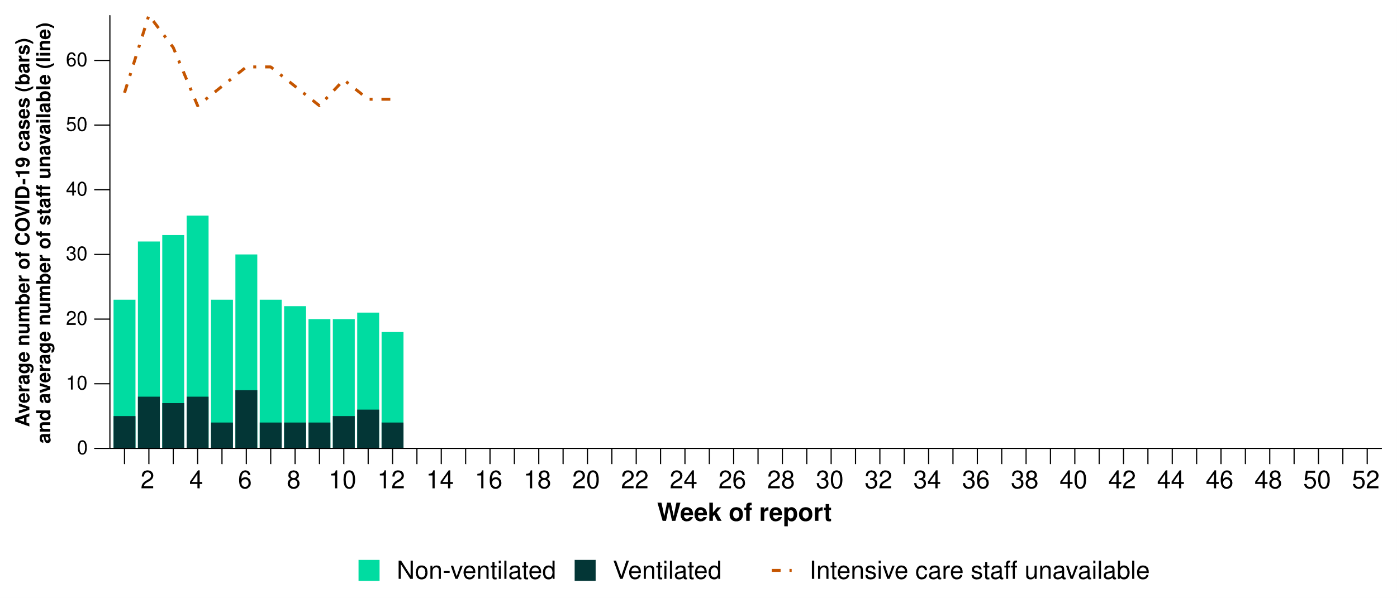
Source: Critical Health Resource Information System (CHRIS)
* Average number of ventilated and non-ventilated COVID-19 cases in intensive care includes only active COVID-19 cases (those in isolation) and does not include cleared COVID-19 cases.
† Intensive care staff include both medical and nursing staff. Staff unavailability will be underestimated in New South Wales as most public hospitals in New South Wales do not report staff unavailability.
- This month, COVID-19 cases in intensive care decreased in New South Wales, Queensland, Victoria, and Western Australia compared with the previous month, while the number of cases in intensive care have remained stable across all other jurisdictions (Figure 14).
- This month, the number of intensive care staff unavailable to work due to COVID-19 exposure or illness has increased in Queensland and South Australia compared with the previous month, while the number of staff unavailable has decreased or remained stable across all other jurisdictions (Figure 14).

Figure 14: Average number of COVID-19 cases in intensive care and the average number of intensive care staff unavailable to work due to COVID-19 exposure or illness by jurisdiction and week of report*†‡, Australia, 1 January to 23 March 2025
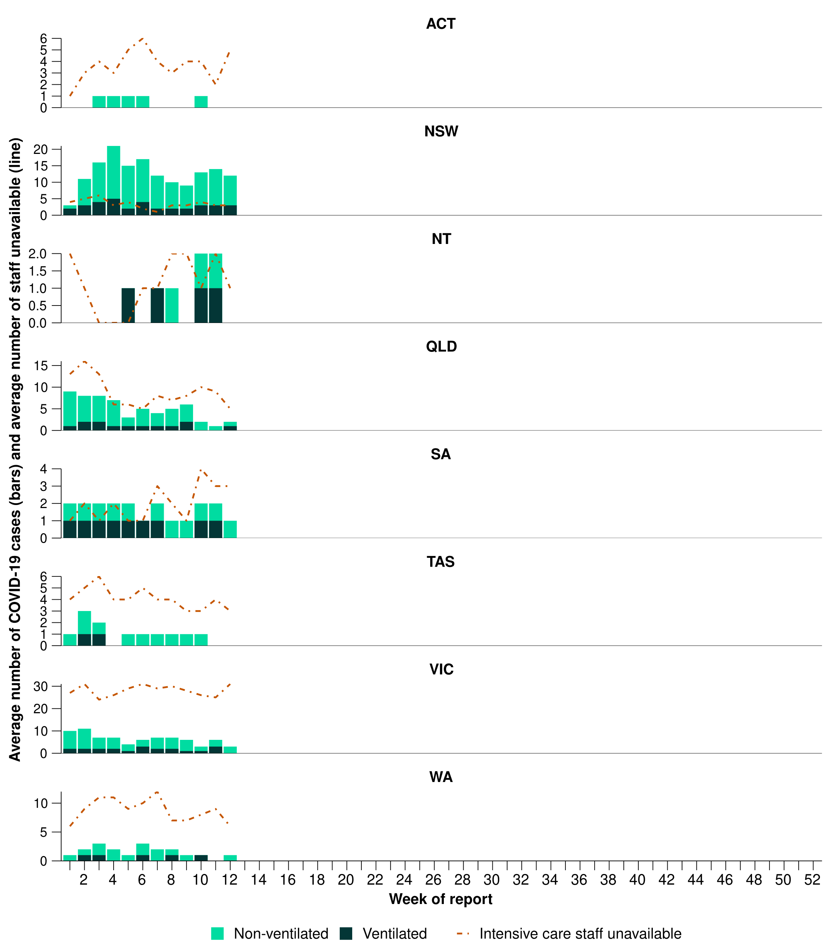
Source: Critical Health Resource Information System (CHRIS)
* Axis varies between jurisdictions.
† Average number of ventilated and non-ventilated COVID-19 cases in intensive care includes only active COVID-19 cases (those in isolation) and does not include cleared COVID-19 cases.
‡ Intensive care staff include both medical and nursing staff. Staff unavailability will be underestimated in New South Wales as most public hospitals in New South Wales do not report staff unavailability.

Mortality surveillance
Death registrations can provide information on the scale and severity of disease associated with acute respiratory infections. Please note, the latest release of the Provisional Mortality Statistics is 28 February 2025, as such the mortality surveillance data presented here have not been updated since the previous report.
- COVID-19 has been the leading cause of acute respiratory infection mortality across 2023-2025.
- Deaths involving COVID-19 increased slightly in November and December 2024 but remain lower than deaths at the same time in 2023. The 4,953 deaths involving COVID-19 in 2024 is 19.5% lower than the 6,154 deaths recorded in 2023.
- Deaths involving influenza remained low in November and December 2024. Influenza-related mortality in 2024 was 67.3% higher than those recorded in 2023 (1,002 deaths compared to 599).
- Deaths involving RSV have been at comparable levels to those recorded in 2023 since July.
- All three of these acute respiratory infections are more likely to cause death in older age groups than younger age groups.
Figure 15: Provisional numbers of acute respiratory infection associated deaths*†‡ by month, year and respiratory infection, Australia, 1 January 2022 – 31 January 2025
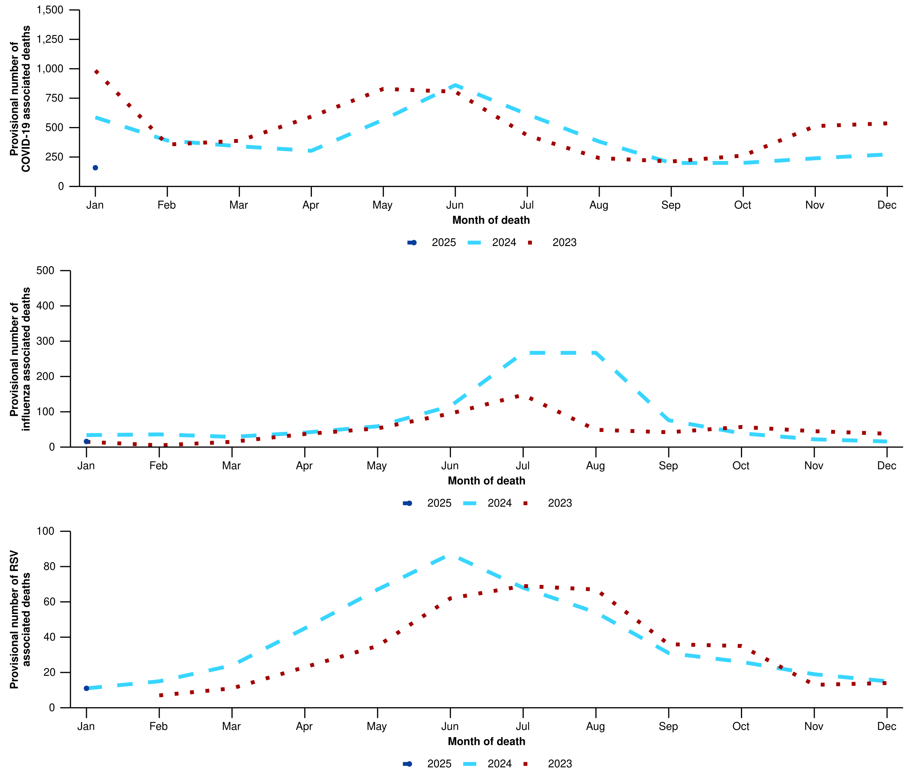
Source: Australian Bureau of Statistics, Provisional Mortality Statistics, Jan - Nov 2024, released 28 February 2025.
* Axis varies between acute respiratory associated deaths. An acute respiratory associated death is one where the disease has either directly caused the death or the person has died with the virus (a person has died from another cause but the disease still contributed significantly to death).
† Data is provisional and subject to change. It can take several weeks for death registrations to be reported, processed, coded, validated, and tabulated. Therefore, the data shown here may be incomplete, and will likely not include all deaths that occurred during a given time. Data includes all deaths (both doctor and coroner certified) that occurred and were registered by 31 January 2025. Please refer to the Technical Supplement for more information.
‡ All deaths involving COVID-19 in this report have been coded to ICD-10 codes U07.1-U07.2, U10.9 or U09.9. All deaths involving influenza have been coded to J09-J11. All deaths involving RSV have been coded to J12.1, J20.5, J21.0, B97.4.

Laboratory surveillance
Sentinel laboratory surveillance monitors and characterises respiratory pathogens to provide information on what pathogens are circulating, potential changes in the pathogens that might affect their infectiousness, severity, ability to evade vaccine and/or infection-acquired immunity, or resistance to antivirals.
- This month (24 February to 23 March 2025), SARS-CoV-2 test positivity has slightly decreased to 3.3% (759/23,256), influenza positivity has slightly increased to 5.0% (1,440/28,528), and RSV positivity has slightly increased to 1.3% (295/23,256) (Figure 16).
Figure 16: Number of tests positive (bars) and test positivity (line) for SARS-CoV-2, influenza or RSV of those specimens tested by sentinel laboratories by week of report*†, Australia, 1 January to 23 March 2025
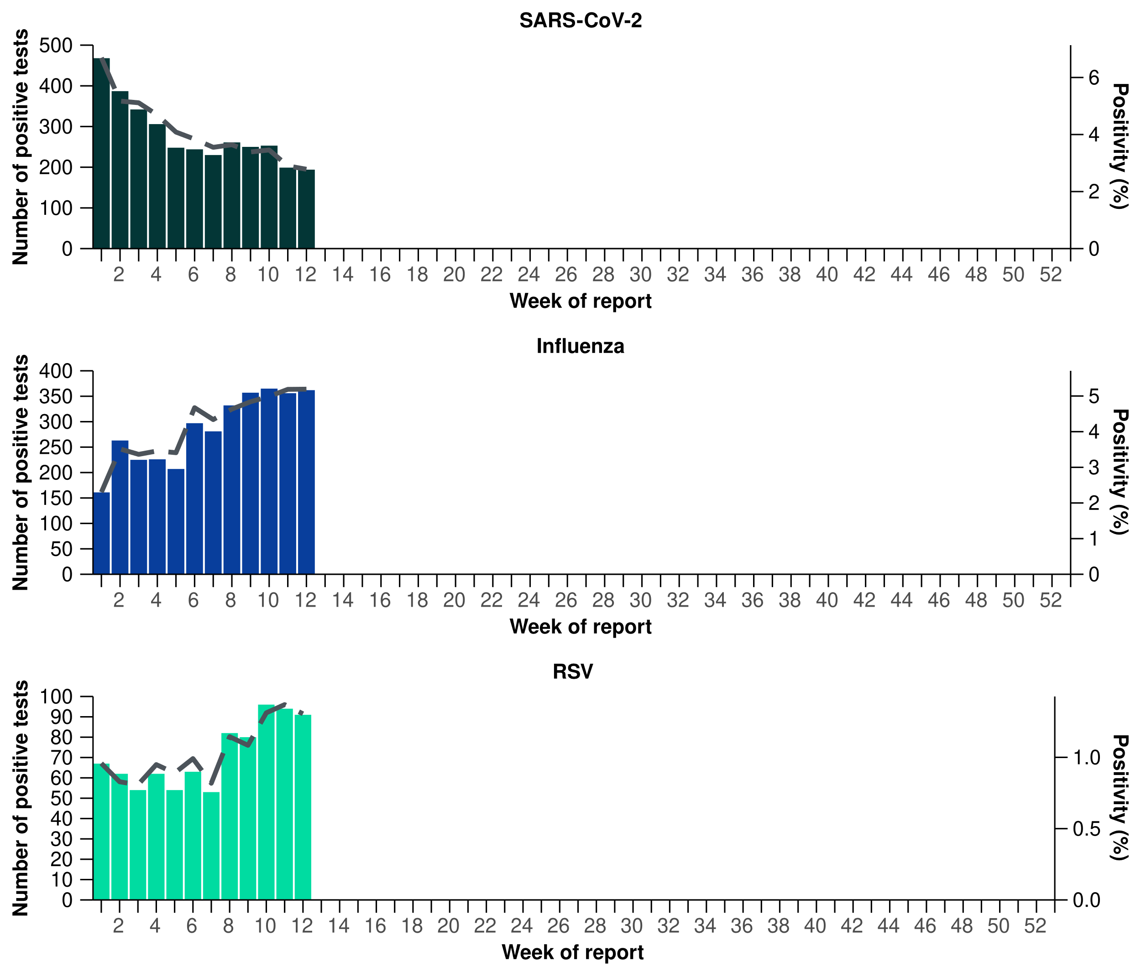
Source: Sentinel laboratories, including National Influenza Centres
* Number of specimens tested excludes data from Western Australia as testing denominator data are different for the three pathogens in Western Australia.
† A small minority of total samples from Victoria are tested only by respiratory panel (influenza, parainfluenza, adenovirus, human metapneumovirus, seasonal coronaviruses, RSV, and some picornaviruses) but not for SARS-CoV-2. These minority samples include only forensic materials; all other samples are tested by respiratory panel and SARS-CoV-2 assay.
- There were 271 sequences uploaded to AusTrakka with dates of collection in the past 28 days (24 February to 23 March 2025). These sequences were from New South Wales, Queensland, South Australia, Tasmania, and Western Australia, with the most recent collection date 10 March 2025.
- All sequences were assigned to the BA.2.86 sub-lineage within B.1.1.529 (Omicron) or recombinants consisting of one or more Omicron sub-lineages (Figure 17). There were no BA.1, BA.3, BA.4, BA.5 or other BA.2 sub-sub-lineage sequences. In the past 28 days:
  - 41.7% (113/271) of sequences were from the sub-sub-lineages JN.1 (BA.2.86.1.1), including from KP.3
  - 58.3% (158/271) of sequences were recombinant or recombinant sub-lineages, including XEC, a recombinant between KS.1.1 (JN.1.13.1.1.1) and KP.3.3.
- XEC is now the dominant circulating variant; however, the proportion of JN.1 sequences has increased in the past 28 days due to a decrease in the proportion of recombinant lineages (Figure 17).
- The World Health Organization (WHO) have identified certain sub-sub-lineages and recombinants as variants under monitoring (VUM) or variants of interest (VOI) because of their epidemiological, pathological, or immunological features of concern. A select number of designated VUM or VOI are highlighted below due to their relevance in the Australian context:
  - There are 275 LP.8.1 sequences in AusTrakka, with 34 collected in the past 28 days. LP.8.1 was designated as a VUM as of 24 January 2025. The February WHO Risk Evaluation, noted the proportion of LP.8.1 sequences is growing rapidly compared to co-circulating variants; however, there is no significant increase in case numbers associated with LP.8.1 infections, and there are no reports to suggest that the associated disease severity is higher.
  - There are 2,415 XEC sequences in AusTrakka, including 149 collected in past 28 days.
  - There are 343 LB.1 sequences in AusTrakka, with five sequences identified in the past 28 days.
  - There are 2,549 KP.3.1.1 sequences in AusTrakka, with 63 sequences identified in the past 28 days.
Figure 17a: Omicron sub-lineage* sequences by sample collection date, showing the proportions of sequences per week^†, Australia, 1 January to 23 March 2025
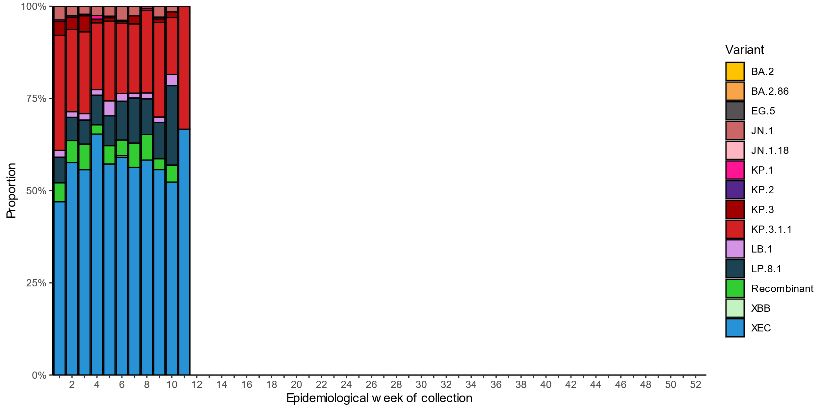
Source: AusTrakka
* Some sub-sublineages are shown alongside their parent lineage, but not included in the parent lineage totals. For instance, KP.2 and KP.3 are sub-sub lineages of JN.1, so the total of JN.1 sequences will be higher than shown in the corresponding colour alone, and should include the KP.2 and KP.3 totals.
^ Sequences in AusTrakka aggregated by week and reported based on date of sample collection, not date of sequencing.
† Proportions in Figure 17a may not be representative when sequence numbers are small; refer to Figure 17b. Data for earlier weeks may change between reporting periods as sequences with older collection dates are uploaded. These numbers are not equivalent to number of cases, as there are many cases which may not be sequenced. Non-VOI and non-VUM Omicron sub-lineages have been collapsed into parent lineages BA.1, BA.2, BA.3, BA.4 and BA.5.
Figure 17b: Omicron sub-lineage* sequences by sample collection date, showing the count of sequences per week^†, Australia, 1 January to 23 March 2025
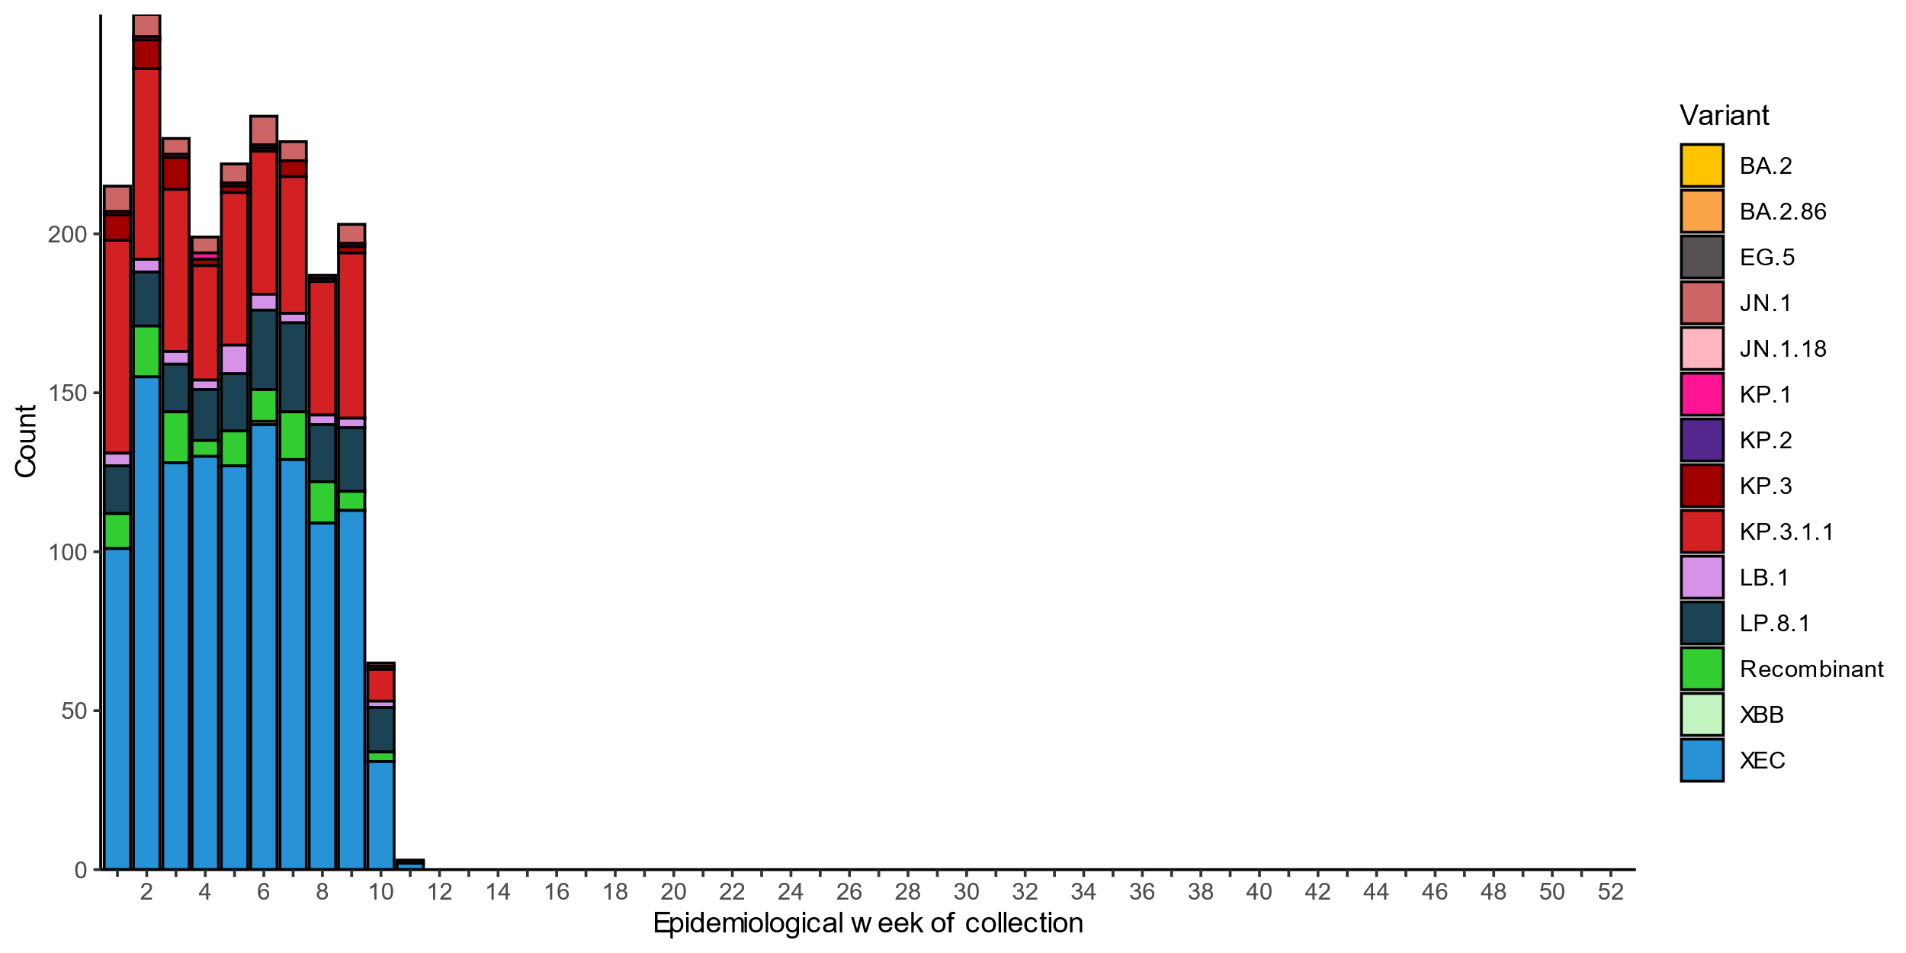
Source: AusTrakka
* Some sub-sublineages are shown alongside their parent lineage, but not included in the parent lineage totals. For instance, KP.2 and KP.3 are sub-sub lineages of JN.1, so the total of JN.1 sequences will be higher than shown in the corresponding colour alone, and should include the KP.2 and KP.3 totals.
^ Sequences in AusTrakka aggregated by week and reported based on date of sample collection, not date of sequencing.
† Data for earlier weeks may change between reporting periods as sequences with older collection dates are uploaded. These numbers are not equivalent to number of cases, as there are many cases which may not be sequenced. Non-VOI and non-VUM Omicron sub-lineages have been collapsed into parent lineages BA.1, BA.2, BA.3, BA.4 and BA.5.
- In the year to date, the WHO Collaborating Centre for Reference and Research on Influenza has antigenically characterised 572 influenza viruses from Australia (Table 4), of which:
  - 80.2% (459/572) have been influenza A(H1N1)
  - 10.8% (62/572) have been influenza A(H3N2)
  - 8.9% (51/572) have been influenza B/Victoria.
- In the year to date, there continue to be no influenza B/Yamagata viruses characterised by the WHOCC (Table 4). The last influenza B/Yamagata virus characterised by the WHO Collaborating Centre in Australia was in a sample from 2020.
- In the year to date, none of the influenza samples tested have demonstrated highly reduced inhibition to Oseltamivir or to Zanamivir.
Table 4: Australian influenza viruses typed by haemagglutination inhibition assay and jurisdiction*†, 1 January to 23 March 2025
Strain | ACT | NSW | NT | Qld | SA | Tas | Vic | WA | Total
A(H1N1) | 85 | 41 | 128 | 10 | 13 | 64 | 114 | 4 | 459
A(H3N2) | 6 | 4 | 24 | 3 | 0 | 2 | 21 | 2 | 62
B/Victoria lineage | 14 | 2 | 3 | 1 | 6 | 2 | 21 | 2 | 51
B/Yamagata lineage | 0 | 0 | 0 | 0 | 0 | 0 | 0 | 0 | 0
Total | 105 | 47 | 155 | 14 | 19 | 68 | 156 | 8 | 572
Source: World Health Organization (WHO) Collaborating Centre for Reference and Research on Influenza
*Viruses tested by the WHO Collaborating Centre for Reference and Research on Influenza are not necessarily a random sample of all those in the community and early-year data may be based on limited samples received. There may be up to a month delay on reporting of samples.
† Jurisdiction indicates the residential location for the individual tested, not the submitting laboratory.

Vaccine coverage, effectiveness and match
Vaccine coverage, effectiveness and match for acute respiratory infections are monitored from several data sources in Australia. Refer to the Technical Supplement for more information.

Vaccine coverage
- Data on vaccine coverage is currently unavailable, but will be included in future reports.

Vaccine effectiveness
- It is too early to assess vaccine effectiveness for the 2025 influenza season.

Vaccine match
- Refer to the Technical Supplement for information on the 2025 southern hemisphere influenza vaccines composition.
- In the year to date, 98.0% (450/459) of influenza A(H1N1) isolates, 100% (62/62) of influenza A(H3N2) isolates and 100% (51/51) of influenza B/Victoria lineage isolates characterised have been antigenically similar to the corresponding 2025 vaccine components.

