Australian Respiratory Surveillance Report

Key messages
This report presents a national epidemiological update for acute respiratory infections, including coronavirus disease 2019 (COVID-19), influenza and respiratory syncytial virus (RSV), with a focus on the current reporting period (24 March to 6 April 2025) and earlier severity reporting periods (up to 23 March 2025).
In the community: Respiratory illness activity (self-reported new fever and cough symptoms) remains lower than observed at the same time in previous years. Slightly more participants reported new fever and cough symptoms compared to the previous fortnight; however, slightly fewer people reported taking time off work due to respiratory illness (self-reported new fever and cough symptoms) compared to the previous fortnight. The number of COVID-19 cases remains low this fortnight. The number of influenza cases this fortnight remains low but is slightly higher than the number of cases seen in the same period in previous years. The number of RSV cases this fortnight is moderate and increasing steadily. This trend may signal the start of the RSV season nationally; however, this steadily increasing trend has not been observed in all jurisdictions.
In general practice: There were slightly more influenza-like-illness (new fever and cough symptoms) consultations at sentinel surveillance sites this fortnight, compared with the last fortnight. Influenza-like-illness rates this fortnight were similar to the rates observed at the same time in previous years and the five-year average.
In hospitals: Sentinel hospital-based surveillance shows the number of patients admitted with severe acute respiratory infections has remained low and stable this severity reporting period. Most of these patients were admitted with COVID-19. The length of hospital stay continues to vary only slightly between illnesses and the proportion of those patients who were admitted directly to an intensive care at a sentinel hospital site has remained low. More children (those aged 16 years and younger) were admitted with RSV or influenza than with COVID-19 at sentinel hospitals, while more adults were admitted with COVID-19 compared to influenza or RSV. Sentinel intensive care surveillance shows the overall number of patients with severe acute respiratory infections has remained low and stable this year. The duration of intensive care stay varies slightly between illnesses. The average number of COVID-19 cases in intensive care has decreased this fortnight. However, the average number of intensive care staff unavailable due to COVID-19 illness or exposure has increased.
Deaths: There are more deaths due to COVID-19 and influenza than deaths with COVID-19 and influenza across 2023–2025. In contrast, there are substantially more people who died with RSV than due to RSV across 2023–2025. COVID-19 has been the leading cause of acute respiratory infection mortality across 2023–2025.
In laboratories: Test positivity for SARS-CoV-2 and influenza remained low this fortnight, while a slight increase in RSV test positivity was observed. The recombinant lineage XEC is now the dominant SARS-CoV-2 variant in Australia; however, the proportion of JN.1 and associated sub-lineages has increased recently due to a decrease in the proportion of recombinant lineages. On 24 January 2025, the World Health Organization designated LP.8.1 as a variant under monitoring. The proportion of LP.8.1 sequences is growing rapidly compared to co-circulating variants; however, there is no significant increase in case numbers associated with LP.8.1 infections, and there are no reports to suggest that the associated disease severity is higher compared to other circulating variants. Small numbers of LP.8.1 sub-lineage sequences have been observed in Australia.
Vaccine coverage, effectiveness and match: It is too early to assess or report vaccine coverage or effectiveness data for 2025. Of influenza isolates characterised in 2025 thus far, over 98% have been a good match to the corresponding 2025 vaccine components.

Australian Respiratory Surveillance Report
This report was prepared by Lauren Kutzner, Suzie Whitehead, Jenna Hassall, and Siobhan St George on behalf of the interim Australian Centre for Disease Control. We thank the staff and participants from the surveillance systems who contribute data for acute respiratory illness surveillance across Australia.
The report presents a national overview of acute respiratory infections in Australia, drawing information from several different surveillance systems. These surveillance systems help us to understand the distribution of acute respiratory illnesses in the community, the severity of infections including which populations might be at risk, and the impact of acute respiratory illnesses on the community and health system in Australia.
Surveillance indicators presented in this report are based on the Australian National Surveillance Plan for COVID-19, Influenza, and RSV. Please refer to the Technical Supplement – Australian Respiratory Surveillance Report for information on our surveillance sources and data considerations, including the considerable impact of the COVID-19 pandemic on acute respiratory infection surveillance in Australia. A summary of data considerations for this report are provided below:
- Due to the dynamic nature of the surveillance systems used in this report, surveillance data are considered preliminary and subject to change as updates are received, with the most recent weeks considered particularly incomplete. Data in this report may vary from data reported in other national reports and reports by states and territories.
- Data in this report are presented by date of event (diagnosis, admission or death) or by the International Organization for Standardization (ISO) week date system, with weeks defined as seven-day periods which begin on a Monday and end on a Sunday. The ISO week date system is used to support trends comparisons over time more effectively. The current reporting period this fortnight includes 24 March to 6 April 2025 and where comparisons to the previous fortnight are made this includes 10 March to 23 March 2025.
- In Australia, states and territories report notified cases to the National Notifiable Diseases Surveillance System (NNDSS) based on the Australian national surveillance case definitions. NNDSS data are analysed and reported based on diagnosis date, which is the true onset date of a case if known, otherwise it is the earliest of the specimen date, the notification date, or the notification received date. The NNDSS data for this report were extracted on 9 April 2025.
- To account for the lag in collection and provision of severity data from some surveillance systems, and for the time delay between illness onset and the development of severe disease outcomes, cases with an admission date or a diagnosis date in the last two weeks are excluded from severity analyses for hospitalisations and intensive care admissions. As such, the severity reporting periods are two weeks behind the end of the current reporting period. For this report, severity reporting includes data from 10 March to 23 March 2025 unless specified otherwise. Where comparisons to the previous severity fortnight are made this includes 24 February to 9 March 2025.
- Death registrations from the Australian Bureau of Statistics (ABS) Provisional Mortality Statistics are now used as the primary data source for measuring acute respiratory infection associated deaths. The ABS mortality data is sourced from the Registry of Births, Deaths and Marriages and is separate from the NNDSS. Registration-based mortality data needs time to be received and processed. For this reason, mortality statistics in this report may lag by at least two months.
- Analysis and reporting outputs were produced using R Statistical Software v4.3.1. While every care has been taken in preparing this report, the Australian Government Department of Health and Aged Care does not accept liability for any injury or loss or damage arising from the use of, or reliance upon, the content of the report or Technical Supplement. For further information about this report refer to the Technical Supplement – Australian Respiratory Surveillance Report or contact respiratory.surveillance@health.gov.au.

Community surveillance
Community surveillance monitors respiratory illnesses in the community, providing information on the number of people reporting respiratory symptoms, testing practices, and the impact of respiratory illnesses. Community surveillance includes notification data obtained from laboratory tests for infections. Infections that are diagnosed and notified are only a subset of the total number of infections occurring in the community.
- Community surveys via FluTracking indicate respiratory illness symptoms and test positivity remain low and stable this fortnight, consistent with the trends observed at the same time in previous years.
- This fortnight (24 March to 6 April 2025), slightly more survey participants reported new fever and cough symptoms (1.2%), than in the previous fortnight (0.9%) (Figure 1).
- This fortnight, more survey participants with new fever and cough symptoms used a rapid antigen test (RAT) (53.5%; 347/649) than a polymerase chain reaction (PCR) test (7.9%; 51/649) to test for severe acute respiratory syndrome coronavirus 2 (SARS-CoV-2).
  - Self-reported SARS-CoV-2 RAT positivity was lower this fortnight (19.0%; 66/347) than in the previous fortnight (21.3%; 69/324), while self-reported SARS-CoV-2 PCR positivity was higher this fortnight (11.8%; 6/51) than in the previous fortnight (9.8%; 6/61).
- This fortnight, 6.8% (44/649) of survey participants with new fever and cough symptoms used a PCR test to test for influenza. Self-reported influenza PCR positivity was lower this fortnight (27.3%; 12/44), than in the previous fortnight (34.6%; 18/52).
- This fortnight fewer survey participants reported taking three or more days off work or normal duties due to fever and cough symptoms (41.4%; 269/649), than in the previous fortnight (47.3%; 270/571).
- From January to early March 2025, the weekly proportion of survey participants with new fever and cough symptoms was relatively consistent with the proportions observed at the same time in 2022–2024. Since mid-March, the weekly proportion has been lower than observed at the same time in 2022–2024 (Figure 1).

Figure 1: Age standardised proportion of survey participants reporting new fever and cough symptoms compared with the five-year average* by year and week of report, Australia, 2022 to 6 April 2025
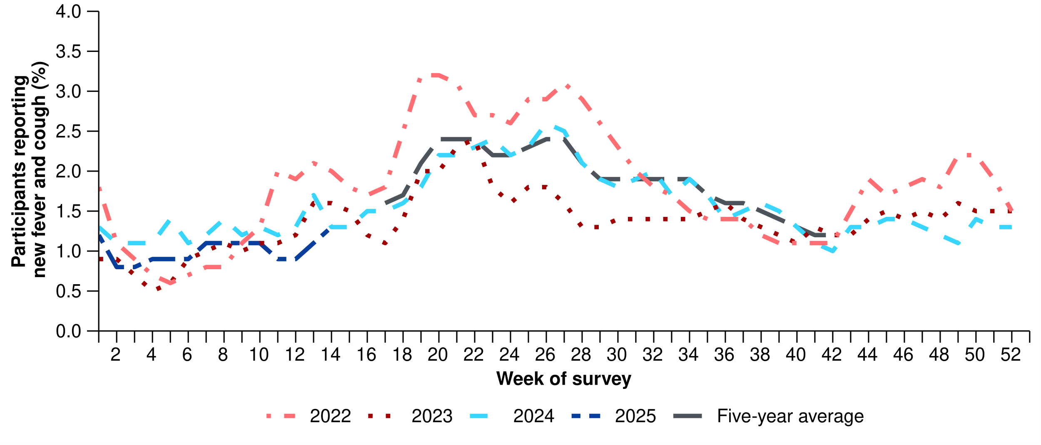
Source: FluTracking
* From 2020, FluTracking expanded their data capture period to year-round. Data before May and after October for any year before 2020 are not available for historical comparisons. The years 2020 and 2021 are excluded when comparing the current season to historical periods when influenza virus has circulated without public health restrictions. As such, the five-year average includes the years 2018 to 2019 and 2022 to 2024. Please refer to the Technical Supplement for interpretation of the five-year average.
- This fortnight (24 March to 6 April 2025), there was an 8.3% decrease in COVID-19 notifications, a 15.5% increase in influenza notifications, and a 30.2% increase in RSV notifications.
Table 1: Notified cases and notification rate per 100,000 population by disease, five-year age group, and jurisdiction*†, Australia, 1 January to 6 April 2025
 | COVID-19 |  |  | Influenza |  |  | RSV
 | Reporting  period  (n) | Year to  date  (n) | Year to  date  (rate) | Reporting  period  (n) | Year to  date  (n) | Year to  date  (rate) | Reporting  period  (n) | Year to  date  (n) | Year to  date  (rate)
Age group (years)
0–4 | 505 | 5,048 | 335 | 1,165 | 5,599 | 371 | 3,936 | 13,973 | 926
5–9 | 126 | 1,261 | 78 | 1,646 | 6,202 | 385 | 540 | 1,604 | 100
10–14 | 154 | 1,391 | 83 | 998 | 4,075 | 243 | 201 | 753 | 45
15–19 | 200 | 1,731 | 104 | 565 | 2,890 | 174 | 121 | 551 | 33
20–24 | 149 | 1,743 | 97 | 322 | 2,117 | 118 | 109 | 489 | 27
25–29 | 218 | 2,093 | 105 | 334 | 2,086 | 105 | 115 | 579 | 29
30–34 | 262 | 2,495 | 122 | 468 | 2,704 | 133 | 179 | 713 | 35
35–39 | 292 | 2,847 | 143 | 589 | 3,403 | 171 | 170 | 650 | 33
40–44 | 264 | 2,703 | 146 | 605 | 3,422 | 185 | 129 | 565 | 31
45–49 | 248 | 2,460 | 151 | 493 | 2,931 | 180 | 118 | 572 | 35
50–54 | 263 | 2,470 | 146 | 468 | 2,906 | 172 | 149 | 715 | 42
55–59 | 212 | 2,326 | 152 | 487 | 2,630 | 172 | 152 | 796 | 52
60–64 | 243 | 2,572 | 168 | 472 | 2,675 | 174 | 169 | 819 | 53
65–69 | 265 | 2,677 | 197 | 452 | 2,365 | 174 | 202 | 889 | 65
70+ | 1,397 | 15,826 | 474 | 1,491 | 7,125 | 213 | 821 | 3,605 | 108
Jurisdiction
ACT | 72 | 655 | 138 | 56 | 607 | 128 | 47 | 249 | 53
NSW | 2,219 | 21,440 | 253 | 3,946 | 20,350 | 240 | 4,228 | 14,342 | 169
NT | 24 | 530 | 208 | 218 | 955 | 374 | 30 | 201 | 79
Qld | 1,041 | 12,430 | 223 | 2,850 | 11,829 | 212 | 1,611 | 7,502 | 134
SA | 348 | 2,976 | 158 | 561 | 2,873 | 153 | 180 | 822 | 44
Tas. | 75 | 669 | 116 | 163 | 677 | 118 | 18 | 169 | 29
Vic. | 771 | 7,921 | 113 | 2,096 | 11,159 | 160 | 864 | 3,068 | 44
WA | 253 | 3,042 | 103 | 676 | 4,693 | 158 | 133 | 921 | 31
Total | 4,803 | 49,663 | 183 | 10,566 | 53,143 | 195 | 7,111 | 27,274 | 100
Source: National Notifiable Diseases Surveillance System (NNDSS)
* Rate per 100,000 population for the given time period. Population data are based on the Australian Bureau of Statistics (ABS) Estimated Resident Population (ERP) for the reference period June 2024, released 12 December 2024.
† Total includes cases with missing age.
- This fortnight, the number of COVID-19 cases remains low. Following an increase in COVID-19 cases in late 2024 and early January 2025, an overall decreasing trend was observed in the past three months. Despite a small, unsustained increase in early February, the number of COVID-19 cases this fortnight remains lower than the number of cases at the same time last year, and is less than half of the number of cases reported in the June 2023 peak (Figure 2).
- This fortnight, COVID-19 notification rates continued to decrease or remained stable across most jurisdictions, except in the Australian Capital Territory and South Australia where a small increase in notification rates compared to the previous fortnight was observed (Figure 3).
- In the year to date, COVID-19 notification rates remain highest in people aged 70 years or over, likely due to higher case ascertainment from targeted testing strategies for populations at-risk of severe disease or who live in a high-risk setting such as a residential aged care home (Table 1).
- In the year to date, COVID-19 notification rates remain highest in New South Wales, Queensland, and the Northern Territory and lowest in Western Australia (Table 1).

Figure 2: Notified COVID-19 cases (laboratory-confirmed only) by year and week of diagnosis, Australia, 2022 to 6 April 2025
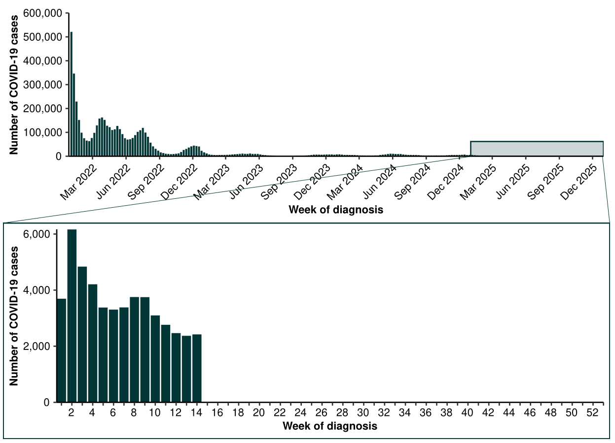Source: National Notifiable Diseases Surveillance System (NNDSS)

Figure 3: Notification rates* per 100,000 population for COVID-19 cases by state or territory and week of diagnosis, Australia, 1 January to 6 April 2025
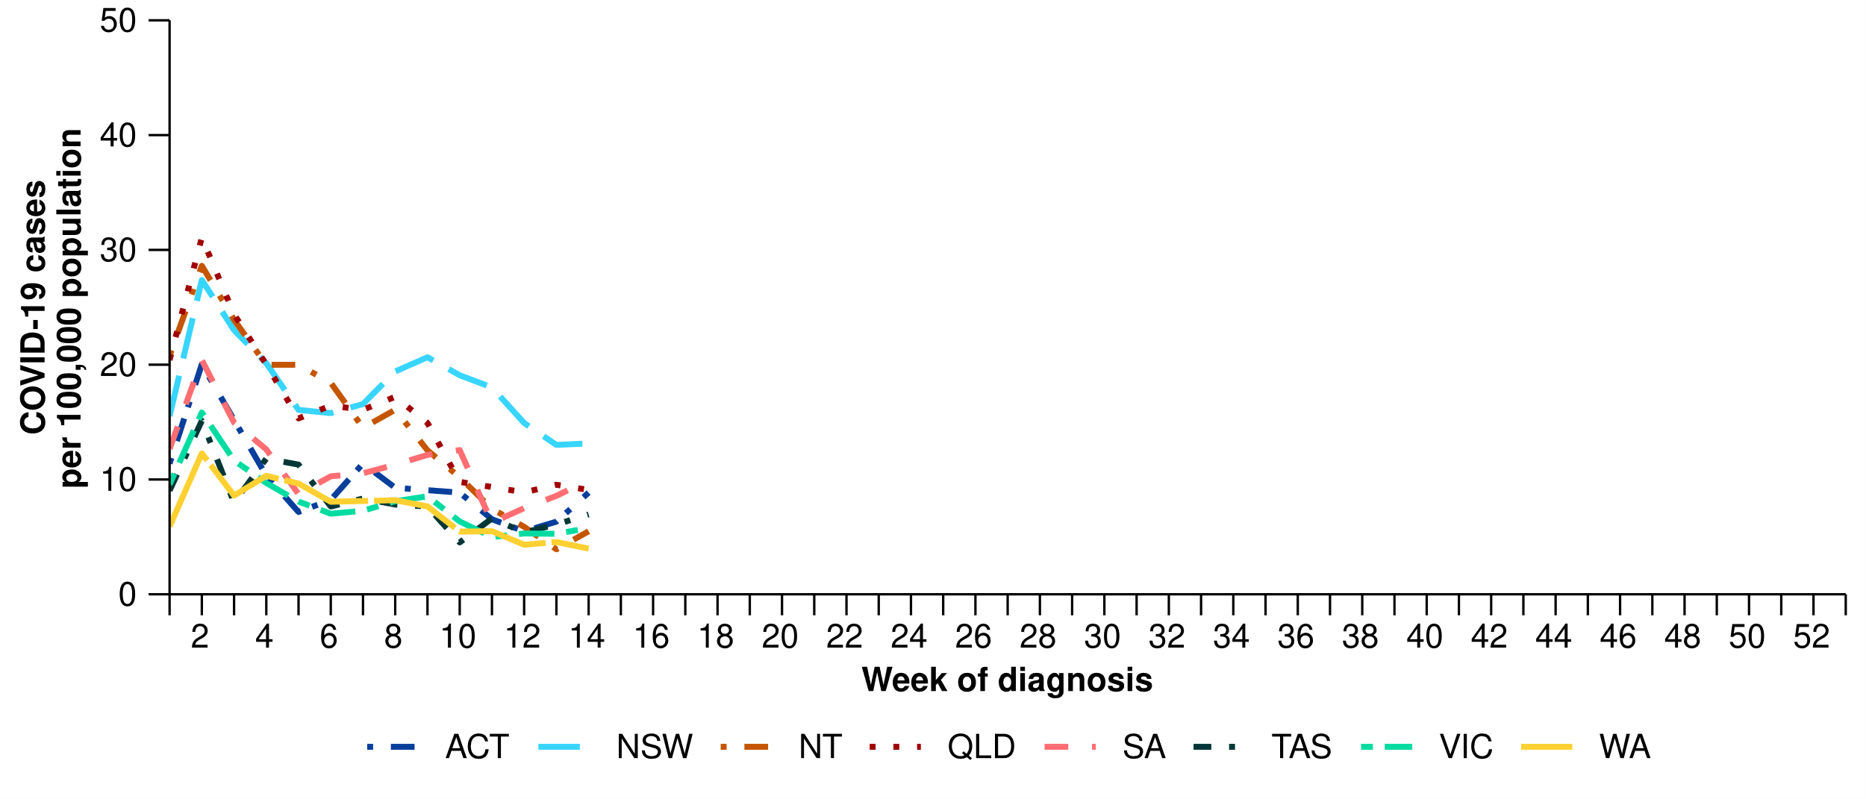
Source: National Notifiable Diseases Surveillance System (NNDSS)
* Rate per 100,000 population for the given time period. Population data are based on the Australian Bureau of Statistics (ABS) Estimated Resident Population (ERP) for the reference period June 2024, released 12 December 2024
Figure 4: Notified influenza cases and five-year average* by year and week of diagnosis, Australia, 2022 to 6 April 2025
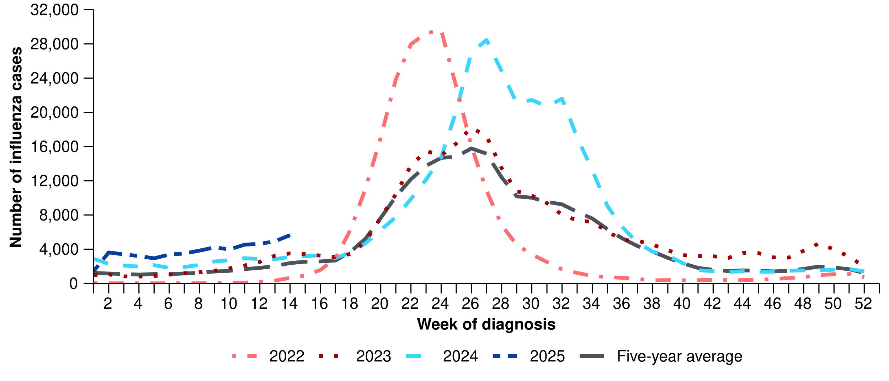
Source: National Notifiable Diseases Surveillance System (NNDSS)
* The years 2020 and 2021 are excluded when comparing the current season to historical periods when influenza virus has circulated without public health restrictions. As such, the five-year average includes the years 2018 to 2019 and 2022 to 2024. Please refer to the Technical Supplement for interpretation of the five-year average.
- This fortnight, the number of influenza cases remains relatively low, though the number of cases per week is increasing consistently. The number of influenza cases this fortnight is slightly higher than the number of cases seen in the interseasonal period in 2023–2024 and the five-year average (Figure 4).
  - Though the number of influenza cases is higher than in the past, the increase in the number of cases this fortnight is consistent with increases observed over the same periods in 2023 and 2024 (Figure 4).
  - This increase could be due to increased influenza circulating in the community, perhaps driven in part by travellers to the northern hemisphere returning with influenza infections. However, it could also be influenced by changes in health-seeking behaviour (increased testing) associated with increases in respiratory virus circulation (especially COVID-19) in the summer period.
- This fortnight, influenza notification rates increased across most jurisdictions compared to the previous fortnight, except in the Australian Capital Territory where a decrease was observed compared to the previous fortnight. Increases in notification rates this fortnight were most pronounced in the Northern Territory and Queensland (Figure 5).
- In the year to date, influenza notification rates remain highest in children aged 5–9 years and children aged 0–4 years (Table 1).
- In the year to date, influenza notification rates remain highest in the Northern Territory and New South Wales and lowest in Tasmania (Table 1).

Figure 5: Notification rates* per 100,000 population for influenza cases by state or territory and week of diagnosis, Australia, 1 January to 6 April 2025
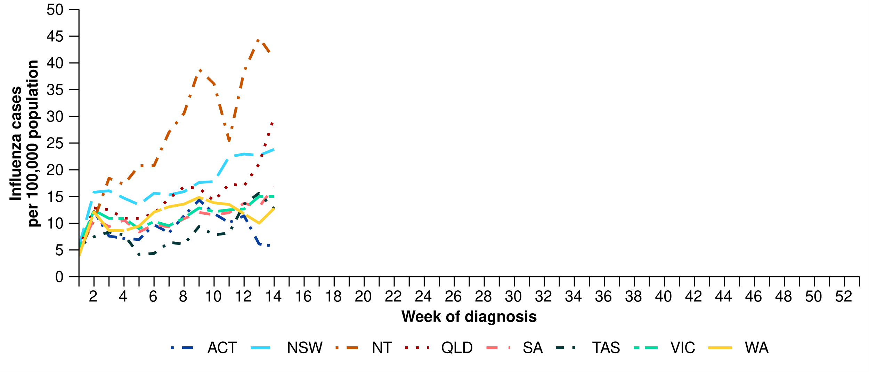
Source: National Notifiable Diseases Surveillance System (NNDSS)
* Rate per 100,000 population for the given time period. Population data are based on the Australian Bureau of Statistics (ABS) Estimated Resident Population (ERP) for the reference period June 2024, released 12 December 2024.
- This fortnight, most influenza notifications were influenza A(Unsubtyped) (74.1%; 7,827/10,566), followed by influenza B (23.0%; 2,431/10,566), then influenza A(H1N1) (2.3%; 245/10,566), and influenza untyped (0.3%; 35/10,566). This fortnight, there have been zero influenza A&B co-detections (Figure 6).
- In the year to date, influenza A(Unsubtyped) has accounted for most cases across all age groups, followed by influenza B in the 0–4 years, 5–19 years and 20–64 years age groups. There were a small number of influenza A(H1N1) and influenza A(H3N2) cases across all age groups (Figure 6).
  - This trend indicates there could be a comparatively higher proportion of influenza B cases this season than observed in 2024. While influenza B is often a good match with the seasonal influenza vaccine strain, influenza B can result in more severe infections in children.
- In the year to date, influenza A(Unsubtyped) has accounted for the majority of influenza cases across all jurisdictions; however, most jurisdictions have been experiencing increasing numbers of influenza B cases (Figure 7). Influenza A(H1N1) and influenza A(H3N2) cases were most commonly observed in Queensland, Tasmania and Western Australia; however, trends in influenza subtypes should be interpreted with caution as there are jurisdictional differences in the proportion and selection of influenza samples that undergo typing.
Figure 6: Notified influenza cases by influenza subtype, age group*, and week of diagnosis, Australia, 1 January to 6 April 2025
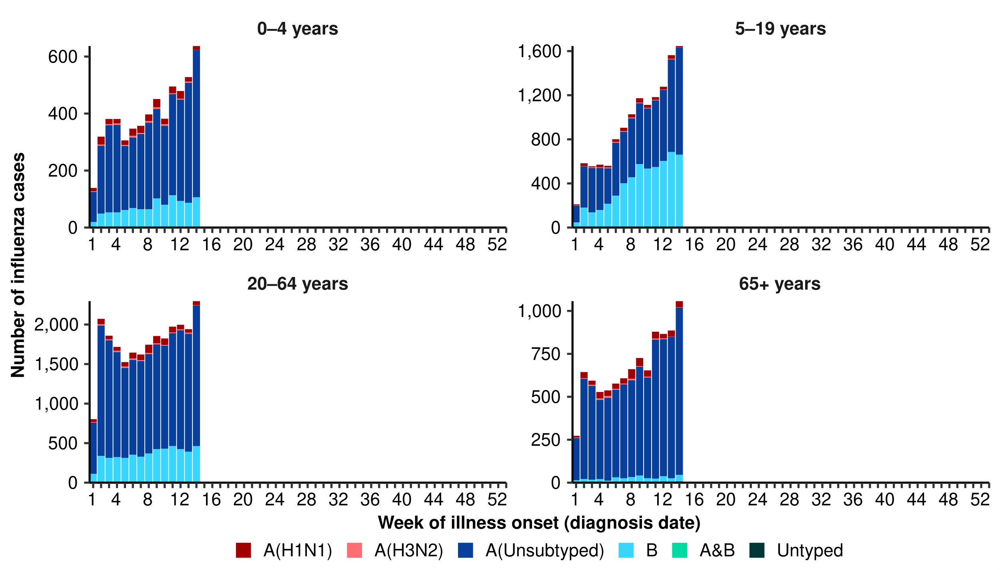
Source: National Notifiable Diseases Surveillance System (NNDSS)
* Axis varies between age groups.
Figure 7: Notified influenza cases by influenza subtype, jurisdiction*, and week of diagnosis, Australia, 1 January to 6 April 2025
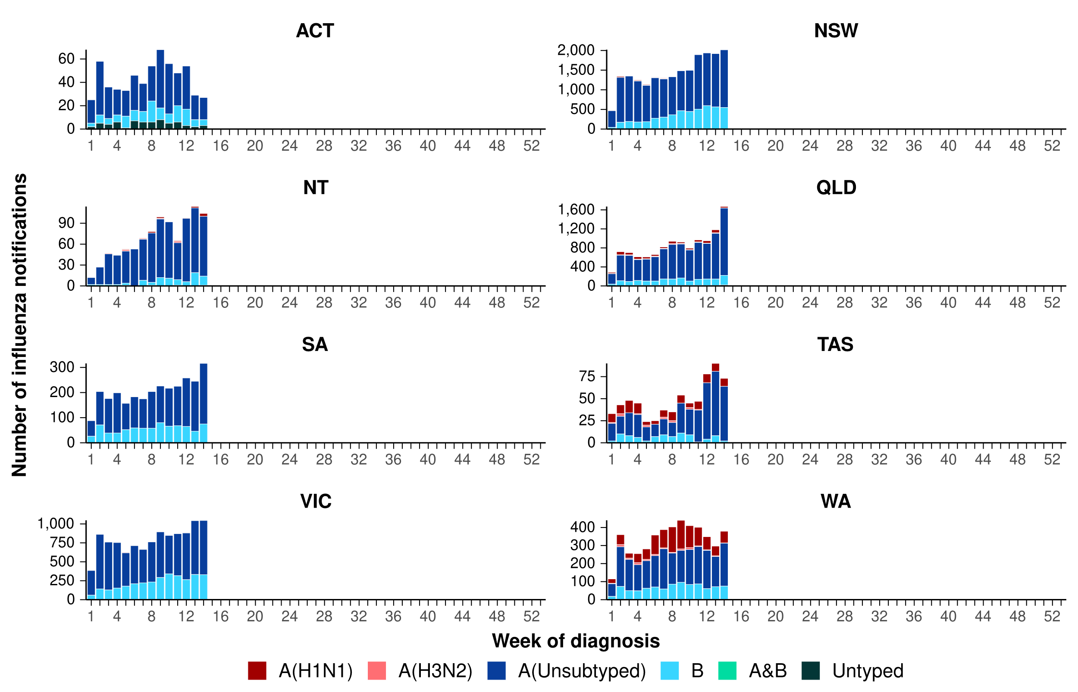
Source: National Notifiable Diseases Surveillance System (NNDSS)
* Axis varies between jurisdictions.
- This fortnight, the number of RSV cases is moderate, though higher than in the previous fortnight, following a steadily increasing trend. The current trend, largely driven by increasing case numbers in New South Wales and Queensland, may signal the start of the RSV season nationally; however, this steadily increasing trend has not been observed in all jurisdictions (Figure 8).
  - Though the number of RSV cases is higher than in the past, the increase in the number of cases this fortnight is consistent with increases observed over the same periods in 2023 and 2024 (Figure 8).
- This fortnight, RSV notification rates increased considerably in New South Wales and Queensland. Notification rates also increased this fortnight in South Australia and Victoria, but remained relatively low and stable in other jurisdictions (Figure 9).
- In the year to date, RSV notification rates remain considerably higher in children aged 0–4 years than in other age groups (Table 1).
- In the year to date, RSV notification rates remain highest in New South Wales and Queensland, and lowest in Tasmania (Table 1).
Figure 8: Notified RSV cases by year and week of diagnosis*, Australia, 2023 to 6 April 2025
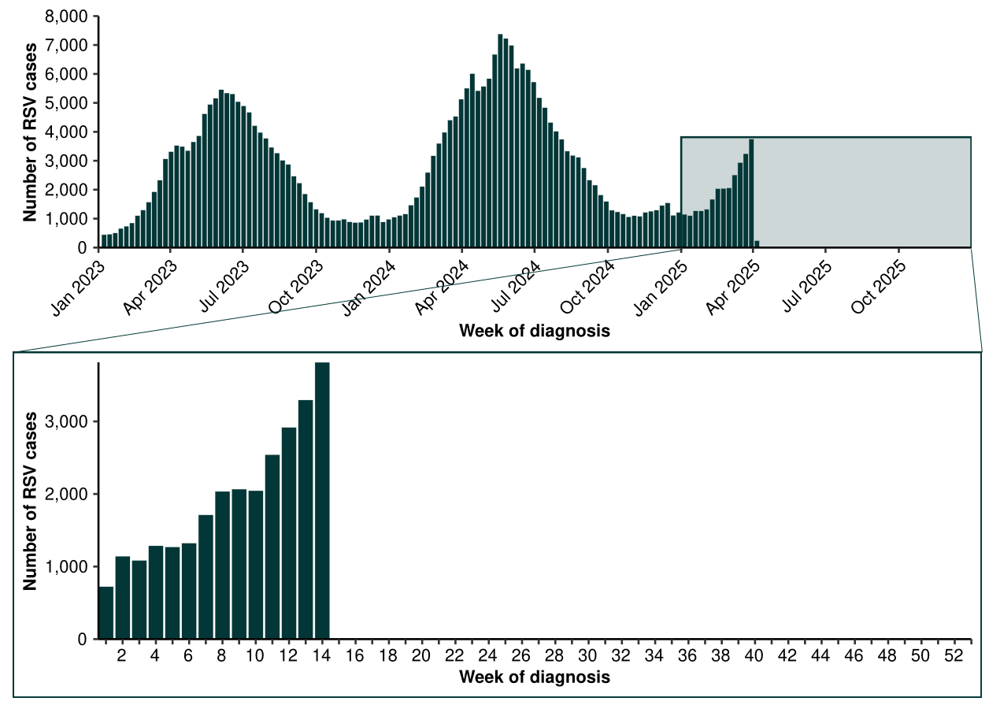
Source: National Notifiable Diseases Surveillance System (NNDSS). Please note, RSV became notifiable in all states and territories on 1 September 2022 and comprehensive national notification data became available after this point. For this reason, RSV notification trends are only presented from 1 January 2023.

Figure 9: Notification rates* per 100,000 population for RSV cases by state or territory and week of diagnosis, Australia, 1 January to 6 April 2025
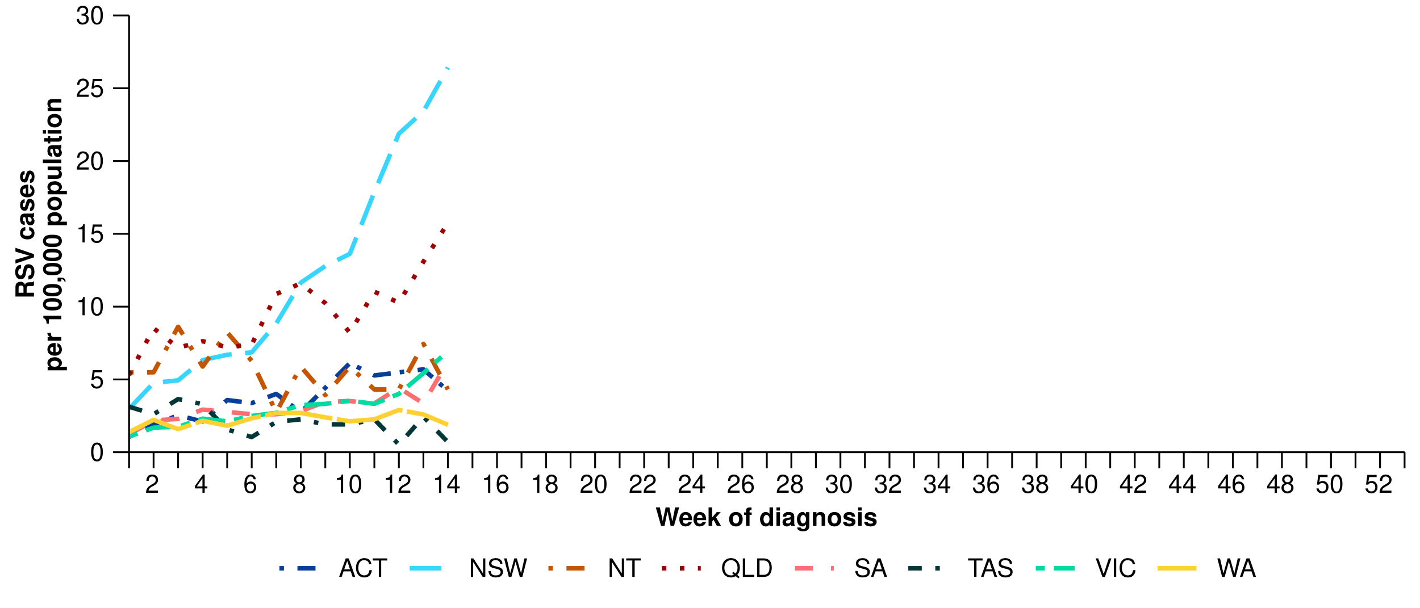
Source: National Notifiable Diseases Surveillance System (NNDSS)
* Rate per 100,000 population for the given time period. Population data are based on the Australian Bureau of Statistics (ABS) Estimated Resident Population (ERP) for the reference period June 2024, released 12 December 2024.

Primary care surveillance
Primary care surveillance monitors the number and characteristics of people who have presented to their general practitioner with influenza-like-illness and provides insight on the different respiratory pathogens that are causing illness in the community.
- Sentinel general practice surveillance indicates medical attendance for respiratory illness has remained low and stable following an increase in influenza-like-illness rates in late 2024 and early January 2025.
- This fortnight (24 March to 6 April 2025), there were slightly more general practice consultations for influenza-like illness (3.1 notifications per 1,000 consultations per fortnight) than in the previous fortnight (2.9 notifications per 1,000 consultations per fortnight), though overall the trend in general practice consultations remains stable (Figure 10).
- From January to late February 2025, influenza-like-illness rates were slightly higher than observed rates at the same period in previous years and the five-year average; however, since March influenza-like-illness rates have been relatively consistent with observed rates in the same period in previous years and the five-year average (Figure 10).

Figure 10: Rate of influenza-like-illness per 1,000 consultations per week with sentinel general practice sites compared with the five-year average by year and week of consultation*†, Australia, 2022 to 6 April 2025
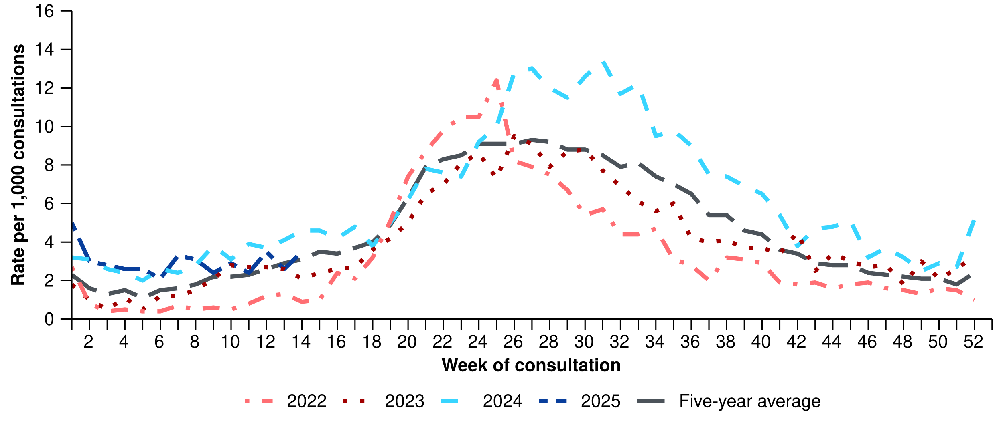
Source: Australian Sentinel Practice Research Network (ASPREN)
* The years 2020 and 2021 are excluded when comparing the current season to historical periods when influenza virus has circulated without public health restrictions. As such, the five-year average includes the years 2018 to 2019 and 2022 to 2024. Please refer to the Technical Supplement for interpretation of the five-year average.
† Please refer to the Technical Supplement for notes on impact of COVID-19 on ASPREN data.

- In the year to date, 61.1% (242/396) of people attending general practice with influenza-like-illness who were tested have then tested positive for a respiratory pathogen.
- In the year to date, rhinovirus (45.5%; 110/242) has been the most commonly detected, followed by influenza (16.1%; 39/242), SARS-CoV-2 (14.5%; 35/242), RSV (6.6%; 16/242), and human metapneumovirus (hMPV) (6.6%; 16/242) (Figure 11).

Figure 11: Number of samples tested for respiratory pathogens among people with influenza-like-illness attending sentinel general practice sites by respiratory pathogen and week of specimen collection, Australia, 1 January to 6 April 2025
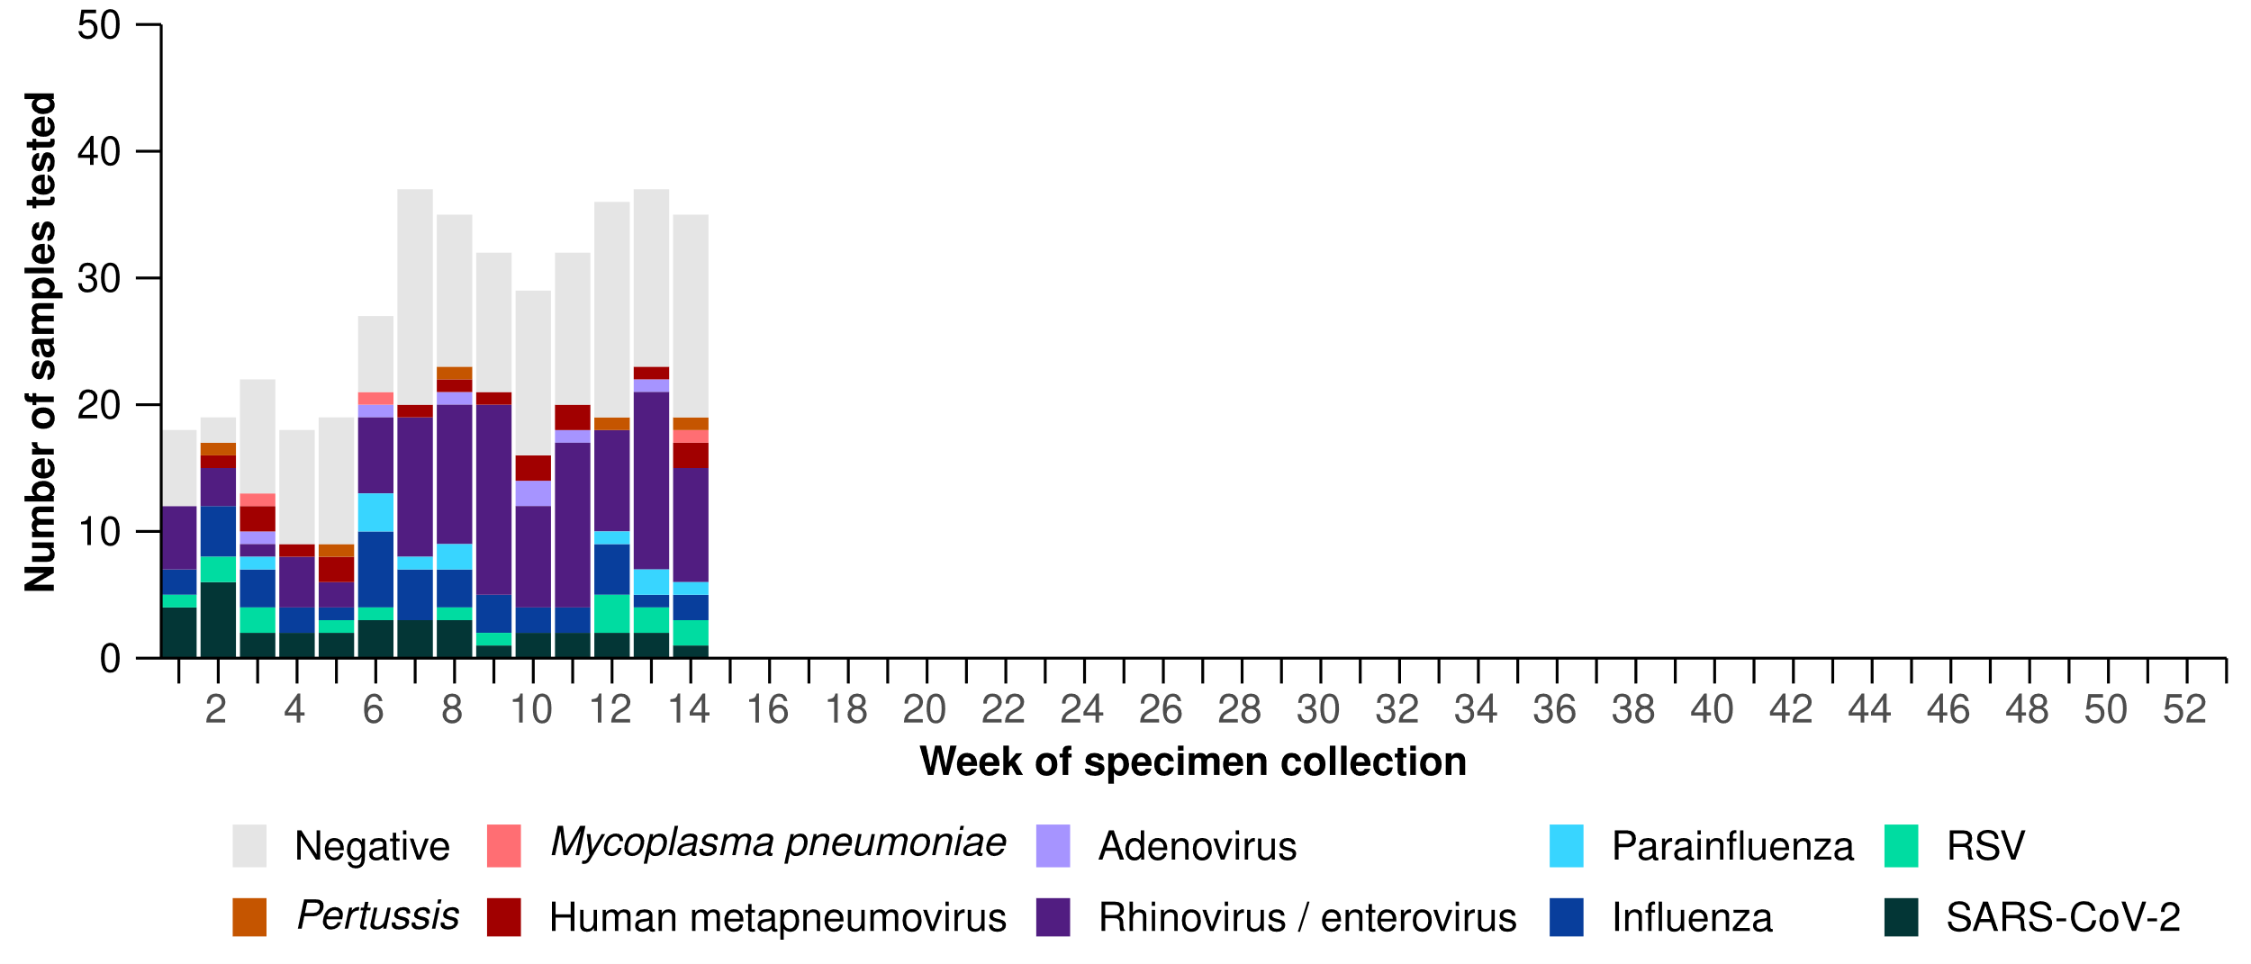
Source: Australian Sentinel Practice Research Network (ASPREN)
Note: All ASPREN swab samples are transported to the SA Pathology laboratory in Adelaide to be tested for viral and bacterial respiratory pathogens via a multiplex real-time reverse transcription polymerase chain reaction (RT-PCR) assay using in-house primers.

Hospital-based surveillance
Hospital-based surveillance monitors persons with more severe illness who have been admitted to hospital for their respiratory illness (severe acute respiratory infections). Hospital-based surveillance also measures the ability of the health system to cope with the number of severe acute respiratory infection admissions to ensure delivery of safe, timely and quality health care.
- Sentinel hospital-based surveillance from the Influenza Complications Alert Network (FluCAN) shows the number of patients admitted with severe acute respiratory infections has remained low and stable overall. The length of hospital stay continues to vary only slightly between illnesses and the proportion of patients with a severe acute respiratory infection who were admitted directly to an intensive care has remained low.
- In this severity reporting period (10 March to 23 March 2025), a similar number of patients were admitted to a sentinel hospital with a severe acute respiratory infection (n = 282), than in the previous severity reporting period (n = 283).
- In the year to date for severity reporting (1 January to 23 March 2025), most patients with a severe acute respiratory infection were admitted with COVID-19 (Figure 12).
- Patients admitted to sentinel hospitals with influenza have mostly been admitted with influenza A (80.9%; 521/644), while 18.9% (122/644) were admitted with influenza B.
  - Most hospital admissions with influenza A have been with influenza A(Unsubtyped) (86.4%; 450/521), followed by influenza A(H1N1) (10.7%; 56/521), and then influenza A(H3N2) (2.9%; 15/521).

Figure 12: Total number of patients (children and adults) admitted with a severe acute respiratory infection to sentinel hospitals by disease and week of admission*†‡, Australia, 1 January to 23 March 2025
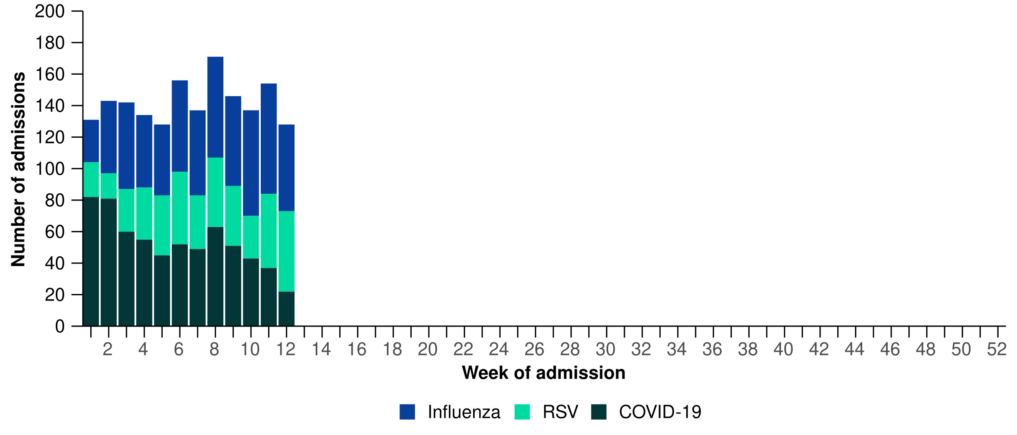
Source: Influenza Complications Alert Network (FluCAN)

- In the year to date for severity reporting, after influenza A(Unsubtyped), influenza B was most commonly detected in children (the <6 months, 6 months–4 years, and 5–16 years age groups). In contrast, influenza A (H1N1) was most commonly detected in adults (17–64 years and 65 years and over) after influenza A(Unsubtyped) (Figure 13).
  - While influenza B is often a good match with the seasonal influenza vaccine strain, influenza B can result in more severe infections in children.

Figure 13: Number of patients admitted with influenza to sentinel hospitals by influenza subtype, age group, and week of admission*, Australia, 1 January to 23 March 2025
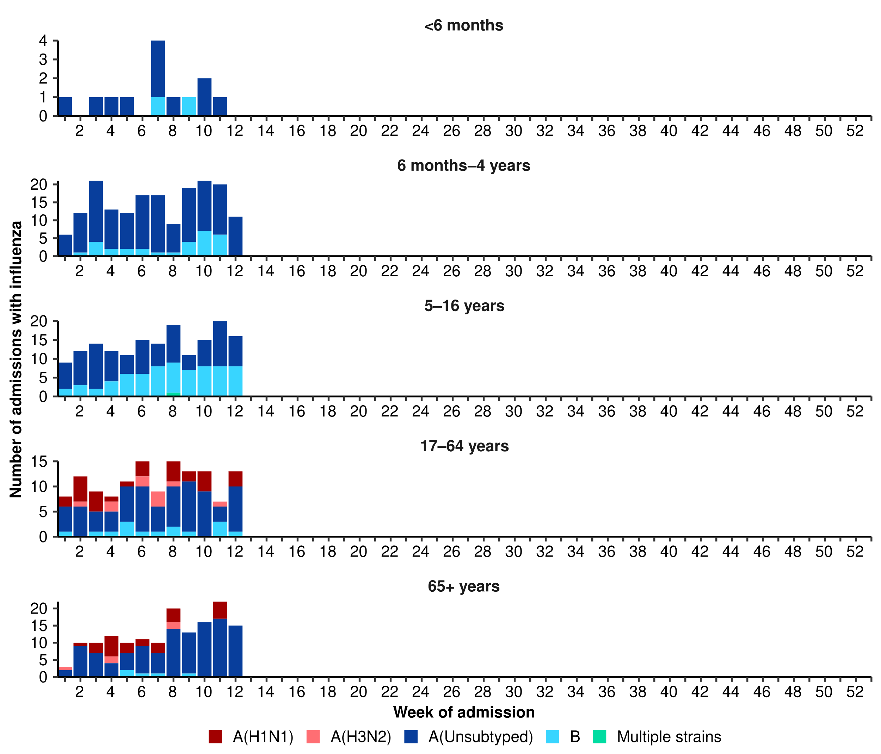
Source: Influenza Complications Alert Network (FluCAN)
* Axis varies between age groups. The age distribution of admissions with influenza may not reflect the age distribution of all patients.

- In the year to date for severity reporting, children (those aged 16 years and younger) were more commonly admitted with influenza or RSV than with COVID-19 at sentinel hospitals (Table 2a).
- Children admitted to sentinel hospitals with influenza tended to be older than children admitted with COVID-19 or RSV (Table 2a).
- Children admitted to sentinel hospitals with RSV had a slightly longer length of hospital stay compared to children with influenza or COVID-19; however, the difference in the length of stay was minor. A higher proportion of children admitted with COVID-19 were admitted directly to intensive care, compared to children admitted with influenza or RSV (Table 2a).
Table 2a: Demographic characteristics and outcomes for children admitted with a severe acute respiratory infection to a sentinel hospital by disease, Australia, 1 January to 23 March 2025
 | COVID-19 | Influenza | RSV
 | Year to date for  severity reporting  (n=257) | Year to date for  severity reporting  (n=359) | Year to date for  severity reporting  (n=342)
Age (years)
Median [IQR] | 1 [0–3] | 4 [1–8] | 1 [0–2]
Age group (years)
< 6 months | 85 (33.1%) | 13 (3.6%) | 78 (22.8%)
6 months – 4 years | 119 (46.3%) | 178 (49.6%) | 237 (69.3%)
5–16 years | 53 (20.6%) | 168 (46.8%) | 27 (7.9%)
Indigenous status
Aboriginal and Torres Strait Islander | 29 (11.3%) | 30 (8.4%) | 25 (7.3%)
Length of hospital stay (days)†
Median [IQR] | 1 [1–2] | 1 [1–2] | 2 [1–3]
Patient admission location‡
Admitted to hospital ward | 240 (93.4%) | 344 (95.8%) | 328 (95.9%)
Admitted to intensive care directly | 17 (6.6%) | 15 (4.2%) | 14 (4.1%)
Discharge status†
Alive | 207 (80.5%) | 307 (85.5%) | 273 (79.8%)
Died | – | – | –
Incomplete/missing | 50 (19.5%) | 52 (14.5%) | 69 (20.2%)
Source: Influenza Complications Alert Network (FluCAN)
* Does not include patients with missing age; therefore, the sum of age-specific totals above may not equal the total number of patients.
† For patients who are still in hospital data may not be complete; therefore, these data are not included in the length of stay or discharge status. In addition, length of stay data excludes patients that acquired their infection in hospital.
‡ Admission location reflects the initial admission ward. Some patients may be initially admitted to general ward then later admitted to an intensive care and this is not reflected here. Does not include patients with missing admission location; therefore, the sum of admission location specific totals above may not equal the total number of patients.
The Paediatric Active Enhanced Disease Surveillance (PAEDS) network carries out enhanced sentinel hospital surveillance for some acute respiratory infections or conditions in children. PAEDS data for acute respiratory infections in children are presented in the Australian Respiratory Surveillance Reports in the sentinel hospital data from FluCAN. For additional information on COVID-19 in children, Paediatric Inflammatory Multisystem Syndrome (PIMS-TS) following COVID-19, influenza in children, or RSV in children please visit the PAEDS webpages and dashboards.

- Adults (those aged 17 years and over) were more commonly admitted with COVID-19 than influenza or RSV at sentinel hospitals (Table 2b).
- Adults admitted to sentinel hospitals with COVID-19 or RSV were predominately 65 years and over, while the proportion of admissions with influenza was similar across the 17–64 years and 65 years and over age groups (Table 2b).
- Adults admitted to sentinel hospitals with COVID-19 had a slightly longer length of hospital stay compared to adults with influenza or RSV; however, the difference in the length of stay was minor . A higher proportion of adults with influenza or RSV were admitted directly to intensive care, compared to adults admitted with COVID-19 (Table 2b).
- Sadly, there have been a small number of adults admitted with a severe acute respiratory infections who have died in hospital (Table 2b).
Table 2b: Demographic characteristics and outcomes for adults admitted with a severe acute respiratory infection to a sentinel hospital by disease, Australia, 1 January to 23 March 2025
 | COVID-19 | Influenza | RSV
 | Year to date for  severity reporting  (n=383) | Year to date for  severity reporting  (n=285) | Year to date for  severity reporting  (n=81)
Age (years)
Median [IQR] | 75 [60–83] | 67 [51–78] | 75 [64–81]
Age group (years)
17–64 years | 119 (31.1%) | 133 (46.7%) | 24 (29.6%)
65 years and over | 264 (68.9%) | 152 (53.3%) | 57 (70.4%)
Indigenous status
Aboriginal and Torres Strait Islander | 32 (8.4%) | 17 (6.0%) | 9 (11.1%)
Length of hospital stay (days)†
Median [IQR] | 5 [2–8] | 4 [2–6] | 4 [2–8]
Patient admission location‡
Admitted to hospital ward | 355 (92.7%) | 256 (89.8%) | 72 (88.9%)
Admitted to intensive care directly | 28 (7.3%) | 29 (10.2%) | 9 (11.1%)
Discharge status†
Alive | 300 (78.3%) | 225 (78.9%) | 48 (59.3%)
Died | 13 (3.4%) | 5 (1.8%) | 4 (4.9%)
Incomplete/missing | 70 (18.3%) | 55 (19.3%) | 29 (35.8%)
Source: Influenza Complications Alert Network (FluCAN)
* Does not include patients with missing age; therefore, the sum of age-specific totals above may not equal the total number of patients.
† For patients who are still in hospital data may not be complete; therefore, these data are not included in the length of stay or discharge status. In addition, length of stay data excludes patients that acquired their infection in hospital.
‡ Admission location reflects the initial admission ward. Some patients may be initially admitted to general ward then later admitted to an intensive care and this is not reflected here. Does not include patients with missing admission location; therefore, the sum of admission location specific totals above may not equal the total number of patients.

- Sentinel intensive care surveillance shows the number of patients admitted to intensive care with severe acute respiratory infections has remained low and stable this year. Please note, sentinel intensive care data are updated each month, as such the sentinel intensive care surveillance data presented here have not been updated since the previous report.
- In this severity reporting period (10 February to 9 March 2025), fewer patients have been admitted to a sentinel intensive care with a severe acute respiratory infection (n=155), than in the previous severity reporting period (n=170) (Figure 14).
- In the year to date for severity reporting (1 January to 9 March 2025), most patients were admitted to sentinel intensive care with COVID-19, followed by rhinovirus / enterovirus (Figure 14; Table 3).

Figure 14: Number of patients admitted with severe acute respiratory infections to a sentinel intensive care by disease and week of admission, Australia, 1 January to 9 March 2025
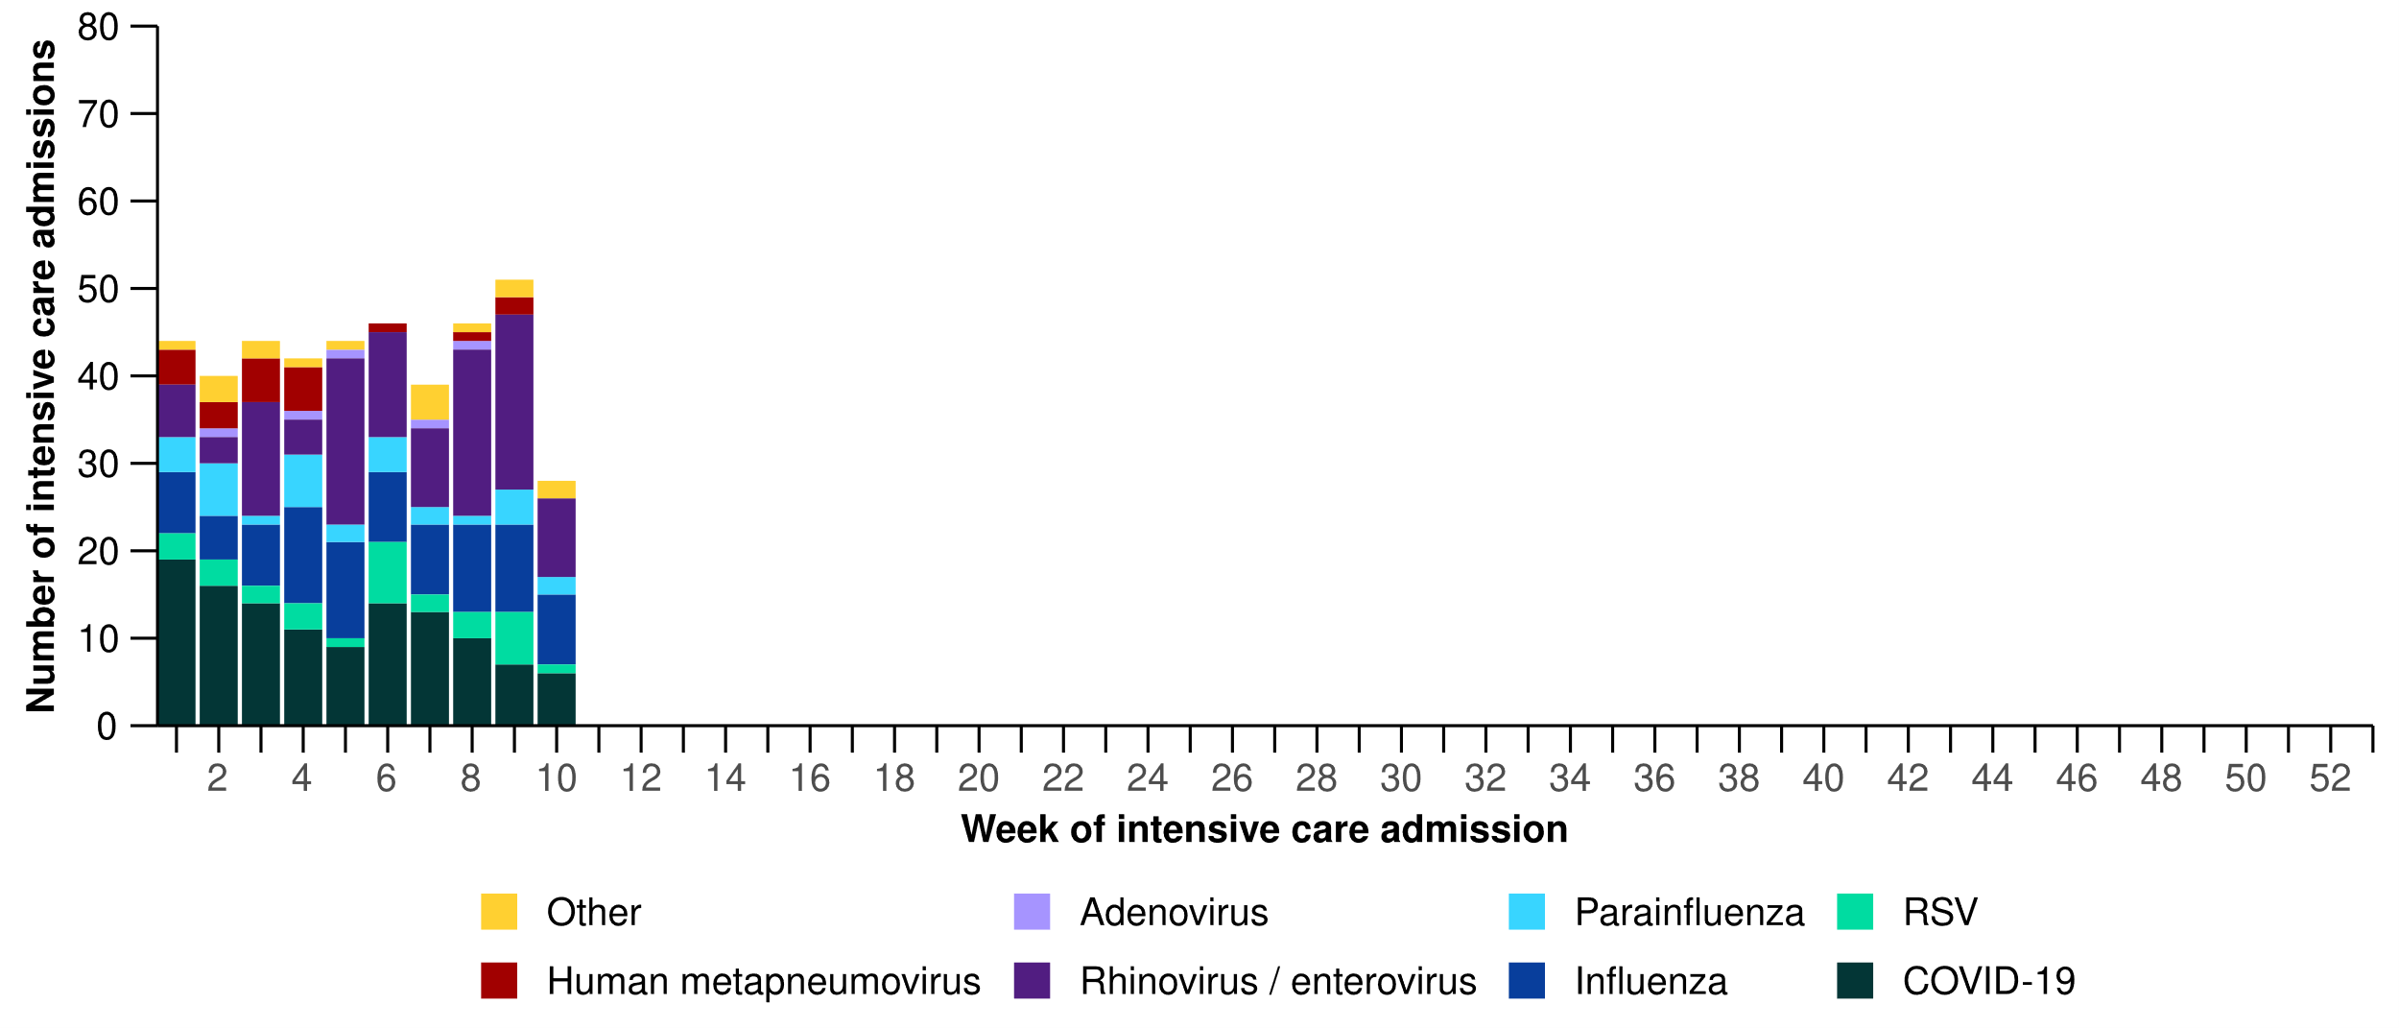
Source: Short Period Incidence Study of Severe Acute Respiratory Infection (SPRINT-SARI) Australia
Note: A range of diagnostic testing procedures are utilised across hospitals in Australia. SPRINT-SARI does not specify which diagnostic testing method should be utilised as this is the domain of the hospital and treating clinicians. Therefore, virological data from SPRINT-SARI should be interpreted with care.
Figure 15: Number of patients admitted with severe acute respiratory infections to a sentinel intensive care by disease and age group*, Australia, 1 January to 9 March 2025
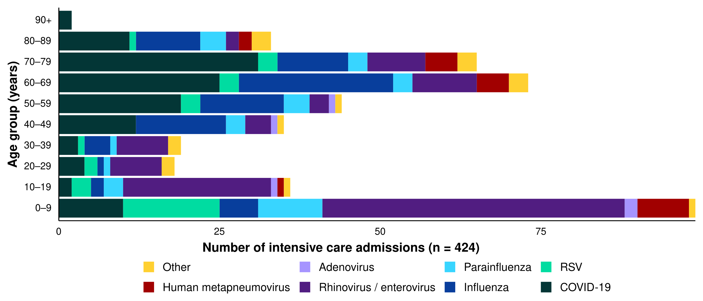
Source: Short Period Incidence Study of Severe Acute Respiratory Infection (SPRINT-SARI) Australia
Note: 3.9% (16/406) of patients had co-infections of respiratory pathogens; therefore, the sum of pathogen-specific totals above may not equal the total number of severe acute respiratory infection patients.
* The age distribution of severe acute respiratory infection intensive care admissions may not reflect the age distribution of all patients.
- Admissions to a sentinel intensive care with COVID-19, hMPV, or influenza have been generally among older people. In contrast, admissions to a sentinel intensive care with rhinovirus or RSV have been among younger people (Figure 15; Table 3).
- A higher proportion of patients with COVID-19, hMPV, influenza, and parainfluenza required invasive mechanical ventilation, and the length of ventilation was highest among those with hMPV and influenza. The length of intensive care stay was similar across diseases (Table 3).
- Most patients admitted to a sentinel intensive care with a severe acute respiratory infection have been discharged home. Sadly, a small number of patients have died in hospital (Table 3).
Table 3: Demographic characteristics and outcomes of patients admitted with a severe acute respiratory infection to a sentinel intensive care by disease*†, Australia, 1 January to 9 March 2025
 | COVID-19 | hMPV | Influenza | Parainfluenza | Rhinovirus | RSV | Other
 | Year to date for severity reporting  (n=119) | Year to date for severity reporting  (n=21) | Year to date for severity reporting  (n=85) | Year to date for severity reporting  (n=32) | Year to date for severity reporting  (n=114) | Year to date for severity reporting  (n=31) | Year to date for severity reporting  (n=22)
Age (years)
Median [IQR] | 65 [49–74] | 66 [3–72] | 61 [46–69] | 42 [4–68] | 13 [4–38] | 10 [4–58] | 52 [22–70]
Indigenous status
Aboriginal and Torres Strait Islander | 16  (13.4%) | 1  (4.8%) | 13  (15.3%) | 2  (6.2%) | 14  (12.3%) | – | 3  (13.6%)
Non-Indigenous | 103  (86.6%) | 20  (95.2%) | 72  (84.7%) | 30  (93.8%) | 100  (87.7%) | 31  (100.0%) | 19  (86.4%)
Received invasive mechanical ventilation
Number (%) | 40  (33.6%) | 7  (33.3%) | 27  (31.8%) | 12  (37.5%) | 25  (21.9%) | 3  (9.7%) | 5  (22.7%)
Length of invasive mechanical ventilation (days)*
Median [IQR] | 3 [1–6] | 6 [2–10] | 5 [1–11] | 3 [1–13] | 2 [1–5] | 0 [0–1] | 2 [2–4]
Length of intensive care stay (days)*
Median [IQR] | 3 [2–5] | 3 [2–5] | 3 [2–7] | 2 [1–5] | 2 [1–4] | 2 [1–4] | 3 [1–6]
Length of hospital stay (days)*
Median [IQR] | 7 [4–14] | 8 [6–14] | 8 [5–12] | 6 [3–10] | 4 [2–8] | 4 [3–9] | 11 [6–18]
Patient outcome†
Ongoing care in intensive care | 8  (6.7%) | 1  (4.8%) | 5  (5.9%) | 2  (6.2%) | 9  (7.9%) | 1  (3.2%) | –
Ongoing care in hospital ward | 8  (6.7%) | – | 7  (8.2%) | 2  (6.2%) | 11  (9.6%) | – | 2  (9.1%)
Transfer to other hospital / facility | 18  (15.1%) | 1  (4.8%) | 10  (11.8%) | 3  (9.4%) | 8  (7.0%) | 2  (6.5%) | 4  (18.2%)
Discharged home | 63  (52.9%) | 17  (81.0%) | 53  (62.4%) | 22  (68.8%) | 82  (71.9%) | 27  (87.1%) | 13  (59.1%)
Died in hospital | 22  (18.5%) | 2  (9.5%) | 9  (10.6%) | 2  (6.2%) | 4  (3.5%) | 1  (3.2%) | 3  (13.6%)
Source: Short Period Incidence Study of Severe Acute Respiratory Infection (SPRINT-SARI) Australia
Note: 3.9% (16/406) of patients had co-infections of respiratory pathogens; therefore, the sum of pathogen-specific totals above may not equal the total number of severe acute respiratory infection patients.
* For patients receiving ongoing care in intensive care data may not be complete; therefore, data are not included in the length of ventilation or stay.
† Patients who have been admitted with no discharge information for less than 90 days have been assumed to have ongoing care in the hospital. Patients who have no outcome entered or have been admitted for more than 90 days with no discharge information have been treated as missing.
- This fortnight (24 March to 6 April 2025), there has been fewer COVID-19 cases in intensive care across Australia than in the previous fortnight (Figure 16).
- This fortnight, there have been more intensive care staff unavailable to work due to COVID-19 exposure or illness across Australia than in the previous fortnight (Figure 16).

Figure 16: Average number of COVID-19 cases in intensive care and the average number of intensive care staff unavailable to work due to COVID-19 exposure or illness by week of report*†, Australia, 1 January to 6 April 2025 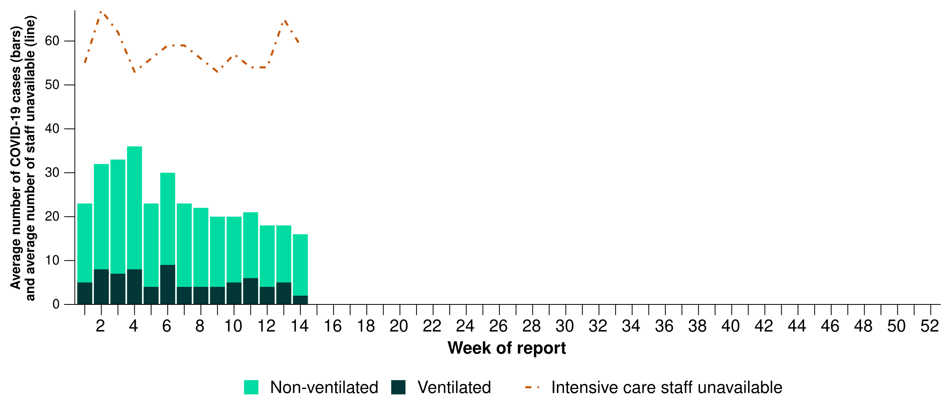
Source: Critical Health Resource Information System (CHRIS)
* Average number of ventilated and non-ventilated COVID-19 cases in intensive care includes only active COVID-19 cases (those in isolation) and does not include cleared COVID-19 cases.
† Intensive care staff include both medical and nursing staff. Staff unavailability will be underestimated in New South Wales as most public hospitals in New South Wales do not report staff unavailability.
- This fortnight, COVID-19 cases in intensive care have decreased or remained stable across most jurisdictions, except in Queensland and Victoria where an increase was observed compared with the previous fortnight (Figure 17).
- This fortnight, the number of intensive care staff unavailable to work due to COVID-19 exposure or illness has increased in the Australian Capital Territory, New South Wales, and Victoria compared with the previous fortnight, but remained stable across all other jurisdictions (Figure 17).

Figure 17: Average number of COVID-19 cases in intensive care and the average number of intensive care staff unavailable to work due to COVID-19 exposure or illness by jurisdiction and week of report*†‡, Australia, 1 January to 6 April 2025
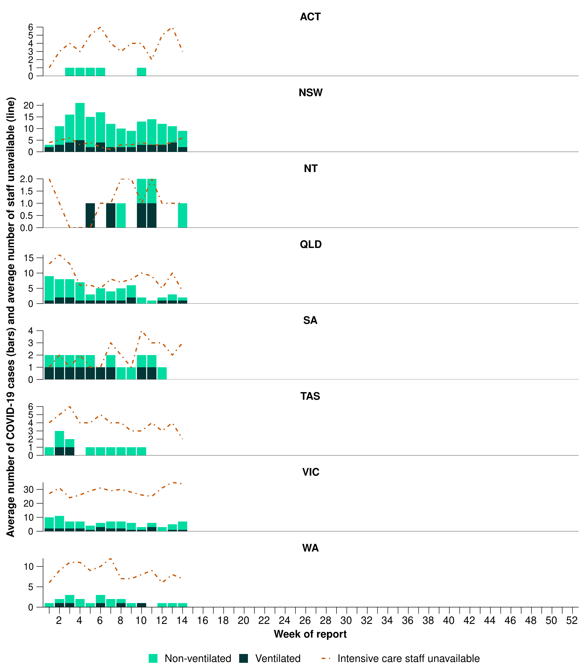
Source: Critical Health Resource Information System (CHRIS)
* Axis varies between jurisdictions.
† Average number of ventilated and non-ventilated COVID-19 cases in intensive care includes only active COVID-19 cases (those in isolation) and does not include cleared COVID-19 cases.
‡ Intensive care staff include both medical and nursing staff. Staff unavailability will be underestimated in New South Wales as most public hospitals in New South Wales do not report staff unavailability.

Mortality surveillance
Death registrations can provide information on the scale and severity of disease associated with acute respiratory infections. Please note, this report presents Provisional Mortality Statistics by number of deaths due to and deaths with acute respiratory infection. For more information on death registrations, including completeness, timeliness and definitions of deaths due to and with acute respiratory infections, refer to the Technical Supplement.
- There are more deaths due to COVID-19 and influenza than deaths with COVID-19 and influenza across 2023–2025. In contrast, there are substantially more people who died with RSV than due to RSV across 2023–2025.
- There were 228 deaths due to COVID-19 in January 2025, an increase since the low recorded in October 2024 (140 deaths); however, the number of deaths due to COVID-19 in January 2025 remains well below the number of deaths due to COVID-19 at the same time in previous years.
- There were 26 deaths due to influenza in January 2025, up from 12 deaths in December. This is comparable to January 2024 (27 deaths) though well above January 2023 (8 deaths).
- There were 10 deaths with RSV in January 2025, comparable to the 8 deaths in January 2024.

Figure 18: Provisional numbers of deaths due to (left) or deaths with (right) acute respiratory infection*†‡ by month, year, and disease, Australia, 1 January 2023 to 28 February 2025
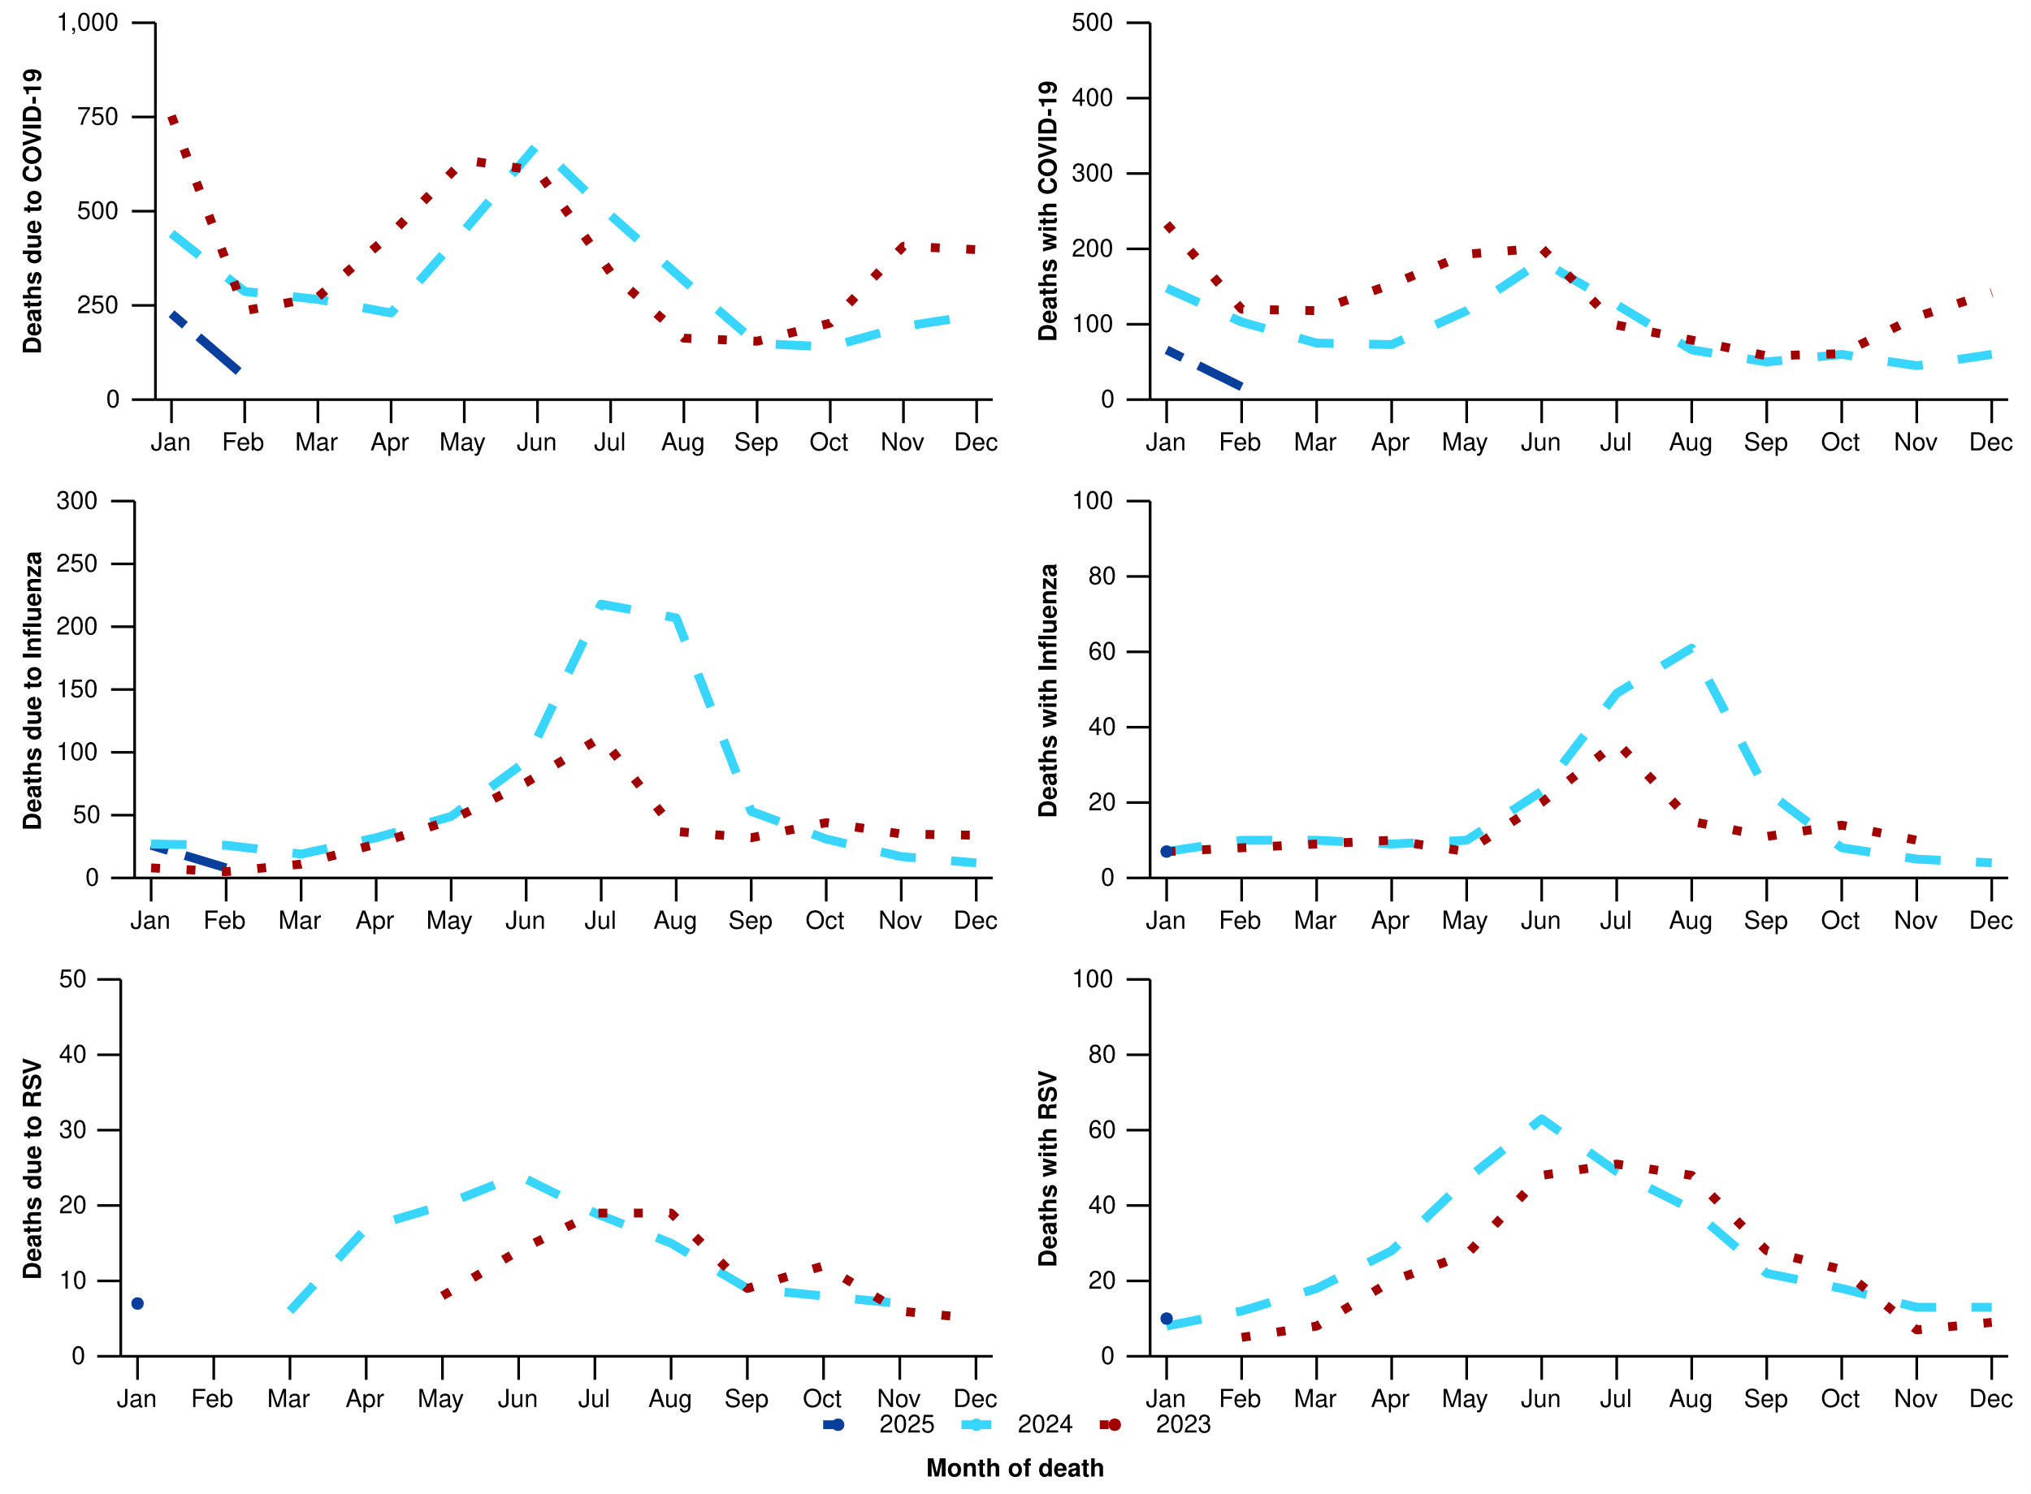
Source: Australian Bureau of Statistics, Provisional Mortality Statistics, Jan - Dec 2024, released 31 Mar 2025.
* Axis varies between acute respiratory infections and by deaths due to or with an acute respiratory infection.
† Data is provisional and subject to change. It can take several weeks for death registrations to be reported, processed, coded, validated, and tabulated. Therefore, the data shown here may be incomplete, and will likely not include all deaths that occurred during a given time. Additionally, data for some months were not published by the ABS due to small counts, and therefore data for these months are not reported in Figure 18. Data includes all deaths (both doctor and coroner certified) that occurred and were registered by 28 February 2025. Please refer to the Technical Supplement for more information.
‡ All deaths due to/with COVID-19 in this report have been coded to ICD-10 codes U07.1-U07.2, U10.9. All deaths due to/with influenza have been coded to J09-J11. All deaths due to/with RSV have been coded to J12.1, J20.5, J21.0, B34.8 with B97.4.

Laboratory surveillance
Sentinel laboratory surveillance monitors and characterises respiratory pathogens to provide information on what pathogens are circulating, potential changes in the pathogens that might affect their infectiousness, severity, ability to evade vaccine and/or infection-acquired immunity, or resistance to antivirals.
- This fortnight (24 March to 6 April 2025), SARS-CoV-2 test positivity remains at 2.9% (347/12,072), influenza positivity has remained relatively stable at 5.1% (745/14,602), and RSV positivity has slightly increased to 1.5% (176/12,072) (Figure 19).

Figure 19: Number of tests positive (bars) and test positivity (line) for SARS-CoV-2, influenza or RSV of those specimens tested by sentinel laboratories by week of report*†, Australia, 1 January to 6 April 2025
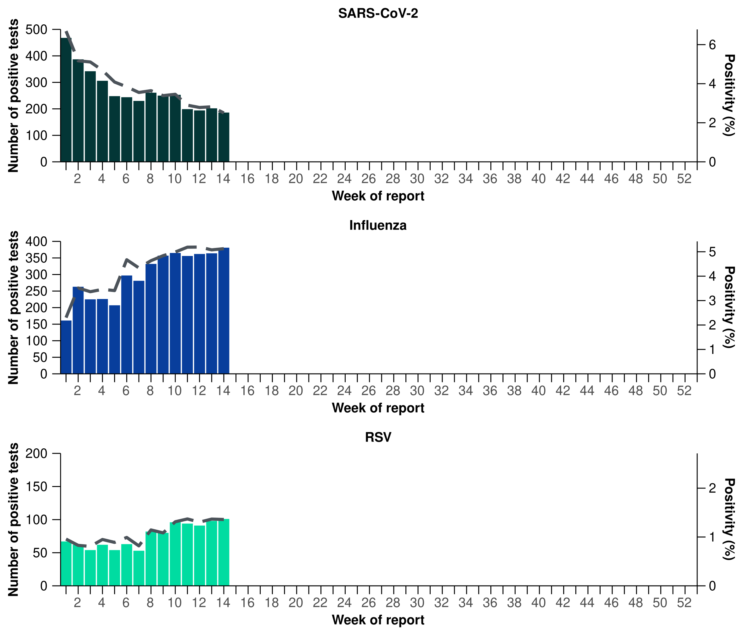
Source: Sentinel laboratories, including National Influenza Centres
* Number of specimens tested excludes data from Western Australia as testing denominator data are different for the three pathogens in Western Australia.
† A small minority of total samples from Victoria are tested only by respiratory panel (influenza, parainfluenza, adenovirus, human metapneumovirus, seasonal coronaviruses, RSV, and some picornaviruses) but not for SARS-CoV-2. These minority samples include only forensic materials; all other samples are tested by respiratory panel and SARS-CoV-2 assay.

- Please note, AusTrakka SARS-CoV-2 sequencing data are updated each month, as such SARS-CoV-2 sequence data presented here have not been updated since the previous report. There were 271 SARS-CoV-2 sequences uploaded to AusTrakka with dates of collection in the past 28 days (24 February to 23 March 2025). These sequences were from New South Wales, Queensland, South Australia, Tasmania, and Western Australia, with the most recent collection date 10 March 2025.
- All sequences were assigned to the BA.2.86 sub-lineage within B.1.1.529 (Omicron) or recombinants consisting of one or more Omicron sub-lineages (Figure 20). There were no BA.1, BA.3, BA.4, BA.5 or other BA.2 sub-sub-lineage sequences. In the past 28 days (24 February to 23 March 2025):
  - 41.7% (113/271) of sequences were from the sub-sub-lineages JN.1 (BA.2.86.1.1)
  - 58.3% (158/271) of sequences were recombinant or recombinant sub-lineages, including XEC, a recombinant between KS.1.1 (JN.1.13.1.1.1) and KP.3.3.
- XEC is now the dominant circulating variant; however, the proportion of JN.1 sequences has increased in the past 28 days due to a decrease in the proportion of recombinant lineages (Figure 20).
- The World Health Organization (WHO) have identified certain sub-sub-lineages and recombinants as variants under monitoring (VUM) or variants of interest (VOI) because of their epidemiological, pathological, or immunological features of concern. A select number of designated VUM or VOI are highlighted below due to their relevance in the Australian context:
  - There are 275 LP.8.1 sequences in AusTrakka, with 34 collected in the past 28 days. LP.8.1 was designated as a VUM as of 24 January 2025. The February WHO Risk Evaluation, noted the proportion of LP.8.1 sequences is growing rapidly compared to co-circulating variants; however, there is no significant increase in case numbers associated with LP.8.1 infections, and there are no reports to suggest that the associated disease severity is higher.
  - There are 2,415 XEC sequences in AusTrakka, including 149 collected in past 28 days.
  - There are 343 LB.1 sequences in AusTrakka, with five sequences identified in the past 28 days.
  - There are 2,549 KP.3.1.1 sequences in AusTrakka, with 63 sequences identified in the past 28 days.

Figure 20a: SARS-CoV-2 Omicron sub-lineage* sequences by sample collection date, showing the proportions of sequences per week^†, Australia, 1 January to 23 March 2025
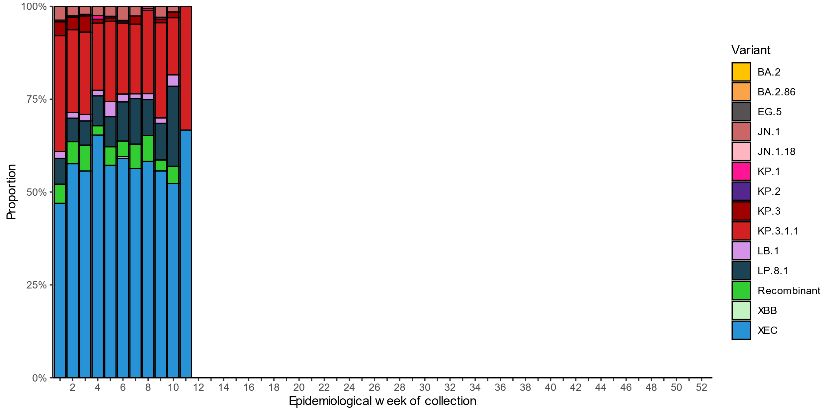
Source: AusTrakka
* Some sub-sublineages are shown alongside their parent lineage, but not included in the parent lineage totals. For instance, KP.2 and KP.3 are sub-sub lineages of JN.1, so the total of JN.1 sequences will be higher than shown in the corresponding colour alone, and should include the KP.2 and KP.3 totals.
^ Sequences in AusTrakka aggregated by week and reported based on date of sample collection, not date of sequencing.
† Proportions in Figure 20a may not be representative when sequence numbers are small; refer to Figure 20b. Data for earlier weeks may change between reporting periods as sequences with older collection dates are uploaded. These numbers are not equivalent to number of cases, as there are many cases which may not be sequenced. Non-VOI and non-VUM Omicron sub-lineages have been collapsed into parent lineages BA.1, BA.2, BA.3, BA.4 and BA.5.
Figure 20b: SARS-CoV-2 Omicron sub-lineage* sequences by sample collection date, showing the count of sequences per week^†, Australia, 1 January to 23 March 2025
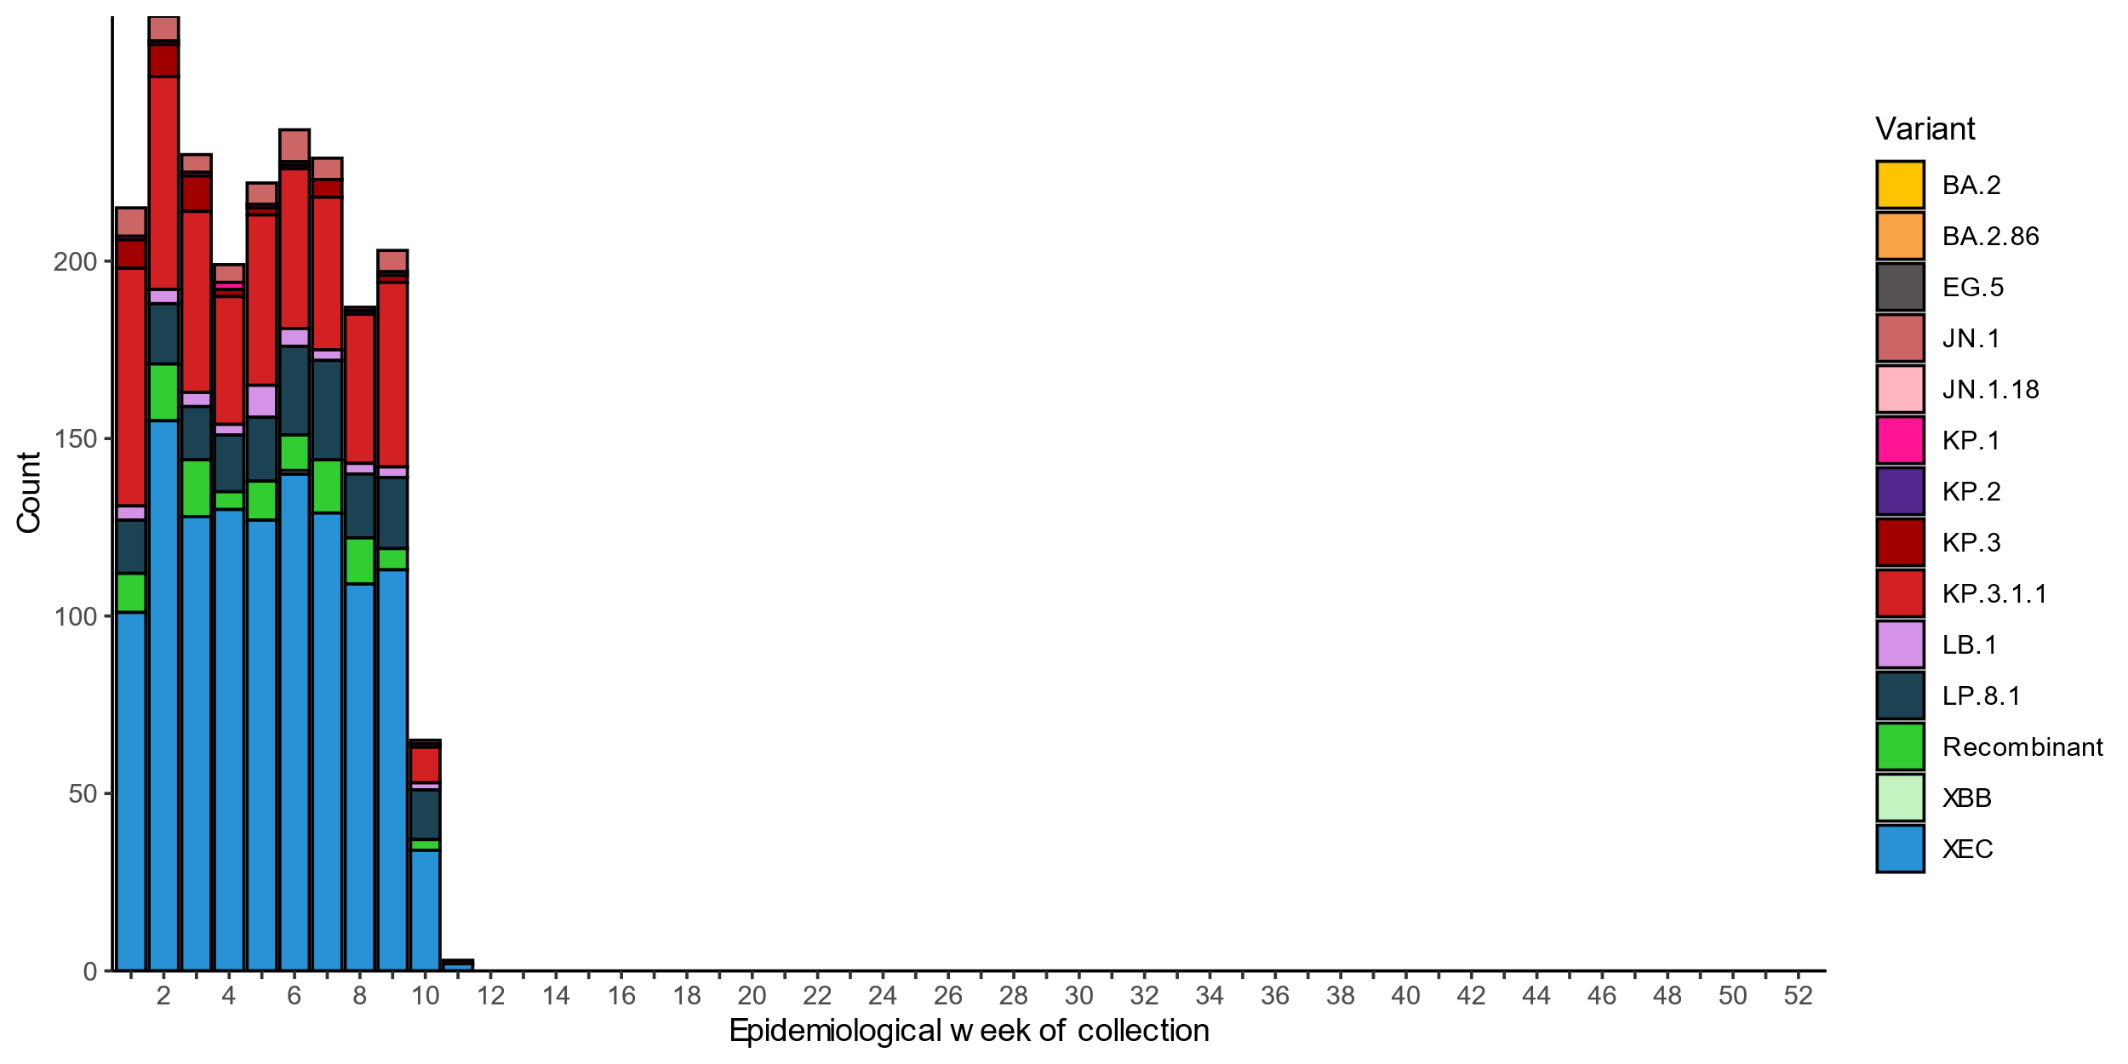
Source: AusTrakka
* Some sub-sublineages are shown alongside their parent lineage, but not included in the parent lineage totals. For instance, KP.2 and KP.3 are sub-sub lineages of JN.1, so the total of JN.1 sequences will be higher than shown in the corresponding colour alone, and should include the KP.2 and KP.3 totals.
^ Sequences in AusTrakka aggregated by week and reported based on date of sample collection, not date of sequencing.
† Data for earlier weeks may change between reporting periods as sequences with older collection dates are uploaded. These numbers are not equivalent to number of cases, as there are many cases which may not be sequenced. Non-VOI and non-VUM Omicron sub-lineages have been collapsed into parent lineages BA.1, BA.2, BA.3, BA.4 and BA.5.
- In the year to date, the WHO Collaborating Centre for Reference and Research on Influenza has antigenically characterised 820 influenza viruses from Australia (Table 4), of which:
  - 74.3% (609/820) have been influenza A(H1N1)
  - 17.3% (142/820) have been influenza A(H3N2)
  - 8.4% (69/820) have been influenza B/Victoria.
- In the year to date, there continue to be no influenza B/Yamagata viruses characterised by the WHOCC (Table 4). The last influenza B/Yamagata virus characterised by the WHO Collaborating Centre in Australia was in a sample from 2020.
- Of the influenza A(H1N1) samples tested for neuraminidase inhibitor resistance, 0.5% (1/207) demonstrated highly reduced inhibition to Oseltamivir. None of the influenza A(H3N2) samples tested for neuraminidase inhibitor resistance demonstrated highly reduced inhibition to Oseltamivir.
- None of the samples tested demonstrated highly reduced inhibition to Zanamivir.

Table 4: Australian influenza viruses typed by haemagglutination inhibition assay and jurisdiction*†, 1 January to 6 April 2025
Strain | ACT | NSW | NT | Qld | SA | Tas. | Vic. | WA | Total
A(H1N1) | 107 | 53 | 193 | 15 | 16 | 73 | 148 | 4 | 609
A(H3N2) | 8 | 15 | 59 | 5 | 2 | 9 | 42 | 2 | 142
B/Victoria lineage | 16 | 6 | 7 | 1 | 6 | 4 | 24 | 5 | 69
B/Yamagata lineage | 0 | 0 | 0 | 0 | 0 | 0 | 0 | 0 | 0
Total | 131 | 74 | 259 | 21 | 24 | 86 | 214 | 11 | 820
Source: World Health Organization (WHO) Collaborating Centre for Reference and Research on Influenza
*Viruses tested by the WHO Collaborating Centre for Reference and Research on Influenza are not necessarily a random sample of all those in the community and early-year data may be based on limited samples received. There may be up to a month delay on reporting of samples.
† Jurisdiction indicates the residential location for the individual tested, not the submitting laboratory.

Vaccine coverage, effectiveness and match
Vaccine coverage, effectiveness and match for acute respiratory infections are monitored from several data sources in Australia. Refer to the Technical Supplement for more information.

Vaccine coverage
- Data on vaccine coverage is currently unavailable, but will be included in future reports.

Vaccine effectiveness
- It is too early to assess vaccine effectiveness for the 2025 influenza season.

Vaccine match
- Refer to the Technical Supplement for information on the 2025 southern hemisphere influenza vaccines composition.
- In the year to date, 98.4% (599/609) of influenza A(H1N1) isolates, 100% (142/142) of influenza A(H3N2) isolates and 100% (69/69) of influenza B/Victoria lineage isolates characterised have been antigenically similar to the corresponding 2025 vaccine components.

