Australian Respiratory Surveillance Report

Key messages
This report presents a national epidemiological update for acute respiratory infections, including coronavirus disease 2019 (COVID-19), influenza and respiratory syncytial virus (RSV), with a focus on the current reporting period (28 July to 10 August 2025) and earlier severity reporting periods (up to 27 July 2025).
In the community: In the last fortnight, influenza-like-illness among national helpline callers remains higher than at the same time last year, though similar to the previous fortnight. New fever and cough symptoms self-reported in community surveys remain lower than the trends observed at the same time last year and the five-year average. The proportion of FluTracking participants who reported new fever and cough symptoms in the last fortnight was similar to the previous fortnight but fewer people reported taking time off work due to respiratory illness compared to the previous fortnight. Nationally, COVID-19 cases continued to decrease in the last fortnight and remain lower than at the same time in previous years. Nationally, influenza cases decreased slightly in the previous fortnight and plateaued in the last fortnight; similar to the trend observed at the same time last year. Nationally, RSV cases in the last fortnight decreased slightly, continuing the gradually decreasing trend in national case numbers observed since mid-July 2025.
In general practice: There were similar rates of influenza-like-illness (new fever and cough symptoms) consultations at sentinel surveillance sites reported in the last fortnight compared with the previous fortnight. Since early June 2025, influenza-like-illness consultation rates have steadily increased and now exceed the five-year average; however, remain lower than the same time last year.
In hospitals: Sentinel hospital-based surveillance indicates admissions with severe acute respiratory infections increased from late March to late June 2025, and have since been following an overall decreasing trend. The proportion of patients who were admitted directly to intensive care at a sentinel hospital site remains low. At sentinel hospitals, more children (those aged 16 years and younger) were admitted with RSV than with influenza or COVID-19, while more adults were admitted with COVID-19 compared to influenza or RSV. Sentinel intensive care surveillance shows the number of admissions with severe acute respiratory infections each week have generally increased since late May 2025, and have been declining from late June 2025. In 2025 to date, most patients were admitted to sentinel intensive care with rhinovirus / enterovirus, followed by influenza; however, in recent weeks patients have predominantly been admitted to sentinel intensive care with influenza. A higher proportion of intensive care admissions with influenza and parainfluenza required invasive mechanical ventilation, and the duration of intensive care stay continues vary slightly between illnesses.
Deaths: COVID-19 has been the leading cause of acute respiratory infection mortality across 2023–2025. All three of these acute respiratory infections are more likely to cause death in older age groups than younger age groups.
In laboratories: Test positivity for SARS-CoV-2 and influenza decreased slightly in the last fortnight, while test positivity for RSV increased. The SARS-CoV-2 variant under monitoring, NB.1.8.1, is the dominant SARS-CoV-2 variant in the last 28 days (14 July to 10 August 2025) accounting for 72.2% of sequences in Australia. Small numbers of sequences of other variants under monitoring, including XFG, LP.8.1, KP.3.1.1 and XEC continue to be observed in Australia.
Vaccine coverage, effectiveness and match: Nationally, fewer adults have received a COVID-19 vaccine in the last 12 months compared to the 12 months prior. Influenza vaccine coverage this year to date is consistent with coverage at the same time last year; however, remains lower than at the same time in 2023 and 2022. Since the commencement of the National RSV Mother and Infant Protection Program, 101,93 Abrysvo doses have been administered and nirsevimab uptake is increasing. Of influenza isolates characterised in 2025 thus far, over 98% have been a good match to the corresponding 2025 vaccine components.

Australian Respiratory Surveillance Report
This report was prepared by Ash Donovan, Lauren Welsh, Suzie Whitehead and Siobhan St George on behalf of the interim Australian Centre for Disease Control. We thank the staff and participants from the surveillance systems who contribute data for acute respiratory illness surveillance across Australia.
The report presents a national overview of acute respiratory infections in Australia, drawing information from several different surveillance systems. These surveillance systems help us to understand the distribution of acute respiratory illnesses in the community, the severity of infections including which populations might be at risk, and the impact of acute respiratory illnesses on the community and health system in Australia.
Surveillance indicators presented in this report are based on the Australian National Surveillance Plan for COVID-19, Influenza, and RSV. Please refer to the Technical Supplement – Australian Respiratory Surveillance Report for information on our surveillance sources and data considerations, including the considerable impact of the COVID-19 pandemic on acute respiratory infection surveillance in Australia. A summary of data considerations for this report are provided below:
- Due to the dynamic nature of the surveillance systems used in this report, surveillance data are considered preliminary and subject to change as updates are received, with the most recent weeks considered particularly incomplete. Data in this report may vary from data reported in other national reports and reports by states and territories.
- Data in this report are presented by date of event (diagnosis, admission or death) or by the International Organization for Standardization (ISO) week date system, with weeks defined as seven-day periods which begin on a Monday and end on a Sunday. The ISO week date system is used to support trends comparisons over time more effectively. The current reporting period includes 28 July to 10 August 2025 and where comparisons to the previous fortnight are made, this includes 14 July to 27 July 2025.
- In Australia, states and territories (the Australian Capital Territory [ACT], New South Wales [NSW], the Northern Territory [NT], Queensland [Qld], South Australia [SA], Tasmania [Tas], Victoria [Vic], and Western Australia [WA]) report notified cases to the National Notifiable Diseases Surveillance System (NNDSS) based on the Australian national surveillance case definitions. NNDSS data are analysed and reported based on diagnosis date, which is the true onset date of a case if known, otherwise it is the earliest of the specimen date, the notification date, or the notification received date. The NNDSS data for this report were extracted on 13 August 2025.
- To account for the lag in collection and provision of severity data from some surveillance systems, and for the time delay between illness onset and the development of severe disease outcomes, cases with an admission date or a diagnosis date in the last two weeks are excluded from severity analyses for hospitalisations and intensive care admissions. As such, the severity reporting periods are two weeks behind the end of the current reporting period. For this report, severity reporting includes data from 14 July to 27 July 2025 unless specified otherwise. Where comparisons to the previous severity fortnight are made this includes 30 June to 13 July 2025.
- Death registrations from the Australian Bureau of Statistics (ABS) Provisional Mortality Statistics are now used as the primary data source for measuring acute respiratory infection associated deaths. The ABS mortality data is sourced from the Registry of Births, Deaths and Marriages and is separate from the NNDSS. Registration-based mortality data needs time to be received and processed. For this reason, mortality statistics in this report may lag by at least two months.
- Analysis and reporting outputs were produced using R Statistical Software v4.3.1. While every care has been taken in preparing this report, the Australian Government Department of Health, Disability and Ageing does not accept liability for any injury or loss or damage arising from the use of, or reliance upon, the content of the report or Technical Supplement. For further information about this report refer to the Technical Supplement – Australian Respiratory Surveillance Report or contact respiratory.surveillance@health.gov.au.

Community surveillance
Community surveillance monitors respiratory illnesses in the community, providing information on the number of people reporting respiratory symptoms, testing practices, and the impact of respiratory illnesses. Community surveillance includes notification data obtained from laboratory tests for infections. Infections that are diagnosed and notified are only a subset of the total number of infections occurring in the community.
- In the last fortnight (28 July to 10 August 2025), the rate of influenza-like-illness among helpline callers to Healthdirect (400 per 1,000 callers per fortnight) was similar to the previous fortnight (408 per 1,000 callers per fortnight) (Figure 1).
- In the last fortnight, the rate of influenza-like-illness among helpline callers has been higher than the rate of influenza-like-illness at the same time in 2024 and 2023 (Figure 1).
Figure 1: Rate of influenza-like-illness per 1,000 helpline callers by year and week of call*, Australia†, 22 March 2023 to 10 August 2025
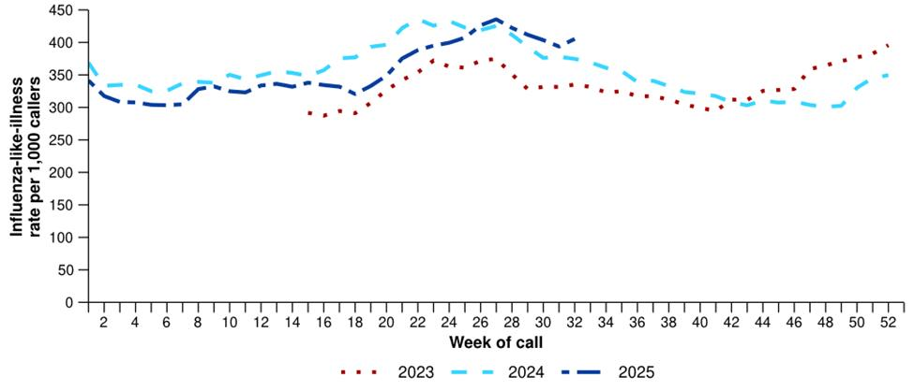
Source: Healthdirect Australia
* Healthdirect data prior to 22 March 2023 are unavailable as prior to this date a different data collection method was used.
† The Healthdirect helpline operates in all states and territories except Qld; therefore influenza-like-illness trends will not be representative of Qld and may be underrepresented. See the Technical Supplement for more information.
- In the last fortnight, there were less Healthdirect helpline callers with influenza-like-illness referred to seek urgent medical care (198 per 1,000 callers per fortnight) than in the previous fortnight (202 per 1,000 callers per fortnight) (Figure 2).
  - Callers referred to seek urgent medical care include those referred to call triple zero, attend a hospital emergency department, contact a virtual emergency department, urgent care clinic or see a general practitioner within two hours.
- In the last fortnight, referral pathways varied between jurisdictions with the ACT, Tas and WA having the highest proportion of people recommended to attend a hospital emergency department (Figure 2). In comparison, NSW, SA and Vic had the highest proportion of people referred to seek other urgent care including virtual emergency departments (Figure 2). This trend should be interpreted with caution as virtual emergency care options vary between jurisdictions.

Figure 2: Proportion of referral categories* for helpline callers with influenza-like-illness by jurisdiction† and call date, Australia, 1 January to 10 August 2025
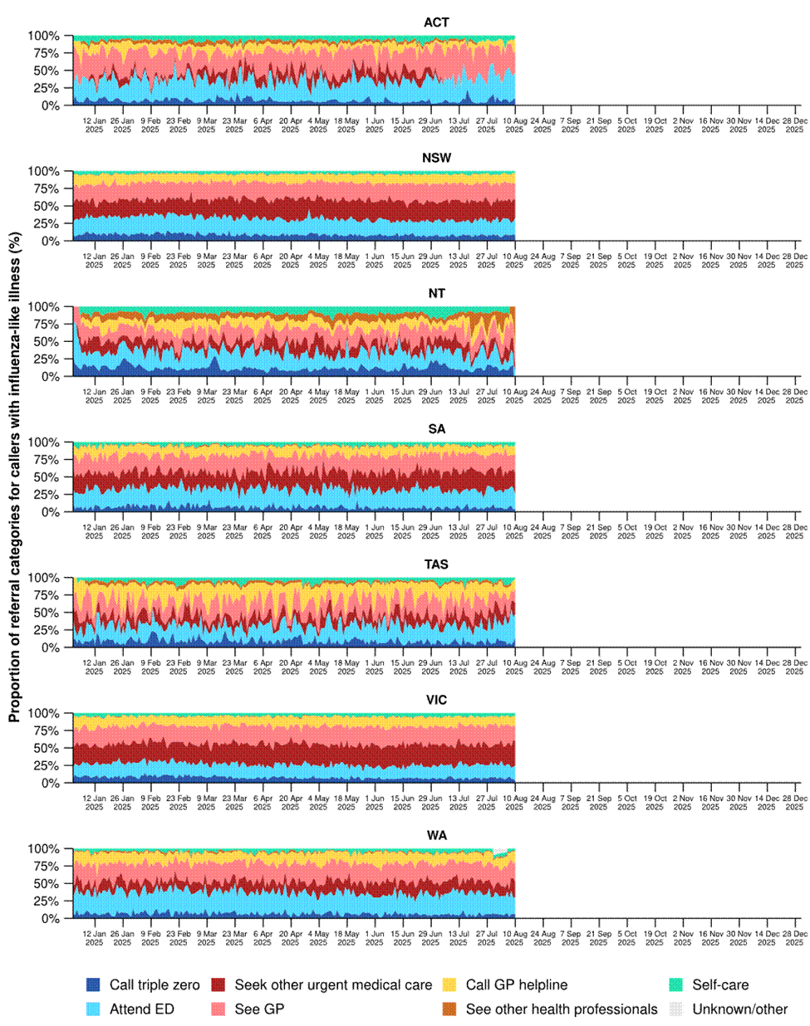
Source: Healthdirect Australia
* See other health professionals category includes pharmacist, dentist, mental health provider, primary maternity care, poison information centre or other.
† The Healthdirect helpline operates in all states and territories except Qld; therefore influenza-like-illness referral trends are not provided for Qld. See the Technical Supplement for more information.

- In the last fortnight (28 July to 10 August 2025), the proportion of FluTracking survey participants reporting new fever and cough symptoms (1.9%) was similar to the previous fortnight (1.8%) (Figure 3).
- In the last fortnight, more survey participants with new fever and cough symptoms used a rapid antigen test (RAT) (54.9%; 615/1,120) than a polymerase chain reaction (PCR) test (9.0%; 101/1,120) to test for severe acute respiratory syndrome coronavirus 2 (SARS-CoV-2).
- Self-reported SARS-CoV-2 RAT positivity was lower in the last fortnight (15.4%; 95/615) than in the previous fortnight (17.8%; 137/769). However, self-reported SARS-CoV-2 PCR positivity was higher in the last fortnight (13.9%; 14/101) than in the previous fortnight (10.1%; 18/178).
- In the last fortnight, 8.1% (91/1,120) of survey participants with new fever and cough symptoms used a PCR test to test for influenza. Self-reported influenza PCR positivity was slightly higher this fortnight (36.3%; 33/91), than in the previous fortnight (34.5%; 58/168).
- In the last fortnight, less survey participants reported taking three or more days off work or normal duties due to fever and cough symptoms (47.4%; 531/1,120), than in the previous fortnight (51.1%; 686/1,343).
- From mid-March to mid-June 2025, the weekly proportion of FluTracking survey participants with new fever and cough symptoms was lower than observed at the same time in 2022, 2023, 2024, and the five-year average; however, since early July the weekly proportion has been relatively similar to the trends observed at the same time last year and the five-year average (Figure 3).
Figure 3: Age standardised proportion of survey participants reporting new fever and cough symptoms compared with the five-year average* by year and week of survey, Australia, 2022 to 10 August 2025
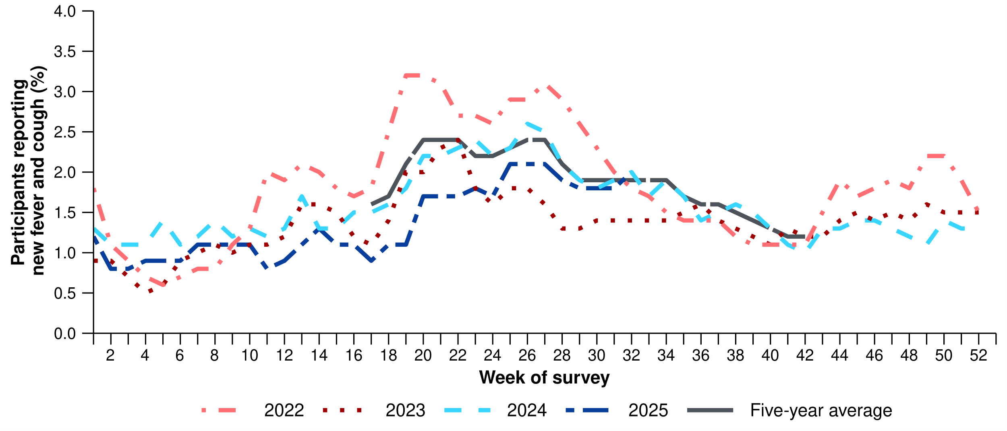
Source: FluTracking
* From 2020, FluTracking expanded their data capture period to year-round. Data before May and after October for any year before 2020 are not available for historical comparisons. The years 2020 and 2021 are excluded when comparing the current season to historical periods when influenza virus has circulated without public health restrictions. As such, the five-year average includes the years 2018 to 2019 and 2022 to 2024. Please refer to the Technical Supplement for interpretation of the five-year average.

- In the last fortnight (28 July to 10 August 2025), there was a 16.1% decrease in COVID-19 cases, a 2.3% increase in influenza cases, and an 8.5% decrease in RSV cases.
Table 1: Notified cases and notification rate per 100,000 population by disease, five-year age group, and jurisdiction*†, Australia, 1 January to 10 August 2025
 | COVID-19 |  |  | Influenza |  |  | RSV
 | Reporting  period  (n) | Year to  date  (n) | Year to  date  (rate) | Reporting  period  (n) | Year to  date  (n) | Year to  date  (rate) | Reporting  period  (n) | Year to  date  (n) | Year to  date  (rate)
Age group (years)
0–4 | 959 | 13,201 | 875 | 4,803 | 33,025 | 2,189 | 4,897 | 61,400 | 4,069
5–9 | 357 | 3,595 | 223 | 5,864 | 38,782 | 2,407 | 908 | 9,105 | 565
10–14 | 337 | 3,897 | 233 | 3,935 | 25,469 | 1,521 | 403 | 3,724 | 222
15–19 | 325 | 4,509 | 271 | 2,472 | 15,524 | 934 | 314 | 2,545 | 153
20–24 | 338 | 4,709 | 263 | 1,389 | 9,104 | 509 | 231 | 2,094 | 117
25–29 | 367 | 5,868 | 294 | 1,361 | 8,924 | 447 | 257 | 2,570 | 129
30–34 | 477 | 7,126 | 349 | 1,876 | 13,095 | 642 | 340 | 3,322 | 163
35–39 | 569 | 8,160 | 411 | 2,488 | 17,640 | 889 | 331 | 3,381 | 170
40–44 | 475 | 7,833 | 423 | 2,500 | 18,053 | 975 | 289 | 2,876 | 155
45–49 | 443 | 6,770 | 416 | 1,980 | 14,008 | 860 | 277 | 2,636 | 162
50–54 | 395 | 6,792 | 402 | 1,842 | 12,810 | 758 | 311 | 3,228 | 191
55–59 | 403 | 6,625 | 432 | 1,611 | 11,682 | 762 | 366 | 3,513 | 229
60–64 | 420 | 7,078 | 461 | 1,461 | 11,381 | 742 | 417 | 3,988 | 260
65–69 | 410 | 7,279 | 535 | 1,321 | 9,975 | 734 | 431 | 4,222 | 311
70+ | 2,340 | 45,385 | 1,359 | 4,565 | 32,855 | 983 | 1,936 | 17,176 | 514
Jurisdiction
ACT | 116 | 2,205 | 465 | 891 | 5,585 | 1,178 | 296 | 2,220 | 468
NSW | 3,459 | 63,226 | 745 | 16,125 | 105,429 | 1,243 | 3,070 | 56,989 | 672
NT | 67 | 986 | 387 | 339 | 2,986 | 1,171 | 38 | 638 | 250
Qld | 2,359 | 28,646 | 513 | 9,621 | 53,654 | 960 | 2,007 | 22,933 | 411
SA | 491 | 8,498 | 452 | 2,400 | 19,650 | 1,046 | 1,530 | 6,874 | 366
Tas | 153 | 2,000 | 348 | 553 | 3,958 | 688 | 266 | 1,478 | 257
Vic | 1,542 | 23,599 | 338 | 6,931 | 63,104 | 904 | 3,014 | 27,534 | 394
WA | 442 | 9,767 | 329 | 2,630 | 18,161 | 612 | 1,487 | 7,125 | 240
Total | 8,629 | 138,927 | 511 | 39,490 | 272,527 | 1,002 | 11,708 | 125,791 | 462
Source: National Notifiable Diseases Surveillance System (NNDSS)
* Rate per 100,000 population for the given time period. Population data are based on the Australian Bureau of Statistics (ABS) Estimated Resident Population (ERP) for the reference period June 2024, released 12 December 2024.
† Total includes cases with missing age.

- In the last fortnight, the number of COVID-19 cases continued to decrease following a national peak in late June (Figure 4). The total number of COVID-19 cases this year to date (n=138,927) is 32.3% less than the number of cases observed in the same time period last year (n=205,155) (Figure 4).
- In the last fortnight, COVID-19 notification rates continued to decrease across most jurisdictions; however, remained relatively stable in Qld, and increased slightly in the ACT, the NT, and SA (Figure 5).
- In the year to date, COVID-19 notification rates remain highest in people aged 70 years or over, likely due to higher case ascertainment from targeted testing strategies for populations at-risk of severe disease or who live in a high-risk setting such as a residential aged care home (Table 1).
- In the year to date, COVID-19 notification rates are highest in NSW and lowest in WA (Table 1).
Figure 4: Notified COVID-19 cases (laboratory-confirmed only) by year and week of diagnosis, Australia, 2022 to 10 August 2025
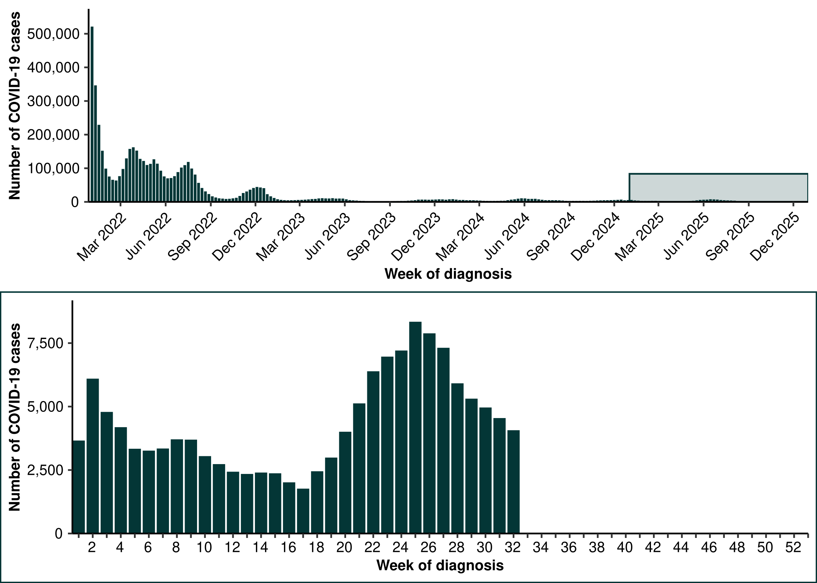
Source: National Notifiable Diseases Surveillance System (NNDSS)

Figure 5: Notification rates* per 100,000 population for COVID-19 cases by state or territory and week of diagnosis, Australia, 1 January to 10 August 2025
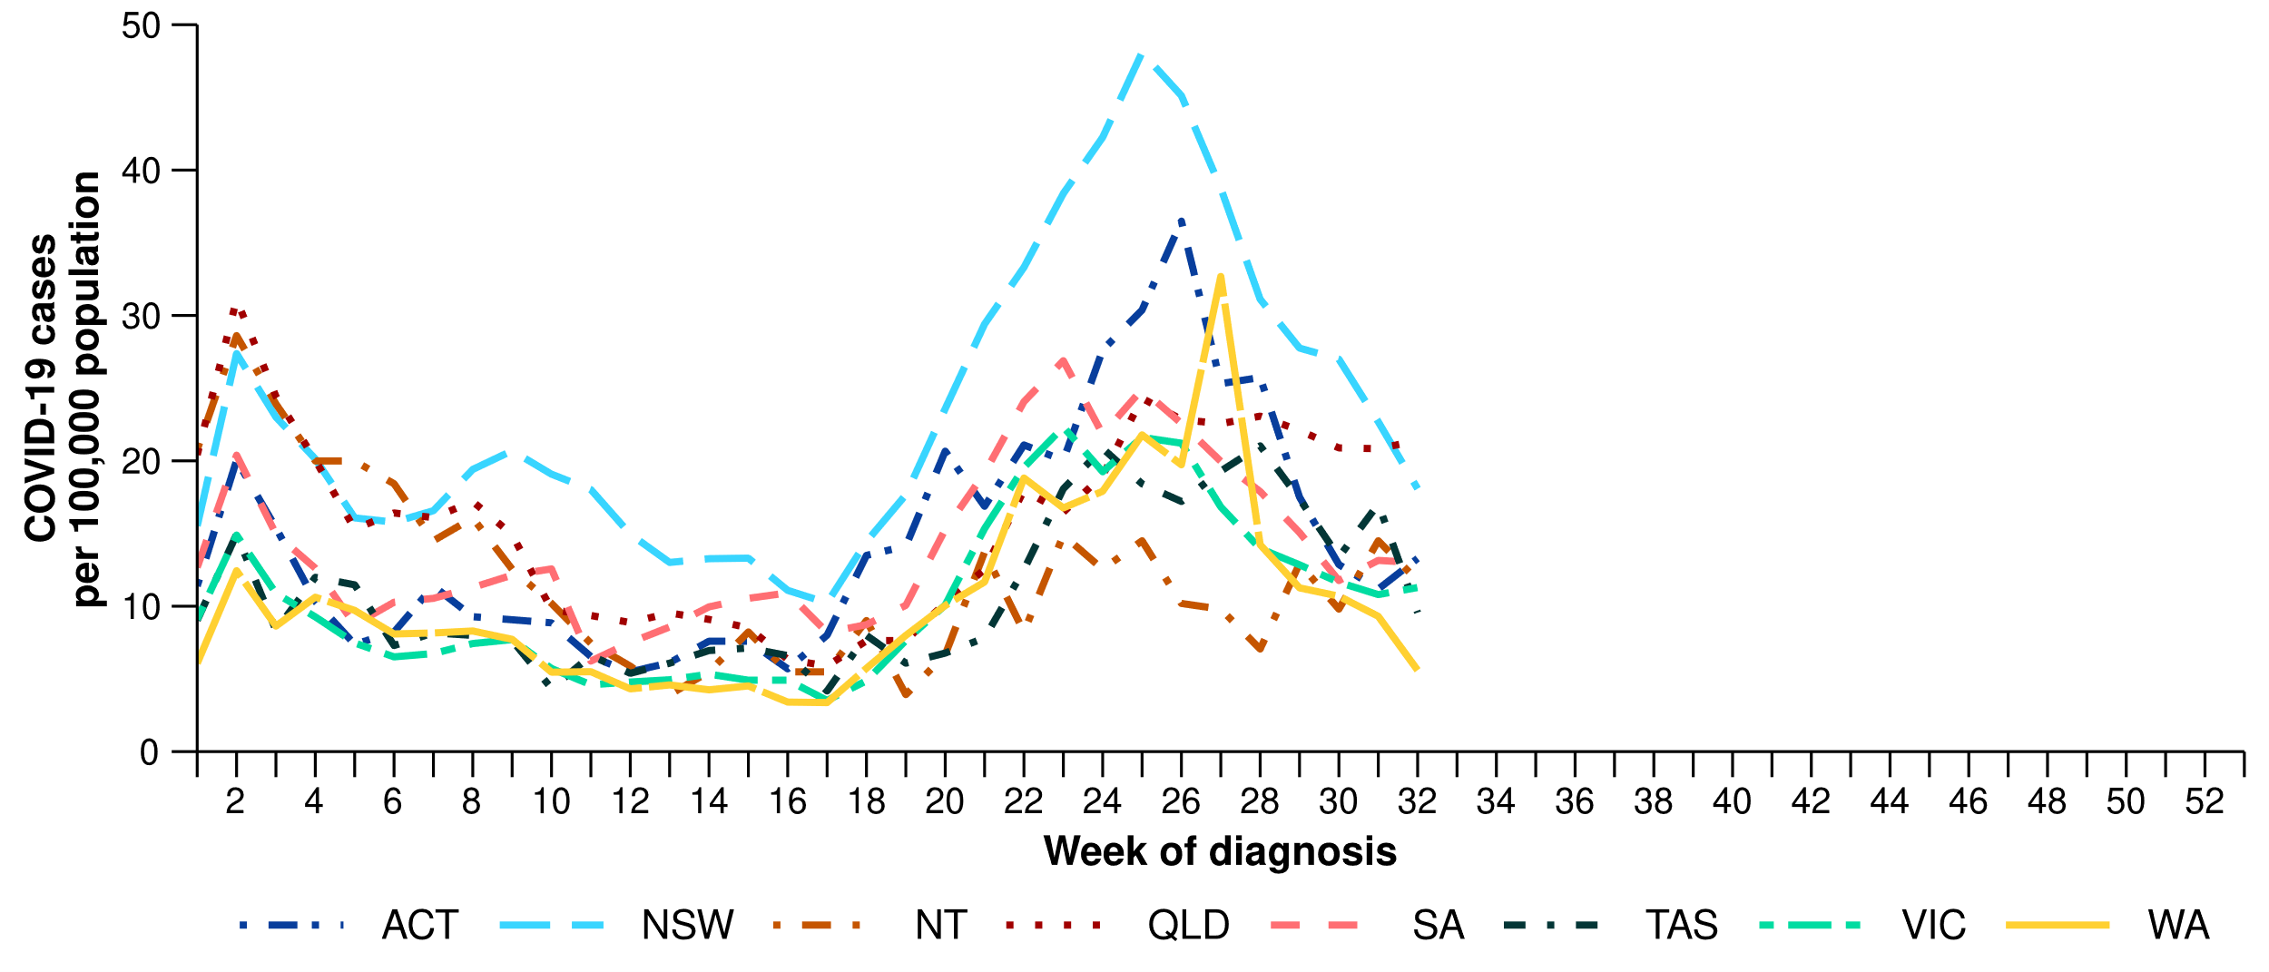
Source: National Notifiable Diseases Surveillance System (NNDSS)
* Rate per 100,000 population for the given time period. Population data are based on the Australian Bureau of Statistics (ABS) Estimated Resident Population (ERP) for the reference period June 2024, released 12 December 2024
Figure 6: Notified influenza cases and five-year average* by year and week of diagnosis, Australia, 2022 to 10 August 2025
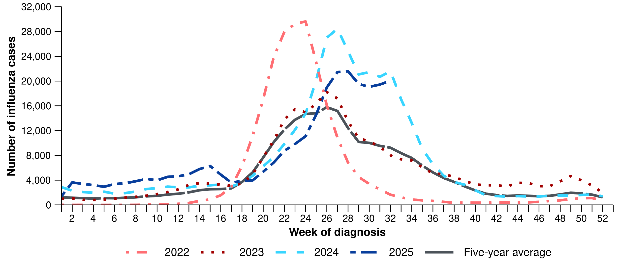
Source: National Notifiable Diseases Surveillance System (NNDSS)
* The years 2020 and 2021 are excluded when comparing the current season to historical periods when influenza virus has circulated without public health restrictions. As such, the five-year average includes the years 2018 to 2019 and 2022 to 2024. Please refer to the Technical Supplement for interpretation of the five-year average.
- After decreasing in the previous fortnight (14 July to 27 July 2025), the number of influenza cases nationally has increased slightly and plateaued, similar to the trend observed at the same time last year (Figure 6).
- The number of influenza cases this year to date (n=272,527) is 4.7% less than the number of cases observed in the same time period last year (n=286,026) (Figure 6). Weekly influenza case numbers in 2025 have not surpassed the number of cases seen at the peak of the influenza season in either 2022 (n=29,621 per week) or 2024 (n= 28,453 per week); however, case numbers remain above the five-year average.
- In the last fortnight, influenza notification rates have varied across all jurisdictions. Notifications rates increased in the ACT, Qld, and WA; remained relatively stable in NSW, Tas and Vic; and decreased in the NT and SA (Figure 7).
- In the year to date, influenza notification rates remain highest in children aged 5–9 years and children aged 0–4 years (Table 1).
- In the year to date, influenza notification rates are highest NSW and lowest in WA (Table 1).
Figure 7: Notification rates* per 100,000 population for influenza cases by state or territory and week of diagnosis, Australia, 1 January to 10 August 2025
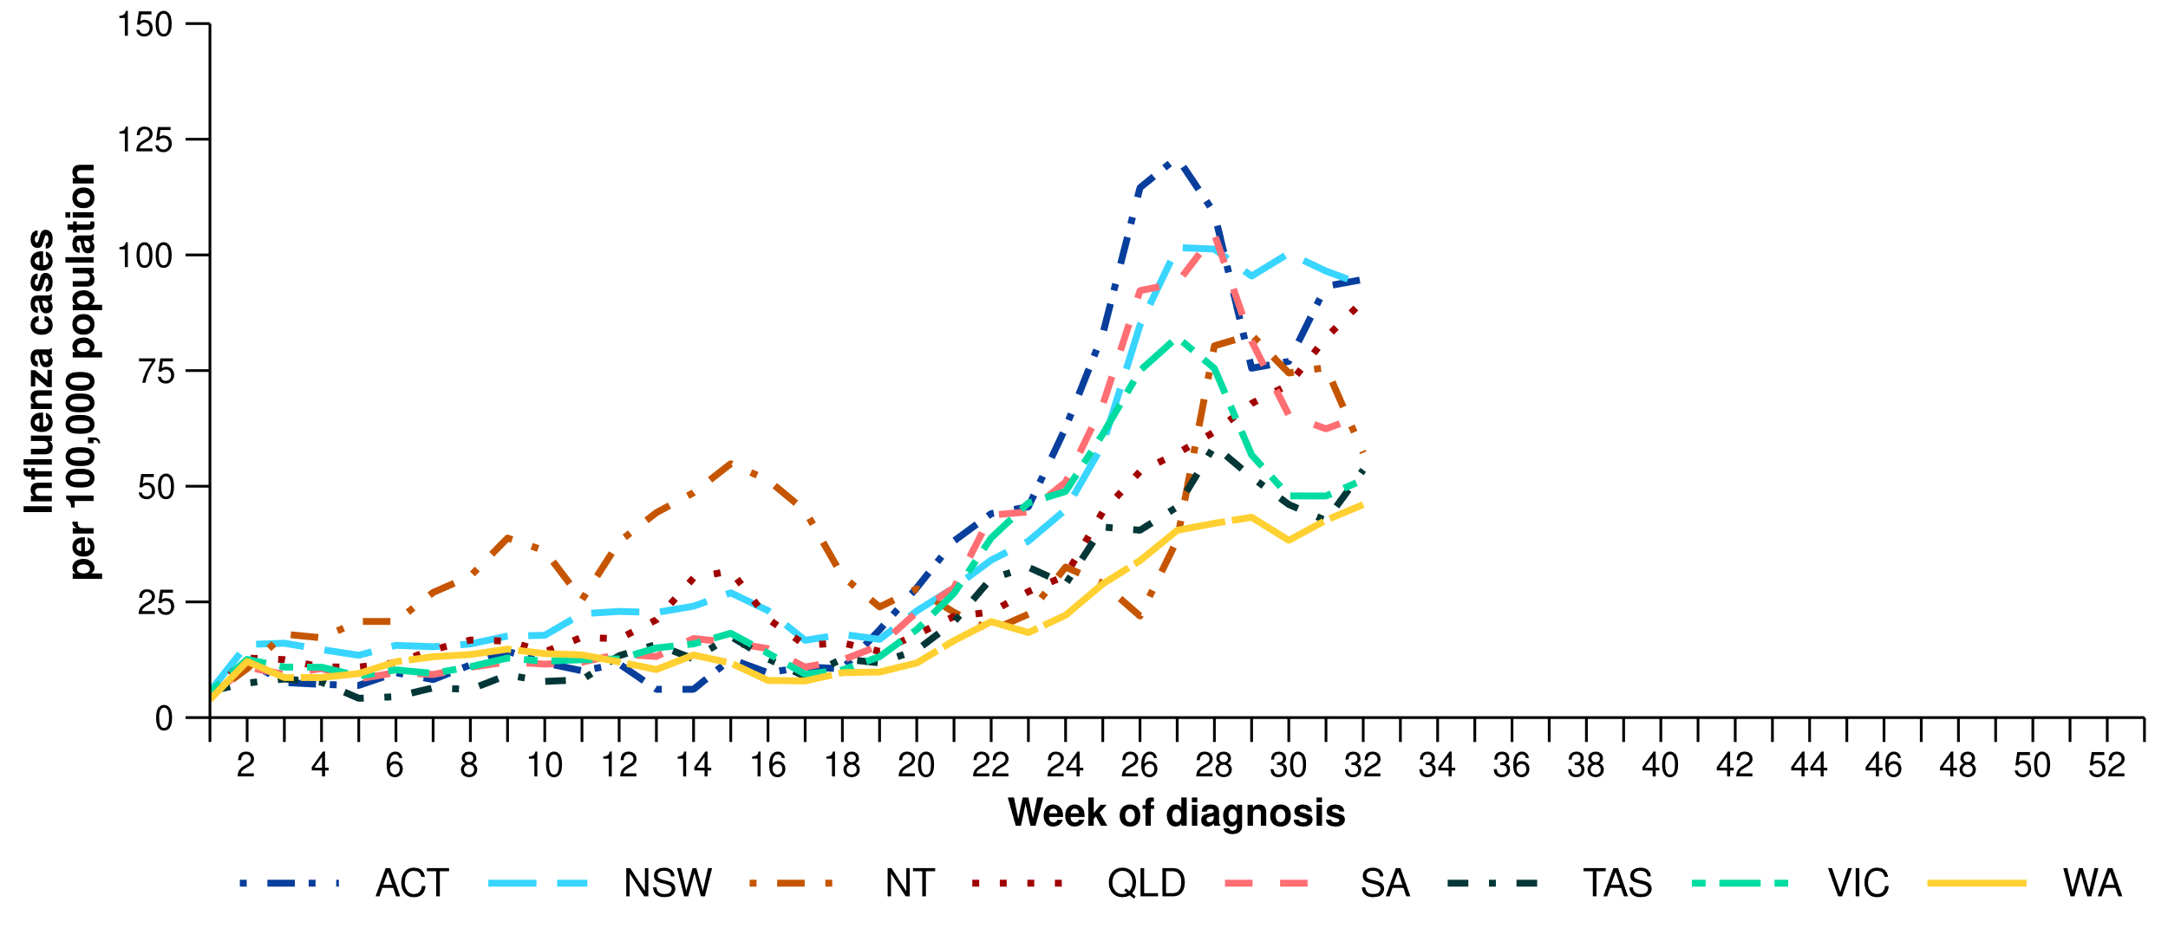
Source: National Notifiable Diseases Surveillance System (NNDSS)
* Rate per 100,000 population for the given time period. Population data are based on the Australian Bureau of Statistics (ABS) Estimated Resident Population (ERP) for the reference period June 2024, released 12 December 2024.
- In the last fortnight, most influenza notifications were influenza A(Unsubtyped) (66.2%; 26,148/39,490), followed by influenza B (31.3%; 12,350/39,490), then influenza A(H1N1) (1.9%; 738/39,490), and influenza untyped (0.4%; 166/39,490). In the last fortnight, there have been 40 influenza A&B co-detections (Figure 8).
- In the year to date, influenza A(Unsubtyped) has accounted for most cases across all age groups, followed by influenza B. The proportion of influenza B cases is the highest in the 5–19 years age group. There has been a small number of influenza A(H1N1) and influenza A(H3N2) cases across all age groups (Figure 8).
  - There is a comparatively higher proportion of influenza B cases this season than observed in 2024. While influenza B is often a good match with the seasonal influenza vaccine strain, influenza B can result in more severe infections in children.
- In the year to date, influenza A(Unsubtyped) has accounted for the majority of influenza cases across all jurisdictions. Several jurisdictions have been experiencing increasing numbers of influenza B cases in the year to date; however, the proportion of influenza B and influenza A varies week-on-week (Figure 9).
- Influenza A(H1N1) and influenza A(H3N2) cases were most commonly observed in Tas and WA (Figure 9); however, trends in influenza subtypes should be interpreted with care as there are jurisdictional differences in the number and selection of influenza samples that undergo typing.

Figure 8: Notified influenza cases by influenza subtype, age group*, and week of diagnosis, Australia, 1 January to 10 August 2025
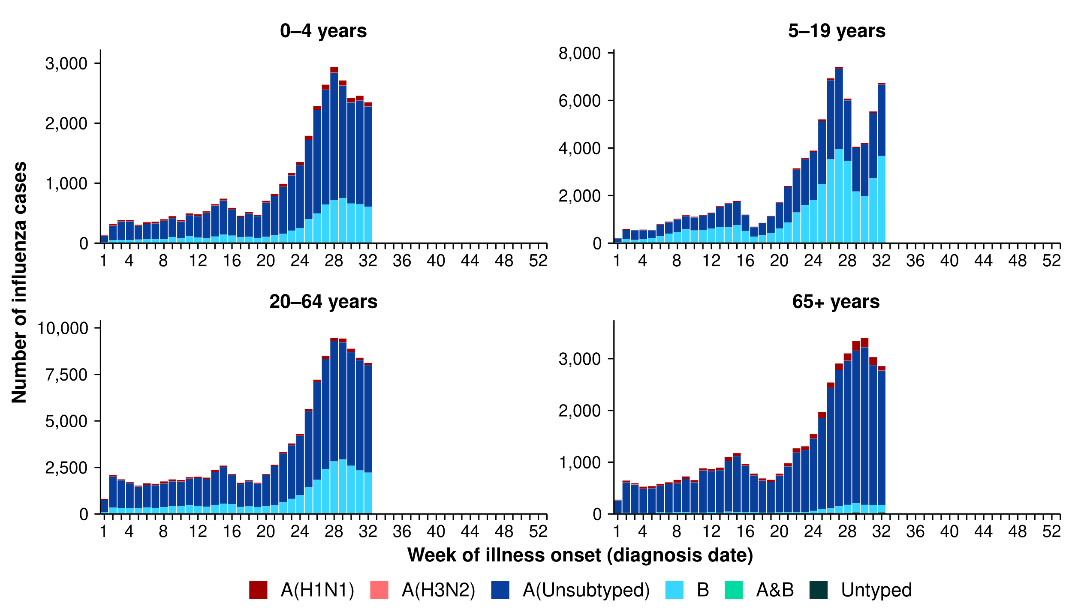
Source: National Notifiable Diseases Surveillance System (NNDSS)
* Axis varies between age groups.
Figure 9: Notified influenza cases by influenza subtype, jurisdiction*, and week of diagnosis, Australia, 1 January to 10 August 2025
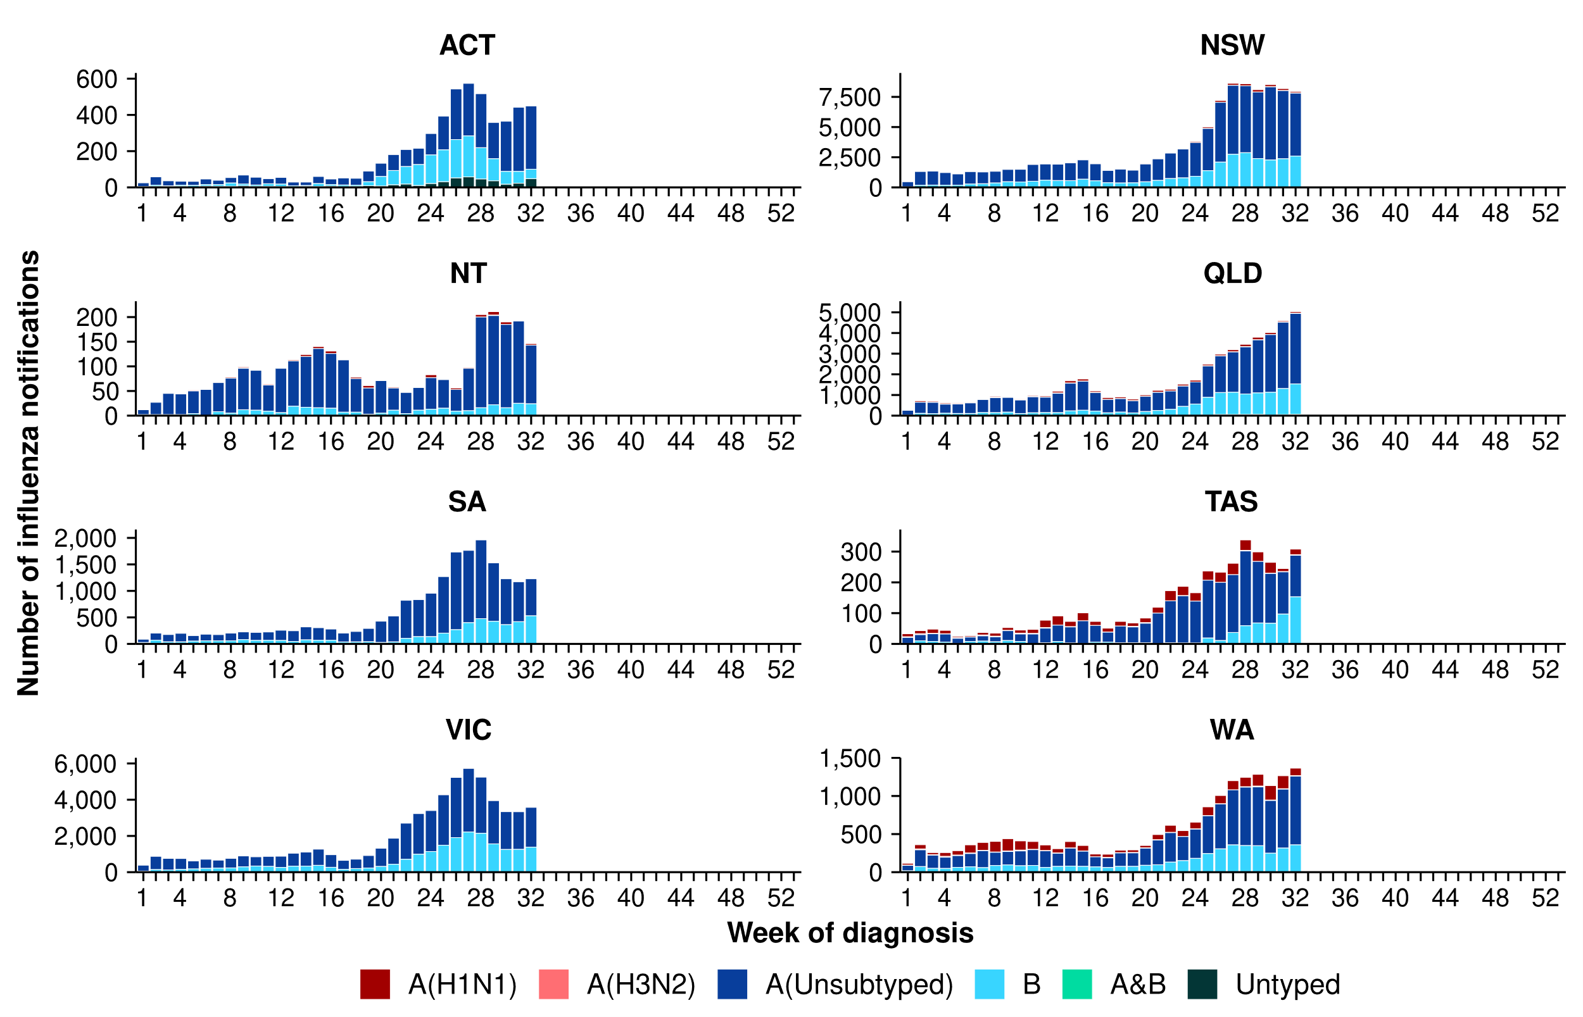
Source: National Notifiable Diseases Surveillance System (NNDSS)
* Axis varies between jurisdictions.
- In the last fortnight, the number of RSV cases decreased slightly, continuing the gradually decreasing trend in national case numbers observed since mid-July 2025 (Figure 10).
- The number of cases this year to date (n=125,791) is 10.3% less than the number of cases observed in the same time period last year (n=140,159), largely due to comparatively fewer cases across May and June 2025 (Figure 10).
- In the last fortnight, RSV notification rates varied across jurisdictions (Figure 11). Overall, RSV notification rates increased in the ACT, the NT and SA; decreased in NSW and Vic; and remained stable in Qld and WA (Figure 11).
- In the year to date, RSV notification rates remain considerably higher in children aged 0–4 years than in other age groups (Table 1).
- In the year to date, RSV notification rates are highest in NSW and lowest in WA (Table 1).
Figure 10: Notified RSV cases by year and week of diagnosis*, Australia, 2023 to 10 August 2025
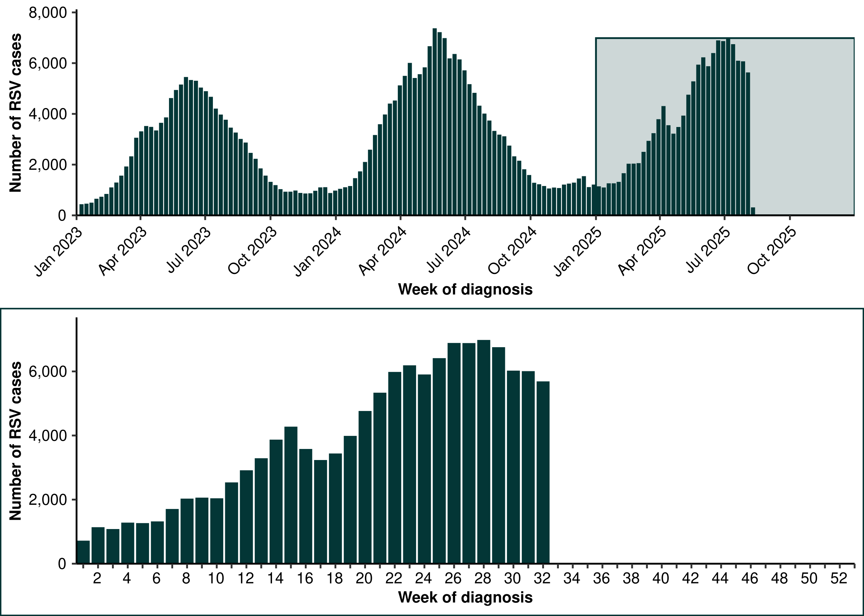
Source: National Notifiable Diseases Surveillance System (NNDSS). * RSV became notifiable in all states and territories on 1 September 2022 and comprehensive national notification data became available after this point. For this reason, RSV notification trends are only presented from 1 January 2023.

Figure 11: Notification rates* per 100,000 population for RSV cases by state or territory and week of diagnosis, Australia, 1 January to 10 August 2025
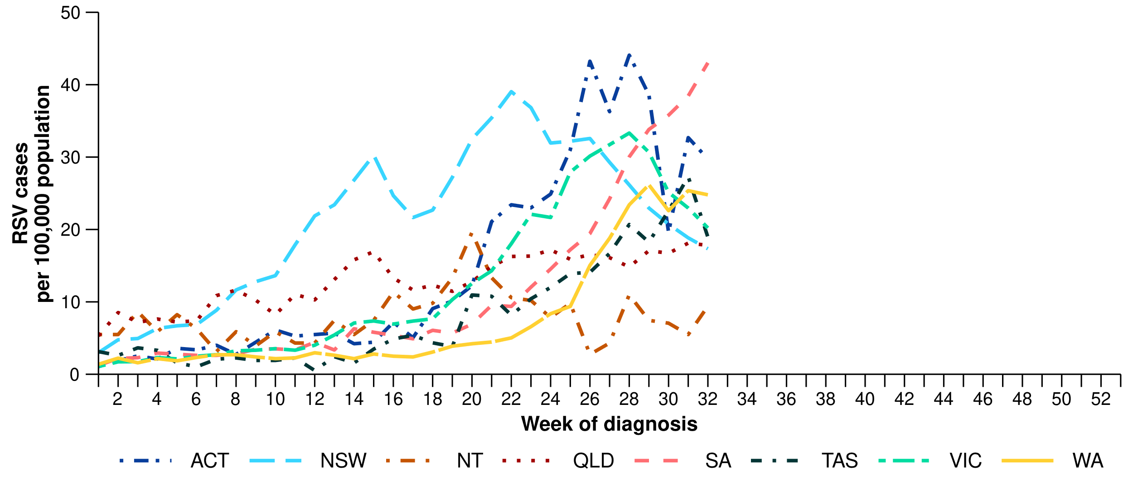
Source: National Notifiable Diseases Surveillance System (NNDSS)
* Rate per 100,000 population for the given time period. Population data are based on the Australian Bureau of Statistics (ABS) Estimated Resident Population (ERP) for the reference period June 2024, released 12 December 2024.

Primary care surveillance
Primary care surveillance monitors the number and characteristics of people who have presented to their general practitioner (GP) with influenza-like-illness and provides insight on the different respiratory pathogens that are causing illness in the community.
- In the last fortnight (28 July to 10 August 2025), there were similar rates of consultations for influenza-like illness (10.9per 1,000 GP consultations per fortnight) compared to the previous fortnight (11.0 per 1,000 GP consultations per fortnight) (Figure 12).
- From January to mid-June 2025, influenza-like-illness consultation rates remained relatively consistent with rates observed in 2024. From mid-June 2025, influenza-like-illness consultation rates have been slightly lower than observed at the same time in 2024, but exceed the five-year average (Figure 12).
Figure 12: Rate of influenza-like-illness consultations per 1,000 consultations per week in sentinel general practice sites compared with the five-year average by year and week of consultation*†, Australia, 2022 to 10 August 2025
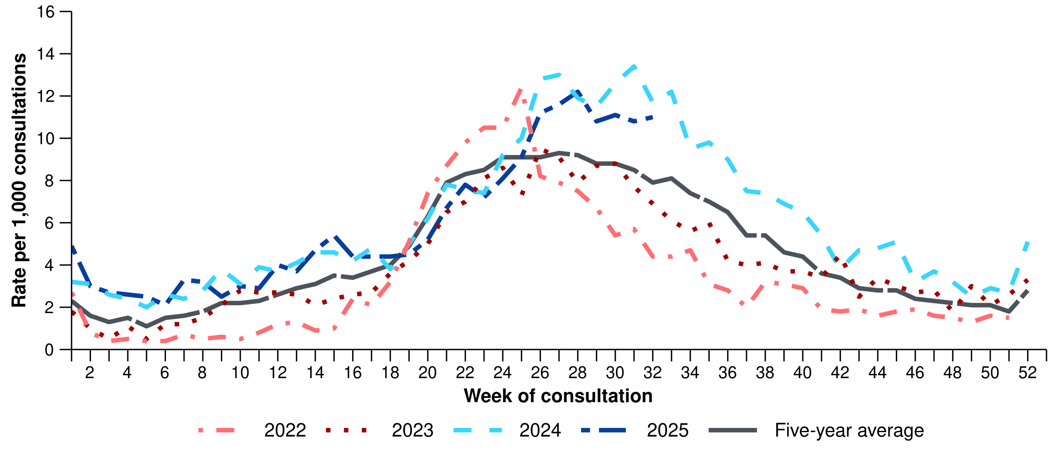
Source: Australian Sentinel Practice Research Network (ASPREN)
* The years 2020 and 2021 are excluded when comparing the current season to historical periods when influenza virus has circulated without public health restrictions. As such, the five-year average includes the years 2018 to 2019 and 2022 to 2024. Please refer to the Technical Supplement for interpretation of the five-year average.
† Please refer to the Technical Supplement for notes on impact of COVID-19 on ASPREN data.
- In the last fortnight, 64.7% (88/136) of people attending general practice with influenza-like-illness who were tested have then tested positive for a respiratory pathogen.
- In the last fortnight, influenza (39.8%; 35/88) was the most commonly detected pathogen, followed by rhinovirus (21.6%; 19/88) and RSV (12.5%; 11/88) (Figure 13).
- In the year to date, 67.8% (1,215/1,793) of people attending general practice with influenza-like-illness who were tested have then tested positive for a respiratory pathogen.
- In the year to date, rhinovirus (34.9%; 424/1,215) has been the most commonly detected pathogen, followed by influenza (29.5%; 359/1,215), SARS-CoV-2 (10.0%; 122/1,215), RSV (9.1%; 111/1,215), and adenovirus (4.6%; 56/1,215) (Figure 13).

Figure 13: Number of samples tested for respiratory pathogens among people with influenza-like-illness attending sentinel general practice sites by respiratory pathogen and week of specimen collection, Australia, 1 January to 10 August 2025
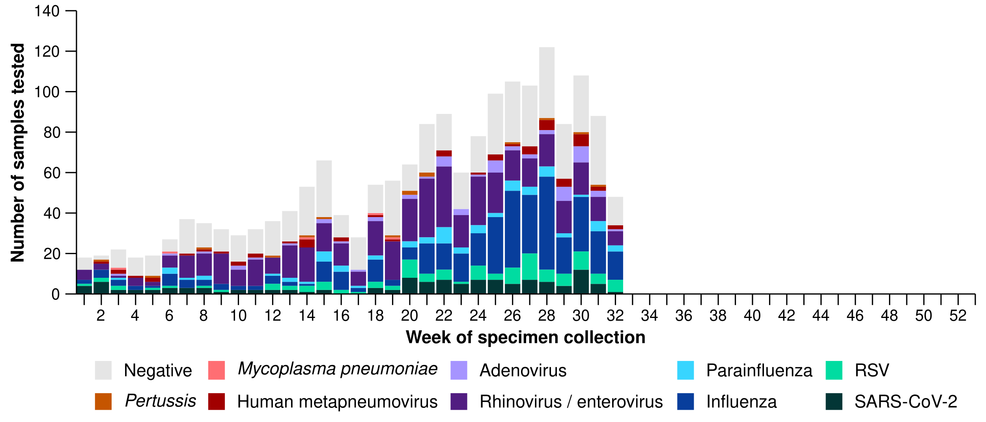
Source: Australian Sentinel Practice Research Network (ASPREN)
Note: All ASPREN swab samples are transported to the SA Pathology laboratory in Adelaide to be tested for viral and bacterial respiratory pathogens via a multiplex real-time reverse transcription polymerase chain reaction (RT-PCR) assay using in-house primers.

Hospital-based surveillance
Hospital-based surveillance monitors persons with more severe illness who have been admitted to hospital for their respiratory illness (severe acute respiratory infections). Hospital-based surveillance also measures the ability of the health system to cope with the number of severe acute respiratory infection admissions to ensure delivery of safe, timely and quality health care.
- In the last severity reporting period (14 July to 27 July 2025), fewer patients were admitted to a sentinel hospital with a severe acute respiratory infection (n=834), than in the previous severity reporting period (n=1,156).
  - In the last severity reporting period, at sentinel hospitals there were 36.5% fewer admissions with COVID-19 (from 170 to 108), 21.9% fewer admissions with influenza (from 588 to 459), and 32.9% fewer admissions with RSV (from 398 to 267), compared to the previous severity reporting period.
- In the year to date for severity reporting (1 January to 27 July 2025), there have been 8,742 admissions with severe acute respiratory infections at sentinel hospitals. Most patients with a severe acute respiratory infection have been admitted with influenza (n=3,638) followed by RSV (n=2,845) (Figure 14).

Figure 14: Total number of patients (children and adults) admitted with a severe acute respiratory infection to sentinel hospitals by disease and week of admission, Australia, 1 January to 27 July 2025
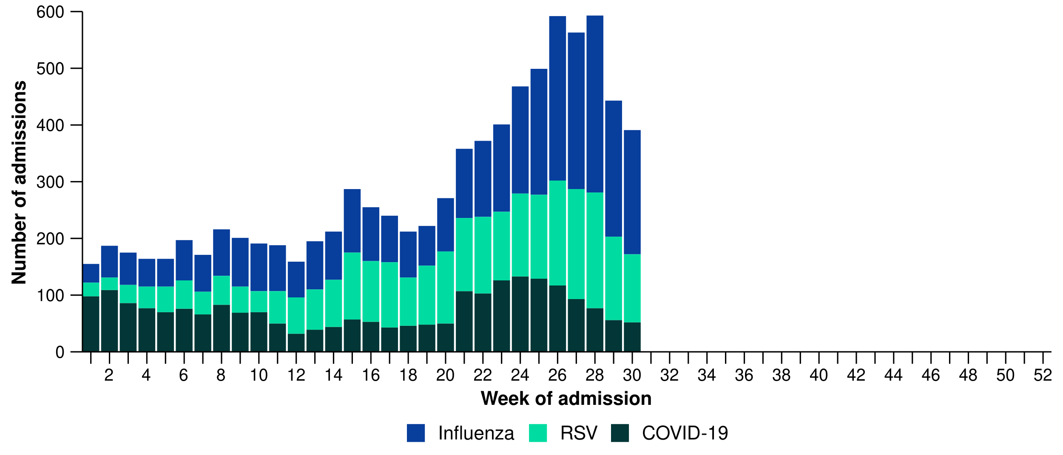
Source: Influenza Complications Alert Network (FluCAN)
- Patients admitted to sentinel hospitals with influenza have mostly been admitted with influenza A (80.6%; 2,934/3,638), while 19.0% (690/3,638) were admitted with influenza B.
  - Most hospital admissions with influenza A have been with influenza A(Unsubtyped) (66.1%; 1,938/2,934), followed by influenza A(H1N1) (32.4%; 952/2,934), and then influenza A(H3N2) (1.5%; 44/2,934).
- In the year to date for severity reporting, influenza A was the most commonly detected influenza subtype in all age groups. Influenza A(H1N1) and influenza A(H3N2) were more commonly observed in adults than children, while influenza B was more commonly observed in children. Of note, school aged children (5–16 years) had the highest proportion of influenza B compared with influenza A (Figure 15).
  - While influenza B is often a good match with the seasonal influenza vaccine strain, influenza B can result in more severe infections in children.
  - In the previous fortnight, a notable decrease was observed in the number of patients admitted with influenza in children aged 5–16 years, both in those with influenza A and influenza B (Figure 15).
  - Trends in influenza subtypes should be interpreted with care as there may be differences in the number and selection of influenza samples that undergo typing.

Figure 15: Number of patients admitted with influenza to sentinel hospitals by influenza subtype, age group*, and week of admission, Australia, 1 January to 27 July 2025
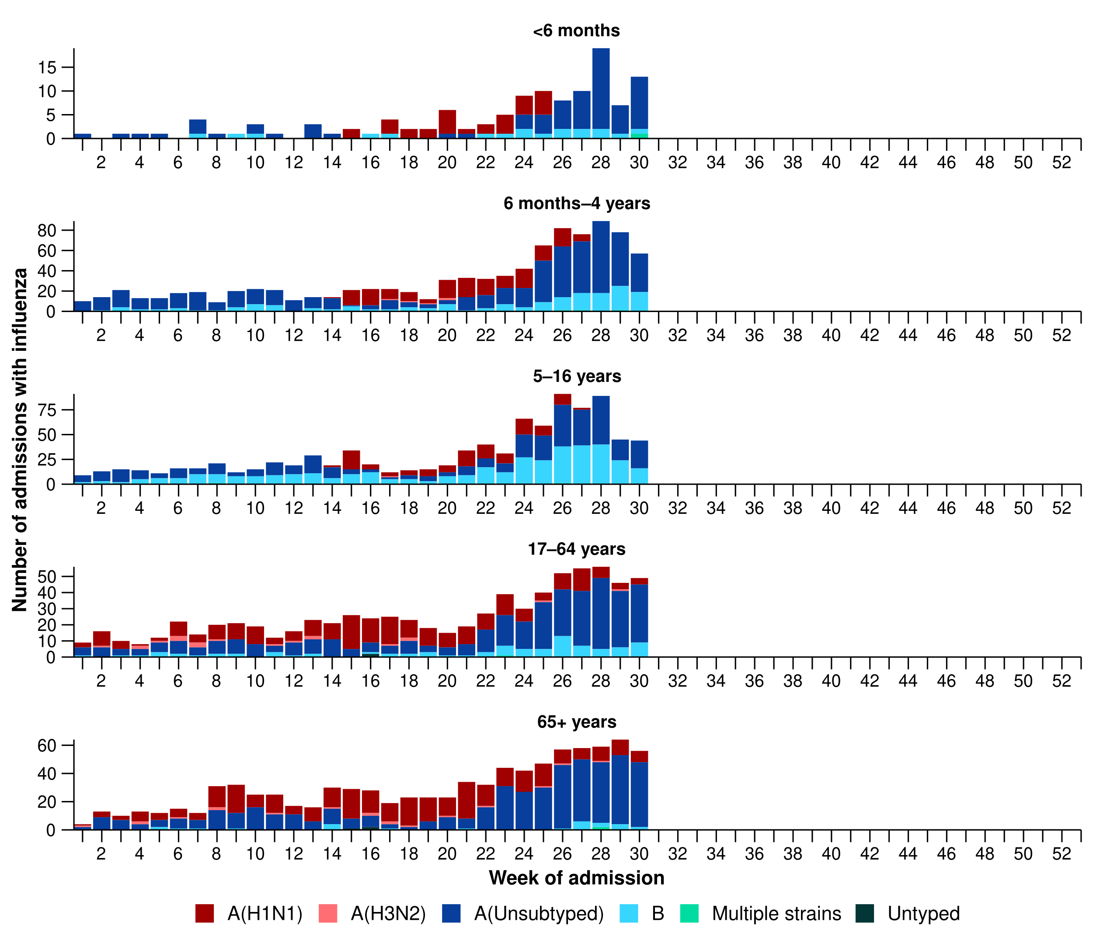
Source: Influenza Complications Alert Network (FluCAN)
* Axis varies between age groups. The age distribution of admissions with influenza may not reflect the age distribution of all patients.
- In the year to date for severity reporting, more children (those aged 16 years and younger) have been admitted to sentinel hospitals with RSV than with influenza or COVID-19 (Table 2a).
- Children admitted to sentinel hospitals with influenza tended to be older than children admitted with COVID-19 or RSV (Table 2a). Children admitted to sentinel hospitals with RSV had a slightly longer length of hospital stay compared to children with influenza or COVID-19; however, the difference in the length of stay was minor. The proportion of children admitted directly to intensive care was slightly higher for COVID-19 than influenza and RSV (Table 2a).
- Sadly, there have been a small number of children admitted with a severe acute respiratory infections who have died in sentinel hospitals (Table 2a).

Table 2a: Demographic characteristics and outcomes for children admitted with a severe acute respiratory infection to a sentinel hospital by disease*†‡, Australia, 1 January to 27 July 2025
 | COVID-19 | Influenza | RSV
 | Year to date for  severity reporting  (n=709) | Year to date for  severity reporting  (n=1,977) | Year to date for  severity reporting  (n=2,419)
Age (years)
Median [IQR] | 1 [0–4] | 4 [1–8] | 1 [0–2]
Age group (years)
< 6 months | 229 (32.3%) | 121 (6.1%) | 585 (24.2%)
6 months – 4 years | 320 (45.1%) | 935 (47.3%) | 1666 (68.9%)
5–16 years | 160 (22.6%) | 921 (46.6%) | 168 (6.9%)
Indigenous status
Aboriginal and Torres Strait Islander | 66 (9.3%) | 133 (6.7%) | 149 (6.2%)
Length of hospital stay (days)†
Median [IQR] | 1 [1–2] | 1 [1–2] | 2 [1–3]
Patient admission location‡
Admitted to hospital ward | 656 (92.5%) | 1871 (94.6%) | 2288 (94.6%)
Admitted to intensive care directly | 53 (7.5%) | 106 (5.4%) | 131 (5.4%)
Discharge status†
Alive | 506 (71.4%) | 1447 (73.2%) | 1589 (65.7%)
Died | – | 5 (0.3%) | 1 (0.0%)
Incomplete/missing | 203 (28.6%) | 525 (26.6%) | 829 (34.3%)
Source: Influenza Complications Alert Network (FluCAN)
* Does not include patients with missing age; therefore, the sum of age-specific totals above may not equal the total number of patients.
† For patients who are still in hospital data may not be complete; therefore, these data are not included in the length of stay or discharge status. In addition, length of stay data excludes patients that acquired their infection in hospital.
‡ Admission location reflects the initial admission ward. Some patients may be initially admitted to general ward then later admitted to an intensive care and this is not reflected here. Does not include patients with missing admission location; therefore, the sum of admission location specific totals above may not equal the total number of patients.
The Paediatric Active Enhanced Disease Surveillance (PAEDS) network carries out enhanced sentinel hospital surveillance for some acute respiratory infections or conditions in children. PAEDS data for acute respiratory infections in children are presented in the Australian Respiratory Surveillance Reports in the sentinel hospital data from FluCAN. For additional information on COVID-19 in children, Paediatric Inflammatory Multisystem Syndrome (PIMS-TS) following COVID-19, influenza in children, or RSV in children please visit the PAEDS webpages and dashboards.

- In the year to date for severity reporting, more adults (those aged 17 years and over) have been admitted to sentinel hospitals with influenza than with COVID-19 or RSV (Table 2b).
- Adults admitted to sentinel hospitals with COVID-19 or RSV were predominately 65 years and over, whereas the proportion of admissions with influenza was only slightly higher in the 65 years and over age group compared to the 17–64 years age group (Table 2b).
- Adults admitted to sentinel hospitals with COVID-19 had a slightly longer length of hospital stay compared to adults with influenza or RSV. However, a higher proportion of adults with influenza were admitted directly to intensive care, compared to adults admitted with COVID-19 or RSV (Table 2b).
- Sadly, there have been a number of adults admitted with a severe acute respiratory infections who have died in sentinel hospitals (Table 2b).
Table 2b: Demographic characteristics and outcomes for adults admitted with a severe acute respiratory infection to a sentinel hospital by disease*†‡, Australia, 1 January to 27 July 2025
 | COVID-19 | Influenza | RSV
 | Year to date for  severity reporting  (n=1,550) | Year to date for  severity reporting  (n=1,660) | Year to date for  severity reporting  (n=426)
Age (years)
Median [IQR] | 75 [62–84] | 67 [52–77] | 73 [60–82]
Age group (years)
17–64 years | 438 (28.3%) | 767 (46.2%) | 127 (29.8%)
65 years and over | 1112 (71.7%) | 893 (53.8%) | 299 (70.2%)
Indigenous status
Aboriginal and Torres Strait Islander | 87 (5.6%) | 105 (6.3%) | 26 (6.1%)
Length of hospital stay (days)†
Median [IQR] | 5 [2–9] | 4 [2–7] | 4 [2–8]
Patient admission location‡
Admitted to hospital ward | 1463 (94.4%) | 1516 (91.3%) | 400 (93.9%)
Admitted to intensive care directly | 87 (5.6%) | 144 (8.7%) | 26 (6.1%)
Discharge status†
Alive | 1118 (72.1%) | 1157 (69.7%) | 268 (62.9%)
Died | 57 (3.7%) | 48 (2.9%) | 17 (4.0%)
Incomplete/missing | 375 (24.2%) | 455 (27.4%) | 141 (33.1%)
Source: Influenza Complications Alert Network (FluCAN)
* Does not include patients with missing age; therefore, the sum of age-specific totals above may not equal the total number of patients.
† For patients who are still in hospital data may not be complete; therefore, these data are not included in the length of stay or discharge status. In addition, length of stay data excludes patients that acquired their infection in hospital.
‡ Admission location reflects the initial admission ward. Some patients may be initially admitted to general ward then later admitted to an intensive care and this is not reflected here. Does not include patients with missing admission location; therefore, the sum of admission location specific totals above may not equal the total number of patients.

- In the last severity reporting period for sentinel intensive care (30 June to 27 July 2025), fewer patients have been admitted to a sentinel intensive care with a severe acute respiratory infection (n=432), than in the previous severity reporting period (n=470) (Figure 16). Admissions to sentinel intensive care in the last severity reporting period were predominantly patients admitted with influenza (46.6%; 210/451) (Figure 16)
- In the year to date for severity reporting (1 January to 27 July 2025), most patients were admitted to sentinel intensive care with rhinovirus / enterovirus, followed by influenza (Figure 16; Table 3).
Figure 16: Number of patients admitted with severe acute respiratory infections to a sentinel intensive care by disease and week of admission, Australia, 1 January to 27 July 2025
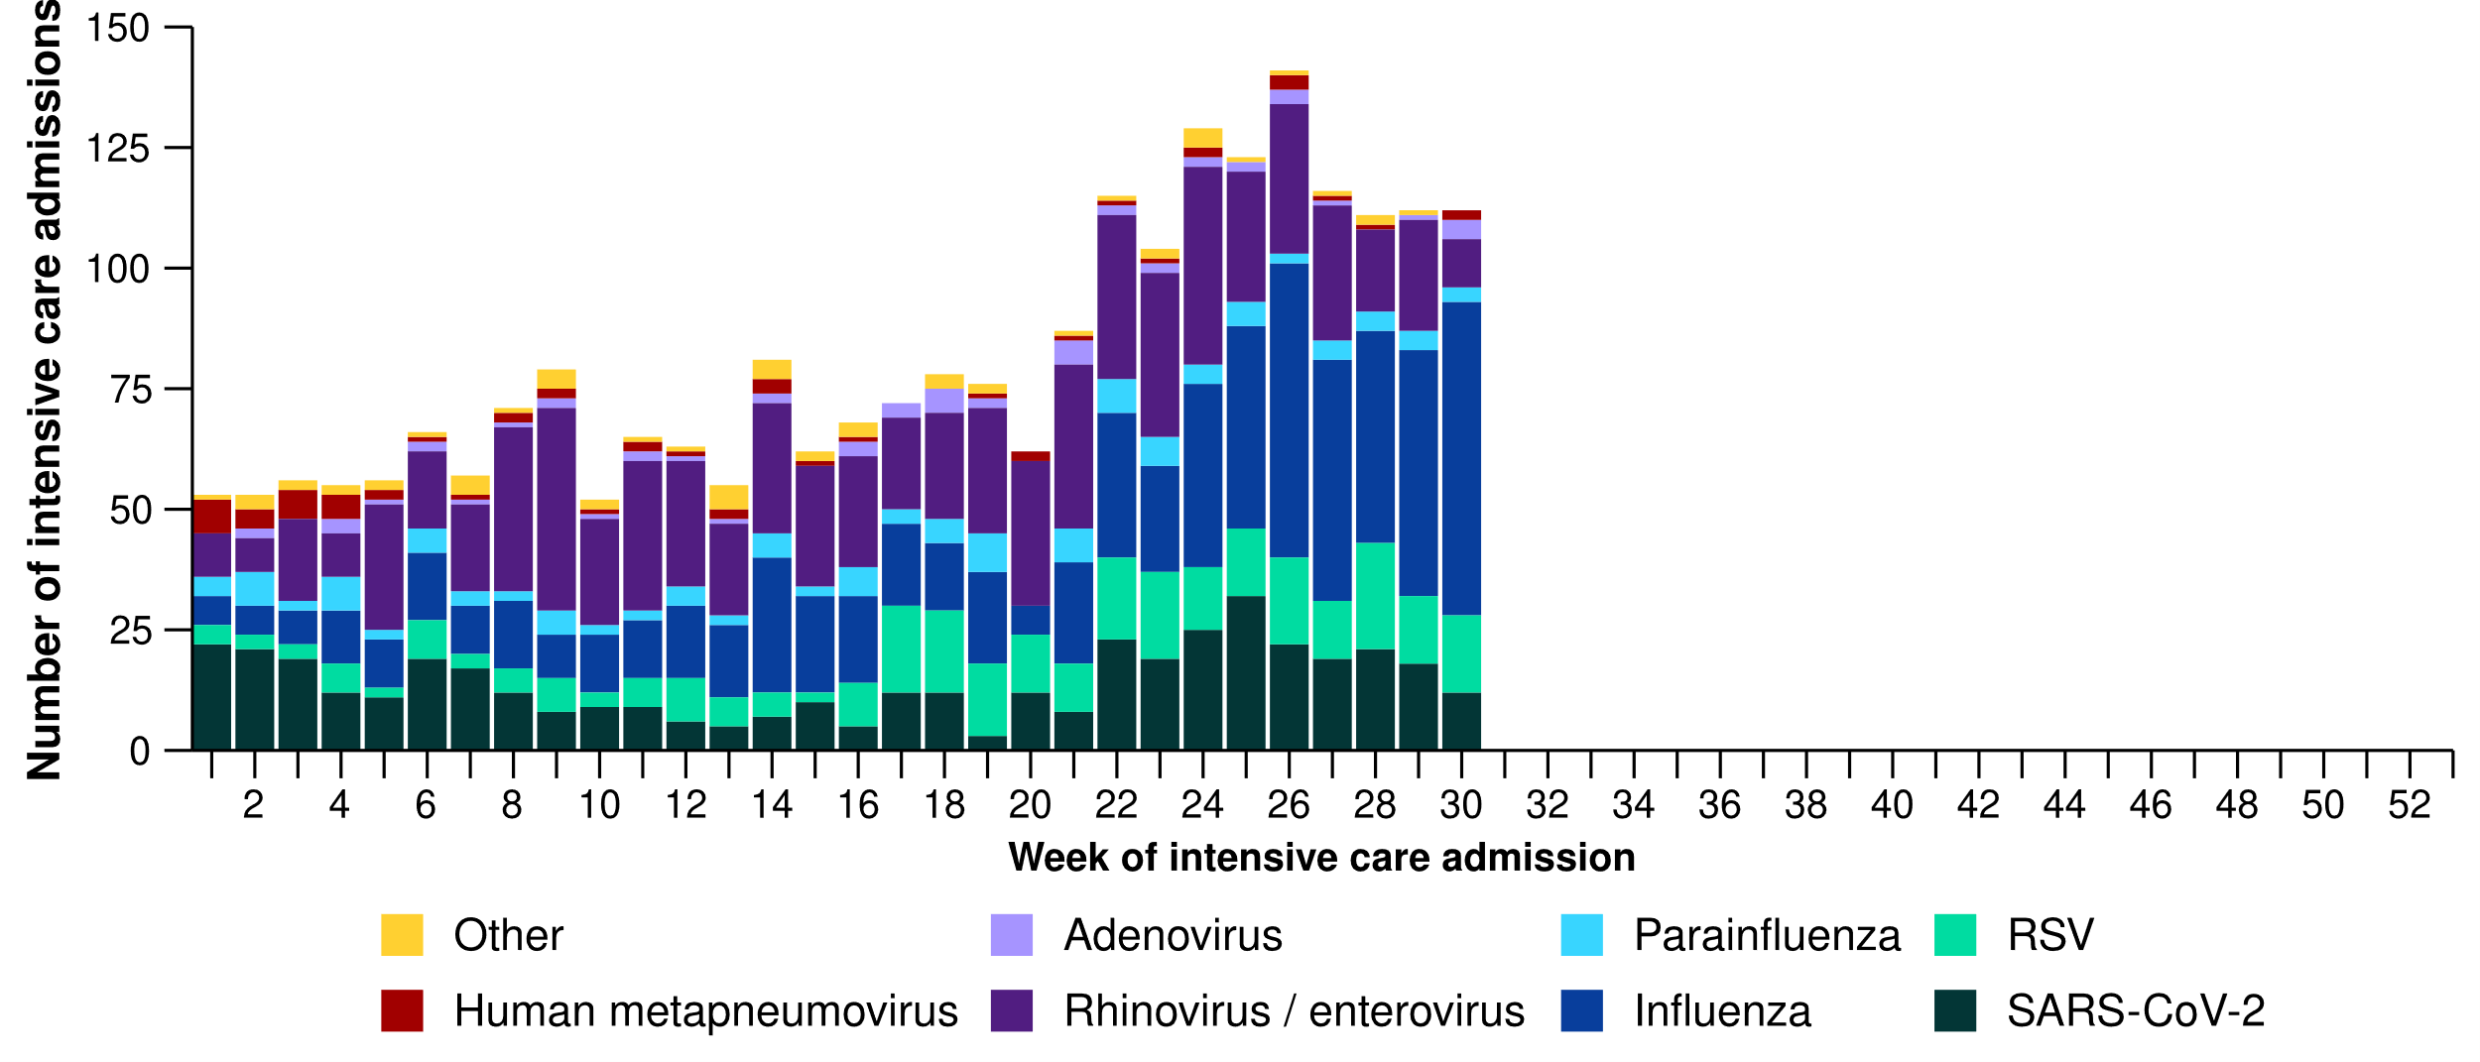
Source: Short Period Incidence Study of Severe Acute Respiratory Infection (SPRINT-SARI) Australia
Note: A range of diagnostic testing procedures are utilised across hospitals in Australia. SPRINT-SARI does not specify which diagnostic testing method should be utilised as this is the domain of the hospital and treating clinicians. Therefore, virological data from SPRINT-SARI should be interpreted with care.
Figure 17: Number of patients admitted with severe acute respiratory infections to a sentinel intensive care by disease and age group*, Australia, 1 January to 27 July 2025
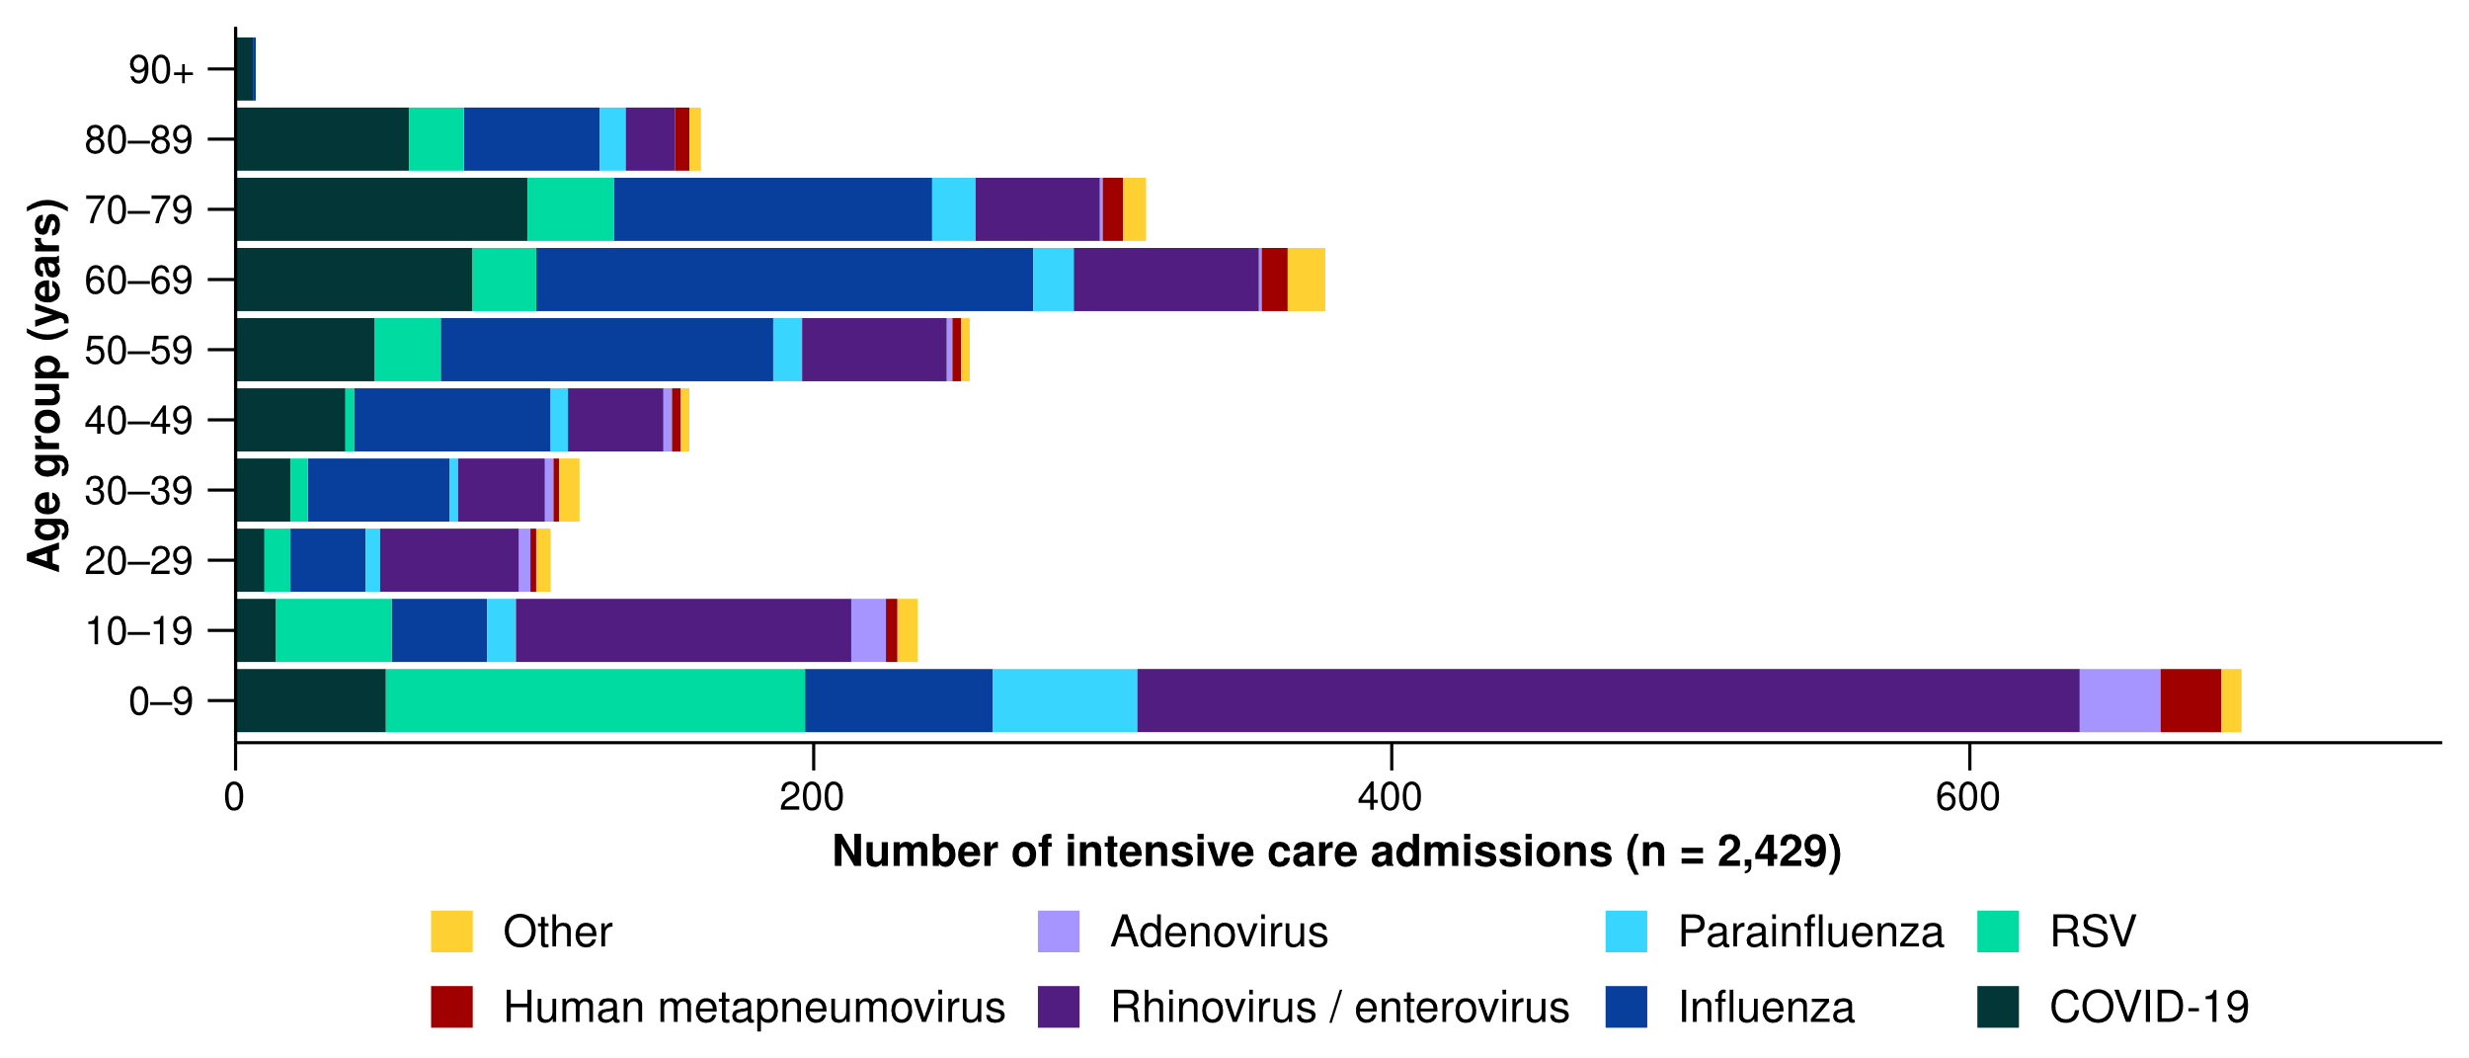
Source: Short Period Incidence Study of Severe Acute Respiratory Infection (SPRINT-SARI) Australia
Note: 4.9% (113/2,308) of patients had co-infections of respiratory pathogens; therefore, the sum of pathogen-specific totals above may not equal the total number of severe acute respiratory infection patients.
* The age distribution of severe acute respiratory infection intensive care admissions may not reflect the age distribution of all patients.

- In the year to date for severity reporting, admissions to a sentinel intensive care with COVID-19 or influenza have generally been among older people. In contrast, admissions with rhinovirus or RSV have been among younger people, primarily those aged 0–9 years old (Figure 17; Table 3).
- A higher proportion of admissions with influenza and parainfluenza required invasive mechanical ventilation, and the length of ventilation was longest among those with influenza. The length of intensive care stay was relatively similar across diseases (Table 3).
- Most patients admitted to a sentinel intensive care with a severe acute respiratory infection have been discharged home. Sadly, a number of patients have died in hospital, predominately among those with COVID-19 (Table 3).
Table 3: Demographic characteristics and outcomes of patients admitted with a severe acute respiratory infection to a sentinel intensive care by disease*†, Australia, 1 January to 27 July 2025
 | COVID-19 | hMPV | Influenza | Parainfluenza | Rhinovirus | RSV | Other
 | Year to date for severity reporting  (n=430) | Year to date for severity reporting  (n=56) | Year to date for severity reporting  (n=687) | Year to date for severity reporting  (n=122) | Year to date for severity reporting  (n=727) | Year to date for severity reporting  (n=297) | Year to date for severity reporting  (n=111)
Age (years)
Median [IQR] | 65  [43–75] | 35  [4–67] | 59  [39–68] | 20  [5–67] | 12  [4–46] | 10  [2–59] | 21  [7–59]
Indigenous status
Aboriginal and Torres Strait Islander | 40  (9.3%) | 3  (5.4%) | 63  (9.2%) | 6  (4.9%) | 71  (9.8%) | 27  (9.1%) | 12  (10.8%)
Non-Indigenous | 390  (90.7%) | 53  (94.6%) | 624  (90.8%) | 116  (95.1%) | 656  (90.2%) | 270  (90.9%) | 99  (89.2%)
Received invasive mechanical ventilation
Number (%) | 119  (27.7%) | 15  (26.8%) | 223  (32.5%) | 50  (41.0%) | 204  (28.1%) | 56  (18.9%) | 43  (38.7%)
Length of invasive mechanical ventilation (days)*
Median [IQR] | 3 [1–6] | 3 [2–9] | 5 [2–10] | 3 [1–11] | 3 [1–7] | 3 [1–4] | 3 [1–6]
Length of intensive care stay (days)*
Median [IQR] | 3 [2–5] | 3 [1–6] | 3 [2–7] | 2 [1–7] | 2 [1–5] | 2 [2–4] | 3 [2–7]
Length of hospital stay (days)*
Median [IQR] | 7 [4–14] | 9 [5–18] | 8 [4–15] | 7 [3–14] | 6 [3–12] | 5 [3–9] | 8 [4–17]
Patient outcome†
Ongoing care in intensive care | 15  (3.5%) | 1  (1.8%) | 41  (6.0%) | – | 6  (0.8%) | 6  (2.0%) | 2  (1.8%)
Ongoing care in hospital ward | 16  (3.7%) | – | 37  (5.4%) | 7  (5.7%) | 24  (3.3%) | 10  (3.4%) | 4  (3.6%)
Transfer to other hospital / facility | 64  (14.9%) | 8  (14.3%) | 103  (15.0%) | 19  (15.6%) | 76  (10.5%) | 36  (12.1%) | 11  (9.9%)
Discharged home | 263  (61.2%) | 43  (76.8%) | 432  (62.9%) | 89  (73.0%) | 568  (78.1%) | 230  (77.4%) | 79  (71.2%)
Died in hospital | 70  (16.3%) | 4  (7.1%) | 72  (10.5%) | 6  (4.9%) | 48  (6.6%) | 15  (5.1%) | 14  (12.6%)
Source: Short Period Incidence Study of Severe Acute Respiratory Infection (SPRINT-SARI) Australia
Note: 4.9% (113/2,308) of patients had co-infections of respiratory pathogens; therefore, the sum of pathogen-specific totals above may not equal the total number of severe acute respiratory infection patients.
* For patients receiving ongoing care in intensive care data may not be complete; therefore, data are not included in the length of ventilation or stay.
† Patients who have been admitted with no discharge information for less than 90 days have been assumed to have ongoing care in the hospital. Patients who have no outcome entered or have been admitted for more than 90 days with no discharge information have been treated as missing.
- In the last fortnight (28 July to 10 August 2025), there were fewer COVID-19 cases occupying intensive care beds across Australia than in the previous fortnight (Figure 18).
- In the last fortnight, there were fewer intensive care staff unavailable to work due to COVID-19 exposure or illness across Australia than in the previous fortnight (Figure 18).
Figure 18: Average number of COVID-19 cases in intensive care and the average number of intensive care staff unavailable to work due to COVID-19 exposure or illness by week of report*†, Australia, 1 January to 10 August 2025 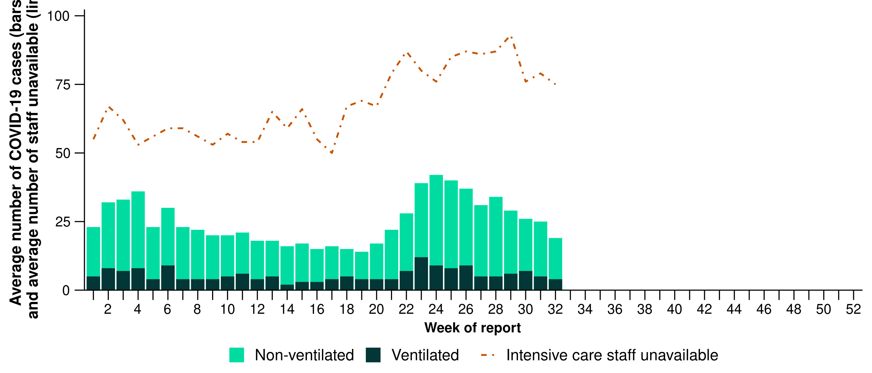
Source: Critical Health Resource Information System (CHRIS)
* Average number of ventilated and non-ventilated COVID-19 cases in intensive care includes only active COVID-19 cases (those in isolation) and does not include cleared COVID-19 cases.
† Intensive care staff include both medical and nursing staff. Staff unavailability will be underestimated in NSW as most public hospitals in NSW do not report staff unavailability.
- In the last fortnight, the number of COVID-19 cases occupying intensive care beds decreased in NSW, and Vic, increased in Tas, and remained stable in the NT, Qld, SA, the ACT, and WA compared with the previous fortnight (Figure 19).
- In the last fortnight, the number of intensive care staff unavailable to work due to COVID-19 exposure or illness decreased in NSW, Vic, the NT, SA, and WA, remained stable in Tas, and the ACT, and increased in Qld compared with the previous fortnight (Figure 19).

Figure 19: Average number of COVID-19 cases in intensive care and the average number of intensive care staff unavailable to work due to COVID-19 exposure or illness by jurisdiction and week of report*†‡, Australia, 1 January to 10 August 2025
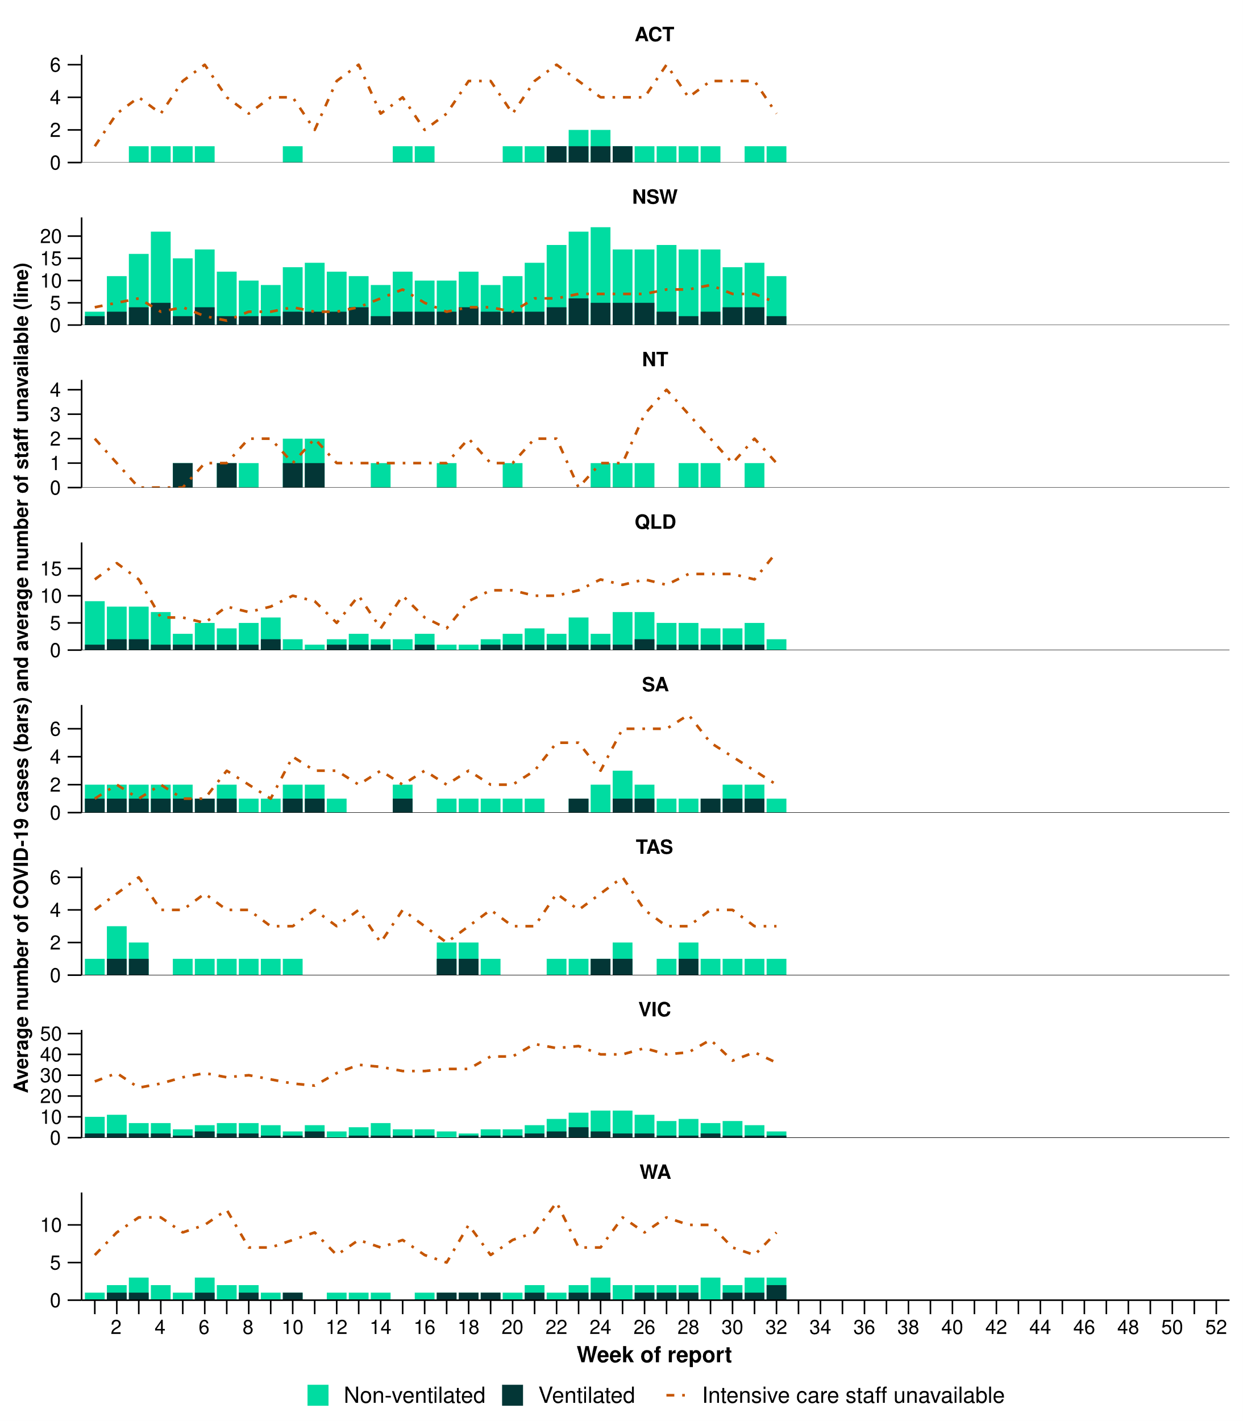
Source: Critical Health Resource Information System (CHRIS)
* Axis varies between jurisdictions.
† Average number of ventilated and non-ventilated COVID-19 cases in intensive care includes only active COVID-19 cases (those in isolation) and does not include cleared COVID-19 cases.
‡ Intensive care staff include both medical and nursing staff. Staff unavailability will be underestimated in NSW as most public hospitals in NSW do not report staff unavailability.

Mortality surveillance
Death registrations can provide information on the scale and severity of disease associated with acute respiratory infections. For more information on death registrations including completeness, timeliness, and definitions of deaths involving (both due to and with), due to and with acute respiratory infections, refer to the Technical Supplement.
- Please note, as there has not been an update to the Provisional Mortality Statistics, the mortality surveillance data presented here have not been updated since the previous report.
- COVID-19 has been the leading cause of acute respiratory infection mortality across 2023–2025.
- Since the end of 2021, a pattern has been observed for COVID-19 where there are two peaks of mortality during the year - one occurring between November and January and the other occurring between May and August. Following an increased number of deaths occurring between November 2024 and January 2025 (which was much lower than in previous years), deaths due to COVID-19 between February and May 2025 were substantially lower (Figure 20a).
- There were 783 deaths due to COVID-19 in the first six months of 2025, this is considerably lower than the deaths due to COVID-19 between January to June in both 2024 and 2023 (Figure 20a).
Figure 20a: Provisional numbers of deaths due to an acute respiratory infection*† by month, year, and disease, Australia, 1 January 2023 to 30 June 2025
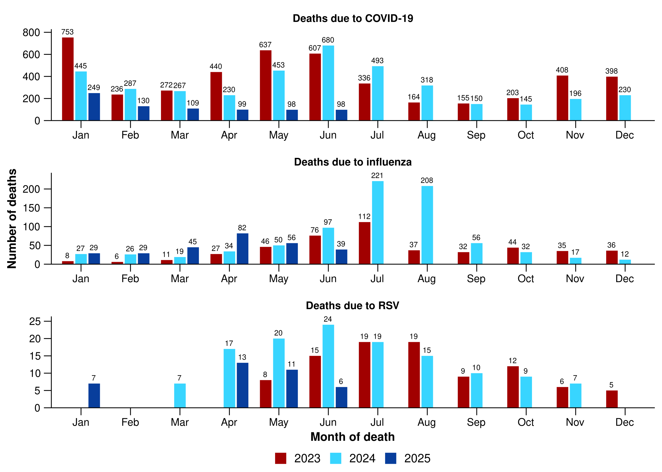
Source: Australian Bureau of Statistics, Provisional Mortality Statistics, released 29 July 2025.
* Axis varies between acute respiratory infections.
† Data is provisional and subject to change. It can take several weeks for death registrations to be reported, processed, coded, validated, and tabulated. Therefore, the data shown here may be incomplete. Data for some months were not published by the ABS due to small counts, and therefore not reported here. Data includes all deaths (both doctor and coroner certified) that occurred and were registered by 30 June 2025.

- There were 280 deaths due to influenza in the first six months of 2025. This is 10.7% more deaths due to influenza than the 253 deaths due to influenza that occurred in the first six months of 2024. Deaths due to influenza decreased in May 2025 and are at comparable levels for the same period in 2023 and 2024 (Figure 20a). The mortality trends observed in March to April 2025 align with the elevated case numbers during the initial period of the influenza season this year.
- There were 43 deaths due to RSV in the first six months of 2025; however, for privacy reasons 6 deaths due to RSV are not published in Figure 20a.
- The mortality rate for deaths due to COVID-19 or influenza for Aboriginal and Torres Strait Islander people was higher than for non-Indigenous people across each year in 2022–2024.
- Deaths with COVID-19 between February and May 2025 have been relatively stable and remain at lower levels than previous years (Figure 20b).
- Deaths with influenza mentioned as a contributory cause increased in April 2025 and declined in May (Figure 20b).
- Deaths with RSV mentioned as a contributory cause in May 2025 are at a similar level to May 2023 but below the level in May 2024 (Figure 20b).
- All three of these acute respiratory infections are more likely to cause death in older age groups than younger age groups.
Figure 20b: Provisional numbers of deaths with an acute respiratory infection*† by month, year, and disease, Australia, 1 January 2023 to 30 June 2025
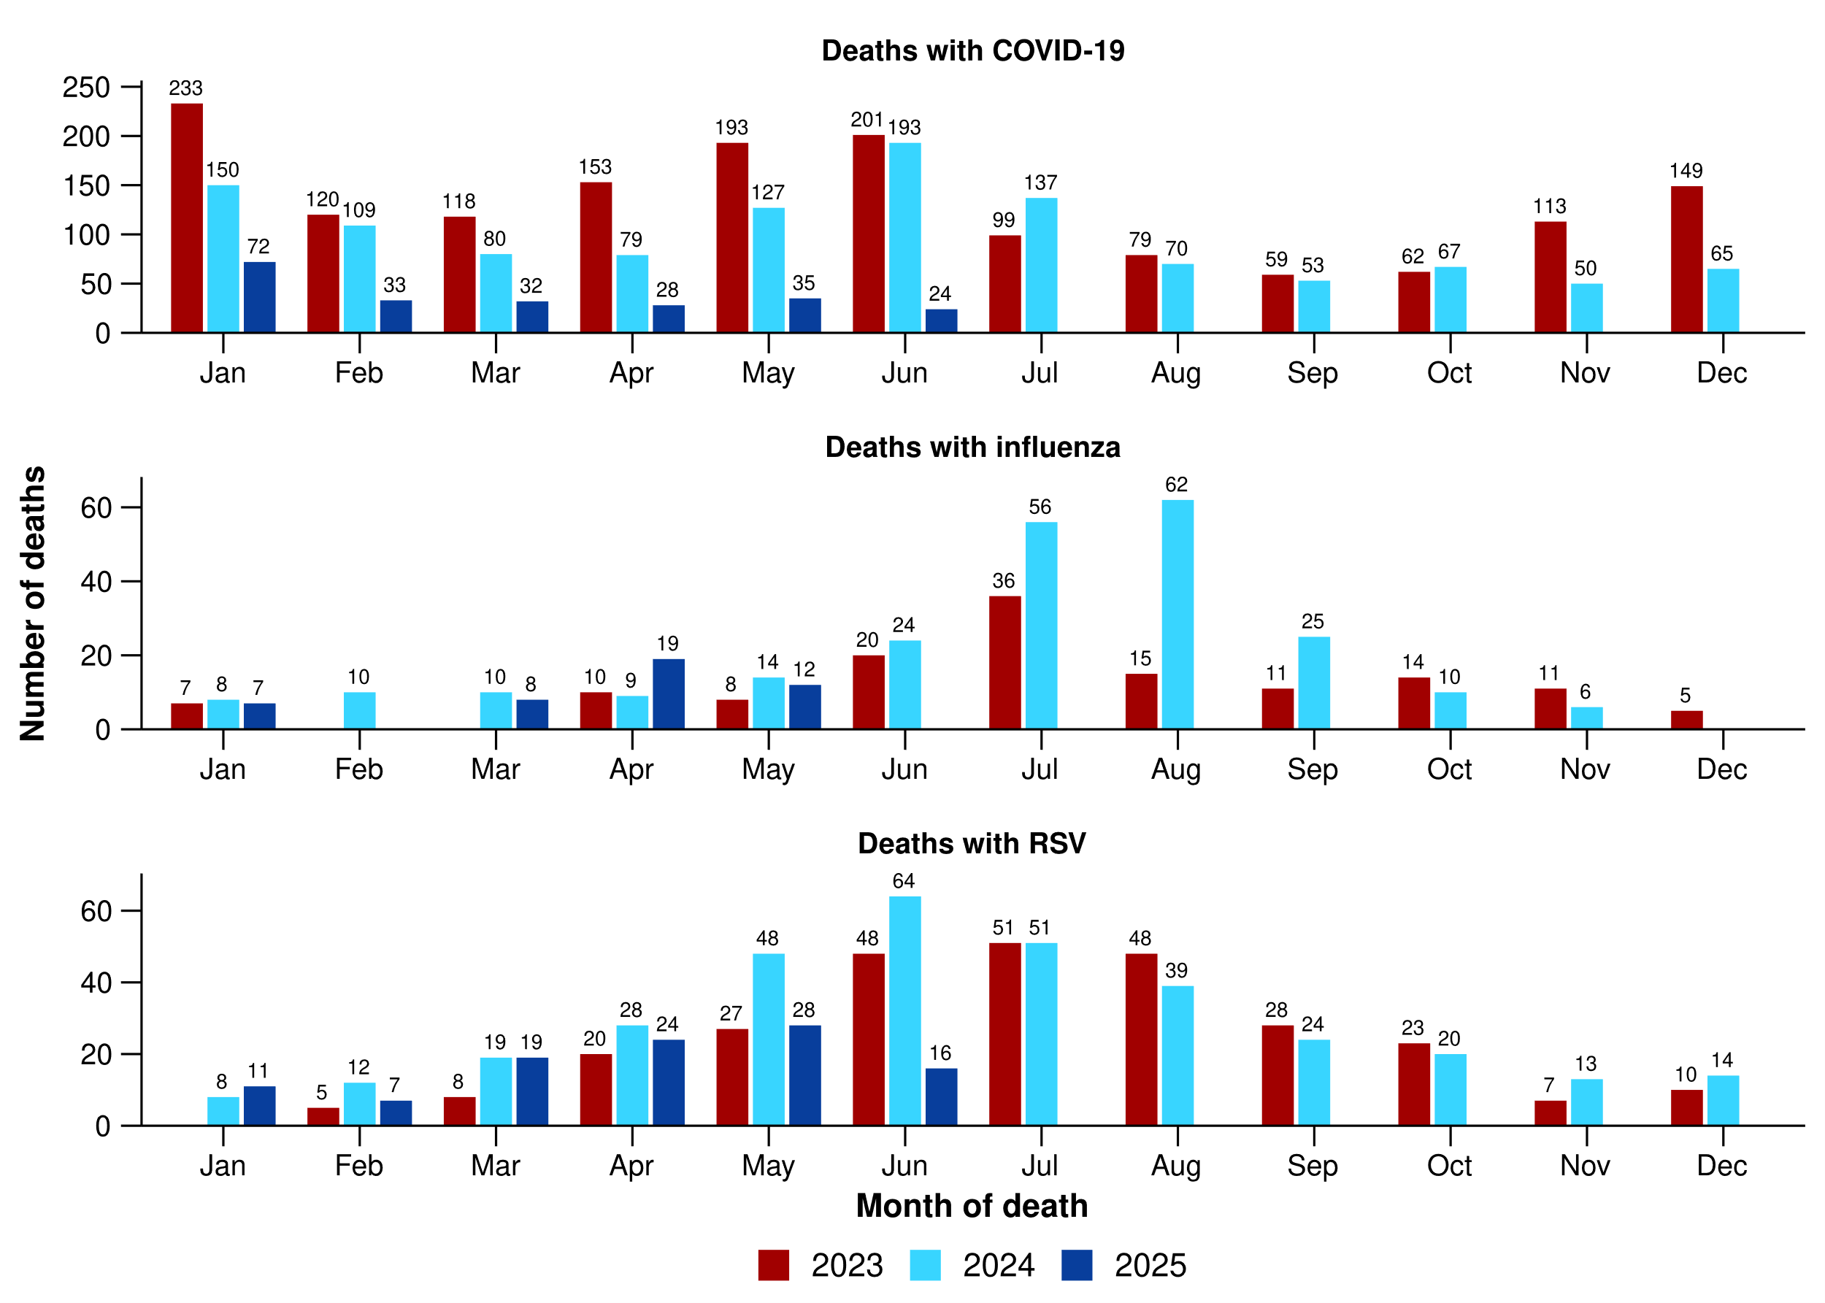
Source: Australian Bureau of Statistics, Provisional Mortality Statistics, released 29 July 2025.
* Axis varies between acute respiratory infections.
† Data is provisional and subject to change. It can take several weeks for death registrations to be reported, processed, coded, validated, and tabulated. Therefore, the data shown here may be incomplete. Data for some months were not published by the ABS due to small counts, and therefore not reported here. Data includes all deaths (both doctor and coroner certified) that occurred and were registered by 30 June 2025.

Laboratory surveillance
Sentinel laboratory surveillance monitors and characterises respiratory pathogens to provide information on what pathogens are circulating, potential changes in the pathogens that might affect their infectiousness, severity, ability to evade vaccine and/or infection-acquired immunity, or resistance to antivirals.
- In the last fortnight (28 July to 10 August 2025), SARS-CoV-2 test positivity decreased to 2.7% (395/14,902), influenza test positivity decreased slightly to 12.6% (2,315/18,378), and RSV test positivity increased to 5.3% (786/14,902) (Figure 21).

Figure 21: Number of tests positive (bars) and test positivity (line) for SARS-CoV-2, influenza or RSV of those specimens tested by sentinel laboratories by week of report*†, Australia, 1 January to 10 August 2025
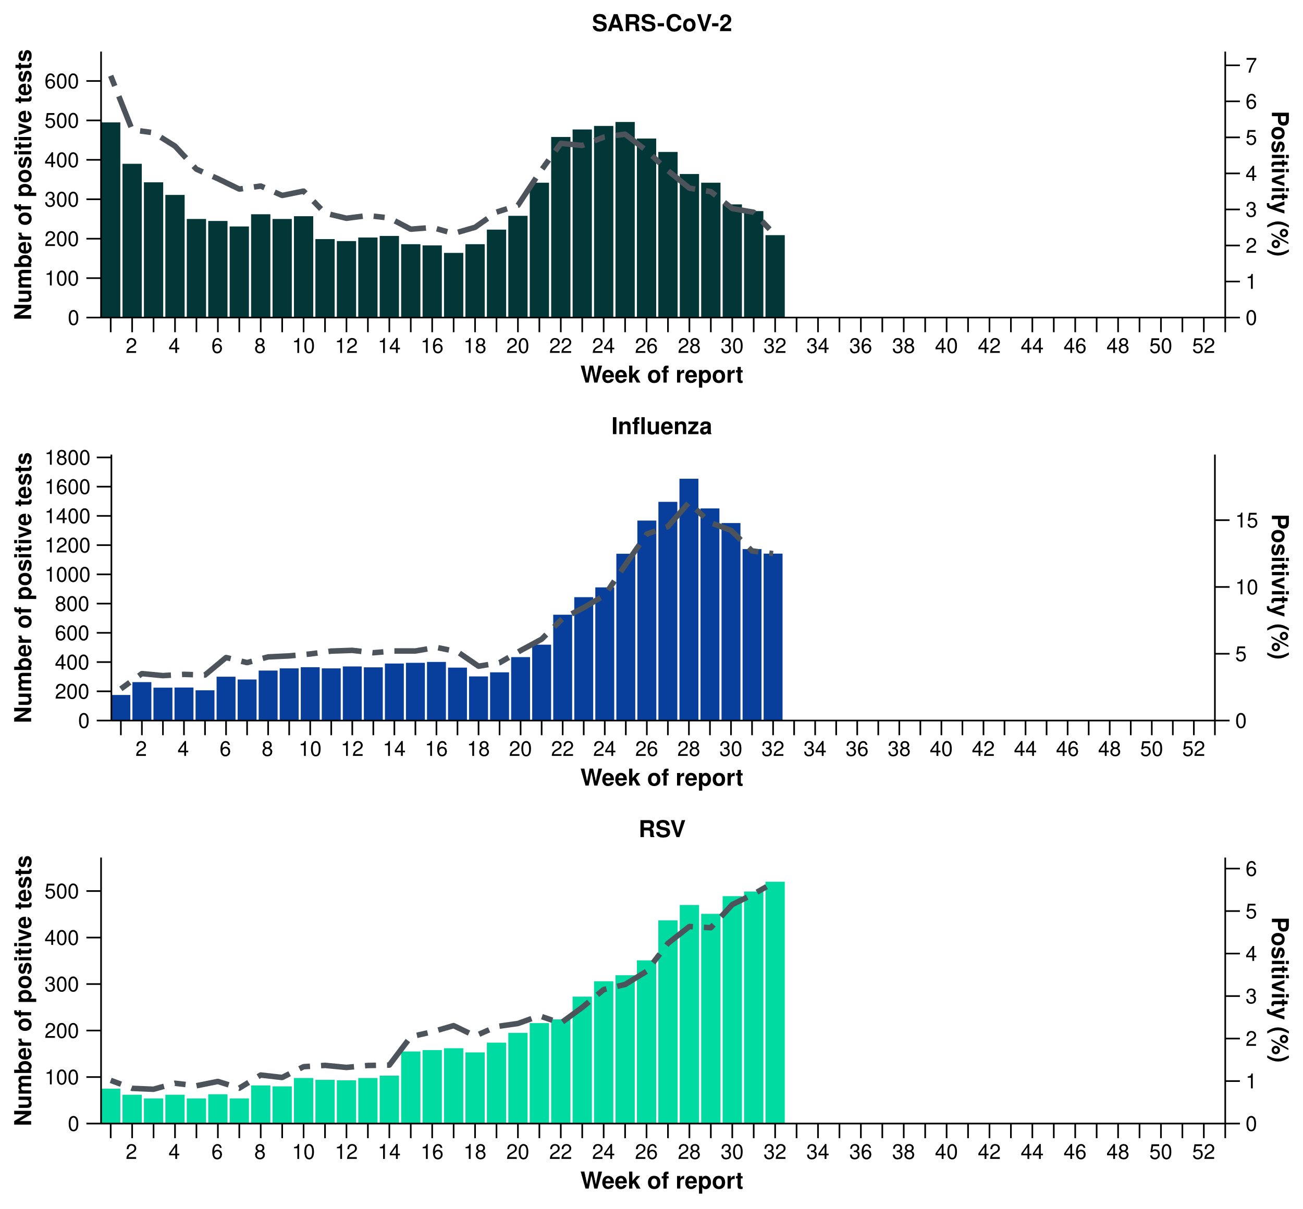
Source: Sentinel laboratories, including National Influenza Centres
* Number of specimens tested excludes data from WA as testing denominator data are different for the three pathogens in Western Australia.
† A small minority of total samples from Victoria are tested only by respiratory panel (influenza, parainfluenza, adenovirus, human metapneumovirus, seasonal coronaviruses, RSV, and some picornaviruses) but not for SARS-CoV-2. These minority samples include only forensic materials; all other samples are tested by respiratory panel and SARS-CoV-2 assay.

- There were 198 SARS-CoV-2 sequences uploaded to AusTrakka with dates of collection in the last 28 days (14 July to 10 August 2025). These sequences were from NSW, Qld, SA, Tas and WA, with the most recent collection date 2 August 2025.
- Most sequences were assigned to the BA.2.86 sub-lineage within B.1.1.529 (Omicron), or recombinants consisting of one or more Omicron sub-lineages (Figure 22a/b). In the last 28 days:
  - 17.7% (35/198) of sequences were from the sub-sub-lineages JN.1 (BA.2.86.1.1).
  - 81.8% (162/198) of sequences were recombinant or recombinant sub-lineages, including NB.1.8.1.
  - there was one BA.3.2 sequence identified in the past 28 days.
  - there were no BA.1, BA.4, BA.5 or other BA.2 sub-sub-lineage sequences.
- NB.1.8.1 is the dominant sub-lineage in the last 28 days, accounting for 72.2% (143/198) of sequences (Figure 22a).
- The World Health Organization (WHO) have identified certain sub-sub-lineages and recombinants as variants under monitoring (VUM) or variants of interest (VOI) because of their epidemiological, pathological, or immunological features of concern. A select number are highlighted below due to their relevance in the Australian context. There are:
  - 160 XFG sequences in AusTrakka, with 17 collected in the last 28 days. XFG was designated a VUM by the WHO on 25 June 2025 and the overall risk evaluation by the WHO is considered low.
  - 1,394 NB.1.8.1 sequences in AusTrakka, with 143 collected in the last 28 days.
  - 752 LP.8.1 sequences in AusTrakka, with 13 collected in the last 28 days.
  - 3,086 KP.3.1.1 sequences in AusTrakka, with 13 sequences collected in the last 28 days.
  - 3,462 XEC sequences in AusTrakka, with 1 sequence collected in last 28 days.
Figure 22a: SARS-CoV-2 Omicron sub-lineage* sequences by sample collection date, showing the proportions of sequences per week†‡, Australia, 1 January to 10 August 2025
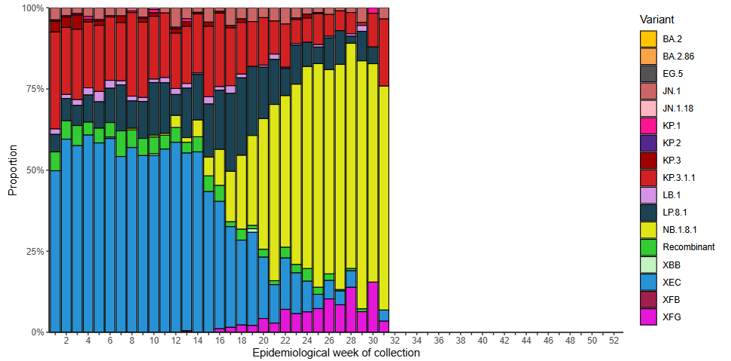
Source: AusTrakka
* Some sub-sublineages are shown alongside their parent lineage, but not included in the parent lineage totals. For instance, KP.2 and KP.3 are sub-sub lineages of JN.1, so the total of JN.1 sequences will be higher than shown in the corresponding colour alone, and should include the KP.2 and KP.3 totals.
† Sequences in AusTrakka aggregated by week and reported based on date of sample collection, not date of sequencing.
‡ Proportions in Figure 22a may not be representative when sequence numbers are small; refer to Figure 22b. Data for earlier weeks may change between reporting periods as sequences with older collection dates are uploaded. These numbers are not equivalent to number of cases, as there are many cases which may not be sequenced. Non-VOI and non-VUM Omicron sub-lineages have been collapsed into parent lineages BA.1, BA.2, BA.3, BA.4 and BA.5.
Figure 22b: SARS-CoV-2 Omicron sub-lineage* sequences by sample collection date, showing the count of sequences per week†‡, Australia, 1 January to 10 August 2025
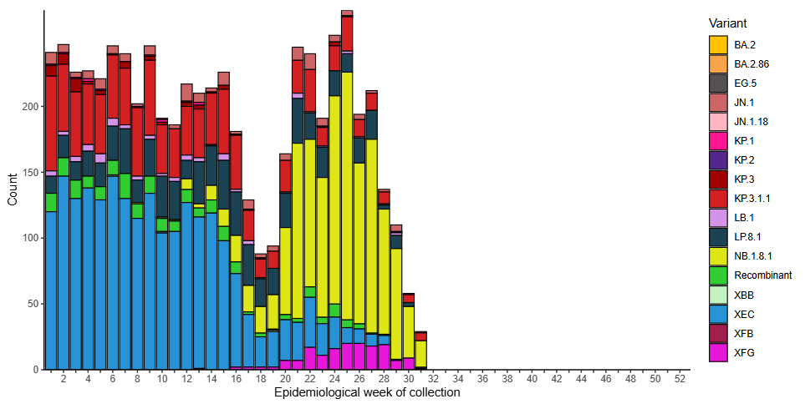
Source: AusTrakka
* Some sub-sublineages are shown alongside their parent lineage, but not included in the parent lineage totals. For instance, KP.2 and KP.3 are sub-sub lineages of JN.1, so the total of JN.1 sequences will be higher than shown in the corresponding colour alone, and should include the KP.2 and KP.3 totals.
† Sequences in AusTrakka aggregated by week and reported based on date of sample collection, not date of sequencing.
‡ Data for earlier weeks may change between reporting periods as sequences with older collection dates are uploaded. These numbers are not equivalent to number of cases, as there are many cases which may not be sequenced. Non-VOI and non-VUM Omicron sub-lineages have been collapsed into parent lineages BA.1, BA.2, BA.3, BA.4 and BA.5.
- In the year to date, the WHO Collaborating Centre for Reference and Research on Influenza has antigenically characterised 3,151 influenza viruses from Australia (Table 4), of which:
  - 73.6% (2,320/3,151) have been influenza A(H1N1)
  - 8.9% (282/3,151) have been influenza A(H3N2)
  - 17.4% (549/3,151) have been influenza B/Victoria.
- In the year to date, there have been no influenza B/Yamagata viruses characterised (Table 4). The last influenza B/Yamagata virus characterised in Australia was in a sample from 2020.
- Of the influenza A(H1N1) samples tested for neuraminidase inhibitor resistance, 1.5% (14/939) demonstrated highly reduced inhibition to Oseltamivir. None of the influenza A(H3N2) samples tested for neuraminidase inhibitor resistance demonstrated highly reduced inhibition to Oseltamivir.
- None of the samples tested demonstrated highly reduced inhibition to Zanamivir.
Table 4: Australian influenza viruses typed by haemagglutination inhibition assay and jurisdiction*†, 1 January to 10 August 2025
Strain | ACT | NSW | NT | Qld | SA | Tas | Vic | WA | Total
A(H1N1) | 259 | 275 | 532 | 120 | 73 | 395 | 630 | 36 | 2,320
A(H3N2) | 14 | 22 | 117 | 20 | 4 | 27 | 73 | 5 | 282
B/Victoria lineage | 90 | 98 | 67 | 23 | 18 | 36 | 183 | 34 | 549
B/Yamagata lineage | 0 | 0 | 0 | 0 | 0 | 0 | 0 | 0 | 0
Total | 363 | 395 | 716 | 163 | 95 | 458 | 886 | 75 | 3,151
Source: World Health Organization (WHO) Collaborating Centre for Reference and Research on Influenza
*Viruses tested by the WHO Collaborating Centre for Reference and Research on Influenza are not necessarily a random sample of all those in the community and early-year data may be based on limited samples received. There may be up to a month delay on reporting of samples.
† Jurisdiction indicates the residential location for the individual tested, not the submitting laboratory.

Vaccine coverage, effectiveness and match
Vaccine coverage, effectiveness and match for acute respiratory infections are monitored from several data sources in Australia. Refer to the Technical Supplement for more information.

Vaccine coverage
- In Australia, regular COVID-19 vaccinations are the best way to stay protected against severe illness, hospitalisation and death from COVID-19. Most adults should get vaccinated annually and adults aged 75 years and over should get vaccinated every six months.
  - More information on COVID-19 vaccines in Australia is available via the department’s COVID-19 webpages or from the National Centre for Immunisation Research and Surveillance (NCIRS).
- Nationally, 9.1% of adults (aged 18 years and over) have received a COVID-19 vaccine in the last six months (Table 5).
- Nationally, fewer adults have received a COVID-19 vaccine in the last 12 months (11.3%; Table 5), compared to the 12 months prior (14.3% from 7 August 2023 to 4 August 2024).
- In the last 12 months, vaccine coverage decreased in all age groups, with the largest decrease seen in 65–74 years age group (from 34.7% in the 12 months prior to 27.4% in the last 12 months).
- There is substantial variation in COVID-19 vaccine coverage across age groups, ranging from 4.8% in adults aged 18–64 years to 43.3% in adults aged 75 years and over. Vaccine coverage increases with increasing age (Table 5).
- There is some variation in vaccine coverage across jurisdictions, ranging from 4.3% in the NT to 19.3% in Tas (Table 5).
Table 5: COVID-19 vaccine coverage*†‡ by age group and jurisdiction, Australia, 5 August 2024 to 10 August 2025
Age group | ACT | NSW | NT | Qld | SA | Tas | Vic | WA | Total
Last 12 months (5 August 2024 to 10 August 2025)
18–64 years | 10.6 | 4.1 | 2.2 | 4.6 | 4.7 | 8.7 | 5.2 | 4.8 | 4.8
65–74 years | 48.5 | 25.4 | 15.2 | 26.3 | 28.2 | 40.6 | 27.9 | 28.0 | 27.4
≥ 75 years | 67.6 | 41.0 | 27.8 | 42.3 | 42.9 | 58.4 | 42.5 | 45.1 | 43.3
All ages (18 years and over) | 18.7 | 10.5 | 4.3 | 10.9 | 12.3 | 19.3 | 11.4 | 11.1 | 11.3
Last 6 months (10 February 2025 to 10 August 2025)
18–64 years | 8.2 | 3.1 | 1.5 | 3.5 | 3.6 | 6.8 | 4.0 | 3.9 | 3.7
65–74 years | 40.0 | 20.8 | 11.9 | 21.1 | 23.3 | 33.6 | 23.0 | 23.5 | 22.5
≥ 75 years | 56.3 | 33.3 | 22.1 | 33.6 | 35.2 | 47.9 | 34.4 | 37.4 | 35.1
All ages (18 years and over) | 15.1 | 8.4 | 3.2 | 8.6 | 10.0 | 15.7 | 9.1 | 9.2 | 9.1
Source: Australian Immunisation Register (AIR) as at 11 August 2025
* COVID-19 vaccine coverage among the general population uses the most recently available Australian Bureau of Statistics Estimated Resident Population (ERP) as denominator for population data. Age in years is calculated as at the reporting week.
† COVID-19 vaccine coverage is influenced by changes in COVID-19 vaccine recommendations and eligibility criteria. For this reason, caution should be used when comparing coverage rates in the current 12 month period to previous 12 month periods. Coverage data in these tables may differ slightly from coverage estimates in other reports due to differences in calculation methodologies and/or different data download dates.
‡ Jurisdiction is based on the state or territory in which a vaccine was administered and may differ from a person’s residential address. Population denominator data used to calculate COVID-19 vaccine coverage are based on an individual’s residential address. Total rows will include individuals where jurisdiction was missing.

- Nationally, 3.7% of Aboriginal and Torres Strait Islander adults (aged 18 years or over) have received a COVID-19 vaccine in the last six months (Table 6).
- Nationally, fewer Aboriginal and Torres Strait Islander adults have received a COVID-19 vaccine in the last 12 months (4.7%; Table 6), compared to the 12 months prior (6.7% from 7 August 2023 to 4 August 2024).
- In the last 12 months, vaccine coverage decreased in all age groups of Aboriginal and Torres Strait Islander people, with the largest decrease seen in ≥ 75 years age group (from 34.2% in the 12 months prior to 27.4% in the last 12 months).
- Among Aboriginal and Torres Strait Islander people there is substantial variation in COVID-19 vaccine coverage across age groups, ranging from 2.7% in adults aged 18–64 years to 27.4% in adults aged 75 years and over. Vaccine coverage increases with increasing age (Table 6).
- Among Aboriginal and Torres Strait Islander people, there is slight variation in vaccine coverage across jurisdictions, ranging from 2.6% in the NT to 9.7% in Tas (Table 6).
Table 6: COVID-19 vaccine coverage*†‡ among Aboriginal and Torres Strait Islander populations by age group and jurisdiction, Australia, 5 August 2024 to 10 August 2025
Age group | ACT | NSW | NT | Qld | SA | Tas | Vic | WA | Total
Last 12 months (5 August 2024 to 10 August 2025)
18–64 years | 6.4 | 2.7 | 1.9 | 2.6 | 2.7 | 5.5 | 4.0 | 2.2 | 2.7
65–74 years | 34.8 | 18.8 | 8.5 | 17.5 | 17.8 | 32.3 | 20.8 | 16.2 | 17.9
≥ 75 years | 51.1 | 29.5 | 13.6 | 25.8 | 29.1 | 43.2 | 32.3 | 26.4 | 27.4
All ages (18 years and over) | 9.6 | 5.1 | 2.6 | 4.4 | 4.8 | 9.7 | 6.7 | 3.8 | 4.7
Last 6 months (10 February 2025 to 10 August 2025)
18–64 years | 5.1 | 2.1 | 1.2 | 2.0 | 2.0 | 4.2 | 3.0 | 1.8 | 2.1
65–74 years | 27.5 | 15.3 | 6.2 | 14.0 | 14.3 | 27.1 | 17.1 | 13.6 | 14.5
≥ 75 years | 41.2 | 23.9 | 11.4 | 20.9 | 23.6 | 34.4 | 26.1 | 22.3 | 22.2
All ages (18 years and over) | 7.6 | 4.1 | 1.8 | 3.5 | 3.8 | 7.7 | 5.2 | 3.1 | 3.7
Source: Australian Immunisation Register (AIR) as at 11 August 2025
* COVID-19 vaccine coverage among Aboriginal and Torres Strait Islander populations is based on the AIR population as known at the reporting week. Age in years is calculated as at the reporting week.
† COVID-19 vaccine coverage is influenced by changes in COVID-19 vaccine recommendations and eligibility criteria. For this reason, caution should be used when comparing coverage rates in the 12 month period to previous 12 month periods. Coverage data in these tables may differ slightly from coverage estimates in other reports due to differences in calculation methodologies and/or different data download dates.
‡ Jurisdiction is based on the state or territory in which a vaccine was administered and may differ from a person’s residential address. Population denominator data used to calculate COVID-19 vaccine coverage are based on an individual’s residential address. Total rows will include individuals where jurisdiction was missing.

- Influenza virus strains change year to year, so annual vaccination before the peak of the influenza season provides Australians with the best protection against influenza and its complications. The seasonal influenza vaccine is recommended for everyone aged six months and over.
  - More information on influenza vaccines in Australia is available via the department’s influenza vaccine webpages or from NCIRS.
- Nationally, influenza vaccine coverage is 29.9% for 2025 so far (Table 7); however, remains lower than coverage at the same time in 2023 and 2022.
- There is substantial variation in influenza vaccine coverage across age groups, ranging from 14.4% in children aged 5–14 years to 60.6% in adults aged 65 years and over (Table 7). The current trend should be interpreted with caution as people aged 5–64 years are generally not eligible for free seasonal influenza vaccine under the National Immunisation Program.
- There is some variation in influenza vaccine coverage across jurisdictions, ranging from 23.1% in the NT to 39.6% in the ACT (Table 7).
- Among Aboriginal and Torres Strait Islander populations, there is substantial variation in influenza vaccine coverage across age groups, ranging from 11.4% in children aged 5–14 years to 59.8% in adults aged 65 years and over (Table 7).
- Among Aboriginal and Torres Strait Islander populations, there is some variation in influenza vaccine coverage across jurisdictions, ranging from 18.5% in WA to 29.3% in the ACT (Table 7).
Table 7: Influenza vaccine coverage*†‡ by age group and jurisdiction, Australia, 1 March to 10 August 2025
 | ACT | NSW | NT | Qld | SA | Tas | Vic | WA | Total
Age groups
6 months to <5 years | 50.6 | 27.0 | 34.4 | 21.4 | 30.1 | 31.9 | 32.9 | 25.1 | 28.0
5–14 years | 24.2 | 13.3 | 12.0 | 12.9 | 15.2 | 14.7 | 16.0 | 15.2 | 14.4
15–49 years | 32.2 | 19.2 | 20.7 | 17.8 | 23.2 | 23.1 | 23.3 | 18.5 | 20.5
50–64 years | 43.9 | 29.7 | 24.9 | 30.9 | 35.6 | 38.7 | 33.8 | 30.6 | 31.9
≥ 65 years | 64.9 | 58.2 | 36.2 | 60.5 | 66.6 | 67.9 | 61.9 | 60.1 | 60.6
All ages (6 months and over) | 39.6 | 28.6 | 23.1 | 27.8 | 34.4 | 35.9 | 32.0 | 28.1 | 29.9
Aboriginal and Torres Strait Islander populations
6 months to <5 years | 31.9 | 17.9 | 33.0 | 14.0 | 17.5 | 21.9 | 21.9 | 17.3 | 18.1
5–14 years | 16.6 | 10.8 | 18.7 | 10.0 | 11.9 | 12.3 | 12.1 | 10.9 | 11.4
15–49 years | 25.3 | 16.4 | 27.3 | 15.0 | 18.6 | 18.9 | 18.8 | 14.9 | 17.2
50–64 years | 45.1 | 35.7 | 40.7 | 33.8 | 37.2 | 44.5 | 36.0 | 31.4 | 35.6
≥ 65 years | 68.1 | 62.2 | 45.1 | 59.6 | 63.1 | 69.2 | 63.2 | 53.4 | 59.8
All ages (6 months and over) | 29.3 | 21.3 | 29.2 | 18.9 | 22.7 | 25.7 | 23.8 | 18.5 | 21.4
Source: Australian Immunisation Register (AIR) as at 11 August 2025
* Influenza vaccine coverage uses the AIR population as the denominator. Coverage data in these tables may differ slightly from coverage estimates in other reports due to differences in calculation methodologies and/or different data download dates.
† Age is calculated based on the person’s age as at 1 July of the reporting year.
‡ From the report ending 13 July 2025, jurisdiction is based on the person’s address on the AIR rather than an individual’s residential address as recorded on Medicare. Total rows will include individuals where jurisdiction was missing. In addition, to align with departmental reporting methodologies, both the numerator (number of persons vaccinated) and denominator (AIR population) for influenza vaccine coverage only consider person records with a Personal Identification Number that was able to be matched to Medicare. Person records with a Synthetic Identification Number are now excluded from both numerator and denominator. For these reasons, influenza vaccine coverage metrics in previous Australian Respiratory Surveillance Reports and coverage metrics from the report ending 13 July 2025 moving forward should be interpreted with care.

- Infants can be protected against severe illness from RSV through the vaccination of pregnant people or the direct administration of monoclonal antibodies like nirsevimab. These are part of the National RSV Maternal and Infant Protection Program which launched on 3 February 2025 and includes both the National Immunisation Program funded Abrysvo vaccine and state and territory nirsevimab programs.
  - More information on RSV immunisation in Australia is available via the department’s RSV vaccine webpages or from NCIRS.
- Since the commencement of the National RSV Mother and Infant Protection Program, 101,934 Abrysvo doses have been administered to pregnant people nationally (Table 8).
- While high maternal vaccine uptake is a positive indicator of maternal program success, it may result in lower nirsevimab uptake rates in infants. This is because maternal antibodies passed to the infant can provide protection against RSV, potentially reducing the need for infant immunisation.
Table 8: Number of doses of Abrysvo administered to pregnant people by jurisdiction*, Australia, 3 February to 10 August 2025
 | ACT | NSW | NT | Qld | SA | Tas | Vic | WA | Total
Age group
15–24 years | 168 | 2,580 | 179 | 2,240 | 552 | 273 | 1,454 | 992 | 8,438
25–39 years | 2,468 | 27,838 | 803 | 15,660 | 6,150 | 1,881 | 24,110 | 9,051 | 87,961
40–54 years | 165 | 1,824 | 41 | 826 | 350 | 85 | 1,681 | 563 | 5,535
Total (15–54 years) | 2,801 | 32,242 | 1,023 | 18,726 | 7,052 | 2,239 | 27,245 | 10,606 | 101,934
Source: Australian Immunisation Register (AIR) as at 11 August 2025
* Jurisdiction is based on the state or territory in which a vaccine was administered and may differ from a person’s residential address. Total rows will include individuals where jurisdiction was missing.
- Nationally, 21.1% of infants (aged < 8 months) have received nirsevimab (Table 9).
- There is substantial variation in nirsevimab uptake in infants across jurisdictions, ranging from 12.9% in NSW to 39.1% in WA (Table 9).
- The current trend is likely due to variation in the seasonality and eligibility criteria between state and territory programs, as well as the presence of previous nirsevimab programs. Some state and territory programs are seasonal (from 1 April to 30 September), whereas others are year-round. In states with seasonal programs (SA, Tas, Vic, and parts of WA), uptake may appear disproportionately lower at this time of the year. In addition, Qld and WA had nirsevimab programs in 2024, which may contribute to higher nirsevimab uptake in 2025 in these states.
Table 9: Nirsevimab (Beyfortus) uptake in the past six months*†‡ by age group and jurisdiction, Australia, 10 February 2025 to 10 August 2025
 | ACT | NSW | NT | Qld | SA | Tas | Vic | WA | Total
Age group
Infants (aged < 8 months) | 16.3 | 12.9 | 25.2 | 21.1 | 30.9 | 34.1 | 20.3 | 39.1 | 21.1
Young children (aged ≥ 8 to 24 months) | 1.1 | 0.4 | 0.4 | 0.2 | 1.0 | 1.4 | 0.9 | 1.2 | 0.7
Source: Australian Immunisation Register (AIR) as at 11 August 2025
* Reporting of RSV monoclonal antibodies to the AIR is not compulsory; therefore, uptake is likely to be underestimated. Uptake data in these tables may differ slightly from estimates in other reports due to differences in calculation methodologies and/or different data download dates.
† For infants and young children vaccinated, age in months is calculate as months between the immunisation encounter and date of birth rounded down as at the reporting date. For the infant and young children population, age in months is calculated as months between the AIR data extract date and date of birth rounded down as at the reporting date.
‡ Jurisdiction is based on the state or territory in which a vaccine was administered and may differ from a person’s residential address. Total rows will include individuals where jurisdiction was missing. Population denominator data used to calculate nirsevimab uptake are based on an individual’s residential address as recorded on Medicare.

Vaccine effectiveness
- It is too early to assess vaccine effectiveness for the 2025 influenza season.

Vaccine match
- Refer to the Technical Supplement for information on the 2025 southern hemisphere influenza vaccines composition.
- In the year to date, 99.3% (2,304/2,320) of influenza A(H1N1) isolates, 100% (282/282) of influenza A(H3N2) isolates and 98.0% (538/549) of influenza B/Victoria lineage isolates characterised have been antigenically similar to the corresponding 2025 vaccine components.

