Australian Respiratory Surveillance Report
Viral Respiratory Diseases Epidemiology and Surveillance Section
Report 6, 2024

Key messages
This report presents a national epidemiological update for coronavirus disease 2019 (COVID-19), influenza and respiratory syncytial virus (RSV) with a focus on the current reporting period (3 June to 16 June 2024) and earlier severity reporting periods (up to 2 June 2024).
Activity: In the year to date, respiratory illness activity (self-reported new fever and cough symptoms) in the community has been higher than, or similar to, the levels of activity observed at the same time in previous years (excluding 2022). General practice consultation rates for respiratory illnesses (new fever and cough symptoms) monitored through sentinel surveillance sites have decreased in the last fortnight, though are slightly higher than consultation rates observed in most previous years. Nationally, there was a decreasing trend in the number of notified COVID-19 cases and the number of notified RSV cases this fortnight, while the number of notified influenza cases continued to increase steadily. However, this increasing trend in influenza activity has not yet been observed across all jurisdictions.
Severity: Since late April 2024, the number of patients hospitalised with a severe acute respiratory infection (SARI) monitored through sentinel hospital-based surveillance has increased. In 2024, the proportion of those patients with a SARI monitored through sentinel hospital-based surveillance admitted directly to an intensive care has remained low and stable. Nationally, since early 2024, the number of patients admitted to sentinel intensive care surveillance sites with a SARI have followed an overall decreasing trend. Patients with COVID-19 accounted for more than half of the SARI admissions at sentinel intensive care surveillance sites.
At-risk populations: For patients admitted with a SARI to sentinel intensive care sites, the largest proportion of in-hospital mortality has been in those aged 60 years or over. Nationally, age-specific mortality rates for COVID-19, influenza and RSV cases have been highest among those aged 70 years or over.
Impact: The proportion of people taking time off work due to respiratory illness (self-reported new fever and cough symptoms) has decreased this fortnight. Nationally, the mean number of COVID-19 cases in intensive care has increased this fortnight, while the mean number of intensive care staff unavailable due to COVID-19 illness or exposure has decreased this fortnight.
Genomic surveillance and virology: Nationally, the Omicron BA.2.86 sublineage, JN.1, remains the dominant circulating sublineage. Of the newly named variants under monitoring, JN.1 sublineages KP.2 and KP.3 are most common in Australia. Since early 2024, influenza A has accounted for most influenza notifications nationally.
Vaccine coverage, effectiveness and match: It is too early to assess influenza vaccine coverage or effectiveness for the 2024 influenza season. COVID-19 and RSV vaccination data will be included in future iterations of the Australian Respiratory Surveillance Report.

Introduction
This Australian Respiratory Surveillance Report was prepared by Tracy Tsang, Jenna Hassall and Siobhan St George on behalf of the interim Australian Centre for Disease Control. We thank the staff and participants from the surveillance systems who contribute data for acute respiratory illness surveillance across Australia.
The Australian Respiratory Surveillance Reports present a national overview of acute respiratory infections in Australia, drawing information from several different surveillance systems. Our surveillance systems help us to understand the distribution of acute respiratory illness activity in the community, the severity of disease, which populations might be at risk severe disease, and the impact of acute respiratory illness on the community and health system in Australia. Surveillance indicators presented in this report are based on the Australian National Surveillance Plan for COVID-19, Influenza and RSV.
A summary of data considerations for this Australian Respiratory Surveillance Report are provided below. Refer to the Technical Supplement – Australian Respiratory Surveillance Report for further detail on our surveillance sources and data considerations, including the impacts of the COVID-19 pandemic on acute respiratory infection surveillance in Australia.

Data considerations
- Due to the dynamic nature of the surveillance systems used in this report, surveillance data are considered preliminary and subject to change as updates are received, with the most recent weeks considered particularly incomplete. Data in this report may vary from data reported in other national reports and reports by states and territories. Data in this report are presented by International Organization for Standardization (ISO) 8601 weeks, with the week ending on Sunday.
- In Australia, states and territories report notified cases to the National Notifiable Diseases Surveillance System (NNDSS) based on the Australian national surveillance case definitions. For COVID-19, both laboratory-confirmed and probable cases are notified to the NNDSS; however, from Report 5 onward only laboratory-confirmed COVID-19 cases are included in this report (except where specified otherwise).
- Data from the NNDSS are analysed and reported based on diagnosis date, which is the true onset date of a case if known, otherwise it is the earliest of the specimen date, the notification date, or the notification received date. NNDSS data were extracted on 19 June 2024.
- To account for the lag in collection and provision of severity data from some surveillance systems, and for the time delay between illness onset and the development of severe disease outcomes, cases with an admission date or a diagnosis date in the last two weeks are excluded from severity analyses, which includes analyses of hospitalisations, intensive care admissions and deaths. As such, the severity reporting periods are two weeks behind the current reporting period. For this report, severity reporting includes data up to 2 June 2024.
- While every care has been taken in preparing this report, the Australian Government Department of Health and Aged Care does not accept liability for any injury or loss or damage arising from the use of, or reliance upon, the content of the report or Technical Supplement. For further details about information contained in this report please refer to the Technical Supplement – Australian Respiratory Surveillance Report or contact respiratory.surveillance@health.gov.au.

1. Activity
Activity measures the capacity of the circulating respiratory viruses to spread from person to person and may be measured indirectly through systems that monitor acute respiratory illnesses and more directly through systems that monitor cases.

1.1 Community-based surveillance

FluTracking
- This fortnight (3 June to 16 June 2024), the mean incidence of new fever and cough among FluTracking participants was 2.3%, a slight decrease compared with the mean incidence of 2.2% in the previous fortnight (Figure 1). Note, FluTracking data are age standardised.
- This fortnight, 12.2% (197/1,613) of FluTracking participants who reported new fever and cough symptoms reported testing for severe acute respiratory syndrome coronavirus 2 (SARS-CoV-2) with a polymerase chain reaction (PCR) test and 71.2% (1,149/1,613) reported testing with a rapid antigen test (RAT) (noting that in some instances a RAT will be followed by a PCR test for the same participant, or vice versa).
  - This fortnight, the self-reported percent positivity among participants with new fever and cough symptoms increased for SARS-CoV-2 PCR tests (24.9%; 49/197) and decreased for RATs (40.1%; 461/1,149) compared with the previous fortnight (23.7% [54/228] and 47.3% [632/1,337] respectively).
- This fortnight, 15.1% (243/1,613) of FluTracking participants with new fever and cough symptoms reported testing for influenza with a PCR test.
  - This fortnight, the self-reported percent positivity among participants with new fever and cough symptoms increased considerably for influenza PCR tests (25.5%; 62/243), compared with the previous fortnight (16.9%; 51/302).
- In the year to date, the incidence of new fever and cough symptoms reported to FluTracking has fluctuated, peaking in the week ending 9 June 2024 at 2.4% (Figure 1). The incidence of fever and cough is currently higher than or similar to the proportion observed in the same period in all previous years (excluding 2022) and the five-year mean (Figure 1).

Figure 1: Age standardised percentage of FluTracking participants reporting new fever and cough symptoms compared with the five-year mean by year and week of report*, Australia, 2017 to 16 June 2024
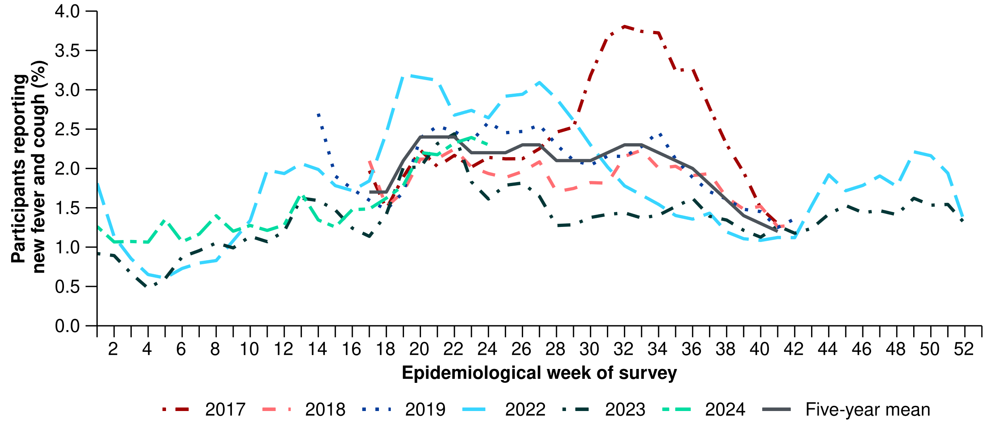
* FluTracking has expanded the reporting period from 2020 onwards due to COVID-19. As such, five-year historical comparisons are not available for data reported before May and after October for any year before 2020. The years 2020 and 2021 are excluded when comparing the current season to historical periods when influenza virus has circulated without public health restrictions. As such, the five-year mean includes the years 2017 to 2019 and 2022 to 2023. Please refer to the Technical Supplement for interpretation of the five-year mean and for notes on impact of COVID-19 on FluTracking data.

Australian Sentinel Practice Research Network (ASPREN)
- This fortnight (3 June to 16 June 2024), a mean rate of 7.4 per 1,000 consultations per fortnight due to new fever and cough symptoms were reported by ASPREN sentinel general practitioners and nurse practitioners. This is a small decrease compared with 7.8 per 1,000 consultations in the previous fortnight (Figure 2).
- This fortnight, 91 people presented to ASPREN sentinel general practitioners and nurse practitioners with new fever and cough symptoms and were tested for respiratory pathogens. Of those, 70.3% (64/91) have tested positive for a respiratory pathogen.
  - Among those positive for a respiratory pathogen, the most common respiratory pathogen reported was rhinovirus (32.8%; 21/64). Other respiratory pathogens detected included influenza (28.1%; 18/64), RSV (17.2%; 11/64), and SARS-CoV-2 (9.4%; 6/64).
- In the year to date, the rate of new fever and cough symptoms per 1,000 consultations per week has been similar to the rate observed in the corresponding weeks of earlier years (excluding 2019 and 2022 in recent weeks) and the five-year mean (Figure 2).
- In the year to date, 897 people presented to ASPREN sentinel general practitioners and nurse practitioners with new fever and cough symptoms and have been tested for respiratory pathogens. Of those, 67.1% (602/897) have tested positive for a respiratory pathogen.
  - Among those positive for a respiratory pathogen, the most common respiratory pathogen reported has been rhinovirus (35.4%; 213/602). Other respiratory pathogens detected included SARS-CoV-2 (15.6%; 94/602), influenza (14.6%; 88/602), RSV (11.8%; 71/602), Mycoplasma pneumoniae (8.0%; 48/602) and adenovirus (4.5%; 27/602).
Figure 2: Rate of new fever and cough symptoms per 1,000 consultations per week with ASPREN sentinel general practitioners and nurse practitioners compared with the five-year mean by year and week of consultation*†, Australia, 2017 to 16 June 2024
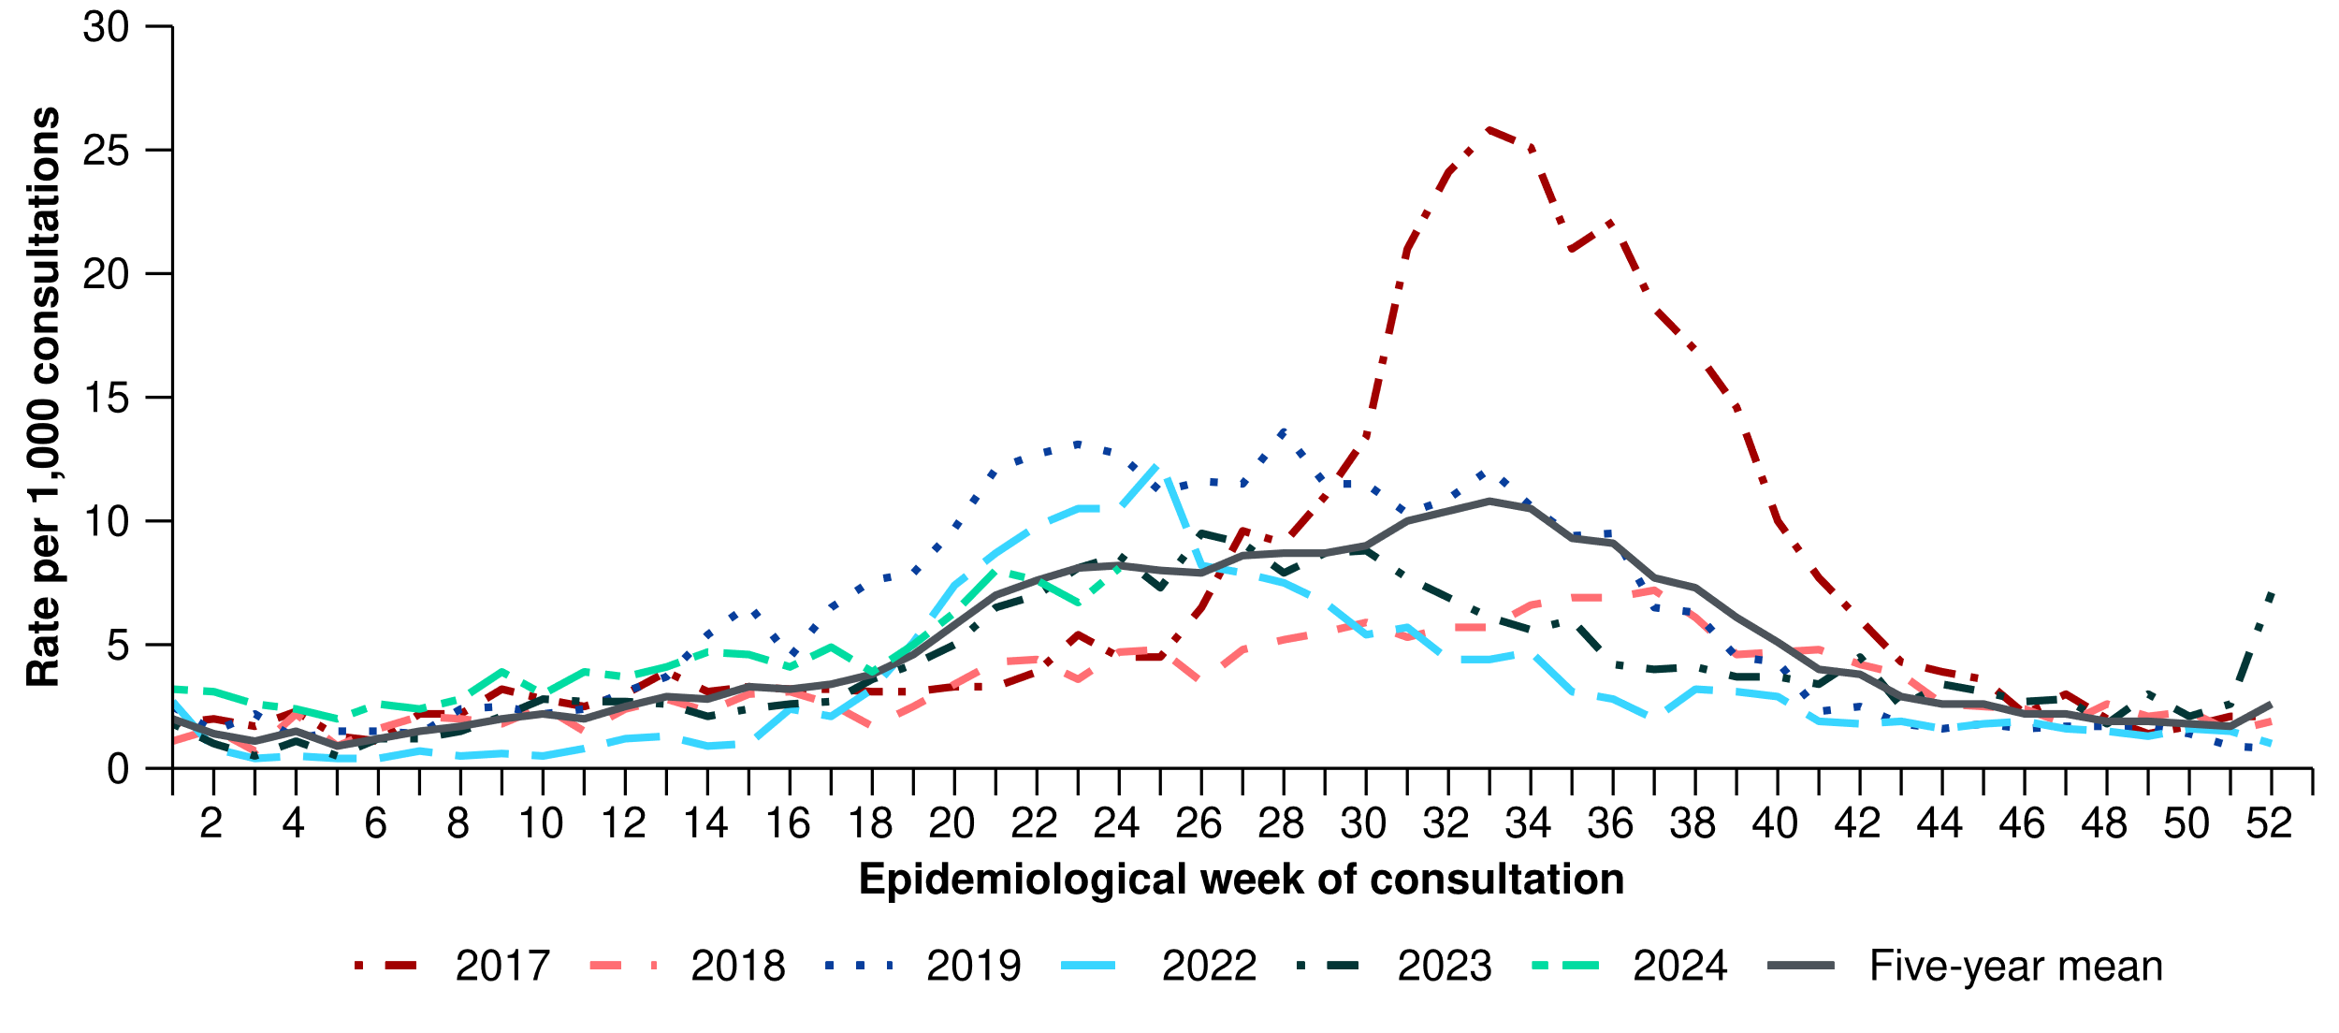
* The years 2020 and 2021 are excluded when comparing the current season to historical periods when influenza virus has circulated without public health restrictions. As such, the five-year mean includes the years 2017 to 2019 and 2022 to 2023. Please refer to the Technical Supplement for interpretation of the five-year mean.
† Please refer to the Technical Supplement for notes on impact of COVID-19 on ASPREN data.

Wastewater surveillance
Wastewater surveillance data for SARS-CoV-2 are only received from Victoria and Western Australia, and therefore, wastewater surveillance data are not nationally representative. In addition, SARS-CoV-2 wastewater surveillance methods in Victoria and Western Australia are not directly comparable and have different reporting periods. Refer to the Technical Supplement – Australian Respiratory Surveillance Report for further detail on SARS-CoV-2 wastewater surveillance methods in Victoria and Western Australia. At present, there are no wastewater surveillance data for influenza or RSV.
- Levels of SARS-CoV-2 in wastewater have been increasing since early April 2024, suggesting increasing prevalence of COVID-19 in the Victorian and Western Australian communities.
  - Quantitative wastewater measures in Victoria indicate levels of circulating SARS-CoV-2 in the Victorian community have followed a sharp increasing trend since mid-May 2024 (Figure 3A).
  - Quantitative wastewater measures in Western Australia indicate levels of circulating SARS-CoV-2 in the Western Australian community have stabilised in recent weeks, after appearing to increase rapidly since mid-April 2024 (Figure 3B). Note, quantitative data were unavailable from Western Australia from the week ending 28 April 2024 to the week ending 5 May 2024 (Figure 3B).

Figure 3: Quantitative wastewater surveillance trends for SARS-CoV-2 by sample collection week, (A) Victoria*, 1 January to 9 June 2024 and (B) Western Australia†‡, 1 January to 16 June 2024
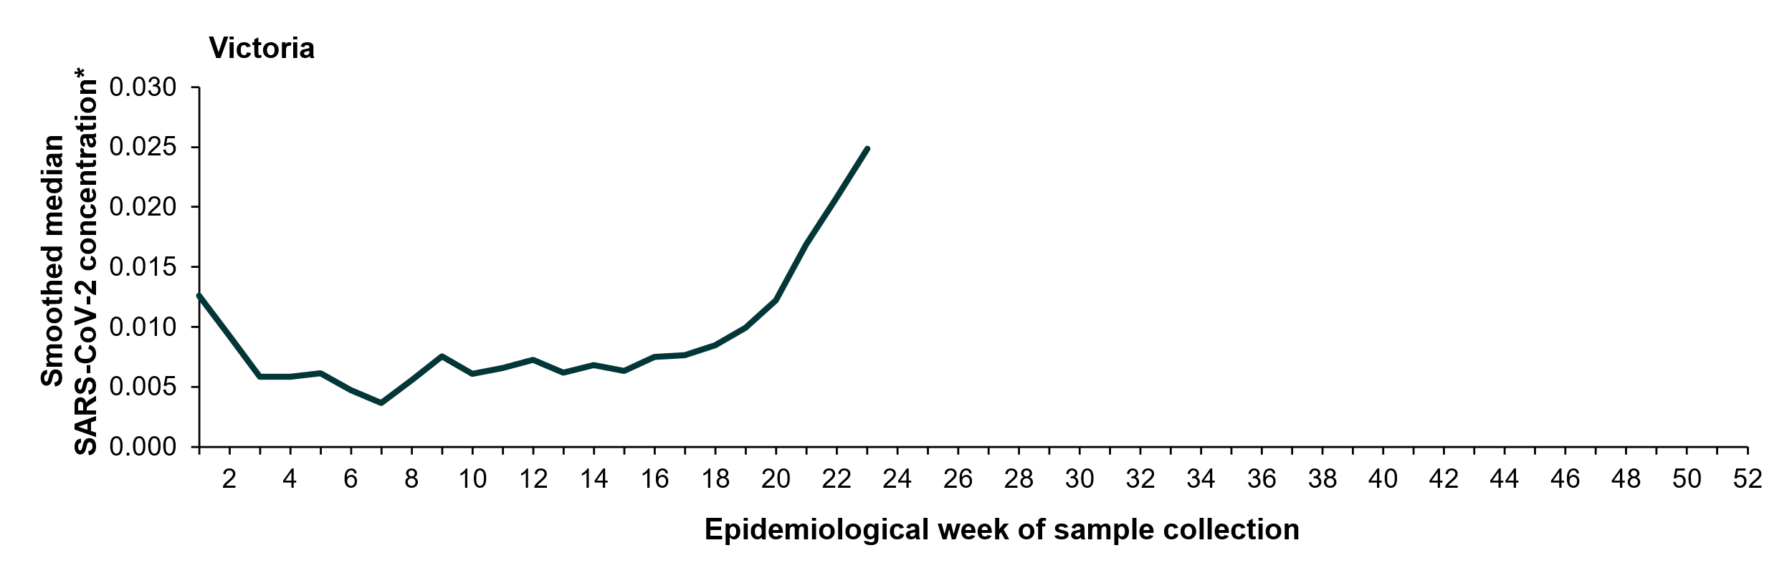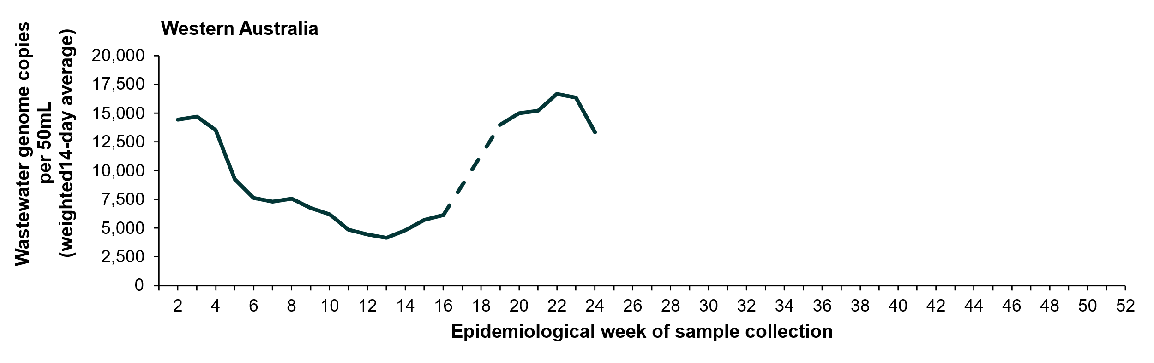
* Quantitative results in Victoria are normalised by PMMoV (pepper mild mottle virus; a non-pathogenic virus that is shed consistently by the population) and smoothed over the read period to account for rainfall, population movements and catchment size.
† Quantitative results in Western Australia generally have a maximum delay of up to three days.
‡ Quantitative results in Western Australia could not be determined for the 14-day period ending 7 January 2024, the 14-day period ending 28 April 2024, or the 14-day period ending 5 May 2024.

- In the year to date, detections of specific strains of SARS-CoV-2 in wastewater samples in Victoria and Western Australia showed that the newly emerged sublineages of JN.1, including KP.3, have been increasing in relative abundance in the community in these jurisdictions since early April 2024 (Figure 4).
  - In Victoria, JN.1 sublineages remain the dominant variant in wastewater samples, though the JN.1 sublineage KP.3 has been detected in increasing abundance (Figure 4A).
  - In Western Australia, KP.X sublineages have recently become the dominant sublineages in wastewater samples (Figure 4B).
  - Due to the time required to perform genome sequencing and analyses, wastewater surveillance variant trend data for SARS-CoV-2 are only available for the period two weeks behind the current reporting period; therefore, reporting periods presented here may not align with other sections of the report.

Figure 4: Quantitative wastewater surveillance trends for SARS-CoV-2 by variant and sample collection week or fortnight*†, (A) Victoria and (B) Western Australia, 1 January to 2 June 2024
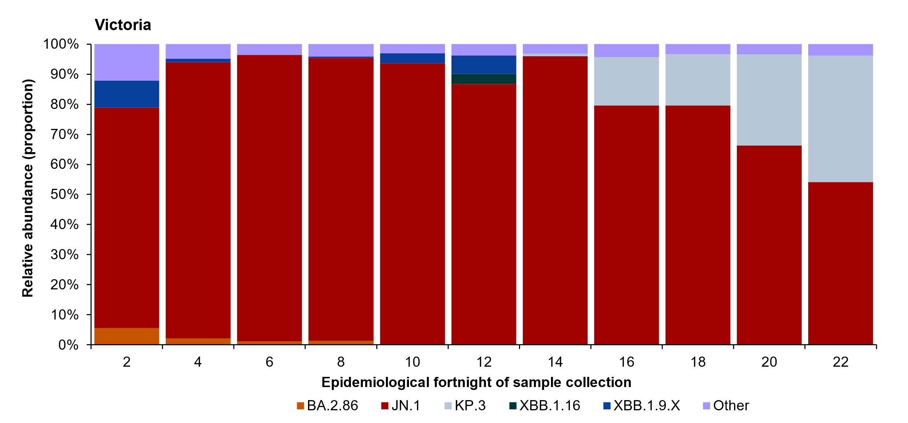
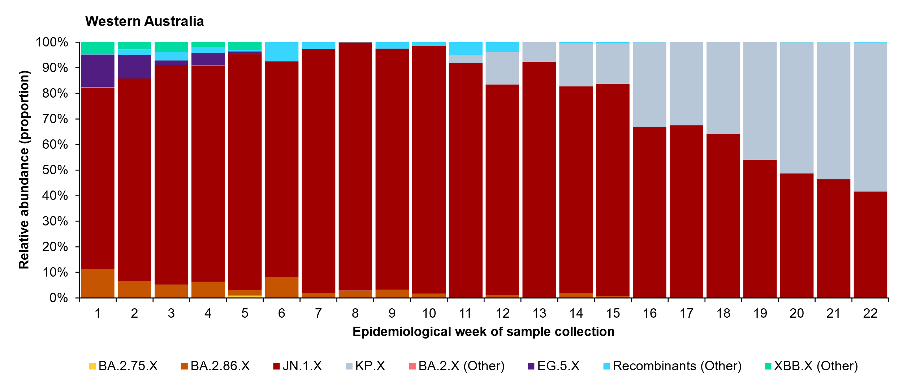
* The .X following the lineage name indicates the inclusion of all respective sub-lineages.
† Genomic results in Victoria and Western Australia may be delayed up to 14 days as sequencing occurs fortnightly.

1.2 Laboratory-based surveillance

Sentinel laboratories, including National Influenza Centres
- This fortnight (3 June to 16 June 2024), 6.7% (1,213/18,002) of samples tested for SARS-CoV-2 across sentinel laboratories have been positive for SARS-CoV-2, a small increase in positivity compared with the previous fortnight (6.2%; 1,039/16,640) (Figure 5).
- This fortnight, 9.1% (1,870/20,648) of the samples tested for influenza across sentinel laboratories have been positive for influenza, an increase in positivity compared with the previous fortnight (6.7%; 1,299/19,330) (Figure 5).
- This fortnight, 4.1% (737/18,002) of the samples tested for RSV across sentinel laboratories have been positive for RSV, an increase in positivity compared with the previous fortnight (3.7%; 616/16,640) (Figure 5).
- This fortnight, the most commonly detected respiratory viruses by sentinel laboratory site and week were:
  - New South Wales: influenza A (both weeks)
  - South Australia: rhinovirus (both weeks)
  - Tasmania: rhinovirus (both weeks)
  - Victoria: influenza A, SARS-CoV-2, parainfluenza, picornavirus (week 23) and influenza A (week 24)
  - Western Australia: SARS-CoV-2 (both weeks).
- In the year to date, 5.4% (8,399/154,716) of samples tested for SARS-CoV-2 have been positive for SARS-CoV-2, 4.2% (7,575/180,762) of samples tested for influenza have been positive for influenza and 2.4% (3,724/154,716) of samples tested for RSV have been positive for RSV (Figure 5).
Figure 5: Total number of specimens tested by sentinel laboratories and proportion of positive sentinel laboratory tests by pathogen and week of report*†, 1 January to 16 June 2024
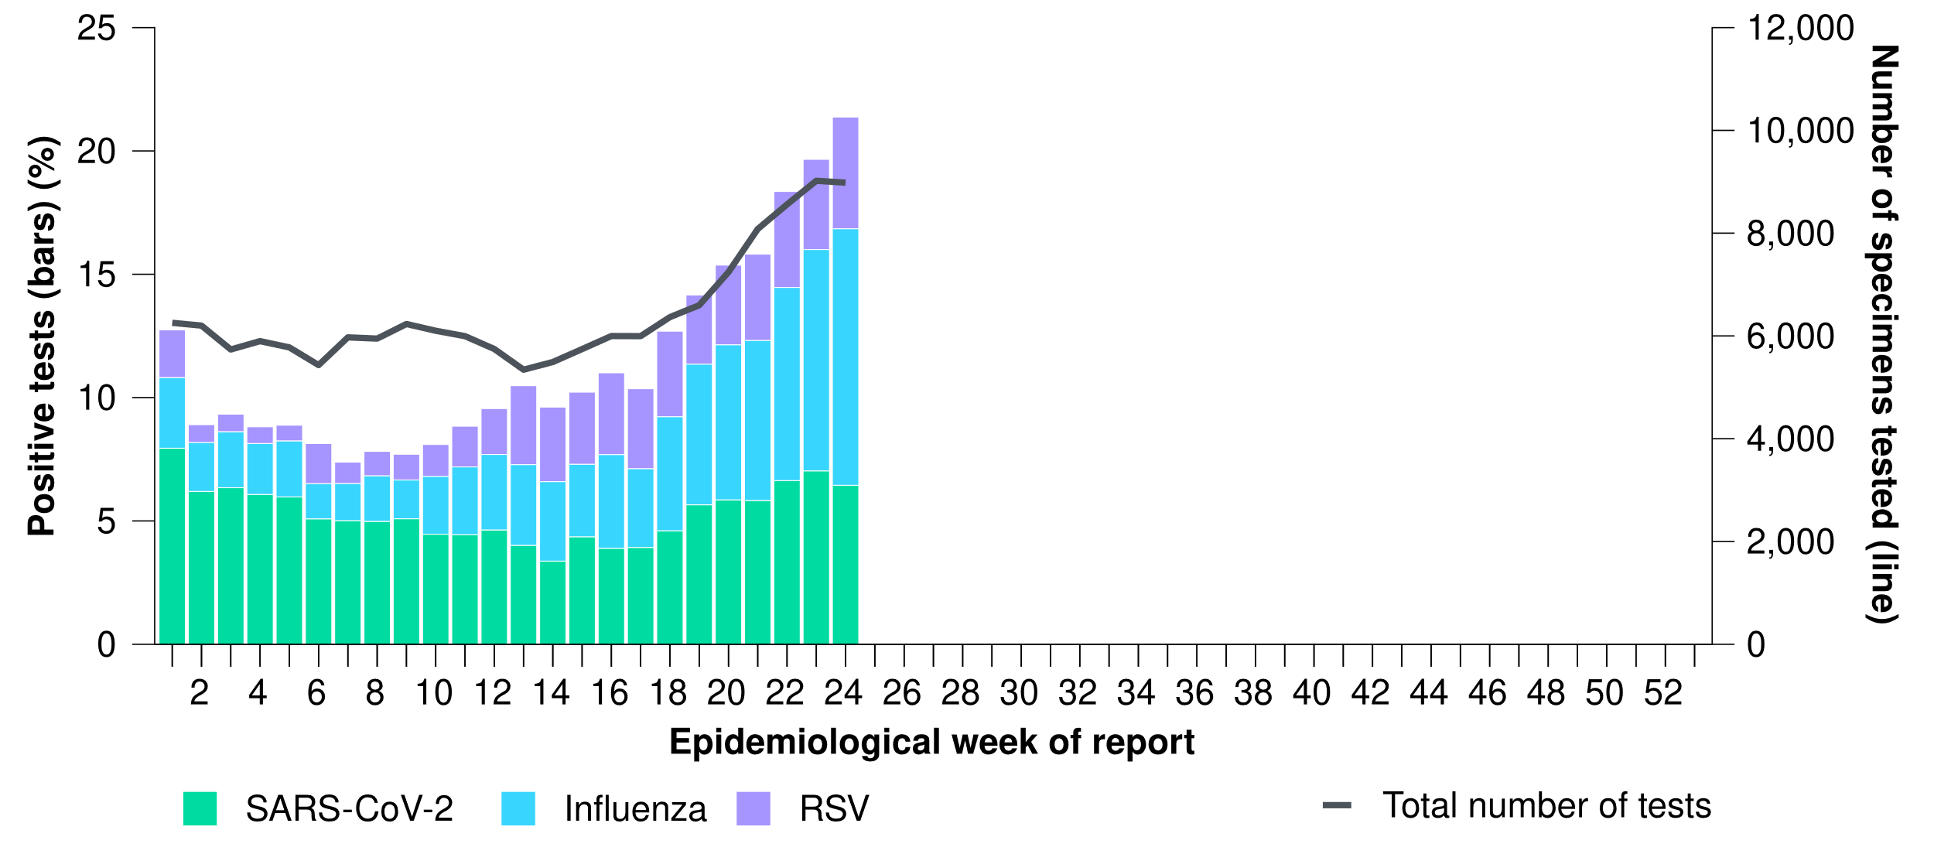
* Number of specimens tested excludes data from Western Australia as testing denominator data are different for the three pathogens in Western Australia.
† A small minority of total samples from Victoria are tested only by respiratory panel (influenza, parainfluenza, adenovirus, human metapneumovirus, seasonal coronaviruses, RSV, and some picornaviruses) but not for SARS-CoV-2. These minority samples include only forensic materials; all other samples are tested by respiratory panel and SARS-CoV-2 assay.

1.3 Case-based surveillance

NNDSS
- Nationally, this fortnight there was a decreasing trend in the number of notified COVID-19 cases and the number of notified RSV cases, while the number of notified influenza cases continued to increase steadily.

Table 1: Notifications to the NNDSS and notification rate per 100,000 population by disease, five-year age group, and jurisdiction*†, Australia, 1 January to 16 June 2024
 | COVID-19 |  |  | Influenza |  |  | RSV
 | Reporting fortnight  (n) | Year to date  (n) | Year to date  (rate) | Reporting fortnight  (n) | Year to date  (n) | Year to date  (rate) | Reporting fortnight  (n) | Year to date  (n) | Year to date  (rate)
Age group (years)
0–4 | 1,526 | 12,132 | 800.3 | 3,759 | 12,736 | 840.1 | 5,752 | 54,467 | 3,592.8
5–9 | 527 | 3,132 | 194.5 | 4,818 | 14,843 | 921.7 | 1,376 | 7,709 | 478.7
10–14 | 578 | 3,298 | 199.0 | 3,147 | 9,430 | 569.0 | 778 | 3,314 | 200.0
15–19 | 587 | 4,152 | 258.1 | 1,802 | 6,154 | 382.5 | 318 | 1,889 | 117.4
20–24 | 630 | 5,049 | 291.5 | 1,041 | 4,624 | 267.0 | 203 | 1,500 | 86.6
25–29 | 744 | 6,459 | 336.1 | 1,173 | 4,995 | 259.9 | 244 | 1,777 | 92.5
30–34 | 940 | 7,474 | 377.0 | 1,387 | 5,709 | 288.0 | 292 | 2,347 | 118.4
35–39 | 1,129 | 8,084 | 417.2 | 1,622 | 6,488 | 334.8 | 301 | 2,316 | 119.5
40–44 | 1,005 | 7,698 | 432.4 | 1,586 | 6,139 | 344.8 | 269 | 1,871 | 105.1
45–49 | 999 | 7,137 | 442.1 | 1,126 | 4,907 | 304.0 | 300 | 1,804 | 111.8
50–54 | 1,028 | 7,697 | 458.1 | 1,000 | 4,713 | 280.5 | 307 | 2,214 | 131.8
55–59 | 924 | 7,564 | 496.5 | 766 | 3,975 | 260.9 | 329 | 2,285 | 150.0
60–64 | 1,061 | 8,021 | 528.8 | 708 | 3,789 | 249.8 | 352 | 2,611 | 172.1
65–69 | 1,103 | 8,517 | 641.8 | 523 | 3,123 | 235.4 | 345 | 2,627 | 198.0
70+ | 7,307 | 53,154 | 1,645.7 | 1,469 | 9,389 | 290.7 | 1,506 | 10,897 | 337.4
Jurisdiction
ACT | 415 | 2,583 | 553.3 | 309 | 1,120 | 239.9 | 354 | 1,792 | 383.9
NSW | 9,679 | 64,343 | 771.6 | 15,995 | 50,187 | 601.8 | 4,704 | 47,987 | 575.4
NT | 216 | 1,568 | 621.1 | 99 | 1,988 | 787.4 | 36 | 1,119 | 443.2
Qld | 4,168 | 33,178 | 607.7 | 3,181 | 18,890 | 346.0 | 2,817 | 23,634 | 432.9
SA | 1,387 | 11,026 | 595.5 | 1,048 | 4,871 | 263.1 | 960 | 3,319 | 179.2
Tas. | 254 | 2,685 | 468.8 | 169 | 795 | 138.8 | 183 | 812 | 141.8
Vic. | 3,198 | 25,798 | 378.7 | 4,663 | 19,444 | 285.4 | 3,303 | 19,205 | 281.9
WA | 780 | 8,679 | 301.5 | 465 | 3,727 | 129.5 | 315 | 1,774 | 61.6
Total† | 20,097 | 149,860 | 562.6 | 25,929 | 101,022 | 379.2 | 12,672 | 99,642 | 374.1
* Rate per 100,000 population for the given time period. Population data are based on the Australian Bureau of Statistics (ABS) Estimated Resident Population (ERP) as at June 2023.
† Total includes cases with missing age.
- Nationally, there were 20,097 COVID-19 notifications with a diagnosis date this fortnight (3 June to 16 June 2024), a small decrease compared with 21,447 notifications in the previous fortnight (Figure 6).
  - Prior to the decrease observed this fortnight, COVID-19 notifications had been following an increasing trend since late April 2024. The increasing trend in case notifications since April 2024 followed a decrease in case numbers from January 2024 (Figure 6).
- In the year to date, there have been 149,860 COVID-19 notifications reported to the NNDSS. This is lower than the number of laboratory-confirmed notifications in the same period in 2023; however, this trend should be interpreted with caution due to a reduction in case ascertainment and reporting in all jurisdictions (Figure 6).
- In the year to date, COVID-19 notification rates have been highest in people aged 70 years or over, followed by children aged 0–4 years (Table 1).
  - This trend for older age groups is likely to be a reflection of higher case ascertainment due to targeted testing strategies in place for populations at-risk of severe disease and who live in a high-risk setting, such as a residential aged care facility.

Figure 6: COVID-19 cases notified to the NNDSS showing (A) laboratory-confirmed and probable cases in all pandemic years 2020–2024 and (B) laboratory-confirmed cases in recent pandemic years 2023 and 2024 by year and week of diagnosis, Australia, 1 January 2020 to 16 June 2024
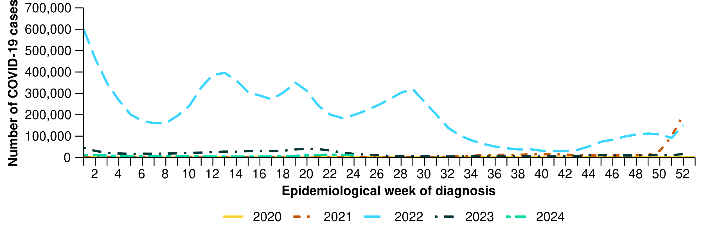
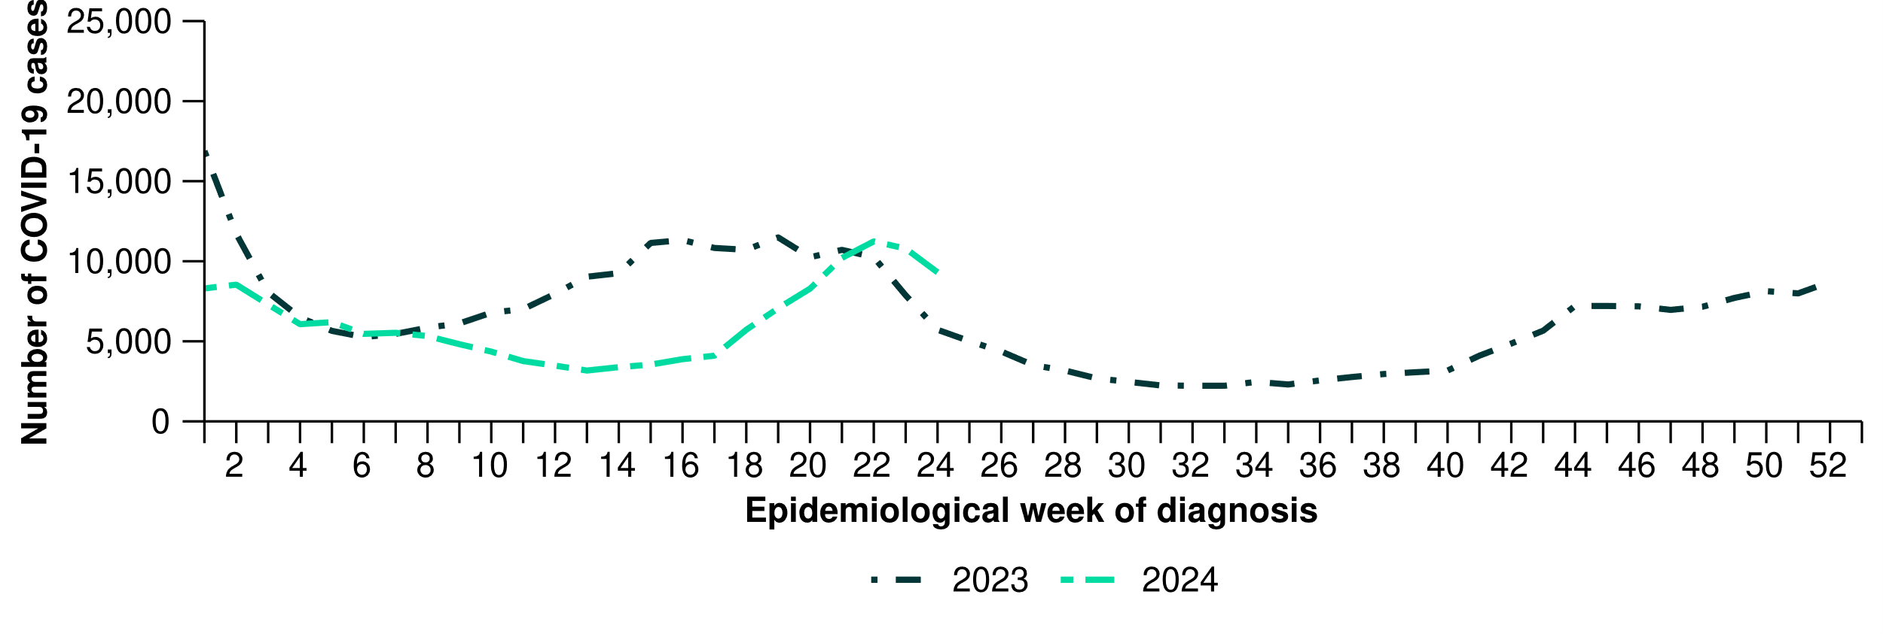
- This fortnight, COVID-19 notification rates have decreased in most jurisdictions compared with the previous fortnight, except in Queensland where an increase was observed compared with the previous fortnight (Figure 7).
- In the year to date, COVID-19 notification rates have been highest in New South Wales, followed by the Northern Territory (Table 1).

Figure 7: Notification rates per 100,000 population for COVID-19 cases notified to the NNDSS* by state or territory and week of diagnosis, Australia, 1 January to 16 June 2024
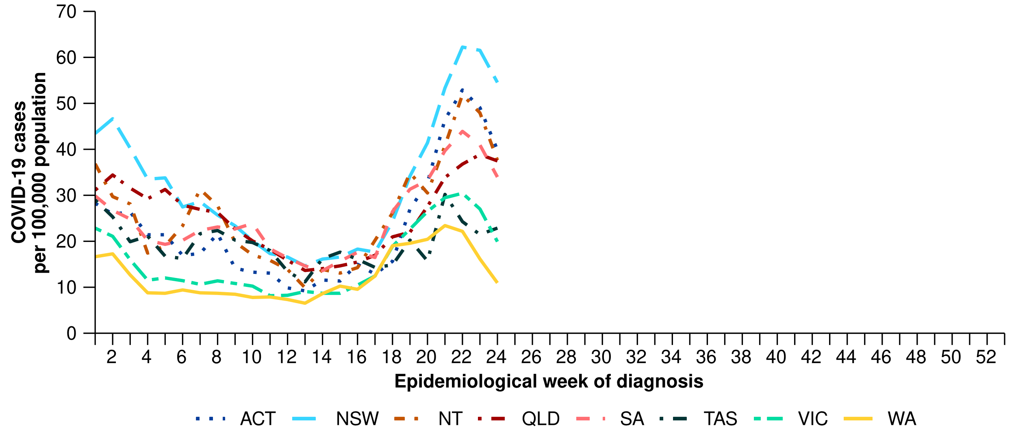
* Rate per 100,000 population for the given time period. Population data are based on the ABS ERP as at June 2023.

- Nationally, influenza notifications have risen steadily since late April. However, this trend has not been observed across all jurisdictions (Figure 8; Figure 9).
- Nationally, there were 25,929 influenza notifications with a diagnosis date this fortnight, a considerable increase compared with 17,574 notifications in the previous fortnight (Figure 8).
- In the year to date, there have been 101,022 influenza notifications reported to the NNDSS, which is higher than the number of notifications in the same period in all other years (excluding 2019 and 2022) (Figure 8).
  - The higher number of influenza notifications observed during the most recent interseasonal period (typically November to the following March) may have been due to an increase in influenza circulation in the community. However, it may also have been influenced by changes in health-seeking behaviour, such as increased laboratory testing for viral respiratory infections, associated with increases in COVID-19 activity observed in many jurisdictions from late 2023 into early 2024.
- In the year to date, influenza notification rates have been highest in children aged 5–9 years, followed closely by children aged 0–4 years (Table 1).

Figure 8: Influenza cases notified to the NNDSS and five-year mean* by year and week of diagnosis, Australia, 2017 to 16 June 2024
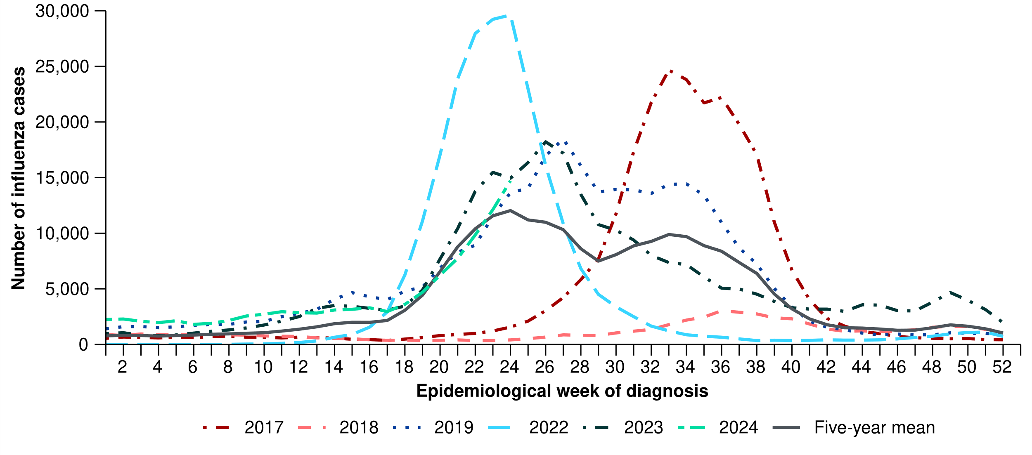
* The years 2020 and 2021 are excluded when comparing the current season to historical periods when influenza virus has circulated without public health restrictions. As such, the five-year mean includes the years 2017 to 2019 and 2022 to 2023. Please refer to the Technical Supplement for interpretation of the five-year mean.

- This fortnight, influenza notification rates were highest in New South Wales (Figure 9). This fortnight, influenza notification rates remained relatively stable in most jurisdictions, except New South Wales and Queensland where notifications continued to increase, and the Northern Territory where notifications continued to decrease (Figure 9).
- Until the most recent fortnight, influenza notification rates had followed an increasing trend in most jurisdictions since late April 2024, though have remained relatively low and stable in Western Australia (Figure 9).
- In the year to date, influenza notification rates have been highest in the Northern Territory, followed by New South Wales (Table 1).
Figure 9: Notification rates per 100,000 population for influenza cases notified to the NNDSS* by state or territory and week of diagnosis, Australia, 1 January to 16 June 2024
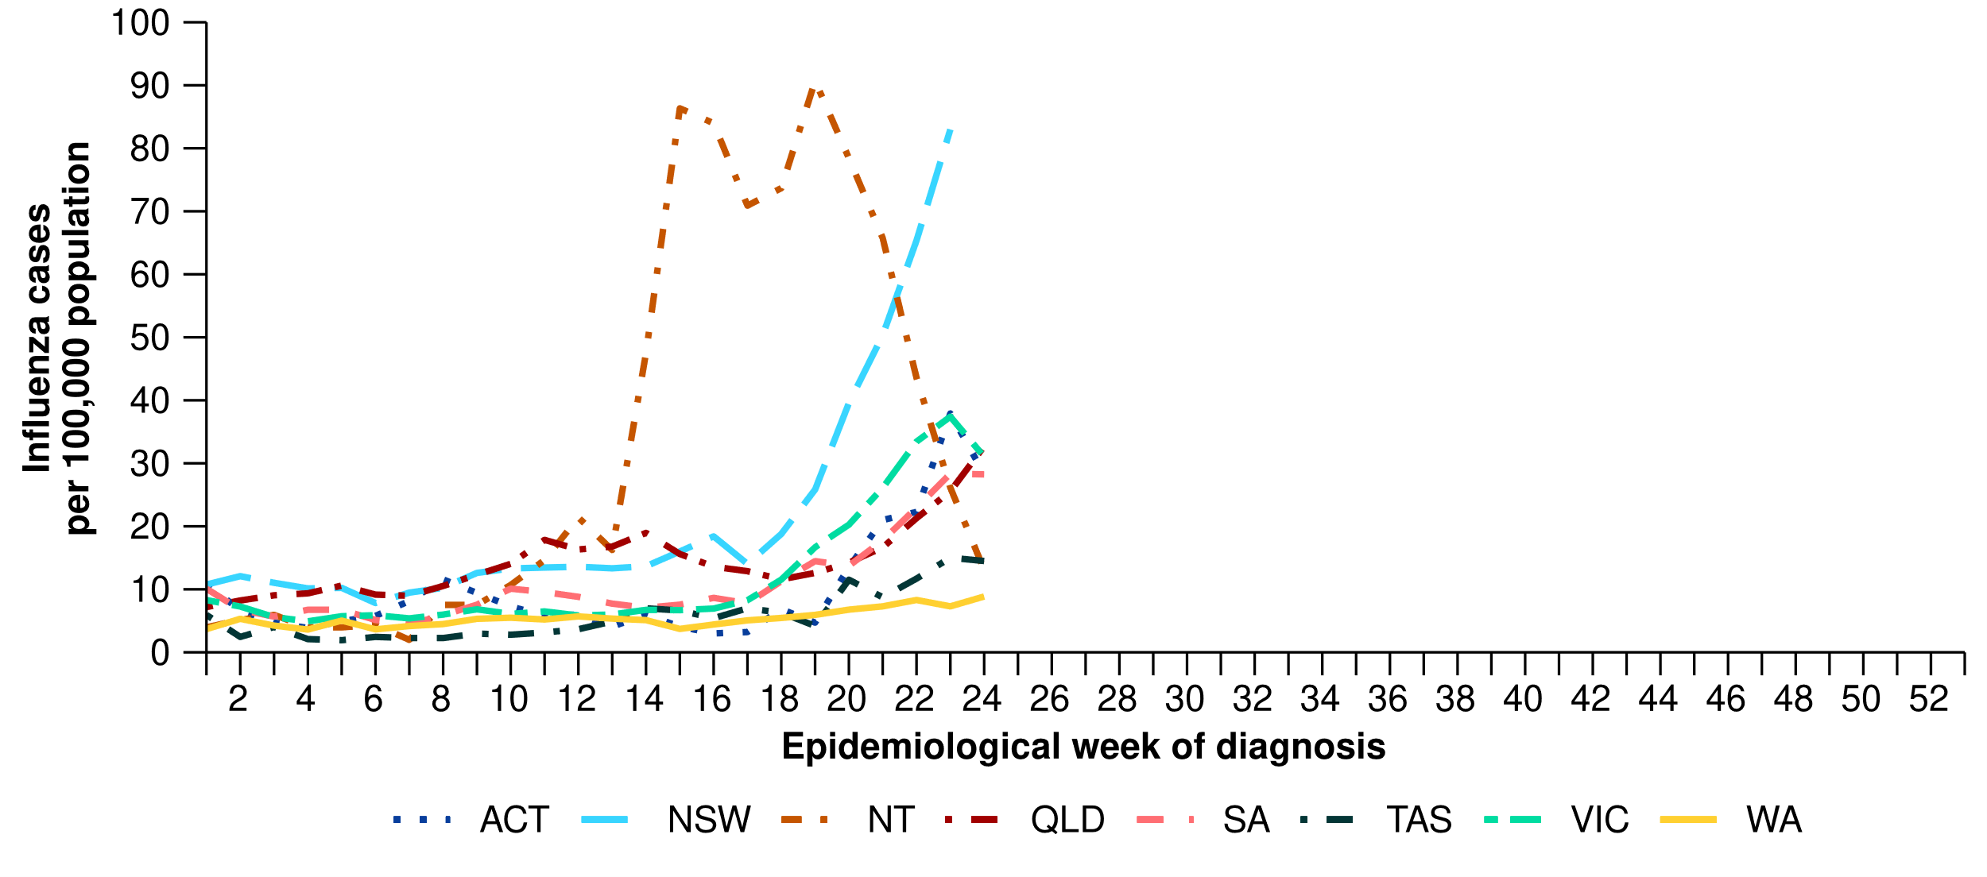
* Rate per 100,000 population for the given time period. Population data are based on the ABS ERP as at June 2023.
- Nationally, there were 12,672 RSV notifications with a diagnosis date this fortnight, a decrease compared with 14,610 notifications in the previous fortnight (Figure 10).
- In the year to date, there have been 99,642 RSV notifications reported to the NNDSS, which is higher than the number of RSV notifications in the same period in 2023 (Figure 10).
  - The higher number of RSV notifications observed during the period January to March 2024 may have been due to an increase in RSV circulation in the community. However, it may also have been influenced by changes in health-seeking behaviour, such as increased laboratory testing for viral respiratory infections, associated with increases in COVID-19 activity observed in many jurisdictions from late 2023 into early 2024. Note, RSV notifications are not available nationally for historical comparisons prior to January 2023.
- In the year to date, RSV notification rates have been highest in children aged 0–4 years, followed by children aged 5–9 years (Table 1).
Figure 10: RSV cases notified to the NNDSS by year and week of diagnosis*, Australia, 2023 to 16 June 2024
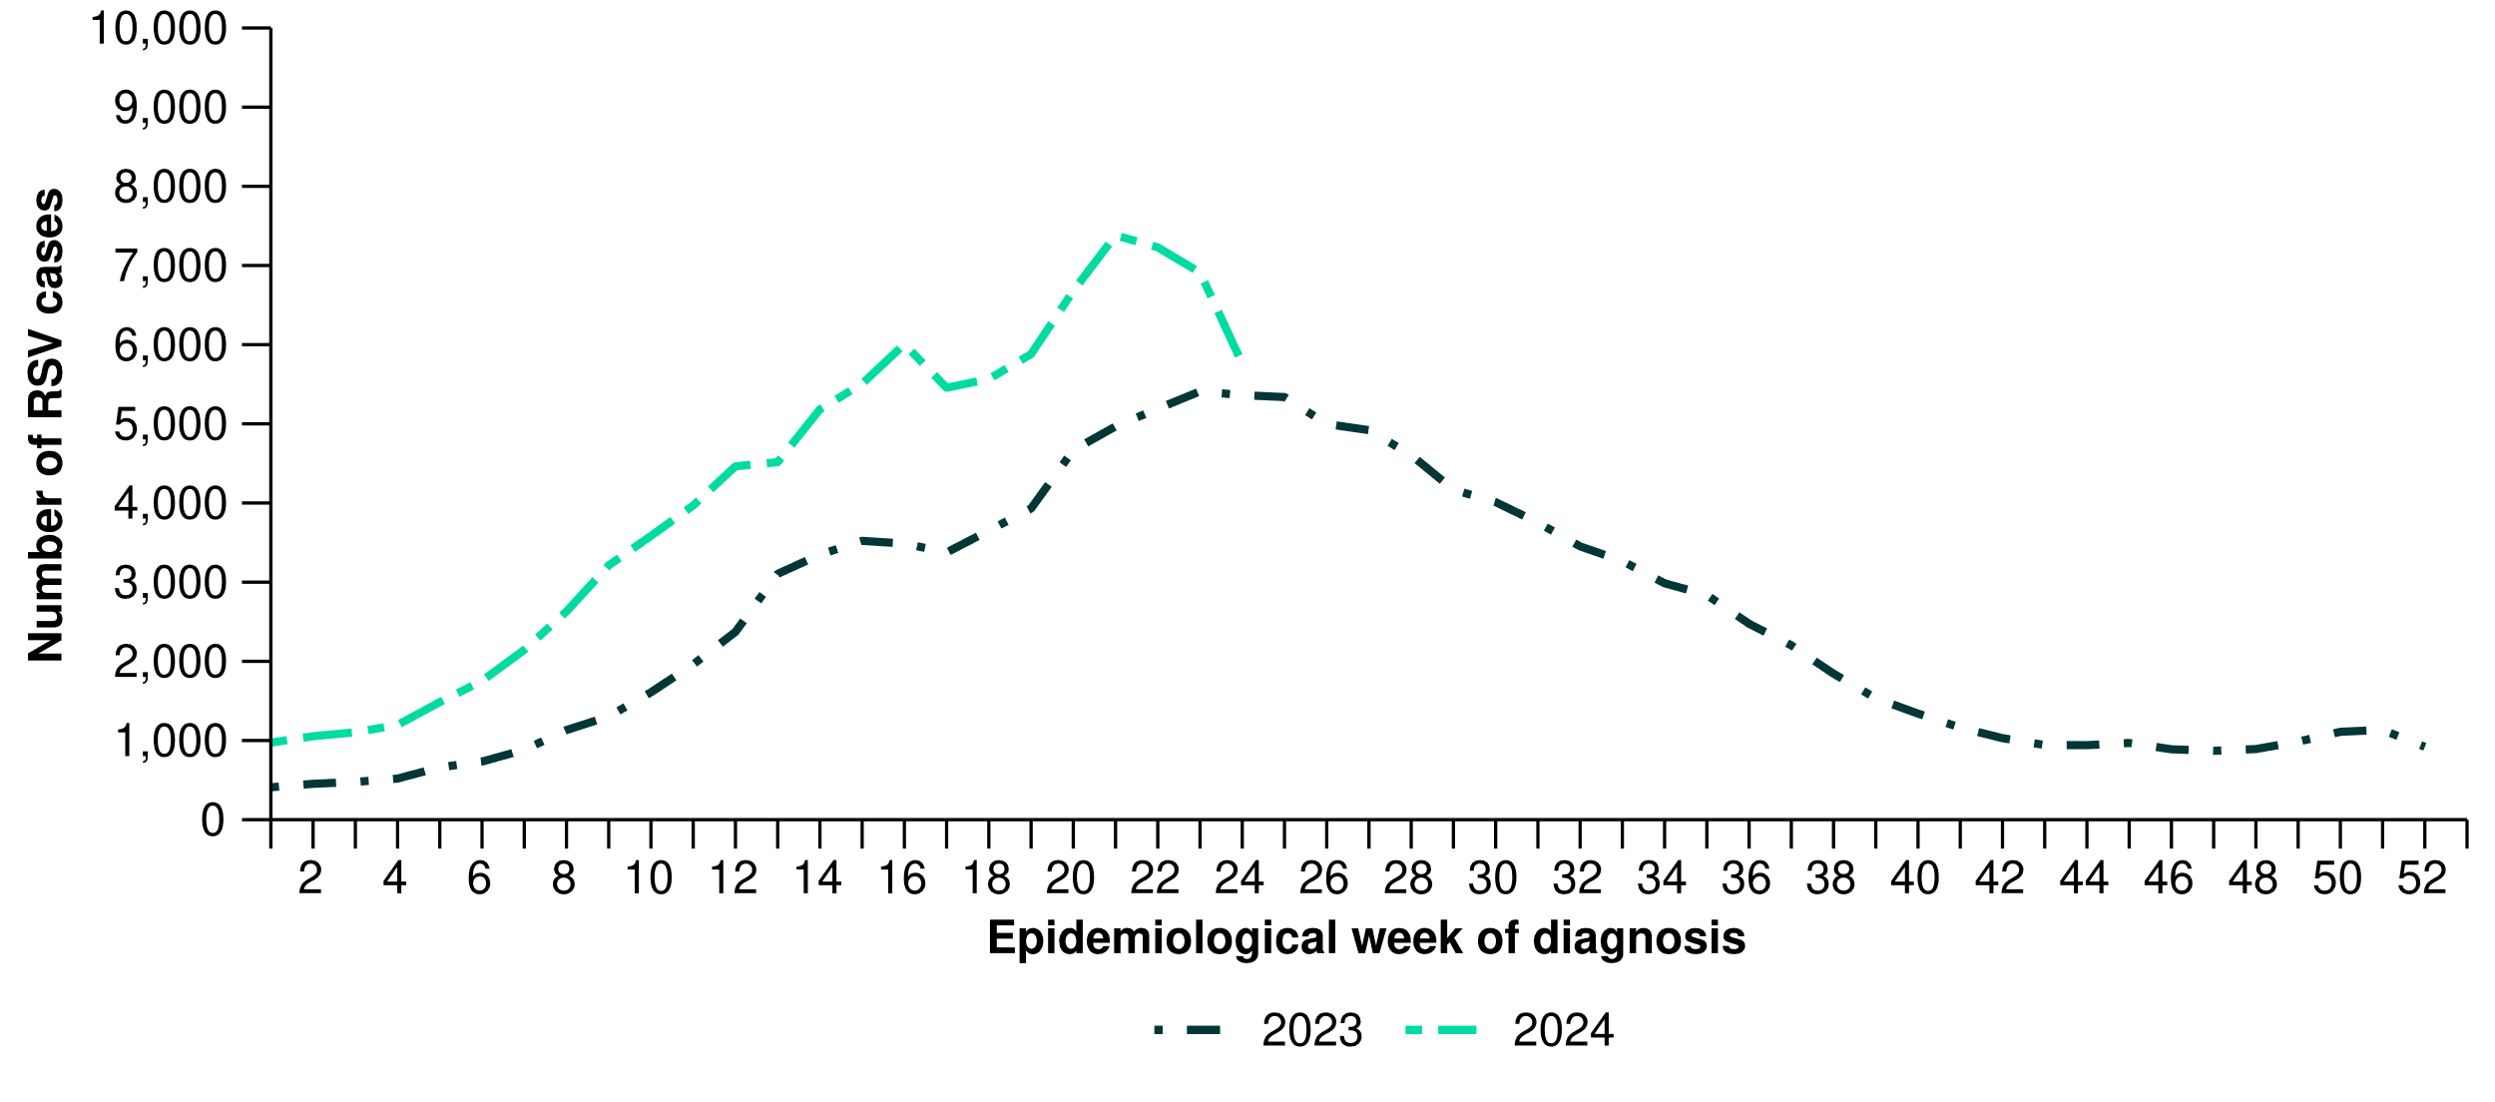
* RSV became notifiable in all states and territories on 1 September 2022. Comprehensive national data for RSV are only available from 2023 onwards.
- This fortnight, RSV notification rates decreased in most jurisdictions, except in South Australia and Western Australia where increases were observed compared with the previous fortnight (Figure 11).
- Since the beginning of 2024, RSV notifications have followed an increasing trend in all jurisdictions except Western Australia, where notification rates have remained comparatively low and stable (Figure 11). In the year to date, RSV notification rates have been highest in New South Wales, followed by the Northern Territory (Table 1).

Figure 11: Notification rates per 100,000 population for RSV cases notified to the NNDSS* by state or territory and week of diagnosis, Australia, 1 January to 16 June 2024
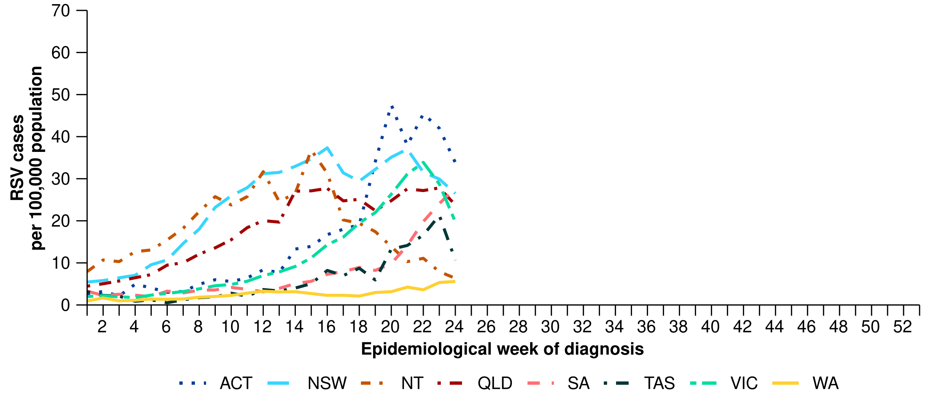
* Rate per 100,000 population for the given time period. Population data are based on the ABS ERP as at June 2023.

For further information regarding respiratory virus activity at the jurisdictional level, please refer to the state and territory health respiratory surveillance reports.

2. Severity*
The severity of acute respiratory infections is measured as those who are hospitalised, admitted to intensive care, or have died. Measuring and understanding severity quantifies the most significant health impacts of circulating respiratory viruses.

2.1 Hospital-based surveillance
In interpreting data from hospital-based sentinel systems, it is important to note these data reflect the sickest patients with severe acute respiratory infections who are hospitalised or admitted to intensive care; data are therefore not generalisable to all cases or patients in hospital.

Influenza Complications Alert Network (FluCAN)
In FluCAN sentinel hospitals RSV surveillance commenced on 1 April 2024; however, due to unforeseen issues RSV data are not yet available. These data will be included in future iterations of the Australian Respiratory Surveillance Report.
- In this fortnight for FluCAN severity reporting (20 May to 2 June 2024), there were 510 patients admitted with a severe acute respiratory infection (SARI) to FluCAN sentinel hospitals, of whom 6.9% (35/510) were admitted directly to intensive care (Figure 12).
- In the year to date for FluCAN severity reporting (1 January to 2 June 2024), there have been 3,135 patients admitted with a SARI to FluCAN sentinel hospitals, of which 6.6% (206/3,135) have been admitted directly to intensive care (Figure 12).
- In the year to date for FluCAN for severity reporting, there have been 2,404 patients admitted with COVID-19 to FluCAN sentinel hospitals, of whom 7.0% (169/2,404) were admitted directly to intensive care (Figure 12). This excludes 24 patients with COVID-19 admitted to FluCAN sentinel hospitals with a missing admission location.
  - For patients admitted with COVID-19 to FluCAN sentinel hospitals, the median length of stay in hospital was 3 days (interquartile range [IQR]: 1–6 days).
  - Note, all length of stay calculations exclude patients that acquired their infection in hospital. Please see the Technical Supplement for further detail.
- Since influenza surveillance commenced on 1 April 2024 to date for FluCAN severity reporting (2 June 2024), there have been 730 patients admitted with influenza to FluCAN sentinel hospitals, of whom 5.1% (37/730) were admitted directly to intensive care (Figure 12).
  - For patients admitted with influenza to FluCAN sentinel hospitals, the median length of stay in hospital was 2 days (IQR: 1–4 days).

* To account for the lag in collection and provision of severity data from some surveillance systems, and for the time delay between illness onset and the development of severe disease, cases with a diagnosis date in the last two weeks are excluded from severity analyses which include analyses of hospitalisations, intensive care admissions and deaths. For this reason, the severity reporting periods are two weeks behind the current reporting period.
Figure 12: Number of patients admitted with a severe acute respiratory infection to FluCAN sentinel hospitals by disease, admission location and week of admission*†‡, Australia, 1 January to 2 June 2024
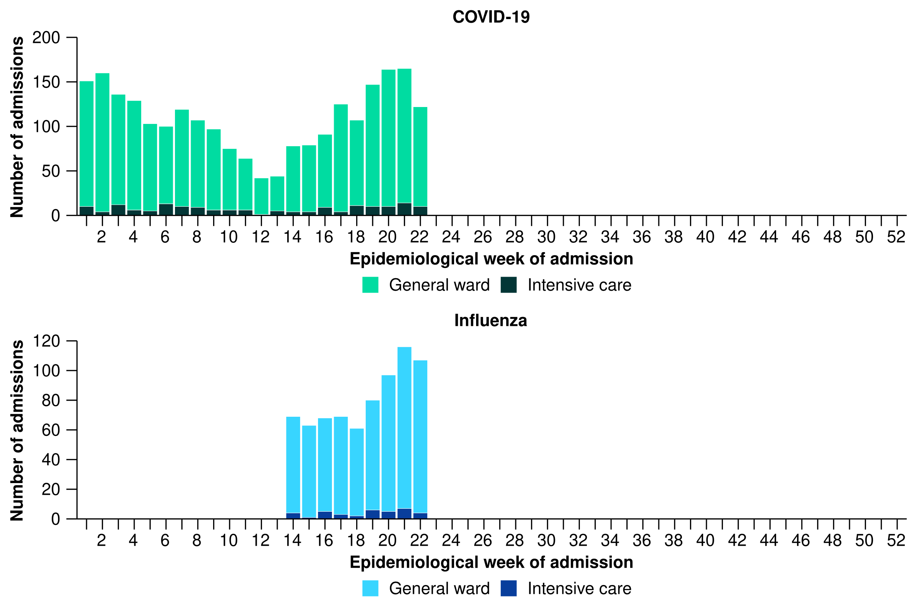
* Axis varies between disease groups.
† Excludes 24 patients with a severe acute respiratory infection admitted to FluCAN sentinel hospitals with a missing admission location.
‡ Admission location reflects the initial admission ward; some patients may be initially admitted to general ward then later admitted to an intensive care and this is not reflected here.

Short Period Incidence Study of Severe Acute Respiratory Infection (SPRINT-SARI) Australia (last updated 7 June 2024)
This section will be updated every four weeks; therefore, reporting periods presented here may not align with other sections of the report. Note, intensive care includes intensive care units and high dependency units that are managed by an intensive care team.
- In the most recent 28-day period for SPRINT-SARI severity reporting (22 April to 19 May 2024), there were 155 patients admitted with a SARI to a SPRINT-SARI sentinel intensive care. Patients with COVID-19 accounted for the highest proportion of patients admitted with a SARI to a SPRINT-SARI sentinel intensive care during this time (Figure 13).
- In the year to date for SPRINT-SARI severity reporting (1 January to 19 May 2024), there have been 800 patients admitted with a SARI to a SPRINT-SARI sentinel intensive care (Figure 13). This includes:
  - 54.1% (433/800) patients with SARS-CoV-2
  - 14.5% (116/800) patients with influenza
  - 15.0% (120/800) patients with RSV
  - 18.4% (147/800) patients with other respiratory pathogens including parainfluenza and rhinovirus.
- Approximately 2.0% (16/800) of patients had co-infections of multiple pathogens; therefore, pathogen-specific totals above may not equal the sum total of the number of patients.
- In the year to date for SPRINT-SARI severity reporting, for all patients admitted with a SARI to a SPRINT-SARI sentinel intensive care, the median duration of mechanical ventilation was 3.1 days (IQR: 1.3–7.2 days), the median length of stay in intensive care was 2.8 days (IQR: 1.6–5.4 days), and the median length of stay in hospital was 7.4 days (IQR: 4.3–13.9 days).
- In the year to date for SPRINT-SARI severity reporting, most patients admitted with a SARI (69.6%; 557/800) have been discharged home, 7.5% (60/800) died in intensive care and 2.4% (19/800) died within the general hospital ward after intensive care admission, with an overall in-hospital mortality rate of 9.9% (79/800) for all patients admitted with a SARI to a SPRINT-SARI sentinel intensive care.
  - Note, deaths in patients admitted with a SARI to a SPRINT-SARI sentinel intensive care may not necessarily represent a death due to SARI.
Figure 13: Number of patients admitted with severe acute respiratory infections to a SPRINT-SARI sentinel intensive care by disease*† and week of admission, Australia, 1 January to 19 May 2024
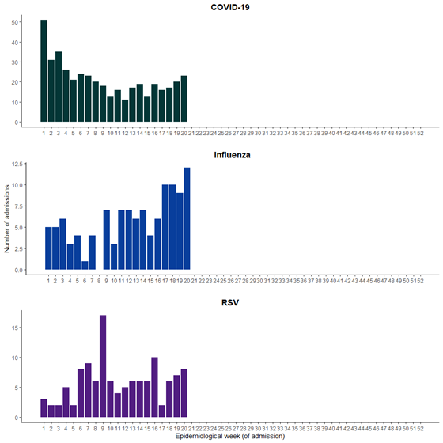
* Axis varies between disease groups.
† Includes four patients with viral co-infection of SARS-CoV-2/influenza/RSV in the year to date for severity reporting.
Table 2: Outcomes for patients admitted with a severe acute respiratory infection(s) to a SPRINT-SARI sentinel intensive care by disease*†‡, Australia, 1 January to 19 May 2024
 | COVID-19 |  | Influenza |  | RSV |  | Other
 | Severity reporting period  (n=76) | Year to date  for severity reporting  (n=433) | Severity reporting period  (n=41) | Year to date  for severity reporting  (n=116) | Severity reporting period  (n=23) | Year to date  for severity reporting  (n=120) | Severity reporting period  (n=17) | Year to date  for severity reporting  (n=147)
Received invasive mechanical ventilation
Number (%) | 17  (22.4%) | 131 (30.3%) | 10  (24.4%) | 34  (29.3%) | 2  (8.7%) | 27  (22.5%) | 4  (23.5%) | 42  (28.6%)
Duration of invasive mechanical ventilation (days)
Median [IQR] | 2.9  [1.2–3.9] | 2.5  [1.0–7.3] | 3.4  [2.3–6.3] | 5.2  [2.8–8.1] | N/A | 4.4  [2.6–6.4] | 7.3  [4.4–10] | 3.4  [2.0–8.5]
Length of intensive care stay (days)
Median [IQR] | 2.6  [1.5–4.8] | 2.7  [1.5–4.9] | 2.7  [1.2–4.5] | 3.0  [1.7–6.2] | 2.7  [1.6–4.3] | 2.7  [1.6–4.4] | 3.7  [2.6–5.6] | 2.9  [1.8–5.7]
Length of hospital stay (days)
Median [IQR] | 5.8  [4.4–11] | 7.8  [4.7–15] | 7.0  [4.0–9.9] | 8.0  [4.9–12] | 6.3  [3.6–8.2] | 6.5  [3.9–10] | 6.7  [4.9–11] | 7.1  [3.6–14]
Patient outcome
Ongoing care in intensive care | 16 (21.1%) | 28 (6.5%) | 7 (17.1%) | 8 (6.9%) | 5 (21.7%) | 7 (5.8%) | 2 (11.8%) | 5 (3.4%)
Ongoing care in hospital ward* | 13 (17.1%) | 18 (4.2%) | 5 (12.2%) | 6 (5.2%) | 2 (8.7%) | 5 (4.2%) | 1 (5.9%) | 3 (2.0%)
Transfer to other hospital or facility | 5 (6.6%) | 33 (7.6%) | 0 (0%) | 3 (2.6%) | 0 (0%) | 5 (4.2%) | 0 (0%) | 12 (8.2%)
Transfer to rehabilitation | 2 (2.6%) | 22 (5.1%) | 1 (2.4%) | 2 (1.7%) | 0 (0%) | 0 (0%) | 0 (0%) | 4 (2.7%)
Discharge home | 34 (44.7%) | 276 (63.7%) | 23 (56.1%) | 87 (75.0%) | 16 (69.6%) | 95 (79.2%) | 13 (76.5%) | 112 (76.2%)
Death† – intensive care† | 4 (5.3%) | 37 (8.5%) | 5 (12.2%) | 9 (7.8%) | 0 (0%) | 7 (5.8%) | 1 (5.9%) | 9 (6.1%)
Death† – hospital ward† | 2 (2.6%) | 15 (3.5%) | 0 (0%) | 1 (0.9%) | 0 (0%) | 1 (0.8%) | 0 (0%) | 2 (1.4%)
Missing‡ | 0 (0%) | 4 (0.9%) | 0 (0%) | 0 (0%) | 0 (0%) | 0 (0%) | 0 (0%) | 0 (0%)
Note: Includes two patients with viral co-infection of multiple pathogens in the 28-day severity reporting period and 16 patients with viral co-infection of multiple pathogens in the year to date for severity reporting. For patients whom are still receiving treatment in intensive care data may not be complete; therefore, data are not included in the duration of ventilation or length of intensive care stay.
* Patients who have been admitted in intensive care/hospital wards with no discharge information for less than 90 days have been assumed to have ongoing care in the hospital.
† Death may not necessarily represent a death due to the disease.
‡ Patients who have been admitted to intensive care/hospital wards for more than 90 days with no discharge information have been treated as missing.

2.2 Case-based surveillance

NNDSS
The number of deaths associated with COVID-19, influenza or RSV reported to the NNDSS is based on data reported to the NNDSS by states and territories. The completeness of information on deaths in the NNDSS varies, as data are sourced in different ways by state and territories based on their local surveillance system capabilities, definitions, priorities, and needs. Therefore, the number of deaths associated with COVID-19, influenza or RSV reported to the NNDSS are likely to be an underestimate and do not represent the true mortality associated with these diseases. In the NNDSS, death notifications may not necessarily represent a death due to the disease and public health follow-up is not a requirement to determine the outcome of disease. For more detail, please refer to reports and data considerations published by individual jurisdictions, or the Technical Supplement – Australian Respiratory Surveillance Report.
- In the year to date for severity reporting (1 January to 2 June 2024), there have been 879 COVID-19-associated deaths notified to the NNDSS (Table 3).
- In the year to date for severity reporting, there have been 91 influenza-associated deaths notified to the NNDSS (Table 3).
  - Of the influenza-associated deaths, 90.1% (82/91) have been attributed to influenza A(unsubtyped), 5.5% (5/91) to influenza A(H1N1), 3.3% (3/91) to influenza A(H3N2) and 1.1% (1/91) to influenza B.
- In the year to date for severity reporting, there have been 59 RSV-associated deaths notified to the NNDSS (Table 3).
Table 3: Notifications of deaths to the NNDSS and mortality rates per 100,000 population by disease and ten-year age groups*†‡, Australia, 1 January to 2 June 2024
 | COVID-19 |  |  | Influenza |  |  | RSV
 | Year to date  (n) | Year to date  (rate) | Year to date  (n) |  | Year to date  (rate) | Year to date  (n) |  | Year to date  (rate)
Age group (years)
0–9 | – | – | – |  | – | – |  | –
10–19 | – | – | – |  | – | – |  | –
20–29 | – | – | – |  | – | – |  | –
30–39 | 7 | 0.2 | – |  | – | – |  | –
40–49 | 8 | 0.2 | – |  | – | – |  | –
50–59 | 24 | 0.7 | 5 |  | 0.2 | – |  | –
60–69 | 69 | 2.4 | 8 |  | 0.3 | 6 |  | 0.2
70+ | 768 | 23.8 | 72 |  | 2.2 | 51 |  | 1.6
Total ‡ | 879 | 3.3 | 91 |  | 0.3 | 59 |  | 0.2
Note: To reduce the risk of re-identification, primary cell suppression has been applied to cells with a value of < 5.
* Rate per 100,000 population for the given time period. Population data are based on the ABS ERP as at June 2023.
† Notified deaths are reported based on diagnosis date not date of death, as date of death data are not collected for influenza or RSV in the NNDSS. Death may not necessarily represent a death due to the disease.
‡ Total may include cases with missing age.

3. At-risk populations*
At-risk populations are people who may be more susceptible to infection with circulating respiratory viruses and/or who may be more likely to experience severe disease associated with their infection.

3.1 Hospital-based surveillance
In interpreting data from hospital-based sentinel systems, it is important to note these data reflect the sickest patients with severe acute respiratory infections who are hospitalised or admitted to intensive care; data are therefore not generalisable to all cases or patients in hospital.

FluCAN
There are a higher proportional number of paediatric hospitals that contribute to the FluCAN dataset. Hospital admissions in children 16 years of age or less are over-represented to provide enhanced surveillance on this at-risk population. For this reason, paediatric (16 years of age or less) and adult (> 16 years of age) patients in the FluCAN dataset are reported on separately. Please note, the age distribution of hospital admissions in the FluCAN sentinel surveillance system may not reflect the age distribution of admissions nationally.
In FluCAN sentinel hospitals RSV surveillance commenced on 1 April 2024; however, due to unforeseen issues RSV data are not yet available. These data will be included in future iterations of the Australian Respiratory Surveillance Report.
- In the year to date for FluCAN severity reporting (1 January to 2 June 2024), there have been 788 paediatric patients admitted with COVID-19 to FluCAN sentinel hospitals (Figure 14). The median age at admission was 1 years (IQR: 0–4 years) and 7.7% (61/788) of admissions were among Aboriginal and Torres Strait Islander people.
  - The highest proportion of paediatric patients admitted with COVID-19 to FluCAN sentinel hospitals with a direct admission to intensive care has been in those aged 6 months–4 years.
- In the year to date for FluCAN severity reporting, there have been 1,640 adult patients admitted with COVID-19 to FluCAN sentinel hospitals (Figure 14). The median age at admission was 75 years (IQR: 62–84 years) and 3.7% (61/1,640) of admissions were among Aboriginal and Torres Strait Islander people.
  - The highest proportion of adult patients admitted with COVID-19 to FluCAN sentinel hospitals with a direct admission to intensive care has been in those aged 65 years or over.
- In the year to date for FluCAN severity reporting, the greatest proportion of patients admitted with confirmed COVID-19 to FluCAN sentinel hospitals has been in those aged 65 years or over. This is consistent with trends observed in all previous years, except in 2020 and 2021 when those aged 17–64 years accounted for the largest proportion of admissions to FluCAN sentinel hospitals (Figure 14).

* To account for the lag in collection and provision of severity data from some surveillance systems, and for the time delay between illness onset and the development of severe disease, cases with a diagnosis date in the last two weeks are excluded from severity analyses which include analyses of hospitalisations, intensive care admissions and deaths. For this reason, the severity reporting periods are two weeks behind the current reporting period.
Figure 14: Number of patients admitted with confirmed COVID-19 to FluCAN sentinel hospitals by age group, year and week of admission*, Australia, 2020 to 2 June 2024
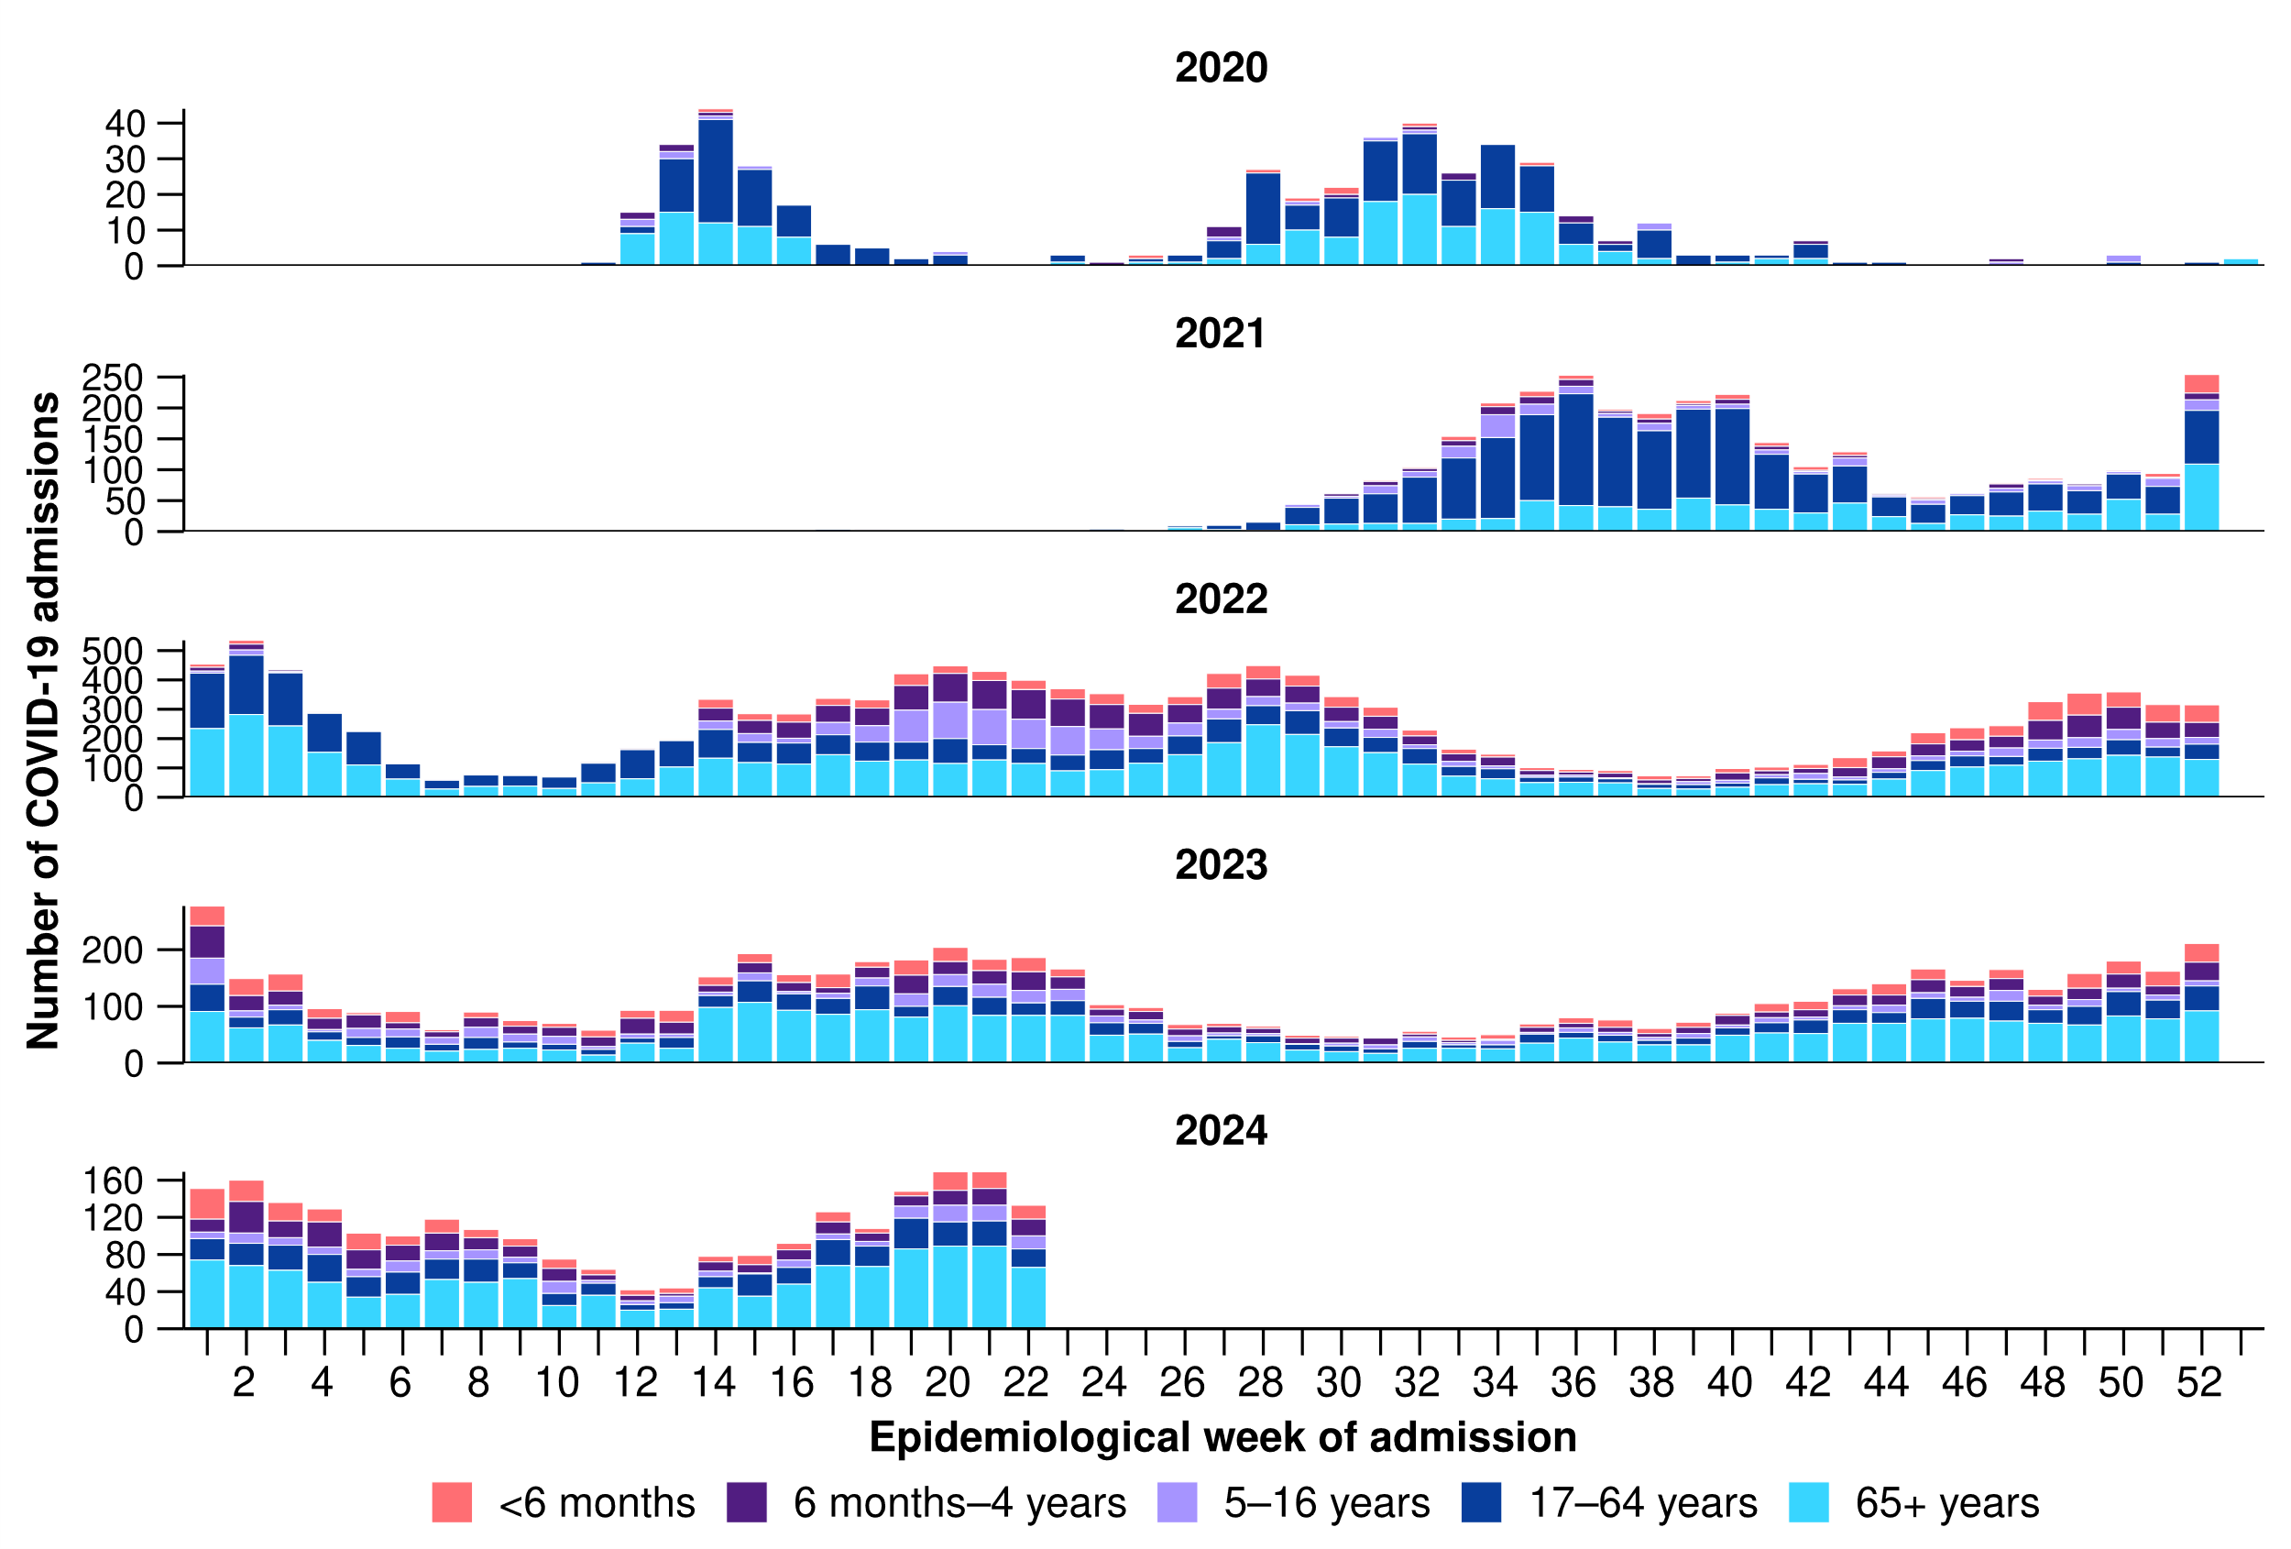
* Axis varies between years.

- Since influenza surveillance commenced on 1 April 2024 to date for FluCAN severity reporting (2 June 2024), there have been 367 paediatric patients admitted with influenza to FluCAN sentinel hospitals (Figure 15). The median age at admission was 4 years (IQR: 2–7 years) and 13.1% (48/367) of admissions were among Aboriginal and Torres Strait Islander people.
  - The highest proportion of paediatric patients with influenza admitted to FluCAN sentinel hospitals with a direct admission to intensive care has been in those aged 5–16 years.
- Since influenza surveillance commenced on 1 April 2024 to date for FluCAN severity reporting, there have been 363 adult patients admitted with influenza to FluCAN sentinel hospitals (Figure 15). The median age at admission was 63 years (IQR: 48–76 years) and 18.2% (66/363) of admissions were among Aboriginal and Torres Strait Islander people.
  - The highest proportion of adult patients with influenza admitted to FluCAN sentinel hospitals with a direct admission to intensive care has been in those aged 17–64 years.

Figure 15: Number of patients admitted with confirmed influenza to FluCAN sentinel hospitals by age group, year and week of admission*†, from April to October, 2017 to 2 June 2024
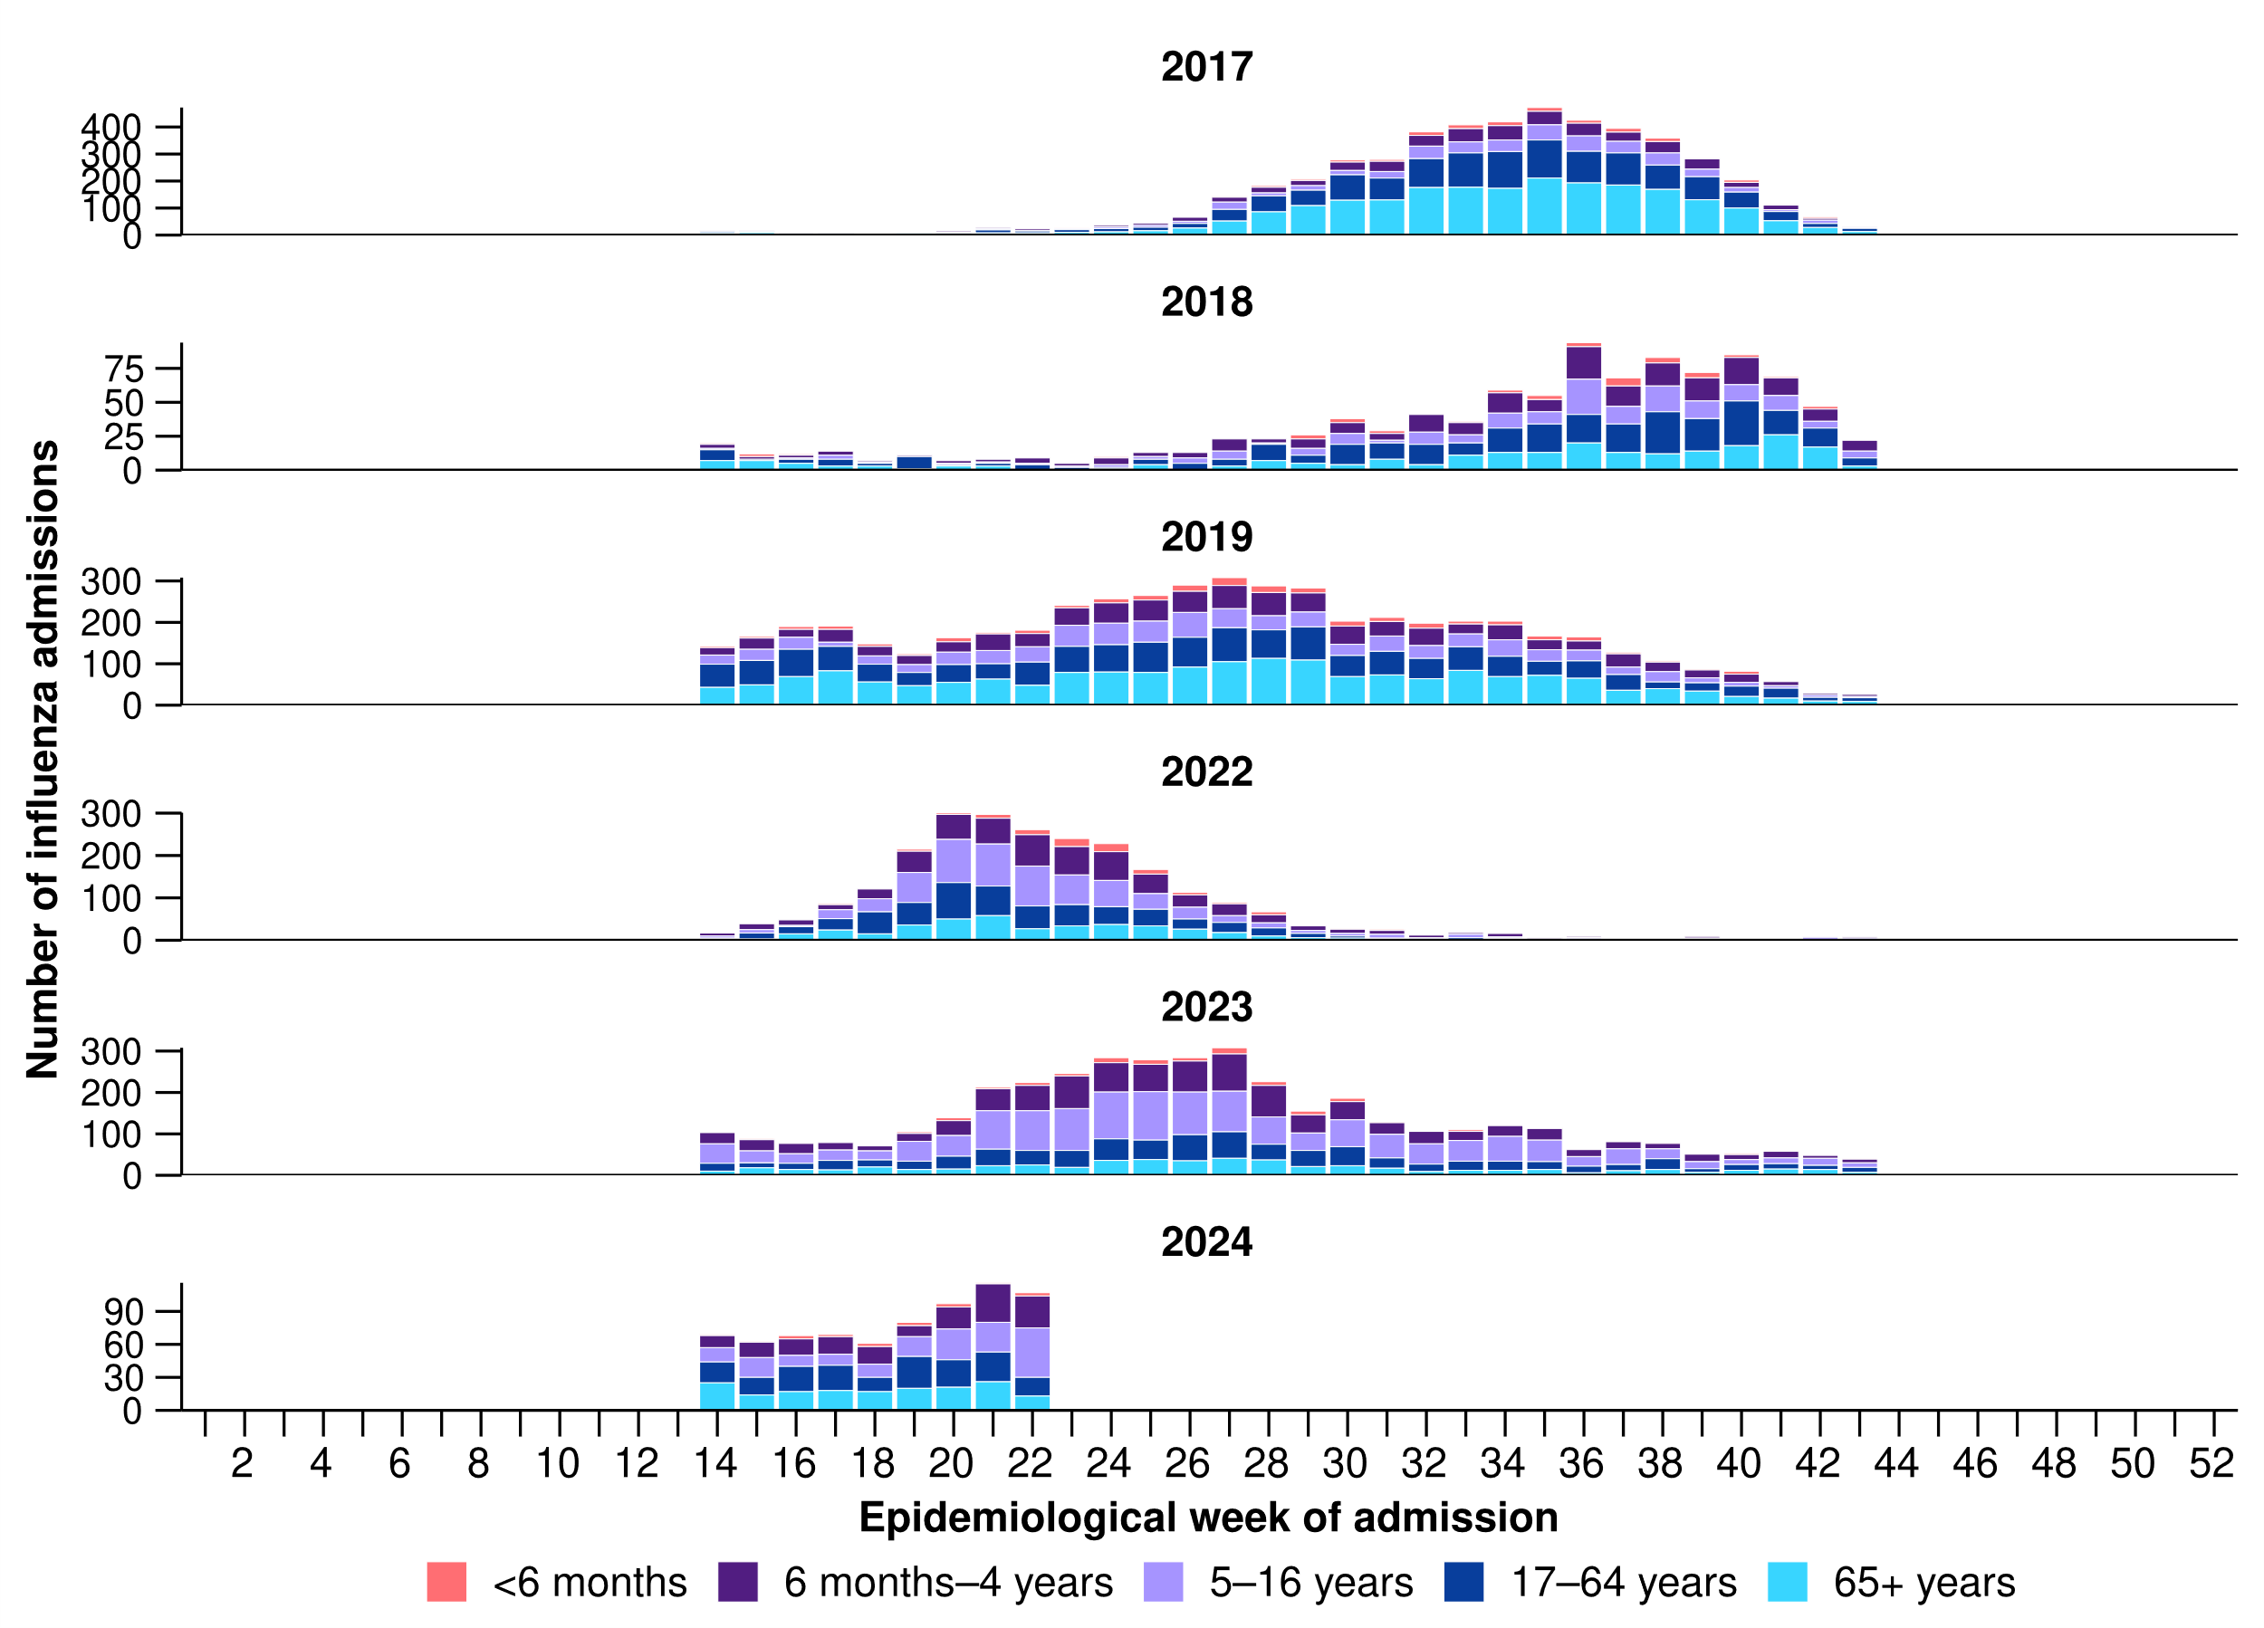
* Axis varies between years.
† The years 2020 and 2021 are excluded when comparing the current season to historical periods when influenza virus has circulated without public health restrictions. Please refer to the Technical Supplement for further detail.

Paediatric Active Enhanced Disease Surveillance (PAEDS) (last updated 7 June 2024)
This section will be updated every four weeks; therefore, reporting periods presented here may not align with other sections of the report.
- Since the start of the COVID-19 pandemic to date for PAEDS severity reporting (1 January 2020 to 19 May 2024), there have been 197 cases of possible, probable, or confirmed paediatric inflammatory multisystem syndrome – temporally associated with SARS-CoV-2 (PIMS-TS) admitted to PAEDS sentinel hospitals. To date for severity reporting, there have been no PIMS-TS associated deaths.
- Since the start of the COVID-19 pandemic to date for PAEDS severity reporting, the highest proportion of PIMS-TS cases occurred in 2022 (67.0%; 132/197), followed by 2021 (15.2%; 30/197). The most recent PIMS-TS case admitted to a PAEDS sentinel hospital was reported in May 2024, noting data have not been updated this fortnight.
- The majority of PIMS-TS cases have occurred in those aged 5 to < 12 years (52.8%; 104/197), followed by those aged 6 months to < 5 years (28.4%; 56/197). Approximately 5.6% (11/197) of PIMS-TS cases occurred among Aboriginal and Torres Strait Islander people.

SPRINT-SARI Australia (last updated 7 June 2024)
This section will be updated every four weeks; therefore, reporting periods presented here may not align with other sections of the report. Note, intensive care includes intensive care units and high dependency units that are managed by an intensive care team.
- In this 28-day period for SPRINT-SARI severity reporting (22 April to 19 May 2024), there have been 155 patients admitted with a SARI to a SPRINT-SARI sentinel intensive care. The median age at admission was 64 years (IQR: 47–75 years) and 6.5% (10/155) of patients admitted with a SARI were among Aboriginal and Torres Strait Islander people.
- In the year to date for SPRINT-SARI severity reporting (1 January to 19 May 2024), there have been 800 patients admitted with a SARI to a SPRINT-SARI sentinel intensive care. The median age at admission was 59 years (IQR: 30–71 years) and 53.6% (429/800) of patients admitted with a SARI have been male. Of the patients admitted with a SARI to a SPRINT-SARI sentinel intensive care, 8.4% (67/800) have been among Aboriginal and Torres Strait Islander people.
- In the year to date for SPRINT-SARI severity reporting, there have been 79 patients admitted with a SARI to a SPRINT-SARI sentinel intensive care who died in hospital. The majority of deaths were in patients aged 60 years or over: 32.9% (26/79) were aged 60–69 years, 34.2% (27/79) were aged 70–79 years, 13.9% (11/79) were aged 80–89 years, and 2.5% (2/79) were aged 90 years or over (Figure 16).
Figure 16: Number of patients admitted with severe acute respiratory infections to a SPRINT-SARI sentinel intensive care by age group, sex and outcome*†‡, Australia, 1 January to 19 May 2024
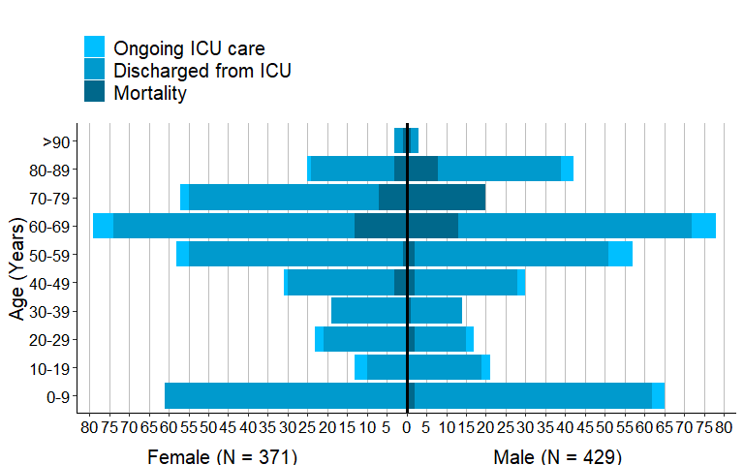
* The age and sex distribution of severe acute respiratory infection (SARI) intensive care admissions in the SPRINT-SARI Australia sentinel surveillance system may not reflect the age or sex distribution of all patients admitted with a SARI nationally.
† Ongoing care reflects the need for ongoing care in intensive care. Where a patient has been discharged from intensive care, the patient may still be receiving ongoing care in a hospital ward.
‡ Death may not necessarily represent a death due to the disease.

3.2 Case-based surveillance

NNDSS
The numbers of deaths in the year to date associated with COVID-19, influenza and RSV notified to the NNDSS are provided in Table 3. Note, the numbers of deaths associated with COVID-19, influenza or RSV reported to the NNDSS are likely to be an underestimate and do not represent the true mortality associated with these diseases. In the NNDSS, death notifications may not necessarily represent a death due to the disease.
- The ascertainment of Indigenous status in the NNDSS for influenza and RSV, and more recently for COVID-19, remains insufficient for accurate epidemiological assessments or meaningful interpretation. This is due to a number of factors, including: most laboratory notifications do not include Indigenous status, case follow-ups are not routinely conducted and are not a requirement of notification, and data linkage systems that have been used to help capture Indigenous status for COVID-19 cases have not been extended for COVID-19 in the post emergency climate, and have not been comprehensively extended to influenza or RSV cases. For this reason, data are only presented for COVID-19 up to the end of 2023.
- Since the start of the COVID-19 pandemic to 31 December 2023, there were 437,260 COVID-19 cases and 522 COVID-19-associated deaths among Aboriginal and Torres Strait Islander people notified to the NNDSS.
  - This includes both laboratory-confirmed and probable cases among Aboriginal and Torres Strait Islander people notified to the NNDSS.
  - Readers are encouraged to consult the COVID-19 Epidemiology Reports previously published in Communicable Diseases Intelligence for information on the epidemiology of COVID-19 in Aboriginal and Torres Strait Islander people in Australia from the start of the COVID-19 pandemic to 10 March 2024.
- In the year to date for severity reporting (1 January to 2 June 2024), the rate of COVID-19-associated deaths in cases notified to the NNDSS has been highest in those aged 70 years or over (Table 3). The median age of COVID-19-associated deaths notified is 84 years.
- In the year to date for severity reporting, the rate of influenza-associated deaths in cases notified to the NNDSS has been highest in those aged 70 years or over (Table 3). The median age of influenza-associated deaths notified is 84 years.
- In the year to date for severity reporting, the rate of RSV-associated deaths in cases notified to the NNDSS has been highest in those aged 70 years or over (Table 3). The median age of RSV-associated deaths notified is 86 years.

4. Impact
Impact measures how circulating respiratory viruses adversely affect the community and the healthcare system.

4.1 Community-based surveillance

FluTracking
- This fortnight (3 June to 16 June 2024), 50.0% (807/1,613) of FluTracking participants reported taking three or more days off work or normal duties due to fever and cough symptoms, a small decrease compared with 52.6% (989/1,882) in the previous fortnight.

4.2 Hospital-based surveillance

Critical Health Resource Information System (CHRIS)
Note, intensive care includes intensive care units and high dependency units that are managed by the intensive care team.
- As of 17 June 2024, 5.3% (85/1,608) of total staffed intensive care beds were occupied by COVID-19 patients.
- This fortnight (3 June to 16 June 2024), the mean number of COVID-19 cases in intensive care across Australia has increased compared with the previous fortnight (Figure 17). This fortnight, the mean number of intensive care staff unavailable to work due to COVID-19 exposure or illness across Australia has decreased compared with the previous fortnight (Figure 17).
Figure 17: Mean number of COVID-19 cases in intensive care and the mean number of intensive care staff unavailable to work due to COVID-19 exposure or illness reported to CHRIS by week of report*†, Australia, 1 January to 16 June 2024
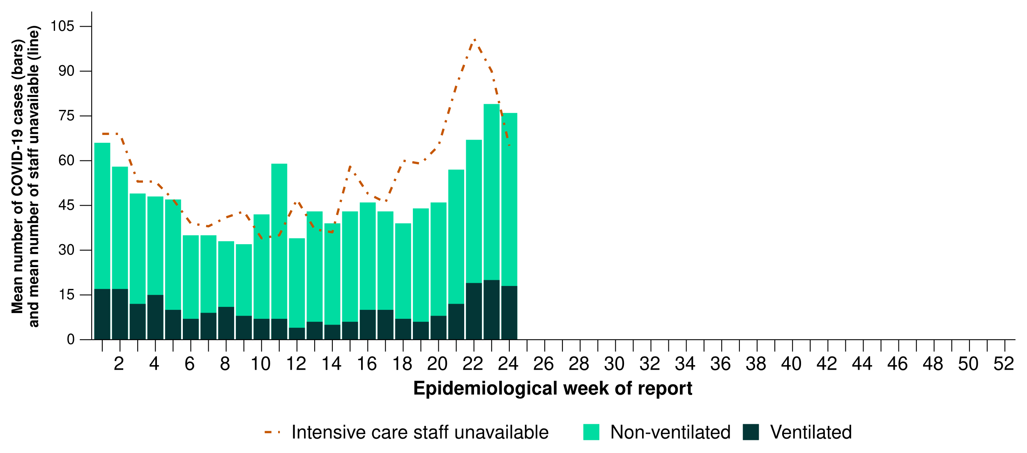
* Mean number of ventilated and non-ventilated COVID-19 cases in intensive care includes only active COVID-19 cases (those in isolation) and does not include cleared COVID-19 cases.
† Intensive care staff include both medical and nursing staff.
- This fortnight, the mean number of COVID-19 cases in intensive care has increased in all jurisdictions compared with the previous fortnight, except in Victoria where a small decrease was observed compared with the previous fortnight (Figure 18).
- This fortnight, the mean number of intensive care staff unavailable to work due to COVID-19 exposure or illness has decreased or remained stable across most jurisdictions, except in South Australia and Tasmania where small increases were observed compared with the previous fortnight (Figure 18).
Figure 18: Mean number of COVID-19 cases in intensive care and the mean number of intensive care staff unavailable to work due to COVID-19 exposure or illness reported to CHRIS by jurisdiction and week of report*†‡, Australia, 1 January to 16 June 2024
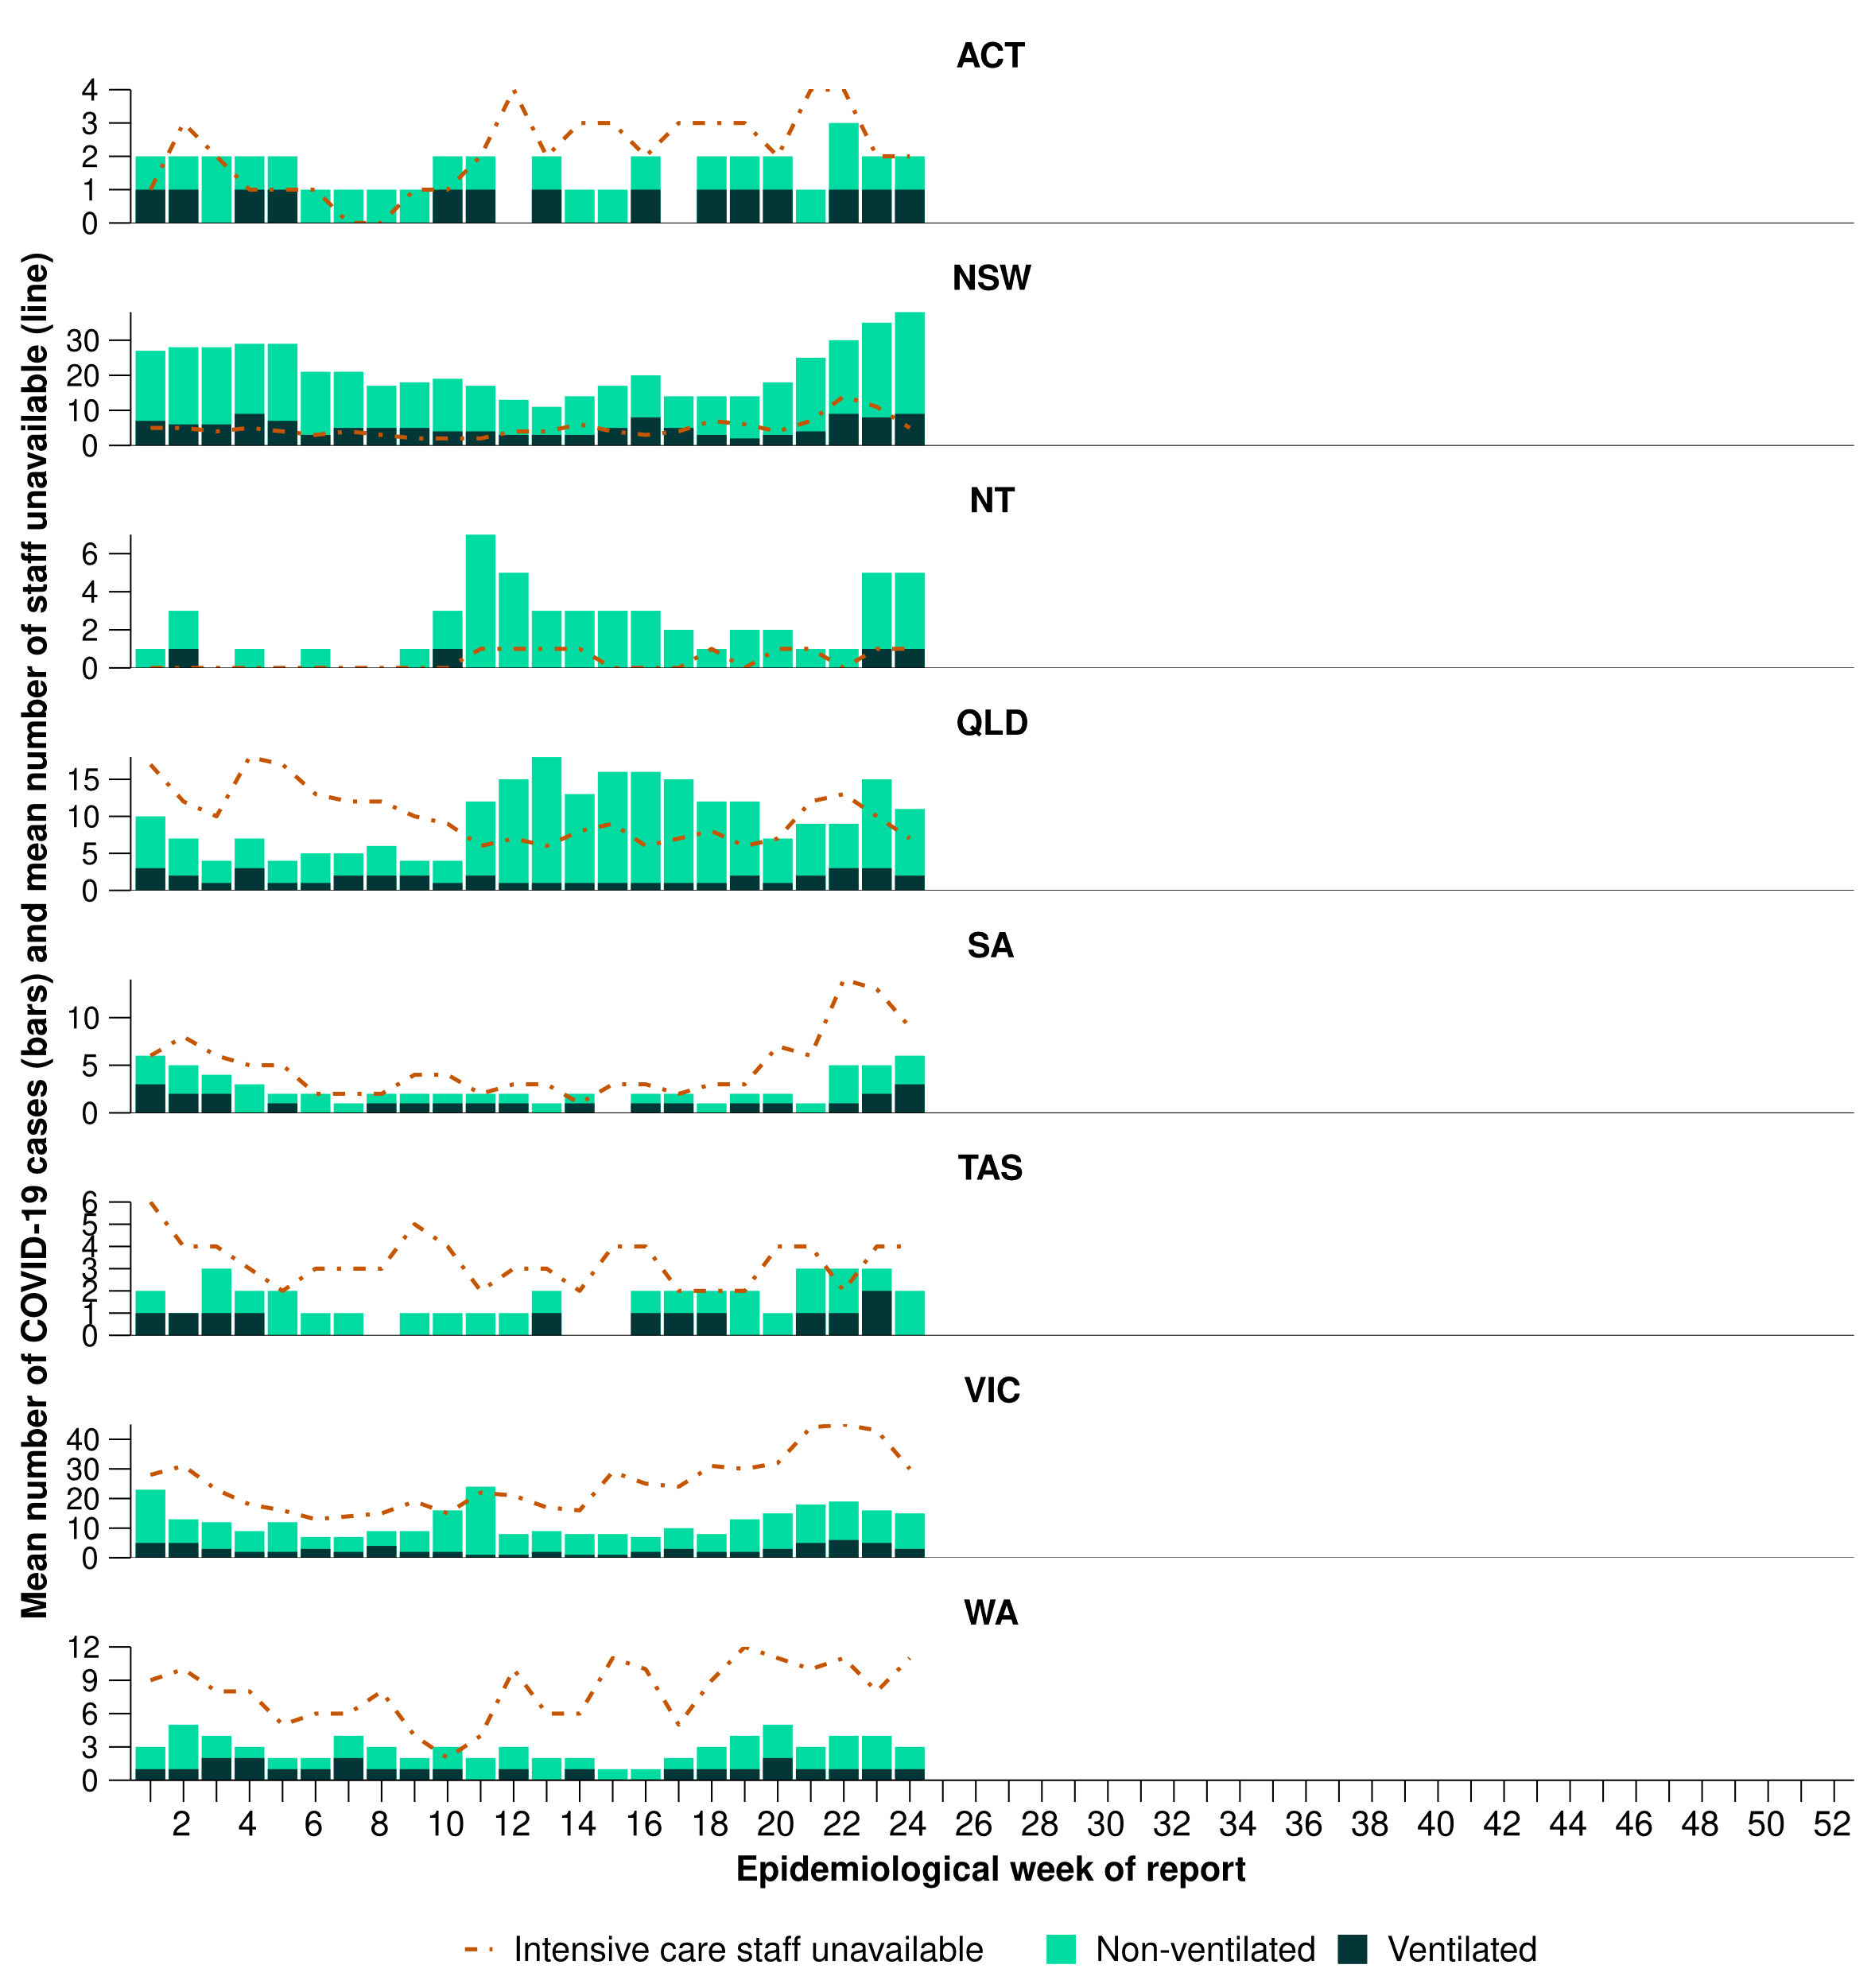
* Axis varies between jurisdictions.
† Mean number of ventilated and non-ventilated COVID-19 cases in intensive care includes only active COVID-19 cases (those in isolation) and does not include cleared COVID-19 cases.
‡ Intensive care staff include both medical and nursing staff.

5. Genomic surveillance and virology

AusTrakka (last updated 7 June 2024)
Data on SARS-CoV-2 genomics should be interpreted with caution as SARS-CoV-2 sequencing strategies have changed significantly, and the representativeness of sequences uploaded to AusTrakka may be limited by the different sample referral pathways for each jurisdiction and a significant reduction in sequencing across the country. Sequences are reported based on date of sample collection, not date of sequencing. Due to the small number of sequences received and some delays in provision of data to AusTrakka, this section will be updated every four weeks; therefore, reporting periods presented here may not align with other sections of the report.
- As of 2 June 2024, jurisdictions that have samples with dates of collection during the past 28 days include New South Wales, Queensland, South Australia, Tasmania, and Western Australia, with the most recent collection date being 26 May 2024.
- As of 2 June 2024, 530 sequences have been uploaded to AusTrakka with dates of collection within the past 28-day period (6 May to 2 June 2024). All sequences were assigned to the BA.2.86 sub-lineage within B.1.1.529 (Omicron) or recombinants consisting of one or more Omicron sub-lineages. There were no BA.1, BA.3, BA.4, BA.5 or other BA.2 sub-sub-lineage sequences identified in the past 28 days (Figure 19).
- Of the 530 sequences collected in the past 28 days, 98.5% (522/530) were a BA.2 sub-lineage, specifically from the sub-sub-lineages JN.1 (BA.2.86.1.1), including from the newly named variants under monitoring KP.2 (70/522) and KP.3 (188/522) (Figure 19). The remaining 1.5% (8/530) were recombinant or recombinant sub-lineages. The recombinant lineages included XDK, XDQ and XDV, recombinants between BA.2.86 and XBB* sub-lineages.
- The increase in JN.1 sequences has driven the increase in the proportion of BA.2 sequences being seen in AusTrakka and the comparative decline in the proportion of recombinant sequences (Figure 19).
- The World Health Organization have identified certain sub-sub-lineages and recombinants as variants under monitoring (VUM) or variants of interest (VOI) because of their epidemiological, pathological, or immunological features of concern. A select number of designated VUM or VOI are highlighted below due to their relevance in the Australian context:
  - As of 3 May 2024, four new VUMs were designated by the WHO, JN.1.7, KP.2, KP.3 and JN.1.18.
  - Of the newly identified VUMs, KP.3 and KP.2 are most common in Australia with a total of 468 KP.3 and 278 KP.2 identified in AusTrakka, including 188 and 70 sequences in the past 28 days, respectively.
  - The number of JN.1.7 and JN.1.18 seen in AusTrakka is currently low, with 75 JN.1.7 (four in the past 28 days) and 93 JN.1.18 (eight in the past 28 days) in total.
  - The proportion of JN.1 sequences has been consistent (98.5%; 522/530) in the past 28 days, compared with the previous 28-day period.
  - No sequences from the XBB lineage, including XBB.1.5, EG.5 or XBB.1.16 have been identified in the past 28-day period.
  - There have been three sequences each from the recently emerged XDV and XDQ recombinant lineages (BA.2.86* and XBB.1.91) identified in the past 28-day period.

Figure 19: Omicron sub-lineage sequences in AusTrakka by sample collection date, showing (A) proportions and (B) count per week*†, Australia, 1 January to 2 June 2024
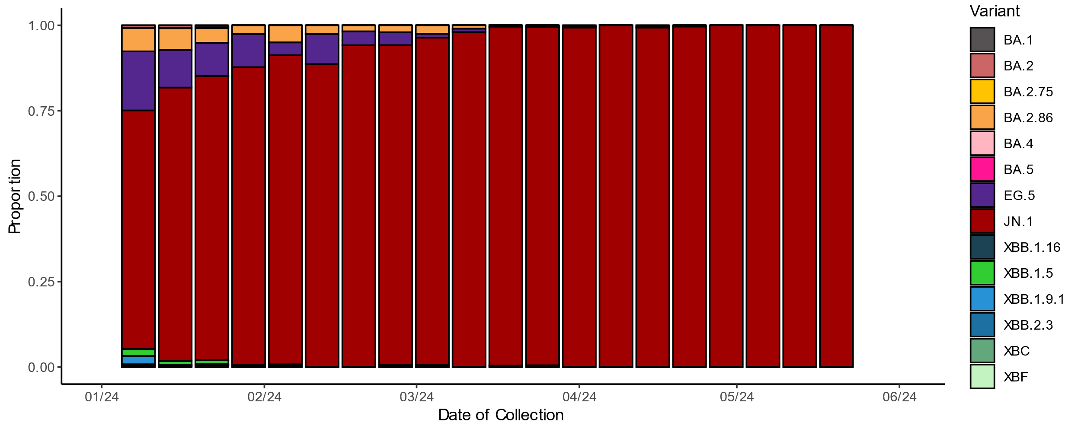
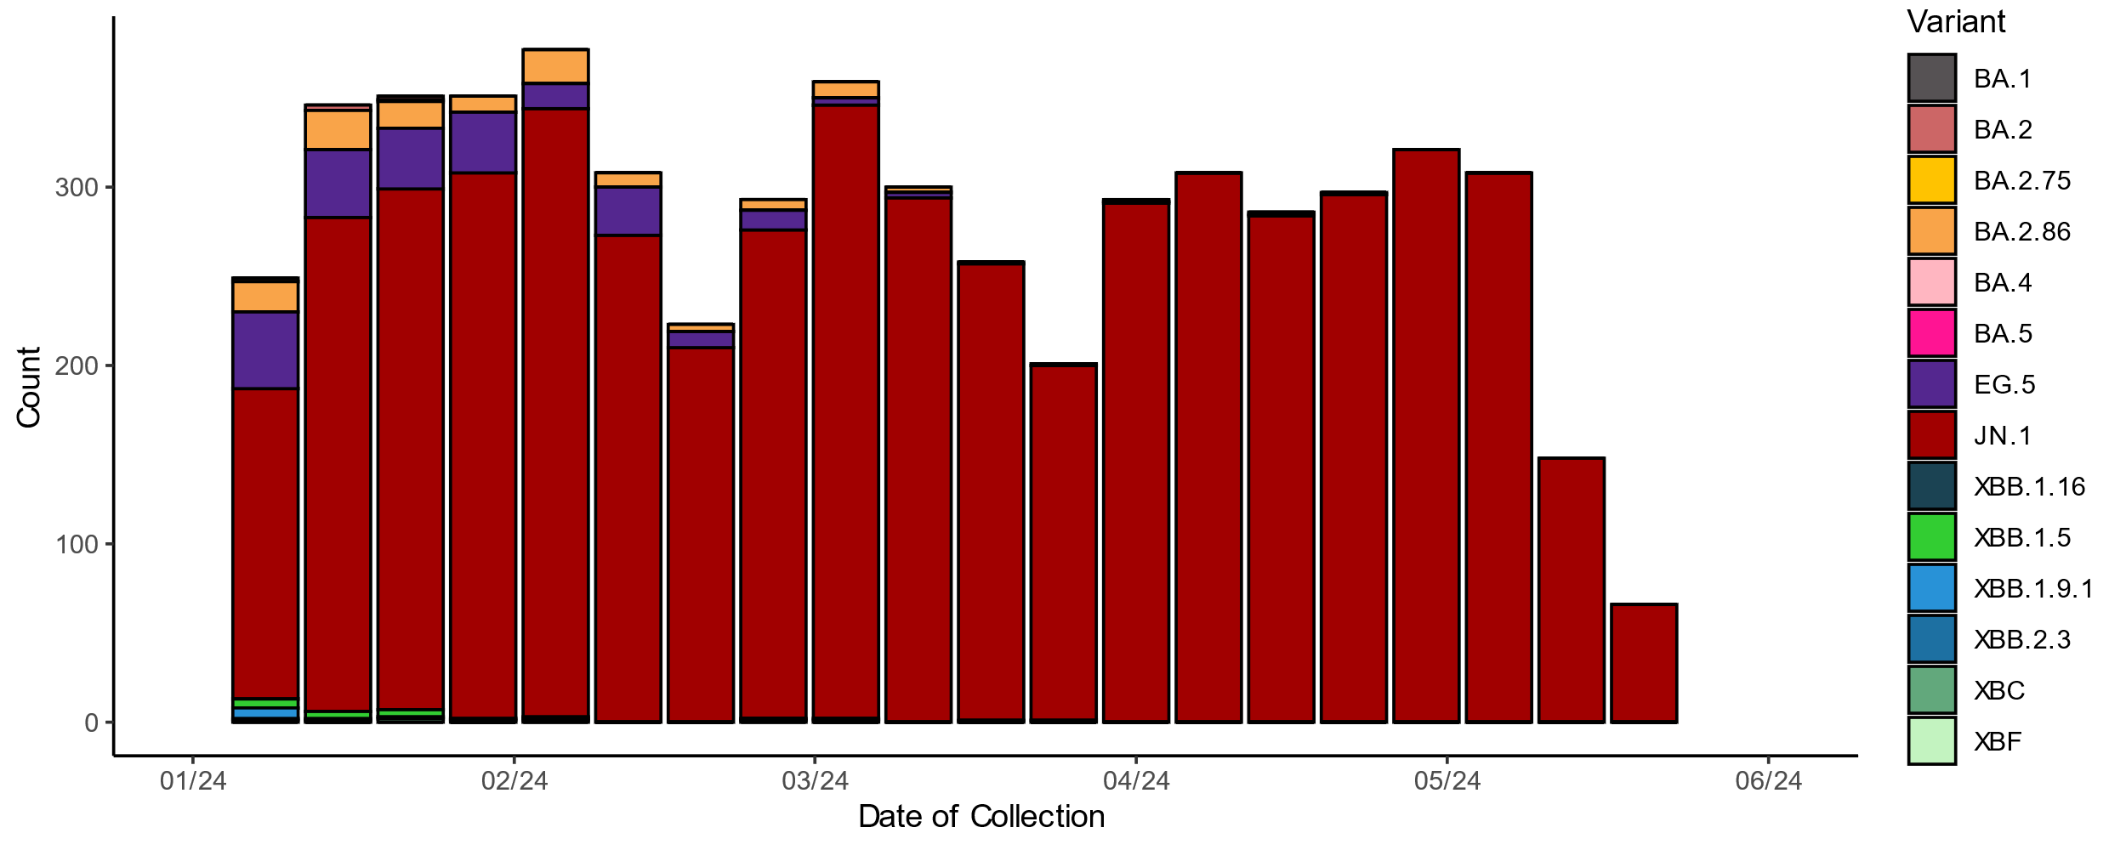
* Sequences in AusTrakka aggregated by epidemiological week. Sequences are reported based on date of sample collection, not date of sequencing.
† Proportions in Figure 19A may not be representative when sequence numbers are small; refer to Figure 19B. Data for earlier epidemiological weeks may change between reporting periods as sequences with older collection dates are uploaded. These numbers are not equivalent to number of cases, as there are many cases which may not be sequenced. Non-VOI and non-VUM Omicron sub-lineages have been collapsed into parent lineages BA.1, BA.2, BA.3, BA.4 and BA.5.

Sentinel laboratories, including National Influenza Centres
- In the year to date, there have been 7,575 influenza positive samples received by sentinel laboratories. Of those, influenza A accounted for 94.9% (7,189/7,575) of positive samples and influenza B accounted for 5.1% (386/7,575) of positive samples (Figure 20).
  - Note, the number of samples by type may not equal the sum total of the number of positive samples, due to multiple influenza detections in some individual samples.

Figure 20: Proportion of sentinel laboratory tests positive for influenza and total number of specimens tested by subtype and week of report*, Australia, 1 January to 16 June 2024
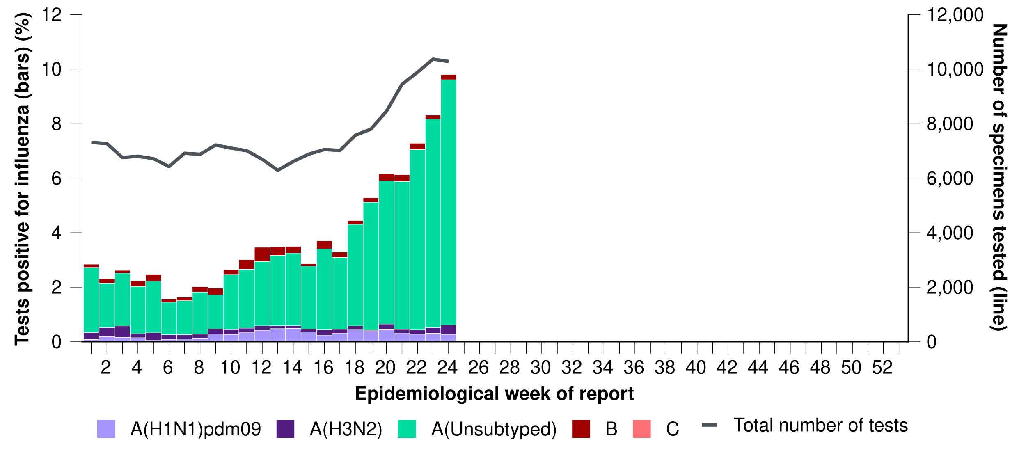
*Total number of tests include all specimens that have been tested for influenza, including multiplex panels used to test for SARS-CoV-2. Testing methodologies vary across jurisdictions and laboratories. Please refer to the Technical Supplement for interpretation of testing methodologies across jurisdictions and laboratories.

World Health Organization Collaborating Centre (WHOCC) for Reference and Research on Influenza
- In the year to date, the WHOCC has characterised 1,183 influenza viruses, of which 55.6% (658/1,183) have been influenza A(H1N1), 41.1% (486/1,183) have been influenza A(H3N2), and 3.3% (39/1,183) have been influenza B/Victoria. In the year to date, there have been no influenza B/Yamagata viruses characterised by the WHOCC (Table 4).
- Of the influenza A(H3N2) samples tested for neuraminidase inhibitor resistance, 0.48% (1/206) demonstrated reduced inhibition to Oseltamivir. Of the influenza A(H1N1)pdm09 samples tested for neuraminidase inhibitor resistance 0.22% (1/447) demonstrated reduced inhibition to Oseltamivir. None of the influenza B/Victoria samples tested for neuraminidase inhibitor resistance demonstrated reduced inhibition to Oseltamivir or Zanamivir.
Table 4: Australian influenza viruses typed by the WHOCC for Reference and Research on Influenza by haemagglutination inhibition assay and jurisdiction*†, 1 January to 16 June 2024
Strain | ACT | NSW | NT | Qld | SA | Tas. | Vic. | WA | Total
A(H1N1) pdm09 | 41 | 52 | 284 | 24 | 30 | 44 | 154 | 29 | 658
A(H3N2) | 48 | 47 | 177 | 27 | 14 | 17 | 108 | 48 | 486
B/Victoria lineage | 7 | 3 | 2 | 4 | 0 | 0 | 18 | 5 | 39
B/Yamagata lineage | 0 | 0 | 0 | 0 | 0 | 0 | 0 | 0 | 0
Total | 96 | 102 | 463 | 55 | 44 | 61 | 280 | 82 | 1,183
*Viruses tested by the WHOCC for Reference and Research on Influenza are not necessarily a random sample of all those in the community and early-year data may be based on limited samples received. There may be up to a month delay on reporting of samples.
† Jurisdiction indicates the residential location for the individual tested, not the submitting laboratory.

NNDSS
- In this fortnight (3 June to 16 June 2024), of the 25,929 influenza notifications reported to the NNDSS, 97.1% (25,166/25,929) were influenza A(Unsubtyped), 1.7% (431/25,929) were influenza B; 0.8% (220/25,929) were influenza A(H3N2); and 0.4% (104/25,929) were influenza A(H1N1). There were six influenza A&B co-detections (Figure 21).
- In the year to date, influenza A has accounted for the majority of influenza notifications in most jurisdictions (Figure 22).
Figure 21: Proportion of influenza notifications to the NNDSS by subtype and week of diagnosis, Australia, 1 January to 16 June 2024
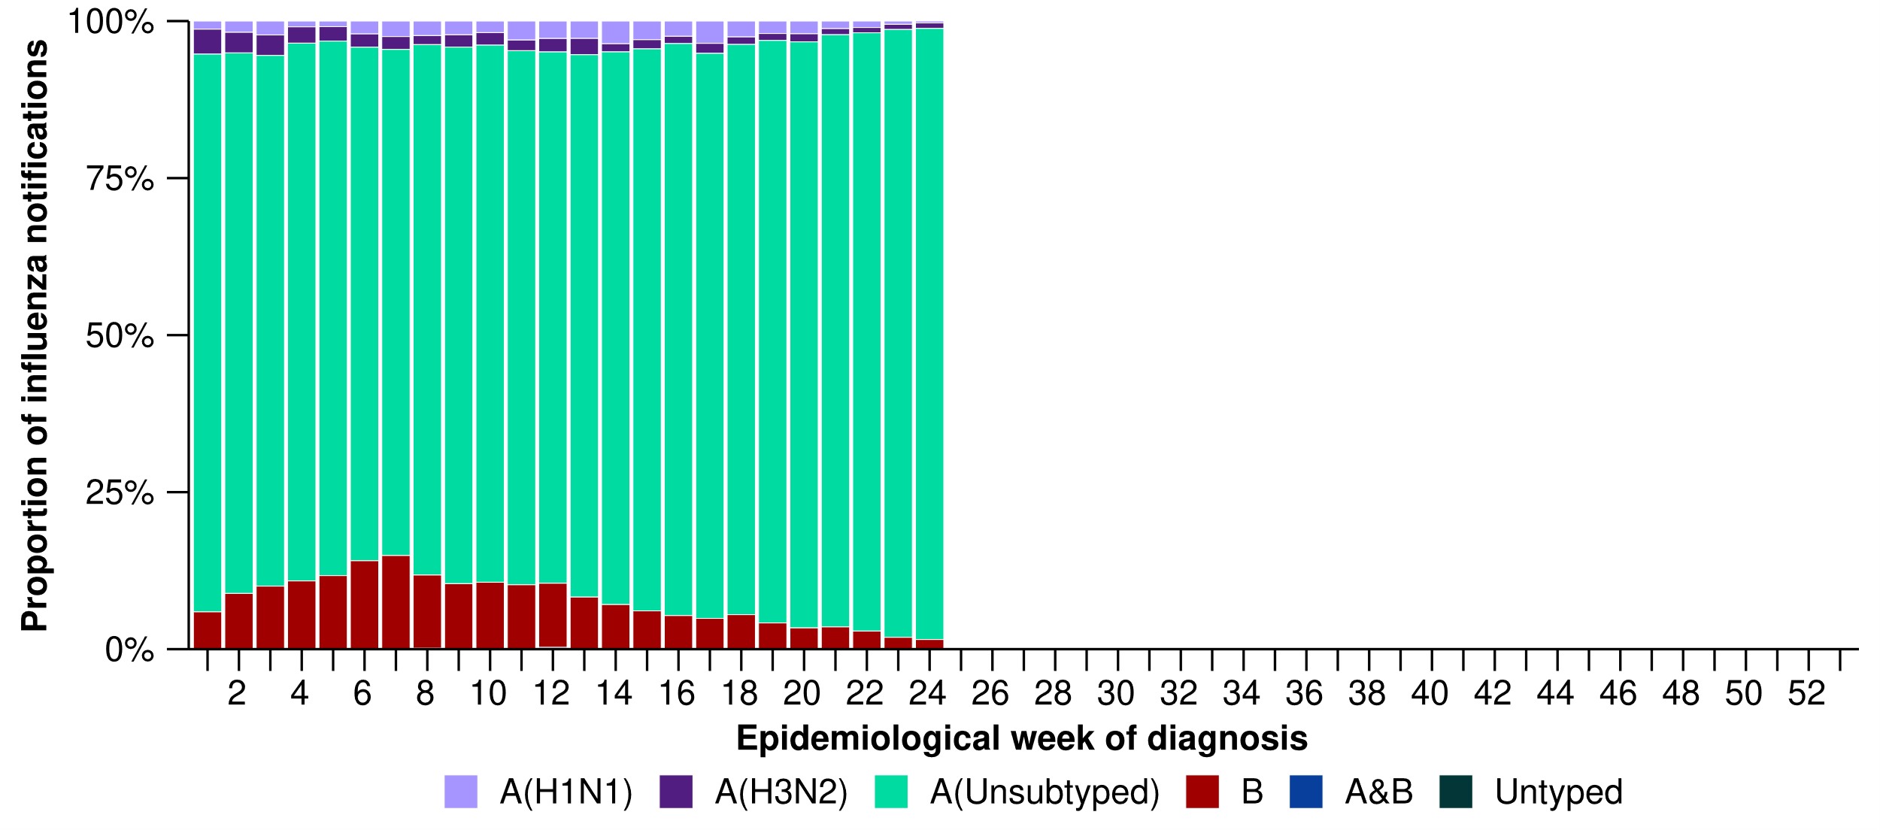
Figure 22: Proportion of influenza notifications to the NNDSS by subtype and jurisdiction*, Australia, 1 January to 16 June 2024
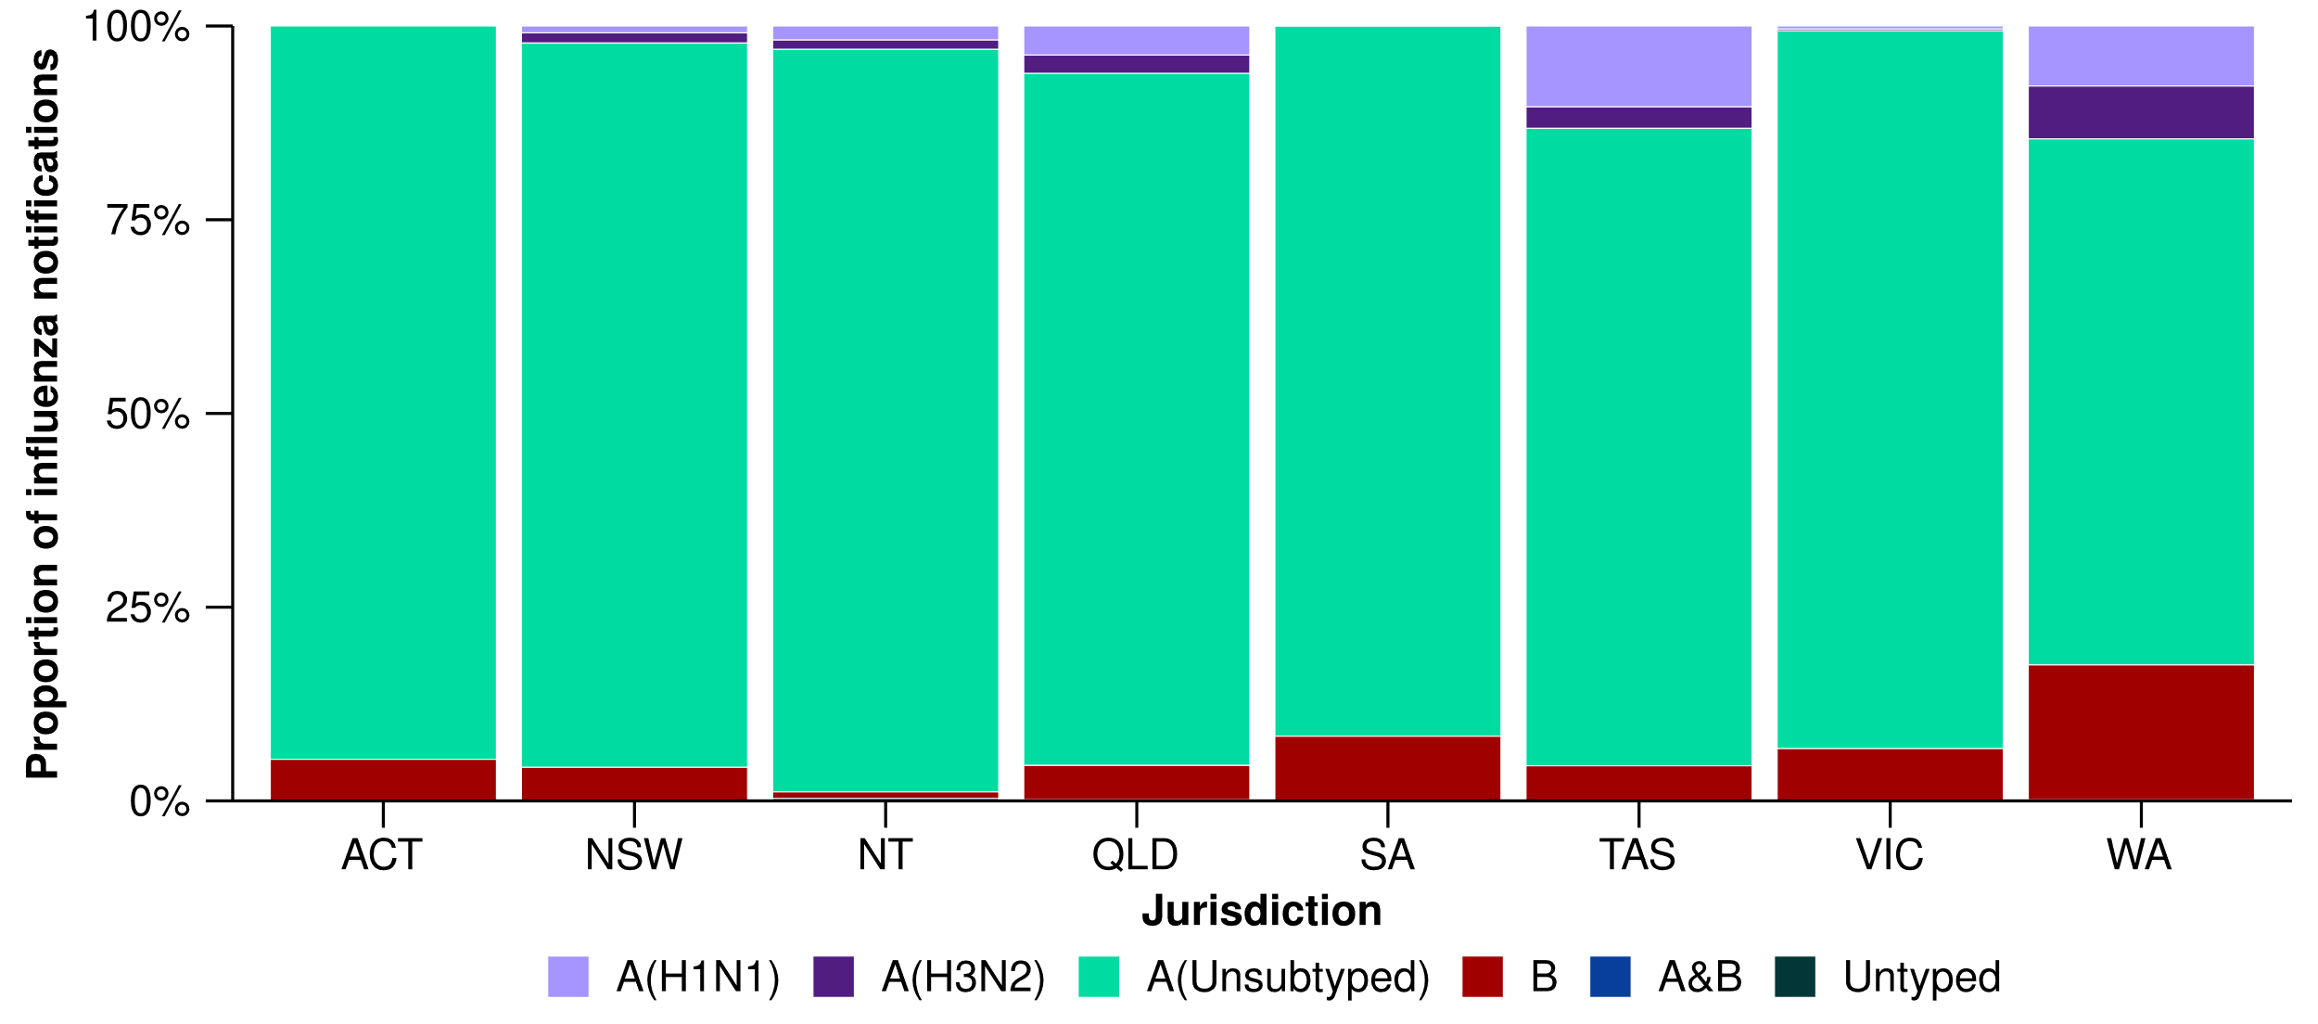

FluCAN
- Since influenza surveillance commenced on 1 April 2024 to date for FluCAN severity reporting (2 June 2024), 96.4% (704/730) of patients admitted with influenza to FluCAN sentinel hospitals have been due to influenza A and 3.6% (26/730) have been due to influenza B. Of the hospital admissions due to influenza A: 91.2% (642/704) were A(Unsubtyped), 7.7% (54/704) were A(H1N1) and 1.1% (8/704) were A(H3N2).
- Since influenza surveillance commenced on 1 April 2024 to date for FluCAN severity reporting, of the 37 patients who have been admitted directly to intensive care in a FluCAN sentinel hospital with influenza, 100.0% (37/37) have been due to influenza A. Of the intensive care admissions due to influenza A: 89.2% (33/37) were A(Unsubtyped) and 10.8% (4/37) were A(H1N1).

6. Vaccine coverage, effectiveness and match
In the present report, data reported on vaccine coverage, effectiveness and match relate to influenza vaccinations. COVID-19 and RSV vaccination data will be included in future iterations of the Australian Respiratory Surveillance Report. Refer to the Technical Supplement – Australian Respiratory Surveillance Report for further detail on relevant vaccine terminology.

6.1 Vaccine coverage
- It is too early to assess vaccine coverage for the 2024 influenza season.

6.2 Vaccine effectiveness
- It is too early to assess vaccine effectiveness for the 2024 influenza season.

6.3 Vaccine match

WHOCC for Reference and Research on Influenza
- In the year to date, of the 1,183 samples referred to the WHOCC, 98.2% (646/658) of influenza A(H1N1) isolates, 94.0% (457/486) of influenza A(H3N2) isolates and 100% (39/39) of influenza B/Victoria isolates have been antigenically similar to the corresponding vaccine components.

Australian Influenza Vaccines Composition 2024
- All 2024 southern hemisphere seasonal influenza vaccinations registered for use in Australia are quadrivalent influenza vaccines.
- The influenza virus strains included in egg-based quadrivalent influenza vaccines in Australia in 2024 are:
  - A/Victoria/4897/2022 (H1N1)pdm09-like virus
  - A/Thailand/8/2022 (H3N2)-like virus
  - B/Austria/1359417/2021 (B/Victoria lineage)-like virus
  - B/Phuket/3073/2013 (B/Yamagata lineage)-like virus.
- The influenza virus strains included in cell-based quadrivalent influenza vaccines in Australia in 2024 are:
  - A/Wisconsin/67/2022 (H1N1)pdm09-like virus
  - A/Massachusetts/18/2022 (H3N2)-like virus
  - B/Austria/1359417/2021 (B/Victoria lineage)-like virus
  - B/Phuket/3073/2013 (B/Yamagata lineage)-like virus.

