Overseas acquired tick-borne diseases – Lyme disease
Important! Watch this video about how to safely remove a tick
https://www.allergy.org.au/patients/insect-allergy-bites-and-stings

What is Lyme disease?
Lyme disease is a bacterial infection transmitted to humans through the bite of an infected tick. Lyme disease is regularly found (endemic) across many countries in the Northern Hemisphere, mainly in the northeast of the United States (US), some areas of Europe including the United Kingdom (UK) and some parts of Asia. It is the most common tick-transmitted infection in temperate areas of Europe, North America and Asia, and locations where it is found are increasing.
Travellers can become infected with Lyme disease if travelling to a Lyme disease endemic area and they undertake outdoor activities such as hiking and camping that can increase their chance of being bitten by infected ticks. However, in areas where Lyme disease is regularly found, not all ticks will carry the Lyme disease bacterium and not all bites from an infected tick will result in Lyme disease. In areas where Lyme disease is endemic, the risk of infection after the bite of an infected tick is low at only 1% and 3% in the US and 3-12% in Europe.
Lyme disease-causing bacteria belong to a group of Borrelia bacteria known as the Borrelia burgdorferi complex. Worldwide, there are over 19 types of Borrelia bacteria in this complex. The main species within this group that cause Lyme disease include:
- Borrelia burgdorferi (in North America, Europe)
- Borrelia afzelii (in Europe, China)
- Borrelia garinii (in Europe, Asia).
The Borrelia bacteria that cause Lyme disease overseas have not, to date, been identified in Australian ticks and patients despite multiple studies that have searched for it. As Lyme disease is not spread from person to person, the Australian Government Department of Health advises the risk to Australia and Australians is low.
Lyme disease has been diagnosed in Australia in overseas travellers, with all confirmed cases to date having been in returned travellers. Most of these confirmed cases of Lyme disease have been in travellers returning from Europe.

What are the symptoms?
Lyme disease causes illness that can affect the skin, joints, nervous system, and the heart.
The illness typically starts within 30 days of the person being bitten by an infected tick. In people recently infected with the bacterium that causes Lyme disease, some people can have no symptoms at all, while some people may get mild, unremarkable symptoms that may be ignored by the person. Also, many people may not notice or remember a tick bite, as ticks are very small and their bites are often painless. When symptoms occur, this is called Lyme disease.
Lyme disease is traditionally divided into three stages: early stage (stage 1); early dissemination (stage 2); and late dissemination (stage 3). The frequency and type of signs and symptoms people may experience in these stages varies and depends on the infecting species of bacterium that cause Lyme disease and whether the person was infected in Europe, Asia or North America.
In the early stage of infection, symptoms can include flu-like symptoms including headache, muscle and joint aches and pains, a fever, fatigue, stiff neck and impaired concentration. These symptoms are common in many infectious and non-infectious diseases.
A tick bite can be followed by a rash called ‘erythema migrans’ (EM) which is considered a characteristic sign of early infection with Lyme disease. The EM rash:
- usually appears around 7 to 14 days after the tick bite
- is seen in about 80% of people with early infection
- can vary in form (see Figure 1). It can either be a single red area that gradually expands from the site of the tick bite, or it can be a central spot surrounded by clear skin that is then surrounded by an expanding red rash (“bulls-eye”) which is centred on the tick bite
- is not significantly raised or painful.
Figure 1: Some examples of Lyme disease rashes (Public domain)
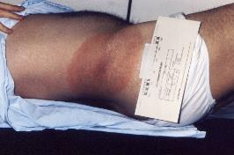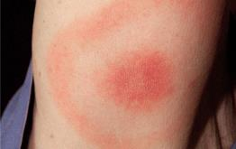
Erythema migrans rash
Public domain: Photo courtesy of CDC
“Classic” Lyme disease rash
Public domain: Photo courtesy of CDC
In the later stages of Lyme disease, some patients may develop symptoms that affect their heart, nervous system or joints.
While some believe that a form of ‘chronic (long-term) Lyme disease’ exists in Australia, globally, ‘chronic Lyme disease’ is a disputed diagnosis which lacks sufficient supporting evidence.

How is it spread?
In countries where Lyme disease occurs, it is spread to humans through the bite of an infected tick that is carrying the Lyme disease bacterium.
These ticks live on the ground and climb 20-70cm onto grasses and bushes where they wait for hosts (questing). The different species of Borrelia bacteria that cause Lyme disease are carried in the blood of wild animals, including small mammals, birds and deer (hosts). Ticks take a blood meal from hosts at each of the three stages of their life cycle (as larvae, nymphs and adults). When the tick finds a host and a feeding spot on the host, it grasps the skin, cuts into the surface and inserts its feeding tube. Ticks become infected with the Lyme disease bacteria when they feed on an infected host. If the tick later feeds on a human, that human can become infected.
Most humans are infected through the bites of immature ticks called nymphs. Nymphs are the main stage of the tick that transmits (vectors) Lyme disease, due to their smaller size (less than 2mm), their lighter colouration which makes them harder to detect, their greater numbers, and their seasonality (when they are most active) which coincides with higher levels of human outdoor activity. Adult ticks can also transmit Lyme disease bacteria, but they are much larger and are more likely to be discovered and removed before they have had time to transmit the bacteria.
Ticks can inject small amounts of saliva with anaesthetic properties so that a person cannot feel that the tick has attached itself. If the tick is in a sheltered spot on a body, it can go unnoticed.
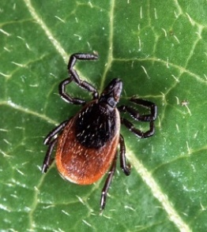
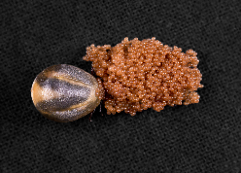
In North America, the ticks that transmit (vector) Lyme disease are mainly the black-legged (deer) tick (Ixodes scapularis) (see Figure 2) and the western black-legged tick (Ixodes pacificus). The black-legged (deer) tick is widely distributed across the eastern US and transmits more than 95% of Lyme disease in North America. The western black-legged tick is found in the Pacific Coast states and transmits Lyme disease in California, the west coast of the US and in Canada.
Public domain: CDC / Sue Partridge (2017)
Figure 2: Adult female black-legged (deer) tick (Ixodes scapularis) (left), with eggs (right) (Public domain)
Public domain: Photo courtesy of the Agricultural Research Service, the research agency of the United States Department of Agriculture.
Photo by Scott Bauer
Image Number: K8002-3, {{PD-USGov-USDA-ARS}}
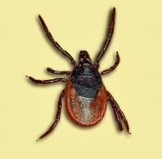
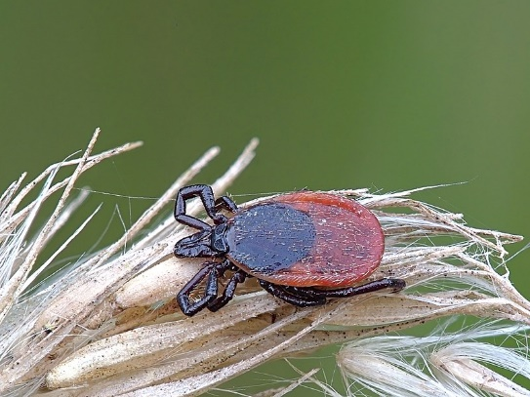
In Europe, the main ticks that transmit (vector) Lyme disease are the castor bean tick (Ixodes ricinus) (see Figure 3) and the taiga tick (Ixodes persulcatus) (see Figure 4). In Northern China, the taiga tick is the main vector of Lyme disease.
Public domain: CC BY-SA 3.0: Lamiot
Public domain: Walter (2021)
Figure 4: Taiga tick (Ixodes persulcatus) (Public domain)
Figure 3: Starved, female castor bean tick (Ixodes ricinus) (Public domain)
There is no evidence that Lyme disease is transmitted from person-to-person, including via touching, kissing or through sexual contact. The risk of mother-to-baby transmission of Lyme disease during pregnancy is very low and with appropriate treatment there is no increased risk of adverse pregnancy outcomes. There are no reports of Lyme disease being spread through breast milk. There is no evidence of transmission through blood products. There is no credible evidence that Lyme disease can be transmitted through air, food, water, or from bites of mosquitoes, flies, fleas, or lice.

Who is at risk?
People who live in, or travel to, areas where Lyme disease infected ticks are regularly found [Lyme disease endemic areas], and who also engage in outdoor activities in these areas, are at increased risk of Lyme disease. See section ‘Risk activities for Lyme disease infection’ for more information.
In Lyme disease endemic areas, people of all ages are at risk of Lyme disease. The highest rates are seen in children aged 5-9 years and in adults older than 50 years of age, in both the US and Europe.
Males and females are equally susceptible to Lyme disease.
The duration of tick attachment is one of the most important predictors of subsequent Lyme disease, with infection more likely the longer a tick is attached to the skin.
The risk of infection for people in Lyme disease endemic areas of the US is minimal if the tick stays attached for less than 72 hours. The risk increases significantly the longer the tick is attached. The risk of subsequent Lyme disease may exceed 20% when a tick has been attached for 72 hours or longer.
The risk of Lyme disease following a tick bite in Europe appears to be different to the US (where the major tick vectors are the black-legged tick and the western black-legged tick). In Europe, there have been a number of reports of people becoming infected within 24 hours of tick attachment by the castor bean tick.

Areas overseas where Lyme disease is regularly found (endemic)
Lyme disease is regularly found (endemic) across many countries in the Northern Hemisphere, mainly in the northeast of the United States (US), some areas of Europe including the United Kingdom (UK) and some parts of Asia (see Figure 5 overleaf).
In the US, most infections occur in the following endemic areas:
- Northeast and mid-Atlantic, from north-eastern Virginia to Maine
- North central states, mostly in Wisconsin and Minnesota
- West Coast, particularly northern California.
Nearly all cases of Lyme disease were reported in 14 states: Connecticut, Delaware, Maine, Maryland, Massachusetts, Minnesota, New Hampshire, New Jersey, New York, Pennsylvania, Rhode Island, Vermont, Virginia, and Wisconsin.
Lyme disease has also spread to Canada and human cases have been reported in Long Point on the Ontario shore of Lake Erie, and in southern Ontario, Nova Scotia, south-eastern Manitoba and New Brunswick. There is the possibility of additional emerging populations in southern Quebec.
In Europe, the regions with highest tick infection rates are central Europe including Austria, Czech Republic, southern Germany, Switzerland, Slovakia and Slovenia. In the UK and Ireland, particularly high-risk areas are the South of England and the Scottish Highlands.
In Asia, the major endemic areas for Lyme disease in China are forests in the Northeast and Northwest, and some areas in Northern China.

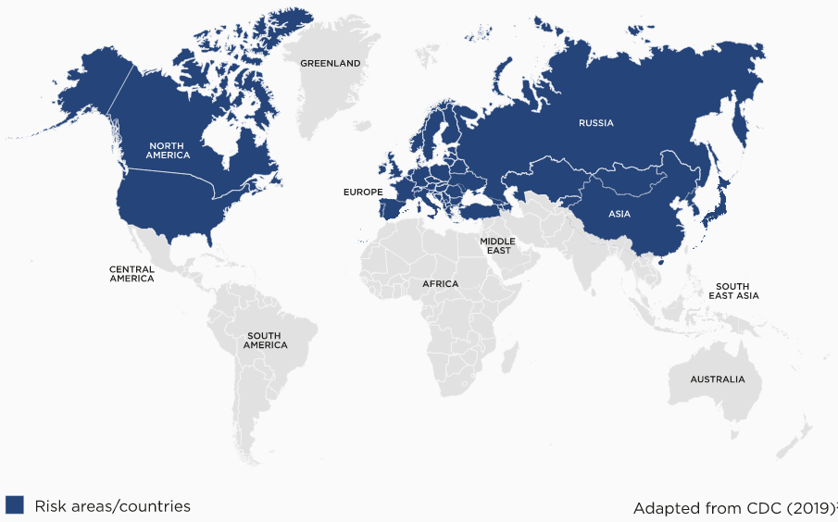
Risk activities for Lyme disease infection
Public domain: Photo courtesy of CDC
Figure 5: Distribution of Lyme disease globally (Public domain)
In risk areas for Lyme disease, people who engage in outdoor recreational or occupational activities are at increased risk of being bitten by ticks. Examples of increased risk activities include hunting, fishing, camping, collecting mushrooms and berries, farming and military training.
The main tick that transmits (vectors) Lyme disease in the US, the black-legged tick, can be found in a variety of landscapes (urban, suburban and rural) in a variety of habitats. These ticks are most abundant in or near wooded areas where wildlife hosts are ample, and a sufficient layer of leaf litter reduces the risk of ticks drying out and promotes their survival.
The habitats of the castor bean tick vary across Europe but typically include deciduous and coniferous woodland, heathland, moorland, rough pasture, forests and urban parks.
Ticks carrying Lyme disease bacteria live on the ground and climb 20-70cm onto grasses and bushes where they quest, (wait for hosts, including humans).

Risk seasons for Lyme disease infection
People living in, or travelling to, Lyme disease endemic areas and who also engage in outdoor activities that increase their risk of tick bites are at greater risk of Lyme disease during the Northern Hemisphere spring and summer. The nymphal questing period is the time of greatest risk. Nymphs can be active and feed from spring through autumn but their activity peaks in late spring and summer in the Northern Hemisphere when most cases of Lyme disease occur. Adult ticks are active year-round but are more active in cooler months.

How is it prevented?
Currently, there is no vaccine available anywhere in the world to protect against Lyme disease.

Personal strategies to prevent tick bites in areas where Lyme disease is regularly found
People travelling to, and residing in, Lyme disease endemic areas should protect themselves from tick bites. This includes avoiding tick risk areas, being informed about how to recognise early symptoms of Lyme disease, wearing protective clothing, using tick repellents, and checking the entire body daily for ticks.
The most effective way to minimise infection with Lyme disease is to avoid tick habitats, such as wooded areas, shrubs, tall grass and particularly the edges where these types of vegetation meet.
Travellers and residents in areas where Lyme disease occurs should:
- be informed – know locations where Lyme disease is present and where to expect ticks.
- wear appropriate clothing such as a long sleeve shirt, long pants tucked into socks and light-coloured clothing to make it easier to see ticks before they attach to skin.
- treat clothing and gear with products containing 0.5% permethrin. Permethrin treated clothing is considered the most effective means of tick bite prevention.
- apply insect repellents containing either diethyl-meta-toluamide (DEET) or picaridin prior to entering a tick infested area. Repellents should be applied and re-applied according to the product/manufacturer’s instructions. Higher concentrations of DEET are not necessarily more effective, but are longer lasting. You should seek advice from a pharmacist if you are unsure if any of these products are suitable for you.
  - Insect repellents that contain DEET include Tropical RID®, Tropical Aerogard®, BushMan®, Aerogard® repellent roll-on, and other repellents that contain picaridin include OFF!®, Aerogard® repellent spray
  - Some commercially available products are not recommended as repellents to prevent tick bites due to insufficient evidence. These products include botanical agents and essential oils (for example, essential oils of rosemary, cinnamon leaf, lemongrass, nootkatone, geraniol, and carvacrol).

- do a full body check for ticks after being outdoors (see Figure 6)
  - A tick check reduces the chance of infection, because feeding ticks can be spotted and removed promptly.
  - Look and feel for ticks under the arms, in and around the ears, inside belly button, back of the knees, in and around the hair, between the legs, and around the waist.
  - Give particular attention to skin-folds – groins, armpits, under breasts, waist band area, backs of knees – as ticks seek out more humid areas for attachment.
  - Check the head (including scalp) and neck area of young children carefully, as tick bites are relatively more common at these sites in this age group.
- bathe or shower soon after being outdoors
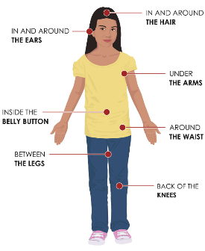
  - Showering within two hours of coming indoors has been shown to reduce people’s risk of getting Lyme disease.
Public domain: Photo courtesy of CDC
Figure 6: Where to check for ticks (Public domain)

Managing a tick bite if bitten in an area where Lyme disease is regularly found
The duration of tick attachment is one of the most important predictors of getting Lyme disease, with infection more likely the longer a tick is attached to the skin.
The Australian Government Department of Health and Aged Care advises overseas travellers, including people travelling to Lyme disease endemic areas, to kill attached ticks where they are by freezing them if an appropriate ether-containing product is available, and without delay, but otherwise follow local guidance, for example, from the Centers for Disease Control and Prevention (CDC).
Refer to the Management of tick bites in Australia factsheet for further information about the Australian developed technique for tick removal.
A short video on how to remove a tick by killing the tick where it is with ether-containing sprays is available here: https://www.allergy.org.au/patients/insect-allergy-bites-and-stings.
Some of the ticks that transmit Lyme disease have been found to cause serious allergies after tick bite. The western black-legged tick in California, the west coast of the US and in Canada; and the castor bean tick in Europe, can cause tick anaphylaxis. The castor bean tick in Europe can also cause mammalian meat allergy after tick bite.
If Australian travellers are known to have a tick allergy, they should go to a hospital to have the tick removed.
When travelling to a Lyme disease endemic area, using the Australian method to manage tick bites by killing ticks where they are and without delay will help prevent infection with Lyme disease as well as preventing tick-induced allergies.

How is it diagnosed?
If you think you have Lyme disease after returning from an endemic area overseas, please see your GP or a doctor.
In Australia, if a returning traveller is suspected of having Lyme disease, the patient will be referred for blood tests. A diagnosis of Lyme disease in Australia requires:
- a careful medical history
- a history of overseas travel to areas where Lyme disease is endemic; a patient must have been exposed to ticks; however, a history of documented tick bite is not essential as many tick bites go unnoticed
- objective clinical findings that are consistent with the signs and symptoms of Lyme disease
- appropriate in vitro diagnostic tests undertaken by pathology laboratories accredited by National Association of Testing Authorities, Australia (NATA) and the Royal College of Pathologists of Australasia (RCPA).
Further information about the diagnosis of Lyme disease can be found in the Debilitating Symptom Complexes Attributed to Ticks (DSCATT) Clinical Pathway (which is available on the Australian Government Department of Health and Aged Care website at www.health.gov.au
using the search term ‘DSCATT clinical pathway’).

How is it treated?
Lyme disease is treated with several types of antibiotics that have activity against the species of Borrelia bacteria that cause Lyme disease. The majority of international guidelines on the treatment of Lyme disease recommend one course of antibiotic therapy for all presentations of Lyme disease.
Refer to the DSCATT Clinical Pathway (at www.health.gov.au) for further information on the treatment of Lyme disease in Australia.

An allergy project supported by the National Allergy Strategy, Australasian Society of Clinical Immunology and Allergy (ASCIA), Allergy & Anaphylaxis Australia (A&AA), and Tick-induced Allergies Research and Awareness (TiARA).
https://www.cdc.gov/ticks/removing_a_tick.html
An allergy project supported by the National Allergy Strategy, ASCIA, A&AA, and TiARA.

