Reducing exposure to metals in drinking water from plumbing products

October 2021

Contents
1. Metals in drinking water 3
1.1. Guideline values for metals in drinking water 3
1.2. How do metals get into drinking water? 3
2. Action to reduce exposure to metals from drinking water 5
2.1. Preventive flushing 5
2.1.1. Households 6
2.1.2. Schools, preschools and child care centres 6
2.1.3. Other buildings with vulnerable populations 7
2.2. Other actions to reduce exposure 7
2.2.1. Using cold water only for drinking, cooking and food preparation 7
2.2.2. Maintenance of the plumbing system 7
2.2.3. Filtration 8
2.2.4. Galvanic corrosion control 8
2.3. Specific advice for public drinking water fountains 8
2.4. Specific advice for rainwater supply systems 8
2.5. Information to occupants 9
3. Sampling drinking water for metals in a plumbing system 9
3.1. Why and when to test for metals in building water systems? 9
3.2. Who should collect water samples? 9
3.3. Where to collect water samples? 9
3.4. Water sampling considerations 10
3.5. Water sampling methodology 11
3.5.1. Incoming water supply 11
3.5.2. Building commissioning –6HS 12
3.5.3. Screening sampling – RDT 13
3.5.4. Investigative sampling – 30MS 14
3.6. Water sampling analysis and interpretation 16
4 Further advice 16

1. Metals in drinking water
Exposure to elevated levels of some metals may pose a health risk. In most cases health effects only arise from chronic exposure over many years but for lead, potential effects including neurodevelopmental impairment can occur after short periods depending on the person’s age and the quantity of lead involved,. Exposure can arise from the inhalation or ingestion of metals contained in air, dust, drinking water or food.
The scope of this document is limited to consideration of the potential risk from consumption of drinking water that contains metals released (leached) from plumbing products in buildings or devices such as drinking water fountains. While the document addresses a number of metals known to leach from plumbing products (Table 1) exposure to lead is of particular concern for pregnant women, infants and young children which are the most vulnerable to resulting impacts^{1, 2}. There have been a number of reports of elevated concentrations of lead detected in drinking water collected from buildings and devices in Australia, North America, Europe and Hong Kong.
The purpose of this document is to assist Australian state and territory health departments in providing advice to homeowners, residents and building and asset managers to reduce exposure to lead and other metals from plumbing products in a plumbing system. This document also provides guidance on collection of samples of drinking water to test for metals in a plumbing system and recommendations for testing as part of building commissioning prior to occupation.
The advice provided is based on guidance developed by international jurisdictions to minimise exposure to lead and other metals from drinking water.

Guideline values for metals in drinking water
The Australian Drinking Water Guidelines (ADWG)² is the authoritative reference for defining safe, good quality drinking water. It includes health-based guideline values for chemical parameters in drinking water, including many metals. These health-based guideline values typically indicate the concentration of metals in drinking water that, based on present knowledge, do not result in significant risk to the health of the consumer over a lifetime of consumption. In a limited number of cases, as indicated in the ADWG, the guideline values apply to risks from acute exposure (e.g. for lead and copper). The guideline values for metals of concern in relation to plumbing products are shown in Table 1.

How do metals get into drinking water?
Public drinking water supplies are routinely monitored up to the point of supply (typically a water meter) and rarely contain metals above the ADWG health-based guideline values. However, once the water moves beyond the point of supply (e.g. into buildings), contact with plumbing products may release metals into the drinking water.
Table 1. ADWG health-based guideline values for metals of concern associated with plumbing products
Metal of concern | ADWG value
Antimony (Sb) | 0.003 mg/L
Cadmium (Cd) | 0.002 mg/L
Chromium (Cr) | 0.05 mg/L
Copper (Cu) | 2 mg/L
Lead (Pb) | 0.01 mg/L
Nickel (Ni) | 0.02 mg/L

Lead may be introduced into drinking water from plumbing-related products. Lead-based drinking water pipes are quite rare in Australia, having not been installed since the 1930s while lead-based solder was phased out of use in Australia in the 1990s, with Australian Standards limiting lead in solders to less than 0.1% within potable water distribution systems. However, brass plumbing products sold in Australia are permitted to contain up to 4.5% lead, and while low-lead products that typically contain no more than 0.25% lead are available they are currently not in common use. Copper pipes are a common component of plumbing systems, and copper is also a major component of brass plumbing products, and as a result may be present in drinking water. Elevated levels of copper in drinking water arising from corrosion of copper pipes used in plumbing systems can result in blue or green staining of plumbing fittings or basins. Although reported less frequently, metals such as chromium, nickel, antimony and cadmium may also be present in drinking water due to use in the manufacture of a variety of plumbing pipework and products.
The Plumbing Code of Australia (PCA) is the national construction code containing the technical provisions for the design, construction, installation, replacement, repair, alteration and maintenance of plumbing and drainage installations.
The compliant installation and management of plumbing products and plumbing systems within buildings is the responsibility of building owners or managers. All products used in drinking water plumbing systems need to comply with AS/NZS 4020 which includes a test to ensure that products do not release metals in concentrations that exceed the guideline values in the ADWG (Table 1). The Australian WaterMark Certification Scheme requires products to comply with AS/NZS 4020. While the certification scheme provides protection against metals of concern it may not be completely effective under all circumstances. Products that are not certified can currently be purchased in Australia, however it is illegal for licenced plumbers to install these.
Metals of concern can be released from plumbing-related sources and products, in both dissolved and particulate form, via chemical reactions within the water and through physical abrasion of surfaces. This is particularly evident when there have been periods of stagnation where drinking water is sitting in contact with plumbing products for extended periods of time (e.g. days to weeks). Plumbing products that are deteriorated or corroded are more prone to releasing metals to drinking water.
The various sources and factors affecting the concentration of metals in drinking water from plumbing systems are identified in Table 2.
Table 2. Sources of and factors affecting the concentration of metals in drinking water from plumbing systems.
Potential sources of metals in a plumbing system | Factors affecting metals in a plumbing system
- brass fittings and components  - water tanks and related components coated with lead-based paint  - old galvanized pipes  - polyvinyl chloride (PVC) and high density polyethylene (HDPE) pipes not designed for use in drinking water systems  - non-WaterMarked plumbing products  - copper pipes, tap aerators, flow restrictors | - water chemistry (e.g. pH)  - temperature  - flow rate and stagnation  - metal content of plumbing products (e.g. percentage of lead)  - condition and design of the plumbing system  - plumbing product manufacturing process  - prolonged hyperchlorination

The responsibility for ensuring that water supplied beyond the water meter remains safe and aesthetically acceptable rests with various stakeholders. Homeowners, residents, building and asset managers, plumbing regulators and plumbers all have a role to play. Section 9.6 of the ADWG provides further information on water quality within buildings.

Action to reduce exposure to metals from drinking water
Homeowners, residents and building and asset managers can take a number of actions to reduce exposure to metals from plumbing products in a plumbing system.

Preventive flushing
When water is in contact with plumbing products for extended periods of time, metals can dissolve into the stagnant water. Preventive flushing applied as a precautionary measure before using water for drinking or cooking is an easy and practical way to remove stagnant water and prevent it from being consumed. The degree of flushing required to remove stagnant water will vary depending on the condition and quality of plumbing products, recent water movement and the design of the plumbing system. When flushing an outlet, the flow should be set as high as practically possible. The ‘flushed’ water can be used for alternate, non-drinking uses (e.g. washing up, cleaning and watering of gardens or plants).
An overview of recommended flushing durations to remove stagnant water from a plumbing system is detailed in Table 3. Recommended flushing regimes for households, schools, preschools, childcare centres and other buildings with young children, infants or pregnant women are provided in sections 2.1.1 to 2.1.3.
Table 3. Recommended flushing durations for cold water outlets
Plumbing system component with stagnant water | Recommended duration
Household kitchen tap first thing in the morning | At least 10 seconds
Household kitchen tap after non-use for more than 48 hours | At least 2 minutes
Non-household plumbing system (e.g. schools, preschools, child care centres) after non-operation for more than 7 days at the furthest outlet from the incoming supply | At least 2 minutes but for large buildings up to 5 minutes may be required
Single outlets in a building plumbing system | At least 10 seconds
Public drinking water fountains | At least 10 seconds

While flushing an outlet for a short period of time is considered an effective method for reducing exposure to metals, if a component of the plumbing system is known or suspected to be causing an exceedance in the concentration of metals (e.g. due to corrosion, observation of discoloured water or staining of fittings and basins), consideration should be given to its removal or replacement.

Households
Homeowners and residents can proactively reduce their potential exposure to metals in drinking water by adopting the following measures:
- as a precautionary measure routinely flushing cold water outlets used for drinking and food preparation for at least 10 seconds first thing in the morning.
- flushing cold water outlets used for drinking and food preparation for at least 2 minutes after periods of non-use for more than 48 hours, such as returning from holidays.

Schools, preschools and child care centres
As young children are most at risk from the adverse health effects associated with exposure to metals, it is recommended that Australian state and territory Education Departments, and other peak bodies for schools, early childhood education, out of school hours care and vacation care facilities consider taking a proactive approach to risk reduction. This particularly applies to primary schools, preschools and child care centres.
Consumption of drinking water from taps in educational and child care facilities does not follow the same pattern as in homes owing to longer stagnation periods and little to no use on weekends. The major concerns are the potential for exposure to elevated concentrations of metals from taps and drinking fountains that have not been used for a week or longer over school holidays. The simplest approach to reducing the exposure from these metals is to flush drinking water systems immediately before students return from school holidays. Flushing should be conducted in the following two stages:
- Select a drinking water outlet(s) furthest from the incoming water supply and flush the outlet(s) for at least 2 minutes. Flushing for a longer period of time (up to 5 minutes) or selecting outlets at a number of locations may be required in schools with larger water distribution systems in order to draw fresh water from the incoming water supply. If a distribution system includes a storage tank then flushing times should be set to draw water from the tank through to the outlet being flushed.
- All outlets and water fountains that are used for drinking (e.g. bubblers) should be flushed for at least 10 seconds to clear any water that has been sitting in the individual plumbing fixture or fitting.
Including flushing in routine maintenance programs should be considered.
Encouraging children to flush drinking water outlets for a short period (at least 10 seconds) before consuming water from any tap should also be considered.

Other buildings with vulnerable populations
Routine flushing of plumbing systems should be employed at buildings where children, infants and pregnant women may be exposed to metals from drinking water, including hospitals and other healthcare facilities.
Flushing frequency and duration will depend on the likelihood of water stagnation, and length and complexity of the plumbing system. For example, taps that are unused for several days or more should be flushed for at least 2 minutes. In facilities that do not provide overnight services, taps used as a source of drinking water and drinking water fountains should be flushed for at least 10 seconds each morning. As good practice, building and asset managers should identify all drinking water outlets to be flushed, documenting the frequency of when flushing is to occur and recording when flushing has occurred.

Other actions to reduce exposure

Using cold water only for drinking, cooking and food preparation
Hot water taps (excluding taps on devices used for preparing tea and coffee) should not be used as a source of drinking water. Hot water may contain more dissolved metals from plumbing due to the heating process and is more prone to stagnation. It also contains less dissolved oxygen and is often of a lower aesthetic quality than cold water. As a precaution, only cold water should be used for cooking and food preparation, including the preparation of infant formula, filling of kettles and making ice for human consumption.

Maintenance of the plumbing system
Homeowners, residents and building and asset managers should be aware of how their plumbing system may increase the concentration of metals from plumbing products, particularly if the design and operation of the system can lead to stagnation. Deteriorating plumbing products (e.g. those with visible corrosion, or prone to delivering discoloured water or associated with staining of fittings) are at a higher risk of increasing the concentration of metals in the drinking water and should be replaced. Low flow areas or dead ends (commonly referred to as dead legs) may increase the likelihood of stagnation and should be removed or incorporated in flushing programs.
During renovations or when replacing plumbing products only products that have been certified to meet the relevant Australian Standards and bear the Australian Building Code Board’s (ABCB) WaterMark certification mark should be installed (Figure 1) (it is illegal for licensed plumbers to install products that are not certified). To further reduce exposure, homeowners and building and asset managers should consider using low-lead or non-metallic products where available.
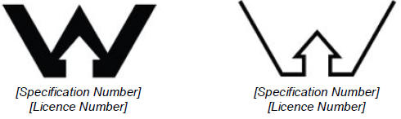
Figure 1. ABCB WaterMark certification marks
Many domestic outlets, such as kitchen taps, use aerators or flow restrictors to prevent splashing and to conserve water. These may potentially trap small metal particles dislodged from plumbing products, which may then dissolve into the drinking water. Aerators and flow restrictors should be removed at least every 6 months from outlets (by unscrewing) and cleaned to remove any metal particles caught in them.

Filtration
Some water filtration units may be effective at removing metals from drinking water. However, this can vary depending on the type and form of the metal (dissolved or particulate) and where the filter is connected into the plumbing system. As filters require regular maintenance and replacement, they should not be viewed as a permanent solution to manage elevated levels of metals. Filters may also trap particles causing metals to dissolve into the drinking water. Buyers of point-of-use filtration devices should look for filters that have been validated to demonstrate metal removal. Manufacturer’s instructions should be followed to ensure they remain effective.

Galvanic corrosion control
Galvanic corrosion is the process in which one metal corrodes preferentially when it is in electrical contact with another. This process may increase the concentration of metals in drinking water. If homeowners, residents or building and asset managers suspect that galvanic corrosion of their plumbing may be a source of elevated metals detected in drinking water, they should seek the services of a licensed electrician and/or plumber to remedy the situation.

Specific advice for public drinking water fountains
Public drinking water fountains and publicly accessible drinking water outlets may not be used regularly, allowing water to become stagnant. It is good practice to flush public drinking water fountains for at least 10 seconds prior to drinking. Asset managers should have a management framework for managing public drinking water fountains. This should include checking for cleanliness and any signs of corrosion or reduced flow that could indicate corrosion of plumbing components within the fountain. Installation of signage on public drinking fountains to encourage users to flush water from the fountain prior to using as a source of drinking water should also be considered.

Specific advice for rainwater supply systems
Rainwater from tanks used as a source of plumbed drinking water may be more prone to the presence of elevated concentrations of metals. Although contemporary metal roofing materials are unlikely to result in elevated concentrations of metals, owners should consider all construction materials used in their roof catchment area. Uncoated lead flashing, lead-based paint (on older pre 1970’s roofs) and lead roofing screw washers may increase the potential for lead to be present in the rainwater. The removal of any lead based paint or products should be done in a safe and controlled manner.
Rainwater tends to be slightly acidic and lacks the ability to buffer pH. This increases the risk of metals being mobilised into drinking water from plumbing products. In addition, as leaf litter breaks down in gutters and rainwater tanks it can increase acidity meaning that cleaning gutters is important to reduce corrosivity of rainwater. Further guidance on the management of rainwater supply systems is provided in the publication Guidance on use of rainwater tanks (enHealth 2010).
For well-maintained rainwater tanks the flushing advice provided in Table 3 should be sufficient.

Information to occupants
Any identified action to reduce the exposure of building occupants to heavy metals should be provided to these consumers. Landlords and building or asset managers should provide advice on the safe use of drinking water and any restrictions on its use, including but not limited to flushing durations and avoiding consumption when sampling results indicate potential health effects. This is particularly important when a building houses vulnerable populations.

Sampling drinking water for metals in a plumbing system
The water sampling methods described below will help to identify metals of concern in a plumbing system. They can also help to find the sources of those metals
Proactive testing of drinking water for metals is not generally required unless there are specific concerns (see below). Similarly, other than at building commissioning, building and asset managers do not need to test drinking water from their plumbing system, without good reason.

Why and when to test for metals in building water systems?
A sampling program to test for metals should be initiated for any of the following reasons:
- During commissioning of new or renovated buildings, excluding sole occupancy dwellings, to ensure the system can supply safe water (e.g. new hospitals or large multi-occupancy commercial buildings)
- If there is evidence of elevated metals in the water supply (e.g. metallic taste, discoloured water, brown or blue/green copper staining of plumbing products) or suspected elevated metals from the use of non-compliant plumbing products
A sampling program to test for metals could be useful in certain circumstances such as:
- verifying/validating the success of a flushing program
- demonstrating that a flushing program is not required or confirming that one is required
- identifying outlets that may require inclusion in a flushing program.

Who should collect water samples?
Water samples in plumbing systems should be collected by appropriately trained personnel (e.g. qualified water samplers). Water samples in smaller residential properties (e.g. a house) may be collected by the homeowners or resident. Testing laboratories will typically provide advice on how to collect samples and some will provide sample bottles. It is important to following any instructions issued by the testing laboratory for the preservation, handling and transportation of samples.

Where to collect water samples?
Water samples should only be collected from outlets used for drinking or food preparation. There is little benefit in collecting water samples at outlets from which water is not regularly consumed. The exception to this is that at least one water sample should be collected from a location that represents the incoming water supply (see section 3.5.1).
In a small plumbing system, all outlets used for drinking or food preparation should be tested. However, this may not be practical in large plumbing systems that contain a significant number of outlets. In these instances, a risk-based approach to sampling may prioritise those outlets used more frequently and those known to be accessed by vulnerable populations (e.g. pregnant women and young children). Healthcare facilities may also have specific clinical functions where contamination by metals is a known risk and these areas may need to be prioritised for water sampling.
If sampling for the presence of metals in a large plumbing system that predominately serves vulnerable populations, representative sample locations may be utilised. A representative sample location should:
- be an outlet used for drinking or food preparation
- be located at the extremity of the plumbing system
- provide information on the presence of metals in relation to a particular floor of a building or branch main in a plumbing system.
The use of hydraulic schematics or building plans may assist in identifying suitable representative sample locations. For example, a children’s hospital may have five or more levels and contain a large, complex plumbing system. In such instances a representative sample may be taken from a drinking water outlet at the extremity of each floor (resulting in at least five samples being taken).
Should results from a representative sample exceed the ADWG health-based guideline value for a metal of concern, consideration should be given to sampling all outlets used for drinking or food preparation for that metal of concern. Advice should also be sought from the local, State or Territory health agency.
Examples of small and large plumbing systems and associated sample locations are shown in Table 4.
Table 4. Plumbing system examples and where to collect water samples
Plumbing system | Building examples | Sample locations
Small plumbing system | Residential buildings such as single dwellings, single story apartment blocks or hostels. | All outlets used for drinking or food preparation.  Outlet representative of incoming water supply.
Small plumbing system with vulnerable populations | Single or multi-unit buildings that predominately host vulnerable populations. May include preschool, child care centres, out of school hours care and vacation care facilities. | All outlets used for drinking or food preparation.  Outlet representative of incoming water supply.
Large plumbing system | Large, wide-spread or multi-level buildings that are professional, residential or commercial in nature. May include large public facilities such as universities or recreational facilities. | Consider a risk-based approach e.g. prioritising higher-use outlets.  Outlet representative of incoming water supply.
Large plumbing system with vulnerable populations | Large, wide-spread or multi-level buildings that predominately host vulnerable populations. May include hospitals, primary schools or healthcare facilities. | Consider taking representative drinking water samples from higher use outlets and those accessed by vulnerable populations plus samples at the extremities of the plumbing system.  Outlet representative of incoming water supply.

Water sampling considerations
Water sampling and analysis should be discussed with the analysing laboratory prior to sample collection. Some laboratories will provide sample bottles. In addition to the requirements of the analysing laboratory, the following should be considered when collecting water samples:
- all water samples should be collected from cold water outlets only, if samples are collected from mixer taps they should be set to the coldest temperature
- water flow should be as high as practically possible when collecting water samples taking care that sample bottles do not overflow (higher flow rates are more likely to disturb any metal particulates and wash them into samples)
- aerators, screens or filters fitted to outlets should be left in place and not cleaned prior to collecting water samples to accurately represent the water quality consumed, (note that cleaning or replacement of these components may be required to assist with remediation)
- all water sample bottles should be clearly marked with relevant sample information (including name of the sampling location, type of sampling method used, the individual number of any sequential samples taken, date and time of sample collection)
- initially, samples should be analysed for ‘total’ concentrations of each target metal, rather than distinguishing between the form (i.e. dissolved or particulate).

Water sampling methodology
There is no single water sampling method for metals in drinking water that is suitable for all circumstances. The sampling method chosen is dependent on the objective. AS/NZS 5667.5 is well designed for collecting drinking water samples from treatment plants and distribution systems but has limitations when collecting drinking water samples within buildings and specifically when the intent of a sample is to determine metal influences from plumbing products. The scope of this guidance covers the water sampling methodologies for four separate objectives (Table 5).
Table 5. Water sampling methodologies
Sampling type | Objective | Sampling methodology
Incoming water supply sampling | To determine the concentration of metals from the incoming water supply | Flushed sample
Building commissioning | To determine the presence of metals in a building as a part of the commissioning process | 6-hour stagnation (6HS)
Screening sampling | To determine the presence of metals in drinking water within the plumbing system | Random daytime (RDT)
Investigative sampling | To identify the potential source of metals in drinking water within the plumbing system | 30-minute stagnation (30MS)

Incoming water supply
Prior to sampling it is suggested that contact should be made with the relevant drinking water provider to determine expected concentrations of metals in the incoming supply. When sampling for metals within the building’s plumbing system, it is still important to take a sample that is representative of the incoming water supply to establish whether there are any localised variations that could contribute to the overall concentrations of metals in the building drinking water supply. The incoming water supply sample should be taken after all other samples from within the plumbing system have been collected.
The incoming water supply sample should be taken from a point closest to the service line. The use of hydraulic schematics or building plans may assist in identifying this point. Water meters and incoming water backflow prevention devices may also assist in identifying an appropriate incoming water sampling point. Once identified, it should be labelled as the incoming water supply sampling point for future reference, particularly in larger plumbing systems. To take an incoming water sample, flush the outlet for at least 2 minutes or 5 minutes or more in large buildings depending on the distance between the outlet being flushed and the incoming water supply and collect a 250 mL water sample. The incoming water sample methodology is shown in Figure 2.
Incoming Water Sample Method
When | After conducting a round of 6HS, RDT or 30MS sampling.
Where | Outlet closest to the incoming water supply.
How | Flush outlet for at least 2 minutes (or longer for large buildings to ensure that water from the external main is drawn in to the sampling location); collect a 250 mL water sample.
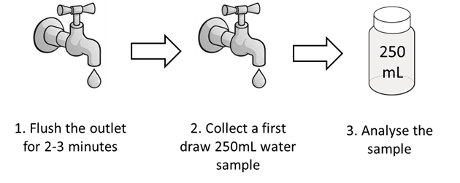
Figure 2. Incoming Water Sample Method.
If a metal of concern exceeds any ADWG health-based guideline value in the incoming water supply sample, the relevant drinking water provider should be notified immediately.

Building commissioning –6HS
In Australia there are specific requirements for the testing and commissioning of a plumbing system. These requirements are detailed in Australian/New Zealand Standard 3500.1:2018 Plumbing and drainage – Part 1 Water services (AS/NZS 3500.1), and include details in relation to system flushing, disinfection and hydrostatic pressure testing.
After completing the requirements of AS/NZS 3500.1, building and asset managers are recommended to undertake water sampling for metals within their plumbing system. This can be applied to newly commissioned or substantially modified buildings. An example of a substantially modified building may include an extension to an existing building, such as a new wing on a hospital, or significant replacement of the plumbing system, such as replacing major service lines.
The 6HS method can be used to verify that correct plumbing materials have been used and that a building’s plumbing system has been adequately cleaned, disinfected and flushed. It can also be employed to determine the presence of metals in a plumbing system after the building has been commissioned in accordance with AS/NZS 3500.1. Before commencing the 6HS sampling method, sample outlets are flushed for at least 2 minutes to draw fresh water through the plumbing system. Plumbing systems in larger buildings may require a flushing period of 5 minutes or more depending on the complexity of the system (advice should be sought from building or asset managers). Once flushed, sample outlets should be allowed to stagnate for a minimum of 6-hours. During the stagnation period, an attempt should be made to prevent water being used within the premises (including flushing of toilets), as water movement may influence the water sample to be collected. After at least 6-hours of stagnation a 1 L first draw (no flushing) water sample should be collected. The 6HS sampling method is outlined in Figure 3.
6HS Sampling Method
When | To determine the presence of metals in a building as a part of the commissioning process.
Where | Outlets that will be commonly used for drinking or food preparation, or where exposure of vulnerable individuals may take place.
How | Flush outlet for at least 2 minutes. Allow water to stagnate for a minimum of 6-hours, during which time no water should be used within the premises. Following this water stagnation period, collect a 1 L sample.
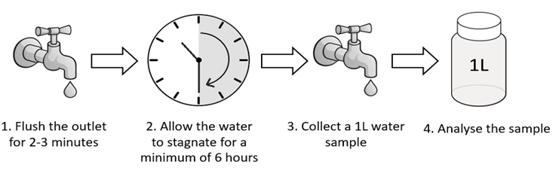
Figure 3. 6HS Sampling Method.
If an exceedance of any ADWG health-based guideline value for a metal of concern is recorded from 6HS sampling, further investigative sampling should be undertaken at the outlets that recorded exceedances, using the 30MS sampling methodology (see section 3.5.4). If advice is required on the sample results or the next steps in undertaking an investigation of plumbing compliance, this may be sought from the State or Territory plumbing regulator.

Screening sampling – RDT
The RDT sampling methodology is used to determine the typical presence of metals in drinking water in a plumbing system. RDT sampling should be used when screening for metals in plumbing systems (including households). The random nature of RDT sampling is subject to variables such as water age, stagnancy time and disinfectant residual.
The RDT sampling method requires a 250 mL first draw sample to be collected at a random time during the day from each identified sample point, without a defined water stagnation period and without prior flushing of the outlet. Collecting water samples during daytime hours (when water is typically being used) reflects general water quality. The RDT sampling method is outlined in Figure 4.
RDT Sampling Method
When | To determine typical presence of metals (often used in screening surveys).
Where | Outlets that are commonly used for drinking or food preparation, or where exposure of vulnerable individuals may take place.
How | During the day, collect a first draw 250 mL sample.

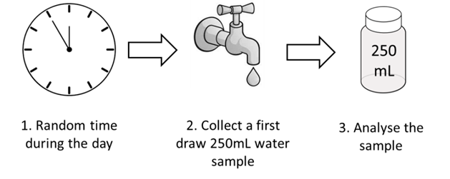
Figure 4. RDT Sampling Method.
If an exceedance of any ADWG health-based guideline value for a metal of concern is recorded, further investigative sampling should be undertaken at the outlets that recorded exceedances using the 30MS sampling methodology (see section 3.5.4).

Investigative sampling – 30MS
The 30MS sampling methodology is used to identify the potential source of metals in drinking water within the plumbing system. For example, where the results of 6HS or RDT sampling show an exceedance of an ADWG health-based guideline value for a metal of concern, 30MS sampling can be used to identify a product(s) within the building’s plumbing system contributing to the metal exceedance.
For the 30MS sampling method, the sample outlet is flushed for at least 2 minutes to draw fresh water into the plumbing system feeding the outlet. Plumbing systems in larger buildings may require a flushing period of 5 minutes or more to draw in fresh water from the incoming water supply. Once flushing has occurred, the outlet should be isolated and allowed to stagnate for a 30-minute period. During the 30-minute stagnation period, an attempt should be made to prevent drinking water being used within the premises (including flushing of toilets), as water movement may influence the water sample to be collected. This may be difficult to achieve in large buildings during normal operation, as such it may be sufficient to prevent use within each individual plumbing branch line being investigated.
Following stagnation, a 250 mL first draw sample should be collected immediately followed by a 1 L sample. The 250 mL sample represents a “first glass” sample while the 1 L sample represents water indicative from the pipework upstream of the tap. It is essential that both the 250 mL and 1 L sample are captured from a continuous flow of water, such that there is minimal ‘water loss’ between samples. The 30MS sampling method is outlined in Figure 5.
30MS Sampling Method
When | If results from the 6HS or RDT method identify a metal of concern exceeding the ADWG health-based guideline value.
Where | Drinking water outlets previously identified to have an elevated metal concentration level.
How | Flush outlets for 2-3 minutes. Allow water to stagnate for a period of 30-minutes, during which no water should be used within the premises, or the respective service line(s) within a large building. Following the stagnation period, collect both a 250 mL and 1 L sample.

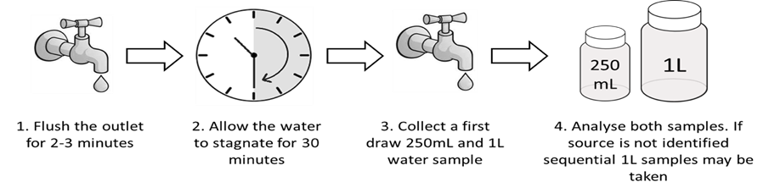
Figure 5. 30MS Sampling Method.
Upon analysis, if only the initial 250 mL sample exceeds the ADWG health-based guideline value for a metal of concern, it is reasonable to suspect that the plumbing fixture or tapware at the sampling site is contributing to the concentration of metals in the water. However, if only the 1 L sample exceeds the ADWG health-based guideline value for a metal of concern, it is reasonable to suspect that the pipework and plumbing products upstream of the outlet (for example a thermostatic mixing valve or brass fitting) are influencing the presence of metals in the water.
If both the 250 mL and 1 L samples exceed the ADWG health-based guideline value for a metal of concern, potentially both the plumbing fixture or tapware and the upstream pipework and plumbing products are contributing to the concentration of metals in the water. It is also possible that there is a plumbing product or pipework further back within the plumbing system influencing the presence of metals in the water. If the source of metal contamination is further back within the plumbing system, it is possible that elevated metals may also be detected at multiple outlets. Onsite water storages, such as header tanks, should be inspected and tested to assess if they are influencing the elevated metals.
The combined use of RDT and 30MS sampling methodologies to investigate drinking water quality in existing buildings is shown in Appendix 1. Where the RDT method has resulted in an exceedance from a particular outlet, but the 30MS method does not, the results of the 30MS method should be relied upon as it is likely to give a more consistent, repeatable result.
If metals exceed the ADWG health-based guideline value in either the 250 mL or 1 L sample, it may be beneficial to determine if the source of the metal is present in a dissolved form, particulate form or both. While this is not essential, understanding if the metal is in a dissolved and/or particulate form may provide insight as to the potential source of the metal and options for corrective action. For example, if most of the metal content is in a particulate form, filtration may be an effective short-term corrective action. The analytical laboratory should be contacted prior to sampling to identify how separate analyses for total metals and dissolved metals may be undertaken.
In instances where 30MS sampling fails to identify the plumbing product influencing the presence of metals in the water, consecutive 1 L samples can be taken to build a water profile of the affected plumbing line(s). Due to the complexity of water supply systems in large buildings, it may be helpful to engage a suitably qualified expert or consultant to conduct 1 L profile sampling.
The relevant State or Territory plumbing regulator should be contacted if a product is identified as being a cause of elevated metal concentrations in drinking water.

Water sampling analysis and interpretation
Analysis of drinking water samples for the presence of metals should be conducted by laboratories that possess appropriate accreditation. The National Association of Testing Authorities (NATA) provides independent accreditation of laboratory facilities to undertake specific tests.
Care should be taken to ensure accurate analysis and interpretation of results received. Except for lead, test results should be assessed using the same number of significant figures as those stated in the ADWG. The ADWG provides further advice on rounding of test results which may assist with interpretation of results. Results from multiple points within a building should not be averaged.

4 Further advice
Concerns about metals in drinking water due to evidence of corrosion, observation of discoloured water or staining of fittings and basins should be raised with the local drinking water provider. Advice about potential health impacts of metal contamination should be sought from the State or Territory Health agency.
Advice about responses to exceedances detected by water sampling should be sought from local government or from the State or Territory Health agency.
Information about the expected concentrations of metals in mains water provided to individual buildings or devices should be sought from the local drinking water provider.
Information about collection and testing of samples should be sought from the testing laboratory (which should be NATA accredited).

Appendix 1. Use of RDT and 30MS sampling to investigate metal concentrations in drinking water supplies in existing buildings
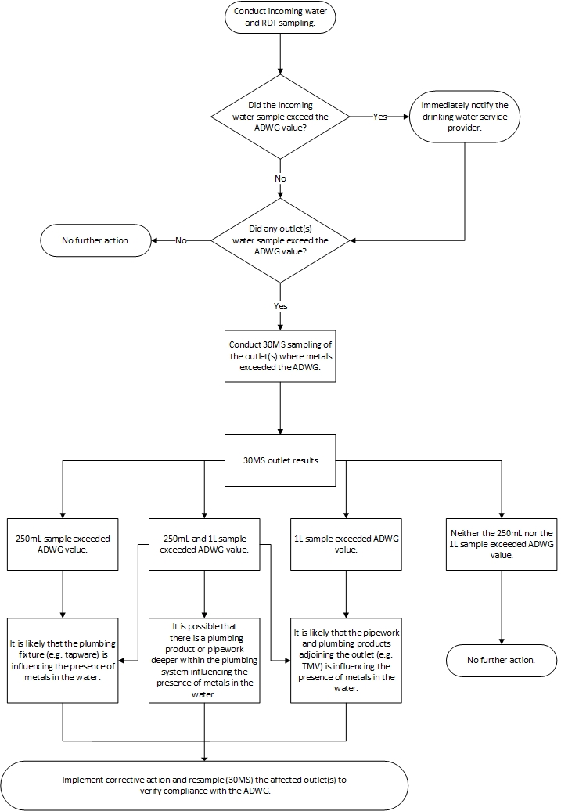

73rd Meeting of the Joint FAO/WHO Expert Committee on Food Additives (JECFA) 2011 – Lead
NHMRC (2018) Australian Drinking Water Guidelines (ADWG) https://nhmrc.gov.au/about-us/publications/australian-drinking-water-guidelines
USEPA (https://www.epa.gov/ground-water-and-drinking-water/basic-information-about-lead-drinking-water); Health Canada (https://www.canada.ca/en/health-canada/services/publications/healthy-living/guidelines-canadian-drinking-water-quality-guideline-technical-document-lead.html); Hong Kong Water Supply Department (https://www.wsd.gov.hk/en/core-businesses/water-quality/action-plan-for-enhancing-of-drinking-water-safety/publicity-and-public-education/index.html).
Australian Standard 3855-2018 Suitability of plumbing and water distribution systems products for contact with potable water
Plumbing Code of Australia https://ablis.business.gov.au/service/ag/the-plumbing-code-of-australia-pca-/31066
Australia New Zealand Standard 4020 – 2005.Testing of products for use in contact with drinking water
WaterMark Certification Scheme https://www.abcb.gov.au/Product-Certification/WaterMark-Certification-Scheme
It is a legal requirement WaterMark Certification Scheme, Australian Building Codes Board, 2016 - https://www.abcb.gov.au/Product-Certification/WaterMark-Certification-Scheme. A database of certified products is maintained.
Manufacturers should be able to provide evidence if metal removal has been validated
Information about the safe removal of lead based paint can be found at https://www.environment.gov.au/protection/chemicals-management/lead/lead-in-house-paint or contact your local, State or Territory health agency
Guidance on use of rainwater tanks, enHealth, 2010 -https://www.health.gov.au/internet/main/publishing.nsf/Content/0D71DB86E9DA7CF1CA257BF0001CBF2F/$File/enhealth-raintank.pdf
Total concentrations for each metal represent the sum of the dissolved and particulate forms
AS/NZS 5667.5. Water Quality –Sampling Part 5: Guidance on sampling of drinking water and water used for food and beverage processing
For further discussion on sampling see Guidelines for Canadian Drinking Water Quality: Guideline Technical Document – Lead. https://www.canada.ca/en/health-canada/services/publications/healthy-living/guidelines-canadian-drinking-water-quality-guideline-technical-document-lead.html
HK WSD (2017). WSD Circular Letter No. 9/2017 New Commissioning Requirements for New Plumbing Works. Hong Kong Water Supplies Department.

