

enHealth Risk Communication Guidance

Risk Communication Principles

Prepared for the Environmental Health (enHealth) Standing Committee

October 2021

Report prepared by: MosaicLab

MosaicLab is a Victorian based consultancy specialising in the areas of community engagement advice, facilitation and deliberative democracy.

Contents
1. What is ‘risk communication’?
2. Principles for Risk Communication
3. Changing assessment over the life of the project
Appendix No.1 - Background Information – Developing These Guidelines
Appendix No.2 - Further work to be completed
Appendix No.3 - Organisational support for risk communication

Acknowledgement
The enHealth working group and Mosaiclab have drawn heavily from the work of Dr. Peter Sandman, one of the preeminent experts in the field of Risk Communication. We would like to thank him for his support in developing the guidance document and acknowledge his understanding of the field of risk controversies and their relationship to communication. Please visit Dr. Peter Sandman’s website for further information.
www.psandman.com

1. What is ‘risk communication’?
The fundamental goal of risk communication is to inform a specific audience on the risk of harm and often includes information or action required to mitigate harm. Risk communication is recognised as being a multi-directional communication and engagement strategy implemented by an organisation to empower the public to take some responsibility for managing the risk, to help minimise the risk itself, and to minimise the impacts should the risk eventuate.
Experts and authorities are less trusted than those within a person’s circle (i.e. known associates, friends, family of friends of friends). Therefore there is a need to provide timely, accessible and accurate information about risks in the context of a digital world where risk information is available from multiple sources has become a new challenge.
How risks are perceived by individuals can vary and their reactions are influenced by how tolerant they may be to a particular risk outcome compared to the perceived benefits, as well as a number of other factors such as:
- emotions or how the risk makes us feel (i.e. how we feel about the risk will affect how we want to communicate about it)
- economic/political/reputational impacts (separate to health impacts)
- value judgements impacted by
  - whether an impact on someone is considered voluntary (i.e. they choose to put themselves at risk) or involuntary (i.e. someone else has forced them into this situation)
  - whether someone feels they control things themselves (or could control things) or it is controlled by others
  - whether it is a risk that people feel familiar with (e.g. driving cars) or it’s unfamiliar or new
  - whether something is considered ‘fair’ (i.e. applied the same to all) or unfair’ (applied to people unevenly)
  - whether the risk is seen as certain (the facts and information feel robust) or uncertain (the fact and evidence are not strong) OR
  - when the impact of a risk occurring is considered too great (i.e. people could get seriously hurt or even die)

This document is developed to assist primarily environmental public health practitioners in understanding and preparing for communicating ‘risks’ to the public.

Dr. Peter Sandman, developed a model for understanding how risk is perceived that addresses the relationship between hazard and outrage as shown in the following diagram.
Dr. Peter Sandman refers to the relationship between ‘Hazard’ and ‘Outrage’ through the lens of this equation: Risk (R) = Hazard (H) + Outrage (O).
Risk experts define the term ‘Hazard’ as the ‘potential for harm to health or the environment’.
For the purposes of risk communication, Dr. Peter Sandman redefines the terms ‘hazard’ and ‘outrage’: Hazard is the ‘actual harm’- mortality, morbidity, ecosystem damage (this is often referred to as ‘risk’ by risk experts). Outrage refers to all the other factors (that influences a person’s decision about a risk).
Dr Sandman’s equation considers both ‘Hazard’ and ‘Outrage’ as two mutually exclusive elements of the situation, and therefore they need to be considered separately to each other.
It is important to note that ‘risk communication’ is as much about how we portray information with our words, actions and reputation than it is about the assessment itself. By doing this the organisation is more understood and ‘believed’ in terms of their genuine desire to ‘care’ for the public. This includes the organisation’s willingness and ability to understand the views of risks perceived by those being affected no matter how different from your views. Without the latter it can create credibility and trust problems for communication.

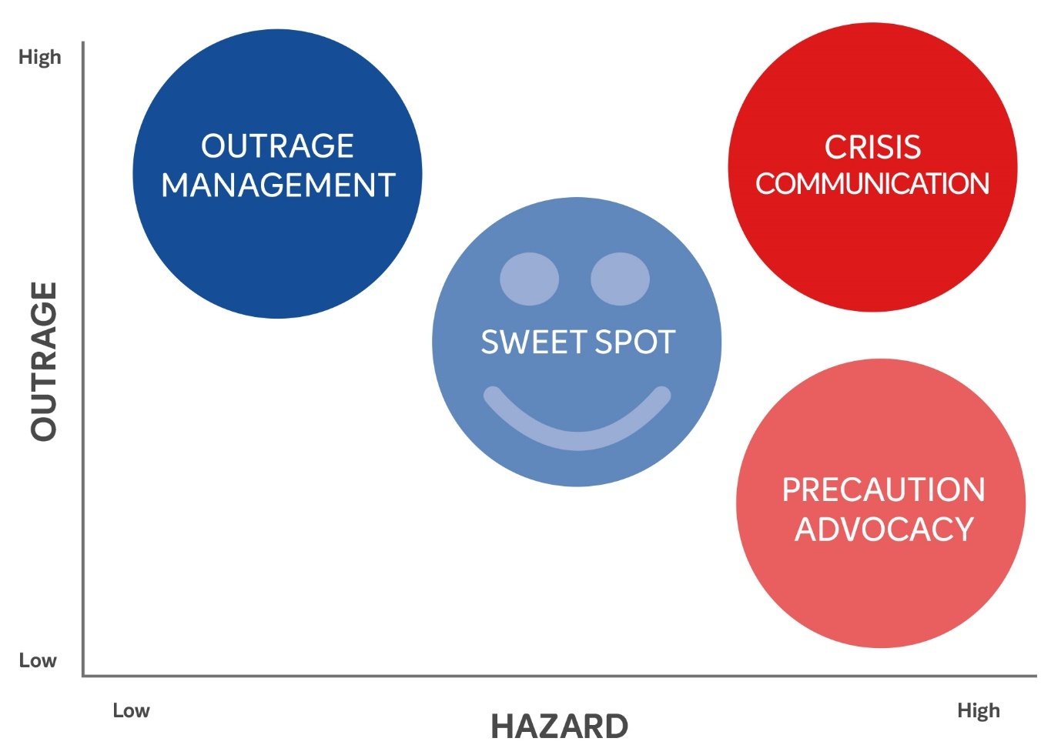

Precaution Advocacy — WATCH OUT!

High Hazard, Low Outrage
When hazard is high and outrage is low, the task is “precaution advocacy” – alerting calm people to serious hazards. “Watch out!”
Audience: Often busy and fairly inattentive to issues other than the immediate; Very large numbers of people – most of the people, most of the time, on most of the issues.
Task: To produce brief (or core) messages that encourage people to undertake what you need them to do to reach your goals. For serious hazards this often means provoking more outrage. EG. Recycling. Consider how you can reach all relevant groups in the affected population” (i.e. engagement with specific communities, information in relevant languages, interpreters etc.).
Medium: One-way, through mass media
Barriers: Audience inattention; audience size; media resistance; short sound bites for complicated messages; policy implications of trying to provoke outrage. Some affected groups in the community may be more difficult to reach through conventional communication (inc. language, channels and approach) and there is a need to consider alternate and tailored approaches.
Advantages: No need to spend time listening or addressing audience concerns, reservations or objections – this audience has few, if any

Crisis Communication — WE CAN DO THIS!

High Hazard, High Outrage
When hazard is high and outrage is also high, the task is “crisis communication” – helping appropriately upset people cope with serious hazards. “We’ll get through this together.”
Audience: Huge and very upset! During a crisis, the outrage is mostly fear and misery rather than anger. It can quickly change to anxiety or terror if the fear is unbearable. Once the crisis has passed (and this can happen very quickly) people often move very quickly to outrage – “Why did you let this happen?”
Task: To help the “audience” bear its fear and misery, and help them get to safety. Key strategies include sharing dilemmas, being human and empathic, providing things to do, acknowledging uncertainty and avoiding over-reassurance. Consider how you can reach all relevant groups in the affected population” (i.e. engagement with specific communities, information in relevant languages, interpreters etc.).
Medium: Involves one-way and two-way flow of information: One-way through mass media – saturating the market space with information. Two-way where possible to help share the dilemma, people can ask questions, put faces to names etc.
Barriers: The stress of the crisis itself and thinking that crisis communication is public relations. Some affected groups in the community may be more difficult to reach through conventional communication (inc. language, channels and approach) and there is a need to consider alternate and tailored approaches.
Advantages: Any outrage during the crisis is often broad and not directed at you – although this passes very quickly as soon as the crisis subsides (this can be day one of the crisis depending on the speed and duration of the event). People are interested and craving information. Everyone is a stakeholder and will gladly get involved.

Sweet Spot — LET’S SOLVE THIS TOGETHER!

Medium Hazard, Medium Outrage
When hazard and outrage are both intermediate, you’re in the “sweet spot” (hence the happy face) – dialoguing with interested people about a significant but not urgent hazard. “And what do you think?”
Audience: Interested and attentive, but not too upset to listen. The ideal audience but a fairly rare one.
Task: To discuss issues openly and rationally, explaining your views and responding to audience questions and concerns. Consider how you can reach all relevant groups in the affected population” (i.e. engagement with specific communities, information in relevant languages, interpreters etc.).
Medium: Dialogue in person, supplemented by specialised media (eg. website, newsletter etc.)
Barrier: Getting to this point in the first place. Often you are in one of the other places first and are trying to transition to this one. Making sure the engagement here is meaningful, influential and genuine – not mistaking it for public relations. Some affected groups in the community may be more difficult to reach through conventional communication (inc. language, channels and approach) and there is a need to consider alternate and tailored approaches.
Advantages: There are so many benefits from this sort of engagement beyond the project/issue you are focused on now. This is the easiest form of communication and is a goal of the other three kinds of communication

Outrage Management — I HEAR YOU!

Low Hazard, High Outrage
When hazard is low and outrage is high, the task is “outrage management” – reassuring excessively upset people about small or low level hazards. “We’re listening”.
Audience: Very angry at you or your organisation. A small group of passionate people are usually accompanied by a larger, slightly less outraged group who are concerned and observing the interplay between you and the passionates
Task: To reduce the outrage by listening, acknowledging, apologising, sharing control and credit, collaborating on solutions, sharing the dilemma etc. The controversy ends when the ‘passionate people’ declare a victory or their constituency thinks they have won enough. The task here is also to ensure your receptivity and ability to be empathetic. This would include demonstrating your understanding by using terms such as: concerns, worries, stresses and losses in a way that genuinely sees these issues as real problems to be addressed and not irrational thoughts. It is important to note that upset people do not process information rationally. Blame and anger are emotionally satisfying but they will impede understanding. A major task here is to manage the emotion (or the arousal) so that thinking can occur. Consider how you can reach all relevant groups in the affected population” (i.e. engagement with specific communities, information in relevant languages, interpreters etc.).
Medium: Two-way, in-person dialogue – the “audience” does most of the talking, and you respond when asked and when the audience is ready. Journalists may also be watching
Barriers: You need to work with the audience’s outrage at you and manage your own outrage at the audience; coming to terms with the need to focus on outrage when you’d really rather talk about content. You may also need to influence reluctance within the organisation to let go of power. Some affected groups in the community may be more difficult to reach through conventional communication (inc. language, channels and approach) and there is a need to consider alternate and tailored approaches.
Advantages: You have the audience’s attention! The audience is taking their anger out at you rather than behind closed doors, talking to investors/media only

2. Principles for Risk Communication

2A. Overarching Principles
These principles apply to all forms of risk communication.
1. Be human and develop relationships:
- Accept and involve the community as a legitimate partner in finding solutions.
- Take the time to meet with people personally (if possible) and build rapport.
- Get feedback on how things are travelling, and ask yourself ‘have I done everything I promised I would?’ and ‘Have I checked in after some time has lapsed to see how people are doing?
2. Plan carefully, but assess quickly:
- Assess each new situation quickly.
- Plan carefully, understanding the context and the people. Know your purpose and have clear objectives. But do not let preparation get in the way of action.
- Understand the history of the issues, know the variation of views (boundary scanning).
- Plan for adequate time and resources and build in flexibility (adapt the plan).
3. Actively listen:
- Listen first, do not assume you know what people know, think or feel.
- If you know there is an issue, be proactive, do not wait for people to notice, become concerned or seek alternate, and possibly unreliable, sources of information.
4. Be honest:
- Be honest, open and frank at all times – admit to limitations and uncertainties in risk. assessment and to any changes to risk when new information is known.
5. Learn from experience:
- Monitor and evaluate the effectiveness of all communication and engagement activities during and at each stage of the process.
6. Choose the messenger:
- Find the most appropriate person for each situation to share the messages or lead the conversation. Trusted sources can vary depending on the situation and the issue. A local trusted voice (people like you, local leader or champion) will always have more influence than an unknown face.
7. Plan for diversity:
- Different communities with different communication needs will require specific tailored approaches. This MUST be planned for within each risk communication activity. Different communication needs might mean different languages, the use of infographics/pictographs, or using different channels to access communities they may not use or trust ‘typical’ communication channels.
8. Clear calls to action:
- Use clear calls to action or simple checklists to make behaviours stand out and easier to act on.

2B. Principles for Outrage Management
1. Agile planning:
- Develop a plan but don’t stop it from making you engage fast and early.
2. Involve the community:
- Involve the public early.
- Involve all groups affected or potentially affected – seek to widen out the process beyond vested interests.
3. Listen to community concerns first:
- Listen first, allow as much time for people to express their views as needed and allow emotion to be expressed before providing any information Do not assume what people know, think or feel.
- Go to the community even when knowing no more than the community – let them observe your process of discovery.
- Be empathetic – put yourself in their shoes.
4. Be honest and accountable:
- Do not expect to be trusted instead aim for accountability – ‘track us don’t trust us’.
- Aim for accountability and submit to being monitored and evaluated by stakeholders/the public as much as possible.
- Ensure you are clear about what the scope of any community session is about – including what is ‘out of scope’ or ‘not negotiable’.
5. Acknowledge prior misbehaviour:
- Clearly state what you have done wrong. The public wish to hear how badly you have treated them.
- Let the public tell you what went wrong, and then apologise.
- The more you acknowledge past problems, the more quickly the audience decides that it’s time to move on.
- It is definitely the public’s choice as to when you can stop apologising and move on.
6. Acknowledge current concerns transparently:
- Be honest about uncertainties and limitations – what you know and what you don’t know, what you can say and what you can’t say and why.
- Credibility will be built if the public can watch you flail.
- Go beyond honesty to transparency - if you cannot answer a question, say so and follow-up with an accurate response later.
- Let the public see you trying to solve problems even when you don’t know the answer yet – let them see you trying new things.
- You don’t need to have all the answers but you need to say you will find it and get back to them.
7. Stake out the middle not the extremes of a position:
- Find out what the ‘other side’s’ good arguments are and include them in your communications, along with your own thoughts. Put all the alarming information in your communications so that the alarmists have nothing to say.
- Practice ‘even though’ statements to help you find the middle ground.
- Avoid getting sucked into trying to change people’s perceptions. Remember angry people resist data that shows they are wrong – it only makes them angrier.
- Be clear when you are talking to those who are angry and those who aren’t.
8. Acknowledge achievements with humility:
- Don’t ‘brag’ about your wins, instead give away credit for your success.
- Acknowledge what your critics have made you do.
9. Share control (collaborate on solutions) or building in accountability:
- The angrier people are, the less they want you to be in control. Let the community do some of the driving.
- Collaborate with the community on finding solutions. Let the public see you struggle to solve the problem – this will build trust.
- Build in joint evaluation mechanisms.
- By providing more public control it will help people understand that you are trying to get it right – they are more likely to accept future failings if they can see that you are genuine in your efforts to reach the best possible solution.
10. Pay attention to unvoiced concerns:
- Listen for factors beyond the hazard such as ideology, self-interest, greed, revenge and ego.
- Say things like ‘I wonder if anyone is worried about…’ or ‘some people may be worried about..’ to bring these to the fore.

2C. Principles for Crisis Communication
1. Accurately represent the risk:
- If you over reassure people, the more ambivalent audiences will likely become more alarmed.
- You can diminish your credibility in the face of this crisis and people may not take action required to mitigate the risks.
- If you are worrying about how far to go and need people to take action to protect against risks – lean towards the side of being more alarming than more reassuring.

2. Acknowledge uncertainty:
- During a crisis, sounding more reassured than you are sounds false, can set you up to be wrong and can provoke debate with those who disagree with you.
- Better to say what you know and what you don’t know (and are learning more about)
- Model the ability to bear uncertainty and take action anyway.
3. Treat emotions as legitimate:
- In a crisis, people are right to be fearful and miserable.
- Anger will always be loud and overt, anxiety and despair will be silent.
- Both emotions are at risk of flipping into denial, or escalating into terror or depression, or alternately receding into apathy.
- All these emotions are legitimate and must be a respected part of the process.
- Balance the strategies for both the minority of those who are upset and the majority who are doing what they are told.
4. Establish your own humanity:
- Express your own feelings – if you seem fearless, you can’t model how we should master our fear.
- Express your wishes: ‘I wish we could give you a more definite answer’ but be mindful it is better to focus on their problems than your own.
- Tell a few stories about your past, your family and your reactions to the crisis where appropriate.
5. Offer people things to do:
- All action helps people bear their emotions and therefore prevent them descending into denial.
- Where possible, offer a choice of actions so again people can feel like they are taking control for themselves.
- Provide a range of actions from simple to more complex so that different people can participate in the response.
6. Share dilemmas:
- Acknowledge when you are not sure what to do or which is the best course of action.
- Share the difficulty of the choices - Share even when you are not sure if it is the right choice of action.
- Say things such as ‘This was a tough decision, and we are still not sure it was the right call’.
- If you focus on only the upset people here you will frustrate the majority who are doing the right thing.
7. Acknowledge opinion diversity:
- When there are tough decisions there are always pros and cons on either side of the argument.
- Let people know about the different opinions and let other people speak up about the pros and cons.

8. Apologise for mistakes:
- Focus on the way you made mistakes – the more you do this others will more likely focus on the ways you didn’t.
- Alternately if you focus on how it wasn’t your fault others will clearly shout out your mistakes.
- Better to be the first at espousing your faults and misbehaviour in relation to the hazard.
- This will help when you hit ‘post-crisis’ when the recriminations will emerge.
9. Aim for absolute candour:
- Too much information gets withheld from the public – make a point of aiming for absolute candour knowing that you will not (and probably should not in some cases) share everything.
- Explain what influenced your thinking or actions that the public would not be in a position to know about.
10. Do anticipatory guidance:
- This means telling people what to expect in the near future – this is especially useful when it’s about uncertainty.
- Examples: ‘We will learn things in the coming weeks that everyone will wish we had known when we started’ or ‘We expect to lessen the restrictions in the coming days but it will depend on the numbers’.
- Even harder than the above is providing pre-crisis anticipatory guidance to get ready for possible emergencies. An example of this is when you know it is going to be a ‘bad’ fire. season with potentially high risk for many rural communities. Get in early at start preparing people for what they can expect in the summer and what they need to do.
11. Timely and targeted communication:
- Provide immediate and regular updates.
- Use communications channels that are accessed by the targeted audience.

2D. Principles for Precaution Advocacy
1. Keep it short:
- Apathetic people have a short attention span.
- Keep your messages clear, succinct and in the right languages to get cut through with many different people.
2. Make it interesting:
- Provide simple and short animated videos, or infographics to engage people and to get the messages across quickly.
- Once you have caught people’s interest draw them over to more detailed information.

3. Get on the front foot and stay on message:
- If you know there is an issue be proactive about communicating it rather than waiting for people to notice or complain.
- Use images and metaphors not concepts.
- When people are not paying attention (or barely!) and could lose interest at any moment it is important to make every word count. Don’t get seduced into thinking more will be better or highlighting a second message. Pick the best one and stay with it.
4. Test your messages:
- Find out what messages people respond to by testing with a few key groups of people.
- By piloting your messages you can better align your thinking with what is going to resonate with the people you are trying to change.
5. Plan for the long haul:
- This sort of communication is all about generational change. Think about recycling, wearing seat belts and other long change programs. Prepare yourself to continue this course of action for many years. Success will not come quickly.
6. Appeal to people’s needs:
- Find out what people’s needs are and link those needs to the features that your program offer. Eg. If people’s needs are about convenience/ease – recycling offers an easy way to get rid of rubbish and feel good about yourself!
7. Appeal to emotions – especially fear:
- People’s emotions fuel action. For precaution advocacy you are trying to ‘alert’ people – WATCH OUT! So fear is a primary emotion to tap into. The key here is to ensure you are elevating their ‘fear’ enough to take action not to overwhelm.
8. Don’t neglect emotions other than fear:
- Although fear and concern is a big driver for taking precautions against a real and dangerous hazard, other emotions play a role too. Safety for others (family) and anger can also be powerful motivators for change.
9. Give people things to do:
- Precaution advocacy is about taking precautions as much as it is about alerting people to the risks/hazards. Give people things to do so they can take precautions (even symbolic ones).
- Think about precautions that are easy and some which would show greater protection – give people choices.
- Sometimes its even better to get people taking precautions and then teaching them about the hazard.
10. Think in stages:
- People adopt precautions in stages. Each transition has its own communication strategies and approaches.
- Think about your messaging in terms of these stages:
  - Stage 1: Unaware and unengaged
  - Stage 2: Aware and unengaged
  - Stage 3: Engaged but undecided about action
  - Stage 4: Engaged and deciding to act (not actually acted yet)
  - Stage 5: Act
  - Stage 6: Decide to keep acting

2E. Principles for the sweet spot
1. Share dilemmas early and genuinely:
- Communicate openly and in depth.
- Invite people in to solve the issue together.
2. Have a clear purpose and plan well:
- Have a clear purpose.
- Decide your stages/phases.
- Define success and how you will know if you get there.
- Plan for what could go wrong.
3. Get your leaders onboard:
- Ensure everyone in your organisation is fully briefed and communicating in line with these principles.
- You don’t want to go backwards whilst mid-flight!
4. Aim for the highest level of influence you can:
- Seek to, at least, collaborate with the community, anything less will lead to more outrage.
- Don’t turn up to inform people when they think they can influence.
5. Unpack who is who:
- Involve all groups affected or potentially affected or a representative sample.
- Widen the engagement out to the broader community, not just vested interests.
- Involve them in finding solutions and evaluating progress.
- Be empathetic – put yourself in their shoes.
6. Work towards a shared solution:
- Find ways to enable community ownership over solutions to problems that affect them.
7. Informed process:
- Provide information to help people understand what dilemmas you face in making decisions.
- Unpack the pros and cons and ensure the information is diverse and includes the polarity of views.
8. Respect the community:
- Listen deeply to the community.
- Never underestimate the public’s technical knowledge and capacity to understand issues.
- Trust, credibility, competence, fairness and empathy are of equal or greater important to the community as facts and figures.
9. Be honest and accountable:
- Be honest about uncertainties and limitations – what you know and what you don’t know, what you can say and what you can’t say and why.
- Do not expect to be trusted instead aim for accountability – ‘track us don’t trust us’.
- Respond when you can.
10. Implement and be responsive:
- To the greatest extent possible, implement the recommendations from the engagement process and if you are unable to do so, publicly explain why.

3. Changing assessment over the life of the project
With all risk communication issues people’s drivers of outrage will change over time and hence the situation is moving between quadrants. This could mean that people become more outraged or less depending on several factors:
- What your organisation does and how you communicate with key cohorts
- What is happening in the media
- What is happening with the hazard
- What is happening in their own lives
The following diagram gives a sense of how this could work in action. One key example of this changing nature of risk communication is that pre-crisis risk communication is likely to be precaution advocacy and post-crisis risk communication is likely to be outrage management. Being mindful of these movements helps to adapt to contextual changes.

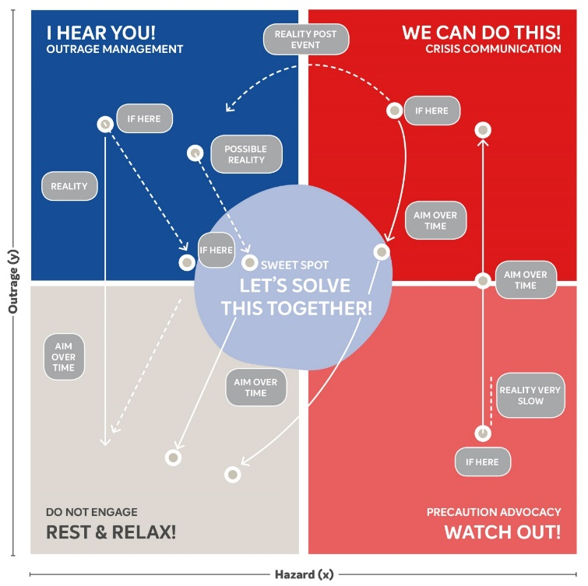
It is important to understand that different target audiences may have different communication needs (and therefore be in different quadrants) – Flexibility is needed to communicate with the different target audiences.

Appendix no.1 - Background Information – Developing These Guidelines
A series of workshops were held in June 2021 to define the tools needed to update the enHealth ‘Risk Communication’ guidance material. As a result of these workshops it was agreed that a set of one-page principles was needed (one page for each of the four risk communication quadrants) together with an overarching one-page set of principles. In addition, a set of tools to assist in responding to risk communication situations has been identified (not developed) plus a set of recommendations for organisational change.

Developing the enHealth Risk Communication Guidance
- Desktop Research & Interviews (Aditya Vyas, Angie Bone, Carolyn Brumley, Chris Lease, Jason Kneipp, Jennifer Savenake, John Piispanen, Lara Purdy, Michael Lindsay, Paul Hunt, Sally Gilbert, Tracy Ward)
May 2021
Reviewed key documents and conducted 12 interviews with EnHealth members from across Australia and New Zealand to inform the collaborative workshops.
- Session 1: Context Exploration
Monday 7th June 2021, 10am to 12pm (AEST) on Zoom
Built a shared understanding of experiences. Explored the feedback (interviews). Clarified the outputs we need, format and who they target (what was needed from the project)
- Session 2: Information Sharing
Friday 11th June 2021, 10am to 12pm (AEST) on Zoom
Considered a range of diverse content, inputs and case studies (where risk communication skills were/could have been helpful). Identified draft risk communications principles.
- Session 3: Critical Friends Review
Friday 18th June 2021, 10am to 1pm (AEST) on Zoom
Tested initial thoughts with a range of peers and working group member, identified gaps and explored alternatives together.
- Post Collaboration Workshops (Victoria’s Behavioural Insights Unit, Alvin Chun, Robert Gordon, Peter Sandman)
August 2021
Final outputs developed in consultation with a range of peers to help shape the final outputs.

Appendix no.2 - Further work to be completed
Organisations should adopt the following tools in order to support the integration of risk communication into the organisation.

Information formats
- Checklist (1 page)
- Case study (2 pages)
- Video (5 mins or less)
- Interactive app
- Standard Operating Procedure (1 page)
- Diagram (1 page)
- Infographic (1 page)
- Specific issue handbook or guidance note (10 pages or less)

Locations where the information is held (and updated)
- an overall handbook – people still wish to retain the handbook as the comprehensive source of information
- website
- an application

Support uptake and use
- Training
- live event
A key element of this project was to identify the tools needed to update the enHealth ‘Risk Communication’ guidance material. Some of these tools (eg a set of principles managing outrage) have been developed as part of this project. Other tools will need to be developed at a later stage.
Tool | Purpose | Format
Risk communication cheat sheet | - To provide just in time guidance for managing an environmental health risk  - To have a set of principles in place for risk communication | Checklist
Outrage management | - To have a set of principles and strategies in place for managing outrage | Guidance note  Checklist  Case study  Video
Precaution Advocacy | - To have a set of principles and strategies in place for managing outrage | Guidance note  Checklist  Case study  Video
Community engagement | - To have a set of principles and strategies in place for managing outrage  - To build organisational competencies in dialoguing with the public | Guidance note  Checklist  Case study  Video
Scenario development/plan ahead | - Plan to be ahead of any issues  - Identify the best approach for a range of issues/scenarios and types of audiences | Scenario planning checklist or infographic  Case studies
Communications checklist | - To know when to initiate, continue and stop risk communication for an incident  - To ensure messages are timed for their greatest effect  - To identify the right person/channel/medium for the job  - To ensure messages are fit for the intended target groups (road test messages) | Checklist  Info video  Focus groups for road testing messages
Social media | - To understand and provide guidance on the best use of social media to enable direct communication with the community, to not be drowned out and to disempower misinformation | Guidance  Checklist
Communications options (Plan B) | - To have a Plan B (alternative engagement or communication mechanisms) in place when communications channels are narrow or when we can’t’ control or influence communications | Checklist  Case study
Style guide for all publications | - To provide consistent language/terms /definitions for enHealth publications that can be used across all jurisdictions | Style guide
Cross jurisdictional framework | - To ensure consistent advice and working arrangements so that the different states and territories are not providing conflicting advice  - To leverage resources and support | Framework diagram  Check list  SOPs
Roles guide | - To define the roles between professions (communications, media, public health professionals) to enable standardisation between jurisdictions (similar to the SONG for communicable diseases appendices) | Diagram
Stakeholder mapping format | - To ensure all stakeholder groups are included in any risk communication process (any of the types) | Standard format for holding stakeholder information
Evaluation framework | - To ensure continual learning and adaption of communication campaigns | Framework  Checklist
Contemporary Case studies | - To ensure continual learning across jurisdictions | Case study  Set of videos
Managing incidents/events that involve legal issues | - To know how to manage communications during and after a risk event/incident where there is an ongoing legal issue | Guidance note
Media familiarisation | - To provide contemporary information to the media about the issue, including sharing information about the science (before it happens)  - For the communications teams to capture file footage | Live event  Video footage
Language | - To provide a one document that sets out the type of language to use in different risk communication situations | One page style guide
Communications fatigue | For protracted issues that require regular and long-term engagement, research/develop:  - Indicators of engagement fatigue and strategies to overcome  - Indicators of how the community’s perception changes over time to enable adjustment of the comms strategy | Info bulletin  Info video
Engagement reach | Seek to understand  - How to reach the unusual voices  - How to reach across language barriers | Info bulletin  Info video
Run Pilots | - To test the efficacy of the assessment tool against some past, present and/or emerging situations to build greater evidence. | Case Studies

Appendix no.3 - Organisational support for risk communication
Based on the shared experiences from the workshops the following outlines the sorts of structural and organisational changes needed to support the move to improved risk communication skills and their application.
The principles in this document form the foundation for a new organisational culture that treats trust building as a legitimate task.
Describe the change | Describe this change as a change! Ceremoniously flag that this is a ‘new way’ of responding. It builds our skills but also asks the organisation to be different in the way it assesses and responds to different outrage/hazard environments.
1. Send change signals | Describe the change in the system by advertising for new roles (with risk communication skills), define new job descriptions, change the planning documents, alter the way performance appraisals take place, flag this change in the organisational schedules. Specific examples are:  - Raise the profile of enHealth  - Build up existing staff resources in this space  - Look after and train current staff in positions that interact with the public  - Ensure the mental health and wellbeing of all staff who are interacting with the community is considered and looked after  - Include the organisation communications experts in environmental/public health risk communication, including those familiar with digital communication and digital analysts
2. Build risk communication skills | - Provide training on all aspects of risk communication (esp. outrage management) to ensure familiarity with the principles, approaches, language and all the tools to support doing the work well  - To provide training on an ongoing basis to cover staff turnover and continuous professional development (to learn about new evidence and best practice)  - Train scientists in media delivery and community engagement to ensure all staff have the skills to engage with the community
3. Build in ongoing learning and collect evidence | - Clearly define what success looks like for the different types of risk communications  - Build in systems to capture learnings inc. case studies  - Undertake evaluation of communications campaigns  - enHealth to hold an annual creative workshop to discuss the renewal of tools and collateral
4. Make sure rewards match the goals | - Find ways to acknowledge, reward and profile those who have undertaken great risk communications  - Make sure these rewards are for all four types of risk communications  - Don’t promote or recognise those people who undertake the risk communications in the ‘old’ or ineffective ways
5. Start with small projects | - Start with something easy and simple to help build confidence in the process  - Going too big and too hard early could kill confidence and set you back  - Actively seek out a project that is lower profile and challenges your current approach to try something new
6. Don’t blindside anyone | - Make sure leaders through to operational staff know what is expected and are set up for success  - Don’t surprise them with new tools without giving them an opportunity to learn and observe
7. Start small | - For a new culture to take root and succeed, it should be led and managed as a learning experience or pilot project involving senior managers through staff  - If the new culture is a big departure from current practices, it will be strategic to begin with a very modest project in order to gain experience and build confidence for future projects  - To manage internal concerns or frustrations in any pilot risk communication project, someone with experience leading such a project can be very useful in focusing the internal discussions to avoid misinterpretations or false conclusions
8. Deal with internal outrage during  the change | - Individual feelings or outrage can create blind spots unless there’s someone who can call attention to them. Your feelings or outrage are important and will need to be acknowledged, and addressed so that they can be effectively managed and not become obstacles to your communications and actions  - How you deal with your internal discussions will be good practice for your collaboration and communication with communities

