Environmental Health

Standing Committee

(enHealth)
  - of the Australian Health Protection Committee
Strategic Plan (2024-27)

Version History
Version No. | Version Date | Description
1 | 3/07/2024 | Finalised version
Table of Contents
Version History 2
Introduction 3
About enHealth 4
Priorities of enHealth 4
Aboriginal and Torres Strait Islander Environmental Health 5
Air quality 5
National Approach 5
Radiation 6
Water Quality 7
Principles 7
Governance and Partnerships 8
AHPC sub-committees 9
Collaborative Partnerships 11
Approach 11
Decision Tree 11
Communication Strategy 11
Advice and Guidance 11
Research and Data 11
Supporting documents 11
Attachment A: Decision Tree 13

Introduction
A healthy environment is vital for human health and development with known avoidable environmental risks estimated to cause about one quarter of all deaths and disease worldwide, amounting to at least 13 million deaths each year. While environmental conditions in Australia are generally considered to be good by global standards, in 2018 it was estimated 1.3% of Australia’s total disease burden was due to air pollution alone.
Environmental health is therefore considered a fundamental component of a comprehensive public health system. Though it is recognised, the solutions for reducing environmental health risks must come from both within the health sector and beyond it. Understanding the links between our environment and health, and how to mitigate the risks to health continues to evolve and inform the evaluation of the risks associated with environmental exposures, mechanisms for prevention, and the delivery of policy and services.
Environmental health encompasses the assessment and control of physical, chemical and non-infectious biological factors in the environment that potentially could, or currently have, an impact on health. The World Health Organisation (WHO) definition of environmental health excludes behaviour not related to environment, as well as behaviour related to the social and cultural environment, and genetics.
The responsibility for managing environmental health in Australia is shared between the Commonwealth government, state and territory governments and independent bodies. In general, risks are managed through regulatory frameworks administered by health and other agencies at the state and territory level. These regulatory frameworks operate within a context of nationally coordinated policy and standard setting.
The Environmental Health Standing Committee (enHealth) plays a key role in the coordination of national responses and policy advice on environmental health issues and is responsible for developing national guidance and resources on environmental health matters.
Ensuring that environmental health issues are effectively managed is dependent on the availability of research and data to support the provision of clear advice and interventions. It is anticipated that the establishment of the Australian Centre for Disease Control (ACDC) will provide a mechanism for greater integration and expansion of environmental health surveillance and contribute to better informed evidence-based practice.
Continued evaluation and improvement are critical as globalisation, varying land-use patterns and changing environmental conditions all have the potential to accelerate the emergence or re-emergence of threats and risks. Emerging global environmental health threats, such as climate change and AMR, will increasingly require anticipatory action to minimise expected risks and impacts; greater understanding of the interrelation between risk factors, and the development of integrated cross-disciplinary responses.
Changes in weather and climate extremes, such as extreme heat, heavy rainfall and coastal inundation, fire and drought, have a large impact on our health and wellbeing. These changes are happening at an increased pace as our climate changes. Climate change disproportionately affects Aboriginal and Torres Strait Islander communities, which have reported seasonal changes, rising seas, temperature increases, a reduction of food and water resources, and the loss of access to Country.
Given the nature of these threats, they are considered across all priorities of enHealth outlined below.

About enHealth
Our vision is for healthier communities for all Australians. We will achieve this by providing timely and practical advice on key environmental health hazards and risks to the AHPC, environmental health stakeholders, and the public.
The Environmental Health Standing Committee (enHealth) advises the Australian Health Protection Committee (AHPC) on environmental factors affecting health. enHealth comprises of experts from the Australian, New Zealand, state and territory health departments and research councils.
enHealth works to:
- provide environmental health expertise and policy advice to the AHPC
- coordinate national responses to environmental health issues through consultation with key stakeholders
- develop guidance and resources on environmental health for the Australian public.
enHealth works to safeguard the health of populations that are particularly vulnerable to certain environmental hazards, such as Aboriginal and Torres Strait Islander communities, children, the elderly, and people with disabilities.

Priorities of enHealth
In order to achieve positive health outcomes, over the course of this Strategic Plan, enHealth will focus on five key priorities.
The AHPC has identified climate change as a health protection priority. enHealth will ensure climate change is considered when engaging with each of its key priorities. In addition, enHealth anticipates climate change will be a key influence on enHealth’s future activities.

Aboriginal and Torres Strait Islander Environmental Health
Work closely with Aboriginal and Torres Strait Islander expert community representatives and community-controlled bodies to provide advice and strategic direction on Aboriginal and Torres Strait Islander Environmental Health issues
enHealth considers that raising the standard of environmental health is critical for improving health outcomes for Aboriginal and Torres Strait Islander people, particularly children.
Strategies endorsed by enHealth to support this include:
- Review and advise on national policies and guidance documents that influence the health of Aboriginal and Torres Strait Islander people.
- Grow and support the Aboriginal and Torres Strait Islander environmental health workforce.
- Collaborate with relevant government and non-government stakeholders to co-design and share resources that support best practices and the evaluation of service delivery in Aboriginal and Torres Strait Islander communities.
- Identify preventable health conditions influenced by environmental health standards.
- Promote environmental health as part of broader health care responses and build and sustain partnerships with non-health agencies whose activities also influence health outcomes - such as healthy housing programs.

Air quality
Provision of nationally consistent frameworks for air quality and health advice
Environment agencies across Australia are responsible for monitoring and managing ambient air quality. In addition, jurisdictional agencies may also be responsible for regulating certain aspects of indoor air quality.
While regulation occurs at the jurisdictional level, enHealth considers there are benefits in working together to assess risks and develop associated heath advice and practical guidance, particularly as there are significant public health benefits to improving air quality. In relation to indoor air quality, this may include reducing the presence of allergens and exposure to particulate and chemical pollutants as well as potentially reducing the transmission of air borne viruses.
The strategies which will assist in achieving this focus area include:
- Developing a national evidence base for indoor air quality.
- Providing national guidance on air quality and health.
- Building effective partnerships with stakeholders, including other relevant committees and research institutions, to ensure a coordinated approach to addressing air borne risks to health.
- Linking air quality to climate change and health work as well as other priorities as appropriate.

National Approach
A national approach to environmental health
enHealth advocates for a national approach and representation of all jurisdictions in addressing environmental health issues. This collaborative approach ensures the often-diverse risks, perspectives and experience across Australia are considered, assists with prioritising work on environmental health challenges and aims to achieve long-term solutions and outcomes. Importantly, it also ensures consistent advice and messaging for Australian public health agencies and the community.
Existing strategies to assist enHealth in achieving this focus area include:
- Jurisdictional representation on and involvement in each of enHealth’s expert reference panels (ERPEH, WQERP, ERPATSIEH and RHERP) and other issue-specific working groups.
- A national approach to management of compliance activities with a view to consistent procedures, policies, guidelines, and standards.
- Consistent data collection and analysis and structure of environmental health services to enable timely and accurate messaging and advice, at both jurisdictional and national levels.
New initiatives to further support a national approach:
- A consistent approach to the environmental health workforce, to ensure coordinated and nationally agreed approaches are implemented to improve the capability and capacity of the workforce.
- Development of a communications strategy to improve the effectiveness of engagement with and provision of advice to enHealth’s many stakeholder groups.

Radiation
Radiation protection for all Australians
Radiation regulatory bodies across Australia are responsible for the licencing and regulation of radiation sources to project people and the environment form the harmful effects of radiation. While Australia has a generally robust regulatory framework, enHealth will drive action across all jurisdictions to ensure our radiation protection systems deliver consistent outcomes for all Australians and are well prepared to respond to any radiation incidents.
The strategies that will assist with achieving this focus area are:
- Assessment of State, Territory and Commonwealth legislation and identification of opportunities for change where inconsistencies exist.
- Develop a national competency framework to ensure a consistent level of qualification to use radiation sources.
- Establish an ongoing program of exercises to test readiness and responsiveness to a large scale incident where these are run involving the Commonwealth and State and territory agencies at least biannually.
- Audit national capabilities to respond to a national radiation emergency (facilities and people).
- Review existing incident reporting systems (including the Australian Radiation Incident Register), and consider a national radiation incident reporting system.

Water Quality
Provision of nationally consistent frameworks for management of water quality and assessment of associated public health risks
Health agencies across Australia are responsible for assessing public health risks and promoting appropriate management approaches associated with drinking water, recycled water, wastewater and recreational waters. Depending on the jurisdiction, health agencies can be responsible for regulating drinking water quality, operation of aquatic facilities and health aspects of recycled water quality and wastewater treatment.
enHealth considers that there are benefits in jurisdictions working together to support nationally consistent approaches to regulation and management of water quality. This includes establishing shared perspectives on emerging public health risks including those subject to climate change such as water quality in distribution systems and prevalence of harmful algal blooms. In addition, there are benefits in supporting a harmonised approach to strategies such as potable reuse being considered in response to climate change and population growth.
Strategies which will assist in achieving this outcome include:
- Contributing to Australian guidelines for drinking water and recycled water quality and safe use of recreational waters and updating guidance on safe use of rainwater
- Supporting communities of practice and sub-groups dealing with health risks from private drinking water supplies, aquatic facilities and recycled water
- Provide advice on funding principles for National Water Grid Authority expenditure on water infrastructure in First Nations communities. Support development of an updated NHMRC Community Water Planner and provide an authoritative voice on technical aspects of water and wastewater management in remote communities. This will include collaboration with ERPATSIEH
- Developing a shared understanding and a harmonised approach to:
- management of water quality in distribution systems and building plumbing systems
- harmful algal blooms including exposure to cyanotoxins and other toxins from contaminated seafood, crops irrigated with recycled water, aerosols and recreational waters
- public health aspects of potable reuse including regulatory and monitoring frameworks and dealing with emerging and trace contaminants
- Contribution to development of tools including national training requirements for drinking water and wastewater operators and for auditing of drinking water supplies
- Influencing research agendas aimed at addressing gaps in knowledge about emerging hazards (e.g. harmful algae, antimicrobial resistant organisms) and exposure assessments

Principles
Members have identified the following key principles which will guide and inform the work of enHealth.
- All hazards approach: human health and wellbeing can be affected by many potential hazards which can be complex and interrelated but are rarely isolated. Health protection work led by enHealth will consider all health protection threats and hazards to achieve the best public health outcomes.
- Pragmatic and evidence-based: enHealth will continue to utilise available resources to review and update existing advice and publications as well as develop new guidance to address gaps. The work of enHealth will support national coordination of consistent, timely and evidence-informed communication around environmental health issues, recognising that consistency across jurisdictions strengthens the communication of risk and effective management.
- Prevention focused: to the extent possible, emergent environmental health risks and threats are better mitigated through hazard minimisation and exposure reduction strategies. This will include horizon scanning to identify emerging risks. Evidence gaps will be acknowledged when identified to inform research and data priorities.
- Collaborative partnerships: enHealth will engage with environmental health stakeholders, both within and outside of government, to facilitate the timely sharing of information and resources.

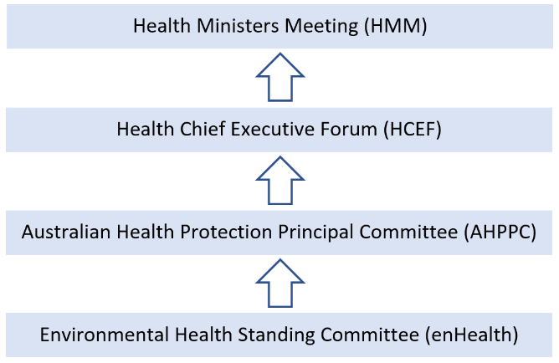
Governance and Partnerships
enHealth reports (Figure 1.) to the Australian Health Protection Committee (AHPC), the key decision-making committee for health emergencies. The AHPC has an ongoing role to advise the Health Chief Executives Forum (HCEF) on health protection matters and national priorities.
The HCEF is an intergovernmental forum for joint decision-making and strategic policy discussions that helps to efficiently deliver health services. The HCEF supports the Health Ministers' Meeting (HMM) to deliver agreed national priorities.
Figure 1. enHealth’s Governance Structure

The HMM works to progress health issues of national importance which require cross-border collaboration. Through the HMM, health ministers progress matters as delegated by National Cabinet.

AHPC sub-committees
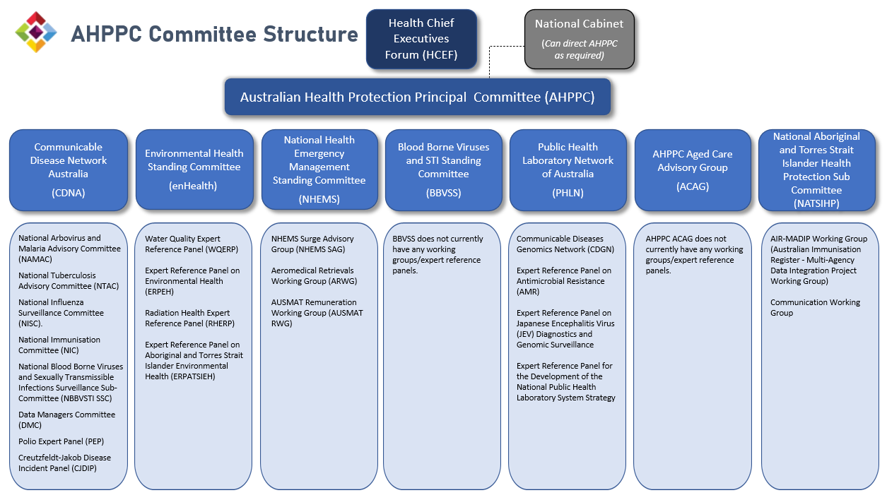
Figure 2. AHPC Committee Structure
Australia's Chief Medical Officer chairs the AHPC, the membership comprises of all state and territory Chief Health Officers. The work of the AHPC is supported through seven Expert Standing Committees, including enHealth (see Figure 2.).
Like enHealth, these Expert Standing Committees collaborate and consult state, territory and local government as well as relevant organisations, to provide expertise and policy advice to the AHPC.
Where there’s benefit, the AHPC encourages cross-membership between its committees. enHealth’s membership includes a small number of members from other AHPC Expert Standing Committees, while some of enHealth members sit on other AHPC Expert Standing Committees as observers.
Standing committee | Description
Communicable Diseases Network Australia (CDNA) | Supporting best practice for the prevention and control of communicable diseases, CDNA provides national public health coordination and leadership, particularly around disease surveillance.
National Health Emergency Management Standing Committee (NHEMS) | Using the ‘prevention, preparedness, response and recovery’ model, NHEMS addresses the operational aspects of disaster medicine and health emergency management in an all-hazards context.
Blood Borne Viruses and STI Standing Committee (BBVSS) | BBVSS provides strategic advice to the Health Chief Executives Forum as part of a coordinated response to bloodborne viruses (BBV) and sexually transmissible infections (STI) across Australia.
Public Health Laboratory Network of Australia (PHLN) | PHLN is Australia’s leading network of public health laboratories which provide expertise and services in public health microbiology.
AHPC Aged Care Advisory Group (AGAC) | ACAG advises on aged care policy related to infectious diseases and emergency preparedness, bringing together experts on the aged care sector, infection control, emergency preparedness and public health responses.
National Aboriginal and Torres Strait Islander Health Protection Committee (NATSIHP) | NATSIHP provides holistic and culturally safe advice on health protection matters for Aboriginal and Torres Strait Islander peoples and communities, particularly on communicable and chronic diseases, environmental health, disaster management in primary health settings, and health issues related to COVID-19.
Table 1. Breakdown of AHPC’s Expert Standing Committees
enHealth delivers its work through the support of its four Expert Reference Panels, comprising of technical government experts from state and territory governments, the Commonwealth and the New Zealand government.
Expert Reference Panels | Description
Expert Reference Panel on Aboriginal and Torres Strait Islander Environmental Health (ERPATSIEH) | ERPATSIEH provides coordinated advice on national Aboriginal and Torres Strait Islander environmental health policies and associated environmental health issues.
Expert Reference Panel on Environmental Health (ERPEH) | ERPEH provides technical guidance on environmental health issues, which is evidence-based, effective and nationally consistent and supports the protection of public health, in particular for the assessment, management and the communication of risk.
Water Quality Expert Reference Panel (WQERP) | WQERP provide advice on emerging regulatory and water-related health aspects, such as drinking water, recycled water, wastewater and recreational water.
Radiation Health Expert Reference Panel (RHERP) | RHERP provides expert advice on radiation protection and nuclear safety issues, comprising of jurisdictional representatives from relevant regulators, and the Australian Radiation Protection and Nuclear Safety Agency (ARPANSA).
Table 2. Breakdown of enHealth’s Expert Reference Panels

Collaborative Partnerships
By using a collaborative approach, enHealth contributes to improving communication, strategic relationships and avoiding duplication of effort within the environmental health field.
enHealth utilises a wide range of collaborative partnerships, including with public and private sectors, Aboriginal and Torres Strait Islander communities, local government, universities, and international counterparts such as New Zealand.
enHealth looks forward to continued collaboration with current key national bodies and providing advice in the establishment of emerging national bodies, such as the Australian Centre for Disease Control and the Federal Environment Protection Authority.

Approach
enHealth has developed a set of tools to assist the committee to work productively and professionally. This is particularly important considering enHealth not only provides environmental health advice to AHPC, but also develops environmental health guidance and resources for the Australian public.

Decision Tree
enHealth has developed a Decision Tree to assist with identifying which tasks are in scope and ensuring efforts are directed towards the highest priority projects. The Decision Tree is at Attachment A.

Communication Strategy
enHealth’s Communication Strategy will outline enHealth’s plan to effectively connect to its audience. As part of the Communication Strategy, a Stakeholder Diagram will be included to better understand its stakeholders and their needs. The Communication Strategy is currently being developed and will soon be available as a separate document.

Advice and Guidance
enHealth is committed to providing trusted timely guidance and advice on environmental health to the Australian public. A collection of enHealth’s publications is available on the enHealth website: www.health.gov.au/resources/collections/enhealth-guidance.

Research and Data
enHealth appreciates the importance of environmental health research and data. enHealth values the critical research carried out by stakeholders and will continue to connect and engage at a high level to ensure this research is incorporated into enHealth advice and made available to the broader Australian community to maximise environmental health outcomes.

Supporting documents
This Strategic Plan is intended to be read in conjunction with enHealth’s Terms of Reference and Work Plan (2024-27). enHealth’s Terms of Reference defines enHealth’s purpose, outlines the scope of work and identifies how enHealth members will work together to achieve its objectives. enHealth’s Work Plan (2024-27) sets out the plan of action to achieve the priorities listed in this Strategic Plan. These documents are available on the Department of health and Aged care website at www.health.gov.au/committees-and-groups/enhealth.

Attachment A: Decision Tree
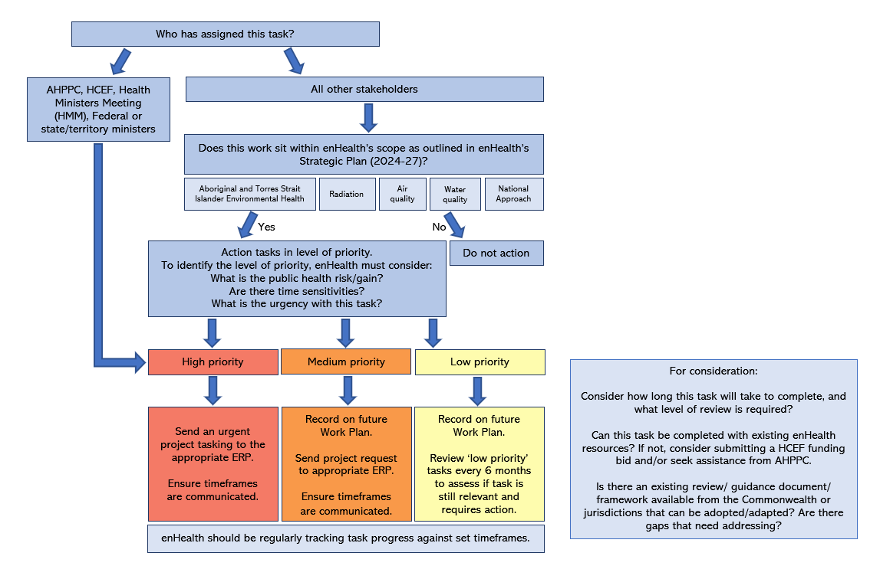

World Health Organisation, WHO global strategy on health, environment and climate change: the transformation needed to improve lives and wellbeing sustainably through healthy environments, accessed 8 June 2023, <9789240000377-eng.pdf (central.health)>.
Australian Institute of Health and Welfare, Australian Burden of Disease Study 2018: Interactive data on risk factor burden, accessed 19 June 2023,<http://www.aihw.gov.au/reports/burden-of-disease/abds-2018-interactive-data-risk-factors/contents/air-pollution>.>.
McCormick, L 2020, ‘The Future of the Environmental Health Profession.’ PMC PubMed Central, no. 297-298, accessed 8 June 2023, <https://www.ncbi.nlm.nih.gov/pmc/articles/PMC7002962/>.
World Health Organisation, Health and the environment, accessed 8 June 2023, <https://photos.hq.who.int/galleries/117>.
Department of Climate Change, Energy, the Environment and Water, Climate change and extreme events, accessed 8 June 2023, <Climate change and extreme events | Australia state of the environment 2021 (dcceew.gov.au)>.

