Practice guide:
National Guidance for doctors
assessing workers exposed to
respirable crystalline silica dust
with specific reference to the occupational
respiratory diseases associated with engineered stone

Disclaimer
The information in this document is current as at December 2021. This document is published by the Department of Health on behalf of the National Dust Disease Taskforce and the National Guidance Working Group (the Working Group).
This document was funded by the Australian Government Department of Health and developed by the Working Group, with assistance provided by HTANALYSTS. The role of the Working Group is to support the effective development and subsequent dissemination of a nationally consistent approach for medical practitioners seeing workers working with or who have previously worked with engineered stone. The Working Group reports to the National Dust Disease Taskforce.
This document is intended to be a general guide to support appropriate practice, subject to the medical practitioner’s judgements and the patient’s preferences in each individual case. It is not intended as a substitute for medical or legal advice. This document is based on expert opinion guided by the best evidence available at the time of development and in consultation with key stakeholders. The Working Group acknowledges debate in the literature is evolving and that there remain limitations in the evidence available to inform the development of this document. For further information on relevant Work Health and Safety (WHS) laws and state regulations, refer to Safe Work Australia (1), Work Safe Victoria (2) and the Government of Western Australia, Department of Mines, Industry Regulation and Safety (3).
Simply reading this document will complement and inform but not increase your scope of practice. It should be seen as a resource for medical education and training. This document interfaces with, and is not intended to replace, other medical guidance and medical guidelines issued by relevant clinical bodies.
Citation
National Dust Disease Taskforce Working Group. National Guidance for doctors assessing workers exposed to respirable crystalline silica dust with specific reference to the occupational respiratory diseases associated with engineered stone. Available on the National Dust Disease Taskforce Website (https://www1.health.gov.au/internet/main/publishing.nsf/Content/ohp-nat-dust-disease-taskforce.htm)
Source of funding
Development of this National Guidance was supported by the Australian Government Department of Health. The development of the final recommendations has not been influenced by the views or interests of the funding body.
Table of Contents
Practice Guide 1
What are occupational respiratory diseases? 1
What is silicosis? 1
Australian perspective 1
Prevention of silicosis 2
Early diagnosis is important 2
What is the impact of exposure to RCS dust and silicosis? 2
What are the duties of the PCBU? 2
National Guidance for identification and surveillance 4
Case identification 5
Step 1: GPs should identify a person exposed to RCS dust due to work with engineered stone and refer them to a suitably qualified respiratory or occupational physician 5
Step 2: Suitably qualified respiratory or occupational physicians should investigate and conduct further assessment 7
Health surveillance 11
Step 3: Ongoing health surveillance 11
Step 4: Notify 12
Appendices 13
Appendix A: Classification of silicosis 14
Appendix B: Prevention of silicosis 15
Appendix C: Exposure risk matrix 16
Appendix D: Shared decision-making tool for patients and medical practitioners 17
Appendix E: Modified MRC questionnaire 19
Appendix F: Modified MRC dyspnoea scale 23
Appendix G: Spirometry case study 24
Abbreviations 25
Glossary 26
References 28

Figures
Figure 1 Identifying the appropriate referral pathway 5
Figure 2 Overview of assessment of a person exposed to RCS dust due to work with engineered stone by a suitably qualified medical practitioner 7
Figure 3 Health surveillance schedule for people who have no diagnosis of silicosis at baseline 11

Practice Guide
This practice guide has been developed from the National Guidance for assessment of workers exposed to respirable crystalline silica (RCS) dust with specific reference to occupational respiratory diseases associated with engineered stone (National Guidance). This summary is to provide medical practitioners including general practitioners (GPs), Consultant Physicians in Occupational and Environmental Medicine and Respiratory Physicians, Researchers and Radiologists, with key practice points to guide them when identifying and assessing workers exposed to RCS dust with engineered stone (case identification) and carrying out health assessments and surveillance. Practice points presented are based upon the best available evidence and a consensus of expert clinicians.

What are occupational respiratory diseases?
Occupational respiratory diseases are diseases arising from hazardous exposure at the workplace via the respiratory system. Occupational exposure to inhaled agents such as dusts are significant causes of respiratory illness in Australia. Many of these illnesses may not be detected until long after the original exposure has ceased. While historically silicosis has been widely studied, the recent increase in engineered stone related silicosis has created an urgent need and opportunity to learn more about the disease and minimise the risk of a life-threatening preventable disease from occurring in the future. People who may be at-risk include those who work or have worked with installing or manufacturing kitchen and bathroom benchtops using engineered stone.

What is silicosis?
Silicosis is an irreversible lung fibrosis (or pneumoconiosis) caused by cumulative exposure to silica (silicon dioxide, SiO₂) and silicate dusts (RCS dust). Silica and silicates are naturally occurring and widely abundant minerals in concrete, rocks and soils. RCS dust is generated in the workplace by processes such as crushing, cutting and drilling rock or products containing silica or silicates. Engineered stone can have an extremely high silica content (> 90%) (1) so there is a significant risk of RCS dust exposure and silicosis for workers using, handling, generating or storing silica. Examples of workers in the engineered stone industry include shapers, machine operators, finishers, polishers and labourers and supervisors involved in the fabrication or installation of engineered stone (4). Other workers may also be exposed to RCS dust in the engineered stone industry including people cleaning work areas or equipment, maintenance workers or salespeople.
Inhaled RCS dust (<10 μm aerodynamic diameter) is carried to the distal airways and alveoli. Once in the respirable zone of the lung, the silica particles are engulfed by alveolar macrophages and activate multiple pro-inflammatory and profibrotic pathways (5-8).
Silicosis is associated with significant premature mortality among workers.

Australian perspective
While millions of workers are estimated to be exposed to RCS dust worldwide (9, 10), the number of people who are affected by silicosis is unknown. The available data from Queensland and Victoria suggests a prevalence of 20-30% for all forms of silicosis in workers exposed from working with engineered stone prior to changes introduced in 2018 (11).
Extensive international data also demonstrate increased morbidity and mortality related to silica exposure (12-14).

Prevention of silicosis
There is currently no treatment for silicosis. Prevention of cumulative exposure that might trigger silicosis is therefore the highest priority.
See Appendix B for a summary of prevention strategies.

Early diagnosis is important
Identifying disease early, before any symptoms develop provides the best options for delaying or stopping progression.
The diagnosis of any type of silicosis is based on:
- a history of exposure to RCS dust; and
- radiological appearances consistent with silicosis; and
- an absence of another more likely diagnosis.
See Appendix A for a summary of the different types of silicosis.
For GPs who would like to follow a learning course on diagnosis and management of silicosis: See the Royal Australian College of General Practitioners learning resource

What is the impact of exposure to RCS dust and silicosis?
Epidemiological studies demonstrate a clear dose-response relationship between cumulative exposure to RCS dust, disease severity and the risk of progression (15, 16).
Even if there is no evidence of disease when first assessed, silicosis can develop years after first exposure. Continued health surveillance may therefore be required (17).
The risk of disease progression continues even after the worker is no longer exposed to RCS dust.
Once a worker has been diagnosed with silicosis, continued exposure to RCS dust is known to contribute to disease progression compared with those with no further exposure (18, 19).
The risk of progression, even if the worker has been removed from further exposure, is strongly associated with cumulative exposure and the severity of disease at the time of diagnosis (16, 20).
RCS dust is also a recognised lung carcinogen with at least an additive risk of lung cancer with concurrent tobacco smoke exposure (21). Access to and support for smoking cessation is vitally important.
For a more detailed understanding on exposure to RCS dust and silicosis, refer to the National Guidance document.

What are the duties of the PCBU?
Under the model Work Health and Safety (WHS) laws in place in all jurisdictions apart from Victoria and Western Australia, a “person conducting a business or undertaking” (PCBU) has specific duties, so far as reasonably practicable, to ensure the health and safety of workers while they are at work in the business or undertaking and of others who may be affected by the carrying out of the work (22, 23).
This National Guidance focuses on the duties of PCBUs under the model WHS laws. Western Australia is in the process of adopting the model WHS laws.
PCBU’s duties include identifying hazards and managing the risks to health and safety when using, handling, generating and storing hazardous chemicals, including silica in the workplace. This must be done by identifying reasonably foreseeable hazards and eliminating or managing the risks in accordance with the hierarchy of controls. In this context, an occupational hygienist aided by an occupational physician may be used to establish whether there was a significant risk to the worker’s health because of exposure to hazardous chemicals.
If a worker is carrying out ongoing work using, handling, generating or storing silica and there is a significant risk to the worker’s health because of exposure, a health monitoring program is required under the model WHS laws (1, 24, 25).
The PCBU has a duty to engage a registered medical practitioner with experience in health monitoring to carry out or supervise their health monitoring program. The medical practitioner responsible for health monitoring will monitor the worker to identify changes in their health status because of exposure.
The PCBU must also pay the costs of health monitoring where health monitoring is required under the model WHS laws (22). The health monitoring of workers required under WHS or occupational health and safety legislation monitoring at the workplace is out of scope in this National Guidance.
Further information on the duties under the model WHS laws of PCBUs working with engineered stone sector can be found in the Safe Work Australia model Code of Practice: Managing the risks of respirable crystalline silica when working with engineered stone (4).
Further guidance on health monitoring can be found in the Safe Work Australia Health monitoring for registered medical practitioners guide (26).


National Guidance for identification and surveillance

Case identification
Case identification is a strategy for targeting resources at individuals or groups who are suspected to be at-risk of silicosis. It involves actively searching systematically for people exposed to engineered stone, rather than waiting for them to present with symptoms or signs of active disease.

Step 1: GPs should identify a person exposed to RCS dust due to work with engineered stone and refer them to a suitably qualified respiratory or occupational physician

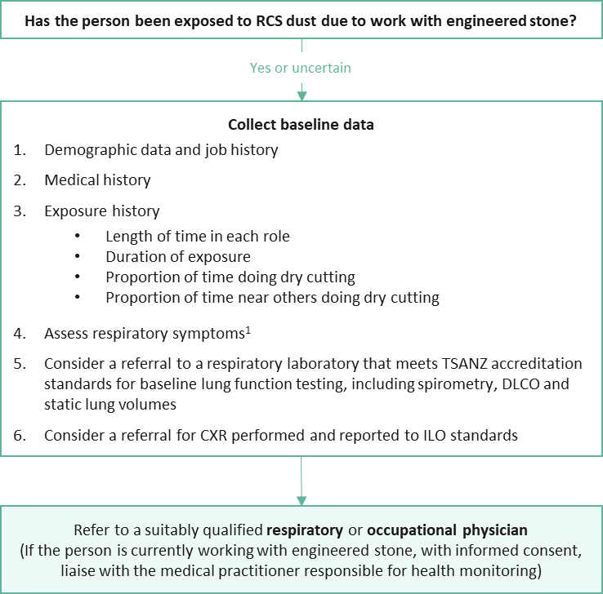
Figure 1 Identifying the appropriate referral pathway
Abbreviations: CXR, chest x-ray; DLCO, carbon monoxide diffusing capacity; ILO, International Labour Organization; RCS, respirable crystalline silica; TSANZ, Thoracic Society of Australia and New Zealand
Notes: Follow the links for the contact database for suitably qualified occupational physicians, respiratory physicians and medical practitioners
¹Consider using the modified Medical Research Council (MRC) respiratory questionnaire (see Appendix E) (27)
How to identify a person at-risk?
- If a person has been exposed to RCS dust and works or has previously worked with engineered stone, refer them to a suitably qualified respiratory or occupational physician
Note: Follow the links for the contact database for suitably qualified medical practitioners (respiratory and/or occupational physicians)
- If the person currently works with engineered stone, health monitoring must be provided (free of charge to the worker by their PCBU [or employer in Victoria and Western Australia]). Contact the medical practitioner responsible for health monitoring (with informed consent) to access available resources

What baseline data should be collected?
- Collect baseline demographic, medical and exposure history, respiratory and physical examination findings
- Assess respiratory symptoms and consider a referral to a respiratory laboratory that meets Thoracic Society of Australia and New Zealand (TSANZ) (28) accreditation standards for baseline lung function testing, including spirometry, carbon monoxide diffusing capacity (DLCO) and static lung volumes consider
- Consider a referral for chest x-ray (CXR) performed and reported to International Labour Organization (ILO) standards (29)
- If available and with informed consent, information collected should be uploaded onto the person’s My Health Record (30). If My Health Record is not available, information should still be provided to the referred physician as part of the referral process

Take home practice points for GPs
- Identify people who have been exposed to RCS dust due to work with engineered stone
- Assess respiratory symptoms and consider a referral to a respiratory laboratory that meets TSANZ accreditation standards
- If performing follow up measures within your practice, ensure use of modern spirometry systems capable to reporting GLI reference equations and customisable trend reports
- Monitor closely
- Refer to suitably qualified medical practitioner if clinical findings warrant
- If you are not experienced in assessing and diagnosing silicosis, always refer the person to a suitably qualified respiratory or occupational physician

Step 2: Suitably qualified respiratory or occupational physicians should investigate and conduct further assessment

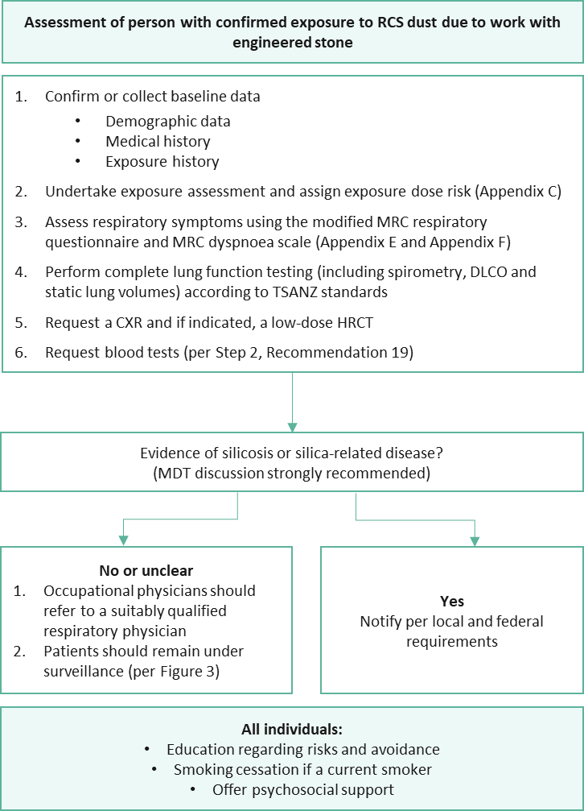
Figure 2 Overview of assessment of a person exposed to RCS dust due to work with engineered stone by a suitably qualified medical practitioner
Abbreviations: CXR, chest x-ray; DLCO, carbon monoxide diffusing capacity; HRCT, high resolution chest tomography; MDT, multidisciplinary team; MRC, Medical Research Council; RCS, respirable crystalline silica; TSANZ, Thoracic Society of Australia and New Zealand
How should a person’s exposure risk be determined?
- Complete the exposure risk matrix (per Appendix C). If you do not have the appropriate experience, refer the person to a more suitably qualified respiratory or occupational physician
- With informed consent, the suitably qualified medical practitioner or medical practitioner responsible for health monitoring has a professional obligation to advise the GP of the outcome

Who should receive complex lung function testing and how?
- All individuals exposed to RCS dust due to work with engineered stone must be referred to a respiratory laboratory that meets TSANZ accreditation standards for baseline lung function testing, including spirometry, DLCO and static lung volumes as early as possible in their working life
- Monitoring with spirometry in the primary care setting should be performed to international standards (31) at least annually and six monthly in those classed as high or very high risk (per Appendix C)
- Primary care practices using spirometry for the purpose of monitoring occupational exposures must be able to report spirometry outcomes using the Global Lung Function Initiative (GLI) spirometry equations as per Australian and international guidelines (31-33)
- The following thresholds require review and/or referral to a respiratory and/or occupational physician as appropriate to the person’s clinical findings and occupational history:
- absolute FEV1 or FEV1/FVC ratio less than the lower limit of the normal (LLN) derived from the GLI Spirometry equations (33) requires consideration for further assessment and bronchodilator responsiveness testing; or
- FVC less than the LLN derived from the GLI Spirometry equations (33) requires consideration for further assessment and a referral for complex lung function testing; or
- Changes in FEV1 or FVC, expressed in GLI percent predicted, declines by >10% but ≤15% from baseline test over any period requires consideration for further assessment and bronchodilator responsiveness testing (see Appendix G for a worked example); or
- Changes in FEV1 or FVC, expressed in GLI percent predicted, declines by >15% over any period requires a referral to a respiratory physician (see Appendix G for a worked example)

Further assessment as determined by the referring doctor may include repeat pre- and post-bronchodilator spirometry, complex lung function testing, other investigations or potentially referral to an occupational and/or respiratory physician depending on the clinical context for that individual

When should a low-dose high resolution computed tomography (HRCT) scan be requested?
- All people exposed to RCS dust due to work with engineered stone should undergo a CXR performed and reported to ILO standards to meet current statutory requirements. ILO classification of a CXR itself should NOT be used to exclude a diagnosis of silicosis or access to statutory entitlements
Note: In Western Australia low-dose HRCT scans are required instead of a CXR
- Request a low-dose HRCT for one or more of the following reasons:
- the individual has had high or very high exposure to RCS dust as calculated or estimated in the exposure risk matrix (per Appendix C); or
- significant respiratory or other symptoms; or
- any spirometry or DLCO findings that falls below the GLI LLN; or
- an ILO CXR >0/1; or
- other CXR findings suggestive of silica-related disease (e.g. lymph node enlargement, hyperinflation and/or pleural changes)
- Because CXR is relatively insensitive in early silicosis, consider a low-dose HRCT when exposure history, symptomatology or lung function testing is suggestive of the need for further investigations, even if the ILO CXR <1/0
- Consider a multidisciplinary team (MDT) review of clinical and imaging findings, including the low-dose HRCT results, if there is any diagnostic uncertainty
Specialist radiologist with expertise in chest computed tomography
- Perform the HRCT using a radiation dose as low as reasonably achievable (ALARA principle)
- The low-dose HRCT should be supervised and reported by a specialist radiologist with appropriate qualifications and/or recognition and credentialling through RANZCR
Refer to the RANZCR silicosis position statement (2019) for further guidance in relation to the approach to the probability of silicosis and other occupational lung diseases being present on the imaging investigation (34)

What other tests should be carried out?
- All people exposed to RCS dust due to work with engineered stone should at a minimum have a full blood count, biochemistry analysis including electrolytes, liver function and creatinine, c-reactive protest test and an autoimmune screen including extractable nuclear antigen (ENA), antinuclear antibodies (ANA),myositis antibodies, anti-cyclic citrullinated peptide (CCP) antibodies, rheumatoid factor, anti-double stranded deoxyribonucleic acid (anti-dsDNA), topoisomerase 1 (Scl70), RNAP (anti-RNA polymerase III) and antineutrophil cytoplasmic antibodies (ANCA) at baseline
- If clinically indicated, order an interferon gamma release assay test for latent or active tuberculosis. Further investigations will depend on the individual’s clinical course

When should psychological support be provided?
- Offer socially and culturally appropriate psychological support to patients diagnosed with silicosis and all workers currently working with or who have previously worked with engineered stone
- Use the shared decision-making tool (see Appendix D) with patients who have been diagnosed with silicosis or overly concerned about silicosis to discuss options on how to respond to the psychosocial impact of RCS dust exposure
- Continue to support workers who choose to keep working with engineered stone after discussing if:
- the worker is able and willing to carry out optimal safe systems of work; and
- their clinical state is able to be monitored more frequently (e.g. 4-monthly instead of 6-monthly); and
- adequate control measures are operational and there is evidence of compliance with the workplace exposure standard; and
- return to work is supported by their PCBU and the worker’s compensation insurer

When should education be provided?
- As smoking has been shown to increase the carcinogenic potential of RCS, encourage and support all patients diagnosed with silicosis and all workers currently working with or who have previously worked with engineered stone to stop smoking and/or vaping. See the Royal Australian College of General Practitioners (RACGP) supporting smoking cessation: a guide for health professionals (35)
- Educate and reinforce safe behaviours at each visit for all workers currently working with engineered stone. Examples of important topics to be covered include:
- safe work practices. For more detail see the model Code of Practice: Managing the risks of respirable crystalline silica when working with engineered stone (4)
- the possible adverse health effects related to exposure
- the importance of personal hygiene and cleanliness
- correctly using PPE
- fit checking and fit testing for effective respiratory protection
- being clean-shaven if negative-pressure respirators are used or if respiratory protective equipment that requires fit testing is used

Health surveillance
Health surveillance is the ongoing investigation in clinical practice after a case (at-risk of being diagnosed with silicosis) has been identified. Unlike health monitoring, it is not a statutory requirement under WHS/Occupational Health and Safety laws and is therefore not paid for by the PCBU. It is also more encompassing of a person’s broader health and wellbeing than health monitoring

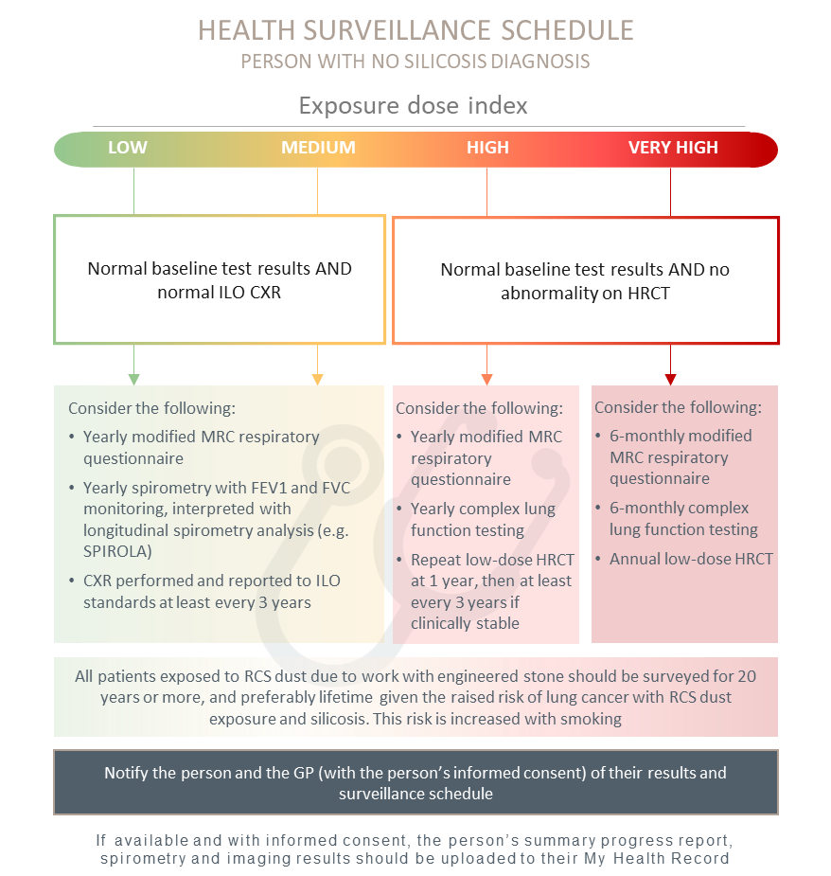
Step 3: Ongoing health surveillance
Figure 3 Health surveillance schedule for people who have no diagnosis of silicosis at baseline
Abbreviations: CXR, chest x-ray; FEV1, forced expiratory volume 1; FVC, forced vital capacity; HRCT, high resolution computed tomography; ILO, International Labour Organization; MRC, Medical Research Council; RCS, respirable crystalline silica; SPIROLA, Spirometry Longitudinal Data Analysis Software
Note: The timeframes for further review based on exposed dose are a recommendation only. Timeframes should be adjusted based on the medical practitioner’s clinical judgement and consideration of individual circumstances including their past and/or continued exposure to RCS dust, history of tobacco and/or other substance use. See the Safe Work Australia “Crystalline Silica Health Monitoring Guide” (36) for additional guidance for people who remain working in the industry. See The National Institute for Occupational Safety and Health for further information on SPIROLA (37)

When should routine health surveillance be carried out?
- Follow the recommended health surveillance schedule (see Figure 3) for people who have not been diagnosed with silicosis at baseline
- For people with low to very high risk of exposure to RCS dust due to work with engineered stone, expert consensus suggests surveillance is required for 20 years or more, and preferably lifetime given the raised risk of lung cancer with RCS dust exposure and silicosis. This risk is increased with smoking

Who carries out ongoing surveillance?
- If the person is in an at-risk industry, the GP should maintain awareness of the results of their patient’s ongoing health monitoring needs
- If the person leaves an at-risk industry, the GP assumes the lead role to carry out ongoing health surveillance. The GP should receive support from any respiratory or occupational physician involved in the person’s care. With informed consent, the medical practitioner previously responsible for health monitoring can share care plans and communicate with any treating medical practitioner involved in the worker’s continued health and wellbeing
- All people should continue to monitor their symptoms. If they have relevant concerns, they should contact their GP or other suitably qualified medical practitioner involved in their care

Step 4: Notify
What are the notification requirements?
- With informed consent, provide the summary of findings, management plan and background description of the surveillance schedule to the person, their GP and medical practitioner responsible for health monitoring. If available and with informed consent, such information should be uploaded to the person’s My Health Record (30)
- Notify the local registry (if available) about all cases of silica-associated disease or follow the requirements for your state or territory
- Once established, notify and submit up to date data to the National Occupational Respiratory Disease Registry about all cases of silica-associated disease in Australia

Appendices

Appendix A: Classification of silicosis
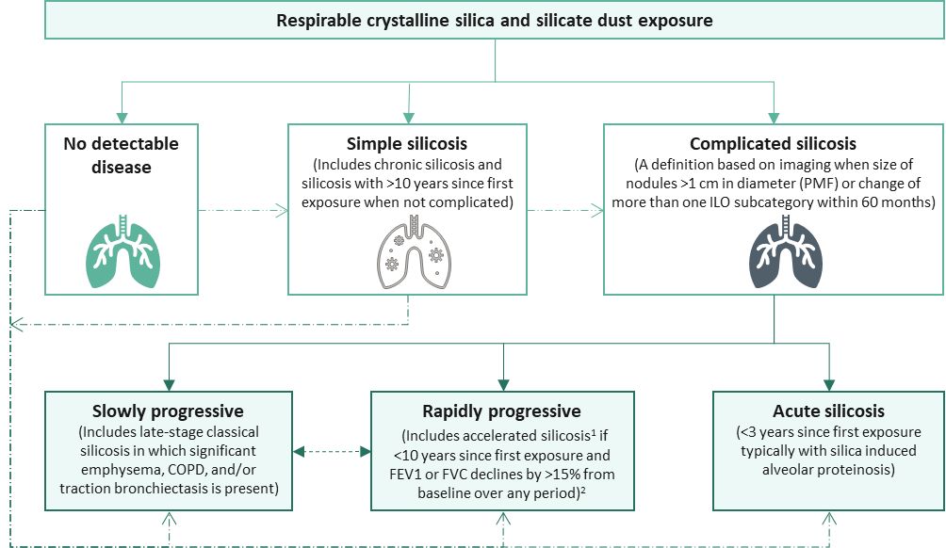
Source: Modified from Álvarez, González (12)
Abbreviations: FEV1, forced expiratory volume in one second; PMF, progressive massive fibrosis; FVC, forced vital capacity
Note: All categories of silicosis carry an increased risk of lung cancer and tuberculosis in at-risk populations.
Dotted lines reflect a lower level of certainty to be informed by ongoing research and updated as required.
¹Historically accelerated silicosis was defined solely on the basis of time since first exposure. This Guidance recommends that until there is evidence of significant progressive disease, persons with <10 years since first exposure should be classed as having simple silicosis
²See the National Guidance for further information

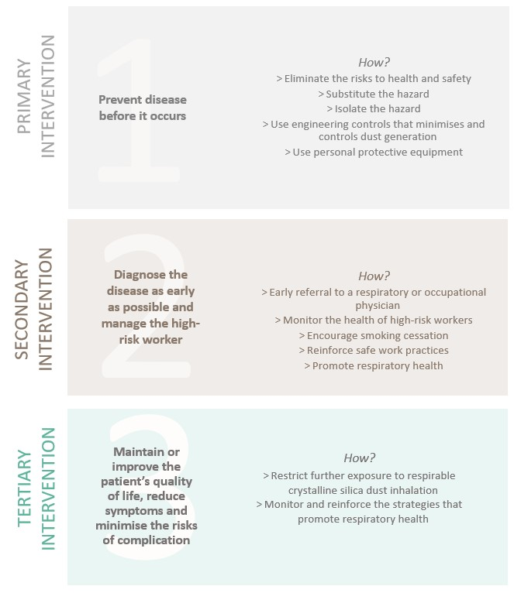
Appendix B: Prevention of silicosis

Appendix C: Exposure risk matrix
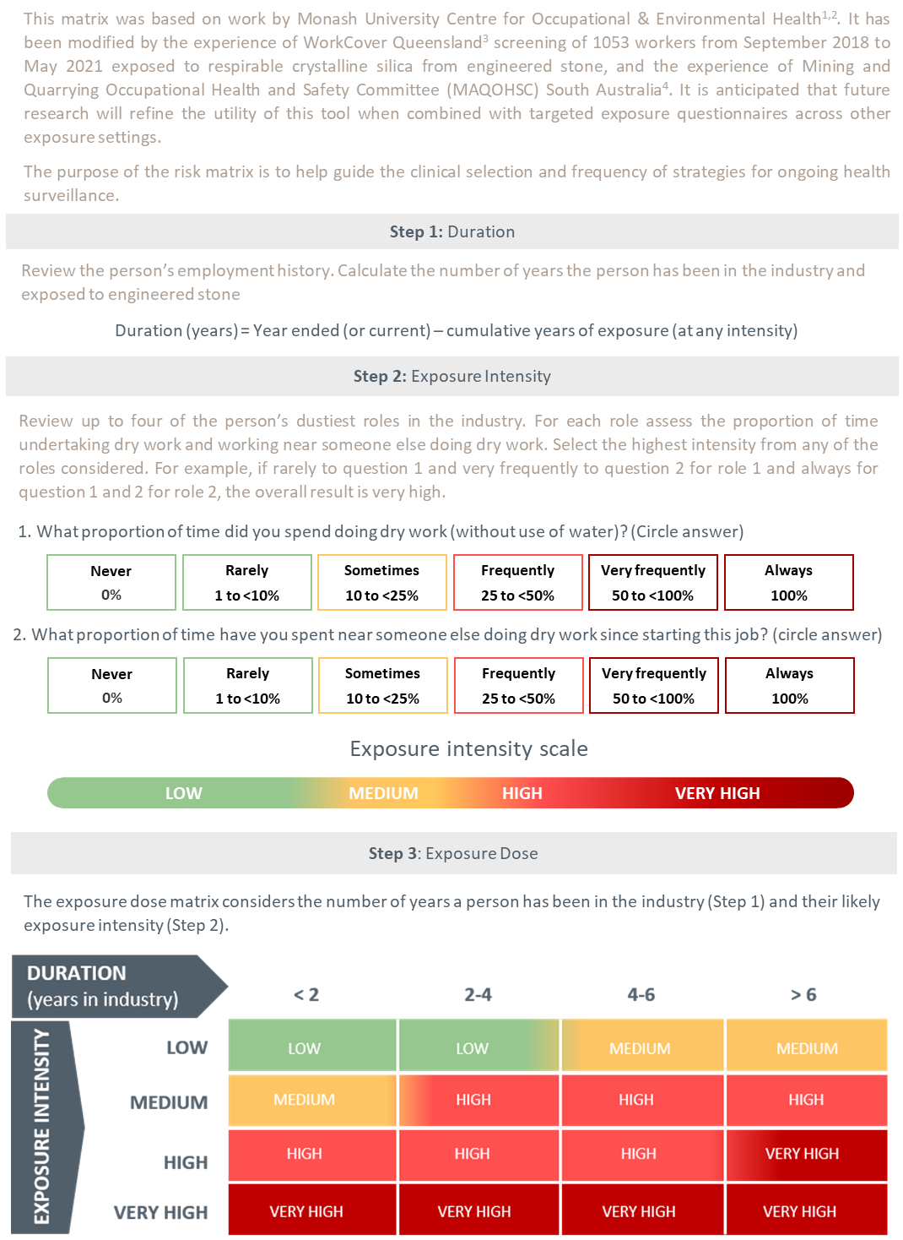
1. Monash University Centre for Occupational & Environmental Health (MonCOEH) (38); 2. Hoy, Glass (39); 3. WorkSafe Queensland Government (11); 4. Government of South Australia (40)

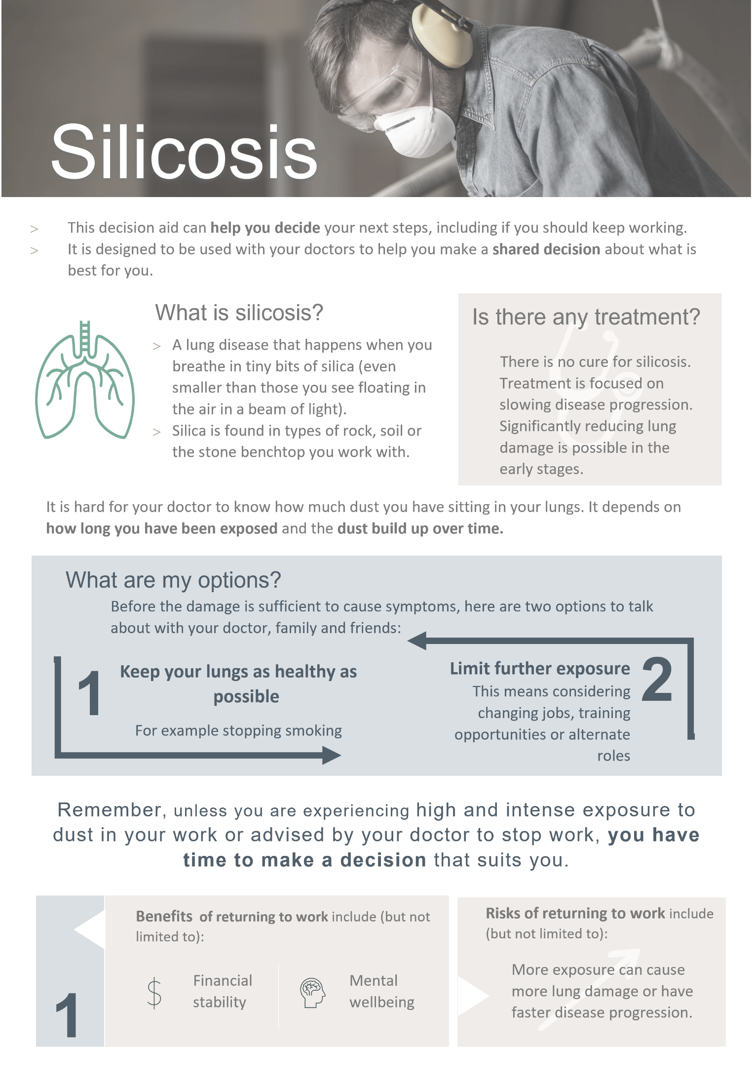
Appendix D: Shared decision-making tool for patients and medical practitioners
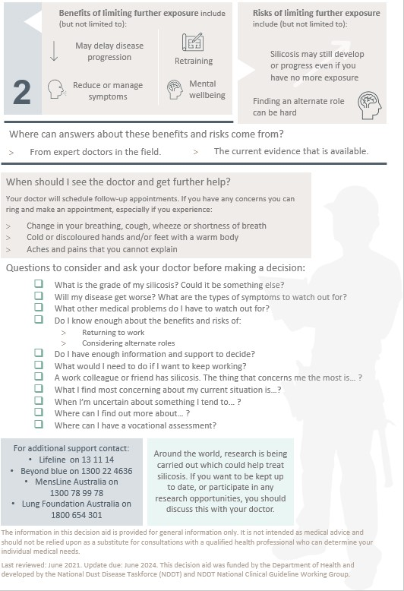

Appendix E: Modified MRC questionnaire
Source: Used with the permission of the Medical Research Council (27)
Note: Original has been re-typeset, with no changes
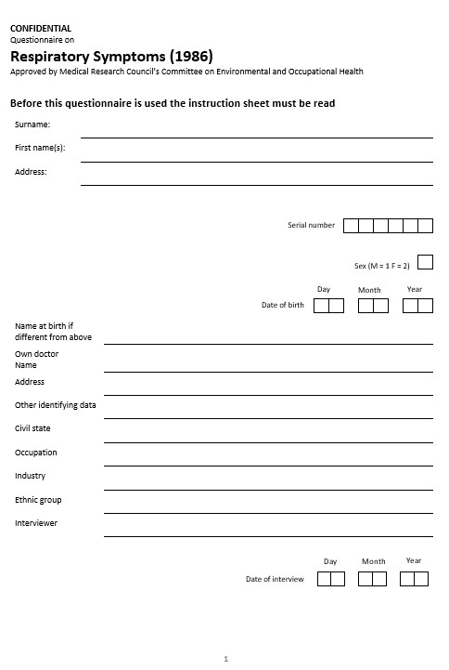

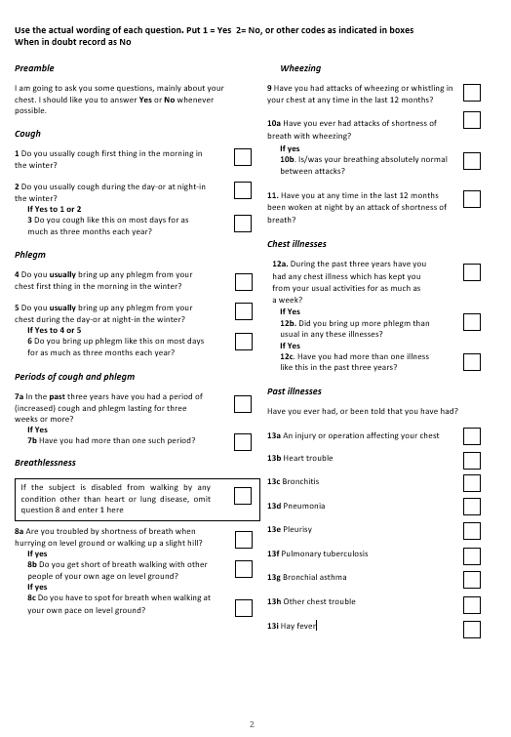

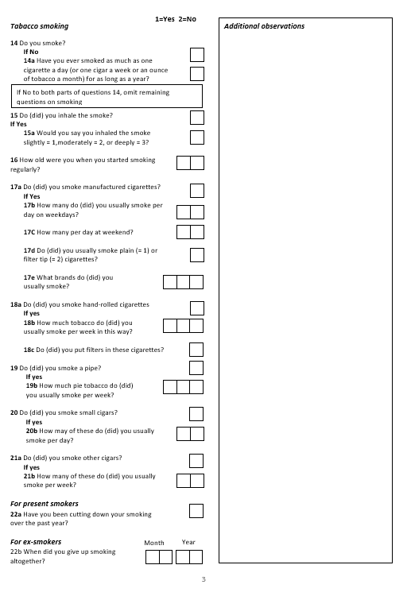

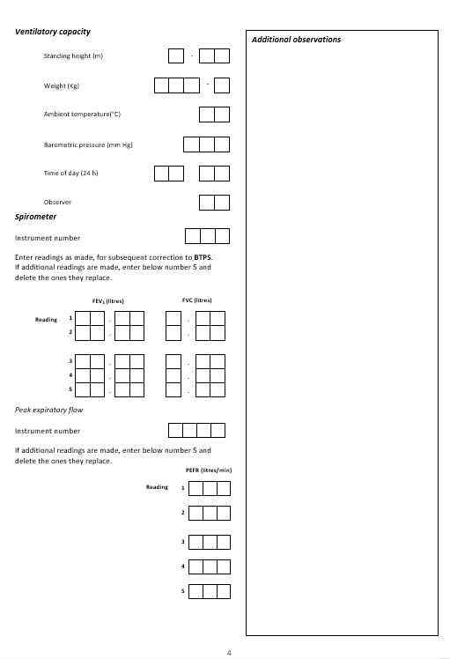

Appendix F: Modified MRC dyspnoea scale
Grade | 0 | “I only get breathless with strenuous exercise”
Grade | 1 | “I get short of breath when hurrying on the level or walking up a slight hill”
Grade | 2 | “I walk slower than people of the same age on the level because of breathlessness or have to stop for breath when walking at my own pace on the level”
Grade | 3 | “I stop for breath after walking about 100 yards or after a few minutes on the level”
Grade | 4 | “I am too breathless to leave the house” or “I am breathless when dressing”
Source: Doherty, Belfer (41)
Note: This is the modified MRC scale that uses the same descriptors as the original MRC scale in which the descriptors are numbered 1-5. The modified MRC scale (0-4) is used for calculation of BODE index

Appendix G: Spirometry case study
The following worked example illustrates how to appropriately determine a change in spirometry over time in an individual. The use of appropriate alignment with robust predicted equations allows for changes with age to be accounted for. This example highlights that a significant decline in lung function can occur in individuals whose lung function remains within the normal range of the broader population.
A female worker, of Aboriginal ancestry, 170.5 cm tall enters the quarrying setting workforce at age 25.5 years. The Global Lung Function Initiative (GLI) Spirometry ‘Other’ predictive equations are used as per Australian and New Zealand Society of Respiratory Science recommendations.
Her lung function on entering the workforce was:
- FEV1 3.48 L (103.1% predicted LLN = 2.74 L)
- FVC 3.94 L (100.8% predicted LLN = 3.16 L)
- FEV1/FVC 0.88 (101.7% predicted LLN = 0.762)
Her spirometry is within normal limits. She does not report taking any respiratory medications.
At age 30 years her respiratory health is reassessed. There are no reported symptoms, she does not report taking any respiratory medications and her lung function is:
- FEV1 3.31 L (95.1% predicted LLN = 2.65 L)
- FVC 3.87 L (99.4% predicted LLN = 3.15 L)
- FEV1/FVC 0.81 (95.2% predicted LLN = 0.750)
Her lung function remains within normal limits. Her change in FEV (percent predicted) over the 5 year period is 8.0% (103.1% - 95.1%) and within acceptable limits.
At age 33.6 years she changes employers and undergoes a repeat assessment. She has no reported symptoms and does not report taking any respiratory medications. Her spirometry is:
- FEV1 2.85 L (87.6% predicted LLN = 2.599 L)
- FVC 3.79 L (98.0% predicted LLN = 3.131 L)
- FEV1/FVC 0.75 (81.9% predicted LLN = 0.741)
Her spirometry is within normal limits. Her change in lung function since entering the quarrying sector workforce at age 25 years is 15.5% (103.1% 87.6% - after adjusting for age-related changes by using the GLI predicted equations). Based on the recommendations (above) her age-related longitudinal decline over the 8.1 years of employment exceeds 10.0%. She should be referred to a respiratory physician for further assessment

Abbreviations
ALARA | As low as reasonably achievable
CCP | Cyclic citrullinated peptide
CT | Computed tomography
CXR | Chest X-ray
DLCO | Carbon monoxide diffusing capacity
ENA | Extractable nuclear antigen
FEV1 | Forced expiratory volume in one second
FVC | Forced vital capacity
GLI | Global Lung Function Initiative
GP | General Practitioners
HRCT | High resolution computed tomography
ICOERD | International Classiﬁcation of HRCT for Occupational and Environmental Respiratory Diseases
IGRA | Interferon gamma release assay
ILD | Interstitial lung disease
ILO | International Labour Organization
LLN | Lower limit of the normal
MDT | Multidisciplinary team
MRC | Medical Research Council
NIOSH | National Institute for Occupational Health and Safety
OHS | Occupational Health and Safety
PCBU | Person conducting a business or undertaking
PMF | Progressive massive fibrosis
PPE | Personal Protective Equipment
RACGP | Royal Australian College of General Practitioners
RANZCR | Royal Australian and New Zealand College of Radiologists
RCS | Respirable crystalline silica
SPIROLA | Spirometry Longitudinal Data Analysis
TSANZ | Thoracic Society of Australia and New Zealand
WHS | Work Health and Safety

Glossary
Best practice | The best standards of practice based on what others are already doing and about which there is limited evidence available
Case identification (also known as case finding) | A strategy for targeting resources at individuals or groups who are suspected to be at-risk of silicosis. It involves actively searching systematically for people exposed to engineered stone, rather than waiting for them to present with symptoms or signs of active disease
Diagnosis | The identification of a disease, usually by a series of tests and/or examination. The diagnosis of a disease does not necessarily mean that a patient is suffering symptoms from this disease. Symptoms may only occur late. Thus, a diagnosis is different from a disablement due to a disease
Engineered stone | Engineered stone is an artificial product that is created by combining and curing natural stone materials (such as quartz or stone aggregate) with chemical constituents (such as water, resins or pigments), and can be manipulated through mechanical processes to manufacture other products (such as kitchen benchtops). Engineered stone does not include natural stone that has not been combined with other products or cured (e.g. granite and quartz in their natural state)
Health monitoring | It is a statutory requirement under Work Health and Safety (WHS)/Occupational Health and Safety (OHS) laws. Health monitoring is referred to as health surveillance in Western Australia. The required monitoring of a worker while they are deployed in a role assessed to be at-risk, to identify changes in their health status because of exposure to specific hazardous substances in the workplace
Health (or medical) screening | A systematic method of detecting risk factors or suspicious abnormalities among people who are symptom-free, so that health problems can be either prevented or followed up, diagnosed and treated as early as possible
Health surveillance | A broad concept which describes the ongoing surveillance in clinical practice after a case (at-risk of or diagnosed with disease or injury) has been identified. Unlike health monitoring, it is not a statutory requirement under WHS/OHS laws and is therefore not paid for by the PCBU. It is also more encompassing of a person’s broader health and wellbeing than health monitoring
Informed consent | Informed consent is a person’s decision, given voluntarily, to agree to a health care treatment, procedure or other intervention that is proposed by their medical practitioner after receiving accurate and relevant information about the intervention, and understands the benefits and risks of the options available
Low-dose high resolution computed tomography (HRCT) | A volumetric thin slice computed tomography (CT) of the chest using a radiation dose as low as reasonably achievable and reconstructed with a high spatial frequency algorithm to obtain high resolution of fine lung structure and pathology
Medical practitioner | Refers to any general practitioner (GP), respiratory physician, occupational physician or other suitably qualified medical practitioner
Multidisciplinary team | A forum in which a case conference can occur; comprising at least three providers from three separate disciplines to provide formal input into case management. The purpose of a case conference is to facilitate and/or inform the management of the care needs of the patient. This includes and is not limited to discussion of exposure history, radiological, pathological and clinical findings, the relative weighting of differential diagnoses, the need for invasive investigations to establish diagnostic confidence, in support of the clinical decisions of the medical practitioner/s responsible for the case management
Occupational hygiene | The discipline of anticipating, recognising, evaluating and controlling health hazards in the working environment with the objective of protecting worker health and wellbeing and safeguarding the community at large (42)
Occupational hygienist | The role of the occupational hygienist contrasts with that of the occupational physician whose focus is on the work, rather than the patient. The hygienist’s focus is on the workplace environment and to complement occupational physicians in the provision of quality occupational health services
Occupational respiratory disease | A generic term used in this context to mean a disease associated with a hazardous exposure at the workplace via the respiratory system. While traditionally associated with the visible dusts, in this context it is used to describe any inhalable substance
Person conducting a business or undertaking (PCBU) | Under the model WHS laws in place in all jurisdictions apart from Victoria and Western Australia, a “PCBU” has specific duties, so far as reasonably practicable, to ensure the health and safety of workers while they are at work in the business or undertaking and of others who may be affected by the carrying out of the work. For further information about the definition of a PCBU see Safe Work Australia (5, 6). Victoria and Western Australia OHS legislation imposes similar duties on employers
Pneumoconiosis | A type of interstitial lung disease caused by inhaling certain dusts that cause scarring (fibrosis) and other damage to the lungs
Respirable crystalline silica (RCS) | A generic term to describe silica and silicate containing dust particles that can reach the alveoli region of gas exchange in the lung. They typically have an aerodynamic diameter less than 10 micrometres (µm). Their mean particle size is less than 5.0 µm and significant toxicity is associated with particles less than 1-2 µm
Silicosis | A parenchymal fibrotic lung condition caused by the inhalation of respirable crystalline silica (RCS) dust
Suitably qualified medical practitioner | An Australian-registered medical practitioner with additional training and certification in Occupational Health/Occupational Health Surveillance/Monitoring, as evidenced by Fellowship of the Australasian Faculty of Occupational and Environmental Medicine (FAFOEM), Fellowship of the Royal Australasian College of Physicians (FRACP) with discipline specific training, or other equivalent specialist qualification in health surveillance

References

1. Safe Work Australia. Crystalline silica and silicosis [cited 12 March 2021]. Available from: https://www.safeworkaustralia.gov.au/silica.
2. WorkSafe Victoria. [cited 7 July 2021]. Available from: https://www.worksafe.vic.gov.au/.
3. Government of Western Australia. [cited 12 July 2021]. Available from: https://www.commerce.wa.gov.au/worksafe/.
4. Safe Work Australia. Managing the risks of respirable crystalline silica from engineered stone in the workplace: Code of Practice 2021 [cited 4 November 2021]. Available from: https://www.safeworkaustralia.gov.au/sites/default/files/2021-10/Model%20Code%20of%20Practice%20-%20Managing%20the%20risks%20of%20respirable%20crystalline%20silica%20from%20engineered%20stone%20in%20the%20workplace.pdf.
5. Hoy RF, Chambers DC. Silica‐related diseases in the modern world. Allergy. 2020;75(11):2805-17.
6. Barnes H, Goh NS, Leong TL, Hoy R. Silica‐associated lung disease: An old‐world exposure in modern industries. Respirology. 2019;24(12):1165-75.
7. Balakrishnan B, Mehta S, Ouellette D, Talavera F, Mosenifar Z, Varkey B, et al. Silicosis 2019 [cited 12 March 2021]. Available from: https://emedicine.medscape.com/article/302027-overview.
8. Ophir N, Shai AB, Korenstein R, Kramer MR, Fireman E. Functional, inflammatory and interstitial impairment due to artificial stone dust ultrafine particles exposure. Occupational and Environmental Medicine. 2019;76(12):875-9.
9. Leso V, Fontana L, Romano R, Gervetti P, Iavicoli I. Artificial stone associated silicosis: A systematic review. International Journal of Environmental Research and Public Health. 2019;16(4).
10. Blanc PD, Annesi-Maesano I, Balmes JR, Cummings KJ, Fishwick D, Miedinger D, et al. The occupational burden of nonmalignant respiratory diseases. An official American Thoracic Society and European Respiratory Society statement. American Journal of Respiratory and Critical Care Medicine. 2019;199(11):1312-34.
11. WorkSafe Queensland Government. Silicosis: Workcover screening outcomes 2020 [cited 12 March 2020]. Available from: https://www.worksafe.qld.gov.au/claims-and-insurance/work-related-injuries/types-of-injury-or-illness/work-related-respiratory-diseases/silicosis.
12. Álvarez RF, González CM, Martínez AQ, Pérez JJB, Fernández LC, Fernández AP. Guidelines for the diagnosis and monitoring of silicosis. Archivos de Bronconeumología (English Edition). 2015;51(2):86-93.
13. National Institute for Occupational Safety and Health (NIOSH). Work-related lung disease surveillance report 2007 [cited 1 November 2020]. Available from: https://www.cdc.gov/niosh/docs/2008-143/pdfs/2008-143.pdf?id=10.26616/NIOSHPUB2008143a.
14. Rose C, King T, Hollingsworth H. Silicosis: UpToDate 2020 [cited 1 November 2020]. Available from: https://www.uptodate.com/contents/silicosis?search=silicosis&source=search_result&selectedTitle=1~27&usage_type=default&display_rank=1%22%20%5Cl%20%22H288865219%22.
15. Almberg K, Go L, Yates D, Waite T, Cohen R. Silicosis return to work review: return to work and vocational rehabilitation support for workers suffering from silicosis. WorkSafe Queensland 2020.
16. León-Jiménez A, Hidalgo-Molina A, Conde-Sánchez MÁ, Pérez-Alonso A, Morales-Morales JM, García-Gámez EM, et al. Artificial stone silicosis. Chest. 2020;158(3):1060-8.
17. Almberg KS, Friedman LS, Rose CS, Go LH, Cohen RA. Progression of coal workers’ pneumoconiosis absent further exposure. Occupational and Environmental Medicine. 2020;77(11):748-51.
18. Carneiro AP, Barreto SM, Siqueira AL, Cavariani F, Forastiere F. Continued exposure to silica after diagnosis of silicosis in Brazilian gold miners. American Journal of Industrial Medicine. 2006;49(10):811-8.
19. Hessel PA, Sluis-Cremer GK, Hnizdo E, Faure MH, Thomas RG, Wiles FJ. Progression of slicosis in rlation to slica dust exposure. The Annals of Occupational Hygiene. 1988;32(inhaled_particles_VI):689-96.
20. Lee HS, Phoon WH, Ng TP. Radiological progression and its predictive risk factors in silicosis. Occupational and Environmental Medicine. 2001;58(7):467-71.
21. Cancer Australia. Risk factors for lung cancer: an overview of the evidence. Surry Hills, NSW: Cancer Australia; 2014.
22. Safe Work Australia. Duties under work health and safety (WHS) laws 2021 [cited 7 July 2021]. Available from: https://www.safeworkaustralia.gov.au/law-and-regulation/duties-under-whs-laws.
23. Safe Work Australia. What is a person conducting a business or undertaking 2021 [cited 13 July 2021]. Available from: https://www.safeworkaustralia.gov.au/doc/what-person-conducting-business-or-undertaking.
24. WorkSafe Victoria. Health monitoring 2020 [cited 3 March 2021]. Available from: https://www.worksafe.vic.gov.au/resources/health-monitoring.
25. Government of Western Australia. Occupational Safety and Health Regulations 1996 [cited 12 July 2021]. Available from: https://www.slp.wa.gov.au/legislation/agency.nsf/dmirs_menu.html&category=8.
26. Safe Work Australia. Health monitoring for registered medical practitioners guide 2020 [cited 4 November 2021]. Available from: https://www.safeworkaustralia.gov.au/doc/health-monitoring-registered-medical-practitioners-guide.
27. Medical Research Council (MRC). MRC dyspnoea scale / MRC breathlessness scale 2021 [cited 17 March 2021]. Available from: https://mrc.ukri.org/research/facilities-and-resources-for-researchers/mrc-scales/mrc-dyspnoea-scale-mrc-breathlessness-scale/.
28. The Thoracic Society of Australia and New Zealand (TSANZ). Spirometry standards 2021 [cited 5 July 2021]. Available from: https://www.thoracic.org.au/respiratorylaboratoryaccreditation/spirometry-standards.
29. International Labour Organization. Guidelines for the use of the ILO international classification of radiographs of pneumoconiosis (Revised Edition 2011) International Labour Organization, Geneva, Switzerland2011 [cited 4 January 2021]. Available from: https://www.ilo.org/safework/info/WCMS_108548/lang--en/index.htm.
30. Australian Government. My Health Record 2021 [cited 5 July 2021]. Available from: https://www.myhealthrecord.gov.au/.
31. Graham BL, Steenbruggen I, Miller MR, Barjaktarevic IZ, Cooper BG, Hall GL, et al. Standardization of spirometry 2019 update. An official American Thoracic Society and European Respiratory Society technical tatement. American Journal of Respiratory and Critical Care Medicine. 2019;200(8):e70-e88.
32. Brazzale D, Hall G, Swanney MP. Reference values for spirometry and their use in test interpretation: a position statement from the Australian and New Zealand Society of Respiratory Science. Respirology. 2016;21(7):1201-9.
33. Quanjer PH, Stanojevic S, Cole TJ, Baur X, Hall GL, Culver BH, et al. Multi-ethnic reference values for spirometry for the 3–95-yr age range: the global lung function 2012 equations. Eur Respiratory Soc; 2012.
34. The Royal Australian and New Zealand College of Radiologists. Silicosis position statement 2019 [cited 16 July 2020]. Available from: https://www.ranzcr.com/college/document-library/silicosis-position-statement.
35. Royal Australian College of General Practitioners (RACGP). Supporting smoking cessation: A guide for health professionals 2021 [cited 11 May 2021]. Available from: https://www.racgp.org.au/clinical-resources/clinical-guidelines/key-racgp-guidelines/view-all-racgp-guidelines/supporting-smoking-cessation.
36. Safe Work Australia. Crystalline silica health monitoring guide [cited 8 March 2021]. Available from: https://www.safeworkaustralia.gov.au/book/crystalline-silica-health-monitoring-guide.
37. The National Institute for Occupational Safety and Health (NIOSH). Spirometry Longitudinal Data Analysis (SPIROLA) Software 2014 [cited 29 July 2020]. Available from: https://www.cdc.gov/niosh/topics/spirometry/spirola-software.html.
38. Monash University Centre for Occupational & Environmental Health (MonCOEH). Silica-associated lung disease health screening research: Phase one final report to WorkSafe Victoria 2020 [cited 2 July 2021]. Available from: https://www.monash.edu/medicine/sphpm/coeh/research/silica-associated-lung-disease-projects.
39. Hoy RF, Glass DC, Dimitriadis C, Hansen J, Hore-Lacy F, Sim MR. Identification of early-stage silicosis through health screening of stone benchtop industry workers in Victoria, Australia. Occupational and Environmental Medicine. 2021;78(4):296-302.
40. Government of South Australia. Silicosis health screening program: Baseline findings – September 2020 [cited 2 July 2021]. Available from: https://www.safework.sa.gov.au/workplaces/chemicals-substances-and-explosives/documents/Silicosis-Health-Screening-Program-Baseline-Findings.pdf.
41. Doherty DE, Belfer MH, Brunton SA, Fromer L, Morris CM, Snader TC. Chronic obstructive pulmonary disease: consensus recommendations for early diagnosis and treatment. Journal of Family Practice. 2006;55(11):S1-S.
42. The International Occupational Hygiene Association (IOHA). What is occupational hygiene? [cited 20 May 2021]. Available from: https://www.ioha.net/about/occupational-hygiene/.

