National Guidance for doctors
assessing workers exposed to
respirable crystalline silica dust
with specific reference to the occupational
respiratory diseases associated with engineered stone

Disclaimer
The information in this document is current as at December 2021. This document is published by the Department of Health on behalf of the National Dust Disease Taskforce and the National Guidance Working Group (the Working Group).
This document was funded by the Australian Government Department of Health and developed by the Working Group, with assistance provided by HTANALYSTS. The role of the Working Group is to support the effective development and subsequent dissemination of a nationally consistent approach for medical practitioners seeing workers working with or who have previously worked with engineered stone. The Working Group reports to the National Dust Disease Taskforce.
This document is intended to be a general guide to support appropriate practice, subject to the medical practitioner’s judgements and the patient’s preferences in each individual case. It is not intended as a substitute for medical or legal advice. This document is based on expert opinion guided by the best evidence available at the time of development and in consultation with key stakeholders. The Working Group acknowledges debate in the literature is evolving and that there remain limitations in the evidence available to inform the development of this document. For further information on relevant Work Health and Safety (WHS) laws and state regulations, refer to Safe Work Australia (1), Work Safe Victoria (2) and the Government of Western Australia, Department of Mines, Industry Regulation and Safety (3).
Simply reading this document will complement and inform but not increase your scope of practice. It should be seen as a resource for medical education and training. This document interfaces with, and is not intended to replace, other medical guidance and medical guidelines issued by relevant clinical bodies.
Citation
National Dust Disease Taskforce Working Group. National Guidance for doctors assessing workers exposed to respirable crystalline silica dust with specific reference to the occupational respiratory diseases associated with engineered stone. Available on the National Dust Disease Taskforce Website (https://www1.health.gov.au/internet/main/publishing.nsf/Content/ohp-nat-dust-disease-taskforce.htm)
Source of funding
Development of this National Guidance was supported by the Australian Government Department of Health. The development of the final recommendations has not been influenced by the views or interests of the funding body.

Table of Contents
Acknowledgments iv
Glossary v
Abbreviations viii
Introduction 4
Purpose of the National Guidance 5
Scope of the National Guidance 5
Target audience 5
Development 6
Use 6
Occupational respiratory diseases 7
Occupational respiratory diseases and silicosis 8
Epidemiology of silicosis 10
Pathophysiology of silicosis 11
Classification of silicosis 13
Acute silicosis 16
Simple silicosis 17
Complicated variants 17
Accelerated silicosis 17
Engineered stone related silicosis 17
Exposure to RCS dust and silicosis 18
Enhanced progression with continued exposure to RCS dust 18
Progression in the absence of further exposure to RCS dust 19
Prevention of silicosis 20
Primary prevention 21
Secondary and tertiary prevention 21
Statutory duties of the PCBU 23
Health monitoring 24
National Guidance for identification and surveillance 26
Case identification 27
Ongoing health surveillance 27
Case identification 28
1. How to identify a person exposed to RCS dust due to work with engineered stone and refer them to a suitably qualified respiratory or occupational physician? (GPs) 29
A. What baseline data should be collected? 30
2. How to carry out further assessments? (respiratory or occupational physicians) 31
B. Exposure stratification 32
C. Lung function stratification 33
D. Diagnostic imaging 37
E. Other investigations 39
3. When should psychosocial support and education to prevent disease or disease progression be provided? (GPs, respiratory or occupational physicians) 40
Ongoing health surveillance 43
4. When should health surveillance be carried out? 43
5. Who carries out ongoing health surveillance? 47
6. What are the notification requirements? 48
Appendices 49
Appendix A: Exposure risk matrix 50
Appendix B: Shared decision-making tool for patients and medical practitioners 51
Appendix C: Modified MRC Respiratory Questionnaire 53
Appendix D: Modified MRC dyspnoea scale 57
Appendix E: Spirometry case study 58
References 59

Tables
Table 1 Prevention of silicosis 20
Table 2 Recommended spirometry action thresholds 35
Table 3 Criteria used in clinical practice to assess disease progression in fibrotic ILD 46

Figures
Figure 1 Different types of rock and rock products and their typical percentage of silica 11
Figure 2 Classification of silicosis 14
Figure 3 Identifying the appropriate referral pathway 28
Figure 4 Overview of assessment of a person exposed to RCS dust due to work with engineered stone 31
Figure 5 Health surveillance schedule for people who have no diagnosis of silicosis at baseline 43

Acknowledgments
We would like to express our appreciation to the members of the National Dust Disease Taskforce Working Group who have contributed information, expertise and ideas to this important document. These include:
- Professor Fraser Brims
- Professor Daniel Chambers
- Dr David Deller
- Dr Graeme Edwards
- Dr Ryan Hoy
- Dr Catherine Jones
- Dr Rosemarie Knight
- Associate Professor Deborah Yates
- Dr Catherine Kelaher
- Ms Jackii Shepherd
- Ms Katherine Stone
- Ms Nicola Wojcik
Please refer to the Administrative Report for additional details on confidentiality and conflict of interest statements as well as how these were managed.
The Administrative Report also details and acknowledges key stakeholders and individuals who participated in consultations and contributed information, expertise and ideas in the development of the National Guidance for doctors assessing workers exposed to respirable crystalline silica dust with specific reference to the occupational respiratory diseases associated with engineered stone.

Glossary
Best practice | The best standards of practice based on what others are already doing and about which there is limited evidence available
Case identification (also known as case finding) | A strategy for targeting resources at individuals or groups who are suspected to be at-risk of silicosis. It involves actively searching systematically for people exposed to engineered stone, rather than waiting for them to present with symptoms or signs of active disease
Contact tracing | The process of identifying, assessing and managing people who may have been exposed to a factor causing disease
Diagnosis | The identification of a disease, usually by a series of tests and/or examination. The diagnosis of a disease does not necessarily mean that a patient is suffering symptoms from this disease. Symptoms may only occur late. Thus, a diagnosis is different from a disablement due to a disease
Engineered stone | Engineered stone is an artificial product that is created by combining and curing natural stone materials (such as quartz or stone aggregate) with chemical constituents (such as water, resins or pigments), and can be manipulated through mechanical processes to manufacture other products (such as kitchen benchtops). Engineered stone does not include natural stone that has not been combined with other products or cured (e.g. granite and quartz in their natural state)
Health-risk behaviour | Any behaviour or action with potentially negative effects on health
Health monitoring | It is a statutory requirement under Work Health and Safety (WHS)/Occupational Health and Safety (OHS) laws. Health monitoring is referred to as health surveillance in Western Australia. The required monitoring of a worker while they are deployed in a role assessed to be at-risk, to identify changes in their health status because of exposure to specific hazardous substances in the workplace
Health (or medical) screening | A systematic method of detecting risk factors or suspicious abnormalities among people who are symptom-free, so that health problems can be either prevented or followed up, diagnosed and treated as early as possible
Health surveillance | A broad concept which describes the ongoing surveillance in clinical practice after a case (at-risk of or diagnosed with disease or injury) has been identified. Unlike health monitoring, it is not a statutory requirement under WHS/OHS laws and is therefore not paid for by the person conducting a business of undertaking (PCBU). It is also more encompassing of a person’s broader health and wellbeing than health monitoring
Informed consent | Informed consent is a person’s decision, given voluntarily, to agree to a health care related activity, treatment, or procedure that is proposed by their medical practitioner after receiving accurate and relevant information about the activity, and understands the benefits and risks of the options available
Lag | Time between first detectable disease and when the disease has progressed to significantly influence deployment and treatment options
Latency | The time between first exposure to a hazard and first presentation of a detectable disease (discovered clinically or by specific investigation)
Low-dose high-resolution computed tomography (Low-dose HRCT) | A volumetric thin slice computed tomography (CT) of the chest using a radiation dose as low as reasonably achievable and reconstructed with a high spatial frequency algorithm to obtain high-resolution of fine lung structure and pathology
Medical practitioner | Refers to any general medical practitioner (GP), respiratory physician, occupational physician or other suitably qualified medical practitioner
Multidisciplinary team | A forum in which a case conference can occur; comprising at least three providers from three separate disciplines to provide formal input into case management. The purpose of a case conference is to facilitate and/or inform the management of the care needs of the patient. This includes and is not limited to discussion of exposure history, radiological, pathological and clinical findings, the relative weighting of differential diagnoses, the need for invasive investigations to establish diagnostic confidence, in support of the clinical decisions of the medical practitioner/s responsible for the case management
Next best practice | The anticipated future next best practice based on the trending of “best practice” and what is anticipated to be the “next best practice”. It requires a commitment to leadership, continued improvement based on the evolving body of evidence
Occupational hygiene | The discipline of anticipating, recognising, evaluating and controlling health hazards in the working environment with the objective of protecting worker health and wellbeing and safeguarding the community at large (4)
Occupational hygienist | The role of the occupational hygienist contrasts with that of the occupational physician whose focus is on the work, rather than the patient. The hygienist’s focus is on the workplace environment and to complement occupational physicians in the provision of quality occupational health services
Occupational respiratory disease | A generic term used in this context to mean a disease associated with a hazardous exposure at the workplace via the respiratory system. While traditionally associated with the visible dusts, in this context it is used to describe any inhalable substance
Person conducting a business or undertaking (PCBU) | Under the model WHS laws in place in all jurisdictions apart from Victoria and Western Australia, a “person conducting a business or undertaking” (PCBU) has specific duties, so far as reasonably practicable, to ensure the health and safety of workers while they are at work in the business or undertaking and of others who may be affected by the carrying out of the work. For further information about the definition of a PCBU see Safe Work Australia (5, 6). In Victoria and Western Australia OHS legislation imposes similar duties on employers
Pneumoconiosis | A type of interstitial lung disease caused by inhaling certain dusts that cause scarring (fibrosis) and other damage to the lungs
Respirable crystalline silica | A generic term to describe silica and silicate containing dust particles that can reach the alveoli region of gas exchange in the lung. They typically have an aerodynamic diameter less than 10 micrometres (µm). Their mean particle size is less than 5.0 µm and significant toxicity is associated with particles less than 1-2 µm
Silicosis | A parenchymal fibrotic lung condition caused by the inhalation of respirable crystalline silica dust
Suitably qualified medical practitioner | An Australian-registered medical practitioner with additional training and certification in Occupational Health/Occupational Health Surveillance/Monitoring, as evidenced by Fellowship of the Australasian Faculty of Occupational and Environmental Medicine (FAFOEM), Fellowship of the Royal Australasian College of Physicians (FRACP) with discipline specific training, or other equivalent specialist qualification in health surveillance

Abbreviations

AFOEM | Australasian Faculty of Occupational and Environmental Medicine
ALARA | As low as reasonably achievable
ANA | Antinuclear antibody
ANCA | Antineutrophil cytoplasmic antibodies
CI | Confidence interval
COPD | Chronic obstructive pulmonary disease
CPD | Continual professional development
CT | Computed tomography
CXR | Chest X-ray
DLCO | Carbon monoxide diffusing capacity
dsDNA | Anti-double stranded deoxyribonucleic acid
ENA | Extractable nuclear antigen
FEV1 | Forced expiratory volume in one second
FVC | Forced vital capacity
GLI | Global Lung Function Initiative
GOLD | Global Initiative for Chronic Obstructive Lung Disease
GP | General Practitioner
HR | Hazard ratio
HRCT | High-resolution computed tomography
ICOERD | International Classiﬁcation of HRCT for Occupational and Environmental Respiratory Diseases
IGRA | Interferon-gamma release assay
ILD | Interstitial lung disease
ILO | International Labour Organization
LLN | Lower limit of the normal
MDT | Multidisciplinary team
MDLD | Mine dust lung diseases
MRC | Medical Research Council
MRFF | Medical Research Future Fund
NIOSH | National Institute for Occupational Safety and Health
OEM | Occupational and environmental medicine
OHS | Occupational Health and Safety
OR | Odds ratio
OSHA | Occupational Safety and Health Administration
PCBU | Person conducting a business or undertaking
PMF | Progressive massive fibrosis
PPE | Personal protective equipment
RACGP | Royal Australian College of General Practitioners
RACP | Royal Australasian College of Physicians
RANZCR | Royal Australian and New Zealand College of Radiologists
RCS | Respirable crystalline silica
SPIROLA | Spirometry Longitudinal Data Analysis
SSN | Sub-solid nodules
TSANZ | Thoracic Society of Australia and New Zealand
TWA | Time weighted average
UFP | Ultra fine particles
WES | Workplace exposure standard
WHS | Work Health and Safety

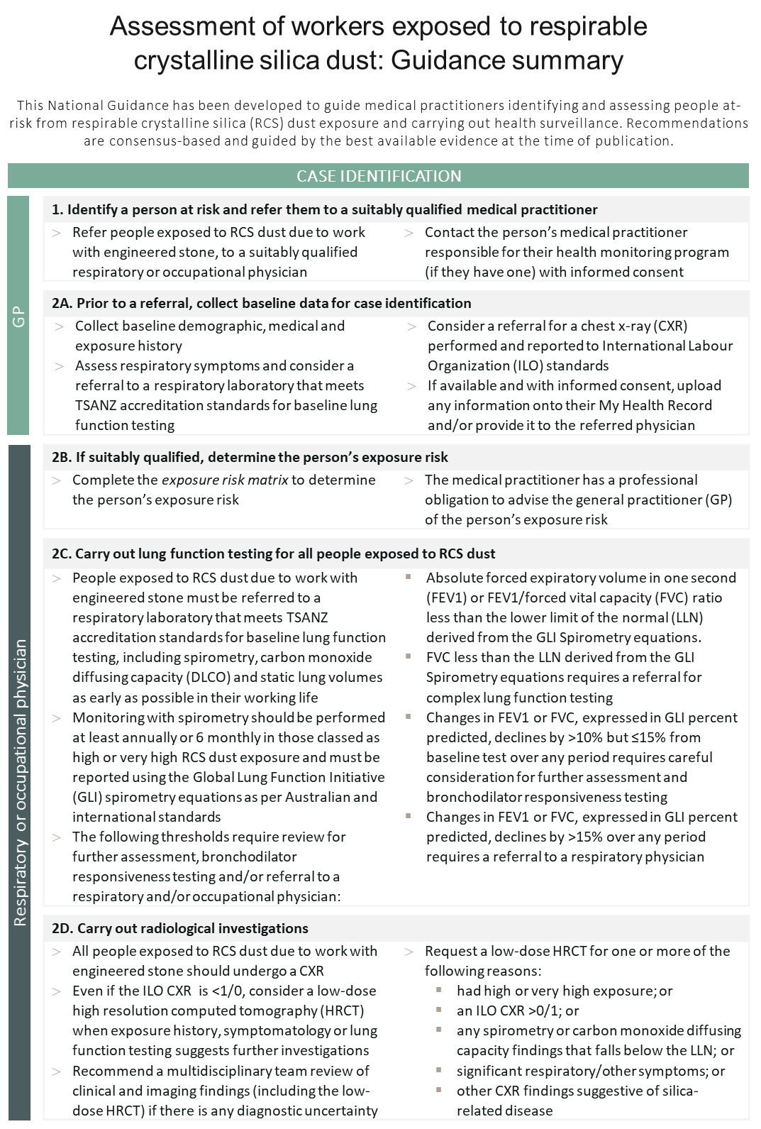
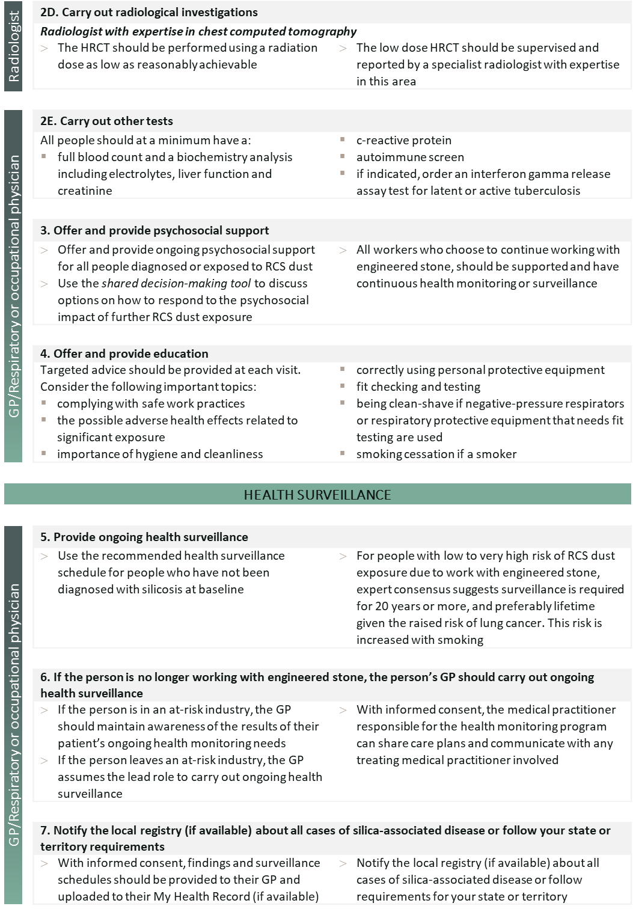

Introduction
The past 15 years have seen the unexpected re-emergence of occupational respiratory diseases across Australia. Of particular concern is the recent resurgence of silicosis, a fibrotic lung condition caused by the inhalation of respirable crystalline silica (RCS) dust.
Silicosis is an incurable, potentially fatal disease and is entirely preventable.
An epidemic of accelerated silicosis has been linked to the cutting, grinding and polishing of engineered stone. This product is commonly used in modern kitchen and bathroom benchtops and often contains a significantly higher percentage (>90%) of crystalline silica compared to natural stone (5-50%) (1).
Commonwealth, state and territory governments have implemented a range of activities aimed at addressing the respiratory health issues in this industry, including guidance for assessing those exposed to RCS dust. New South Wales has introduced specific regulations to prohibit the uncontrolled dry cutting of engineered stone to protect workers from RCS dust exposure (7). Queensland and Victoria also have codes of practice prohibiting dry cutting (8, 9). WHS ministers have also agreed to a model code of practice for engineered stone (10) that expressly prohibits uncontrolled processing of engineered stone (Published 27 October 2021).
In July 2019, the Australian Government Department of Health established the National Dust Disease Taskforce (the Taskforce) to inform a national approach to the prevention, early identification, control and management of occupational respiratory diseases in Australia (11). The Terms of Reference for the Taskforce requested that it provide advice on:
- Actions that have been taken to date to address occupational dust disease across all Australian jurisdictions.
- Existing policy and regulatory arrangements in Australia to protect those at-risk from occupational dust disease, more specifically reviewing what controls are in place and how these are applied and monitored.
- Opportunities for improvement across the system to ensure protection of those at-risk populations.
- Options for sustainable approaches for the future prevention, detection and management of occupational dust diseases, including the consideration of the establishment of a National Occupational Respiratory Disease register, including its scope and anticipated outcomes.
- Options for potential new research required to support understanding, prevention and treatment of preventable occupational respiratory disease.
The Taskforce undertook extensive consultation over three phases with a broad range of stakeholders. Through these consultations, the Taskforce heard differing views on what the most appropriate health screening methods are, with many critical of the health monitoring processes required under WHS laws. Health monitoring (referred to as health surveillance in Western Australia) is the monitoring of a worker to identify changes in their health status because of exposure to specific hazardous substances in the workplace while a person is employed and at-risk of exposure. Common themes raised during consultations were the need for a more comprehensive understanding of the workplace, clearer exposure risk characterisation, clinical guidance and enhanced enforcement of safe work practices for those who remain in the industry.
In the engineered stone industry, the Taskforce found that historically, health monitoring had not been undertaken. The lack of monitoring of workers exposed to RCS dust resulted in many workers being diagnosed with symptomatic, late-stage disease. The Taskforce also identified that inadequate or inappropriate health monitoring was being conducted in other industries such as building and construction, mining, quarrying and tunnelling.
The Royal Australasian College of Physicians (RACP), the Thoracic Society of Australia and New Zealand (TSANZ), the Australasian Faculty of Occupational and Environmental Medicine (AFOEM), and the Royal Australian and New Zealand College of Radiologists (RANZCR) have all called for the development of National Guidance for case identification, assessment and health surveillance of at-risk populations for silicosis.
As part of its Interim Advice to the Minister for Health, the Taskforce recommended, “the development of National Guidance on an approach to actively search for people at-risk from RCS dust exposure at the workplace” (11).
In its Final Report, the Taskforce confirmed the importance of early detection of occupational respiratory disease to enable appropriate management of affected workers and to identify deficiencies in workplace controls. It also confirmed the need for the National Guidance to be finalised and provided to relevant medical practitioners.
Purpose of the National Guidance
The National Guidance for doctors assessing workers exposed to RCS dust due to work with engineered stone (the National Guidance) has been developed to provide a consistent framework to:
- identify workers exposed to RCS dust in the engineered stone industry at any time during their working lifetime; and
- support all relevant medical practitioners to carry out health surveillance within their specific training and experience.
The National Guidance is a guide to appropriate practice to be followed subject to clinical judgement and individual patient preferences.

Scope of the National Guidance
The National Guidance covers the most critical components and strategies to effectively identify and assess people at-risk of silicosis from RCS dust exposure due to work with engineered stone and carry out health surveillance.
The following is out of scope for the National Guidance:
- Medical practitioner involvement in contact tracing of colleagues of an affected worker.
- Treatment of workers diagnosed with silicosis or other occupational respiratory diseases.
- Activity involving the medical practitioner in the process of identifying people who have been similarly exposed to an index case.
- Identification and management of other occupational respiratory diseases, not directly related to engineered stone related silicosis.
- The health monitoring of workers required under Work Health and Safety (WHS) or Occupational Health and Safety (OHS) legislation monitoring at the workplace.

Target audience
The National Guidance is intended for use by registered medical practitioners collaboratively with their patients. Medical practitioners include GPs, specialists in Occupational and Environmental Medicine, Radiology and Respiratory Medicine and researchers. This also includes any medical practitioner who has had a patient referred to them from a medical practitioner responsible for health monitoring.

Development
The National Guidance has been developed under the direction of an interdisciplinary Working Group. The Administrative Report details the Working Group membership, process, consultations and terms of reference.
The literature referenced in this document is not intended to be a comprehensive evidence-based literature review but rather a selective reference to the relevant literature to inform the reader about the salient issues, available evidence, gaps in knowledge and the rationale for the recommendations. Consequently, the National Guidance has been developed based on a consensus of clinicians on the Working Group as well as the best available evidence at the time of publication.

Use
The primary goal of the National Guidance is to help medical practitioners work with their patients and actively identify and assess people at-risk of disease from RCS dust exposure in the engineered stone industry and carry out surveillance.
Guidance documents differ from the clinical care or clinical pathway documents. Guidance documents provide an overview of the current best evidence translated into clinically relevant statements or practice points. Care or clinical pathways, also known as critical pathways, care paths or case management plans, are based on best practice guidelines but provide a local link between the guidelines and their application.
The National Guidance recommends shared decision-making processes for assessing the respiratory health of a person who has been exposed to RCS dust. In addition, the National Guidance identifies triggers for additional testing or investigations to reflect the person’s circumstances, subject to the medical practitioner’s judgement and individual patient preferences.


Occupational respiratory diseases

Occupational respiratory diseases and silicosis
Occupational exposure to fumes, dusts and vapours is known to be a significant cause of respiratory illness in Australia. Many of these illnesses may not be detected until long after the original exposure has ceased. Once diagnosed, many patients may experience long-term disablement and have a shorter life expectancy (12).
Examples of occupational respiratory diseases include:
- silicosis due to RCS dust exposure
- chronic obstructive pulmonary disease (COPD)
- chronic bronchitis
- emphysema
- asbestos-related diseases (malignant and non-malignant)
- mining related dust pneumoconiosis such as coal mine dust (black lung), mixed dust pneumonoconiosis and diffuse dust related pulmonary fibrosis
- other types of pneumoconiosis caused by breathing in specific types of dust particles such as berylliosis (beryllium metal) and byssinosis (cotton bracts)
- work-related asthma/occupational asthma
- hypersensitivity pneumonitis – in which the lungs develop specific sensitivity to inhaled particles containing fungus, moulds or chemicals.
In addition to the lung parenchymal and airway spectrum of occupational respiratory diseases, other diseases associated with RCS dust include:
- lung cancer
- scleroderma and other autoimmune sequelae such as rheumatoid arthritis
- chronic kidney disease.
While historically silicosis has been widely studied, the recent increase in engineered stone related silicosis has created an urgent need and opportunity to learn more about the disease and minimise the risk of a life-threatening preventable disease from occurring in the future.
Silicosis is an irreversible pneumoconiosis caused by cumulative exposure to silica (silicon dioxide, SiO₂) and silicate dusts (RCS dust). It is characterised by a long interval between first exposure to the hazardous dust and first detectable disease (discovered clinically or by specific tests). This interval is known as ‘latency’. While some factors such as intensity of exposure, cumulative dose and nature of the hazard are known to affect the length of latency, the specificity and sensitivity of tests used to detect the presence of silicosis is also important. Overall, the longer the latency, the more difficult it becomes to identify the link between the RCS dust exposure and harm. The latency influences the frequency and form of the health surveillance required.
Lag also critically influences health surveillance protocols. Lag is the time between first detectable disease and when the disease has progressed to significantly influence deployment and treatment options. During this period, the person may appear well but must manage any further exposure that may influence disease progression. During this lag phase of their disease, their biopsychosocial adjustment to a disease that will shorten their life, becomes the critical focus of medical management.
For people with slowly progressing or inactive disease, preventing future exposures is important. This can be influenced by, but is not solely dependent on, the actions of medical practitioners.
Provided the tests selected for health surveillance have sufficient sensitivity to detect the earliest clinically significant disease, the health surveillance activities conducted by medical practitioners, serve three functions:
- Identifying people who are the most vulnerable to disease due to their historic exposure.
- Reinforcing the importance of following safe practices in the workplace.
- Identifying new outbreaks of disease associated with novel exposures, often involving changed or new industrial processes.
For an intervention to have the best chance of favourably influencing the outcome, early diagnosis is essential.
Recent experience has again revealed that the traditional indices used (time since first exposure, spirometry, International Labour Organization (ILO) CXRs or the presence of symptoms) has meant that for some people, silicosis is already well established at the time of diagnosis. At this stage, the opportunity for intervention to materially alter the person’s clinical course is under investigation and may be limited.
Understanding the early disease indicators of at-risk individuals will greatly assist in identifying and implementing effective measures that may prevent, arrest and, if possible, reverse disease progression.
Having identified at-risk individuals in the latency or lag phase of the disease, the minimum required activity as described by WHS legislation for health monitoring, may need to be augmented by other strategies. For example, the use of low-dose HRCT instead of an ILO chest X-ray (CXR) and the engaging the services of a clinical psychologist.

Epidemiology of silicosis
Accurate assessment of the prevalence of occupational respiratory disease is difficult for many reasons. Silica and silicates are widely used in a large number of industrial applications. While millions of workers are estimated to be exposed to RCS dust worldwide (13, 14), the number of people who are affected by silicosis is unknown. This is primarily because of poor record-keeping practices, time delays between exposure and diagnosis and limited understanding of the relationship between exposure and disease (15).
In Queensland, as at 31 May 2021, 1053 people working or who have worked with engineered stone have been screened since the screening program was announced on 18 September 2018 (16). Thirty-two cases have since been identified with progressive massive fibrosis (PMF) and 191 cases meeting the criteria for any other forms of silicosis. This suggests a prevalence of 20% to 30% for all forms of silicosis in exposed workers in the engineered stone industry. Unfortunately, analysis of the cohort by exposure history, type of disease or the nature of disease progression was not available. Additional data is anticipated from the “Respiratory Health Screening of Stonemasons in Victoria” established by WorkSafe Victoria in conjunction with Monash University.
Silica-related diseases are associated with significant premature mortality among workers of all ages (14, 17).
Internationally, in the United States between 1996 and 2005, 1,746 deaths due to silica exposure resulted in 20,234 years of life lost, with an average of 11.6 years of life lost (18). For the same period, among 307 people who died before age 65, there were 3,045 years of life lost, with an average of 9.9 years of life lost from a working life (19, 20).
In Australia, the absence of a centralised registry to pool individual case-based data perpetuates the lack of knowledge around silicosis. The Australian Government has provided funding to support the establishment and operations of a National Occupational Respiratory Disease Registry (the Registry). The Registry is currently being built by the Commonwealth Department of Health.
The National Guidance will be linked with the Registry once it becomes operational. This will enable future editions of the National Guidance to be informed by the data collected by the Registry. A range of research activities are also under way which will inform future editions of the National Guidance.

Pathophysiology of silicosis
Silicosis is an irreversible pneumoconiosis caused by cumulative exposure to crystalline silica (silicon dioxide, SiO₂) and silicate dusts (RCS dust). Silica and silicates are naturally occurring and widely abundant minerals in concrete and most rocks and soils. There are non-crystalline forms of silicon dioxide. The non-crystalline or amorphous forms of silica can also be associated with parenchymal lung damage (21), although pneumoconiosis has also been observed secondary to these exposures.
"Free" crystalline silica – also known as quartz, cristobalite and tridymite – is unbound to other minerals. "Combined" forms of silica, called silicates, are compounds in which silica is bound to other minerals. Examples of silicates used in industry include asbestos (hydrated magnesium silicate), talc (Mg₃Si₄O₁₀(OH)₂), and kaolinite (Al₂Si₂O₅(OH)₄), a major component of kaolin (China clay) (18). Engineered stone has the highest percentage of silica (Figure 1) (1). Aggregates including mortar and concrete have various levels of silica present (1). All have been described as causing pneumoconiosis.
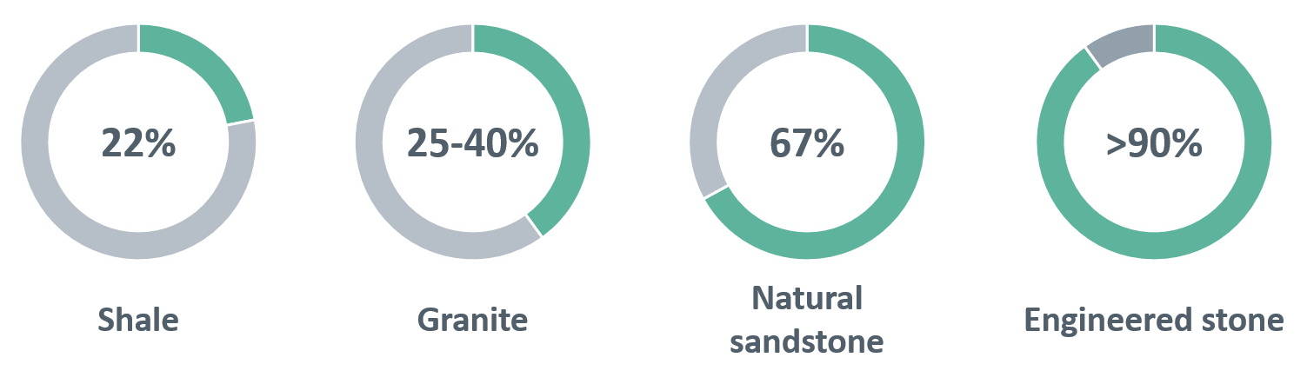

Figure 1 Different types of rock and rock products and their typical percentage of silica
Source: Safe Work Australia (1)
RCS dust is generated in the workplace by mechanical processes such as crushing, cutting, drilling, grinding, sawing or polishing of natural or man-made products containing silica. For example, cutting a kitchen benchtop to size and holes for positioning a sink and tap.
Inhaled RCS dust (<10 μm aerodynamic diameter) can be carried to the distal airways and alveoli. Larger particles deposit on the muco-ciliary epithelium of the nose, throat and larger upper airways and therefore fewer reach the gas exchange regions of the lung to create the potential for harm.
Studies of dust composition and explanted lungs have identified a consistent presence of sub-2 μm sized silica particles (22). Ophir, Shai (23) showed a possible association between ultrafine particles (UFP) (<1 µm) and poorer pulmonary function test results, worsening findings on computed tomography (CT) and elevated inflammatory biomarkers. Freshly generated RCS dust is more toxic than aged dust particles (24, 25) and a growing body of evidence suggests surface area rather than RCS mass are important factors contributing to toxicity. Currently, the evidence is not at the level necessary to trigger revision of workplace exposure standard (WES) (26). However, this is an area under continuing review and was last amended by Safe Work Australia in 2019.
Once in the respirable zone of the lung, the silica particles are engulfed by alveolar macrophages (24) and several pro-inflammatory and profibrotic pathways are activated (15, 23, 27). Inflammasome activation leads to secretion of Interleukin (IL)-1 and IL-1β with subsequent enhanced production of tumour necrosis factor, fibroblast growth factor and transforming growth factor- β (TGF- β).
The affected macrophages undergo cell necrosis, autophagy and release non-degraded intracellular silica and/or silicates. If the cumulative silica load is sufficient to overcome the host’s clearance mechanisms, early alveolar air space, parenchymal and lymphatic changes will result. These changes cause the centrilobular ground glass opacification which characterises early silicosis on CT scans. Eventually, further macrophages recruitment and release of oxidants, proteases, inflammatory cytokines and arachidonic acid metabolites occurs. This cycle continues, causing progressive alveolar inflammation and fibrosis. Factors that may slow or stop the process in individuals who develop inactive disease are largely unknown.
Understanding the role of the alveolar macrophage has recently been enhanced by improvements in laboratory technologies and better understanding of macrophage lineage and function (28). Preliminary studies have also shown significant promise to identify reliable biomarkers of disease, especially when findings are interpreted in the presence of other less specific markers; however, further research is needed for this to be validated.

Classification of silicosis
The diagnosis of any type of silicosis is based on:
- a history of exposure to RCS and silicate dusts; and
- radiological appearances consistent with silicosis; and
- an absence of another more likely diagnosis.
Clinical manifestations are not necessary for a formal diagnosis. Over the last 70 years, diagnostic criteria have evolved with improvements and standardisation of chest radiographs and health surveillance programs that identify pre-symptomatic disease. Historically, silicosis was subclassified primarily on the basis of time since first exposure leading to acute, accelerated and chronic subtypes.
This National Guidance recommends that until there is evidence of significant progressive disease, persons with <10 years since first exposure should be classed as having simple silicosis once the complicated forms of the disease (at first diagnosis) are excluded. See Figure 2 for the different classifications of silicosis.
A significant cohort of workers were made known to the National Dust Diseases Taskforce with exposure durations <10 years, who were asymptomatic, and over their limited follow up (since 2018), were not manifesting progressive disease. For this cohort, there was a conflict between the diagnostic label characterising their disease, and their clinical course. Labelling these people as suffering from “accelerated silicosis” or “PMF” without evidence of clinical progression materially contributed to their psychological distress, uncertainty, and the range of occupational management options available to holistically support the affected person and their families while they adjusted to their situation.
During this time, the primary need for the worker at-risk of rapidly progressive disease, both before and after diagnosis is established, is the psychological support from doctors who understand their patient’s predicament – their exposure history, their current workplace and employment capacity, and their immediate and medium-term health needs during a period of great uncertainty. Consequently, general medical practitioners need to engage with the specialist doctors responsible for the earliest detection of the disease, ideally, the consultant physician in Occupational and Environmental Medicine supervising the health monitoring of the at-risk workforce.
Rapidly progressive pneumoconiosis (RPP, associated with coal mine dust exposure) is deﬁned by the development of PMF and/or an increase in small opacity profusion greater than one International Labour Ofﬁce (ILO) subcategory over <5 years (29). Queensland's Workers’ Compensation Regulatory Services (30), in developing its guidance for “returning workers with mine dust lung diseases (MDLD) to the workplace”, defined rapid progression for MDLD as an increase in the small opacity profusion by the equivalent of more than one ILO subcategory over five years, or an increase in the ICOERD score (31) for small opacities by two or more points to an ICOERD score of four or greater, or the development of PMF. “Two or more” ILO subcategories is the equivalent to “more than one”, and León-Jiménez, Hidalgo-Molina (32) used the same threshold expressed in a slightly different way: “increased profusion of small opacities in two or more subcategories, the presence of large opacities (A, B, or C), or an increase in the large opacities category”.
Antao, Petsonk (33) used a <5 year interval to assess the change in ILO classification. This interval was used to reduce the risk of false positive cases in their retrospective study. In the early stages of the disease, it is not yet known if progression is linear or a more complex non-linear pattern.
Using these criteria, a classification system for use in Australia is proposed which includes the rate of progression after first diagnosis: using a change ILO category within 5 years (60 months) to distinguish between simple and complicated silicosis.
The relative insensitivity of CXR in monitoring for clinically significant change, means the ICOERD equivalent of more than one ILO subcategory change following serial low-dose high-resolution computed tomography (HRCT) will inform future recommendations, particularly when considering any progression of the associated RCS dust related pathologies of emphysema, traction bronchiectasis and COPD.
At this stage, the threshold used by Antao, Petsonk (33) has been adopted with the recommendation that a minimum of two years data is acquired before a person is managed as suffering from an uncomplicated non progressive or slowly progressive form of the disease. This is based on the clinical experience of doctors seeing workers exposure to engineered stone RCS.

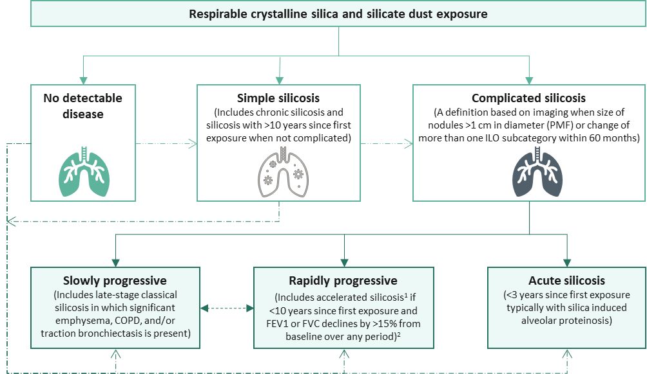
Figure 2 Classification of silicosis
Source: Modified from Álvarez, González (19)
Abbreviations: FEV1, forced expiratory volume in one second; PMF, progressive massive fibrosis; FVC, forced vital capacity
Note: All categories of silicosis carry an increased risk of lung cancer and tuberculosis in at-risk populations.
Dotted lines reflect a lower level of certainty to be informed by ongoing research and updated as required.
¹Historically accelerated silicosis was defined solely on the basis of time since first exposure. This National Guidance recommends that until there is evidence of significant progressive disease, persons with <10 years since first exposure should be classed as having simple silicosis.
²See C. Lung function stratification for further information

The rate of disease progression is clearly important to clinical decision-making. However, insufficient data is currently available to warrant proposing a formal re-classification system (29) beyond highlighting the distinction between simple and complicated version of the disease. Screening programs have also identified two important subgroups:
- Hilar or mediastinal lymphadenopathy (with or without calcification) but without parenchymal disease.
- Chronic simple silicosis with numerous nodules below the resolution of conventional ILO CXRs, some complicated by PMF not detectable by ILO CXR.
Given the purpose of diagnostic sub-classification is to assist targeted intervention and research, a simplified classification system for the Australian setting is recommended:
- Uncomplicated simple: parenchymal disease without evidence of rapid progression, parenchymal distortion or nodular aggregation.
- Complicated: parenchymal disease where the radiological appearance involves distorted or destructed architecture (traction bronchiectasis or emphysema) and includes aggregation of nodules to >1 cm (PMF).
- Acute: silicoproteinosis (ground glass appearance) is the dominant feature on low dose HRCT and clinically there is evidence of rapid radiological or functional progression.
In Australia since 2018, case identification activities in workers who have been exposed to RCS dust from engineered stone have revealed increased prevalence of the accelerated and complicated forms of silicosis. The case identification activities have also highlighted that some workers do not meet the established diagnostic criteria for silicosis but are clearly at-risk of crossing the threshold – given their significant exposure histories and detectable radiological changes.
Furthermore, the epidemic of engineered stone related silicosis has raised the possibility that toxicity observed in this cohort may relate to a combination of factors in addition to the magnitude of exposure, namely:
- the nature of the resin used to bind the silica in engineered stone; or
- the other elements used to create the range of composite materials supplied to the market; or
- gene environment interactions.
These are matters that require careful investigation. Complicating the toxicology further, for acute silicosis (diagnosed within 3 years of first exposure) and to a lesser extent accelerated silicosis (diagnosable within 10 years of first exposure), case-based experience suggests that cumulative lung burden should not be considered linear. High intensity exposures have the potential to not just shorten the time required to accumulate a sufficient lung load but could also trigger alternative mechanisms of toxicity. This could explain differences in the incidence of acute and accelerated silicosis with engineered stone.
In all forms of silicosis there appear two distinct subsets – those who rapidly progress and those who do not.
Rate of progression in workers exposed to RCS dust is known to show individual variation and is likely to be influenced by factors that are currently unknown, and therefore require further research.

Silico-lymphadenopathy (no parenchymal disease)
For GPs who would like to follow a learning course on diagnosis and management of silicosis: see the Royal Australian College of General Practitioners learning resource
The presence of silica-related hilar and mediastinal lymphadenopathy, without radiological evidence of parenchymal change has long been recognised. These cases do not meet the diagnostic criteria for silicosis and have become easier to detect through CT scanning. The frequency with which these cases have been seen in people exposed to RCS dust reinforces the need to identify these workers as an at-risk category who should be identified and be subject to ongoing surveillance.

Acute silicosis
A diagnosis of acute silicosis is made in exposed individuals who experience rapid onset and/or worsening of symptoms including dyspnoea, cough, fever and sometimes pleuritic pain. Early accelerated silicosis can present with similar features.
Acute silicosis is a type of alveolar proteinosis. Bilateral perihilar consolidations as seen with alveolar proteinosis can be seen on CXR, and low-dose HRCT reveals ground glass opacities or air space consolidations. There is usually progressive breathlessness, pleuritic chest pain, fever, cough, fatigue, weight loss and rapid progression to death from respiratory failure.
Acute silicosis is generally caused by massive exposure. Examples of at-risk exposures include sandblasting with sand (but not usually sand substitutes), silica flour manufacture and abrasive fabrication and uncontrolled manufacturing processes involving high silica content substrates.
When acute silicosis is suspected in a person with recent high dose exposure to RCS dust (up to 3 years prior), the initial assessment is aimed at understanding the exposure history and excluding other possibilities contributing to the differential diagnosis, such as pneumonia, acute respiratory distress syndrome, heart failure, diffuse alveolar haemorrhage, eosinophilic pneumonia, lipoid pneumonia, and pulmonary alveolar proteinosis (18). Silica particles are identifiable within the pulmonary macrophages and provide good sensitivity and specificity for this diagnosis. However, there are difficulties in accessing such testing in Australia. Consequently, further testing is always required to formally exclude alternative diagnoses (15).
Urgent referral to a respiratory physician and/or hospital is recommended. Tests such as full blood count and differential, brain natriuretic peptide are helpful in excluding possibilities from the differential diagnosis. While extended testing may be necessary to exclude other pathologies, these are best considered by the respiratory physician and should not delay referral.
People with acute silicosis should be diagnosed early to reduce any parenchymal changes from any treatable cause becoming established. Potentially favourable interventional trials are in planning or already under way.

Simple silicosis
Chronic silicosis can be challenging to diagnose. It is often asymptomatic or presents with only very mild exertional dyspnoea. Simple silicosis generally appears after 10 or 15 years of exposure.
The classic radiological sign of simple silicosis is a bilateral diffuse nodular pattern (opacities <1 cm), with greater upper lobe and posterior involvement. The simple form may progress to complicated silicosis in which nodular conglomeration occurs (nodules ≥1 cm in diameter), associated with parenchymal retraction.
Examples of at-risk exposures include foundry work, quarrying and mining.
The primary clinical focus is to optimise respiratory health, support the psychosocial needs of the affected person and aggressively treat any reversible complications, in particular intercurrent infections.

Complicated variants
Disease progression can be characterised by progressive fibrotic destruction, enlargement of nodules, calcification or worsening of airways disease and emphysematous changes. Necrosis and cavitation are uncommon and may be a sign of complicating infection including tuberculosis. In more advanced cases, there is extensive structural breakdown with formation of fibrotic masses, respiratory failure, pulmonary arterial hypertension, cor pulmonale and right heart failure. Lung transplantation may be indicated.
This progression from simple to complicated silicosis is a consequence of a complex interaction between intensity and duration of exposure. It is likely also that genetic susceptibility is a contributing factor.

Accelerated silicosis
Accelerated silicosis is an intermediate entity between the acute and chronic forms that generally appears after a period of exposure of 3 to 10 years. It progresses more rapidly than other forms of silicosis. However, even some individuals with radiological evidence of PMF do not appear to progress. Symptoms of breathlessness occur earlier than in chronic silicosis, and complications such as emphysema and respiratory failure are more likely to develop in people with accelerated silicosis (15).
Examples of at-risk exposures with an increased incidence of accelerated silicosis include sandblasting, stonemasonry using powered tools without dust controls and respiratory protection, and any modification of engineered stone. There have also been several cases reported in association with tunnelling and quarrying.
Again, early identification of people with rapidly progressing silicosis is important to reduce significant parenchymal disruption or distortion due to fibrosis becoming established.

Engineered stone related silicosis
Engineered stone related silicosis is a spectrum of disease presentations, similar to the historical forms of silicosis but with shorter latency and more rapid progression. The diagnostic label is applied due to the source of silica exposure and has been added to the classification scheme after this new type of silicosis was described. This new nomenclature highlights the possibility of exposure factors which may be involved in influencing disease progression, potentially binding resins and/or composite substances that create the range of stone finishes. The typical presentation early in the disease course is of soft centrilobular ground glass infiltrates which are predominantly upper zone.

Exposure to RCS dust and silicosis
Epidemiological studies (32, 34) based primarily on standardised CXR findings using ILO criteria, have demonstrated a clear dose-response relationship between cumulative exposure to RCS dust, disease severity and the risk of progression. This risk of progression continues even after the worker is no longer exposed to RCS dust. Many studies have examined the effect of RCS dust exposure on longitudinal lung function, however these have not shown uniform results.
Hertzberg, Rosenman (35) attempted to assess the effect of silica exposure assuming 40 years of maximal exposure at 0.1 mg/m³, eight-hour time weighted average (TWA). The results suggest continued exposure at this level would result in a longitudinal declined of forced vital capacity (FVC) and/or forced expiratory volume in 1 second (FEV1) of 1.6 mL/year and 1.1 mL/year respectively, per mg/m³ of mean RCS dust exposure. The normal rate of FEV1 decline due to ageing in non-smokers is approximately 30 mL/year (36). However, other studies have shown a greater rate of decline (37).
In Australia, the current WES for RCS dust is a TWA of 0.05 mg/m³ in all jurisdictions except for Tasmania.
During an eight-hour shift the level of RCS dust may fluctuate above and below this threshold and still remain below the prescribed level when averaged over an 8-hour shift. As there are different shift profiles for different occupations, when a shift is greater than 8 hours, TWAs can be adjusted down to provide the equivalent protection while accounting for longer exposure duration and reduced recovery hours between shifts.
As a medical practitioner asked to assess the safety of a workplace, it is important to realise that generally, a dust generating process is not considered to be under control if short-term exposures exceed three times the TWA exposure standard for more than a total of 30 minutes per eight-hour working day, or if a single short-term value exceeds five times the TWA exposure standard (38).
When assessing the exposure potential of a workplace it is therefore important to look beyond the reported TWAs and qualitatively assess the pattern and intensity of dust generation that can be masked by ‘averaging’.

Enhanced progression with continued exposure to RCS dust
Once a worker has been diagnosed with silicosis, continued exposure to RCS dust may cause increased disease progression. For example, gold miners with ongoing exposure had greater functional impairment and radiological severity of disease compared to those who ceased exposure (39). Hessel, Sluis-Cremer (40) showed that continued exposure increased the number of workers who progressed (94.6% vs 88.3% for workers with continued exposure and those without, respectively). Carneiro, Barreto (39) also showed continuing RCS dust exposure was associated with risk of developing significant radiological changes (ILO nodule perfusion category 3, odds ratio [OR] = 6.42, 95% confidence interval [CI]: 1.20–34.27), presence of PMF and/or large opacities (OR = 3.85, CI: 1.07–13.93) compared to those who left the high exposure setting studied.
In a prospective cohort study of 141 granite workers with silicosis, Lee, Phoon (41) found that 37% showed radiographic evidence of disease progression over a 2 to 17 year follow up period. Progression was strongly associated with duration of exposure and severity of disease status at the time of initial CXR. Workers were also at an increased risk of progression if they had evidence of large opacities on their initial CXR. These findings have also been reported in coal mine workers (42).

Progression in the absence of further exposure to RCS dust
Silicosis can progress in the absence of further exposure. This has been demonstrated in many studies including a retrospective cohort study of Japanese tunnel workers (43). A series of silicosis cases in Turkish denim sandblasters who had been subject to very high exposures, also showed rapid disease progression in the absence of further RCS dust exposure in as little as four years (44).
There are some studies which have not shown inevitable progression in their cohort, at least in terms of their CXR imaging and lung function tests. This could relate to insensitive tests (CXR vs low-dose HRCT), a pattern of episodic progression not previously described, and/or a relatively short follow up. Unfortunately, available literature failed to reveal descriptors that might identify this group, and their longer-term clinical course. However, in some studies there appears to be a consistent group of workers who do not manifest rapidly progressive disease.
A recent example, León-Jiménez, Hidalgo-Molina (32) focused on the rapid progression observed in their cohort with 56% of their patients progressing two or more ILO subcategories. Even so, they documented that 55% of patients with ILO category 1; 47% with ILO Category 2; and 29% with ILO Category 3 did not significantly progress within their 4 -year follow up duration. Longer follow up is required to better characterise these workers.
Mohebbi and Zubeyri (45) reported that 34.8% of their case series including 23 silica flour packers with acute and accelerated silicosis did not progress over a mean follow up period of 30 months (range 12–54 months). Ress and Murray (46) suggested patients with progressive disease might be between one- to two-thirds of affected workers.
Developing silicosis in the previously exposed worker, but without evidence of disease when first seen at the time of entering a surveillance program, can occur even in the absence of further exposure (42). Combined with the potential for transient lapses in safe work practices and/or short-term high level exposure, once silicosis is recognised or even strongly suspected, it is recommended that further RCS dust exposure is best avoided.
However, until there is clear evidence of disease progression, the decision to stop work should be a patient-centred shared decision.

Prevention of silicosis
Prevention of silicosis is broadly divided into three categories: primary, secondary and tertiary prevention, as summarised in Table 1.
Currently, there is no treatment for silicosis. Prevention of cumulative exposure that might trigger silicosis is therefore the highest priority.
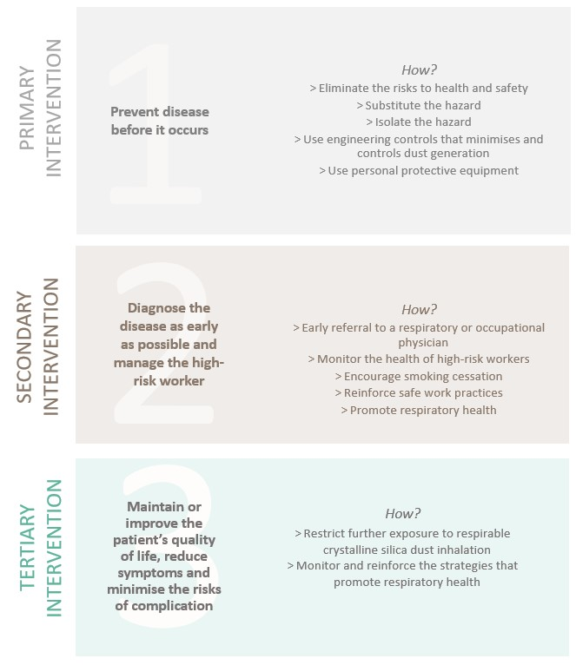
Table 1 Prevention of silicosis

Primary prevention
While not their responsibility, medical practitioners contribute to primary prevention of silicosis by promoting awareness of the health consequences and actively reinforcing and encouraging safe work practices.
Primary prevention adopts, as far as reasonably practicable, the Hierarchy of Control Measures (1) which includes:
- Eliminate the risk to health and safety.
- Substitute the hazard that gives rise to the risk with a safer product (e.g. sourcing a stone benchtop with a lower percentage of silica).
- Isolate the hazard from any person exposed to it (e.g. designate areas for tasks that generate dust and appropriate worker positioning during these tasks); Reduce the risks through engineering controls.
- Reduce exposure to the hazard using administrative controls.
- Use personal protective equipment (PPE).
See the model Code of Practice: Managing the risks of respirable crystalline silica when working with engineered stone (10) which provides further information.
A process is not considered to be under reasonable control if:
- short-term exposures exceed three times the TWA exposure standard for more than a total of 30 minutes per eight-hour working day; or
- if a single short-term value exceeds five times the 8-hour TWA exposure standard, even if there is an acceptable 8-hour TWA exposure measurement.
High, short-term exposures to RCS dust for just 15 minutes (cumulatively across the shift or once a shift), at levels equivalent to five times the exposure standard (e.g. the now explicitly banned activity of dry cutting), could also have significant cumulative effects on a worker’s health. (38)
Consequently, health monitoring is strongly recommended for workers who should wear PPE for tasks where significant RCS dust is generated, even if only for 15 minutes in their day.
RCS dust is also a recognised lung carcinogen with additive risk of lung cancer with concurrent tobacco smoke exposure (47, 48). All persons diagnosed with silicosis, as well as workers currently working or who have previously worked with engineered stone, should be provided access to and support for smoking and vaping cessation. See the Royal Australian College of General Practitioners (RACGP) supporting smoking cessation: a guide for health professionals (49)

Secondary and tertiary prevention
For secondary prevention, diagnosing a person with disease as early as possible can be challenging. Exposure assessment has not yet achieved the level of sophistication to enable robust stratification of an individual’s risk of developing silicosis. Currently, it is also not possible to describe what increment of additional cumulative exposure is needed for a person with potential sub-clinically detectable, dormant or slowly progressing chronic disease to develop into more rapidly progressive disease. Given the ethical research considerations, such insights are unlikely to be discoverable by prospective case-controlled studies. Consequently, it is not possible to know what the risk of silicosis is for an individual from continued exposure at or below the Australian WES. The clinical trajectory of any individual will also be unknown until sufficient time has elapsed to observe the disease behaviour in that person.
When encountering an individual with established disease, the default recommendations, regardless of their clinical state, are prudent avoidance of further exposure to RCS dust (34), and consider alternate roles that do not carry with them any risk of exposure. This advice should be balanced against the significant impact of ceasing or changing work – psychologically, socially and financially. Upon diagnosis, it can be difficult for a person to process that it may be their own workplace that is causing them harm. This can compound their sense of hurt and psychological distress. Although not required by the WHS laws, it is suggested their workplace should be independently assessed before a medical practitioner provides such an opinion. The pathway for assessment is dependent on the injury claim setting.
Unless there is a clinical indication to do so, there is no urgency to leave the workplace until the nature of the worker’s disease and circumstances are better understood. It is recommended that further RCS dust exposure is best avoided. However, unless there is a real risk of a short-term intense additional RCS dust exposure, deployment to a workplace with exposure below the current WES, is unlikely to materially contribute to the natural progression of their disease. This is because the disease is already established and naturally progressing due to the historic exposures, not necessarily recent low-level exposure. During the worker’s adjustment to the diagnosis, the worker warrants optimal support to make informed decisions.
Consequently, a shared decision-making process is highly recommended (50, 51). In a patient-centred model of health care delivery, providing the opportunity for people to understand and ask questions as well as take the time needed to make an informed decision is central to facilitating desired behavioural change (see Appendix B). The same principle applies for health surveillance.

Statutory duties of the PCBU
Under the model WHS laws, a person conducting a business or undertaking (PCBU) has specific duties to ensure the health and safety of workers while they are at work in the business or undertaking and of others who may be affected by the carrying out of the work. The concept of a PCBU captures modern work relationships outside of the traditional contract of employment between employer and employee. For example, it captures host employers in a labour hire arrangement, as well as multiple employers in sub-contracting arrangements. For further information about the definition of a PCBU see Safe Work Australia (5, 6).
This National Guidance focuses on the duties of PCBUs under the model WHS laws, which have been implemented in all jurisdictions except Victoria and Western Australia. However, Western Australia is in the process of adopting the model WHS laws. In those jurisdictions, employers may hold similar duties to eliminate or manage WHS risks, and these have been noted throughout this document. For further information on the duties of employers in Victoria and Western Australia, please refer to:
- WorkSafe Victoria – Occupational health and safety – your legal duties (52).
- WorkSafe Western Australia – Employers – your responsibilities and Employees – your rights and responsibilities (53).
PCBUs’ duties include identifying hazards and managing the risks to health and safety when using, handling, generating and storing hazardous chemicals, including silica in the workplace. This must be done by identifying reasonably foreseeable hazards and eliminating or managing the risks in accordance with the hierarchy of controls (see Primary prevention). In this context, an occupational hygienist aided by an occupational physician, may be used to establish whether there was a significant risk to the worker’s health because of exposure to a hazardous chemical. If the PCBU fails to identify the hazard and characterise the risk, then workers may remain at-risk of exposure until an inspector assesses the workplace and corrective actions are implemented.
Approved codes of practice are practical guides for duty holders, including PCBUs, to achieve the standards of health, safety and welfare required under the model WHS laws. To have legal effect in a jurisdiction, a model Code of Practice must be approved as a code of practice there.
Further information on the duties of PCBUs, including on health monitoring, can be found in:
- The model Code of Practice: Managing the risks of respirable crystalline silica when working with engineered stone (10) which provides further information on the duties of PCBUs.
- Managing RCS dust exposure in the stone benchtop industry (applies in Queensland) (8).
- Compliance code: Managing exposure to crystalline silica – engineered stone (applies in Victoria) (9).

Health monitoring
Under the model WHS laws, a PCBU must provide health monitoring for workers if they carry out ongoing work using, handling, generating or storing crystalline silica, and there is a significant risk to the worker’s health because of exposure. Examples of workers in the engineered stone sector that the PCBU should provide health monitoring - include:
- shapers
- machine operators including saw operators
- finishers
- polishers, and
- labourers and supervisors involved in the fabrication or installation of engineered stone.
A PCBU should also consider providing health monitoring to other workers who might be exposed to RCS dust from these processes. This includes workers who are exposed to dust while cleaning work areas or equipment, maintenance workers, salespeople or those who perform administrative work in the vicinity of fabrication and installation. (1, 54, 55)
The PCBU has a duty to engage a registered medical practitioner with experience in health monitoring to carry out or supervise their health monitoring program. However, the PCBU is under no obligation to engage a registered medical practitioner when conducting the risk assessment or designing any health monitoring for the workers identified to be at-risk. Also, the supervising medical practitioner has no statutory authority to identify which workers must undergo health monitoring.
The PCBU must also pay the costs of health monitoring where health monitoring is required under the model WHS laws (5). In Victoria and Western Australia, employers must pay for the costs of health monitoring under the Occupational Health and Safety Regulations 2017 (OHS Regulations) in Victoria (54) or the Occupational Safety and Health Regulations 1996 (OSH Regulations) in Western Australia (55).
Importantly, the duties to provide and pay for health monitoring exist only so long as the worker continues to be engaged by the PCBU (or employer in Victoria and Western Australia) in an at-risk role.
Consequently, if a worker presents that you suspect has been exposed to RCS dust, it is highly recommended that you obtain informed consent to liaise with the medical practitioner responsible for health monitoring at their workplace. The medical practitioner responsible for health monitoring should have valuable intelligence about the worker’s access to the relevant PCBU’s health monitoring program, the workplace’s level of commitment to safe systems of work, and an established relationship with your patient’s PCBU that can provide ongoing operational, logistic and financial support for you and your patient. If your patient does not undergo health monitoring, you can refer your patient to:
- a consultant physician in Occupational and Environmental Medicine (OEM), or
- a respiratory physician with expertise in occupational lung diseases.
Safe Work Australia has published a Crystalline Silica Health Monitoring Guide for Medical Practitioners which recommends at least annual health monitoring of at-risk individuals (56). It provides further information on the role and responsibilities of a medical practitioner conducting health monitoring for exposure to hazardous chemicals which overlaps with health surveillance.
As a medical practitioner, your patient or sometimes their workplace insurer, may ask your advice concerning the risk of harm should the worker return to their place of work. This can be difficult when only limited information is available and is best undertaken in consultation with a suitably qualified medical practitioner and/or occupational hygienists. When counselling your patient, your assessment of ‘when’ the exposure “most likely” occurred is important. As work practices change over time, current work practices may have substantially reduced the risk of further exposure. Given the nature of the disease process the critical exposure will more likely be “years ago” (especially for chronic silicosis). As the workforce is typically migratory, the significant exposure may have occurred in the course of a patient’s former work. It is therefore important to engage with your patient in a shared decision-making process (see Appendix B) when determining your advice.

National Guidance for identification and surveillance
The identification, assessment and ongoing surveillance of workers exposed to RCS dust associated with engineered stone can be divided into case identification, assessment and ongoing health surveillance. The following practice points are provided to describe a set of minimum standards to inform medical practitioners undertaking case identification, assessment and health surveillance.

Case identification
Primary healthcare professionals have an important role in identifying people exposed to RCS in the workplace, particularly those who no longer work in the engineered stone industry or are self-employed, and referring them for appropriate investigations.
Case identification is a strategy for targeting resources at individuals or groups who are suspected to be at high-risk for a particular disease. The overall aim is early identification of individuals with silicosis and those without disease who have been exposed. Risk stratification of those without disease must be carried out for further investigation and ongoing surveillance.
To change health-risk behaviours or reinforce safe practices, awareness and understanding of behaviours that can negatively impact a person’s health are critical. Historically (prior to April 2018) this had been lacking across the engineered stone industry (57). More recently, in all jurisdictions, broad promotion of the issues of hazardous dusts and silicosis and various jurisdictional specific case identification programs has enhanced health awareness with variable effectiveness (58).
While broad health promotion messages at the population-level have been successful in some settings, cultural and language barriers have posed challenges reaching a wider population. Consequently, case identification requires a high level of suspicion by medical practitioners to diagnose silicosis and identify people who have been exposed to RCS dust and require health surveillance.
The purpose of case identification is to:
- Identify people with established disease and refer them for specialist shared care.
- Provide counsel and support for people with early disease and apply interventions to minimise the risk of rapid progression.
- Identify, educate and support people with no early markers of disease but who remain at-risk of cumulative exposure or have a history of cumulative exposure that requires more frequent health surveillance.

Ongoing health surveillance
Health surveillance describes the clinical practice after a case (at-risk of or diagnosed with silicosis) has been identified. Unlike health monitoring, it is not a statutory requirement under WHS/OHS laws and is therefore not paid for by the PCBU. Health surveillance also encompasses the multidimensional nature of a person’s health and is informed by the body of medical evidence at the individual and public health levels as well as the societal need.
Activities are undertaken within a schedule that reflects what is known of the pathophysiology of silicosis and surveying for the earliest reliable indices of clinical significance. Consequently, health surveillance is informed by the evolving body of knowledge concerning the:
- Appropriate intervals to detect a change of significance, sensitive to the natural intra and inter-individual variation.
- Detection of more rapidly progressive forms of the disease as soon as practical.
- Next best practice principles endorsed by the medical profession for assessing and diagnosing occupational lung diseases (29).

Case identification
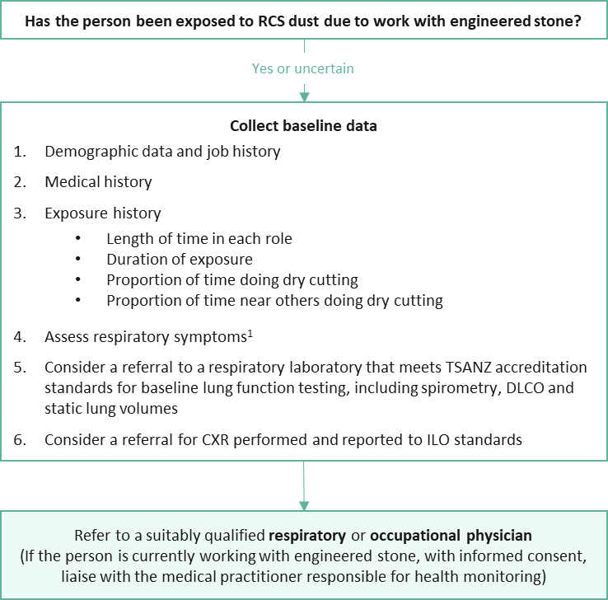
Figure 3 Identifying the appropriate referral pathway
Abbreviations: CXR, chest x-ray; DLCO, carbon monoxide diffusing capacity; ILO, International Labour Organization; RCS, respirable crystalline silica; TSANZ, Thoracic Society of Australia and New Zealand
Notes: Follow the links for the contact database for suitably qualified occupational physicians, respiratory physicians and medical practitioners
¹Consider using the modified Medical Research Council (MRC) respiratory questionnaire (see Appendix C) (59)

1. How to identify a person exposed to RCS dust due to work with engineered stone and refer them to a suitably qualified respiratory or occupational physician? (GPs)
Key practice points
- If a person has been exposed to RCS dust and works or has previously worked with engineered stone, refer them to a suitably qualified respiratory physician or occupational physician
Note: Follow the links for the contact database for suitably qualified medical practitioners (respiratory and/or occupational physicians)
- If the person currently works with engineered stone, health monitoring must be provided (free of charge to the worker by their PCBU [or employer in Victoria and Western Australia]). Contact the medical practitioner responsible for health monitoring (with informed consent) to access available resources
For an initial assessment of a worker or person exposed to RCS dust, they may present to a GP.
If you suspect that the person currently works or has worked in the engineered stone industry, ask:
Have you worked with engineered stone or have any concerns about the dust at your workplace?
If the answer is yes, refer them to a suitably qualified occupational or respiratory physician. A person with respiratory symptoms is considered at high-risk of silicosis until a satisfactory explanation is identified.
If your patient currently works with engineered stone and is provided with health monitoring by their PCBU, a health and risk assessment should be available upon request with informed consent from the person.
If your patient’s current place of employment does not provide health monitoring, there is no funding beyond Medicare to pay for the medical practitioner’s professional time and investigations. Where cases are identified, remember that the person’s current workplace may not be the source of their significant exposure.

A. What baseline data should be collected?
Key practice points
- Collect baseline demographic, medical and exposure history, respiratory and physical examination findings
- Assess respiratory symptoms and consider a referral to a respiratory laboratory that meets TSANZ accreditation standards for baseline lung function testing, including spirometry, carbon monoxide diffusing capacity (DLCO) and static lung volumes
- Consider a referral for CXR performed and reported to ILO standards
- If available and with informed consent, information collected should be uploaded onto the person’s information to their My Health Record. If My Health Record is not available, information should still be provided to the referred physician as part of the referral process
Baseline data including demographic, exposure and medical history, respiratory symptoms (if any) and physical examination findings should be collected. Consider performing spirometry to TSANZ standards (60) and a referral for CXR performed and reported to ILO standards (61).
The modified MRC respiratory questionnaire is recommended to be used to assess respiratory symptoms so the data can then be incorporated into the National Occupational Respiratory Disease Registry when/if the individual develops the disease.
If available and with the person’s informed consent, all baseline information and ongoing follow up should be recorded on the individuals My Health Record (62). This will enable continuity of care and can improve the ability for a medical practitioner to make informed management decisions if there are clinically significant changes.

Take home practice points for GPs
- Identify people who have been exposed to RCS dust due to work with engineered stone
- Assess respiratory symptoms and consider a referral to a respiratory laboratory that meets TSANZ accreditation standards
- If performing follow up measures within your practice, ensure use of modern spirometry systems capable to reporting GLI reference equations and customisable trend reports
- Monitor closely
- Refer to suitably qualified medical practitioner if clinical findings warrant
- If you are not experienced in assessing and diagnosing silicosis, always refer the person to a suitably qualified respiratory or occupational physician

2. How to carry out further assessments? (respiratory or occupational physicians)
Figure 4 presents the steps for a suitably qualified occupational or respiratory physician involved in case identification. Additional detail has also been provided on exposure and lung function testing, diagnostic imaging and additional investigations (2B to 2E).

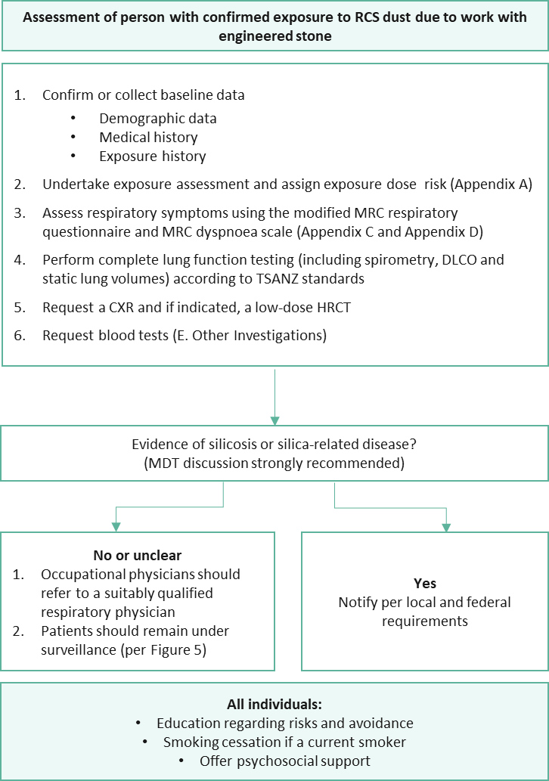
carbon monoxide diffusing capacitycarbon monoxide diffusing capacity
carbon monoxide diffusing capacitycarbon monoxide diffusing capacity
Figure 4 Overview of assessment of a person exposed to RCS dust due to work with engineered stone
Abbreviations: CXR, chest x-ray; DLCO, carbon monoxide diffusing capacity; MDT, multidisciplinary team; MRC, Medical Research Council; RCS, respirable crystalline silica; TSANZ, Thoracic Society of Australia and New Zealand

B. Exposure stratification
Key practice points
- Complete the exposure risk matrix (per Appendix A). If you do not have the appropriate experience, refer the person to a more suitably qualified respiratory or occupational physician
- With informed consent, the suitably qualified medical practitioner or medical practitioner responsible for health monitoring undertaking the exposure risk assessment has a professional obligation to advise the GP of the outcome
Given the nature of occupational respiratory diseases, the exposure risk matrix should only be carried out by suitably qualified medical practitioners who have the experience and resources to do so. If you have the appropriate experience, use the exposure risk matrix (per Appendix A) for the stratification of a person’s exposure risk. The purpose of the risk matrix is to help guide the clinical selection and frequency of strategies for ongoing surveillance.
All people who have been exposed to RCS dust due to work with engineered stone over their working lifetime should have their exposure risk determined. Rarely, a worker may be exposed to very intense short-term exposure in a workplace which triggers disease years later.
With informed consent, the medical practitioner or medical practitioner responsible for health monitoring undertaking the exposure risk matrix has a professional obligation to advise the GP of the outcome.

C. Lung function stratification
Key practice points
- All individuals exposed to RCS dust due to work with engineered stone must be referred to a respiratory laboratory that meets TSANZ accreditation standards for baseline lung function testing, including spirometry, DLCO and static lung volumes as early as possible in their working life
- Monitoring with spirometry in the primary care setting should be performed to international standards (63) at least annually, and six monthly in those classed as high or very high-risk (per Appendix A)
- Primary care practices using spirometry for the purpose of monitoring occupational exposures must be able to report spirometry outcomes using the Global Lung Function Initiative (GLI) spirometry equations as per Australian and international guidelines (63-65)
- The following thresholds require review and/or referral to a respiratory and/or occupational physician as appropriate to the persons clinical findings and occupational history:
- absolute FEV1 or FEV1/FVC ratio less than the lower limit of the normal (LLN) derived from the GLI Spirometry equations (65) requires consideration for further assessment and bronchodilator responsiveness testing; or
- FVC less than the LLN derived from the GLI Spirometry equations (65) requires consideration for further assessment and a referral for complex lung function testing; or
- Changes in FEV1 or FVC, expressed in GLI percent predicted, declines by >10% but ≤15% from baseline test over any period requires consideration for further assessment and bronchodilator responsiveness testing (see Appendix E for a worked example); or
- Changes in FEV1 or FVC, expressed in GLI percent predicted, declines by >15% over any period requires a referral to a respiratory physician (see Appendix E for a worked example)

Further assessment as determined by the referring doctor may include repeat pre- and post-bronchodilator spirometry, complex lung function testing, other investigations or potentially referral to an occupational and/or respiratory physician depending on the clinical context for that individual
When there is genuine concern created by significant RCS dust exposure, missing a person with early disease at a time when intervention might make a substantial difference to their health and wellbeing, is untenable. However, there is understandable concern about the problem of false positive and false negative findings should over-zealous or too insensitive action thresholds be identified. There is an absolute need for robust protocols when the pre-test probability of a false positive result is higher than desirable.
The intrinsic advantage of using serial GLI (63-65) percentage of predicted values (which incorporate adjustments for the person’s age, height, gender and ethnicity) is well established (66). There is clear international agreement that when a person manifests changes in FEV1 or FVC, expressed in GLI percent predicted, declines by >15% over any period, then the person needs to be assessed by a respiratory physician.
Published position statements by ACOEM (67) and ATS (66) highlight the concerns that exist when there is >10% decline in predicted lung function from baseline. Redlich, Tarlo (66) discussed the uncertainties underpinning the 15% threshold and indicated that “action levels” which “trigger further evaluation, need to be established” when dealing with defined populations. ACOEM’s 2020 statement, reviewing the evolving body of evidence since the ATS 2014 statement, states “declines of 10% to 15% may indicate a problem”. This is consistent with the unpublished case-based experience reported to the National Dust Diseases Taskforce (2019-2021).
Performing health surveillance of workers, defined by their detailed exposure history assessed in accordance with this guidance, is likely to result in improved pre-test probability that a positive test result is real, i.e. the likelihood of a false positive test result is reduced. More research is desirable, and the National Occupational Respiratory Disease Registry will greatly assist with the accumulation of relevant data.
Two levels of lung function testing are used for respiratory health surveillance in this National Guidance:
- screening pre-bronchodilator and when indicated, post-bronchodilator spirometry performed to the internationally accepted standards described by TSANZ. Screening spirometry can be enhanced by the addition of tests of diffusion capacity when available.
- complex lung function testing which extends simple spirometry to include tests of diffusion capacity and lung volumes.
However, there can be significant intra-individual between test variation (63, 66) that must be considered when using spirometry and complex lung function tests to monitor the health of a worker over time. This intra-individual variation is best addressed by ‘repeat testing’. The positive predictive value of the repeat test vastly improves the reliability the test finding. Combining the repeat test absolute values with the GLI predicted values for a given gender, height and ethnicity (65, 68, 69), enables the robust adjustment for the change in age associated with the serial analysis of data.
The more tests imputed into any longitudinal trend analysis, the more reliable the ‘line of best fit’ calculated by linear regression and hence the rate of decline obtained. For both spirometry and complex lung function testing, when only two values sets are available, and less than 4 years have elapsed, uncertainty can remain high. An advantage of repeat complex lung function test results is that it offers more parameters to assess the intrinsic within-test reliability of any abnormal finding.

Complex lung function testing
Complex lung function testing is recommended for all workers exposed to RCS dust due to work with engineered stone (ideally at the commencement of their first employed or contracted role). Testing should include the standardised measurement of FEV1, FVC and the FEV1/FVC ratio together with printouts or other permanent records of the flow-volume loops and volume time curves, pre and post bronchodilator, carbon monoxide diffusing capacity (DLCO) and lung volumes.
Complex lung function testing should ideally be performed by accredited personnel at an accredited laboratory. Results of these tests will be interpreted by a qualified respiratory specialist. Serial spirometry performed to international standards (63) can be used for ongoing health surveillance to detect lung function deterioration before the individual develops clinically significant or symptomatic disease. When indicated, post-bronchodilator spirometry is less susceptible to intra-individual ‘normal’ variation (60). When concern arise, repeat complex lung function testing is recommended.
Findings of spirometry testing in patients with silicosis may range between normal values and obstructive or restrictive patterns with marked decreases in FEV1 and/or FVC. Observational studies in large series of patients have shown that loss of lung function with reduced FEV1 and/or FVC is associated with the magnitude of exposure, extent of radiological lesions and history of tuberculosis. It is strongly recommended that tracking software such as SPIROLA is used to facilitate monitoring and appropriate interpretation of changes in a patient’s condition and/or lung function overtime (70). Such programs can utilise standardised LLN reference values and linear regression modelling to more reliably assess for change (66).
Unless there is an established explanation, the recommended action thresholds for spirometry results as appropriate to the persons clinical findings and occupational history are presented in Table 2 .
If spirometry is abnormal, ensure that temporary reasons for this have been excluded (e.g. upper respiratory tract infection, reversible obstruction). Repeat spirometry including post-bronchodilator values and check for other reasons (60), including outdated predictive values.

Table 2 Recommended spirometry action thresholds
Measurement | Description | Result | Action to take
Absolute FEV1 | Reduced in individuals with airway obstruction¹ | Normal: >LLN derived from the GLI Spirometry equations (65) | Repeat at least annually and six monthly in those classed as high or very high-risk (per Appendix A)
Absolute FEV1 | Reduced in individuals with airway obstruction¹ | Abnormal: <LLN | Perform bronchodilator responsiveness testing. Consider further assessments²
FEV1/FVC ratio | Indicative of obstructive lung function¹ | Normal: >LLN derived from the GLI Spirometry equations (65) | Repeat at least annually and six monthly in those classed as high or very high-risk (per Appendix A)
FEV1/FVC ratio | Indicative of obstructive lung function¹ | Abnormal: <LLN | Perform bronchodilator responsiveness testing. Consider further assessments²
FVC | Suggestive of restrictive lung disease – pleural alveolar interstitial neuromuscular thoracic (PAINT) | Normal: >LLN derived from the GLI Spirometry equations (65) | Repeat at least annually and six monthly in those classed as high or very high-risk (per Appendix A)
FVC |  | Abnormal: <LLN | Refer for complex lung function testing. Consider further assessments²
Bronchodilator responsiveness testing for spirometry | Reduces intra-individual variation | Positive response: Change in FEV1 and/or FVC <12% AND 200 mL | If indicated repeat at least annually
Bronchodilator responsiveness testing for spirometry | Screens for reversible obstruction (suggestive of asthma) | Clinically relevant bronchodilator response defined as change in FEV1 and/or FVC >12% and 200 mL AND post bronchodilator FEV1/FVC >LLN | Suggestive of asthma – consider other clinical symptoms and signs and manage as per relevant guidelines
Bronchodilator responsiveness testing for spirometry | Non-reversible obstruction indicative of COPD | Post bronchodilator FEV1/FVC <LLN irrespective of the presence of a clinically relevant bronchodilator response (as above) | Suggestive of COPD – consider other clinical symptoms and signs and manage as per relevant guidelines
Serial metrics | Progressive disease (66, 67) | Normal: Changes in FEV1 or FVC, expressed in GLI percent predicted, declines by ≤10% from baseline test over any period | Repeat at least annually and six monthly in those classed as high or very high-risk (per Appendix A)
Serial metrics | Progressive disease (66, 67) | Borderline change of concern: Changes in FEV1 or FVC, expressed in GLI percent predicted, declines by >10% but ≤15% from baseline test over any period | Perform bronchodilator responsiveness testing. Consider further assessments²
Serial metrics | Progressive disease (66, 67) | Abnormal decline: Changes in FEV1 or FVC, expressed in GLI percent predicted, declines by >15% over any period | Refer to respiratory physician
Abbreviations: COPD, chronic obstructive pulmonary disease; FEV1, forced expiratory volume in one second; FVC, forced vital capacity; GLI, Global Lung Function Initiative; GOLD, Global Initiative for Chronic Obstructive Lung Disease; ILD, Interstitial lung disease; LLN, lower limit of the normal
1. Changes in FEV1 and FEV1/FVC are indicative of obstructive lung disease and are not specific to the casual disease (for example asthma, COPD, silicosis or other occupational lung diseases). Findings should be considered in the context of other clinical information.
2. Further assessment as determined by the referring medical practitioner may include repeat pre- and post-bronchodilator spirometry, complex lung function testing, other investigations or potentially referral to an occupational and/or respiratory medical practitioner depending on the clinical context for that individual.
3. Refer to Appendix E for a worked example on the calculation of changes in spirometry over time of changes in spirometry over time.

D. Diagnostic imaging
Key practice points
- All people exposed to RCS dust due to work with engineered stone should undergo a CXR performed and reported to ILO standards to meet current statutory requirements. ILO classification of a CXR itself should NOT be used to exclude a diagnosis of silicosis or limit access to statutory entitlements
Note: In Western Australia low-dose HRCT scans are required instead of a CXR
- Request a low-dose HRCT for one or more of the following reasons:
- the individual has had high or very high exposure to RCS dust as calculated or estimated in the exposure risk matrix (per Appendix A); or
- significant respiratory or other symptoms; or
- any spirometry or DLCO findings that falls below the GLI LLN; or
- an ILO CXR >0/1; or
- other CXR findings suggestive of silica-related disease (e.g. lymph node enlargement, hyperinflation and/or pleural changes)
- Because CXR is relatively insensitive in early diagnosis, consider a low-dose HRCT when exposure history, symptomatology or lung function testing is suggestive of the need for further investigations, even if the ILO CXR <1/0
- Consider a multidisciplinary team (MDT) review of clinical and imaging findings, including the low-dose HRCT results, if there is any diagnostic uncertainty
Specialist radiologist with expertise in chest CT
- Perform the HRCT using a radiation dose as low as reasonably achievable (ALARA principle)
- The low-dose HRCT should be supervised and reported by a specialist radiologist with appropriate qualifications and/or recognition and credentialling through RANZCR

When should a low-dose HRCT scan be requested?
A low-dose HRCT is clinically indicated for one or more of the following:
- the individual has been deemed to have had a high or very high exposure as calculated or estimated in the exposure risk matrix (see B. Exposure stratification); or
- the individual has been identified to have significant respiratory, other symptoms or examination signs; or
- the individual has either spirometry or DLCO findings that falls below the GLI LLN; or
- the individual has had an ILO CXR >0/1; or
- other CXR findings suggestive of silica-related disease (e.g. lymph node enlargement, hyperinflation and/or pleural changes).
All chest CTs currently performed in Australia are effectively “high-resolution” compared with early versions of the technology. However, the abbreviation of HRCT often carries a residual belief that HR also means high dose and the acronym means different settings for different indications. The HRCT should be a non-contrast low-dose HRCT scan including supine inspiratory and supine expiratory acquisitions. Thin slice images must be available for interpretation and it is recommended to reconstruct maximum intensity projection images and coronal images.
The low-dose HRCT should be performed using a radiation dose ALARA to produce the diagnostic quality imaging necessary for serial assessment. The administered radiation dose should be reported. The low-dose HRCT should be reported by a specialist radiologist with appropriate qualifications and/or recognition and credentialling through RANZCR. The specialist radiologist reporting on low-dose HRCTs should also be reporting other cases of interstitial lung disease (ILD), have demonstrable expertise and currency of practice in this area, have demonstrable ongoing continual professional development (CPD) in this area and regularly contribute to MDT meetings dedicated to ILD.
It is recommended that any diagnostic uncertainty on the low-dose HRCT interpretation or other aspects of disease diagnosis, be discussed by an MDT approach on a case-by-case basis. Refer to the RANZCR silicosis position statement (2019) for further guidance in relation to the approach to the probability of silicosis and other occupational lung diseases being present on imaging investigation (71).

When should a CXR be requested?
Historically CXR’s were the primary imaging modality used to detect early or accelerated lung disease due to silica exposure. Evidence that low-dose HRCT performs better than CXR as the first line investigation in a screening setting is not currently available in workers exposed to RCS dust due to work with engineered stone in Australia. It is anticipated that research data will become available in 2022.
A preliminary review of the data from Australian centres caring for workers with engineered stone related disease has found that CXRs are failing to reliably detect early or accelerated disease. In one cohort of Queensland workers 43% with a normal CXR had early disease visible on low-dose HRCT. In the same cohort, bilateral PMF opacities were only visible on CXR in 64% of workers with this finding on the low-dose HRCT. A range of interstitial lung abnormalities have also been identified on low-dose HRCTs in workers in the engineered stone industry, including subtle findings such as small ground glass attenuation nodules that must be distinguished from other possible causes (72).
Although only preliminary data is available, low-dose HRCT is currently the preferred radiological modality in the diagnosis of silicosis as it lowers the risk associated with potentially false negative CXR for the accelerated form of the disease. However, because of the risk of false positives with the use of low-dose HRCT in a screening context, it is not currently recommended as a frontline screening modality in those who do not meet eligibility criteria that would otherwise warrant immediate investigation for diagnostic purposes. The need for a chest CT is based on the individual’s risk stratification. Emerging evidence on the utility of low-dose HRCT as a screening tool may change this recommendation.
Despite CXR lacking sensitivity and not being able to characterise disease as accurately as a low-dose HRCT, a baseline CXR is recommended in all cases, and may still be needed to meet some jurisdictional requirements for the foreseeable future. In selected cases a CXR can be used as an alternative or in conjunction to low-dose HRCT for ongoing follow up in low-risk settings. The ILO has guidelines for the classification of radiographs of pneumoconiosis that were developed to standardise classification of lung opacities and reduce inter-reader variability.
Historically, all patients with a 0/0, 0/- or 0/1 CXR were classified as screening negative on initial radiological screening. However, because of the possibility for true positive cases to be occult on CXR, CXRs serve only as a preliminary assessment tool to be used in conjunction with results of lung function testing, symptomology, exposure history and a low-dose HRCT.
As outlined above, further radiology in the form of a low-dose HRCT must be considered where lung function testing, symptomology or exposure history is suggestive of the need for further investigations, even if the ILO classification is less than 1/0. Additionally, other findings identified in the ILO report format (which do not contribute to the ILO score) such as pleural changes and nodal enlargement are also indicative of silica-related changes.

What imaging expertise is required?
Radiologists reporting silicosis should have experience in thoracic imaging including the imaging of ILD, be proficient in the use of the ILO CXR reporting system (61) and the International Classiﬁcation of low-dose HRCT for Occupational and Environmental Respiratory Diseases (ICOERD) (31). While the ILO accreditation in CXR reading is acknowledged in its historical application to the reporting of occupational lung disease, “B-Reader status” is not recommended by the RANZCR as a mandatory requirement for radiologists reporting a CXR or low-dose HRCT in Australia. Radiologists reporting a CXR or low-dose HRCT for occupational lung disease should, however, be regularly reporting for other ILDs and undergo demonstratable CPD in this area.
Radiologists reporting a low-dose HRCT for occupational ILD should also participate in ILD-MDT meeting at established ILD sites (or an equivalent review group).

E. Other investigations
Key practice points
- All people exposed to RCS dust due to work with engineered stone should at a minimum have a full blood count, biochemistry analysis including electrolytes, liver function and creatinine, c-reactive protein test and an autoimmune screen including extractable nuclear antigen (ENA), antinuclear antibodies (ANA), myositis antibodies, anti-cyclic citrullinated peptide (CCP) antibodies, rheumatoid factor, anti-double stranded deoxyribonucleic acid (anti-dsDNA), topoisomerase 1 (Scl70), RNAP (anti-RNA polymerase III) and antineutrophil cytoplasmic antibodies (ANCA) at baseline.
- If clinically indicated, order an interferon-gamma release assay test for latent or active tuberculosis. Further investigations will depend on the individual’s clinical course
All people exposed to RCS dust due to work with engineered stone should at a minimum have the following tests to exclude other diagnoses:
- full blood count
- biochemistry analysis including electrolytes, liver function tests and creatinine
- autoimmune screen including ENA and ANA, myositis antibodies, anti-CCP antibodies, rheumatoid factor, anti-dsDNA and ANCA
- c-reactive protein
Interferon-gamma release assays may also be indicated in diagnosing mycobacterium tuberculosis infection for individuals born overseas or those who are clinically deemed to be at-risk of developing latent or active tuberculosis. This possibility should be considered in any worker with long-term exposure to RCS dust due to work with engineered stone.
People exposed to RCS dust have a higher-than-average population risk of developing emphysema, lung cancer, pleural thickening, interstitial pulmonary fibrosis and occupational bronchitis. They also have a higher risk of developing rheumatological, immunological and connective tissue disorders. Referral along an appropriate treatment pathway will depend on the spirometry results, imaging findings, test results and symptomology.
Additionally, other pathologies may present on chest imaging which are unrelated to the occupational respiratory exposure, e.g. cardiac pathology, lung infection and inflammatory processes and skeletal disorders. Identification of these other diseases should prompt appropriate history taking, further investigation and treatment outside this National Guidance. Consistent with standard professional practice, any Incidental medical finding that might be significant to the general wellbeing of the worker’s health and wellbeing should generate a ‘duty of care’ referral letter to the examinee’s treating practitioner.

3. When should psychosocial support and education to prevent disease or disease progression be provided? (GPs, respiratory or occupational physicians)
Key practice points
- Offer socially and culturally appropriate psychological support to people diagnosed with silicosis and all workers currently working with or who have previously worked with engineered stone
- As smoking has been shown to increase the carcinogenic potential of RCS dust, encourage and support all people diagnosed with silicosis and all workers currently working with or who have previously worked with engineered stone to stop smoking and/or vaping. See the RACGP supporting smoking cessation: a guide for health professionals
- Educate and reinforce safe behaviours at each visit for all workers currently working with engineered stone. Examples of important topics to be covered include:
- safe work practices. For more detail see the model Code of Practice: Managing the risks of respirable crystalline silica when working with engineered stone which provides further information on the duties of PCBUs
- the possible adverse health effects related to exposure
- the importance of personal hygiene and cleanliness
- correctly using PPE
- fit checking and fit testing for effective respiratory protection
- being clean-shaven if negative-pressure respirators or if respiratory protective equipment that requires fit testing is used
- Use the shared decision-making tool (see Appendix B) with patients who have been diagnosed with silicosis or overly concerned about silicosis to discuss options on how to respond to the psychosocial impact of RCS dust exposure
- Continue to support workers who choose to keep working with engineered stone after discussing if:
- the worker is able to carry out optimal safe systems of work; and
- their clinical state is able to be monitored more frequently (e.g. 4-monthly instead of 6-monthly); and
- adequate control measures are operational and there is evidence of compliance with the WES; and
- return to work is supported by their PCBU and the worker’s compensation insurer

Upon diagnosis, it can be difficult for a person to process the fact that it may be their current workplace that is causing them harm. It is suggested that the workplace be independently assessed. The pathway for assessment is dependent on the injury claim setting. Be certain before expressing an opinion that the current workplace is causing the worker harm. This is particularly important if the person has normal complex lung function (FEV1 and/or FVC and DLCO) and is clinically asymptomatic or minimally symptomatic.
When encountering an individual who has been recently diagnosed, an individualised, patient-centred, shared decision-making approach is highly recommended. Use the shared decision-making tool available in Appendix B to assist workers to make an informed decision on options to minimise further RCS dust exposure.
The shared decision-making tool will assist workers to begin thinking about their next steps if they have been diagnosed with silicosis, facilitating consideration of the benefits and potential harms of stopping or continuing work. The tool also provides several questions for the person to consider and ask their medical practitioner to assist them in making a decision.
Given the nature of occupational respiratory diseases, the person should be provided with the socially and culturally appropriate support to make an informed decision. The specialist medical practitioner establishing the diagnosis may not be the treating specialist. If the GP does not have the appropriate experience or expertise, referral to a treating occupational physician or respiratory physician should be actioned. If the worker is medically able to remain at their place of employment, ongoing health monitoring can be provided by their employer. Consequently, the medical practitioner supervising the health monitoring can also be engaged.
The goal of the shared decision-making tool is to enable the person and their primary supports to be involved in the decision-making
Supporting a worker’s return to work while their clinical state and rate of progression is closely monitored can be considered if:
- their clinical state is able to be monitored more frequently – i.e. four instead of six monthly; and
- adequate control measures are operational and compliance with WES is evident; and
- your patient can comply with optimal safe systems of work; and
- return to work is supported by their PCBU and the workplace compensation insurer.
For all workers continuing in the workplace, individually targeted advice should be provided by a suitably qualified medical practitioner at the time of each health surveillance encounter. Such encounters should remind and reinforce safe work practices and optimal respiratory health. The consequences of exposure should also be repeatedly highlighted.
All persons diagnosed with silicosis and workers currently working or who have previously worked with engineered stone should be encouraged to quit smoking. See the RACGP Supporting smoking cessation: a guide for health professionals (49).
Examples of other important topics to be covered include (73):
- safe work practices. For more detail see the model Code of Practice: Managing the risks of respirable crystalline silica when working with engineered stone which provides further information on the duties of PCBUs.
- the possible adverse health effects related to exposure.
- fit checking and fit testing for effective respiratory protection.
- following protocols to correctly put on and off PPE as well as maintain and store PPE and clothing.
- being clean-shaven if negative-pressure respirators or if respiratory protective equipment that requires fit testing is used.
- the importance of personal hygiene and cleanliness, including:
- washing face and hands before eating, drinking, smoking and chewing gum
- not eating, drinking or smoking in the workshop
- showering and changing into clean clothes and footwear before leaving the workplace. dusty clothing should remain at work to be cleaned or put into airtight containers for transport to be cleaned
- parking vehicles out of any dust plume
- not taking the dust home.

Ongoing health surveillance

4. When should health surveillance be carried out?
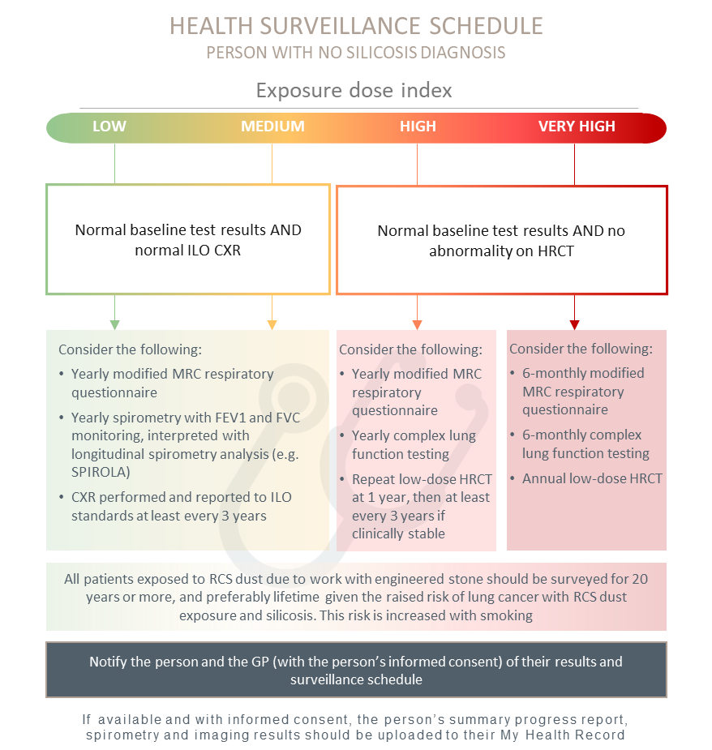
Figure 5 Health surveillance schedule for people who have no diagnosis of silicosis at baseline
Abbreviations: CXR, chest x-ray; FEV1, forced expiratory volume in one second; FVC, forced vital capacity; HRCT, high-resolution computed tomography; ILO, International Labour Organization; MRC, Medical Research Council; RCS, respirable crystalline silica; SPIROLA, Spirometry Longitudinal Data Analysis
Note: The timeframes for further review based on exposed dose are a recommendation only. Timeframes should be adjusted based on the medical practitioner’s clinical judgement and consideration of individual circumstances including their past and/or continued exposure to RCS dust, history of tobacco and/or other substance use. See the Safe Work Australia “Crystalline Silica Health Monitoring Guide” (56) for additional guidance for people who remain working in the industry. See The National Institute for Occupational Safety and Health for further information on SPIROLA (74)
Key practice points
- For people who have not been diagnosed with silicosis at baseline, the recommended surveillance schedule (per Figure 5) should be followed
- For people with low to very high-risk of exposure to RCS dust due to work with engineered stone, expert consensus suggests surveillance is required for 20 years or more, and preferably lifetime given the raised risk of lung cancer with RCS dust exposure and silicosis. This risk is increased with smoking
The clinical utility of health surveillance activity should ideally be associated with predictive modelling reflecting the case mix of the population in which it is to be used, the prevalence of outcomes of interest and the population from which it was derived. In the absence of robust modelling, the National Guidance is based on expert consensus informed by analogy and modelling in associated domains. Ge, Peters (75) have demonstrated the robust exposure-response relationship regardless of smoking, silicosis status and cancer subtype. It is anticipated the refinements to these recommendations will emerge once sufficient data has been collected and analysed from the Registry.
Given the latency period of silicosis for people with low-risk of exposure and its clear carcinogenic potential it is suggested that individuals have ongoing health surveillance for 20 years or more, and preferably over the course of their lifetime given the raised risk of lung cancer with RCS dust exposure and silicosis (76). If they are a current or former smoker this risk is increased. With the multiplicative effect demonstrated by Ge, Peters (75), their potential increased cancer risk means their surveillance should continue indefinitely. The optimal intervals and duration of surveillance will continue to be informed by ongoing research and updated as required.
An annual respiratory review reminds the worker of the risks associated with their work and brings to consciousness the strategies necessary to keep them safe, for example fit checking and fit testing for those workers needing negative-pressure respiratory protection.
The timeframe for periodic follow up will be adjusted based on an exposure assessment, consideration of the person’s individual circumstances including their past and/or continued exposure to RCS dust and their level of risk determined at any one time.
Individuals, or a treating practitioner on their behalf, may request an earlier health surveillance review if there is concern about the development of respiratory symptoms including persistent cough, breathlessness or chest pains.

Principles or guidance applied
The following have been applied in developing the surveillance schedule:
- There is a critical need to understand the nature and rate of progression of silica-related diseases in its first detectable forms.
- Understanding the clinical course of the pathology at its earliest detectable state, provides the greatest opportunity for meaningful clinical intervention.
- Baldwin and Callister (77) British Thoracic Society guidelines for the investigation and management of small pulmonary nodules provides robust evidence-based recommendations and includes:
- Reassessing all sub-solid nodules (SSN) with a repeat thin-section (maximum thickness of 1.25 mm) CT at 3 months with maximum intensity projection or volume rendering to improve nodule detection and characterisation.
- For nodules <300 mm³ or 8 mm diameter, CT follow up is indicated and the presence of multiple nodules only had a small negative effect on the likelihood of malignancy developing in any one nodule. Consequently, nodule management can be determined by the largest nodule when more than one nodule is present.
- Part-solid nodules that show enlargement of the solid component, or for pure ground glass nodules (pGGNs) that develop a solid component or enlarge ≥2 mm in maximum diameter require further assessment.
- Repeat low-dose, thin-section CT at 1, 2 and 4 years from baseline is appropriate where the risk of malignancy is approximately <10%.
Further clinical insight has been derived from observations of the 229 cases with silicosis and 32 cases with PMF identified to 31 May 2021 from Queensland Government’s screening of 1,053 engineered stone workers (78). The screening program commenced in September 2018, and therefore increasing numbers are transitioning through a workers’ compensation two-year statutory entitlement assessment of ‘permanent impairment’. At this time, peer reviewed pooled data analysis is not available, consequently the evidence is limited to personal observation and expert discussions associated with ILD-MDT case presentations.
This experience has been recently complemented by the Phase I report of the more rigorous pooled data analysis of workers participating in WorkSafe Victoria’s stone benchtop worker screening program undertaken by Monash University since May 2019 (79). This program has identified 133 cases of silicosis (29% with 31 diagnosed with complicated silicosis) from 456 workers to July 2020. Phase II of this program continues. The more detailed analysis of first 12 months of observations from 239 workers which included 86 workers with silicosis, and 21 with complicated forms of the disease, was published online in March 2021 (80).
A consensus clinical impression, not yet verified by the data, is that if an individual is more likely to rapidly progress, they will demonstrate that progression within the first 12 months of surveillance from first diagnosis. Consequently, the schedule has been structured applying a precautionary approach to detect as early as possible those individuals that may progress in a non-linear pattern. There is a greater frequency of interaction that diminishes with evidence of stability.

Routine surveillance
Routine surveillance for disease progression in people who meet the diagnostic criteria of any ILD is presented in Table 3. The criteria has been modified from Cottin (81) and includes the assessment and progression of nodules.
Table 3 Criteria used in clinical practice to assess disease progression in fibrotic ILD
Lung function | - <LLN derived from the relevant GLI lung function reference equations (see Table 2)  - Absolute or relative changes in FEV1 or FVC (GLI percent predicted)
Symptoms and patient- reported outcomes | - Change in symptoms  - Change in everyday life exercise capacity  - Modified MRC Respiratory Questionnaire monitoring shortness of breath, cough and quality of life
Acute worsening (defined) | - Acute exacerbation of fibrosis (idiopathic or triggered)  - Non-elective hospitalisation associated to a respiratory cause
Low-dose HRCT | - Change in extent or texture of features on low-dose HRCT:  - Change in solid nodule size (largest cross-sectional measurement or volumetry)  - Change in SSN
Need for supportive care | - Availability of social and emotional supports  - Initiation of ambulatory oxygen therapy at exercise  - Initiation of supplemental oxygen therapy at rest or change in flow of oxygen
Exercise capacity | - Absolute change in six-minute walking test distance  - Change in oxygen saturation nadir during six-minute walking test  - Change in maximal exercise capacity
Serum biomarkers | - None validated  - Not yet applicable in clinical practice
Source: Modified from Cottin (81)
Abbreviations: DLCO, carbon monoxide diffusing capacity; FEV1, forced expiratory volume in one second; FVC, forced vital capacity; GLI, Global Lung Function Initiative; HRCT, high-resolution computerised tomography; MRC, Medical Research Council; SSN, sub-solid nodules
Until further intelligence is known, a surveillance schedule represents a considered balance of:
- the years and pattern of exposure; and
- the anticipated prevalence of the respiratory diseases associated with RCS dust; and
- the possible patterns and rate of progression; and
- the sensitivity and accessibility of the surveillance activity; and
- predictions of future exposure to RCS dust.

5. Who carries out ongoing health surveillance?
Key practice points
- If the person is in an at-risk industry, the GP should maintain awareness of the results of their patient’s ongoing health monitoring program
- If the person leaves an at-risk industry, the GP assumes the lead role to carry out ongoing health surveillance. The GP should receive support from any respiratory or occupational physician involved in the person’s care. With informed consent, the medical practitioner previously responsible for health monitoring can share care plans and communicate with any treating medical practitioner involved in the worker’s continued health and wellbeing
- All people should continue to monitor their symptoms. If they have relevant concerns, they should contact their GP or other suitably qualified medical practitioner involved in their care
The medical practitioner responsible for health monitoring will carry out or supervise any health monitoring activity for as long as they are engaged by the PCBU to do so. If the person leaves an at-risk industry, ongoing health surveillance should be carried out by the person’s GP. The GP should continue to be supported by any respiratory or occupational physician involved in the person’s care. The nature of the follow-up, however, will depend on the person’s:
- disease status; or
- personal circumstances; or
- work status.
It is recommended that the contact details of the medical practitioner responsible for health monitoring of a worksite should be available to other medical practitioners and maintained by a responsible regulator. With the person’s consent, a GP is then able to contact the relevant medical practitioner responsible for health monitoring for additional information if needed.
The workers’ compensation insurer may be responsible for the costs associated with the assessment of an occupational illness or disease. If the GP becomes concerned about a possible RCS dust related disease developing over the course of health surveillance, they should follow their usual referral procedures to either a respiratory or occupational physician and issue an associated worker’s compensation certificate indicating “known occupational silica dust exposure requires specialist assessment”. If known, the referral should identify the case reference number if the person was involved in any historic health screening activity.
Issuing a worker’s compensation certificate is associated with an escalation of the health surveillance activity. This enables case identification independent of any current employment status.

6. What are the notification requirements?
Key practice points
- A summary of findings, management plan and a background description of the scheme should be provided to the person, and with informed consent to their GP and the medical practitioner responsible for health monitoring. If available and with informed consent, such information should be uploaded onto the person’s My Health Record
- Notify the local registry (if available) about all cases of silica-associated disease or follow the requirements for your state or territory
- Once established, notify and submit up to date data to the National Occupational Respiratory Disease Registry (with informed consent) about all cases of silica-associated disease in Australia
With informed consent, professional ethics requires that any medical practitioner conducting health surveillance, if not the treating GP, provide a report to the worker, their GP and the supervising health monitoring medical practitioner for the worker’s PCBU (54).
In some states and territories, specialist medical practitioners who have diagnosed an individual with an occupational dust lung disease are obligated to notify their local authorities. Queensland, for example has established a Notifiable Dust Lung Disease Register (82). Medical practitioners in New South Wales must also notify New South Wales Health when they diagnose a case of silicosis (83).
In other states, such as Victoria, Monash University has been commissioned by WorkSafe Victoria to undertake research into assessment of silica-associated lung disease.
The National Occupational Respiratory Disease Registry is expected to be operational in late 2022. Once operational, silicosis is expected to be mandatory to notify and other occupationally caused respiratory diseases will be voluntary to notify.

Appendices

Appendix A: Exposure risk matrix
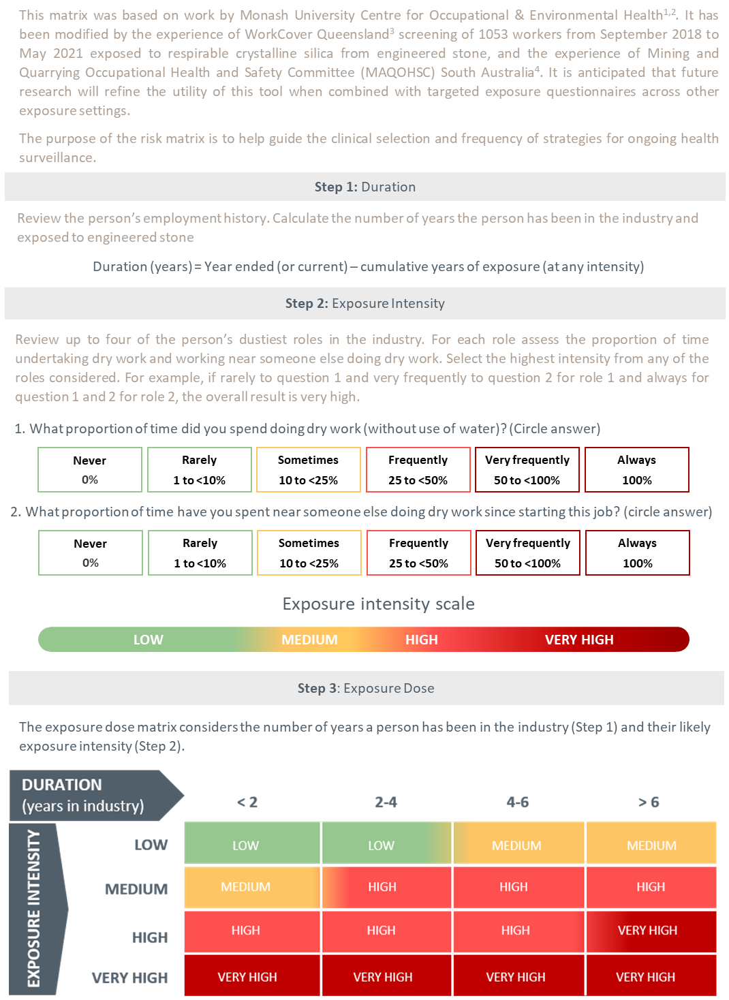
1. Monash University Centre for Occupational & Environmental Health (MonCOEH) (79); 2. Hoy, Glass (80); 3. WorkSafe Queensland Government (16); 4. Government of South Australia (84)

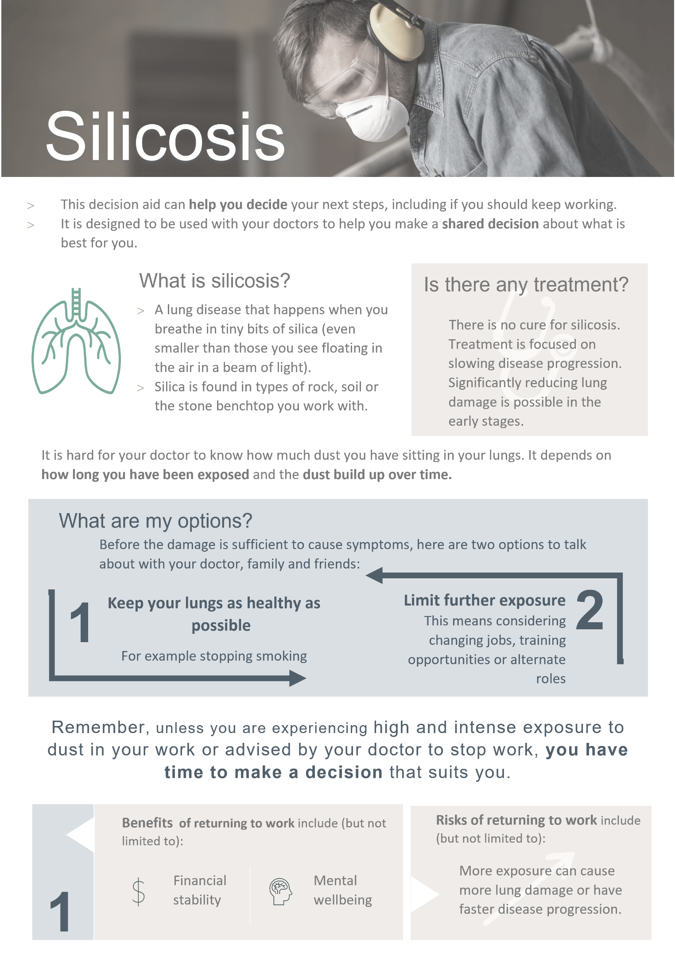
Appendix B: Shared decision-making tool for patients and medical practitioners
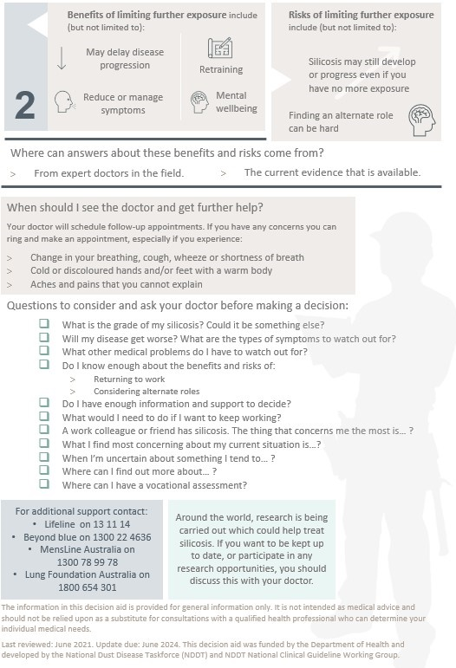

Appendix C: Modified MRC Respiratory Questionnaire
Source: Used with the permission of the Medical Research Council (59)
Note: Original has been re-typeset, with no changes
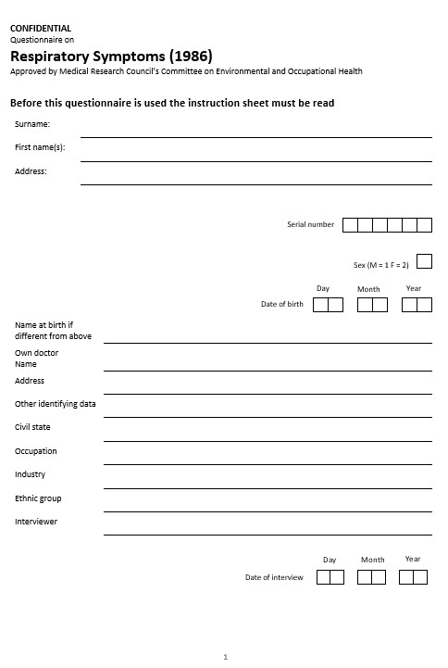

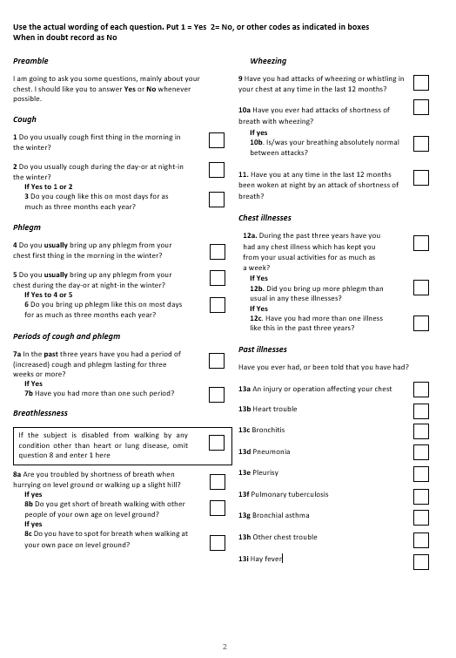

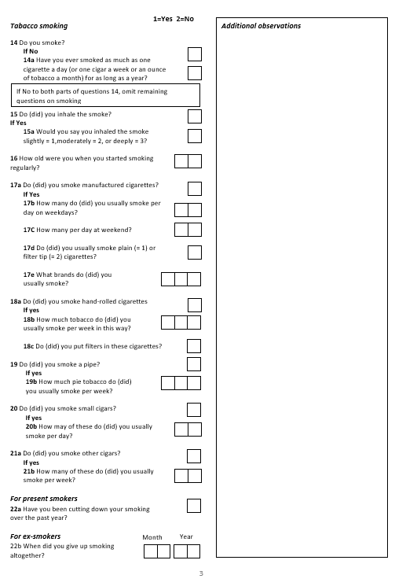

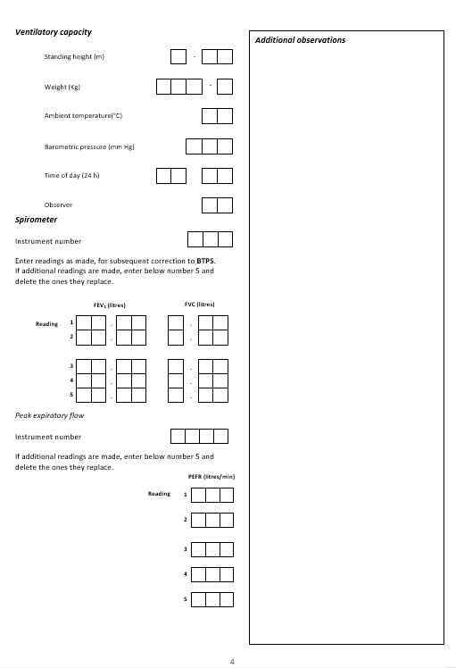

Appendix D: Modified MRC dyspnoea scale

Grade | 0 | “I only get breathless with strenuous exercise”
Grade | 1 | “I get short of breath when hurrying on the level or walking up a slight hill”
Grade | 2 | “I walk slower than people of the same age on the level because of breathlessness or have to stop for breath when walking at my own pace on the level”
Grade | 3 | “I stop for breath after walking about 100 yards or after a few minutes on the level”
Grade | 4 | “I am too breathless to leave the house” or “I am breathless when dressing”
Source: Doherty, Belfer (85)
Note: This is the modified MRC scale that uses the same descriptors as the original MRC scale in which the descriptors are numbered 1-5. The modified MRC scale (0-4) is used for calculation of BODE index.

Appendix E: Spirometry case study
The following worked example illustrates how to appropriately determine a change in spirometry over time in an individual. The use of appropriate alignment with robust predicted equations allows for changes with age to be accounted for. This example highlights that a significant decline in lung function can occur in individuals whose lung function remains within the normal range of the broader population.
A female worker, of Aboriginal ancestry, 170.5 cm tall enters the quarrying setting workforce at age 25.5 years. The Global Lung Function Initiative Spirometry ‘Other’ predictive equations are used as per Australian and New Zealand Society of Respiratory Science recommendations.
Her lung function on entering the workforce was:
- FEV1 3.48 L (103.1% predicted LLN = 2.74 L)
- FVC 3.94 L (100.8% predicted LLN = 3.16 L)
- FEV1/FVC 0.88 (101.7% predicted LLN = 0.762)
Her spirometry is within normal limits. She does not report taking any respiratory medications.
At age 30 years her respiratory health is reassessed. There are no reported symptoms, she does not report taking any respiratory medications and her lung function is:
- FEV1 3.31 L (95.1% predicted LLN = 2.65 L)
- FVC 3.87 L (99.4% predicted LLN = 3.15 L)
- FEV1/FVC 0.81 (95.2% predicted LLN = 0.750)
Her lung function remains within normal limits. Her change in FEV (% predicted) over the 5 year period is 8.0% (103.1% - 95.1%) and within acceptable limits.
At age 33.6 years she changes employers and undergoes a repeat assessment. She has no reported symptoms and does not report taking any respiratory medications. Her spirometry is:
- FEV1 2.85 L (87.6% predicted LLN = 2.599 L)
- FVC 3.79 L (98.0% predicted LLN = 3.131 L)
- FEV1/FVC 0.75 (81.9% predicted LLN = 0.741)
Her spirometry is within normal limits. Her change in lung function since entering the quarrying sector workforce at age 25 years is 15.5% (103.1% 87.6% – after adjusting for age related changes by using the GLI predicted equations). Based on the recommendations (above) her age related longitudinal decline over the 8.1 years of employment exceeds 10.0%. She should be referred to a respiratory physician for further assessment.

References

1. Safe Work Australia. Crystalline silica and silicosis [cited 12 March 2021]. Available from: https://www.safeworkaustralia.gov.au/silica.
2. WorkSafe Victoria. [cited 7 July 2021]. Available from: https://www.worksafe.vic.gov.au/.
3. Government of Western Australia. [cited 12 July 2021]. Available from: https://www.commerce.wa.gov.au/worksafe/.
4. The International Occupational Hygiene Association (IOHA). What is occupational hygiene? [cited 20 May 2021]. Available from: https://www.ioha.net/about/occupational-hygiene/.
5. Safe Work Australia. Duties under work health and safety (WHS) laws 2021 [cited 7 July 2021]. Available from: https://www.safeworkaustralia.gov.au/law-and-regulation/duties-under-whs-laws.
6. Safe Work Australia. What is a person conducting a business or undertaking 2021 [cited 13 July 2021]. Available from: https://www.safeworkaustralia.gov.au/doc/what-person-conducting-business-or-undertaking.
7. SafeWork New South Wales Government. Crystalline silica [cited 12 July 2021]. Available from: https://www.safework.nsw.gov.au/hazards-a-z/hazardous-chemical/priority-chemicals/crystalline-silica.
8. Workplace Health and Safety Queensland. Managing respirable crystalline silica dust exposure in the stone benchtop industry: Code of practice 2019 [cited 7 July 2021]. Available from: https://www.worksafe.qld.gov.au/__data/assets/pdf_file/0013/32413/managing-respirable-crystalline-silica-dust-exposure-in-the-stone-benchtop-industry-code-of-practice-2019.pdf.
9. WorkSafe Victoria. Compliance code: Managing exposure to crystalline silica – engineered stone 2020 [cited 7 July 2021]. Available from: https://www.worksafe.vic.gov.au/resources/compliance-code-managing-exposure-crystalline-silica-engineered-stone.
10. Safe Work Australia. Managing the risks of respirable crystalline silica from engineered stone in the workplace: Code of Practice 2021 [cited 4 November 2021]. Available from: https://www.safeworkaustralia.gov.au/sites/default/files/2021-10/Model%20Code%20of%20Practice%20-%20Managing%20the%20risks%20of%20respirable%20crystalline%20silica%20from%20engineered%20stone%20in%20the%20workplace.pdf.
11. The Department of Health. National Dust Disease Taskforce 2021 [cited 3 March 2021]. Available from: https://www1.health.gov.au/internet/main/publishing.nsf/Content/ohp-nat-dust-disease-taskforce.htm?Open=&utm_source=health.gov.au&utm_medium=redirect&utm_campaign=digital_transformation&utm_content=dust.
12. Alif S, Glass D, Abramson M, Hoy R, AM MS. Occupational lung diseases in Australia.
13. Leso V, Fontana L, Romano R, Gervetti P, Iavicoli I. Artificial stone associated silicosis: A systematic review. International Journal of Environmental Research and Public Health. 2019;16(4).
14. Blanc PD, Annesi-Maesano I, Balmes JR, Cummings KJ, Fishwick D, Miedinger D, et al. The occupational burden of nonmalignant respiratory diseases. An official American Thoracic Society and European Respiratory Society statement. American Journal of Respiratory and Critical Care Medicine. 2019;199(11):1312-34.
15. Balakrishnan B, Mehta S, Ouellette D, Talavera F, Mosenifar Z, Varkey B, et al. Silicosis 2019 [cited 12 March 2021]. Available from: https://emedicine.medscape.com/article/302027-overview.
16. WorkSafe Queensland Government. Silicosis: Workcover screening outcomes 2020 [cited 12 March 2020]. Available from: https://www.worksafe.qld.gov.au/claims-and-insurance/work-related-injuries/types-of-injury-or-illness/work-related-respiratory-diseases/silicosis.
17. Occupational Safety and Health Administration (OSHA). Occupational exposure to respirable crystalline silica: Proposed rule. Federal Register 78 (177), FR Doc No: 2013-20997. 2013 [cited 1 November 2020]. Available from: https://www.osha.gov/pls/oshaweb/owadisp.show_document?p_table=FEDERAL_REGISTER&p_id=23900.
18. Rose C, King T, Hollingsworth H. Silicosis: UpToDate 2020 [cited 1 November 2020]. Available from: https://www.uptodate.com/contents/silicosis?search=silicosis&source=search_result&selectedTitle=1~27&usage_type=default&display_rank=1%22%20%5Cl%20%22H288865219%22.
19. Álvarez RF, González CM, Martínez AQ, Pérez JJB, Fernández LC, Fernández AP. Guidelines for the diagnosis and monitoring of silicosis. Archivos de Bronconeumología (English Edition). 2015;51(2):86-93.
20. National Institute for Occupational Safety and Health (NIOSH). Work-related lung disease surveillance report 2007 [cited 1 November 2020]. Available from: https://www.cdc.gov/niosh/docs/2008-143/pdfs/2008-143.pdf?id=10.26616/NIOSHPUB2008143a.
21. Merget R, Bauer T, Küpper HU, Philippou S, Bauer HD, Breitstadt R, et al. Health hazards due to the inhalation of amorphous silica. Archives of Toxicology. 2002;75(11-12):625-34.
22. Carrieri M, Guzzardo C, Farcas D, Cena LG. Characterization of silica exposure during manufacturing of artificial stone countertops. International Journal of Environmental Research and Public Health. 2020;17(12):4489.
23. Ophir N, Shai AB, Korenstein R, Kramer MR, Fireman E. Functional, inflammatory and interstitial impairment due to artificial stone dust ultrafine particles exposure. Occupational and Environmental Medicine. 2019;76(12):875-9.
24. Hoy RF, Chambers DC. Silica‐related diseases in the modern world. Allergy. 2020;75(11):2805-17.
25. Rimal B, Greenberg AK, Rom WN. Basic pathogenetic mechanisms in silicosis: current understanding. Current Opinion in Pulmonary Medicine. 2005;11(2):169-73.
26. Cohen R, Go L. November 9, personnel communications. DNRME industry workshop forum 2019.
27. Barnes H, Goh NS, Leong TL, Hoy R. Silica‐associated lung disease: An old‐world exposure in modern industries. Respirology. 2019;24(12):1165-75.
28. Aran D, Looney AP, Liu L, Wu E, Fong V, Hsu A, et al. Reference-based analysis of lung single-cell sequencing reveals a transitional profibrotic macrophage. Nature Immunology. 2019;20(2):163-72.
29. Perret JL, Miles S, Brims F, Newbigin K, Davidson M, Jersmann H, et al. Respiratory surveillance for coal mine dust and artificial stone exposed workers in Australia and New Zealand: A position statement from the Thoracic Society of Australia and New Zealand*. Respirology. 2020;25(11):1193-202.
30. Queensland Workers’ Compensation Regulatory Services. Returning workers with mine dust lung diseases to the workplace.n.d. [cited 18 January 2021]. Available from: https://www.worksafe.qld.gov.au/__data/assets/pdf_file/0029/88913/mine-dust-lung-disease-guidelines.pdf.
31. Kusaka Y, Hering KG, Parker JE. International classification of HRCT for occupational and environmental respiratory diseases: Springer; 2005.
32. León-Jiménez A, Hidalgo-Molina A, Conde-Sánchez MÁ, Pérez-Alonso A, Morales-Morales JM, García-Gámez EM, et al. Artificial stone silicosis. Chest. 2020;158(3):1060-8.
33. Antao VC, Petsonk EL, Sokolow LZ, Wolfe AL, Pinheiro GA, Hale JM, et al. Rapidly progressive coal workers' pneumoconiosis in the United States: geographic clustering and other factors. Occup Environ Med. 2005;62(10):670-4.
34. Almberg K, Go L, Yates D, Waite T, Cohen R. Silicosis return to work review: return to work and vocational rehabilitation support for workers suffering from silicosis. WorkSafe Queensland 2020.
35. Hertzberg VS, Rosenman KD, Reilly MJ, Rice CH. Effect of occupational silica exposure on pulmonary function. Chest. 2002;122(2):721-8.
36. Sircar K, Hnizdo E, Petsonk E, Attfield M. Decline in lung function and mortality: implications for medical monitoring. Occupational and Environmental Medicine. 2007;64(7):461-6.
37. Hnizdo E. Loss of lung function associated with exposure to silica dust and with smoking and its relation to disability and mortality in South African gold miners. Br J Ind Med. 1992;49(7):472-9.
38. Safe Work Australia. Guidance on the interpretation of workplace exposure standards for airborne contaminants 2013 [cited 23 November 2021]. Available from: https://www.safeworkaustralia.gov.au/system/files/documents/1705/guidance-interpretation-workplace-exposure-standards-airborne-contaminants-v2.pdf.
39. Carneiro AP, Barreto SM, Siqueira AL, Cavariani F, Forastiere F. Continued exposure to silica after diagnosis of silicosis in Brazilian gold miners. American Journal of Industrial Medicine. 2006;49(10):811-8.
40. Hessel PA, Sluis-Cremer GK, Hnizdo E, Faure MH, Thomas RG, Wiles FJ. Progression of slicosis in rlation to slica dust exposure. The Annals of Occupational Hygiene. 1988;32(inhaled_particles_VI):689-96.
41. Lee HS, Phoon WH, Ng TP. Radiological progression and its predictive risk factors in silicosis. Occupational and Environmental Medicine. 2001;58(7):467-71.
42. Almberg KS, Friedman LS, Rose CS, Go LH, Cohen RA. Progression of coal workers’ pneumoconiosis absent further exposure. Occupational and Environmental Medicine. 2020;77(11):748-51.
43. Dumavibhat N, Matsui T, Hoshino E, Rattanasiri S, Muntham D, Hirota R, et al. Radiographic progression of silicosis among Japanese tunnel workers in Kochi. Journal of Occupational Health. 2013:12-0258-OA.
44. Akgun M, Araz O, Ucar EY, Karaman A, Alper F, Gorguner M, et al. Silicosis appears inevitable among former denim sandblasters: a 4-year follow-up study. Chest. 2015;148(3):647-54.
45. Mohebbi I, Zubeyri T. Radiological progression and mortality among silica flour packers: a longitudinal study. Inhalation Toxicology. 2007;19(12):1011-7.
46. Taylor A, Cullinan P, Blanc P, Pickering A. Parkes' Occupational Lung Disorders, Fourth Edition. 2016: Chapter 18, 187-205.
47. Safe Work Australia. Health Monitoring Guidance - Crystalline Silica 2020 [cited 16 July 2021]. Available from: https://www.safeworkaustralia.gov.au/doc/health-monitoring-guidance-crystalline-silica-pdf-doc.
48. Cancer Australia. Risk factors for lung cancer: an overview of the evidence. Surry Hills, NSW: Cancer Australia; 2014.
49. Royal Australian College of General Practitioners (RACGP). Supporting smoking cessation: A guide for health professionals 2021 [cited 11 May 2021]. Available from: https://www.racgp.org.au/clinical-resources/clinical-guidelines/key-racgp-guidelines/view-all-racgp-guidelines/supporting-smoking-cessation.
50. Australian Commission on Safety and Quality in Healthcare. Shared decision making [cited 7 March 2021]. Available from: https://www.safetyandquality.gov.au/our-work/partnering-consumers/shared-decision-making.
51. Hoffmann TC, Legare F, Simmons MB, McNamara K, McCaffery K, Trevena LJ, et al. Shared decision making: what do clinicians need to know and why should they bother? Medical Journal of Australia. 2014;201(1):35-9.
52. Victoria WS. Occupational health and safety – your legal duties 2021 [cited 4 November 2021]. Available from: https://www.worksafe.vic.gov.au/occupational-health-and-safety-your-legal-duties.
53. Government of Western Australia. Employers – your responsibilities 2021 [cited 4 November 2021]. Available from: https://www.commerce.wa.gov.au/worksafe/employers-your-responsibilities.
54. WorkSafe Victoria. Health monitoring 2020 [cited 3 March 2021]. Available from: https://www.worksafe.vic.gov.au/resources/health-monitoring.
55. Government of Western Australia. Occupational Safety and Health Regulations 1996 [cited 12 July 2021]. Available from: https://www.slp.wa.gov.au/legislation/agency.nsf/dmirs_menu.html&category=8.
56. Safe Work Australia. Crystalline silica health monitoring guide [cited 8 March 2021]. Available from: https://www.safeworkaustralia.gov.au/book/crystalline-silica-health-monitoring-guide.
57. Safe Work Australia. Insights report: Exploring dust exposure in the stone industry 2020 [cited 12 March 2021]. Available from: https://www.safeworkaustralia.gov.au/doc/insights-report-exploring-dust-exposure-stone-industry.
58. Hall & Partners. National Dust Disease Taskforce consultation synthesis report Department of Health 2021 [cited 2021 30 March]. Available from: https://www1.health.gov.au/internet/main/publishing.nsf/Content/562CF83B7AECFC8FCA2584420002B113/$File/Final-Report-Second-Phase-Consultation.pdf.
59. Medical Research Council (MRC). MRC dyspnoea scale / MRC breathlessness scale 2021 [cited 17 March 2021]. Available from: https://mrc.ukri.org/research/facilities-and-resources-for-researchers/mrc-scales/mrc-dyspnoea-scale-mrc-breathlessness-scale/.
60. The Thoracic Society of Australia and New Zealand (TSANZ). Spirometry standards 2021 [cited 5 July 2021]. Available from: https://www.thoracic.org.au/respiratorylaboratoryaccreditation/spirometry-standards.
61. International Labour Organization. Guidelines for the use of the ILO international classification of radiographs of pneumoconiosis (Revised Edition 2011) International Labour Organization, Geneva, Switzerland2011 [cited 4 January 2021]. Available from: https://www.ilo.org/safework/info/WCMS_108548/lang--en/index.htm.
62. Australian Government. My Health Record 2021 [cited 5 July 2021]. Available from: https://www.myhealthrecord.gov.au/.
63. Graham BL, Steenbruggen I, Miller MR, Barjaktarevic IZ, Cooper BG, Hall GL, et al. Standardization of spirometry 2019 update. An official American Thoracic Society and European Respiratory Society technical tatement. American Journal of Respiratory and Critical Care Medicine. 2019;200(8):e70-e88.
64. Brazzale D, Hall G, Swanney MP. Reference values for spirometry and their use in test interpretation: a position statement from the Australian and New Zealand Society of Respiratory Science. Respirology. 2016;21(7):1201-9.
65. Quanjer PH, Stanojevic S, Cole TJ, Baur X, Hall GL, Culver BH, et al. Multi-ethnic reference values for spirometry for the 3–95-yr age range: the global lung function 2012 equations. Eur Respiratory Soc; 2012.
66. Redlich CA, Tarlo SM, Hankinson JL, Townsend MC, Eschenbacher WL, Von Essen SG, et al. Official American Thoracic Society Technical Standards: Spirometry in the Occupational Setting. American Journal of Respiratory and Critical Care Medicine. 2014;189(8):983-93.
67. Townsend MC. Spirometry in Occupational Health—2020. Journal of Occupational and Environmental Medicine. 2020;62(5):e208-e30.
68. Stanojevic S, Graham BL, Cooper BG, Thompson BR, Carter KW, Francis RW, et al. Official ERS technical standards: Global Lung Function Initiative reference values for the carbon monoxide transfer factor for Caucasians. Eur Respir J. 2017;50(3).
69. Hall GL, Filipow N, Ruppel G, Okitika T, Thompson B, Kirkby J, et al. Official ERS technical standard: Global Lung Function Initiative reference values for static lung volumes in individuals of European ancestry. Eur Respir J. 2021;57(3).
70. Centers for Disease Control and Prevention. Spirometry Longitudinal Data Analysis (SPIROLA) Software 2014 [cited 19 October 2021]. Available from: https://www.cdc.gov/niosh/topics/spirometry/spirola-software.html.
71. The Royal Australian and New Zealand College of Radiologists. Silicosis position statement 2019 [cited 16 July 2020]. Available from: https://www.ranzcr.com/college/document-library/silicosis-position-statement.
72. The Royal Australian and New Zealand College of Radiologists (RANZCR). Imaging of occupational lung disease: Position statement 2019 [Available from: file:///C:/Users/AiyaTaylor/Downloads/Silicosis%20Position%20Statement.pdf.
73. Department of Mines - Industry Regulation and Safety. Silica Dust (respirable crystalline) – Health Surveillance – Guide for medical practitioners: Government of Western Australia; 2020 [cited 4 March 2020]. Available from: https://www.commerce.wa.gov.au/worksafe/silica-dust-respirable-crystalline-health-surveillance-guide-medical-practitioners.
74. The National Institute for Occupational Safety and Health (NIOSH). Spirometry Longitudinal Data Analysis (SPIROLA) Software 2014 [cited 29 July 2020]. Available from: https://www.cdc.gov/niosh/topics/spirometry/spirola-software.html.
75. Ge C, Peters S, Olsson A, Portengen L, Schüz J, Almansa J, et al. Respirable crystalline silica exposure, smoking, and lung cancer subtype risks. A pooled analysis of case–control studies. American Journal of Respiratory and Critical Care Medicine. 2020;202(3):412-21.
76. Kimura K, Ohtsuka Y, Kaji H, Nakano I, Sakai I, Itabashi K, et al. Progression of Pneumoconiosis in Coal Miners after Cessation of Dust Exposure: A Longitudinal Study Based on Periodic Chest X-ray Examinations in Hokkaido, Japan. Internal Medicine. 2010;49(18):1949-56.
77. Baldwin DR, Callister ME. The British Thoracic Society guidelines on the investigation and management of pulmonary nodules. Thorax. 2015;70(8):794-8.
78. WorkSafe Queensland Government. Silicosis 2020 [cited 29 March 2021]. Available from: https://www.worksafe.qld.gov.au/claims-and-insurance/work-related-injuries/types-of-injury-or-illness/work-related-respiratory-diseases/silicosis.
79. Monash University Centre for Occupational & Environmental Health (MonCOEH). Silica-associated lung disease health screening research: Phase one final report to WorkSafe Victoria 2020 [cited 2 July 2021]. Available from: https://www.monash.edu/medicine/sphpm/coeh/research/silica-associated-lung-disease-projects.
80. Hoy RF, Glass DC, Dimitriadis C, Hansen J, Hore-Lacy F, Sim MR. Identification of early-stage silicosis through health screening of stone benchtop industry workers in Victoria, Australia. Occupational and Environmental Medicine. 2021;78(4):296-302.
81. Cottin V. Treatment of progressive fibrosing interstitial lung diseases: a milestone in the management of interstitial lung diseases. European Respiratory Review. 2019;28(153):190109.
82. Queensland Health. Notifiable dust lung disease register: Queensland Government; 2020 [cited 15 March 2021]. Available from: https://www.health.qld.gov.au/public-health/industry-environment/dust-lung-disease-register
83. SafeWork New South Wales Government. Notification of silicosis diganosis [cited 3 November 2021]. Available from: https://www.safework.nsw.gov.au/legal-obligations/medical-practitioners-obligation-to-notify-of-a-disease/notificationofsilicosis.
84. Government of South Australia. Silicosis health screening program: Baseline findings – September 2020 [cited 2 July 2021]. Available from: https://www.safework.sa.gov.au/workplaces/chemicals-substances-and-explosives/documents/Silicosis-Health-Screening-Program-Baseline-Findings.pdf.
85. Doherty DE, Belfer MH, Brunton SA, Fromer L, Morris CM, Snader TC. Chronic obstructive pulmonary disease: consensus recommendations for early diagnosis and treatment. Journal of Family Practice. 2006;55(11):S1-S.

A list of consultant physicians in Occupational and Environmental Medicine can be accessed at https://www.racp.edu.au/about/college-structure/australasian-faculty-of-occupational-and-environmental-medicine/find-a-consultant
In Queensland, a list of Respiratory Physicians with a special interest in Coal Workers Pneumoconiosis which includes silicosis can be accessed at https://www.thoracic.org.au/information-public/register-of-physicians-in-queensland
A suitably qualified physician is an Australian-registered medical practitioner with additional training and certification in Occupational Health/Occupational Health Surveillance/Monitoring, as could be evidenced by Fellowship of the AFOEM (FAFOEM) or other qualification acceptable to jurisdictional authority..
A suitably qualified respiratory physician must be registered through the Royal Australasian College of Physicians and the Australian Health Practitioner Regulation Agency (AHPRA), with the Medical Board of Australia. The minimum education requirement for a respiratory physician is Fellowship of the Royal Australasian College of Physicians (FRACP).
A list of accredited laboratories can be accessed at https://www.thoracic.org.au/respiratorylaboratoryaccreditation/list-of-accredited-labs
Guidelines for the use of the International Labour Organization (ILO) International Classification of Radiographs of Pneumoconiosis (revised edition 2011)

