Contents
Introduction 1
Agency reports available 2
The quick view 4
Fields in the quick view 4
The detailed view/extract 5
Fields in the Detailed view/extract 6
Data transformations 13
Navigating the data extracts 14
Reference data 15
Diseases 16
Disease causing agents 17
Medical tests 22
Job tasks 22

Introduction
The National Occupational Respiratory Disease Registry (National Registry) receives notifications of occupational respiratory diseases. The diseases are available to State and Territory Health, and Work Health and Safety agencies through the Agency Portal.
To access the Agency Portal your agency must first add you as an authorised officer.
This document provides a guide on the detailed record extracts available to States and Territories in the Agency Portal.
This document has the following sections:
• Agency reports available
• The Quick view
• The Detailed view/extract
• Navigating the data extracts
• Reference data.
To view and run the reports in the Agency Portal use the Reports and record extracts tile from your Agency dashboard.
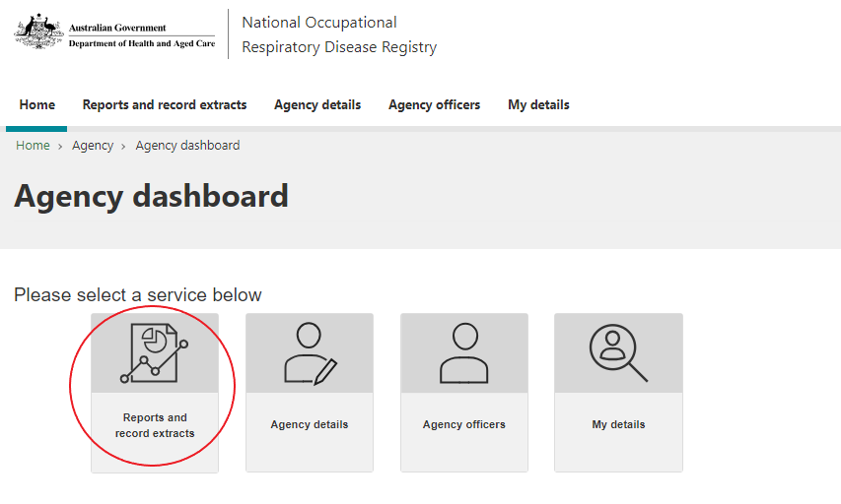
The reports and extracts reflect the latest diseases notified.
For more information, or to report an issue, please contact helpdesk@nordr.au.

Agency reports available
The bottom of the screen lists all of the reports available. Select a report and it will display above.

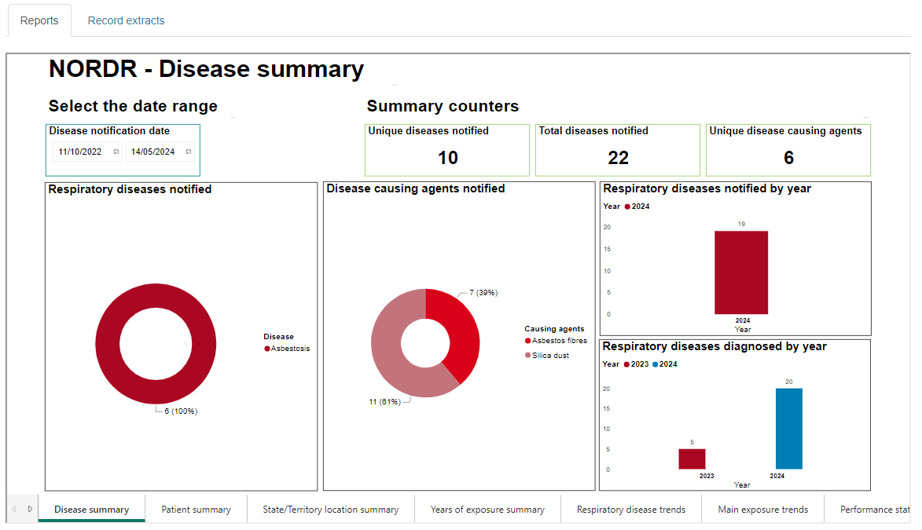

There are two groups of reports available:
- The "Reports” tab shows de-identified reports that do not identify patients, workplaces or physicians. These reports include all occupational respiratory diseases in Australia that are in the National Registry. Counts less than 5 are hidden for privacy reasons.
- The "Record extracts" tab shows detailed views/extracts that do identify patients, workplaces and physicians. These reports restrict the records that are available to the agency officer to those that are relevant to their jurisdiction. Records of individuals with an occupational respiratory disease are relevant if:
ü they reside, or
ü the physician diagnosing the disease, or
ü whose last exposure, or
ü whose main exposure was
in the State/Territory of the agency for which the agency officer is a part of.

There are two detailed reports available, as follows:
    - Data extract quick view: Presents key fields for the diseases that meet the date range specified that are relevant to the agency officer’s jurisdiction.
    - Data extract full view: Presents all fields for the diseases that meet the date range specified that are relevant to the agency officer’s jurisdiction.
You can also export these to Excel.

The quick view
The quick view shows the key fields to determine if there are records of interest. It shows records for individuals with an occupational respiratory disease within the selected notification date range. It is a subset of the fields in the Full view/extract. The quick view will show records for individuals:
ü that reside, or
ü were diagnosed, or
ü whose last exposure, or
ü whose main exposure was
in your State/Territory.
The field Notification/Updated record dates: This is the date range used to extract records to populate the Quick view table. It is not the same as the notification date range (which uses Disease notification date) included on the 21 de-identified reports. The records extracted are those that meet the date range selected for any one of these three fields:
- Disease notification date, OR
- The date patient details - date last updated, OR
- Disease and exposure details - date last updated.
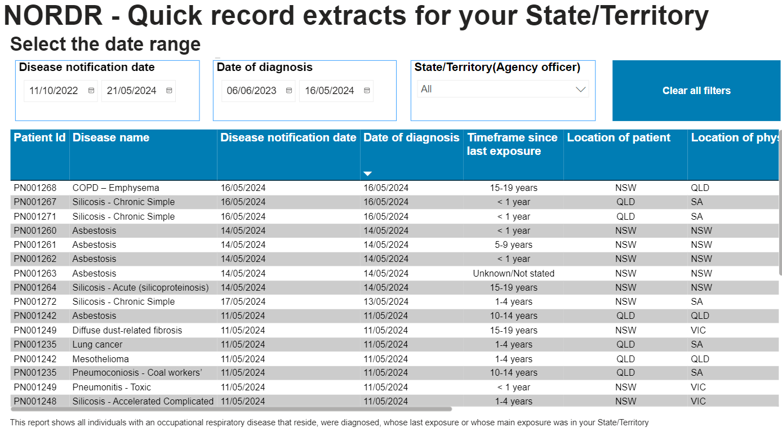
You can sort the Quick view table on any field by selecting the arrow in the column heading.

Fields in the quick view
If a patient has more than one disease they will have a record in the quick view for each disease.
Here is a data dictionary for the fields displayed in the quick view:

Field name | Field description
Patient Id | This is a unique identifier allocated to each patient.
Disease name | This is the name of the respiratory disease for this patient.
Disease notification date | This is the date the physician notified the disease to the National Registry.
Date of diagnosis | This is the date the physician said they diagnosed the disease
Time frame since last exposure | This is the time frame since the individual believes they were last exposed at work to a hazardous agent that contributed/caused the disease.
Location of patient | This is the State or territory where the individual resides. If they reside outside Australia it shows ‘Overseas’.
Location of physician | This is the State or territory where the physician’s place of business is where they made the diagnosis.
Location last exposure | This is the State or territory where the individual believes they had their last exposure at work to a hazardous agent that contributed/caused the disease. If the last exposure was outside Australia it shows ‘Overseas’.
Location main exposure | This is the State or territory where the individual believes they had their main exposure at work to a hazardous agent that contributed/caused the disease. If the main exposure was outside Australia it shows ‘Overseas’.
Patient first notified date | This is the date the National Registry received the first disease for this patient.
Date patient details last updated | This is the date of the last update to the patient’s details. Patient details contain:  - the patient’s date of birth  - date of death  - name  - country of birth  - language spoken at home  - sex  - indigenous status  - email address  - phone contact  - postal address  If this date is later than the Disease notification date, then the patient’s details have changed after the notification of the disease.
Date disease and exposure details last updated | This is the date of the last update to the patient’s disease and exposure details. Disease and exposure details contain:  - the main and secondary causing agents  - date of diagnosis  - time frames since last and main exposure  - the last and main industry, occupation and job task when the exposure occurred  - the last and main workplace where the exposure occurred.  If this date is later than the Disease notification date, then the patient’s details have changed after the notification of the disease.

The detailed view/extract
The Detailed view/extract view shows every field in the minimum notification information for individuals with an occupational respiratory disease. It shows records where they are within the selected notification date range, and they are relevant to the agency’s state or territory.
The Detailed view/extract will show records for individuals:
ü that reside, or
ü were diagnosed, or
ü whose last exposure, or
ü whose main exposure was in your State/Territory.
The field Notification/Updated record dates: This is the date range used to extract records to populate the Detailed view/extract table. It is not the same as the notification date range (which uses Disease notification date) included on the 21 de-identified reports. The records extracted are those that meet the date range selected for any one of these three fields:
- Disease notification date, OR
- The date patient details - date last updated, OR
- Disease and exposure details - date last updated.
The detailed view/extract table contains a single row for each disease a patient has, with fields in the following categories:
- Patient details
- Lung function values
- Disease details
- Last exposure details
- Main exposure details
- Physician details.
If a patient has more than one disease they will have a row for each disease with the details in blue replicated.
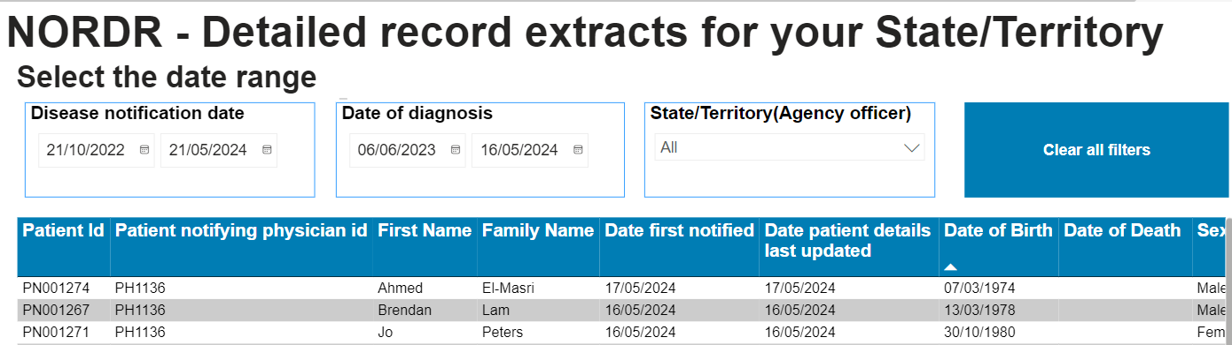

Fields in the Detailed view/extract
Here is a data dictionary for the fields in the detailed view/extract:

Field name | Field description
Patient details
Patient Id | This is a unique identifier allocated to each patient.
Patient notifying physician Id | This is the unique identify for the physician that was the first to notify this patient to the National Registry.
First name | This is the first name for the patient.
Last name | This is the patient’s last/family name.
Patient first notified date | This is the date the National Registry received the first disease for this patient.
Date patient details last updated | This is the date of the last update to the patient’s details. Patient details contain:  - the patient’s date of birth  - date of death  - name  - country of birth  - language spoken at home  - sex  - indigenous status  - email address  - phone contact  - postal address  If this date is later than the Disease notification date, then the patient’s details have changed after the notification of the disease.
Date of birth | This is the patient’s date of birth
Date of death | The National Registry updates the date of death once a year using the AIHW National Death Index. A physician can also update the date of death.
Sex | The patient’s sex at birth. The ABS categories collected are Male, Female and Indeterminate/Intersex/Unspecified.
Indigenous status | This is the indigenous status of the patient. The ABS categories used are Not indigenous, Aboriginal, Torres Strait Islander, Aboriginal & Torres Strait Islander, Not stated
Country of birth | This is the country of birth for the patient. We use the ABS country classification (SACC) for physicians to pick the patient’s country of birth.
Language spoken at home | This is the main language spoken in the patient’s home. We use the ABS language classification (SACL) for physicians to pick the patient’s language spoken at home.
Email address | This is the email address of the patient.
Address line 1 | This is first address line of the patient’s residential address.
Address line 2 | This is second address line of the patient’s residential address.
Suburb | This is the suburb of the patient’s residential address.
Field name | Field description
Postcode | This is postcode of the patient’s residential address.
Patient State territory of residence | This is the State or territory where the individual resides. If they reside outside Australia it shows ‘Overseas’.
Country | This is the country in which the patient resides.
Mobile number | This is the mobile phone number for the patient.
Landline number | This is the landline phone contact number for the patient.
Lung function values
Lung function test date | This is the date of the Spirometry or Gas transfer lung function tests.
FEV1 actual | FEV1 (Forced Expiratory Volume) actual is the PRE Bronchodilator amount of air you can force from your lungs in one second in litres (X.xx). Spirometry tests (also known as a pulmonary function test) measure FEV1.
FEV1 % predicted | The percentage of the predicted amount of air you can force from your lungs in one second for similar individuals without a lung condition.
FVC actual | FVC (Forced vital capacity) actual is the PRE Bronchodilator amount of air (in litres X.xx) that can be forcibly exhaled from your lungs. Spirometry tests (also known as a pulmonary function test) measure FVC.
FVC % predicted | The percentage of the predicted amount of air that can be forcibly exhaled from your lungs after taking the deepest breath possible. It compares this to similar individuals without a lung condition.
DLCO actual | DLCO is the diffusing capacity for carbon monoxide ( also known as the transfer factor for carbon monoxide or TLCO). It measures the conductance of gas transfer from inspired gas to the red blood cells in litres (XX.xx). Diffusing capacity tests/gas transfer tests measure DLCo.
DLCO % predicted | The percentage of the predicted diffusing capacity for carbon monoxide for similar individuals similar without a lung condition.
VA actual | VA is the alveolar volume. It measures in litres (X.xx) the number of contributing alveolar units during the single breath . Diffusing capacity tests/gas transfer tests measure VA.
VA % predicted | This is the percentage of the predicted number of contributing alveolar units measured during the single breath for similar individuals without a lung condition.
Disease details
Disease name | This is the name of the respiratory disease for this patient.
Disease SNOMED code | We use the SNOMED international disease classification system for coding respiratory diseases (Disorders). Where the physician does not use a disease listed in SNOMED but enters their own disease, the SNOMED code will be ‘0’. The Department reviews the text entered to find a suitable SNOMED code to update the SNOMED field. A SNOMED code of ‘9’ means there is no suitable code.
Mandatory/Voluntary disease | A ‘Mandatory’ disease is a prescribed respiratory disease at the date of notification to the National Registry. If not a prescribed disease this field contains ‘Voluntary’ meaning the patient consented to the notification.
Field name | Field description
Date of diagnosis | This is the date the physician said they diagnosed the disease.
Disease notification date | This is the date the physician notified the disease to the National Registry.
Date disease and exposure details last updated | This is the date of the last update to the disease and exposure details. The disease and exposure details contain:  - the main and secondary causing agents  - date of diagnosis  - time frames since last and main exposure  - the last and main industry, occupation and job task when the exposure occurred  - the last and main workplace where the exposure occurred  If this date is later than the Disease notification date, then the patient’s disease and exposure details have changed after the notification of the disease.
Occupational likelihood | This field is the physician’s view of the likelihood that the individual’s work caused or contributed to the respiratory disease. The default value is ‘Likely’. The National Registry requires the physician to believe it is at least likely that the individual’s work has contributed to the disease. The other values are ‘Very likely’ and ‘Certain’.
Age group on diagnosis | This is the age group the patient was in when first diagnosed with the respiratory disease. The age groups are:  - < 20 years  - 20 -29 years  - 30 – 39 years  - 40 – 49 years  - 50 – 59 years  - 60- 69 years  - 70 – 79 years  - 80 + years  The patient’s date of birth and the date of diagnosis determine the age group on diagnosis.
Main causing agent | This is the main disease causing agent the patient/physician believes the patient had exposure to at work. Additionally, the exposure caused or contributed to the respiratory disease.
Main causing agent SNOMED code | We use the SNOMED international disease classification system for coding disease causing agents (substances). Where the physician does not use a causing agent listed in SNOMED but enters their own causing agent, the SNOMED code will be ‘0’. The Department reviews the text entered to find a suitable SNOMED code to update the SNOMED field. A SNOMED code of ‘9’ means there is no suitable code.H
Secondary causing agent | This is the secondary disease causing agent the patient/physician believes the patient had exposure to at work. Additionally, the exposure caused or contributed to their respiratory disease.
Secondary causing agent SNOMED code | We use the SNOMED international disease classification system for coding disease causing agents (substances). Where the physician does not use a causing agent listed in SNOMED but enters their own causing agent, the SNOMED code will be ‘0’. The Department reviews the text entered to find a suitable SNOMED code to update the SNOMED field. A SNOMED code of ‘9’ means there is no suitable code.
Medical tests used to diagnose | These are some of the medical tests used to diagnose the patient’s respiratory disease.
Field name | Field description
Diagnosis confirmed by MDT | This filed captures whether a Multi-disciplinary Team confirmed the diagnosis. There is no need for a Multi-disciplinary Team to confirm the respiratory disease diagnosis.
Total years of exposure | This reflects the total years of exposure that the patient believes they had to a disease causing agent. The year ranges collected are:  - < 1 year  - 1 – 4 years  - 5 – 9 years  - 10 – 14 years  - 15 – 19 years  - 20 + years  - Unknown/Not stated
Last exposure details
Time frame since last exposure | This is the time frame since the individual believes they were last exposed at work to a disease causing agent. The year ranges collected are:  - < 1 year  - 1 – 4 years  - 5 – 9 years  - 10 – 14 years  - 15 – 19 years  - 20 + years  - Unknown/Not stated
Last exposed industry | This is the industry in which the patient was working when they believed they had their last exposure to a disease causing agent at work. We use the ABS ANZSIC industry classification system. The physician can also enter in their own industry if they cannot find the one they are looking for in the list.
Last exposed industry ANZSIC division | This is the ABS ANZSIC industry division in which the patient was working when they believed they had their last exposure.
Last exposed industry ANZSIC code | This is the ABS ANZSIC industry code in which the patient was working when they believed they had their last exposure.
Still working in last exposure industry | This field indicates if the patient is still working in the industry where the individual believes they were last exposed at work.
Last exposed occupation | This is the occupation of the patient when they believed they had their last exposure to a disease causing agent at work. We use the ABS ANZSCO occupation classification system to present the list of occupations to choose from. The physician can also enter in their own occupation if they cannot find the one they are looking for in the list.
Last exposed occupation ANZSCO code | This is the ABS ANZSCO code associated with the occupation chosen. A code of ‘&&&&&&’ means Not stated. The ANZSCO code is ‘000000’ if the physician does not use an occupation from the list they can enter their own occupation. The department will try and find a valid occupation that matches the text entered and will then reset the ANZSCO code. An occupation ANZSCO code of ‘000000’ means the department has not yet found a valid ANZSCO code. An ANZSCO code of ‘@@@@@@’ means the occupation entered is not a valid occupation.
Last exposed job task | This is the main job task the patient believes they were performing that led to the last exposure to a hazardous disease causing agent.

Field name | Field description
Last exposure business name | This is the name of the business employing the patient where they believe they had their most recent exposure to a disease causing agent. Where there is no business name we use the text ‘Unknown or Not stated’.
Last exposure business email | This is the email contact address for the business employing the patient where they believe they had their most recent exposure.
Last exposure business landline | This is the email contact address for the business employing the patient where they believe they had their most recent exposure.
Last exposure address line 1 | This is the physical address line 1 for the business employing the patient where they believe they had their most recent exposure.
Last exposure address line 2 | This is the physical address line 2 for the business employing the patient where they believe they had their most recent exposure.
Last exposure suburb | This is the suburb for the physical address of the business employing the patient where they believe they had their most recent exposure.
Last exposure postcode | This is the postcode for the physical address of the business employing the patient where they believe they had their most recent exposure.
Location last exposure | This is the State or territory where the individual believes they had their last exposure at work to a hazardous agent that contributed/caused the disease. If the last exposure was outside Australia it shows ‘Overseas’.
Still working at last exposure workplace | This indicates if the patient is still working at the place of business where they had their last exposure.
Last exposure was also the main exposure | This field indicates whether the last exposure to a disease causing agent was also the main exposure. Where the last exposure was also the main exposure then all main exposure fields will mirror the contents of the last exposure fields.
Main exposure details
Time frame since main exposure | This is the time frame since the individual believes they had their main exposed at work to a disease causing agent. The year ranges collected are:  - < 1 year  - 1 – 4 years  - 5 – 9 years  - 10 – 14 years  - 15 – 19 years  - 20 + years  - Unknown/Not stated
Main exposure industry | This is the industry in which the patient was working when they believed they had their main exposure to a disease causing agent at work. We use the ABS ANZSIC industry classification system. The physician can also enter in their own industry if they cannot find the one they are looking for in the list.
Main exposure industry ANZSIC division | This is the ABS ANZSIC industry division in which the patient was working when they believed they had their main exposure.
Main exposure industry ANZSIC code | This is the ABS ANZSIC industry code in which the patient was working when they believed they had their main exposure.

Field name | Field description
Still working in main exposure industry | This field indicates if the patient is still working in the industry where the individual believes they had their main exposure at work.
Main exposure occupation | This is the occupation of the patient when they believed they had their main exposure to a disease causing agent at work. We use the ABS ANZSCO occupation classification system to present the list of occupations to choose from. The physician can also enter in their own occupation if they cannot find the one they are looking for in the list.
Main exposure occupation ANZSCO code | This is the ABS ANZSCO code associated with the occupation chosen. A code of ‘&&&&&&’ means Not stated. The ANZSCO code is ‘000000’ if the physician does not use an occupation from the list they can enter their own occupation. The department will try and find a valid occupation that matches the text entered and will then reset the ANZSCO code. An occupation ANZSCO code of ‘000000’ means the department has not yet found a valid ANZSCO code. An ANZSCO code of ‘@@@@@@’ means the occupation entered is not a valid occupation.
Main exposure job task | This is the main job task the patient believes they were performing that led to the main exposure to a hazardous disease causing agent.
Main exposure business name | This is the name of the business employing the patient where they believe they had their main exposure (most severe) to a disease causing agent. Where there is no business name we use the text ‘Unknown or Not stated’.
Main exposure business email | This is the email contact address for the business employing the patient where they believe they had their main exposure.
Main exposure business landline | This is the email contact address for the business employing the patient where they believe they had their main exposure.
Main exposure address line 1 | This is the physical address line 1 for the business employing the patient where they believe they had their main exposure.
Main exposure address line 2 | This is the physical address line 2 for the business employing the patient where they believe they had their main exposure.
Main exposure postcode | This is the postcode for the physical address of the business employing the patient where they believe they had their main exposure.
Location main exposure | This is the State or territory where the individual believes they had their main exposure at work to a hazardous agent that contributed/caused the disease. If the main exposure was outside Australia it shows ‘Overseas’.
Still working at main exposure workplace | This indicates if the patient is still working at the place of business where they had their main exposure.
Physician details
Disease notifying Physician Id | This is the unique identify for the physician that notified this disease for this patient to the National Registry.
Physician First name | This is the physician’s first name.
Physician Family name | This is the physician’s last/family name
Medical speciality | This is the registered medical speciality of the physician. Valid values are ‘Respiratory’ (for Respiratory and sleep medicine physicians) and ‘Occupational’ (for Occupational and environmental physicians).
Field name | Field description
Physician Organisation | This is the name of the organisation/business that the physician works in.
Physician Work email | This is the work email address for the physician.
Physician Address line 1 | This is the physical address line 1 of the business where the physician works.
Physician Address line 2 | This is the physical address line 2 of the business where the physician works.
Physician Suburb | This is the suburb for the physical address of the business where the physician works.
Physician Postcode | This is the postcode for the physical address of the business where the physician works.
Physician State territory | This is the State or territory where the physician’s place of business is where they made the diagnosis.
Physician Landline | This is the landline contact number for the physician at work.
Physician Fax | This is the fax number for the physician at work.
Date Physician details last updated | This is the date of the last update to the physician’s details. Their details include:  - their name  - the name of the organisation/business they work for  - the place of business address  - medical speciality  - their email, phone and fax contact details

Data transformations
- Not stated or Unknown
For Last exposure business name and Main exposure business name if they are not supplied, then the text ‘Not stated or Unknown’ is displayed.
- Invalid entry
When the physician supplies a value in an 'Other' field, then the Registry Operator will review the text to confirm it is a valid entry.
If the value entered is found to be invalid, then the text is updated to 'Invalid entry'. The text 'Invalid entry' will then be used in the Power BI reporting.
These are the 10 Other fields for which this logic applies:
- Disease name
- Main causing agent
- Secondary causing agent
- Medical test used
- Last exposed industry
- Last exposed occupation
- Last exposed job task
- Main exposure industry
- Main exposure occupation
- Main exposure job task
- Not reported
If no Secondary causing agent has been supplied then the text ‘Not reported’ is shown.

Navigating the data extracts
Sorting: You can click on any column header and sort the table by that header.
If you place your cursor in the top right hand corner of the table, then four tools display:
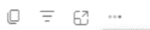
Explanations for table tools

Copies the table image with a caption to your clipboard
This shows the filters that are impacting this table
This shows the table on its own page
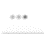
If you choose … then you get more options
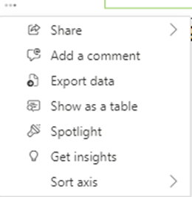

If you select one of these tools, you can go back to the normal report by clicking on
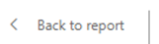
Back to report.

Exporting data: To export the data behind a table select the icon at the top of the table, and then select “Export data”. The system will then create an excel file with the data for you.

For example, selecting and then
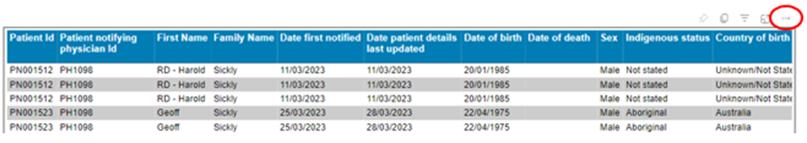
Creates this Excel file:
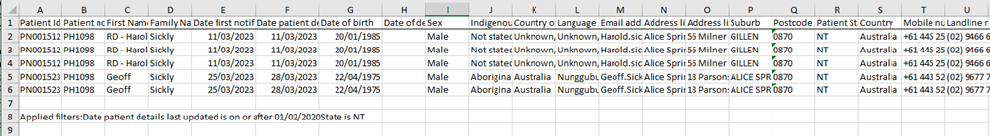

Reference data
In the National Registry we supply drop down lists and look-up tables to make it easier for the physician to do their data entry. This also provides consistency and quality in the data collected.
In the data dictionary presented above the following fields have their reference data values listed:
- Sex
- Indigenous status
- Age group on diagnosis
- Time frame since last/main exposure
- Total years of exposure
For Industry, Occupation, Country of Birth and Language spoken at home the list of values is too large to incorporate into a document. These are available on the Australian Bureau of Statistics Website.
The following reference data set values are not detailed in the data dictionary:
- Diseases
- Disease causing agents
- Medical tests, and
- Job tasks
The value sets for these fields are detailed below.

Diseases
The National Registry presents the physician with following common respiratory diseases to populate the drop down list of relevant diseases. This table also shows the SNOMED code associated with each disease.

Display order | Disease | Mandatory notify | SNOMED code
1 | Silicosis - Acute (silicoproteinosis) | Y | 233760007
2 | Silicosis - Accelerated Simple | Y | 1606841000168106
3 | Silicosis - Accelerated Complicated | Y | 1606851000168108
4 | Silicosis - Chronic Simple | Y | 1601731000168104
5 | Silicosis - Chronic Complicated | Y | 1601741000168108
6 | Asbestosis | N | 22607003
7 | Asthma - Occupational | N | 57607007
8 | Asthma - Work-exacerbated | N | 1599021000168109
9 | COPD – Chronic Bronchitis | N | 63480004
10 | COPD – Emphysema | N | 87433001
11 | Diffuse dust-related fibrosis | N | 1598901000168106
12 | Lung cancer | N | 93880001
13 | Mesothelioma | N | 109378008
14 | Pneumoconiosis - Coal workers’ | N | 29422001
15 | Pneumoconiosis - Mixed dust | N | 32139003
16 | Pneumonitis - Hypersensitivity | N | 37471005
17 | Pneumonitis - Toxic | N | 233733000
18 | Silica associated lymphadenopathy | N | 1598501000168103
19 | Other | N | TBD
If a physician selects ‘Other’, then the physician can search SNOMED to select a different disease (disorder), or they can just type in a different disease. The list of common respiratory diseases makes it easier for the physician to do their data entry. It also provides more consistency and quality in the diseases notified.

Disease causing agents
The National Registry presents the following common causing agents to populate the drop down list depending on the disease selected. This table also shows the SNOMED code associated with the causing agent.
Disease | Display order | Causing agent | SNOMED code
Silicosis - Chronic Simple | 1 | Silica dust | 311429008
Silicosis - Chronic Complicated | 1 | Silica dust | 311429008
Silicosis - Accelerated Simple | 1 | Silica dust | 311429008
Silicosis - Accelerated Complicated | 1 | Silica dust | 311429008
Silicosis - Acute | 1 | Silica dust | 311429008
Silica associated lymphadenopathy | 1 | Silica dust | 311429008
Diffuse dust-related fibrosis | 1 | Silica dust | 311429008
Diffuse dust-related fibrosis | 2 | Coal dust | 52141008
Pneumoconiosis - Coal workers’ | 1 | Coal dust | 52141008
Pneumoconiosis - Mixed dust | 1 | Coal dust | 52141008
Pneumoconiosis - Mixed dust | 2 | Mixed dust | 7271004
Pneumoconiosis - Mixed dust | 3 | Silica dust | 311429008
Pneumoconiosis - Mixed dust | 4 | Other mineral dust | 26227005
Pneumoconiosis - Mixed dust | 5 | Unknown | 261665006
Pneumoconiosis - Mixed dust | 6 | Other | TBD
COPD – Chronic Bronchitis | 1 | Coal dust | 52141008
COPD – Chronic Bronchitis | 2 | Engine exhaust | 76213002
COPD – Chronic Bronchitis | 3 | Fire smoke | 64197008
COPD – Chronic Bronchitis | 4 | Mixed dust | 7271004
COPD – Chronic Bronchitis | 5 | Passive smoking | 228523000
COPD – Chronic Bronchitis | 6 | Paint solvent-based | 228990004
COPD – Chronic Bronchitis | 7 | Welding fumes | 255737005
COPD – Chronic Bronchitis | 8 | Unknown | 261665006
COPD – Chronic Bronchitis | 9 | Other | TBD
COPD – Emphysema | 1 | Coal dust | 52141008
COPD – Emphysema | 2 | Cotton fibres | 89889006
COPD – Emphysema | 3 | Diesel fumes | 1598931000168104
COPD – Emphysema | 4 | Grain dust | 304628004
COPD – Emphysema | 5 | Mixed dust | 7271004
COPD – Emphysema | 6 | Passive smoking | 228523000
COPD – Emphysema | 7 | Wood dust | 64601002
COPD – Emphysema | 8 | Unknown | 261665006
COPD – Emphysema | 9 | Other | TBD
Asthma - Occupational | 1 | Acrylates - artificial nails/eyelash/cosmetics/Dentistry | 272159008
Asthma - Occupational | 2 | Aldehydes e.g., Formaldehyde | 60530008
Asthma - Occupational | 3 | Animal dander | 264287008
Asthma - Occupational | 4 | Anhydrides/Acids | 34957004
Asthma - Occupational | 5 | Arthropods/mites | 106762008
Asthma - Occupational | 6 | Bio aerosols (mould/pollen) | 26071008
Asthma - Occupational | 7 | Epoxy | 65345002
Asthma - Occupational | 8 | Flour | 63766005
Asthma - Occupational | 9 | Industrial cleaning agents | 79007002
Asthma - Occupational | 10 | Isocyanates | 255771001
Asthma - Occupational | 11 | Latex | 111088007
 | 12 | Metals | 425620007
 | 13 | Wood dust | 64601002
 | 14 | Unknown | 261665006
 | 15 | Other | TBD
Asthma - Work-exacerbated | 1 | Allergens (e.g. pollen, mould, animals, dust mites) | 277054007
Asthma - Work-exacerbated | 2 | Ammonia | 43953005
Asthma - Work-exacerbated | 3 | Extreme temperatures | 1004049005
Asthma - Work-exacerbated | 4 | Humidity | 3525006
Asthma - Work-exacerbated | 5 | Irritants (e.g. cleaning products, smoke, fumes, dusts) | 406429003
Asthma - Work-exacerbated | 6 | Physical exertion | 19487008
Asthma - Work-exacerbated | 7 | Unknown | 261665006
Asthma - Work-exacerbated | 8 | Other | TBD
Pneumonitis - Hypersensitivity | 1 | Grain dust | 304628004
Pneumonitis - Hypersensitivity | 2 | Wood dust | 64601002
Pneumonitis - Hypersensitivity | 3 | Hay dust | 255703002
Pneumonitis - Hypersensitivity | 4 | Unknown | 261665006
Pneumonitis - Hypersensitivity | 5 | Other | TBD
Pneumonitis - Toxic | 1 | Ammonia | 43953005
Pneumonitis - Toxic | 2 | Bromine | 85378003
Pneumonitis - Toxic | 3 | Chlorine | 29276003
Pneumonitis - Toxic | 4 | Formaldehyde | 111095003
Pneumonitis - Toxic | 5 | Hydrogen Chloride | 27763000
Pneumonitis - Toxic | 6 | Hydrogen Fluoride | 42757007
Pneumonitis - Toxic | 7 | Methylisocyanate | 79522001
Pneumonitis - Toxic | 8 | Nitrogen Dioxide | 91424007
Pneumonitis - Toxic | 9 | Phosgene | 70221002
Pneumonitis - Toxic | 10 | Sulphur Dioxide | 86233005
Pneumonitis - Toxic | 11 | Unknown | 261665006
 | 12 | Other | TBD
Mesothelioma | 1 | Asbestos fibres | 16369005
Asbestosis | 1 | Asbestos fibres | 16369005
Lung cancer | 1 | Arsenic | 47809000
Lung cancer | 2 | Asbestos fibres | 16369005
Lung cancer | 3 | Chromium | 111070004
Lung cancer | 4 | Coal dust | 52141008
Lung cancer | 5 | Diesel fumes | 1598931000168104
Lung cancer | 6 | Mixed dust | 7271004
Lung cancer | 7 | Passive smoking | 228523000
Lung cancer | 8 | Polycyclic aromatic hydrocarbons | 34862004
Lung cancer | 9 | Radon gas | 72927002
Lung cancer | 10 | Silica dust | 311429008
Lung cancer | 11 | Soot | 1598481000168107
 | 12 | Unknown | Unknown
 | 13 | Other
Other | 1 | Acrylates - artificial nails/eyelash/cosmetics/Dentistry | 272159008
Other | 2 | Aldehydes e.g., Formaldehyde | 60530008
Other | 3 | Allergens (e.g. pollen, mould, animals, dust mites) | 277054007
Other | 4 | Ammonia | 43953005
Other | 5 | Anhydrides/Acids | 34957004
Other | 6 | Animal dander | 264287008
Other | 7 | Arsenic | 47809000
Other | 8 | Arthropods/mites | 106762008
Other | 9 | Asbestos fibres | 16369005
Other | 10 | Bio aerosols (mould/pollen) | 26071008
Other | 11 | Bromine | 85378003
 | 12 | Chlorine | 29276003
 | 13 | Chromium | 111070004
 | 14 | Coal dust | 52141008
 | 15 | Cotton fibres | 89889006
 | 16 | Diesel fumes | 1598931000168104
 | 17 | Engine exhaust | 76213002
 | 18 | Epoxy | 65345002
 | 19 | Extreme temperatures | 1004049005
 | 20 | Fire smoke | 64197008
 | 21 | Flour | 63766005
 | 22 | Formaldehyde | 111095003
 | 23 | Grain dust | 304628004
 | 24 | Hay dust | 255703002
 | 25 | Humidity | 3525006
 | 26 | Hydrogen Chloride | 27763000
 | 27 | Hydrogen Fluoride | 42757007
 | 28 | Industrial cleaning agents | 79007002
 | 29 | Irritants (e.g. cleaning products, smoke, fumes, dusts) | 406429003
 | 30 | Isocyanates | 255771001
 | 31 | Latex | 111088007
 | 32 | Metals | 425620007
 | 33 | Methylisocyanate | 79522001
 | 34 | Mixed dust | 7271004
 | 35 | Nitrogen Dioxide | 91424007
 | 36 | Other mineral dust | 26227005
 | 37 | Paint solvent-based | 228990004
 | 38 | Passive smoking | 228523000
 | 39 | Phosgene | 70221002
 | 40 | Physical exertion | 19487008
 | 41 | Polycyclic aromatic hydrocarbons | 34862004
 | 42 | Radon gas | 72927002
 | 43 | Silica dust | 311429008
 | 44 | Soot | 1598481000168107
 | 45 | Sulphur Dioxide | 86233005
 | 46 | Welding fumes | 255737005
 | 47 | Wood dust | 64601002
 | 48 | Other | TBD
 | 49 | Unknown | 261665006
If a physician selects ‘Other’, then the physician can search SNOMED to select a different causing agent (substance), or they can just type in a different causing agent. The list of common causing agents makes it easier for the physician to do their data entry. It also provides more consistency and quality in the causing agents notified.

Medical tests
The National Registry presents the following common medical tests used to diagnose a respiratory disease:
- Blood test
- Bronchial provocation
- CT Scan
- Gas Transfer
- Lung volumes
- Peak expiratory flow
- Pulse oximetry
- Spirometry
- X-ray
- Other medical test.
If a physician selects ‘Other medical test’ then the physician can search SNOMED to select a different medical test (procedure), or they can just type in a different medical test. The list of common medicals test makes it easier for the physician to do their data entry. It also provides more consistency and quality in the medical tests being used to diagnose respiratory diseases.

Job tasks
The National Registry presents the following common job tasks to populate the drop down list of main job tasks causing the last and main exposures:
- Abrasive/Sand blasting
- Assay laboratory sample preparing
- Cleaning tools, surfaces, or the workspace
- Cutting, Shaping, Sawing
- Excavating, drilling, earth moving
- Food preparation
- Installing
- Labouring
- Livestock, vegetation management
- Maintenance
- Mobile plant operator
- Office work
- Painting
- Polishing
- Spraying
- Transporting
- Wood working
- Not Stated
- Other
If a physician selects ‘Other’, then the physician can type in a different job task. The list of common job tasks makes it easier for the physician to do their data entry. It also provides more consistency and quality in the job tasks notified.

